|  |  |  |
| --- | --- | --- |
|  | **ACCEPTED MANUSCRIPT (06 DEC 2013)** Journal of Cleaner Production journal homepage: www.elsevier.com |  |

**Sustainability in the Malaysian palm oil industry**

**Choong Chee Guan**

Mechanical Engineering Department, Ungku Omar Polytechnic,31400 Ipoh, Malaysia.

**Alison McKay**

Institute of Engineering Systems and Design, School of Mechanical Engineering, University of Leeds, Leeds LS2 9JT, United Kingdom.

|  |  |
| --- | --- |
| ARTICLE INFO | ABSTRACT |
| Article history:  Received  Received in revised form  Accepted  Available online | With a rapidly growing world population, the demand for palm oil is increasing. In 2010, palm oil accounted for 36.5% of the world’s vegetable oil production and it is projected to be the leading vegetable oil in the world by 2016. As the Malaysian palm oil industry is committed to delivering sustainable palm oil products to meet customer demand, this research was to enable identification and prioritisation of areas for improvement. As an example, the Roadmap of Malaysian Palm Oil Industry 2009-2020 was finalised as one of its strategies to attain sustainable production of palm oil and improvement in the quality of planet, people and profit. These include the implementations of Environment Management Systems (since 2004) and National Life Cycle Assessment Project (since 2006). The implementation of carbon footprint labelling is currently being carried out under the National Carbon Footprint Labelling Scheme (2011-2015) by the Standards and Industrial Research Institute of Malaysia (SIRIM) as part of continuous improvements for the delivery of sustainable palm oil products. Current approaches used for governing sustainable palm oil products are unsatisfactory due to limitations such as lack of potential impact models, data availability and uncertainty of impact results. Hence, this research addressed the need to improve understanding of having clear information requirements based on the different impacts in the Malaysian palm oil industry supply network tiers. Simulation experiments were then used to explore the aggregation of these information requirements across the Malaysian palm oil industry supply network. Agent-based and system dynamics modelling techniques were applied to simulate the behaviours of different entities and their interactions in the plantation, mill and mill-refinery models. These simulation techniques were able to build understanding on how information could be linked throughout the different tiers in the supply network. In order to have significant results, the output of the models of each tier must be linked (e.g. the mill and refinery models were linked together).  2013 Elsevier Ltd. All rights reserved. |
| Keywords:  Sustainability  Supply network  Agent-based modelling  System dynamics modelling  Eco-labelling  Information flow |

1. Introduction

Sustainability issues are increasingly important among government, consumers and corporations around the world (Kumar et al., 2005, p. 215, Geibler, 2013). A widely adopted and quoted definition of sustainability is that of the Brundtland Commission ([World Commission on Environment and Development, 1987, p. 8](http://www.emeraldinsight.com/Insight/ViewContentServlet?Filename=Published/EmeraldFullTextArticle/Articles/0050380502.html#idb159#idb159)): “development that meets the needs of the present without compromising the ability of future generations to meet their needs.” This broad rubric of sustainability includes issues such as understanding the environmental impact of economic activity in both developing and industrialised economies ([Erlich and Erlich, 1991](http://www.emeraldinsight.com/Insight/ViewContentServlet?Filename=Published/EmeraldFullTextArticle/Articles/0050380502.html" \l "idb47#idb47" \o "b47.)); ensuring worldwide food security ([Lal](http://www.emeraldinsight.com/Insight/ViewContentServlet?Filename=Published/EmeraldFullTextArticle/Articles/0050380502.html" \l "idb87#idb87" \o "b87.) *[et al.](http://www.emeraldinsight.com/Insight/ViewContentServlet?Filename=Published/EmeraldFullTextArticle/Articles/0050380502.html" \l "idb87#idb87" \o "b87.)*[, 2002](http://www.emeraldinsight.com/Insight/ViewContentServlet?Filename=Published/EmeraldFullTextArticle/Articles/0050380502.html" \l "idb87#idb87" \o "b87.)); ensuring that basic human needs are met ([Savitz and Weber, 2006](http://www.emeraldinsight.com/Insight/ViewContentServlet?Filename=Published/EmeraldFullTextArticle/Articles/0050380502.html" \l "idb122#idb122" \o "b122.)); and assuring the conservation of non-renewable resources ([Whiteman and Cooper, 2000](http://www.emeraldinsight.com/Insight/ViewContentServlet?Filename=Published/EmeraldFullTextArticle/Articles/0050380502.html#idb153#idb153)).

The definition of sustainability is still very broad. The fact that there is no common agreement from stakeholders’ perspectives of what information is needed for the definition of sustainability represents a research opportunity. In the Malaysian palm oil industry, the primary tools applied are environmental management systems and life cycle assessment which reflect the importance of environmental sustainability. Friends of Earth (2011) demand prioritisation of protecting land use for future food production. This is to control future land expansion in order to reduce environmental impacts (e.g. greenhouse effect). Hence, the scope of this research was on environmental sustainability focussing on strategies to address climate change such as environmental management systems, life cycle assessment and eco-labelling. This provided a basis for assessments with respect to the environmental sustainability performance.

There is a growing awareness among manufacturers of the benefits of considering triple bottom line performance and to recognise that environmental challenges represent both business opportunities and a societal responsibility (Marks and Spencer, 2012). A summary report from Department for Environment, Food and Rural Affairs (DEFRA, 2006) asserts that the UK government commitment to stimulate the market for more sustainable goods and services and to shift consumption patterns of business and consumers is a move to a more sustainable economy. In 2008, recommendations were also made available from the International Reference Life Cycle Data System (ILCD, 2008), set up by the European Commission in consultation with several non-EU countries, industry associations, as well as scientific experts to facilitate development of formal international recommendations for life cycle assessment (LCA). Life cycle assessment is a tool used to assess environmental impacts and resources used throughout a product’s life cycle (Finnveden et al., 2009). One of the instruments in supporting life cycle assessment activities is the life cycle impact assessment. This instrument is important since increasing environmental impacts occur in fast growing economies. Life cycle thinking is important for all countries to avoid shifting of burdens between countries rather than reducing overall impacts (Finnveden et al., 2009). Urgent action in many countries is critical for sustainable development.

In responding to these recommendations, Malaysia was among the participating representatives involved with the National Life Cycle Assessment Project since 2006 to support a national eco-labelling programme and fulfil the requirements of foreign legislation that demand evidence on the control measures taken to reduce environmental impact of products and services throughout their life cycles. For example, in the implementation of eco-labelling, information of a product needs to be traced back to the plantation tier (e.g. raw materials) of the supply network. In this respect, the Standards and Industrial Research Institute of Malaysia (SIRIM) Berhad is mandated as the implementing agency by the Government of Malaysia and the Ministry of Natural Resources and Environment, specifically the Environmental Conservation and Management Division as the executive agency; both to work together to ensure delivery of the national life cycle project outputs by the end of the Ninth Malaysia Plan (2006-2010). The objectives of the National Life Cycle Assessment Project are:

i. To develop a national life cycle inventory database;

ii. To develop a critical mass of local Life Cycle Assessment practitioners;

iii. To develop eco-labelling criteria documents for the National Eco-labelling Programme; and

iv. To create awareness among industry and consumer groups on the importance of Life Cycle Assessment in today’s manufacturing and procurement practice.

M:\CCG Backup PhD Files\PhD 2012\CCG PhD Final Thesis\Figures\Timeline Current Practices MPOI.tif

Fig. 1. Key milestones of current practices in Malaysian palm oil industry

The key milestones of current practice implementation and future action plans of the Malaysian palm oil industry are illustrated in Fig. 1. These include the implementation of Environment Management Systems (since 2004) and National Life Cycle Assessment Project (since 2006). The implementation of carbon footprint labelling is currently being carried out under the National Carbon Footprint Labelling Scheme (2011-2015) by SIRIM as part of continuous improvements for the delivery of sustainable palm oil products.

1. Sustainability in the context of Malaysian palm oil industry

Palm oil is the most traded vegetable oil in the world. The demand for it is expected to continue to increase with rising consumer income and population growth (Wahid et al., 2007). Such economic impact in the growth of population for the next two decades is likely to affect the demand for food items including palm oil (Basiron and Simeh, 2005). As a result, the total consumption of world palm oil is expected to be 43 million tonnes in 2020.

As far as food security for palm oil as a source of edible oil is concerned, there are two main factors that are crucially important (Lam, 2008). The first factor is that there should be ample supply to meet the current market demand and also for future expanding demand. Secondly, the price should be stable and affordable to the majority of the world’s population. In order to cope with increased global demand for palm oil, Malaysia’s government is committed to and has identified environmental, social, and economic or planet, people and profit challenges. This is evidenced through various environmental, social and economic implementation strategies put forward in the national Malaysia Plans (e.g. National Life Cycle Assessment Project since 2006). In addition, during the entire period of the 9th Malaysia Plan (2006-2010), the Roadmap of Malaysian Palm Oil Industry 2009-2020 (MPOB, 2009) was being finalised as one of its strategies to attain sustainable production of palm oil and improvement in the quality of planet, people and profit. Studies of materials flow and energy balance of fresh fruit bunches (FFB) analyses using integrated technology also showed improved economic viability (i.e., integrated technology of biogas and compost production can provide a good solution for palm oil mills to utilize their by-products more profitability). This integrated technology such as using simulation software can be a new solution for a more sustainable palm oil industry management, while simultaneously addressing all the three pillars of sustainability of profit, people and planet (Yoshizak, et al., 2013).

The Malaysian Palm Oil industry supply network is illustrated in Fig. 2. The palm oil industry supply network can be divided into four tiers: (1) plantations; (2) mills; (3) refineries; and (4) manufacturers of different palm-based products. These tiers are linked together from upstream to downstream. Upstream tiers comprise of plantations and mill sectors. Plantations sectors are involved in the seedlings and nursery establishments, plantation of palm oil plants and the production of fresh fruit bunches. Whereas, downstream tiers comprise of palm oil refineries, palm kernel crushers and different manufacturers of palm-based products such as biodiesel, chemical, cosmetic, food, feeds and other value-added products. The network structure was used to inform the definition of the simulation models. These models were developed based on the identified system boundaries of the Malaysian palm oil industry supply network. As the key characteristics of sustainability vary across the different tiers of the supply network (e.g. such as the impacts of fertilisers and pesticides used at the seedling stage), different models were needed for the simulation of different environments. These simulation models were connected (e.g. the output of plantation model was used as the input of mill model) in order to demonstrate the behaviours of different tiers in the supply network. By doing so, information flows in the supply network

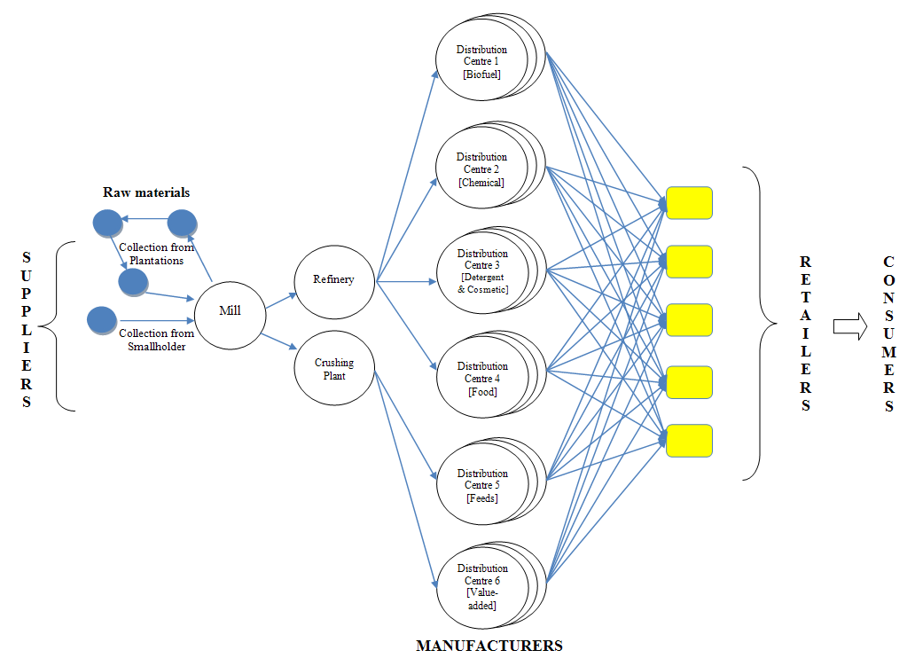

Fig. 2. The Malaysian palm oil industry supply network

tiers can illustrate how productivity in a certain tier affects the sustainability of other tiers in the supply network.

Extensive research has been carried out by the Malaysian Palm Oil Board in the area of sustainability initiatives related to palm oil products for impacts identification along the different system boundaries across the supply network. Results showed the way sustainability is defined, varies across different tiers in the Malaysian palm oil industry supply network. The tiers of plantation, mill and refinery are mainly referred to as the Malaysian palm oil industry. Manufacturer, retailer and consumer tiers vary between different products (manufacturer) and services (retailer) across different needs (consumer). As for the plantation tier, the key characteristics of sustainability depend on types of growers which include large plantations and smallholders. Plantation growers have the capabilities to achieve demands by expanding palm trees growth due to land availability and also to enhance the production of fresh fruit bunches from quality seedlings. These factors are different to the limited capabilities of the smallholders who have limited land supply. Hence, the measurement of sustainability differs between these two different sizes of organisations. On the other hand, in the mill tier, sustainability is measured in terms of energy efficiency, emissions and waste management impacts from the operating mill plants (Yusoff, 2006). Hence, the measurement of sustainability depends on the different impacts occurred in each tier. The knowledge on causal links between standards setting and induced sustainability effects is an essential requirement for the successful establishment of sustainability in value chains. (Geibler, 2013). As an example, operators of the mill plants are concerned about how to become compliant with sustainability standards regulated by the government and regulatory agencies. Meanwhile, manufacturers and retailers have different concerns due to different requirements from the consumers. The flow of information and knowledge across tiers is important to understand sustainability requirements (e.g. eco-labelling), risks on sustainability issues (e.g. land clearance), uncertainties (e.g. on the consequences of climate change) and future opportunities (e.g. improving resource use efficiency from the plantation tier).

1. Methodology

The report published in the International Manufacturing Professors’ Symposium (2009) stressed the importance of understanding relationships between industrial and environment sustainability, customer value and stakeholder requirements in the design of sustainable industrial systems. Based on this report, the need to understand potential methods and tool applications applied by the Malaysian palm oil industry were investigated through case studies. The enterprise engineering framework (McKay et. al, 2009) was used to identify improvement options in the delivery of sustainable palm oil for the Malaysian palm oil industry in Fig. 3.

|  |  |  |  |
| --- | --- | --- | --- |
|  | **Define** | **Develop** | **Deploy** |
| **Purpose** | Strengths and weaknesses |  |  |
| **Agency** | Supply network map | **Enterprise operating system** |  |
| **Products & services** | Definition of sustainable palm oil |  | Sustainable palm oil |

Fig. 3. The role of enterprise engineering framework

Different enterprise operating systems were used in the formulation of each case study; this resulted in a holistic view of the Malaysian palm oil industry in the form of multiple organisations in focussing different sustainability needs. A network structure was derived through these case studies using the enterprise engineering framework to inform the definition of simulation models. The identified relationships between the different tiers in the supply network were then used to summarise significant environmental impacts. These environmental impacts were simulated using different models of plantation, mill and mill-refinery. The usage of simulation software can help to analyse, exchange and aggregate information flow based on the different models from the Malaysian palm oil industry supply network tiers.

In response to the simulation experiments, the supply network map of the Malaysian palm oil industry was used for the analysis of plantation growth; fresh fruit bunches inputs and refinery outputs together with potential impacts such as energy, waste, and emission. NetLogo simulation software was used for the purpose of intervening system behaviours to investigate the current practices developed by the Malaysian palm oil industry. Information sharing within the supply network tiers can be viewed to show interactions between different stakeholders. This was to build understanding on how sustainability issues can be potentially intervened using three different models of verification.

* 1. Simulation using NetLogo

In order to effectively assess performance requirements in the Malaysian palm oil industry system, agent-based and system dynamics modelling were used to simulate the behaviours of different entities and their interactions in the plantation, mill and mill-refinery models. These simulation techniques were able to build understanding on how information could be linked throughout different tiers in the supply network. Agent-based modelling system was used to capture changes of plantations growth in the interacting modelling system agents of the supply network. Meanwhile, system dynamics modelling was used to simulate the behaviour of different tiers within a product development scenario and study of the effect of their interactions in the supply network.

To begin with, the Malaysian palm oil industry supply network agent-based model was developed by identifying the agent types and other objects with their attributes. For this study, the NetLogo simulation was verified as a numerical technique that takes input data and creates output data based upon a model of a palm oil supply network system. As an example, a palm oil plantation may be defined as an agent with inputs of I1 (seedlings) and I2 (land use) in order to produce O1 (fresh fruit bunches) as output before being sent to the mill. The plantation model structure is shown in Fig. 4 and the formula derived as:-

**Fresh fruit bunches = function (seedlings, land use)**

***O1 = f ( I1, I2 )***

I1, seedlings

I2, land use O1,fresh fruit bunches

(FFB)

**Fig. 4.** Plantation model structure

The understanding on how supply network interventions might address sustainability issues in the Malaysian palm oil industry was also carried out using two different models: mill model and mill-refinery model. By developing the mill model, the process of milling of fresh fruit bunches extraction from the plantation model in the earlier stage can be used to express the relationships between quantities and the interactions between fresh fruit bunches as the flow input to produce crude palm oil. The stock flow diagram for mill model is shown in Fig. 5 and the formula derived as:-

**Processing Energy = *function (processing quantity and***

***weights, energy per operation)***

**Waste = *function (waste quantity, cost)***

**Emission = *function (corresponding supply network***

***element, water)***

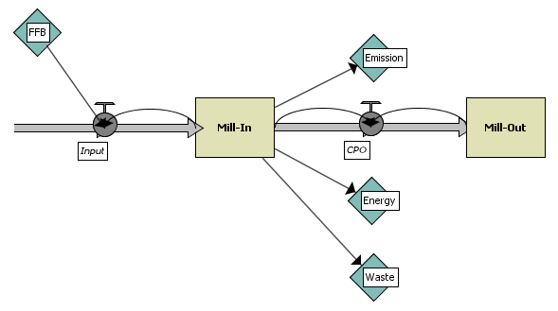

**Fig. 5.** Stock flow diagram of mill model

The mill-refinery model was used to understand the process of refining crude palm oil to be purified as edible oils from the previous mill model. The stock flow diagram of mill-refinery model is shown in Fig. 6 and the formula derived as:-

**Processing Energy = *function (processing quantity and***

***weights, energy per operation)***

**Waste = *function (waste quantity, cost)***

**Emission = *function (corresponding supply network***

***element, air)***

* 1. Lists of assumptions

Lists of assumptions were developed in order to simplify problems, while developing these models in Table 1:-

**Table 1.** Lists of assumptions of the simulated models

|  |  |
| --- | --- |
| **Plantation Model** | |
| *add1* | turtles used as agents to complex with seeds (example: water) |
| *add2* | turtles used as agents to complex with seeds (example: sun) |
| *Seed* | representative of palm trees seedlings |
| *Land* | plantation area of palm trees [approximately 1000 – 6000 ha of land per plantation] |
| *Palm* | representative of palm trees [1 ha of land = 140 palm trees] |
| *Fruit* | representative of fresh fruit bunches (FFB) [1 palm tree = 140 kg FFB] |
| *seed-add1-growth* | representative of fertilisers used [scale: 0 to 100] |
| *Seed-add2-growth* | representative of pesticides used [scale: 0 to 100] |
| **Mill Model** | |
| *Energy_number* | representative of Energy Efficiency [scale: 0.1 to 1.0] |
| *Waste_number* | representative of Waste Management [scale: 0.1 to 1.0] |
| *Emission_number* | representative of Emission [scale: 0.1 to 1.0] |
| *Land* | plantation area of palm trees [approximately 1000 – 6000 ha of land per plantation] |
| *palm* | representative of palm trees [1 ha of land = 140 palm trees] |
| *Fruit* | representative of fresh fruit bunches (FFB) [1 palm tree = 140 kg FFB] |
| **Mill-Refinery Model** | |
| *Energy_number1* | representative of Energy Efficiency from Mill Model [scale: 0.1 to 1.0] |
| *Waste_number1* | representative of Waste Management from Mill Model [scale: 0.1 to 1.0] |
| *Emission_number1* | representative of Emission from Mill Model [scale: 0.1 to 1.0] |
| *Energy_number2* | representative of Energy Efficiency from Refinery Model [scale: 0.1 to 1.0] |
| *Waste_number2* | representative of Waste Management from Refinery Model [scale: 0.1 to 1.0] |
| *Emission_number2* | representative of Emission from Refinery Model [scale: 0.1 to 1.0] |
| *land* | plantation area of palm trees [approximately 1000 – 6000 ha of land per plantation] |
| *palm* | representative of palm trees [1 ha of land = 140 palm trees] |
| *fruit* | representative of fresh fruit bunches (FFB) [1 palm tree = 140 kg FFB] |

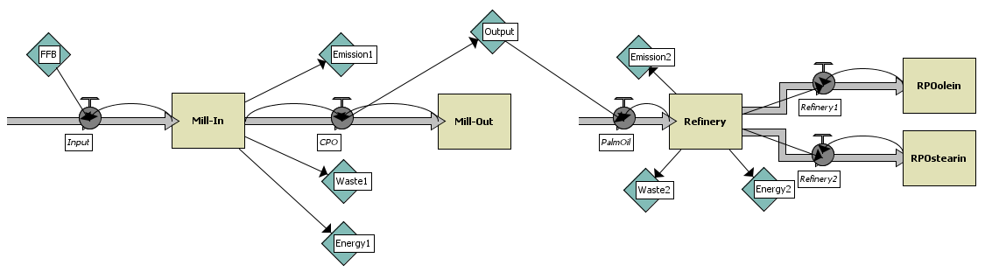

**Fig. 6.** Stock flow diagram of mill-refinery model

* 1. Programming codes

The code programming of the plantation model was written in a specific format in the procedures tab commands. The program has three parts: (1) global variables definitions; (2) setup procedure was written to initialise the simulation; and (3) go procedure was written to execute the system repeatedly (in a loop). The go procedure assigns each agent (turtles) to carry out the given instruction independently. Agents in NetLogo model were referred as turtles (refer to List of Assumptions). Typically, a population of turtles was initialised and procedures were written that control the behaviour of the turtles. The turtles represent physical entities whose behaviours result in movements around the two dimensional world (2D).

As for the mill and mill-refinery models, system dynamics modelling was used to generate NetLogo variables and procedures. The code programming of these models was written in a specific format in the procedures tab commands. These procedures showed how the models performed based on the defined equations made. The NetLogo procedures generated from the models were displayed in the procedures tab of the system dynamics modelling window. The disadvantage of this system dynamics modelling was the contents of the procedures tab cannot be modified and in order to make any modifications, the models must be edited.

1. Results and discussion

In the beginning of the first three years, when the seeds were planted, the setting was for no fruit formation. The *seed_units* were set at 140 for 1 ha of plantation land with full *add1* (example: water) and *add2* (example: sun light) units. From the graph obtained, when the *seeds* (red) were planted, the usage of *add1* and *add2* decreased when the palm trees (green) become matured. The usage of *seed-add1-growth* (fertilisers) and *seed-add2-growth* (pesticides) were set at 25 and 50 respectively. No fruit was available in this period. The *seed_rate* and *land_rate* eventually became constant.

The plantation model was tested on a full 100% fruits formation. From the graph below, the same results were obtained. For example, for 100 ha of plantation land, it produced 14,100 palm trees which can yield up to 1,954,400 kg of fresh fruits. From the graph obtained (Fig. 7), when the palm trees (green) started to yield, the *seed_rate* started to increase due to fruits formation process. This will eventually come to a constant after a certain time period. The usage of *seed-add1-growth* (fertilisers) and *seed-add2-growth* (pesticides) were set at 100 and 100 respectively.

The mill model was simulated with no impacts of additional defined variables such as energy efficiency, waste management and emission, the production of crude palm oil was seen to increase constantly until the given time period of yielding of the palm trees planted of 25 – 30 years. For instance, an increasing function in the early stage of the mill-out process was affected by a stock input of the mill-in which was the fresh fruit bunches, while at a later point in time various resources (fresh fruit bunches variable) remained idle and induced a higher flow. When the energy efficiency, waste management and emission impacts were applied to the mill model, the production of crude palm oil showed significant reduction in the output value of mill-out. The plotted graph is shown in Fig. 8.

When the mill-refinery model was simulated with no impacts of additional defined variables such as energy efficiency, waste management and emission, the production of crude palm oil was seen increasing constantly until the given time period of yielding of the palm trees planted of 25 – 30 years. The RPO*olein* and RPO*stearin* were displayed as two different outputs from the actual mill-out stock input. The hysteresis shape plotted from the graph was a reaction function of the mill model transforming into the refinery stock.

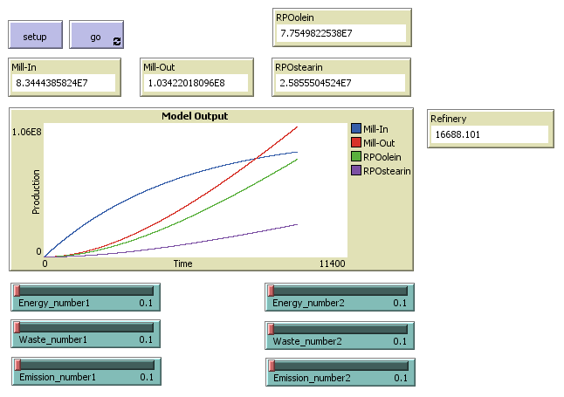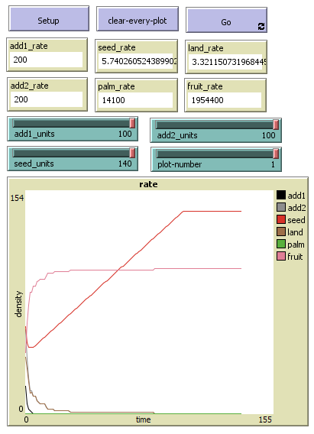

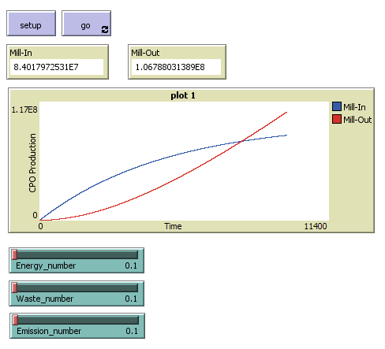**Fig. 7.** Plantation model result for 100% of fruits formation

Fig. 8. Mill model result for no impact from additional defined variables

For instance, an increasing function in the early stage of the refining process was affected by a stock input of the milling model, while at a later point in time various resources (crude palm oil) remained idle and induced higher flow. The overshoot graph suggested that the refinery model flow (growth) would outpace the ability of the mill model to supply crude palm oil, showing a high demand of refined palm oil. When the energy efficiency, waste management and emission impacts were applied to the mill-refinery model, the production of refined palm oil showed less significant reduction in the output values. The plotted graph is shown in Fig. 9.

Fig. 9. Mill-refinery model result for no impact from additional defined variables

From the simulation results obtained, information flow across the tiers in the supply network was identified as being important to the delivery of sustainability requirements used to simulate the behaviours of different entities and their interactions in the plantation, mill and mill-refinery models. In order to do so, these simulation models were connected (e.g. the output of plantation model was used as the input of mill model) to demonstrate the behaviours of different tiers in the supply network. For example, in the implementation of eco-labelling, information of a product needs to be traced back to the plantation tier (e.g. raw materials) of the supply network. These simulation experiments have showed the important elements of aggregating information across the supply network for the purpose of eco-labelling. Hence, information flows in the supply network tiers illustrated how productivity in a certain tier can affect the sustainability of other tiers in the supply network.

Agent-based modelling and systems dynamic modelling were proven feasible for modelling and understanding how individual tiers in the sub systems behave, and how the interaction of these tiers can lead to continuous improvement of the supply network performance. There was an opportunity to reduce the impacts of energy consumption, resulting in wastes and emissions. The developed models could be populated with real-world data. To achieve this, the simulation techniques would need to be developed further with the identification of system boundaries, simulation parameters related to stakeholder needs, capture of operating environments, and risks and uncertainties in the validation of models.

1. Conclusions

The importance of having clear information requirements based on the different impacts in the supply network tiers can be used to capture data related triple bottom line performance indicators in the design of sustainable industrial systems. As an example, eco-labelling for carbon footprint is part of the control measures taken to reduce environmental impact of products and services throughout the life cycle of the Malaysian palm oil industry supply network. A priority of implementing eco-labelling was due to consumer needs for reliable information to better inform purchasing decisions. This priority has created market incentives for manufacturers to develop and supply more environmentally sound products such as biodiesel, biofuel or biogas (Silalertruksa et al., 2012 and Reijnders & Huijbregts, 2008). In order to deliver eco-labelling, there is a need to gather information throughout the different tiers of the Malaysian palm oil industry supply network. A number of issues need to be addressed in the establishment of information systems that can be used to collect sustainability related data. The following were identified through this research:-

1. Aligning information perspectives according to the tiers of the supply network in order to capture different types of data. For example, information related to land use can be captured from the plantation tier. Whilst in the milling and refinery tiers, sustainability issues were referred to energy efficiency, waste management and emission impacts.
2. Aggregating data within tiers of the supply network (e.g. in the milling and refinery plants), to capture data of different production and process issues such as energy efficiency, waste management and emission impacts.
3. Tracing and connecting data through the network. For example from the end product perspective, such as the ingredient contents, a jar of peanut butter may consist of palm oil, peanuts and sugar. From the consumer tier, connectivity of data through the network from different perspectives is important for use in eco-labelling. Information gathered from these different perspectives can be translated into requirements to achieve traceability in eco-labelling for the delivery of sustainable palm oil.
4. Gathering provenance from the information system, e.g. capturing data and how the data is processed across the network, can be used to support sustainable supply networks of other sectors.

Simulation experiments were based on different tiers in the Malaysian palm oil industry supply network. The results from these simulation experiments showed that the output of the models of each tier must be linked. In order to have significant results, the mill and refinery models have been linked together. As such, in the implementation of eco-labelling, information of a product needs to be traced back to the plantation tier (e.g. raw materials) of the supply network. Hence, these simulation experiments have showed the important elements of aggregating information across the supply network for the purpose of eco-labelling. Further results from the simulation experiments showed that the behaviours of these models in different tiers can affect the continuity of information flow across the supply network. It was found that, in order to study the flow of information, these models need to be developed from the upstream to downstream tiers of the Malaysian palm oil industry supply network.

Information on supply and demands perceived by the plantation, mill and refinery tiers can be assessed according to the sequential flow of information in the supply network. For example, any risks encountered by the tiers that may affect the supply network performance on product sustainability can be traced. Hence, by improving traceability and responsiveness, lead time to demand satisfaction of the consumers can be reduced. In addition to that, knowledge and information gathered across the supply network can be disclosed to support sustainability reporting among practitioners. Interdependencies and information between tiers are likely to be transformed into knowledge and capabilities for the purpose of creating value added advantages across the supply network. These can be further initiated to better understand the sources of sustainable challenges, issues and uncertainties from different tiers in the supply network.

Agent-based modelling system was found to be an approach capable of capturing the changes of plantations growth in the interacting modelling system agents of the supply network. It was particularly applicable when agent adaptation and emergence were important considerations. The system dynamics modelling was used to simulate the behaviour of different entities within a product development scenario and the study of the effect of their interactions in the supply network. Both methods promise to have far-reaching effects into the future on how businesses can use computer simulations to support decision-making, government can use models to make and support policy guidelines, and researchers can use digital laboratories to further their research.

References

1. Basiron Y. and Simeh MA. (2005). Vision 2020 – The Palm Oil Phenomenon. Oil Palm Industry Economic Journal, Vol. 5(2).
2. Department for Environment, Food and Rural Affairs (DEFRA). (2006). Sustainable Procurement National Action Plan: Recommendations from the Sustainable Procurement Task Force. United Kingdom.

Available online at: http://www.defra.gov.uk/sustainable/government/publications/

procurement-action-plan/index.htm

1. Erlich, P.R. and Erlich, A.H. (1991). The Population Explosion. *Touchstone*. New York.
2. Finnveden, G., Hauschild, M.Z., Ekvall, T., Guine´e, J., Heijungs, R., Hellweg, S., Koehler, A., Pennington, D. and Suh, S. (2009). Recent developments in Life Cycle Assessment. *Journal of Environmental Management, 91*. pp. 1-21.
3. Friends of the Earth. (2011). Sustainability and profit. London,United Kingdom.

Available online at: http://www.foe.co.uk/living/articles/sustainability.html

1. Geibler, J. (2013). Market-based governance for sustainability in value chains: conditions for successful standard setting in the palm oil sector. *Journal of Cleaner Production, 56. pp. 39-53*.
2. International Manufacturing Professors’ Symposium. (2009). Towards a sustainable industrial system: accelerating the contribution of education and research. *University of Cambridge and Cranfield University*.
3. International Reference Life Cycle Data System (ILCD).

Available online at: http://lct.jrc.ec.europa.eu/eplca/deliverables/international-

reference-life-cycle-data-system-ilcd-handbook

1. Kumar, V., Haapala, K.R., Rivera, J.L., Hutchins, M.J., Endres, W.J., Gershenson, J.K., Michalek, D.J. and Sutherland, J.W. (2005). Infusing Sustainability Principles into Manufacturing/Mechanical Engineering Curricula. *Journal of Manufacturing Systems Vol 24(3)*. pp. 215-225.
2. Lal, R., Hansen, D.O., Uphoff, N. and Slack, S.A. (2002). Food Security and Environmental Quality in the Developing World. *CRC Press*. Boca Raton, Florida.
3. Lam, M.K., Tan, K.T., Lee, K.T. and Mohamed, A.R. (2008). Malaysian palm oil: Surviving the food versus fuel dispute for a sustainable future. *Renewable and Sustainable Energy Reviews*.
4. Malaysian Palm Oil Board (MPOB). (2009). Roadmap for the Malaysian Palm Oil Industry 2009-2020. *Selangor*, Malaysia.
5. Marks and Spencer’s Plan A. (2012). Plan A: Doing the right thing.

Available online at: http://plana.marksandspencer.com

1. McKay, A., Kundu, S. and Pennington, A.d. (2009). Supply networks: An approach to designing an extended enterprise. *International Conference on Product Lifecycle Management*. Inderscience Publishing Limited.
2. Savitz, A.W. and Weber, K. (2006). The Triple Bottom Line. *Jossey-Bass*. San Francisco, CA.
3. Silalertruksa, T., Bonnet, S. and Gheewala, S.H. (2012). Life cycle costing and externalities of palm oil biodiesel in Thailand. *Journal of Cleaner Production, 28. pp. 225-232*.
4. Reijnders, L. and Huijbregts, M.A.J. (2008). Palm oil and the emission of carbon-based greenhouse gases. *Journal of Cleaner Production, 16. pp. 477-482*.
5. Wahid, M.B., Lim, W.S. and Simeh, M.A. (2007). Technological Development and New Growth Areas of the Oil Palm Industry. *Oil Palm Industry Economic Journal. Vol. 7(1)*.
6. WCED. (1987). Our Common Future. *Oxford University Press*, Oxford.
7. Whiteman, G. and Cooper, W.H. (2000) Ecological embeddedness. *Academy of Management Journal, Vol. 43 No.6*. pp. 1265-82.
8. Yoshizak, T., Shirai, Y., Hassan, M.A., Baharuddin, A.S., Raja

Abdullah, N.M., Sulaiman, A. and Busu, Z. (2013). Improved

economic viability of integrated biogas energy and compost production for sustainable palm oil mill management*. Journal of Cleaner Production, 44. pp. 1-7*.

1. Yusoff, S. (2006). Renewable energy from palm oil - innovation on effective utilization of waste. *Journal of Cleaner Production, 14. pp. 87-93*.