Experimental Study, Dynamic Modelling, Validation and Analysis of Hydrogen Production from Pyrolysis/Gasification of Biomass in a Two-Stage Fixed Bed Reaction System
Akeem K. Olaleyeª , Kunle J. Adedayoª, Chunfei Wu^{b}, Mohamad A. Nahil ^{b}, Meihong Wang^{a,*}, Paul T. Williams ^{b,*}
ª Process and Energy Systems Engineering Group, School of Engineering, University of Hull, Hull HU6 7RX, UK
(Tel: +44 (0)1482 466688; email: Meihong.Wang@hull.ac.uk)
^{b} Energy Research Institute, The University of Leeds, Leeds, LS2 9JT, United Kingdom
(Tel: +44 1133432504; Email: p.t.williams@leeds.ac.uk)

ABSTRACT
There is great interest in producing hydrogen from renewable sources such as biomass rather than from fossil fuels. This paper presents new experimental results at different pyrolysis temperatures and development of a dynamic model for a biomass pyrolysis/steam reforming process in a two stage fixed bed reactor. The model considers the hydrodynamics of the fixed bed reactor, the interfacial mass and energy transfer between the fluid-solid systems and the porous catalyst, and the energy transfer on a kinetic model. The 2D dynamic model resulted in a system of partial differential equations which was solved numerically in gPROMS®. The model was validated with the experimental results. The model predictions show good agreement with the experimental results. The model can be used as a useful tool for design, operation, optimization and control of the biomass steam gasification process.
Keywords: Biomass, Hydrogen production, Steam reforming, Gasification, Fixed bed reactor, Process Modelling

Nomenclature
Symbol | Description | Units
 | Heat of reaction i | kJ/kg
 | Molar Concentration of component j | mol/ m³
 | Specific Heat Capacity of fluid | J/kg K
 | Diffusivity coefficient of component j in radial direction | m²/s
 | Diffusivity coefficient of component j in axial direction | m²/s
 | Activation energy of reaction i | kJ/mol
 | Thermal conductivity in radial direction | W/m K
 | Thermal conductivity in axial direction | W/m K
 | Temperature of wall | K
 | Conversion of component j | -
 | friction factor | -
 | rate constant of reaction i
 | rate of reaction of reaction i
 | superficial gas velocity | m/s
 | Mass fraction of component j | -
 | Heat transfer coefficient | W/ m² K
L | Length of reactor | m
N_{c} | Number of components | -
N_{r} | Number of reactions | -
N_{j} | Molar flux of component j | mol/s
P1-P5 | Pyrolysis reactions | -
R1-R5 | Reforming reactions | -
R | Radius of reactor | m
V | Volume | m³
 | ideal gas constant
 | Temperature in the axial and radial direction | K
 | Gravitational constant | m/s²
 | Heat flow | J/s
Greek Symbol
δ_{ij} | Order of reaction | -
α_{ij} | Stoichiometry of reaction | -
 | Bed porosity | -
Ρ | Density of component | kg/m³
 | Fluid viscosity | Pa. s
Subscript
s | Solid
b | bulk fluid
f | Fluid
w | Wall
wood | Wood
p | particle

1 Introduction
1.1 Background
Global energy demand is increasing with increase in world population and standard of living. Energy supply relies mainly on fossil fuels. With reserves of fossil fuels depleting and their use being the largest single source of greenhouse gas emissions, there is a shift towards the use of clean and renewable sources such as biomass fuels. Hydrogen has been identified as a clean and renewable source expected to play a significant role in future energy systems. A promising method for biomass gasification is the so-called ‘staged reforming’ method developed by the German company D.M.2. During gasification, the fuel is pyrolysed into a combustible gas by adding a gasification or reforming agent; i.e. steam, oxygen, air or a mix of these may be used. After the gasifier, the raw syngas is cooled and ash particles are removed, as well as sulfur components, before the gas is supplied to the shift reaction section (Ball et al, 2010). The resulting syngas is treated to produce hydrogen. The use of biomass pyrolysis and steam reforming for the production of hydrogen has drawn extensive interest from scientists, engineers and government agencies worldwide (Wu et al., 2012; Chen et al., 2012). Two-stage fixed bed reaction systems have been used extensively for investigating gasification processes due to advantages of easy temperature control at each stage, catalyst recycling and improved contact between derived pyrolysis products and catalyst (Wu et al., 2009).

1.2 Motivations
Current experimental practice is to construct fixed bed reactors for small scale research study. The fixed bed reactors are used repeatedly for experiments to predict product yields when new feedstock is used or when operating conditions change. With a model developed and validated using experimental results, the product yield from fixed bed reactors used in pyrolysis/steam reforming of biomass components can be predicted. The mathematical models for systems of this kind are derived using the fundamental physical principle that whatever quantity of mass and energy enters a control volume either leaves or accumulates within this volume. Mathematical models of steam gasification can be used for studies of design, operation, and control of reactors used in the biomass steam gasification process. This can avoid excessive experiments.

1.3 Literature Review
Hydrogen as a clean fuel has become attractive and its production from biomass has raised a lot of interest from researchers (Tinaut et al., 2008; Inayat et al., 2009; Elumalai and Pan., 2011; Wampler, 2011). Enriched hydrogen gas can be produced from biomass via pyrolysis and steam reforming processes (Tinaut et al., 2008; Inayat et al., 2009). The quality of hydrogen in the gas produced varies significantly with different types of gasification agents (Inayat et al., 2009). Experimental studies have been carried out using fixed bed reactors (Di Blasi, 1997, 2004; Wu et al., 2011, 2013), fluidized bed reactors (Luo et al., 2005), and screw kiln reactors (Efika et al., 2012).
1.3.1 Literature Experimental results used for modelling validation
Gasification of different biomass components (lignin, cellulose and hemicellulose) carried out in our previous work (Wu et al., 2013a) will be used to validate the developed model. The experiments were carried out using a two-stage fixed bed reaction system, where temperatures for pyrolysis and steam reforming can be well controlled. Raw biomass sample was initially pyrolysed in the first reactor at a temperature of around 500 °C; the derived vapours were catalytically reformed in the second reactor (around 800 °C) where Ni-based catalyst was placed. Liquid products containing water and hydrocarbon oils were collected with several condensers, the non-condensed gases (mainly CO, CO₂, H₂, CH₄) were collected with a TedlarTM gas bag and were further analysed using a Varian 3380 gas chromatograph (GC).

1.3.2 Modelling and simulation
The accuracy and complexity of a model to be developed depends on the end use of the model, availability of the experimental results/data for model validation, and the computation time required. Understanding what phenomena that needs to be modeled is highly important, e.g. the flow of solid particles, the gas flow in porous media, and the homogeneous and heterogeneous chemical reactions and the unclear reaction steps of pyrolysis and steam reforming of biomass make the modelling of these processes difficult. Furthermore, the kinetics of pyrolysis and gasification processes greatly influence char conversion whose modelling remains subject to discussion despite the fact that they have been studied in the past (Van de Steene et al. 2010; Hashimoto et al. 2011).
Several studies through modelling and simulation have been proposed for fixed bed reactors. Ghavipour and Behbahani (2013) developed a 1D unsteady state heterogeneous model to simulate adiabatic and non-adiabatic fixed-bed reactors for methanol to dimethyl ether reaction. The temperature profile and methanol conversion along the reactors were predicted while varying feed rate and feed temperature. Tinaut et al (2008) presented a 1D steady state model of biomass gasification in a fixed bed downdraft gasifier. The model is based on the mass and energy conservation equations and also includes the heat transfer between solid and gaseous phases, and the heat transfer by radiation from the solid particles. Di Blasi (2004) presented a 1D unsteady mathematical model of fixed bed counter-current wood gasifiers. The model couples heat and mass transport with wood drying and devolatilization, char gasification, and combustion of both char and gas-phase species.
The generalized representation of pyrolysis/steam reforming of biomass is based on the kinetics of the process. The kinetics model should account for the decomposition of biomass into primary products of pyrolysis i.e. oil, char and gases and also account for further decomposition of the primary products. Several reaction models that have been applied widely for pyrolysis assumed that it consists of three independent first order parallel reactions for cellulose, lignin and hemicellulose present in biomass (Hashimoto et al. 2011). Hashimoto et al. (2011) pointed out that several reaction kinetics models proposed for the pyrolysis of biomass have focused on estimating kinetic parameters from the proposed models that fits the result obtained from thermo gravimetric experiments. However, the kinetic parameters obtained from these experimental fitted models cannot be applied to any other biomass sample, as such new experiments will be necessary to estimate these parameters (Hashimoto et al., 2011). Bamford et al. (1946), Bilbao et al. (1996), and Matsumoto et al. (1969) modelled the pyrolysis of wood with a single first order reaction scheme but with fixed heat of reaction. Matsumoto et al. (1969) modified the Bamford et al (1946) model by considering the oxidative rate of char removal. Grana et al. (2010) also proposed a two-stage reaction mechanism for the pyrolysis of biomass sample by distinguishing a two reaction mechanism: the primary reactions (where the three main products char, bio-oil and gas are produced from pyrolysis) and the secondary reactions which further convert the bio-oil into char and gas. Koufopanos et al. (1991) proposed two competing and consecutive reactions accounting for both primary and secondary reactions. Koufopanos et al. (1991) discovered that using assumptions of first order kinetics for all the three parallel biomass pyrolysis reactions can get accurate predictions.
1.4 Aim of this Study and its Novel Contribution
This paper presents experiments, dynamic modelling, model validation, and process analysis of biomass steam gasification. It offers a unique approach to predict the main product yields without the need for repeated experiments. New experimental results at different biomass pyrolysis temperature are presented for pyrolysis/steam reforming of wood sawdust. Previously, Wu et al. (2013a & 2013b) presented experimental results at fixed pyrolysis temperature (500 °C) for pyrolysis/steam reforming of biomass components using different catalysts. This study also developed a 2D dynamic model for biomass pyrolysis/steam reforming. Previous models for wood gasification have been based on steady state (Tinaut et al. 2008) and 1D dynamic model (Di Blasi. 2004). The newly developed model was validated with results from the experimental study described in Section 2 using wood sawdust as raw material. The validated model was then used to carry out process analysis to predict product yields.

2 Experimental Setup/Procedures/Results
2.1 The Experimental setup
Several new experiments were carried out to investigate the influence of pyrolysis temperature on the hydrogen production from catalytic gasification of biomass. 1.0 g raw wood sawdust and 0.5 g 10 wt. % Ni/Al₂O₃ catalyst were used for each experiment, which was studied using a two-stage reaction system (a schematic diagram shown in Fig. 1). In each experiment, the second stage containing catalyst was heated up to 800 °C initially, then water was injected to the middle of the two reactors with a flow rate of 4.74 g/h, and the first reactor containing wood sawdust was heated to the designed temperature (300, 400, 500 or 600 °C) with a heating rate of 40 °C/min. The derived vapours from pyrolysis of wood sawdust pass through the catalyst bed in the presence of steam. The final products were condensed with two condensers in air atmosphere and dry ice respectively. Non-condensed gases collected in the Tedlar™ bag were analysed off-line by gas chromatography (GC). The total reaction time of each experiment was around 40 min, and N₂ with a flow rate of 80 mL/min was used as carrier gas.
H₂, CO and N₂ were analysed with a Varian 3380 GC on a 60-80 mesh molecular sieve column with argon carrier gas, whilst CO₂ was analysed by another Varian 3380 GC on a Hysep 80-100 mesh column with argon carrier gas. C₁ to C₄ hydrocarbons were analysed using a Varian 3380 gas chromatograph with a flame ionisation detector, with a 80-100 mesh Hysep column and nitrogen carrier gas.
System
Gas Sample
Syringe
Pump
Second
Furnace
Thermocouple
Biomass
Catalyst/Sand
Condenser
Bag
Thermocouple
Water
First
Furnace
Nitrogen
Figure 1: Schematic diagram of the pyrolysis/gasification of biomass
2.2 Experimental Results
The experimental results are shown in Table 1. It is shown that gas yield in terms of the weight of biomass was increased from 21.65 to 58.04 wt. % with the increase of pyrolysis temperature from 300 to 600 °C, while the char product (residue after pyrolysis) yield was reduced from 46.00 to 21.00 wt. %. In addition, the hydrogen yield calculated from the mole of produced hydrogen divided by the weight of raw biomass was increased significantly from 4.24 to 11.01 (mmol/g biomass). Product yield in terms of the weight of biomass and injected water were also presented in Table 1; the sum of gas, liquid, and char in relation to the total weight of biomass was close to 100 wt. % indicating good mass balance for the experiment.
Concentrations of non-condensed gases (N₂ free) are also shown in Table 1. The majority of gases from catalytic steam gasification of wood sawdust are H₂, CO and CO₂. Unlike the yield of products, gas concentration excluding carrier gas shows a different trend with the increase of pyrolysis temperature. It seems that H₂ concentration was reduced with the increase of pyrolysis temperature from 300 to 400 °C, and then H₂ concentration increased from 32.99 to 38.12 Vol.% with the further increase of pyrolysis temperature to 600 °C.
Table 1 Mass balance and gas concentration of biomass gasification at different pyrolysis temperatures
Pyrolysis temperature (°C) | 300 | 400 | 500 | 600
Mass balance (wt. %)
Gas/biomass | 21.65 | 51.18 | 54.83 | 58.04
Char/biomass | 46.00 | 28.00 | 25.00 | 21.00
Oil/biomass | 32.35 | 20.82 | 20.17 | 20.96
H₂ yield (mmol/g biomass) | 4.24 | 8.12 | 9.77 | 11.01
Gas concentration (Vol. %) (N₂ free)
CO | 25.16 | 29.67 | 31.74 | 29.51
H₂ | 40.04 | 32.99 | 36.49 | 38.12
CO₂ | 24.16 | 18.40 | 19.14 | 19.58
CH₄ | 8.60 | 13.71 | 9.56 | 9.85
C₂-C₄ | 2.04 | 5.22 | 3.07 | 2.94
Total | 100.00 | 100.00 | 100.00 | 100.00

3 Dynamic Model Development and Validation
This section describes the dynamic model development of the two-stage fixed bed reactor for hydrogen production from pyrolysis/steam reforming of biomass.
3.1 Model Assumptions
To develop the 2D model of the two-stage fixed bed reactor the following conditions and assumptions (Di Blasi, 2004; Du Pont et al, 2007) were adopted: (a) conservation of mass and energy for the gas and the solid phase; (b) no momentum transfer; (c) the catalyst pellet is a porous solid with same pore size and shapes; (d) constant porosity of the bed; (e) constant thermal conductivity and diffusivity; (f) heat and mass transfer correlations for the non-reacting systems; (g) catalyst porosity included in the accumulation term (it is assumed that accumulation only occurs in the gas phase).

3.2 General Modelling Equations for the Fixed Bed Reactors
The model consists of conservation equations for the solid and the gas phase fixed bed catalytic reactor, the catalyst particles as well as for the gas phase. The resistances to mass and heat transfer at the gas-solid interface were also considered.
For the mass balance equation, the diffusion and chemical reaction are important. Hence, the concentration of components j (i.e.) vary with direction. This effect is particularly significant in the gas-phase species. Hence, the general mass balance equation (2-D) is developed as shown in Eq. (1) using the assumptions in section 3.1.
Where is the stoichiometry of reaction i for component j and is the rate of reaction i. Eq. (1) can be expressed in terms of mass fraction thus;
where and are the axial and radial diffusivity respectively. The total mass fraction expected at the exit of the reactor should be equal to 1 i.e. . The yield can be estimated thus;
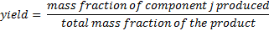
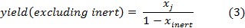
The general energy balance for the fixed bed reactor is shown in Eq. (4)
Where is the temperature of the bulk fluid, and are the thermal conductivities in the radial and axial direction respectively, is the porosity, is the heat capacity of the fluid, i for component j and is the rate of reaction i.

3.3 Pyrolysis
In pyrolysis, organic materials (e.g. biomass) are converted or decomposed into volatile gases, bio-oil and char through a thermo-chemical process. It is necessary to develop model equations for pyrolysis of biomass to predict accurately the product yield (Luo et al. 2005).

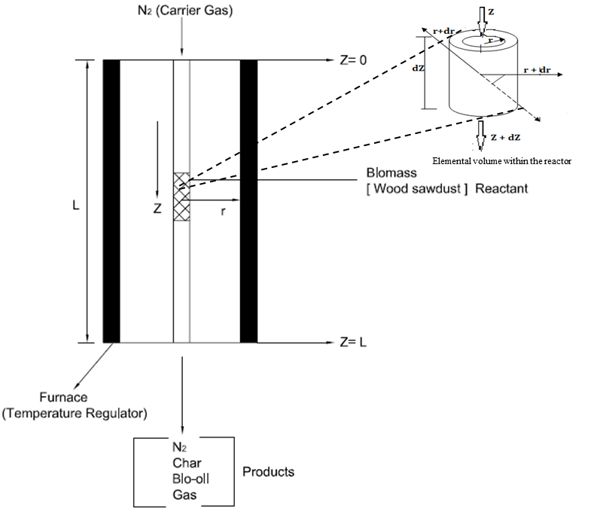
Figure 2: 1st stage Fixed bed Reactor for Biomass Pyrolysis

The effect of diffusion and convective flow was added into the mass balance over a differential volume of the fixed bed reactor (Figure 2). Eq. (2) and Eq. (4) in section 3.2 is the same for the 2-D mass and energy balance for the pyrolysis reactor. The rate of reaction is expressed as
, 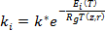
where is the rate constant and its dependent on temperature in the axial and radial direction, is the reaction order for component j in reaction i. is Arrhenius constant and E is the activation energy. Hence, the rate of reaction can be expressed thus
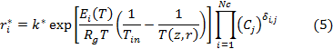
The conversion is
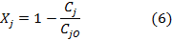
where represent the initial concentration of the fluid, represents the conversion of reactant. The overall conversion at a given distance z from the reactor entrance is
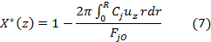
Initial and boundary conditions
1. for the radial concentration and temperature boundary conditions:
- No mass transfer to a boundary, at the wall of non-reacting pipe, no convective flow, hence, , at r = R
- At the tube wall r = R,
ℎeat
at r = R
- Concentration gradient of each specie for radial diffusion is zero at the centre of the reactor, , at r = 0
2. for the axial concentration and temperature boundary conditions:
- At the entrance of the reactor, z = 0,
- At the exit of the reactor z = L,
, at z = L

3.3.1 Pyrolysis Reaction
Biomass materials are different according to the composition of their main components. Pyrolysis of biomass is significantly dependent on the main components of cellulose, hemicellulose and lignin (Wu et al, 2013a). During pyrolysis reaction, biomass materials (i.e. wood sawdust, grass, or rice husk) are decomposed to give gaseous compounds, bio-oil, and char due to temperature increase in the reactor. Table 2 shows the composition of biomass components in different biomass materials. Wu et al, 2011 carry out experimental analysis of the properties of wood sawdust in terms of its ultimate and proximate analysis as shown in Table 3. The results of the new experiment described in section 2 will be used in this study for model validation.
Table 2: Fractions of Cellulose, Hemicellulose and Lignin in different Biomass materials (Adapted from Couhert et al. 2009)
Materials | Wood bark | Grass | Rice husk | beech wood
Cellulose (wt. %) | 24.0 | 58.0 | 42.0 | 47.0
Hemicellulose (wt. %) | 33.0 | 38.0 | 36.0 | 35.0
Lignin (wt.%) | 43.0 | 4.0 | 22.0 | 18.0

Table 3: Proximate and Ultimate Analysis of the Wood Sawdust (Wu et al, 2011)
 | Ultimate Analysis |  |  |  |  | Proximate Analysis
 | C | H | O | N | S | Moisture | Volatiles | Fixed Carbon | Ash
Wood sawdust | 47.1 | 5.9 | 46.9 | 0. 1 | 0.02 | 6.4 | 74.8 | 18.3 | 1.2
Biomass pyrolysis involves a complex set of parallel and series chemical reactions influenced by heat and mass transfer. The selection of different reaction paths is based on the reaction mechanism adopted. In this study, we adopted the mechanism proposed by Chan (1983) and presented in Sinha et al (2000) for wood pyrolysis as shown in Figure 3. The wood sawdust was modelled as hydrocarbon (CH_{a}O_{b}N_{c}S_{d}) as shown in Table 4 using the elemental compositions in Table 3 and its molecular weight, neglecting the N and S components.
Table 4: Chemical Composition of Wood Sawdust
Coefficients (mol/mol C) | Parameters
a | 1.4925
b | 0.7475
c | 0.0018
d | 0.0002
Chemical Formula | CH_{1.4925}O_{0.7475}
Molecular weight (g/mol)* | 99.79
* estimated from the chemical analysis in Table 3
k₂
k₃

Wood

)
k₁
k₄
Gas
Bio-oil
Char
Oil + Gas

Figure 3: Pyrolysis of wood (Chan, 1983)

For wood sawdust;
P1. Gas formation from wood devolatilization:
reaction rate expression:
P2. Gas and Bio-oil formation: (consecutive reaction)
(P4)
reaction rate expression:
P3. Char formation from Wood devolatilization:
reaction rate expression:
The composition of the biomass sample and the process temperature determine the quality and type of the product. For example, if pure cellulose is used as the biomass sample in the fixed bed reactor and the temperature of the process is altered, then the type of product generated during pyrolysis will vary with when lignin is used (Shafizadeh, 1982; Thurner and Mann, 1981; Chan et al., 1983; Wu et al, 2013b) i.e.

3.3.2 Model Equations for the Pyrolysis reactions
Fluid Phase
Gas and Oil component balance in the reactor: The general equation remains the same, due to the nature of diffusivity or convective flow of their molecules
(9a)
or expressed in mass concentration,
(9b)
Energy balance:
Solid Phase
Char: the equation is reduced and simplified since char is solid (negligible diffusion),
(11a)
or
(11b)
Char energy balance:
(12)
Wood: wood is solid and cannot diffuse but possesses convective fluid-like properties (13)
Wood energy balance:
(14)
Where,
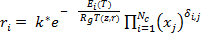 (15)
Where j = wood, gas, oil, and char in equations (9) – (15). For more gas is formed and with an increase in the temperature of the reactor, the forward reaction is favoured. Oil and Char undergo thermal cracking to produce more gas at high temperature. The kinetic parameters for the pyrolysis were obtained from literature as shown in Table 5. The kinetic parameter for the secondary cracking of bio-oil was obtained from Boronson (1987).

Table 5: Kinetic Constants for the pyrolysis reactions
Rxn | Wood (Chan, 1983) (s⁻¹)
p1 | 1.3  2  1.08  1.48 *
p2
p3
p4
*
3.4 Steam Reforming
Steam reforming is a thermo-chemical process involving the partial combustion of organic materials in a flowing gas with minimal oxygen at a temperature higher than fast pyrolysis. The steam reforming occurs in the second stage fixed bed reactor (Figure 4) resulting in gas products. The heat transfer to the product in the second stage is achieved by entraining products from the pyrolysis reactor into a fresh steam which is then passed through an externally heated tubular reactor. In order to improve the process performance the use of catalysts has also been proposed (Wu et al., 2001, 2012, 2013a and 2013b). The operation requires high operating temperatures and very short contact times.
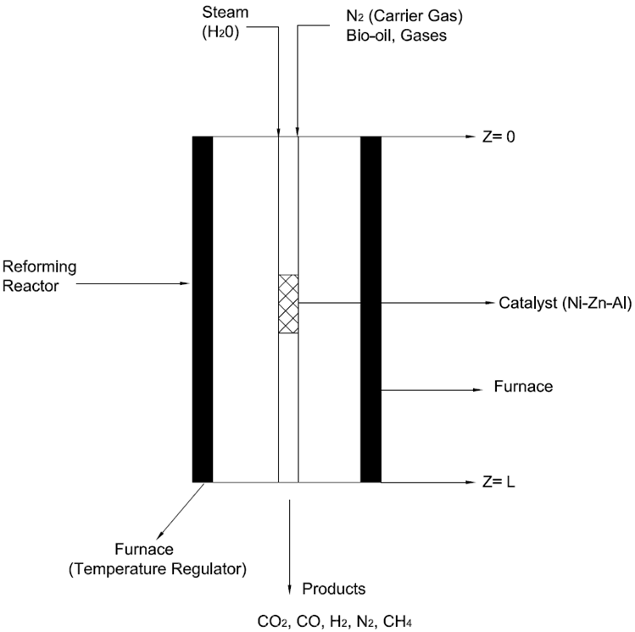
Figure 4: 2nd Stage Fixed Bed reactor for Steam Reforming

3.4.1 Mass Balance on the Steam Reforming Reactor
Expressing the laws of conservation of mass in terms of mass concentration in axial (z-direction), we have
(16)
Similarly, for radial (r-direction)
(17)
For component A in a bulk and incompressible fluid in both directions, we thus have
(18)
Where the flux can be expressed in terms of mass concentration, is the reaction stoichiometry coefficient of component j, in reaction i. From Fick's law of diffusion, for axial direction,
(19)
for both direction,
(20)
For a constant diffusivity flux,
(21)
We can then transform the above equation to
+ (22)
Hence, for a multicomponent fluid system with constant fluid velocity along axial direction and negligible fluid velocity along radial direction, we have
+ (23)
Energy balance on the steam reforming reactor
The energy balance around the reforming reactor is;
Initial and Boundary Conditions
Radial:
- ,
- Planes of symmetry.
Axial:
- At the entrance of the reactor ,
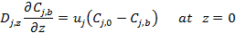
- at the exit of the reactor
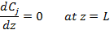

3.4.1 Steam Reforming Reactions
The steam reforming reactions include the reactions of bio-oil [modelled as CH_{1.522}O_{0.0228} according to Bryden and Ragland (1996) with molar mass of 94 g/mol (Corrella et al., 1991)] and the non-condensable gases (CO, CH₄, CO₂, H₂ etc.) with steam to H₂ and CO₂. The gas is mixed with steam and preheated before it is channelled into the reformer. This consists of reactor pipes containing a nickel catalyst. In this way, the gas–steam mix is transformed to H₂, CO, CO₂ and water. Considerable excess steam is used in the process. The synthesis gas exits the reformer and enters a shift converter. The carbon monoxide contained in the gas is then converted into H₂ and CO₂ using steam. The kinetic parameters were obtained from literature and listed in Table 6.
r1. Bio-oil (tar) steam reforming reaction
Steam reforming of bio-oil presents significant difficulties, especially in terms of carbonaceous deposits (i.e. coke formation). Due to the high temperature of the reaction, it is likely that partial thermal decomposition (Rxn 1(a)) and the Boudouard reaction (Rxn 3) can occur simultaneously (Rioche et al, 2005):
r1(a)
The complete steam reforming reaction of bio-oil is
r1(b)
reaction rate expression:
r2. Methanation reaction
reaction rate expression:
r3. Boudouard reaction
reaction rate expression:
r4. Methane steaming reforming reaction
reaction rate expression:
r5. Water gas shift reaction
reaction rate expression:
Table 6: Kinetic Parameter for the steam reforming reactions
Reaction | Kinetics Parameters | References
r1 | 3.12 | Akande et al, 2006
r2 | 0.12 | Inayat et al, 2009
r3 | 4.40 | Inayat et al, 2009
r4 | 3.0 | Inayat et al, 2009
r5 | 10.20 | Inayat et al, 2009

3.5 Catalyst Particle
3.5.1 Catalyst/Gas Interface Flow Modelling
Although the catalyst particles of a fixed bed may not be spherical, an analysis based on flow in a regularly packed bed of spheres gives good approximation for heat transfer. The spheres are assumed to be packed in the closest possible arrangement. The bed consists of parallel layers of spheres in planes normal to the direction of flow. The method of assumption is that for any sphere in the bed, the heat transfer is the same as it would be for flow past a single sphere at the velocity through one of the orifices between the spheres.
The centre of the sphere is chosen as the origin of the coordinate system. At radial distance r from the centre, we have a spherical surface at a uniform temperature T. At distance r+dr is another surface at temperature T+dT. These two surfaces can be considered as the boundaries of the control volume.
Hence,
(25)
(26)
(27)
The Net heat flow can be found by subtracting (26) from (27). After this is done, all second order and third differentials can be dropped (because they are negligible), giving
(29)
(30)
Where H is the enthalpy which could be related in the expression
(31)
Substituting enthalpy and volume into equation (30), and assuming the volume and shape of the catalyst are constant, and then we have
(32)
Substituting both accumulation and net flow in into the balance and introducing the reaction term therefore we have
(33)
Dividing equation (33) by, from which we obtain the equation for unsteady state conduction
Energy balance:
34)
Similarly for mass balance on specie
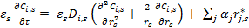 (35)
Initial and Boundary Conditions
;
;
3.5.2 Heterogeneous Catalysis Reaction
Volatile species in the reactor may further be broken down into smaller gases within the particles during transport either heterogeneously by reaction with the char or solid biomass, or homogeneously in the gas phase (Boroson, 1987). The complexity in the reaction system makes it extremely difficult to model reactions of individual components involved in pyrolysis; however, simplified models have been proposed using lumped products such as gases, oil and char and could provide good insight to the overall process (Boroson, 1987).
Applying the Langmuir-Hinshelwood reaction mechanism to the secondary cracking of oil, where A (oil), and B (gas product formed) are the reactant and product respectively.
1.
2. rate determining step
3.
From reaction (1) the rate of the reversible reaction with respect to the forward and the backward reaction is given by
From reaction (3) since reaction (2) is the rate determining step,
For steady state approximation, = 0
Hence reaction (1) becomes: and reaction (3)
From reaction (2), substituting for AS in the above equation;
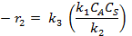
Therefore:
Substituting for AS, BS in the above equation
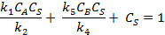
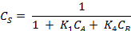
Substituting for in the above equations
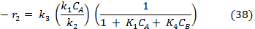

(39)

3.6 Hydrodynamics of the Fixed Bed
Flow of a fluid through a packed bed or granular particles occurs frequently in chemical processes i.e. fixed bed reactor. As for flow past tube banks, there exist many correlations for calculating the pressure drop in flow through a fixed bed. We choose to apply the method based on the use of Hydraulic radius (r_{H}). This method is applicable to incompressible beds composed of nearly spherical particles. The bed porosities (fractional void-space) may range from 0.3 - 0.6. A successful method for the prediction of the behaviour of flow through a bed from flow past a single sphere is given by Ranz and Marshall (1952).
For the fixed bed with N_{p} particles,
(40)
If the represents the volume of particles and represents the surface area of a particle, then the specific surface of a particle is defined by
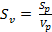 (41)
For spherical particle: (42)
, (43)
Reynolds number: (44)
Friction factor, (45)
Hence, pressure drop across bed is calculated thus;
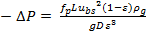 (46)
There are few systems, however in which mass transfer occurs between a solid and a fluid and in such systems we have not only laminar boundary layer adjacent to the solid surface, but also the possibility of developed laminar flow throughout the fluid phase
Velocity profile for the plug flow:
For laminar flow, the velocity profile is
(47)
Where u₀ is the average velocity inside the reactor and R is the fixed bed reactor radius.

Table 7 Parameters for Fixed Bed Properties for Wood
Parameters | Value | Reference
 | 360.0 kg/m³ | Di Blasi (2004)
 | 0.5 | Di Blasi (2004)
L | 2.0 m | Wu et al (2011)
 | 0.5 m | Wu et al (2011)
 | 0.002 m | Wu et al (2011)
 | 9.81 m/s²
 | 300 K
 | 1.256 W/m² K | Di Blasi (2004)

3.7 Numerical Solution of the model
The dynamic model results in a set of partial differential and algebraic equations (PDAEs) describing the mass and energy balances. The resulting PDAEs were solved by the SRADAU solver in gPROMS. The axial and the radial variables were discretized using the method of centred finite differences and orthogonal collocation respectively on finite elements over a uniform grid. All the simulations were performed at a time step of 0.01s and spatial steps of 0.1 cm.

4 Model Validation
Steady-state performance of the model was validated using experimental data as described in Section 2. The two-stage reaction system is a fixed bed reactor with a diameter of 0.2 m and a total height of 2.0 m. This reactor consist of 0.5 m packed bed sections with a. The experiment (conducted at pyrolysis temperatures of 300, 400, 500, and 600ºC) described in Section 2 were selected for steady state model validation. Table 7 shows the summary of the parameters for the bed properties of the wood sawdust used for the experiment.
Simulation results were validated using the product yield of the two-stage fixed bed reactor in the experiment as shown in Table 1. In addition, the measured gas concentration (vol. %, N₂ free) taken at different reforming temperature was compared with values obtained from the simulation. Table 8 to Table 12 shows the comparison of the experimental results and the model prediction.
Table 8 Validation of Char yield at outlet of pyrolysis reactor
Temperature (ºC) | Experiment (wt. %) | Model (wt. %) | Relative Error (%)
300 | 46 | 44.7 | 2.83
400 | 28 | 23.6 | 15.71
500 | 25 | 20.2 | 19.20
600 | 21 | 18.6 | 11.43

Table 9 Validation of Oil yield at outlet of pyrolysis reactor
Temperature (ºC) | Experiment (wt. %) | Model (wt. %) | Relative error (%)
300 | 32.35 | 30.89 | 4.49
400 | 20.82 | 20.14 | 3.23
500 | 20.17 | 19.74 | 2.13
600 | 20.96 | 18.93 | 0.97

Table 10 Validation of Gas yield at outlet of pyrolysis reactor
Temperature (ºC) | Experiment (wt. %) | Model (wt. %) | Relative error (%)
300 | 21.65 | 16.72 | 22.77
400 | 51.18 | 40.4 | 21.06
500 | 54.83 | 50.6 | 7.71
600 | 58.04 | 54.41 | 6.25

Table 11 Validation of Hydrogen yield at reformer outlet
Temperature (ºC) | Experiment (mmol/g) | Model (mmol/g) | Relative error (%)
300 | 4.24 | 5.16 | 21.70
400 | 8.12 | 9.06 | 11.58
500 | 9.77 | 11.65 | 19.24
600 | 11.01 | 13.42 | 21.89

Table 12 Validation of Gas Composition (vol. %) at reformer outlet
Temperature (ºC) | Components List | Experiment (vol. %) | Model (vol. %) | Relative error (%)
300 | CO | 25.16 | 24.5 | 2.60
 | H₂ | 40.04 | 41.3 | 3.15
 | CO₂ | 24.16 | 23.9 | 1.08
 | CH₄ | 10.64 | 10.30 | 3.20
400 | CO | 29.67 | 26.03 | 12.27
 | H₂ | 32.99 | 34.09 | 3.33
 | CO₂ | 18.4 | 19.56 | 6.30
 | CH₄ | 18.93 | 20.32 | 7.34
500 | CO | 31.74 | 29.87 | 5.89
 | H₂ | 36.49 | 38.32 | 5.02
 | CO₂ | 19.14 | 17.76 | 7.21
 | CH₄ | 12.63 | 14.05 | 11.24
600 | CO | 29.51 | 26.20 | 11.22
 | H₂ | 38.12 | 43.50 | 14.11
 | CO₂ | 19.58 | 16.94 | 13.48
 | CH₄ | 12.79 | 13.36 | 4.46

The measured gas concentration (vol. %, N₂ free) at different pyrolysis temperature was compared with values obtained from the simulation as shown in Table 12. The results show that the highest gas yield (54 wt. %) was achieved at the highest pyrolysis temperature of 600ºC and the least value (47 wt. %) was obtained at 300ºC. For the char yield, the highest fraction of char (44 wt. %) was obtained at 300ºC, while the least amount of char fraction (18.6 wt. %) was observed at 600ºC. The high yield of char means a very low conversion of wood sawdust to volatile products; hence the least oil yields (18.93 wt. %) occurring at pyrolysis temperature and vice versa.

Table 12 shows the gas concentrations in the non-condensed gas products from the pyrolysis-steam reforming of the wood sawdust. The model considers CO, H₂, CO₂, and CH₄ as the main gas components. The effects of the C₂-C₄ hydrocarbons were lumped into the CH₄ fraction for simplicity. As shown in Table 12, the highest H₂ concentration (58.6 vol. %) was obtained for lignin; the lowest CO concentration (11 vol. %) was found in lignin etc. the simulation results matched reasonably well with the experimental results.
5 Process Analysis
5.1 Product yields
Figure 5, Figure 6, and Figure 7 shows the comparison of the product yields (gas, bio-oil and char) from the pyrolysis of wood sawdust at increasing temperature. The char yield (Figure 5) shows a rapid decrease with time. This trend is similar for the different pyrolysis temperature. The char yield decreases with increase in pyrolysis temperature from 300ºC – 600ºC with individual steady state value approached at nearly 10 seconds after the start of the pyrolysis reaction. The actual time taken to achieve complete conversion in the reactor is dependent on the heating rate applied and the ultimate analysis of the biomass sample.

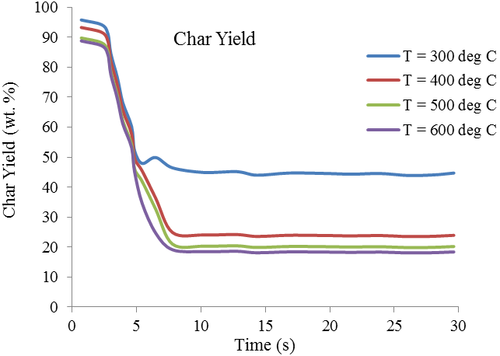
Figure 5 Char yield at different pyrolysis temperature
The oil and the gas yield (Figure 6 and Figure 7) show a similar trend at different pyrolysis temperature. The steady state value approached at nearly 10 seconds after the start of the pyrolysis reaction. The time taken to achieve steady oil yield from each biomass is dependent on the heating rate applied and the ultimate analysis of the biomass samples.

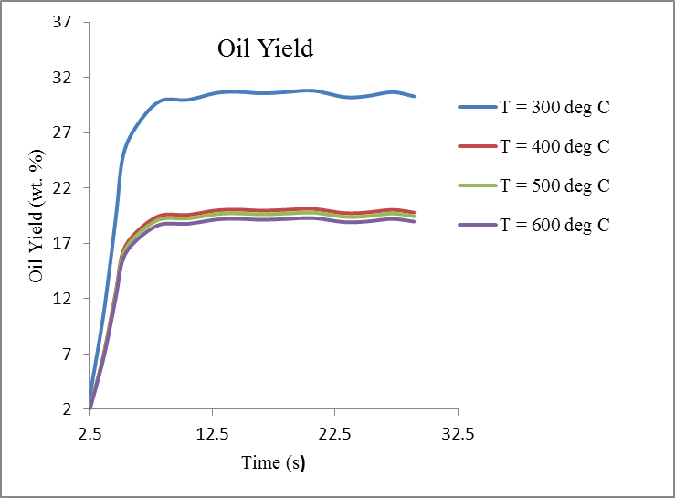
Figure 6 Oil yield at different pyrolysis temperature
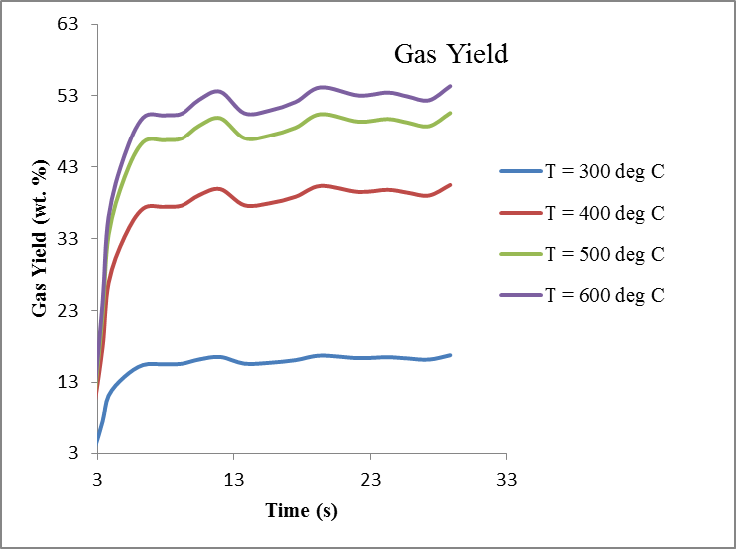
Figure 7 Gas yield at different pyrolysis temperature

5.2 Gas Concentration
Figure 8 shows the gas concentrations (vol. %) as a function of increasing pyrolysis temperature. It shows that the increase of reaction temperature favours the hydrogen production as H₂ concentration increases from 34% to 44%. On the contrary, CO shows a decrease from 30% to 26%. CH₄ decreases slightly from 20% to 14% and CO₂ decreases from 24% to 14%. This indicates that the temperature plays an important role in the gas concentration and the hydrogen yield

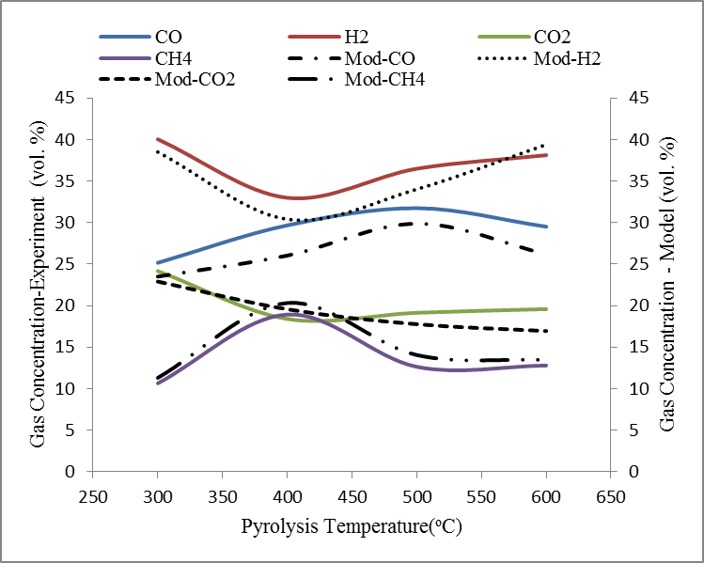
Figure 8 Gas Concentration (vol. %) at increasing pyrolysis temperature

5.3 Hydrogen Yield
The yield of H₂ (in mmol/g biomass sample) from the model is shown in Table 11. The yield of H₂ increases from 5 to 13 mmol/g at increasing pyrolysis temperature (300ºC - 600ºC) as shown in Table 11. The H₂ produced may be due to the influence of the catalyst particle model described in section 3.5. The influence of the type of catalyst on hydrogen production was investigated by Wu et al, 2013. The predicted H₂ yield is in good agreement with the experimental results.

5.4 Temperature Profile in the fixed bed reactors
The temperature at any point in the reactor at any time can be determined from the model. Figure 9 and Figure 10 show the temperature profile in the first and second stage fixed bed reactor respectively from the gPROMS® model. The first reactor was initially heated to the pyrolysis temperature (i.e. 300ºC, 400ºC, 500ºC, and 600ºC). Similarly, the second reactor was initially heated to a temperature of 800ºC, before the volatiles and non-condensable gases from the first-stage reactor were introduced. The fluid phase temperature profile in the second-stage reactor is shown in Figure 9 and Figure 10. Figure 9 shows the change in temperature along the reactor length within 1 to 5 seconds (at a time step of 0.01s) after the start of the reaction and Figure 10 shows the profile after 5 to 30s of simulation. As can be seen from the profile, the temperature increase along the reactor length (z = 0 m to z = 2m). The fluid temperature profile oscillates within 500ºC to 800ºC at the beginning of the reforming process (Figure 9) to a more moderate once (Figure 10) as the reforming reaction progresses.

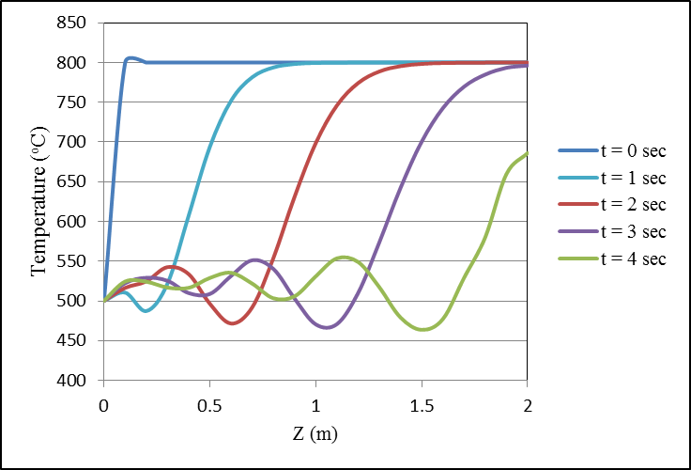
Figure 9: Temperature Profile in the fixed bed reactor

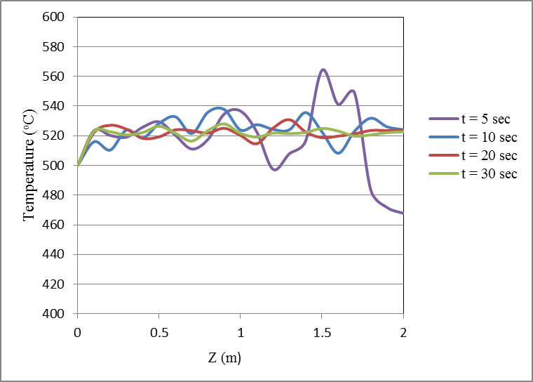
Figure 10: Temperature Profile in the fixed bed reactor
6 Conclusion and Recommendation for Future Work
Hydrogen has been identified as a clean and renewable source expected to play a significant role in the future energy systems. This paper presents new experimental results for pyrolysis under different temperatures and development of a dynamic model of biomass pyrolysis/steam reforming of wood sawdust in two-stage fixed bed reactors. The model was validated with experimental data. The model shows good agreement with the experimental data in predicting the product yields from pyrolysis, hydrogen yield and the temperature profile in steam reforming stage. The dynamic model can be used to predict the hydrogen production capability of different biomass feedstock (i.e. wood, grass, rice husk etc.). In the future, such a model can be improved to predict product yields of biomass pyrolysis/steam gasification based on the mass fraction of the biomass’ main components (i.e. cellulose, hemicellulose and lignin). The influence of different catalyst particle in the process can also be included.
Acknowledgement

This work was partly supported by the White Rose Collaboration Fund (2013.1) of the White Rose collaboration of the Universities of Leeds, York and Sheffield, UK.

References

Akande, A., Aboudheir, A., Idem, R., Dalai A., (2006). Kinetic modelling of hydrogen production by the catalytic reforming of crude ethanol over a co-precipitated Ni-Al2O3 catalyst in a packed bed tubular reactor, International Journal of Hydrogen Energy, 31, pp. 1707-1715.
Ball, M., Wietschel, M., (2010). The Hydrogen Economy: Opportunities and Challenges, Cambridge University Press. Cambridge University Press.
Bamford, C. H., Crank, J., Malan, D.H., (1946). The combustion of wood. Part I. Mathematical Proceedings of the Cambridge Philosophical Society, 42(2), 166-182.
Bilbao R., Mastral, J.F., Ceamanos, J., Aldea, M.E. (1996). Modelling of pyrolysis of wet wood. Journal of Analytical and Applied Pyrolysis, 36, 81-97.
Boronson M.L., (1987), Secondary Reactions of Tars from Pyrolysis of Sweet Gum Hardwood, PhD thesis, Department of Chemical Engineering, Massachusetts Institute of Technology.

Bradbury A. G. W., Yoshio Sakai, Shafizadeh Fred, (1979), A kinetic model for pyrolysis of cellulose, Journal of Applied Polymer Science, Volume 23, Issue 11, pp 3271–3280.

Byden, K.M., and Ragland, K., (1996). Numerical Modelling of a Deep, Fixed-Bed Combustor, Energy and Fuels,10, 269.
Chan W. C. R., (1983), Analysis of chemical and physical processes during pyrolysis of large biomass pellets, PhD thesis, Department of Chemical Engineering, University of Washington.
Chen, G., Zhao, L. (2012), Preliminary investigation on hydrogen-rich gas production by co-steam-reforming of biomass and crude glycerin. Int. J. Hydrogen Energy vol 37; 765–73.
De Toledo, E.C.V., Morais, E.R., Melo, D.N.C., Mariano, A.P., Meyer, J.F.C.A., Filho, R.M., (2011). Suiting Dynamic Models of Fixed-Bed Catalytic Reactors for Computer-Based Applications, Engineering 3, pp 778-785.
Di Blasi C., (1993). Modelling and Simulation of Combustion Processes of Charring and Non-charring Solid Fuels. Prog. Energy. Combust. Sci. 19, 71-10.
Corella, J., Aznar, M.P., Delgado, J., Aldea, E., (1991). Steam Gasification of Cellulosic Wastes in a Fluidized Bed with Downstream Vessels, Industrial Engineering Chemistry Research, 30, 2252.
Di Blasi, C., (1996a). Heat Transfer Mechanisms And Multi-Step Kinetics In The Ablative Pyrolysis Of Cellulose. Chemical Engineering Science, Vol. 51. No 10., pp. 2211-2220.
Di Blasi C. (1996b). Influences of Model Assumptions on the Predictions of Cellulose Pyrolysis in the Heat Transfer Controlled Regime. Fuel 75 (1), pp. 58-66
Di Blasi, C., (1997), Influences of physical properties on biomass devolatilization characteristics, Fuel 76 (10), 957-964.
Di Blasi, (2004), Modeling Wood Gasification in a Countercurrent Fixed-Bed Reactor, American Institute of Chemical Engineers AIChE J, 50: 2306–2319, 2004.
Efika, C., Wu C., Williams P.T., (2012). Syngas production from pyrolysis-catalytic steam reforming of waste biomass in a continuous screw kiln reactor. J. Anal. Appl. Pyrolysis 95, 87-94.
Elumalai, S., Pan, X. J. (2011). Chemistry and Reactions of Forest Biomass in Bio-refining, Biological Systems Engineering, University of Wisconsin−Madison, 460 Henry Mall, Madison, WI 53706.
Ghavipour, M., Behbahani, R.M., (2013). Fixed bed reactor modelling for methanol to dimethyl ether (DME) reaction over y-Alumina using a new practical reaction rate model. J. Ind. Eng. Chem. In Press (2013).
Grana, R., Sommariva, S., Maffei, T., Cuoci, A., Faravelli, T., Frassoldati, A., Pierucci, S., Ranzi, E., (2010). Detailed kinetics in the mathematical model of fixed bed gasifiers, 20th European Symposium on Computer Aided Process Engineering (2010) – ESCAPE20, S. Pierucci and G. Buzzi Ferraris (Editors).
Hashimoto K., Hasegawa, I., Hayashi, J., Mae, K., (2011). Correlations of kinetic parameters in biomass pyrolysis with solid residue yield and lignin content, Fuel 90 (2011) 104–112.
Inayat, A., Ahmad, M.M., Mutalib, M.I., Yunus, M.K., (2009). Kinetic Modeling of Biomass Steam Gasification System for Hydrogen Production with CO2 Adsorption, Proceedings of International Conference for Technical Postgraduates (TECHPOS 2009), Kula Lumpur, Malaysia, 14-15 December, 2009.
Koufopanos, C., Maschio, G. Lucchesi, A. (1989). Kinetic modelling of the pyrolysis of biomass and biomass components. Canadian Journal Chemical Engineering, 67, 75-84.
Koufopanos, C., Papayannakos, N., Maschio, G. & Lucchesi, A. ( 1991). Modelling of the pyrolysis of biomass particles. Study on kinetics, thermal and heat transfer effects. Canadian Journal of Chemical Engineering, 69, 907-15.
Luo, Z., Wang, S., Cen, K., (2005), A model of wood flash pyrolysis in fluidized bed reactor. Renewable Energy 30, 377-392.
Matsumoto T., Fujiwara T., Kondo J., (1969). 12th Symposium on Combustion, The Combustion Institute, Pitts : 515-531.
Ranz, W.E. and Marshall, W.R. Jr., (1952). Evaporation from Drops, Chemical Engineering Progress, 48, Part I, 141-146; Part II, 173-180.
Rioche, C., Kulkarni, S., Meunier F.C., Breen, J.P., Burch, R., (2005). Steam reforming of model compounds and fast pyrolysis of bio-oil on supported noble metal catalysts, Applied Catalysis B: Environmental 61, pp 130-139.
Shafizadeh, F. (1982), Introduction to Pyrolysis of Biomass, Journal of Analytical and Applied Pyrolysis 3, 283-305.
Sinha, S., Jhalani, A., Ravi, M.R., Ray, A. (2000) Modelling of pyrolysis in wood: a review Journal of Solar Energy Society of India 10, 41–62.
Tinaut, F.V., Melgar, A., Perez, J.F., Horrillo, A. (2008). Effect of biomass particle size and air superficial velocity on the gasification process in a downdraft fixed bed gasifier. An experimental and modelling study. Fuel Proc. Tech. 89, 1076-1089.
Tinney, E.R., (1965). The combustion of wood dowels in heated air, 10th Symposium (International) on Combustion, The Combustion Institute : 925-930.
Thurner, I., and Mann, U., (1981). Kinetic investigation of wood pyrolysis, Industrial and Engineering Chemistry Process Design and Development, 20(3), pp 482-488.
Van de Steene, L., Tagutchou, J.P., Mermoud, F., Martin, E., Salvador, S., (2010). A new experimental Continuous Fixed Bed Reactor to characterise wood char gasification. Fuel, 89, 3320–3329.
Wampler T., (2006). Applied Pyrolysis handbook. CRC Press Taylor & Francis Group, ISBN-13: 978-1-57444-641 Page 1-6.
Wu, C., Williams P.T., (2009), Hydrogen production by steam gasification of polypropylene with various nickel catalysts. Appl. Catalysis B: Environ 2009;87:152–61.
Wu C., Williams P.T., (2010), Pyrolysis–gasification of plastics, mixed plastics and real world plastic waste with and without Ni-Mg-Al catalyst. Fuel, vol 89; 3022–3032.
Wu, C., Wang, L., Williams P.T., Shi, J., Huang, J., (2011). Hydrogen production from biomass gasification with Ni/MCM-41 catalyst: Influence of Ni content. Appl. Catalysis B: Environ. 108-109, 6-13.
Wu C., Wang Z., Huang J., Williams P. T., (2013a) Pyrolysis/gasification of cellulose, hemicellulose and lignin for hydrogen production in the presence of various nickel-based catalysts. Fuel, vol 106; 697-706.
Wu, C., Wang, Z., Dupont, V., Huang, J., Williams, P.T., (2013b). Nickel-catalyzed pyrolysis /gasification of biomass components. Journal of Analytical and Applied Pyrolysis 99, 143-148.

