Title page
Manuscript title:
‘Surviving the sting’:
The use of solicited diaries in children and young people with oral mucosal disease

Authors:
S Carew O’ Donnell, Z Marshman, H Zaitoun

Institute:
Department of Paediatric Dentistry, Charles Clifford Dental Hospital. Sheffield, S10 2SZ, UK

Key words:
Child, qualitative, service evaluation, oral ulcers, oral medicine

Corresponding author:
Suzi Carew O’ Donnell, Department of Paediatric Dentistry, Charles Clifford Dental Hospital, Wellesley Rd., Sheffield, S10 2SZ, UK
Tel: +44 114 2717882 Fax: +44 114 2717855
Email: suzicarewodonnell@btinternet.com

Abstract
Background: Chronic oral mucosal conditions, such as oral ulcers, commonly affect children and young people and are capable of significant pain and morbidity. Little is known about patient perception of paediatric oral medicine services offered in relation to these conditions. The concept of a diary is increasingly being recognised as a valuable way to capture patient events and perspective in healthcare research. Aim of the paper: This paper provides the background to the use of solicited diaries as a method of accessing the perspective of children and young people and describes a service evaluation that aimed to explore the experiences of young people with chronic oral ulcers attending the paediatric oral medicine clinic in a UK Dental Hospital. Results: Chronic oral ulcers were found to significantly impact on a variety of physical and psychosocial aspects of young people’s lives. Overall, feedback regarding the specialist service was positive but suggestions were made for improvements. Conclusion: This paper reviews the use of the solicited diary within healthcare research. It also illustrates, via the service evaluation presented, the value of the diary in exploration of children and young people’s perspective on their chronic oral mucosal disease. In addition, a need for further research in this area has been highlighted.
‘Surviving the sting’- The use of solicited diaries in children and young people with oral mucosal disease

This paper reflects on the use of solicited diaries as a method of accessing the perspective of children and young people on chronic oral mucosal disease and its management. It will first consider the use of diaries as research tools in healthcare and with children.

Background
Diaries are commonly associated with historical, anthropological and psychological research in which daily life and associated experiences are documented by individuals for personal reflection^{1,2}. A diary, for some, can be a very personal account whereas for others, it is meant for the public or audience. The latter has become increasingly viable with the advent of the internet and applications such as Facebook, Twitter and personal blogs. Whatever form it takes, the concept of a diary is increasingly being recognised as a valuable way to capture the rituals and experiences of everyday life².

The use of diaries in health research
Elliott¹ describes two main categories; diaries that are viewed as (auto) biographical or act as ‘life documents,’ and diaries for research. The latter category will be the focus of this paper. Researcher-driven or solicited diaries are usually compiled in order to collect specific information about a particular topic for research purposes. Diaries used in such a way enable the collection of details about behaviour, events and other aspects of an individual’s daily life³. The solicited diary can collect data for qualitative or quantitative data^{1,4}.

Quantitative diaries have been used in healthcare research about illness, diet and alcohol or drug consumption³. They traditionally involve a structured format⁵ where participants are invited to record items from a list of health actions¹ or log certain symptoms^{6,7}. Diaries containing qualitative data are used less frequently, although it has been acknowledged that they can offer more rich, participant–centred data^{1,5}. This approach has been taken to obtain individual perspectives on treatment regimes and self-care information from those patients with chronic health problems¹. Diary-keeping in this context can also serve to illict concerns about illness which may be omitted in more structured forms of enquiry¹. Diaries of this kind have thus been argued to be an empowering data collection method ^{2,8} where the participant can be both an observer and informant⁹ . There are obvious advantages for the use of the solicited diary as a data collection tool in relation to an individual’s experience of chronic illness (Table 1).

Advantages
- Familiar format
- Use of ‘natural language’
- Allows contemporaneous record of data
- Able to complete without set time or environmental boundaries
- Used easily in conjunction with other methods e.g. in-depth interview
- Patient(child)-centered

Limitations
- Self-censorship
- Backfilling
- Conditioning effects
- Commitment on the part of the participant
- Skills required to complete the diary e.g. literacy
Table 1: Summary of advantages and limitations of the diary as a data collection tool

Use of diaries with children
There has been growing interest in the use of solicited diaries to explore health events with children. Health diaries have already been used in a variety of paediatric studies of acute and chronic illnesses including: symptoms of wheeze, cough and shortness of breath in children with asthma^{7,10}, pain in infants toddlers and adolescents with sickle cell disease^{6,11}, adherence to medical treatments in children with cystic fibrosis¹², and the impact of chronic pain on the quality of life of adolescents and their families¹³. In the majority of these studies, the diary allowed the data to be examined on a daily basis and over a period of time. It follows that patterns or trends in health behaviour, not previously brought forward by more traditional data collection methods, may be discovered .

In summary, a health diary can examine patient symptoms, adherence to medication use or assessment of a problem that relies on accurate recall of health events over an extended time period. The use of a diary can enable a more authentic presentation of an individual’s health behaviours as well as their personal perceptions and experiences of health.

The aim of the service evaluation was to explore the experiences of young people with chronic oral ulcers attending the paediatric oral medicine clinic in a UK Dental Hospital through completion of a two-week diary.

Diary format
The qualitative diary included closed and open questions and opportunities for drawing or sticking things in, for example packaging from foods that irritated their ulcers. The young people were asked to start filling in the diary from the day it was given to them. After two weeks, they were instructed to post back their diaries in a pre-paid envelope.

Participants
Qualitative methods typically involve relatively small numbers of participants that do not attempt to be statistically representative¹⁴. The sample included English-speaking children, aged 8-16 years old, who attended the paediatric oral medicine clinic regarding management of chronic oral ulceration. Patients with chronic ulceration that forms part of a systemic condition were included, in addition to those suffering from recurrent chronic oral ulcers in isolation. Over a period of five months, 19 children and young people attended the paediatric oral medicine clinic with chronic oral ulceration, 16 gave their consent to take part in the service evaluation. The project was approved by the Sheffield Teaching Hospitals NHS Foundation Trust Clinical Effectiveness Committee.

Data analysis
Data collection and analysis was carried out concurrently by two investigators. Diaries were read in detail to identify themes without any prior assumptions. Notes were taken during the familiarisation phase to form the basis for the thematic frameworks with data then organised according to these themes¹⁵. These themes were modified as further diaries were collected and analysed (Figure 2).

Results

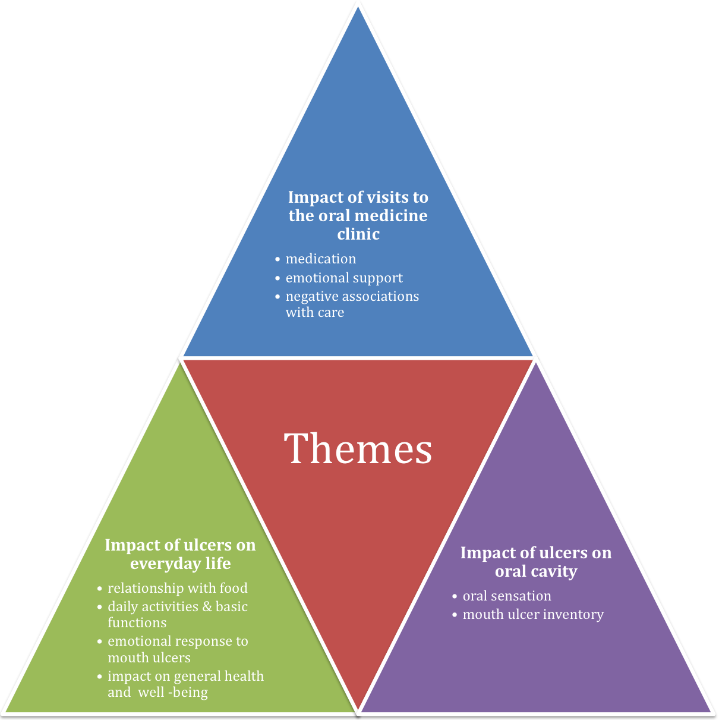Fig. 2 Illustration of major themes and associated sub-themes

Sample
Of the 16 diaries distributed, eight were returned. Of these, four were completed by girls and four by boys, all aged between eight and fifteen years. The participants came from both rural and urban areas across South Yorkshire, Nottinghamshire and North Derbyshire, UK and from different ethnic groups.
Data analysis revealed a generally positive perspective with regard to the care participants received on the paediatric oral medicine clinic. Some negative aspects were identified along with suggestions for service improvement. In addition, insights were given into the overall impact of the condition on the participants’ lives. Three main themes were identified: the impact of visits to the oral medicine clinic; the impact of ulcers on the oral cavity and the impact of ulcers on everyday life. These themes are further explored below with the use of pseudonyms

Impact of visits to the paediatric oral medicine clinic
Patients seemed to have very definite ideas about what they wanted from their referral to a specialist service:
‘getting medication to take my ulcers away and take the pain away’ Jenny (female, 12 years)
‘anything that helps relieve the pain and heal the ulcer helps…….nothing works so you have to suffer til they start healing’ Jake (male, 14 years)
It was obvious from the diaries that participants had tried multiple medications, often from numerous prescribers in an effort to control their condition. However these medications did not necessarily fully relieve the pain caused by oral ulcers but rather distracted participants by causing an alternative sensation in the mouth:
‘I have tried loads (of medications) saltwater wash different mouthwash from dentist and doctor’ Charlie (male, 10 years)
‘it (gel) felt tingly and hurt but after a while it took the pain away’ Rachel (female, 12 years)
The impact of the pharmacological management was obviously outweighed in favour of the emotional support and reassurance offered by the clinic staff (Figure 3). Showing empathy and providing participants with the opportunity to express their views and feelings appeared to be important to them.
‘I think they are really nice and kind and help me feel better and comfortable’ Jenny (female, 12 years)
Various approaches to self-management were described including distraction techniques:
‘I either sing or watch TV and I forget about it’ Gemma (12 years)
In his diary, Jake (male, 15 years) drew pictures to illustrate what he does to make himself feel better when he is in pain (Figure 4).
Suggestions for service improvement were also provided. These included visual aids:
‘show them a model of a mouth ulcer and mouthwash/gels/tablets and show what it does to the ulcer’ Rachel (female, 12 years)
Some negative aspects of care were alluded to, including blood tests and clinical examinations.
‘(My least favourite thing is) injections for blood’ Charlie (male, 10 years)
‘I dread the part when the dentist feels my ulcer as it hurts’ Jenny (female, 12 years)
Other negative aspects included the time it took to travel to the hospital, missing time from school and the time patients were sometimes kept waiting for their appointment.
‘Going and waiting for ages and when you get called its past your appointment time’ Rachel (female, 12 years)
The impact of oral ulcers on everyday life
Living with such a chronic condition clearly impacted on the everyday lives of the young people involved in terms of eating, schooling, emotional aspects and general health perceptions.
Participants described how their relationship with food was generally adversely affected during ulcerative episodes:
‘I couldn’t eat all my dinner ‘cause of my ulcer.....you cant chew on the side its on, it really hurts to tuch’ Natasha (female, 9 years)
‘it hurts my mouth when I eat different foods’ Charlie (male, 10 years)
However, not all accounts of food were negative. Some of the participants used food, either independently or as advised by a clinician, as part of their therapy regime:
‘since I went on my diet of no spices and no tomatoes and no milk I have not had any ulcers in my mouth’ Andy (male, 15 years)
Education was disrupted, including both attendance and progress at school:
‘(missed) school as my mouth ulcers hurt and I usually get ill when I have a mouth ulcer’ Jenny (female, 12 years)
‘it slowes me down at school’ Charlie (male, 10 years)
‘I haven’t always tried my best to do things when I have ulcers’ Gemma (female, 12 years)
Mouth ulcers also had reported negative impacts on a variety of basic functions (for example speaking) and hobbies:
‘the ulcer stops you from doing things’ Jenny (female, 12 years)
‘stayed a bit quiet because my ulcers hurt my mouth when I talk’ Rachel (female, 12 years)
‘running - it moves my lip when I run and it irritates it’ Natasha (female, 9 years)
Previously in her diary Rachel (female, 12 years) had identified herself as a ‘chatterbox’. Therefore the effect of recurrent oral ulceration in this case appeared to go beyond the physical limitation of speech to impact on the individual’s identity.
In addition to physical effects, ulcers also elicited an emotional impact in terms of moodiness, fear and upset.
‘It keeps me awake at night so I am moody the next day’ Charlie (male, 10 years)
‘(the ulcer) becomes more painful and makes me cry because it hurts so much’ Rachel (female, 12 years)
‘can make you feel upset because you can’t join in on things you like’ Jenny (female, 12 years)
Perceptions of general health were also impacted for some as the symptoms of ulceration went beyond the effect on the oral cavity.
‘Felt sick and faint on the bus’ Jenny (female, 12 years)
Impact of ulcers on the oral cavity
Specific symptoms associated with oral ulcers were also described. Participants were concerned both with the sensation and number of ulcers in their mouth at any one time.
‘When my lip touches my ulcer it stings’ Robbie (male, 9 years)
‘I had an ulcer started on 21/1/11, I still have my ulcer on 24/1/11, it is really irritable, it gives pain all around it’ Natasha (female, 9 years)
Counting or cataloguing of ulcers was another important sub-theme that emerged:
‘I found out I had 6 ulcers 2 big ones under my tongue’ Jenny (female, 12 years)
‘I had three mouth ulcers and they all joined together and I had a massive one on the bottom of my gum it was very painful’ Gemma (female, 12 years)
This suggests the recurrent and unpredictable nature of the disease was frustrating for the patients.
Discussion
This service evaluation aimed to explore what children and young people think of the service provided by the paediatric oral medicine clinic in relation to chronic oral ulceration through the use of a solicited diary. No previous service evaluations have been published, although findings from this project do concur with other studies and provide additional insights.

The pain of oral ulceration had both physical and psychosocial components. This supports earlier work by McGrath and Bedi¹⁶ in which the ‘considerable morbidity’ of recurrent oral ulcers is attributed to the ability of the condition to influence the daily life of patients in a variety of ways.

The functional limitations imposed on sufferers of oral mucosal disease have been previously eluded to¹⁷⁻¹⁹. The diary format resulted in participants putting forward lists of food and drink that helped or hindered them during periods of chronic oral ulceration. As well as this, the variation in the specific foods described, reinforces the fact that chronic oral ulceration is truly a condition specific to the individual, what works for one patient may aggravate another.

Other daily performances have also been reported to be adversely affected by oral mucosal conditions. Studies within the paediatric population by Gherunpong¹⁹, Krisdapong^{20, 21} and colleagues included daily performances such as: speaking, sleeping, smiling and cleaning the teeth. All of these featured within the data generated by the diaries. For example, speech was reported as being affected, while concurrently being a significant aggravating factor for pain in the mouth itself and appeared to impact on the very identity of one young patient. The extent of the impact on young people’s daily lives has not been previously highlighted in the literature and warrants further investigation. Consideration should be given to the development of a child oral health related quality of life measure specific to oral mucosal conditions to further improve understanding of this condition and the effectiveness of its management.

A variety of emotions were described in the diaries, most with negative connotations. This mirrors previous studies that listed oral ulcers as one of the main perceived causes of oral impacts on emotion^{19, 21}. Some participants were brought to tears because of the pain experienced with recurrent oral ulcers. Therefore, while the literature does reflect that recurrent oral ulcers impact on an individual’s emotional health, further research is needed as to the cause and extent of emotional impacts.

Another interesting finding was the fact that patients seemed to keep a record of their mouth ulcers both in terms of how many were present at any one time and the incidence of newly erupting lesions. Perhaps this gives the patient some element of control over what is otherwise a rather unpredictable recurring condition. This has not been previously reported.

The literature focuses mainly on pharmacological or nutritional management of this condition. Within the diaries it became clear that participants had come up with their own ways of coping. The method of distraction featured throughout the diaries as one such strategy.

Despite numerous medications being offered by multiple professionals, participants were less than enthusiastic with regard to reported therapeutic effects. Topical mouthwashes and gels were the most popular medications, but their useful effects were short-lived. These often caused an alternative sensation in the patient’s mouth, rather than provide actual resolution of pain.

The diary data suggests that the emotional support and reassurance offered by staff on the clinic was valued. This is supported in the literature which states that patients’ overall assessment of healthcare is primarily related to their perspectives of the ‘process of care’ (e.g. provision of nursing care, patient-clinician communication)²². Thus the rationale for using patient perceptions as a measure of health-care quality is further supported.

Interestingly, participants appeared to attend the clinic with predetermined expectations of care, which were not always fulfilled. This finding suggests further investigation is needed of patient’s expectations of treatment to ensure these are realistic and to minimise disappointment. The recommendation for healthcare professionals to personalise the evaluation and provision of health-care for patients with oral mucosal disease has also been highlighted in previous studies ^{17, 23-24}. In an effort to directly address this, the study diary has been adapted for use as an oral medicine clinic assessment tool with an opportunity to record the frequency, number and size of the ulcers in addition to the impact on daily life and well being. The data provided is utilised to create and monitor patient-centred treatment strategies and appropriately manage patient expectations. It is recognised that the approach to this project had some limitations. The clinic only occurred once every month, and had high cancellation rates that limited recruitment. The 8-16 year - old age range was a challenge with regard to diary design, and future evaluations may need to separate diary designs for younger children and adolescents. Another potential limitation was the choice of one data collection method, namely diaries, for participants to express themselves. It may be that this choice was not acceptable to some children and young people and resulted in the small number of diaries returned. In future projects a range of participatory research methods could be offered.

Conclusion
This paper reviews the use of solicited diaries and describes a service evaluation of children and young people’s perspectives attending a paediatric oral medicine clinic for the management of chronic oral ulcers. The findings have led to service improvements and have highlighted the need for research in this area.

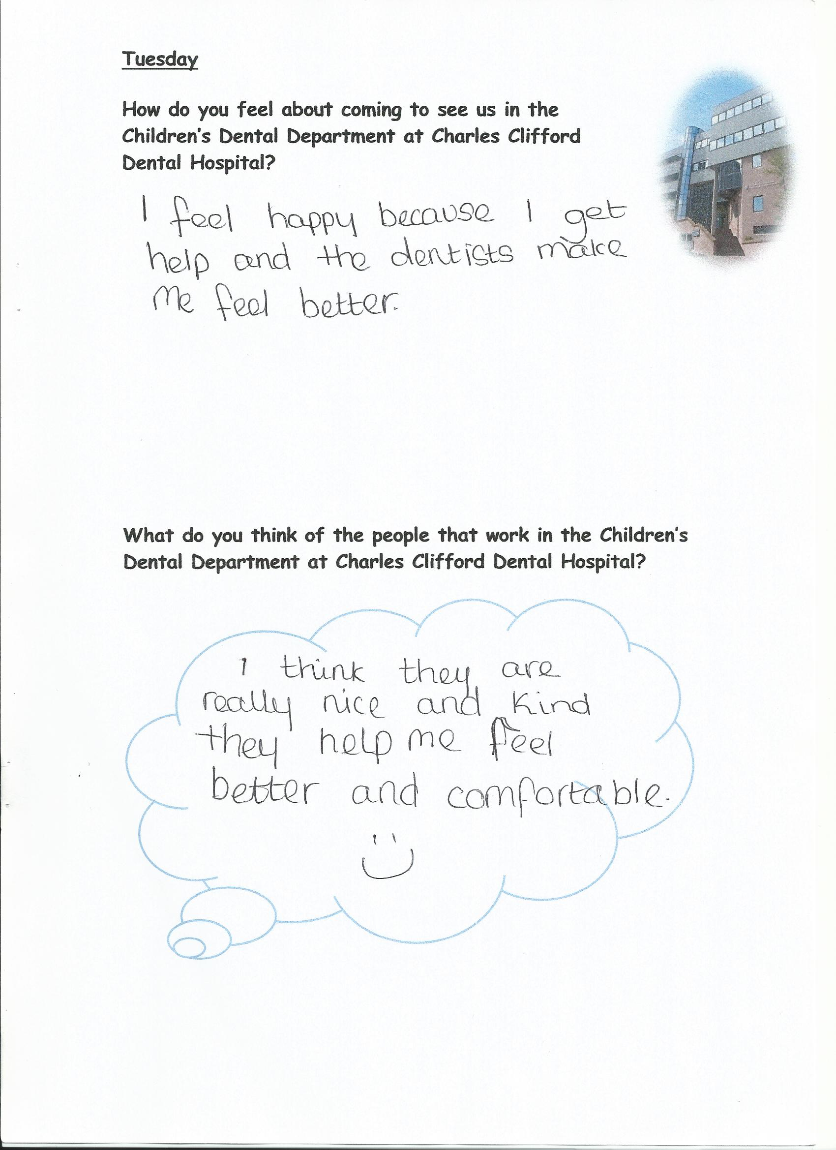

Fig. 3 Excerpt from Gemma’s diary
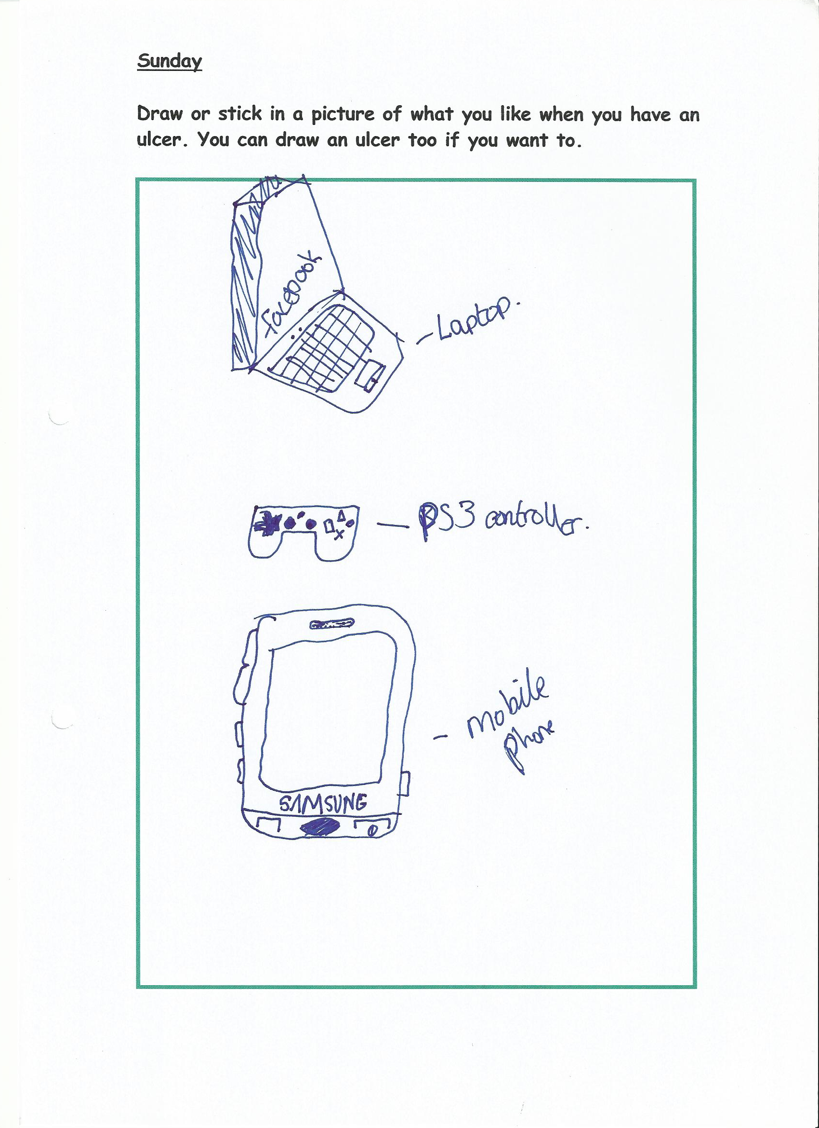

Fig. 4 Excerpt from Jake’s diary

References

- Elliot, H. The Use of Diaries in Sociological Research on Health Experience. Sociological Research Online 1997; 2: 2. Available: http://www.socresonline.org.uk/socresonline/2/2/7.html.
- Kenten C. Narrating Oneself: Reflections on the Use of Solicited Diaries with Diary Interviews. Forum: Qualitaitve Social Research 2010; 11(2): Art. 16.
- Corti L. Using diaries in social research. Social Research Update 2 [Online] 1993. Available: http://sru.soc.surrey.ac.uk/SRU2.html.
- Pavis S, Masters H and Cunningham-Burley S. Lay concepts of positive mental health and how it can be maintained. Edinburgh: University of Edinburgh; 1996.
- Milligan C. Geographies of care: space, place and the voluntary sector. Aldershot: Ashgate, 2001.
- Ely B, Dampier C, Gilday M, O’Neal P and Brodecki D. Caregiver report of pain in infants and toddlers with sickle cell disease: reliability and validity of a daily diary. Journal of Pain 2002; 3: 50-57.
- Hensley M, Chalmers A, Clover K, Gibson P, Toneguzzi R and Lewis P. Comparison of a parent-completed retrospective quastionnaire with a prospective daily symptoms diary. Pediatric Pulmonology 2003; 36: 509-513.
- Meth P. Entries and omissions: using solicited diaries in geographical research. Area 2003; 35(2): 195-205.
- Zimmerman D and Weider D. The diary interview method. Urban Life 1977; 5(4): 479-498.
- Butz A. Use of health diaries in pediatric research. Journal of Pediatric Health Care 2004; 18(5): 262-263.
- Gil K, Carson J, Porter L, Ready J, Valrie C, Redding-Lallinger R, and Daeschner C. Daily Stress and Mood and Their Association With Pain, Health-Care Use, and School Activity in Adolescents With Sickle Cell Disease. Pediatr. Psychol. 2003; 28(5): 363-373.
- Modi A and Quittner A. Barriers to Treatment Adherence for Children with Cystic Fibrosis and Asthma- what gets in the way? J. Pediatr. Psychol. 2006; 31(8): 846-858.
- Huntfield JA, Perquin CW, Duinvenvoorden HJ, Hazebroek – Kampschreur AA, Passchier, van Suijlekom-Smit LW and van der Wouden JC. Chronic pain and its impact on quality of life in adolescents and their families. J Pediatr. Psychol 2001; 26(3): 145-53.
- Sandelowski M. Sample size in qualitative research. Research in Nursing and Health 1995; 18:179-83.
- Ritchie J, Lewis J. Qualitative Research Practice: A Guide for Social Science Students and Researchers. 2nd Edn. London: Sage Publications Ltd., 2009.
- McGrath M, Bedi R. A review of the influences of oral health on the quality of life. Int J Health Prom Edu 1999; 37: 116.
- Lopez-Jornet P, Camacho – Alonso F. Quality of life in patients with Sjogren’s syndrome and sicca complex. J Oral Rehabil 2008; 35(12): 875-88.
- Lopez-Jornet P, Camacho – Alonso F, Lucero-Berdugo M. Quality of life in patients with burning mouth syndrome. J Oral Pathol Med 2008; 37(7): 389-394.
- Gherunpong S. A socio-dental approach to assessing children’s oral health needs: integrating an oral health-related quality of life (OHRQoL) measure into oral health service planning. Bull World Health 2006; 84: 36-42.
- Krisdapong S, Sheiham A, Tsakos G. Oral health related quality of life of 12- to 15-year-old Thai children: findings from a national study. Community Dentistry and Oral Epidemiology 2009; 37(6): 509-517.
- Krisdapong S, Sheiham A, Tsakos G. Impacts of recurrent aphthous stomatitis on quality of life of 12- and 15-year-old Thai children. Qual Life Res 2012; 21(1): 71-76.
- Rosenthal GE, Shannon SE. The Use of Patient Perceptions in the Evaluation of Health-Care Delivery Systems. Medical Care 1997; 35(11): NS58-NS68.
- Tabolli S, Bergamo F, Alessandroni L, Di Pietro C, Sampogna F, Abeni D. Quality of life and psychological problems of patients with oral mucosal disease in dermatological practice. Dermatology 2009; 218(4): 314-320.
- Thomson M, Lawrence HP, Broadbent JM, Poulton R. The impact of xerostomia on oral health related quality of life among younger adults. Health and Quality of Life Outcomes 2006; 4: 86.

