Figure S1. Differences between max(F) derived under two different definitions of F. The solid line shows the upper bound of F as a function of MAF derived in this study using the definition of F proposed by Weir and Cockerham (1984). The dotted line shows the upper bound derived by other investigators (Maruki et al. 2012; Jakobsson et al. 2013) using Nei's definition (Nei 1973).

Figure S2. Differentiation between 7 French and 17 Rwandan Drosophila melanogaster lines at 4-fold degenerate sites in regions where crossing over occurs, binned by proxies of codon usage bias. (A) Unweighted mean F_{ST} (F^{U}) binned by the frequency of optimal codons (FOP) for autosomal sites, and (B) for X-linked sites; (C) F^{U} binned by K_{S} (to D. yakuba) for autosomal sites, and (D) for X-linked sites; (E) weighted average F_{ST} (F^{W}) binned by FOP for autosomal sites, and (F) for X-linked sites; (G) F^{W} binned by K_{S} (to D. yakuba) for autosomal sites, and (H) for X-linked sites.
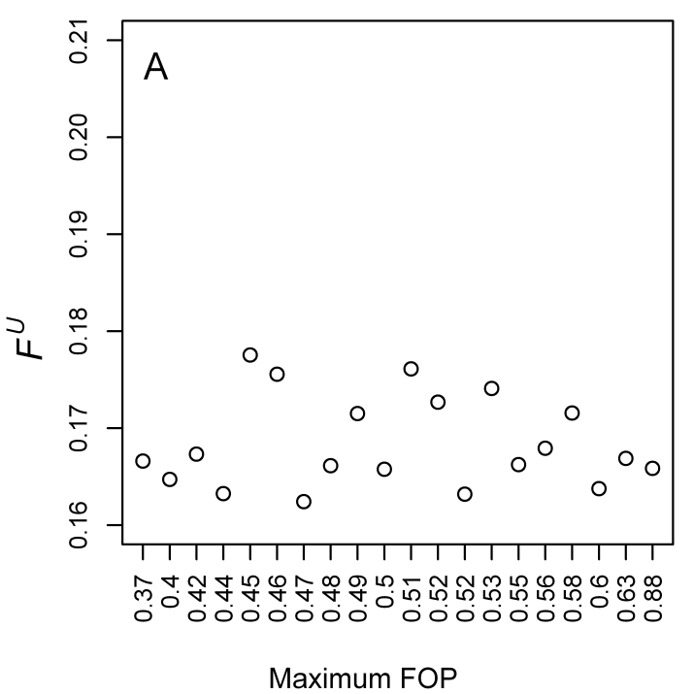 | 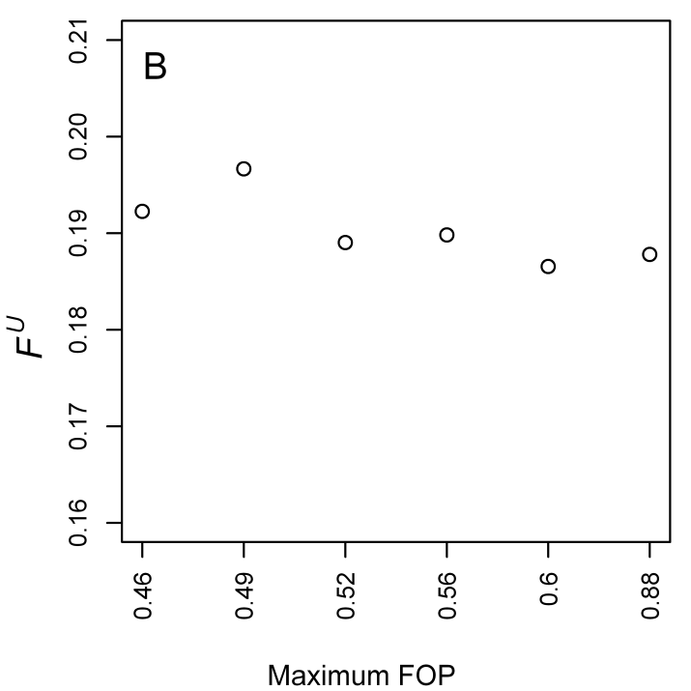
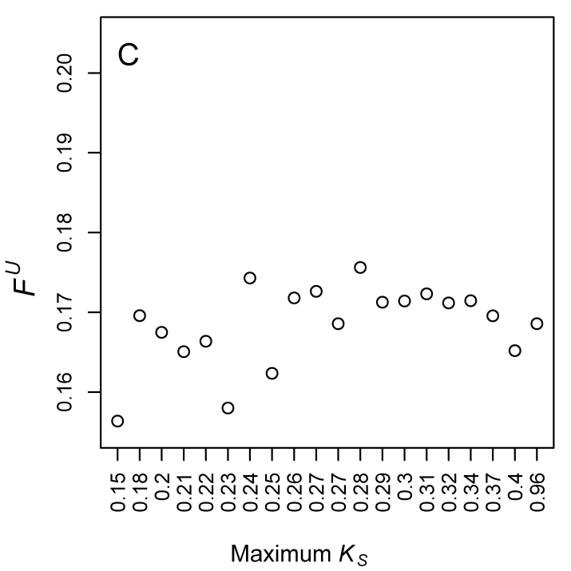 | 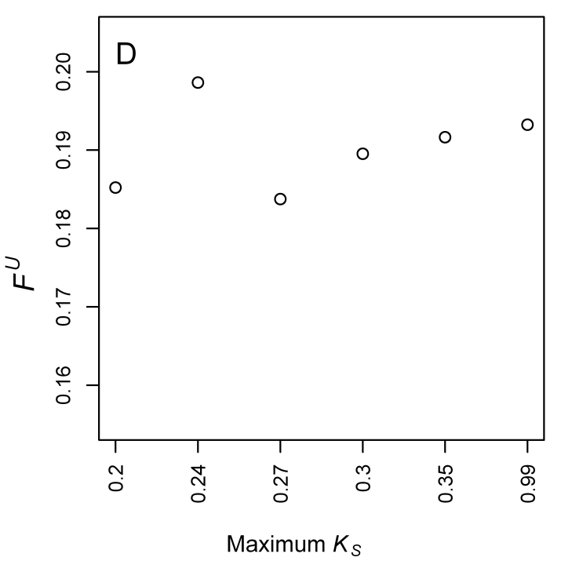
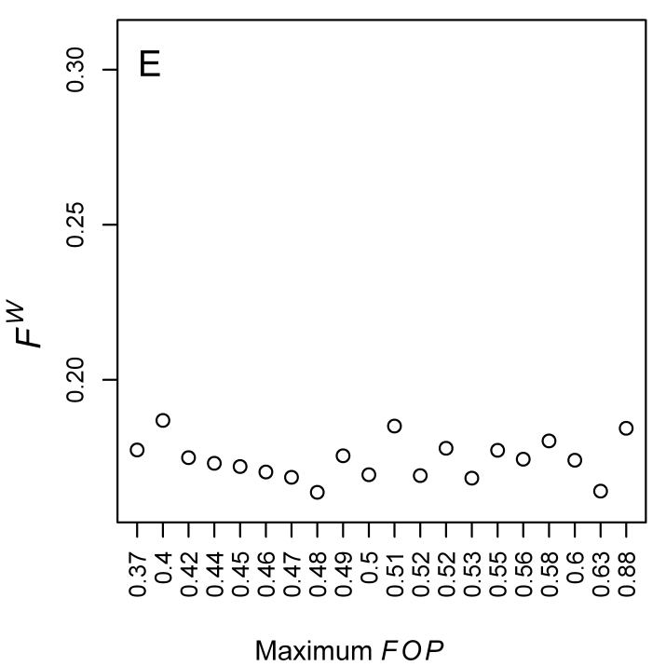 | 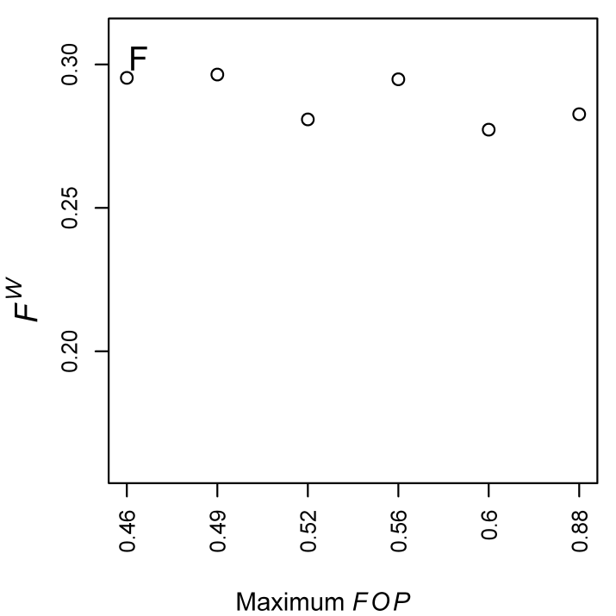
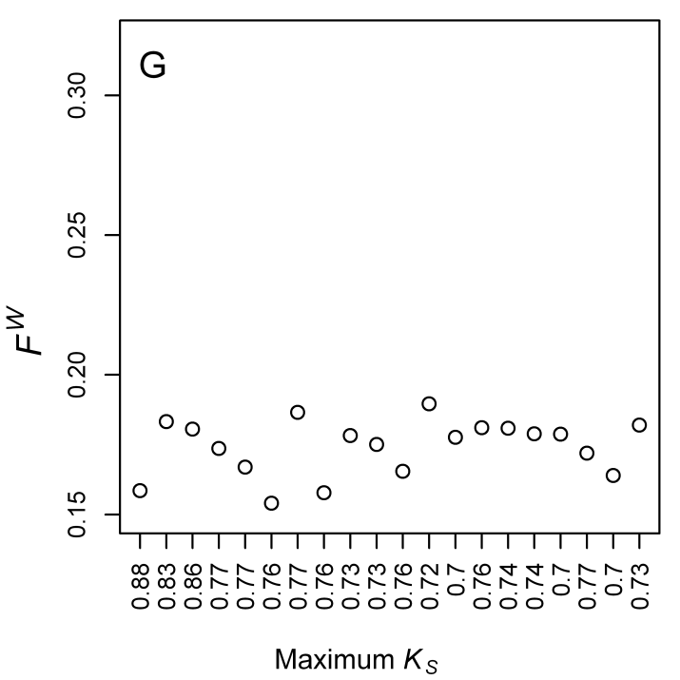 | 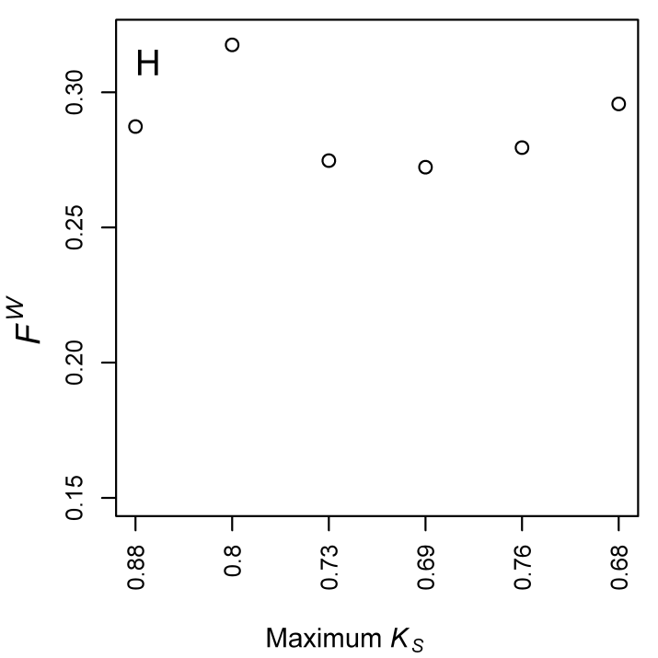

Figure S3. Polymorphism within 7 French D. melanogaster lines, for coding sequence (CDS) binned by K_{A} value (to D. yakuba), and for positions 8-30bp of introns ≤ 65 bp in length (SI sites). (A) Nucleotide diversity (π) for autosomal CDS where crossing-over occurs (CDS-C) and (B) X-linked CDS-C regions; (C) Tajima’s D for autosomal CDS-C regions and (D) X-linked CDS-C regions. Symbols: 0-fold degenerate sites—open circles; 4-fold degenerate sites—open triangles; SI sites—open red squares.

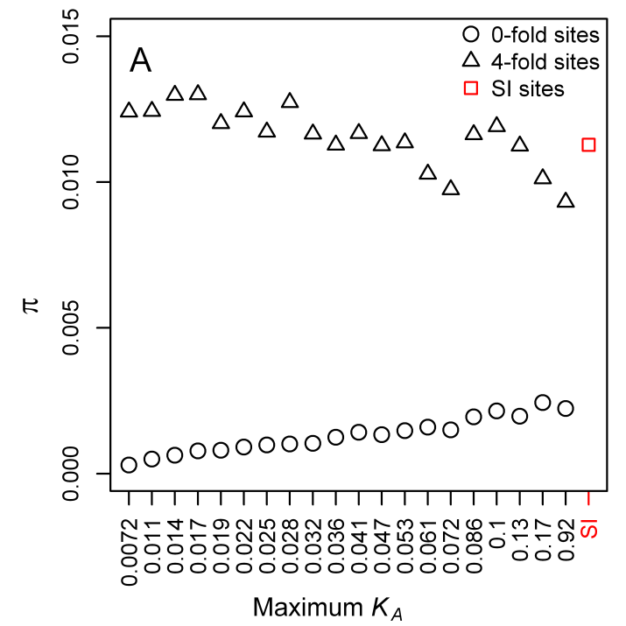 | 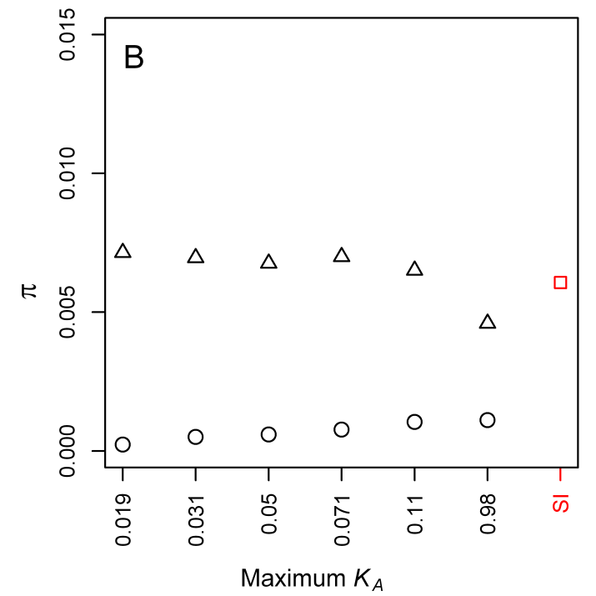
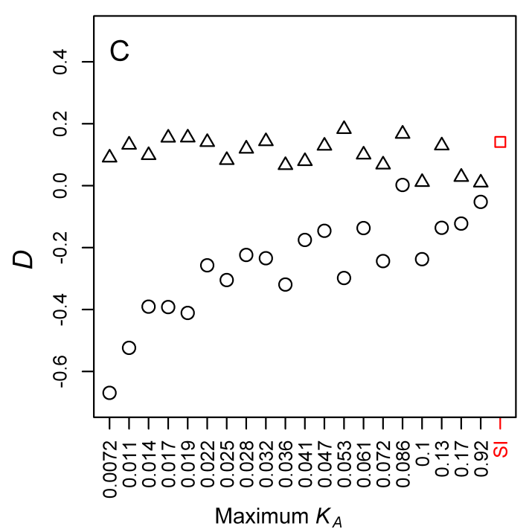 | 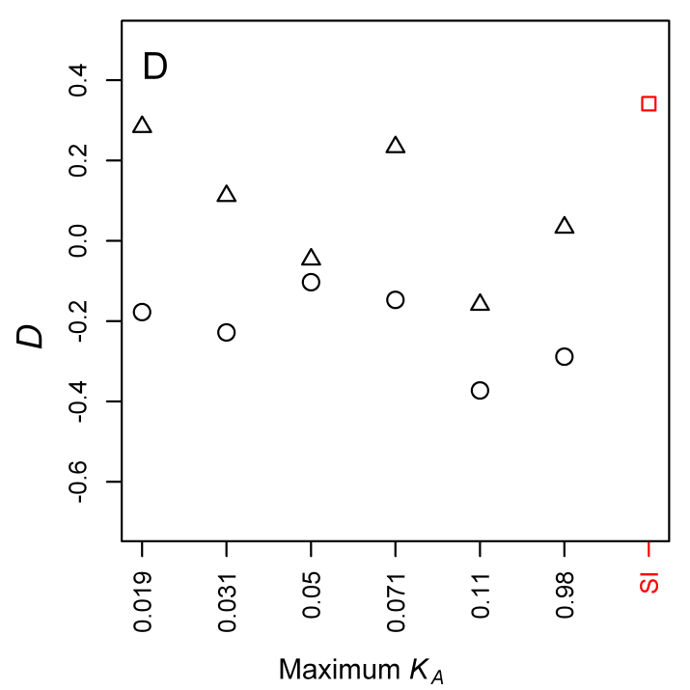

Figure S4. Polymorphism patterns within 17 Rwandan D. melanogaster lines for coding sequence (CDS) binned by K_{A} value (to D. simulans), and for sites in the 8-30 bp regions of short introns ≤ 65 bp (SI sites). (A) Nucleotide diversity (π) for autosomal CDS where crossing-over occurs (CDS-C) and (B) X-linked CDS-C regions; (C) Tajima’s D for autosomal CDS-C regions and (D) X-linked CDS-C regions. The x-axes show the maximum K_{A} value in each bin. Symbols: 0-fold degenerate sites—open circles; 4-fold degenerate sites—open triangles; SI sites—open red squares.

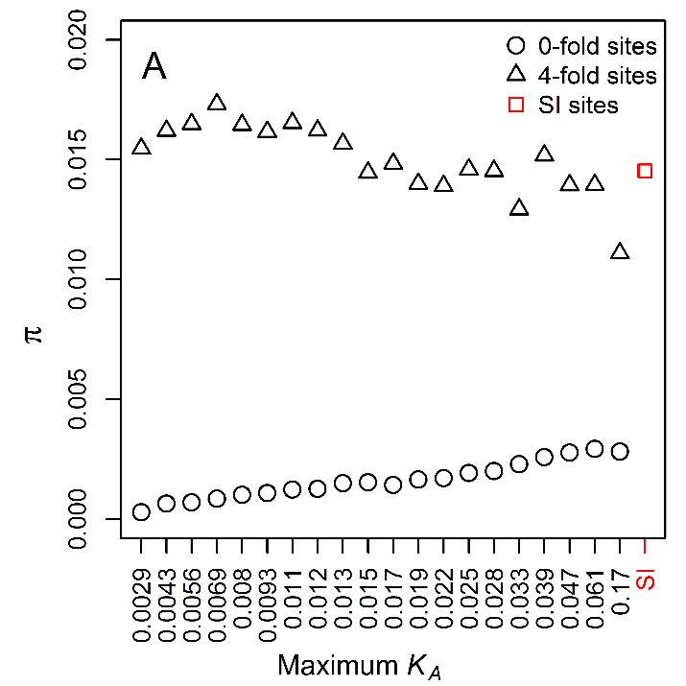 | 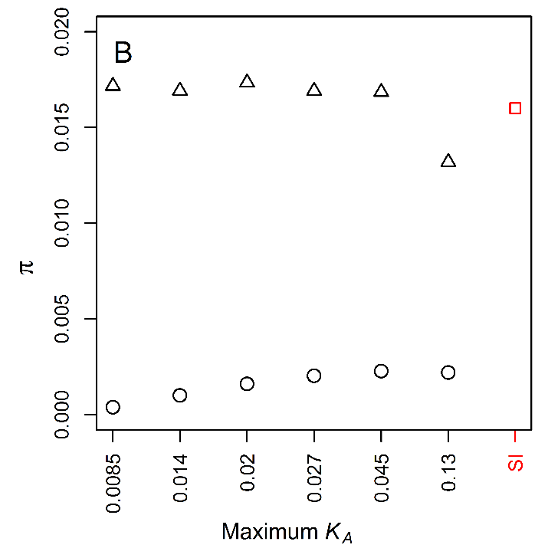
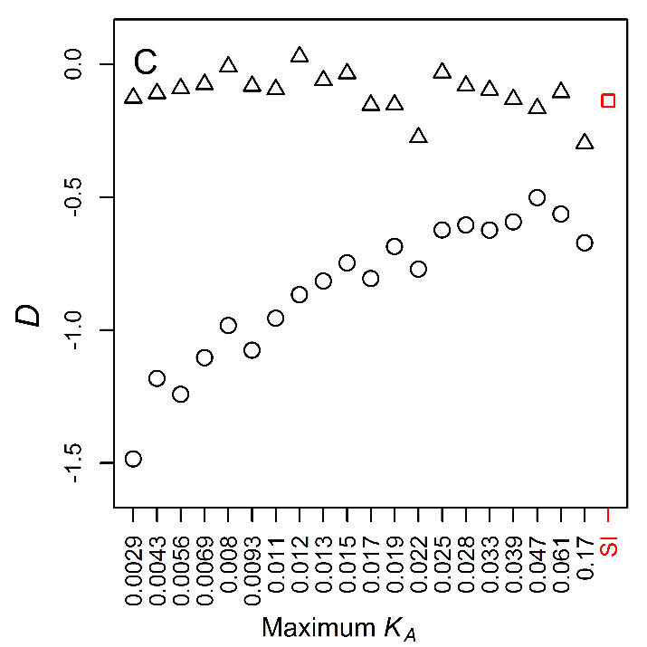 | 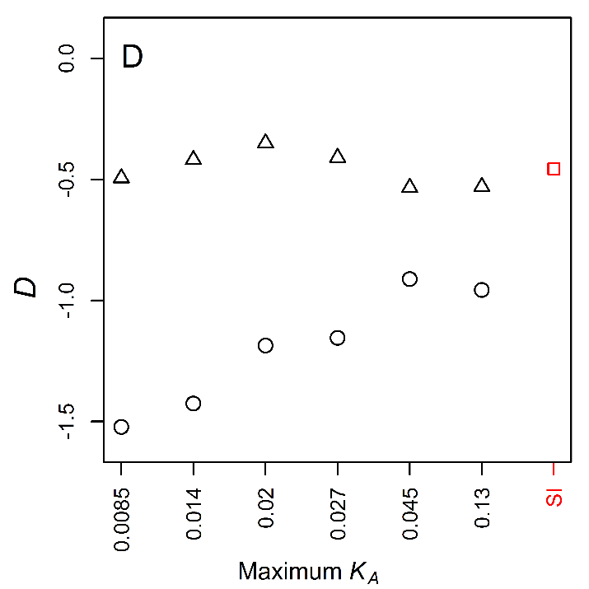

Figure S5. Differentiation patterns between 7 French and 17 Rwandan D. melanogaster lines for coding sequence (CDS) binned by K_{A} value (to D. simulans), and for SI sites. (A) Unweighted mean F_{ST} [F^{U}; Eq. (5)] for autosomal coding CDS where crossing-over occurs (CDS-C) and (B) X-linked CDS-C regions; (C) population-average minor allele frequency (MAF) for autosomal CDS-C regions and (D) X-linked CDS-C regions; (E) the proportion of SNPs per bin in which one allele was private to one of the D. melanogaster populations for autosomal CDS-C regions and (F) X-linked CDS-C regions. Symbols: 0-fold degenerate sites—open circles; 4-fold degenerate sites—open triangles; SI sites—open red squares.
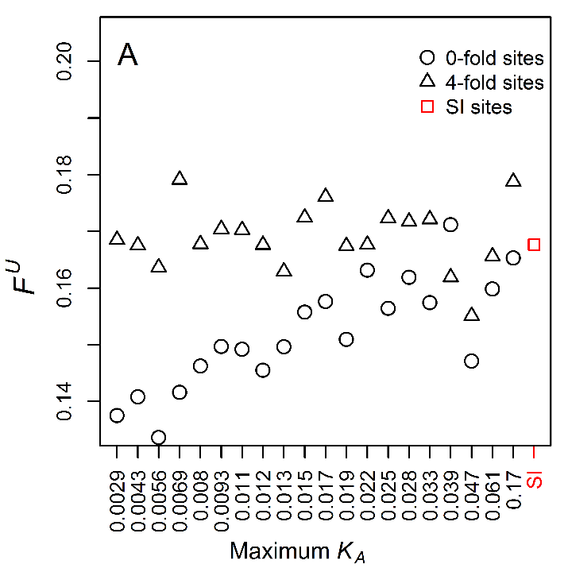 | 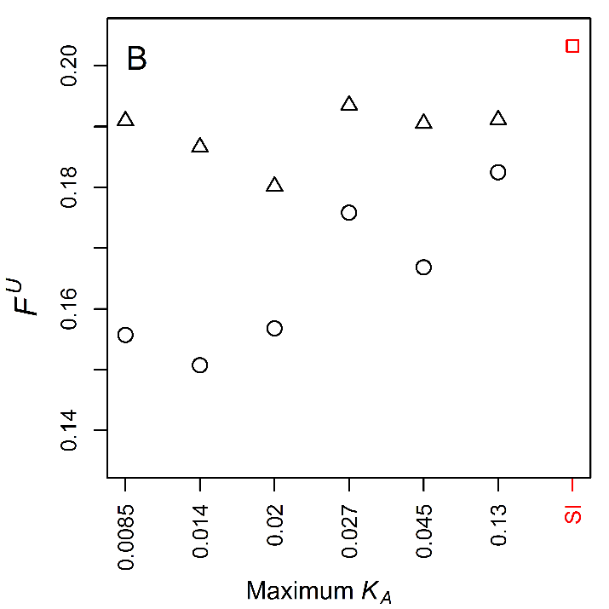
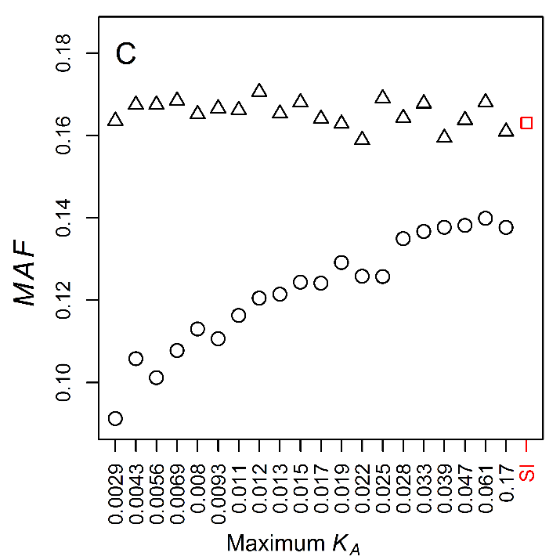 | 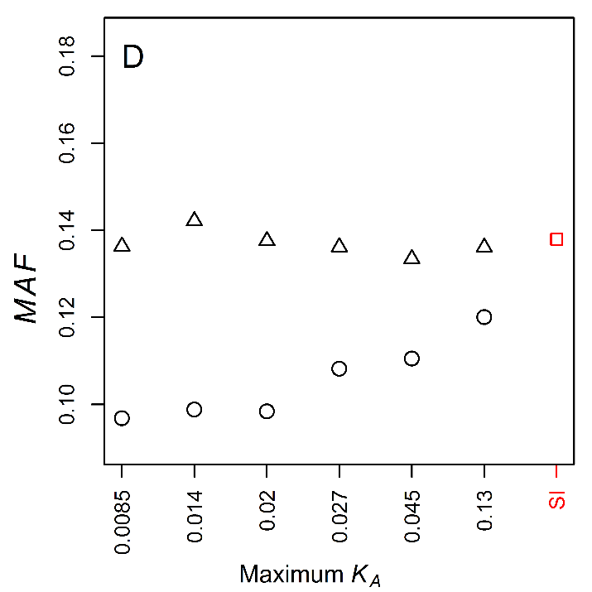
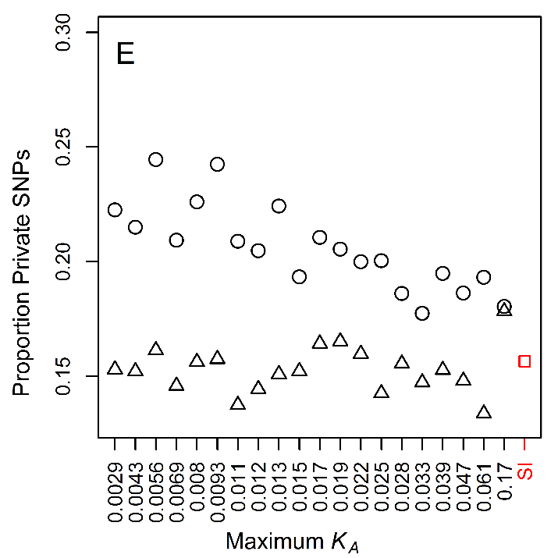 | 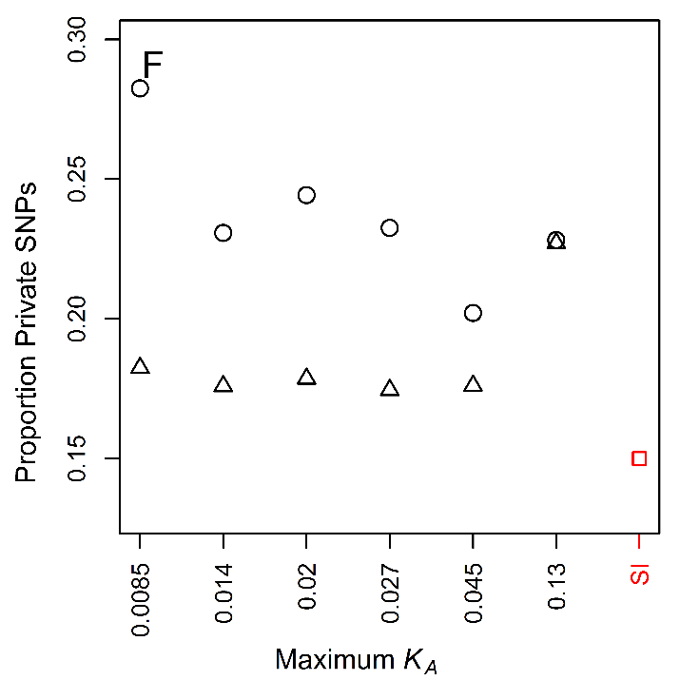

Figure S6. Differentiation between 7 French and 17 Rwandan D. melanogaster lines, for coding sequence (CDS) binned by K_{A} value (to D. yakuba), and for positions 8-30bp of introns ≤ 65bp in length (SI sites). (A) Weighted mean F_{ST} (F^{W}) for 0-fold degenerate sites in autosomal CDS where crossing-over occurs (CDS-C) (Kendall’s  = 0.4, P = 0.015) and (B) 4-fold degenerate and SI sites in autosomal CDS-C (Kendall’s  = 0.0947, P = 0.58, data not including the SI point); (C) F^{W} for 0-fold degenerate sites in X-linked CDS-C (Kendall’s  = 0.467, P = 0.26 and (D) 4-fold degenerate and SI sites in X-linked CDS-C (Kendall’s  = 0.467, P = 0.26. Symbols: 0-fold degenerate sites—open circles; 4-fold degenerate sites—open triangles; SI sites—open red squares.
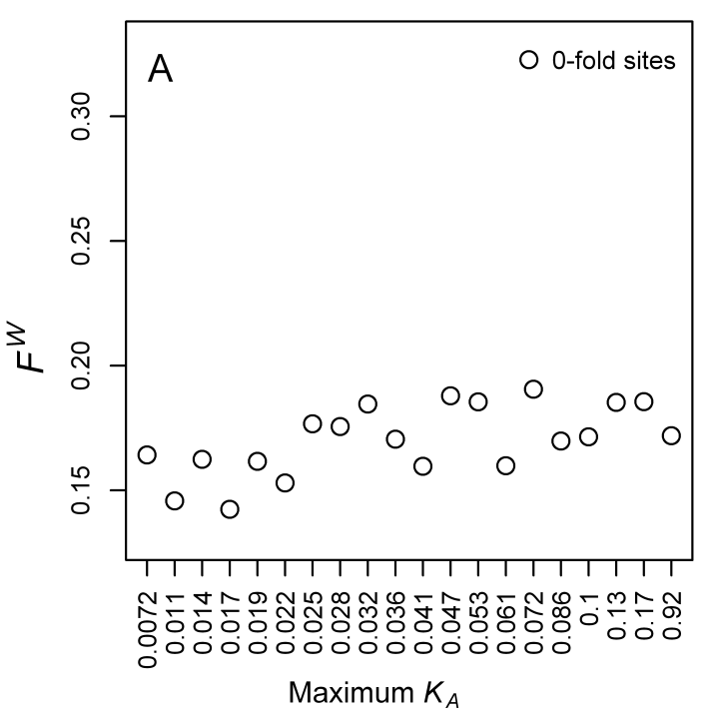 | 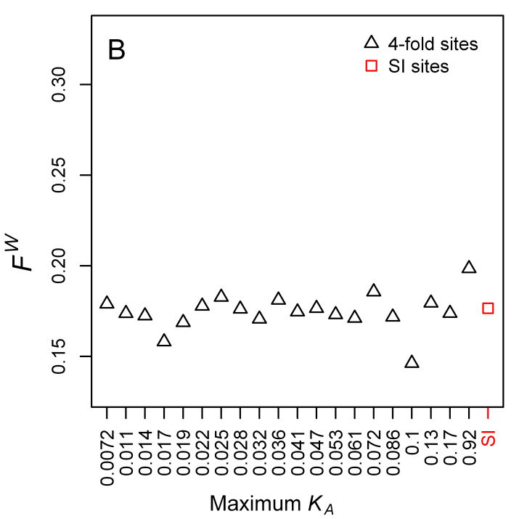
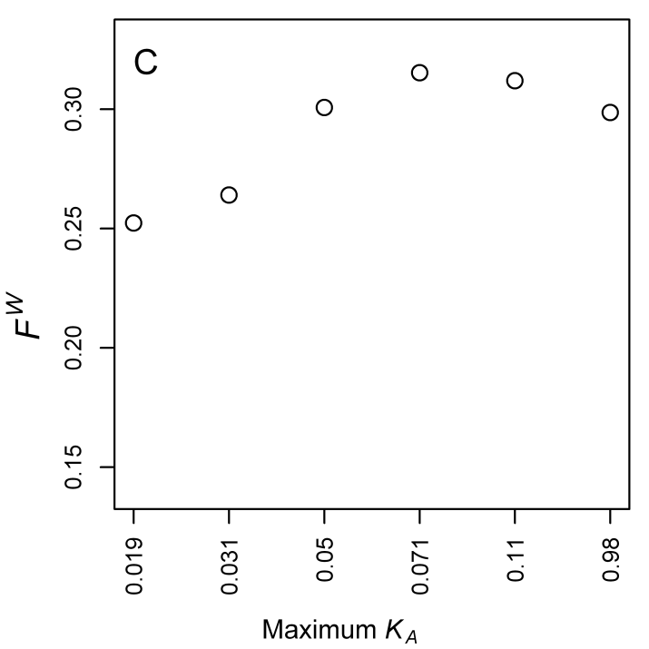 | 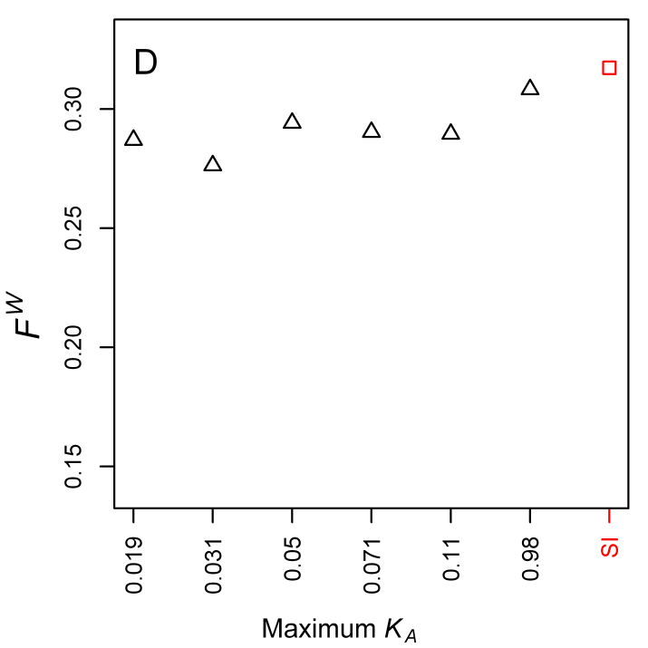

Figure S7. Polymorphism within 7 French Drosophila melanogaster lines, for intronic sites > 65bp (long introns), binned by K value (to D. simulans), with comparison to positions 8-30bp of introns ≤ 65bp in length (SI sites). (A) Nucleotide diversity (π) for autosomal introns and (B) X-linked introns; (C) Tajima’s D for autosomal introns and (D) X-linked introns. Symbols: long introns sites—open circles; SI sites—open red squares.

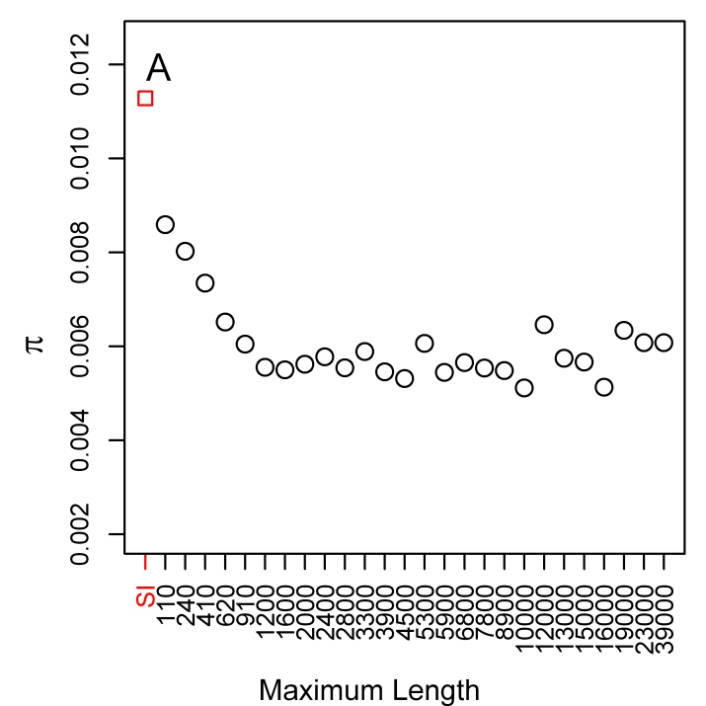 | 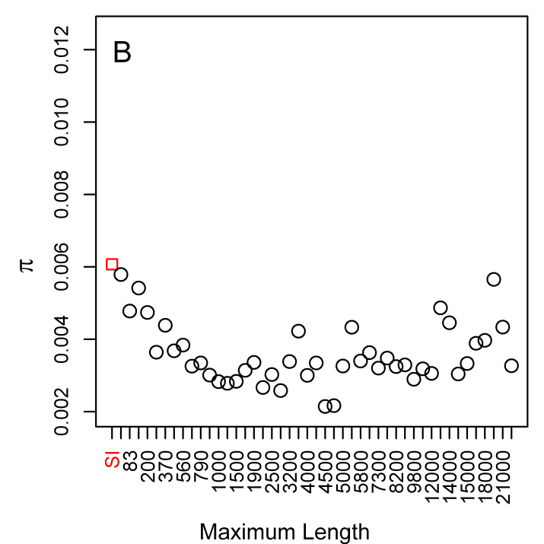
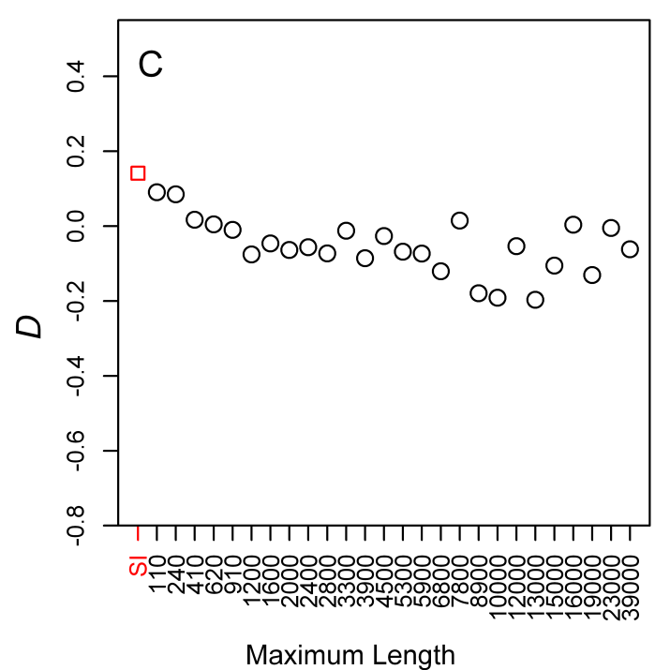 | 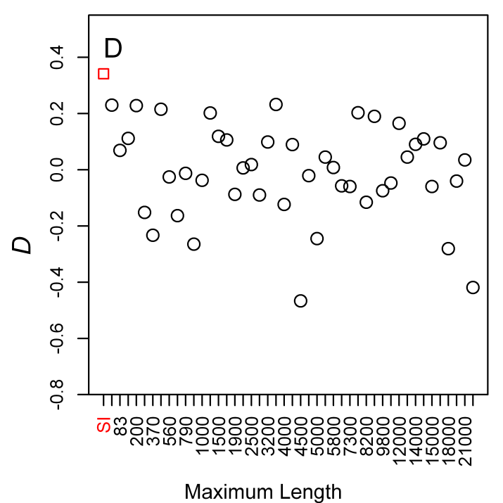

Figure S8. Differentiation between 7 French and 17 Rwandan Drosophila melanogaster lines, for intronic sites > 65bp (long introns), binned by intron length, with comparison to positions 8-30bp of introns ≤ 65bp in length (SI sites). (A) Population-average minor allele frequency (MAF) for autosomal introns and (B) X-linked introns; (C) proportion of private alleles for autosomal introns and (D) X-linked introns; (E) weighted mean F_{ST} (F^{W}) for autosomal introns and (F) X-linked introns. Symbols: long intron sites—open circles; SI sites—open red squares.
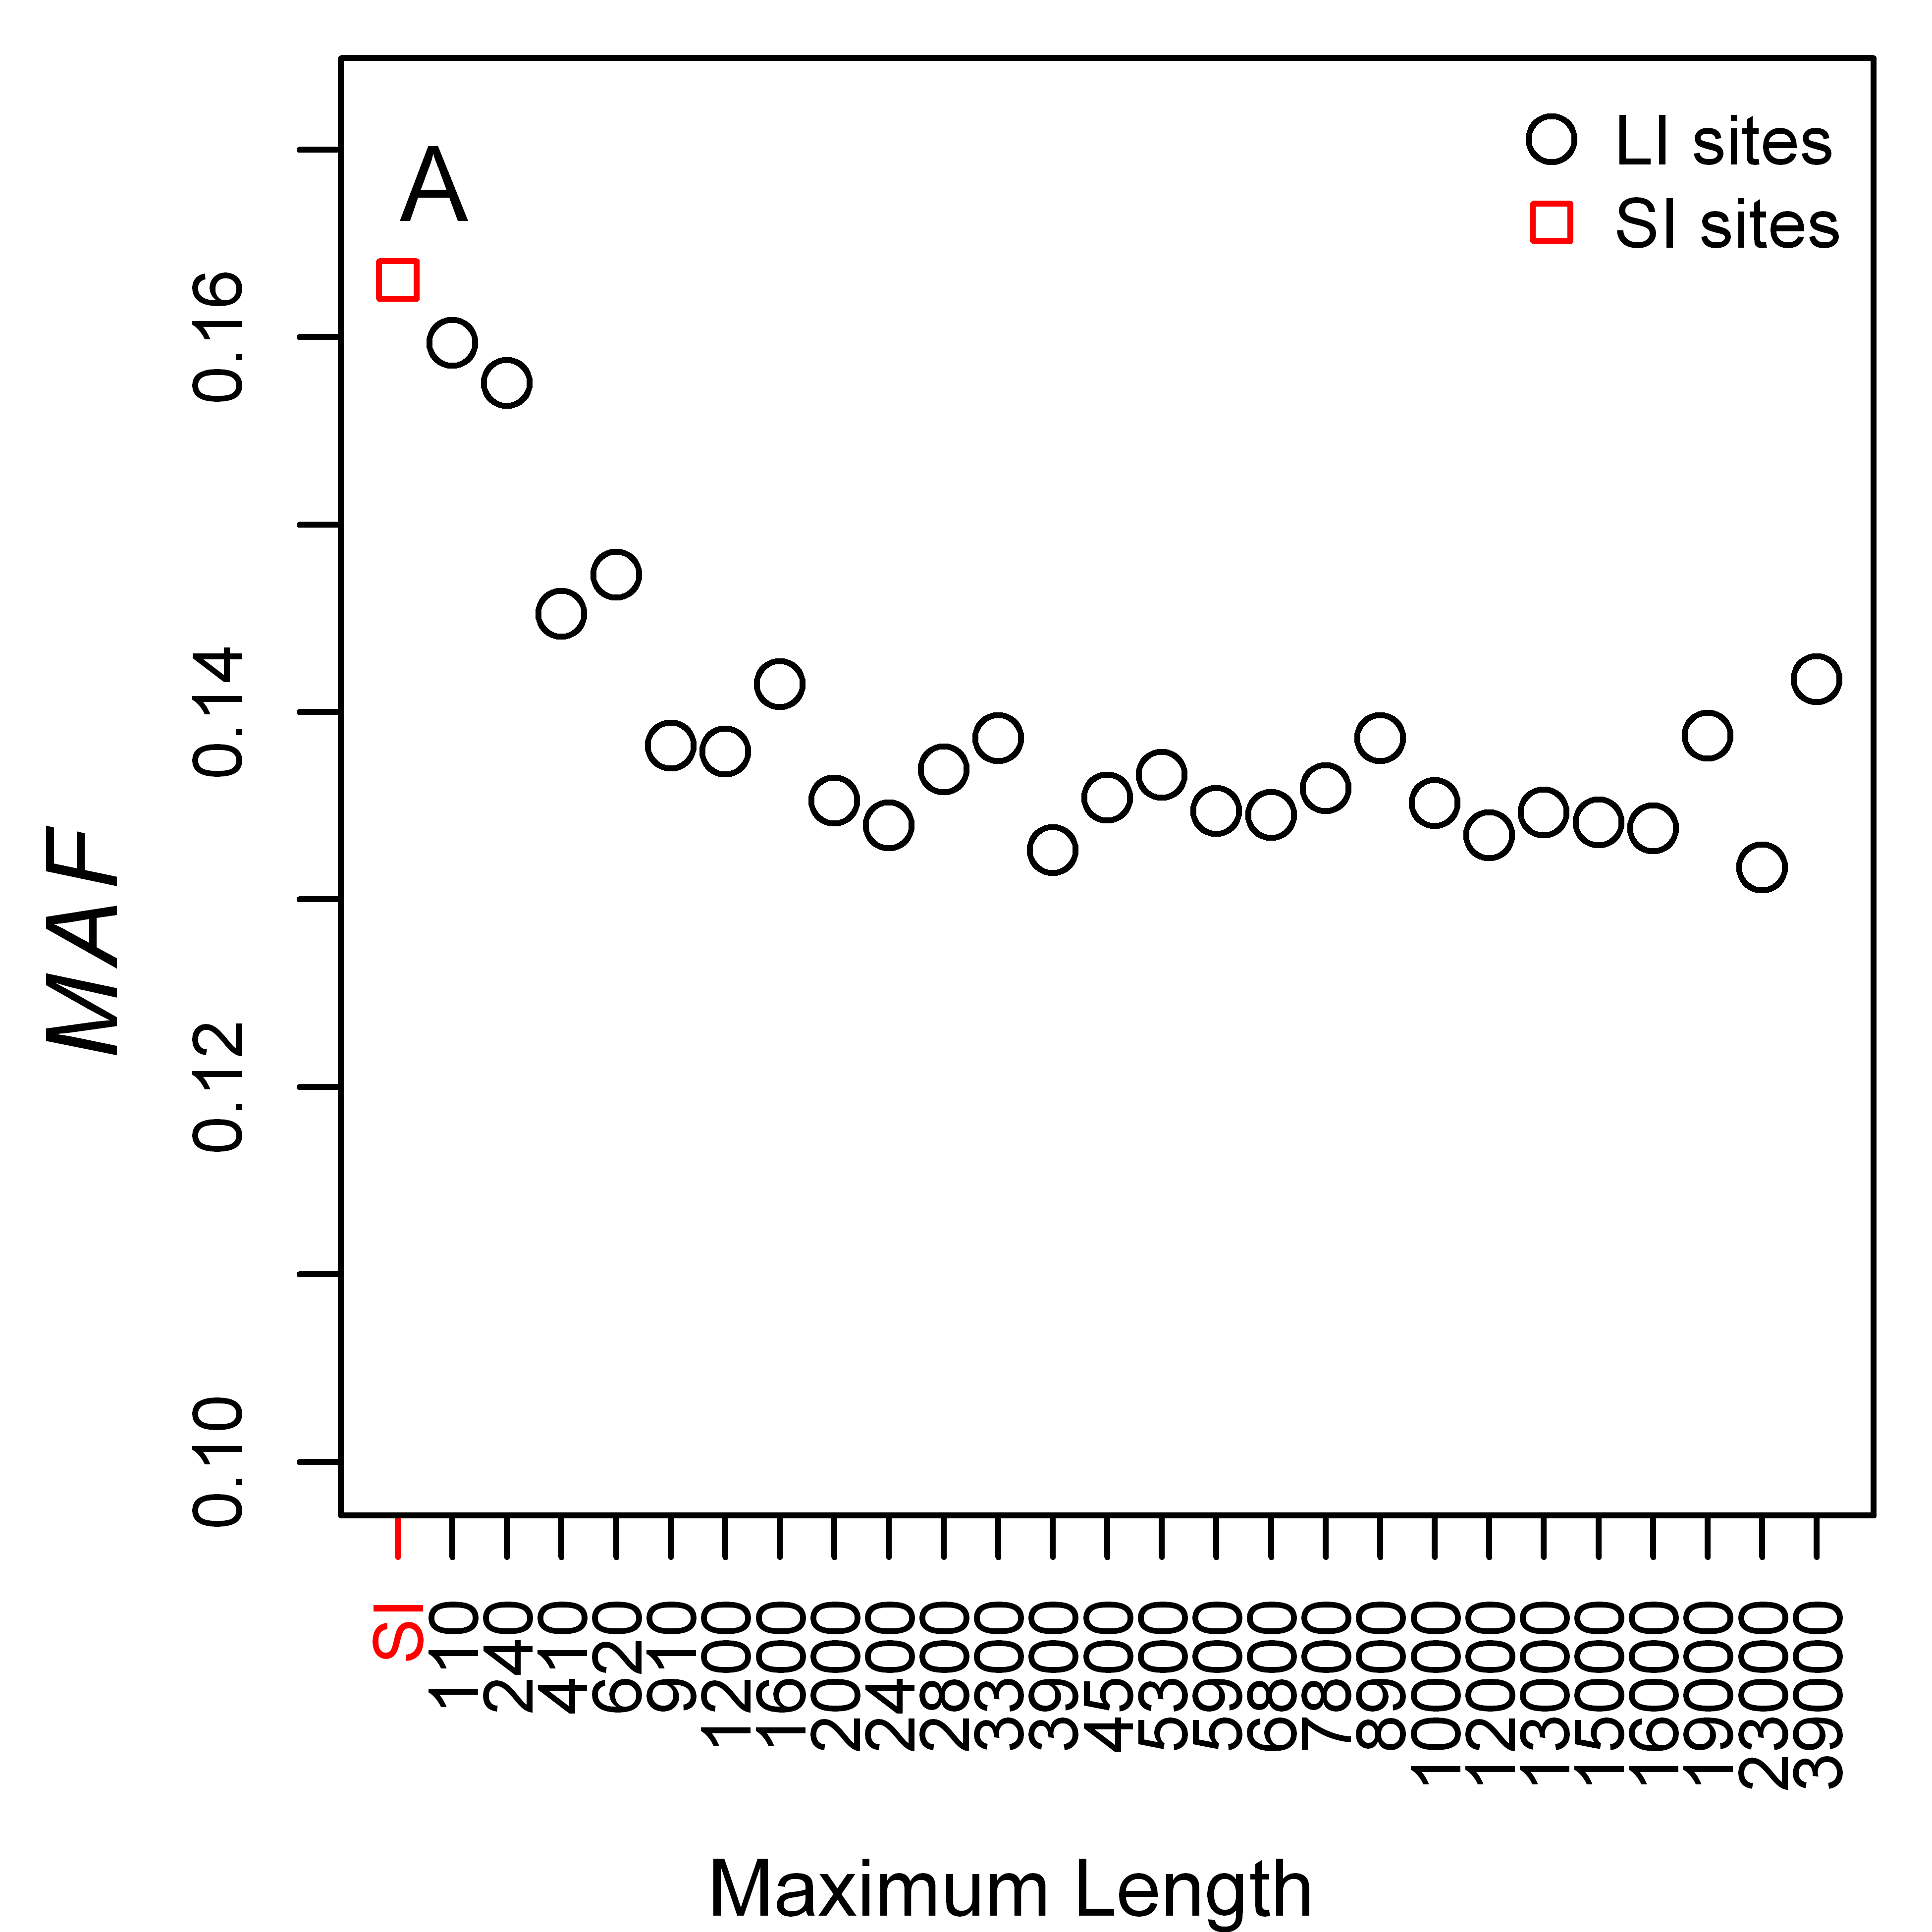 | 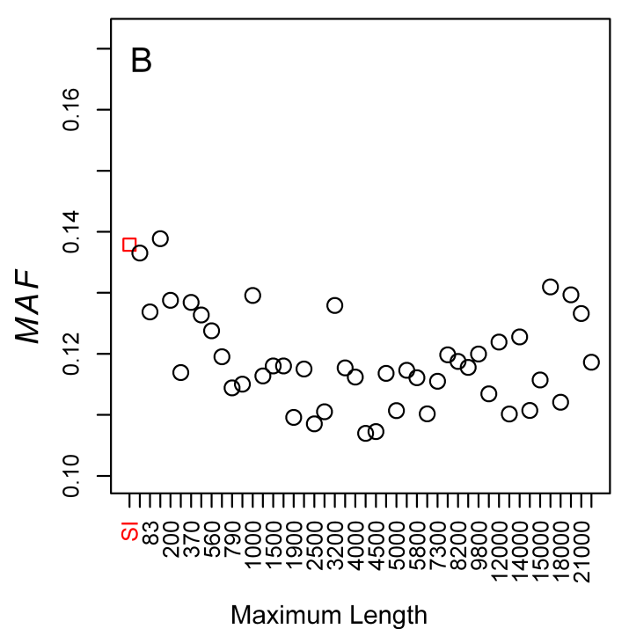
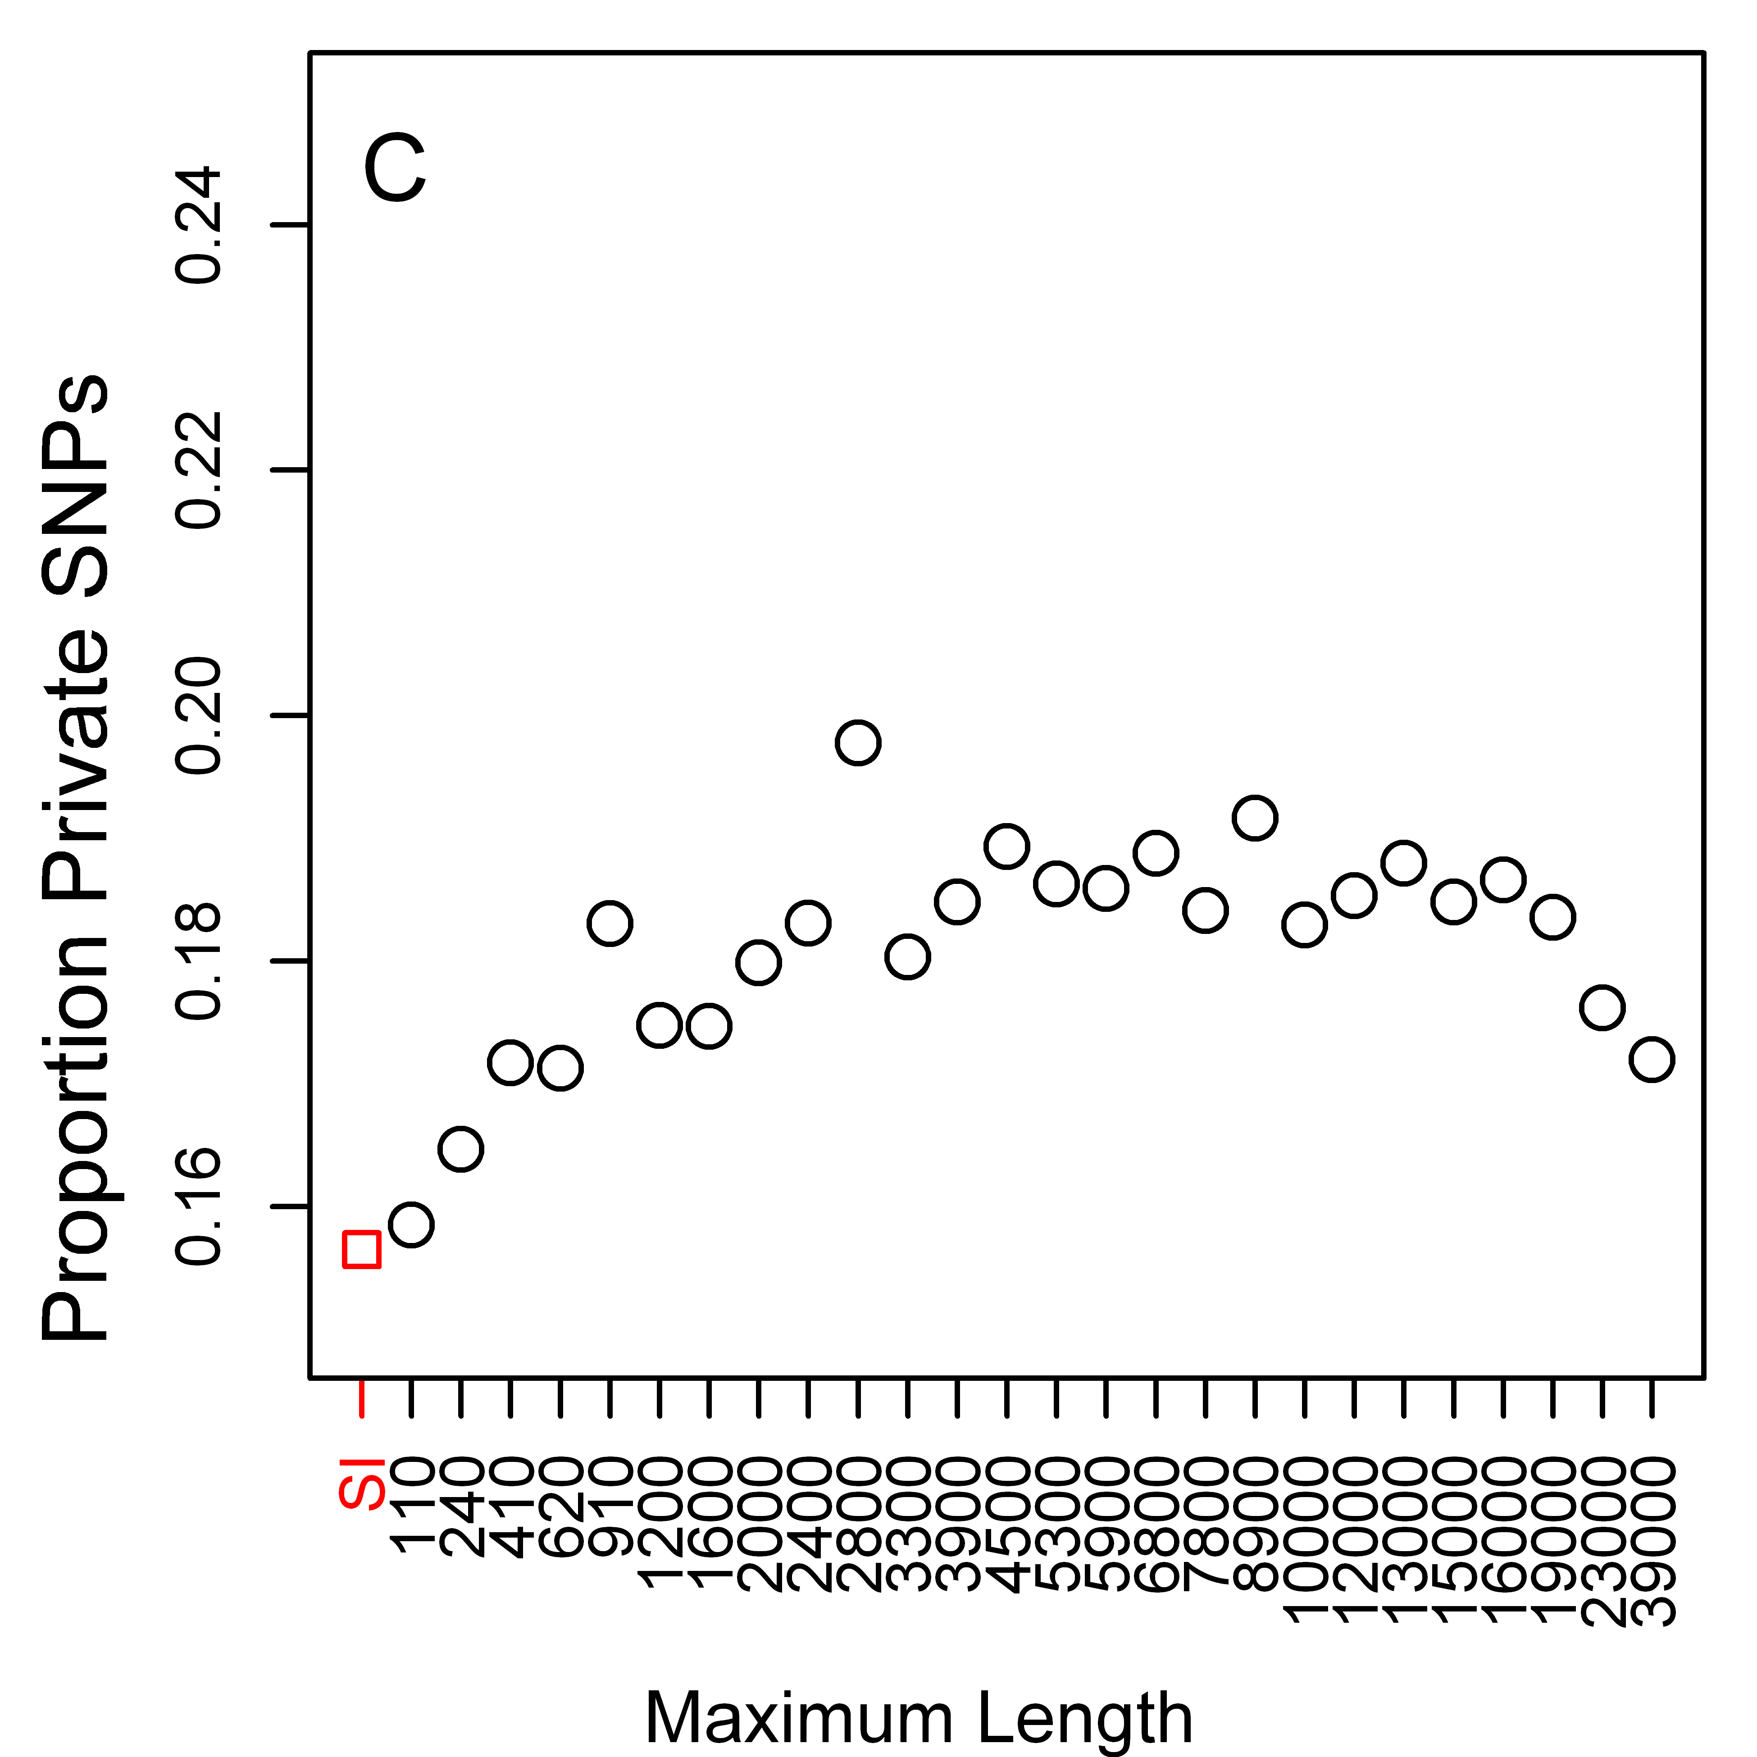 | 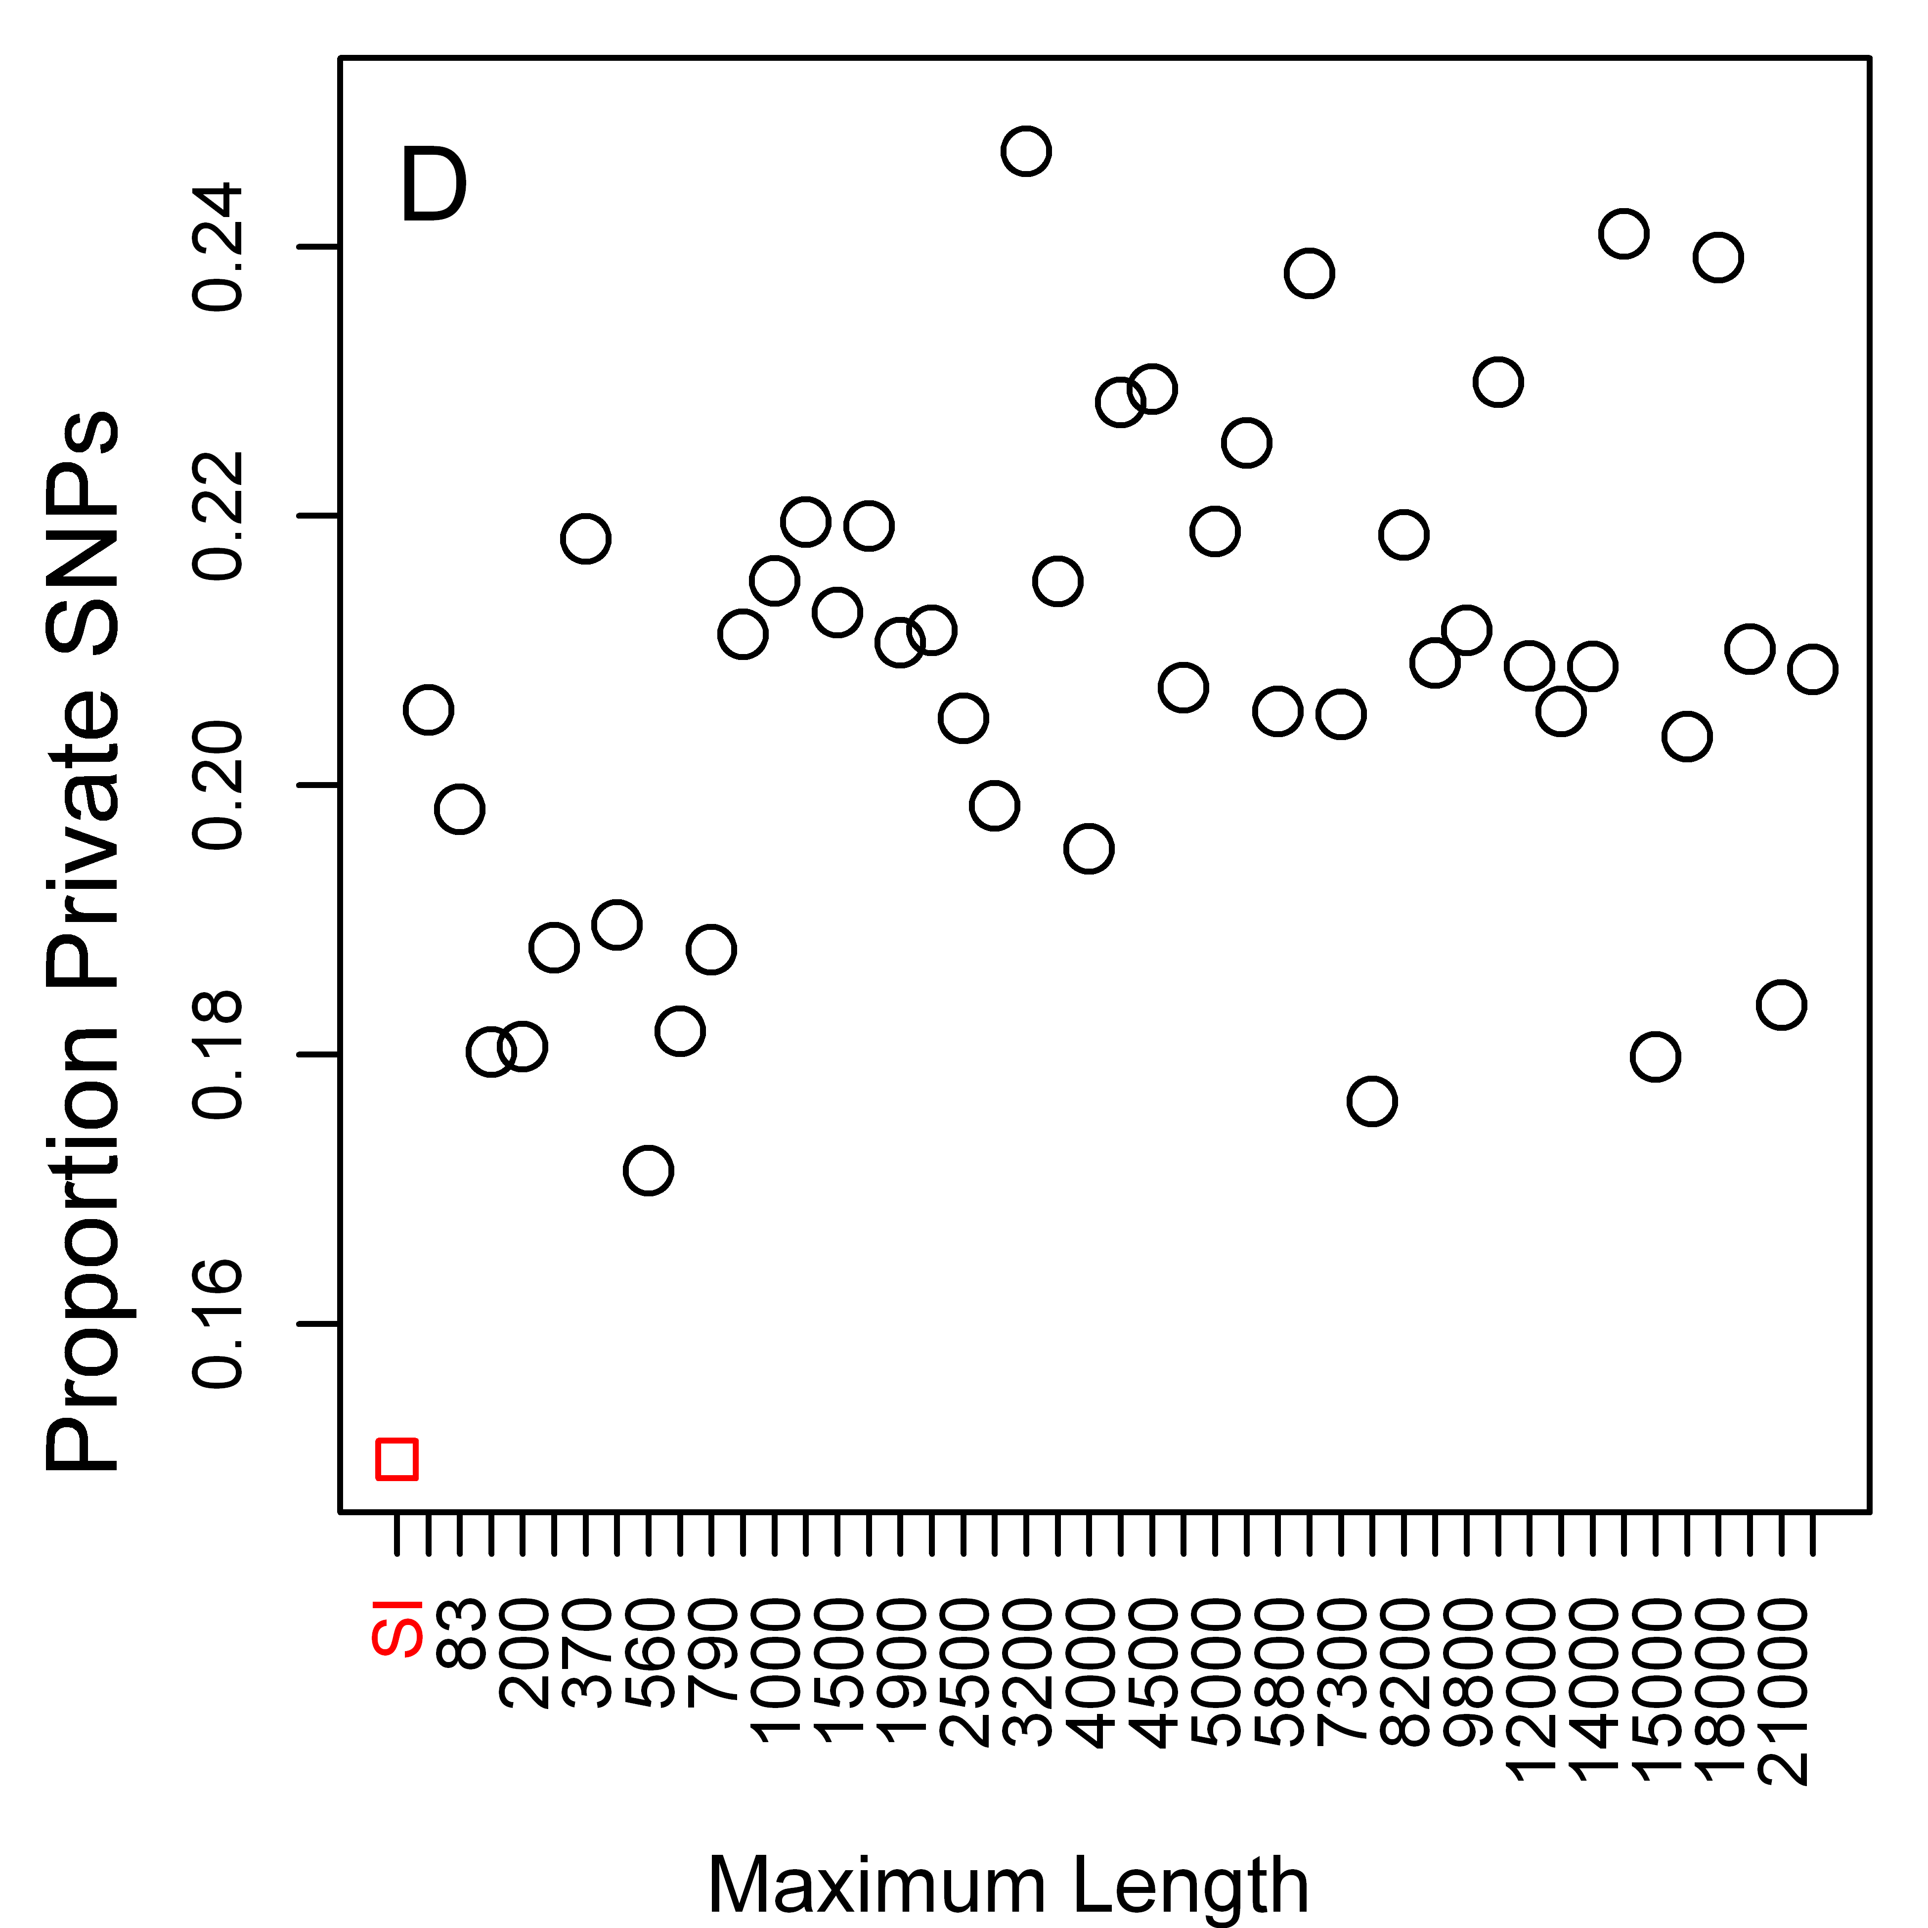
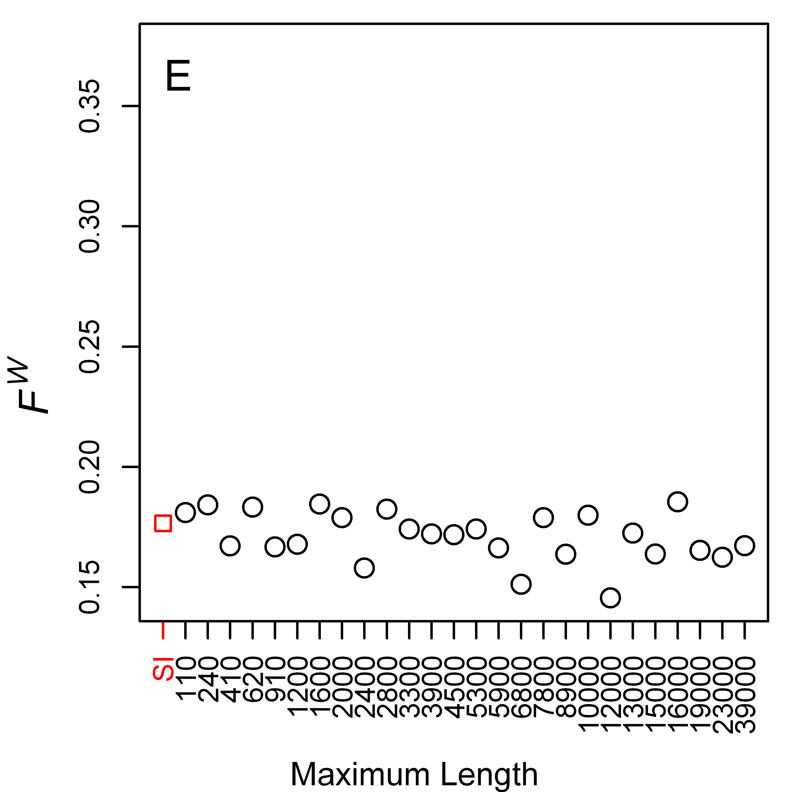 | 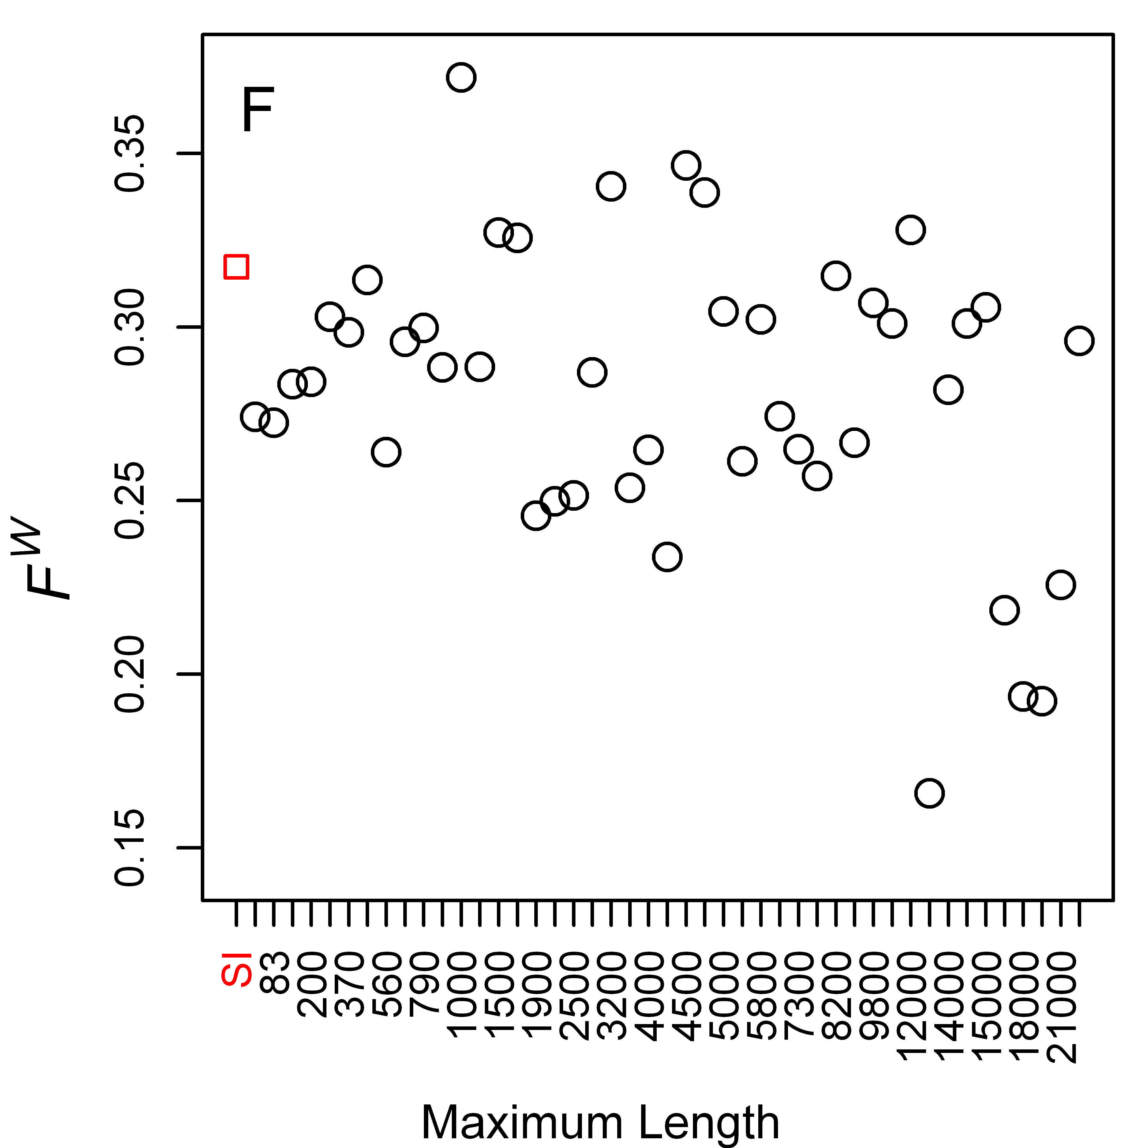

Figure S9. Differentiation between 7 French and 17 Rwandan Drosophila melanogaster lines for X-linked 4-fold degenerate sites and positions 8-30bp of introns ≤ 65bp in length (SI sites), as a function of local recombination rate. Unweighted mean F_{ST} (F^{U}) for X-linked 4-fold degenerate sites (A) and X-linked SI sites (B), respectively. The red square in (A) represents data from 4-fold sites in NC regions. Kendall's  for the two figures are -0.2 (P = 0.71) and -0.7 (P = 0.06), respectively
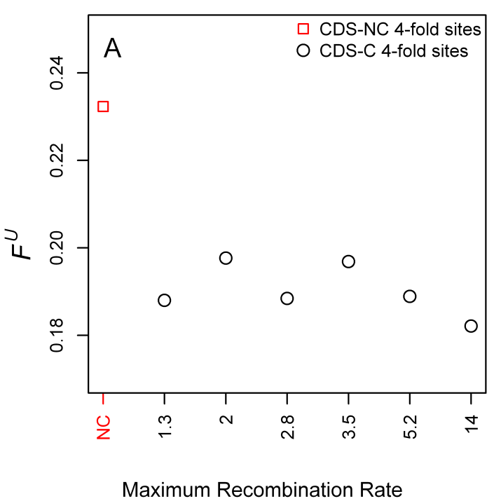 | 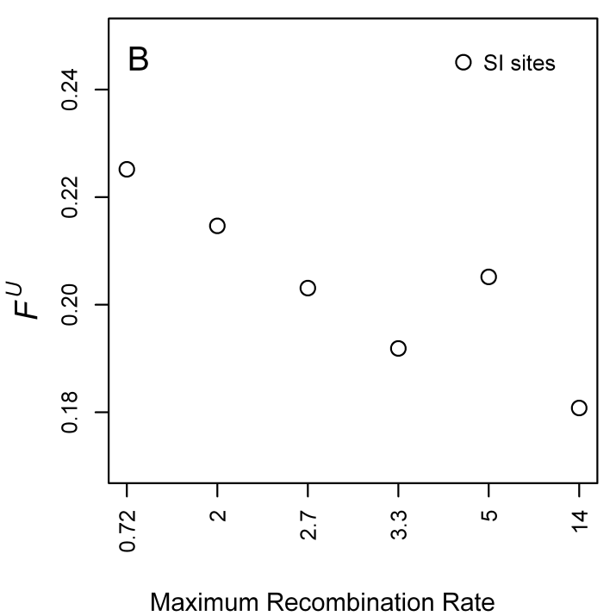

Figure S10. Differentiation between 7 French and 17 Rwandan Drosophila melanogaster lines, for 4-fold degenerate sites in coding sequence where crossing over occurs (CDS-C), as a function of local recombination rate, and for coding sequence where crossing over does not occur (CDS-NC). (A) Weighted mean F_{ST} (F^{W}) for autosomal CDS (Kendall’s  = -0.337, P = 0.041, data not including the NC point), (B) X-linked CDS (Kendall’s  = -0.467, P = 0.26), (C) autosomal SI sites (Kendall’s  = -0.0526, P = 0.77), and (D) X-linked SI sites (Kendall’s  = -0.6, P = 0.13).
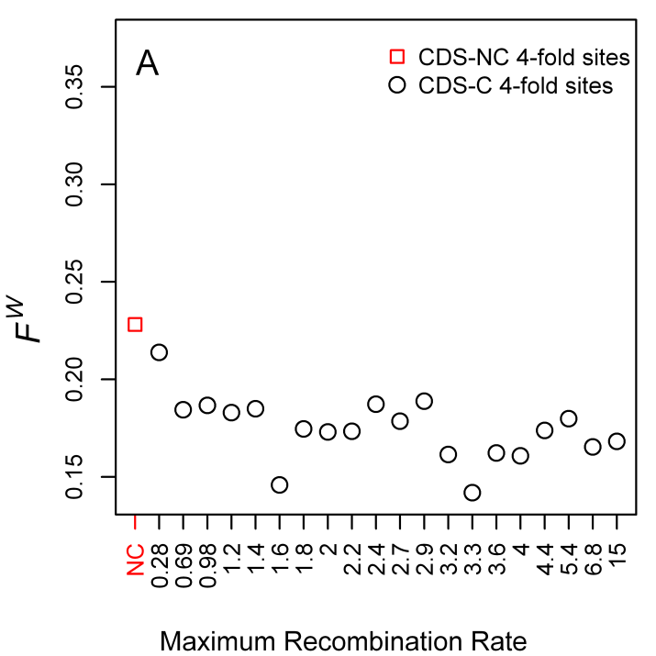 | 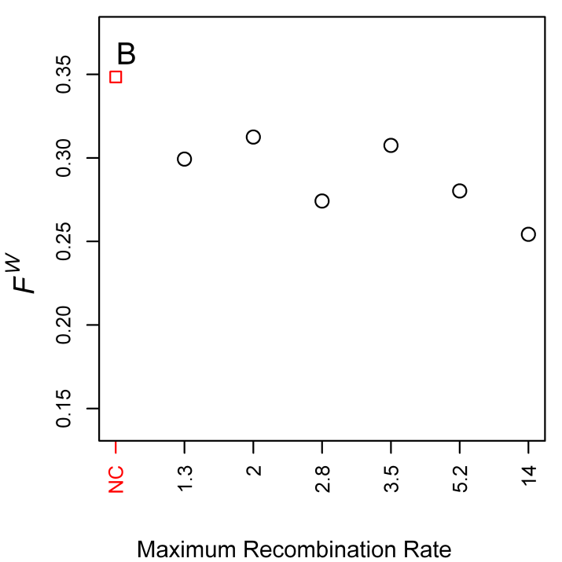
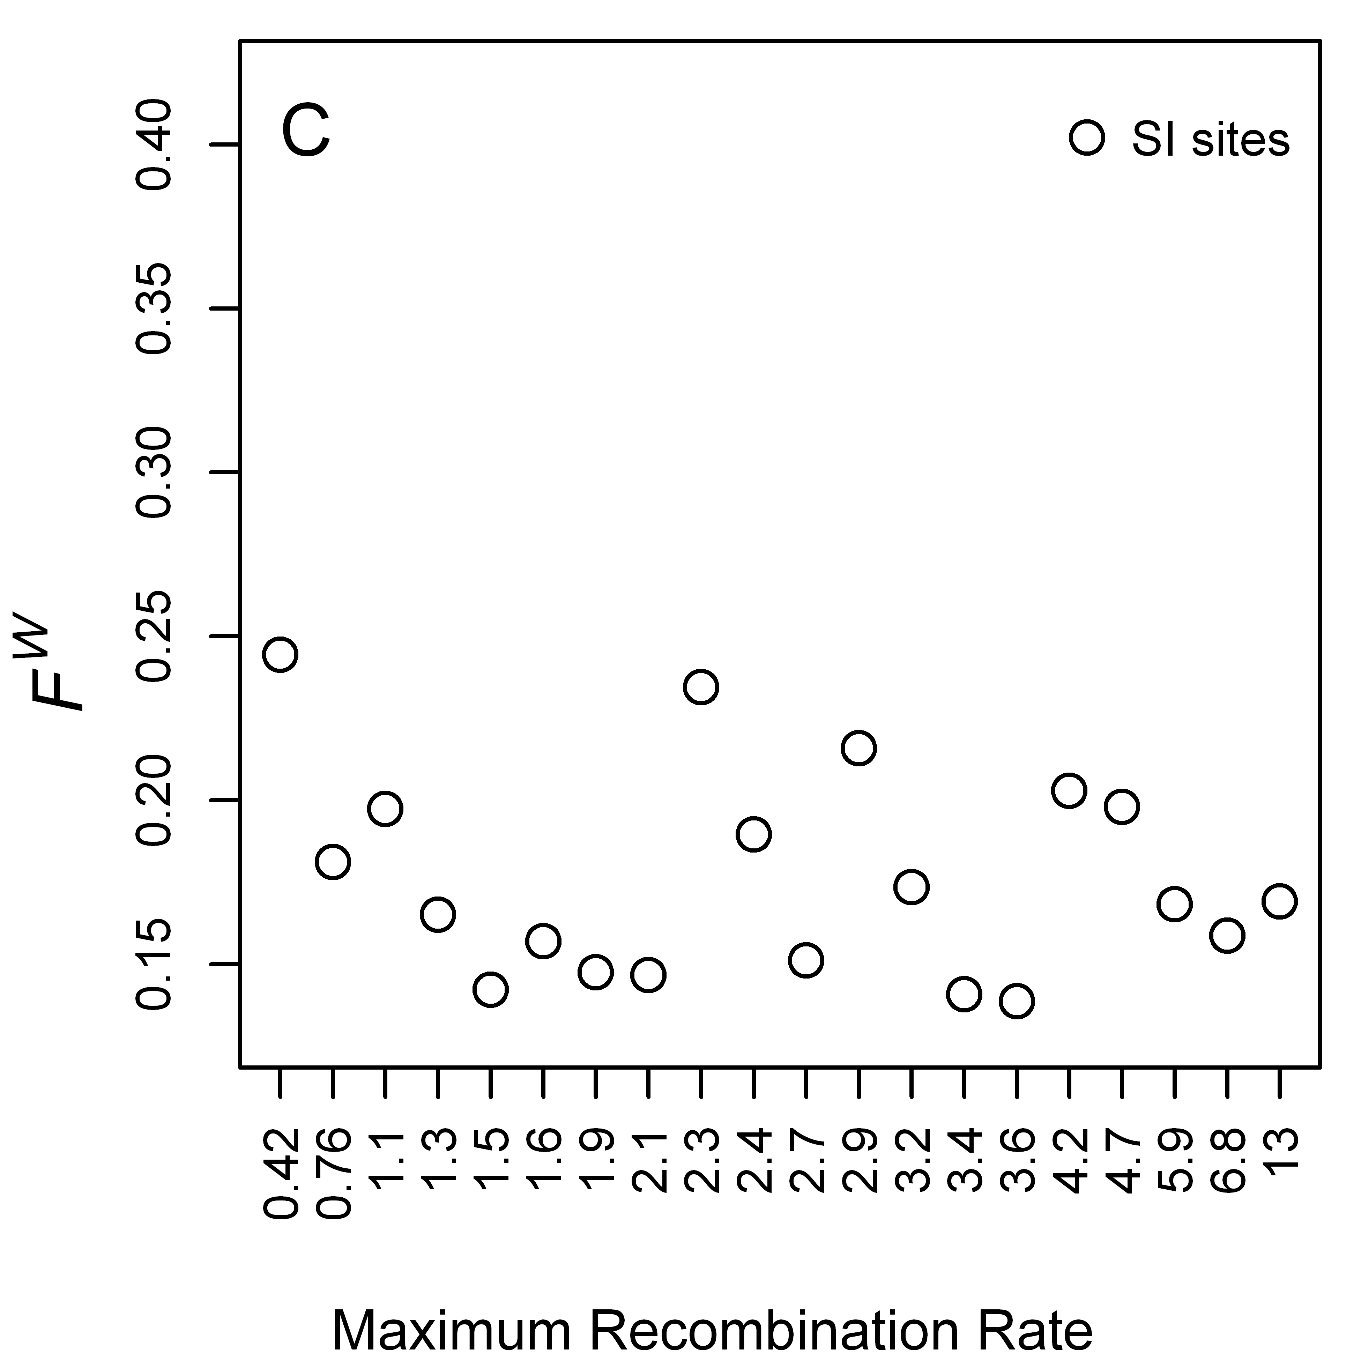 | 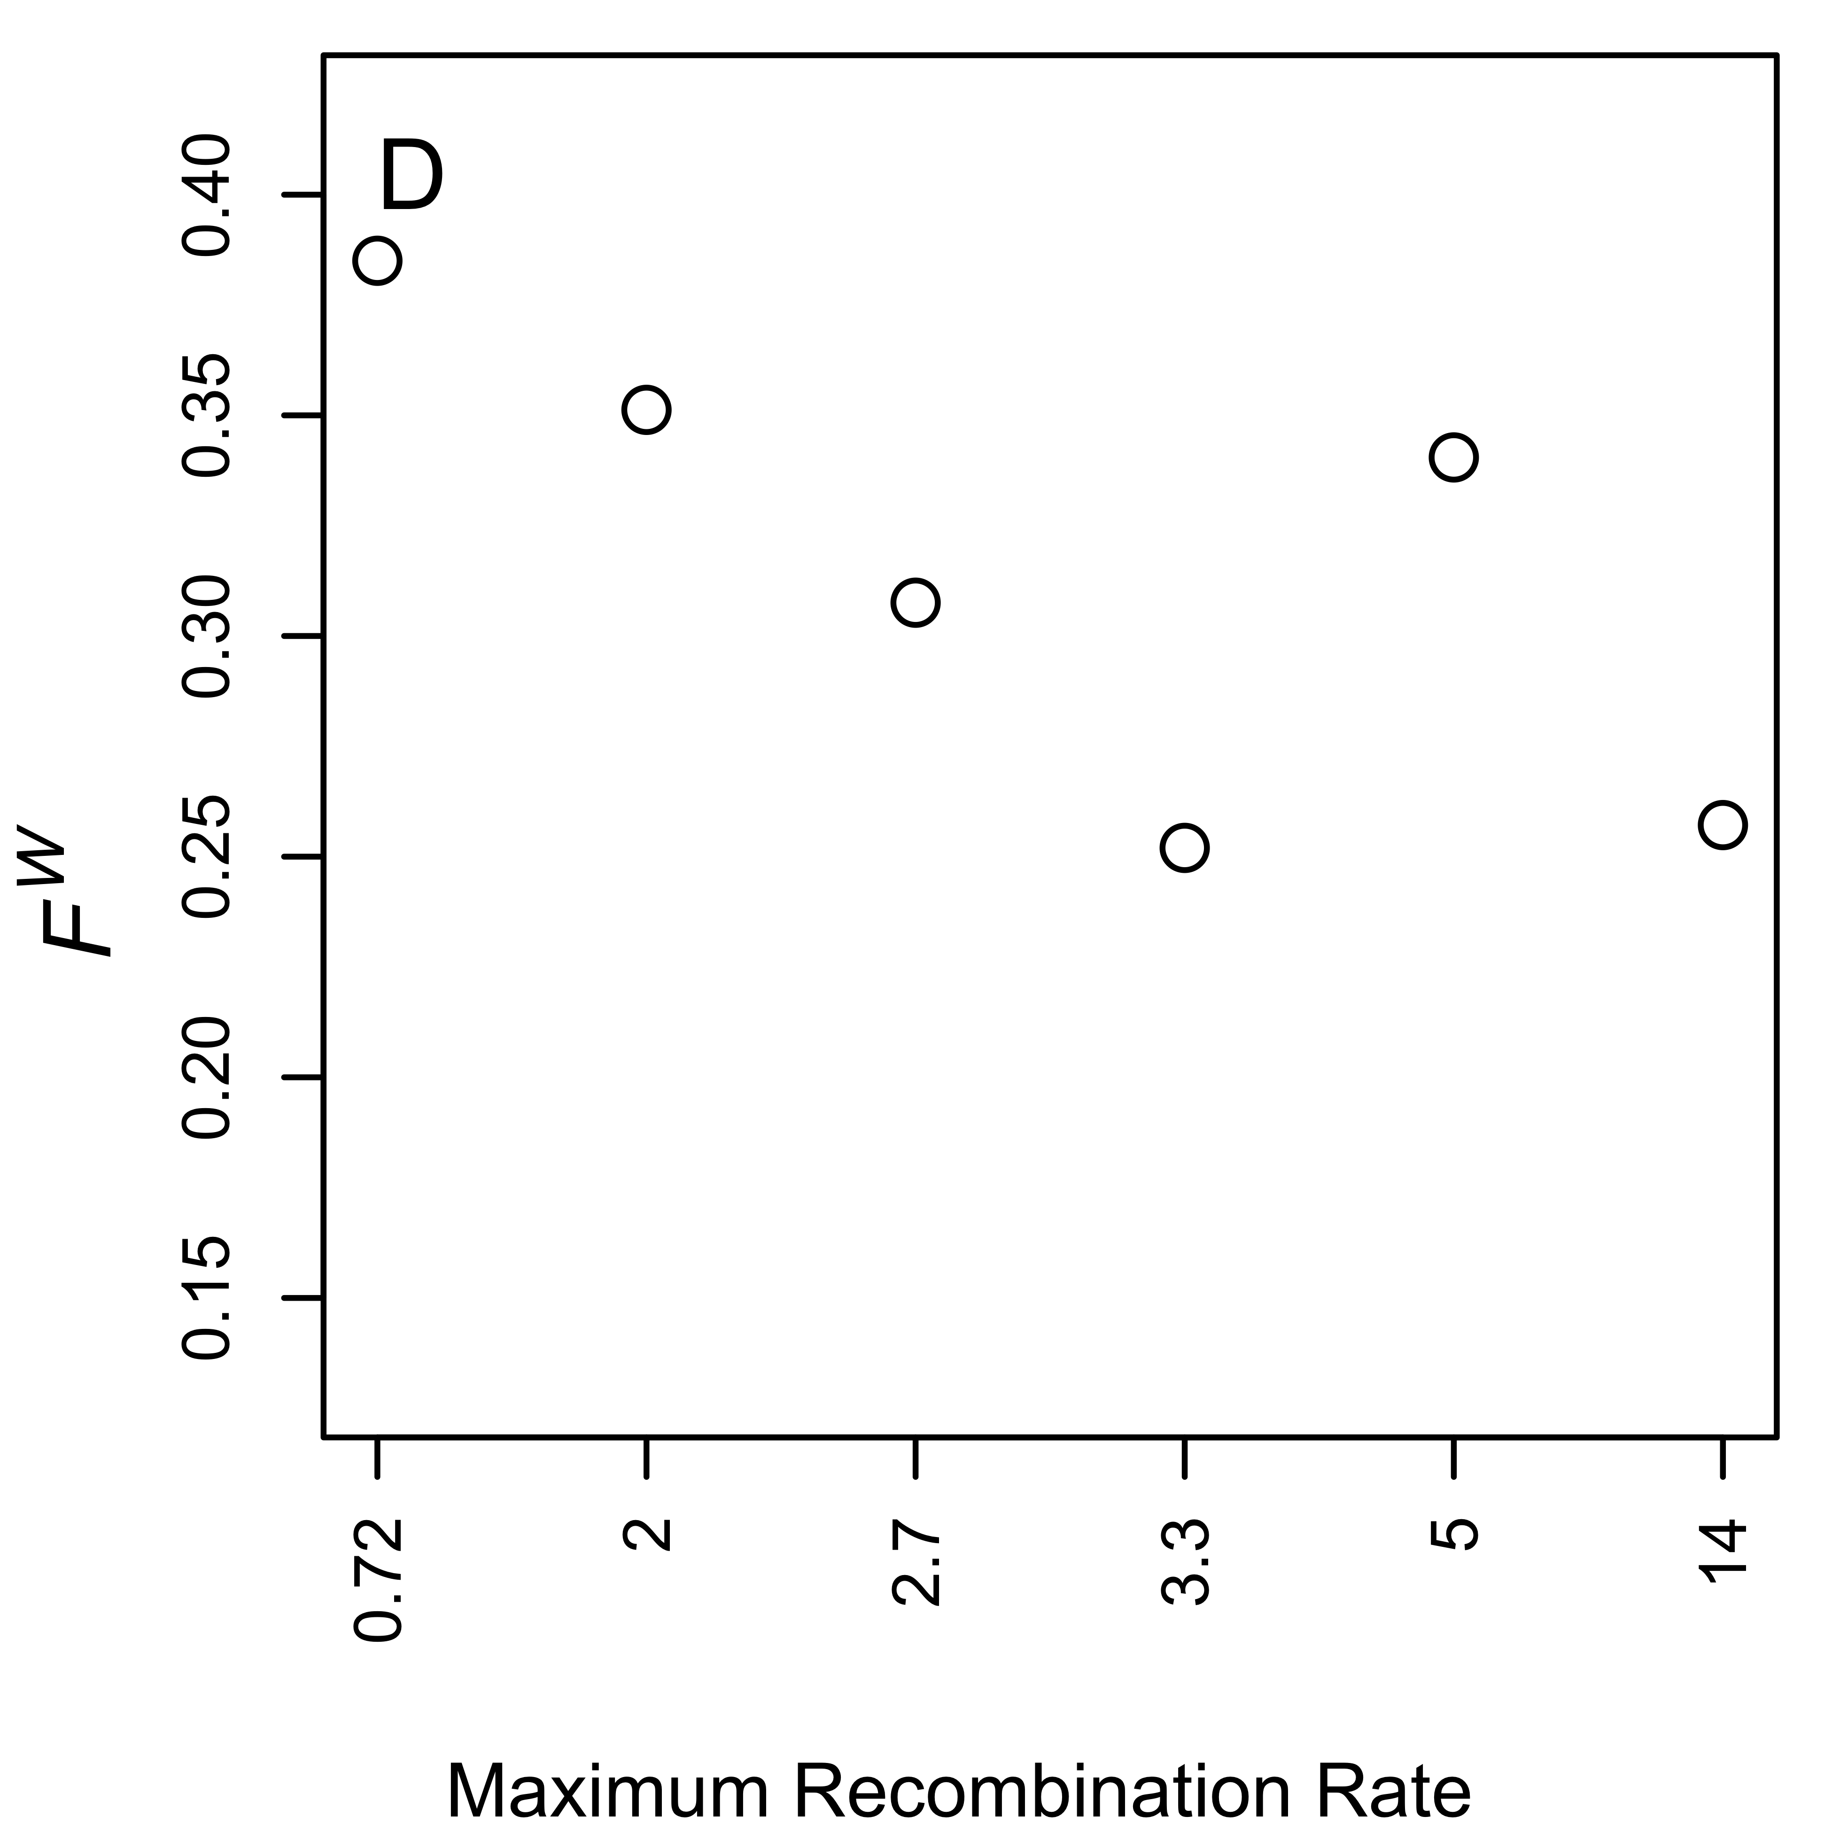

Figure S11. Correlation between intron length and local recombination rate. Autosomal and X-linked introns are shown in (A) and (B), respectively. The x-axes give the maximum local recombination rates for the recombination rate bins.
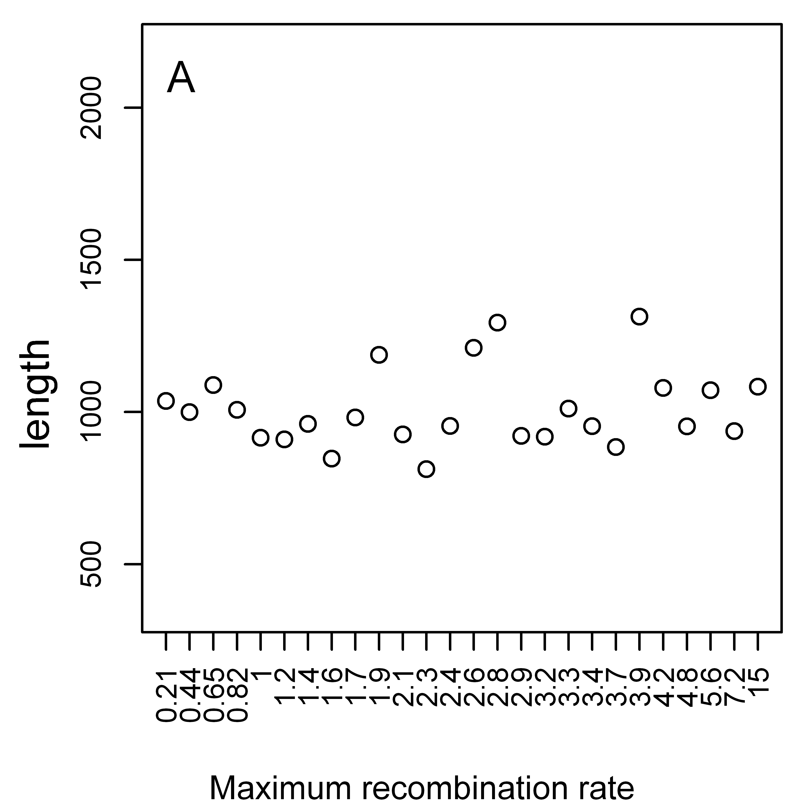 | 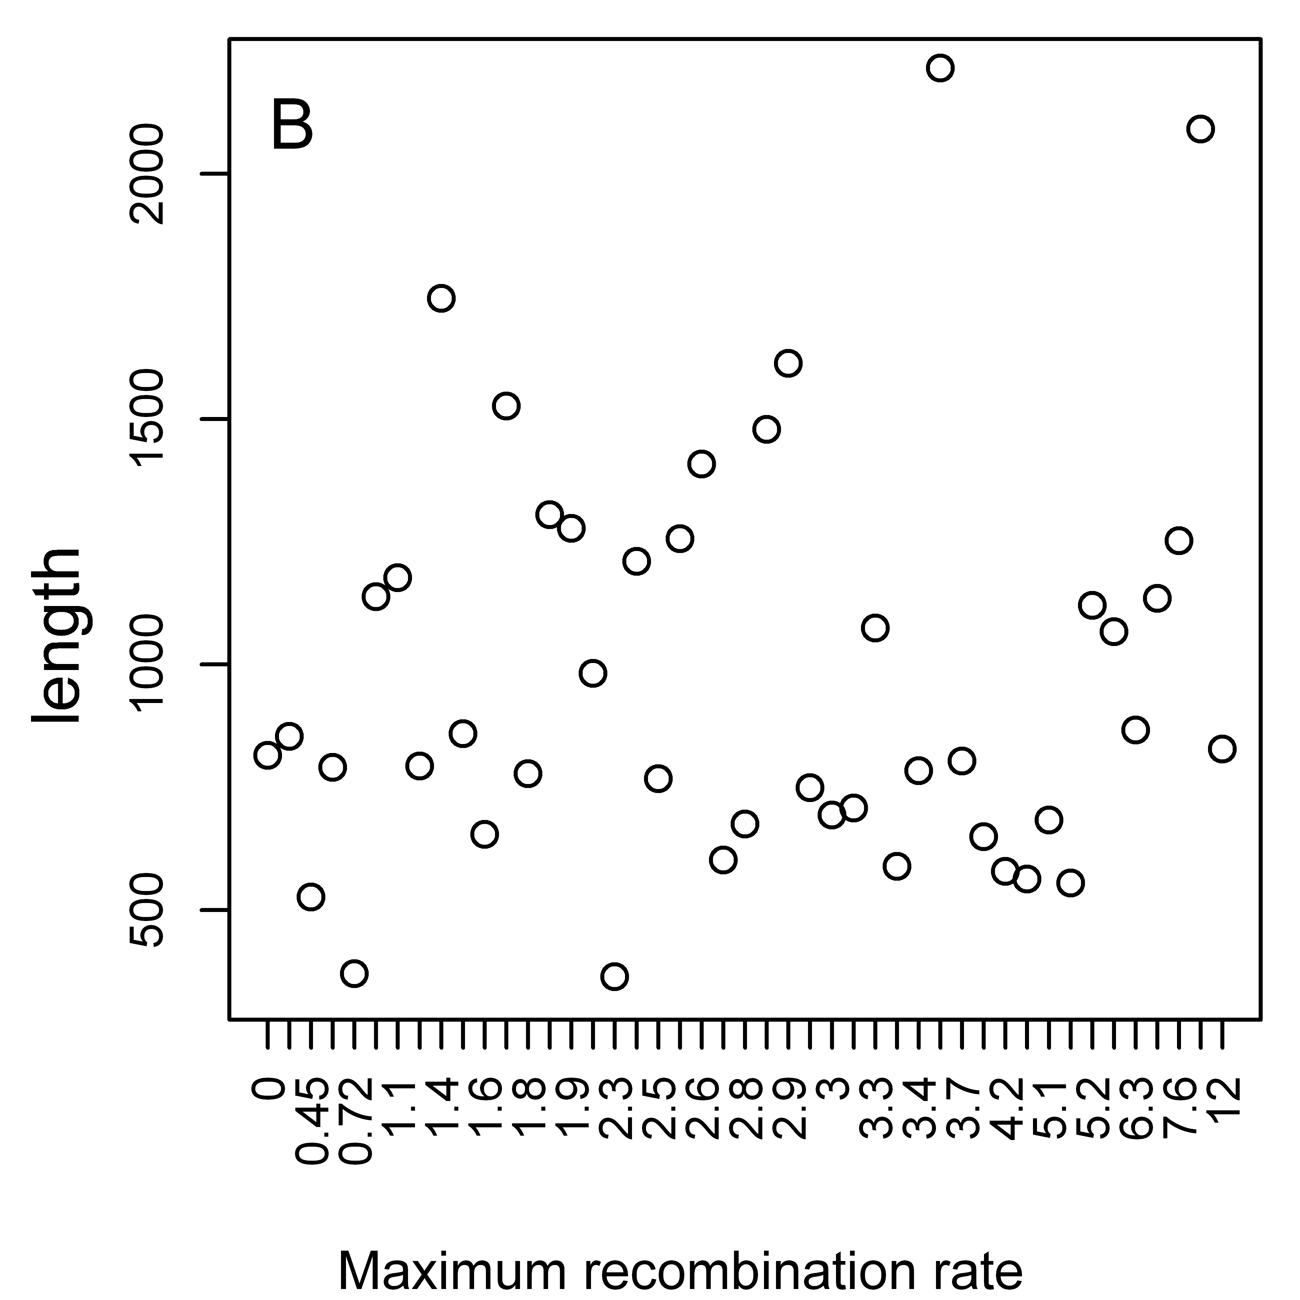

Figure S12. Unweighted mean F_{ST} (F^{U}) between 7 French and 17 Rwandan Drosophila melanogaster lines for autosomal coding sequence where crossing over occurs, and after removing data from chromosome 3R, binned by K_{A} (to D. yakuba). Symbols: 0-fold degenerate sites—open circles; 4-fold degenerate sites—open triangles; SI sites—open red squares.
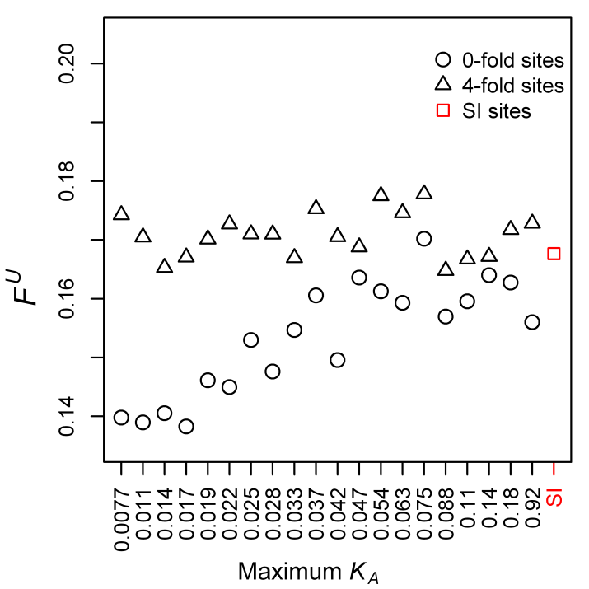

Figure S13. Nucleotide diversity (π) at 4-fold degenerate sites and positions 8-30bp of introns ≤ 65bp in length (SI sites), as a function of local recombination rate. (A) π at autosomal 4-fold degenerate sites in regions where crossing over occurs (CDS-C) and in regions where crossing over does not occur (CDS-NC), Rwandan sample; (B) π at X-linked 4-fold CDS-C and CDS-NC, Rwandan sample; (C) π at autosomal 4-fold CDS-C and CDS-NC, French sample; (D) π at X-linked 4-fold CDS-C and CDS-NC, French sample; (E) π at autosomal SI sites, Rwandan sample; (F) π at X-linked SI sites, Rwandan sample; (G) π at autosomal SI sites, French sample; (H) π at X-linked SI sites, French sample.

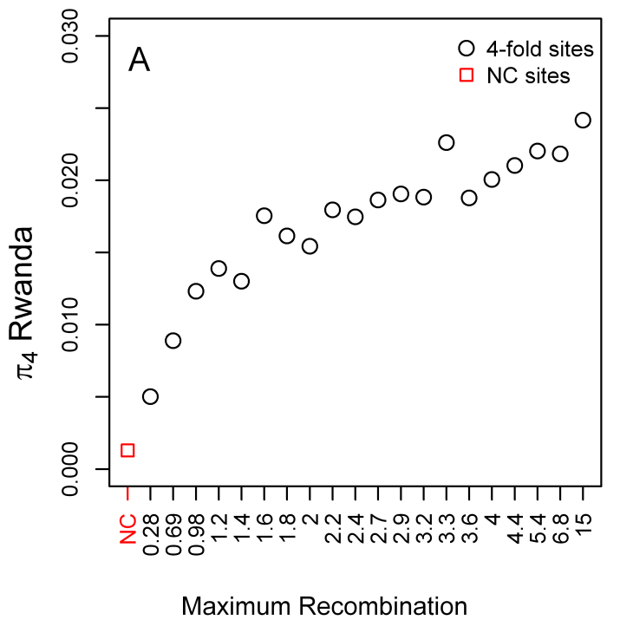 | 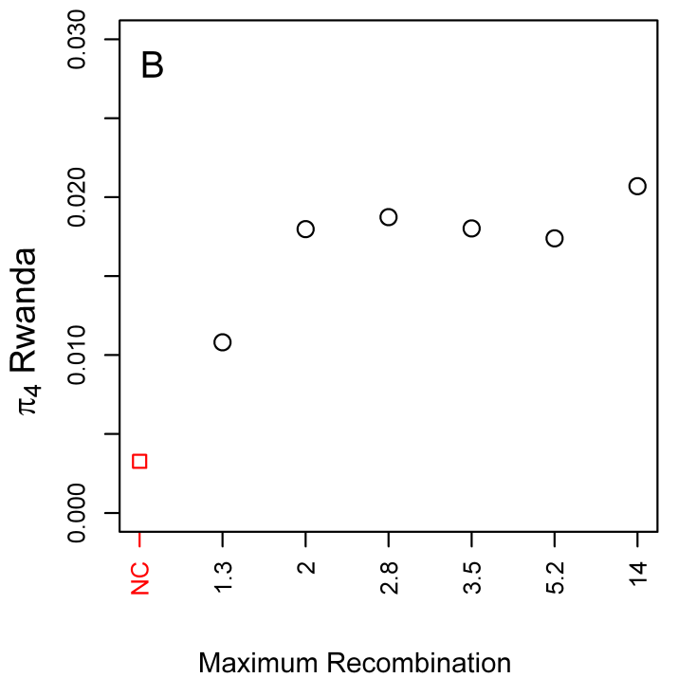
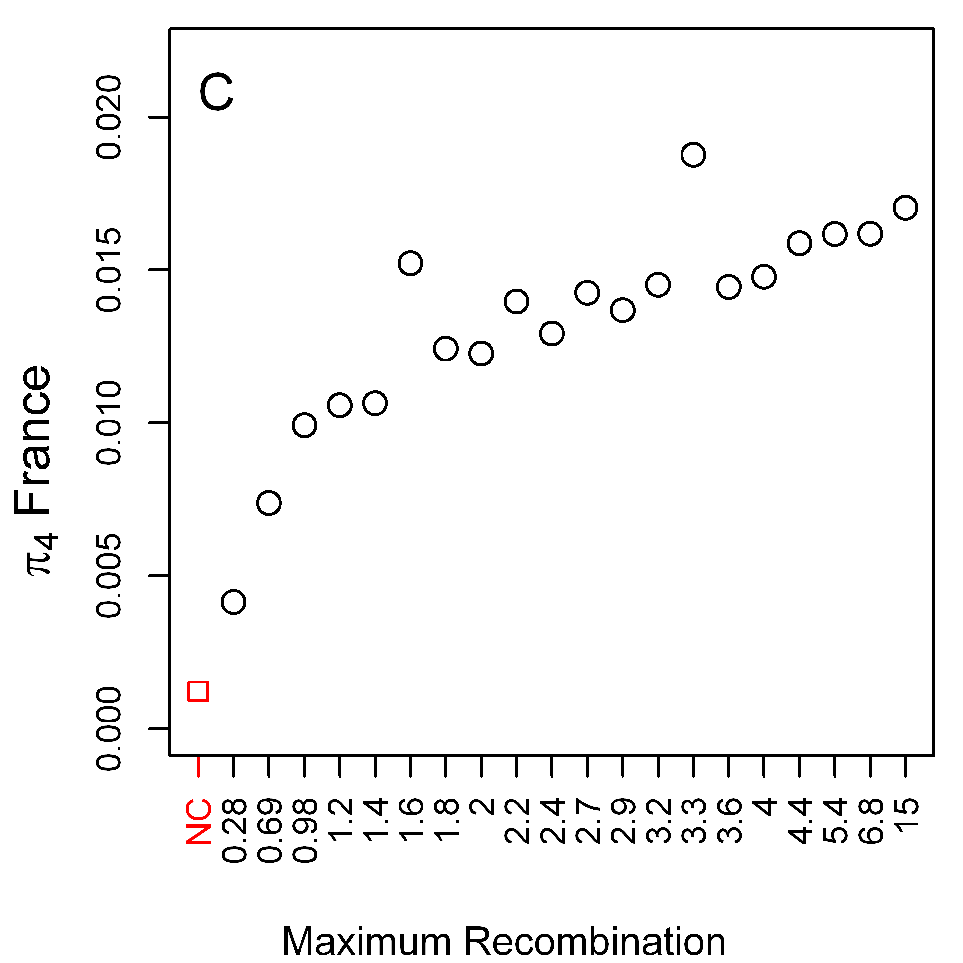 | 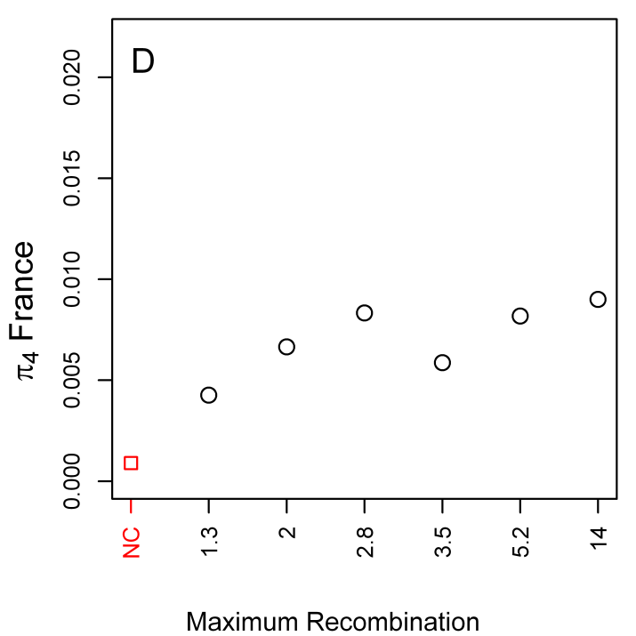
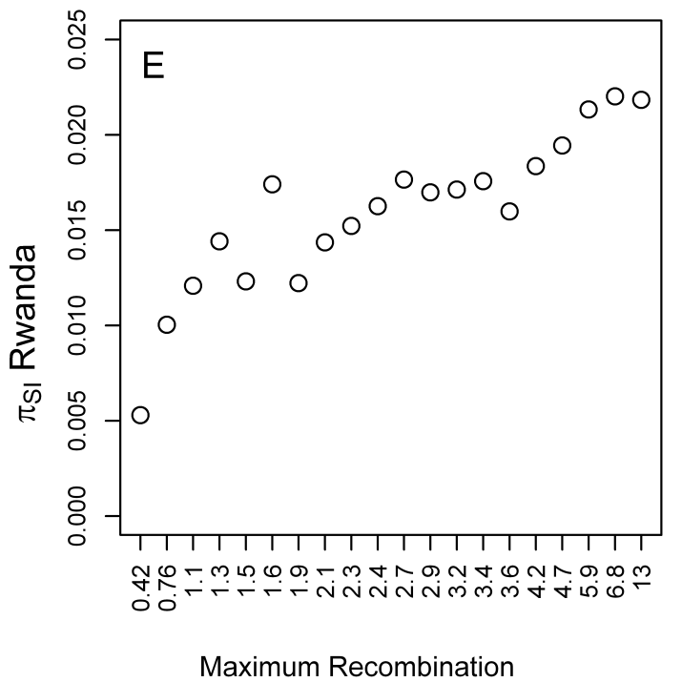 | 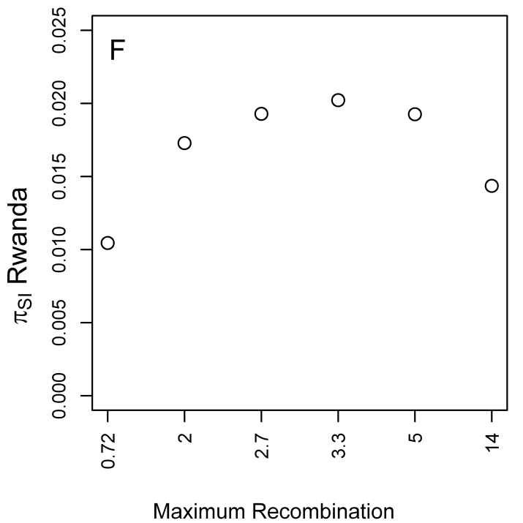
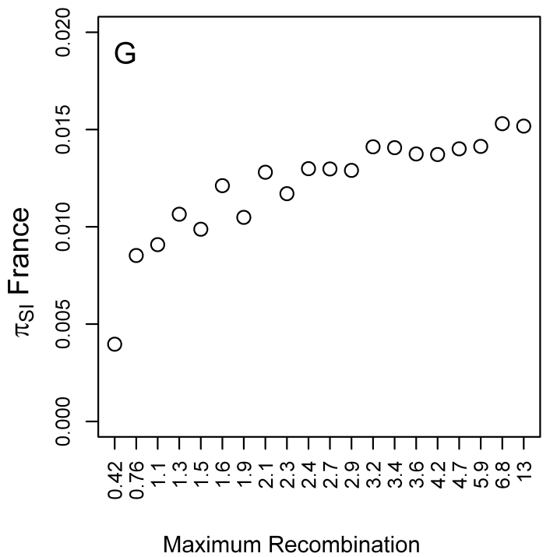 | 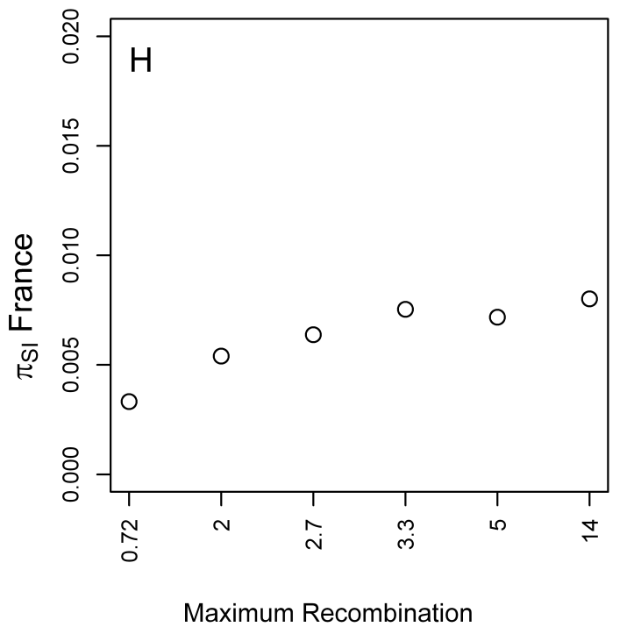

Figure S14. Tajima’s D at 4-fold degenerate sites and positions 8-30bp of introns ≤ 65bp in length (SI sites), binned by recombination rate. (A) D at autosomal 4-fold degenerate sites in regions where crossing over occurs (CDS-C) and in regions where crossing over does not occur (CDS-NC), Rwandan sample; (B) D at X-linked 4-fold CDS-C and CDS-NC, Rwandan sample; (C) D at autosomal 4-fold CDS-C and CDS-NC, French sample; (D) D at X-linked 4-fold CDS-C and CDS-NC, French sample; (E) D at autosomal SI sites, Rwandan sample; (F) D at X-linked SI sites, Rwandan sample; (G) D at autosomal SI sites, French sample; (H) D at X-linked SI sites, French sample.

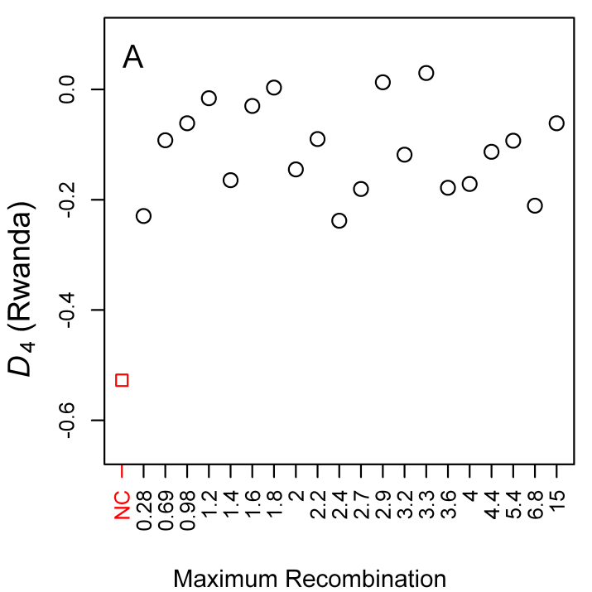 |  | 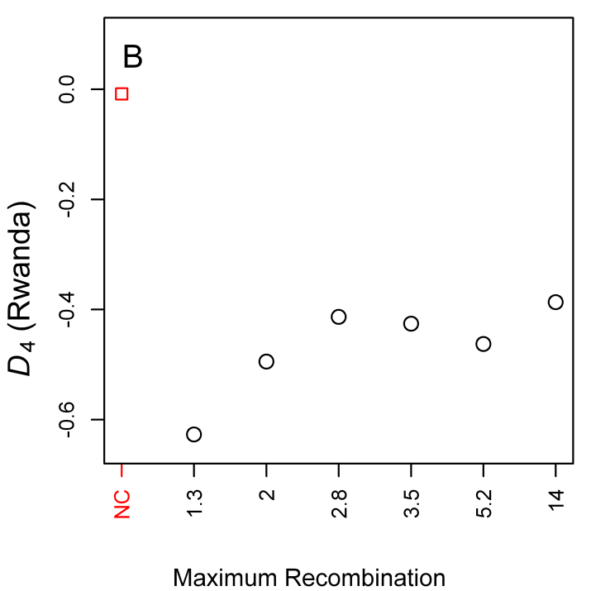
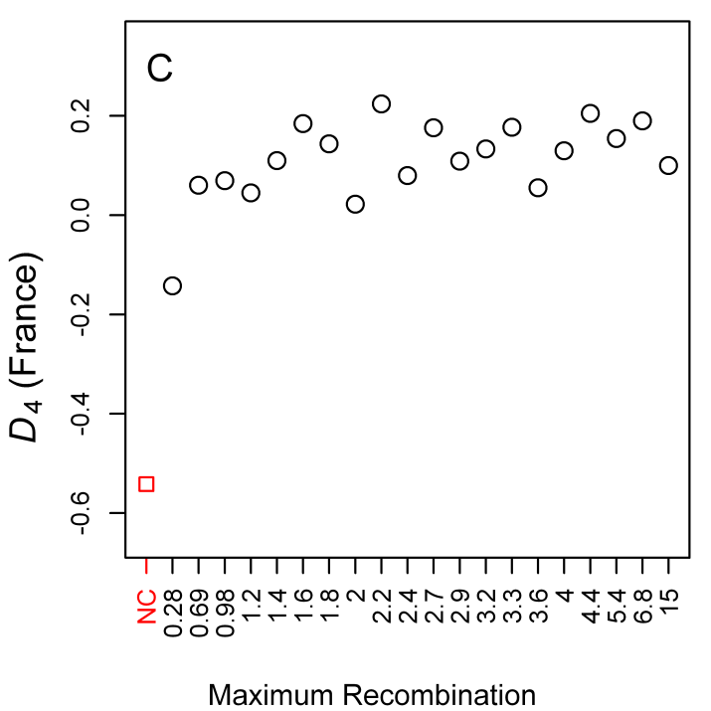 |  | 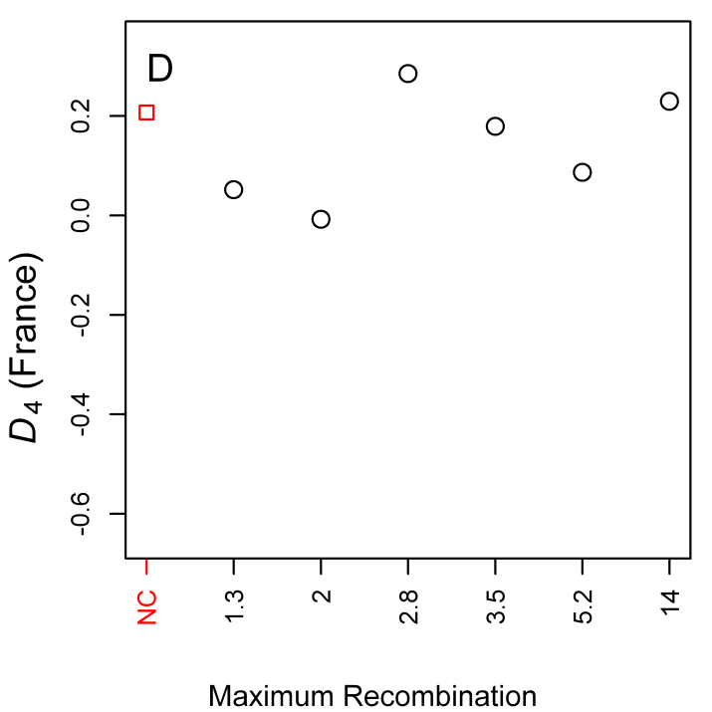
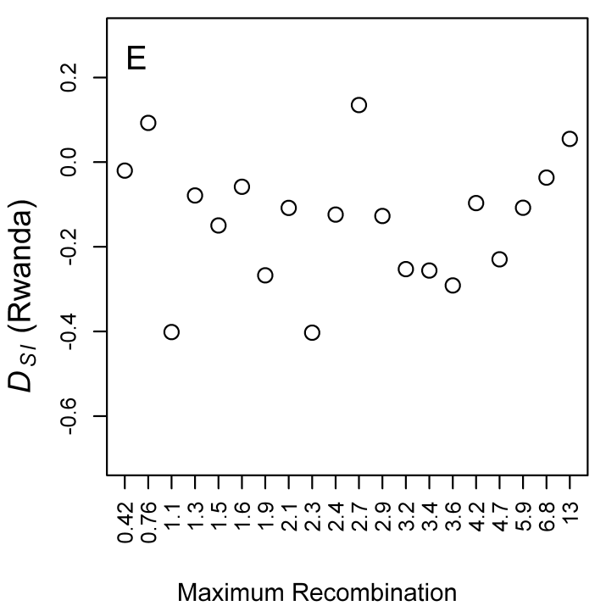 |  | 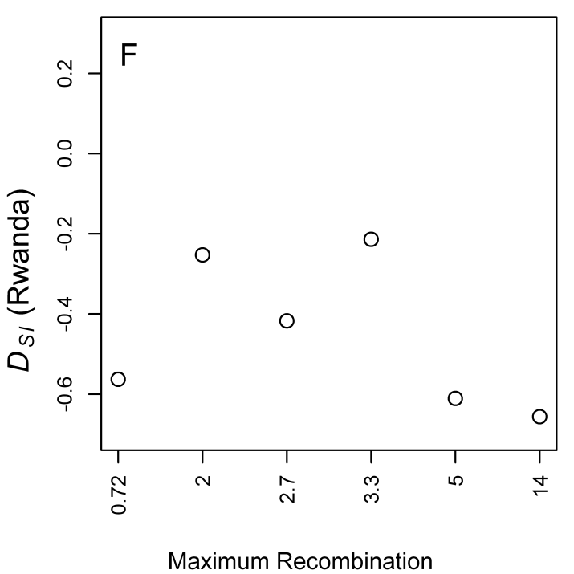
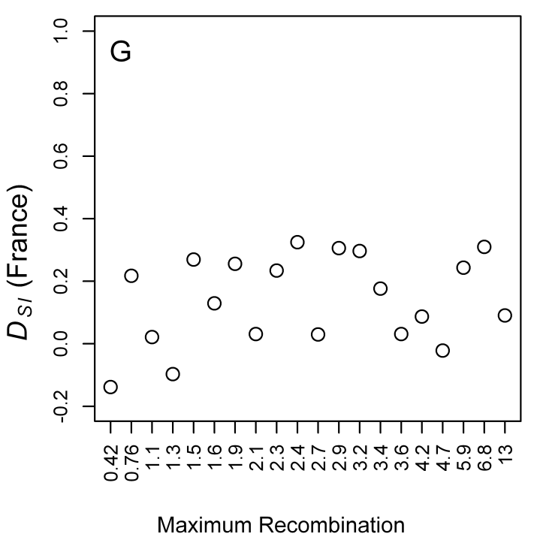 | 