A Review of Symptomatic Leg Length Inequality Following Total Hip Arthroplasty
Running Title:
Length Inequality after Total Hip Replacement.
Authors
Mr Anthony B. McWilliams B.Sc MB BS FRCS (T & Orth)¹,
Dr Andrew J Grainger, MRCP FRCR¹
Dr Philip J O’Connor MRCP FRCR FFSEM¹
Dr Anthony C. Redmond MSc PhD¹
Dr Todd D Stewart PhD¹
Mr Martin H Stone MB ChB MPhil FRCS (Ed) FRCS (Eng) ¹

¹ NIHR Leeds Musculoskeletal Biomedical Research Unit, Chapel Allerton, Leeds, LS7 4SA, United Kingdom
Corresponding Author
Mr Anthony B. McWilliams B.Sc MB BS FRCS (Tr & Orth)¹
Associate Clinical Research Fellow,
NIHR Leeds Musculoskeletal Biomedical Research Unit
Chapel Allerton, Leeds, LS7 4SA, United Kingdom
abmcwill@hotmail.com Tel) 00447803008920

This work is attributed to
NIHR Leeds Musculoskeletal Biomedical Research Unit, Chapel Allerton, Leeds, LS7 4SA, United Kingdom

Financial Support
This work was supported by the NIHR (National Institute for Health Research) through funding of the NIHR Leeds Musculoskeletal Biomedical Research Unit. In addition this work was partially funded through WELMEC, a Centre of Excellence in Medical Engineering funded by the Welcome Trust and EPSRC, under grant number WT 088908/Z/09/Z.
Informed consent
All radiographs used were of patients who had given informed consent for the images to be used in research.
The project was part of a larger study for which ethical approval was obtained from the Leeds West National Health Service Ethics Committee. Ref: 09/H1307/63

Conflict of interest
The Authors declare no conflict of interest

A Review of Symptomatic Leg Length Inequality Following Total Hip Arthroplasty
McWilliams A B, Grainger A. J, O’Connor P, White D, Redmond A C, Stewart T D, Stone M H.
NIHR Leeds Musculoskeletal Biomedical Research Unit, Chapel Allerton Hospital, Leeds, United Kingdom

Abstract
Leg length inequality (LLI) following total hip replacement is a complication which is features increasingly in the recent literature. The definition of LLI is complicated by lack of consensus regarding radiological measurement, clinical measurement and the incomplete relationship between LLI and associated symptoms. This paper reviews 79 reports relating to LLI post hip replacement, detailing definitions and classification and highlighting patient populations prone to symptomatic LLI.
While there is no universal definition of LLI, there is a broad consensus that less than 10mm of difference on AP view plain radiographs is clinically acceptable. There are few techniques described that consistently produce a post-operative LLI of less than this magnitude. Where post-operative LLI exists, lengthening appears to cause more problems than shortening.
In cases of mild LLI, non-surgical management produces adequate outcomes in more than half of cases, with functional LLI cases doing better than those with true LLI. Operative correction is effective in half of cases, even where nerve palsy is present, and remains an important option of last resort. Poor outcomes in patients with LLI may be minimised if individuals at risk are identified and counselled appropriately.

- Introduction
It was not until the 1990s that post operative leg length inequality (LLI) came to prominence in the literature¹. Though many cases are asymptomatic, residual LLI following hip replacement surgery can result in limp, unremitting pain, neurological complications or recurrent dislocations². LLI is the most common cause of litigation against orthopaedic surgeons in the United States and is now the fourth most common for hip replacements in the U.K.³⁻⁵. The cost to the national health service litigation authority of litigation specifically citing LLI is greater than £3.8 million GBP⁶.
There is a lack of agreement in the literature about what constitutes a significant LLI both pre and post operatively, and for any given magnitude of inequality only a proportion of cases will be symptomatic. Asymptomatic leg length inequality of 2cm or more is relatively common in the general population who have not undergone hip replacement arthroplasty and it is well recognised that both lengthening and shortening of this magnitude can occur with hip replacement arthroplasty. Consequently there are both patients who remain satisfied with their arthroplasty despite having an LLI which might be symptomatic in others while others appear to experience symptoms or functional compromise with relatively small inequalities. This occurs against a backdrop of a poor understanding of why this is the case.
Currently, there is no globally accepted LLI measurement protocol and so there are differences in both definitions and reported normative values. While the consensus from the literature appears to be that post operative LLI of 10mm or less is likely to be acceptable, there is little agreement about an upper limit of LLI that would be considered definitively unacceptable. While one study has reported a prevalence of LLI following THR of some 30%⁹ the absence of agreed definitions has led to a paucity of good quality epidemiological data on the scale of the problem.
Furthermore, while the preceding section has focused on radiologically confirmed LLI, it is clear that patient perception of LLI and presence of a radiographic LLI do not correlate well.. In one study of THR outcomes at 5 to 8 years post-op follow-up, some 30% of patients (329 of 1114) perceived an LLI following total hip replacement, while radiographic analysis of a section of this sub group of patients indicated that only 36% (27 of 75) had a LLI of ≥5mm⁹.
Multiple studies have demonstrated the benefits of total hip replacement and have shown that satisfaction and dissatisfaction is multi-factorial¹¹⁻¹³ There is, however, disagreement about clinical significance of radiologically evident LLI following total hip replacement. White et al found no association between LLI (21mm shortening to 35mm lengthening) and either functional outcome or patient satisfaction¹⁴, and this poor correlation between extent of LLI and outcomes has also been confirmed recently¹⁵
Conversely, a link between LLI following total hip replacement and poorer outcomes has been proposed, however even relatively small magnitudes of LLI can be associated with limping and pain², and one third of all THR patients were reported to perceive differences in limb length to the point where they ‘annoyed’ by it⁸. To-date there has been no formal study attempting to set a scientifically derived threshold for magnitude of LLI that may relate to a level of clinical significance. Using a cut point of 10mm, Beard et al found that patients with LLI >10mm at follow up of up to three years had significantly worse Oxford hip scores¹⁷. Mancuso found that symptoms associated with LLI to be an independent risk factor for the outcome for total hip replacement¹³. This review of nearly 80 papers aimed to examine the literature relating to LLI following total hip arthroplasty and to highlight causes, consequences and techniques to minimise the problem.

2 Definitions
LLI can be described as true or apparent (also described as structural and functional respectively)
True or structural LLI can be further subdivided according to aetiology. Type 1 or primary symptomatic LLI is due directly to component mal-positioning (Figure 1) i.e. where a narrow femoral canal or high femoral cut leads to in incomplete stem insertion resulting in a stem which sits too proud, or where the acetabular cup has been placed too low⁵.
Type 2 or secondary symptomatic LLI occurs when a limb length discrepancy is accompanied by component malposition. For example, when poor version of the acetabular component requires increased soft tissue tension to prevent dislocation. The surgeon achieves this by increasing the femoral length (Figure 2).
It is important to distinguish between the types of LLI prior to any revision surgery. Revising only one component of a type 1 LLI may correct the problem, however in a type 2 LLI a single component revision is likely to result in an unstable arthroplasty.

3 Diagnosis of Symptomatic LLI following total hip replacement.
Clinical Presentation
The clinical presentation of problematic LLI varies and can include limp, fatigue, pain, or nerve damage. Patients tend to tolerate shortening better than lengthening. Symptoms can occur immediately in the post-operative period or develop at a later date. Although not mutually exclusive, nerve pain and palsy will tend to present earlier than mechanical and gait associated symptoms.
Patients may also complain of symptoms in other joints due to compensation mechanisms including hip or knee flexion, equinus and decreased walking speed . Many patients adopt the pathognomonic stance of LLI, with the long leg flexed at the hip and knee (Figure 3). Back pain is commonly reported, likely due to the development of a functional scoliosis.
The pelvic tilt associated with a LLI can also result in the longer limb becoming abducted, changing the load distribution in the lower limbs, which may contribute to progressive pain and osteoarthritis in the healthy contralateral knee and the hip, or to edge loading and accelerated wear in prosthetic joints. The biomechanical changes associated with post replacement LLI are complex and have not however been extensively investigated²¹.

In the presence of limb lengthening the sciatic nerve is especially vulnerable, with damage leading to motor impairment, sensory alterations or referred pain. Nerve injuries (of all causes) have been reported in 1% to 3% in primary and 3% to 7% of revision arthroplasties . Females are at higher risk, due to their reduced femoral offset and the closer proximity of the nerve to the surgical site . Various studies have found post-operative nerve palsy associated with lengthening of between 13mm and 51mm ³¹,³⁴.

Clinical and radiological measurement of LLI
During physical examination LLI can be quantified clinically ; although clinical measurements can be inaccurate by 10 mm or more and confirmatory radiological investigation is often required. Two radiological techniques predominate in the literature and are widely used in clinical practice. The methods described by Williamson and Reckling (Figure 4) and by Woolson et al (Figure 5), the latter has a reported mean inter-observer variation of 0.5mm. Neither method takes into account however, deformities such as hip flexion or abduction at the time of the x-ray (which will tend to reduce the measured LLI) or any causes of LLI not involving the hip. A more recent study of various methods found that the Williamson and Reckling technique was the more reproducible but was still associated with errors of 4-5mm error in measurements derived from plain x-ray⁴⁰.
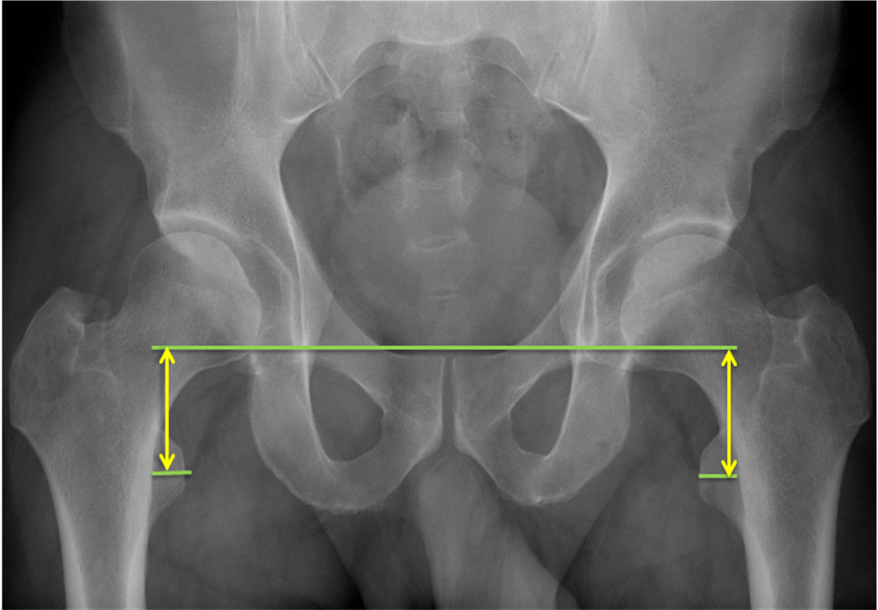Fig 1 The Woolson method.
A reference line is drawn through the most inferior part of the acetabular teardrops. Two lines parallel to this are drawn through the centre of the lesser trochanter. The difference in the perpendicular distance between the two lines is defined as the leg length discrepancy

4 Approach to Minimizing Symptomatic LLI
Identification of Patients Most at Risk
There are several identifiable factors that increase the risk of a patient suffering a symptomatic LLI (Table 1). Atypical anatomy, such as excessive femoral bowing, narrow femoral canal or poor bone stock can cause difficulties in obtaining proper alignment or insertion of the components. This can be further complicated when using an uncemented femoral stem⁴¹ or in the obese patient.
The patient with a short varus neck of femur is sensitive to stretching of the abductor muscles, resulting in a tilted hemi-pelvis with the operated side lower (functional LLI)³⁶. In short stature patients, any lengthening will represent a greater percentage of the patients overall height. In addition, smaller patients tend to have a narrower pelvis, which produces a greater amount of pelvic tilt for any given LLI⁴².
The legs of patients with pre-existing gluteal shortening will tend to lie pre-operatively in an abducted and externally rotated position, resulting in an apparent lengthening. If these patients are then lengthened as a result of THR they will consequently either increase their pelvic tilt or, if the required compensation is too great, will have to pivot on the shorter leg to place the longer leg on the ground.
Furthermore, patients with low physiological reserve are less able to tolerate the increased demands that a vaulting gait requires for any given level of mobility²⁶

Finally, patients with pre-existing but asymptomatic LLI may be less likely to tolerate any increase in their leg length inequality and can experience worse morbidity than would be associated with a similar LLI in other patients.

Pre-operative techniques to minimize LLI.
Pre-operative techniques typically involve some form of overlay template While highlighting the importance of templating, Hofmann also noted that the plan was changed intra-operatively in 50% of cases¹. Others found that templating made no difference and another found errors associated with magnification of >3mm in 17% of subjects’ X-rays, equating to more than one component size and making effective pre-operative planning difficult .
Five papers have reported pre-operative measures to minimise LLI following THA and provided operative data for leg length. The mean lengthening observed was 2.7mm (-22mm to 27mm) and the most successful studies report 92% of cases with LLI within ±5mm, 99% within one component size and 92% and 90% accuracy for the stem and the cup respectively. Woolson et al, using radiographs to plan the neck resection, reported that 86% of patients were level to within 6mm and 97% of patients within 10mm ³⁸.

Intra-operative techniques to minimize LLI.
Twenty two papers described intra-operative techniques attempting to minimise LLI most of which have involved measuring from a fixed reference such as a Steinman or K-wire in the ilium and a fixed point on the greater trochanter . Five papers described methods that take into account rotation, measurement of length parallel to the limb axis or single pin loosening. They describe using a proximal reference on a fixed point at the posterior rim of the acetabulum, close to the centre of rotation ⁶², and using an ‘ L’ shaped calliper⁶¹ or spirit level³⁵ or a ‘calliper dual pin retractor .
Limb position is a known source of error, with five degrees of adduction or abduction intra-operatively causing as much as 8mm error in leg length measurement and ten degrees of abduction/adduction causing up to 17mm error in length ⁷².

Other techniques described in the literature are; direct comparison of leg length with the contra-lateral limb¹, intra-operative radiographs¹, direct measurement either with a ruler ⁵⁷, or with knotted umbilical tape⁵⁹ or meticulous attention to the originally described technique of arthroplasty and soft tissue assessment^{14.} One paper was able to demonstrate that a system of computer navigation was able to provide accurate assessment of the intra-operative change in leg length ⁶⁰. Twelve papers reported the results of their own intra-operative techniques. The range of LLI across all eleven studies varied from 20mm shortening to 35mm lengthening, a range of 55mm. Seven of the twelve papers published means which ranged from 0.3mm to 12mm.
The techniques employing evaluation of soft tissues are primarily assessing stability and the accuracy of any soft tissue balancing test is dependent on the force applied and the soft tissue relaxation. Soft tissues are affected by pre-operative contractures and by anaesthetic type and Sathappen et al found that more than half (33/63) of the patients with a spinal anaesthesia had greater than 10mm LLI while of the corresponding group under general anaesthesia only one patient of 69 had an LLI over 10mm .

The shuck test assesses soft tissue tension by applying traction to the reduced hip replacement. If tension is correct, the prosthetic femur should sublux by 10mm. The Ober Test estimates iliotibial band (ITB) tension. The hip is extended and abducted, and if positive (if the ITB is tight) the limb will tend to remain extended and abducted . The Kick Test for quadriceps tension is performed in the lateral position by holding the leg parallel to the contralateral limb, with some extension. The knee is flexed and if the limb has been lengthened it will swing passively into extension .

5 Management of the patient with symptomatic LLI

Non-operative management of symptomatic LLI.
One of the difficulties in evaluating the treatment of LLI, is the well reported improvement in symptoms over time even in the absence of treatment. Konyves et al found that of 56 patients with LLI (mean 9mm), only 33% at 12 months perceived the inequality¹⁶. The prognosis for recovery from functional LLI can be good, especially where not due to component malposition, with 94% of patients reporting a good or excellent outcome following intensive non-operative therapy. Ranawat et al found that all patients with functional LLI and pelvic obliquity had resolution of symptoms after six-months of stretching exercises and that seven of nine ‘persistent functional LLI’ improved with further physiotherapy and orthotics, Goldstein et al further stated that most symptomatic issues resolve by one year.

The use of a shoe raise has been extensively reported in the literature and most if not all patients with a symptomatic LLI are likely to gain at least some improvement in symptoms and posture, with some going on to complete resolution of symptoms . While orthoses are helpful, they must be used with some caution as early and injudicious use can prevent a functional LLI from correcting spontaneously .

Operative Correction of LLI
The results of surgery to correct symptomatic LLI are encouraging, even when associated with nerve palsy³¹. In a series of 17 patients undergoing revision surgery for nerve deficit (mean lengthening 24mm, range 13 to 41mm), nine patients had an excellent result, two had partial improvement and six had no improvement. Time from recognition of symptoms to revision surgery ranged from 4 hours to 4 months and the mean time from primary to revision surgery was 10 weeks (8 hours to 26 weeks). Of the 17 patients reported, two acetabular cups were repositioned, five modular femoral heads were changed, and in 10 patients the femoral stem was revised. Eight hips were found to be unstable, four had trochanteric advancement and four had constrained acetabular prostheses³¹.

Parvizi et al reported the results of 21 revisions for symptomatic leg length with a mean LLI of 40mm (range 20 to 70mm). In 15 cases the acetabular cup was revised, in three the femoral stem and in three cases both the femur and the acetabulum were revised. Fifteen patients had equalisation of limb length at revision surgery and the mean improvement of LLI was to 10mm (5 to 20mm). Nineteen of 21 patients were satisfied with the outcome of the revision. Of the remaining two, one had persistent back and hip pain, the other continued to sublux ⁵. This contrasts Konyves et al who attributed almost all his LLI to lengthening on the femoral side in 55 of 56 patients¹⁶. The importance of patient selection was recently highlighted in a study by McMurray et al in which 12 of 13 patients with a mean LLI of 12mm (6 to 22mm) with disabling leg pain pre-operatively, were very satisfied following revision surgery⁷⁹

6 Conclusion
Leg Length Inequality can result in serious patient morbidity although the correlation between magnitude of radiology measured LLI and symptoms is weak. Patients are more likely to complain of a long leg than a short leg, although shortening can result in instability which may itself be cause for revision. In total, thirty papers reported specific data on LLI following THR. The overall range varied from 38mm shortening to 35mm of lengthening. Only eight papers reported ranges in which maximum lengthening was below 10mm . It is evident, therefore, that even using techniques specifically designed to equalise leg length after THR, achieving equality of length is not always possible. Furthermore, as the indications for arthroplasty broaden and a more demanding population are undergoing THR, what may have been considered an acceptable outcome previously, may not be thought adequate today.

There is a broad consensus in the literature that any residual LLI of less than 10mm on AP radiographs is clinically acceptable, but there is no agreement over an upper limit that would be considered clearly unacceptable. Many surgeons highlight the importance of considering clinical outcome although this is subjective, variable and even more difficult to define than a radiological diagnosis.

Despite a specific focus on, and the adoption of pre-operative and intra-operative techniques to minimize LLI, post-operative values greater than 10mm appear still to be common. In cases where mild LLI persists post operatively, non-surgical management produces adequate outcomes in more than half of cases, and operative correction is also effective in approximately half of more severe cases, even where nerve palsy is present. Poor outcomes in patients with LLI may be minimised if individuals at risk are identified and counselled appropriately.

References

1. Hofmann AA, Bolognesi M, Lahav A, Kurtin S. Minimizing leg-length inequality in total hip arthroplasty: use of preoperative templating and an intraoperative x-ray. Am J Orthop (Belle Mead NJ) 2008;37-1:18-23.
2. Plaass C, Clauss M, Ochsner PE, Ilchmann T. Influence of leg length discrepancy on clinical results after total hip arthroplasty--a prospective clinical trial. Hip Int 2011;21-4:441-9.
3. Clark CR, Huddleston HD, Schoch EP, 3rd, Thomas BJ. Leg-length discrepancy after total hip arthroplasty. J Am Acad Orthop Surg 2006;14-1:38-45.
4. McWilliams AB, Douglas S, Grainger AJ, O’Connor P, White D, Redmond AC, Stewart TD, Stone MH. Litigation for Total Hip Replacement within the NHS - Why are we being sued? British Hip Society Annual Meeting 2011. Torquay, 2011.
5. Parvizi J, Sharkey PF, Bissett GA, Rothman RH, Hozack WJ. Surgical treatment of limb-length discrepancy following total hip arthroplasty. J Bone Joint Surg Am 2003;85-A-12:2310-7.
6. Freedom of Information request to National Health Service Litigation Authority (unpublished). 2010.
7. Gurney B. Leg length discrepancy. Gait Posture 2002;15-2:195-206.
8. Edeen J, Sharkey PF, Alexander AH. Clinical significance of leg-length inequality after total hip arthroplasty. Am J Orthop (Belle Mead NJ) 1995;24-4:347-51.
9. Wylde V, Whitehouse SL, Taylor AH, Pattison GT, Bannister GC, Blom AW. Prevalence and functional impact of patient-perceived leg length discrepancy after hip replacement. Int Orthop 2009;33-4:905-9.
10. Benedetti MG, Catani F, Benedetti E, Berti L, Di Gioia A, Giannini S. To what extent does leg length discrepancy impair motor activity in patients after total hip arthroplasty? Int Orthop 2010;34-8:1115-21.
11. MacWilliam CH, Yood MU, Verner JJ, McCarthy BD, Ward RE. Patient-related risk factors that predict poor outcome after total hip replacement. Health Serv Res 1996;31-5:623-38.
12. Roder C, Parvizi J, Eggli S, Berry DJ, Muller ME, Busato A. Demographic factors affecting long-term outcome of total hip arthroplasty. Clin Orthop Relat Res 2003-417:62-73.
13. Mancuso CA, Jout J, Salvati EA, Sculco TP. Fulfillment of patients' expectations for total hip arthroplasty. J Bone Joint Surg Am 2009;91-9:2073-8.
14. White TO, Dougall TW. Arthroplasty of the hip. Leg length is not important. J Bone Joint Surg Br 2002;84-3:335-8.
15. Boutenfnouchet T. Minimising Leg -Length Discrepancy following primary total hip arthroplasty: a simple intra-operative measurement technique. j.orthopaedics 2012;9(1)e14.
16. Konyves A, Bannister GC. The importance of leg length discrepancy after total hip arthroplasty. J Bone Joint Surg Br 2005;87-2:155-7.
17. Beard DJ, Palan J, Andrew JG, Nolan J, Murray DW. Incidence and effect of leg length discrepancy following total hip arthroplasty. Physiotherapy 2008;94-2:91-6.
18. Maloney WJ, Keeney JA. Leg length discrepancy after total hip arthroplasty. J Arthroplasty 2004;19-4 Suppl 1:108-10.
19. Theruvil B, Kapoor V. Surgical treatment of limb-length discrepancy following total hip arthroplasty. J Bone Joint Surg Am 2004;86-A-8:1829; author reply
20. Friberg O. Biomechanical significance of the correct length of lower limb prostheses: a clinical and radiological study. Prosthet Orthot Int 1984;8-3:124-9.
21. Bhave A, Paley D, Herzenberg JE. Improvement in gait parameters after lengthening for the treatment of limb-length discrepancy. J Bone Joint Surg Am 1999;81-4:529-34.
22. Schmalzried TP, Amstutz HC, Dorey FJ. Nerve palsy associated with total hip replacement. Risk factors and prognosis. J Bone Joint Surg Am 1991;73-7:1074-80.
23. Bhave A, Mont M, Tennis S, Nickey M, Starr R, Etienne G. Functional problems and treatment solutions after total hip and knee joint arthroplasty. J Bone Joint Surg Am 2005;87 Suppl 2:9-21.
24. Cummings G, Scholz JP, Barnes K. The effect of imposed leg length difference on pelvic bone symmetry. Spine (Phila Pa 1976) 1993;18-3:368-73.
25. Giles LG, Taylor JR. Low-back pain associated with leg length inequality. Spine (Phila Pa 1976) 1981;6-5:510-21.
26. Gurney B, Mermier C, Robergs R, Gibson A, Rivero D. Effects of limb-length discrepancy on gait economy and lower-extremity muscle activity in older adults. J Bone Joint Surg Am 2001;83-A-6:907-15.
27. Golightly YM, Allen KD, Helmick CG, Renner JB, Jordan JM. Symptoms of the knee and hip in individuals with and without limb length inequality. Osteoarthritis Cartilage 2009;17-5:596-600.
28. Friberg O. Clinical symptoms and biomechanics of lumbar spine and hip joint in leg length inequality. Spine (Phila Pa 1976) 1983;8-6:643-51.
29. Golightly YM, Allen KD, Helmick CG, Schwartz TA, Renner JB, Jordan JM. Hazard of incident and progressive knee and hip radiographic osteoarthritis and chronic joint symptoms in individuals with and without limb length inequality. J Rheumatol 2010;37-10:2133-40.
30. Hofmann AA, Skrzynski MC. Leg-length inequality and nerve palsy in total hip arthroplasty: a lawyer awaits! Orthopedics 2000;23-9:943-4.
31. Pritchett JW. Nerve injury and limb lengthening after hip replacement: treatment by shortening. Clin Orthop Relat Res 2004-418:168-71.
32. Nogueira MP, Paley D, Bhave A, Herbert A, Nocente C, Herzenberg JE. Nerve lesions associated with limb-lengthening. J Bone Joint Surg Am 2003;85-A-8:1502-10.
33. Williamson JA, Reckling FW. Limb length discrepancy and related problems following total hip joint replacement. Clin Orthop Relat Res 1978-134:135-8.
34. Edwards BN, Tullos HS, Noble PC. Contributory factors and etiology of sciatic nerve palsy in total hip arthroplasty. Clin Orthop Relat Res 1987-218:136-41.
35. Bose WJ. Accurate limb-length equalization during total hip arthroplasty. Orthopedics 2000;23-5:433-6.
36. Ranawat CS, Rodriguez JA. Functional leg-length inequality following total hip arthroplasty. J Arthroplasty 1997;12-4:359-64.
37. Naito M, Ogata K, Asayama I. Intraoperative limb length measurement in total hip arthroplasty. Int Orthop 1999;23-1:31-3.
38. Woolson ST, Hartford JM, Sawyer A. Results of a method of leg-length equalization for patients undergoing primary total hip replacement. J Arthroplasty 1999;14-2:159-64.
39. Khanduja V, Tek V, Scott G. The effect of a neck-retaining femoral implant on leg-length inequality following total hip arthroplasty: a radiological study. J Bone Joint Surg Br 2006;88-6:712-5.
40. Heaver C, St Mart JP, Nightingale P, Sinha A, Davis E. Measureing Leg Length Discrepancy Using Pelvic Radiographs. EFORT. Berlin, 2012.
41. Ahmad R, Sharma V, Sandhu H, Bishay M. Leg length discrepancy in total hip arthroplasty with the use of cemented and uncemented femoral stems. A prospective radiological study. Hip Int 2009;19-3:264-7.
42. Walsh M, Connolly P, Jenkinson A, O'Brien T. Leg length discrepancy--an experimental study of compensatory changes in three dimensions using gait analysis. Gait Posture 2000;12-2:156-61.
43. Rubash HE, Parvataneni HK. The pants too short, the leg too long: leg length inequality after THA. Orthopedics 2007;30-9:764-5.
44. Goodman SB, Adler SJ, Fyhrie DP, Schurman DJ. The acetabular teardrop and its relevance to acetabular migration. Clin Orthop Relat Res 1988-236:199-204.
45. Gonzalez Della Valle A, Slullitel G, Piccaluga F, Salvati EA. The precision and usefulness of preoperative planning for cemented and hybrid primary total hip arthroplasty. J Arthroplasty 2005;20-1:51-8.
46. Woolson ST. Leg length equalization during total hip replacement. Orthopedics 1990;13-1:17-21.
47. Matsuda K, Nakamura S, Matsushita T. A simple method to minimize limb-length discrepancy after hip arthroplasty. Acta Orthop 2006;77-3:375-9.
48. Eggli S, Pisan M, Muller ME. The value of preoperative planning for total hip arthroplasty. J Bone Joint Surg Br 1998;80-3:382-90.
49. Knight JL, Atwater RD. Preoperative planning for total hip arthroplasty. Quantitating its utility and precision. J Arthroplasty 1992;7 Suppl:403-9.
50. Capello WN. Preoperative planning of total hip arthroplasty. Instr Course Lect 1986;35:249-57.
51. Goldstein WM, Gordon A, Branson JJ. Leg length inequality in total hip arthroplasty. Orthopedics 2005;28-9 Suppl:s1037-40.
52. Suh KT, Cheon SJ, Kim DW. Comparison of preoperative templating with postoperative assessment in cementless total hip arthroplasty. Acta Orthop Scand 2004;75-1:40-4.
53. Goodman SB, Huene DS, Imrie S. Preoperative templating for the equalization of leg lengths in total hip arthroplasty. Contemp Orthop 1992;24-6:703-10.
54. Della Valle CJ, Di Cesare PE. Complications of total hip arthroplasty: neurovascular injury, leg-length discrepancy, and instability. Bull Hosp Jt Dis 2001;60-3-4:134-42.
55. Hossain M, Sinha AK. A technique to avoid leg-length discrepancy in total hip arthroplasty. Ann R Coll Surg Engl 2007;89-3:314-5.
56. Mihalko WM, Phillips MJ, Krackow KA. Acute sciatic and femoral neuritis following total hip arthroplasty. A case report. J Bone Joint Surg Am 2001;83-A-4:589-92.
57. Lakshmanan P, Ahmed SM, Hansford RG, Woodnutt DJ. Achieving the required medial offset and limb length in total hip arthroplasty. Acta Orthop Belg 2008;74-1:49-53.
58. Takigami I, Itokazu M, Itoh Y, Matsumoto K, Yamamoto T, Shimizu K. Limb-length measurement in total hip arthroplasty using a calipers dual pin retractor. Bull NYU Hosp Jt Dis 2008;66-2:107-10.
59. Cuckler JM. Limb length and stability in total hip replacement. Orthopedics 2005;28-9:951-3.
60. Murphy SB, Ecker TM. Evaluation of a new leg length measurement algorithm in hip arthroplasty. Clin Orthop Relat Res 2007;463:85-9.
61. Shiramizu K, Naito M, Shitama T, Nakamura Y, Shitama H. L-shaped caliper for limb length measurement during total hip arthroplasty. J Bone Joint Surg Br 2004;86-7:966-9.
62. Ranawat CS, Rao RR, Rodriguez JA, Bhende HS. Correction of limb-length inequality during total hip arthroplasty. J Arthroplasty 2001;16-6:715-20.
63. Itokazu M, Masuda K, Ohno T, Itoh Y, Takatsu T, Wenyi Y. A simple method of intraoperative limb length measurement in total hip arthroplasty. Bull Hosp Jt Dis 1997;56-4:204-5.
64. Jasty M, Webster W, Harris W. Management of limb length inequality during total hip replacement. Clin Orthop Relat Res 1996-333:165-71.
65. Bal BS. A technique for comparison of leg lengths during total hip replacement. Am J Orthop (Belle Mead NJ) 1996;25-1:61-2.
66. McGee HM, Scott JH. A simple method of obtaining equal leg length in total hip arthroplasty. Clin Orthop Relat Res 1985-194:269-70.
67. Woolson ST, Harris WH. A method of intraoperative limb length measurement in total hip arthroplasty. Clin Orthop Relat Res 1985-194:207-10.
68. Love BTR, Wright K. Leg Length Discrepancy After Total Hip Joint Replacement. J Bone Joint Surg Br 1983;65-1:1.
69. Ranawat CS. The pants too short, the leg too long! Orthopedics 1999;22-9:845-6.
70. Huddleston HD. An accurate method for measuring leg length and hip offset in hip arthroplasty. Orthopedics 1997;20-4:331-2.
71. Knight WE. Accurate determination of leg lengths during total hip replacement. Clin Orthop Relat Res 1977-123:27-8.
72. Sarin VK, Pratt WR, Bradley GW. Accurate femur repositioning is critical during intraoperative total hip arthroplasty length and offset assessment. J Arthroplasty 2005;20-7:887-91.
73. Woo RY, Morrey BF. Dislocations after total hip arthroplasty. J Bone Joint Surg Am 1982;64-9:1295-306.
74. Sathappan SS, Ginat D, Patel V, Walsh M, Jaffe WL, Di Cesare PE. Effect of anesthesia type on limb length discrepancy after total hip arthroplasty. J Arthroplasty 2008;23-2:203-9.
75. Charnley J. Low friction arthroplasty of the hip : theory and practice Berlin ; New York :: Springer-Verlag, 1979:376.
76. Bhave A, Marker DR, Seyler TM, Ulrich SD, Plate JF, Mont MA. Functional problems and treatment solutions after total hip arthroplasty. J Arthroplasty 2007;22-6 Suppl 2:116-24.
77. D'Amico M, Ciarrocca F, Liscio G, Serafini P, Tommasini M, Vallasciani M. Balance lower limb loads and 3D spine modifications after total hip joint replacement: effects of leg length discrepancy correction. Stud Health Technol Inform 2006;123:409-14.
78. Rancont CM. Chronic psoas syndrome caused by the inappropriate use of a heel lift. J Am Osteopath Assoc 2007;107-9:415-8.
79. McMurray D, O'Connor P, Grainger A, McWilliams A, Stone M. Revision Surgery for Leg Length Inequality After Primary Hip Replacement
British Hip Society Manchester, 2012.

Acknowledgements
This work was supported by the NIHR (National Institute for Health Research) through funding of the LMBRU (Leeds Musculoskeletal Biomedical Research Unit). In addition this work was partially funded through WELMEC, a Centre of Excellence in Medical Engineering funded by the Welcome Trust and EPSRC, under grant number WT 088908/Z/09/Z.
Tables and Figures

Table 1. Risk factors for symptomatic LLI following total hip replacement

Narrow femoral canal  Abnormal femoral diaphysis  Acetabular abnormality  Poor bone stock  High BMI  Uncemented stem  Short Stature | Female gender  Pre-existing Scoliosis  Ipsi and contra lateral knee and ankle pathology  Short, varus femoral neck  Narrow pelvic width  Pre-existing shortening of abductors  Pre-existing LLI

Figure 1. A radiograph of a total hip replacement where the femoral cut is too proximal resulting in a type 1 true leg length inequality.
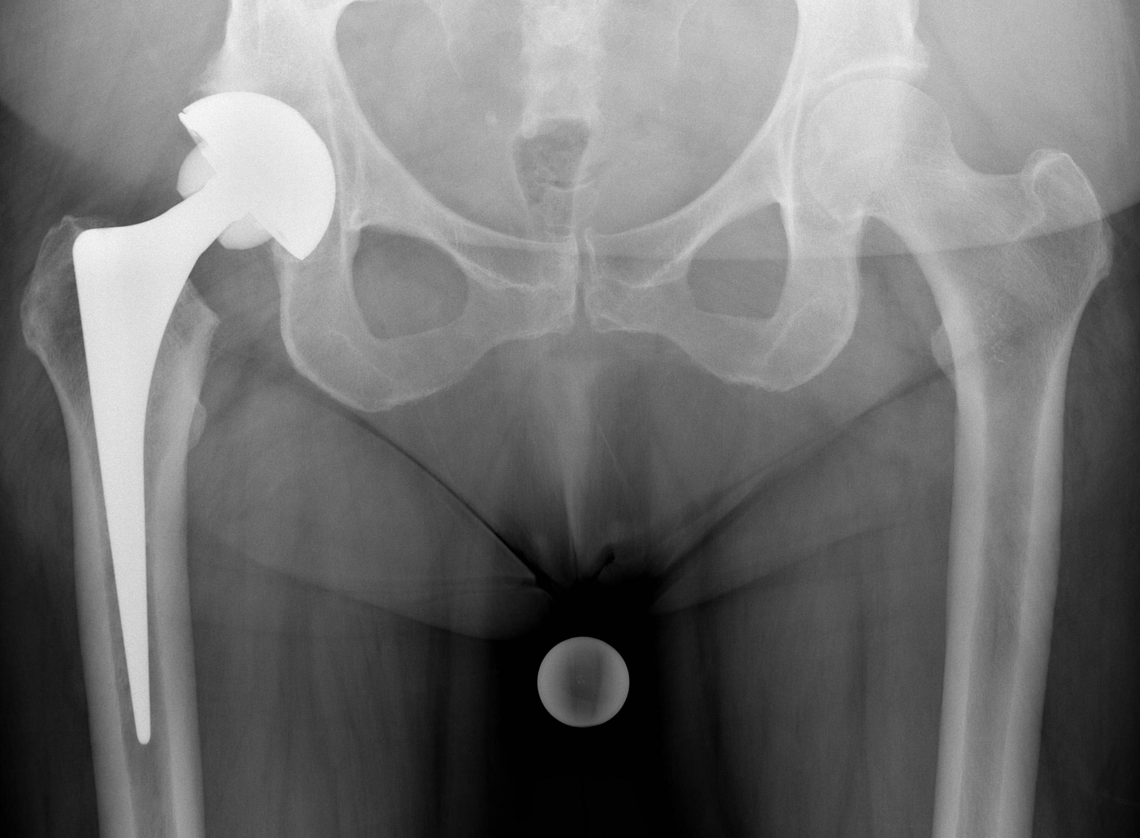

Figure 2. Example of a type two LLI, the cup is malpositioned and stability has been achieved by lengthening at the stem.
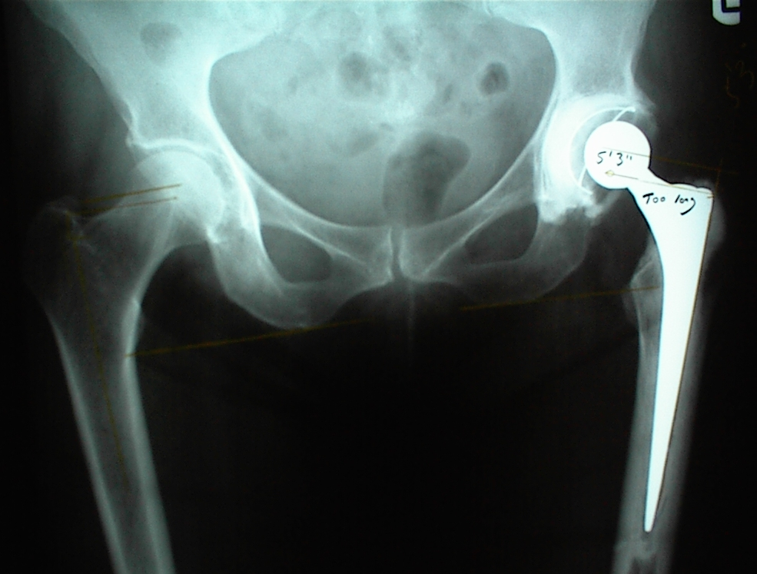

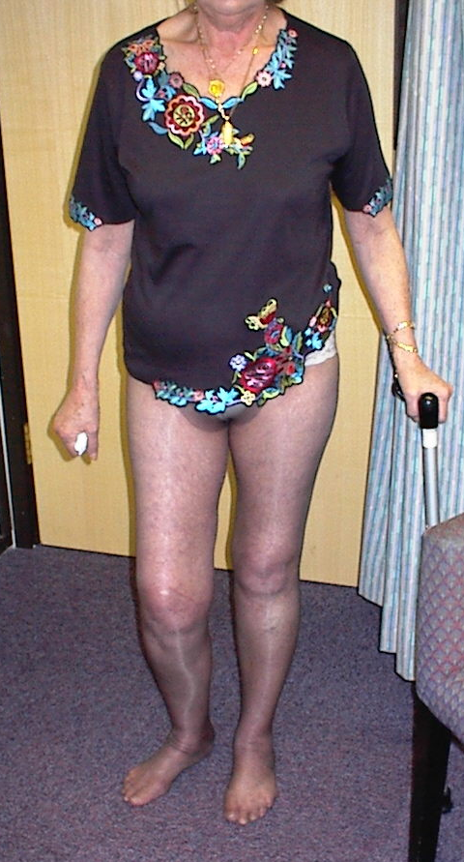
Figure 3. The typical stance of a patient with LLI. Note that the long limb is flexed at the hip and the knee to produce an apparent shortening and equalised leg length.

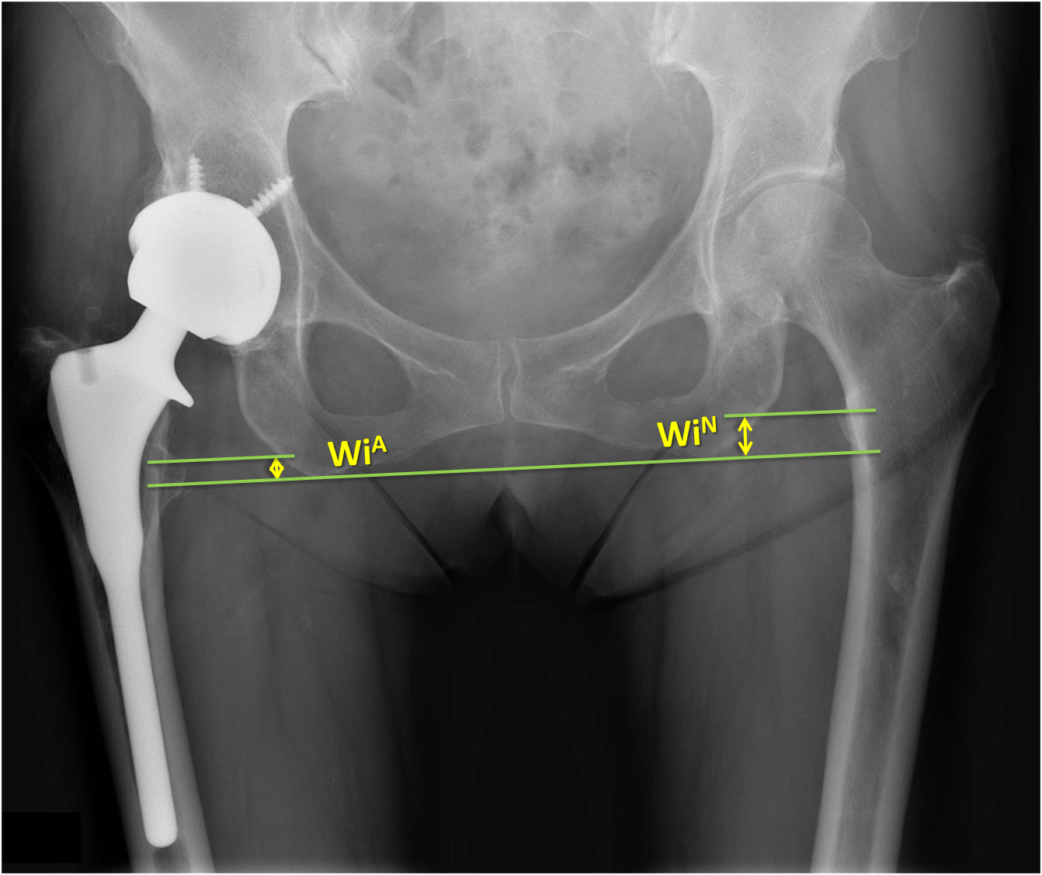
Figure 4. The method described by Williamson and Reckling. A reference line tangential and parallel to the most inferior portion of the Ischia is constructed. Two further parallel lines are drawn through the most prominent part of the lesser trochanter and the perpendicular distance between the lines measured. The difference between the left and right sides is the measure of LLI.

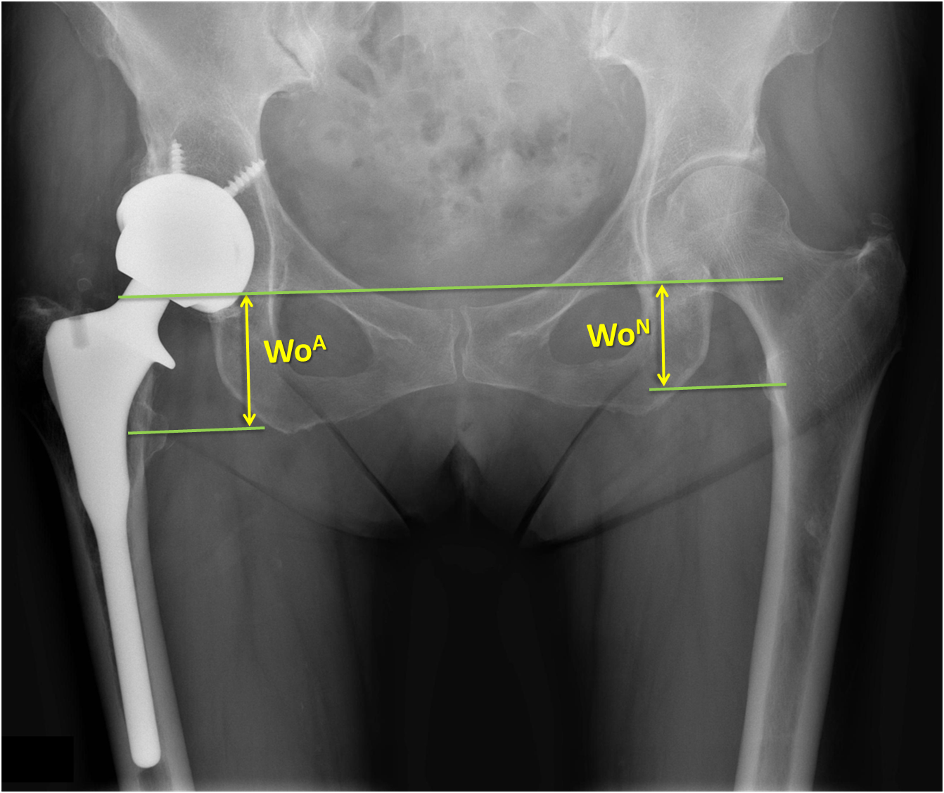
Figure 5. The method described by Woolson et al. A reference line is drawn through the most inferior part of the acetabular teardrop. Two lines parallel to this are drawn through the centres of the lesser trochanter. The difference in the perpendicular distance between the left and right sides is defined as the LLI.

