Periprosthetic femoral fracture – a biomechanical comparison between Vancouver type B1 and B2 fixation methods

Mehran Moazen, PhD^{1,2}
Jonathan H. Mak, MEng¹
Lee W. Etchels, MEng¹
Zhongmin Jin, PhD^{1,3}
Ruth K. Wilcox, PhD¹
Alison C. Jones, PhD¹
Eleftherios Tsiridis, MD, MSc, PhD, FRCS⁴⁻⁶

- Institute of Medical and Biological Engineering,
School of Mechanical Engineering,
University of Leeds,
Leeds, LS2 9JT, UK

- Medical and Biological Engineering,
School of Engineering,
University of Hull,
Hull, HU6 7RX, UK

- Institute of Advanced Manufacturing Technology,
School of Mechanical Engineering,
Xi’an Jiaotong University,
Xi’an, 710049, P.R. of China

- Academic Department of Orthopaedic and Trauma,
University of Leeds,
Leeds, LS2 9JT, UK

- Department of Surgery and Cancer, Division of Surgery,
Imperial College London,
London, W12 0HS, UK

- Academic Orthopaedics and Trauma Unit,
Aristotle University Medical School,
University Campus 54 124, Thessaloniki, Greece

Corresponding author:
Mehran Moazen, PhD
Medical and Biological Engineering,
School of Engineering,
University of Hull, Hull, HU6 7RX
Tel: +44 (0) 1482 466760
Fax: +44 (0) 1482 466664
Email: Mehran_Moazen@yahoo.com; M.Moazen@hull.ac.uk
Periprosthetic femoral fracture – a biomechanical comparison between Vancouver type B1 and B2 fixation methods

Abstract
Current clinical data suggests a higher failure rate for internal fixation in Vancouver type B1 periprosthetic femoral fracture (PFF) fixations compared to long stem revision in B2 fractures. The aim of this study was to compare the biomechanical performance of several fixations in the aforementioned fractures. Finite element models of B1 and B2 fixations, previously corroborated against in vitro experimental models, were compared. The results indicated that in treatment of B1 fractures, a single locking plate can be without complications provided partial weight bearing is followed. In case of B2 fractures, long stem revision and bypassing the fracture gap by two femoral diameters is recommended. Considering the risk of single plate failure, long stem revision could be considered in all comminuted B1 and B2 fractures.

Keywords: Vancouver type B, fracture, strain, stiffness, finite element method
Running title: Biomechanics of Vancouver type B1 and B2 fracture fixations

1. Introduction
Periprosthetic femoral fractures (PFF) can occur following total hip arthroplasty [1-6]. Management of these fractures remains a surgical challenge due to the presence of the underlying prosthesis. The Vancouver classification has been widely used to classify these fractures [2]. Vancouver type B refers to fractures located within the stem region, with subsets representing those with a stable implant (B1), a loose implant (B2) and a loose implant plus insufficient bone stock (B3), and represent approximately 80% of all PFF [5,6]. This study will focus on Vancouver type B1 and B2 fractures.

Current treatment algorithms generally recommend open reduction and internal fixation (ORIF) using screws and cables for B1 fractures, and stem revision to a long stem [2,4] for B2 (and B3) fractures. Clinical data suggests a higher failure rate for ORIF in B1 fractures compared to the revision in the case of B2 fractures [3]. In the case of B1 fracture fixations, one of the common sites of failure has been in the plate [7-9] and therefore several authors have recommended the use of biplanar constructs [7,10]. However, other studies have obtained satisfactory results from single lateral plate fixation [11,12]. Interestingly these have reported partial weight bearing for six to ten weeks [11,12] and at least some of the single plate failure cases are suggested by the authors to be as a result of full weight bearing [8,13]. In the case of B2 fracture fixations, a common clinical failure mechanism has been reported to be due to loosening of the revision femoral stem or non-union [14]. However, generally authors have reported high success rates for long stem revision and there seems to be a general consensus with regard to early full weight bearing of these patients [15].

Experimental in vitro models have been commonly used to test different fixation methods for PFF [16-18]. Computational models based on the finite element (FE) method is an alternative approach that allows the full pattern of strain and stress distribution to be assessed, as well as providing the flexibility to test a wider range of cases [19-21]. Such investigation can enhance our understanding of failure mechanism and the likelihood of healing for various fixation methods, and lead towards the optimum biomechanical management of PFF [20-23].

In this study a FE model of PFF fixation was used to examine the biomechanical performance of six different PFF fixation methods for Vancouver type B1 and B2 fractures. Here a comminuted fracture was modelled with10mm fracture gap. The construct stiffness, pattern of strain and stress distribution and level of fracture movement within different fixation methods were compared. The underlying hypothesis of this study was that post-operative load bearing can have a major influence on the success of any type of PFF fixation. In particular, the aims of this study were to compare (1) the performance of three plating options for B1 fractures, (2) three long stem revision options for B2 fractures, and (3) the B1 versus B2 fracture treatment options, under partial and full weight bearing conditions.

2. Materials and Methods
A finite element model of PFF fixation (using an eight hole locking plate) was used in this study, and was based on a series of experimental tests undertaken using a synthetic bone PFF model in the laboratory. The corroboration between the experimental data and the computational models has been described in detail elsewhere. In brief, the predicted strain on the plate was in good agreement with the experimentally measured values and provided confidence that the models could be used to predict plate failure. The construct stiffness was overestimated by the models compared to the experiments, due to the idealised nature of the boundary conditions and interfaces, however the same ranking between different cases was observed, indicating that the models can be used to compare the relative stiffness between different constructs. These results provided confidence in the initial FE models, which were then altered in this study to investigate the six alternative fixation methods.

Model development: A computer aided design (CAD) model of the femur was obtained from Biomed Town managed by the Intituti Ortopedici Rizzoli (Bologna, Italy) [24]. CAD files of the stem and locking plate were provided by manufacturer (Stryker, NJ, USA). The periprosthetic femoral fracture model was assembled in SolidWorks (Dassault Systemes, MA, USA). First, virtual total hip arthroplasty was performed where the stem position was determined based on AP and ML radiographs of an experimental model. The cement mantle was reconstructed based on the CT images of a reamed specimen. Second, a comminuted transverse fracture was modelled by creating a 10mm fracture gap 5mm below the tip of the stem.

This construct was fixed using six different fixations methods (Fig. 1):
A) Eight hole locking plate: fixed laterally using three uni-cortical screws proximally and three bi-cortical screws distally
B) Ten hole locking plate: fixed using four uni-cortical screws proximally and four bi-cortical screws distally
C) Double locking plates: as with method A plus an additional anterior eight hole locking plate fixed using three uni-cortical screws proximally and three bi-cortical screws distally
D) Revision stem (201 mm): short stem used in method A-C replaced by a 201mm long stem; the cement mantel was expanded medio-laterally to fit
E) Revision stem (201 mm) and eight hole plate: as with method D plus an additional eight hole locking plate fixed proximally with three uni-cortical screws and distally with one unicortical and two bi-cortical screws
F) Revision stem (241mm): as with method D except stem extended by 40mm

Method A,B and C represent three different PFF fixation options for a Vancouver type B1 fracture and method D,E and F represent three different PFF fixation options for a Vancouver type B2 fixation.

The distal PMMA cement, grub screws (i.e. non-surgical headless screws used here purely for mechanical purposes) and cylindrical pot that were used experimentally were included in all the models. Each model was then exported to a finite element package (ABAQUS v. 6.9, Dassault Systemes, MA, USA) for analysis.

Material properties: All sections were assigned isotropic material properties with an elastic modulus of 16.3 GPa for cortical bone [25], 0.15 GPa for cancellous bone [20], 2.45 GPa for cement [20] and 200 GPa for Stainless steel [19]. A Poisson’s ratio of 0.3 was used for all materials [19].

Interactions, boundary conditions, loads and mesh sensitivity: Aforementioned input parameters for the FE models were described in details elsewhere. In brief, a coefficient of friction of 0.3 was used at the stem-cement, housing-cement and plate-bone interfaces [26,27]. Screw-bone interfaces were modelled using an approach which has been shown to lead to closer agreement between experimental and computational models than tied interfaces when simulating screw-bone fixation [28]. The constructs were positioned at 10° adduction in the frontal plane and aligned vertically in the sagittal plane. This position simulates anatomical one-legged stance [29]. An axial load of 500 N, corresponding to recommended partial weight bearing was applied to the femoral head [30]. The distal cylindrical pot was fixed in all directions. In addition, to test the performance of the PFF fixations under higher loading, as would occur during full weight bearing, all the models were also analysed under an axial load of 2300 N [29]. Tetrahedral (C3D10M) elements were used to mesh all of the components in ABAQUS. The solution converged on the parameter of the interest (≤ 5% - axial stiffness, strain, stress and fracture movement) with over one million elements.

Measurements: In all models, axial stiffness was calculated by dividing the magnitude of axial load by the displacement of the proximal section of the specimen. Strain was averaged from four nodes on the medial side of the femur 0, 40, 80 and 200 mm below the lesser trochanter (SG1-SG4), on the lateral side of the femur 200 mm below the lesser trochanter (SG5), and on the lateral side of the plate above (SG6), between (SG7) and below (SG8) the two empty holes across the fracture gap (see Fig. 2). These positions matched the attachment sites of strain gauges in the previous experimental model. Fracture movement was quantified from the displacement coordinates of the proximal and distal bony fragments on the medial and anterior side of the femur.

3. Results
Comparison between the overall stiffness and the deformed shape of the construct are shown in Fig. 3. The stiffness of eight hole plating method (A) compared to ten hole plating method (B) and double plating method (C) was increased by ca. 20% and 120% respectively. There was much less difference between stiffness of long stem revision methods (i.e. D to F - ca. 5%). However, the stiffness of B1 fracture treatment options (A to C) was considerably lower than B2 fracture treatment options (D to F). For example, eight hole plating method was three times less stiff than long stem revision method (F).

Detailed predicted strain values, maximum von Mises stress on the stem and plate, and fracture movement for all fixation methods under the two axial loading cases are presented in Tables 1 and 2. These data highlighted several points:

- Axial strains in the proximal section of the femur (SG1-3) in single plating methods (A and B) were lower than in double plating method (C), whilst in the distal section of the femur (SG4 and 5) the strains in single plating were considerably (ca. two times) higher than double plating. Comparing long stem revision methods i.e. D, E and F respectively, strains in the proximal (SG1-3) section of the femur gradually increased and in the distal section (SG4 and 5) gradually decreased. Strain in the proximal femur was generally higher in long stem revision methods (D to F) compared to single plating methods (A and B).
- The maximum von Mises stress in the fixation devices in plating methods (A to C) was generally higher than long stem revision methods (D to F). As expected, increasing the axial loading from 500 N to 2300 N led to a rise in the maximum von Mises stress on the fixation devices. However, the size of the increase varied across the fixation methods from a multiple of 4.5 to 5.4.
- The fracture movement at 500 N in only single plating methods (A and B) was in the range of 0.2-1 mm, whereas at the higher load of 2300 N in double plating and long stem revision methods (C to F), the movement was also in this range.

Patterns of von Mises stress distribution across the fixation devices at 2300 N axial loading are shown in Fig. 4. Maximum von Mises stress in plating methods (A to C) occurred below the most distal screw on the proximal fragment of the femur. In double plating method (C), the stress level in the anterior plate was higher than the lateral plate. In long stem revision methods (D to F), the maximum stress level on the long stem was at the stem-cement interface at the fracture gap in the proximal fragment. There was elevated level of stress ca. 80MPa at this position on the cement mantel (in Methods D to F). Furthermore, there was a high level of stress in the cement mantel at the stem tip-cement interface in long stem revision methods (D to F) that is highlighted in Fig. 5; the stress level at this interface in plating methods (A to C) was considerably lower.

4. Discussion
Treatment of comminuted Vancouver type B1 and B2 periprosthetic femoral fractures is challenging [1-15]. Current clinical data suggests that failure rate of ORIF in Vancouver type B1 PFF fixation is higher than long stem revision cases in B2 PFF fixation failures. This study to best of our knowledge is the first biomechanical study comparing the aforementioned treatment options between B1 and B2 fractures. In each case, peak stress values in the fixation devices were compared with the yield stress and fatigue life (as a result of cyclic loading) for three different fixation methods under two loading bearing conditions.

B1 fixations: The comparison between single plating versus double plating methods i.e. A to C, for B1 fracture fixation suggest that current failure cases of single plating could be due to overloading of such fixations [8,13]. The results of this study indicate that single plating can be without complication only if patients are committed to partial weight bearing [11,12,31]. Under full weight bearing, single plate fixations, with the lengths considered in this study, would be under high levels of stress, potentially above the yield stress of stainless steel (ca. 800MPa) [32]. Single plating therefore runs the risk of failure shortly after operation if full weight bearing is permitted [7,8,19,21].

Double plating clearly increases the stiffness of the fixation and might be used if there is a high risk that the patient would not follow partial weight bearing recommendations. In this case, the stress level in the plates would likely be within the fatigue life of the stainless steel (ca. 450MPa) [32] corresponding to approximately five years of normal walking [33]. Nevertheless, double plating requires significant amount of “metal work” and addition of biological fixation instead of second anterior plate might be a better option [10].

B2 fixations: The comparison between long stem revision methods i.e. D to F, for B2 fracture fixation, indicate that the maximum stress within the stem is within the fatigue life of stainless steel in all cases. Methods D and F corresponded to a long stem revision case bypassing the fracture by one and two femoral diameters respectively. The latter approach compared to the former one is biomechanically advantageous since: (1) the stress in the proximal part of the femur was higher therefore there would be lower risk of stress shielding in this region (2) the stress within the cement mantle at the stem tip was lower suggesting a lower risk of cement failure and (3) the longer revision stem reduced the maximum stress in the stem which further decreases the risk of stem failure. These results provide further biomechanical evidence that long stem revision in B2 fractures by two femoral diameters could result in better clinical outcome than shorter stem revisions [34-36].

A noteworthy result in the comparison between long stem revision methods D and E was that, although the addition of the plate (i.e. method E) slightly increased the stiffness of the long stem revision case (method D) and reduced the maximum von Mises stress level in the long stem, there was a higher level of stress in the cement at the stem tip (Fig. 5). This could be due to the placement of the bicortical screws below the stem tip that cross through the distal part of the cement mantel. Based on these results it would be recommended that in cases of lateral plating in addition to cemented long stem revision, distal bicortical screws should be placed below the cement mantel in the distal fragment.

B1 versus B2 fixations: Comparison between B1 and B2 fracture treatment options showed that B2 long stem revision cases are stiffer constructs with a lower risk of failure and cause higher strain levels in the proximal femur than B1 treatment options. Based on these findings, it might be recommended that B1 fractures need to be treated same as B2 fractures wherever that is possible. This is particularly important in the case of comminuted fractures or where a fracture gap is present postoperatively [6,23,37].

In terms of fracture healing, the fracture movement under partial weight bearing for single plating methods (A and B) was similar to that under full weight bearing for double plating and long stem revision methods (C to F), indicating that post operative load bearing will be crucial to the healing process as well as the survival of the implants. Cases of non-union following stem revision [14] could be due to partial weight bearing, where the fracture movement (and interfragmentary strain) was found to be minimal and may fall below the range that is recommended to promote callus formation (0.2-1mm) [38-42]. However, under full weight bearing the fracture movement is within the aforementioned range.

Limitations: There were several limitations in this study. The most important was that only static loading at specific configurations was considered, whereas in reality the fixation construct is under cyclic loading and in various configurations. Nevertheless, these limitations were kept the same across all the models developed in this study allowing a like-for-like comparison. Also the predicted stress values were compared against the fatigue limit of the stainless steel to provide an indication of the life time of the fixations. In addition, no failure criteria were included for the cement or other components. The local peak in stress that was observed on the femoral stem in long stem revision methods (D to F) near the fracture gap was coupled with a high stress in the cement at this interface. In reality, this would lead to cement failure before damage to the stem, but since the stresses were sufficiently low that stem failure was not identified as a risk, it was not deemed necessary to model the cement failure in this study. Last but not least, it is crucial to bear in mind that results presented in this study were obtained from a single device and manufacturer. Clearly presented results in this study are design-specific, however, the relative comparisons that are described here remain valid.

In conclusion, in the treatment of comminuted Vancouver type B1 fractures, a single locking plate can be without complications provided that partial weight bearing is followed. Double plating can offer a stronger alternative if there is a risk of full weight bearing. Double plating is however challenging to apply whilst in addition causes significant soft tissue injury. In the treatment of comminuted B2 fractures, long stem revision and bypassing the fracture gap by two femoral diameters is recommended, and full weight bearing may be necessary to promote callus formation. Considering the risks of single plating, long stem revision could be considered for all comminuted B1 and B2 fractures.

References
- Mont MA, Maar DC. Fractures of the ipsilateral femur after hip arthroplasty. A statistical analysis of outcome based on 487 patients. J Arthroplasty.1994;9:511-9.
- Duncan CP, Masri BA. Fractures of the femur after hip replacement. Instr Course Lect. 1995;44:293-304.
- Lindahl H, Malchau H, Herberts P, Garellick G. Periprosthetic femoral fractures: classification and demographics of 1049 periprosthetic femoral fractures from the Swedish National Hip Arthroplasty Register. J Arthroplasty. 2005;20:857-65.
- Parvizi J, Rapuri VR, Purtill JJ, Sharkey PF, Rothman RH, Hozack WJ. Treatment protocol for proximal femoral periprosthetic fractures. J Bone Joint Surg [Am]. 2004;86:8-16.
- Lindahl H, Malchau H, Oden A, Garellick G. Risk factors for failure after treatment of a periprosthetic fracture of the femur. J Bone Joint Surg [Br]. 2006;88:26-30.
- Corten K, Vanrykel F, Bellemans J, Reynders Frederix P, Simon JP, Broos PLO. An algorithm for the surgical treatment of periprosthetic fractures of the femur around a well-fixed femoral component. J Bone Joint Surg [Br]. 2009;91:1424–30.
- Tsiridis E, Haddad FS, Gie GA. Dall-Miles plates for periprosthetic femoral fractures. A critical review of 16 cases. Injury. 2003;34:107-10.
- Buttaro MA, Farfalli G, Paredes Nunez M, Comba F, Piccaluga F. Locking compression plate fixation of Vancouver type-B1 periprosthetic femoral fractures. J Bone Joint Surg [Am]. 2007;89:1964-9.
- Erhardt JB, Grob K, Roderer G, Hoffmann A, Forster TN, Kuster MS. Treatment of periprosthetic femur fractures with the non-contact bridging plate: a new angular stable implant. Arch Orthop Trauma Surg. 2008;128:409-16.
- Haddad FS, Duncan CP, Berry DJ, Lewallen DG, Gross AE, Chandler HP. Periprosthetic femoral fractures around well-fixed implants: use of cortical onlay allografts with or without a plate. J Bone Joint Surg [Am]. 2002;84:945-50.
- Ricci WM, Bolhofner BR, Loftus T, Cox C, Mitchell S, Borrelli JJr. Indirect reduction and plate fixation, without grafting, for periprosthetic femoral shaft fractures about a stable intramedullary implant. J Bone Joint Surg [Am]. 2005;87:2240-5.
- Bryant GK, Morshed S, Agel J, Henley MB, Barei DP, Taitsman LA, Nork SE. Isolated locked compression plating for Vancouver Type B1 periprosthetic femoral fractures. Injury. 2009;40(11):1180-6.
- Graham SM, Moazen M, Leonidou A, Tsiridis E. Locking plate fixation for Vancouver B1 periprosthetic femoral fractures: A critical analysis of 135 cases Running title: Vancouver B1 periprosthetic fractures. J Orth Sci. 2013;18:426-36.
- Springer BD, Berry DJ, Lewallen DG. Treatment of periprosthetic femoral fractures following total hip arthroplasty with femoral component revision. J Bone Joint Surg [Am]. 2003;85:2156-62.
- Neumann D, Thaler C, Born U. Management of Vancouver B2 and B3 femoral periprosthetic fractures using a modular cementless stem without allografting. Int Orthop. 2012;36:1045-50.
- Schmotzer H, Tchejeyan GH, Dall DM. Surgical management of intra- and postoperative fractures of the femur about the tip of the stem in total hip arthroplasty. J Arthroplasty. 1996;11:709-17.
- Zdero R, Walker R, Waddell JP, Schemitsch EH. Biomechanical evaluation of periprosthetic femoral fracture fixation. J Bone Joint Surg [Am]. 2008;90:1068-77.
- Moazen M, Jones AC, Jin Z, Wilcox RK, Tsiridis E. Periprosthetic fracture fixation of the femur following total hip arthroplasty: a review of biomechanical testing. Clin Biomech. 2011;26:13-22.
- Chen G, Schmutz B, Wullschleger M, Pearcy MJ, Schuetz MA. Computational investigation of mechanical failures of internal plate fixation. Proc Inst Mech Eng Part H. 2010;224:119-26.
- Shah S, Kim SYR, Dubov A, Schemitsch EH, Bougherara H, Zdero R. The biomechanics of plate fixation of periprosthetic femoral fractures near the tip of a total hip implant: cables, screws, or both? Proc Inst Mech Eng Part H. 2011; 225:845-56.
- Moazen M, Jones AC, Leonidou A, Jin Z, Wilcox RK, Tsiridis E. Rigid versus flexible plate fixation for periprosthetic femoral fracture - computer modelling of a clinical case. Med Eng Phys. 2012; 34:1041-8.
- Huiskes R. Stress analyses of implanted orthopaedic joint prostheses for optimal design and fixation. Acta Orthop Belg. 1980; 46:711-27.
- Moazen M, Mak JH, Etchels LW, Jin Z, Wilcox RK, Jones AC, Tsiridis E. The effect of fracture stability on the performance of locking plate fixation in periprosthetic femoral fractures. J Arthroplasty (in press).
- Desmarais-Trépanier C. “femur_sawbone.zip, From the Biomechanics European Laboratory _BEL_, Finite Element Mesh Repository,” http://www.tecno.ior.it/VRLAB. 2009.
- Heiner AD. Structural properties of fourth-generation composite femurs and tibias. J Biomech. 2008;41:3282-4.
- Hayes WC, Perren SM. Plate-bone friction in the compression fixation of fractures. Clin Orthop.1972;89:236-40.
- Nuno N, Groppetti R, Senin N. Static coefﬁcient of friction between stainless steel and PMMA used in cemented hip and knee implants. Clin Biomech. 2006;21:956-62.
- Moazen M, Mak JH, Jones AC, Jin Z, Wilcox RK, Tsiridis E. Evaluation of a new approach for modelling the screw-bone interface in a locking plate fixation – a corroboration study. Proc Inst Mech Eng Part H. 2013;227:746-56.
- Bergmann G, Deuretzbacher G, Heller M, Graichen F, Rohlmann A, Strauss J, Duda GN. Hip contact forces and gait patterns from routine activities. J Biomech. 2001;34:859-71.
- Ryf CR, Arraf J: Postoperative fracture treatment: general considerations. p. 447. In Ruedi TP, Buckley RE, Moran CG, eds. AO principal of fracture management, 2ed. Davos: AO Publishing; 2007.
- Augat P, Merk J, Ignatius A, Margevicius K, Bauer G, Rosenbaum D, Claes L. Early, full weight bearing with flexible fixation delays fracture healing. Clin Orthp Relat Res. 1996;328:194-202.
- Brunski JB: Metals In: Classes of materials used in medicine. p. 137. In Ratner BD, Hoffman AS, Schoen FJ, et al., eds. Biomaterials Science: an introduction to material in medicine, 2ed. California: Elsevier Academic Press;2004.
- Silva M, Shepherd EF, Jackson WO, Dorey FJ, Schmalzried TP. Average patient walking activity approaches 2 million cycles per year. J Arthroplasty. 2002;17:693-7.
- Panjabi MM, Trumble T, Hult JE, Southwick WO. Effect of femoral stem length on stress raisers associated with revision hip arthroplasty. J Orthop Res. 1985;3;447-55.
- Mann KA, Ayers DC, Damron TA, Effects of stem length on mechanics of the femoral hip component after cemented revision. J Orthop Res. 1997:15;62-8.
- Paprosky WG, Aribindi R. Hip replacement: treatment of femoral bone loss using distal bypass fixation. Instr Course Lect. 2000;49:119-30.
- Oh JK, Sahu D, Ahn YH, Lee SJ, Tsutsumi S, Hwang JH, Jung DY, Perren SM, Oh CW. Effect of fracture gap on stability of compression plate ﬁxation: a ﬁnite element study. J Orthop Res. 2010;28:462-7.
- Goodship AE, Kenwright J. The influence of induced micromovement upon the healing of experimental tibial fractures. J Bone Joint Surg [Br]. 1985;67:250-5.
- Claes L, Wilke H-J, Augat P, Rubenacker S, Margevicius KJ. Effect of dynamization of gap healing of diaphyseal fractures under external fixation. Clin Biomech. 1995;8:227-34.
- Egol KA, Kubiak EN, Fulkerson E, Kummer FJ, Koval KJ. Biomechanics of locked plates and screws. J Orthop Trauma. 2004;18:488-93.
- Perren SM. Evolution of the internal fixation of long bone fractures. The scientific basis of biological internal fixation: choosing a new balance between stability and biology. J Bone Joint Surg [Br]. 2002;84:1093-110.
- Bottlang M, Doornink J, Lujan TJ, Fitzpatrick DC, Marsh JL, Augat P, von Rechenberg B, Lesser M, Madey SM. Effects of construct stiffness on healing of fractures stabilized with locking plates. J Bone Joint Surg [Am]. 2010;92:12-22.

Acknowledgments
This work is supported by British Orthopaedic Association (BOA) through the Latta Fellowship and was partially funded through WELMEC (Wellcome Trust & EPSRC, under grant WT 088908/Z/09/Z) and LMBRU through NIHR (National Institute for Health Research). The components for the experimental and computational models were provided by Stryker (SA, Switzerland).
Figure legends
Fig. 1: A summary of six different fixation methods considered in this study. Dashed line highlight the stem tip position.
Fig. 2: Fixation method A with the locations that strain (red circles) and fracture movement (gray stars) data are taken from.
Fig. 3: Comparison between the overall construct stiffness and deformed shapes (magnified three times) at a load of 2300 N for all PFF fixation methods.
Fig. 4: Comparison between von Mises stress contour plot of all fixation methods. The regions of maximum von Mises stress are highlighted by ovals.
Fig. 5: Comparison between the von Mises stress contour plot of cement mantel in the transverse plane at the stem tip between fixation method D to F.

Table legends
Table 1: Summary of the strain measurements and maximum von Mises stress on the stem and plate in all fixation methods. Note positive values indicate tensile strain and negative values indicate compressive strain. Lat, ant, and NA abbreviate lateral, anterior and not applicable respectively.
Table 2: Summary of the axial fracture movement (mm) of all PFF fixation constructs.
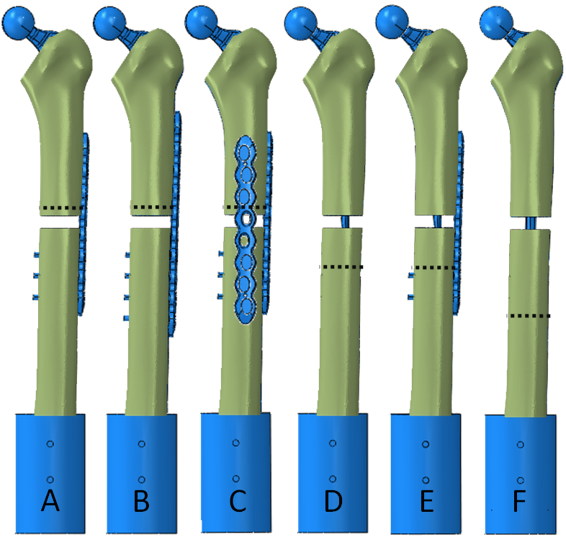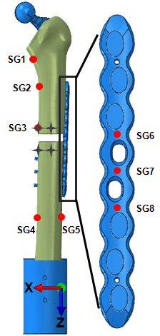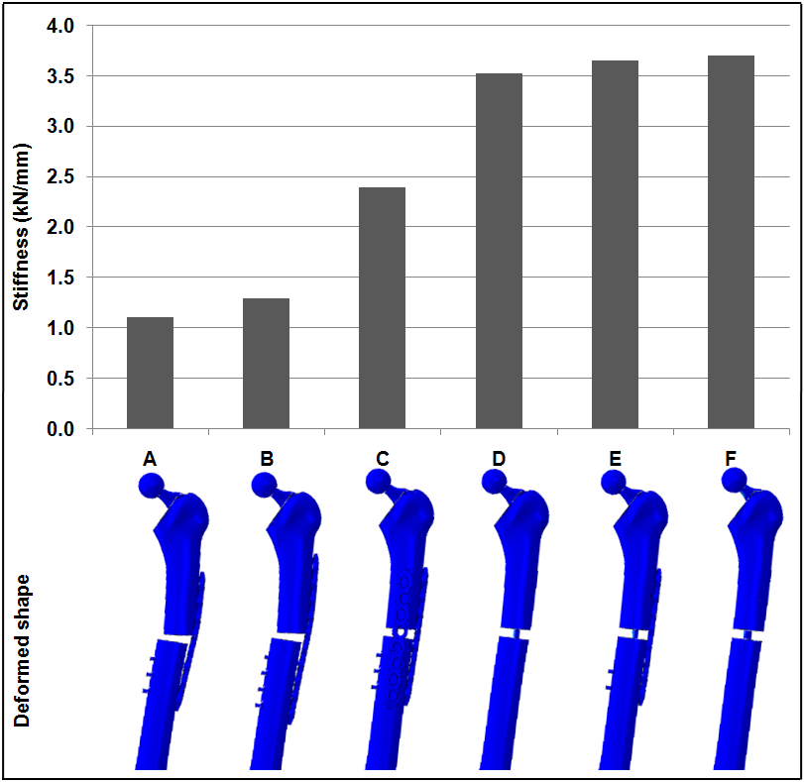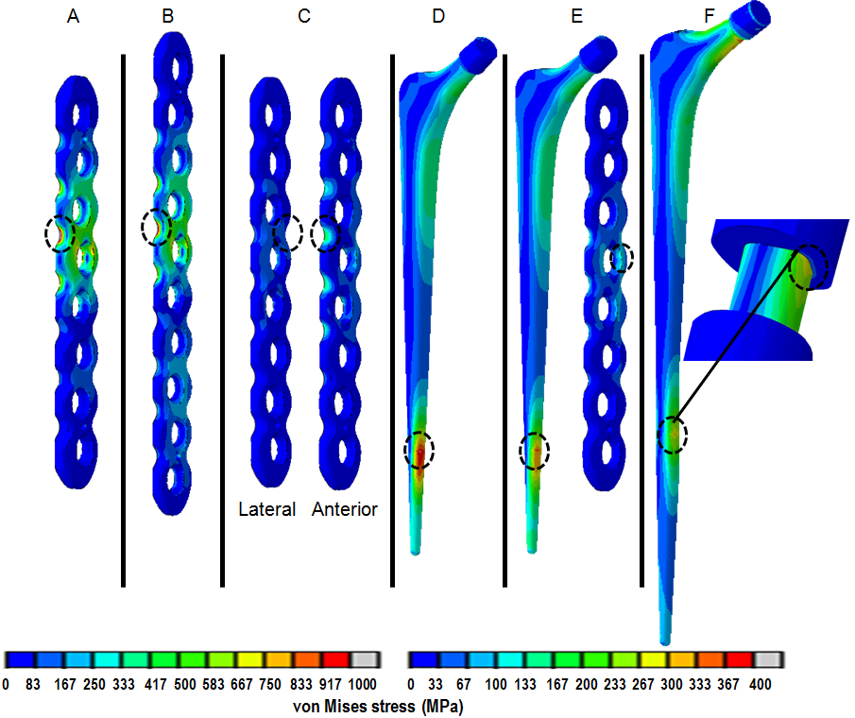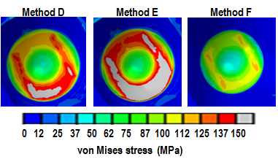

Table 1: Summary of the strain measurements and maximum von Mises stress on the stem and plate in all fixation methods. Note positive values indicate tensile strain and negative values indicate compressive strain. Lat, ant, and NA abbreviate lateral, anterior and not applicable respectively.
Fixation method | A |  |  | B |  |  | C |  |  | D |  |  | E |  |  | F
Axial load (N) | 500 | 2300 |  | 500 | 2300 |  | 500 | 2300 |  | 500 | 2300 |  | 500 | 2300 |  | 500 | 2300
ST1 | -50 | -230 |  | -36 | -194 |  | -67 | -316 |  | -51 | -245 |  | -53 | -257 |  | -69 | -328
ST2 | -52 | -260 |  | -40 | -196 |  | -129 | -610 |  | -106 | -512 |  | -108 | -518 |  | -143 | -677
ST3 | -1 | -5 |  | -1 | -3 |  | 0 | 1 |  | -8 | -41 |  | -6 | -30 |  | -15 | -65
ST4 | 419 | 2059 |  | 454 | 2140 |  | 187 | 906 |  | 189 | 910 |  | 159 | 724 |  | 126 | 610
ST5 | -493 | -2392 |  | -519 | -2446 |  | -252 | -1201 |  | -285 | -1348 |  | -255 | -1164 |  | -225 | -1060
ST6 | 509 | 2510 |  | 426 | 2304 |  | 109 | 526 |  | NA | NA |  | 59 | 245 |  | NA | NA
ST7 | 204 | 985 |  | 127 | 795 |  | 57 | 274 |  | NA | NA |  | 36 | 153 |  | NA | NA
ST8 | 15 | 41 |  | -38 | -71 |  | 14 | 60 |  | NA | NA |  | 17 | 73 |  | NA | NA
Svon stem (MPa) | 44 | 209 |  | 45 | 210 |  | 49 | 229 |  | 84 | 424 |  | 75 | 362 |  | 65 | 313
Svon plate (MPa) | 255 | 1258 |  | 219 | 1177 |  | lat:68 ant:97 | lat:330 ant:457 |  | NA | NA |  | 30 | 136 |  | NA | NA

Table 2: Summary of the axial fracture movement (mm) of all PFF fixation constructs.
Fixation method | A |  | B |  | C |  | D |  | E |  | F
Axial load (N) | 500 | 2300 | 500 | 2300 | 500 | 2300 | 500 | 2300 | 500 | 2300 | 500 | 2300
Anterior | 0.202 | 0.973 | 0.16 | 0.846 | 0.045 | 0.208 | 0.039 | 0.16 | 0.041 | 0.172 | 0.027 | 0.11
Medial | 0.343 | 1.665 | 0.286 | 1.5 | 0.12 | 0.553 | 0.082 | 0.367 | 0.078 | 0.341 | 0.055 | 0.244

