Abstract—Broadband time-domain spectroscopy was used to measure the terahertz frequency absorption of protein single crystals in order to study global protein dynamics. Temperature dependent dynamics were measured for lysozyme, and the terahertz frequency spectrum of mouse urinary protein was compared to calculated spectra.
Katarzyna M. Tych,ª Andrew D. Burnett,^{b} Christopher D. Wood,ª Richard W. Malham,^{b} Lianhe Li,ª John E. Cunningham,ª Arwen R. Pearson,^{b} Emanuele Paci,^{b} Edmund H. Linfield,ª and A. Giles Davies.ª
ªSchool of Electronic and Electrical Engineering, University of Leeds, Leeds LS2 9JT, UK
^{b}Astbury Centre for Structural Molecular Biology, University of Leeds, Leeds LS2 9JT, UK.
Terahertz time-domain spectroscopy of lysozyme and mouse urinary protein single crystals.

INTRODUCTION And BACKGROUND
Terahertz (THz) frequency spectroscopy has been shown to be a sensitive probe of the long-range order and chemical environment of small organic systems. In particular, it has become apparent that a number of normal modes observed at THz frequencies can be attributed to external vibrations that are present only when the molecule is fixed within a crystalline lattice, and arise because of the lack of free rotation of the molecules within the crystal.
Here, we measure the THz frequency response of lyophilised powders and single crystal proteins at cryogenic temperatures. We focus on two exemplar systems: hen egg white lysozyme (HEWL) and mouse urinary protein (MUP). The use of cryogenic temperatures allows the crystals to be mounted directly onto small apertures and removes the need for protective sample cells to prevent sample dehydration .

RESULTS
Lyophilised HEWL powder (3 × crystallized, Sigma Aldrich, UK) were formed into pellets for measurement without further purification. Concentrations of 25%, 50%, 75% and 100% (w/w) HEWL were studied, using 1 μm particle size polytetrafluoroethylene (PTFE) as the matrix material. Samples were placed in a liquid helium cryostat which allowed spectra to be acquired between 4 – 300 K.
When the absorption coefficient at a single frequency is plotted as a function of temperature for each concentration, a local minima is found between 80 – 100 K for all concentrations (Fig. 1a), with the onset of linear behaviour starting at ~100 K. This is close to the low temperature (~100 – 120 K) inflection, linked to methyl side-group dynamics, observed previously in proteins using neutron scattering .
HEWL was then crystallized using the published conditions , yielding crystals of ~500 × 300 × 300 µm³. The HEWL crystals were cryoprotected by submerging them for 60 seconds in a droplet of crystallization solution containing 20% (v/v) glycerol. The crystals were then
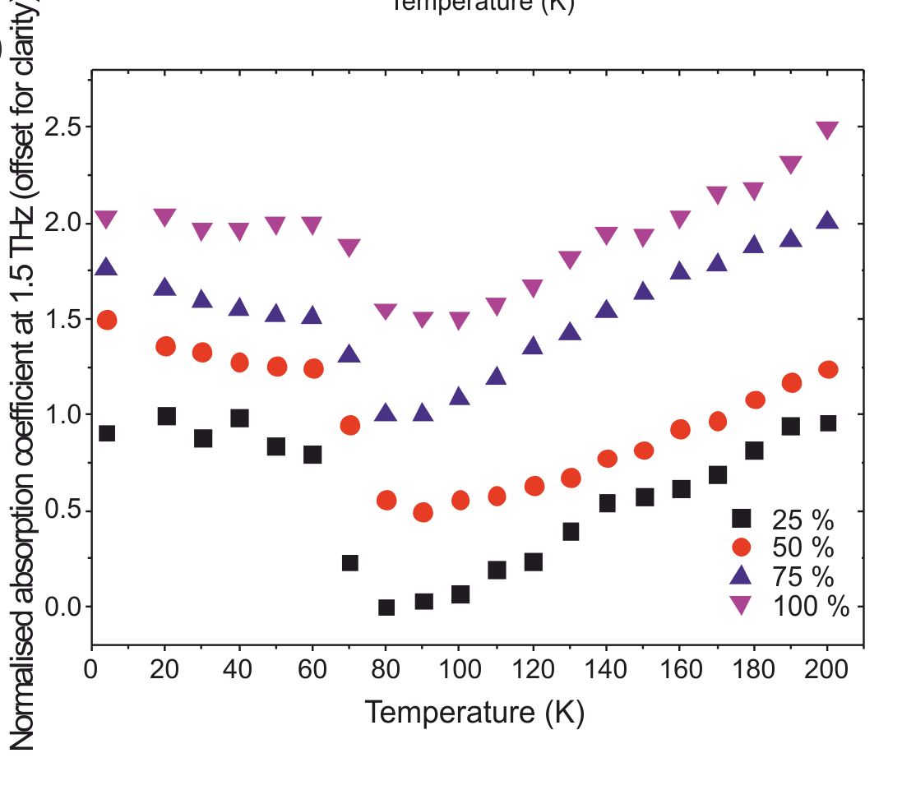
a
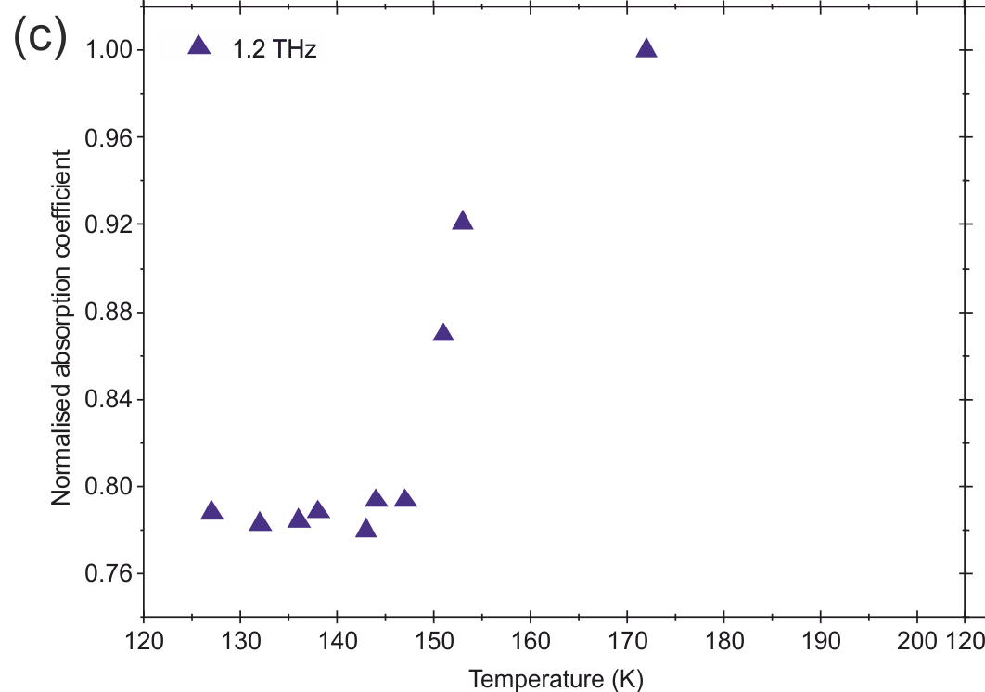
b
Fig. 1 (a) The normalized absorption coefficient at 1 THz for pressed HEWL pellets at concentrations of 25%, 50%, 75% and 100%, recorded from 4 K – 200 K. (b) The normalized absorption at 1.2 THz of a HEWL crystal, cryoprotected with glycerol, and measured from 127 – 197 K.
transferred using nylon loops, onto the surface of a pinhole aperture (300 μm diameter), before being flash cooled under a nitrogen cryostream. By purging with dry air, to prevent condensation of water on the sample, THz spectra were recorded over a temperature range from 127 K to 175 K, at which point the bulk of the solvent sublimes and the crystal integrity is lost. The THz frequency-dependent absorption coefficient was calculated and a change in coefficient was observed for each frequency at ~147 K (Fig. 1b), close to the reported glass transition for a 30% glycerol in water mixture . This transition occurred at a lower temperature than the dynamical transition typically reported for proteins (180 – 250 K), but is very close to the HEWL crystal true glass transition, T_{g} = 150 K, measured by differential scanning
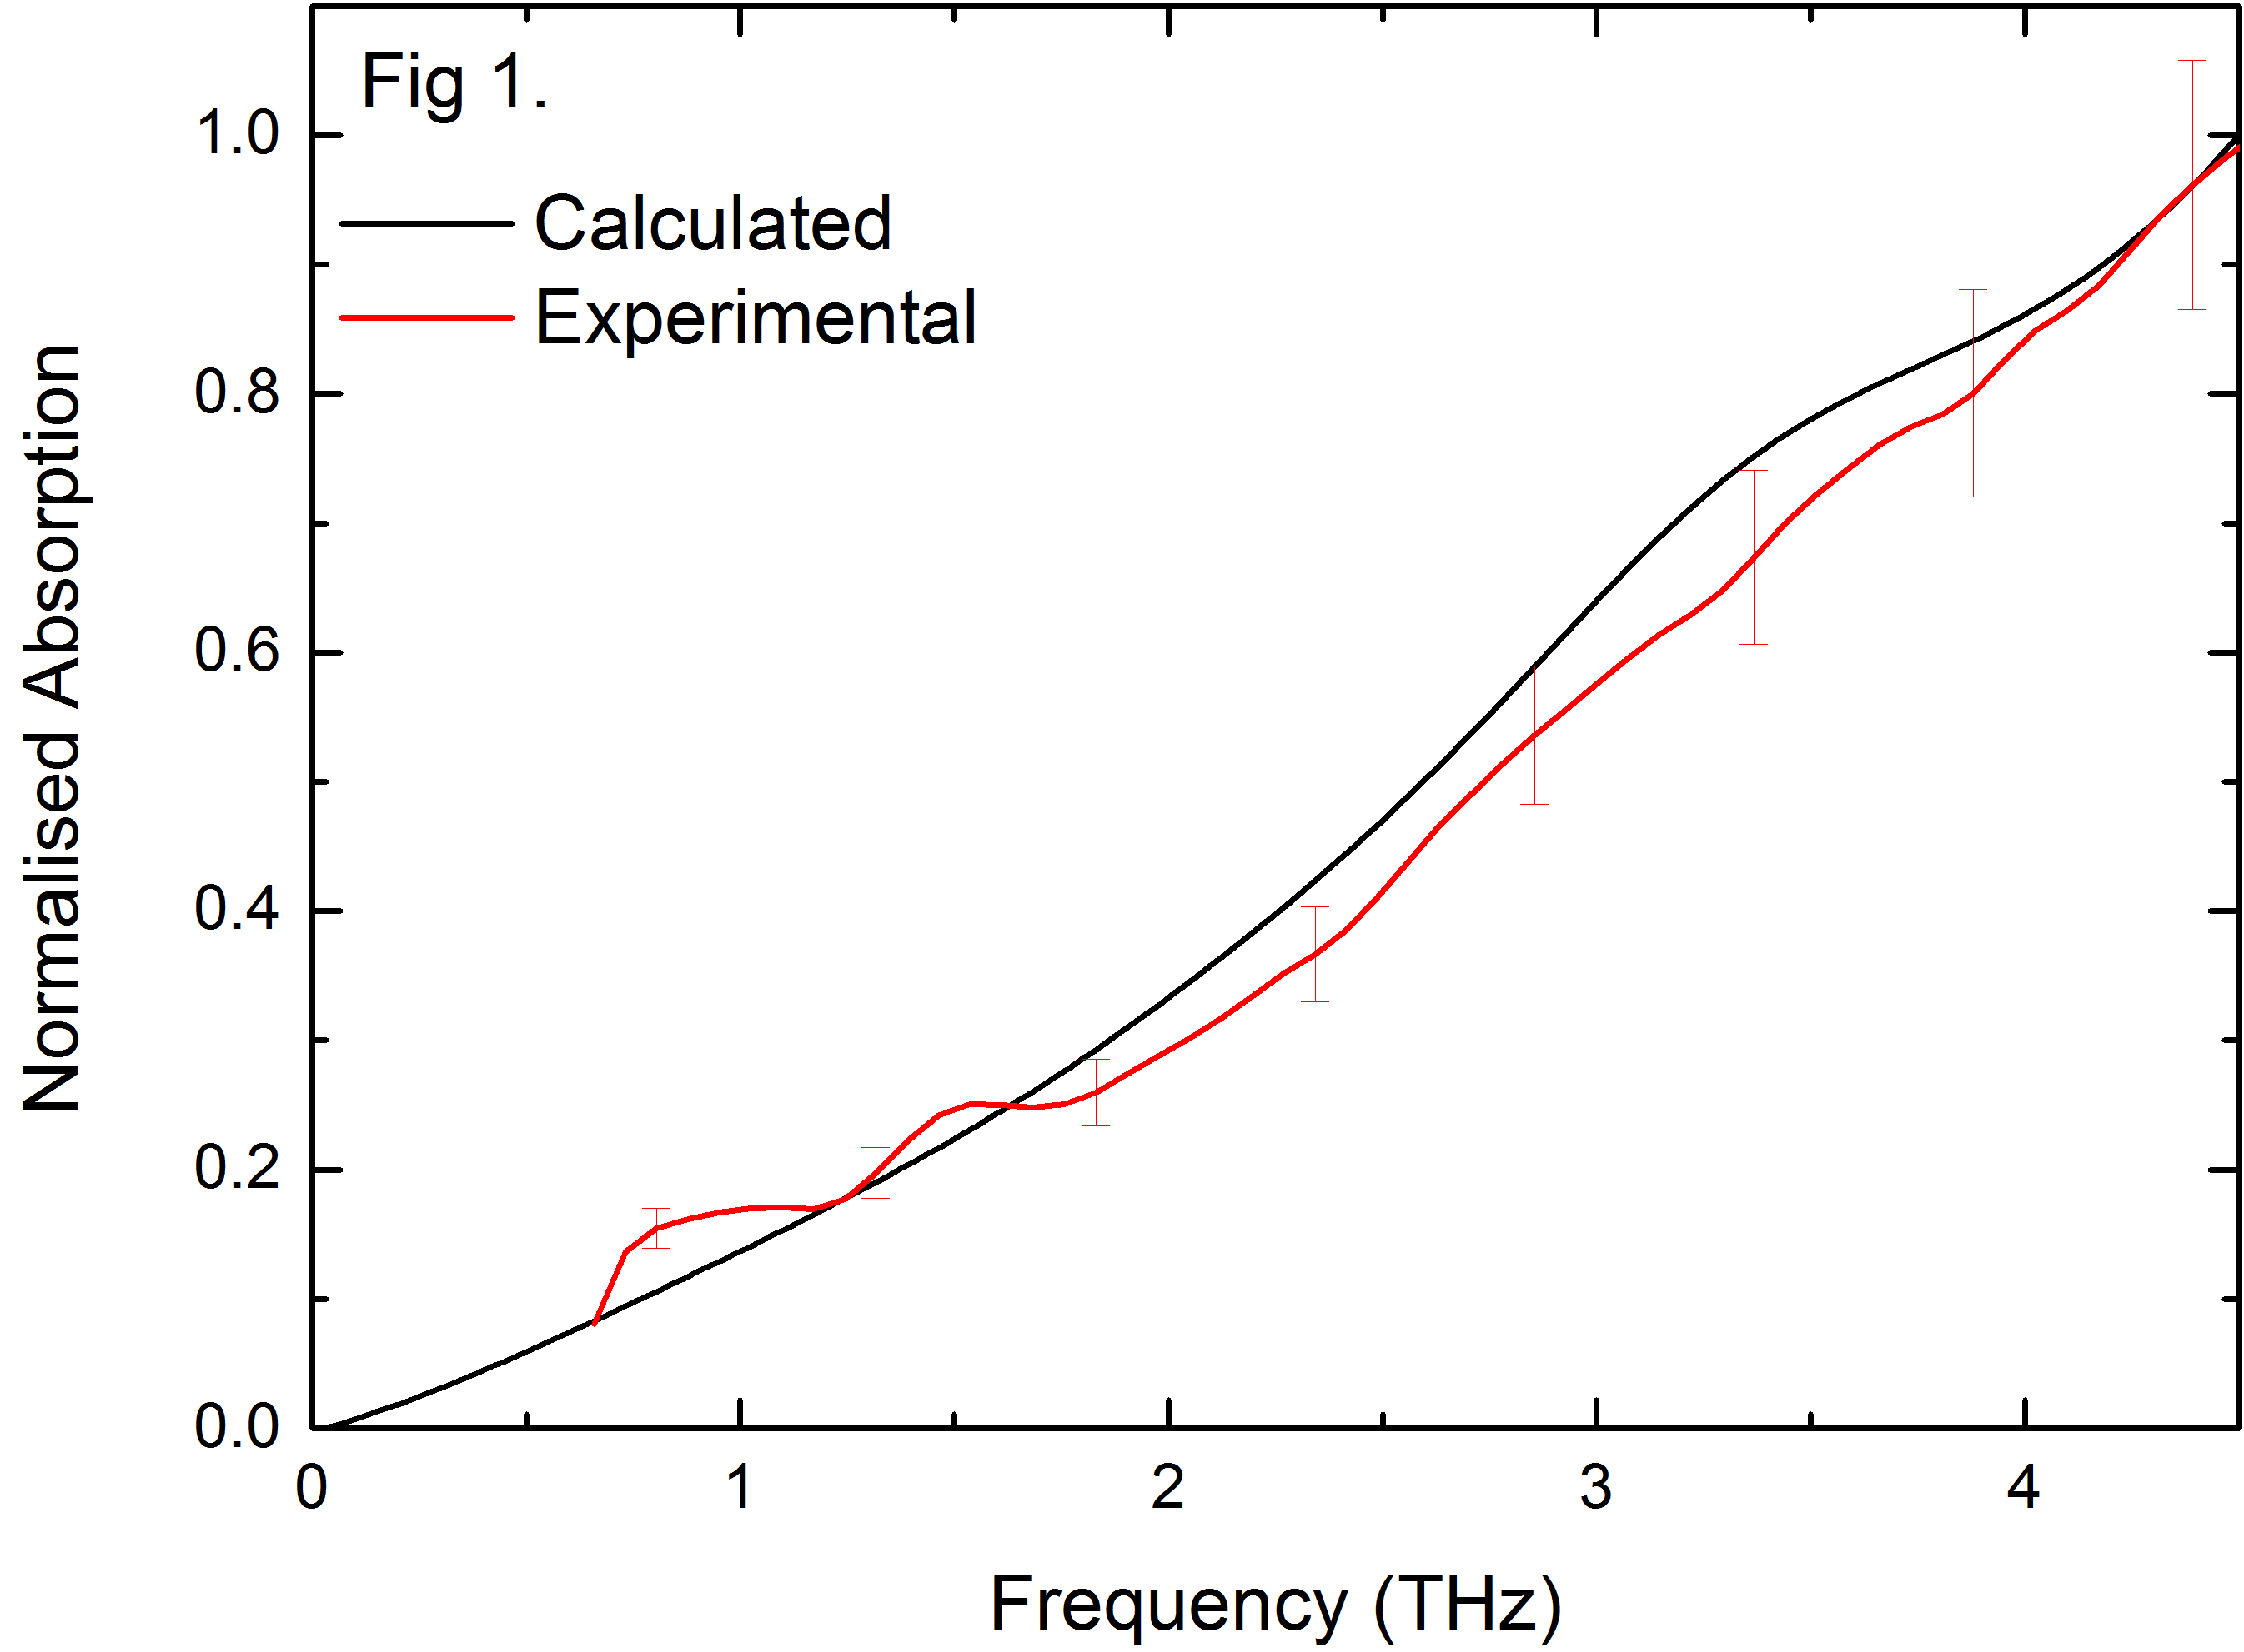
Fig. 2 The averaged THz spectra of MUP single crystals (red curve) compared to a calculated THz spectra of MUP obtained from NMA calculations of a range of structures obtained from a short MD simulation (black curve). Both spectra have been normalized between 0 and 1 for comparison.
calorimetry of HEWL crystals at . We did not observe this glass transition in lyophilised lysozyme pellets (Fig. 1a). However, a transition at this temperature was observed in crystallization mother liquor with and without glycerol, in the absence of protein. This suggests that the glass transition measured calorimetrically at ~150 K in HEWL crystals may be solvent mediated.
In a separate set of experiments, MUP was recombinantly expressed and crystallized as previously described , and the crystals were then cryoprotected by soaking in a drop containing 30% (v/v) polyethylene glycol 400, and 70% crystallization solution.
The crystals were then mounted in a similar way to the HEWL and cooled to ~110 K, and the spectral response measured (Fig. 2).
To complement the experimental data on MUP, molecular dynamics (MD) simulations were performed with the protein placed in an octahedral box with ~7,000 water molecules using CHARMM and the CHARMM22 force field . A disulphide bridge was specified between residues 64 and 157 as observed in the crystal structure. Long range electrostatic interactions were treated using the particle mesh Ewald method. SHAKE was applied to constrain all hydrogen bonds, allowing a 2 fs timestep. Minimisation involved 1000 steps steepest descent followed by 100 steps adopted basis Newton-Raphson method. The system was subsequently heated from 50 K to 298 K over 50 ps, before performing 18 ns of equilibrium trajectory at constant temperature and pressure (298 K, 1 atm). 100 frames at equal 180 ps intervals were extracted from each trajectory, reoriented and aligned with respect to the first frame of the trajectory. All water molecules not within 5 Å of any protein’s atom were removed. The structures obtained from this short MD run allow us to obtain a range of starting structures for MUP. These structures allow us to sample sub-minima in the native well (this has been shown to diminish idiosyncratic modes whilst enhancing the modes common to sub-minima) thus generating a more representative picture of native vibrational fluctuations . For each of these structures the normal mode frequencies and dipole derivatives were obtained for all modes below 5 THz. THz spectra were then calculated by fitting Lorentzian curves with a FWHM of 35 cm^{–1} to each of the modes, using the square of the dipole derivative as an estimate for the infrared intensity. The spectra for all starting structures were then averaged and normalized between 0 and 1. The resulting data is plotted in Fig 2, which also shows the average THz spectra obtained from eight measurements for each of the four MUP crystals recorded at 110K, again normalized between 0 and 1. The results show the same pattern of increasing absorption as a function of frequency.
In conclusion we have measured the THz spectra of two different types of protein crystals, along with the THz spectra of lyophilized HEWL. In the variable temperature spectra of HEWL we note a transition close to the glass transition in the crystals, while a lower transition was observed in the lyophilized powder. In the case of MUP we have performed a large number of normal mode calculations in order to calculate the THz frequency response of the protein with reasonable success.
We acknowledge support from the ESPRC (UK), the Leverhulme trust, the Royal Society and the Wolfson Foundation.
References
[1] K. M. Tych, et al., "Applying broadband terahertz time-domain spectroscopy to the analysis of crystalline proteins: a dehydration study," Journal of Applied Crystallography, vol. 44, pp. 129-133, 2011.
[2] J. H. Roh, et al., "Dynamics of tRNA at Different Levels of Hydration," Biophysical Journal, vol. 96, pp. 2755-2762, 2009.
[3] K. Wood, et al., "Coincidence of Dynamical Transitions in a Soluble Protein and Its Hydration Water: Direct Measurements by Neutron Scattering and MD Simulations," Journal of the American Chemical Society, vol. 130, pp. 4586-4587, 2008.
[4] G. Alderton and H. L. Fevold, "Direct Crystallization of Lysozyme from Egg White And Some Crystalline Salts of Lysozyme," Journal of Biological Chemistry, vol. 164, pp. 1-5, 1946.
[5] M. Weik, et al., "Temperature Derivative Fluorescence Spectroscopy as a Tool to Study Dynamical Changes in Protein Crystals," Biophysical Journal, vol. 86, pp. 3176-3185, 2004.
[6] V. S. Bajaj, et al., "Observation of a Low-Temperature, Dynamically Driven Structural Transition in a Polypeptide by Solid-State NMR Spectroscopy," Journal of the American Chemical Society, vol. 131, pp. 118-128, 2008.
[7] Y. Miyazaki, et al., "Low-Temperature Heat Capacity and Glassy Behavior of Lysozyme Crystal†," The Journal of Physical Chemistry B, vol. 104, pp. 8044-8052, 2000.
[8] Z. Böcskei, et al., "Crystallization of and preliminary X-ray data for the mouse major urinary protein and rat α-2u globulin," Journal of Molecular Biology, vol. 218, pp. 699-701, 1991.
[9] B. R. Brooks, et al., "CHARMM: The biomolecular simulation program," Journal of Computational Chemistry, vol. 30, pp. 1545-1614, 2009.
[10] H. W. T. van Vlijmen and M. Karplus, "Analysis of Calculated Normal Modes of a Set of Native and Partially Unfolded Proteins," The Journal of Physical Chemistry B, vol. 103, pp. 3009-3021, 1999.

