Ben Richard Hughes, S.A.A. Abdul Ghani, Investigation of a windvent passive ventilation device against current fresh air supply recommendations, Energy and Buildings, Volume 40, Issue 9, 2008, Pages 1651-1659, ISSN 0378-7788, http://dx.doi.org/10.1016/j.enbuild.2008.02.024.

Investigation of a Windvent Passive Ventilation Device against Current Fresh Air Supply Recommendations

Ben Richard Hughes and S A A Abdul Ghani

Sheffield Hallam University
Faculty of Arts, Computing, Engineering and Sciences
Materials and Engineering Institute
Sheffield, South Yorkshire
United Kingdom
S1 1WB

Keywords: - CFD, buildings, passive ventilation, natural ventilation, sustainable resources

Abstract

Recent ecological and political developments have created an increased focus on sustainable energy sources. The purpose of this paper is to examine a passive ventilation device, the Windvent, and evaluate its potential against current British Standards BS5952:1991 [1] recommended fresh air delivery rates. The results provide useful information for both engineers and architects when examining ways to reduce new and existing buildings running costs, and conform to new legislation. Numerical analysis is carried out using a commercial Computational Fluid Dynamics (CFD) code, to investigate the effect of various external wind velocities (1-5 m/s) and directions (Concurrent and counter current) on the device performance. The results show that the Windvent is capable of providing recommended rates of fresh air supply even at relatively low incident wind velocities. The performance indications show that the device warrants further analysis and provides a sustainable alternative ventilation system.

1.0 Introduction

The United Kingdom is becoming increasingly aware of its carbon footprint. From April 2007 all public buildings including museums, galleries, and town halls must be energy rated and display these ratings to the public [2]. The regulations on the energy performance of buildings have further stipulated energy performance certificates for homes, similar to the consumer friendly fridge rating system [3].

Recent political and ecological developments, the Kyoto protocol and climate change respectively, have led to an increased demand for naturally ventilated devices. However, technical data regarding the performance of these macro to micro climate interfaces is scarce.

Natural ventilation is a passive method of providing high quality air to buildings without the aid of mechanical systems, thus enabling fresh air delivery to occupants utilising sustainable and energy efficient methods.

Wind driven ventilation is not a modern development. In hot climates, such as Iran, it was used in buildings from as early as 3000BC. The Malkalf or wind catch was used by ancient Egyptians and is represented in wall paintings from the period 900AD [4].

The Malkalf, consists of a shaft rising above the height of the building, which traps the air at higher velocity and channels it down into the interior of the building. This device is used in the hot climates of Arabia. However, modern day equivalents are available for use in the UK which has an altogether different climate. The focus of this paper is to investigate their effectiveness and suitability for its current application.

The application of these devices ranges from classroom to large factories, as does the legislative guidelines, therefore the selection of micro climate and legislation have to be carefully matched.

A standard small classroom is chosen as the micro climate in accordance with current guidelines [5] and their suggested occupancy levels and areas adhered to. The targeted fresh air supply rate is taken from the British Standards BS5952:1991 [2]. Although other measures are available from Heating Ventilation Air Conditioning (HVAC) applications it has been determined that in the case of natural ventilation these are unsuitable, as the external wind velocity cannot be guaranteed neither can the air changes per hour [6].

The numerical simulation procedure used in this study is described and the results of varying external wind speeds and incident wind directions and their effect on the air infiltration in comparison with the recommended rates.

2.0 Previous related work

Information regarding the performance of passive ventilation devices of this kind is not readily available. However, as this is based on an early Egyptian design it seems poignant to begin any research in this region.

Hassan Fathy [7] describes in detail the Malgaf (see figure 1) of the Qã'a Muhib Ad-Din in Cairo which dates from the fourteenth century. This Malgaf was the focus of a study carried out in 1973 by scholars from the Architectural Association School of Architecture in London, which substantiate the airflow patterns described previously [8].

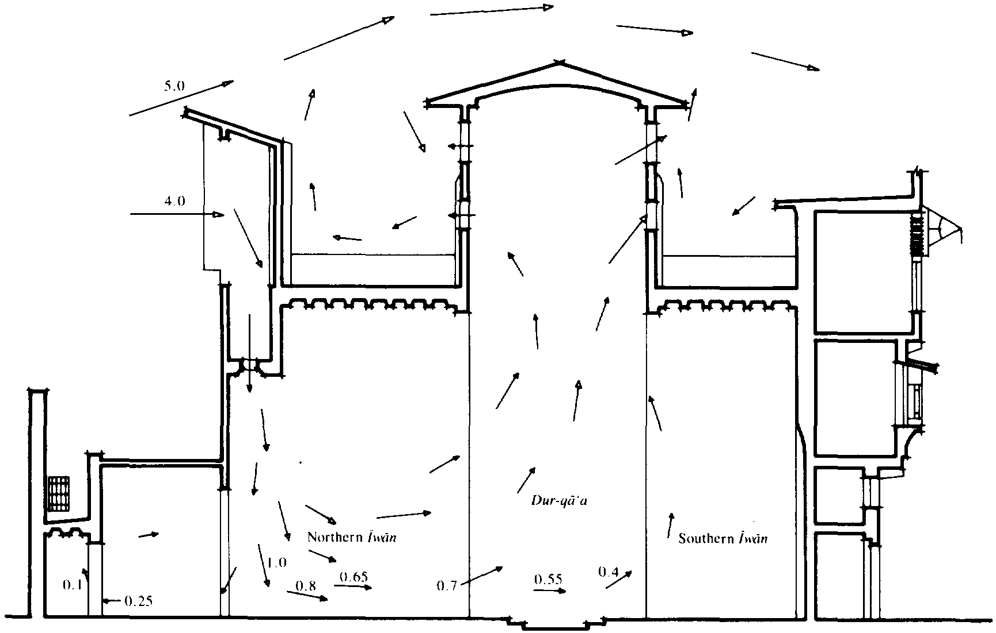
Figure 1 The Mulgalf and wind-escape produce internal air movement

G.Ziskind et al. [9] used CFD and experimental studies to examine the effects of induced natural ventilation in Iran using a passive solar system for natural ventilation. The system achieved relative success and showed good correlation between both methods of analysis.

R.Priyadarsini et al. [10] also used CFD and experimental tools to analyse the different effects of passive and active (fan-assisted) stack systems in Singapore. The active stack in their study proved to be more successful at air distribution, again with good correlation between the two experimental techniques.

Elmualim [11] studied a similar passive ventilation device, The Wind catcher and he compared CFD experimental and numerical techniques when assessing the ventilation potential of the device in 2006. This approach did show good correlation between CFD code and windtunnel experiments, but omitted the diffuser distribution of the device.

Elamualim [12] followed up on the earlier work by including dampers and diffuser, and a heat source to further assess the ventilation capabilities of the device. This again yielded a good correlation between CFD results and the windtunnel, with the diffuser effectively reducing the ventilation rate.

While the later work of Elamualim has yielded useful results, the CFD model did not take into count the physical geometry of the device. Namely the louvers and dampers, due to computational time and geometry complexity.

The previous work carried out underlines the importance of windvent devices and their potential as a natural ventilation interface. The earlier works demonstrate the effectiveness in design and in acrid climates their suitability. The good correlation between CFD and experimental results suggests that CFD is a reliable design tool for this device and as such has been used for the purpose of this paper.

This paper shows the full geometry of the windvent and the effect it has on the achievable airflow rates. The CFD models are compared for varying external wind speeds (1-5 m/s) and direction (concurrent and counter current), and the air supply achieved compared to current legislative requirements.

3.0 CFD set-up

The CFD model was developed using FLUENT, a commercially available general-purpose code. This code uses the finite volume method approach and employs the Semi-Implicit Method for Pressure-Linked Equations Consistent (SIMPLEC) velocity-pressure coupling algorithm. The turbulent nature of the flow is modelled by the standard k-e model. The governing equations are the well known Navier-Stokes and energy equation which will not be repeated here but are available in detail in [13].

The Geometry was created using Proengineer software and then imported into Gambit (FLUENT pre-processor) was used to create the geometry, with a 6000 x 6000 x 3000mm (500mm false ceiling height) micro climate representing a small classroom. The windvent geometry (see figure 3) was a 1000 x 1000 mm windvent including cross dividers and damper faces, centrally placed above the room. In order to obtain sufficient distance between boundary conditions the macro climate was sized appropriately [5] and consists of a 6000 x 6000 x 4000 mm volume placed directly above the microclimate, thus creating a direct interface through the wind catcher geometry.

3.1 Boundary conditions

The diffuser (egg crate grill - figure 2) has been modelled using the porous jump boundary condition, which acts as thin membrane or filter with user defined inputs of permeability and medium thickness. A tertiary term of pressure jump coefficient is available to the user for this type of boundary condition (see equation 1) however as a reliable coefficient is currently unavailable, the software reduces to the Darcy's law in the absence of this input [13].
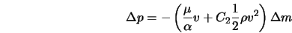
Equation 1
Where;
$α$ is the permeability of the medium (m²)
C₂ is the pressure-jump coefficient (1/m)
$Δp$ is the pressure change (Pa)
$μ$ is the laminar fluid viscosity (kg/ms)
$Δ$m is the thickness of the medium (m)
$ρ$ is the fluid density (kg/m³)
$υ$ is the fluid velocity (m/s)
The macro climate created, to simulate the incident wind velocity (see figure 3), consists of a velocity inlet ( values of 1,2,3,4,4.5, and 5 m/s) at one complete side, and a pressure outlet (atmospheric pressure) on the opposing side. The remainder of the macro climate faces were named as symmetry faces, thus eleviating any return velocities which may distort the results.
Top Hat
Vent Blade
Diffuser (Egg crate grill)

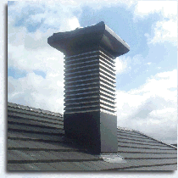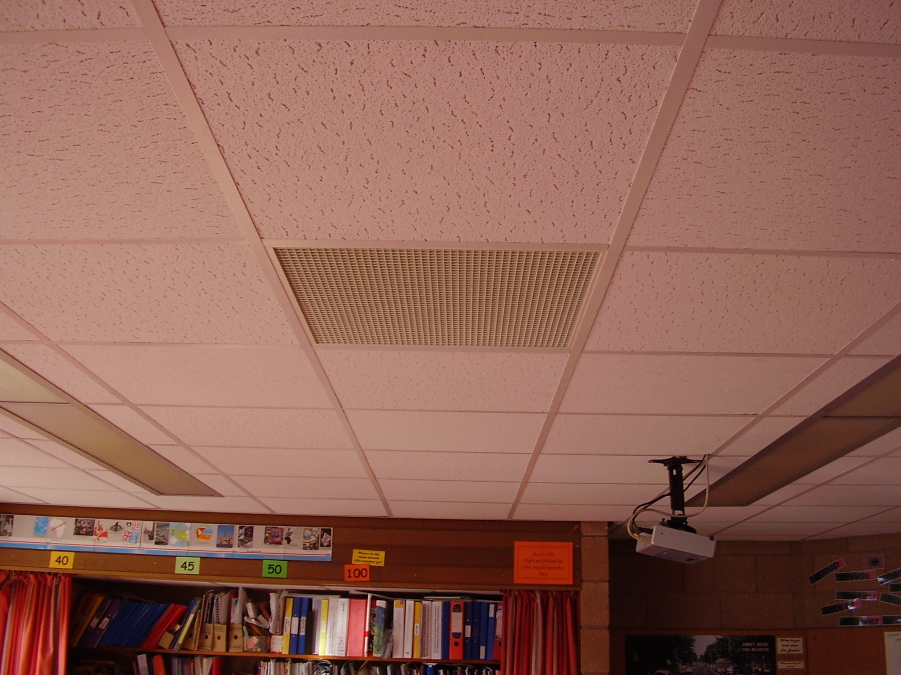
Figure 2 Illustration of Windvent and Diffuser - courtesy of Midtherm Ltd.
Macro climate
Velocity Inlet
Dampers
Windvent
Cross dividers
Pressure Outlet

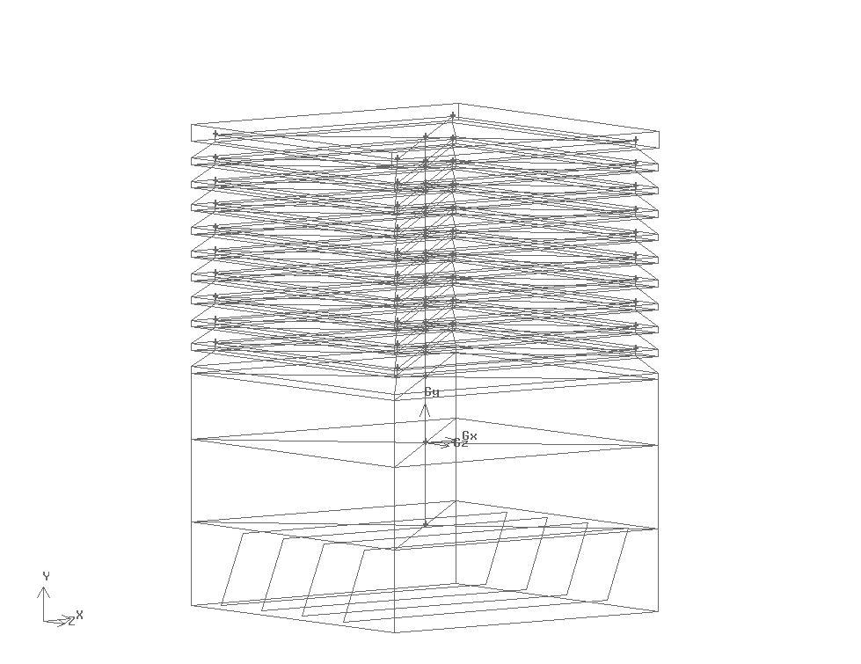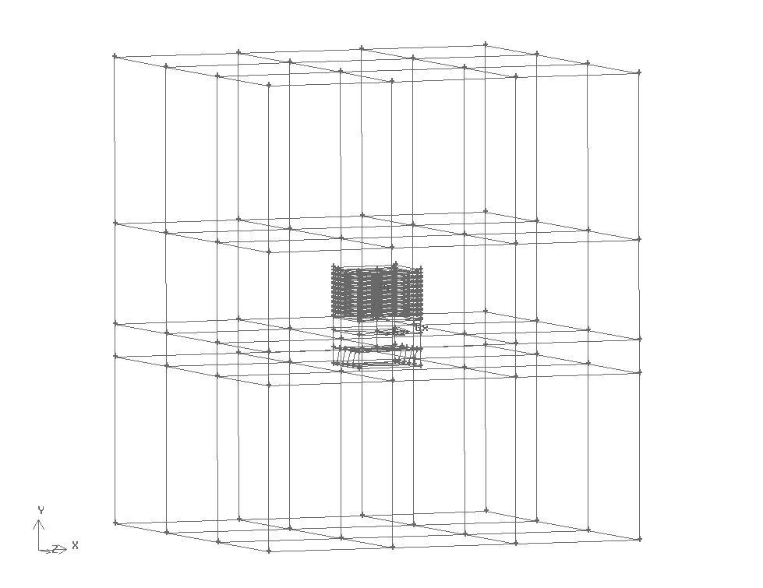
Figure 3 Physical Geometry recreated in GAMBIT
False ceiling
Micro climate

4.0 Grid adaption

Due to the geometrical complexity the computational mesh was generated using triangular elements. In order to accurately resolve the solution fields, the grid was refined and enriched using hp-methods [14]. This process of adaption requires a decision as to the usage of h-refinements (the mesh size) or p-enrichments (higher order approximations) by the use of a posteriori error estimate.

The posteriori estimate used in the developed model is the average weighted velocity taken on the face between the windvent and the micro climate. The initial coarse grid was evaluated, and subsequent refinements were evaluated until the error deemed negligible between refinements. It is important to note that a compromise must be reached when refining the grid, between accuracy and computational time. The boundary conditions remain fixed throughout this process to ensure accurate comparison of the error indicator.

Figure 4 Grid Adaption

The initial coarse grid consisted of 860,166 elements which was refined over three stages until an acceptable error of 0.01% was achieved with a total of 1,216,987 elements. The model was split into three areas, Windvent (stage 1), Macro climate (stage 2), and micro climate (stage 3), and each area refined as illustrated below.

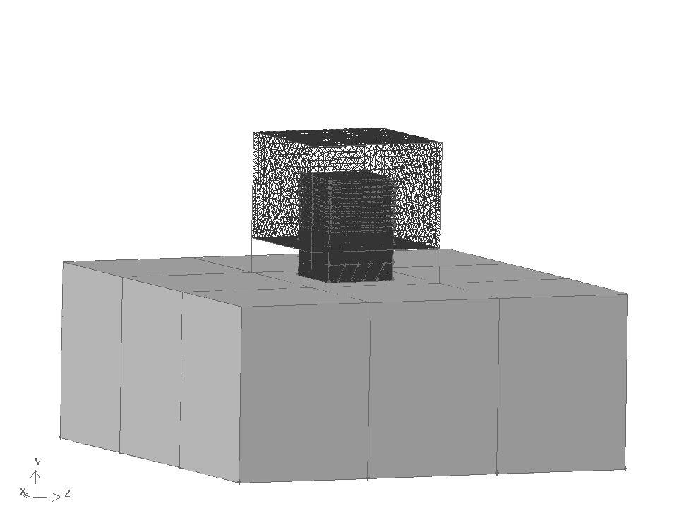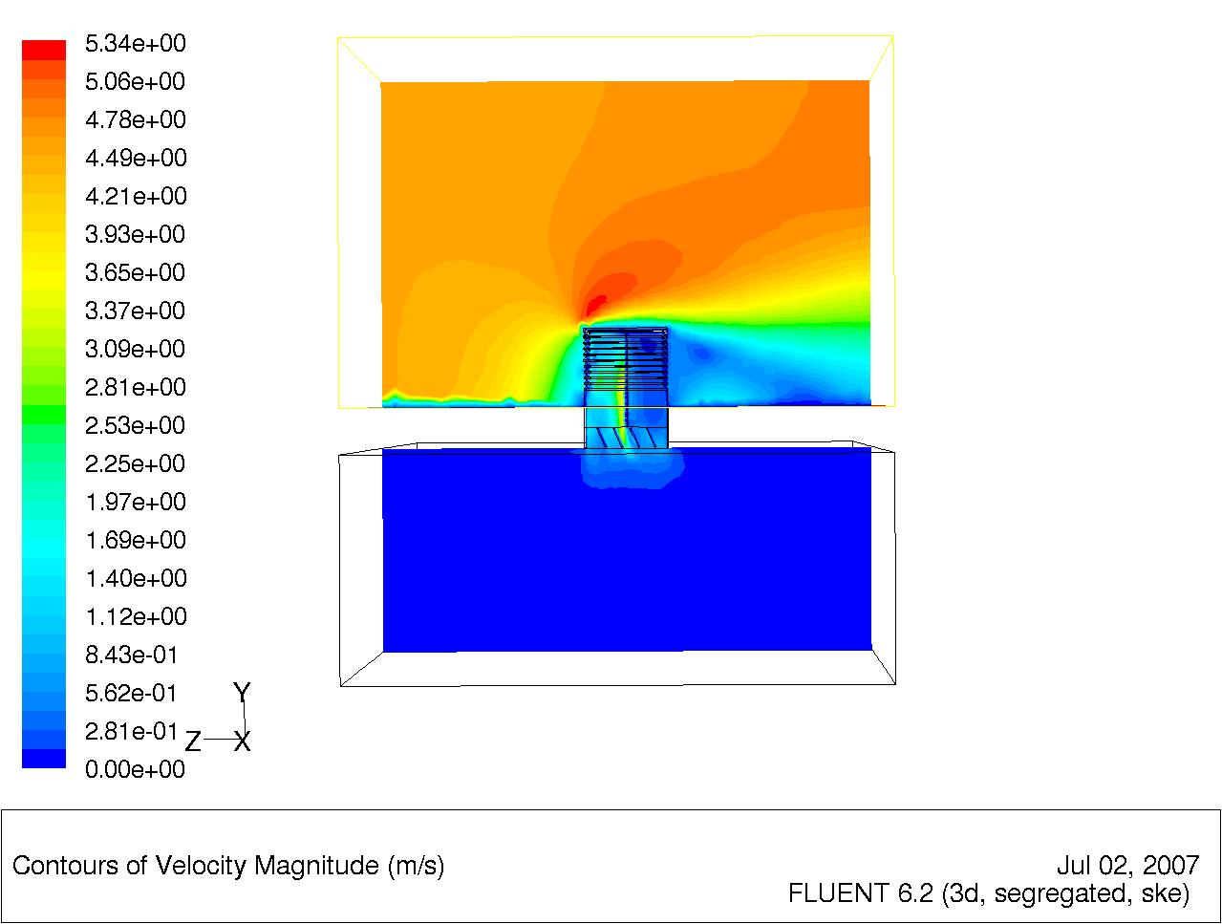
Figure 5 Stage 1 Grid Adaption
Stage 1 of the grid adaption concentrates on the windvent and immediate surroundings (as illustrated in figure 5), keeping the remaining grid sizes constant throughout the process. The velocity contour plot in figure 5 shows the separation of the velocity around the windvent, and the diffuser to micro climate.

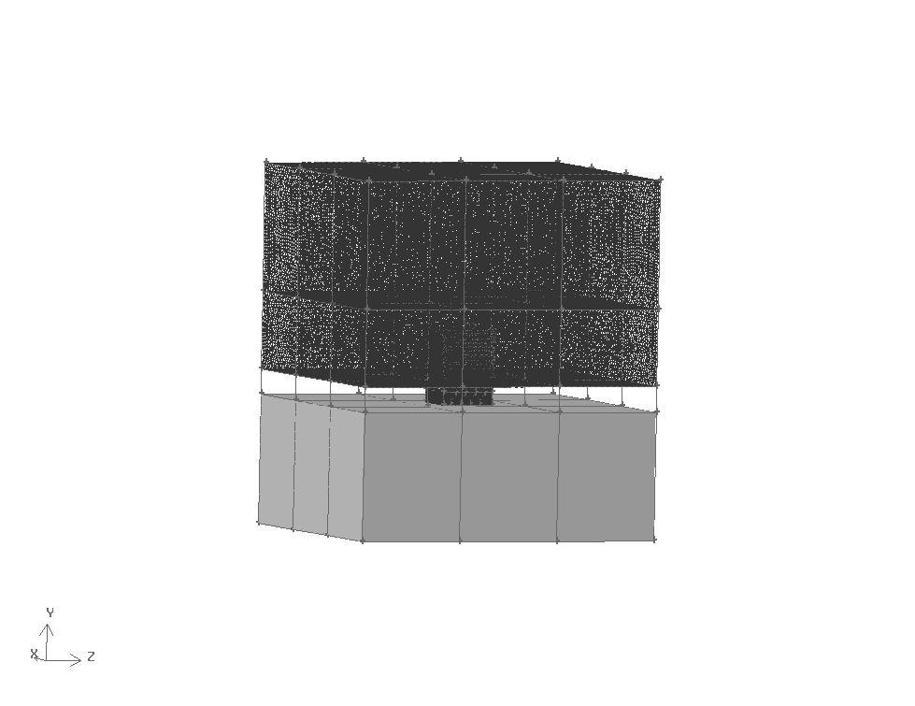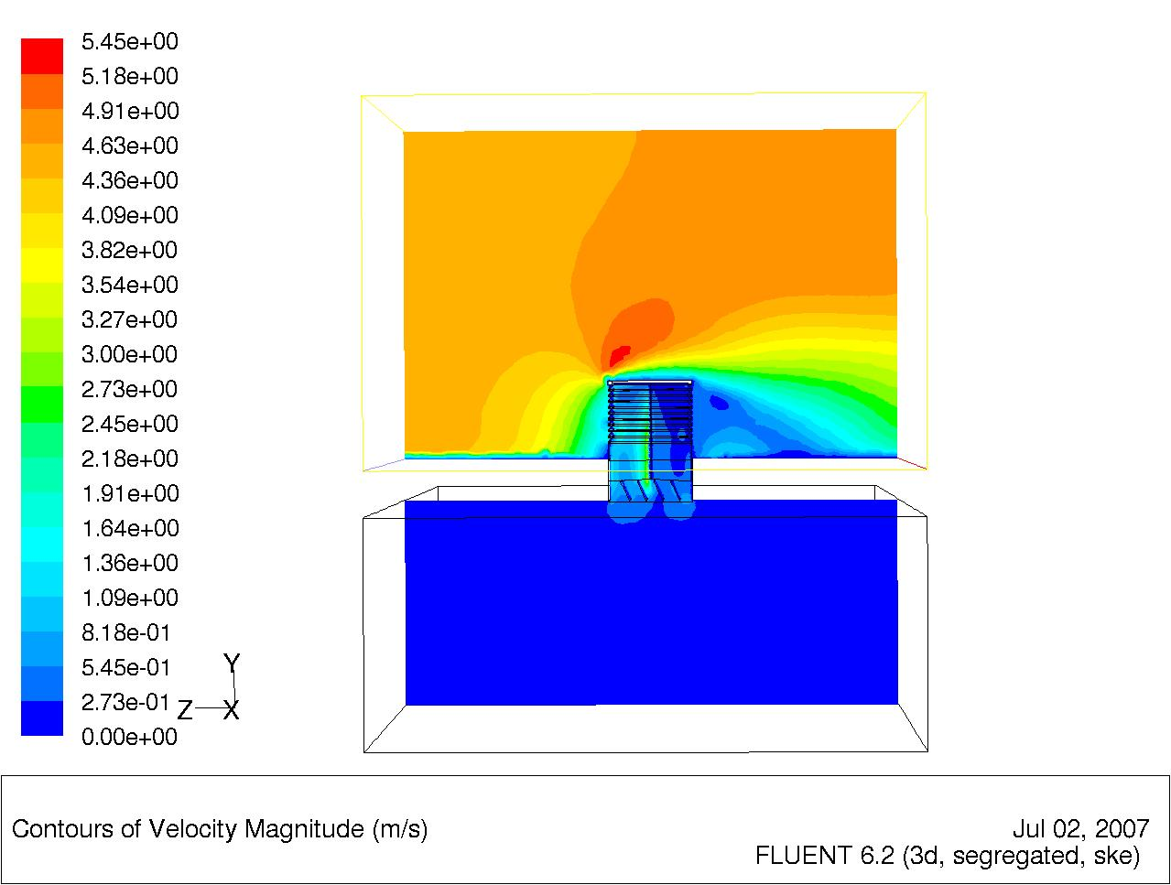
Figure 6 Stage 2 Grid Adaption
Stage 2 of the adaption concentrates on the macro climate leaving the remaining cell sizes constant (see figure 6). The velocity contour plot illustrates the separation of velocities is now more defined. The definition is evident at the diffuser to micro climate and also the velocity differences after the windvent and above respectively.

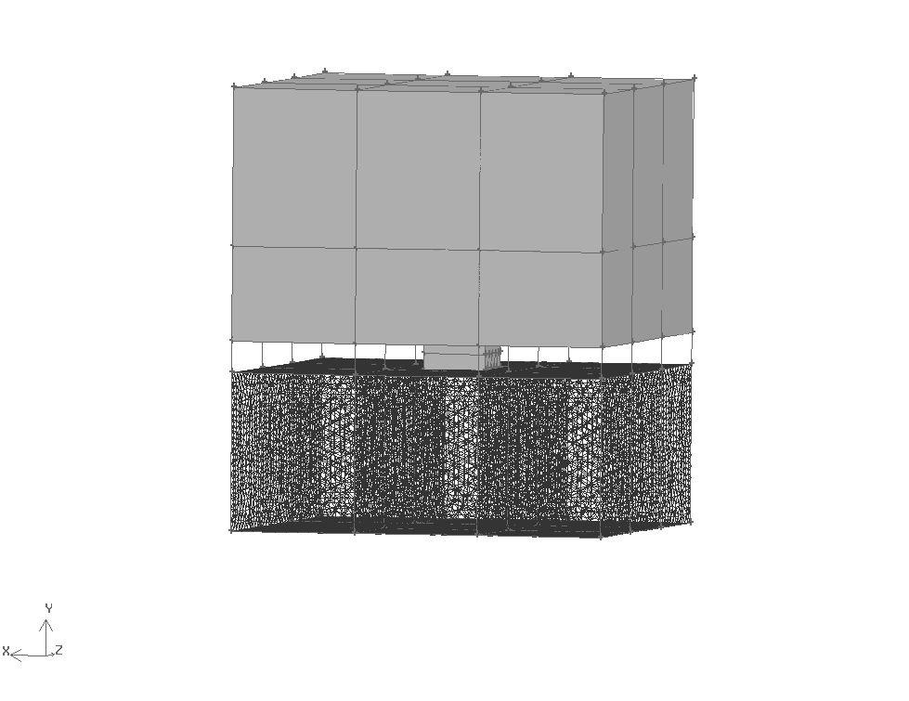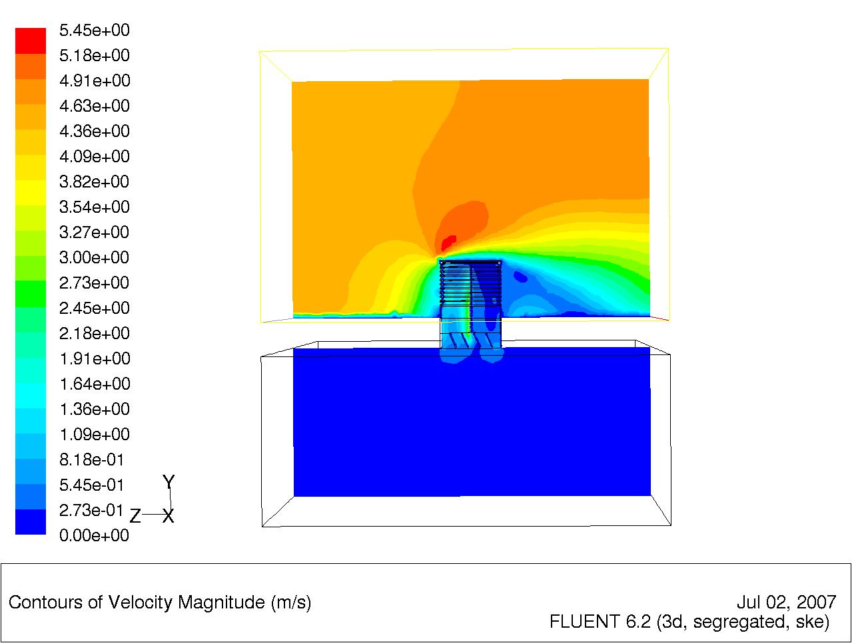
Figure 7 Stage 3 Grid Adaption
Stage 3 of the adaption concentrates on the micro climate leaving the remaining cell sizes constant. Once again the separation in the velocity contours is more defined than the previous refinement, although not to the same extent as this is the final stage of refinement.

Having achieved grid independency, the model was run for various wind directions and velocities, with the results presented in section 5.0.

The following figures (figures 8-13) illustrate the flow path calculated in the FLUENT model, for both the concurrent and counter current flow paths, and show the distribution in the micro climate.

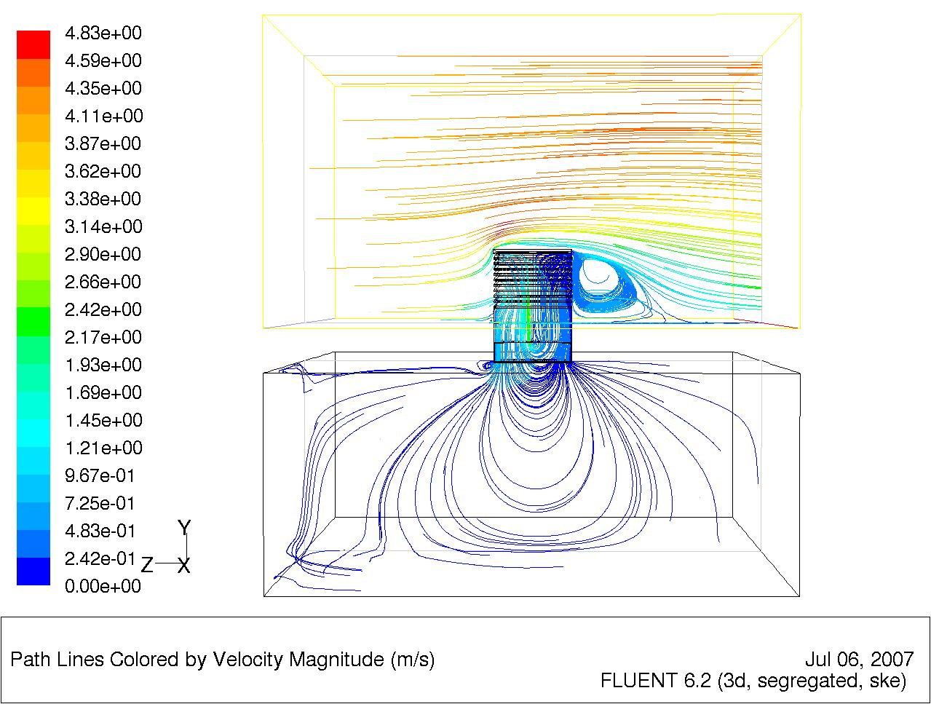
Figure 8 Fluent Flow distribution
Figure 8 shows the flow entering from the left (velocity inlet), the flow splits with some of the air entering the interface and some passing over and exiting to the right (pressure outlet). The geometry shown includes a supplementary vertical plane created to assist in the illustrative analysis of the model.

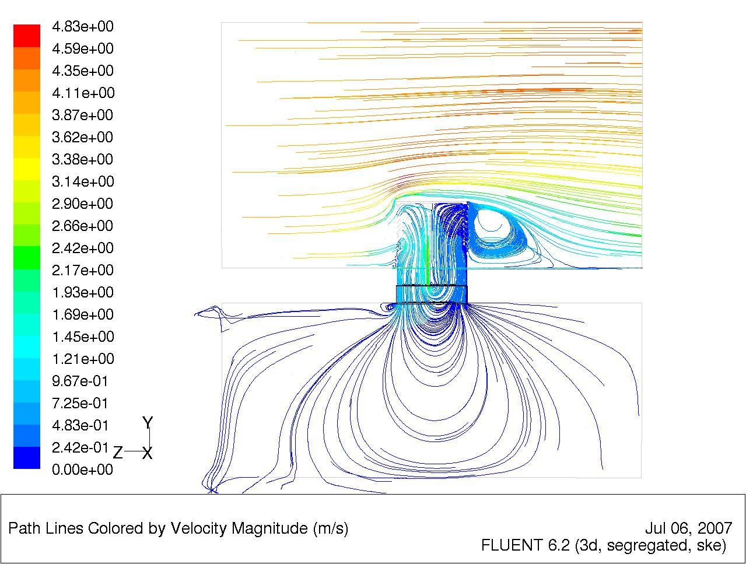
Figure 9 Supplementary plane view
Figure 9 shows the supplementary face without the surrounding geometry. The vertical face cuts through the model through the centre to show an accurate cross section of the model, and assist the illustrative analysis. The flow is concurrent with the direction of the dampers.

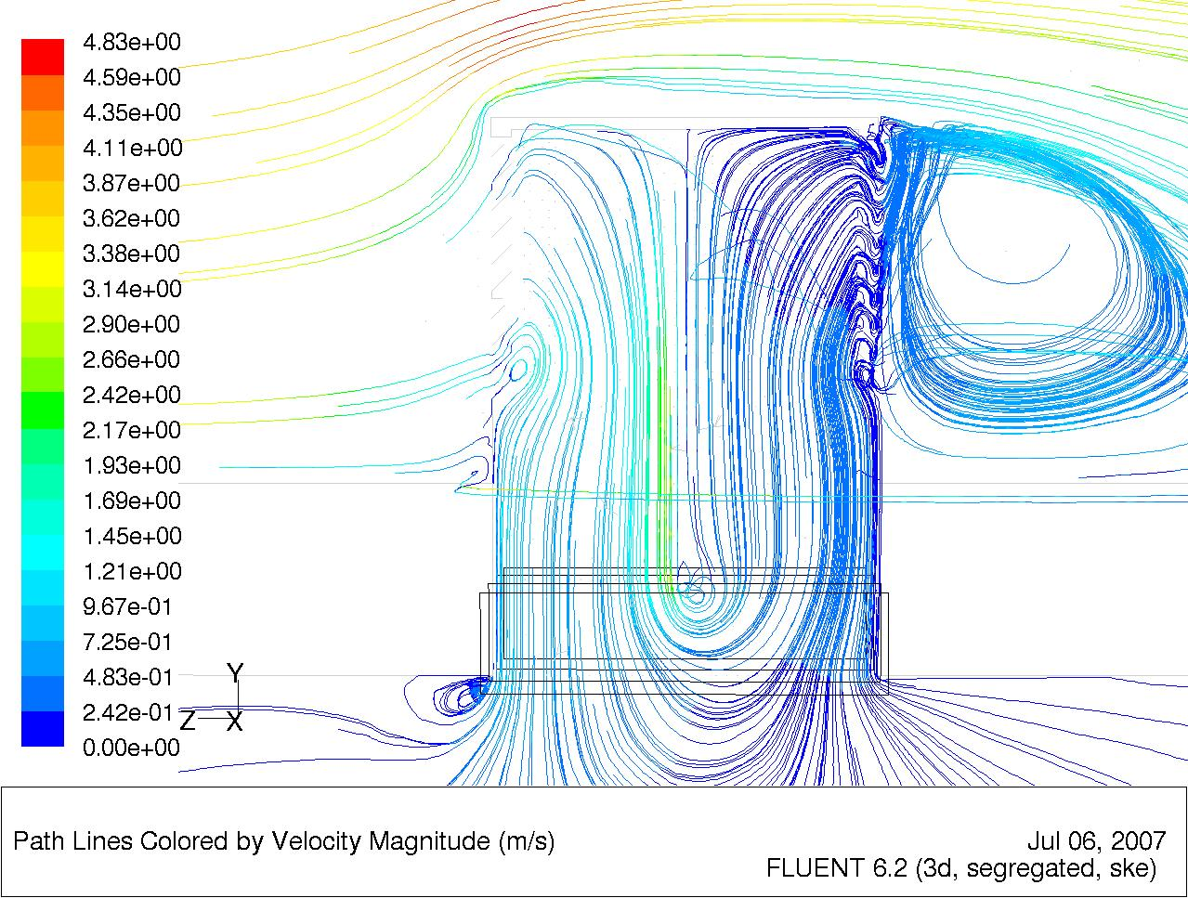
Figure 10 Windvent concurrent flow

Figure 10 is a close up view of the windvent air distribution with concurrent flow, and as can be seen much of the flow exits the vent without entering the micro climate, a phenomena known as short circuiting.
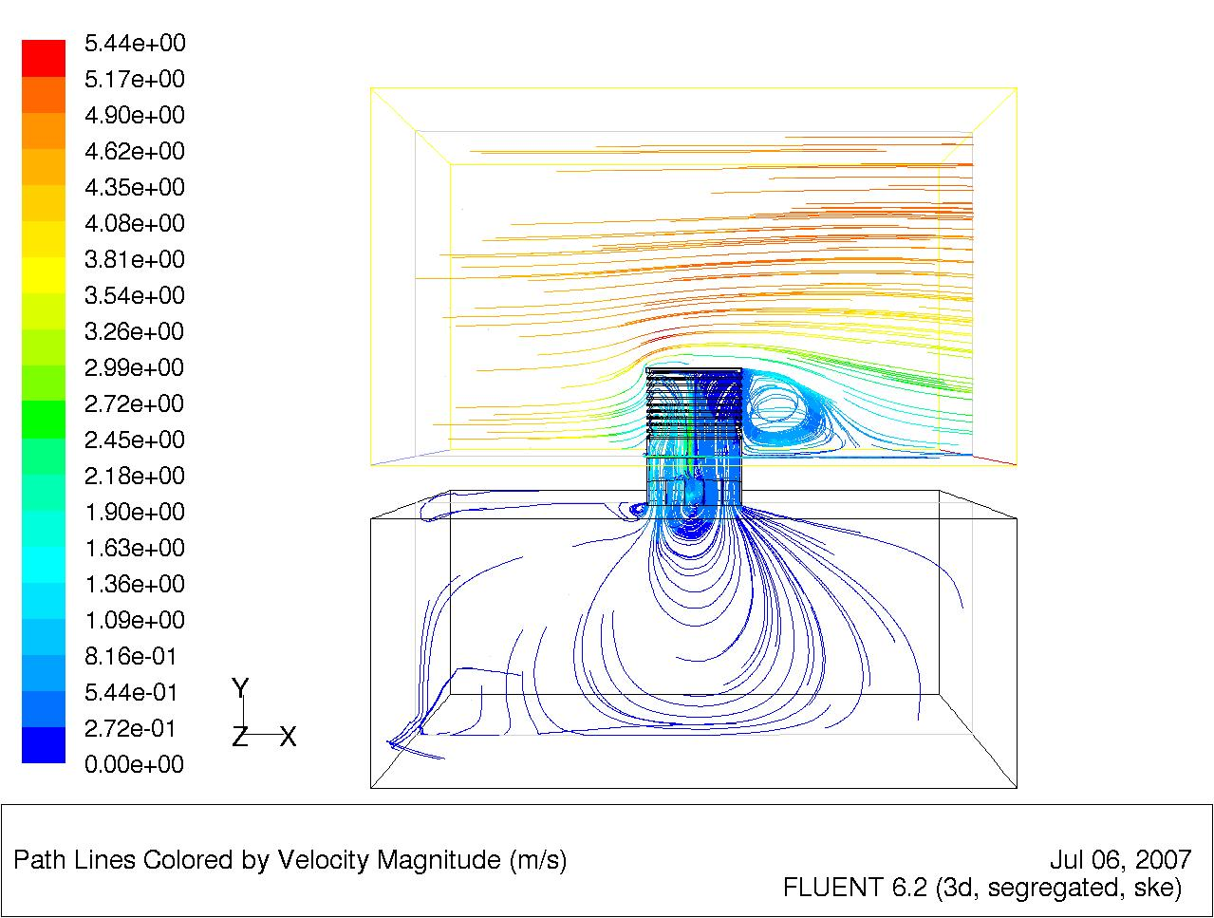
Figure 11 Fluent Flow Distribution
Figure 11 is similar to figure 8, as it shows both the geometry and a supplementary face. The flow in this model is counter current to the direction of the dampers.

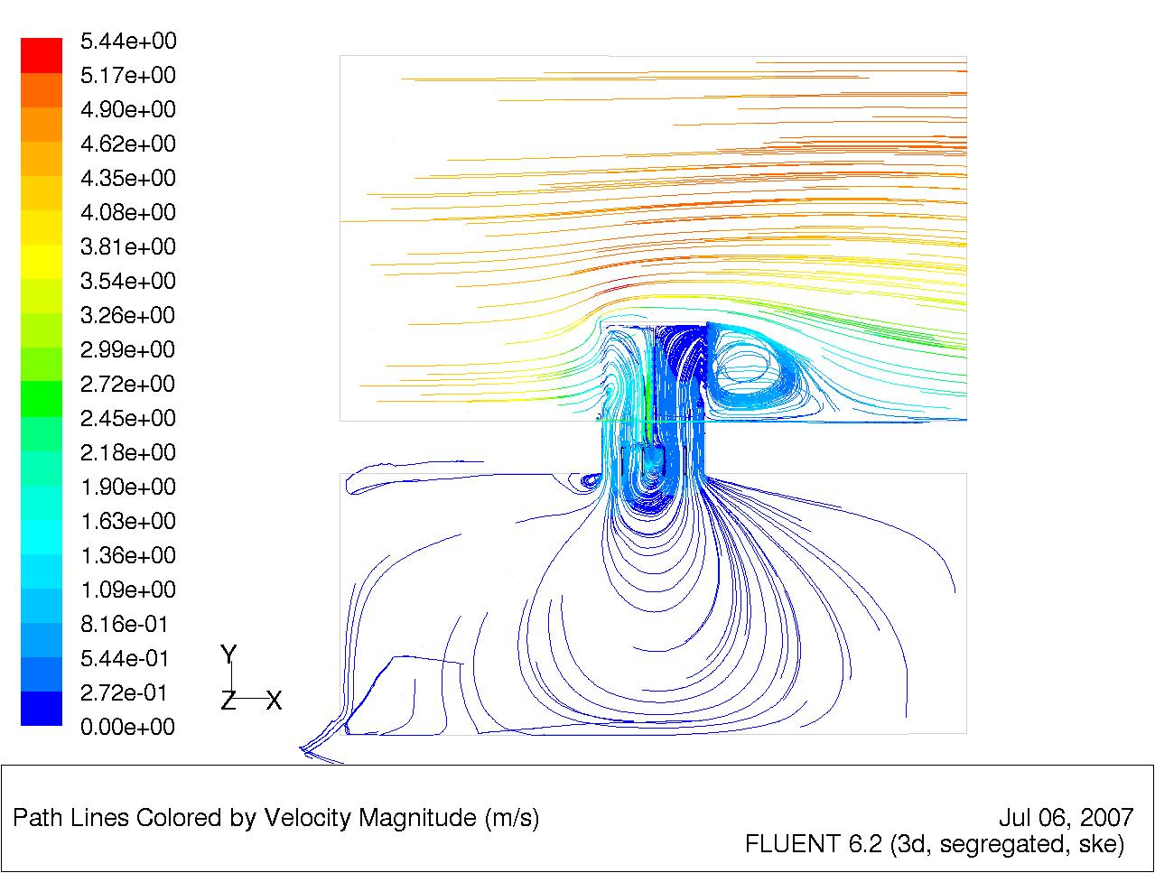
Figure 12 Supplementary Plan View
Figure 12 shows the flow on the supplementary plane, and as can be seen by the velocity scale on the left hand side of the picture an increased velocity range is experienced.

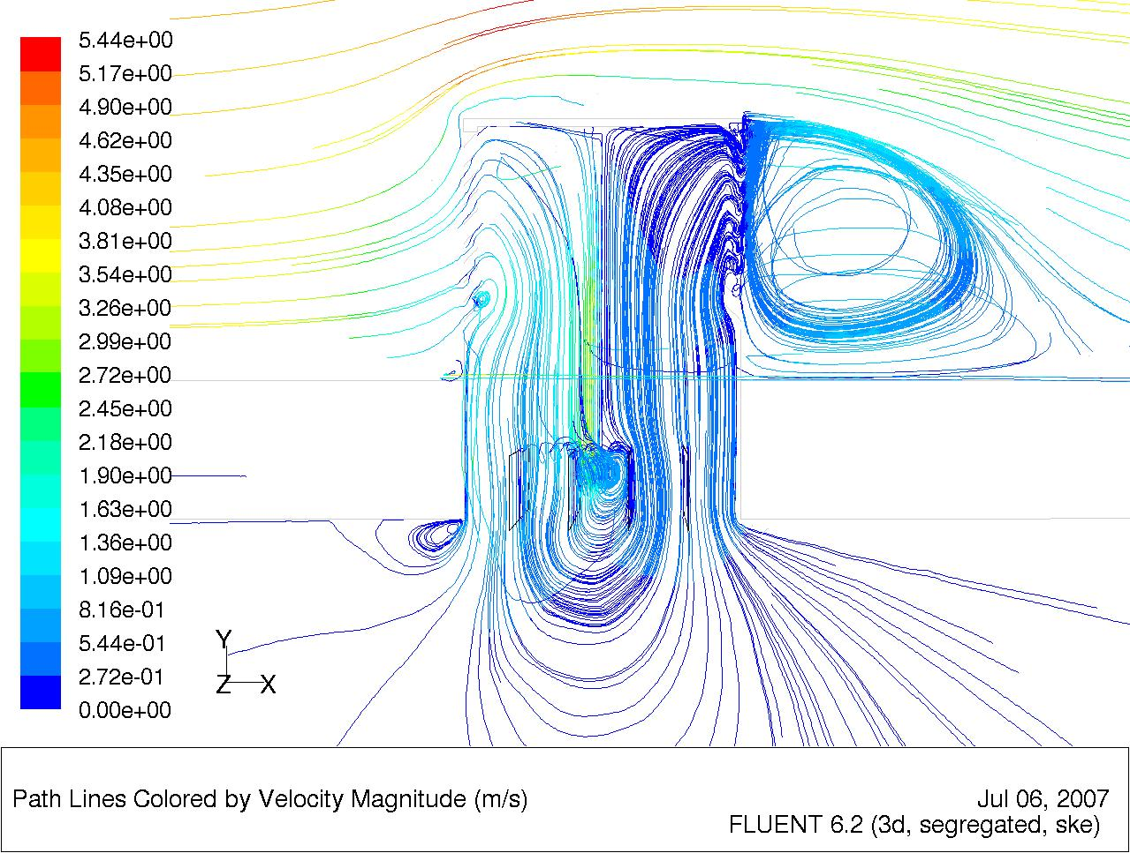
Figure 13 Windvent Counter flow
Figure 13 is a close up of the velocity distribution inside the windvent. Once again it is evident that the flow short circuits, however in comparison with figure 11 it is greatly reduced.

5.0 Results

For two different wind directions, concurrent and counter current with the geometrical dampers, the CFD model was run with wind speeds between 1 - 5 m/s, the results are presented below.

Figure 14 Improvement with Counter current Flow

L/s per m²
0
5
10
15
20
1
2
3
4
5
6
External Wind Velocity m/s
L/s per m²
Figure 15 Concurrent flow

L/s per m²
0
5
10
15
20
1
2
3
4
5
6
External Wind Velocity m/s
L/s per m²
Figure 16 Counter current Flow

L/s per Occupant
0
10
20
30
40
1
2
3
4
5
6
External Wind Velocity m/s
L/s per occupant
Figure 17 Concurrent Flow

L/s per Occupant
0
10
20
30
40
1
2
3
4
5
6
External Wind velocity m/s
L/s per occupant
Figure 18 Counter current Flow

Table 1 CFD Vs BS5952:1991 recommendations concurrent flow
External wind Velocity m/s | BS5952:1991 L/s per m² | CFD  L/s per m² | BS5952:1991  L/s per occupant | CFD  L/s per occupant
1 | 0.8 | 2.26 | 5 | 4.07
2 | 0.8 | 5.56 | 5 | 10
3 | 0.8 | 9.15 | 5 | 16.47
4 | 0.8 | 12.41 | 5 | 22.33
4.5 | 0.8 | 13.95 | 5 | 25.11
5 | 0.8 | 16.68 | 5 | 30.03

Table 2 CFD Vs BS5959:1991 recommendations counter current flow
External wind Velocity m/s | BS5952:1991 L/s per m² | CFD  L/s per m² | BS5952:1991  L/s per occupant | CFD  L/s per occupant
1 | 0.8 | 2.39 | 5 | 4.29
2 | 0.8 | 5.85 | 5 | 10.53
3 | 0.8 | 9.37 | 5 | 16.86
4 | 0.8 | 12.99 | 5 | 23.38
4.5 | 0.8 | 15.04 | 5 | 27.06
5 | 0.8 | 18.06 | 5 | 32.51

6.0 Discussion

The CFD models were run for varying wind speeds and two different wind directions, concurrent and counter current with the direction of the dampers. The wind direction was varied in order to establish the effect of the dampers on the flow, and whether they remove some of the short circuiting phenomena experienced with these devices.

The graph (Figure 14) shows that when the flow is counter current to the direction of the dampers a greater velocity is experienced through the diffuser, which indicates that some of the short circuiting has been removed by the dampers. On average the delivered performance improves by around 5% when compared to that of the current flow model. Full details of the flow comparisons can bee seen in tables 1 and 2.

The British standard BS5952:1991 [1], recommends a minimum 0.8 L/s per m² and therefore this is the minimum rate that must be achieved. As can be seen in the graphs (Figures 15, 16) the Windvent easily achieves the minimum figures regardless of the wind direction.

The recommended occupancy figures for a small classroom are 20 occupants [6], and as such the BS5952:1991 suggests a minimum rate of 5 L/s per occupant. The graphs (Figures 17, 18) show that at low external wind speeds of 1 m/s the device barely supplies the minimum rate, however this is easily surpassed as the external velocity increases. In order to comply with current recommendations, a supplementary ventilation device is required (active stack) for occasions of low external wind velocity, which may be more frequent in urbanised or well shaded locations.

The average external UK air velocity is approximately 4.5 m/s [2] depending on the geographical location, therefore it may be prudent to evaluate the devices performance in this condition. When evaluating the performance the higher velocities of the counter current flow are referred to, as in practice the dampers are non static, the flow will inevitably become counter current.

At external velocity of 4.5 m/s the device provides 15.1 L/s per m², this is 19 times the recommended minimum of 0.8 L/s per m². When using the occupancy levels stipulated as 20 for a small classroom [5], the device provides 27.1 L/s per occupant, which is 5.5 times the recommended minimum of 5 L/s per occupant.

The results show that the device consistently exceeds the recommended delivery rates, which may not always be beneficial for the occupants. Thermal comfort is a very subjective condition to assess, however it is clear that more often than not a degree of damping will be required for this device in order to effectively control the delivery rates into a controlled environment.

In addition to the high velocities, the results also indicate that the dampers when used counter current with the external wind flow, increase delivery rates and reduce the short circuiting experienced by users of the device.

As the dampers have been shown to have a significant effect on the delivery rates they require further investigation. This investigation will focus on the effect of varying the angle of the dampers compared to external velocity, and the amount of short circuiting created by such a change.

7.0 Conclusion

The Windvent was capable of providing the recommended fresh air rates at relatively low external wind velocities. These results therefore show that even in urbanised or well shaded applications the device is a viable alternative to mechanical ventilation.

The added facility of dampers removes some of the short circuiting currently experienced, and is vital to control the delivery rates when high external winds prevail. The rate of delivery directly affects the occupant's perceived thermal comfort, and as such these results must be taken in the context in which they are intended.

These results are intended to illustrate the devices ability to achieve the British Standards minimum fresh air supply rates, and not to assess the thermal comfort of the occupants. The thermal comfort may be examined in further works, to take into account the overall energy balance of the room and the windvents contribution to this.

The CFD results show good correlation, and the grid adaption technique is a well recognised practice for achieving reliable results with the chosen software. Previous works have illustrated the potential of the software for this application, however to verify the results experimental testing will take place and the results shared in future publications.

Acknowledgements

The authors would like to acknowledge the support of EPSRC, and MidTherm, Naturally Driven Ltd in carrying out this investigation.

References

1. British Standards(1991). Ventilation principles and designing for natural ventilation. BS5925:1991.
2. CLOVER, C. (2007). Buildings will have to display energy rating. Telegraph, News. United Kingdom.
3. BUILDING AND BUILDINGS, ENGLAND AND WALES (2007). The Energy Performance of Buildings (Certificates and Inspections). England and Wales regulations 2007. 991
4. SANTAMOURIS, M. (2002). Natural ventilation in buildings A design handbook. United Kingdom, Cromwell Press.
5. Department for Education and Skills Briefing framework for secondary school projects. Building Bulletin 98. United Kingdom.

6. Liddament, M.W.(1996). "A Guide to Energy Efficient Ventilation". Air Infiltration and ventilation Centre, United Kingdom.
7. FATHY, H. (1986). Natural energy and vernacular architecture, principles and examples with reference to hot arid climates. London, University of Chicago press.

8. Afshar Farroukh, Allan Cain, John Norton, and M. R. Dardie. Oman: Problems and Potentials of Indigenous Building. Development Workshop Report. London: Architectural Association School of Architecture, 1974.
9. DRORI, U. and ZISKIND, G. (2004). Induced ventilation of a one-story real-size building. Energy and buildings, 36 881-890.
10. PRIYADARSINI, R., CHEONG, K. W. and WONG, N. H. (2004). Enhancement of natural ventilation in high-rise residential buildings using stack system. Energy and buildings, 36 61-71.
11. ELMUALIM, Abbas A. a. e. a. u. Dynamic modelling of a wind catcher/tower turret for natural ventilation. Building Services Engineering Research and Technology. Vol. 27, 3 pp 165-182.
12. ELMUALIM, Abbas A. (2006/8). Effect of damper and heat source on wind catcher natural ventilation performance. Energy and buildings, 38 (8), 939-948.
13. FLUENT. Fluent user manual 6.2. Fluent Incorporated.
14. CHUNG, T. J. (2002). Computational fluid dynamics. Cambridge, University press.

