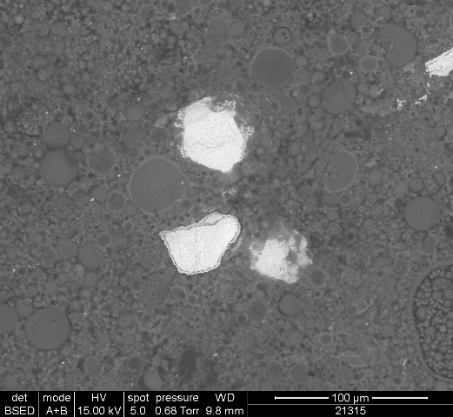
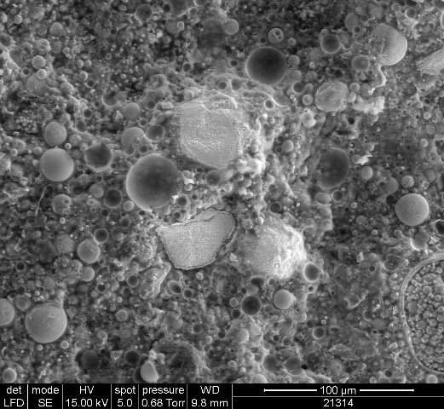

Figure 4: SEM secondary (left) and backscattered (right) electron image micrographs of fractured surface of PFA:OPC leached at 90ºC

