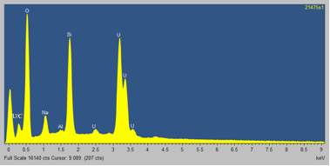
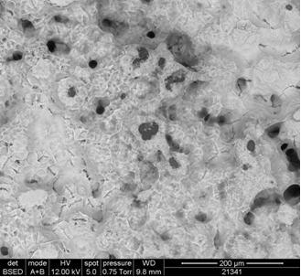
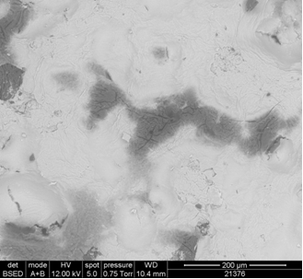
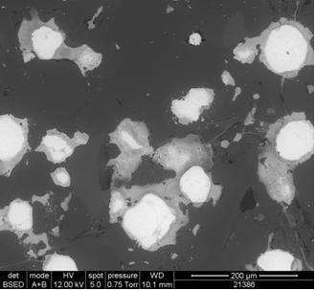
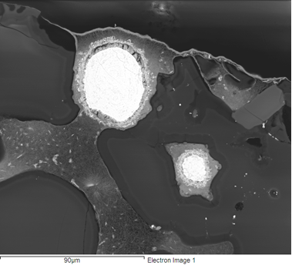
a)
b)
c)
d)
e)
Na-U-Si-O
UO₃
MWAZ
MWAZ
Void
Na-U-Si-O
UO₃
Figure 1: SEM backscattered electron images of 28 day leached 50:50 UO₃:MWAZ (550°C glass melting temperature); a) top surface, b) cut surface, c) mounted cross-section, d) mounted cross-section at edge of sample and e) EDX trace representative of the white phase on the sample surface and of the alteration phase surrounding the UO₃ particles.

