Particle Number Emissions from a Light-Duty Diesel Engine with Biodiesel Fuels under Transient-State Operating Conditions
Pi-qiang TAN^{a,}*, Shuai-shuai RUANª, Zhi-yuan HUª, Di-ming LOUª, Hu LI^{b}
(ª School of Automobile, Tongji University, Shanghai 201804, China)
(^{b} Energy Research Institute, University of Leeds, Leeds, LS2 9JT, UK)

*Corresponding author phone: +8621 69589981; fax: +8621 69589981; e-mail: tanpq@hotmail.com
Abstract: Exhaust particle numbers from a light-duty vehicle diesel engine for transient-state operating conditions were studied. The test fuels were petroleum diesel, pure Jatropha biodiesel (B100), 20% and 50% biodiesel blends with diesel fuel (B20 and B50). The results show that the number of accumulation-mode particles decreases with the biodiesel blend ratio, but the number of nucleation-mode particles increases. The accumulation-mode particle size at peak value decreases with increasing biodiesel blend ratio. The total particle number concentration increases with the biodiesel blend ratio, and the total particle numbers for B20, B50 and B100 biodiesel fuels are approximately 3 times to 4 times that of pure diesel, with the nucleation-mode particle concentration dominating the total particle number. The number of nucleation-mode particles increases when using petroleum diesel during transient operating conditions (increasing torque at constant speeds). The mass of the accumulation-mode particles of the engine with the four kinds of fuels are larger than the nucleation-mode particles under the six operating conditions. The number of accumulation-mode particles increases at the initial stage of transient process and then decreases with increasing torque. The total particle number increases steadily with torque during transient operating conditions, and the accumulation-mode particles dominate the total particle number in the beginning, while nucleation-mode particles dominate the latter stages of transient operating conditions. The change characteristics in particle number during the transient process for lower biodiesel blends are similar to those of petroleum diesel, whereas higher biodiesel blends show distinct differences, and the total particle number and nucleation-mode particle number for B50 and B100 fuels are obviously larger from beginning to end than those for pure diesel, while the accumulation-mode particle number remains smaller. For B100 fuel, the nucleation-mode particle number increases rapidly until the end of the transient process, and the accumulation-mode particle number decreases steadily.
Keywords: Biodiesel, Diesel engine, Emission, Particle number, Transient-state operation condition

1. Introduction
Particulate matter (PM) emissions in the exhaust from diesel engines consists primarily of agglomerated soot particles, soluble organic fractions (SOF), lesser amounts of sulfate compounds, and other species [1-3]. There are two main typical PM modes in the exhaust from diesel engines: nucleation and accumulation modes [4-6]. Nucleation-mode particles typically range in diameter from 3 to 30 nm and consist of SOF and sulfate, and are formed during exhaust gas dilution and cooling. Nucleation-mode particles typically make up less than a few percent of the particle mass and a large percentage of the particle number. The accumulation-mode particles range in size from approximately 30 to 1000 nm. Most of the particles making up the emissions mass, primarily agglomerated soot and adsorbed materials, are in this size range. Toxicity increases with decreasing particle size, and very small particles exhibit high deposition efficiency in the respiratory tract. Ultrafine particles, less than 100 nm in size, especially nucleation-mode particles, are detrimental to human health [7,8]. These nucleation-mode particles have less mass, but dominate the total particle number, and do more harm.
Current PM emission legislations in the European Union, USA, Japan and China, are primarily based on the PM mass. Recently, particle number and size distribution is gain increasing attention, because the toxicity increases as the particle size decreases and number increases. Therefore, in addition to PM mass, the particle number emission limit is gradually introduced in diesel emission regulations for new engines or vehicles in the world. Currently, the European Union has added particle number limits to its Euro 5b emission standards for light-duty vehicles from September 2011, and Euro 6 emission standards for heavy-duty diesel engines from January 2013 [9]. Low emission vehicle III (LEV III) standards California regulations, which will be phased-in through model years 2015-2025, also add the limit for the particle number emission for cars and light-duty trucks.
There is an increasing amount of recent research about particle number emission from diesel engines, and these researches are mostly based on steady-state operating conditions [10-12]. However, transient-state operating conditions of diesel engines are dominating in actual daily vehicle driving conditions, and only a very small portion of vehicle driving conditions is in true steady-state mode. Transient operations are shorter in duration, and the supply rate of fuel and air varies with engine condition. The air-fuel ratio, thermodynamic state parameters, and many parameters of transient conditions are not in ideal states, and transient-condition combustion and emission characteristics are quite different from those of steady-state conditions [13-15].
Thereby, the motivation is aroused to investigate particle number emitted by diesel engines under transient operating conditions. Most of these studies focus on transient test cycle under emission regulations, such as New European Driving Cycle (NEDC) for cars and light-duty trucks or European Transient Cycle (ETC) for heavy-duty diesel engines in the European Union, US Federal Test Procedure (FTP) transient cycle, or engine starting conditions [16-19]. These transient cycles usually include a large amount of different transient conditions, and these transient conditions change very quickly (such as transient conditions at the ETC cycle changes one conditions per second), and the phenomenon and regularity of combustion and emissions of diesel engines during these transient conditions are difficult to recognize. So, a controllable or given transient condition, such as increasing torque at constant speeds, or increasing speed at constant torques, will be very helpful for the researchers to understand the detailed phenomenon and regularity in the transient conditions. Currently, studies about these controllable transient conditions of diesel engines are very seldom reported.
Biodiesel, as an alternative fuel for internal combustion engines, is attracting increasing attention worldwide, and is defined as a mixture of fatty acid methyl or ethyl esters derived from a renewable lipid feedstock, such as vegetable oil or animal fat, and can be used pure or in blends with petroleum diesel fuel [20-22]. Biodiesel has many advantages over conventional diesel fuel, and it can reduce exhaust PM mass [23-26]. Many studies have shown that conventional diesel engines generally do not require any modifications to use low-blend-ratio biodiesel. Even high-blend-ratio biodiesel can be used in many diesel engines with little or no modification [27-30]. As far as the authors are concerned, considerable studies are focused on steady-state particle number emissions from engines with biodiesel, or particle number under NEDC, ETC or FTP transient cycles, but very few study has ever been performed on particle number emissions from engines at controllable transient conditions [13].
The target of the current work is to expand past research on transient conditions of diesel engines with biodiesel, especially particle number emissions at controllable transient conditions. Study on particle number from diesel engines with diesel-biodiesel blends and B100 at controllable transient conditions, such as increasing torque at constant speeds, were performed in this study.

2. Experimental Section
2.1. Test Engine. The engine used in this study was a light-duty, direct injection, four-cylinder, four-stroke, turbocharged and intercooled diesel engine with a high-pressure common-rail fuel system. The common-rail fuel injection system was from Bosch, and has a high-pressure (over 1300 bar) fuel rail. It has a 3.3-L displacement with a rated power output of 79 kW at 3200 rpm and a peak torque output of 275 N∙m at 2000 rpm.
2.2. Fuel Properties. The biodiesel fuel used in this study was obtained and converted from Jatropha seed in China. First, the Jatropha oil was obtained from Jatropha seeds. Then, the biodiesel was produced through a chemical process called transesterification, whereby glycerin is separated from the Jatropha oil. The process leaves behind two products: Jatropha oil methyl ester (the chemical name for biodiesel,) and glycerin (a valuable byproduct usually sold to be used in soaps and other products). The base diesel fuel is the common petroleum diesel fuel used in China. Important physical and chemical properties of the petroleum diesel and biodiesel fuels are listed in Table 1. This biodiesel has a higher cetane number, density, and flash point and lower sulfur content than petroleum diesel and contains no aromatics. Biodiesel contains no petroleum, but it can be blended at any level with petroleum diesel to create a biodiesel blend. To better understand the effects of the biodiesel blend ratio on the transient particle emissions of diesel engines, four types of fuels, including the standard on-road petroleum diesel fuel used in China, 20%, and 50% v/v biodiesel blends with diesel fuel, and pure biodiesel fuel (B0, B20, B50 and B100 fuels) were tested in this study. The physical and chemical properties of B20 and B50 fuels are also given in the Table 1.
2.3. Test Equipment. The test engine was coupled with an electric dynamometer, and a PUMA transient test bed automation system by AVL was used to run and control the test engine. Different transient engine conditions could be achieved using the PUMA automation system. The measurement of fuel consumption is done by the AVL 735S dynamic fuel meter, and air mass flow consumption is measured by the ABB Sensyflow P mass flow meter for air.
Particle number and size distribution in the engine exhaust were measured using an Engine Exhaust Particle Sizer (EEPS) by TSI, Inc. The EEPS is based on the development of the electric aerosol spectrometer and measures particle sizes from 5.6 to 560 nm, with a sizing resolution of 32 channels. The EEPS measures particle sizes rapidly and obtains particle size distributions at a frequency of 10 Hz, making it an ideal instrument for measuring engine particle number and size distribution during transient engine conditions.
Raw exhaust from the engine was sampled and diluted before entering the EEPS. A rotating-disk thermo-diluter was used for sampling, diluting and conditioning exhaust particles from diesel engines. It features an exhaust probe and a separate control unit that effectively dilutes and thermally conditions the sample at the tailpipe to preserve it for accurate measurement. The dilution ratio can be adjusted from 15:1 to 3000:1. The thermo-diluter works with the EEPS, and a total dilution ratio used of 500:1 and two-stage dilutions were used in this study. The primary dilution ratio of the exhaust gas sample as controlled by the rotating disk thermo-diluter was 200:1. Secondary dilution was achieved using an air-flow controller, which compensates the inlet flow for the EEPS and dilutes the exhaust gas at a dilution ratio of 2.5:1. The particles greater than 1 µm in diameter were wiped off when the exhaust gas flowed through a filter, and the filter gas was collected in the equipment.
2.4. Experimental Procedure. Engine tests were performed without any modification to the engine fuel and air supply systems. The fuels were tested in the following sequence: diesel (B0), B20, B50 and B100 fuels. Under actual vehicle engine operating conditions, sharp load changes at constant speeds are one of the typical transient operating modes. Three typical operating conditions, i.e., torque from 28 N·m to 206 N·m at three constant speeds, 2000 rpm (the speed at maximum torque), 2600 rpm, and 3200 rpm (the rated speed), were examined in this study. The three transient operating conditions are shown in Fig.1 and are named the A, B and C operating conditions. A transient process time of 10 seconds was set for the A, B and C operating conditions respectively. The A, B and C conditions were examined for each of the four types of fuels.
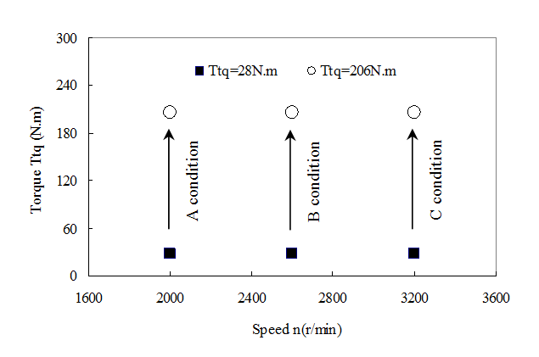
Fig. 1 Three transient operating conditions of the test engine
A complete transient-operating-condition test was defined as requiring 60 seconds total to complete and being divided into three stages in the following sequence: an initial stage of steady-state operating conditions, a middle stage of transient-state operating conditions and a last stage of steady-state operating conditions).
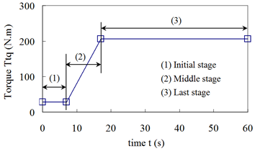
Fig.2 Experimental procedure for the A operating-condition
The details of the procedure for the A transient operating condition are given in Fig.2, and the process are as follows: (1) An initial stage of steady-state operating conditions, during which the engine is kept running at initial steady-state operating conditions (a torque of 28 N·m and a speed of 2000 rpm) from the 1st second to the 7th second. (2) A middle stage of transient-state operating conditions, during which the torque is increased from 28 N·m to 206 N·m, starting from the 7th second and continuing for 10 seconds. (3) A last stage of steady-state operating conditions, during which the engine gradually attains steady-state operating conditions (at a torque of 206 N·m and a speed of 2000 rpm), and is kept running until the end of the 60th second. Over the 60 seconds, the relevant data on diesel engine performance are recorded in real time by the PUMA automation system, and the exhaust particle number and size distributions are recorded by the EEPS.

3. Results and Discussion
3.1. Particle Emissions under Steady-State Operating Conditions
To better understand particle emissions under transient operating conditions, exhaust particle number, surface area, mass and their size distributions of the diesel engine under steady-state operating conditions should be studied at first. Six steady-state operating conditions (the torque of 28 N·m and 206 N·m at the speed of 2000, 2600 and 3200 rpm, respectively) preceding and following the A, B and C transient operating condition were selected. The particle number size distributions of these fuels at the engine operating conditions were obtained and showed good reproducibility. The results are shown in Fig.3. For all these test fuels with different biodiesel blend ratios, the particle number sizes exhibited unimodal or bimodal log-normal distributions, the nucleation-mode particles were typically less than 30 nm in diameter, and the accumulation-mode particles were greater than 30 nm in diameter.
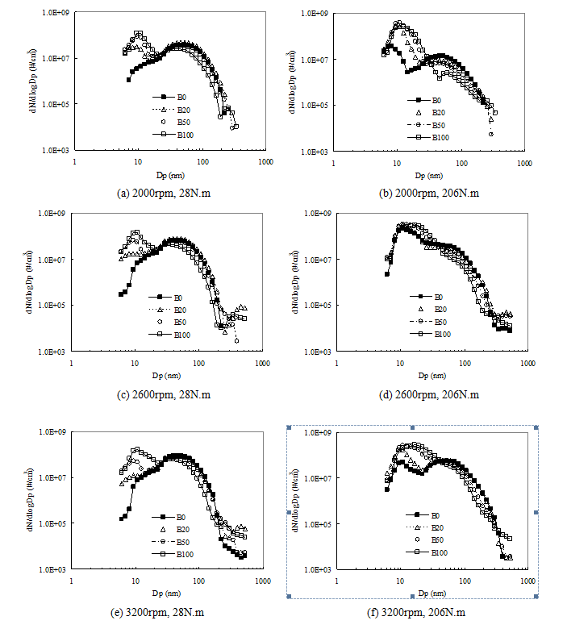
Fig. 3 Particle number size distributions of the diesel engines under six steady-state conditions
(1) Size-number distribution of the particles
Accumulation-mode particles: Most of the particle mass, primarily soot agglomerates and adsorbed materials, falls in this category. The number of accumulation-mode particles greater than 30 nm in diameter decreases with increasing biodiesel blend ratio at the engine operating condition. The oxygen content of biodiesel molecules improves combustion in fuel-rich diffusion-flame regions of the combustion chamber, and promotes the oxidation of the already formed soot. In addition, the lack of aromatic hydrocarbons in biodiesel fuel also reduces soot precursors. All this could lead to a decrease in production of accumulation-mode particles consisting mainly of soot agglomerates. The peak size of accumulation-mode particles size decreases from 61 nm to 39 nm as the biodiesel blend ratio increases. The oxygen content of biodiesel fuel causes particles to change from larger to smaller sizes, and free aromatic hydrocarbons in biodiesel fuel lessen soot formation, and the two factors combine to yield the observed results.
Nucleation-mode particles: Nucleation-mode particles typically consist of SOF, sulfate, metallic compounds, and ultrafine carbonaceous compounds. The number of nucleation-mode particles below 30 nm increases with the increasing biodiesel blend ratio at the engine operating condition. Very low biodiesel fuel sulfur content could contribute to reducing the number of nuclei-mode particles, so nuclei-mode particles consisting of sulfate do not have a dominant effect in this study. There are three main possible reasons for this. First, biodiesel fuel reduces the number of accumulation-mode particles. As a result, fewer solid soot surfaces are created, SOF condensation and adsorption on soot particles are weakened, and high super-saturation may lead to the formation of new particles by nucleation, leading to the probable creation of many more nucleation-mode particles. Second, the increased viscosity and lower volatility of biodiesel could result in evaporation and air mixing in the area of the combustion chamber being slower and poorer, in comparison with evaporation and air mixing with pure diesel fuel. This may result in an increase in SOF and may lead to the number of nucleation-mode particles increasing because these particles consist mainly of SOF. Third, the oxygen content of biodiesel fuel causes carbonaceous particles to change from fine size to ultrafine size or nano-particle size, which also results in an increase in the number of nucleation-mode particles.
Another phenomenon is that the nucleation-mode particle size at peak value increases from 6 nm to 11 nm with increasing biodiesel blend ratio. An increase in the amount of biodiesel fuel injected in the combustion chamber and a decrease in the number of accumulation-mode particles promote more coagulation of independent liquid nano-particles and more adsorption of unburned hydrocarbon on ultrafine or carbonaceous nano-particles, resulting in an increase in nucleation-mode particle size at peak value with increasing biodiesel blend ratio.
(2) Size-surface area distribution of the particles
The particle surface area size distributions of the diesel engine at the six operating conditions were obtained and given in Fig.4.
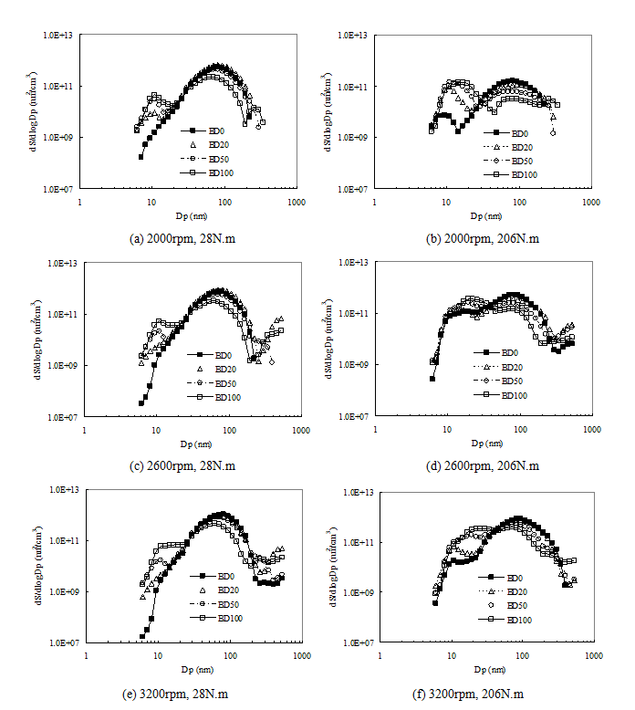
Fig. 4 Particle surface area size distributions of the diesel engines under six steady-state conditions
The possible toxicity trends of the particle are relative to particle surface area. The size-surface area distributions of the particle at the six conditions are distinctly different. At the torque of 28 N·m at the speed of 2000, 2600 and 3200 rpm, the surface area of the accumulation-mode particles of the engine with the four kinds of fuels are larger than the nucleation-mode particles. At the torque of 206 N·m at the speed of 2000, 2600 and 3200 rpm, the surface area of the accumulation-mode particles of the engine with the pure diesel fuel is larger than the nucleation-mode particles, but the B20, B50 and B100 fuel show different results, and surface areas of the accumulation-mode particles of the engine are near to the nucleation-mode particles.
(3) Size-mass distribution of the particles
In addition, the particle mass size distributions were obtained and given in Fig.5. The mass-size distribution of the particles can be obtained by multiplying the corresponding particle volume and particle apparent density. Compared to the size-number distribution, the size-mass distribution is quiet distinct. The mass of the accumulation-mode particles of the engine with the four kinds of fuels are larger than the nucleation-mode particles under the six operating conditions, and the phenomenon is more clear at the torque of 28 N·m at the speed of 2000, 2600 and 3200 rpm.
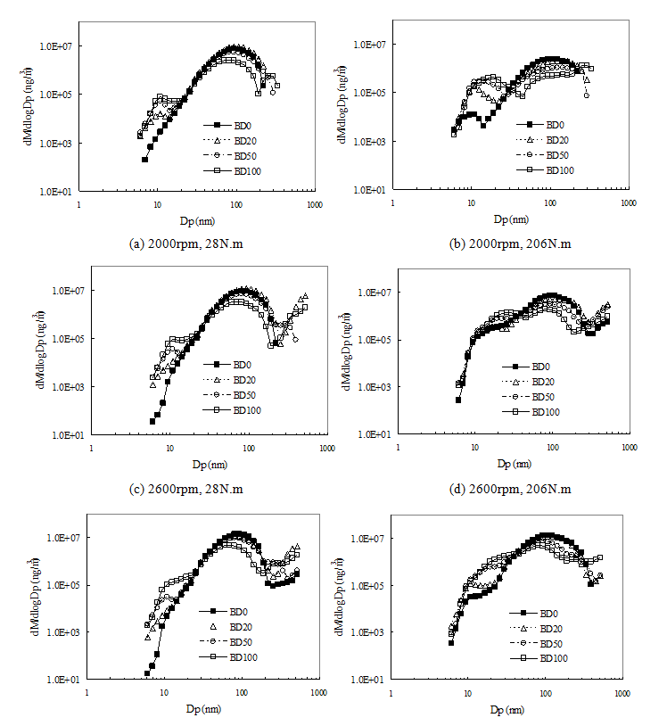
Fig. 5 Particle volume size distributions of the diesel engines under six steady-state conditions
3.2. Particle Number Emissions under Transient-State Operating Conditions
The exhaust particle numbers associated with transient processes are given in Fig.6 to Fig.8.
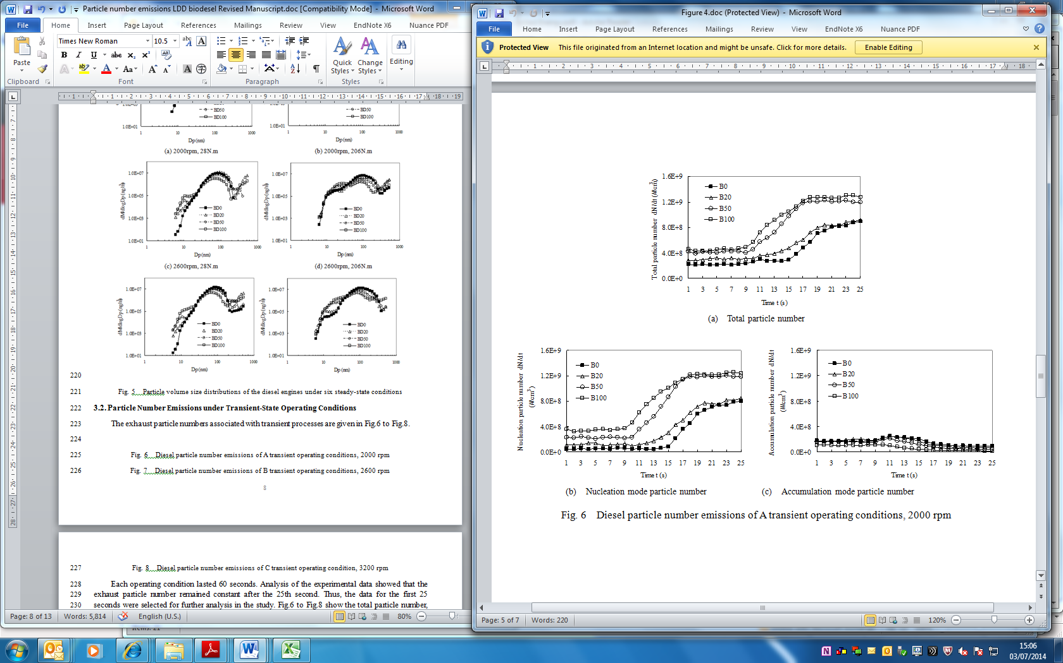
Fig. 6 Diesel particle number emissions of A transient operating conditions, 2000 rpm

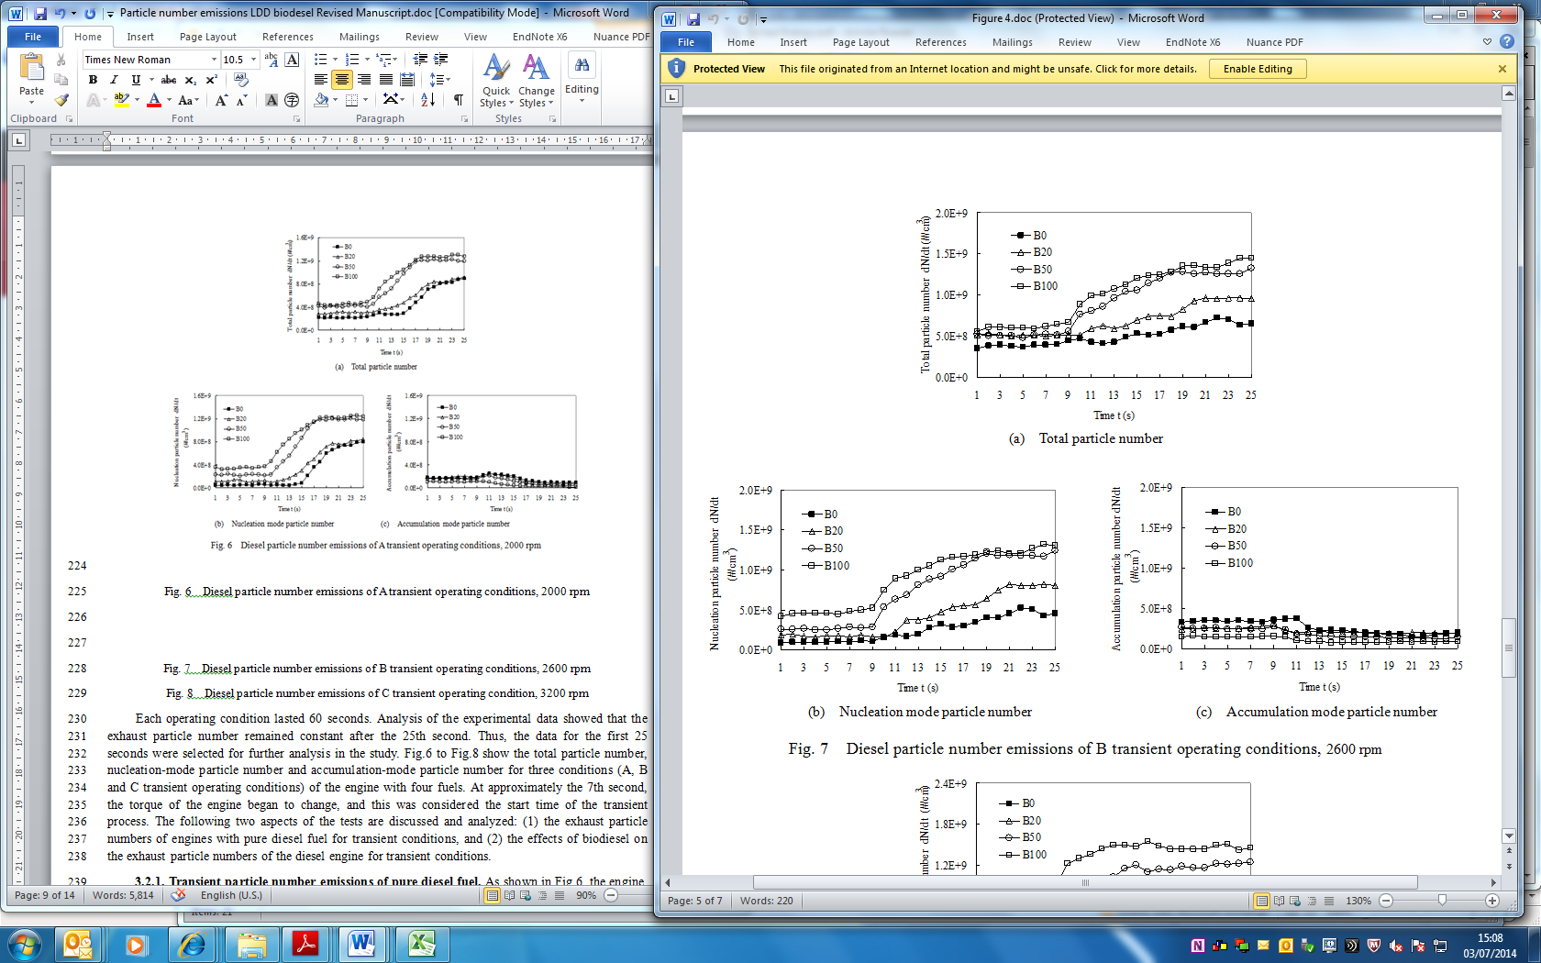
Fig. 7 Diesel particle number emissions of B transient operating conditions, 2600 rpm

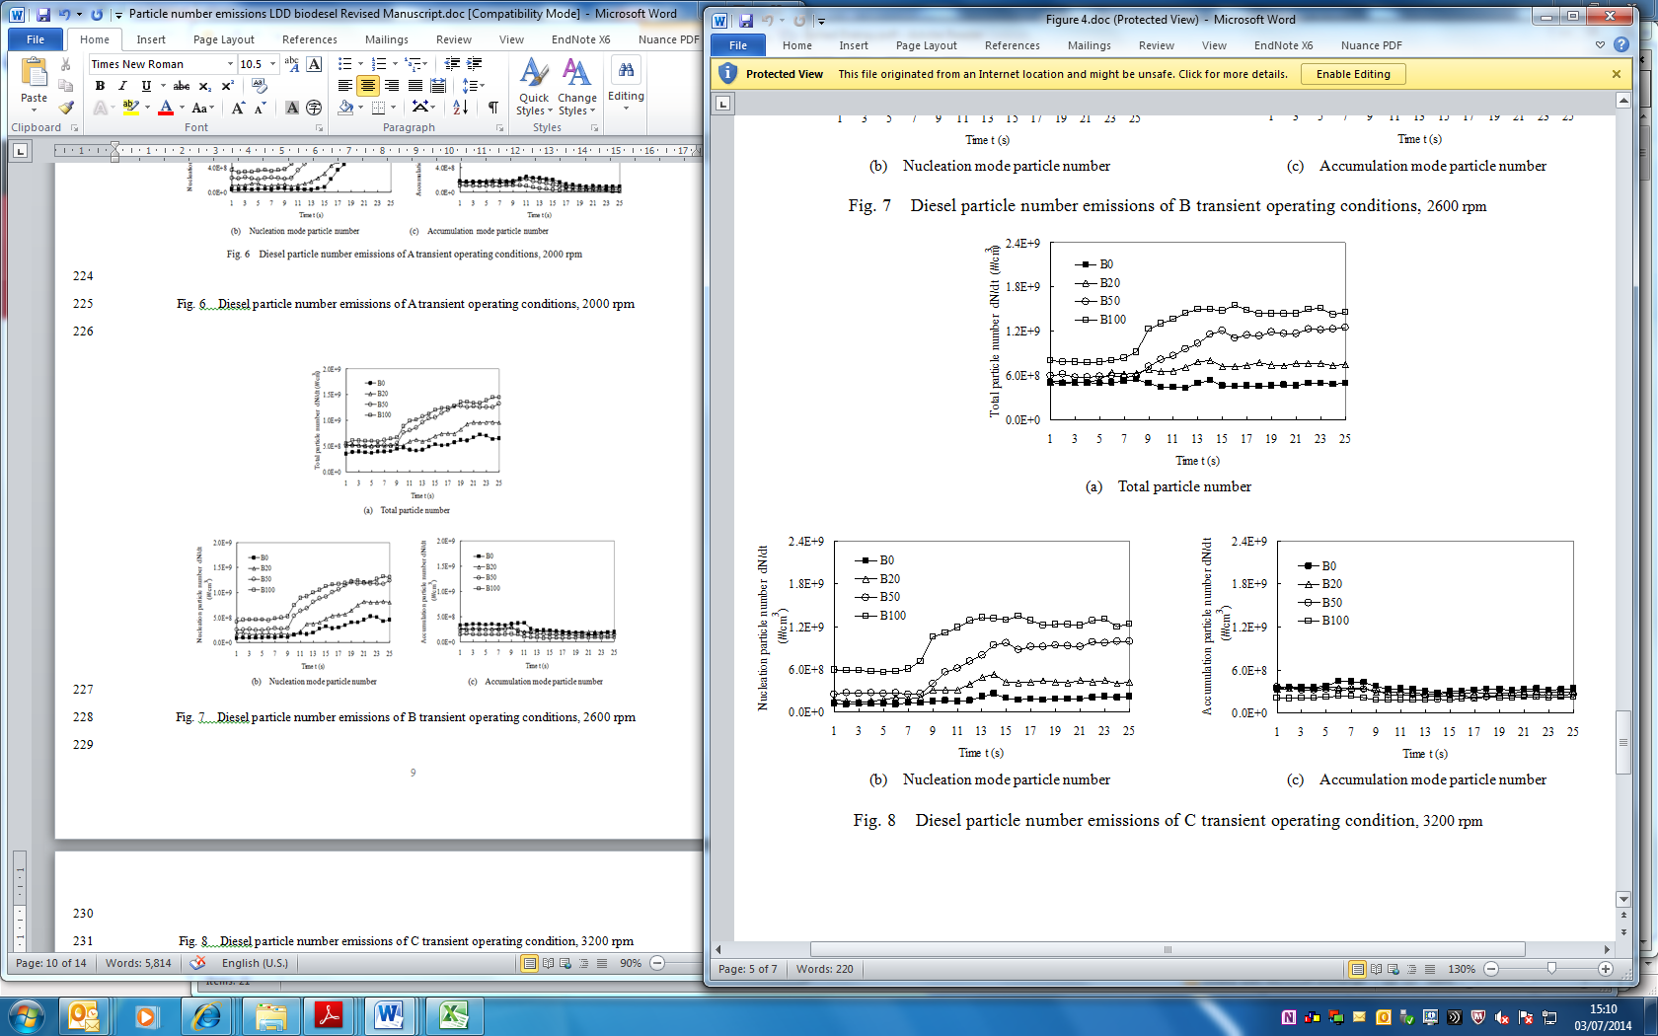
Fig. 8 Diesel particle number emissions of C transient operating condition, 3200 rpm
Each operating condition lasted 60 seconds. Analysis of the experimental data showed that the exhaust particle number remained constant after the 25th second. Thus, the data for the first 25 seconds were selected for further analysis in the study. Fig.6 to Fig.8 show the total particle number, nucleation-mode particle number and accumulation-mode particle number for three conditions (A, B and C transient operating conditions) of the engine with four fuels. At approximately the 7th second, the torque of the engine began to change, and this was considered the start time of the transient process. The following two aspects of the tests are discussed and analyzed: (1) the exhaust particle numbers of engines with pure diesel fuel for transient conditions, and (2) the effects of biodiesel on the exhaust particle numbers of the diesel engine for transient conditions.
3.2.1. Transient particle number emissions of pure diesel fuel. As shown in Fig.6, the engine was at a steady state during the first 7 seconds of the A operating condition (2000 rpm). During the first 7 seconds, the parameters, which include the total particle number, nucleation-mode particle number and accumulation-mode particle number, change very little. During the subsequent transient process, the parameters did not change instantly after the 7th second. In fact, they are a little delaying response because of the sampling equipment of the dilution system. Though the EEPS has a rapid measuring speed, the response of the whole system is still a little delayed.
Fig.6 shows that the trend of total particle number and nucleation-mode particle number for pure diesel fuel increases slowly at first and then increases more rapidly. The accumulation-mode particle number increases first and then steadily decreases. The nucleation-mode particle number dominates the trend in total particle number variation. As the experiment continues, the total particle number, nucleation-mode particle number and accumulation-mode particle number gradually tend toward a steady state. The particle number emissions of the engine for the A operating condition are discussed in detail as follows.
(1) Accumulation-mode particle number. The transient process features a sharp torque increase at a constant engine speed. During the initial period after the 7th second, the amount of fuel injected into the cylinder was increased, but the intake air supply was delayed due to the behavior of the exhaust turbocharging system. As a result, the transient in-cylinder air–fuel ratio is decreased, resulting in a local lack of oxygen and poor combustion. Then, the soot emissions increase and the accumulation-mode particle number, of which soot accounts for a large percentage, increases. As the torque increases further, the exhaust energy is added, the air supply delay of the turbocharging system is improved, the combustion improves, and soot emission decreases, leading to a reduction in the accumulation-mode particle number.
(2) Nucleation-mode particle number. In the initial period after the 7th second, the nucleation-mode particle number did not change noticeably. As the torque increases further, the added amount of fuel injected leads to more heavy unburned HC emissions, which promote the formation of nucleation-mode particles. During the transient process, the nucleation-mode particle number is far higher than the accumulation-mode particle number.
(3) Total particle number. The total particle number is the sum of the numbers of nucleation-mode and accumulation-mode particles. During the initial period of increasing torque under the A operating condition, the accumulation-mode emissions contribute more to the total emissions, while later, nucleation-mode particles make up a larger percentage and dominate the total particle number.
As Fig.7 shows, the accumulation-mode particle number of the engine with pure diesel fuel under the B transient operating condition (2600 rpm) also increases initially and then decreases, for the same reasons as for the A operating condition (2000 rpm).
The nucleation-mode particle number also increases, but not as much as for the A. Because of the greater number of work cycles per unit time for the operating condition B (2600 rpm) than for the operating condition A (2000 rpm), the transient time is shorter. The total particle number increases under the B operating condition. As with the A operating condition, the accumulation-mode number makes up a large portion of total particle number in the early stage of the B operating condition, but the nucleation-mode particles contribute more in the later stages.
As Fig.8 shows, the total exhaust particle number of the engine with pure diesel fuel under the C operating condition (3200 rpm) declined slightly. The accumulation-mode particle number increases initially and then decreases, and there is no dramatic change for the duration of the transient condition. These results show that the response delay of the turbocharging system is shorter and that a steady state is reached more rapidly at higher engine speeds. The nucleation-mode particles increase in number with little fluctuation because the engine work cycles per unit time are even greater at a speed of 3200 rpm, and the transient time is even shorter. The temperature in the cylinder is high at high speeds and high loads, so the heavy unburned HC emissions are relatively fewer. The combined result of the above two phenomena is that the formation of nucleation-mode particles is suppressed.
3.2.2. Effects of biodiesel on transient particle number emissions. Particle number emissions for B20, B50 and B100 fuels are different from those for pure diesel fuel (see Fig.6 to Fig.8). Compared to B100 or blended biodiesel fuels, the total particle number for pure diesel remains the smallest during the A transient process. The total particle number and nucleation mode particle number for B20 fuel are slightly higher than those for diesel fuel, while the accumulation-mode particle number is slightly smaller. The dynamic characteristics of the total particle number, nucleation-mode particle number, and accumulation-mode particle number for B20 fuel are similar to those for pure diesel fuel. The total particle number emissions for B50 fuel are apparently higher than those for B20 fuel, and the accumulation-mode particle number is somewhat lower, but the nucleation-mode particle number is dramatically higher. The total particle number and nucleation-mode particle number for B100 are consistently larger than for B50 fuel. These results indicate that nucleation-mode particles account for the majority of total particles in this condition. During the entire A transient process, no large differences were observed between B50 and B100 in terms of the total particle number, and the nucleation-mode particle numbers of the two fuels are significantly greater than their respective accumulation-mode particle numbers. The transient performance of the nucleation-mode particles of the B50 is similar to the B100, as well as the accumulation-mode particles. These findings indicate that high-blend-ratio biodiesel will cause a dramatic increase in total particle number concentration, especially nucleation-mode particle number concentration.
During the B and C transient processes, the total particle number and nucleation-mode particle number for pure diesel are lower than those for B100 or blended biodiesel fuels, while the accumulation-mode particle number emissions are nearly the highest. These trends are similar to those observed for the A transient process. As the biodiesel blend ratio increases, the number of total particles and the number of nucleation-mode particles exhibit stable upward trends during the B and C transient processes, while the number of accumulation-mode particles decreases steadily, except for the B20 fuel under the C operating condition.
The numbers of total particles, nucleation-mode particles and accumulation-mode particles produced by the engine with the four fuels under the three operating conditions were summed respectively, and the results are shown in Fig.9.
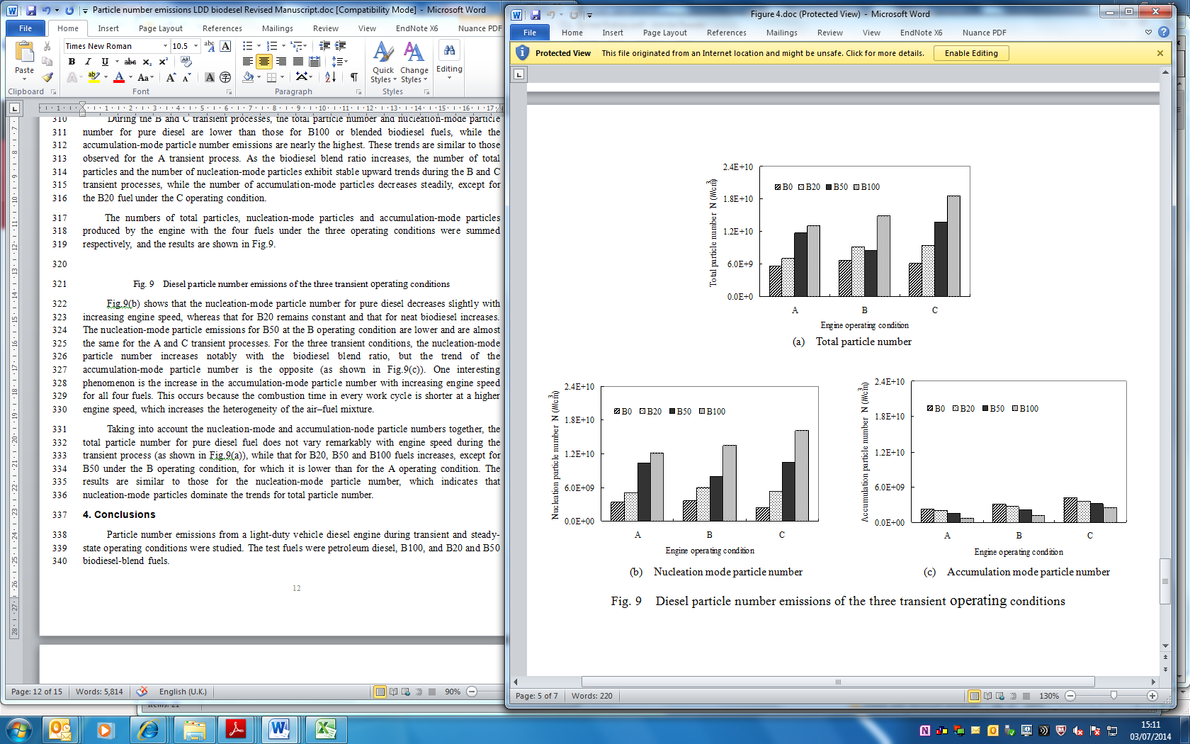
Fig. 9 Diesel particle number emissions of the three transient operating conditions
Fig.9(b) shows that the nucleation-mode particle number for pure diesel decreases slightly with increasing engine speed, whereas that for B20 remains constant and that for neat biodiesel increases. The nucleation-mode particle emissions for B50 at the B operating condition are lower and are almost the same for the A and C transient processes. For the three transient conditions, the nucleation-mode particle number increases notably with the biodiesel blend ratio, but the trend of the accumulation-mode particle number is the opposite (as shown in Fig.9(c)). One interesting phenomenon is the increase in the accumulation-mode particle number with increasing engine speed for all four fuels. This occurs because the combustion time in every work cycle is shorter at a higher engine speed, which increases the heterogeneity of the air–fuel mixture.
Taking into account the nucleation-mode and accumulation-node particle numbers together, the total particle number for pure diesel fuel does not vary remarkably with engine speed during the transient process (as shown in Fig.9(a)), while that for B20, B50 and B100 fuels increases, except for B50 under the B operating condition, for which it is lower than for the A operating condition. The results are similar to those for the nucleation-mode particle number, which indicates that nucleation-mode particles dominate the trends for total particle number.

4. Conclusions
Particle number emissions from a light-duty vehicle diesel engine during transient and steady- state operating conditions were studied. The test fuels were petroleum diesel, B100, and B20 and B50 biodiesel-blend fuels.
(1) Steady-state operating conditions: For all test fuels, the particle number sizes show unimodal or bimodal log-normal distributions, with a nucleation-mode particle size peak value and an accumulation-mode particle size peak value. Accumulation-mode particle number decreases as the biodiesel blend ratio increases. The oxygen content and absence of aromatic hydrocarbons of biodiesel could lead to accumulation-mode particle number decreasing. Nucleation-mode particle Number increases as the biodiesel blend ratio increases. Three main mechanisms lead to nucleation-mode particle number increasing: high super-saturation leading to formation of new particles by nucleation under lower solid soot surfaces, increased viscosity and lower volatility of biodiesel causing an increase in SOF, and the oxygen content of biodiesel causing carbonaceous particles to change from fine size to ultrafine size or nano-particle size. The total particle number concentration increases with the biodiesel blend ratio, and the nucleation-mode particle concentration dominating the total particle number concentration. The mass of the accumulation-mode particles of the engine with the four kinds of fuels are larger than the nucleation-mode particles under the six operating conditions.
(2) Transient-state operating conditions: The results show that nucleation-mode particle number from the engine increases when using petroleum diesel during transient operating conditions (increasing torque at constant speeds). The number of accumulation-mode particles increases at the initial stage of the transient processes and then decreases with increasing torque. The total particle number increases with torque during transient operating conditions, and accumulation-mode particles are an important part of the total particle number in the beginning, while nucleation-mode particles dominate the latter part of transient operating conditions. The dynamic characteristics of particle number during the transient process for lower-biodiesel blends are similar to that for petroleum diesel, whereas the particle number trends for higher-biodiesel blends exhibit distinct differences. The total particle number and nucleation-mode particle number for B50 and B100 fuels are considerably larger than those for pure diesel from beginning to end, while the accumulation-mode particle number remains smaller. For B100 fuel, the nucleation-mode particle number increases rapidly until the end of the transient process, and the accumulation-mode particle number decreases steadily.

Acknowledgments
This study was supported by the National Natural Science Foundation of China (50906062), Fundamental Research Funds for the Central Universities, Open Funds of State Key Laboratory of Engines, and Research Funds for the Doctoral Program of Higher Education in China, and University of Leeds Fund for International Research Collaborations (FIRC) (UK-China).

References
[1] Guido C, Beatrice C, Napolitano P. Application of bioethanol/RME/diesel blend in a Euro5 automotive diesel engine: Potentiality of closed loop combustion control technology. Applied Energy, 2013; 102: 13–23.
[2] Lapuerta M, Armas O, Rodriguez-Fernandez J. Effect of biodiesel fuels on diesel engine emissions. Progress in Energy and Combustion Science, 2008; 34: 198–223.
[3] Hulwan DB, Joshi SV. Performance, emission and combustion characteristic of a multicylinder DI diesel engine running on diesel–ethanol–biodiesel blends of high ethanol content. Applied Energy, 2011; 88: 5042–5055.
[4] Nabi MN, Hustad JE. Influence of oxygenates on fine particle and regulated emissions from a diesel engine. Fuel, 2012; 93: 181–188.
[5] Yoon SH, Lee CS. Effect of biofuels combustion on the nanoparticle and emission characteristics of a common-rail DI diesel engine. Fuel, 2011; 90: 3071–3077.
[6] Kim H, Choi B. The effect of biodiesel and bioethanol blended diesel fuel on nanoparticles and exhaust emissions from CRDI diesel engine. Renewable Energy, 2010; 35: 157–163.
[7] Katoshevski D, Ruzal M, Shakked T, Sher E. Particle grouping, a new method for reducing emission of submicron particles from diesel engines. Fuel, 2012; 89: 2411–2416.
[8] Ushakov S, Valland H, Nielsen JB, Hennie E. Particle size distributions from heavy-duty diesel engine operated on low-sulfur marine fuel. Fuel Processing Technology, 2013; 106: 350–358.
[9] Squaiella LL, Martins CA, Lacava PT. Strategies for emission control in diesel engine to meet Euro VI. Fuel, 2013; 104: 183–193.
[10] Labecki L, Cairns A, Xia J, Megaritis A, Zhao H, Ganippa LC. Combustion and emission of rapeseed oil blends in diesel engine. Applied Energy, 2012; 95: 139–146.
[11] Lapuerta M, Armas O, Hernández JJ, Tsolakis A. Potential for reducing emissions in a diesel engine by fuelling with conventional biodiesel and Fischer–Tropsch diesel. Fuel, 2013; 89: 3106–3113.
[12] Hassaneen A, Munack A, Ruschel Y, Schroeder O, Krahl J. Fuel economy and emission characteristics of Gas-to-Liquid (GTL) and Rapeseed Methyl Ester (RME) as alternative fuels for diesel engines. Fuel, 2012; 97: 125–130.
[13] Giakoumis EG., Rakopoulos CD, Dimaratos AM, Rakopoulos DC. Exhaust emissions of diesel engines operating under transient conditions with biodiesel fuel blends. Progress in Energy and Combustion Science, 2012; 38: 691–715.
[14] Colaco MJ, Teixeira CV, Dutra LM. Thermal analysis of a diesel engine operating with diesel–biodiesel blends. Fuel, 2010; 89: 3742–3752.
[15] Giakoumis EG, Dimaratos AM, Rakopoulos CD. Experimental study of combustion noise radiation during transient turbocharged diesel engine operation. Energy, 2011; 36: 4983–4995.
[16] Macor A, Avella F, Faedo D. Effects of 30% v/v biodiesel/diesel fuel blend on regulated and unregulated pollutant emissions from diesel engines. Applied Energy, 2011; 88: 4989–5001.
[17] Lin YC, Hsu KH, Chen CB. Experimental investigation of the performance and emissions of a heavy-duty diesel engine fuelled with waste cooking oil biodiesel/ultra low sulfur diesel blends. Energy, 2011; 36: 241–248.
[18] Schröder Olaf, Bünger J, Munack A, Knothe G, Krahl J. Exhaust emissions and mutagenic effects of diesel fuel, biodiesel and biodiesel blends. Fuel, 2013; 103: 414–420.
[19] Rakopoulos CD, Dimaratos AM, Giakoumis EG, Rakopoulos DC. Study of turbocharged diesel engine operation, pollutant emissions and combustion noise radiation during starting with biodiesel or n-butanol diesel fuel blends. Applied Energy, 2011; 88: 3905–3916.
[20] Knothe G. Biodiesel and renewable diesel: A comparison. Progress in Energy and Combustion Science, 2010; 36: 364–373.
[21] Varuvel EG, Mrad N, Tazerout M, Aloui F. Experimental analysis of biofuel as an alternative fuel for diesel engines. Applied Energy, 2012; 94: 224–231.
[22] Tan P, Hu Z, Lou D, Li Z. Exhaust emissions from a light-duty diesel engine with Jatropha biodiesel fuel. Energy, 2012; 39: 356–362.
[23] Payri R, Salvador FJ, Gimeno J, Bracho G. The effect of temperature and pressure on thermodynamic properties of diesel and biodiesel fuels. Fuel, 2011; 90: 1172–1180.
[24] Hirkude JB, Padalkar AS. Performance and emission analysis of a compression ignition Engine operated on waste fried oil methyl esters. Applied Energy, 2012; 90: 68–72.
[25] Ndayishimiye P, Tazerout M. Use of palm oil-based biofuel in the internal combustion engines: Performance and emissions characteristics. Energy, 2012; 44: 955–963
[26] Buyukkaya E. Effects of biodiesel on a DI diesel engine performance, emission and combustion characteristics. Fuel, 2010; 89: 3099–3105.
[27] Ng JH, Ng HK, Gan S. Characterisation of engine-out responses from a light-duty diesel engine fuelled with palm methyl ester (PME). Applied Energy, 2012; 90: 58–67.
[28] Kalam MA, Masjuki HH, Jayed MH, Liaquat AM. Emission and performance characteristics of an indirect ignition diesel engine fuelled with waste cooking oil. Energy, 2011; 36: 397–402.
[29] Pinzi S, Rounce P, Herreros JM. The effect of biodiesel fatty acid composition on combustion and diesel engine exhaust emissions. Fuel, 2013; 104: 170–182.
[30] Tompkins BT, Song H, Bittle JA, Jacobs TJ. Efficiency considerations for the use of blended biofuel in diesel engines. Applied Energy, 2012; 98: 209–218.

