Fig. 1 A cattle scapula, pierced to allow it to be hung for smoking (T. P. O’Connor)

Site | Date by century AD | % of Cattle | % of Sheep/Goat | % of Pig | NISP
Harbour-side | 1st bc/1st AD | 25 | 9 | 66 | 53
Harbour-side | 1-4th | 18 | 50 | 32 | 102
Gk Charioteer | 2-4th | 17 | 53 | 30 | 294
Cistern 1 | 5th | 2 | 54 | 44 | 2142
Cistern 3 | 5-6th | 7 | 52 | 42 | 489
Greek Charioteer | 5-6th | 2 | 58 | 40 | 60
Harbour-side | 5-6th | 16 | 32 | 52 | 166
Ave. Bourgiba | 5-6th | 2 | 63 | 36 | 2304
Ave. Bourgiba | 6th | 1 | 63 | 36 | 469
Ave. Bourgiba | 6-7th | 1 | 75 | 24 | 2067
Greekk Charioteer | 6-7th | 6 | 65 | 29 | 112
Cistern 2 | 6-7th | 1 | 56 | 44 | 1234
Harbour-side | 6-7th | 4 | 66 | 30 | 221
Ave. Bourgiba | 7th | 1 | 66 | 33 | 874
Ecclesiastical | 7th | 2 | 64 | 34 | 1066
Ecclesiastical | 10-11th | 2 | 73 | 25 | 227
Byrsa Hill | 11th | 9 | 91 | 0 | 56

Fig. 2 Proportions of cattle, sheep/goat and pig from a number of recent excavations at Carthage. Figures are derived from Mattingly and Hitchner (1995) but re-ordered by approximate date. Data sources comprise: Harbour-side: Levine (1994); Greek Charioteer and Ecclesiastical: Reese (1977); Cisterns 1-3: Reese (1981); Ave. Bourgiba: Schwartz (1984); Byrsa Hill: Payne (1981).

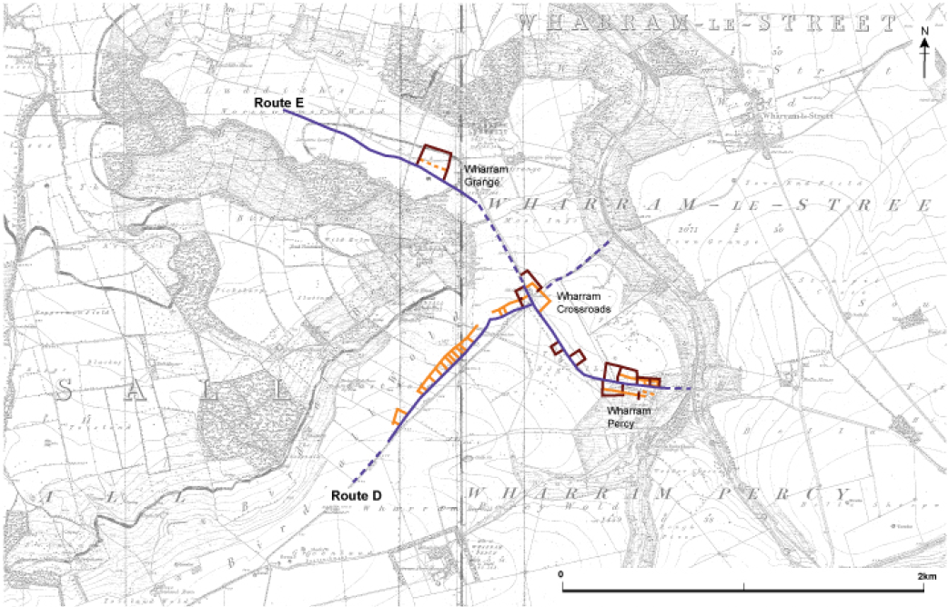

Fig. 3 The development of the Roman landscape around Wharram Percy. Early trackways (Routes D and E, in blue) had later ‘ladder settlements’ (orange) set up beside them during the Late Iron Age and Early Roman periods. These were replaced around AD200 by a series of discrete enclosures (dark red) at Wharram Crossroads and Wharram Percy, overseen by a ‘villa’ established on a hill to the north at Wharram Grange. (E Marlow-Mann, after Stoertz (1997))

