Does Fast Mapping Accelerate Lexical Integration? Evidence From Spoken and Written Novel Words

Shane Lindsay¹, Andrew Lucas¹, Richard J. O’Connor¹, Kevin Riggs¹, and M. Gareth Gaskell²

¹ School of Psychology and Social Work, University of Hull, United Kingdom
² School of Psychology, University of York, United Kingdom

Correspondence information:
Shane Lindsay, School of Psychology and Social Work
University of Hull
HU6 7RX
United Kingdom
s.lindsay@hull.ac.uk

Abstract
Fast mapping (FM) is an encoding paradigm in which a novel label is learned incidentally by inference. Some studies have interpreted FM training as capable of bringing forward the integration of novel words into existing lexical networks relative to typical consolidation timelines, although the evidence is mixed. We conducted three experiments to investigate whether FM promotes faster lexical integration compared to explicit encoding (EE). Experiments 1 and 2 extended prior orthographic fast mapping work, testing whether the rapid lexical integration claim generalises to the auditory (spoken) domain. Participants learned novel spoken words through either FM or EE training. Lexical integration was assessed using a pause detection task immediately after learning, one day later, and one week later (Experiment 1 only). Neither experiment found evidence that FM led to more rapid lexical integration compared to EE. Experiment 3 was a direct replication of previous orthographic fast mapping research (Coutanche & Thompson-Schill, 2014), using a semantic categorisation task to assess integration of visually presented novel words. Again, we found no advantage for FM in promoting rapid lexical integration. Across all experiments, EE consistently produced superior explicit memory for the novel words compared to FM. These findings fail to support claims that FM-based training allows novel words to bypass time-dependent consolidation processes and become rapidly integrated into the mental lexicon. The results are consistent with complementary learning systems accounts positing that lexical integration typically benefits from offline consolidation, regardless of encoding method.

Keywords: word learning; fast mapping; lexical integration; complementary learning systems; memory consolidation

Does Fast Mapping Accelerate Lexical Integration? Evidence From Spoken and Written Novel Words
The Complementary Learning Systems (CLS) model of word learning (Davis & Gaskell, 2009; Gaskell, 2024; Lindsay & Gaskell, 2010) builds on a computational framework (McClelland et al., 1995) that distinguishes between two complementary systems involved in learning words. According to this model, the initial encoding of novel words typically relies on a medial temporal lobe memory system, primarily mediated by the hippocampus. This system, characterised by distinct, pattern-separated representations, supports episodic memory for words and enables "one-shot" learning, linking cortical representations of form and meaning. In parallel, lexical representations are gradually encoded in the neocortex through repeated exposures, resulting in distributed and overlapping representations. The CLS model proposes that sleep can provide a favourable context for integrating episodic memory traces associated with learning new words into long-term cortical memory networks.
The foundational evidence supporting the CLS model of word learning comes from studies investigating the time course of lexical competition during phonological word recognition. Gaskell and Dumay (2003) developed a paradigm in which participants were taught novel words (e.g., "skeletobe") derived from base words (e.g., "skeleton") with an early uniqueness point (the point at which the spoken word becomes distinct from all other words in the listener's lexicon). Lexical competition was assessed using a pause detection task (with similar findings observed in a lexical decision task), where participants detected pauses inserted into words near the uniqueness point. The response latency served as an indicator of lexical activity at the point of perceiving the pause (Mattys & Clark, 2002). Consistent with the cohort model of word recognition (Gaskell & Marslen-Wilson, 2002), a key behavioural outcome of lexical integration would be a slowing of word recognition, as novel words compete for activation in existing lexical networks (Gaskell & Dumay, 2003). Gaskell and Dumay (2003) tested participants both immediately after learning and at later time points. Crucially, they observed this slowing effect indicative of lexical competition only after a significant delay (e.g., several days or a week later, depending on the specific experiment), with no significant competition effect immediately after training. This suggested that, under these learning conditions, lexical competition became detectable only after a period of consolidation. Further research demonstrated that sleep often facilitates this integration (Dumay & Gaskell, 2007; Tamminen et al., 2010; for a meta-analysis, see Schimke et al., 2021), although exceptions may exist, particularly if the new learning can exploit lexical prior knowledge (Gaskell, 2024).
A related paradigm that further supports the CLS model of word learning has examined the emergence of lexical competition in orthographic word recognition. Bowers et al. (2005) taught participants novel words (e.g., "banara") derived from "hermit" base words, which are words with no pre-existing lexical neighbours that could be formed by changing or removing a single letter (e.g., "banana"). Participants were trained on the novel words, and lexical competition was subsequently assessed using a speeded semantic categorisation task. In this task, participants judged whether base words presented on the screen were natural kinds or artefacts. This task therefore requires an explicit judgement about meaning, and any competition effect is inferred from slowed semantic decisions rather than from a decision about word form. Using a logic similar to that of Gaskell and Dumay (2003), evidence for lexical competition was indicated by slower responses to base words that had newly learned competitors compared to hermit words without such competitors. Like Gaskell and Dumay, Bowers et al. found no evidence of competition immediately after training; competition effects only emerged on the following day. Further studies in Dutch also reported no immediate competition effects but found significant effects a day after training, both for written words and in a cross-modal task where learning involved spoken words and testing involved an orthographic format (Bakker et al., 2014). Additionally, sleep-associated memory consolidation appears to play an influential role in the emergence of competition effects (Wang et al., 2017), consistent with predictions from the CLS model of learning (McClelland et al., 1995).
Research on the lexical integration of phonological and orthographic forms has been joined by studies focused on semantic integration, in which novel forms are trained with meanings and later assessed using meaning-based measures such as semantic priming (e.g., Tamminen & Gaskell, 2013; Tham et al., 2015). These studies have generally found that semantic integration, like form integration, takes time and benefits from offline consolidation, consistent with the CLS model. While the CLS model of word learning has been successful in explaining a range of findings, there is increasing interest in understanding the conditions under which lexical integration can occur relatively rapidly rather than only after a period of offline consolidation. Lindsay and Gaskell (2013) showed that phonological lexical competition could emerge within a single day through repeated training and testing, indicating that sleep may be sufficient but not necessary for lexical integration to occur. Walker et al. (2019) found significant evidence for competition in visual word recognition with an adaptation of the Bowers et al. (2005) paradigm immediately after training. Since this immediate competition effect contrasts with the delayed effects typically associated with lexical integration, this suggests that the task may not be truly diagnostic of lexical integration (Gaskell & Lindsay, 2019). Similarly, several other paradigms that appear to rely on lexical integration have demonstrated evidence for pre-sleep lexicalisation (Kapnoula et al., 2015; Kapnoula & McMurray, 2016; see Palma & Titone, 2021, for a review). However, such findings do not necessarily undermine the CLS model, which can potentially accommodate rapid integration effects depending on the specific learning conditions (Gaskell, 2024; McClelland, 2013). Indeed, while robust evidence indicates that sleep-based consolidation often supports lexical integration, particularly for spoken words, the existence of rapid integration phenomena prompts a closer examination of the learning conditions that might bypass or accelerate this process. The key question, therefore, is not whether rapid integration can occur at all, but under what learning conditions it emerges and through which mechanisms it is supported.
Particularly relevant to this question, Coutanche and Thompson-Schill (2014) reported rapid, same-day lexical integration of written forms using a particular encoding method. Inspired by Sharon et al.'s (2011) application of fast mapping to adults with amnesia, Coutanche and Thompson-Schill employed a test of lexical integration adapted from Bowers et al. (2005) but manipulated the training of the novel written words in a between-participants design. In Bowers et al., participants were trained on the novel word forms alone, with 10 presentations of each novel word. Coutanche and Thompson-Schill used just two presentations, but also provided semantic information by pairing the novel written words with images of rare animals that were generally not known to the participants. In one group, called the Explicit Encoding condition (EE), participants were explicitly instructed to encode a novel orthographic label for a picture of the novel animal on the screen (e.g., “remember the puncil”). In their “Fast Mapping” condition (FM), word learning was more incidental. Participants were presented with both a novel and a known animal on screen, and had to infer that the presented novel word referred to the novel animal, with questions such as “Are the antennae of the puncil pointing up?” Their striking result was that the FM condition showed immediate lexical competition (i.e., on the same day as training, before overnight consolidation), even though the EE condition did not. Despite these differences in lexical competition, tests of declarative memory showed that memory for novel word-to-picture mappings was stronger following explicit training. Further work following Coutanche and Thompson-Schill has also reported lexical competition or related evidence of lexical integration after FM training (Zaiser et al., 2022; Qu, 2024; Senaldi et al., 2026; Li et al., 2026). However, some attempts to replicate the original lexical integration advantage have yielded negative results (e.g., Coutanche & Koch, 2017; McGregor et al., 2020; Gurunandan et al., 2023; see General Discussion).
The type of training used in their FM condition originates from the developmental literature on word learning. The term "fast mapping" was first used by Carey (1978) to describe the remarkable ability of children to rapidly acquire words by mapping a novel form to a novel referent with limited exposure, via an inference. Rather than describing an inherent ability, the term "fast mapping" has become associated with a specific methodological procedure used in experimental studies of word learning. This paradigm has defining features that Coutanche and Thompson-Schill employed with adults, where the labelling of a novel word is incidental rather than ostensive, requiring participants to infer the referent of the novel word form. In developmental studies, this often involves presenting a familiar, named object alongside a novel object, prompting the child to select the novel object upon hearing the novel word. Children are thought to apply the principle of mutual exclusivity (the assumption that each word has a single referent) to assign labels to unfamiliar objects (Carey, 1978). However, selecting a referent in a fast mapping task does not necessarily result in a stable, long-term mapping in 2-year-olds (Horst & Samuelson, 2008), or even 3–5-year-olds for certain word types (Holland et al., 2015). Indeed, a recent meta-analysis found that while children aged 1 to 5 show robust mutual exclusivity responses during initial referent selection, retention of these mappings is substantially weaker (Mather & Lindsay, 2025). For this reason, "fast mapping" best describes tasks that have certain characteristics during referent selection when encountering a novel word (implicit, inferential, limited exposure), rather than describing an inherent word-learning ability.
Sharon et al. (2011) applied the FM paradigm from developmental research to study learning in patients with amnesia. They compared FM and EE conditions for learning novel word-object associations in four individuals with amnesia and healthy controls. Their results revealed a striking interaction: while participants with amnesia performed poorly in the EE condition, their performance in the FM condition was comparable to that of controls. This finding suggested that FM training might enable rapid neocortical learning, bypassing the typical hippocampus-dependent memory consolidation process. In line with this possibility, neurophysiological studies in healthy adults report rapid cortical responses following fast mapping and early divergences from explicit encoding, including left anterior temporal involvement (Shtyrov et al., 2021, 2022). However, subsequent research indicates mixed outcomes. One conceptually related study found preserved 24-hour FM memory in patients with amnesia, although without an EE comparison in the amnesic group (Merhav et al., 2014), whereas several other studies, including close replication attempts and conceptually related variants, report null effects (e.g., Smith et al., 2014; Warren & Duff, 2014; Warren et al., 2016; see Cooper et al., 2019). Furthermore, the developmental basis for expecting FM to support hippocampus-independent learning has been challenged. O’Connor and colleagues (2019a, 2019b) argue that the developmental literature does not support the notion that, prior to mature hippocampal development, FM supports superior word learning compared to EE, pointing to findings that long-term retention via FM typically emerges only alongside functional hippocampus-dependent memory and does not reliably surpass explicit encoding methods.
Despite these controversies, reports of rapid lexical integration effects after FM have prompted interest in whether fast mapping engages learning mechanisms that differ from standard explicit encoding and might support relatively rapid consolidation of new lexical representations. Within updated accounts of complementary learning systems (McClelland, 2013; Gaskell, 2024), such rapid learning can, in principle, be accommodated, since consolidation is expected to be relatively rapid when new information is consistent with prior knowledge or a schema (Tse et al., 2007, 2011; van Kesteren et al., 2012). It remains unclear, however, whether fast mapping paradigms engage such schema-based mechanisms. Novel words paired with novel animals do not obviously benefit from prior lexical or semantic knowledge (although the contextual presence of a semantically related image with a known label in the fast mapping paradigm may help), and even if semantic integration is enhanced, existing fast mapping accounts typically appeal to semantic mechanisms rather than to processes that would selectively accelerate early form-level competition. Resolving these theoretical questions first requires establishing whether the accelerated integration effect is itself robust and generalisable.
The original findings of Coutanche and Thompson-Schill have been highly influential. However, subsequent studies testing whether FM accelerates lexical integration relative to EE have yielded both positive (e.g., Li et al., 2026; Qu, 2024) and negative results (e.g., Gurunandan et al., 2023; McGregor et al., 2020). Given this mixed evidence, establishing the robustness and generality of the effect remains an open question. Our primary objective was to test whether the accelerated lexical integration reported for written words also emerges for novel spoken words. We therefore adapted the training design from Experiment 1 of Coutanche and Thompson-Schill to the phonological domain, pairing novel spoken labels with pictures of novel animals under fast mapping and explicit encoding conditions. Because the accelerated integration account does not predict modality-specific effects, finding comparable immediate competition for spoken words would support the generality of the phenomenon. At the same time, cross-modal work reports dissociations in the timing and modality of competition (e.g., Bakker et al., 2014), so differences between orthographic and phonological outcomes would also be theoretically informative.
Investigating these effects within the phonological domain also offers several important advantages. First, it aligns closely with the developmental literature on fast mapping, where infants and children naturally acquire novel spoken words through auditory input, enhancing ecological validity. Second, consolidation effects have been characterised far more extensively for spoken than for visual word recognition, including overnight polysomnography studies linking sleep architecture to lexical integration (e.g., Tamminen et al., 2010). Consistent with this emphasis, the CLS-based account of consolidation in word learning was developed primarily around evidence from spoken-word recognition (Davis & Gaskell, 2009). Thus, examining lexical competition with novel spoken forms provides a particularly well-motivated context in which to evaluate the putative rapid integration mechanism proposed by Coutanche and Thompson-Schill and to derive constraints on theories of consolidation that aim to explain when lexical integration is rapid or delayed.
To measure lexical integration of novel phonological forms, we employed the pause detection task (Dumay & Gaskell, 2007). Participants were tested shortly after learning and then again one day later, following the procedure of Coutanche and Thompson-Schill. Since they found no lexical competition effects in the EE condition a day after learning, we included an additional test one week after training to explore potential longer-term effects (an approach similar to that of Tamminen & Gaskell, 2013). The inclusion of the one-week test served two purposes. First, it provided another opportunity to detect delayed or emergent lexical competition effects that may not be apparent after a single night’s consolidation. Second, it assessed whether any observed fast mapping effects exhibit the kind of durability and stability expected if they reflect lasting changes within the lexical competition network.
Following the findings of Coutanche and Thompson-Schill, if FM training can accelerate the time course of lexical integration regardless of modality, we should expect to observe both a competition effect after FM and a larger effect after FM than after EE at the immediate test. The second criterion is the critical test because acceleration is a relative claim about the encoding method. It does not depend on the absence of an EE effect, only that the immediate FM effect reliably exceeds the immediate EE effect. Alongside this possible integration difference, we would also expect to replicate the less controversial findings that EE leads to improved declarative memory compared with the FM condition, which has been replicated elsewhere with adults (e.g., Greve et al., 2014).
In line with the complementary learning systems model of word learning, we further hypothesised that both lexical integration and declarative memory effects would be enhanced after a 24-hour consolidation period (Davis & Gaskell, 2009; Dumay & Gaskell, 2007), reflecting offline consolidation processes that strengthen memory over time.

Data Availability
Anonymised trial-level data and the R scripts required to reproduce the analyses, tables, and figures reported in this manuscript are stored on the Open Science Framework at https://osf.io/xq7ju/.

Experiment 1: Phonological Stimuli

Method

Participants
Forty-six participants from the University of York took part in this study (15 male) for course credit. Sample size was determined by availability of participants during a fixed time period of a teaching semester. Ages ranged from 18 to 23 years (M = 20.7, SD = 1.1). All were native English speakers, with no self-reported sleep, learning, or language disorders, and all reported normally having at least six hours of sleep per night. The study was approved by the Department of Psychology Ethics Committee at the University of York.

Overview of Design
The experiment employed a between-participants design, comparing novel phonological word learning under two conditions: Fast Mapping (FM) and Explicit Encoding (EE). The overall procedure adapted Coutanche and Thompson-Schill (2014) for phonological stimuli, incorporating several key modifications.
Notably, while Coutanche and Thompson-Schill used only two presentations per novel item in their orthographic study, we increased this to four for our phonological adaptation. This decision was based on findings suggesting that more exposure than the two presentations used in the original orthographic study may be necessary to elicit delayed lexical competition effects with spoken words, with even higher numbers sometimes proving insufficient (Sobczak & Gaskell, 2019). Using four presentations represented a compromise, aiming to provide sufficient exposure for integration while keeping the number of encounters closer to the limited exposure characteristic of fast mapping paradigms than to the high repetitions often used solely for explicit learning (e.g., Dumay & Gaskell, 2007).
Figure 1
Overview of the Design of Experiment 1
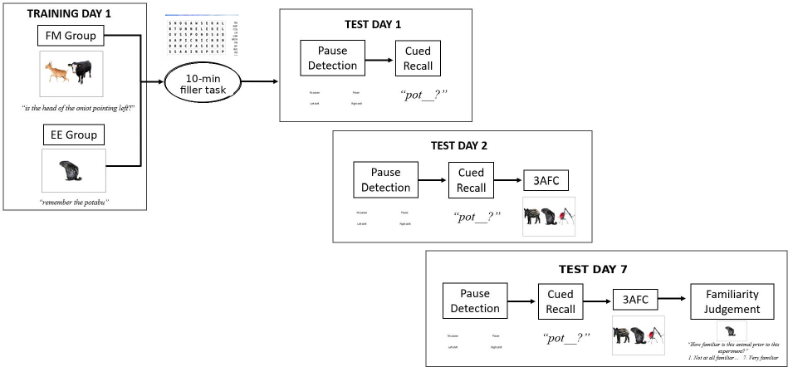

As illustrated in Figure 1, participants completed three sessions. Session 1 involved the training phase (either FM or EE), followed by a brief filler task (a 10-minute vocabulary questionnaire featuring synonym multiple-choice items and a word-search) and the first testing phase, which assessed lexical integration using a pause detection task (our primary dependent variable of interest). Cued recall was administered after pause detection in this first session. Session 2, occurring approximately 24 hours later, included the pause detection task again, followed by cued recall and 3AFC recognition. Session 3 took place approximately one week after Session 1 (Mdn = 7 days, range = 6 to 9 days) and repeated the pause detection, cued recall, and recognition tests. This multi-session design allowed us to assess immediate learning effects (Session 1), effects after a period of overnight consolidation (Session 2), and longer-term retention and integration (Session 3).
We also modified the declarative memory testing procedures used by Coutanche and Thompson-Schill. First, because their free recall task yielded performance near floor levels, we employed a cued recall task instead. Second, we altered the timing of these tests. Whereas Coutanche and Thompson-Schill administered declarative tests before the lexical integration test in Session 1, we administered declarative memory tests after the pause detection task. Cued recall was administered after pause detection in all three sessions, whereas 3AFC recognition was introduced only from Session 2 onward to avoid additional picture-name exposure before the primary Day 1 lexical integration test. This change was implemented to limit any additional exposure to the novel words during Session 1 that might obscure potential differences arising purely from the distinct FM and EE encoding manipulations.

Stimuli
Participants learned a set of animals paired with novel words. We used the same colour photographs of unfamiliar animals used in Coutanche and Thompson-Schill (2014), showing the entire body of each animal with backgrounds cropped. The set included mammals, insects, birds, and fish, chosen to be likely unfamiliar to participants, based on a norming study reported in Coutanche and Thompson-Schill. From the 16-item set, we selected a smaller set of 12 based on the authors’ judgement of likely unfamiliarity for a UK adult sample. Examples of the images are shown in Figure 1. An additional 48 images of familiar animals were used in the FM condition as comparison items, which had been chosen to come from the same taxonomic class as the unfamiliar animal.
Twenty-four novel words were taken from a previous study investigating spoken-word competition (Henderson et al., 2015). Assignment of words to animals was counterbalanced across two lists so that each word was associated with two animals across participants. These novel words were derived from English base words (e.g., “pyramid”) that had been altered to form novel words (e.g., “pyramon”). Base words had an early uniqueness point, allowing identification before hearing the final consonant or consonants (Gaskell & Marslen-Wilson, 2002). Learning the novel word aimed to create an onset competitor, with the consequence of delaying the point at which the base word could be identified with certainty during word recognition (Gaskell & Dumay, 2003), once the novel word had been successfully lexically integrated. Base words were taken from a range of semantic categories (animals, food, plants, clothing, ornaments, and landmarks) and matched for number of syllables, phonemes, spoken-word length, and frequency (as described in Henderson et al., 2015).
Each participant learned 12 novel words. During the testing phase, participants heard 24 base words: 12 for which a novel competitor had been learned in training, and 12 without a learned competitor. Additionally, 24 filler items were included in the pause detection task, selected to match the average lexical properties of the base words. We counterbalanced the assignment of words to the learned competitor condition and the presentation of pauses within words.
All words were recorded by a female native English speaker. For the training phase, these recordings were cross-spliced onto the same spoken carrier sentence (with a single sentence used in the EE condition). In trials containing a pause, a 200 ms silent interval was inserted immediately before the onset of the final syllable, following the method of Henderson et al. (2015). The remainder of the word followed this pause. To control for potential effects of pause presence, we created counterbalanced lists, ensuring that each word was heard both with and without a pause.

Procedure
All tasks, except the final familiarity assessment, were presented using DMDX software (Forster & Forster, 2003) on a 1024 × 768 monitor. Auditory stimuli were delivered via headphones. The presentation order was randomised for each participant, with the exception of the familiarity task, which followed a fixed sequence. The 12 target animals were presented four times across four blocks, with all 12 animals appearing within each block.

Training
In the EE condition, animals were displayed individually in the centre of a white background, as illustrated on the right in Figure 1. Throughout the task, participants heard the instruction "remember the [novel word]" via headphones, coinciding with the image onset. After a 250 ms interval, the recording of the animal's name was played. Each image remained on the screen for 4000 ms, followed by a 250 ms inter-trial interval displaying a blank screen.
During FM training, unfamiliar animals were presented alongside well-known animals on a white background, as illustrated in Figure 1. The novel animal appeared randomly on either the left or right side (50% probability for each). Each unfamiliar animal was paired with four different familiar animals from the same taxonomic class across four presentations. The comparison animals were selected for their familiarity and nameability to participants. For each presentation, participants heard a question incorporating the unfamiliar animal's novel name (e.g., "Is the head of the oniot pointing left?"). These questions referred to visual characteristics present in both animals, ensuring that answers could not be based solely on the presence or absence of a feature. A unique question was posed for each of the four presentations.
Participants responded using designated keys on the left and right sides of the keyboard to indicate "no" or "yes," respectively. The questions were designed so that "yes" and "no" responses were equally probable. A time limit of 6000 ms was imposed for each response.
Following the training phase in Session 1, participants completed a 10-minute vocabulary questionnaire as a filler task, after which they immediately proceeded to the testing phase.

Lexical Integration
Lexical competition was assessed using a pause detection task, following the methodology of Gaskell and Dumay (2003) and Mattys and Clark (2002). Participants listened to a series of words, half of which contained an inserted pause. Their task was to indicate the presence or absence of this pause using keyboard responses, using the left Shift key for 'pause absent' and the right Shift key for 'pause present'.
Before each target word presentation, on-screen prompts displaying the button mapping appeared for 1000 ms. The target word was then played, and participants were instructed to respond as quickly and accurately as possible. A response window of 5000 ms was provided, with response times recorded from the onset of each word.

Cued Recall
Participants heard the first syllable of each novel word (e.g., “daff” for “daffodat”) and were required to say the entirety of the learned animal name, guessing if unsure. Responses were recorded through DMDX. The task was self-paced. Participants chose when to move to the next trial by pressing a key, and the cue could be replayed as many times as required.

3AFC Recognition
This part of the test phase comprised 12 trials, each presenting three of the unfamiliar animals from the training phase (see Figure 1). At the onset of each trial, participants heard one of the trained novel words. They then had 5000 ms to identify the corresponding animal by pressing 1, 2, or 3 on the keyboard's number row, matching the animal's position on the screen. To prevent identification based solely on familiarity, each animal served as a foil in two trials where it was not the target.

Familiarity
At the end of the final session, participants were asked to rate their familiarity with the 12 animals before starting the experiment, using a 7-point Likert scale ranging from ‘not at all familiar’ (1) to ‘very familiar’ (7). Photos of each item were presented on paper, with the rating scales below each animal.

Results
Table 1 summarises the behavioural results across all experiments, while Figure 2 illustrates the behavioural outcomes for all tasks in Experiment 1. We conducted analyses across tasks and experiments using mixed-effects models implemented with the lme4 package (version 1.1-25; Bates et al., 2015) and the afex package (version 1.5-0; Singmann et al., 2023). Type III ANOVA p-values were calculated using the Satterthwaite approximation. Planned comparisons derived from the model were computed using the emmeans package (version 1.10.2; Lenth, 2024), employing the Tukey method to control for family-wise error rates in paired comparisons and the Kenward-Roger approximation for degrees of freedom calculation.
The random-effects structure for each model was determined using the buildmer package (version 2.12; Voeten, 2023), which uses a forward stepwise approach, starting from an empty model and adding terms based on the largest improvement in log-likelihood to identify the maximal converging random-effects structure supported by the data. For the declarative memory models, this process resulted in convergence warnings indicating a singular fit when random effects for participants were complex (likely due to sparse data). Therefore, for these specific models, we retained only random intercepts for participants to account for the repeated measures design while ensuring model stability. All contrasts were sum-coded to facilitate the interpretation of main effects in the presence of interactions.

Familiarity and Exclusion
We applied the same exclusion criteria as Coutanche and Thompson-Schill. For individual participants, we excluded trials involving animals rated with a familiarity score greater than three from the lexical competition, cued recall, and recognition data. Participants who rated more than half of the animals with a familiarity score exceeding three were removed from the study. This resulted in the exclusion of one participant from the FM condition and two from the EE condition. For the remaining participants, 5.2% of individual trials were excluded based on high familiarity ratings.
Four participants in the FM condition did not complete the final session. To maximise statistical power, we retained these participants in the analyses. The mixed-effects models were estimated using restricted maximum likelihood, which uses all available trials under a missing-at-random assumption rather than listwise deletion.

Lexical Competition
To account for variations in word length, we subtracted the cue length before the pause from the response times. No participants were excluded based on the response accuracy criterion (<70%). We eliminated trials with incorrect responses (3.6%) and those with reaction times (RTs) below 300 ms or above 1500 ms (2.9% of the remaining data), following the criteria used by Bowers et al. (2005) and Coutanche and Thompson-Schill (2014). Table 1 presents the means and standard deviations, while Figure 2 illustrates these results graphically.
To investigate the presence or absence of lexical competition effects across different time points, we employed a mixed-effects model. This model incorporated fixed effects for two within-participant factors, test session (day 1, day 2, and day 7 post-learning) and competitor acquisition (base words with novel competitors vs. control base words without novel competitors), and for the between-participant factor of encoding condition (EE vs. FM).
Using the buildmer package, we iteratively searched for the maximal converging random-effects structure (Voeten, 2023), specifying a maximal model:
RT ~ competitor acquisition * session * encoding condition + (1 + competitor acquisition * session * encoding condition | participant) + (1 + competitor acquisition * session * encoding condition | item).
Model fitting with buildmer led to a final model with by-participant random slopes for session and by-item random intercepts:
RT ~ competitor acquisition * session * encoding condition + (1 + session | participant) + (1 | item)
Our overall model revealed a main effect of competitor acquisition [F(1, 2531.7) = 5.87, p = .0155], indicating slower RTs for detecting pauses in words with newly acquired competitors. We also found a significant competitor acquisition by session interaction [F(2, 2540.4) = 3.12, p = .044], suggesting that this lexical competition effect varied across sessions. Additionally, there was a main effect of encoding condition [F(1, 41.0) = 4.58, p = .038], with participants in the FM condition showing slower pause detection responses overall compared to those in the EE condition. As this reflects a baseline RT difference and did not interact with competitor acquisition within sessions, it is not of primary theoretical interest. A key goal was to determine whether encoding in the FM condition could lead to the emergence of a lexical competition effect on the first day without requiring a period of consolidation. In the first session, we found no significant interaction between encoding condition and competitor acquisition [F(1, 2539.7) = 2.269, p = .132], and no overall main effect of competitor acquisition [F(1, 2540.4) = 0.396, p = .53]. This indicated that acquiring a novel competitor did not influence lexical competition on the first day of learning, regardless of the encoding method.
On the second day after encoding, we observed a significant main effect of competitor acquisition [F(1, 2540.0) = 5.694, p = .017], with pause detection latencies to base words with an acquired competitor significantly slower than those without. There was no significant interaction between competitor acquisition and encoding [F(1, 2539.8) = 0.509, p = .48], suggesting that the encoding type did not affect the overall lexical competition effect found in this session.
We also examined whether these competition effects persisted to the final session, approximately seven days after encoding. Again, we found evidence consistent with lexical integration of the novel words, with slower responses to base words with a novel competitor [F(1, 2537.8) = 5.778, p = .0163]. As in the earlier sessions, the encoding method did not influence lexical competition, with no significant interaction between encoding and competitor acquisition [F(1, 2536.8) = 0.000, p = .99].

Table 1
Responses Across All Behavioural Tasks in Experiments 1, 2, and 3
Learning | Day | Experiment 1
 |  | Integration task (Pause detection) |  |  | Cued recall | 3AFC
 |  | Base word | Control | Difference
EE | 1 | 696 (150) | 681 (121) | 15 (65) | .32 (.19) |  | —
 | 2 | 660 (132) | 628 (110) | 32 (62) | .43 (.17) |  | .80 (.18)
 | 7 | 650 (146) | 621 (106) | 30 (84) | .49 (.22) |  | .81 (.19)
FM | 1 | 712 (151) | 737 (157) | -24 (61) | .11 (.11) |  | —
 | 2 | 759 (182) | 743 (172) | 16 (78) | .17 (.09) |  | .59 (.24)
 | 7 | 765 (174) | 739 (157) | 26 (74) | .36 (.16) |  | .63 (.19)
Experiment 2
 |  | Integration task (Pause detection) |  |  | Cued recall | 3AFC
 |  | Base word | Control | Difference
EE | 1 | 727 (125) | 691 (136) | 36 (69) | .24 (.18) |  | .62 (.22)
 | 2 | 730 (127) | 719 (150) | 11 (68) | .33 (.21) |  | .66 (.25)
FM | 1 | 757 (174) | 741 (149) | 15 (60) | .14 (.13) |  | .48 (.25)
 | 2 | 749 (184) | 776 (193) | -27 (88) | .17 (.14) |  | .52 (.22)
Experiment 3
 |  | Integration task (Semantic categorisation) |  |  | Free recall | 3AFC
 |  | Non-hermit | Hermit | Difference
EE | 1 | 863 (219) | 858 (207) | 4 (101) | .09 (.11) |  | .63 (.27)
 | 2 | 816 (207) | 795 (214) | 22 (83) | .11 (.12) |  | .62 (.33)
FM | 1 | 910 (246) | 898 (234) | 11 (89) | .04 (.09) |  | .47 (.22)
 | 2 | 857 (230) | 837 (222) | 27 (69) | .09 (.15) |  | .44 (.16)
Note. Responses for the integration tasks are in milliseconds. Responses for free and cued recall and 3AFC are proportions correct. Brackets denote standard deviations. The Difference column reports participant-level paired differences (Studied - Control).

Figure 2
Responses Across All Behavioural Tasks for Experiment 1 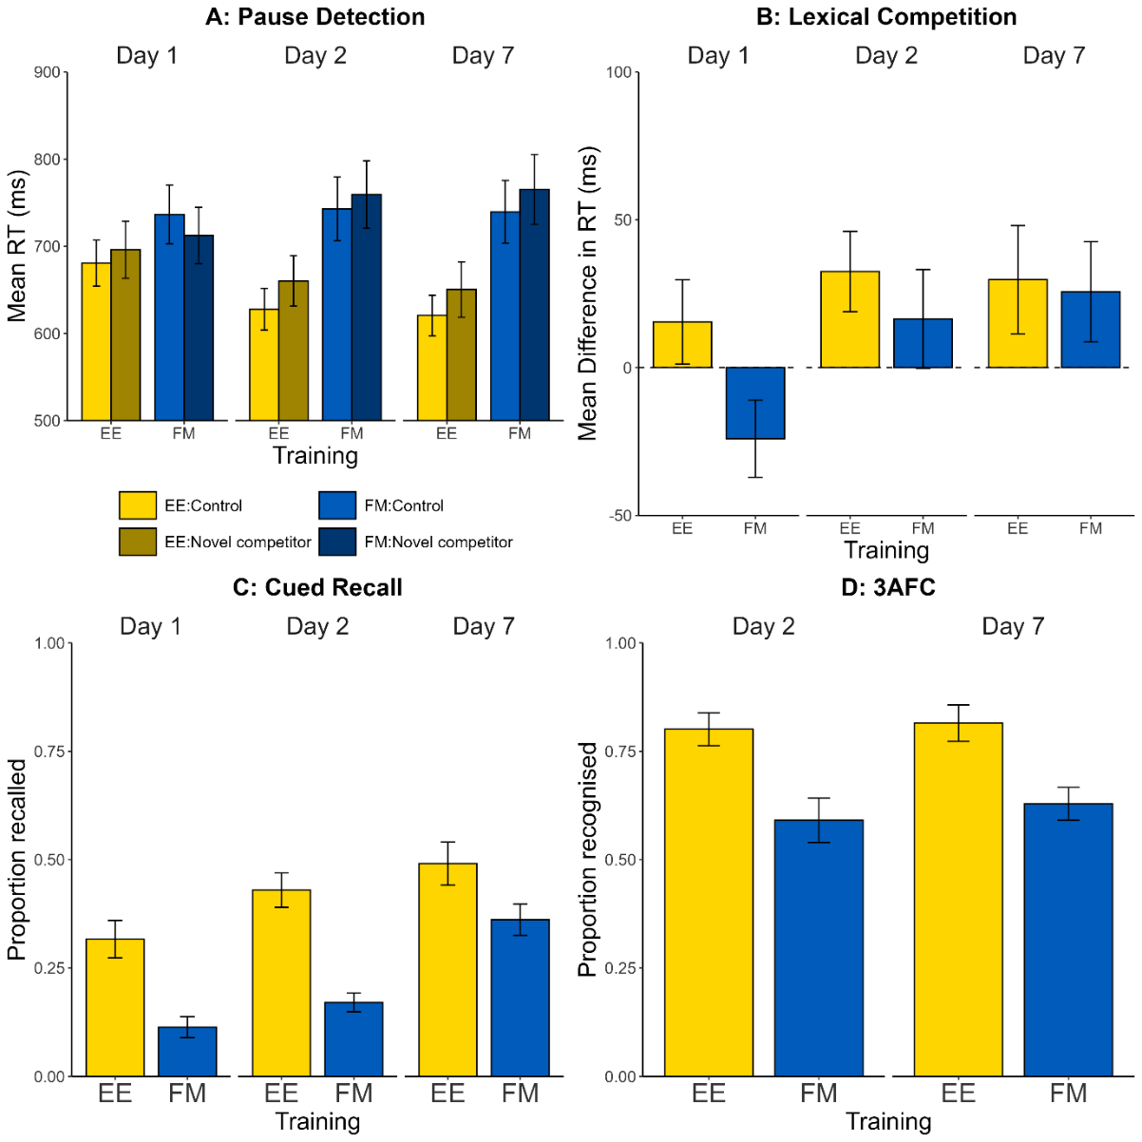
Note. Error bars show standard errors.

Cued Recall
Following Henderson et al. (2015), we coded cued recall recordings as follows: exact matches received a score of two, responses differing by one phoneme (e.g., "daffodit" for "daffodat") received a score of one, and responses matching the original base word or differing by more than one phoneme scored zero. We excluded participants who did not complete the task correctly (e.g., only saying the name endings), resulting in the removal of 6 participants (4 EE, 2 FM).
As illustrated in Figure 2 (and Table 1), despite low overall performance, clear patterns emerged. Cued recall scores improved across the three sessions, with EE training consistently yielding higher scores than FM training. The EE benefit was largest in the second session and smallest in the last session.
We fitted a linear mixed-effects model on the proportion of correct responses, allowing for by-participant random intercepts and fixed effects of session and training condition, including their interaction. The model revealed a significant main effect of session on average cued recall score [F(2, 72) = 28.92, p < .001], reflecting better memory scores in later sessions. Additionally, mean cued recall scores were significantly higher in the EE condition across sessions [F(1, 36) = 22.55, p < .001]. The interaction between encoding condition and session was not significant [F(2, 72) = 2.71, p = .073].
Planned comparisons showed that the superior memory performance for EE training was reliable on the first day of learning [t(78.3) = 3.860, p < .001] and a day later [t(78.3) = 4.928, p < .001]. The difference observed one week later was also statistically significant [t(78.3) = 2.461, p = .0161]. These results indicate a substantial advantage for EE training over FM training in cued recall performance across all sessions, with the strongest differences observed during the first two sessions.

3AFC Recognition
We calculated the proportion of correctly identified animals for each participant, adjusting denominators if items were removed through the familiarity check. As illustrated in Figure 2, performance was generally high (compared to chance performance of .33), with EE-trained participants correctly identifying a greater proportion of animal images from the corresponding names than FM-trained participants.
We fitted a linear mixed-effects model on the proportion of correct responses, allowing for by-participant random intercepts and fixed effects of session and training condition, including their interaction. The model revealed a significant main effect of training condition [F(1, 43.8) = 15.10, p < .001], reflecting superior recognition for the EE condition. However, we found no significant effect of session [F(1, 43.0) = 0.66, p = .42], nor a significant interaction between session and training condition [F(1, 43.0) = 0.51, p = .48].
Planned comparisons showed that the superior memory performance for EE training was reliable both a day after learning [t(75.7) = 3.627, p < .001] and a week after learning [t(75.7) = 2.830, p < .01]. These results indicate a substantial advantage for EE training over FM training in both sessions, with the strongest difference observed a day after learning.

Discussion
In this extension of Coutanche and Thompson-Schill (2014), we tested novel word integration using phonological, rather than orthographic, form-referent pairings. We replicated one finding from Coutanche and Thompson-Schill, that EE training led to better explicit memory, as shown by both a cued recall measure (used here instead of free recall) and recognition memory of the novel word forms. However, we did not replicate their counterintuitive finding that, despite worse explicit memory performance following FM training, FM training nonetheless led to evidence for lexical competition. Unlike explicit memory tests that directly probe knowledge of the novel words, lexical competition provides an indirect measure of how well these words have been integrated into the mental lexicon. Contrary to their findings, we did not observe evidence that the FM training condition accelerated the time course of lexical competition. Consistent with other studies examining lexical competition from novel words in the phonological domain (e.g., Gaskell & Dumay, 2003), we found no lexical competition shortly after learning in either training condition. Instead, competition effects emerged when testing a day later, aligning with the Complementary Learning Systems model of word learning (Davis & Gaskell, 2009). This model suggests that sleep-associated memory consolidation may promote the integration of novel words into the mental lexicon (Dumay & Gaskell, 2007). This lexical competition effect remained robust one week after training.
While our results in Experiment 1 did not support the rapid lexical integration hypothesis for FM, they did reveal delayed lexical competition effects emerging after 24 hours in both conditions. This suggests our decision to use four presentations (though still a relatively low number compared to typical phonological studies, e.g., Gaskell & Dumay, 2003) provided sufficient exposure to observe integration after a consolidation period, perhaps aided by the explicit learning instructions employed. However, this methodological deviation, potentially necessary to elicit any integration effect with phonological stimuli, might also explain the discrepancy regarding rapid integration. It is possible that increasing the training presentations from two to four altered the balance between implicit and explicit learning processes, potentially disrupting the specific conditions under which rapid fast mapping effects were previously reported. Additionally, our decision to delay the 3AFC recognition task until Session 2 deviated from their protocol. These methodological variations might have affected the encoding and consolidation processes, potentially masking any FM-specific rapid integration effects.
To address these methodological discrepancies, we designed Experiment 2 as a closer replication of Coutanche and Thompson-Schill's original study, while still focusing on phonological stimuli. By reducing the number of presentations to two and reintroducing the 3AFC task in Session 1, we brought our methodology more in line with theirs. This approach allows us to examine whether the discrepancies in our findings might be related to these specific procedural differences. Additionally, Experiment 2 serves as an internal replication of Experiment 1, allowing us to assess the robustness of our findings under slightly different learning conditions.

Experiment 2: Phonological Stimuli With Two Presentations

Method

Participants
Forty-six participants (30 female) took part in this study. Sample size was determined by participant availability during a fixed teaching semester period. Ages ranged from 18 to 23 years (M = 20.7, SD = 1.4). Participants were first- and second-year psychology students from the University of Hull, participating for course credit. They met the same exclusion criteria as in Experiment 1. The Department of Psychology Ethics Committee at the University of Hull approved the study.

Stimuli, Design, and Procedure
Experiment 2 was methodologically identical to Experiment 1 except for three key changes. We used two repetitions of each word in training, instead of four, matching Coutanche and Thompson-Schill's design. The 3AFC recognition task was reintroduced in Session 1, following their protocol, whereas in Experiment 1 this task was delayed until Session 2 to reduce novel word exposure. The Day 7 test session was removed, aligning with their design and focusing on immediate lexical competition and overnight consolidation effects while reducing dropout rates.
Due to a script error, the pause detection task omitted the first item, leaving 11 items per condition instead of 12.

Results
Figure 3 displays results for all behavioural tasks in Experiment 2.

Familiarity and Exclusion
Following the same exclusion criteria as Experiment 1, we excluded trials involving animals rated with a familiarity score greater than three from all analyses. One participant from the FM condition was excluded for rating more than half of the animals with high familiarity scores.

Lexical Competition
As in Experiment 1, we excluded trials in which items were rated as familiar (5.5% of data), trials with incorrect responses (3% of remaining data), and RTs below 300 ms or above 1500 ms (5.0% of remaining data). We used the same analysis strategy as Experiment 1, with model selection allowing for by-participant random slopes for session and by-item slopes for competitor acquisition:
RT ~ competitor acquisition * session * encoding condition + (1 + session | participant) + (1 + competitor acquisition | item)
Our overall model revealed no significant main effects or interactions. There was no main effect of encoding condition [F(1, 42.2) = 0.77, p = .39], no main effect of session [F(1, 43.3) = 0.88, p = .35], and no main effect of competitor acquisition [F(1, 22.2) = 0.15, p = .70]. We observed a marginally significant interaction between session and competitor acquisition [F(1, 1803.2) = 3.43, p = .064]. The interaction between encoding condition and competitor acquisition was not significant [F(1, 1801.1) = 2.36, p = .13]. There was also no significant three-way interaction between encoding condition, session, and competitor acquisition [F(1, 1802.9) = 0.03, p = .85].
On the first day of testing, we again found no significant evidence for a lexical competition effect. There was no main effect of competitor acquisition [F(1, 33.7) = 1.333, p = .2565], and no significant interaction between competitor acquisition and encoding [F(1, 1803.2) = 0.908, p = .34].
Similarly, on the second day, we found no evidence for lexical competition. There was no significant effect of competitor acquisition [F(1, 33.4) = 0.211, p = .65], and no significant interaction between competitor acquisition and encoding condition [F(1, 1802.7) = 1.492, p = .22].

Figure 3
Responses Across All Behavioural Tasks for Experiment 2
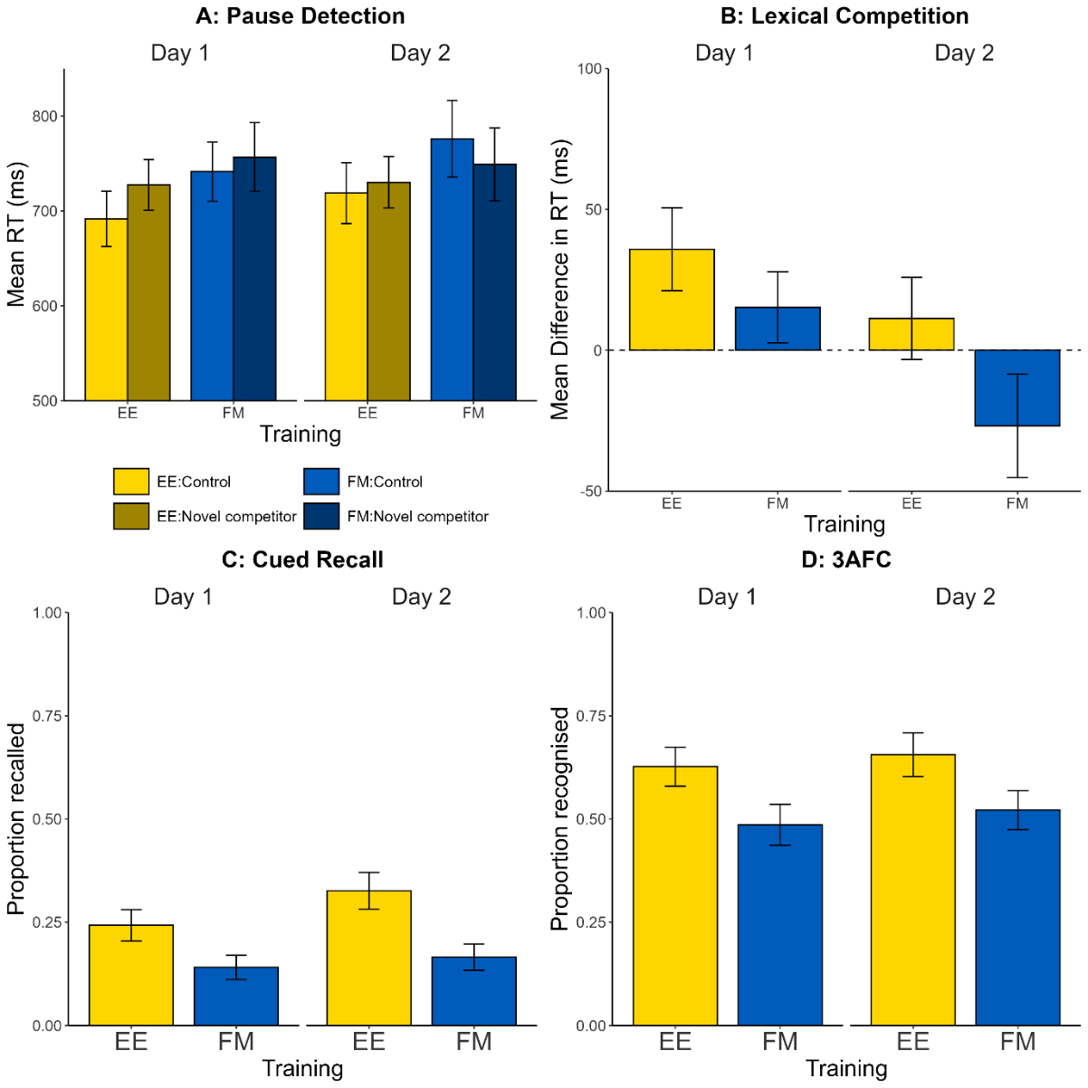
Note. Error bars indicate standard errors.

Cued Recall
As with Experiment 1, we excluded participants who did not complete the task correctly, resulting in the removal of 5 participants (1 EE, 4 FM).
Using the same model structure as Experiment 1, we found similar results. Overall recall performance increased from Day 1 to Day 2 [F(1, 40) = 5.59, p = .023]. EE training led to higher overall recall [F(1, 40) = 7.92, p < .01]. As shown in Figure 3 and Table 1, this difference was slightly larger on the second day, but the interaction was not significant [F(1, 40) = 1.64, p = .21]. The EE training benefit approached significance shortly after learning [t(58.2) = 1.963, p = .055] and was significant one day later [t(58.2) = 3.092, p < .01].

3AFC Recognition
As in Experiment 1, and as shown in Figure 3, EE led to improved recognition memory scores compared to FM encoding. Using the same model specification, we found significantly better memory for the EE condition [F(1, 45.0) = 4.97, p = .031], but no significant effect of session [F(1, 44.2) = 1.84, p = .181], nor an interaction [F(1, 44.2) = 0.00, p = .966]. Planned comparisons showed superior recognition memory performance on the day of learning [t(58.1) = 2.095, p = .041] and a day later [t(58.9) = 2.053, p = .045].

Discussion
Across Experiments 1 and 2, we found no evidence that fast mapping accelerates lexical competition in spoken-word recognition on the day of learning or after a 24-hour delay. Experiment 2 aimed to more closely align with Coutanche and Thompson-Schill's methodology while maintaining our focus on phonological forms. Despite reducing the number of presentations (from 4 to 2) and reintroducing the 3AFC task in Session 1, we again observed superior explicit memory performance following EE compared to FM, in both cued recall and recognition tasks. This advantage persisted across both testing sessions, reinforcing the effectiveness of explicit encoding strategies for declarative memory formation.
We again found no evidence that FM accelerated lexical integration compared to EE, with no lexical competition effects observed in either condition immediately after learning or the following day. Unlike Experiment 1, we found no evidence for lexical competition after a 24-hour delay in either the FM or EE condition. This lack of lexical competition effects on the second day contrasts with Experiment 1 and suggests that the reduced number of exposures may have been insufficient to trigger lexical integration, regardless of encoding method (cf. Sobczak & Gaskell, 2019). Across both experiments, we found no evidence that fast mapping accelerates lexical integration for spoken words. This was the case even in Experiment 2, which more closely aligned with Coutanche and Thompson-Schill's methodology. These results therefore raise questions about the generalisability of the original orthographic effect to phonological stimuli. However, given that theories of fast mapping and lexical integration are not modality-specific, this explanation may not fully account for the divergent results.
The consistent lack of rapid lexical integration effects in our phonological experiments, contrasting with Coutanche and Thompson-Schill's findings using orthographic stimuli, highlights the need for a direct replication of their work. One possibility is that any fast mapping advantage is confined to orthographic materials or to lexical integration tests that require semantic decisions, such as semantic categorisation. In Experiments 1 and 2, our pause detection test required detection of brief acoustic pauses and did not require access to the trained meanings, providing a stringent test of form-based competition. Consequently, we designed Experiment 3 to closely replicate their methodology and stimuli. This approach serves two critical purposes. First, it allows us to test the robustness of their reported rapid lexical integration effect following fast mapping. Second, it provides an opportunity to directly compare outcomes across modalities within our series of experiments. This comparison will help determine whether the rapid lexical integration effect observed in their written word study is reproducible and specific to orthographic word forms.

Experiment 3: Orthographic Stimuli

Method

Participants
We tested 82 participants from the University of Hull (67 female), who took part for course credit and were native English speakers with the same exclusion criteria as the previous two studies. Ages ranged from 18 to 35 years (M = 19.7, SD = 2.3). Sample size was determined by availability of participants during a fixed time period of two teaching semesters. The study was approved by the Department of Psychology Ethics Committee at the University of Hull.

Materials
The experiment closely followed Coutanche and Thompson-Schill's original study, with modifications to align with Experiments 1 and 2. We used 12 items rather than the 16 used in Coutanche and Thompson-Schill, matching our previous experiments. Following Coutanche and Thompson-Schill, these items were taken from word lists originally created by Bowers et al. (2005), creating novel words by changing a single letter of six-letter hermit words to form new pronounceable lexical competitors. Novel words were randomly paired with images and counterbalanced across two lists.
During training, text was presented on screen (e.g., "Is the tail of Holmet pointing down?") below the images in 36-point Arial font, rather than auditorily.

Design and Procedure
The procedure closely followed Coutanche and Thompson-Schill's design, with training and testing in the first session and a second test session approximately 24 hours later. Training followed the same FM and EE structure as Experiments 1 and 2 and matched the original study in using two presentations per item, differing from the earlier experiments in the use of orthographic rather than spoken stimuli. After training, participants completed the same 10-minute vocabulary questionnaire filler described above before testing commenced.
Lexical integration was assessed using Bowers et al.'s (2005) semantic categorisation task, as employed by Coutanche and Thompson-Schill. Participants judged whether on-screen words referred to man-made or natural objects using left or right Shift key presses. Words appeared in the middle of the screen, and response prompts of “man-made” and “natural” were below and to the left and right, respectively. Each trial had an 800 ms fixation cross followed by a 3000 ms response window. Feedback of “Correct!” or “Incorrect” was presented in the middle of the screen for 1000 ms after each trial. Stimuli included 12 learned hermit words (e.g., "walnut" after learning "walnot"), 12 unlearned hermit words, and 29 fillers. Item presentation was randomised per participant, with the first 5 trials always being fillers. Participants were instructed to respond as quickly and accurately as possible.
Declarative memory testing followed, consisting of oral free recall (where participants’ responses were recorded) and a 3AFC recognition task. The latter was similar to previous experiments but presented written stimuli (e.g., "Sleere?") below animal pictures. Item order was randomised per participant. As before, participants rated animal familiarity at the end of the second session.

Results

Familiarity and Exclusion
Six participants (4 EE condition, 2 FM condition) were excluded for having more than half of the unfamiliar animals rated above three. Of the remaining participants, two did not complete the second session in the EE condition, and five in the FM condition. As before, we included all participants in our models. Because of a data recording problem, RTs for one of the items in one of the two lists were not included. Responses across all tasks are plotted in Figure 4.
Figure 4
Mean Responses Across All Behavioural Tasks for Experiment 3
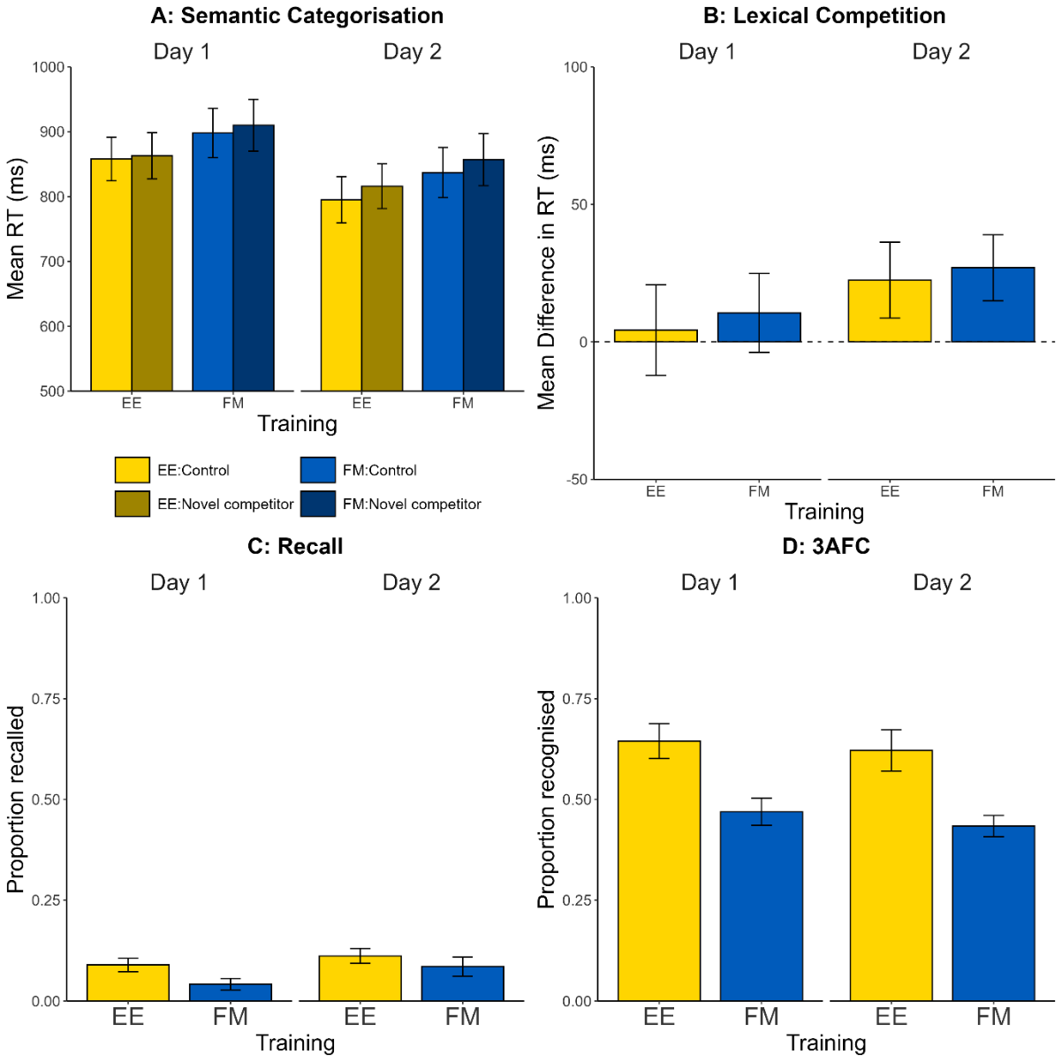
Note. Error bars indicate standard errors.

Lexical Competition
The analysis logic mirrored Experiments 1 and 2, but instead compared responses to former hermit words with new neighbours with responses to hermit words without new neighbours.
We excluded items rated as familiar (14%), incorrect responses (7%), and RTs below 300 ms or above 1500 ms (8.4%). As in previous experiments, we used a mixed-effects model. The maximal converging model included by-participant slopes for session and by-item slopes for session:
RT ~ competitor acquisition * session * encoding condition + (1 + session | participant) + (1 + session | item).
Our overall model showed no significant main effect of competitor acquisition [F(1, 2473.3) = 3.04, p = .081], nor was the interaction between encoding condition and competitor acquisition significant [F(1, 2477.1) = 0.50, p = .479]. No other interaction was significant. There was no significant three-way interaction between encoding condition, session, and competitor acquisition [F(1, 2493.4) = 0.14, p = .707], nor a significant interaction between session and competitor acquisition [F(1, 2490.8) = 1.28, p = .258]. There was a significant main effect of session [F(1, 45.2) = 24.08, p < .001], as reaction times decreased in the second session. There was a marginal main effect of encoding condition [F(1, 71.6) = 3.47, p = .067], with FM trials slightly slower overall.
Crucially, on the first day of testing, there was no significant interaction between competitor acquisition and encoding [F(1, 2491.0) = 0.596, p = .440]. There was also no main effect of lexical competition across conditions [F(1, 2490.0) = 0.192, p = .661]. Again, there was a marginally significant effect of encoding condition [F(1, 74.1) = 3.044, p = .085], with FM trials slower on average than EE trials.
On the second day, RTs were slightly slower overall for words with a new competitor, and this effect was statistically significant [F(1, 2476.0) = 4.072, p = .044]. There was no significant main effect of encoding condition [F(1, 71.0) = 2.455, p = .122], and no significant interaction between competitor acquisition and encoding condition [F(1, 2481.2) = 0.055, p = .815].

Free Recall
As can be seen in Figure 4 and Table 1, absolute performance was lower for free recall than for the cued recall tasks used in Experiments 1 and 2, which justifies the use of cued recall in those earlier experiments. Because of the incidence of zero scores (particularly in the FM condition), a linear model led to non-normally distributed residuals. Therefore, we used a signed rank transform, which can assist with zero-inflated data and, by visual inspection, improved the normality of the model residuals.
With this transformed dependent variable and using the same model structure as the previous studies, we found a significant main effect of encoding condition, reflecting better memory in the EE condition [F(1, 79) = 8.07, p < .01], and a significant effect of session [F(1, 79) = 6.94, p = .01], indicating better performance on the second day. The interaction between condition and session was not significant [F(1, 79) = 0.24, p = .63].
Planned comparisons found significantly better recall performance for the EE condition both on the day of learning [t(115) = 2.764, p < .01] and a day later [t(115) = 2.331, p = .02].

3AFC Recognition
In Experiment 3, as shown in Figure 4, we again saw a clear recognition-memory benefit for EE compared with FM. Using the same mixed-effects model approach as before, we found an overall significant main effect of encoding condition, reflecting better memory in the EE condition [F(1, 77.9) = 11.67, p < .01]. However, we did not find a significant effect of session [F(1, 72.6) = 0.37, p = .545], nor a significant interaction between encoding condition and session [F(1, 72.6) = 0.02, p = .894].
Planned comparisons found significantly better recognition memory performance for the EE condition both on the day of learning [t(129) = 2.820, p < .01] and a day later [t(134) = 2.838, p < .01].

Discussion
Experiment 3 aimed to directly replicate Coutanche and Thompson-Schill's study using orthographic stimuli, allowing us to compare outcomes across modalities within our series of experiments. Despite closely mirroring their methodology, our results diverged from their original findings.
Contrary to Coutanche and Thompson-Schill's results, we did not observe evidence of rapid lexical integration following FM. Neither the FM nor the EE condition showed significant lexical competition effects immediately after learning. We observed a small delayed lexical competition effect on Day 2, with slightly slower RTs for words with new competitors, but no evidence that this effect differed between FM and EE. Thus, as in Experiments 1 and 2, the critical prediction of greater lexical competition following FM was not supported.
Consistent with our previous experiments and Coutanche and Thompson-Schill's findings, EE training led to superior explicit memory performance compared to FM. This advantage was evident in both free recall and recognition tasks, persisting across both testing sessions. These results further reinforce the effectiveness of explicit encoding strategies for declarative memory formation, regardless of stimulus modality. Consistent with our previous experiments, free recall performance improved in the second session, mirroring the pattern observed with cued recall in Experiments 1 and 2.

General Discussion
Our series of experiments investigated the effects of FM on lexical integration, comparing it with EE across both phonological and orthographic modalities. First, across two auditory experiments (Experiments 1 and 2) we found no evidence that FM accelerates lexical integration: neither experiment produced lexical competition immediately after learning, and any competition effects emerged only after a period of offline consolidation. To our knowledge, this study is the first to directly test whether fast mapping can induce lexical competition effects prior to consolidation in spoken-word recognition, a domain with the strongest existing evidence base of consolidation processes. Second, and contrary to Coutanche and Thompson-Schill's (2014) original findings, in Experiment 3 we found no evidence that FM accelerates lexical integration of written word forms, with no significant differences between FM and EE in terms of lexical competition. Across all three experiments, the only consistent difference between FM and EE was superior explicit memory performance for EE conditions.
These results are consistent with CLS-inspired accounts of word learning (Davis & Gaskell, 2009; Gaskell, 2024) in which lexical integration often benefits from offline consolidation. We also found consistent evidence for better recall following an offline consolidation period that included sleep. In Experiment 1, using phonological stimuli, lexical competition effects emerged only after a 24-hour delay in both fast mapping and explicit encoding conditions, and persisted when tested after seven days. Experiment 2, with fewer presentations, showed no significant competition effects at any delay, while Experiment 3, closely replicating the original orthographic paradigm, showed no immediate competition effect, with a small competition effect emerging only after a one-day delay. Within an updated complementary learning systems framework that allows for both rapid and slower consolidation depending on prior knowledge and schema consistency (McClelland, 2013; Tse et al., 2007, 2011; van Kesteren et al., 2012), these findings suggest that the particular fast mapping implementations used here did not engage conditions that would produce accelerated lexical integration relative to explicit encoding.

Why did delayed competition emerge in Experiment 1 but not Experiment 2? One possible contributor was the amount of training on the novel phonological forms. Phoneme-monitoring studies have often used substantially more presentations (e.g., 36) to elicit reliable lexical competition following a consolidation period (Dumay & Gaskell, 2007; Gaskell & Dumay, 2003; Lindsay & Gaskell, 2013). Sobczak and Gaskell (2019), comparing phoneme monitoring and implicit Hebb repetition, found no lexical competition following twelve presentations in either condition, despite better explicit recognition for the phoneme monitoring group. They attributed the lack of competition to this low exposure level. When repetitions were increased, however, competition emerged in the phoneme-monitoring condition. Another example comes from Walker et al. (2019), who used repeated typing to teach novel written words and found an increase in lexical competition from the immediate to the delayed test with 10 and 20 exposures per word. A separate experiment using five exposures showed no corresponding increase despite evidence of consolidation in explicit memory. Although our EE task differed from the phoneme-monitoring and repeated-typing tasks, the exposure effects reported in these studies suggest that exposure may have contributed to the different delayed outcomes of our Experiments 1 and 2, which used four and two presentations, respectively. However, positive same-day FM effects have been reported after only two or four presentations (Coutanche & Thompson-Schill, 2014; Li et al., 2026; Senaldi et al., 2026), suggesting that extensive exposure may not be a general requirement. The delayed competition findings may instead reflect an influence of exposure on offline lexical integration (Sobczak & Gaskell, 2019; Walker et al., 2019), consistent with broader evidence that sleep-associated consolidation varies with initial encoding strength (e.g., Denis et al., 2020).

The absence of reliable competition in Experiment 2, and the relatively small delayed effect in Experiment 3, should also be considered alongside recognition performance, which was weaker overall in these minimal-exposure experiments. Relative to the most directly comparable orthographic studies, recognition in Experiment 3 was lower overall, particularly in EE, and FM recognition was lower than in Coutanche and Thompson-Schill’s (2014) Experiment 1 and than that reported by Gurunandan et al. (2023), although it was close to Coutanche and Thompson-Schill’s (2014) Experiment 2. Recognition strength alone therefore does not fully explain the cross-study pattern, but weaker initial learning under these minimal-exposure conditions may nevertheless have reduced sensitivity to lexical competition in Experiments 2 and 3. This raises the possibility that greater exposure and better learning may be needed to detect lexical competition more reliably. However, because fast mapping is distinctive in part by virtue of minimal exposure, increasing exposure sufficiently to strengthen learning may move the task away from a prototypical fast mapping procedure. This creates a tension for tests of FM-based lexical integration. The relatively modest samples also mean that small differences between fast mapping and explicit encoding cannot be ruled out, and larger studies designed to detect such effects reliably would be needed.
As we noted in the Introduction, findings from spoken-word recognition provide particularly strong evidence that lexicalisation often depends on offline consolidation. What has been missing is a direct test of whether FM can circumvent this consolidation requirement for spoken words. Our comparison of FM and EE suggests that, under the conditions tested here, fast mapping does not provide a special route to rapid lexical integration in this domain. More broadly, the absence of an FM advantage across our three experiments, including the first test with spoken words, raises questions about the generality and robustness of the FM advantage. Positive reports exist (e.g., Coutanche & Thompson-Schill, 2014; Li et al., 2026; Senaldi et al., 2026; Zaiser et al., 2022; Qu, 2024), but other studies, including ours, have found no such advantage.
In parallel with our work, Gurunandan et al. (2023) conducted a series of experiments investigating the effect of fast mapping training on orthographic word recognition. Their study included a direct replication of Coutanche and Thompson-Schill's (2014) experiment, along with two extensions. Across three studies, with a total of 152 participants in fast mapping conditions, they consistently found no evidence of significant same-day lexical competition following fast mapping training. Their first experiment closely mirrored Coutanche and Thompson-Schill's methodology, while following experiments explored potential moderating factors such as semantic priming and referent typicality. Their combined analysis across the three studies provided strong evidence against the presence of a reliable lexical competition effect on the day of learning.
A further failure to replicate the FM advantage comes from Coutanche and Koch (2017). Their study included FM and EE conditions in a single-session experiment. While their methods closely mirrored the original Coutanche and Thompson-Schill study, they introduced a manipulation of typicality in the FM condition, using high or low typicality ratings of real animals (e.g., "sparrow" vs. "penguin" for birds) as foils. They found significantly poorer declarative memory for FM compared to EE training, consistent with our results. However, they did not report comparisons of lexical integration effects across conditions, which we interpret as a failure to replicate the key finding of immediate lexical integration in FM. The descriptive statistics for the FM condition (calculated from their Table 3) indicate a small facilitation effect of 2.5 ms, suggestive of the lack of a significant difference. Instead, their analyses focused on questionnaire responses, subgroup analyses, and the typicality manipulation. Intriguingly, they found an integration effect only for participants with high self-reported semantic memory who were exposed to high-typicality comparison animals in FM training. While these exploratory analyses are interesting, they warrant replication to confirm their reliability and generalisability.
In another study, McGregor et al. (2020) attempted to replicate the purported FM advantage, closely following the design of Coutanche and Thompson-Schill (2014) but with a small number of modifications: they increased the number of items from 16 to 24, doubled the number of exposures from 2 to 4, and employed a within-participants design. In this design, participants completed training and testing for one condition before moving on to the other condition within a single session. They compared 24 adults with developmental language disorder and 24 adults with typical language development. They did not find a significant lexical competition effect in the FM or EE condition, or a difference between them. Given the within-participants design, counterbalancing meant the FM condition was no longer truly implicit when it came second, as participants had already experienced explicit learning in the EE condition. However, even when analysing only those participants who completed the FM condition first (when learning would be genuinely implicit but with lower statistical power), no competition effects were detected.
As mentioned in the Introduction, alongside these null findings a number of studies have reported rapid effects after training based on fast mapping. Qu (2024), working with Mandarin-speaking university EFL learners, taught eight English action verbs from short videos and then used an orthographic competition task requiring abstract versus concrete judgements. On the immediate test, participants in the fast mapping condition showed larger slowdowns for base words with newly learned competitors, and semantic priming effects, than those in the explicit encoding condition, but after approximately 24 hours competition and priming were present in both conditions and the between-condition difference was no longer reliable. Zaiser et al. (2022) also reported same-day effects in German, creating novel neighbours of existing words and assessing learning with both a semantic categorisation task and a semantic priming task. They manipulated the degree of featural overlap between the novel items and the familiar animals presented during fast mapping training, for example pairing a novel bird with either a real bird (high overlap) or an artefact (low overlap). In their semantic categorisation task, they observed immediate lexical competition following fast mapping training, with no modulation by feature overlap, while in their priming task they found immediate semantic priming only in the high overlap condition.
This pattern can be related to recent complementary learning systems proposals in which schema-consistent information can be incorporated more rapidly into cortical networks (McClelland, 2013; Tse et al., 2007; van Kesteren et al., 2012; Gaskell, 2024). However, Zaiser et al. did not include an explicit encoding control condition, so it is unclear whether any fast-mapping-specific aspect of their training was critical, and comparable Day 1 orthographic competition effects have been reported in paradigms that do not use fast mapping at all (Walker et al., 2019). Qu (2024) and Li et al. (2026), by contrast, included EE comparisons and reported immediate FM advantages, while Senaldi et al. (2026) reported competition effects that varied across learning conditions and item and participant characteristics. The literature therefore includes reports of rapid integration after FM as well as immediate FM advantages over EE in some designs, but it remains unclear when the latter occurs reliably. From the perspective of updated complementary learning systems accounts, some of these findings may reflect cases where the new information is highly consistent with existing schemas. Similarly, Antony et al. (2017) propose that active retrieval can accelerate memory consolidation and explicitly link this account to fast mapping, arguing that both may involve active inference and knowledge activation. This account therefore identifies a possible mechanism through which fast mapping could reduce reliance on later offline consolidation. However, the fast mapping procedures tested here did not produce robust, form-based competition advantages relative to explicit encoding.
Zaiser et al.'s (2022) observation that semantic priming emerged only under high featural overlap could be incorporated into recent versions of the CLS model of word learning (Gaskell, 2024). This framework suggests that the high-overlap condition facilitated schema-consistent learning; such learning is proposed within CLS theory (e.g., McClelland, 2013; Tse et al., 2007; van Kesteren et al., 2012) to integrate more rapidly into cortical networks, potentially bypassing the typical consolidation delay for arbitrary associations. However, we interpret Zaiser et al.'s findings cautiously, given that no EE control was included, and comparable Day 1 orthographic lexical competition effects have been reported on the first day of testing with non-FM training (Walker et al., 2019).
The positive reports described above (e.g., Qu, 2024; Zaiser et al., 2022) concern lexical competition observed on the day of learning. Related findings have examined differences in retention and neural indices rather than immediate form-based competition. Behavioural studies report that memory following FM can remain stable across sleep and over extended delays, whereas EE often shows higher immediate performance that subsequently declines (Himmer et al., 2017; Li et al., 2020; Chen et al., 2023). Neurophysiological work has also found rapid cortical changes after fast mapping for spoken words, with early left anterior temporal activity differentiating FM from EE (Shtyrov et al., 2021, 2022). These outcomes speak to durability and neural implementation and are compatible with the idea that fast mapping can influence consolidation trajectories, but they do not demonstrate that FM accelerates lexical competition of word forms relative to EE.
When interpreting divergent outcomes in this literature, it is important to be clear about the theoretical claim under examination. In the case of FM, we take the critical claim to be that, under matched exposure, FM produces a larger lexical competition effect than EE on the day of learning, before there has been an opportunity for overnight consolidation. Establishing such an acceleration effect therefore requires a within-study comparison between FM and a suitable control condition (e.g., EE). Studies reporting only an FM condition with same-day competition or priming (e.g., Zaiser et al., 2022) demonstrate that rapid integration is possible, but they do not demonstrate that fast mapping accelerates lexical competition of word forms relative to explicit encoding.
With this criterion in mind, our experiments contribute in two distinct ways. Experiments 1 and 2 extended the original orthographic fast mapping paradigm to spoken input and to a form-based test of lexical competition (pause detection) that does not require semantic categorisation. This provides a particularly stringent assessment of whether fast mapping accelerates lexical engagement at the level of word form. The absence of any FM advantage over EE encoding in same-day competition in these spoken-word studies constrains the generality of the accelerated integration claim, but divergence across modalities and test demands does not, by itself, cast doubt on the reproducibility of the original orthographic effect. By contrast, Experiment 3, Gurunandan et al.’s (2023) Experiment 1, and Coutanche and Koch (2017) closely followed the original orthographic paradigm and therefore provide direct tests of its reproducibility. None reported a reliable overall FM advantage in lexical competition.
Although studies using varied procedures have reported findings consistent with rapid lexical integration following FM, the sources of inconsistency across studies remain unclear. Possible moderators include the use of orthographic materials or lexical integration tests requiring meaning judgements, a high degree of featural overlap between novel and comparison concepts (Zaiser et al., 2022), low typicality of novel concepts or participants’ self-reported semantic memory (Coutanche & Koch, 2017), and the interactions involving base-word frequency and language experience reported by Senaldi et al. (2026). Additionally, methodological details such as training modality, item characteristics, and task ordering could influence results. The explanatory value of these proposed moderators depends on whether prospective tests show that they predict when the effect emerges. An effect that depends on a narrow set of conditions would also have more limited generality and real-world significance. Questions about robustness and generality are particularly important given that foundational studies suggesting rapid cortical learning via FM, such as Sharon et al. (2011), which partly inspired the Coutanche and Thompson-Schill approach, have themselves faced significant replication challenges, especially regarding robust learning independent of the hippocampus (see Cooper et al., 2019). Alternatively, FM training may produce a small but reliable effect on lexical integration, and close replications of the original finding, such as our Experiment 3, may have lacked sufficient power to detect it. However, if the effect is so small that it requires very large samples to detect, its theoretical implications and practical relevance may again be limited.
While these empirical challenges are significant, they may reflect a more fundamental issue. Fast mapping is typically framed as a mechanism for establishing word-referent mappings and supporting semantic learning. By contrast, the key dependent variable in lexical competition paradigms is integration of the novel word form into the competition dynamics of the lexicon. Coutanche and Thompson-Schill (2014) suggested that presenting a same-category foil may recruit rapid neocortical learning to avoid catastrophic interference, potentially supporting faster integration. However, it remains unclear why this training should selectively accelerate the integration of phonological or orthographic forms into form-based lexical competition.
Consistent with the lack of a clear account of how semantic learning would accelerate form-based lexicalisation, evidence that providing meanings produces such an advantage is mixed. Dumay et al. (2004) found that adding semantics did not influence the emergence of competition, which appeared only on the second day of testing for novel phonological forms. Takashima et al. (2014) likewise observed pause detection competition effects only after a delay, and only for word forms trained without explicit semantic information. These results suggest that semantic enrichment does not reliably speed the emergence of form-based competition, and they support treating claims of rapid form integration following fast mapping with caution.
Given the lack of a clear explanation for how FM training might accelerate lexical form integration, tests of semantic integration may be more theoretically motivated. In Coutanche and Thompson-Schill (2014), semantic priming emerged only in the FM condition on the second day, but the priming manipulation was confounded with category membership (related items were animals; unrelated items were artefacts), leaving open the possibility of baseline category differences. Zaiser et al. (2022) reported immediate semantic priming following FM training, but only when the novel item and the known comparison item shared high feature overlap, suggesting that any semantic integration advantage may be contingent on overlap with existing conceptual structure. Computational modelling likewise suggests more rapid word-to-meaning mapping under FM conditions when pre-existing phonological and conceptual representations can be linked to the new item (Constant et al., 2023). Empirically, several studies have reported rapid integration following FM, including immediate advantages over EE in some designs, whereas close orthographic replications have not consistently reproduced the original advantage. The conditions under which an FM advantage in form integration emerges therefore remain unclear. More specific effects on semantic integration may occur under particular conditions, but their reliability and boundary conditions remain uncertain. Future work should test semantic integration using fully counterbalanced designs that include an explicit encoding control to determine the conditions under which fast mapping alters the time course of meaning integration.
In conclusion, Experiments 1 and 2 tested whether the purported rapid lexical integration benefits of fast mapping generalise to spoken-word recognition, using a pause detection measure of lexical competition that does not require semantic categorisation. Across both experiments, we found no evidence that fast mapping produced a larger lexical competition effect than explicit encoding on the day of learning, and any evidence of competition emerged, at most, only after an overnight delay. This pattern suggests that, under the conditions tested here, fast mapping does not provide a general shortcut to rapid integration of spoken word forms into the lexical competition system. One interpretation is that any fast mapping advantage, if it exists, may be restricted to orthographic materials and/or to meaning-based tests of lexical engagement. Experiment 3, a direct replication of the original orthographic paradigm, likewise failed to show a reliable fast mapping advantage in same-day lexical competition. Across all three experiments, explicit encoding yielded superior declarative memory for the novel labels, reinforcing the efficiency of intentional learning strategies for explicit retention. Our findings align more naturally with consolidation-dependent accounts of lexical integration than with the claim that fast mapping reliably accelerates form-based lexical competition relative to explicit encoding.

References
Antony, J. W., Ferreira, C. S., Norman, K. A., & Wimber, M. (2017). Retrieval as a fast route to memory consolidation. Trends in Cognitive Sciences, 21(8), 573–576.
Bakker, I., Takashima, A., van Hell, J. G., Janzen, G., & McQueen, J. M. (2014). Competition from unseen or unheard novel words: Lexical consolidation across modalities. Journal of Memory and Language, 73, 116–139.
Bates, D., Mächler, M., Bolker, B., & Walker, S. (2015). Fitting linear mixed-effects models using lme4. Journal of Statistical Software, 67(1), 1–48.
Bowers, J. S., Davis, C. J., & Hanley, D. A. (2005). Interfering neighbours: The impact of novel word learning on the identification of visually similar words. Cognition, 97(3), B45–B54.
Carey, S. (1978). The child as word learner. In M. Halle, J. Bresnan, & G. A. Miller (Eds.), Linguistic theory and psychological reality (pp. 264–293). MIT Press.
Chen, S., Wang, Y., & Yan, W. (2023). More stable memory retention of novel words learned from fast mapping than from explicit encoding. Journal of Psycholinguistic Research, 52(3), 905–922.
Constant, M., Pulvermüller, F., & Tomasello, R. (2023). Brain-constrained neural modeling explains fast mapping of words to meaning. Cerebral Cortex, 33(11), 6872–6890.
Cooper, E., Greve, A., & Henson, R. N. (2019). Little evidence for fast mapping (FM) in adults: A review and discussion. Cognitive Neuroscience, 10(4), 196–209.
Coutanche, M. N., & Koch, G. E. (2017). Variation across individuals and items determine learning outcomes from fast mapping. Neuropsychologia, 106, 187–193.
Coutanche, M. N., & Thompson-Schill, S. L. (2014). Fast mapping rapidly integrates information into existing memory networks. Journal of Experimental Psychology: General, 143(6), 2296–2303.
Davis, M. H., & Gaskell, M. G. (2009). A complementary systems account of word learning: Neural and behavioural evidence. Philosophical Transactions of the Royal Society B: Biological Sciences, 364(1536), 3773–3800.
Denis, D., Schapiro, A. C., Poskanzer, C., Bursal, V., Charon, L., Morgan, A., & Stickgold, R. (2020). The roles of item exposure and visualization success in the consolidation of memories across wake and sleep. Learning & Memory, 27(11), 451–456.
Dumay, N., & Gaskell, M. G. (2007). Sleep-associated changes in the mental representation of spoken words. Psychological Science, 18(1), 35–39.
Dumay, N., Gaskell, M. G., & Feng, X. (2004). A day in the life of a spoken word. In K. Forbus, D. Gentner, & T. Regier (Eds.), Proceedings of the 26th Annual Conference of the Cognitive Science Society (pp. 339–344). Erlbaum.
Forster, K. I., & Forster, J. C. (2003). DMDX: A Windows display program with millisecond accuracy. Behavior Research Methods, Instruments, & Computers, 35(1), 116–124.
Gaskell, M. G. (2024). EPS mid-career prize: An integrated framework for the learning, recognition and interpretation of words. Quarterly Journal of Experimental Psychology, 77(12), 2365–2384.
Gaskell, M. G., & Dumay, N. (2003). Lexical competition and the acquisition of novel words. Cognition, 89(2), 105–132.
Gaskell, M. G., & Lindsay, S. (2019). Reasons to doubt the generalizability, reliability, and diagnosticity of fast mapping (FM) for rapid lexical integration. Cognitive Neuroscience, 10(4), 234–236.
Gaskell, M. G., & Marslen-Wilson, W. D. (2002). Representation and competition in the perception of spoken words. Cognitive Psychology, 45(2), 220–266.
Greve, A., Cooper, E., & Henson, R. N. (2014). No evidence that “fast-mapping” benefits novel learning in healthy older adults. Neuropsychologia, 60, 52–59.
Gurunandan, K., Cooper, E., Tibon, R., Henson, R. N., & Greve, A. (2023). No evidence of fast mapping in healthy adults using an implicit memory measure: Failures to replicate the lexical competition results of Coutanche and Thompson-Schill (2014). Memory, 31(10), 1320–1339.
Henderson, L. M., Devine, K., Weighall, A., & Gaskell, M. G. (2015). When the daffodat flew to the intergalactic zoo: Off-line consolidation is critical for word learning from stories. Developmental Psychology, 51(3), 406–417.
Himmer, L., Müller, E., Gais, S., & Schönauer, M. (2017). Sleep-mediated memory consolidation depends on the level of integration at encoding. Neurobiology of Learning and Memory, 137, 101–106.
Holland, A., Simpson, A., & Riggs, K. J. (2015). Young children retain fast mapped object labels better than shape, color, and texture words. Journal of Experimental Child Psychology, 134, 1–11.
Horst, J. S., & Samuelson, L. K. (2008). Fast mapping but poor retention by 24-month-old infants. Infancy, 13(2), 128–157.
Kapnoula, E. C., & McMurray, B. (2016). Training alters the resolution of lexical interference: Evidence for plasticity of competition and inhibition. Journal of Experimental Psychology: General, 145(1), 8–30.
Kapnoula, E. C., Packard, S., Gupta, P., & McMurray, B. (2015). Immediate lexical integration of novel word forms. Cognition, 134, 85–99.
Lenth, R. V. (2024). emmeans: Estimated marginal means (R package version 1.10.2) [R package]. https://CRAN.R-project.org/package=emmeans.
Li, C., Hu, Z., & Yang, J. (2020). Rapid acquisition through fast mapping: Stable memory over time and role of prior knowledge. Learning & Memory, 27(5), 177–189.
Li, X., Zhang, C., Zhu, H., Du, J., & Yan, H. (2026). Influences of explicit encoding and fast mapping on EFL vocabulary learning. Humanities and Social Sciences Communications. https://doi.org/10.1057/s41599-026-08266-w
Lindsay, S., & Gaskell, M. G. (2010). A complementary systems account of word learning in L1 and L2. Language Learning, 60(S2), 45–63.
Lindsay, S., & Gaskell, M. G. (2013). Lexical integration of novel words without sleep. Journal of Experimental Psychology: Learning, Memory, and Cognition, 39(2), 608–622.
Mather, E., & Lindsay, S. (2025). How well do children remember fast-mapped words? A pre-registered meta-analysis of retention following the mutual exclusivity response. Infant and Child Development, 34(3), e70019.
Mattys, S. L., & Clark, J. H. (2002). Lexical activity in speech processing: Evidence from pause detection. Journal of Memory and Language, 47(3), 343–359.
McClelland, J. L. (2013). Incorporating rapid neocortical learning of new schema-consistent information into complementary learning systems theory. Journal of Experimental Psychology: General, 142(4), 1190–1210.
McClelland, J. L., McNaughton, B. L., & O’Reilly, R. C. (1995). Why there are complementary learning systems in the hippocampus and neocortex: Insights from the successes and failures of connectionist models of learning and memory. Psychological Review, 102(3), 419–457.
McGregor, K. K., Eden, N., Arbisi-Kelm, T., & Oleson, J. (2020). The fast-mapping abilities of adults with developmental language disorder. Journal of Speech, Language, and Hearing Research, 63(9), 3117–3129.
Merhav, M., Karni, A., & Gilboa, A. (2014). Neocortical catastrophic interference in healthy and amnesic adults: A paradoxical matter of time. Hippocampus, 24(12), 1653–1662.
O’Connor, R. J., Lindsay, S., Mather, E., & Riggs, K. J. (2019b). Why would a special FM process exist in adults, when it does not appear to exist in children? Cognitive Neuroscience, 10(4), 221–222.
O’Connor, R. J., & Riggs, K. J. (2019a). Adult fast-mapping memory research is based on a misinterpretation of developmental-word-learning data. Current Directions in Psychological Science, 28(6), 528–533.
Palma, P., & Titone, D. (2021). Something old, something new: A review of the literature on sleep-related lexicalization of novel words in adults. Psychonomic Bulletin & Review, 28(1), 96–121.
Qu, Y. (2024). Second language action words learning in Chinese EFL learners through fast mapping and explicit encoding. Journal of Linguistics and Communication Studies, 3(4), 76–89.
Senaldi, M. S. G., Palma, P., Iniesta, A., & Titone, D. (2026). Putting new words to sleep: Novel word learning depends on individual differences in bilingual experience. Bilingualism: Language and Cognition, 1–17.
Schimke, E. A., Angwin, A. J., Cheng, B. B. Y., & Copland, D. A. (2021). The effect of sleep on novel word learning in healthy adults: A systematic review and meta-analysis. Psychonomic Bulletin & Review, 28(6), 1811–1838.
Sharon, T., Moscovitch, M., & Gilboa, A. (2011). Rapid neocortical acquisition of long-term arbitrary associations independent of the hippocampus. Proceedings of the National Academy of Sciences of the United States of America, 108(3), 1146–1151.
Shtyrov, Y., Filippova, M., Blagovechtchenski, E., Kirsanov, A., Nikiforova, E., & Shcherbakova, O. (2021). Electrophysiological evidence of dissociation between explicit encoding and fast mapping of novel spoken words. Frontiers in Psychology, 12, 571673.
Shtyrov, Y., Filippova, M., Perikova, E., Kirsanov, A., Shcherbakova, O., & Blagovechtchenski, E. (2022). Explicit encoding vs. fast mapping of novel spoken words: Electrophysiological and behavioural evidence of diverging mechanisms. Neuropsychologia, 172, 108268.
Singmann, H., Bolker, B., Westfall, J., Aust, F., Ben-Shachar, M. S., & Fox, J. (2023). afex: Analysis of factorial experiments (R package version 1.5-0) [R package]. https://CRAN.R-project.org/package=afex.
Smith, C. N., Urgolites, Z. J., Hopkins, R. O., & Squire, L. R. (2014). Comparison of explicit and incidental learning strategies in memory-impaired patients. Proceedings of the National Academy of Sciences of the United States of America, 111(1), 475–479.
Sobczak, J. M., & Gaskell, M. G. (2019). Implicit versus explicit mechanisms of vocabulary learning and consolidation. Journal of Memory and Language, 106, 1–17.
Takashima, A., Bakker, I., van Hell, J. G., Janzen, G., & McQueen, J. M. (2014). Richness of information about novel words influences how episodic and semantic memory networks interact during lexicalization. NeuroImage, 84, 265–278.
Tamminen, J., & Gaskell, M. G. (2013). Novel word integration in the mental lexicon: Evidence from unmasked and masked semantic priming. Quarterly Journal of Experimental Psychology, 66(5), 1001–1025.
Tamminen, J., Payne, J. D., Stickgold, R., Wamsley, E. J., & Gaskell, M. G. (2010). Sleep spindle activity is associated with the integration of new memories and existing knowledge. The Journal of Neuroscience, 30(43), 14356–14360.
Tham, E. K. H., Lindsay, S., & Gaskell, M. G. (2015). Markers of automaticity in sleep-associated consolidation of novel words. Neuropsychologia, 71, 146–157.
Tse, D., Langston, R. F., Kakeyama, M., Bethus, I., Spooner, P. A., Wood, E. R., Witter, M. P., & Morris, R. G. M. (2007). Schemas and memory consolidation. Science, 316(5821), 76–82.
Tse, D., Takeuchi, T., Kakeyama, M., Kajii, Y., Okuno, H., Tohyama, C., Bito, H., & Morris, R. G. M. (2011). Schema-dependent gene activation and memory encoding in neocortex. Science, 333(6044), 891–895. https://doi.org/10.1126/science.1205274
van Kesteren, M. T. R., Ruiter, D. J., Fernández, G., & Henson, R. N. (2012). How schema and novelty augment memory formation. Trends in Neurosciences, 35(4), 211–219.
Voeten, C. C. (2023). buildmer: Stepwise elimination and term reordering for mixed-effects regression (R package version 2.12) [R package]. https://CRAN.R-project.org/package=buildmer.
Walker, S., Henderson, L. M., Fletcher, F. E., Knowland, V. C. P., Cairney, S. A., & Gaskell, M. G. (2019). Learning to live with interfering neighbours: The influence of time of learning and level of encoding on word learning. Royal Society Open Science, 6(4), 181842.
Wang, H. C., Savage, G., Gaskell, M. G., Paulin, T., Robidoux, S., & Castles, A. (2017). Bedding down new words: Sleep promotes the emergence of lexical competition in visual word recognition. Psychonomic Bulletin & Review, 24(4), 1186–1193.
Warren, D. E., & Duff, M. C. (2014). Not so fast: Hippocampal amnesia slows word learning despite successful fast mapping. Hippocampus, 24(8), 920–933.
Warren, D. E., Tranel, D., & Duff, M. C. (2016). Impaired acquisition of new words after left temporal lobectomy despite normal fast-mapping behavior. Neuropsychologia, 80, 165–175.
Zaiser, A. K., Meyer, P., & Bader, R. (2022). High feature overlap and incidental encoding drive rapid semantic integration in the fast mapping paradigm. Journal of Experimental Psychology: General, 151(1), 97–120.

As part of the manuscript revision, we reran the analysis pipeline in the reproducible OSF environment. For the Experiment 3 Day 2 lexical integration model, buildmer selected a random-effects structure that differed from the previous analysis. The previous analysis retained a by-item random slope for competitor acquisition, yielding F(1, 70.4) = 3.713, p = .058. In the reproducible OSF analysis, buildmer selected a model without this by-item slope. We report this latter model here.

