Title：
Climate-induced forest destabilization and shrub stabilization in Africa

Authors and affiliations:
Linhai Cheng^{a,c}, Qiang Tangª*, Nan Lu^{b}, Yafeng Wang^{d}, Changjia Li^{e}, Shuai Wang^{e}, Xiangyi Li^{f}, Phuping Sucharitakul^{g}, Yongzhe Chen^{h}, Zhihong Xu^{c}, Lindsay C. Stringer^{i,j} & Bojie Fu^{b}

ªChongqing Jinfo Mountain Karst Ecosystem National Observation and Research Station, School of Geographical Sciences, Southwest University, Chongqing 400715, China
^{b}State Key Laboratory of Urban and Regional Ecology, Research Center for Eco-Environmental Sciences, Chinese Academy of Sciences, Beijing 100085, China
^{c}Centre for Planetary Health and Food Security, School of Environment and Science, Griffith University, Nathan, QLD 4111, Australia
^{d}State Key Laboratory of Tibetan Plateau Earth System, Environment and Resources, Institute of Tibetan Plateau Research, Chinese Academy of Sciences, Beijing 100101, China
^{e}State Key Laboratory of Earth Surface Processes and Resource Ecology, Faculty of Geographical Science, Beijing Normal University, Beijing 100875, China
^{f}State Key Laboratory of Wetland Conservation and Restoration, National Observations and Research Station for Wetland Ecosystems of the Yangtze Estuary, Ministry of Education Key Laboratory for Biodiversity Science and Ecological Engineering, and Institute of Eco-Chongming, School of Life Sciences, Fudan University, Shanghai, 200438, China
^{g}School of Environment, Tsinghua University, Beijing 100084, China
^{h}State Key Laboratory of Earth Surface Processes and Disaster Risk Reduction, Faculty of Geographical Science, Beijing Normal University, Beijing100875, China
^{i}Department of Environment and Geography, University of York, York YO10 5DD, UK
^{j}York Environmental Sustainability Institute, University of York, York YO10 5DD, UK
*Corresponding authors: Qiang Tang (email: qiangtang@swu.edu.cn)

Abstract
The stability of multiple African biomes under increasing environmental pressures is critical for global biodiversity and climate regulation, particularly given the continent’s exposure to disproportionate climate anomalies. Although resilience losses in certain biomes elsewhere, such as the Amazon rainforests, have been documented, the evolution of resilience across diverse African biomes and its main drivers remain unexplored. Herein, the resilience dynamics of African biomes over the period 2001–2020 were investigated using the first-order auto-regression coefficient. While proportions of resilience loss and gain were comparable in savannas and grasslands, we revealed a pronounced resilience loss of closed forests in tropical Africa and a remarkable gain in resilience of shrublands in southern and eastern parts of the continent. A further machine-learning-based analysis demonstrates that the resilience levels and trends of all biome states were synthetically modulated by multiple climatic factors, including precipitation, precipitation seasonality, temperature, drought conditions, and solar radiation. Non-climatic factors including soil fertility, grazing intensity, and human accessibility are less important in influencing resilience levels and dynamics compared to climatic drivers on a continental scale. Our findings imply that ongoing climate change may be amplifying resilience imbalances among African biome states, potentially increasing uncertainty regarding the long-term stability and diversity of terrestrial ecosystems.

Keywords:
Ecosystem resilience; Biome state; Climate change; Tropical forests; Shrub stabilization; Sustainability.
1 Introduction
African terrestrial ecosystems play a crucial role in global biodiversity maintenance and climate change mitigation (Ciais et al., 2011; Midgley & Bond, 2015). Due to the interactions between ecosystem components, including positive feedbacks, these ecosystems are formed as diverse biome states with distinctive structures and functionality (Cheng et al., 2021; Dantas et al., 2016; Hirota et al., 2011; Staver et al., 2011). One example of such positive feedbacks is that between grass and fire, which acts to establish contrasting open savannas and closed forests under homogeneous climatic conditions (Pausas & Bond, 2020; Pausas & Bond, 2022). The resilience of ecosystems in a certain biome state, where resilience is defined as the ability of the ecosystem to withstand and recover from external perturbations (Folke et al., 2004; Hodgson et al., 2015), is limited and susceptible to environmental pressures. Given that excessive environmental change or perturbation can overload ecosystem resilience and trigger long-term biome shifts, resulting in devastating biodiversity loss and disruption to carbon cycling, sustaining the resilience of African terrestrial ecosystems is of great concern. In recent decades, global terrestrial ecosystems have suffered significant climate change and intensified anthropogenic disturbances (Huang et al., 2016; Lee et al., 2023; Masson-Delmotte et al., 2019). Particularly, Africa has been exposed to disproportionate climate anomalies (Tzachor et al., 2023), increasing the risk of ecosystem resilience crises and biome shifts on the continent. While some biomes elsewhere, such as the rainforests in the Amazon (Boulton et al., 2022; Lovejoy & Nobre, 2018, 2019), are documented to have undergone extensive resilience loss, it remains uncertain how resilient African ecosystems are in their present biome states and whether they are prone to abrupt shifts under current global change.

Theoretical studies based on complex system models have suggested that the declining resilience of an ecosystem when approaching the tipping point of a regime shift can be indicated by a slowing recovery rate from disturbance, a phenomenon called critical slowing down (Scheffer et al., 2009). Although a variety of ecosystem resilience metrics, such as the temporal first-order auto-regression coefficient (AR1), variance (or standard deviation), and skewness, have been proposed based on their theoretical correlation with critical slowing down, some of these metrics show inconsistency when characterizing ecosystem resilience variations along environmental gradients (Cheng et al., 2023). However, recent research approved the reliability of the AR1 metric (or its mathematical approximation, first-order auto-correlation coefficient) as a measurement of the autocorrelation level of time series at adjacent moments in quantifying ecosystem resilience, as it was found to match the empirical return rate derived from satellite-recorded disturbance events in global vegetation (Smith et al., 2022).

Using AR1 derived from remotely sensed vegetation indices, a few existing studies have uncovered ecosystem resilience patterns and dynamics at regional or global scales and have explored their dependence on climate conditions (Boulton et al., 2022; Lenton et al., 2022; Smith & Boers, 2023; Smith et al., 2022). However, while considerable attention has been paid to certain biomes suffering resilience loss (Boulton et al., 2022; Forzieri et al., 2022), the possibility that some biomes may be benefitting from current environmental change and prevailing over others in resilience dynamics has been overlooked. Particularly, if divergent resilience changes occur among theoretically alternative biome states, it could provide crucial insights into terrestrial biome evolution. Additionally, although strong correlations between ecosystem resilience and climatic factors (e.g., precipitation) have been disclosed (Smith & Boers, 2023), it remains unclear whether other drivers may have a similar influence on ecosystem resilience. Understanding these drivers is significant for developing a range of management strategies to mitigate the climatic impacts on ecosystem resilience.

In this study, the resilience level and trend of African ecosystems over 2001–2020 were evaluated. We used the AR1 metric derived from the satellite-based kernel normalized difference vegetation index (kNDVI), where a higher AR1 value indicates a slower recovery rate of the ecosystem from external disturbances and thus a lower level of resilience. The kNDVI is a variant of normalized difference vegetation index (NDVI), which demonstrates an improved and powerful indicator of vegetation dynamics in greenness and productivity (Camps-Valls et al., 2021). We further analyzed the dependence of ecosystem resilience mean level and trend on a variety of environmental factors, including climatic variables, soil fertility, grazing intensity, and direct anthropogenic pressure indicated by human footprint, in consideration of their potential influences on the maintenance of ecosystem structure and functions (see specific indices and related information in Table 1). As resilience refers to the ability of an ecosystem to maintain a specific stable state (or equilibrium) and thus should be compared individually within each stable state (Hodgson et al., 2015), our analyses were conducted in the context of seven biome states: closed forest, woody savanna, savanna, dense grassland, sparse grassland, closed shrubland, and open shrubland, in line with a previous study on alternative biome state identification in Africa (Cheng et al., 2021). Through these, we expect to reveal divergent resilience dynamics across African biome states under environmental change and provide implications for sustaining the diversity of African terrestrial ecosystems.

2 Materials and methods
2.1 Biome state classification
Previous studies used land-cover classification to avoid the uncertainty derived from multistability in resilience comparison and attribution (Boulton et al., 2022; Smith & Boers, 2023; Smith et al., 2022). Here, we classified African terrestrial ecosystems into seven biome states (closed forest, woody savanna, savanna, dense grassland, sparse grassland, closed shrubland, and open shrubland) with the thresholds cited from a previous study (Cheng et al., 2021). This classification considered both the land-cover type (i.e., the vegetation growth form) and the multistability of eigen-coverage. Closed forest, woody savanna, and savanna are forest land-cover types with tree cover of 70–100%, 40–50% and 20–35%, respectively. Dense grassland and sparse grassland are grassland land-cover types with short vegetation cover of 70–100% and 20–60%, respectively. Closed shrubland and open shrubland are shrubland land-cover types with short vegetation cover of 60–100% and 20–50%, respectively. Land-cover differentiation for forest, grassland, and shrubland was conducted using the Moderate Resolution Imaging Spectroradiometer (MODIS) Land Cover dataset (MCD12Q1.V061, 500 m, annually) (Friedl & Sulla-Menashe, 2022), referring also to the International Geosphere-Biosphere Programme (IGBP) classification. We employed the land-cover data for 2001-2020 to filter out samples that experienced land-cover change, and pixels with consistent land-cover types were retained. Then, the MODIS Vegetation Continuous Fields dataset (MOD44B.V061, 250 m, annually) (Dimiceli et al., 2015) was used to calculate the mean tree cover and short vegetation cover during 2001–2020 for biome state classification. All data for biome state classification and the following analyses were resampled to 1-km spatial resolution before analysis. The classified biome states excluded ecosystems with certain vegetation cover in between biome states, such as forest with tree cover of 50–70%. These ecosystems are close to unstable equilibria between alternative stable states and may therefore not recover to the same biome state following perturbations. Instead, disturbances may induce transitions across attractor domains, a phenomenon related to flickering dynamics (Scheffer et al., 2009). Under such conditions, resilience indicators based on critical slowing down theory, including AR1, become difficult to interpret because their underlying assumption of fluctuations around a relatively stable attractor is no longer satisfied. Therefore, including these transitional ecosystems could introduce substantial uncertainty into the comparison and attribution analyses of resilience among biome states. Additionally, non-vegetated deserts and human-dominated lands (e.g., urban and agricultural areas) were excluded as they are out of our scope of natural terrestrial biomes.

2.2 Resilience level and trend evaluation
We evaluated the ecosystem resilience with the AR1 metric based on the kNDVI time series. The AR1 metric is a robust and widely adopted indicator for the critical slowing down phenomenon occurring when a system is losing resilience and approaching a tipping point (Boulton et al., 2022; Cheng et al., 2023; Lenton et al., 2022; Scheffer et al., 2009; Verbesselt et al., 2016). It is calculated as the coefficient of first-order auto-regression on the time series of ecosystem variables:
$$\begin{aligned}z_{t+1}=α_{1}z_{t}+ε_{t},\#\left(1\right)\end{aligned}$$
where$z_{t+1}$ and $z_{t}$ are the variable values at two adjacent moments t and t+1, $ε_{t}$is the Gaussian white noise, and $α_{1}$ is the autoregressive coefficient of order 1 (AR1). For an ecosystem, a higher value of AR1 refers to a slower recovery to its stable equilibrium from perturbation, i.e., a lower resilience (Scheffer et al., 2009).

Notably, some previous studies have attempted to combine multiple resilience indicators—typically AR1 and temporal variance—to enhance the robustness of resilience assessments (Feng et al., 2021; Fernández-Martínez et al., 2023; Smith et al., 2022). However, this strategy may not always be effective, as different indicators vary in reliability. Based on an analysis of simulated timeseries (see Supplementary Text 1 in Supplementary Material), we found that temporal variance responds not only to system resilience but also to disturbance regimes. This suggests that relying on temporal variance may lead to misestimation of resilience levels and dynamics, particularly under heterogeneous disturbance regimes. In contrast, AR1 shows no sensitivity to disturbance regimes and therefore provides a more reliable indicator, especially for continental-scale applications such as in this study, where disturbance regimes vary across regions and time periods.

The NDVI time series provided by MODIS Vegetation Index Products (MOD13A2.V061, 1 km, 16-day) (Didan, 2014) were employed and converted to kNDVI following the equation (Camps-Valls et al., 2021):
$$\begin{aligned}kNDVI=\tanh\left({NDVI}^{2}\right).\#\left(2\right)\end{aligned}$$
Though a simple nonlinear generalization of NDVI, kNDVI has proved to be a more accurate proxy for ecosystem parameters, including gross primary productivity and sun-induced chlorophyll fluorescence. Thus, it has been increasingly adopted for inferring ecosystem resilience (Chen et al., 2025; Forzieri et al., 2022). Notably, we applied an improved Spatiotemporal Savitzky–Golay (iSTSG) method to the original NDVI sequences before converting them to kNDVI data (Wang et al., 2025). This advanced NDVI reconstruction approach can filter out the noisy signals induced by adverse atmospheric conditions (e.g., cloud cover), and thereby eliminate resilience misestimation caused by those spurious fast recovery signals related to noises. We did not employ other indices, like vegetation optical depth (Boulton et al., 2022; Smith et al., 2022), because their spatial resolution (e.g., 0.25°/~28 km) is too coarse to differentiate biome states by pixels. As the resilience evaluation should focus on the ecosystem dynamics under random perturbations, the kNDVI time series were detrended by STL (seasonal and trend decomposition using Loess) decomposition (Cleveland et al., 1990) to exclude the influence of seasonal fluctuation and long-term trend, and only the residuals were used for AR1 calculation (Boulton et al., 2022; Smith & Boers, 2023; Smith et al., 2022).

The ecosystem resilience mean level of African biome states was evaluated by the AR1 of the kNDVI time series for 2001–2020 (460 points). Then, we conducted a 6-year (138 points) sliding window with a 1-year (23 points) step length on the NDVI time series to obtain AR1 sequences. The ecosystem resilience trend was evaluated by the slope of AR1 sequences estimated by the Theil-Sen method (Sen, 1968), a robust estimation for the trend of temporal variation. We confirmed that the resilience trend is insensitive to window size selection by comparing results extracted with 4-year, 6-year, and 8-year windows, which exhibited high spatial consistency and strong value correlations (Figure S1 in Supplementary Material). Therefore, we used the resilience trend derived from the 6-year window for presentation and further analysis. Additionally, we examined the significance of the resilience trend using the Mann-Kendall method. The analyses were completed in R (v4.3.1) with packages “earlywarnings” and “trend” (Dakos et al., 2012; Pohlert, 2023).

Furthermore, for each biome state type, we divided the samples into four categories based on the quantiles of AR1 mean values: 0–25%, 25–50%, 50–75%, and 75–100%, corresponding to high, moderately high, moderately low, and low resilience levels, respectively. We then counted the number of samples exhibiting significant resilience increases and decreases within each category to explore whether resilience changes follow systematic patterns across different initial resilience levels.

2.3 Attribution analysis
To identify the main factors influencing ecosystem resilience level and trend, we selected multiple factors covering climatic conditions, soil fertility, grazing intensity, and anthropogenic pressure (Table 1). The climate factors were derived from the TerraClimate dataset (~4 km, monthly) (Abatzoglou et al., 2018). The annual value of each index was calculated with monthly data by averaging (for temperature, TEMP; Palmer Drought Severity Index, PDSI; and solar radiation, SRAD) or summing (for precipitation, PPT). The seasonality index of precipitation (SI) was not directly available from the dataset but derived through further calculation with the formula (Walsh & Lawler, 1981):
$$\begin{aligned}SI=\frac{1}{P_{a}}\sum_{n=1}^{12}{\left|P_{n}-\frac{P_{a}}{12}\right|},\#\left(3\right)\end{aligned}$$
where $P_{a}$ is the annual mean precipitation and $P_{n}$ is the precipitation of each month in that year. Soil fertility was indicated by the soil organic carbon (SOC) and effective cation exchange capacity (CEC) obtained from iSDAsoil (30 m, single map) (Hengl et al., 2021; Miller et al., 2021). The mean SOC and CEC values for the 0–50 cm depth were calculated and resampled to 1-km resolution. Grazing intensity was indicated by the livestock density (LSD) provided by Gridded Livestock of the World (GLW3, ~10 km, single year for 2010) (Gilbert et al., 2018). The density maps of multiple animals were unified and grouped into a tropical livestock unit (TLU), a 250-kg-equivalent animal unit, by different scales (0.7 for cattle, 0.5 for buffalo, and 0.1 for goats and sheep) (Bernardi et al., 2019). To include the direct influence of human activity, we employed a human footprint (HFP) dataset (1 km, single map for 2009) produced by Venter et al. (2016b). This map provides a synthesized evaluation of human accessibility based on multiple datasets, such as the extent of the built environment, agricultural land, human population density, and transportation construction. For climatic factors, we calculated both the mean level over 2001–2020 and the trend (with the same sliding window and Theil-Sen method as for the resilience trend) as influencing factors of ecosystem resilience; for other factors, such as SOC, CEC and, LSD, the single map of them was regarded as the mean level during the studied period. We used suffixes “_m” and “_t” to distinguish mean-state drivers (e.g., the mean of PPT) and trend-based drivers (e.g., the trend of PPT), respectively (Table 1). All data on influencing factors were resampled to 1-km resolution, consistent with the evaluated ecosystem resilience. Continuous variables with coarser native spatial resolutions, including climatic and livestock-density datasets, were resampled using bilinear interpolation.

In addition, we examined Pearson’s correlation coefficients among potential influencing factors both across all samples and within each biome state type (Figure S2 in Supplementary Material). When all samples were combined, no strong correlation (absolute Pearson’s correlation coefficient |r| > 0.7) was detected, and most biome state types showed generally weak-to-moderate correlations among predictors. However, several strong correlations emerged within specific biome state types. For example, in closed forests, SRAD_t and PPT_t exhibited a strong negative correlation (r = −0.83), as did SOC_m and TEMP_m (r = −0.91). In both closed and open shrublands, PPT_t and PDSI_t showed strong positive correlations (r = 0.82). These patterns indicate that certain environmental factors may become more tightly coupled under specific ecological contexts. Because these strong correlations are not pervasive across all biome state types but instead occur in a state-dependent manner, we did not apply additional dimensionality reduction or variable exclusion strategies tailored to individual biome states. Such approaches could reduce model interpretability and obscure the ecological meaning of individual predictors. Instead, we retained the full set of variables for attribution analysis. It should be noted, however, that in cases where predictors are strongly correlated, the estimated contributions may reflect the combined influence of coupled environmental gradients rather than strictly independent effects of individual variables. Therefore, the attribution results are interpreted with caution, particularly when evaluating the ecological implications of specific predictors.

We analyzed the dependence of ecosystem resilience mean level and trend on influencing factors with the random forest (RF) model, a machine learning algorithm that predicts the dependent variable with predictors by bagging plenty of regression and classification trees (Breiman, 2001). The RF model is robust for differentiating the contribution of each predictor because each tree is built on a randomly extracted set of predictors rather than all predictors, and then integrated into the final model. We built RF models separately for each of the seven biome states and the dependent variables (i.e., resilience mean level and trend). Notably, the models explaining the mean level of resilience include only mean-state factors (9 variables with the “_m” suffix) as potential drivers, since the spatial variation in resilience is more closely associated with mean environmental conditions than with trends in climate variables. In contrast, the models explaining resilience trends incorporate both mean-state and trend-based variables, as changes in resilience are theoretically related to both the baseline and the dynamics of environmental conditions. For each biome state, 70% of samples (pixels) were randomly extracted for training RF model and the rest (30%) for model validation. We trained RF models with the “ranger” package in R (Wright & Ziegler, 2017). The minimum node size was set at 30 to limit the depth of each tree model. The number of trees was set at 1000 to guarantee a steady performance of the RF model (Figure S3 in Supplementary Material). We examined the coefficient of determination (R²) of RF models on both the training and test datasets and found similar performance on the two datasets in all cases (Figure S4 in Supplementary Material). This indicates the absence of overfitting in our RF models.

Based on the RF models, we evaluated the relative importance of influencing factors on resilience mean level and trend. The relative importance of each predictor (influencing factor) was measured by the increase in mean-square error of model prediction when the predictor was permuted. We then extracted the partial dependence of the resilience mean level or trend on each influencing factor. The partial dependence refers to the correlation between the responding variable and each predictor when the effects of other predictors are averaged. Next, we categorized the partial dependence (or correlation) into three types, positive, negative, and non-monotonic, using Pearson’s correlation test.

3 Results
3.1 Ecosystem resilience levels and trends across African biome states
The mean AR1 exhibits an ascending gradient over 2001–2020 from central Africa to its periphery, which is closely related to the spatial distribution of seven biome states, i.e., from the forests and savannas in the center of the continent towards the other biomes (Figure 1a, b). The AR1 mean values differ considerably across seven biome states, ranging from 0.25 to 0.6 for closed forest and from 0.55 to 0.95 for open shrubland (Figure 1d). These inter-biome differences highlight the importance of differentiating biome states when comparing and attributing ecosystem resilience, as alternative biome states may exhibit distinct ecological maintenance mechanisms (Hodgson et al., 2015). For instance, despite the significant difference in AR1 between closed forests and sparse grasslands, it delivers no information for resilience comparison as they are organized as different states. Instead, in each biome state, AR1 mean values follow a unimodal distribution with visible variances (Figure 1d), suggesting unequal stability among ecosystems within the same state, implying the influence of in-situ environmental conditions on the ecosystem resilience level.

Ecosystem resilience dynamics were evaluated using the Theil–Sen slope of AR1 sequences extracted from sliding windows. We found relatively more resilience decreases (positive AR1 trend) in central and northern Africa and more resilience increases (negative AR1 trend) in the east and south of the continent (Figure 1c). This spatial pattern generally corresponds with findings from recent global-scale studies (Lenton et al., 2022; Smith et al., 2022). The statistical test indicates that around 39.5% (by pixels) of resilience changes are significant, including 21.0% of resilience decline and 18.5% of rise (Figure 1e). Savanna and dense grassland contribute to the majority (>50%) of either significant increases or decreases in resilience (Figure 1e) due to their wide spatial distribution across the continent. The rate of significant resilience increases and decreases varies across the African biome states (Figure 1f). The proportions of significant resilience increase and decrease are comparable in savanna (19.3% vs. 20.8%), dense grassland (19.3% vs. 19.3%), and sparse grassland (18.4% vs. 20.1%). However, a higher proportion of significant resilience decrease than that of increase is found in closed forest and woody savanna. Particularly, the proportion of significant resilience decrease is more than three times as large as that of increase in closed forest (33.3% vs. 10.3%; Figure 1f). In contrast, for two shrubland biome states, the proportion of significant resilience increase is apparently larger than that of decrease (19.7% vs. 16.1% in closed shrublands, 25.1% vs. 14.6% in open shrublands; Figure 1f). The imbalance in resilience gain and loss demonstrates uneven resilience dynamics across African biomes, characterized by the destabilization of closed forests in the tropics and the stabilization of closed and open shrublands in the east and south of the continent.

We further explored the occurrence of significant resilience changes at different resilience mean levels for each biome state, considering their varying ecological implications. In woody savanna, savanna, and open shrubland, significant increases in resilience are more prevalent in ecosystems at relatively low resilience levels, while resilience decreases are more common in those at initially high resilience levels (Figure 2b,c&g), suggesting that resilience loss in these biomes might not lead to imminent consequences as it mainly occurs in well-stabilized ecosystems. In contrast, significant resilience changes in other biome states do not show clear divergence across different resilience levels (Figure 2). Especially, resilience loss in closed forest occurs across ecosystems at all resilience levels, suggesting an overall degradation of African closed forests (Figure 2a).

3.2 Principal factors influencing ecosystem resilience level and trends
Our results show that multiple climatic factors, including SI_m, PPT_m, TEMP_m, SRAD_m, and PDSI_m, present comparable importance in regulating AR1 level, which is significantly higher than the importance of non-climatic factors (e.g., LSD_m, SOC_m, CEC_m, and HFP_m) in all seven biome states (Figure 3a). The dependence of AR1 mean on PPT_m shows a consistent negative correlation across biome states (Figure 3b), suggesting that, in each biome state, ecosystems in dry regions with less precipitation are less resilient than those in humid regions. Moreover, the partial correlation between AR1 mean and PPT_m shows a nonlinear pattern in most biome states except closed shrubland and open shrubland, featuring an abrupt decrease of AR1 mean at a relatively low PPT_m level, followed by an imperceptible change with further PPT_m increase (Figure 3b). This implies that the ecosystem resilience advantage due to high water availability from precipitation mainly presents in relatively drier areas but tends to saturate in more humid areas. In contrast, the dependence of AR1 mean on other climatic factors (e.g. TEMP_m, SI_m, and PDSI_m) exhibits divergence across biome states. For instance, higher SI_m is associated with higher AR1 mean in closed forest, woody savanna, and savanna, representing an adverse impact on resilience level, while the opposite relationship is observed in the others (Figure 3b). PDSI_m shows a positive association with AR1 mean in closed forest, woody savanna, savanna, whereas its relationship is weak or negative in the remaining biome states (Figure 3b). These cross-biome differences reflect variations in the sensitivity of different vegetation types to complex environmental conditions, including hydroclimatic regimes and thermal variability.

As a fundamental factor in photosynthesis and plant growth, SRAD_m demonstrates a beneficial influence on ecosystem resilience in closed forest, dense grassland, and sparse grassland. However, it exhibits an adverse effect on resilience in the two shrubland biome states (Figure 3b). This contrasting pattern likely reflects differences in dominant limiting factors across biome states. In relatively humid ecosystems, solar radiation can act as an important constraint on plant productivity, whereas in dryland systems such as shrublands, water availability is the primary limiting factor. Under such conditions, higher solar radiation may enhance evapotranspiration and intensify water stress, thereby exerting a negative influence on ecosystem resilience.

The ecosystem resilience dynamics indicated by AR1 trends are also primarily influenced by climatic factors, including both their mean levels and trends (Figure 4). In most biome states, ecosystem resilience declines (i.e., positive AR1 trends) are more likely to be observed in areas with higher PPT_m and SRAD_m, whereas resilience increases occur more in the opposite environmental conditions (Figure 4b). In closed and open shrublands, PPT_m shows a strong influence on the AR1 trend with a positive correlation, whereas PPT_t is negatively correlated with AR1 trends. This suggests that ecosystem resilience dynamics in these biomes, characterized by more resilience enhancement than reduction, could partly be driven by humidification in areas that were originally dry. In woody savanna, savanna, and dense grassland, TEMP_t plays an important role and is positively correlated with AR1 trends (Figure 4). This indicates that temperature change is an important direct driver of resilience dynamics, and warming may undermine ecosystem stability in these biomes.

Notably, PPT_t and PDSI_t show moderate-to-strong positive correlations across all biome states (Figure S2 in the Supplementary Material), indicating that temporal changes in precipitation amount are generally accompanied by corresponding changes in drought conditions. Consistent with this pattern, PDSI_t shows a negative correlation with the AR1 trend in closed forest, woody savanna, savanna, dense grassland, and sparse grassland, suggesting that drought alleviation generally contributes to enhanced ecosystem resilience in these biome states. In contrast, the relationship becomes non-monotonic in closed shrubland, while open shrubland exhibits a clear positive correlation between PDSI_t and the AR1 trend. This contrasting response in open shrubland may reflect the unique ecological characteristics of extremely arid systems but the underlying mechanisms require further investigation.

Non-climatic factors, including soil fertility (SOC_m and CEC_m), grazing intensity (LSD_m), and anthropogenic pressure (HFP_m), play inconspicuous roles in determining either the AR1 mean or trend in all biome states (Figure 3&4). This illustrates that the low level or declining trend of ecosystem resilience is not strongly associated with relatively poor soil fertility, high grazing intensity, or severe anthropogenic pressures, as might be hypothesized.

4 Discussion
4.1 Prevalent resilience losses in tropical forests
Our results reveal that closed forests, mainly distributed in central Africa (the Congo Basin), are experiencing the most pronounced resilience losses among terrestrial biomes on the continent, as indicated by the disproportionately higher frequency of significant increases than decreases in temporal autocorrelation. This finding adds to growing evidence of widespread resilience losses in tropical forests worldwide. Specifically, tropical forests were suggested to be formed as alternative biome states and susceptible to nonlinear degradation to open ecosystems (Hirota et al., 2011; Staver et al., 2011), so whether they are stable in their current state has received great attention. On the global scale, tropical forests have been reported to experience significant resilience declines over recent decades (Forzieri et al., 2022). In the case of the Amazon, most rainforests have shown continuous resilience losses since the early 2000s (Boulton et al., 2022), reinforcing concerns that Amazon rainforests may be approaching a tipping point (Lovejoy & Nobre, 2018, 2019). Together, these findings suggest that resilience loss may be becoming a pervasive feature of tropical forest ecosystems worldwide. Given the critical role of tropical forests as major reservoirs of carbon and biodiversity (Hubau et al., 2020; Lewis et al., 2009; Midgley & Bond, 2015), such widespread resilience losses may imply substantial risks of large-scale and potentially catastrophic ecosystem degradation.

Recent studies have suggested that rising temperatures may play an important role in the destabilization of tropical forests. For example, Doughty et al. (2023) proposed that tropical forests are approaching a critical temperature threshold, beyond which photosynthetic functioning may become increasingly vulnerable. Because tropical trees are already adapted to relatively high ambient temperatures, continued global warming may leave limited thermal safety margins for further climate adaptation (Slot et al., 2021). However, our results indicate that resilience losses in African tropical forests are not most strongly associated with either higher mean temperatures or faster warming rates (Figure 4b). Instead, factors related to hydroclimatic conditions, particularly declining mean annual precipitation and worsening moisture conditions, show more consistent relationships with resilience decline. These findings suggest that, in addition to thermal stress, greater attention should also be paid to hydroclimatic processes and their impacts on tropical forest resilience under climate change.

4.2 Stabilizing shrublands and their implications for biome transitions
In contrast to recent studies that have predominantly reported widespread resilience declines in terrestrial ecosystems, our study identifies a notable case of ecosystem stabilization in African shrub biome states, particularly in open shrublands. This pattern suggests that resilience dynamics under global change are not universally characterized by destabilization but may involve state-dependent increases in ecosystem resilience. According to alternative stable state theory, resilience reflects the capacity of an ecosystem to maintain its current state under perturbations (Hodgson et al., 2015). Therefore, when different biome states exhibit divergent resilience dynamics, transitions may become more likely from states experiencing resilience loss toward those showing resilience enhancement (Figure 5). Such transition tendencies may be particularly relevant under frequent disturbance events, which can push ecosystems away from their current attractor domains and increase the probability of shifts toward alternative stable states (Beisner et al., 2003; Lamothe et al., 2019).

This theoretical implication appears broadly consistent with observations from southern Africa, where shrub encroachment has been widely documented during the past (O'Connor et al., 2014; Venter et al., 2018). In particular, regions such as Namibia and Botswana exhibit pronounced resilience increases in open shrublands, whereas both dense and sparse grasslands show slightly higher frequencies of resilience loss than resilience gain (Figure 6). Such contrasting resilience dynamics among alternative biome states may play a role in transitions toward shrub-dominated states under ongoing environmental change.

Nevertheless, our study does not directly quantify vegetation state transitions or shrub encroachment dynamics. Therefore, the proposed link between resilience divergence and shrub expansion should be regarded as a theoretical implication derived from alternative stable state theory rather than direct empirical evidence. Future studies integrating long-term vegetation dynamics with resilience observations are needed to further evaluate this hypothesis and clarify the mechanisms underlying shrub expansion in dryland ecosystems.

4.3 Climatic dominance and uncertainties in resilience attribution
Our results suggest that climatic factors play a dominant role in shaping imbalanced resilience changes among African biome states. This pattern differs somewhat from findings in the Amazon, where tropical forest resilience decline has been associated not only with hydroclimatic conditions, such as water availability, but also with human accessibility and anthropogenic disturbances (Boulton et al., 2022). Such differences may reflect regional variation in the relative importance of climatic and non-climatic drivers of ecosystem resilience.

Notably, several sources of uncertainty and limitation may influence the estimated contributions of non-climatic factors in our attribution analyses. For example, livestock density data were originally available at a relatively coarse spatial resolution compared with the resilience analyses, which may limit the representation of fine-scale grazing heterogeneity and potentially weaken the detected influence of grazing intensity on ecosystem resilience. In addition, strong correlations among certain predictors within specific biome states may complicate the interpretation of individual factor contributions. For instance, SOC_m and TEMP_m exhibit a strong negative correlation in closed forests, which may partially obscure their independent effects on resilience dynamics.

Furthermore, some potentially important environmental processes may not have been fully represented in the present analyses due to current data limitations. A recent study showed that many African dryland ecosystems strongly depend on groundwater resources (Rohde et al., 2024). Groundwater has also been recognized as an important water source in drylands in addition to precipitation (Scanlon et al., 2023). Unlike precipitation, however, groundwater availability is not determined solely by local rainfall conditions but is jointly regulated by multiple factors, including regional hydroclimatic conditions, subsurface geological structures, and groundwater storage characteristics. Therefore, groundwater dynamics may contribute to resilience changes in certain biome states, such as open shrublands, in ways that are not fully captured by climatic variables alone. However, broad-scale observations of groundwater dynamics remain limited, making it difficult to comprehensively evaluate their role in resilience dynamics at the continental scale. Future improvements in broad-scale environmental observations and higher-resolution datasets may help better resolve these uncertainties and improve resilience attribution analyses across large spatial scales.

5 Conclusion
In summary, our study revealed divergent trends of ecosystem resilience across African biomes over the past two decades, characterized by comparable proportions of resilience loss and gain of savannas and grasslands, pronounced resilience loss of closed forests in the tropics, and remarkable resilience gain of shrublands in the south and east of the continent. Climatic factors proved to play a dominant role in influencing ecosystem resilience patterns and dynamics. Our findings extend the recognition of the resilience dynamics of terrestrial ecosystems to multiple biomes. An important implication of our study is that ongoing climate change may further amplify resilience imbalances among diverse terrestrial biome states. The potential ecological consequences associated with such ongoing resilience divergence demand serious attention.

Data and code availability
The MODIS datasets are provided by NASA EARTHDATA and available In Didan (2014) for MOD13.V061 (https://doi.org/10.5067/MODIS/MOD13A3.061), Friedl and Sulla-Menashe (2022) for MCD12Q1.V061 (https://doi.org/10.5067/MODIS/MCD12Q1.061) , and Dimiceli et al. (2015) for MOD44B.V061 (https://doi.org/10.5067/MODIS/MOD44B.061). The climate dataset provided by TerraClim (Abatzoglou et al., 2018) is available at https://doi.org/10.1038/sdata.2017.191. The soil fertility dataset provided by iSDAsoil (Hengl et al., 2021; Miller et al., 2021) is available at https://www.isda-africa.com/isdasoil/. The livestock density dataset provided by GLW3 (Gilbert et al., 2018) is available at https://doi.org/10.1038/sdata.2018.227. The human footprint dataset provided by Venter et al. (2016b) is available at https://doi.org/10.1038/ncomms12558. The code for NDVI reconstruction provided by Wang et al. (2025) is available at https://doi.org/10.1109/TGRS.2025.3528988. Other codes supporting the findings of this study are available at https://doi.org/10.5281/zenodo.15766937.

CRediT authorship contribution statement
Linhai Cheng: Conceptualization, Methodology, Formal Analysis, Investigation, Data Curation, Writing - original draft, Writing - review & editing. Qiang Tang: Conceptualization, Methodology, Supervision, Funding Acquisition, Writing - review & editing. Nan Lu: Conceptualization, Methodology, Supervision, Writing - review & editing. Yafeng Wang: Formal Analysis, Investigation, Writing - review & editing. Changjia Li: Investigation, Writing - review & editing. Shuai Wang: Investigation, Writing - review & editing. Xiangyi Li: Investigation, Validation, Writing - review & editing. Phuping Sucharitakul: Formal Analysis, Investigation, Writing - review & editing. Yongzhe Chen: Formal Analysis, Investigation, Writing - review & editing. Zhihong Xu: Conceptualization, Methodology, Supervision, Writing - review & editing. Lindsay C. Stringer: Validation, Writing - review & editing. Bojie Fu: Conceptualization, Methodology, Supervision, Funding Acquisition, Writing - review & editing.

Declaration of competing interest
The authors declare that they have no known competing financial interests or personal relationships that could have appeared to influence the work reported in this paper.

Acknowledgements
This work was supported by the Joint CAS-MPG Research Project (HZXM20225001Ml), the Special Fund for Youth Team of Southwest University (SWU-XDJH-202306), and the International Partnership Program of the Chinese Academy of Sciences (177GJHZ2022020BS).

Table 1. Potential factors determining ecosystem resilience pattern and dynamics
Factor | Index | Abbreviation | Potential influence on resilience
Climate conditions | Annual precipitation (mm) (mean level and trend) | PPT_m, PPT_t | Supporting and constraining the basic ecological processes (e.g., germination and photosynthesis) that are important for ecosystems to withstand and recover from disturbance (Willis et al., 2018).
Climate conditions | Palmer drought severity index (mean level and trend) | PDSI_m, PDSI_t
Climate conditions | Seasonality index of precipitation (mean level and trend) | SI_m, SI_t
Climate conditions | Annual mean temperature (℃) (mean level and trend) | TEMP_m, TEMP _t
Climate conditions | Shortwave solar radiation (W/m²) (mean level and trend) | SRAD_m, SRAD_t
Soil fertility | Soil organic carbon (g/kg) (mean level) | SOC_m | Supporting the regrowth of vegetation after disturbance (Poorter et al., 2016).
Soil fertility | Soil effective cation exchange capacity (cmol/kg) (mean level) | CEC_m
Grazing intensity | Livestock density (TLU/km²) (mean level) | LSD_m | Influencing plant regrowth (D'Odorico et al., 2013); maintaining grassy biomes from woody plant encroachment (Staver & Bond, 2014).
Direct anthropogenic pressure | Human footprint (mean level) | HFP_m | Potential pressures and disturbance from human activities on ecosystems (Venter et al., 2016a).
Note: Suffix “_m”, the mean level of the variable over 2001-2020; suffix “_t”, the trend of the variable over 2001-2020 estimated by Theil–Sen method; TLU, tropical livestock unit (see Materials and Methods).
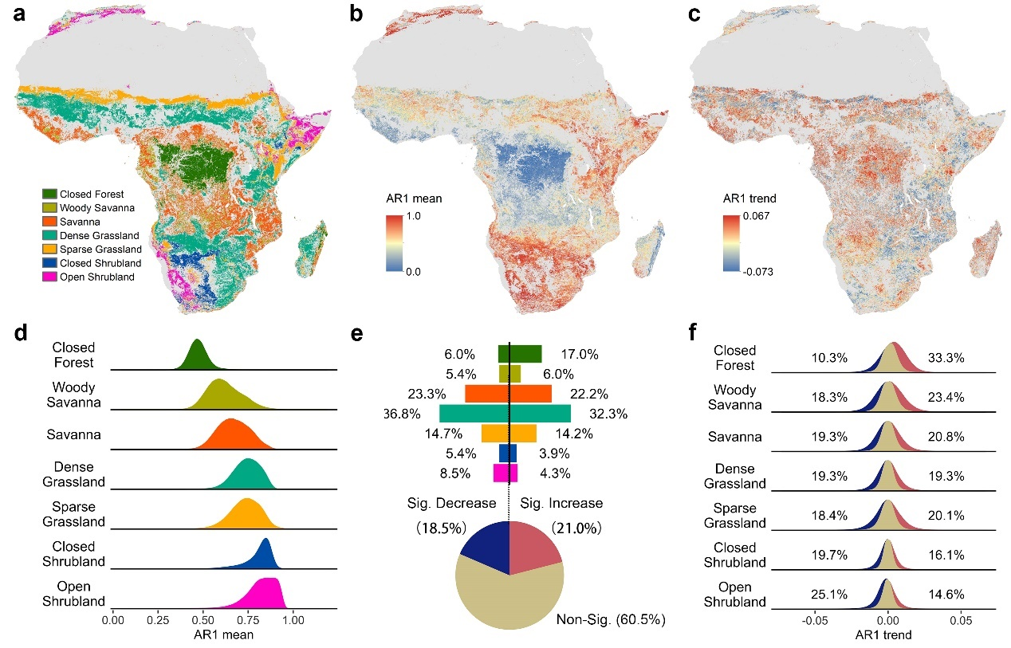
Figure 1. Ecosystem resilience pattern and dynamics of seven African biome states over 2001-2020. (a), The distribution of seven biome states in Africa. (b), The spatial distribution of AR1 mean level. (c), The spatial distribution of AR1 trends. (d), The frequency distribution of AR1 means across seven biome states. (e), The contribution of diverse biome states to significant increases (Sig. Increase) and decreases (Sig. Decrease) in AR1 (sharing the colored legend of biome states with (a) & (d)). (f), The frequency distribution of AR1 trend of seven biome states with noted percentages of significant increases (red) and decreases (blue). The AR1 trend was estimated with the Theil–Sen method (i.e., Sen’s slope), and the significance of the AR1 trend was examined by Mann-Kendall’s test.
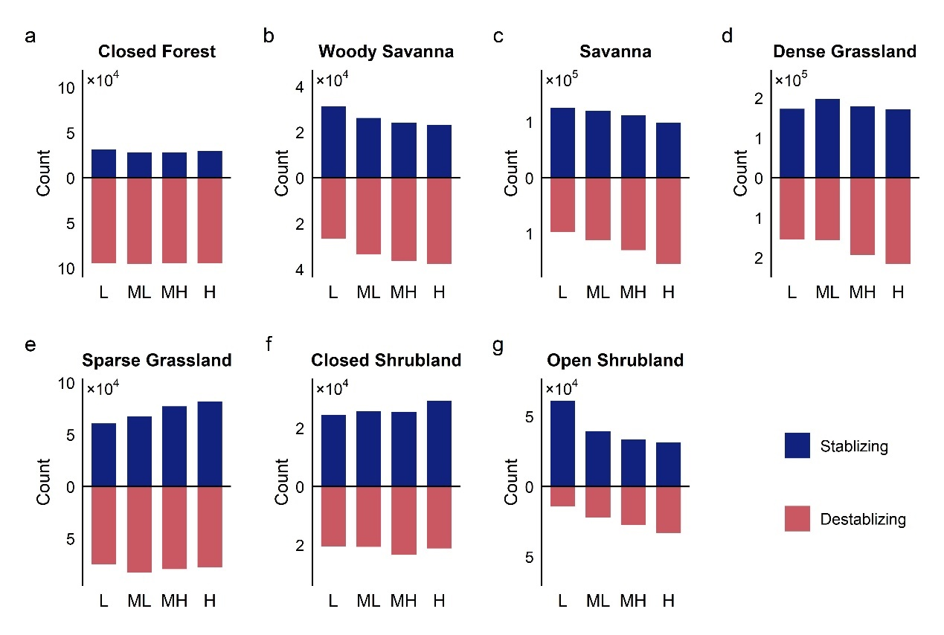
Figure 2. Significant changes in ecosystem resilience at different resilience mean levels across African biome states. For each biome state, samples are grouped into four resilience levels based on the quantiles of AR1 mean (L, low level of resilience, 75-100%; ML, moderately low level of resilience, 50-75%; MH, moderately high level of resilience, 25-50%; H, high level of resilience, 0-25%). The bars show the amount of samples exhibiting significant decreasing and increasing trend in AR1 (stabilizing and destabilizing, respectively) at different resilience levels.
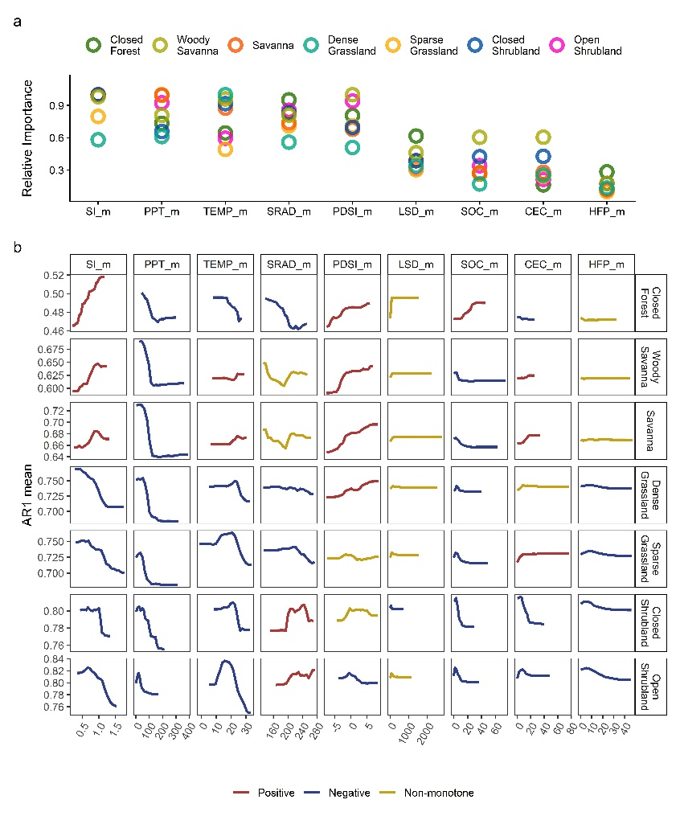
Figure 3. Relative importance of factors and their effects on AR1 mean level in each biome state. (a), Relative importance of factors evaluated by the increase in mean-square error when a factor was permuted in the RF model of each case. Abbreviations for environmental factors are clarified in Table 1. (b), Partial dependence of AR1 mean level on each environmental factor. The correlation type (positive, negative, or non-monotone) between the response variable (AR1 mean) and each factor is classified based on Pearson’s correlation test.
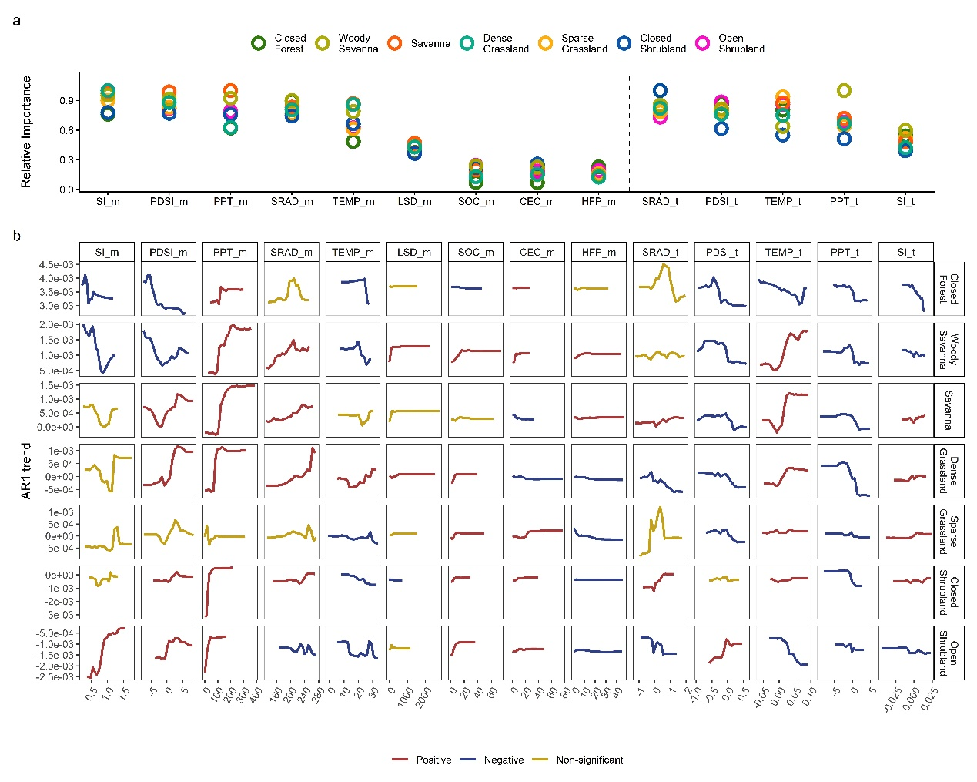
Figure 4. Relative importance of factors and their effects on AR1 trend in each biome state. (a), Relative importance of factors evaluated by the increase in mean-square error when a factor was permuted in the RF model of each case. Abbreviations for environmental factors are clarified in Table 1. (b), Partial dependence of AR1 trend on each environmental factor. The correlation type (positive, negative, or non-monotone) between the response variable (AR1 trend) and each factor is classified based on Pearson’s correlation test.

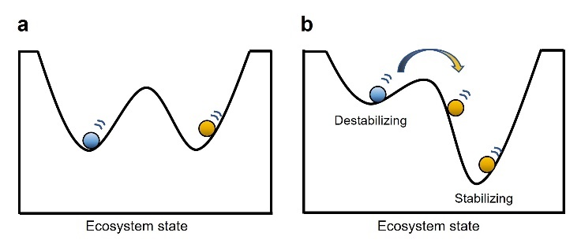
Figure 5. Potential for ecosystem transitions across alternative stable states driven by imbalanced resilience changes. The ball in each cup represents an ecosystem maintained in a stable state, while the shape of the cup (i.e., its depth) indicates the resilience of that state. Imbalanced changes in resilience—illustrated by opposing changes in the depths of the two cups—can increase the likelihood of transitions from the destabilizing state to the more stable one, while inhibiting the reverse transition. This asymmetry can increase the potential for the replacement of one state by the other.

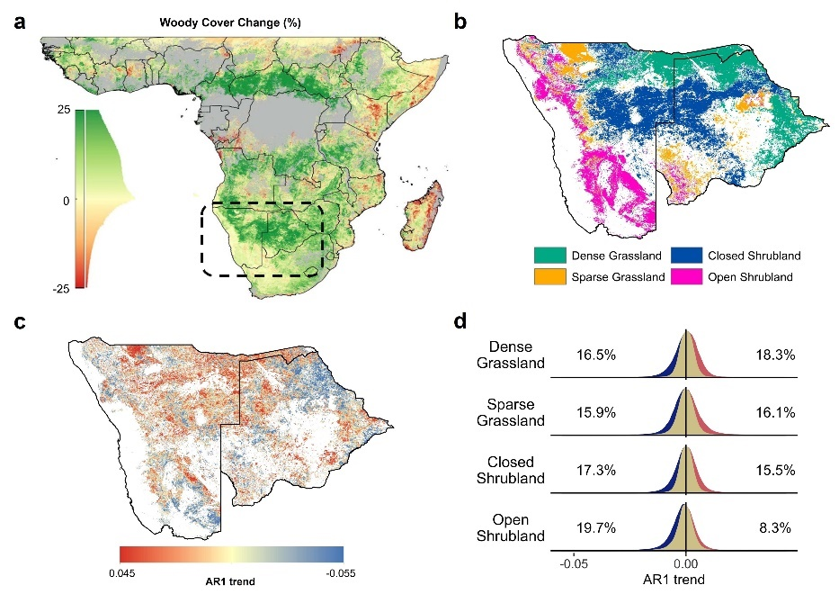
Figure 6. Shrubland stabilization in southern Africa (Namibia and Botswana). (a), The woody cover change during 1986-2016 in Africa suggests that Namibia and Botswana (marked as the dashed box) in the southern part of the continent has undergone significant shrub encroachment. This map is obtained from the study of Venter et al. (2018). (b&c), The biome state distribution and AR1 trend in Namibia and Botswana. (d), The frequency distribution of AR1 trend of seven biome states with noted percentages of significant increases (red) and decreases (blue).
References
Abatzoglou, J. T., Dobrowski, S. Z., Parks, S. A., & Hegewisch, K. C. (2018). TerraClimate, a high-resolution global dataset of monthly climate and climatic water balance from 1958–2015. Scientific Data, 5, 170191. https://doi.org/10.1038/sdata.2017.191
Beisner, B. E., Haydon, D. T., & Cuddington, K. (2003). Alternative stable states in ecology. Frontiers in Ecology and the Environment, 1(7), 376–382. https://doi.org/10.1890/1540-9295(2003)001[0376:ASSIE]2.0.CO;2
Bernardi, R. E., Staal, A., Xu, C., Scheffer, M., & Holmgren, M. (2019). Livestock herbivory shapes fire regimes and vegetation structure across the global tropics. Ecosystems, 22(7), 1457–1465. https://doi.org/10.1007/s10021-019-00349-x
Boulton, C. A., Lenton, T. M., & Boers, N. (2022). Pronounced loss of Amazon rainforest resilience since the early 2000s. Nature Climate Change, 12(3), 271–278. https://doi.org/10.1038/s41558-022-01287-8
Breiman, L. (2001). Random forests. Machine Learning, 45(1), 5–32. https://doi.org/10.1023/A:1010933404324
Camps-Valls, G., Campos-Taberner, M., Moreno-Martínez, A., Walther, S., Duveiller, G., Cescatti, A., Mahecha, M. D., Muñoz-Marí, J., García-Haro, F. J., Guanter, L., Jung, M., Gamon, J. A., Reichstein, M., & Running, S. W. (2021). A unified vegetation index for quantifying the terrestrial biosphere. Science Advances, 7(9), eabc7447. https://doi.org/10.1126/sciadv.abc7447
Chen, H., Liu, J. X., He, W., Xu, P. P., Nguyen, N. T., Lv, Y. M., & Huang, C. C. (2025). Shifted vegetation resilience from loss to gain driven by changes in water availability and solar radiation over the last two decades in Southwest China. Agricultural and Forest Meteorology, 368, 110543. https://doi.org/10.1016/j.agrformet.2025.110543
Cheng, L., Lu, N., Fu, B., & Xu, Z. (2023). Are multiple ecosystem stability metrics equally sensitive and consistent to environmental gradient? A test for African terrestrial biomes. Global and Planetary Change, 230, 104264. https://doi.org/10.1016/j.gloplacha.2023.104264
Cheng, L., Lu, N., Wang, M., Fu, B., & Xu, Z. (2021). Alternative biome states of African terrestrial vegetation and the potential drivers: A continental-scale study. Science of the Total Environment, 800, 149489. https://doi.org/10.1016/j.scitotenv.2021.149489
Ciais, P., Bombelli, A., Williams, M., Piao, S. L., Chave, J., Ryan, C. M., Henry, M., Brender, P., & Valentini, R. (2011). The carbon balance of Africa: Synthesis of recent research studies. Philosophical Transactions of the Royal Society A: Mathematical, Physical and Engineering Sciences, 369(1943), 2038–2057. https://doi.org/10.1098/rsta.2010.0328
Cleveland, R. B., Cleveland, W. S., McRae, J. E., & Terpenning, I. (1990). STL: A seasonal-trend decomposition procedure based on loess. Journal of Official Statistics, 6(1), 3–73.
D’Odorico, P., Bhattachan, A., Davis, K. F., Ravi, S., & Runyan, C. W. (2013). Global desertification: Drivers and feedbacks. Advances in Water Resources, 51, 326–344. https://doi.org/10.1016/j.advwatres.2012.01.013
Dakos, V., Carpenter, S. R., Brock, W. A., Ellison, A. M., Guttal, V., Ives, A. R., Kéfi, S., Livina, V., Seekell, D. A., van Nes, E. H., & Scheffer, M. (2012). Methods for detecting early warnings of critical transitions in time series illustrated using simulated ecological data. PLOS ONE, 7(7), e41010. https://doi.org/10.1371/journal.pone.0041010
Dantas, V. de L., Hirota, M., Oliveira, R. S., & Pausas, J. G. (2016). Disturbance maintains alternative biome states. Ecology Letters, 19(1), 12–19. https://doi.org/10.1111/ele.12537
Didan, K. (2015). MOD13A2 MODIS/Terra vegetation indices 16-day L3 global 250m SIN grid V006 [Data set]. NASA EOSDIS Land Processes Distributed Active Archive Center. https://doi.org/10.5067/MODIS/MOD13A2.006
Dimiceli, C., Carroll, M., Sohlberg, R., Kim, D., Kelly, M., & Townshend, J. (2015). MOD44B MODIS/Terra vegetation continuous fields yearly L3 global 250m SIN grid V006 [Data set]. NASA EOSDIS Land Processes Distributed Active Archive Center. https://doi.org/10.5067/MODIS/MOD44B.006
Doughty, C. E., Keany, J. M., Wiebe, B. C., Rey-Sanchez, C., Carter, K. R., Middleby, K. B., Cheesman, A. W., Goulden, M. L., da Rocha, H. R., Miller, S. D., Malhi, Y., Fauset, S., Gloor, E., Slot, M., Menor, I. O., Crous, K. Y., Goldsmith, G. R., & Fisher, J. B. (2023). Tropical forests are approaching critical temperature thresholds. Nature, 621(7977), 105–111. https://doi.org/10.1038/s41586-023-06391-z
Feng, Y., Su, H., Tang, Z., Wang, S., Zhao, X., Zhang, H., Ji, C., Zhu, J., Xie, P., & Fang, J. (2021). Reduced resilience of terrestrial ecosystems locally is not reflected on a global scale. Communications Earth & Environment, 2(1), 88. https://doi.org/10.1038/s43247-021-00163-1
Fernández-Martínez, M., Peñuelas, J., Chevallier, F., Ciais, P., Obersteiner, M., Rödenbeck, C., Sardans, J., Vicca, S., Yang, H., Sitch, S., Friedlingstein, P., Arora, V. K., Goll, D. S., Jain, A. K., Lombardozzi, D. L., McGuire, P. C., & Janssens, I. A. (2023). Diagnosing destabilization risk in global land carbon sinks. Nature, 615(7954), 848–853. https://doi.org/10.1038/s41586-023-05725-1
Folke, C., Carpenter, S., Walker, B., Scheffer, M., Elmqvist, T., Gunderson, L., & Holling, C. S. (2004). Regime shifts, resilience, and biodiversity in ecosystem management. Annual Review of Ecology, Evolution, and Systematics, 35, 557–581. https://doi.org/10.1146/annurev.ecolsys.35.021103.105711
Forzieri, G., Dakos, V., McDowell, N. G., Ramdane, A., & Cescatti, A. (2022). Emerging signals of declining forest resilience under climate change. Nature, 608(7923), 534–539. https://doi.org/10.1038/s41586-022-04959-9
Friedl, M., & Sulla-Menashe, D. (2022). MCD12Q1 MODIS/Terra+Aqua land cover type yearly L3 global 500m SIN grid V061 [Data set]. NASA EOSDIS Land Processes Distributed Active Archive Center. https://doi.org/10.5067/MODIS/MCD12Q1.061
Gilbert, M., Nicolas, G., Cinardi, G., Van Boeckel, T. P., Vanwambeke, S. O., Wint, G., & Robinson, T. P. (2018). Global distribution data for cattle, buffaloes, horses, sheep, goats, pigs, chickens and ducks in 2010. Scientific Data, 5, 180227. https://doi.org/10.1038/sdata.2018.227
Hengl, T., Miller, M. A. E., Križan, J., Shepherd, K. D., Sila, A., Kilibarda, M., Antonijević, O., Glušica, L., Dobermann, A., Haefele, S. M., McGrath, S. P., Acquah, G. E., Collinson, J., Parente, L., Sheykhmousa, M., Saito, K., Johnson, J.-M., Chamberlin, J., Silatsa, F. B. T., . . . Crouch, J. (2021). African soil properties and nutrients mapped at 30 m spatial resolution using two-scale ensemble machine learning. Scientific Reports, 11(1), 6130. https://doi.org/10.1038/s41598-021-85639-y
Hirota, M., Holmgren, M., van Nes, E. H., & Scheffer, M. (2011). Global resilience of tropical forest and savanna to critical transitions. Science, 334(6053), 232–235. https://doi.org/10.1126/science.1210657
Hodgson, D., McDonald, J. L., & Hosken, D. J. (2015). What do you mean, “resilient”? Trends in Ecology & Evolution, 30(9), 503–506. https://doi.org/10.1016/j.tree.2015.06.010
Huang, J. P., Yu, H. P., Guan, X. D., Wang, G. Y., & Guo, R. X. (2016). Accelerated dryland expansion under climate change. Nature Climate Change, 6(2), 166–171. https://doi.org/10.1038/nclimate2837
Hubau, W., Lewis, S. L., Phillips, O. L., Affum-Baffoe, K., Beeckman, H., Cuní-Sanchez, A., Daniels, A. K., Ewango, C. E. N., Fauset, S., Mukinzi, J. M., Sheil, D., Sonké, B., Sullivan, M. J. P., Sunderland, T. C. H., Taedoumg, H., Thomas, S. C., White, L. J. T., Abernethy, K. A., Adu-Bredu, S., . . . Zemagho, L. (2020). Asynchronous carbon sink saturation in African and Amazonian tropical forests. Nature, 579(7797), 80–87. https://doi.org/10.1038/s41586-020-2035-0
Lamothe, K. A., Somers, K. M., & Jackson, D. A. (2019). Linking the ball-and-cup analogy and ordination trajectories to describe ecosystem stability, resistance, and resilience. Ecosphere, 10(3), e02629. https://doi.org/10.1002/ecs2.2629
IPCC. (2023). Climate Change 2023: Synthesis Report. Contribution of Working Groups I, II and III to the Sixth Assessment Report of the Intergovernmental Panel on Climate Change (Core Writing Team, H. Lee, & J. Romero, Eds.). Intergovernmental Panel on Climate Change. https://doi.org/10.59327/IPCC/AR6-9789291691647
Lenton, T. M., Buxton, J. E., Armstrong McKay, D. I., Abrams, J. F., Boulton, C. A., Lees, K., Powell, T. W. R., Boers, N., Cunliffe, A. M., & Dakos, V. (2022). A resilience sensing system for the biosphere. Philosophical Transactions of the Royal Society B: Biological Sciences, 377(1857), 20210383. https://doi.org/10.1098/rstb.2021.0383
Lewis, S. L., Lopez-Gonzalez, G., Sonké, B., Affum-Baffoe, K., Baker, T. R., Ojo, L. O., Phillips, O. L., Reitsma, J. M., White, L., Comiskey, J. A., Djuikouo, M. N., Ewango, C. E. N., Feldpausch, T. R., Hamilton, A. C., Gloor, M., Hart, T., Hladik, A., Lloyd, J., Lovett, J. C., . . . Wöll, H. (2009). Increasing carbon storage in intact African tropical forests. Nature, 457(7232), 1003–1006. https://doi.org/10.1038/nature07771
Lovejoy, T. E., & Nobre, C. (2018). Amazon tipping point. Science Advances, 4(2), eaat2340. https://doi.org/10.1126/sciadv.aat2340
Lovejoy, T. E., & Nobre, C. (2019). Amazon tipping point: Last chance for action. Science Advances, 5(12), eaba2949. https://doi.org/10.1126/sciadv.aba2949
IPCC. (2019). Climate Change and Land: An IPCC special report on climate change, desertification, land degradation, sustainable land management, food security, and greenhouse gas fluxes in terrestrial ecosystems (P. R. Shukla et al., Eds.). Intergovernmental Panel on Climate Change. https://doi.org/10.1017/9781009157988
Midgley, G. F., & Bond, W. J. (2015). Future of African terrestrial biodiversity and ecosystems under anthropogenic climate change. Nature Climate Change, 5(9), 823–829. https://doi.org/10.1038/nclimate2753
Miller, M. A. E., Shepherd, K. D., Kisitu, B., & Collinson, J. (2021). iSDAsoil: The first continent-scale soil property map at 30 m resolution provides a soil information revolution for Africa. PLOS Biology, 19(11), e3001441. https://doi.org/10.1371/journal.pbio.3001441
O’Connor, T. G., Puttick, J. R., & Hoffman, M. T. (2014). Bush encroachment in southern Africa: Changes and causes. African Journal of Range & Forage Science, 31(2), 67–88. https://doi.org/10.2989/10220119.2014.939996
Pausas, J. G., & Bond, W. J. (2020). Alternative biome states in terrestrial ecosystems. Trends in Plant Science, 25(3), 250–263. https://doi.org/10.1016/j.tplants.2019.11.003
Pausas, J. G., & Bond, W. J. (2022). Feedbacks in ecology and evolution. Trends in Ecology & Evolution, 37(8), 637–644. https://doi.org/10.1016/j.tree.2022.03.008
Pohlert, T. (2023). trend: Non-parametric trend tests and change-point detection (R package version 1.1.6). https://CRAN.R-project.org/package=trend
Poorter, L., Bongers, F., Aide, T. M., Almeyda Zambrano, A. M., Balvanera, P., Becknell, J. M., Boukili, V., Brancalion, P. H. S., Broadbent, E. N., Chazdon, R. L., Craven, D., de Almeida-Cortez, J. S., Cabral, G. A. L., de Jong, B. H. J., Denslow, J. S., Dent, D. H., DeWalt, S. J., Dupuy, J. M., Durán, S. M., . . . Rozendaal, D. M. A. (2016). Biomass resilience of Neotropical secondary forests. Nature, 530(7589), 211–214. https://doi.org/10.1038/nature16512
Rohde, M. M., Albano, C. M., Huggins, X., Klausmeyer, K. R., Morton, C., Sharman, A., Zaveri, E., Saito, L., Freed, Z., Howard, J. K., Job, N., Richter, H., Toderich, K., Rodella, A.-S., Gleeson, T., Huntington, J., Chandanpurkar, H. A., Purdy, A. J., Famiglietti, J. S., . . . Stella, J. C. (2024). Groundwater-dependent ecosystem map exposes global dryland protection needs. Nature, 632, 101–107. https://doi.org/10.1038/s41586-024-07702-8
Scanlon, B. R., Fakhreddine, S., Rateb, A., de Graaf, I., Famiglietti, J., Gleeson, T., Grafton, R. Q., Jobbágy, E., Kebede, S., Kolusu, S. R., Konikow, L. F., Long, D., Mekonnen, M., Schmied, H. M., Mukherjee, A., MacDonald, A., Reedy, R. C., Shamsudduha, M., Simmons, C. T., . . . Zheng, C. (2023). Global water resources and the role of groundwater in a resilient water future. Nature Reviews Earth & Environment, 4(2), 87–101. https://doi.org/10.1038/s43017-022-00378-6
Scheffer, M., Bascompte, J., Brock, W. A., Brovkin, V., Carpenter, S. R., Dakos, V., Held, H., van Nes, E. H., Rietkerk, M., & Sugihara, G. (2009). Early-warning signals for critical transitions. Nature, 461(7260), 53–59. https://doi.org/10.1038/nature08227
Sen, P. K. (1968). Estimates of the regression coefficient based on Kendall’s tau. Journal of the American Statistical Association, 63(324), 1379–1389. https://doi.org/10.1080/01621459.1968.10480934
Slot, M., Cala, D., Aranda, J., Virgo, A., Michaletz, S. T., & Winter, K. (2021). Leaf heat tolerance of 147 tropical forest species varies with elevation and leaf functional traits, but not with phylogeny. Plant, Cell & Environment, 44(7), 2414–2427. https://doi.org/10.1111/pce.14060
Smith, T., & Boers, N. (2023). Global vegetation resilience linked to water availability and variability. Nature Communications, 14(1), 498. https://doi.org/10.1038/s41467-023-36207-7
Smith, T., Traxl, D., & Boers, N. (2022). Empirical evidence for recent global shifts in vegetation resilience. Nature Climate Change, 12(5), 477–484. https://doi.org/10.1038/s41558-022-01352-2
Staver, A. C., Archibald, S., & Levin, S. A. (2011). The global extent and determinants of savanna and forest as alternative biome states. Science, 334(6053), 230–232. https://doi.org/10.1126/science.1210465
Staver, A. C., & Bond, W. J. (2014). Is there a “browse trap”? Dynamics of herbivore impacts on trees and grasses in an African savanna. Journal of Ecology, 102(3), 595–602. https://doi.org/10.1111/1365-2745.12230
Tzachor, A., Richards, C. E., Gudoshava, M., Nying’uro, P., Misiani, H., Ongoma, J. G., Yair, Y., Mulugetta, Y., & Gaye, A. T. (2023). How to reduce Africa’s undue exposure to climate risks. Nature, 620(7974), 488–491. https://doi.org/10.1038/d41586-023-02557-x
Venter, O., Sanderson, E. W., Magrach, A., Allan, J. R., Beher, J., Jones, K. R., Possingham, H. P., Laurance, W. F., Wood, P., Fekete, B. M., Levy, M. A., & Watson, J. E. M. (2016a). Global terrestrial Human Footprint maps for 1993 and 2009. Scientific Data, 3, 160067. https://doi.org/10.1038/sdata.2016.67
Venter, O., Sanderson, E. W., Magrach, A., Allan, J. R., Beher, J., Jones, K. R., Possingham, H. P., Laurance, W. F., Wood, P., Fekete, B. M., Levy, M. A., & Watson, J. E. M. (2016b). Sixteen years of change in the global terrestrial human footprint and implications for biodiversity conservation. Nature Communications, 7, 12558. https://doi.org/10.1038/ncomms12558
Venter, Z. S., Cramer, M. D., & Hawkins, H. J. (2018). Drivers of woody plant encroachment over Africa. Nature Communications, 9, 2272. https://doi.org/10.1038/s41467-018-04616-8
Verbesselt, J., Umlauf, N., Hirota, M., Holmgren, M., van Nes, E. H., Herold, M., Zeileis, A., & Scheffer, M. (2016). Remotely sensed resilience of tropical forests. Nature Climate Change, 6(11), 1028–1031. https://doi.org/10.1038/nclimate3108
Walsh, R. P. D., & Lawler, D. M. (1981). Rainfall seasonality: Description, spatial patterns and change through time. Weather, 36(7), 201–208. https://doi.org/10.1002/j.1477-8696.1981.tb05400.x
Wang, W., Cao, R., Liu, L., Zhou, J., Shen, M., Zhu, X., & Chen, J. (2025). An improved spatiotemporal Savitzky–Golay (iSTSG) method to improve the quality of vegetation index time-series data on the Google Earth Engine. IEEE Transactions on Geoscience and Remote Sensing, 63, 1–17. https://doi.org/10.1109/TGRS.2025.3528988
Willis, K. J., Jeffers, E. S., & Tovar, C. (2018). What makes a terrestrial ecosystem resilient? Science, 359(6379), 988–989. https://doi.org/10.1126/science.aar5439
Wright, M. N., & Ziegler, A. (2017). ranger: A fast implementation of random forests for high dimensional data in C++ and R. Journal of Statistical Software, 77(1), 1–17. https://doi.org/10.18637/jss.v077.i01

