Titre: Trouver la scénographie dans les atmosphères urbaines quotidiennes
Title: Finding scenography in everyday urban atmospheres
Auteur principal/Lead Author: Joslin McKinney
Joslin McKinney is Professor of Scenography in the School of Performance and Cultural Industries at the University of Leeds, UK. Her publications include The Cambridge Introduction to Scenography (Cambridge University Press, 2009) and Expanded Scenography; an introduction to contemporary performance design (Bloomsbury Methuen, 2017). Her next book will be Scenographic City: performance design and urban imaginaries (Bloomsbury Methuen, 2027). Her research interests include scenographic materiality and embodied spectatorship, scenographic research methods and urban scenography. j.e.mckinney@leeds.ac.uk

Résumé
Cet article explore comment les concepts de la scénographie peuvent être appliqués à la reconnaissance des atmosphères affectives dans les lieux familiers. En réponse aux appels à développer des méthodologies de recherche qui prennent en compte l'expérience directe de l'engagement sensoriel et corporel avec la matérialité des atmosphères urbaines, j'explore comment les scénographies « trouvées » peuvent constituer une technique d'enregistrement et d'examen de la diversité des atmosphères urbaines. Recourant à la phénoménographie, je m'appuie sur la pensée scénographique pour développer un cadre et une perspective pour la perception et l'analyse des atmosphères urbaines quotidiennes. L'article encourage des modes d'engagement corporel imaginatifs et performatifs avec les environnements urbains afin d'appréhender les enchevêtrements dynamiques des corps, des espaces et des matériaux qui constituent ces environnements, ainsi que la gamme potentielle d'affects pour différents corps.

Mots-clés
atmosphère affective, scénographie, urbain, matérialité, phénoménographie

Abstract
This article explores how concepts from the field of scenography can be applied to the recognition of affective atmospheres in familiar places. Responding to calls to develop research methodologies that attend to the first-hand experience of sensory and bodily engagement with the materiality of urban atmospheres, I explore how ‘found’ scenographies can be a technique for registering and examining the varieties of urban atmosphere. Utilising phenomenography, I draw on scenographic thinking to develop a focus and a framework for the perception and analysis of everyday urban atmospheres. The article promotes imaginative and performative modes of bodily engagement with urban environments in order to appreciate the dynamic entanglements of bodies, spaces and materials that constitute urban environments and the potential range of affects for diverse bodies.

Keywords
affective atmosphere, scenography, urban, materiality, phenomenography

Introduction

Illustration 1: Frog Walk, Sheffield 7:24am 14 December 2021, source and copyright:Author
I’ve turned off a main well-lit road and into this shortcut that runs steeply down the side of the General Cemetery. I’ve got my hood up – so the sound of my breathing is amplified and the contrast between the chilly air and the warmth inside my hood is noticeable. The gradient of the path pushes my toes to the front of my trainers. My feet crunch and slip on patches of loose gravel. The walls are high with a narrow gap between – old brick patched with concrete and damp with moss. Overhanging trees and ivy enclose the alley and make it a tunnel. A security light from a building nearby highlights the graffitied wall at the top, but further down it is dark and shadowy. I’m reminded of how this path has been used for decades, centuries even - people using it as a short cut to get to work. This morning I only pass a couple of other people. We take care to leave each other room – because of covid – but maybe also because of the reputation of this place – people often seem to want to signal that they mean no harm. I often think twice about taking this path, but it’s exciting, too, and this morning as I arrive safely into the thin December sunlight glinting off the river at the bottom of the path. It makes me feel energised and alive.

During the period of the covid pandemic, when going outside became a rare treat, the ‘affective atmospheres’ (Anderson, 2009) of my neighbourhood felt newly vivid and graspable. With fewer people and less traffic, the features and qualities of familiar places came into sharper focus and I noticed new things and particular constellations of things and how I was being affected. I started documenting my solo walks using photographs taken on my smart phone, aiming to capture moments, such as the one in Frog Walk, when resonances between my body and the surrounding environment seemed to coalesce as an atmospheric envelopment (McCormack, 2018). The atmosphere in Frog Walk that particular morning was tinged by its commonly-held reputation in the neighbourhood as a site of robberies and sexual assaults. However, being attentive to the vibrant matter (Bennett, 2010) of the place produced a sense of an ongoing formation of atmosphere where the immediate materialities of the place mingled with embodied experience revealing a complex interaction of sensory feeling and being.
As a trained scenographer - a designer of sets and costumes for theatre for 10 years before becoming an academic in theatre and performance - I understand the creation of scenes as the facilitation of active and generative relationships between performers, audiences and theatrical environments. Concepts of the theatre, and especially stage sets, are often used to evoke ideas of the deliberate the creation of urban atmospheres (Simpson, 2021, p.95-96) that is conducive to shoppers, citizens, workers or cultural tourists being and behaving in public space through the ‘simulation and manipulation of affect and emotions’ (Bille et al., 2015, p.37). Scenography is cited as a ‘paradigm’ of the making and manipulation of intentional urban atmospheres (Böhme, 2013) through lighting, sound and the aesthetic arrangement in the architecture and design of shopping centres or the staging of public events (Gandy, 2017). However, atmospheres are everywhere (Anderson, 2009) including non-designed spaces such as Frog Walk, which can nonetheless become a ‘scene’ where the intensities of the immanent forces of the ordinary become palpable (Stewart, 2007) and an atmosphere is brought into focus through scenographic sensibilities.
The significance of urban atmosphere, whether engineered or not, is closely connected to non-representational approaches (Thrift, 2007) that address the embodied, affective and material dimension of urban experience and the palpable dynamism of spaces of the everyday (Simpson, 2021). Examining urban atmospheres is a way of understanding ‘the co-existence of embodied experience and the material environment’ (Bille, Bjerregaard & Sørensen, 2015, p.6) that offers ‘a richer understanding of collective forms of urban consciousness and experience’ (Gandy, 2017, p.353). Concepts of urban atmosphere have been productively applied in empirical research into urban experience through perspectives including; planning and regeneration (Buser, 2014; Degen & Lewis, 2020; Eronen, 2024; Thibaud, 2015; Edensor & Sumartojo 2015), shopping (Healy, 2014), night- time economy (Shaw, 2014), urban lighting (Bille, 2017; Sumartojo et.al., 2019; Abusaada, Elshater, Neseem & Fouad, 2024), architecture (Pallasmaa, 2012, 2014; De Matteis, 2021; Stenslund, 2022), streetscapes (Wesener, 2019) and the distinctiveness of cities (Bille & Schwabe, 2023; Albertsen, 2019). Fundamentally, an atmospheric approach embraces the idea that urban environments are affective and dynamic, capable of influencing feelings and behaviours (Griffero, 2019, p.100; Simpson, 2021, p. 96). Although the intentional making and manipulation of urban atmosphere through architecture and urban design has understandably attracted much scholarly attention, it is important to consider what we can learn from researching perceptions of urban atmosphere which may or may not align with what is intended (Griffero, 2019; De Matteis, 2021; Peterson, 2023) and which materialise in ordinary, un-designed urban space. Doing so requires engaging with atmospheric affects as experienced by specific individuals (Simpson, 2021, p. 103) in order to appreciate the political dimension of affective atmosphere that emerges through ‘surpluses, traces, noises, and charges in and around the beliefs of embodied agents’ (Thrift, 2004, p.71). In this article, I draw on my sensory and embodied experiences as a kind of ‘recording machine’ (Dewsbury, 2009, p. 327) that can access the formation of affective atmospheres. Paying attention to the emergence of atmospheres in quotidian places like Frog Walk allows us to step out of what Böhme calls the ‘permanent staging of our everyday world’ (2017, p.121), where we are typically cast as compliant consumers of the designed urban environment, and experience how we are actually always active co-producers of atmosphere. However, , utilising a scenographic framing for empirical research does not only draw attention to the individual sensing body; it simultaneously highlights the imaginative and performative dimension of atmospheric envelopment which foregrounds the agency of more-than-human aspects. Opening up to an appreciation of liveliness and mutability of urban environments in this way reflects a post – phenomenological acknowledgement of the autonomous existence of non-human things (Ash and Simpson 2016). As such, this research contributes to new thinking and techniques of non-representational, geographical research that has embraced broadly creative methodologies and methods (Vannini, 2015; Boyd and Edwardes, 2019; Simpson, 2021 ) , and, specifically, it re-positions scenography as ‘device’ (McCormack, 2015) of atmospheric research, rather than a paradigm of coercive urban design.
Empirical methods for investigating the perception of atmospheres are challenged by the ‘seemingly insurmountable enigmatic nature’ of atmosphere (De Matteis, et al., 2019, p.15). And working with such methods mean encountering ‘the double-bind of representational and non-representational modes of thought’ (Dewsbury, 2009, p. 321) risks embracing uncertainty and failure. Nonetheless, development of ‘phenomenographic’ techniques that employ intersecting expressive media to encompass ‘spatial, corporeal and affective spheres’ in representations of lived situations (De Matteis, et al., 2019, p.5) offer one way forward. For example, Le Calvé and Gaudin, use a combination of their on-the-spot drawings, which they conceive as ‘mnemonic’ tools for capturing everyday atmosphere (2019, p.3), and their post-hoc reflections to capture and reflect on the occurrence of atmospheric envelopment in ‘unplanned interstices’ of Berlin (2019, p.15). A range of more-than-textual approaches to investigating sensorial impressions gives access to aspects of experience that can be hard to gain with more objective methods (Wesener, 2019, p.10). The image and notes from Frog Walk are a form of phenomenography where photographic images and reflective notes together aim to capture the perception and formation of an atmosphere . In this article, I present and reflect on this and three more phenomenographies of everyday urban environments in order to address these questions: How does scenographic understanding illuminate the variety of ordinary urban atmospheres? How does a scenographic approach provide focus and new framing to attuning to, reporting on and analysing atmospheres? My approach to phenomenography adopts a postqualitative stance in that, rather than set out with a pre-planned process, I have aimed to meet the material flows of the urban in the ‘speculative middle’ (Springgay & Truman 2018). The method emerged - through a combination of walking, noticing, feeling, photographing, imagining and post-hoc reflection - as a way of being in the world rather than as means to report on it (Springgay & Truman 2018).

Concepts of urban atmospheres
Much current research into urban atmospheres draws on concepts derived from philosophers Gernot Böhme (1993, 2013, 2017) and Tonino Griffero (2013, 2014, 2016, 2017, 2019) that give ‘special attention to the built environment’ (De Matteis, 2021, p.3). In particular, three interconnected properties together articulate a philosophy of atmosphere that point towards the spatial, material and embodied nature of atmosphere formation in the urban everyday.

Firstly, atmospheres are formed in-between subjects (sensing bodies) and objects (environments). They are ‘quasi-things’ (Griffero, 2017), belonging neither to surrounding environment nor to the perceiver. Urban environments consist of apparently ‘objective’ architectural forms as well as ‘non-physical, non-objective and non-physical forms’ such as sound, light and weather; either might be considered as generators of urban atmosphere (Böhme, 2017, p.92). But even though environments have ‘atmospheric affordances’ (Griffero, 2019), atmospheres do not pre-exist their perception; they require subjects to sense them (Böhme, 2013, p.2). At the same time, reception of atmospheres is not entirely subjective or dependent on the disposition or mood of the perceiver, despite the recognition that individual, historical and cultural differences can lead to the perception of different atmospheres in the same environment (Griffero, 2019, p.106 -7).

Secondly, atmospheres are spatially dispersed through the ‘ecstacises’ of people and environmental, ‘emanating from and produced by things, people or their constellations’ (Böhme, 2017, p.23). The qualities of things (including perceiving bodies) are not bound by their physical form; they radiate beyond to assert their presence in space (Böhme, 2017, p. 49 -51). For example, sound, smell and colour are ‘energetic or material emanations’ which can fill a space. They do not belong to the thing they are associated with, but radiate outwards, ‘tinging and tinting’ other the things (Böhme, 2017, p.51). The spatially dispersed nature of atmospheres also defines how they are experienced, directly as felt-bodily resonances, and in a particular place and time (Griffero, 2019, p.100).

Thirdly, atmospheres are vague and yet powerfully able to affect emotions, physical reactions, behaviour and judgments (Griffero, 2019). The affect of atmospheres is relatively inpenetrable in a cognitive sense (Griffero, 2019, p. 67). Sense or meaning in atmospheres is ‘unfurled’ through bodily presence rather than objectively determined (Böhme, 2017, p.91). Through bodily disposition and haptic sense we sense mood qualities such as ‘expansiveness or tightness…uplift or depression…closeness and distance’ (Böhme, 2017, p. 92). For Griffero, the communication of atmospheres operates through ‘embodiment’ rather than semiotics and comes about as the result of ‘an exchange process between bodies and things’ (Griffero, 2019, p.104).

These ideas have been utilised by geographers, especially through the concept of affective atmospheres defined as ‘a class of experience that occur before and alongside the formation of subjectivity, across human and non-human materialities, and in-between subject/object distinctions’ (Anderson, 2009, p.78). They have also informed new understanding of how scenography works.

Scenographic atmospheres of the everyday
In the twenty-first century, expanded concepts of scenography have facilitated a more dispersed and relational understanding of scenographic events. The influence of ‘postdramatic’ forms of performance (Lehmann, 2006), including installation, immersive, site-specific and participatory performance mean that the role of the perceiver has been re-conceived as an active component of the generation of theatrical atmosphere rather than a mere observer (Fischer-Lichte, 2008; White, 2013). Recent scholarship emphasises the dynamic interactions of performing and spectating bodies, space, objects and materials that give rise to scenography as a performance medium (Bleeker & Germano, 2014; Shearing, 2014; McKinney, 2015; Salter, 2017; Hann, 2019). This means that scenography can be thought of as an ‘interlocking’ between ‘atmospheric phenomena like light, heat, vibrations, smells, and air currents and the human inhabitants of these conditions’ (Salter, 2017, p.174). In this way, scenography is a process of atmosphere formation where particular and localised atmospheres emerge through spectators’ attentive engagement with the materiality of a performance environment (Hann, 2019; Shyldkrot, 2019; Graham, 2020). A person’s bodily, sensory capacities, together with their life experiences, memories and imaginations are an active part of theatrical atmosphere formation (McKinney, 2017). At the same time, material nonhuman elements activate scenographic atmospheres (Donald, 2016; Shyldkrot, 2019; Graham, 2020; McKinney, 2020), not only through human intervention, but as ‘vibrant’ things themselves (Bennett, 2010). New Materialist ideas, such as Jane Bennett’s notion of ‘thing-power’, or the ‘vitality intrinsic to materiality’ (2010, p.2 -3) have expanded understanding of how scenography might be implicated in atmospheres both on and off the stage by decentring human action and acknowledging the liveliness of all kinds of matter.
Expanded scenography does not even require a pre-determined scenography; it can simply be ‘found’ in everyday environments by the spectator through ‘active witnessing’ (Lotker & Gough, 2013, p. 3 - 6). There are affinities here with Kathleen Stewart’s notions of ‘scenes’ of ‘ordinary affect’ (Stewart, 2007, p.4 - 5) that emerge through her thick descriptions of moments when she has ‘the sense of something happening becomes tactile’ (Stewart, 2011, p. 445 ). However, the idea of found scenography might extend understanding of the affective atmospheres of the everyday, both in offering new ways to represent them, for example through scenographic phenomenography and also through the mobilisation of scenographic framing to structure and analyse them.
McKinney and Palmer (2017, p.7 -13) identify three inter-related concepts help to identify three key ways in which expanded forms of scenography operate. Scenographic ‘relationality’, refers to spatial relationships between spectators, performers, places, sites, materials from which a scenographic experience might emerge. Scenographic ‘materiality’ refers to the emergent agentic capacities of all kinds of matter (including light, sound, smell, colour, texture, bodies of all kinds) to interact and produce affective atmospheres within scenography. Scenographic ‘affectivity’ deals with the multi-sensory way in which scenographic experiences generate feeling and the extralinguistic or ‘sensorial, affective and more-than-cognitive’ registers that are often inaccessible through language alone (Donald, 2016, p.3). Although it was envisaged that this framework could be applied to a range of scenographic events and performances, the potential for it to be applied to non-designed, everyday urban atmospheres has not yet been explored. However, these three terms have affinities with three properties of atmosphere outlined above. The relational dimension of scenography relates closely to the formation of atmospheres in between atmospheric affordances and sensing bodies. The materiality of scenography deals with how things assert their presence in space as ecstatic, energetic emanations. The affectivity of scenography connects with the way atmospheres produce feeling and physical reaction through felt-body communication. Together, these concepts might be developed as a framing for attuning to and reflecting on first-hand experiences of quotidian atmospheres.

Finding scenography as a phenomenographic method
As outlined above, better understanding of the perception of atmospheres contributes to our ability, as researchers and citizens, to engage actively and critically with urban environments. It is therefore important to develop methodologies that attend to first-hand and varied experience of the sensory qualities of space and to a direct engagement with the materiality of urban atmospheres (Miller, 2014; Edensor & Sumartojo, 2015; Shilon, 2023). The corporeal and affective nature of the way atmospheres are registered means we need to pay attention to subjective first-hand accounts of atmosphere (De Matteis et.al 2019, p. 1) that will differ one from another due to the ‘corporeal disposition and personal biography’ (De Matteis et. al., 2019, p.3) of the person doing the reporting. Further, feminist and intersectional approaches to lived urban experience emphasise the need for research to adopt relational, reflexive and positional approaches that can account for multiple subjugated identities in lived experience (Falconer Al-Hindi & Eaves, 2023). Bearing these points in mind, I explore the process of scenographic phenomenography in more detail.
Overall, my aim with a phenomenography such as Frog Walk is to convey the sense of a ‘found’ scenography (Lotker & Gough, 2013) where latent forces coalesce in an expression of the intertwining of spatially dispersed things in ordinary urban environments. A phenomenography is essentially auto-ethnographic, but in utilising combinations of expressive media, it provides a productive tension between the moment of lived experience and subsequent reflection (De Matteis et.al, 2019, p. 5).
The phenomenography of Frog Walk is expressed above through a single image, taken in situ, from which post-hoc reflective notes have been constructed. On this walk, I took several images at points when I became instinctively aware of atmospheric coalescences, or the sense ‘that something is happening’ (Stewart, 2007, p.5). In the moment of walking, I limited the use of the camera to quick snaps rather than carefully composed images to help keep the focus on being there and being open to the affective resonances of the place. After the walk, I looked back at the images and reflected on what I could see in the image and what I could remember feeling in my body. The images are not simply representational, they are ‘blocks of sensation with an affective intensity’ (Latham & McCormack, 2009: 253) which means they retain some of the embodied sensation that was present when they were taken. Between the image and the reflective notes, I aimed to analyse and then re-present the atmosphere of this scene, taking into account the relationality, materiality and affectivity of the place as though it were a scenography. In constructing the phenomenography, I have cropped the image and tweaked the colour- balance of the photo so that it communicates a visceral sense of that moment as I recall it and I have edited and refined the notes so that they are in dialogue with the image (Cronin, 2011). The notes allow some translation of embodied experience, but this cannot be completed; the singular yet vague nature of atmospheres means that they hesitate ‘at the edge of the unsayable’ (Anderson, 2009, p.78). They emerge from the ‘excessive world’ that lies beyond what I can grasp, but is nonetheless, central to my experience (Ash & Simpson 2016, p.63).
In addition to my professional training, my age, class, physical ability, personal circumstances and experiences also have a bearing on how I notice and interpret the sensorial environment. I have lived in this neighbourhood in Sheffield for over 30 years and I have accrued decades of experiences and memories of places such as Frog Walk that are sedimented in my body. Being a woman influences whether I feel safe walking alone, especially in the dark, but that has changed over time. Now, as a post-menopausal woman I have attained a certain invisibility, which can sometimes be useful. My ageing white body can move through the city without attracting much attention, yet I can’t take my strength and mobility for granted and increasingly my awareness of how my body is moving through environments is heightened.
Phenomenographies of found scenography such as Frog Walk are underpinned by my positionality and my lived experience but at the same time, they reflect the liveliness and agentic capacities of non-human and non-organic entities. Three more examples will help to develop a scenographic approach to phenomenographies.

Waitrose entrance
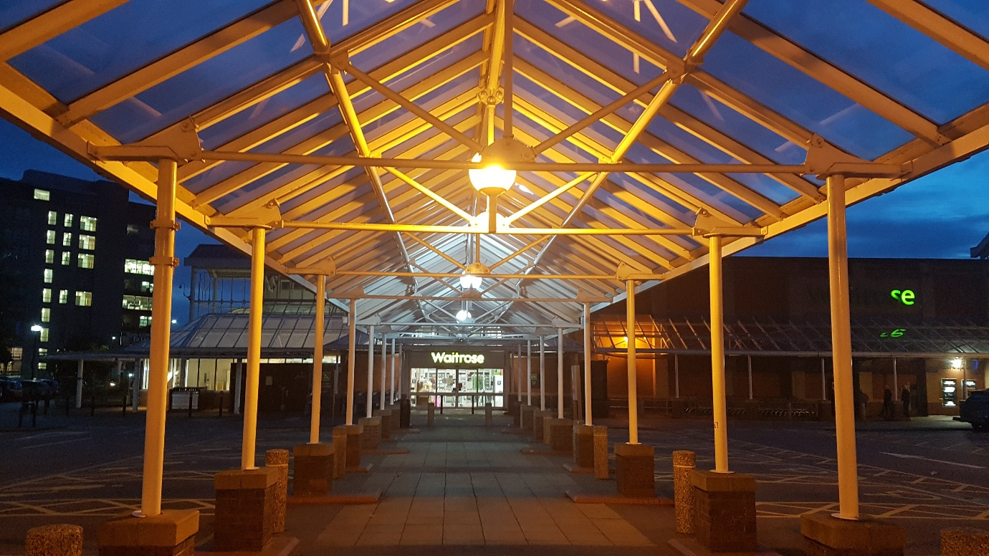
Illustration 2: Waitrose Entrance, 6.50 am, 9 October 2020, source and copyright: Author
A grandiose entrance. Early in the morning, before the supermarket is open. The lamps throw a light across the structure that appears golden, lending it even more ironic sense of splendour than usual. Despite myself, I’m enjoying the feeling of walking down the colonnade, standing a little taller than usual, aware of my pace and a slight lift in my step.
It’s an uplifting, expansive feeling, like walking into a cathedral, but it’s a supermarket. There’s also a sense of being watched, like I’m on a catwalk and I’m more conscious of where I’m putting my feet, aware of my heightened visibility under the light, but as far as I can tell, no one is watching.
Waitrose is generally considered to a be a premium supermarket, with higher quality produce and higher prices, so the grand entrance was likely a deliberate design decision, aiming to make shoppers register the specialness of the shop with allusions to luxury. Retailers have long used scenographic strategies such as illuminated glazed passageways to recover the seductive atmosphere of marketplaces of ‘classical civilisations’ (Tabački, 2020, p.14) in order to cast consumers as ‘active players in bourgeois society’ (p.16). However, out of hours, the atmospheric affordances aimed at shoppers had an ambivalent effect on me. The walkway’s architecture – the height of the roof, the rhythm of the evenly spaced columns – draw shoppers effortlessly towards the store entrance. But in heavy lace-up boots and a thick waterproof jacket, I felt like a subversive interloper, performing my subversion of the architecture. The image reflects this tension in the cartoonish impression of the yellow roof structure and the dark blue dawn sky and the anti-climatic effect of the fuzzy, Waitrose sign at the vanishing point of the colonnade.

Scaffolding
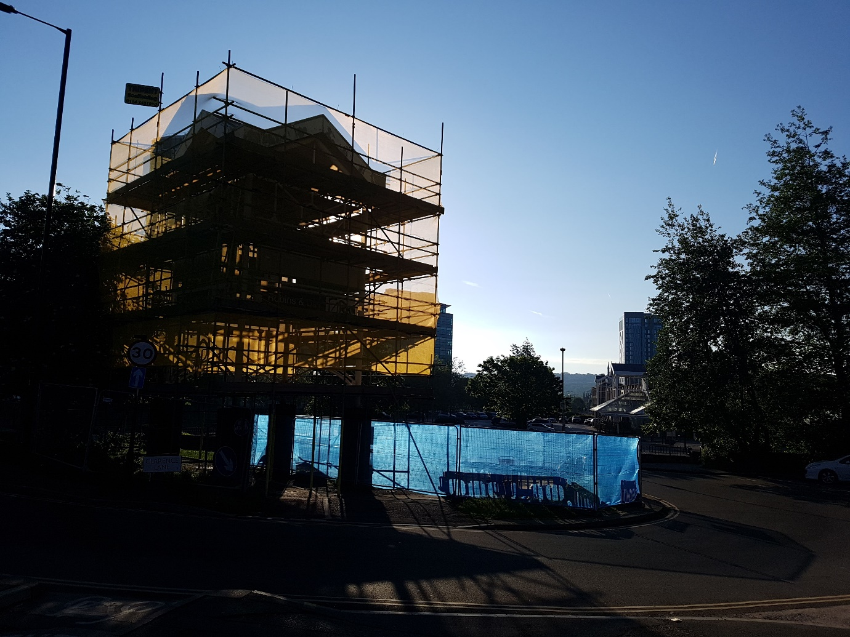
Illustration 3: Scaffolding 6.50am 20 May 2020, source and copyright: Author
Plastic mesh stretched across the scaffolding catches and holds the light. Backlit, this structure is a mass of intersecting lines and angles that spill across the pavement and dissolve its solidity, making it blend and connect with the trees and the road. I can feel the lines of shadow falling on me and I’m blended into my surroundings.
Normally, this is a busy traffic junction, on a main road through Sheffield, but under lockdown it is quiet. It is part of my regular route, but this was the first time I had noticed this arrangement; it felt to me as though it has just appeared. With the sun illuminating the structure, it was arresting and almost overwhelming. This light was ‘ecstatic’ in the sense that Böhme has described, where things ‘step beyond themselves in order to display their presence to their surroundings’ (Bille, 2017, p.41). It was intertwined with other ecstatic things – the plastic mesh, the trees, the tarmac, my own body - that were transcending their ‘tangible’ borders (Bille, 2017, p. 26). My written notes do not fully capture the sense of relief I remember at dissolving into the environment, escaping the boundaries of my body at the same time as I was having anxious thoughts about sickness and the pandemic. Griffero says that ‘sometimes it is only by virtue of the external atmospheric expressiveness that a vague mood is incorporated and clarified’ (2019, p.80). My bodily feeling was shaped by attuning to the surroundings and then further defined as a mood, in a reciprocal action between my body and the environment.

Yellow Steps
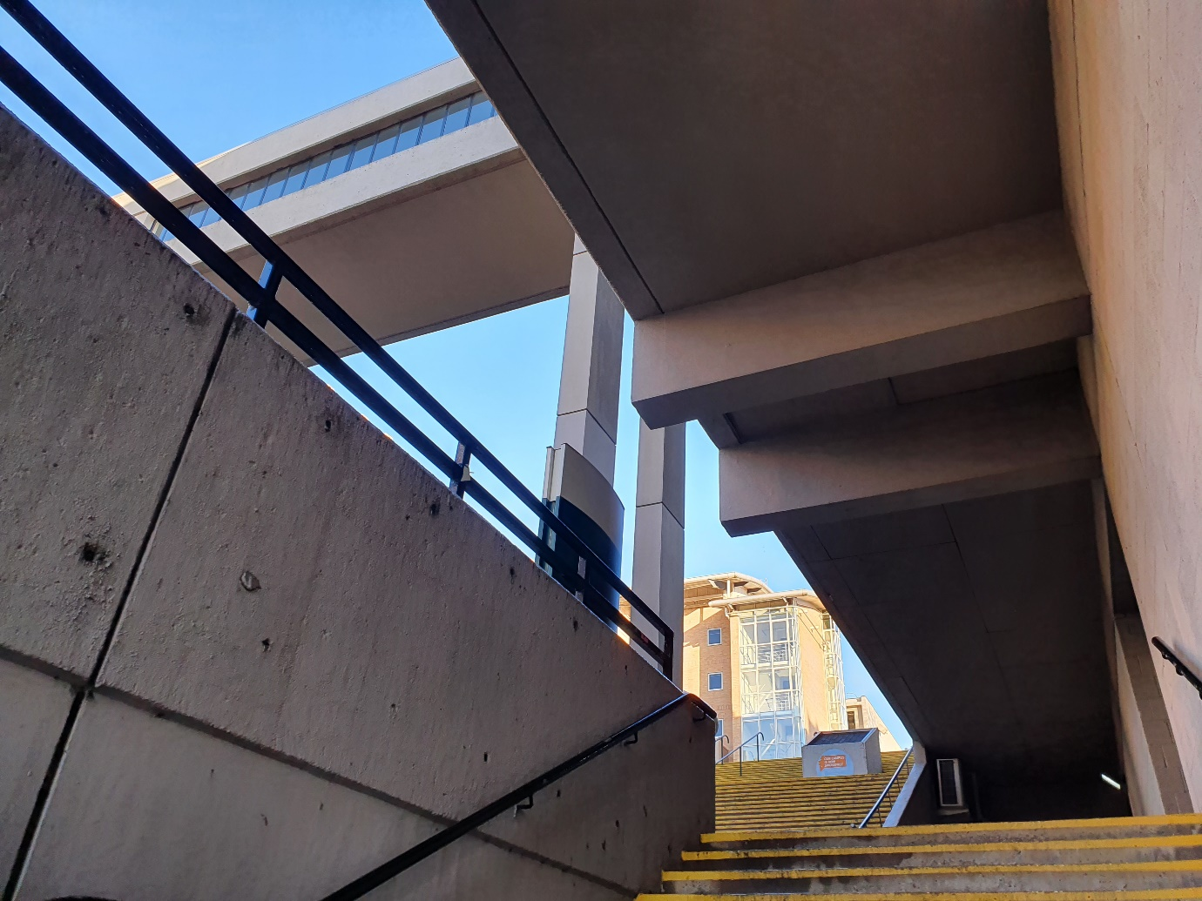
Illustration 4: Yellow Steps 8.46am 13 Nov 2020, source and copyright: Author
Sunlight is creating a strong contrast between open bright space at the top of the stairs and the shadowy angular passage that needs to be negotiated to get there. It highlights the texture of the thick hard concrete slabs on the wall and the low heavy ceiling halfway up the stairs. I’m aware of looking up towards the light, readying myself to climb and turn, whilst being careful to place my feet safely on the steep, narrow steps with their clumsy, flaky yellow edges. I’m thinking about the emerging into the crisp air and bright sunlight but also wondering what could be lurking in the dark recess halfway up. In early autumn dead leaves gather there. I’ve seen thick cardboard stashed there, too; I think someone has been sleeping there. I can feel the brightness pulling me up.
This is a place on the campus of the University Leeds where I work. It houses a lively mixture of architectural styles, including these Brutalist steps, which on this day were practically deserted. The empty steps offered atmospheric possibilities that I had not noticed before. The contrast between the dark recess and the brightness beyond meant that, as with Frog Walk, the phenomenography develops a narrative trajectory around emerging from dark into light. The use of light as a metaphor in performance contributes to the way we read a scenography, but it is not a purely cognitive process; light is also ‘a substance encountered through the body’ (Graham, 2023, p.166), an active and material force that is felt, in its intensity and temperature, through the body. In this ‘found’ scenography, the light is the most noticeably active material force, but it is acting alongside other materials. In the image, the dark and stained bulk of the concrete roof above the steps contrasts with the light blue sky.

Scenographic framing of urban atmospheres
Across the four examples presented in this article, a scenographic sensibility has guided a process of attuning to the formation of atmospheres (as ‘found’ scenographies) and has informed the selection and presentation of the phenomenography. Working in this way has allowed a concentrated focus on the reciprocal exchanges between my body and the surrounding environment through attentiveness towards the liveliness of matter. Conceptualising these ordinary atmospheres as ‘found scenography’ borrows from the familiar idea that ‘staged’ atmospheres can be powerfully affective for a collective audience (Simpson, 2021, p. 95) but redirects it towards the experience of the individual perceiver as part of an assemblage of all kinds of vibrant materials (Bennett, 2010). The three inter-related concepts of contemporary scenography outlined above can be further delineated to outline a scenographic approach to attending to and accounting for first-hand experiences of urban atmospheres.
- Relationality
In the context of urban atmospheres, scenographic relationality highlights how positions, proximities and trajectories shape encounters across and between bodies and environments. It recognises that things work together in dynamic assemblage, each capable of affecting other things. In the examples above this is registered in two different modes; the first through internal sensations and bodily feelings and secondly with a more externalised sense of how I am spatially positioned in relation to other bodies and things.

The Waitrose Entrance with its brightly lit canopy, affects how I walk, making me self-conscious about how I place my feet and hold my ageing body. In Frog Walk, the steep incline of the path determines the way I walk; as it propels me downhill I have to bend my knees to stop myself going too fast and falling. Climbing the Yellow Steps, means twisting through the dark concrete structure into the light and stepping carefully to negotiate the narrow, flaky steps. Other bodies with different physical capacities would likely respond differently to these same atmospheric affordances; a focus on the particular ‘relational dynamics’ of atmosphere formation (Edensor, 2022, p.16) foregrounds urban experience at a bodily level.

Encounters with other bodies, actual or perceived, are also part of the atmospheric potential. In Frog Walk, the narrowness of the path and the high walls frame a careful negotiation between me and other walkers. The Waitrose Entrance frames a sense of being positioned in relation to imagined observers. Things that seem out of place, like a stack of squashed cardboard hidden in an alcove beside the Yellow Steps, offer a different perspective on the use of the space, as a place to hide and sleep. My immediate physical sensations are inflected with a sense of positionality and feelings of belonging or being in control, of being safe, of being watched. In Frog Walk, I feel some comfort in the invisibility of being a post-menopausal woman, but another body with experiences, background or physical capacities other than mine would have a different response to this same place. In a found scenography, the positionality of the perceiver reveals itself through the relations between bodies and things.

- Materiality
Scenographic materiality refers to the material-discursive nature of theatre that ‘allow[s] matter its due in a performance’s becoming’ (Bleeker, 2017, p.128). Materials on stage are more than a backdrop; they are a fundamental constituent of theatrical atmospheres, radiating energies of colour, light, texture and structure that infuse scenes with potential feeling and meaning. Attuning to the potent materiality of everyday atmospheres can draw attention to the vitality and agency of nonhuman things and their significant contribution to urban atmospheres.

Frog Walk is alive with smells (damp moss and dead leaves, metallic early morning air), sounds (distant traffic, footsteps, amplified breathing) textures (worn brick walls patched over with concrete, embellished with graffiti) and colours (vivid green ivy, pinkish concrete, blue spray paint). It exhibits ‘thing-power’, derived from the capacity of objects to operate in an assemblage and generate ‘an energetic vitality’ (Bennett, 2010, p.5). One thing draws attention to another thing; the security light spills over the top of a wall and spotlights a patch of graffiti and the condensation on the leaves diffuses the streetlight up ahead making a green, glowing tunnel entrance. Through these actions, it is possible to appreciate multiple material elements and become of aware of the different scales and temporalities at which nonhuman things might be operating. These urban materials come to ‘matter’ through an on-going and emergent process (Simpson, 2011, p. 108 - 109) which is captured as a found scenography. The capacity of scenographic materials to speak their own ‘language’ in (Heiner Goebbels in Lehmann, 2006, p. 86) is relevant beyond the theatre. Found scenographies foreground the ‘pre-signifying affective materiality’ of images in relation to non-representational perspectives of the everyday (Latham & McCormack, 2009, p.253).

- Affectivity
A scenographic perspective on affectivity privileges an embodied and multisensory experience of an environment, connecting urban affect with sensory and haptic engagement (Edensor, 2022, p.33). Whilst affective atmospheres can be apprehended by emotion, they are indeterminate and open to being differently experienced through densities of affective excess (Anderson, 2009, p. 79 – 80). In a similar vein, whilst affective atmospheres can tend towards narrative and signification, their indeterminacy means the opposite is also true (Anderson, 2009, p. 79 – 80).

Through the interactions and combinations of smells, textures, light, sounds, colours, objects and bodies, including my own, I detect a mixture of bodily sensations, memories, stories and imaginings. Some of these densities form an emergent sense of dramaturgy or narrative. For example, in Frog Walk, the shifts in light levels as I walk affect my mood; trepidation as the alley closes in, then relief and renewed energy as I come out into the sunlight. However, there is often an undecidability or contradictory quality to the atmosphere in these found scenographies. In Waitrose Entrance, the sense of being on a supermarket/cathedral/catwalk is disorienting and I am suspended in reverberating set of signs, feelings and imaginings that have no clear outcome or meaning.

Sunlight or electric light features in all four of my examples and is strongly implicated in my affective experience. When Böhme cites scenography as a paradigm of atmosphere production, he does so with specific reference to lighting design and the way that theatre lighting can claim to orchestrate the collective mood of an audience in tune with the overall intention of a production. However, light in urban landscapes can contribute to affective feelings, without any overarching design at work. As Tim Edensor has noted, light in combination with landscape ‘solicits particular sensory, perceptual, affective, epistemological and imaginative engagements’ (Edensor, 2017, p.631). Even though we cannot touch light, it has considerable material attributes and it is possible to register changes in its intensity and direction at a bodily level (Graham, 2023). At the same time, it should be acknowledged that light’s metaphorical associations underpin ‘world-understanding and self-understanding (Graham, 2023, p.165). However, whilst there is cognitive meaning-making potential in light, it is also doing something at a kinaesthetic and haptic level on its own account and as it interacts with other materials; plastic mesh (Scaffolding), leaves studded with beads of condensation (Frog Walk), bulky concrete (Yellow Steps). In these found scenographies, the materiality of encounters between my body and the surrounding environment is often powerfully potent without being fully articulated, generating multiple and sometimes contradictory feelings, memories and speculations.

Working with images and text as a way of reflecting on embodied experience allows some access to the excessive affective world, but it does not attempt a complete and ‘transparent representation’ of the experience, rather it is an ‘interference’ (Dewsbury, 2009, p. 332) in the normal way of going about. Starting from a sense of something happening during a walk, I have worked with photographic images and text to explore ways in which scenographic sensibilities and concepts can illuminate the dynamics of everyday urban atmospheres.

Conclusion
In this article, I have explored the use of scenographic technique to attune to everyday atmospheres, drawing attention to the dynamic and contingent nature of familiar places that are often overlooked and yet which have significant impact on day-to-day experience. Whilst theatrical scenography has been discussed as tool of urban atmosphere generation, especially in the sense of aiming to achieve a particular kind of collective affect (Simpson 2021, p.94 97), I have here used scenographic understanding to explore individual embodied entanglement with environments and the distributed agency of things as atmospheres. The phenomenographies presented here show how a technique of finding scenography in the everyday together with concepts of scenographic perception can provide new perspectives on embodied experience of urban space that foreground the formation of affective atmospheres from a first-hand perspective.

‘Found scenography’ is proposed as a way of attuning to and representing the variety and vibrancy of urban atmospheres and how they register on diverse bodies. Focusing on the imaginative and speculative ways in which subjectivities emerge within and alongside (Anderson, 2009, p. 78) urban environments can help to address concerns of the universalist tendencies of affective atmospheres and address the need to account for ‘differentiated affectual capacities’ (Tolia-Kelly, 2006, p.216). The approach I have taken here can be adapted by researchers and participants to explore how subjectivities emerge differently across and alongside human and non-human materialities as part of urban atmospheres. The scenographic approach I advocate here is informed and shaped by my practice and thinking, but it is not exclusive to trained scenographers. It is more akin to the experience of being a performer, participant or spectator; that is being alert to how how all manner of things are assembling and performing. Essentially, it requires a developing a ‘sensuous disposition to the body as part of a wider ecology of things’ as Boyd and Edwardes have identified (2019, n.p.) and being alert to the moments when the materialities coalesce and the affects of an atmosphere on an individual body become palpable.

Iteratively working between photographic images and framing derived from scenography facilitates the ‘giving oneself over to different trajectories of thinking’ (McCormack, 2015, p.103) and an examination of the dynamic and diverse ways a body is co-constituted with spatial and material. As well as facilitating representations of first-hand experiences, scenographically-inflected phenomenographic accounts offer a more-than-textual register to the consideration of urban atmosphere, mobilising images in an effort to acknowledge sensation and imagination as part of a non-representational way of thinking about cities (Latham & McCormack, 2009, p. 260).

Found scenographies can be considered as ‘atmospheric things’ that can help us make ‘the variations of the world palpable and potentially actionable’ (McCormack, 2015, p.94). Finding scenographies in the everyday is a way of imaginatively engaging with lived experiences of urban space. Engaging with the dynamic entanglements of bodies, spaces and materials that constitute urban environments can help to become more sensitive to recognising, and therefore more equipped, to resist dominant narratives of neo-liberal urban space and imagine alternative subjectivities.

Bibliography

Abusaada, H., Elshater, A, Neseem,& Fouad, M. (2024). Convivial Evening Atmospheres in Old Cairo: Urban Planning and Design Toolkit. Journal of Urban Planning and Development, Volume 150, Issue 2
Albertsen, N. (2019). Urban Atmospheres, Ambiances [Online], http://journals.openedition.org/ambiances/2433
Anderson, B. (2009). Affective atmospheres. Emotion, Space and Society, 2(2), 77-81.
Ash, J. and Simpson, P. 2016. Geography and post-phenomenology. Progress in human geo graphy. 40(1), pp.48–66.
Stenslund, A. (2022). Atmosphere in Urban Design : A Workplace Ethnography of an Architecture Practice: Taylor & Francis.
Bennett, J. (2010). Vibrant matter : a political ecology of things. Durham, N.C: Duke University Press.
Bille, M. (2017). Ecstatic things: The Power of Light in Shaping Bedouin Homes. Home cultures, 14(1), 25-49.
Bille, M., Bjerregaard, P., & Sørensen, T. F. (2015). Staging atmospheres: Materiality, culture, and the texture of the in-between. Emotion, Space and Society, 15, 31-38.
Bille, M. & Schwabe, S. (2023). The Atmospheric City: Taylor & Francis.
Bleeker, M. (2017). Thinking That Matters: Towards a Post-Anthropocentric Approach to Performance Design. McKinney, Joslin, & Palmer, Scott eds. Scenography expanded : an introduction to contemporary performance design. London: Bloomsbury Publishing. 125 – 135.
Bleeker, M., & Germano, I. (2014). Perceiving and Believing: An Enactive Approach to Spectatorship. Theatre journal (Washington, D.C.), 66(3), 363-383.
Buser, M. (2014). Thinking through non-representational and affective atmospheres in planning theory and practice. Planning Theory, 13(3), 227-243.
Böhme, G. (1993). Atmosphere as the Fundamental Concept of a New Aesthetics. Thesis eleven, 36(1), 113-126.
Böhme, G. (2013). The art of the stage set as a paradigm for an aesthetics of atmospheres. UMR 1563 - Ambiances Architectures Urbanités (AAU).
Böhme, G. (2017). Atmospheric architectures : the aesthetics of felt spaces. New York: Bloomsbury Academic.
Boyd, C.P., & Edwardes, C. (2019). Non-Representational Theory and the Creative Arts [Online]. Springer Singapore. Available from: https://www.perlego.com/book/3483400/nonrepresentational-theory-and-the-creative-arts-pdf.
Cronin, A. M. (2011). Researching Urban Space, Reflecting on Advertising: A Photo Essay. Space and Culture, 14(4), 356-366.
Degen, M., & Lewis, C. (2020). The changing feel of place: the temporal modalities of atmospheres in Smithfield Market, London. Cultural geographies, 27(4), 509-526.
De Matteis, F. (2020). Affective Spaces: architecture and the living body: Taylor & Francis
De Matteis, F., Bille, M., Griffero, T. & Jelić ,A. (2019) Phenomenographies: describing the plurality of atmospheric worlds, Ambiances [Online], 5 | 2019, Online http://journals.openedition.org/ambiances/2526
Dewsbury, J.D. 2009. ‘Performative, Non-Representational, and Affect-Based Research: Seven Injunctions ‘ in Dydia DeLyser, Steve Herbert, Stuart Aitken, Mike Crang, Linda McDowell 2009. The SAGE Handbook of Qualitative Geography, SAGE Publications. 321- 334.

Donald, M. (2016). The performance ‘apparatus’: performance and its documentation as ecological practice. Green Letters, 20(3), 251-269.
Edensor, T. (2017). Seeing with light and landscape: a walk around Stanton Moor. Landscape Research, 42(6), 616-633.
Edensor, T. (2022). The affective and sensory potencies of urban stone: Textures and colours, commemoration and geologic convivialities. Thesis eleven, 172(1), 16-35.
Edensor, T., & Sumartojo, S. (2015). Designing Atmospheres: introduction to Special Issue. Visual Communication, 14(3), 251-265.
Fischer-Lichte, E. (2008). The Transformative Power of Performance : A New Aesthetics: Taylor & Francis.
Eronen, M. (2024). Aesthetic atmospheres and their affordances in urban squares. Journal of Place Management and Development, 17(3), 257-275.
Falconer Al-Hindi, K. and Eaves, L.E. 2023. Feminist Research Methods and Intersectionality: An Introduction to the Focus Section. The Professional geographer. 75(4), p.642–647.
Gandy, M. (2017). Urban atmospheres. Cultural Geographies, 24(3), 353-374.
Graham, K. (2020). Between material and perception: towards an aesthetics of scenography. Theatre and performance design, 6(1-2), 9-25.
Graham, K. (2023). Aesthetics, materiality and meaning-making in scenographic light. Graham, Katherine, Palmer, Scott, & Zezulka, Kelli. (2023). Contemporary performance lighting: experience, creativity and meaning. London: Methuen Drama.165 – 181.
Griffero, T. (2013). The atmospheric “skin” of the city. Ambiances.
Griffero, T. (2014). Who's afraid of atmospheres (and of their authority)?, Lebenswelt, (4), 193 – 213
Griffero, T. (2016). Atmospheres: Aesthetics of Emotional Spaces: Taylor & Francis.

Griffero, T. (2017). Quasi-Things : The Paradigm of Atmospheres: State University of New York Press.
Griffero, T. (2019). Places, Affordances, Atmospheres : A Pathic Aesthetics: Taylor & Francis.
Hann, R. (2019). Beyond scenography. Abingdon, Oxon ;: Routledge, Taylor & Francis Group.
Healy, S. (2014). Atmospheres of consumption: Shopping as involuntary vulnerability. Emotion, Space and Society, 10(1), 35-43.
Latham, A. and McCormack, D.P. (2009). Thinking with images in non-representational cities: vignettes from Berlin. Area (London 1969). 41(3), p.252–262.
Lehmann, H.-T. (2006). Postdramatic theatre. London: Routledge.
Le Calvé, M.& Gaudin,O. (2019). Depicting Berlin’s Atmospheres: Phenomenographic Sketches, Ambiances [Online], 5 | 2019. http://journals.openedition.org/ambiances/2667
Lotker, S., & Gough, R. (2013). On Scenography: Editorial. Performance Research, 18(3), 3-6.
McCormack, D. P. (2015). Devices for Doing Atmospheric Things: Routledge.
McCormack, D. P. (2018). Atmospheric Things: On the Allure of Elemental Envelopment: Duke University Press.
McKinney, J. (2015). The Agency of Things in the Context of Scenography. In M. Bleeker, J. Foley & E. Nedelkopoulou (Eds.), Performance and Phenomenology: Traditions and Transformations. Abingdon; New York: Routledge. p121- 139
McKinney, J. (2017). Seeing scenography: scopic regimes and the body of the spectator. In Aronson, A ed. The Routledge Companion to Scenography, Abingdon: Taylor & Francis. p 102 -118.
McKinney, J., & Palmer, S. (2017). Scenography expanded : an introduction to contemporary performance design. London: Bloomsbury Publishing.

Miller, J.C. (2014). Affect, Consumption, and Identity at a Buenos Aires Shopping Mall. Environment and planning. A. 46(1), p.46–61.
Pallasmaa, J. (2012). The eyes of the skin : architecture and the senses (Third edition. ed.). Chichester: Wiley.
Pallasmaa, J. (2014). Space, place and atmosphere. Emotion and peripherical perception in architectural experience. Lebenswelt (4), 2014. p.230-245
Peterson, M. (2023). Libraries as felt spaces: Atmospheres, public space and feelings of dis/comfort. Emotion, Space and Society, 49, 100986
Salter, C. (2017). Participation, interaction, atmosphere, projection: new forms of technological agency and behavior in recent scenographic practice. Aronson, A ed. The Routledge Companion to Scenography, Abingdon: Routledge, p. 161 – 180.
Shaw, R. (2014). Beyond night-time economy: Affective atmospheres of the urban night. Geoforum, 51(C), 87-95.
Shearing, D. (2014). Scenographic landscapes. Studies in theatre and performance, 34(1), 38-52.
Shilon, M. (2023). Effective Methodologies to Study Affects: New Tools for Engaging With Socio-Spatial Relations. International journal of qualitative methods. 22.
Shyldkrot, Y. (2019). Mist opportunities : haze and the composition of atmosphere. Studies in Theatre and Performance, 39 (32). p. 147-164.
Simpson, P. (2021) Non-representational theory. London and New York: Routledge
Springgay, S., & Truman, S. E. (2018). On the need for methods beyond proceduralism: Speculative middles, (in)tensions, and response-ability in research. Qualitative Inquiry, 24(3), 203–214.

Stewart, K. (2007). Ordinary Affects: Duke University Press.
Stewart, K. (2011). Atmospheric Attunements. Environment and Planning D: Society and Space, 29(3), 445-453.
Sumartojo,S., Edensor, T., & Pink, S. (2019). Atmospheres in Urban Light. Ambiances (En ligne), 5. https://journals.openedition.org/ambiances/2586
Tabački, N. (2020). Consuming scenography : the shopping mall as a theatrical experience. London: Methuen Drama.
Thibaud, J.-P. (2015). The backstage of urban ambiances: When atmospheres pervade everyday experience. Emotion, Space and Society, 15, 39-46.
Thrift, N. (2007). Non-representational theory: Space, politics, affect. London and New York: Routledge.
Tolia-Kelly, D.P. (2006). Affect - an ethnocentric encounter? Exploring the ‘universalist’ imperative of emotional/affectual geographies. Area (London 1969). 38(2), p.213–217.
Vannini, P. (ed.). (2015). Non-representational methodologies : re-envisioning research. London: Routledge.
Wesener, A. (2019). The atmosphere of a street: Experimental fieldwork on urban ambiances. SHS web of conferences, 64, 1016.
White, G. (2013). Audience participation in theatre aesthetics of the invitation. Basingstoke: Palgrave Macmillan.

