Removal of antibiotics metronidazole, sulfamethoxazole, and trimethoprim by the green microalga Chlorella sorokiniana, and assessment of their biotransformation products

Authors
Ornrumpha Sethanunt ^{a,b}, Kgato P. Selwe ^{c}, Laksamee Jeanmard ^{d}, J. Brett Sallach ^{c}, James P. J. Chong ª, Thierry Tonon ^{e,*}
Affiliations
ª Centre of Excellence for Anaerobic Digestion (CEAD), Department of Biology, University of York, York, YO10 5DD, United Kingdom
^{b} Department of Environmental Science, Academic Division, Chulachomklao Royal Military Academy, Nakhon Nayok, 26000, Thailand
^{c} Department of Environment and Geography, University of York, York, YO10 5DD, United Kingdom
^{d} The Government Pharmaceutical Organization of Thailand, Bangkok, 10400, Thailand
^{e} Centre for Novel Agricultural Products (CNAP), Department of Biology, University of York, York, YO10 5DD, United Kingdom
* Corresponding author: thierry.tonon@york.ac.uk

Abstract
Antibiotic consumption for human and animal health is increasing. This results in significant quantities of antibiotics remaining unmetabolized, entering wastewater and contaminating aquatic environments. Antibiotics disrupt microbial communities and pose environmental and human health risks. Microalgae-based bioremediation has emerged as an effective strategy for antibiotic removal. However, degradation pathways that produce transformation products (TPs) impact on microalgal growth, and nutrient dynamics remain underexplored when comparing single and mixed antibiotics treatments. In this study, antibiotics sulfamethoxazole (SMX), trimethoprim (TMP), and the less well investigated metronidazole (MTZ), were spiked individually or in combination into cultures of the green microalga Chlorella sorokiniana in BG11 medium, and the mechanisms associated with their degradation evaluated (in terms of % removal). After 21 days, the highest removal efficiency was observed for MTZ (98.8 %), followed by TMP (52 %) and SMX (36.2 %) under the single antibiotic condition. In the presence of mixed antibiotics, the removal efficiency decreased to 31.6 % for MTZ, 25.4 % for TMP, and 34.5 % for SMX. Biodegradation was the primary mechanism, with removal of 82.2 % for MTZ, 42.7 % for TMP and 31.6 % for SMX in the presence of single antibiotics, and reduced to 2 % for MTZ, 20.3 % for TMP and 7.5 % for SMX in the mixture. TPs analysis and identification for MTZ, TMP, and SMX suggested possible degradation pathways. C. sorokiniana growth significantly reduced chemical oxygen demand, and decreased nitrate, ammonium, and phosphate content in the growth media. These findings demonstrate the potential of C. sorokiniana for antibiotic and nutrient bioremediation and pave the way for future assessment of TPs environmental risk, in particular those associated with MTZ degradation.

Keywords
Antibiotics; Biotransformation products; Chlorella sorokiniana; Microalgae; Nutrient removal

- Introduction
Quantities of antibiotics consumed worldwide are on the rise both for human and animal health (Van Boeckel et al., 2015; Schar et al., 2020; Klein et al., 2024). After consumption, most antibiotics are not fully metabolised in the digestive system and are discharged into water bodies and aquatic systems (Burns et al., 2017; Rodriguez-Mozaz et al., 2020; Wilkinson et al., 2022; Qiu et al., 2024). Wilkinson et al. (2022) reported the presence of pharmaceutical pollution in 258 rivers in 104 countries on all continents. Among the quantified contaminants, some exhibit a very wide range of concentration depending on locations, including the antibiotics metronidazole (MTZ, 12.2 - 39,900 ng/l), sulfamethoxazole (SMX, 4 - 16,700 ng/l), and trimethoprim (TMP, 1.89 - 4,190 ng/l). MTZ and SMX were among the contaminants detected at the highest concentrations, and TMP was detected in all continents except Antarctica. These antibiotics have different mechanisms of action. SMX is an antibiotic of the sulfonamide class and is often used in combination with TMP (diaminopyrimidine class) (Smith and Powell, 2000). Both molecules block two sequential steps in the bacterial folic acid synthesis: SMX inhibits the dihydropteroate synthase enzyme, and TMP inhibits the dihydrofolate reductase enzyme (Kapoor et al., 2017; Wishart et al., 2018). In contrast, MTZ contains a nitroimidazole group considered to be the main active component supporting its ability to kill microorganisms (Ang et al., 2017); it enters bacterial cells and forms intermediate intracellular metabolites that disrupt nucleic acid synthesis

Bioremediation technologies are widely utilized globally as wastewater treatment methods (Matamoros et al., 2016). Microalgae are particularly relevant in this context as they are more resistant to antibiotics than bacterial cells (Liu et al., 2017). They exhibit effective antibiotic removal both at lab- and pilot-scale (Hom-Diaz et al., 2022; Ricky et al., 2022; Ndlela et al., 2023; Zhou et al., 2023), with the concomitant production of a wide variety of transformation products (TPs) (Chu et al., 2022; Zhang et al., 2022a; Kiki et al., 2022). It has been shown that these TPs helped decrease the concentrations of antibiotics, being potentially less toxic than their respective parent molecules (Kiki et al., 2022). In this context, several studies have investigated TPs associated with antibiotics removal and have advanced understanding of the pathways involved in green microalgae, particularly in the Chlorella genus. A microalgal-bacterial consortium (Chlorella vulgaris and Rhodopseudomonas palustris) was used to treat MTZ (1 mg/l) in wastewater and four degradation pathways were suggested that included 18 TPs (Zhang et al., 2022a). C. vulgaris was also used to assess the removal of SMX in two other studies (50 - 500 µg/l and 0.1 - 2 mg/l, respectively), with 14 and 11 TPs being identified, respectively (Kiki et al., 2022; Zhang et al., 2022b). Sixteen TPs were identified when assessing the degradation of SMX (0.1 and 5 mg/l) by C. sorokiniana (Chu et al., 2022), and 7 TPs were found to be produced by Scenedesmus obliquus in presence of the same antibiotic (0.01 to 0.2 mg/l concentrations) (Xiong et al., 2019). The cultivation of C. pyrenoidosa in presence of SMX (0.4 µM or 101.31 µg/l) allowed the identification of 16 TPs (Xiong et al., 2020). A consortium of C. vulgaris and bacteria of the genera Pseudomonas, Brevundimonas and Hydrogenophaga was used to also remove SMX (500 µg/l) and 8 TPs were identified (Xie et al., 2020). Chlamydomonas reinhardtii (UTEX ID 2243), C. sorokiniana (UTEX ID 1663), Dunaliella tertiolecta (UTEX ID LB999) and Pseudokirchneriella subcapitata were tested individually in toilet wastewater to remove the antibiotics azithromycin (AZI), erythromycin (ERY), clarithromycin (CLA), ofloxacin (OFC), ciprofloxacin (CFC), norfloxacin (NFC), sulfapyridine (SPY), TMP, and pipemidic acid (PMA) at a final concentration at 100 µg/l (Jaén-Gil et al., 2018). Two TPs (TP274 and TP260) were found after incubation with each of the microalgae tested. Four microalgae, Haematococcus pluvialis, Selenastrum capricornutum, Scenedesmus quadricauda and C. vulgaris, were cultured in synthetic wastewater with a ten antibiotic mixture containing sulfamerazine (SMR), SMX, sulfamonomethoxine (SMM), TMP, CLA, AZI, roxithromycin (ROX), lomefloxacin (LOM), levofloxacin (LEV), flumequine (FLU) at a final concentration of 100 µg/l; twelve TPs were identified (Kiki et al., 2020). In addition, the capacity of C. vulgaris to grow in BG11 with single and mixed antibiotics (SMX, TMP, AZI, and LEV at 500 µg/l) was assessed, and 14 TPs were identified for SMX, 18 for TMP (Kiki et al., 2022).

In our previous studies, C. sorokiniana showed variable capacity to remove 10 antibiotics when incubated as a mixture (Sethanunt et al., 2026). Among the antibiotics tested, SMX, TMP, and MTZ were added at concentrations of 20 µg/l, 80 µg/l, and 180 µg/l, respectively. The total removal/biodegradation percentages were 10.5/9.1 % for SMX, 53.8/50 % for TMP, and 31.6/20.5 % for MTZ. Building on this work, the current study had several objectives: (1) to assess the removal potential of MTZ, SMX, and TMP added to BG11 medium individually or as mixture by the green microalga Chlorella sorokiniana; (2) to determine the impact of antibiotic degradation on cell growth and nutrient phycoremediation; and (3) to identify and quantify the degradation products associated with the removal of the three antibiotics, as well as to determine the processes involved (photodegradation, bioadsorption, bioaccumulation, and biodegradation).

2. Materials and methods
2.1. Algal culture and maintenance
Chlorella sorokiniana SAG211-8k, sourced from the Culture Collection of Algae at Göttingen University (EPSAG), was provided in liquid media by the Mackinder group at the Centre for Novel Agricultural Products (CNAP), Department of Biology, University of York. This strain was cultured in BG11 medium prepared according to the UTEX Culture Collection of Algae protocol (Table S1).

Solid medium was supplemented with 15 g/l of agar and 1 mM sodium thiosulfate pentahydrate. For liquid cultivation, C. sorokiniana was grown in 250 ml Erlenmeyer flasks containing 100 mL of BG11 broth. Cultures were maintained at 25 °C under fluorescent light (40 µmol m⁻² s⁻¹, Skye Instruments, UK) with a 16:8-hour light/dark cycle and agitated at 130 rpm.

2.2. Assessment of antibiotic removal under biotic and abiotic conditions
SMX (CAS No: 443-48-1), TMP (CAS No. 738-70-5), and MTZ (CAS No. 723-46-6) with > 98% purity (HPLC grade) were purchased from Merck (Gillingham, UK). They were dissolved in methanol to prepare individual stock solutions at 1 mg/ml and stored at - 20 ˚C before use.

in line with previous mechanistic experimental work and guided by detection limits, each antibiotic was spiked at a final concentration of 500 µg/l individually or in combination, and thirteen experimental conditions were tested in triplicate for 21 days. This included four biotic antibiotic treatments (C. sorokiniana with metronidazole [CS-MTZ], sulfamethoxazole [CS-SMX], trimethoprim [CS-TMP], and a mixture of all three antibiotics [CS-Mixed]), four abiotic light conditions (L-MTZ, L-SMX, L-TMP, L-Mixed), and four abiotic dark conditions (D-MTZ, D-SMX, D-TMP, D-Mixed). A control treatment (CS-MeOH) in which the antibiotic mix was replaced by methanol only was conducted under the same conditions as the biotic antibiotic treatments (Table 1).

Table 1. Treatments conducted to assess antibiotic removal and associated transformation products under different biotic and abiotic conditions.
Treatment test | Experimental Condition | Culture | Antibiotic | Illumination
CS-MTZ; CS-SMX;  CS-TMP; CS-Mixed | Biotic | C. sorokiniana | + | +
CS-MeOH | Control | C. sorokiniana | - | +
L-MTZ; L-SMX;  L-TMP; L-Mixed | Abiotic light | - | + | +
D-MTZ; D-SMX;  D-TMP; D-Mixed | Abiotic dark | - | + | -

2.3. Determination of C. sorokiniana growth and cell dry weight (CDW)
Algal cultures were inoculated at a density of 1 × 10⁵ cells/mL for all biotic conditions and control treatment. Cell concentrations were monitored on days 0, 4, 7, 11, 14, 18, and 21 using a Countess II FL automated cell counter (Invitrogen, USA) and by measuring absorbance at 750 nm with a Cary 50 Bio UV-Visible spectrophotometer (Varian, USA). For all treatments, 10 ml samples were collected on days 0, 7, 14, and 21. While only liquid samples were obtained for the abiotic light and dark conditions, samples from the biotic antibiotic treatments and control were centrifuged at 4,000 rpm for 20 minutes to separate cells from the liquid medium. The algal cells were shock-frozen in liquid nitrogen before storage at - 20 °C. The supernatant and liquid fractions were collected and filtered through a 0.20 µm non-pyrogenic, endotoxin-free syringe filter (SARSTEDT AG & Co. KG, Nümbrecht, Germany) and stored at - 20 °C before analysis of antibiotic concentrations and nutrient content.

Frozen microalgal pellets were lyophilized at - 108 °C under a vacuum pressure of 0.6 mbar using a Heto PowerDry II 1500 freeze dryer (Thermo Scientific, USA). The resulting dried biomass was weighed to four decimal places using an Adventurer Analytical Balance (PX224, Ohaus, USA) and then stored at room temperature.

2.4. Determination of MTZ, SMX, and TMP concentrations and removal
MTZ, SMX, and TMP concentrations in filtered supernatants at days 0, 7, 14, and 21 were determined using an Agilent Infinity II 1260 HPLC system coupled with an MSDiQ single quadrupole mass spectrometer (Agilent Technologies, USA). Instrument control, data acquisition, and processing were conducted with Agilent OpenLab CDS v2.6 software. The mobile phase consisted of solvent A, LC-MS grade water with 0.1 % (v/v) formic acid, and solvent B, LC-MS grade methanol with 0.1 % (v/v) formic acid. An elution gradient was performed at a flow rate of 0.45 ml/min, starting from 80% A and 20 % B, transitioning linearly to 100 % B over 9 min, maintained for 6 min, then returning to the initial composition for a 6-min re-equilibration before the next injection. Chromatographic separation was achieved using a Zorbax SB-C18 column (4.6 × 100 mm, 3.5 µm) maintained at 40 °C and using a 10 µl injection volume. To prevent detector contamination, the eluent from the first 3 min was diverted to waste. Detection was carried out using an electrospray ionization source in positive ion mode, monitoring the following protonated ions: m/z 172.3 for MTZ, 254.1 for SMX, and 291.2 for TMP. Calibration curves were constructed using serial dilutions of a mixed antibiotic stock solution (1,000 µg/l each) with concentrations ranging from 500, 100, 50, 5, 1, to 0 µg/l in deionized water/methanol (80:20, v/v) (Figure S1). These standard solutions were stored in amber vials at - 20 °C until analysis.

The total antibiotic removal percentage was calculated using Equation 1 and as described in previous studies (Xiong et al., 2016; Xiong et al., 2017; Hom-Diaz et al., 2022; Ricky et al., 2022). Various experimental treatments and equations were considered to elucidate the mechanisms involved in antibiotic removal. Bioadsorption (Rad) was assessed by resuspending cell pellets in 1 ml of deionized water, followed by centrifugation at 2,100g for 10 min, as previously described (Xiong et al., 2016; Xiong et al., 2017). The supernatants were filtered and stored at - 20 °C prior to antibiotic analysis. Bioaccumulation (Rac) within algal cells was determined following the procedure reported by Xiong et al. (2016 and 2017): 1 ml of extraction solvent (dichloromethane:methanol; 1:2 v/v) was added to the cell pellet, vortexed for 1 min, and sonicated for 1 hour. The supernatant was obtained by centrifugation at 15,000 rpm for 10 min, filtered through a 0.2 µm filter, evaporated at room temperature, redissolved in deionized water:methanol (1:1 v/v), filtered again, and stored at - 20 °C before HPLC-MS analysis. Photodegradation was evaluated by comparing antibiotic concentrations after incubation under light and dark conditions in absence of algal cells (abiotic controls). The removal percentage under abiotic conditions (Ra) was calculated using Equation 2. Biodegradation was assessed using Equation 3, where Ci represents the initial antibiotic concentration, Cr is the residual concentration, Rad denotes the bioadsorption contribution, Rac indicates the bioaccumulation contribution, and Ra corresponds to the removed under abiotic conditions.

Total removal (%) = $\frac{Initial antibiotic concentration \left(Ci\right) - Residual concentration \left(Cr\right)}{Initial antibiotic concentration (Ci)}$ X 100 (1)
Ra (%) = $\frac{Residual concentration \left(abiotic dark\right) - Residual concentration (abiotic light)}{Initial antibiotic concentration (Ci)}$ X 100 (2)
Biodegradation (%) = $\frac{Ci - Cr - Rad - Rac - Ra}{Ci}$ X 100 (3)

2. 5. Determination of nutrient removal
Chemical oxygen demand (COD), nitrate, ammonium, and phosphate concentrations were analysed for days 0, 7, 14, and 21.
COD was assessed using the LCK 514 COD cuvette test (100 -2000 mg/L O₂ range). Two milliliters of supernatant were added to the cuvettes, which were then incubated at 170 °C for 15 min in a High-Temperature Thermostat HT200S (Hach, USA). Post-incubation COD values were measured with a DR 1900 portable spectrophotometer (Hach, USA). COD removal percentages were calculated using Equation 4.

COD removal (%) = $\frac{Initial COD concentration \left(Ci\right) - Final COD concentration \left(Cr\right)}{Initial COD concentration (Ci)}$ X 100 (4)

For determination of nitrate, ammonium, and phosphate concentrations, at least 3 ml per sample (treatment A and B; days 0, 2, 6, 9, 14, 19) were filtered through 0.20 µm filter disks membranes (SARSTEDT AG & Co. KG, Nümbrecht, Germany). Nutrient concentrations were quantified using the Seal Analytical AutoAnalyzer 3 (AA3 HR., Seal Analytical Inc., UK). AutoAnalyser control and evaluation used AACE7 Seal Analytical software version 7.10 SP3 2018 (AA3 HR., Seal Analytical Inc., UK). Standard methods provided by Seal Analytical were considered for quantification: Nitrate (NO₃⁻) G-109-94 Rev.1 (Multitest MT7/MT8), Ammonium (NH₄⁺) G-102-93 Rev.1 (Multitest MT7/MT8), and Phosphate (PO₄³⁻) G-103-93 Rev. 10 (Multitest MT7/MT8). Standard curves for each nutrient (NO₃⁻, NH₄⁺, and PO₄³⁻) (Supplemental table S2) were obtained by preparing a stock solution of 1,000 mg/l, and then serial dilutions to 2.0, 1.5, 1.0, 0.5, and 0 mg/l with deionised water. Dilutions were stored at 4 ˚C before analysis by AutoAnalyser. Four reagents (ammonium molybdate reagent, ascorbic acid reagent, sulfuric acid reagent, and system wash solution; Supplemental table S2) were used as mobile phase. The AutoAnalyzer’s parameters were set as follows: water checks included bubble pattern assessments with liquid times ranging from 500 to 2,000 milliseconds and a maximum variation of 2%; light energy measurements had reference values between 250 and 2,500 mV, with a sample reference ratio minimum of 0.3; water baseline checks allowed for a maximum drift of 5 mAU/hr and noise up to 0.5 mAU. Reagent baselines were maintained with absorbance values between 0 and 0.1 AU, drift limited to 6 mAU/hr, and noise not exceeding 0.5 mAU. During runs, light energy reference values remained between 250 and 2,500 mV, with baseline and sensitivity drifts capped at 5 %. Sensitivity was maintained above 0.1, and carryover effects were limited to a maximum of 2 %, with calibration coefficients not falling below 0.9. Temperature settings included standard heating baths 3 and 4 at 40 °C, internal distillation baths 1 and 2 at 40 °C, and an external ADM at 25 °C. Each sample analysis was completed within 1 minute, followed by a 12-second wash cycle. Absorbance measurements were recorded at 520 nm for nitrate, 660 nm for ammonium (salicylate method), and 660 nm for phosphate.

The percentage of total nutrient removal for each analyte was calculated using equations 5, 6, and 7.
NH₄⁺ removal (%) = $\frac{Initial ammonium concentration - Final ammonium concentration}{Initial ammonium concentration}$ X 100 (5)
NO₃⁻ removal (%) = $\frac{Initial nitrate concentration - Final nitrate concentration }{Initial nitrate concentration}$ X 100 (6)
PO₄³⁻ removal (%) = $\frac{Initial phosphate concentration - Final phosphate concentration}{Initial phosphate concentration}$ X 100 (7)

2.6. Determination of C and N content
The carbon and nitrogen content, along with the C/N ratio of C. sorokiniana biomass harvested at day 0, 7, 14, and 21, were analyzed using a Thermo Finnigan Flash EA 1112 elemental analyzer (Thermo Fisher Scientific, Waltham, MA, USA). Approximately 1 - 3 mg of lyophilized algal biomass was encapsulated in 8 mm × 5 mm tin foil capsules (Elemental Microanalysis, Devon, UK) and weighed before analysis. The combustion reactor, packed with copper oxide and silvered cobaltous oxide, was maintained at 900 °C, while the reduction reactor, containing reduced copper, was held at 840 °C. Helium served as the carrier gas at 140 ml/min for 900 °C and 100 ml/min for 840 °C flow rates. Sample introduction was synchronized with a 10-second oxygen pulse at 250 ml/min to ensure complete combustion. The resulting gases were detected using a thermal conductivity detector, with each analysis completed in approximately 5 minutes. Instrument control and data acquisition were performed using Eager Smart software v.1 (2016) (Thermo Fisher Scientific). Aspartic acid (certified number 363797–25-Nov-25, Elemental Microanalysis) was used as a calibration and drift correction standard.

2.7. Transformation products
2.7.1. Analytical methodology
Before analysis, samples from days 0, 7, 14, and 21 were prepared by adding 800 µl of each to 200 µl of a MeOH + 0.1% formic acid solution. A quality control vial was prepared by pooling 15 µl from each of the samples. This quality control sample solution vial was injected 10 times to condition the LC column before analysis, and once after every eight sample injections alongside a blank solution injection. The blank sample was prepared by adding 800 µl deionised water to 200 µl MeOH + 0.1 % formic acid. All samples were injected in triplicate, and only compounds identified in at least two injections were considered true detections. The TPs were identified using previously described methods (Selwe et al., 2023). Basically, an ultra-high performance liquid chromatography (Ultimate 3000, Thermo Scientific, USA) system was coupled with a high-resolution mass spectrometer. LC separation was achieved using a Cortecs T3 2.7 µm (2.1 x 150 mm) column with a Water VanGuard 2.7 µm (2.1 x 5 mm) column guard. Mobile phases used were (A) 0.01 M formic acid in water and (B) 0.01 M ammonium formate in MeOH with a total chromatographic run time of 28 min. Details of the gradient elution method can be found in the supplementary information (Table S3).

Spectra were generated using an LC system coupled with the mass spectrometer (Orbitrap Fusion Tribrid Mass Spectrometer, Thermo Scientific, USA) in positive ionization mode. The scan mode was within a mass-to-charge (m/z) range of 100–1000 m/z at a resolving power of 120,000 FWHM, RF lens 60 %, maximum injection time 50 ms. Mass spectrometry conditions were as follows: ion source type H-ESI; spray voltage static in positive ion 3500 V; ion transfer tube temperature 325 °C; vaporizer temperature 350 °C; sheath gas pressure 50 arb; aux gas flow rate 10 arb; sweep gas 1 arb; collision energy 35 eV CID; isolation mode quadrupole; isolation window 1.6 m/z; HCD collision energies 15, 20, 45 %. The entire system was controlled by Xcalibur 2.1 software.

2.7.2. Data processing
Post experiment data analysis used Compound Discoverer 3.3. software (Thermo Scientific, USA) (Figure S2). Chromatographic and mass spectral features were subjected to several strict selection steps including signal to noise ratios, peak shape and intensity, chromatographic alignment, and mass error as previously described (Selwe et al., 2023). All the features meeting these requirements were compared to a list of predicted compounds established based on the calculated molecular mass, m/z value, and molecular formulae of the three parent compounds (MTZ, SMX, and TMP) using data gathered from the literature (Table S4, S5, and S6) (Jaén-Gil et al., 2018; Kiki et al., 2020; Chu et al., 2022; Kiki et al., 2022; Zhang et al., 2022a; Zhang, et al., 2022b). Molecular masses were calculated from actual mass (g/mol). Exact masses of predicted transformation products were also added to this list. Only those mass spectral features that matched with the exact masses from the screening list were considered as truly detected compounds (Table S4, S5, and S6). Two-dimensional structures of compounds of interest were prepared with ChemDraw Professional version 23.1.2 to represent biotransformation pathways.

The % presence (relative concentration) of each transformation product was calculated using equation 8 and as previously described (Jaén-Gil et al., 2018).

% presence = = $\frac{Peak area of target compound at specific time}{Peak area of parent compound at initial time}$ X 100 (8)

2.8. Statistical analysis
All data were presented as mean ± standard deviation (SD) from three independent experiments. Considering values obtained on day 21 for all the parameters tested, the Shapiro-Wilk test was used to assess the distribution of the data. As data did not meet the assumption of normality, the Kruskal-Wallis test was used to determine potential significant differences between the conditions tested, followed by a Dunn’s post-hoc test for multiple pairwise comparisons. Statistical analyses were performed using GraphPad Prism (version 10.4.1), with a significance level of α = 0.05.

3. Results
3.1. Influence of different antibiotic conditions on C. sorokiniana growth
Algal growth was monitored at days 0, 4, 7, 10, 14, 18, and 21 (Figure 1A and Table S7). From day 0 to day 7, the growth curves for all treatment conditions were similar. After day 7, a slight increase in the cell density was observed in the CS-MTZ treatment compared to the control. At the end of the experiment, the CS-MTZ treatment exhibited the highest cell concentration, reaching 3.6 x 10⁷ cells/ml after 21 days. Final cell density for the other tested conditions was as follows: CS-Mixed, 2.3 x 10⁷ cells/ml; CS-MeOH, 2.1 x 10⁷ cells/ml; CS-SMX at 2.0 x 10⁷ cells/ml; and CS-TMP treatment 1.5 x 10⁷ cells/ml. These results suggested that the tested antibiotics affected C. sorokiniana growth, with CS-MTZ triggering the highest increase in cell density (+89.9 % vs. control), while the antibiotic mix (CS-Mixed) had a mild stimulatory effect (+11.4 %). In contrast, SMX and TMP demonstrated inhibitory effects, reducing growth by 6.9 % and 28.9 %, respectively. However, these differences were not statistically supported (p-value = 0.0857).

Consistent with the results on cell density, the CS-MTZ treatment showed the highest cell dry weight (CDW), reaching 0.68 g/l by day 21. Between days 0 and 14, the CDW trends for the four other conditions were similar. At the end of the experiment, the CDWs were estimated as follows: 0.36 g/l for CS-Mixed, 0.33 g/l for CS-SMX, 0.26 g/l for CS-MeOH, and 0.22 g/l for CS-TMP. These differences were statistically significant (p-value = 0.0312) (Figure 1B and Table S7).

3.2. Elemental analysis of algal cells
The initial carbon (C) content of the CDW was 34.1 %. Under all the physiological conditions tested, a rapid increase of this parameter was observed from day 0 to day 7, followed by a slower change from day 7 to day 21. By the end of the experiment, the highest carbon content (45.3 %) was measured for the CS-MTZ treatment, and similar values were determined under the other conditions tested: CS-Mixed (44.7 %), CS-MeOH (43.7 %), CS-TMP (43.6 %), and CS-SMX (43.5 %) (Figure 2A). No statistically supported differences were observed between treatments (p-value = 0.1351).

On day 0, nitrogen (N) CDW content was 6.3 %. An increase in nitrogen accumulation was observed for the CS-MTZ treatment, rising to 9.4 % over 21 days. In the four other treatments (CS-SMX, CS-TMP, CS-Mixed, and CS-MeOH), the values determined were not statistically different (p-value = 0.0890; between 7.3 % and 7.7 %) (Figure 2B). The initial C/N ratio was 5.4, which increased to 6 by day 21 for CS-SMX and CS-TMP, 5.8 for CS-Mixed, and 5.9 for CS-MeOH. For CS-MTZ, it dropped to 4.8 (Figure 2C). No statistically supported differences were observed between treatments (p-value = 0.0938).

3.3. Removal of nutrients
The organic carbon demand was assessed by measuring change in the chemical oxygen demand (COD). The initial COD value was 1,699 mg/l. The treatments CS-MTZ, CS-SMX, and CS-Mixed showed higher percentages (84 %) of COD removal compared to the control condition (15 %) (CS-MeOH), while CS-TMP treatment showed lower value. Over 21 days, all treatments exhibited a similar trend, except for CS-MTZ. For the latter, the percentage of COD removal increased gradually from day 0 to day 7, reaching 19 %, and then 84 % by the end of the experiment. In contrast, by day 21, the other treatments showed slower changes in COD removal (CS-SMX 27 %, CS-Mixed 22 %, CS-MeOH 15 %, and CS-TMP 12 %) (Figure 3A). The differences in percentage of COD removal among the treatments were statistically significant (p-value = 0.0013).

The nitrate concentration on day 0 was 131 mg/l. Over 21 days, the percentage of nitrate removal in the four treatments exhibited a similar trend. The values measured were 13 % for CS-Mixed, 10 % for CS-SMX, and 9 % for both CS-MeOH and CS-TMP conditions. In contrast, CS-MTZ showed the most efficient nitrate removal, with 31 % by day 21, significantly higher than the other treatments, including the control condition (Figure 3B). The differences in nitrate removal among treatments were statistically significant (p value = 0.0158).

The concentration of ammonium on day 0 was 1.5 mg/l. The CS-MTZ treatment exhibited the most efficient removal, with 48 % by day 21. The four other treatments showed a lower percentage removal, with values of 24 % for CS-Mixed, 23 % for both CS-TMP and CS-MeOH, and 22 % for CS-SMX, and no significant differences were observed (p-value = 0.1314) (Figure 3C).

The concentration of phosphate on day 0 was 3.2 mg/l. All treatments effectively removed phosphate, achieving removal rates ranging between 93 % (CS-Mixed) and 100 % (CS-MTZ, CS-SMX, and CS-MeOH), with no statistically supported differences between treatments (p-value = 0.0659) (Figure 3D).

3.4. Antibiotic removals by C. sorokiniana and mechanisms involved
MTZ was the antibiotic most efficiently removed among the three individual treatments tested after 21 days. Removal of MTZ was limited during the first 7 days, but this was followed by a rapid elimination by day 14, reaching 98 % removal, and ultimately achieving 99 % by the end of the study. In contrast, SMX was eliminated gradually throughout the experimental time, with a total removal of 36 % by day 21. The removal of TMP remained low from day 0 to day 14 at 13 % but increased significantly to 52 % by day 21 (Figure 4A and Table 2). Each antibiotic in the mixed solutions exhibited similar removal patterns. By day 21, the removal of SMX in mixed solutions reached the highest value at 35 %, followed by MTZ at 32 % and TMP at 25 % (Figure 4B and Table 2). These values indicated that the total removal for each of the antibiotics was lower under mixed conditions compared to the individual treatments.

Four degradation mechanisms, photodegradation, bioadsorption, bioaccumulation, and biodegradation, were then investigated (Table 2 and Figure S3). Biodegradation was identified as the dominant mechanism contributing to the removal of the three antibiotics, with values of 82 % for MTZ, 43 % for TMP and 32 % for SMX in individual antibiotic treatments. These values differed from those calculated for the mixed antibiotic test. Under this condition, the biodegradation rate for TMP was the highest at 20 %, followed by SMX at 8 % and MTZ at 2 % (Table 2). Photodegradation played a key role in the antibiotic removal, with values of 16 % for MTZ, 5 % for TMP, and 2 % for SMX in individual treatments. Under the mixed antibiotic condition, rates were identical for MTZ and SMX at 9 %, and 1 % for TMP (Table 2 and Table S8). Both bioadsorption and bioaccumulation mechanisms showed very limited contributions to total removal, with values below 1 %.

Table 2. Removal processes (%) of metronidazole (MTZ), sulfamethoxazole (SMX), and trimethoprim (TMP) under single and mixed antibiotic conditions. CS-MTZ, C. sorokiniana with metronidazole; CS-SMX, C. sorokiniana with sulfamethoxazole; CS-TMP, C. sorokiniana with sulfamethoxazole trimethoprim; CS-Mixed, C. sorokiniana with a mixture of all three antibiotics.
Treatment | Antibiotic detection | Total Removal | Photo-degradation | Bio-adsorption | Bio-accumulation | Bio-degradation
CS-MTZ | MTZ | 99 ± 0.2 | 16 ± 2.2 | 0.05 ± 0.04 | 0.007 ± 0.005 | 82 ± 2.3
CS-SMX | SMX | 36 ± 9.2 | 2 ± 0.9 | 0.007 ± 0.002 | 0.009 ± 0.002 | 32 ± 8.5
CS-TMP | TMP | 52 ± 0.3 | 5 ± 3 | 0.03 ± 0.03 | 0.12 ± 0.03 | 43 ± 6
CS-Mixed | MTZ | 32 ± 3.8 | 9 ± 2.1 | 0.1 ± 0.05 | 0.01 ± 0.002 | 2 ± 0.8
CS-Mixed | SMX | 35 ± 10.7 | 9 ± 3.3 | 0.01 ± 0.006 | 0.08 ± 0.01 | 8 ± 9.5
CS-Mixed | TMP | 26 ± 2.6 | 1 ± 1.1 | 0.05 ± 0.01 | 0.16 ± 0.07 | 20 ± 1.3

3.5. Analysis of transformation products (TPs)
3.5.1. TPs associated with MTZ removal
Previous studies have revealed the occurrence of four biodegradation pathways including 18 TPs for MTZ elimination (Figure 5A) (Zhang et al., 2022a). Six of these were detected after cultivation of C. sorokiniana in the presence of this antibiotic alone (CS-MTZ): MTZ_I_1, MTZ_I_2, MTZ_II_1, MTZ_II_2, MTZ_III_1, and MTZ_III_2. The most abundant TP observed during the elimination of MTZ was MTZ_I_1 (m/z 186.05098), with a relative concentration of 12.7 % after 7 days and 3.7 % after 21 days, resulting from the direct oxidation of this antibiotic. In pathway I, MTZ_I_1 can be denitrified and hydroxylated to produce MTZ_I_2 (m/z 157.06081), which was found at very low concentrations on day 7 (less than 0.1 % of initial MTZ). MTZ_II_1 (m/z 127.08671), the first intermediate in pathway II (denitrification of MTZ), represented 2.8 % of initial MTZ after 14 days and decreased to 1.8 % at the end of the experiment. MTZ_II_2 (m/z 143.0816), generated throughout the hydroxylation of MTZ_II_1, was detected on days 7, 14, and 21, with values lower than 0.1, 1.1, and 0.7 % of initial MTZ. MTZ_III_1 (m/z 156.07682), produced by reduction of MTZ in pathway III, was found at constant concentrations throughout the experiment. This compound can be hydrogenated to produce MTZ_III_2 (m/z 158.09246), which accounted for 3.2 % of initial MTZ on day 14 and then decreased to 0.5 % of initial MTZ. When the three antibiotics were incubated simultaneously in the presence of algae, five TPs derived from MTZ were detected (MTZ_I_2, MTZ_II_1, MTZ_II_2, MTZ_III_1, and MTZ_III_2). The TP formation profile was altered compared to the previous condition, with MTZ_III_1 and MTZ_III_2 being the most abundant TPs during the experiment (Figure 5B).

To complete these observations, TPs of MTZ degradation were investigated under abiotic conditions. Under illumination, MTZ_III_1 was the only TP identified in both individual and mixed antibiotic conditions, with relative concentrations of 0.6 % and 1 % on day 21 respectively. This TP was also the most abundant under the dark abiotic condition, and all the other MTZ TPs were observed at very low concentrations (ranging from 0 % to 0.6 % of initial MTZ) in the single and mixed antibiotic experiments.

3.5.2. TPs associated with sulfamethoxazole (SMX) removal
Three pathways have been identified for the biodegradation of SMX (Chu et al., 2022; Kiki et al., 2022; Zhang et al., 2022b) (Figure 6A). Among the TPs included in these metabolic pathways, 11 were detected within the six different treatments (CS-SMX, CS-Mixed, L-SMX, L-Mixed, D-SMX, and D-Mixed) (Table 1). TP production for SMX (Figure 6B) followed a similar trajectory whether it was tested alone or in combination with MTZ and TMP. SMX_II_12 (m/z 127.03907) and SMX_II_15 (m/z 122.09659) were present at the start of the experiment, and their levels decreased over the course of the experiment. SMX_II_12 varied from 16.9 % (day 0) to 6 % (day 21) of initial SMX during CS-SMX treatment, and from 14.2 % (day 0) to 5.3 % (day 21) under CS-Mixed condition. SMX_II_15 (m/z 122.09659) was present in CS-SMX treatment on day 0 at 22.2 % of initial SMX and in CS-Mixed treatment at 4.3 %, and was absent after 21 days of algal cultivation. Concomitantly, an accumulation of SMX_I_2 (m/z 239.04855) and SMX_II_14 (m/z 123.05541) was observed, and both were found in CS-SMX and CS-Mixed conditions from day 7 to day 21. SMX_I_2 was present from 2.3 % (day 7) to 14.6 % (day 21) of initial SMX for CS-SMX condition and from 2.7 % (day 7) to 12.5 % (day 21) for CS-Mixed condition. SMX_II_14 was present from 4.5 % (day 7) to 9.8 % (day 21) of initial SMX for CS-SMX condition and from 4.2 % (day 7) to 12.5 % (day 21) for CS-Mixed condition. Six other TPs, namely SMX_I_11, SMX_I_17, SMX_II_5, SMX_II_8, SMX_II_11, and SMX_II_16, were detected with values ranging from 0.1% to 2% of initial SMX across the experiment (Figure 6B).

In the absence of algal cells, six TPs (SMX_I_2, SMX_I_17, SMX_II_8, SMX_II_11, SMX_II_12, and SMX_II_16) were detected under the abiotic light condition in the presence of SMX alone (L-SMX), and six TPs SMX_I_2, SMX_I_17, SMX_II_8, SMX_II_11, SMX_II_12, and SMX_II_15) were present during the L-Mixed treatments. Nine TPs (SMX_I_2, SMX_I_3, SMX_I_17, SMX_II_5, SMX_II_8, SMX_II_11, SMX_II_12, SMX_II_14, and SMX_II_16) were found from D-SMX treatment, and ten TPs (including SMX_II_15) were identified in the D-Mixed treatment. The most abundant TPs under the abiotic condition was SMX_II_12 in the presence of SMX only, and SMX_II_12 and SMX_II_15 under the mixed antibiotic conditions. The variation of SMX_II_12 in the L-SMX and D-SMX treatments fluctuated, ranging from 4.6 % to 13.5 % of initial SMX for L-SMX and from 1.4 % to 7.3 % of initial SMX for D-SMX. SMX_II_12 in the L-Mixed and D-Mixed conditions was present from 5.2 % (day 0) to 9.1 % (day 21) of initial SMX for L-Mixed condition and from 7.8 % (day 0) to 2.2 % (day 21) for D-Mixed. The percentage of SMX_II_15 in the L-Mixed treatment was 32.8 % (day 7) and 18.7 % (day 14) before complete degradation by the end of the experiment. In the D-Mixed treatment, the highest relative concentration (25.2 %) was observed on day 14 and then decreased to 0 % by day 21 (Figure 6B).

3.5.3. TPs associated with TMP removal
Three transformation pathways have been identified previously for TMP (Jaén-Gil et al., 2018; Kiki et al., 2020; Kiki et al., 2022) (Figure 7), and four of the associated TPs were detected under the six different treatments for this antibiotic (CS-TMP, CS-Mixed, L-TMP, L-Mixed, D-TMP, and D-Mixed) (Figure 7A). The main TP identified under CS-TMP and CS-Mixed treatments was TMP_II_6 (m/z 277.12823), produced by the demethylation of TMP. This TP was detected from the beginning of the experiment, and its relative concentration was the highest on day 21, accounting for approximately 5.5 % of initial TMP in the CS-TMP condition and 8.2 % of initial TMP in the CS-Mixed condition. Two other TPs were identified under the CS-TMP conditions, TMP_I_1 (m/z 307.14023; product of hydroxylation of TMP), with 0.1 % of initial TMP on day 21 and TMP_I_12 (m/z 305.12454; generated by oxidation of TMP_I_1), with 0.02 % of initial TMP on day 21. Four TPs were detected under the CS-Mixed condition. In addition, TMP_I_11 (m/z 321.15573; resulting from the methylation of TMP_I_1), was detected in the mixed treatment. TMP_I_1, TMP_I_11, and TMP_I_12 were detected at a range of less than 1 % of initial TMP (Figure 7B).

Under both light and dark abiotic conditions, TMP_II_6 was the most abundant TP observed. Higher relative concentrations were detected on day 21, corresponding to 9.0 % of the initial TMP under L-TMP and L-Mixed conditions, and to 9.3 % of the initial TMP under D-TMP and D-Mixed conditions. TMP_I_1 was detected in the D-TMP and D-Mixed treatments, representing 0.1 % to 0.2 % of initial TMP on days 7 and 14, and was completely degraded to 0 % on day 21 (Figure 7B).

4. Discussion
4.1. Influence of single and mixed antibiotics on C. sorokiniana growth
The three antibiotics (MTZ, SMX, and TMP), tested at an initial concentration of 500 µg/l in our experiments, impacted differently the growth of C. sorokiniana. MTZ alone increased cell density and cell dry weight as observed after 21 days of incubation, in contrast with SMX and TMP. No variations were determined between the control and mixed antibiotics conditions. The higher growth observed in presence of MTZ alone is concomitant with an almost complete removal of this antibiotic. In addition, intermediates of the degradation pathway II, starting with the denitrification of MTZ into MTZ_II_1, were among the most abundant TPs associated with MTZ degradation. As it has been shown that Chlorella species can use nitrite as source of nitrogen (Burhenne and Tischner, 2000), it is tempting to speculate that nitrite from MTZ degradation may be used by C. sorokiniana as an additional source of nitrogen.
In line with our study, MTZ, SMX and TMP have been shown to impact differently the growth of other Chlorella species, depending on their concentrations and the species tested. Increasing concentrations of MTZ (0 to 50 mg/l) were observed to decrease the growth of C. pyrenoidosa in BG11 after 7 days of cultivation (Li et al., 2023). Conversely, the cell density of C. vulgaris grown in BG11 for 16 days increased concomitantly to concentrations of SMX (from 0.1 to 1 mg/l), while growth was inhibited at 10 mg/l (Li et al., 2025). Auxenochlorella protothecoides (previously known as C. protothecoides) was investigated to remove a mixture of antibiotics (ciprofloxacin (CIP), clarithromycin (CLR), ofloxacin (OFL), TMP, erythromycin (ERY), MTZ, and SMX; each at a final concentration of 100 µg/l) in BG11 medium for 9 days (Frascaroli et al., 2024). This alga showed a slight increase in cell density in the presence of antibiotics, reaching 2.7 × 10⁶ cells/ml compared to 2 × 10⁶ cells/ml in the no antibiotic control. In another study, C. vulgaris cultured in BG11 medium with varying concentrations of SMX (0.1, 0.5, 1, and 2 mg/l) showed lower cell densities at higher SMX concentrations (Zhang et al., 2022b). Finally, C. variabilis was cultured in artificial seawater with a concentration of 1 mg/l of MTZ for 72 hours, which resulted in a 10 % inhibition compared to the control (Rex et al., 2025).

4.2. Nutrient removals
In our experiments, individual and mixed antibiotic treatments impacted the removal of nutrients differently. The CS-MTZ condition showed the highest efficiency for COD (84 %), NO₃⁻ (31 %) and NH₄⁺ (48 %) removal, while values for these parameters were very similar under the other conditions tested. This is consistent with the increased growth observed for C. sorokiniana under this condition. PO₄³⁻ is an exception to this trend, as full or almost full removal of this element was observed for all the conditions tested. Compared to a previous study in which we grew C. sorokiniana SAG211-8k in the presence of a ten-antibiotic mixture containing MTZ, SMX, and TMP in BG11 medium (Sethanunt et al., 2026), we observed lower remediation of nitrate and ammonium remediation in the new study, while COD and phosphate removal were similar. In the same vein, C. vulgaris strain FACHB-416 grown in BG11 spiked with SMX concentrations ranging from 0.1 to 10 mg/l showed COD removal rates between 66.7 % and 82.4 %, N removal rates of 58.7 % to 64.1 %, and P removal rates ranging from 94.4 % to 91.7 % (all values quoted from low to high SMX concentration) (Li et al., 2025).

4.3. Antibiotic removal and associated mechanisms
In previous work, cultivation of C. sorokiniana SAG211-8k in BG11 medium containing a mixture of ten antibiotics showed 31.6 % of removal for MTZ, 10.5 % for SMX, and 53.8 % for TMP after 19 days (Sethanunt et al., 2026). The values obtained in the current study for the mixed antibiotic condition (32 % for MTZ, 35 % for SMX, and 26 % for TMP) showed similar percentage removal for MTZ, higher for SMX and lower for TMP. When comparing the mixed condition with the single antibiotic experiments, more efficient removal of MTZ (99 %) and TMP (52 %) was observed under the latter condition, while SMX elimination (36 %) was similar. Sethanunt et al. (2026) showed that biodegradation/photodegradation rates were 20.5/11 % for MTZ, 9.1/1.4 % for SMX, and 50/3.6 % for TMP, while bioabsorption and bioaccumulation rates were below 1 %. These values are different compared to those obtained here. Individual treatments provided values for biodegradation/photodegradation equal to 82/16 % for MTZ, 32/2 % for SMX and 43/5 % for TMP. When these 3 antibiotics were incubated together, biodegradation/photodegradation accounted for 2/9 % of MTZ removal, 8/9 % for SMX, and 20/1 % for TMP. Differences observed through these experiments may be linked to the different concentrations of antibiotics used, the composition of the mix of antibiotics, and slight changes to growth duration.
In line with both studies considering C. sorokiniana SAG211-8k, other strains of C. sorokiniana have been tested for the removal of TMP and SMX under condition of single or mix antibiotics. Different patterns for total removal and the mechanisms involved were observed. Secondary effluent from wastewater treatment plant containing TMP alone (final concentration of 50 µg/l) and in combination with SMX (TMP:SMX ratio of 1:1) was treated using C. sorokiniana collected from a eutrophic environment (tilapia fish breeding tank, at the botanical garden at the Federal University of Ouro Preto) for seven days (Rodrigues et al., 2025). The removal of TMP when incubated alone was 24.58 %, while the mixed antibiotic solution showed 18.34 % of removal for TMP and 48.34 % for SMX. The biodegradation percentages were 9.5 % for TMP alone and 15.93% in presence of SMX, suggesting that the presence of SMX increased the biodegradation of TMP. Another strain of C. sorokiniana (Freshwater Algae Culture Collection, Institute of Hydrobiology, Wuhan, China) was investigated to remove SMX at concentrations of 0.1 mg/l and 5 mg/l in artificial wastewater for 10 days (Chu et al., 2022). The total removal rates were 60 % for 0.1 mg/l and 80 % for 5 mg/l, with bioabsorption contributing less than 10 %, and photodegradation less than 1 % (Chu et al., 2022). The high impact of biodegradation in the total removal of SMX in these experiments is reminiscent of what we observed in our current study for C. sorokiniana SAG211-8k. Finally, C. sorokiniana UTEX ID 1663 was grown in TAP medium containing a mixture of nine antibiotics, including TMP, at concentrations ranging between 20 and 100 µg/l (Hom-Diaz et al., 2022). The total removal of TMP ranged from 11 % to 34 %, which is in line with values observed in our study (26 % total removal) when TMP was tested in the presence of SMX and MTZ. However, no biodegradation of TMP was observed in this experiment, in contrast to our results (20 % TMP biodegradation).

4.4. Transformation products
There is currently limited information on TPs associated with MTZ biodegradation. We used the pathways and TPs identified after cocultivating C. vulgaris and Rhodopseudomonas palustris in the presence of this antibiotic as a reference (Zhang et al., 2022a). We confirmed the presence of six TPs and three pathways in our experiments: pathway I with MTZ_I_1 (m/z 186.05098) and MTZ_I_2 (m/z 157.06081); pathway II with MTZ_II_1 (m/z 127.08671) and MTZ_II_2 (m/z 143.0816); and pathway III with MTZ_III_1 (m/z 156.07682) and MTZ_III_2 m/z (158.09246). Comparison between incubation in the presence and absence of C. sorokiniana suggested that MTZ_I_1 was mainly generated by the algae. In contrast, MTZ_III_1 was present from the start of the experiment and probably originated from abiotic transformation. This latter observation is consistent with the fact that the two TPs corresponding to pathway III have been previously detected in wastewater after cathodic degradation (Kong et al., 2015) and the use of modified graphite felt electrodes (Saidi et al., 2016) for the removal of antibiotics prior to environmental discharge.

In our study, we detected a total of 11 TPs for SMX, and observed that for SMX_II_12, SMX_II_14, and SMX_II_15, both C. sorokiniana and abiotic conditions contributed to their production. Seven of these, SMX_I_2, SMX_I_3, SMX_I_11, SMX_II_5, SMX_II_14, SMX_II_15, and SMX_II_16, have been previously reported (Kiki et al., 2020). Additionally, SMX_II_12 was identified during a study assessing the removal of SMX by Scenedesmus quadricauda in synthetic wastewater containing a mixture of ten antibiotics (Kiki et al., 2020). SMX_I_11, SMX_I_17, and SMX_II_5 were found after cultivation of C. sorokiniana (Freshwater Algae Culture Collection at the Institute of Hydrobiology, Wuhan, China) in BG11 medium containing SMX (Chu et al., 2022). SMX_II_5, SMX_II_8, SMX_II_11, and SMX_II_12 were also identified in a study testing C. vulgaris strain FACHB-8 in BG11 medium (Zhang et al., 2022b). SMX_I_17 was detected in a culture of C. pyrenoidosa in BG11 medium (Wang et al., 2024) and SMX_I_3, SMX_II_5, and SMX_II_12 were identified after growth of in S. obliquus strain FACHB-12 in BG11 medium (Xiong et al., 2020). In a different study investigating the removal of SMX by microalgae (C. vulgaris strain FACHB-8) - bacteria (Pseudomonas, Brevundimonas and Hydrogenophaga) consortium in BG11 medium, five TPs were experimentally detected (Xie et al., 2020), including P2-157 corresponding to SMX_II_5 identified in our study. Finally, during the co-cultivation of cyanobacteria (Synechococcus sp. and Chroococcus sp.) with sewage bacteria, seven transformation products were detected and included in the proposed degradation pathway of SMX by the consortium (Fang et al., 2024). Among these seven TPs, SMX_I_2 and SMX_II_14 were also detected, consistent with our findings.

Regarding TMP, we identified four TPs associated with C. sorokiniana SAG211-8k: TMP_I_1 (m/z 307.14023), TMP_I_11 (m/z 321.15573), TMP_I_12 (m/z 305.12454), and TMP_II_6 (m/z 277.12823). All four TPs were also detected in C. vulgaris FACHB-24 grown in BG11 medium (Kiki et al., 2022). TMP_I_1 was identified using four different species H. pluvialis (FACHB-874), S. capricornutum (FACHB-271), S. quadricauda (FACHB-1475), and C. vulgaris (FACHB-24) in BG11 medium as corresponding to a previously recognized TP in this pathway (Kiki et al., 2020). TMP_II_6 TP (in our study) or TP274 (Jaén-Gil et al., 2018) was previously identified in four microalgae species: C. reinhardtii (UTEX 2243), C. sorokiniana (UTEX 1663), D. tertiolecta (UTEX LB999), and P. subcapitata (UTEX 1648) when tested for the removal of a nine-antibiotic mixture from toilet wastewater (Jaén-Gil et al., 2018). Both TMP_I_1 and TMP_II_6 TPs were detected in an activated sludge system treating municipal wastewater over a 16-month period (Jewell et al., 2016).

Based on our results, removal of antibiotics was less efficient in mixed compared to single antibiotic treatments. More specifically, biodegradation of MTZ, and to a lesser extent of SMX, tended to be less efficient in presence of three antibiotics, suggesting potential metabolic and/or competitive mechanisms related to these two antibiotics. In line with this, different profiles of TPs were observed for MTZ between single and mixed antibiotic conditions, with MTZ_I_1 being the predominant TP in the former, and MTZ_III_1 and MTZ_III_2 in the latter. In contrast, the main SMX TPs were the same under individual and mixed treatments and followed similar profiles in terms of production and degradation. Comparable observations were made for TMP, although TMP_I_11 was found only in the mixed treatment. These results suggest that MTZ degradation was influenced by the presence of SMX and TMP, while the effects were less marked for the removal of SMX and TMP. No enzymes specifically involved in the production of these TPs have been biochemically characterized in algae yet, paving the way for future molecular characterization of the enzymatic pathways involved.
Finally, Different patterns of production for the TPs associated with the removal of MTZ, SMX and TMP were observed during our experiments. Some of these TPs increased and then decreased during the experiments, while others remained at constant concentration or reached their highest levels after 21 days. Our results may only represent a partial view of the metabolism of TPs under the single and mixed antibiotic conditions tested as we cannot rule out further abiotic and biotic transformations of some of these TPS, including their mineralization, as previously shown for SMX (Jebalbarezi et al., 2022), TMP (Lu et al., 2024), and MTZ (Beltrán et al., 2025). One other important aspect to consider in relation to TPs is their potential toxicity and environmental implications, including to enhance the spread of antibiotic resistance (Löffler et al., 2023). Further research considering computerized predictive system such as the Ecological Structure Activity Relationships (ECOSAR) Class Program to predict chemical acute and chronic toxicity to aquatic organisms (Mayo-Bean et al., 2012), and/or lab-based toxicity analysis using different bioassays (Studziński et al., 2025) would be appropriate to consider these aspects.

5. Conclusion
Our study showed that C. sorokiniana can effectively remove the antibiotics metronidazole, sulfamethoxazole, and trimethoprim, and remediate other potentially contaminating nutrients. Different mechanisms were found to be involved in antibiotic degradation, in particular for the biotransformation of MTZ, and their contribution to the overall process depends on the presence of individual or mixed antibiotics. Analysis of antibiotic transformation products revealed the production of compounds previously identified in other green microalgae, but not yet in C. sorokiniana. Our work advanced knowledge on the mechanisms involved in the degradation of metronidazole as this antibiotic has been less studied so far compared to others such as sulfamethoxazole and trimethoprim. This research suggests that C. sorokiniana, like other green microalgae, has promises for mitigating antibiotic contamination in aquatic environments, although many challenges remain to implement phycoremediation at scale.

CRediT authorship contribution statement
Ornrumpha Sethanunt: Conceptualization, Formal analysis, Data curation, Writing – original draft & writing, Writing – review & editing. Thierry Tonon: Conceptualization, Writing – original draft & writing, Writing – review & editing, Supervision. Brett J. Sallach: Conceptualization, Writing – original draft & writing, Writing – review & editing, Supervision. Laksamee Jeanmard: Software, Writing – original draft & writing, Writing – review & editing. Kgato Selwe: Software, Formal analysis, Writing – original draft & writing. James P. J. Chong: Conceptualization, Writing – original draft & writing, Writing – review & editing, Supervision. All authors have read and agreed to the published version of the manuscript.

Declaration of Competing Interest
The authors declare that they have no known competing financial interests or personal relationships that could have appeared to influence the work reported in this paper.

Data availability
Data will be made available on request.

Acknowledgments
The present study was financially supported by the Chulachomklao Royal Military Academy, Royal Thai Army, Thailand. We acknowledge the lab technicians and staff of the Centre of Excellence in Mass Spectrometry, a joint initiative of the Departments of Biology and Chemistry (Dr Tony Larson and Dr Ed Bergstrom) and Department of Environment and Geography (Dr Matt Pickering and Rebecca Sutton) at the University of York, for their assistance. We are grateful to Dr Sarah Forrester for comments on the manuscript.

Figure legends
Figure 1. C. sorokiniana growth under control, individual and mixed antibiotic treatments over 21 days. (A) cell concentrations (10⁷ cells/ml) and (B) cell dry weight (g/l). CS-MTZ, C. sorokiniana with metronidazole; CS-SMX, C. sorokiniana with sulfamethoxazole; CS-TMP, C. sorokiniana with sulfamethoxazole trimethoprim; CS-Mixed, C. sorokiniana with a mixture of all three antibiotics; CS-MeOH, C. sorokiniana with methanol (0.5 % v/v) and no antibiotics.

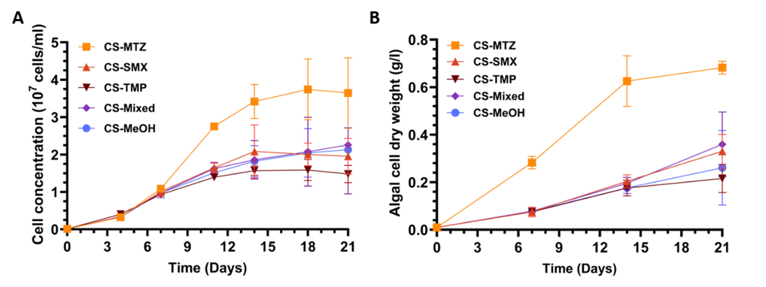
Figure 2. Elemental analysis of C. sorokiniana after 21 days of cultivation in BG11 medium under single antibiotic treatments, mixed antibiotic treatment, and control conditions. (A) Carbon content (% CDW), (B) nitrogen content (% CDW), and (C) carbon/nitrogen ratio (% CDW). CS-MTZ, C. sorokiniana with metronidazole; CS-SMX, C. sorokiniana with sulfamethoxazole; CS-TMP, C. sorokiniana with sulfamethoxazole trimethoprim; CS-Mixed, C. sorokiniana with a mixture of all three antibiotics; CS-MeOH, C. sorokiniana with methanol (0.5 % v/v) and no antibiotics.
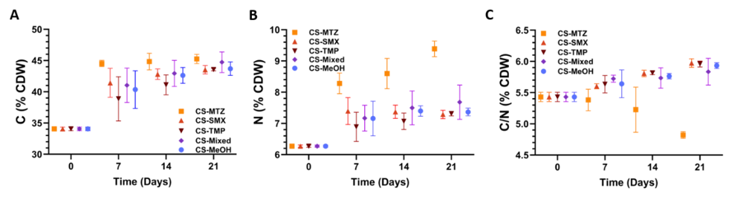
Figure 3. Removal of nutrients (%) by C. sorokiniana grown in BG11 medium under single antibiotic treatments, mixed antibiotic treatment, and control condition. (A) Chemical oxygen demand (COD), (B) nitrate (NO₃⁻), (C) ammonium (NH₄⁺), and (D) phosphate (PO₄³⁻). CS-MTZ, C. sorokiniana with metronidazole; CS-SMX, C. sorokiniana with sulfamethoxazole; CS-TMP, C. sorokiniana with sulfamethoxazole trimethoprim; CS-Mixed, C. sorokiniana with a mixture of all three antibiotics; CS-MeOH, C. sorokiniana with methanol (0.5 % v/v) and no antibiotics.

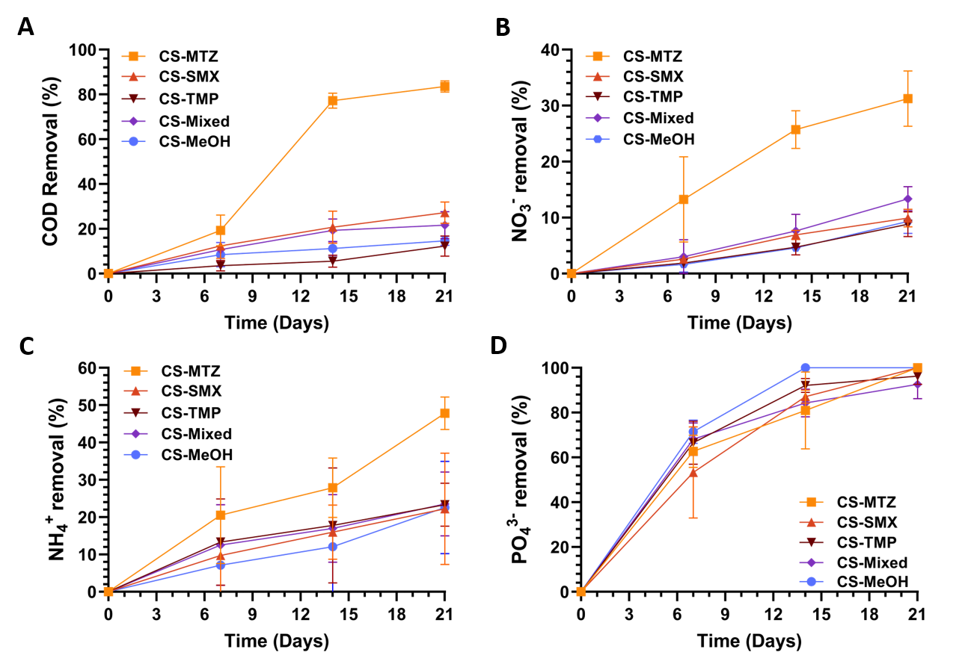
Figure 4. Total removal (%) of antibiotics MTZ, SMX, and TMP after 21 days. (A) single antibiotic treatments and (B) mixed antibiotic treatment. CS-MTZ, C. sorokiniana with metronidazole; CS-SMX, C. sorokiniana with sulfamethoxazole; CS-TMP, C. sorokiniana with sulfamethoxazole trimethoprim; CS-Mixed, C. sorokiniana with a mixture of all three antibiotics.

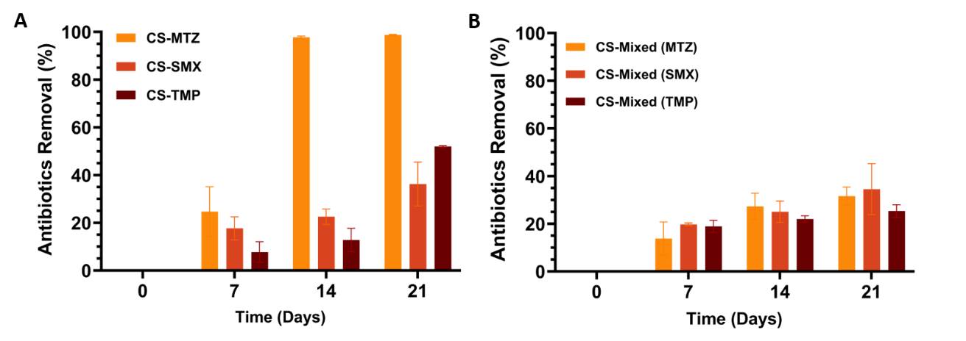
Figure 5. Suggested biotransformation pathways of MTZ by C. sorokiniana. (A) Arrows indicated TPs formed mainly by biotransformation; blue boxes highlight TPs identified in the presence of algae. (B) Presence of MTZ and of its transformation products at days 0, 7, 14, and 21 under different experimental conditions: biotic (CS-MTZ and CS-Mixed), light-abiotic (L-MTZ and L-Mixed) and dark-abiotic (D-MTZ and D-Mixed). Relative concentrations of TPs were calculated as described in section 2.7.2.
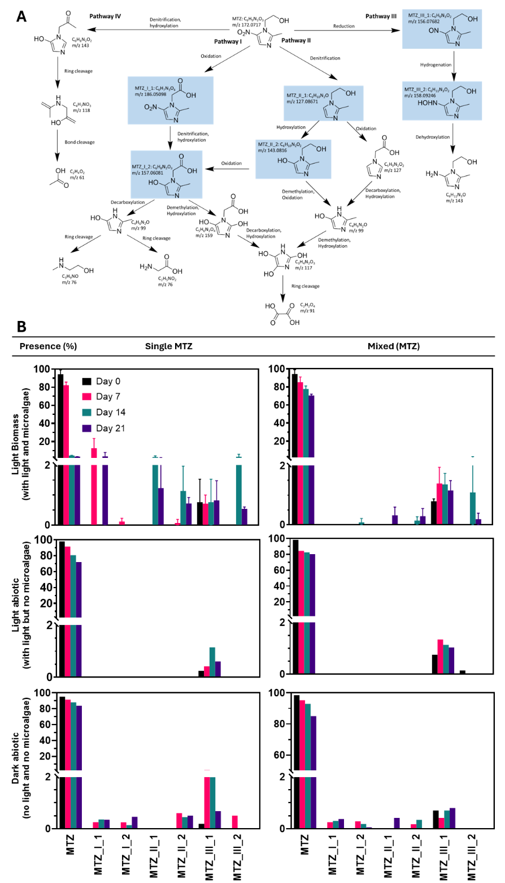
Figure 6. Suggested biotransformation pathways of SMX by C. sorokiniana. (A) Arrows indicated TPs formed mainly by biotransformation; blue boxes highlight TPs identified in presence of algae. (B) Presence of SMX and of its transformation products at days 0, 7, 14, and 21 under different experimental conditions: biotic (CS-SMX and CS-Mixed), light-abiotic (L-SMX and L-Mixed) and dark-abiotic (D-SMX and D-Mixed). Relative concentrations of TPs were calculated as described in section 2.7.2.
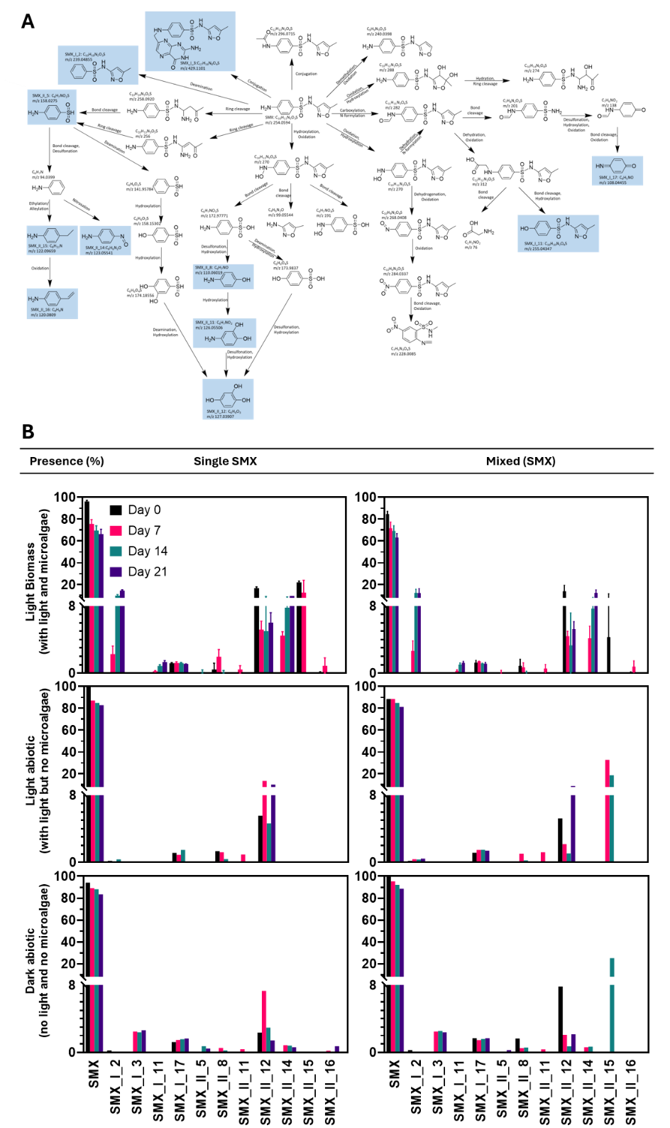
Figure 7. Suggested biotransformation pathways of TMP by C. sorokiniana. (A) Arrows indicated TPs formed mainly by biotransformation; blue boxes highlight TPs identified in presence of algae. (B) Presence of TMP and of its transformation products at days 0, 7, 14, and 21 under different experimental conditions: biotic (CS-TMP and CS-Mixed), light-abiotic (L-TMP and L-Mixed) and dark-abiotic (D-TMP and D-Mixed). Relative concentrations of TPs were calculated as described in section 2.7.2.

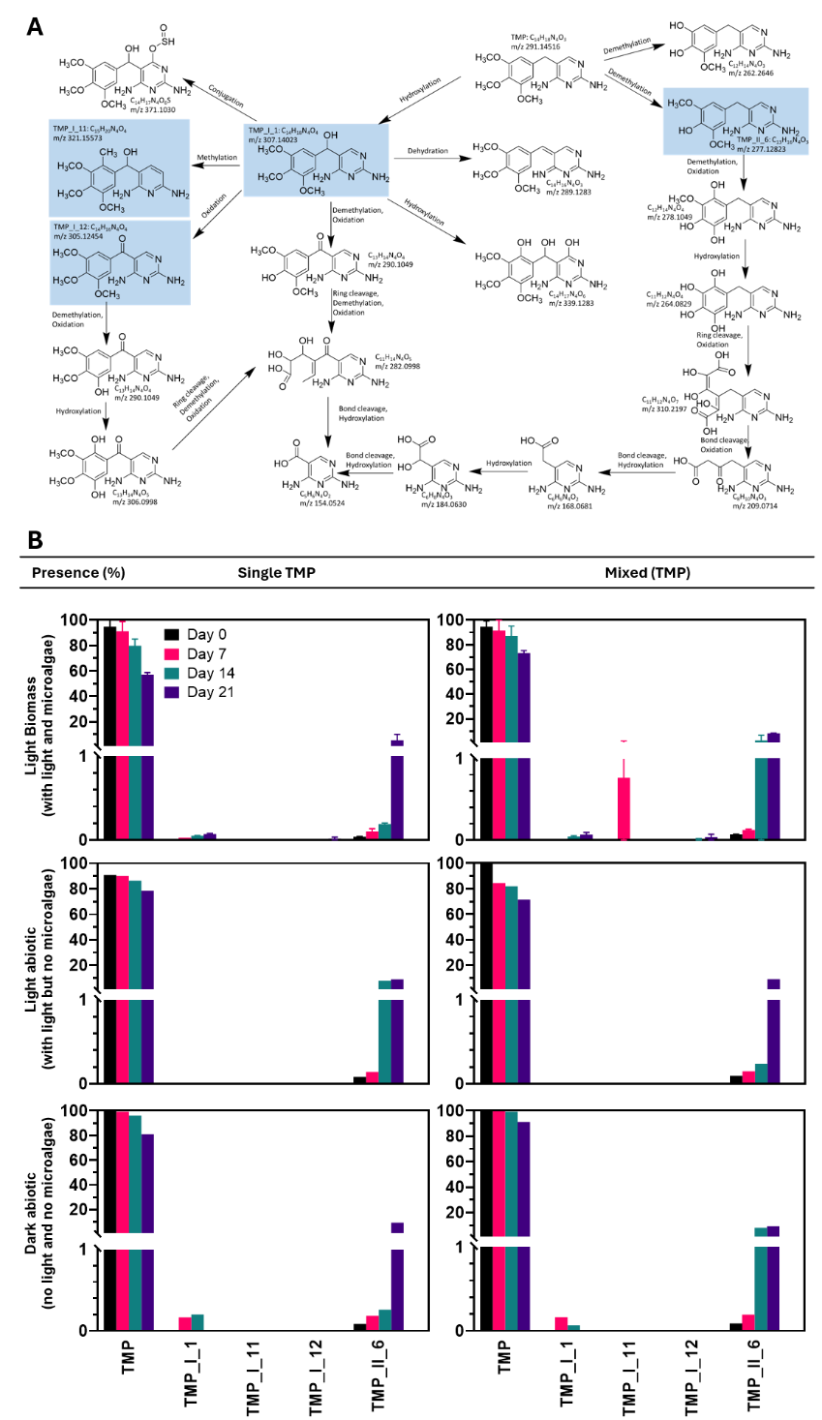
References
Ang, C.W., Jarad, A.M., Cooper, M.A., Blaskovich, M.A.T., 2017. Nitroimidazoles: molecular fireworks that combat a broad spectrum of diseases. J. Med. Chem. 60, 7636–7657.
Beltrán, F.J., Jiménez-López, M.A., Álvarez, P.M., Rivas, F.J. 2025. Kinetic modeling of photocatalytic oxidation-ozonation of metronidazole removal from water. J. Environ. Chem. Eng. 13, 115869.
Burhenne, N., Tischner, R., 2000. Isolation and characterization of nitrite-reductase-deficient mutants of Chlorella sorokiniana (strain 211-8k). Planta 211, 440–445.
Burns, E.E., Thomas-Oates, J., Kolpin, D.W., Furlong, E.T., Boxall, A.B.A., 2017. Are exposure predictions, used for the prioritization of pharmaceuticals in the environment, fit for purpose? Environ Toxicol Chem 36 (10), 2823-2832.
Chu, Y., Zhang, C., Wang, R., Chen, X., Ren, N., Ho, S.-H., 2022. Biotransformation of sulfamethoxazole by microalgae: Removal efficiency, pathways, and mechanisms. Water Res 221, 118834.
Fang, Y., Lin, G., Liu, Y., Zhang, J., 2024. Removal of sulfamethoxazole and production of cyanobacterial lipid promoted by the construction of a consortium containing a non-toxic cyanobacterium and sewage bacteria. J Clean Prod 447, 141544.
Frascaroli, G., Hunter, C., Roberts, J., Escudero, A., 2024. Antibiotic Removal by Three Promising Microalgae Strains: Biotic, Abiotic Routes, and Response Mechanisms. Water, Air, Soil Pollut 235 (9), 600.
Hom-Diaz, A., Jaén-Gil, A., Rodríguez-Mozaz, S., Barceló, D., Vicent, T., Blánquez, P., 2022. Insights into removal of antibiotics by selected microalgae (Chlamydomonas reinhardtii, Chlorella sorokiniana, Dunaliella tertiolecta and Pseudokirchneriella subcapitata). Algal Res 61, 102560.
Jaén-Gil, A., Hom-Diaz, A., Llorca, M., Vicent, T., Blánquez, P., Barceló, D., et al., 2018. An automated on-line turbulent flow liquid-chromatography technology coupled to a high resolution mass spectrometer LTQ-Orbitrap for suspect screening of antibiotic transformation products during microalgae wastewater treatment. J Chromatogr A 1568, 57-68.
Jebalbarezi, B., Dehghanzadeh, R., Sheikhi, S., Shahmahdi, N., Aslani, H., Maryamabadi, A. 2022. Oxidative degradation of sulfamethoxazole from secondary treated effluent by ferrate(VI): kinetics, by-products, degradation pathway and toxicity assessment. J. Environ. Health Sci. Eng. 20, 205-218.
Jewell, K.S., Castronovo, S., Wick, A., Falås, P., Joss, A., Ternes, T.A., 2016. New insights into the transformation of trimethoprim during biological wastewater treatment. Water Res 88, 550-557.
Kapoor, G., Saigal, S., Elongavan, A., 2017. Action and resistance mechanisms of antibiotics: A guide for clinicians. J Anaesthesiol Clin Pharmacol 33 (3), 300-305.
Kiki, C., Rashid, A., Wang, Y., Li, Y., Zeng, Q., Yu, C.-P., et al., 2020. Dissipation of antibiotics by microalgae: Kinetics, identification of transformation products and pathways. J Hazard Mater 387, 121985.
Kiki, C., Rashid, A., Zhang, Y., Li, X., Chen, T.-Y., Eloise Adéoye, A.B., et al., 2022. Microalgal mediated antibiotic co-metabolism: Kinetics, transformation products and pathways. Chemosphere 292, 133438.
Klein, E.Y., Impalli, I., Poleon, S., Denoel, P., Cipriano, M., Van Boeckel, T.P., et al., 2024. Global trends in antibiotic consumption during 2016–2023 and future projections through 2030. ProcNatl Acad Sci USA 121 (49), e2411919121.
Kong, D., Liang, B., Yun, H., Cheng, H., Ma, J., Cui, M., et al., 2015. Cathodic degradation of antibiotics: Characterization and pathway analysis. Water Res 72, 281-292.
Li, J., Wang, Y., Fan, Z., Tang, P., Wu, M., Xiao, H., et al., 2023. Toxicity of Tetracycline and Metronidazole in Chlorella pyrenoidosa. Int J Environ Res Public Health 20 (4), 1-12.
Li, P., Zhuang, L.-L., Zhang, J., Wu, Y.-H., Hu, H.-Y., 2025. Effects of sulfamethoxazole on Chlorella vulgaris growth, pollutant removal, and algal physicochemical properties in a suspended-attached microalgae culture system. J Clean Prod 486, 144611.
Liu, Y., Wang, Z., Yan, K., Wang, Z., Torres, O.L., Guo, R., et al., 2017. A new disposal method for systematically processing of ceftazidime: The intimate coupling UV/algae-algae treatment. Chem Eng J 314, 152-159.
Löffler, P., Escher, B.I., Baduel, C., Virta, M.P., Lai, F.I. 2023. Antimicrobial transformation products in the aquatic environment: global occurrence, ecotoxicological risks, and potential of antibiotic resistance. Environ. Sci. Technol. 57, 9474-9494.
Lu, W., Wang, A., Zhang, Y., Ren, S., Zhang, Z. 2024. Insights into the efficient mineralization of antibiotic trimethoprim in aqueous media by Fe²⁺ catalytically enhanced vacuum-UV irradiation: Kinetics, mechanisms, and toxicity evaluation. Environ. Res. 250, 118363.
Matamoros, V., Uggetti, E., García, J., Bayona, J.M., 2016. Assessment of the mechanisms involved in the removal of emerging contaminants by microalgae from wastewater: a laboratory scale study. J Hazard Mater 301, 197-205.
Mayo-Bean, K., Moran, K., Meylan, B., & Ranslow, P. 2012. Methodology document for the ecological structure-activity relationship model (ECOSAR) class program. US-EPA, Washington DC, 46.
Ndlela, L.L., Schroeder, P., Genthe, B., Cruzeiro, C., 2023. Removal of Antibiotics Using an Algae-Algae Consortium (Chlorella protothecoides and Chlorella vulgaris). Toxics 11 (7), 588.
Qiu, X., Pu, M., Zhang, H., Xu, B., Wang, J., Xuan, R., 2024. Occurrence, distribution, and correlation of antibiotics in the aquatic ecosystem of Poyang Lake Basin, China. J Hazard Mater 479, 135656.
Rex M, C., Poddar, B., Mandal, S., Das, S., Mukherjee, A., 2025. Interactive toxicity effects of metronidazole, diclofenac, ibuprofen, and differently functionalized nanoplastics on marine algae Chlorella sp. Environ. Sci. Process Impacts, 1-16.
Ricky, R., Chiampo, F., Shanthakumar, S., 2022. Efficacy of Ciprofloxacin and Amoxicillin Removal and the Effect on the Biochemical Composition of Chlorella vulgaris. Bioengineering (Basel) 9 (4), 1-12.
Rodrigues, D.A.d.S., da Cunha, C.C.R.F., Pereira, A.R., Espírito Santo, D.R.d., Silva, S.d.Q., Starling, M.C.V.M., et al., 2025. Biodegradation of trimethoprim and sulfamethoxazole in secondary effluent by microalgae-bacteria consortium. Int J Hyg Environ Health 264, 114517.
Rodriguez-Mozaz, S., Vaz-Moreira, I., Varela Della Giustina, S., Llorca, M., Barceló, D., Schubert, S., et al., 2020. Antibiotic residues in final effluents of European wastewater treatment plants and their impact on the aquatic environment. Environ Int 140, 105733.
Saidi, I., Soutrel, I., Fourcade, F., Amrane, A., Bellakhal, N., Geneste, F., 2016. Electrocatalytic reduction of metronidazole using titanocene/Nafion®-modified graphite felt electrode. Electrochim Acta 191, 821-831.
Schar, D., Klein, E.Y., Laxminarayan, R., Gilbert, M., Van Boeckel, T.P., 2020. Global trends in antimicrobial use in aquaculture. Sci Rep 10 (1), 21878.
Selwe, K.P., Sallach, J.B., Dessent, C.E.H., 2023. Nontargeted Screening of Contaminants of Emerging Concern in the Glen Valley Wastewater Treatment Plant, Botswana. Environ Toxicol Chem 43 (1), 52-61.
Sethanunt, O., Tonon, T., Sallach, J.B., Chong, J.P.J., 2026. Study of the green microalga Chlorella sorokiniana for the removal of nutrients and multiple antibiotics in wastewater treatment. Environ Toxicol Chem 45 (1), 236-274.
Smith, C.L., Powell, K.R., 2000. Review of the Sulfonamides and Trimethoprim. Pediatr. Rev. 21 (11), 368–371.
Studziński, W., Gackowska, A., Kudlek, E., Przybytek, M. 2025. Environmental and toxicological aspects of sulfamethoxazole photodegradation in the presence of oxidizing agents. Environ. Sci. Pollut. Res. 32, 4733–4753.
Van Boeckel, T.P., Brower, C., Gilbert, M., Grenfell, B.T., Levin, S.A., Robinson, T.P., et al., 2015. Global trends in antimicrobial use in food animals. Proc Natl Acad Sci USA 112 (18), 5649-5654.
Wang, P., Li, D., Sun, M., Yin, J., Zheng, T., 2024. Microalgae enhanced co-metabolism of sulfamethoxazole using aquacultural feedstuff components: Co-metabolic pathways and enzymatic mechanisms. J Hazard Mater 470, 134279.
Wilkinson, J.L., Boxall, A.B.A., Kolpin, D.W., Leung, K.M.Y., Lai, R.W.S., Galbán-Malagón, C., et al., 2022. Pharmaceutical pollution of the world's rivers. Proc. Natl.Acad.Sci. USA 119 (8), 1-10.
Wishart, D.S., Feunang, Y.D., Guo, A.C., Lo, E.J., Marcu, A., Grant, J.R., et al., 2018. DrugBank 5.0: a major update to the DrugBank database for 2018. Nucleic Acids Res 46 (D1), D1074-d1082.
Xie, B., Tang, X., Ng, H.Y., Deng, S., Shi, X., Song, W., et al., 2020. Biological sulfamethoxazole degradation along with anaerobically digested centrate treatment by immobilized microalgal-bacterial consortium: Performance, mechanism and shifts in bacterial and microalgal communities. Chem Eng J 388, 124217.
Xiong, J.-Q., Kim, S.-J., Kurade, M.B., Govindwar, S., Abou-Shanab, R.A.I., Kim, J.-R., et al., 2019. Combined effects of sulfamethazine and sulfamethoxazole on a freshwater microalga, Scenedesmus obliquus: toxicity, biodegradation, and metabolic fate. J Hazard Mater 370, 138-146.
Xiong, J.-Q., Kurade, M.B., Abou-Shanab, R.A.I., Ji, M.-K., Choi, J., Kim, J.O., et al., 2016. Biodegradation of carbamazepine using freshwater microalgae Chlamydomonas mexicana and Scenedesmus obliquus and the determination of its metabolic fate. Bioresour Technol 205, 183-190.
Xiong, J.-Q., Kurade, M.B., Jeon, B.-H., 2017. Biodegradation of levofloxacin by an acclimated freshwater microalga, Chlorella vulgaris. Chem Eng J 313, 1251-1257.
Xiong, Q., Liu, Y.S., Hu, L.X., Shi, Z.Q., Cai, W.W., He, L.Y., et al., 2020. Co-metabolism of sulfamethoxazole by a freshwater microalga Chlorella pyrenoidosa. Water Res 175, 115656.
Zhang, X., Sun, J., Zhao, M., 2022a. Enhanced metronidazole removal by binary-species photoelectrogenic biofilm of microaglae and anoxygenic phototrophic bacteria. J Environ Sci 115, 25-36.
Zhang, Y., Wan, J., Li, Z., Wu, Z., Dang, C., Fu, J., 2022b. Enhanced removal efficiency of sulfamethoxazole by acclimated microalgae: Tolerant mechanism, and transformation products and pathways. Bioresour Technol 347, 126461.
Zhou, T., Zhang, Z., Liu, H., Dong, S., Nghiem, L.D., Gao, L., et al., 2023. A review on microalgae-mediated biotechnology for removing pharmaceutical contaminants in aqueous environments: Occurrence, fate, and removal mechanism. J Hazard Mater 443 (Pt A), 130213.

