Supplementary Material

Table S.1. Modal proportions of soy arriving at exporting ports in Brazil. * indicates the waterway is a lagoon, so not considered exposed to drought in the same way as a river. Source: Embrapa, 2016.
Exporting Port | Road | Rail | Waterway
SANTOS | 32% | 68% | -
PARANAGUA | 76% | 24% | -
RIO GRANDE | 58% | 23% | 18%*
SAO LUIS | 16% | 84% | -
SAO FRANCISCO DO SUL | 43% | 57% | -
VITORIA |  | 100% | -
BARCARENA | 10% | - | 90%
MANAUS | - | - | 100%
SANTAREM | - | - | 100%
SALVADOR | 100% | - | -
IMBITUBA | 100% | - | -
PORTO MURTINHO | 100% | - | -
ARACAJU | 100% | - | -
SANTANA DO LIVRAMENTO | 100% | - | -
ITAJAI | 100% | - | -
BONFIM | 100% | - | -
CHUI | 100% | - | -
ASSIS BRASIL | 100% | - | -
URUGUAIANA | 100% | - | -
PACARAIMA | 100% | - | -
PORTO VELHO | 100% | - | -
JAGUARAO | 100% | - | -
SAO PAULO | 100% | - | -
CORUMBA | 100% | - | -

Table S.2. Soy throughput in rail stations and river ports per exporting port. Source: Péra et al., 2021.
Origin station/port  (state in brackets) | Destination port  (state in brackets) | Quantity shipped, 2019 (1,000 tonnes) | Relative quantity shipped, 2019 (%)
Alegrete (RS) | Rio Grande (RS) | 29.9 | 0.1
Alto Araguaia (MT) | Santos (SP) | 237.9 | 0.8
Araguari (MG) | Serra (ES) | 3,367.9 | 11.3
Araguari (MG) | Santos (SP) | 278.7 | 1.0
Cacequi (RS) | Rio Grande (RS) | 327.3 | 1.1
Campinas (SP) | Santos (SP) | 68.0 | 0.2
Cascavel (PR) | Guarapuava (PR) | 271.9 | 0.9
Cascavel (PR) | Paranaguá (PR) | 183.9 | 0.6
Cascavel (PR) | São Francisco do Sul (SC) | 56.7 | 0.2
Chapadão do Sul (MS) | Santos (SP) | 801.6 | 2.8
Cruz Alta (RS) | Rio Grande (RS) | 1,936.4 | 6.7
Guarapuava (PR) | São Francisco do Sul (SC) | 5.5 | 0.0
Ijuí (RS) | Rio Grande (RS) | 52.0 | 0.2
Itiquira (MT) | Santos (SP) | 609.1 | 2.1
Júlio de Castilhos (RS) | Rio Grande (RS) | 312.4 | 1.1
Londrina (PR) | Paranaguá (PR) | 252.8 | 0.9
Londrina (PR) | São Francisco do Sul (SC) | 36.5 | 0.1
Marialva (PR) | Paranaguá (PR) | 1,182.4 | 4.1
Marialva (PR) | São Francisco do Sul (SC) | 229.0 | 0.8
Maringá (PR) | São Francisco do Sul (SC) | 1,399.0 | 4.9
Maringá (PR) | Paranaguá (PR) | 785.7 | 2.7
Palmeirante (TO) | São Luís (MA) | 2,447.8 | 8.5
Pederneiras (SP) | Santos (SP) | 725.9 | 2.5
Pirapora (MG) | Serra (ES) | 790.9 | 2.7
Ponta Grossa (PR) | Paranaguá (PR) | 253.3 | 0.9
Porto Franco (MA) | São Luís (MA) | 1,428.2 | 5.0
Porto Nacional (TO) | São Luís (MA) | 1,386.1 | 4.8
Pradópolis (SP) | Santos (SP) | 29.9 | 0.1
Rolândia (PR) | Paranaguá (PR) | 225.4 | 0.8
Rolândia (PR) | São Francisco do Sul (SC) | 95.6 | 0.3
Rondonópolis (MT) | Santos (SP) | 5,580.8 | 19.4
Rondonópolis (MT) | Campinas (SP) | 68.5 | 0.2
Santa Luzia (MG) | Serra (ES) | 137.6 | 0.5
Santo Ângelo (RS) | Rio Grande (RS) | 85.6 | 0.3
Sarandi (PR) | Paranaguá (PR) | 42.4 | 0.1
Tupanciretã (RS) | Rio Grande (RS) | 84.1 | 0.3
Uberaba (MG) | Santos (SP) | 2,975.1 | 10.3

A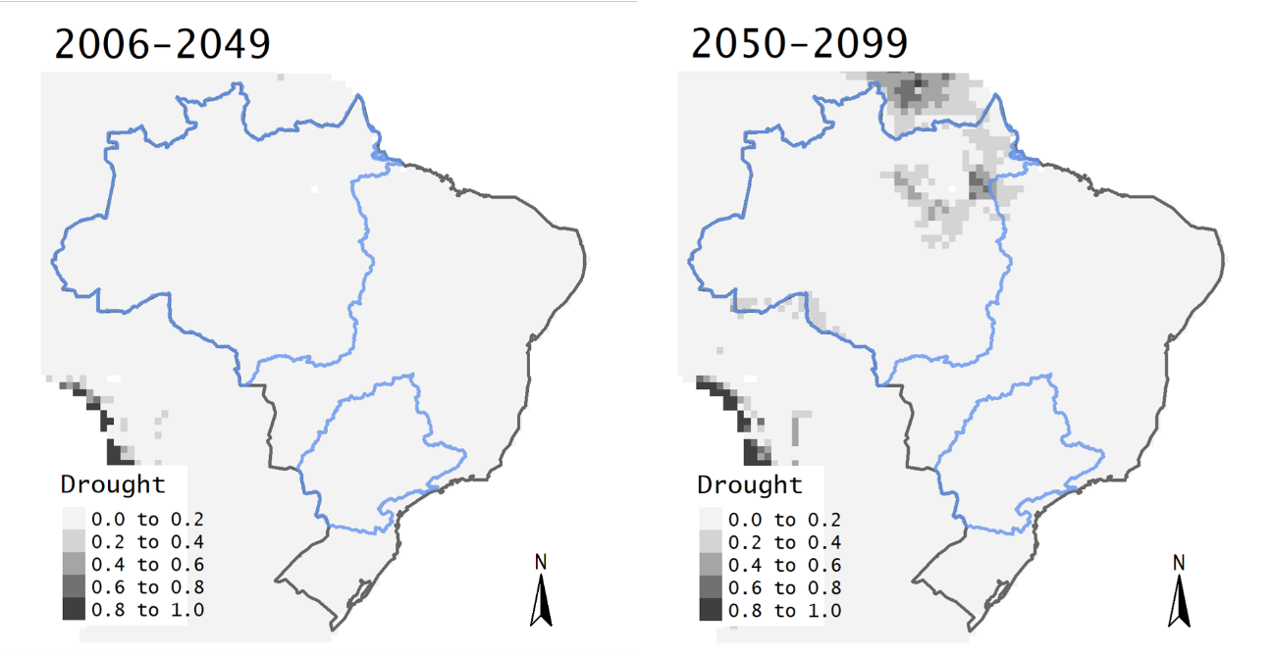
B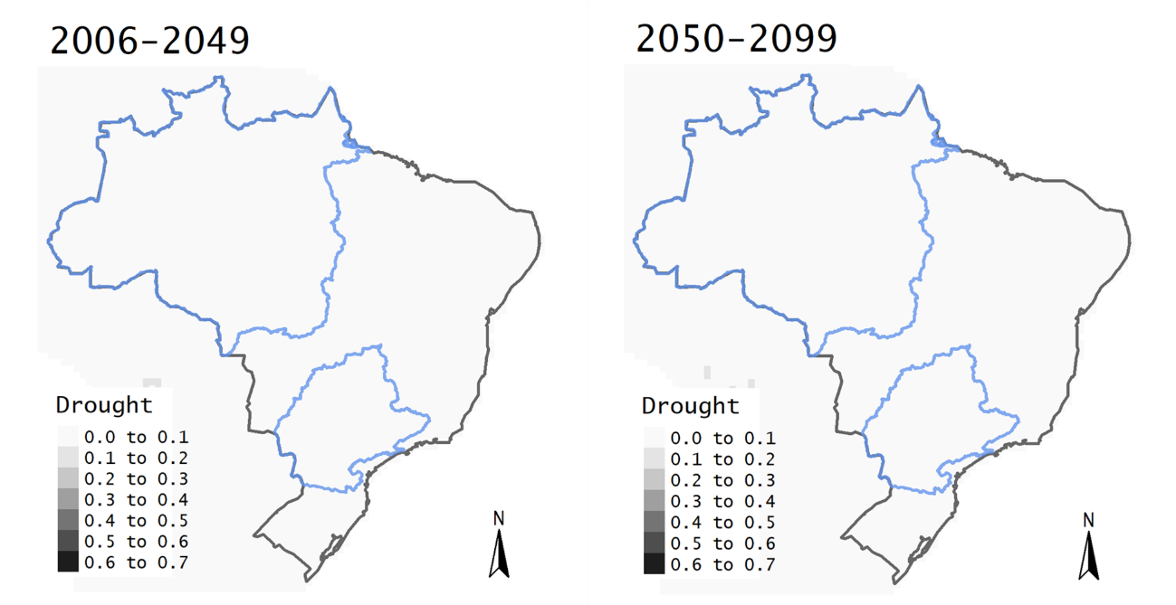
C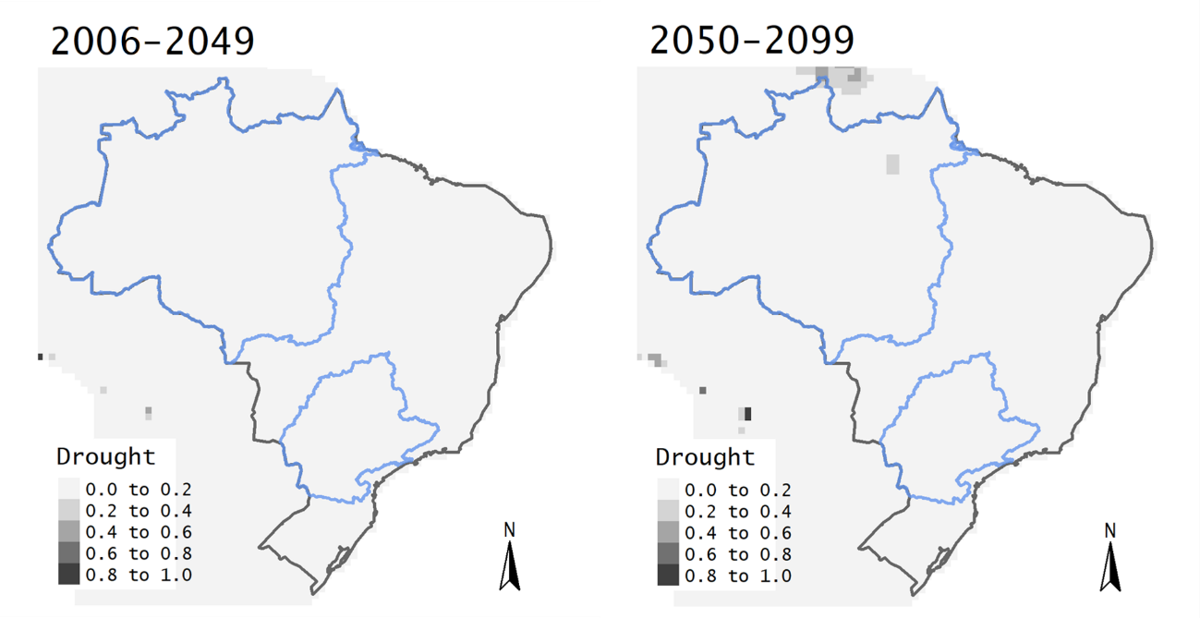
D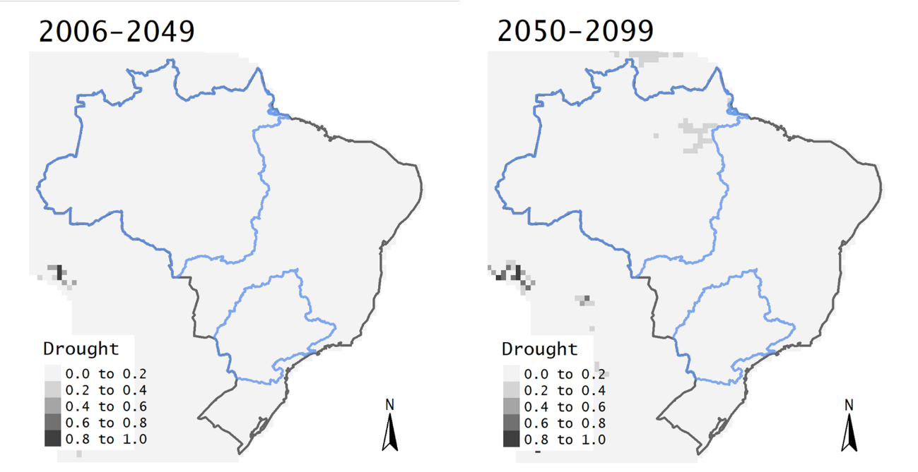
E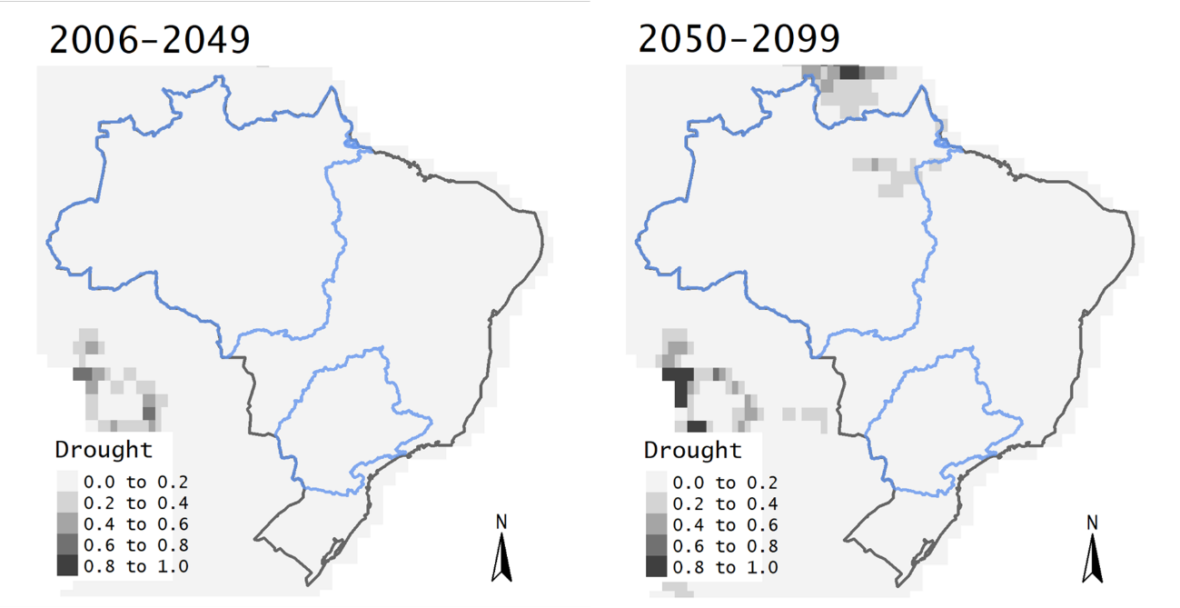
F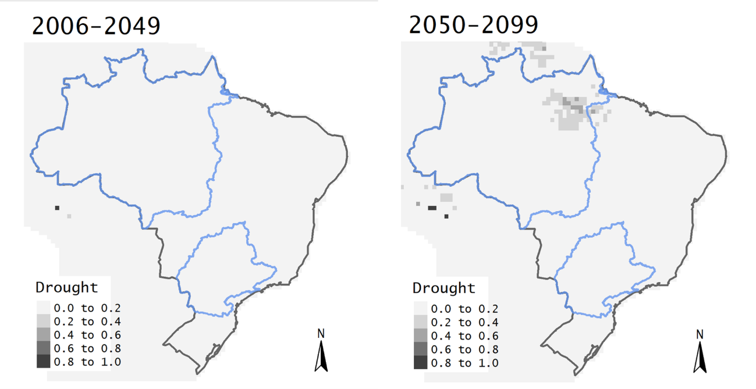
Fig. S.1. Fig. 7 for other climate impact models: A) CLM45, B) H08, C) JULES-W1, D) LPJmL, E) ORCHIDEE, F) WaterGAP2.

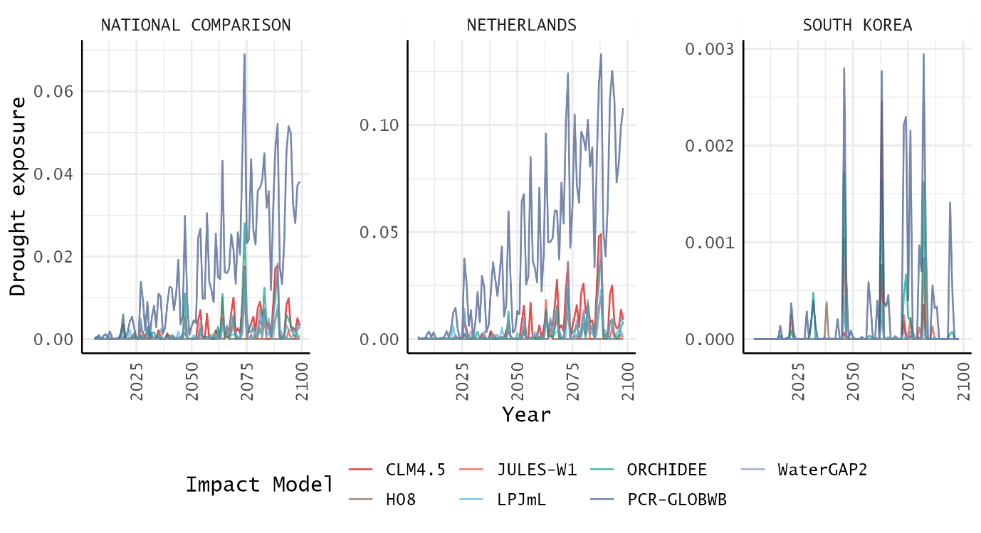
Fig. S.2. Fig. 8 with individual y-axis scales.

