Supplementary Materials for “Positive Atlantic Multidecadal Oscillation–La Niña synergy enhances recent East Asian dust activity via hydrothermal anomalies”
Ruibo Zhao^{a,b}, Xiaoming Feng^{a,b*}, Changjia Li^{c,d}, Yun Yang^{e}, Lindsay C. Stringer^{f,g}, Bojie Fu^{a,b}

ª State Key Laboratory of Regional and Urban Ecology, Research Center for Eco-Environmental Sciences, Chinese Academy of Sciences, Beijing 100085, China
^{b} University of Chinese Academy of Sciences, Beijing 100049, China
^{c} State Key Laboratory of Earth Surface Processes and Disaster Risk Reduction (ESPDRR), Faculty of Geographical Science, Beijing Normal University, Beijing 100875, China
^{d} Institute of Land Surface System and Sustainable Development, Faculty of Geographical Science, Beijing Normal University, Beijing 100875, China
^{e} Faculty of Geographical Science, Beijing Normal University, Beijing 100875, China
^{f} Department of Environment and Geography, University of York, York YO10 5DD, UK
^{g} York Environmental Sustainability Institute, University of York, York YO10 5DD, UK

* Corresponding author.
E-mail address: fengxm@rcees.ac.cn (X. Feng)

Figure S1. Time series comparison of dust activity proxies from different data sources.

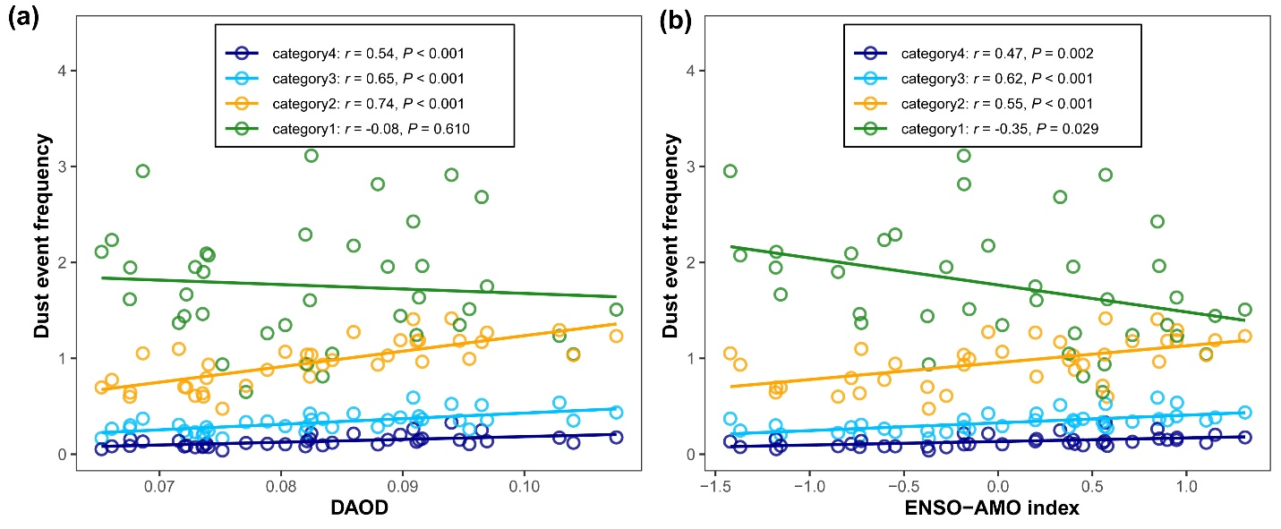
Figure S2. Correlations of four categories of dust event frequencies with DAOD (a) and ENSO-AMO index (b). Categories 1–4 correspond to floating dust, blowing dust, moderate dust storm, and severe dust storm, respectively.

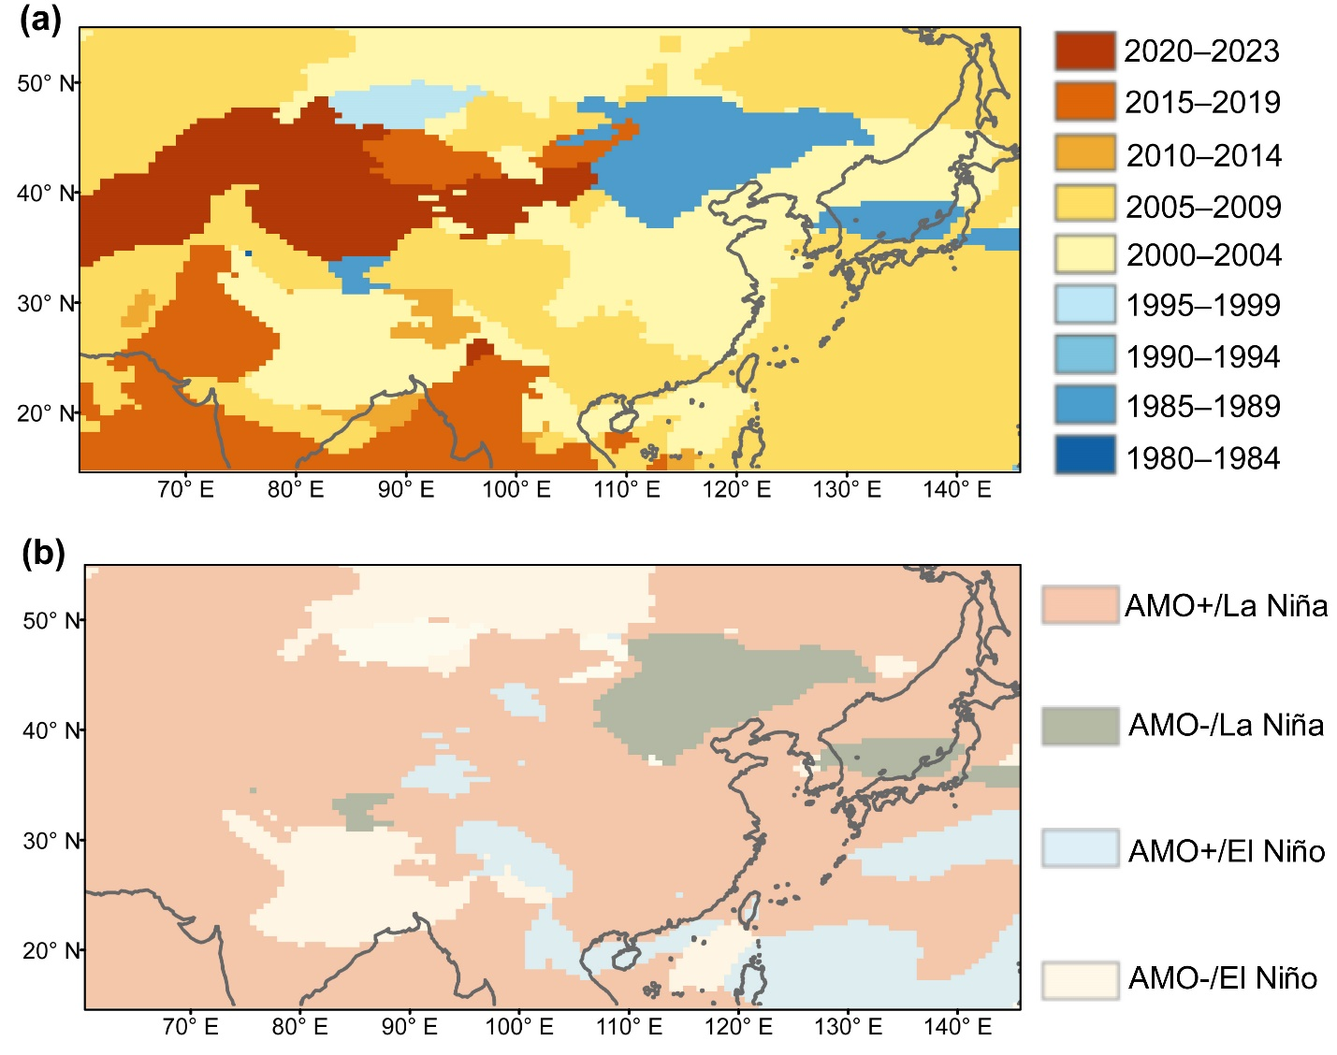
Figure S3. a Spatial distribution of the years with maximum DAOD during 1980-2023. b Spatial distribution of the ENSO and AMO phase combinations corresponding to the years with maximum DAOD.

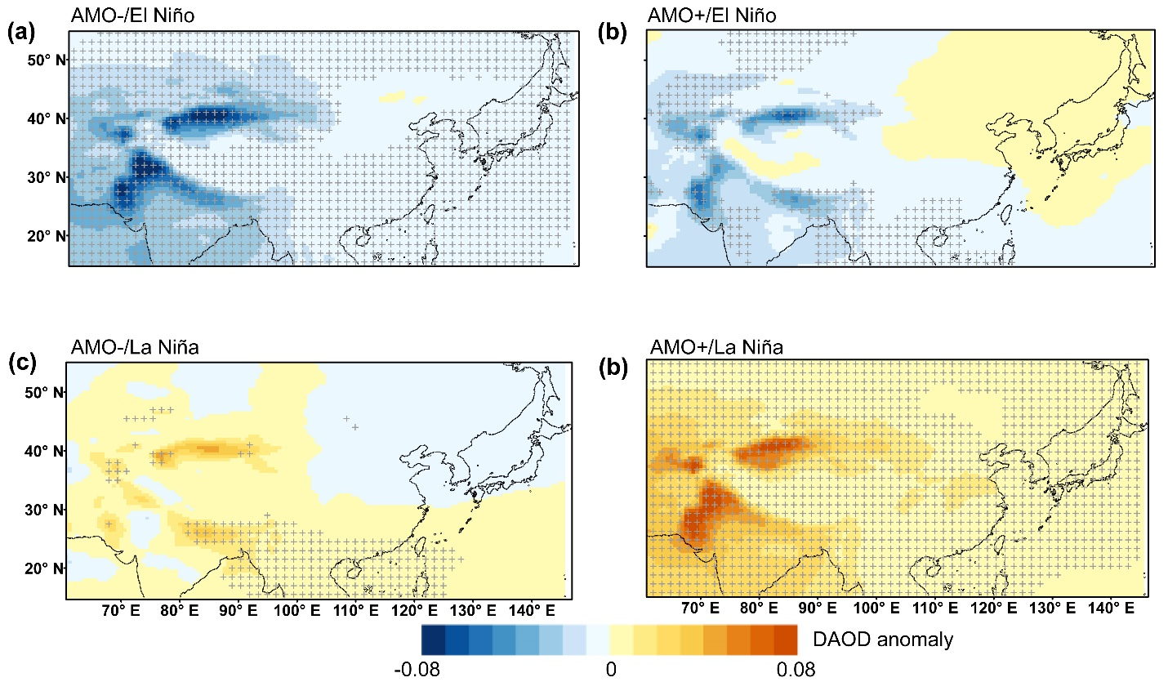
Figure S4. Spatial distribution of DAOD anomalies under different AMO-ENSO phase combinations. Gray cross marks indicate statistical significance at the 95% confidence level. (a) AMO- / El Niño, (b) AMO- / La Niña, (c) AMO+ / El Niño, (d) AMO+ / La Niña.

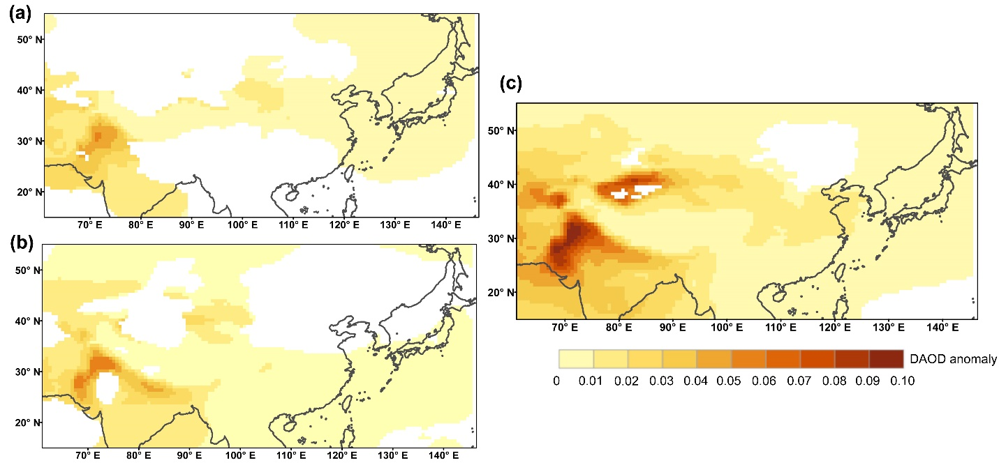
Figure S5. Spatial Distribution of DAOD Anomalies during La Niña years (a), positive AMO phase years (b), and concurrent positive AMO–La Niña years (C). Shaded areas indicate anomalies significant at the 95% confidence level (P < 0.05).

Figure S6. Discrepancies in the frequency of four dust event categories under varying AMO-ENSO climate backgrounds. Categories 1–4 correspond to floating dust, blowing dust, moderate dust storm, and severe dust storm, respectively.

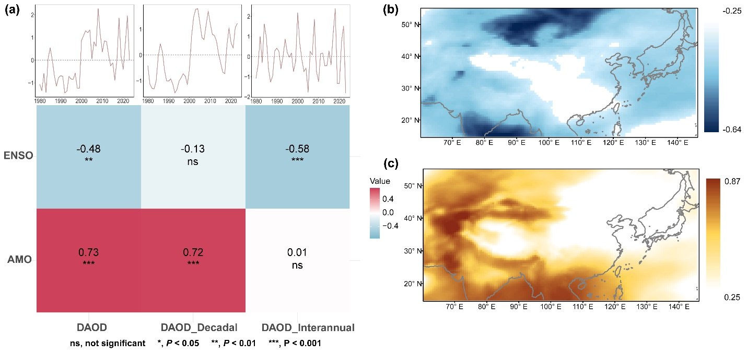
Figure S7. The relationship between interannual and decadal components of DAOD variability and ENSO/AMO. a Correlation between the time series of DAOD, its interannual and decadal components and ENSO/AMO index. b Spatial distribution of the correlation between the interannual component of DAOD and the ONI index. c Spatial distribution of the correlation between the decadal component of DAOD and the AMO index. The regions showing colors in b and c indicate correlations that are significant at the 95% confidence level (P < 0.05).

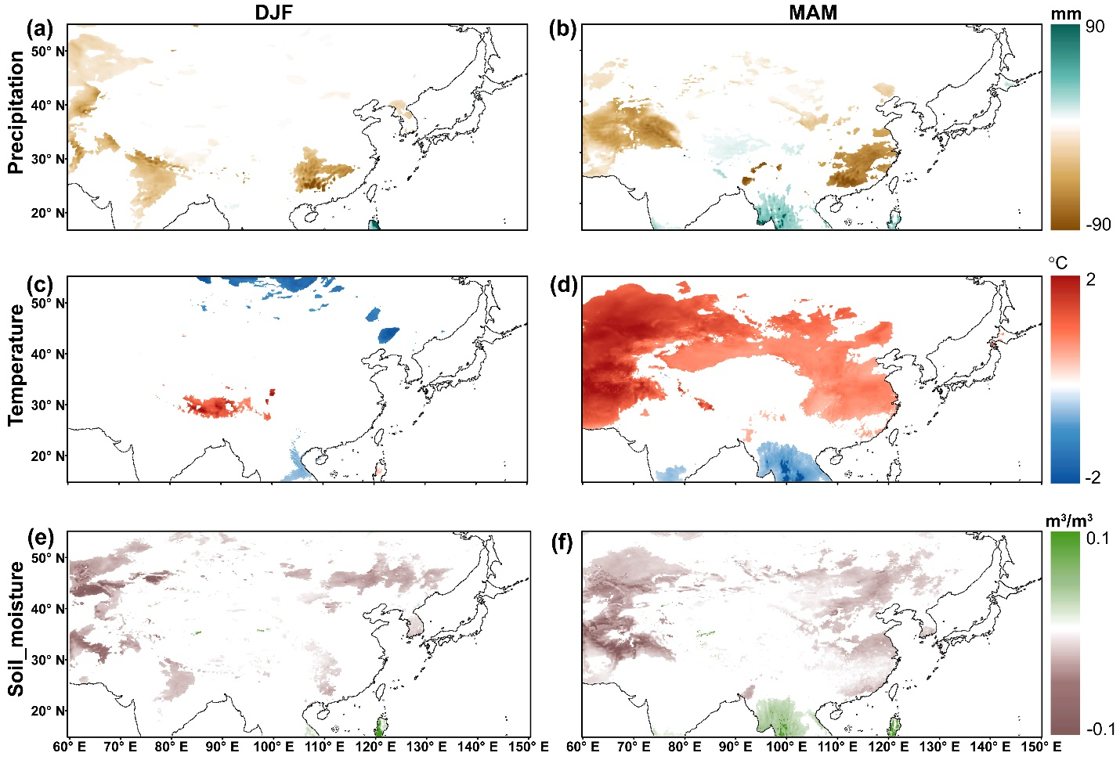
Figure S8. Spatial distribution of local meteorological anomalies during concurrent La Niña event and AMO positive phase. a&b Precipitation anomalies in winter (DJF) and spring (MAM). c&d Same as a&b, but for 2 m temperature. e&f Same as a&b, but for soil moisture. Shaded areas indicate anomalies significant at the 95% confidence level (P < 0.05).

Figure S9. Comparison of dynamic conditions (mean wind speeds) during four categories of dust events between AMO positive/La Niña co-occurrence years and other years. Categories 1–4 correspond to floating dust, blowing dust, moderate dust storm, and severe dust storm, respectively. The central horizontal line represents the mean, and the upper and lower edges of the bars indicate the mean ±1 standard deviation (SD). "ns" denotes no significant difference (P > 0.05), while asterisks indicate statistical significance (* P < 0.05, ** P < 0.01).

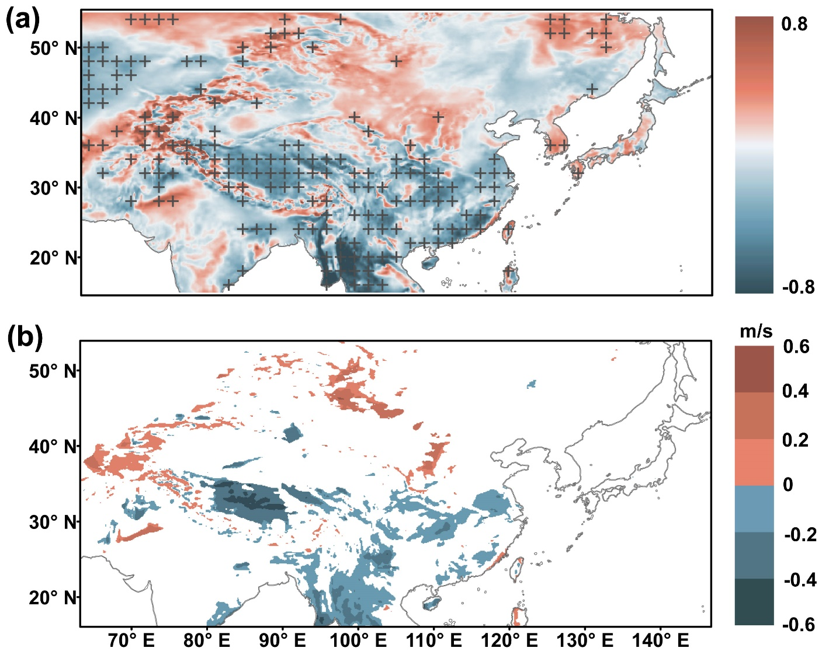
Figure S10. a Correlation map between the ENSO-AMO index and spring surface wind speed. The cross mark indicates significance at the 95% level (P < 0.05). b Spring surface wind speed anomalies during concurrent La Niña event and AMO positive phase. Shaded areas indicate anomalies significant at the 95% confidence level (P < 0.05).

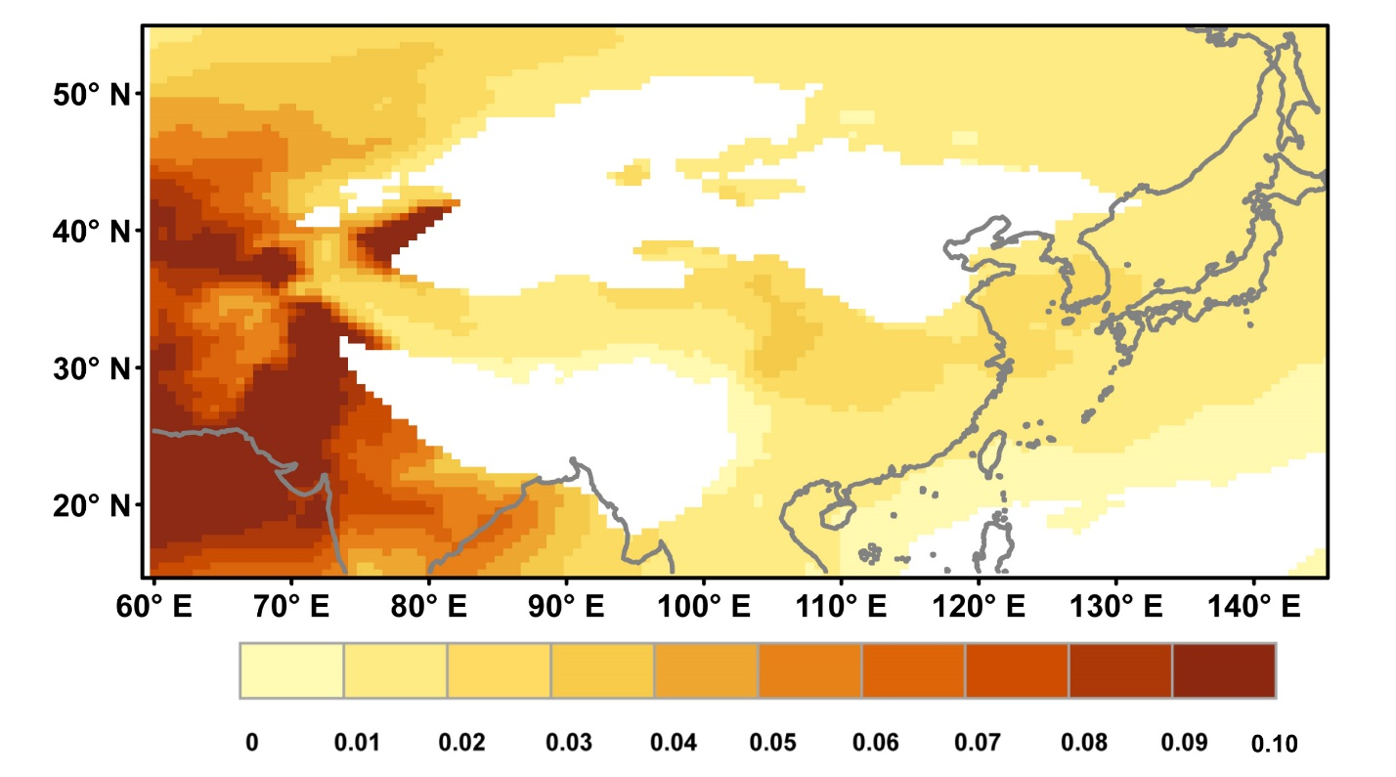
Figure S11. Spatial distribution of DAOD anomalies during 2008, a year of maximum DAOD over East Asia during 1980-2023. Shaded areas indicate DAOD > 90th percentile.
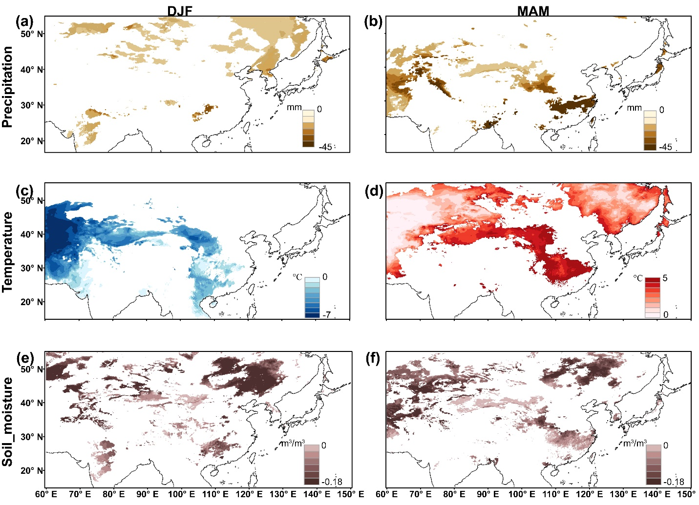
Figure S12. Spatial distribution of local meteorological conditions anomalies in winter and spring of 2008. a&b Spatial distribution of extreme precipitation anomalies (< 10th percentile during 1980–2023) in winter (DJF) and spring (MAM). c same as a, but for extreme cold anomalies (< 10th percentile). d same as b, but for extreme warm anomalies (> 90th percentile). e&f Same as a&b, but for extreme soil moisture anomalies (< 10th percentile).

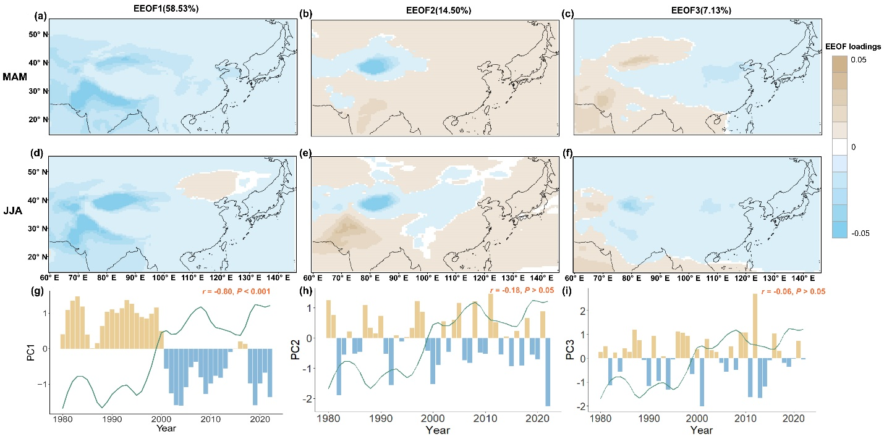
Figure S13. Leading three EEOF modes of dust decadal variability (a-f) and corresponding principal component (PC_{d}) time series with the AMO index (g-i). Each mode includes spring and summer (MAM-JJA) pattern. The percentage of variance explained by each mode is denoted above the Figure. The filled bars in represent the PC time series and grey lines represent the AMO index, with their correlation coefficients denoted in red.

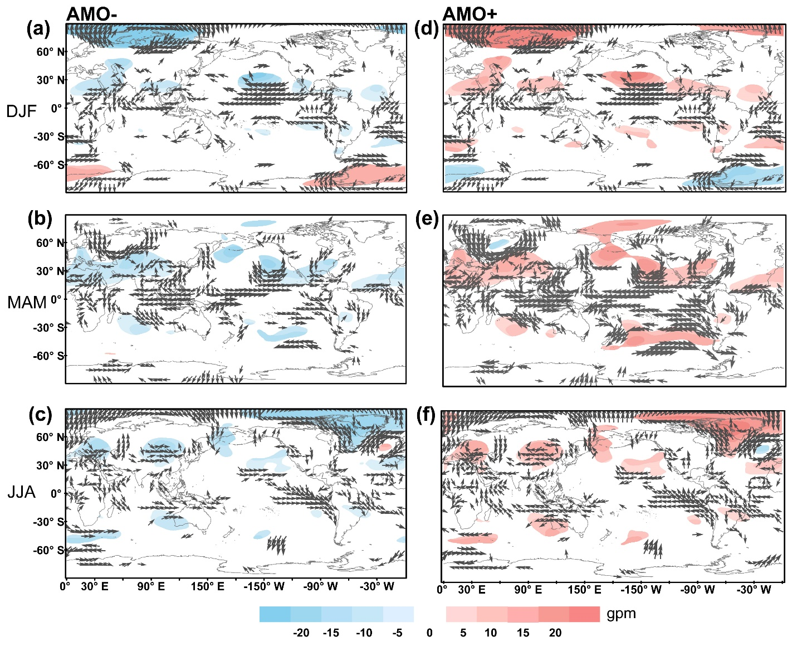
Figure S14. Composite 500 hpa geopotential height (shaded, gpm) and 850 hpa wind (vector, m/s) anomalies during AMO negative phase (in (a) DJF, (b) MAM and (c) JJA) and positive phase (in (d) DJF, (e) MAM and (f) JJA). The anomalies for all parameters are shown at the 95% significance level.

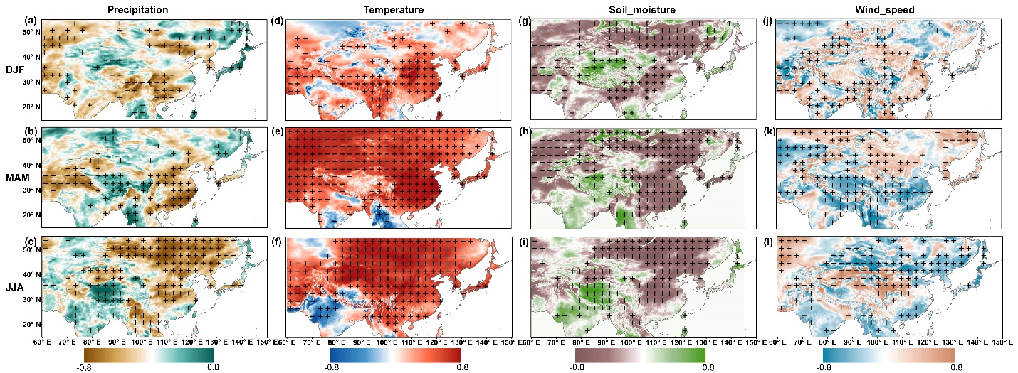
Figure S15. Correlation maps between the AMO index and precipitation (a-c), 2 m temperature (d-f), soil moisture (g-i) and surface wind (j-l). The cross mark indicates significance at the 95% level (P < 0.05).

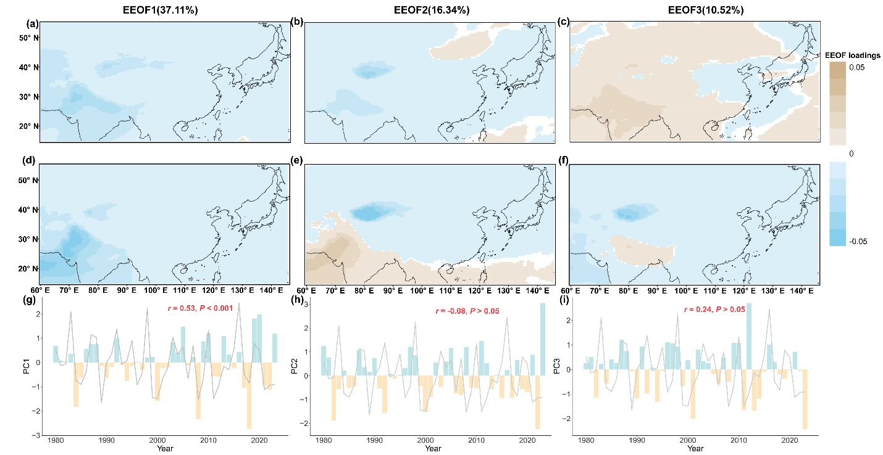
Figure S16. Leading three EEOF modes of dust interannual variability (a-f) and corresponding principal component (PC_{i}) time series with ENSO ONI index (g-i). Each mode includes spring and summer (MAM-JJA) pattern. The percentage of variance explained by each mode is denoted above the Figure. The filled bars represent the PC time series and grey lines represent the ENSO ONI index, with their correlation coefficients denoted in red.

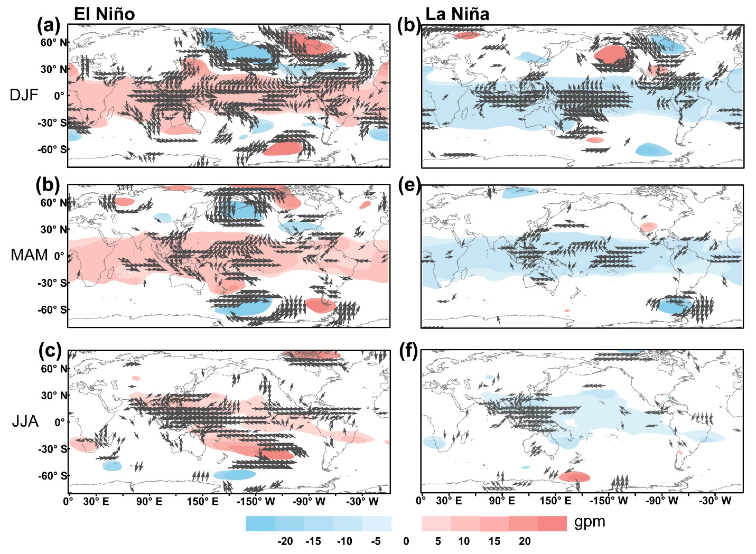
Figure S17. Composite 500 hpa geopotential height (shaded, gpm) and 850 hpa wind (vector, m/s) anomalies during El Niño (in (a) DJF, (b) MAM and (c) JJA) and La Niña (in (a) DJF, (b) MAM and (c) JJA). The anomalies for all parameters are shown at the 95% significance level.

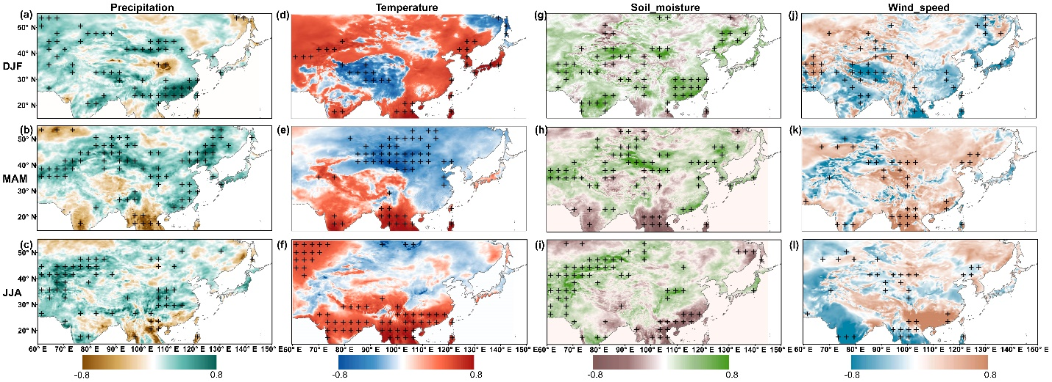
Figure S18. Correlation maps between the ENSO ONI index and precipitation (a-c), 2 m temperature (d-f), soil moisture (g-i) and surface wind (j-l). The cross mark indicates significance at the 95% level (P < 0.05).

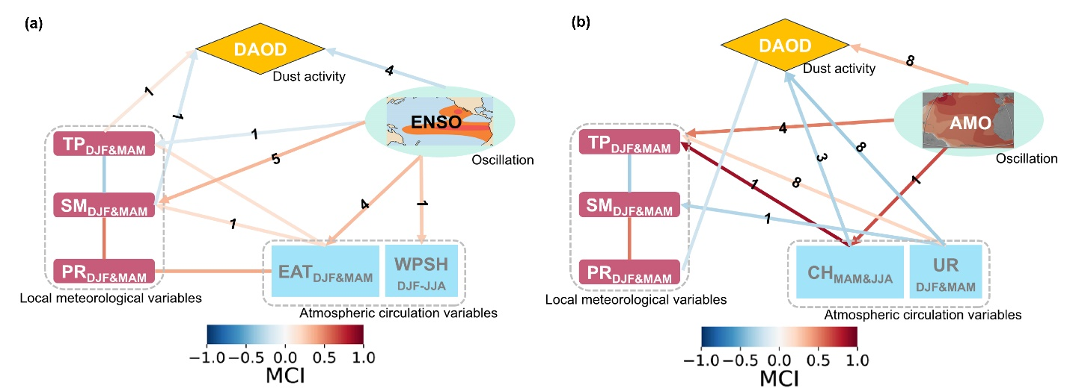
Figure S19. Causal pathway of ENSO (a) and AMO (b) driving dust activity variability. The local meteorological variables involved include precipitation (PR), temperature (TP), and soil moisture (SM); atmospheric circulation variables include the East Asian trough (EAT, represented by the mean 500 hpa geopotential height averaged over 30°N–45°N, 125°E–145°E), the western Pacific subtropical high (WPSH, represented by the mean 500 hpa geopotential height averaged over 0°–35°N, 120°E–160°E), the continental high (CH, represented by the mean 500 hpa geopotential height averaged over 15°N–55°N, 60°E–120°E), and the Ural blocking high (UR, represented by the mean 500 hpa geopotential height averaged over 40°N–60°N, 80°E–120°E). Arrows indicate directed causal links between variables, lines indicate undirected causal links, and the color intensity represents the strength of the link. Numbers indicate the lag time corresponding to the strongest causal link. All causal links are shown at the 99% significance level (P < 0.01).

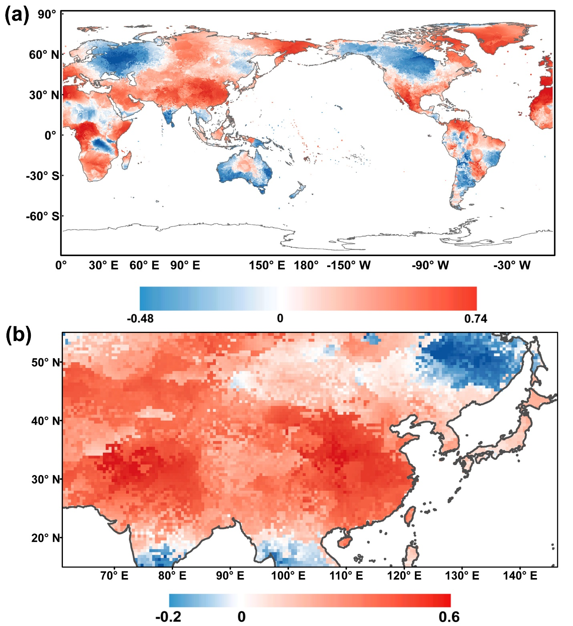
Figure S20. Relationship between the AMO and spring (March-May) mean surface temperature during 1900–2023. a Spatial pattern of the correlation coefficient between the AMO index and spring mean global surface temperature. b Composite difference in spring mean surface temperature (℃) between positive and negative AMO phases over East Asia. Shaded areas in both panels indicate significance at the 95% confidence level. Long-term trends were removed from all variables to eliminate the influence of global warming.
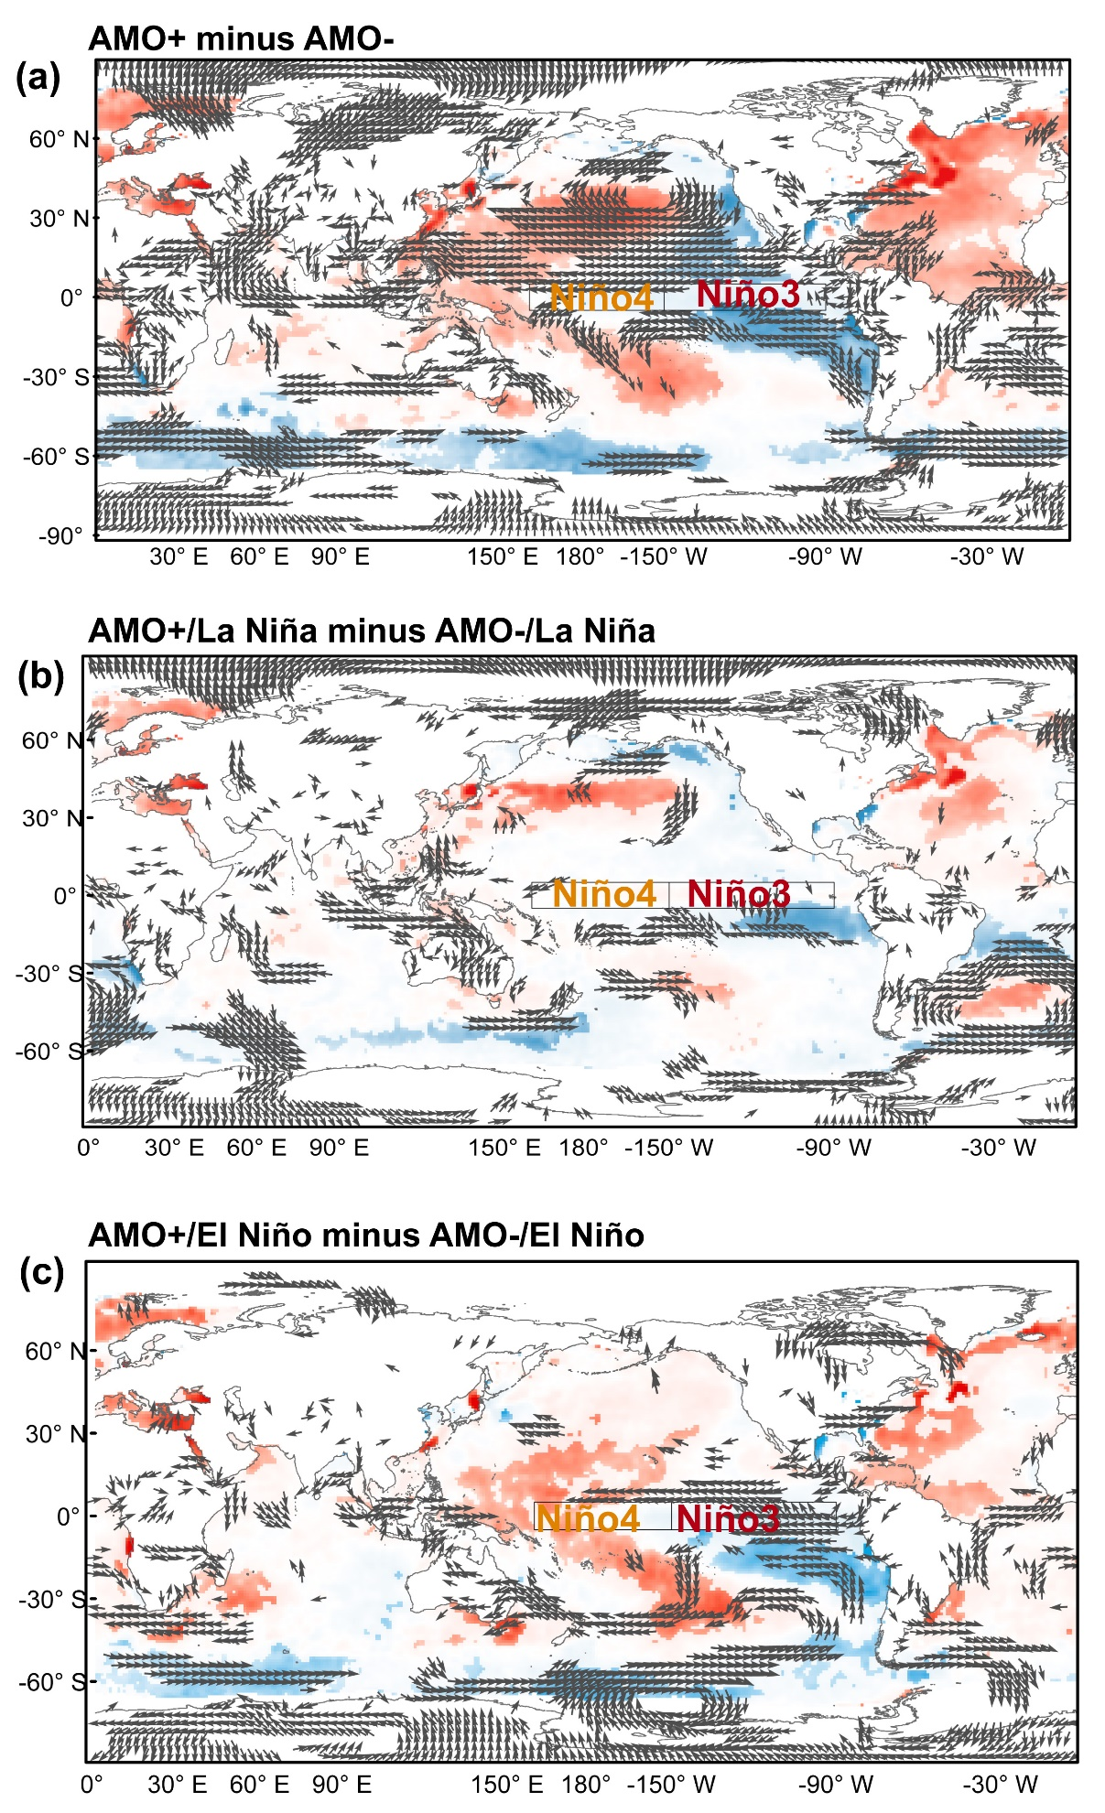
Figure S21. Modulation of AMO on winter ENSO SST anomalies and 850 hPa winds. (a) Difference in winter (DJF) mean SST anomalies between AMO positive and negative phases; (b) Composite difference of DJF SST anomalies during La Niña events between AMO positive and negative phases; (c) Same as (b), but for El Niño events. Shaded areas and vectors indicate statistical significance at the 95% confidence level.

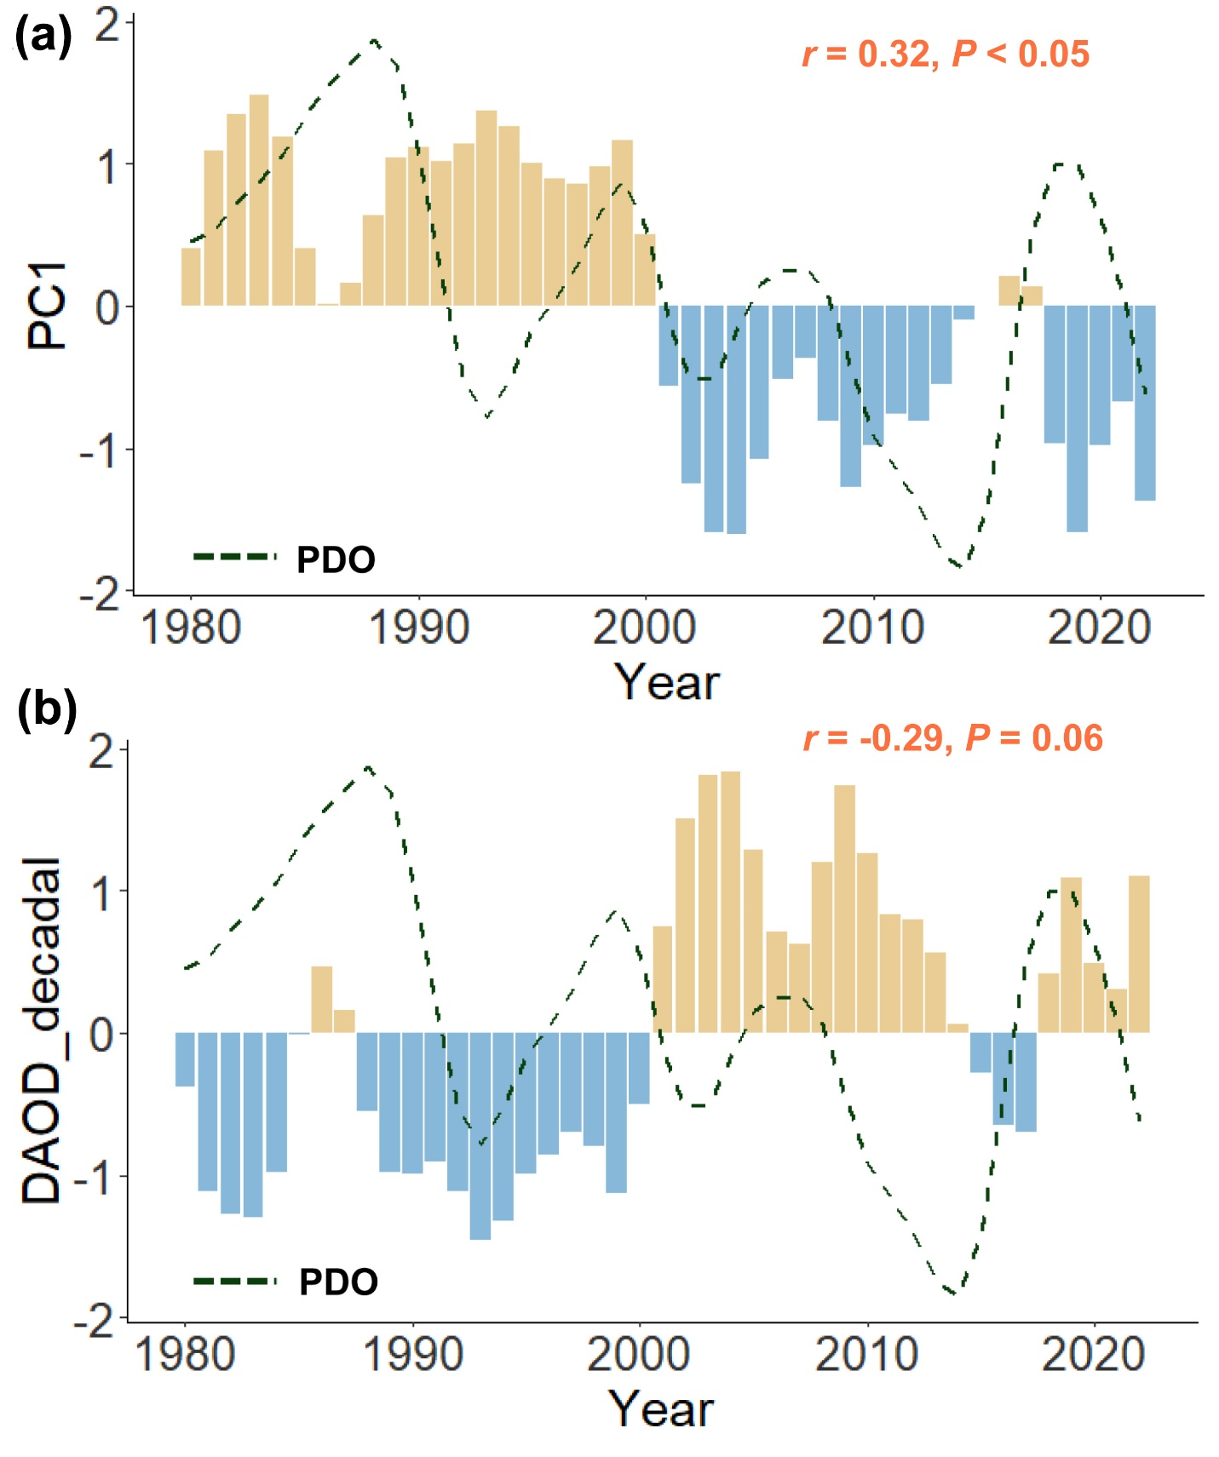
Figure S22. Correlation between (a) the principal component (PC1_{d}) of the leading mode of decadal DAOD variability (EEOF1_{d}), (b) the decadal component of DAOD time series and the PDO index.
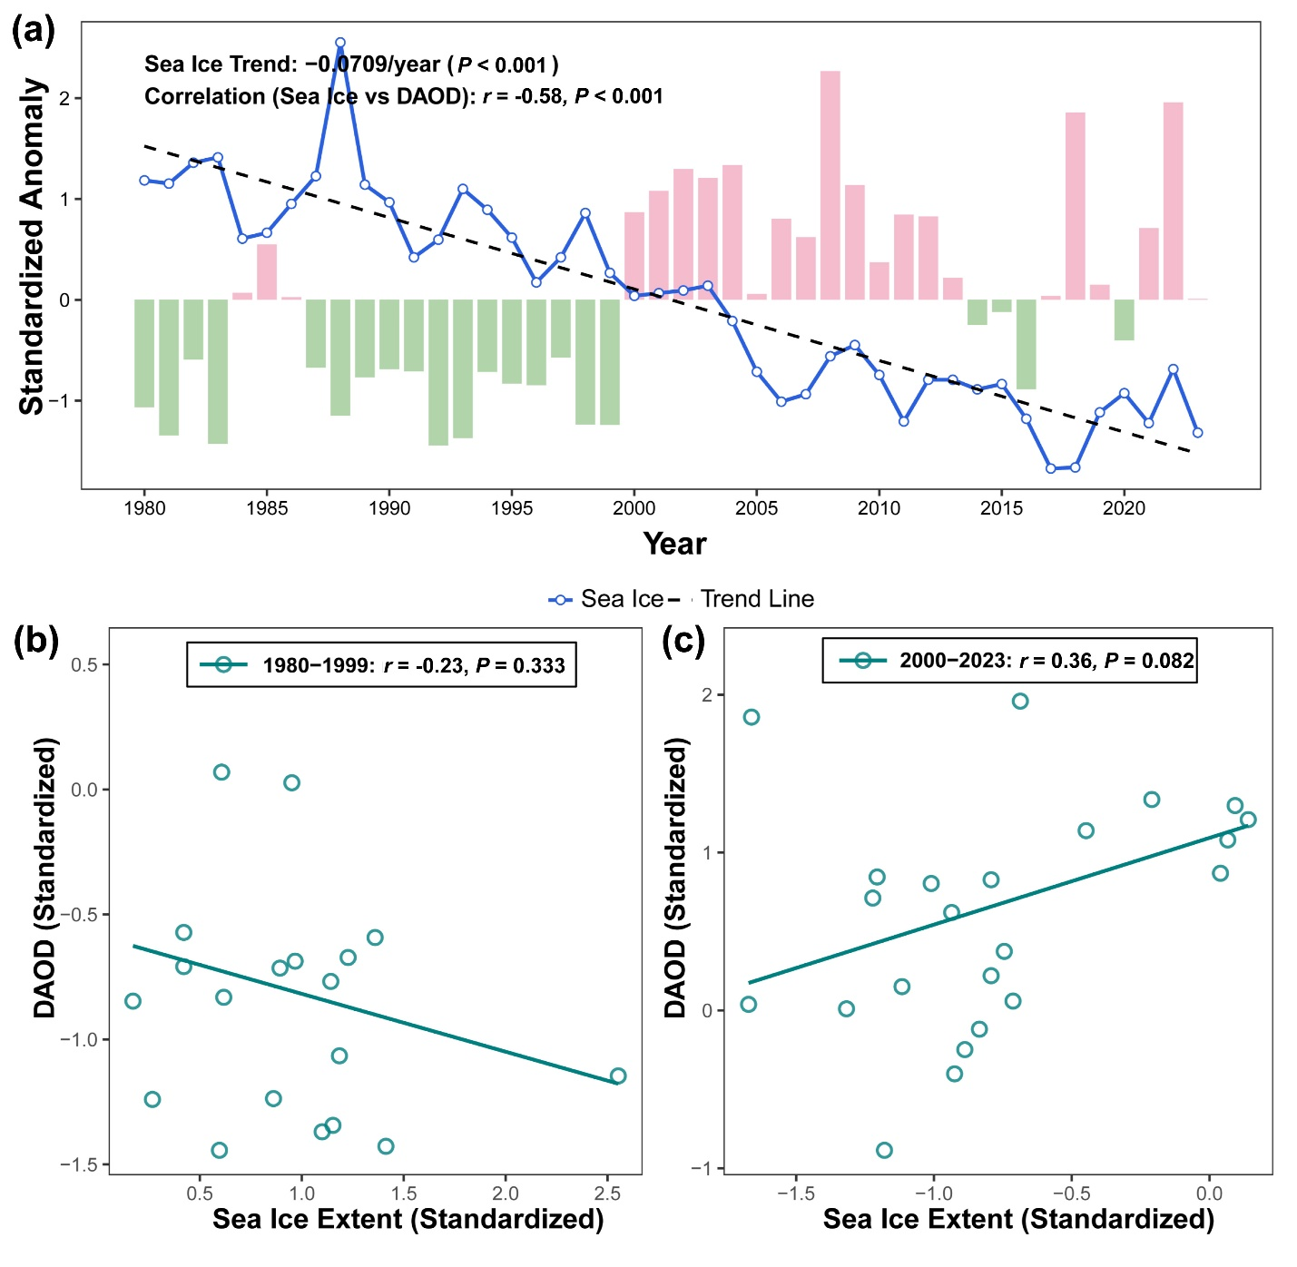
Figure S23. Temporal evolution and correlation analysis of Arctic sea ice extent (SIE) and East Asian DAOD (1980–2023). a Time series of standardized anomalies from 1980 to 2023. The blue solid line represents the winter Arctic SIE, while the bars indicate the DAOD anomalies over East Asia. The black dashed line denotes the significant long-term linear decline of the SIE. b Scatterplot of DAOD vs SIE (1980–1999). c Scatterplot of DAOD vs SIE (2000–2023).

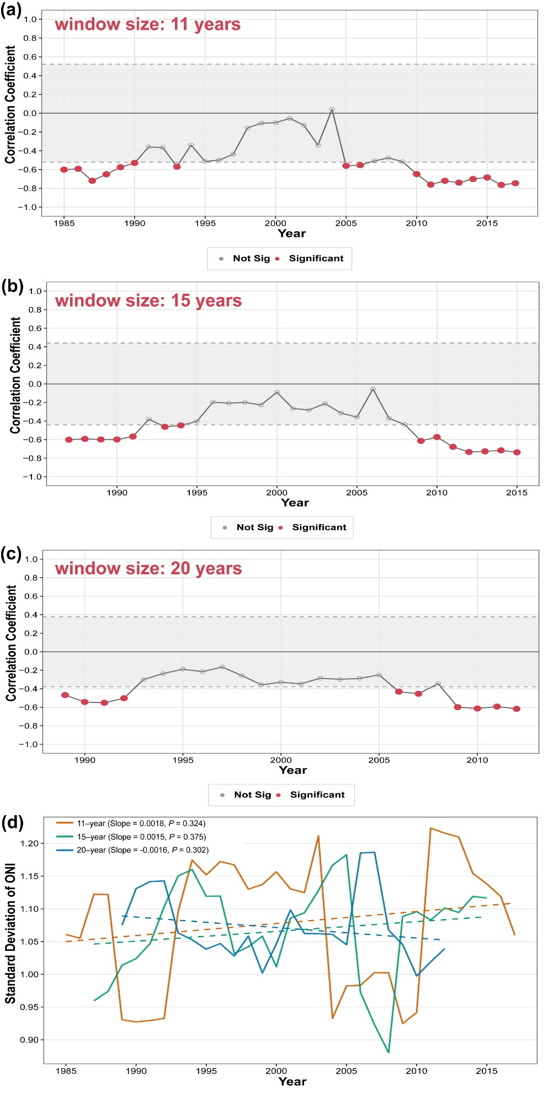
Figure S24. Evolution of ENSO amplitude and the relationship between ENSO and East Asian dust during 1980–2023. (a)–(c) Sliding correlation coefficients between the ONI index and DAOD based on window widths of 11, 15, and 20 years, respectively. Gray shading indicates the range where correlations are statistically insignificant (P > 0.1). (d) Sliding standard deviations of the ONI index (representing ENSO amplitude). The orange, green, and blue solid lines denote 11-, 15-, and 20-year sliding windows, respectively, while the dashed lines represent their corresponding linear trends.

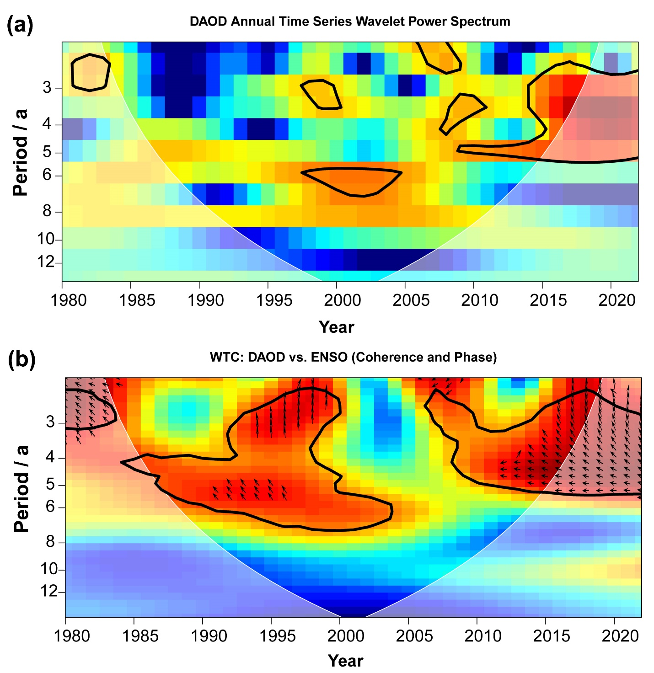
Figure S25. Interannual Periodicity of DAOD and Coherence with ENSO. (a) Continuous Wavelet Power Spectrum of the DAOD annual series. (b) Wavelet Coherence between DAOD and the ENSO index (ONI). The thick solid line encloses regions of 95% statistical significance. The arrows indicate the phase relationship.

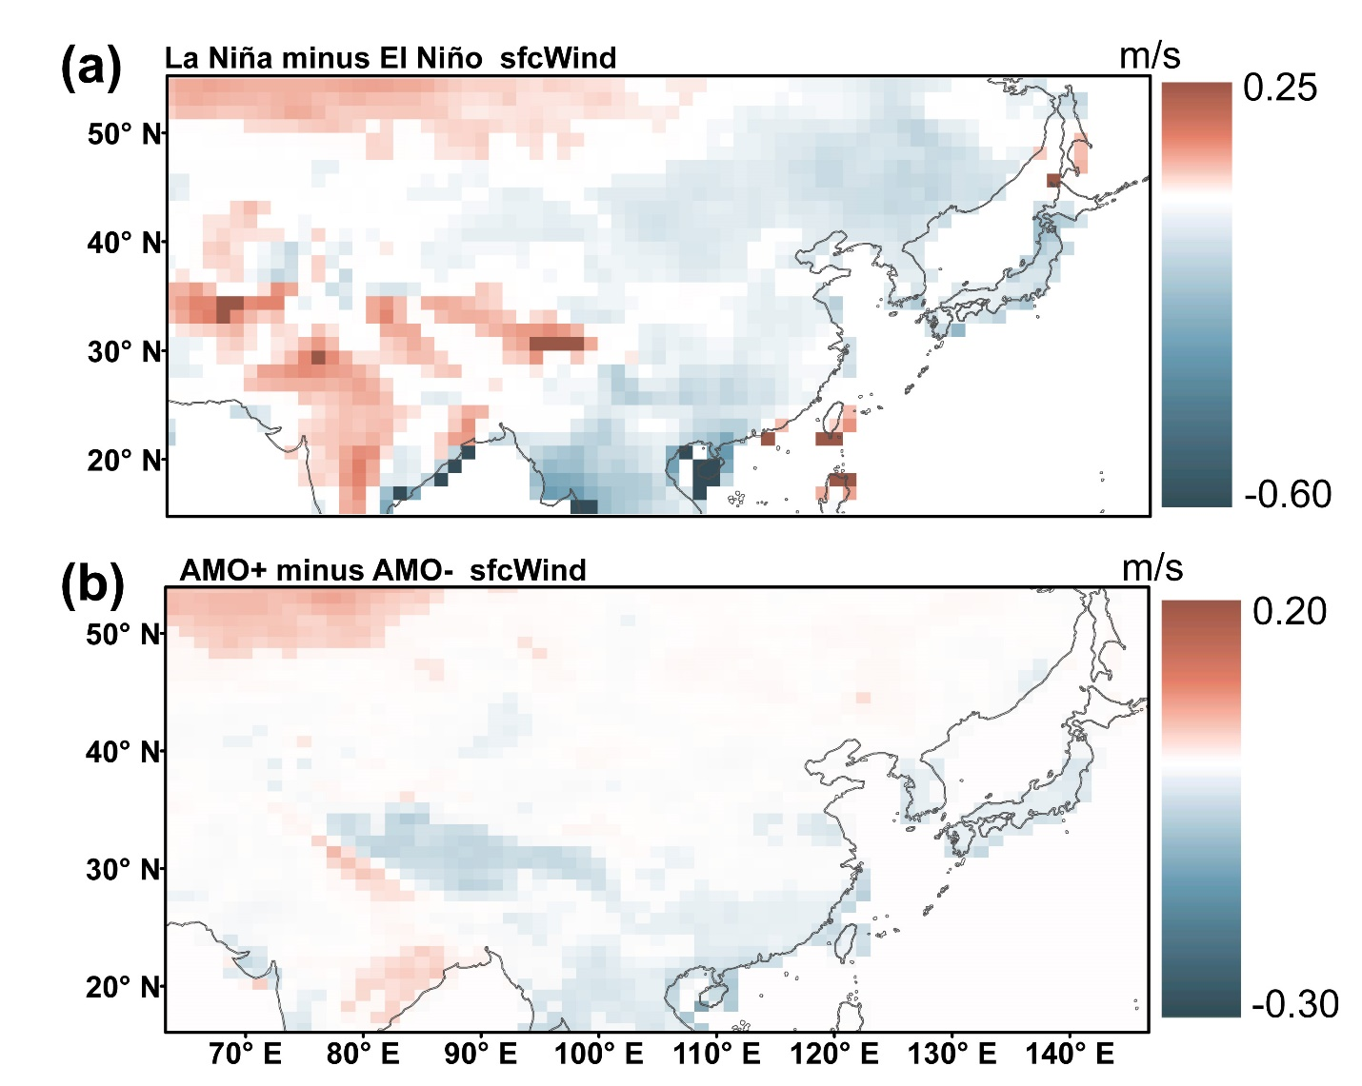
Figure S26. Simulated response of East Asian spring wind speed to independent Tropical Pacific and North Atlantic SST forcing. a Spring wind speed anomalies (La Niña minus El Niño). b Spring wind speed anomalies (positive minus negative AMO phases). The shaded areas indicate the 95% confidence level.

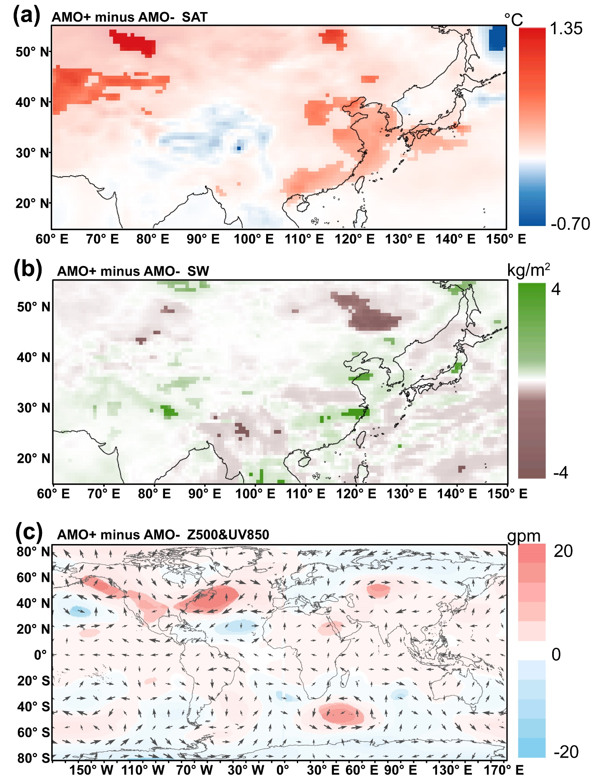
Figure S27. Simulated response of East Asian spring climate to North Atlantic SST anomalies in CMIP6 DCPP experiments. Composite differences in spring surface air temperature (a), soil moisture (b), and atmospheric circulation (500 hPa geopotential height and 850 hPa wind) (c) between warm (AMO+) and cold (AMO-) North Atlantic SST forcing experiments from DCPP. The shaded areas indicate anomalies significant at the 95% confidence level.

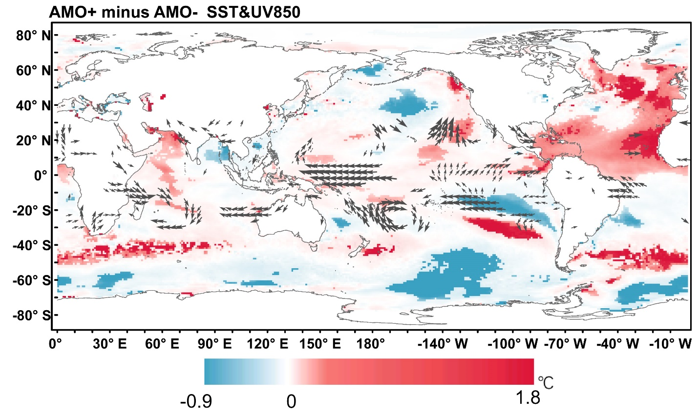
Figure S28. Simulated winter global SST and 850 hPa wind anomalies driven by idealized North Atlantic SST forcing. The figure displays the composite differences of winter (DJF) Sea Surface Temperature (SST) anomalies (shading) and 850 hPa wind field anomalies (vectors, confined to 30°S–30°N) between the AMO+ and AMO- forcing experiments in DCPP. Only anomalies significant at the 90% confidence level are shown.

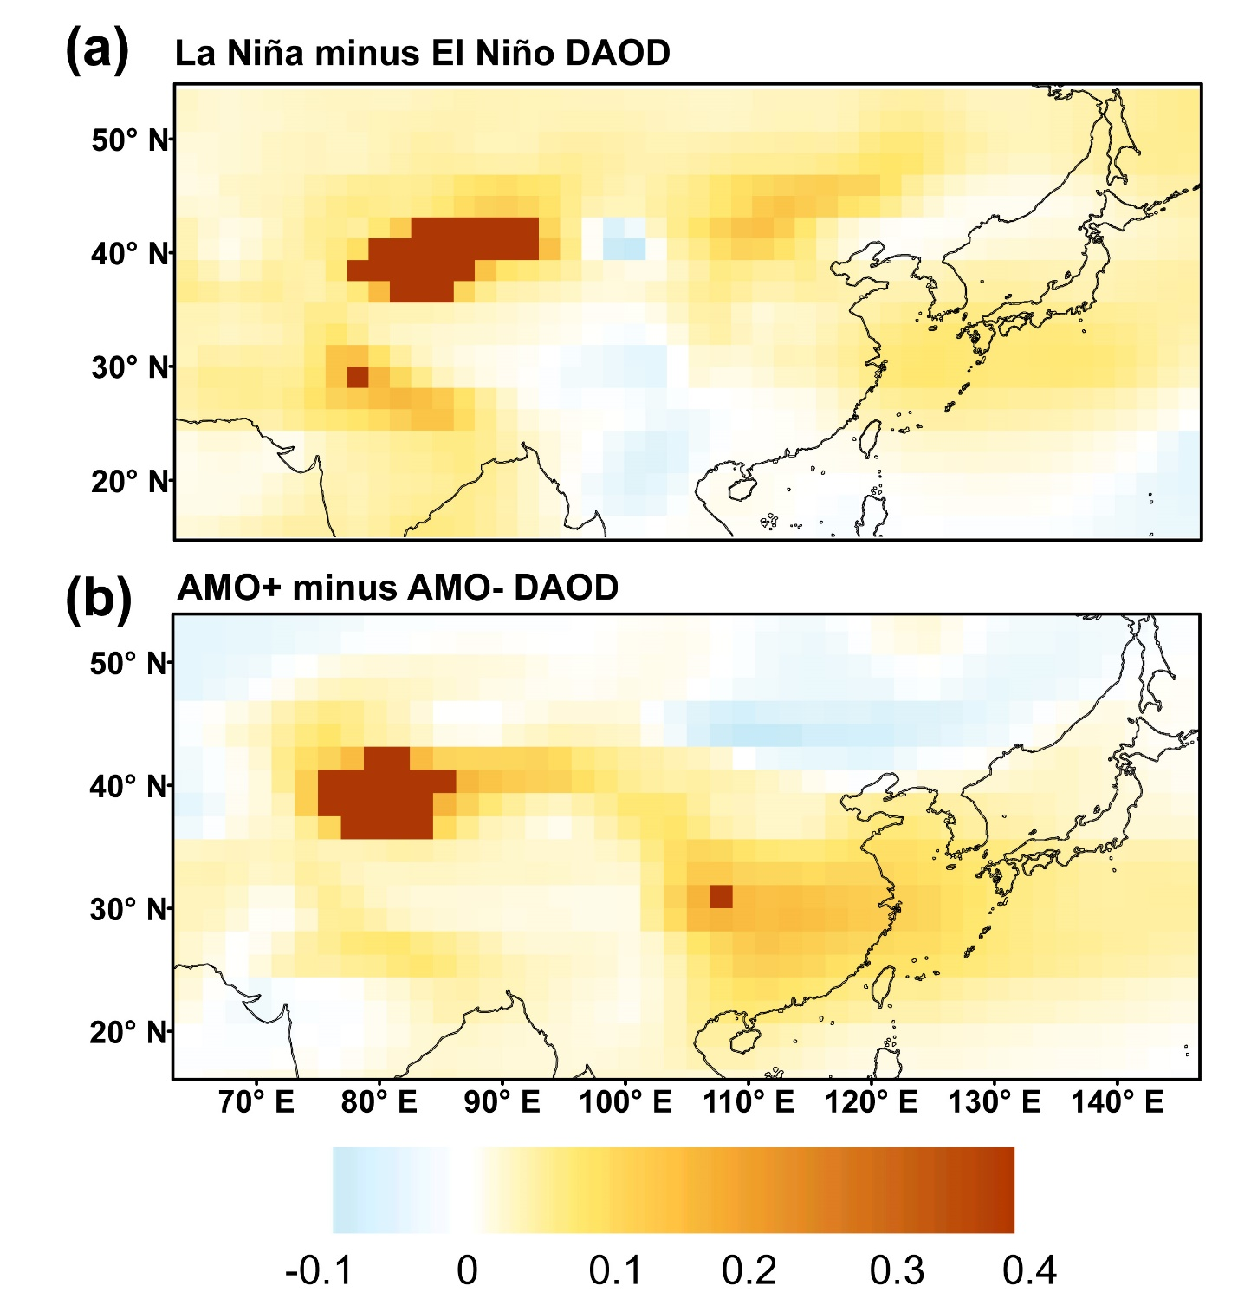
Figure S29. Response of East Asian Dust Aerosol Optical Depth (DAOD) to ENSO and AMO variability simulated by the CMIP6 AMIP multi-model ensemble. (a) DAOD response to ENSO variability (Composite differences for La Niña minus El Niño years). (b) DAOD response to AMO variability (Composite differences for positive minus negative AMO phases). The shaded areas indicate anomalies significant at the 95% confidence level. Note: The results represent the ensemble mean of 12 CMIP6 models forced by observed sea surface temperatures, verifying the direct modulation of dust activity by SST anomalies.

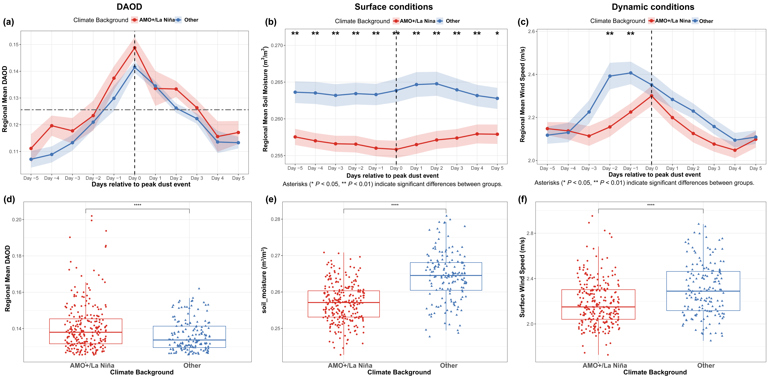
Figure S30. Temporal evolution and statistical distributions of regional mean DAOD, soil moisture, and surface wind speed during extreme dust events. a-c Temporal evolution of regional mean DAOD (a), soil moisture (c), and surface wind speed (e) from Day -5 to Day +5 relative to the peak of extreme dust events (Day 0). The horizontal dashed line in (a) denotes the 90th percentile threshold of DAOD to define extreme dust days. d-f Boxplot comparisons of regional mean (b) DAOD, (c) soil moisture, and (d) surface wind speed across all extreme dust days. Asterisks indicate the level of statistical significance (* P < 0.05, ** P < 0.01, *** P < 0.001, **** P < 0.0001) based on independent two-sample Welch’s t-tests.

Table S1. Comparative performance of the joint ENSO-AMO indices constructed using different schemes in fitting DAOD variability.
Methods | Simple correlation coefficient weighting | Multilinear regression coefficient
Correlation coefficient | 0.802*** | 0.807***
Device explained rate | 64% | 64%
Leave-One-Out Cross-Validation | 0.771*** | 0.775***
The two methods correspond to: Simple correlation coefficient weighting (a linear combination of ENSO and AMO weighted by their respective simple correlation coefficients with DAOD) and Multilinear regression coefficient (a linear combination of ENSO and AMO using the coefficients derived from the multilinear regression of DAOD against ENSO and AMO) (see Methods). *** denotes significance at the P < 0.001 level

Table S2. Comparative assessment of the Goodness-of-Fit of Generalized Additive Models (GAMs). Incorporating independent and interactive effects of climate indices (ENSO, AMO, and PDO) on DAOD (see methods)
 | GAM model1 independent effects (ENSO, AMO) | GAM model2  independent effects  (ENSO, PDO, AMO) | GAM model3  independent and interactive effects  (ENSO, AMO)
Adjusted R² | 0.633 | 0.689 | 0.735
Device explained rate | 65.1% | 73.3% | 78%
Note | ENSO and AMO terms are significant (P < 0.05) | ENSO and AMO terms are significant (P < 0.05), the PDO term is not significant (P = 0.16) | ENSO, AMO as well as their interaction terms are all significant (P < 0.05).

Table S3. Simple and partial correlation coefficients of AMO and PDO with DAOD and dust event frequencies. (*** indicate statistical significance at the P < 0.001 level)
Climate Index | Statistical Metric | DAOD | Blowing dust frequency | Moderate dust storm frequency | Severe dust storm frequency
AMO | Correlation  (R) | 0.73*** | 0.61*** | 0.65*** | 0.51***
AMO | Partial Correlation  (PR) | 0.71*** | 0.59*** | 0.68*** | 0.52***
PDO | Correlation  (R) | -0.24 | -0.21 | -0.05 | -0.09
PDO | Partial Correlation  (PR) | 0.10 | 0.05 | 0.29 | 0.14

