Understanding the Non-Urgent Use of Emergency Care in Yorkshire and the Humber: An Integrated Care Board Level Analysis
Applied Research Collaboration (ARC) Yorkshire and Humber Report.

Dacheng Huo¹, Sebastian Hinde¹, Laura Bojke¹ & Suzanne Mason²
¹Centre for Health Economics, University of York
²Sheffield Centre for Health and Related Research, University of Sheffield

Corresponding author: Sebastian Hinde, Senior Research Fellow, Centre for Health Economics, University of York. Sebastian.Hinde@york.ac.uk

Funding and data disclaimer
The research was funded by the Applied Research Collaboration (ARC) Yorkshire and Humber. The views expressed are those of the author(s), and not necessarily those of the NIHR or the Department of Health and Social Care.
This work uses data provided by patients and collected by the NHS as part of their care and support. The Emergency Care Data Set (ECDS) 2019/20 - 2024/25 is copyright, NHS England. Re-used with the permission of NHS England. All rights reserved.
This project was undertaken on the Data Safe Haven, which is an ISO 27001 certified environment for handling sensitive data, and is provided by the University of York. We are grateful for support from the University of York Data Safe Haven team and the Research Computing team.

One Page Summary
Emergency Departments (EDs) across the UK have been under sustained pressure for a prolonged period of time, resulting in extended periods of wait before patients can be seen and reducing the ability of the system to provide high quality care to those most in need. It has been estimated that for every 82 patients whose care is delayed one of them will die as a result.
One area that has caused pressure on EDs is people using it to access care which could be more appropriately dealt with elsewhere, as well as those attending ED when they do not need any care, often unintentionally. For example, someone may go to ED if they are unable to book an appointment at their GP or attending ED for minor injuries that require no care. These are termed non-urgent attendances.
In 2018 some of this team created a definition of what non-urgent attendances looked like, estimating that 15.1% of all first-time attendances were non-urgent. Since then, there have been many changes to the NHS and the richness of the data available on who attends ED and why. In this study we take another look at the data, exploring which groups have higher and lower proportions of non-urgent attendance. To make the analysis relevant to policymakers in Yorkshire we break the information down by where the EDs are, comparing all of Yorkshire with the rest of England, as well as the three organisations (Integrated Care Boards, ICBs) within Yorkshire.
In the 12 months from 1st August 2024 (the most recent period we have data on) there were over 16 million first attendances at EDs across England, 3.1 million of which (18.9%) could be thought of as ‘non-urgent’. In Yorkshire this level was slightly lower at 17.3% and appears to be lower than the rest of England over the year, as shown in the figure below.
Within Yorkshire, the proportion of non-urgent attendances appeared to vary across the three different ICBs, with North Yorkshire & Humber having only 13.2% of all first attendances being non-urgent, South Yorkshire 15.9%, and West Yorkshire 20.2%. Unfortunately, we do not know from the data why the varied, but we can tell something about the type of person who was causing it.
As in the 2018 study we found that the younger people were the more likely it was for an attendance to be non-urgent, with around a third of attendances by under 11-year-olds being non-urgent. We also found that the time of the day made a big difference, with the highest proportion being between 7pm and 10pm, especially during the week, and the lowest being between 5am and 6am.
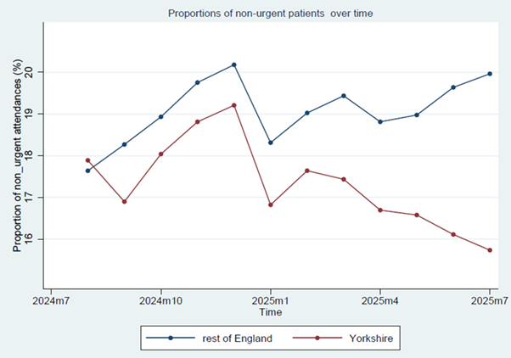
At a time when the NHS is under more pressure than ever, it is important that services are being used appropriately. With an attendance at ED costing around £150 for the NHS to manage even with no investigations or treatment it is important that more is done to help people find the best way to access care.

Content
One Page Summary 1
1. Background and Rationale 3
2. Methods 4
2.1. Data Collection 4
2.2. Definition of non-urgent attendance 4
2.3. Index of Multiple Deprivation (IMD) 5
2.4. Handling of missing data 5
2.5. Statistical Analysis 6
3. Results 6
3.1. Attendance types 6
3.2. Urgent and non-urgent attendance over time 7
3.3. Age at arrival 9
3.4. Mode of arrival 10
3.5. Time of arrival 10
3.6. Socioeconomic status (IMD) 12
3.7. Main complaint 13
4. Discussion 13
4.1. Summary of main results 13
4.2. Comparability of findings 14
4.3. Limitations 14
4.4. Future Analysis 14
5. Conclusion 15

Background and Rationale
Delays in the initiation of appropriate treatment after patient attendance at an Emergency Department (ED) has a detrimental impact on patient care, with recent research finding that there is one extra death within 30 days for every 82 patients whose time to admission is delayed beyond 6 to 8 hours.
The 2025/26 National Health Service (NHS) England ‘Urgent and Emergency Care Plan’ outlined a number of priority actions including a target of a minimum of 78% of patients who attend ED are admitted, transferred or discharged within 4 hours. This marks a continued reduction in the target, down from a target of 95% in the 2010 Constitution of the English NHS, showing the continued pressures on EDs.
It has been argued that a significant factor in the struggle to maintain ED waiting times within the target has been the attendance of patients who may be more appropriately cared for elsewhere, e.g. primary care or through a pharmacy, or require no medical intervention. With a view to generating evidence that could be used to reduce pressures on emergency services, a previous study by O'Keeffe, Mason, Jacques, and Nicholl in 2018 analysed three years of ED data from one region in England to classify and quantify these non-urgent attendances. The study found that 15.1% of first-time attendances to EDs were non-urgent, with younger adults being significantly more likely to use ED to seek less urgent healthcare. These attendances add to the capacity issues in EDs and the benefits of attending could be questioned if indeed these patients could be managed more effectively elsewhere in the healthcare system.
This study seeks to build on and extend the O’Keeffe et al. analysis in a number of ways. Firstly, we use the Emergency Care Dataset (ECDS), the national dataset for urgent and emergency care which replaced the Accident and Emergency Commissioning Dataset from 2017. ECDS represents a richer and more complete dataset than was available for O’Keeffe et al., allowing us to understand more about the type of patient attending, why they did so, and what occurred to them. Secondly, O’Keeffe focussed on Yorkshire and Humber alone, whereas this analysis explores ED data across the three Yorkshire and Humber Integrated Care Boards (ICBs), comparing these across the rest of England to supply wider context.
Finally, by conducting an updated analysis we are able to inform contemporary policy decisions regarding non-urgent attendances at an ICB and regional level. Not only has over a decade passed since the data used by O’Keeffe et al was collected, 2011 to 2014, but the covid-19 pandemic and other factors have been argued to have changed how patients interact with the NHS.

Methods

Data Collection
The English ECDS database is a collection of patient data from EDs in England. De-identified patient-level data were collected on several factors, including age, gender, attendance date, attendance type (first or follow-up), arrival mode (ambulance or other means), discharge destination (discharged, admitted, or referred for follow-up), activity and event time stamps, ICB region, main complaint, clinical investigations, clinical treatments, and diagnosis.
At the time of analysis, data was available for the continuous period from the start of the 2019/20 financial year to the end of July 2025. However, due to the size of the dataset and desired contemporaneous nature of this report only 12 months of data from August 2024 were included. Data is accessed via the Centre for Health Economic’s Programme Level Agreement with NHS England.

Definition of non-urgent attendance
This report seeks to use the same definition of non-urgent attendance as that developed in the O'Keeffe algorithm (2018). Consistent with their approach we focus on patients attending as a first attendance to a Type 1 ED. In the original study by O'Keeffe (2018), the algorithm was designed for use with CDS-10 codes, as used in the now replaced Accident and Emergency Commissioning Dataset. However, as ECDS uses CD-11 codes adjustments were made to align with the newly applied codes. A cross-reference table is provided in Appendix 1 but in brief the O’Keeffe algorithm defines non-urgent attendance as any patient episode that met the following three conditions:
- Not requiring urgent investigation in, and
- Not requiring urgent treatment, and
- Discharged from the ED without treatment or referred to their GP.
Specifically, the list of investigations, treatments, and discharge codes used to identify non-urgent ED attendances are shown in Table 1.

Table 1 List of investigations and treatments identifying non-urgent ED attendances
Investigation
None
Urinalysis
Pregnancy test
Dental investigation
Treatment
Prescriptions
Guidance/advice only
Recording vital signs
Dental treatment
Prescription
None
Disposal
Discharged-following treatment to be provided by GP
Discharged-did not require any follow-up treatment
Left department before being treated

Index of Multiple Deprivation (IMD)
As part of this analysis, we sought to explore the role of socio-economic deprivation on ED attendance and the propensity for non-urgent attendance. The Index of Multiple Deprivation (IMD) is a measure of relative socioeconomic deprivation which combines data on indicators such as income, employment, health, education, and crime to provide a comprehensive representation of deprivation levels in each geographic area (measured by Lower Layer Super Output Area, LSOA). IMD values range from 1 (most deprived) to 10 (least deprived). Our analysis uses the location of the individual’s GP practice to inform their IMD status (assuming that an individual’s place of residence is near to their GP practice or in a similar IMD area).

Handling of missing data
For the majority of this analysis a complete case approach was taken. However, some data in the treatment and investigation fields of ECDS were found to be missing with no clear indication if this was due to no treatment or investigation conducted or truly missing data. Therefore, the assumption was made that if a treatment or investigation field was blank, but at least one other field for treatment, investigation, or attendance disposal contained data, the missing field was considered as indicating no treatment or investigation. However, if all fields for treatment, investigation, and attendance disposal were blank, the case was categorised as "missing".

Statistical Analysis
The analysis focusses on graphical and summary statistics alone, with rates and proportions of total and non-urgent attendances reported across the three ICBs, combined into a full Yorkshire region, and across the rest of England. Summaries of attendance and non-urgent attendance are reported across a range of the clinical and socioeconomic variables available to us.

Results

Attendance types
Across all of England a total of 17,115,223 attendances were recorded across all Major Emergency Care Departments from 1st August 2024 to 31st Just 2025. As shown in Figure 1, of these, 16,437,380 were classified as first-time ED attendances. Of these, 3,110,052 (18.9%) were considered non-urgent by definition and could have more appropriately been treated by alternative care services or not requiring care at all. Figure 1 illustrates the classification of attendance type according to our process.

Figure 1: Classification of all attendances, all of England Major Emergency Care Departments

For Yorkshire (defined as the area covered by all three of the Yorkshire ICBs) there were 1,718,794 attendances at Major Emergency Care Departments in the same period, 1,668,938 were first attendance, 289,558 (17.3%) of which were non-urgent. Across the three ICBs these headline proportions of non-urgent attendances vary, with North Yorkshire & Humber having 13.2% of all first attendances being non-urgent, South Yorkshire 15.9%, and West Yorkshire 20.2%.

Urgent and non-urgent attendance over time
In this section we report how volumes of attendances at EDs, and the proportion of non-urgent cases, varies over the 12 months of the analysis period. Figures 2 and 3 report the levels of all unplanned first attendances and non-urgent attendance per month for all of England (Figure 2) and Yorkshire (Figure 3). These show that the trend is attendances in both areas is broadly flat, with the exception of the winter period, and very similar for both all of England and Yorkshire.

Figure 2: Total first-time and non-urgent attendances by month, all England
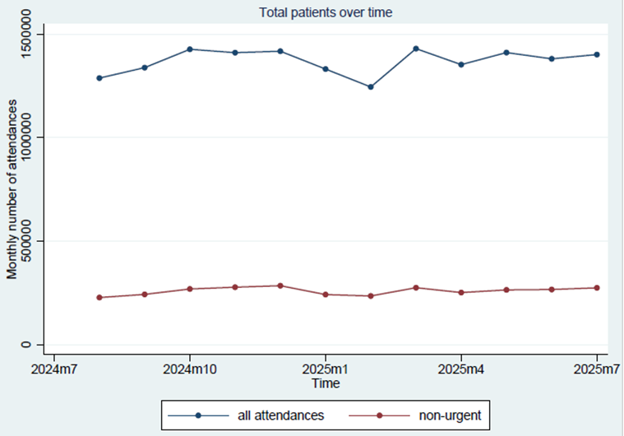

Figure 3: Total first-time and non-urgent attendances by month, Yorkshire
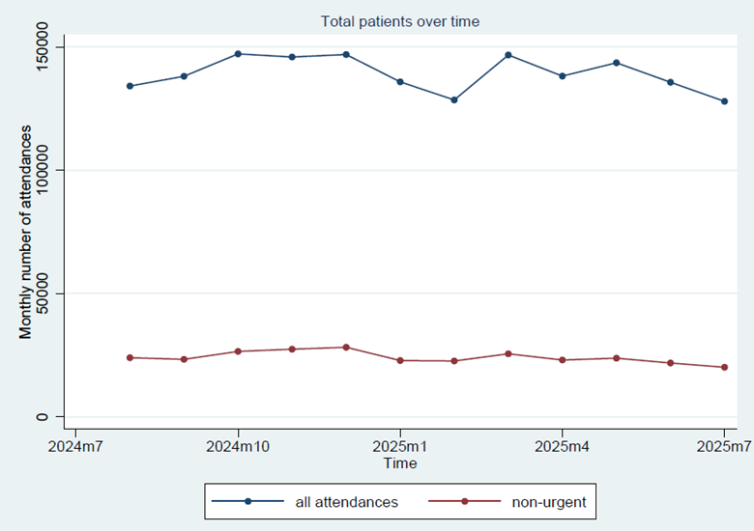

We can also directly compare the proportion of non-urgent attendances between Yorkshire and the rest of England which we do in Figure 4. This shows that while Yorkshire has always had a lower proportion of non-urgent attendances, in the region of 1% for most of the 2024 period, this lower rate appears to have diverged at a continuously increasing rate through 2025.
Figure 4: Non-urgent proportion in Yorkshire vs rest of England
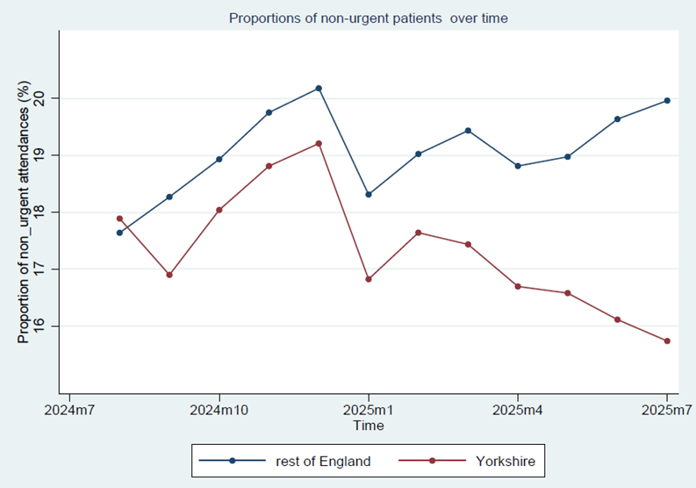

Similarly, we can explore the rate of non-urgent attendance by Yorkshire ICB, see Figure 5. The additional level of disaggregation suggests that the rate of non-urgent attendance varies across the ICBs, with West Yorkshire experiencing a similar rate to the rest of England, but South and Humber and North Yorkshire less. It is important to note here that the three ICBs cover very different populations and settings, with the West Yorkshire ICB EDs handling roughly double the total number of attendances compared to the other two.
Figure 5: Proportion of non-urgent attendances by Yorkshire ICBs and the rest of England
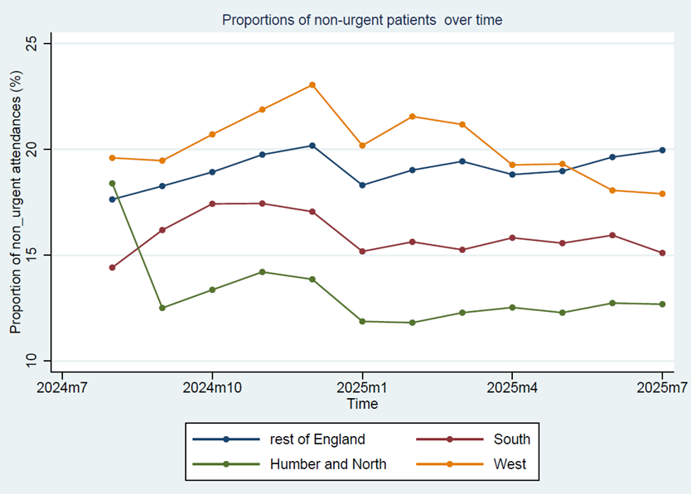

Age at arrival
O'Keeffe et al’s study revealed significant variation in the proportion of non-urgent attendance according to age, showing the highest proportion in the youngest age group with around two-thirds occurring in the under-45s. Table 1 shows the percentage of first emergency attendances that are non-urgent by age category. Consistent with O’Keeffe we found a significant variation in rates of non-urgent attendance by age, with older groups consistently less likely to be considered non-urgent, with over a third of under 11 attendances being non-urgent compared to only 3.5% in over 90-year-olds.
Compared to the rest of England, Yorkshire had lower proportions of non-urgent attendance across all age groups, always between 1% and 2% less. When split into the constituent ICBs we again see similar relationships between age and proportions of non-urgent attendances. Humber & North Yorkshire and South Yorkshire ICBs appear to have similar proportions, suggesting the differences seen in Figure 5 are the result of different population age profiles. In contrast, West Yorkshire ICB has noticeable higher proportions of non-urgent attendances, above the rest of England for all but the two lowest age categories.

Table 1: First emergency attendance by age group, percentage non-urgent for each age
age category | Rest of England (%) | Yorkshire (%) | Humber & NY (%) | South (%) | West (%)
< 11 | 34.6 | 33.3 | 32.6 | 33.1 | 33.7
11-20 | 25.0 | 23.4 | 22.0 | 21.7 | 24.9
21-30 | 23.6 | 22.0 | 17.5 | 17.4 | 25.9
31-40 | 21.0 | 19.1 | 14.8 | 15.5 | 22.7
41-50 | 18.6 | 17.2 | 14.1 | 13.6 | 20.5
51-60 | 15.2 | 13.3 | 10.3 | 10.4 | 16.5
61-70 | 11.7 | 9.7 | 7.2 | 8.0 | 12.2
71-80 | 8.1 | 6.2 | 4.6 | 5.0 | 8.2
81-90 | 5.5 | 4.1 | 3.3 | 3.1 | 5.5
> 90 | 3.5 | 2.8 | 2.3 | 1.8 | 3.8

Mode of arrival
Patients arriving through different modes of transportation are likely to have varying levels of urgency regarding their medical needs, with those arriving by ambulance expected to be more severe. Analysing the arrival mode provides insights into how patients are accessing emergency care services. As shown in Table 2 the percentage of non-urgent attendances vary from 7.0% for emergency road ambulances to 25.5% for police transport. Variation is also evident between Yorkshire, each ICB, and the rest of England.
Table 2:First emergency attendance by arrival mode, percentage non-urgent for each mode
arrival mode | Rest of England (%) | Yorkshire (%) | Humber & NY (%) | South (%) | West (%)
non-emergency road ambulance | 11.7 | 9.6 | 9.5 | 7.9 | 10.1
own transport | 23.3 | 21.0 | 17.4 | 18.9 | 23.9
police transport | 25.5 | 23.7 | 20.3 | 22.5 | 25.7
emergency road ambulance | 7.0 | 7.0 | 5.9 | 6.6 | 8.1
prison transport | 16.3 | 12.1 | 13.1 | 13.0 | 10.7
public transport | 24.0 | 27.4 | 21.1 | 29.1 | 27.2

Time of arrival
Analysing the arrival time provides information on when patients are seeking care. Figure 6 shows how the percentage of first attendances being non-urgent varies over time, for Yorkshire and the rest of England. The proportion of non-urgent attendances vary significantly through the week, peaking in the evening roughly between 19:00 to 22:00, specifically on Monday. The proportion reaches the lowest point early in the morning, around 05:00-06:00, again noticeably on Monday. Yorkshire’s proportion was consistently the same or under the rest of England’s.
Figure 6: Non-urgent proportion by time of arrival, Yorkshire and rest of England
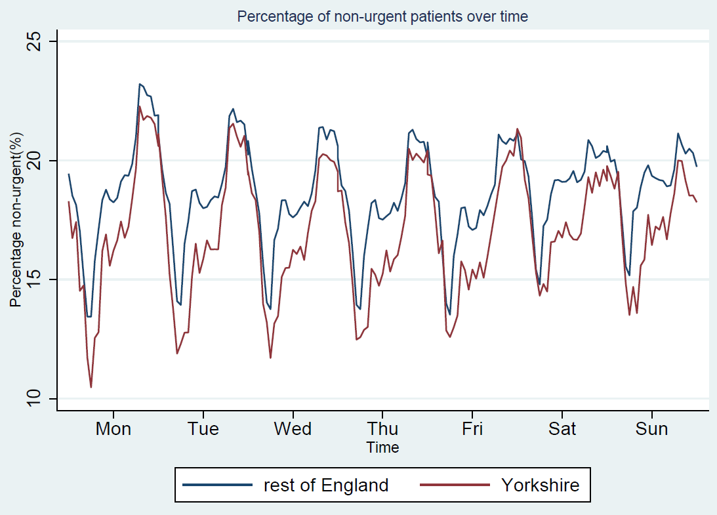
NB the x-axis runs from 00:00 Monday morning to 23:59 Sunday evening such that the day of the week markers show midday for each day

Figure 7 provides the same information as Figure 6 but with Yorkshire split into the three constituent ICBs. The large extent of variation across the areas and over time makes interpretation of any trends or consistent differences challenging, however, it is notable that each day the proportion of non-urgent attendances appear to converge during the peak periods (the evening roughly between 19:00 to 22:00) but diverge substantially over the rest of the period, with the differences appearing to be greatest around lunchtime each day.

Figure 7: Non-urgent proportion by time of arrival, Yorkshire ICBs and rest of England
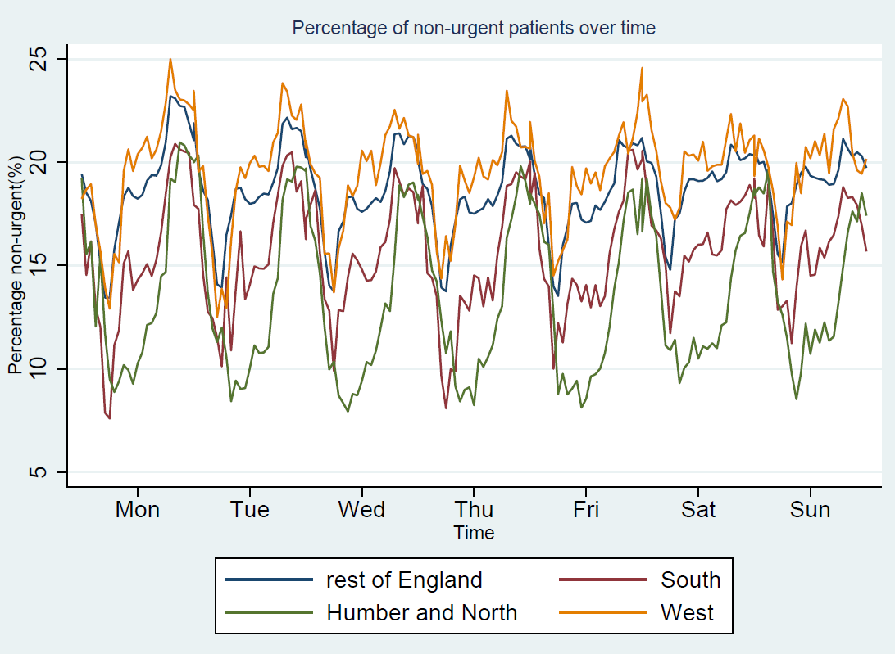

Socioeconomic status (IMD)
Table 3 reports the percentage of first attendances that are non-urgent by IMD decile across the different areas, showing a similar percentage of non-urgent first attendances across levels of deprivation with the exception of the most deprived (IMD1) across the rest of England. A similar trend is evident in West Yorkshire ICB, with 23.1% of first attendances in IMD1 being non-urgent but all others between 17.2% (IMD5) and 19.5% (IMD7). However, across Humber & North Yorkshire and South Yorkshire ICBs a different trend is apparent, with rates of attendances being non-urgent lower in the least and most deprived than some of the intermediate IMDs.
Table 3: Percentage of attendances that are non-urgent by IMD decile and area
IMD decile | Rest of England (%) | Yorkshire (%) | Humber & NY (%) | South (%) | West (%)
1 | 22.2 | 18.7 | 13.7 | 14.6 | 23.1
2 | 19.0 | 17.6 | 12.3 | 16.8 | 19.0
3 | 18.1 | 16.1 | 11.2 | 16.5 | 18.8
4 | 18.4 | 14.3 | 10.3 | 13.2 | 17.4
5 | 17.8 | 17.1 | 14.9 | 18.6 | 17.2
6 | 19.5 | 18.6 | 17.1 | 20.0 | 19.3
7 | 17.5 | 17.6 | 14.7 | 17.8 | 19.5
8 | 17.0 | 14.3 | 12.7 | 13.7 | 17.7
9 | 17.7 | 14.0 | 11.6 | 16.1 | 17.3
10 | 17.8 | 14.7 | 15.3 | 9.8 | 17.9
IMD1 – most deprived IMD10 – least deprived

Main complaint
The chief complaint is the main reason or concern that a patient presents to a healthcare provider seeking medical attention, which is the symptoms or problems the patient is experiencing that prompted them to seek medical care rather than any diagnosis by medical professional. Table 4 shows the percentage of attendance that are non-urgent by the Top 9 complaints given, stratified by area.
Patients presenting with complaints related to fever and head injury tend to have the highest proportion of non-urgent attendance across all areas (between 20.9% and 31.8%), in contrast to chest pains (3.6% to 7.6%). Notably percentages of non-urgent attendance are higher across all Yorkshire areas for difficulty of breathing than the rest of England, and there is large variation across the ICBs, notably in between West Yorkshire and the other two ICBs.

Table 4: Percentage of attendances that are non-urgent by Top 9 complaints and area

Complaint | Rest Of England (%) | Yorkshire (%) | Humber & NY (%) | South (%) | West (%)
Abdominal Pain | 12.2 | 12.6 | 7.4 | 10.0 | 16.9
Chest Pain | 7.6 | 4.5 | 3.6 | 5.1 | 4.5
Short of Breath | 10.0 | 8.1 | 5.2 | 6.2 | 10.9
Head Injury | 27.0 | 28.8 | 28.4 | 27.0 | 30.4
Fever | 26.3 | 26.9 | 20.9 | 24.5 | 31.8
Generalised Weakness | 11.5 | 10.5 | 6.9 | 6.6 | 14.2
Injury of Shoulder / Arm / Elbow / Wrist / Hand | 11.5 | 10.9 | 8.4 | 10.7 | 11.6
Injury of Hip / Leg / Knee / Ankle / Foot | 12.5 | 12.3 | 8.7 | 13.1 | 12.7
Difficulty Breathing | 14.9 | 18.8 | 18.7 | 19.9 | 18.1

Discussion

Summary of main results
This study analysed 17 million ED attendances in England covering the 12 months from 1st August 2024 and identified that 18.9% were considered non-urgent over that period. In Yorkshire this level was slightly lower at 17.3% and appeared to have diverged from the rate in the rest of England over the course of 2025. Within Yorkshire, the proportion of non-urgent attendances appeared to vary across the three different ICBs, with North Yorkshire & Humber having only 13.2% of all first attendances being non-urgent, South Yorkshire 15.9%, and West Yorkshire 20.2%. This analysis did not explore potential factors influencing these variations which are likely to be a combination of patient (e.g. disease prevalence, demographic makeup) and service characteristics (e.g. number and accessibility of primary care services, relative urbanisation).
Younger patients were found to be more likely to have non-urgent attendances, with around a third of the youngest age group’s (<11 years) attendances being non-urgent across all regions. The relationship between IMD of the individual’s GP practice and non-urgent attendance appeared to differ across areas, with the most deprived typically having the highest proportions, but this was not always evident. As expected, time of attendance, mode of arrival, and main complaint recorded had a large role in the proportion of non-urgent attendance. This reflects the need to have alternative health care services that are convenient for working people and families in the out of hours periods, when they can more easily find time to attend for minor illness and injury related problems.

Comparability of findings
The proportion of non-urgent care was estimated to be 15.1% by O’Keeffe et al.², so a few percentage points lower than we have found. While it is not possible to determine definitively if this is due to changes in the data (with the shift from the A&E dataset to ECDS from 2017 implying an improved level of data completeness) previous unpublished analysis by these authors indicated a significant increase in the proportion of non-urgent attendances after the covid-19, suggesting this increase has been maintained.
As with O’Keeffe study, the non-urgent attendance in younger generations (especially children) remains high compared with the elderly. The non-urgent attendance still peaked in out-of-work hours. There is a decrease in the proportion of non-urgent attendances arriving by ambulance, with a larger proportion of patients arriving via their own transport.

Limitations
This study has several limitations that need to be considered. Firstly, the nature of administrative data means there are many assumptions and simplifications that must occur to create a binary assessment of urgency of attendance. Alongside recurrent issues of missing and uncategorised data this implies the definition of non-urgent attendance and resultant comparisons must be interpreted carefully. Secondly, the IMD used in the analysis to describe socio-economic status is based on the patient's residential area rather than the patient's individual characteristics, which may not provide a complete picture of the patient's socioeconomic status.
Additionally, consistent with the O’Keeffe analysis we focus only on individuals attending for a first time (excluding re-attendances for a previous complaint, i.e. follow-up care) at a Major Emergency Care Department (excluding other categories such as mono-speciality EDs and Urgent Treatment Centres). Finally, due to the size of the informative data we selected to focus on the most contemporary 12 months of data available to us, this risks loss of generalisability across years if our period had some unique elements either nationally, e.g. a severe flue season, or locally, e.g. an ED closure. For this reason, care in needed when interpreting the comparative scale of non-urgent proportions.

Future Analysis
Due to the scope of the data, it was not possible to summarise the proportion of non-urgent attendance across all the variables available. Variables that future analysis could explore include different measures of waiting time, gender, clinical investigation, diagnosis, treatment, and discharge destination. It was also not possible in this analysis to link to other datasets, so we are oblivious to how individuals had interacted with the NHS before or after their ED attendance. It would also be beneficial to conduct statistical analysis of differences between Yorkshire and elsewhere as well as within the region.

Conclusion
In conclusion, this analysis of routine data from NHS secondary care provides valuable insights into non-urgent visits to emergency departments across England and within Yorkshire. The study reveals that non-urgent visits made up 18.9% of all first-time ED visits between August 2024 and July 2025, and that younger patients were more likely to have non-urgent visits, with the highest proportion in the youngest age group. The analysis emphasises the importance of alternative services to manage non-urgent demand, mindful of the variable nature of attendances through the course of a week. Further research is required to better comprehend why young patients have a high proportion of non-urgent visits and the most effective approach to reducing this, both to improve care provided to those who attend for non-urgent reasons and those who are forced to wait longer for necessary care as a result.

Jones, S., Moulton, C., Swift, S., Molyneux, P., Black, S., Mason, N., Oakley, R. and Mann, C., (2022). Association between delays to patient admission from the emergency department and all-cause 30-day mortality. Emergency Medicine Journal, 39(3), pp.168-173.
NHS England https://www.england.nhs.uk/long-read/urgent-and-emergency-care-plan-2025-26/ [Accessed: 27th January 2026]
Great Britain. Department of Health Social Care (2022) Handbook to the NHS Constitution for England. Available at: https://www.wyevalley.nhs.uk/media/39361/The-NHS-Constitution-Interactive-Version.pdf [Accessed: 27th January 2026]
Nuffield trust (2026) Quality Watch Indicators: A&E waiting times. Available at: https://www.nuffieldtrust.org.uk/qualitywatch/nhs-performance-dashboard [Accessed: 27th January 2026]
O’Keeffe, C., Mason, S., Jacques, R. and Nicholl, J., (2018). Characterising non-urgent users of the emergency department(ED): a retrospective analysis of routine ED data. PLoS One, 13(2), p.e0192855.
Humber and North Yorkshire ICB, South Yorkshire ICB, West Yorkshire ICB
Homeniuk, R. and Collins, C., (2021). How COVID-19 has affected general practice consultations and income: general practitioner cross-sectional population survey evidence from Ireland. BMJ Open, 11(4), p.e044685.
NHS England. (2026) Emergency Care Data Set. Available at: https://digital.nhs.uk/data-and-information/data-collections-and-data-sets/data-sets/emergency-care-data-set-ecds [Accessed: 27th January 2026
Centre for Health Economics and NHS England Data Sharing Agreement. Available at: https://drive.google.com/file/d/1st1OOr9SxcZtn3Rk6cVYs5cJ4lfpZ8DJ/view [Accessed: 27th January 2026]
Ingram, E. et al. (2021) Household and area-level social determinants of multimorbidity: A systematic review. J. Epidemiol. Community Health 75, 232–241
NB previous unpublished analysis by this team indicated these rates fell during the covid-19 pandemic (from an estimated 14% non-urgent attendances) but then rose sharply post-2021 and have maintained this higher level.

