A Network Approach to Developmental Differences and Disorders
Emre Deniz¹, Jo Hutchinson², Kathryn Asbury³, Dianne Newbury⁴, Umar Toseeb⁵
¹Department of Education, University of York, York, UK. Emre.deniz@york.ac.uk, https://orcid.org/0000-0001-7083-5562
²Education Policy Institute, London, UK. Jo.hutchinson@epi.org.uk, https://orcid.org/0000-0002-8475-1535
³Department of Education, University of York, York, UK. Kathryn.asbury@york.ac.uk, https://orcid.org/0000-0003-0011-457X
⁴Department of Psychiatry, University of Oxford, Oxford, UK. dianne.newbury@well.ox.ac.uk, https://orcid.org/0000-0002-9557-268X
⁵Department of Psychology, University of York, York, UK. umar.toseeb@york.ac.uk, https://orcid.org/0000-0002-7536-2722
Corresponding Author. Correspondence regarding this article should be addressed to Prof. Umar Toseeb, Department of Psychology, University of York, York YO10 5DD. Email: umar.toseeb@york.ac.uk
Data Availability Statement. The data that support the findings of this study are available from various sources. The MCS and BCS datasets are available through the UK Data Service. The ALSPAC data is available through the University of Bristol. The TEDS dataset is available through the King’s College London. All data requests are subjected to the data holders’ permission. The authors do not hold permission to share any data used in this study.
Funding Statement. This secondary analysis of existing data was funded by the Nuffield Foundation (EDO/FR-000023791). The content is solely the responsibility of the authors, and it does not reflect the views of The Nuffield foundation.
The UK Medical Research Council and Wellcome (Grant ref: 217065/Z/19/Z) and the University of Bristol provide core support for ALSPAC. This publication is the work of the authors and Deniz, Hutchinson, Asbury, Newbury and Toseeb will serve as guarantors for the contents of this paper.
The Economic and Social Research Council funds the Centre for Longitudinal Studies (CLS) Resource Centre (ES/W013142/1) which provides core support for the CLS cohort studies (BCS and MCS). While the CLS Resource Centre makes these data available, CLS does not bear any responsibility for the analysis or interpretation of these data by researchers. The CLS cohorts are only possible due to the commitment and enthusiasm of their participants, their time and contribution is gratefully acknowledged.
TEDS is funded by a programme grant (MR/V012878/1) from the UK Medical Research Council (MRC) awarded to Professor Thalia C. Eley (previously MR/M021475/1 awarded to Professor Robert Plomin).
Conflicts of Interest Disclosure. The authors declared no potential conflicts of interest with respect to the research, authorship, and/or publication of this article.
Ethical Approval Statement. Each of the four datasets used obtained ethical approval locally
- Ethical approval for the study was obtained from the ALSPAC Ethics and Law Committee and the Local Research Ethics Committees
- Ethical approval is obtained from a National Health Service Research Ethics Committee in advance of each sweep of data collection
- Ethical approval for data collection was obtained by the Centre for Longitudinal Studies, University College London. More information regarding ethics approvals for each wave of the MCS can be found here.
- The TEDS study received ethical approval from Kings College London Research Ethics Committee (References: PNM/09/10–104 and HR/DP‐20/21–22060). Consent was obtained before data collection at every wave.
We did not seek further ethical approval for secondary analysis of existing data, in line with local ethics policies at the Department of Education, University of York.

Permission to reproduce material from other sources. NA.
Acknowledgements: We are extremely grateful to all the families who took part in this study, the midwives for their help in recruiting them, and the whole ALSPAC, BCS, MCS, and TEDS teams, which includes interviewers, computer and laboratory technicians, clerical workers, research scientists, volunteers, managers, receptionists and nurses. We wish to thank the all data teams and the UK Data service for preparing datasets and granting data access. We would also like to thank our co-production panels and advisory groups for their input.

Abstract
Child and adolescent development is influenced by complex interplay between a range of diverse factors. The network approach is gaining popularity as a way of modelling such complex processes. Here we used the network approach to investigate whether developmental differences and disorders can be conceptualised as arising from interactions between characteristics and symptoms. We used data from four population-based birth cohorts in England (n=47,315), those born in the 1970s, 1990s, and 2000s, to investigate interrelations between areas of psychological functioning that underpin learning and engagement in education settings (i.e., memory, attention, non-verbal ability, arithmetic skills, reading, language and communication, motor skills, neurodevelopmental characteristics, psychopathology, social functioning, and wellbeing). We fitted 12 undirected psychometric network models; one network for each cohort and developmental stage (early childhood; 3-5 years, middle childhood; 7-10 years, adolescence; 13-18 years). We then determined how these areas of functioning cluster within developmental domains. In early and middle childhood, psychological functioning, generally, clustered within two related developmental domains: (1) cognition and language and (2) social and emotional functioning. In adolescence, they clustered within three developmental domains (1) cognition and language and (2) social functioning, and (3) emotional functioning. We demonstrate that developmental differences and disorders can be conceptualised through the network modelling approach. One possibility requiring further investigation is that they arise through bottom-up processes, whereby a given symptom or characteristic activates or leads to another; symptoms or characteristics that activate or lead to each other cluster together and appear as neurodevelopmental or psychiatric conditions. Differences and disorders that appear to be similar, prima facie, may be underpinned by diverse etiologies. Our work provides the first population-level evidence for a needs-based support system in schools; children and adolescents with developmental disorders and differences should be supported by targeting specific characteristics and symptoms. Such an approach does not rely on waiting for a diagnostic assessment through lengthy processes.
Key Words: Childhood; Adolescence; Development; Disorders; Special Educational Needs; ALSPAC; BCS; MCS; TEDS.

A Network Approach to Developmental Differences and Disorders
Child and adolescent development occurs through complex interactions between various psychological factors. Determining how to identify and support young people with developmental differences and disorders requires the investigation of how psychological characteristics or symptoms are related to each other. These relationships are typically understood through the lens of diagnostic nosology, where symptoms or characteristics are thought to be indicators of disorder and difference. In this top-down approach, the co-occurrence of symptoms or characteristics within a diagnostic category (e.g., depression, ADHD, autism, dyslexia) is assumed to reflect their shared classification within an established nosological framework. An alternative, or complementary approach, considers that characteristics or symptoms arise together because they are causally related; that is, they may be mutually reinforcing. From this bottom-up perspective, diagnostic categories can be viewed as social constructs that aim to describe these causal relationships between characteristics or symptoms. The aim of our investigation was to take the first step towards modelling a bottom-up approach to child and adolescent developmental differences and disorders using psychometric network modelling.
Diverse Etiologies
Development is complex. Early attempts to understand developmental differences and disorders typically adopted a single deficit approach, focussing on a single cause. For example, single genes were considered important for the development of speech and language disorders (Lai et al., 2003). Early applications of single-deficit approaches typically assumed “a single cause for a single disorder”; they assumed that each disorder is a well-defined entity, which exists independently of sociocultural norms, and that it has a single cause. But in reality, developmental differences and disorders have complex etiologies and there is little evidence that they are objective categories independent of social construction. The multiple-deficit model of developmental differences and disorders acknowledges these complex etiologies and provides a theoretical framework to investigate them (Pennington, 2006). The model posits that development is complex and can be investigated at various levels of analysis: etiologic risk and protective factors; neural systems; cognitive processes; and complex behavioural disorders. Whilst better placed to model the complex etiologies of developmental differences and disorders, multiple-deficit models also suffer from the assumption that diagnostic categories are objective and coherent realities that can be identified and studied.
Rethinking Diagnostic Nosology
Why is an individual experiencing a given difficulty? A dominant approach to answering this question is diagnostic nosology. The Diagnostic and Statistical Manual of Mental Disorders (DSM5: American Psychiatric Association, 2013) describes hundreds of diagnostic labels including neurodevelopmental and psychiatric conditions and their subtypes. An individual who is experiencing difficulties is thought to be because of their psychiatric or neurodevelopmental condition (e.g., she has difficulty reading because she has dyslexia or he does not enjoy socialising anymore because he has depression). In theory, treating the neurodevelopmental or psychiatric condition will result in the alleviation of its symptoms or characteristics. Such diagnostic categories do not, however, map on to young people’s needs in educational settings; the same diagnostic label may be given to two young people with a different combination of symptoms (e.g., young person A has depressed mood without anhedonia, young person B has depressed mood with anhedonia, and young person C anhedonia without depressed mood; all three could be given a diagnosis of depression even though they are experiencing different symptoms). Furthermore, even when two young people with the same diagnostic label present with the same combination of symptoms or characteristics, this is not informative about their needs in an education setting (e.g., both young person A and B have depressed mood with anhedonia; this does not help in supporting a young person who is disengaged with teaching and learning activities). Additionally, the same symptom or characteristic might feature across a number of diagnostic categories; for example, emotion dysregulation is considered a key transdiagnostic indicator of a range of mental health and neurodevelopmental conditions. Therefore, diagnostic categories may not efficiently capture the difficulties experienced by young people in education settings.
Latent vulnerability models have been used to overcome some of the drawbacks of diagnostic nosology. For example, symptoms or characteristics of the numerous diagnostic categories can be captured under two broad, unobserved, latent factors: the p- and g-factor. The p-factor captures underlying vulnerability to various aspects of psychopathology (e.g., Allegrini et al., 2020; Patalay et al., 2018), suggesting that symptoms of psychiatric conditions (e.g., depression, anxiety, conduct problems etc.) are external manifestations of an underlying, latent vulnerability. Similarly, for cognitive differences and disorders, the g-factor captures the latent vulnerability for cognitive development (e.g., Spinath et al., 2003). The co-occurrence of difficulties across g- and p-factors are explained in terms of relations between these latent p- and g-factors (von Stumm et al., 2023). Latent vulnerability models are helpful in reducing the hundreds of diagnostics labels, which often overlap, to a smaller number of latent factors. That is, a young person who is experiencing difficulties is thought to be so due to their underlying vulnerability to either psychopathology and/or cognitive difficulties.
While transdiagnostic latent vulnerability models address some of the limitations of traditional diagnostic nosology, both approaches rest on similar assumptions. They propose that symptoms or characteristics of developmental differences and disorders cluster together because they reflect underlying entities that cannot be measured directly (e.g., depression, ADHD, autism, general psychopathology factor (p-factor) etc.); their symptoms or characteristics can be measured. Such processes are thought to operate in a top-down manner. For example, symptoms of depression are assumed to co-occur because they are all expressions of the same underlying disorder. Likewise, characteristics of autism are thought to cluster because they belong to a coherent condition, or symptoms of depression and anxiety are seen to co-occur due to a shared vulnerability captured by the p-factor. These approaches view diagnostic categories, like depression, anxiety, ADHD, dyslexia, and latent constructs such as the p- and g-factors, as if they are objective realities rather than socially constructed tools to help interpret differences in psychological functioning.
This is problematic because there is limited evidence that these diagnostic categories correspond neatly to distinct profiles of social, emotional, or cognitive functioning in young people (Astle et al., 2021). In fact, many psychological characteristics (e.g., inattention, hyperactivity, difficulties in social communication, or problems with phonological processing) are found across a range of neurodevelopmental conditions (e.g., ADHD, autism, dyslexia, dyscalculia, developmental language disorder). These overlaps raise concerns about how children and young people are identified and supported in schools. To comprehensively understand child and adolescent developmental differences and disorders, and subsequently identify and support those in need, alternatives to diagnostic nosology and latent vulnerability approaches are needed.
A Network Approach
A network approach has been proposed as a data driven statistical framework to understand the complexities of human development. The approach is yet to be comprehensively applied to developmental differences and disorders. Rather than viewing characteristics or symptoms of developmental differences and disorders as arising from top-down mechanisms (e.g., the p- or g-factor, depression, anxiety, dyslexia etc.), the network approach models how observed characteristics or symptoms of developmental differences and disorders (i.e., nodes) influence each other (i.e., edges) in a causal manner. Central to the approach is that characteristics or symptoms cluster due to causal interactions between them. That is, one symptom or characteristic (e.g., low mood) activates, or leads to, another symptom or characteristic (e.g., anhedonia). Some symptoms or characteristics are more closely related to each other, giving rise to clusters, which are commonly viewed as neurodevelopmental or psychiatric conditions (e.g., depression, ADHD, dyslexia etc.). The network approach is different to the diagnostic nosology and latent factor approaches in that it views developmental differences and disorders a result of bottom-up processes (symptoms or characteristics of a disorder or difference co-occur because they are mutually reinforcing) whereas diagnostic nosology and latent factor approaches can be thought of as a top-down approaches (symptoms or characteristics of a disorder or difference co-occur because they are symptoms or characteristics of a disorder or difference).
The network approach has an emerging evidence base. It has been used to conceptualise psychopathology (Borsboom, 2017), map neurodevelopmental characteristics (Montazeri et al., 2023), and the relationship between them (Farhat et al., 2023). These studies demonstrate that common psychiatric conditions, such as depression and anxiety, can be conceptualised as arising from interactions between clusters of symptoms. They also demonstrate that neurodevelopmental characteristics and psychopathology can be thought of as distinct clusters of characteristics linked through social processes. That is, they suggest that young people with neurodevelopmental conditions likely experience poor mental health due to social processes. Whilst informative, these studies are limited as they only consider a limited sub-set of characteristics or symptoms across a range of neurodevelopmental and psychopathology domains; not all of those required to engage with education and learning. Additionally, they do not consider a range of developmental stages across childhood and adolescence. We addressed these gaps in the literature to provide an evidence base for network models to be used to comprehensively understand developmental differences and disorders.

The Current Study
We conducted a series of cross-sectional analyses focussed on the clustering of multiple characteristics or symptoms of developmental disorders and differences. We were specifically interested in how network models can be used to improve young people’s education and learning. Therefore, we focussed on psychological indicators of developmental differences and disorders that likely impact upon education and learning (e.g., psychopathology, neurodevelopmental characteristics, social skills, wellbeing, memory, attention, non-verbal ability, arithmetic skills, reading, language, communication, motor skills etc.), across three developmental stages (i.e., early childhood, middle childhood, adolescence). These indicators were chosen as part of a co-production exercise with young people with lived experiences of neurodevelopmental conditions and their parents (see supplementary materials). We also drew upon existing literature on the indicators of developmental differences and disorders (e.g., executive functions: Astle et al., 2018., non-word repetition: Gathercole et al., 1994). Further details are provided in the methods section.
Network models, as we implemented them, are exploratory models intended to generate, rather than test, hypotheses. The relationships between indicators of psychological functioning within network models are relative; they are conditional upon which other variables are included in the model. Therefore, we decided against testing specific hypotheses. Instead, we adopted an exploratory approach to answer our research questions and generate further hypotheses to be tested by future research. We expected that this would allow us to understand how developmental differences and disorders arise; leading to future work on how to identify and support young people who struggle at school.
We addressed the following research questions: 1) how do various psychological indicators of developmental differences and disorders cluster across development; 2) which psychological indicators are most strongly connected to others, highlighting their relative importance for development; 3) which indicators most commonly connect clusters, enhancing our understanding of the possible causal pathways for development that can be tested in future work.

Methods

Datasets
We used existing data from four population-based birth cohorts in England: Avon Longitudinal Study of Parents and Children (ALSPAC, n=15,645; Boyd et al., 2013; Fraser et al., 2013); Millennium Cohort Study (MCS, n=18,827; University College London, 2024); Twins Early Development Study (TEDS, n=7,859: Lockhart et al., 2023), British Cohort Study (BCS, n=12,509; Sullivan et al., 2022). Full details of the cohorts are provided in the supplementary materials. Specifically, we used parent-, teacher-, and self-report-data, as well as direct assessments, of children and adolescents’ psychological functioning.

Participants
In all four datasets, we focused on young people from England only. Approximately 50% of the samples were male (ALSPAC=49%, MCS=51%, TEDS=49%, and BCS=42%), and most were of white ethnicity (ALSPAC=96%, MCS=73%, TEDS=92%, BCS=74%), and they were from range of socioeconomic backgrounds. We focussed on data collected when children and adolescents were 3-5 years old (early childhood), 7-9 years old (middle childhood) and 13-18 years old (adolescence).

Measurements
We focussed on measures that likely capture the underpinning skills that children and adolescents require to access formal schooling. These included memory, attention, non-verbal ability, arithmetic skills, reading, language and communication, motor skills, neurodevelopmental characteristics, psychopathology, social functioning, and wellbeing. The specific measures differed for each cohort and developmental stage but were selected to reflect similar skills. Our approach to selecting variables to include in psychometric network models consisted of three steps: 1) we consulted young people with lived experiences and their parents; 2) we searched the literature for indicators of developmental disorders and differences; 3) we identified relevant variables in the datasets. Our approach to selecting variables in the datasets was pragmatic. We were guided by young people, their parents, and the literature but within the constraints of what was available within each developmental stage. We chose developmental stages that were informative from a developmental perspective but also those that maximised the overlap in measurement across datasets. Similarly, we chose variables that captured indicators and also maximised the comparability across datasets. Our approach may have led to a loss in specificity but as is the case in many secondary analyses of existing data, the broad measures serve as proxies for more specific symptoms or characteristics. All measures were re-coded so that higher scores indicate better functioning. The measures are briefly summarised below and more details are provided in Table 1 with a full description in the supplementary materials.
[Table 1]

Cognition
We relied on two sources: young people’s performance during research clinic assessments and parent-report questionnaires. We focussed on non-verbal ability, reading, maths, attention, short-term memory, literacy, decision making, and risk taking. We use these broad terms to describe the different aspects of cognition that we investigated but the exact cognitive function measured differed depending on each dataset (e.g., in some datasets reading refers to non-word and word reading whereas in others it refers to word reading only). The majority of cognitive measures were standardised tools but there were also some cohort specific novel measures.
Language and Communication
We relied on two sources: young people’s performance during in-clinic assessments and parent-report questionnaires. We used indicators of intelligibility, receptive, expressive, and pragmatic language, which were either standardised measures of language ability or screening questionnaires of language and communication difficulties. We also used some cohort specific non-standardised measures of language and communication.

Motor Skills
We relied on two sources: young people’s performance during in-clinic assessments and parent-report questionnaires. We focussed on fine motor skills.

Neurodevelopmental Characteristics
We relied on parent-report questionnaires. Specifically, we focussed on autistic characteristics as captured by screening questionnaires designed to identify children and adolescents requiring further assessment for autism.

Social Functioning
We relied on two sources: self- and parent-report questionnaires. We focussed on peer problems, cooperation skills, and prosocial skills. All of the measures were screening questionnaires intended to identify children and adolescents requiring further assessment.

Psychopathology
We relied on two sources: self- and parent-report questionnaires. We focussed on externalising psychopathology (e.g., conduct problems, hyperactivity), internalising psychopathology (e.g., symptoms of depression and anxiety), and transdiagnostic indicators of non-specific psychopathology (e.g., emotional regulation, self-regulation, inattention). All of the measures were screening questionnaires intended to identify children and adolescents requiring further assessment for psychiatric conditions.

Wellbeing
We relied on self-report questionnaires in adolescence. We focussed on two aspects of wellbeing, specifically individuals’ self-esteem and subjective wellbeing.

Statistical Analyses
We fitted network models in R (R Core Team, 2021). To note, nodes in the network models represent scores for observed variables (e.g., emo is the emotional difficulties subscale score from the Strengths and Difficulties Questionnaire) and edges represent the partial correlations between nodes after conditioning on all other nodes in the model. Prior to fitting the network models, we computed pairwise correlations and used the function is.positive.definite() to ensure that the included nodes do not suffer from linear dependency and that all nodes are correlated in the positive direction (i.e., higher scores mean better functioning). Additionally, we used the goldbricker function (Jones et al., 2018) to detect potential redundant nodes.
For each dataset, pairwise correlation matrices were positive definite suggesting there was no multicollinearity in any of the network models. As can be seen in Figure S1 (supplementary materials), all included variables were correlated in a positive direction with higher scores indicating better functioning. This was expected given we re-coded all variables to be in the same direction. Whilst there were some high zero-order correlations between certain nodes, the goldbricker function indicated no redundant nodes across all 12 models. This suggests that while some nodes were highly correlated, they were measuring similar but distinct symptoms or characteristics; therefore, no nodes were removed from network models. Although GGMs assume multivariate normality, our large sample sizes in each candidate dataset mitigate concerns related to non-normality through the Central Limit Theorem (Kwak & Kim, 2017). Hence, we interpret potentially spurious negative edges with caution, when zero-order correlations are positive.

Network Estimation
We fitted 12 Gaussian Graphical Models (GGM: Epskamp et al., 2018), four for each developmental stage (early childhood, middle childhood, adolescence) and each dataset separately, using the bootnet package (estimateNetwork, default = “EBICglasso”). In this approach, sparsity (regularisation) was induced by the graphical lasso (ℓ1-penalised precision matrix estimation) while model selection among lasso-regularised solutions was performed by the Extended Bayesian Information Criterion (EBIC). We set the EBIC hyperparameter to γ = 0.50 (tuning = 0.5), following recommendations for a balanced sensitivity/specificity trade-off (Foygel & Drton, 2010). We also estimated unregularized GGMs for comparison. For node layouts, we used the Fruchterman–Reingold algorithm: thicker/blue edges represent stronger positive correlations, and red edges represent negative associations. Given that higher scores indicate better functioning, red edges may represent spurious associations due to the limitations of GGM in estimating polychoric correlations or due to the collider effect where two nodes influence a third (Briganti et al., 2019).

Community Detection
We used the Walktrap community detection algorithm to report which nodes cluster together in networks using codes provided by Andrews et al. (2024).

Measures of Centrality
We calculated two centrality indices: (1) node strength, which quantifies how strongly a node is directly connected to other nodes by summing the absolute weights of all edges incident to that node, and (2) bridge betweenness, which captures the extent to which a node lies on the shortest paths connecting different communities. Node strength was computed using the qgraph package and the centralityPlot() function (Epskamp & Fried, 2018). Bridge betweenness was calculated with the networktools package via the bridge() function, using Walktrap community assignments derived from the igraph package (Jones & Jones, 2018).

Network Stability and Edge Accuracy
To evaluate the stability of the centrality metrics, we conducted case-dropping bootstraps (bootnet(type = "case", statistics = c("strength", "bridgeBetweenness"), communities = community_membership)), in which increasing proportions of cases (10%–75%) were randomly omitted without replacement across 1,000 resamples. We reported correlation-stability coefficients (CS-coefficients), CS ≥ 0.25 is considered acceptable (Epskamp et al., 2018), which indicate the largest proportion of cases that can be dropped while maintaining a correlation of at least 0.70 between the centrality indices derived from the full sample and those from the case-dropped samples. In contrast, edge-weight accuracy was assessed via nonparametric bootstrapping (bootnet(type = "nonparametric"), B = 1,000), which provides 95% bootstrap confidence intervals and edge-difference tests to evaluate the precision and robustness of estimated edge weights.
Preregistration
We pre-registered the analysis for two of four datasets (https://osf.io/pdn49); data access to the other two datasets was granted after we made substantial progress with the analysis for the first two datasets.

Results

Network Estimation
Unregularised models resulted in dense networks (Figures S2–S4). In contrast, the graphical-lasso–regularised models selected via the Extended Bayesian Information Criterion (EBIC; γ = 0.50) yielded much sparser and more interpretable structures. We therefore based our interpretation on these EBIC-selected regularised networks. The lasso regularisation parameter values for all models are reported in the supplementary materials (Table S4).

Community Detection
In early and middle childhood, for all four datasets, there were two clusters (see Figure 1 and 2): 1) cognition and language and 2) social and emotional functioning. In adolescence (see Figure 3), in three of the four datasets, there were three clusters: 1) cognition and language, 2) social functioning, and 3) emotional functioning. In the fourth dataset (BCS), there were the same two clusters as early and middle childhood. That is, in early and middle childhood there are at least two distinct, but related, domains of development whereas in adolescence there are at least three.

Measures of Centrality
We report two centrality indices: node strength and bridge betweenness. Prior to reporting these indices, we evaluated their stability using case-dropping bootstraps. Across all 12 networks, stability for node strength was consistently high, with most values reaching the recommended threshold of ≥ 0.75 indicating strong stability (see, Table S3 and Figures S17-19, supplementary materials). However, it is important to note that we detected relatively low stability for bridge betweenness across cohorts, which suggests more caution is needed when interpreting bridge betweenness centrality metrics.

Node Strength
We examined which nodes had the highest strength centrality within each cluster, developmental stage, and dataset. As shown in Table 2, the strongest node differed depending on the developmental stage, cluster, and dataset. To evaluate whether these differences in node strength were statistically meaningful, we conducted centrality difference tests using the bootnet package (see, Figures S5b–S16b, supplementary materials). In early childhood, expressive language (cognition and language cluster) and conduct problems (social and emotional functioning cluster) were the strongest nodes in two of the four datasets. In middle childhood and adolescence, the nodes that were significantly stronger than others in the cluster were different in each of the network models. Therefore, across developmental stages and datasets there were very few consistent strongest nodes. This is not unexpected given that the exact variables differed for each of the network models.
[Table 2]

Bridge Betweenness
We mapped each node against each node in every other cluster to determine the shortest path (in terms of edge weights). We then assigned nodes a count value based on how many times they appeared on the shortest path between two nodes in different clusters. Nodes with the high counts are important bridging nodes between clusters; they are likely to be important pathways through which cognition and language influences social and emotional functioning or vice versa. The nodes with the highest count value within each cluster stratified by developmental stage and dataset are shown in Table 3 (full counts for each of the nodes is presented in the supplementary materials S32).
[Table 3]
Given the count values, we did not statistically test bridge betweenness. We describe the trends here. In early childhood, two nodes were most commonly on the shortest path between clusters (in two of the four datasets): expressive language (cognition and language cluster) and hyperactivity/inattention (social and emotional functioning cluster). In middle childhood, reading (cognition and language cluster) and hyperactivity (social and emotional functioning cluster) were the most common nodes on the shortest path between clusters across all four datasets. In adolescence, hyperactivity (social functioning) was the most common node on the shortest path between clusters in two datasets, self-esteem in two datasets (emotional functioning) and language (expressive or receptive) in two datasets (cognition and language). Unlike node strength, for bridge betweenness, there was some consistency within developmental stage, across datasets, in terms of which nodes are important across clusters.

Network Stability and Accuracy
To assess the stability of the estimated network and the accuracy of the edge weights and centrality metrics, we used non-parametric bootstrapping (n=1000), implemented via the bootnet package in R (Epskamp et al., 2018). Overall, edge weights across all 12 models appeared robust as the sample mean and bootstrapped mean were close, and the range of confidence intervals were narrow. Additionally, we also conducted edge-weight difference tests to assess whether specific edges differed significantly from one another. These results are reported in Figures S5a –S16a (supplementary materials). Moreover, case-dropped bootstraps (see Figures S18 and Table S3, supplementary materials) showed that the node strength centrality metric was mostly stable across networks. However, bridge betweenness centrality metric was mostly unstable across networks.
Discussion
Our data-driven population-level investigation provides a novel framework through which developmental differences and disorders can be conceptualised. In early and middle childhood, various aspects of psychological functioning cluster within two developmental domains: 1) cognitive and language skills and 2) social and emotional functioning. In adolescence, psychological functioning clusters within three developmental domains 1) cognitive and language skills, 2) social functioning, and 3) emotional functioning. No single area of psychological functioning emerged as uniquely important for broad development across all domains. Our work demonstrates that developmental differences and disorders can be conceptualised using a network approach. It is the first step towards thinking of developmental differences and disorders as bottom-up processes, whereby symptoms or characteristics activate or lead to others, creating clusters. Additionally, difficulties that appear to be similar, prima facie, may have diverse etiologies. We discuss these findings with reference to psychological theory and previous research.

Related but Distinct Developmental Domains
Our findings provide novel insights into the structure of developmental differences and disorders during childhood and adolescence. The identification of two developmental domains in childhood, cognition and language and social and emotional functioning, is similar to the broad clustering of the p- and g- factors (Allegrini et al., 2020; Patalay et al., 2018; von Stumm et al., 2023) and early theories of children’s cognitive development (Piaget, 1962). During adolescence, the social and emotional functioning domain become more nuanced and separates into two domains: social functioning and emotional functioning, emphasising the importance of mental health during this period. As with childhood, in adolescence, the cognition and language developmental domain is broadly similar to the g-factor (Allegrini et al., 2020) and the social and emotional functioning domains are broadly similar to externalising and internalising psychopathology, respectively, of the p-factor (Patalay et al., 2018). Importantly, the developmental domains of social and emotional functioning also include indicators of positive functioning (e.g., prosocial behaviour, self-esteem) rather than merely the absence of negative functioning (e.g., conduct problems, depression symptoms), which is typically the case for the p-factor. This supports previous scholarship demonstrating that positive and negative functioning are related but independent constructs (Patalay & Fitzsimons, 2016; Westerhof & Keyes, 2010). Our work provides an alternative to diagnostic nosology in educational settings by demonstrating that a wide range of characteristics and symptoms, those required for engagement with education and learning in school, cluster within 2-3 categories. Whilst the clusters may appear to be similar to the p- and g-factors, we argue that they potentially operate differently; they could be bottom-up rather than top-down.
Bottom-Up Processes
Our work is the first step towards thinking of developmental differences and disorders as arising from bottom-up processes. Based on our exploratory network modelling, we hypothesise that characteristics or symptoms of developmental differences and disorders activate or lead to closely related characteristics or symptoms in a network structure. We expect that these interactions are likely to be causal and give rise to clusters of characteristics or symptoms, we call these developmental domains. Typically such clusters are interpreted through the lens of diagnostic categories or latent vulnerability models. We argue that diagnostic labels and latent vulnerability models are social constructs used to understand these hypothesised causal interactions between symptoms or characteristics; they are not the reason why characteristics or symptoms arise together. If our hypotheses are confirmed by future research, it would suggest that support for children and adolescents with developmental differences and disorders should target specific characteristics and symptoms with the aim of deactivating clusters or preventing the spread of activation.
Diverse Etiologies
Our exploratory network models demonstrate that each area of functioning (e.g., reading ability) is connected to multiple other areas of functioning (e.g., mathematics, non-verbal ability, self-regulation etc.). Given we were unable to determine the direction of these effects in our cross-sectional analyses, we make suggestions for how these could be tested in future work. If we assume that these relationships are bidirectional, we can hypothesise that the outward manifestation of any given symptom or characteristic will have several underlying causes. That is, we expect that no single characteristic or symptom is necessary for a given developmental difference or disorder to arise, though a few may be necessary, which is in line with the multiple-deficit model (Pennington, 2006). For example, reading difficulties in middle childhood may result from underlying difficulties in oral language through impairments in short-term memory or non-verbal difficulties through hyperactivity/inattention or various other paths (see Figure 2, ALSPAC). Similarly, low wellbeing in adolescence might result from low self-esteem via depression symptoms, or hyperactivity/inattention via autistic characteristics or conduct problems, or various other paths (see Figure 3, TEDS). Such pathways could be tested in future work with panel data and consistent measures collected at multiple time-points within developmental stages. Temporal and contemporaneous within-person associations can be modelled using such panel network models. For example, one might investigate whether deviations from an individual’s mean for variable 1 (e.g., short-term memory) at one time point are associated with deviations from an individual’s mean for variable 2 (e.g., reading ability) at the subsequent time point. Our cross-sectional analysis provides the framework for investigating, using panel data, multiple causal pathways to difficulties that, on the face of it, manifest in the same way.
Indicators of General Development
We could not identify a single node that was consistently the strongest across all of the datasets and developmental stages. Instead, the most strongly connected symptom or characteristic varies depending on the dataset and developmental stage. We outline two possible explanations for this.
The first possibility is measurement heterogeneity. Each of the 12 network models had slightly different measures. For example, some models had measures of both expressive and receptive language whereas others had just expressive language. Some models had separate measures of hyperactivity and inattention whereas others had a combined measure. We were limited by the measures available in the datasets but we attempted to ensure some level of alignment across models. Based on the available dataset and our analytic models, we are unable to rule out the possibility that the lack of a single consistent strongest node across models is due to measurement heterogeneity. Future work with consistent measures across and within developmental stages should specifically test this possibility.
The second possibility is that no single psychological indicator dominates across development, and that developmental differences and disorders may not be driven by a single transdiagnostic core symptom or characteristic. We outline some speculations that should be tested specifically in future work. First, there may exist between person heterogeneity in developmental pathways—different children and adolescents may exhibit different combinations of challenges, and the same characteristic or symptom (e.g., hyperactivity, language ability) may play a stronger or weaker role depending on the broader constellation of co-occurring characteristics or symptoms. Second, the absence of a universal “core” characteristics or symptoms undermines the idea that developmental disorders or differences share a single underlying cause or latent vulnerability factor. Instead, it may provide further support for the multiple-deficit model of developmental differences and disorders (Pennington, 2006), highlighting the need for more individualised support for children and adolescents with developmental disorders and differences. Third, our findings are the first step towards supporting a bottom-up, network-based perspective on developmental differences and disorders, where symptoms and characteristics interact dynamically and causally with each other, rather than passively reflecting an underlying latent construct. In this view, psychological functioning emerges from the mutual reinforcement of interconnected characteristics, which may vary in prominence across different children and adolescents and contexts. Such a view goes against one-size-fits-all explanations of developmental disorders and differences. Instead, highlighting the need for developmentally sensitive, characteristic or symptom focused approaches to identifying and supporting children and adolescents who struggle at school. We reiterate that these are speculative interpretations that need to be tested specifically in future longitudinal network models.
Indicators Bridging Developmental Domains
We found two psychological characteristics or symptoms that consistently emerged as the strongest bridging nodes across datasets and developmental stages. As a reminder, the strongest bridging node is one that appears most frequently between two nodes in distinct developmental domains. The metric was, however, unstable across all models suggesting it is not a reliable indicator. This is a common finding in the psychometric network model literature (e.g., Epskamp et al., 2018) as betweenness measures often appear unstable due to relying on shortest paths in the network which could be disproportionally influenced by sampling variability. Bridge betweenness is not an attractive measure of centrality in psychometric network models (Jones et al., 2021); we argue that its stability issues may be the reason for this. Hence, the following should be interpreted with caution.
First, hyperactivity/inattention was a frequent bridging node across nearly all datasets and developmental stages. Hyperactivity/inattention have been consistently linked to poor cognitive skills such as difficulties in reading and listening (Cain & Bignell, 2014), maths skills (Tosto et al., 2015), language impairments (Gremillion & Martel, 2014; Parks et al., 2021), and deficits in theory of mind and executive functioning (Becker & Langberg, 2014). Our work raises the possibility that hyperactivity/inattention might not be the cause of cognitive and language difficulties but a bridge from other types of social and emotional difficulties. We hypothesise that hyperactivity/inattention serves a transdiagnostic function, connecting cognition and language with social and emotional functioning. We recommend that other researchers test causal pathways from cognitive and language skills to social and emotional development through hyperactivity/inattention (or vice versa).
Second, oral language and reading nodes were consistently identified as bridging nodes, particularly in middle childhood and adolescence. This supports previous work highlighting the relationship between oral language and social and emotional functioning across childhood and adolescence (Hobson et al., 2019. Yew & O’Kearney, 2013, Toseeb et al., 2022, Toseeb et al., 2023). Again, our work raises the possibility that oral language and reading might not be the cause of social and emotional difficulties but a bridge from other types of cognitive difficulties. We hypothesise that language and reading serve transdiagnostic functions connecting cognition and language skills with social and emotional functioning. We recommend that other researchers test causal pathways from cognitive and language skills to social and emotional development through language and reading (or vice versa).
Testing these hypotheses will generate answers to questions like why do children and adolescents with disorders or differences of cognition and language also have poorer social and emotional functioning (or vice versa)? We provide a framework to test the causal relationships between distinct areas of functioning. For example, with panel network models, it is possible to test whether changes in cognitive and language skills are associated with within-person changes in social and emotional functioning, and whether these changes happen via hyperactivity/inattention and/or language and reading skills. This would shed new light on the direction of causal effects; do improvements cognitive and language skills lead to improvements in social and emotional functioning, do improvements in social and emotional functioning, lead to improvements in cognitive and language skills, or is the causal effect reciprocal.
Strengths and Limitations
Our study has several strengths and limitations. First, the use of psychometric network models is a major strength as it allows us to report partial correlations between psychological indicators after accounting for the influence of other variables in the models, hence reducing confounding. Second, the large datasets provided high levels of statistical power, allowing us to capture associations that contribute to meaningful variations at the population level. There are also some limitations. First, the use of existing data meant that we had to make use of available measures of psychological functioning. Therefore, some areas of functioning may appear more or less prominent based on whether they were measured or not (e.g., autistic characteristics appeared less prominently in adolescence, which may reflect lower population prevalence or less measurement of these characteristics than hyperactivity/inattention and conduct problems). We recognise that hyperactivity and inattention are not the same or even similar constructs and there is extensive debate about whether inattention is psychopathology. We were limited by the measures we had and tried to separate the two where possible. Interpretations of the findings on hyperactivity/inattention should be interpreted with this key limitation in mind. Second, using existing data meant that cross-cohort and cross-developmental comparisons were not possible due to measurement heterogeneity. This also meant that our approach was between-person, which tells us nothing about within-person variation in development. Furthermore, the lack of consistency of measurement across developmental stages, might explain why we did not find a consistent strongest node across developmental stages and datasets. Finally, the cross-sectional nature of the data means that our findings do not indicate direction of the associations in the reported networks. Future research should take a within-person approach and replicate our findings to unpack individual differences in child and adolescent development. It is also important to note that network structures can change depending on many factors such as number of variables, type of variables, quality of measures, and characteristics of samples. Hence, although our network models show consistency across four population-level cohorts, including more or different indicators of psychological functioning may lead to a different structure of the reported networks.

Conclusion
We applied a network approach to developmental differences and disorders. We demonstrate that children and adolescents’ development can be conceptualised as a network of complex interactions within and between developmental domains. In childhood, they are: 1) cognition and language; 2) social and emotional functioning. During adolescence, development occurs in three developmental domains: 1) cognition and language; 2) social functioning; 3) emotional functioning. One prediction arising from our work is that developmental differences and disorders likely arise through bottom-up processes, whereby a given symptom or characteristic activates or leads to another; symptoms or characteristics that activate or lead to each other cluster together and appear as neurodevelopmental or psychiatric conditions; this needs to be tested specifically in future work. Difficulties that appear to be similar, prima facie, could be underpinned by diverse etiologies; again this needs to be tested in future work. Our work is the first step towards using a network approach to understand the onset and progression of developmental differences and disorders.

References
Allegrini, A. G., Cheesman, R., Rimfeld, K., Selzam, S., Pingault, J. B., Eley, T. C., & Plomin, R. (2020). The p factor: genetic analyses support a general dimension of psychopathology in childhood and adolescence. Journal of Child Psychology and Psychiatry, 61(1), 30-39. https://doi.org/https://doi.org/10.1111/jcpp.13113

American Psychiatric Association. (2013). Diagnostic and statistical manual of mental disorders (5th edition). American Psychiatric Publishing.

Andrews, J. L., Astle, D. E., Jones, J. S., & Blakemore, S. J. (2024, Jun). Mapping the role of sexuality in adolescent mental health and substance use. Royal Society Open Science, 11(6), 230955. https://doi.org/10.1098/rsos.230955

Astle, D. E., Holmes, J., Kievit, R., et al. (2021). Annual research review: The transdiagnostic revolution in neurodevelopmental disorders. Journal of Child Psychology and Psychiatry, n/a(n/a). https://doi.org/https://doi.org/10.1111/jcpp.13481

Becker, S. P., & Langberg, J. M. (2014, Feb). Attention-deficit/hyperactivity disorder and sluggish cognitive tempo dimensions in relation to executive functioning in adolescents with ADHD. Child Psychiatry Human Development, 45(1), 1-11. https://doi.org/10.1007/s10578-013-0372-z

Borsboom, D. (2017). A network theory of mental disorders. World Psychiatry, 16(1), 5-13. https://doi.org/10.1002/wps.20375

Boyd, A., Golding, J., Macleod, J., Lawlor, D. A., Fraser, A., Henderson, J., Molloy, L., Ness, A., Ring, S., & Smith, G. D. (2013). Cohort Profile: The 'Children of the 90s'-the index offspring of the Avon Longitudinal Study of Parents and Children. International Journal of Epidemiology, 42(1), 111-127. https://doi.org/10.1093/ije/dys064

Briganti, G., Fried, E. I., & Linkowski, P. (2019). Network analysis of Contingencies of Self-Worth Scale in 680 university students. Psychiatry Research, 272, 252-257. https://doi.org/https://doi.org/10.1016/j.psychres.2018.12.080

Cain, K., & Bignell, S. (2014). Reading and listening comprehension and their relation to inattention and hyperactivity. British Journal of Educational Psychology, 84(1), 108-124. https://doi.org/10.1111/bjep.12009

Deldar, Z., Gevers-Montoro, C., Khatibi, A., & Ghazi-Saidi, L. (2021). The interaction between language and working memory: a systematic review of fMRI studies in the past two decades. AIMS Neurosci, 8(1), 1-32. https://doi.org/10.3934/Neuroscience.2021001

Epskamp, S., Borsboom, D., & Fried, E. I. (2018). Estimating psychological networks and their accuracy: A tutorial paper. Behavior research methods, 50(1), 195-212. https://doi.org/10.3758/s13428-017-0862-1

Epskamp, S., & Fried, E. I. (2018). A tutorial on regularized partial correlation networks. Psychological methods, 23(4), 617. https://doi.org/10.1037/met0000167
Epskamp, S., Waldorp, L. J., Mõttus, R., & Borsboom, D. (2018). The Gaussian Graphical Model in Cross-Sectional and Time-Series Data. Multivariate Behavioral Research, 53(4), 453-480. https://doi.org/10.1080/00273171.2018.1454823

Farhat, L. C., Blakey, R., Davey Smith, G., Fujita, A., Shephard, E., Stergiakouli, E., Eley, T. C., Thapar, A., & Polanczyk, G. V. (2023). Networks of Neurodevelopmental Traits, Socioenvironmental Factors, Emotional Dysregulation in Childhood, and Depressive Symptoms Across Development in Two U.K. Cohorts. American Journal of Psychiatry, 180(10), 755-765. https://doi.org/10.1176/appi.ajp.20220868

Foygel, R., & Drton, M. (2010). Extended Bayesian information criteria for Gaussian graphical models. Advances in neural information processing systems, 23. https://doi.org/10.48550/arXiv.1011.6640
Fraser, A., Macdonald-Wallis, C., Tilling, K., Boyd, A., Golding, J., Smith, G. D., Henderson, J., Macleod, J., Molloy, L., Ness, A., Ring, S., Nelson, S. M., & Lawlor, D. A. (2013). Cohort Profile: The Avon Longitudinal Study of Parents and Children: ALSPAC mothers cohort. International Journal of Epidemiology, 42(1), 97-110. https://doi.org/10.1093/ije/dys066

Gathercole, S. E., Willis, C. S., Baddeley, A. D., et al. (1994). The children's test of nonword repetition: A test of phonological working memory. Memory, 2(2), 103-127. https://doi.org/10.1080/09658219408258940

Gremillion, M. L., & Martel, M. M. (2014). Merely misunderstood? Receptive, expressive, and pragmatic language in young children with disruptive behavior disorders. Journal of Clinical Child and Adolescent Psychology, 43(5), 765-776. https://doi.org/10.1080/15374416.2013.822306

Hobson, H., Brewer, R., Catmur, C., & Bird, G. (2019). The Role of Language in Alexithymia: Moving Towards a Multiroute Model of Alexithymia. Emotion Review, 11(3), 247-261. https://doi.org/10.1177/1754073919838528

Jones, P., & Jones, M. P. (2018). Package ‘networktools’. Internet].[cited 2018 Jun]. Available from: https://cran. rproject. org/web/packages/networktools/networktools. Pdf.
Jones, P. J., Mair, P., Riemann, B. C., Mugno, B. L., & McNally, R. J. (2018). A network perspective on comorbid depression in adolescents with obsessive-compulsive disorder. Journal of Anxiety Disorders, 53, 1-8. https://doi.org/10.1016/j.janxdis.2017.09.008

Jones, P. J., Ma, R., & McNally, R. J. (2021). Bridge centrality: a network approach to understanding comorbidity. Multivariate behavioral research, 56(2), 353-367. https://doi.org/10.1080/00273171.2019.1614898

Knickmeyer, R. C., Gouttard, S., Kang, C., Evans, D., Wilber, K., Smith, J. K., Hamer, R. M., Lin, W., Gerig, G., & Gilmore, J. H. (2008). A Structural MRI Study of Human Brain Development from Birth to 2 Years. The Journal of Neuroscience, 28(47), 12176-12182. https://doi.org/10.1523/jneurosci.3479-08.2008

Kwak, S. G., & Kim, J. H. (2017). Central limit theorem: the cornerstone of modern statistics. Korean journal of anesthesiology, 70(2), 144. https://doi.org/10.4097/kjae.2017.70.2.144

Lai, C. S. L., Gerrelli, D., Monaco, A. P., Fisher, S. E., & Copp, A. J. (2003). FOXP2 expression during brain development coincides with adult sites of pathology in a severe speech and language disorder. Brain, 126(11), 2455-2462. https://doi.org/10.1093/brain/awg247

Lockhart, C., Bright, J., Ahmadzadeh, Y., Breen, G., Bristow, S., Boyd, A., Downs, J., Hotopf, M., Palaiologou, E., Rimfeld, K., Maxwell, J., Malanchini, M., McAdams, T. A., McMillan, A., Plomin, R., & Eley, T. C. (2023). Twins Early Development Study (TEDS): A genetically sensitive investigation of mental health outcomes in the mid-twenties. JCPP Advances, 3(2), e12154. https://doi.org/https://doi.org/10.1002/jcv2.12154

Montazeri, F., Buitelaar, J. K., Oosterling, I. J., de Bildt, A., & Anderson, G. M. (2023). Network Structure of Autism Spectrum Disorder Behaviors and Its Evolution in Preschool Children: Insights from a New Longitudinal Network Analysis Method. Journal of Autism and Developmental Disorders, 53(11), 4293-4307. https://doi.org/10.1007/s10803-022-05723-8

Nampijja, M., Kizindo, R., Apule, B., Lule, S., Muhangi, L., Titman, A., Elliott, A., Alcock, K., & Lewis, C. (2018). The role of the home environment in neurocognitive development of children living in extreme poverty and with frequent illnesses: a cross-sectional study. Wellcome Open Res, 3, 152. https://doi.org/10.12688/wellcomeopenres.14702.1

Ozonoff, S., Heung, K., Byrd, R., Hansen, R., & Hertz-Picciotto, I. (2008). The onset of autism: patterns of symptom emergence in the first years of life. Autism Research, 1(6), 320-328. https://doi.org/10.1002/aur.53

Parks, K. M. A., Cardy, J. E. O., Woynaroski, T. G., Sehl, C. G., & Stevenson, R. A. (2021). Investigating the Role of Inattention and/or Hyperactivity/impulsivity in Language and Social Functioning Using a Dimensional Approach. Journal of Communications Disorders, 89, 106036. https://doi.org/10.1016/j.jcomdis.2020.106036

Patalay, P., & Fitzsimons, E. (2016). Correlates of Mental Illness and Wellbeing in Children: Are They the Same? Results From the UK Millennium Cohort Study. Journal of the American Academy of Child Adolescent Psychiatry, 55(9), 771-783. https://doi.org/10.1016/j.jaac.2016.05.019

Patalay, P., Fonagy, P., Deighton, J., Belsky, J., Vostanis, P., & Wolpert, M. (2018). A general psychopathology factor in early adolescence. British Journal of Psychiatry, 207(1), 15-22. https://doi.org/https://doi.org/10.1192/bjp.bp.114.149591

Pennington, B. F. (2006). From single to multiple deficit models of developmental disorders. Cognition, 101(2), 385-413. https://doi.org/10.1016/j.cognition.2006.04.008

Piaget, J. (1962). The stages of the intellectual development of the child. Bulletin of the Menninger Clinic, 26(3), 120-128.

R Core Team. (2021). R: A language and environment for statistical computing. R Foundation for Statistical Computing. https://www.R-project.org/.

Sawyer, S. M., Azzopardi, P. S., Wickremarathne, D., & Patton, G. C. (2018). The age of adolescence. Lancet Child Adolescent Health, 2(3), 223-228. https://doi.org/10.1016/s2352-4642(18)30022-1

Snowling, M. J., & Hulme, C. (2021). Annual Research Review: Reading disorders revisited – the critical importance of oral language. Journal of Child Psychology and Psychiatry, 62(5), 635-653. https://doi.org/https://doi.org/10.1111/jcpp.13324

Spinath, F. M., Ronald, A., Harlaar, N., Price, T. S., & Plomin, T. (2003). Phenotypic g early in life: On the etiology of general cognitive ability in a large population sample of twin children aged 2–4 years. Intelligence, 31(2), 195-210. https://doi.org/https://doi.org/10.1016/S0160-2896(02)00110-1

Strine, T. W., Lesesne, C. A., Okoro, C. A., McGuire, L. C., Chapman, D. P., Balluz, L. S., & Mokdad, A. H. (2006). Emotional and behavioral difficulties and impairments in everyday functioning among children with a history of attention-deficit/hyperactivity disorder. Preventing Chronic Disease, 3(2), A52.

Sullivan, A., Brown, M., Hamer, m., & Ploubidis, G. B. (2022). Cohort Profile Update: The 1970 British Cohort Study (BCS70). International Journal of Epidemiology, 52(3), e179-e186. https://doi.org/10.1093/ije/dyac148

Toseeb, U., Oginni, O., & Dale, P. S. (2022). Developmental language disorder and psychopathology: Disentangling shared genetic and environmental influences. Journal of Learning Disabilities, 55(3), 185-199. https://doi.org/https://doi.org/10.1177/00222194211019961

Toseeb, U., Vincent, J., Oginni, O. A., et al. (2023). The development of mental health difficulties in young people with and without developmental language disorder: A gene–environment interplay study using polygenic scores. Journal of Speech, Language, and Hearing Research, 66(5), 1639-1657. https://doi.org/doi:10.1044/2023_JSLHR-22-00664

Tosto, M. G., Momi, S. K., Asherson, P., & Malki, K. (2015). A systematic review of attention deficit hyperactivity disorder (ADHD) and mathematical ability: current findings and future implications. BMC Medicine, 13, 204. https://doi.org/10.1186/s12916-015-0414-4

University College London. (2024). Millennium Cohort Study. [data series]. 16th Release (SN: 2000031; UK Data Service. DOI: http://doi.org/10.5255/UKDA-Series-2000031

van Borkulo, C. D., van Bork, R., Boschloo, L., Kossakowski, J. J., Tio, P., Schoevers, R. A., Borsboom, D., & Waldorp, L. J. (2023). Comparing network structures on three aspects: A permutation test. Psychological Methods, 28(6), 1273-1285. https://doi.org/10.1037/met0000476

von Stumm, S., Malanchini, M., & Fisher, H. L. (2023, Jul 5). The developmental interplay between the p-factor of psychopathology and the g-factor of intelligence from age 7 through 16 years. Development and Psychopathology, 1-10. https://doi.org/10.1017/s095457942300069x

Westerhof, G. J., & Keyes, C. L. M. (2010). Mental Illness and Mental Health: The Two Continua Model Across the Lifespan. Journal of Adult Development, 17(2), 110-119. https://doi.org/10.1007/s10804-009-9082-y

Yew, S. G. K., & O'Kearney, R. (2013). Emotional and behavioural outcomes later in childhood and adolescence for children with specific language impairments: meta-analyses of controlled prospective studies. Journal of Child Psychology and Psychiatry, 54(5), 516-524. https://doi.org/https://doi.org/10.1111/jcpp.12009

Tables and Figures
Table 1
Network variables (nodes)
 | Early Childhood |  |  |  |  | Middle Childhood |  |  |  |  | Adolescence
Domain | A | M | B | T |  | A | M | B | T |  | A | M | B | T
Receptive language | * |  |  | * |  | * |  | * |  |  |  |  |  | *
Expressive language | * | * | * | * |  | * |  | * | * |  | * | * | * | *
Fine motor skills | * |  | * | * |  | *
Non-verbal ability |  | * |  | * |  | * | * | * | * |  | * |  | * | *
Reading (or spelling) |  |  | * |  |  | * | * | * | * |  | * |  | * | *
Math ability |  | * |  | * |  | * | * | * |  |  |  |  | * | *
Intelligibility | *
Attention |  |  |  |  |  | *
Short-term memory |  |  |  |  |  | * |  | * |  |  | *
Literacy |  |  |  | *
Risk Taking |  |  |  |  |  |  |  |  |  |  |  | *
Quality of Decision Making |  |  |  |  |  |  |  |  |  |  |  | *
Emotional problems | * | * | * | * |  | * | * | * | * |  |  |  | *
Conduct problems | * | * | * | * |  | * | * | * | * |  | * | * | * | *
Hyperactivity/Inattention | * | * | * | * |  | * | * | * | * |  | * | * | * | *
Peer problems |  | * | * | * |  | * | * | * | * |  | * | * | *
Prosocial skills | * | * |  | * |  | * | * |  | * |  | * | * |  | *
Autistic characteristics |  |  |  | * |  | * |  |  | * |  | * |  |  | *
Pragmatic use of language
Self-regulation |  | * |  |  |  |  | *
Emotion regulation |  | * |  |  |  |  | *
Cooperation |  |  |  |  |  |  | *
Self-Esteem |  |  |  |  |  |  |  |  |  |  | * | * |  | *
Wellbeing |  |  |  |  |  |  |  |  |  |  | * | * |  | *
Mood |  |  |  |  |  |  |  |  |  |  |  | * |  | *
Note. A= ALSPAC, M= MCS, B= BCS, T= TEDS
Table 2
The Strongest Node in Each Network Model (Node Strength)
 | Early Childhood |  | Middle Childhood |  | Adolescence
Dataset | Cognition & Language | Social & Emotional Functioning | Cognition & Language | Social & Emotional Functioning | Cognition & Language | Social Functioning | Emotional Functioning
ALSPAC | Exp* | Con* | Exp | Hyp | Exp* | Aut* | Est*
MCS | Exp* | Hyp/Ina | Mat* | Con | RTA* | Con | Wel
TEDS | Lit | Con | Exp* | Con* | Rec | Hyp | Wel*
BCS | Mot* | Con* | Mat | Hyp without Ina* | Rea* | Inaª
Note. ªbelongs to social and emotional functioning. Exp: Expressive language, Lit: Literacy, Mot: Fine motor skills, Con: Conduct problems, Hyp: Hyperactivity/Inattention, Ina: Inattention, Coo: Cooperation, Hyp without Ina: Hyperactivity measured separately from Inattention, Rea: Reading skills, Mat: Maths skills, Aut: Autistic Characteristics, Est: Self-esteem, Moo: Mood (Depression), Wel:Wellbeing, RTA: Risk taking. Reg. Self regulation. *indicates strength significantly different from all other nodes in the cluster

Table 3
Nodes with the highest count for bridge betweenness in each network model
 | Early Childhood |  | Middle Childhood |  | Adolescence
Dataset | Cognition & Language | Social & Emotional Functioning | Cognition & Language | Social & Emotional Functioning | Cognition & Language | Social Functioning | Emotional Functioning
ALSPAC | Proª | Hyp | Rea | Hyp | Rea | Aut | Est
MCS | NVA | Hyp | Rea | Hyp | Exp | Hyp | Moo
TEDS | Exp | Pro | Rea | Hyp | Rec | Hyp | Est
BCS | Exp | Con | Rea | Ina | Mat | Ina^{b}
Note. ªPro: Prosociality clusters with cognition and language nodes in the ALSPAC Early Childhood model. ^{b}Ina in the BCS Adolescence model belongs to the Social & Emotional Functioning cluster.

Figure 1
Early Childhood Network Model
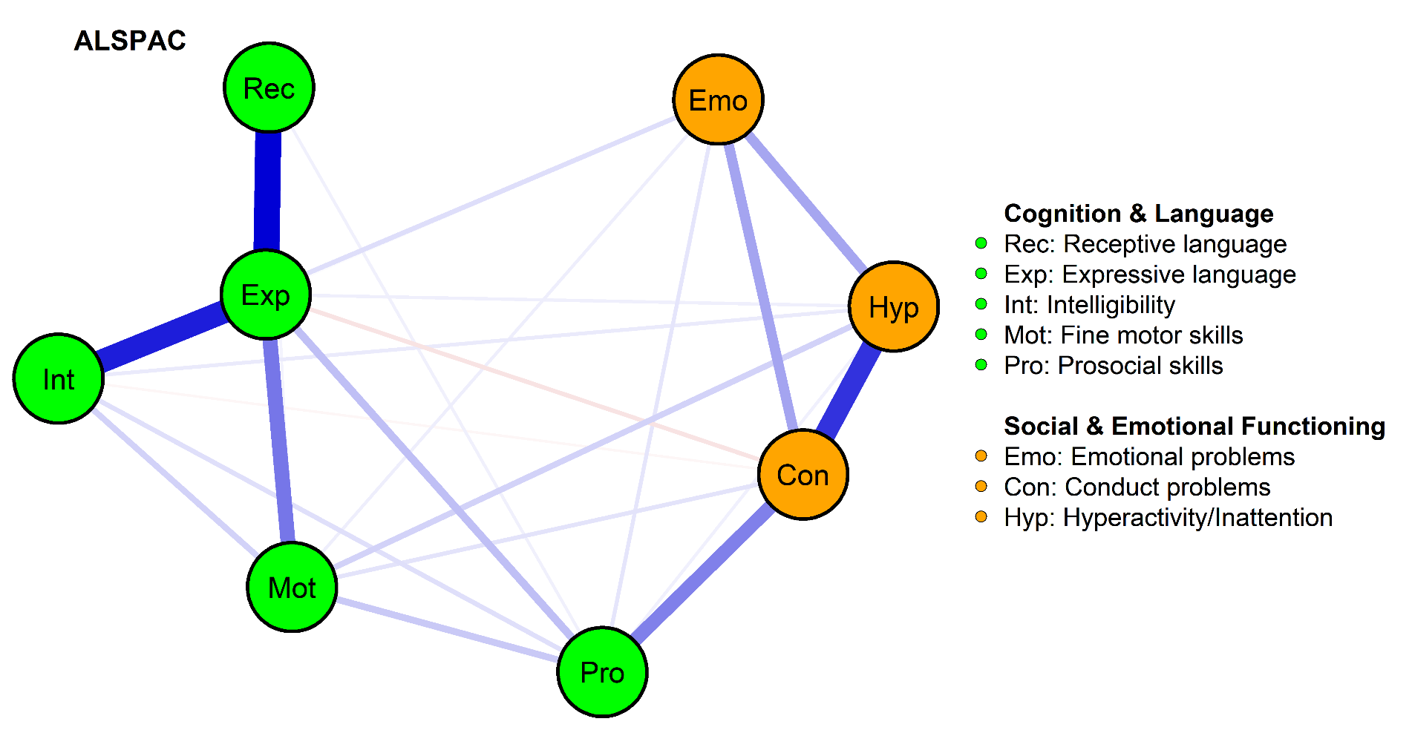

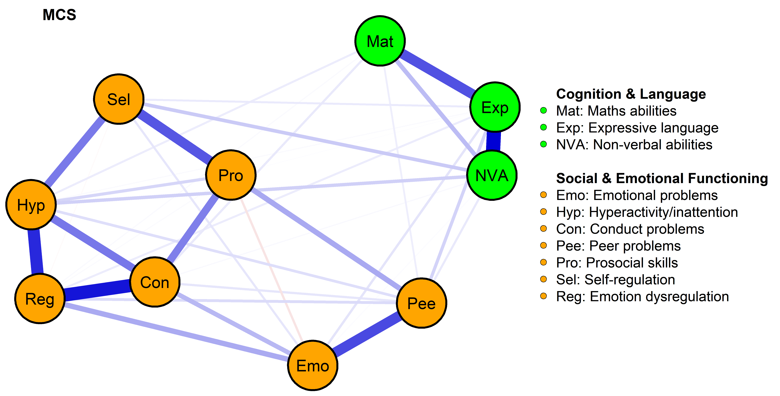

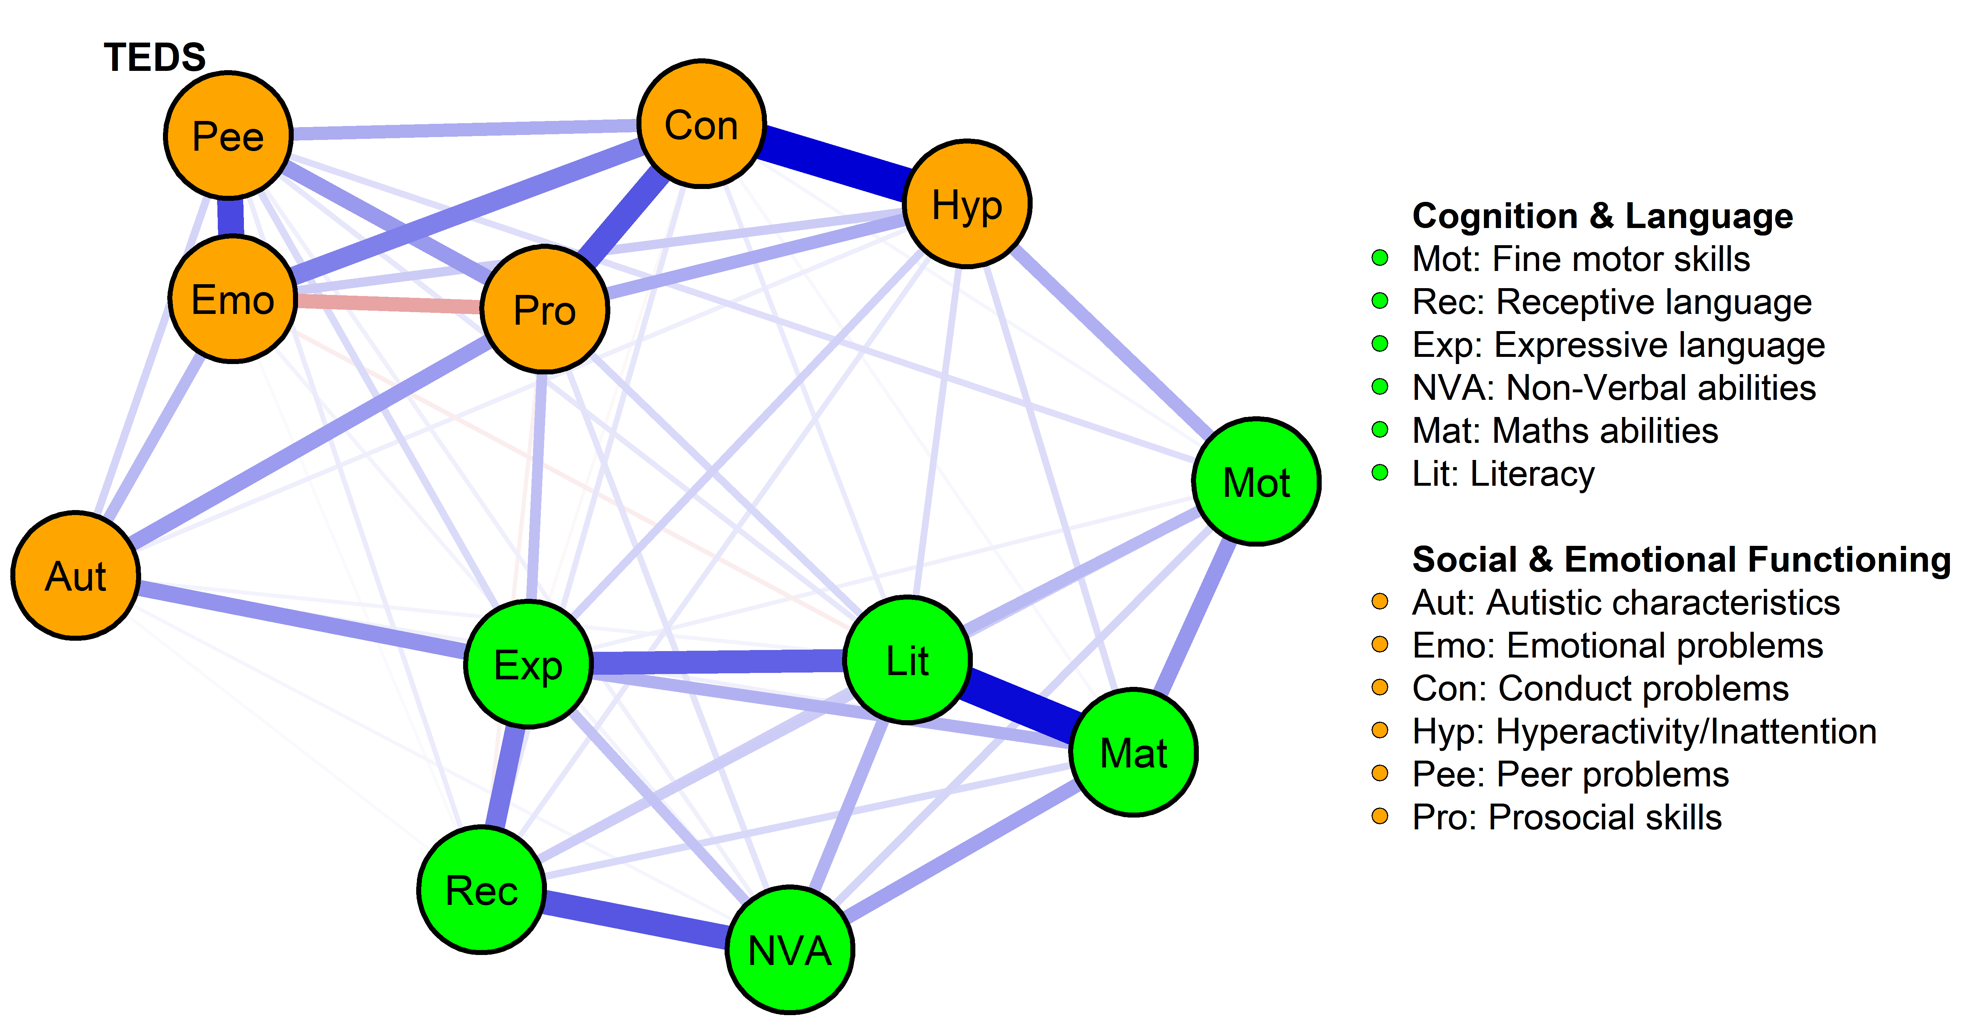

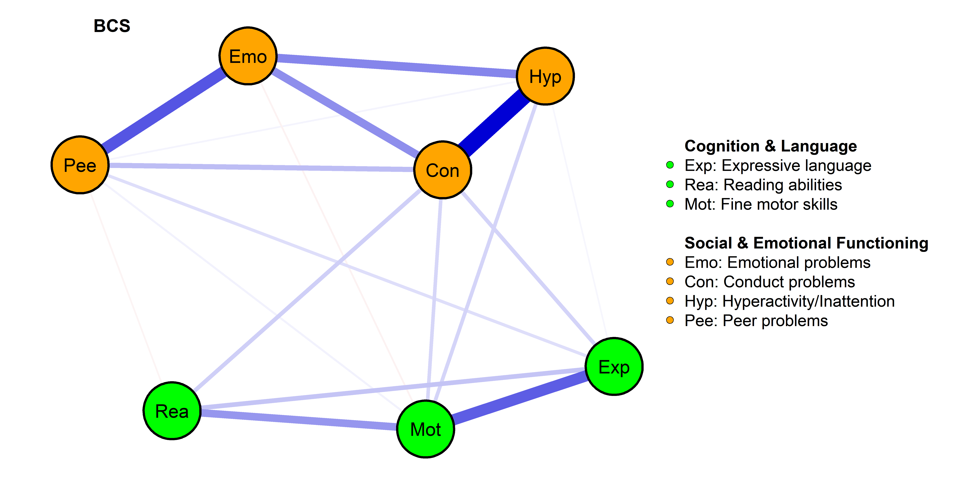

Figure 2
Middle Childhood Network Models
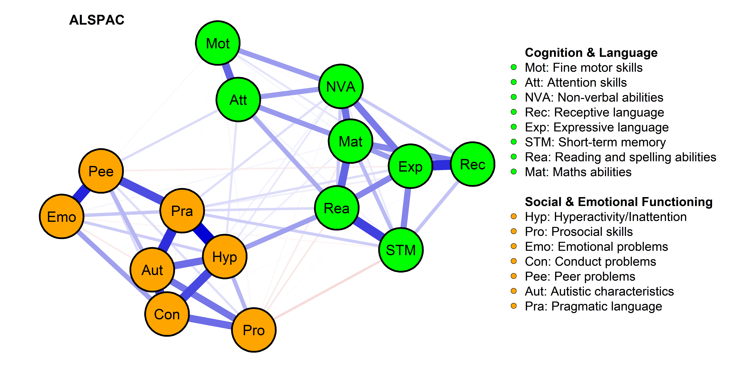

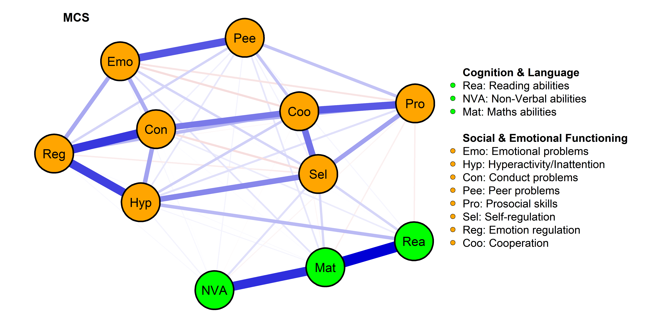

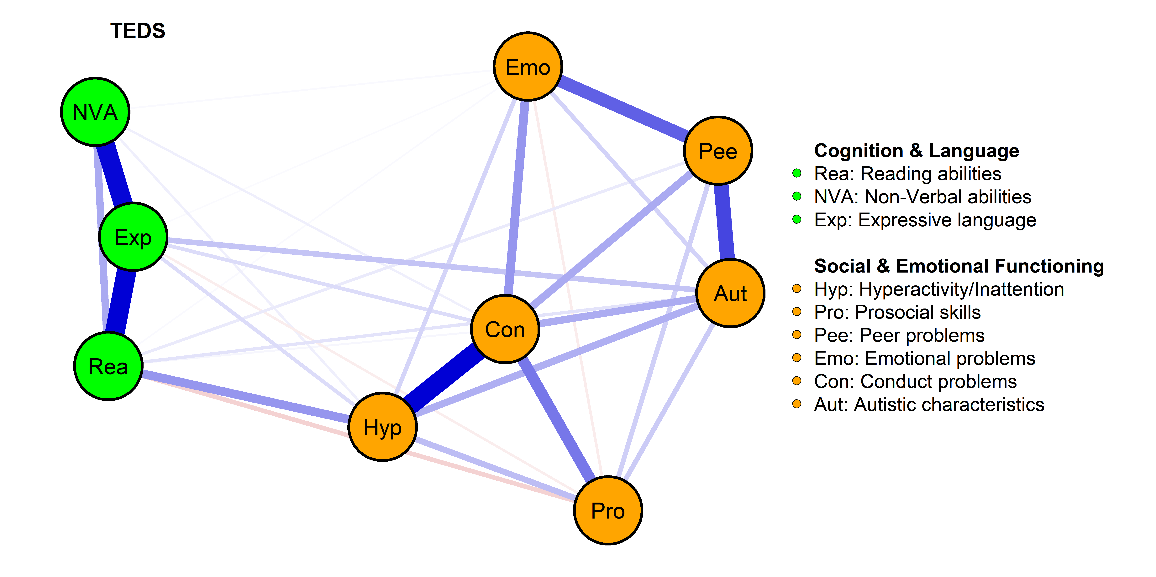

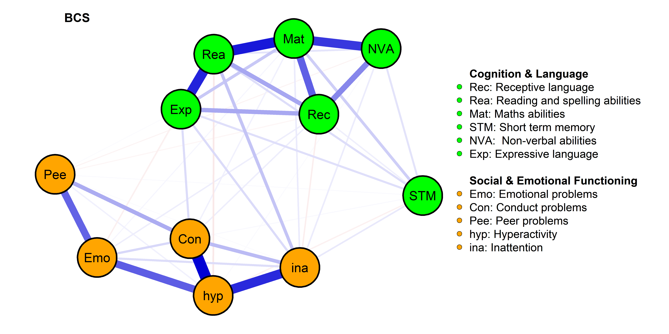

Figure 3
Adolescence Network Models
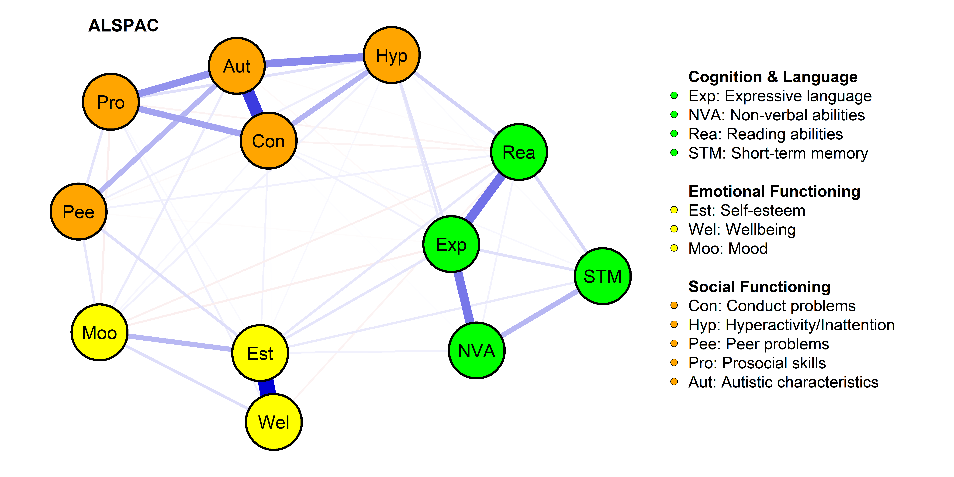

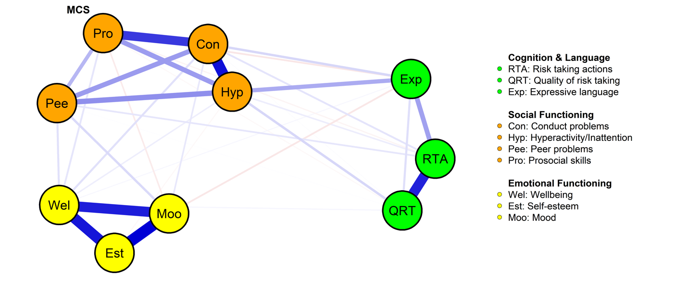

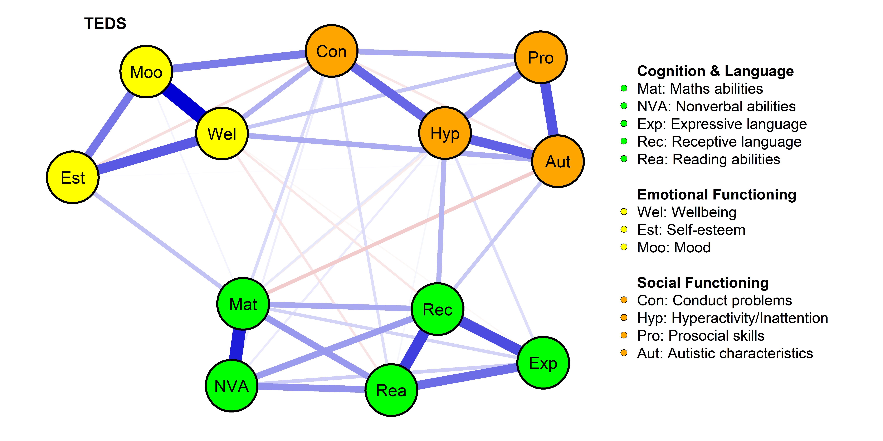

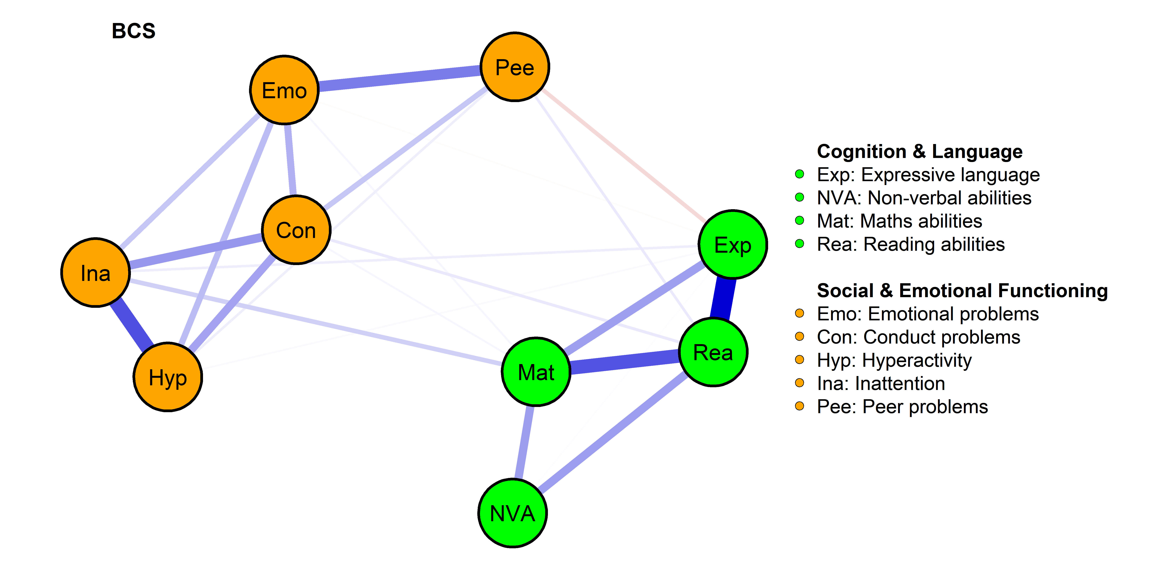

Supplementary Materials

Datasets
Avon Longitudinal Study of Parents and Children (ALSPAC)
Pregnant women resident in Avon, UK with expected dates of delivery between 1st April 1991 and 31st December 1992 were invited to take part in the study. The initial number of pregnancies enrolled was 14,541 and 13,988 children who were alive at 1 year of age. The total sample size for analyses using any data collected after the age of seven is therefore 15,447 pregnancies of these 14,901 children were alive at 1 year of age. This meant that there were 14,203 unique mothers were initially enrolled in the study. This provides a total of 14,833 unique women (G0 mothers). Mothers and children were followed up at various points during childhood and adolescence. We used data from various data collected sweeps from early childhood (3 years) to adolescence (18 years). These are described in full detail under the measures section of the supplementary materials.
Please note that the study website contains details of all the data that is available through a fully searchable data dictionary and variable search tool" and reference the following webpage: http://www.bristol.ac.uk/alspac/researchers/our-data/.
Ethical approval for the study was obtained from the ALSPAC Ethics and Law Committee and the Local Research Ethics Committees
British Cohort Study (BCS)
The 1970 British Cohort Study (BCS70) is an ongoing, multidisciplinary, longitudinal study of a cohort of over 17 000 births in England, Scotland and Wales. The initial sample comprised all births in Britain in a single week in 1970. Participants were followed up at multiple points throughout life. For the analysis reported here, we used data collected between early childhood (age 3 years) and adolescence (18 years). These are described in full detail under the measures section of the supplementary materials.
Ethical approval is obtained from a National Health Service Research Ethics Committee in advance of each sweep of data collection
Millennium Cohort Study (MCS)
The MCS is a United Kingdom (UK) based nationally representative birth-cohort study with an original sample of approximately 19,000 children born between 2000 and 2002 in the four nations of the UK (England, Scotland, Wales and Northern Ireland). Families were recruited to the study when the young person was 9 months old and followed-up at ages 3, 5, 7, 11, 14, and 17 years. Parents completed questionnaires about themselves and their child and, when the young people were able to, they completed questionnaires and in-clinic assessments. For the analysis reported here, we used data from all time points. These are described in full detail under the measures section of the supplementary materials.
Ethical approval for data collection was obtained by the Centre for Longitudinal Studies, University College London. More information regarding ethics approvals for each wave of the MCS can be found here.
Twins Early Development Study (TEDS)
TEDS is a longitudinal twin cohort study of children born in England and Wales between 1994 and 1996. Nearly 14,000 families took part in the first wave of data collection when the twins were 18 months old. Subsets of the original sample were invited to take part in subsequent waves. At the time of recruitment, the sample was representative of the U.K. population. The analysis reported here focused on the sample of twins who took part in an follow-up waves between ages 3 years (early childhood) and adolescence (18 years). Note. One twin from each participating family was excluded. These are described in full detail under the measures section of the supplementary materials.
The TEDS study received ethical approval from Kings College London Research Ethics Committee (References: PNM/09/10–104 and HR/DP‐20/21–22060). Consent was obtained before data collection at every wave
Measures
We focused on measures of memory, attention, non-verbal ability, arithmetic skills, reading, language and communication, motor skills, neurodevelopmental characteristics, psychopathology, social functioning, and wellbeing. To identify cognitive measures in MCS, BCS, and ALSPAC we used the CLOSER data longitudinal archive based at the Social Research Institute (SRI), University College London. To identify social and emotional functioning measures in MCS, BCS, ALSPAC, we used the Catalogue of Mental Health Measures archive. All measures in the TEDS dataset were identified using the TEDS website.
Motor Skills
1) Fine motor skills
ALSPAC. In early childhood (57 months old), parents reported their children’s fine motor skills by answering the following questions:My child can: a) hold a pencil and scribble b) copy a vertical line with a pencil c) wiggle their thumb d) draw a circle e) bang two objects they are holding together f) draw or copy a cross g) draw or copy a square h) write their name i) write any numbers j) draw a man k) pick up a small object using finger and thumb only, l) can turn the pages of a book m) build a tower putting one object on top of another, n) build a tower of four bricks o) build a tower of six bricks p) build a tower of eight bricks q) put bricks together to make a bridge. The items were answered on a 3-point likert type scale (0=has not done yet, 2=yes, can do well). All items were summed to generate a total score with higher scores indicating better fine motor skills. In middle childhood (8.5 years old), we made use of a clinical measure - Test of Everyday Attention for Children (TEACh) - as the measure of children’s fine motor skills. Specifically, we made use of the motor score which is derived as a sum score for time taken in seconds for the motor task performed by the child divided by the number of correct pairs with higher scores indicating better fine motor skills.
BCS. In early childhood (5 years old), we used the raw scores of the following measures: Copying Designs Test, Human Figure Drawing test, and Complete a Profile Test. In the Copying Designs Test, the child was asked to copy 8 drawings which were dummy coded (0=poor copy, 1=good copy) and a sum score ranging from 0 to 8 were generated with higher scores indicating better copying skills. In the Human Figure Drawing Test, the child was asked to draw a human and their drawings were given 1 point per present feature (e.g., presence of an arm) with a sum score ranging from 0 to 30, higher scores indicating better human drawing scores. Finally, in the Complete a Profile Test, the child was asked to complete an online presented human face by filling with features such as eyes and nose etc. with sum scores ranging from 0 to 16, higher scores indicating better profile completing skills. We scaled these three tests and summed their scores to generate the fine motor skills total score with higher scores indicating better fine motor skills.
TEDS. In early childhood (4 years old), we made use of the Design Drawing Task from the Parents Reports of Children’s Abilities (PARCA, McCarthy, 1972) The test consisted of six items with a sum score ranging from 0 to 9, higher scores indicating better fine motor skills.

Cognition
We used a wide range of measures to test children’s cognitive abilities. These measures included both children’s performances on cognitive tests and parent-reports of children’s cognitive abilities (PARCA). Detailed information about each measured construct, per network model, is outlined below.
Maths abilities
ALSPAC. In middle childhood (8.5 years old), we used the Arithmetic measure from the Wechsler Intelligence Scale for Children (WISC-III, Wechsler, 1991). This measure consisted of 24 items measuring arithmetic abilities related to picture stimuli (5 items), solving problems read to the child (13 items) and reading arithmetic problems and solving them (6 items). We made use of the raw score which is the total score of the three tests in which higher scores indicated better maths abilities.
BCS. In middle childhood (10 years old), we used the 72-items Friendly Maths Test (FMT, REF). The FMT consisted dummy-coded 72 items (0=incorrect, 1=correct) testing the following maths abilities: Basic arithmetic skills (36 items), measures (16 items), algebra (6 items), geometry (10 items), and statistics (4 items). We summed all 72 items to generate a total test scale (ranging from 0-72) with higher scores indicating better maths skills. In adolescence (16 years old), we made use of the arithmetic test from the Applied Psychology Unit (APU, Closs, 1976). This test consisted of dummy-coded 60 items (0=incorrect, 1=correct) testing children’s following arithmetic abilities (e.g., arithmetic expressions, proportions and percentages). We made use of the derived raw score mathscore in which higher scores indicated better maths abilities.
MCS. In early childhood (3 years old), we used the sizes and numbers subscales from the Bracken School Readiness Assessment-Revised (BSRA-R, Bracken, 2002). These included one, two, and three dimensional concepts (sizes) and recognising single/double-digit numbers and assigning numbers to value to a set of objects (numbers). We summed derived variables bdszsc00 and bdnosc00 (sizes and numbers raw scores) to generate overall maths abilities total test scale with higher scores indicating better maths abilities. In middle childhood (7 years old), we used the National Foundation for Educational Research Progress in Maths (NFER, REF). This test consisted of 20 questions which were testing children’s knowledge of numbers, shapes, and measurement. We made use of the existing variable dcmtotscor (derived raw score) in which higher scores indicated better maths abilities.
TEDS. In early childhood (4 years old), we made use of a 5-item measure which was based on parents reports of their children’s knowledge of numbers such as “can your child count from 1 to 10 in order?”. All items were dummy coded (0=no, 1=yes). We generated a mean score of all five items with higher scores indicating better maths abilities. In adolescence (16 years old), we made use of the Dot Task (online web test) which consists of 150 items that were dummy-coded (0=incorrect, 1=correct). In each item, an image showing a number of yellow and blue dots was presented to children on the screen and children were asked to indicate whether there were more blue or yellow dots. Detailed information is outlined on the TEDS website.
Non-verbal abilities
ALSPAC. In middle childhood (8.5 years old), we used the performance IQ (non-verbal IQ) subscale from the WISC-III. This subscale included five domains: object assembly, coding, block design, picture arrangement, and picture completion. We made use of the existing derived score Performance IQ in which higher scores indicated better non-verbal abilities. In adolescence (15.5 years old), we used the Matrix Reasoning measure from the Wechsler Abbreviated Scale Of Intelligence (WASI,Wechsler, 1999). In this test, the child was asked to complete a matrix series by selecting the correct response option amongst 6-multiple choice answers. We made use of the already existing raw score for matrix reasoning with higher scores indicating better non-verbal abilities.
MCS. In early childhood (5 years old), we used the pattern construction and picture similarities subscales from the British Ability Scales II (BAS II, Elliott et al., 1996). This scale consisted of 36 pictures in which the child was asked to name the object on each picture. We made use of the ability and age adjusted standardised score ccnvtscore in which higher scores indicated better non-verbal abilities. In middle childhood (7 years old), we used the pattern construction subscale from the BAS II. In this test, a number of patterns -each child was administered varying numbers of items dependent on age and performance - were presented to the child, and the child was asked to replicate these patterns by using plastic cubes in two different colours on each side. We made use of the already derived raw score dctots00 in which higher scores indicated better non-verbal abilities.
BCS. In middle childhood (10 years old), we used the 28-item matrices subscale from the BAS which was dummy-coded (0=incorrect, 1=correct). We generated a total score by adding scores of 28 items with higher scores indicating better non-verbal abilities. In adolescence (16 years old), we made use of the matrices subscale from the BAS. In total, the child was presented with 11 matrices and was asked to choose the design to complete the matrix amongst 5 multiple choice answers. Each item was dummy coded (0=incorrect, 1=correct). We used the already derived raw score scr_m in which higher scores indicated better non-verbal abilities.
TEDS. In early childhood (4 years old), we made use of two subscales from the Parent-Administered PARCA: Oddity task (Bayley, 1993) and puzzle task (Raven et al., 1996). We made use of the already derived sum scores doddt1 and dpuzt1 by standardising and combining them to generate a total scale of non-verbal abilities with higher scores indicating better non-verbal abilities. In middle childhood (7 years old), we made use of the word similarities subscale from the WISC. The word similarities subscale consisted of 13 items some of which were dummy-coded (items 1-4) and other items (5-13) were coded on a 3-point Likert-type scale (0-2). We used the already generated sum score gsimilt1 (ranging from 0 to 22) in which higher scores indicated better non-verbal abilities. In adolescence (16 years old), we made use of the Raven's Progressive Matrices Web Test This test consisted of 30 incomplete series of patterns and children were asked to identify missing patterns. Each item was dummy coded (0=incorrect, 1=correct) and the total test score ranged from zero to 30 with higher scores indicating better non-verbal abilities.
Reading
ALSPAC. In middle childhood (9 years old), we made use of the Word Reading measure (Nunes et al., 2003). In this test, children were asked to read 10 words out loud. We made use of the already derived sum score f9mw031 in which higher scores indicated better reading skills. In adolescence (13 years old), we used the Tests Of Reading Efficiency/Fluency (TOWRE, Torgesen et al., 1999). In this test, children were given two lists of words, consisting of real and non-real words, and asked to read them out loud as fast as they could. Each item was dummy coded (0=incorrect, 1=correct). We scaled sum scores of both real word and non-real word reading measures (i.e., standardised) to generate an overall reading score in which higher scores indicated better reading abilities.
MCS. In middle childhood (9 years old), we used the Word Reading measure from the BAS II which contained 10 words. In this test, children were asked to read each word and each answer was dummy coded (0=incorrect, 1=correct). The number of correct answers were summed to generate a total score with higher scores indicating better functioning.
BCS. In early childhood (5 years old), we made use of the shortened version of the Schonell Reading Test (SRT, Schonell & Goodacre 1971). In this test, children were asked to read 50 words and each item was dummy-coded (0=incorrect, 1=correct). We made use of the already derived total raw score b5sread (ranging from 0 to 50) in which higher scores indicated better reading skills. In middle childhood (10 years old), we used the short version of the Edinburgh Reading Test (ERT, Parsons, 2014) which measures various reading skills such as word recognition, vocabulary, syntax, sequencing, comprehension and retention. This test consisted of 67 questions and following sections: selecting one from four words to describe a picture (5 items), crossing out a word that did not belong in the sequence (5 items), matching 5 answers to 5 questions (4 items), completing a picture quiz (5 items) and reading and answering questions (48 items). Each item was dummy coded (0=incorrect, 1=correct). We made use of the already derived standardised sum score bd3read (ranging from 0 to 67) in which higher scores indicated better reading abilities. In adolescence (16 years old), similar to BCS middle childhood, children’s reading abilities were measured using the ERT. The adolescence ERT version, although this is also a shortened version, consisted of 75 questions which measured on the following reading abilities: skimming, vocabulary, reading for facts, points of view, comprehension. We made use of the already derived total score of all these sections scrtotal (ranging from 0 to 75) in which higher scores indicated better reading comprehension.
TEDS. In middle childhood (7 years old), similar to ALSPAC adolescence measure of reading comprehension, we made use of the TOWRE Word and Non-Word reading test. We used the already derived sum score of both subscales (word reading and non-word reading), namely gtowt1, in which higher scores indicated better reading comprehension. In adolescence (16 years old), we made use of the Passages Web Test. In this test, children were given two passages each accompanied by 13 multiple choice questions. Children were asked to read passages and answer multiple choice questions each of which was dummy coded (0=incorrect, 1=correct). We generated a total score as the sum score of all items (ranging from 0 to 26) in which higher scores indicated better reading comprehension.
Spelling
Spelling was measured in ALSPAC middle childhood (9 years old). In this test, children were asked to spell 15 words, regular and irregular. Each item was dummy coded (0=incorrect, 1=correct). We made use of the already derived sum score f9mw097 in which higher scores indicated better spelling scores. To note, spelling was combined with reading in the middle childhood network model in ALSPAC to prevent multicollinearity as they were highly correlated.
Attention
Attention was measured in ALSPAC middle childhood (8.5 years old). We summed the decrement score from the attention dual task and mean time taken in seconds (in both same world and opposite world) from the TEACh to generate a total score in which higher scores indicated better attention skills.
Risk taking and quality of decision making
Risk taking behaviours and quality of decision making were measured in MCS adolescence (14 years old). To report these, we made use of the Cambridge Neuropsychological Test Automated Battery (CANTAB). In this test, adolescents were given 100 points in which they bet in the effort of finding the yellow token in a total of 10 boxes(some red, some blue). Adolescents selected a proportion of their bet every time they tried to find the hidden yellow token. Some derived variables were generated based on children’s performance (e.g., time taken, quality of decision making, risk taking, etc). We made use of the already derived sum scores for risk taking and quality of decision making, fcgtriskt and fcgtqofdm, respectively, in which higher scores indicated improved functioning in those skills.
Working/Short-term memory.
ALSPAC. In middle childhood (8.5 years old), we made use of the nonword repetition test (Gathercole & Baddeley, 1996). In this test, children were presented with 12 non-real words and asked to listen and repeat each word. We made use of the already derived raw score which was sum score of each dummy-coded item (ranging from 0-12) with higher scores indicating better short-term memory abilities. In adolescence (17.5 years old), we used the N-back Task (Kirchner, 1958) to measure working/short-term memory. In this test, children were shown a sequence of stimuli and asked to decide whether the current stimulus was the same as the one presented before (1x, 2x, or 3x-time before). Specifically, we made use of an already available derived score fjnb100 which indicated the “mean accuracy to identify targets for the two back procedure” with higher scores indicating better working memory.
BCS. In middle childhood (10 years old), we used recall of digits subscale of the BAS. This scale consisted of 34 items each of which was dummy-coded (0=incorrect, 1=correct). We generated a total score (ranging from 0 to 24) with higher scores indicating better working memory.
Language and Communication
Receptive language
ALSPAC. In early childhood (38 months old), we used the MacArthur Communicative Development Inventory (CDI, Fenson, 2002). In this measure, parents reported the number of words their child understands out of 123 words at age 38 months old. The total derived score was used in which higher scores indicated better receptive language skills. In middle childhood (8.5 years old), we used Wechsler Objective Language Dimensions (WOLD, Rust, 1996) to measure receptive language. In this test, children were read aloud a paragraph about a picture and asked questions about what they had heard. We made use of the already derived total raw score f8sl040 in which higher scores indicated better receptive language skills.
BCS. In middle childhood (10 years old), we used the Pictorial Language Comprehension Test (PLCT, Brimmer & Dunn, 1962). In this test, children were provided 100 sets of four picture tests containing vocabulary (71 items), sentences (16 items), and sequence (13 items) and asked to choose the correct picture corresponding to the words, sentences, sequences. Each item was dummy-coded (0=incorrect, 1=correct). We generated a sum score by combining all items (ranging from 0-100) in which higher scores indicated better receptive language skills.
TEDS. In early childhood (4 years old), we made use of the Parent-administered Receptive Picture Vocabulary test (Dunn & Dunn, 198). In this test, children were shown 8 pictures in which they were asked to identify the objects asked by their parents. We made use of the already derived total score dpictot1 (ranging from 0 to 8) in which total scores indicated better receptive language skills. In adolescence (16 years old), we made use of the Figurative Language Web Test. Children were asked to match expression of figures of speech with similar meanings. The test consisted of 15 items each dummy coded (0=incorrect, 1=correct). We made use of the already derived total scores for this test pcfltot1 (ranging from 0 to 15) with higher scores indicating better receptive language skills.
Expressive language
ALSPAC. In early childhood (38 months old), we used a derived variable “DV: Number of words the child can say out of 123 words” with higher scores indicating better expressive language skills. In middle childhood (8.5 years old), we used the oral expression subscale from the Wechsler Objective Language Dimensions (WOLD, Rust, 1996) to report children’s expressive language abilities. The raw score was used with higher scores indicating better expressive language skills. In adolescence (15,5 years old), we made use of the Vocabulary subscale from the WASI. In this test, adolescents were shown 42 pictures and asked to describe what they see in each picture. We made use of the already derived raw score (i.e., sum score of 42 items) in which higher scores indicated better expressive language skills.
BCS. In early childhood (5 years old), we used the English Picture Vocabulary Test (EPVT, Brimer & Dunn, 1962). In this measure, children were shown 56 sets of four pictures and asked to choose the correct picture associated with the shown word at each time. We made use of the bd2read (derived standardised EPVT score) in which higher scores indicated better expressive language skills. In middle childhood (10 years old),we used the following 13 items answered on a 47-point Likert scale (1=reluctantly/simple, 47=readily/advanced) as indicators of children’s expressive language: “1=child uses non verbal communication, 2=tells friends important happenings, 3=tells teacher important happenings, 4=talkative when talking to friends, 5=talkative when talking to teacher, 6= vocabulary simple or advanced 7=simple/advanced language structure, 8=assimilation/use of new vocabulary, 9=organisation of child's thoughts, 10=articulation of child's speech, 11=words clipped or well finished, 12=understandable in 'standard English', 13=child makes syntactical mistakes”. In adolescence (16 years old), we used the 75 items vocabulary subscale from the Applied Psychology Unit (APU) scale.
MCS. In early childhood (5 years old), we used the naming vocabulary subscale from the BAS II in which children were asked to name 36 pictures. We used the total raw score with higher scores indicating better expressive language abilities. In adolescence (14 years old), we used the shortened version (20 out of 75 items) of the vocabulary subscale of the Applied Psychology Unit (APU, Closs, 1976). In this test, the child was shown 20 words and asked to choose a word that indicates the same meaning amongst 5-multiple-choice items. We made use of the raw score for the vocabulary scale with higher scores indicating better expressive language abilities.
TEDS. In early childhood (4 years old), we made use of the expressive vocabulary measure - adapted from the MCDI - (Fenson et al., 1994). We made use of the dvocab1 variable which is a total score derived as the sum of 48 MCDI items (ranging from 0-48) with a higher score indicating better expressive language abilities. In middle childhood (7 years old), we made use of the vocabulary measure from the WISC in which the test scale was computed as the sum scores of 36 items (ranging from 0 to 36) with higher scores indicating better expressive language abilities. In adolescence (16 years old), we made use of the Mill Hill Vocabulary Web Test. The test consisted of a series of 33 multiple choice questions in which twins were presented a word and asked to choose a word that was closest in meaning amongst 6 words in total. Each item was dummy coded (0=incorrect, 1=correct). We made use of the derived variable pcvctota1 in which higher scores indicated better expressive language skills.
Literacy
Literacy skills were measured in TEDS early childhood (4 years old) using a questionnaire developed by Steve Petrill. Parents were asked to report their children’s early literacy skills by answering questions about their children’s engagement with books such as “Does your child like sitting and being read to?”. This is a non-standardised measure that contains 10 questions answered on a binary response scale (0=No, 1=Yes) with higher scores indicating better literacy skills.
Intelligibility
Intelligibility was measured in ALSPAC early childhood (57 months old) by using three items: Parent understands what child says, family understands what child says, visitors understand what child says, answered on 3-point Likert scale (0=Never, 3=Always). These items were summed to generate a total score with higher scores indicating better intelligibility.

Neurodevelopmental Characteristics
We made use of autism screening questionnaires to report individuals’ autistic characteristics which were measured in ALSPAC (middle childhood and adolescence) and TEDS (early and middle childhood and adolescence). In ALSPAC, autistic characteristics were screened using the Social and Communication Disorders Checklist (SCDC, Skuse et al., 1997). The SCDC is a 12-item measure answered by parents on a 3-point Likert scale (ranging from 0=very or often true to 2=not true). In ALSPAC middle childhood, we made use of the social cognition sum score (derived variable from the SSCDC) as an indicator of autistic characteristics while in adolescence, we generated a sum score across 12 items. In both ALSPAC middle childhood and adolescence models, higher scores indicated lower levels of autistic characteristics. In TEDS, autistic characteristics were measured using different scales across different developmental stages. In early childhood, parents reported their children’s autistic characteristics on the Checklist for Autism in Toddlers (CHAT, Baron-Cohen et al., 2000) when their child was aged 4 years old. In middle childhood, parents reported their children’s autistic characteristics when they were aged 8 and 9 years old on the Child Aspergers Symptoms Test (CAST, Scott et al., 2002). Finally, in adolescence, individuals self-reported their autistic characteristics using the Abbreviated Autism Quotient (AQ, Baron-Cohen et al., 2001). Details of the autism screening measures and scoring guidelines can be found on the TEDS website.
Social Functioning
To report social functioning, we focussed on peer problems and prosocial skills which were measured using the Strengths and Difficulties Questionnaire (SDQ, Goodman, 1997) and cooperation skills (e.g., is calm and easy going) which were measured using the Child Social Behaviour Questionnaire (CSBQ, Sammons et al., 2004). The peer problems and prosociality subscales from the SDQ and the cooperation subscale from the CSBQ consisted 5 questions and were answered on a 3-point Likert scale (ranging from 1=not true to 3=certainly true); a sum score was generated for each with higher scores indicating better social functioning.

Psychopathology
To measure internalising and externalising psychopathology, focused on child-self-reports as well as parent- and teacher-reported child’s psychopathology. Detailed information for who reported child’s psychopathology in each network model can be seen in Table S4. In early and middle childhood, we mainly used the SDQ and the Rutter scale (Rutter, 1967), which is an earlier version of the SDQ, to report child psychopathology. Specifically, for internalising problems, we made use of the emotional difficulties (e.g., often worried, many worries) and peer problems (e.g., rather solitary, tend to do things alone) subscales from the SDQ and the Rutter scales. For externalising problems, we made use of conduct problems (e.g., often fights with other children), and hyperactivity/inattention (e.g., restless, overactive) subscales from the both measures. In adolescence (in ALSPAC, MCS, TEDS), we made use of additional measures of internalising psychopathology such as Moods and Feelings Questionnaire (MFQ, Angold et al., 1995) to report adolescents’ depressive symptomatology. Additionally, in BCS, we made use of the Conners Comprehensive Behavior Rating Scale (Conners, 2008) to measure hyperactivity (e.g., is impulsive, excitable) and inattention (e.g., inattentive, easily distracted), separately. Finally, in MCS early and middle childhood, we also made use of the CSBQ to report children’s self-regulation, that is, independence and self-regulation (e.g., likes to work things out for self) and emotional dysregulation (e.g., shows mood swings. Each of these subscales from the CSBQ were answered on a 3-point Likert scale (ranging from 1=not true to 3-certainly true). We constructed sum scores across five items for each subscale with higher scores indicating better self-regulation and emotion regulation skills.
Wellbeing
As indicators of wellbeing, we made use of adolescents’ self-reports of self-esteem and subjective wellbeing in ALSPAC, MCS, TEDS. More specifically, in ALSPAC, self-esteem was measured when individuals were 17.6 years old using the 10-item Bachman Revision of the Rosenberg Self-esteem Scale (RSE-B, Bachman, 1970). The RSE-B is a self-report measure answered on a 5-point Likert-type scale (ranging from 1=never true to 5=almost always true). We summed scores from 10 items to create a total test score with higher scores indicating better self-esteem. In MCS, adolescents’ self-esteem was measured at age 14 years old using the five-item version of the Rosenberg Self-Esteem scale (RSE; Rosenberg, 1965). The RSE scale was self-reported on a four-point scale (ranging from 0 = strongly disagree to 3 = strongly agree). A summary score of the five items were generated with higher scores indicating better self-esteem. In TEDS, self-esteem was measured when individuals were aged 16 years old by asking them a single question “I have high self-esteem” which was answered on a 5-point Likert scale (ranging from 1=not like me at all to 5=very much like me) with higher scores indicating better self-esteem.

In ALSPAC and MCS, adolescents’ subjective wellbeing was measured using the Warwick-Edinburgh Mental Wellbeing Scale (SWEMWBS, REF). In ALSPAC, the 14-item measure was used when adolescents were aged 17.6 years old while in MCS, the 7-item shortened version was used when adolescents were 17 years old. Both scales were answered on a 4-point Likert-type scale ranging from 1=none of the time to 4=all of the time. In both scales, we generated sum scores across all items with higher scores indicating better wellbeing. In TEDS, we made use of the Subjective Happiness Scale (SHS, Lyubomirsky & Lepper, 1999) which consisted of four questions answered on a 7-point Likert scale (1-7). We used the sum scale (pcbhshsm1) which is a sum score of four variables with higher scores indicating better wellbeing.
Co-Production
We held two co-production research workshops, one with young people with lived experiences of special educational needs (n=10) and one with parents of children with special educational needs (n=8). Young people and parents were asked to guide us in terms of which specific developmental skills to look for when identifying areas of functioning. Young people reported what they find hard with schoolwork, social interactions, and their emotions. The following are what young people reported finding hard: 1) peer relationships, 2) homework, 3) exams, 4) questions in maths exercises, 5) reading, 6) communication, 7) their emotions and behaviour. Additionally, parents were provided with a list of behaviours and skills and asked to choose the ones they thought were relevant to investigate to better understand their child’s developmental needs. Similar to what young people reported, parents also indicated that areas of functioning related to their children’s communication skills (e.g., expressing themselves), cognitive skills (e.g., attention, reading), and emotional and behavioural difficulties (e.g., emotional distress, conduct problems). Finally, we, as the researchers, also included some measures that we deemed relevant/proxy to the constructs reported by young people or parents such as risk taking behaviours and quality of decision making as indicators of cognition in adolescence. A full list of measures included in the current study - and whether they were included due to young people’s guidance, parents’ guidance, or researchers’ judgement of being a relevant/proxy measure - can be found in the Table S5.

References
Angold, A., Costello, E. J., Messer, S. C., & Pickles, A. (1995). Development of a short questionnaire for use in epidemiological studies of depression in children and adolescents. International Journal of Methods in Psychiatric Research, 5(4), 237–249.
Bayley, N. (1993): Bayley Scales of Infant Development, 2nd Edition; San Antonio, TX: Psychological Corporation.
Brimer, M. A., & Dunn, L. M. (1962). English Picture Vocabulary Test: Educational Evaluation Enterprises. English version of the Peabody Picture Vocabulary Test (PPVT; Dunn, 1959).
Closs, S. J. (1976). APU vocabulary test (multiple choice format, 1986). Kent: Hodder and Stoughton Educational Ltd.
Bachman, J. G. (1970). Youth in Transition. Volume II, The Impact of Family Background and Intelligence on Tenth-Grade Boys.
Baron-Cohen, S., Wheelwright, S., Cox, A., Baird, G., Charman, T., Swettenham, J., ... & Doering, P. (2000). Early identification of autism by the Checklist for Autism in Toddlers (CHAT). Journal of the royal society of medicine, 93(10), 521-525. https://doi.org/10.1177/0141076800093010
Baron-Cohen, S., Wheelwright, S., Skinner, R., Martin, J., & Cubley, E. (2001). The autism-spectrum quotient (AQ): Evidence from Asperger syndrome/high-functioning autism, males and females, scientists and mathematicians. Journal of autism and developmental disorders, 31, 5-17. https://doi.org/10.1023/A:1005653411471
Bracken, B.A. (2002). Bracken School Readiness Assessment: Administration Manual. San Antonio, Texas: Psychological Corporation.
Conners, C. K. (2008). Conners comprehensive behavior rating scales: Manual. Multi-Health Systems.
Dunn, L. M., & Dunn, L. M. (1981). Peabody Picture Vocabulary Test-Revised. Circle Pines, MN: American Guidance Service.
Elliott, C. D., Smith, P., & McCulloch, K. (1996). British Ability Scales Second Edition (BAS II). Administration and Scoring Manual. London: Nelson.
Fenson, L. (2002). MacArthur Communicative Development Inventories: User's guide and technical manual. Paul H. Brookes.
Fenson, L., Pethick, S., Cox, J.L. (1994): The MacArthur Communicative Development Inventories: short form versions; unpublished manuscript: San Diego State University.
Gathercole, S. E., & Baddeley, A. D. (1996). The children’s test of nonword repetition. Pearson.
Goodman, R. (1997). The Strengths and Difficulties Questionnaire: a research note. Journal of child psychology and psychiatry, 38(5), 581-586. https://doi.org/10.1111/j.1469-7610.1997.tb01545.x
Kirchner, W. K. (1958). Age differences in short-term retention of rapidly changing information. Journal of Experimental Psychology, 55(4), 352.
Lyubomirsky, S., and Lepper, H. S. (1999). A measure of subjective happiness: Preliminary reliability and construct validation. Social Indicators Research, 46, 137-155. https://doi.org/10.1023/A:1006824100041
McCarthy, D. (1972): McCarthy Scales of Children's Abilities; New York: The Psychological Corporation.
Nunes, T., Bryant, P., & Olsson, J. (2003). Learning morphological and phonological spelling rules: An intervention study. Scientific Studies of Reading, 7(3), 289-307.
Parsons, S. (2014). Childhood cognition in the 1970 British cohort study.
Raven, J.C., Court, J.H., Raven, J. (1996): Manual for Raven's Progressive Matrices and Vocabulary Scales: Section 3 - Standard Progressive Matrices; Oxford Psychologists Press.
Rust, J. (1996). The manual of the Wechsler objective language dimensions (WOLD) UK Edition. London: The Psychological Corporation.
Rutter, M. (1967). A children's behaviour questionnaire for completion by teachers: preliminary findings. Child Psychology & Psychiatry & Allied Disciplines. https://doi.org/10.1111/j.1469-7610.1967.tb02175.x
Sammons, P., Sylva, K., Melhuish, E., Siraj-Blatchford, I., Taggart, B, Elliott, K., & Marsh, A.
(2004). The Effective Provision of Pre-school Education (EPPE) Project: Technical Paper
11: The continuing effect of pre-school education at age 7 years. London: Institute of
Education
Scott, F. J., Baron-Cohen, S., Bolton, P., & Brayne, C. (2002). The CAST (Childhood Asperger Syndrome Test) Preliminary development of a UK screen for mainstream primary-school-age children. Autism, 6(1), 9-31. https://doi.org/10.1177/1362361302006001003
Schonell & Goodacre (1971). The psychology and teaching of reading. London: Oliver & Boyd
Skuse, D. H., James, R. S., Bishop, D. V., Coppin, B., Dalton, P., Aamodt-Leeper, G., ... & Jacobs, P. A. (1997). Evidence from Turner's syndrome of an imprinted X-linked locus affecting cognitive function. Nature, 387(6634), 705-708. https://doi.org/10.1038/42706
Torgesen, J. K., Rashotte, C. A., & Wagner, R. K. (1999). TOWRE: Test of word reading efficiency. Austin, TX: Pro-ed.
Wechsler, D. (1991). WISC-III: Wechsler intelligence scale for children: Manual. Psychological Corporation.
Wechsler, D. (1999). Manual for the Wechsler abbreviated intelligence scale (WASI). San Antonio, TX: The Psychological Corporation.
Tables
Table S1
Reporters of Measures: Child’s performance, child-report, parent-report, teacher report
 | Early Childhood |  |  |  | Middle Childhood |  |  |  | Adolescence
Domain | A | M | B | T | A | M | B | T | A | M | B | T
Receptive language | P |  |  | CP | CP |  | CP |  |  |  |  | CP
Expressive language | P | CP | CP | CP | CP |  | T | CP | CP | CP | CP | CP
Fine motor skills | P |  | CP | CP | CP
Non-verbal ability |  | CP |  | CP | CP | CP | CP | CP | CP |  | CP | CP
Reading (or spelling) |  |  | CP |  | CP | CP | CP | CP | CP |  | CP | CP
Math ability |  | CP |  | P | CP | CP | CP |  |  |  | CP | CP
Intelligibility | P
Attention |  |  |  |  | CP
Working/Short-term memory |  |  |  |  | CP |  | CP |  | CP
Literacy |  |  |  | P
Risk Taking |  |  |  |  |  |  |  |  |  | CP
Quality of Decision Making |  |  |  |  |  |  |  |  |  | CP
Emotional problems | P | P | P | P | P | P | P | P |  |  | P
Conduct problems | P | P | P | P | P | P | P | P | P | C | P | C
Hyperactivity/Inattention | P | P | P | P | P | P | T | P | P | C | T | C
Peer problems | P | P | P | P | P | P | P | P | P | C | P
Prosocial skills | P | P | P | P | P | P | P | P | P | C |  | C
Autistic characteristics |  |  |  | P | P |  |  | P | P |  |  | C
Pragmatic use of language
Self-regulation |  | P |  |  |  | P
Emotion regulation |  | P |  |  |  | P
Cooperation |  |  |  |  |  | P
Self-Esteem |  |  |  |  |  |  |  |  | C | C |  | C
Wellbeing |  |  |  |  |  |  |  |  | C | C |  | C
Mood |  |  |  |  |  |  |  |  |  | C |  | C
Note. A= ALSPAC, M= MCS, B= BCS, T= TEDS. C=Child’s self-report, CP= Child’s performance on a clinical test (cognitive or language), P=Parent-report, T=Teacher’s report
Table S2
Inclusion of measures: young people-suggested, parents-suggested, researchers-suggested
Domain | Young people | Parents | Researchers
Receptive language | * | * | *
Expressive language | * | * | *
Fine motor skills |  | * | *
Non-verbal ability |  | * | *
Reading |  | * | *
Math ability | * | * | *
Intelligibility |  | * | *
Attention |  | * | *
Working memory |  | * | *
Literacy |  |  | *
Risk Taking |  |  | *
Quality of Decision Making |  |  | *
Emotional problems | * | * | *
Conduct problems | * | * | *
Hyperactivity/Inattention | * | * | *
Peer problems | * |  | *
Prosocial skills |  |  | *
Autistic characteristics |  |  | *
Pragmatic use of language |  | * | *
Self-regulation | * | *
Emotion regulation | * | *
Cooperation |  | *
Self-Esteem |  | *
Wellbeing |  | *
Mood | * | * | *

Table S3
Stability of Centrality (Strength and Bridge Strength)

Dataset | Strength | Bridge Betweenness
Early Childhood
ALSPAC | 0.75  (caseMin = 0.672, caseMax = 1) | 0 -  (caseMin = 0, caseMax = 0.05)
MCS | 0.75  (caseMin = 0.672, caseMax = 1) | 0.517  (caseMin = 0.439, caseMax = 0.594)
TEDS | 0.75  (caseMin = 0.672, caseMax = 1) | 0.361  (caseMin = 0.283, caseMax = 0.439)
BCS | 0.75  (caseMin = 0.672, caseMax = 1) | 0.439  (caseMin = 0.361, caseMax = 0.517)
Middle Childhood
ALSPAC | 0.75  (caseMin = 0.672, caseMax = 1) | 0.672  (caseMin = 0.594, caseMax = 0.75)
MCS | 0.75  (caseMin = 0.672, caseMax = 1) | 0.594  (caseMin = 0.517, caseMax = 0.672)
TEDS | 0.75  (caseMin = 0.672, caseMax = 1) | 0.672  (caseMin = 0.594, caseMax = 0.75)
BCS | 0.75  (caseMin = 0.672, caseMax = 1) | 0.439  (caseMin = 0.361, caseMax = 0.517)
Adolescence
ALSPAC | 0.75  (caseMin = 0.672, caseMax = 1) | 0.206  (caseMin = 0.128, caseMax = 0.283)
MCS | 0.75  (caseMin = 0.672, caseMax = 1) | 0.05  (caseMin = 0, caseMax = 0.128)
TEDS | 0.75  (caseMin = 0.672, caseMax = 1) | 0.283  (caseMin = 0.206, caseMax = 0.361)
BCS | 0.672  (caseMin = 0.594, caseMax = 0.75) | 0.361  (caseMin = 0.283, caseMax = 0.439)

*Maximum drop proportions to retain correlation of 0.7 in at least 95% of the samples
Table S4. Lasso regularisation parameters (λ) selected by EBIC for each cohort and developmental period

Data | λ
Early Childhood
ALSPAC | 0.01063996
MCS | 0.008745407
TEDS | 0.009315143
BCS | 0.005673543
Middle Childhood
ALSPAC | 0.01149481
MCS | 0.00630631
TEDS | 0.009749077
BCS | 0.009400861
Adolescence
ALSPAC | 0.01050622
MCS | 0.01118687
TEDS | 0.01608126
BCS | 0.01957543

Figures
Figure S1
Pairwise Correlations
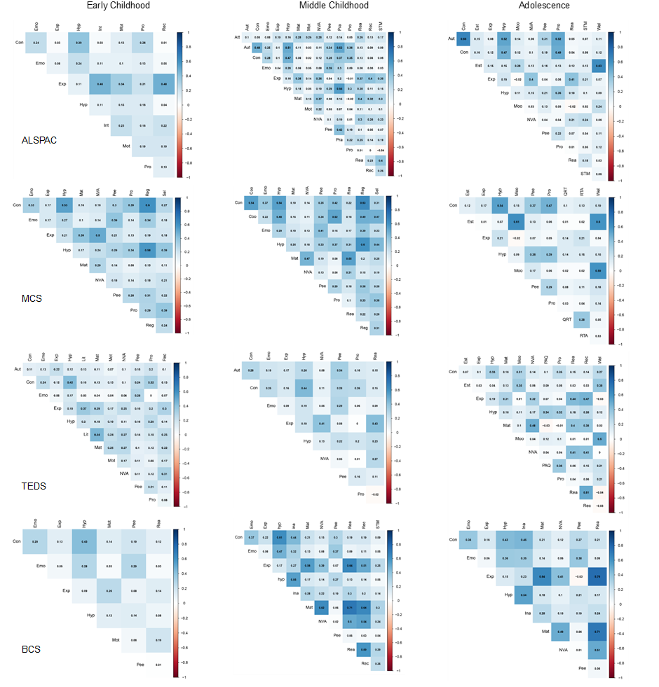

Note.
Figure S2
Early Childhood Unregularized Networks
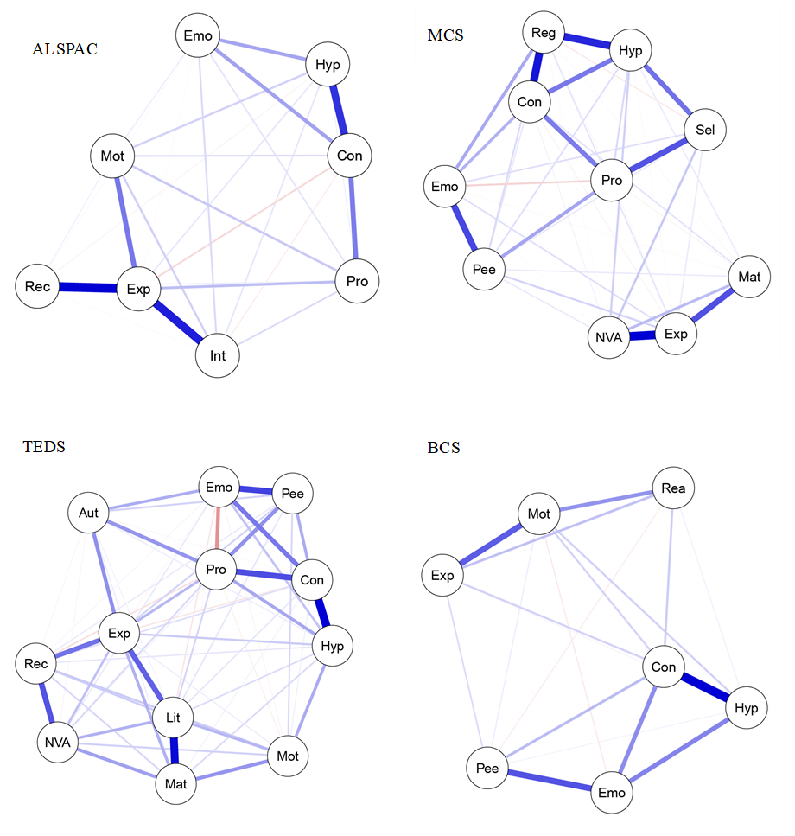

Figure S3
Middle Childhood Unregularized Networks
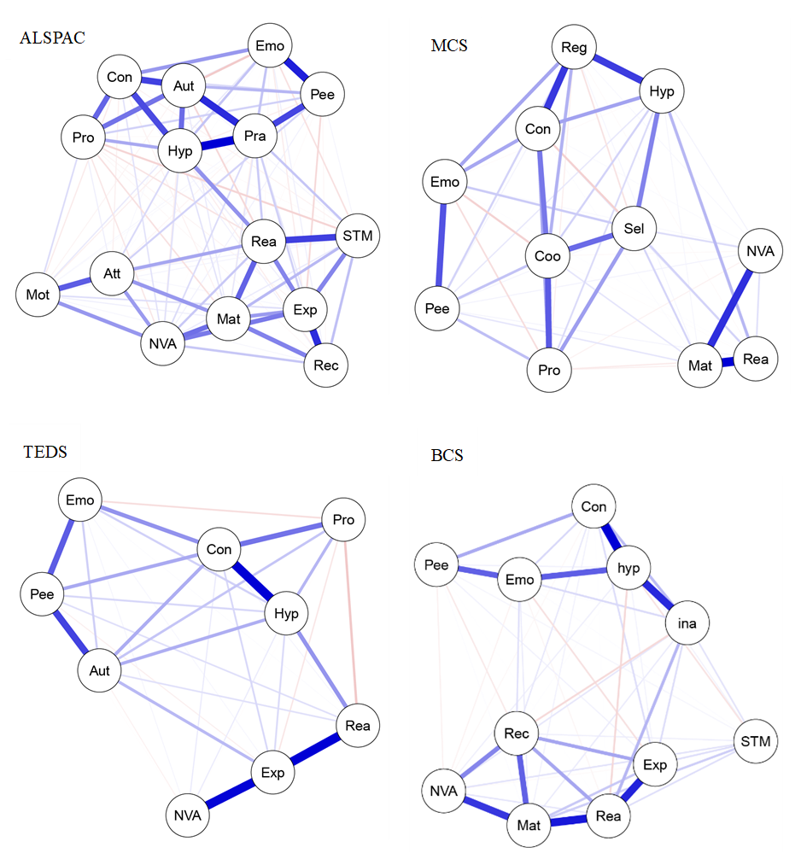

Figure S4
Adolescence Unregularized Networks
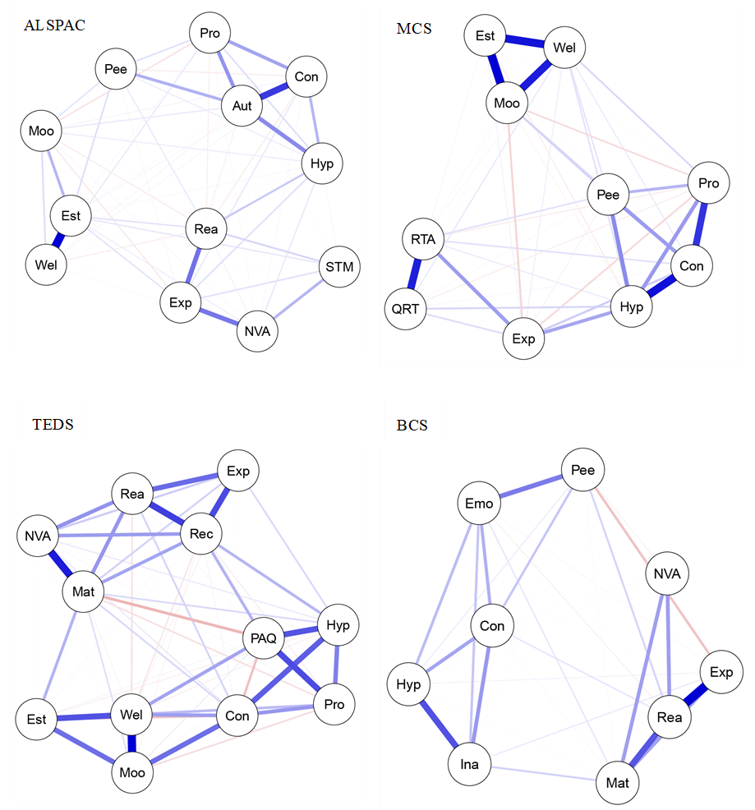
Figure S5a
ALSPAC Early Childhood Edge-weight difference test

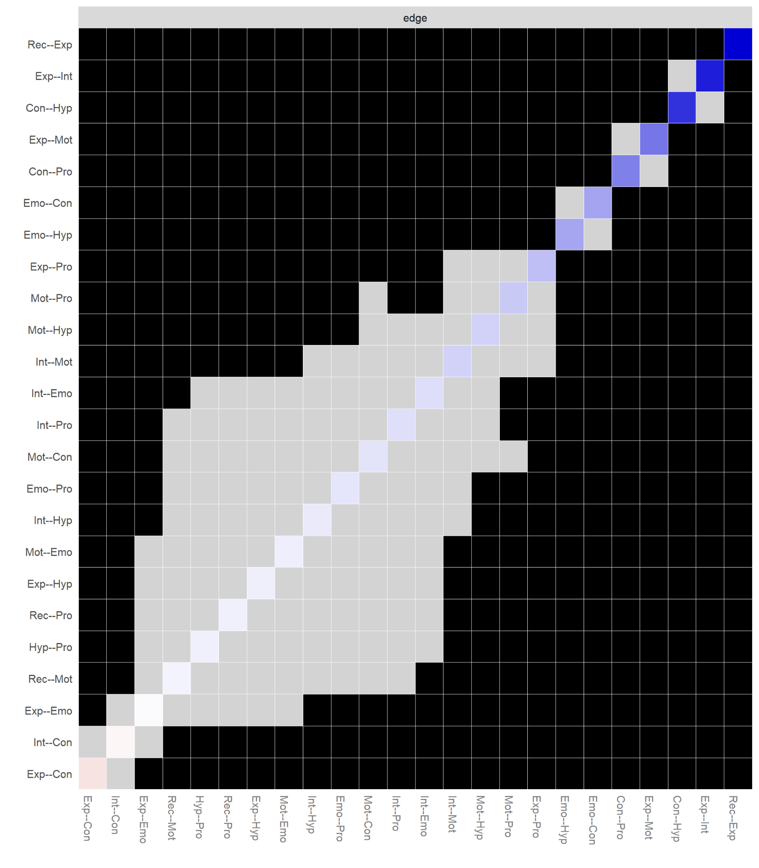
Note. Gray boxes represent edges (e.g., edges between node-1 and node-2 and edges between node-3 and node-4) that do not differ significantly from one-another and black boxes represent edges that do differ significantly. Colored boxes indicate the colour of the edge (i.e., blue coloured edges are positive, red coloured edges are spurious or negative).
Figure S5b
ALSPAC Early Childhood strength difference test

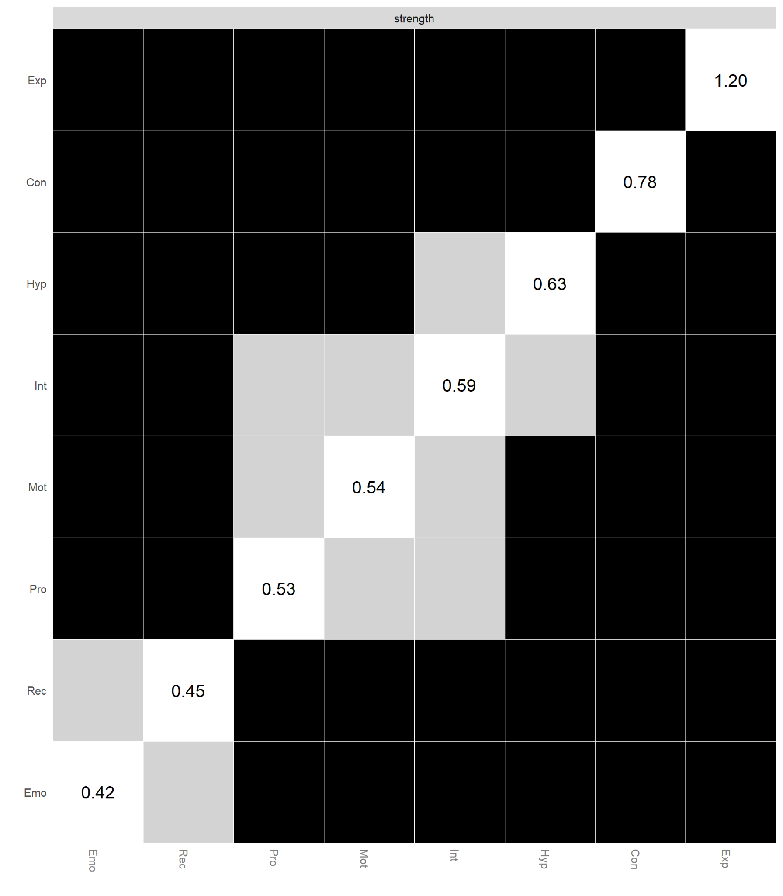
Note. Gray boxes represent edges (e.g., edges between node-1 and node-2 and edges between node-3 and node-4) that do not differ significantly from one-another and black boxes represent edges that do differ significantly. The numerical values in white boxes show node strength values.
Figure S6a
MCS Early Childhood Edge-weight difference test
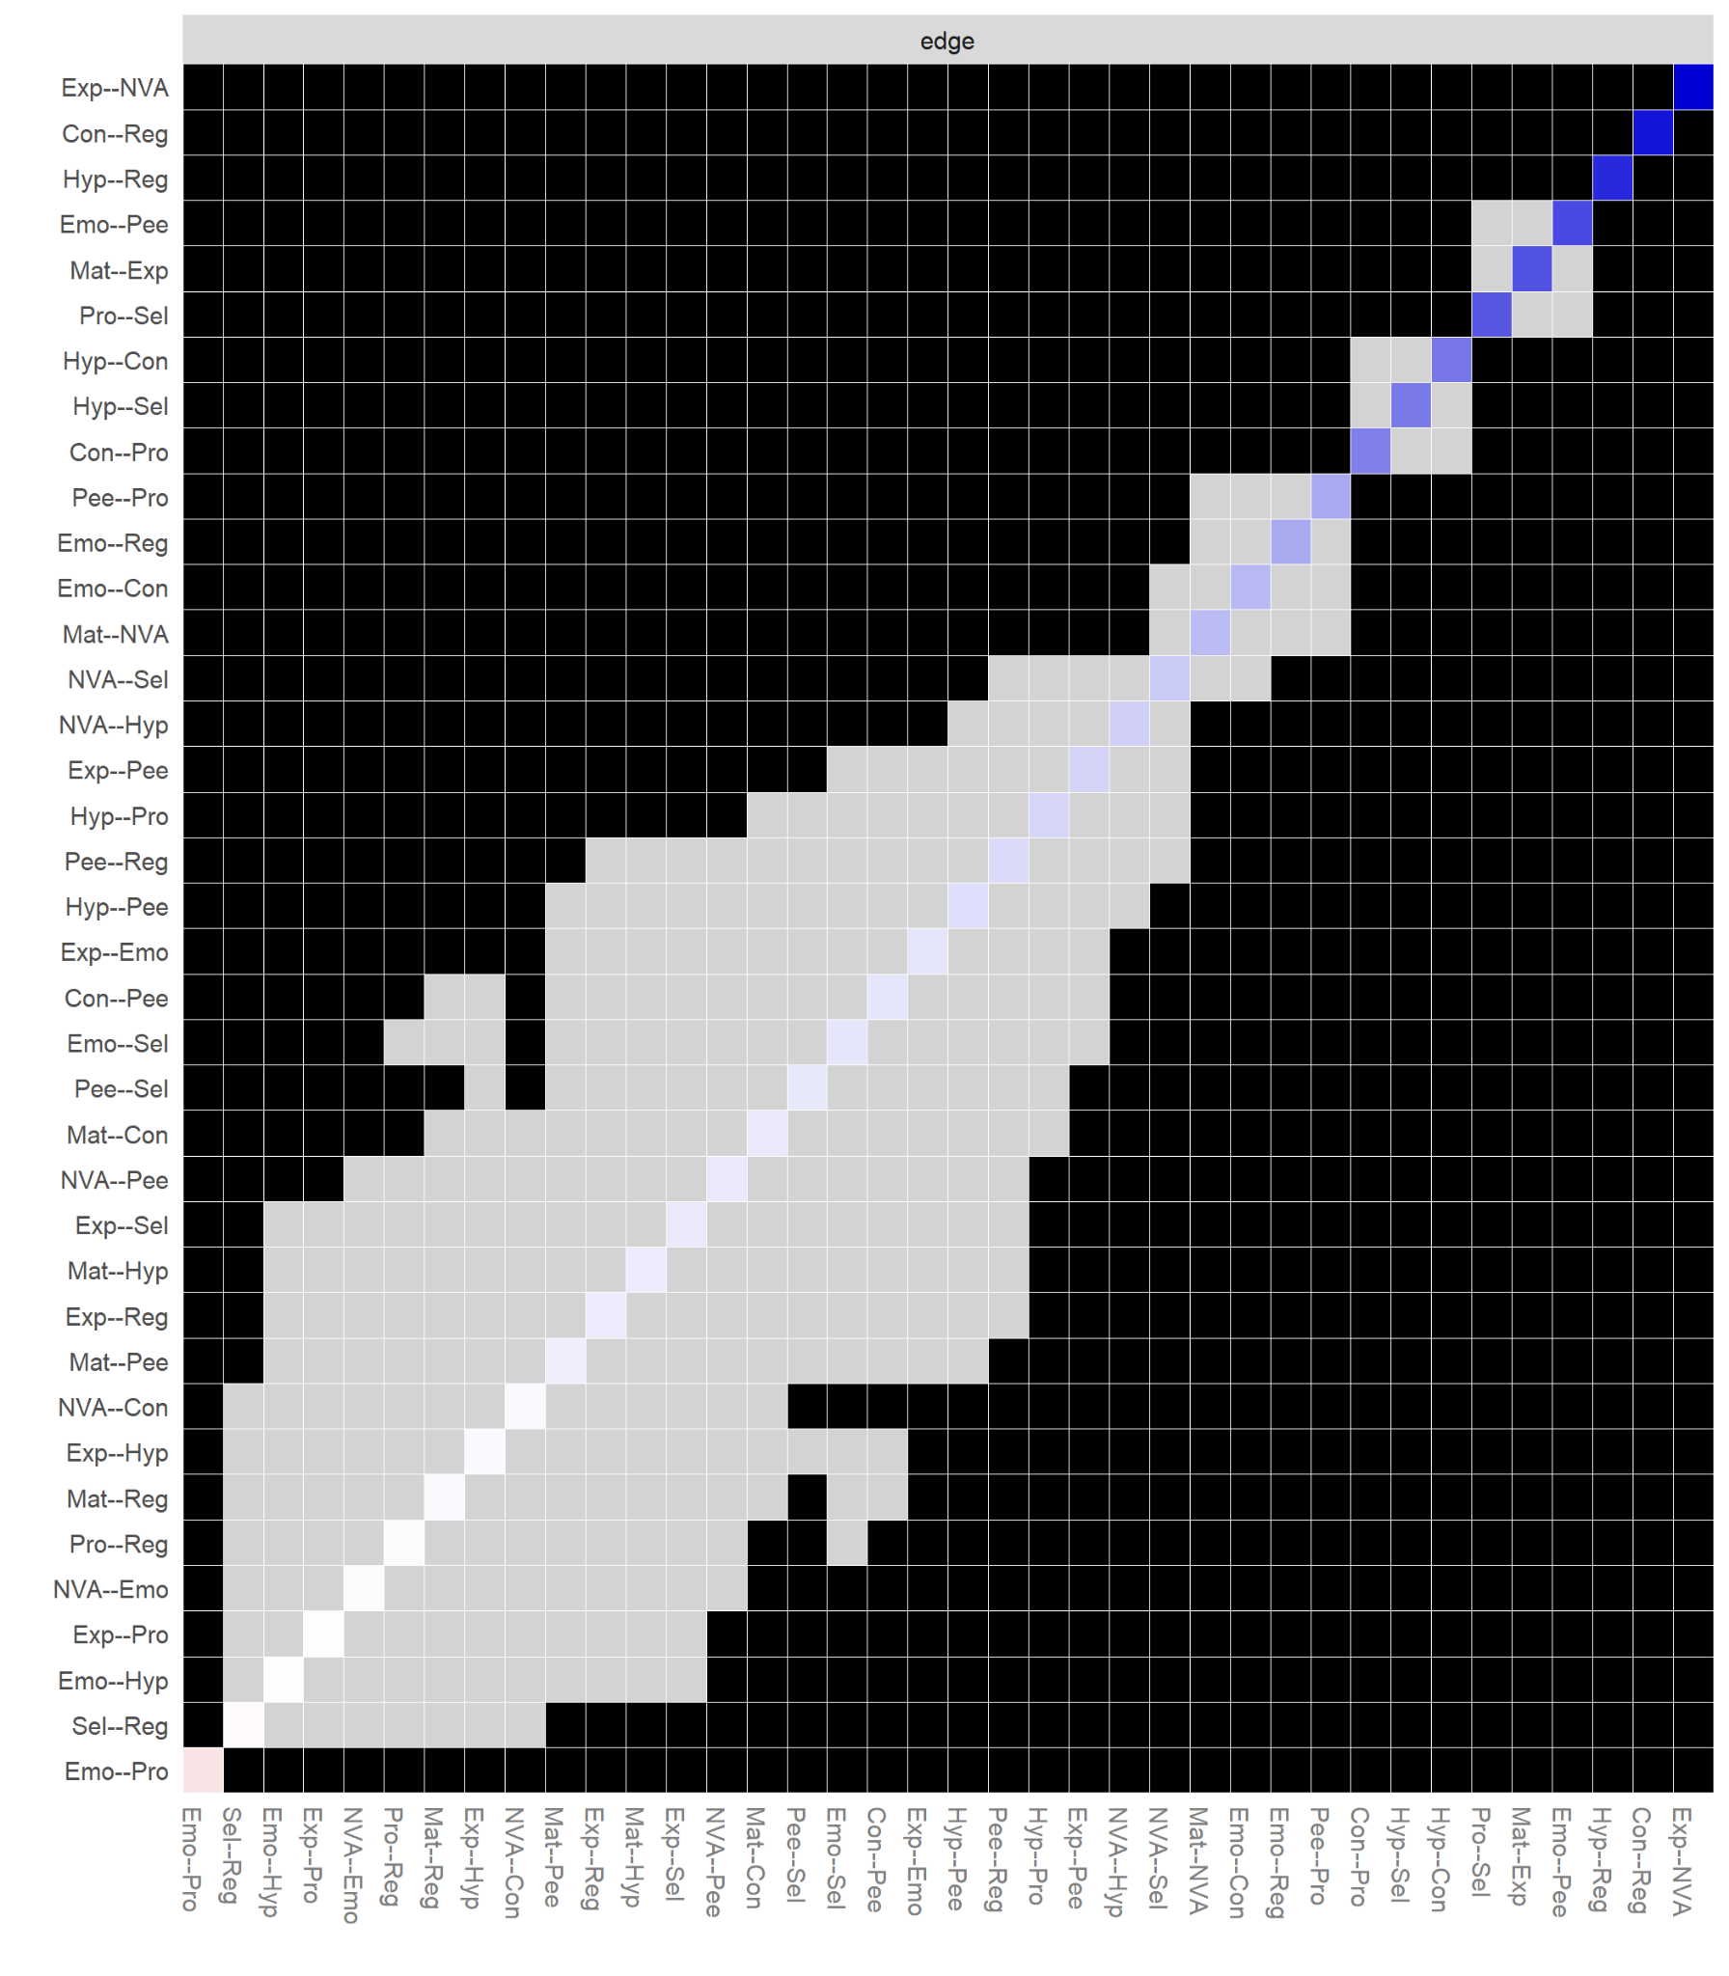
Note. Gray boxes represent edges (e.g., edges between node-1 and node-2 and edges between node-3 and node-4) that do not differ significantly from one-another and black boxes represent edges that do differ significantly. Colored boxes indicate the colour of the edge (i.e., blue coloured edges are positive, red coloured edges are spurious or negative).

Figure S6b
MCS Early Childhood strength difference test
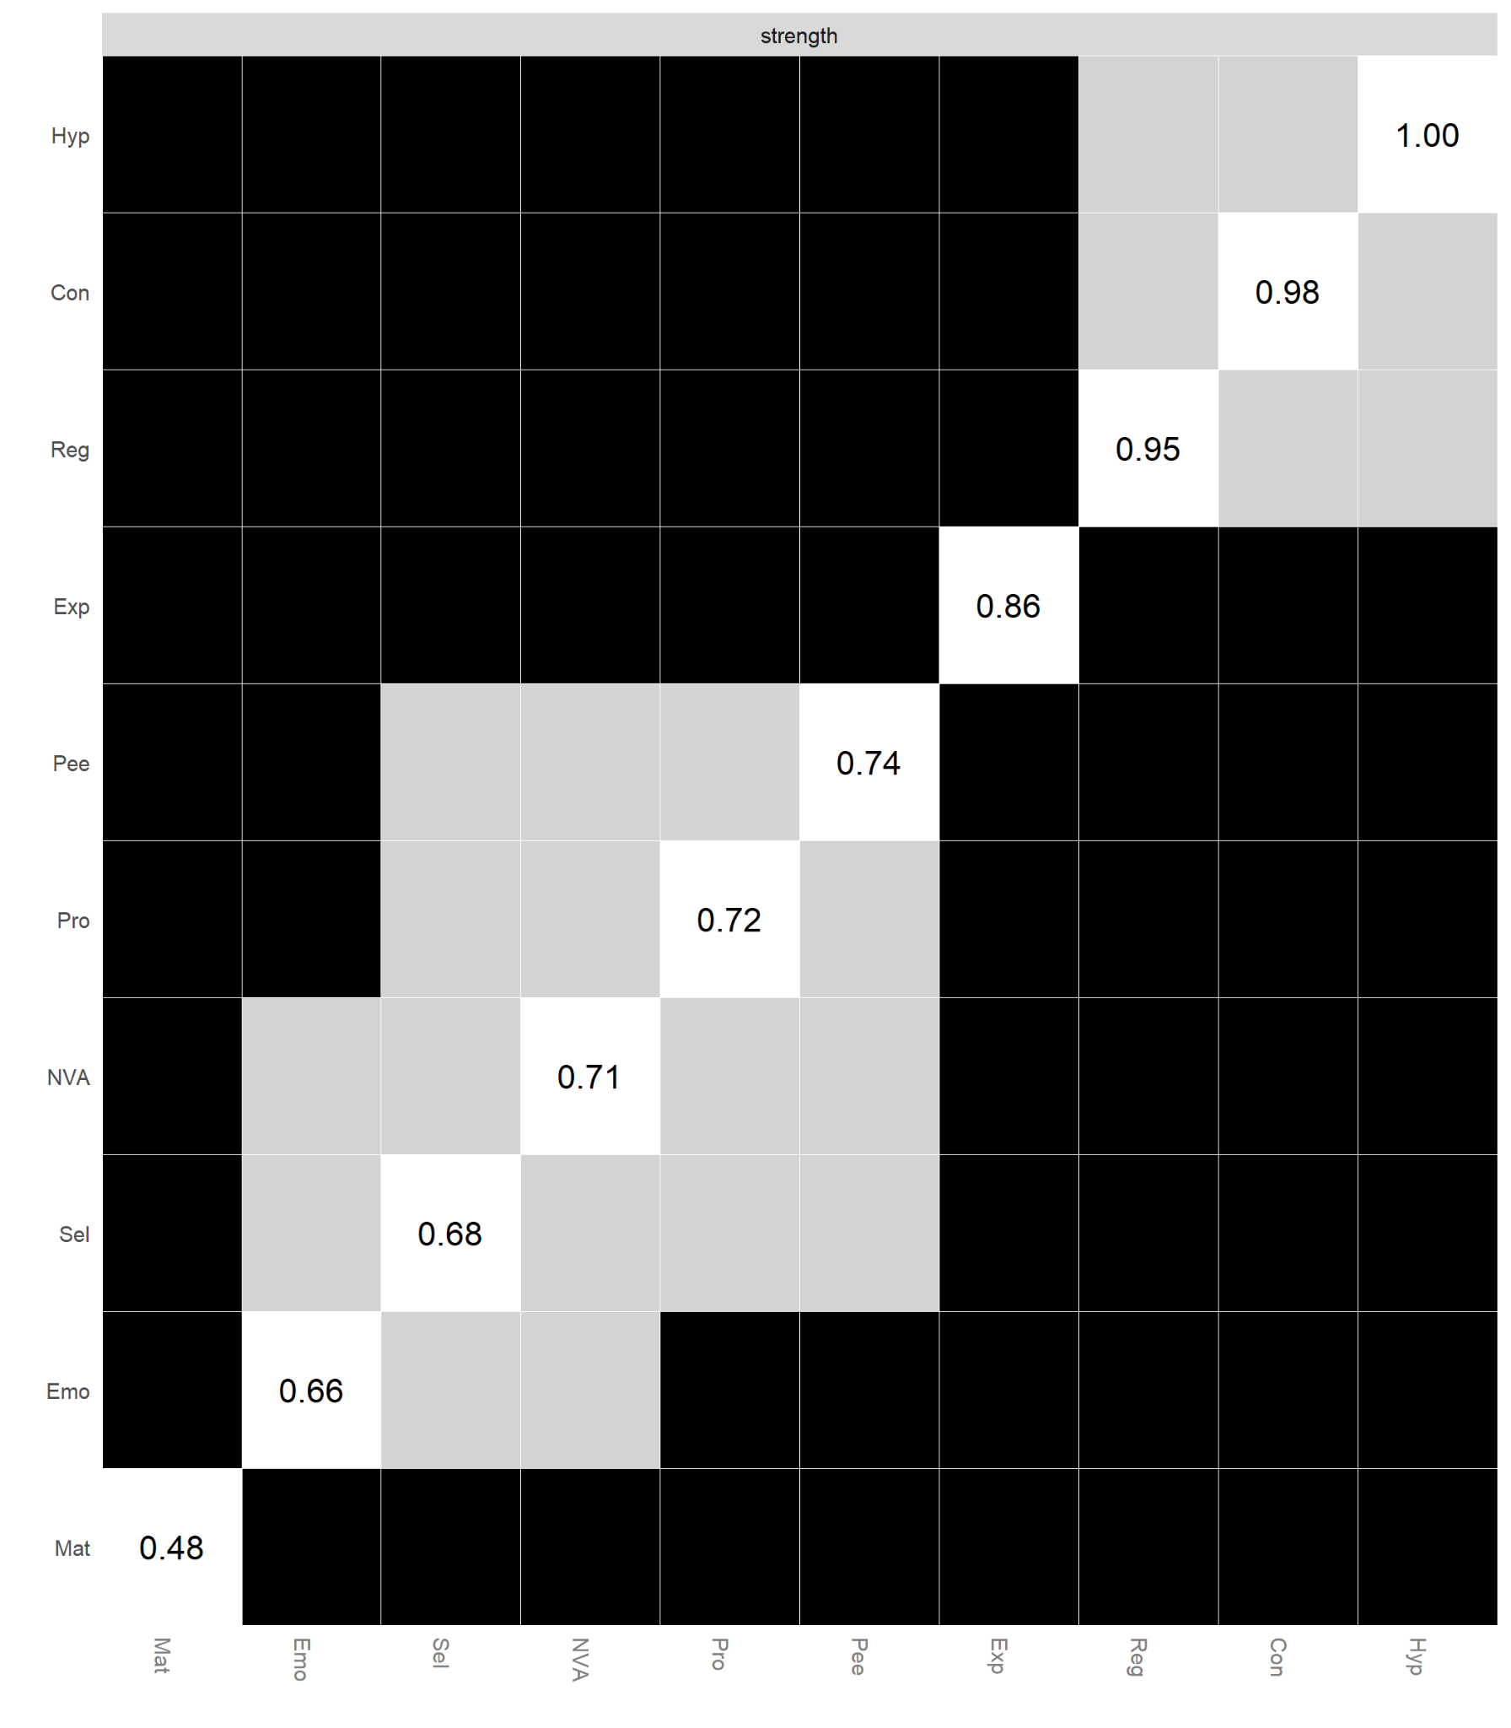
Note. Gray boxes represent edges (e.g., edges between node-1 and node-2 and edges between node-3 and node-4) that do not differ significantly from one-another and black boxes represent edges that do differ significantly. The numerical values in white boxes show node strength values.

Figure S7a
TEDS Early Childhood Edge-weight difference test
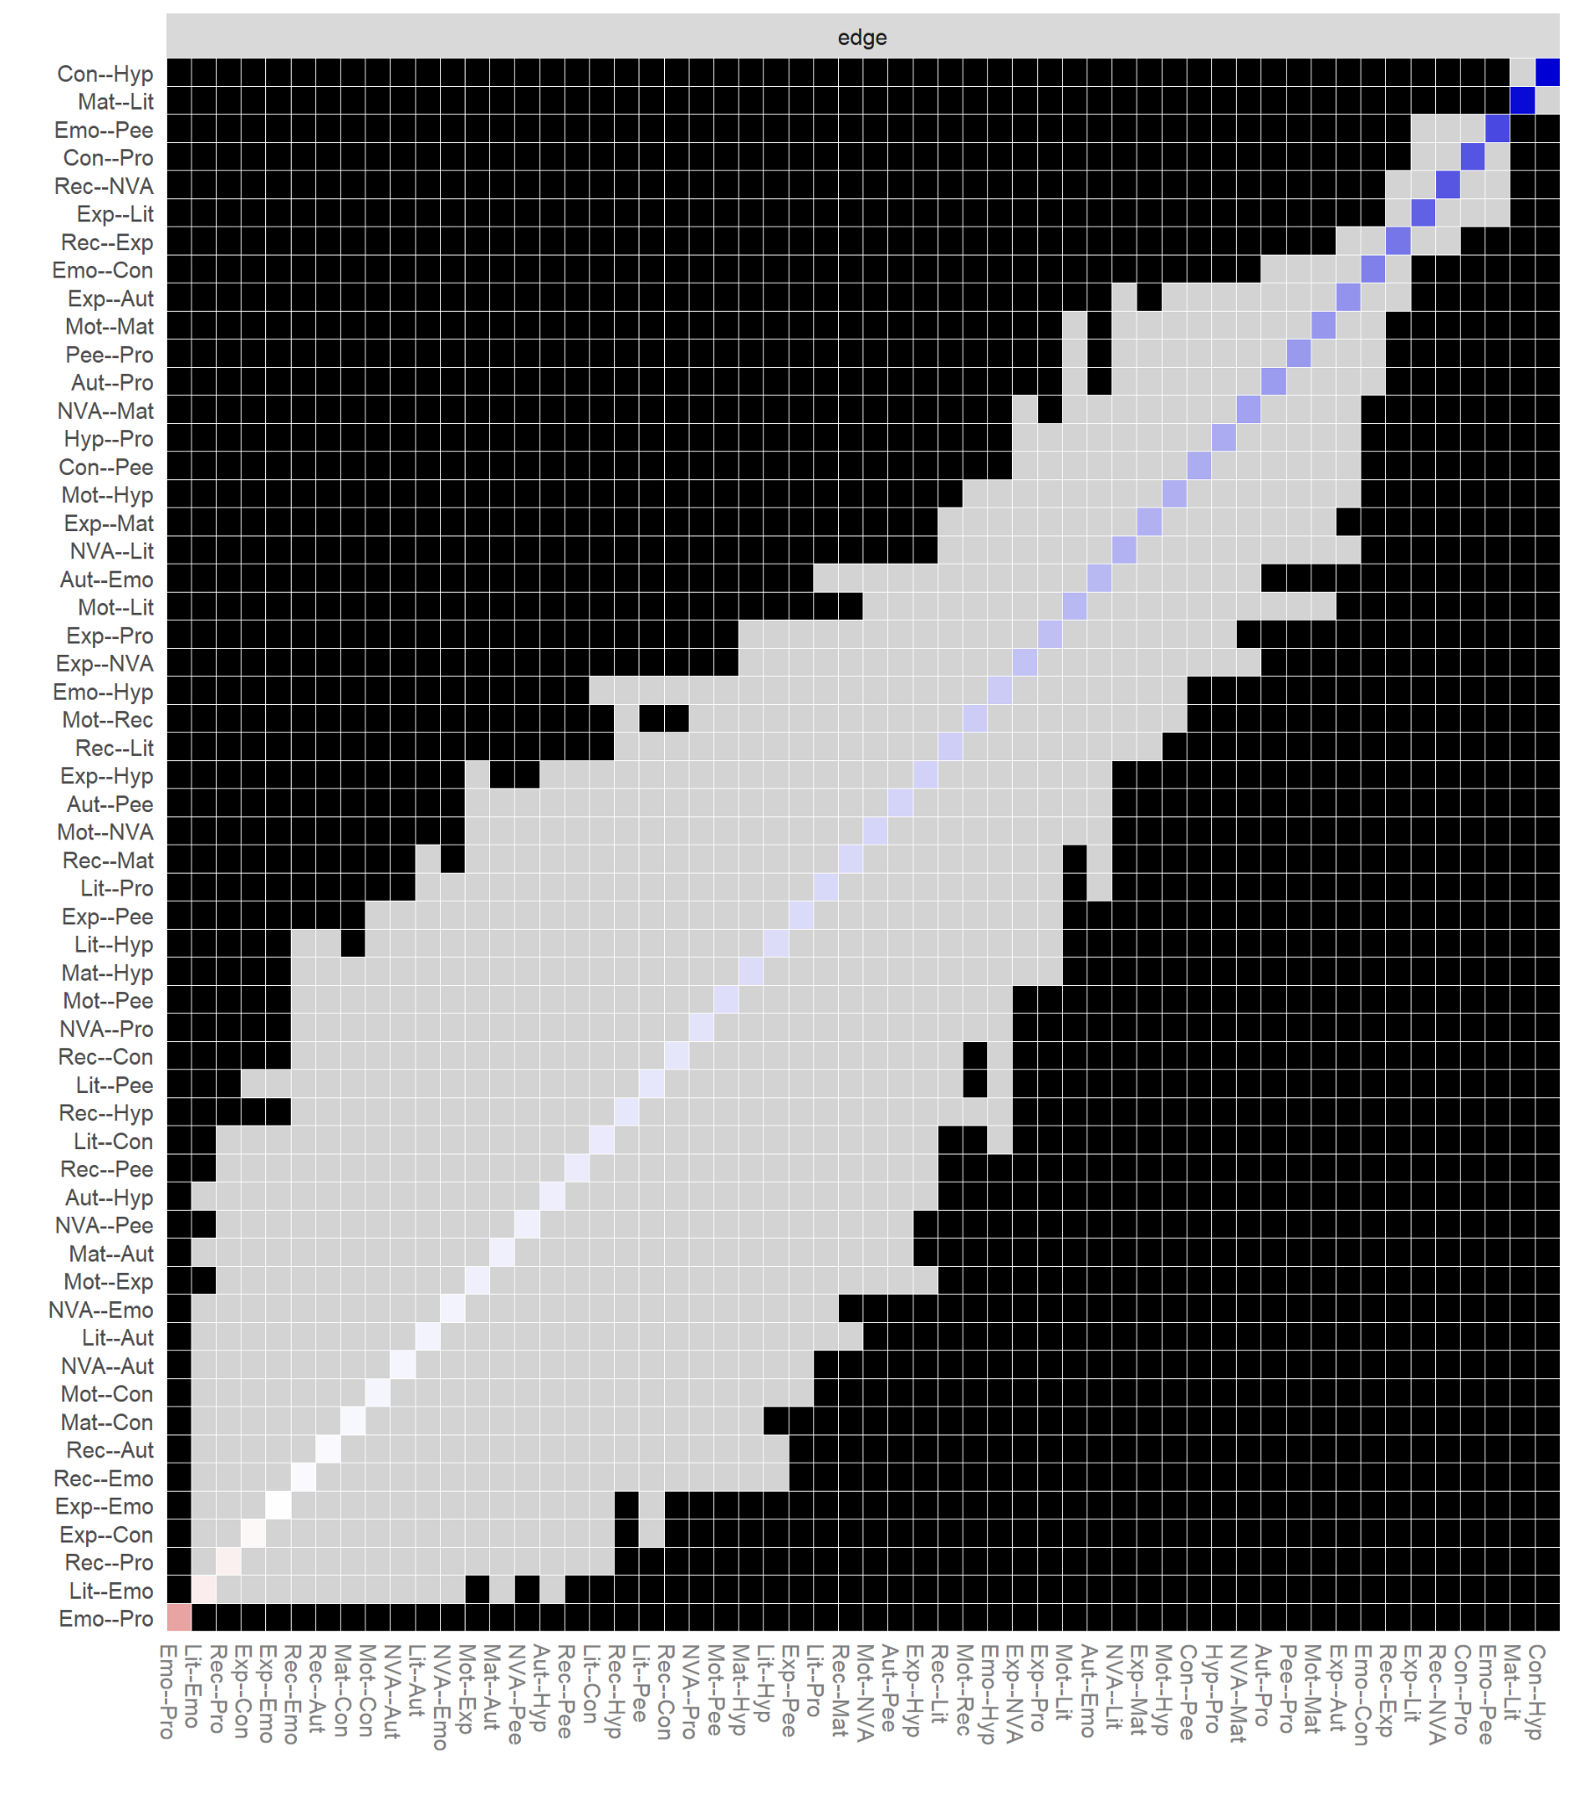
Note. Gray boxes represent edges (e.g., edges between node-1 and node-2 and edges between node-3 and node-4) that do not differ significantly from one-another and black boxes represent edges that do differ significantly. Colored boxes indicate the colour of the edge (i.e., blue coloured edges are positive, red coloured edges are spurious or negative).
Figure S7b
TEDS Early Childhood strength difference test
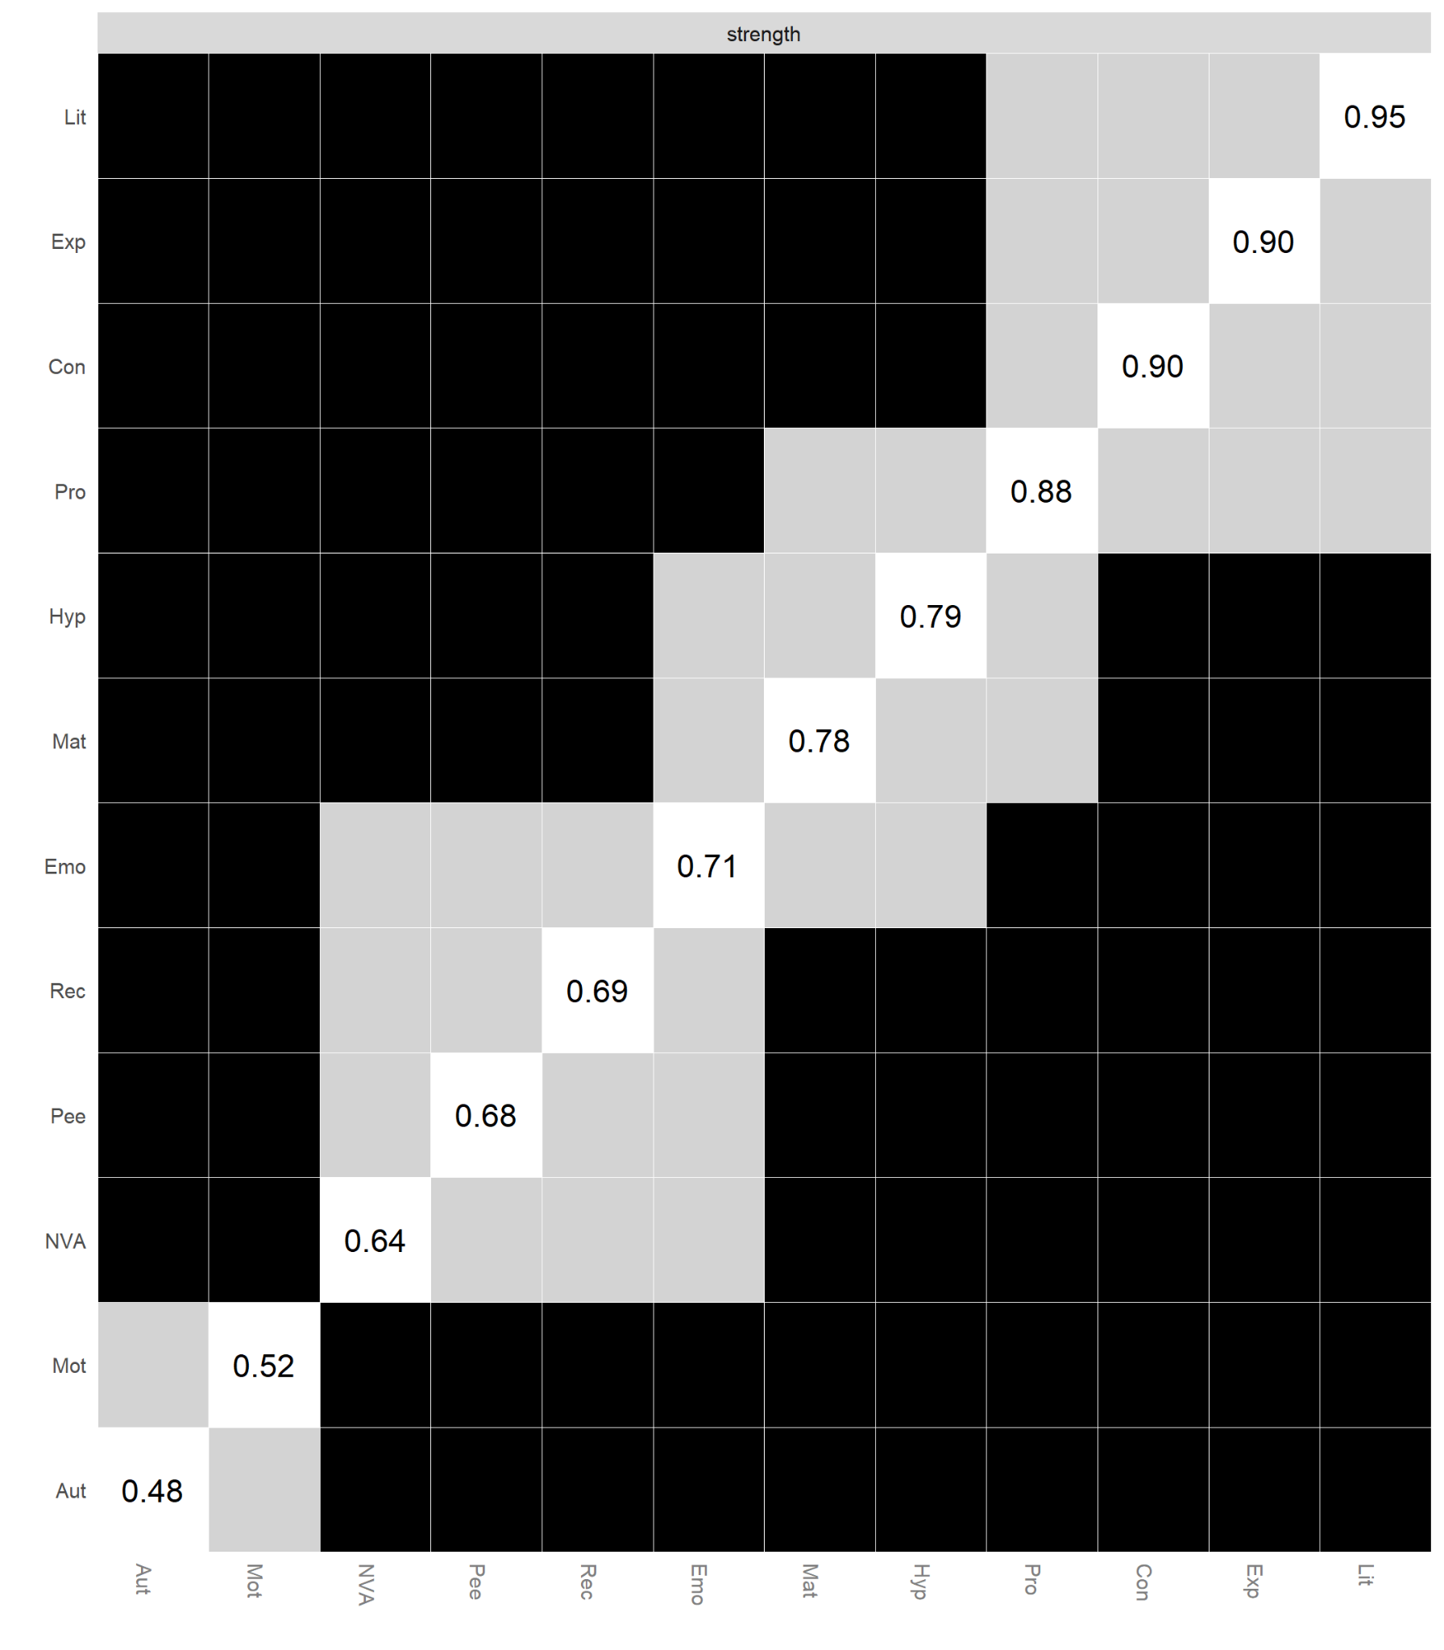
Note. Gray boxes represent edges (e.g., edges between node-1 and node-2 and edges between node-3 and node-4) that do not differ significantly from one-another and black boxes represent edges that do differ significantly. The numerical values in white boxes show node strength values.
Figure S8a
BCS Early Childhood Edge-weight difference test

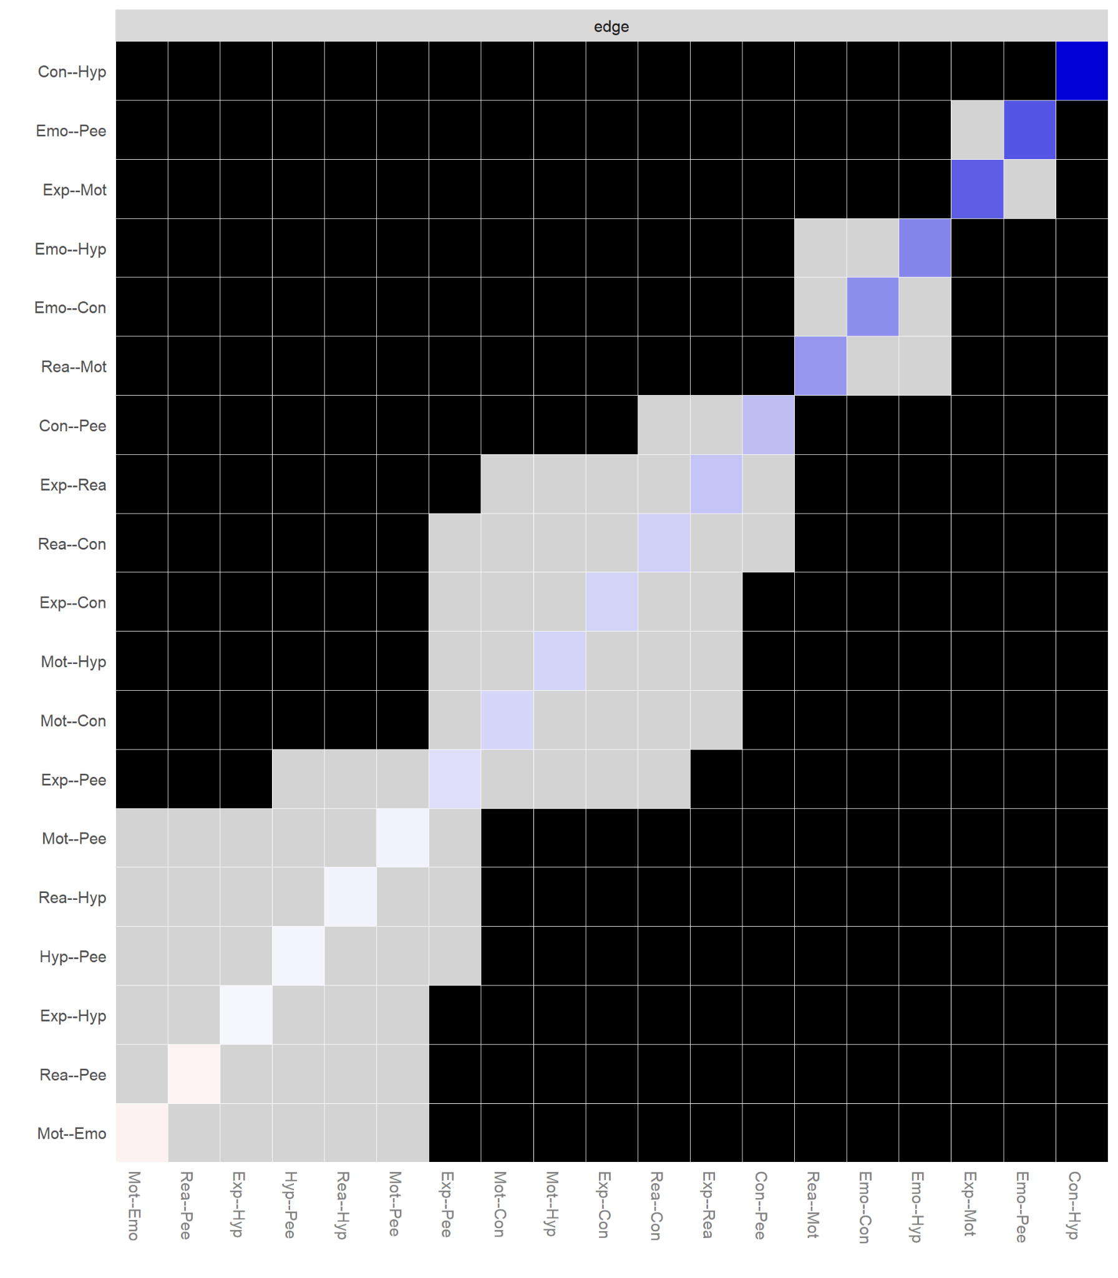
Note. Gray boxes represent edges (e.g., edges between node-1 and node-2 and edges between node-3 and node-4) that do not differ significantly from one-another and black boxes represent edges that do differ significantly. Colored boxes indicate the colour of the edge (i.e., blue coloured edges are positive, red coloured edges are spurious or negative).
Figure S8b
BCS Early Childhood strength difference test

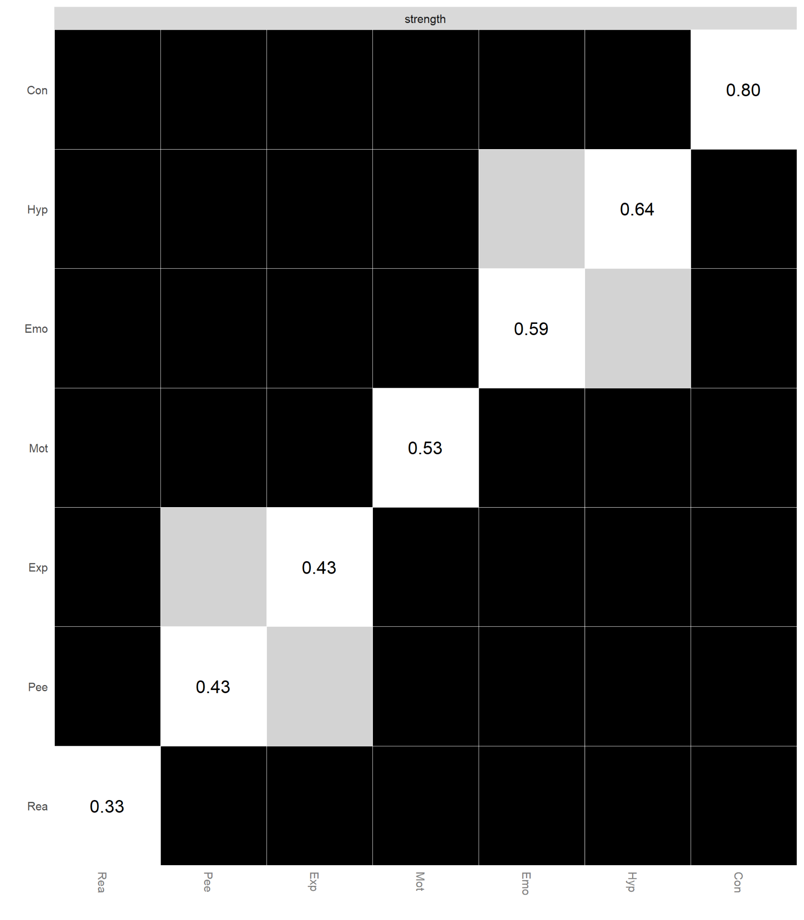
Note. Gray boxes represent edges (e.g., edges between node-1 and node-2 and edges between node-3 and node-4) that do not differ significantly from one-another and black boxes represent edges that do differ significantly. The numerical values in white boxes show node strength values.

Figure S9a
ALSPAC Middle Childhood Edge-weight difference test
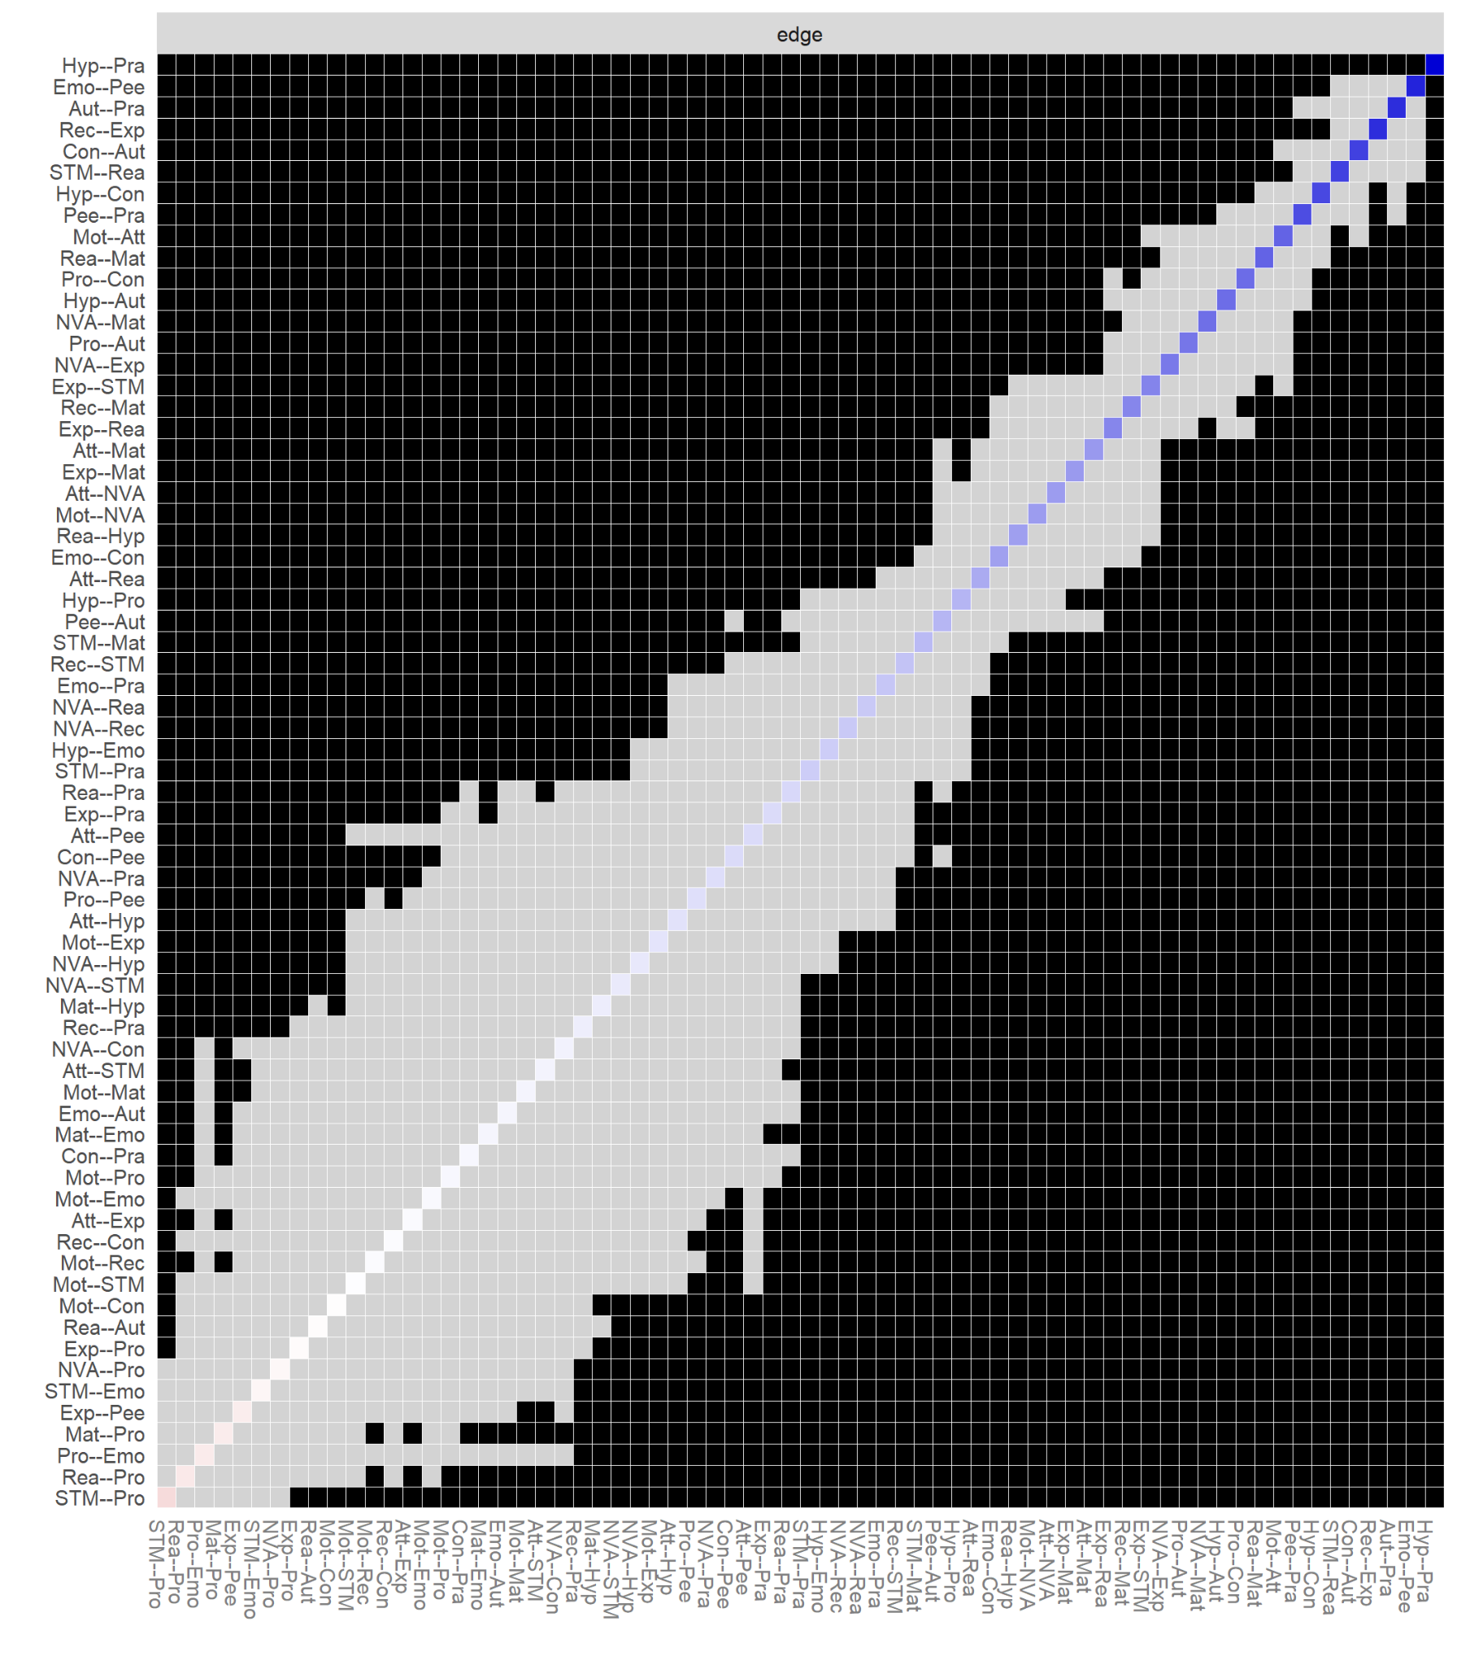
Note. Gray boxes represent edges (e.g., edges between node-1 and node-2 and edges between node-3 and node-4) that do not differ significantly from one-another and black boxes represent edges that do differ significantly. Colored boxes indicate the colour of the edge (i.e., blue coloured edges are positive, red coloured edges are spurious or negative).

Figure S9b
ALSPAC Middle Childhood strength difference test

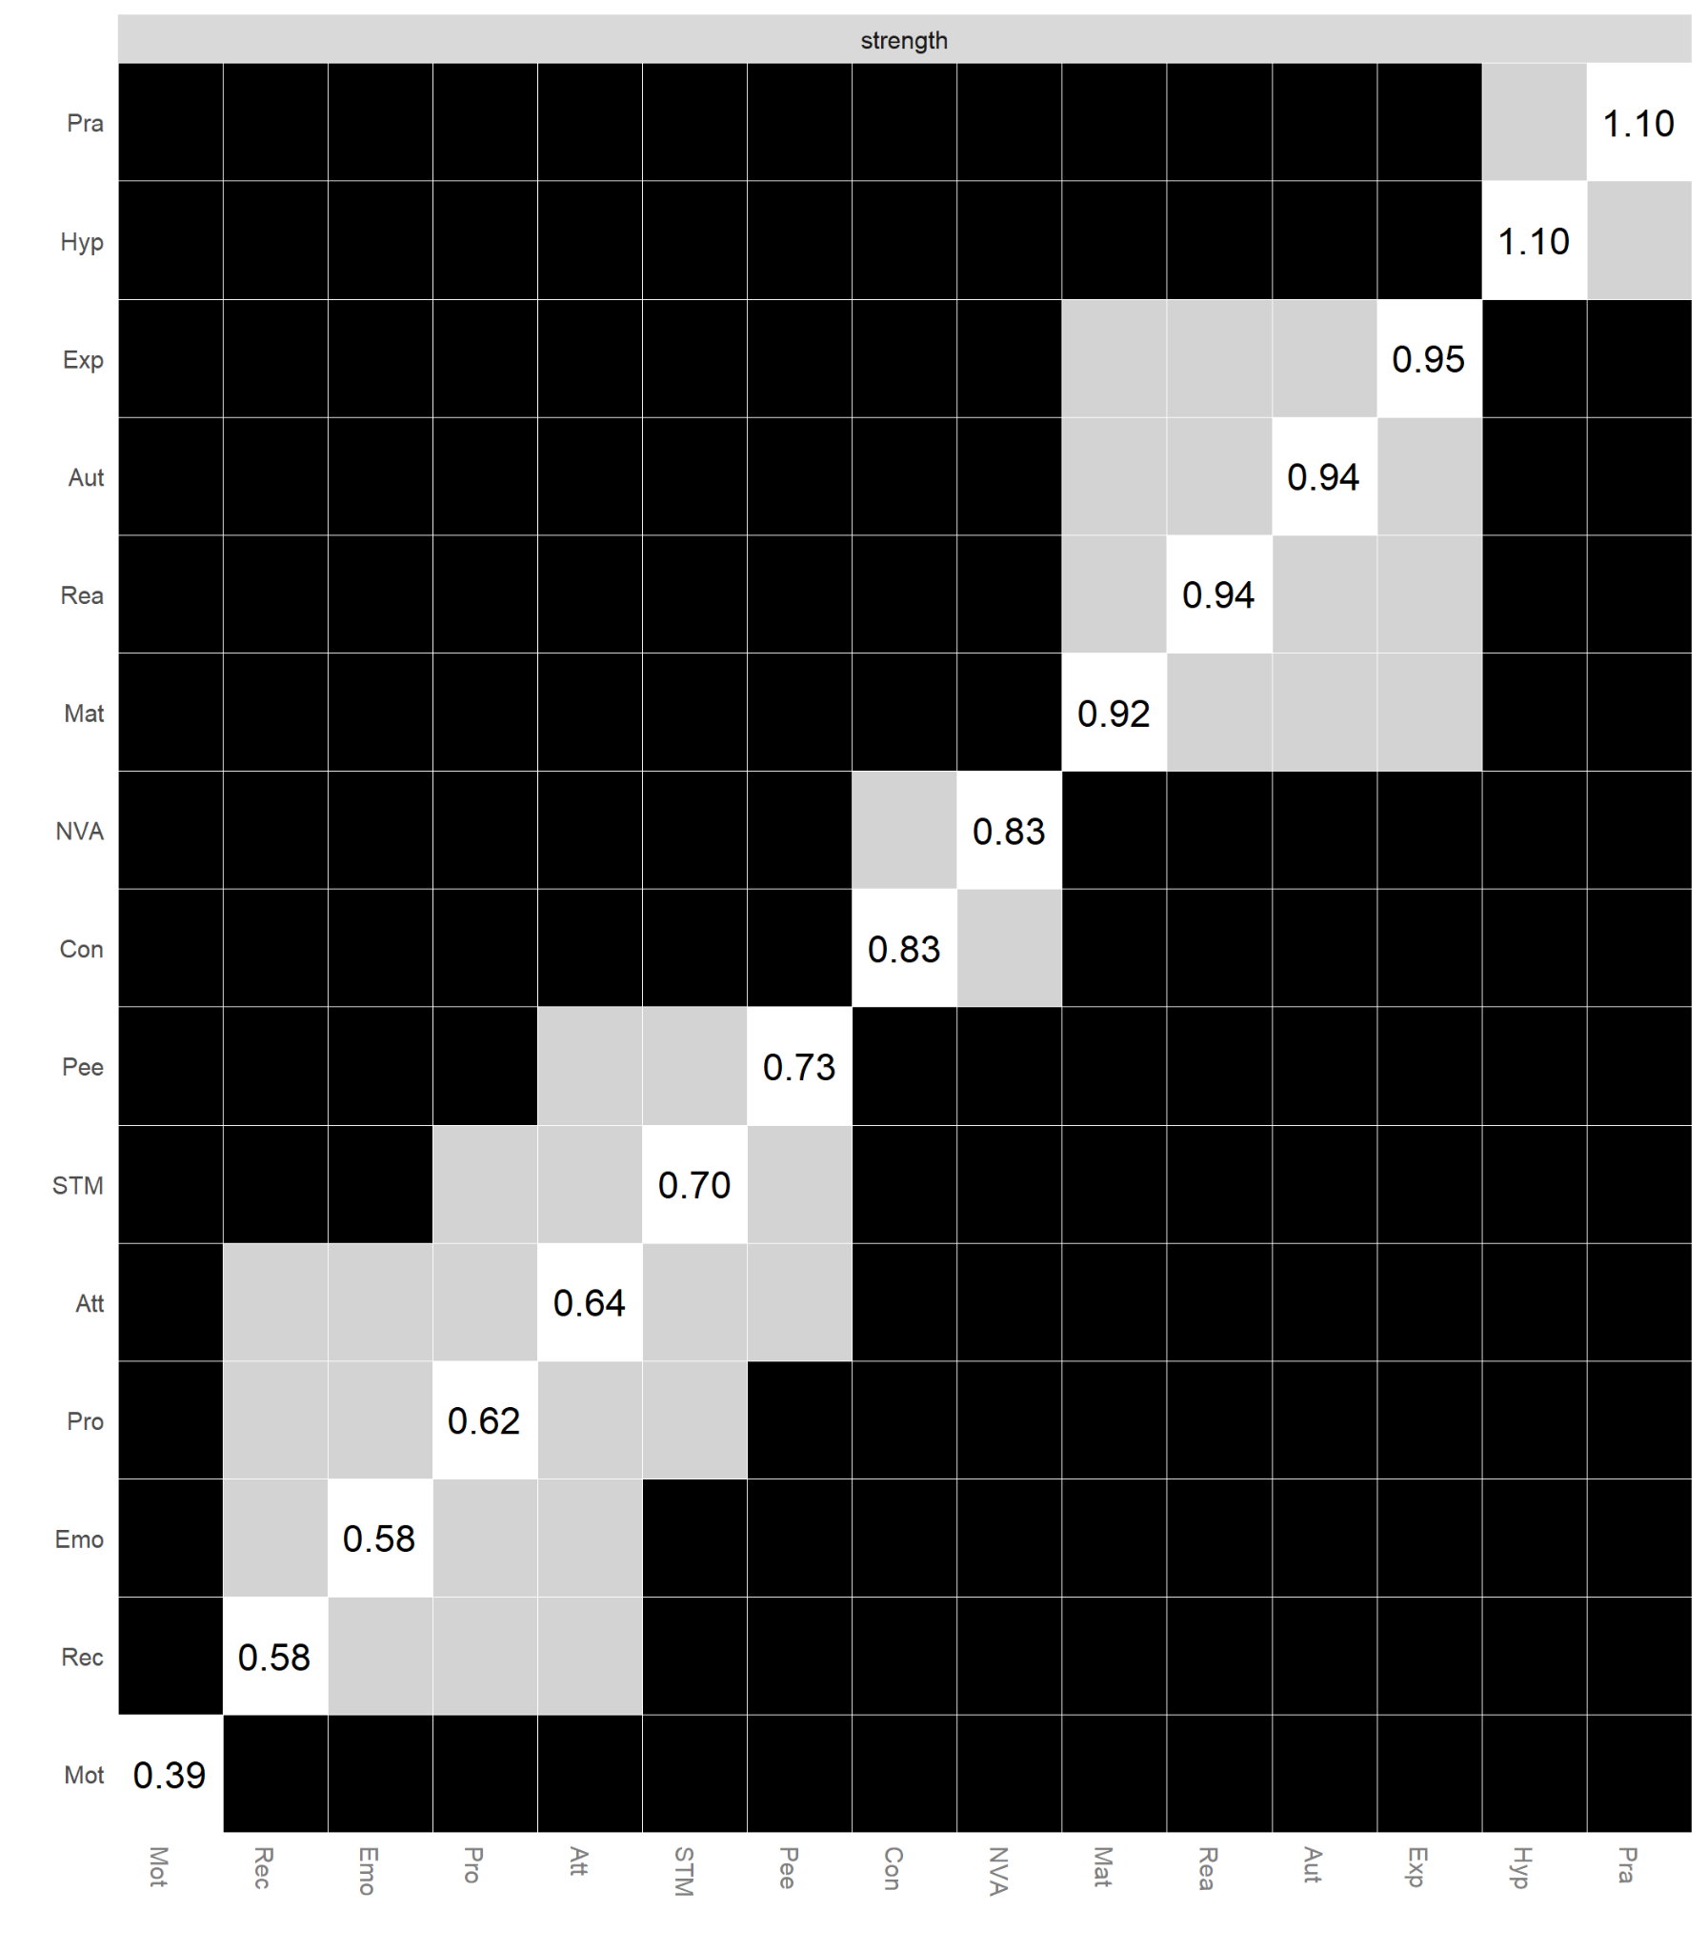
Note. Gray boxes represent edges (e.g., edges between node-1 and node-2 and edges between node-3 and node-4) that do not differ significantly from one-another and black boxes represent edges that do differ significantly. The numerical values in white boxes show node strength values.
Figure S10a
MCS Middle Childhood Edge-weight difference test
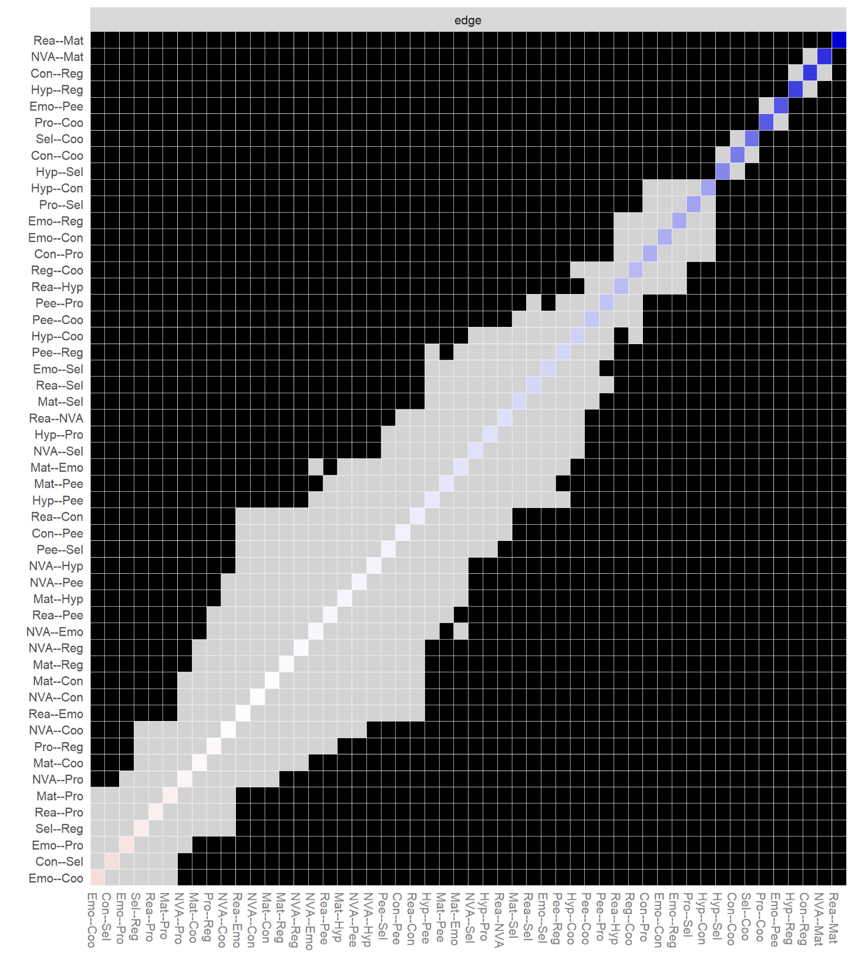
Note. Gray boxes represent edges (e.g., edges between node-1 and node-2 and edges between node-3 and node-4) that do not differ significantly from one-another and black boxes represent edges that do differ significantly. Colored boxes indicate the colour of the edge (i.e., blue coloured edges are positive, red coloured edges are spurious or negative).

Figure S10b
MCS Middle Childhood strength difference test
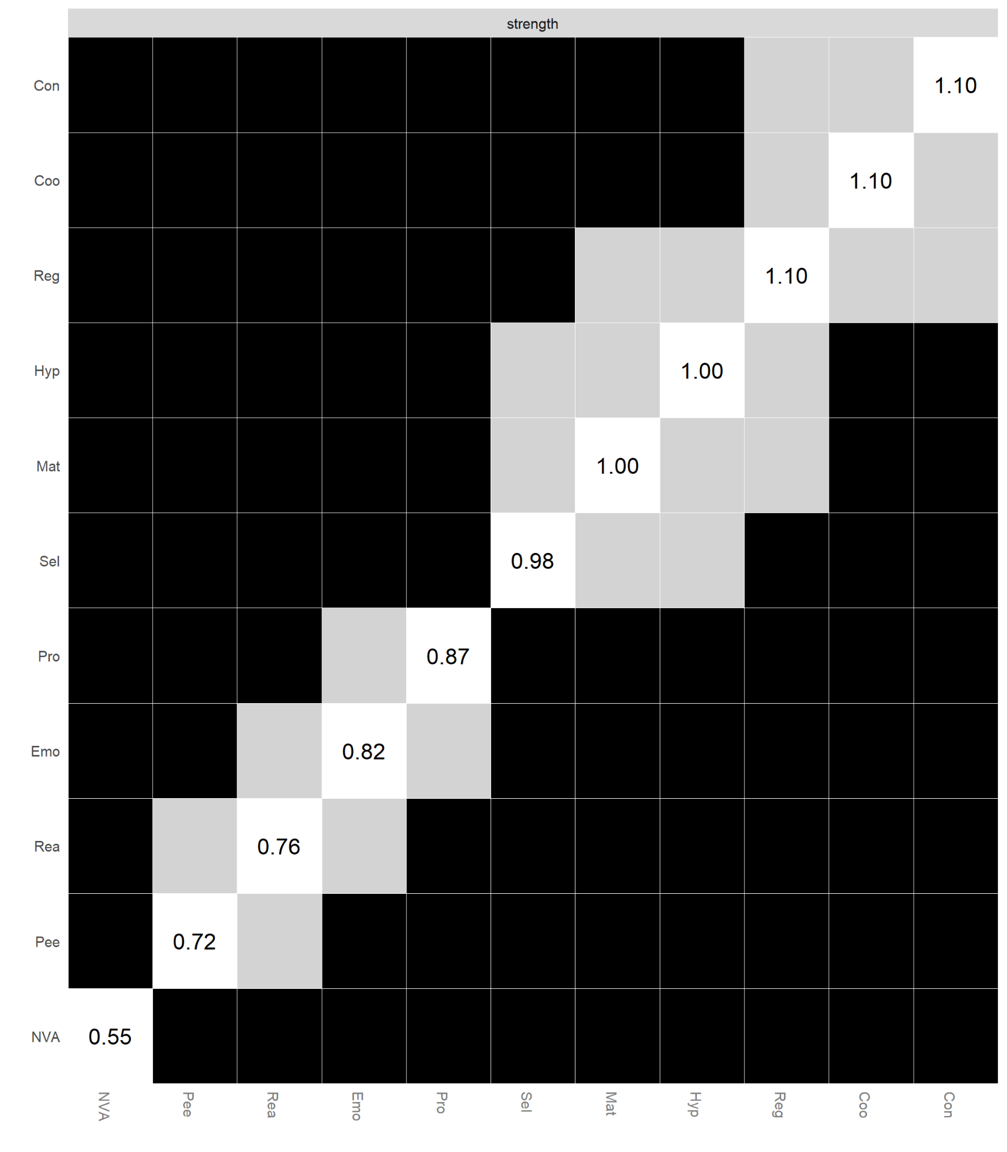
Note. Gray boxes represent edges (e.g., edges between node-1 and node-2 and edges between node-3 and node-4) that do not differ significantly from one-another and black boxes represent edges that do differ significantly. The numerical values in white boxes show node strength values.

Figure S11a
TEDS Middle Childhood Edge-weight difference test
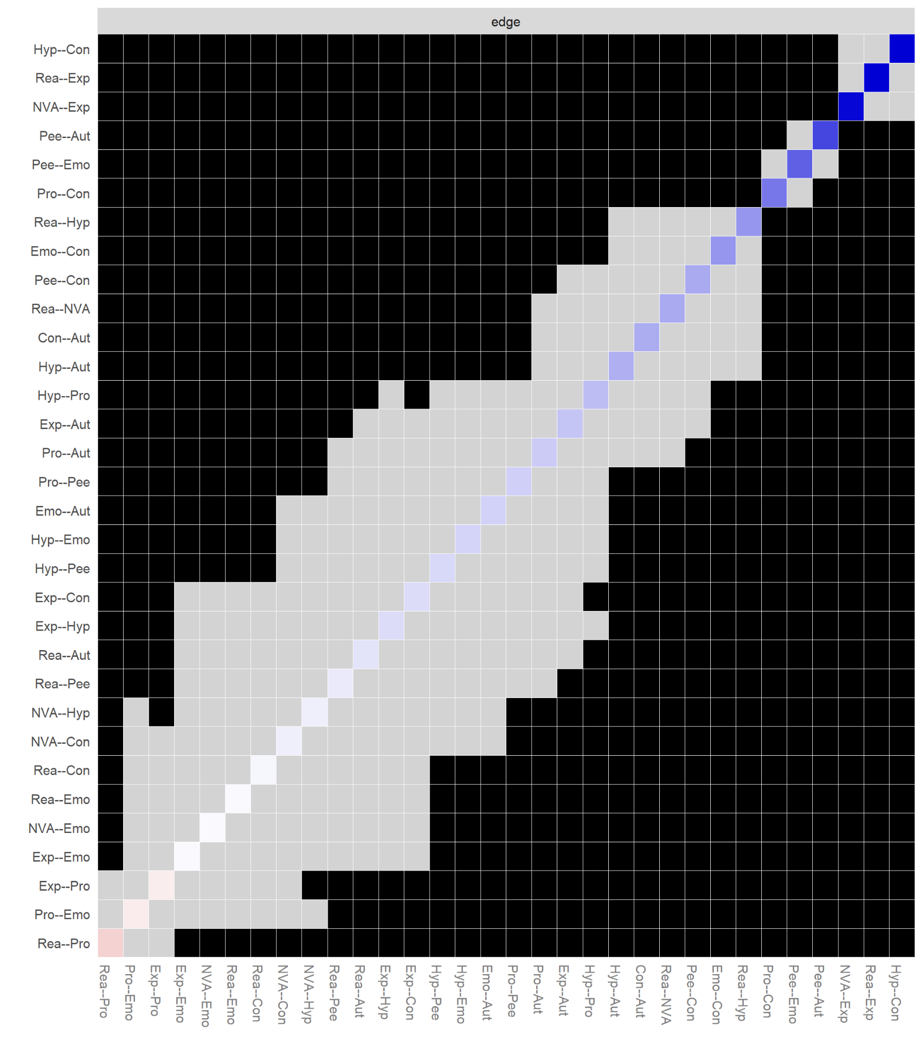
Note. Gray boxes represent edges (e.g., edges between node-1 and node-2 and edges between node-3 and node-4) that do not differ significantly from one-another and black boxes represent edges that do differ significantly. Colored boxes indicate the colour of the edge (i.e., blue coloured edges are positive, red coloured edges are spurious or negative).

Figure S11b
TEDS Middle Childhood strength difference test
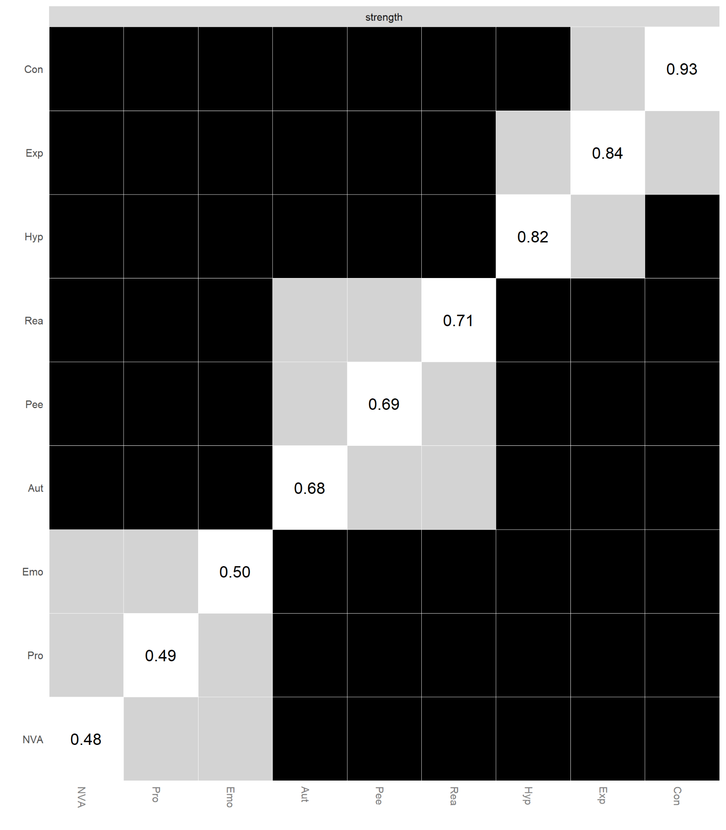
Note. Gray boxes represent edges (e.g., edges between node-1 and node-2 and edges between node-3 and node-4) that do not differ significantly from one-another and black boxes represent edges that do differ significantly. The numerical values in white boxes show node strength values.
Figure S12a
BCS Middle Childhood Edge-weight difference test

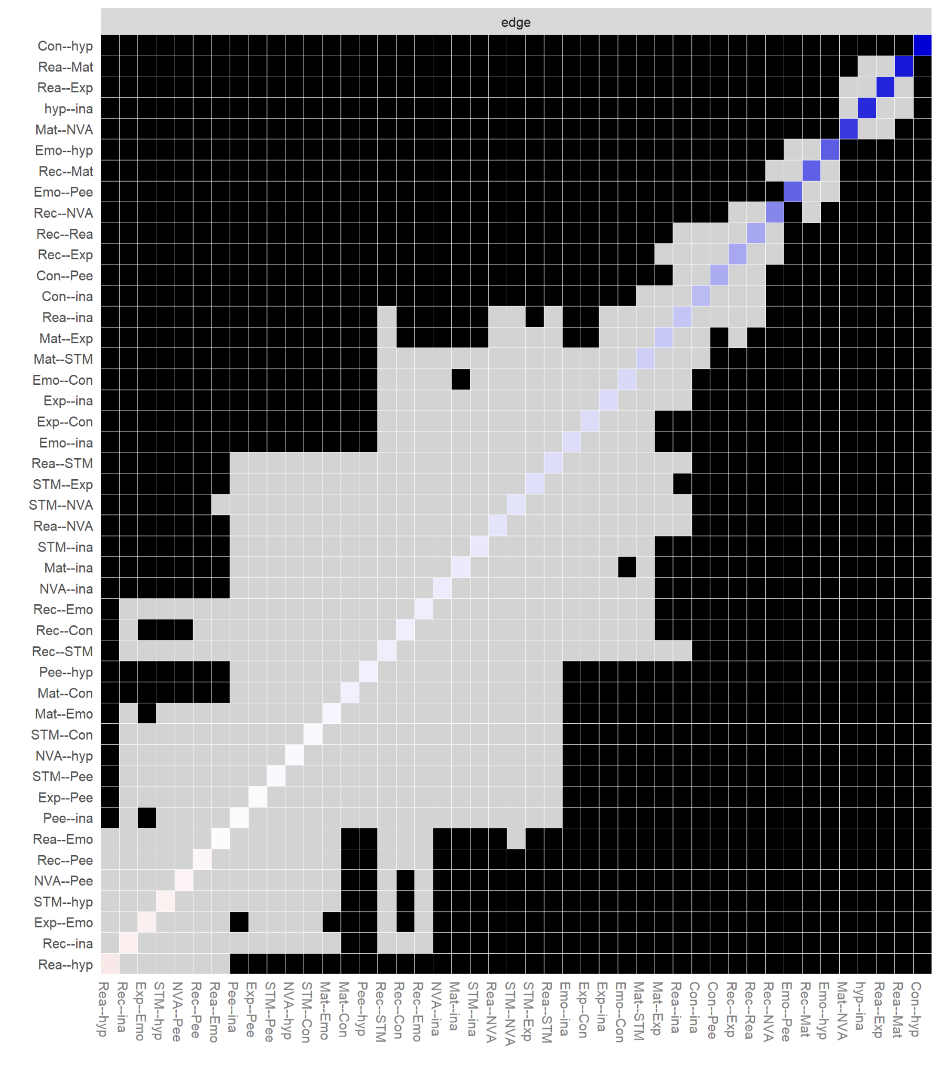
Note. Gray boxes represent edges (e.g., edges between node-1 and node-2 and edges between node-3 and node-4) that do not differ significantly from one-another and black boxes represent edges that do differ significantly. Colored boxes indicate the colour of the edge (i.e., blue coloured edges are positive, red coloured edges are spurious or negative).
Figure S12b
BCS Middle Childhood strength difference test

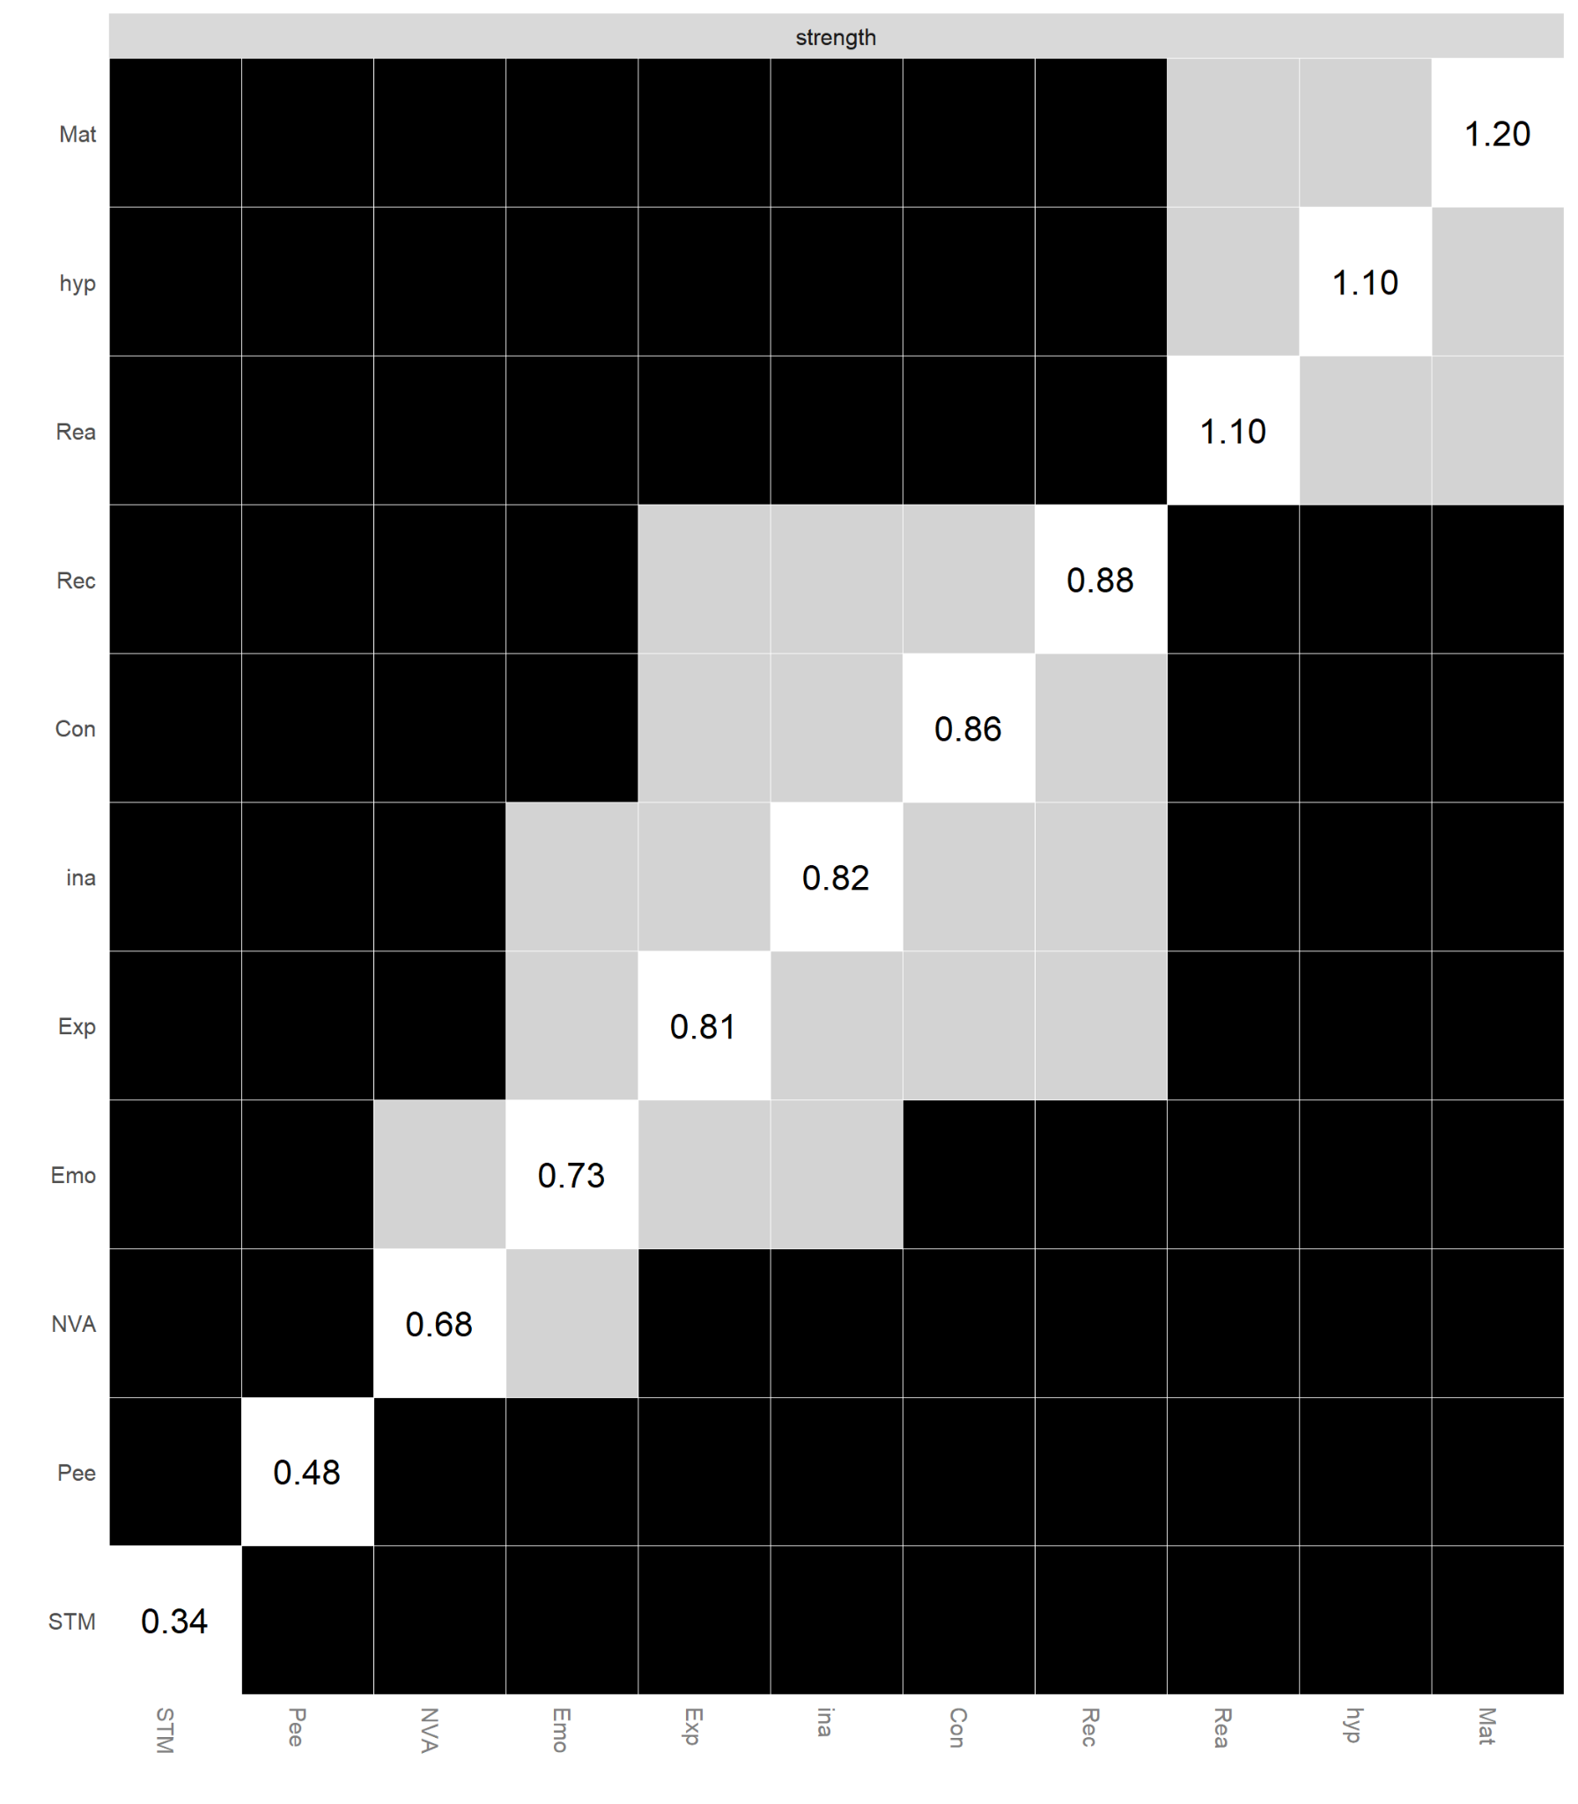
Note. Gray boxes represent edges (e.g., edges between node-1 and node-2 and edges between node-3 and node-4) that do not differ significantly from one-another and black boxes represent edges that do differ significantly. The numerical values in white boxes show node strength values.

Figure S13a
ALSPAC Adolescence Edge-weight difference test

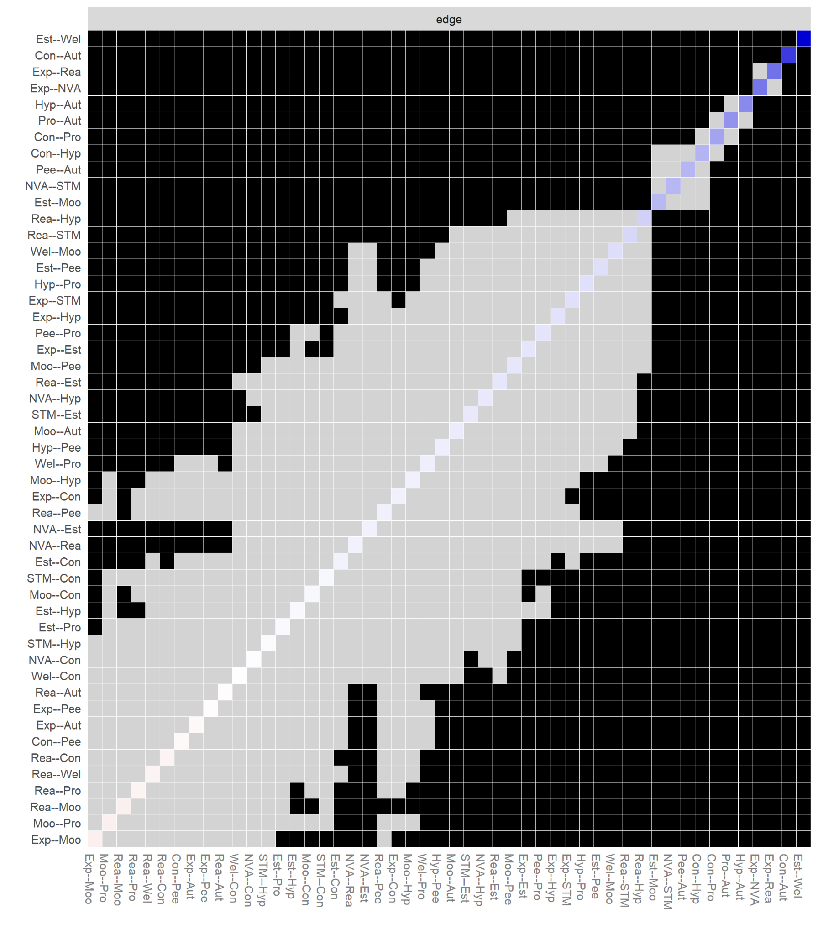
Note. Gray boxes represent edges (e.g., edges between node-1 and node-2 and edges between node-3 and node-4) that do not differ significantly from one-another and black boxes represent edges that do differ significantly. Colored boxes indicate the colour of the edge (i.e., blue coloured edges are positive, red coloured edges are spurious or negative).
Figure S13b
ALSPAC Adolescence strength difference test
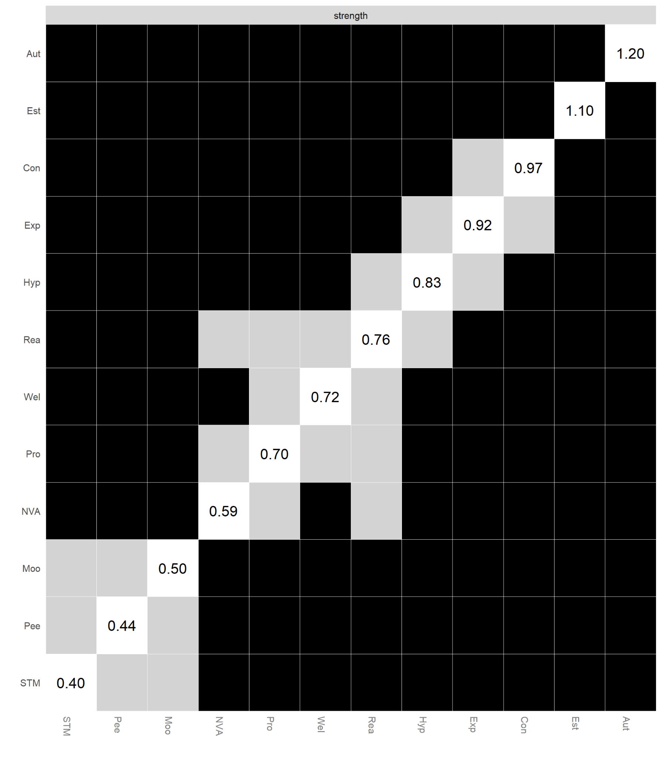
Note. Gray boxes represent edges (e.g., edges between node-1 and node-2 and edges between node-3 and node-4) that do not differ significantly from one-another and black boxes represent edges that do differ significantly. The numerical values in white boxes show node strength values.
Figure S14a
MCS Adolescence Edge-weight difference test
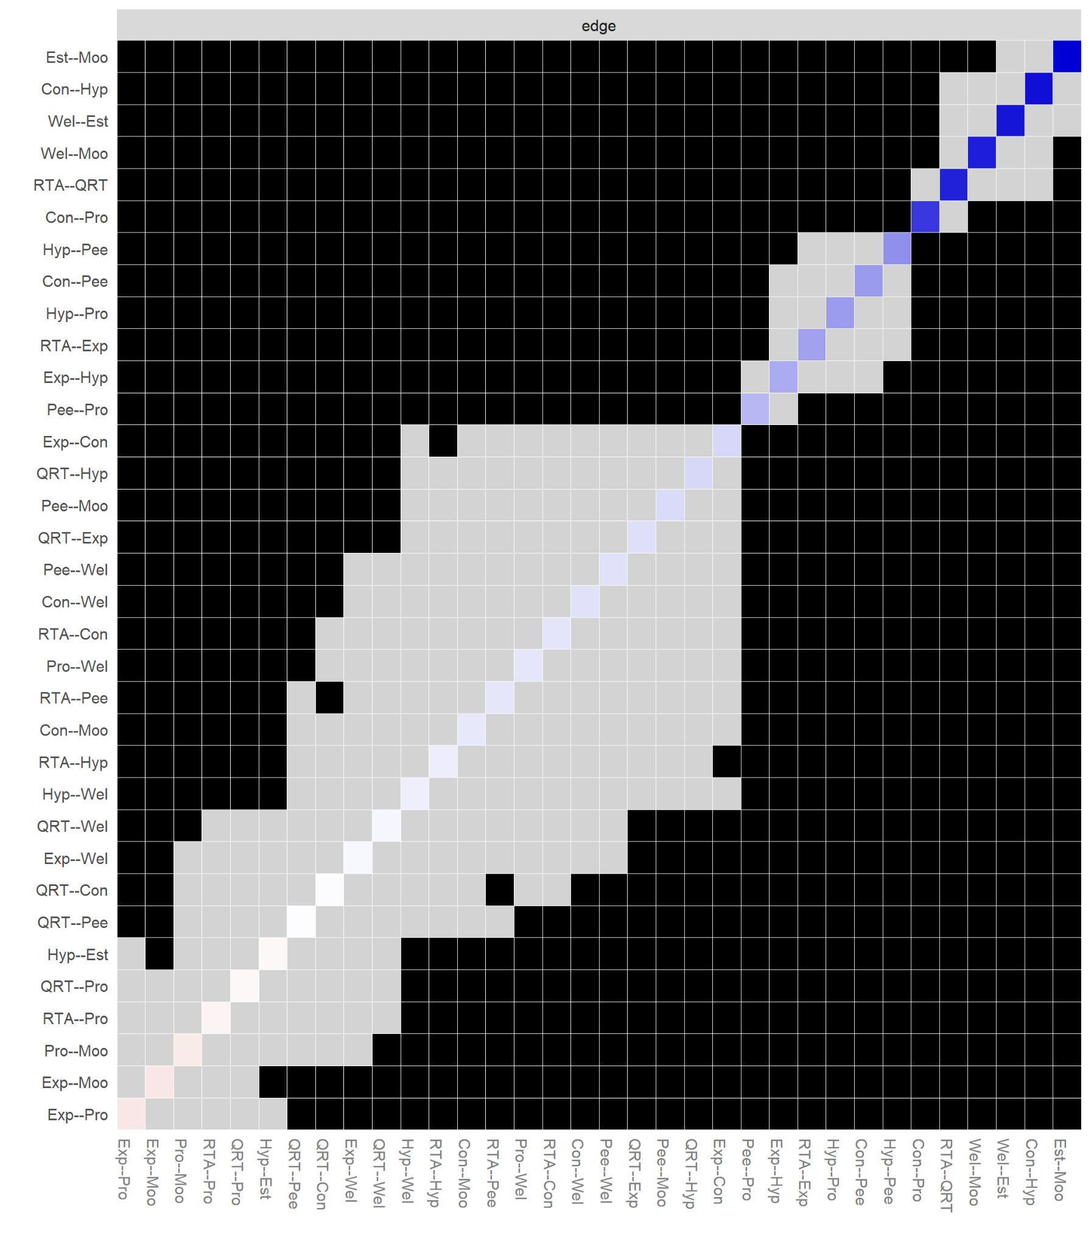
Note. Gray boxes represent edges (e.g., edges between node-1 and node-2 and edges between node-3 and node-4) that do not differ significantly from one-another and black boxes represent edges that do differ significantly. Colored boxes indicate the colour of the edge (i.e., blue coloured edges are positive, red coloured edges are spurious or negative).

Figure S14b
MCS Adolescence strength difference test
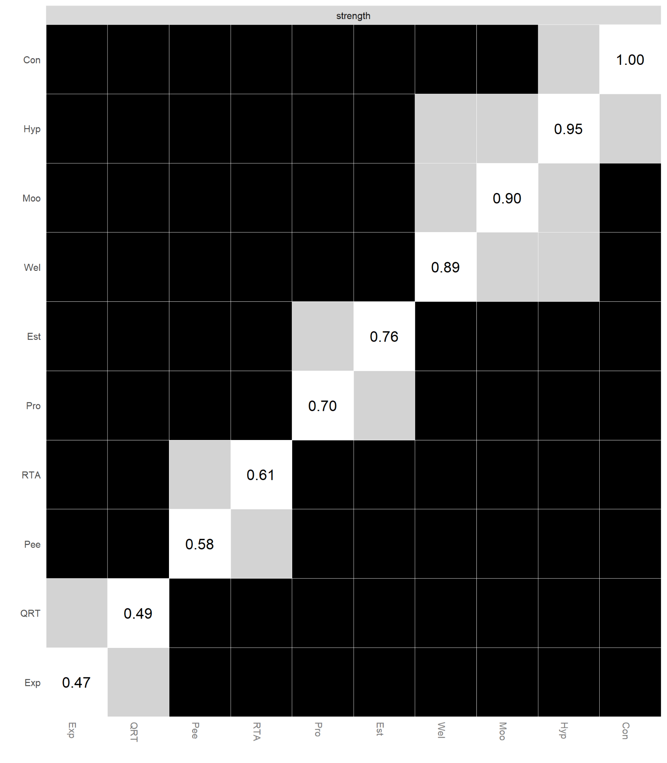
Note. Gray boxes represent edges (e.g., edges between node-1 and node-2 and edges between node-3 and node-4) that do not differ significantly from one-another and black boxes represent edges that do differ significantly. The numerical values in white boxes show node strength values.

Figure S15a
TEDS Adolescence Edge-weight difference test
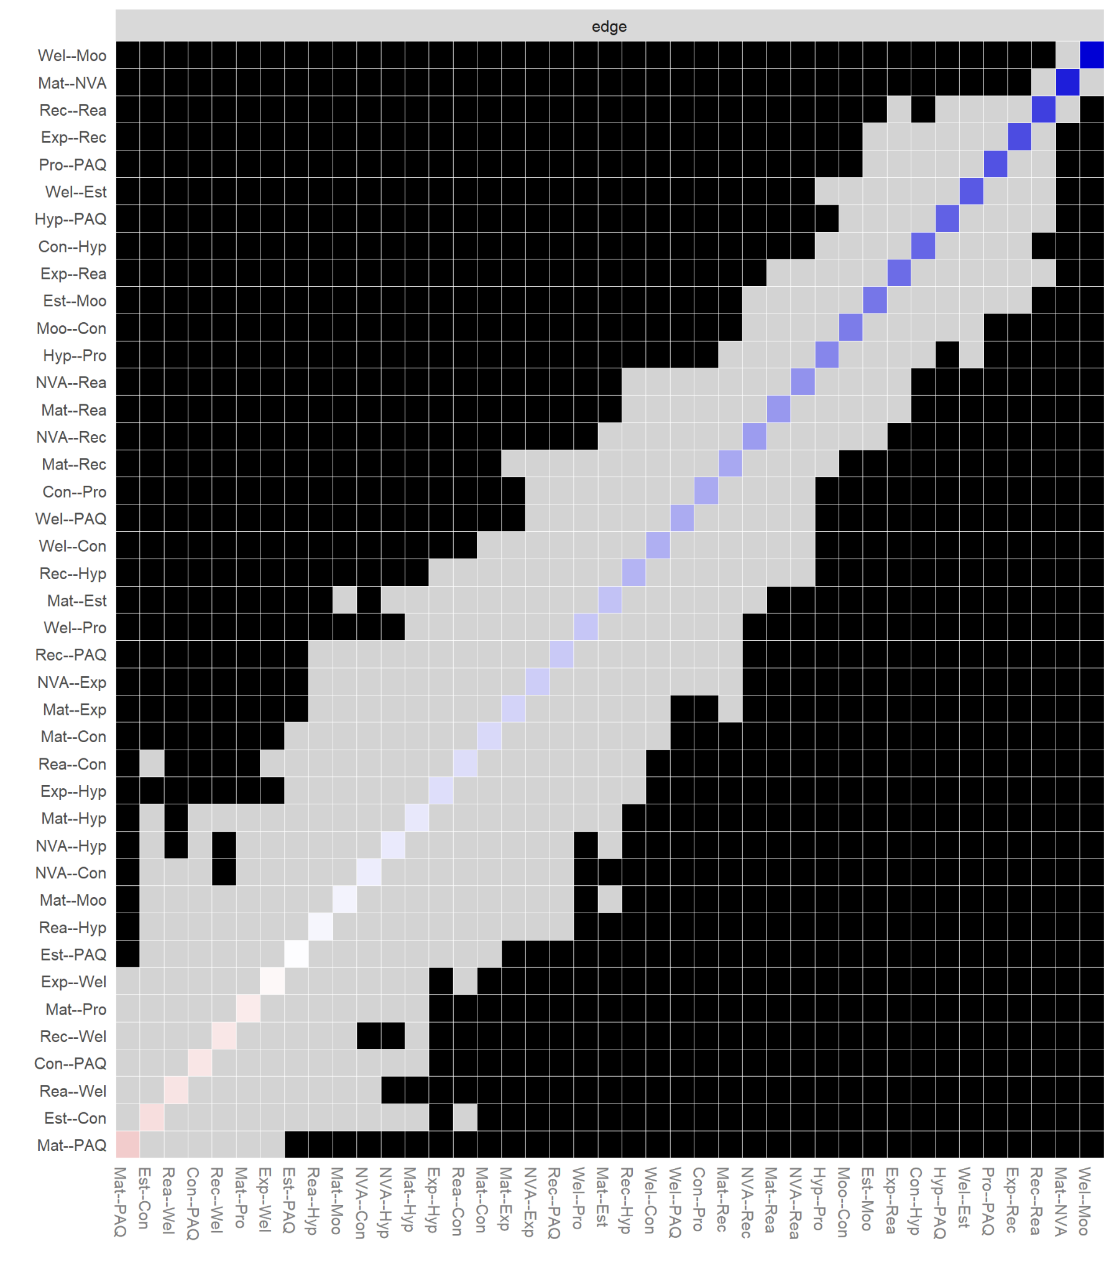
Note. Gray boxes represent edges (e.g., edges between node-1 and node-2 and edges between node-3 and node-4) that do not differ significantly from one-another and black boxes represent edges that do differ significantly. Colored boxes indicate the colour of the edge (i.e., blue coloured edges are positive, red coloured edges are spurious or negative).
Figure S15b
TEDS Adolescence strength difference test
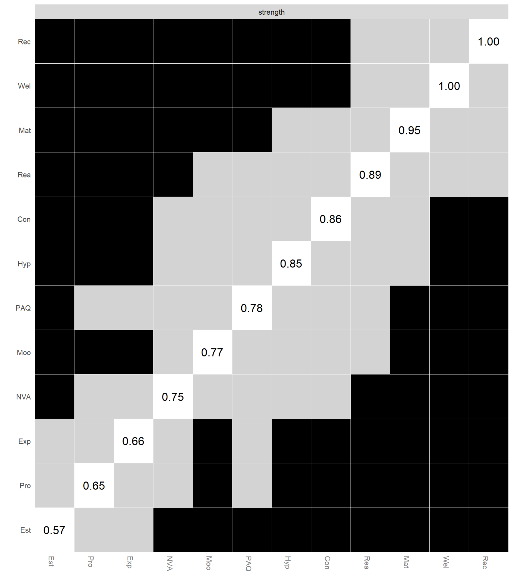
Note. Gray boxes represent edges (e.g., edges between node-1 and node-2 and edges between node-3 and node-4) that do not differ significantly from one-another and black boxes represent edges that do differ significantly. The numerical values in white boxes show node strength values.
Figure S16a
BCS Adolescence Edge-weight difference test
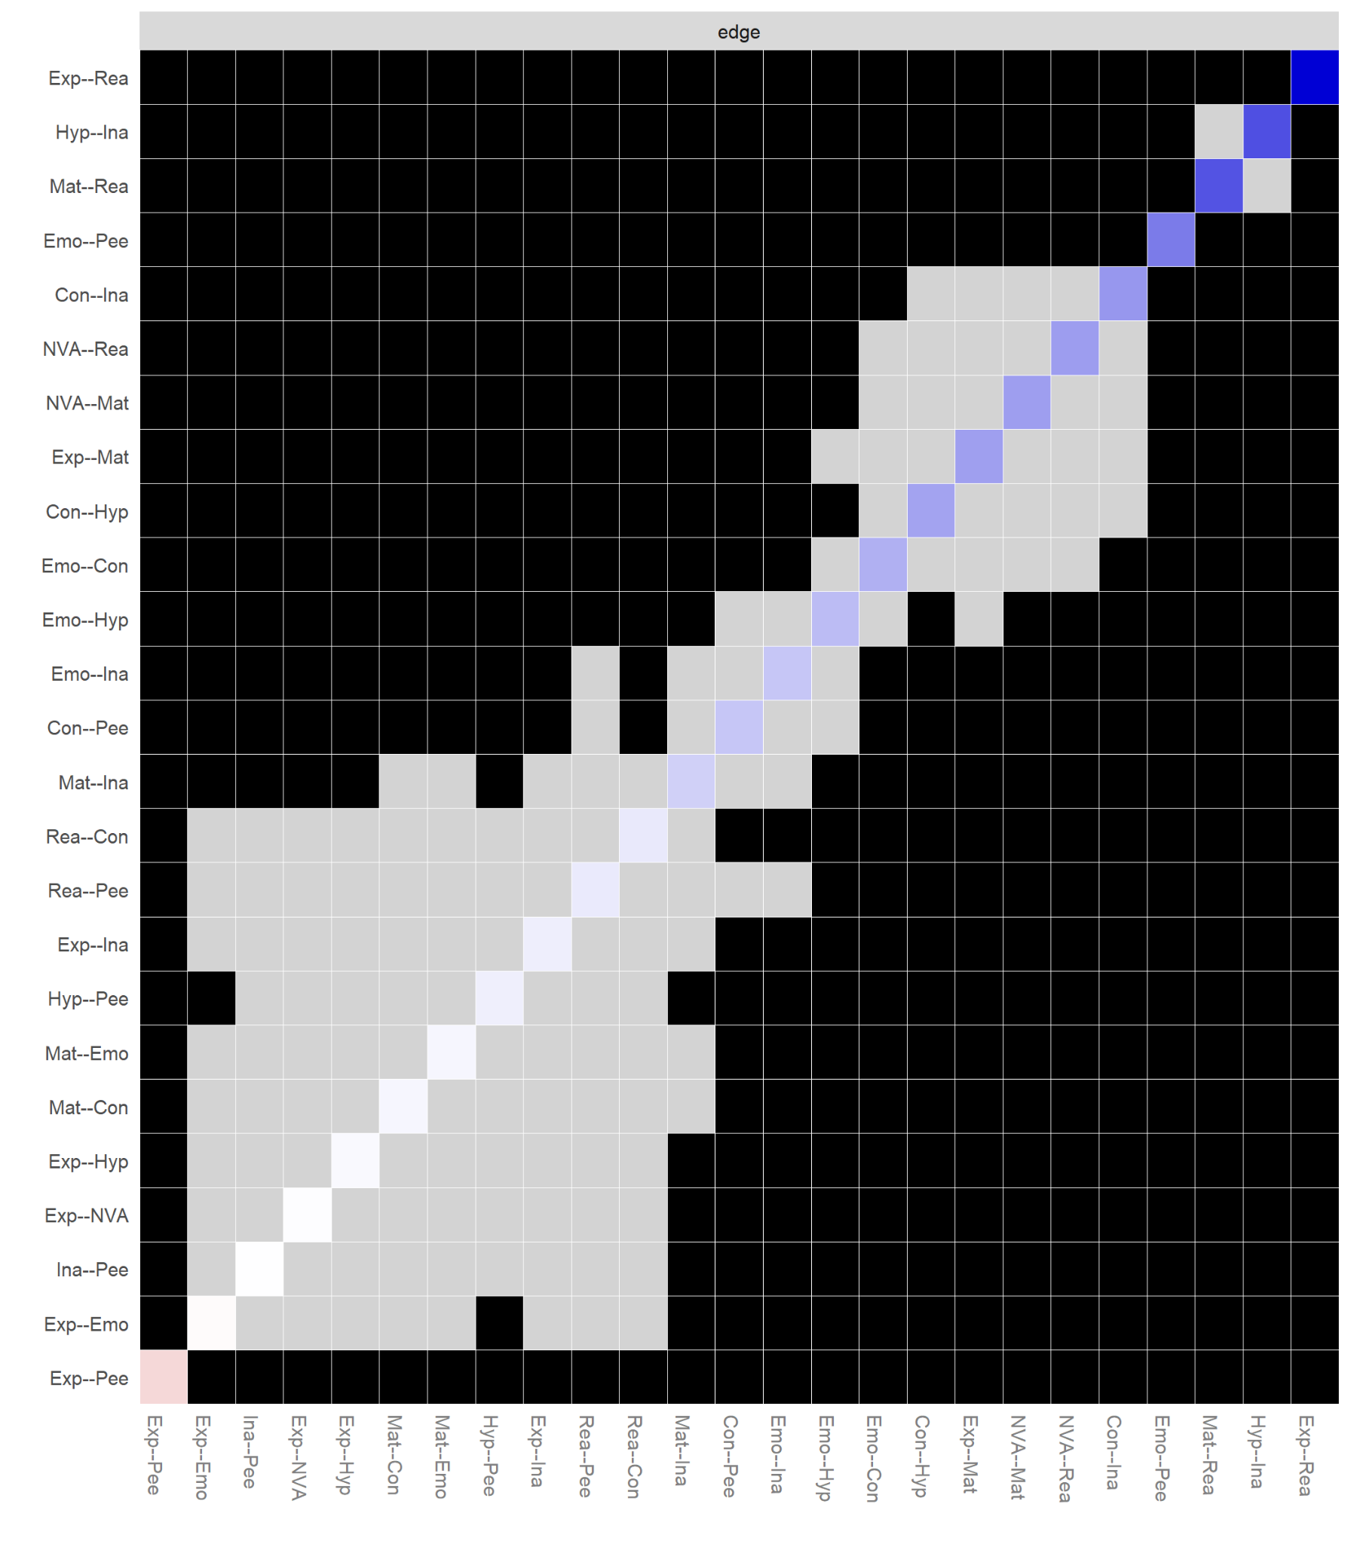
Note. Gray boxes represent edges (e.g., edges between node-1 and node-2 and edges between node-3 and node-4) that do not differ significantly from one-another and black boxes represent edges that do differ significantly. Colored boxes indicate the colour of the edge (i.e., blue coloured edges are positive, red coloured edges are spurious or negative).

Figure S16b
BCS Adolescence strength difference test
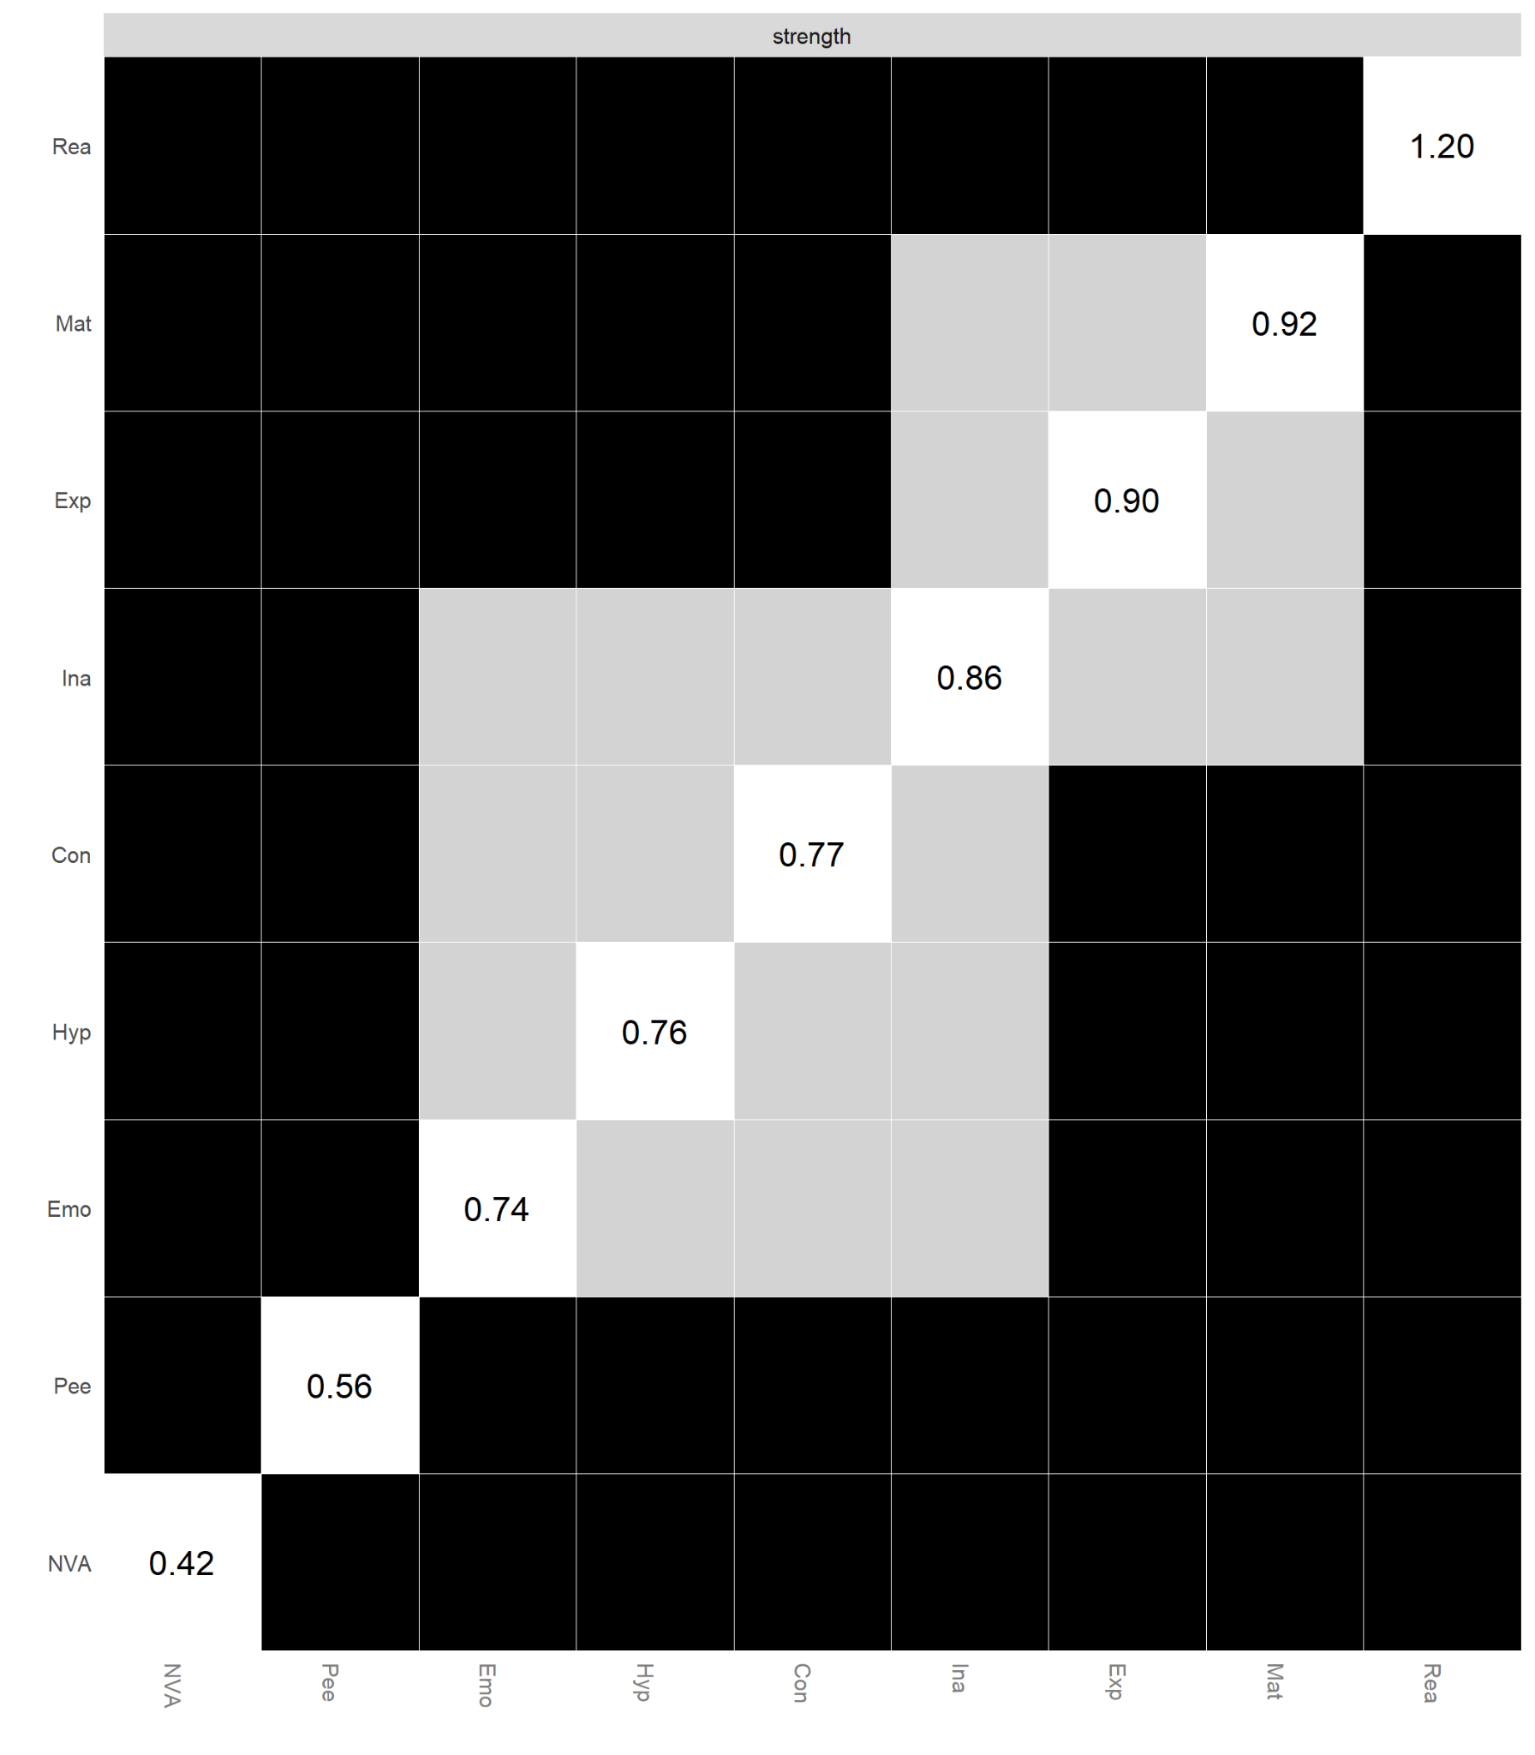
Note. Gray boxes represent edges (e.g., edges between node-1 and node-2 and edges between node-3 and node-4) that do not differ significantly from one-another and black boxes represent edges that do differ significantly. The numerical values in white boxes show node strength values.

Figure S17
Early Childhood Stability of Strength and Bridge Strength

ALSPAC  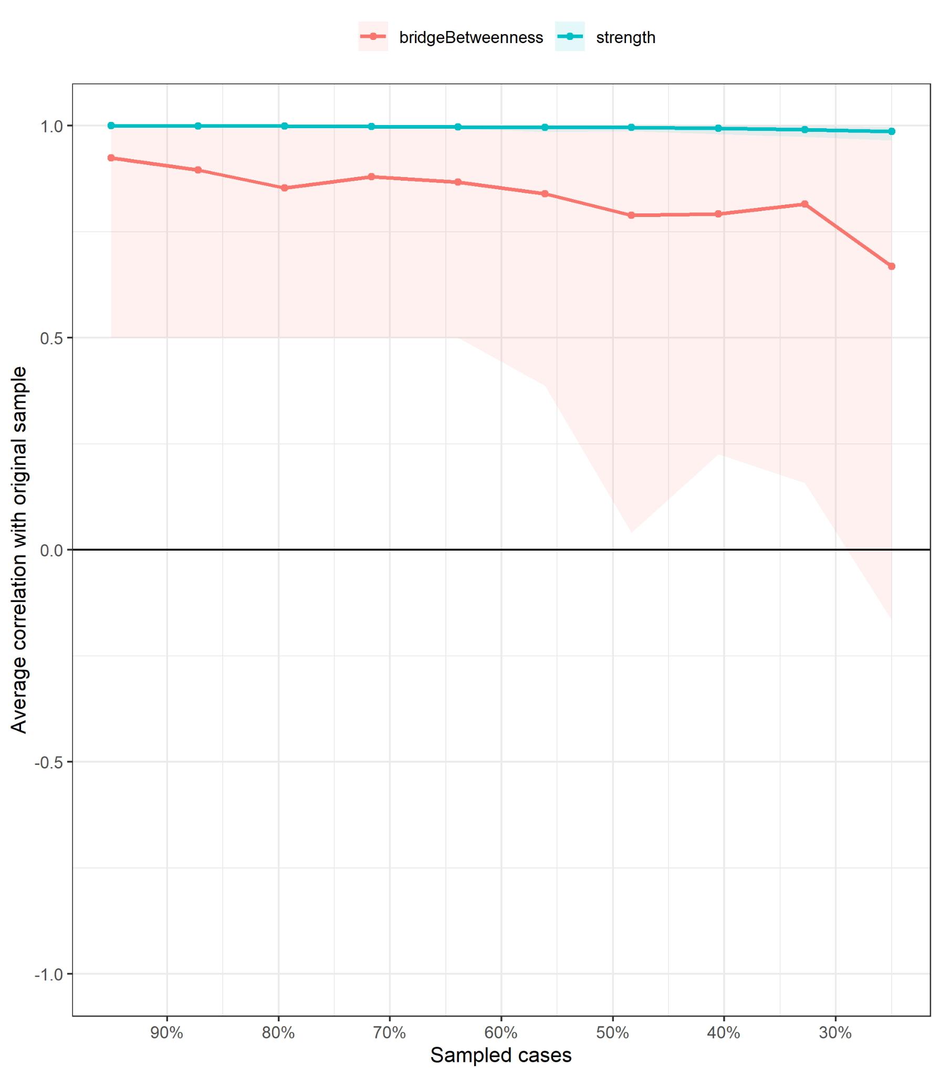 | MCS  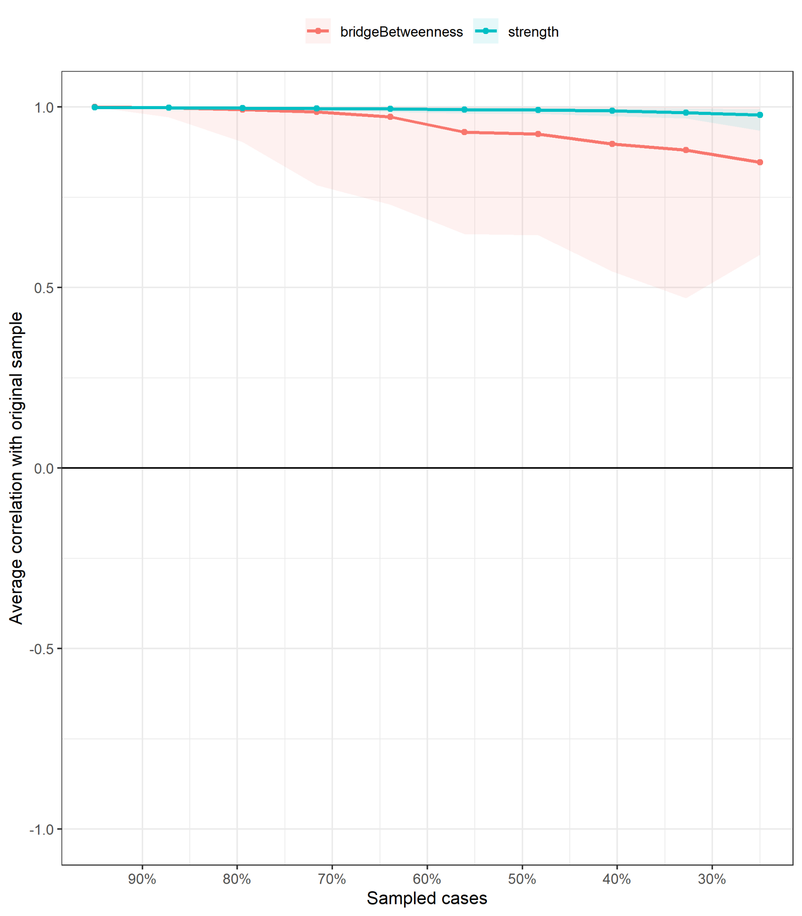
TEDS  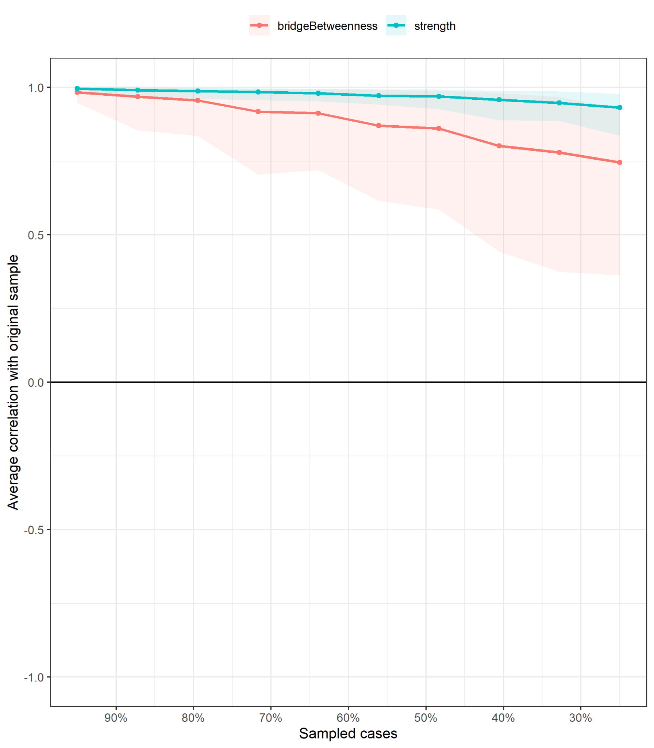 | BCS  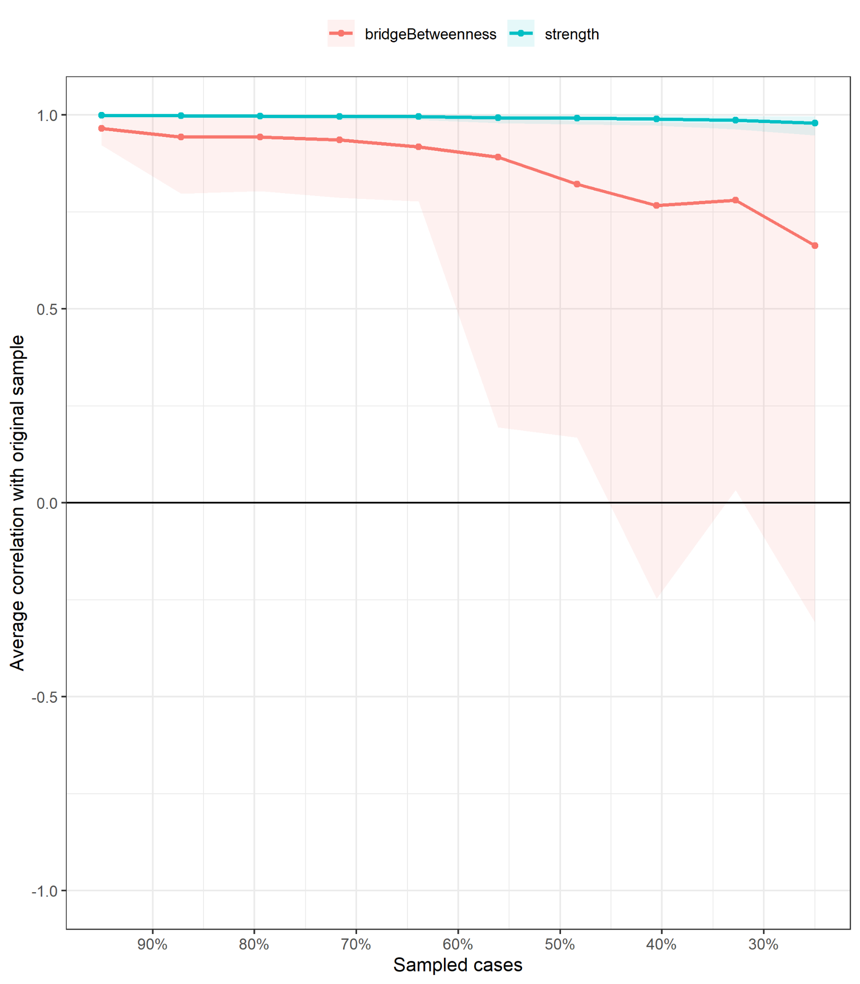

Figure S18
Middle Childhood Stability of Strength and Bridge Strength

ALSPAC  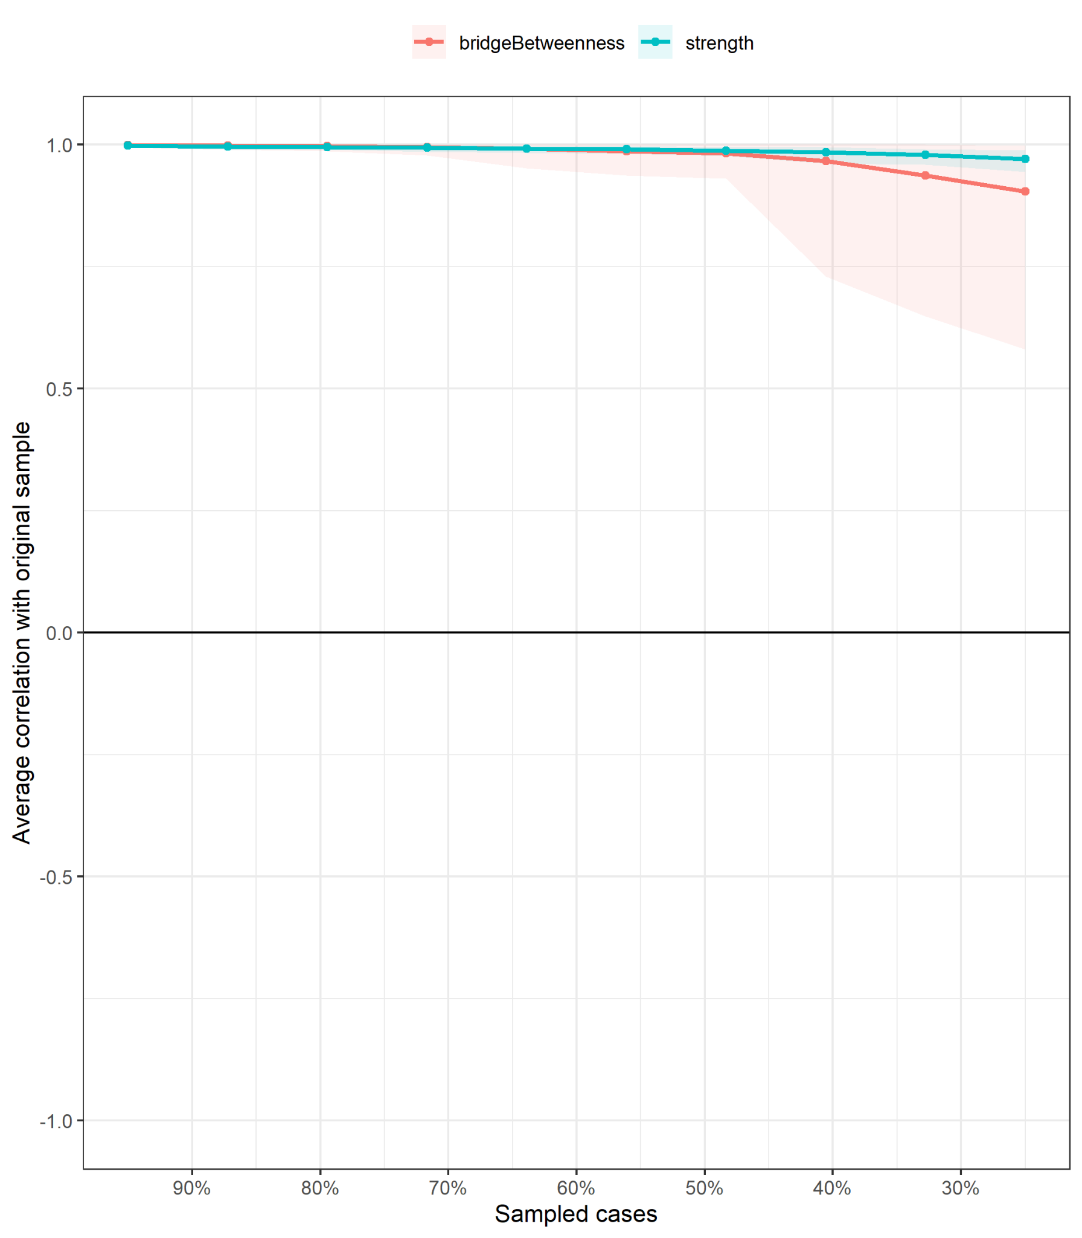 | MCS  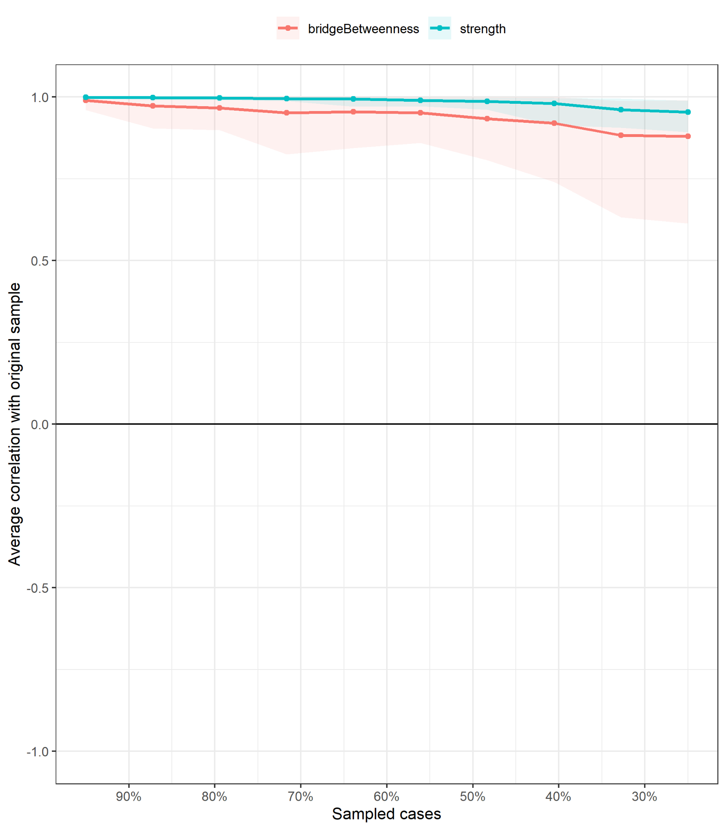
TEDS  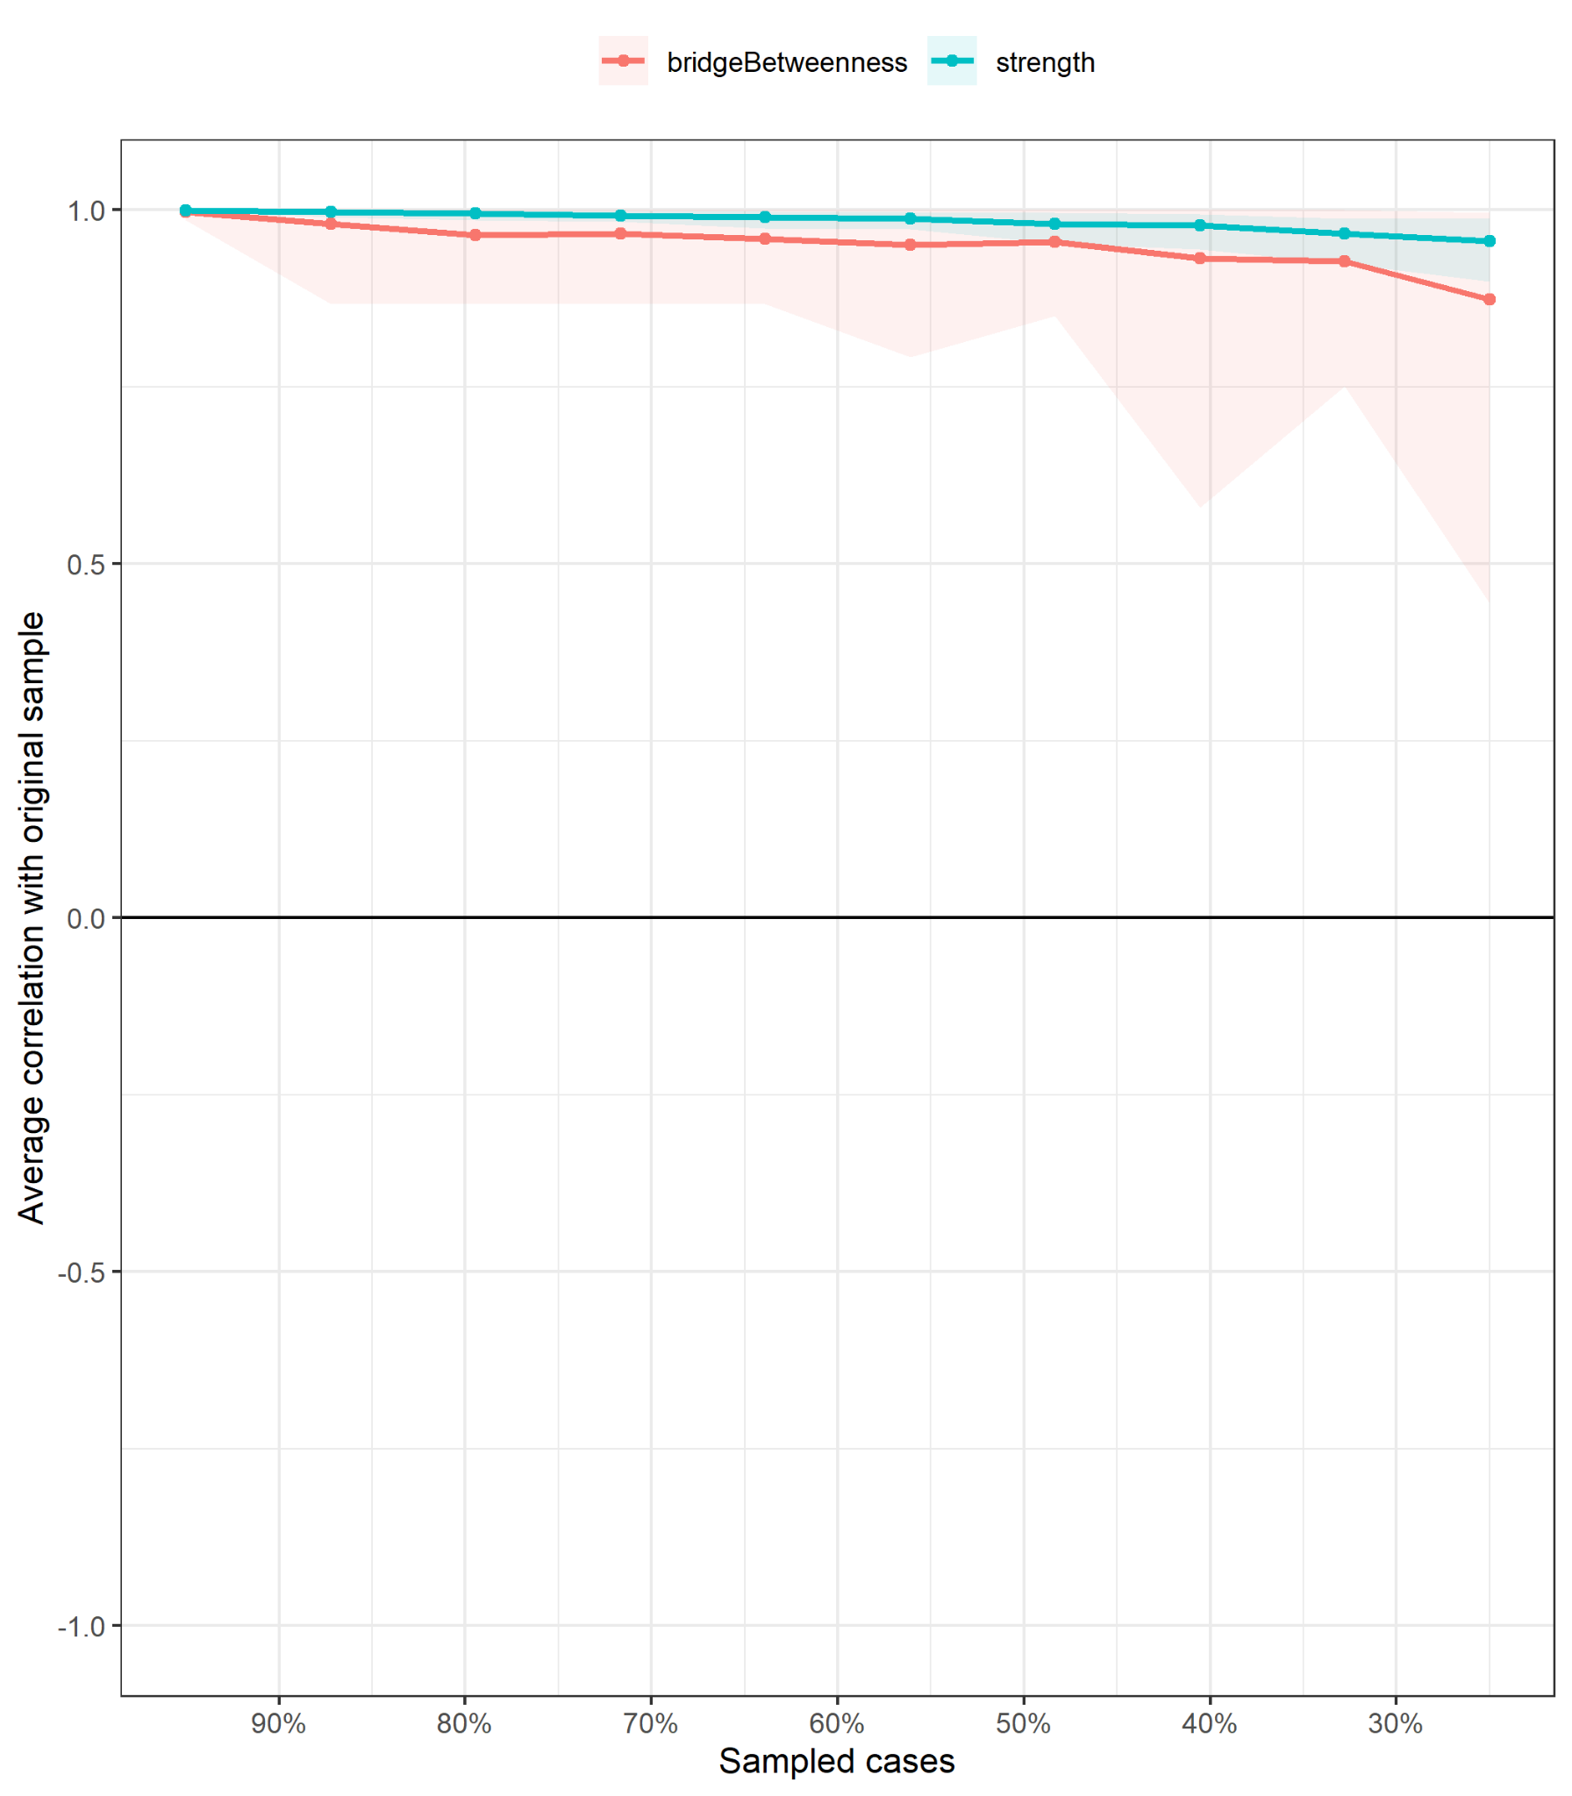 | BCS  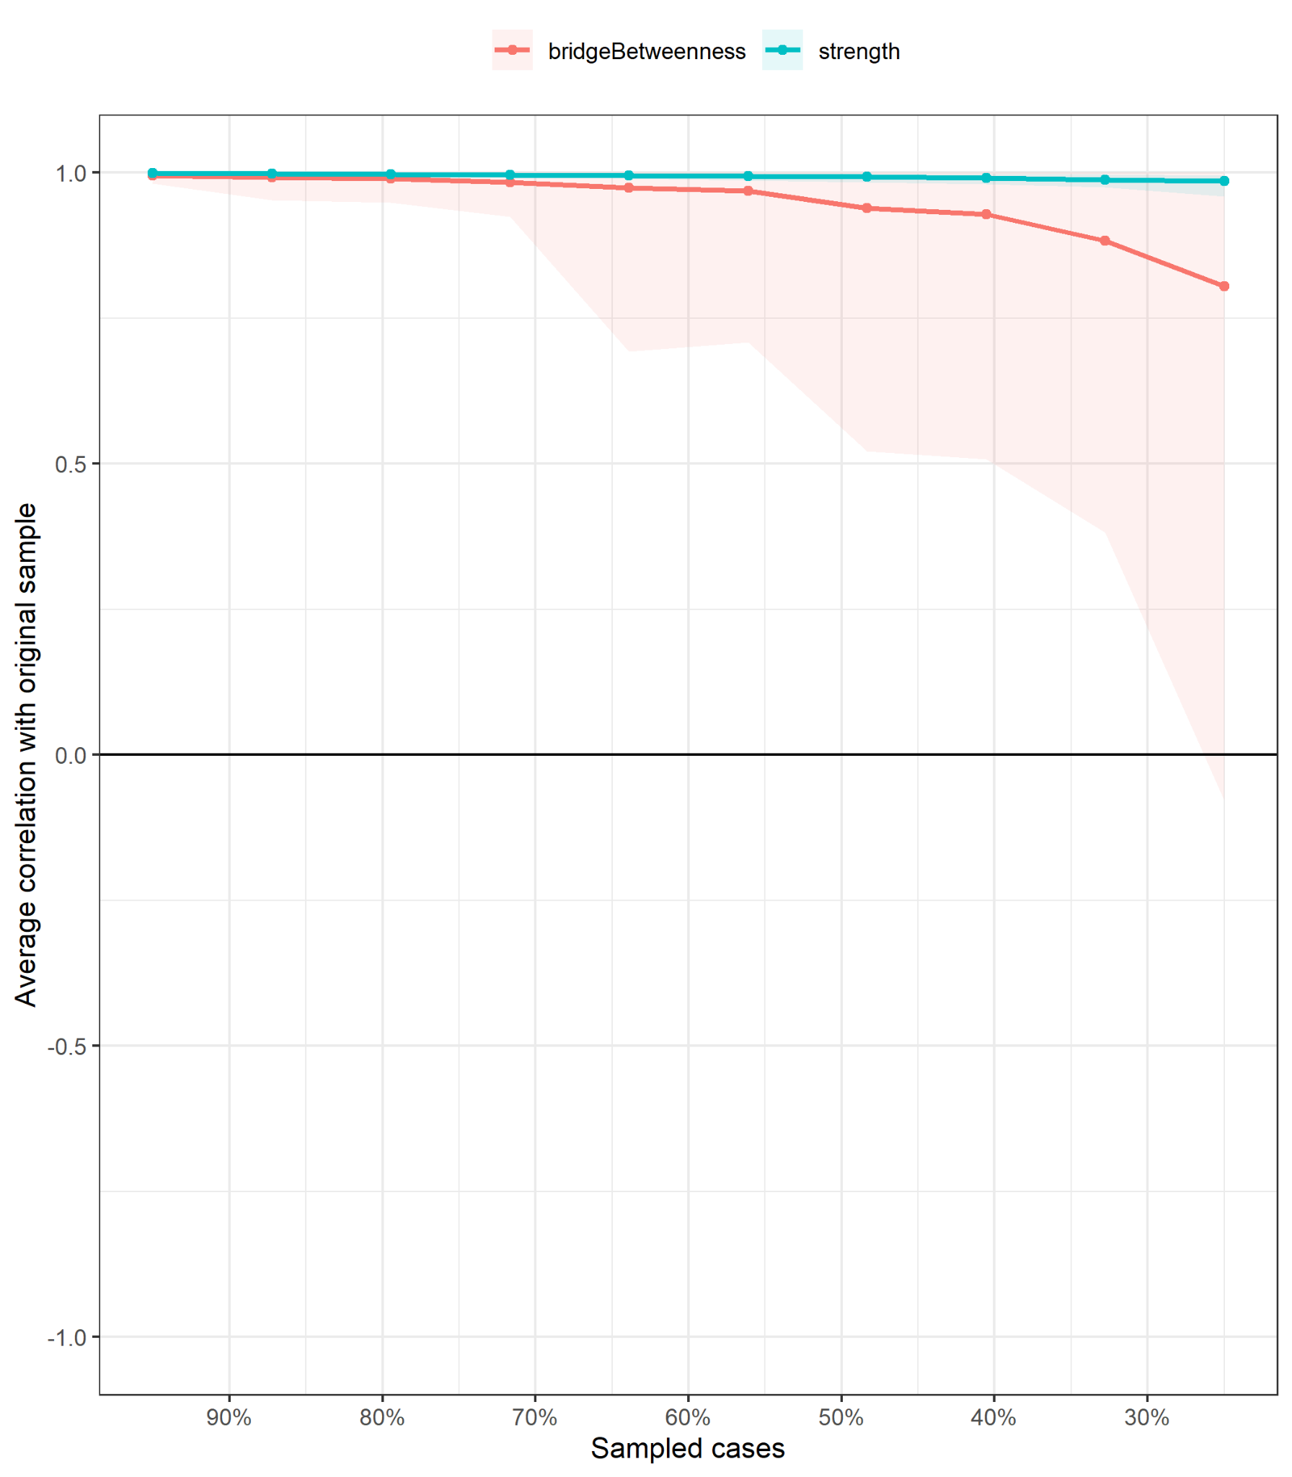

Figure S19
Adolescence Stability of Strength and Bridge Strength

ALSPAC  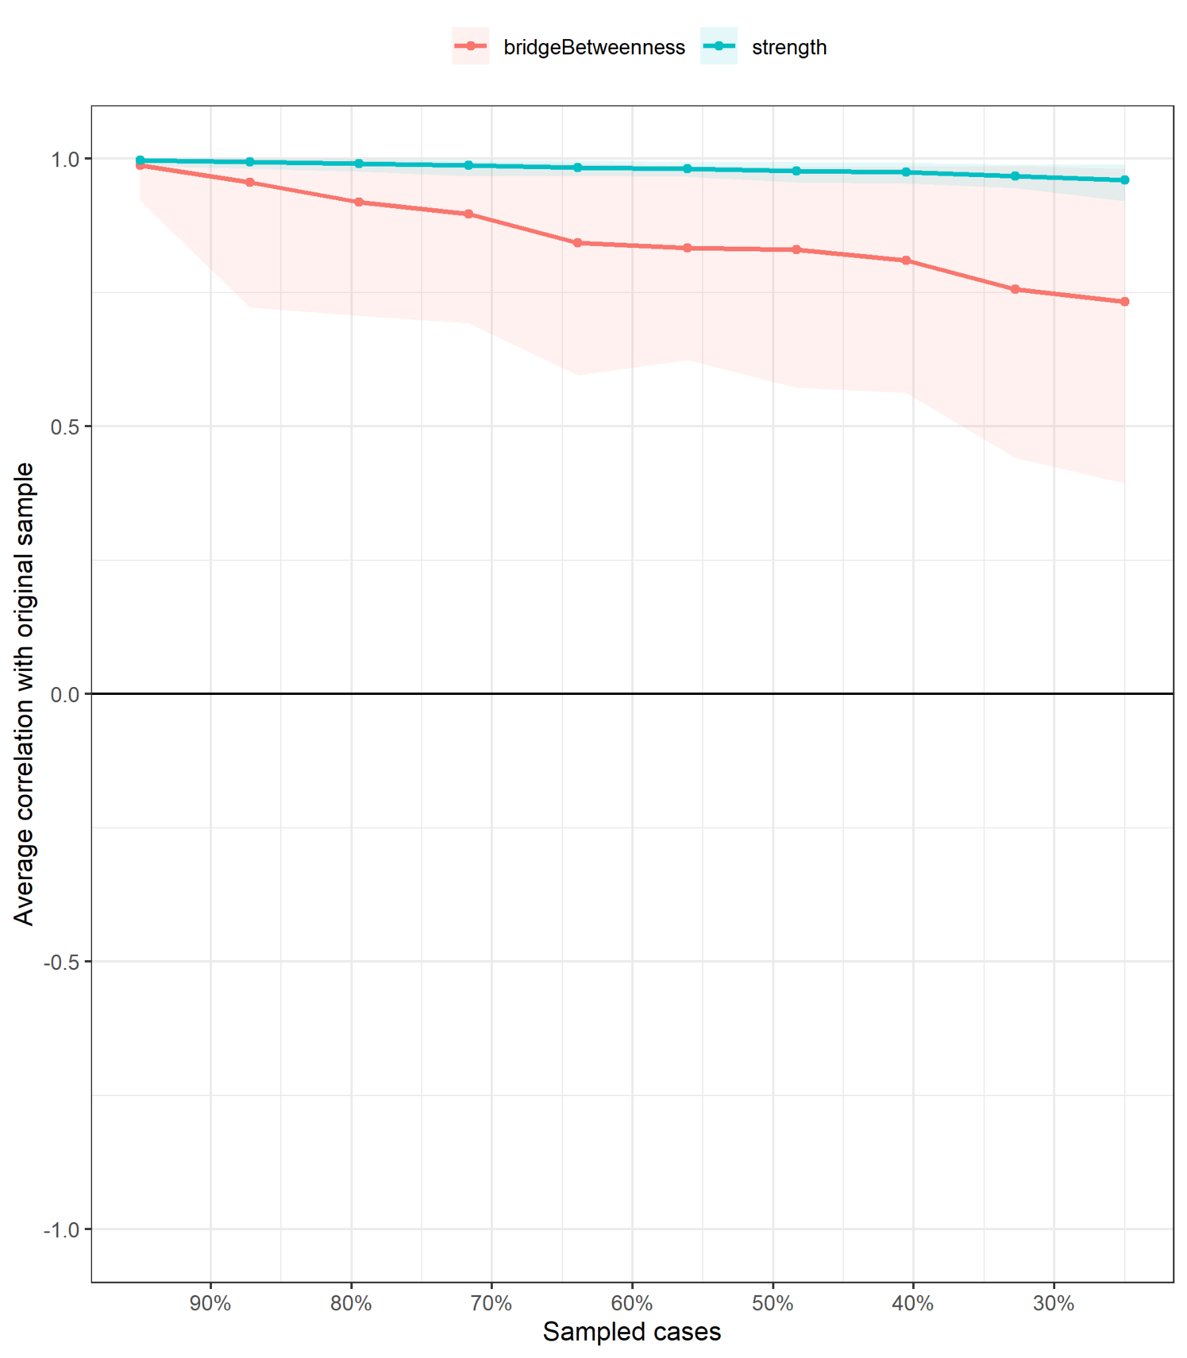 | MCS  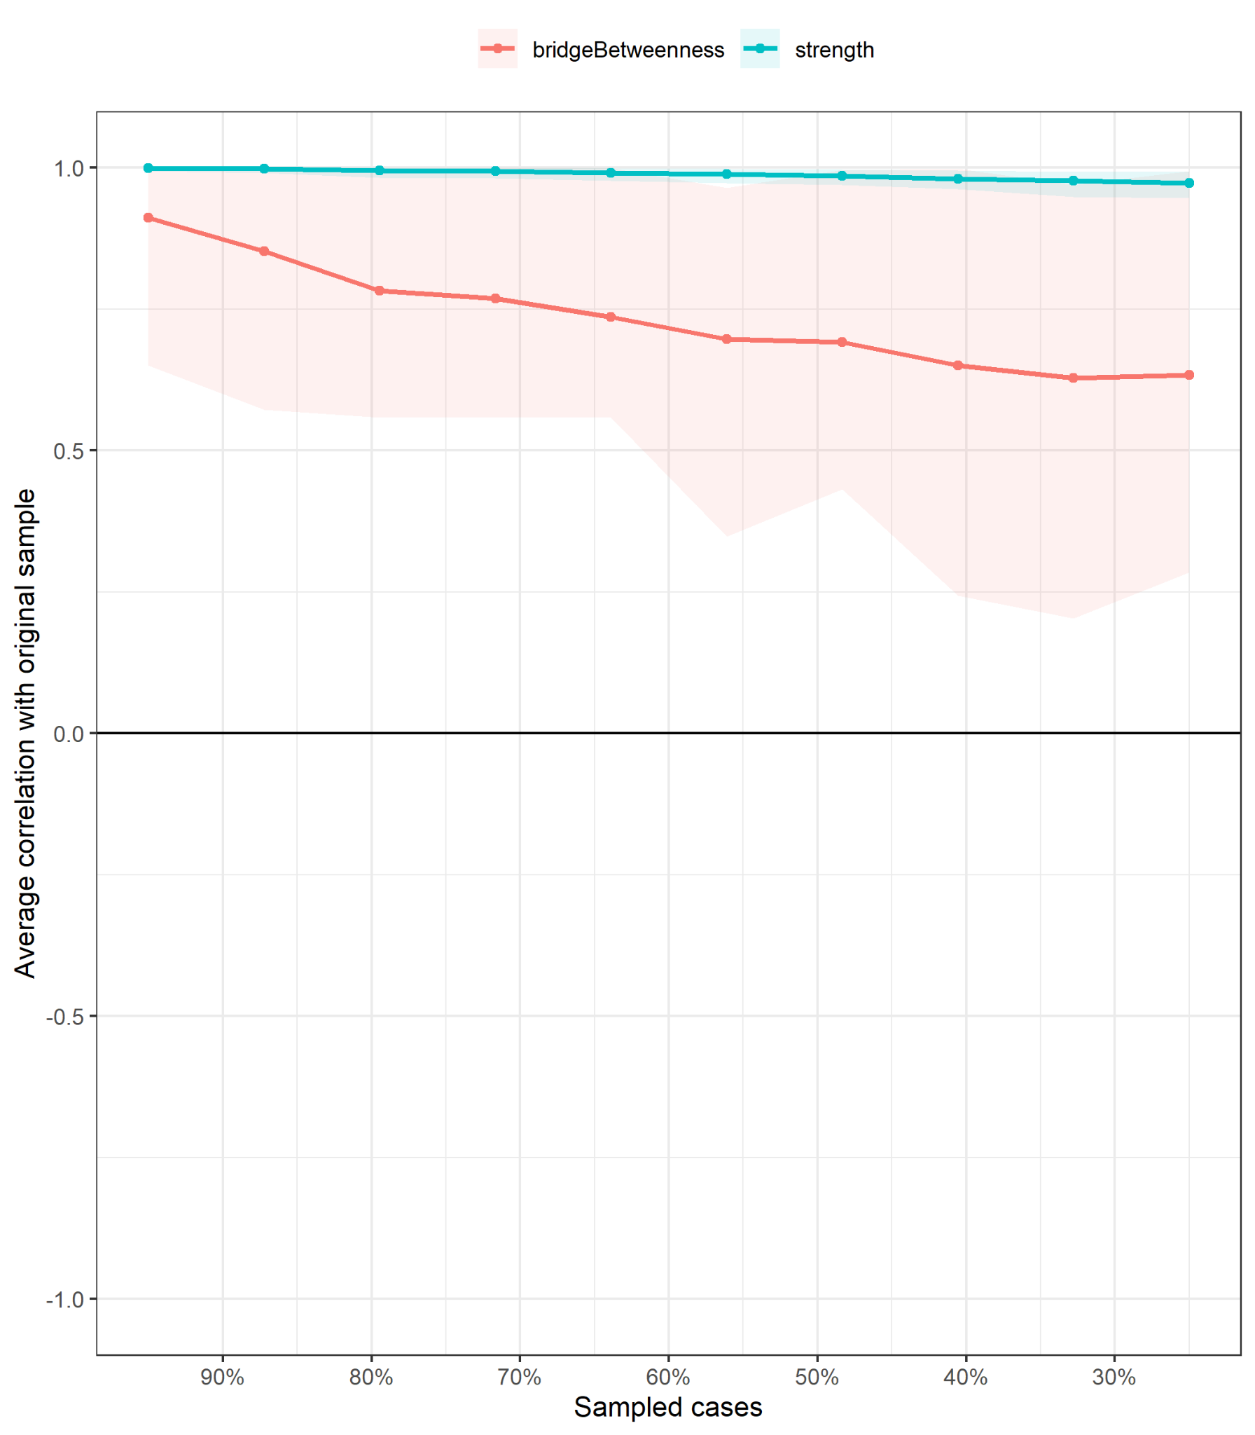
TEDS  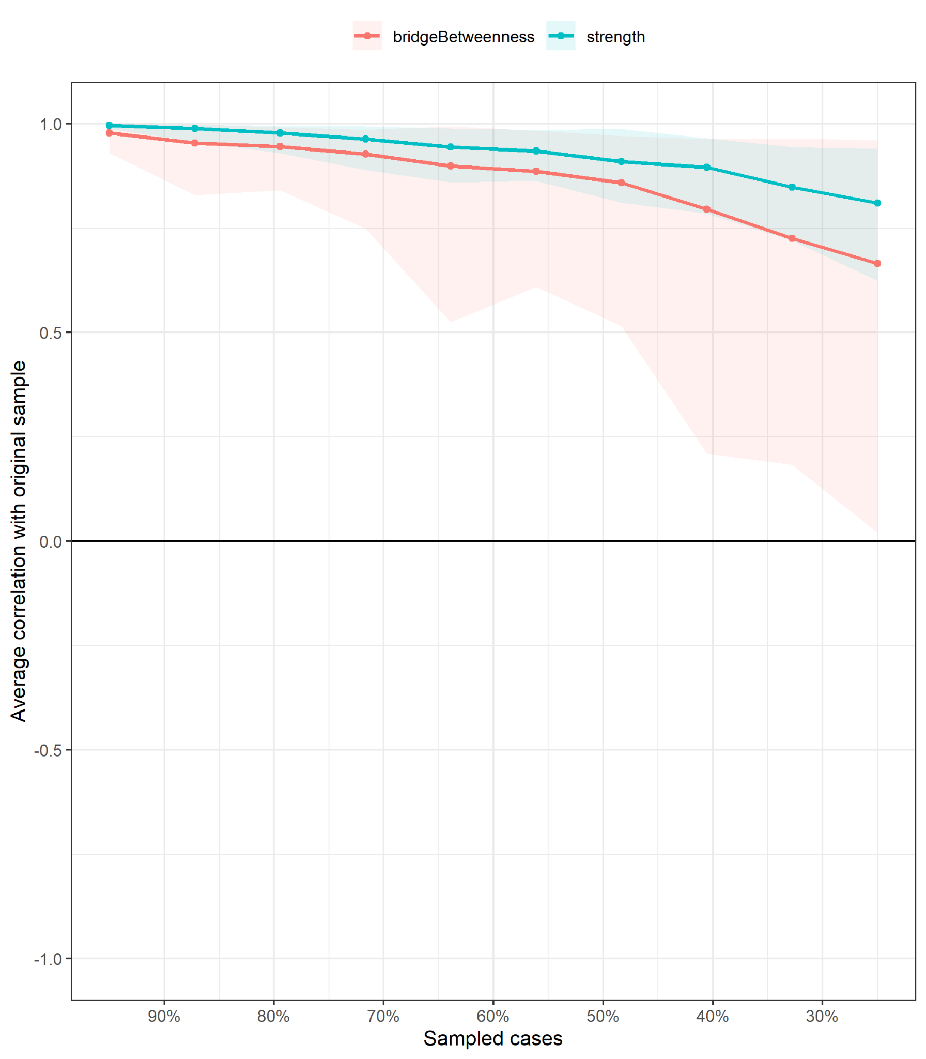 | BCS  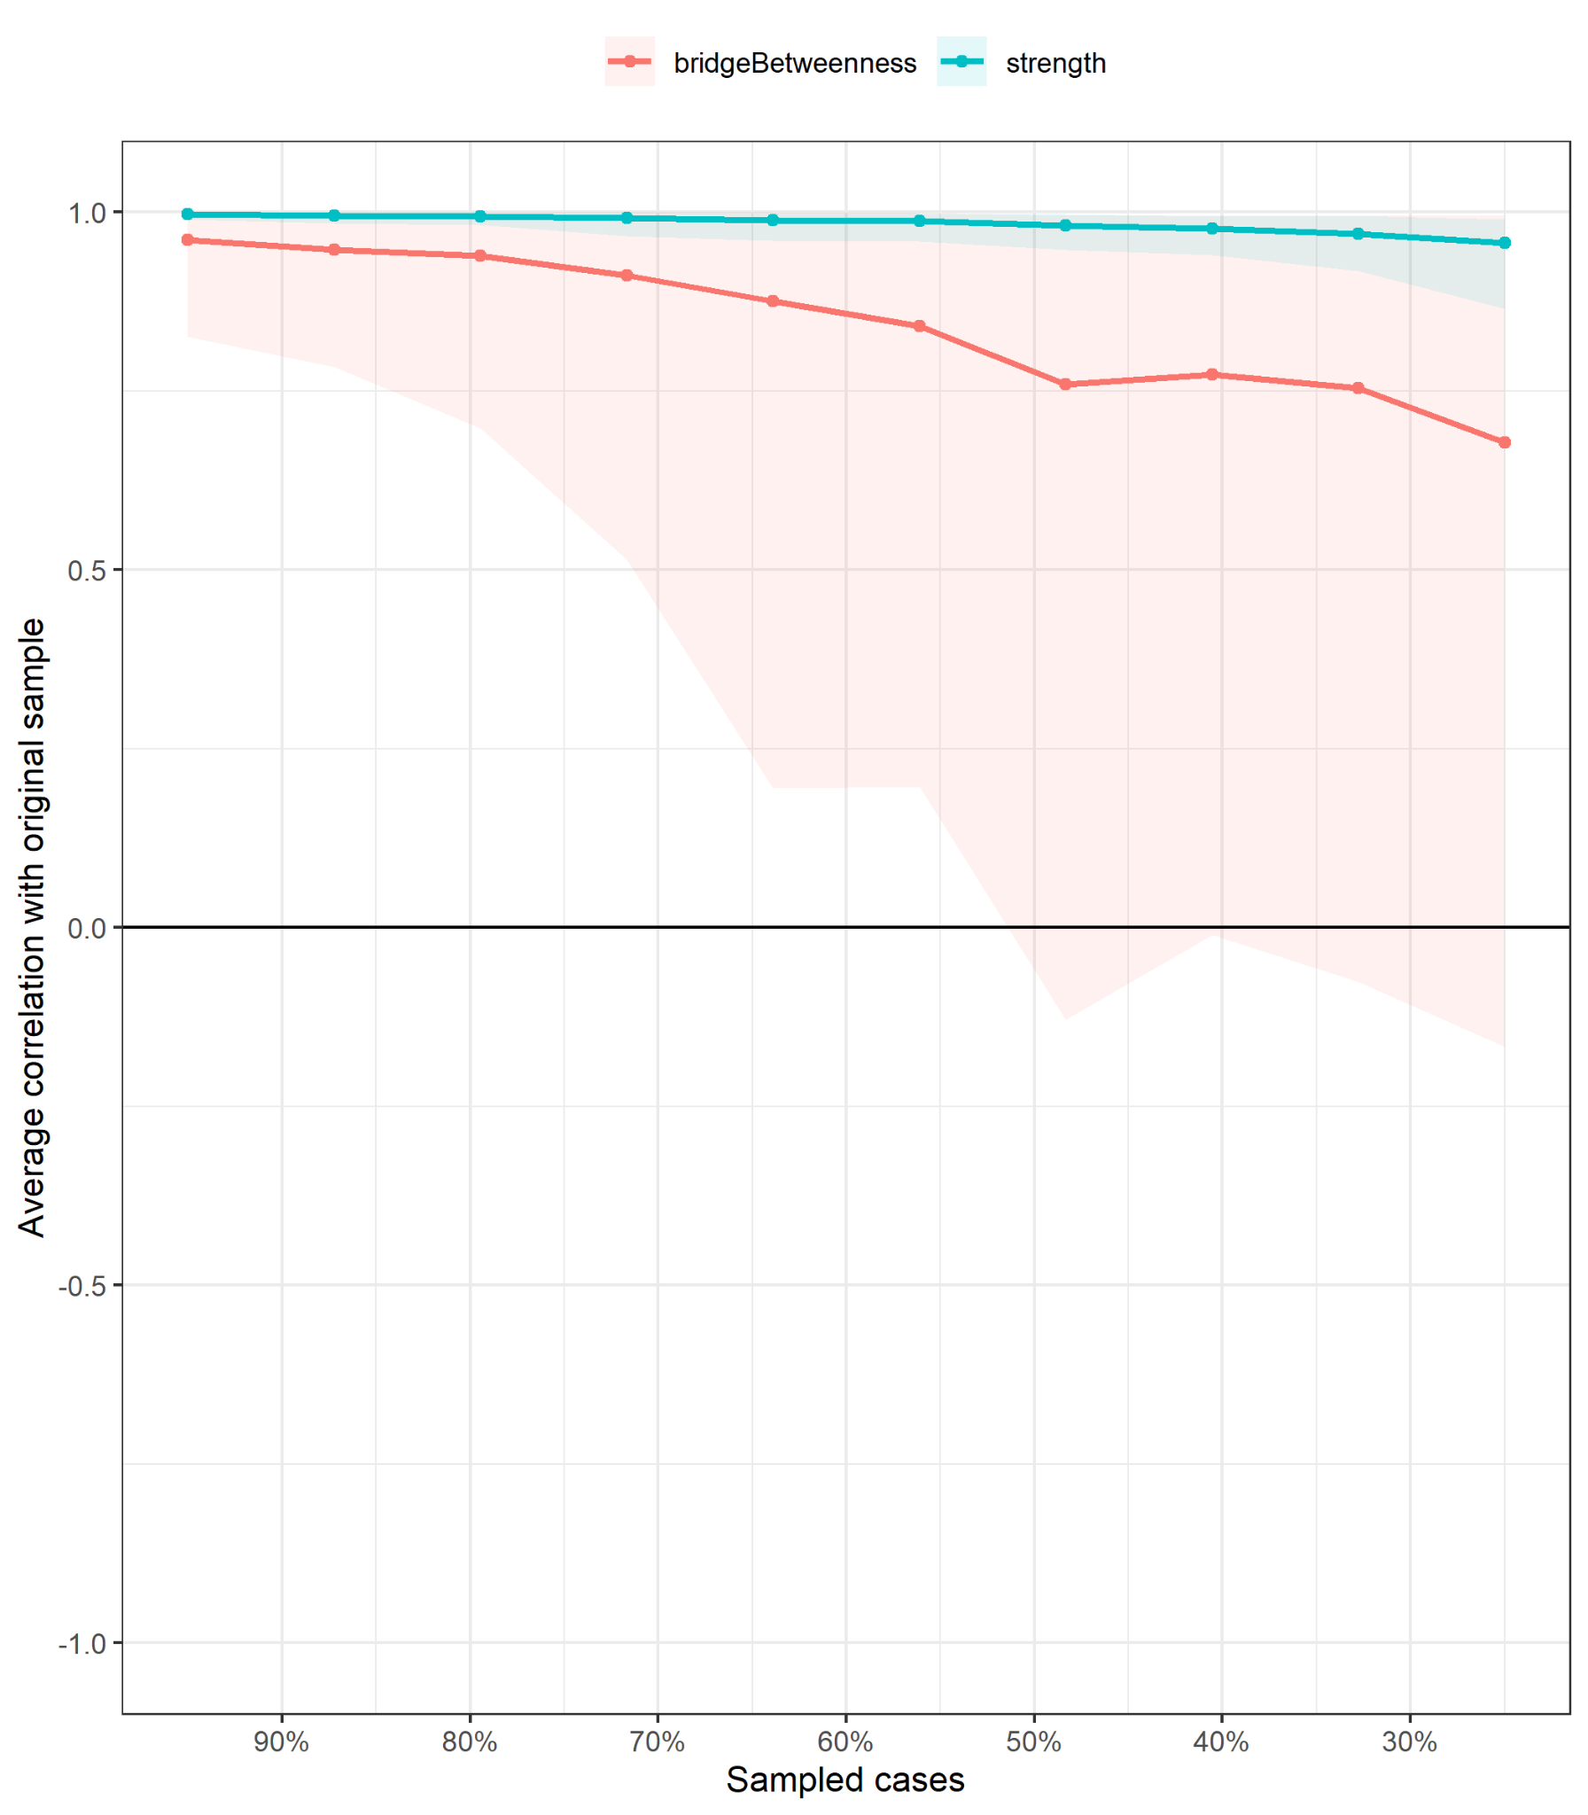

Figure S20
ALSPAC Early Childhood Bootstrapped Confidence Intervals (Edge accuracy)
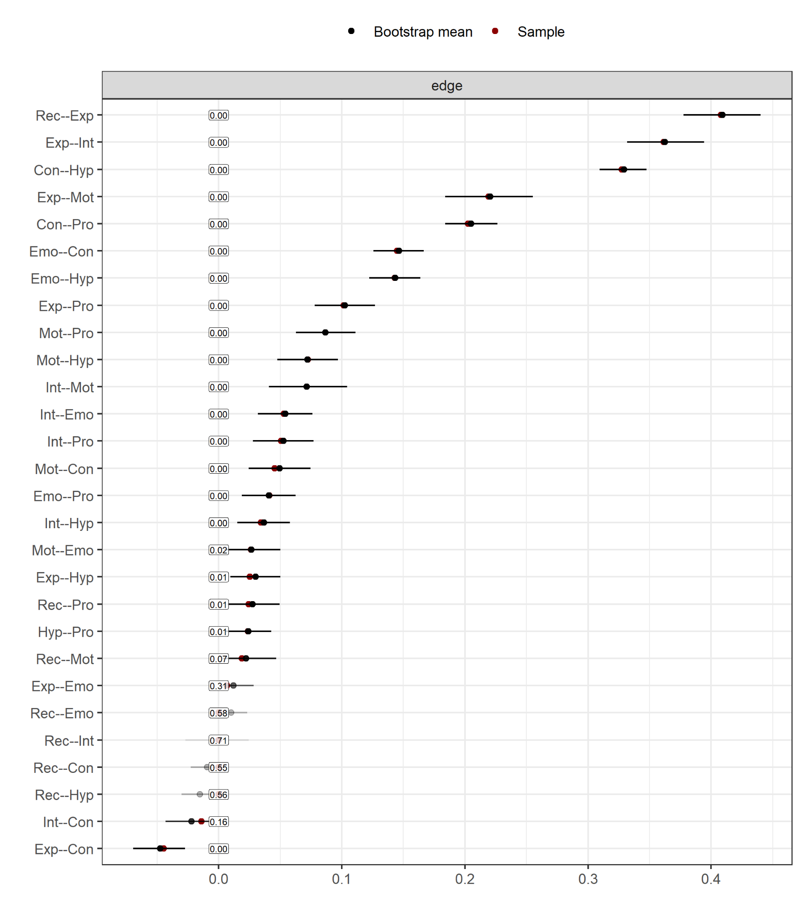
Note. This plot shows the stability and accuracy of edge weights based on 1,000 nonparametric bootstrap samples. Each black dot represents the edge weight estimated from the original data and red dots show bootstrapped mean. Edges with confidence intervals that include zero should be interpreted cautiously, as they may reflect spurious or weak associations.
Figure S21
MCS Early Childhood Bootstrapped Confidence Intervals (Edge accuracy)
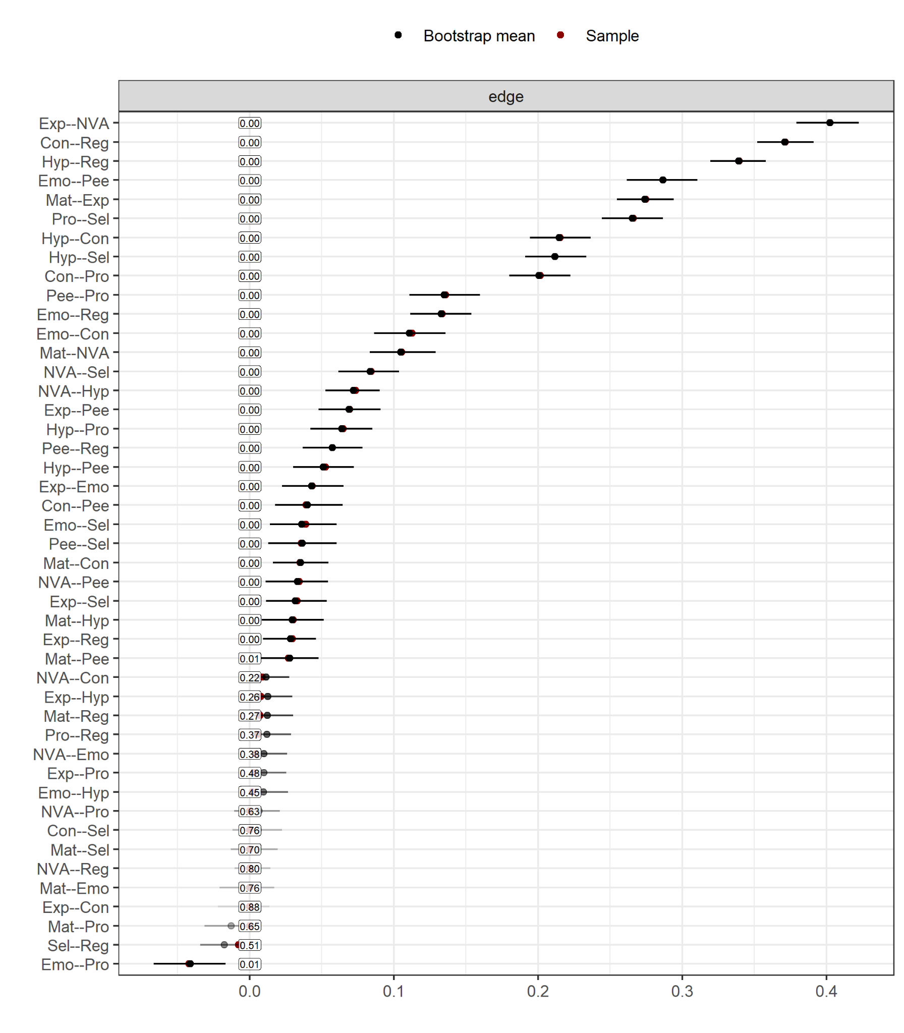
Note. This plot shows the stability and accuracy of edge weights based on 1,000 nonparametric bootstrap samples. Each black dot represents the edge weight estimated from the original data and red dots show bootstrapped mean. Edges with confidence intervals that include zero should be interpreted cautiously, as they may reflect spurious or weak associations.

Figure S22
TEDS Early Childhood Bootstrapped Confidence Intervals (Edge accuracy)
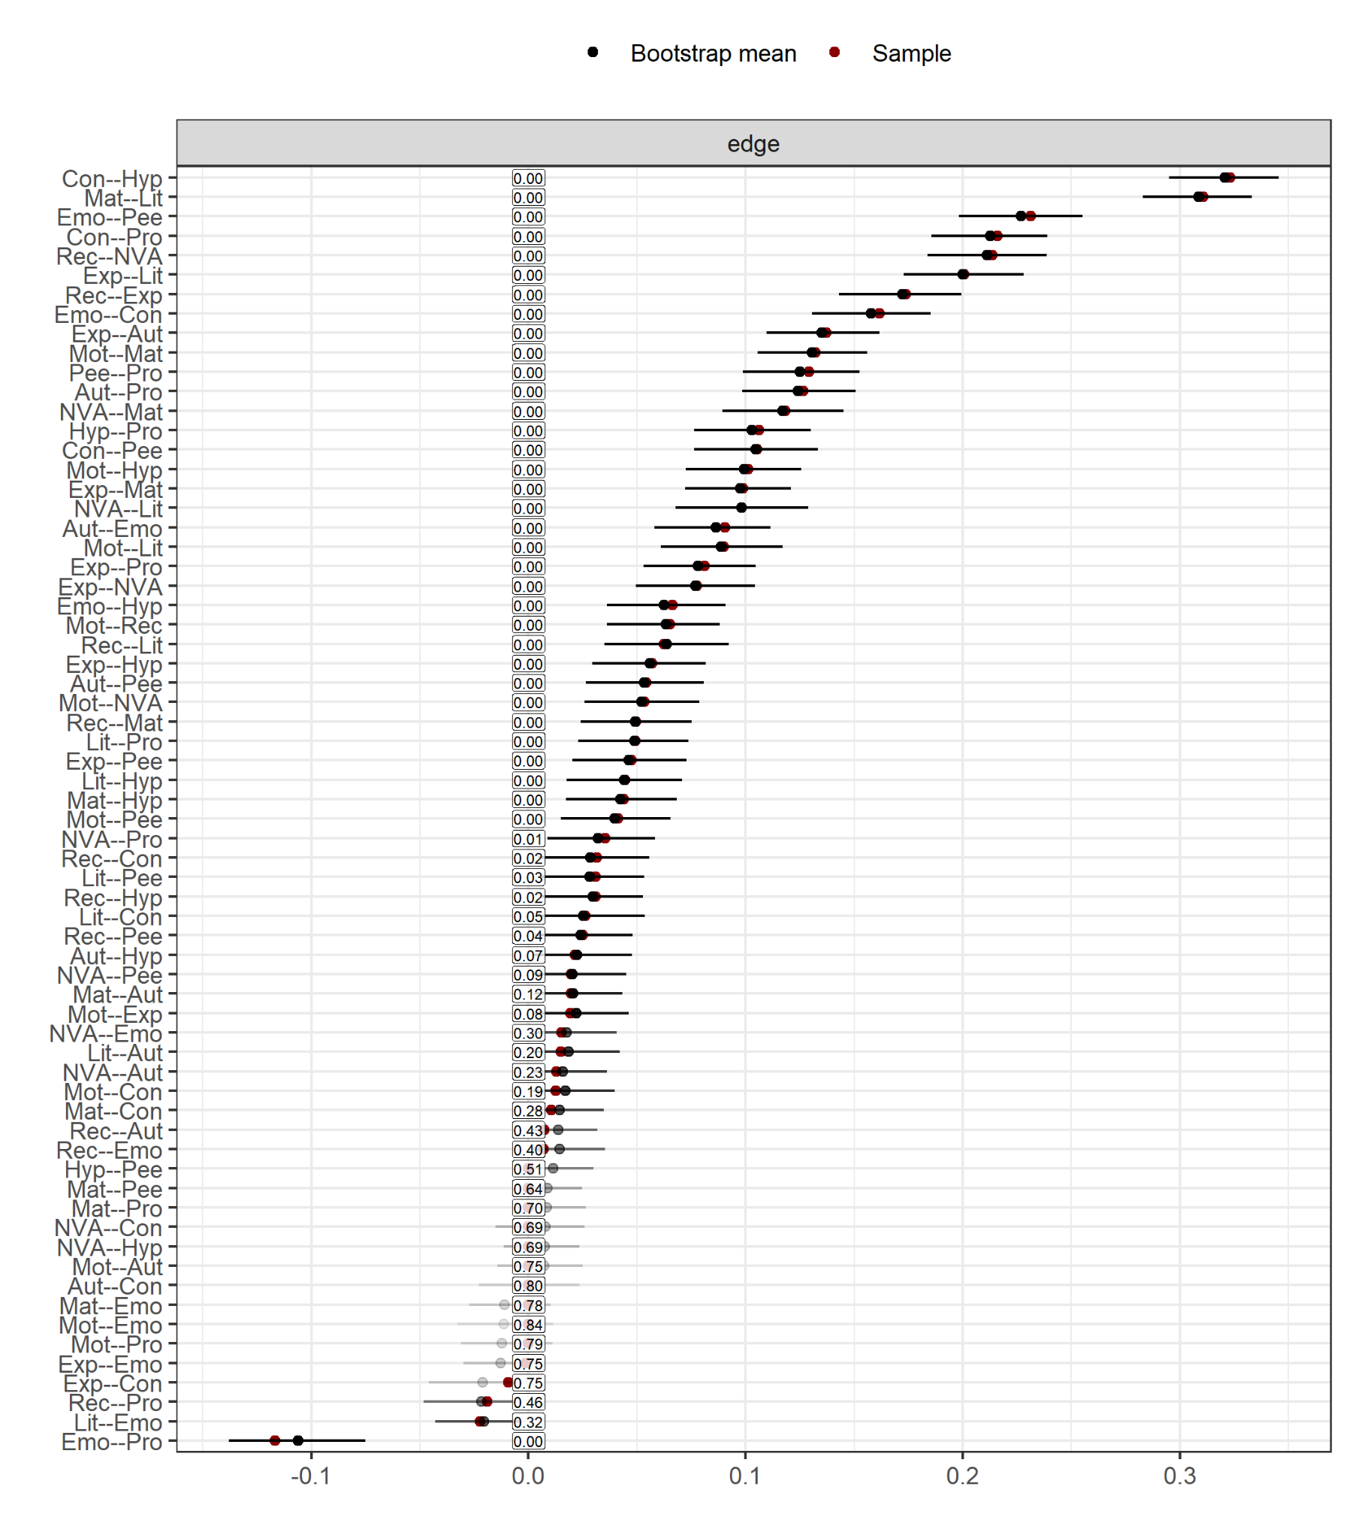
Note. This plot shows the stability and accuracy of edge weights based on 1,000 nonparametric bootstrap samples. Each black dot represents the edge weight estimated from the original data and red dots show bootstrapped mean. Edges with confidence intervals that include zero should be interpreted cautiously, as they may reflect spurious or weak associations.

Figure S23
BCS Early Childhood Bootstrapped Confidence Intervals (Edge accuracy)
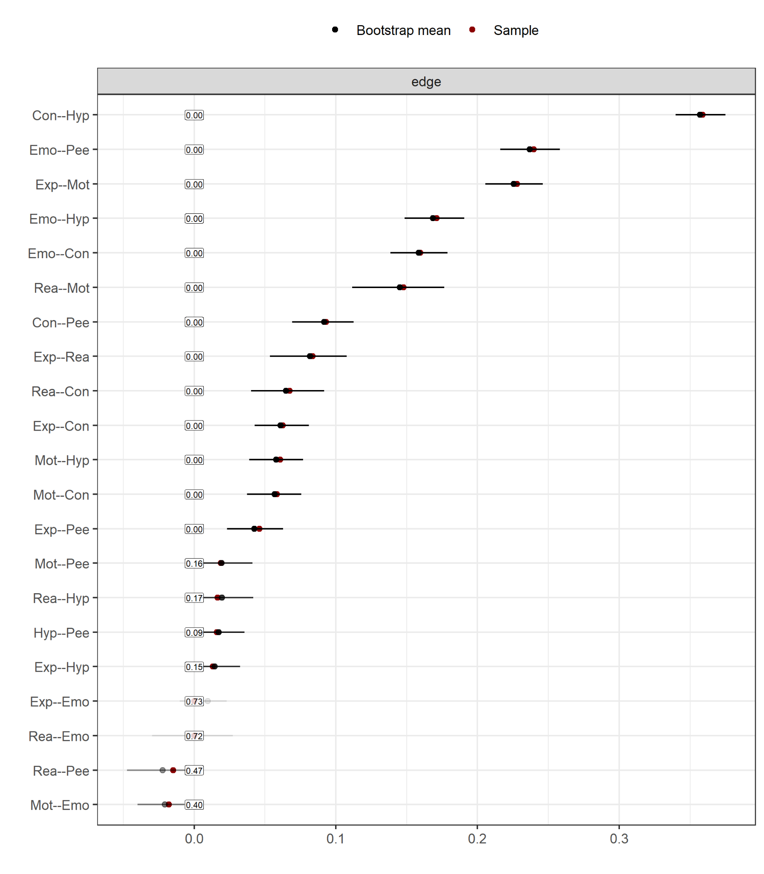
Note. This plot shows the stability and accuracy of edge weights based on 1,000 nonparametric bootstrap samples. Each black dot represents the edge weight estimated from the original data and red dots show bootstrapped mean. Edges with confidence intervals that include zero should be interpreted cautiously, as they may reflect spurious or weak associations.

Figure S24
ALSPAC Middle Childhood Bootstrapped Confidence Intervals (Edge accuracy)
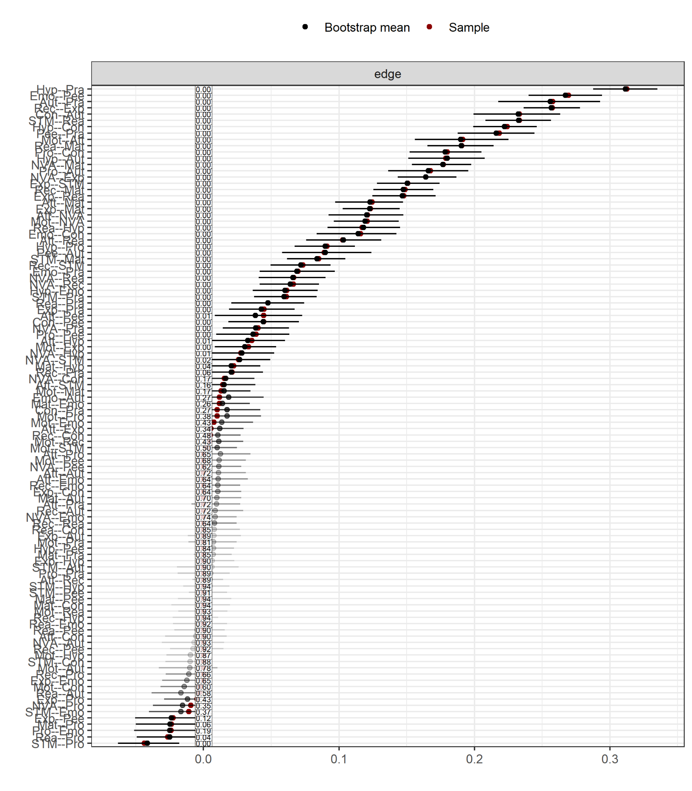
Note. This plot shows the stability and accuracy of edge weights based on 1,000 nonparametric bootstrap samples. Each black dot represents the edge weight estimated from the original data and red dots show bootstrapped mean. Edges with confidence intervals that include zero should be interpreted cautiously, as they may reflect spurious or weak associations.
Figure S25
MCS Middle Childhood Bootstrapped Confidence Intervals (Edge accuracy)
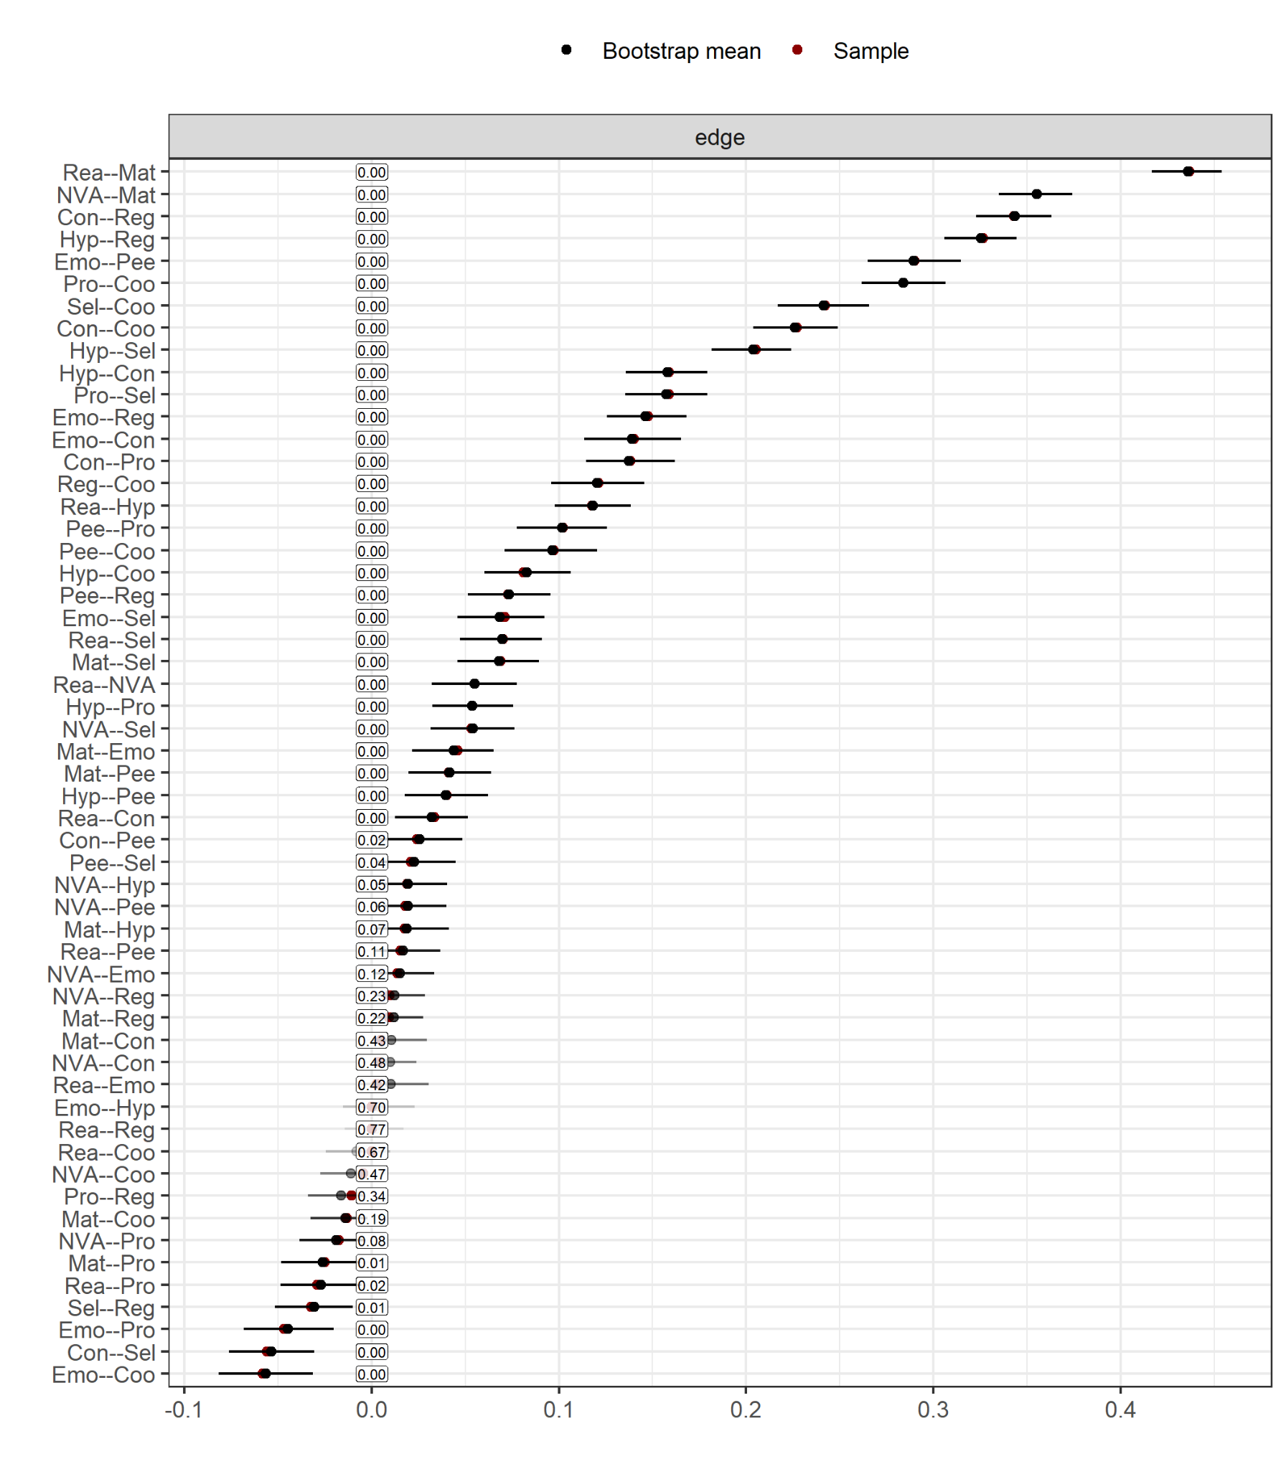
Note. This plot shows the stability and accuracy of edge weights based on 1,000 nonparametric bootstrap samples. Each black dot represents the edge weight estimated from the original data and red dots show bootstrapped mean. Edges with confidence intervals that include zero should be interpreted cautiously, as they may reflect spurious or weak associations.

Figure S26
TEDS Middle Childhood Bootstrapped Confidence Intervals (Edge accuracy)
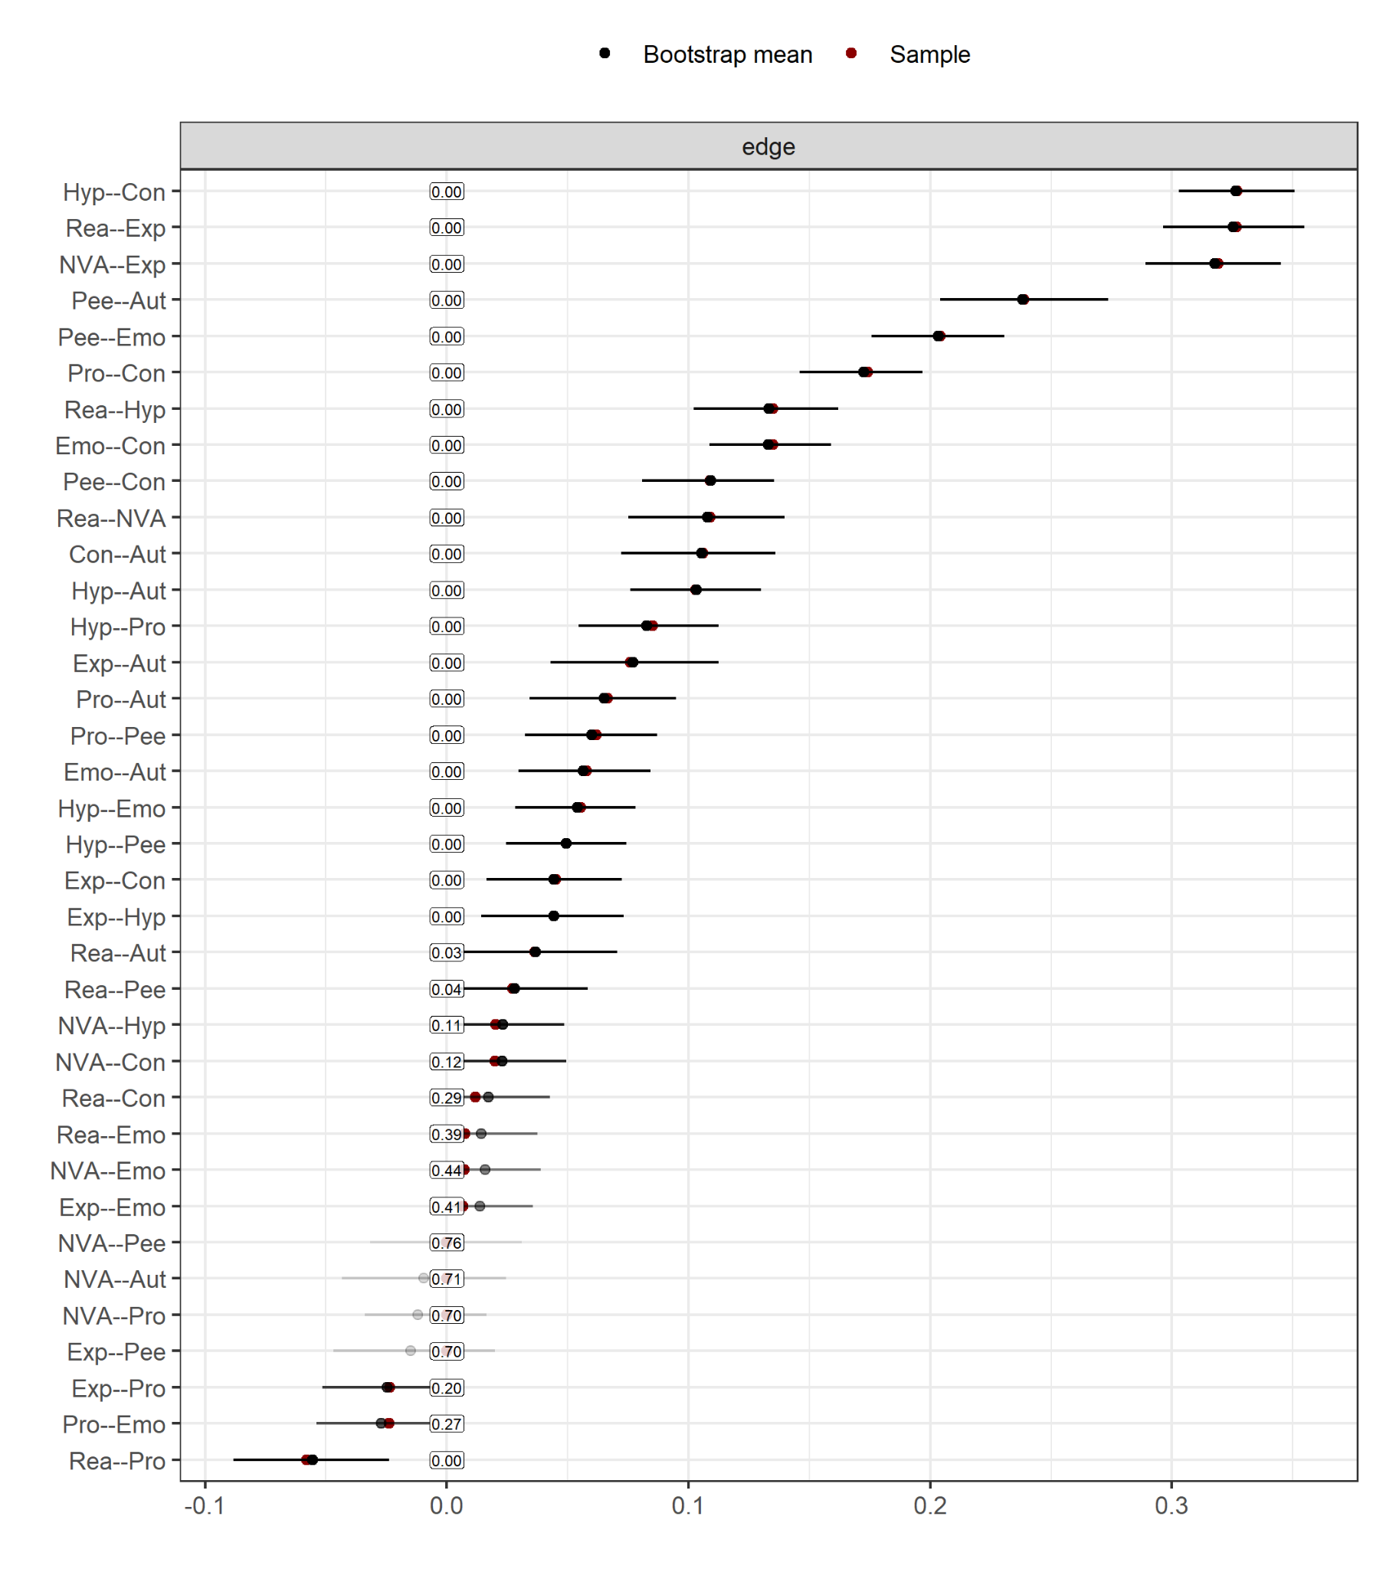
Note. This plot shows the stability and accuracy of edge weights based on 1,000 nonparametric bootstrap samples. Each black dot represents the edge weight estimated from the original data and red dots show bootstrapped mean. Edges with confidence intervals that include zero should be interpreted cautiously, as they may reflect spurious or weak associations.

Figure S27
BCS Middle Childhood Bootstrapped Confidence Intervals (Edge accuracy)
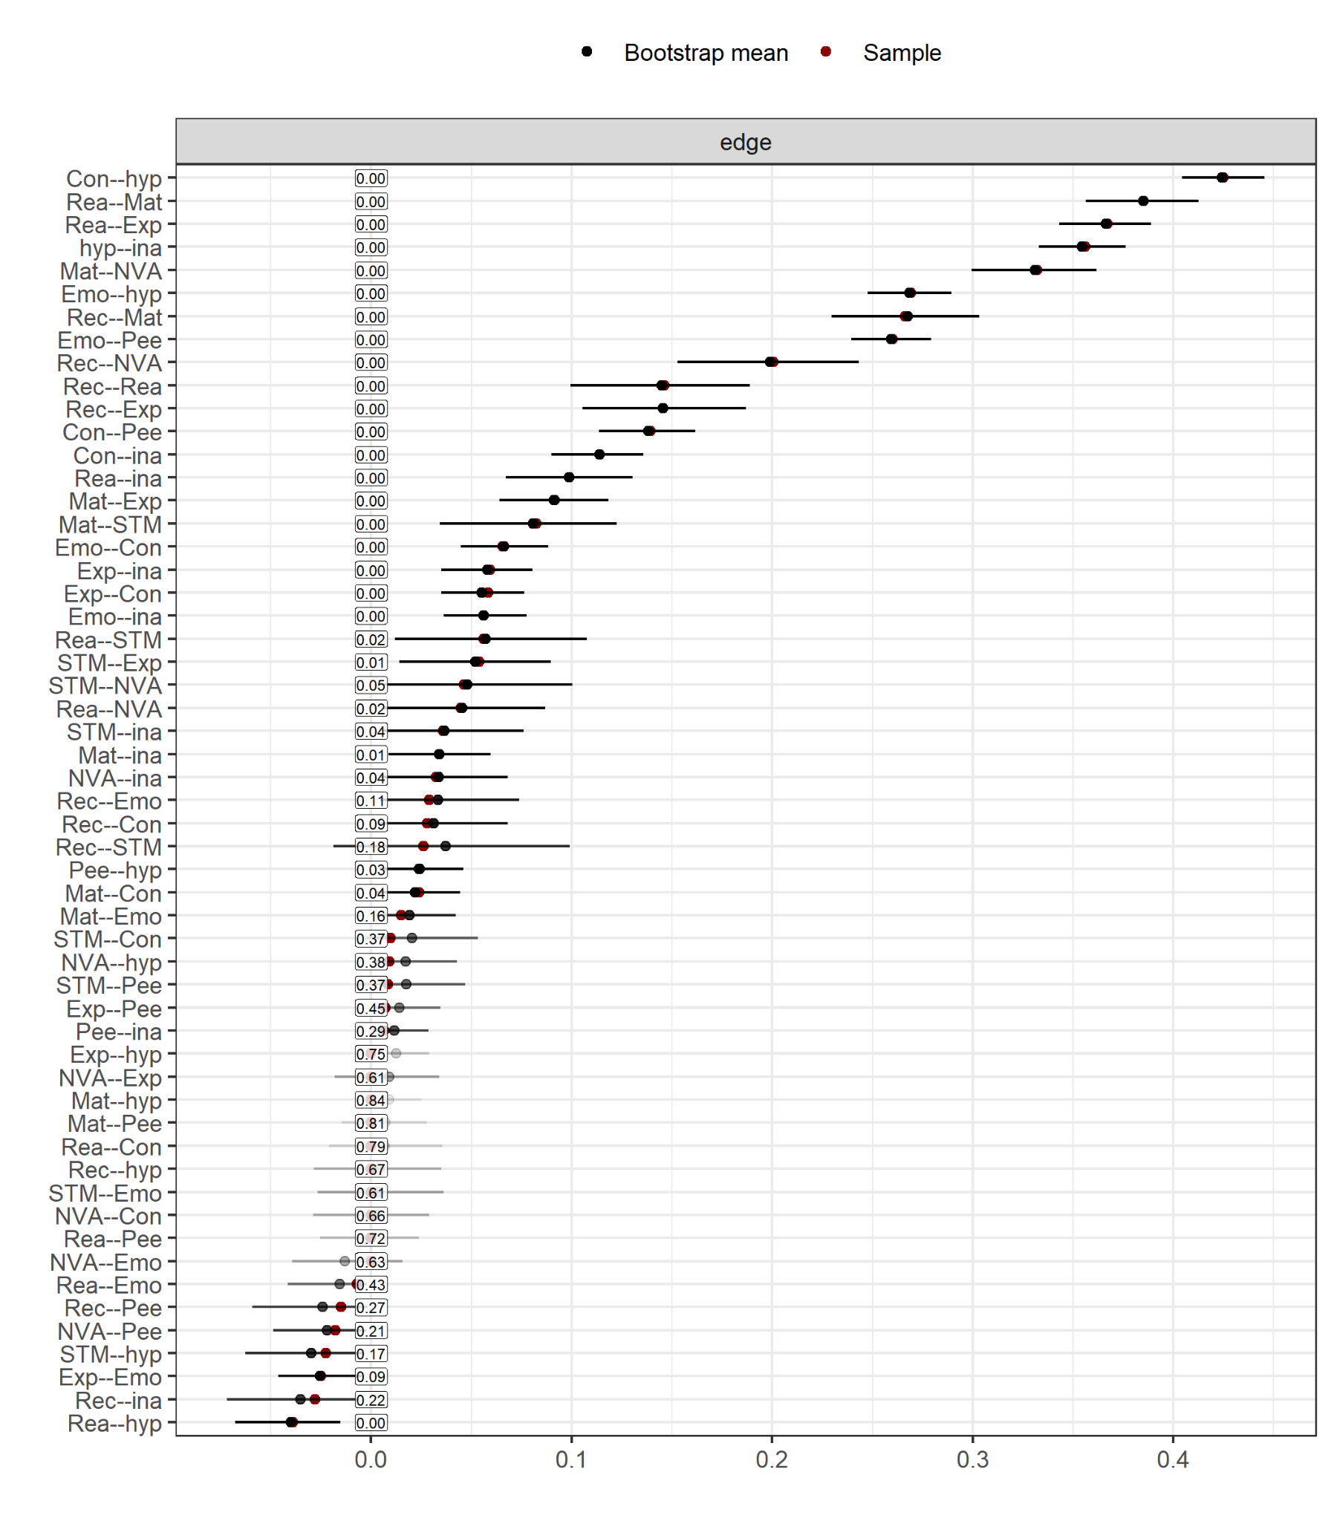
Note. This plot shows the stability and accuracy of edge weights based on 1,000 nonparametric bootstrap samples. Each black dot represents the edge weight estimated from the original data and red dots show bootstrapped mean. Edges with confidence intervals that include zero should be interpreted cautiously, as they may reflect spurious or weak associations.

Figure S28
ALSPAC Adolescence Bootstrapped Confidence Intervals (Edge accuracy)
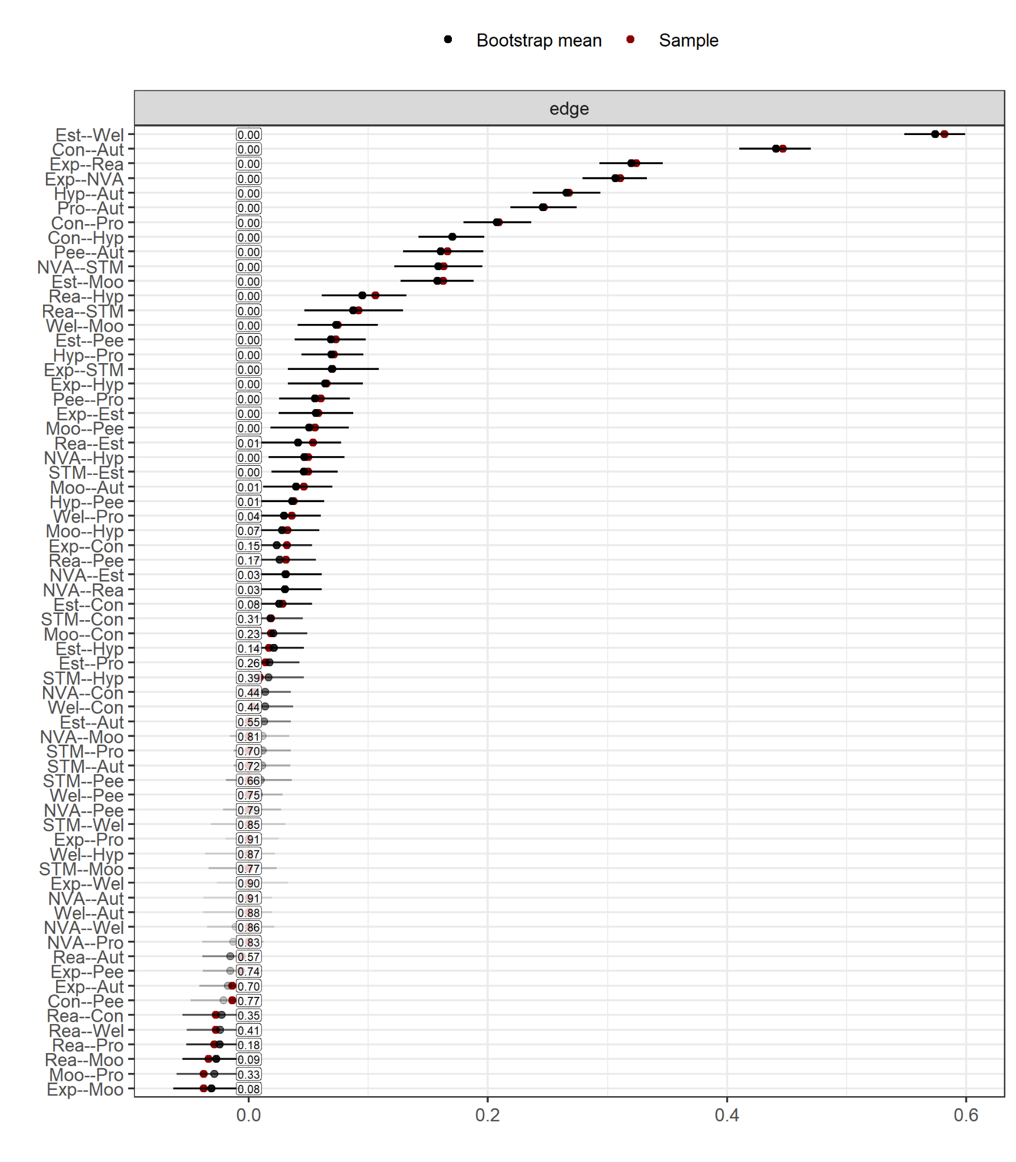
Note. This plot shows the stability and accuracy of edge weights based on 1,000 nonparametric bootstrap samples. Each black dot represents the edge weight estimated from the original data and red dots show bootstrapped mean. Edges with confidence intervals that include zero should be interpreted cautiously, as they may reflect spurious or weak associations.

Figure S29
MCS Adolescence Bootstrapped Confidence Intervals (Edge accuracy)
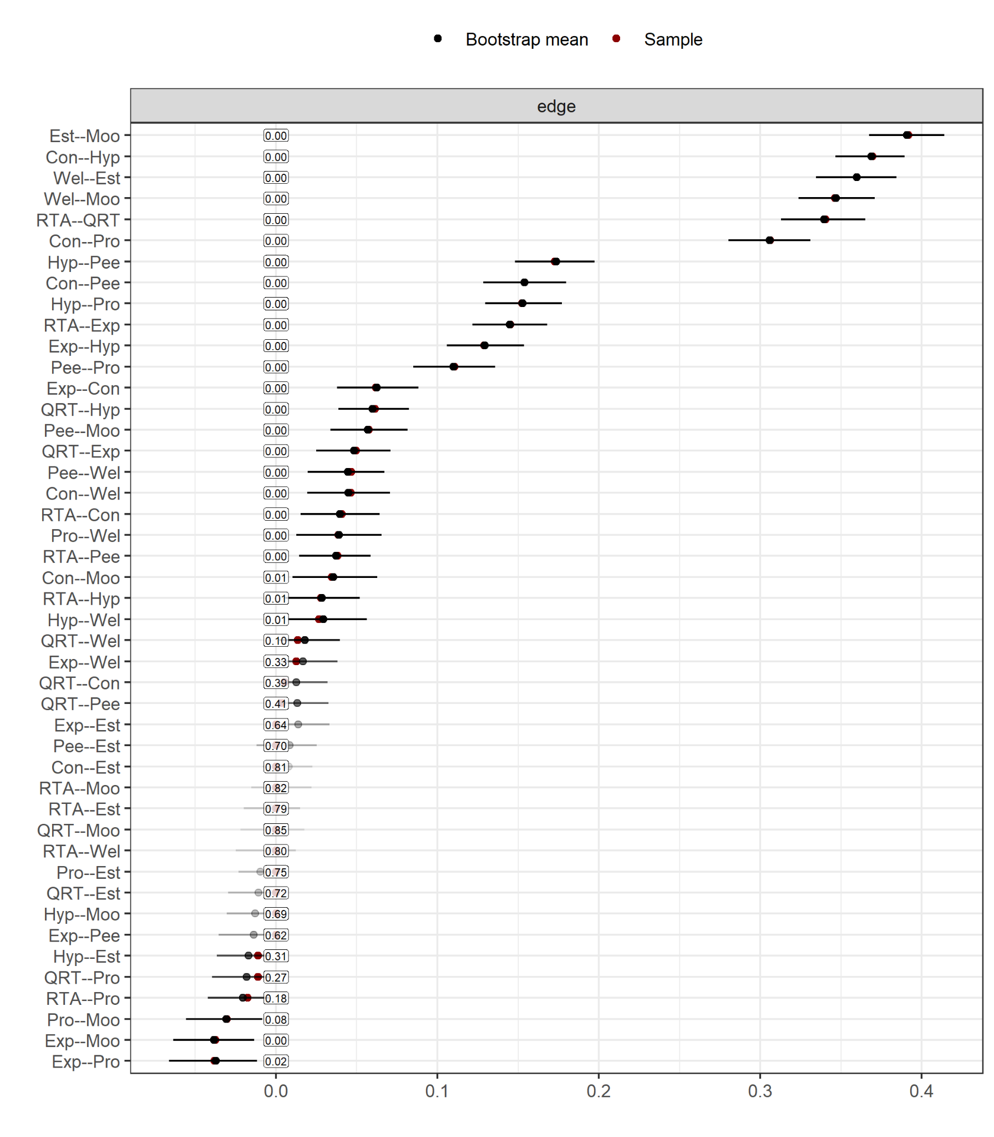
Note. This plot shows the stability and accuracy of edge weights based on 1,000 nonparametric bootstrap samples. Each black dot represents the edge weight estimated from the original data and red dots show bootstrapped mean. Edges with confidence intervals that include zero should be interpreted cautiously, as they may reflect spurious or weak associations.

Figure S30
TEDS Adolescence Bootstrapped Confidence Intervals (Edge accuracy)
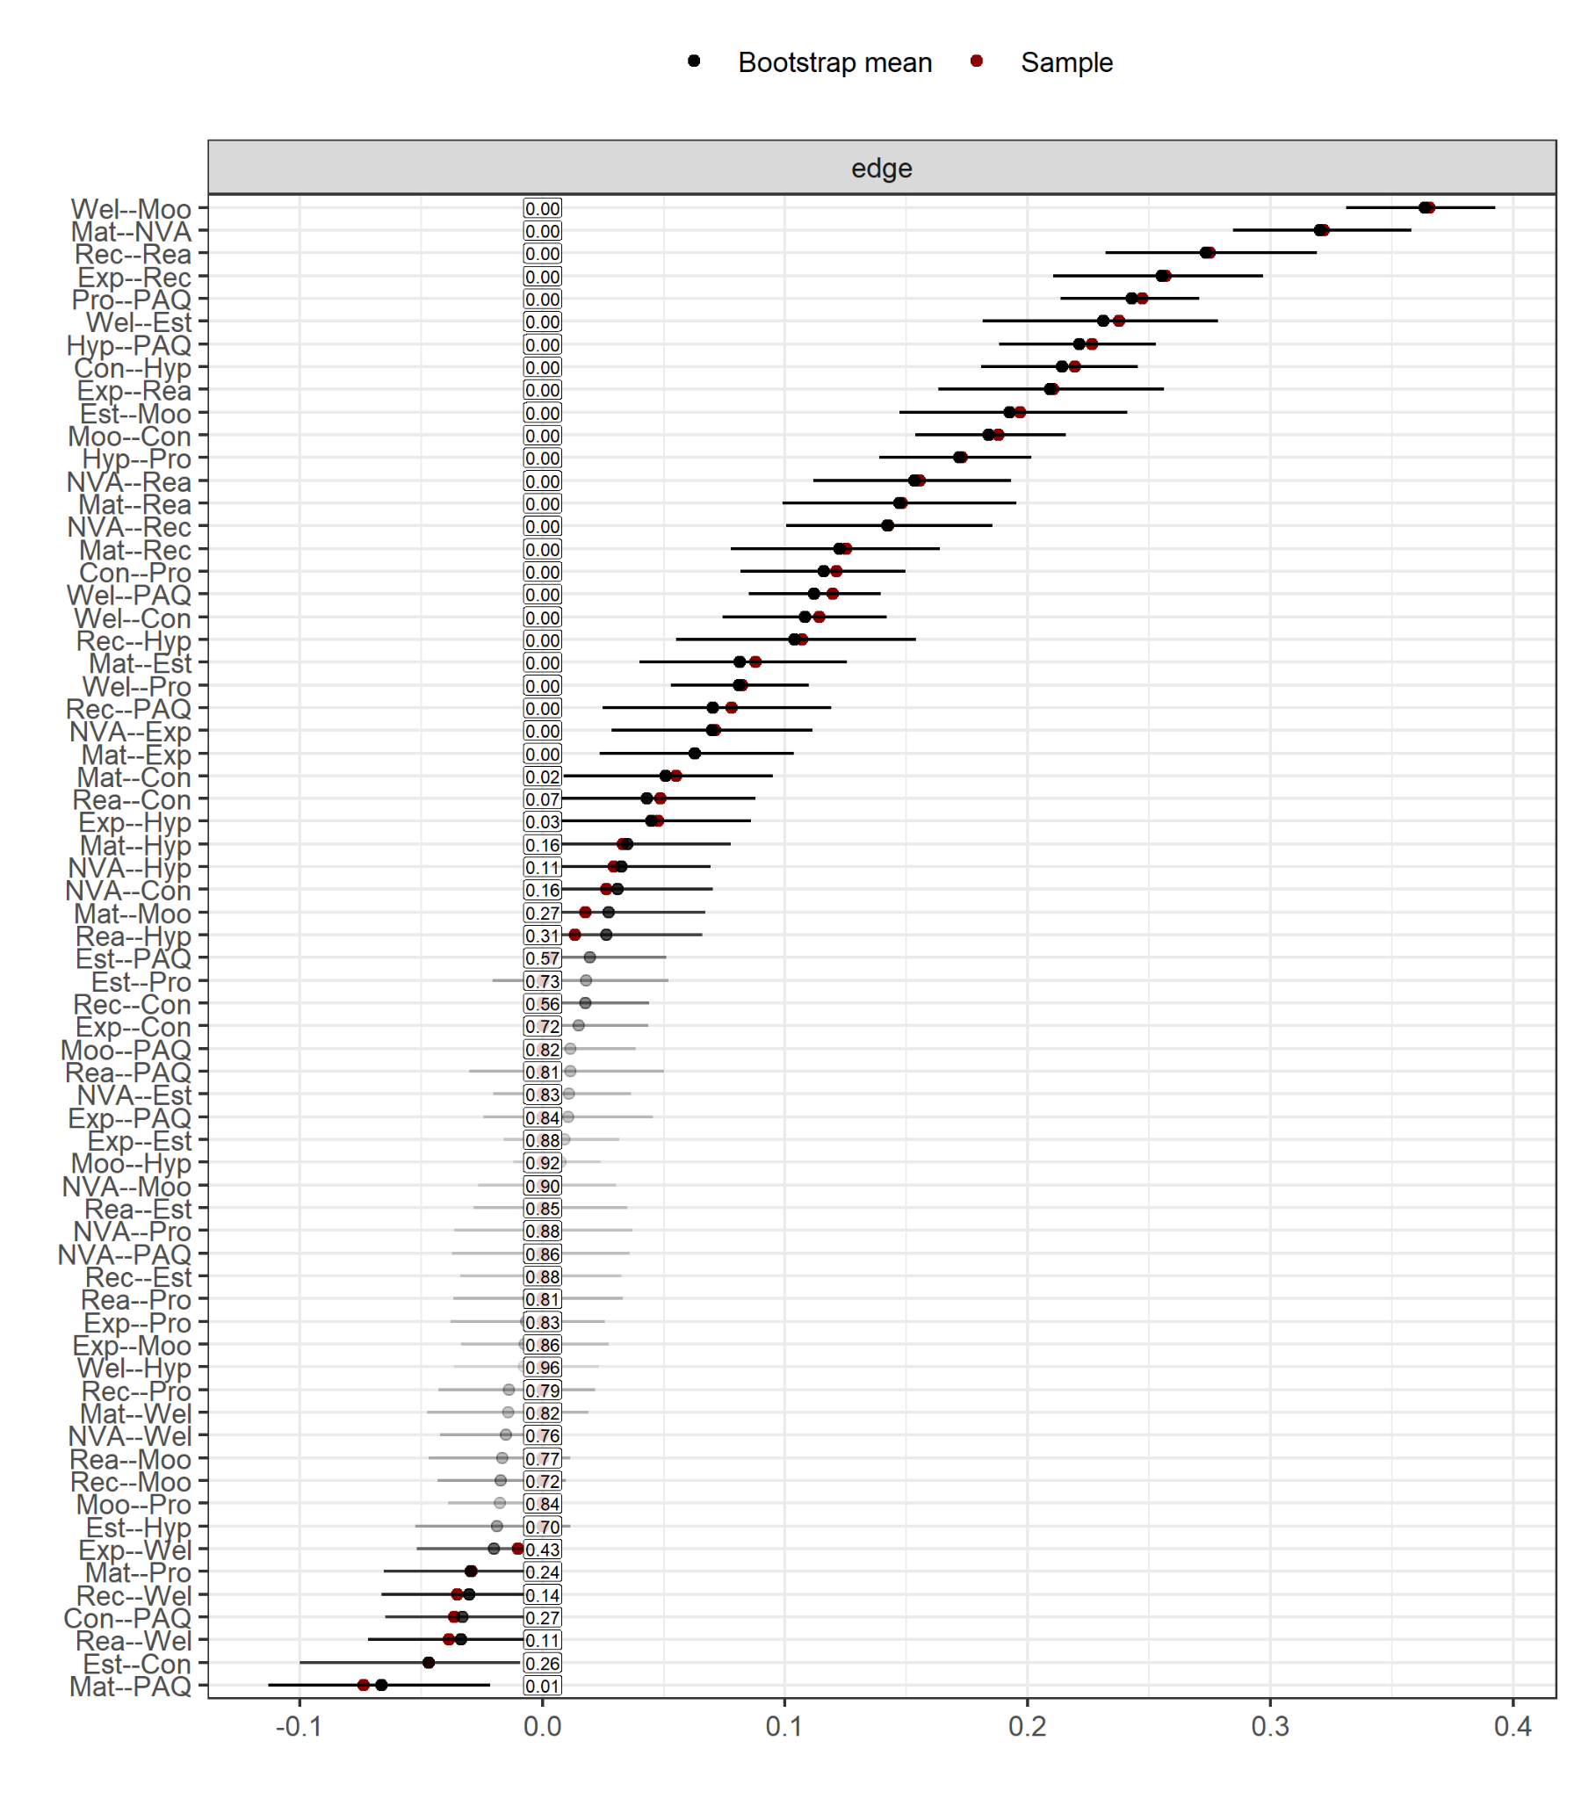
Note. This plot shows the stability and accuracy of edge weights based on 1,000 nonparametric bootstrap samples. Each black dot represents the edge weight estimated from the original data and red dots show bootstrapped mean. Edges with confidence intervals that include zero should be interpreted cautiously, as they may reflect spurious or weak associations.

Figure S31
BCS Adolescence Bootstrapped Confidence Intervals (Edge accuracy)
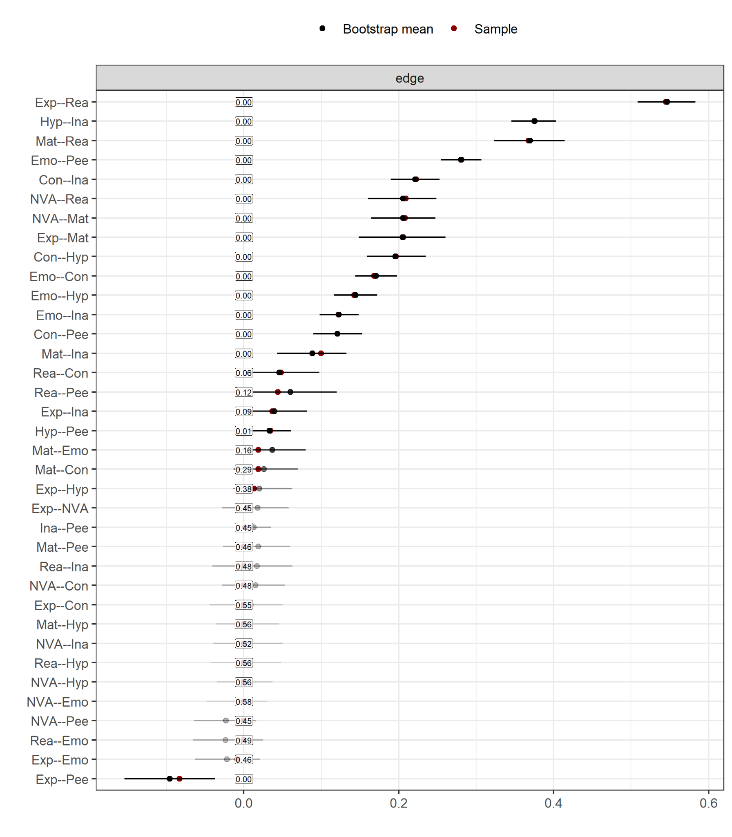
Note. This plot shows the stability and accuracy of edge weights based on 1,000 nonparametric bootstrap samples. Each black dot represents the edge weight estimated from the original data and red dots show bootstrapped mean. Edges with confidence intervals that include zero should be interpreted cautiously, as they may reflect spurious or weak associations.

Figure S32
Bridge Betweenness
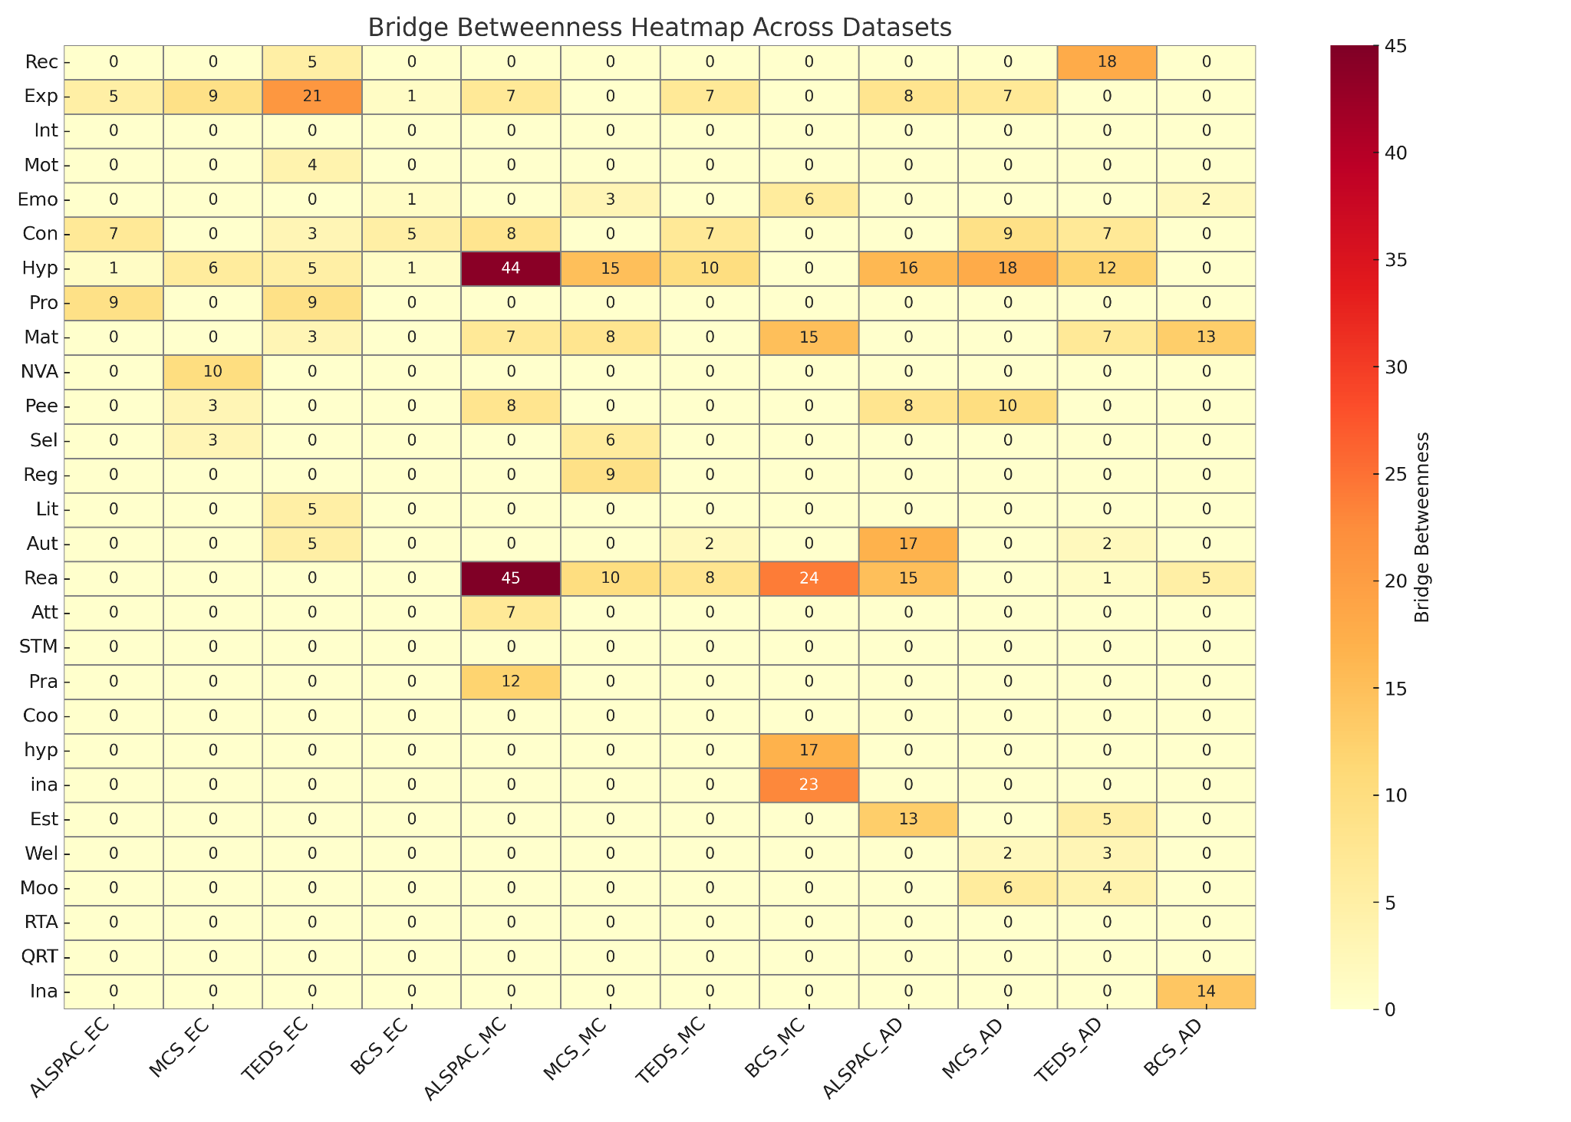
Note. Not all nodes were present in each dataset. That is, some of the nodes that have 0 betweenness may not have been present in the relevant dataset.

Note. Additional measures of emotional functioning (self-esteem, and wellbeing) were available in the three datasets with three communities.
TEACh: details can be found here.
Copying Designs Test: details can be found here
Human Figure Drawing test: details can be found here
Complete a Profile Test: details can be found here
PARCA Design Drawing Test: details can be found here
WISC-III: details can be found here
FMT: details can be found here
mathscore: details can be found here
BSRA-R: details can be found here
NFER: details can be found here
numbers knowledge: details can be found here
Dot Task: details can be found here
WISC-III: details can be found here
WASI: detailed information can be found here
BAS II: details can be found here
BAS II: details can be found here
matrices subscale: details can be found here
scr_m: details can be found here
doddt1: details can be found here
dpuzt1: details can be found here
Ravens matrices: details can be found here
Word reading: details can be found here
TOWRE: details can be found here
BAS II: details can be found here and found here
SRT: details can be found here
ERT: details can be found here
scrtotal: details can be found here
gtowt1: details can be found here
Passages Web Test: details can be found here
Spelling: details can be found here
TEACh: details can be found here
CANTAB: details can be found here
N-back Task: details can be found here
fjnb100: details can be found here
BAS: details can be found here
f8sl040: details can be found here
PLCT: details can be found here
dpictot1: details can be found here
Figurative Language Web Test: details can be found here
WOLD: details can be found here
WASI Vocabulary: details can be found here
EPVT: details can be found here
BAS II: details can be found here
APU: details can be found here
dvocab1: details can be found here
Mill Hill Vocabulary Web Test: details can be found here
Literacy: details can be found here
Autism screening measures in TEDS: details can be found here
SDQ: detailed information can be found here.
To note: we removed the emotional difficulties subscale of the SDQ (or Rutter scale) from the adolescence models in ALSPAC, MCS, and TEDS to prevent multicollinearity with adolescents’ depressive symptomology measured by MFQ.
SHS: details can be found here

