Table 1.
Context ID | Elements | Osteological sex | Age group | Palaeopathological summary
Skull A.681 | Skull | Indeterminate | Adult | Cribra orbitalia, ectocranial porosity
A17 SID 6 | Small fragments of parietal or frontal bone, and left temporal bone, right orbit and zygomatic process, left maxilla with ULPM2, ULM1, ULM2, left mandible with LLC–LLM3, right clavicle, right humerus head, two cervical and three thoracic verts | Indeterminate | Young adult | Discarthrosis, osteoarthritis, and ossification of the ligamentum flava on three thoracic vertebrae. Clavicle with well-developed entheses
A18 SID 7 | Cranial vault fragments, maxilla with ULM2, left mandibles (3, incomplete), one with LLM2, one thoracic fragment, right humerus head, left humerus (condyles), proximal left ulna, proximal right radius, one proximal manual phalanx, right tibia diaphysis, right calcaneum | Unobservable | Adult | Oroantral fistula (ULM3), possible rotator cuff disease, ulna and radius with well-developed entheses
A19 | Cranium | Indeterminate | Old adult | Ectocranial porosity. Partial atlanto-occipital fusion, cranial blastic lesion
A22 SID 7 – 13 | Humerus | Probable Male | Adult | No pathology observed
A22 SID 7 – 14 | Humerus | Unobservable | Not assessable | No pathology observed
A22 SID 7 – 16 | Occipital squama and left parietal bone | Unobservable | Not assessable | Not assessable
A22 SID 7 – 17 | Maxilla and mandible | Unobservable | Adult | Periapical lesion (URM2), linear enamel hypoplasia (one line, URPM1)
A22 SID 7 – 20 | Temporal bone | Unobservable | Not assessable | Not assessable
A22 SID 7 – 21 | Maxilla and mandible | Unobservable | Old adult | Increased porosity at maxillary palatine process accompanied by irregular deposits of porous compact bone
A22 SID 7 – Warre? | Cranial fragments – sphenoid, zygomatic bones (3), frontal, petrous bones (3), occipital bones (2), left parietal bones (2) | Unobservable | Adult | Ectocranial porosity
A23 SID7 | Vertebrae, both humeri, right ulna and both radii, left scaphoid, left 5th metacarpal, two proximal manual phalanges, three intermediate manual phalanges, both femora and tibiae, left talus, two proximal pedal phalanges | Probable male | Adult | Schmorl’s nodes. Healed trauma at proximal pedal phalanx, possible dislocation at a manual distal interphalangeal joint. Long bone fragments with well-developed entheses.
A24 SID 7 – Skull 4 | Frontal bone | Probable male | Not assessable | Not assessable
A24 SID 7 – Skull 5 | Frontal bone | Indeterminate | Not assessable | Not assessable
A24 SID 7 – Skull 8 | Frontal and parietal bone fragments | Unobservable | Not assessable | No pathology observed
A24 SID 7 | Small fragments of scapular blade, manubrium, right radius, right ulna, 1st right metacarpal, metacarpal head, two cervical, five thoracic and one lumbar verts, ribs, os coxa, sacrum, left fibula, navicular, right cuboid, one metatarsal, one pedal phalanx | Unobservable | Adult | No pathology observed
A28 SID 7 | Cranial fragments: right temporal, right parietal, left parietal and occipital bones | Probable male | Not assessable | Not assessable
A30 SID 7 – R1 | Pelvis fragments | Male | Young adult | No pathology observed
A30 SID 7 – R2 | Pelvis fragments | Unobservable | Old adult | Entheseal changes at the ischial tuberosity and at the iliac crest
A30 SID 7 – L | Pelvis fragment | Unobservable | Old adult | Entheseal changes at the ischial tuberosity and at the iliac crest
A30 SID 7 – additional fragments | 1st sacral vertebra, right acromion, right 2nd metacarpal | Unobservable | Adult | No pathology observed
A 33 – Cranium III / ARCHtemp 49 | Skull | Indeterminate | Old middle adult | Carious lesion (URM1, mesial), palatine porosity, button osteoma (small benign osteoma)
A70 SID 11 | Humerus | Unobservable | Adult | No pathology observed
A71 SID 11 | Small fragments – axis, right clavicle, humeri, right ulna, right radius (2), left femur, right femur (2), unsided tibia | Unobservable | Probably adult | Not assessable
A72 SID 11 | Femur | Unobservable | Adult | No pathology observed
A73 SID 11 | Femur | Unobservable | Adult | No pathology observed
A75 SID 11 | Femur | Unobservable | Adult | No pathology observed
ARCHtemp 51 | Skull | Male | Young adult | Linear enamel hypoplasia (mandibular canines and premolars), button osteoma
ARCHtemp356 | Cranium | Indeterminate | Possible young adult | Not assessable
Femur 9 | Femur | Unobservable | Adult | Periarticular osteophytosis at the head and well developed entheses. Raised area at medial aspect.

Table 2.
Context ID | Element | Location | Characteristics
Skull A.681 | Left & right parietal, occipital bones | Left parietal bone (5), left mastoid area (2), left/right parietal bone (1), occipital bone (1), occipital/left parietal bone (1) | 10 instances of SFT
A19 | Left & right parietal bones | Left parietal boss, right parietal boss, right frontal bone | 3 instances of BFT
A22 SID 7 – 14 | Left humerus | Lateral supracondylar crest | 1 instance of SFT
A22 SID 7 – 21 | Left mandible | Left gonial angle | Possible BFT
A22 SID 7 – Warre | Left parietal bone | Left parietal bone | 1 instance of SFT
A24 SID 7 – Skull 5 | Frontal bone | Centre of frontal squama | 1 instance of SFT
A28 SID 7 | Left parietal bone | Left parietal bone | Possible oblique SFT
ARCHtemp51 | Left & right parietal bones | Left parietal boss, right parietal boss | 2 instances of SFT
Femur 9 | Right femur | Proximal ⅓ of lateral aspect | 1 instance of SFT

Table 3.
Harvard genetic ID | GENLAB code | Context ID | Element | SNPs hit on autosomal targets on 1240k snpset | Molecular Sex | Y haplogroup | mtDNA haplogroup
I11142 | 1 | A17 SID6 | Left petrous | 758,912 | M | R1b1a1b1a1a2c1a6a1 | H3b+16129
I11143 | 2 | A22 SID7, box 20 | Right petrous | 762,738 | M | R1b1a1b1a1a2a | H3b+16129
I11991 | 3 & 5 | A22 SID7 & A22 SID7, skull 15 | Left & Right petrous | 940,694 | M | R1b1a1b1a1a2c1 | H3b+16129
I11992 | 4 & 11 | A22 SID7 & A22 SID7 – 19 | Left petrous & LRPM2 | 917,328 | M | R1b1a1b1a1a2c1 | H3b+16129
I13726 | 6 & 10 | A18 SID7 & A22 SID7 – 18 | Right petrous & LRM2 | 841,613 | M | R1b1a1b1a1a2c1 | H13a1a1
I16596 | 7 | box 482, ARCHtemp51 | URM3 | 6,352 | M | - | H3b+16129
I13681 | 8 | A22 SID7 – 21 | LRM2 | 6,431 | M | - | H3b+16129
I16598 | 9 | A22 SID7 – 6 | LLM2 | - | - | - | -

Context ID | GENLAB code | Element | Raw Date (BP) | Calibrated date (1σ) | Calibrated date (2σ) | δ¹³C relative to VPDB | δ¹⁵N relative to air | C/N ratio | Lab code
A17 SID6 | 1 | Left petrous | 2103±27 | 161–55 cal BCE | 197–44 cal BCE | -20.7 ‰ | 11.6 ‰ | 3.6 | SUERC-94960
A22 SID7, box 20 | 2 | Right petrous | 2146±30 | 344–111 cal BCE | 352–53 cal BCE | -20.5 ‰ | 12.3 ‰ | 3.5 | SUERC-94961
A22 SID7 | 3 | Left petrous | 2133±30 | 337–104 cal BCE | 349–50 cal BCE | -20.4 ‰ | 12.3 ‰ | 3.4 | SUERC-94962
A22 SID7 | 4 | Left petrous | 2122±30 | 193–57 cal BCE | 343–50 cal BCE | -20.7 ‰ | 11.5 ‰ | 3.4 | SUERC-94963
A18 SID7 | 6 | Right petrous | 2141±30 | 342–107 cal BCE | 351–52 cal BCE | -20.1 ‰ | 12.1 ‰ | 3.4 | SUERC-94964
Table 4.

Figure 1

Figure 2

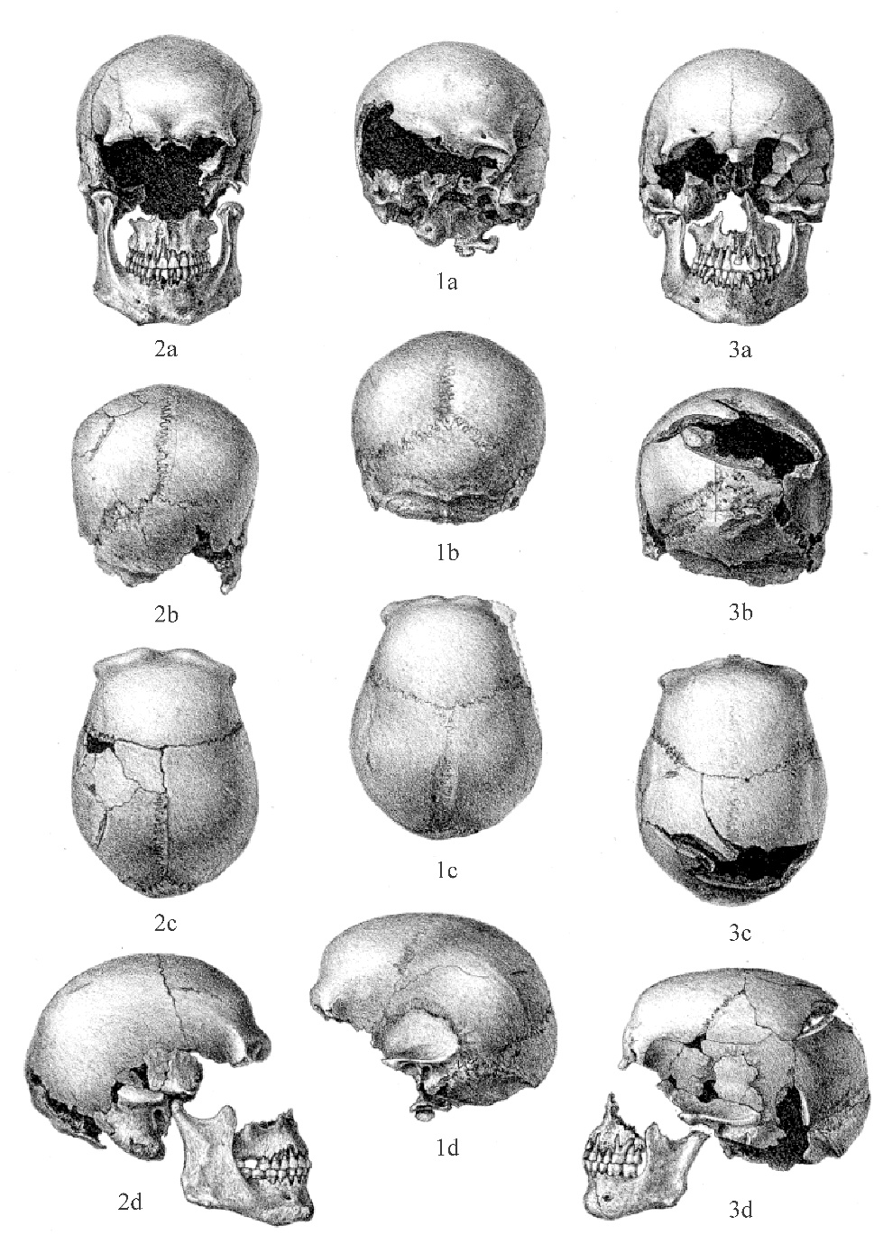
Figure 3

Figure 4

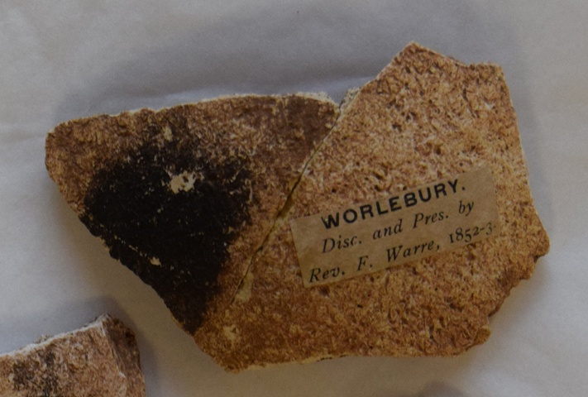

Figure 5

Figure 6

Figure 7

Figure 8

Figure 9
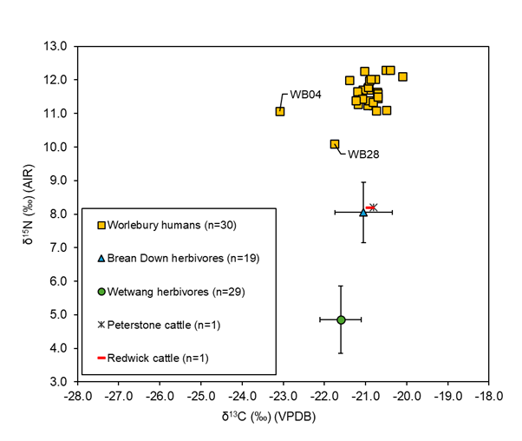

Figure 10

