Title
Applying Systems Thinking and Participatory Design to Policy Development

Abstract
This article explores the application of systems thinking to address complex policy challenges, or ‘wicked problems’. Addressing complex policy problems is difficult when they exist in dynamic environments with interconnected systems, each with their own subsystems and lack clear causal chains. Grounded in systems theory and thinking, an inductive, participatory soft systems methodology is adopted, moving beyond linear, top-down approaches to demonstrate how policy problems that account for the whole system(s) and its interactions are considered, thereby offering a more effective approach to policy development. The article uses a case study of female entrepreneurs in York and North Yorkshire, England to illustrate this approach. NVivo is employed to generate clusters or ‘systems’ to demonstrate the interconnected nature of challenges faced by female entrepreneurs and identify potential policy levers to address them. Rational approaches alone are insufficient for policymaking and by embedding a soft systems methodology with an inductive participatory approach, hidden systems and subsystems are uncovered, enabling the design of inclusive, place-based policy interventions. This approach uncovers patterns, derives actionable insights, and designs targeted, context-sensitive policy interventions.

Key words
Systems thinking, participatory policy design, policymaking, qualitative analysis

Introduction
General systems has been likened to a “methodological maxim” (Von Bertalanffy, 1972: 424), adopting hard and soft paradigms (see Ison, 2008) and methodological pluralism. Policymakers often use rationality leading to a linear ‘hard’ approach of policymaking that seeks solutions to immediate policy concerns, often by reducing pieces of complex problems into separate, rationally manageable components (Chapman, 2004). However “The solution to a mess can seldom be obtained by independently solving each of the problems of which it is composed.” (Ackoff, 1974: 31) and linear policymaking fails to address the complexities of real-world, dynamic systems, temporal changes and interconnections (Head, 2022). While a hard approach is useful for well-defined problems such as engineering a bridge (Checkland, 1994), it is not useful for engineering social issues systems (Ison, 2008) as “policy making and evaluation are not purely technical processes” (Sanderson, 2006: 125). Alternatively, Vickers (1965) developed a soft systems approach through an appreciative systems theory, which Checkland (1994) later explains as a flux of events in a recursive loop that generates appreciation, which in and of itself contributes to that flux. This approach is better applicable to ‘wicked problems’ as popularised by Rittel and Webber (1973). These problems lack a structural centre, an end to a causal chain, clear root causes, definitive solutions, and often involve social complexities, such as conflicting interests and values spread across government departments (Gardner et al., 2019), meaning there is no single best approach to tackle them (Von Bertalanffy, 1972; Head and Alford, 2015; Alford et al., 2024). This informs the preferred adaption of a ‘soft’ systems approach to understand the dynamic complexity of policy challenges in our case study of barriers to female entrepreneurship in York and North Yorkshire (YNY), England.
Where general systems theory sets up the theoretical considerations, systems thinking provides a framework to tackle “messes”, which Ackoff (1974) coined to represent a “system of problems”. Systems thinking highlights how all entities operate within interconnected systems, where the overall functionality depends on the linkages between distributed systems. This is often illustrated in reinforcing and balancing feedback loops that shape system behaviour (Meadows, 2009). However, limitations arise, such as questions over the appropriate methodology given the pluralistic nature of systems thinking (Althaus et al., 2021) and researcher bounded rationality impacting accurate systems mapping (Forrester, 1971).
To address such challenges, participation in policy design is purposefully embedded in our case study to prioritise human-centred, bottom-up processes that actively involve citizens and stakeholders from the early stages of policymaking (Michels and De Graaf, 2010; Lewis, McGann and Blomkamp, 2020). Induction enables the discovery of hidden subsystems and insights derived organically from real-world interactions, enhancing both analysis and decision-making. In doing so, this methodological case study of systems thinking is offered which shifts the focus from traditional problem-solving and analytical methods toward creating policies that deliver meaningful, desired outcomes.
Recognising that stronger support for female entrepreneurs in YNY could significantly contribute to regional economic growth and job creation, the research focuses on identifying key barriers and potential policy solutions. This research builds on The Alison Rose Review of Female Entrepreneurship (The Alison Rose Report, 2019), which analysed national-level challenges and recommendations. The recent devolution deal in YNY (Gov.uk, 2022), which includes investment funds aimed at boosting regional productivity, creates a timely opportunity to explore how these recommendations can be tailored locally to support female entrepreneurs and drive economic growth across diverse regional settings.
Firstly, this article explains the approach to integrating systems thinking with participatory policy design. It is demonstrated how combining systems thinking with an inductive participatory approach provides an effective framework for policymaking. Next, the methodology is discussed, emphasising the use of qualitative research methods and NVivo data software to generate clusters or systems from inductively coded data. This analysis reveals interconnected systems and subsystems, enabling the identification of holistic and impactful policy interventions.

A systems approach in addressing policy in complex systems
Everything exists within systems. Systems are composed of subsystems, which in turn can serve as subsystems of larger frameworks with “no ends to the causal chains that link interacting open systems” (Rittel and Webber, 1973: 162). The human body is a common analogy for demonstrating this, described by Ison and Straw (2020: 111) as an “ecology of organisms” reliant on interdependencies with other organisms and the biosphere, also exemplified by Meadows (2009), she uses the human body as an analogy to demonstrate resilience in systems and subsystems, showing how parts adapt—fighting infections, generating new cells—while the system’s purpose remains intact. However, if critical components (or balancing loops) are too compromised, the system can collapse; for instance if the kidneys demand all available resources, other parts of the body (system) suffer, leading to dysfunction (or suboptimisation). This interconnectedness highlights the ripple effects of interventions of policy where changes in one subsystem can ripple through others, producing both intended and unintended consequences, a point also made by Forrester (1971) is his reflection of equating industrial growth with progress, which overlooks the ripple effect of environmental degradation.
Systems and subsystems can be self-generating, an ever more pertinent characteristic given that technological advancements “spawns system after system” (Arnold and Wade, 2015: 669) as new complexities and interconnections emerge in already complex systems. To address such challenges, a common methodological approach system thinkers use to understand and capture this dynamic behaviour are feedback loops. Forrester (1971: 17) describes it as “…the closed path that connects an action to its effect in the surrounding conditions, and these resulting conditions in turn come back as ‘information’ to influence further action.” While there are some ‘positive-feedback loops’ that generate growth in a system, the majority are ‘negative-feedback loops’ that are equilibrium seeking. Systems are made up of stocks, the core components that shift over time due to inflows and outflows and these movements are tracked over time calibrated to data (Peters, 2014), focusing on trends rather than individual events. For example, population levels serve as a stock within the system, influenced by births (inflows) and deaths (outflows) and present as a collection of feedback processes.
Feedback loops can provide a helpful starting point for model conceptualisation to help portray a system and identify specific relationships of interest (Richmond, 1994; BeLue et al., 2012). But these equilibrium-seeking approaches often fail to adequately account for the possibility that not all agents are rational (Mercure et al., 2016) and can oversimplify relationships’ interactions. Complex systems have many independent agents with strong connections or “couplings” (Schaefer, 1974: 342). This is demonstrated through system maps which show nodes and their relationships (and can include feedback loops as connections to depict a system’s components, relationships and outputs). System maps better address challenges around systemic interactions between agents and their socio-political and cultural context as they explore nuanced relationships, taking into account the normative factors influencing behaviour. Such an approach is preferential to our case study on barriers to female entrepreneurship as prior research acknowledges the key intersecting role that place, social, economic and psychological constructs have on female entrepreneurship.
To form these systems maps, this research adopts a participatory approach to demonstrate how systems thinking and policy design can uncover hidden subsystems by amplifying the voices of policy end-users, i.e., our female entrepreneurs. Unlike traditional stakeholder engagement approaches that often address wicked problems from a top-down perspective, this method prioritises the lived experiences of those directly affected by policies. By incorporating a bottom-up, human-centred approach, citizens and stakeholders actively contribute to the policymaking process at an early stage, offering a corrective to rationalist approaches (Lewis, McGann and Blomkamp, 2020; Saguin and Cashore, 2022). This responds to what Senge (2006) highlights as the importance of being “learningful” when analysing systems and what Forrester (1971) refers to as the subjective ‘mental mode’, as we are often entangled in the very systems we seek to understand.
This is demonstrated by Ison and Straw's (2020) study of the Environmental Agency’s (EA) engagement with residents of Shaldon on flood prevention measures. While the EA focused on tidal flooding, local residents highlighted surface water runoff and inadequate sewer capacity as the real issues—insights only revealed through participatory methods. This underscores the value of inductive, participatory methods in systems thinking—systems are complex, and a top-down approach may miss key subsystems that participatory methods would reveal (Richmond, 1994). To further counteract concerns where perceptions are often faulty or biased, this research engages stakeholders at the research design phase, has multiple rounds of iteration, conducts analysis purposively with participants with different characteristics, has academic input into findings and uses computational analysis to draw upon clusters (and ultimately systems and subsystems) to mitigate against researcher or sample bias.

Methodology
This research uses a case study analysis with a three-stage fieldwork process. The case study focuses on female entrepreneurs in YNY and their experienced barriers and challenges in entrepreneurship. Entrepreneurship is interpreted broadly as being self-employed. This research was conducted in collaboration with local partners who were essential both for access to networks of female entrepreneurs but also in providing feedback and insight on research design. Firstly, community consultations through the form of focus groups were conducted both in-person and online, with approximately 30 participants. Additionally, a small number (n = 4) of interviews were conducted with a purposive sample to ensure that participants with diverse identities were included. These focus groups aimed to explore the specific challenges females face in their entrepreneurial journeys. Secondly, a survey was developed to collect quantitative data. Survey questions were tailored to reflect the issues identified during the consultations. The survey was shared through the university and partners through a networked approach. It covered key thematic areas inductively generated by prior qualitative data analysis. While this article does not focus on the survey’s findings, it provides context for the broader research design and analysis.
Thirdly, a participatory workshop was held. Using analysis from consultations and survey, primary challenges were identified and workshopped by approximately 40 females in business who were invited to attend using the networked approach. In the workshop, participatory problem analysis techniques of problem and solution trees (PASTs) were used. The problem tree, also called situational analysis or problem analysis, helps find solutions by mapping the anatomy of cause and effect around an issue in a similar way to a Mind Map, but with more structure (Wageningen University and Research, 2022). Using the pre-identified challenges, participants reflected on the root causes of challenges (in the roots of the tree) and their consequences (branches) using post-it notes. Solution trees were then used to enable the participants to reframe the core problem into a positive statement, and convert the causes and effects into means and ends (Chevalier and Buckles, 2013). All trees were documented through photographs and research assistants facilitated discussion and took notes at the tables.

Discussion of Findings

Creating subsystems of systems with cluster analysis
The connection between creating subsystems, systems thinking, policy design and cluster analysis lies in the shared goals of addressing complexity, interconnectedness and highlighting patterns to inform effective decision-making. To this end, analysis was carried out in NVivo data analysis software using inductive reflexive thematic analysis on qualitative data collected. Themes were reflexively developed by establishing patterns via open coding of the data following data transcription. While Richmond (1994) and Forrester (1971) have concerns about seeing the forest from the tress and the mental mode, computational cluster analysis of the codes generated based on coding similarity can add depth and identify relationships and patterns that may not be readily apparent and group similar data points together (Nancholas, 2023), aiding against researcher bias particularly when dealing with complex systems. Clustering by coding similarity in NVivo—using Jaccard’s coefficient—assesses relationships between codes where 1 indicates a strong relationship and 0 a weak one. This allows researchers to observe emergent clusters and their relative strengths, mimicking the interrelationships evident in systems thinking to demonstrate interconnections between themed data to create subsystems.
Clustering can help uncover the structure of relationships between themes and visual tools, offering a clear view of these connections. In a dendrogram, codes that participants frequently discuss together (such as Code A and Code B) will appear in the same branches with proximity and colour indicating the strength of the connection. On the NVivo software, by clicking into specific clusters, researchers can access overlapping comments or examples, helping to substantiate patterns and support emerging theoretical insights. For presentation, excerpts of this cluster analysis are included to demonstrate existing relationships identified. Within Chart 1a, there is a strong connection between all codes represented by their shared green colour.
Chart 1: Example cluster analysis of all codes
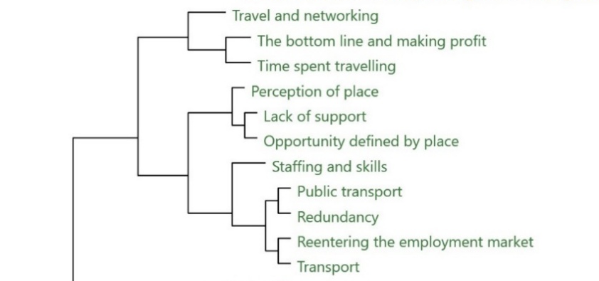
Table 1: Example cluster analysis of all codes with Jaccard’s coefficient
Code A | Code B | Jaccard's coefficient
Opportunity defined by place | Lack of support | 1
Perception of place | Lack of support | 1
Perception of place | Opportunity defined by place | 1
Trade-offs | Buildings and space | 1
Trade-offs | Services | 1
Familial support to run a business | Different ambitions and motivations between men and women | 0.8
Time spent travelling | The bottom line and making profit | 0.8

Findings show there is a strong relationship between ‘time spent travelling’ and ‘the bottom line and making profit’ with a Jaccard’s coefficient of 0.8 (or 80% similarity), as shown in Table 1, quantifying this connection. This relationship is contextualised by examining qualitative data in which participants frequently discuss the extensive time spent traveling across North Yorkshire to reach clients or attend networking events. Participants noted the limited availability of public transport, necessitating reliance on private vehicles. This significant travel time often restricts their ability to allocate time more productively, impacting business profitability. These insights underscore the place-based challenges in the area, highlighting how local infrastructure issues are linked to economic outcomes for female entrepreneurs, showing the dynamic interplay of many issues in this system.
The analysis also highlights that many female entrepreneurs strongly rely on familial support to sustain their businesses. This dependency appears tied to gendered differences in ambitions and motivations, where societal expectations play a significant role, with a Jaccard’s coefficient of 0.8 linking the two codes in Table 1. Males are often assumed to have familial support readily available due to traditional gender roles, whereas females frequently juggle caregiving and household responsibilities alongside their entrepreneurial pursuits. For females, the support they receive can directly influence their business ambitions. Many are unable to start or expand their ventures without financial backing from a partner or practical help, such as caregiving support, from extended family. For example, a partner contributing additional household income offers stability, enabling the entrepreneur to focus on their business without solely shouldering the financial burden. Females whose families depend on their stable income may avoid pursuing higher-risk, high-reward opportunities. Qualitative and secondary data shows that female entrepreneurs often prioritise stability and balance over maximising profits, reflecting their unique circumstances. Compounding these challenges are persistent stereotypes that female entrepreneurs lack ambition, are less serious about their businesses, and do not prioritise profit, further perpetuating systemic biases.

Testing Interrelationships
It is also possible to test the relationship between specific codes to understand their interrelationship as exemplified in Chart 2 and Table 2. For example, two parent codes (Thematic areas), ‘Diversity of place’ and ‘Culture’, each with multiple child nodes (subcodes) reveal notable relationships both within and across themes. ‘Diversity of place’ reflects the varied landscape of YNY while ‘Culture’ reflects gendered issues, including gender stereotypes, perception of female entrepreneurs, imposter syndrome and female skills. Analysis highlights both expected relationships (e.g., ‘female skills’ and ‘emotional trade’) and unexpected relationships such as a link between ‘Male Spaces’ and ‘Difficulty in Coming into YNY for Business’.
The ‘Male Spaces’ code highlights challenges females face in traditionally male-oriented entrepreneurial spaces—ranging from networking barriers and underrepresentation in their sectors to differential access to business resources. These challenges are compounded for those coming into YNY for business, as they often feel isolated and lack necessary support. This connection suggests that the geographic and social marginalisation of female entrepreneurs is mutually reinforcing, demonstrating a need for more inclusive, accessible support systems for females in business across diverse locations.
Chart 2: Diversity of place x Culture
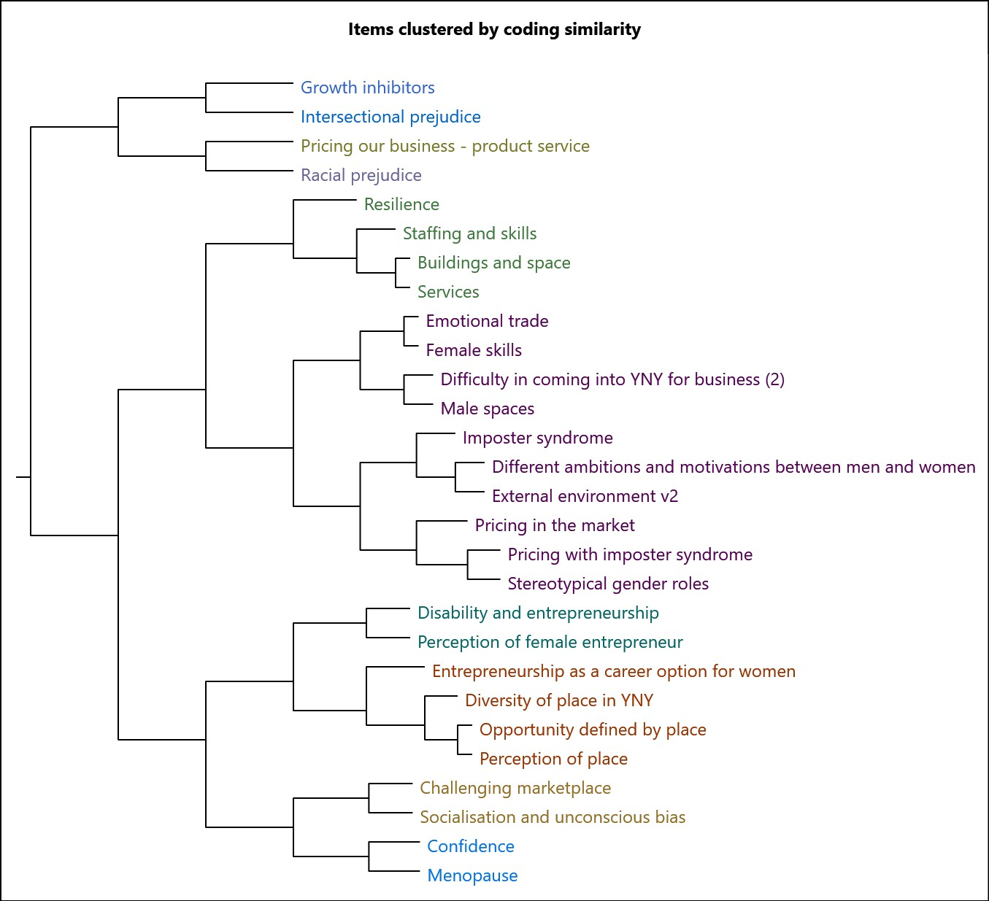
Table 2: Cluster analysis of codes ‘Diversity of place’ and ‘Culture’ with Jaccard’s coefficient
Code A | Code B | Jaccard's coefficient
Female skills | Emotional trade | 1
Services | Buildings and space | 1
Imposter syndrome | Different ambitions and motivations between men and women | 0.8
Male spaces | Difficulty in coming into YNY for business | 0.8
Stereotypical gender roles | Male spaces | 0.8
Emotional trade | Difficulty in coming into YNY for business | 0.75
Female skills | Difficulty in coming into YNY for business | 0.75
Pricing with imposter syndrome | Different ambitions and motivations between men and women | 0.75
Stereotypical gender roles | Pricing with imposter syndrome | 0.75
Socialisation and unconscious bias | Challenging marketplace | 0.6

This approach emphasises the need for inclusive interventions that address interconnected challenges and highlight leverage points where strategic interventions can create widespread change. In our case study, cluster analysis reveals how geographic and social marginalisation reinforce one another. Levers such as improving access to resources, fostering inclusive networks and decentralising support systems can be identified. Additionally, this process helps to identify meso-level variables, such as how organisations, the community or institutions interact with the wider system. This not only improves transparency but also clarifies who is responsible for different parts of the system and their roles in delivering interventions. It may also be a useful starting point in uncovering dynamics between meso-level variables, such as the relationship between community and local government.
Another useful tool employed is the coding matrix, especially when used with case profiles. Cases are units of analysis in NVivo that can place and group common identifiers on files, including age, sex, profession, etc. In this research, the identifier of geographical location is used, and participants are ‘cased’ as e.g., Coastal, Rural, Urban, etc., as demonstrated in Table 3. Using this method focuses and targets interventions in areas against characteristics where they are highlighted. For example, there are more acute difficulties in acquiring staff and skills needed in rural and coastal areas, which inform the intervention approach, decision-making and stakeholder engagement.
Table 3: Matrix Coding Query of selected codes and cases
 | Green Transport | Time spent travelling | Staffing and Skills | Challenging Marketplace | Community networking | Flexibility for familial reasons | Imposter syndrome
Rural | 7 | 7 | 8 | 4 | 6 | 8 | 4
City | 0 | 0 | 0 | 2 | 0 | 4 | 2
Coastal | 0 | 2 | 5 | 1 | 0 | 3 | 5

Systems Map
System complexity is demonstrated through a systems map. The approach is reminiscent to a ‘rich picture’, a form of diagram from soft systems methodology to capture the different perspectives of a messy problem to encourage holistic rather than reductionist thinking (Checkland, 1999). For presentation, a systems map is developed including relationships between codes that have a Jaccard’s coefficient of 0.6 or above. This is demonstrated in Chart 4a where codes are organised thematically by colour associated with their parent code.

Chart 3a: Systems map

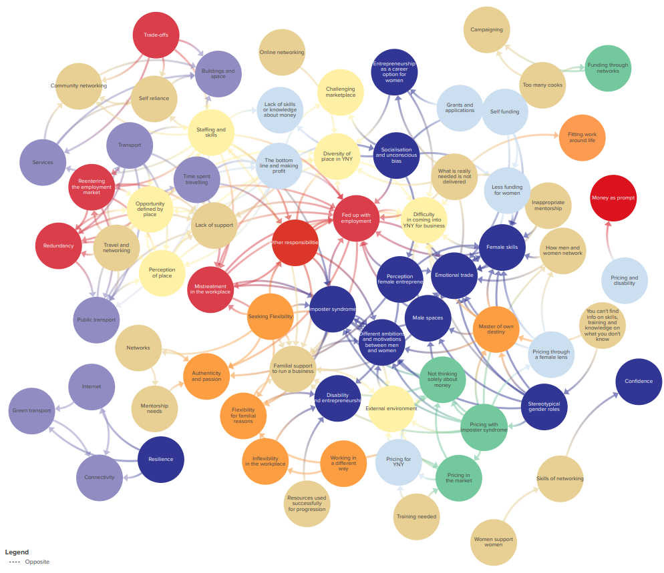

In Chart 4b, each code has its own subsystem of interrelationships. When looking at ‘Imposter Syndrome’, it has a relationship with ‘male spaces’ and ‘ambitions and motivations’, which is expected and aligns with previous qualitative assessments. Furthermore, imposter syndrome is linked with ‘mistreatment in the workplace’ and in being ‘fed up with employment’. This supports the observation that many women are pushed into self-employment due to poor workplace conditions, which could understandably impact confidence and contribute to imposter syndrome. Interestingly, there is also a connection between ‘imposter syndrome’ and ‘flexibility’. Females who prioritise flexibility over traditional business growth goals may experience imposter syndrome, as their ambitions do not align with typical entrepreneurial expectations. Additional causal analysis can determine the strength of this hypothesis.

Chart 3b: Systems map of Imposter Syndrome node
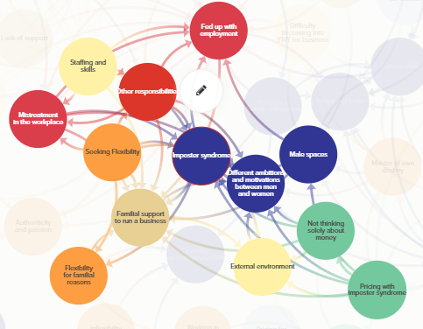

Problem and Solution Trees (PASTs) to Identify Policy Interventions
In embedding creativity, as part of our participatory workshop PASTs were used to workshop key solutions to policy problems. As demonstrated in Image 1, participants identified barriers or challenges at the roots of the trees, consequences in the branches of the trees represented by leaf post its and solutions represented by stars.
Image 1: PASTs of mentorship and family/life commitments tree
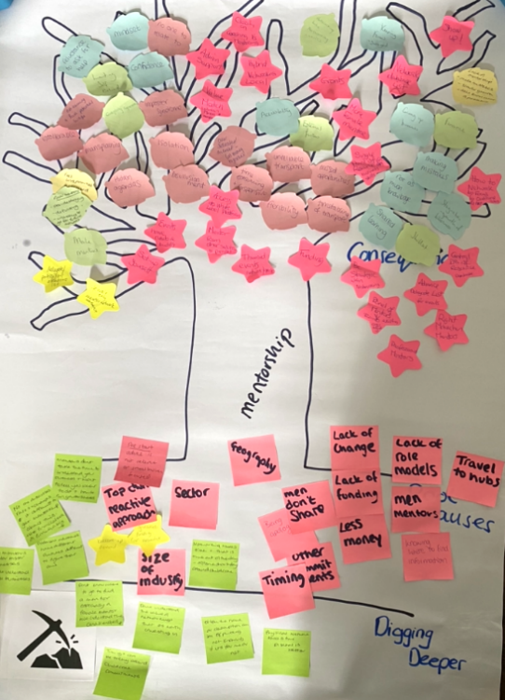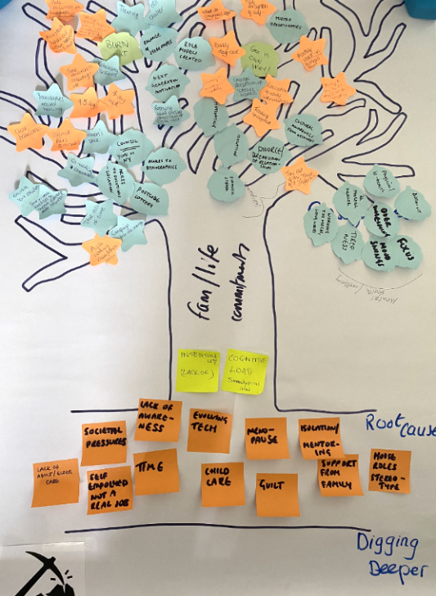

One identified solution to challenges in balancing work and life is the implementation and embedding of flexible working conditions. By referring to the systems map, how this solution might impact various parts of the system is analysed, including the ripple effects, pertinent in in increasingly complex systems where everything is connected (Arnold and Wade, 2015). Hypothetically, embedding flexible work conditions could influence gendered roles, particularly by addressing the need for flexibility due to familial responsibilities. Additionally, it may serve as a lever to reduce imposter syndrome and bridge ambition gaps between male and female entrepreneurs. Flexible working conditions could also alleviate staffing and skills challenges by attracting a larger pool of potential employees who value workplace flexibility. These solutions can be incorporated into the systems map as policy intervention levers. Doing so will help evaluate their potential reach and feasibility within the system. Moreover, this approach offers a benchmark for future testing and evaluation of these policies, ensuring they are effective and impactful.
Some policy interventions, such as targeted financial support for childcare, may effectively address specific challenges, such as affordability. However, it may fail to tackle other related issues, such as the lack of transport to access childcare facilities. By examining how various elements of the system interact, we begin to uncover the broader consequences of pulling certain levers. For instance, providing financial support for childcare might inadvertently exacerbate existing inequalities if transport barriers are not simultaneously addressed. This kind of analysis underscores the need for holistic approaches that account for the ripple effects of interventions across the system and the ability to identify who and how can deliver policy interventions.

Conclusion
We need to build more complex solutions that are as complex as the problem(s) itself and to do so, we need a much better understanding of interdependencies, ripple effects, trade-offs and leverage points to meet policy goals. To do so, the utility of systems thinking in tackling “wicked problems” (Rittel and Webber, 1973) and “messes” (Ackoff, 1974) is utilised and applied to the case study and provides an insight into the practical application of policy-related research that challenges traditional policymaking. Beyond the advantages of policy design more effectively capturing complex policy issues, the approach outlined in this paper shows key learnings when reflecting on research design and how researchers can think about their sample, how best to capture and incorporate lived experience, and stresses an importance on understanding and including the socio-political and cultural context of those policy end-users.
The integration of community-level insights and dynamic modelling tools ensure policies remain responsive to emergent complexities. This is particularly important when responding to dynamic wicked problems. An inductive participatory approach is integrated to uncover systems and subsystems that may otherwise remain hidden, enabling a more accurate understanding of the challenges faced by policy end-users and thereafter, more accurate policy development. Exemplified by the case study and by utilising computational tools, the interconnectedness of issues such as access to support, socialisation, and marketplace challenges is highlighted, underscoring the need for inclusive, place-based interventions tailored to the unique needs of female entrepreneurs that acknowledge the complexity of subsystems and interlinkages between them and their knock-on effect to all within that system. By using an inductive participatory approach to system’s map creation, this can provide a practical framework, facilitate intervention testing and provide the bed test for horizon scanning for complex policy issues.

Future Research and Practical Implications
This approach is applicable to a range of modern policy contexts, including “super wicked problems” (Levin et al., 2012) such as poverty, mental health and climate adaptation, which demand dynamic, adaptive frameworks to navigate competing interests and multi-level governance. Certainly, there will be increased calls for adopting such an approach as our world and policy problems become more complex and interrelated. While systems thinking can break down complex systems into manageable components allowing policymakers to focus on key intervention areas, they do so while retaining sight of interconnected ripple effects. This methodology counters static, siloed policy design to anticipate unintended consequences—essential for wicked challenges where linear solutions often fail. Systems thinking and a systems map is appropriate to outline key nodes and their relationships, rather than a focus solely on inputs and outputs of a system.
At a practical level, systems thinking is becoming an increasing priority within the UK government (Gov.uk, 2023). A dedicated systems thinking toolkit now supports civil servants in designing and delivering policies and services. The toolkit encourages policymakers to move beyond siloed approaches, tackle complex policy challenges, and identify leverage points within systems to inform more effective design and understanding. The government also places emphasis on integrating both qualitative and quantitative factors into a shared framework to support more evidence-informed decision-making. This research contributes to that agenda by embedding participatory policy research tools and demonstrating how they can be used to create systems maps, complementing a broader suite of approaches that support systems mapping and systems thinking in practice. This paper offers an approach for collecting, analysing, and creating a systems map through an alternative participatory methodology, providing a way to understand the system and identify potential policy problems and opportunities for action.
In more advanced studies, interconnections, as exemplified in this case study, could be rigorously tested by simulating or measuring the impact of specific policy interventions on the broader system. Researchers could use systems modelling or experimental trials to assess how a policy like subsidised childcare affects not only childcare accessibility but also other factors, such as employment rates, family dynamics, and local transportation networks. This kind of analysis enables policymakers to refine their approaches to achieve more comprehensive and sustainable outcomes. Furthermore, testing the impact of interventions on interconnected systems can help determine whether the policies are achieving their intended goals and uncover any areas where additional adjustments or complementary policies may be needed. Such a method could also inform iterative policy design, where findings from initial interventions are used to adapt and expand policies in ways that maximise their effectiveness. Extended research can also benefit from applying causal process tracing (CPT) to validate or test the relative strength of the hypotheses and their causal mechanisms to address ‘why’ and ‘how’ a hypothesis is led to an outcome. Notably, in Bayesian CPT enables the researcher to ground their hypotheses in diverse evidence and facilitates the testing of the relative strength of a hypothesis against another (Fairfield and Charman, 2022). Such an approach of grounding hypotheses in diverse evidence aids against researcher bias where researchers are cautioned against relying solely on their view of the system.
By extending this research to include a systems of provisions approach, which maps out key agents and stakeholders associated with interventions (e.g., see Haines-Doran, 2022; Mattioli et al., 2020), such mapping can identify transferable levers and meso-level variables to address challenges (Crowley et al., 2020). Such an approach can inform stakeholder engagement strategies to ensure that all appropriate stakeholders are included in decision-making processes. This becomes particularly significant within the context of English devolution, which has created a landscape of asymmetric powers across devolved areas (LGA, 2025). Different regions therefore hold varying degrees of authority and decision-making capability, meaning that each effectively operates within a distinct system(s) of provision. This is important because these asymmetries shape the range of levers, actors, and institutional dynamics available in each context. By linking systems of provision mapping with devolution, researchers can identify not only the current levers and stakeholders but also anticipate emerging powers and governance arrangements, helping forecast how different devolved areas might adapt and interact over time. Furthermore, such mapping can account for the heterogeneity of agents, their different roles, and interests, and how this can impact a system, subsystem, and strategy over time.

Ethics: Ethical approval was granted by the University of York
Funding Details: This research was funded by Research England by way of the Yorkshire and Humber Policy Engagement and Research Network (Y-PERN).
Disclosure Statement: No potential conflict of interest is disclosed.

References
Ackoff, Russell., L. (1974) Redesigning the Future. A Systems Approach to Societal Problems. New York: Wiley & Sons.
Alford, K.R. et al. (2024) ‘Exploring Systems Thinking Typologies and Paradigms’, Sage Open, 14(2), p. 21582440241255180. Available at: https://doi.org/10.1177/21582440241255180.
Althaus, C. et al. (2021) ‘Research and education in public sector practice: a systems approach to understanding policy impact’, Policy Design and Practice, 4(3), pp. 309–322. Available at: https://doi.org/10.1080/25741292.2021.1977478.
Arnold, R.D. and Wade, J.P. (2015) ‘A Definition of Systems Thinking: A Systems Approach’, Procedia Computer Science, 44, pp. 669–678. Available at: https://doi.org/10.1016/j.procs.2015.03.050.
BeLue, R. et al. (2012) ‘Systems Thinking Tools as Applied to Community-Based Participatory Research: A Case Study’, Health Education & Behavior, 39(6), pp. 745–751. Available at: https://doi.org/10.1177/1090198111430708.
Chapman, J. (2004) System Failure: Why governments must learn to think differently. 2nd edn. London: Demos. Available at: https://demos.co.uk/wp-content/uploads/files/systemfailure2.pdf (Accessed: 18 November 2024).
Checkland, P. (1994) ‘Systems Theory and Management Thinking’, The American Behavioral Scientist, 38(1), pp. 75–91.
Checkland, P. (1999) Systems Thinking, Systems Practice. Includes a 30-year retrospective. Chichester: Wiley & Sons.
Chevalier, J. and Buckles, D. (2013) Participatory Action Research: Theory and Methods for Engaged Inquiry. Taylor & Francis Group.
Crowley, K. et al. (2020) ‘Reconsidering policy systems’, in K. Crowley et al. (eds) Reconsidering Policy: Complexity, Governance and the State. Policy Press, p. 0. Available at: https://doi.org/10.1332/policypress/9781447333111.003.0002.
Fairfield, T. and Charman, A.E. (2022) Social Inquiry and Bayesian Inference. Cambridge: Cambridge University Press.
Forrester, Jay., W. (1971) World Dynamics. Cambridge, Massachusetts: Wright-Allen Press, INC.
Gardner, K. et al. (2019) ‘How can systems thinking enhance stewardship of public services?’
Gov.uk (2022) York and North Yorkshire devolution deal, GOV.UK. Available at: https://www.gov.uk/government/publications/york-and-north-yorkshire-devolution-deal/york-and-north-yorkshire-devolution-deal (Accessed: 3 December 2024).
Gov.uk (2023) An introductory systems thinking toolkit for civil servants - GOV.UK. Available at: https://www.gov.uk/government/publications/systems-thinking-for-civil-servants/toolkit#how-systems-thinking-can-help-develop-policies-and-deliver-services (Accessed: 20 October 2025).
Haines-Doran, T. (2022) ‘A reflection on the Systems of Provision framework of analysis by way of a practical example’, Consumption and Society, 1(1), pp. 211–215. Available at: https://doi.org/10.1332/ADZW1174.
Head, B.W. (2022) Wicked Problems in Public Policy. Understanding and Responding to Complex Challenges. Palgrave Macmillan.
Head, B.W. and Alford, J. (2015) ‘Wicked Problems: Implications for Public Policy and Management’, Administration & Society, 47(6), pp. 711–739. Available at: https://doi.org/10.1177/0095399713481601.
Ison, R. (2008) ‘Systems thinking and practice for action research.’, in P. Reason and H. Bradbury (eds) The Sage Handbook of Action Research Participative Inquiry and Practice. 2nd edn. London: Sage Publications, pp. 139–158.
Ison, R. and Straw, E. (2020) The Hidden Power of Systems Thinking: Governance in a Climate Emergency. London: Routledge.
Levin, K. et al. (2012) ‘Overcoming the tragedy of super wicked problems: constraining our future selves to ameliorate global climate change’, Policy Sciences, 45(2).
Lewis, J.M., McGann, M. and Blomkamp, E. (2020) ‘When design meets power: design thinking, public sector innovation and the politics of policymaking’, Policy & Politics, 48(1), pp. 111–130. Available at: https://doi.org/10.1332/030557319X15579230420081.
LGA (2025) Devolution deals | Local Government Association, Devolution deals. Available at: https://www.local.gov.uk/topics/devolution/devolution-hub/devolution-deals (Accessed: 20 August 2025).
Mattioli, G. et al. (2020) ‘The political economy of car dependence: A systems of provision approach’, Energy Research & Social Science, 66. Available at: https://doi.org/10/1-s2.0-S2214629620300633-main.pdf.
Meadows, Donella., H. (2009) Thinking in Systems. A Primer. Earthscan: London.
Mercure, J.-F. et al. (2016) ‘Modelling complex systems of heterogeneous agents to better design sustainability transitions policy’, Global Environmental Change, 37, pp. 102–115. Available at: https://doi.org/10.1016/j.gloenvcha.2016.02.003.
Michels, A. and De Graaf, L. (2010) ‘Examining Citizen Participation: Local Participatory Policy Making and Democracy’, Local Government Studies, 36(4), pp. 477–491. Available at: https://doi.org/10.1080/03003930.2010.494101.
Nancholas, B. (2023) Clustering and cluster analysis: an explainer, Keele University - Study online. Available at: https://online.keele.ac.uk/clustering-and-cluster-analysis-an-explainer/ (Accessed: 6 November 2024).
Peters, D.H. (2014) ‘The application of systems thinking in health: why use systems thinking?’, Health Research Policy and Systems, 12(1), p. 51. Available at: https://doi.org/10.1186/1478-4505-12-51.
Richmond, B. (1994) ‘Systems thinking/system dynamics: Let’s just get on with it’, System Dynamics Review, 10(2–3), pp. 135–157. Available at: https://doi.org/10.1002/sdr.4260100204.
Rittel, H.W.J. and Webber, M.M. (1973) ‘Dilemmas in a general theory of planning’, Policy Sciences, 4(2), pp. 155–169. Available at: https://doi.org/10.1007/BF01405730.
Saguin, K. and Cashore, B. (2022) ‘Two logics of participation in policy design’, Policy Design and Practice, 5(1), pp. 1–11. Available at: https://doi.org/10.1080/25741292.2022.2038978.
Sanderson, I. (2006) ‘Complexity, “practical rationality” and evidence-based policy making’, Policy & Politics, 34(1), pp. 115–32. Available at: https://doi.org/10.1332/030557306775212188.
Schaefer, G.F. (1974) ‘A General Systems Approach to Public Policy Analysis’, Policy & Politics, 2(4), pp. 331–346. Available at: https://doi.org/10.1332/030557374783219790.
Senge, Peter., M. (2006) The Fifth Discipline. The Art & Practice of The Learning Organisation. London: Random House Business Books.
The Alison Rose Report (2019) The Alison Rose Review of Female Entrepreneurship, GOV.UK. Available at: https://www.gov.uk/government/publications/the-alison-rose-review-of-female-entrepreneurship (Accessed: 6 December 2023).
Vickers, G. (1965) Art of Judgement. A Study of Policy Making. London: Chapman & Hall.
Von Bertalanffy, L. (1972) ‘The History and Status of General Systems Theory’, The Academy of Management Journal, 15(4), pp. 407–426. Available at: https://doi.org/10.2307/255139.
Wageningen University and Research (2022) ‘Problem Tree’, MSP Guide, 18 March. Available at: https://mspguide.org/2022/03/18/problem-tree/ (Accessed: 17 June 2024).

