Navigating the Global Regulatory Chain: The Role of the State in Frontier Technology Sectors

Su Yeone Jeon*
University of York, York, United Kingdom
*Correspondence: suyeone.jeon@york.ac.uk

Abstract

As the crux of the global economy shifts from capital-intensive to technology-driven industries, debate continues over the state’s role in frontier technology sectors. Studies emphasize the importance of state support for domestic R&D, but in frontier technology sectors, even when firms innovate, they may struggle to reach the market if they fail to navigate regulatory barriers across various stages of the value chain. Thus, we must reconsider the relationship between upgrading and commercialization, examining how regulation affecting various links in the chain can either constrain competitiveness or, in some cases, create opportunities for late developers. Focusing upon the South Korean pharmaceuticals industry, this paper argues that one crucial way the state can support domestic firms today is to pursue a strategy of regulatory upgrading, helping firms navigate what I term the global regulatory chain, which spans national borders and impacts all stages of the production process and market entry.

Keywords: regulation, frontier technology, state, innovation, upgrading, global value chain, pharmaceuticals

- Introduction

For much of the second half of the 20th century, the “developmental state” model was the standard explanation of East Asia’s rapid industrialization, emphasizing state efforts to strategically select industries for upgrading via top-down, interventionist policies (Amsden, 1989; Chibber, 2003; Evans, 1995). In today’s era of “compressed development” (Whittaker et al., 2020), where innovation and production unfold simultaneously and upgrading follows a non-linear path centered on frontier technologies and value capture from intellectual property (IP) and other intangible assets, the relative importance of state-led initiatives is increasingly debated. The inherent technological complexity, uncertain R&D outcomes, extended development timelines, and immense investment required make it difficult for conventional government support to stimulate substantial growth in frontier industries (Wang et al., 2012; Wield, 2013; Wong, 2011).
Given this, some argue that the state’s role has significantly diminished, with firms now clearly leading the way by integrating themselves into global value chains/global production networks (GVCs/GPNs) (Pirie, 2018; Yeung, 2016). Others contend that states remain pivotal in steering markets, identifying new growth sectors, and deploying financial and regulatory support (Thurbon and Weiss, 2021; Wade, 2018). While the degree of state involvement remains contested, there is a consensus that its role has been “reconfigured,” and that state-industry alliances have been “reconstituted” into new forms and institutions (Chu, 2021; Gereffi and Sturgeon, 2013).
To better understand how the reconfiguration plays out in practice, this paper explores one frontier technology industry, pharmaceuticals, in a country often advanced as the paradigmatic successful late developer: South Korea. To that end, it builds on recent efforts to reconceptualize the evolving role of the state in GVCs/GPNs (Horner and Alford, 2019; Behuria, 2020; Hauge, 2020) and the nature of regulatory capitalism (Buckley et al., 2022; Durand and Milberg, 2020; Kapczynski, 2020).
With the rise of financialization, marked by a surge in mergers and acquisitions and stock buybacks, the global pharmaceuticals industry has become increasingly concentrated in the hands of a few Big Pharma companies headquartered in the United States and Europe (Lazonick and Tulum, 2024; Muzaka, 2024). Regulatory protections – IPRs, ancillary exclusivities, and patent-linked approval processes among them – have been instrumental in consolidating their market power, transforming innovation into tradable financial assets (Pagano, 2014; Schwartz, 2021). These mechanisms sustain the decades-long dominance of U.S. and European firms, reinforcing a broader stability in the global pharmaceutical hierarchy (with the notable exception of China’s recent prominence).
As a latecomer to this oligopolistic market, South Korea has ramped up R&D expenditure and state-led pharmaceutical initiatives over the past two decades, now investing approximately 5.3% of its GDP in science and technology—second only to Israel. Despite building science parks, expanding infrastructure, and recruiting foreign and diaspora experts, however, its pharmaceutical industry still trails global leaders in sales, revenue, and patent ownership (KISTEP, 2024).
South Korea’s relative success in expanding scientific capacity, juxtaposed with its persistent performance gaps, prompts broader questions about the role the state in supporting latecomer firms to compete in frontier industries. Scholars have emphasized the state’s role in fostering innovation, often assuming that the R&D stage is where value capture occurs (Thurbon and Weiss, 2021; Wong, 2011; Mazzucato, 2016, Ch.3). Even when firms succeed in innovation, however, they may struggle to reach the market if they cannot overcome regulatory barriers. Since regulatory jurisdictions are inherently interconnected, each has global ramifications. Thus, we must broaden our understanding of the relationship between upgrading and commercialization, examining how regulations affecting links in a chain can either constrain competitiveness or even create new opportunities for late developers.
Accordingly, this paper asks: how can states effectively support the innovation efforts of domestic firms operating in highly regulated frontier technology industries? To promote both innovation itself and its subsequent successful commercialization, I argue that states and firms must learn to engage with what I term the global regulatory chain—the interconnected array of regulatory measures and organizations that spans national borders and impacts all stages of the production process in global industries. States, if they are to navigate this landscape successfully, must pursue a strategy of regulatory upgrading, endeavoring to shape both international and domestic regulatory environments to facilitate firm-level upgrading and expand global engagement.
Although the regulatory environment, as an application of state authority, has traditionally been treated as part of a country’s domestic institutional context (Evans, 1995), I show how pharmaceuticals regulation increasingly transcends national borders, influencing all stages of a GVC/GPN, from R&D (e.g., patent claims), through clinical studies (e.g., ensuring compliance with safety and ethical guidelines), and into the distribution and marketing phase (e.g., recalls or drug renewals) (Wong, 2011; Tewari, 2017). It is therefore important to examine how states make regulatory decisions at each stage of the value chain, as the consequences of these choices extend well beyond domestic contexts.
The paper proceeds as follows: first, it outlines the limitations of conventional industrial policy approaches in assessing frontier technology sectors, then it examines why late developers struggle to upgrade despite growing state support, highlighting the structural constraints imposed by the global regulatory chain. I develop the concept of regulatory upgrading, drawing on empirical evidence from South Korea’s pharmaceuticals industry. Finally, I reflect on the broader implications, including the tensions and trade-offs states face in pursuing such strategies.
- The State’s Shifting Role in Frontier Technology Sectors

Since the establishment of the World Trade Organization (WTO) in 1995 and the 1997-1998 Asian Financial Crisis, scholars have argued that the “developmental space” available to states has shrunk, due partly to multilateral agreements restricting use of classic industrial policy tools (Haggard, 2018; Wade, 2003), but also the rise of “private governance” led by multinational companies (MNCs) that constrain value capture for companies from developing countries (Bair, 2017; Mayer and Gereffi, 2010). Scholars building on neo-developmental state perspectives contend that the role of the state has not necessarily diminished, but has rather evolved. They emphasize the creation of environments conducive to innovation and collaboration as an aspect of development (Larson and Park, 2014; McNamara, 2016). The facts reveal, however, that the inherent complexity of frontier technologies poses challenges to the implementation of such initiatives (Breznitz and Ornston, 2018; Wong, 2011).
Others argue that states have shifted from direct intervention to rule-setting and oversight. In response to neoliberal reforms and market liberalization, scholarship on the regulatory state suggests that governments can still exert power and influence primarily through regulation, with delegated authorities using legal and administrative tools to fund innovation and govern markets (Lavenex et al., 2021; Levi-Faur, 2017; Majone, 1997). Regulatory state scholars argue that states maintain an arm’s length relationship with market actors, providing targeted regulatory support to indirectly influence industries. A related field, the regulatory state of the South (RSoS), however, challenges this view, asserting that governments in the South often lack in practice the full autonomy ascribed to them by regulatory state scholars. Their regulatory models are shaped largely by external forces, including international financial institutions, MNCs, donors, and other regulatory bodies (Dubash and Morgan, 2013; Samford, 2015 see also Chorev, 2019). Given this, regulatory governance in the South can differ from the northern model. The difference reflects distinct southern state-market relations conditioned by historical dependence and global economic hierarchies, which disproportionately impact their regulatory capacity (Desai, 2020). In this sense, the RSoS literature acknowledges the tension between global regulatory norms and local institutional contexts.
The developmental and regulatory state models (including RSoS) focus on how domestic institutional capacity may be strengthened, paying less attention to how states may support the innovative activities of firms that operate under multiple interlinked regulatory regimes. It is important to identify not only how domestic institutions are impacted by global regulatory dynamics, but also how they, in turn, can shape the global environment. The following subsections examine first how regulatory capitalism—building on regulatory state theory—describes a global regulatory landscape constructed to preserve the status quo and limit competition. This is followed by a discussion of the GVC/GPN literature, which offers insights into how latecomer states can help their domestic innovators overcome regulatory barriers in the global economy.

  - The Regulatory State in the Era of Regulatory Capitalism

In today’s frontier technology sectors, intangible assets (e.g., patents, brands, trademarks, and copyrights) have become a key source of market power and a major driver of global inequality (Buckley et al., 2022; Durand and Milberg, 2020; Kapczynski, 2020). IPRs and non-IP rights protections are stressed in international conventions such as Trade-Related Aspects of Intellectual Property Rights (TRIPS) under the WTO, as well as in bilateral and regional trade agreements. These initiatives have been largely driven by the United States and the European Union, home to MNCs that, in the aggregate, own most of the world’s IPRs (Andia and Chorev, 2023; Shadlen et al., 2020).
As global regulatory regimes expanded and shaped domestic institutions, some regulatory state scholars explored regulation at the global level, suggesting that the contemporary global economy can be understood through the lens of regulatory capitalism (or “regulatory globalization”) (Levi-Faur, 2017; Schneiberg and Bartley, 2008; Rikap and Lundvall, 2020). Regulation is particularly crucial in frontier technology sectors such as the pharmaceuticals industry—a “long cycle-based” sector (Lee and Kim, 2018) that builds extensively on existing knowledge and requires high investment over a prolonged period. Historically dominated by advanced economies, the global pharmaceuticals industry remains heavily influenced by American and European MNCs and their home country governments, whose vast IPR holdings—reinforced by data and market exclusivity provisions designed to protect their interests—naturally mean high barriers to entry for new competitors from late-developing countries.
Recently, patent stacking—the practice of filing secondary patents on top of original patents—has entrenched what some scholars call “intellectual monopoly capitalism” (Pagano 2014; see also Goode and Chao, 2022). Advanced economies have also pushed for standardized regulatory approval processes that prevent national health authorities from granting market authorization for a drug until all patent disputes are resolved, effectively delaying market entry for follow-on drugs (Demortain, 2015; Kapczynski, 2023). Muzaka (2024) describes MNCs as “knowledge-leveraging corporations”, arguing that they not only utilize state-backed IP protections, but also harness knowledge to control and coordinate a variety of factors impacting production, inter alia in the regulatory sphere.
The global regulatory context thus partially explains why latecomers struggle to upgrade and innovate in pharmaceuticals, particularly in comparison to their relative success in short-cycle industries like semiconductors. The regulatory capitalism literature, however, focuses on the strategies and perspectives of MNCs and advanced economies, with little recognition of the agency of late-developing countries and companies. For instance, while regulatory capitalism scholars may be right that limiting patent duration does not necessarily end monopolies (since other IPRs can continue to block competition) (Rikap, 2019; Kapczynski, 2023; Sampat and Shadlen, 2017, p.694), the case of biosimilars (follow-on versions of patented biopharmaceuticals drugs) shows that the expiration of key IPRs can create market entry opportunities for late developers, even if capitalizing on these opportunities remains challenging. A more comprehensive framework is needed to account for how emerging players—many of them former downstream producers that upgraded to become lead innovators—are reshaping the global regulatory landscape. In this sense, the literature on regulatory capitalism can benefit from the insights of GVC/GPN literature, particularly in examining how latecomer states can leverage regulation across various production stages and jurisdictions to support domestic firms operating at the global-local nexus.
  - Regulatory Upgrading and the Role of States in GVCs/GPNs

Since the COVID-19 pandemic, amidst ongoing tariff wars, scholars have raised questions about whether global trade and production are undergoing structural transformation. While the overall pace of GVC expansion appears to be slowing, technology-intensive sectors like pharmaceuticals continue to exhibit fragmentation, with international actors collaborating across the value chain to produce medicines for diverse markets (Haakonsson, 2009; Muzaka, 2024, p.275) (Figure 1).
[Figure 1 near here]
For decades, global value chain and global production network (GVC/GPN) analyses have focused primarily on interfirm relations, particularly how global lead firms—typically MNCs—coordinate trade and shape suppliers’ upgrading trajectories, especially in developing countries. While some GVC/GPN research has acknowledged institutional contexts that enable domestic firms’ “strategic coupling” to GVCs/GPNs (Ponte and Gibbon, 2005; Lane, 2008; Yeung and Coe, 2015), this body of work has tended to focus much less on states than on firms. With the rise of China, growing South-South trade, and latecomer firms increasingly becoming “heads of GVCs” (Gereffi, 2019), however, a growing body of work is re-centering the role of the state, but in new ways.
Recent GVC/GPN literature recognizes that even as private actors assume an expanded role in governing value chains, states continue to support domestic firms’ upgrading, playing the roles of facilitator, regulator, producer, or buyer (Horner, 2017; Horner and Alford, 2019; Mayer and Phillips, 2017). Behuria (2019) describes how Rwanda’s government guided upgrading in the coffee sector by acting as a facilitator, regulator, and producer, particularly by expanding coffee bean washing stations, fostering public-private partnerships, and regulating producer sales. Similarly, Alford and Phillips (2018) document how South Africa’s facilitative, regulatory and distributive actions helped integrate its fruit sector into global markets; however, it struggled to protect workers and small-scale producers, as efforts to improve labor conditions and wages were hampered by European supermarket chains. These cases highlight the tension between the state’s regulatory and facilitative roles, underscoring the complexities of GVC/GPN governance.
In pharmaceuticals, the state typically acts as facilitator (supporting innovation), regulator (ensuring quality control and safety), and buyer (procuring essential medicines, a key role during COVID-19). Horner (2022) shows that South Africa shifted from facilitator to producer and buyer because its previous approach had left domestic firms heavily reliant on imported active pharmaceutical ingredients (APIs) and finished goods. To enhance pharmaceutical autonomy, the state aimed procurement policies at strengthening its roles as buyer and producer, expanding state-owned enterprises and public-private partnerships.
While the GVC/GPN literature has examined the state as facilitator (e.g., providing economic incentives or lobbying at the inter-state level), regulatory activity has received less attention beyond such constraints on global lead firms and domestic suppliers as tariffs, quotas, price controls, and foreign investment restrictions (Ferrari, 2023; Horner, 2017; Mayer and Phillips, 2017). Facilitation, however, is not merely providing incentives; it also necessarily entails regulatory mechanisms, such as in the case of Special Economic Zones or the enforcement of trade agreements (Hess, 2021). There are two critical insights here. First, rules can enable as well as constrain, blurring the conventional distinction between the roles of facilitation and regulation. Second, while existing typologies acknowledge the overlapping roles states can play (Horner and Alford, 2019, p.558), how these roles overlap in ways that generate tensions and other consequences remains underexplored.
This paper aims to broaden our understanding of the state’s role as a regulator by examining how states engage in regulatory upgrading. The term builds on the concept of upgrading in GVC/GPN literature, which highlights strategies—e.g., product, process, functional, supply chain, and inter-chain—by which firms move into higher value-added activities and increase value capture (Humphrey and Schmitz, 2002; Gereffi, 2019). It recognizes that rather than solely a constraint on firms, regulations can be proactively leveraged by states to facilitate domestic innovators’ success in global markets. In current case study, I analyze how a state engages in regulatory upgrading in the pharmaceutical chain’s three main segments (R&D, manufacturing, and distribution). They do so by innovating policies or refining regulatory frameworks to shape both national and global regulatory environments in ways that might benefit domestic innovators. While the effectiveness of regulatory upgrading may vary across value chain stages, we will see that states do actively leverage available opportunities to support domestic innovation, structural constraints notwithstanding.
2.3 The Global Regulatory Chain and Regulatory Upgrading

Value creation and capture in frontier technologies depend largely on an ability to navigate regulatory hurdles at various stages of the value chain. While the regulatory burden varies by industry, pharmaceuticals and agri-biotechnology, as sectors involving human consumption and health risks, are subject to particularly stringent regulatory oversight. These industries face regulatory barriers at every stage, meaning that even when value is created, commercialization and value capture can be obstructed if regulatory requirements are not met (Figure 2). Frontier technology sectors are profoundly impacted by what I term the “global regulatory chain” (GRC): an interconnected array of multifaceted regulations extending along the value chain. Here, regulatory issues at one stage of the production process have spillover effects on subsequent stages.
[Figure 2 near here]

Research on GVCs/GPNs explains how fragmented production processes are coordinated across geographies, particularly through supplier-buyer transactions that drive value creation. More recently, with the rise of financialization, scholars have proposed global wealth chains (GWCs) as a complementary perspective to GVC/GPN analysis, emphasizing how lead firms maximize value capture, and ultimately shareholder value, through outsourcing and offshore operations (Seabrooke and Wigan, 2017; Grasten et al., 2021). They argue that MNCs not only globalize production, but also strategically allocate wealth across multiple jurisdictions to exploit tax advantages and maximize financial secrecy. GWCs thus highlight how producers, in collaboration with law firms, financial institutions, and shell companies, engage in regulatory arbitrage to leverage differences in tax laws, banking secrecy, and investment protections.
Just as GWCs are “entangled” with GVCs/GPNs (Bair et al., 2023), the GRC intersects both. GVC/GPN analysis explains how value is created and GWC examines how captured value is safeguarded and expanded, but the GRC, a critical link between value creation and capture, remains underexplored. Even when value is created, it cannot be fully realized without market entry, and regulatory barriers are often the decisive factor determining whether that is possible. What we need is an analytical lens that bridges value creation and capture, one that focuses on the regulatory steps that shape this transition.
The global dimension of the regulatory chain is evident in at least two key areas. First, a country’s regulatory standards influence markets beyond its borders, so that the influence of regulatory jurisdictions overlap and intersect globally (Schneiberg and Bartley, 2008). As discussed in Section 2.1, MNCs and their home governments wield institutional power to shape global rules and standards (Dallas et al., 2019). In the pharmaceuticals industry, for instance, drug approval is often contingent on resolution of IPR issues, a process shaped by “linkage provisions”. Initially established by the U.S. Food and Drug Administration (FDA), these provisions have since been widely adopted, as FDA guidelines often become global benchmarks. Under this system, regulators must confirm that a follow-on drug (e.g., biosimilar) does not infringe existing patents before approval. This enables original patent holders—typically MNCs—to extend market exclusivity, frequently delaying market entry for more affordable alternatives (Chorev and Shadlen, 2015; Shadlen et al., 2020).
The global nature of this process is further reinforced by pharmaceutical patenting strategies. Patent holders, particularly MNCs, secure patents in multiple jurisdictions simultaneously under the Patent Cooperation Treaty (PCT) (Zhao, 2022). A single PCT application is examined by an International Searching Authority (ISA), streamlining the process. However, the high costs associated with PCT applications make this a viable option primarily for Big Pharma, exacerbating disparities in the industry.
Second, like GVCs/GPNs and GWCs, GRCs involve interdependent actors across multiple jurisdictions, with varied and often competing interests as they navigate complex regulatory landscapes. To date, the global regulatory chain has primarily served as a protective mechanism for innovators from advanced economies and MNCs. However, as we will see, some innovative value chain actors have successfully moved upstream—transitioning from downstream suppliers to “head” firms—by leveraging regulatory strategies and state support. While overcoming regulatory hurdles requires tacit knowledge, expertise, and institutional capacity that many latecomer countries and firms may initially lack, the regulatory landscape, perhaps unexpectedly, can also create opportunities. After the Methodology section, below, I will focus on the relationship between regulation and upgrading, particularly how states pursue regulatory upgrading to foster environments conducive not only to innovation, but also to global market entry.
- Methods

This study employs a mixed-methods approach, integrating interviews, archival data analysis, and short-term observation at government offices. Data collection took place from May 2021 to September 2022, with additional follow-up interviews in 2024 and 2025. I conducted sixty-nine semi-structured, in-depth interviews with key actors connected with the pharmaceuticals industry. My informants included industry actors in the Korean domestic pharmaceuticals sector; representatives of global pharmaceuticals companies, either located in Korea or partnering with Korean firms; public officials, including regulators and representatives of bureaucratic organizations that provide support for pharmaceuticals R&D; patent lawyers; and scientists working with biological products. For the full list of interviewees, categorized by occupation, see Table 1.
[Table 1 near here]

I supplement these data with an analysis of annual industry reports, legal and regulatory documents, videos of the 2021 and 2022 National Assembly audits, applications for R&D support, information on clinical and non-clinical trials, price data, and news reports concerning the pharmaceuticals industry. I used newspaper articles primarily for fact-checking purposes.
Informants were sampled purposively to secure responses from people versed in trends in the pharmaceuticals industry and related regulatory frameworks. In both 2021 and 2022, I attended the Bio Korea International Convention—an annual expo and conference for the global health and bioindustry. Sponsored by the Ministry of Health and Welfare and other government organizations, this three-day event allowed me to meet a wide range of experts in a single setting. I began constructing my initial pool of interviewees using contacts established at this event, and I used snowball sampling to recruit additional interviewees.
Most interviews were conducted in person, but some took place via Zoom or telephone due to the Covid-19 pandemic. The interviews lasted 1-2 hours and were recorded either at the informants’ offices or another location convenient for them. They were held in Korean or English, depending on the language each informant was most comfortable with. Interviews were transcribed shortly after they were conducted and coded in NVivo. To protect informants’ privacy, I identify them by interview chronology and occupation (e.g., “government official 1”), obviating the need for pseudonyms.

- An Overview of the Global Pharmaceuticals Industry: South Korea’s Role and Challenges

South Korea has consistently ranked 12th or 13th in terms of market size over the past 15 years (KPBMA, 2022) in the oligopolistic global pharmaceuticals sector. These global rankings have remained relatively stable, with the U.S. leading in market share and innovation, as reflected in the number of patents filed, new drugs produced, technology transfers, joint ventures, and more (Figure 3). Korean firms occupy an intermediate position between U.S. and EU-based Big Pharma MNCs and strong generics producers from emerging markets like China and India. They are typically small or mid-sized, as is common for latecomer pharmaceuticals-producing countries, and lack the large domestic markets that allow Chinese and Indian firms to absorb substantial production and establish strong footholds in markets in the global South (Chorev, 2019; Haakonsson, 2009).
[Figure 3 near here]

South Korea has long aimed to develop globally recognized innovative drugs. When it entered the global pharmaceuticals value chain in the mid-1960s, it initially concentrated on repurposing pharmaceuticals factories from the Japanese colonial era with foreign aid from the U.S. International Cooperation Agency (ICA) and operated primarily as a supplier for foreign companies, assembling final products from imported APIs and non-APIs (e.g., fillers, flavorings, coatings, and preservatives). As biotechnology emerged globally in the 1980s, South Korea sought to strengthen domestic innovation capacity, introducing national patent laws in 1987 and launching its first biotechnology R&D program under the Ministry of Science and Technology (MOST). To further prioritize biotech innovation, the Ministry of Trade, Industry and Energy (MOTIE) implemented the Plan for the Development of the Biotechnology Industry in 1989, which evolved into the Bio-Star Project in 2008 (see Hwang, 2015 for details). The Ministry of Health and Welfare (MOHW), which oversees the national healthcare system, began providing industry support in 1996, particularly for the production of generic drugs, which comprised the bulk of Korean production and are essential to sustaining universal healthcare.
As a result of these government initiatives, firms significantly expanded R&D investment, scaled up manufacturing infrastructure, and formed joint ventures with university labs and Big Pharma to in-license patents and develop more complex drugs for export and global market entry. This upgrading led to key milestones: in 1999, Korea’s first domestically developed innovative drug, Sunpla, was launched, followed by Factive in 2003, the first branded Korean drug to receive US FDA approval. Notwithstanding the technological achievement, both drugs struggled in domestic and overseas markets, highlighting the challenges latecomers face in competing with Big Pharma, and particularly in securing global market access and navigating regulatory barriers.
Recognizing these limitations, many firms shifted their focus in the early 2000s to biopharmaceutical drugs (“biologics”), as the global pharmaceuticals industry increasingly prioritized these therapies due to their ability to target diseases more precisely, cause fewer side effects, and command higher prices than chemical-based drugs. However, biologics production is highly complex, requiring the cultivation of specifically engineered living cells and stricter regulatory compliance than is demanded of chemically synthesized drugs. Figure 4 illustrates two possible upgrading paths from generics production. One is the innovation of new chemical drugs, while the other uses biosimilars as a steppingstone to developing novel biologics. While these trajectories may appear to reflect only product upgrading, they also involve functional, process, and supply chain upgrading.
Given the high cost and risks associated with developing novel biologics, many Korean firms that initially began as generics producers turned to biosimilars as a strategic intermediate step. This shift required substantial investment in new facilities or significant modifications to existing production lines. Since the procedures for growing biological cells inevitably vary, biosimilars can only be “highly similar” to their reference drugs in terms of quality, safety, and efficacy, unlike generics, which are exact copies of brand-name chemical drugs (Moorkens et al., 2020).
[Figure 4 near here]

With new chemical or biopharmaceutical drugs considered the gold standard, the Korean government did not at first treat biosimilars as “fully innovative”. In part this reflected how biosimilars producers seek to capitalize on mature markets established by original drugmakers, benefitting from the shorter development timelines and lower costs of a streamlined regulatory process (Agbogbo et al., 2019). Government support for biosimilars remained limited until 2013, when a South Korean biosimilar secured its first European Medicines Agency (EMA) approval. Since then, the state has been more proactive, working to shape both global and domestic regulatory frameworks to strengthen its industry’s competitive position. As of December 2024, South Korea accounted for 19 of the 64 biosimilars approved by the US FDA and 16 of the 109 approved by the EMA, making it the third-largest producer in both markets, after the U.S. and EU.
Despite success in biosimilars and steadily increasing total R&D spending—along with expanded collaboration through bio-clusters and open innovation—South Korea continues to lag in commercialization of innovative medicines (Song and Shin, 2019). Today, MOST primarily funds public R&D (conducted at government-run institutes, universities, and public-private partnerships), while MOTIE remains focused on supporting biotech start-ups. MOHW, whose primary objective is ensuring the supply of affordable drugs, has continued to prioritize generics production, despite its stated goal of supporting new drug development (Hwang, 2015). As discussed in Section 5.3, this divergence in priorities has led to tension between MOHW, MOST, and MOTIE, as industrial competitiveness and healthcare affordability often conflict.
[Table 2 near here]

Moreover, direct government support for drug development is often only a fraction of the costs of producing a single biologic drug. In 2023, the government announced its Third Five-Year Comprehensive Plan, pledging $200 million for new drug development through 2028—far short of the over $1 billion typically required to bring such a drug to market (Table 2). This reveals the limitations of current industrial policies in fostering breakthrough innovations.
While conventional strategies aimed at improving domestic capabilities have yet to achieve transformative change in the pharmaceuticals industry, South Korea has been relatively successful in targeting the global regulatory chain. As we will show in the next section, regulatory upgrading—both globally and domestically—has become a key mechanism for the state as it pursues its broader industrial goals.
- Navigating the Global Regulatory Landscape

The process of bringing a drug to market extends the length of the GVC/GPN. Within each of the three “umbrella” stages—R&D, manufacturing, and distribution—are substages where the state can implement regulatory upgrading to exert practical influence and aid domestic firms in navigating the globally interconnected regulatory chain.
The R&D stage involves a range of actions and events, among them identifying a candidate molecule, conducting preclinical research, resolving patent issues, running clinical trials to assess safety and efficacy, and obtaining regulatory approval. Opportunities available to a state here include active participation in global regulatory fora, such as World Health Organization (WHO) working groups or the International Council for Harmonisation of Technical Requirements for Registration of Pharmaceuticals for Human Use (ICH), particularly in drafting drug guidelines for international standard-setting bodies. Regulatory bodies around the world base their own regulatory decision-making on those global standards, so attempting to influence this segment of the regulatory chain is an obvious choice.
At the manufacturing stage, states can prioritize quality control by implementing regulation to set standards sufficient to facilitate export and thus support firms aiming to upgrade their value chain activities. This, however, may lead to restructuring the domestic market, pushing out firms that fail to comply with stricter new manufacturing guidelines or lack the capacity to innovate.
At the distribution stage, which includes price negotiation and drug procurement for the domestic healthcare system, states can employ price control mechanisms to strengthen local firms’ bargaining power in the global market. Yet, depending on the country’s healthcare system, price regulation may be more favorable to follow-on drugs than to new and innovative medicines.
In the following sub-sections, I detail how states incorporate regulatory upgrading at each link in the chain, the kinds of regulatory support provided, and the extent to which these efforts have been effective (Table 3). As we will see, the roles a state typically assumes at different points in the value chain often intersect—by regulating, for instance, the state not only ensures drug safety, but also facilitates upgrading, and by establishing price regulations, the state can incentivize domestic innovation and support global market entry.
[Table 3 near here]

  - The Research & Development Stage

Pharmaceuticals production begins with drug discovery. The duration and cost of R&D is unpredictable, and ultimately this determines a drug’s fate (Wong, 2011). R&D includes all activities leading up to manufacturing.
While firms handle most of these tasks, the state can indirectly support domestic companies by fostering a regulatory environment conducive to drug development and commercialization. One way the government can help firms navigate the R&D stage of the regulatory chain is by acting to shape the regulatory landscape at the global level. Specifically, participation in drafting global regulatory frameworks can enhance a country’s reputation for having a strong pharmaceutical industry, thereby facilitating drug commercialization and export at the distribution stage. More importantly, shaping global regulations will make them more familiar to domestic firms that have already undergone the regulatory process at home. This can ultimately streamline the R&D aspects of regulatory approval for those firms in foreign markets. The Korean government has adopted this strategy, increasing its engagement with international regulatory bodies, such as the ICH and the WHO.
Since 2011, the South Korean Ministry of Food and Drug Safety (MFDS) has been part of the WHO Collaboration Center Forum, where regulatory bodies from member states jointly develop pharmaceuticals regulations. In 2013, as a pioneering member of the Biosimilars Working Group within the International Pharmaceutical Regulators Programme (IPRP), the MFDS, along with regulatory agencies from the U.S., EU, and Japan, published guidelines on biosimilars. This initiative aims to enhance transparency, standardize regulations across member countries, and promote the interchangeability of biosimilars with patented biologics. Notably, the MFDS played a leading role in drafting and revising key regulatory documents, including the Guidelines for Production and Quality Control of Monoclonal Antibodies (MABs) for Human Administration and Guidelines for Evaluation of Biosimilars (MFDS, 2023). This is partly due to Korea’s strong presence in MAB biosimilars, with firms like Celltrion and Samsung Bioepis successfully launching products in the EU and U.S. markets. Applying its experience in consulting on the development and evaluation of these products, the MFDS not only helped shape global biosimilars standards, but also leveraged Korea’s first-mover advantage to gain influence in the international biosimilars regulatory landscape.
Although further causal analysis is needed, MFDS’s growing role in the global regulatory arena has coincided with a steady rise in biosimilars exports and market share over the past decade. Specifically, between 2022 and 2024, Korea’s share of the EU biosimilars market grew from 45% to 54% (IQVIA, 2024). Figure 5 shows the rise of approved Korean biosimilars in the U.S. and EU, including the names of the specific products.
[Figure 5 near here]

The MFDS’s contribution to the global regulatory landscape was further strengthened by its accession to the ICH as the sixth regulatory member in 2016, gaining voting rights on the adoption, amendment, or withdrawal of ICH guidelines. Established in 1990 as a partnership among the U.S., EU, and Japan, the ICH aims to harmonize regulatory standards for clinical trials and drug approvals, facilitating trade among member countries. In 2018, the MFDS was elevated to a seat on the ICH Management Committee as well, which oversees administrative and financial operations, in addition to the activities of all working groups. When asked about the implications of first becoming a regulatory member and later promoted to the ICH management committee, one interviewee from MFDS said:

Becoming a regulatory member of the ICH means joining an OECD for pharmaceuticals. The MFDS became part of the so-called “P6”. After joining the P6 (the “Pharmaceutical 6”, much like how powerful states are referred to as the “G7”), Korea saw drug approval procedures streamlined in markets like the Middle East and Taiwan…ultimately strengthening the position of Korean pharmaceutical exporters. Previously, firms had to negotiate MOUs with foreign governments independently, but now the Korean government can handle this process on their behalf (Regulator 3).

For many years, Big Pharma companies and their home countries have leveraged harmonization as a tool to maintain global hegemony in the pharmaceuticals market (Davis and Abraham, 2013; Sunder Rajan, 2012). This amounted, in essence, to an oligopoly in the global regulatory setting that persists even now.
The growing number of new entrants into the global pharmaceuticals market, however, has begun to shift these dynamics. For example, in the late 1990s some East Asian countries, led by Japan, have advocated for changes to ICH guidelines to incorporate ethnic sensitivity analysis into clinical trial evaluations, arguing that drug responses may vary by race and ethnicity (Yasuda et al., 2008). Regulatory authorities from Korea, Japan, and China have since formed a tripartite collaboration to study ethnic factors in drug responses. As a result, the issue has been formally integrated into the ICH framework, enabling regulatory authorities in some regions to request a “bridge study” to supplement existing clinical trial data and examine potential links between drug sensitivity and ethnicity (Kuo, 2008). A stronger global presence, then, represents at least a partial “window of opportunity” (Gereffi, 2019) for latecomer countries—not only to share their insights, but also to “change [policies] or influence one another” (Kuo, 2012).
Overall, the state’s efforts at the R&D stage have been relatively successful, as its engagement has shaped the global regulatory landscape in international fora, leading to changes in other countries’ regulatory systems (Kang et al., 2021). While Korea’s experience in the global regulatory chain may not be easily replicable, its strategy at least demonstrates how states can facilitate domestic industries by actively influencing global regulatory frameworks for specific drug categories (e.g., MABs). Moreover, the MFDS’s regulatory upgrading at the global level exemplifies a crucial role that the state alone can play in this process.

  - The Manufacturing Stage

The manufacturing process for a medicine can begin immediately after regulatory approval, marking the start of drug commercialization. The government can promote regulatory upgrading in the manufacturing stage in two key ways. First, by implementing stricter quality control measures and aligning production practices with international Good Manufacturing Practices (GMP) standards, it can secure Mutual Recognition Agreements (MRAs), which facilitates exports. Second, by enforcing rigorous manufacturing standards, the government can incentivize firms to shift from generics to R&D-driven innovation, while sidelining those that fail to upgrade.
Two international instruments, the Pharmaceutical Inspection Convention and the Pharmaceuticals Inspection Co-Operation Scheme (PIC/S), were established to oversee and harmonize GMP standards across countries. As in other international organizations, PIC/S grants membership only to states, serving as a validation of a country’s pharmaceutical manufacturing capacity and facilitating market access (Chorev, 2019). Typically, obtaining PIC/S membership takes four to five years, requiring legislative reforms, upgraded inspections, enhanced quality systems, and rigorous inspector training. However, South Korea secured membership in 2014 after just three years—perfectly timed for Celltrion’s launch of Korea’s first biosimilar in Europe in February 2015.
One reason Korea completed the process so quickly was its proactive effort to align its existing manufacturing regulations, known as Korean GMP (KGMP), with PIC/S guidelines both before and during the review. The MFDS conducted a comparative analysis of KGMP against EU-GMP, c-GMP (the US FDA’s version) and PIC/S GMP guidelines. Based on this review, it updated standards for pre-GMP evaluation, validation, automation and safety testing, enhancing manufacturing quality control requirements in the process (MFDS, 2013). According to an interviewee at the MFDS:

After Korea joined the PIC/S, the KGMP guidelines were brought into line with global standards. In some cases, the KGMP may even be “more global” than EU-GMP or cGMP, as those guidelines were originally developed to meet local needs. In contrast, KGMP underwent extensive restructuring to ensure full harmonization with international standards (Regulator 4).

PIC/S membership can pave the way for MRAs on pharmaceutical GMP among member countries. Without an MRA, manufacturing facilities must undergo inspections by both domestic and importing countries’ regulators. Korea has MRAs with Switzerland since 2019 and Singapore since 2024. Additionally, in May 2019, Korea became the EU’s seventh “whitelisted” country, its exporters exempt from submitting written confirmation of GMP compliance—typically required to verify compliance with EU-equivalent standards. In October 2023, Korea’s MFDS was also designated a WHO Listed Authority (WLA), further streamlining procurement processes. As a result, Dongkook Pharmaceutical’s new drug, Fexuclue, was exempted from GMP inspections for export to Latin America. Given these factors, and as noted by a regulatory affairs specialist from a Korean firm, PIC/S membership has become a “necessary condition” for pharmaceuticals exports.
These examples reveal how the state navigates the manufacturing stage of the global regulatory chain, most crucially in its role as regulator. A key drawback of this harmonization initiative, however, is that by integrating multiple regulatory guidelines, the MFDS has created a more stringent framework than it originally intended. While this rigor benefits domestic firms in export markets, it also makes importing drugs more difficult, potentially limiting Korean patients’ access to specific treatments (Interview with Regulator 4).
The rigorous GMP guidelines also aimed to restructure the Korean pharmaceutical industry by encouraging firms to transition out of generic production and invest more in R&D. As discussed in Section 4, during the 2000s, the government heavily invested in expanding generics production to reduce healthcare costs (Wong and Quach, 2009). The expectation was that, once financially stable, generics producers would transition to developing new drugs. However, firms generally remained content with selling generics and accumulating cash without investing in innovation. This led to an oversaturated domestic generics market. Today, the state sees this as an impediment to innovation, and so it has tightened bioequivalence testing requirements, aiming to push generics producers toward R&D and higher-value innovation.
To gain regulatory approval, generic drug producers must demonstrate the bioequivalence of their product and the reference drug. For years, manufacturers without production facilities (a common case in industry practice) could reduce costs by purchasing test results from a single facility that sold identical data to multiple clients, provided the drugs had the same formulation and manufacturing process (a process known as “joint drug development”). In 2018, excessive flexibility in testing procedures led to the recall of over 115 generic versions of the blood pressure medication Valsartan in Korea, compared to 10 in the U.S., 5 in the UK, and 21 in Canada (Sohn, 2018).
To prevent similar issues and, ultimately, to streamline the overcrowded generics market, the Korean government revised regulations, introducing the “1+3 restriction” under the Pharmaceutical Affairs Act. This rule allows a single bioequivalence test result to support no more than four generic drug approvals. Since the implementation of more stringent regulations, generic drug approvals have declined (Graph 1). At the same time, the number of generics producers conducting their own bioequivalence testing has surged from 52 in 2022 to 219 in 2023 (MFDS, 2023). This move away from contract testing was driven in part by a new policy incentivizing in-house bioequivalence testing and the use of registered APIs, which allows producers to maintain prices at the maximum cap of 53.55 percent of the original drug’s price.
[Graph 1 near here]
Although it is too early to determine whether these regulatory upgrades will yield long-term benefits, Japan’s experience suggests they could. In the 1980s and 1990s, the Japanese government’s efforts to consolidate generics producers ultimately helped its pharmaceutical sector become the third most innovative in the world (Kim, 2014). Brazil raised the bar for generics manufacturers by implementing stricter approval regulations and enforcing them more systematically (Shadlen and Fonesca, 2013). While this reduced the number of suppliers, it also led to “product upgrading” (De Marchi and Alford, 2022) by eliminating lower-quality and less safe drugs from the market. By tweaking its regulatory policies to strengthen quality control for both export and domestic markets, the Korean government has sought not only to restructure pharmaceutical manufacturing, but also replicate Japan’s trajectory, driving industry-wide innovation.
  - The Distribution Stage

The distribution stage is where medicines are commercialized. Producers negotiate with insurers, government agencies, and private buyers to determine drug prices and reimbursement schemes. This typically involves price regulations, but in the case of South Korea, these have been used to indirectly subsidize the pharmaceutical industry. This strategy has not yet led to a measurable increase in the pace of innovation, however. The state’s ability to pursue regulatory upgrading via its pricing stream is constrained by the need to balance firms’ profitability with drug affordability for patients, as explained below.
As far back as the classic developmental state era, price regulation has been a common strategy for East Asian governments to both protect domestic industries and discipline them, encouraging greater efficiency and competitiveness (Amsden, 1989). This approach continues, with both price floors and price ceilings applied to pharmaceuticals in the domestic market. Price floors were established to support domestic firms producing generics, while price ceilings were imposed on new and innovative drugs—most of which, at least until the mid-2000s, were imported from Big Pharma firms (Wong and Quach, 2009). However, as Korea’s pharmaceuticals industry has become more export-oriented and the number of domestic innovative drug producers has grown, why does the state continue to enforce a price control system?
There are two reasons why state enforces price floors on follow-on drugs (both generics and biosimilars): first, to help domestic firms generate higher profits for reinvestment in R&D, and second, to strengthen firms’ negotiating power when setting export prices. Although more than 30 percent of Korean pharmaceuticals firms are now exclusively focused on developing new and innovative drugs, and although government support is specifically designed to advance this goal, most domestically produced drugs still consist of follow-on types. Given this, the practical beneficiaries of price regulation continue to be generics and biosimilars producers.
As discussed in Section 5.2, generic drugs in Korea are typically reimbursed at around 53.55 percent and biosimilars at 80 percent of the standard sales price of original drugs. In October 2016, the government introduced the “Plan for Improving Insurance Prices for Biopharmaceuticals and Global Innovative Drugs” to support biosimilar pricing. Initially, biosimilars were priced at less than 70 percent of reference drug prices, but under this policy that figure increased to 80 percent. Studies indicate that biosimilars prices in Korea are higher than in Japan, the EU, or the U.S. For instance, Celltrion’s Herzuma, a breast cancer biosimilar to Herceptin, costs 31 percent less than the reference drug in Japan but only 19.9 percent less than it cost in Korea. One explanation is that if Korean biosimilars were priced lower at home, it could negatively impact price negotiations in foreign markets (Lee, 2021). By maintaining a relatively high domestic price through a price floor, the government, which is the effective buyer of almost all medicines in Korea, indirectly subsidizes its biosimilars industry.
This protective mechanism has had a more pronounced effect on generics than on biosimilars. According to Bae et al. (2021), generics in Korea are priced 41 to 54 percent higher than in OECD countries, even when accounting for exchange rates and health care premiums. A recent RAND report (Mulcahy et al., 2024) similarly confirms that when South Korea’s generic drug prices are used as a baseline (100 percent), the same drug costs approximately 21 to 45 percent less in other advanced economies (Graph 2).
[Graph 2 near here]
This contrasts with the price ceiling still imposed on new and innovative drugs. Originally, this measure was aimed at constraining the cost of expensive branded drugs, primarily imported from advanced economies. However, with a growing number of domestically produced innovative drugs, producers now seek higher prices to recoup R&D investments.
Despite these changes, South Korea’s single-payer national healthcare system requires the government to prioritize affordability. As a result, through its Health Insurance Review and Assessment Service (HIRA), MOHW enforces a “reference-based pricing system” (Wong and Quach, 2009). Under this system, drug prices are based on pricing in the “Advanced 9” (A9) countries: the U.S., UK, Germany, France, Italy, Switzerland, Japan, Canada, and Australia; the country with the lowest average price among these nine becomes the reference. Even if a drug is both new and the first of its kind developed by a domestic firm, HIRA establishes a reference by identifying the closest comparable drug and assessing its pricing in other markets. In fact, as we can see from Graph 3, the average price of original drugs in Korea (including domestically developed ones) is the lowest among A9 countries.
[Graph 3 near here]
MOHW’s approach conflicts, at least to some extent, with those of MOST and MOTIE, which prioritize upgrading and supporting innovative firms in generating profits to reinvest and further expand R&D efforts. They favor high domestic drug prices and view price ceilings on new drugs as “an obstacle to the growth of the biopharmaceuticals industry” (Government Official 2). The tensions among multiple state agencies, each with its own objectives, highlight the complexity of regulatory upgrading efforts and partly explain why no domestically developed new biologics have emerged as of yet.
From the MOHW’s perspective, though, retaining the price ceiling and using a reference-based system was essential. With the growing number of domestic innovators, incentivizing them with higher prices could significantly drain the government’s budget for the national healthcare system, especially given the high costs of biopharmaceutical drugs. South Korea’s role as a monopsonistic “buyer” of healthcare has been well documented elsewhere (see Wong and Quach, 2009).
While frequent changes to price regulation have primarily sought to stimulate biosimilar and generic production—areas in which Korean firms have excelled—we can also see how domestic innovation for new drugs is constrained by both the national healthcare system and global market forces. The tension between the state as buyer, working to keep medicine affordable for the national healthcare system, and the state as facilitator, promoting innovation, is expressed in contrasting price regulations for new and follow-on drugs. This conflicted policy, arising from the state’s overlapping roles, partly explains the slow pace of innovation and the relatively modest growth of the Korean pharmaceuticals industry over the past few decades.
- Conclusion

This paper has examined how states can support the innovation efforts of domestic firms in the context of today’s highly regulated frontier technology industries, in which where upgrading lacks a clear pathway and overcoming a complex regulatory landscape has become central to value capture. While the existing literature emphasizes the state’s role in fostering R&D, this paper argues that it is equally important to examine the crucial link between R&D and commercialization, particularly how the global regulatory chain shapes firm competitiveness and how states can help navigate it. My analysis demonstrates that states can incorporate regulatory upgrading across various stages of the value chain by proactively shaping both domestic and international regulatory environments to reduce barriers and facilitate their domestic firms’ global engagement. As the findings section illustrates, however, the impact of regulatory upgrading may vary across stages of the value chain. In some cases, more rigorous regulatory standards can disadvantage producers that are unable to meet them.
The regulatory upgrading strategy discussed here may not be feasible for all latecomer countries, especially those lacking the capacity or influence to shape the global regulatory landscape. Clearly, South Korea’s pharmaceuticals industry has benefited from unique institutional contexts that support the development and export of innovative drugs, as well as state-facilitated opportunities for global market entry. However, other countries have also successfully leveraged regulatory upgrading to enhance their bargaining power and secure affordable medicines. Brazil was among the first to challenge Big Pharma’s IP protections on HIV/AIDS drugs by incorporating TRIPS flexibilities into national law, issuing a compulsory license for Merck’s Efavirenz to lower costs and strengthen local manufacturing capacity (Flynn, 2013). This tactic influenced other late developers, including South Africa and India in their fight against patent monopolies. In East Africa, Tanzania upgraded its GMP standards to align with WHO requirements, driven largely by foreign aid and donor pressure. While this led to the exit or acquisition of many local firms that were unable to comply (Wangwe et al., 2022), it also allowed higher-quality generics to circulate and allowed some Tanzanian firms to expand regional exports (Chorev, 2019).
Pharmaceuticals is not the only sector where states use regulatory upgrading to induce changes in an industry. The EU’s 2018 General Data Protection Regulation (GDPR) extended compliance obligations beyond its borders, prompting Japan and South Korea to revise their privacy laws. Both were granted EU “adequacy decisions” in 2021, enabling unrestricted data flows with the EU (Ferrari, 2023). In the agri-food sector, the introduction of more stringent food safety and certification standards demanded by export markets has promoted regulatory upgrading and expanded access to high-value global markets. However, these transformations also entail significant opportunity costs, including the exclusion of producers unable to upgrade and thus become compliant, industry consolidation and resulting job loss, and heightened transaction and coordination costs (Cramer et al. 2014; Neilson, 2008; Tran et al., 2013). These dynamics highlight the importance of critically evaluating the social and economic trade-offs inherent in pursuing regulatory upgrading as state policy.
Whether in pharmaceuticals or other industries, the global regulatory chain has become a key element in any state’s arsenal for promoting upgrading and innovation. Amid ongoing tariff wars and the limited policy options currently available, government decisions must be both subtle and precise. South Korea’s approach to leveraging regulation to transform its pharmaceuticals industry exemplifies how, despite shifting constraints, state influence can remain both significant and effective. Future research on the global regulatory chain framework might explore other value chain actors, offering deeper insights into how regulatory burdens are distributed. This can help identify who faces the greatest regulatory constraints and why particular regulations are enforced or bypassed in certain circumstances.

Acknowledgements
The author is grateful to Dr. Jennifer Bair for her guidance on multiple drafts of this article, the TEMPO workshop at the University of Virginia for insightful feedback, and two anonymous reviewers for their constructive and thoughtful comments. The author also thanks the informants who generously shared their perspectives on the Korean pharmaceutical industry.

Funding

The Bankard Fund for Political Economy and Center for Global Inquiry & Innovation at the University of Virginia

References

Agbogbo, F. et al. (2019). “Current perspectives on biosimilars.” Journal of Industrial Microbiology & Biotechnology, 46:1297-1311.

Alford, M. and Phillips, N. (2018). “The political economy of state governance in global production networks: change, crisis and contestation in the South African fruit sector.” Review of International Political Economy, 25(1):98-121.

Amsden, A. (1989). Asia’s Next Giant: South Korea and Late Industrialization. New York: Oxford University Press.

Andia, T. and Chorev, N. (2023). “How to Study Global Lawmaking: Lessons from Intellectual Property Rights and International Health Emergencies.” Annual Review of Law and Social Science, 19:215-234.

Bae, EM. et al. (2021). “제네릭 의약품의 국가 간 약가 비교: 분석방법별 약가 수준의 차이 고찰.” The Korean Journal of Health Economics and Policy, 27(2): 49-71.

Bair, J. (2017). “Contextualising compliance: hybrid governance in global value chains.” New Political Economy, 22(2):169-185.

Bair, J. et al. (2023). “Entangled chains of global value and wealth.” Review of International Political Economy, 30(6):2423-2439.

Behuria, P. (2019). “The domestic political economy of upgrading in global value chains: how politics shapes pathways for upgrading in Rwanda’s coffee sector.” Review of International Political Economy, 27(2):348-376.

Breznitz, D and Ornston, D. (2018). “The politics of partial success: fostering innovation in innovation policy in an era of heightened public scrutiny.” Socio-Economic Review, 16(4):721-741.

Buckley, P. et al. (2022). “Rent appropriation in global value chains: The past, present, and future of intangible assets.” Global Strategy Journal, 12(4):679-696.

Chibber, V. (2003). Locked in Place: State-Building and Late Industrialization in India. Princeton, NJ: Princeton University Press.

Chorev, N. (2019). “Making Medicines in Kenya, Tanzania, and Uganda in the AIDS Era: Toward a Sociology of Developmental Foreign Aid.” Sociology of Development, 5(2):115-224.

Chorev, N. and Shadlen, K. (2015). “Intellectual property, access to medicines, and health: new research horizons.” Studies in Comparative International Development, 50(2):143-156.

Chu, YW. (2021). “Democratization, globalization, and institutional adaptation: the developmental states of South Korea and Taiwan.” Review of International Political Economy, 28(1):58-80.

Cramer, C. et al. 2014. “Fairtrade cooperatives in Ethiopia and Uganda: uncensored.” Review of African Political Economy, 41(S1):S115-S127.

Dallas, M. et al. (2019). “Power in global value chains.” Review of International Political Economy, 26(4):666-694.

Davis, C. and Abraham, J. (2013). Unhealth Pharmaceutical Regulation: Innovation, Politics and Promissory Science. New York: Palgrave Macmillan.

Demortain, D. (2015). “The tools of globalization: ways of regulating and the structure of the international regime for pharmaceuticals.” Review of International Political Economy, 22(6):1249-1275.

De Marchi, V. and Alford, M. (2022). “State policies and upgrading in global value chains: A systematic literature review.” Journal of International Business Policy, 5:88-111.

Dubash, N. and Morgan, B. (Eds.) (2013). The Rise of the Regulatory State of the South: Infrastructure and Development in Emerging Economies. Oxford: Oxford University Press.
Durand, C. and Milberg, W. (2020). “Intellectual monopoly in global value chains.” Review of International Political Economy, 27(2):404-429.
European Commission (EC). (2021). “Data protection: European Commission launches the process towards adoption of the adequacy decision for the Republic of Korea.” 15 Jun. Press release.
Evans, P. (1995). Embedded Autonomy: States and Industrial Transformation. Princeton, NJ: Princeton University Press.

Ferrari, F. (2023). “State roles in platform governance: AI’s regulatory geographies.” Competition & Change, 0(0):1-19.

Flynn, M. (2013). “Origins and Limitations of State-based Advocacy: Brazil’s AIDS Treatment Program and Global Power Dynamics.” Politics & Society, 41(1):3-28.

Gereffi, G. (2019). Global Value Chains and Development. New York: Cambridge University Press.

Gereffi, G. and Sturgeon, T. (2013). “Global value chains and industrial policy: the role of emerging economies.” In Elms, D. and Low, P. (eds.), Global Value Chains in a Changing World, pp 329–360. Geneva: World Trade Organization.

Goode, R. and Chao, B. (2022). “Biological patent thickets and delayed access to biosimilars, an American problem.” Journal of Law and the Biosciences, 9(2):1-24.

Grasten, M. et al. (2021). “Legal affordances in global wealth chains: How platform firms use legal and spatial scaling.” Environment and Planning A: Economy and Space, 55(4):1062-1079.

Haakonsson, SJ. (2009). “The Changing Governance Structures of the Global Pharmaceutical Value Chain.” Competition & Change, 13(1):75-95.

Haggard, S. (2018). Developmental States. Cambridge, UK: Cambridge University Press.

Hess, M. (2021). “Global production networks: the state, power and politics.” In Rethinking Value Chains: Tackling the Challenges of Global Capitalism. Palpacuer, F. and Smith, A. (eds). Bristol, UK: Policy Press

Horner, R. (2017). “Beyond facilitator? State roles in global value chains and global production networks.” Geography Compass, 11(2):e12307.

Horner, R. (2022). “Global value chains, import orientation, and the state: South Africa’s pharmaceutical industry.” Journal of International Business Policy, 5:68-87.

Horner, R. and Alford, M. (2019). “The roles of the state in global value chains: an update and emerging agenda.” In Handbook of Global Value Chains, Gereffi, Ponte, Stefano et al. (eds). Northampton: Edward Elgar Publishing Limited.

Humphrey, J. and Schmitz, H. (2002). “How does insertion in global value chains affect upgrading in industrial clusters?” Regional Studies, 36(9):1017-1027.

Hwang, SW. (2015). “Latecomers’ science-based catch-up in transition: the case of the Korean pharmaceutical industry.” PhD dissertation, Department of Science and Technology Policy Studies, University of Sussex.

Kang, HN. et al. (2021). “Regulatory challenges with biosimilars: an update from 20 countries.” Annals of the New York Academy of Sciences, 1491(1):42-59.

Kapczynski, A. (2020). “The Law of Informational Capitalism.” Yale Law Journal, 129(5):1276-1599.

Kapczynski, A. (2023). “The Political Economy of Market Power in Pharmaceuticals.” Journal of Health Politics, Policy and Law, 48(2):DOI 10.1215/03616878-10234184

Kim, H. et al. (2021). “Promoting Entrepreneurship under the Shadow of Big Business in Korea: The Role of the Government.” In Drivers of Innovation: Entrepreneurship, Education, and Finance in Asia. Yong Suk Lee and Fei Yan. (eds.). Stanford: Walter H. Shorenstein Asia-Pacific Research Center.

Kim, J. (2014). “최근 일본 제약기업의 연구개발 실태 비교분석.” KHIDI Brief. Vol. 123. April 28.

KISTEP. (2024). “A study on the overview and enhancing efficiency of government R&D in drug development.” Korea Institute of S&T Evaluation and Planning.

KPBMA. (2022). “2022 Databook of the Korean Bio/Pharmaceutical Industry.” Korea Pharmaceutical and Bio-Pharma Manufacturers Association.
Kuo, WH. (2008). “Understanding Race at the Frontier of Pharmaceutical Regulation: An Analysis of the Racial Difference Debate at the ICH.” Journal of Law, Medicine, and Ethics, 36(3): 498-505.

Kuo, WH. (2012). “Transforming States in the Era of Global Pharmaceuticals: Visioning Clinical Research in Japan, Taiwan, and Singapore.” In Lively Capital: Biotechnologies, Ethics, and Governance in Global Markets. Ed. Kaushik Sunder Rajan. (ed). Durham: Duke University Press.

Lane, C. (2008). “National capitalisms and global production networks: an analysis of their interaction in two global industries.” Socio-Economic Review, 6(2):227-260.

Lavenex, S. et al. (2021). “Power transitions and the rise of the regulatory state: Global market governance in flux.” Regulation & Governance, 15(3):445-471.

Lazonick, W and Tulum, Ö. (2024). “Sick with “shareholder value”: US pharma’s financialized business model during the pandemic.” Competition & Change, 28(2):251-273.

Lee, K and Kim, YY (2018). “Comparing the National Innovation Systems in East Asia and Latin America: Fast Versus Slow.” In Innovation in the Asia Pacific. Clarke, T., Lee, K. (eds). Springer, Singapore. Pp. 63-82.

Lee, HK. (2021). “日 50% 점유했다는 토종 바이오시밀러…국내선 ‘찬밥’, 왜?” Medicopharma, August 17.

Levi-Faur, D. (2017). “Chapter 17. Regulatory capitalism.” In Peter Drahos, ed., Regulatory Theory: Foundations and Applications. Acton: Australian National University Press.

Majone, G. (1997). “From the Positive to the Regulatory State: Causes and Consequences of Changes in the Mode of Governance.” Journal of Public Policy, 17(2):139-167.

Mayer, F. and Gereffi, G. (2011). “Regulation and Economic Globalization: Prospects and Limits of Private Governance.” Business and Politics, 12(3):1-25.
McNamara, D. (2016). “Innovation Systems, Strategies and Corporate Performance in China and South Korea.” Pp. 359-386 in Richard Whitley and Xiaoke Zhang, eds., Changing Asian Business Systems: Globalization, Socio-Political Change, and Economic Organization. Oxford: Oxford University Press.

MFDS. (2013). “PIC/S 가입 추진 경과.” Ministry of Food and Drug Safety: Drug Quality Division. July 5.

MFDS. (2023). “2022년 의약품 허가보고서.” Ministry of Food and Drug Safety. Report # 11-1471047-000120-10.
Mayer, F. and Phillips, N. (2017). “Outsourcing governance: states and the politics of a ‘global value chain world.’” New Political Economy 22, 134–152.

Mulcahy A.W. et al. (2024). “International Prescription Drug Price Comparisons.” (Report No. RR-A788-3). RAND Corporation.
Moorkens, E. et al. (2020). “An overview of patents on therapeutic monoclonal antibodies in Europe: are they a hurdle to biosimilar market entry?” mAbs, 12(1):e1743517.

Muzaka, V. (2024). “The knowledge-leveraging corporation in the neoliberalisation-financialisation nexus.” Competition & Change, 28(2):274-292.

Neilson, J. 2008. “Global Private Regulation and Value-Chain Restructuring in Indonesian Smallholder Coffee Systems.” World Development, 36(9):1607-1622.

Pagano, U. (2014). “The crisis of intellectual monopoly capitalism.” Cambridge Journal of Economics, 38(6):1409-1429.
Pirie, I. (2018). “Korea and Taiwan: The Crisis of Investment-Led Growth and the End of the Developmental State.” Journal of Contemporary Asia, 48(1):133-158.

Ponte, S and Gibbon, P. (2005). “Quality standards, conventions and the governance of global value chains.” Economy and Society, 34(1):1-31.

Rikap, C. and Lundvall, B. (2020). “Big tech, knowledge predation and the implications for development.” Innovation and Development, 12(3):389-416.

Samford, S. (2015). “Innovation and public space: The developmental possibilities of regulation in the global south.” Regulation & Governance, 9: 294-308.

Sampat, B. and Shadlen, K. (2017). “Secondary pharmaceutical patenting: A global perspective.” Research Policy, 46(3):693-707.
Schneiberg, M. and Bartley, T. (2008). “Organizations, Regulation, and Economic Behavior: Regulatory Dynamics and Forms from the Nineteenth to Twenty-First Century.” Annual Review of Law and Social Science, 4:31-61.

Schwartz, HM. (2021). “Global secular stagnation and the rise of intellectual property monopoly.” Review of International Political Economy, 29(5):1448-1476.
Seabrooke, L and Wigan, D. (2017). “The governance of global wealth chains.” Review of International Political Economy, 24(1):1-29.
Shadlen, K. and Fonesca, EM. (2013). “Health Policy as Industrial Policy: Brazil in Comparative Perspective.” Politics & Society, 41(4): 567-587.

Shadlen, K. et al. (2020). “Patents, trade and medicines: past, present and future.” Review of International Political Economy, 27(1):75-97.

Shim, CK. et al. (2007). “The History of Pharmacy in Korea.” Yakhak Hoeji, 51(6):361-382.
Sohn, JY. (2018). “Korea recalls 59 more hypertension drugs for potential cancer risks.” The Korea Herald, August 6.

Song, C and Shin, K. (2019). “Business Model Design for Latecomers in Biopharmaceutical Industry: The Case of Korean Firms.” Sustainability, 11:4881.

Sunder Rajan, K. (2012). “Introduction: The Capitalization of Life and the Liveliness of Capital.” In Lively Capital: Biotechnologies, Ethics, and Governance in Global Markets. Kaushik Sunder Rajan. (ed). Durham: Duke University Press.

Tewari, M. and Guinn, A. (2017). “Leveraging Global Production Networks: Evidence from the Vizag-Chennai Economic Order.” Asian Development Bank South Asia Working Paper Series, No.51.

Thurbon, E. and Weiss, L. (2021). “Economic statecraft at the frontier: Korea’s drive for intelligent robotics.” Review of International Political Economy, 28(1): 103-127.

Tran, N. et al. (2013). “Governance of Global Value Chains in Response to Food Safety and Certification Standards: The Case of Shrimp from Vietnam.” World Development, 45:325-336.
Wade, R. (2003). “What strategies are viable for developing countries today? The World Trade Organization and the shrinking of ‘developmental space’”. Review of International Political Economy, 10(4):621-644.

Wade, R. (2018). “The Developmental State: Dead or Alive?” Development and Change, 49(2): 518-546.
Wang, JH. et al. (2012). “In Search of an Innovative State: The Development of the Biopharmaceutical Industry in Taiwan, South Korea and China.” Development and Change, 43(2):481-503

Wangwe, Samuel et al. (2022). “Upgrading under globalization in health-related industries in Tanzania: the case for dynamic industrial deepening.” Innovation and Development, 12(3):479-496.
Whittaker, DH. et al. (2020). Compressed Development: Time and Timing in Economic and Social Development. Oxford, UK: Oxford University Press.
Wield, D. (2013). “Bioeconomy and the global economy: industrial policies and bio-innovation.” Technology Analysis &
Strategic Management, 25(10):1209-1221.

Wong, J. and Quach, U. (2009). “Coordinating Health Biotechnology Development in Asia.” Journal of Comparative Policy Analysis, 11(4):451-475.
Wong, J. (2011). Betting on Biotech: Innovation and the Limits of Asia’s Developmental State. Ithaca, NY: Cornell University Press

Yasuda, S. et al. (2008). “The role of ethnicity in variability in response to drugs: focus on clinical pharmacology studies.” Clinical Pharmacology & Therapeutics, 84(3):417-23.
Yeung, HW and Coe, NM. (2015). “Toward a Dynamic Theory of Global Production Networks.” Economic Geography, 91(1):29-58.
Yeung, HW. (2016). Strategic Coupling: East Asian Industrial Transformation in the New Global Economy. Ithaca, NY: Cornell University Press.
Zhao, L. (2022). “On the grant rate of Patent Cooperation Treaty applications: Theory and evidence.” Economic Modelling, 117:1-11.

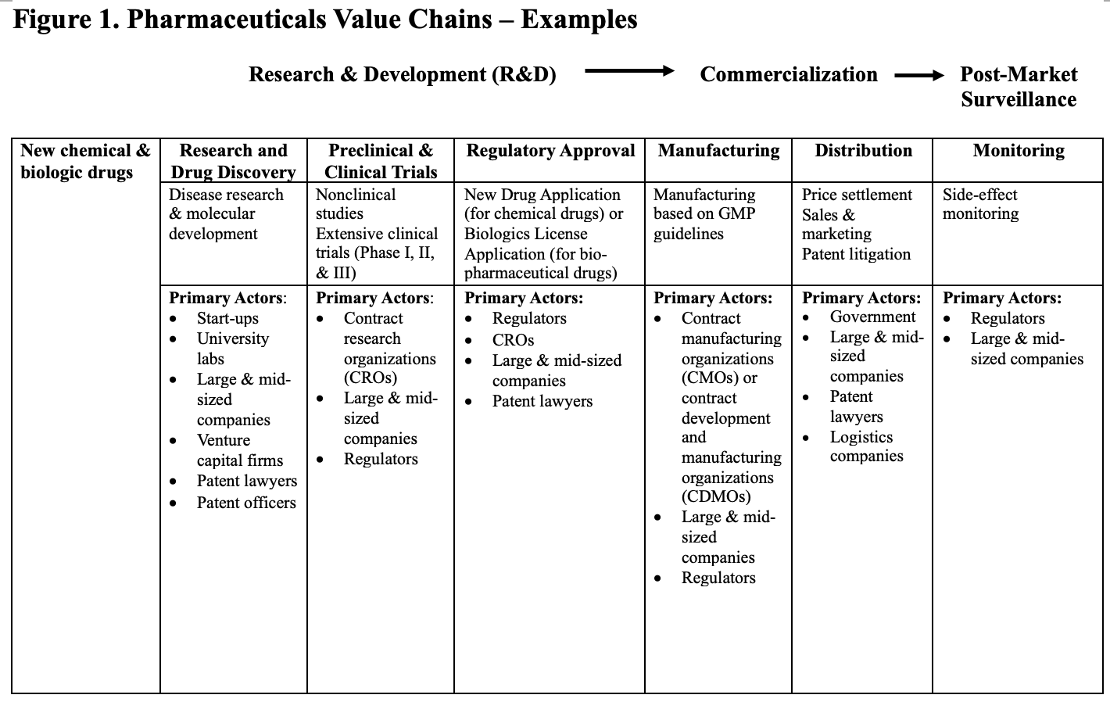
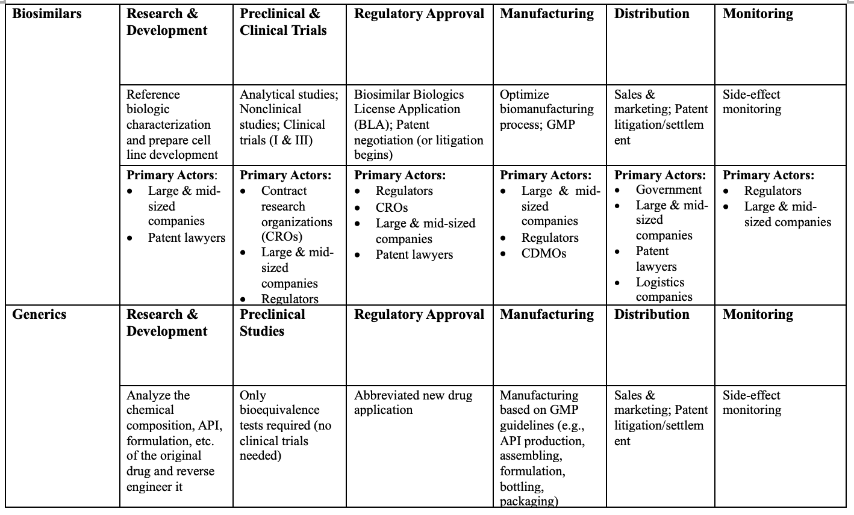
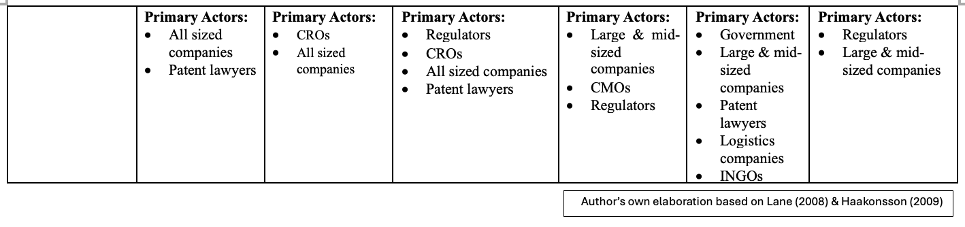

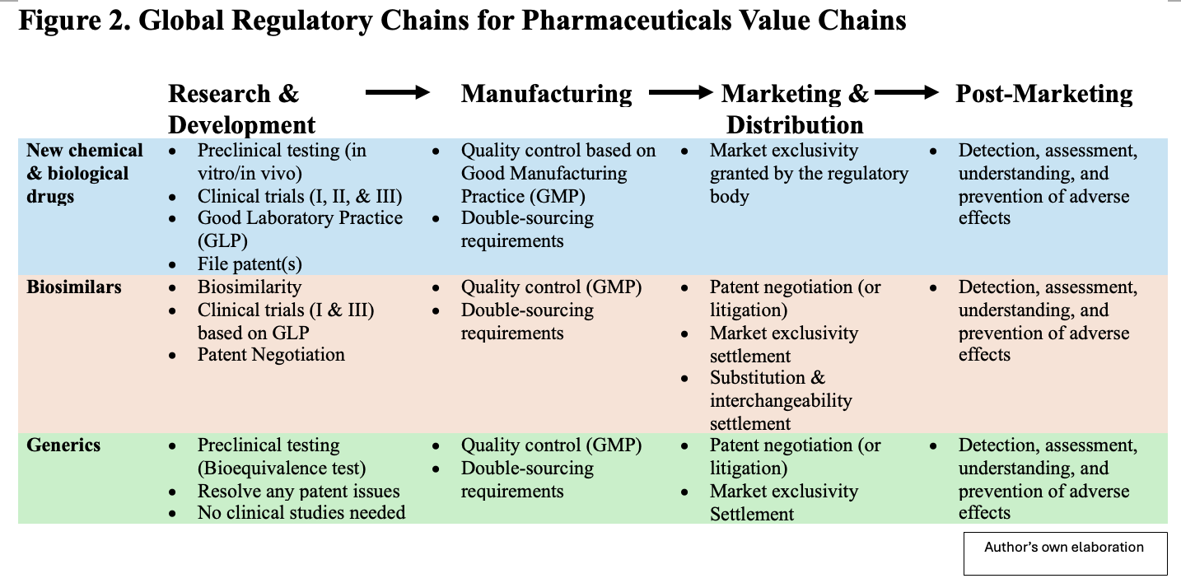
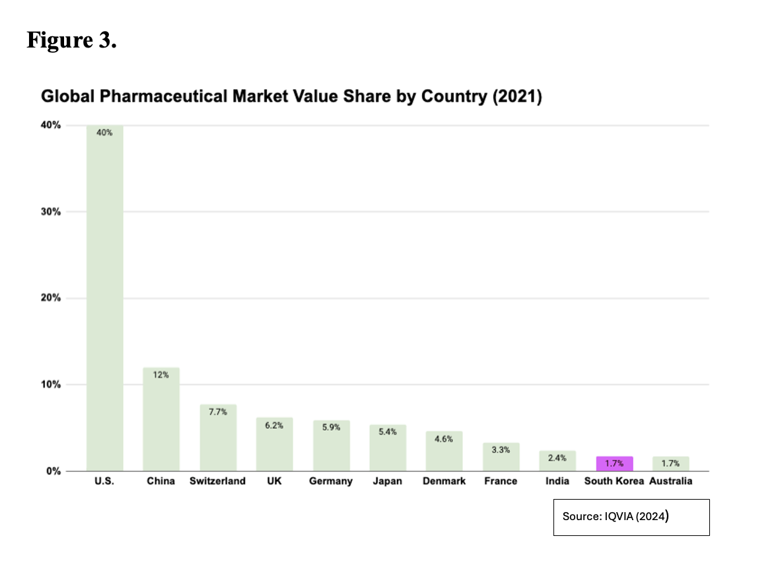
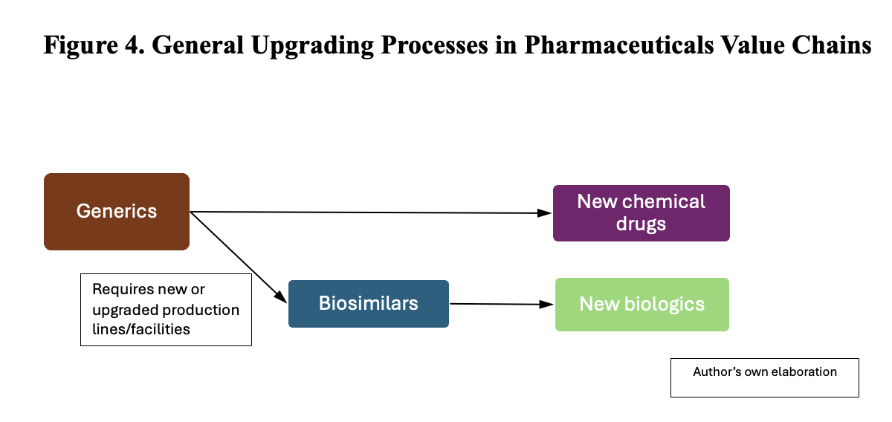
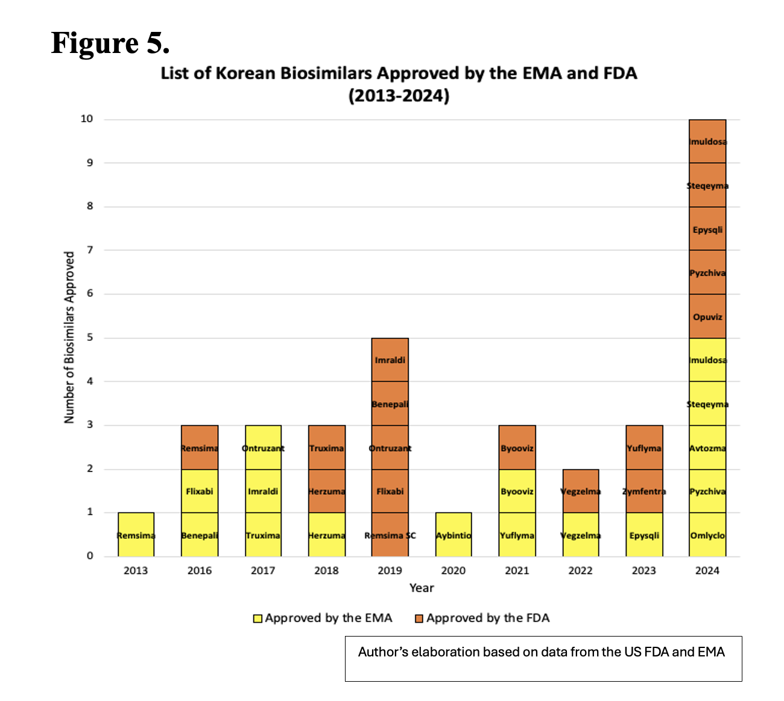
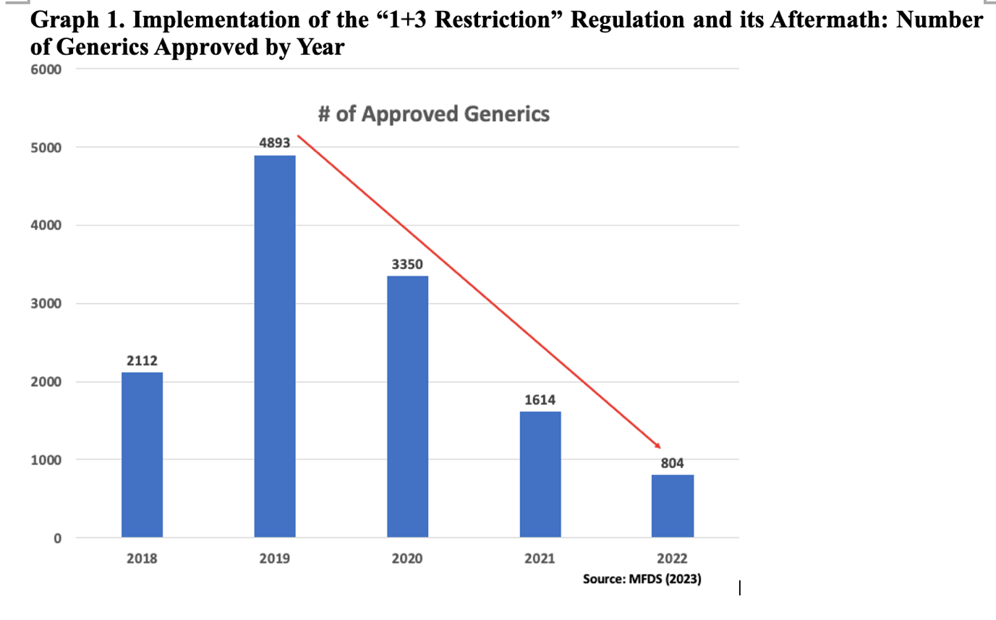
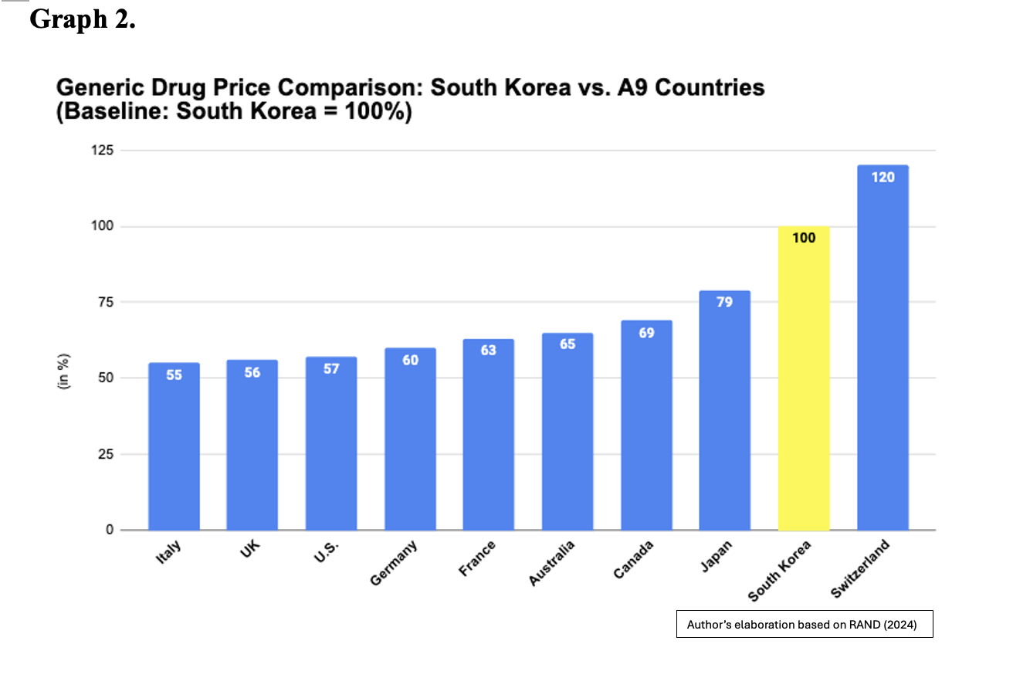
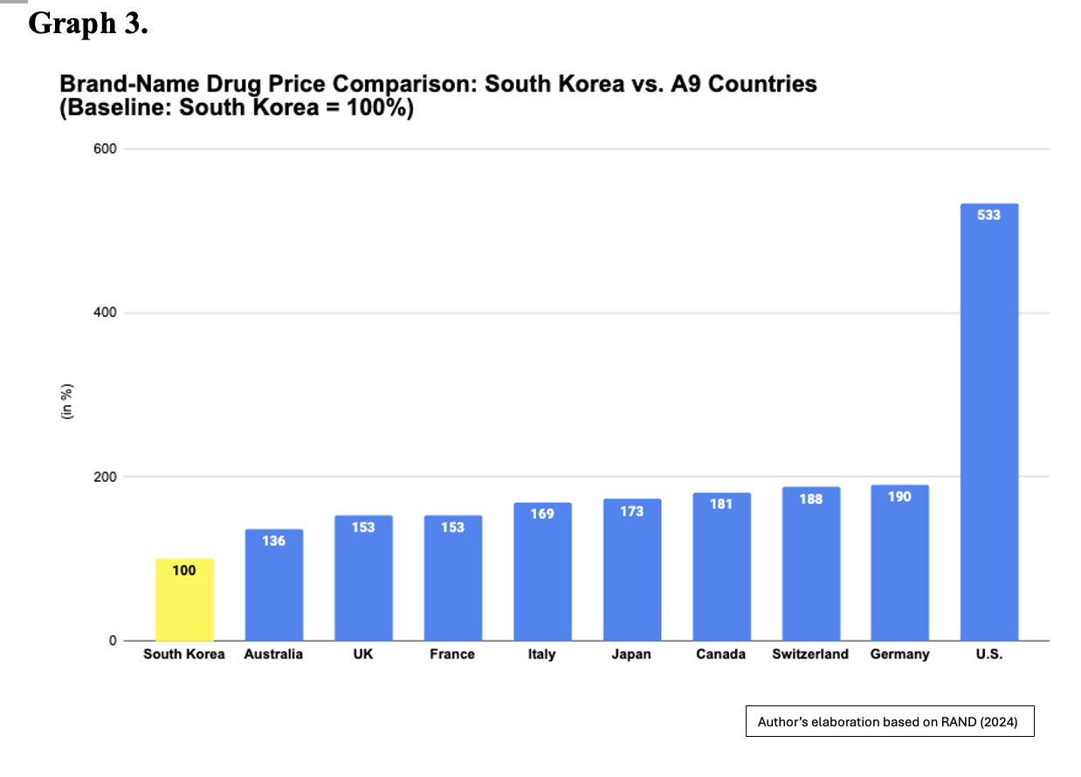
Table 1. List of Informants (Sorted by Occupation)
Government Officials | Government bureaucrats | 9
Government Officials | Regulators (Korean & foreign) | 6
Industry Representatives | Large domestic firms | 19
Industry Representatives | Small and medium domestic firms (including start-ups) | 17
Industry Representatives | Foreign companies  (including “Big Pharma” firms) | 10
Patent Lawyers |  | 4
Scientists |  | 4
Total |  | 69

Table 2. Biosimilars, Biologics, and Generics Production: Key Differences
 | Biosimilars | Biologics | Generics
Synthesis | Synthesized by a living cell | Synthesized by a living cell | Chemically synthesized small molecules
Estimated Development Costs | 100-300 million USD | 1-2 billion USD | 2-3 million USD
Typical Development Timeline | 7-9 years | 10-15 years | 2-3 years
Clinical studies requirement | Phase I & III | Phase I, II, & III | Pharmacovigilance only
Source: Author’s compilation based on Diependaele (2018) and Niazi (2020)

Table 3. Types of Regulatory Support for Knowledge-Intensive Sectors
Stages of the Value Chain | Types of Support | State’s Primary Role | Level of the Effectiveness of the State Intervention
R&D | International recognition: Participation in the drafting of global regulatory rules | Facilitator | Moderately High
Manufacturing | Quality control: Modifying domestic regulation to increase stringency and safety | Regulator | Moderately High
Distribution | Indirect subsidies: Price controls imposed by regulation to help firms to better negotiate their prices at the global level | Buyer and Facilitator | Low

