Title: Increased Holocene diversity in Europe linked to human-associated vegetation change

Running title: HOLOCENE HUMAN-BIODIVERSITY ASSOCIATIONS

Abstract

Aim. It is widely reported that aspects of present-day global biodiversity are declining, with humans largely to blame. However – perhaps paradoxically – in Europe, floristic diversity and human populations have grown in tandem for millennia. Disturbance intensity and habitat heterogeneity potentially explain this phenomenon, though we lack understanding of how human land use intensity affected biodiversity at numerous spatial scales over the Holocene. Here, we examine the relationships between anthropogenic vegetation change and floristic diversity over the last 12 millennia in Europe, at multiple spatial scales.

Location. Europe.

Time period. The Holocene (11,700-100 cal yr BP).

Major taxa studied. Plants.

Methods. We examined the spatio-temporal dynamics of, and relationships between, floristic richness, evenness and compositional turnover with an index of anthropogenic vegetation change since 11,700 cal yr BP, analysing 7,853 pollen samples from 213 records (sites). We evaluated how changes to the proportional site occupancies of human-associated and other taxa related to diversity patterns.

Results. (1) Floristic richness, evenness, and compositional turnover increased from 9,000 years ago to 1850 CE. (2) Temporal increases in richness and evenness were positively associated with the anthropogenic vegetation index in the majority of vegetation zones and sites, whereas compositional turnover was only associated with the anthropogenic index at the site level. (3) Holocene site occupancies of all human-associated taxa were positively associated with biodiversity gains, whereas the results for other taxa (that were not associated with people) were mixed.

Main conclusions. Following the onset of warmer Holocene conditions, floristic diversity initially declined, while subsequent increases were positively associated with human impacts over the vast majority of Europe. From the mid-Holocene onwards, farming populations increasingly disturbed European landscapes – perhaps replicating the now-lost megafaunal disturbance regimes – to produce patchy and increasingly diverse vegetative communities, the legacies of which are still present today.

Keywords: Anthropocene, disturbance, diversity, farming, Holocene, human impact, megafauna, pollen, turnover

Main text

Introduction
Recent global conservation strategies reflect the tension between setting aside ‘separate places’ for nature versus integrating people and biodiversity within landscapes where human-modification has already taken place over substantial periods of time (CBD, 2022; Thomas, Hill, Ward, & Hatfield, 2022). In Europe and elsewhere, there are increasing calls to protect, rewild and restore ecosystems in ways that commonly aim to minimise the impacts of people on biodiversity (Cortina-Segarra et al., 2021; Palmer, Zedler, & Falk, 2016; Pereira & Navarro, 2015; Pettorelli, Durant, & du Toit, 2019). Yet, many individual species have declined in recent decades as a consequence of major reductions in traditional land management, typically because historic management practices are no longer economic (except where subsidised) (Luoto, Pykälä, & Kuussaari, 2003). For example, there has been widespread cessation of traditional coppicing of woodlands in western Europe (Buckley, 2020) and abandonment of montane meadows and Mediterranean shrublands (Anselmetto, Weisberg, & Garbarino, 2024; Halada, Evans, Romão, & Petersen, 2011). Elsewhere, land management has been intensified, such as the conversion of ‘semi-natural’ grazing land into ‘improved’ pastures (Suggitt et al., 2023). This raises several questions regarding the ways in which human management has influenced the composition of ecological communities and how rapidly those communities change (turnover), as well as the long-term impact of human interventions on the diversity of local communities (richness, evenness) throughout the Holocene epoch. The answers to such questions will shape the likely consequences of land abandonment or withdrawing traditional management as a part of conservation programmes.

Previous work has partially addressed some of these questions. Turnover metrics (rates of European floristic community change as deduced from fossil pollen sequences) suggest increasing peak rates of compositional change commencing around 6,000 – 4,000 cal yr BP (Mottl et al., 2021) and increasing average turnover rates from 9,000 cal yr BP (Gordon, Fagan, Milner, & Thomas, 2024), while average site-level and regional richness and evenness have increased over similar timeframes (Giesecke et al., 2019; Gordon et al., 2024). These patterns of vegetation change are often interpreted as being linked to inferred human demographic and cultural (farming, land use) developments at regional and sub-regional scales, but contrasting relationships have been identified at various different spatial and temporal scales using a range of human proxies and modelling approaches (Gordon et al., 2024; Kuneš, Abraham, & Herben, 2019; Marquer et al., 2017; Woodbridge et al., 2023, 2021). However, human influences are commonly assumed rather than included explicitly within analyses. Where they are included within statistical analyses, they typically represent temporally and spatially smoothed extrapolations (Gordon et al., 2024; Marquer et al., 2017), rather than empirical human influences at the specific times and places from which pollen samples are derived - as used here. Accounting inadequately (or not at all) for uncertainties within data-generating and modelling processes has the capacity to strongly bias modelled trends and parameter estimates (Edeling et al., 2021; Simmonds & Jones, 2024). Thus, the scales (from site to continent) at which positive or negative relationships might exist between humans and diversity and turnover metrics, whilst considering these uncertainties, require explicit analyses.

Here, using a fully standardised pollen dataset, we model spatio-temporal trends in European pollen diversity metrics in relation to an index of human ecosystem modification, as well as climate variables. We account for the biases and uncertainties inherent to fossil pollen data across multiple levels, which includes measures to counter the confounding issues of relative pollen production, dispersal and source areas, whilst incorporating pollen sampling uncertainties, age-depth model probability distributions and statistical uncertainty in our results. We also directly investigate how human associated and non-human associated taxa contributed to these modelled temporal diversity changes to increase confidence in the causality of relationships. We examine the relationships of floristic turnover rates, community richness and evenness with an empirical, locally-specific pollen-based indicator of human influence on Holocene European vegetative communities (Deza-Araujo et al., 2022) and, as a robustness check, we compare this pollen-based index to three other proxies for human population and ecological impact: summed probability distributions of archaeological radiocarbon date datasets (‘radiocarbon SPDs’; Bird et al., 2022; Crema & Bevan, 2021), past human population estimates from the History Database of the Global Environment (‘HYDE’; Klein Goldewijk, Beusen, Doelman, & Stehfest, 2017) and human land use simulations (Kaplan et al., 2011; Kaplan, Krumhardt, & Zimmermann, 2009). Together, these analyses provide robust insights into Europe’s Holocene spatio-temporal diversity patterns, and their drivers.

These analyses also allow us to investigate – at broad temporal and spatial scales – expectations from ecological theory that diversity should be maximised at intermediate levels of (in this case, human) disturbance (Connell, 1978; Grime, 1973) and maximal habitat heterogeneity (MacArthur & MacArthur, 1961). Overall, this work provides direct, sample-based evidence that intensifying human activity during the mid- to late-Holocene – and the land use mosaics this created – generated conditions that contributed to Europe’s increasing floristic diversity.

Methods
Pollen data standardisation and processing. We followed the recommendations from Flantua et al. (2023) for fossil pollen record standardisation, which we outline in the following paragraphs. We downloaded all available European fossil pollen records from Neotoma (Williams et al., 2018) using an approximate European bounding box. Fossil pollen data contain information relating to past plant compositions and their diversities (Birks et al., 2016; Blaus et al., 2020; S. E. Connor et al., 2021; Felde, Peglar, Bjune, Grytnes, & Birks, 2016; Senn et al., 2022). However, issues relating to variation in pollen production and dispersal between pollen-producing plants, in addition to challenges arising from varying pollen source areas and taphonomic processes, complicate interpretation of changing fossil pollen counts as direct, linear reflections of changes to the compositions (and diversities) of parent plant communities (Sugita, 1994; Sugita, Gaillard, & Broström, 1999). To overcome these challenges (as far as is possible), we adjusted the raw pollen count data using estimated past regional vegetation covers for pollen samples from the Regional Estimates of Vegetation Abundance from Large Sites (REVEALS) model (Sugita, 2007). Compiling the relevant data for computing REVEALS is a substantial time investment and we thus restricted our analyses to those pollen records for which the prerequisite data were provided in the Githumbi et al. (2022) European synthesis (n = 694 stratigraphic pollen sequences; ‘records’). We subset only those pollen types in the upland herbs, tree/shrub, palms and succulents ecological groups and then filtered the total set of 694 available European pollen records based on (i) the number and spread of a record’s chronological control points (datings) and (ii) the number of pollen samples each pollen record contained (see Appendix 2, Extended Methods: Data filter for further detail). This procedure identified 213 records consisting of 7,853 pollen samples that would be most robust for inclusion in our analyses.

For each of these 213 pollen records, we used the average European relative pollen production, dispersal and relevant pollen source area data from Githumbi et al. (2022) to run the REVEALS model for each pollen sample. Across these records, for those taxa modelled by REVEALS, we then multiplied original pollen counts by their REVEALS-estimated proportions. The REVEALS model does not estimate past covers for all taxa, but it does include all the dominant types. These other taxa were not transformed (i.e. their counts remained the same as in the original dataset), following Felde et al. (2016).

We resampled 200 pollen grains from each REVEALS-adjusted pollen sample to standardise pollen counts, thereby ensuring comparability in diversity metrics among samples and records. We repeated this resampling procedure 1,000 times, assigning a draw from each pollen record’s recomputed Bayesian age-depth model (see Appendix 2, Extended Methods, Age-depth modelling) to each resampled pollen sample. These age model sampling and pollen-count resampling procedures generated 1,000 pollen datasets, with pollen samples represented by a slightly different pollen assemblage (variation arising from the resampling) and a different age draw (from the posterior of the age-depth model for each pollen record). Hence, the variation associated with pollen sampling comparability and age uncertainties were retained throughout the analyses.

Diversity metrics. We computed two measures of sample-based pollen-type diversity and one measure of turnover for the 1,000 resampled pollen datasets (each of which consists of 213 pollen records): richness (the number of unique pollen types per 200 grain subsample), evenness (Pielou’s evenness, a measure that quantifies how equally the pollen grains are distributed among pollen types in each subsample) and temporal community turnover (the change in the identity and abundances of pollen types between successive samples, computed using the Bray-Curtis dissimilarity measure, adjusted for the time interval between samples). We also calculated an established pollen sample-based measure of inferred human impact intensity on ecosystems, the agricultural land use probability index (LUPi) (Deza-Araujo et al., 2022), which sums regionally-weighted relative abundances of pollen types deemed to indicate human presence. The agricultural land use probability index dataset was strongly right skewed (see Appendix 2, Extended Methods: Agricultural land use probability index), so we transformed it using the square-root. We use this square-root transformed variable in all following analyses as our indicator of past human ecological impact. To prevent circularity in our analyses, we excluded LUPi pollen types before resampling and calculating richness, evenness and turnover (see Appendix 2, Extended Methods, Diversity calculations). These analyses resulted in 1,000 sets of Holocene pollen richness, evenness, turnover and LUPi values for each pollen record, which we modelled through time (Figs. 1a-d) and across space (Figs. 1e-bi) using spatio-temporal hierarchical generalised additive models (HGAMS). We present predictive uncertainties across the 1,000 sets of spatial predictions per metric in Appendix 1, Fig. S1.2.

Association of diversity with human impacts. To investigate how human impact intensity related to aspects of Holocene floristic diversity, we used HGAMs to estimate the relationships of human ecological impact (LUPi) and climate [temperature and precipitation from Arthur, Roche, Fyfe, Quiquet, & Renssen (2023)] with each pollen diversity metric across the 1,000 sets of resamples. In addition to European-scale analyses, we ran separate models for each vegetation zone. For each Europe-wide and vegetation zone analysis, we performed an AIC variable selection procedure, considering all possible combinations of predictor variables and effects: LUPi, temperature, and precipitation, as well as random slope and intercept terms per variable for each pollen record, including random effects only where the fixed effect was also present (see Appendix 1, Table S1.1 for matrix of variables included per model run). We then selected the ‘best’ model based on AIC improvement. We examined the residuals, smooth flexibility and concurvity – which is the non-linear analogue of colinearity – for these models. We detected strong concurvity between the random slope terms for temperature and precipitation (concurvity estimates ~ 0.9), indicating a high degree of shared variance explained by these terms. To address this, we simplified the suite of candidate model variants. Because the variation in slope estimates across pollen records was substantially lower for temperature than for precipitation for all metric and region combinations, we excluded models incorporating random slopes for temperature from further consideration. Our final model selection was then based on comparisons of AIC values among the remaining models (models 1–18; Appendix 1, Table S1.1), with the model exhibiting the lowest AIC identified as the final ‘best fitting’ model (see Appendix 3, Model AICs for full set of AIC values for each model variant and Appendix 2, Extended methods: AIC variable selection and model fitting procedure for more details of the procedure).

Performing variable selection and fitting these models to each vegetation zone in turn allowed for potential differences in climate and human drivers of floristic diversity change and turnover rates within each vegetation zone to be identified. We present the LUPi estimates from these models for each vegetation zone in Fig. 2 (see Appendix 2, Extended methods, Estimating the relationships between LUPi and diversity) and for each pollen record in Fig. 3. We present the estimates for all predictor variables selected in the ‘best’ model per metric and vegetation zone combination in Appendix 1, Fig. S1.3.

We present adjusted R² values to compare four combinations of predictors fit to each region (vegetation zone and Europe) and metric combination: (i) the ‘best’ fitting model (chosen using our AIC procedure), (ii) the ‘best’ fitting model but with the per-record random slopes for LUPi removed (i.e. without site-level human effects), (iii) a climate-only model (i.e. no LUPi effects, either fixed or random) and (iv) a model without any predictor variables except a smooth time effect per pollen record and random intercepts per record and resample. These provide estimates of model fit overall (for the ‘best model’) and also approximately indicate the amount of variation explained by the random LUPi effects, all LUPi effects and all LUPi plus climate effects (Appendix 1, Fig. S1.4 for comparisons; see Appendix 3, Table S3.1 for coefficient summaries and adjusted R² values for final models). Finally, we also present head-to-head AIC comparisons of the best model – which, except for European-scale evenness, always contained LUPi – with that of the ‘climate-only’ version of the model (Appendix 1, Fig. S1.5).

The dynamics of different pollen taxa. We also investigated relationships between the proportion of sites occupied by each pollen type and European diversity trends. For these analyses, we summarised the diversity data in 20 equal-duration bins (580 years) over the Holocene by computing the median value for each bin. To calculate the proportion of sites occupied, we computed the proportion of pollen records that each pollen type was present in in each 580 year bin. We accounted for variation across and within the pollen record with a random resampling approach (see Appendix 2, Extended methods, Pollen type proportional site occupancy and diversity correlations). We then regressed (in separate models) the median European richness, evenness and turnover data onto the proportional site occupancy of each pollen type using ARIMA models. We present the resultant slope coefficients for proportional site occupancy, plus an estimate of the model error, for all pollen types in Fig. 4.

LUPi robustness. The use of specific pollen types to indicate past human presence (‘cultural human indicator pollen types’) from fossil pollen records is a long-standing approach [Behre, 1981; Tinner et al., 2003; Turner, 1964; see Deza-Araujo et al. (2020) for a review], but the present study represents the first application of such a measure at such broad spatial and temporal scales. As such, the robustness of LUPi warrants further investigation. To do this, we generated pollen-record specific time series of three other datasets that are commonly used to infer Holocene human (relative) population sizes and/or ecological impact. These datasets included (i) summed probability distributions (SPDS) of archaeological radiocarbon date datasets (Bird et al., 2022; Crema & Bevan, 2021), (ii) past human population estimates from the History Database of the Global Environment (hereafter ‘HYDE’) (Klein Goldewijk et al., 2017) and (iii) past human land use estimates from the ‘Krumhardt Kaplan 2010’ anthropogenic land cover change scenario (hereafter ‘KK10’) (Kaplan et al., 2011, 2009). We compared these three datasets with the LUPi estimates by computing the medians and 95% ranges of each dataset in decile bins, plotting them against each other and computing their Kendall’s correlation. We made these comparisons at the European (Fig. 5) and vegetation zone scales (Appendix 1, Fig. S1.6-8).

Results
Continental-scale patterns of change.
Immediately following the transition from the end-Pleistocene (Younger Dryas) to the warmer Holocene interglacial, pollen richness declined, reaching a minimum ~10,000 cal yr BP. This minimum was followed by a period of ~8,500 years of steady increase, during a time of increasing land use change (Gordon et al., 2024), but with a brief period of declining richness decline between ~1,000 to ~400 cal yr BP. Richness subsequently increased from 400 until 100 cal yr BP (the end of the time sequence considered here; Fig. 1a). Temporal Holocene evenness patterns were qualitatively similar to those of richness, though the evenness trend fluctuated more around the generally positive trend (Fig. 1b). Turnover also declined over the early Holocene until ~9,000 cal yr BP, as the vegetation stabilised under the new Holocene conditions, but increased thereafter. Overall, turnover rates increased from 9,000 - 2,500 cal yr BP, after which rates accelerated up to 1850 CE (Fig. 1c).

The land use probability index (LUPi) is a measure of the estimated intensity of human impact on an ecosystem surrounding a pollen deposition environment (based on the presence and frequency of ‘human associated’ pollen types present in each sample), contemporaneous with the deposition and preservation of the pollen in the record (Deza-Araujo et al., 2022). Over the period 11,700 - 8,000 cal yr BP, average LUPi levels remained consistently relatively low (though perhaps slightly increasing), suggesting limited overall human impact on European vegetation over this period (Fig. 1d). However, after ~8,000 cal yr BP LUPi exponentially increased up to 1850 CE.

We illustrate these temporal Holocene richness, evenness, turnover and LUPi data (Figs. 1a-d) as smooth modelled surfaces that describe changing pollen-record diversity, turnover and LUPi across the European terrestrial surface in sequential ‘time slices’ through the Holocene (Figs. 1e–1bi). These maps highlight a pattern of increasing richness and evenness moving towards the north and north-west of Europe over the course of the early and mid Holocene, into the later Holocene. Richness and evenness values remained consistently highest in those areas surrounding the Adriatic sea over the Holocene, though by the final time period (1,000 cal yr BP, Fig. 1y & z) much of Europe south of ~55 degrees north (~southern Fennoscandia) had comparable values. Compositional turnover was high across the majority of Europe at 11,000 cal yr BP, following the climatic transition from the late-Pleistocene (Younger Dryas) to the Holocene, with relatively low values in the higher latitudes over the mid/late Holocene but increasing rates in the mid latitudes (Fig. 1g). LUPi values were low across most of Europe up to ~9,000 cal yr BP, though there were relatively higher values in the Aegean, Anatolia (modern-day Turkey) and northern Italy during the first two time slices examined here (Fig. 1h & l). Following ~9,000 cal yr BP, and increasing more strongly after 7,000 cal yr BP, average LUPi increased across Europe (Fig. 1d & p). From ~5,000 cal yr BP onwards, LUPi values was considerably higher across all of Europe, but most strongly in the regions dominated in the earlier Holocene by temperate deciduous forest (Fyfe, Woodbridge, & Roberts, 2015; Roberts et al., 2018; Zanon, Davis, Marquer, Brewer, & Kaplan, 2018) (Fig. 1t, x & bi).

Relationships between diversity and turnover patterns and human indices
Our hierarchical generalised additive models revealed that richness and evenness were significantly positively associated with LUPi for the majority of vegetation zones (Figs. 2a & b, coloured bars; Appendix 3, Table S3.1 for all coefficients) and for Europe as a whole for richness (Figs. 2a & b, black bars; richness, b = 1.079, CI [1.063, 1.096]. The exceptions are the Sub-Mediterranean (b = 1.018, CI [0.985, 1.051]) and Boreal zones (b = 1.004, CI [0.95, 1.062]) for richness and the Sub-Mediterranean (b = 1.056, CI [0.981, 1.137]), Montane (b = 1.02, CI [0.97, 1.075]), Hemiboreal (b = 1.161, CI [0.977, 1.38]) and Boreal zones (b = 1.023, CI [0.936, 1.059]) for evenness, which show generally positive but non-significant relationships. Despite the majority of zones showing positive relationships between evenness and LUPi, LUPi was not selected by our AIC variable selection procedure in the ‘best’ European-scale evenness model. Overall, as these calculations do not include the LUPi taxa, we conclude that the expected average richness and evenness of pollen samples increased with the estimated intensity of human impacts across the majority of the European terrestrial surface, and most strongly in the temperate regions.

The overall relationships between LUPi and compositional turnover are less clear. There is a non-significant positive relationship between LUPi and turnover for Europe as a whole (Fig. 2c, black bar for Europe, b = 1.02, CI [0.991, 1.05]). There are non-significant relationships between turnover and LUPi across all vegetation zones, though the majority show positive mean associations. Thus, we conclude that LUPi does not predict changes in turnover well overall (i.e. for Europe as a whole), and that the magnitude and direction of relationships may vary among vegetation zones; potentially because certain human-modified environments can be relatively stable.

These per-vegetation zone conclusions are reflected in relationships identified at the scale of the individual pollen records. The vast majority of pollen records show locally (individual record) significant positive associations between LUPi and richness (Fig. 3a, 76% significant) and evenness (Fig. 3b, 73%). However, 15% and 11% showed significant negative relationships for richness and evenness, respectively. Overall, relationships of richness with LUPi are normally positive at all scales considered: for Europe, vegetation zones, and individual sites (pollen records) (Fig. 2a & 3a). For evenness, relationships with LUPi are also normally positive at the scale of the vegetation zone and pollen record, but LUPi is not deemed important for predicting evenness overall at the European level (Fig. 2b & 3b).

In contrast to the predominantly inconclusive relationships between turnover and LUPi identified at the scale of the vegetation zone (generally non-significant LUPi estimates), relationships identified at the scale of the pollen record were more conclusive (generally significant LUPi estimates): around half (51%) of the individual pollen records demonstrate positive associations between turnover and LUPi, while around a third (32%) show negative relationships (Fig. 3c). This shows that there is substantial variation in turnover and LUPi associations between individual records within each vegetation zone. With 83% of individual pollen records showing significant relations, it implies that changes in turnover rates are linked to human modification at the local scale, but that turnover can either increase or decrease with human influence, depending on (currently unknown) circumstances.

For each pollen metric and vegetation zone combination, our AIC variable selection procedure identified models containing LUPi as both a ‘fixed effect’ (as an average across records) and a ‘random effect’ at the level of individual records (i.e. per-record deviations from the fixed effect) as the ‘best fitting’ model across all regions and metrics considered, except for evenness at the European scale, where LUPi was not selected. Across the majority of pollen metric and vegetation zone combinations, the AIC selection procedure also selected temperature and precipitation as contributing to the ‘best fitting’ model, though not universally (see Appendix 1, Fig. S1.3). Models that included LUPi showed substantially lower AIC values than for the climate-only version of the same model (reductions in AIC units of ~1,000 or more; Appendix 1, Fig. S1.5). Across most – but not all – vegetation zones, the relative effect sizes for LUPi were larger than the combined effects of temperature and precipitation for richness and evenness. For turnover, climate variables dominated. This underlines the importance of both climate and human predictors for explaining the variance in the Holocene pollen diversity data and that human impacts are clear, even when climate variables are included in the models (Appendix 1, Fig. S1.3).

Overall, these results accord with the positive association between the continental-scale spatio-temporal pollen richness and evenness patterns with those of LUPi (Fig. 1). Richness and evenness increases – and their associations with our index of anthropogenic vegetation change – were particularly strong in the mid-latitude, temperate zones. These were regions with vegetative communities characterised by broad-leaved deciduous woodland in the early- to mid-Holocene, which is consistent with human activities converting extensive and relatively uniform forested ecosystems into diverse habitat mosaics. For turnover, our models suggest that it was a combination of humans and climate that drove the turnover increases at the vegetation zone level (both human and climate variables were included in all of the ‘best’ per-vegetation zone models Appendix 1, Fig. S1.4, except in the Western, Central and Southeastern Birch/Fir zone where no climate variables were chosen by the AIC procedure), though only climate effects were significant (Appendix 1, Fig. S1.3). However, a substantial majority (83%) of individual landscapes (i.e. the relevant pollen source areas of each fossil pollen record) indicate significant relationships (both positive and negative) between turnover and LUPi (Fig. 3c), which implies important but complex effects of human activity on community turnover.

Proportional site occupancies of different pollen taxa
We also evaluated which pollen types contributed to increases in European-scale richness, evenness and turnover. Considering each individual pollen type separately, we found that, for all human-associated (LUPi) taxa and a majority of other taxa, an increase in the proportion of pollen records the type is found in was associated with increasing continental-scale floristic diversity (Figs. 4a &b, significant slope effects in colour, all other slope effects in grey; insets represent the full distribution of slopes across all pollen types); linked to increasing proportional site occupancies of all LUPi taxa and a majority of other taxa (Appendix 1, Fig. S1.9 & Table S1.2). Similarly, all LUPi taxa and a majority of other taxa were more likely to be recorded at times/places in pollen records with high turnover rates (Fig. 4c, significant correlations in colour, all other slope effects in grey). The LUPi taxa are not included in the diversity measures, and hence the positive correlations for these suggest common causation.

However, for the other pollen types (i.e., non-LUPi types), individual pollen type proportional site occupancies (and their abundances, as turnover is calculated using Bray-Curtis) contribute to turnover and evenness, and are components of richness (continental-scale average richness in time bin t $=$ mean occupancy(t)$⨉$ number of taxa). It is noteworthy, therefore, that some pollen types show significantly negative associations, while others show positive associations with average continental richness over the Holocene; the same is true for evenness and turnover. Pollen types for which proportional site occupancies are negatively correlated with European diversity over the Holocene are dominated by woody plant species, especially trees, many of which expanded their ranges following the onset of the Holocene, peaked during the mid-Holocene (Giesecke, Brewer, Finsinger, Leydet, & Bradshaw, 2017; Seppä et al., 2015) but then declined as a result of forest clearances by human populations, mainly from the early Neolithic and intensifying after the Bronze Age (~4,000 cal yr BP) (Roberts et al., 2018; Zanon et al., 2018). Many non-LUPi taxa are well correlated (both positively and negatively) with the diversity and turnover changes (Fig. 4), and future iterations of the LUPi (and other similar indices) could consider broadening the pool of potential pollen types to investigate these.

Caveats
It is important to note that these analyses involve pollen data, not observation-based plant data, and therefore do not represent exact inventories of past plant taxa and their abundances (Birks et al., 2023), a challenge that the REVEALS analysis aims to address. It is also worth noting that our diversity trends, and thus predictions from models, are averaged over locations from which pollen data are available, which are non-random locations across the European surface (mainly the landscapes surrounding water bodies and wetlands). In the early Holocene (time point 11,000 cal yr BP, column 2 in Fig. 1), much of the land area of Fennoscandia was still covered in remnants of Pleistocene cover so there are no fossil pollen data available from this period for this region. This is compounded by substantially less data in the earlier compared to the later Holocene, so spatial and temporal patterns are less certain for these locations and during these times (Appendix 1, Fig. S1.1 & 2). In addition, the majority of pollen types recorded in fossil pollen records are not identifiable to the taxonomic level of species, most are identified to genus or family, and thus our diversity measures represent those of pollen-type assemblages per sample, rather than of plant species in the landscape.

To overcome challenges relating to relative pollen production and dispersal, taphonomic considerations and variation in pollen source areas among records, we analyse a pollen dataset adjusted to reflect past vegetation covers, estimated from the REVEALS model. Overall, despite the potential challenges of interpreting pollen diversity patterns, previous work has shown that there is a positive relationship between pollen-based diversity estimates and diversity estimates of the parent plant communities (Birks et al., 2023; Blaus et al., 2020; Odgaard, 1999; Papadopoulou et al., 2022; Väli, Odgaard, Väli, & Poska, 2022, cf. Goring, Lacourse, Pellatt, & Mathewes, 2013; Gosling et al., 2018).

Discussion
Holocene patterns
The results presented here suggest that human activity, as indicated by the presence and frequencies of human-associated pollen types (the LUPi), was a key driver of floristic diversity change (increasing richness and evenness) from the mid-Holocene onwards across the majority of Europe’s terrestrial surface (Figs. 2-4). We suggest this change occurred as previously relatively continuous ‘natural’ habitats were converted into mosaic landscapes that contained both ‘natural’ remnants and derived low intensity crops, grazing land and other uses. Human activity was also a strong influence on the rates at which the vegetation composition changed (turnover rates) but, contrary to previous studies (Gordon et al., 2024), we found that rate changes varied, increasing in some locations but declining in others (Fig. 3c).

During the early Holocene, we were unable to detect a signature of human impacts within the pollen records - a period represented by generally low LUPi values (Fig. 1d & h) when European human populations subsisted primarily by hunting, fishing and gathering wild resources. At that time, reductions in pollen diversity were likely driven by the shift from mixed and herbaceous to largely forested landscapes due to the Pleistocene-Holocene climatic transition (Figs. 1a-c). This shift was followed by increases in richness, evenness, and turnover from ~10,000 cal yr BP (Fig. 1a-c), changes that predate the detected increase in average LUPi values observed from ~8,500 cal yr BP (Fig 1d). If the initial upticks were generated by human activity, then small amounts of land transformation that introduced new habitats and associated species over this period may have been sufficient to raise both richness (as expected from power law and other species-area relationships (E. F. Connor & McCoy, 1979; Matthews, Guilhaumon, Triantis, Borregaard, & Whittaker, 2020)), evenness and turnover, while pollen grains from LUPi taxa remained a small minority in pollen samples (note that average LUPi values do increase slightly over the first ~3,000 years of the Holocene [Fig. 1d], driven by increases in southern and southeastern Europe [Fig. 1h & l)).

Average richness, evenness and turnover increases were concurrent with an inferred increase in average human impact intensity on European environments from ~8,500 cal yr BP (Fig. 1d), though with rising human impact in south-eastern Europe from the first time point considered here, 11,000 cal yr BP (Fig. 1hl). These changes were followed by intensified impacts and increasing floristic diversity after ~7,500 cal yr BP across the continent (Fig. 1d, p, t). Broadly speaking, practices of cultivating and rearing domestic crops and animals entered Europe with migrating populations from Anatolia after ~8,500 cal yr BP (Lazaridis et al., 2014; Racimo et al., 2020), reaching northern Europe ~5,500 cal yr BP (Vanhanen et al., 2019). Previous work has suggested that the spread of these initial Anatolian farmers and their practices had a minimal impact on the composition of European vegetation, with the major opening of European forests coeval with later migrations of Yamnaya steppe populations into Europe during the Bronze age, ~4,000 cal yr BP (Racimo et al., 2020) and accelerating again after ~2,000 cal yr BP. Our results resonate with aspects of these findings, with our spatio-temporal models identifying a modest increase in human-associated pollen taxa from ~8,500 cal yr BP – but with potentially stronger impacts on richness, evenness and turnover – and a much more rapid continental-scale increase in human impact intensity and measures of diversity and turnover after ~7,500 cal yr BP (Fig. 1a-d)

Between the last interglacial period (LIG) (~130,000 years ago) and the onset of the Holocene (~11,700 cal yr BP), the once abundant and widespread populations of Europe’s largest megafauna rapidly declined, a process driven (primarily) by humans (Lemoine, Buitenwerf, Faurby, & Svenning, 2025; Lemoine, Buitenwerf, & Svenning, 2023; Svenning et al., 2024). European forests in the LIG – particularly in the temperate, mid latitude regions – were represented in approximately equal proportions by open/semi-open and closed vegetation types (Pearce et al., 2024, 2023). In the absence of explained climatic effects, it has been suggested that these heterogenous forests were likely maintained by populations of megafauna who disturbed Europe’s landscapes (Pearce et al., 2025, 2024, 2023). In the early Holocene, populations of the largest disturbance-generating megafauna were absent, which perhaps resulted in the expansion of European vegetative communities that were increasingly devoid of their once-abundant open and semi-open components (Roberts et al., 2018; Zanon et al., 2018). It is during this period that our modelled measures of diversity and turnover were at their minima (Fig. 1). We suggest that following the expansion of farming populations across the European continent, disturbance of Europe’s relatively, and uncharacteristically (relative to the LIG, at least), closed systems increased, which raised landscape-scale heterogeneity and boosted floristic diversity (Figs. 1-4). Thus, we argue that humans replaced – to some degree – those activities of previous populations of megafauna, providing biodiversity gains at the continental scale, especially in temperate regions where human-associated richness and evenness increases were greatest (Figs. 2-4) and where forests were historically represented by the highest proportions of open/semi-open components (Pearce et al., 2023). Indeed, it is those regions under ‘traditional management’ that represent some of the most diverse regions in Europe in the present-day, regions categorised by the European Environmental Agency as ‘high nature value farmlands’ (EEA, 2004).

Hence, we suggest that humans and domesticated livestock represent the primary drivers of later-Holocene, diversity-boosting European disturbance. These results are consistent with several, niche-based ecological hypotheses: the ‘perturbation hypothesis’ that ecological communities in transition may contain an ‘excess’ of species, with representatives of past and emerging communities coexisting at least temporarily (Suggitt, Lister, & Thomas, 2019), the ‘habitat heterogeneity hypothesis’, which posits that the variety of environment types in an area (here within pollen source areas) is typically the strongest predictor of species richness (MacArthur & MacArthur, 1961), and the ‘intermediate disturbance hypothesis’ whereby a series of (potentially localised) disturbances prevent domination by the most competitive species (Connell, 1978; Grime, 1973). These all rely on the different requirements of species being provided by the variety of environmental and biotic conditions existing in space and time, a variety – we suggest – provided and maintained by human action from the mid Holocene onwards.

Different metrics of past human ecological impact
In these analyses, we use LUPi as our index of past human ecological impact, though quantifying past human ecological impact on Holocene landscapes is a major challenge for studies such as these. Other possible measures include summed probability distributions of archaeological radiocarbon date datasets, human land use simulations and human population simulations, though no measure is without substantial limitations. Radiocarbon SPDs suffer from biases relating to past cultural choices, archaeological sampling and statistical methods (Crema, 2022; Crema & Bevan, 2021; Torfing, 2015), which combine to generate artificial apparent reductions after ~3,000 cal yr BP in Europe. Population estimates underlying HYDE’s modelled population surfaces and the KK10 anthropogenic land use surfaces are highly uncertain and represent (in the HYDE authors’ words) “guest-imates” for the period pre-1500 CE, i.e., the majority of the Holocene (Klein Goldewijk, Beusen, & Janssen, 2010, p. 571). On top of this, HYDE and KK10 model outputs represent extremely temporally and spatially smoothed surfaces that describe any particular location (i.e. a landscape surrounding a fossil pollen record) poorly (see Appendix 2, Extended Methods: human metric limitations for a more detailed discussion). Despite this, these methods are widely used across multiple disciplines and our LUPi robustness checks indicate a strong correlation both at the European (Fig. 5) and the vegetation zone (Appendix 1, Fig. S1.6–8) scales between LUPi and these metrics (significant positive correlations across all comparisons and regions considered). This suggests that LUPi is a robust indicator of human influences on the vegetation on average. However, as noted above, increases in diversity changes were detected marginally earlier than substantial LUPi increases (Fig. 1), which may imply a lack of LUPi sensitivity at very low levels of human transformation (i.e., pollen samples with much higher pollen sums might be required than are present in most pollen records). This is highlighted best by the relationship between LUPi and the KK10 (Fig. 5 and Appendix 1, Fig. S1.6), which shows increasing KK10 human land use estimates whilst (average, per decile bin) LUPi values remain zero for the first four LUPi deciles.

While both the response (diversity and turnover) and predictor (LUPi) variables originate from the same pollen samples, we have implemented methods to eliminate the risk of circularity as far as possible. LUPi estimates have the advantage in the sense that they relate to conditions in the specific landscapes in question, at exactly the same times as the pollen samples were deposited, in contrast to HYDE and KK10 estimates that represent spatially and temporally smoothed (averaged) surfaces, which do not apply locally. LUPi estimates also do not experience the decline radiocarbon SPDs do after ~3,000 cal yr BP, a period when (‘true’) human population size is known to have increased; European populations were clearly higher in, e.g. 1600 CE than 2500 cal yr BP. Thus, we find that LUPi’s spatial and temporal advantages outweigh its problems compared to other measures in this case.

Conclusions
Overall, there has been a measured increase in average, community-level pollen diversity over the Holocene in Europe (Figs. 1a & b), associated with significant changes in community compositions (Fig. 1c). By quantifying a measure of human impact intensity for all pollen samples (Fig. 1d) and incorporating this into models, we show that pollen richness, evenness and, for many locations (but not as an overall or by vegetation-zone average), turnover increases were associated with an increasing human impact intensity over the Holocene across Europe, as measured by the relative abundances of human indicator pollen types in pollen samples (Figs. 2 & 3). While humans have undoubtedly driven declines in many species, the overall effect of post-Neolithic accelerating human environmental modification until ~1850 CE appears to have been to increase average floristic diversity (Figs. 2a & b, 3a & b), while turnover increased in some individual locations but declined in others (Fig. 3c). Intensifying human disturbances from ~8,500 cal yr BP onwards perhaps replicated those disturbance regimes of past megafaunal populations that once generated diverse and heterogeneous European landscapes. These human modifications may have also generated a novel set of late Holocene ‘winners’ (Fig. 4), taxa well suited to the increasing disturbance and nutrient regimens of heavily modified environments, alongside taxa cultivated for direct consumption (food crops) and their commensal weeds.

Our results highlight the complexity of developing conservation strategies since the individual human histories and biodiversity trends of sites and regions vary (Fig. 1). Exclusion of historical human management and other influences may result in reductions rather than increases in local diversity (given the long term co-development of humans and diverse ecological systems in Europe). Our results suggest that facilitating and accepting biological changes that maintain or increase the local diversity of Anthropocene communities may be preferable to, as well as more realistic (Thomas et al., 2022), than approaches that attempt to resist change or restore ecological communities to an imagined state with minimal human influence.

References
Anselmetto, N., Weisberg, P. J., & Garbarino, M. (2024). Global change in the European Alps: A century of post-abandonment natural reforestation at the landscape scale. Landscape and Urban Planning, 243, 104973. https://doi.org/10.1016/j.landurbplan.2023.104973

Arthur, F., Roche, D. M., Fyfe, R., Quiquet, A., & Renssen, H. (2023). Simulations of the Holocene climate in Europe using an interactive downscaling within the iLOVECLIM model (version 1.1). Climate of the Past, 19(1), 87–106. https://doi.org/10.5194/cp-19-87-2023
Behre, K.-E. (1981). The interpretation of anthropogenic indicators in Pollen Diagrams. Pollen et Spores, 23, 225–245.

Bird, D., Miranda, L., Vander Linden, M., Robinson, E., Bocinsky, R. K., Nicholson, C., … Freeman, J. (2022). P3k14c, a synthetic global database of archaeological radiocarbon dates. Scientific Data, 9(1), 27. https://doi.org/10.1038/s41597-022-01118-7

Birks, H. J. B., Bhatta, K. P., Felde, V. A., Flantua, S. G. A., Mottl, O., Haberle, S. G., … Seddon, A. W. R. (2023). Approaches to pollen taxonomic harmonisation in Quaternary palynology. Review of Palaeobotany and Palynology, 319, 104989. https://doi.org/10.1016/j.revpalbo.2023.104989

Birks, H. J. B., Felde, V. A., Bjune, A. E., Grytnes, J. A., Seppä, H., & Giesecke, T. (2016). Does pollen-assemblage richness reflect floristic richness? A review of recent developments and future challenges. Review of Palaeobotany and Palynology, 228, 1–25. https://doi.org/10.1016/j.revpalbo.2015.12.011

Blaus, A., Reitalu, T., Gerhold, P., Hiiesalu, I., Massante, J. C., & Veski, S. (2020). Modern Pollen–Plant Diversity Relationships Inform Palaeoecological Reconstructions of Functional and Phylogenetic Diversity in Calcareous Fens. Frontiers in Ecology and Evolution, 8. Retrieved from https://www.frontiersin.org/articles/10.3389/fevo.2020.00207

Buckley, P. (2020). Coppice restoration and conservation: A European perspective. Journal of Forest Research, 25(3), 125–133. https://doi.org/10.1080/13416979.2020.1763554
CBD. (2022). Kunming-Montreal Global biodiversity framework. Draft decision submitted by the President. CBD/COP/15/L.25. Retrieved from https://www.cbd.int/doc/c/e6d3/cd1d/daf663719a03902a9b116c34/cop-15-l-25-en.pdf

Connell, J. H. (1978). Diversity in Tropical Rain Forests and Coral Reefs. Science, 199(4335), 1302–1310. https://doi.org/10.1126/science.199.4335.1302

Connor, E. F., & McCoy, E. D. (1979). The Statistics and Biology of the Species-Area Relationship. The American Naturalist, 113(6), 791–833. https://doi.org/10.1086/283438

Connor, S. E., van Leeuwen, J. F. N., van der Knaap, W. O. (Pim), Akindola, R. B., Adeleye, M. A., & Mariani, M. (2021). Pollen and plant diversity relationships in a Mediterranean montane area. Vegetation History and Archaeobotany, 30(5), 583–594. https://doi.org/10.1007/s00334-020-00811-0

Cortina-Segarra, J., García-Sánchez, I., Grace, M., Andrés, P., Baker, S., Bullock, C., … Ventocilla, J. L. (2021). Barriers to ecological restoration in Europe: Expert perspectives. Restoration Ecology, 29(4), e13346. https://doi.org/10.1111/rec.13346

Crema, E. R. (2022). Statistical Inference of Prehistoric Demography from Frequency Distributions of Radiocarbon Dates: A Review and a Guide for the Perplexed. Journal of Archaeological Method and Theory, 29(4), 1387–1418. https://doi.org/10.1007/s10816-022-09559-5

Crema, E. R., & Bevan, A. (2021). INFERENCE FROM LARGE SETS OF RADIOCARBON DATES: SOFTWARE AND METHODS. Radiocarbon, 63(1), 23–39. https://doi.org/10.1017/RDC.2020.95

Deza-Araujo, M., Morales-Molino, C., Conedera, M., Henne, P. D., Krebs, P., Hinz, M., … Tinner, W. (2022). A new indicator approach to reconstruct agricultural land use in Europe from sedimentary pollen assemblages. Palaeogeography, Palaeoclimatology, Palaeoecology, 599, 111051. https://doi.org/10.1016/j.palaeo.2022.111051

Deza-Araujo, M., Morales-Molino, C., Tinner, W., Henne, P. D., Heitz, C., Pezzatti, G. B., … Conedera, M. (2020). A critical assessment of human-impact indices based on anthropogenic pollen indicators. Quaternary Science Reviews, 236, 106291–106291. https://doi.org/10.1016/j.quascirev.2020.106291

Edeling, W., Arabnejad, H., Sinclair, R., Suleimenova, D., Gopalakrishnan, K., Bosak, B., … Coveney, P. V. (2021). The impact of uncertainty on predictions of the CovidSim epidemiological code. Nature Computational Science, 1(2), 128–135. https://doi.org/10.1038/s43588-021-00028-9

EEA. (2004). High nature value farmland—Characteristics, trends and policy challenges [Publication]. Copenhagen: European Environment Agency. Retrieved from European Environment Agency website: https://www.eea.europa.eu/publications/report_2004_1

Felde, V. A., Peglar, S. M., Bjune, A. E., Grytnes, J.-A., & Birks, H. J. B. (2016). Modern pollen–plant richness and diversity relationships exist along a vegetational gradient in southern Norway. The Holocene, 26(2), 163–175. https://doi.org/10.1177/0959683615596843

Flantua, S. G. A., Mottl, O., Felde, V. A., Bhatta, K. P., Birks, H. H., Grytnes, J.-A., … Birks, H. J. B. (2023). A guide to the processing and standardization of global palaeoecological data for large-scale syntheses using fossil pollen. Global Ecology and Biogeography, 32(8), 1377–1394. https://doi.org/10.1111/geb.13693

Fyfe, R. M., de Beaulieu, J.-L., Binney, H., Bradshaw, R. H. W., Brewer, S., Le Flao, A., … Tonkov, S. (2009). The European Pollen Database: Past efforts and current activities. Vegetation History and Archaeobotany, 18(5), 417–424. https://doi.org/10.1007/s00334-009-0215-9

Fyfe, R. M., Woodbridge, J., & Roberts, N. (2015). From forest to farmland: Pollen-inferred land cover change across Europe using the pseudobiomization approach. Global Change Biology, 21(3), 1197–1212. https://doi.org/10.1111/gcb.12776

Giesecke, T., Brewer, S., Finsinger, W., Leydet, M., & Bradshaw, R. H. W. (2017). Patterns and dynamics of European vegetation change over the last 15,000 years. Journal of Biogeography, 44(7), 1441–1456. https://doi.org/10.1111/jbi.12974

Giesecke, T., Wolters, S., van Leeuwen, J. F. N., van der Knaap, P. W. O., Leydet, M., & Brewer, S. (2019). Postglacial change of the floristic diversity gradient in Europe. Nature Communications, 10(1). https://doi.org/10.1038/s41467-019-13233-y

Githumbi, E., Fyfe, R., Gaillard, M.-J., Trondman, A.-K., Mazier, F., Nielsen, A.-B., … contributors, L. data. (2022). European pollen-based REVEALS land-cover reconstructions for the Holocene: Methodology, mapping and potentials. Earth System Science Data, 14(4), 1581–1619. https://doi.org/10.5194/essd-14-1581-2022

Gordon, J. D., Fagan, B., Milner, N., & Thomas, C. D. (2024). Floristic diversity and its relationships with human land use varied regionally during the Holocene. Nature Ecology & Evolution, 8(8), 1459–1471. https://doi.org/10.1038/s41559-024-02457-x

Goring, S., Lacourse, T., Pellatt, M. G., & Mathewes, R. W. (2013). Pollen assemblage richness does not reflect regional plant species richness: A cautionary tale. Journal of Ecology, 101(5), 1137–1145.

Gosling, W. D., Julier, A. C. M., Adu-Bredu, S., Djagbletey, G. D., Fraser, W. T., Jardine, P. E., … Moore, S. (2018). Pollen-vegetation richness and diversity relationships in the tropics. Vegetation History and Archaeobotany, 27(2), 411–418. https://doi.org/10.1007/s00334-017-0642-y

Grime, J. P. (1973). Competitive Exclusion in Herbaceous Vegetation. Nature, 242(5396), 344–347. https://doi.org/10.1038/242344a0

Halada, L., Evans, D., Romão, C., & Petersen, J.-E. (2011). Which habitats of European importance depend on agricultural practices? Biodiversity and Conservation, 20(11), 2365–2378. https://doi.org/10.1007/s10531-011-9989-z

Kaplan, J. O., Krumhardt, K. M., Ellis, E. C., Ruddiman, W. F., Lemmen, C., & Goldewijk, K. K. (2011). Holocene carbon emissions as a result of anthropogenic land cover change. The Holocene, 21(5), 775–791. https://doi.org/10.1177/0959683610386983

Kaplan, J. O., Krumhardt, K. M., & Zimmermann, N. (2009). The prehistoric and preindustrial deforestation of Europe. Quaternary Science Reviews, 28(27), 3016–3034. https://doi.org/10.1016/j.quascirev.2009.09.028

Klein Goldewijk, K., Beusen, A., Doelman, J., & Stehfest, E. (2017). Anthropogenic land use estimates for the Holocene—HYDE 3.2. Earth System Science Data, 9, 927–953. https://doi.org/10.5194/essd-9-927-2017

Klein Goldewijk, K., Beusen, A., & Janssen, P. (2010). Long-term dynamic modeling of global population and built-up area in a spatially explicit way: HYDE 3.1. Holocene, 20(4), 565–573. https://doi.org/10.1177/0959683609356587

Kuneš, P., Abraham, V., & Herben, T. (2019). Changing disturbance-diversity relationships in temperate ecosystems over the past 12000 years. Journal of Ecology, 107(4), 1678–1688. https://doi.org/10.1111/1365-2745.13136

Lazaridis, I., Patterson, N., Mittnik, A., Renaud, G., Mallick, S., Kirsanow, K., … Krause, J. (2014). Ancient human genomes suggest three ancestral populations for present-day Europeans. Nature, 513(7518), 409–413. https://doi.org/10.1038/nature13673

Lemoine, R. T., Buitenwerf, R., Faurby, S., & Svenning, J.-C. (2025). Phylogenetic Evidence Supports the Effect of Traits on Late-Quaternary Megafauna Extinction in the Context of Human Activity. Global Ecology and Biogeography, 34(7), e70078. https://doi.org/10.1111/geb.70078

Lemoine, R. T., Buitenwerf, R., & Svenning, J.-C. (2023). Megafauna extinctions in the late-Quaternary are linked to human range expansion, not climate change. Anthropocene, 44, 100403. https://doi.org/10.1016/j.ancene.2023.100403

Luoto, M., Pykälä, J., & Kuussaari, M. (2003). Decline of landscape-scale habitat and species diversity after the end of cattle grazing. Journal for Nature Conservation, 11(3), 171–178. https://doi.org/10.1078/1617-1381-00052

MacArthur, R. H., & MacArthur, J. W. (1961). On Bird Species Diversity. Ecology, 42(3), 594–598. https://doi.org/10.2307/1932254

Marquer, L., Gaillard, M.-J., Sugita, S., Poska, A., Trondman, A.-K., Mazier, F., … Seppä, H. (2017). Quantifying the effects of land use and climate on Holocene vegetation in Europe. Quaternary Science Reviews, 171, 20–37. https://doi.org/10.1016/j.quascirev.2017.07.001

Matthews, T. J., Guilhaumon, F., Triantis, K. A., Borregaard, M. K., & Whittaker, R. J. (2020). On the form of species–area relationships in habitat islands and true islands. Global Ecology and Biogeography, 29(6), 1094–1094. https://doi.org/10.1111/geb.13095

Mottl, O., Flantua, S. G. A., Bhatta, K. P., Felde, V. A., Giesecke, T., Goring, S., … Williams, J. W. (2021). Global acceleration in rates of vegetation change over the past 18,000 years. Science, 372(6544), 860–864. https://doi.org/10.1126/science.abg1685

Odgaard, B. V. (1999). Fossil pollen as a record of past biodiversity. Journal of Biogeography, 26(1), 7–17. https://doi.org/10.1046/j.1365-2699.1999.00280.x

Palmer, M. A., Zedler, J. B., & Falk, D. A. (Eds.). (2016). Foundations of Restoration Ecology. Washington, DC: Island Press/Center for Resource Economics. https://doi.org/10.5822/978-1-61091-698-1

Papadopoulou, M., Tsiripidis, I., Panajiotidis, S., Fotiadis, G., Veres, D., Magyari, E., … Giesecke, T. (2022). Testing the potential of pollen assemblages to capture composition, diversity and ecological gradients of surrounding vegetation in two biogeographical regions of southeastern Europe. Vegetation History and Archaeobotany, 31(1), 1–15. https://doi.org/10.1007/s00334-021-00831-4

Pearce, E. A., Mazier, F., Davison, C. W., Baines, O., Czyżewski, S., Fyfe, R., … Svenning, J.-C. (2025). Beyond the closed-forest paradigm: Cross-scale vegetation structure in temperate Europe before the late-Quaternary megafauna extinctions. Earth History and Biodiversity, 3, 100022. https://doi.org/10.1016/j.hisbio.2025.100022

Pearce, E. A., Mazier, F., Fyfe, R., Davison, C. W., Normand, S., Serge, M.-A., … Svenning, J.-C. (2024). Higher abundance of disturbance-favoured trees and shrubs in European temperate woodlands prior to the late-Quaternary extinction of megafauna. Journal of Ecology, 112(12), 2813–2827. https://doi.org/10.1111/1365-2745.14422

Pearce, E. A., Mazier, F., Normand, S., Fyfe, R., Andrieu, V., Bakels, C., … Svenning, J.-C. (2023). Substantial light woodland and open vegetation characterized the temperate forest biome before Homo sapiens. Science Advances, 9(45), eadi9135. https://doi.org/10.1126/sciadv.adi9135

Pereira, H. M., & Navarro, L. M. (Eds.). (2015). Rewilding European Landscapes. Springer Nature. https://doi.org/10.1007/978-3-319-12039-3

Pettorelli, N., Durant, S. M., & du Toit, J. T. (2019). Rewilding. Ecological Reviews. Cambridge, UK: Cambridge University Press.
R Core Team. (2022). R: A Language and Environment for Statistical Computing. Vienna, Austria: R Foundation for Statistical Computing. Retrieved from https://www.R-project.org/

Racimo, F., Woodbridge, J., Fyfe, R. M., Sikora, M., Sjögren, K.-G., Kristiansen, K., & Vander Linden, M. (2020). The spatiotemporal spread of human migrations during the European Holocene. Proceedings of the National Academy of Sciences, 117(16), 8989–9000. https://doi.org/10.1073/pnas.1920051117

Roberts, N., Fyfe, R. M., Woodbridge, J., Gaillard, M.-J., Davis, B. a. S., Kaplan, J. O., … Leydet, M. (2018). Europe’s lost forests: A pollen-based synthesis for the last 11,000 years. Scientific Reports, 8(1), 716. https://doi.org/10.1038/s41598-017-18646-7

Senn, C., Tinner, W., Felde, V. A., Gobet, E., van Leeuwen, J. F., & Morales-Molino, C. (2022). Modern pollen – vegetation – plant diversity relationships across large environmental gradients in northern Greece. The Holocene, 32(3), 159–173. https://doi.org/10.1177/09596836211060494

Seppä, H., Schurgers, G., Miller, P. A., Bjune, A. E., Giesecke, T., Kühl, N., … Salonen, J. S. (2015). Trees tracking a warmer climate: The Holocene range shift of hazel (Corylus avellana) in northern Europe. The Holocene, 25(1), 53–63. https://doi.org/10.1177/0959683614556377

Simmonds, E. G., & Jones, O. R. (2024). Uncertainty propagation in matrix population models: Gaps, importance and guidelines. Methods in Ecology and Evolution, 15(2), 427–438. https://doi.org/10.1111/2041-210X.14276

Suggitt, A. J., Lister, D. G., & Thomas, C. D. (2019). Widespread Effects of Climate Change on Local Plant Diversity. Current Biology, 29(17), 2905–2911. https://doi.org/10.1016/j.cub.2019.06.079

Suggitt, A. J., Wheatley, C. J., Aucott, P., Beale, C. M., Fox, R., Hill, J. K., … Auffret, A. G. (2023). Linking climate warming and land conversion to species’ range changes across Great Britain. Nature Communications, 14(1), 6759. https://doi.org/10.1038/s41467-023-42475-0

Sugita, S. (1994). Pollen Representation of Vegetation in Quaternary Sediments: Theory and Method in Patchy Vegetation. Journal of Ecology, 82(4), 881–897. https://doi.org/10.2307/2261452

Sugita, S. (2007). Theory of quantitative reconstruction of vegetation I: Pollen from large sites REVEALS regional vegetation composition. The Holocene, 17(2), 229–241. https://doi.org/10.1177/0959683607075837

Sugita, S., Gaillard, M.-J., & Broström, A. (1999). Landscape openness and pollen records: A simulation approach. The Holocene, 9(4), 409–421. https://doi.org/10.1191/095968399666429937

Svenning, J.-C., Lemoine, R. T., Bergman, J., Buitenwerf, R., Roux, E. L., Lundgren, E., … Pedersen, R. Ø. (2024). The late-Quaternary megafauna extinctions: Patterns, causes, ecological consequences and implications for ecosystem management in the Anthropocene. Cambridge Prisms: Extinction, 2, e5. https://doi.org/10.1017/ext.2024.4

Thomas, C. D., Hill, J. K., Ward, C., & Hatfield, J. H. (2022). FAR-sighted conservation. Ecological Solutions and Evidence, 3(4), e12188. https://doi.org/10.1002/2688-8319.12188

Tinner, W., Lotter, A. F., Ammann, B., Conedera, M., Hubschmid, P., van Leeuwen, J. F. N., & Wehrli, M. (2003). Climatic change and contemporaneous land-use phases north and south of the Alps 2300 BC to 800 AD. Quaternary Science Reviews, 22(14), 1447–1460. https://doi.org/10.1016/S0277-3791(03)00083-0

Torfing, T. (2015). Neolithic population and summed probability distribution of 14C-dates. Journal of Archaeological Science, 63, 193–198. https://doi.org/10.1016/j.jas.2015.06.004
Turner, J. (1964). The Anthropogenic Factor in Vegetational History. New Phytologist, 63(1), 73–90. https://doi.org/10.1111/j.1469-8137.1964.tb07361.x

Väli, V., Odgaard, B. V., Väli, Ü., & Poska, A. (2022). Pollen richness: A reflection of vegetation diversity or pollen-specific parameters? Vegetation History and Archaeobotany, 31(6), 611–622. https://doi.org/10.1007/s00334-022-00879-w

Vanhanen, S., Gustafsson, S., Ranheden, H., Björck, N., Kemell, M., & Heyd, V. (2019). Maritime Hunter-Gatherers Adopt Cultivation at the Farming Extreme of Northern Europe 5000 Years Ago. Scientific Reports, 9(1), 4756. https://doi.org/10.1038/s41598-019-41293-z

Williams, J. W., Grimm, E. C., Blois, J. L., Charles, D. F., Davis, E. B., Goring, S. J., … Takahara, H. (2018). The Neotoma Paleoecology Database, a multiproxy, international, community-curated data resource. Quaternary Research, 89(1), 156–177. https://doi.org/10.1017/qua.2017.105

Woodbridge, J., Fyfe, R., Smith, D., de Varielles, A., Pelling, R., Grant, M. J., … Waller, M. (2023). Agricultural systems regulate plant and insect diversity and induce ecosystem novelty. Anthropocene, 41, 100369. https://doi.org/10.1016/j.ancene.2023.100369

Woodbridge, J., Fyfe, R., Smith, D., Pelling, R., de Vareilles, A., Batchelor, R., … Davies, A. L. (2021). What drives biodiversity patterns? Using long-term multidisciplinary data to discern centennial-scale change. Journal of Ecology, 109(3), 1396–1410. https://doi.org/10.1111/1365-2745.13565

Zanon, M., Davis, B. A. S., Marquer, L., Brewer, S., & Kaplan, J. O. (2018). European forest cover during the past 12,000 years: A palynological reconstruction based on modern analogs and remote sensing. Frontiers in Plant Science, 9, 253–253. https://doi.org/10.3389/fpls.2018.00253

Data accessibility: All pollen and chronological data used in this study are open access and obtained from the Neotoma Paleoecological Database (Williams et al., 2018) (hereafter ‘Neotoma’; database last accessed July 2024) and its constituent databases, in particular the European Pollen Database and the Alpine Pollen Database (Fyfe et al., 2009). Appendix 1, Table S1.3 details the individual pollen records, and their locations, included in these analyses. Data used in the REVEALS modelling steps are freely available from Githumbi et al. (2022). Climate data are freely available from Arthur et al. (2023). Pollen indicator information used in these analyses is available from Deza-Araujo et al (2022). We performed all data manipulations and analyses in this study in R (R Core Team, 2022) (R version 4.4.1) and all ‘packages’ mentioned throughout are software extensions to R. Analysis code is available on Dryad: https://doi.org/10.5061/dryad.h9w0vt4tm.

Figures
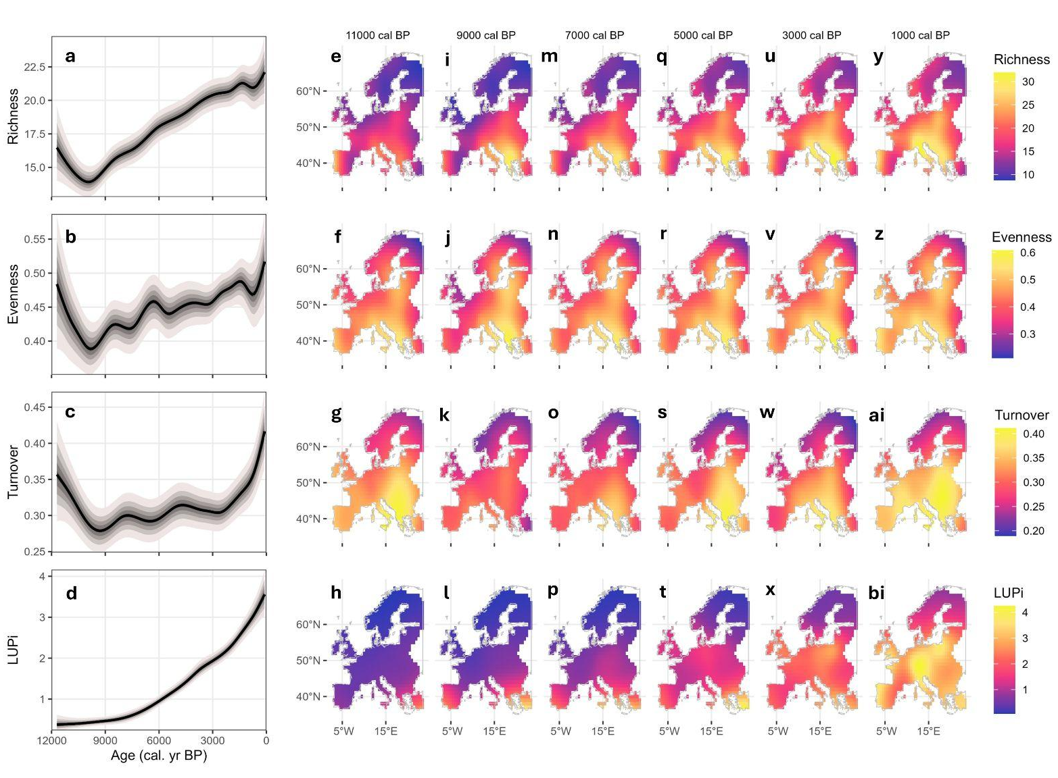
Fig. 1. European Holocene pollen richness, turnover and LUPi trends. Column one represents the a) richness, b) evenness, c) turnover and d) LUPi temporal trends over the Holocene. Dark lines represent the median fits and grey intervals represent the 90% credible intervals across all 100,000 draws from the spatio-temporal GAMs fit to each metric. The credible interval for LUPi is present but is small. Columns two to seven represent the median (across the 1,000) predicted richness, evenness, turnover, and LUPi values for each grid cell at points through the Holocene: (e-h) 11,000 cal yr BP, (i-l) 9,000 cal yr BP, (m-p) 7,000 cal yr BP, (q-t) 5,000 cal yr BP, (u-x) 3,000 cal yr BP and (y-bi) 1,000 cal yr BP. We did not predict values for grid cells further than four degrees from the nearest pollen record to avoid over-extrapolation, and these locations are coloured white on the maps (see Appendix 1, Fig. S1.1 for pollen record locations). Spatial predictions are made from the same spatio-temporal GAMs as those temporal fits shown in column one. LUPi values are square-root transformed. Note that 11,000 cal yr BP some of Fennoscandia was still covered in remnants of Pleistocene ice cover. Total pollen record N = 213.

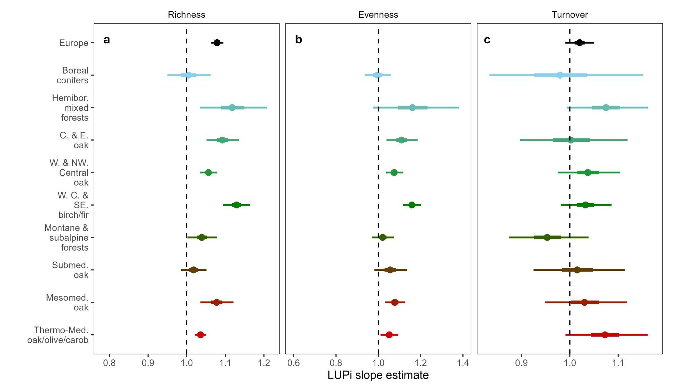
Fig. 2. Relationship between LUPi and pollen (a) richness, (b) evenness and (c) turnover for Europe and each vegetation zone over the Holocene. LUPi slope estimates from mixed models (see Appendix 2, Extended Methods: Estimating the relationships between LUPi and diversity) for each vegetation zone (colours) and Europe as a whole (black). Our AIC variable selection procedure did not identify LUPi as contributing to the ‘best’ European-scale evenness model, so this row is blank (panel b, row one). Points represent the mean estimates and bars represent the 50% (thick bar) and 95% (thinner bar) confidence interval of the mean. All estimates have been exponentiated, such that richness estimates represent rate ratios and evenness and turnover estimates represent odds ratios (for both, values above one represent positive associations and below one represent negative ones). Vegetation zones are organised by approximate latitude from north (top) to south (bottom). Number of pollen records in each region (full vegetation zone names provided in parentheses): Europe (all vegetation zones), 213; Boreal conifers (Boreal spruce and pine forests), 17; Hemibor. mixed forests (Hemiboreale deciduous-broadleaved spruce-pine mixed forests), 12; C. & E. oak (Central and Eastern European mixed oak forests), 23; W. & NW. Central oak (Western and northwestern Central European mixed oak forests), 44; W. C. & SE. birch/fir (Western, Central and Southeastern European beech and beech fir forests), 70; Montane & subalpine forests (Montane and subalpine mountain coniferous forests and Krummholz bushes), 21; Mesomed. Oak (Mesomediterranean evergreen and deciduous oak forests), 12; Submed. Oak (Submediterranean and southern Mediterranean thermophilous mixed oak forests), 12; Thermo-Med. oak/olive/carob (Thermo-Mediterranean evergreen oak forests and olive carob tree woodlands), 3.
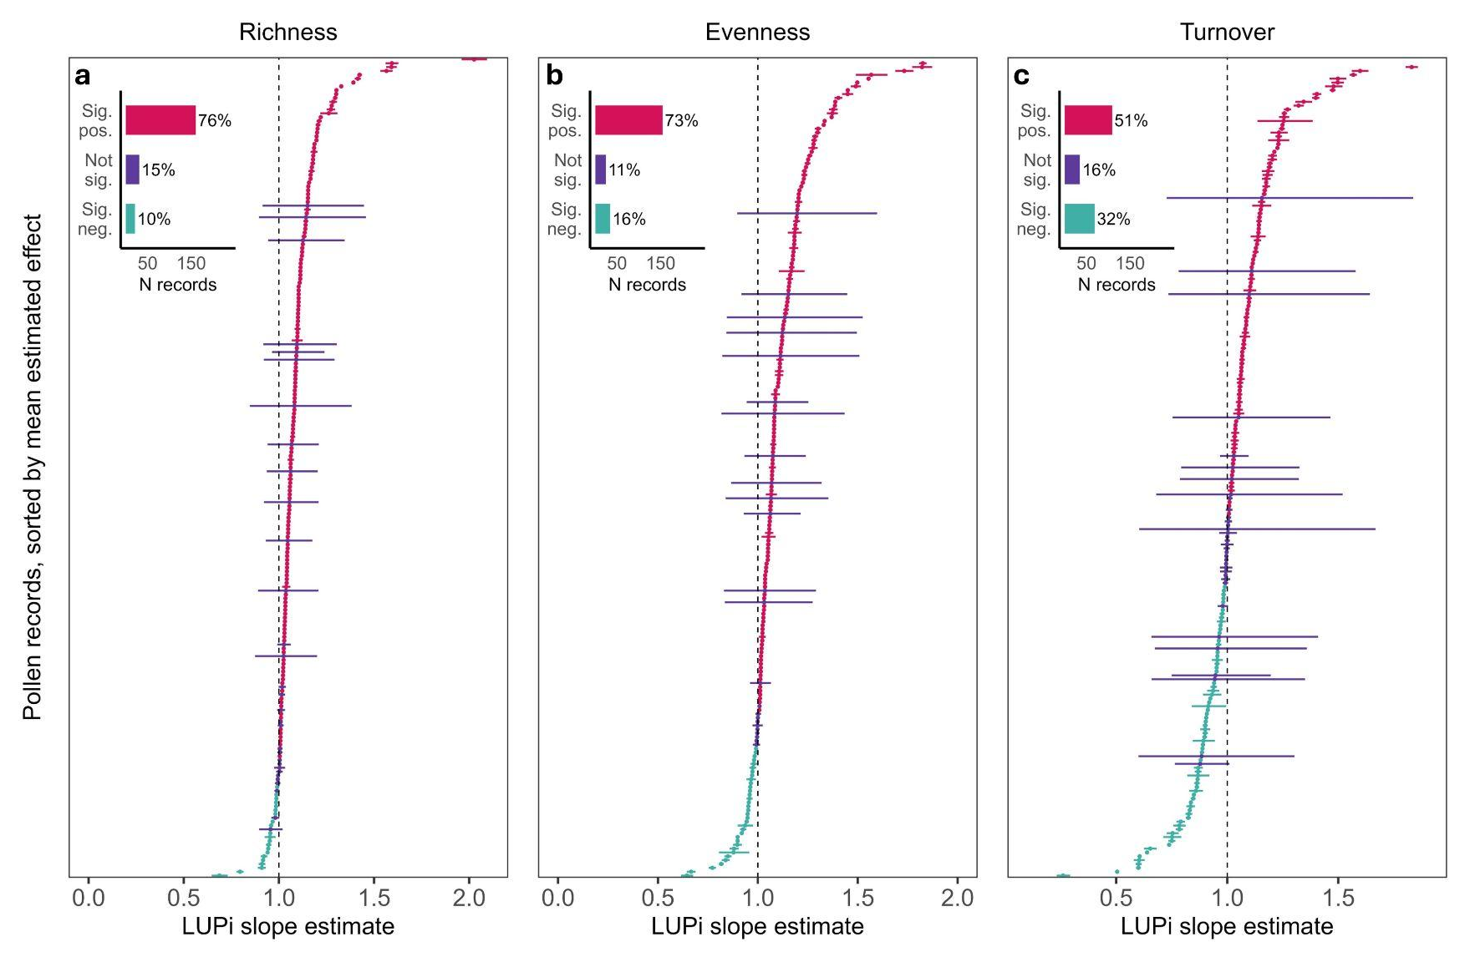
Fig. 3. Relationships between LUPi and European pollen (a) richness, (b) evenness and (c) turnover for each pollen record. Each row represents a slope estimate for an individual pollen record, estimated from each per-vegetation zone mixed model (see Appendix 2, Extended Methods: Estimating the relationships between LUPi and diversity)). Points represent the mean estimates and bars represent the 95% confidence interval of the mean. All estimates have been exponentiated, such that richness estimates represent rate ratios and evenness and turnover estimates represent odds ratios (for both, values above one represent positive associations and below zero represent negative ones). Pollen records with significant positive slope estimates are coloured in pink, pollen records with significant negative slope estimates in green and pollen records with non-significant slopes (in either direction) are coloured in purple (significance judged at 0.05). Barplot inset represents the number and percentage of records that have significant positive, not significant and significant negative relationship between LUPi and each diversity metric and turnover. Note that the percentage values have been rounded to zero decimal places, such that the three values may not sum to 100. Number of pollen records in total = 213.

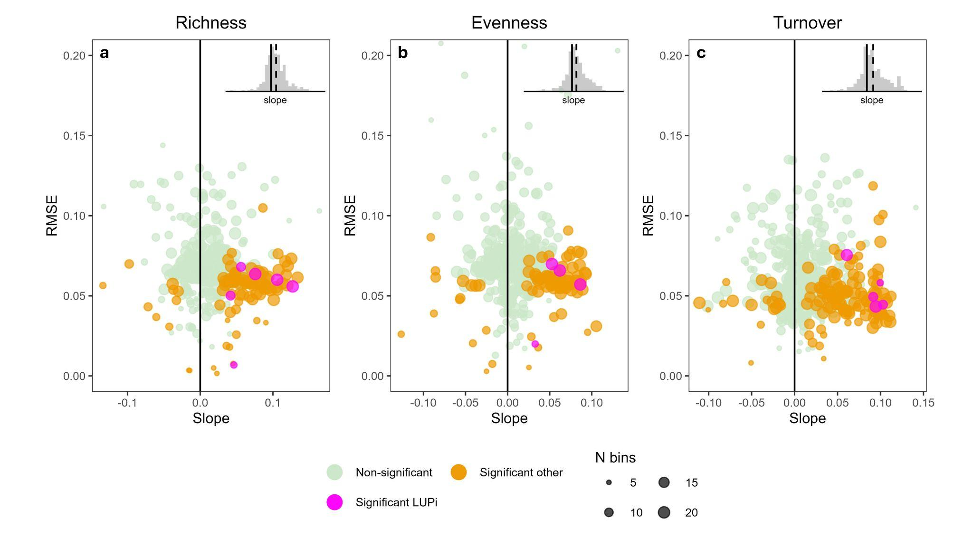
Fig. 4. Strength of relationships between each pollen types’ proportional site occupancy and adjusted average (a) richness, (b) evenness and (c) turnover. Each point is the (standardised) slope estimate (x-axis, effect size) and its root mean square-error (RMSE, an estimate of overall model error; lower is better) estimates (y-axis) for ARIMA models characterising a pollen type’s proportional site occupancy effect on the given diversity metric. Each point is coloured based on if the corresponding relationship is significant (otherwise, light green) and pollen type (LUPi, pink, otherwise, orange). Point size represents the number of time bins each pollen type is present in through the Holocene (maximum = 20). Pollen types included are those present in at least five 580-year duration time bins, representing a minimum of 2,900 years (not all pollen types met this criterion). Note that we have truncated the y-axis for presentation purposes, but retain >99.95% of the points (maximum RMSE is ~15 times as large as the maximum RMSE presented here). The inset histogram represents slope values for all pollen type proportional occurrences with each of richness, evenness and turnover, with the solid vertical line representing zero and the dotted vertical line representing the mean effect across all pollen types per diversity metric and turnover. Richness, evenness and turnover values were calculated after excluding the pollen type used in the regression and those pollen types included in the LUPi. Pollen types: LUPi n = 13, other pollen types n = 313.

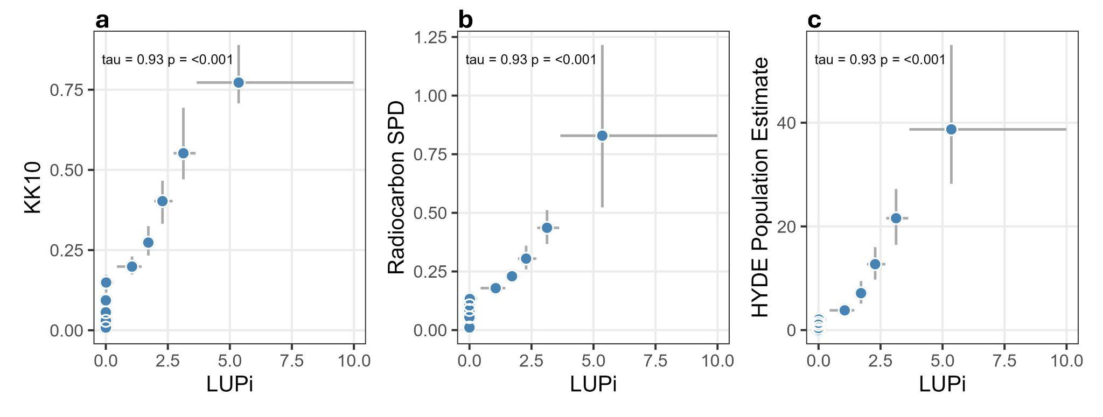Fig. 5. Comparison of LUPi with three other human indices. (a) The KK10 anthropogenic land cover change scenario. (b) Summed probability distributions of archaeologically-attested radiocarbon dates. (c) HYDE population estimates. Datasets are aggregated by decile bins and summarised as the median (points) and 95% range of the data (intervals). Correlations are Kendall’s rank correlations (tau) of the median values. Note that the radiocarbon SPD and HYDE population estimates have been square-root transformed. LUPi values are also square-root transformed. Total pollen record N = 213.

Appendix 1, Supplementary Figures and Tables.
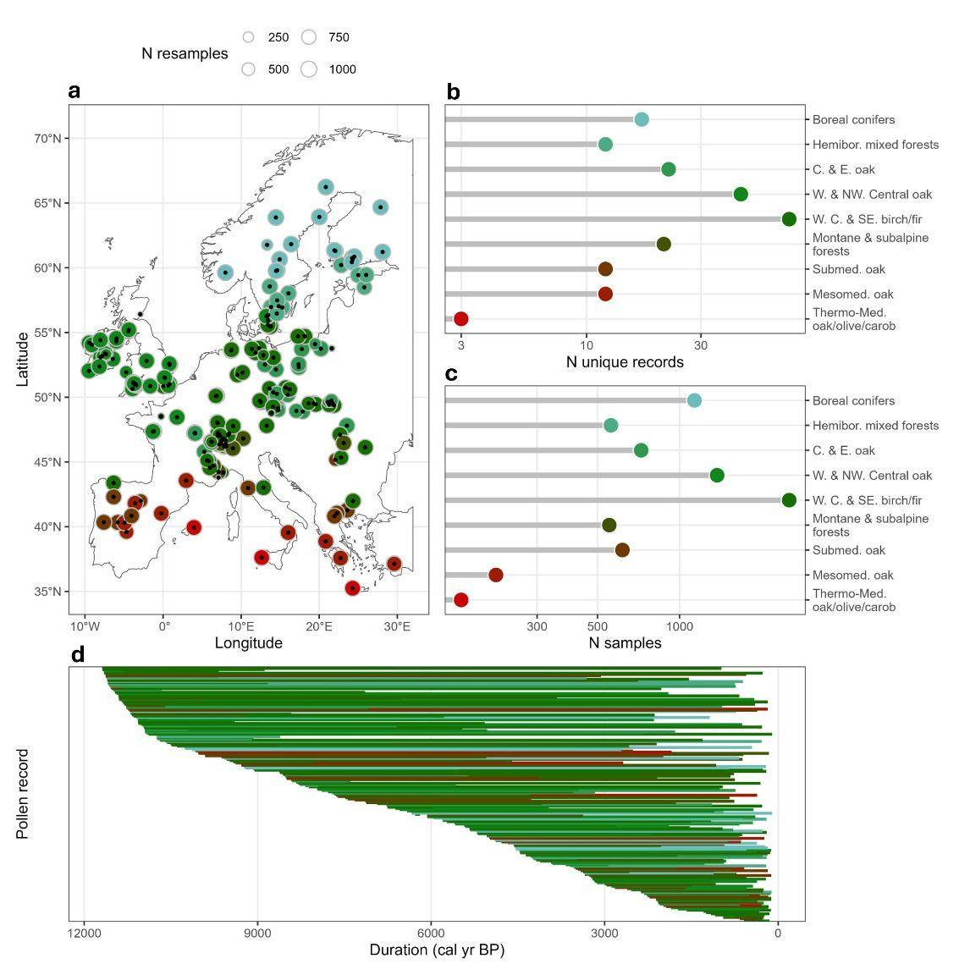Fig. S1.1. Fossil pollen record data descriptions. (a) Fossil pollen record locations. (b) Number of unique pollen records per vegetation zone (note logarithmic scaling of x-axis). (c) Number of unique pollen samples per vegetation zone (note logarithmic scaling of x-axis). (d) Duration of each pollen record, coloured by vegetation zone and ordered along the y-axis by start date and duration. Total pollen record N = 213.

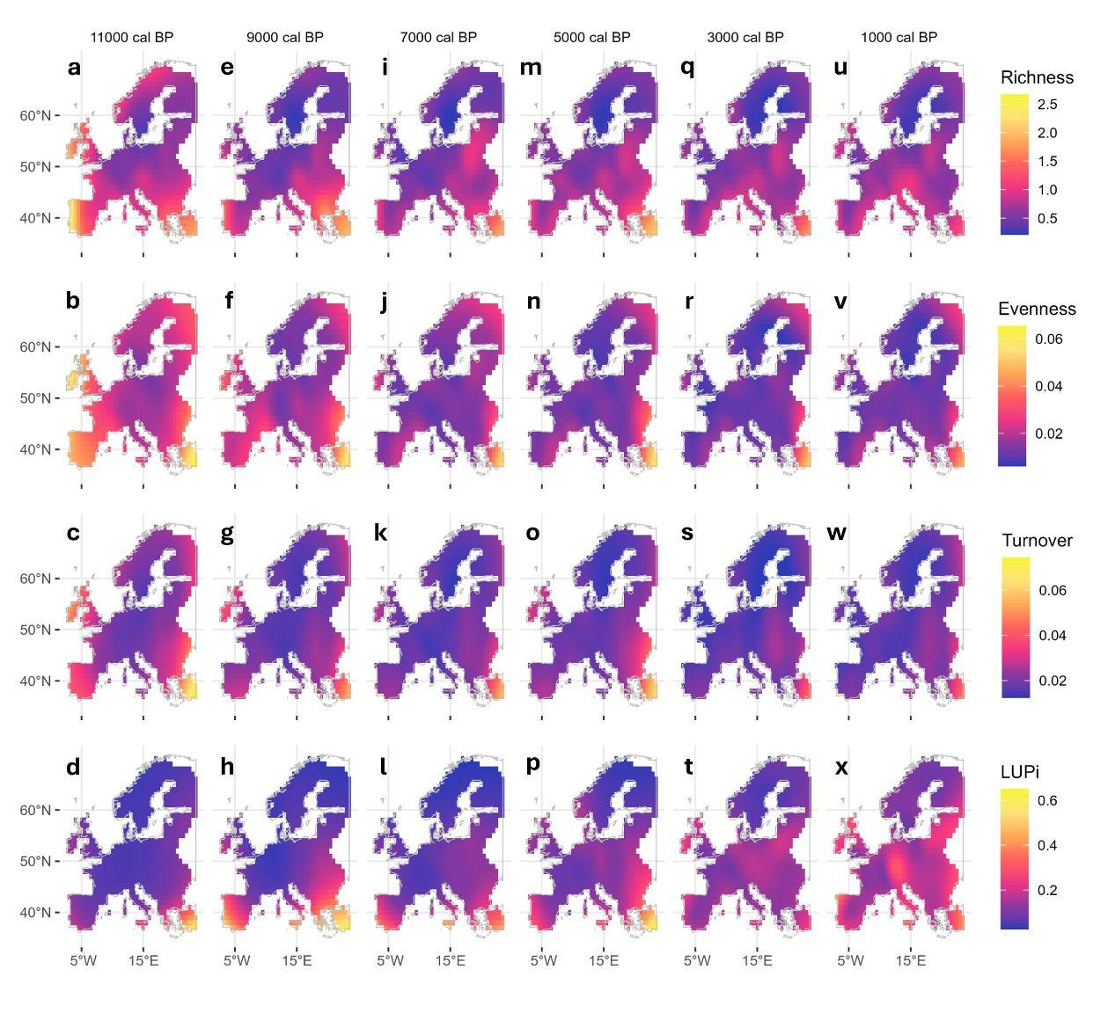
Fig. S1.2. Predictive uncertainty from spatiotemporal models for each of the pollen metrics and periods considered in Fig. 1. Columns represent time points through the Holocene and are identical to those of Fig. 1: (a-d) 11,000 cal yr BP, (e-h) 9,000 cal yr BP, (i-l) 7,000 cal yr BP, (m-p) 5,000 cal yr BP, (q-t) 3,000 cal yr BP and (u-x) 1,000 cal yr BP. Uncertainty represents the standard deviation across all 1,000 predictions for each grid cell and time point combination, with the 1,000 predictions arising from the 1,000 resamples.

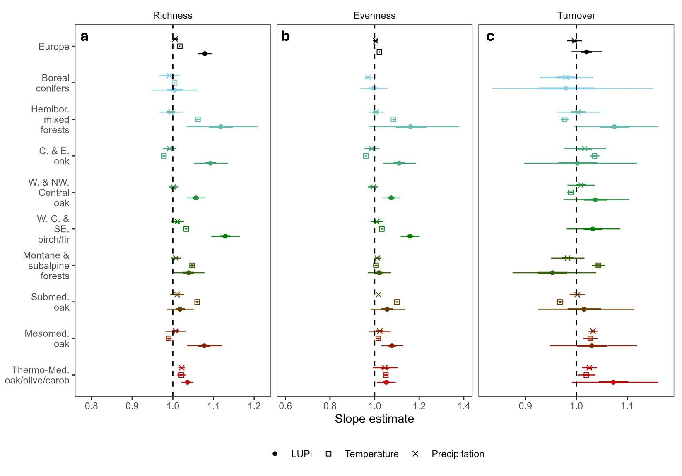
Fig. S1.3. LUPi, precipitation and temperature slope estimates for (a) richness, (b) evenness and (c) turnover, for Europe and each vegetation zone over the Holocene. Slope estimates from mixed models (see Appendix 2, Extended Methods: Estimating the relationships between LUPi and diversity) for each vegetation zone (colours) and Europe as a whole (black). Points represent the mean LUPi (circle symbol) , temperature (square symbol) and precipitation (cross symbol) slope estimates and bars represent the 50% (thick bar) and 95% (thinner bar) confidence intervals of the mean slope estimates. All estimates have been exponentiated, such that richness estimates represent rate ratios and evenness and turnover estimates represent odds ratios (for both, values above one represent positive associations and below zero represent negative ones). Vegetation zones are organised by approximate latitude from north (top) to south (bottom). Note that our AIC selection procedure did not select all predictor variables for all metric and vegetation zone combinations. Number of pollen records in each region: Europe (all vegetation zones), 213; Boreal conifers, 17; Hemibor. mixed forests, 12; C. & E. oak, 23; W. & NW. Central oak, 44; W. C. & SE. birch/fir, 70; Montane & subalpine forests, 21; Mesomed. oak, 12; Submed. oak, 12; Thermo-Med. oak/olive/carob, 3.

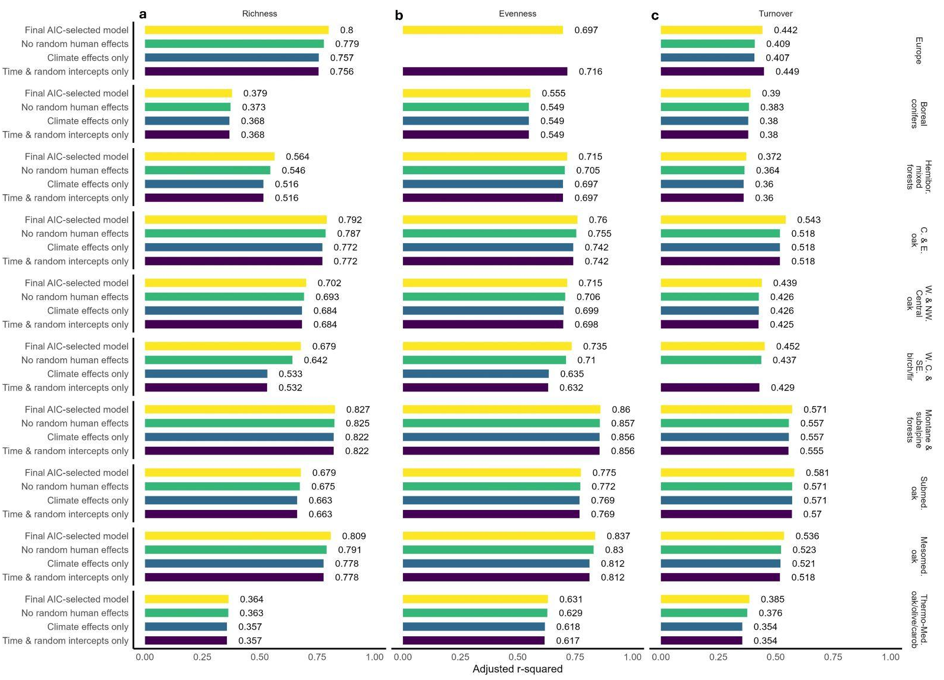Fig. S1.4. Adjusted R² comparisons for four variable combinations for the LUPi models spanning the Holocene for (a) richness, (b) evenness and (c) turnover. ‘Final AIC-selected model’ represents the model that minimised AIC across the cohort of fits per metric and vegetation zone, plus Europe, combination (effects presented in Fig. 2 and Appendix 1, Fig. S1.3). ‘No random human effects’ represents the same model as ‘Final AIC-selected model’ but without the random slopes and intercepts for LUPi. ‘Climate effects only’ represents the same model as the ‘Final AIC-selected model’ but without any LUPi effects. ‘Time and random intercepts only’ represents a model run with only time and random intercepts for resample and pollen record included. LUPi was included as a fixed and random effect in the best model for all region and metric combinations, except European-scale evenness, where LUPi was not included. Thus, the ‘no random human effects’ version of the final model does not exist for European evenness (given that the fixed effect needs to be present for the random effect to also be present) and the ‘climate effects only’ version represents the final AIC-selected model. Given this, and to avoid replication, the second and third rows of European-scale evenness are blank. No climate effects were selected in the final AIC-selected model for turnover in the Western, Central and Southeastern Birch/Fir zone, so the ‘climate effects only’ row is blank here.

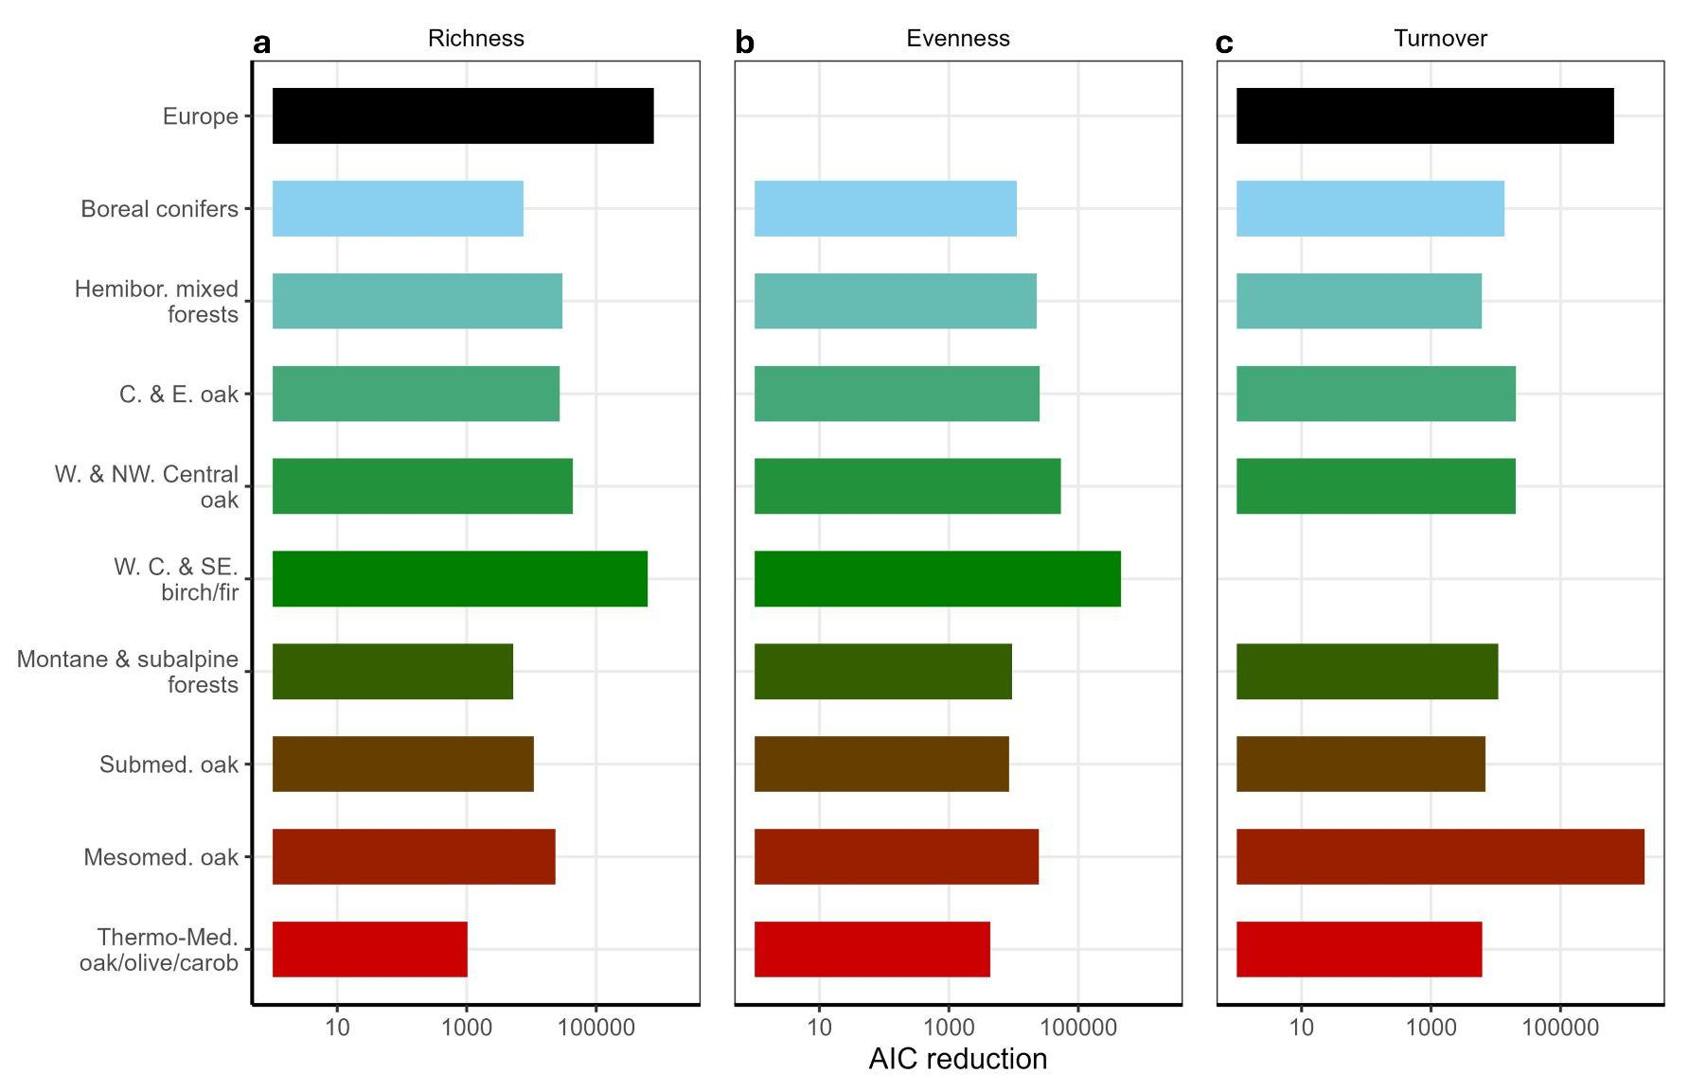
Fig. S1.5. AIC improvement of LUPi and climate model over climate-only model for (a) richness, (b) evenness and (c) turnover. Bars represent the AIC improvement of the LUPi and climate model over the climate-only version of the same model. Rows are blank for European-scale evenness and Western, Central and Southeastern Birch/Fir zone turnover because either LUPi (European evenness) or climate variables (Western, Central and Southeastern Birch/Fir turnover) were not included in the final AIC-selected models. See Appendix 4, Model AICs, for AIC values for each of the 18 model variants per vegetation zone and metric combination, and for Europe. Note the logarithmic scaling of the x-axis.

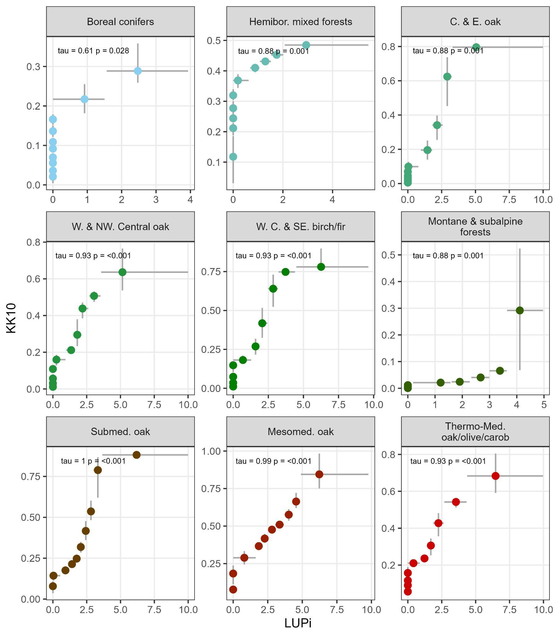
Fig. S1.6. Comparison of LUPi and the KK10 anthropogenic land cover change scenario, per vegetation zone. Datasets are aggregated by decile bins and summarised as the median (points) and 95% range of the data (intervals). Correlations are Kendall’s rank correlations (tau) of the median values. Note that KK10 estimates have been square-root transformed. LUPi values are also square-root transformed. Number of pollen records in each region: Boreal conifers, 17; Hemibor. mixed forests, 12; C. & E. oak, 23; W. & NW. Central oak, 44; W. C. & SE. birch/fir, 70; Montane & subalpine forests, 21; Mesomed. oak, 12; Submed. oak, 12; Thermo-Med. oak/olive/carob, 3.

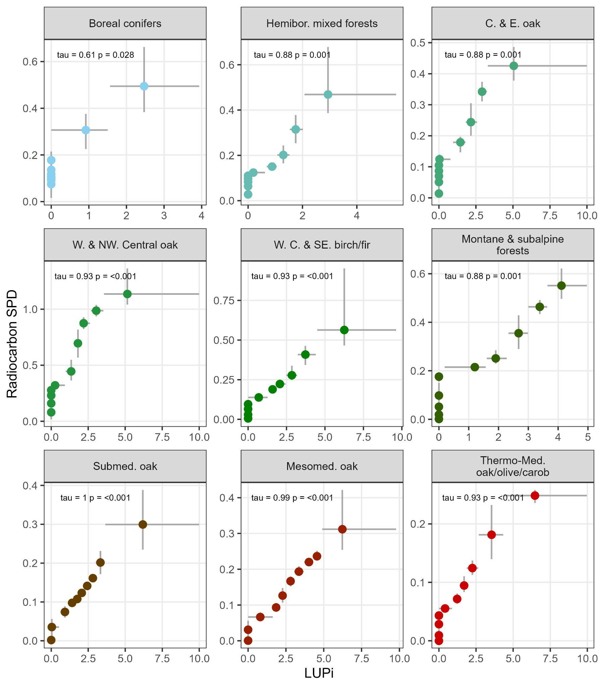
Fig. S1.7. Comparison of LUPi and SPDs of archaeological radiocarbon date estimates per vegetation zone. Datasets are aggregated by decile bins and summarised as the median (points) and 95% range of the data (intervals). Correlations are Kendall’s rank correlations (tau) of the median values. LUPi values have been square-root transformed. Number of pollen records in each region: Boreal conifers, 17; Hemibor. mixed forests, 12; C. & E. oak, 23; W. & NW. Central oak, 44; W. C. & SE. birch/fir, 70; Montane & subalpine forests, 21; Mesomed. oak, 12; Submed. oak, 12; Thermo-Med. oak/olive/carob, 3.

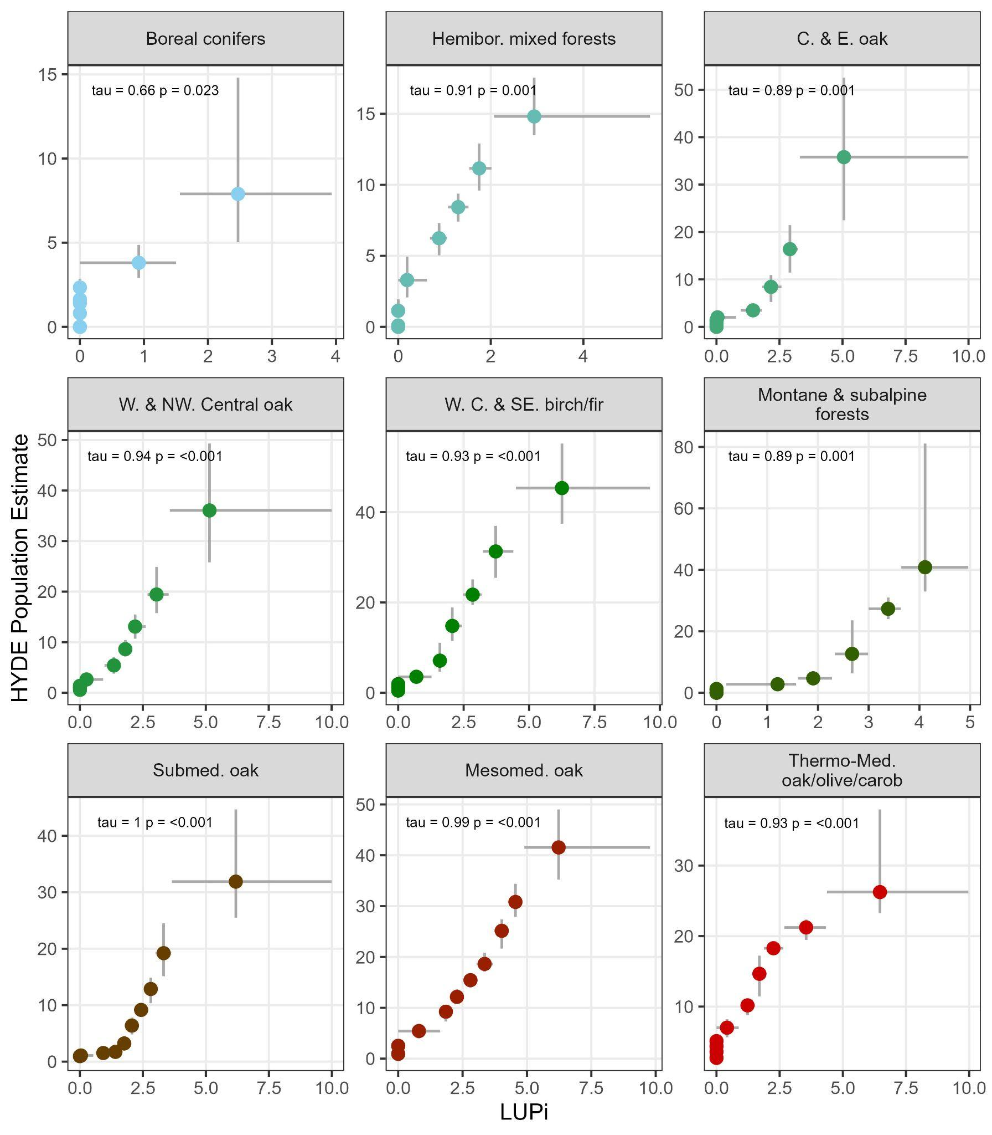
Fig. S1.8. Comparison of LUPi HYDE population estimates per vegetation zone. Datasets are aggregated by decile bins and summarised as the median (points) and 95% range of the data (intervals). Correlations are Kendall’s rank correlations (tau) of the median values. Note that HYDE population estimates have been square-root transformed. LUPi values are also square-root transformed. Number of pollen records in each region: Boreal conifers, 17; Hemibor. mixed forests, 12; C. & E. oak, 23; W. & NW. Central oak, 44; W. C. & SE. birch/fir, 70; Montane & subalpine forests, 21; Mesomed. oak, 12; Submed. oak, 12; Thermo-Med. oak/olive/carob, 3.
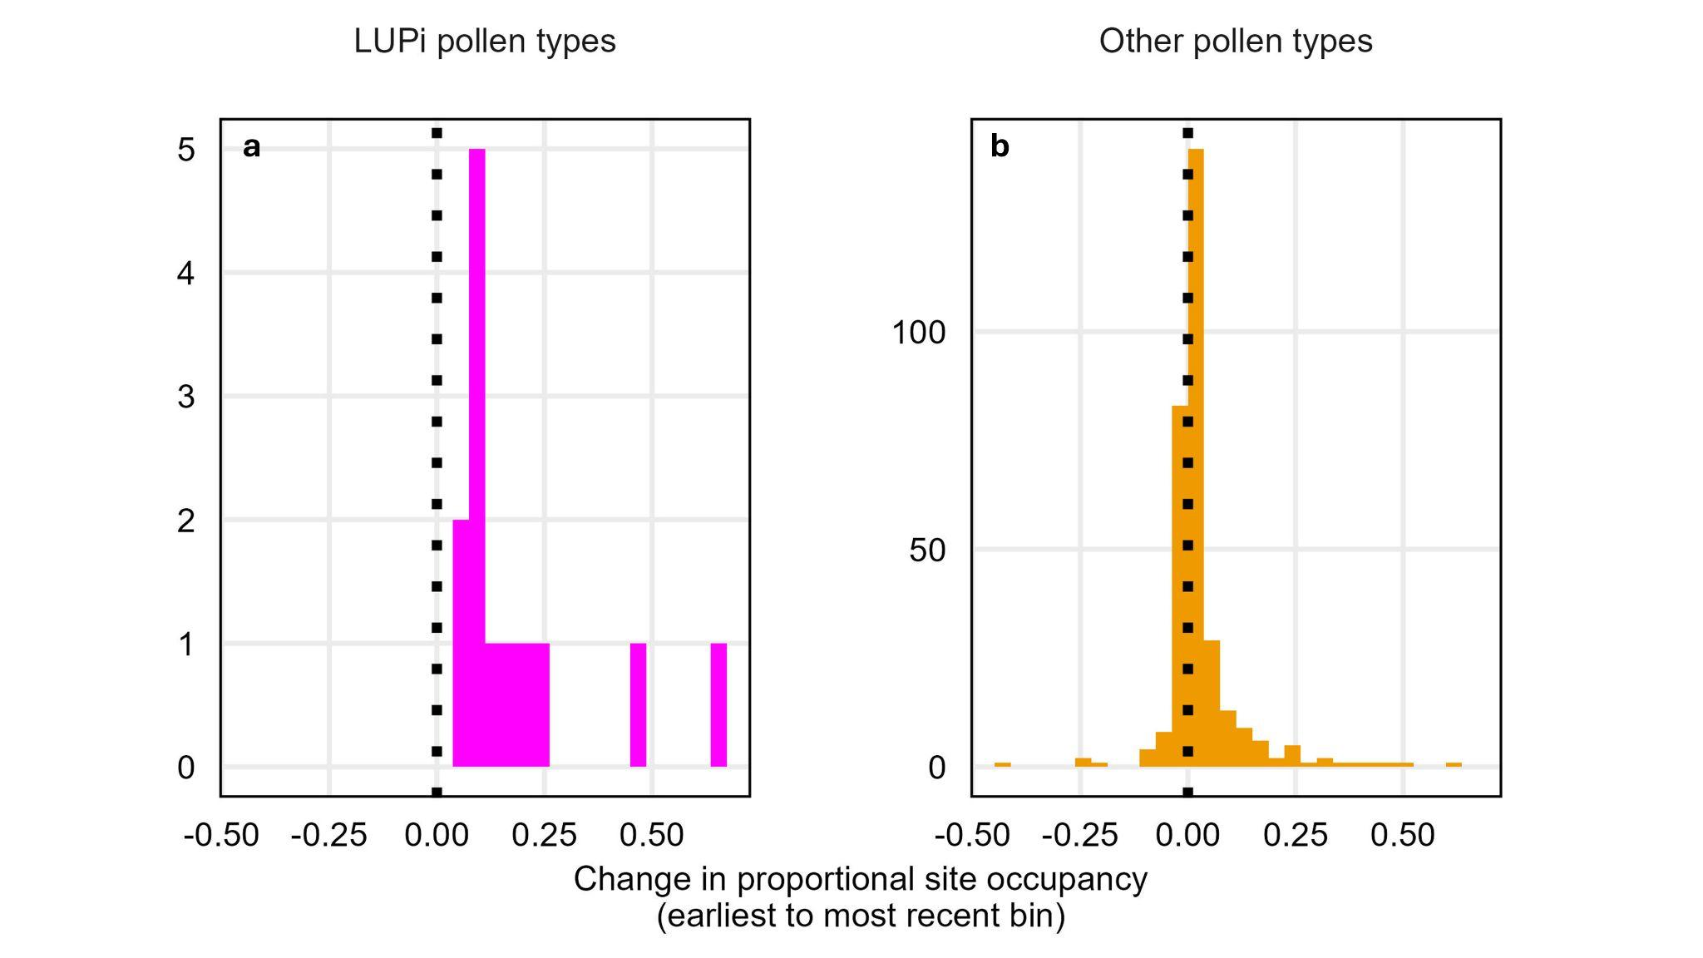Fig. S1.9. Change in proportional site occupancy of each taxon over the Holocene. Values represent the change (mean across 1,000 resamples) in the proportion of pollen records that each pollen type is present in from the earliest time bin (i.e. closest to the start of the Holocene, 11,700 cal yr BP) to the most recent (closest to the present) for a) LUPi pollen types and b) other pollen types. Pollen types included are those present in at least five 580-year duration time bins, representing a minimum of 2,900 years and are the same set of pollen types as those present in Fig. 4 (LUPi n = 13, other pollen types n = 314. Note that not all pollen types satisfied the inclusion criteria; see Appendix 2, Extended methods, Pollen type proportional site occupancy and diversity correlations). LUPi (human-associated) taxa all increased in their frequencies of occurrence (~range sizes) over the course of the Holocene, whilst non-LUPi taxa exhibit a heterogeneity of occurrence trajectories, but with more taxa expanding than contracting their ranges. Both distributions are significantly different from zero (see Table S1.2 for t-test summary).

Table S1.1: Variable inclusion matrix. Yes (1) / No (0) matrix of variables included in each of the 27 model runs (leftmost column) per metric and location. The table is organised by increasing complexity so that each combination of predictor variables and effects included are considered with human variables varying most frequently. `Time` represents a per-record smooth for time, plus a random intercept for each record. `*fixed` represents the average effect of * across all records. `*random` represents the per-record effect of *, as a deviation from the corresponding fixed effect. Note that the random effects can only be present if the fixed effects are. Model formula for the full model (i.e. mod_27) in Appendix 2, Extended Methods: Estimating the relationships between humans and diversity. Note that model variants with temperature as a random slope per pollen record were not included in the final set for AIC comparison (models 19 – 27, in bold), given the issues with model identifiability the inclusion of this term caused (see Appendix 2, Extended Methods).
Mod_run | Time | Resample ID | Temp  fixed | Temp  random | Prec  fixed | Prec  random | Human  fixed | Human  random
mod_1 | 1 | 1 | 0 | 0 | 0 | 0 | 0 | 0
mod_2 | 1 | 1 | 0 | 0 | 0 | 0 | 1 | 0
mod_3 | 1 | 1 | 0 | 0 | 0 | 0 | 1 | 1
mod_4 | 1 | 1 | 0 | 0 | 1 | 0 | 0 | 0
mod_5 | 1 | 1 | 0 | 0 | 1 | 0 | 1 | 0
mod_6 | 1 | 1 | 0 | 0 | 1 | 0 | 1 | 1
mod_7 | 1 | 1 | 0 | 0 | 1 | 1 | 0 | 0
mod_8 | 1 | 1 | 0 | 0 | 1 | 1 | 1 | 0
mod_9 | 1 | 1 | 0 | 0 | 1 | 1 | 1 | 1
mod_10 | 1 | 1 | 1 | 0 | 0 | 0 | 0 | 0
mod_11 | 1 | 1 | 1 | 0 | 0 | 0 | 1 | 0
mod_12 | 1 | 1 | 1 | 0 | 0 | 0 | 1 | 1
mod_13 | 1 | 1 | 1 | 0 | 1 | 0 | 0 | 0
mod_14 | 1 | 1 | 1 | 0 | 1 | 0 | 1 | 0
mod_15 | 1 | 1 | 1 | 0 | 1 | 0 | 1 | 1
mod_16 | 1 | 1 | 1 | 0 | 1 | 1 | 0 | 0
mod_17 | 1 | 1 | 1 | 0 | 1 | 1 | 1 | 0
mod_18 | 1 | 1 | 1 | 0 | 1 | 1 | 1 | 1
mod_19 | 1 | 1 | 1 | 1 | 0 | 0 | 0 | 0
mod_20 | 1 | 1 | 1 | 1 | 0 | 0 | 1 | 0
mod_21 | 1 | 1 | 1 | 1 | 0 | 0 | 1 | 1
mod_22 | 1 | 1 | 1 | 1 | 1 | 0 | 0 | 0
mod_23 | 1 | 1 | 1 | 1 | 1 | 0 | 1 | 0
mod_24 | 1 | 1 | 1 | 1 | 1 | 0 | 1 | 1
mod_25 | 1 | 1 | 1 | 1 | 1 | 1 | 0 | 0
mod_26 | 1 | 1 | 1 | 1 | 1 | 1 | 1 | 0
mod_27 | 1 | 1 | 1 | 1 | 1 | 1 | 1 | 1

Table S1.2: t-test summaries. Two-sided t-test tests whether the cohorts (for each pollen indicator category) of pollen type proportional site occupancy changes are equal to zero. All estimated mean values are not equal to zero.
Estimated mean | Statistic | p.value | Degrees of freedom | 2.5% CI of mean | 97.5% CI of mean | Human indicator category
0.186 | 3.744 | 0.003 | 12 | 0.078 | 0.294 | LUPi pollen types
0.03 | 5.597 | <0.001 | 313 | 0.019 | 0.04 | Other pollen types

Table S1.3: Pollen records included in these analyses, with references. .csv file attached.

Appendix 2, Extended Methods.

Data collection, processing and standardisation
We downloaded pollen records and associated chronological data from Neotoma using the neotoma2 package (Vidaña & Goring, 2023) and an approximate Europe bounding box. Each pollen record is constituted of a number of individual samples from different deposit depths, with each sample containing counts of pollen types. This initial query of Neotoma returned 3,021 pollen records alongside associated chronological information.

Data filter
Pollen records hosted on Neotoma are compiled from a range of individual pollen studies, each of which may employ varying methods relating to pollen and chronological control point sampling. Given this heterogeneity in sampling effort between pollen studies, we filtered the total set of 3,021 European pollen records based on (i) the dating intensity (number, spread - see below paragraph) of a record’s chronological control points and ii) the number of pollen samples (relating to different depths) contained in a pollen record. If a pollen record satisfied criteria relating to both its chronology and its pollen sampling, it was included in this study.

We included pollen records in these analyses if i) there were three or more Holocene chronological control points (usually radiocarbon dates but tephra, section tops, varves and Lead-210 dates also included), to ensure robust age estimates for each pollen sample, ii) there were no more than 3,000 years between these chronological control points, for the same reason and iii) there were at least five pollen samples along the pollen record, with each sample containing a minimum number of pollen grains (see below, Pollen resampling). We only analysed pollen samples with estimated ages younger than 11,700 calibrated radiocarbon years before present (hereafter cal yr BP; with ‘radiocarbon present’ as 1950 CE) and older than 100 cal yr BP, to avoid including surface pollen samples. If a specific section (i.e. a continuous run of pollen samples through a record) of a given pollen record met these inclusion criteria, but the record as a whole did not, we included that conforming section only. If multiple sections of a pollen record met the inclusion criteria, but the record as a whole did not, we included the section of the pollen record represented by the largest number of chronological control points.

Modelling past vegetation covers from pollen counts
Counts of pollen types within samples of material extracted from natural environmental archives (e.g., lake sediments, peat bogs) represent - but by no means exactly reflect - the compositions of the parent plant communities surrounding a pollen record extraction location (i.e. in a pollen source area) (Sugita, Gaillard, & Broström, 1999; Sugita, Hicks, & Sormunen, 2010). The majority of fossil pollen types recorded in Quaternary pollen records are not identifiable to the taxonomic level of species, most are identified to genus or family. On top of this, of those plants that produce pollen, rates of pollen production, pollen dispersal distances and pollen preservation vary between plant taxa (Flantua et al., 2023; Prentice, 1985; Seppä & Bennett, 2003). One result of these differences is the overrepresentation of highly mobile pollen types and/or pollen types from high pollen producing plant types in pollen samples and records. In a palaeo-diversity context, this variation can lead to standardised (i.e., rarefied) pollen counts being dominated by pollen types that are overrepresented in pollen assemblages (Giesecke, Ammann, & Brande, 2014), with implications for a range of diversity estimates.

To overcome these biases (as far as is possible), we modelled pollen counts using the “Regional Estimates of VEgetation Abundance from Large Sites” (REVEALS) model (Sugita, 2007) implemented using REVEALS code developed by Abraham, Oušková, & Kuneš (2014). The REVEALS model is a mechanistic model that takes pollen count data and a number of pollen-type and abiotic variables [which we obtained from Githumbi et al. (2022)] as input data, to provide proportional estimates (per pollen sample) of past vegetation covers per pollen sample [see Githumbi et al. (2022) for further detail of method]. We identified the intersection of pollen records with i) the requisite REVEALS information compiled by Githumbi et al. (2022) and ii) pollen and chronological data available on Neotoma (n = 694). For the records that passed our inclusion criteria, we then ran the REVEALS model on all pollen samples to estimate past vegetation covers. We then multiplied the original pollen counts by the outputted REVEALS proportional past vegetation estimates to convert the REVEALS estimates back to pollen counts, after Felde, Peglar, Bjune, Grytnes, & Birks (2016). The REVEALS model provides past vegetation estimates for the most numerically abundant pollen types in fossil pollen spectra and we combined the adjusted counts for these taxa as well as the unadjusted counts from the remaining taxa, carrying them forwards to the next stage of our analyses.

Pollen resampling
There is a significant heterogeneity in pollen sampling effort between pollen samples and records (more pollen grains are identified in some pollen samples than others), which, if left unaccounted for, would have implications for all diversity measures in these analyses. To account for the heterogeneous pollen sampling effort between pollen samples, we randomly resampled (without replacement) 200 pollen grains from each REVEALS-adjusted pollen sample using the rrarefy function from the vegan (Oksanen et al., 2022) package. We repeated this procedure 1,000 times to generate 1,000 datasets with a uniform 200 grain pollen count per sample.

The result of the standardisation, filtering and resampling steps resulted in the reduction of the 3,021 initially downloaded pollen records down to 213 Holocene (11,700 - 100 cal yr BP) pollen records, represented by 7,853 individual pollen samples.

Flantua et al. (2023) recommend stratifying pollen records and analyses by deposition environment in studies such as these, to ensure that any differences in taphonomy, pollen source areas, accumulation rates (etc., see paper for further details) between fossil pollen records do not confound diversity and turnover estimates. Though we accept that this can indeed be an issue, we do not implement this recommendation from Flantua et al. in this work for two main reasons: (i) our REVEALS treatment of the pollen data helps to adjust for differences in the relevant pollen source areas between fossil pollen records from different deposition environments and (ii) using a leave-one-out approach, previous work has identified the relatively minor influence of deposition environment on broad patterns of pollen diversity change over the Holocene in Europe (Gordon, Fagan, Milner, & Thomas, 2024) (Extended Data Fig. 8), scales reflected in this work.

Age-depth modelling
We recomputed Bayesian age-depth models for all pollen records that met our inclusion criteria in the package Bchron (Haslett & Parnell, 2008). The majority of chronological control points included were radiocarbon dates but we also include tephra, annual lamination and section top datings. All pollen records are located in Europe, so we selected the IntCal20 (Heaton, Blaauw, et al., 2020) and Marine20 (Heaton, Ramsey, Bard, & Reimer, 2020) radiocarbon calibration curves to calibrate terrestrial and marine radiocarbon dates, respectively. We ran each age-depth model with 50,000 iterations, a thin value of 40 and a burnin of 10,000 iterations. We did not allow age extrapolation greater than 3,000 years past the oldest or youngest chronological control point.

Overall, the above procedures generated 1,000 REVEALS-adjusted European pollen datasets, where each pollen sample was represented by a randomly resampled pollen assemblage with a standardised number of pollen grains and a randomly drawn estimated age from the posterior distribution of the corresponding age-depth model for that sample’s depth. This bootstrapping procedure includes the variation inherent to both resampling and age-depth modelling in our analyses.
Metrics of past human population size or ecological impact
In these analyses we are interested in identifying relationships between the extent and intensity of human impacts on past vegetative communities and aspects of the diversity (richness, evenness) and compositional turnover of these communities. To do this, our primary predictor variable is LUPi (Deza-Araujo et al., 2022). However, this study represents the first attempt to apply a pollen-based metric of past human impact at such broad spatial and temporal scales. As a LUPi robustness analysis, we investigated the relationships between LUPi and three other frequently used indices of past human population size and/or ecological impact: the ‘Krumhardt Kaplan 2010’ (‘KK10’) anthropogenic land cover change (ALCC) scenario, summed probability distributions of archaeologically-attested radiocarbon dates [using data from Bird et al. (2022)] and modelled population estimates from the History Database of the Global Environment (‘HYDE’) (Klein Goldewijk, Beusen, Doelman, & Stehfest, 2017) (Kaplan et al., 2011; Kaplan, Krumhardt, & Zimmermann, 2009).

Land use probability index (LUPi) estimates
Bioindicators are organisms, or groups of organisms, that have known ecological requirements (Gerhardt, 2002). The presence/absence, or changing abundances, of bioindicator organisms is often used to infer anthropogenic presence/activity in an environment. The greater the quantity (or more common the occurrence) of a human-associated bioindicator, the higher the likelihood that humans are present in, and have impacted, that environment. Likewise, the bioindicator approach is used in palaeoecology to estimate human-presence in the past, by identifying fossilised organisms deemed to be cultural human indicators (Behre, 1981; Deza-Araujo et al., 2020). In the context of these analyses, these fossilised organisms are pollen grains - for example crop species, or arable weeds - archived in deposits such as peat bogs, sediment cores, soil samples, etc. We use the agricultural land use probability index of Deza-Araujo (2022) in these analyses as a pollen sample-based estimate of past anthropogenic impact on ecological communities surrounding a pollen record.

Deza-Araujo et al. (2022) review a range of European cultural human indicators used in the palynological literature and select those pollen types with the greatest capacity to indicate human impact intensity on ecosystems. In the method, the relative abundances of these pollen types are then up- or down-weighted by region-specific anthropogenic indicator values (H. H. Birks, Birks, Kaland, & Moe, 1988) (AIV) and summed by sample. These AIV values inflate or penalise a pollen type’s relative weight in a region based on a pollen type’s native range, pollen production/dispersal and taxonomic resolution. A pollen type that is deemed to be a human indicator but is also native to a region is down-weighted, for example. The resultant agricultural land use probability estimate for a given pollen sample is then the summed, weighted relative abundances of those pollen types that are the best regional indicators of human impact intensity. It is worth noting that the LUPi authors generated a longlist of pollen types deemed to indicate a human presence in European Holocene landscapes and assessed them based on their indicator quality. Table S1 from Appendix A, Supplementary Data in Deza-Araujo (2022) contains the gradings of all the longlisted pollen types based on five key criteria: adventiveness, taxonomic resolution, pollen production/deposition, increase through a pollen diagram, and overrepresentation. The pollen types included in the LUPi measure in this study are only those taxa graded highest – i.e. four star – taxa deemed best able and most reliably to indicate a past human presence/impact in Holocene Europe.

The original LUPi authors suggest capping the index at 100, so we set all values greater than 100 (<0.0001% of values) to 100. We estimated the LUPi for each sample across all resampled pollen records that made it through the filtering steps detailed above. Exploratory analyses highlighted orders of magnitude differences between the minimum and maximum LUPi values (min = 0 [50% of the data are zeros], median LUPi = 0, mean LUPi = 6, max LUPi = 100]). We therefore transformed the LUPi variables using the square-root, given that the logarithm and logarithm plus one transformations were inappropriate choices for the often-zero LUPi values. We carried forward the square-root transformed LUPi values into all of the following analyses.

KK10 Anthropogenic Land Cover Change
The KK10 ALCC scenario provides a proportional estimate of human land use per five arc-minute grid cell, in annual time slices over the period 8,000 – 100 cal yr BP. The KK10 uses estimates of past human population sizes [primarily from Lemmen (2009), McEvedy & Jones (1978) and Wirtz & Lemmen (2003)], current agriculture/pasture suitability maps and estimates of per-capita land use to model human land use through time (Kaplan et al., 2009). The KK10 ALCC has been used in previous studies to investigate the relationships between human land use and aspects of floristic diversity changes and turnover rates at regional (Marquer et al., 2017) and continental (Gordon et al., 2024) scales. For each pollen record, we sampled the KK10 surface using the latitude and longitude of each record and generated a time series of pollen-record specific KK10 values by stacking the sampled KK10 surfaces per record over the period of KK10 representation, 8000 – 100 cal yr BP.

Summed probability distributions of radiocarbon dates
Summed probability distributions of archaeologically attested calibrated radiocarbon dates (radiocarbon SPDs) are increasingly used as a proxy for past changes to relative human population sizes. The “dates-as-data” approach of radiocarbon SPDs assumes that past human populations deposited products into the archaeological record and that these products (once excavated, radiocarbon dated and collated across many studies) indicate relative levels of human activity through time: the greater the human activity, the greater the number of products deposited into the archaeological record to be excavated and radiocarbon dated (Crema, Bevan, & Shennan, 2017). There have been a range of criticisms levelled at the use of radiocarbon SPD-based methods, relating primarily to sampling error, variation in the slopes of calibration curves, variance in sampling effort through time and space and taphonomic (archaeological preservation) biases (Carleton & Groucutt, 2021; Crema & Bevan, 2021). Notwithstanding these limitations, measures can be taken during the radiocarbon date collation phase and when generating a radiocarbon SPD (see below) to mitigate (as far as is possible) their impact (Crema et al., 2017; Shennan et al., 2013; Williams, 2012).

We used the package rcarbon (Crema & Bevan, 2021) to generate a local-in-space SPD for each pollen record, using a global compilation of archaeological radiocarbon dates as the input data (Bird et al., 2022). For each pollen record in turn, we subset the total Bird et al. radiocarbon date database by those dates that fell within 100km of each pollen record. If there were insufficient dates (fewer than 100) to generate an SPD, we increased the radius to 250km. We then calibrated these radiocarbon dates using the IntCal20 (Reimer et al., 2020) radiocarbon calibration curve, creating probability distributions for each radiocarbon date on the scale of calibrated radiocarbon years before present (with ‘present’ as 1950 CE). We did not normalise these age distributions to unity given that this generates artificially spikey curves that very likely reflect the steepness of the calibration curve, rather than any ‘real’ past change in human populations (Weninger, Clare, Jöris, Jung, & Edinborough, 2015).

To prevent overrepresentation of some time periods due to heterogeneous sampling effort (at the same site), we took all samples and associated probability distributions from the same site and binned overrepresented time periods into 200 year bins [after Shennan et al. 2013)] using rcarbon’s binning function binprep, which determines optimal bin locations by considering the medians of each sample’s calibrated age distribution. We then pooled the calibrated date distributions within each bin at each site to form a local (in time and site) SPD (Shennan et al., 2013) and then passed each bin’s SPD, across all sites and times, to rcarbon’s spd function to create the final SPD for the pollen record. We repeated this procedure for all pollen records included in our final dataset, to generate a local-in-space SPD of the relevant archaeologically-attested radiocarbon dates per record.

HYDE population estimates
Finally, we extracted population estimates from the History Database of the Global Environment (‘HYDE’) (Klein Goldewijk et al., 2017) (HYDE version 3.2) for each pollen record using their latitude and longitudes. The HYDE authors compile national and subnational historical population estimates to generate time series encompassing the period 10,000 BCE (~12,000 cal yr BP) to 1950 CE, which they then downscale to 5 min resolution grid cells based on overall modelled relationships with other variables deemed important (such as distance to water and soil productivity). HYDE’s underlying population estimates are based on similar literature to those of the KK10, relying heavily on the UN estimates for the 1950 – 2015 CE period and the McEvedy and Jones (1978), Livi-Bacci (2007) and Maddison (2001) estimates for the period before the UN dataset coverage.

The HYDE dataset provides population estimates in 1,000-year slices from 10,000 - 0 BCE, followed by 100 year slices up to 1700 CE, followed by 10 year slices up to 1950 CE (these analyses only extend up to 1850 CE so HYDE estimates after this date – they extend up to 2015 CE – are not relevant). For each pollen record, we then linearly interpolated the HYDE population estimates for each pollen sample, based on that sample’s median estimated age. We deemed this interpolation preferable to upscaling each of the other human indices to the temporal resolution of the HYDE dataset, given the substantial loss of information this would have resulted in.

Limitations of human metrics
Summed probability distributions of compilations of archaeologically-attested radiocarbon dates (radiocarbon SPDs), HYDE population estimates and KK10 anthropogenic land use estimates have been much-used to describe changes in past relative human population sizes and ecological impact, though each of them suffer from their own set of limitations. Radiocarbon SPDs have been argued to represent changes in human palaeodemography and, by implication, changing human-environmental relationships [e.g. (McLaughlin et al., 2025; Shennan et al., 2013)]. However, radiocarbon SPDs are biased by archaeological sampling (only locations and periods of archaeological interest are sampled) and changing human ritual and subsistence choices over time (Torfing, 2015). On top of this, radiocarbon SPDs do not reliably extend past ~3,000 cal yr BP in Europe, after which time the dating of archaeological material is preferentially done using methods other than radiocarbon dating [see Crema (2022) and Crema & Bevan (2021) for full discussion].

HYDE’s model-based simulations of historic population size is another frequently used dataset (Gaillard et al., 2010; S. Li, He, Zhang, & Zhou, 2019; Zhang, Fang, & Yang, 2021), a dataset underpinned by population estimates from UN census data for post-1950 CE and ‘guesti-mates’ (Klein Goldewijk, Beusen, & Janssen, 2010, p. 571) obtained from the literature for the more distant past. These pre-1950 CE population estimates are highly uncertain, with the authors urging caution when using their estimates for dates preceding 1950 CE (Klein Goldewijk et al., 2017, p. 941). On top of this, the assumed relationships between human population size, land use and other variables (e.g. slope, distance to water) that are used to model population sizes extending back into the Holocene are also disputed (Kabora, Stump, Thomas, & Beale, 2024; Zhang et al., 2021).

Finally, simulations of past human land use, such as the KK10, rely on the same historic population estimates as HYDE and combine them with present-day datasets on agricultural/pastoral suitability and an assumed logistic function between time and per capita land use to model past human land use (Kaplan et al., 2009). On top of the uncertainties associated with the underlying population estimates and human land use relationships, it is also unclear whether present-day agricultural/pastoral suitability maps represent the suitability of landscapes for agricultural production over the long-term past, given the obvious variation in climate, environments, soils (etc) and human subsistence choices over multi-millennial time scales. On top of these sources of uncertainty, simulated population and land use datasets such as HYDE and KK10 represent intensely smoothed temporal and spatial surfaces and thus land use estimates for individual locations (i.e. the pollen source areas relevant to fossil pollen records) are highly uncertain.

Diversity calculations
To ensure that our pollen diversity results were comparable between different pollen records, we harmonised the taxonomies and nomenclature of all pollen names present across the European pollen records included in these analyses. To do this, we standardised the names and taxonomies of all pollen types in the dataset using the taxonomic harmonisation table provided in (Birks et al., 2023). We checked for the extent of the coverage of the Birks et al. harmonisation table for our pollen dataset and updated the table for full coverage to our specific compilation of pollen records.

Prior to computing the diversity metrics, we removed LUPi pollen types from pollen samples to avoid circularity in our analyses, performed the resampling procedure and computed our diversity metrics on these resampled, LUPi-removed pollen datasets. We computed richness, evenness and turnover for all 1,000 pollen datasets, resulting in 1,000 sets of richness, evenness and turnover time series for each pollen record

Richness
Richness is a measure of the number of unique pollen types present in a pollen sample (Birks & Line, 1992), with pollen samples in these analyses standardised to a uniform number of pollen grains (200). Whilst the relationship between pollen richness and the richness of the plant communities the pollen represents has been debated in the literature, many studies demonstrate a positive relationship between them (Birks et al., 2023; Blaus et al., 2020; Meltsov, Poska, Reitalu, Sammul, & Kull, 2013; Odgaard, 1999; Papadopoulou et al., 2022; Väli, Odgaard, Väli, & Poska, 2022; cf. Goring, Lacourse, Pellatt, & Mathewes, 2013; Gosling et al., 2018). There is a trade-off between bias within samples and regional bias imposed by standardisation requirements, with pollen samples with lower pollen grain counts necessarily excluded at higher resampling values. Work has shown that at low pollen counts, pollen richness estimates are influenced more strongly by the evenness of pollen spectra than at higher pollen counts and can lead to richness underestimations (Odgaard, 1999; van der Knaap, 2009) an issue arising from differential pollen production, dispersal and preservation between taxa (Giesecke et al., 2014; Odgaard, 1999; Peros & Gajewski, 2008). We have mitigated against some of these effects in our main analysis by adjusting pollen counts using proportional estimates of past vegetation cover from REVEALS, and randomly resampling these corrected assemblages down to 200 pollen grains per sample.

Evenness
We compute the evenness of each standardised pollen spectrum per sample using Pielou’s evenness, J (Pielou, 1966), J = H/log(S), where S is the total number of pollen types in the sample and H is the Shannon Index (Shannon, 1948). We computed the Shannon index using vegan.

Turnover
We quantified the turnover of pollen types through a pollen record using a time-adjusted measure of Bray-Curtis (Bray & Curtis, 1957). For each pollen record, we computed the Bray-Curtis dissimilarity between successive samples using the vegdist function in vegan (Oksanen et al., 2022). We corrected for the varying time interval between any two pollen samples by computing i) the Bray-Curtis dissimilarity between all pairs of samples in each pollen record and ii) the associated time differences between them. We then regressed the Bray-Curtis values against the logarithm of the time-difference values from all sites using a beta regression, Bray-Curtis ~ log(time_diff), and subtracted the raw pairwise Bray-Curtis value from that which is expected given the time interval between the two samples. This resulted in a measure of Bray-Curtis adjusted for time interval; our compositional turnover rate, which we normalised to be on the [0,1] scale.

Estimating spatial and temporal diversity and LUPi trends
We modelled our computed pollen diversity data through time and across space using spatio-temporal hierarchical generalised additive models (HGAMs). We initially attempted to model the 1,000 pollen diversity datasets per metric in the same HGAM, however model testing showed that this was computationally intractable given the large number of parameters to estimate (smooth terms plus random effect structure) and the magnitude of the dataset. Thus, we devised a procedure – based on bootstrapping – that retains the uncertainty across the pollen resampling and age-depth modelling procedures, whilst also incorporating the uncertainty inherent to the HGAM fitting procedure.

For each resampled diversity metric and for LUPi (i.e. for all metric and resample combinations, represented by Diversity_{_i,} below), we fitted a spatio-temporal HGAM to the total European dataset. This model includes non-interacting terms for time and space, and an interaction effect between time and space, which allows both temporal and spatial trends (through time) to be estimated from within the same model. These models took the form,

Diversity_{_i} ~ s(age_draw, bs = “cr”, k = 20) +
s(lat, long, bs = “ds”, k = 80) +
s(age_draw, datasetid,
bs = ”fs”, xt = list(bs = “cr”)) +
ti(long, lat, age_draw,
bs = c(“ds”, “cr”), d = c(2, 1),
k = c(40, 10))

For these spatio-temporal models we used the bam function from mgcv for model fitting, with betar (Beta distribution) as the family for turnover and evenness, poisson (Poisson distribution) for richness and tw (tweedie) family for LUPi. We used the log link function for each. To improve the computational efficiency of all our models, we discretised our predictor variables (Z. Li & Wood, 2020) and used fast REML (Wood, 2011) to estimate the model parameters.

Temporal trends
For each spatio-temporal model fit, we simulated 100 draws from the posterior of each estimated temporal function using the fitted_samples function from gratia (Simpson, 2024). Given the estimated model parameters, this function generates posterior draws for Diversity_{_i} that includes the uncertainty in the expected values. For each diversity metric, this posterior simulation procedure resulted in 100 posterior draws associated with each of the 1,000 resamples, which resulted in 100,000 individual temporal draws for each metric across the total dataset. We summarise and present these 100,000 temporal draws using the median and a 90% credible interval for each metric in Figs. 1a-d.

Spatial trends
We present the richness, evenness, turnover and LUPi data as smoothed surfaces across the European terrestrial surface by predicting values from the above spatio-temporal model across a Holocene spatio-temporal grid. For each model fit (i.e. for each metric and resample combination), we predicted the expected values for grid cells across Europe for the time points 11,000, 9,000, 7,000, 5,000, 3,000 and 1,000 cal yr BP. This resulted in 1,000 predictions per grid cell and time point combination, which we summarise and present in Fig. 1 using the median. We summarise the variation by computing the standard deviation across these 1,000 predictions and present these standard deviations (per grid cell and time point combination) in Appendix 1, Fig. S1.2.

Estimating the relationships between LUPi and diversity/turnover
To investigate the relationships between the diversity of pollen samples and the intensity of human impact at both the continental and the sub-continental scales, we fitted hierarchical generalised additive models to the richness, evenness and turnover data (with richness, evenness and turnover calculated on pollen datasets with LUPi pollen types removed) as a function of LUPi and climate. For each of richness, evenness and turnover, we fit:
Diversity as a function of LUPi, temperature and precipitation (variables chosen by AIC, see below) over the period 11,500 – 100 cal yr BP,

- Per-vegetation zone separately
- The whole of Europe in one model

We ran each model on (1) the subset of the pollen data that fell into each of Lang’s vegetation zones (Lang, Tinner, Morales-Molino, Schwörer, & Ammann, 2023) in turn and (2) the entire pollen dataset (i.e. for Europe as a whole). We use Lang et al.’s (2023) vegetation zones as our sub-continental spatial units (Appendix 1, Fig. S1.1), the same unit as in the original LUPi methodology (Deza-Araujo et al., 2022). Each vegetation zone is represented by varying numbers of pollen records, with some zones containing too few samples and records to do any meaningful analyses. We therefore only included vegetation zones with a minimum of three pollen records constituted by a minimum total of 40 pollen samples per resample.

We chose mean annual temperature and precipitation as the climate variables to include in our models. We used the annually resolved, spatially gridded (0.25° kilometric) estimates of temperature and precipitation generated by a downscaled version of the iLOVECLIM model (Arthur, Roche, Fyfe, Quiquet, & Renssen, 2023) over the period 11,500 - 0 cal yr BP. We generated temperature and precipitation time-series from this dataset by spatially partitioning the simulations for each pollen record and each annual time slice, then combining all slices into a continuous series for each pollen record.

AIC variable selection and model fitting procedure
For both the European and the per-vegetation zone models per metric, we performed an AIC variable selection procedure to identify the ‘best’ set of predictor variables. Running separate models per vegetation zone allowed potentially variable influences of climate and humans on pollen diversity over Europe’s different vegetation zones to be identified, differences that would be missed performing variable selection at the European-scale only.

The AIC variable selection procedure for the European models and the per-vegetation zone models was the same. For each metric and spatial unit (vegetation zone/Europe) combination, we built candidate models including combinations of temperature, precipitation and LUPi as fixed effects, plus random slope terms for each predictor at the scale of the pollen record (in total, 27 unique combinations of predictor variables per model set, see Appendix 1, Table S1.1). We only allowed random slope terms to be selected in models that also selected the ‘fixed’ effect of the same variable, using the random terms to represent the deviation from the fixed terms. Across all model runs (i.e. in combination with each unique combination of predictor variables) we also included a random intercept term for each pollen record, a temporal smooth for each pollen record (on account of the response data being correlated through time; ‘random’ form per record) and a random intercept for each resample. We also computed a model without any of the climate or the human variables included (i.e. with only the random intercepts for pollen record and resample plus the temporal smooth per record), against which we could compare the other models. During model testing, we investigated any potentially confounding effects of spatial autocorrelation using Moran’s I, though there were none present.

Below is the potential ‘full’ (i.e. most complex) model that the AIC variable selection procedure could choose (model number 27 in Table S1.1).

diversity ~ #richness/evenness/turnover
LUPi + #LUPi fixed effect
Temp + #temperature fixed effect
Prec + #precipitation fixed effect
s(datasetid, LUPi,
bs = “re”) + #random slope for LUPi*pollen record
s(datasetid, Temp,
bs = “re”) + #random slope for Temp*pollen record
s(datasetid, Prec,
bs = “re”) + #random slope for Prec*pollen record
s(age_draw, datasetid,
bs = “fs”,
xt = list(bs = “cr”))⦽ + #temporal smooth & random intercept
per pollen record
s(resample, bs = “re”)⦽ + #random intercept per resample
family = family. #rich. = poisson(link = “log”)
#turn. = betar(link = “cloglog”)
#even. = betar(link = “cloglog”)

⦽terms included in all models as standard. Other terms selected using AIC procedure, described.

We fit models to the full cohort of 1,000 richness, evenness and turnover datasets at once for each individual combination of predictor variables (Appendix 1, Table S1.1). We used the bam function from mgcv for model fitting, with betar (Beta distribution) as the family for turnover and evenness and poisson (Poisson distribution) for richness. We used the cloglog link function for the turnover and evenness models (given the skewed conditional data) and the log link for the richness models. To improve the computational efficiency of all our models, we ran our models in parallel, discretised our predictor variables (Z. Li & Wood, 2020) and used fast REML (Wood, 2011) to estimate the model parameters.

For each metric and region combination, we identified the model (of the 27) that minimised AIC. We checked model fit using gam.check to check for sufficient flexibility in the smooth functions and checked the residuals using the appraise function from gratia, which were acceptable. We also investigated the concurvity (the analog to colinearity for smooth terms) of the fitted models, using the concurvity function from mgcv. Across each model fit – i.e. for the AIC-chosen ‘best’ variable combination – we found the random slopes for temperature and precipitation to be strongly concurve (concurvity estimates ~ 0.9). This indicated replicated variance explained between the temperature and precipitation random slope terms, which meant that the model was unable to accurately partition the total variance explained by the precipitation and temperature variables between them. The overall result was uncertain and unreliable temperature and precipitation fixed effect (i.e. vegetation zone/European-scale) estimates, which was a problem for inference and interpretation. We inspected the random components of each of the fitted models and found there to be substantially lower variation in the slope estimates among pollen records for temperature compared to precipitation. We therefore discarded those models that contained random slopes for temperature (model numbers 19 – 27, bold typeface rows in SI Table 1.1) and performed another AIC comparison of the remaining models (model numbers 1 – 18, non-bold typeface rows in SI Table 1.1).

For this second round of AIC comparisons, across each metric and spatial unit (vegetation zone/Europe) combination, the AIC selection procedure (for those models that did not contain temperature as a random slope) universally identified the ‘best’ fitting model as containing the human impact variable as both fixed and random terms, i.e. as an average effect and also as a per-pollen record effect (except for European-scale evenness, which did not select LUPi as either a random or fixed effect). Across the vast majority of vegetation zones, and for Europe, the best model per diversity metric and turnover also included temperature and precipitation (though see missing slope estimates for precipitation and temperature for the turnover and evenness panels in a small number of zones in Appendix 1, Fig. S1.3). We checked the concurvity and the residuals of these final models, which were acceptable.

We present the European and vegetation-zone estimates for LUPi over the period 11,500 – 100 cal yr BP for each metric in Fig. 2, and for all predictor variables in Appendix 1, Fig. S1.3. We present the LUPi slope estimates for each pollen record from the per vegetation models in Fig. 3.

Pollen type proportional site occupancy and diversity correlations
To understand how individual pollen types were associated with European richness, turnover and evenness, we calculated the relationship between the proportional site occupancy (spatial coverage) of each pollen type and average European richness, evenness and turnover. This asks how increases in the number of records a pollen type is found in relate to Europe-scale diversity and turnover metrics. We repeated the following steps for each pollen type (pollen type i, with i ranging from 1 through to n) individually, repeating the analyses for pollen type i 100 times (run j ranging from 1 through to 100), to incorporate the uncertainty in pollen sampling and age-depth modelling into these analyses.

For each run j, we generated a European pollen dataset (as described previously in Data filter through to Age-depth modelling). We then removed all of the LUPi pollen types from this total European dataset, to ensure consistency with our other analyses. Then, we removed pollen type i from the total (LUPi-removed) European dataset, randomly resampled 200 grains and calculated the richness, evenness and turnover for each pollen record (with that pollen type removed). We then summarised these per-record diversity and turnover datasets by computing the median value across all samples in 20 equal-duration (580 year) time bins through the Holocene (11,700 – 100 cal yr BP).

To calculate the proportional site occupancy of pollen type i, we partitioned all pollen samples into the same time bins used to summarise the median diversity over. Individual bins in run j are represented by different numbers of pollen records, which has the capacity to bias results, especially considering the reduced number of records earlier in the Holocene (see Appendix 1, Fig. S1.1). Thus, we identified the bin with the lowest number of unique contributing pollen records and resampled this number of records from all bins, such that each bin was represented by the same number of pollen records. Then, for each time bin in run j we calculated the proportion of pollen records (each of which corresponds to a single geographic location) that pollen type i was present in. We repeated this resampling (within bins) and proportional site occupancy calculation 100 times to include variation across this internal resampling (i.e. within bins) and took the median value per bin. We then computed the median per bin across the 100 resampled proportional site occupancy values for pollen type i to provide a dataset of proportional occurrences in sampled locations across Europe (a surrogate for relative range size) for all pollen types in the same bins over which the median diversity and turnover data were calculated.

For pollen type i, this procedure generated 100 sets (runs 1 through to n) of proportional site occupancy and average diversity values in 20 time bins through the Holocene. We then computed the median proportional site occupancy, diversity and turnover values per time bin across these 100 runs. We log-transformed the richness values and logit-transformed the evenness and turnover values before the modelling step, described below.

We computed the relationship between the average continental-scale diversity and turnover data and the average proportional site occupancy of pollen type i using an Autoregressive Integrated Moving Average (ARIMA) model, implemented in the forecast package (Hyndman & Khandakar, 2008). An ARIMA model assumes that current/future values of the outcome variable (here, each diversity metric and turnover) can be estimated using its past values, plus some error, and any other predictor variables (here, the sole predictor variable of pollen type i’s proportional site occupancy). An ARIMA model is therefore well suited to investigating Holocene diversity given the autoregressive nature of diversity through time. We used the auto.arima function in the forecast package, which automatically selects the p, d and q parameters of the ARIMA model (Hyndman & Khandakar, 2008). Briefly, auto.arima uses information theory to choose: p, the optimal number of lags of the outcome variable to include; d, the optimal number of times to take the difference of the outcome variable; and q, the size of the moving average window.

An ARMA(p, q) model for the diversity vector $X_{t }$ is calculated as,

$$X_{t }=δ + ϕ_{1} X_{t - 1 }+ϕ_{2} X_{t - 2} + . . . +ϕ_{p} X_{t - p}$$
$$+ A_{t} - θ_{1 }A_{t - 1 }+θ_{2 }A_{t - 2 } - . . .-θ_{q }A_{t - p }$$

where $A_{t},...$ and $A_{t-p}$ are white noise terms, $δ = (1 -\sum_{i = 1}^{p}{}ϕ_{i}) μ$, with $μ$ indicating the process mean, $p$ indicates the order of the moving average component and $θ_{1 }...θ_{q}$and $ϕ_{1 }...ϕ_{q}$are the parameters fitted by the model (NIST/SEMATCH, 2006). This model is an ARMA(p, q) model and thus requires the time series $X_{t}$ be stationary, which is handled by auto.arima. We include a single external regressor in the model – proportional site occupancy. Together, this forms a linear regression of each diversity metric (richness, evenness, turnover) against proportional site occupancy for pollen type i, with the error term captured by the ARMA model.

For each model fit (i.e. for each pollen type), we then extracted the slope coefficient for the proportional site occupancy predictor variable. We also computed the root-mean square error (RMSE) for the model, which is a commonly used metric to estimate goodness of fit in ARIMA models (Romanuke, 2022). We plot the cohort of proportional site occupancy slope estimates for all pollen types that were present in at least five Holocene bins (327 pollen types met this criterion out of a potential 640 types included across the total dataset) and the associated RMSE values in Fig. 4. We also calculate the change in proportional representation of each pollen type over time by calculating the difference in proportional site occupancy from the first bin a pollen type is present in, to the final bin a pollen type is present in. We present these values for LUPi and non-LUPi pollen types in Appendix 1, Fig. S1.9.

Appendix 3, Model summaries. .csv attached.

Appendix 4, AIC Comparisons. .csv attached.

Methods references
Abraham, V., Oušková, V., & Kuneš, P. (2014). Present-Day Vegetation Helps Quantifying Past Land Cover in Selected Regions of the Czech Republic. PLOS ONE, 9(6), e100117. https://doi.org/10.1371/journal.pone.0100117

Arthur, F., Roche, D. M., Fyfe, R., Quiquet, A., & Renssen, H. (2023). Simulations of the Holocene climate in Europe using an interactive downscaling within the iLOVECLIM model (version 1.1). Climate of the Past, 19(1), 87–106. https://doi.org/10.5194/cp-19-87-2023

Behre, K.-E. (1981). The interpretation of anthropogenic indicators in Pollen Diagrams. Pollen et Spores, 23, 225–245.

Bird, D., Miranda, L., Vander Linden, M., Robinson, E., Bocinsky, R. K., Nicholson, C., … Freeman, J. (2022). P3k14c, a synthetic global database of archaeological radiocarbon dates. Scientific Data, 9(1), 27. https://doi.org/10.1038/s41597-022-01118-7

Birks, H. H., Birks, H. J. B., Kaland, P. E., & Moe, D. (1988). The cultural landscape: Past, present and future. Cambridge University Press.

Birks, H. J. B., Bhatta, K. P., Felde, V. A., Flantua, S. G. A., Mottl, O., Haberle, S. G., … Seddon, A. W. R. (2023). Approaches to pollen taxonomic harmonisation in Quaternary palynology. Review of Palaeobotany and Palynology, 319, 104989. https://doi.org/10.1016/j.revpalbo.2023.104989

Birks, H. J. B., & Line, J. M. (1992). The use of Rarefaction Analysis for Estimating Palynological Richness from Quaternary Pollen-Analytical Data. The Holocene, 2(1), 1–10. https://doi.org/10.1177/095968369200200101

Blaus, A., Reitalu, T., Gerhold, P., Hiiesalu, I., Massante, J. C., & Veski, S. (2020). Modern Pollen–Plant Diversity Relationships Inform Palaeoecological Reconstructions of Functional and Phylogenetic Diversity in Calcareous Fens. Frontiers in Ecology and Evolution, 8. Retrieved from https://www.frontiersin.org/articles/10.3389/fevo.2020.00207

Bray, J.R. and Curtis, J.T., 1957. An ordination of the upland forest communities of southern Wisconsin. Ecological monographs, 27(4), pp.326-349.

Carleton, W. C., & Groucutt, H. S. (2021). Sum things are not what they seem: Problems with point-wise interpretations and quantitative analyses of proxies based on aggregated radiocarbon dates. The Holocene, 31(4), 630–643. https://doi.org/10.1177/0959683620981700

Crema, E. R. (2022). Statistical Inference of Prehistoric Demography from Frequency Distributions of Radiocarbon Dates: A Review and a Guide for the Perplexed. Journal of Archaeological Method and Theory, 29(4), 1387–1418. https://doi.org/10.1007/s10816-022-09559-5

Crema, E. R., & Bevan, A. (2021). INFERENCE FROM LARGE SETS OF RADIOCARBON DATES: SOFTWARE AND METHODS. Radiocarbon, 63(1), 23–39. https://doi.org/10.1017/RDC.2020.95

Crema, E. R., Bevan, A., & Shennan, S. (2017). Spatio-temporal approaches to archaeological radiocarbon dates. Journal of Archaeological Science, 87, 1–9. https://doi.org/10.1016/j.jas.2017.09.007

Deza-Araujo, M., Morales-Molino, C., Conedera, M., Henne, P. D., Krebs, P., Hinz, M., … Tinner, W. (2022). A new indicator approach to reconstruct agricultural land use in Europe from sedimentary pollen assemblages. Palaeogeography, Palaeoclimatology, Palaeoecology, 599, 111051. https://doi.org/10.1016/j.palaeo.2022.111051

Deza-Araujo, M., Morales-Molino, C., Tinner, W., Henne, P. D., Heitz, C., Pezzatti, G. B., … Conedera, M. (2020). A critical assessment of human-impact indices based on anthropogenic pollen indicators. Quaternary Science Reviews, 236, 106291–106291. https://doi.org/10.1016/j.quascirev.2020.106291

Felde, V. A., Peglar, S. M., Bjune, A. E., Grytnes, J.-A., & Birks, H. J. B. (2016). Modern pollen–plant richness and diversity relationships exist along a vegetational gradient in southern Norway. The Holocene, 26(2), 163–175. https://doi.org/10.1177/0959683615596843

Flantua, S. G. A., Mottl, O., Felde, V. A., Bhatta, K. P., Birks, H. H., Grytnes, J.-A., … Birks, H. J. B. (2023). A guide to the processing and standardization of global palaeoecological data for large-scale syntheses using fossil pollen. Global Ecology and Biogeography, 32(8), 1377–1394. https://doi.org/10.1111/geb.13693

Gaillard, M.-J., Sugita, S., Mazier, F., Trondman, A.-K., Broström, A., Hickler, T., … Seppä, H. (2010). Holocene land-cover reconstructions for studies on land cover-climate feedbacks. Climate of the Past, 6(4), 483–499. https://doi.org/10.5194/cp-6-483-2010

Gerhardt, A. (2002). Bioindicator species and their use in biomonitoring. Environmental Monitoring, 1, 77–123.

Giesecke, T., Ammann, B., & Brande, A. (2014). Palynological richness and evenness: Insights from the taxa accumulation curve. Vegetation History and Archaeobotany, 23(3), 217–228. https://doi.org/10.1007/S00334-014-0435-5

Githumbi, E., Fyfe, R., Gaillard, M.-J., Trondman, A.-K., Mazier, F., Nielsen, A.-B., … contributors, L. data. (2022). European pollen-based REVEALS land-cover reconstructions for the Holocene: Methodology, mapping and potentials. Earth System Science Data, 14(4), 1581–1619. https://doi.org/10.5194/essd-14-1581-2022

Gordon, J. D., Fagan, B., Milner, N., & Thomas, C. D. (2024). Floristic diversity and its relationships with human land use varied regionally during the Holocene. Nature Ecology & Evolution, 8(8), 1459–1471. https://doi.org/10.1038/s41559-024-02457-x

Goring, S., Lacourse, T., Pellatt, M. G., & Mathewes, R. W. (2013). Pollen assemblage richness does not reflect regional plant species richness: A cautionary tale. Journal of Ecology, 101(5), 1137–1145.

Gosling, W. D., Julier, A. C. M., Adu-Bredu, S., Djagbletey, G. D., Fraser, W. T., Jardine, P. E., … Moore, S. (2018). Pollen-vegetation richness and diversity relationships in the tropics. Vegetation History and Archaeobotany, 27(2), 411–418. https://doi.org/10.1007/s00334-017-0642-y

Haslett, J., & Parnell, A. (2008). A simple monotone process with application to radiocarbon-dated depth chronologies. Journal of the Royal Statistical Society. Series C: Applied Statistics, 57(4), 399–418. https://doi.org/10.1111/j.1467-9876.2008.00623.x

Heaton, T. J., Blaauw, M., Blackwell, P. G., Ramsey, C. B., Reimer, P. J., & Scott, E. M. (2020). The IntCal20 Approach to Radiocarbon Calibration Curve Construction: A New Methodology Using Bayesian Splines and Errors-in-Variables. Radiocarbon, 62(4), 821–863. https://doi.org/10.1017/RDC.2020.46

Heaton, T. J., Ramsey, C. B., Bard, E., & Reimer, P. J. (2020). Marine20—The marine radiocarbon age calibration curve (0–55,000 cal BP). Radiocarbon, 62(4), 779–820. https://doi.org/10.1017/RDC.2020.68

Hyndman, R. J., & Khandakar, Y. (2008). Automatic Time Series Forecasting: The forecast Package for R. Journal of Statistical Software, 27, 1–22. https://doi.org/10.18637/jss.v027.i03

Kabora, T. K., Stump, D., Thomas, C. D., & Beale, C. M. (2024). Assessing inconsistencies in historical land-use reconstructions for Africa at 1800. Regional Environmental Change, 24(2), 55. https://doi.org/10.1007/s10113-024-02224-5

Kaplan, J. O., Krumhardt, K. M., Ellis, E. C., Ruddiman, W. F., Lemmen, C., & Goldewijk, K. K. (2011). Holocene carbon emissions as a result of anthropogenic land cover change. The Holocene, 21(5), 775–791. https://doi.org/10.1177/0959683610386983

Kaplan, J. O., Krumhardt, K. M., & Zimmermann, N. (2009). The prehistoric and preindustrial deforestation of Europe. Quaternary Science Reviews, 28(27), 3016–3034. https://doi.org/10.1016/j.quascirev.2009.09.028

Klein Goldewijk, K., Beusen, A., Doelman, J., & Stehfest, E. (2017). Anthropogenic land use estimates for the Holocene—HYDE 3.2. Earth System Science Data, 9, 927–953. https://doi.org/10.5194/essd-9-927-2017

Klein Goldewijk, K., Beusen, A., & Janssen, P. (2010). Long-term dynamic modeling of global population and built-up area in a spatially explicit way: HYDE 3.1. Holocene, 20(4), 565–573. https://doi.org/10.1177/0959683609356587

Lang, G., Tinner, W., Morales-Molino, C., Schwörer, C., & Ammann, B. (2023). Late-glacial and Holocene vegetation changes and their causes. In G. Lang, B. Ammann, K.-E. Behre, & W. Tinner (Eds.), Quaternary vegetation dynamics of Europe. Bern: Haupt Verlag.

Lemmen, C. (2009). World distribution of land cover changes during pre- and protohistoric times and estimation of induced carbon releases. Géomorphologie: Relief, Processus, Environnement, 15(4), 303–312. https://doi.org/10.4000/geomorphologie.7468

Li, S., He, F., Zhang, X., & Zhou, T. (2019). Evaluation of global historical land use scenarios based on regional datasets on the Qinghai–Tibet Area. Science of The Total Environment, 657, 1615–1628. https://doi.org/10.1016/j.scitotenv.2018.12.136

Li, Z., & Wood, S. N. (2020). Faster model matrix crossproducts for large generalized linear models with discretized covariates. Statistics and Computing, 30(1), 19–25. https://doi.org/10.1007/s11222-019-09864-2

Livi-Bacci, M. (2007). A Concise History of World Population (4th ed.). Oxford, UK: Blackwell Publishing.

Maddison, A. (2001). The World Economy: A Millennial Perspective. Paris, France: Organisation for Economic Co-operation and Development (OECD).

Marquer, L., Gaillard, M.-J., Sugita, S., Poska, A., Trondman, A.-K., Mazier, F., … Seppä, H. (2017). Quantifying the effects of land use and climate on Holocene vegetation in Europe. Quaternary Science Reviews, 171, 20–37. https://doi.org/10.1016/j.quascirev.2017.07.001

McEvedy, C., & Jones, R. (1978). Atlas of World Population History. Harmondsworth: Penguin Books.

McLaughlin, T. R., Robson, H. K., Maring, R., Boethius, A., Guiry, E., Groß, D., … Craig, O. E. (2025). Marine exploitation and the arrival of farming: Resolving the paradox of the Mesolithic-Neolithic transition in Denmark. Quaternary Science Reviews, 363, 109447. https://doi.org/10.1016/j.quascirev.2025.109447

Meltsov, V., Poska, A., Reitalu, T., Sammul, M., & Kull, T. (2013). The role of landscape structure in determining palynological and floristic richness. Vegetation History and Archaeobotany, 22(1), 39–49. https://doi.org/10.1007/s00334-012-0358-y
NIST/SEMATCH. (2006). E-handbook of statistical methods, https://doi.org/10.18434/M32189, 20/10/2022. US Department of Commerce.

Odgaard, B. V. (1999). Fossil pollen as a record of past biodiversity. Journal of Biogeography, 26(1), 7–17. https://doi.org/10.1046/j.1365-2699.1999.00280.x

Oksanen, J., Simpson, G. L., Blanchet, F. G., Kindt, R., Legendre, P., Minchin, P. R., … Weedon, J. (2022). _vegan: Community Ecology Package_. R package version 2.6-2, \textlesshttps://CRAN.R-project.org/package=vegan\textgreater. Retrieved from https://CRAN.R-project.org/package=vegan

Papadopoulou, M., Tsiripidis, I., Panajiotidis, S., Fotiadis, G., Veres, D., Magyari, E., … Giesecke, T. (2022). Testing the potential of pollen assemblages to capture composition, diversity and ecological gradients of surrounding vegetation in two biogeographical regions of southeastern Europe. Vegetation History and Archaeobotany, 31(1), 1–15. https://doi.org/10.1007/s00334-021-00831-4

Peros, M. C., & Gajewski, K. (2008). Testing the reliability of pollen-based diversity estimates. Journal of Paleolimnology, 40(1), 357–368. https://doi.org/10.1007/s10933-007-9166-2

Pielou, E. C. (1966). The measurement of diversity in different types of biological collections. Journal of Theoretical Biology, 13, 131–144. https://doi.org/10.1016/0022-5193(66)90013-0

Prentice, I. C. (1985). Pollen representation, source area, and basin size: Toward a unified theory of pollen analysis. Quaternary Research, 23(1), 76–86. https://doi.org/10.1016/0033-5894(85)90073-0

Reimer, P. J., Austin, W. E. N., Bard, E., Bayliss, A., Blackwell, P. G., Ramsey, C. B., … Talamo, S. (2020). The IntCal20 Northern Hemisphere Radiocarbon Age Calibration Curve (0–55 cal kBP). Radiocarbon, 62(4), 725–757. https://doi.org/10.1017/RDC.2020.41

Romanuke, V. (2022). Arima Model Optimal Selection for Time Series Forecasting. Maritime Technical Journal, 224(1), 28–40. https://doi.org/10.2478/sjpna-2022-0003

Seppä, H., & Bennett, K. D. (2003). Quaternary pollen analysis: Recent progress in palaeoecology and palaeoclimatology. Progress in Physical Geography, 27(4), 548–579.
Shannon, C. E. (1948). A mathematical theory of communication. The Bell System Technical Journal, 27(3), 379–423. https://doi.org/10.1002/j.1538-7305.1948.tb01338.x

Shennan, S., Downey, S. S., Timpson, A., Edinborough, K., Colledge, S., Kerig, T., … Thomas, M. G. (2013). Regional population collapse followed initial agriculture booms in mid-Holocene Europe. Nature Communications, 4(1), 2486. https://doi.org/10.1038/ncomms3486

Simpson, G. L. (2024). gratia: An R package for exploring generalized additive models. Journal of Open Source Software, 9(104), 6962. https://doi.org/10.21105/joss.06962

Sugita, S. (2007). Theory of quantitative reconstruction of vegetation I: Pollen from large sites REVEALS regional vegetation composition. The Holocene, 17(2), 229–241. https://doi.org/10.1177/0959683607075837

Sugita, S., Gaillard, M.-J., & Broström, A. (1999). Landscape openness and pollen records: A simulation approach. The Holocene, 9(4), 409–421. https://doi.org/10.1191/095968399666429937

Sugita, S., Hicks, S., & Sormunen, H. (2010). Absolute pollen productivity and pollen–vegetation relationships in northern Finland. Journal of Quaternary Science, 25(5), 724–736. https://doi.org/10.1002/jqs.1349

Torfing, T. (2015). Neolithic population and summed probability distribution of 14C-dates. Journal of Archaeological Science, 63, 193–198. https://doi.org/10.1016/j.jas.2015.06.004

Väli, V., Odgaard, B. V., Väli, Ü., & Poska, A. (2022). Pollen richness: A reflection of vegetation diversity or pollen-specific parameters? Vegetation History and Archaeobotany, 31(6), 611–622. https://doi.org/10.1007/s00334-022-00879-w

van der Knaap, W. O. (2009). Estimating pollen diversity from pollen accumulation rates: A method to assess taxonomic richness in the landscape. The Holocene, 19(1), 159–163. https://doi.org/10.1177/0959683608098962

Vidaña, S. D., & Goring, S. J. (2023). neotoma2: An R package to access data from the Neotoma Paleoecology Database. Journal of Open Source Software, 8(91), 5561. https://doi.org/10.21105/joss.05561

Weninger, B., Clare, L., Jöris, O., Jung, R., & Edinborough, K. (2015). Quantum theory of radiocarbon calibration. World Archaeology, 47(4), 543–566. https://doi.org/10.1080/00438243.2015.1064022

Williams, A. N. (2012). The use of summed radiocarbon probability distributions in archaeology: A review of methods. Journal of Archaeological Science, 39(3), 578–589. https://doi.org/10.1016/j.jas.2011.07.014

Wirtz, K. W., & Lemmen, C. (2003). A global dynamic model for the Neolithic transition. Climatic Change, 59(3), 333–367. https://doi.org/10.1023/A:1024848916644

Wood, S. N. (2011). Fast stable restricted maximum likelihood and marginal likelihood estimation of semiparametric generalized linear models. Journal of the Royal Statistical Society: Series B (Statistical Methodology), 73(1), 3–36. https://doi.org/10.1111/J.1467-9868.2010.00749.X

Zhang, D., Fang, X., & Yang, L. E. (2021). Comparison of the HYDE cropland data over the past millennium with regional historical evidence from Germany. Regional Environmental Change, 21(1), 15. https://doi.org/10.1007/s10113-020-01735-1

