Title: Curriculum development for Postgraduate UK Veterinary General Practice Training; A rapid review and documentary analysis

Abstract
Background
There is currently a shortage of United Kingdom (UK) veterinary practitioners. Retention issues may be worsened by the lack of career development. Worldwide, veterinary general practice at the specialty postgraduate level lacks a clear education pathway. The overall aim of this review is to establish what is known on specialty training and postgraduate education in primary healthcare to help identify ways to develop UK veterinary general practice training.
Methods
A rapid literature review and documentary analysis was completed. Relevant electronic sources were searched for studies including: Scopus, MEDLINE, EMBASE, and PSYCInfo. Documents were reviewed from relevant websites plus additional resources.
Findings
A total of 2,583 papers were identified and screened for the literature review. Subsequently, 14 papers were included. For the documentary analysis, 18 documents were reviewed: nine veterinary postgraduate programmes and nine medical postgraduate and general practice programme documents. Collectively, the findings identified effective approaches to learning and teaching, assessment, trainee satisfaction and self-efficacy, career and professional development. There was limited data regarding selection and entry requirements.
Implications
To our knowledge this is the first study to review what is known in relation to veterinary general practice specialty training. Whilst the medical profession provides many useful examples, there is a lack of specific guidance for the veterinary profession in regard to identifying student support, aligning learning to individual needs, and clearly defining learning outcomes. The implications of the work may help to develop further research and training to facilitate veterinary general practice specialty training.

Key words: Veterinary general practice, rapid review, documentary analysis, specialty, postgraduate

Background
Internationally, many countries face a shortage in the recruitment and retention of veterinary surgeons (Hagen, 2020; Federation of Veterinarians in Europe, 2024). Lack of career progression, mental health challenges, burnout, unsustainable career portfolio and fear of litigation are key drivers impacting on retention (Gibson, 2022). In the veterinary profession, specialists are recognised following completion of an internship and residency in their specialism (or equivalent flexible routes) and passing the relevant Specialty College Diploma examination. To remain on the Specialist Register they must demonstrate enhanced continuing professional development and relevant case experience. However, there is a lack of postgraduate specialty training opportunities to sustain careers (Hagen, 2020). Furthermore, veterinary ‘General Practice’ is not currently recognised as a ‘specialty’ in its own right.
In clinical education, specialty level training generally occurs during the postgraduate stage, where an individual pursues in-depth expertise in a specific field after initial training (NHS, 2025). In November 2023, the Royal College of Veterinary Surgeons (RCVS) Council approved a strategic review to develop clinical career pathway opportunities for veterinary surgeons in the UK. Consequently, there is a need to understand the impact of expanded specialty training opportunities in veterinary general practice, parallels to current opportunities for such training in human medicine, and ways to bridge the gaps in training using medical career pathways as a model, or by doing further research to clarify the best approaches for veterinary medicine. The opportunity to learn best practice from other contexts, settings and professions may present numerous ways to advance general practice training in the veterinary sciences.
In the medical profession, specialty training is well established. After a medical trainee completes the Foundation programme they may go on to specialty or general practitioner (GP) training, where successful completion of specialty training leads to the trainee attaining a consultant position. GP training lasts three years and other specialties can last 5-8 years (NHS, 2025). There are two types of training programmes: 1. run-through training, and 2. uncoupled training. For run-through training, trainees apply once at the beginning of the programme whereas their uncoupled training peers apply for core training and then apply for higher specialty training.
In the dental context, most dental graduates follow a general dental practice route where Dental Core Training usually follows on from the first year of Dental Foundation Training lasting between 1-3 years, however dentists can also follow a specialist route by gaining entry to a Specialty Training programme or to General Practice (Dental HEE NHS, 2024). However, there is no general practice specialty route in dentistry.
Learning from other professions and relevant postgraduate education, there is an opportunity to consider the evidence base in relation to the learning environment, assessment approaches, and wellbeing of learners. Assessment approaches may vary between workplace-based assessments and specific tests examining skills, knowledge and behaviour. In regard to learning environments, the Safe Learning Environment Charter (2023) supports the development of positive safety cultures and continuous learning across all learning environments in the NHS. It is underpinned by principles of equality, diversity, and inclusion. The Charter was created in response to healthcare learners’ feedback on their clinical experiences in maternity services, set out in the Kirkup (2015 and 2022) and Ockenden (2020 and 2022) reports. The Charter covers: respect and feeling valued, positive identity, wellbeing, raising concerns and speaking up, placement induction, communication, flexibility, supervision, teaching and learning needs, and time and space for learning. Additionally, the General Medical Council (GMC) Standards for Medical Education and Training (2016) mandates a culture where learners and educators can raise concerns about patient safety and investigates and learns from mistakes and reflects on incidents and near misses.
The overall aim of this research is to review what is known in relation to specialty training in veterinary general practice with a view to developing a veterinary general practice curriculum.
Methods
The research involved two parts, a rapid literature review and documentary analysis. Combining these methods enabled both breadth and depth to the findings. We evaluated empirical research, outcomes of relevant postgraduate training and the approaches used.

Rapid literature review
Rapid literature reviews are useful to examine a focused area of evidence in a short timeframe (Armstrong et al. 2011). We followed rapid review standards discussed by Khangura et al 2012. A search strategy and inclusion/exclusion were devised (See Box 1). Between June-September 2024, we searched for articles in the date range 2003-2024. One researcher (UO) screened all titles and abstracts. A second reviewer (PC, MK, AE, ZM, CD) independently screened approximately 10% of the records. Disagreements regarding which studies to include were resolved by consensus. A similar approach was taken to screen full-texts. The quality of studies was assessed using the CASP tool for qualitative and mixed method studies, and the Medical Education Research Study Quality Indicator (MERSQI 2007) tool for quantitative studies. These tools were used descriptively to inform the analysis but were not formally reported.
Box 1. Rapid review, search strategy

Rapid literature review
Search Strategy and Terms
Electronic databases were searched and hand searches were undertaken of relevant key journals including the Journal of Veterinary Medical Education. Relevant electronic sources were searched for studies including: Scopus, MEDLINE, EMBASE, PSYCinfo. The search strategy was reviewed by the full research team. In addition, an information scientist at the University of York was consulted on the strategy and search terms. The search terms related to four concepts:
    - Relevant professions for specialist level training (e.g. veterinary medicine, medicine, dental, physiotherapy, social care, law, engineering),
AND
    - Postgraduate training (e.g. specialty, generalism)
AND
    - Educational principles (e.g. teaching and learning, assessment)
AND
    - Outcomes (e.g. trainee satisfaction, accessibility, wellbeing, career progression)

Example search terms:
1. (“Veterinary Medicine” OR “vet science” OR medicine OR law OR engineering OR “social care” OR dentistry OR physiotherapy)
AND
2. (Postgraduate OR PhD OR doctorate OR Masters OR specialty OR specialist OR training OR continu* OR graduate OR “general practice” OR “primary care” OR generalism)
AND
3. (“educational model*” OR assessment* OR “learning and teaching” OR selection OR “entry requirements OR “learning environments”
AND
4. (Experience OR Impact* OR satisfaction OR outcome OR wellbeing OR “career progression”)

Types of studies included
All study types which could reveal what is known about postgraduate general practice training in various health professions. English Language, Studies conducted between 2003-2024. Types of Papers: Full journal articles, evaluating experiences related to fitness to practise. Study Designs included both Qualitative and Quantitative Studies, all types of studies.

Participants/population
The search was focused on disciplines and professions including: Healthcare professionals, Social care professionals, Lawyers, Engineers.

Documentary analysis
Following Gross (2018), a systematic approach was used to identify documents including evidence from professional websites relating to specialist level training and education, resources sourced from funder discussions and personal contacts. Exclusion and inclusion criteria were drawn up for the documentary analysis (See Table 1). A list of documents were gathered, informed by the project advisory group, research team and expert insight. We identified documents from regulators, postgraduate training bodies, colleges and councils, and other relevant organisations. The types of documents included were handbooks, regulatory documents, codes of conduct, website pages, learner feedback data.
Table 1. Inclusion and exclusion criteria
Inclusion criteria | Exclusion criteria
Year: Published(dated) within the last 5 years to be relatively current and reflective of today’s education standards | Published(dated) outside of last 5 years
Professions: similar postgraduate training equivalent to RCVS e.g. GMC, Nursing and Midwifery Council, dental | Non relevant professions, undergraduate training, CPD
Types of documents: media (e.g. videos), templates, proformas, outcome  reports, information sheets, posters, process diagrams, assessment data, guidance and policies, feedback data, reviews. | Academic and peer-reviewed literature e.g. journals, commentaries, reviews, insights
Relevance: Any document covering the core principles of educational best practice for postgraduate general practice training:  accessibility, clarity, design, learning environment, fairness, independence,  confidentiality, assessment | Documents that relate to other aspects of postgraduate training other than general practice

Data analysis
For the rapid review, given the heterogeneity of the types of studies coupled with the relevant inclusion of qualitative, quantitative and mixed-methods studies, a narrative data synthesis was deemed most appropriate. Qualitative data from research reports were coded by one researcher (UO) and reviewed by other team members. Similarly, the qualitative synthesis was led by one researcher (UO) and reviewed with other researchers. The conceptual contribution of each study was explored in relation to the final synthesis. We also examined the literature base to establish how it was conceptually organised and investigated whether there was any dominance regarding geography, professional interest and theoretical standpoints. The quantitative and qualitative analyses was conducted in parallel, allowing comparisons between the different findings and informing further exploration to provide depth to the review. Analysis focused on reporting, at individual, departmental and organisational levels, the different factors and interventions that are explored.
For the documentary analysis, close attention was afforded to those documents from across professions relevant to the evidence of outcomes from postgraduate general practice specialty level training. These were reviewed for trainee satisfaction, accessibility, wellbeing, career progression. Data from documents were coded and analysed within NVivo. The research team involved experienced educational researchers (PC, UO, AE, MK, CD PT), as well as those working solely in the field of veterinary sciences (LPC, JST). This enabled both insider and outsider perspectives to bring to the research.

Findings
Rapid literature review
Please see appendix 1 for a breakdown of the search results across databases and Figure 1 for the search flowchart. Overall, a total of 2,583 papers were screened across four databases, following removal of duplicates. 93 papers were selected for full-text screening, with 79 papers excluded for reasons including: conference abstracts; not being empirical studies; having no relevance to postgraduate studies; having irrelevant participants; having irrelevant outcomes and being literature reviews. Subsequently, 14 papers were included in the final review (see appendix 2 for paper details).
Of the 14 studies selected, seven studies were based in the United States, five studies in the UK, and two studies based in Hong Kong and Spain respectively. Four studies were cross-sectional, four were mixed-methods, three were cohort studies, two were qualitative studies and one was an exam result audit. Four studies were focused on students from doctoral training programmes, three were focused on students from Masters-level programmes, three from specialty training programmes, and one study each from Postgraduate Certificate (PGCert), residency training and consultant training programmes respectively. Six studies were based on postgraduate programmes in healthcare; four studies were based on postgraduate programmes in psychology; two studies included participants from both healthcare and psychology-related programmes, and two studies included participants from general STEM-related postgraduate programmes.
The papers included demonstrated heterogeneity in study design, with six of the studies having a significant qualitative research component. This enabled for the inclusion of first-hand student perspectives around learning experiences in their programme, with three of four main themes in this review (Assessment; Career and Personal Development; Learning and Teaching) having qualitative input. The mixed-methods studies allowed for subjective qualitative perspectives to be corroborated with objective quantitative data, although Ganapati et al (2021) conducted qualitative analysis on short answer responses from questionnaires rather than interview or focus group transcripts, which may decrease validity of the data given the importance of non-verbal communication during face-to-face interviews.
There was one study from each type of study design which reported findings based on learning and teaching. Various types of questionnaires were used to evaluate the impact of programmes upon the practice of study participants. However, although Sherrill et al (2021) demonstrated encouraging post-training results on knowledge and skill acquisition, there were no insights provided on the types of educational approaches used in the study. The study by Mackelprang et al (2014) also used a questionnaire and found no significant difference between participants undertaking formal training and supervision and those undertaking only one of these or neither raised questions on the training approaches of the programme, but no details were provided on the training approaches used. This could have been used for discussions around future research possibilities. Learning approaches which were praised by participants included interprofessional learning (IPL), case-based learning and role playing. Participants from the study conducted by Wharton et al (2013) unanimously agreed to the high value of IPL in teaching and learning and Regas et al (2017) reported students to find role-play activities valuable in attaining feedback. Both Wharton et al (2013) and Regas et al (2017) included participants from psychology-related programmes. IPL and role-play have been highly regarded as effective learning approaches in health education (Guraya and Barr, 2018; Alrehaili et al, 2022). This highlights the potential effectiveness of these learning approaches across education in various professions.
Regarding assessment, Open Book Examinations (OBEs) were favoured by participants due to the lower stressful nature of the exam format. However, those taking OBEs did not demonstrate statistically significant higher exam scores when compared to other exam formats (Dale et al, 2009; Millar and Hussein, 2024). Importantly, the studies did not attempt to investigate the value of exam scores from OBEs and whether they were predictive of clinical practice quality metrics.
The study conducted by Zhang et al (2019) provided a unique perspective in attempting to associate trainee satisfaction with individual thinking styles. It used a myriad of tools to investigate this association and found thinking styles to be highly influential towards multiple aspects of trainee satisfaction. The other two studies around trainee satisfaction and self-efficacy were also of a purely quantitative nature, and both would have benefitted from the addition of feasible qualitative research to further understanding around trainee satisfaction.
Studies reporting data related to career and professional development discussed participant perspectives in depth, with Ganapati et al (2021) identifying gaps and areas where career development can be improved, however, career and professional development can be fully appraised if participants are followed up over a longer period (5-10 years). This would provide a more reliable insight into the level of professional development that programmes could stimulate in the long-term.

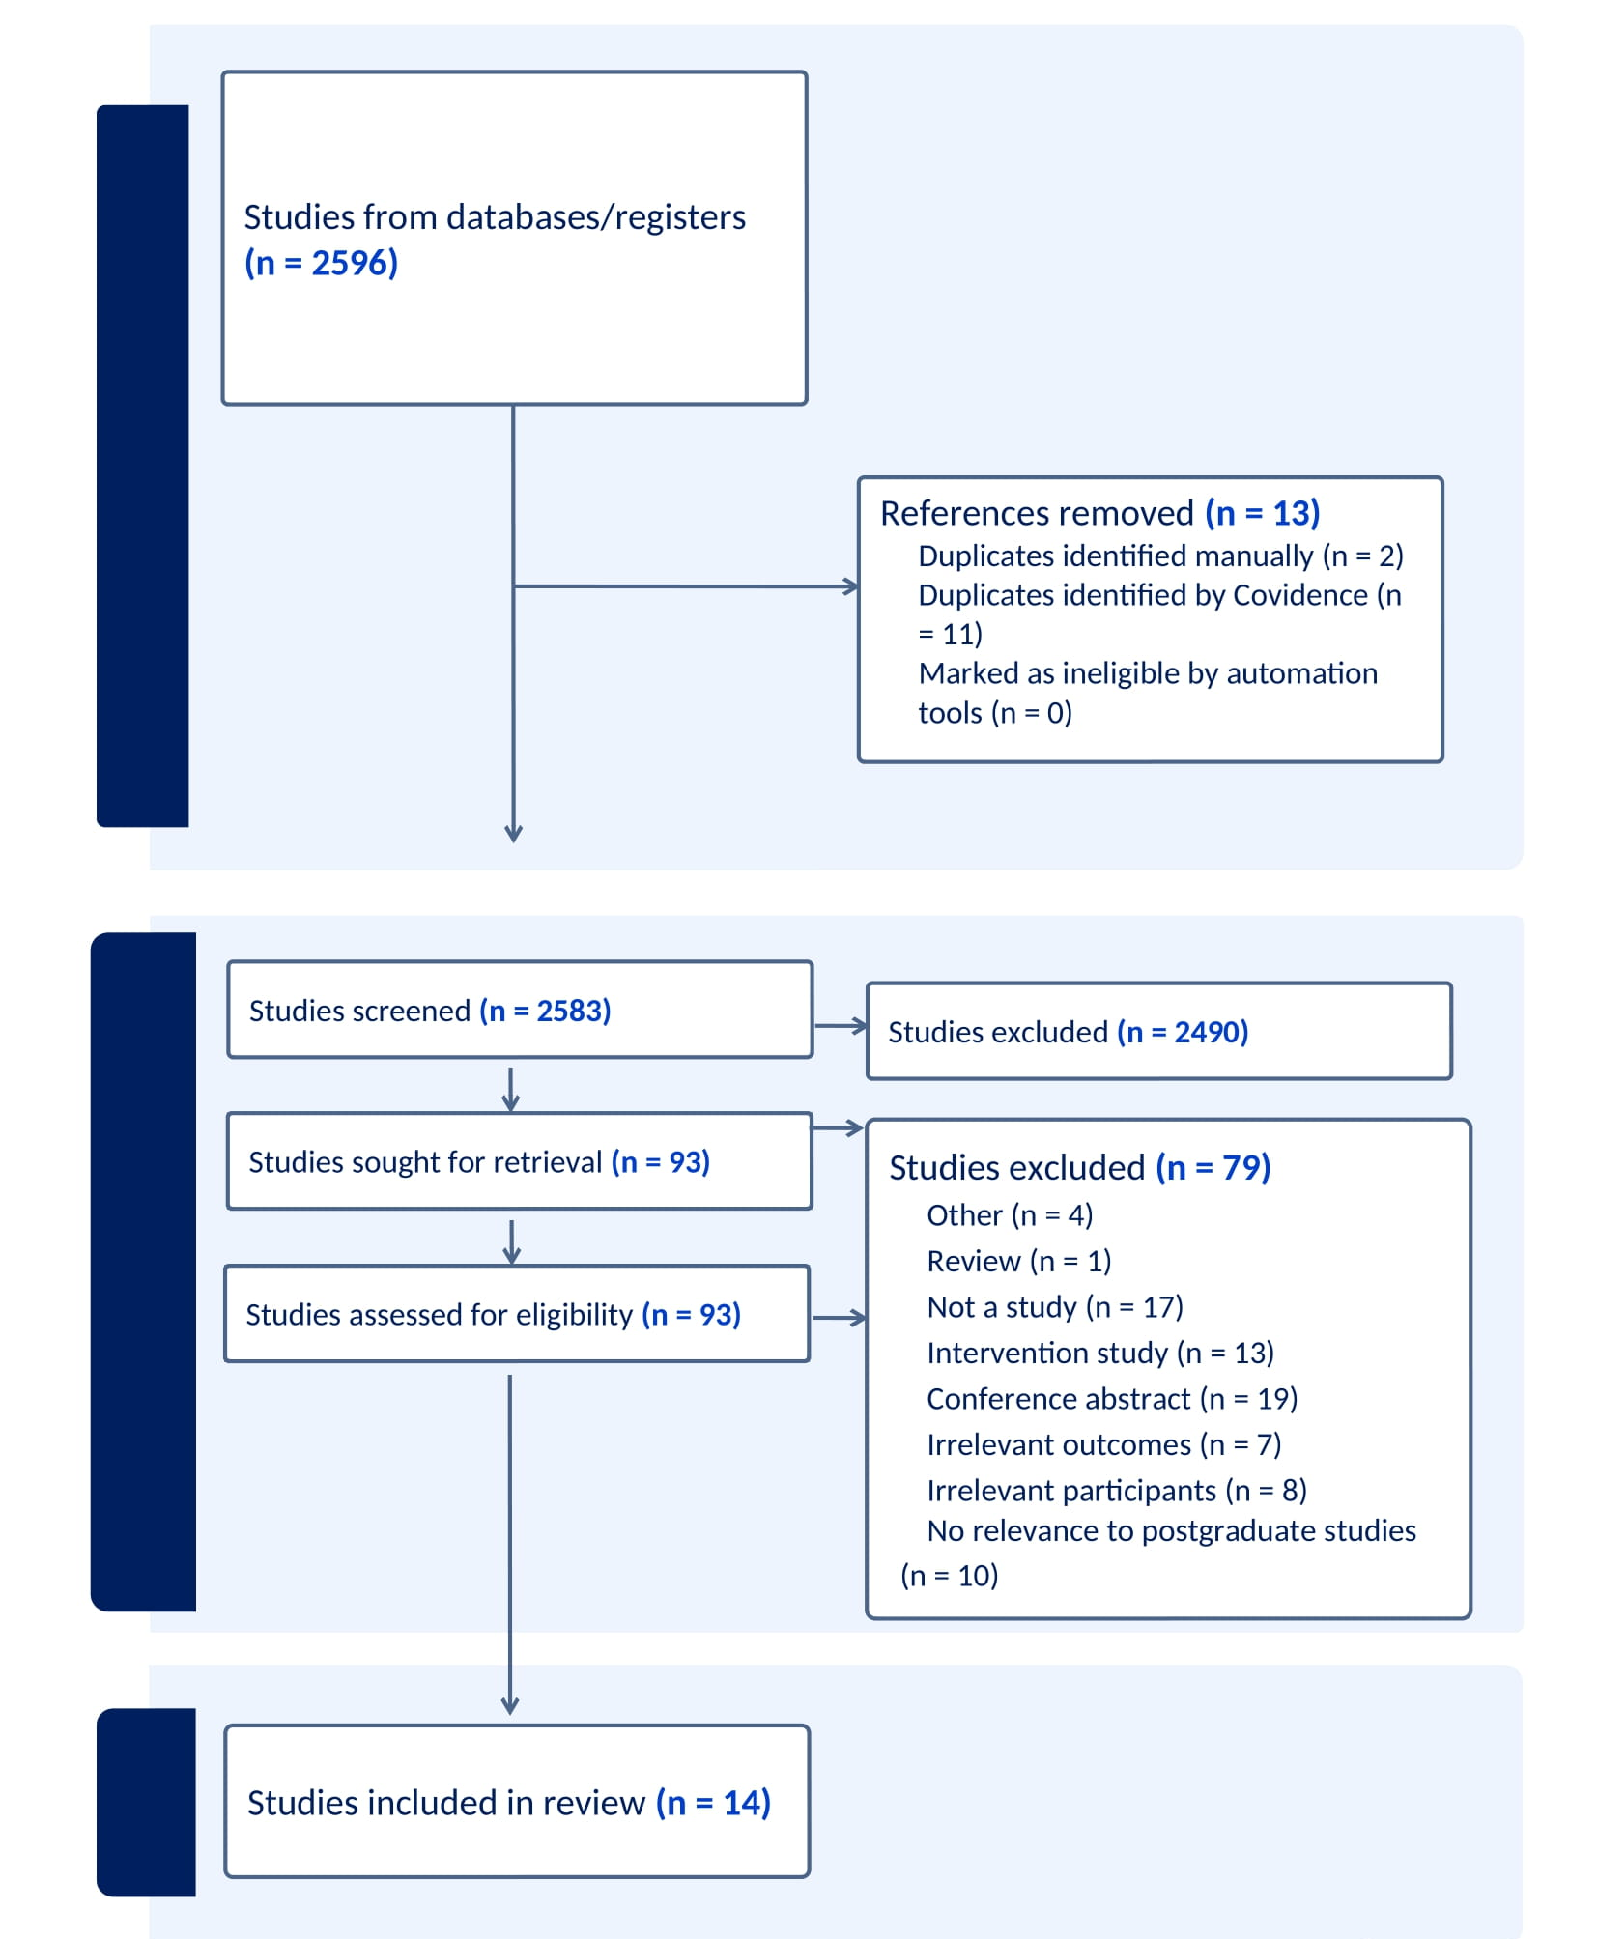
Figure 1: Literature Review PRISMA Diagram

Documentary analysis
A total of 18 documents were reviewed including nine veterinary postgraduate programmes and nine medical postgraduate and general practice programme documents (see appendix 3). Out of the nine medical postgraduate and general practice programme documents, four originated outside of the UK. These international documents discussed areas such as learning in clinical practice and developing research skills in more detail than documents originating from UK-based programmes. However, areas such as programme satisfaction, accessibility and completion and attrition rates were not detailed in any of the programme documents identified.
The veterinary programme documents provided important information around programme structure. In contrast, learning outcomes and approaches, assessment and programme outcomes were described in less detail. The RCVS Advanced Practitioner requirements were brief when compared to stipulations mandated by medical organisations such as the RCGP and HEE for postgraduate medical and GP programmes. Additionally, some veterinary postgraduate documents were written in an informal style, which enhanced difficulty in analysing information.
The development of a veterinary specialist general practice pathway could thus, perhaps learn from medical postgraduate and GP programmes. This would support them in providing detailed information for assessment, both formative and summative. GP programmes discuss the process of PDPs and progress reviews in specific detail, and new veterinary programmes should consider the use of PDPs and progress reviews in a similar process to GP programmes. Similarly, there is a need to model development of communication skills from GP programmes.

Implications
We identified a range of implications for educators relating to teaching and learning methods, assessment, programme outcomes and requirements. To synthesize the data we produced Figure 2, 3 and 4 to provide meaningful learning across key domains.

Teaching and Learning Methods
Information was provided for learner support, prolonged exposure, personalised flexible learning, formal training, peer relationships and inclusive learning environments. Learning approaches which were praised by participants across studies included IPL, case-based learning and role playing. In the documentary analysis, both Veterinary postgraduate and Medical GP programmes apply various teaching and learning approaches. Most veterinary general practice programmes list the teaching methods they use, such as lectures, demonstrations, videos, practical work, discussions, field visits, directed reading, clinical caseloads, case-based learning and clinical skills sessions. However, Medical GP programmes provide specific guidance on how learning occurs, such as where placements happen and the supervisory process due to a focus of a programme of education rather than taught material. Placements for medical GPs take place in both primary and secondary care settings. GP training also emphasises importance to the role of supervisors. Medical GP programmes provide depth on programme structure, including around specialist rotations. The Malta Specialist Training in Family Medicine programme references six educational strategies around curriculum approaches.
Figure 2. Learning and Teaching

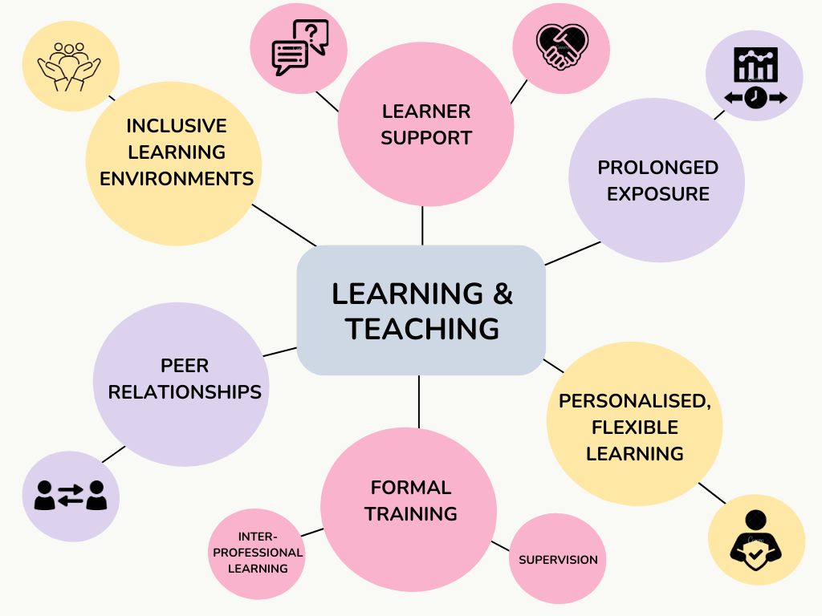

Assessment
Assessment information was captured across multi-source feedback approaches, OBEs, mini-clinical evaluations, direct observation of practical skills, and formative assessment. Assessment strategy is most comprehensively provided by the University of Surrey Veterinary general practice PGCert. It details how the summative assessment methods include single best answer examinations; short answer question examinations and OSCEs. There are major areas covered by medical GP programmes which include personal development plans (PDPs) and progress reviews. GP programmes offer the comprehensive Membership of the Royal College of General Practitioners (MRCGP) assessment system, which is the licensing examination for entering General Practice.

Figure 3. Assessment

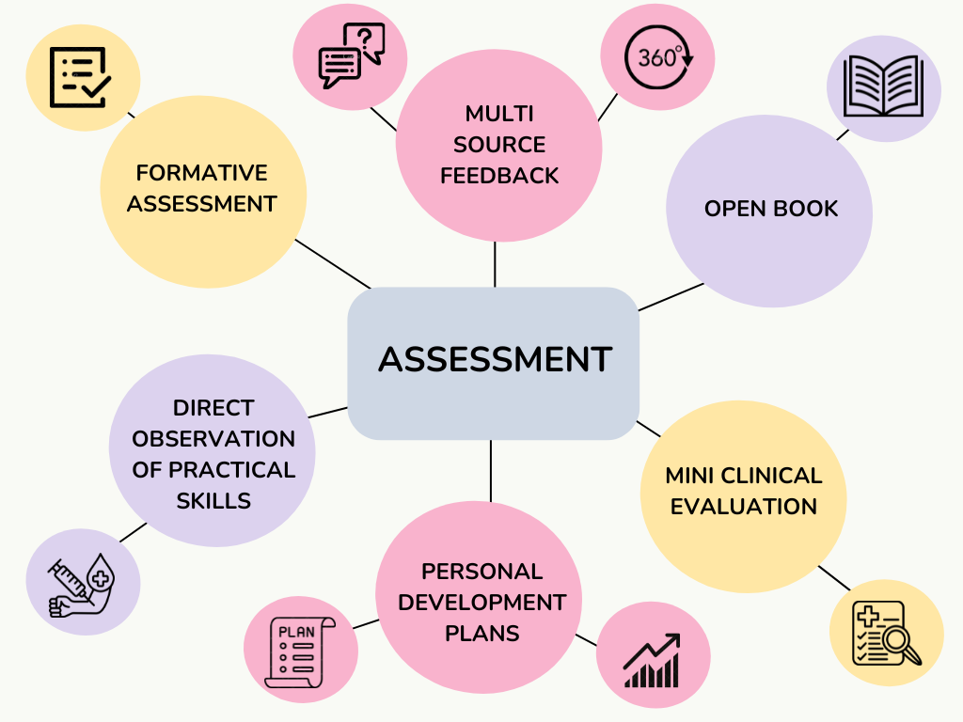

Programme Outcomes, careers and professional development
We identified a range of implications for professional networking, personal growth, inter-professional experiential learning, and knowledge and skill acquisition. There was a lack of data relating to student satisfaction. Some studies reported data related to career and professional development discussing participant perspectives in depth. Ganapati et al (2021) identified gaps and areas where career development can be improved.
Veterinary programmes provide important insights around career development. The UCLAN PGCert in Veterinary Primary Care has designed the programme to support key, transferable skills to aid student progress in veterinary clinical practice or other areas of the veterinary industry. However, details around programme satisfaction and improving quality of care are lacking in veterinary PG programme documents. Both veterinary postgraduate and Medical GP programmes are comprehensive in presenting aims and learning outcomes. Pertinent information is presented in various documents around clinical reasoning, critical thinking, and ethics and professionalism. Medical GP programme documents provide more comprehensive guidance on communication skills. There is a brief overview in some veterinary postgraduate curriculum documents regarding development of research skills.

Figure 4. Career and professional development

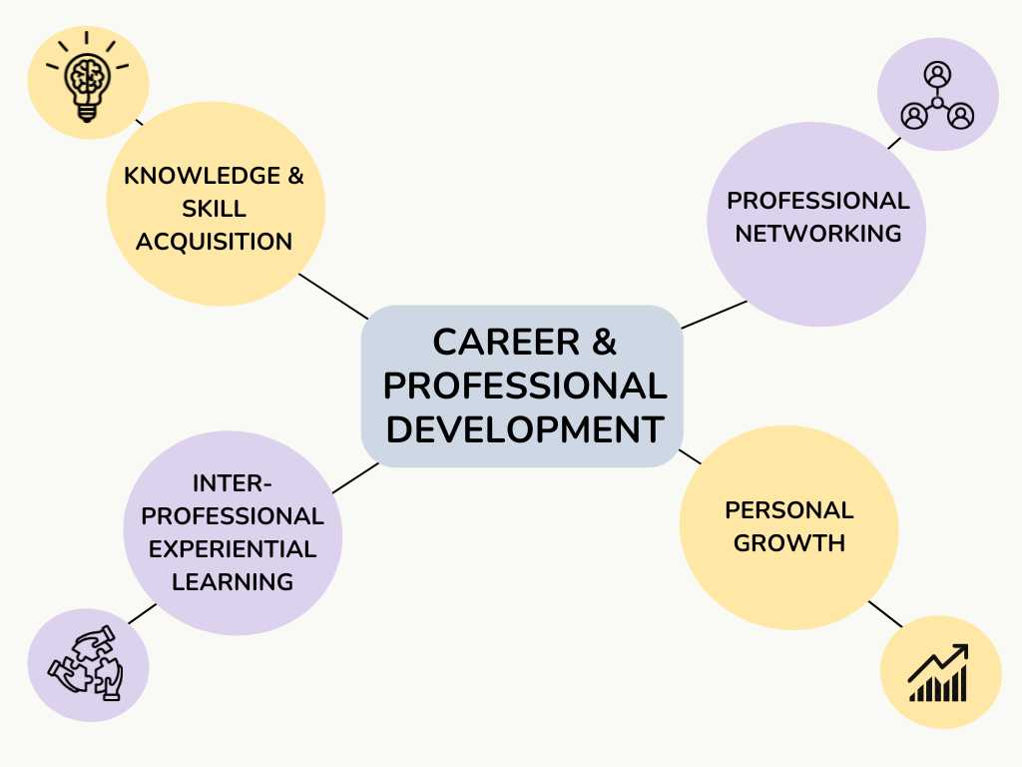

Actions required and gaps in knowledge
Informed by the details uncovered in the review, we propose actions that can be taken in relation to organisational delivery requirements, programme structure, programme learning outcomes, teaching and learning methods, and assessment (Table 2). There is the need to clearly map out programme requirements such as those by Medical GP programme requirements stipulated by the RCGP, mandating GPs to gain skills in the assessment and management of general UK population. Medical GP programmes provide depth on programme structure, including around specialist rotations. However, in human medicine specialty training is mandatory for doctors – we are not suggesting it should be the same for veterinary sciences, but an option for career development for those wishing a more structured approach to gaining experience and advanced knowledge.
In order to provide the information needed in order to proceed with developing a plan to offer high quality training for veterinary general practitioners, further research is required to canvas programme director and expert insight. The findings from this project are based on secondary sources therefore there is the need to collect primary data in order to further develop and test the resonance of the findings. There are key differences that need exploring further between medicine and the veterinary profession, particularly in relation to the educational bodies which support postgraduate education and the balance between patient safety and educational development. Although we initially searched for relevant specialty level evidence across vocational professions, we did not find sufficient evidence in many areas such as programme flexibility, student satisfaction and training models.
Table 2. Practical considerations
Domain | Actions required to develop postgraduate veterinary general practice
Board and Organisational Requirements | - Develop and map RCVS general practice specialty requirements to programme aims and objectives  - Identify how programmes will develop skills required at specialty level
Programme Structure | - Define how support will be available to students on the programme and  - Provide students with options to seek support in the way best suited to their individual needs.
Programme Learning Outcomes | - Align learning outcomes relevant to communication skills required  - Outline how students will develop communication skills on the programme.
Teaching and Learning Methods | - Map teaching approaches to six educational strategies developed by the Malta Specialist Training in Family Medicine  - Consider how relevant teaching methods are from medical professional training is for veterinary general practice  - Conduct research on the use and effectiveness of teaching approaches such as IPL and role-play  - Define the role of the supervisor in clinical practice and how they can facilitate the development of the student in developing competencies
Assessment | - Consider the use of PDPs and define progress points throughout the programme  - Develop formative assessments  - Conduct research on preferences of students around optimal ways of receiving feedback  - Explore the relevance and feasibility of adapting the MRCGP assessment system  - Investigate the use of assessment processes such as OBEs and whether the could they could be associated with higher standards of clinical practice
Programme Outcomes | - Conduct research on student satisfaction, completion and attrition rates pertaining to specialty training

Strengths and limitations
The study explores the development of postgraduate veterinary general practice training which is lacking in the literature. We used rigorous and transparent methods in order to search, review and appraise documents mapped to the CARDA framework (Cleland et al, 2023). The literature review only included 14 papers which is a relatively low number for a rapid review. This is partially due to the ways in which curriculum outcomes are inherently difficult to directly link to specialty training pathways and insufficient reporting within papers. There was a lack of studies identified from veterinary specialty training programmes in European colleges or American colleges. We also excluded intervention studies that may have only addressed partial elements of postgraduate specialty training (i.e. mentoring). For the rapid review, only a portion of papers were double-screened at title abstract screening stage, and all papers were screened by one reviewer at full text screening. Moreover, due to time restraints the rapid review did not report a detailed quality appraisal. The documentary analysis was limited to in-depth review of those deemed more pertinent to the research objectives. Given the scope of the project and time constraints, the document review could only primarily focus on veterinary and medical postgraduate programmes, with brief overviews from relevant law and engineering programmes included. Additionally, non-English documents could also have been included in the review.

Conclusion
To our knowledge, this is the first study to review what is known in relation to veterinary general practice specialty level training. In the development of such initiatives there is a need to develop and map programme aims and objectives to those such as professional requirements. There is a need to clearly define how support will be available to students, provide students with options to seek support in the way best suited to their individual needs, and clearly define learning outcomes. Veterinary general practice specialty training should also define the role of the supervisor in clinical practice. Further research such as a modified Delphi could be used to approach experts which could provide a larger breadth and range of information on specialty training provision including areas such as programme satisfaction and completion rates. The implications of the work may help to develop veterinary general practice specialty training curricula to help facilitate career progression and retention.

Ethics approval
The study was based on publicly available documents so was not subject to ethical considerations

Data availability statement: The data that support the findings of this study are available from the corresponding author upon reasonable request.

References

E.A. Alrehaili and H. Al Osman, “A virtual reality role-playing serious game for experiential learning,” Interactive Learning Environments 30, no. 5 (2022): 922-935.
R. Armstrong, B.J. Hall, J. Doyle, and E. Waters, “Scoping the scope’ of a cochrane review,” J Public Health 33, no. 1, (2011): 147–50.
J. Cleland, A. MacLeod and R.H. Ellaway, “CARDA: Guiding document analyses in health professions education research,” Medical Education 57, no. 5 (2023): 406-417.
Critical Skills Appraisal Programme (CASP) Qualitative checklist. Accessed from: https://casp-uk.net/casp-tools-checklists/qualitative-studies-checklist/ on 15.03.25
C.C Cordes, M.P. Martin, C.R. Macchi, A. Lindsey, K. Hamm, J. Kaplan, and D. Moreland, “Expanding interprofessional teams: Training future health care professionals in screening, brief intervention, and referral to treatment (SBIRT),” Families, Systems, & Health 40, no. 4 (2022): 559.
V.H. Dale, B. Wieland, B. Pirkelbauer, and A. Nevel, “Value and benefits of open-book examinations as assessment for deep learning in a post-graduate animal health course. Journal of Veterinary Medical Education 36, no. 4 (2009): 403-410.
Dental Health Education England NHS Website. Accessed from: https://dental.hee.nhs.uk/dental-trainee-recruitment/dental-foundation-training/dental-foundation-training-schemes on 15.10.25
J.H. Foreman, D.E. Morin, T.K. Graves, M.A. Mitchell, F.A. Zuckermann, and H.E. Whiteley, “Veterinary curriculum transformation at the University of Illinois, 2006–2016.” Journal of veterinary medical education 44, no. 3 (2017): 471-479.
S. Ganapati, and T.S. Ritchie, “Professional development and career-preparedness experiences of STEM Ph.D. students: Gaps and avenues for improvement.” Plos one 16, no. 12 (2021): e0260328.
J. Gibson, K. White, L. Mossop, C. Oxtoby, and M. Brennan. “We're gonna end up scared to do anything’: a qualitative exploration of how client complaints are experienced by UK veterinary practitioners.” Veterinary Record 191, no. 4 (2022):e1737.
General Medical Ccouncil Standards for Medical Education and Training. Accessed from: https://www.gmc-uk.org/education/standards-guidance-and-curricula/standards-and-outcomes/promoting-excellence on 14.10.25.
General Medical Council. National Training Survey 2024 Results. Accessed from https://www.gmc-uk.org/-/media/documents/national-training-survey-summary-report-2024_pdf-107834344.pdf on 14.10.25.
S.Y. Guraya, and H. Barr, 2018. “The effectiveness of interprofessional education in healthcare: A systematic review and meta-analysis.” The Kaohsiung journal of medical sciences 34 no. 3 (2018): 160-165.
J.R. Hagen, R. Weller, T.S. Mair, and T. Kinnison. “Investigation of factors affecting recruitment and retention in the UK veterinary profession.” Veterinary Record 187, no. 9 (2020):354.
S. Khangura, K. Konnyu, R. Cushman, J. Grimshaw, and D. Moher. "Evidence summaries: the evolution of a rapid review approach." Systematic reviews 1, no. 1 (2012): 10.
B. Kirkup. "The impact of the Kirkup report." Midwives 18, no. 2 (2015): 51.
B. Kirkup. "Reading the signals: maternity and neonatal services in East Kent–the report of the independent investigation." Department of Health and Social Care. London: House of Commons (2022).
Federation of Veterinarians of Europe (FVE), 2024. Shortage of Veterinarians in Rural and Remote Areas—Summary Report. https://fve.org/cms/wp-content/uploads/ap15_VetVision_Shortage_Vets_FYI.pdf. Accessed on 03.03.25
J.L. Mackelprang, J. Karle, K.M. Reihl, and R.E. Cash, “Suicide intervention skills: Graduate training and exposure to suicide among psychology trainees.” Training and Education in Professional Psychology 8, no. 2 (2014): 136.
B. Millar, and F. Hussain, "Assessment of an online open‐book examination in postgraduate dentistry." European Journal of Dental Education 28, no. 2 (2024): 447-451.
NHS England (2025). Workforce, training, and education. https://medical.hee.nhs.uk/medical-training-recruitment/medical-specialty-training/general-practice-gp/how-to-apply-for-gp-specialty-training. Accessed on 23.09.25
R. A. Neimeyer, and A.M. Pfeiffer, "Evaluation of suicide intervention effectiveness." Death studies 18, no. 2 (1994): 131-166.
M. Nguyen, P. Chhun, C. McCauley, M. Grant-Beuttler, and N. Jonathan, "Alumni perspectives on interprofessional experiential learning and interprofessional collaborative practice in health care settings." Families, Systems, & Health 40, no. 4 (2022): 578.
NHS Digital: Education and Training Standards and self-assessment. 2016. Accessed from: https://digital.nhs.uk/services/training-quality-improvement/education-and-training-standards-and-benchmarking. Accessed on 23.09.25
D. Ockenden. "Emerging findings and recommendations from the independent review of maternity services at the Shrewsbury and Telford Hospital NHS Trust." London: TSO (2020).
D. Ockenden. "Ockenden report—final: findings, conclusions and essential actions from the independent review of maternity services at The Shrewsbury and Telford Hospital NHS trust." Open Government Licence 3 (2022).
D. A. Reed, D. A. Cook, T. J. Beckman, R. B. Levine, D. E. Kern, and S. M. Wright, "Association between funding and quality of published medical education research." JAMA 298, no. 9 (2007): 1002-1009.
S.J. Regas, K. M. Kostick, J. W. Bakaly, and R. L. Doonan. "Including the self-of-the-therapist in clinical training." Couple and Family Psychology: Research and Practice 6, no. 1 (2017): 18.
A.R. Zambudio, F. S. Gascón, L. G. Moro, and M. G. Fernández. "Research training during medical residency (MIR). Satisfaction questionnaire." Rev Esp Enferm Dig 96, no. 10 (2004): 695-704.
RCVS, 2023. RCVS Council approves comprehensive new project to enhance veterinary clinical career pathways. https://www.rcvs.org.uk/news-and-views/news/rcvs-council-approves-comprehensive-new-project-to-enhance/. Accessed on 23.09.25
Safe Learning Environment Charter. NHS England. https://www.england.nhs.uk/mat-transformation/safe-learning-environment-charter/#:~:text=The%20Safe%20Learning%20Environment%20Charter,equality%2C%20diversity%2C%20and%20inclusion. Accessed on 23.09.25
A.M. Sherrill, M.S. Burton, L.C. Zwiebach, E.E. Fenlon, S.A.M. Rauch, and B.O. Rothbaum. "Creating a national network of community-based consultants in prolonged exposure for PTSD: Outcomes and lessons learned from a consultant training program." Psychological trauma: theory, research, practice, and policy 13, no. 8 (2021): 911.
P. Simoens, A. de Kruif, and W. Swannet. "The new veterinary curriculum at Ghent University." Journal of Veterinary Medical Education 31, no. 3 (2004): 234-238.
R.J. Sternberg, R. K. Wagner, and L. F. Zhang. "Thinking styles inventory: revised II (TSI-R2)." Tufts University (2007).
M. Tunbridge, D. Dickinson, and P. Swan. "Outcomes of assessments of registrars in the medical specialties." Clinical medicine 4, no. 1 (2004): 66-68.
R. Vize, Richard. "Ockenden report exposes failures in leadership, teamwork, and listening to patients." BMJ 376 (2022).
T. Wharton, A.Shah, F.R. Scogin, and R. S. Allen. "Evidence to support the Pike’s peak model: The UA geropsychology education program." Training and Education in Professional Psychology 7, no. 2 (2013): 139.
J.R. Wilkinson, J.G.M. Crossley, A. Wragg, P. Mills, G. Cowan, and W. Wade. "Implementing workplace‐based assessment across the medical specialties in the United Kingdom." Medical Education 42, no. 4 (2008): 364-373.
G.R. Williamson, C. Webb, N. Abelson‐Mitchell, and S. Cooper. "Change on the horizon: issues and concerns of neophyte advanced healthcare practitioners." Journal of Clinical Nursing 15, no. 9 (2006): 1091-1098.
L.F. Zhang, H. Horta, J. Jung, G.Chen, and G.A. Postiglione, "The role of thinking styles in program satisfaction and perceived intellectual competence among STEM doctoral students." Journal of Educational Psychology 111, no. 4 (2019): 573.

