Learning through play? What board games reveal and conceal about climate change.
Lynda Dunlopª, Emerson Joucoski^{b} and Prasad Sandbhor^{c}

ªDepartment of Education, University of York, Heslington, York YO10 5DD; lynda.dunlop@york.ac.uk https://orcid.org/0000-0002-0936-8149

^{b}Department of Science Education, Federal University of Paraná, Brazil; joucoski@ufpr.br https://orcid.org/0000-0002-7339-9476

^{c}Department of Computer Science, University of York, Heslington, York YO10 5DD; prasad.sandbhor@york.ac.uk https://orcid.org/0000-0002-7781-1704

Abstract
Board games bring pleasure through collaboration, simulated action, fun and challenge and are receiving increased attention for their role in climate change education and awareness raising. This article reports on a critical discourse analysis of commercially available board games: Carbon City Zero, Catan: New Energies, Daybreak, Kyoto and Tipping Point. We find that ahistorical, collaborative ‘problem solving’ discourses are present in climate change board games, with mitigation and adaptation possibilities often enabled or constrained by economic considerations. There is relatively little attention to representing inequalities or tackling the colonial and capitalist roots of the crisis. Tensions exist between reflecting realities and possibilities, and between representing the seriousness and absurdity of climate (in)action. The more radical reimagining of society that is possible through Daybreak suggests the value of future work to identify what sorts of societal projects and climate actions players value and how they perceive differences between the game world and real world. There is room for more playful imaginings of climate change and climate action in board games, and for the use of devices that make transparent the role of corporate actors and the tactics used to promote narratives of deny, delay and doom which obstruct climate action.

Acknowledgments
Thank you to the friends and family who played climate games with us: Sahana Arun Kumar, Maria Turkenburg-van Diepen, Tom de Simone, Sophia Cheng and Alex Dunlop Gibson. We are grateful for the support of Environmental Sustainability at York and the York Environmental Sustainability Institute for the Play for the Planet network.

Introduction
The board games industry is booming (Wachs & Vedrez, 2021), as are board game events, clubs and meet ups. About one-fifth of the global population reports playing board games or cards as a hobby (YouGov, 2023). Despite the growing interest in climate change games, little scholarly attention has been devoted to commercial board games, and it remains largely unknown how these games address or represent climate change. The first climate change board game available from a commercial publisher, KEEP COOL, was designed by scientists and available in English and German from 2004. Alongside providing a positive game experience regardless of interest in the topic, it was intended to serve as a tool to enhance awareness and understanding of climate change (Eisenack, 2012). Although the game was evaluated with students rather than the broader population, Meya and Eisenack (2018) found that game play changed beliefs towards greater optimism about international cooperation, more confidence in the potential of climate politics and greater personal responsibility. This demonstrates the potential for commercial climate change games for climate change communication.

People play board games for different reasons: to be together, to share values and life experiences, to get to know each other, to experience emotions, to get closer, relieve family tensions, and to enhance communication between generations (Cès et al., 2024). Board games can create space for discussions about controversial issues as they create a temporary shared symbolic space in which people can experiment and interact playfully (Mertens et al., 2022). These facilities of games may explain the increasing attention to climate change in commercial board games. Games can be conceived of as models, mesocosms, simulations or environmental texts that reflect the world (van Schaik, 2023; Makai, 2024), and there is growing attention in research to climate change games for different purposes: to educate or communicate on climate change, to simulate reality, to collect data and to promote action (Gerber et al., 2021). However, games created for non-educational purposes such as pleasure tend not to be subjects of research (Galeote & Hamari, 2021). This study aimed to investigate the ways in which games represent and communicate climate change by critically analysing discourses present in commercially available climate change board games.

Climate change games
Several recent reviews and perspectives have focused on climate change games for education and communication. Games featuring climate change have been developed by businesses and consultancies, non-governmental organisations, government authorities and by academics, and formats include role-playing games, online games, video games, board games, simulations and card games (Reckien & Eisenack, 2013). The majority of climate change games are designed for learning, with other purposes including entertainment, awareness raising, impact, data collection and advertising (Gerber et al., 2021). An example of gamification is the use of serious games for purposes such as learning, reflection, civic engagement, behaviour change and leadership preparation, for example in the context of adaptation to climate change (Flood et al., 2018). Other reviews have focused on the outcomes or impacts of climate change games such as attitude or behaviour change, finding that gamification can promote pro-environmental behaviour and that board games are particularly effective at visualising the effects of climate change (Douglas and Brauer, 2021). A review of serious games (Ahmadov et al., 2024) reveals that board games are a popular type of game for environmental education, particularly for teaching complex systems as they are visual and interactive and allow for deep cognitive processing. In this study, we focus not on educational or serious games, but rather those played for pleasure.

Playing for pleasure
Board games are accessible and tactile (Fjællingsdal & Klöckner, 2020) and can break the ice between players and reduce resistance to novel ideas (Eisenack, 2012). Board games encompass a range of challenges: cognitive challenges, such as logical reasoning, problem-solving, and strategizing; social and collaborative challenges, including negotiation, persuasion, and teamwork; and progressive challenges that sustain motivation by offering multiple levels of difficulty. In addition, they incorporate engagement mechanisms designed to balance players’ skills with the complexity of the tasks, thereby maintaining sustained interest. Their pleasurable nature encourages repeated play and therefore repeated exposure to game content, with social interaction allowing for competition, collaboration and cooperation a key reason why people like to play them (Fjællingsdal & Klöckner, 2020). Fernández Galeote et al. (2021) analyse how games can engage the public with climate change, finding that narrative is a key attribute in games for entertainment. Climate change may not appear to be an obvious theme for a board game, as its severe and unsettling consequences for humanity stand in stark contrast to an activity typically associated with leisure, lightness, and enjoyment. Kwok (2019) questions whether climate change games can reach audiences beyond those already interested in climate change, but Fjællingsdal and Klöckner (2020) recruited playtesters through Facebook group invitations to board game nights during which players could choose which environmental themed games (Settlers of Catan: Oil Springs; Evolution: Climate, Global Warming and KEEP COOL) to play. Drawing on an analysis of focus group data, they found that the games simplified environmental issues and immersed players in microworlds where they could experiment with roles, try out different actions and experience alternative future realities, where environmental mechanics were incorporated. Fjællingsdal and Klöckner identified varied learning outcomes of game play and varied depths of engagement with climate change. In this study, we are not concerned with the outcomes of conversations on climate change, but rather the discourses, or storylines, present in board games which stimulate decision making and conversation about climate change in the game.

Climate change conversations
Although there exists widespread concern about climate change (e.g. Badullovich et al., 2025), it is often avoided as a topic of conversation, especially when there are perceived differences in degrees of concern or interest in the topic (Wright & Irwin, 2024). For example, parents and teachers report that although children express interest, they also experience anxiety in talking about climate change (Baker et al., 2020), and people have been found to rein in climate talk to prevent stress and negative emotions with family and friends (Wright & Irwin, 2024). Corner and Groves (2014) argue that climate change communication is inherently political as it concerns the question ‘how should we live?’ and therefore, must engage with questions of ideology and identity that govern the social domain. They call for new social infrastructure that can bridge climate science and public engagement to enable people to express and discuss their “concerns, fears, dreams and hopes for the future” (p. 744). Board games have the potential to enable these conversations, addressing the question of how we should live in a climate changed world, supporting conversations in a playful way that acknowledges feelings, supports emotional wellbeing and promotes hope and action. In their review of literature on environmental games, Douglas and Brauer (2021) argue that games, by providing a simulated environment to learn about the risks of (not) taking certain types of action and incentives to create and maintain new habits, can help create new social norms, develop self efficacy and communicate evidence for climate change, which are some of the strongest predictors of adaptive behaviour. They note that board games may be particularly useful for players to visualise the effect that they have on other players and therefore the environment. Whilst these findings are promising, studies tend not to discuss the specific discourses in relation to climate change present in board games.

Reading games
Games can be examined in terms of how they represent climate change and possible responses to it, as well as the degree to which they question or reinforce the existing social order. These discourses - shared ways of apprehending the world - are embedded in language and are used to construct meanings and relationships, define ‘common sense’ and legitimate knowledge, and coordinate action (Dryzek, 2013, p.9). Different discourses produce different ways of making sense of the causes, consequences, impacts and responses to climate change. In his work on adult popular education, Paulo Freire (1974) contends that individuals ‘read the world’ before they ‘read the word’, and that ‘the more accurately people [sic] grasp true causality, the more critical their understanding of reality will be’. He further emphasizes that critical consciousness is inseparable from lived reality, with the nature of action directly corresponding to the depth and quality of understanding. He contrasts critical consciousness with magic consciousness (which attributes facts to a superior power, and is characterised by fatalism and resigned resistance to change) and naïve consciousness (which sees facts as static and unchanging) describing ‘conscientização’ as the process of becoming aware of the social and political contradictions in the world, and taking action against oppression illuminated by that understanding (Freire, 1999). Through discourse analysis, we aim to identify the narratives present in climate change games in order to identify the role they may play in critical consciousness.

Whilst we have not found analyses of discourses present in board games, there is a growing body of literature drawing on conceptual analyses to understand how climate change is communicated through games. For example, Ouariachi et al. (2018) propose a framework for climate change engagement through serious games, while van Schaik (2023) has analysed how ‘uncertainty’ is represented in a range of free or inexpensive games across different formats (serious, commercial, digital, and board). Van Shaik identifies various ways in which uncertainty is represented and addressed, particularly regarding potential actions to tackle climate change, its consequences, and the different perspectives surrounding it. These uncertainties represent spaces for exploration and imagination where there might or might not be the possibility of resolution of uncertainty in the game or beyond. More recently, reporting on an online game challenging the role of corporate interests in the climate crisis, Dunlop et al. (2025) found that players engaged with climate change when it was integrated into the game story, was presented in decision-making moments, and when interaction prompted discussion.

Examining videogames, Abraham and Jayemanne (2017) identify four modes of representation of how humans relate to the rest of nature: the environment as backdrop, functioning as a static frame for action; the environment as resource, positioned as something to be exploited or extracted for collection, creation, or development; the environment as antagonist, operating as an obstacle that resists the player; and the environment as text, conveying meaning or narrative through processes of construction, deconstruction, deformation, or creation. Similarly, in the context of an ecolinguistic analysis of the digital simulation game Animal Crossing: New Leaf, Poole and Spangler (2020) found that the identities and human-rest of nature relationships at the root of the ecological crisis are reflected, reproduced and normalised through game features. Abraham and Jayemanne (2017) argue that climate change can be more effectively examined when it is conceptualised as the reciprocal participation and entanglement of humans in the process of environment-making, i.e. when games engage with the roots of the climate crisis and seek to reconfigure ‘Western’ conceptualisations of the human–nature relationship.

In political theory, Dryzek (2013) outlines a range of environmental discourses, taking industrial society as the point of departure. Drawing on the analogy of chess, he distinguishes between prosaic departures from industrialism — those that accept existing political-economic conditions and propose solutions that do not envision a fundamentally new society — and imaginative departures, which seek to redefine the very structure of the chessboard. Dryzek describes the scale of change as small (reformist) or large (radical) (Table 1). As Barry (2007) notes however, there are significant absences including ecofeminist, eco-Marxism, and global justice environmental discourses from Dryzek’s analysis. Furthermore, taking industrialisation as the departure point for environmental discourses reflects an ahistorical approach. As Ghosh (2021) argues, colonialism and structured violence were the foundations upon which industrialism was built, with fossil fuels reinforcing these power structures, particularly through the petrodollar. To tackle the climate crisis, he argues that we must tackle colonial exploitation rather than focus narrowly on carbon emissions which omit both military and historical emissions.
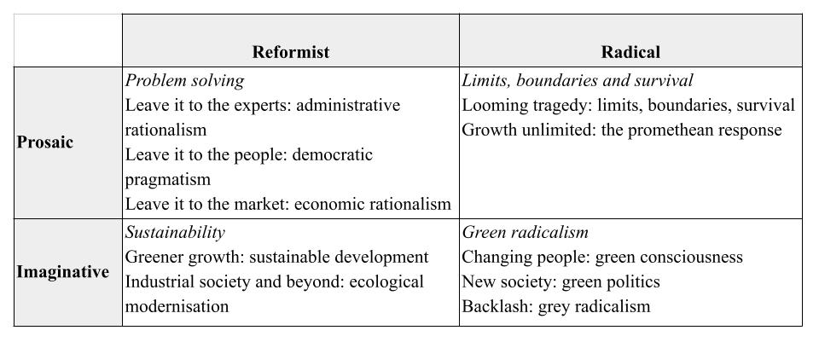
Table 1: Classifying environmental discourses from Dryzek (2013, p.14).

The research question guiding this study is: what discourses about climate change are present in commercially available board games, and how are they produced?

Methodology

Research design: critical discourse analysis
Discourses provide a shared way of reading the world that can be used to promote particular ways of being and resist others. This study aims to generate insights into how discourses reflected in, and produced by, climate change board games reproduce or resist social and political inequalities. The methods are therefore rooted in critical discourse analysis. Critical discourse analysis can identify how players are persuaded of particular positions linked to ideologies and systems of reference (Wood, 2019). It focuses on how power and ideology are enacted and reflected through texts (Fairclough, 2001) and how these co-evolve and co-produce each other. The analysis addresses three key questions: What are the principal features of the text, including genre, vocabulary, and textual structures? What meanings are constructed, and how do these relate to the production and consumption of the text, that is, its purpose? How do socio-cultural, economic, political, and environmental contexts shape the interpretation of the text? Discourses are underpinned by assumptions, judgments, and contentions that frame the terms of analysis and influence how environmental issues are defined, understood, and addressed (Dryzek, 2013). In common with Cole and Barker (2020) we consider board games as texts, i.e. as cultural artefacts that can be read. Cole and Barker suggest making observations of games and reflecting on what is trying to be achieved, identifying the techniques used in the game, and their purpose, considering what these observations mean for society and whether the assumptions and values are implicit or explicit. Expanding on this in the context of climate change games, we aim to identify the discourses embedded within these games and evaluate the extent to which they might cultivate critical consciousness (Freire, 2013), enabling players to perceive and question underlying social, political, and environmental structures, and thereby fostering pathways for transformative and emancipatory engagement with the world.

Critical discourse analysis has been used in the analysis of video games, for example to explore heteronormativity in World of Warcraft (Pulos, 2013) and representations of religion in Medal of Honor: Warfighter (Trattner, 2017). Poole and Spangler (2019) argue for bringing critical discourse studies, climate change and sustainability together because inequalities and injustices are increasingly the result of ecological transformation. They do so through the focus on language in a videogame, Animal Crossing: New Leaf, finding that the cycle of debt, labour, consumption and recycling are built into the game, running the risk of ‘normali[sing] the ideological frameworks of contemporary society which contribute to our urgent ecological crisis’ (p.355). Poole and Spangler focused specifically on the use of language; in our study we also include game mechanics, aims, winning conditions and illustrations in our analysis. We see games as part of this system of meaning making symbols which can (re)produce or resist ideologies. Below, we describe how we analysed the games.

Sampling: selecting the games
First, we identified commercially available board games which make explicit reference to climate change, available to the general public in the location of the study at the time of the research (2024-2025). The inclusion criteria were: (i) the games were board games, i.e. a tabletop game with pieces such as cards, tokens and boards AND (ii) the games were commercially available (online or in shops) in the jurisdiction of the study AND (iii) the game includes climate change in its marketing material. Exclusion criteria mirrored the inclusion criteria: games were excluded if they were online or video games, not available for purchase in the UK, if they were serious games available only for download and if they did not include climate change explicitly even where themes e.g. nature, economics might be relevant to understanding climate change. We conducted an internet search to identify games.

A total of five board games were identified (Table 2). The complexity of board games depends on factors including number of rules, play duration, amount of luck, technical skill required, number of choices available, and record keeping required. The games were of varying levels of complexity. Board Game Geek, a community created database of board games, rates game complexity from user votes, and all games in this study are rated medium light - medium, except for Carbon City Zero which is not rated. Daybreak was rated most complex out of the games included, and Kyoto least complex. We paid between £9 and £57 for the games.
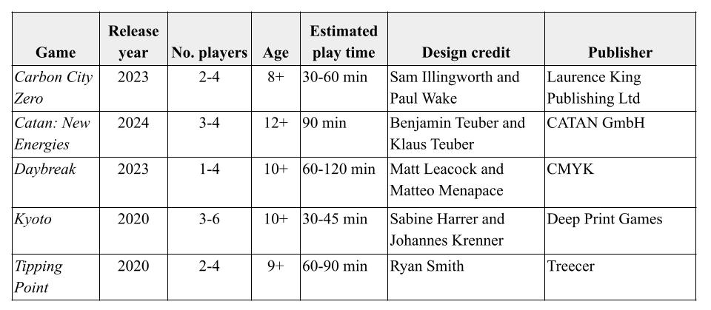
Table 2: Commercially available climate change board games included in the analysis.

Playing the board games to ‘read’ them
A critical discourse analysis typically involves reading texts. However games cannot be understood just by reading the rule books. To gain a deeper sense of the narratives communicated, we also played the games. This was for the purpose of ‘reading’, not collecting data on players’ experiences or perspectives.

Next, we played the games once in a social context with each other, family and friends (4-5 players for each game), allowing 3 hours for play and conversation. Play sessions occurred between August 2024 and July 2025. Author 3 facilitated each game session by preparing in advance. Preparation involved referring to the game components, rulebooks and online 'how to play videos' of each game before each respective play session. After each game session, the authorsdiscussed the underlying assumptions that had come to light through play and our feelings about the game and climate change, and made some notes on each game, identifying contradictions, tensions, and ambiguities. This phase did not involve data collection, but rather was an opportunity for the authors to ‘read’ the game through play.

After playing all the games socially, the authorsmet for a series of three analysis workshops to focus on identifying and describing the discourses present in games based on analysis of the play experience, the rules, and game elements (box, images, words, rule book, the board or play space, characters, playing pieces, mechanics, objectives, mode of play). We discussed each game in turn using questions such as the following to structure discussion between the authors and analyse the discourses present in the games:

- How is climate change represented?
- How are responses to climate change represented?
- What are the win and lose conditions?
- What types of action or conversation does the game generate?
- How does one feel while and after playing the game?

The same questions were used to analyse each game. The questions and our summary answers (following discussion between the authors) were summarised in a matrix (see supplementary material) which we then used to identify discourses present in the games, drawing on Dryzek’s (2013, Table 1) classification of environmental discourses. The answers drew on evidence, e.g. from the rule book, board and pieces, and game play. Disagreements were resolved through discussion, with the final themes agreed by consensus. The games were understood as metaphors for reality, and attention was paid to the entities recognised or constructed in the game, the assumptions about natural relationships and time evident, and agents and motives that make things happen in the game, as understood by how play is organised and the win and lose conditions. Finally, we each identified three distinguishing features of each game that we were left with following the analysis. These were written on post it notes independently, stuck to a whiteboard, and used to characterise the games.

Finally, we identified patterns across the board games, including how language, images, rules and mechanics (re)produce ideologies and incentivise certain types of actions or social practice. We identified values that were present and absent (e.g. individualism, competition, or cooperation), discussed the ways in which the games contribute to normalising or problematising inequities, injustices, different knowledge systems and social orders (including classed, gendered and racialised inequalities), and different perspectives on global geopolitics, such as which countries are represented or given prominence.

Positionality
The first author is a researcher and practitioner of formal and non-formal climate change and environmental sustainability education, the second author is a researcher and teacher educator in science education and outreach, and the third author is an applied game designer, board game enthusiast and climate change games researcher. Originating from colonised nations (Ireland, Brazil and India respectively) and working together in England, we were interested in how temporal, and specifically historical, dimensions of social and political inequality and environmental (in)justice were reflected in climate change board games. We are all motivated - in work and in our private lives - by the consensus that anthropogenic activity has caused widespread changes in the Earth’s climate system leading to negative impacts on people and nature, disproportionately affecting the most vulnerable communities who have contributed least, and that action is therefore urgent across all sectors of society (IPCC, 2023). Findings should be interpreted in light of how our positionality might have drawn our attention to different aspects of the games.

Findings
We identified four key discourses evident in climate change board games: climate change is a problem to be solved, caused by carbon dioxide emissions; ‘it’s (almost) all about the money’, reflecting the centrality of economic considerations in games; ‘all animals are equal but some are more equal than others’, highlighting inequities hidden against a facade of apparent equality as in Animal Farm (Orwell, 2024); and we win and lose together, representing the foregrounding of collaborative game play.

Climate change is a problem to be solved
The discourse of climate change as a problem to be solved dominated the board games examined, perhaps reflecting the extent to which the board game format lends itself to strategic thinking and problem-solving. The problem tended to be framed in terms of the need to reduce greenhouse gas emissions (most commonly, carbon dioxide; there was little reference to other greenhouse gases) to prevent excessive planetary warming. Players assumed the role of a mayor, city, country, or bloc, devising strategies to decarbonise, limit temperature rise, and avert potential disaster. The game features linked to carbon dioxide emissions are presented in Table 3. Reducing emissions is connected to win and lose conditions, but they are not the only element: feeding the population, avoiding communities in crisis and preventing species extinction also play a role in winning and losing.

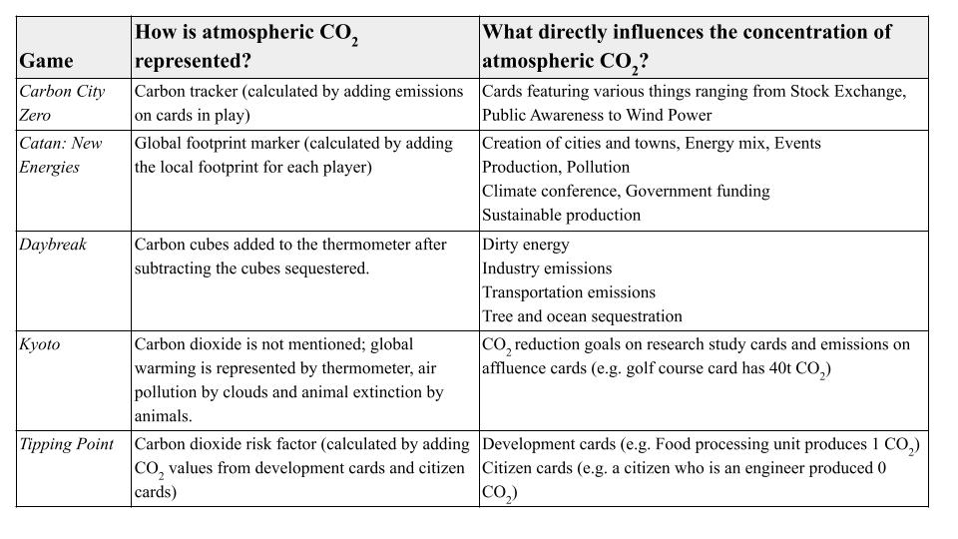Table 3. Game features linked to carbon dioxide emissions.

As Table 3 shows, carbon counting systems were common in these games with net carbon counted in all but Kyoto. Daybreak and Tipping Point included carbon sequestration and carbon capture and storage, with only Daybreak including the role of the oceans and more directly including representation of the cumulative impact of CO₂ emissions in the present, reflecting its persistence in the atmosphere. Only Daybreak recognised different starting points for different groups of countries, in terms of projects, energy mix, resilience and communities in crisis, and as such was more inclusive of the global human population, more focused on what is at stake when we talk about climate change, and clearer about differentiated responsibility for emissions, and vulnerability to climate change.

Increasing concentration of CO₂ in the atmosphere was associated with increased temperature and tended to lead to extreme weather and related events and disasters. The nature of these events varied across games. Impacts were often environmental (e.g. animal extinction, air pollution and global warming in Kyoto; weather-related disasters impacting forests, food supplies, infrastructure and resources in Tipping Point). Daybreak also has social crisis cards including economic recession, healthcare crisis, social unrest and housing market collapse.

All the games analysed featured mitigation and adaptation actions, representing different responses to the problem of climate change. The interventions available were broadly realistic, plausible, and under discussion in climate change and policy forums. Actions were frequently constrained by funds, as we explain below.

Finally, all games, except Kyoto, provide additional material that explains climate change and suggests solutions. Tipping Point has interspersed such information in 'blue boxes', the Catan: New Energies rulebook contains a small essay describing the theme of the game, the Carbon City Zero rulebook presents a glossary of terms used on its cards and Daybreak has an extensive website that explains projects and crises one encounters in the game.

It’s (almost) all about the money
The discourse framing development as inherently desirable and existing economic systems as unquestionable was evident in the majority of games. The ways in which money is represented in the games is presented in Table 4. In some games (Kyoto, Tipping Point) financial accounting is built into the assessment of the system and ‘success’ includes considerations of wealth, and in the latter, determines the action that can be taken. Most games analysed, with the exception of Daybreak, do not seek to redefine the metaphorical chess board: their responses consist of adjustments aimed at managing environmental problems through market mechanisms, regulation, or policy interventions.
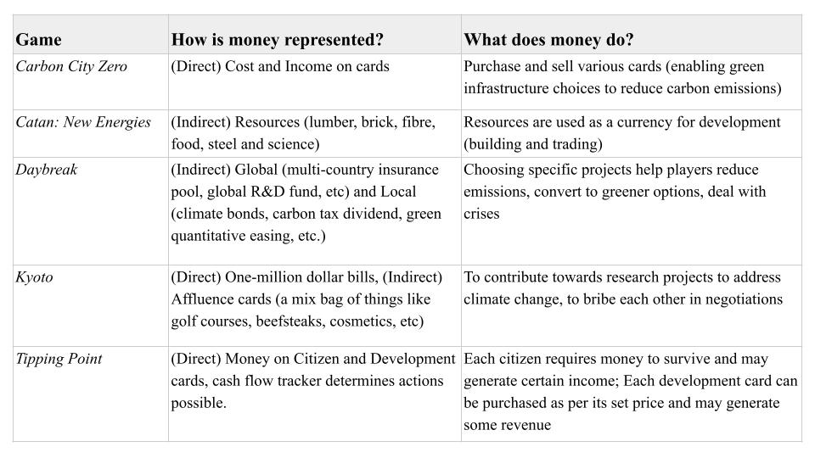
Table 4. Game features linked to money.

Development in the games was experienced through settlement (Catan: New Energies), the selection of development cards (Catan: New Energies, Tipping Point), affluence cards (Kyoto) and market cards (Carbon City Zero). These mechanisms tended to emphasise economic imperatives, resource extraction and use, population growth, energy demands, and food supply requirements, with both grey and green development pathways available within the games. Catan: New Energies can’t escape its colonial origins: a game where settling is assumed and the longest trade route is rewarded. In Carbon City Zero, investment is needed to make the city more sustainable, in Kyoto, countries start with the same amount of money, and must maintain their wealth whilst negotiating with others to fund research studies into climate change, and in Tipping Point, cash flow must be maintained to enable mitigation and adaptation actions.

In contrast, Daybreak does not incorporate money directly into its gameplay. It neither serves as a requirement for action nor features in the win/lose conditions, prioritising instead communities and their resilience and social and political actions. Economic elements are instead embedded within project cards (e.g. development assistance, green quantitative easing, multi-country insurance pool) and crisis cards (e.g. economic recession, housing market collapse). By decoupling climate action from immediate economic concerns, Daybreak encourages imaginative thinking beyond financial constraints, enabling players to envisage alternative political-economic systems. It also communicates the climate system as complex, with feedback loops and tipping points (melting permafrost, desertification, ocean acidification, loss of sea ice, dieback of the Amazon and extreme weather) coming into play through a roll of the die for each temperature band.

Several games explicitly highlight the role of corporate interests. In Carbon City Zero, cards represent greenwashing and fossil fuel lobbying; in Kyoto, lobbying and secret agendas influence players’ negotiation strategies; and in Daybreak, crisis cards depict oil industry pollution, negligence, collusion, and fossil fuel subsidies and lobbying. Identifying these obstacles to climate action is important for fostering critical consciousness, but only in Kyoto are players unavoidably confronted with them; in the other games, their occurrence depends on the choices players make regarding actions or projects.

‘All animals are equal, but some are more equal than others’
This discourse reflects how climate justice is represented in games. Relatively little attention is given to the colonial and capitalist roots of the crisis, limiting players’ engagement with the structural causes of inequality. Responses are framed predominantly from a human-centric perspective, and the global majority – whether by land mass or population – is seldom afforded meaningful participation. From a Freirean perspective, such representations constrain the development of critical consciousness, as players are rarely encouraged to interrogate the social, political, and economic structures that shape environmental outcomes.

First, who is represented in climate change games? In Carbon City Zero, Catan: New Energies and Tipping Point, players assume the roles of decision-makers in abstract settlements, starting from the same position and tasked with development and decarbonisation, with differences based on chance and strategic choices during play. In contrast, Kyoto and Daybreak represent actual countries. In Kyoto, players may take on the roles of the EU, Canada, China, Russia, the USA, or Australia. The absence of the majority world is striking, particularly given the significant role played by small island developing states – through the Alliance of Small Island States – in highlighting vulnerabilities during negotiations of the Kyoto protocol. Only Daybreak explicitly acknowledges historical inequalities, assigning different starting positions to the USA, China, European Union and Global Majority with respect to energy demand, energy mix, emissions, resilience and communities in crisis. This reflects contemporary social and economic disparities resulting from colonial histories, makes the link between historical injustice and amplified present-day climate risk explicit, and creates opportunities to explore justice understood as fairness.

Secondly, who participates in decision-making in these worlds? Players make choices either individually or collaboratively (see ‘we win and lose together’) constrained by their economic position or available resources (Carbon City Zero, Catan: New Energies, Kyoto, Tipping Point). Evidence of democratic processes limiting or shaping actions is limited, although erosion of democracy and eco-fascism are represented as crises in Daybreak and decision-making is more explicitly interdependent, providing greater incentives for democratic engagement during play. Similarly in Kyoto, players must negotiate decision-making collectively. There is also little evidence of societal goals and philosophies, such as those related to spirituality, degrowth or Gross National Happiness. Beyond humans, there was little representation of other animals across the games, with human- rather than eco-centrism playing incentivised; only in Kyoto did non-human animal extinctions feature. Across all games, an instrumental ‘ecosystem services’ framing predominates, valuing ecosystems primarily in terms of their direct or indirect benefits to humans rather than their cultural or intrinsic worth – likely a reflection of the overarching ‘climate change as a problem to be solved’ discourse.

Finally, how are climate change harms distributed in the games? Extreme weather events and disasters feature across the board games, and affect all players (Carbon City Zero, Kyoto), sometimes by chance, sometimes depending on food supply, cash flow and developments (Tipping Point), local footprint (Catan: New Energies) or community resilience (Daybreak). Protection against extreme weather and disaster is conferred by ecological, infrastructural or social resilience (Daybreak). Only in Daybreak do impacts relate directly to communities in crisis, and resilience, reflecting that the most vulnerable communities are the most affected.

In all of the games analysed, players play as a city, country or bloc, but in a way are represented as citizens of nowhere because of the absence of democratic processes in all games except for Daybreak which features social movements and citizens assemblies as projects. Citizens’ roles as workers are represented in Tipping Point, where people have value through their ability to produce food, pay taxes and fulfil specific societal roles. Also absent are homes, relationships, family, friends and different forms of social organisation. From a Freirean perspective, such representations limit opportunities for developing critical consciousness, as players are rarely encouraged to engage with the social, political, and relational dimensions of human life, which are essential for understanding structural inequalities and imagining transformative, emancipatory possibilities.

We win and lose together
Across the five games, both competitive and collaborative modes of play were used.
Table 5 represents the modes of play possible in the games, along with win and lose conditions.
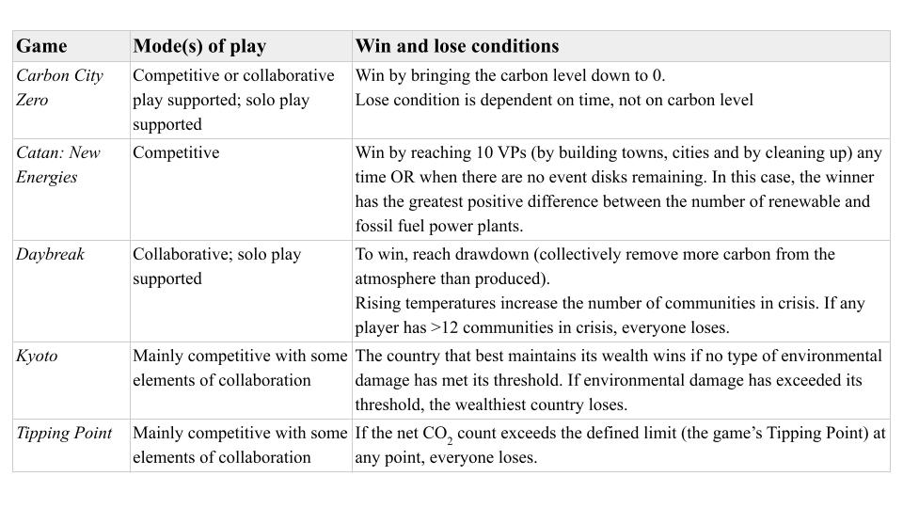Table 5: Modes of play.

In the two collaborative games, players win by collectively reducing the city’s carbon emissions to (net) zero (Carbon City Zero) and meet ‘drawdown’, i.e. when they remove more carbon from the board than they emit while surviving one last round of crisis (Daybreak). Players might lose together if they run out of time (Carbon City Zero, Tipping Point) or if global warming hits the maximum (Daybreak). Additionally, in Daybreak, all players lose if any player has more than 12 communities in crisis.

The competitive win conditions of Tipping Point and Catan: New Energies favour sustainable development. Tipping Point is won by players whose cities are developed and inhabited the most. The first player who collects 10 Victory Points (by building cities, renewable power plans and cleaning up pollution) wins Catan: New Energies. Kyoto, on the other hand, pushes players to gather the most points by meeting their secret agendas (which often lead to environmental damage) and collecting affluence cards and money (which is supposed to contribute towards research studies for the conference to succeed). However, it lets the player with the most points win only if the conference succeeds. This is where, we believe, the game attempts to be ‘satirical’ (as mentioned in the rulebook) as the player who has not contributed to the green agenda might even win the game. Even where not collaborative, games modelled connections between players through trading and trade routes (Catan: New Energies), consensus-seeking negotiation (Kyoto), migration and conflict (Tipping Point) or through the possibility of semi-collaborative team play (Tipping Point). Collaboration is therefore a key feature of climate change board games, reflecting interdependencies in climate in(action).

The interconnectedness of players’ fate is reflected in different ways. Catan: New Energies uses a board with the play space mapped out where players encounter each other. Across the games, environmental degradation (e.g. biodiversity loss, pollution) and weather events are experienced by all players, and a thermometer or carbon counter was a common element that introduced interconnection, if not collaboration. Interconnection tended to be focused on actions to reduce carbon dioxide emissions, but in Tipping Point military actions were also possible, where one player can annex another’s developments.

Discussion
The analysis identified discourses present in commercially available board games, relating to the causes of climate change, hidden inequalities, the role of collaboration, and the dominance of economic considerations in climate action. These discourses are important as they appear in games in non-formal, non-educational (and rarely facilitated) spaces, where people may experience social conversations and learn about climate change. In this section, we discuss what these discourses mean in relation to critical consciousness about climate change, firstly in relation to discourses identified, and secondly in relation to our reflections on game play.

The discourse that climate change is a problem to be solved by tackling carbon dioxide emissions was present, with games creating space to simulate different ways of responding to climate change through mitigation and adaptation actions. This discourse appeared across all games, with economic or resource considerations driving possibilities and determining success in all games with the exception of Daybreak, and an ecosystem services (Millennium Ecosystem Assessment, 2005) framing of nature representing plants and non-human animals in terms of their benefit to people. In common with Abraham and Jayemanne (2017)’s findings for video games, nature was represented as a resource and as an antagonist in the board games, although in a more reciprocal way because the games tended to recognise that humans depend on the environment (and a particular temperature range) for survival and flourishing. This discourse is consistent with Dryzek’s (2013) prosaic and reformist approach which presents mitigation and adaptation responses from within the economic system, indicating the embeddedness of capitalism in decision making. Whilst financial transactions are familiar and allow players to identify and discuss different responses to climate change and associated trade-offs within the current system, the risk of including money as a requirement for action is that capital is prioritised rather than end goals of climate action or flourishing and resilient societies. Pathiranage’s (2024) econometric analysis found that a 1% increase in GDP leads to a 0.42% rise in CO₂ emissions, and Schöngart’s (2025) modelling-based analysis found that high-income groups disproportionately contribute to climate extremes worldwide, indicating the entrenched environmental costs of wealth and economic development. It may be naïve to expect commercial board games to challenge capitalism, and there is a tension between reflecting current realities, past injustices and future possibilities, using reality as a context to explore and play with responses, and challenging that reality and presenting alternative possibilities. Nevertheless if a game intends to tackle climate change, it is essential to problematise the economic systems driving it, to enable players to ‘read the world’ and develop critical consciousness of the social and political contradictions in the world (Freire, 1999). Neglecting to do so can reinforce existing harmful systems and make some climate actions seem less possible, closing out opportunities to imagine more environmentally just responses to climate change. Daybreak achieves this by liberating players from making decisions driven by economic considerations, by including more radical and imaginative projects and crises, and by foregrounding the concept of community resilience. Similarly, Happy Shoppers, a downloadable hacked version of Happy Families (Frank and Alex, n.d.) (not a commercially available board game) demonstrates that it is possible to draw attention to the link between climate change and capitalism, exploitation, extraction, colonialism, and environmental destruction using well known mechanics, reflecting both the seriousness of climate change and absurdity of climate inaction. Relatedly, the absence of historical context in the board games analysed (Daybreak being the only exception, with different starting points for different countries in terms of projects, emissions profiles and community resilience) hides the systemic roots of climate injustices in structures of violence and exploitation associated linked to settler-colonialism and capitalism (Sultana, 2022; Trott, 2023). The intended satire in Kyoto, which draws attention to the role of vested interests in the current system may be too deeply hidden, and there is little space or stimulus within the game to challenge mechanics such as cash flow. Whilst Carbon City Zero, Daybreak and Tipping Point are relatively self-explanatory in relation to climate change through game play, Catan: New Energies and Kyoto might benefit from a debriefing session. Rather than providing explanatory material about climate change which can be difficult to summarise in printed space, future climate change board games might provide a debrief guide including questions and/or prompts to help players reflect upon and discuss climate change in relation to the ideas and mechanisms in the game. There is relevant practice in live action role playing games (‘larps’) which have a tradition of post-game action and debriefing to facilitate reflection and enable players to process their experiences (Johansson et al., 2024). Questions for a debriefing guide might include ‘what does the game suggest about the causes and consequences of climate change, and do you agree?’, ‘how does the game suggest that climate change can be tackled, and do you agree with this?’ and ‘what do you know or think about climate change that is absent from this game?’. Debriefing guides could be created collaboratively by game designers and climate change educators and made available as a stimulus for discussion on social media, or on the forum of Board Game Geek to expand the conversation and community beyond those who play together.

Although a vast literature exists on serious games, i.e. those that are fun and engaging whilst also being educational (Cook et al., 2022), commercial board games remain relatively underexplored in scholarly research. We have identified discourses present in widely available games that may influence how players perceive and think about climate change. It is important to note that exposure to discourses in games does not mean that game designers believe these to be ideal, or that players will accept these or endorse them as such. These questions could be explored through research with game designers and debriefing focus groups with players. Since these games are not specifically designed for educational purposes, it is important to reflect on whether they were actually enjoyable to play, as enjoyment is crucial for players to choose them over other popular games, such as the original Catan. We enjoyed playing all the games – as an opportunity to come together socially, get to know each other, exchange ideas and laugh – and appreciated different features of the games, with each holding opportunities for repeated play and testing different strategies to win. The games explored different aspects of systemic or collective action and are unlikely to alienate players by focusing on individual actions. Carbon City Zero was accessible and achievable, Catan: New Energies was an outlet for competition and creative strategising, Daybreak was - despite the challenge and complexity - motivating, fulfilling and a collective experience, Kyoto allowed us to play with negotiation and manipulation strategies that led nowhere, and Tipping Point highlighted interconnectedness and unpredictability. The game we frequently return to for replay is Daybreak. Although the detail is not always noticed in the heat of the moment as attention is directed to the goal (reducing emissions and preventing communities entering crisis) rather than imagining how the projects play out, we found most imaginative possibility, creativity, challenge, realism and hope in Daybreak, with its attention to community resilience and collaborative challenge between players. In all, the board games present opportunities for wider general audiences to play with ideas about climate change. We cannot be sure what the designers’ motivations behind these games were, beyond creating them for fun and/or commercial markets. We therefore acknowledge that we don't know whether the creators had any specific agenda in relation to public education - yet they all hold that potential so warrant analysis.

Limitations
The study used games produced in English only and available to purchase in the UK. Most games are relatively recent, reflecting dominant discourses at this moment of time in the first half of the 2020s. Board games available in other languages, in different regions of the world, or from different historical periods may generate distinct discourses. Further studies could explore games produced in countries facing acute climate change challenges, such as Brazil or India, to examine how local environmental realities shape the narratives and engagements embedded within these games. Games available in the UK are worthy of study as they are characteristic of discourses produced by one of the highest global emitters of greenhouse gases (Ritchie & Roser, 2024), in a context shaped by the legacies of colonialism and British empire, which contributed to the configuration of contemporary structural inequalities, including economic, political, and environmental disparities. These legacies influence both the uneven distribution of climate change impacts and the differing capacities of countries to respond, reinforcing power dynamics that perpetuate the vulnerability of marginalized nations and populations (Sultana, 2022). Finally, we have analysed discourses based on the games and game play alone. There may be other intentions or interpretations that could be brought to light through interviews with game designers or players.

Conclusion
This research offers new insights into how climate change is represented – and, importantly, how it is omitted – in commercially available board games. These games bring pleasure through collaboration, simulated action, challenge and satire, making them potentially valuable tools in the context of popular education and in raising critical consciousness about climate change. We identified four discourses present in the games analysed: climate change is a problem to be solved; it is (almost) all about the money; ‘all animals are equal, but some are more equal than others’; and we win and lose together. These discourses indicate what players are likely to learn, implicitly or explicitly, from playing climate change board games. The study provides a reference point for board game designers, climate change educators and communicators to understand how game elements bring different discourses to life, and how these are interpreted and understood by players. Such insights can inform the design of games that incorporate alternative discourses, to stimulate discussion and learning about climate change in ways that challenge dominant narratives, and to plan debriefing sessions following game play. From a Freirean perspective, this approach fosters critical consciousness, enabling players not only to understand environmental issues but also to question underlying social, political, and economic structures, thereby supporting transformative and emancipatory learning. Future studies may build on the findings of this research by exploring games in contexts and countries that have been disproportionately affected by climate change. Such work would enhance understanding of how cultural, historical and socio-economic factors shape discourses and practices related to environmental and social challenges, revealing perspectives and priorities that may differ from those represented in widely available board games.

Whilst there are restrictions associated with the board game format which allows only a certain level of imagination and role playing, there is room for more radical imaginings of climate change in board games, as demonstrated by Daybreak. Future games might strengthen links between in-game scenarios and real-world climate action, or make greater use of satirical devices to expose historical exploitation, economic inequalities and the tactics that corporate actors use to promote narratives of deny, delay and doom which make it difficult for state and other actors to negotiate the global action needed. The capacity for more radical reimagining of society in Daybreak highlights the value of future work to identify what sorts of societal projects and climate actions players prioritise, and how they perceive differences between the game worlds and real-world contexts.

Board games that tackle climate change are proliferating and are emergent sites of engagement, discussion and knowledge construction, offering new ways to think about climate action. Future research might examine the extent to which these or other narratives are recognised by players, particularly those less familiar with climate change. This could be achieved through structured debriefing sessions following gameplay. Following Freire’s principle of ‘read the world’ (Freire, 1999), we urge emerging board game designers to critically examine and challenge dominant ideologies that reproduce inequalities, and to design games that explicitly tackle these ideologies and link climate action within the game world to meaningful action in the real world.

References

Abraham, B. & Jayemanne, D. (2017) Where are all the climate change games? Locating digital games’ response to climate change. Transformations 30. http://www.transformationsjournal.org/wp-content/uploads/2017/11/Trans30_05_abraham_jayemanne.pdf

Ahmadov, T., Karimov, A., Durst, S., Saarela, M., Gerstlberger, W., Wahl, M. F., & Karkkainen, T. (2024). A two-phase systematic literature review on the use of serious games for sustainable environmental education. Interactive Learning Environments, 33(3), 1945–1966. https://doi.org/10.1080/10494820.2024.2414429

Baker, C., Clayton, S., & Bragg, E. (2020). Educating for resilience: parent and teacher perceptions of children’s emotional needs in response to climate change. Environmental Education Research, 27(5), 687–705. https://doi.org/10.1080/13504622.2020.1828288

Badullovich, N., Kotcher, J., Myers, T.A. et al. Understanding six “key truths” about climate change predicts policy support, discussion, and political advocacy. Climatic Change 178, 89 (2025). https://doi.org/10.1007/s10584-025-03934-3

Barry, J. (2007). [Review of The Politics of the Earth: Environmental Discourses, 2nd edition, by J. Dryzek]. Environmental Values, 16(2), 269–272. http://www.jstor.org/stable/30302257

Cès, P., Duflos, M., & Giraudeau, C. (2025). “I can't wait to play with you again!”: Intergenerational board games within families. Family Relations, 74(1), 378-394.

Cole, A., & Barker, D. (2020). Games as texts: A practical application of textual analysis to games. Boca Raton: CRC Press. https://www.taylorfrancis.com/books/mono/10.1201/9780429331329/games-texts-alayna-cole-dakoda-barker

Cook, J., Ecker, U. K. H., Trecek-King, M., Schade, G., Jeffers-Tracy, K., Fessmann, J., … McDowell, J. (2022). The cranky uncle game—combining humor and gamification to build student resilience against climate misinformation. Environmental Education Research, 29(4), 607–623. https://doi.org/10.1080/13504622.2022.2085671

Corner, A., Groves, C. Breaking the climate change communication deadlock. Nature Climate Change 4, 743–745 (2014). https://doi.org/10.1038/nclimate2348

Douglas, B. D., & Brauer, M. (2021). Gamification to prevent climate change: a review of games and apps for sustainability. Current opinion in psychology, 42, 89-94.

Dunlop, L., Nuttall, E., Street, Z., Allison, T., Carlin, B., Ingle, J., & Turkenburg-van Diepen, M. (2025). Climate education through online narrative games: the importance of innovation, integration, interaction and intervention. Environmental Education Research, 1–19. https://doi.org/10.1080/13504622.2025.2539476

Dryzek, J. (2013) The Politics of the Earth: Environmental Discourses. Oxford: OUP Oxford.

Eisenack, K. (2013). A climate change board game for interdisciplinary communication and education. Simulation & Gaming, 44(2-3), 328-348. https://doi.org/10.1177/10468781124526

Fairclough, N. (2001). Critical Discourse Analysis As A Method in Social Scientific Research. In R. Wodak and M. Meyer. Methods of Critical Discourse Analysis. Sage: London https://doi.org/10.4135/9780857028020.n6

Fernández Galeote, D., & Hamari, J. (2021). Game-based climate change engagement: analyzing the potential of entertainment and serious games. Proceedings of the ACM on Human-Computer Interaction, 5(CHI PLAY), 1-21. https://doi.org/10.1145/3474653

Flood, S., Cradock-Henry, N. A., Blackett, P., & Edwards, P. (2018). Adaptive and interactive climate futures: systematic review of ‘serious games’ for engagement and decision-making. Environmental Research Letters, 13(6), 063005. https://iopscience.iop.org/article/10.1088/1748-9326/aac1c6/meta

Fjællingsdal, K. S., & Klöckner, C. A. (2020). Green across the board: Board games as tools for dialogue and simplified environmental communication. Simulation & Gaming, 51(5), 632-652. https://doi.org/10.1177/1046878120925133

Frank and Alex Games (n.d.) Happy Shoppers. A New and Most Disgusting Game For Consumers of All Ages. https://frankandalex.itch.io/happy-shoppers

Freire, P. (1974) Education for Critical Consciousness. Continuum.

Freire, P. (1999) Educação como prática da liberdade. 23. ed. Rio de Janeiro: Paz e Terra.

Gerber, A., Ulrich, M., Wäger, F. X., Roca-Puigròs, M., Gonçalves, J. S., & Wäger, P. (2021). Games on climate change: Identifying development potentials through advanced classification and game characteristics mapping. Sustainability, 13(4), 1997.

Ghosh, A. (2021). The nutmeg's curse: Parables for a planet in crisis. University of Chicago Press.

IPCC (2023) Climate Change 2023 Synthesis Report Summary for Policymakers. https://www.ipcc.ch/report/ar6/syr/downloads/report/IPCC_AR6_SYR_SPM.pdf

Johansson, K., Robinson, R., Back, J., Bowman, S. L., Fey, J., Márquez Segura, E., ... & Isbister, K. (2024). Why Larp? A Synthesis Article on Live Action Roleplay in Relation to HCI Research and Practice. ACM Transactions on Computer-Human Interaction, 31(5), 1-35.

Kwok, R. (2019). Can climate change games boost public understanding? https://www.pnas.org/doi/abs/10.1073/pnas.1903508116

Mertens, K., Bwambale, B., & Delima, G. (2023). Politicizing disaster governance: Can a board game stimulate discussions around disasters as matters of concern?. Environment and Planning E: Nature and Space, 6(1), 514-536.

Meya, J.N., and Eisenack, K. Effectiveness of gaming for communicating and teaching climate change. Climatic Change 149, 319–333 (2018). https://doi.org/10.1007/s10584-018-2254-7

Millennium Ecosystem Assessment, 2005. Ecosystems and Human Well-being: Synthesis.
Island Press, Washington, DC. https://www.millenniumassessment.org/documents/document.356.aspx.pdf

Orwell, G. (2024). Animal Farm. London: Penguin.

Ouariachi, T., Olvera-Lobo, M. D., Gutiérrez-Pérez, J., & Maibach, E. (2018). A framework for climate change engagement through video games. Environmental Education Research, 25(5), 701–716. https://doi.org/10.1080/13504622.2018.1545156

Pathiranage, H. S. K. (2024). Navigating the trade-offs between economic growth and environmental sustainability: A global analysis of long-term trends and strategic policies. Sustainable Environment, 10(1). https://doi.org/10.1080/27658511.2024.2419161

Poole, R., & Spangler, S. (2019). ‘Eco this and recycle that’: an ecolinguistic analysis of a popular digital simulation game. Critical Discourse Studies, 17(3), 344–357. https://doi.org/10.1080/17405904.2019.1617177

Pulos, A. (2013). Confronting heteronormativity in online games: A critical discourse analysis of LGBTQ sexuality in World of Warcraft. Games and Culture, 8(2), 77-97. https://journals.sagepub.com/doi/full/10.1177/1555412013478688

Reckien, D., & Eisenack, K. (2013). Climate change gaming on board and screen: A review. Simulation & Gaming, 44(2-3), 253-271. https://doi.org/10.1177/1046878113480

Ritchie, H. & Roser, M. (2024) CO₂ emissions. How much CO₂ does the world emit? Which countries emit the most? https://ourworldindata.org/co2-emissions

Schöngart, S., Nicholls, Z., Hoffmann, R. et al. High-income groups disproportionately contribute to climate extremes worldwide. Nature Climate Change 15, 627–633 (2025). https://doi.org/10.1038/s41558-025-02325-x

Sultana, F. (2022). The unbearable heaviness of climate coloniality. Political Geography, 99, 102638. https://doi.org/10.1016/j.polgeo.2022.102638

Trattner, K. (2017). Critical Discourse Analysis: Studying Religion and Hegemony in Video Games. In Methods for Studying Video Games and Religion (pp. 17-31). Routledge. https://www.taylorfrancis.com/chapters/edit/10.4324/9781315518336-2/critical-discourse-analysis-kathrin-trattner

Trott, C. D., Lam, S., Roncker, J., Gray, E. S., Courtney, R. H., & Even, T. L. (2023). Justice in climate change education: a systematic review. Environmental Education Research, 29(11), 1535–1572. https://doi.org/10.1080/13504622.2023.2181265

van Schaik, F. (2023). What happens if …? Uncertainty in games and climate change education. Environmental Education Research, 29(12), 1891–1910. https://doi.org/10.1080/13504622.2023.2225811

Wachs, J., & Vedres, B. (2021). Does crowdfunding really foster innovation? Evidence from the board game industry. Technological Forecasting and Social Change, 168, 120747.

Wright, K., & Irwin, S. (2025). Not talking about climate change: everyday interactions, relational work and climate silences. Sociology, 59(3), 406-423.

YouGov (2023). Who plays board games and what distinguishes them from video game players? https://business.yougov.com/content/47308-who-plays-board-games-and-what-distinguishes-them-from-video-game-players

Supplementary material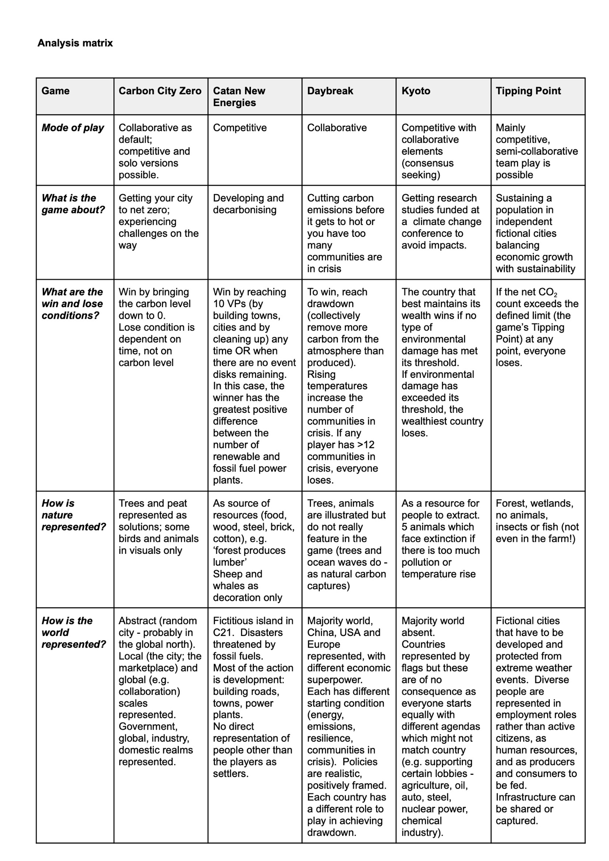
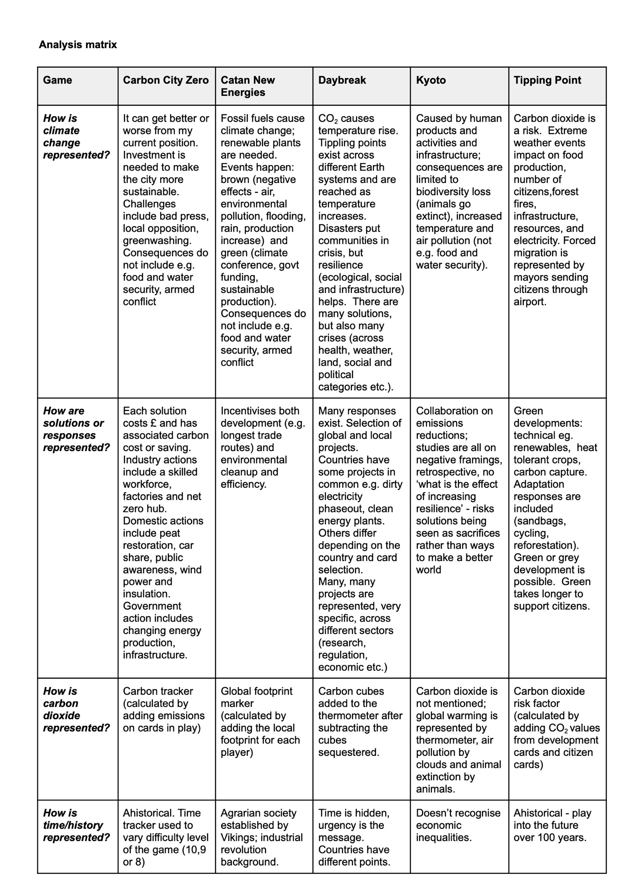

See for example https://www.nytimes.com/2025/04/19/nyregion/new-york-city-giant-game-night.html
According to CNN, by 2024, Catan had sold over 45 million copies across the world https://edition.cnn.com/2024/04/11/us/creating-catan-board-games-card-cec

