**Reorienting agricultural practices on the Qinghai-Tibetan Plateau for internal–external sustainability benefits**

Chongchong Ye1, Shuai Wang1,*, Changjia Li1, Lindsay C. Stringer2,3, Xutong Wu1, Shaolin Wu4, Yuyang Wang5

1State Key Laboratory of Earth Surface Processes and Resource Ecology, Faculty of Geographical Science, Beijing Normal University, Beijing, China.

2Department of Environment and Geography, University of York, York, UK.

3York Environmental Sustainability Institute, University of York, York, UK.

4School of Ecology, Sun Yat-sen University, Shenzhen, China.

5College of Grassland Science and Technology, China Agricultural University, Beijing, China.

*Corresponding author:

Prof. Shuai Wang

State Key Laboratory of Earth Surface Processes and Resource Ecology

Faculty of Geographical

Beijing Normal University

No.19 Xinjiekouwai Street, Haidian District, Beijing

Beijing 100875, P. R. China

Email: [shuaiwang@bnu.edu.cn](mailto:shuaiwang@bnu.edu.cn)

# Abstract

Agricultural practices threaten environmental sustainability at both local and transboundary scales, yet how to optimize them for improved sustainability across these multiple scales remains poorly understood. Here we propose an integrated framework combining safe and just operating spaces, spatial optimization, and extended multiregional Input-Output model to optimize crop-livestock systems on the Qinghai-Tibetan Plateau for sustainable internal–external outcomes. We show that 6.5% of the Qinghai-Tibetan Plateau has exceeded three or more environmental boundaries, but 56.1% of these could be alleviated by reorienting crop and livestock distributions. Such optimizations could reduce greenhouse gas emissions (8.7%) and phosphorus surplus (3.0%), increase agricultural output by 9.5%, and save water resources to benefit downstream areas (1.3%–74.5%), while realizing a reduction of 0.14 megatons of CO2-equivalent, 1.21 kilotons of nitrogen, and 0.22 kilotons of phosphorus emissions outside the Qinghai-Tibetan Plateau. This framework underscores the importance of integrated spatial planning for achieving sustainability at local and transboundary scales.

**Keywords:** environmental sustainability, crop-livestock systems, Qinghai-Tibetan Plateau, local and transboundary scales

# Introduction

Contemporary agricultural practices, including the expansion of overgrazing and rising cultivation intensity, are increasingly putting competing pressures on environmental sustainability at both local and transboundary scales1. For example, local emissions of greenhouse gases (GHG), nitrogen (N) and phosphorus (P) have become more widespread2, environmental spillover effects (virtual material flows embodied in agricultural trade) have increased prominently because of inefficient local agricultural practices3, downstream water quality has degraded due to upstream pollution sources4, and downstream water availability has dropped owing to upstream overextraction4. This suggests that the degradation of environmental sustainability caused by agricultural practices is tightly coupled at larger spatial scales than in the past5, highlighting a possible extension of the boundaries that are typically taken into account in the study and management of agricultural practices6.

Recognizing the importance of addressing the environmental pressures caused by agricultural practices, existing studies have primarily focused on the local sustainability benefits derived from optimizing these practices7-10, with limited attention given to the potential transboundary sustainability gains. Although a few studies have provided insights into the spillover effects of agricultural optimization11-13, they have mainly considered the virtual environmental impacts embodied in agricultural trade flows, with less emphasis on the environmental spillover impacts associated with natural processes such as transboundary rivers14. Consequently, in the face of local and transboundary environmental sustainability degradation caused by agricultural practices, there is an urgent need to optimize local agricultural practices to ensure sustainable outcomes at both local and transboundary scales, while taking into account the environmental spillovers driven by both natural and anthropogenic processes14. By adopting a local and transboundary perspective, we can better uncover how strategic transitions in agricultural practices can mitigate environmental pressures, enhance ecological integrity, and contribute to the attainment of global sustainability goals compared to previous studies.

The Qinghai–Tibetan Plateau (QTP), known as the Earth’s Third Pole and exemplifying this premise of both local and transboundary perspectives4, is rich in glaciers, permafrost, snow, river, and mountain systems that provide essential goods and services to underpin internal and external livelihoods15. These vital benefits include regional carbon sequestration and water availability for the nearly two billion people living in downstream regions, but are increasingly threatened by the intensification of local agricultural practices16. Therefore, the QTP is a natural testing ground for the implementation of agricultural practices optimized to achieve local and transboundary sustainable outcomes.

Here our aim is to propose an integrated framework to assess the feasibility of improving internal–external (reflecting both local and transboundary perspectives) sustainability outcomes from the management of the QTP through the spatial relocation of crops and livestock (Supplementary Fig. 1), taking into account ‘safe and just operating spaces’ (that is, maximum allowed human alteration and multigenerational equal use of natural resources17), biodiversity conservation (that is, mitigating human-wildlife conflicts, see Methods), and environmental spillover impacts (for example, transboundary services of river and virtual material flows embodied in agricultural trade). This framework is conducted through integrating a linear optimization model and environmentally extended multiregional Input-Output (EEMRIO) analysis.

First, we use four dominant pressure classes (water resource use, GHG emissions (GHGs), N surplus and P surplus (N and P runoff/leaching into surface water)) considering safe boundary transgressions, as well as grazing pressure related to grassland carrying capacity and human-wildlife conflict, to assess the current environmental burden of the QTP. Second, we identified six target scenarios: i) minimize water resource use, ii) minimize GHGs, iii) minimize N surplus, iv) minimize P surplus, v) maximize economic output of agriculture production, and vi) Pareto-efficient solutions (multi-objective optimization) taking into account eight necessary constraint criteria (see Methods) based on linear optimization model and EEMRIO analysis to assess the contribution of spatial relocation of crop and livestock to the internal–external sustainability benefits of the QTP. Finally, we examine the changes in distribution of crops and livestock relative to the current pattern in different optimization and future scenarios. Our modelling framework and findings have profound implications for both the QTP and integrated crop–livestock spatial planning across other regions, shaping sustainable futures at both local and transboundary scales.

# Results

## Current environmental pressures of the QTP

We assessed the spatial hotspots of current safe boundaries transgressions for water resource use, GHGs, N surplus, and P surplus (Fig. 1a and Supplementary Fig. 2-5). Safe boundary transgressions are spatially widespread across the QTP, with 6.5% of areas showing three or more safe boundaries transgressed and occurring primarily in northeastern and northwest QTP (Fig. 1a). Among the remaining areas, 45.3% underwent one to two safe boundaries transgressed, and 54.7% adhered to these safe boundaries (Fig. 1a).

We further examined where current grazing activities below or above the local threshold. Our finding shows that substantially larger proportions (nearly 70%) of land remain below the ecological carrying capacity (Fig. 1b), particularly in the central and eastern QTP. Nevertheless, there was still approximately 30% of land that exceeded the local threshold (Fig. 1b), falling primarily in southern, northwest, and northeast regions. Moreover, we projected the spatial patterns of encounter risk between human and wildlife across the QTP (Fig. 1c and Supplementary Fig. 7) and found that the high risk zone (top 20% of probabilities, see Supplementary Methods) is widely spread in agricultural areas (Supplementary Fig. 8). These findings suggest that the environmental sustainability of the QTP encountered multidimensional challenges.

## Potentials for internal and external sustainability outcomes

We further explored the extent to which benefits for internal and external sustainability of QTP could be generated through the spatial relocation of crops and livestock (see Methods). Potential water savings on the QTP were substantial under all target scenarios (Fig. 2a and Supplementary Fig. 9a-14a), compared to the current status, with a 54.9% (53.7-56.9%) decline in demand. Prioritizing the reduction of GHGs can achieve sizeable benefits across corresponding dimensions (Fig. 2b and Supplementary Fig. 9b-14b), reducing total GHGs by 8.7% (7.0% to 11.0%). The largest decrease in P surplus is 15.4%, which would result from prioritizing P reduction (Fig. 2d). In contrast, the priority of maximizing economic output from agricultural production would lead to a 7.5% increase in P surplus (Fig. 2d), while we have set safe boundaries to ensure that P surplus to surface water below 0.4 mg P L-1 to maintain healthy aquatic ecosystems across different basins. We also ensure that the safe boundary for N surplus to surface water (2 mg N L-1) is not breached, even though the total amount of N surplus would increase 16.8% (1.1%–29.6%) (Fig. 2c and Supplementary Fig. 9c-14c), there is no water quality degeneration over a wider area (Fig. 2f). For the economic output from agricultural production, we found that spatial relocation of crops and livestock can contribute a 9.5% (0%–18.4%) increase (Fig. 2e and Supplementary Fig. 9e-14e). It is noteworthy that crop and livestock relocation to ensure that the threshold of water use, GHGs, and nutrient surpluses are not breached at the 5  ×  5 km grid-cell level, which could alleviate 56.1% of cases where three or more safe boundaries were transgressed (Fig. 2f).

In addition to the internal sustainability benefits, transitions in agricultural practices could also realize positive externalities. Under all target scenarios, spatial relocation of crops and livestock would prompt considerable increases in water saving across different exorheic basins: +74.5% (+74.0% to +75.4%) for the Yellow River; +59.2% (+58.6% to +60.0%) for the Tarim River; +27.6% (+24.7% to +31.9%) for the Yangtze River; +33.9% (+31.7% to +37.7%) for the Ganges-Brahmaputra River; +11.8% (+8.8% to +15.2%) for the Mekong River; and +1.3% (+0% to +4.2%) for the Salween River (Fig. 3a). For the Indus River, all target scenarios show that water use remains essentially at the status quo (Fig. 3a). By assessing the changing virtual GHG, N and P flows embodied in agricultural trade (see Methods), we also found that the associated environmental spillover impacts are reduced by 0.14 Mt CO2eq (0.003 to 0.28 Mt CO2eq), 1.21 kt N (0.25 to 2.09 kt N), and 0.22 kt P (0.06 to 0.37 kt P) emissions, respectively (Fig. 3b-d). Of these, prioritizing the maximization of agricultural output leads to significantly higher virtual emission reductions than that in the other scenarios (Fig. 3b-d). These scenarios prioritize minimizing local water resource use, GHGs, N surplus and P surplus within the QTP, which does not necessarily maximize agricultural production. Although local use (or emissions) is declining, the smaller scale of agricultural production under these scenarios results in a relatively modest reduction in virtual emissions beyond the QTP, as the region's demand for external agricultural products is decreasing in proportion to its lower level of agricultural production. In contrast, maximizing agricultural output within the QTP requires significantly increased local agricultural production, which substantially reduces the need for importing agricultural products from external regions. This displacement of external demand leads to the greatest reduction in virtual emissions beyond the QTP. Such spatial relocation could simultaneously achieve sizeable local and transboundary benefits for multiple aspects of environmental sustainability.

## Associated changes in crop-livestock systems

Our analyses revealed that the spatial relocation of crops and livestock reduced environmental impacts to deliver more sustainable benefits within and beyond the QTP to support global sustainability goals. Under the Pareto-efficient solutions (Supplementary Fig. 15), such improvements can be achieved by primarily increasing the populations of goats (7.7 × 107 head) and sheep (9.6 × 105 head) and reducing the planting areas of barley (0.20 Mha), wheat (0.25 Mha), rapeseed (0.30 Mha), potatoes (0.22 Mha) and populations of cattle (8.49 × 106 head) and chickens (8.0 × 106 head). The prescribed relative change for other crop-livestock systems are relatively small compared with the eight aforementioned crop-livestock systems (Fig. 4). Reducing the hotspot areas of crop-livestock systems were mainly concentrated in northeastern parts of QTP (Fig. 4), which have the higher agricultural production (Supplementary Fig. 8) and experienced five safe boundaries transgressed (current water resource use, GHGs, N surplus, P surplus, and grazing activities; Fig. 1a,b). Moreover, the spatial hotspots of increasing cattle and goat populations were not evenly distributed in the east (Fig. 4f,h), compensating for the decline of sheep over these areas (Fig. 4i).

## Future changes and options to ensure internal–external benefits

We found that future trends in water availability (precipitation – evapotranspiration) on the QTP during the period 2020-2050 exhibit varying spatial patterns (Fig. 5a-c). The majority of the region is projected to experience an increase in water availability, with 66.63%, 68.06%, and 62.24% of the total area under SSP126, SSP370 and SSP585, respectively. Notably, only 0.55%, 0.66% and 14.49% of the region under SSP126, SSP370 and SSP585 respectively show significant increases (*P*  <  0.05). The region of significant increase under SSP585 is mainly distributed in the southern QTP (Fig. 5c). Trends in future carbon sinks on the QTP also show pronounced spatial heterogeneity (Fig. 5d-f). As the scenarios from SSP126 to SSP585, the area exhibiting an increasing trend in carbon sink gradually expands, accounting for 45.44%, 58.4% and 64.43% of the total area, respectively. Similarly, the area showing a significant increase (*P*  <  0.05) in carbon sink follows the same pattern, with proportions of 12.29%, 15.04% and 21.95% under SSP126, SSP370 and SSP585, respectively. The regions displaying a significant increase in carbon sink are primarily located in the southeastern QTP across all three scenarios (Fig. 5d-f). In contrast, the southeastern Tibet region consistently exhibits a significant decreasing trend in carbon sink. The above results suggest that the QTP will face severe adaptation challenges in the future with regard to the maintenance of internal and external environmental sustainability. To ensure positive effects on internal–external environmental sustainability of the QTP, we propose the following mitigation strategies: shifting towards a sustainable future requires a marked increase the populations of goats (1.90 × 107 to 3.03 × 107 head) and sheep (3.81 × 107 to 8.01 × 107 head), while reducing the planting areas of barley (0.20 Mha), wheat (0.25 Mha), rapeseed (0.31 Mha), potatoes (0.22 to 0.23 Mha), maize (0.190 to 0.192 Mha) and populations of cattle (8.92 × 106 head), chickens (8.41 × 106 to 9.65 × 106 head) and pigs (1.73 × 106 to 1.88 × 106 head), compared with the baseline year (Fig. 5g).

# Discussion

Our findings underscore the critical importance of optimizing agricultural practices to ensure sustainability outcomes at both local and transboundary scales. By developing an integrated framework that combines safe and just operating spaces, extended multiregional input-output modeling, and spatial optimization, we demonstrate the potential for transformative change in the QTP's crop-livestock systems. The optimization scenarios reveal pathways to substantially mitigate local environmental pressures (Fig. 2; 56.1% of mitigation where three or more boundaries were transgressed; a 3.0%–8.7% reduction for GHGs and P surplus; a 9.5% increase for agricultural output), enhance transboundary water (Fig. 3a; an increase of 1.3%–74.5% in water resource saving for the Yellow, Tarim, Yangtze, Ganges-Brahmaputra, Mekong, and Salween rivers), and reduce environmental spillover impacts (Fig. 3b-g; achieving a reduction of 0.14 Mt CO2-equivalent, 1.21 kt N and 0.22 kt P emissions outside the QTP). Our fine-scale optimization results can be systematically aggregated to provincial and county administrative levels, providing policymakers with both the spatial targeting intelligence (showing exactly where changes are most needed) and quantitative summaries (such as total emission reductions and water savings per administrative unit) for direct integration into existing policy frameworks. These strategies offer a promising roadmap for the QTP and serve as a model for other regions grappling with the complex challenges of balancing agricultural production, environmental conservation, and societal well-being in a changing climate.

Our analysis revealed that 6.5% of areas showed three or more safe boundaries transgressed, occurring mainly in the northeastern and northwest QTP (Fig. 1a), suggesting that these regions may face challenges of water resource imbalance4, climate variability18, and eutrophication of surface water19. The northeastern region of the QTP has the highest intensity of agricultural production and population density (Supplementary Fig. 8), accompanied by higher water consumption, GHGs, N surplus, and P surplus (Supplementary Fig. 2a-5a) to meet agricultural, domestic, and industrial demands20, thereby triggering regional-scale tipping points and raising concerns of unwanted geophysical or biological impacts on the terrestrial ecosystem21. The most arid areas in the northwest and northern parts of QTP were widely transgressed (Fig. 1a) and had smaller safe operating areas (Supplementary Fig. 2b-5b), which substantially reflected the fierce competition between the interaction of environmental limitations and inclusive human development22. These spatial heterogeneities provide important insights for both policymakers and researchers to identify leverage points for addressing differentiated environmental pressures23 in order to enhance the overall stability and resilience of the ecosystems.

Our findings illustrate that reorienting crop and livestock distributions to ensure the internal and external sustainability outcomes of the QTP is primarily to increase the production of cattle and goats in the east (Fig. 4f,h), while substantially moving away from barley, wheat, rapeseed, potatoes, maize, chickens and sheep in the northeastern parts of the QTP (Fig. 4). Reorienting distributions of crops and livestock not only could help achieve sizeable benefits for the QTP’s internal sustainability (mitigation of the current boundary transgressions, water savings, reduction of GHGs and P surplus, and increase of agricultural output; Fig. 2a,b,d,f) but also reduce the associated environmental spillover impacts (achieving a reduction of QTP’s outsourced environmental impact; Fig. 3b-d) and save water resources to benefit downstream areas (Yellow, Tarim, Yangtze, Ganges-Brahmaputra, Mekong, and Salween river, Fig. 3a). Spatially explicit transitions in northeastern parts of the QTP would largely alleviate excessive GHG, N and P emissions, regional water use (corresponding to improvement in downstream water availability) and grazing pressures, and keep use (or emissions) within environmental safe boundaries, thereby contributing to more sustainable crop-livestock system patterns (Supplementary Fig. 9-14). In the eastern QTP, while the increases in cattle and goats partially replacing chickens and sheep have elevated GHG and nutrient emissions (Fig. 4f-i), these increases remain within their safe boundaries (we impose constraints at the grid level) and have significantly enhanced the region's agricultural output (Supplementary Fig. 14b-e). These strategies could facilitate the moderation of, adaptation to, and recovery of, water resource imbalances4,24, grassland degradation16, methane emissions25, permafrost degradation26,27 and climate change28, and are supplementary to the results of previous studies29. Our solutions emphasize spatial complementarity of crop-livestock systems at the landscape scale, which respects these ecological and social realities—reducing overgrazing in sensitive areas while strategically locating crop production in suitable areas to support crop-livestock systems on the QTP.

Looking ahead, our projections indicate that the QTP is likely to face increasing adaptation challenges due to future changes in water availability and carbon sink with pronounced spatial heterogeneity (Fig. 5a-f). To ensure the QTP's long-term sustainability and provision of vital ecosystem services, proactive strategies are needed to adapt agricultural practices to these changing conditions. Our optimization results for future scenarios (Fig. 5c) suggest that further shifts towards livestock grazing (goats and sheep) and reductions in crop cultivation and cattle, chicken and pig farming will be necessary. Implementing such transformations will require robust, forward-looking policies and investments in capacity building and support for herding communities. Integrating climate resilience and adaptation into land use planning will be crucial for navigating the QTP's future sustainability challenges. Our optimization framework considers both current and future conditions, while incorporating provisions for regular updates to account for evolving environmental and socio-economic factors. This adaptive approach through medium-to-long-term planning ensures that production patterns maintain optimal sustainability over time.

We executed the optimizations based on the six target scenarios and eight key constraints (safe and just boundaries, ensuring internal sustainability outcomes, preventing cropland expansion, increasing downstream water availability, preventing surface water eutrophication, biodiversity conservation, reducing the environmental spillover impacts, and environmental adaptability). Previous agricultural optimization approaches have mainly been based on crop switching10,30,31, but we included livestock systems (to account for the widespread grazing activities on the QTP) and considered resource use (or emissions) from the industrial sector alongside subsistence (taking full account of the impact of human activities on environmental boundaries) at a finer spatial resolution. This approach makes the potential predictions of local and transboundary sustainability outcomes more robust as a basis for evidence-based management and policy. Moreover, our study represents an important advance in linking local and transboundary sustainability5 to the optimization framework, highlighting how the improvement of ecosystem functioning and services in particular geographical regions underpins livelihood activities both within and beyond this region. Understanding the connections between different system components across multiple scales is an important objective for global sustainability. The multi-dimensional benefits of implementing the optimization scheme can be realized for crop-livestock systems at a finer spatial resolution, rather than being confined to a prefecture or province in its entirety. Nevertheless, when applied to other regions, it is imperative to consider the spatial heterogeneity of various emission factors and local environmental boundaries. Although the proposed optimal configuration of crop-livestock systems has taken into account multiple necessary constraints, this does not, however, mean that it can be immediately used to change crop and livestock distributions on the QTP. The literature recognizes the importance of the fit between ecological systems (the QTP in our case) and the administration and institutions responsible for their governance32. Because the QTP consists of different provinces, the implementation of specific management policies requires central coordination to deliver transboundary synergies on the ground14.

Further research is also needed to address the uncertainties and limitations of our approach. This refinement encompasses sharpening data quality, considering fine-resolution input data of multiple indicators, expanding field surveys, standardizing methodologies, and drawing on other social and natural science data (such as other industrial and service sectors, soil erosion, and climate change adaptation) to minimize uncertainty of estimated environmental pressures and crop-livestock system optimization schemes, as well as take into account societal changes that could, for example, affect population distribution in the future. Moreover, future research should explore synergies between reorienting distributions and precision farming/waste recycling strategies. While reorientation addresses large-scale ecological mismatches, precision farming and waste recycling could enhance sustainability in optimized production zones. Key challenges include balancing spatial planning with technological limitations and local adoption barriers. Investigating these integrated approaches could reveal more sustainable pathways for fragile ecosystems like the QTP.

Collectively, the implications of our findings extend far beyond the QTP. Many regions worldwide face similar trade-offs between agricultural production, environmental conservation, and societal well-being. Our integrated framework offers a powerful tool for policymakers and researchers to assess these trade-offs, identify synergies, and develop evidence-based strategies for sustainable land-use planning. By linking local and transboundary sustainability outcomes, our approach highlights the interconnectedness of ecosystems and the importance of considering cross-scale dynamics in environmental decision-making. Achieving these transformations in practice will require strong political will, stakeholder engagement, and innovative policy solutions that balance ecological integrity and human well-being in a changing climate.

# Methods

Our integrated framework was executed following three phases (Supplementary Fig. 1). First, we confirmed several dominant pressures of environment on the QTP. Second, we defined the environment pressures of safe and just operating spaces on the QTP. Third, based on the substance of the first two steps, we developed the advanced single-objective and multi-objective optimization framework for crop-livestock systems to ensure internal–external sustainability outcomes of the QTP in different optimization and future scenarios. As our study emphasizes the role of policy interventions in promoting sustainable development, defining the QTP's extent based on its area within China allows us to better assess the effectiveness of these strategies and their potential for broader application.

## Overview of environment pressures

We focus on four dominant environment pressures linked to human activities—water resource consumption, GHGs, N surplus and P surplus. These pressures represent multiple biogeochemical and biogeophysical processes and components of life-support systems21. We also considered the two critical environment pressures of the QTP—grazing pressures and human-wildlife conflicts—that seriously threaten the stability and resilience of Plateau and are of growing concerns to both policymakers and researchers16. To standardize the spatial analyses of environmental pressures, we adopted a spatial resolution of 5 × 5 km as the planning unit, because previous studies have demonstrated that it is appropriate for regional scale studies in Asia33.

For water resource consumption, we reported the total blue and green water footprint, which is inseparably linked to internal–external livelihood security on the QTP4, considering agricultural, domestic, and industrial requirements. Agricultural water consumption is estimated primarily from crop and livestock practices. Crops in this study incorporated barley, wheat, rapeseed, potatoes, and maize, which predominate on the QTP and account for > 80% of the total sowing area34,35. We calculated the consumptive green water of these five crops following the Penman–Monteith equation (see Supplementary Methods) recommended by the Food and Agriculture Organization (FAO)30. The livestock in this study considered cattle, chickens, goats, sheep and pigs, which dominated the main livestock system of the QTP and were supported by previous studies16,36. The water consumption of these animals was calculated based on the water consumption quotas of each animal in different provinces, including the drinking and servicing water, and mixing water for feed. This did not include the virtual water from feed because the previous step had calculated crop water footprints, while the grazing-related water footprint was considered to directly sustain the balance of terrestrial vegetation. For domestic and industrial water consumption, we have not taken into account the return of the withdrawn water to the system, due to the underdeveloped wastewater treatment technology on the QTP19. Supplementary Methods provide further details on how these components were assessed.

For GHGs, our approach is based on mitigating climate change related emissions on the QTP by calculating the GHGs from crop and livestock practices, transportation, industries, and residential life37. For crop practices, we evaluated the emissions of crop residue burning, crop residue release, and synthetic fertilizer application, but we did not include paddy rice cultivation owing to the relatively small rice planting areas on the QTP34,35. For livestock practices, we calculated the emissions from enteric fermentation and manure management. We also calculated the emissions from daily excreta by humans. From a systems perspective, human waste represents an integral component of nutrient flows and biogeochemical cycles. Although the direct control of human waste emissions lies outside the scope of agricultural activities, the magnitude of these emissions imposes a severe constraint on the "safe operating space" within which agriculture can function sustainably. By accounting for human waste emissions, we can more precisely delineate the upper bounds of permissible agricultural emissions, thereby ensuring that ecological thresholds are not surpassed. For other industrial and service sectors, GHGs were assessed by relying on data sourced from the Emissions Database for Global Atmospheric Research (Supplementary Table 7). In this study, all GHGs (CO2, CH4, and N2O) were standardized to CO2eq so CH4 and N2O were multiplied by 25 and 298, respectively, following the Global Warming Potential for a 100-year time scale23. Supplementary Methods contain further information on how these components were calculated.

For nutrient surplus, we evaluated the reactive N and P runoff/leaching into surface water from crop and livestock practices and human faecal waste. For crop practices, we calculated the excess nutrient inputs from crop residue burning, crop residue release, and synthetic fertilizer application. For livestock practices, our assessment calculated excess nutrient inputs based on the different manure management (see Supplementary Methods). We also assessed N and P surplus from human faecal waste that is likely to runoff/leach. We did not evaluate the atmospheric N deposition from ammonia and nitrogen oxide emissions because critical and precise concentration limits are not available to set safe boundaries for terrestrial ecosystems. Moreover, we excluded other industrial and service sectors owing to data limitations. Supplementary Methods have more detailed information.

For grazing activities, we adopted the total biomass requirement for livestock consumption as an indicator to capture the grazing pressure on the QTP. We calculated the total intake of dry matter per year from cattle, goats and sheep, considering average forage intake across the different life cycles, because it is difficult to assess growth stages and livestock weights in different regions and for many numbers of animals due to data limitations. The numbers of cattle, goats and sheep were extracted from the Gridded Livestock of the World (Supplementary Table 7). Detailed information is available in the Supplementary Methods.

For human-wildlife conflicts, our approach is based on preventing disturbance of human activities on the wildlife by assessing the probability of conflict between human and carnivore. In this study, conflict refers to the attacks on livestock or the intrusion into pastoralists' homes, reflecting the spatial overlap between human activities and wildlife habitats that may lead to potential threats to the normal survival of wildlife. Based on 130 conflict incidents form 592 wildlife perception questionnaires across the QTP, we employed an ensemble model38 that combined the farmer population density, vegetation coverage, topographic relief, distance to rivers, distance to rivers, and livestock density to determine the probability of human–wildlife conflicts. The ensemble model included seven different spatial algorithms that can predict presence–absence: random forests, support vector machine models, generalised additive models, generalised linear models, multivariate adaptive regression splines, generalized boosted regression models and recursive partitioning and regression trees. We combined these seven predictions to get the final probability of human–wildlife conflicts. Supplementary Methods have further parameters on how these predictions are executed.

## Defining the safe and just operating spaces

The safe and just operating spaces are a powerful approach for assessing environmental boundary transgressions and evaluating the current environmental pressures faced by a region. This approach can be effectively applied at both local and regional scales, making it highly appropriate for assessing the QTP's current pressing environmental challenges. By defining the safe operating space within planetary boundaries and the just operating space based on social foundations, this approach enables a comprehensive assessment of the region's environmental and social sustainability. We used a myriad of datasets following the ‘multiple elements’ and ‘spatial aggregation’ methods to define safe and just boundaries. The safe boundaries in this study were determined as the upper limit for sustaining the stability and resilience of plateau through the supply of ecosystem services available in the selected region. The just boundaries in this study were defined as the multigenerational equal use of water, GHG, N and P per capita9, ensuring that the these boundaries are allocated to each person from a fairness perspective.

We adopted the available water to set safe boundaries by considering the difference between natural runoff (precipitation minus actual natural evaporation) and environmental flow requirements (defined as the minimum river flow required to sustain the ecosystem, assumed to be 80% of the natural runoff, following Mekonnen and Hoekstra39). We obtained the water just boundary for the QTP by dividing China's national blue water footprint by the total population and multiplying by the number of people on the QTP. The limit for China's national blue water footprint is taken from previous research37 and is 53 km3 yr−1 (range of 21–86 km3 yr−1).

For GHGs, our approach aims to mitigate climate change and prevent declines in the stability and resilience of the QTP25. Thus, we adopted the safe boundaries according to the total carbon sequestration service provided, evaluated as the sum of its forest, grassland and soil carbon sequestration capacity. We acknowledge that the safe boundaries of our study are stricter due to data limitations that do not include non-carbon sequestration, but they also remain potentially realistic because the warming rate on the QTP is twice the global average4. We employed the forest carbon sequestration map from the Global Forest Watch Project40, grassland carbon sequestration map taken from Wang et al.41, and soil organic carbon sequestration map from the FAO42 to assess the carbon sequestration capacity. Our approach for just boundaries were similar to that of water, the China’s national budget was 0.97 Gt CO2eq yr−1 (range of 0.88–1.1 Gt CO2eq yr−1) from previous research37. Detailed information is available in the Supplementary Methods.

For nutrient surplus, we mainly relied on the China’s environmental quality standards for surface water43 to set safe boundaries of N and P surplus and prevent eutrophication. Under the standards, total N and P surpluses of surface water in agricultural regions are limited to 2 mg/L and 0.4 mg/L, respectively. Our approach for just boundaries are similar to those used for water and GHGs, the China’s national discharge were 580 kt N yr−1 (range of 486–749 kt N yr−1) for N and 317 kt P yr−1 (range of 162–337 kt P yr−1) for P from previous research37. To ensure comparability between safe and just boundaries, we assessed the level of their summation in surface water (precipitation minus actual natural evaporation minus water resource use). Supplementary Methods have more detailed information.

We also explicitly addressed the safe boundaries of grazing activities using the aboveground biomass map taken from Piipponen et al.44, which used the feed efficiency to calculate the aboveground biomass available for grazing. This was calibrated with an updated vegetation map of China by eliminating unvegetated areas45.

## Optimizing model for crop-livestock systems

The spatial optimization model is an effective tool for addressing resource allocation problems and determining the optimal configuration of agricultural practices under various constraints. By considering multiple objectives and constraints, such as maximizing economic output while minimizing environmental impacts and resource consumption, this model can generate optimal solutions that balance the competing demands on the QTP's limited resources. We developed a crop-livestock system optimization model based on single and multi-objective scenarios to enhance the internal and external sustainability outcomes of the QTP46. Given the complexity of industrial processes, we did not include industrial optimization, which may result in areas of industrial concentration where boundary transgressions persist after optimization. The single-dimensional focus on crop-livestock system optimization incorporated five scenarios: i) minimize water resource use, ii) minimize GHGs, iii) minimize N surplus, iv) minimize P surplus, and v) maximize economic output of agricultural production on the QTP, exploring transitions in agriculture practices focusing on barley, wheat, rapeseed, potatoes, maize, cattle, chicken, goats, sheep, and pigs. We operationalized the multi-objective scenario by assigning a weight of 0 or 1 to water consumption, GHGs, nutrient surplus, and agriculture output so that there are 25 (32) reorienting schemes in crop-livestock systems, which (each being Pareto optimal) represent a set of Pareto-efficient solutions30. The weights 0 and 1 indicate whether the designers consider the indicator to be the least or most important, respectively. To enhance internal and external sustainability outcomes of the QTP, the optimization model is formulated as follow:

$minimize(\sum_{i}^{n}{\sum_{j}^{12}{\left({Ag}_{i,j}×F_{i,j}\right)}+\sum_{i}^{n}{{Hu}_{i}})}$ (1)

$maximize\sum_{i}^{n}{\sum_{j}^{12}{({Ag}_{i,j}×{out}_{i,j})}}$ (2)

so that

$\sum_{j}^{12}{({Ag}_{i,j}×F_{i,j})}+{Hu}_{i}≤{safe}_{i,k}$ (3)

$0≤\sum_{l}^{5}{({Ag}_{i,l}×{AGB}_{l})}≤{TAGB}_{i}$ (4)

$\sum_{i}^{n}{\sum_{j}^{12}{({Ag}_{i,j}×F_{i,j})}+\sum_{i}^{n}{{Hu}_{i}}≥}{just}_{k}$ (5)

$0≤\sum_{c}^{5}{{Ag}_{i,c}}≤{TLand}_{i}$ (6)

$\sum_{i}^{exo}{\sum_{j}^{12}{({Ag}_{i,j}×W_{i,j})}+\sum_{i}^{exo}{{Hu}_{i}}≤}CL$ (7)

$\frac{\sum_{i}^{exo}{\sum_{j}^{12}{\left({Ag}_{i,j}×{NP}_{i,j}\right)+\sum_{i}^{exo}{{Hu}_{i}}}}}{SW}≤Sta$ (8)

$\sum_{j}^{12}{({Ag}_{pa/hwc,j}×F_{i,j})}+{Hu}_{pa/hwc}≤MPA$ (9)

$\sum_{i}^{n}{\sum_{j}^{12}{({Ag}_{i,j}×{out}_{i,j})}}≥CL$ (10)

$0≤{Ag}_{i,nl}≤{UP}_{i,nl}$ (11)

where, equations (1) and (2) represent the objective function; *Agi,j* denotes the cultivated area of barley, wheat, rapeseed, potatoes and maize, and head of cattle, chicken, goats, sheep and pigs in grid *i*; *Fi,j* is the use (or emissions) factor of the *j*th agricultural practice in grid *i*, *outi,j* is the economic output of the *j-*th agricultural practice in grid *i* (Table S8), *Hui* represents use (or emissions) caused by human activities in grid *i*, and *n* is the total number of grids on the QTP. We set the following constraints at grid, watershed and regional levels:

(1) Water resource use, GHGs, nutrient surplus, and grazing activities within each grid cell cannot transgress safe boundaries based on equation (3) and (4), ensuring the stability and resilience of ecosystem and internal sustainability outcomes of the QTP. *safei,k* is the safe boundary of *k-*th use (or emission; including water, GHGs, N surplus and P surplus) in grid *i, Agi,l* is the head of livestock *l* (including cattle, goats and sheep) in grid *i, AGBl* is the consumed biomass each year of livestock *l, TAGBi* is the total available aboveground biomass in grid *i*.

(2) The QTP’s water resource use, GHGs, and nutrient surplus must meet just boundaries based on equation (5), enabling multigenerational equal use of water, GHG, N and P per capita. Given that the population distribution is more mobile, we impose constraints at the regional level. *justk* is the just boundary of the *k-*th use (or emissions) on the QTP.

(3) The cultivated area within each grid cell cannot exceed the current level based on equation (6), preventing the expansion of arable land. *Agi,c* is the cultivated area of barley, wheat, rapeseed, potatoes and maize in grid *i*, *TLandi* is the total available cultivated area in grid *i.*

(4) Water resource use within each exorheic basin cannot exceed the current level based on equation (7), ensuring that water resource in downstream regions is not adversely affected. *Wi,j* is water resource use of the *j-*th agricultural practice in grid *i*, *exo* is the total number of grids for the QTP’s exorheic basins (Yellow, Tarim, Yangtze, Ganges-Brahmaputra, Mekong, Salween, and Indus River).

(5) Nutrient surplus within each basin cannot exceed the maximum acceptable concentration based on equation (8), preventing surface water eutrophication and adverse impacts on downstream water quality. *NPi,j* is N (or P) emission of the *j-*th agricultural practice in grid *i*, *SW* is the surface water of each basin (precipitation minus actual natural evaporation minus water resource use), *Sta* is the environmental quality standards for surface water (with the boundary equal to 2 mg/L and 0.4 mg/L for N and P, respectively).

(6) Water resource use, GHGs, and nutrient surplus in protected areas and high-risk areas of human-wildlife conflicts (Supplementary Methods and Supplementary Fig. 7) cannot exceed the corresponding average in protected areas based on equation (9), reflecting biodiversity conservation targets. *Agpa/hwc* is the *j-*th agricultural practice in protected areas or high-risk zones for human-wildlife conflicts, *Hupa/hwc* represents human activities that result in use (or emissions) of protected areas or high risk zone of human-wildlife conflicts*, MPA* is the average use (or emissions) of protected areas.

(7) To guarantee a regional agricultural output that is greater than or equal to the current level, thereby ensuring that agricultural output on the QTP is not affected.

(8) We set the maximum head limits for non-critical livestock (including chicken and pigs) on the QTP in the optimization scenario so that their numbers do not increase too much, ensuring that they are only produced where they are adapted to the environmental conditions. We constrain increases of chicken and pigs to no more than the maximum growth rate of the last three years (2019-2021). *Agi,nl* is the head of chicken and pigs in grid *i, UPi,nl* represents their upper limits in grid *i*. The optimization was solved based on the Julia 1.9.0 using the standard optimization solver (Gurobi 10.0.1), with the following libraries: JuMP v1.21.1 and MultiObjectiveAlgorithms.

## Environmentally extended multi-regional input–output analysis

We adopted an environmentally extended multiregional Input-Output (EEMRIO) analysis to evaluate the external environmental impacts, including the virtual GHG, N and P flows embodied in agricultural trade11,13. The MRIO datasets used in this study are based on China’s interprovincial IO tables47 that mitigated the heterogeneity between different sources of statistical data and regional IO and integrated the separate information of foreign-owned firms inside each province (or industry pair). We employed the interprovincial IO tables for 2017 to carry out the EEMRIO analysis, as the latest year currently available. The linked MRIO model can be shown as48:

(12)

in which *X* expresses the total economic output matrix consisting of $x_{j}^{s}$ that is, the total output of sector *j* in region *s*; *A* represents the direct consumption coefficient matrix composed of $a_{i,j}^{r,s}$, that is, the input from sector *i* in region *r* required to yield one unit for sector *j* in region *s*; *I* is the identity matrix; $L={(I-A)}^{-1}$ is the Leontief inverse matrix; *Y* represents the final demand matrix consisting of $y_{j}^{s,t}$, that is, the final requirement of region *t* for products of sector *j* in region *s*.

The GHGs, N surplus and P surplus embodied in the monetary flows of a sector in a specific region can be quantified based on the EEMRIO model:

$VE={\hat{F}[(I-A)}^{-1}Y]$ (13)

where *VE* expresses the virtual GHGs, N surplus and P surplus embodied in trade flows; *F* is an emission intensity vector consisting of $f_{i}^{r}$ that represents the GHGs (or N surplus, or P surplus) per unit of economic output of sector *i* in region *r.* Our study only included the agricultural sector related virtual GHGs, N and P flows. Considering the low share of foreign trade with the QTP47, we only evaluated the virtual GHG, N and P flows between the domestic districts and assumed that the agricultural trade of the QTP would be changed by original share after optimization.

## Climate scenario analysis in 2050

To explore the pressure of the QTP to pursue internal–external environmental outcomes in the future, we assess the multi-model mean changes in water availability and carbon sink during the future periods (2020–2050) under different SSP-RCP scenarios (SSP126, SSP370 and SSP585). Water availability reflects the amount of water available for use in an agricultural system, as well as the ability of ecosystems to absorb excess N and P. In this study, the future water availability was calculated based on the difference between precipitation and evapotranspiration, which were obtained from the CMIP6 climate projections (Supplementary Table 7) with a spatial resolution of 0.5°. We used the GFDL-ESM4, IPSL-CM6A-LR, MRI-ESM2-0 and UKESM1-0-LL models, which correspond to carbon sink modelling. Carbon sink was assessed based on the difference between gross primary production minus autotrophic respiration minus heterotrophic respiration minus carbon emissions from fires, derived from the Inter-sectoral Impact Model Intercomparison Project phase 3b (ISIMIP3b) ELM-ECA model (Supplementary Table 7) with a spatial resolution of 0.5°, including the global climate models of GFDL-ESM4, IPSL-CM6A-LR, MRI-ESM2-0 and UKESM1-0-LL models. We use the average of aforementioned four models to calculate the changing trend from 2020 to 2050. For the available water resources and carbon sink in 2050, this study employs the average values of aforementioned four models from the 2041–2060 period as a substitute to reduce uncertainty.

For the adaptation options of crop-livestock systems to future climate change, taking into account internal–external environmental outcomes, we construct the spatial optimization of crop-livestock systems to estimate the effects of future water availability, carbon sink, cropland, above-ground biomass, population, domestic and industrial water withdrawal, and crop production on the adaptation of QTP’s crop-livestock systems. The detailed information of water availability and carbon sink has been described above. The future cultivated land area (2041–2060) was obtained from the Cao et al.49 with a spatial resolution of 1 km. We counted the area of cropland in 0.5 degree grid. The future above-ground biomass was calculated based on the difference between gross primary production and autotrophic respiration, converted by root-crown ratio (from Mokany et al.50) based on the future Köppen-Geiger maps51. The future population data (2041–2060) was acquired from the Wang et al.52 with a spatial resolution of 1 km, which was aggregated to 0.5°. The future domestic and industrial water withdrawal (2041–2060) were based on calculations using the global hydrological model of ISIMIP3b H0853 with a spatial resolution of 0.5°. The future crop yield of barley, wheat, rapeseed, potatoes and maize were obtained from the FAO's Food and Agriculture Projections to 2050 based on the level of China54. All future data were selected by using the SSP-RCP scenarios of SSP126, SSP370 and SSP585. To construct the spatial optimization of crop-livestock systems, the predicted water requirement of crops was calibrated using the future potential evapotranspiration data55, other predicted emission factors of crops was assessed based on the future crop yield and current relevant parameters. Considering that animal production is less affected by climate, we assume that the animal productivity, animal diet and manure management options remain the same as in 2020. The future spatial optimization of crop-livestock systems was carried out on a 0.5° grid, other variants were designed as in 2020, ensuring internal sustainability outcomes, preventing cropland expansion, increasing downstream water availability, preventing surface water eutrophication, ensuring biodiversity conservation, reducing the environmental spillover impacts, and ensuring environmental adaptability.

## Uncertainty analysis

In this study, uncertainty was mainly associated with emission factors, province data from statistical yearbooks, previous publications, activity data and parameter values. Here we employed Monte Carlo simulations to run 1000 to assess the uncertainty of optimized results. The emission factors and activity data were assumed to obey normal distribution as elaborated in Liang et al.56 The coefficients of variation of emission factors, fertilizer, crop yield, activity data and estimated parameters were assumed to be 10% (ref.37,57). All optimized results of uncertainty were demonstrated at the range of the 2.5th–97.5th percentile for the QTP. Although our Monte Carlo simulations accounted for parameter uncertainties in emission factors, statistical data, and activity variables, several broader sources of uncertainty warrant careful consideration when interpreting our findings. The climate change projections underlying our analysis introduce inherent uncertainties regarding future precipitation patterns and evapotranspiration regimes—all of which could substantially alter the productivity and spatial suitability of both crops and livestock systems. Our optimization model contain provincial-scale statistical data, despite its finer spatial resolution than previous studies, inevitably masks local heterogeneity in emissions, resource use, and management practices that influence actual environmental impacts and production potentials. Furthermore, our assumption of fixed livestock productivity under climate change may underestimate future grazing pressures or overestimate adaptive capacity, particularly given the QTP's vulnerability to climate change. The implementation uncertainties—including unquantified switching costs, potential resistance to land-use changes, and the administrative challenges of coordinating transboundary policies across provincial jurisdictions—represent another critical layer of practical constraints beyond our quantitative uncertainty analysis. While our multi-dimension approach advances previous single-dimension optimizations by incorporating safe-just boundaries and transboundary impacts, these conceptual frameworks themselves carry normative uncertainties about intergenerational equity thresholds and ecosystem resilience limits that merit ongoing refinement through interdisciplinary collaboration and higher-resolution field validation.

## Data availability

All data used in the study are open access: AgERA5, ERA5-Land, and CMIP6 climate projections (https://cds.climate.copernicus.eu/); Current potential evapotranspiration from ref.58; Future potential evapotranspiration from ref.55; Current cropland area from ref.59; Future cropland area from ref.49; Gridded Livestock of the World (https://www.fao.org/livestock-systems/en/); Current industrial water withdrawal from ref.60; Future domestic and industrial water withdrawal from ISIMIP3b (https://data.isimip.org/); Spatial Production Allocation Model (https://mapspam.info/); Emissions Database for Global Atmospheric Research (https://edgar.jrc.ec.europa.eu/); Global Forest Watch Open Data Portal (<https://data.globalforestwatch.org/>); Grassland carbon sequestration from ref.41; Global Soil Sequestration Potential Map (<https://www.fao.org/>); Aboveground biomass from ref.44; Updated vegetation map of China from ref.45; WorldPop Project (https://www.worldpop.org/); Future population data from ref.52; Future gross primary production, autotrophic respiration, heterotrophic respiration, and carbon emissions from fires from ISIMIP3b (https://data.isimip.org/); Future Köppen-Geiger map from ref.51; Food and agriculture projections to 2050 (https://www.fao.org/).

**Code availability**

The standard optimization solver (Gurobi 10.0.1) available in open-access software (Julia 1.9.0) can be used to replicate the analysis. The code and related description of JuMP and MultiObjectiveAlgorithms can be accessed at <https://jump.dev/JuMP.jl/stable/> and <https://jump.dev/JuMP.jl/stable/tutorials/linear/multi_objective_examples/>, respectively. All the processing codes are available from the corresponding author on request.

# References

1 Foley, J. A. *et al.* Global consequences of land use. *Science* **309**, 570-574 (2005).

2 Jiang, L., Xing, R., Chen, X. & Xue, B. A survey-based investigation of greenhouse gas and pollutant emissions from household energy consumption in the Qinghai-Tibet Plateau of China. *Energy and Buildings* **235**, 110753 (2021).

3 Wo, R., Fang, D., Song, D. & Chen, B. Analysis of embodied carbon emissions and carbon sequestration in Tibetan Plateau-Case study of Tibet and Qinghai. *Applied Energy* **347**, 121449 (2023).

4 Yao, T. *et al.* The imbalance of the Asian water tower. *Nature Reviews Earth & Environment* **3**, 618-632 (2022).

5 Wamsler, C., Osberg, G., Osika, W., Herndersson, H. & Mundaca, L. Linking internal and external transformation for sustainability and climate action: Towards a new research and policy agenda. *Global Environmental Change* **71**, 102373 (2021).

6 Moore, M.-L. *et al.* Moving from fit to fitness for governing water in the Anthropocene. *Nature Water*, 1-10 (2024).

7 Wang, Y. *et al.* Mitigation potential of methane emissions in China’s livestock sector can reach one-third by 2030 at low cost. *Nature Food* **5**, 603-614 (2024).

8 Wang, Z. *et al.* Integrating crop redistribution and improved management towards meeting China’s food demand with lower environmental costs. *Nature food* **3**, 1031-1039 (2022).

9 Liu, L. *et al.* An optimized crop–livestock system can achieve a safe and just planetary boundary for phosphorus at the sub-basin level in China. *Nature Food*, 1-14 (2024).

10 Yin, L. *et al.* Novel cropping-system strategies in China can increase plant protein with higher economic value but lower greenhouse gas emissions and water use. *One Earth* **6**, 560-572 (2023).

11 Gu, W. *et al.* Climate adaptation through crop migration requires a nexus perspective for environmental sustainability in the North China plain. *Nature Food* **5**, 569-580 (2024).

12 Zhao, H. *et al.* Holistic food system innovation strategies can close up to 80% of China’s domestic protein gaps while reducing global environmental impacts. *Nature Food* **5**, 581-591 (2024).

13 Zhong, H. *et al.* Global spillover effects of the European Green Deal and plausible mitigation options. *Nature Sustainability*, 1-11 (2024).

14 Xiao, H. *et al.* Global transboundary synergies and trade-offs among Sustainable Development Goals from an integrated sustainability perspective. *Nature Communications* **15**, 500 (2024).

15 Li, J. *et al.* Recent intensified erosion and massive sediment deposition in Tibetan Plateau rivers. *Nature Communications* **15**, 722 (2024).

16 Zhu, Q. *et al.* An early warning signal for grassland degradation on the Qinghai-Tibetan Plateau. *Nature Communications* **14**, 6406 (2023).

17 Aleissa, Y. M. & Bakshi, B. R. Possible but rare: Safe and just satisfaction of national human needs in terms of ecosystem services. *One Earth* **6**, 409-418 (2023).

18 Wu, F. *et al.* Reorganization of Asian climate in relation to Tibetan Plateau uplift. *Nature Reviews Earth & Environment* **3**, 684-700 (2022).

19 Feng, Z. *et al.* Comprehensive efficiency evaluation of wastewater treatment plants in northeast Qinghai–Tibet Plateau using slack–based data envelopment analysis. *Environmental Pollution* **311**, 120008 (2022).

20 Foley, J. A. *et al.* Solutions for a cultivated planet. *Nature* **478**, 337-342 (2011).

21 Rockström, J. *et al.* Safe and just Earth system boundaries. *Nature* **619**, 102-111 (2023).

22 Liu, H. *et al.* Conflict or Coordination? The Spatiotemporal Relationship Between Humans and Nature on the Qinghai‐Tibet Plateau. *Earth's Future* **11**, e2022EF003452 (2023).

23 Halpern, B. S. *et al.* The environmental footprint of global food production. *Nature Sustainability* **5**, 1027-1039 (2022).

24 Li, X. *et al.* Climate change threatens terrestrial water storage over the Tibetan Plateau. *Nature Climate Change* **12**, 801-807 (2022).

25 Chen, H. *et al.* Carbon and nitrogen cycling on the Qinghai–Tibetan Plateau. *Nature Reviews Earth & Environment* **3**, 701-716 (2022).

26 Song, L., Wang, L., Luo, D., Chen, D. & Zhou, J. Assessing hydrothermal changes in the upper Yellow River Basin amidst permafrost degradation. *npj Climate and Atmospheric Science* **7**, 57 (2024).

27 Zhao, L. *et al.* Investigation, Monitoring, and Simulation of Permafrost on the Qinghai‐Tibet Plateau: A Review. *Permafrost and Periglacial Processes* **0**, 1-11 (2024).

28 Shen, M. *et al.* Plant phenology changes and drivers on the Qinghai–Tibetan Plateau. *Nature Reviews Earth & Environment* **3**, 633-651 (2022).

29 Yu, L. *et al.* Strategies for agricultural production management based on land, water and carbon footprints on the Qinghai-Tibet Plateau. *Journal of Cleaner Production* **362**, 132563 (2022).

30 Xie, W. *et al.* Crop switching can enhance environmental sustainability and farmer incomes in China. *Nature* **616**, 300-305 (2023).

31 Davis, K. F., Rulli, M. C., Seveso, A. & D’Odorico, P. Increased food production and reduced water use through optimized crop distribution. *Nature Geoscience* **10**, 919-924 (2017).

32 Ekstrom, J. A. & Young, O. R. Evaluating functional fit between a set of institutions and an ecosystem. *Ecology and Society* **14**, 16 (2009).

33 Zhu, L. *et al.* Regional scalable priorities for national biodiversity and carbon conservation planning in Asia. *Science Advances* **7**, eabe4261 (2021).

34 Qinghai Statistical Yearbook. <http://tjj.qinghai.gov.cn/> (2022).

35 Tibet Statistical Yearbook. https://tjj.xizang.gov.cn/ (2022).

36 Meng, N. *et al.* A high-resolution gridded grazing dataset of grassland ecosystem on the Qinghai–Tibet Plateau in 1982–2015. *Scientific Data* **10**, 68 (2023).

37 Hu, Y. *et al.* Food production in China requires intensified measures to be consistent with national and provincial environmental boundaries. *Nature Food* **1**, 572-582 (2020).

38 Struebig, M. J. *et al.* Addressing human-tiger conflict using socio-ecological information on tolerance and risk. *Nature communications* **9**, 1-9 (2018).

39 Mekonnen, M. M. & Hoekstra, A. Y. Blue water footprint linked to national consumption and international trade is unsustainable. *Nature Food* **1**, 792-800 (2020).

40 Harris, N. L. *et al.* Global maps of twenty-first century forest carbon fluxes. *Nature Climate Change* **11**, 234-240 (2021).

41 Wang, Y. *et al.* Persistent and enhanced carbon sequestration capacity of alpine grasslands on Earth’s Third Pole. *Science Advances* **9**, eade6875 (2023).

42 Peralta, G. *et al.* *Global soil organic carbon sequestration potential map (GSOCseq v1. 1)–Technical manual*. (Food & Agriculture Org., 2022).

43 Environmental quality standards for surface water (GB 3838—2002). (2002).

44 Piipponen, J. *et al.* Global trends in grassland carrying capacity and relative stocking density of livestock. *Global change biology* **28**, 3902-3919 (2022).

45 Su, Y. *et al.* An updated vegetation map of China (1: 1000000). *Science Bulletin* **65**, 1125-1136 (2020).

46 Castonguay, A. C. *et al.* Navigating sustainability trade-offs in global beef production. *Nature Sustainability* **6**, 284-294 (2023).

47 Chen, Q. *et al.* An interprovincial input–output database distinguishing firm ownership in China from 1997 to 2017. *Scientific Data* **10**, 293 (2023).

48 Yang, Y. *et al.* Mapping global carbon footprint in China. *Nature Communications* **11**, 2237 (2020).

49 Cao, B. *et al.* A 1 km global cropland dataset from 10 000 BCE to 2100 CE. *Earth Syst. Sci. Data* **13**, 5403–5421 (2021).

50 Mokany, K., Raison, R. J. & Prokushkin, A. S. Critical analysis of root: shoot ratios in terrestrial biomes. *Global change biology* **12**, 84-96 (2006).

51 Beck, H. E. *et al.* High-resolution (1 km) Köppen-Geiger maps for 1901–2099 based on constrained CMIP6 projections. *Scientific data* **10**, 724 (2023).

52 Wang, X., Meng, X. & Long, Y. Projecting 1 km-grid population distributions from 2020 to 2100 globally under shared socioeconomic pathways. *Scientific Data* **9**, 563 (2022).

53 Satoh, Y. *et al.* Multi‐model and multi‐scenario assessments of Asian water futures: The Water Futures and Solutions (WFaS) initiative. *Earth's Future* **5**, 823-852 (2017).

54 FAO. *The future of food and agriculture – Alternative pathways to 2050*, <https://www.fao.org/global-perspectives-studies/food-agriculture-projections-to-2050/en/> (2018).

55 Zomer, R. J. & Trabucco, A. *Future Global Aridity Index and PET Database (CMIP_6)[DS/OL]. V6. Science Data Bank*, <https://doi.org/10.57760/sciencedb.nbsdc.00086> (2024).

56 Liang, D. *et al.* China’s greenhouse gas emissions for cropping systems from 1978–2016. *Scientific data* **8**, 171 (2021).

57 Gu, B., Ju, X., Chang, J., Ge, Y. & Vitousek, P. M. Integrated reactive nitrogen budgets and future trends in China. *Proceedings of the National Academy of Sciences* **112**, 8792-8797 (2015).

58 Singer, M. B. *et al.* Hourly potential evapotranspiration at 0.1 resolution for the global land surface from 1981-present. *Scientific Data* **8**, 224 (2021).

59 Jie, Y. & Xin, H. The 30 m annual land cover datasets and its dynamics in China from 1990 to 2021. <https://zenodo.org/records/5816591>. (2022).

60 Hou, C. *et al.* High-resolution mapping of monthly industrial water withdrawal in China from 1965 to 2020. *Earth System Science Data Discussions* **2023**, 1-25 (2023).

# Acknowledgments

This work was enabled by funding provided by the Second Tibetan Plateau Scientific Expedition and Research Program (2019QZKK0405), the National Natural Science Foundation of China (W2412142), the Fundamental Research Funds for the Central Universities and the 111 Project of China (B23027), the National Natural Science Foundation of China (42521001), and the Open Project of Middle Yarlung Zangbo River Natural Resources Observation and Research Station (2025YJZKF006).

**Author contributions**

S.W. and C.Y. conceived and designed the study. C.Y. and S.W. organized core drilling. C.Y. split the cores and prepared the samples. C.Y. and Shaolin Wu downloaded and preprocessed the data. C.Y. and C.L. analyzed the model results. C.Y., S.W., C.L., L.S., X.W. and Y.W. wrote and revised the manuscript. All authors discussed and contributed to the revision of the manuscript.

**Corresponding author**

Prof. Shuai Wang, Email: shuaiwang@bnu.edu.cn

**Competing interests**

The authors declare no competing interests.

**Fig.1** **| Maps of current environmental pressures.** **a**, The number of local water resource use, GHGs, N surplus, and P surplus safe boundaries transgressed by location. **b**, Discrepancy between aboveground grass biomass (AGB) consumed by grazing activities and AGB available. **c**, Risk of human-wildlife conflicts predicted by an ensemble model.

**Fig.2** **| Internal** **sustainability benefits through transitions in agriculture practices.** **a-e**, Internal relative changes in the water resource use (**a**), GHGs (**b**), N surplus (**c**), P surplus (**d**), and economic output of agriculture production (**e**) following optimization of crop and livestock distributions for the six target scenarios— i) minimize water resource use, ii) minimize GHGs, iii) minimize N surplus, iv) minimize P surplus, v) maximize economic output of agriculture production, and vi) Pareto-optimal solution. **f**, Post-optimization pattern for local water resource use, GHGs, N surplus, and P surplus transgressions by location. Whiskers denote the range of Pareto-optimal outcomes.

**Fig.3 | External sustainability benefits through spatial relocation of crops and livestock.** **a**, Relative changes in the water saving for main exorheic basins. **b**–**d**,Relative changes in total virtual GHG (**b**), N (**c**), and P (**d**) emissions following six target scenarios (these six scenarios refer to the minimization of water resource use and emissions within the QTP, as well as the maximization of agricultural output).

**Fig.4 | Prescribed changes in crop planting areas and livestock populations by crop-livestock system optimization.** **a**–**d**, Average relative changes in planting area of barley (**a**), wheat (**b**), rapeseed (**c**), potatoes (**d**), maize (**e**) under the Pareto-optimal solution. **f**–**l**,Average relative changes in populations of cattle (**f**), chickens (**g**), goats (**h**), sheep (**i**), and pigs (**j**) under the Pareto-optimal solution.

**Fig.5 | Future variation for water availability and carbon sink and adaptation options on the Qinghai-Tibetan Plateau.** Multi-model mean changes in water availability (precipitation – evapotranspiration) (**a-c**) and carbon sink (**d-f**) during future (2020–2050) periods on the basis of SSP126, SSP370 and SSP585 scenarios. **g**, Relative changes in planting area of barley (SB), wheat (WW), rapeseed (RA), potatoes (PO), maize (SM) and populations of cattle (CA), chickens (CH), goats (GO), sheep (SH), and pigs (PI) under the Pareto-optimal solution by 2050 on the basis of SSP126, SSP370 and SSP585 scenarios.

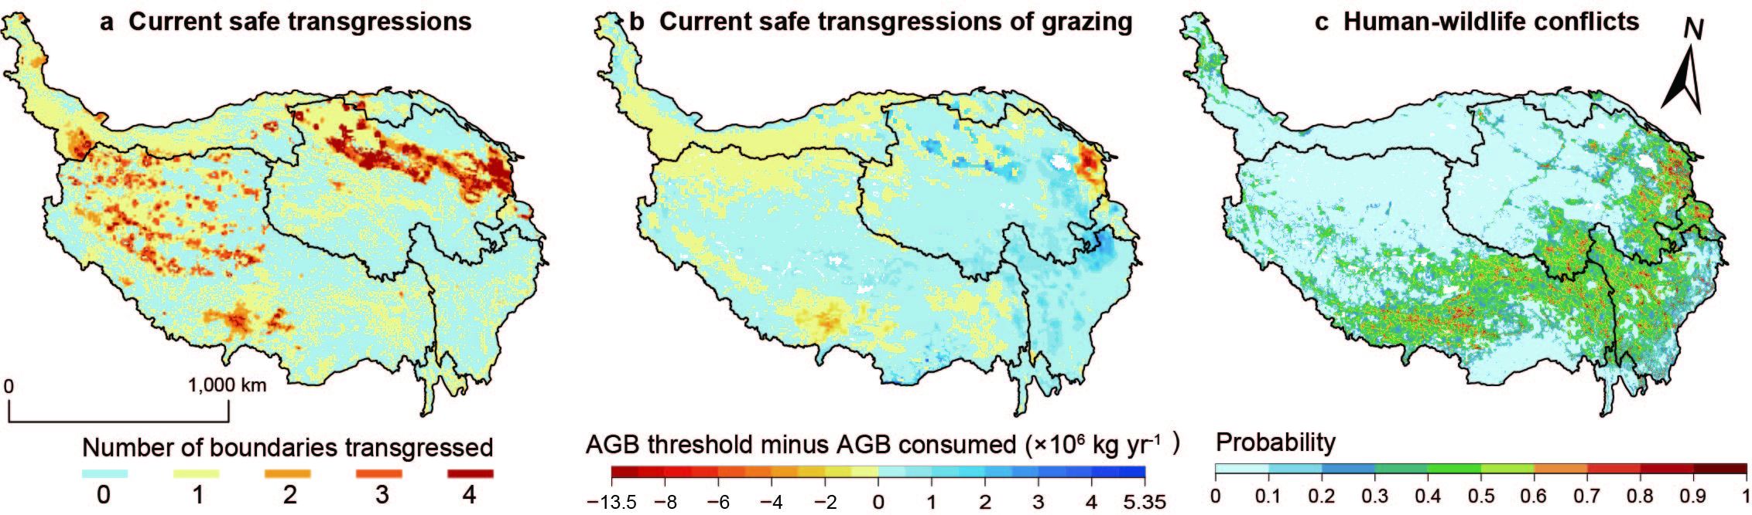

**Fig.1**

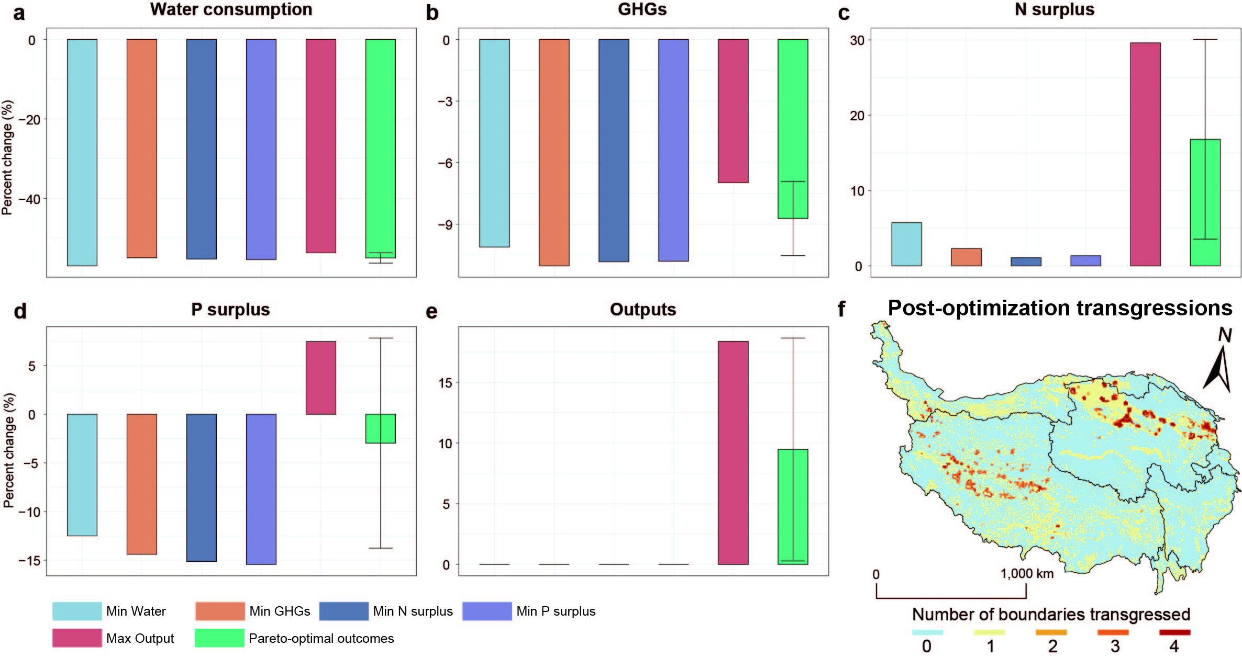

**Fig.2**

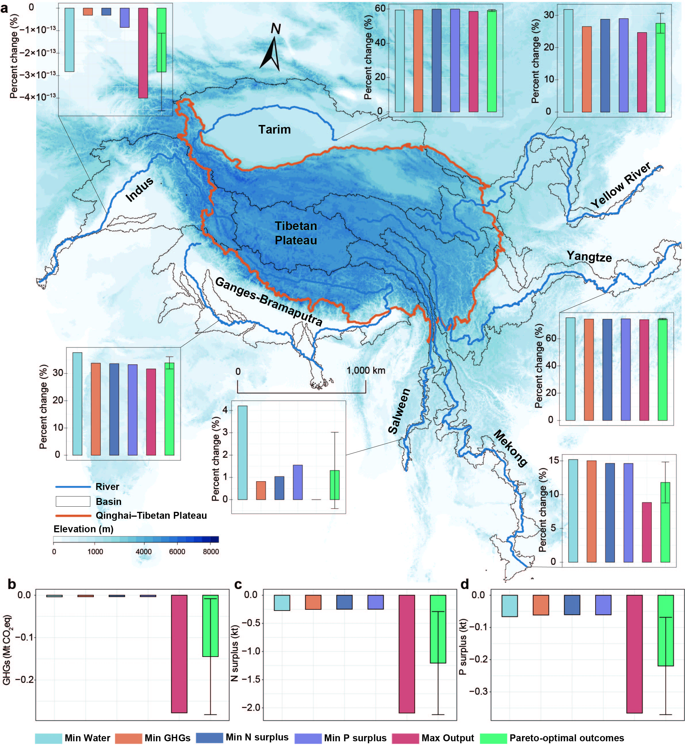

**Fig.3**

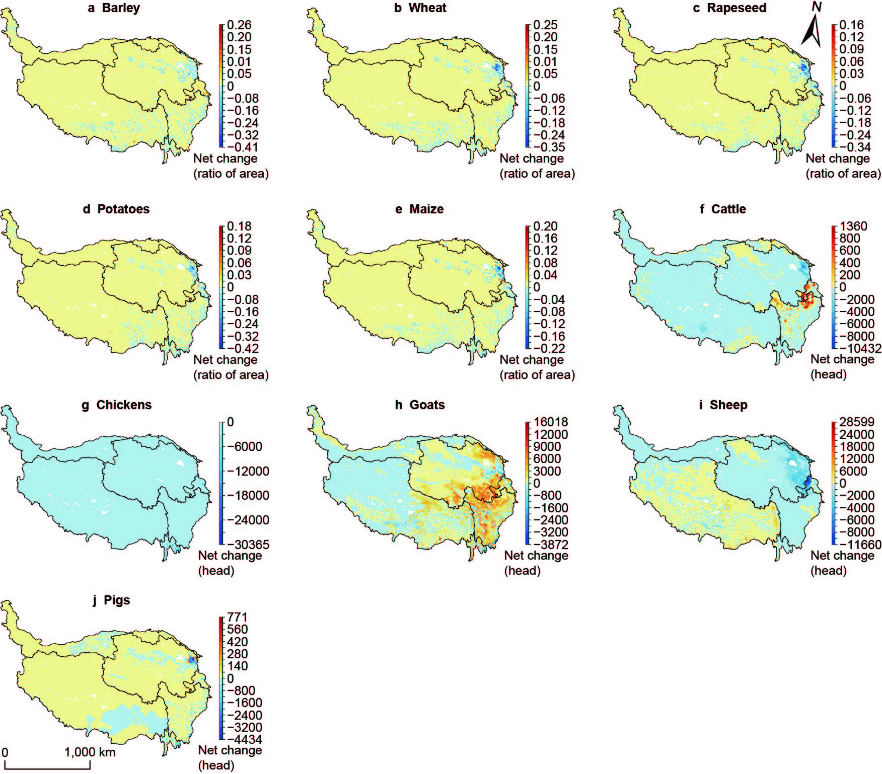

**Fig.4**

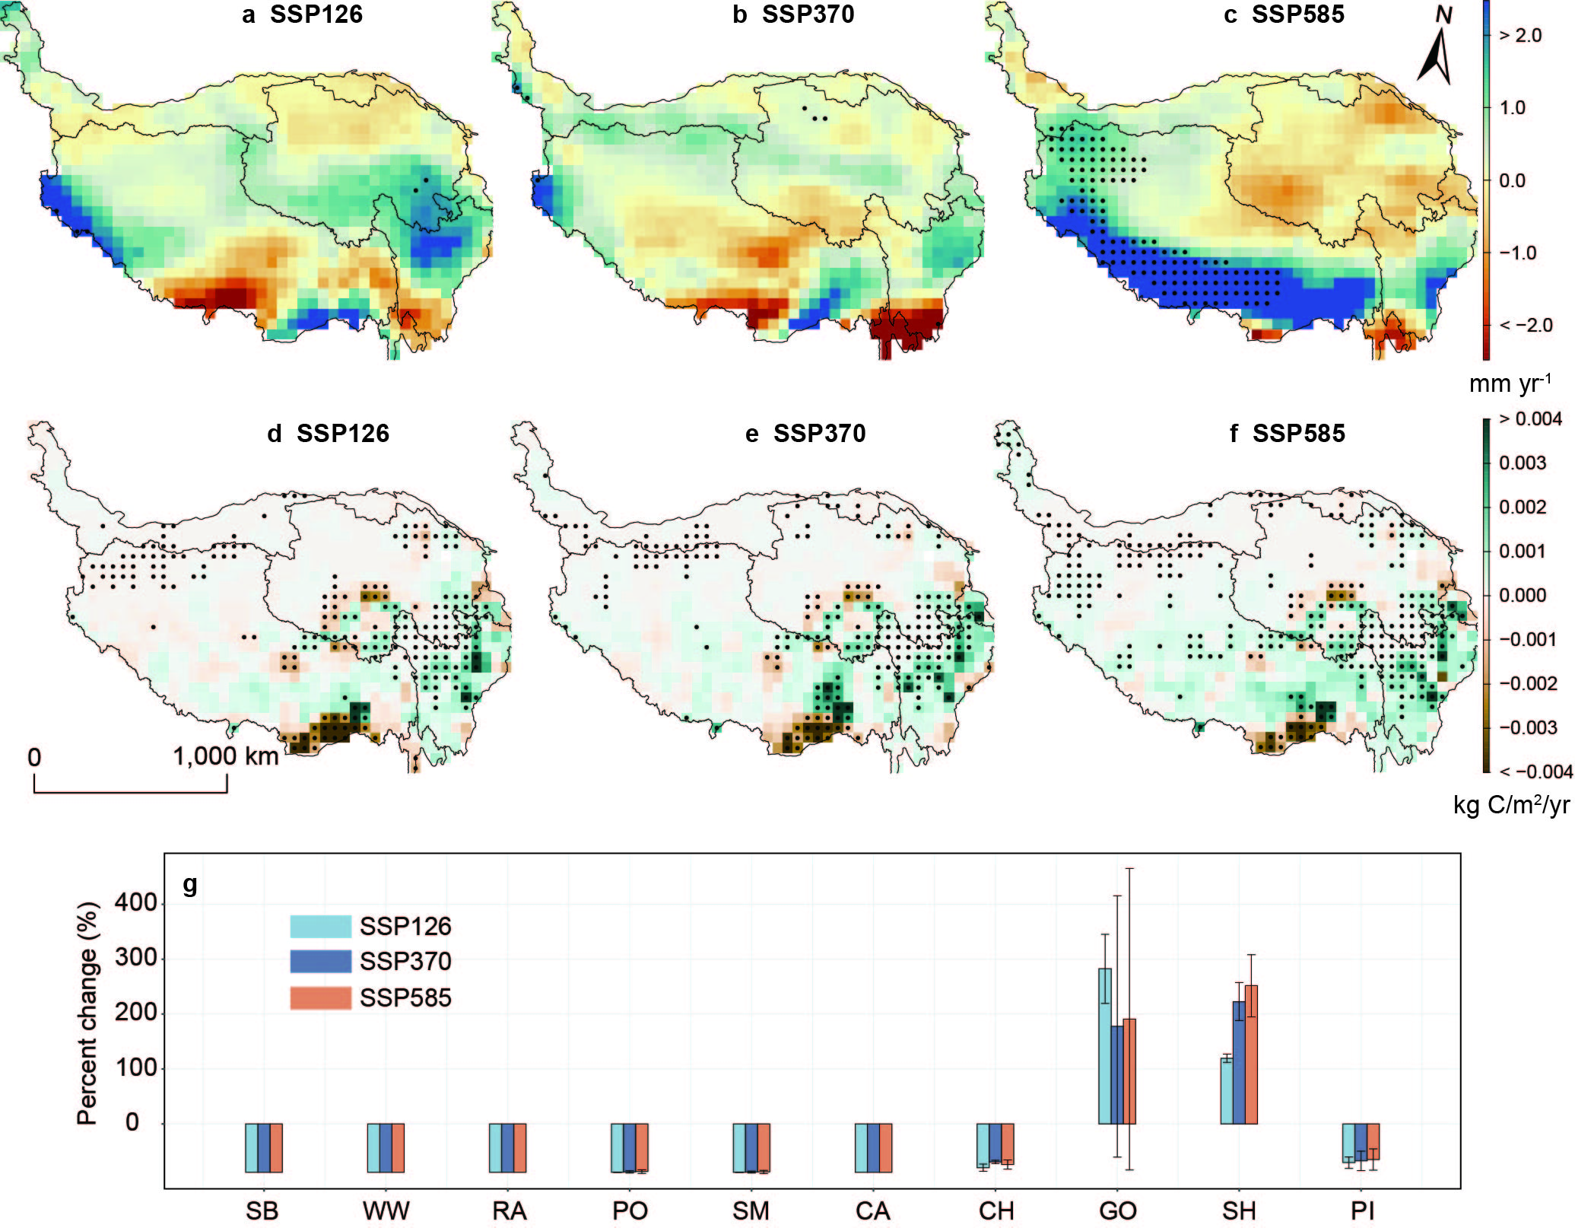

**Fig.5**