Break the political deadlock on drought through an integrated policy approach
Abstract
Globally, 80% of people are projected to be affected by drought by 2050, creating environmental, economic and societal risks that require urgent attention. The 16th United Nations Convention to Combat Desertification (UNCCD) Conference of the Parties (CoP16) held in Riyadh in December 2024, brought drought to the political foreground through proposals for a separate framework or protocol specifically targeting drought. However, the CoP16 negotiations ended in a deadlock. As the UNCCD’s post-2030 framework discussions begin in mid-2025, the possibility for an integrated policy approach to desertification, land degradation and drought under the UNCCD emerges. This paper explores what such an approach could entail. We argue that an integrated policy approach should be internally coherent, facilitate alignment with the goals of and successors to the Paris Agreement, Kunming-Montreal Global Biodiversity Framework, and the Sustainable Development Goals, and enable drought to be addressed as a cross-cutting issue, in line with its biophysical manifestations. Interlinked global challenges need long-term integrated governance and action.
Keywords: policy integration, land degradation, desertification, United Nations negotiations, water, risk

- Introduction
Globally, drought frequency and severity are intensifying (Walker & Van Loon, 2023) with their impacts increasingly felt by societies, ecosystems, economies and communities across continents (Toreti et al., 2024). Ethiopia is currently considered to be the most drought-stricken country in the world, with several other countries in the Horn of Africa (Somalia, Djibouti, Eritrea) ranking highly in terms of their drought risk scores (World Population Review, 2025). Nevertheless, drought is not confined to Africa. Recent devastating fires in early 2025 around Los Angeles in the United States were fuelled by a multi-year drought in California with exceptionally dry conditions (NOAA, 2025), with damages linked to these fires alone anticipated to reach billions of dollars. Similarly, in 2025, Europe has faced a particularly dry start to 2025 (Niranjan, 2025), with the European Drought Observatory reporting alert conditions in much of Southern and Central Europe, and watch conditions for several parts of the UK, Baltic Sea region and Scandinavia (JRC, 2025). By 2050, 80% of the world’s population is anticipated to be affected by drought, while today $307 billion USD of annual economic damage is attributed to the issue (Thomas et al, 2024). Scientists generally agree that an integrated, systems approach is required in addressing drought (Hagenlocher et al., 2023) but concerted, joined-up global policy attention is trailing behind the urgent need for action.
During the last quarter of 2024, Conferences of the Parties (CoPs) convened for each of the three major multilateral environmental agreements on climate change (UNFCCC- CoP29), biodiversity (CBD- CoP16) and desertification (UNCCD- CoP16). While drought disrupts progress towards the goals of each of these treaties, hopes were pinned on UNCCD CoP16 to deliver ambitious and agile global drought action. Cautious optimism that agreement would be reached at UNCCD CoP16 in Riyadh in December 2024 had been fuelled by a number of preparatory actions that laid a strong foundation for discussions. For example, drought had been included as a key focus in the UNCCD science-policy interface’s third biennial work programme (2018-2019), the UNCCD Intergovernmental Working Group on Drought (2022-2024) had identified policy options on drought, while publication of a 2024 report on the Economics of Drought (Thomas et al, 2024), and parallel initiatives such as the International Drought Resilience Alliance (led by Spain and Senegal) had raised awareness of the challenges caused by drought, globally. Together, these activities provided an evidence base for action and suggested the political urgency to tackle drought was being recognised. Political agreement at UNCCD CoP16 nevertheless failed to materialise, despite unprecedented engagement in the Conference (>20,000 participants) and pledges of > $12 billion USD, largely to tackle drought.
Negotiations stalled over the type of instrument to be developed and its legal status: a legally binding protocol or a non-legally binding framework. While the African Group made strong calls for a protocol, the US, EU and some Latin American countries made clear that while business-as-usual is not feasible, neither is a drought protocol (IISD, 2024). Proponents of a drought protocol argued that it would elevate the issue within the UNCCD and other international agendas, hold governments accountable, unlock new finance, set clear targets for action and confirm political commitments (Nyagi, 2024). Objectors however, argued that a drought protocol would take years to negotiate and involve significant costs, whereas a non-legally binding framework would be less costly and directly operational. Some also argued that since droughts have local causes and impacts a one-size-fits-all global policy is not the best solution (You, 2024), despite nationally differentiated approaches. UNCCD CoP16 concluded with only a procedural decision agreeing to continue discussions on drought at UNCCD CoP17 in 2026. Hardened political positions and a globally challenging context for multilateralism offer little indication that views will radically alter by then.
In this paper, we argue that drought needs to be tackled through a systems approach under the UNCCD’s Post-2030 Framework that will succeed the current UNCCD 2018–2030 Strategic Framework from 2030 onwards, and not in a separate framework or protocol. This is in keeping with Article 4 of the Convention, which encourages Parties to “adopt an integrated approach for addressing the physical, biological and socio-economic aspects of the processes of desertification and drought” (UNCCD, 1994). While a protocol or framework separate from the UNCCD’s post-2030 framework may initially increase visibility of drought, fragmenting the global governance of these challenges is not conducive to action and would likely exacerbate collaboration gaps and inefficiencies (Hamilton et al, 2021). We further consider the need for alignment with the UNFCCC’s Paris Agreement and the CBD’s Kunming-Montreal Global Biodiversity Framework (GBF) and their successors, as well as the post-2030 development agenda (SDGs+) given the cross-cutting nature of drought and the effects of desertification, land degradation and drought on progress toward the goals of all these agreements.
- The present governance landscape for addressing desertification, land degradation and drought
In terms of the present governance of desertification, land and drought as both separate and interlinked issues, several legally binding and non-legally binding global policies and other policy efforts exist at multiple levels. The key legally binding international agreement remains the UNCCD. The UNCCD covers each of desertification, land degradation and drought, as reflected in the Convention’s full title: the United Nations Convention to Combat Desertification in those countries experiencing serious drought and/or desertification, particularly in Africa. While academic debates continue over definitions, for operational purposes we employ those in the UNCCD (Article 1). Here, desertification is ‘land degradation in arid, semi-arid and dry sub-humid areas’ with land degradation referring to reduction or loss of ‘biological or economic productivity and complexity of rainfed cropland, irrigated cropland, or range, pasture, forest and woodlands.’ This definition makes it clear that desertification is closely linked to soil, water, vegetation and climate. Drought occurs ‘when precipitation has been significantly below normal recorded levels, causing serious hydrological imbalances that adversely affect land resource production systems’ (UNCCD, 1994).
The UNCCD’s implementation is currently guided by its 2018-2030 Strategic Framework, in which strategic objectives 1 and 2 particularly focus on land degradation and desertification, with objective 3 tackling drought. Desertification and land degradation are also addressed through voluntary goal-oriented frameworks (e.g. the Sustainable Development Goals (SDGs), Land Degradation Neutrality (LDN) targets and SDG target 15.3, and the Bonn Challenge), cross-sectoral funding and resourcing mechanisms (the programmes of the Global Mechanism, Global Environment Facility, and the LDN Fund), as well as regional initiatives (e.g. Great Green Wall, Terrafrica, Green Middle East Initiative), and cross-sectoral policies (e.g. EU policies, UK agri-schemes, China’s National Environment Programmes). Many of these efforts, including the UN Decade of Ecosystem Restoration, nevertheless focus on land aspects and landscape restoration (2021-2030), with less emphasis placed on integrating and tackling drought.
While Article 4 of the UNCCD encourages an integrated approach to desertification, land degradation and drought, Parties have interpreted it in different ways over the past 30 years, with some making progress towards drought management and others lagging behind. UNCCD Decision 29/COP.13 on ‘policy advocacy on drought’ in 2017 initiated a process for the Global Mechanism and UNCCD Secretariat to support Parties to develop national drought plans (UNCCD, 2017), following which, >70 countries are engaged in the development of national drought plans, with the 35 national drought plans available in English, French or Spanish showing that at least 33 national plans clearly pursue integrated approaches to addressing drought, yet differentiated according to their specific national circumstances.
African countries are developing national policies for integrated water resources management and climate resilience, with national drought plans in place or under development (e.g. in Ethiopia, Kenya, South Africa, Senegal, Ghana, Morocco). Early warning systems are being developed for drought using satellite technology, while other efforts are intensifying around climate-smart agriculture and soil conservation as well as fostering regional cooperation for watershed and water resource management. Asian efforts are focusing on national and regional policies for risk management and climate adaptation (with national drought management plans in place or under development in e.g. India, China, Pakistan, Iran, Indonesia), investments in water infrastructure and access, community training in water conservation, and the use of advanced technologies for climate prediction and monitoring. In Latin America and the Caribbean, progress is being made through legal frameworks and national strategies for climate adaptation focused on drought, promotion of agroforestry and sustainable agriculture, local water governance with community participation and regional cooperation for watershed management. Drought management plans have been developed or are in process in e.g. Mexico, Brazil, Argentina, Peru and Colombia. Beyond this, international organisations (e.g. the World Meteorological Organization (WMO) together with the Global Water Partnership’s Integrated Drought Management Progamme) have established initiatives to build drought resilience, but these lack the binding legal backdrop of multi-lateral environmental agreements. Overall, desertification and land degradation are relatively better covered in policies at a global and regional level and have stronger legal backing, while drought is underrepresented and has been highlighted as a major shortcoming in the UNCCD implementation process since its adoption in 1994 (Akhtar-Schuster et al., 2022). Together, the current situation points towards important but fragmented efforts to address drought, and the need for an integrated approach to desertification, land degradation and drought.
- The case for an integrated approach to desertification, land degradation and drought under the UNCCD
Globally, at least 3.2 billion people and an area of 1.5 billion hectares are affected by land degradation (IPBES, 2018), while >75 % of the Earth’s terrestrial area is drier today than it was three decades ago (Vicente-Serrano et al., 2024). Consequently, drylands have expanded by >3 %, or an area of about 4.3 million km^{2,} (Vicente-Serrano et al., 2024). In 2022 and 2023 alone, almost 25% of people worldwide (>1.8 billion people) were drought-affected, of whom 85 % were in low- and middle-income countries (Toreti et al., 2024). These statistics demonstrate that each of these issues alone is important. Yet, from a biophysical and environmental process perspective, even when examined at the most basic level, desertification, land degradation and drought cannot be separated.
Water inputs balance surface evaporation from land and vegetation surfaces, with dry areas prone to desertification facing a higher sensitivity to water input and output dynamics (Stringer et al., 2021). With prolonged drought, aridity and reduced rainfall, soil loses moisture, making it difficult for plants to grow. Resulting vegetation die-off weakens the soil structure (Gazol et al., 2018), reducing its water holding capacity, leaving it exposed to erosion. Erosion contributes to soil fertility losses, leaving the land unproductive (Xiong et al., 2024), feeding a vicious cycle that exacerbates water scarcity and the impacts of future droughts. Both individually and together, desertification, land degradation and drought act as important threat multipliers for climate change and biodiversity losses (Mirzabaev et al., 2022), with the potential for impacts to extend far beyond the geographical areas in which the drought occurs. Maladaptive responses to drought can also cause land degradation and desertification. For example, inter-basin water transfer projects offer a potential solution that involves the redistribution of water resources to ensure water stability and reduce drought risks. However, alongside the benefits from such efforts, the literature shows a diverse range of undesirable environmental, economic and social impacts from water transfer schemes (see e.g. Morote et al., 2017; Faúndez et al., 2023). Other drought adaptations such as water use restrictions are typically short-term but offer little to enhance long-term resilience and can create new vulnerabilities. These linkages suggest that any approach under the UNCCD should focus on all three topics within the scope of the Convention (desertification, land degradation and drought), maintaining its internal coherence, and offering an appropriate fit between system governance and the environmental processes that governance is seeking to manage (Young, 2002).
As well as being inseparable from one another, desertification, land degradation and drought are closely entwined with challenges of climate change and biodiversity loss. Climate change affects precipitation and temperatures, increasing aridity in many of the world’s drylands and acting as a drought risk multiplier (Stringer et al., 2021). Declines in plant species richness and critical shifts in their composition are triggered by drought, land use change, poor land management and reduction or fragmentation of habitats, as well as decreased soil biodiversity. Desertification, land degradation and drought, both individually and in combination, also have stark social and economic impacts that cut across geopolitical boundaries. For example, desertification, land degradation and drought can each play a role in fuelling human migration and displacement across a range of societal and economic settings (Hermans et al., 2023), in combination with multiple other drivers that exacerbate livelihood vulnerability (Birkmann et al., 2022; Stringer et al., 2021). Researchers are seeking to unravel the complex relationships between desertification, land degradation, drought and conflict (Mirzabaev et al., 2022), as well as their interplay with other development challenges, e.g. lack of clean water and sanitation, hunger, poverty, gender equality, health, education (Pradhan et al., 2017). Ensuring that the UNCCD’s post-2030 framework recognises the interface between drought and development will also be important given the importance of tackling drought in achieving the SDGs (Zhang et al., 2019) and in reducing disaster risks in line with the Sendai Framework on Disaster Risk Reduction, and because sustainable development can reduce the risk of future impacts from drought (Tabari and Willems, 2023).
Given the shared challenges that drought creates for the environment and human development, we emphasise the potential for co-benefits and synergy across the Rio Conventions in tackling drought under the UNCCD, appreciating that an appropriate interface will also be needed with the post-2030 development agenda, as well as successors to the other agreements for which progress is impeded by drought (Figure 1). Setting targets, measures, and desired outcomes including the interventions mentioned in the center of the Figure that can deliver co-benefits and synergy across the Rio Conventions, will benefit significantly from considering the achievements and shortcomings of ongoing international frameworks.

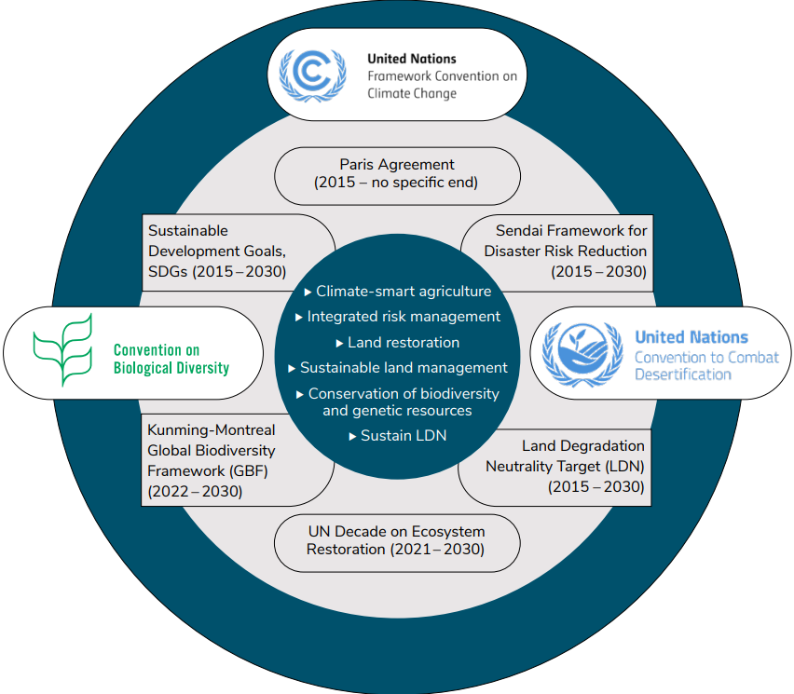
Figure 1: Key interfaces that need consideration in the UNCCD’s post-2030 strategic framework. Many frameworks and agreements have an end date of 2030, so their successors will also need consideration to harness synergy and co-benefits.

- Integration pays
From an economic standpoint, evidence demonstrates cost-effectiveness in an integrated policy approach where related issues and the interventions to address them are well aligned to deliver co-benefits and synergy. In Rwanda, coordinated land restoration leveraging synergies across the three Conventions and their respective national implementation plans can save implementation costs of approximately 45.6 million USD per year, largely by reducing transaction costs by >50 % (Mirzabaev et al., 2023). Coordinated action in Central Asia can save up to 7.9 billion USD or 24 % of the total land restoration investments needs of 33 billion USD between 2020 and 2050 (Mirzabaev et al., 2024). This evidence demonstrates that transaction costs for implementation are significant and substantial: 25 % of total costs in the case of land restoration in Rwanda. Fragmented implementation multiplies these costs, while integrated action has significant cost reduction potential.
Research further demonstrates the need to match ecosystem properties (and their biophysical relationships) with the characteristics of the institutions that govern them, recognising that the governance of sustainability challenges cannot be distinct from their social and environmental contexts (Bergsten et al., 2019). Addressing this requires assessment of the consequences of interactions across spatial and temporal scales (recognising that actions at one scale affect others), considering the linkages and coordination between institutions (Young, 2002).
Decision 4/COP.16 committed Parties to the UNCCD to establish an Intergovernmental Working Group on the Future Strategic Framework of the Convention. Decisions on the UNCCD post-2030 framework that will build from the work of this group are expected to support an effective framework to guide UNCCD implementation at the national level. Given the relationships and evidence presented above, we argue that future drought negotiations under the UNCCD could be brought back on track by focusing on the interactions between desertification, land degradation and drought, while recognising their relationships to biodiversity loss, climate change and development. Such an integrated approach would be both prudent and less resource intensive for all the Rio Conventions. It could be scientifically informed by the UNCCD’s science-policy interface (SPI), which is already mandated to collaborate with the Intergovernmental Panel on Climate Change (IPCC) and the Intergovernmental Science-Policy Platform on Biodiversity and Ecosystem Services (IPBES). Indeed, scientific evidence provided by the SPI has already supported the UNCCD's integrated and differentiated approach to addressing drought by encouraging Parties to consider the physical, biological and socio-economic aspects, while also encouraging further collaboration with strategic partners on drought (UNCCD, 2024).

- Foundational requirements for the UNCCD’s post-2030 framework
The UNCCD post-2030 framework will need to move away from project-based approaches that focus on single domains, instead taking a systemic, landscape view (Hagenlocher et al., 2023; Young 2002). This requires promoting coordinated decision-making and action at multiple temporal and spatial scales to align practices and policies that integrate ecological, social, and economic dimensions. Sustainable convergence will require continuous and stringent national coordination and the continuous development of capacities at all levels. Instruments such as integrated land use planning and integrated landscape management are already discussed within UNCCD fora and support national frameworks and process developments at multiple spatial levels, to anchor sustainable land use systems and thus to achieve and maintain land degradation neutrality.
The UNCCD post-2030 framework needs to maintain a set of core targets and a communicable focus, alongside more action-oriented targets specific to each of the dimensions of desertification, land degradation and drought, that would also map onto the targets and goals in the Paris Agreement and the GBF (Akhtar-Schuster et al., 2017; Chasek et al., 2019) with durations and deadlines that are aligned with successor agreements. In determining these targets and touch-points, the UNCCD will need to harness innovative and inclusive approaches that address the complexity of desertification, land degradation and drought in a nexus setting and which support the longer-term transformations needed to harness potential economic and resource efficiencies (Grumbine & Xu, 2021). This requires courageous, interconnected and durable governance at all levels, supported by proactive provisions that translate global targets into nationally appropriate actions. Efforts can be supported by monitoring systems that operate at multiple temporal and spatial scales, delivering information on shared targets and indicators across the Rio Conventions (Hughes et al., 2022; Gichuki et al., 2019).
Societal readiness may need to be built (van Loon et al., 2024), accepting that e.g. some areas currently used for agricultural production cannot be supported indefinitely to remain productive and profitable under increasing drought, given the strength of feedback between land, biodiversity and climate. It will likely demand livelihood transitions, planned and managed in an inclusive way (Fisher et al., 2022), to lessen the negative impacts of change on social and cultural values associated with agricultural land use (Parris et al., 2022; Reimer et al., 2013). This requires national level decision-makers to listen to local concerns, take a whole-of-society approach and ensure opportunities for all voices and knowledge types to contribute, including Indigenous and local knowledge (Akhtar-Schuster et al., 2024; Stringer et al., 2017). At the same time, an integrated approach will need to harness evidence-based transdisciplinary science alongside opportunities offered by new technologies, to mobilize awareness, provide critical inter-operable information and share data, as well as to effectively capture the potential efficiencies from integration (Bagstad et al., 2025). These foundational requirements are synthesized in Figure 2. Science and research will need to play an important role in supporting the generation, validation, and implementation of national and subnational data and knowledge to harmonize standards and promote participatory approaches to support the context-specific design, implementation, monitoring, and reporting of measures (Akhtar-Schuster et al., 2024).
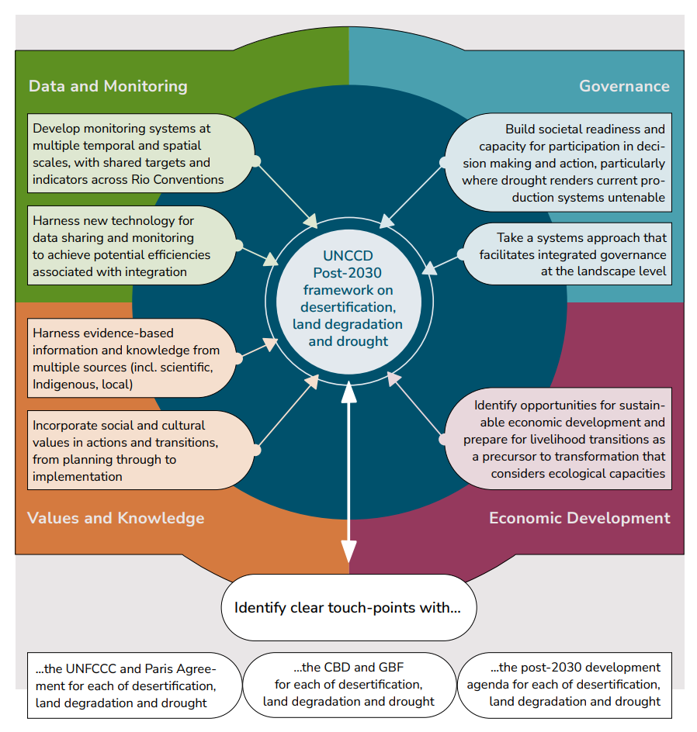
Figure 2: Foundational requirements for the UNCCD’s post-2030 framework to take an integrated approach to tackling desertification, land degradation and drought
- Conclusion
Without policy integration to tackle drought, the world will persist in committing resources to produce more of the same. The need for action has never been greater or more urgent. Transformation is no longer optional but a necessity, otherwise the vicious cycle of desertification, land degradation and drought will continue to amplify biodiversity loss and climate change, undermining human wellbeing and development. Current political discussions and CoP17 need to mobilize transformative action on drought by improving efficiency and effectiveness in its governance, unlocking investment through a global, ambitious, actionable UNCCD post-2030 framework in which drought is a core component. Calls for a separate protocol or framework on drought should be set aside.
- References
Akhtar-Schuster, M., Stringer, L.C., Barger, N. (2024). Fast-tracking action on the Sustainable Development Goals by enhancing national institutional arrangements. PLoS One, 19, e0298855. https://doi.org/10.1371/journal.pone.0298855
Akhtar-Schuster, M., Stringer, L.C., Metternicht, G., Barger, N.N., Chotte, J.-L., Kust, G. (2022). Assessing the Impact of Science in the Implementation of the United Nations Convention to Combat Desertification. Land, 11, 568. https://doi.org/10.3390/land11040568
Akhtar-Schuster, M., Stringer, L.C., Erlewein, E., Metternicht, G., Minelli, S., Safriel, U., Sommer, S. (2017). Unpacking the concept of land degradation neutrality and addressing its operation through the Rio Conventions. Journal of Environmental Management 195 (1) 4-15. http://dx.doi.org/10.1016/j.jenvman.2016.09.044
Bagstad, K.J. Balbi, S., Adamo, G., Athanasiadis, I. N., Affinito, F., Willcock, S., Magrach, A., Hayashi, K., Harmáčková, Z. V., Niamir, A., Smets, B., Buchhorn, M., Drakou, E. G., Alfieri A., Edens, B., Gonzalez Morales, L., Vári, A., Sanz, M.-J., Villa. F. (2025). Interoperability for ecosystem service assessments: Why, how, who, and for whom? Ecosystem Services, 72, 101705. https://doi.org/10.1016/j.ecoser.2025.101705
Bergsten, A., Jiren, T.S., Leventon, J., Dorresteijn, I., Schultner, J., Fischer, J. (2019). Identifying governance gaps among interlinked sustainability challenges. Environmental Science & Policy 91, 27-38. https://doi.org/10.1016/j.envsci.2018.10.007.
Birkmann, J., E. Liwenga, R. Pandey, E. Boyd, R. Djalante, F. Gemenne, W. Leal Filho, P.F. Pinho, L. Stringer, and D. Wrathall, 2022: Poverty, Livelihoods and Sustainable Development. In: Climate Change 2022: Impacts, Adaptation, and Vulnerability. Contribution of Working Group II to the Sixth Assessment Report of the Intergovernmental Panel on Climate Change [H.-O. Pörtner, D.C. Roberts, M. Tignor, E.S. Poloczanska, K. Mintenbeck, A. Alegría, M. Craig, S. Langsdorf, S. Löschke, V. Möller, A. Okem, B. Rama (eds.)]. Cambridge University Press, Cambridge, UK and New York, NY, USA, pp. 1171-1274, doi:10.1017/9781009325844.010.
Chasek, P., Akhtar-Schuster, M., Orr, B.J., Luise, A., Ratsimba, H. R., Safriel U. (2019). Land degradation neutrality: The science-policy interface from the UNCCD to national implementation. Environmental Science & Policy, 92, 182-190. https://doi.org/10.1016/j.envsci.2018.11.017
Faúndez, M., Alcayaga, H., Walters, J., Pizarro, A., Soto-Alvarez, M. (2023). Sustainability of water transfer projects: A systematic review. Science of the Total Environment 860, 160500. https://doi.org/10.1016/j.scitotenv.2022.160500
Fisher, E., Brondizio, E., Boyd, E. (2022). Critical social science perspectives on transformations to sustainability. Current Opinion in Environmental Sustainability, 55, 101160. https://doi.org/10.1016/j.cosust.2022.101160
Gazol, A., Camarero, J.J., Jiménez, J.J., Moret-Fernández, D., López, M.V., Sangüesa-Barreda, G., Igual, JM. (2018). Beneath the canopy: Linking drought-induced forest die off and changes in soil properties. Forest Ecology and Management 422: 294-302 https://doi.org/10.1016/j.foreco.2018.04.028
Gichuki, L., Brouwer, R., Davies, J., Vidal, A., Kuzee, M., Magero, C., Walter, S., Lara, P., Oragbade, C., Gilbey, B. (2019). Reviving land and restoring landscapes. IUCN. ISBN: 978-2-8317-1991-7
Grumbine, R.E., Xu, J. (2021). Five Steps to Inject Transformative Change into the Post-2020 Global Biodiversity Framework. Bioscience 71, 637-646. https://doi.org/10.1093/biosci/biab013
Hagenlocher, M., Naumann, G., Meza, I., Blauhut, V., Cotti, D., Döll, P., Ehlert, K., Gaupp, F., Van Loon, A. F., Marengo, J. A., Rossi, L., Sabino Siemons, A. S., Siebert, S., Tsehayu, A. T., Toreti, A., Tsegai, D., Vera, C., Vogt, J., Wens, M. (2023). Tackling Growing Drought Risks—The Need for a Systemic Perspective. Earth's Future 11, e2023EF003857. https://doi.org/10.1029/2023EF003857.
Hamilton, M., Fischer, A.P., and Jasny, L. (2021). Bridging collaboration gaps in fragmented environmental governance systems. Environmental Science & Policy 124, 461-470. https://doi.org/10.1016/j.envsci.2021.07.014.
Hermans, K., Müller, D., O’Byrne, D., Olsson, L., Stringer, L.C. (2023). Land degradation and migration. Nature Sustainability, 6, 1503-1505 https://doi.org/10.1038/s41893-023-01231-4
Hughes, A., Xiaoli, S., Corlett, R., Li, L., Luo, M., Woodley, S., Zhang, Y., Ma, K. (2022). Challenges and possible solutions to creating an achievable and effective Post-2020 Global Biodiversity Framework. Ecosystem Health and Sustainability, 8, 2124196. https://doi.org/10.1080/20964129.2022.2124196
IISD (2024). Summary report, 2–13 December 2024, 16th Session of the Conference of the Parties to the UNCCD (COP 16). https://enb.iisd.org/convention-combat-desertification-unccd-cop16-summary.
IPBES. (2018). The IPBES assessment report on land degradation and restoration. Bonn, Germany.
JRC. (2025). European and Global Drought Observatories: Current Drought Situation in Europe. https://joint-research-centre.ec.europa.eu/european-and-global-drought-observatories/current-drought-situation-europe_en Accessed 30 June 2025. Online.
Mirzabaev, A., Bisom, N., Kruse, J., Akramkhanov, A., Ingabire, C. (2024). Making use of synergies from integrated land-climate-biodiversity action pays off. Rural 21: The International Journal for Rural Development. Land Matters, 2pp.
Mirzabaev, A., L.C. Stringer, T.A. Benjaminsen, P. Gonzalez, R. Harris, M. Jafari, N. Stevens, C.M. Tirado, and S. Zakieldeen, 2022: Cross-Chapter Paper 3: Deserts, Semi-Arid Areas and Desertification. In: Climate Change 2022: Impacts, Adaptation, and Vulnerability. Contribution of Working Group II to the Sixth Assessment Report of the Intergovernmental Panel on Climate Change [H.-O. Pörtner, D.C. Roberts, M. Tignor, E.S. Poloczanska, K. Mintenbeck, A. Alegría, M. Craig, S. Langsdorf, S. Löschke, V. Möller, A. Okem, B. Rama (eds.)]. Cambridge University Press, Cambridge, UK and New York, NY, USA, pp. 2195-2231, doi:10.1017/9781009325844.020
Mirzabaev A., Tello Leon, C., Dzudzor, M., Satoyama, T., Ingabire, C. (2023). Economics of Harmonizing Land Restoration Activities across the Rio Conventions in Rwanda and Implications for Food Security, Economics of Land Degradation Initiative, Bonn, Germany.
Morote, Á.-F., Olcina, J., Rico, A.-M. (2017). Challenges and Proposals for Socio-Ecological Sustainability of the Tagus–Segura Aqueduct (Spain) under Climate Change. Sustainability, 9(11), 2058. https://doi.org/10.3390/su9112058
Niranjan, A. (2025). ‘It’s a critical time’: European farmers struggle through driest spring in a century, The Guardian, UK. https://www.theguardian.com/environment/2025/may/22/its-a-critical-time-european-farmers-struggle-through-driest-spring-in-a-century, Accessed 30 May 2025 (online).
NOAA. (2025). Monthly Drought Report for Annual 2024. National Centers for Environmental Information. https://www.ncei.noaa.gov/access/monitoring/monthly-report/drought/202413. Accessed 26 June 2025 (online).
Nyagi, D. (2024). Gridlock as Riyadh CO16 fails to deliver drought protocol deal. African Climate Wire https://africanclimatewire.org/2024/12/gridlock-as-riyadh-cop16-fails-to-deliver-drought-protocol-deal/ Accessed 17 August 2025 (online).
Parris, H., Sorman, A.H., Valor, C., Tuerk, A., Anger-Kraavi, A. (2022). Cultures of transformation: An integrated framework for transformative action. Environmental Science & Policy, 132, 24-34. https://doi.org/10.1016/j.envsci.2022.02.008
Pradhan, P., Costa, L., Rybski, D., Lucht, W., Kropp, J.P. (2017). A Systematic Study of Sustainable Development Goal (SDG) Interactions. Earth's Future, 5, 1169-1179. https://doi.org/10.1002/2017EF000632
Reimer, M. (2013). Planning Cultures in Transition: Sustainability Management and Institutional Change in Spatial Planning. Sustainability, 5, 4653-4673. https://doi.org/10.3390/su5114653
Stringer LC, Mirzabaev A., Benjaminsen TA, Harris RMB, Jafari M, Lissner TK, Stevens N, Tirado-von der Pahlen C. (2021). Climate change impacts on water security in global drylands. One Earth 4 (6) 851-864. https://doi.org/10.1016/j.oneear.2021.05.010
Stringer, L.C., Reed, M.S., Fleskens, L., Thomas, R. J., Quang, B. L., Lala-Pritchard, T. (2017). A New Dryland Development Paradigm Grounded in Empirical Analysis of Dryland Systems Science. Land Degradation & Development, 28, 1952-1961. https://doi.org/10.1002/ldr.2716
Tabari, H., Willems, P. (2023). Sustainable development substantially reduces the risk of future drought impacts. Communications Earth & Environment, 4, 180. https://doi.org/10.1038/s43247-023-00840-3
Thomas, R., Davies, J., King, C., Kruse, J., Schauer, M., Bisom, N., Tsegai, D., Madani, K. (2024). Economics of Drought: Investing in Nature-Based Solutions for Drought Resilience – Proaction Pays. A joint report by UNCCD, ELD Initiative and UNU-INWEH. Bonn, Germany; Toronto, Canada.
Toreti, A., Tsegai, D., Rossi, L. (2024). World Drought Atlas. Publications Office of the European Union. https://doi.org/10.2760/3842670
UNCCD. (1994). United Nations Convention to Combat Desertification in those countries experiencing serious drought and/or desertification, particularly in Africa, Bonn, Germany.
UNCCD. (2017). Report of the Conference of the Parties on its thirteenth session. ICCD/COP(13)/21/Add.1.
UNCCD. (2024). Follow-up on policy frameworks and thematic issues: Drought. ICCD/COP(16)/15.
Van Loon, A. F., Kchouk, S., Matanó, A., Tootoonchi, F., Alvarez-Garreton, C., Hassaballah, K. E. A., Wu, M., Wens, M. L. K., Shyrokaya, A., Ridolfi, E., Biella, R., Nagavciuc, V., Barendrecht, M. H., Bastos, A., Cavalcante, L., de Vries, F. T., Garcia, M., Mård, J., Streefkerk, I. N., Teutschbein, C., Tootoonchi, R., Weesie, R., Aich, V., Boisier, J. P., Di Baldassarre, G., Du, Y., Galleguillos, M., Garreaud, R., Ionita, M., Khatami, S., Koehler, J. K. L., Luce, C. H., Maskey, S., Mendoza, H. D., Mwangi, M. N., Pechlivanidis, I. G., Ribeiro Neto, G. G., Roy, T., Stefanski, R., Trambauer, P., Koebele, E. A., Vico, G., and Werner, M.: Review article: Drought as a continuum – memory effects in interlinked hydrological, ecological, and social systems, Nat. Hazards Earth Syst. Sci., 24, 3173–3205, https://doi.org/10.5194/nhess-24-3173-2024.
Vicente-Serrano, S.M., Pricope, N. G., Toreti, A., Morán-Tejeda, E., Spinoni, J., Ocampo-Melgar, A., Archer, E., Diedhiou, A., Mesbahzadeh, T., Ravindranath, N. H., Pulwarty R. S., Alibakhshi, S. (2024). The Global Threat of Drying Lands: Regional and global aridity trends and future projections. A Report of the Science-Policy Interface United Nations Convention to Combat Desertification (UNCCD). Bonn, Germany.
Walker, D.W., Van Loon, A.F. (2023). Droughts are coming on faster. Science 380, 130-132. https://doi.org/10.1126/science.adh3097
World Population Review. (2025). Droughts by Country. https://worldpopulationreview.com/country-rankings/droughts-by-country. Accessed 30 May 2025 (online)
Xiong, J., Wu, H., Wang, X., Ma, R., Lin, C. (2024). Response of soil fertility to soil erosion on a regional scale: A case study of Northeast China. Journal of Cleaner Production 434 140360 https://doi.org/10.1016/j.jclepro.2023.140360
You, X. (2024). As Earth dries out, countries fail to reach drought agreement. Climate Home News. https://www.climatechangenews.com/2024/12/16/as-earth-dries-out-countries-fail-to-reach-drought-agreement/ Accessed 17 August 2025 (online)
Young, O.R. (2002). The Institutional Dimensions of Environmental Change: Fit, Interplay, and Scale (The MIT Press). https://doi.org/10.7551/mitpress/3807.001.0001
Zhang, X., Chen, N., Sheng, H., Ip, C., Yang, L., Chen, Y., Sang, Z., Tadesse, T., Lim, T. P. Y., Rajabifard, A., Bueti, C., Zeng, L., Wardlow, B., Wang, S., Tang, S., Xiong, Z., Li, D., Niyogi, D. (2019). Urban drought challenge to 2030 sustainable development goals. Science of The Total Environment, 693, 133536. https://doi.org/10.1016/j.scitotenv.2019.07.342

8. Conflict of interest statement
The third author was notified (July 2025) that they have been selected as a member of the UNCCD Intergovernmental Working Group for the Future Strategic Framework (the post-2030 framework).

9. Acknowledgements
Thank you to Christine Nau for help with designing the Figures and to the reviewers for their comments in strengthening our paper. Figure 1 was inspired by discussions at the side event on “Enhancing Capacity for Synergistic Rio Conventions Implementation” at the UNFCCC Conference of the Subsidiary Body for Scientific and Technological Advice and the Subsidiary Body for Implementation (SB 62) in June 2025 in Bonn, Germany, chaired by the representative of the Rio Conventions Joint Capacity-building Programme (see: https://unfccc.int/topics/capacity-building/projects/rio-conventions-joint-capacity-building-programme).

