Effects of land-use change on soil total carbon pool: a meta-analysis
Zhuobing Ren^{1,2}, Changjia Li^{1,2*}, Shuai Wang^{1,2}, Wenxin Zhou^{1,2,3}, Lindsay C. Stringer^{4,5}, Bojie Fu⁶
1. State Key Laboratory of Earth Surface Processes and Disaster Risk Reduction (ESPDRR), Faculty of Geographical Science, Beijing Normal University, Beijing, China
2. Institute of Land Surface System and Sustainable Development, Faculty of Geographical Science, Beijing Normal University, Beijing, China
3. School of Agriculture, Food and Ecosystem Sciences, Faculty of Science, University of Melbourne, Melbourne, Australia
4. Department of Environment and Geography, University of York, York, UK
5. York Environmental Sustainability Institute, University of York, York, UK
6. State Key Laboratory of Urban and Regional Ecology, Research Center for Eco-Environmental Sciences, Chinese Academy of Sciences, Beijing, China

*Corresponding author: changjia.li@bnu.edu.cn

Abstract
Soil carbon is crucial for plant growth, agricultural productivity, and ecosystem functions as it provides essential nutrients and improves soil structure. Land-use change is widely recognized to have a profound effect on the soil carbon pool. However, there remains a lack of comprehensive understanding regarding the global response of soil total carbon, which includes both organic and inorganic carbon, to such changes. Here, we present a thorough assessment of the impact of land-use change on soil total carbon through a pairwise comparative meta-analysis of 1033 paired observations from 73 sites across six continents. These sites encompass covering six major land-use changes: forest to cropland (FC), grassland to cropland (GC), cropland to forest (CF), cropland to grassland (CG), sandy land to forest (SF), and grassland to forest (GF). Contrary to expectations, FC and GC were not found to have a significant adverse effect on soil total carbon (lnRR₊₊ < 0.05). Similarly, restoration from CF and CG did not result in the anticipated significant increase in soil total carbon (lnRR₊₊ ~0.08), largely due to the offsetting effects of organic and inorganic carbon. Afforestation in sandy land (SF) significantly increased soil total carbon, whereas its impact on grasslands (GF) was not significant. The effects of SF and FC on soil total carbon become more pronounced with higher precipitation levels. Conversely, the effect of CF on soil total carbon diminishes with rising temperatures. Additionally, the impact of GC and CG on total carbon increased with both the depth and duration of the change. These findings underscore the complexity of soil total carbon responses to various land-use changes and environmental factors, and highlight the necessity of incorporating soil total carbon assessments in carbon storage evaluations and land-use change modelling, particularly in the context of intensifying climate change and human activities.

Keywords: land management, soil organic carbon, soil inorganic carbon, driving factors

Introduction
Soil total carbon, which comprises both soil organic carbon and soil inorganic carbon, represents the largest carbon pool in terrestrial ecosystems (Batjes, 1996; Lal, 2004). Within the top 1 meter of soil, it is estimated that soil carbon stocks amount to 1425 Pg, while soil inorganic carbon stocks are approximately 686 Pg (Plaza et al., 2018). Comparatively, the carbon stored in soil exceeds the amount found in the atmosphere by over three times and surpasses that in vegetation by four times (Pütz et al., 2014; Lal, 2018). Thus, changes in soil total carbon are critical to the global carbon cycle. Land-use change is globally essential for mitigating the challenges arising from climate change (Arneth et al., 2014; Popp et al., 2014), overpopulation (Yang et al., 2023), and the expansion of agricultural and industrial activities (Lambin and Meyfroidt, 2011). Globally, land is distributed across various categories, with cropland covering approximately 1.57 billion hectares (ha), grasslands 3.23 billion ha, forest areas 4.06 billion ha, and deserts 1.75 billion ha (Chen et al., 2023; FAO, 2025). Within Asia, these figures are approximately 0.58 billion ha for cropland, 1.08 billion ha for grasslands, 0.62 billion ha for forests, and 0.65 billion ha for deserts. Land-use changes in these areas, are significantly impacting soil carbon pools (Song et al., 2022; Beillouin et al., 2023). Such changes, including the expansion of cultivation, large-scale ecological restoration and ambitious afforestation initiatives (Li et al., 2021), directly influence vegetation coverage, type, productivity, and basic soil physical and chemical properties. Consequently, these alterations, in turn, markedly affect the distribution patterns and stocks of soil carbon (Guo and Gifford, 2002; Shi et al., 2024). The intricate nature of carbon cycling across various land-use systems complicates the understanding of these dynamics. Although numerous studies have investigated the impacts of land-use change on soil organic carbon (Sanderman et al., 2017; Yang et al., 2019; Hong et al., 2020) and on inorganic carbon (Hong and Chen, 2022; Song et al., 2022; Liu et al., 2023b) separately, a comprehensive assessment of soil carbon dynamics under land-use change remains elusive. This challenge is primarily due to technical difficulties in accurately measuring and distinguishing between carbon pools, particularly inorganic carbon, throughout the soil profile. These challenges are especially pronounced in circum-neutral soils, where the interactions between land-use changes and soil total carbon are complex. Consequently, our understanding of the effects of land-use change on soil total carbon is limited. Despite these challenges, acquiring such knowledge is essential, as it can inform land-use and management strategies, providing insights and guidance for future carbon sequestration efforts.
Previous research indicates that land-use change exerts distinct effects on soil organic and inorganic carbon. For example, the conversion of natural ecosystems to croplands typically results in significant losses of soil organic carbon (Don et al., 2011; Beillouin et al., 2023), while it may lead to the accumulation of soil inorganic carbon in specific regions (An et al., 2019). Soil inorganic carbon is formed from cations and dissolved inorganic carbon in the soil, which can also be re-dissolved in water and either run off or emit CO₂ into the atmosphere through processes such as soil acidification and irrigation (Sanderman, 2012; Song et al., 2022). In contrast, transitioning from croplands to grasslands and forests may partially restore organic carbon stock (Yang et al., 2019) but may reduce inorganic carbon stocks (Liu et al., 2023a). While afforestation is widely recognized for enhancing organic carbon levels, some studies suggest it may also reduce soil inorganic carbon under certain conditions (Hong and Chen, 2022). These contrasting patterns in soil carbon dynamics associated with land use change have been substantiated by numerous meta-analyses, which consistently demonstrate that the conversion of natural ecosystems to cropland leads to substantial declines in soil carbon stocks (Guo and Gifford, 2002; Don et al., 2011; Deng et al., 2016; Tang et al., 2019; Huang et al., 2024). Conversely, ecological restoration and afforestation have been shown to increase soil carbon stocks, primarily focusing on the organic fraction (Shi and Han, 2014; Li et al., 2023; Tian et al., 2023; Guo et al., 2024; He et al., 2024). Although Liu et al. (2023a) considered both organic and inorganic carbon, their analysis was restricted to restoration scenarios and did not address the broader net effects of diverse land-use changes on soil total carbon. Such divergent effects are driven by a complex interplay of factors, including soil disturbance from tillage that accelerates organic carbon erosion and consumption (Juricová et al., 2025; Liu et al., 2025), irrigation that modifies soil moisture and ion composition (Entry et al., 2004), and alterations in vegetation structure and soil pH that regulate carbon stabilization processes and carbonate formation (Hong and Chen, 2022).
Despite this substantial body of work, individual studies have yet to fully elucidate the overall impact of land-use changes - such as cultivation, restoration, and afforestation - on the soil carbon pool, particularly concerning total carbon. This gap in understanding highlights the need for a comprehensive analysis that considers the simultaneous effects on both carbon pools. Additionally, numerous factors such as climate change (particularly changes in precipitation and temperature), lag times (duration of carbon losses/gains post-land-use change), and variability with soil depth (An et al., 2019; Tang et al., 2019; Hong et al., 2020; Tian et al., 2023), further complicate this uncertainty and can lead to contrasting effects on organic or inorganic carbon for the same land-use change. The specific regulation by these factors, modulating the effects of land-use change on soil total carbon remains unexplored, hindering our ability to predict the overall extent of changes in the carbon cycle driven by land-use change, and to develop appropriate management strategies.
We hypothesize that the conversion of land to cropland will significantly reduce soil total carbon, while ecological restoration and afforestation will significantly increase it. To test these hypotheses, we conducted a synthesis of findings from 55 publications comprising 1033 observations, spanning all continents except Antarctica and encompassing a wide range of climate zones. Our comprehensive review, which included all pertinent literature available up to 2023, examined both organic and inorganic carbon responses to land-use changes. We also considered factors such as climatic conditions, soil depth (0-100 cm), and the duration following land-use changes to assess their impacts. From the database, we identified six primary types of land-use changes, including transitioning i) from grassland to cropland (GC); ii) from forest to cropland (FC); iii) from cropland to grassland (CG); iv) from cropland to forest (CF); v) from grassland to forest (GF); and vi) from sandy land to forest (SF). The objectives of this study were to: (1) examine the response of soil total carbon to land-use changes; (2) investigate how various factors influence the effects of land-use changes on soil total carbon; and (3) determine the key factors affecting the impacts of different land-use changes on soil total carbon.

Materials and methods
2.1 Data collection
An extensive literature review was conducted for peer-reviewed journal articles published up to December 2022 using both the Web of Science and the China National Knowledge Resource Integrated databases. Our search strategy involved a comprehensive set of keywords, including ‘land use’ or ‘land-use change’ or ‘afforestation’ or ‘vegetation restoration’ or ‘cultivation’ or ‘land degradation’ or ‘farming’ or ‘grain-for-green’ or ‘grain-for-tree’ or ‘land desertification’ or ‘plantation’ and ‘soil inorganic carbon’ and ‘soil carbon’. This strategic selection ensures extensive coverage of studies examining the impacts of cropland expansion, ecological restoration, and afforestation on soil total carbon. Due to the limited literature on inorganic carbon, we excluded ‘soil organic carbon’ as a keyword to expedite the selection of studies on both organic and inorganic carbon. Articles were selected based on the following criteria: i) the soil organic, inorganic, and total carbon data for both experimental and control groups were explicitly reported in the literature and could be determined as data before and after land-use change at the same location; ii) the means and standard deviations or standard errors, coefficient of variation, and sample sizes could be extracted; and iii) multiple soil sampling depths and time since planting or restoration were considered as independent studies. When visual representations of data were utilized, the numerical information was extracted and digitized using the Get Data Graph Digitizer (version 2.24). We initially collected over 2,000 articles. To ensure the relevance and quality of the data, we retained only those articles that included empirical soil carbon stock data and control groups, while removing duplicates and studies lacking statistical data. After applying these criteria, we ultimately selected 55 peer-reviewed articles (Fig 1), encompassing a total of 1033 observations across 73 sites, which conformed to our stipulated criteria from various regions worldwide (Fig. 2). The number of soil samples per location is presented in Table S1. Due to the low inorganic carbon content in paddy field soil, this study primarily examined observations from upland fields (Table S2) and discussed the results accordingly.
Due to the similarity in history, topography, climate, soil formation processes, original vegetation, natural succession, or human disturbance between adjacent land and study land, and because adjacent land still retains its original vegetation and has a similar soil condition and initial condition to the original land, adjacent land is approximated as the soil state of the study land before land-use change. Therefore, the space-for-time substitution method was used to obtain the carbon response of the same land before and after land-use change. The literature selected in this study includes directly observed or indirectly obtained paired data of the three types of carbon using the space-for-time substitution method.
For all peer-reviewed papers found, the compilation also collected the following information: data source, author, latitude and longitude, climate (climate type, mean annual precipitation [MAP], mean annual temperature [MAT], and potential evapotranspiration), land use conversion type, time since land-use change, soil depth, soil pH, and soil classification. For groups with different precipitation, temperature, soil depth and age, we used averages to homogenize soil carbon data. Given the diverse depth studied in the literature, we categorized them into two groups: 0-30 cm and 30-100 cm, to highlight the differences in responses between topsoil and subsoil. Six major types of land-use changes were filtered from all observations: GC, FC, CG, CF, GF, and SF. The major soil classifications and pH ranges across the reviewed studies are summarized in Table S3.

2.2 Data analysis
In our dataset, in addition to the directly available soil organic carbon, inorganic carbon, and total carbon stocks, other data provide the concentration, depth, and bulk density of soil carbon. The stocks of organic and inorganic carbon can be calculated using the following equations (Guo and Gifford, 2002):
$$\begin{aligned}SOC=0.1×C_{SOC}×BD×D\#\left(1\right)\end{aligned}$$
$$\begin{aligned}SIC=0.1×C_{SIC}×BD×D\#\left(2\right)\end{aligned}$$
where $SOC$ and $SIC$ are soil organic and inorganic carbon stocks (Mg ha⁻¹); $C_{SOC}$ and $C_{SIC}$ are soil organic and inorganic carbon concentration (g kg⁻¹); BD is soil bulk density (g cm⁻³); and D is the thickness of the horizon (cm). Furthermore, soil total carbon stock (Mg ha⁻¹) was calculated using the following equation (3):
$$\begin{aligned}STC=SOC+SIC\#\left(3\right)\end{aligned}$$
Responses of soil organic, inorganic and total carbon to land-use change were determined using meta-analysis (Fig. 3). The effect of land-use change for each observation was assessed using the response ratio (RR), defined as the natural logarithm of the ratio between the mean value of the variable in the treatment group and that in the control group (Hedges et al., 1999):
$$\begin{aligned}lnRR=\ln{({\overline{X_{t}}}/{\overline{X_{c}}})}=\ln\left(\overline{X_{t}}\right)-\ln\left(\overline{X_{c}}\right)\#\left(4\right)\end{aligned}$$
where $\overline{X_{t}}$ and $\overline{X_{c}}$ are the mean values of the relevant variable in the treatment (current land use) and control (original land use) groups, respectively. The corresponding variance (V) of each RR is calculated as:
$$\begin{aligned}V=\frac{S_{t}^{2}}{n_{t}\overline{X_{t}^{2}}}+\frac{S_{c}^{2}}{n_{c}\overline{X_{c}^{2}}}\#\left(5\right)\end{aligned}$$
where $S_{t}$, $S_{c}$, $n_{t}$, $n_{c}$, $\overline{X_{t}}$, $\overline{X_{c}}$ are the standard deviation, sample size, and sample mean in the treatment and control groups, respectively (Hedges et al., 1999). The square of the sample mean is used as a coefficient for standardization. Although variations in soil carbon measurement techniques could influence the absolute values, calculating lnRR minimizes potential bias arising from different analytical methods when assessing effects across the reviewed studies.
A random effects model was used to estimate the average weighted response ratio for each pairwise comparison between the treatment and control groups, $lnRR_{++ij}$ (i = 1,2,3…m; j = 1,2,3…k) calculated as:
$$\begin{aligned}{lnRR}_{++}=\frac{\sum_{i=1}^{m}{\sum_{j=1}^{k}{w_{ij}{RR}_{ij}}}}{\sum_{i=1}^{m}{\sum_{j=1}^{k}{w_{ij}}}}\#\left(6\right)\end{aligned}$$
where m is the number of groups (different land-use changes, soil sampling depth, precipitation, temperature, and time); k is the number of pairs (the number of lnRR); w is the inverse of the variance (w_{ij} = 1 / V_{ij}), which is also considered as the weight of lnRR (Borenstein et al., 2009). The formula for calculating the standard error of lnRR₊₊ is:
$$\begin{aligned}SE\left({lnRR}_{++}\right)=\sqrt{\frac{1}{\sum_{i=1}^{m}{\sum_{j=1}^{k}{w_{ij}}}}}\#\left(7\right)\end{aligned}$$
The "metafor" package in R 4.3.2 was used to calculate the natural logarithm of lnRR for individual and combined treatments, while also providing the standard error and significance level of lnRR. The formula for calculating the proportion of variation in the variables is as follows:
$$\begin{aligned}Change \left(\%\right)=\left[\exp\left(ln{RR}_{++}\right)-1\right]×100\%\#\left(8\right)\end{aligned}$$
The "rfPermute" package in R was then used to calculate the relative importance of each factor (MAP, MAT, soil depth, and time) under each type of land-use change, for soil organic, inorganic, and total carbon.

Results
3.1 Effects of six land-use changes on soil total carbon
Overall effects on soil total carbon varied across the six land-use changes (Fig. 4). FC or GC did not result in significant changes in soil total carbon (p > 0.05), indicating it remained relatively stable (lnRR = -0.02 and -0.03, respectively). Despite this overall stability, GC led to a significant decrease in organic carbon and a notable increase in inorganic carbon (p < 0.001). A similar pattern was observed for FC, where organic and inorganic carbon responded in opposite directions, but the total carbon change remained insignificant. Likewise, afforestation on grasslands and forest restoration on croplands did not show a significant change in total carbon (lnRR = 0.02 and 0.07, respectively). In contrast, other land-use changes had significant impacts on soil total carbon. CG led to a significant increase in total carbon (lnRR = 0.10, p<0.001). Afforestation significantly increased soil total carbon in sandy land (lnRR = 1.01), showing significant positive impacts on both organic and inorganic carbon (p<0.001).

3.2 Analysis of factors modulating effects of different land-use changes on soil total carbon
Conversion to cropland had a positive effect on soil total carbon in regions with lower precipitation, particularly on grassland receiving 160-250 mm of rainfall (lnRR = 0.23, p<0.001; Fig. 5a). However, at higher rainfall levels, soil total carbon decreased post-cultivation such as in forests with MAP > 1000 mm (lnRR = -0.44, p < 0.001). Furthermore, the effect on organic carbon shifted from positive to negative with increasing precipitation. In contrast, the effect on inorganic carbon was mainly positive under moderate precipitation, insignificant with low precipitation and negative with high precipitation levels. Conversion to cropland appeared to have a positive effect on total carbon in grasslands with temperatures between 7-12°C (lnRR = 0.26, p < 0.05), and in forests with temperatures ranging from 20-25°C (lnRR = 0.15, p < 0.01). The impact of cultivation duration on total carbon differed between grasslands and forests. In forests, the effect on total carbon increased over time (lnRR: -0.49 to 0.19; Fig. 5b), whereas in grasslands the effect remained relatively stable (lnRR: -0.03 to 0.01). The negative effect on organic carbon decreased over time in grasslands (lnRR: -0.37 to -0.07), but shifted from negative to positive in forests (lnRR: -0.49 to 0.32). In both ecosystems, the effects on inorganic carbon generally showed a decreasing trend over time. At a soil depth of one meter, the effect of conversion to cropland was consistent on total carbon, whereas in the subsoil (30-100 cm), the effects on organic and inorganic carbon exhibited reduced difference.
CG and CF had significant positive effects on soil total carbon under varying precipitation levels of 400-500 and 250-500 mm (lnRR = 0.09 and 0.32, respectively; Fig. 5c and 6c). Organic carbon increased with higher precipitation, while inorganic carbon initially increased but then decreased. MAT had minimal impact on the effect of grassland restoration, while forest restoration was found to promote soil total carbon at moderate temperatures of 8.5-12°C (lnRR = 0.28 and 0.09, p<0.001). CF exhibited a significant increase in organic carbon when MAT was above 8.5°C (p < 0.001), whereas inorganic carbon decreased significantly at temperatures exceeding 12°C (lnRR = -0.37, p < 0.001). The modulating effect of time since cropland abandonment on total carbon varied between grassland and forest restoration. As the time increased, the effect of grassland restoration on total carbon shifts from negative to positive (lnRR = 0.35, p<0.001), with a significant increase in organic carbon (lnRR: 0.13 to 0.61). Conversely, the effect of forest restoration on total carbon showed a decreasing trend with increasing organic carbon and decreasing inorganic carbon as time progressed. With increasing soil depth, the responses of organic, inorganic, and total carbon to the two land-use changes became nonsignificant.
Afforestation in grasslands showed a significant increase in total carbon only when MAP was <250mm or MAT was > 10°C (p<0.001, lnRR = 0.29 and 0.14, respectively; Fig. 6a). In the subsoil layer (30-100 cm), there was a negative effect on organic carbon (lnRR = -0.24). The positive effect of SF on total carbon increased with precipitation (lnRR: 0.51 to 1.35), which is associated with a decreasing effect on organic carbon and increasing effect on inorganic carbon (Fig. 6b). Afforestation had a less effect on all soil carbon components in the subsoil. Temperature has minimal influence on the positive effect on total carbon. The duration since afforestation positively modulates the effects on total carbon, with a significantly increasing effect on inorganic carbon (p < 0.001).

3.3 Importance and significance of factors modulating land-use change effects on soil total carbon
Throughout forest disturbance and restoration processes, climate is the primary driver of the effects on total carbon (Fig. 7b, d, and e). MAP had the most significant impact on the effects of afforestation (13%, p < 0.01) and deforestation (15%, p < 0.01), with both positive and negative effects increasing significantly with precipitation (p<0.001; β = 0.0021 and -0.0003, respectively). MAT was the most influential factor in CF (19%, p < 0.01), and the effect on soil total carbon decreased significantly with increasing temperature (p<0.001). For grassland land-use change, soil depth and time since the change were the primary drivers of effects of conversion to cropland (27%, p < 0.01) and restoration (22%, p < 0.01), respectively (Fig. 7a and c). The effects on soil total carbon significantly increased with depth and time (p<0.001; β = 0.0013 and 0.0089, respectively). After land-use changes, the average ranking of factors influencing the soil total carbon response ratio was observed as MAT > MAP > time > soil depth (17%, 16%, 14% and 13%, respectively; p < 0.01). Similarly, the ranked importance of factors influencing the organic and inorganic carbon response ratio is shown in Fig. S2 and S3. Precipitation is the most influential environmental factor affecting the response of organic carbon and inorganic carbon (47% and 48%, respectively; p < 0.01). As precipitation increases, the response of organic carbon decreases significantly (β = -0.0007; p < 0.001), while the response of inorganic carbon remains largely unchanged (p > 0.05).

Discussion
Our study investigates the effects of land-use change on soil total carbon pool by integrating both soil organic and inorganic carbon. The results demonstrate that six major land-use changes either maintain or increase soil total carbon due to the complementary or synergistic relationship between organic and inorganic carbon. The impacts of land-use changes were variably influenced by precipitation, temperature, time, and soil depth. Our analysis of soil total carbon changes following conversion to cropland revealed that these changes were small and not statistically significant. Restoration to forest and grassland resulted in increases that were lower than anticipated, specifically less than the increase in soil organic carbon, offering insights not provided by previous studies. However, our study has limitations compared to meta-analyses that focus on individual soil carbon components, particularly in terms of sample size, distribution range, and control of other management factors. Despite these limitations, our research serves as an exploratory analysis, laying the groundwork for a more accurate and comprehensive understanding of soil carbon dynamics.

4.1 Effects of conversion to cropland on soil total carbon
Conversion to cropland showed no significant impacts on soil total carbon due to their mutual offsetting effects on organic and inorganic carbon (Fig. 5). This pattern can be explained by agricultural practices that simultaneously reduce soil organic carbon and increase inorganic carbon. The observed decrease in organic carbon under cultivation is consistent with previous studies showing that practices like tillage and harvesting accelerate carbon loss possibly through increased aeration, decomposition, and erosion (Juricová et al., 2025; Liu et al., 2025), while irrigation can enhance mineralization (Savadogo et al., 2007). Meanwhile, the increase in soil inorganic carbon might be due to enhanced carbonate precipitation driven by elevated soil CO₂ levels and irrigation water rich in calcium ions (Entry et al., 2004). Our results further indicate that the net effect of conversion to cropland may vary under different environmental conditions due to these counteracting processes. For instance, the overall effect on total carbon can shift from positive to negative with increasing precipitation, and from negative to positive over longer cultivation periods (Fig. 5b). Deng et al. (2016) reported that soil organic carbon may increase after thirty years of cultivation, while Powers et al. (2011) found significant organic carbon losses in tropical regions with higher rainfall, consistent with our observation that precipitation and time can modulate these dynamics. In regions with limited moisture, agricultural activities may improve poor soils, increase productivity and promote the accumulation of both organic and inorganic carbon. Conversely, in more humid grasslands, greater biomass increases soil organic carbon stocks naturally (Ren et al., 2023), so conversion to cropland may amplify these losses (Fig. 5a). Higher precipitation also increased leaching losses of inorganic carbon, especially in croplands with reduced vegetation cover that provided less interception of rainwater (Liu et al., 2018). Further studies on soil carbon dynamics following the conversion to cropland should consider both soil organic and inorganic carbon simultaneously.

4.2 Effects of restoration to grassland and forest on soil total carbon
Our results show that restoration to grasslands and forests does increase soil organic carbon but is often accompanied by a decline in inorganic carbon, resulting in a smaller net increase in soil total carbon than expected (Fig. 5c and 6c). This partially contradicts the common assumption that ecological restoration always leads to substantial gains in soil carbon. The decline in inorganic carbon may be attributed to the combined effects of lower pH, greater soil moisture, and stronger plant uptake of calcium, which limit carbonate formation (White, 2001; Yang et al., 2022). Moreover, in grassland restoration, the positive effect on organic carbon appears to intensify with time (Fig. 5c) as vegetation productivity, root biomass, and fine particle accumulation increase (Liu et al., 2017; Eze et al., 2023). Conversely, in the case of forest restoration, the total carbon benefit remains limited, likely due to a stronger offset between rising soil organic carbon and declining inorganic carbon. This pattern seems to be modulated by precipitation, temperature, and time (Fig. 6c).

4.3 Effects of afforestation on soil total carbon
Afforestation on sandy land in our study led to a notable increase in both soil organic and inorganic carbon, resulting in a clear positive effect on total carbon stocks (Fig. 6b). This finding aligns with the expectation that afforestation in degraded sandy areas promotes carbonate accumulation due to improved sediment interception (Li et al., 2013) and ion availability (Wang et al., 2015). The increase in organic carbon can raise the partial pressure of carbon dioxide, driving the equilibrium to the right as shown in Equations (9) and (10) (Ferdush and Paul, 2021):
$$\begin{aligned}{CO}_{2}\left(g\right) + {H_{2}O ↔ H_{2}{CO}_{3}\left(aq\right) ↔ HCO}_{3}^{-}\left(aq\right)+ H^{+}\#\left(9\right)\end{aligned}$$
$$\begin{aligned}{Ca}^{2+}\left(aq\right)+ {HCO}_{3}^{-}\left(aq\right) ↔ {CaCO}_{3}\left(s\right)+ H^{+}\#\left(10\right)\end{aligned}$$
The strength of this effect appears to depend on local conditions. For example, sandy soils in high precipitation areas inherently contain higher organic carbon content, rendering the effects of afforestation on organic carbon relatively less pronounced. Furthermore, organic carbon content reaches a state of equilibrium relatively quickly after afforestation typically within a decade. This equilibrium state may be attributed to the poor quality of sandy soils, where water and nutrient availability constrain microbial activities and plant photosynthesis (Berdugo et al., 2022). Inorganic carbon tends to increase with the years following afforestation, aligning with general trends observed in carbon dynamics (Gao et al., 2017; Zhu et al., 2024). However, afforestation in grasslands shows negligible effects on organic, inorganic, or total carbon content, consistent with recent research findings (An et al., 2019; Beillouin et al., 2023). Further analysis reveals total carbon levels remain relatively stable in most conditions, with minimal fluctuations (Fig. 6a). While practices such as irrigation and fertilization accompanying afforestation in more arid regions may promote soil organic carbon formation, the initial years of afforestation in grasslands may witness a decline in total carbon content. The deeper root systems of trees can cause the decomposition of soil organic carbon in the subsoil (Fig. 6a) due to potential rhizosphere priming effects (Yin et al., 2018).
Afforestation of sandy areas leads to a significant increase in total carbon; however, it may also lead to challenges such as soil moisture depletion and a reduction in groundwater resources (Feng et al., 2016; Zhu et al., 2024). The findings indicate that afforestation in grasslands, in particular, may not be a cost-effective strategy, as it does not significantly increase soil total carbon. Moreover, it can disrupt the natural grassland ecosystem, thereby reducing biodiversity and the provision of ecosystem services (Prangel et al., 2023). To optimize the carbon storage benefits of afforestation, it is advisable to focus on regions with suitable moisture conditions and to avoid areas that already possess abundant carbon stores.

4.4 Key drivers and mechanisms modulating soil total carbon response
For forest disturbance and restoration, climate emerged as the primary driver (Fig. 7b, d, and e): MAP had the most significant impact on both afforestation and deforestation effects (13% and 15% of total importance, respectively; p < 0.01), exhibiting positive and negative responses that increased with precipitation (p < 0.001). Given that forests in humid regions tend to exhibit higher productivity and organic carbon content (Toledo et al., 2011; Oliveira et al., 2022), cultivation and afforestation are more likely to induce significant changes in soil carbon stocks. In contrast, MAT was the most influential factor affecting forest restoration (19% importance; p < 0.01), with the effect on soil total carbon decreasing significantly with increasing temperature (p < 0.001). This inverse relationship may stem from warming-enhanced decomposition of biomass and soil carbon (Song et al., 2019), and temperature-facilitated carbonate leaching (Tan et al., 2014). While secondary to MAT, MAP also exerted considerable influence (14%, p < 0.01). Although higher precipitation generally enhances plant productivity, leading to increased soil organic carbon stocks, it can also intensify leaching processes. Such processes promote the downward movement and subsequent loss of soluble carbonates, ultimately reducing soil inorganic carbon. For grassland conversions, soil depth and time since conversion were identified as the dominant factors (Fig. 7a and c). The effect of conversion to cropland was mainly driven by soil depth (27% importance, p < 0.01), demonstrating a positive correlation between soil depth and soil total carbon. This suggests that tillage mainly disturbs the top 0-30 cm of soil, leading to losses of organic carbon in this layer, whereas the deeper soil horizons retain their carbon stocks. On the other hand, grassland conversion results indicated that irrigation might alter the distribution of inorganic carbon across soil depths. This is likely caused by increased leaching and the supply of calcium ions, which facilitate carbonate precipitation (Denef et al., 2008) and are further exacerbated by the relatively dry climate and alkaline environment typical of grasslands. The effect of grassland restoration was primarily time-dependent (22% importance, p < 0.01), as longer abandonment periods allowed organic carbon to accumulate and partially transformed into inorganic forms (An et al., 2019; Ren et al., 2024). Together, these results underscore the complex interplay between MAP, MAT, soil depth, and time since conversion in modulating the net effect of land-use change on soil total carbon, providing valuable insights into the underlying mechanisms that govern soil carbon dynamics.

4.5 Limitations and Prospects
While this study yields intriguing insights into the effects of land-use change on soil total carbon, it is important to acknowledge certain methodological and data limitations.
To investigate the scientific question of the net effect of land use change on soil total carbon, it was essential for the literature included in this study assessed both organic and inorganic carbon. This requirement led to a smaller sample size compared to meta-analyses that focus on individual carbon pools. Despite this limitation, there were sufficient samples to support our research question concerning the overall net effect of each land-use change. However, the data available for evaluating effects classified by factors such as precipitation, temperature, depth, and time remain limited. Our current results provide an exploratory analysis and highlight the necessity for further investigations into total carbon, especially in deeper soils (depth > 1 m), in future research.
The uneven spatial distribution of sampling sites may pose a limitation on the applicability of our conclusions to certain regions, such as Africa, South America, and Australia. Our study predominantly utilized samples from temperate and drylands areas, where research on inorganic carbon is more concentrated. Consequently, the conclusions drawn from this study are biased towards temperate and arid regions, potentially limiting their relevance and applicability to other geographical areas.
Finally, the conclusions regarding the effects of land-use changes on soil total carbon are primarily applicable to upland fields. In humid regions, although paddy fields exhibit low soil inorganic carbon, they contain large amounts of dissolved inorganic carbon (He et al., 2015). Future research should consider integrated analyses of soil organic carbon, dissolved organic carbon, and dissolved inorganic carbon in these regions. The current experimental designs allow for testing differences in soil carbon between major land-use changes but do not disentangle the effects of irrigation and fertilizer application in croplands. We recommend that future studies explicitly separate the influence of irrigation and fertilization on soil total carbon changes to provide a clearer understanding of these factors.

Conclusions
Our synthesis provides valuable new insights into the effects of land-use changes on the soil total carbon pool. After conversion to cropland, soil total carbon did not decline significantly as organic and inorganic carbon tend to counterbalance each other. CG and CF was less effective in enhancing soil carbon storage than previously assumed, especially in areas with MAP below 400 mm and MAT below 8.5 °C. The effects of conversion to cropland and ecological restoration on grasslands were closely linked to soil depth and the duration since intervention, both of which had significant positive impacts on the responses of soil total carbon. On the other hand, responses of total carbon in forests were more heavily influenced by MAP and MAT. Increased precipitation significantly enhanced the effect of SF while reducing the effect of FC. Notably, FC significantly reduced organic carbon, inorganic carbon, and total carbon in regions where annual rainfall exceeded 1000 mm. Given the limited amount of available data and the diverse methodologies employed in existing studies, these conclusions should be regarded as preliminary working hypotheses, which can serve as a foundation for designing future targeted investigations aimed at expanding the current database. A comprehensive assessment of land-use change effects on soil carbon dynamics would require simultaneous measurements of organic and inorganic carbon, which could lead to more reliable strategies for addressing climate change.

CRediT authorship contribution statement
Zhuobing Ren: Conceptualization; Data curation; Formal analysis; Investigation; Visualization; Writing – original draft; Writing – review and editing. Changjia Li: Conceptualization; Methodology; Supervision; Writing – review and editing; Funding acquisition. Shuai Wang: Writing – review and editing. Wenxin Zhou: Visualization. Lindsay C. Stringer: Writing – review and editing. Bojie Fu: Supervision; Writing – review and editing; Funding acquisition.

Declaration of competing interest
The authors declare that they have no known competing financial interests or personal relationships that could have appeared to influence the work reported in this paper.

Acknowledgements
This research is jointly funded by the National Natural Science Foundation of China Project (grant W2412142, 42471056), and the Fundamental Research Funds for the Central Universities.

Data availability
Data will be made available on request.

Figures

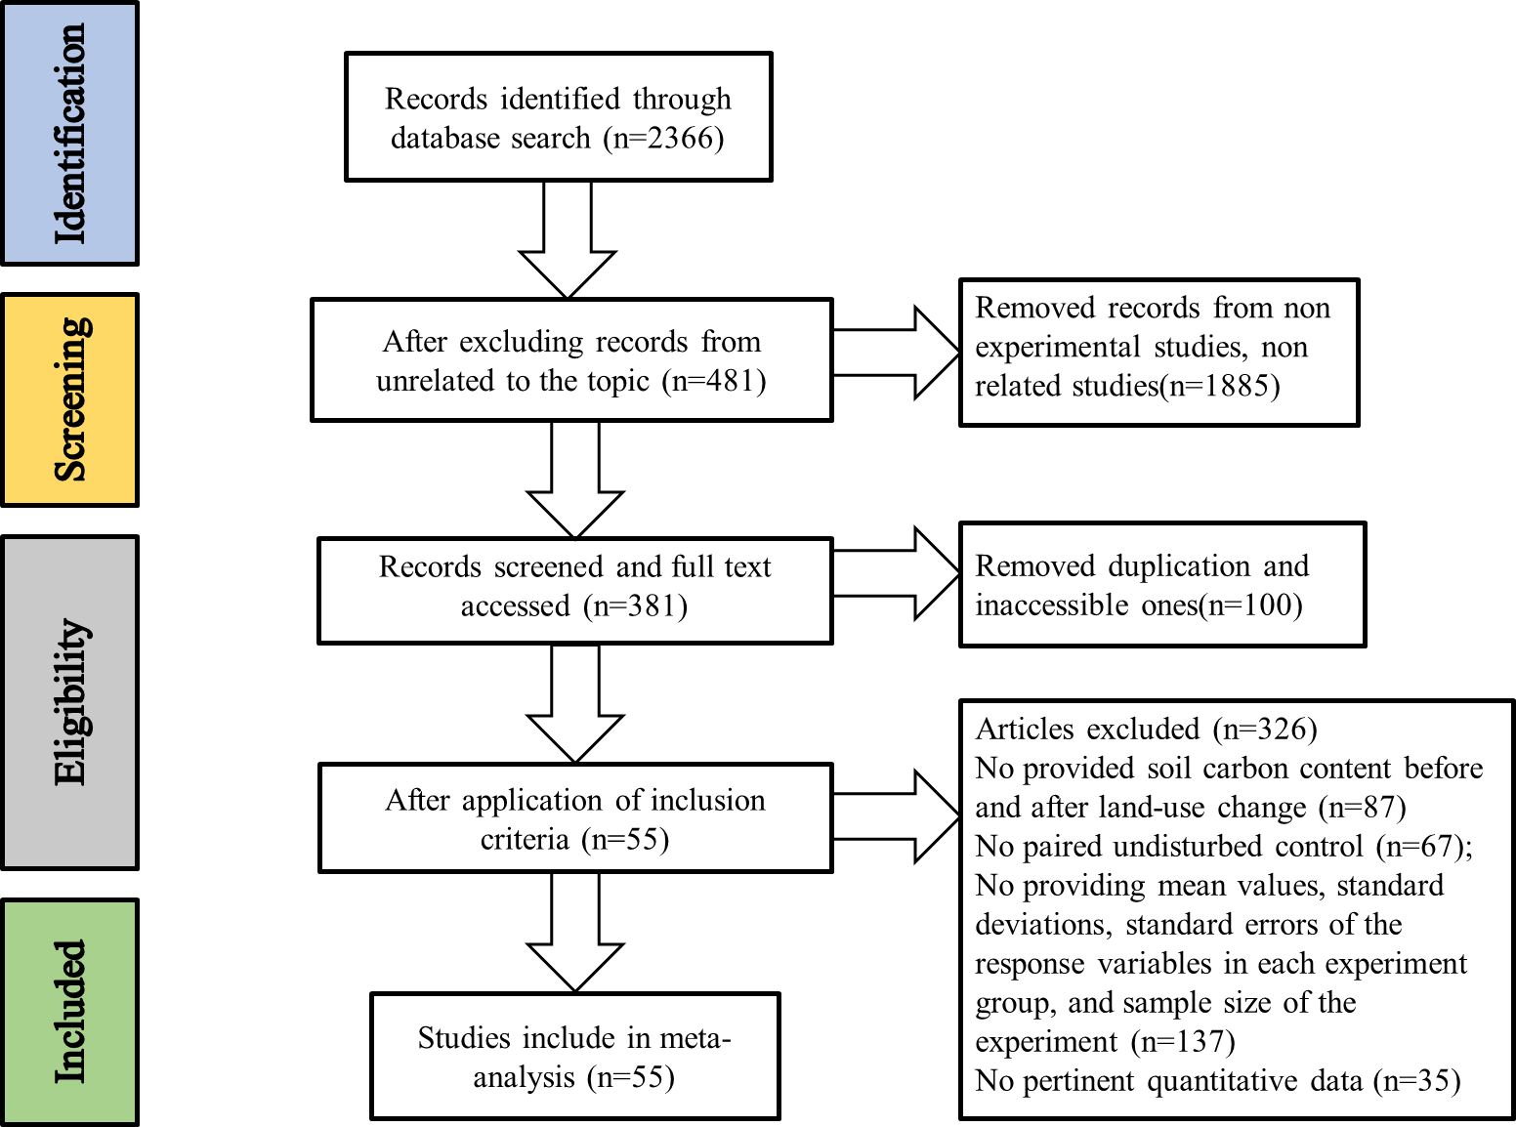

Fig. 1. Soil total carbon meta-analysis literature searching PRISMA flow diagram.

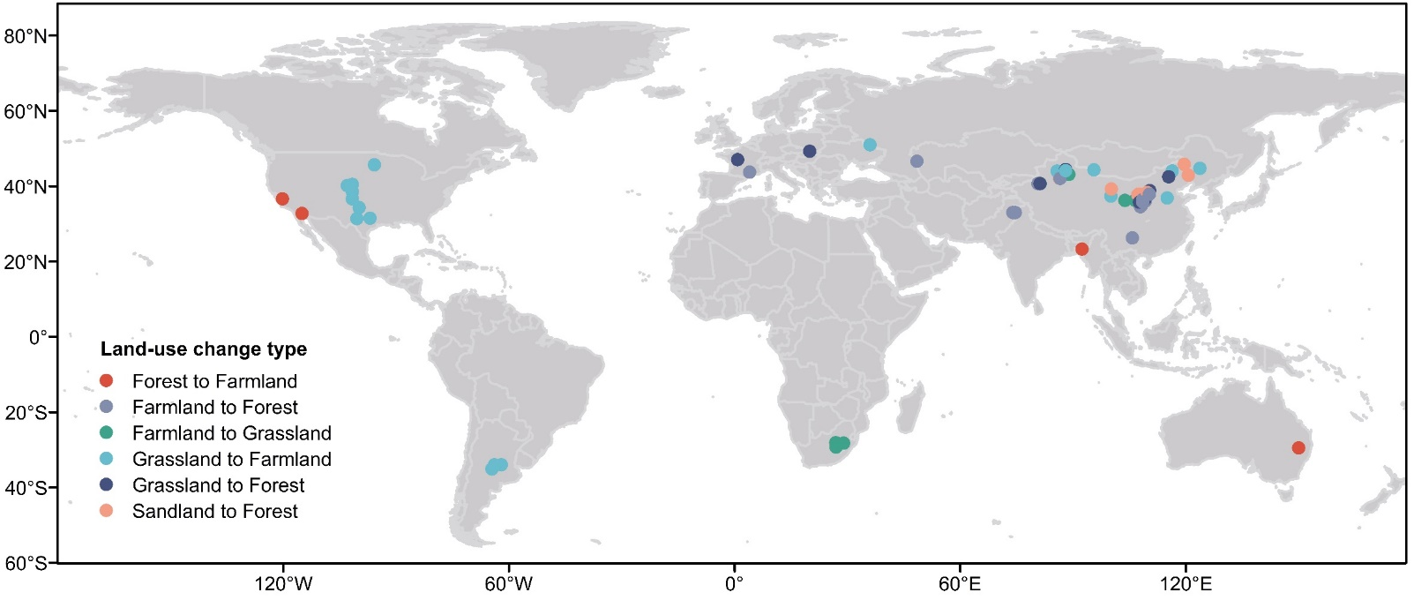
Fig. 2. Locations of the experimental sites investigating land-use change effects on both soil organic and inorganic carbon stocks. The number of surveyed locations is 73.

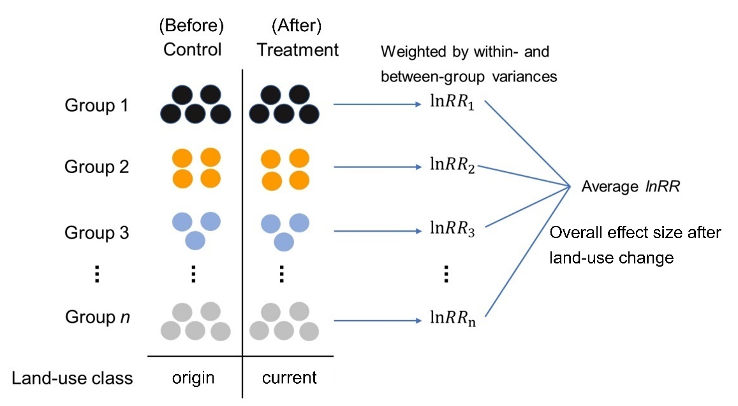
Fig. 3. Schematic representation of the approach used to quantify the responses of SOC, SIC and STC to changes in land use. The control and treatment group represent the carbon content (SOC/SIC/STC) before and after land-use change, respectively. Each dot represents one soil sampling site. Dots with the same color indicate that they share the same mean annual temperature, mean annual precipitation, time since land-use change or soil depth, and are categorized into different groups. This comparison involves assessing the differences in the variations of SOC, SIC, and STC changes between the periods before and after land-use changes. Meta-analytical techniques are applied to calculate the effect size for each comparison, represented as the natural logarithm of the response ratio (lnRR). Additionally, a weighted average effect size (lnRR₊₊) was estimated using the inverse of the sum of within-group and between-group variances. SOC, soil organic carbon; SIC, soil inorganic carbon; STC, soil total carbon.

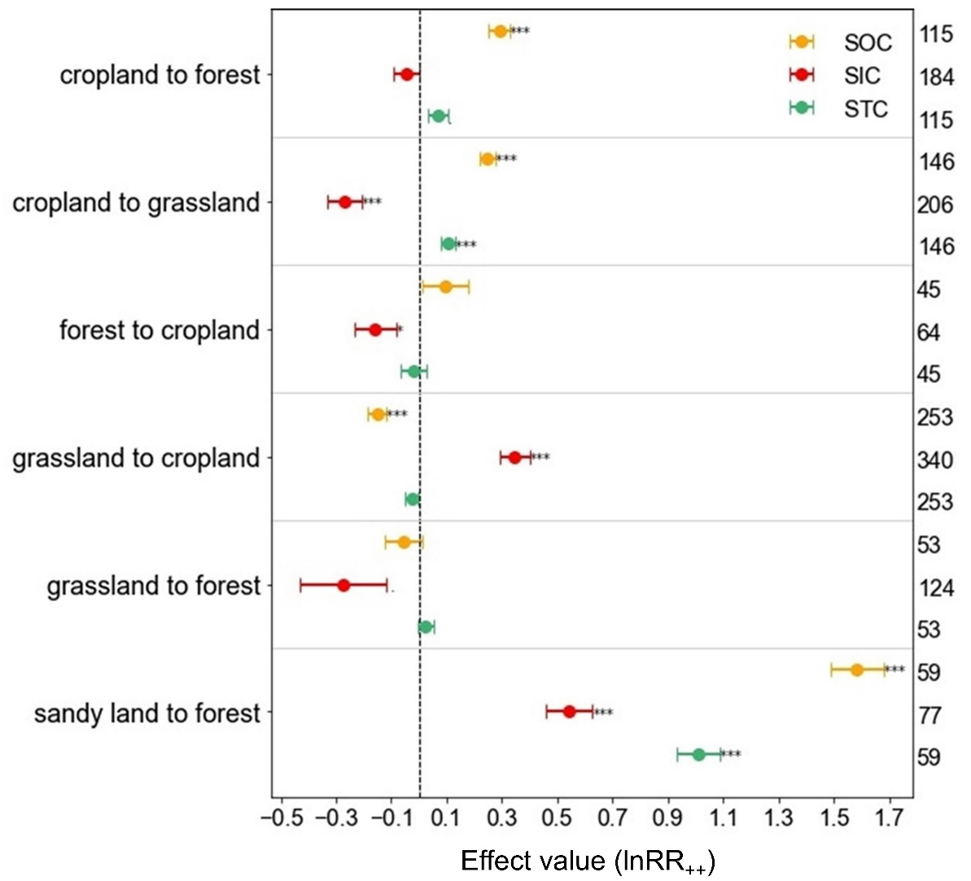
Fig. 4. Effects of land-use change on SOC, SIC, and STC, categorized by land-use change type. The error bars represent standard errors (se) and asterisks denote significant changes (*, ** and *** show p<0.05, p<0.01 and p<0.001, respectively). The x-axis shows the weighted response ratios (lnRR₊₊) and the numbers on the right side are the sample size for each category. SOC, soil organic carbon; SIC, soil inorganic carbon; STC, soil total carbon.
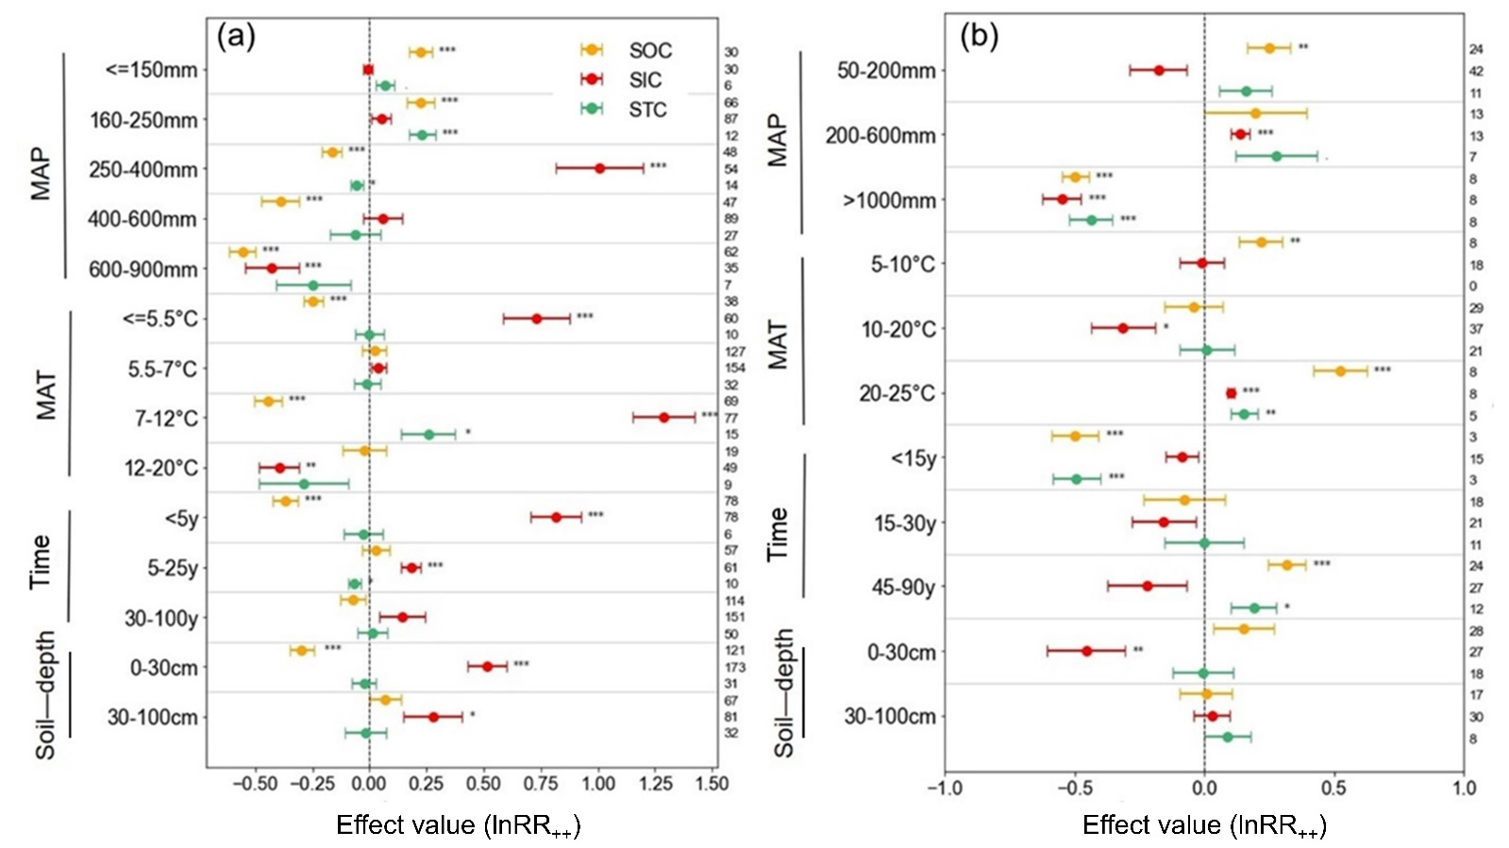
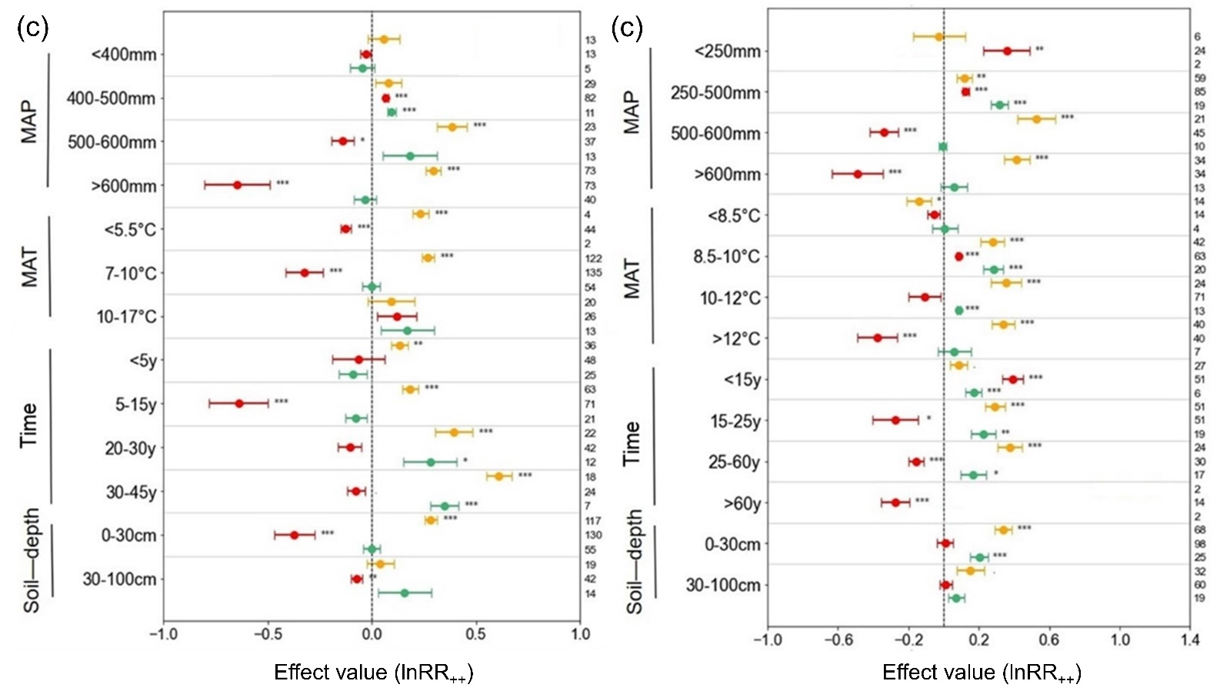
Fig. 5. Effects of MAP, MAT, time, and soil depth on SOC, SIC and STC after conversion (a) from grassland to cropland; (b) from forest to cropland; and (c) from cropland to grassland. The error bars represent standard errors (se) and asterisks denote significant changes (*, ** and *** show p<0.05, p<0.01 and p<0.001, respectively). The x-axis shows the weighted response ratios (lnRR₊₊) and the numbers on the right side are the sample size for each category. The y-axis represents the grouping of different environmental factors, with the grouping range determined by the original data and classification. SOC, soil organic carbon; SIC, soil inorganic carbon; STC, soil total carbon; MAT, mean annual temperature; MAP, mean annual precipitation; Time, duration after land-use change.
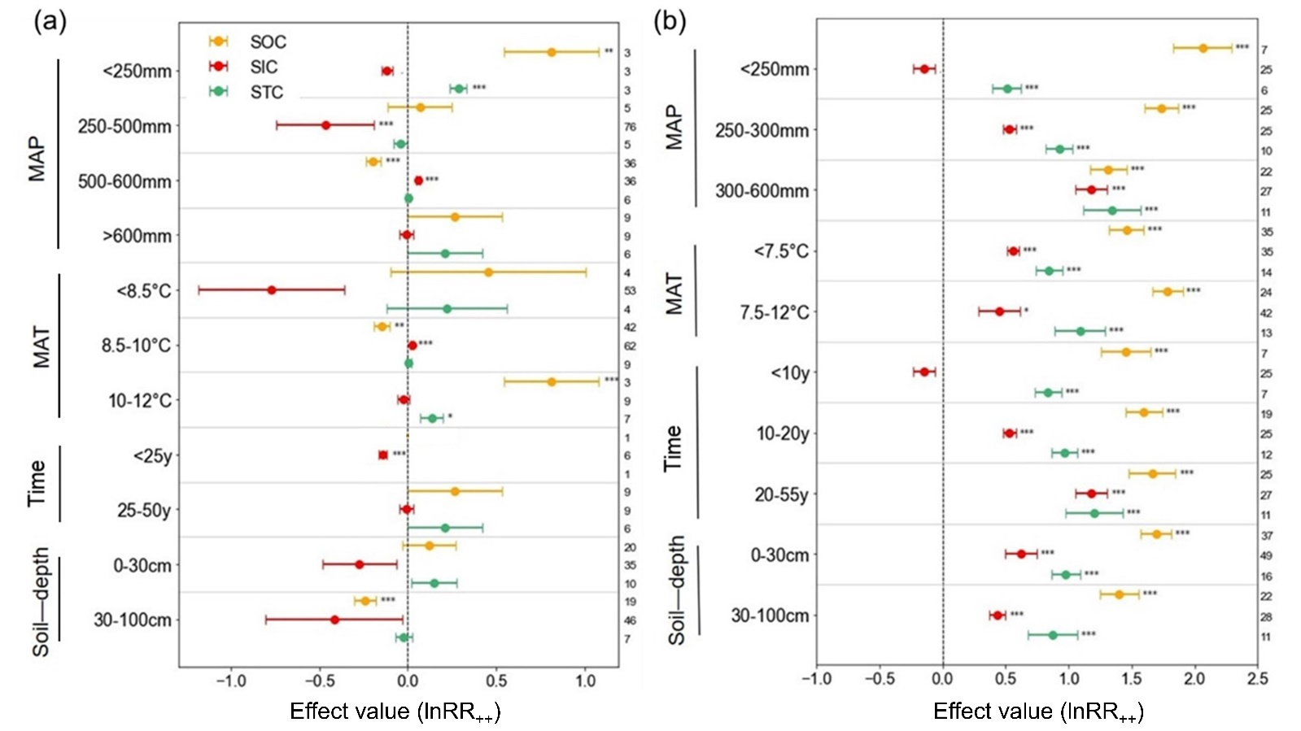
Fig. 6. Effects of MAP, MAT, time, and soil depth on SOC, SIC and STC after conversion (a) from grassland to forest; (b) from sandy land to forest; and (c) from cropland to forest. The error bars represent standard errors (se) and asterisks denote significant changes (*, ** and *** show p<0.05, p<0.01 and p<0.001, respectively). The x-axis shows the weighted response ratios (lnRR₊₊) and the numbers on the right side are the sample size for each category. The y-axis represents the grouping of different environmental factors, with the grouping range determined by the original data and classification. SOC, soil organic carbon; SIC, soil inorganic carbon; STC, soil total carbon; MAT, mean annual temperature; MAP, mean annual precipitation; Time, duration after land-use change.

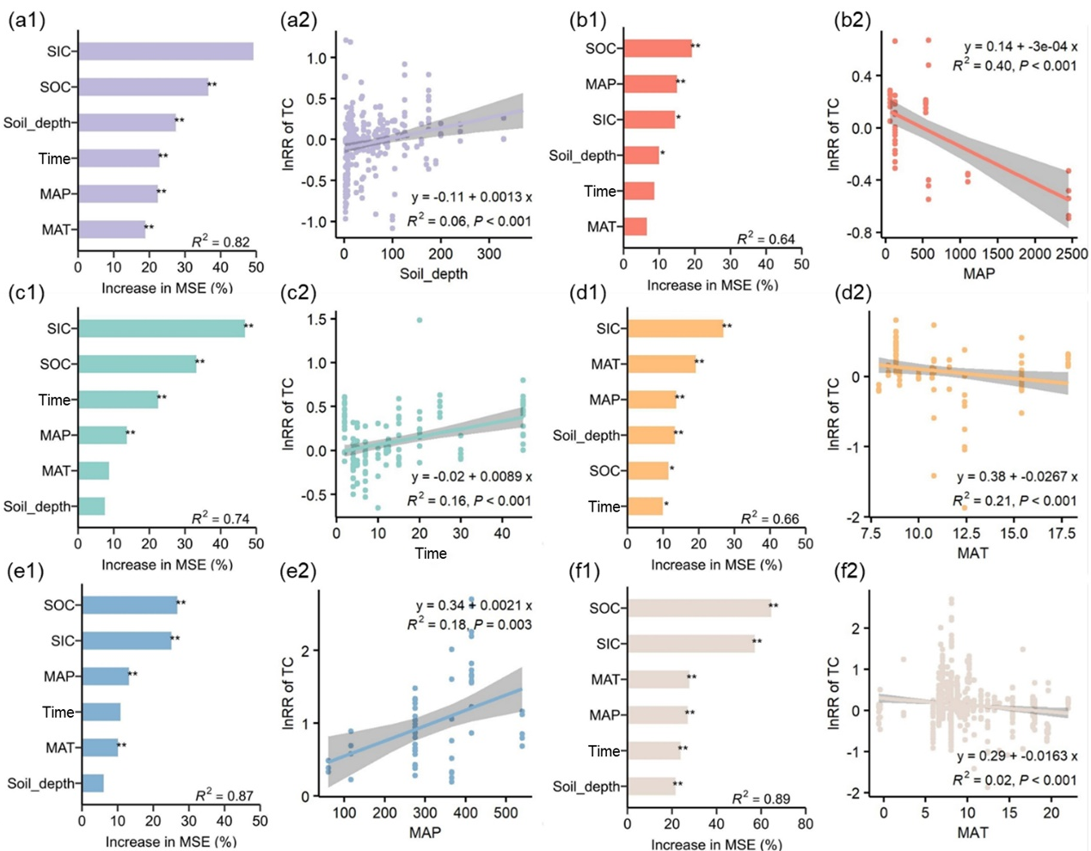
Fig. 7. Ranked importance of influencing factors for STC response ratio (lnRR) (a1-f1) and regression of STC with the most significant external factors (a2-f2). Land-use changes include (a) grassland to cropland conversion, (b) forest to cropland conversion, (c) cropland to grassland conversion, (d) cropland to forest conversion, (e) sandy land to forest conversion, and (f) average. Asterisks indicate significant levels (* and ** show p<0.05 and p<0.01, respectively), and the x-axis indicates the degree of importance in a1-f1. SOC, soil organic carbon; SIC, soil inorganic carbon; STC, soil total carbon; MAT, mean annual temperature; MAP, mean annual precipitation; Time, duration after land-use change.

References
An, H., Wu, X.Z., Zhang, Y.R., Tang, Z.S., 2019. Effects of land-use change on soil inorganic carbon: A meta-analysis. Geoderma 353, 273-282.
Arneth, A., Brown, C., Rounsevell, M.D.A., 2014. Global models of human decision-making for land-based mitigation and adaptation assessment. Nature Climate Change 4, 550-557.
Batjes, N.H., 1996. Total carbon and nitrogen in the soils of the world. European Journal of Soil Science 47, 151-163.
Beillouin, D., Corbeels, M., Demenois, J., Berre, D., Boyer, A., Fallot, A., Feder, F., Cardinael, R., 2023. A global meta-analysis of soil organic carbon in the Anthropocene. Nat Commun 14.
Berdugo, M., Vidiella, B., Solé, R.V., Maestre, F.T., 2022. Ecological mechanisms underlying aridity thresholds in global drylands. Functional Ecology 36, 4-23.
Borenstein, M., Hedges, L.V., Higgins, J.P.T., Rothstein, H.R., 2009. Random-Effects Model. Introduction to Meta‐Analysis, pp. 69-75.
Chen, Y., Lu, H.Y., Wu, H.J., Wang, J.J., Lyu, N., 2023. Global desert variation under climatic impact during 1982-2020. Science China-Earth Sciences 66, 1062-1071.
Denef, K., Stewart, C.E., Brenner, J., Paustian, K., 2008. Does long-term center-pivot irrigation increase soil carbon stocks in semi-arid agro-ecosystems? Geoderma 145, 121-129.
Deng, L., Zhu, G.Y., Tang, Z.S., Shangguan, Z.P., 2016. Global patterns of the effects of land-use changes on soil carbon stocks. Glob Ecol Conserv 5, 127-138.
Don, A., Schumacher, J., Freibauer, A., 2011. Impact of tropical land-use change on soil organic carbon stocks - a meta-analysis. Global Change Biol 17, 1658-1670.
Entry, J.A., Sojka, R.E., Shewmaker, G.E., 2004. Irrigation increases inorganic carbon in agricultural soils. Environ Manage 33, S309-S317.
Eze, S., Magilton, M., Magnone, D., Varga, S., Gould, I., Mercer, T.G., Goddard, M.R., 2023. Meta-analysis of global soil data identifies robust indicators for short-term changes in soil organic carbon stock following land use change. Sci Total Environ 860.
FAO, 2025. Land statistics 2001–2023 – Global, regional and country trends. FAO., Rome.
Feng, X.M., Fu, B.J., Piao, S., Wang, S.H., Ciais, P., Zeng, Z.Z., Lü, Y.H., Zeng, Y., Li, Y., Jiang, X.H., Wu, B.F., 2016. Revegetation in China's Loess Plateau is approaching sustainable water resource limits. Nature Climate Change 6, 1019-+.
Ferdush, J., Paul, V., 2021. A review on the possible factors influencing soil inorganic carbon under elevated CO2. Catena 204, 105434.
Gao, Y., Tian, J., Pang, Y., Liu, J.B., 2017. Soil Inorganic Carbon Sequestration Following Afforestation Is Probably Induced by Pedogenic Carbonate Formation in Northwest China. Frontiers in Plant Science 8.
Guo, L.B., Gifford, R.M., 2002. Soil carbon stocks and land use change: a meta analysis. Global Change Biol 8, 345-360.
Guo, Z.H., Zhang, S.T., Zhang, L.C., Xiang, Y.Z., Wu, J.P., 2024. A meta-analysis reveals increases in soil organic carbon following the restoration and recovery of croplands in Southwest China. Ecological Applications 34.
He, T.H., Ding, W.X., Cheng, X.L., Cai, Y.J., Zhang, Y.L., Xia, H.J., Wang, X., Zhang, J.H., Zhang, K.R., Zhang, Q.F., 2024. Meta-analysis shows the impacts of ecological restoration on greenhouse gas emissions. Nat Commun 15.
He, Y., Siemens, J., Amelung, W., Goldbach, H., Wassmann, R., Alberto, M.C.R., Lücke, A., Lehndorff, E., 2015. Carbon release from rice roots under paddy rice and maize-paddy rice cropping. Agriculture Ecosystems & Environment 210, 15-24.
Hedges, L.V., Gurevitch, J., Curtis, P.S., 1999. The meta-analysis of response ratios in experimental ecology. Ecology 80, 1150-1156.
Hong, S.B., Chen, A.P., 2022. Contrasting Responses of Soil Inorganic Carbon to Afforestation in Acidic Versus Alkaline Soils. Global Biogeochem Cy 36.
Hong, S.B., Yin, G.D., Piao, S.L., Dybzinski, R., Cong, N., Li, X.Y., Wang, K., Peñuelas, J., Zeng, H., Chen, A.P., 2020. Divergent responses of soil organic carbon to afforestation. Nat Sustain 3, 694-+.
Huang, X.Z., Ibrahim, M.M., Luo, Y.Q., Jiang, L.F., Chen, J., Hou, E.Q., 2024. Land Use Change Alters Soil Organic Carbon: Constrained Global Patterns and Predictors. Earths Future 12.
Juricová, A., Öttl, L.K., Wilken, F., Chuman, T., Zízala, D., Minarík, R., Fiener, P., 2025. Tillage erosion as an underestimated driver of carbon dynamics. Soil Till Res 245.
Lal, R., 2004. Soil carbon sequestration to mitigate climate change. Geoderma 123, 1-22.
Lal, R., 2018. Digging deeper: A holistic perspective of factors affecting soil organic carbon sequestration in agroecosystems. Global Change Biol 24, 3285-3301.
Lambin, E.F., Meyfroidt, P., 2011. Global land use change, economic globalization, and the looming land scarcity. P Natl Acad Sci USA 108, 3465-3472.
Li, C.J., Fu, B.J., Wang, S., Stringer, L.C., Wang, Y.P., Li, Z.D., Liu, Y.X., Zhou, W.X., 2021. Drivers and impacts of changes in China's drylands. Nature Reviews Earth & Environment 2, 858-873.
Li, W.L., Shang, X.J., Yan, H.P., Xu, J., Liang, T.A., Zhou, H.K., 2023. Impact of restoration measures on plant and soil characteristics in the degraded alpine grasslands of the Qinghai Tibetan Plateau: A meta-analysis. Agriculture Ecosystems & Environment 347.
Li, Y.Q., Brandle, J., Awada, T., Chen, Y.P., Han, J.J., Zhang, F.X., Luo, Y.Q., 2013. Accumulation of carbon and nitrogen in the plant-soil system after afforestation of active sand dunes in China's Horqin Sandy Land. Agriculture Ecosystems & Environment 177, 75-84.
Liu, E.Y., Liu, Z., Sun, Z.G., Li, J., Gong, H.R., Peng, J.B., Zhu, O.Y., 2023a. Soil inorganic carbon stocks increase non-synergistically with soil organic carbon after ecological restoration practices in drylands. Journal of Environmental Management 348.
Liu, H.Y., Liang, Y.Q., Liu, J.J., Zhang, Q., Liu, Y.Y., Zeng, J., Wang, X., Yang, G.H., Ren, C.J., Han, X.H., 2025. Long-term no-tillage enhanced soil multifunctionality and reduced microbial metabolic entropy. Appl Soil Ecol 206.
Liu, J.B., Zhang, P., Gao, Y., 2023b. Effects of vegetation rehabilitation on soil inorganic carbon in deserts: A meta-analysis. Catena 231.
Liu, T., Wang, L., Feng, X.J., Zhang, J.B., Ma, T., Wang, X., Liu, Z.G., 2018. Comparing soil carbon loss through respiration and leaching under extreme precipitation events in arid and semiarid grasslands. Biogeosciences 15, 1627-1641.
Liu, Y., Dang, Z.Q., Tian, F.P., Wang, D., Wu, G.L., 2017. Soil Organic Carbon and Inorganic Carbon Accumulation Along a 30-year Grassland Restoration Chronosequence in Semi-arid Regions (China). Land Degradation & Development 28, 189-198.
Oliveira, J.D., Lopes, R.D., Araújo, M.D., Magalhães, M.S., Vasconcelos, M.D.D., Lima, A.R.L., Bastos, F.D., Pereira, M.G., 2022. How does increasing humidity in the environment affect soil carbon and nitrogen stocks and the C/N ratio in tropical drylands? Evidence from northeastern Brazil. CATENA 213, 106208.
Plaza, C., Zaccone, C., Sawicka, K., Méndez, A.M., Tarquis, A., Gascó, G., Heuvelink, G.B.M., Schuur, E.A.G., Maestre, F.T., 2018. Soil resources and element stocks in drylands to face global issues. Scientific Reports 8.
Popp, A., Humpenöder, F., Weindl, I., Bodirsky, B.L., Bonsch, M., Lotze-Campen, H., Müller, C., Biewald, A., Rolinski, S., Stevanovic, M., Dietrich, J.P., 2014. Land-use protection for climate change mitigation. Nature Climate Change 4, 1095-1098.
Powers, J.S., Corre, M.D., Twine, T.E., Veldkamp, E., 2011. Geographic bias of field observations of soil carbon stocks with tropical land-use changes precludes spatial extrapolation. P Natl Acad Sci USA 108, 6318-6322.
Prangel, E., Kasari-Toussaint, L., Neuenkamp, L., Noreika, N., Karise, R., Marja, R., Ingerpuu, N., Kupper, T., Keerberg, L., Oja, E., Meriste, M., Tiitsaar, A., Ivask, M., Helm, A., 2023. Afforestation and abandonment of semi-natural grasslands lead to biodiversity loss and a decline in ecosystem services and functions. Journal of Applied Ecology 60, 825-836.
Pütz, S., Groeneveld, J., Henle, K., Knogge, C., Martensen, A.C., Metz, M., Metzger, J.P., Ribeiro, M.C., de Paula, M.D., Huth, A., 2014. Long-term carbon loss in fragmented Neotropical forests. Nat Commun 5.
Ren, Z., Li, C., Fu, B., Wang, S., Zhou, W., Stringer, L.C., 2023. Belowground soil and vegetation components change across the aridity threshold in grasslands. Environ Res Lett 18.
Ren, Z.B., Li, C.J., Fu, B.J., Wang, S., Stringer, L.C., 2024. Effects of aridification on soil total carbon pools in China's drylands. Global Change Biol 30, e17091.
Sanderman, J., 2012. Can management induced changes in the carbonate system drive soil carbon sequestration? A review with particular focus on Australia. Agriculture Ecosystems & Environment 155, 70-77.
Sanderman, J., Hengl, T., Fiske, G.J., 2017. Soil carbon debt of 12,000 years of human land use. P Natl Acad Sci USA 114, 9575-9580.
Savadogo, P., Sawadogo, L., Tiveau, D., 2007. Effects of grazing intensity and prescribed fire on soil physical and hydrological properties and pasture yield in the savanna woodlands of Burkina Faso. Agriculture Ecosystems & Environment 118, 80-92.
Shi, J.W., Deng, L., Wu, J.Z., Bai, E., Chen, J., Shangguan, Z.P., Kuzyakov, Y., 2024. Soil Organic Carbon Increases With Decreasing Microbial Carbon Use Efficiency During Vegetation Restoration. Global Change Biol 30.
Shi, S.W., Han, P.F., 2014. Estimating the soil carbon sequestration potential of China's Grain for Green Project. Global Biogeochem Cy 28, 1279-1294.
Song, J., Wan, S., Piao, S., Knapp, A.K., Classen, A.T., Vicca, S., Ciais, P., Hovenden, M.J., Leuzinger, S., Beier, C., Kardol, P., Xia, J.Y., Liu, Q., Ru, J.Y., Zhou, Z.X., Luo, Y.Q., Guo, D.L., Langley, J.A., Zscheischler, J., Dukes, J.S., Tang, J.W., Chen, J.Q., Hofmockel, K.S., Kueppers, L.M., Rustad, L., Liu, L.L., Smith, M.D., Templer, P.H., Thomas, R.Q., Norby, R.J., Phillips, R.P., Niu, S.L., Fatichi, S., Wang, Y.P., Shao, P.S., Han, H.Y., Wang, D.D., Lei, L.J., Wang, J.L., Li, X.N., Zhang, Q., Li, X.M., Su, F.L., Liu, B., Yang, F., Ma, G.G., Li, G.Y., Liu, Y.C., Liu, Y.Z., Yang, Z.L., Zhang, K.S., Miao, Y., Hu, M.J., Yan, C., Zhang, A., Zhong, M.X., Hui, Y., Li, Y., Zheng, M.M., 2019. A meta-analysis of 1,119 manipulative experiments on terrestrial carbon-cycling responses to global change. Nat Ecol Evol 3, 1309-1320.
Song, X.D., Yang, F., Wu, H.Y., Zhang, J., Li, D.C., Liu, F., Zhao, Y.G., Yang, J.L., Ju, B., Cai, C.F., Huang, B.A., Long, H.Y., Lu, Y., Sui, Y.Y., Wang, Q.B., Wu, K.N., Zhang, F.R., Zhang, M.K., Shi, Z., Ma, W.Z., Xin, G., Qi, Z.P., Chang, Q.R., Ci, E., Yuan, D.G., Zhang, Y.Z., Bai, J.P., Chen, J.Y., Chen, J., Chen, Y.J., Dong, Y.Z., Han, C.L., Li, L., Liu, L.M., Pan, J.J., Song, F.P., Sun, F.J., Wang, D.F., Wang, T.W., Wei, X.H., Wu, H.Q., Zhao, X., Zhou, Q., Zhang, G.L., 2022. Significant loss of soil inorganic carbon at the continental scale. Natl Sci Rev 9.
Tan, W., Zhang, R., Cao, H., Huang, C., Yang, Q., Wang, M., Koopal, L., 2014. Soil inorganic carbon stock under different soil types and land uses on the Loess Plateau region of China. Catena 121, 22-30.
Tang, S.M., Guo, J.X., Li, S.C., Li, J.H., Xie, S., Zhai, X.J., Wang, C.J., Zhang, Y.J., Wang, K., 2019. Synthesis of soil carbon losses in response to conversion of grassland to agriculture land. Soil Till Res 185, 29-35.
Tian, D.S., Xiang, Y.Z., Seabloom, E., Wang, J.S., Jia, X.X., Li, T.T., Li, Z.L., Yang, J., Guo, H.B., Niu, S.L., 2023. Soil carbon sequestration benefits of active versus natural restoration vary with initial carbon content and soil layer. Commun Earth Environ 4.
Toledo, M., Poorter, L., Peña-Claros, M., Alarcón, A., Balcázar, J., Leaño, C., Licona, J.C., Llanque, O., Vroomans, V., Zuidema, P., Bongers, F., 2011. Climate is a stronger driver of tree and forest growth rates than soil and disturbance. Journal of Ecology 99, 254-264.
Wang, J.P., Wang, X.J., Zhang, J., Zhao, C.Y., 2015. Soil organic and inorganic carbon and stable carbon isotopes in the Yanqi Basin of northwestern China. European Journal of Soil Science 66, 95-103.
White, P.J., 2001. The pathways of calcium movement to the xylem. Journal of Experimental Botany 52, 891-899.
Yang, D., Luan, W.X., Zhang, X.L., 2023. Projecting spatial interactions between global population and land use changes in the 21st century. Npj Urban Sustain 3.
Yang, Y., Dou, Y.X., Wang, B.R., Wang, Y.Q., Liang, C., An, S.S., Soromotin, A., Kuzyakov, Y., 2022. Increasing contribution of microbial residues to soil organic carbon in grassland restoration chronosequence. Soil Biol Biochem 170.
Yang, Y., Tilman, D., Furey, G., Lehman, C., 2019. Soil carbon sequestration accelerated by restoration of grassland biodiversity. Nat Commun 10.
Yin, L.M., Dijkstra, F.A., Wang, P., Zhu, B.A., Cheng, W.X., 2018. Rhizosphere priming effects on soil carbon and nitrogen dynamics among tree species with and without intraspecific competition. New Phytologist 218, 1036-1048.
Zhu, X.L., Si, J.H., He, X.H., Jia, B., Zhou, D.M., Wang, C.L., Qin, J., Liu, Z.J., 2024. Effects of long-term afforestation on soil water and carbon in the Alxa Plateau. Frontiers in Plant Science 14.

Supplementary Information for Effects of land-use change on soil total carbon pool: a meta-analysis

Zhuobing Ren^{1,2}, Changjia Li^{1,2*}, Shuai Wang^{1,2}, Wenxin Zhou^{1,2,3}, Lindsay C. Stringer^{4,5}, Bojie Fu⁶
1. State Key Laboratory of Earth Surface Processes and Disaster Risk Reduction (ESPDRR), Faculty of Geographical Science, Beijing Normal University, Beijing, China
2. Institute of Land Surface System and Sustainable Development, Faculty of Geographical Science, Beijing Normal University, Beijing, China
3. School of Agriculture, Food and Ecosystem Sciences, Faculty of Science, University of Melbourne, Melbourne, Australia
4. Department of Environment and Geography, University of York, York, UK
5. York Environmental Sustainability Institute, University of York, York, UK
6. State Key Laboratory of Urban and Regional Ecology, Research Center for Eco-Environmental Sciences, Chinese Academy of Sciences, Beijing, China

*Corresponding author: changjia.li@bnu.edu.cn

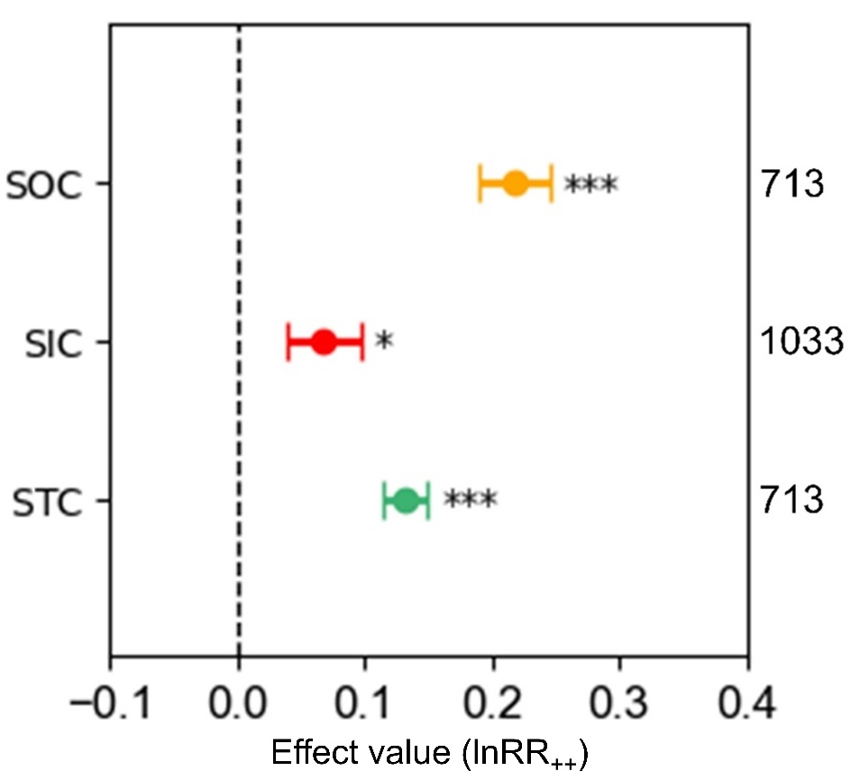

Fig. S1. Effects of land-use change on SOC, SIC and STC across all the pairs of control and experimental groups. The responses of SOC, SIC, and STC are shown in yellow, red and green. The error bars represent standard errors (se) and asterisks denote significant changes (*, ** and *** show p<0.05, p<0.01 and p<0.001, respectively). The x-axis shows the weighted response ratios (lnRR₊₊) and the numbers on the right side are the sample size for each group. SOC, soil organic carbon; SIC, soil inorganic carbon; STC, soil total carbon.

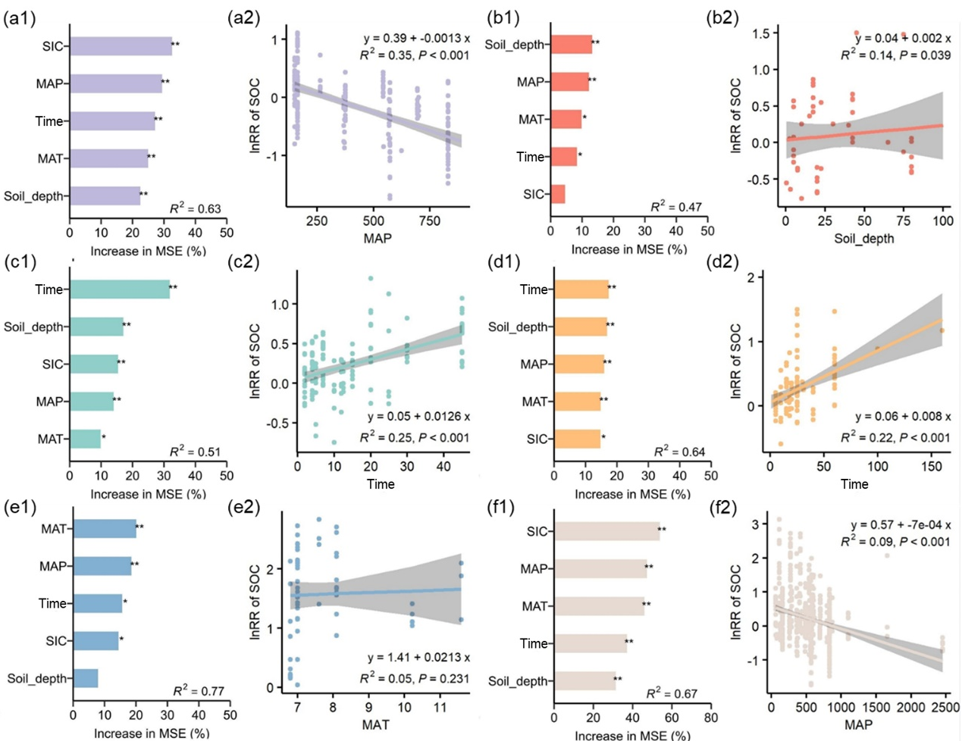

Fig. S2. Ranked importance of influencing factors for soil organic carbon response ratio (lnRR) (a1-f1) and regression of soil organic carbon with the most significant external factors (a2-f2). Land-use changes include (a) grassland to cropland conversion, (b) forest to cropland conversion, (c) cropland to grassland conversion, (d) cropland to forest conversion, (e) sandy land to forest conversion, and (f) average. Asterisks indicate significant levels (* and ** show p<0.05 and p<0.01, respectively), and the x-axis indicates the degree of importance in a1-f1. SOC, soil organic carbon; SIC, soil inorganic carbon; MAT, mean annual temperature; MAP, mean annual precipitation; Time, duration after land-use change.

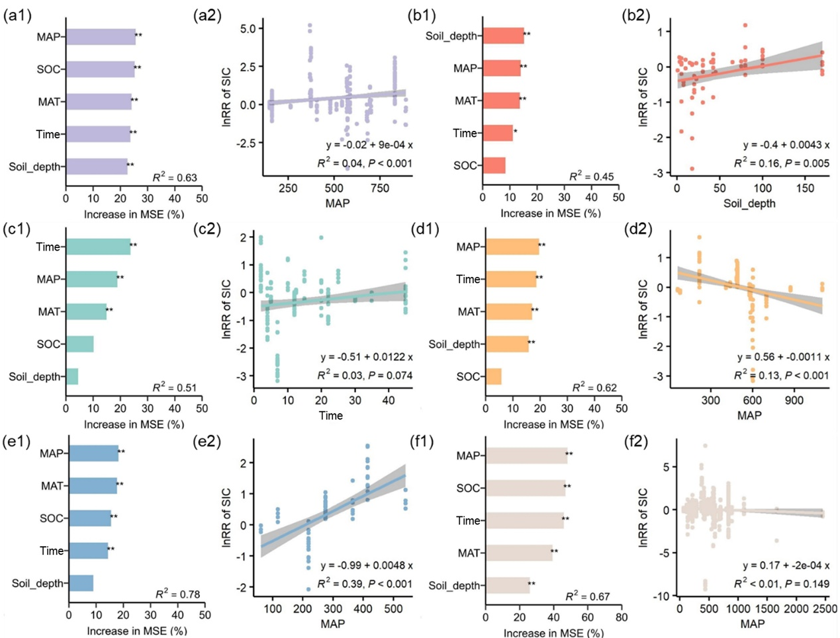

Fig. S3. Ranked importance of influencing factors for soil inorganic carbon response ratio (lnRR) (a1-f1) and regression of soil inorganic carbon with the most significant external factors (a2-f2). Land-use changes include (a) grassland to cropland conversion, (b) forest to cropland conversion, (c) cropland to grassland conversion, (d) cropland to forest conversion, (e) sandy land to forest conversion, and (f) average. Asterisks indicate significant levels (* and ** show p<0.05 and p<0.01, respectively), and the x-axis indicates the degree of importance in a1-f1. SOC, soil organic carbon; SIC, soil inorganic carbon; MAT, mean annual temperature; MAP, mean annual precipitation; Time, duration after land-use change.

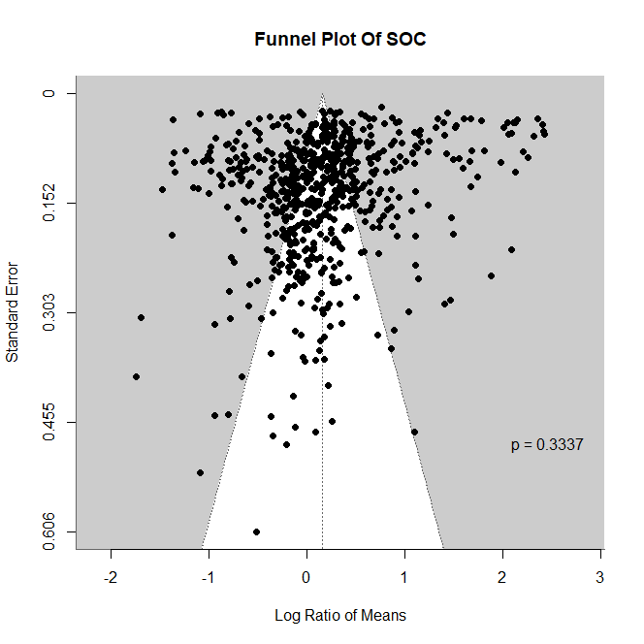
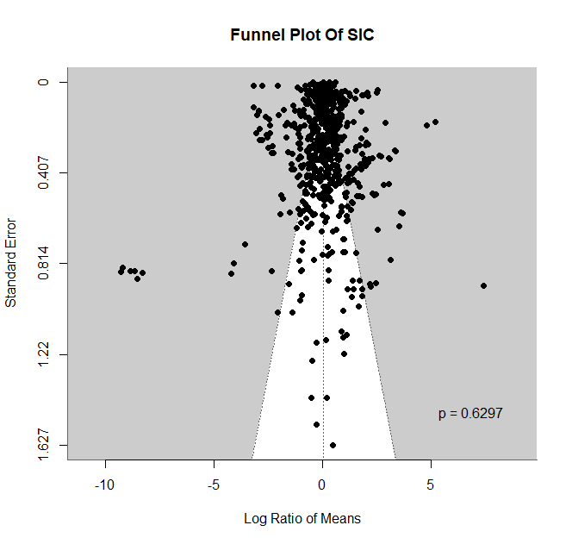
Fig. S4. Begg's test and funnel plots for soil organic carbon and soil inorganic carbon. SOC, soil organic carbon; SIC, soil inorganic carbon.

Supplementary Table 1. The number of soil samples per surveyed location.
Site ID | Latitude | Longitude | Number of soil samples
1 | 37.62 | 107.09 | 9
2 | -34.00 | -62.00 | 4
3 | 36.87 | 115.17 | 12
4 | 43.72 | 4.02 | 4
5 | 36.07 | 109.20 | 7
6 | -31.56 | -65.4 | 8
7 | 40.15 | -102.95 | 10
8 | 40.5 | -101.6333 | 8
9 | 35.8333 | 108.6583 | 5
10 | 44.116667 | 88.05 | 18
11 | 37.7 | 107.2167 | 10
12 | 37.9 | 107.45 | 15
13 | 44.0417 | 116.3667 | 6
14 | 40.666667 | 80.666667 | 3
15 | 40.666667 | 81.25 | 3
16 | 40.666667 | 81.216667 | 3
17 | 40.6583 | 81.2333 | 3
18 | 36.435 | 109.33 | 6
19 | 36.33 | 108.75 | 6
20 | 36.435 | 109.33 | 6
21 | 33.165 | 74.6908 | 13
22 | 43.13 | -88.87 | 117
23 | 34.5583 | 107.9333 | 10
24 | 35.7333 | 107.6333 | 10
25 | 46.6316 | 48.3892 | 14
26 | 31.40 | -100.40 | 4
27 | 31.50 | -96.90 | 4
28 | -34.10 | -63.70 | 1
29 | 34.30 | -99.80 | 1
30 | -34.00 | -63.80 | 8
31 | -35.10 | -64.50 | 4
32 | 36.60 | -101.60 | 8
33 | 38.50 | -101.60 | 8
34 | -34.00 | 151.00 | 5
35 | 37.87 | 110.18 | 6
36 | 42.9167 | 120.6833 | 10
37 | 37.35 | 100.0667 | 8
38 | 38.3333 | 109.7333 | 12
39 | 36.2667 | 106.425 | 40
40 | 35.2333 | 107.6833 | 21
41 | 43.355 | 115.435 | 14
42 | -28.1324 | 26.9455 | 2
43 | -28.2543 | 29.0318 | 2
44 | -29.2934 | 27.0266 | 2
45 | 44.4167 | 88.0417 | 19
46 | 38.8083 | 110.3667 | 30
47 | 51.00 | 36.00 | 22
48 | 47.025 | 0.833333 | 6
49 | 39.4 | 100.35 | 7
50 | 44.1 | 88.0417 | 8
51 | 45.68 | -95.75 | 25
52 | 26.2624 | 105.7741 | 12
53 | 23.275 | 92.3667 | 6
54 | 45.8 | -119.55 | 36
55 | 34.5583 | 107.9333 | 9
56 | 34.8 | 108.15 | 9
57 | 44.3342 | -95.5544 | 12
58 | 39.2333 | 100.1917 | 6
59 | 42.0417 | 86.4417 | 15
60 | 42.05 | 86.55 | 3
61 | 42.1667 | 86.5 | 3
62 | 36.05 | 108.5 | 30
63 | 44.3333 | 87.9063 | 60
64 | 49.15 | 19.59 | 3
65 | 32.52 | 94.07 | 15
66 | 32.6333 | -86.3333 | 9
67 | 44.4 | 85.775 | 30
68 | 38.28 | 109.75 | 6
69 | 44.7333 | 123.7333 | 28
70 | 36.85 | 109.3167 | 65
71 | 36.75 | 109.25 | 45
72 | 36.2167 | 103.7833 | 18
73 | 36.7333 | 109.2417 | 26

Supplementary Table 2. The management practices reported in the literature concerning cropland.
Study | Upland or paddy field | Irrigation | Type of crops | Fertilization
Song et al., 2020 | Upland | No | Wheat-maize rotation | Yes
Jelinski et al., 2009 | Upland | \ | Maize-soybean rotation | \
Li et al., 2016 | Upland | Yes | Brassica campestris | Yes
Wang et al., 2019 | Upland | Yes | Cotton, maize, and wheat | Yes
Loke et al., 2019 | Upland | \ | Wheat-maize rotation | Yes
Sartori et al., 2007 | Upland | Yes | Onion, potato, wheat, pea, and maize | Yes
Strock et al., 2022 | Upland | No | Maize | \
Mikhailova et al., 2006 | Upland | \ | Soybean, red clover, barley, maize, sugar beet, winter wheat, and sunflower. | Yes
Papiernik et al., 2007 | Upland | \ | Wheat, soybean, and maize | \
Bughio et al., 2016 | Upland | Yes | Wheat-maize rotation | Yes
Chang et al., 2012 | Upland | No | Wheat | Yes
Liu et al., 2014 | Upland | \ | Wheat, oat and potato | Yes
Liu et al., 2016 | Upland | \ | Maize | \
Yu et al., 2014 | Upland | No | Maize and soybean | Yes
Jia et al., 2019 | Upland | \ | Wheat and maize | Yes
Hussain et al., 2019 | Upland | \ | Maize-wheat/mustard | \
Zhang et al., 2018 | Upland | No | \ | Yes
Juvinyà et al., 2021 | Upland | \ | \ | \
Cardinael et al., 2020 | Upland | \ | \ | Yes
Denef et al., 2008 | Upland | Yes | Wheat–maize–soybean rotation | Yes
Kim et al., 2020 | Upland | Yes | Wheat, maize, soybean, etc. | Yes
Zhang et al., 2013 | Upland | Yes | Maize and wheat | Yes
Geng et al., 2008 | Upland | \ | Wheat | \
Niu et al., 2016 | Upland | Yes | Cotton, corn, and grape | \
Gong et al., 2017 | Upland | Yes | Cotton | \
Yan et al., 2016 | Upland | Yes | Cotton, corn, grape, etc. | Yes
Zhang et al., 2012 | Upland | \ | \ | \
Luo et al., 2017 | Upland | Yes | Wheat, maize, and grape | Yes
Wang et al., 2016 | Upland | \ | Foxtail millet, maize, potato, and soybean | \
Han et al., 2018 | Upland | No | Maize | Yes
Qin et al., 2022 | Upland | \ | Maize-Brassica napus rotation | \
Lan et al., 2021 | Upland | \ | Potato, green onion, and millet | Yes
Sahoo et al., 2019 | Upland and paddy field | \ | Rice, banana, papaya, etc. | Yes
Deng et al., 2016 | Upland | \ | Maize | Yes
Berhongaray et al., 2013 | Upland | \ | Soybean, wheat, and maize | \

Supplementary Table 3. Major soil classifications and pH ranges across the reviewed studies.
Study | pH | Soil classification
An et al., 2019 | 8.8-9.2 | Arenosol
An et al., 2016 | \ | Solonchak
Berhongaray et al., 2013 | 4.9-9.5 | Mollisol
Bughio et al., 2016 | 7.6-8.3 | Fluvic Cambisol
Cardinael et al., 2020 | \ | Fluvisol
Chang et al., 2012 | \ | Entisol
Conti et al., 2014 | 6.9-7.8 | Aridisol
Denef et al., 2008 | 6-7 | Mollisol
Deng et al., 2016 | 7.2-7.7 | Cambisol
Deng et al., 2017 | 7.5-9.5 | Solonchak
Gao et al., 2018 | 8.1-8.6 | Cambic Arenosol
Gao et al., 2017 | 8.0-9.0 | Quartzipsamment
Geng et al., 2008 | 6.4-7.9 | Mollisol
Gong et al., 2017 | 7.6-8.7 | Kastanozem
Han et al., 2018 | \ | Cambisol
Hussain et al., 2019 | 6.5-7.2 | Entisol
Jelinski and Kucharik, 2009 | 7.1-7.5 | Entisol
Jia et al., 2019 | \ | Cambisol
Jin et al., 2014 | \ | \
Juvinyà et al., 2021 | Neutral-alkaline | Calcaric Regosol, Calcic Luvisol
Kim et al., 2020 | \ | Mollisol
Knowles and Singh, 2003 | 8.9-9.3 | Vertosol
Lan et al., 2021 | \ | Loessi-Orthic Primosol
Li et al., 2013 | \ | Cambic Arenosol
Li et al., 2016 | 8.0-8.6 | Dark Chestnut soil
Li et al., 2021 | 7.7-8.1 | Aeolian Sandy soil
Liu et al., 2014 | 8.1-8.7 | Loessial soil, Mountain Gray Cinnamon soil
Liu et al., 2017 | 7.6-8.1 | Dark Loess soil
Liu et al., 2020 | 8.5-9.2 | Kastanozem
Loke et al., 2019 | 5.6-6.2 | Plinthosol
Luo et al., 2017 | \ | Entisols, Aridisol
Mao et al., 2018 | 8.4-9.2 | Aridic Calcisol
Mikhailova and Post, 2006 | 5.8-7.8 | Hapludoll
Nadal-Romero et al., 2016 | 7.0-8.0 | Leptic Calcaric Regosol
Niu et al., 2022 | 8.3-9.0 | Wind-sand soil
Niu et al., 2016 | 8.5-9.0 | \
Papiernik et al., 2007 | 6.7-7.6 | Hapludoll
Qin et al., 2022 | 6.0-7.0 | Mollic Inceptisol
Sahoo et al., 2019 | 4.1-6.0 | \
Sartori et al., 2007 | 5.0-8.2 | Torripsamment
Song et al., 2020 | 7.0-8.5 | Anthrosol
Strock et al., 2022 | 6.6-8.0 | Eutrudept
Su et al., 2010 | \ | Aripsamment, Calciorthid
Wang et al., 2015a | 8.2-8.4 | Haplic Calcisol, Calcaric Cambisol
Wang et al., 2015b | 8-9.4 | Haplic Calcisol, Calcaric Cambisol
Wang et al., 2016 | 7.9-8.3 | Haplustalf
Wang et al., 2019 | 7.5-9.9 | Aridisol
Wasak and Drewnik, 2015 | 4.3-7.9 | Hyperskeletic Leptosol
Wu et al., 2008 | 8.0-9.2 | Entisol
Yao, 2020 | \ | Aeolian soil, Saline-alkali soil
Yu et al., 2014 | 7.8-9.3 | Salic Solonetz
Zhang et al., 2012 | \ | Loessial soil
Zhang et al., 2013 | 8.8-9.4 | Sierozem
Zhang et al., 2018 | ~8.5 | Calcaric Cambisol
Zhao et al., 2016 | 8.4-8.6 | Calcaric Cambisol

Supplementary Text 1: List of publications reviewed in this synthesis.
An, H., Li, Q.L., Yan, X., Wu, X.Z., Liu, R.T., Fang, Y., 2019. Desertification control on soil inorganic and organic carbon accumulation in the topsoil of desert grassland in Ningxia, northwest China. Ecol Eng 127, 348-355.
An, Y., Wang, Z., Li, Z.J., 2016. Profile distribution of soil organie carbon and inorganic carbon in oasissaline soil during different reclaimed period. Journal of Xinjiang Agricultural University 39, 246-252.
Berhongaray, G., Alvarez, R., De Paepe, J., Caride, C., Cantet, R., 2013. Land use effects on soil carbon in the Argentine Pampas. Geoderma 192, 97-110.
Bughio, M.A., Wang, P.L., Meng, F.Q., Qing, C., Kuzyakov, Y., Wang, X.J., Junejo, S.A., 2016. Neoformation of pedogenic carbonates by irrigation and fertilization and their contribution to carbon sequestration in soil. Geoderma 262, 12-19.
Cardinael, R., Chevallier, T., Guenet, B., Girardin, C., Cozzi, T., Pouteau, V., Chenu, C., 2020. Organic carbon decomposition rates with depth and contribution of inorganic carbon to CO2 emissions under a Mediterranean agroforestry system. European Journal of Soil Science 71, 909-923.
Chang, R.Y., Fu, B.J., Liu, G.H., Wang, S., Yao, X.L., 2012. The effects of afforestation on soil organic and inorganic carbon: A case study of the Loess Plateau of China. Catena 95, 145-152.
Conti, G., Pérez-Harguindeguy, N., Quètier, F., Gorné, L.D., Jaureguiberry, P., Bertone, G.A., Enrico, L., Cuchietti, A., Díaz, S., 2014. Large changes in carbon storage under different land-use regimes in subtropical seasonally dry forests of southern South America. Agriculture Ecosystems & Environment 197, 68-76.
Denef, K., Stewart, C.E., Brenner, J., Paustian, K., 2008. Does long-term center-pivot irrigation increase soil carbon stocks in semi-arid agro-ecosystems? Geoderma 145, 121-129.
Deng, C.Y., Wang, Y.G., Niu, Z.R., Li, Y., 2017. Effect of land reclamation age on soil physicochemical properties and inorganic carbon in arid areas. J Soil Water Conserv 31, 254-259.
Deng, L., Wang, K.B., Tang, Z.S., Shangguan, Z.P., 2016. Soil organic carbon dynamics following natural vegetation restoration: Evidence from stable carbon isotopes (δ13C). Agriculture Ecosystems & Environment 221, 235-244.
Gao, Y., Dang, P., Zhao, Q.X., Liu, J.L., Liu, J.B., 2018. Effects of vegetation rehabilitation on soil organic and inorganic carbon stocks in the Mu Us Desert, northwest China. Land Degradation & Development 29, 1031-1040.
Gao, Y., Tian, J., Pang, Y., Liu, J.B., 2017. Soil inorganic carbon sequestration following afforestation is probably induced by pedogenic carbonate formation in northwest China. Frontiers in Plant Science 8.
Geng, Y.B., Luo, G.Q., Yuan, G.F., Li, M.F., Meng, W.Q., Dong, Y.S., 2008. Effects of cultivating and grazing on soil organic carbon and soil inorganic carbon in temperate semiarid grassland. Journal of Agro-Environment Science 27, 2518-2523.
Gong, L., Luo, Y., Xie, L.N., 2017. Changes in SOC and SIC concentration with land uses and their soil influencing factors in northern marginal zones of Tarim Basin. Journal of China Agricultural University 22, 83-94.
Han, X.Y., Gao, G.Y., Chang, R.Y., Li, Z.S., Ma, Y., Wang, S., Wang, C., Lü, Y.H., Fu, B.J., 2018. Changes in soil organic and inorganic carbon stocks in deep profiles following cropland abandonment along a precipitation gradient across the Loess Plateau of China. Agriculture Ecosystems & Environment 258, 1-13.
Hussain, S., Sharma, V., Arya, V.M., Sharma, K.R., Rao, C.S., 2019. Total organic and inorganic carbon in soils under different land use/land cover systems in the foothill Himalayas. Catena 182.
Jelinski, N.A., Kucharik, C.J., 2009. Land-use effects on soil carbon and nitrogen on a US Midwestern floodplain. Soil Science Society of America Journal 73, 217-225.
Jia, X.X., Wang, X., Hou, L.C., Wei, X.R., Zhang, Y., Shao, M.A., Zhao, X.N., 2019. Variable response of inorganic carbon and consistent increase of organic carbon as a consequence of afforestation in areas with semiarid soils. Land Degradation & Development 30, 1345-1356.
Jin, Z., Dong, Y.S., Wang, Y.Q., Wei, X.R., Wang, Y.F., Cui, B.L., Zhou, W.J., 2014. Natural vegetation restoration is more beneficial to soil surface organic and inorganic carbon sequestration than tree plantation on the Loess Plateau of China. Sci Total Environ 485, 615-623.
Juvinyà, C., LotfiParsa, H., Sauras-Yera, T., Rovira, P., 2021. Carbon sequestration in Mediterranean soils following afforestation of abandoned crops: Biases due to changes in soil compaction and carbonate stocks. Land Degradation & Development 32, 4300-4312.
Kim, J.H., Jobbágy, E.G., Richter, D.D., Trumbore, S.E., Jackson, R.B., 2020. Agricultural acceleration of soil carbonate weathering. Global Change Biol 26, 5988-6002.
Knowles, T.A., Singh, B., 2003. Carbon storage in cotton soils of northern New South Wales. Aust J Soil Res 41, 889-903.
Lan, Z.L., Zhao, Y., Zhang, J.G., Jiao, R., Khan, M.N., Sial, T.A., Si, B.C., 2021. Long-term vegetation restoration increases deep soil carbon storage in the Northern Loess Plateau. Scientific Reports 11.
Li, C.L., Li, Q., Zhao, L., Ge, S.D., Chen, D.D., Dong, Q.M., Zhao, X.Q., 2016. Land-use effects on organic and inorganic carbon patterns in the topsoil around Qinghai Lake basin, Qinghai-Tibetan Plateau. Catena 147, 345-355.
Li, J., Awasthi, M.K., Zhu, Q., Chen, X.Y., Wu, F.Q., Wu, F.Y., Tong, X.G., 2021. Modified soil physicochemical properties promoted sequestration of organic and inorganic carbon synergistically during revegetation in desertified land. Journal of Environmental Chemical Engineering 9.
Li, Y.Q., Brandle, J., Awada, T., Chen, Y.P., Han, J.J., Zhang, F.X., Luo, Y.Q., 2013. Accumulation of carbon and nitrogen in the plant-soil system after afforestation of active sand dunes in China's Horqin Sandy Land. Agriculture Ecosystems & Environment 177, 75-84.
Liu, S.S., Zhou, L.H., Li, H., Zhao, X., Yang, Y.H., Zhu, Y.K., Hu, H.F., Chen, L.Y., Zhang, P.J., Shen, H.H., Fang, J.Y., 2020. Shrub encroachment decreases soil inorganic carbon stocks in Mongolian grasslands. Journal of Ecology 108, 678-686.
Liu, W.G., Wei, J., Cheng, J.M., Li, W.J., 2014. Profile distribution of soil inorganic carbon along a chronosequence of grassland restoration on a 22-year scale in the Chinese Loess Plateau. Catena 121, 321-329.
Liu, Y., Dang, Z.Q., Tian, F.P., Wang, D., Wu, G.L., 2017. Soil Organic Carbon and Inorganic Carbon Accumulation Along a 30-year Grassland Restoration Chronosequence in Semi-arid Regions (China). Land Degradation & Development 28, 189-198.
Loke, P.F., Kotzé, E., du Preez, C.C., Twigge, L., 2019. Dynamics of Soil Carbon Concentrations and Quality Induced by Agricultural Land Use in Central South Africa. Soil Science Society of America Journal 83, 366-379.
Luo, Q., Wang, Y.G., Deng, C.Y., Ma, J., 2017. Distribution of Inorganic Carbon in Soil Profile and Its Relationship with Soil Saline-alkali Property in Arid Area. J Soil Water Conserv 31, 240-246.
Mao, N., Huang, L., Shao, M., 2018. Vertical distribution of soil organic and inorganic carbon under different vegetation covers in two toposequences of the Liudaogou watershed on the Loess Plateau, China. J Soil Water Conserv 73, 479-491.
Mikhailova, E.A., Post, C.J., 2006. Effects of land use on soil inorganic carbon stocks in the Russian Chernozem. Journal of Environmental Quality 35, 1384-1388.
Nadal-Romero, E., Cammeraat, E., Pérez-Cardiel, E., Lasanta, T., 2016. Effects of secondary succession and afforestation practices on soil properties after cropland abandonment in humid Mediterranean mountain areas. Agriculture Ecosystems & Environment 228, 91-100.
Niu, Z.R., Su, Y.Z., An, F.J., Liu, T.N., 2022. Changes in soil carbon and nitrogen content, associated with aggregate fractions, after conversion of sandy desert to irrigation farmland, northwest China. Soil Use and Management 38, 396-410.
Niu, Z.R., Wang, Y.G., Deng, C.Y., Li, Y., 2016. Effects of tillage on inorganic carbon in upper soil profiles in arid zone. Chinese Journal of Ecology 35, 2714-2721.
Papiernik, S.K., Lindstrom, M.J., Schumacher, T.E., Schumacher, J.A., Malo, D.D., Lobb, D.A., 2007. Characterization of soil profiles in a landscape affected by long-term tillage. Soil Till Res 93, 335-345.
Qin, C.Q., Li, S.L., Yu, G.H., Bass, A.M., Yue, F.J., Xu, S., 2022. Vertical variations of soil carbon under different land uses in a karst critical zone observatory (CZO), SW China. Geoderma 412.
Sahoo, U.K., Singh, S.L., Gogoi, A., Kenye, A., Sahoo, S.S., 2019. Active and passive soil organic carbon pools as affected by different land use types in Mizoram, Northeast India. Plos One 14.
Sartori, F., Lal, R., Ebinger, M.H., Eaton, J.A., 2007. Changes in soil carbon and nutrient pools along a chronosequence of poplar plantations in the Columbia Plateau, Oregon, USA. Agriculture Ecosystems & Environment 122, 325-339.
Song, Y., Yao, Y.F., Qin, X., Wei, X.R., Jia, X.X., Shao, M.G., 2020. Response of carbon and nitrogen to afforestation from 0 to 5 m depth on two semiarid cropland soils with contrasting inorganic carbon concentrations. Geoderma 357.
Strock, J.S., Johnson, J.M.F., Tollefson, D., Ranaivoson, A., 2022. Rapid change in soil properties after converting grasslands to crop production. Agronomy Journal 114, 1642-1654.
Su, Y.Z., Wang, X.F., Yang, R., Lee, J., 2010. Effects of sandy desertified land rehabilitation on soil carbon sequestration and aggregation in an arid region in China. Journal of Environmental Management 91, 2109-2116.
Wang, J.P., Wang, X.J., Zhang, J., Zhao, C.Y., 2015a. Soil organic and inorganic carbon and stable carbon isotopes in the Yanqi Basin of northwestern China. European Journal of Soil Science 66, 95-103.
Wang, K.B., Ren, Z.P., Deng, L., Zhou, Z.C., Shangguan, Z.P., Shi, W.Y., Chen, Y.P., 2016. Profile Distributions and Controls of Soil Inorganic Carbon along a 150-Year Natural Vegetation Restoration Chronosequence. Soil Science Society of America Journal 80, 193-202.
Wang, X.J., Wang, J.P., Xu, M.G., Zhang, W.J., Fan, T.L., Zhang, J., 2015b. Carbon accumulation in arid croplands of northwest China: pedogenic carbonate exceeding organic carbon. Scientific Reports 5.
Wang, Y.G., Jiang, J., Niu, Z.R., Li, Y., Li, C.H., Feng, W.T., 2019. Responses of soil organic and inorganic carbon vary at different soil depths after long-term agricultural cultivation in Northwest China. Land Degradation & Development 30, 1229-1242.
Wasak, K., Drewnik, M., 2015. Land use effects on soil organic carbon sequestration in calcareous Leptosols in former pastureland - a case study from the Tatra Mountains (Poland). Solid Earth 6, 1103-1115.
Wu, L.S., Wood, Y., Jiang, P.P., Li, L.Q., Pan, G.X., Lu, J.H., Chang, A.C., Enloe, H.A., 2008. Carbon sequestration and dynamics of two irrigated agricultural soils in California. Soil Science Society of America Journal 72, 808-814.
Yao, S.S., 2020. Characteristics and Mechanism Analysis of Impacts of Different Land Management Types on Soil Carbon Sequestration. Journal of Physics: Conference Series 1549, 022123.
Yu, P.J., Li, Q., Jia, H.T., Li, G.D., Zheng, W., Shen, X.J., Diabate, B., Zhou, D.W., 2014. Effect of Cultivation on Dynamics of Organic and Inorganic Carbon Stocks in Songnen Plain. Agronomy Journal 106, 1574-1582.
Zhang, L., Zhao, W., Zhang, R., Cao, H., Tan, W.F., 2018. Profile distribution of soil organic and inorganic carbon following revegetation on the Loess Plateau, China. Environmental Science and Pollution Research 25, 30301-30314.
Zhang, L.H., Xie, Z.K., Wang, Y.J., Guo, Z.H., 2013. The Impact of Land Use Change on Soil Organic Carbon and Soil Inorganic Carbon Contents at Loess Plateau in Longzhong. Journal of Soil Science 44, 369-375.
Zhang, R., Cao, H., Huang, C.Q., Tan, W.F., 2012. Effects of Topography and Land Use on Spatial Distribution of Soil Inorganic Carbon in a Small Watershed of the Loess Hilly-gully Region. J Soil Water Conserv 26, 143-147.
Zhao, W., Zhang, R., Huang, C.Q., Wang, B.Q., Cao, H., Koopal, L.K., Tan, W.F., 2016. Effect of different vegetation cover on the vertical distribution of soil organic and inorganic carbon in the Zhifanggou Watershed on the loess plateau. Catena 139, 191-198.

