High Health System Performance, Low Health System Resilience: Navigating Vulnerability – an illustrative example using Small and Island States

Authors: Finn McGuire^{ab}, Megha Raoª, Simon Walkerª, Bruno Meessen^{c}, Juliet Nabyonga-Orem^{d}, Gibril Jarjue^{e}, Ntombifuthi Ginindza^{f}, Emmanuel Odame^{g}, Simon Bland^{h}, Anna Bershteyn^{i}, Paul Revillª

ª Centre for Health Economics, University of York
^{b} East, Central and Southern African Health Community, Tanzania
^{c} Health Financing and Economics Department, World Health Organisation, Geneva
^{d} World Health Organisation, Namibia
^{e} Ministry of Health, The Gambia
^{f} Ministry of Health, Eswatini
^{g} Korle-Bu Teaching Hospital, Ghana
^{h} Global Institute for Disease Elimination, Abu Dhabi, United Arab Emitares
^{i} Department of Population Health, New York University, United States of America

Corresponding author
Correspondence to Finn McGuire – finn.mcguire@york.ac.uk

Declaration of interests
Declarations of interest: none

Data availability
All data available upon request

Code availability
All code available upon request

Funding
This study was funded by the Global Institute for Disease Elimination (Thanzi Labwino project).

Author statement
The authors are themselves alone responsible for the views expressed in this article, which do not necessarily represent the views, decisions or policies of their agency.

Keywords
Health system vulnerability; health system resilience, small and island states, UHC

Abstract

Background
While health system vulnerability and resilience are gaining traction among even the best-performing health systems in high-income countries, low-income countries have been concerned with such issues for some time. Small and island states grapple with substantial challenges, including being uniquely vulnerable to exogeneous shocks including climate disasters and economic shocks, which impact health system functionality and population health. As shocks are increasing in frequency and severity, S&IS may provide lessons applicable to high-income health systems.

Objective
We investigate health system performance and resilience in fourteen African small and island states. Acknowledging the distinction between health system performance and resilience, we assess whether these states experience greater vulnerabilities compared to other African countries. We then examine if this heightened vulnerability has led these states to prioritise strengthening their health system resilience.

Methods
We undertake a quantitative cross-country analysis of health system vulnerabilities and resilience. We explore the bivariate correlations between measures of country-level vulnerability, various measures of health system performance and health system resilience.

Results
While African S&IS exhibit strong health system performance, they are disproportionately exposed to exogeneous shocks. Despite this, African S&IS have less resilient health systems compared to their larger, less vulnerable counterparts. This underscores the importance of distinguishing between health system performance and resilience.

Conclusions
This suggests a potential policy failure if African S&IS are unaware of their level of risk exposure or have not enacted appropriate policies to counter these risks. Many health system vulnerabilities are dynamic, in the face of growing vulnerabilities, policy-makers must actively build health system resilience.

Research in Context

- What is already known about the topic?
Health systems globally face significant risks which can negatively impact health system functionality and performance and ultimately population health. Certain countries have greater exposure to economic, environmental and social vulnerabilities. Recent global events have highlighted the importance of health system resilience as a concept.

- What does this study add to the literature?
This study examines the concepts of vulnerability and resilience for country health systems in the context of small and island states. This country grouping is acknowledged as having structural vulnerabilities which may negatively impact the sustainability of their health systems. The study examines whether high levels of vulnerability compel countries to build health system resilience.

- What are the policy implications?
Even in contexts where countries face well-established structural vulnerabilities, this does not automatically result in building health system resilience. Governments must prioritise building health system resilience commensurate to the level and types of vulnerabilities to which they are exposed as an active policy-choice.

- Background

“In the context of development, being small poses substantial problems” (Collier, 2007).

Small and island states (S&IS) have been noted as facing idiosyncratic social, economic, and environmental vulnerabilities (Easterly & Kraay, 2000; Collier & Dollar, 1999)¹. Atkins et al. (2000) highlight that “high economic exposure, remoteness and isolation, and proneness to natural disasters have a debilitating effect on small economies, despite the fact that some of them exhibit relatively high per capita incomes”. Despite some S&IS having achieved substantial economic development, these ‘structural’ factors, beyond the control of the state, and ‘non-structural’ factors, more dependent on the will of governments, increase their vulnerability to exogeneous shocks (World Bank, 2008; Briguglio, 2022). In addition to being generally vulnerable, their small populations, remoteness, and economic volatility also result in the health systems of S&IS being particulary vulnerable to changing global circumstances. It is, therefore, important to examine whether the health system resilience (HSR) of S&IS is commensurate to their exposure to such risks, taking into account their unique circumstances and vulnerabilities.

Various economic, social, and environmental factors contribute to S&IS vulnerability and exposure to risk (Appendix A). Small domestic markets inhibit S&IS ability to exploit economies of scale in the production of goods and the provision of public services (Winters & Martin, 2004). This makes private investment less attractive, often resulting in larger public sectors (Rodrik, 1998). Favaro (2008) notes the average share of GDP of government expenditure is 19.4% in S&IS, compared to 15.7% in ‘large’ states. S&IS are typically dependent on a limited number of economic activities, such that the economic health of a small number of sectors determine S&IS overall economic situation. This leads to greater volatility in S&IS economies which can then lead to potentially higher volatility in domestic health financing, increasing the difficulty of achieving sustainable health systems. For example, in Eswatini, whereSouthern African Custom Union (SACU) receipts constituted 58% of tax revenue, SACU revenue fell from US$600M to US$420M (MOEPD, 2016; Central Bank of Swaziland, 2016) between 2014/15-2016/17, leading to challenges in the implementation of the essential health care package (Magagula, 2017).

Small domestic markets also increase the importance of trade. However, the lack of economies of scale and high transaction costs stemming from often remote geographies of S&IS undermines trade competitiveness. Horscroft (2007) suggests this constrains S&IS potential to benefit from globalisation and in the long run, under the current multilateral trade liberalisation paradigm, leads to their further economic decline. Further, the inability to sustainably produce medical products, pharmaceuticals and equipment domestically and high transport costs raises the cost of health care. Kassim et al. (2015) found the procurement prices of imported pharmaceuticals in Comoros was significantly higher than other countries (between 3-11 times the international reference price). Additionally, lower quantity orders may be de-prioritised resulting in unpredictable supply of medicines. Moreover, many S&IS do not have training capacity, particularly for specialist health workers, and rely on other countries for the education of certain cadres of health workers limiting state institutional capacity and the ability to provide quality public services (Meessen et al. 2024).

S&IS are also disproportionately exposed to both climate and weather shocks². Many S&IS are located in regions susceptible to extreme weather. Further, many have a small geographic footprint and concentrated populations, limiting options for re-location (Hausmann, 2001). As a result, natural disasters are often more disruptive macro-level events for S&IS (Rahman et al. 2022). As well as the direct population impact, given the small geographical size of many S&IS, natural disasters can have significant effects on the agricultural sector and therefore nutrition. In 2022/2023, drought and extreme weather in Eswatini contributed to approximately 22% of total population facing acute food insecurity (WHO, 2022).

Weather shocks also have significant consequences on productive capacity, tax base, and economic recovery. The annual cost of natural disasters in S&ISs is close to 2% of GDP, more than four times the corresponding cost in larger countries (IMF, 2016). Although S&IS and larger states in Africa are relatively comparable in the costs imposed by natural disasters as a proportion of GDP, at 7.20% and 8.43% respectively, individual S&IS can suffer significant costs e.g. Comoros, 23.72%; Mauritius, 31.19%; Seychelles, 12.14% (Domeland and Sander, 2007)³. These costs account for a significant diversion of resource away from progress in achieving development goals, including universal health coverage (UHC). Appendix B provides more details on the vulnerabilities S&IS face.

The concept of resilience as applied to health systems uses various terminologies including ‘health system resilience’ (Kruk et al. 2015); ‘shock-responsive health systems’ (Newton-Lewis et al. 2021); ‘health security’ (Kluge et al. 2018; Lal et al. 2021); and ‘emergency/disaster preparedness’ (Gooding et al. 2022). Just as terminology has varied, a singular definition of HSR remains elusive, although most definitions highlight the ability the capacity of health institutions and communities to anticipate and manage crises effectively, sustain essential functions during disruptions, and adapt or reorganize as needed based on insights gained from the crisis (Blanchet et al. 2015; Kruk et al. 2015). Newton-Lewis et al. (2021) defines a ‘shock-responsive’ health systems as “one that can adapt and scale up to address needs that arise due to a shock at the same time as maintaining essential service delivery”. Shocks impact both the demand- and supply-side, drastically increasing the demand for health care while also potentially reducing the available supply of health care. Avoidance and response to the external shocks is as intrinsic to HSR as is the ability for health systems to provide services when shocks occur (Hanefeld et al. 2018). However, HSR extends beyond ‘shock-responsiveness’, as it also applies to adaptation and response to more chronic stressors, such as persistent supply-chain issues, health-worker shortages and turnover or general under-funding (Gilson et al. 2017; Barasa et al. 2018).

Consequently, S&IS health systems are at a crossroads. If S&IS fail to build HSR and remain uniquely exposed to external shocks, this will impact the long-term performance and sustainability of their health systems, with subsequent implications for population health. Alternatively, if S&IS focus on long-term adaptation and policies aimed at off-setting such risks and building resilience, this may be at the expense of current health systems capabilities. We verify if African S&IS are indeed exposed to greater risk and vulnerabilities. Given the vulnerabilities facing S&IS, we then provide an exploratory comparison of the HSR of African S&IS, contrasting this to their larger peers.

- Methods

We focus on the fourteen African S&IS as defined by Domëland & Sander (2007) and the World Bank Small States Forum⁴. Using country-level indicators of structural vulnerability, HSR, and measures of health system performance, we descriptively examine country’s vulnerability and resilience profiles. Specifically, we calculate bivariate correlations to compare how these measures relate in African S&IS compared to non-S&IS.

  - Data
    - Vulnerability

Calls to better account for vulnerability in decision-making and increased attention on building resilience led to the development several indices measuring countries vulnerability to exogeneous shocks. These have related particularly to climate change (University of Notre Dame Global Adaptation Index, 2023); pandemics (European Investment Bank, 2020); economic systems (Briguglio et al. 2008; Guilaumont, 2008). Aggregate multi-dimensional indicators have also been constructed including the Commonwealth Secretariat’s ‘Universal Vulnerability Index’ (UVI) (The Commonwealth, 2021) and the United Nations Multidimensional Vulnerability Index (MVI) (Sachs et al. 2021). The UVI finds identifies nations classified as ‘Least Developed Countries’ as the most vulnerable group, with Small Island Developing States at the frontline of the climate crisis. Specifically, the report highlights that vulnerability is most acute in Africa, with the Pacific and Caribbean regions following closely behind.

A major difference among the multi-dimensional indices capturing multiple vulnerabilities is their treatment of governance and internal conflict. For example, the Commonwealth UVI includes endogenous factors such as governance and internal conflict, while the United Nations MVI (Sachs et al. 2021) uses only exogenous factors largely beyond countries control. The choice of whether to include endogenous factors is complex. Newton-Lewis et al. (2021) argue that endogenous factors have unique features that should not be bundled with exogenous shocks. The present study adopts this view, considering endogenous factors – such as conflict – as a distinct type of shock with unique features impacting HSR, and should, therefore, not be bundled with exogeneous shocks. We use the UN MVI, focused specifically on exogenous vulnerability factors, reflecting system structural vulnerabilities via 18 indicators across three categories: economic, structural development and environmental vulnerabilities. The MVI is constructed using a five year average with 2015-2019 used in most cases⁵.

    - Health System Resilience

Witter et al. (2023) highlight that a well-functioning health system is not the same as a resilient health system. Health systems may be generally effective and high-performing but simultaneously not resilient to shocks, leading to service disruption or collapse. Figure 1 illustrates how different types of shocks and stressors may impact health systems with differing levels of resilience. A health system may have high capacity, resulting in effective operation and health system performance under ‘normal’ conditions, while simultaneously having poor HSR, such that a chronic stressor or acute shock results in a deterioration in the health systems performance. Almost all countries, irrespective of the level of income and health system strength, reported disruption of health services during the Covid-19 pandemic (WHO, 2021).

This highlights a distinction between HSR and health system capacity and performance. Health system capacity might be thought of as the health system inputs e.g. infrastructure, health workers, budgets. These represent some of the factors that can determine health system performance. Compared to their larger peers, African S&IS, on average, have higher health expenditures, perform better in terms of health system inputs, and relatively better health outcomes (McGuire et al. R&R). Health system performance is related to the objectives and goals of health care systems, which may vary across countries. However, across international frameworks for health system performance assessment there is some consensus on the broad intermediate objectives and final goals of healt systems through which performance might be assessed including access, quality, efficiency, population health, financial risk protection and equity (Papanicolas et al. 2022). Health system performance assessment is complex and multidimension, with international health system performance comparison and benchmarking performance across countries even more challenging (Smith & Papanicolas, 2012).

Figure 1: Health system capacity and resilience
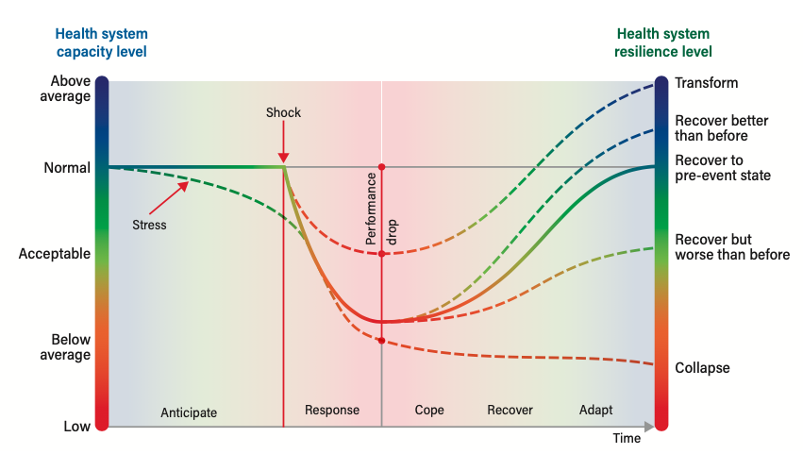
Source: WHO (2022)

Metrics concentrating on HSR are in a greater state of infancy than vulnerability indices. Early attempts to operationalise indices include McGuire et al. (2022) who developed a HSR index comparing five high-income countries, and Oppenheim et al. (2019) who develop an epidemic preparedness index. A number of initiatives have attempted to capture information on health systems resilience capacities and emergency preparedness. The International Health Regulations (IHR) State Party Self-Assessment Annual Reporting (SPAR) is a globally endorsed, compulsory international health emergency mechanism designed to improve health security. Countries self-report on 13 IHR capacities to detect, assess, notify, report, and respond to public health risks. This mandatory annual assessment is complemented by the externally led voluntary Joint External Evaluations (JEE), intended to take place every 5 years (Razavi et al. 2021). Similarly, launched in 2019, the Global Health Security (GHS) Index captures country-level resilience information across six categories: prevention, detection and reporting, rapid response, health system robustness, compliance with international norms, and risk environment. Newton-Lewis et al. (2021) note while these frameworks focus on the risk of international disease outbreaks, many of the indicators relate to wider resilience and shock-responsiveness. Karamagi et al. (2022) develop their own HSR index, the ‘Inherent System Resilience Score’, which distinguishes between emergency preparedness and response for predicted shocks, using IHR SPAR data and the ‘inherent’ HSR, required to respond to unpredictable shocks, based on facility-level surveys. They calculate HSR for 47 African countries. Despite weaknesses in each index, they offer an initial insight into a country's HSR and areas requiring improvement.

Recognising the limitation that no single composite indicator can measure whole health system performance, we also utilize data from the 2019 Global Burden of Disease (GBD) to assess health system performance, specifically in achieving effective Universal Health Coverage (UHC) and in delivering quality health care services as proxies for health system performance. The GBD UHC Effective Coverage Index evaluates how well health systems provide essential health services, not just in terms of coverage, but also in alignment with countries' health needs and with sufficient quality to improve health outcomes (Ng et al., 2014). The index covers 23 essential interventions (Lozano et al., 2020) and enables cross-country comparisons by accounting for country-specific disease profiles. The GBD Health Access + Quality (HAQ) Index, measures broader health system performance based on its ability to reduce amenable mortality. By risk-standardizing mortality rates, the HAQ index attempts to isolate the impact of health system performance, excluding the influence of behavioral and environmental risk factors (Haakenstad et al., 2022). Amenable mortality has often been used as an indicator to benchmark international performance in health service delivery (Mackenbach et al. 2013). While the Effective UHC and HAQ indices are calculated in a standardised manner across countries and undertake some degree of adjustment for case-mix and contextual circumstance, like all single measures, they should not be considered comprehensive assessments of health system performance, but only partial indicators. The indices scale scores (0-100) against the global best- and worst-achievers⁶, not against what’s achievable given each country’s health spending or level of economic development, as such it provides no information on resource use efficiency. Further, the indices are not informative for other objectives such as equity, financial risk protection or patient satisfaction/experience. While these limitations restrict policy interpretations, it allows score comparisons and the identification of the best and worst performers on these service provision-focused metric.

- Results

Table 1 presents descriptive statistics for African S&IS. Although there is a high degree of variation across S&IS, on average they have much smaller geographic footprints – with only Botswana and Namibia larger than the continental average – and an average population density 77% larger than the non-S&IS African average. S&IS are more economically developed with a higher GDP per capita, although the average GDP per capita of African non-S&IS rises from 35% to 44% of S&IS GDP per capita when adjusted for purchasing-power, possibly reflecting the relatively higher costs of goods and services in S&IS.

Table 1: African Small and Island States Descriptive Statistics
Country | Population (2022) | Population ordinal global ranking | Land Area (sq. km) | Population density | GDP Per Capita (2021 US$) | GDP Per Capita (2021 Int$ - PPP-adjusted) | Income Classification (2021) | Per Capita Development Assistance for Health (2021 US$)
Botswana | 2,607,583 | 142/195 | 566,730 | 5 | 6,805 | 16,449 | UM | 28.0
Cabo Verde | 590,503 | 167/195 | 4,030 | 147 | 3,293 | 7,275 | LM | 16.6
Comoros | 829,245 | 160/195 | 1,861 | 446 | 1,577 | 3,563 | LM | 12.4
Djibouti | 1,113,147 | 158/195 | 23,180 | 48 | 3,150 | 5,421 | LM | 15.4
Eswatini | 1,197,454 | 157/195 | 17,200 | 70 | 3,978 | 9,773 | LM | 83.4
Equatorial Guinea | 1,655,207 | 150/195 | 28,050 | 59 | 7,507 | 16,151 | UM | 5.2
Gabon | 2,365,207 | 144/195 | 257,670 | 9 | 8,635 | 15,244 | UM | 4.3
Gambia | 2,672,890 | 141/195 | 10,120 | 264 | 772 | 2,291 | L | 8.8
Guinea-Bissau | 2,083,089 | 148/195 | 28,120 | 74 | 795 | 2,021 | L | 15.0
Lesotho | 2,294,313 | 145/195 | 30,360 | 76 | 1,094 | 2,530 | LM | 34.6
Mauritius | 1,299,134 | 155/195 | 2,030 | 640 | 9,106 | 23,064 | UM | 5.9
Namibia | 2,549,182 | 143/195 | 823,290 | 3 | 4,866 | 10,161 | UM | 35.8
Sao Tome and Principe | 225,155 | 176/195 | 960 | 235 | 2,361 | 4,471 | LM | 50.3
Seychelles | 106,887 | 182/195 | 460 | 232 | 14,653 | 30,503 | H | 9.9
African S&IS Mean | 1,542,071 | - | 128,147 | 165 | 4,900 | 10,637 | 2.4 | 23.3
African non-S&IS Mean | 31,623,366 | - | 696,460 | 93 | 1,726 | 4,698 | 1.5 | 10.8
Africa Mean | 25,614,028 | - | 549,120 | 112 | 2,580 | 6,297 | 1.7 | 14.1
Notes: Population estimates and ranking from the UN World Population Prospects 2022. Country land size and GDP per capita from World Bank World Development Indicators. World Bank Analytical Country Classifications use GNI per capita. Data from Bank FY23 corresponding to 2021 calendar year. Per capita development assistance for health values reflect the annual average over the period 2010-2021 from the WHO GHED. Table adapted from McGuire et al. (R&R)

Figure 2 shows African countries vulnerabilities, as measured by the Sachs et al. (2021) MVI, against GDP per capita. The top seven most vulnerable countries in Africa are S&IS.

Figure 2: African Countries Multidimensional Vulnerability Index
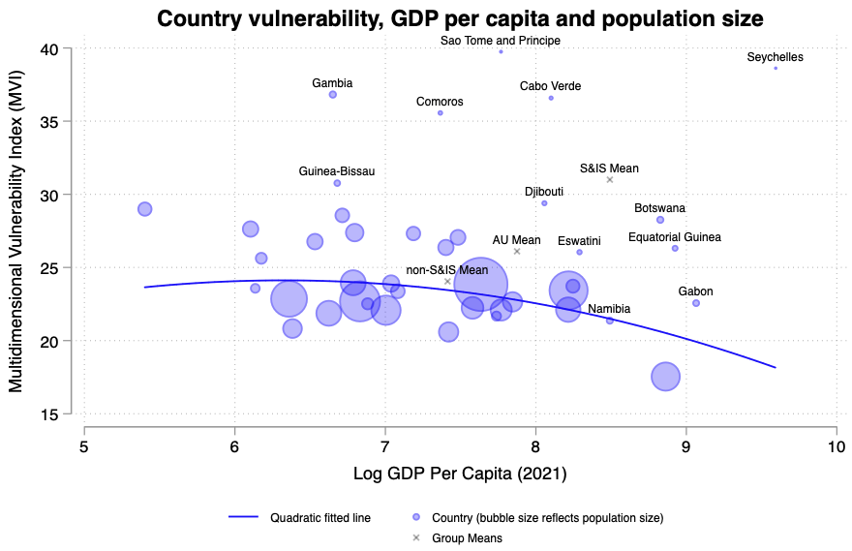
Source: Authors calculations based on Sachs et al. (2021) ⁵.

Appendix C shows the HSR scores of African S&IS from the IHR SPAR, GHS and Karamagi et al. (2021) indices. Importantly, for all three metrics, African S&IS have lower mean resilience than their larger peers. Consequently, despite having higher national vulnerabilities to various exogeneous shocks, their health systems are estimated to have lower resilience, and therefore be worse equipped to cope with shocks and stressors.

Finally, we plot the Global Burden of Disease Effective UHC Index and the HAQ Index, representing partial measures of health system performance, against the IHR and Global Health Security scores. Figures 3(a) and 3(b) show the 2019 IHR SPAR scores against the UHC Index and Access and Quality Index respectively (see Appendix D for the same graphs using Global Health Security Score as the measure of HSR). The graphs are split into four quadrants based on the mean IHR and UHC scores across all observations.

For both the UHC Index and HAQ Index, the majority of S&IS are in the right-hand quadrants indicating above average scores. For the IHR scores, however, a majority of S&IS find themselves below the average score. It is noteworthy that Namibia and Sao Tome & Principe, which are measured as having, within our sample of 12 of 14 African S&IS, the lowest and highest vulnerabilities (Figure 2), have above and below average IHR scores, the opposite of what we might expect if a countries vulnerability was a significant determinant of having HSR as a central health system policy.

Figure 3(a): IHR SPAR Score and GBD UHC Index
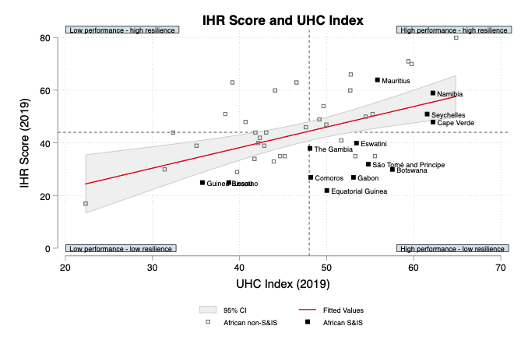
Source: Authors calculations
Figure 3(b): IHR SPAR Score and GBD Access & Quality Index
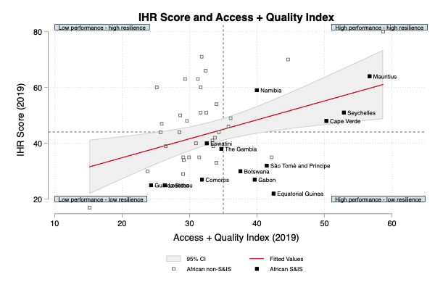
Source: Authors calculations
Therefore, while there is a positive relationship between these measures of health system performance and resilience, it is not a given that high performing health systems will have greater HSR. The pearson’s pairwise correlation coefficients are 0.49 and 0.40 between IHR SPAR score and GBD UHC Index and GBD HAQ Index respectively, providing suggestive evidence that health system performance and HSR as distinct concepts as measured by these indicators in this sample. Consequently, we can see that vulnerable health systems, as with our illustrative example of African S&IS, can have lower HSR, as measured by IHR SPAR and Global Health Security Indices.

- Discussion

The issues of vulnerability and resilience have long been considered in the context of S&IS (Briguglio, 1995; 2004; 2014; Briguglio et al. 2004; 2008; 2009). Briguglio (2009; 2014) developed a framework and indices for measuring economic vulnerability and resilience, where economic vulnerability refers to states inherent characteristics which influence exposure to exogenous shocks and resilience refers to policy measures influencing the ability to mitigate potential shocks. Many countries face ‘structural vulnerabilities’ – exposure to exogenous shocks – which pose significant threats either by directly impacting health system functionality (supply-side impacts) or imposing additional demands and burdens on them (demand-side impacts). However, as highlighted in our illustrative example (figures 2 & 3), vulnerabilities and exposure to shocks does not automatically result in health systems building resilience, which is a policy choice. Further, many standard measures of health system performance will not be informative about the level of HSR. Recent global shocks have led to the concept of resilience being increasingly applied to a wider set of health systems, where resilience refers to the policy-induced ability to withstand, recover from or adjust to exogeneous shocks. This may be particularly pertinent for health care systems which face heightened ‘structural’ vulnerabilities and exposure to exogeneous shocks. However, vulnerabilities and risks are dynamic, and as seen from the COVID-19 pandemic, which exposed weaknesses in even the best performing national health systems, no system is immune to shocks and stressors.

Using an illustrative example of African S&IS, this paper provides an argument that HSR is distinct from health system performance, and that it is not given that a well-performing health is a resilient health system. This represents the first cross-country comparison exploring HSR within the context of countries assessed level of vulnerabilities to shocks. Following the growing evidence that S&IS are disproportionately exposed to exogeneous shocks, we test the hypothesis that they respond to this by building HSR. However, it does not appear to be the case that nations with high risk exposure automatically increase HSR. Even in circumstances where health system vulnerabilities are well recognised – such as the structural vulnerabilities facing S&IS – this does not necessarily lead to higher levels of promotion of system resilience. Given the higher vulnerabilities faced by these countries, in addition to the higher performance of their health systems as measured by the UHC and HAQ Indices, this suggests that the low HSR index scores represent a policy choice, rather than there being a constraint preventing the attainment of higher scores.

The development of indices such as the UVI and MVI reflects a growing appreciation that income-based measures such as GDP/GNI fail to reflect the fundamental differences in systemic risks countries face⁷. The Commonwealth (2021) proposed combining the UVI with GDP to establish a new system for country-classification system, ‘GDP+’, incorporating the concepts of vulnerability and resilience alongside income-based measures. Table 1 shows that African S&IS have over double the development assistance for health (DAH) per capita than African non-S&IS, despite having a higher average level of economic development. However, this introduces another vulnerability, as Official Development Assistance (ODA) has fallen by 70% between 2021-2025 (African CDC, 2025). For the most part, existing vulnerability indices are used for ranking or classification purposes and not for resource allocation. The Global Fund, for example, only considers country’s disease burden and economic capacity (Global Fund, 2023). Sao Tome and Principe is expected to transition out of GAVI and Global Fund assistance in the near future, despite it having the second highest level of donor financing for health per capita in Africa over the last decade (annual average of US$53 per capita). Because of the higher per capita DAH African S&IS currently benefit from, loosing access or reductions in this source of health financing could potentially crowd-out other health priorities such as non-communicable diseases and further de-prioritise enhancing health system resilience in these countries.

In attempting to build health system resilience, African S&IS should make a number of considerations. Each country should identify the relative significance of their country-specific vulnerabilities and how these might impact their health systems. Although we have presented an aggregate multidimension vulnerability index, each S&IS will face idiosyncratic risk exposures which may pose distinct problems for health systems. For example, geographic isolation may pose challenges for Comoros, Cape Verde and Sao Tome Principe, but not Botswana and Djibouti. Among natural hazards, drought has the highest historical average annual occurrence for Cape Verde, epidemics for Guinea-Bissau and insect infestation and floods for Seychelles (FAO, 2021). Recommendations for building health system resilience must recognise the commonalities of the problems facing these countries while appreciating their differences.

Relatedly, African S&IS should seek to build regional collaboration and interconnectedness to enhance health system resilience, as “resilience is not self-sufficiency” (Kruk et al. 2017). Such collaboration may be among S&IS, such as pooled procurement mechanisms to benefit from collective bargaining and economies of scale. However, this may be more challenging for African S&IS than Caribbean S&IS, for example, due to the wider geographical dispersion of these countries. Alternatively, African S&IS may partner with larger countries for specialist overseas care or telemedicine services.

A unique opportunity S&IS may have to reduce a vulnerability and enhance health system resilience is through the elimination of neglected tropical diseases. The impact of outbreaks on S&IS has been seen where, for instance, an estimated >50% of the populations of Mauritius and Comoros infected in 2005-06 (Wahid et al. 2017). While investing in elimination and surveillance may not bear immediate returns, it strengthens long-term resilience.

However, it should be considered that there may be underlying reasons as to why African
S&IS are currently assessed as having lower health system resilience. Meessen et al. (2024) highlight that there may be additional difficulties in implementing health system strengthening (HSS) in S&IS health systems. This hints that S& IS may not only face higher idiosyncratic vulnerabilities and exposures to shocks, but may face additional barriers in building health system resilience. Farrugia (1993) suggests the relatively smaller administrations of S&IS results in multifunctional roles and more demands on personnel. This may lead to a prioritisation of immediate policy concerns rather than contingency planning. However, this same issue likely increases the difficulty of responding to crises, increasing the benefits of risk mitigation. Given the policy importance of building resilient health systems for S&IS, future research should seek to understand better the constraints of doing so in such settings.

This paper takes a broad perspective when considering health system vulnerability and resilience issues. However, system vulnerabilities may be idiosyncratic, requiring specific policy-responses. While cross-country indicators measuring vulnerability and HSR may be of use from a comparative benchmarking perspective, policy makers must recognise that country-specific vulnerabilities require system specific policies to build resilience.

It is worth highlighting that this illustrative study remains descriptive, rather than making any statements based on statistical inference. While the differences in average HSR scores are small between African S&IS and non-S&IS, every independently calculated resilience index has African S&IS as having, on average, lower resilience than larger African states. Given that African S&IS are both hypothesised and measured – by the UN MVI – as being more vulnerable, their level of resilience is clearly not commensurate with their exposure to risk. While the indices provide no indication of the ‘right’ level of resilience, the information makes clear that larger African states have lower vulnerability and higher current levels of HSR than S&IS.

There remains a need for greater conceptual clarity, for both country vulnerabilities and HSR. HSR, particularly, as a concept is in its infancy with continuing debate about its theoretical foundation. Current indices and attempts to measure HSR are almost exclusively based on preparedness, and have been highlighted as having little predictive power in terms of the impact of and response to shocks (Razavi et al. 2020; Abbey et al. 2020; Biddle et al. 2020). Ideally, measures of HSR would relate to factors that influence the expected trajectory health system objectives take after a shock. This requires information on the counterfactual trajectory health systems would take in presence or absence of certain policies or actions, in order to identify the important components of building HSR. Given the idiosyncratic nature of shocks, this is no easy feat. Current indices of HSR appear to lack proper theoretical justifications for variable selection. Greater conceptual clarity is a pre-requisite to ensuring robust measurement. Only then can international research efforts to build rigorous and accepted measures of HSR take place. These challenges in identifying and generating evidence on health system constructs and policies which proactively build HSR may explain why, to date, most country-level efforts have been restricted to developing preparedness plans to respond to an specifically-outlined adverse event. Further evidence is required in terms of how discretionary health spending can be allocated towards health system inputs to improve HSR.

Figure 1 raises several of these and additional policy questions. What is the threshold for a shock considered to test resilience and distinguishing a shock from a stressor? Is a health system which faces a sharper decrease in capacity for a shorter duration considered more resilient than one which has a smaller reduction in capacity but takes longer to recover i.e. how important is the curvature? What is the relevant time-frame for assessing recovery progress post-shock? It has been noted that “weak health systems cannot be resilient” (Kieny et al. 2014). However, a weak system may quickly return to its previous (low) capacity. This introduces the concept of a minimum acceptable level not captured in the figure. Given shocks are often one-time events which may only impact one or a few countries, how do we assess how well a system has dealt with each distinct shock, against how we might expect it to?

Although distinct concepts, the relationship between health system capacity, performance and resilience warrant further examined. On-going shocks to a health system lacking resilience will inevitably impact longer-term performance. For instance, exogeneous shocks which worsen working conditions or increase demands on health workers may increase health worker attrition rates, placing further stress on those who remain (Lin et al. 2022; Witter et al. 2023).

- Conclusion

Planning for future ‘unforeseen events’, which involve a high degree of uncertainty, is rarely prioritised. Particularly in circumstances when low- and middle-income country’s health systems face many, more immediate current problems. However, given the policy importance and the relative strength of health systems in some S&IS, this provides a strong foundation and rationale for increasing attention towards HSR in these settings. While much analytical work remains to be done on the concepts and measurement of vulnerability and HSR, S&IS health policymakers likely cannot afford to wait for academic clarity. These countries should be viewed as global priorities for building HSR. Lessons learnt of what works and what doesn’t in these settings can subsequently be used by and applied to the wider health community.

Endnotes

- Wide-spread recognition of small island developing states (SIDS) as a distinct group first occurred at the UN Conference on Environment and Development (UNCED) in 1992. Since then, UN SIDS member countries have participated in several meetings and developed programmes to facilitate their sustainable development. Since 2001, work on UN SIDS has been led by the United Nations Office of the High Representative for the Least Developed Countries, Landlocked Developing Countries, and Small Island Developing States (UN-OHRLLS). Aiyar (2008) notes that such a grouping reflects the view of SIDS being comparable with least developed countries.
- As noted in Dell, Jones & Olken (2015), climate can be “thought of as referring to a distribution of outcomes, which can be summarized by averages over several decades, while weather refers to a particular realization from that distribution and can provide substantial variability”.
- They are missing damage cost data for Equatorial Guinea, Gabon, Guinea-Bissau and Sao Tome and Principe.
- See McGuire et al. (R&R) for more details on the fourteen African S&IS.
- We are missing data on the Structural Development dimension (one of the 3 dimensions used to aggregate the MVI) for nine non-S&IS countries; Kenya, Liberia, Libya, Madagascar, Malawi, Mali, Mauritania, Morocco and Mozambique, and two S&IS; Lesotho and Mauritius. Although an aggregate MVI score could be constructed for all countries using the 2 remaining dimensions (economic vulnerability and environmental vulnerability) for all countries, given countries face unique sets of vulnerabilities, we have omitted these countries and use the total MVI for all other countries with full data. We do not expect this to change the substantive findings of the analysis.
- For the HAQ Index the 1st and 99th percentile of scores were used to scale scores between 0-100 within each of the 32 mortality cause categories across the full data period 1990-2019, then aggregated for each age group. Therefore the HAQ Index gives an ordinal ranking of countries health systems access and quality with respect to the worst and best performers over this 30 year period. A comparable anchoring approach was used for the Effective UHC Index using the 2.5th and 97.5th percentiles.
- As a result, there is growing demand for development partners to consider factors beyond (per capita) income levels as the primary eligibility criterion determining access to concessional finance and development support. Recognising this, the IMF lending framework introduced a ‘small country exception’ in 2010, increasing the eligibility threshold for accessing IMF financing facilities for select S&IS (IMF, 2022). Specifically, this relates to the Poverty Reduction and Growth Trust (PRGT) where S&IS are eligible if 1) they do not have the capacity to easily access international financial markets; 2) per capital GNI is less than twice the International Development Association (IDA) operational threshold for small states or less than five times the IDA threshold for microstates (IMF, 2013). The standard IDA threshold is $1,205 (World Bank, 2022). Another IMF facility – the Catastrophe Containment and Relief Trust (CCRT) – may benefit S&IS as it provides financing to states where a shock has directly affected at least one-third of the population and destroyed over ¼ of a states’ productive capacity, or caused damage worth in excess of 100% of GDP. Similarly, 13 S&IS have access to IDA assistance under the ‘small island economies exception, despite having per capita GNIs on average four times the eligibility threshold (World Bank, 2016).

References

Atkins, J., S. Mazzi and C. Easter, 2000: Commonwealth vulnerability index for developing countries: the position of small states. Economic Paper No. 40, Commonwealth Secretariat, London, 64 pp.

Africa Centre for Disease Control. (2025). Africa’s Health Financing in a New Era – April, 2025.

Barasa, E. Mbau, R. Gilson, L. (2018). What is resilience and how can it be nurtured? A systematic review of empirical literature on organizational resilience. International journal of health policy and management. 7(6), p.491.

Blanchet, K. (2015). Thinking shift on health systems: from blueprint health programmes towards resilience of health systems. International Journal of Health Policy Management. 4, 307–309.

Briguglio, L. (1995). Small Island Developing States and Their Economic Vulnerabilities. World Development.

Briguglio, L. (2004). Economic Vulnerability and Resilience: Concepts and Measurements. In Briguglio, L. and Kisanga, E.J. (eds), Vulnerability and Resilience of Small States. Commonwealth Secretariat and the University of Malta, 43-53.

Briguglio, L. (2014). A vulnerability and resilience framework for small states. Report prepared for the Commonwealth Secretariat.

Briguglio, L. (2009). Conceptualising and Measuring Economic Vulnerability and Resilience. Powerpoint Deck Prepared for the Conference “Small States and the State”. University of Malta.

Briguglio, L. (2018). Handbook of Small States Economic, Social and Environmental Issues. Routledge.

Briguglio, L. (2022). Economic Growth of Small Developing States—A Literature Review. Independent Evaluation Office Background Paper. International Monetary Fund.

Briguglio, L. Kisanga, E. (2004). Vulnerability and Resilience of Small States. Islands and Small States Institute of the University of Malta and the Commonwealth Secretariat, London. ISBN: 99909-49-22-0.

Briguglio, L. Cordina, G. Farrugia, N. Vella, S. (2008). Economic vulnerability and resilience concepts and measurements, WIDER Research Paper, No. 2008/55, ISBN 978-92-9230-103-3, The United Nations University World Institute for Development Economics Research.

Briguglio, L. Cordina, G. Farrugia, N. Vella, S. (2009). Economic Vulnerability and Resilience: Concepts and Measurements, Oxford Development Studies. 37:3, 229-247.

Central Bank of Swaziland (2016) ‘Annual Report 2015/16’, Central Bank of Swaziland: Mbabane.

The Commonwealth. (2021). The Commonwealth Universal Vulnerability Index: For a Global Consensus on the Definition and Measurement of Vulnerability.

Collier, P. Dollar, D. (1999). ‘Aid, Risk, and the Special Concerns of Small States’. Development Research Group, The World Bank, Washington, DC.

Collier, P. (2007). Africa’s Economic Growth: Opportunities and Constraints. African Development Review. 19(1): 6-25.

Domerland, D. Sander, F. (2007). Growth in African Small States. PRMED, The World Bank.

Easterly, W. Kraay, W. (2000). Small States, Small Problems? Income, Growth, and Volatility in Small States?. World Development. 28(11): 2013-27.

The European Investment Bank. (2020). The EIB Covid-19 Economic Vulnerability Index.

Favaro, E. (2008). Small States Smart Solutions: Improving Connectivity and Increasing the Effectiveness of Public Services. World Bank Publications - Books, The World Bank Group, number 6416.

The Global Fund. (2023). Description of the 2023-2025 Allocation Methodology Date published: 18 January 2023. [accessed December 2023: https://www.theglobalfund.org/media/12675/fundingmodel_2023-2025-allocations_methodology_en.pdf]

Gooding, K. Bertone, M. Loffreda, G. Witter, S. (2022). Strengthening coordination for shock preparedness and response: lessons for health system resilience. ReBUILD for Resilience. Working Paper.

Gilson, L. Barasa, E. Nxumalo, N. et al. (2017). Everyday resilience in district health systems: emerging insights from the front lines in Kenya and South Africa. BMJ Global Health.

Guillaumont, P. (2008). An Economic Vulnerability Index: Its Design and Use for International Development Policy. WIDER Working Paper Series.

The European Central Bank. (2020). The EIB COVID-19 Economic Vulnerability Index – An analysis of countries outside the European Union.

Hanefeld, J. Mayhew, S. Legido-Quigley, H. et al. (2018). Towards an understanding of resilience: responding to health systems shocks. Health Policy and Planning.

Hausmann, R. (2001). Prisoners of Geography. Foreign Policy. 122. 44-53.

Horscroft, V. Small Economies and Special and Differential Treatment: Strengthening the Evidence, Countering the Fallacies. In Commonwealth Small States: Issue and Prospects. By Kisanga and Danchie. Commonwealth Secretariat. 2007.

International Monetary Fund. (2016). Small States' Resilience to Natural Disasters and Climate Change - Role for the IMF.

International Monetary Fund. (2022). The IMF Framework for Engagement with Small States.

Karamagi HC, Titi-Ofei R, Kipruto HK, Seydi AB-W, Droti B, Talisuna A, et al. (2022) On the resilience of health systems: A methodological exploration across countries in the WHO African Region. PLoS ONE. 17(2): e0261904.

Kassim, S. Alolga, R. Assanhou, A. et al. (2015). Medicine pricing: Impact on accessibility and affordability of medicines vis a vis the product origin as pharmaco-economic drivers in Comoros. Journal of public health and epidemiology. 7.

Kieny, M-P. Evans, D. Schmets, G. Kadandale, S. (2014). Health-system resilience: reflections on the Ebola crisis in western Africa. Bulletin of the World Health Organisations.

Kluge, H., Martin-Moreno, J.M., Emiroglu, N., Rodier, G., Kelley, E., Vujnovic, M., et al. (2018). Strengthening global health security by embedding the International Health Regulations requirements into national health systems. BMJ Global Health. 3, e000656.

Kruk, M. Myers, M. Varpilah, T. Dahn, B. (2015). What is a resilient health system? Lessons from Ebola. Lancet. 385. 1910-1912.

Lal, A. Erondu, N. Heymann, D. Gitahi, G. Yates, R. (2021). Fragmented health systems in COVID-19: rectifying the misalignment between global health security and universal health coverage’. Lancet. 397(10268),pp. P61–67.

Magagula, S. (2017). A case study of the Swaziland Essential Health Care Package. EQUINET Discussion Paper 112.

Mackenbach JP, Hoffmann R, Khoshaba B, et al. (2013). Using ‘amenable mortality’ as indicator of healthcare effectiveness in international comparisons: results of a validation study. Journal of Epidemiological Community Health. 67: 139–46.

McGuire, A. Wharton, G. Besley, S. Kourouklis, D. Jofre-Bonet, M. (2022). Healthcare Sustainability and Resilience Index: Quantifying sustainable and resilient healthcare systems. LSE Working Paper.

McGuire, F. Mohan, S. Rao, M. Nabyonga-Orem, J. Nundoochan, A. Kataika, E. Drummond, M. Bland, S. Revill, P. (Submitted). Health Financing and Systems in African Small and Island States: Unique Challenges and Opportunities in achieving Universal Health Coverage.

Meessen, B. Ancia, A. Gill, D. LaFoucade, A. Lalta, S. Sandoval, G. Waqa, G. (2024). When one size does not fit all: Aid and health system strengthening for small island developing states. Health Policy and Planning.

Mboussou, F. Ndumbi, P. Ngom, R. (2019). Infectious disease outbreaks in the African region: overview of events reported to the World Health organization in 2018. Epidemiology & Infection.

MOEPD (2016) ‘Economic Bulletin’, 18th ed, Government of Swaziland: Mbabane.

Newton-Lewis, T. Witter, S. Gooding, K. et al. (2021). What is a Shock-Responsive Health System? Maintains Working Paper.

Oppenheim, B. Gallivan, M. Madhav, N. (2019). Assessing global preparedness for the next pandemic: development and application of an Epidemic Preparedness Index. BMJ Global Health.

Rahman, M. Anbarci, N. Ulubasogli, M. (2022). Storm autocracies: Islands as natural experiments. Journal of Development Economics.

Razavi, A. Collins, S. Wilson, A. Okereke, E. (2021). Evaluating implementation of International Health Regulations core capacities: using the Electronic States Parties Self-Assessment Annual Reporting Tool (e-SPAR) to monitor progress with Joint External Evaluation indicators. Globalization and Health. 17. 69.

Rodrik, D. (1998). Why Do More Open Countries Have Bigger Governments?. Journal of Political Economy. 106 (5): 997–1032.

Lozano, R. et al. (2020). Measuring universal health coverage based on an index of effective coverage of health services in 204 countries and territories, 1990–2019: a systematic analysis for the Global Burden of Disease Study 2019. Lancet. 396: 1250–84. https://doi.org/10.1016/ S0140-6736(20)30750-9

Haakenstad, A. (2022). GBD 2019 Healthcare Access and Quality Collaborators. Assessing performance of the Healthcare Access and Quality Index, overall and by select age groups, for 204 countries and territories, 1990–2019: a systematic analysis from the Global Burden of Disease Study 2019. The Lancet Global Health. doi: 10.1016/S2214-109X(22)00429-6.

Sachs, J. Massa, I. Marinescu, S. Lafortune, G. (2021). The Decade of Action and Small Island Developing States: Measuring and addressing SIDS’ vulnerabilities to accelerate SDG progress. Working Paper.

Sochas, L. Channon, A. Nam, S. (2017). Counting indirect crisis-related deaths in the context of a low-resilience health system: the case of maternal and neonatal health during the Ebola epidemic in Sierra Leone. Health Policy & Planning.

University of Notre Dame Global Adaptation Initiative. (2023). University of Notre Dame Global Adaptation Initiative Country Index Technical Report.

Winters & Martin (2004). When comparative advantage is not enough: business costs in small remote economies. World Trade Review.

Witter, S. Thomas, S. Topp, S. Barasa, E. Chopra, M. Cobos, D. Blanchet, K. Teddy, G. Atun, R. Ager, A. (2023). Health system resilience: a critical review and reconceptualization. The Lancet Global Health.

World Bank. (2016). Approach Paper Clustered Country Program Evaluation For Small States.

World Bank. (2022). World Bank Group Support to Small States.

World Bank. (2008). The Growth Report: Strategies for Sustained Growth and Inclusive Development.

World Health Organisation. (2021). Second round of the national pulse survey on continuity of essential health services during the COVID-19 pandemic: January-March 2021 Interim report.

World Health Organisation. (2022). Country Cooperation Strategy 2022-2026 Eswatini.

World Health Organisation. (2022). Measuring the climate resilience of health systems.

Lin, T. Werner, K. Kak, M. Herbst, C. (2022). Health-care worker retention in post-conflict settings: a systematic literature review. Health Policy and Planning.

Witter, S. Wurje, H. Chandiwana, P. et al. (2023). How do health workers experience and cope with shocks? Learning from four fragile and conflict-affected health systems in Uganda, Sierra Leone, Zimbabwe and Cambodia. Health Policy and Planning.

Wahid, B. Ali, A. Radique, S. Idrees, M. (2017). Global expansion of chikungunya virus: mapping the 64-year history. International Journal of Infectious Diseases.

Razavi, A. Erondu, N. Okereke, E. (2020). The Global Health Security Index: what value does it add? BMJ Global Health.

Farrugia, C. (1993). The Special Working Environment of Senior Administrators in Small States. World Development. 21(2): 221-226.

Biddle, L. Wahedi, K. Bozorgmehr, K. (2020). Health System Resilience: a literature review of empirical research. Health Policy and Planning.

Abbey, E. Khalifa, B. Oduwole, M. Ayeh, S. Nudotor, R. Salia, E. (2020). The Global Health Security Index is not predictive of coronavirus pandemic responses among Organization for Economic Cooperation and Development countries. PLOS One.

Smith, P. Papanicolas, I. (2012). Health system performance comparison: an agenda for policy, information and research. World Health Organisation.

Papanicolas, I. Rajan, D. Karanikolos, M. Soucat, A. Figueras, J. editors. Health system performance assessment: a framework for policy analysis. Geneva: World Health Organization; 2022 (Health Policy Series, No. 57). Licence: CC BY-NC-SA 3.0 IGO.

Appendix

Appendix A: Vulnerabilities and challenges facing Small and Island States

Theme | Vulnerability | Resulting challenges
Economic | • Small population  • Often remote or isolated (islands or landlocked)  • Limited resource endowments | • Small domestic market  • Significant trade transaction costs  • Inability to benefit from economies of scale in production of goods and provision of public services  • High production costs  • Highly dependent on trade  • Uncompetitive exports  • Concentrated export bases directed to small number of markets  • Few importers with large market power  • Constrained access to international capital/investment  • Vulnerability to external economic shocks
Social | • High fixed cost of higher education  • Limited labour market | • Potential for brain drain  • Shortage of skilled labour impacting state capacity  • Lack of specialist services
Environmental | • Geographically concentrated populations  • Exposure to climate and environmental risk | • Vulnerability to natural disasters  • Lower tourism revenue, which may be significant source of income  • Reduced arable land

Appendix B: Literature on the vulnerabilities of Small and Island States

An extensive literature has examined the various unique challenges facing S&IS and their impacts.

- Small states may suffer from diseconomies of scale in both the production of goods and provision of public services, resulting in high costs (Winters & Martin, 2004). Both have indivisibilities that result in increasing returns to scale. There are notably high fixed costs in areas such as transport, defence, and higher education. Smaller populations also results in a smaller spread of the cost of public expenditure. The indivisibility of expenditure on the provision of public goods particularly impacts infrastructural spending, often resulting in public budgets heavily leaning towards recurrent expenditures. The economies of scale constraints and indivisibilities also impact private investment and expenditure. This combined with the small internal markets also results in public sectors often becoming one of the primary employers in S&IS. Favaro (2008) notes the average share of government GDP expenditure is 19.4% in S&IS compared to 15.7% in ‘large’ states.

- Many S&IS are geographically remote (islands or landlocked), reducing their ability to integrate with the world economy. Theory suggests distance from major markets increases the cost of foreign trade (imports and exports), thereby reducing export competitiveness and foreign direct investment (Brito, 2015). This makes clear that the challenges faced by the Pacific islands are very different from those faced by Caribbean islands which are in close proximity to the USA, which in turn are different from those faced by landlocked mountainous countries like Bhutan.

- Many S&IS suffer from climate and environment issues. Specifically, many S&ISs are in regions vulnerable to natural hazards such as hurricanes, cyclones, droughts, and volcanic eruptions. Added to the less diversified economies this can have severe state-wide economic consequences. The annual cost of natural disasters in S&ISs is close to 2% of GDP, more than four times suffered in larger countries (IMF, 2016). Domeland and Sander (2007) highlight this difference within Africa, with S&ISs suffering damage costs of 58.25% of GDP compared to 8.43% for larger states.

These structural disadvantages have several consequences:

- S&IS have higher growth volatility due to disadvantage 1 and 2. S&IS are typically dependent on only a small number of economic activities. This over-reliance on a limited number of sectors means the economic health of a small number of sectors has a strong determining impact on the overall economic situation. S&IS generally have very open economies due to the need to import essentially which cannot be internally produced. This exposes S&IS to changes in the global economic outlook and trade shocks. Additionally, as noted, the impact of periodic natural disasters has a significant economic impact. The World Bank (2005) noted that volatility (measured as standard deviation of growth rate of per capital GDP) in S&IS was 3.9, as opposed to 1.4 in LICs and 1.5 in MICs. This can result in fiscal policies and public expenditure with a large procyclical trend due to revenue volatility and unforeseen significant costs.

- Many S&IS suffer from brain drain. This is due to the high costs for S&IS of developing tertiary education and the limited opportunities for high-skilled employment. Beiner et al. (2008) suggest that S&IS may be relatively good at producing skilled workers, but that this human capital is frequently lost as they fail to retain them. Docquier & Marfouk (2005) note that 86% and 83% of college graduates migrate from Guyana and Jamaica respectively. This is particularly problematic as many S&IS lack natural resources, and therefore rely strongly on human capital for economic growth (Armstrong & Read, 2003). This brain drain results in limited government administrative and technical capacity in many S&IS.

- S&IS often suffer from fiscal imbalances due to the inability to diversify tax revenue sources and a heavy reliance on trade taxes. This imbalance often results in high public debt to GDP ratios (Aiyar, 2008). Additionally, the World Trade Organisation (WTO), established in 1995, follows the key principles of multilateral trade liberalisation and non-discrimination. This has seen some S&IS suffering ‘preference erosion’ as preferential trade agreements (PTA) expire; and PTAs lose value with the global falling of trade tariffs (World Bank, 2008).

- Many S&IS are now in a long-term state of aid dependence. A World Bank evaluation (IEG, 2006) showed that the average net aid received by small states was $201.1 per capita, as against only $12.3 per capita for all developing countries and $18.1 per capita for all developing countries excluding China and India. In other words, small states averaged more than 16 times as much aid as developing countries as a whole. Measured as a proportion of gross national income, average net aid was 14.8% for small states as against just 1.1% for all developing countries. That is, small states got 14 times as much aid in relation to their GNI. All pacific island states have risen to middle-income status largely with the help of huge aid flows. Related to aid-dependence there is also a dependence on remittances.

However, research in the 90s and early 2000s cast doubt on the narrative that S&IS suffer a natural development disadvantage. A number of studies empirically examined the hypothesis that S&IS were developmentally worse off, finding limited evidence supporting this. A World Bank-Commonwealth review showed that between 1990–2005, small states had on average slower economic growth (3.5% per year) than all developing countries (4.2%) (Briguglio et al. 2005). However, Easterly & Kraay (2000) found that in 1960—95 small states grew as fast as large ones. The World Bank (2008) concluded that S&IS did not have lower GDP or slower growth relative to larger states. Easterly & Kraay (2000) argue that S&IS should not be considered differently from other states. They find that S&IS have higher GDP and similar growth trajectories to other states. However, they do identify that S&IS have higher growth volatility, due to greater trade openness. As a result of their study, they suggest S&IS should receive similar policy advice as larger states.

Acknowledging that S&IS have higher GDP than larger states, Aiyar (2008) argues that S&IS have been relatively over-aided (relate back to the point that IEG, 2006 found S&IS receive orders of magnitude more aid per capita than developing countries as a whole). Additionally, he points to a relatively low number of S&IS being both heavily indebted and poor (of 41 countries covered by the Heavily Indebted Poor Countries (HIPC) initiative, only five are small – Comoros, Gambia, Guinea-Bissau, Guyana and Sao Tome and Principe (Aiyar, 2008). He also shows that economic differences among small states are more dramatic than average differences between small and large states, suggesting size is not a key determinant of economic success. These differences among small states suggest that policies and institutions matter more than size. Domeland & Sander (2007) note that AU S&IS which have developed strong governance and institutions, such as Botswana and Mauritius, have benefited, while those that have not, such as Comoros and Guinea-Bissau, have remained poor.

Therefore, empirical evidence generally does not find strong evidence that smallness is a disadvantage, from an economic perspective. This suggests that while S&IS may have disadvantages, there are reasons why they do not appear to be economically lagging. Favaro (2008) refers to these as ‘compensating factors’. Additionally, S&IS may also have some inherent advantages.

African S&IS have high levels political stability. This is reflected in African S&IS only having a 3% probability of state failure (measured by coup, civil war, genocide), while the probability is 26% for all sub-Saharan states (Domeland & Sander, 2007). This lower incidence of conflict holds even after controlling for degree of ethnic fractionalisation, suggesting there is a state size specific factor (Domeland & Sander, 2007). Additionally, African S&IS have superior good governance indicators as measured by voice and accountability, government effectiveness, regulatory quality, rule of law and corruption (Kauffman et al. 2006). Rogrigues Sanches et al. (2021) note that smallness results in closer links between populations and politicians while Cheeseman (2021) notes being an island can insulate from the ‘politics of belonging’.

A large literature has examined the impact of social capital and cohesion on economic growth (and a number of other outcomes such as health, education etc.). Baldacchino (2005) argue ‘social capital’ theory makes for a more informed understanding of how many (though not all) S&IS manage to generate good standards of living. Briguglio (2016) contends that improvements in social conditions, a requisite for improvement in social capital, could reduce the harm arising from a S&IS exposure to external shocks because it affects the extent to economic apparatus without the hindrance of civil unrest.

Briguglio (2022), in a document outlining the literature on economic growth and development of S&IS, breaks the literature into three thematic types:
- One emphasises the structural weaknesses of S&IS and adopts a fatalistic stance that these handicaps are insurmountable.
- One arguing that S&IS have inherent weaknesses, but that these can be addressed with appropriate economic and social policies.
- One that argues S&IS are no different to larger states and there should be no fundamental difference in economic policies pursued and approach to development (beyond the idiosyncratic differences each state globally takes based on its comparative advantages and disadvantages).

Appendix C
Health System Resilience Measures (IHR SPAR, GHS, Karamagi et al. (2022))
Country | Average of 13 IHR core capacity scores (2018) | Average of 13 IHR core capacity scores (2019) | Average of 13 IHR core capacity scores (2020) | Global Health Security 2019: Overall Index | Global Health Security 2021: Overall Index | Karamagi et al. (2022) Inherent System Resilience Score
Botswana | 26 | 30 | 43 | 31 | 34 | 70
Cape Verde | 46 | 48 | 52 | 33 | 34 | 27
Comoros | 19 | 27 | 41 | 25 | 25 | 45
Djibouti | - | - | - | 24 | 25 | -
Eswatini | 42 | 40 | 46 | 31 | 29 | 63
Equatorial Guinea | 22 | 22 | 26 | 18 | 17 | 34
Gabon | 40 | 27 | 40 | 20 | 22 | 6
The Gambia | 35 | 38 | 35 | 30 | 29 | 56
Guinea-Bissau | 40 | 25 | 35 | 19 | 21 | 71
Lesotho | 33 | 25 | 40 | 33 | 31 | 66
Mauritius | 62 | 64 | 64 | 38 | 40 | 22
Namibia | 47 | 59 | 61 | 31 | 30 | 47
São Tomé and Principe | 39 | 32 | 31 | 21 | 27 | 30
Seychelles | 48 | 51 | 56 | 33 | 32 | 40
African S&IS Mean | 38 | 38 | 44 | 28 | 28 | 44
African non-S&IS Mean | 43 | 47 | 50 | 30 | 29 | 51
African Mean | 42 | 44 | 49 | 29 | 29 | 49

Appendix D

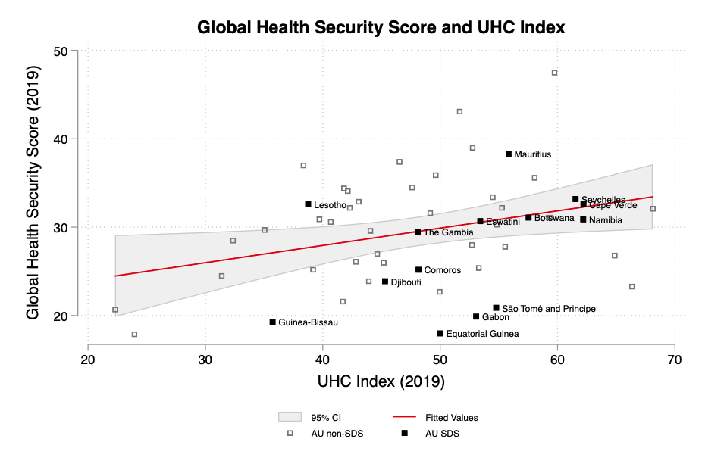

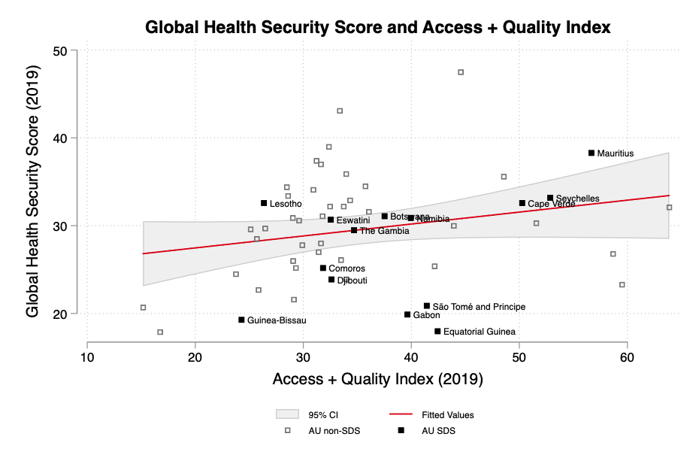

Countries such as Liechtenstein, Latvia, Lithuania, Iceland, Malta, Qatar, Brunei and Luxemburg and city states like Singapore and Monaco all rank very high in GDP per capita and human development.
Aiyar (2008) lists 12 inherent advantages: relatively homogenous populations; relatively insulated from spill-overs of violence from neighbours; disproportionately large benefits from foreign investment; single mineral windfall in small states can offset many failings’ have exploited tax arbitrage opportunities; Have benefited from niches like military bases and lightly regulated financial centres; Get disproportionately large benefits from migration and remittances; Get disproportionately large benefits from tourism; Can export items that are usually non-tradable; Get disproportionately large benefits from the Law of the Sea; Infrastructural investments in small states quickly reach most of the population; Get disproportionately large trade preferences.

