Shaping the ‘studenthood’: purpose-built student accommodation and planning law

Caroline Hunter, Professor, University of York, orcid.org/0000-0002-7504-3422 and Carl Makin, PhD candidate, University of York

Address for correspondence:
Caroline Hunter, York Law School, University of York, York, YO10 5DD, United Kingdom
caroline.hunter@york.ac.uk

Abstract
One of the most intriguing changes to urban living over the last 40 years has been the growth of student populations in cities and other university towns across the world. Much of the existing literature in this area focuses on processes of ‘studentification’ whereby family homes in area adjacent to campuses are converted into houses in multiple occupancy (HMOs) for students. Local and national regulatory responses to these processes of change have often focused on regulating the potential spill-over effects of housing intensification in these areas, such as property condition, noise and waste management. The focus of this chapter is on a relatively new frontier of studentification – purpose-built student accommodation (PBSA). This shift has seen an influx of institutional investors capitalising on a new ‘metropolitan habitus’ to build accommodation at scale which segregates students from neighbouring populations.
Through an analysis of planning decisions across three local authorities in England, this article seeks to achieve two things. First, it develops the existing literature on PBSA by understanding the legal and political responses of local authorities to applications to develop PBSA across different geographies. Second, it demonstrates the largely untapped potential of planning decision archives as a site for fruitful empirical socio-legal research.

Keywords
Studentification, planning law, purpose-built student accommodation, houses in multiple occupancy

Introduction
One of the changes to urban living over the last 40 years has been the growth of students in cities and university towns across the world. As Kinton et al. (2016) recognise students are ‘an influential social group in enacting urban change.’ In the UK, much of the literature on ‘studentification’ has focused on the conversion of family houses adjacent to campuses into houses in multiple occupancy (HMOs), leading to densification and associated pressures on local infrastructures. Regulatory responses to these processes have hence focused on common issues that arise from living in close proximity, such as property condition, noise, rubbish, and other ‘streetscape’ issues which create conflicts between student and non-student neighbours.
The development of purpose-built student accommodation (PBSA) by private companies has altered the geographies of studentification in the UK (Hubbard 2008, Nakazawa 2017, Kinton al 2016, Gibb et al 2022). Quite different from the model of private landlords slicing up family homes to accommodate students and maximise rental yields across what is often a small portfolio of properties, PBSA often involves developing or redeveloping land at scale with the sole purpose of servicing student populations, principally in prime city centre locations close to higher education institutes. This development of accommodation at scale forms part of wider trends involving the commodification and gentrification of studenthood, within which developers capitalise on what Hubbard characterises as a unique student ‘metropolitan habitus’ equipped with sufficient buying power to pay for convenient inner-city accommodation (Hubbard 2009, p. 1904).
In the UK, this commodified studenthood has been largely shaped by the higher education policies of successive governments of various political colours which have led to market liberalisation and increasing student numbers amongst both home and international student groups. Yet, it has also been shaped by the ability and willingness of cities to accommodate students, and in turn these student communities have shaped the cities they inhabit. These physical manifestations of the new studenthood are mediated locally through planning law, as planning permission is required to develop purpose-built accommodation.
Our focus in this article is on private PBSA. Of course, as Cowan and Boroumand (2024) have illustrated, the relationship between universities and providers of PBSA is complex. Although providers may simply offer the accommodation without a relationship with the universities in the particular city or town, creating a relationship benefits for both parties. Cowan and Boroumand (2025, p.222) point three different models leasing, nominations, and University-owned (perhaps with management outsourced). In the article we have not considered University-owned PBSA.
While a number of authors have examined the growth of PBSAs in different cities in the UK (Hubbard 2008, Kinton et al 2016, Sage et al 2013, Ruiu 2017, Mulhearn and Franco 2018) we are not aware of planning decisions for PBSA having been used as a data source. Perhaps this lack of interest in detailed planning decisions reflects the ‘relative neglect of planning by legal scholars’ (Lee 2022, p.4). In this article we present empirical data on planning decisions concerning PBSA in three university cities in England: Manchester, Sheffield and York. We both seek to add to the literature on student accommodation and its relationship with urban living, but also to demonstrate that socio-legal empirical methods can be usefully deployed in planning law scholarship.
We start the article with a short history of the growth of PBSA in the UK. Then we examine how planning law has been instrumentalised at a national level to address concerns relating to studentification and the extent to which PBSA has been considered as part of this response. Finally, we turn to the local level to present our empirical findings.
The growth of PBSA
UK Government policy on higher education has favoured on-going growth of student numbers since the 1960’s. The Robbins report of 1963 that heralded that first wave of growth ‘regarded it as unrealistic to expect more than one third of students to live either at home or in private rented lodgings’ (Rugg et al 2000, p.2). As ‘the overwhelming majority of UK undergraduates, attending university means leaving home’ (Whyte 2019, p.7) this meant halls of residence would have to expand. However, this expansion did not keep up with the student numbers. This lack of university residences, plus changing preference for independent living ‘contributed to an increase in the numbers seeking privately rented accommodation’ (Silver 2004, p.128).
In 1967 there were 197,000 full-time students in the UK. By 2000, undergraduate numbers had reached 1.15 million (Jobbins, nd). It is no wonder that by the end of the 20th century there was a growing and buoyant ‘niche market’(Rugg et al 2000) of student HMOs, and an academic interest in the emerging phenomenon of ‘studentification’ began. Smith, who coined the term, describes studentification as the ‘the distinct social, cultural, economic and physical transformations within university towns, which are associated with the seasonal, in-migration of HE students’ (Smith 2005, p. 74).
The process of studentification involves residential areas of university cities and town becoming student enclaves (Munro et al 2008). In terms of the housing market, former ‘single-family’ homes or existing rented housing is repackaged as HMO student housing by small-scale, often individual, actors (Smith 2005). While high concentrations of students may have positive effects on the prosperity of urban areas, local neighbourhoods can be negatively impacted by transience and conflicts between student lifestyles and those of their neighbours (Munro et al 2008).
In 2008, the Labour Government noted some of these challenges in an evidence review on HMOs, and the particularly vocal opposition of local resident groups (DCLG 2008, p.7). At the time, such opposition was politically quite valuable, as New Labour focused its energies on nurturing its ‘balanced communities’ agenda (Smith 2008). Indeed, it was pressure from the National HMO Lobby that led to the Office of the Deputy Prime Minister funding research by Universities UK into studentification and good practice amongst institutions (Universities UK 2006). Here, the Government was clear that the research should focus on ‘non-legislative, non-regulatory solutions’, but the scope of the project also included consideration of existing powers of local authorities in planning law and the use of ‘Student Housing Restraint Areas’ (National HMO Lobby, nd).
As Hubbard notes, New Labour regarded planning law as an instrument through which national government could support the amelioration of some of the local political issues arising from studentification (Hubbard 2008). This is a very different form of legal regulation from the other major form of regulation – licensing of HMOs under the Housing Act 2004 - that has also been used to control studentification. Licencing does not limit the numbers of HMOs in an area but sets conditions for the management of the HMO. Under that Act the Supreme Court in Nottingham City Council v Parr [2018] had indicated that in setting conditions local authorities should treat students differently from other occupants of HMOs and ‘lower’ standards could be applied to them.
As New Labour was considering how to control student HMOs, the market for student accommodation began to pique the interest of institutional investors (Nakazawa 2017, pp.4-5):
[S]ome developers have raised funds and developed apartment buildings as PBSAs promoting them as sound investments, particularly in times of low interest rates. PBSAs are typically equipped with private kitchens and bathrooms to compensate for their pricy rents, and luxurious PBSAs even offered gyms, lounges, kiosks, and so forth.
Since then, the PBSA sub-sector has grown to become what Savills described in 2019 as ‘the most mature and liquid of the operational property markets’ (Savills 2019). Indeed, the policy pivot towards PBSA in the mid-2000s seems to have been broadly welcomed not only by lobby groups, but also universities and local authorities as a potential cure-all for the problems associated with studentification (Gibb et al 2025, p.25).
Through the 2010s local authorities in the UK, often in collaboration Universities (Ruiu 2017), sought to use some legal measures to limit the growth of HMOs and to promote PBSA (Ruiu 2017 and Brown 2018). This view was shared by the National HMO Lobby which saw planning law and the development of PBSA as a pincer movement that could deal with studentification (National HMO Lobby 2006, para 7):
In resolving the student housing issue, purpose-built accommodation is the carrot. The stick is how the planning system should respond. All round the country, local authorities are adopting policies to address the issue of HMOs in general and student housing in particular.
Part of the criticism of HMOs has been the poor quality of the housing and there is some evidence that PBSA has improved the quality of accommodation on offer (Whyte 2019 and Gibb et al 2022). But it comes with a price of higher rents (Gibb et al 2002, Chapter 5, NUS 2021). Indeed, the move to PBSA has not been without its own critiques. In particular, there is a concern about the way the price of PSBA excludes some students, creating polarised student accommodation market (Reynolds 2020, Kinton et al 2016). As well as catering for the growth home students, the PSBA market has been fuelled by the internationalisation of higher education (de Wit and Altbach 2021, HM Government 2019). There has been an assumption that international students predominantly seek high‐quality PBSA and are steered into this form of accommodation by agents (Kinton et al 2018).
The high rents and targeting of international students have led to concerns that PBSA creates exclusive student communities. This has two negative aspects. Firstly, PBSA often replicates gated communities and:
shifts the student experience away from on‐campus sites for social encounter and engagement towards the internal spaces of the student communities and generates inequalities between students (Kenna and Murphy 2021, p.141).
This underscores the polarisation of the student experience. In 2023 it was reported that ‘fewer than one in 10 beds in major university cities are now affordable to the average student in receipt of maintenance loans and grants’ (Weale 2023). Secondly the move to gated-communities also distances students from the general community. Accordingly, they ‘play a limited role in sustaining public services, volunteering and regeneration local economies’ (Gibb et al, p.28). Generally they are ‘sites of self‐segregation and social withdrawal of affluent students’ (Nakazawa 2017, p.5).
One other aspect of the changing geography of PSBA is the movement into high-rise buildings in city centres. Chatterton (2010) comments on two residential student high-rise towers that had just been added to the Leeds skyline. One of them claimed to be the tallest student accommodation block in the world, with 37 storeys and 557 bedrooms (Chatterton 2010, p.509). In Liverpool PBSA has been focused on the city centre (Mulhearn and Franco 2018). For Chatterton the ‘significance of these new centrally located student skyscapers should not be overestimated for the evolving urban form and the social habits of cities’ Chatterton 2010, p.513).
PBSA has clearly emerged as a viable and quite separate market to traditional student HMOs and has had important socio-spatial consequences for student populations and their neighbours. Before we examine this at a local level, we consider the extent to which planning law and policy at a national level has shaped this recent frontier of urban studentification.

Shaping at national level
The planning system in the United Kingdom is characterised by plan-led decision-making, whereby plans and policies provide direction to discretionary decision-making (Sheppard et al 2017). In effect ‘developments rights in the UK [are] nationalised’ (Sheppard et al 2017) and there cannot be development without planning permission from the local authority (Town and Country Planning Act 1990, s.57, ‘TCPA’). Those decisions must be made whilst taking into account the local authority’s development plan (TCPA 1990, s.70(2)(a)). Those local plans are guided by a national framework (see R (Wright) v Resilient Energy Severndale Ltd [2019]). In terms of student accommodation the national framework states (DLUHC, 2019, para. 04) that:
Local planning authorities should plan for sufficient student accommodation […]. Encouraging more dedicated student accommodation may provide low-cost housing that takes pressure off the private rented sector and increases the overall housing stock. Plan makers are encouraged to consider options which would support both the needs of the student population as well as local residents before imposing caps or restrictions on students living outside of university-provided accommodation. Plan makers should engage with universities and other higher educational establishments to better understand their student accommodation requirements.
Within this legal framework, the definition of development is key as it makes clear when planning permission is required. It is broadly defined to capture a range activity on land: ‘“development,” means the carrying out of building, …or other operations in, on, over or under land, or the making of any material change in the use of any buildings or other land’ (TCPA 1990, s.55).
The first limb of this definition – operational development – covers any newly built PBSA (Sheppard et al 2017, p.84). However, the second limb – change of use e.g. office space to domestic housing - also requires planning permission. It is through this second mode of development control that New Labour sought to build on local efforts and utilise planning law to control the progression (rather than simply the consequences of) studentification by restricting the growth of HMOs.
… local authorities and the Government have received increased lobbying from residents, local politicians and other groups who want to be able to limit concentrations of HMOs, particularly those occupied by students, by implementing a number of planning policy measures. Such measures including planning restraint or threshold policies, seek to ameliorate the problems by stipulating that planning permission for a change of use to an HMO will be refused once a certain concentration, defined as a percentage of the housing stock in that area, has been reached. (DLCG, 2008, para 2.4.2)
Through this, we see the seeds of regulating studentification through planning law and specifically the use class. Use classes are governed by the Town and Country Planning (Use Classes) Order 1987 (the Use Classes Order), which sets out various categories of land use, ranging from shops, to hotels and industrial forms of use. Until 2010, dwellinghouses were captured by use class C3, which encompassed residences used by people living together as a family or not more than six persons living together as a single household (the Use Classes Order, sch 1, para 3). Where more than six individuals were not living together as a ‘single household’, i.e. they formed a house in multiple occupation (HMO), it was treated as a sui generis (‘in a class of its own’) use and therefore as a separate class requiring planning permission (the Use Classes Order, art 3, para 6. sch 1, para 3). As Samuels (2007, p.518) notes:
Six is an arbitrary number. Five students can cause as much disturbance as seven. Investigating and identifying the exact number can be very difficult, especially for a transient group of resident students.
For these smaller HMOs there was in effect no requirement for any planning permission as they were remodelled from family homes in HMOs.
Cognisant of these issues, it was during the final days of New Labour Government that the then Minister for Housing, John Healy, amended the Use Classes Order 1987 to provide for a specific definition of an HMO (HC Deb, 2010, 504, cols 55-56W). Planning permission was required to change the use of a property from C3 dwelling house to an HMO (C4) (Town and Country Planning (Use Classes) (Amendment) (England) Order 2010 (SI 653/2010)).
We see a direct deployment of planning law as a tool to control the proliferation of HMOs and consequentially processes of studentification. However, these changes were largely undone within six months of operation following the 2010 General Election. The new Conservative housing minister Grant Shapps MP placed the Order on the Government’s ‘Red Tape Challenge’ hit list (HM Government, n.d.) to do away with ‘bureaucracy aimed at micro-managing rented housing’ (DLCG, 2010).
In October 2010 the Order was amended to allow changes between C3 and C4 classes without the need for a planning application. Where local authorities wish to control conversions between C3 and C4, they are now required to issue an ‘Article 4 Direction’ which curtails these Permitted Development Rights. Home (2017, p.202) suggests that 10% of English local authorities have proceeded with Article 4 directions ‘mostly in city areas affected by studentification.’ Indeed, all three local authorities considered later in this paper have issued Article 4 directions.
So far this section has explored the extent to which planning law at a national level has been used as a tool to ameliorate the wider impacts of ‘studentification’ on non-student neighbours through limiting the growth of HMOs. Although efforts were made in the dying days of New Labour to instrumentalise planning law as a tool to meet their policy aims of sustainable communities, this high-water mark was briskly retreated from under the Coalition Government in late 2010.
But what of PBSA? Of course, new developments required planning permission as did any material changes of existing buildings into large student residences that would be captured as sui generis HMOs. However, the national view of planning law was changing more generally. Lord and Tewdwr-Jones (2014) have tracked the neoliberalisation of planning law and policy at a national level from 1997. Under New Labour there was a focus on place-shaping and property-led economic development. From 2010, as the government changed, a deep-rootedly incoherent approach to planning emerged (Lees and Shepherd 2015) with both a localism agenda and a "presumption" in favour of sustainable development. The need to satisfy the requirements of the presumption in favour of sustainable development is imposed on local planning authorities at both the decision-making and the plan-making stage.
For Lord and Tewdwr-Jones (2015, p.356) neoliberalisation of the planning system risks losing ‘many of its regulatory teeth’, retiring the entire system into an ‘animator of taken-for-granted growth’ rather than allowing it to play any proper role in processes of urban contestation. We move now to local level to examine how these bigger trends played out in decisions on PBSA.

Shaping at local level
The actual decisions on any individual planning application are taken in principle by elected officials for both limbs of the development definition. However, they are advised by officers with experience and expertise in planning (Lee 2022, p.15) who will advise based on the local plan (TCPA1990, s.70(2)(a)). Sheppard et al (2017, p.107) describe three broad phases of an application: preparation, submission, and decision. Although it is the decision that is made public and includes publicity and consultation prior to that decision, it is important the recognise that much happens earlier in the process. The developer is likely to have been in discussion with the local authority before an application is made.
Pre-application discussions are intended are intended to improve the outcomes of a projects by obtaining other views, perspectives and information relevant to the proposed development. (Sheppard et al 2017, p.107.)
Given this process is it likely that most applications will be approved. However, in giving permission the local authority can and usually will include conditions (TCPA 1990, s.72). These conditions ‘should be tailored to address specific issues, rather than used to impose unjustified controls’ (Sheppard et al 2017, p.126).
The remainder of this article turns its focus to examine more recent examples of moves by local authorities to shape studentification in their localities. Having established the ambivalence of national planning policy post-2010 towards the increased demand for student accommodation and the impact of studentification on local communities, it is important to consider how planning responses have shaped studentification over the past decade. We focus here specifically on purpose-built student accommodation due to its emergence as a new model shaping the student living and because of the signalling by central government (DLGHC 2019) and pressure groups that it offers an opportunity to soften the impacts of studentification brought about by the conversion of C3 dwelling houses into HMOs.

Data
Because planning decisions are public, local authorities must make them accessible. Accordingly, most planning applications are submitted online to facilitate this. Each study authority has a ‘planning portal’, which allows applications to be searched by date and key words. For this research we searched for applications with the key words ‘student accommodation’ between 1 January 2015 and 31 December 2019 and created a database all decisions. We removed the following from database:
- any application from the Universities in each city (our focus was on ‘private’ PBSA as an alternative to HMOs, although we recognise there is a growing blurring between university accommodation and private providers of PBSA),
- outline permissions,
- minor applications (e.g. signage or minor changes to existing permissions), and
- applications that were withdrawn without a decision.
Applications generally have many documents. In each case we examined the actual decision (which is usually a short document) and the officer report. In a number of cases the application did not have an officer report. But in each of these cases there was instead a report that the developer and submitted, usually written by a planning consultant. Our database captured:
- The date of the application
- Nature of the decision – whether a new development or change of use
- Decision whether positive or negative. If negative the reason of the refusal.
- The number of bed-spaces in the application

In addition, we noted any conditions added to the permissions and particular comments on the relevant report.

The three cities
Sheffield
Sheffield is a city of just over 500,000 inhabitants with an industrial past. It has two large Universities – the University of Sheffield and Sheffield Hallam University. In 2020-21 they had together a total 55,132 students. It is worth noting that Sheffield Hallam University no longer provides any student accommodation directly. It has nomination agreements with private providers of PBSA (Cushman and Wakefield 2021). 23% of private sector beds are nominated by both institutions, roughly in line with other major markets such as Birmingham and Manchester (Cushman and Wakefield 2021, para. 4.10).
A study of PBSA in Sheffield by Stevenson and Askham in 2011, shows that even then there were concerns of an oversupply of total student accommodation stock. In 2013 the local authority – Sheffield City Council (SCC) – created a student accommodation strategy (SCC, 2013). This also noted (p.3) the potential over supply:
The city has a mixed accommodation offer for students, with an increasing amount of Purpose Built Student Accommodation (PBSA). Whilst demand for PBSA is continuing to grow, particularly from the newer international student market, our existing stock is still not at full occupancy, and there is a risk that the provision of more PBSA will lead to oversupply and older blocks falling empty.
This was further confirmed in a 2021 report (Cushman and Wakefield) commissioned by SCC.
There was some evidence in 2011 that the new PBSA was having an indirect effect on the spatial distribution of student properties in Sheffield with a higher concentration of student properties closer to the city centre (Stevenson and Askham 2011, p.12). At that point SCC had just adopted an Article 4 direction (SCC 2010). This did not cover the whole of the city but areas with a concentration of shared housing as a proportion of residential properties of 10% or higher:
The proposed boundary includes areas around the two universities and in the south-western suburbs, where there are high levels of housing shared by students or other groups such as young professionals (SCC 2010, para. 6.4).
The Article 4 direction and decisions as to whether planning permission would be given for change of use was linked to SCC Core Strategy planning policy CS41: Creating Mixed Communities (SCC 2009). This also was at the heart of decision-making for PBSA planning applications.
Mixed communities will be promoted by encouraging development of housing to meet a range of housing needs including a mix of prices, sizes, types and tenures, and
- providing housing for a broad range of smaller households in the City Centre and other highly accessible locations where no more than half the new homes in larger developments should consist of a single house type;
- […]
c) providing new purpose-built student accommodation as part of a mix of housing development, with a mix of tenures and sizes of unit on larger sites, primarily in the City Centre and the areas directly to the north west and south of the City Centre;
d) limiting new or conversions to hostels, purpose-built student accommodation and Houses in Multiple Occupation where the community is already imbalanced by a concentration of such uses or where the development would create imbalance.
Manchester
Manchester has just over 550,000 inhabitants, and like Sheffield an industrial history. Across three institutions - the University of Manchester, Manchester Metropolitan University, and Royal Northern College of Music - in 2020-21 there were 73,562 students registered to study in the city. All three institutions are primarily based on the Oxford Road corridor, stretching from centre of the city southwards.
In 2009 Manchester City Council (MCC) with both the University of Manchester and Manchester Metropolitan University, commissioned a report on student accommodation in the city. That shown a significant growth in ‘private halls’ (i.e. PBSA) in the previous 10 years. These had 9,699 bed spaces, amounting to 54% of all student bedspaces in halls in the city (Tribal 2009):
The development of new private halls has focussed on the main university campus area, the southern part of the City Centre and the lower end of Wilmslow Road, nearest the universities. … [The] private halls are concentrated just to the south of the City Centre along the Oxford Road corridor.
That report led to MCC implementing an interim planning policy on new PBSA (MCC 2009) – Planning Policy H12. The policy set-out seven criteria for PBSA:
- In close proximity to university campuses or to high frequency public transport route to universities
- High density developments should have retail within walking distance
- Proposals should contribute to providing a mix of uses and support district and local centres, in line with other relevant plans
- Safe and secure for users and avoiding increase in crime in the area
- Design and layout should minimise effect on residential amenity for surrounding areas
- Waste management should be considered
- Must demonstrate need for additional accommodation.

The implementation plan also included additional licensing of HMOs under the Housing Act 2004. This was not actioned. However, with the changes to planning MCC did implement an Article 4 direction in 2011 requiring planning permission for any conversion to an HMO. The report proposing the Direction recognised the numbers of students in HMOs were in high concentrations in the south of the city and were spreading further south. The Direction covered the whole of Manchester to ensure ‘the problems are not merely dispersed to another part of Manchester’ (MCC 2010).
In 2019 MCC reported on ‘Purpose Built Student Accommodation Within the Changing Market Context’ (MCC 2019). This noted that increasing numbers of students were choosing to live in the centre of the city. It is clear from the report that there had been growth of private PBSA in the previous years. The report notes PBSA Completions and a ‘future pipeline’ 2017/18 as including a total of 4,324 bedspaces (MCC 2019, Appendix H). Most were private PSBA and in the centre city. The report also notes issues with the quality of PBSA and affordability.
The 2019 report led to a consultation exercise on PBSA. This noted that following the publication of the Student Strategy in 2009 there were fears of an oversupply of PBSA (MCC 2020), but that had not been the main issue:
whilst Policy H12 remains relevant, and provides an effective tool in determining planning applications, market changes, which have seen higher numbers of second and third year students in particular living in the mainstream private rented sector in the city centre, set a new context in which the Policy needs to be interpreted and applied. This will primarily respond to affordability challenges and the need to locate accommodation in close proximity to the HEI’s.
York
York is both smaller as a city than Sheffield and Manchester – about 210,000 inhabitants - and smaller in terms of student numbers. The two Universities – the University of York and York St John - had a combined total of 26,561 students in 2020-21. As a city with an historical centre, York has a buoyant tourist industry. For complicated political reasons it has failed to agree a city-wide Local Plan for 60 years. However, planners at the City of York council (CYC) have relied on a draft plan (from 2005) that has been used to guide planning decisions. That includes a strategic plan to safeguard the historic character and setting of York. This includes the protection of the York Minster’s dominance, at a distance, on the York skyline and City Centre roofscape (CYC 2005).
On student housing the 2005 plan states (CYC 2005, p.87):
The University and York St John College will be expected to accommodate any extra demand created by an increase in student numbers on their campuses or on land in their ownership, or control. …
Planning applications for off campus residential accommodation will need to meet the following criteria:
1. there is an identified need for the development; and
2. there is good accessibility by foot, cycle and public transport to the relevant educational institution and local facilities; and
3. the location and scale of the development is appropriate to its immediate surroundings; and
4. the development would not be detrimental to the amenity of nearby residents and the design and access arrangements would have minimal impact on the local area; and
5. car parking will be satisfactory managed.
In 2011 the City adopted an Article 4 direction. This covered the main urban area of York (including the areas around the two Universities). In the Article 4 Supplementary Planning Document CYC (2012) acknowledges the debate on HMOs has been ‘driven by the increasing number of student households in the city and focuses on the detrimental impact large concentrations of HMOs can have on neighbourhoods, such as the loss of family and starter housing.’
In terms of private PBSA the scale of development has been small. In a response to the York Local Plan Examination in 2022, the University of York stated (O’Neill Associates 2022a):
As a broad-brush measure, currently in the city 30% of students live in university accommodation, 30% are in HMOs, 10% in the PBSA sector, 20% in their own permanent home, rented or owned, and the remainder are in the parental home.
In their response York St. John noted (O’Neill Associates 2022b):
The PBSA market in York includes a range of accommodation options but a significant proportion of recent development has been weighted toward provision high-end units with a higher proportion of more costly studio units. These are not affordable for many students, and anecdotal evidence from continuing York St John students suggests that lower cost PBSA accommodation is becoming increasingly difficult to find.
Summary
This consideration of the planning strategies of each city demonstrates their concerns with changing patterns of student accommodation. The plan for each had considered the use and encouragement of PBSA to ameliorate the problems of HMOs. Turning to the decisions on individual applications we look how these strategies play out (or not). We start with the raw numbers of decisions and refusals, before an analysis based on the criteria identified in the history and literature above under the following headings:
- Space and amenity for students
- Student affordability
- Impact on locality: e.g. nuisance, noise and waste management
- Urban form – size and geography of PBSA.

Analysing the data
Decisions and refusals
The data shows a very different pattern of application across each city with the highest number of applications in Sheffield.
[Table 1 – near here]
Perhaps unsurprisingly, given the process outlined above, there were not many refusals. In Sheffield there was one and in York none. Manchester despite having a lower number of applications also had the most refusals. Refusals were generally linked to heritage issues or how the scheme sat with existing buildings. We will examine other reasons for refusals further below.
The number of applications also does not give any sense of the size and nature of the planned PBSA. Looking the number of bed spaces for each application gives a much clearly sense of the differences between applications across the cities.
[Figure 1 – near here]
The appetite for PBSA in this period was lower in Manchester and York than in Sheffield, although all had a smaller number of applications by 2019. The high numbers in Sheffield are surprising given the concern about oversupply in Sheffield already seen above. In Manchester the applications were mostly adding to existing PBSA sites. Only two approved applications were entirely new developments.
This study is not geared to probe the market, but it suggests that developers in Sheffield had a different understanding of the market for PBSA from the council. It may also reflect the nature of the different local plans. The local plan in Sheffield was less constraining in terms of the criteria for PBSA approval. In Manchester the potential sites available for development were diminishing. However, there is also evidence of the oversupply in Sheffield within the applications. In 2018 to there was an application to demolish a building used for student accommodation.
Space and amenity for students
The decision in the Nottingham City Council v Parr [2018] in the case of HMO licencing demonstrates that students will be seen differently in terms of space needs (see also Hubbard 2023). There was some evidence in the applications that planning officers were concerned about internal layout and space for students. In an application in York the report states:
The floor plans of the proposal have been amended to improve the footprint and/or layout of a number of the rooms. All now have room for a bed, wardrobe and desk and a good sized window. The communal facilities have been extended so that there is more circulation space. It is considered that for temporary residents the level of amenity provided is acceptable however that as permanent accommodation the small size of rooms would provide insufficient space for good levels of amenity. Therefore a condition is recommended to ensure the development is only used by students or conference delegates.
The lack of concern for student amenity space is also illustrated in a Sheffield application where concerns were raised in the officer report surrounding lack of natural light and privacy:
A daylight report has been submitted which shows that 12 of the rooms will not meet the minimum daylight factor for bedrooms under the BRE guidelines. It should also be noted that student bedrooms will double as study rooms and in my view a higher standard of daylighting is appropriate given the dual use….[…]. Due to the restricted dimensions of the courtyard there are directly facing bedroom windows with 10m separation and angled overlooking of less than this. This affects many of the bedrooms facing on to the courtyard. Whilst students living in a communal environment are likely to be tolerant of lower levels of privacy than the general population the privacy standards on this part of the scheme are poor….
Despite this the application was approved. Only one of the refusals in Manchester cited low quality, substandard spaces in its reasoning.
The type of space is also issue. While in University accommodation most students live cluster flats, PBSA has driven a growth in studio flats (NUS/Unipol 2016). This is particularly true in Sheffield, see Cushman and Wakefield (2021). Yet there is some evidence that students living in single occupancy studios or alone are less happy with their accommodation (Knight Frank 2021). The applications had a range of layouts but included many applications with a large number of individual studio flats. In Sheffield one scheme proposed 151 studio units (79%), 12 two-bedroom units (6%) and 29 Cluster flats (15%) and therefore was contrary to council’s own policy (CS41(a)). Despite this the scheme was approved:
Although this mix is not ideal, the applicant has made a case that identifies the benefit of allowing this vacant site, adjacent to the conservation area, to be developed,…. It has also been made clear that any dilution in the proposed mix will result in the site being left vacant owing to the current market conditions. It is therefore considered that on this issue alone it would not be reasonable to refuse the scheme, given these wider regeneration benefits on offer.
It is notable that in Manchester several applications involved the reconfiguration of existing PBSA to include more studio apartments, presumably to support higher rental yields.
Student affordability
The history of PBSA above shows the concern about the targeting of affluent students, particularly international students and its effect on rent levels. Planning policy can require housing to be affordable (MHCLG 2024). In 2021 the approved London Plan for PBSA included a requirement for 35% of PBSA to be affordable (GLA 2021).
None of the policies in our cities included an affordability criterion for PBSA. It is not surprising therefore that it does not feature in any of the decisions. However, it is worth noting that Manchester has been considering the issue:
It is critical to ensure there is a residential market, which meets the needs of students at an affordable price. The city cannot allow affordability to impact on the ability to attract and retain students from a range of backgrounds, and/or prohibit them from living in areas close to the university campuses. An approach similar to the London policy of 35% affordable units within any new PBSA should be encouraged (MCC 2019).
There was also some evidence in Manchester that one developer was using concerns about affordability for justify a scheme:
Unite have identified that an opportunity exists to enhance Kincardine Court to increase the provision of student accommodation at the site. The proposal seeks to cater for a pressing demand by returning students for accommodation at the site and will deliver a more diverse range of accommodation at price points which are affordable to the undergraduate market and in close proximity to the main university campuses.
Despite the concern on affordability that were expressed by York St. John in the examination of the York Plan in 2022 (O’Neill Associates 2022b), the current draft plan does not include any requirement for affordability. Nor does it seem to be on the radar in Sheffield, possibly because average weekly rents are below both the national and competitor average (Cushman and Wakefield 2021).
Impact on locality
We started this article remarking on the friction points between students and non-student neighbours noted in the literature, e.g., noise, waste management, overgrown gardens, issues with parking. We wanted to see how far planning permission can prevent or mitigate these issues.
For some developments there had been objections to more student accommodation in the area. In Manchester this was part of the basis for refusing permission in one case. The officer report details the objection:
The development will support a transient nature of student population while clearly destroying the local community and turning the area into an area of multiple tenure dwellings with zero cohesion and continuity.
Another Manchester refusal also cited the fact that the existing student accommodation on site was a ‘poorly managed accommodation block and the impacts on the adjacent properties are unacceptable’.
However, in Sheffield concerns about anti-social behaviour are seen by officers as not a planning issue:
Student accommodation helps to support a vibrant city centre. Whilst there are concerns about anti-social behaviour issues these are largely down to the management of the accommodation and there is no reason to assume that it will be poorly managed.
There is some evidence planning conditions being used to control issues such as bins and noise. Generally, these were quite generic, but some conditions were very specific:
The student accommodation … shall not be occupied unless the bin storage facilities …, have been provided in accordance with the plan and thereafter retained for use by occupiers of the development.
It was usual to have conditions on noise in terms of requirements for noise insulation in the building. This provides protection for both residents and neighbours. It was much less usual to have a specific prohibition on noise such as a condition imposed on one application in Manchester: ‘no playing of live or amplified music in the external areas associated with the amenity block.’
Cars are often a source of conflict. This was acknowledged by Universities UK in 2006 (UUK 2006, p.16). This may be at the start and end of terms as students move in and out of the accommodation or the parking of student cars during term time. The latter has been dealt with in each city by PBSA having very limited car parking but space for bike storage. Whether not providing space of cars will stop students bringing cars to cities in not evidenced. The former was dealt through required Management Plans in some cases.
Form and geography
In Manchester and Sheffield the applications are generally for high-rise (i.e. above 4 stories) buildings. At the extreme end one application in Sheffield was 21-storey building comprising 78 studios and 61 cluster flats providing a total of 455 bedspaces. This continued the trend in earlier years for high-rise blocks in both cities. As such they illustrate the move to ‘student skyscrapers’ (Chatterton 2010).
In York the strategic plan to safeguard the historic character and setting of York has limited the move to high-rise as it does for all new developments. Most applications were for 4 storey buildings and the highest was 5 storeys.
Mapping the applications shows the geography of the planning applications. Each city demonstrates the pulls to the city centre. In York, the University of York is away from the centre (just under 2 miles), yet the applications are closer to the centre than the University campus. In Manchester the MMC criteria for proximity to university campuses or to high frequency public transport route to universities seemed to be limiting the applications to the city centre of the Oxford Road corridor. In both Sheffield and York there are some outlier applications neither close to the city centre nor the University campus. The research in Scotland (Gibb et al 2022) demonstrates the important of location, both distance from the campus and closeness to amenities and areas popular to students (often centre centres). Such outlier accommodation is likely to be less in demand.
[Figures 2,3,4 – about here]
Conclusions
We sought in this project to use under-researched public data (applications for planning permission) to examine the growth of PBSA. We must acknowledge that simply using the data from planning applications has limitations given the importance of the pre-application process. There is evidence within the applications we analysed of some of those discussions between developer and planners. However, no doubt further evidence relating to pre-application discussions would add to our understanding of how the criteria for PBSA are applied. Despite this, as a socio-legal exercise, examining applications for PBSA has enabled us to provide evidence of how three local planning authorities have responded to the potential issues posed by studentification and how they use planning to the shape the studenthood.
Each city had embraced PBSA as a response to studentification. Each had sought to limit the growth of HMOs by introducing an Article 4 direction, while encouraging the building of PBSA. The local plans had criteria for approving PBSA. It is noticeable that the criteria for Sheffield were looser than that in Manchester and York. This may help to understand why there are more applications in Sheffield. There was also evidence that in Sheffield were willing to approve applications that did not fall into their criteria. The push to development trumped the local plan.
Turning to the concerns around studentification, there is evidence of some issues being addressed, e.g. cars. However, it was very rare that conditions and refusals tackled issues such as student nuisance. The move towards city centre sites in our two larger conurbations (Manchester and Sheffield) may mean that these concerns are diminished in any case.
None of the cities had criteria that responded to concerns about the affordability of PSBA and the polarisation of the student experience. In Manchester it was on the radar of the city, but no action had been taken. Across the applications, students were seen as not requiring the same amenities, particularly around space, as other residents. In terms of planning, as in housing law, students are second class citizens.
Acknowledgements
The authors like to thank the participants at the Onati workshop “‘Living Cheek by Jowl’: Socio-legal explorations of the challenges of housing intensification” for their comments on the article and to Phil Hubbard for his very helpful review. Also to Dr Jed Meers for the mapping. The usual caveats apply.
Disclosure statement
The authors report there are no competing interests to declare.
References
Brown R., 2018. ‘Is the St Andrews Bubble About to Burst? Assessing the Economic and Social Impact of Studentification and HMO Policy in a Small University Town.’ Working Papers in Responsible Banking & Finance WP Nº18-002, 1st Quarter 2018. https://crbf.wp.st-andrews.ac.uk/working-papers/ [Accessed 24 June 2025].
Chatterton P., 2010. ‘The student city: an ongoing story of neoliberalism, gentrification, and commodification’ 42 Environment and Planning A 509 (Commentary).
City of York Council, 2005. Draft Local Plan Incorporating the 4th set of Changes. Development Control Local Plan www.york.gov.uk/downloads/download/820/the-development-control-local-plan-2005-and-proposals-maps [Accessed 24 June 2025].
City of York Council, 2012, 2014. Supplementary Planning Document, DRAFT Controlling the Concentration of Houses in Multiple Occupation www.york.gov.uk/downloads/file/2867/houses-in-multiple-occupation-draft-spd [Accessed 24 June 2025].
Cowan D. and Boroumand K., 2025 ‘The business of Universities: A case study of halls of residence’ Critical Social Policy, 45(2), 212-233.
Cushman and Wakefield, 2021. Purpose-Built Student Accommodation Market Study Sheffield City Council www.sheffield.gov.uk/sites/default/files/2022-09/sheffield-city-council-pbsa-study-161221.pdf
[Accessed 24 June 2025].
DCLG, 2008. Evidence Gathering - Housing in Multiple Occupation and possible planning responses. London: DCLG.
DCLG, 2010, ‘Sensible Approach to Manage Shared Homes’ https://www.gov.uk/government/news/sensible-approach-to-manage-shared-homes [Accessed 24 June 2025].
DHCLG, 2012 - 2025, National Planning Policy Framework. www.gov.uk/government/publications/national-planning-policy-framework--2, [Accessed 24 June 2025].
DLUHC, 2019. Guidance: Housing needs of different groups. www.gov.uk/guidance/housing-needs-of-different-groups [Accessed 24 June 2025].
de Wit H. and Altbach P.G., 2021. ‘Internationalization in higher education: global trends and recommendations for its future’ 5 Policy Reviews in Higher Education 28.
Gibb K. and others, 2022. Research on purpose-built student accommodation (PBSA) and student housing in Scotland. Scottish Government.
Greater London Authority, 2021. The London Plan: The Spatial Development Strategy For Greater London, Policy H15. www.london.gov.uk/programmes-strategies/planning/london-plan/new-london-plan/london-plan-2021 [Accessed 24 June 2025].
HC Deb (2010) 504, cols 55-56W
HM Government, 2019. ‘International Education Strategy global potential, global growth,’ www.gov.uk/government/publications/international-education-strategy-global-potential-global-growth [Accessed 24 June 2025].
HM Government, No date. Red Tape Challenge - Planning Administration: List of Regulations to be improved or scrapped https://webarchive.nationalarchives.gov.uk/ukgwa/20221204115410/https:/assets.publishing.service.gov.uk/government/uploads/system/uploads/attachment_data/file/253698/Red_Tape_Challenge_-_Planning_Administration_-_List_of_Regulations_to_be_improved_or_scrapped.pdf [Accessed 24 June 2025].
Home R., 2017. ‘Deregulating planning control over Britain's housing stock’ (2017) 9 International Journal of Law in the Built Environment 193, 202
Housing Act 2004, c.34.
Hubbard P., 2008. ‘Regulating the social impacts of studentification: a Loughborough case study’ 40 Environment and Planning A 323,
Hubbard P., 2009 ‘Geographies of studentification and purpose-built student accommodation: leading separate lives?’ 41 Environment and Planning A 1903.
Hubbard P., 2023. Enforcing the Nationally Described Space Standard: the regulation of “Sub-standard” English housing, Property, Planning and Environmental Law 15(3) 152-169.
Jobbins D., ‘UK higher education since Robbins – A timeline’ www.universityworldnews.com/post.php?story=20131028123008296 [Accessed 24 June 2025].
Kenna T. and Murphy A., 2021. ‘Constructing exclusive student communities: The rise of
“superior” student accommodation and new geographies of exclusion’187 The Geographical Journal 138.
Kinton C. et al, 2018. ‘New frontiers of studentification: The commodification of student housing as a driver of urban change’ 184 Geographical Journal 242
Kinton C., Smith D. and Harrison J., 2016. ‘De-studentification: emptying housing and neighbourhoods of student populations’ 48 Environment and Planning A 1617.
Knight Frank, 2021. Student Accommodation Survey https://content.knightfrank.com/research/1663/documents/en/knight-frank-ucas-student-accommodation-survey-report-2021-7707.pdf [Accessed 24 June 2025].
Lee M., 2022. ‘The importance of taking English planning law scholarship seriously.’ In Lee M. and Abbott C., eds, Taking English Planning Law Scholarship Seriously. London: UCL Press, 3-9.
Lee M., ‘English planning law: An outline.’ In Maria Lee and Abbott C. (Eds) Taking English Planning Law Scholarship Seriously. London: UCL Press, 10-32.
Lees E. and & Shepherd E., 2015. 'Incoherence and Incompatibility in Planning Law' 7 Int'l JL Built Env't 111
Lord A. and Tewdwr-Jones M., 2014. ‘Is Planning “Under Attack”? Chronicling the Deregulation of Urban and Environmental Planning in England, 22 European Planning Studies 345.
Manchester City Council, 2009. Student Strategy Implementation. https://democracy.manchester.gov.uk/Data/Executive/20091021/Agenda/StudentStrategy.pdf [Accessed 24 June 2025].
Manchester City Council, 2010, Article 4 Direction report. https://www.manchester.gov.uk/downloads/download/4086/article_4_direction, [Accessed 24 June 2025].
Manchester City Council, 2019. Consideration of H12: Purpose Built Student Accommodation Within the Changing Market Context. https://democracy.manchester.gov.uk/documents/s11499/Student%20Accommodation.pdf [Accessed 24 June 2025].
Manchester City Council, 2020. PBSA in Manchester report https://democracy.manchester.gov.uk/documents/s20052/Purpose%20Built%20Student%20Accommodation.pdf [Accessed 24 June 2025].
Munro M., Turok I. and Livingston M., 2008. ‘Students in cities: a preliminary analysis of their patterns and effects’ 41 Environment and Planning A 1805.
Mulhearn C. and Franco M., 2018.‘If you build it will they come? The boom in purpose-built student accommodation in central Liverpool: Destudentification, studentification and the future of the city’ 33 Local Economy 477.
Nakazawa T., 2017. ‘Expanding the scope of studentification studies’ 11 Geography Compass e12300,
National HMO Lobby, 2006. Written evidence to Select Committee on Office of the Deputy Prime Minister: Housing, Planning, Local Government and the Regions. https://publications.parliament.uk/pa/cm200506/cmselect/cmodpm/703/703we07.htm [Accessed 24 June 2025].
National HMO Lobby, nd, Universities UK, Studentification a guide to opportunities, challenges and practice www.hmolobby.org.uk/natstudentifguide [Accessed 24 June 2025].
National Union of Students, 2021. Accommodation Costs Survey 2021 www.unipol.org.uk/acsreport2021 [Accessed 24 June 2025].
National Union of Students and Unipol, 2016 Accommodation Costs Survey 2014-16, www.unipol.org.uk/getmedia/12234c8f-6cb7-4ec7-a98b-3be0758320ec/Unipol_NUS_AccommodationCostsSurvey2015_1.pdf.aspx [Accessed 24 June 2025].
Nottingham City Council v Parr [2018] UKSC 5
O’Neill Associates, 2022a. York Emerging Local Plan Examination in public Phase 3 Hearings Matter 3 Student Housing Response on behalf of the University of York. www.york.gov.uk/downloads/file/8178/ex-hs-p3-m3-sh-6-uoy-oneill [Accessed 24 June 2025].
O’Neill Associates, 2022b. Examination of the City of York Local Plan 2017-33, Phase 3 Hearings Response on Matter 3 (Student Housing) on behalf of York St John University. www.york.gov.uk/downloads/file/8180/ex-hs-p3-m3-sh-8-st-john-uni-oneill [Accessed 24 June 2025].
Planning and Compulsory Purchase Act 2004, c.5.
Reynolds A., 2020 ‘Geographies of purpose built student accommodation: Exclusivity, precarity and (im)mobility’ 14 Geography Compass e12543.
Ruiu M.L., 2017. ‘Collaborative management of studentification processes: the case of Newcastle upon Tyne’ 32 Journal Housing and the Built Environment 843.
Rugg J., Rhodes D. and Jones A., 2002. The nature and impact of student demand on housing markets. York: Joseph Rowntree Foundation.
R (Wright) v Resilient Energy Severndale Ltd [2019] UKSC 53.
Sage J., Smith D. and Hubbard P., 2013. ‘New-build Studentification: A Panacea for Balanced Communities?’ 50 Urban Studies 2623.
Samuel A., ‘Student house: change of use?’ [2007] Journal of Planning & Environment Law 518, 518.
HC Deb 27 January 2010, vol 504, cols 55-56W.
Savills Research, 2019. The Sky’s The Limit? pdf.euro.savills.co.uk/residential---other/uk-operational-real-estate.pdf [Accessed 24 June 2025].
Sheffield City Council, 2009, Sheffield Development Framework Core Strategy. https://conservationcorridor.org/cpb/Sheffield_City_Council_2009.pdf [Accessed 24 June 2025].
Sheffield City Council, 2010. Article 4 Direction – Delegated Powers Report. www.sheffield.gov.uk/sites/default/files/docs/planning-and-development/planning-applications/Article%204%20Direction%20Report.pdf [Accessed 24 June 2025].
Sheffield City Council, 2013, Student Accommodation Strategy 2014-19. https://www.readkong.com/page/student-accommodation-strategy-2014-2019-2886900, [Accessed 24 June 2025].
Sheppard A. et al, 2017. The Essential Guide to Planning Law: Decision-Making and Practice in the UK. Bristol: Policy Press.
Silver H., 2004. ‘‘Residence’ and ‘accommodation’ in higher education: abandoning a tradition’ 36 Journal of Educational Administration and History 123.
Smith D., 2005. ‘Studentification: the gentrification factory.’ In R. Atkinson R. and Bridge G. Gentrification in a Global Context. London: Routledge 73-90.
Smith D., 2008. ‘The Politics of Studentification and '(Un) balanced' Urban Populations: Lessons for Gentrification and Sustainable Communities?’ 45 Urban Studies 2451.
Stevenson R. and Askham P., 2011. ‘Purpose built student accommodation: changing face of student accommodation in Sheffield’ 3 Sheffield Hallam University Built Environment Research Transactions, 6.
Town and Country Planning Act 1990, c.8.
Town and Country Planning (General Permitted Development) Order 2015 SI 2015/596.
Town and Country Planning (Use Classes) Order 1987 SI 1987/765.
Town and Country Planning (Use Classes) (Amendment) (England) Order 2010 SI 653/2010.
Tribal, 2009. Manchester Student Strategy, Final Report (2009), para. www.manchester.gov.uk/egov_downloads/10.1_Student_Strategy_Tribal_Final_Report_140509.pdf [Accessed 24 June 2025].
Universities UK, 2006. Studentification: A Guide to Opportunities, Challenges and Practice. London: UUK.
Weale S., 2023, ‘UK university students facing ‘unprecedented rent rises’ The Guardian, 27 September.
Whyte W., 2019. Somewhere to live: Why British students study away from home – and why it matters. Oxford: HEPI 2019.

Table 1: Applications for planning permission 2015-19, Sheffield, Manchester and York.
City | 2015 | 2016 | 2017 | 2018 | 2019
Sheffield | 5 | 6 | 12 | 7 | 4
Manchester | 0 | 0 | 2 | 4 | 2
York | 1 | 3 | 0 | 3 | 1

Figure 1 – Bed Spaces in applications 2015-19

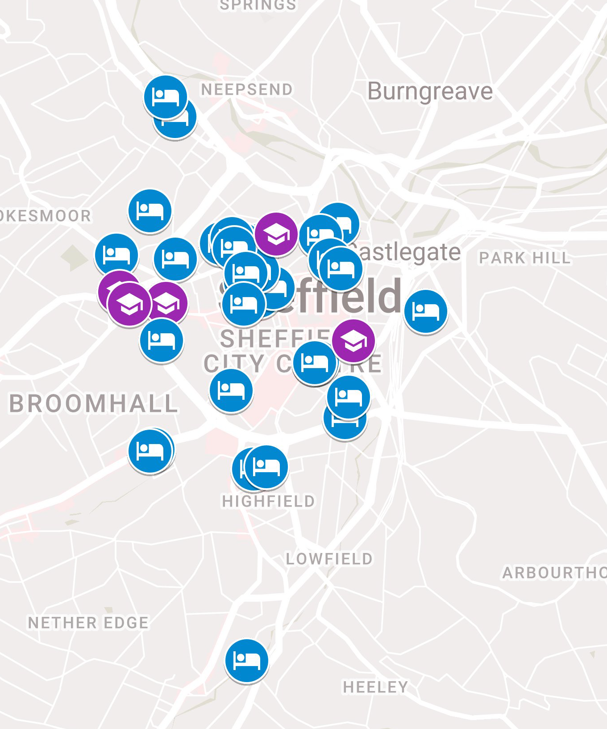
Figure 2: Map of Sheffield Applications

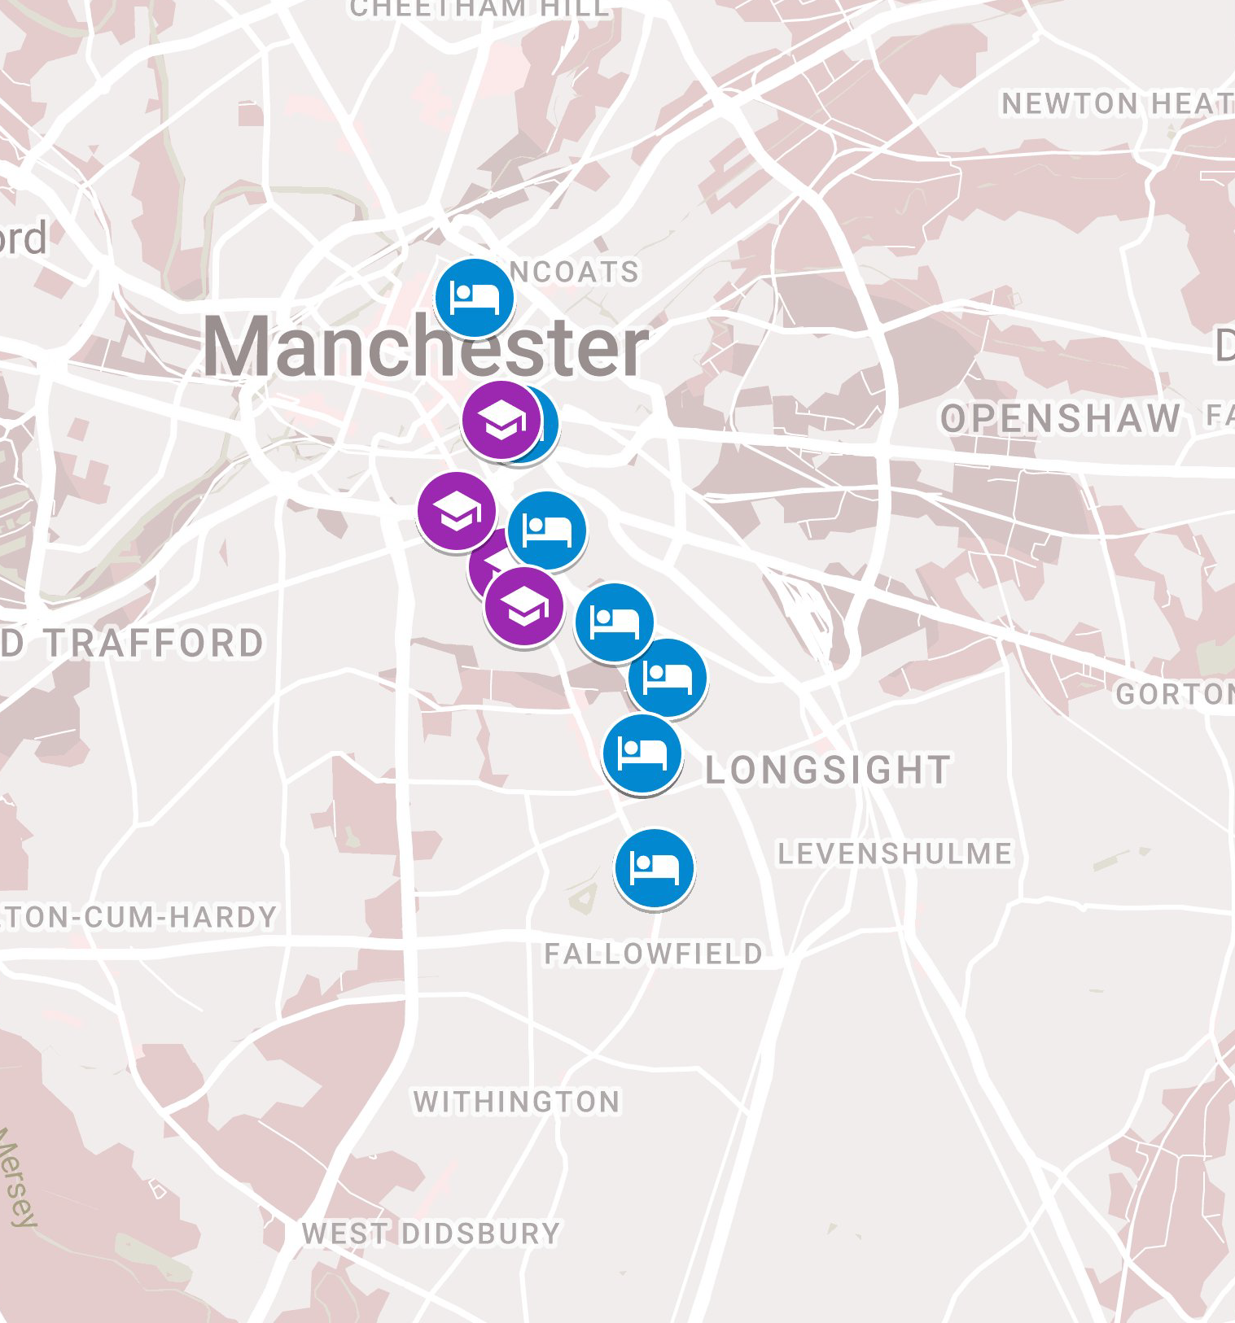
Figure 3: Map of Manchester Applications

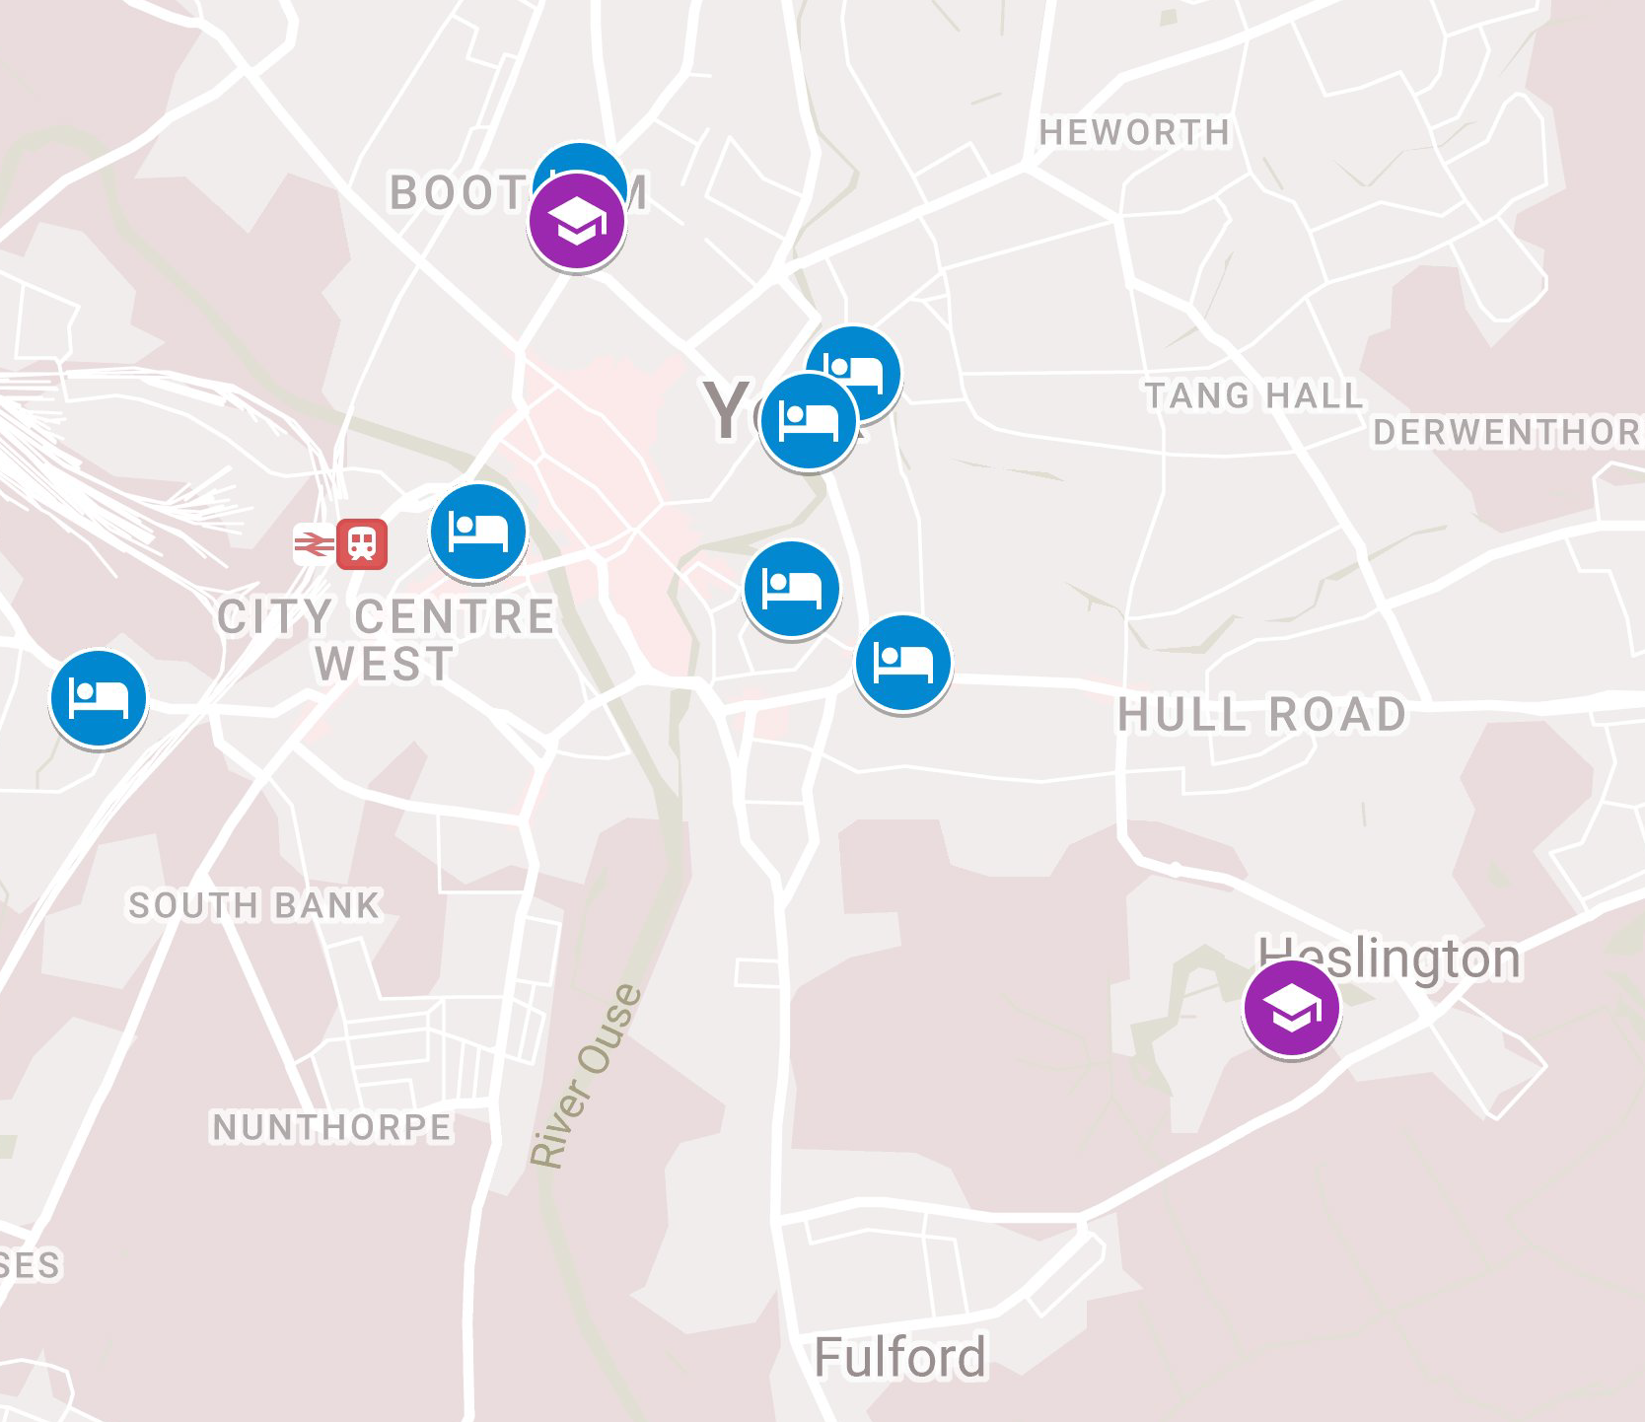
Figure 4: Map of York Applications

Under the Housing Act 2004, the core definition for a HMO is that the occupants do not form a single household, i.e., they are not member of the same family: Housing Act 2004, s.258
Although higher education housing practices are largely the same across the UK, devolution has made the legal regulation of planning different. Accordingly, our legal analysis will be limited to England.
The current order, the Town and Country Planning (General Permitted Development) Order 2015 (SI 2015/596), replicates the position.
The current order, the Town and Country Planning (General Permitted Development) Order 2015 (SI 2015/596), replicates the position.
See Planning and Compulsory Purchase Act 2004, s.38(6) and Town and Country Planning Act 1990, s.70(2). The sustainable development requirement was first included in the 2012 National Planning Policy Framework. See now www.gov.uk/government/publications/national-planning-policy-framework--2, Chap.2.
York: https://planningaccess.york.gov.uk/online-applications/ Sheffield: https://planningapps.sheffield.gov.uk/online-applications/ Manchester: https://www.manchester.gov.uk/info/200074/planning/5865/planning_permission
See eg Manchester 117078/FO/2017 and 120908/FO/2018 and Sheffield 15/01180/FUL.
Sheffield application 18/03177/FUL.
York application 17/02739/FUL.
Sheffield application 17/03619/FUL.
Manchester application 118550/FO/201.
Sheffield application 15/00650/FUL.
See, for example, Manchester 114962/FO/2017 and 122314/FO/2019.
Manchester Application 124472/FO/2019.
Manchester Application 117078/FO/2017.
Manchester Application 117078/FO/2017.
Sheffield Application 18/01530/FUL.
Sheffield application 17/02944/FUL.
Manchester application 121142/FO/2018.
Sheffield application 17/03619/FUL.
Eg in Sheffield application 17/03619/FUL where some ameliorations are noted in the officer report.

