Unlocking Policy Support for Nature Based Solutions

Synthesis of research findings 30 April 25

Introduction
This report presents the findings from the initial three stages of the research. The findings then fed into Stage 2 the development of the Summary Report for Stakeholder Feedback
The three stages of the research were:
- Survey of practitioners which received 128 responses (from December 24 to February 25)
- Systematic literature review (SLR) of evidence of impacts from NBS activities – over 120 documents were reviewed (conducted from January to March 25)
- Themed stakeholder workshops: 1) Green Finance: Unlocking Green Finance Opportunities; 2) Nature Based Solutions: Identifying key priorities and solutions; 3) Natural Flood Management Community of Practice Monitoring Skill Share Event (led by Ousewem). There were approximately 150 participants across these three workshops (held from January to April 25)
Contents
Unlocking Policy Support for Nature Based Solutions 1
Synthesis of research findings 30 April 25 1
Introduction 1
1) Survey Findings 3
Profile of survey respondents 3
Main findings 3
Most important policy change 8
2) Stakeholder feedback so far: Workshops 13
Workshop 1: ICASP Confluence – Stakeholder priority NBS challenges and solutions. 13
Workshop 2: Green Finance: Unlocking green finance opportunities. 13
Workshop 3: Natural Flood Management Community of Practice Monitoring Skill Share Event. 15
3) Systematic Literature Review (Summary) 16
Introduction 16
Inclusion/ exclusion criteria 16
How the data are presented 16
Key overarching findings 17
Evidence and Impacts 18
Appendix 1 Detailed Findings from the SLR 21
Biodiversity 21
Water Management 22
Woodland Management and Forestry 25
Natural Flood Management 27
Coastal Areas 29
Agriculture 31
Urban NBS 32
Cross Cutting Issues 40
Appendix 2 Reference list 47

Survey Findings
We surveyed NBS practitioners to identify the key policy challenges and solutions around NBS implementation. The survey ran from December 2024 to the end of February 2025 and received 128 responses. A copy of the survey is available here: https://app.onlinesurveys.jisc.ac.uk/s/leeds/icasp-nbs-policy-challenges-survey-duplicate

Profile of survey respondents
NBS focus: 38% (n=48) identified NFM as their main area of focus, with 19% (n=24) identifying Nature Recovery/ Biodiversity/ Rewilding as their key focus. Other areas of focus included water quality, peatland restoration and Woodland/ Forest planting & restoration. In terms of landscapes - 46% (n=58) identified river catchments as their main area of focus.
Organisations: Respondents from Civil Society Organisations/ Charities/ Voluntary Sector had the most respondents 31% (39), with government agencies, private companies, local government and public bodies also well represented.
Local Nature Partnerships (LNPs): 45% (57) of respondents were involved in LNPs.
Location: 24% (30) worked at a national level, but the main location of respondents was in Yorkshire and Humberside 52% (66), but we had respondents from all regions of England.

Main findings

What are the most critical challenges to implementing Nature Based Solutions in your area of focus - which can be addressed or improved by policy support?
We asked respondents to rank 16 challenges as 1) very challenging, 2) challenging, 3) not challenging and 4) success/ enhances our work. In Figure 1 below, the main challenges are ranked by the highest percentage of respondents that identified a challenge as very challenging. Respondents could answer that a policy or practice is both a challenge and a success if that best describes their experience.
Figure 1: Main challenges identified by survey respondents
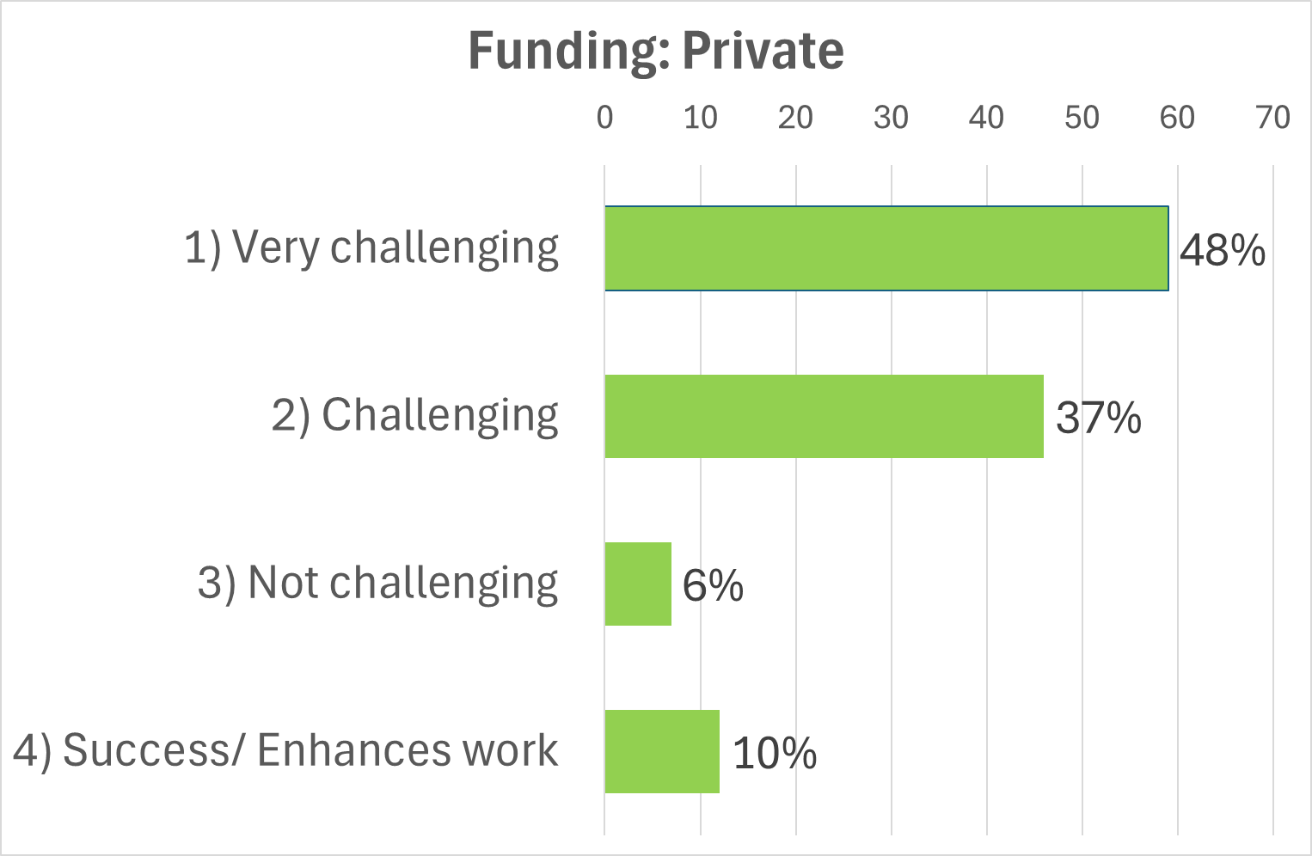 | 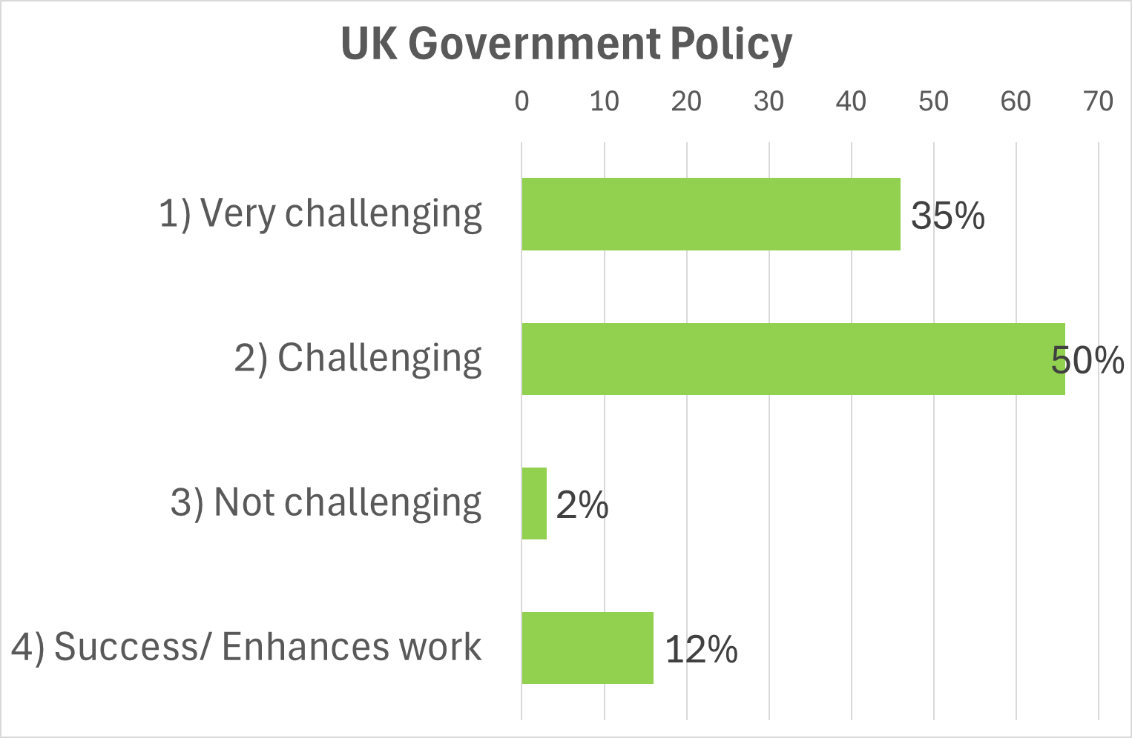
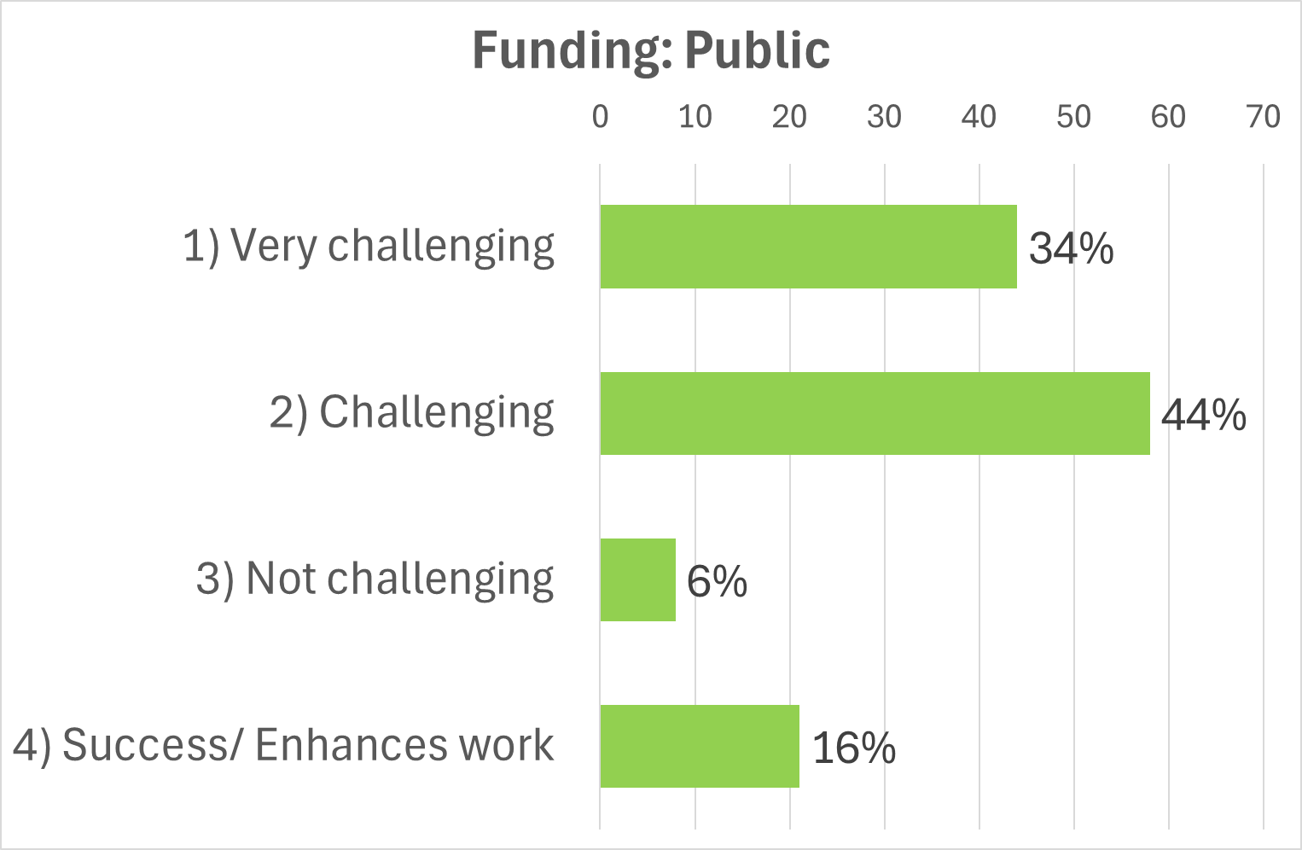 | 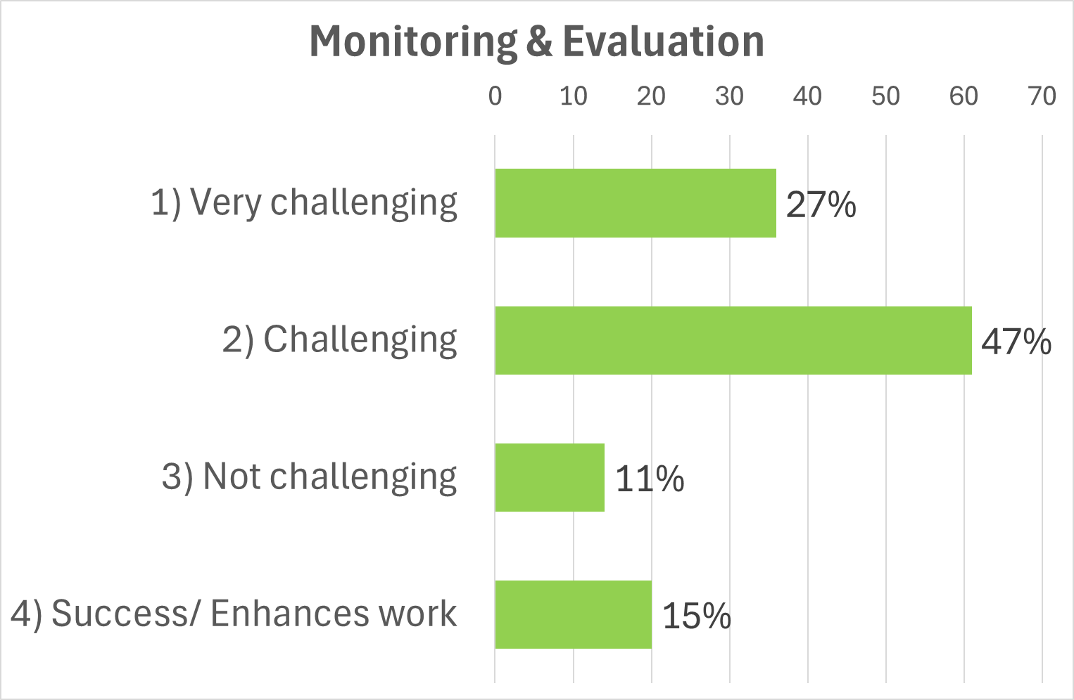
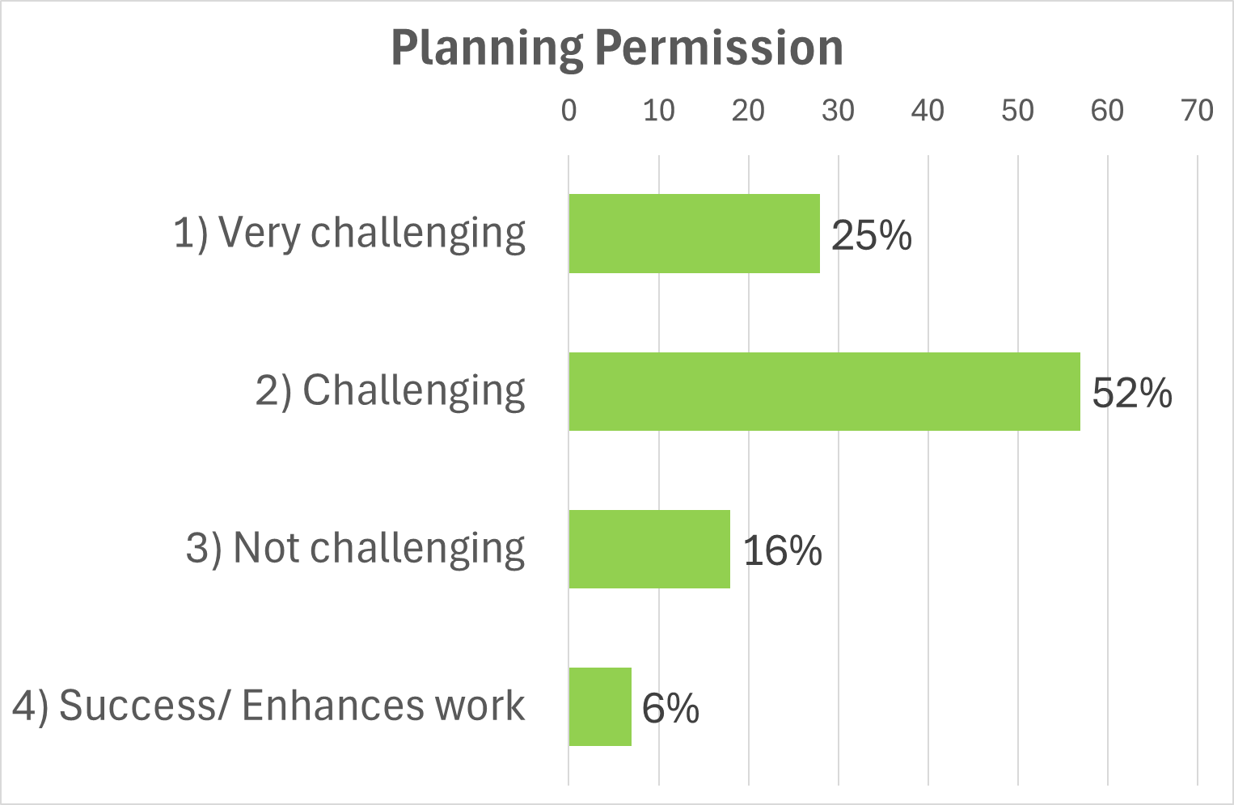 |  | 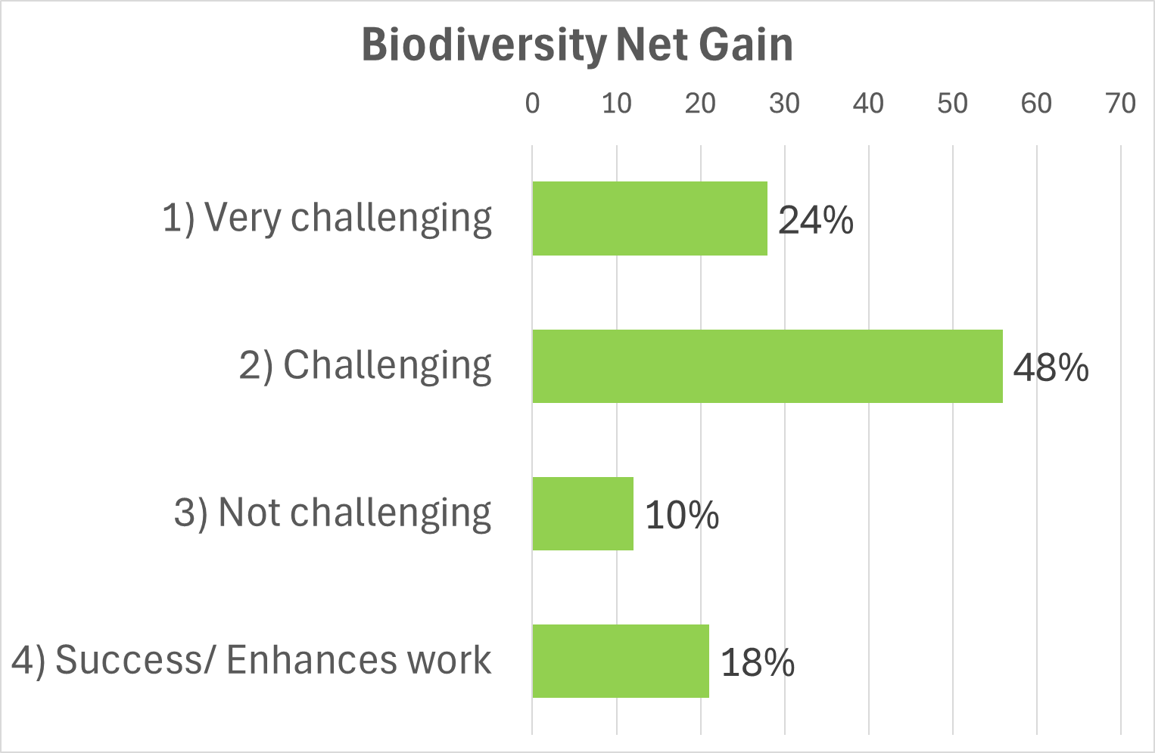
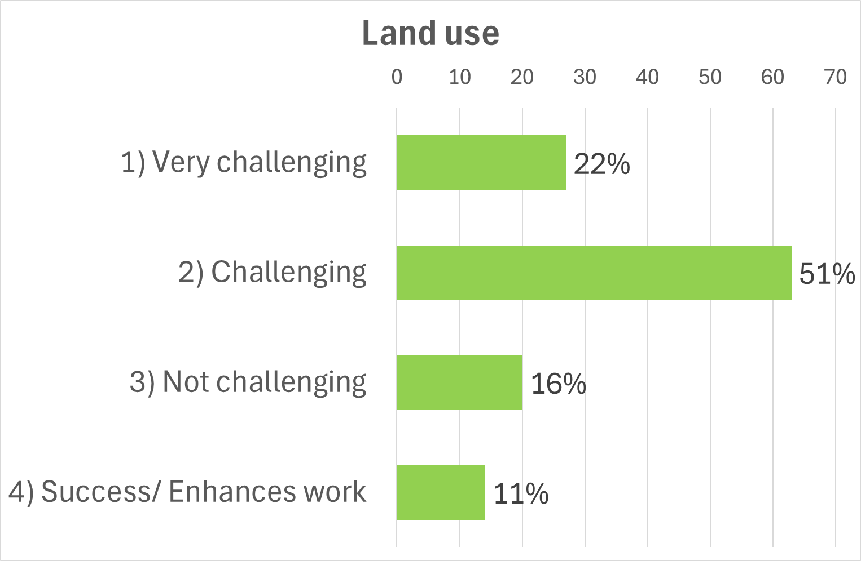 |  | 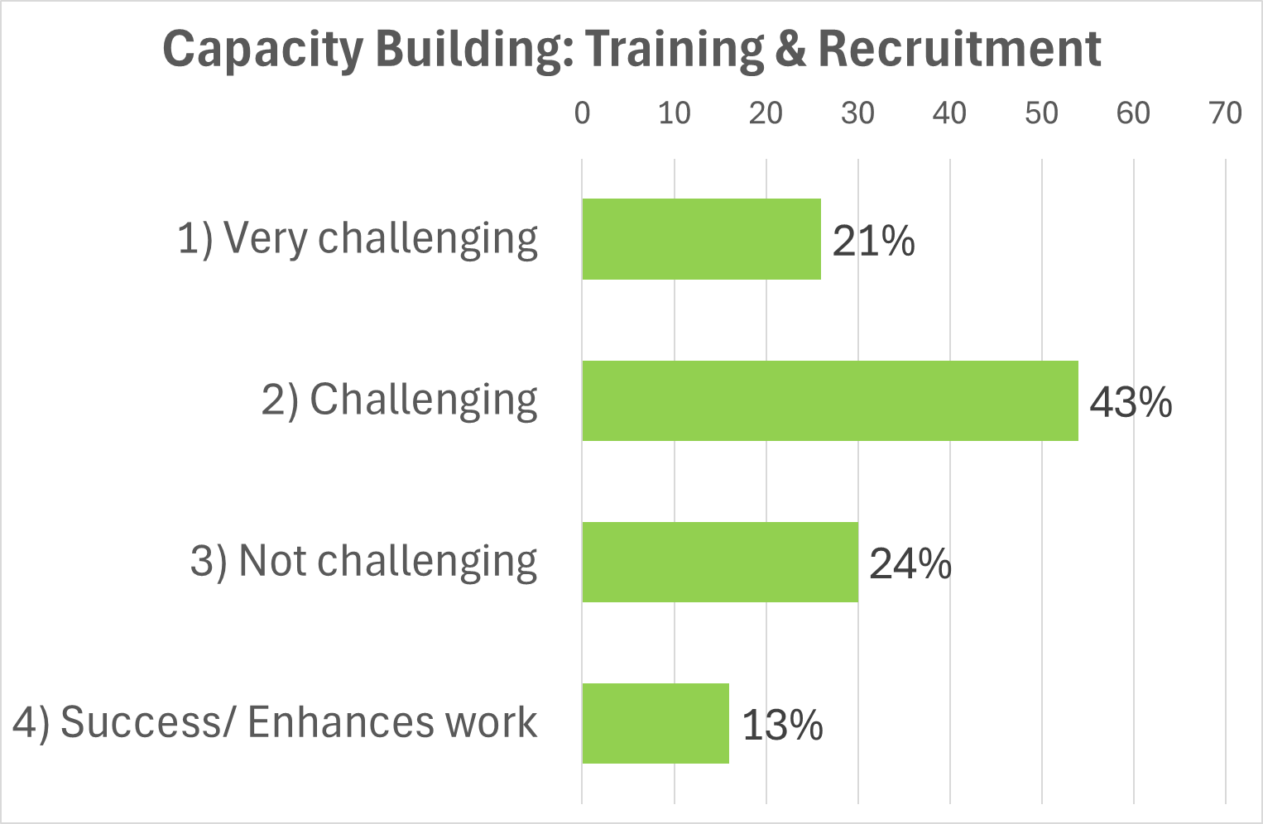
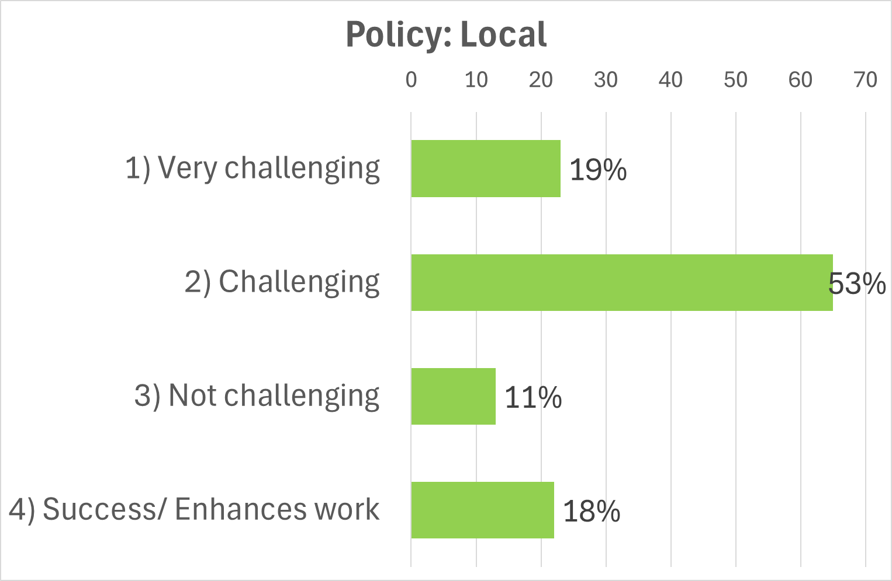 |  | 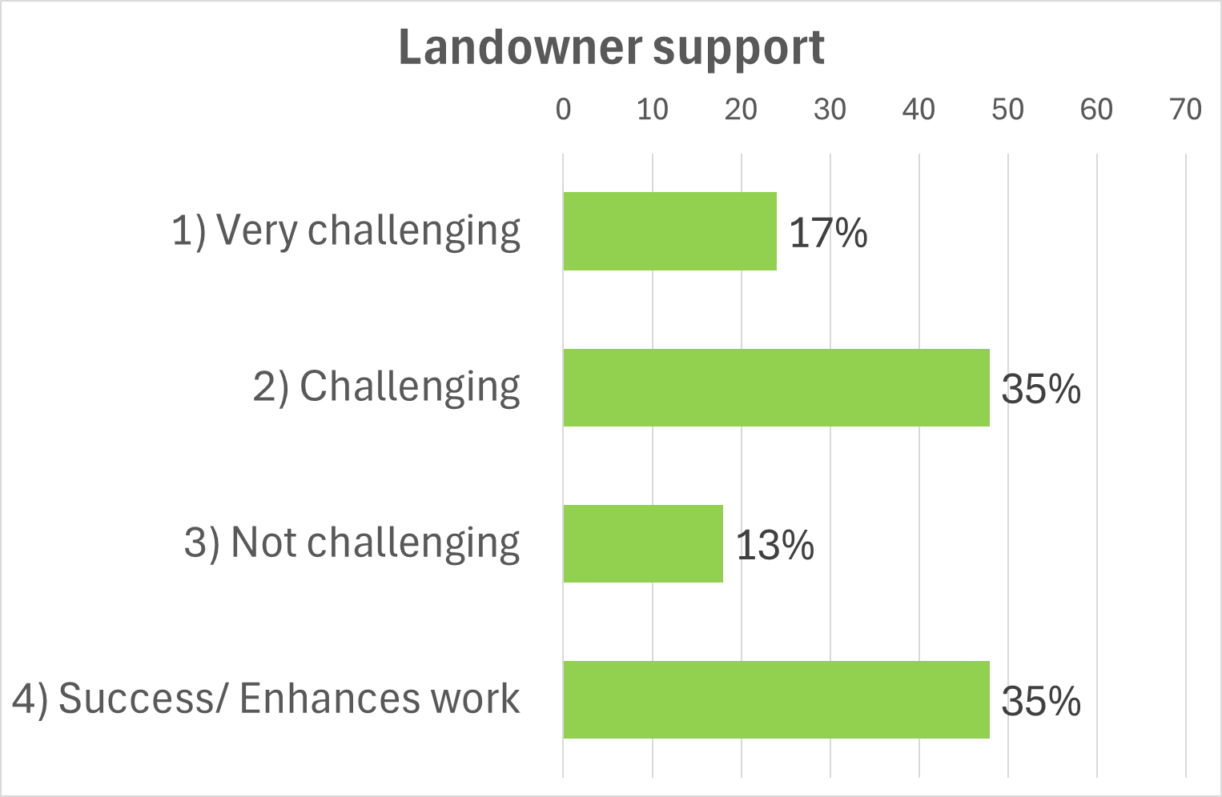
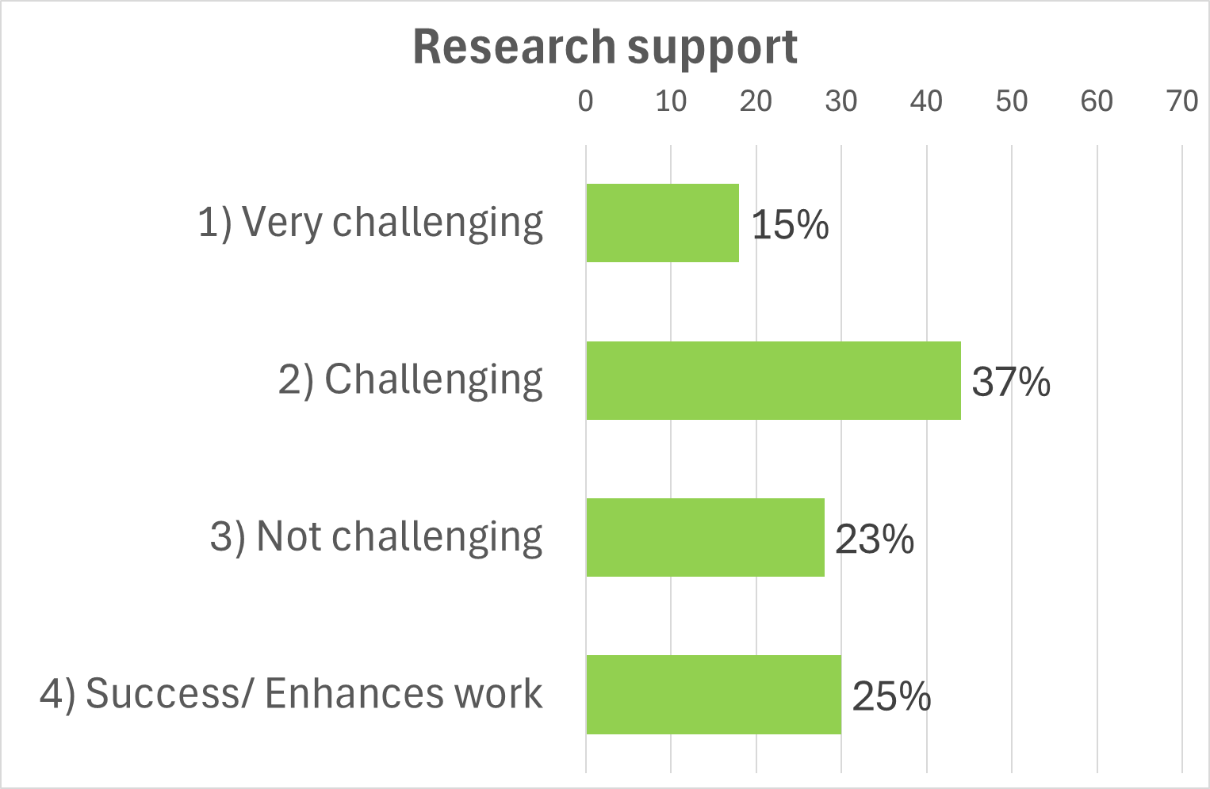 |  | 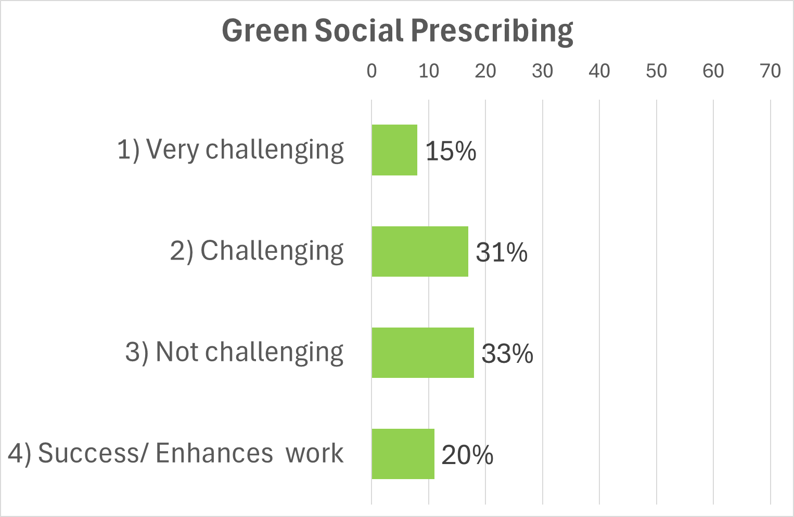
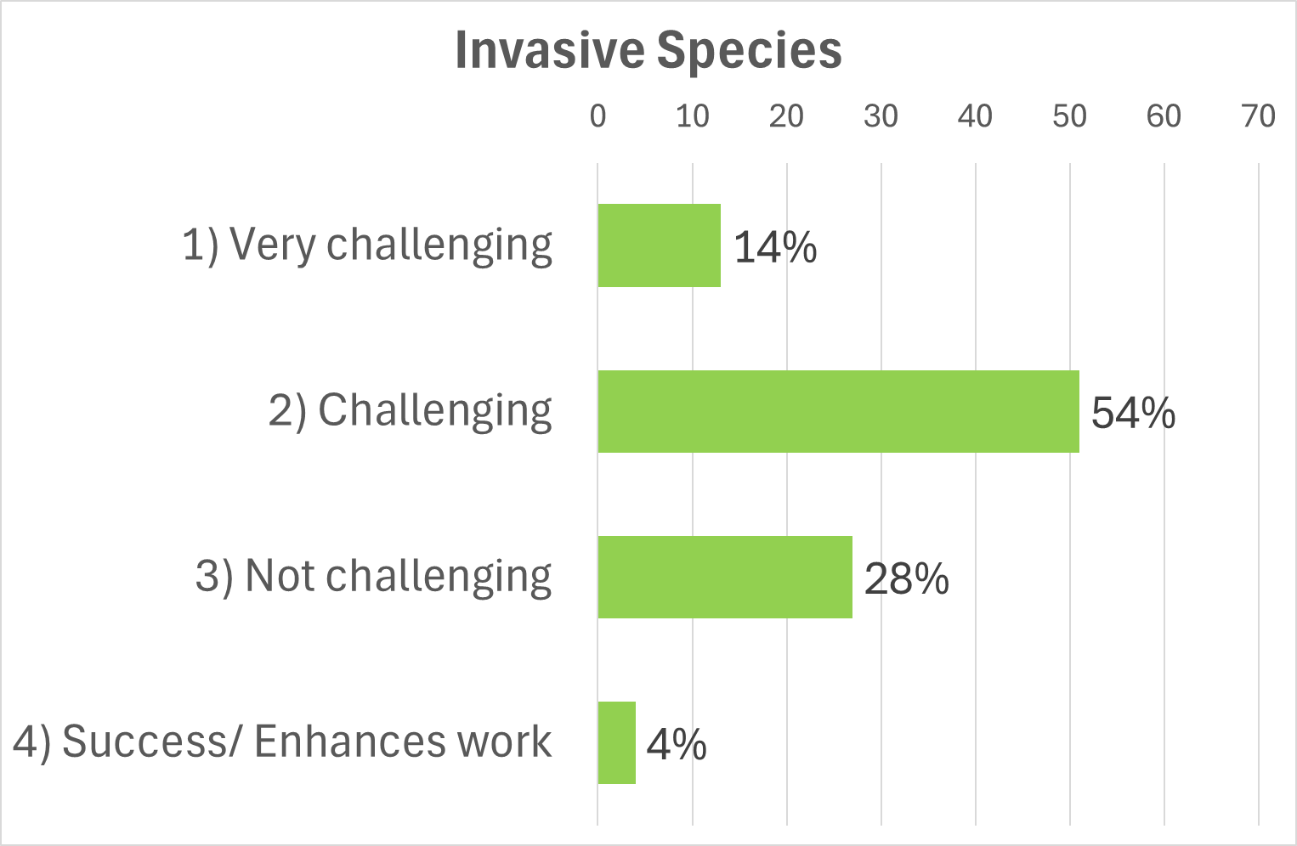 |  | 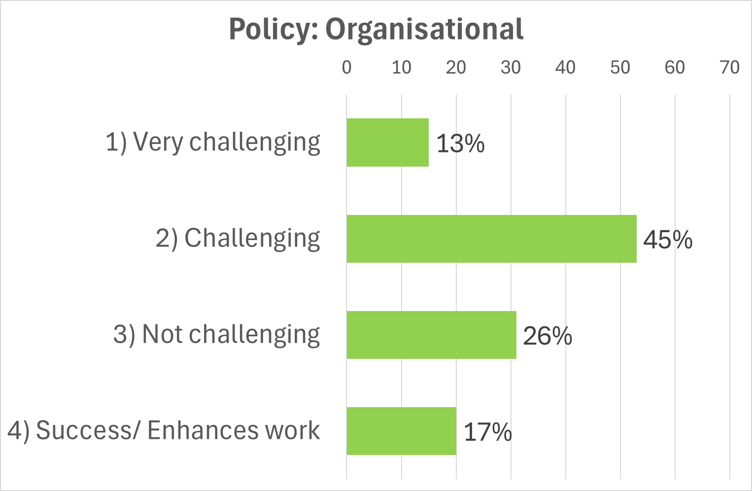
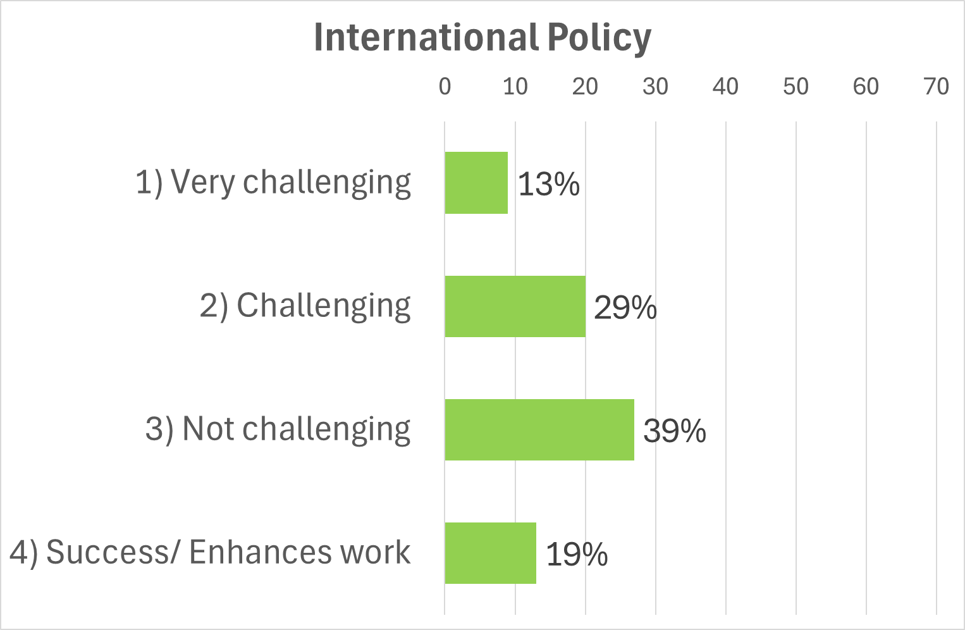 |  | 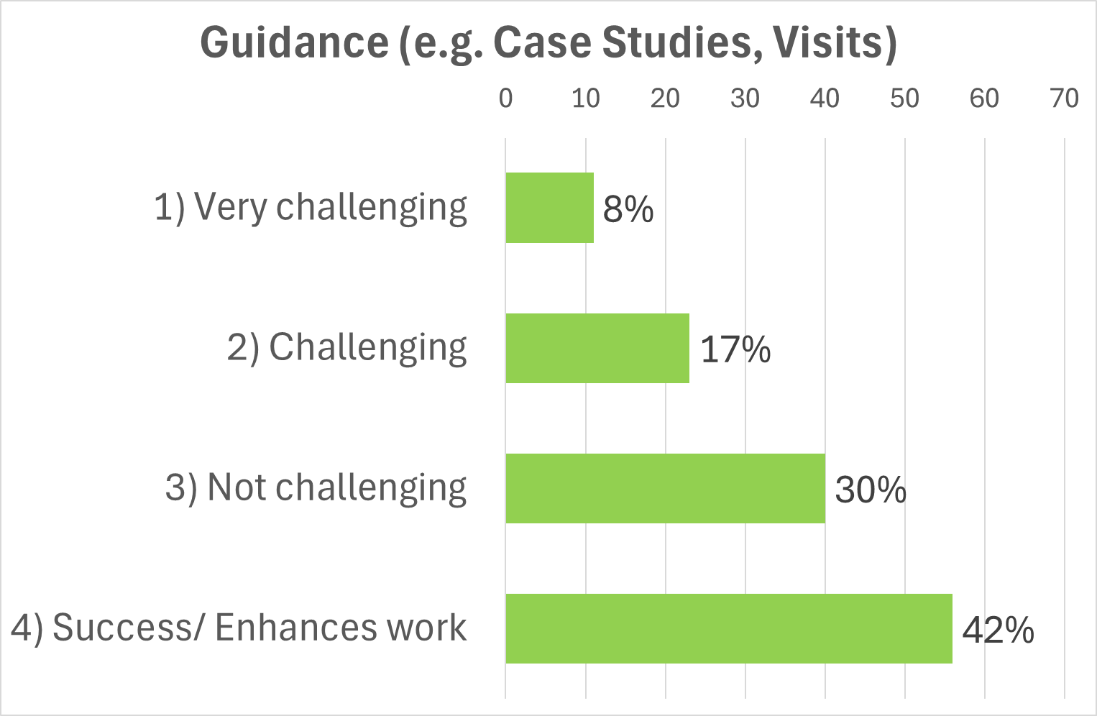
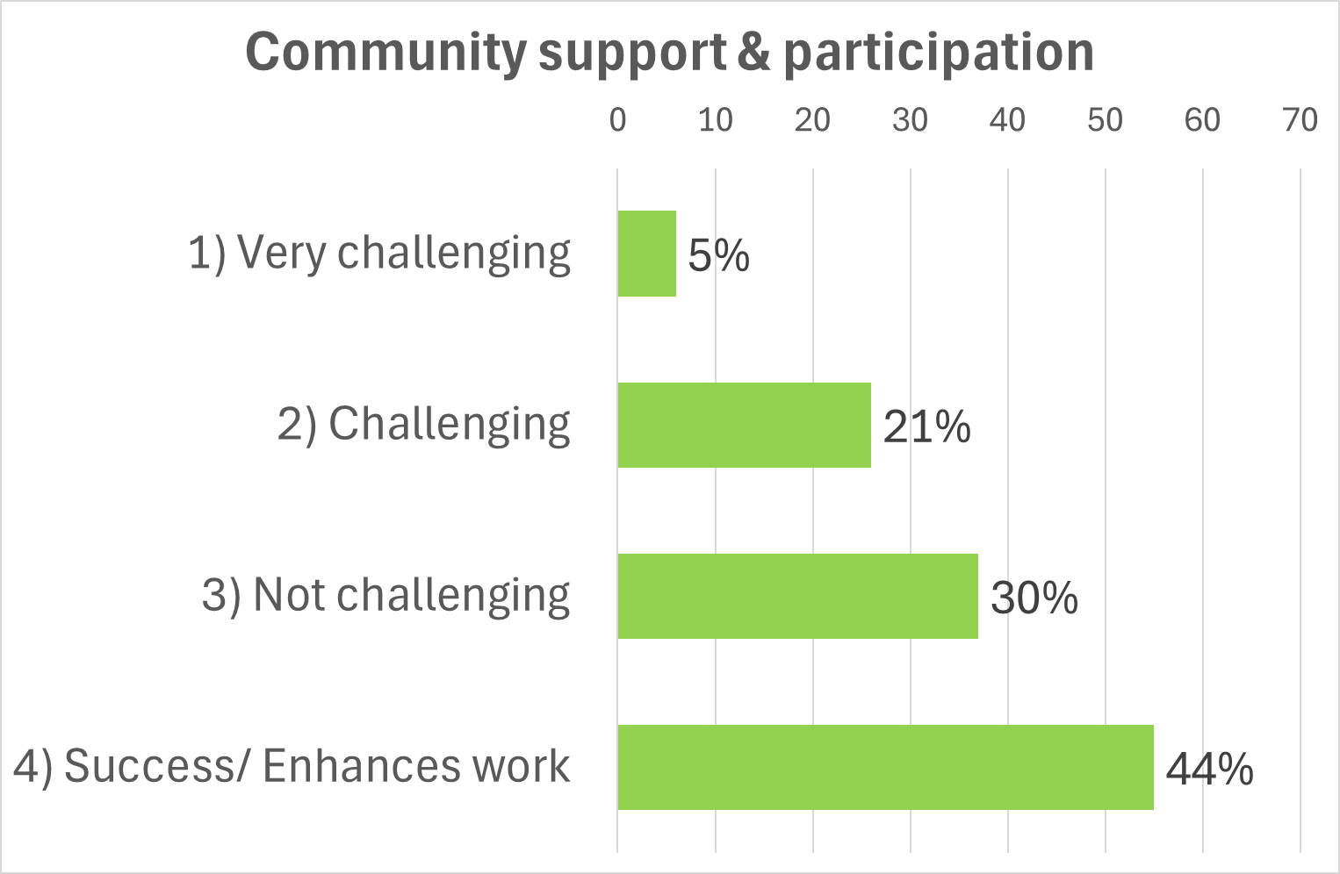 |  | 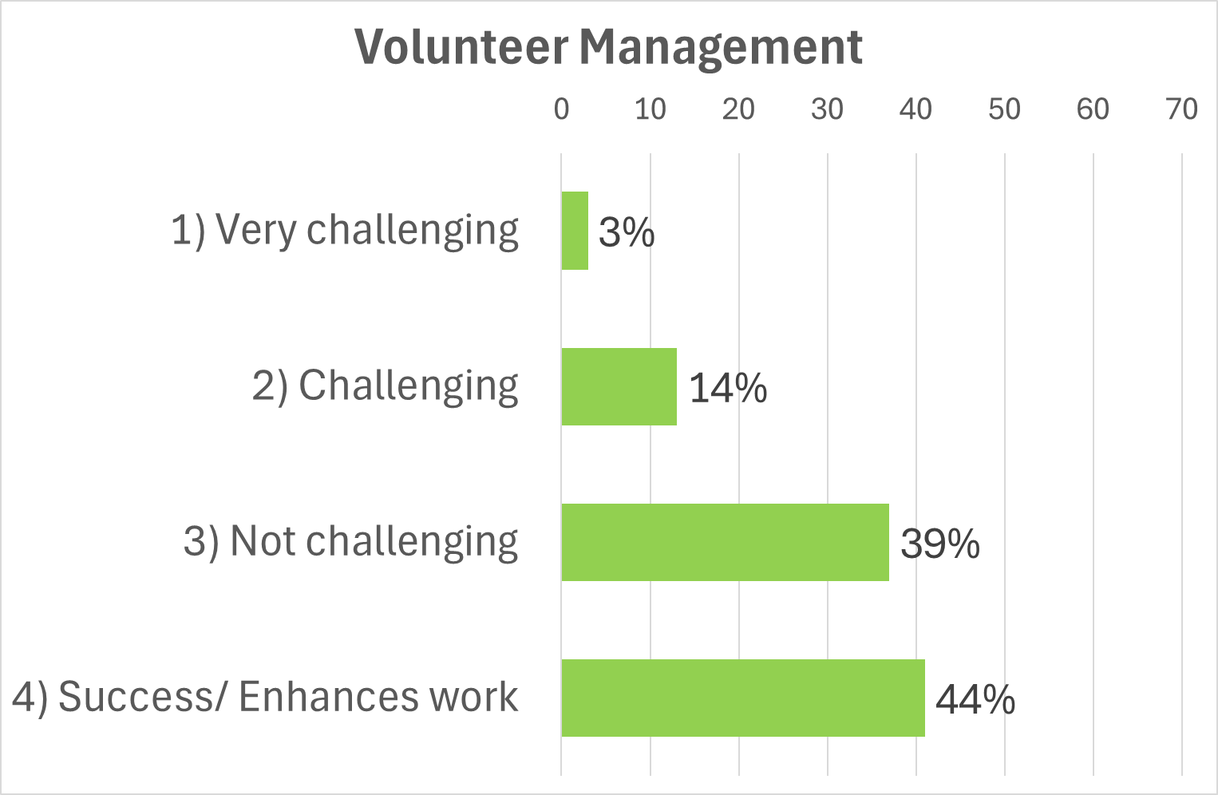

Open responses allowed for in-depth answers allowed respondents to explain significant challenges. Table 1 below identifies the key themes from these responses, and illustrative quotes.

Table 1 Significant challenges described by survey respondents
Theme | Response
Green Finance | ‘Developing nature markets and investor interest are both challenging and enhancing, it's not an 'either/or'. Challenging to make green finance opportunities fit with on the ground priorities and projects; enhancing to have finance available to fill the gap between public funding and nature recovery need/targets. Same for public funding - in some cases public funding is currently 'crowding out' private finance, but it is also essential in supporting project development and capacity building’.  ‘Lack of clear and consistent Government positioning on green finance’
Government Funding | ‘Accounting for stacked benefits where funding is for specific purpose (e.g., funding cannot often be for biodiversity net gain, and net zero, and flood management)’  ‘Funding which accounts for long-term monitoring and/or monitoring before NBS are implemented. Especially in initiatives where NBS should improve over times (e.g. woodland planting)’
Funding & NFM | ‘Lack of recognition of NFM as a key option to reduce flood risk [to attract government funding] - currently it is very hard to secure [Flood Defence Grant In Aid] FDGIA/Local levy funding because of the need to demonstrate closely defined benefits, usually requiring expensive monitoring etc which can cost as much or often more than delivering the interventions themselves, thereby drastically driving up the cost to benefit ratio’.
Funding and Landowners | ‘Funding - specifically ability to offer landowners payments for having NBS on their land’
Government Policy | ‘There is no consideration of integrated water management, each discreet policy for flood risk, drought, water quality and biodiversity have such stringent criteria that it is very difficult to bring forward schemes that hit multiple benefits for each policy and funding mechanism’
Partnerships | ‘Partnerships between the highest government agencies is needed to unblock NBS overall, i.e. National Highways, National Rail, Defra, Natural England, Electric Grid Authority, over all infrastructure agency that own lands. EA and Defra are trying to push NBS forward but national government is now getting in the way and produce policies that change this direction in the coming years. Ignoring once again small rural communities' plight’.
Government Policy Flood Risk Management | ‘The lack of focus and long-term planning at the highest level of government. Many policies are not adapted to support how NBS actually works, especially in Flood Risk Management, i.e. highways flooding is a real issue in rural communities. This is not accountable in the FCRM processes’.
Assessments/ frameworks and targets | ‘Focus of policy on one or another benefits or one particular type of "solution" over another, when the best outcomes will be based upon delivering multiple benefits through a well considered intervention that is relevant to the setting. e.g. Tree planting targets tend to cause this intervention to be used in situations where they may not be the best solution, or may not be a net benefit at all. Also, BNG assessments were not designed for environmental restoration projects and often give perverse results which affect the delivery’.
Monitoring & evaluation | Evidence is not yet mature enough to completely inform policy.  ‘The actual policy of Defra and Ofwat to promote and encourage NBS for water quality regardless of adequate evidence of long-term performance, costs and carbon footprint’.  But that: ‘The cost of the modelling/economic appraisal costs more than the scheme itself’.
Planning Permission | “There is already plenty of guidance …. but no use if every council and relevant planning authority is not using the same guidance. If there was one way of constructing a bund or pond which you knew would be signed off by every planner in the UK, we could train contractors to use this method and avoid so much project funding being used on designers, planners and modellers”.
Land use & BNG | ‘Lack of a land use framework to balance the many competing demands on land, lack of integration of Sustainable Farming Initiative (SFI) with NFM and BNG’
BNG & Planning Permission | ‘The need for BNG and planning permission for simple interventions like scrapes, ponds and bunds’.
Capacity | ‘Specialist capacity is grossly inadequate. One EA NFM specialist on two large river catchments. River Trust severely under capacity with 1.5 staff available on 1500 km² catchment’.
Community participation | “Specialists have their associations, institutes and conferences but communities who own the risks don't. We use open social media and online debate to build self-help networks. This communication separation does not help build partnership”.
Climate Change | ‘Climate change emergency and how this will impact on individuals and communities not fully publicised - so there is a lack of readiness for NBS to be overcome as a very real challenge. This could be tackled on a government scale across the country as a detailed awareness raising campaign so that the practical solutions are more openly received and engagement and looking for alternatives to land use and management etc can overcome more easily’

Most Significant Policy Challenge

Respondents describe their most significant policy challenge to implementing Nature Based Solutions in Figure 2 below

Figure 2: Word Cloud of most significant policy challenge
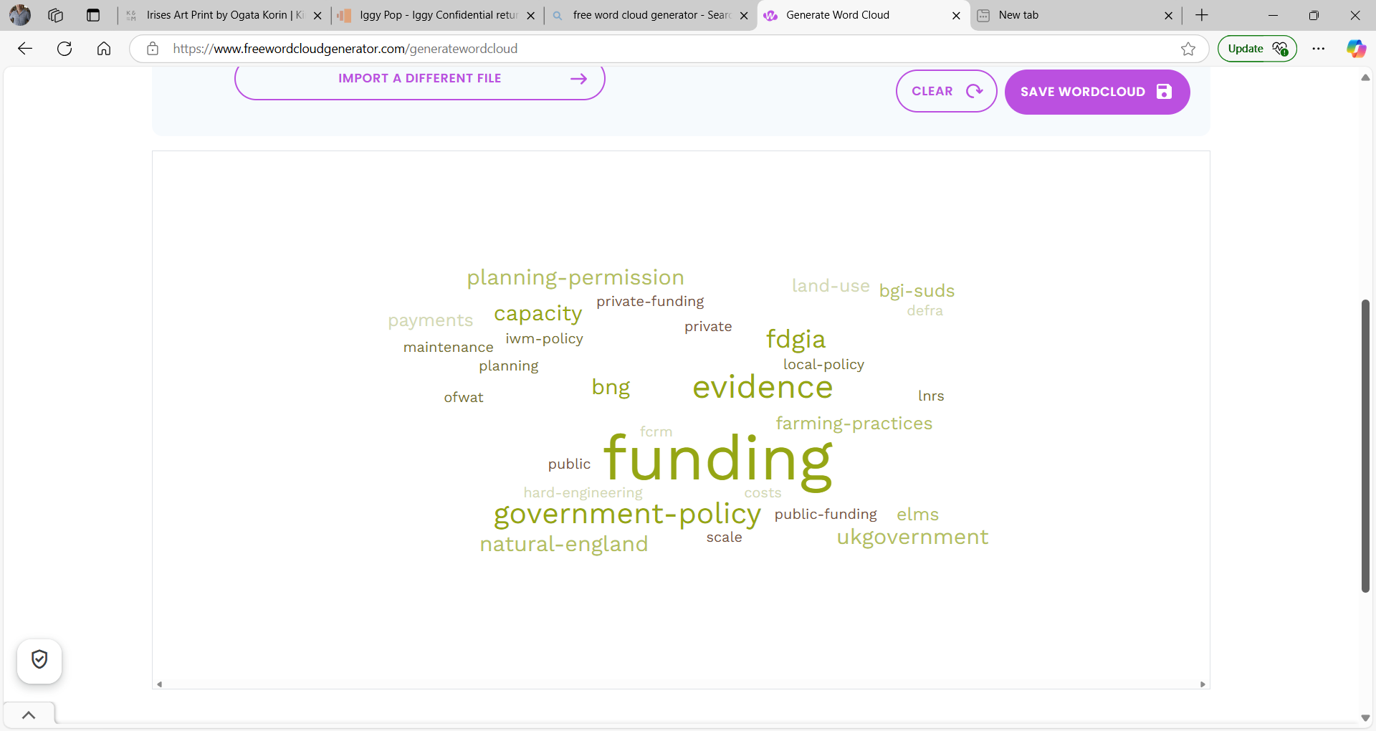
There were 117 responses to this question which have been grouped into key themes in the word cloud. Funding was identified as the most significant policy barrier, covering both public and private funding, and government policy towards funding. Specifically, respondents identified issues with the Flood Defence Grant In Aid (FDGIA) favouring hard-engineering over NFM projects, and uncertainty, lack of clarity and lack of integration for the Environmental Land Management (ELMS) and Sustainable Farming Initiative (SFI) for landowners/ agriculture).
Government policy was also questioned more broadly including joined up government priorities and the role of government agencies/ public bodies including DEFRA, Ofwat, Natural England and National Infrastructure Bodies.
The need to develop strong evidence was identified as an issue but difficulties developing strong pre-project baselines, a reliance on modelling and lack of funding for developing an evidence base/ M&E identified as key issues.
The word cloud includes policy challenges with two or more entries

Most important policy change
The survey received 114 detailed responses to this question.
- Many of the responses covered a range of critical areas (more than one suggestion)
- Improving different areas of government policy was the main focus of solutions (69 respondents). This covered supporting NBS as a key focus to tackle the climate change emergency, supporting partnerships, frameworks and regulation including using polluter pays funding to support NBS, with 12 of these respondents focusing on planning permission. 14 focused on the need to the effectiveness government agencies and public bodies (e.g. DEFRA and Natural England) to support to NBS, including better collaboration with public bodies/ utilities and better participation from NBS practitioners and communities. Only two respondents focused on the need to fund and support LNPs/ LNRS.
- Funding was identified as the key challenge where respondents suggested solutions (36 respondents) including improving transparency and flexibility of public funding (such as FDGIA, ELMS and SFI), improving guidance and support to access Green Finance/ Blended Finance, and solutions to improve carbon markets.
- Supporting the development of clear and appropriate evidence was identified by nine respondents. Other key issues to be addressed included: educational/ behaviour change and better communications; organisational capacity building; imposition of inappropriate targets
Table 2 below highlights illustrative quotes selected from respondents
Table 2 Most Important Policy Change identified by respondents
Challenge | Illustrative quotes
Government Policy/ Climate Emergency | ‘Government policy and legislation has not kept pace with the level of the challenge around climate resilience and nature recovery. We are in an emergency situation but the current legislation promotes the status quo and actively discourages innovation in land use and nature recovery. We cannot continue like this, policy needs to change rapidly and keep pace with the public and private funding with clarity for land managers. The scale of the challenge requires a complete overhaul of government and society; we should be on a war footing’.
Government Policy/ LNRS | ‘Government to require lead authorities to implement LNRS strategies and fund them accordingly’.
Government Policy/ Planning Permission | ‘Planning permission is not consistent across different local authorities. In many cases NBS is subject to all the requirements that large scale developments must meet which is very often disproportionate to the scale of works and prohibitively expensive. More appropriate planning requirements should be developed for NBS, consistently rolled out across all local authorities, and planners trained in NBS so that they know what they are dealing with and can manage appropriately. Some local authorities are already doing this and could be worked with to help pave the way.’  ‘All county councils to have an identical & simplified NBS focused area on planning portals to deal quickly with applications. Works under a certain size ie. ponds & bunds which can prove they are no risk to highways, public rights of way or buildings could be fast-tracked’.
Government Policy/ Partnership/ Planning/ Funding | Have the FCERM team talk to the SFI team in Defra and coordinate/align their policies and funding regimes. Issue a national planning policy statement for how the planning system will deal with environmental projects such as NFM and issue mandatory awareness training for planners.
Government Policy/ Partnership | Need for all the agencies involved to work together to provide a clearer and simpler approach to delivery of NBS at scale. Too easy to get diverted onto trying to measure the impact / cost: benefit of every element to the nth degree and lose sight of the big picture
Government Policy/ National Parks/ Habitat | The government, Defra and National Park Authority should rehaul their priorities for national parks. They are not managed for nature but for people and farming. They are heavily farmed, over grazed and heritage is prioritised over increasing biodiversity and creating natural flood management. If this landscape was drastically changed it could have incredible benefits.
Funding/ Green Finance | - Defra to adopt a contracts for difference style approach as used by the Department for Business, Energy and Industrial Strategy [BEIS] for encouraging and attracting investment into wind and solar technologies during the 1990's. Government underwrites the difference between what the market will pay and agreed strike (realistic) price. Over time as the market develops, confidence grows and the price rises; government money reduces.  - Peatland restoration and subsequent optimal management needs green financiers to be confident and to allow the right conditions for the market to be ramped up. This nascent market needs underpinning by Treasury to create some confidence that there is something of meaningful worth to actually trade.  - The UK government have announced that they expect NBS funding to come from private sources in addition to public money. But there is no clear guidance about how this could and should be achieved. Environmental groups are unsure how to access funding opportunities, and private investors do not always understand the long-term requirements and mixed success of NBS. As the Green Finance industry is relatively new, it is difficult to find experts to speak to about this. Partnership working is key - and I've experienced some fantastic collaborations towards improved NBS - but currently partnerships with Green Finance are very challenging to understand or engage with. We need a forum for understanding the basics and making the right connections; then the right people in place to be the link between NBS and GF.
Government Policy/ Participation | Policy needs to be lead from the ground up and not top down. Many policy makers don't have the experience or knowledge to understand what these features have the potential to do.
Funding/ Landowners/ ELMS | Defra need to show some leadership and make the full rollout of ELMS (and then how it will interact with public and private finance) fully available and comprehensive. The delay makes planning for individual businesses hard and there is no concrete commitment to nature recovery. It needs deeds not words. It has been years now and it is still an utter shambles. Many landowners want to make significant changes for nature and climate outcomes on their land but they need to know that they will be supported.
Funding/ NFM | Updates to the DEFRA/EA Partnership funding calculators and national Grant in Aid funding guidelines to allow consideration of schemes which have benefits for not only flood risk but also water quality, amenity and biodiversity to be funded.
Funding/ Regulation/ BNG | Pressure on Government esp Chancellor to honour the the Polluter Pays principle and to make BNG work.
Funding/ NBS & Health and Wellbeing | Establishment of joint public-private funding schemes by LAs, NHS and government agencies for NBS that target both nature and health.
Evidence | Researchers/groups that can quantify benefits & impact of NBS - present the evidence to policy makers - provide the certainty needed to unlock investment. Evidence for the strategic land decisions.
Targets/ Tree Planting/ BNG | Replace national tree planting targets with more balanced habitat restoration targets, and embed this balanced approach into the regional/ national forest organisations (Obviously we may still need commercial forestry - but the needs of this should not be confused with nature recovery. Lets not let the needs of commercial forestry cloud the issue of what is best for nature). Offer equivalence of natural regeneration with tree planting - or even prioritise natural regen (as this is less resource intensive and doesn't need so much plastic/ fertiliser etc). I guess this is a national policy issue. Probably DEFRA/ forestry commission/ Natural England.  Remove the need for BNG from environmental restoration projects seeking planning permission - or devise a new system of counting BNG that is more appropriate for environmental restoration projects.
Targets/ Water | To my mind unpicking Water Framework Directive (WFD) and really focussing on the right outcomes, such as river ecology (not single chemical determinants), is something that needs to be looked at. The "one out all out" approach to WFD classification doesn't allow for recognition of some great work that gets done in our catchments, and the single-minded approach to individual quality determinants takes no account of broader impacts (cost, carbon, resilience, etc.).

Most successful NBS project and why
We asked respondents to describe the most successful NBS project and why? Overall responses are shown in the word cloud below, and then explained in more detail.

Figure 3 Most successful NBS projects
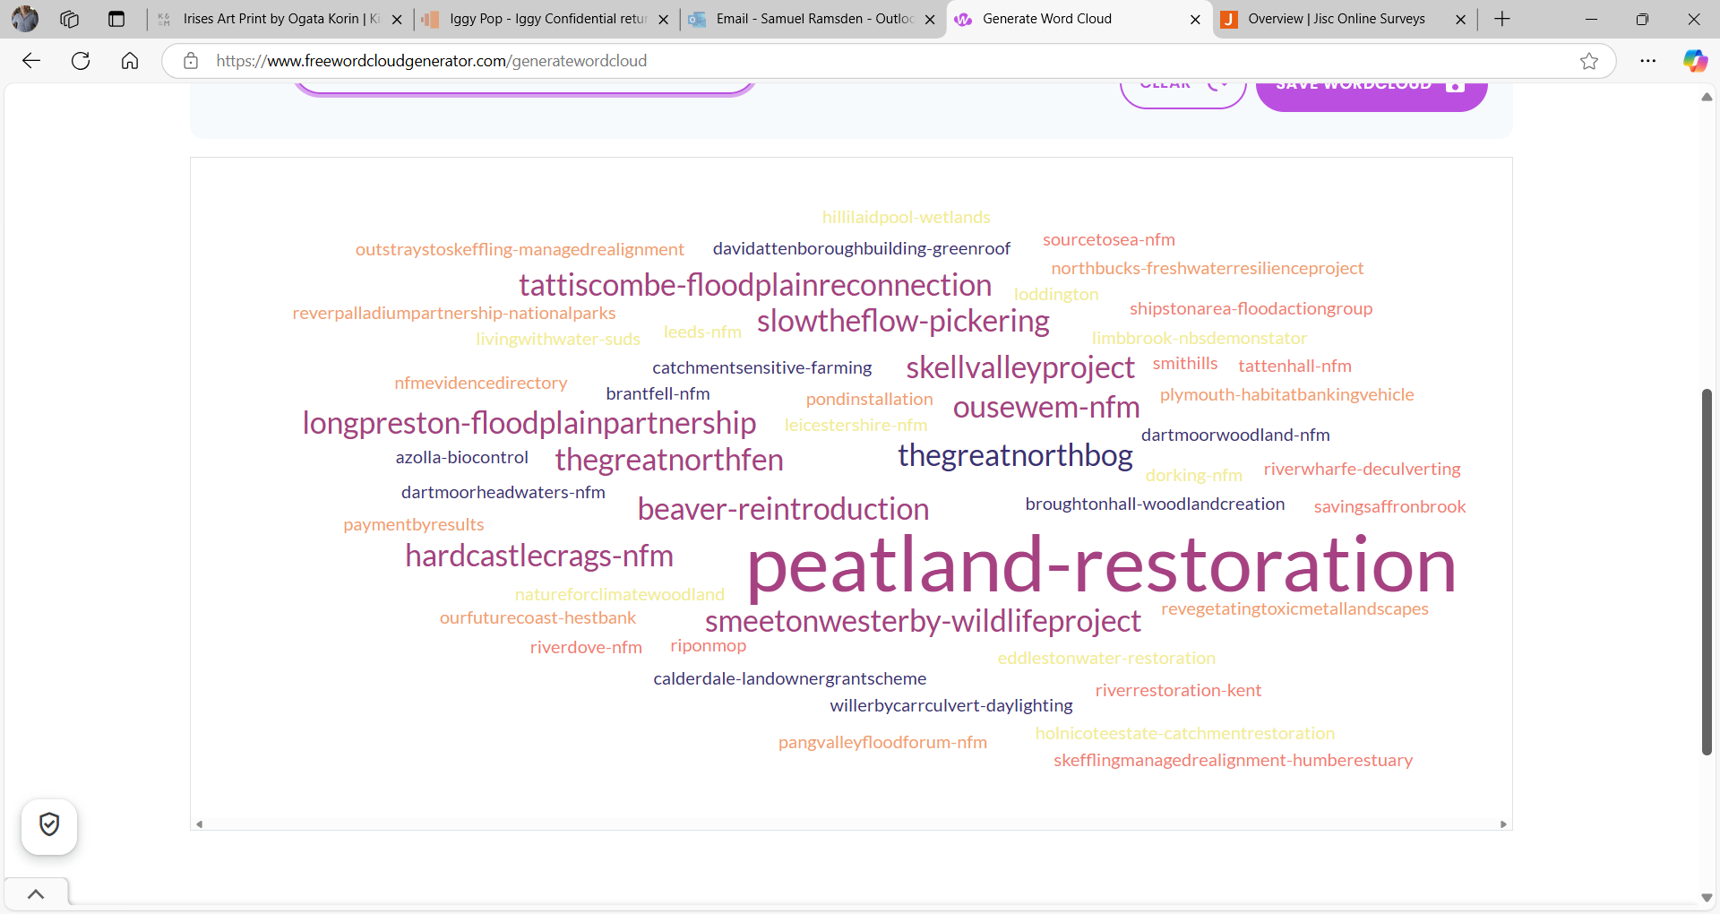
- 106 responses were received and 63 projects named as good examples. There was a very good spread around country, but projects were mainly rural based. Some respondents did not want to name a project because of anonymity/ confidentiality.
- The main NBS focus of successful projects were: NFM projects (featured in 23 answers); Peatland Restoration (9) (plus Wetlands (4)); Woodland management (8) and Tree Planting projects (7).
- Some respondents mentioned the flexibility of pilot NFM projects (including supported by EA and DEFRA) where there were ‘No real rules to the use of funding or contractors. It was so successful, that the community flood group have continued the work since the project ended, with significant help from myself to upskill them’. ICASP also received mentions for good support to NFM projects. The Living with Water partnership in Hull and East Yorkshire was identified for exemplar SuDS and de-culverting projects. The NFM Evidence Directory also received a mention.
- NBS themes with individual projects identified included: Health and Wellbeing, Payments-by-Results, Catchment Sensitive Farming Projects, Green Roofs, Biocontrol, Revegetating Toxic Metal Landscapes
- Two Green Finance projects were also mentioned: ‘REVER - Palladium partnership with UK National Parks - because they have taken projects from idea through to implementation registering carbon credits via the peatland and woodland code, blending private finance with grant money. https://revere.eco/’. In addition one respondent mentioned the Woodland Creation Aggregation Project).
There were also some constructive comments in the answers to this question including: ‘I've worked on some partial successes for some environmental outcomes, like some peatland restoration programmes, but most have not been delivered well to date, in a means which I'd suggest optimises the complete range of potential benefits and the overall VFM [Value for Money]. Optimisation needs to be considered at the catchment level, not the individual site level and sites need to optimise specified combinations of ecosystem services, not necessarily the range of multiple benefits.

Stakeholder feedback so far: Workshops

Workshop 1: ICASP Confluence – Stakeholder priority NBS challenges and solutions.
We tested our initial headline findings from the Survey Results and Systematic Literature review in iCASP’s annual Confluence held on 27 February 2025. We held a workshop with ~ 50 stakeholders from predominantly wetlands, NFM and water quality backgrounds, but who are also focused on other areas such as resilient communities.
We asked the stakeholders to review the main survey findings and work together to identify the three main priority challenges and potential solutions: Respondents highlighted the following key priorities:
- A strong evidence base is required (Baseline, Identify Risks, Impacts, but also honest about things that don’t work). E.g. NFM has come out with a clear evidence base but not the same for other aspects of NBS: Water Quality, Air Pollution, Tree planting? – some very niche evidence and not high confidence.
- Green Finance and funding for evidence and projects. Further comment into need for FDGIA to be more responsive to NFM. Reforms to flood funding and investment to protect farming communities - GOV.UK
- Capacity Building: Training over a long period and staff retention
- Support Landowners/ Farmers and Communities. They are not always getting much information – support for associations.
- Effective Communications is essential: to help communities, to reach policy holders
- Policy: As well as targeting MPs, Ministers, Secretary of State to develop a Bold Vision – it is also essential to target Mayors of Combined Authorities. (Slow the Flow is a good local example of working with Westminster Representatives). We should also target other policy opportunities such as current land use planning review.

Workshop 2: Green Finance: Unlocking green finance opportunities.
The West Yorkshire Flood Innovation Programme (WYFLIP) hosted a workshop on 29 January 2025 as part of the Accelerator project that brought together key stakeholders from finance, academia, and environmental sectors to explore pathways to sustainable investment in nature-based solutions (NBS) and climate resilience. 50 participants provided their thoughts and insights on what needs to change to help unlock green finance opportunities and how this change can be delivered.
Table 3 below identifies the key changes participants identified to help unlock flood-related green finance opportunities

Table 3 key changes required to unlock flood-related green finance opportunities
Regulation | Agree a common regulatory framework across different authorities, aligned with the 2024 National Planning Policy Framework, enabling larger scale projects.  Develop unified guidance and language to help navigate current planning regulations.
Regulation (cont) | Change regulations in pensions, insurance, and other parts of the financial system to recognise the role of nature in providing effective risk management in reducing losses to assets from flooding either through impaired values or lower asset productivity i.e., lower returns. In doing so, it would enable long-term investments in nature.
Knowledge exchange | Conduct a skills gap analysis and provide training.  Raise general awareness of the opportunities that NBS can bring.  Facilitate knowledge exchange between all sectors.
Modelling | Improve representation of NFM in hydrological models using real world data.  Develop a multi-model hydrological approach to show a range of predictions as with climate models.
Funding Mechanisms | Adopt common business cases to facilitate the stacking of benefits.  Clearly define and demonstrate the return on investment.  Develop new markets and funding streams.  De-risking investment by ensuring schemes are designed to withstand shocks.
Collaboration | Brokers are needed to connect those that have funds with those that need it.  Early engagement with stakeholders to align needs and priorities can help identify opportunities.

What is needed to enact these changes?

Develop a value proposition with a full range of beneficiaries, mapping who they are, and what return / cost saving they receive.

Create a NFM calculator, akin to the Peatland Code, which can be associated with simple monitoring that can demonstrate financial and environmental additionality.

Develop an approach for running ensembles of hydrological models, with associated training, to standardise NBS planning and benefit calculations, build confidence and reduce risk in investments.

Establish a range of training resources and products, including CPD courses, workshops and conferences to upskill, educate and influence stakeholders on the use of models, NBS implementation and evaluation, business case development and green finance mechanisms.

Produce policy briefs for different audiences highlighting the need for regulation change and a more streamlined planning process.

Facilitate the development of larger holistic schemes, with multiple stacked benefits, to attract investment from the financial sector.

Establish a consortium of stakeholders to share knowledge, identify synergies and co-ordinate activities.

Develop the framework above and market the approach as globally leading to i) attract investment into the region/UK and ii) provide our services to other countries and international clients.

Workshop 3: Natural Flood Management Community of Practice Monitoring Skill Share Event.
This was an NFMCOP event held on 11 April led by OUSEWEM. It was not directly supported by the NBS Policy Project but the findings have been included in this research:
- it was supported by ICASP,
- included a wide range of respondents to the NBS Policy Project Survey and participants of the ICASP Confluence NBS Policy Project Workshop,
- and also took forward one of the key NBS priorities: Monitoring and Evaluation.
A write-up from the event is contained on this Ousewem blog: Building better evidence: Reflections from the NFM Monitoring Skill Share – Ousewem

3) Systematic Literature Review (Summary)

Introduction
In the first stage of the Systematic Literature Review we searched Web of Science and Scopus Search Engines for articles with the terms "Nature Based Solutions" and (evidence) on 28 January 2025. In addition, we asked for recommended literature from the project team and wider stakeholders (which included the NFM evidence directory and BNS and Freshwater evidence synthesis).
Table 4 below shows how the review was conducted
Table 4: Approach to conducting the Systematic Literature Review
 | Search | Recommended reports and articles
Web of Science | 382 (28 Jan)
Scopus | 368 (28 Jan)
Combined | 443
Abstract (removing articles which did not meet inclusion criteria in title) | 347
Article/ Report Review (removing articles which did not meet search criteria abstract) | 135 | 25 (with 2 also identified by the search)
NFM covered by EA/ FCERM research directory (this was identified as the primary source of evidence) | 16 | 4
Used in evidence (removing articles that did not contain evidence and did not meet inclusion criteria) | 94 | 19

Inclusion/ exclusion criteria
As well as needing to present evidence, the following requirements were needed for inclusion:
- Cool temperate locations (e.g. covering case studies in cool temperate locations) as identified in World Climate Regions,
- Marine/ Blue infrastructure was not included
- Qualitative based evidence using interviews/ surveys was included.

How the data are presented
The data are presented in two ways: The Table below presents the evidence by 1) NBS aims and tries to identify whether there is 2) clear evidence and 3) this is supported by a body of research. However, there are some key issues that are explained below.
Appendix 1 contains evidence by NBS type sourced from the research articles and reports identified by the search and recommended articles. In line with Bona et al. (2022) [17] evidence of NbS has been grouped ‘according to sectors and thematic areas of social importance: (I) water management, (II) forests and forestry, (III) agriculture, (IV) urban areas, and (V) coastal areas’. However, we also identified a need to consider overarching objectives such as carbon storage and biodiversity, add a specific section on Natural Flood Management, and a section on cross-cutting issues such as disaster management, health and wellbeing, participation and green finance.

Key overarching findings
- Good quality evidence is required in many areas: 1) in terms of over-arching NBS aims (e.g. carbon storage, biodiversity, drought) and 2) by different types of interventions with the possible exception of NFM. However, searching by the term NBS could be a barrier as some interventions are better represented than others.
- In many articles, evidence is very general rather than specific and can be too positive e.g. ‘We conclude that … small-scale NBS can support climatic, health, or ecological improvements in specific instances’ [18]. Conversely, some evidence is very niche, based on very specific modelling, and it is hard to extrapolate to wider systems (e.g. research comparing two different types of oak and responses to climate change [19]).
- There is a very clear and accessible evidence bases provided by the NBS and Freshwater Evidence Synthesis [4] and the NFM Evidence Directory [5]. With the recently released NBS and Freshwater Evidence Synthesis including evidence of flood management, water quality and biodiversity & habitat impacts from a range of NBS approaches in different English catchment types including both urban and rural (whereas the NFM evidence base does not consider wider urban Flood Risk Management (FRM) measures such as SuDS, permeable paving and green rooves).
- However for NFM, Zhu et al. (2025) [20] identify issues with global NFM evidence including: 1) ‘despite the wide use of NFM techniques, there is a lack of quantitative evidence for the effectiveness of NFM interventions in flood reduction’; 2) evidence at large catchment scales is lacking; and 3) many evidence based studies are based on modelling rather than fieldwork (including for flood peak reduction). In addition, the NFM Evidence Directory [5] does not include NBS type measures in urban flood risk management such as SuDS. However, the NBS and Freshwater Evidence Synthesis [4] contains evidence on the impacts of SuDS (focused on permeable paving, green roofs and bioretention systems/ rain gardens) in urban environments, although this is less accessible.
- However, while there is confidence in positive impacts of many NFM interventions on reducing flood risk and creating other benefits including biodiversity [5], there is evidence on negative impacts of NBS on water quality depending on catchment type and NBS intervention [4]. For example, there is confidence in negative impacts of a range of methods on nutrient and sediment management including from constructed wetlands and temporary water storage features. There is also solid evidence on negative impacts of poorly planned “tree planting” [6].
- Absence of clear evidence directories: While there is scope for improving the NFM evidence directory, it is an excellent model for other areas of NBS to aim for. For example, the WaterLANDS project team have co-produced a White Paper on recommendations for upland peatland restoration in England [21], and in it they suggest that an evidence hub should be created. . Carbon storage, Biodiversity, Drought, Coastal Protection and Urban Heat Mitigation - are other areas where there appears to be solid evidence but no clear evidence directory.
- In addition, published evidence around NBS does not focus enough on the potential impacts of climate change [7], [8] and need to understand impacts over the long-term [9].
- Resilient communities are an important aspect of NBS. However, there is little evidence on impacts on health and wellbeing within NBS studies [10] [11]. There is also an absence of more specific health and wellbeing studies that link to NBS e.g. due to health and wellbeing focused articles not using the term ‘NBS’.
- There can be a tension around whose knowledge counts [87] with a focus on top-down scientific expertise and quantitative data, and this links to lack of participation. Could Communities of Practice be a way forward? e.g. NFMCOP [13].
- In general, it would help to develop evidence for NBS if articles/ reports used Nature Based Solutions (NBS) in their title/ abstract/ key words – this would help in rapid evidence review.
- Recommendation: What is the best way to develop accessible evidence directories? Research institutes such as iCASP to lead in priority areas of NBS to start the process of developing evidence by confidence levels e.g. Waterlands, Peatlands or Hedgerows to bring together existing knowledge; or focus on key aims such as Carbon Storage or Biodiversity.

Evidence and Impacts
In table 5 below we try to summarise the amount of evidence and levels of confidence by key NBS Impacts.
Table 5: NBS impacts, amount of evidence and levels of confidence.
Impact | Confidence | Amount of evidence
Carbon Storage | High confidence in positive impacts from wetlands, peatlands, forest management, hedgerow planting | Good from wetlands, peatlands, forest management, hedgerows  Patchy in other areas
Biodiversity | Medium to High confidence in positive impacts from freshwater interventions (wetland, peatlands, woodland mgt and hedgerows, agricultural management); NFM interventions, and coastal interventions supported by evidence including user perspectives.  Medium confidence: urban meadows  Also identify negative impacts from plus negative impacts badly planned tree-planting | Good from wetlands, peatlands, NFM  Promising from Urban Meadows, Hedgerows, Coastal Protection  Patchy/ low in other areas: need more information on impacts of connectivity, diversity inc species detail including native v non-native species [23].
Flood Control/ Flood Risk (rural NFM) | High confidence in positive impacts from some NFM activities: Ron off pathway management, Salt marsh and mudflat mgt, Beach Nourishment, Sand Dune Mgt,  Medium to High Confidence: Woodland Catchment Mgt, Soil & Land Management,  Medium confidence: River restoration, Leaky Barriers, Beavers, Offline Storage Areas, Riparian Woodland, Headwater Drainage Mgt  Low to medium confidence: floodplain and floodplain wetland restoration, floodplain woodland  Low confidence from cross-slope woodland, reef management | NFM Evidence [5] Directory provides good quality evidence for rural NFM although based on modelling and field studies could be increased.
Flood Control/ Flood Risk (Urban) | Medium to high confidence in beneficial impacts from Suds, BGI, Green Rooves and Permeable Paving (incl through NBS/ Freshwater evidence [4])  Low confidence from Urban Woodland Management/ Tree Planting due to lack of evidence. | Evidence from SuDS type approaches, but less evidence from tree planting/ urban woodland management,
Water Quality | High confidence in positive impacts from coastal management including reef mgt, sand dunes, salt marsh and mud flats, plus woodland management [5]  Medium confidence but mixed impacts (positive/ negative) from Beaver re-introduction, Afforestation, Constructed wetlands, Temporary water storage features, Riparian restoration, Buffer strips/zones, Hedgerows and vegetative barriers, Instream wood, Peatland restoration, Instream substrate addition, Channel restoration, Floodplain reconnection, Permeable pavement, Green roofs, Bioretention systems/rain gardens, Sustainable soil management, Assisted natural regeneration (through NBS/ Freshwater evidence [4])  Limited confidence in positive impacts from wetlands, peatlands.  Mixed confidence in positive impacts from urban NBS interventions: confidence from Bioretention and permeable paving (not green rooves) [4] | Good amount of evidence, but needs more modelling [22]
Drought management | Some beneficial impacts from peatland management, rewetting uplands, beavers, river restoration, instream wood management.  More evidence needed in many areas including above plus rewilding, SuDS,  Decreased stream discharge causes issues. | Low number of studies/ more evidence required/ evidence scattered through reports.
Coastal Protection | High confidence in positive impacts from some coastal activities including Saltmarshes. E.g. on Flood Risk Management, Biodiversity and Water Quality | Could be improved in specific areas: e.g. more research on seagrass needed (there is research on Mangroves) [23]
Regenerative agriculture | Medium confidence in positive impacts from NBS focused agriculture activities impacts on flood risk including soil, land and pathway mgt (through NFM directory[5])  Medium confidence in mixed impacts from NBS focused agriculture activities on water quality (through NBS/ Freshwater evidence [4])  Limited confidence in benefits of co-cropping and impacts on sustainable water planning, drought preparation and environmental intervention policies.  There is also a focus on conflicts in this area. | Needs more research in line with agriculture supporting different stated aims of NBS (e.g. Biodiversity in addition to NFM).
Urban Heat Mitigation | High confidence in positive impacts | But needs more research on long-term results
Urban Air Pollution | Very limited confidence on positive impacts due to impacts of other conditions outside NBS. | Needs more research including on impacts by type of species and influence of other conditions
Health and Wellbeing | High confidence in positive impacts from some activities: e.g. Community Gardening; Urban Greening; Access to woodlands. | But needs more explicit evidence attached to specific projects with NBS aims including rural based projects.
Disaster Management (inc Landslips) | Medium confidence on impacts on landslides | There is some evidence focused on NBS and landslides, but patchy on drought (e.g. discuss some beneficial impacts) and no specific studies found through searching on NBS.

Appendix 1 Detailed Findings from the SLR

Biodiversity
Area of NBS | Evidence (excerpts from papers)
Biodiversity/ ecology | Key et al. (2022) systematically reviewed the outcomes of 109 nature-based interventions for climate change adaptation using 33 indicators of ecosystem health across eight broad categories (e.g., diversity, biomass, ecosystem composition). ‘88% of interventions with reported positive outcomes for climate change adaptation also reported benefits for ecosystem health. We also showed that interventions were associated with a 67% average increase in species richness. ….. However, there were also trade-offs, mainly for forest management and creation of novel ecosystems such as monoculture plantations of non-native species. Our review highlights two key limitations in our understanding of the outcomes of NbS for ecosystem health. First, a limited selection of metrics are used and these rarely include key aspects such as functional diversity and habitat connectivity. Second, taxonomic coverage is limited: 50% of interventions only had evidence for effects on plants, and 57% of outcomes did not distinguish between native and non-native species. [24]’  Increasing spatial (habitat) network properties is beneficial to their target species in their habitats. On the other hand, increasing temporal (habitat) network properties could have mixed effects. According to the three selected large-scale NBS project case studies for spatial network properties, literature evidence show that increasing network areas had positive effects on the overall biodiversity. In addition, increasing the structural heterogeneity had positive effects on the individual species viability. On the other hand, in the artificial lake of Greater Aarhus in Denmark, altering network connectivity harms the migratory fish because some sensitive species could not adapt to sudden or unexpected changes. Although increasing network connectivity could increase the diversity of species such as birds and vegetation, the character of network connectivity also allows pollution or diseases to spread much faster and easier along rivers [25]’  One of the best examples of a mega-eco project is the Yellowstone to Yukon Conservation Initiative (Y2Y). Founded in 1993, Y2Y is a non-profit agency that collaborates with local and Indigenous governments, landowners, other non-profits, and corporations to create interconnected landscapes between disparate protected areas. Together they have spent millions of dollars on landscape conservation and restoration within an identified boundary of 470,000 km2 , stretching nearly 3700 km (Hilty et al. 2019). Y2Y has had extraordinary success, where “the rate of protected area growth increased 90%” since its inception, and with the creation of over 100 wildlife road-crossing structures (Hebblewhite et al. 2022, p. 1)[26]  Freshwater biodiversity: Plant diversity in streams: plants constitute an important part of the biodiversity, but also because they positively affect the macroinvertebrate community. Moreover, macrophyte-friendly management can be seen as a nature-based solution to mitigate the degraded physical conditions characterising many streams in agricultural catchments.[27]
Biodiversity ecology (Ponds/ lakes/ river catchments) | Bartons et al. (2024) study underscores the multifunctionality of ponds/pondscapes and provides insights about their significant potential as cost-effective NbS for enhancing ecosystem and societal resilience to climate change and biodiversity.[28]  Lakes: Van Leeuwen et al. (2021) The freshwater lake Markermeer in the Netherlands was formed by closing off an estuary for flood protection. Within 4 years, the Marker Wadden project shows how forward‐looking sustainable development of lake ecosystems using a rewilding approach can enhance natural processes and attract birds and fish, without conflicting with existing ecosystem services. This inspires new directions for halting and reversing the degradation of other vital ecosystems worldwide.[29]  Lakes: The most effective and widely used restoration measures target nutrient loading (both catchment and in-lake) while hydrological modifications and the implementation of nature-based solutions are used to a lesser extent. Measures for the control of non-native invasive species are rarely applied and are viewed as being largely ineffective.[30]  Beaver reintroduction: Impacts of beavers on landscapes: (1) beaver dams have considerable potential to store water but their ability to reduce flood risk is difficult to assess because of the complex interactions between the material available for dam construction, geomorphology, and the duration, extent and intensity of rainfall events; (2) beaver dams, especially when combined with buffer zones along water courses have considerable potential to enhance the resilience of agricultural landscapes and support a shift from intensive to agroecological farming; (3) scaling beaver reintroduction will evolve with the application of policies and practices that enhance the ability of land users to adapt and learn how to coexist with beavers.[31]  Stakeholder perspectives: Multi Criteria Analysis in Germany: The results reveal a wide agreement among participants on the positive impacts of NBS on biodiversity and water quality. Participants also tended to judge those ecological dimensions as more important than non-ecological ones. The rankings of alternatives differed when elicited individually but seemed to converge during the deliberation process. Overall, the results indicate a relative preference of participants for medium NBS interventions, but also shed light on potential implementation hurdles[32].

Water Management
Area of NBS | Evidence (excerpts from papers)
River Catchments | NbS were shown to enhance water quality through intercepting, transforming and storing nutrient pollutants in a wide range of settings. However, several studies indicated mixed or negative effects of NbS on water quality. This highlights the importance of selecting the right interventions and implementing them in the right places. In some cases, the effectiveness of NbS varies over time. Hedgerows and ponds can trap nutrients mobilised in storm events but release stored nutrients in subsequent storms. Extreme events and a changing climate may affect the outcomes that can be achieved by NbS. More studies address the potential of NbS for flood risk management than for low flows, biodiversity or habitats. The most studied contexts are mixed agricultural areas and arable-dominated landscapes with lighter soils. Notable knowledge gaps remain in wet upland landscapes and lowland peat environments.[4]  Within (online) the evidence directory [4], there is a matrix for the  1) Impacts of different NBS solutions: Beaver re-introduction; Afforestation; Constructed wetlands; Temporary water storage features; Riparian restoration; Buffer strips/zones; Hedgerows and vegetative barriers; Instream wood; Peatland restoration; Instream substrate addition; Channel restoration; Floodplain reconnection; Permeable pavement; Green roofs; Bioretention systems/rain gardens; Sustainable soil management; Assisted natural regeneration.  2) Across different catchments/ outcomes: Low flow management; Flood management; Nutrient and sediment management; Physico-chemical & biological water quality; Biodiversity & Habitat  3) Different catchment types: Western Upland Landscapes; Northern Upland Landscapes; Western Livestock Agriculture; Patchwork Middle England; Urban-dominated Areas, Mixed Agricultural Areas, Arable on Lighter Soils; Cereals on Heavier Soils
Wetlands | Carbon sequestration. Pang & Deal (2024) analyze carbon flux rates across 13 distinct wetland types in Illinois to help quantify useful information related to designing for carbon outcomes. Our analysis reveals that in Illinois, bottomland forests function as primary carbon sinks (709,462 MtC/year), while perennial deepwater rivers act as significant carbon emitters (−2,573,586 MtC/year). We also identify a notable north–south gradient in sequestration capacity, that helps demonstrate how regional factors influence wetland and other stormwater management design strategies [33].  Stakeholder perspectives: Janzen et al. (2024) surveyed diverse groups, including non-architecture students and non-traditional architects, who perceived higher beauty in wetland configurations compared to traditional architects and architecture students (mean beauty scores: 7.8 and 7.5 vs. 6.2 and 6.4, respectively). Statistical analysis revealed a strong correlation (r = 0.731, p < 0.05) between beauty assessments and Shannon-Weaver entropy, highlighting the importance of topographic diversity. We also observed that higher beauty scores correlated with greater consensus among respondents, as evidenced by a decrease in the coefficient of variation from 0.52 to 0.34. Multicriteria analyses, integrating beauty with functionality, identified optimal wetland configurations for urban landscapes.[34]
Peatland | The England Peat Action Plan recognises re-wetting peatland areas and returning them to their natural state could make a significant contribution to achieving the UK’s legally binding target to meet net zero by 2050, while also having other benefits for water quality, nature and flood mitigation[21]. Some key benefits are outlined including:  - Carbon storage: A 2019 estimate suggests peat and peatlands in England store ~ 580 million tonnes of carbon29. A mean annual water-table depth of ~10 cm will be optimum for carbon sequestration and delivering a net greenhouse gas cooling effect  - Biodiversity: England’s upland peatlands are a unique, but threatened, habitat that are home to many priority species, including amphibians, birds, butterflies, flowering plants, fungi, mammals., mosses, moths, reptiles and spiders. They are an important habitat for some of the rarest and most threatened ground nesting birds including black and red grouse, snipe, dunlin, lapwing, curlew, golden plover and meadow pipit and raptors such as merlin and hen harriers  - Flood control: Well vegetated peat, especially with Sphagnum cover, reduces downstream flood peaks, whereas degraded peat is associated with increased flood peaks  - Water quality: Degraded peat increases fine sediment release and reduces stream biodiversity. Dissolved organic carbon (DOC) from peatland waters is expensive for water companies to treat. There is a clear relationship between DOC concentration and water-table depth in bog systems globally with shallow water tables being best for low DOC [21].  Considered over the long term, for instance tens or hundreds of years, rewetted peatlands have the potential to fulfil multiple restoration goals, including those targeting climate change mitigation, water quality protection and species conservation. In short term, ill‐informed decisions on the approach to peatland restoration can generate negative impacts, for instance on the downstream water quality or radiative forcing gas emissions.[35]  Peatland restoration is ‘one of the best nature-based solutions to mitigate climate global warming and restore biodiversity. For the past 30 years, the Canadian Sphagnum Peat Moss Association (CSPMA) has been 1) supporting R&D in peatland restoration, 2) engaging in trials and errors toward responsible management of degraded peat extraction sites, and 3) holding workshops on seeking solutions to the after-use of peatlands. All these actions have made it possible to assist the recovery of Sphagnum-dominated peatlands that had been degraded or damaged. [21]  Successful impacts include: ‘biodiversity recovery for flora, insects or birds, good control of invasive plants, resilience of a restored peatland to fire post-restoration (a first demonstration in the science of ecosystem restoration) and ‘the fantastic return of the most emblematic ecological function of peatland ecosystems: that is the recovery peat accumulating function in less than 15 years’.[36]
Water quality | Review of Modelling: The literature (using Nitrogen and/or Phosphorus as the studied water quality indicators and focusing predominantly on wetlands) suggests that NBS can positively impact surface water quality, even under future climate conditions, while being a justified investment from an economic standpoint. [22]

Woodland Management and Forestry
Area of NBS | Evidence (excerpts from papers)
Forest/ Woodland Management | Natural forests and sustainability of carbon sinks. Hisano, et al. (2024) analyze 57 years of inventory data from dryland forests in Canada, and show that productivity of dryland forests decreased at an average rate of 1.3% per decade, in concert with the temporally increasing temperature and decreasing water availability. Increasing functional trait diversity from its minimum (monocultures) to maximum value increased productivity by 13%. Our results demonstrate the potential role of tree functional trait diversity in alleviating climate change impacts on dryland forests. While recognizing that nature-based climate mitigation (e.g., planting trees) can only be partial solutions, their long-term (decadal) efficacy can be improved by enhancing functional trait diversity across the forest community.[37]  Carbon Storage: We 6 capitalize on spaceborne lidar data from NASA’s Global Ecosystem Dynamics Investigation 7 (GEDI) and on-the-ground forest inventory and analysis (FIA) data from 1796 plots across the 8 contiguous United States to assess relationships among the structural and species diversity of live 9 trees and aboveground carbon storage. We found that carbon storage was more strongly 10 correlated with structural diversity than with species diversity, for both forest inventory-based 11 metrics of structural diversity (e.g., height and DBH diversity) and GEDI-based canopy metrics 12 (i.e., foliage height diversity (FHD)). However, the strength of diversity-carbon storage 13 relationships was mediated by forest origin and forest types. For both plot-based and GEDI14 based metrics, the relationship between structural diversity (i.e., height diversity, DBH diversity, 15 and FHD) and carbon storage was positive in natural forests for all forest types (broadleaf, 16 mixed, conifer). For planted forests, structural diversity showed positive relationships in planted 17 conifer forests but not in planted mixed forests. Species diversity did not show strong 18 associations with carbon storage in natural forests but showed a positive relationship in mixed 19 coniferous-broadleaf planted forests. Although plot-based structural diversity metrics refine our 20 understanding of drivers of forest carbon balances at the plot scale, remotely sensed metrics such 21 as those from GEDI can help extend that understanding to regional/national scales in a spatially 22 continuous manner. Carbon storage showed stronger associations with plot-based structural 23 diversity than with stand age, soil variables, or climate variables. Incorporating structural 3 24 diversity into management and restoration strategies could help guide efforts to increase carbon 25 storage and mitigate climate change as nature-based solutions.[38]  Peat‐forming wet woodlands (forested wetlands) are naturally occurring carbon‐dense ecosystems that have considerable potential to form an important part of net zero woodland establishment and peatland strategies, as well as provide crucial co‐benefits to restore biodiversity and regulate hydrological systems. Despite their potential, temperate peat‐forming wet woodlands have been widely lost, are critically understudied and are being overlooked in land‐use strategies. Unlike temperate ‘dry’ woodlands, some wet woodlands are peat forming and can store large amounts of carbon below‐ground in peat in addition to the carbon in the tree biomass. The complex structure of these peat‐forming wet woodlands creates high abiotic heterogeneity, resulting in a wide variety of microhabitats to support high levels of biodiversity, and this structural complexity can also increase water storage in the landscape and slow flood flows, providing natural flood protection. [39].  Carbon storage and fire risk. Herbert, C., et al. (2024) compared the vertical forest structure and vegetation canopy trends on forest offsets with forests that are receiving fuel treatment. We found California forests managed for carbon under the Improved Forest Management (IFM) program by the California Air Resources Board had higher levels of biomass than forests managed for fire risk reduction as indicated by 2016 lidar-estimated fuel loads. In addition, IFM-participating forests did not reduce their fuel loads between 2016 and 2020, whereas lands receiving grants for fuel management did, indicating that on average, the IFM projects were not engaging in fuel reduction efforts. However, despite the differences in fuel management between IFM projects and active fuel treatments, we found that both types of management saw a declining trend in vegetation greenness between 2015 and 2021. While declining greenness is expected of active fuel treatments associated with vegetation removal, such a trend in the case of IFM indicates additional wildfire risk. Managing forests for long-term carbon storage and sequestration requires consideration of fire risk mitigation. Given the little evidence of fuel reduction in the first decade of IFM projects implementation we question whether the century-long duration of carbon stocks in these offsets is realistic [40].
Tree planting/ Afforestation | Large scale programs of tree planting in plantations. Establishment of such plantations could deliver benefits to biodiversity, but this is not guaranteed, …. we propose to increase the multi-scale landscape heterogeneity of NbCS forests by fostering both structural and compositional landscape diversity within and between habitat patches. [41]  Sandy Heathland: ‘Afforestation decreased soil pH more strongly under conifers than broadleaves. Carbon and nitrogen concentrations and stocks increased in organic layers. Changes in mineral layers were minimal, despite nearly a century of afforestation. There was little difference between alternative forest management options. Afforestation must consider soil type, particularly for carbon sequestration goals’[42].
Plus dangers of tree planting/ afforestation when managed badly: Afforestation of drained peatlands without restoring their hydrology does not fully restore ecosystem functions. Evidence on long-term climate benefits is lacking and it is unclear whether CO₂ sequestration of forest on drained peatland can offset the carbon loss from the peat over the long-term. While afforestation may offer short-term gains in certain cases, it compromises the sustainability of peatland carbon storage. Thus, active afforestation of drained peatlands is not a viable option for climate mitigation under the EU Nature Restoration Law and might even impede future rewetting/restoration efforts. Instead, restoring hydrological conditions through rewetting is crucial for effective peatland restoration.[43]

To illustrate the causes and consequences of these misperceptions, we show that the World Resources Institute and the International Union for Conservation of Nature misidentified 9 million square kilometers of ancient grassy biomes as providing “opportunities” for forest restoration. Establishment of forests in these grasslands, savannas, and open-canopy woodlands would devastate biodiversity and ecosystem services. Such undesired outcomes are avoidable if the distinct ecologies and conservation needs of forest and grassy biomes become better integrated into science and policy.[44]

The prevailing nature‐based solution to tackle climate change is tree planting. However, there is growing evidence that it has serious contraindications in many regions. The main shortcoming of global tree planting is its awareness disparity to alternative ecosystem types, mainly grasslands. Grasslands, where they constitute the natural vegetation, may support higher biodiversity and a safer, soil‐locked carbon stock than plantations and other forests. We suggest replacing “tree planting” by “restore native vegetation.” This improved action terminology reduces the risks of inappropriate afforestation and, by diversifying target ecosystem types, does not reduce but increases potential land area for nature‐based climate mitigation.[6]

Hedgerow | Carbon Storage: Soil under hedges stored on average 40 tonnes more carbon per hectare than managed grassland in all locations and that this did not vary due to differences in soil type, rock formation and climate across England. In addition to carbon storage, hedgerows offer many environmental benefits. They connect vital habitats throughout farmland and provide refuge and food to plants, wildlife and livestock. Hedge planting has been widely encouraged as a way to meet the UK’s environmental targets. The UK Government has announced its goal of planting 72,500 kilometres of hedges throughout England by 2050, while the UK Climate Change Committee has proposed increasing the hedge network by 40% by 2050 to help mitigate climate change. In 2024, the government published hedgerow management legislation which requires landowners to maintain a ‘buffer’ of two metres between hedges and farmland, in which they can’t use pesticides or fertilisers. It also implemented a hedgerow cutting ban over the summer months. This research, which is the first to identify that hedgerows’ increased soil carbon stocks are the same across England, underlines the importance of these actions[45].  - Soil under hedges stores additional ∼40 Mg C ha⁻¹ compared to grassland fields.  - Soil Organic Carbon (SOC) sequestration rates similar across locations, substantially decreasing over time.  - SOC content of l-POM increased by 194 % under 20 + year old hedges compared to fields.  - Planting and maintaining hedges will contribute to climate change mitigation[45].

Natural Flood Management
Area of NBS | Evidence
Natural Flood Management | Main source: https://www.gov.uk/government/publications/natural-flood-management-evidence  Covers:  - River and flood plain management (River restoration, Floodplain and floodplain wetland restoration, Leaky Barriers, Beavers, Offline Storage Areas)  - Woodland management (Catchment woodland, Cross-slope woodland, Floodplain woodland, Riparian Woodland,  - Run off management (Soil and land management, Run-off pathway management, Headwater drainage management,  - Coastal and estuary management (Saltmarsh and mudflat management/restoration, beach nourishment, Sand dune management, Reefs, Submerged aquatic vegetation (SAV) and kelp)  Does not cover Urban Flooding/ Green Blue Infrastructure/ SuDS, Green Rooves) or User Perspectives below  Plus: Zhu et al. (2025) This paper examined 454 NFM relevant articles over the past 30 years, and the data they contain… content analysis was conducted on literature directly related to NFM and NBS, revealing that research in large‐scale catchments continues to be dominated by modeling approaches. While past reviews have suggested that increased catchment scale and rainfall intensity may diminish the effectiveness of NFM, we did not find strong empirical evidence (field monitoring and modeling) for this in our systematic review, although research at large catchment scale is still lacking. By assessing the confidence in NFM studies, the paper concludes that integrated understanding of a network of combined NFM interventions at a large catchment scale is necessary for future nature‐based flood mitigation strategies[20].
NFM – User Perspectives | Bark et al. (2021) survey water and environmental management stakeholders in the United Kingdom and found ‘evidence that some stakeholders view NFM as a “no-brainer”; a judgement based on perceived cost-effectiveness, social and environmental benefits and the failure of the protection paradigm exposed in recent floods. Others, typically farmers and landowners, have more cautious views about change. All our respondents generally agree that responsibility to enable, implement, and fund NFM should be shared across society, but disagreements remain about the detail and the basis for any enabling payments. [46].  Santoro et al. (2019) identified in their study in Slovenia that ‘practitioners and policy-makers realized that grey infrastructures may not be the most suitable solution to reduce flood risk, and that a shift from grey solutions to Nature Based Solutions is required’. [47]  Han et al. (2023) conducted a citizen survey (n = 304) in Germany, where dike relocation and floodplain restoration projects have been conducted along the Elbe River…… With regard to risk‐related constructs, well‐communicated information and perceived co‐benefits were consistently positive factors for both perceived risk‐reduction effectiveness and supportive attitude. Trust in local flood risk management was a positive and threat appraisal a negative predictor of perceived risk‐reduction effectiveness affecting “supportive attitude” only through “perceived risk‐reduction effectiveness.” Regarding place attachment constructs, place identity was a negative predictor of a supportive attitude. The study emphasizes that risk appraisal, pluralities of place contexts to each individual, and their relations are key for determining attitudes toward NBS.[48]
NFM: Social impacts (inc health, cultural etc) | NFM evidence directory[49]  Woodland management:  Uplands are popular destinations for visitors. Visits are likely to include some form of physical exercise, with a visitor survey in the Peak District National Park showing that the main activity undertaken was walking (87% of visitors). Some 59% of those surveyed claimed that they had visited for the tranquillity (Davies 2006), potentially contributing to positive mental health. Improving the landscape is likely to increase the number of visitors partaking in healthpromoting activities. Amenities such as boardwalks may be needed to maintain access after rewetting areas. Recreation: Uplands offer a range of recreational activities including walking, biking, climbing, horse riding and wildlife watching. Economic value The value per person per trip for mountains, moors and heathlands has been estimated at £9.19, higher than most landscapes. For rock climbers, this value rises to £35 per visit. Iconic species associated with moorlands have significant cultural value, with one study showing that the public has a considerable willingness to pay for raptors (Hanley et al. 2010). Grouse shooting and deer stalking are also popular pursuits, with approximately 450 grouse shooting moors in the UK, covering 16,763km2 (Richards 2004). These activities need to be carefully managed to avoid conflict with conservation objectives. Peatlands also offer substantial educational opportunities. Maintaining a high water table helps to preserve archaeological remains by keeping them waterlogged.  Many NFM activities and some SuDS activities are provided by conservation volunteers working with Voluntary, Community and Social Enterprise (VCSE) organisations. Volunteers may receive health and wellbeing benefits through opportunities to contribute and engagement with nature although this may not be stated as an aim or motivation. NBIS that involve NFM activities might provide participants with enhanced health and wellbeing benefits through opportunities to contribute to nature and their local communities. These activities may also appeal to people from communities and demographics who are currently underrepresented within NBIs and GSP. However, barriers exist: These include practical issues of capacity, affordability and transport, and also difficulties in communication and understanding between the health and social care sector and VCSE nature-based organisations. There may also be further barriers and needs for both participants and providers that are particularly associated with formalising or developing NFM related volunteering into NBIs. If not addressed these barriers might reduce the take up of GSP initiatives and worsen health inequalities while also potentially having negative impacts on NFM delivery and VCSE providers of NFM and NBIs [50].
Coastal Areas
Area of NBS | Evidence (excerpts from papers)
Coastal Protection | Healthy coastal ecosystems provide services, ranging from food provisioning and carbon sequestration to nutrient cycling and water purification. These ecosystems, including salt marshes, seagrasses, mangroves, kelp forests, shellfish reefs, and coral reefs, also serve to buffer communities from coastal hazards by reducing physical impacts, such as shoreline erosion, wave energy, and storm surge. For example, wave height can be reduced by salt marsh vegetation by 60%, fringing oyster reefs by 30–50%, and coral reefs by 84%. The ability of coastal systems to dampen wave energy can reduce erosion and in some cases, trigger a shift from coastal erosion or shoreline retreat to accretion. Attenuation of storm surge by mangrove forests and marshes may also contribute to coastal protection by substantially decreasing the vulnerability of coastal communities.[51]  Seagrass. There is a general paucity of projects investigating interacting effects between different NbS for coastal protection, although the practice of combining beach nourishment with techniques to retain the sand is more common. Despite never having been explicitly tested as an NbS for coastal protection, there is ample evidence of seagrass meadows’ effects on wave, current and sediment dynamics. Although several articles illustrate the efficiency and feasibility of different coastal NbS in different areas, seagrass restoration is largely absent from the coastal protection literature and to date, no seagrass restoration projects have been carried out specifically targeted for coastal protection purposes. This lack of data contrasts with other coastal vegetated ecosystems, such as mangroves, for which restoration has been used specifically for coastal protection purposes (Spalding 2010).[23]
Coastal Protection – user perspectives
Residents Survey of NBS in Nova Scotia: Results revealed ongoing trust in traditional hard‐line approaches, but also interest in knowing more about nature‐based options. There was general support for living shorelines, albeit with scepticism; a concern that accommodation is just a “band‐aid” approach; resistance to retreat, despite general recognition of its future utility; and a lack of understanding of dyke realignment. The successful implementation of nature‐based coastal adaptation approaches will require more evidence of their viability, better options for financing them, and engagement with communities around the best‐fit alternatives for them.[52]

The success of living shorelines in protecting shoreline property and ecosystem integrity varies based on the biogeomorphology and hydrology of the region and is also heavily reliant on social acceptance of the chosen approach and best practice for implementation. The relatively lower lifecycle cost and associated co-benefits of living shorelines have well positioned them as a promising alternative approach in theory. There are, however, gaps in regional long-term datasets and evidence-based guidelines [53].

The results demonstrate that virtually all respondents {Sweden] had noticed a change in the coastline in recent years, mainly that the coastline had retreated. While beach nourishment measures were recognized among respondents to counter the shoreline erosion, there was very little understanding of the role that eelgrass plantations can play in creating biodiversity and benefits for society. Still, most acknowledged the importance of making room for water and biodiversity at the coast stating how the coastline was valued for primarily health and spiritual reasons[54].

Salt Marshes | Salt marshes provide valuable nature-based, low-cost defences protecting against coastal flooding and erosion. Storm sedimentation can improve the resilience of salt marshes to accelerating rates of sea-level rise, which poses a threat to salt marsh survival worldwide. It is therefore important to be able to accurately detect the frequency of storm activity in longer-term sediment records to quantify how storms contribute to salt marsh resilience.[55]  Brooks et al. (2022) compare ‘two marshes of contrasting sedimentology at Tillingham marsh, East England and Warton marsh, Northwest England. Soil shear strength and compressibility are determined by applying geotechnical methods to determine marsh resistance to shear and vertical effective stresses. This research was able to isolate the influence of roots on substrate shear strength in a three‐dimensional sample. In response to vertical effective stress, both the expected displacement magnitude and the vertical recovery potential of a marsh substrate are affected by past stress conditions on the marsh, particularly those resulting from desiccation. The substrate response to vertical effective stress also influences substrate shear strength through the effect of consolidation on the void ratio (or bulk density). Brooks et al. (2022) present evidence for the connection between marsh composition and substrate behaviour under applied stress. The results shed light on potential determinants of marsh resistance to edge erosion, which is ultimately essential for the informed implementation of both nature‐based coastal flood defences and coastal restoration schemes.[56]

Agriculture
Area of NBS | Evidence (excerpts from papers)
Agriculture inc Regenerative Agriculture | Agricultural co-cropping is being evaluated in temperate environments as a potential nature-based solution to the changing climate. However, the understanding of underlying physiological processes in co-cropping and its potential to provide climate resilience in temperate agroecosystems remains limited. This study investigated water sources for plants in five distinct cereal-legume co-cropping systems and four of their corresponding cereal monocultures at four main growth stages, under contrasting temperate hydro-climatological conditions in Scotland. Stable water isotope compositions (δ²H and δ¹⁸O) for soil water and xylem water were established. Based on the isotope compositions, a Bayesian multi-source mixing model was used to explore proportional soil water uptake patterns for cereal crop plants. Cereals grown in monocultures in this environment took more than 60 % of their water from the upper topsoil (soil depth <5 cm) during the main growth stages, under both wet and dry conditions. However, cereals cultivated as co-crops with legumes modified their water uptake strategy through increased water acquisition from the lower topsoil (5 – 30 cm) compared to monocultures, independent of environmental conditions. These novel findings suggest that co-cropping systems could potentially provide climate resilience for temperate agricultural systems. The findings provide an evidence-base for sustainable water planning, drought preparation and environmental intervention policies.[57]  User perspectives: An innovative methodology using a quasi-dynamic Fuzzy Cognitive Map approach based on multiple-time-steps was developed in order to assess NBS effectiveness, and to detect and analyze trade-offs among stakeholders due to differences in co-benefits perception. The developed methodology was implemented in the Lower Danube case study. The trade-off analysis among stakeholders shows that they are quite low in the short term. Most of the potential conflicts can be detected in the long term, involving mainly the stakeholders that assigned a high value to the agricultural productivity variable. The results demonstrated that accounting for the different stakeholders' perception of the co-benefits is key for reducing trade-offs and enhance NBS acceptability.[58]  Citizen Science -NbS coupling increases the harmony between human and natural systems, increasing agri-food transformation possibilities[59]

Urban NBS
Area of NBS | Evidence (excerpts from papers)
Urban environments/ cities | General overview: Anderson & Gough (2021) identifies a range of benefits of NBS in Urban Environments: Stormwater and wastewater management cost reductions can be realized in avoiding grey infrastructure construction, reducing sewage treatment costs, and avoided flood losses support the initial investment. In addition, green infrastructure provides ecosystem services necessary for human health and well-being including clean drinking water, breathable air, food, climate change mitigation, and natural resources for a range of human activities. Globally, ecosystem services are valued at approximately USD 125T which annually support farming, fishing, forestry, and tourism industries with over a billion people employed. Green infrastructure such as tree-based intercropping systems can ameliorate water quality in lakes and rivers, by reducing reliance on pesticides and fertilizers commonly used in conventional agricultural systems. Green infrastructure applications have improved respiratory health conditions resulting from air pollutants and extreme heat. For example, green-roofing and green wall technologies can reduce air pollutant concentrations and provide urban cooling [8,10,14,39–41]. Patients recovering from surgery have benefited from exposure to vegetation and forestry [42]. The urban forests in the United States have impacted air pollution and this has been valued at USD 4B with the abatement of 711,000 metric tonnes of pollutants annually while trees in 86 Canadian cities removed 16,500 tonnes of air pollution with resulting human health benefits valued at approximately CAD 227M. Human panel studies have demonstrated that exposure to vegetation and forestry can produce positive health benefits. Residential green infrastructure has been linked to reduced mortality from cardiovascular, respiratory, and other causes in various cohort studies. Green infrastructure reduces the risk of spreading of infectious disease by providing suitable habitats for vector and zoonotic reservoir populations. While landscape fragmentation can amplify disease spread in human and animal populations, green infrastructure can behave as a barrier [60]  Green buildings: Systems and technologies integrated into nature-inspired construction projects (green buildings), such as green roofs and green walls—green facades, vertical gardens, or living walls—are opportunities to foster a transformation in buildings by creating effective NbS solutions, reducing thermal stress in cities, and improving air quality. NbS also offer synergies in reducing flood and drought risks while improving water quality and quantity, meeting the objectives of various European regulations such as the Floods Directive and the Water Framework Directive[17].  Dushkova & Haase (2020) analyse valued recreational areas. They provide many benefits for urban dwellers such as fresh air, moisture, oxygen, and biogenic essentials as well as many cultural and place-based values. They are very efficient spaces for climate change mitigation, water and matter regulation, pollutants fixation, and flood water retention. Thus, they represent perfect nature-based solutions for almost all current sustainable developments goals, particularly in the case of dense urban areas of Leipzig. These goals include risk mitigation and adaptation to the effects of climate extremes such as flood and drought, the disruption of food provision, social justice, and more. Moreover, they can serve as a buffer against high air temperatures and provide moisture during heatwaves. However, urban wetlands and riparian forests are often endangered by different land-use conflicts that have resulted from urbanization pressure such as land take for construction purposes and pollution [61]  Memorial Parking Trees (MPTs) are a new variant of a nature-based solution composed of a bioswale and a street tree allocated in the road, occupying a space that is sub-utilised by parked cars. This infill green practice can maximise the use of street trees in secondary streets and have multiple benefits in our communities. Using GIS mapping and methodology can support implementation in vulnerable neighbourhoods. In this research, we based vulnerability assessments for London, Rio de Janeiro, and Los Angeles on the following three indicators: extreme temperature, air quality, and flood-prone areas. Evidence is emerging that disadvantaged populations may live at higher risks of exposure to environmental hazards. The income and healthcare accessibility of neighbourhoods are the two indicators that will help us target these communities for a better and faster decision-making process. The contrast between the results and the 15-min city concept supports our detecting and prioritising neighbourhoods for MPTS implementation, among other NbS solutions integrated int o a more inclusive and sustainable urban design.[62]  Public perceptions: Our results showed that the NBS policy is widely supported by the public over the status quo and that this preference is mirrored in citizens’ concerns about climate change and the risks posed by heatwaves particularly. Species diversity matters in the portrayed scenarios, suggesting that (bio)diverse NBS generate additional public value over single species measures and that policy which targets biodiversity may gain support. Implementation of NBS in public spaces (e.g., street trees, rain gardens) is preferred over measures implemented on public buildings (green roofs and facades). Furthermore, adverse experiences with heatwaves has increased support for the policy.[63]

Urban Biodiversity
Area of NBS | Evidence (excerpts from papers)
Urban meadows | Marshall et al., (2023) used biodiversity surveys, Wilcoxon signed rank and ANOVA models to compare species richness, abundance and composition of plants, spiders, bugs, bats and nematodes supported by the meadow, and remaining lawn, over 3 years. We estimated the climate change impact of meadow vs lawn from maintenance emissions, soil carbon sequestration and reflectance effect. We surveyed members of the university to quantify the societal benefits of, and attitudes towards, increased meadow planting on the collegiate university estate. 3. In spite of its small size (0.36 ha), the meadow supported approximately three times more plant species, three times more spider and bug species and individuals, and bats were recorded three times more often over the meadow than the remaining lawn. Terrestrial invertebrate biomass was 25 times higher in the meadow compared with the lawn. Fourteen species with conservation designations were recorded on the meadow (six for lawn), alongside meadow specialist species. 4. Reduced maintenance and fertilising associated with meadow reduced emissions by an estimated 1.36 Mg CO2-e per hectare per year compared with lawn. Relative reflectance increased by 25%–34% for meadow relative to lawn. Soil carbon stocks did not differ between meadow and lawn[64]  Hoyle & Sant’Anna (2023) research showed that as well as improving site users’ satisfaction and aesthetic enjoyment, compared with short mown grassland, the introduction of native meadows can generate real biodiversity benefits: biologically diverse grasslands supporting more diverse and abundant invertebrate communities, and restructured soil microbial communities.[19]  Biodiversity and Health and wellbeing. Introducing urban meadows in different contexts has similar synergistic benefits: improvements in wellbeing amongst site users, enhanced invertebrate habitat and resource provision, as well as possible reductions in future maintenance costs. Milan’s Biblioteca degli Alberi and Bosco Verticale provide synergistic benefits too: enhanced biodiversity, human recreational and aesthetic value as well as localised cooling and heat island mitigation. In the case where trade-offs occur, for example, between biodiversity conservation and human recreation, priorities can be identified for specific sites, for example, in Lyon, where the Greenspace Division manages the city’s UGI as ‘Nature’ ‘Living’ and ‘Flowered’ spaces. [19].  UK Local Authority managers identified three dominant factors (aesthetics and public reaction, locational context, and human resources and economic sustainability). Additional factors (local politics, communication, biodiversity and existing habitat and physical factors) varied in importance according to personal values and managerial role. Support for future meadow introduction and a desire to overcome the economic challenge of the disposal of meadow arisings were related to manager biocentricity. Managers were aware of changing public values leading to increasing acceptance of a messier urban aesthetic. They perceived perennial meadows as a realistic alternative to amenity mown grass that in specific contexts could increase local biodiversity and enhance aesthetics if implemented in consultation with the public and local councillors. Our findings - Changes in management practice such as the introduction of perennial meadows have significant political, strategic, economic and practical implications and cannot be viewed purely as a technical challenge.[65]
Urban woodland | Statistical analysis comprised a national study in England covering 143 sites with substantial urban cover, totaling 4226 invertebrate community observations over 30 years. Two satellite-derived land cover maps were used to enable discrimination between urban and extra-urban woodland. The analysis supported the literature evidence that impervious land had negative effects and woodland positive effects. In the urban and upstream catchment, woodland was more important than pasture or cropland. There was some evidence of those woodland effects being more advantageous when trees are located within the urban area itself. Benefits attributable to woodland were distinctly apparent against a backdrop of improving macroinvertebrate diversity found to be synchronous with long-term reductions in urban pollution signatures. The presence of sparse land, even in small amounts, was detrimental to macroinvertebrate diversity. These areas of low vegetative cover might be detrimental due to high sediment input and legacy industrial contamination.[66]
Urban gardens | Biodiversity: Small urban gardens hold large potential for supporting urban insect communities. Total vegetation cover was the strongest predictor for insect diversity and richness. Plant richness was the second strongest predictor, but not for herbivorous insects. Garden size had no effect on insect diversity or richness. Native plant species did not impact insect diversity or richness[67].  Public perceptions & climate change: Asking 249 people to walk through one of three contrasting areas of planting: exotic (climate-adapted); traditional or cottage-garden, within a designed garden setting, whilst conducting a self-guided questionnaire assessing participants’ perceptions of aesthetics, self-reported restorative effect, and plant and invertebrate biodiversity. Participants’ held values in relation to climate change, non-native species, and nature-connectedness were also addressed. Findings indicated aesthetic preference for climate-adapted planting over the other two styles, providing further evidence of cultural acceptance for policymakers and land-managers seeking to ‘futureproof’ cities by introducing climate-adapted UGI. Planting of a cottage-garden style was perceived as the least attractive, but the most restorative. Socio-cultural characteristics including age, educational qualifications, and taking holidays overseas were drivers of perceptions. Professional involvement and interest in the environment, landscape, and horticulture were identified as drivers of perceptions and values. Values in relation to climate change were directly related to participants’ educational qualifications[68].
Urban/ Ornamental Ponds | Oertli et al. (2023) investigated in 41 ornamental ponds designed for providing aesthetic enjoyment in the city of Geneva (Switzerland). The biodiversity was assessed, as well as selected ecosystem services (water retention, phytopurification, cooling effect, carbon sequestration). A survey among the population was also conducted. This survey underlined a recognized contribution of ornamental ponds to well-being. However, the assessment of the ecosystem services evidenced a lack of multifunctionality for most of these ponds. They presented a low biodiversity, compared to more natural ponds and to unimpaired ponds. Furthermore, they performed poorly for most other ecosystem services investigated. There were nevertheless exceptions, with selected ponds displaying a multifunctionality, even for ecosystem services for which they were not designed. It was also shown that ornamental ponds could easily be optimized for biodiversity by simple low-cost management measures.[69]

Urban NBS: Other key impacts
Area of NBS | Evidence (excerpts from papers)
Urban Agriculture/ Community Gardening | Using a case study approach and qualitative data sources, the findings suggest that while urban agriculture demonstrates potential in reducing resource consumption, it requires further evidence-based research and clear monitoring tools to assess its environmental impact and economic viability. Obstacles to urban agriculture implementation include regulatory challenges, social acceptance of waste, high investment costs, and limited recognition of its indirect impacts. Concerning recommendations, local governance and public policies were found to play a central role in fostering circular urban agriculture by promoting collaboration, fostering innovation, developing regulatory frameworks, and showcasing successful examples.[70]  As the evidence grows that community gardening is beneficial for health and wellbeing, our findings are critical to understanding how community gardening could serve as a health promotion strategy. With the presence of ongoing, friendly support from others, more individuals may adhere to this socially connective, nature-based practice. Participants in both cities [Montpellier & Denver] developed competence as gardeners and autonomy through a regular practice reinforced by contact with fellow gardeners and garden leaders. Both samples included examples of gardeners sharing food and each other's company. However, Montpellier gardeners referenced slowing down and seeking pleasure to convey their motivations for gardening. Denver gardeners more often emphasized the aspiration to meet new contacts, skill building, and garden production when describing why they gardened. The sample size and variety of experiences shared made generalizing across contexts challenging. However, as observed with collectively managed garden plots in Montpellier, gardeners in settings with active regular workdays and in-garden educational events learned more readily and shared increased inclination to continue. CG events in several Montpellier gardens were advertised via chalkboards in the garden and through word of mouth. These events helped with informal social integration. When guided by other gardeners, participants at both sites described expansive feelings of connectedness with others while learning new skills in a supportive outdoor environment [71]  Community garden project in Hull, UK. The project implemented urban agriculture activities based around a community garden and a team of volunteers. The project successfully engaged marginalised people, who strongly voiced outcomes including increased skills and confidence, reduced isolation, improved health and wellbeing, and the opportunity to give back to their local community. Support from staff, volunteering in a team, enjoying gardening and accessing nature provided a strong platform for engagement and impacts. However, there were also significant challenges which required ongoing professional management such as ensuring a safe and comfortable environment. In addition, after the funding finished, the future of the community garden was fragile and marginalised participants were vulnerable to outcomes not being sustained in the long term [72].  Rehabilitation gardens: Alnarp Rehabilitation Garden is a restorative environment. Participants already on arrival get a feeling of 'Being Away' when they enter through the gate. The garden has a clear coherent identity, where participants have opportunities to take excursions to the meadows and orchards in the area without feeling concern that they leave the area; i.e. the Rehabilitation Garden has ‘Extent’. The Perceived Sensory Directions (PSD) Space represents a spacious and free room, a restful feeling of entering a coherent world). Some physical features of these supportive locations related to PSD Space: secluded and sheltered semi-open spaces, offering varied ground cover; free growing vegetation including both shrubs and trees with blurred borders of hedges; edible plants; rich flora and fauna; no odd or strong colours in the vegetation, some sitting facilities; and no formal paths. In these locations, PSD Nature is also strongly present [73]
Urban Heat Mitigation | Sahani et al. (2023) conduct a comparative assessment of the cooling efficiency of green (woodland and grassland) and blue (waterbody) NBS in contrast to a built-up area. Over a year of continuous fixed monitoring showed that the average daily maximum temperatures at NBS locations were 2–3 °C (up-to 15%) lower than the built-up area. Woodland showed the maximum temperature reduction in almost all seasons, followed by waterbody and grassland. NBS performed the best during the summers, peak sunshine, and heatwave hours (up to ∼ 6 °C cooler than built-up area). Using an e-bike for mobile monitoring, the areas where green–blue NBS were combined showed the highest spatial cooling extent, followed by waterbody, woodland, and grassland areas.[74]  Results show [Eindhoven] that, in the short-term, NBS have a local cooling effect due to an increase in green/blue spaces and, in the medium to long-term, an urban compaction effect due to attraction of residents from peripheral areas to areas surrounding attractive NBS. This study provides evidence that NBS can be used to reduce the effects of urban heating and urban sprawl and that an integrated modelling approach allows to better understand its overall effects[75].  UGI is found to cool European cities by 1.07 °C on average, and up to 2.9 °C, but in order to achieve a 1 °C drop in urban temperatures, a tree cover of at least 16% is required. The microclimate regulation ES is mostly dependent on the amount of vegetation inside a city and by transpiration and canopy evaporation. Furthermore, in almost 40% of the countries, more than half of the residing population does not benefit from the microclimate regulation service provided by urban vegetation. Widespread implementation of UGI, in particular in arid regions and cities with insufficient tree cover, is key to ensure healthy urban living conditions for citizens[76]  Torkfar & Russo (2023) evaluated the benefits of two scenarios for regenerating an existing car park space in Cheltenham with 30% and 50% NBS. These design scenarios were the outcomes of a 3-day design workshop aiming to create a climate-resilient public space with NBS. Using ENVI-met software (version 5.0.3) and weather data for the second-highest heatwave in Cheltenham, UK, in 2017 and 2050 predictions, we analysed temperature impacts. Results show NBS could reduce the mean radiant temperature by 6 to 15 degrees. An average decrease of 1.2 in the predicted mean vote (PMV) value, indicating an improvement in thermal comfort within the 50% NBS scenario, highlights its climate adaptation benefits. Comparison between the 30% and 50% NBS scenarios reveals the importance of strategy implementation. [68]  The construction of Blue-Green Infrastructure (BGI) can improve the regulation of surface energy exchange processes. However, the time needed for a BGI to deliver a stable cooling performance, referred to here as the Cooling Establishment Time (CET), is poorly understood and quantified in the literature and dependent on environmental, design and maintenance factors. Here, we analyze the feasibility of using satellite data to derive the CET for different BGIs across the city of Zurich, Switzerland. Results showed that remote sensing can quantify the land surface temperature impact of BGIs and assist in estimating their CET. BGI with trees or climbing plants required a longer CET (seven to ten years) before any notable shift in surface temperatures were visible, while grasses or artificial irrigated systems led to shorter CETs (one to three years). These results allow us to better account for BGI cooling establishment when planning for areas that need urgent action under warming climates [9]
Air Pollution | The relationship between green and grey urban infrastructure, local meteorological conditions, and traffic-related air pollution is complex and dynamic. The environmental modelling simulations examined the effects of changes in urban morphology on air quality, focusing on the height of the vegetation and buildings around the city square park. The study found that the optimal vegetation height for improving air quality in the park varied with wind direction: vegetation 21 m tall was most effective for parallel winds, while vegetation 7 m tall was better for perpendicular winds. Additionally, taller buildings increased PM levels by up to 37.0% on footpaths with perpendicular wind, and raising leeward buildings led to a rise in PM by up to 30.9% with parallel winds. The findings highlight the complex morphological relationship between the buildings and vegetation in air quality assessment. They emphasize the importance of considering urban form dynamics in planning and decision-making for city square parks and modifications to buildings, as both green and grey infrastructure represent evolving features in the built environment that can affect air quality. The limitation of the study is the evaluation of only simplified vegetation as the NBS, without investigating a range of different vegetation specie. Future studies should focus on the impacts of various vegetation species and other NBS solutions on air quality, and field measurements should also be conducted in different seasons with varying meteorological conditions. [77]
Noise pollution | Koprowska, K., et al. (2017) found that the direct effect of objectively measured noise levels, education, the presence of noisy neighbours, and building characteristics were the most important variables influencing the self-reported perception of noise by urban residents. The indirect effect of green space availability on noise perception was not strong, yet statistically significant. Although our study does not provide clear-cut evidence, it indicates that the indirect, psychological effects of urban green spaces can positively affect the life satisfaction of urban residents.[78]

Urban Water Management
Area of NBS | Evidence (excerpts from papers)
Urban Flood Risk Management | General: Miller et al (2023) apply ‘Adapted Nature-based-solutions Rational Method’ (ANaRM) this model to the city of Birmingham. The validated ANaRM model provided robust estimates of peak flow using design storm rainfall. It proved capable of simulating the hydrological effects of NBS such as land use change from urban to green, or installation of SuDS and ponds. Results suggest ponds are found most effective for achieving peak flow reduction in channels and are the best option for mitigating fluvial flooding downstream. Reduction in localised runoff and pluvial flooding is best achieved by converting impervious surfaces such as buildings, hardstanding and roads to green solutions such as green roofs, permeable pavements and greenspace. [79]  SuDS: Urban areas are at greater risk of surface water flooding due to the high cover of impermeable surfaces; SuDS therefore crucially aim to increase infiltration and reduce surface run-off. Bioretention systems and rain gardens designed to treat urban stormwater run-off have been shown to reduce run-off volume and peak flow by 40 to 97 % at a local 20 of 151 scale (Ahiablame et al., 2012). These interventions have also been shown to increase lag time and provide significant flow storage (Dietz and Clausen, 2005). Similarly, a designed river corridor located on a rural-urban interface showed attenuation of flow within wetland areas (Cockburn et al., 2022 [4]  Blue Green Infrastructure/ SuDS: Grey to Green Scheme in Sheffield (UK) where flood mitigation, biodiversity enhancement and dramatic improvements to the aesthetics of the public realm are all positive outcomes.[19]  Suds in Schools: The first school project was a sensory rain garden co-created with parents, staff and learners at Selworthy Special School in Taunton. The school uses outdoor spaces to enable their pupils to learn in the environment that suits them best. However, flooding due to a blocked surface drain sometimes left the grounds too muddy to be used. The rain garden was designed to resolve the issue, removing the need for traditional drainage. Aside from reducing flooding by storing 10 m3 of water, the garden incorporates sensory and interactive elements to enhance the space for children and staff. Children, parents and staff took part in workshops and interactive lessons on flooding and climate change and co-designed as well as planted the rain garden. From an evaluation point of view, in total, more than 800 m2 of the roof was disconnected, more than 250 people were involved, 40 events were held, more than 12 activities were co-created and a 3 min video was produced. [80].  Green Rooves: A review of green roofs found that on average, 57 % of rainfall was retained and this translated into delays in peak run-off and discharge (Berndtsson, 2010). The reviewed evidence also suggested that green roofs were more effective during low magnitude rainfall events. A review by Ahiablame et al. (2012) found that green roofs retained between 20 and 100 % of rainfall, though rainfall volume and duration were noted as important factors determining effectiveness. Soil depth and vegetation type were also shown to influence the efficacy of water retention in green roofs. [4]  we modeled the current impact of stormwater flooding using the Arc-Malstrom model in Helsinki. The model was used to identify districts under high stormwater flood risk. Then, we zoomed in to a focus area and tested a combination of scenarios representing four levels of green roof implementation, two levels of green roof infiltration rates under 40-, 60-, 80-, 100 mm precipitation events on the available rooftops. We utilized open geographic data and geospatial data science principles implemented in the GIS environment to conduct this study. Our results showed that low-level implementation of green roofs with low retention rates reduces the average flood depth by only 1 %. In contrast, the maximum green roof scenario decreased most of the average flood depth (13 %) and reduced the number of vulnerable sites. [81]  Green Rooves & Trees: Munich, Germany. The results reveal that both trees and green roofs increase water storage capacities and hence reduce surface runoff, although the main contribution of trees lies in increasing interception and evapotranspiration, whereas green roofs allow for more retention through water storage in their substrate. With increasing precipitation intensities as projected under climate change their regulating potential decreases due to limited water storage capacities. The performance of both types stays limited to a maximum reduction of 2.4% compared to the baseline scenario, unless the coverage of vegetation and permeable surfaces is significantly increased as a 14.8% reduction is achieved by greening all roof surfaces. We conclude that the study provides empirical support for the effectiveness of urban green infrastructure as nature-based solution to stormwater regulation and assists planners and operators of sewage systems in selecting the most effective measures for implementation and estimation of their effects[82].  Permeable Paving: Evidence suggests that permeable pavements can reduce runoff by between 50 and 93 % (Ahiablame et al., 2012). A 2-year study monitoring a permeable pavement found that runoff volume was significantly lower than asphalt pavement, even in large rainfall events (Fassman and Blackbourn, 2010). The authors concluded that the effects of the permeable pavement were comparable to the pre-development hydrology of the area, with the underdrain lag time and hydrograph duration being similar to a vegetated area.[4]  Urban tree-planting: Realizing the full potential of trees in urban water management decision-making would benefit from more rigorous evidence [83].
Urban Water Management | Water quality: Following the restoration of the disused South Docks in Liverpool in the 1980s, natural colonization of mussels rapidly improved dock-basin water quality and supported diverse taxa, including other filter feeders. …. Surveys conducted in 2012 and 2022 confirmed the continued dominance of mussels and estimates of mussel biofiltration rates confirm that mussels are continuing to contribute to maintaining water quality. A decline in salinity was observed in both docks in 2022, with evidence of recovery. While these ecosystems appear relatively stable, careful management of the hydrological regime is crucial to ensuring the persistence of mussels and resilient ecosystem service provision through biofiltration.[84]

Cross Cutting Issues
Disaster Management | By coordinating adaptation and disaster risk management policies, multiple benefits can be achieved. Ecosystem-based adaptation (EbA) offers a cost-effective adaptation and DRR at different scales and under multiple scenarios. EbA uses natural or managed ecosystem processes to increase resilience and adaptation to climate change. EbA delivers other benefits, including mitigating greenhouse gases, and improving biodiversity, water and air quality. These co-benefits can be the primary driver for implementation and reflect related policy objectives. EbA are also associated with different land use or habitat types (e.g. agriculture, forestry, coastal, urban, or freshwater ecosystems). However, gaps often remain in our knowledge of the biophysical and economic benefits, or negative impacts, of EbA indicating that research and monitoring remain a priority.[85]
Disaster Management: Landslides | NBS actions against landslides and erosion should potentially modify the site topography by reworking and flattening the slope where they are deployed. The timber structure of the NBS actions and their living components (i.e., plants) should reinforce mechanically the ground either through the insertion of new structural elements in the soil such as timber members, steel/wooden nails or plant roots or through, for example, the long-term incorporation of organic matter to the soil originating in the decay of plant parts (e.g., Adamczyk et al., 2019). The establishment of a dense vegetation cover on the NBS structure should promote drainage and water uptake, overall leading to drier soil conditions and to the regulation of the local climate. Moreover, the establishment of the vegetation cover on the NBS will contribute to intercept rainfall to reduce the mechanical impact of raindrops on the soil, to regulate the temperature in the soil to stimulate the colonisation by soil fauna and native flora, and much more (e.g., hosting pollinators and birds; seed dispersal, pest regulation, resistance to windstorms, etc; providing overall resilience towards change and disturbance and making the ecosystem more complex and stable (Pimm, 1984). Plant establishment and development will make the intervened landscape aesthetically pleasant, encouraging recreational activities within the intervened area, such as walks or birdwatching, and fostering the positive perception and acceptance of the NBS actions by the human communities exposed to landslides and erosion such as the community at OAL-UK; provided that effective communication and engagement with the end-users is established to increase their awareness of the benefits. The stabilisation of the slope with a solid, timber structure that eventually merges with the local landscape (Figures 1C,D) will also have a positive impact on the risk awareness and perception by the affected community [86]  In OAL-Austria, the hazard is a deep-seated landslide, and the NbS analysed is afforestation. Modelling results show that in today's climate and a landcover scenario of mature forest, a reduction in landslide velocity of 27.6 % could be achieved.[87]  In OAL-UK, the hazard is shallow landslides, and the NbS is high-density planting of two different tree species. Modelling results under two different climate scenarios show that both tree species were able to improve slope stability, and that this increased over time as the NbS matured[87].
Disaster Management: Drought | NBS and Freshwater Evidence Synthesis {England, 2025 #232}  - Rewilding has been hypothesised to help mitigate the impacts of drought, though there is currently a lack of evidence due to its novelty and therefore high uncertainty on its effectiveness (Harvey and Henshaw, 2023).  - In their review of beavers as ecosystem engineers, Brazier et al. (2020) found that the gradual release of water from beaver ponds can maintain flows during dry periods, thereby providing better low flow refuges, greater potential for recolonisation, and increasing ecological resilience to drought  - Peatland restoration measures are therefore likely to enhance the resilience of these ecosystems to drought.  - Only one study considered how instream wood contributes to drought resilience. Norbury et al. (2021) found that willowed engineered log jams made up of timber and willow saplings were able to elevate baseflows by 27 % through slowing rapid run-off pathways and wetting the landscape, thereby enhancing resilience to dry conditions.  - Decreased stream discharge during low flow conditions could reduce the resilience of ecological communities to drought events, with impacts on longitudinal connectivity and habitat availability being exacerbated during prolonged dry periods  - Within the reviewed literature there was little evidence on the ability of SuDS to enhance low flows and resilience to drought.  NFM evidence directory {Burgess-Gamble, 2017 #226;Agency, 2025 #229}  - River restoration often incorporates consideration of low flows within the design work, the opposite to previous traditional flood risk management schemes, where the focus is on extreme and infrequent bankfull capacity. River restoration tends to sustain low flows, particularly when subsurface hydrological connectivity with the floodplain is reinstated. Restoring natural hydrological connectivity and water-retaining features (for example, scoured and naturally dammed pools) allows water to be retained within the channel even in drought conditions. [49]  - Large wood can divert low and high flows, providing respite for organisms from flooding and drought events. Woody barriers induce water ponding upstream, and scouring of the bed and banks both around the barrier and downstream of it, creating pools which store water and can regulate low flows during dry periods (Booth et al. 1997, Gurnell 2013).[49]  - Rewetting uplands creates habitats for a range of species including specialised vegetation, fungi, birds, amphibians and water mammals. Drought-sensitive species such as aquatic invertebrates in particular benefit from a higher water table (Verberk et al. 2010)[49]  - Managed realignment can reinstate the natural tidal prism, restoring estuary morphology. Although it can act as a barrier against erosion, in some cases increases in downdrift retreat have been caused (Brown et al. 2008). Managed realignment has the potential to increase water levels across the estuary, with the extent partly dependent on how rapidly the site refills Working with Natural Processes – Evidence Directory 174 Environmental benefits (Pontee 2015). This is beneficial for birds, fish and other estuarine species during periods of extended drought[49]  Scour pool located at the engineered logjam complex in May, showing the value of engineered logjams to create deep and extensive pools for fish, especially during years of drought [88]  Drought and impact on rural communities: Martin et al. (2021) The Medina del Campo Groundwater Body was used as a frame for the analysis. The model simulation results show a decrease of rural population on all management and climate change scenarios (Fig. 6C). Scenarios where NBS are implemented with measures to increase citizens awareness show one peak of increase followed by a rapid decline of rural population levels. The influence of NBS on environmental quality and the economy of the area (NJEO) is not sufficient to maintain the rural population. The general results show that, although the implementation of NBS improves the state of the aquifer, it is not enough to achieve a full recovery. Likely, NBS implementation is not enough to address the main environmental, economic and social challenges.[8]
Health and wellbeing (general) | Ausseil, et al. (2022) results showed that regulating ecosystem services or nature’s contributions to people (ES/NCP) contributed to the six broader categories of well-being, with non-material ES/NCP contributing to health, social relations, material well-being, and environmental quality categories. Material ES/NCP, such as food, energy, and timber, contributed mainly to material well-being, with small contributions to social relations and environmental quality well-being categories. [89]  The results show that there is a shared understanding that the NbS concept encompasses benefits of restoration and rehabilitation of ecosystems, carbon neutrality, improved environmental quality, health and well-being, and evidence for such benefits. This study also shows that most NbS-related projects and activities in Europe use hybrid approaches, with NbS typically developed, tested, or implemented to target specific types of environmental–social–economic challenges. The results of this study indicate that NbS as a holistic concept would be beneficial in the context of climate action and sustainable solutions to enhance ecosystem resilience and adaptive capacity within cities.[90]  Van den Bosch et al. (2024) reviewed European research on forest-based mitigation strategies that acknowledge the interconnection between mitigation strategies and human impacts. We also aimed to assess whether synergies and trade-offs between forest-based carbon sink capacity and human co-benefits has been analysed and quantified. From the initial 4,062 records retrieved, 349 reports analysed European forest management principles and factors related to climate change mitigation capacity. Of those, 97 studies acknowledged human co-benefits and 13 studies quantified the impacts on exposure pathways or health co-benefits [91].
Participation diversity and justice (inc indigenous) | General participation: The results indicate a strong commitment to participation and local communities’ involvement, evidenced by specific practices across the projects, although at times driven by individuals rather than institutionally. Processes were conceived to foster actor participation, including those in vulnerable positions; build local capacity and strengthen ownership. Approaches to local communities’ involvement typically begin by eliciting their views and values to design projects with ecological and social benefits. We discuss good practices, like extensive stakeholder mapping, citizen committees to represent local views, and multi-stakeholder platforms to articulate and communicate people’s views and values. The findings underscore the need for a more comprehensive governance approach following an enhanced concept of pluralism that, beside considering plural values of nature and beyond social equity, includes diverse voices, perspectives and forms of knowledge in conservation governance.[92]  Participation marginalised groups: The literature demonstrates that success of NbS is dependent on the inclusion of a variety of stakeholders and that indigenous peoples and women and girls are critically important stakeholders. As the inclusion of these stakeholders is vital to the success of NbS, funding projects that specifically include these stakeholders will help the EU to achieve two important policy goals: the goal to provide evidence for NbS and the goal to advance the development, uptake and upscale of NbS.[93]  Scientific study shows that Indigenous-held or claimed lands contain 80% of the Earth’s biodiversity, despite representing less than 5% of the world’s population [26].  In 2010, Chicago Park District (CPD) began Burnham Wildlife Corridor (BWC). CPD’s ecological restoration objective was to create a native oak-dominated woodland that provides habitat for migratory birds, pollinators and other wildlife. Bronzeville residents participated in tree planting events and public art projects that shaped the BWC, highlighting the determination to ensure that their histories associated with this place were not scrubbed away with the weeds and garbage as instances of green gentrification. Community leaders have demanded that a Great Migration Trail be designated in the BWC and that young people gain experience in it to launch environmental careers. Such heritage-based place-making fosters a key sustainability objective for the years to come; it elevates a level of place attachment that builds resilience in the face of both gentrification and out-migration. Valuing locations in the urban core offsets suburban land use conversion, biodiversity loss, increased vehicle miles traveled, and new material and energy inputs to supply new neighborhoods in favor of re-use of established locations. In short, the heritage-based strategy is also a climate resilience strategy[91]  Participation & evidence: Mabon et al. (2022) finds common issues: the risk of quantifiable evidence about the distribution of NbS and its benefits closing down the aims of NbS strategies to meeting narrowly-defined indicators; the potential for self-defined communities of experts becoming de facto authorities on NbS; and the need for those tasked with implementing NbS ‘on the ground’ to have access to the fora and knowledge systems in which NbS strategies are developed. A key message is that more participation alone is insufficient to address epistemic justice concerns, unless it comes at a stage where a broad range of stakeholders (and their knowledges) can influence adaptation strategies and the role of NbS within them. Given the inter- and transdisciplinary nature of NbS scholarship, we argue attention must be focused on the potential for exclusion of key knowledge systems from policy and governance processes.[12]  Participation & evidence: Han & Luo, (2024) suggest that discursive tensions between stakeholder narratives in new NBS projects contribute to NBS non-acceptance and slow/lack of implementation. This aligns with the reformist narrative’s call for evidence-based implementation and adaptive management, supported by scientific research and effective communication strategies to build trust and support for NBS among stakeholders [94].
Gentrification (esp North America) | Nesbitt et al. (2023) investigate gentrification consequences of NBS in Vancouver: ‘The gentrification issues most encountered by practitioners were changes to neighbourhood character and uneven investment in public infrastructure, and those working in domains linked to planning, equity, and engagement were most likely to encounter gentrification issues. [95]  Triguero-Mas, et al. (2022) More than half of our models showed that parks—together with other factors such as proximity to the city center—are positively associated with gentrification processes, particularly in the US context, except in historically Black disinvested postindustrial cities with lots of vacant land [96]
Communities of Practice | NFMCOP. Purposive data was used to examine the ability of a CoP to foster social learning, overcome the challenges identified prior to its establishment and evaluate the extent to which a CoP contributes to inducing a NBS paradigm shift, using a multi-loop social learning framework. Results demonstrate that the CoP was effective in delivering social learning and improving NFM instalment and delivery. While most evidence of social learning point to incremental rather than transformational changes, it did reveal abundant questioning of the current framing of flood management. Furthermore, the CoP seems to have encouraged some participants to re-think the current governance structures for NFM and the boundaries of current actor networks, raising promise that, if sustained in the longer term, the CoP could induce a paradigm shift [13].
Case studies | We use an online questionnaire to examine rail industry professionals' knowledge, experience and thoughts in relation to perceived and/or actual obstacles to the use of NbS as climate change adaptation (CCA) measures for railways, and establish what could aid their wider implementation. This research confirms multiple examples of NbS being used in rail which are not included in the literature, and identifies a lack of awareness of NbS as the largest perceived barrier to their uptake. Education on and promotion of NbS in the industry will therefore be key to its successful widespread deployment. Policy, standards, and client specification were viewed as the best vehicles to enable greater NbS uptake; rail NbS case studies are therefore recommended as means of gathering robust evidence and examples to inform the development of these instruments. Demonstration sites could be used to inform rail stakeholders and communities to garner wider support for the concept [97].
Green Finance | Le Coent et al. (2021) find that the cost of implementation and maintenance is lower for NBS strategies than for grey solutions for the same level of risk reduction, thereby confirming the cost-effectiveness advantage of these solutions. Benefits in terms of avoided damages are however generally not sufficient to cover these costs. Co-benefits represent the major share of the monetary value generated by NBS strategies. Finally, the results of the cost-benefit analysis reveal context-specific results on the overall economic efficiency of NBS. These results urge decision makers to tailor funding strategies to the specificity of NBS economic value.[98]  Although a wide range of economic valuation tools exist and can be applied to support NBS development, limited evidence was found for their uptake and application in practice across the contexts examined. We discuss potential reasons for limited uptake, which may include overburdensome data demands, incommensurability with existing decision-making and accounting practices, and limited staffing, financial and technical capacity - even within large cities. Results suggest that successful NBS interventions may portray economic impacts, but NBS propositions should not depend upon monetary valuations alone; social and ecological criteria remain centrally important. Participatory impact assessment methods may support improved business cases and monetary valuations for urban NBS.[99]
NBS and house prices | We apply hedonic price models to estimate homeowners' willingness-to-pay for NbS, which offer flood safety and environmental benefits, while controlling for spatio-temporal changes in capitalized flood risk discounts due to the 1993-1995 floods in the Limburg Province, the Netherlands. We reveal a pre-flood effect of 5.6% (discounting on average -€12,753 for flood-prone properties), which rises to 10.9% (−€24,691 on average) immediately after the floods. However, the effect is only transitory. The flood discount of home values diminishes over time and eventually vanishes in 9–12 years, which coincides with the implementation of the largest and oldest NbS intervention in the Netherlands. Our analysis shows that NbS amenities provide a 15% (€33,687 on average) premium to nearby residential property prices. This evidence of the evolving flood risk discount and the stable NbS premium for individual homeowners could support the economic feasibility and wide acceptability of NbS for climate change adaptations.[100]

Appendix 2 Reference list
1. Hodge, I., The potential for local environmental governance: A case study of Natural Cambridgeshire. Journal for Nature Conservation, 2024. 79: p. 126631.
2. Kampelmann, S., Knock on wood: Business models for urban wood could overcome financing and governance challenges faced by nature-based solutions. Urban Forestry & Urban Greening, 2021. 62: p. 127108.
3. Mayor, B., et al., State of the art and latest advances in exploring business models for nature-based solutions. Sustainability, 2021. 13(13): p. 7413.
4. England, J.R.a.J., Multiple benefits of nature-based solutions: an evidence synthesis. 2025, Environment Agency: Bristol.
5. Agency, F.a.C.E.R.M.R.a.D.P.E., Natural Flood Management evidence. 2025.
6. Tölgyesi, C., et al., Urgent need for updating the slogan of global climate actions from “tree planting” to “restore native vegetation”. Restoration Ecology, 2022. 30(3): p. e13594.
7. Hielkema, T.W., C.A. Schipper, and B. Gersonius, Global nature conservation and the apparent ineffective adaptation to climate pressures. Aquatic Ecosystem Health & Management, 2023. 26(2): p. 33-46.
8. Martin, E.G., et al., Assessing the long-term effectiveness of Nature-Based Solutions under different climate change scenarios. Science of the Total Environment, 2021. 794: p. 148515.
9. Gobatti, L., et al., Using satellite imagery to investigate Blue-Green Infrastructure establishment time for urban cooling. Sustainable Cities and Society, 2023. 97: p. 104768.
10. Hekrle, M., What benefits are the most important to you, your community, and society? Perception of ecosystem services provided by nature‐based solutions. Wiley Interdisciplinary Reviews: Water, 2022. 9(6): p. e1612.
11. Paxton, A.B., et al., Evidence on the performance of nature-based solutions interventions for coastal protection in biogenic, shallow ecosystems: a systematic map. Environmental Evidence, 2024. 13(1): p. 28.
12. Mabon, L., et al., Whose knowledge counts in nature-based solutions? Understanding epistemic justice for nature-based solutions through a multi-city comparison across Europe and Asia. Environmental Science & Policy, 2022. 136: p. 652-664.
13. King, P., et al., Mainstreaming nature-based solutions: What role do Communities of Practice play in delivering a paradigm shift? Environmental science & policy, 2023. 144: p. 53-63.
14. Saunders, M.I., et al., A roadmap to coastal and marine ecological restoration in Australia. Environmental Science & Policy, 2024. 159: p. 103808.
15. Säumel, I., S.E. Reddy, and T. Wachtel, Edible city solutions—one step further to foster social resilience through enhanced socio-cultural ecosystem services in cities. Sustainability, 2019. 11(4): p. 972.
16. Frantzeskaki, N., Seven lessons for planning nature-based solutions in cities. Environmental science & policy, 2019. 93: p. 101-111.
17. Bona, S., et al., Nature-based solutions in urban areas: a European analysis. Applied Sciences, 2022. 13(1): p. 168.
18. Mell, I., S. Clement, and F. O’Sullivan, Mainstreaming nature-based solutions in city planning: Examining scale, focus, and visibility as drivers of intervention success in Liverpool, UK. Land, 2023. 12(7): p. 1371.
19. Hoyle, H.E. and C.G. Sant’Anna, Rethinking ‘future nature’through a transatlantic research collaboration: climate-adapted urban green infrastructure for human wellbeing and biodiversity. Landscape Research, 2023. 48(4): p. 460-476.
20. Zhu, Q., et al., A Quantitative Review of Natural Flood Management Research. Wiley Interdisciplinary Reviews: Water, 2025. 12(1): p. e1765.
21. Jiren Xu, L.B., Richard Grayson, Andy Baird, Pippa Chapman, Paul Morris, Cat Moody and Joseph Holden Wetland functional relationships and drivers of change: literature data analysis. 2023, University of Leeds: water@leeds, School of Geography, . p. 160.
22. Matos, F.A. and P. Roebeling, Modelling impacts of nature-based solutions on surface water quality: a rapid review. Sustainability, 2022. 14(12): p. 7381.
23. Kindeberg, T., et al., Toward a multifunctional nature‐based coastal defense: a review of the interaction between beach nourishment and ecological restoration. Nordic Journal of Botany, 2023. 2023(1): p. e03751.
24. Key, I.B., et al., Biodiversity outcomes of nature-based solutions for climate change adaptation: Characterising the evidence base. Frontiers in Environmental Science, 2022. 10: p. 905767.
25. Wu, B.-S., et al., Environmental design features for large-scale nature-based solutions: Development of a framework that incorporates landscape dynamics into the design of nature-based solutions. Sustainability, 2021. 13(11): p. 6123.
26. Levinthal, R. and R. Weller, Mega-eco projects: a global assessment of large-scale ecological restoration initiatives. Socio-Ecological Practice Research, 2023. 5(3): p. 341-361.
27. Baattrup-Pedersen, A., et al., Inter-linkages between in-stream plant diversity and macroinvertebrate communities. Hydrobiologia, 2024: p. 1-13.
28. Bartrons, M., et al., Unlocking the potential of ponds and pondscapes as nature-based solutions for climate resilience and beyond: Hundred evidences. Journal of Environmental Management, 2024. 359: p. 120992.
29. Van Leeuwen, C.H., et al., Enhancing ecological integrity while preserving ecosystem services: Constructing soft‐sediment islands in a shallow lake. Ecological Solutions and Evidence, 2021. 2(3): p. e12098.
30. Poikane, S., et al., A global assessment of lake restoration in practice: New insights and future perspectives. Ecological Indicators, 2024. 158: p. 111330.
31. Jones, M. and C. Jones, The Cornwall Beaver Project: navigating the social-ecological complexity of rewilding as a nature-based solution. Frontiers in Conservation Science, 2023. 4: p. 1252275.
32. Brillinger, M., S. Scheuer, and C. Albert, Deliberating options for nature-based river development: Insights from a participatory multi-criteria evaluation. Journal of Environmental Management, 2022. 317: p. 115350.
33. Pang, B. and B. Deal, Wetland Carbon Dynamics in Illinois: Implications for Landscape Architectural Practice. Sustainability, 2024. 16(24): p. 11184.
34. Janzen, J.G., L.J.d.S. Flores, and L.E.F. Moraes, Beyond functionality: topographical complexity as a driver of aesthetic value in urban green infrastructure. Landscape Research, 2024: p. 1-14.
35. Zak, D. and R.J. McInnes, A call for refining the peatland restoration strategy in Europe. Journal of Applied Ecology, 2022. 59(11): p. 2698-2704.
36. Breton, G., C. Boismenu, and L. Rochefort. The ecological restoration of Canadian peatlands. in I International Symposium on Growing Media, Compost Utilization and Substrate Analysis for Soilless Cultivation 1389. 2023.
37. Hisano, M., et al., Functional diversity enhances dryland forest productivity under long-term climate change. Science Advances, 2024. 10(17): p. eadn4152.
38. Crockett, E.T., et al., Structural and species diversity explain aboveground carbon storage in forests across the United States: Evidence from GEDI and forest inventory data. Remote Sensing of Environment, 2023. 295: p. 113703.
39. Milner, A.M., et al., The forgotten forests: Incorporating temperate peat‐forming wet woodlands as nature‐based solutions into policy and practice. Ecological Solutions and Evidence, 2024. 5(2): p. e12346.
40. Herbert, C., et al., Managing nature-based solutions in fire-prone ecosystems: competing management objectives in California forests evaluated at a landscape scale. Frontiers in Forests and Global Change, 2022. 5: p. 957189.
41. Vasiliev, D. and S. Greenwood, Making green pledges support biodiversity: Nature-based solution design can be informed by landscape ecology principles. Land Use Policy, 2022. 117: p. 106129.
42. Tew, E.R., E.I. Vanguelova, and W.J. Sutherland, Alternative afforestation options on sandy heathland result in minimal long-term changes in mineral soil layers. Forest Ecology and Management, 2021. 483: p. 118906.
43. Jurasinski, G., et al., Active afforestation of drained peatlands is not a viable option under the EU Nature Restoration Law. Ambio, 2024: p. 1-14.
44. Veldman, J.W., et al., Where tree planting and forest expansion are bad for biodiversity and ecosystem services. BioScience, 2015. 65(10): p. 1011-1018.
45. Biffi, S., et al., Consistent soil organic carbon accumulation under hedges driven by increase in light particulate organic matter. Agriculture, Ecosystems & Environment, 2025. 382: p. 109471.
46. Bark, R.H., J. Martin-Ortega, and K.A. Waylen, Stakeholders’ views on natural flood management: Implications for the nature-based solutions paradigm shift? Environmental Science & Policy, 2021. 115: p. 91-98.
47. Santoro, S., et al., Assessing stakeholders' risk perception to promote Nature Based Solutions as flood protection strategies: The case of the Glinščica river (Slovenia). Science of the total environment, 2019. 655: p. 188-201.
48. Han, S., et al., A place‐based risk appraisal model for exploring residents’ attitudes toward nature‐based solutions to flood risks. Risk analysis, 2023. 43(12): p. 2562-2580.
49. Burgess-Gamble, L., et al., Working with natural processes–evidence directory. Environmental Agency, Report No. SC150005, 2017.
50. Harrison, L., WYFLIP Accelerator (WP2): Natural Flood Management and Green Social Prescribing Feasibility Study Report 2025, University of York.
51. Paxton, A.B., et al., What evidence exists on the performance of nature-based solutions interventions for coastal protection in biogenic, shallow ecosystems? A systematic map protocol. Environmental Evidence, 2023. 12(1): p. 11.
52. Sutton, K., et al., Coastal resident perceptions of nature‐based adaptation options in Nova Scotia. The Canadian Geographer/Le Géographe canadien, 2023. 67(3): p. 366-379.
53. Ficzkowski, N. and G. Krantzberg, Enhancing Climate Resiliency Through Improving Ecosystem Services in Shoreline Municipalities–Lessons from Canada. Coastal Management, 2024. 52(6): p. 291-314.
54. Van Well, L., et al., Public perceptions of cultural ecosystem services provided by beach nourishment and eelgrass restoration in southern Sweden. Nordic Journal of Botany, 2023. 2023(1): p. e03654.
55. Pannozzo, N., et al., Novel luminescence diagnosis of storm deposition across intertidal environments. Science of the Total Environment, 2023. 867: p. 161461.
56. Brooks, H., et al., How strong are salt marshes? Geotechnical properties of coastal wetland soils. Earth Surface Processes and Landforms, 2022. 47(6): p. 1390-1408.
57. Durodola, O.S., et al., Stable water isotopes reveal modification of cereal water uptake strategies in agricultural co-cropping systems. Agriculture, Ecosystems & Environment, 2025. 381: p. 109439.
58. Giordano, R., et al., Enhancing nature-based solutions acceptance through stakeholders' engagement in co-benefits identification and trade-offs analysis. Science of the Total Environment, 2020. 713: p. 136552.
59. Loghmani-Khouzani, T., et al., Can citizen science in water-related nature-based solutions deliver transformative participation in agri-food systems? A review. Agricultural Systems, 2024. 220: p. 104052.
60. Anderson, V. and W.A. Gough, Enabling nature-based solutions to build back better—an environmental regulatory impact analysis of green infrastructure in Ontario, Canada. Buildings, 2022. 12(1): p. 61.
61. Dushkova, D. and D. Haase, Not simply green: Nature-based solutions as a concept and practical approach for sustainability studies and planning agendas in cities. Land, 2020. 9(1): p. 19.
62. Acosta, F. and S. Haroon, Memorial parking trees: Resilient modular design with nature-based solutions in vulnerable urban areas. Land, 2021. 10(3): p. 298.
63. Badura, T., et al., Public support for urban climate adaptation policy through nature-based solutions in Prague. Landscape and Urban Planning, 2021. 215: p. 104215.
64. Marshall, C.A., et al., Urban wildflower meadow planting for biodiversity, climate and society: An evaluation at King's College, Cambridge. Ecological Solutions and Evidence, 2023. 4(2): p. e12243.
65. Hoyle, H., et al., “Not in their front yard” The opportunities and challenges of introducing perennial urban meadows: A local authority stakeholder perspective. Urban Forestry & Urban Greening, 2017. 25: p. 139-149.
66. Qu, Y., et al., River invertebrate biodiversity benefits from upstream urban woodland. Landscape and Urban Planning, 2025. 254: p. 105251.
67. Morpurgo, J., et al., Vegetation density is the main driver of insect species richness and diversity in small private urban front gardens. Urban Forestry & Urban Greening, 2024. 101: p. 128531.
68. Torkfar, P. and A. Russo, Assessing the benefits of climate-sensitive design with nature-based solutions for climate change adaptation in urban regeneration: a case study in Cheltenham, UK. Sustainability, 2023. 15(22): p. 15855.
69. Oertli, B., et al., Ornamental ponds as nature-based solutions to implement in cities. Science of the Total Environment, 2023. 888: p. 164300.
70. De Jesus, A. and L. Aguiar Borges, Pathways for Cleaner, Greener, Healthier Cities: What Is the Role of Urban Agriculture in the Circular Economy of Two Nordic Cities? Sustainability, 2024. 16(3): p. 1258.
71. Sachs, A., et al., “To me, it's just natural to be in the garden”: a multi-site investigation of new community gardener motivation using Self-Determination Theory. Wellbeing, space and society, 2022. 3: p. 100088.
72. Ramsden, S., “It’s one of the few things that… pulls us together when the outside world is really tough.” Exploring the outcomes and challenges of a charity-led community garden in a disadvantaged English city. Local Environment, 2021. 26(2): p. 283-296.
73. Pálsdóttir, A.M., et al., The qualities of natural environments that support the rehabilitation process of individuals with stress-related mental disorder in nature-based rehabilitation. Urban Forestry & Urban Greening, 2018. 29: p. 312-321.
74. Sahani, J., P. Kumar, and S.E. Debele, Efficacy assessment of green-blue nature-based solutions against environmental heat mitigation. Environment International, 2023. 179: p. 108187.
75. Augusto, B., et al., Short and medium-to long-term impacts of nature-based solutions on urban heat. Sustainable Cities and Society, 2020. 57: p. 102122.
76. Marando, F., et al., Urban heat island mitigation by green infrastructure in European Functional Urban Areas. Sustainable cities and society, 2022. 77: p. 103564.
77. Jin, M.-Y., et al., Evaluating the impact of evolving green and grey urban infrastructure on local particulate pollution around city square parks. Scientific Reports, 2024. 14(1): p. 18528.
78. Koprowska, K., et al., Subjective perception of noise exposure in relation to urban green space availability. Urban Forestry & Urban Greening, 2018. 31: p. 93-102.
79. Miller, J.D., et al., Hydrological assessment of urban Nature-Based Solutions for urban planning using Ecosystem Service toolkit applications. Landscape and Urban Planning, 2023. 234: p. 104737.
80. Ward, S., N. Paling, and A. Rogers. Mobilising sustainable, water-resilient communities in the UK: Evidence and engagement across scales. in Proceedings of the Institution of Civil Engineers-Engineering Sustainability. 2022. Emerald Publishing Limited.
81. Twohig, C., Y. Casali, and N.Y. Aydin, Can green roofs help with stormwater floods? A geospatial planning approach. Urban Forestry & Urban Greening, 2022. 76: p. 127724.
82. Zölch, T., et al., Regulating urban surface runoff through nature-based solutions–an assessment at the micro-scale. Environmental research, 2017. 157: p. 135-144.
83. Baker, H.J., M.G. Hutchins, and J.D. Miller, How robust is the evidence for beneficial hydrological effects of urban tree planting? Hydrological Sciences Journal, 2021. 66(8): p. 1306-1320.
84. Firth, L.B., et al., Ecosystem engineers enhance the multifunctionality of an urban novel ecosystem: Population persistence and ecosystem resilience since the 1980s. Science of the Total Environment, 2024. 952: p. 175675.
85. McVittie, A., et al., Ecosystem-based solutions for disaster risk reduction: Lessons from European applications of ecosystem-based adaptation measures. International journal of disaster risk reduction, 2018. 32: p. 42-54.
86. Gonzalez-Ollauri, A., et al., The ‘Rocket Framework’: a novel framework to define key performance indicators for nature-based solutions against shallow landslides and erosion. Frontiers in Earth Science, 2021. 9: p. 676059.
87. Bowyer, P., et al., Modelled effectiveness of NbS in reducing disaster risk: evidence from the OPERANDUM project. Nature-Based Solutions, 2024. 5: p. 100127.
88. A. Tritinger, Z.H., C. E. Chambers, B. C. Suedel, E. M. Bourne, E. B. Moynihan, R. K. Mohan, and J. K. King, Engineering With Nature: An Atlas, Volume 3., ERDC, Editor. 2024, U.S. Army Engineer Research
and Development Center.
89. Ausseil, A.-G.E., et al., A novel approach to identify and prioritize the connections between nature and people’s well-being in New Zealand. Frontiers in Environmental Science, 2022. 10: p. 782229.
90. Liu, H.-Y., M. Jay, and X. Chen, The role of nature-based solutions for improving environmental quality, health and well-being. Sustainability, 2021. 13(19): p. 10950.
91. van den Bosch, M., et al., A scoping review of human health co-benefits of forest-based climate change mitigation in Europe. Environment International, 2024: p. 108593.
92. Tallent, T. and A. Zabala, Social equity and pluralism in Nature-based Solutions: Practitioners' perspectives on implementation. Environmental Science & Policy, 2024. 151: p. 103624.
93. Gaspers, A., T.L. Oftebro, and E. Cowan, Including the Oft-Forgotten: the Necessity of including women and indigenous peoples in nature-based solution research. Frontiers in Climate, 2022. 4: p. 831430.
94. Han, S. and A. Luo, Unravelling stakeholder narratives on nature-based solutions for hydro-meteorological risk reduction. Sustainability Science, 2024. 19(5): p. 1677-1691.
95. Nesbitt, L., et al., Greening practitioners worry about green gentrification but many don’t address it in their work. Ecology and Society, 2023. 28(4).
96. Triguero-Mas, M., et al., Exploring green gentrification in 28 global North cities: the role of urban parks and other types of greenspaces. Environmental research letters, 2022. 17(10): p. 104035.
97. Blackwood, L., F.G. Renaud, and S. Gillespie, Rail industry knowledge, experience and perceptions on the use of nature-based solutions as climate change adaptation measures in Australia and the United Kingdom. Environmental Research: Infrastructure and Sustainability, 2023. 3(4): p. 045011.
98. Le Coent, P., et al., Is-it worth investing in NBS aiming at reducing water risks? Insights from the economic assessment of three European case studies. Nature-Based Solutions, 2021. 1: p. 100002.
99. Wild, T., et al., Valuation of urban nature-based solutions in Latin American and European cities. Urban Forestry & Urban Greening, 2024. 91: p. 128162.
100. Mutlu, A., D. Roy, and T. Filatova, Capitalized value of evolving flood risks discount and nature-based solution premiums on property prices. Ecological Economics, 2023. 205: p. 107682.

