# Supplementary Information for Detecting zone-type thresholds for soil organic, inorganic, and total carbon pools in China's drylands

Zhuobing Ren1,2, Changjia Li1,2*, Bojie Fu3, Wenxin Zhou1,2,4, Xinli Chen5, Shuai Wang1,2, Lindsay C. Stringer6,7

1. State Key Laboratory of Earth Surface Processes and Disaster Risk Reduction (ESPDRR), Faculty of Geographical Science, Beijing Normal University, Beijing, China

2. Institute of Land Surface System and Sustainable Development, Faculty of Geographical Science, Beijing Normal University, Beijing, China

3. State Key Laboratory of Urban and Regional Ecology, Research Center for Eco-Environmental Sciences, Chinese Academy of Sciences, Beijing, China

4. School of Agriculture, Food and Ecosystem Sciences, Faculty of Science, University of Melbourne

5. State Key Laboratory of Subtropical Silviculture, Zhejiang A&F University, Hangzhou, China

6. Department of Environment and Geography, University of York, York, UK

7. York Environmental Sustainability Institute, University of York, York, UK

*Correspondence: Changjia Li (changjia.li@bnu.edu.cn)

**Laboratory method**

Soil samples were sealed in plastic bags, packed and sent by express to the Institute of Mountain Hazards and Environment (IMHE), Chinese Academy of Sciences, Chengdu, for lab analysis. The measured soil properties included bulk density, soil particle size, soil moisture, pH, soil organic carbon, total nitrogen, total phosphorus, and calcium carbonate. All soil samples were manually homogenized. Gravel and visible root residues and stones were removed prior to laboratory analysis. All samples were air-dried and crushed to pass through a 2 mm mesh, followed by grinding in a mortar and passing through a 0.25 mm mesh to determine the soil organic carbon, total nitrogen and total phosphorus contents. Soil bulk density (g cm-3) was determined through the oven-drying method (at 105 °C for 48 h). Soil particle size was determined using a laser particle sizer (Mastersizer 2000, Malvern, UK). Soil pH was quantified using a pH meter (HQ30d, HACH, USA). Soil organic carbon (g g-1) and total nitrogen (g g-1) were determined using an elemental analyzer (Vario MACRO Cube, PerkinElmer, USA). Soil total phosphorus (mg kg-1) was measured using the Mo-Sb colorimetric method (ICP‒OES Avio 200, PerkinElmer, USA). Soil calcium carbonate (g kg-1) was measured by the titrimetric method.

**Additional description of the dataset**

The WorldClim dataset: The data layers were generated through interpolation of average monthly climate data from weather stations on a 30 arc-second resolution grid (often referred to as “1 km2” resolution). Global Aridity Index and Potential Evapotranspiration Climate Database: The Global-Aridity and Global-PET are both modeled using the data available from the WorldClim Global Climate Data (Hijmans et al., 2005) as input parameters. The WorldClim, based on a high number of climate observations and SRTM topographical data, is a high-resolution global geo-database (30 arc seconds or ~ 1km at equator) of monthly average data (1950-2000) for the following climatic parameters: precipitation, mean, minimum and maximum temperature.

The China Soil Information Grids project employs an integrated approach that combines predictive soil mapping paradigms with adaptive depth function fitting, state-of-the-art ensemble machine learning and high-resolution characterization of soil-forming environments, all within a high-performance parallel computing framework. This methodology facilitates the generation of national gridded maps of nine soil properties (pH, organic carbon, nitrogen, phosphorus, potassium, cation exchange capacity, bulk density, coarse fragments, and thickness) at depth intervals of 0-5, 5-15, 15-30 cm across China.

**Model parameter setting**

The Gradient Forest (GF) model was configured with the following parameters: The number of trees (ntree) was set to 500, ensuring a robust ensemble model capable of capturing complex relationships within the data. No transformation (transform = NULL) was applied to the response variables. The model was set to operate in compact mode (compact = T), which reduces memory usage. Given that soil organic carbon, inorganic carbon and total carbon are in the same unit and similar ranges, the nbin parameter was set to 101 to ensure consistent binning resolution across response variables, facilitating comparative analysis of variable importance. The maximum depth of each tree (maxLevel) was limited to 3, preventing overfitting by controlling the complexity of individual trees. We set corr.threshold = 0.5 to prevent highly correlated variables from being permuted among themselves, which could otherwise bias the variable importance assessment. These parameter choices collectively ensure a balance between model accuracy and computational efficiency. The gradient forest model explains 93%, 61%, and 56% of the variance in soil organic carbon, inorganic carbon, and total carbon, respectively.

The hyperparameters adjusted and assessed in our gradient forest model are maxlevel and ntree. The value of maxlevel was determined using the formula: lev <- floor(log2(nSites * 0.368 / 2)), and it was set to 3, where nSites refers to the 82 site-level observations used in this study.

For ntree, based on the overview vignette and literature (Chen & Olden, 2020; Egidi et al., 2023), we started with 500 trees and then tested 1000, 1500, and 2000 trees, calculating R2 and MSE (Table S3). We found that increasing the number of trees had little effect on R2 and MSE. Considering both computational speed and goodness of fit, we selected 500 trees.

**Spatial autocorrelation and its influence on soil carbon modeling**

The spatial autocorrelation of the soil and climatic variables was tested with a Mantel test (999 permutations), which returned a significant (*p* = 0.001, *R* = 0.53 for soil data; *p* = 0.001, *R* = 0.59 for climatic data) correlation between environmental attributes and spatial coordinates (latitude and longitude). To account for spatial autocorrelation of environmental variables, principal coordinates of neighbour matrices (PCNMs) were also included as explanatory variables in Gradient Forest analyses to examine the importance of spatial heterogeneity on soil carbon (Egidi et al., 2023). PCNMs were calculated with the vegan R package, and the first two of the positive PCNMs were retained. The results showed that their importance was low in the models for soil organic carbon, inorganic carbon, and total carbon, and they did not affect the ranking of key drivers (Figure S15).

**Supplementary Figure 1: Relative importance of environmental factors in predicting soil organic, inorganic and total carbon across China’s drylands.** The figure shows the random forest mean predictor importance (the percentage of increase in the mean variance error [MSE]) of climate, soil and vegetation variables on soil organic, inorganic and total carbon in China’s drylands.The red bars indicate significance (*p < 0.05), and black bars indicate no significant difference.

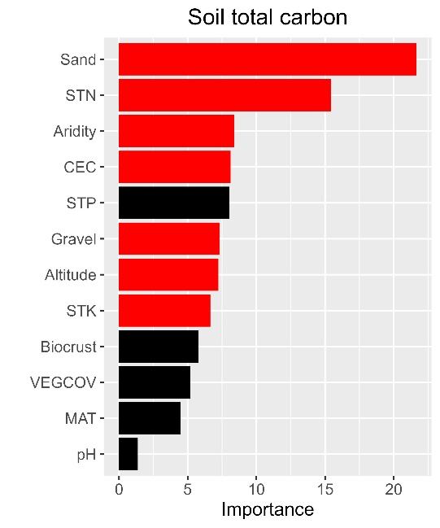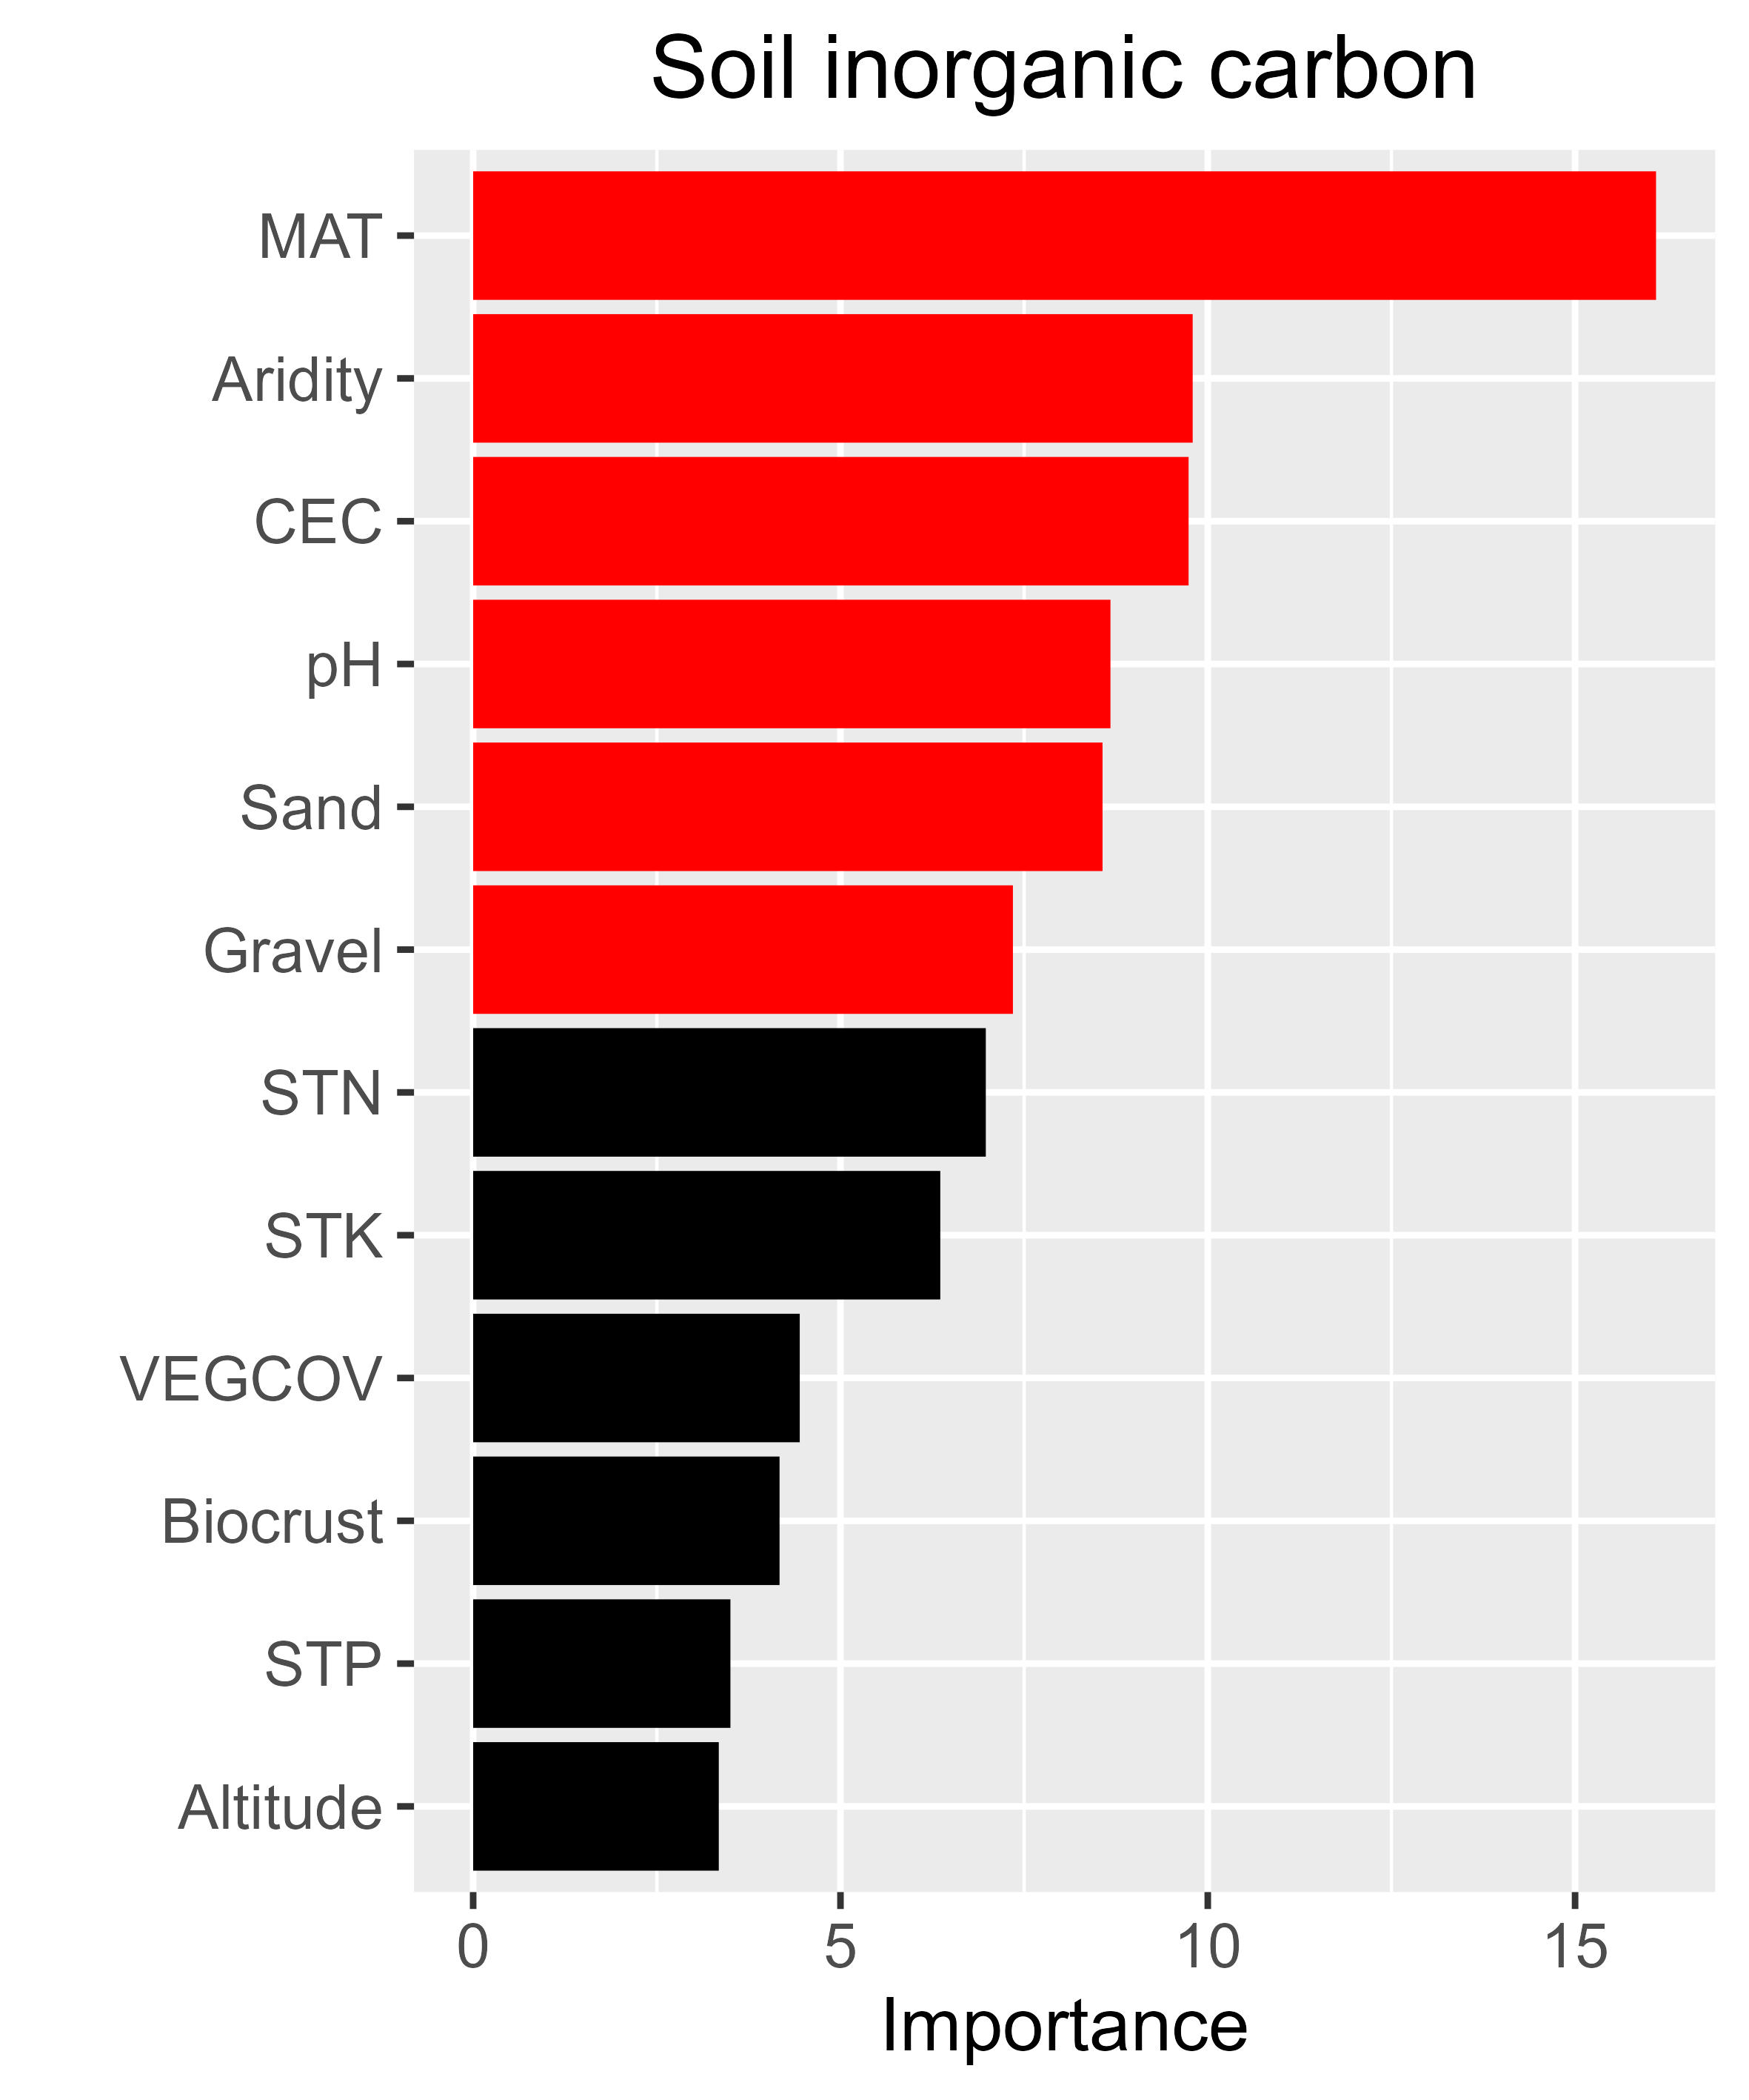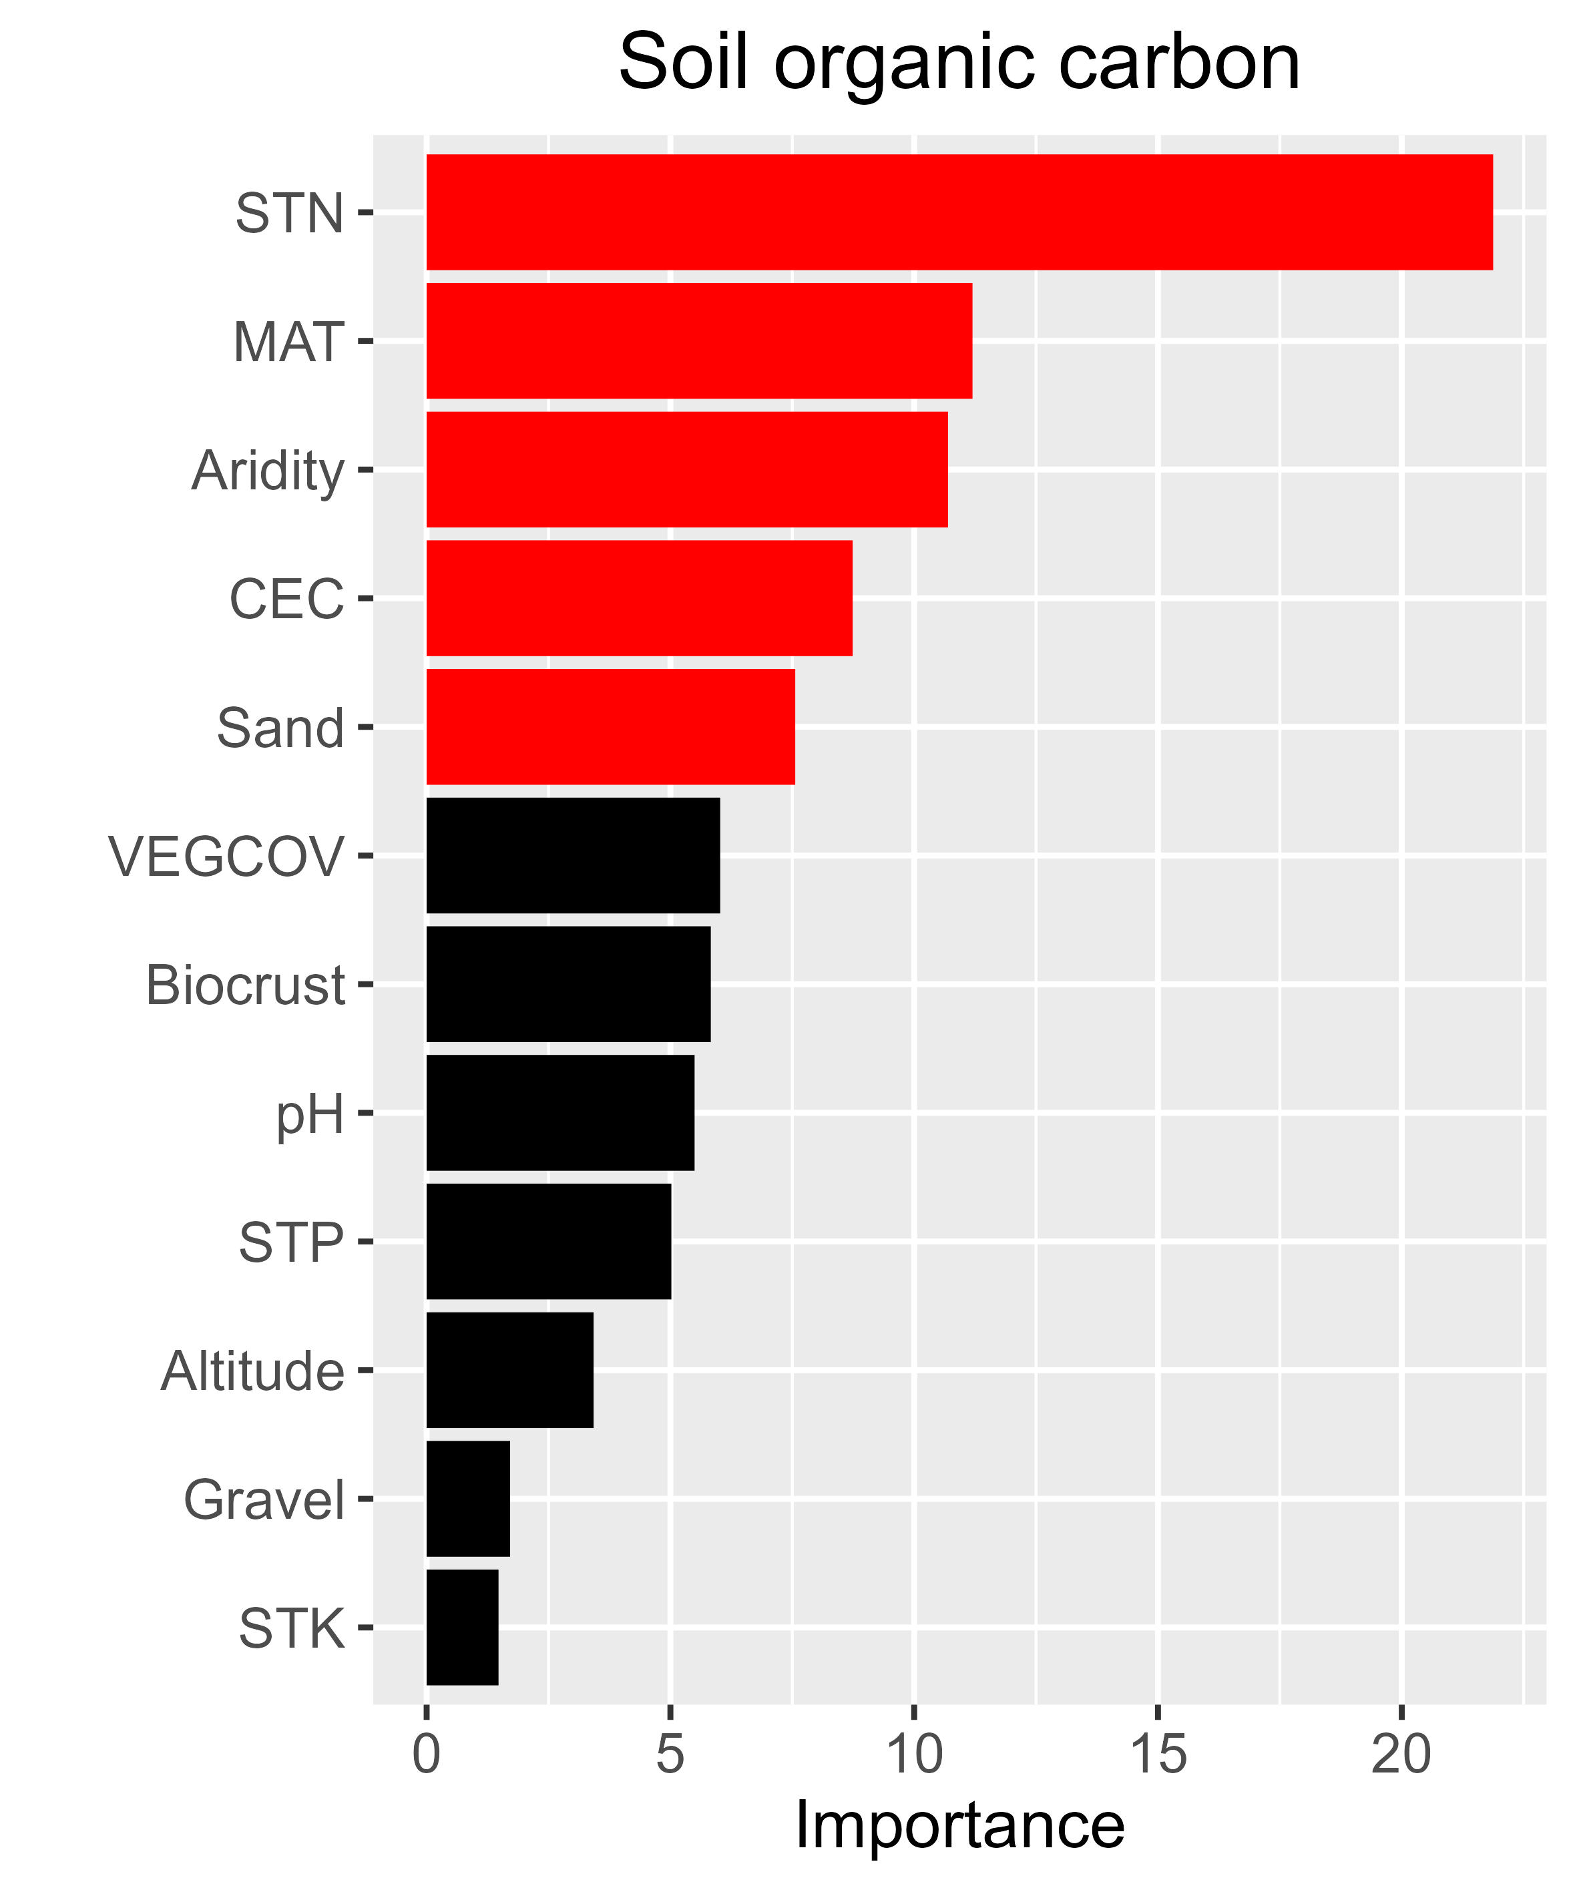

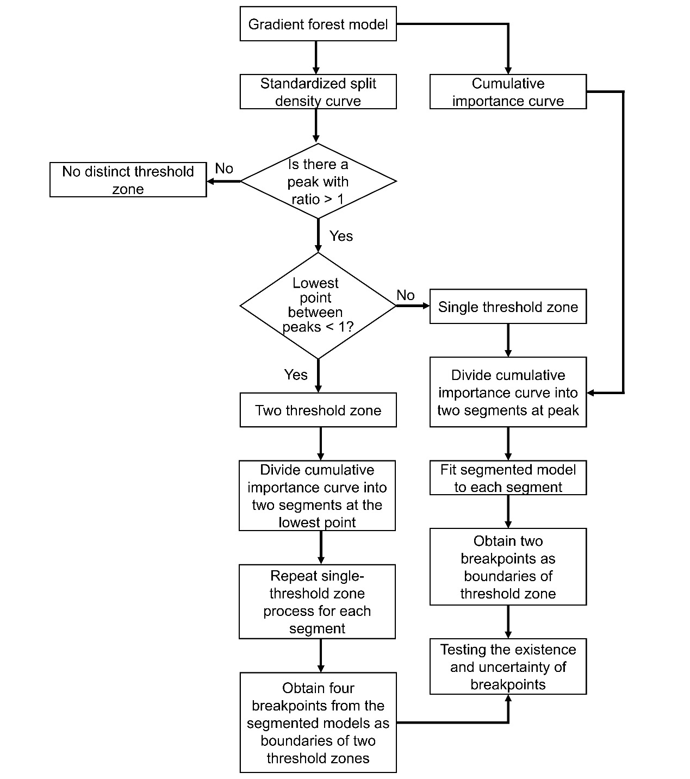

**Supplementary Figure 2** **Flowchart for identifying threshold zones based on the Gradient Forest model.** A single threshold zone is defined when a peak in split density exceeds 1 and no valley below 1 is observed between peaks. Two threshold zones are considered when the lowest point between two peak values falls below 1. Breakpoints in segments are estimated via segmented regression on the cumulative importance curve.

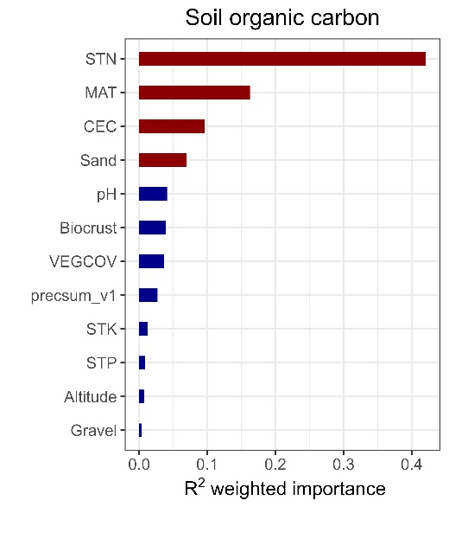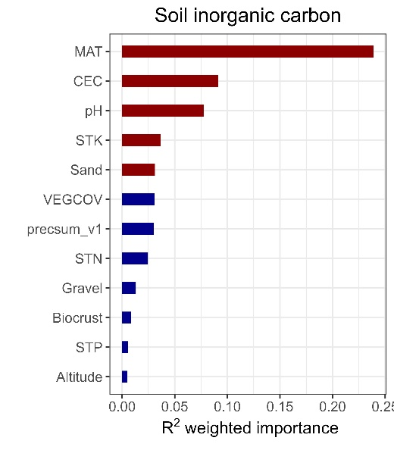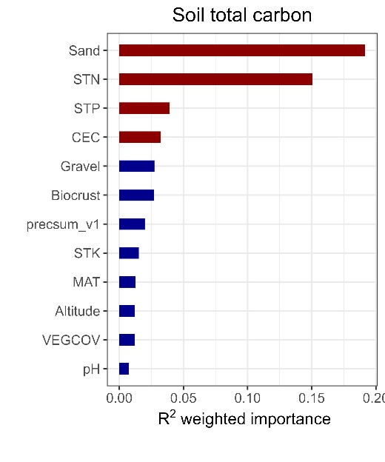

**Supplementary Figure 3: Environmental predictors of soil organic, inorganic and total carbon in China’s drylands.** Aridity has been replaced with mean annual precipitation (precsum_v1).

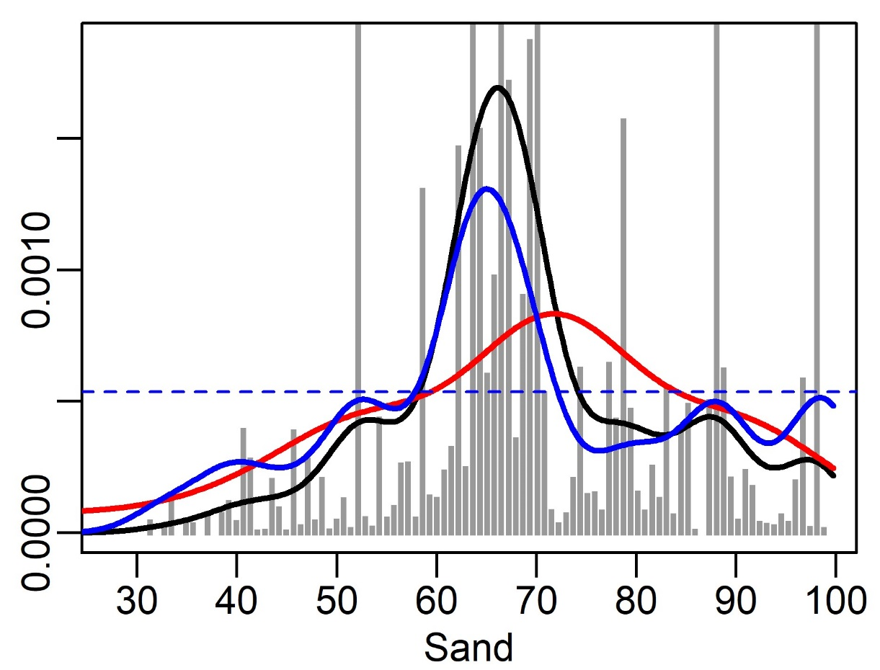

Density

**Supplementary Figure 4: Kernel density of random forest splits along sand content for soil inorganic carbon.** Sand represents sand content.

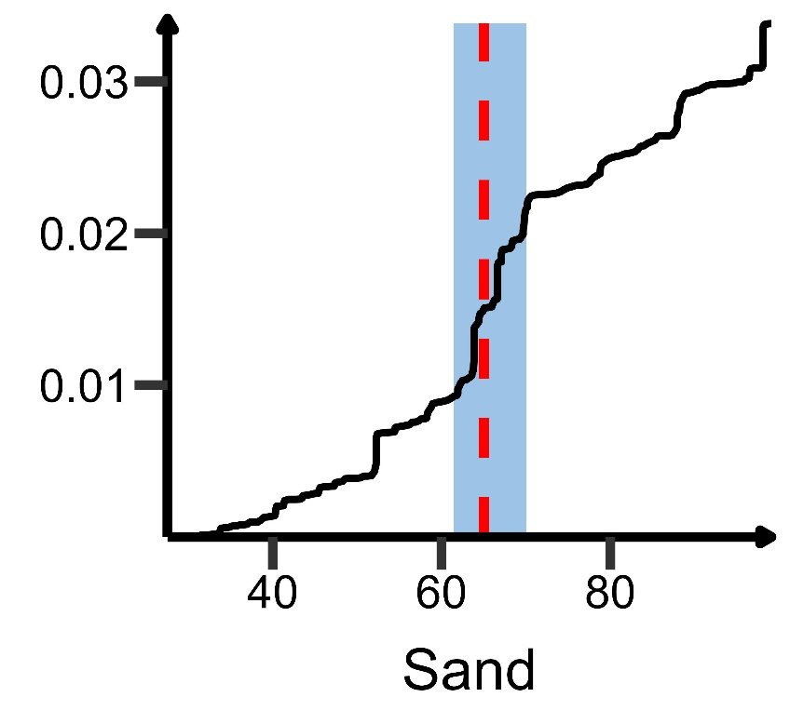

Cumulative importance

**Supplementary Figure 5: Sand content’s critical range for soil inorganic carbon.** Sand represents sand content.

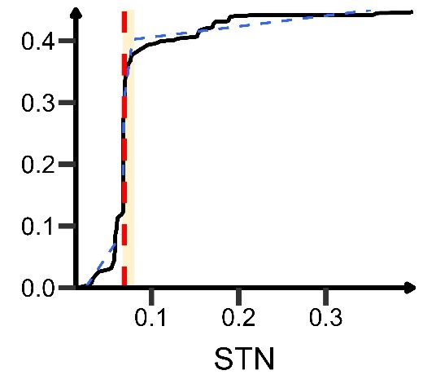 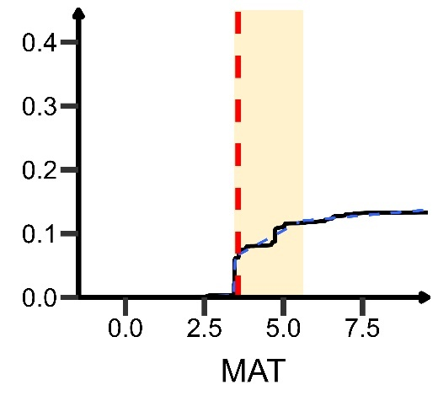

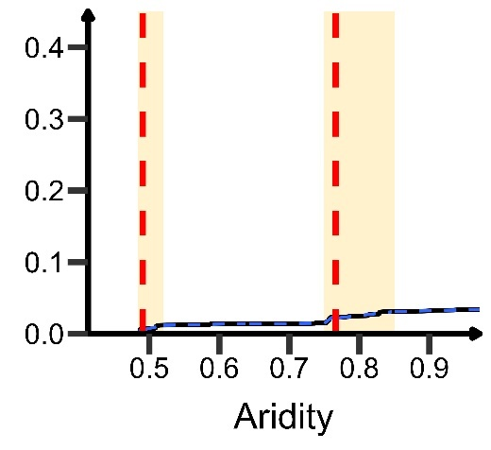 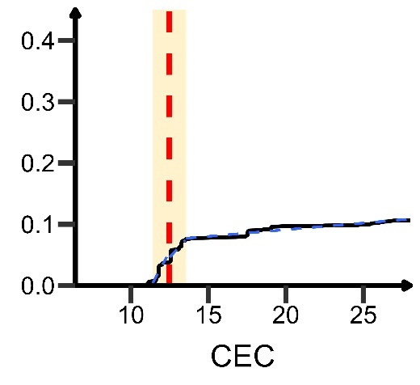

**Supplementary Figure 6: Critical ranges of environmental factors for soil organic carbon.** CEC, cation exchange capacity; MAT, mean annual temperature; STN, soil total nitrogen.

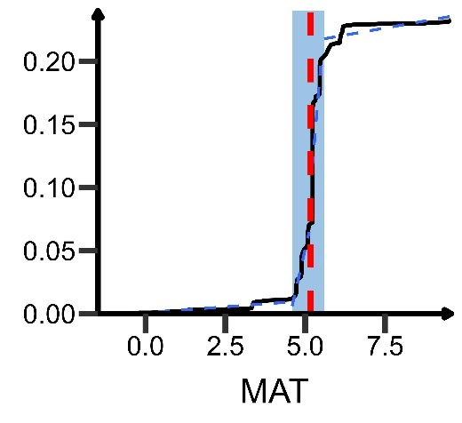 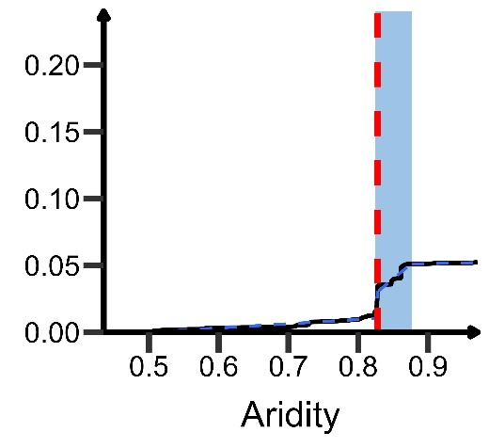

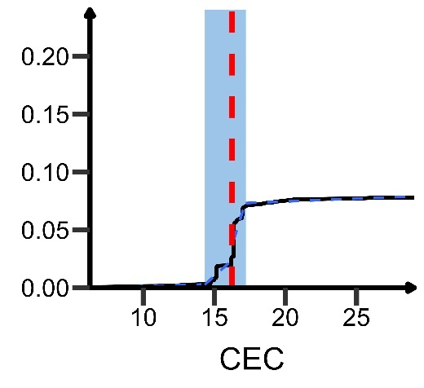 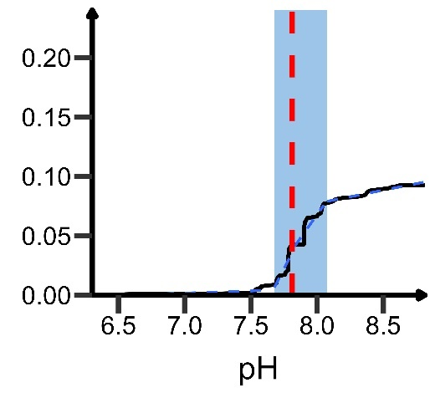

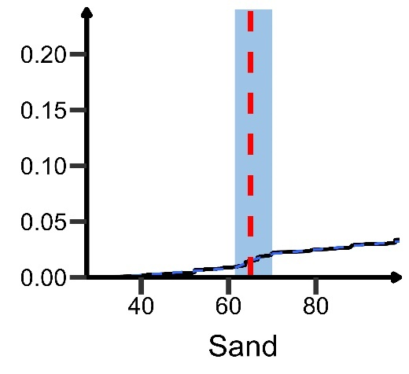

**Supplementary Figure 7: Critical ranges of environmental factors for soil inorganic carbon.** CEC, cation exchange capacity; MAT, mean annual temperature; Sand, sand content; STN, soil total nitrogen.

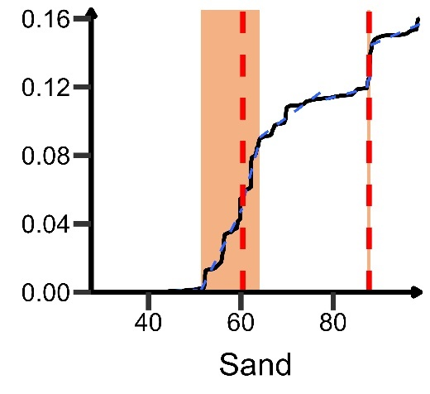 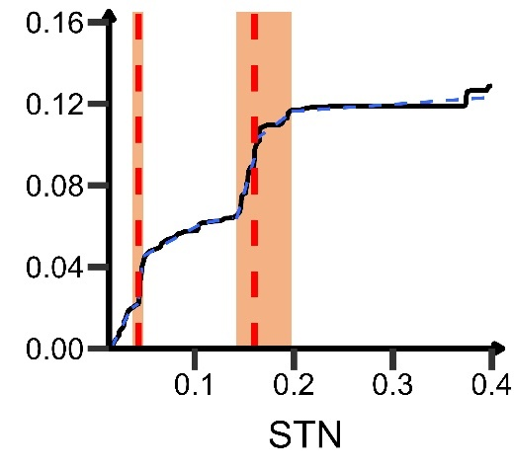

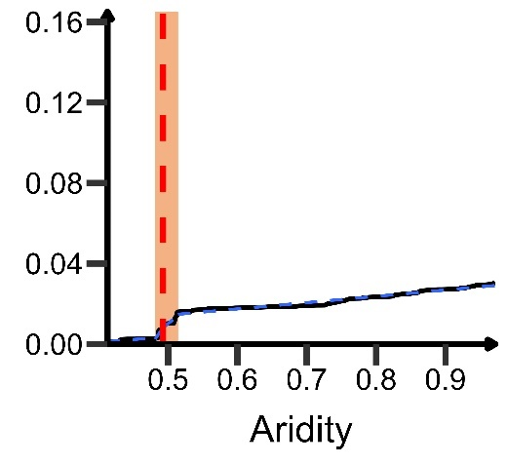 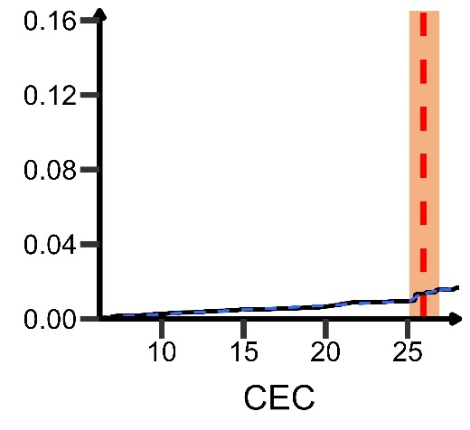

**Supplementary Figure 8: Critical ranges of environmental factors for soil total carbon.** CEC, cation exchange capacity; Sand, sand content; STN, soil total nitrogen.

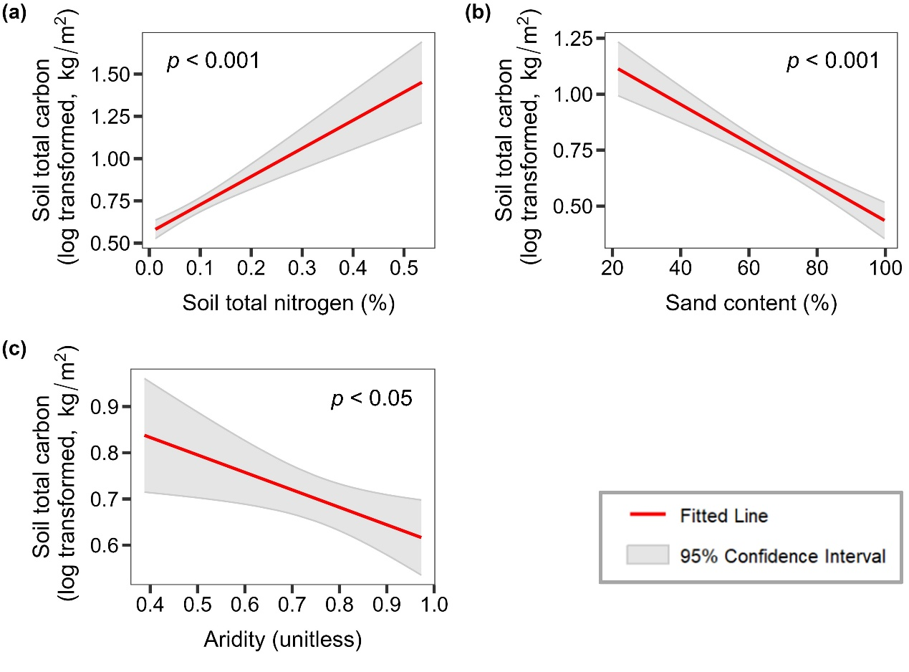

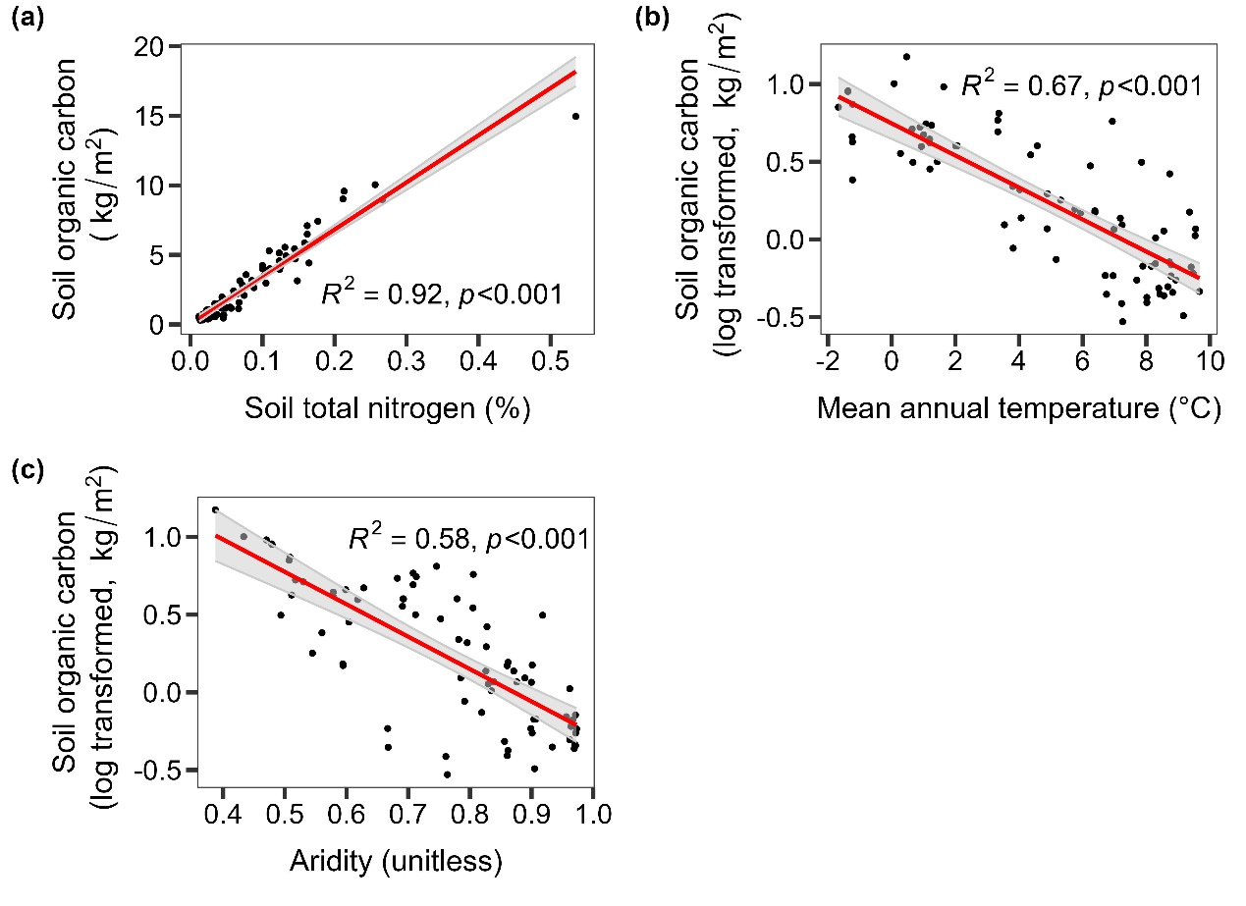

**Supplementary Figure 9: Relationships between soil total carbon and major global change-driven factors.**

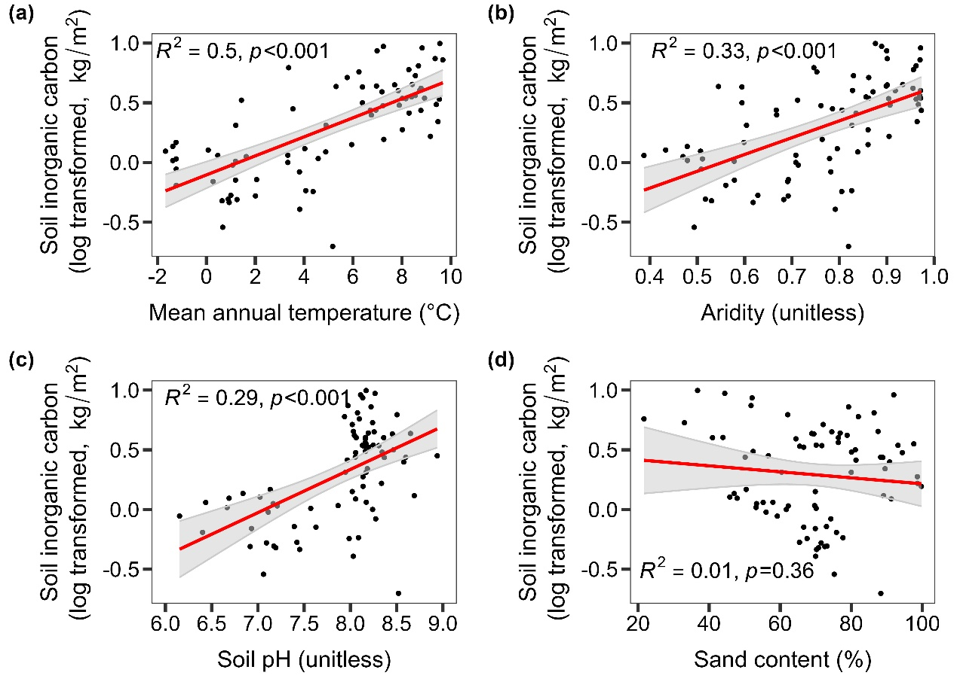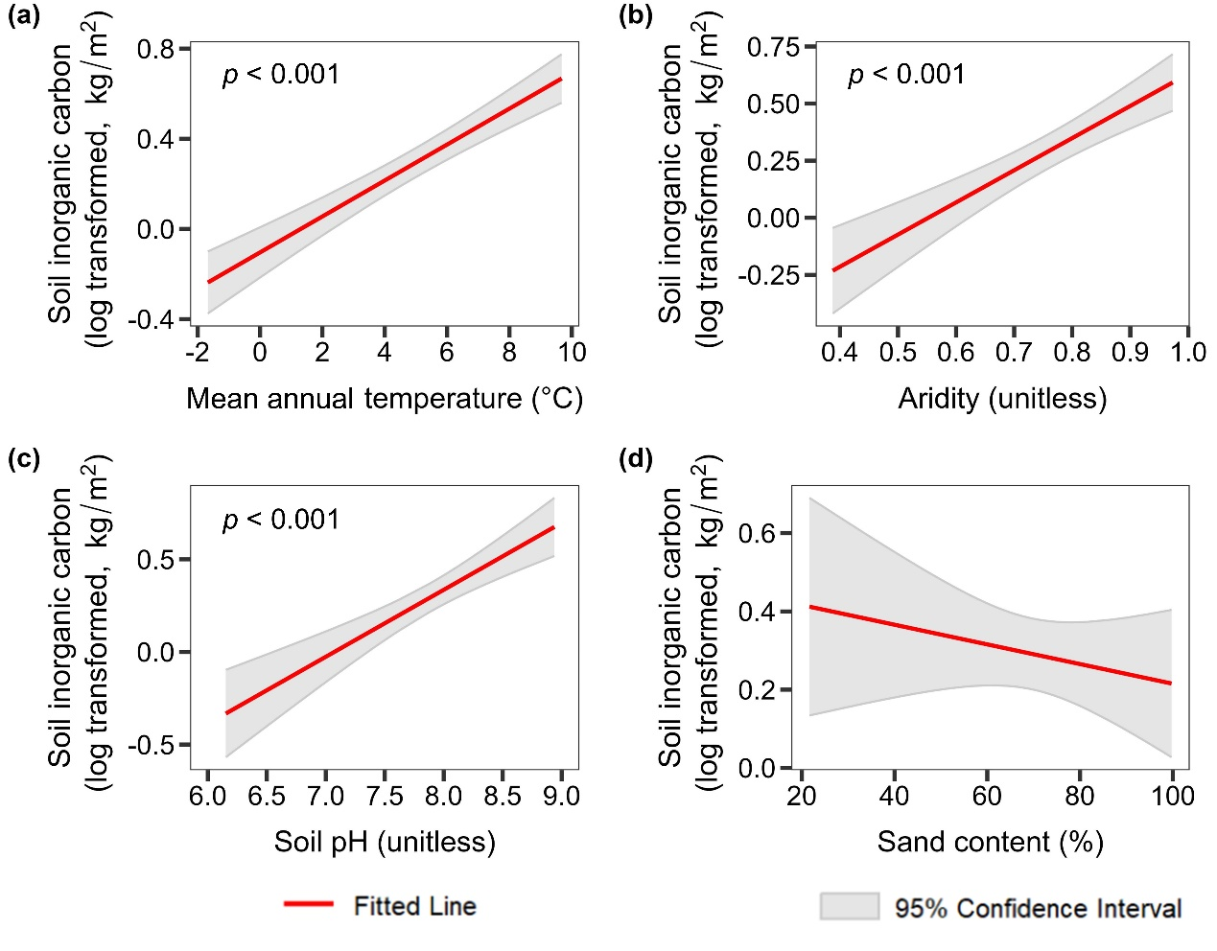

**Supplementary Figure 10: Relationships between soil inorganic carbon and major global change-driven factors.**





**Supplementary Figure 11: Relationships between soil organic carbon and major global change-driven factors.**

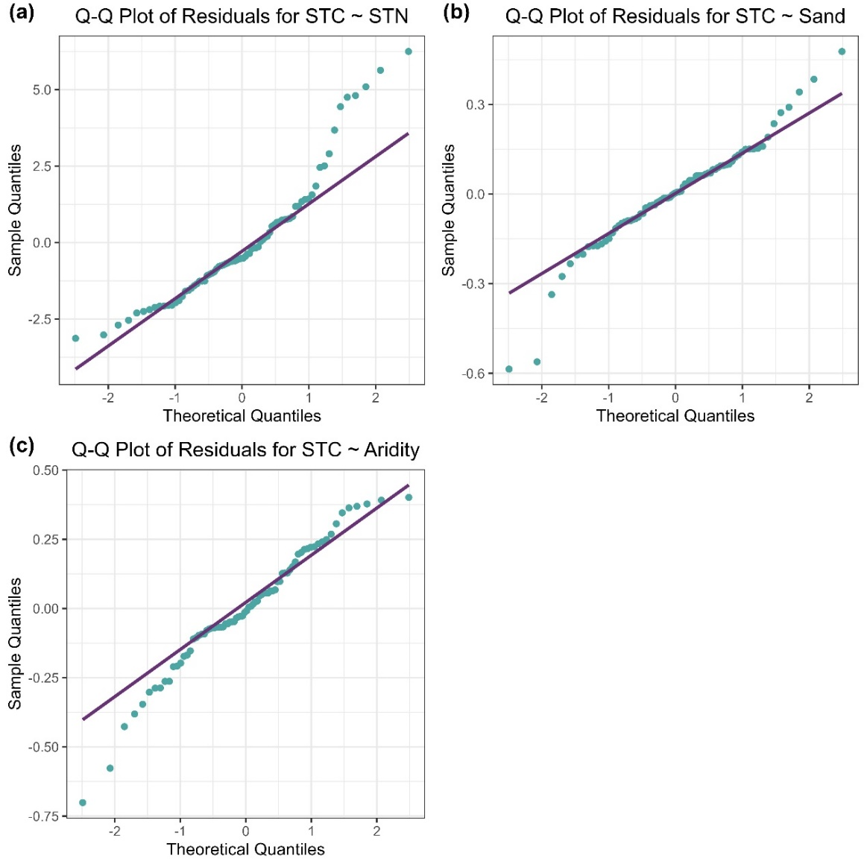

**Supplementary Figure 12: Q-Q plot of relationships between soil total carbon and major global change-driven factors.**

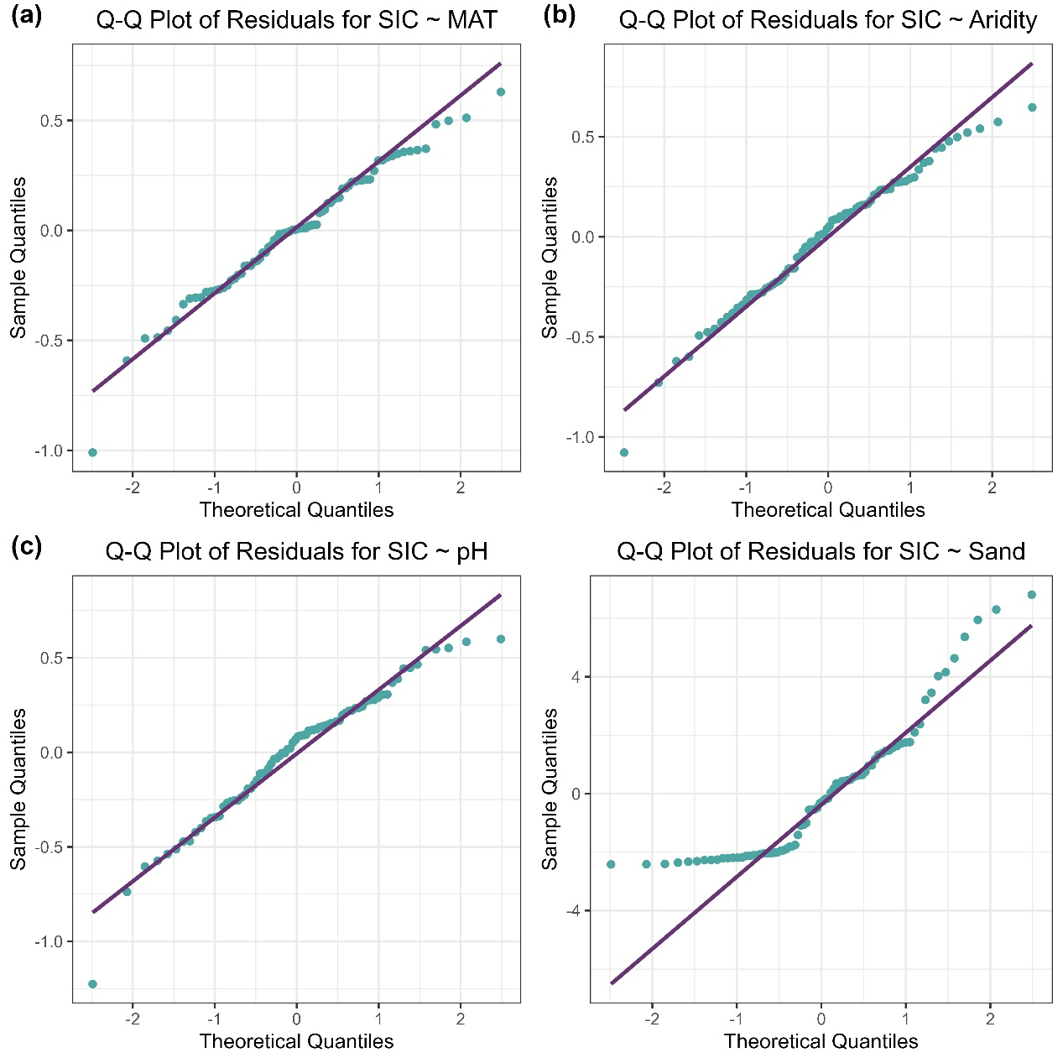

**Supplementary Figure 13: Q-Q plot of relationships between soil inorganic carbon and major global change-driven factors.**

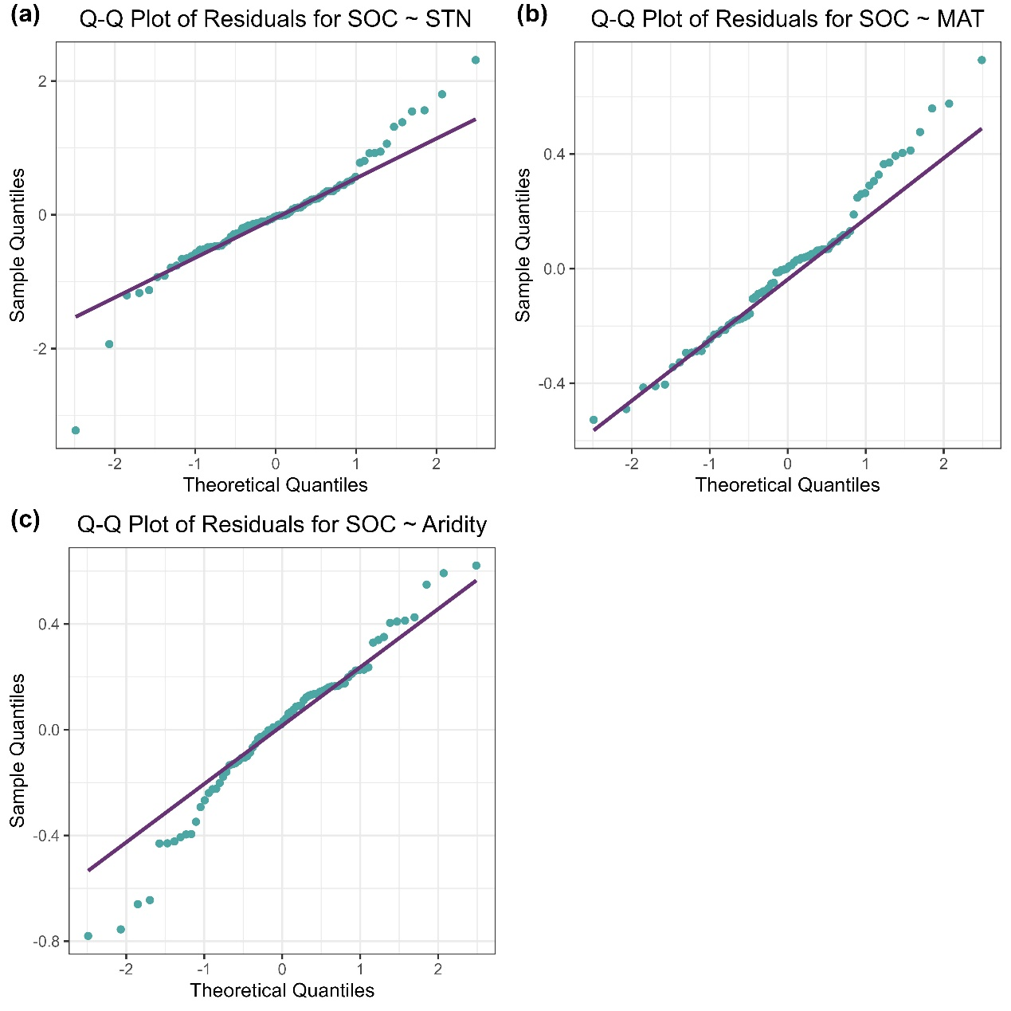

**Supplementary Figure 14: Q-Q plot of relationships between soil organic carbon and major global change-driven factors.**

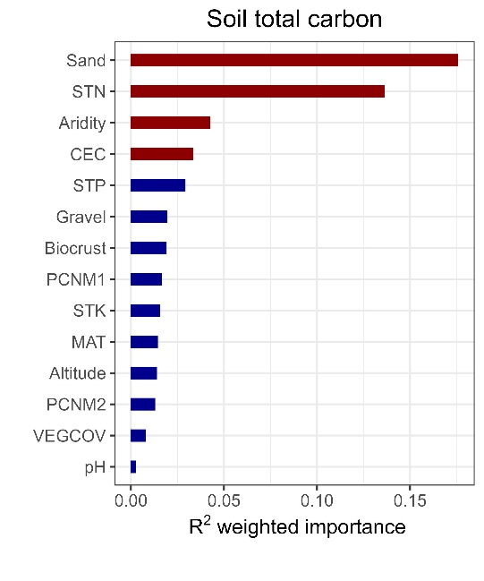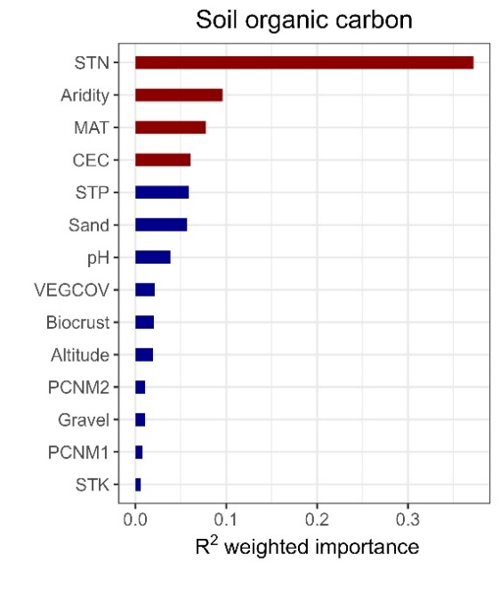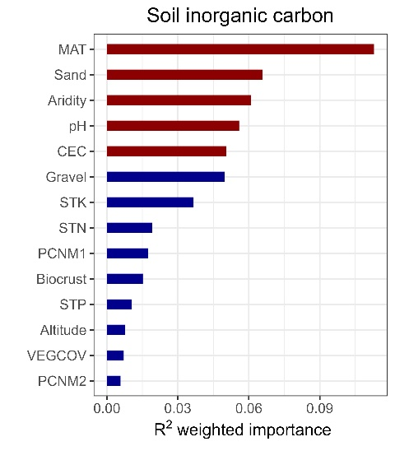

**Supplementary Figure 15: Environmental predictors of soil organic, inorganic and total carbon in China’s drylands.** PCNMs were included as explanatory variables to examine the importance of spatial heterogeneity on soil carbon.

**Supplementary Table 1. Spatial location of sampling sites**

|  |  |  |  |
| --- | --- | --- | --- |
| Site ID | Latitude (°) | Longitude (°) | Altitude (m) |
| 1 | 40.43388 | 108.62974 | 1111.25 |
| 2 | 40.447828 | 108.62363 | 1102.50 |
| 3 | 42.027757 | 107.74206 | 1347.50 |
| 4 | 41.58413 | 108.41727 | 1383.50 |
| 5 | 40.632974 | 107.42534 | 1040.25 |
| 6 | 40.631127 | 107.43194 | 1038.25 |
| 7 | 39.752746 | 106.83457 | 1101.50 |
| 8 | 40.243098 | 105.45792 | 1714.50 |
| 9 | 39.700868 | 105.73675 | 1021.00 |
| 10 | 38.802933 | 102.90008 | 1347.25 |
| 11 | 38.986889 | 102.1303 | 1348.50 |
| 12 | 39.276269 | 101.29539 | 1442.50 |
| 13 | 39.629231 | 100.67105 | 1548.00 |
| 14 | 40.157875 | 100.07544 | 1226.50 |
| 15 | 41.694314 | 101.00821 | 960.25 |
| 16 | 42.016989 | 100.94548 | 928.75 |
| 17 | 42.289496 | 101.13911 | 908.50 |
| 18 | 42.033048 | 101.33102 | 928.50 |
| 19 | 41.919981 | 100.80035 | 946.50 |
| 20 | 42.687423 | 93.994213 | 824.75 |
| 21 | 42.427889 | 94.396929 | 850.50 |
| 22 | 42.867838 | 93.60711 | 812.75 |
| 23 | 43.174523 | 92.6921 | 1141.25 |
| 24 | 43.392369 | 91.613632 | 966.75 |
| 25 | 44.378225 | 87.935427 | 451.00 |
| 26 | 44.158336 | 87.747516 | 478.25 |
| 27 | 43.649073 | 87.651906 | 1098.25 |
| 28 | 44.063715 | 87.1323 | 566.75 |
| 29 | 44.01251 | 86.161165 | 1046.25 |
| 30 | 44.557104 | 85.007671 | 366.25 |
| 31 | 45.548268 | 85.05294 | 261.25 |
| 32 | 47.024968 | 87.197219 | 532.75 |
| 33 | 47.40767 | 87.828759 | 501.75 |
| 34 | 47.799537 | 87.144773 | 530.00 |
| 35 | 47.677369 | 88.240026 | 704.75 |
| 36 | 47.334089 | 88.172833 | 619.50 |
| 37 | 40.744114 | 95.154741 | 1244.75 |
| 38 | 40.121911 | 94.559358 | 1161.25 |
| 39 | 40.579914 | 96.315949 | 1307.00 |
| 40 | 39.800536 | 98.084299 | 1779.75 |
| 41 | 39.267217 | 99.568008 | 1592.25 |
| 42 | 38.899933 | 100.25475 | 1598.75 |
| 43 | 43.5500357 | 116.66951 | 1260.10 |
| 44 | 43.550762 | 116.67282 | 1269.50 |
| 45 | 44.1413065 | 116.52479 | 1162.50 |
| 46 | 44.2684427 | 116.53084 | 1141.75 |
| 47 | 43.9443062 | 114.79663 | 1116.75 |
| 48 | 43.9107812 | 115.4963 | 1131.00 |
| 49 | 44.3746368 | 116.10147 | 938.00 |
| 50 | 44.3720037 | 116.099 | 935.00 |
| 51 | 42.792316 | 112.68141 | 1099.00 |
| 52 | 42.7921252 | 112.68402 | 1096.75 |
| 53 | 43.1768393 | 112.90648 | 1023.00 |
| 54 | 43.163719 | 112.91512 | 1023.00 |
| 55 | 43.589254 | 113.35704 | 970.00 |
| 56 | 43.0198835 | 111.93392 | 1072.00 |
| 57 | 42.5483343 | 112.37414 | 1036.00 |
| 58 | 41.8435567 | 111.92722 | 1450.50 |
| 59 | 41.6531843 | 110.78365 | 1485.25 |
| 60 | 41.6519085 | 110.78549 | 1486.25 |
| 61 | 41.353008 | 111.20816 | 1606.00 |
| 62 | 40.5863625 | 111.77509 | 1057.25 |
| 63 | 40.5879075 | 111.78037 | 1055.50 |
| 64 | 40.3171047 | 110.00268 | 1037.75 |
| 65 | 40.3184608 | 109.99279 | 1037.75 |
| 66 | 44.4554787 | 117.17922 | 1050.25 |
| 67 | 44.7682105 | 118.16183 | 1025.75 |
| 68 | 45.0416182 | 118.91295 | 1015.50 |
| 69 | 45.3160113 | 119.35152 | 972.25 |
| 70 | 45.1395265 | 121.52822 | 275.00 |
| 71 | 46.4425667 | 120.88571 | 777.25 |
| 72 | 45.9639475 | 120.49222 | 684.75 |
| 73 | 46.427817 | 120.45907 | 769.75 |
| 74 | 49.3493618 | 120.11814 | 669.00 |
| 75 | 49.3474795 | 120.11876 | 668.30 |
| 76 | 48.4926153 | 119.67027 | 752.75 |
| 77 | 48.4961045 | 119.66793 | 749.25 |
| 78 | 50.1690167 | 119.38495 | 524.25 |
| 79 | 49.7431068 | 118.54335 | 544.00 |
| 80 | 49.3807197 | 117.08658 | 709.00 |
| 81 | 48.4559537 | 116.47018 | 614.50 |
| 82 | 47.9182808 | 117.38793 | 594.25 |

|  |  |  |  |  |  |  |
| --- | --- | --- | --- | --- | --- | --- |
| Variable typology | Variable name | Abbreviation | Unit | Description | Data source | Resolution |
| Climate | Aridity |  | Unitless | Aridity calculated as 1 – annual  precipitation/annual evapotranspiration | Global Aridity and PET Database | 30 arc-secs |
| Climate | Mean annul temperature | MAT | °C | Mean annul temperature, interpolated from global climate dataset | WorldClim dataset | 30 arc-secs |
| Topography | Altitude |  | m | The mean altitude of the four vertices of the sampling plot | Field survey | Local |
| Biology | Vegetation coverage | VEGCOV | % | $$VEGCOV=\frac{Vegetation records}{Total number of records}$$ | Field survey | Local |
| Biology | Biological soil crust | Biocrust | % | $$Biocrust=\frac{Biocrust records}{Total number of records}$$ | Field survey | Local |
| Soil | Soil organic carbon | SOC | kg/m2 | The mean value of bare soil samples | Field survey | Local |
| Soil | Soil inorganic carbon | SIC | kg/m2 | Field survey | Local |
| Soil | Soil total nitrogen | STN | % | Field survey | Local |
| Soil | Soil pH | pH | Unitless | Field survey | Local |
| Soil | Soil total phosphorus | STP | mg/kg | Field survey | Local |
| Soil | Sand content | Sand | % | Field survey | Local |
| Soil | Soil total carbon | STC | kg/m2 |  | Field survey | Local |
| Soil | Gravel content | Gravel | % | Soil gravel content, interpolated from China soil information grids | National Soil Information Grids of China | 1km |
| Soil | Soil total potassium | STK | g/kg | Soil total potassium content, interpolated from China soil information grids | National Soil Information Grids of China | 1km |
| Soil | Cation exchange capacity | CEC | cmol(+)/kg | Cation exchange capacity, interpolated from China soil information grids | National Soil Information Grids of China | 1km |

**Supplementary Table 2. Description and origin of variables used in this study.**

**Supplementary Table 3.** **Parameter tuning for gradient forest model.**

|  |  |  |  |
| --- | --- | --- | --- |
|  | ntree | R² | MSE |
| SOC | 500 | 0.93 | 0.013 |
| SOC | 1000 | 0.93 | 0.013 |
| SOC | 1500 | 0.93 | 0.013 |
| SOC | 2000 | 0.93 | 0.013 |
| SIC | 500 | 0.61 | 0.063 |
| SIC | 1000 | 0.61 | 0.063 |
| SIC | 1500 | 0.60 | 0.063 |
| SIC | 2000 | 0.61 | 0.063 |
| STC | 500 | 0.56 | 0.022 |
| STC | 1000 | 0.55 | 0.022 |
| STC | 1500 | 0.55 | 0.023 |
| STC | 2000 | 0.55 | 0.023 |

**Supplementary** **Table 4. The 95% confidence intervals for thresholds and their segment parameters.** Lowercase letters represent significant differences at p< .05 level below and above threshold.

|  |  |  |  |  |  |
| --- | --- | --- | --- | --- | --- |
|  | Threshold | Slope above threshold | Slope below threshold | Intercept above threshold | Intercept below threshold |
| SOC~STN (1) | 0.067 ± 0.000 | 160 ± 2 a | 2.1 ± 0.03 b | -11 ± 0.001 | -0.05 ± 0.001 |
| SOC~STN (2) | 0.080 ± 0.002 | 0.17 ± 0.002 a | 10 ± 0.62 b | 0.39 ± 0.000 | -0.39 ± 0.006 |
| SOC~MAT (1) | 3.4 ± 0.001 | 1.3 ± 0.018 a | 0.001 ± 0.000 b | -4.4 ± 0.000 | 0.0 ± 0.000 |
| SOC~MAT (2) | 5.6 ± 0.020 | 0.004 ± 0.000 a | 0.026 ± 0.000 b | 0.097 ± 0.000 | -0.027 ± 0.000 |
| SOC~Aridity (1) | 0.48 ± 0.000 | 2.34 ± 0.80 a | 0.007 ± 0.000 b | -1.1 ± 0.003 | -0.003 ± 0.000 |
| SOC~Aridity (2) | 0.52 ± 0.001 | 0.019 ± 0.000 a | 0.22 ± 0.023 b | 0.002 ± 0.000 | -0.10 ± 0.000 |
| SOC~Aridity (3) | 0.75 ± 0.000 | 0.80 ± 0.034 a | 0.012 ± 0.000 b | -0.59 ± 2e-04 | 0.006 ± 0.000 |
| SOC~Aridity (4) | 0.85 ± 0.001 | 0.025 ± 0.000 a | 0.11 ± 0.001 b | 0.010 ± 0.000 | -0.064 ± 0.000 |
| SOC~CEC (1) | 11 ± 0.022 | 0.049 ± 0.002 a | 0.001 ± 0.000 b | -0.56 ± 0.001 | -0.0051 ± 0.000 |
| SOC~CEC (2) | 13 ± 0.016 | 0.002 ± 0.000 a | 0.028 ± 0.000 b | 0.048 ± 0.000 | -0.30 ± 0.000 |
| SIC~MAT (1) | 4.6 ± 0.009 | 0.11 ± 0.001 a | 0.002 ± 0.000 b | -0.50 ± 0.000 | 0.001 ± 0.000 |
| SIC~MAT (2) | 5.6 ± 0.020 | 0.004 ± 0.000 a | 0.29 ± 0.003 b | 0.20 ± 0.000 | -1.4 ± 0.001 |
| SIC~Aridity (1) | 0.82 ± 0.000 | 9.8 ± 0.059 a | 0.031 ± 0.000 b | -8.1 ± 0.000 | -0.015 ± 0.000 |
| SIC~Aridity (2) | 0.88 ± 0.001 | 0.011 ± 0.000 a | 0.43 ± 0.009 b | 0.041 ± 0.000 | -0.33 ± 0.000 |
| SIC~CEC (1) | 14 ± 0.026 | 0.011 ± 0.000 a | 0.000 ± 0.000 b | -0.16 ± 0.000 | -0.002 ± 0.000 |
| SIC~CEC (2) | 17 ± 0.030 | 0.000 ± 0.000 a | 0.039 ± 0.000 b | 0.065 ± 0.000 | -0.60 ± 0.000 |
| SIC~pH (1) | 7.7 ± 0.006 | 0.22 ± 0.002 a | 0.004 ± 0.000 b | -1.7 ± 0.000 | -0.023 ± 0.000 |
| SIC~pH (2) | 8.1 ± 0.006 | 0.022 ± 0.000 a | 0.16 ± 0.001 b | -0.099 ± 0.000 | -1.2 ± 0.000 |
| SIC~Sand (1) | 61 ± 0.83 | 0.002 ± 0.000 a | 0.000 ± 0.000 b | -0.10 ± 0.000 | -0.010 ± 0.000 |
| SIC~ Sand (2) | 70 ± 0.13 | 0.000 ± 0.000 a | 0.001 ± 0.000 b | -0.006 ± 0.000 | -0.064 ± 0.000 |
| STC~Sand (1) | 51 ± 0.071 | 0.005 ± 0.000 a | 0.000 ± 0.000 b | -0.28 ± 0.000 | -0.003 ± 0.000 |
| STC~Sand (2) | 64 ± 0.071 | 0.002 ± 0.000 a | 0.010 ± 0.000 b | -0.038 ± 0.000 | -0.55 ± 0.000 |
| STC~Sand (3) | 87 ± 0.24 | 0.019 ± 0.004 a | 0.001 ± 0.000 b | -1.5 ± 0.35 | 0.057 ± 0.012 |
| STC~Sand (4) | 88 ± 0.028 | 0.001 ± 0.000 a | 0.081 ± 0.007 b | 0.051 ± 0.000 | -7.0 ± 0.001 |
| STC~STN (1) | 0.037 ± 0.001 | 0.32 ± 0.055 a | 0.97 ± 0.10 b | 0.008 ± 0.002 | -0.015 ± 0.003 |
| STC~STN (2) | 0.048 ± 0.001 | 0.26 ± 0.002 a | 4.6 ± 0.081 b | 0.034 ± 0.000 | -0.17 ± 0.000 |
| STC~STN (3) | 0.14 ± 0.000 | 1.7 ± 0.011 a | 0.10 ± 0.002 b | -0.18 ± 0.000 | 0.050 ± 0.000 |
| STC~STN (4) | 0.20 ± 0.001 | 0.035 ± 0.001 a | 0.37 ± 0.005 b | 0.11 ± 0.000 | 0.043 ± 0.000 |
| STC~Aridity (1) | 0.48 ± 0.000 | 0.50 ± 0.11 a | 0.028 ± 0.001 b | -0.24 ± 0.001 | -0.01 ± 0.000 |
| STC~Aridity (2) | 0.51 ± 0.000 | 0.031 ± 0.000 a | 0.28 ± 0.003 b | -0.001 ± 0.000 | -0.13 ± 0.000 |
| STC~CEC (1) | 25 ± 0.12 | 0.006 ± 0.000 a | 0.000 ± 0.000 b | -0.15 ± 0.000 | -0.002 ± 0.000 |
| STC~CEC (2) | 27 ± 0.053 | 0.001 ± 0.000 a | 0.002 ± 0.000 b | -0.015 ± 0.000 | -0.038 ± 0.000 |

**Supplementary Table 5. Impacts of major global change-driven factors on soil carbon in this study.**

|  |  |  |  |
| --- | --- | --- | --- |
| Soil carbon type | Global change-driven factors | Effects on soil carbon | Rationale |
| Organic carbon | Soil nitrogen content | Positive | Increasing nitrogen deposition (Ackerman et al., 2019) and anthropogenic nitrogen additions (Houlton et al., 2019) lead to elevated soil nitrogen levels, which increase plant productivity and microbial biomass. |
| Mean annul temperature | Negative | Global warming creates positive feedback that accelerates organic carbon decomposition (Crowther et al., 2016). |
| Aridity | Negative | Increasing meteorological drought reduces vegetation productivity (Zeng et al., 2023), thereby decreasing the input of organic carbon. |
| Inorganic carbon | Aridity | Positive | Global aridification is accelerating (J. P. Huang et al., 2016), resulting in reduced leaching of inorganic carbon and supersaturation of the soil solution. |
| Mean annul temperature | Positive | Rising temperature in drylands leads to the retention of soil calcium (Sharififar et al., 2023). |
| Soil pH | Positive | Soil acidification has intensified inorganic carbon losses worldwide (Y. Y. Huang et al., 2024). |
| Sand content | Negative | Climate change and human activities drove the continued expansion of global desertification (Burrell et al., 2020), which hindered the formation of soil inorganic carbon. |

**References**

Ackerman, D., Millet, D. B., & Chen, X. (2019). Global Estimates of Inorganic Nitrogen Deposition Across Four Decades. *Global Biogeochemical Cycles, 33*(1), 100-107. doi:10.1029/2018gb005990

Burrell, A. L., Evans, J. P., & De Kauwe, M. G. (2020). Anthropogenic climate change has driven over 5 million km2 of drylands towards desertification. *Nature Communications, 11*(1). doi:10.1038/s41467-020-17710-7

Chen, K., & Olden, J. D. (2020). Threshold responses of riverine fish communities to land use conversion across regions of the world. *Global Change Biology, 26*(9), 4952-4965. doi:10.1111/gcb.15251

Crowther, T. W., Todd-Brown, K. E. O., Rowe, C. W., Wieder, W. R., Carey, J. C., Machmuller, M. B., Snoek, B. L., Fang, S., Zhou, G., Allison, S. D., Blair, J. M., Bridgham, S. D., Burton, A. J., Carrillo, Y., Reich, P. B., Clark, J. S., Classen, A. T., Dijkstra, F. A., Elberling, B., Emmett, B. A., Estiarte, M., Frey, S. D., Guo, J., Harte, J., Jiang, L., Johnson, B. R., Kröel-Dulay, G., Larsen, K. S., Laudon, H., Lavallee, J. M., Luo, Y., Lupascu, M., Ma, L. N., Marhan, S., Michelsen, A., Mohan, J., Niu, S., Pendall, E., Peñuelas, J., Pfeifer-Meister, L., Poll, C., Reinsch, S., Reynolds, L. L., Schmidt, I. K., Sistla, S., Sokol, N. W., Templer, P. H., Treseder, K. K., Welker, J. M., & Bradford, M. A. (2016). Quantifying global soil carbon losses in response to warming. *Nature, 540*(7631), 104-+. doi:10.1038/nature20150

Egidi, E., Delgado-Baquerizo, M., Berdugo, M., Guirado, E., Albanese, D., Singh, B. K., & Coleine, C. (2023). UV index and climate seasonality explain fungal community turnover in global drylands. *Global Ecology and Biogeography, 32*(1), 132-144. doi:10.1111/geb.13607

Hijmans, R. J., Cameron, S. E., Parra, J. L., Jones, P. G., & Jarvis, A. (2005). Very high resolution interpolated climate surfaces for global land areas. *International Journal of Climatology, 25*(15), 1965-1978. doi:10.1002/joc.1276

Houlton, B. Z., Almaraz, M., Aneja, V., Austin, A. T., Bai, E., Cassman, K. G., Compton, J. E., Davidson, E. A., Erisman, J. W., Galloway, J. N., Gu, B. J., Yao, G. L., Martinelli, L. A., Scow, K., Schlesinger, W. H., Tomich, T. P., Wang, C., & Zhang, X. (2019). A World of Cobenefits: Solving the Global Nitrogen Challenge. *Earths Future, 7*(8), 865-872. doi:10.1029/2019ef001222

Huang, J. P., Yu, H. P., Guan, X. D., Wang, G. Y., & Guo, R. X. (2016). Accelerated dryland expansion under climate change. *Nature Climate Change, 6*(2), 166-+. doi:10.1038/Nclimate2837

Huang, Y. Y., Song, X. D., Wang, Y. P., Canadell, J. G., Luo, Y. Q., Ciais, P., Chen, A. P., Hong, S. B., Wang, Y. G., Tao, F., Li, W., Xu, Y. M., Mirzaeitalarposhti, R., Elbasiouny, H., Savin, I., Shchepashchenko, D., Rossel, R. A. V., Goll, D. S., Chang, J. F., Houlton, B. Z., Wu, H. Y., Yang, F., Feng, X. M., Chen, Y. Z., Liu, Y., Niu, S. L., & Zhang, G. L. (2024). Size, distribution, and vulnerability of the global soil inorganic carbon. *Science, 384*(6692), 233-239. doi:10.1126/science.adi7918

Sharififar, A., Minasny, B., Arrouays, D., Boulonne, L., Chevallier, T., Van Deventer, P., Field, D. J., Gomez, C., Jang, H.-J., & Jeon, S.-H. J. A. i. A. (2023). Soil inorganic carbon, the other and equally important soil carbon pool: distribution, controlling factors, and the impact of climate change. *178*, 165-231.

Zeng, Z. Q., Wu, W. X., Li, Y. M., Huang, C., Zhang, X. Q., Peñuelas, J., Zhang, Y., Gentine, P., Li, Z. L., Wang, X. Y., Huang, H., Ren, X. S., & Ge, Q. S. (2023). Increasing meteorological drought under climate change reduces terrestrial ecosystem productivity and carbon storage. *One Earth, 6*(10), 1326-1339. doi:10.1016/j.oneear.2023.09.007