**Detecting zone-type thresholds for soil organic, inorganic, and total carbon pools in China's drylands**

Zhuobing Ren1,2, Changjia Li1,2*, Bojie Fu3, Wenxin Zhou1,2,4, Xinli Chen5, Shuai Wang1,2, Lindsay C. Stringer6,7

1. State Key Laboratory of Earth Surface Processes and Disaster Risk Reduction (ESPDRR), Faculty of Geographical Science, Beijing Normal University, Beijing, China

2. Institute of Land Surface System and Sustainable Development, Faculty of Geographical Science, Beijing Normal University, Beijing, China

3. State Key Laboratory of Urban and Regional Ecology, Research Center for Eco-Environmental Sciences, Chinese Academy of Sciences, Beijing, China

4. School of Agriculture, Food and Ecosystem Sciences, Faculty of Science, University of Melbourne

5. State Key Laboratory of Subtropical Silviculture, Zhejiang A&F University, Hangzhou, China

6. Department of Environment and Geography, University of York, York, UK

7. York Environmental Sustainability Institute, University of York, York, UK

*Correspondence: Changjia Li (changjia.li@bnu.edu.cn)

# **ABSTRACT**

Growing concerns about the accelerating global changes in drylands have intensified interest in understanding the impacts of diverse environmental factors on various soil carbon components, particularly their potential threshold effects, which may lead to abrupt nonlinear changes in both the quantity and composition of soil carbon. However, most research has predominantly focused on identifying key environmental drivers of either organic or inorganic carbon separately, often neglecting the presence and range of multiple critical thresholds. This study addresses this gap by analyzing extensive field data, including soil carbon measurements and ecosystem variables, collected across a ~4,000 km transect in China’s drylands. Utilizing a gradient forest model combined with threshold analyses, we assess the impacts of key drivers, including sand content, total nitrogen, aridity, and cation exchange capacity, on soil carbon pools. Our findings indicate that nitrogen content is the most influential factor for soil organic carbon, which was sensitive to low levels of nitrogen (0.07-0.08%), with a slower response observed at higher levels. Aridity significantly affects both organic and inorganic carbon pools, with identified threshold zones for organic carbon at aridity levels of 0.48-0.52 and 0.75-0.85, and for inorganic carbon at 0.82-0.88. Threshold zones of sand content for total carbon are identified at lower levels and a wider range (51.4-64.1% and 87.3-88.1%), due to its negative effects on both organic and inorganic carbon, impacting 20% of the dryland area. Spatial variations in threshold effects revealed a trade-off between nitrogen and pH in regulating soil total carbon. The combined threshold effects of climate warming and aridification may pose a greater threat to soil organic carbon in high-latitude regions. This research enhances understanding of soil carbon dynamics in arid environments and offers novel approaches and insights for identifying thresholds in ecosystems that are increasingly at risk of reaching tipping points.

**Keywords:** carbon dynamics, environmental factors, risk area, soil inorganic carbon, soil organic carbon, threshold analysis

# **1 Introduction**

Drylands are defined as regions with aridity [calculated as 1 – (precipitation/potential evapotranspiration)] greater than 0.35 (UNCCD, 2017) and cover approximately 45% of the Earth's surface (Pravalie, 2016). Climate change is expected to exacerbate aridification across terrestrial ecosystems, leading to a projected 11-23% expansion of global dryland areas in 2100 (J. P. Huang et al., 2016). However, these ecosystems are considered fragile and highly vulnerable to environmental changes (C. J. Li et al., 2024). Drylands are estimated to have a total carbon storage in the soil of about 1883 petagrams (Pg) to 2 m (Lal, 2019), consisting of 646 Pg of soil organic carbon and 1237 Pg of soil inorganic carbon, making up 52% of the global soil carbon (Plaza et al., 2018). The estimated soil total carbon pool in drylands is 16 times greater than the biotic carbon pool (Bernoux & Chevallier, 2014), underscoring its vital role in the carbon sequestration function of dryland ecosystems. In the context of accelerating global changes, climate change (J. P. Huang et al., 2017), land degradation (Berdugo et al., 2020), and desertification (Lal, 2003, 2004) have a substantial effect on soil carbon in drylands. For instance, increasing aridity results in an abrupt surge in inorganic carbon (Z. B. Ren et al., 2024), while rising temperatures decrease organic carbon, exacerbated by coarser soil structures (Hartley et al., 2021). Additionally, soil degradation and soil acidification, which reduce soil nutrient availability and lower pH, contribute to declines in soil organic carbon and inorganic carbon content, respectively. The surface soil (0-30 cm) has been shown to exhibit a general decline in soil inorganic carbon stocks at a rate of 11.33 g C m-1 yr-1 (Song et al., 2022), and an estimated 0.22-0.53 Pg of organic carbon are lost annually (S. Ren et al., 2024). Such losses are expected to intensify in the future (J. Q. Li et al., 2024; Melillo et al., 2017).

While previous research has identified key environmental drivers (i.e. climate, soil and vegetation attributes) of soil organic (Doetterl et al., 2015; Dong et al., 2024; M. M. Wang et al., 2022) and inorganic carbon (Y. Y. Huang et al., 2024; J. Q. Li et al., 2024; Song et al., 2022), most studies treat these components separately. Changes in specific environmental factors can lead to varying impacts on organic and inorganic carbon within the total carbon composition. First, aridification typically results in a reduction of organic carbon levels and an elevation of inorganic carbon content (Z. B. Ren et al., 2024), while the addition of soil nutrients tends to boost organic carbon concentrations (Shi et al., 2024; C. H. Xu et al., 2021), but causes a loss of soil inorganic carbon (Song et al., 2022). Increasing soil pH has a positive effect on inorganic carbon formation (Ferdush & Paul, 2021), but may decrease organic carbon stability (Tavakkoli et al., 2022). In addition, vegetation cover increases organic carbon and reduces its loss (Ren et al., 2023), but decreases inorganic carbon in alkaline soils (Hong & Chen, 2022). As multiple factors interactively affect soil total carbon, the key factors potentially differ from those influencing soil organic carbon or soil inorganic carbon individually. However, these key factors remain unclear, and limited research on this issue constrains our capacity to comprehensively predict soil carbon dynamics under changing environments.

Numerous studies have demonstrated that even minor variations in environmental drivers can provoke significant shifts in soil carbon dynamics once ecological thresholds are crossed. Ecological threshold is defined as the external environmental conditions at which abrupt changes in ecosystem attributes occur (Groffman et al., 2006). For example, Berdugo et al. (2020) identified an aridity threshold for soil organic carbon through a global survey, while Z. B. Ren et al. (2024) calculated an aridity threshold for inorganic carbon in China’s drylands. Similarly, other researchers have investigated thresholds related to temperature, sand content, and nitrogen content in relation to soil carbon (Cai et al., 2023; Cheng et al., 2018; Georgiou et al., 2024). However, these thresholds are typically conceptualized as “point-type”, implying a fixed value at which abrupt changes occur. In reality, neither external forces nor feedback mechanisms guarantee instantaneous abrupt changes. Instead, such transitions often involve a gradual process, ultimately leading to the observed shift (J. P. Li et al., 1996). Emerging evidence suggests that threshold is better represented as ranges or “zone-type” thresholds, rather than fixed points (Huggett, 2005; Shennan-Farpón et al., 2021). Furthermore, multiple thresholds may manifest along environmental gradients (Hobbs & Harris, 2001), particularly in complex ecosystems undergoing dynamic change. The concept of "zone-type" thresholds is particularly valuable as it provides early warnings indicators of impending changes while offering greater flexibility for interventions to prevent critical transitions. With growing recognition of their importance in ecosystem management (Rietkerk et al., 2021), various statistical methods have been developed to identify these thresholds. For example, the S-shaped curve method can delineate threshold zones (Maureaud et al., 2020), provided the observed data conform to the assumptions of S-shaped curve distributions or growth patterns. Alternatively, U-shaped fitting functions can determine threshold zones by identifying points where the slope of the curve equals 1 (Yin et al., 2017). While these approaches are versatile across various response types, they require predefined statistical models and are generally limited to identifying a single threshold zone. Recent advancements, such as the gradient forest method, offer the potential to identify multiple thresholds and detect abrupt changes (Chen & Olden, 2020; Egidi et al., 2023). However, these methods have yet to explicitly define threshold zones, leaving a critical gap in their application. Despite the conceptual emphasis on “zone-type” thresholds in the literature, their empirical and quantitative validation remains limited. In the context of soil carbon dynamics in drylands, Berdugo et al. (2020) highlighted the occurrence of soil carbon decline as an abrupt change involving multiple processes, underscoring the necessity of analysing threshold zones. However, existing threshold models, such as those based on segmented regression, are primarily designed to identify 'point-type' thresholds, leaving the 'zone-type' threshold of soil total carbon unexplored. Addressing this gap is essential for identifying accurate early warning signals to predict catastrophic soil carbon loss and for defining the operating space necessary to devise targeted conservation strategies.

The hypothesis of this study is that soil organic carbon, inorganic carbon, and total carbon exhibit threshold zones along key environmental gradients. We aim to (1) determine critical ranges (“zone-type” thresholds) for soil organic, inorganic and total carbon across key environmental gradients and (2) spatially map the critical regions for soil carbon in China’s drylands. We collected soil organic carbon, inorganic carbon, nutrients (total nitrogen and phosphorus), structure (bulk density and particle size), vegetation coverage, biological crust, and other environmental attributes through a ~4000km transect survey conducted along an aridity gradient in northern China. A gradient forest model was used to evaluate the most important environmental predictors. Combined with the threshold model, we propose a new approach to determine the range of abrupt changes in the importance of environmental factors for soil carbon. The spatial distribution of the critical areas for soil carbon was detected based on “zone-type” threshold results and high-resolution soil datasets.

# **2 Materials and Methods**

**2.1 Study area**

The study area in China encompasses one of the largest dryland regions in the world, covering approximately 6.6 million km2 (C. J. Li et al., 2023)and contains a substantial amount of soil organic carbon and inorganic carbon (C. J. Li et al., 2021). These drylands accounted for one-third of the global dryland expansion observed between 1980 and 2000 (Pravalie et al., 2019). A 4,000 km transect survey was conducted between July and August of 2020 and 2021, selected to capture the region’s diverse ecosystems and environmental gradients (Figure 1). The primary environmental gradients varied considerably: aridity (0.39-0.97), mean annual temperature (-1.7 to 9.7°C), soil nitrogen content (0.01-0.54 %), sand content (21.64-99.74%), and pH (6.15-8.94).

**2.2 Field sampling data**

Field sampling was conducted in eighty-two 45 × 45 m plots during July and August of 2020 and 2021, following the BIODESERT global survey methodology (Maestre et al., 2022). The plots were precisely located using a high-precision GPS instrument to record coordinates, including longitude, latitude, and altitude. Within each plot, a primary 45 m transect was established downslope for vegetation and soil surveys, supplemented by three additional parallel transects, each positioned 10 m apart across the slope. Ground cover was surveyed using the line-point intercept method, which categorized cover types such as bare soil, rock, vegetation, litter, and biological soil crust at 20 cm intervals along the transects (Maestre et al., 2022). Soil samples were collected from three randomly selected points in open areas with less than 5% cover by perennial vascular plants. Soil samples were collected at depths of 0-10, 10-20 and 20-30 cm to measure a comprehensive array of physicochemical properties included soil sand content, pH, soil organic carbon, total nitrogen, total phosphorus, calcium carbonate and total carbon (Table S2). The total number of observations was 82 sites × 3 locations × 3 depths, resulting in 738 observations. For analysis, soil property values were first averaged across depths (while carbon stocks were summed), and then the three random locations at each site were averaged. This methodological approach enabled the capture of diverse soil characteristics across China’s drylands. All field sampling data used in this study were obtained from the same dataset previously published in Z. B. Ren et al. (2024). Further details regarding the survey design and laboratory analysis methods are available in the supplementary material.

**2.3 Data collection of environmental variables**

To identify the primary determinants of soil carbon in drylands, we collected data on two categories of environmental factors: climatic and edaphic. Climatic variables, including mean annual precipitation (MAP) and mean annual temperature (MAT), were obtained from the WorldClim dataset, which offers a spatial resolution of approximately 1 × 1 km (http://www.worldclim.org/). Aridity data were retrieved from the Global Aridity Index and Potential Evapotranspiration Climate Database (https://cgiarcsi.community/). Edaphic variables, including soil total potassium (STK), cation exchange capacity (CEC), and gravel content, were derived from the high-resolution China Soil Information Grids basic soil property dataset, also with a resolution of ~1 km (http://doi.org/10.11666/00073.ver1.db). To maintain consistency across varying soil depth intervals (0-5 cm, 5-15 cm, and 15-30 cm), we employed depth-weighted averaging. Environmental data for each plot were extracted based on its specific geographic coordinates, including longitude and latitude.

**2.4 Data analysis**

To explore the environmental drivers of dynamics of soil organic, inorganic and total carbon in China’s drylands, we employed the Gradient Forest (GF) method to rank the importance of factors. GF is a nonparametric, nonlinear method suited for analyzing the relative importance of multiple predictors and capturing their nonlinear relationships with soil carbon composition (Ellis et al., 2012). In particular, it can provide split values of random forests to be used for threshold identification and delineation (Egidi et al., 2023). Furthermore, GF's flexibility in managing multiple environmental variables and its robustness to data noise enhance the reliability of threshold detection, making it particularly suitable for large-scale, heterogeneous datasets utilized in this study. We applied the GF framework with the sample data to assess the impact of each environmental factor on the different soil carbon components. These analyses were performed using the R packages “gradientForest” (Ellis et al., 2012) and “extendedForest” (Liaw & Wiener, 2002). GF model performance was assessed by the cross-validated out-of-bag R2 values, while the importance of each environmental variable was assessed by the relative importance weighted by R2 values. In addition, we introduced a random numeric vector into the gradient forest models for soil organic carbon, inorganic carbon and total carbon. The modelling process was repeated 100 times and the average importance of each feature was calculated. Any features with importance values lower than those of the random vector were excluded from further analysis.

The random forest method is capable of ranking the importance of environmental factors and assessing the significance of their importance through the permutation of response variables (Archer, 2022). In our analysis, we used the rfPermute function to evaluate the significance of each variable’s importance score based on permutation within a random forest framework. The model performance and the observed importance values were assessed using the out-of-bag predictions, which result from the bootstrap sampling. We set the number of trees to 500 and used the default 100 permutations. Specifically, the response variable was permuted 100 times, with a new random forest model built at each permutation step. The p-value for each predictor was calculated by comparing its observed importance value with the null distribution of importance metrics obtained from the permuted models. Based on the random forest results (Figure S1), we identified the key drivers in the most conservative way, using the importance ranking from the gradient forest. The key drivers were identified under the following conditions: (1) the factor’s importance was statistically significant (*p* < 0.05) in the random forest model; and (2) the ranking of significant factors in the random forest model was consistent with the ranking of importance from the gradient forest model. The "rfPermute" package in R was used to build the model.

The shape of the resulting distribution curves describes the magnitude of soil carbon change along environmental gradients, with the standardized ratio of split density >1 indicating the highest manifestation of a threshold (Pitcher et al., 2012). Raw split density can be affected by variables such as sample size, predictor range, or data structure, which may obscure the true thresholds. By normalizing these effects, the standardized ratio compares the observed split density against an expected baseline, thereby accentuating regions where changes in the response variable occur with disproportionate frequency. When the lowest point between two peak values is <1, they are considered to represent two distinct thresholds. Threshold zones, i.e., "zone-type" thresholds, were determined by calculating the cumulative importance generated from the gradient forest model combined with the threshold model (Figure 2). The changes in importance along the environmental gradient were separated using the identified threshold peaks. For curves with a single threshold, we applied a segmented regression model to fit the two segments and obtain two breakpoints, which define the boundaries of the threshold zone. For curves with two distinct thresholds, we first divided the cumulative importance curve into two segments at the lowest point between the two peaks in the standardized split density curve. Next, we repeated the single-threshold procedure for each segment. Finally, four breakpoints were obtained from the segmented models, which define the boundaries of the two threshold zones (Figure S2). To account for the continuous variation in the cumulative importance of variables along the gradient, we employed a segmented model rather than relying on step and stegmented calculations (Berdugo, 2020). The segmented model was implemented using the chngptm function from the ‘chngpt’ package, which identifies the maximum likelihood estimate of the threshold model parameters. Specifically, we used a grid ranging from the 5th to the 95th percentile (0.05-0.95) of the threshold variable, with 500 equally spaced candidate values. This corresponds to a quantile interval of approximately 0.0018. The estimated change point was determined by fitting the threshold regression model with the maximum likelihood. Threshold values and segment parameters were calculated with a 95% confidence interval (Table S4). To assess whether thresholds significantly influenced the slopes, a bootstrap analysis was performed on linear regressions (Canty & Ripley 2021). The results were subsequently compared using the Mann−Whitney U test (Table S4). This approach strengthens the soundness of thresholds, as “zone-type” thresholds account for the inherent variability and uncertainty in ecological responses, providing a more reliable and comprehensive understanding of critical ecosystem transitions. These analyses were conducted using R 4.1.3 in RStudio. Based on the environmental data collection, we spatialized the calculated threshold ranges to preliminarily explore regions where abrupt changes may occur. This approach can identify priority areas of risk and intervention for soil carbon stocks in drylands, supporting the development of conservation strategies for soil carbon sinks.

# **3 Results**

**3.1 Importance of environmental factors for soil organic, inorganic and total carbon**

Soil organic carbon was most strongly associated with soil total nitrogen, mean annual temperature, aridity and cation exchange capacity (relative importance: 0.37, 0.12, 0.11 and 0.08, respectively) (Figure 3a). Importance in relation to other environmental predictors was also high (> 0.03) for soil pH, biocrust, vegetation coverage, soil total phosphorus and sand content, while altitude, soil total K and gravel content had the lowest importance values (< 0.01). The key driving factors of inorganic carbon were mean annual temperature, aridity, cation exchange capacity, soil pH and sand content (relative importance: 0.15, 0.10, 0.07, 0.05 and 0.04, respectively), followed closely by soil total nitrogen, gravel content, vegetation coverage and soil total K, with relative importance above 0.02 (Figure 3b). The least impact was observed for altitude, biocrust, and soil total phosphorus. Soil total nitrogen and sand content showed strong and significant contributions to soil total carbon (relative importance: 0.18 and 0.15, respectively), followed by aridity and cation exchange capacity (relative importance: 0.05 and 0.04, respectively) (Figure 3c). The remaining factors of total carbon were found to be of lesser importance (<0.03). Moreover, the relative importance of the random vector was substantially lower than that of the key drivers for soil organic carbon, inorganic carbon, and total carbon, with values of 0.002, 0.003, and 0.002, respectively.

**3.2 Detection of thresholds for soil organic, inorganic and total carbon changes**

To identify significant changes in soil carbon along major environmental gradients, frequency histograms and density plots of the values used by classification trees for splits (i.e., the split density plots in Figures 4 and S4) were analyzed. The mean annual temperature showed a threshold point at 3.6°C for soil organic carbon, where the density ratio reached its maximum (Figure 4), indicating that beyond this threshold, organic carbon declined more rapidly. For soil total nitrogen and cation exchange capacity, the threshold points were identified as 0.07% and 12.5 cmol/kg, respectively. Beyond the nitrogen threshold, the increase in organic carbon continued but at a slower rate. Regarding aridity, two distinct peaks were observed in the density ratio, with the curve dropping below 1 between these peaks, suggesting that organic carbon remained relatively stable at these aridity values. The threshold points for aridity in relation to organic carbon were identified as 0.49 and 0.77, with a clear decreasing trend in organic carbon below 0.49 and above 0.77. For soil inorganic carbon, peak values occurred at specific threshold points: 5.2°C for mean annual temperature, 0.83 for aridity, 16.2 cmol/kg for cation exchange capacity, 7.8 for soil pH, and 65.0% for sand content, with inorganic carbon stocks increasing significantly beyond these thresholds. Soil total carbon exhibited abrupt changes at 60.4% and 87.8% sand content, declining continuously beyond these points. The most likely thresholds of soil total nitrogen to total carbon were 0.04% and 0.16%, with total carbon increasing at a slower rate upon crossing these thresholds. The influence of aridity and cation exchange capacity on soil total carbon was marked by a sharp rise at 0.49 and 26.0 cmol/kg, respectively, and beyond the aridity threshold, the decline of soil total carbon slowed down.

By utilizing threshold models on both sides of the “point-type” threshold, we detected critical ranges on different environmental gradients where abrupt changes in the importance of soil organic, inorganic, and total carbon occurred. Shifts in soil inorganic carbon were recorded with critical ranges of mean annual temperature, aridity, cation exchange capacity, soil pH, and sand content (Figure 5 and S5). Specifically, the critical ranges for MAT, aridity, CEC, pH, and sand content were observed to be 4.6-5.6 °C, 0.82-0.88, 14.3-17.2 cmol/kg, 7.7-8.1, and 61.4-70.0%, respectively. Additionally, a distinct split in soil organic carbon was observed at 0.48-0.52 followed by another split at 0.75-0.85 along the aridity gradient. Critical ranges for soil total nitrogen, mean annual temperature, and citation exchange capacity influencing organic carbon were found to be 0.07-0.08%, 3.4-5.6°C, and 11.4-13.6 cmol/kg, respectively. Splits in soil total carbon content were noted when soil sand content fell within the ranges of 51.4-64.1%, and 87.3-88.1%. The two critical ranges for the change in soil total carbon with total nitrogen were 0.04-0.05 % and 0.14-0.20 %. A shift in soil total carbon also occurred at 0.48-0.51 aridity and 25.1-26.9 cmol/kg CEC.

**3.3 Locating critical regions for soil carbon in China’s drylands**

We identified five key factors influencing soil carbon dynamics in China's drylands: mean annual temperature, aridity, soil total nitrogen, pH, and sand content (Table S5 and Figure 3). These factors were chosen due to their high responsiveness to anticipated global changes. Climate change is contributing to rising temperature and increased aridity, while human activities are exacerbating acidification, nitrogen addition, and alterations in land cover. Additionally, processes of land degradation and desertification are leading to changes in soil sand content. Based on their positive or negative impacts (Z. B. Ren et al., 2024) and relationships with soil organic, inorganic, and total carbon (Figure S9-11) and the critical range of these factors (Figure 5), we further spatially identified the critical region of soil carbon. The critical region of soil total nitrogen for organic carbon, as shown in Figure 6, is primarily found in the dry sub-humid and semi-arid regions of the eastern part of China and the Qinghai-Tibetan Plateau, accounting for 10.4% of the drylands in China (55.2 × 104 km2). The critical region of mean annual temperature covers an area of 59.6× 104 km2 and is located in the high-latitude interior and the Qaidam Basin. The critical region related to aridity's impact on organic carbon is spread out (such as the edge of the drylands, semi-arid and arid areas), with an area of about 99.0 × 104 km2 (18.6% of the total drylands in China). The arid regions of northern Xinjiang, central Inner Mongolia, and northern Tibet are the critical region of aridity for inorganic carbon (38.3 × 104 km2). The critical region of mean annual temperature is sporadically distributed, except for two clusters in western Jilin and Qinghai. The critical area of soil pH is widely distributed, occupying about 38.4% of the dryland area, while the critical regions of sand content are scattered across the grasslands of Inner Mongolia and the Qinghai-Tibet Plateau. The distribution of soil total nitrogen's critical region for total carbon is found from east to west in China’s drylands. Most of the critical regions of aridity for total carbon were situated at the edge of drylands (25.3 × 104 km2). The critical region of sand content was primarily found in the western of China and Qinghai-Tibet Plateau (106.1×104 km2, 20.0% of China’s drylands).

# **4 Discussion**

**4.1 Major environmental drivers of soil organic, inorganic and total carbon**

The results indicate that soil total nitrogen, temperature, aridity, and CEC are the primary drivers of soil organic carbon (Figure 3a), with the model explaining 93% of the variance. Total nitrogen was most critical compared to the other three variables. Soil nitrogen content is generally positively related to organic carbon as nitrogen enhances plant productivity (LeBauer & Treseder, 2008) and microbial biomass (W. T. Li et al., 2023), both of which contribute to organic matter inputs and carbon storage in the soil.

In drylands, temperature and aridity are the primary factors influencing changes in soil inorganic carbon (Figure 3b), and the model account for 61% of the variance. These factors affect soil pH and structure, which, in turn, enhance soil inorganic carbon levels. Rising temperatures destabilize soil aggregates by transforming macropores into micropores, a process that increases inorganic carbon content (Kelishadi et al., 2018). Concurrently, increased aridity reduces the leaching of metal cations, leading to an increase in soil pH. This rise in pH, driven by elevated calcium ion concentrations on the left side and a reduction in hydrogen ions on the right side of the reaction promote calcium carbonate formation:

$$\begin{aligned}{Ca}^{2+}\left(aq\right)+ {HCO}_{3}^{-}\left(aq\right) ↔ {CaCO}_{3}\left(s\right)+ H^{+}\#\left(1\right)\end{aligned}$$

Moreover, higher temperatures and greater aridity contribute to the accumulation of soil inorganic carbon by reducing the dissolution of carbon dioxide and increasing the saturation of calcium carbonate(Gocke & Kuzyakov, 2011; Z. B. Ren et al., 2024; Zamanian et al., 2016). Collectively, these processes facilitate the storage and accumulation of soil inorganic carbon in dryland environments.

Temperature, as an important factor influencing both organic and inorganic carbon, has a minimal impact on soil total carbon (Figure 3), for which the model explains 56% of the variance. This could be due to the offsetting effect - accelerating organic carbon decomposition (Trumbore et al., 1996) while promoting inorganic carbon accumulation through carbonate formation (Ferdush & Paul, 2021). In contrast, sand content has the strongest influence, likely because it significantly affects both organic and inorganic carbon negatively. Given the strong contribution of soil total nitrogen to organic carbon (Figure 3a), this may explain its continued substantial impact on total carbon. Our results indicate that aridity is a major factor influencing soil organic, inorganic, and total carbon, highlighting the crucial role of water conditions in dryland soil carbon stocks under environmental changes.

The gradient forest model exhibited relatively higher explanatory power for soil organic carbon and inorganic carbon, suggesting that it may be beneficial to consider their thresholds separately. This aligns with the notion that soil organic carbon and inorganic carbon are governed by distinct processes and underlying mechanisms. Meanwhile, a broader perspective is also important: although the model explained a relatively lower proportion of the variance in soil total carbon, it still captured the combined effects of environmental change on dryland carbon dynamics and offers valuable insights at an integrated level.

**4.2 Environmental factors’ critical ranges for soil organic, inorganic and total carbon**

Our results indicated that the critical range of total nitrogen for soil organic carbon was 0.07-0.08%, beyond which the increase in organic carbon slowed (Figure 5), potentially related to nutrient saturation and shifts in microbial biomass mentioned above. Previous studies have found that with increasing soil nitrogen, the productivity of ecosystems tends to rise initially and then stabilize (Musinguzi et al., 2013; Peng et al., 2020). The rate of soil respiration demonstrated a threshold response to elevated soil nitrogen levels, exhibiting an initial increase before subsequently declining (C. Wang et al., 2020). The critical temperature range for soil organic carbon was found to be 3.4-5.6°C in China’s drylands. Rising temperatures can promote root growth (J. S. Wang et al., 2021), enhancing carbon inputs into soil, while it may exceed the ecological niche of ectomycorrhizal fungi (Vetrovsky et al., 2019), leading to a reduction in soil respiration. Research has shown that in regions with a mean annual temperature of 5°C, a 1°C increase leads to an organic carbon loss of over 10%, whereas in regions with a mean annual temperature of 30°C, the reduction is only 3% (Kirschbaum, 1995). The two critical ranges of aridity for soil organic carbon (Figure 5) align with the degradation phases of the dryland ecosystem proposed by Berdugo et al. (2020). The range of 0.48-0.52 corresponds to the vegetation decline phase, where reduced productivity led to decreased organic carbon input. At an aridity level of 0.75-0.85, soil nutrient cycling showed signs of decoupling (Delgado-Baquerizo et al., 2013), accompanied by a reduction in vegetation cover and a further decline in soil organic carbon (Berdugo et al., 2022). Our threshold zone analysis captured accelerating and decelerating response patterns of soil organic carbon to nitrogen content, temperature, and aridity, providing a suitable framework for identifying such ranges at regional or global scales where data are available.

The critical temperature range for both inorganic and organic carbon is notably similar, primarily due to the substantial increase in soil respiration observed within this range. The decomposition of organic carbon releases CO₂, which in turn facilitates the formation of inorganic carbon. This process is closely linked to a marked increase in silicate weathering intensity (Deng et al., 2022). The critical aridity range of 0.82-0.88 advanced the understanding of this threshold by transitioning from a singular point to a more generalizable and sounder range. The critical pH range for inorganic carbon is identified as 7.7-8.1 (Figure 5), which closely corresponds to the theoretical pH at which calcium carbonate begins to precipitate. While prior research predominantly focused on regions with pH values exceeding 8.5 (Zamanian et al., 2016), our findings indicate that pH may start influencing processes at lower levels. This revelation presents a potential opportunity for intervention. The sand content critical range, identified as 61.4-70.0%, is characteristic of sandy soils with low water-holding capacity. This condition impedes the formation of calcium carbonate by reducing soil moisture and limiting the chemical conditions necessary for carbonate precipitation (Ferdush & Paul, 2021).

The first critical range of sand content for total carbon is lower than the critical range of sand for inorganic carbon (Figure 5), likely due to its simultaneous negative effect on organic carbon. In the second critical range of sand content, the shift towards a desert ecosystem likely reduced productivity, vegetation cover (Berdugo et al., 2022) and diversity (Spohn et al., 2023), leading to a further decrease in organic carbon, while increased infiltration resulted in most inorganic carbon being stored in groundwater (Y. Li et al., 2015). The first abrupt change in total carbon with soil nitrogen content is associated with an increase in organic carbon. The second critical range may result from rising nitrogen levels, leading to the leaching of metal cations and soil acidification (Tian & Niu, 2015), which reduces inorganic carbon and offsets the increase in organic carbon. The aridity critical range for soil total carbon is 0.48-0.51, located at the boundary between dry sub-humid and semi-arid regions. Two distinct aridity threshold zones have been identified for soil organic carbon: 0.48-0.52 and 0.75-0.85. In contrast, soil inorganic carbon exhibits a single threshold zone at 0.82-0.88, which overlaps with and offsets the second threshold zone of organic carbon, resulting in a combined total carbon threshold zone of 0.48-0.51. Furthermore, soil total carbon demonstrates multiple abrupt transitions along gradients of sand content and nitrogen content, underscoring the complexity of real-world ecosystems compared to the behavior of individual components such as organic or inorganic carbon. The proposed approach offers a distinct advantage in identifying these transitions, as it represents, to the best of our knowledge, the only method capable of simultaneously determining multiple threshold zones across ecological and soil science domains.

**4.3 Spatial distribution of critical areas for soil organic, inorganic and total carbon changes in China’s drylands**

The critical region for the effect of soil nitrogen content on organic carbon is concentrated in the southeastern part of China’s drylands (Figure 6a), where favorable precipitation and temperature conditions allow nitrogen to significantly boost productivity, leading to increased organic carbon accumulation. The temperature-critical regions for inorganic carbon are located in western Jilin and Qinghai, and northern parts of Inner Mongolia and Xinjiang (Figure 6c), where sparse vegetation reduces the input of organic matter, allowing temperature-driven processes such as microbial activity and mechanical weathering to dominate carbonate formation (Carroll, 1970). The critical regions of aridity for inorganic carbon experience minimal human disturbance and may potentially serve as carbon sinks under future climate change. In these areas, increasing aridity promotes the accumulation of inorganic carbon, which could help offset some carbon losses elsewhere. The pH-critical regions covered the largest area, and studies have shown that shifts in pH lead to substantial losses of inorganic carbon (Y. Y. Huang et al., 2024). Nitrogen application to grasslands in Inner Mongolia and farmland in Hebei and Henan should be carefully managed, as it can lead to soil acidification, which reduces inorganic carbon storage (Figure 6c). These regions have experienced a substantial reduction in inorganic carbon from the 1980s to the 2010s (Song et al., 2022). Our results also show that the critical regions of nitrogen content for total carbon do not overlap with the critical regions of pH for inorganic carbon (Figure 6), in contrast to those for organic carbon, likely due to the trade-off between soil nitrogen content and pH in regulating organic versus inorganic carbon pools.

Climate warming and aridification accelerate organic carbon decomposition and reduce input of organic matter into the soil (Nissan et al., 2023; Pellegrini et al., 2023; Pries et al., 2017). Regions where warming and aridification effects overlap face higher risks of organic carbon loss. The results indicate that these high-risk areas are located in northern Xinjiang, northern Inner Mongolia, and western Jilin (Figure 6b). These regions may experience severe organic carbon loss in the future. Aridity had a critical impact on organic carbon in Ningxia and Inner Mongolia (Figure 6b). Selecting drought-tolerant native species for vegetation restoration can simultaneously enhance carbon sequestration, reduce soil erosion, and help control dust storms. The critical regions for sand content affecting inorganic carbon are distributed around sandy lands (Figure 6d), making the variability of soil inorganic carbon stocks closely related to the expansion and management of these areas. A significant portion of the critical regions for sand content affecting total carbon is found in the Qinghai-Tibet Plateau, an area not previously included as a desertification-prone region (X. M. Wang et al., 2023). This finding highlights the increasing impact of sandification on soil carbon sinks in this area. The critical regions for total carbon due to aridity are situated at the edges of drylands, making them more vulnerable to the effects of climate change and increased aridity. There is minimal overlap between the critical regions for sand content and aridity. While direct impacts of aridity are limited, aridification can indirectly promote desertification (Burrell et al., 2020), leading to a reduction in soil total carbon.

**4.4 Implications**

From the perspective of carbon peaking and carbon neutrality, regions where environmental conditions favor carbon sequestration can be prioritized for implementing measures (such as nitrogen application) to enhance carbon sink function or to prevent significant losses of existing carbon stocks due to pH changes. However, these two primary measures - nitrogen application and pH management - are contradictory, as they involve trade-offs between aboveground and belowground carbon stocks, as well as between organic and inorganic soil carbon pools, which require further consideration. Desertification control can increase local soil carbon stocks to some extent, but desertification itself may not fully represent a loss of terrestrial ecosystem carbon stocks, as it may simply involve carbon transfer. For example, inorganic carbon may be stored in groundwater rather than soil, and organic carbon may be transported to other regions by external forces. In practice, regions with low nitrogen content (0.07–0.08%) exhibit higher soil organic carbon benefits from nitrogen application. In areas with sand content ranging from 51.4% to 64.1%, vegetation restoration can enhance the retention of fine particles and organic matter, thereby increasing soil total carbon. However, in regions with sand content as high as 87.3%–88.1%, effective management of sand transport (e.g., using checkerboard barriers or artificial sand fences) may play a more pivotal role. We have also identified vulnerable regions for soil carbon under environmental change, where the overlap of these regions forms “risk” areas (Figure 6). The superimposed effects on soil carbon dynamics in “risk” areas require further investigation and should be integrated into future projection.

The threshold zone identification method we proposed is versatile, extending beyond its application to soil carbon in drylands. It can be used to determine threshold zones for both structural and functional attributes of various regions and ecosystems. This is particularly valuable in scenarios characterized by uncertain nonlinear models and potential multiple abrupt changes, which are common in real-world ecosystems (Scheffer et al., 2001). Ecosystem states frequently undergo transitions due to climate change, land-use change, and other environmental factors, leading to critical tipping points that involve acceleration and deceleration processes (L. Xu et al., 2023). Our method effectively identifies turning points within these processes, facilitating a deeper understanding of multi-stable dynamics and aiding in the design of interventions. In cases where the area is not exceptionally narrow—meaning it does not coincide with the critical point—it can function as a viable working area. When critical points appear beyond the initial range, the onset of a 'zone-type' threshold can serve as an early warning signal.

# **4.5** **Limitations and Prospects**

While the methods and data used in this study provide valuable insights into the key environmental drivers and their threshold zones for soil carbon, we acknowledge that the environmental data show spatial autocorrelation, which is related to the sampling design along spatial gradients. We have added results indicating that the importance of the principal coordinates of neighbour matrices was low in the models for soil organic carbon, inorganic carbon, and total carbon, and did not affect the ranking of the key drivers (Figure S15). To further reduce the influence of spatial heterogeneity, future studies would benefit from increasing the sampling density and ensuring a more uniform distribution of sampling points across the study area.

# **5 Conclusion**

We employed extensive field survey data from China’s drylands to identify the critical ranges and areas of soil carbon pools affected by key environmental gradients. By integrating a gradient forest model with threshold models, we developed an innovative approach to discern “zone-type” thresholds and multiple threshold ranges. Our findings reveal that the primary factors influencing soil total carbon include soil sand content, total nitrogen, aridity, and cation exchange capacity, with aridity serving as a driver for organic, inorganic and total carbon under climate change conditions. Within this framework, we determined ‘zone-type’ thresholds for soil organic, inorganic and total carbon, noting that multiple thresholds exist for organic and total carbon along a single driving factor. Spatial analysis indicates that the critical regions of sand content for soil total carbon encompass 20% of China’s drylands. Our research highlights a trade-off relationship between soil nitrogen and pH with total carbon. Regions where temperature and aridity overlap are particularly vulnerable to organic carbon loss. This study enhances the detection of thresholds and the understanding of abrupt changes in soil carbon, offering valuable insights into ecosystem regime shifts. These findings will inform future modeling efforts and contribute to the development of strategies to mitigate the impacts of environmental change on global carbon cycles.

# **Author Contributions**

**Zhuobing Ren:** conceptualization, data curation, formal analysis, investigation, methodology, software, visualization, writing – original draft, writing – review and editing. **Changjia Li:** conceptualization, supervision, writing – review and editing, funding acquisition. **Bojie Fu:** supervision, writing – review and editing, funding acquisition. **Wenxin Zhou:** writing – review and editing. **Xinli Chen:** writing – review and editing. **Shuai Wang:** writing – review and editing. **Lindsay C. Stringer:** writing – review and editing.

# **Acknowledgments**

This research is jointly funded by the National Key R&D Program of China (Grant 2024YFF1309200), National Natural Science Foundation of China Project (grant 42471056), and the Fundamental Research Funds for the Central Universities.

# **Conflicts of Interest**

The authors declare no conflicts of interest.

# **Data Availability Statement**

The data that support the findings of this study are available from figshare at https://doi.org/10.6084/m9.figshare.24638412.v2. The code used in this study is available from figshare at https://figshare.com/s/172aa9667235cec01b91.

# **References**

Archer, E. (2022). rfPermute: Estimate Permutation p-Values for Random Forest Importance Metrics.

Berdugo, M., Delgado-Baquerizo, M., Soliveres, S., Hernandez-Clemente, R., Zhao, Y. C., Gaitan, J. J., Gross, N., Saiz, H., Maire, V., Lehman, A., Rillig, M. C., Sole, R. V., & Maestre, F. T. (2020). Global ecosystem thresholds driven by aridity. *Science, 367*(6479), 787-790. doi:10.1126/science.aay5958

Berdugo, M., Vidiella, B., Solé, R. V., & Maestre, F. T. (2022). Ecological mechanisms underlying aridity thresholds in global drylands. *Functional Ecology, 36*(1), 4-23. doi:10.1111/1365-2435.13962

Bernoux, M., & Chevallier, T. (2014). Carbon in dryland soils: multiple essential functions. *Les dossiers thematiques du CSFD.*, France.

Burrell, A. L., Evans, J. P., & De Kauwe, M. G. (2020). Anthropogenic climate change has driven over 5 million km2 of drylands towards desertification. *Nature Communications, 11*(1). doi:10.1038/s41467-020-17710-7

Cai, Q. Y., Wang, X. S., Ma, T., & Ye, J. S. (2023). Soil fertility thresholds driven by sand content indicate drylands degradation phases on the Tibetan Plateau. *Land Degradation & Development, 34*(11), 3272-3280. doi:10.1002/ldr.4682

Carroll, D. (1970). Temperature in Weathering. In D. Carroll (Ed.), *Rock Weathering* (pp. 129-133). Boston, MA: Springer US.

Chen, K., & Olden, J. D. (2020). Threshold responses of riverine fish communities to land use conversion across regions of the world. *Global Change Biology, 26*(9), 4952-4965. doi:10.1111/gcb.15251

Cheng, S. L., Fang, H. J., & Yu, G. R. (2018). Threshold responses of soil organic carbon concentration and composition to multi-level nitrogen addition in a temperate needle-broadleaved forest. *Biogeochemistry, 137*(1-2), 219-233. doi:10.1007/s10533-017-0412-z

Delgado-Baquerizo, M., Maestre, F. T., Gallardol, A., Bowker, M. A., Wallenstein, M. D., Quero, J. L., Ochoa, V., Gozalo, B., Garcia-Gomez, M., Soliveres, S., Garcia-Palacios, P., Berdugo, M., Valencia, E., Escolar, C., Arredondol, T., Barraza-Zepeda, C., Bran, D., Carreiral, J. A., Chaiebll, M., Conceicao, A. A., Derak, M., Eldridge, D. L., Escudero, A., Espinosa, C. I., Gaitan, J., Gatica, M. G., Gomez-Gonzalez, S., Guzman, E., Gutierrez, J. R., Florentino, A., Hepper, E., Hernandez, R. M., Huber-Sannwald, E., Jankju, M., Liu, J. S., Mau, R. L., Miriti, M., Monerris, J., Naseri, K., Noumi, Z., Polo, V., Prina, A., Pucheta, E., Ramirez, E., Ramirez-Collantes, D. A., Romao, R., Tighe, M., Torres, D., Torres-Diaz, C., Ungar, E. D., Val, J., Wamiti, W., Wang, D. L., & Zaady, E. (2013). Decoupling of soil nutrient cycles as a function of aridity in global drylands. *Nature, 502*(7473), 672-+. doi:10.1038/nature12670

Deng, K., Yang, S. Y., & Guo, Y. L. (2022). A global temperature control of silicate weathering intensity. *Nature Communications, 13*(1). doi:10.1038/s41467-022-29415-0

Doetterl, S., Stevens, A., Six, J., Merckx, R., Van Oost, K., Pinto, M. C., Casanova-Katny, A., Muñoz, C., Boudin, M., Venegas, E. Z., & Boeckx, P. (2015). Soil carbon storage controlled by interactions between geochemistry and climate. *Nature Geoscience, 8*(10), 780-+. doi:10.1038/Ngeo2516

Dong, H. X., Lin, J. J., Lu, J. Y., Li, L. J., Yu, Z. G., Kumar, A., Zhang, Q., Liu, D., & Chen, B. B. (2024). Priming effects of surface soil organic carbon decreased with warming: a global meta-analysis. *Plant and Soil, 500*(1-2), 233-242. doi:10.1007/s11104-022-05851-1

Egidi, E., Delgado-Baquerizo, M., Berdugo, M., Guirado, E., Albanese, D., Singh, B. K., & Coleine, C. (2023). UV index and climate seasonality explain fungal community turnover in global drylands. *Global Ecology and Biogeography, 32*(1), 132-144. doi:10.1111/geb.13607

Ellis, N., Smith, S. J., & Pitcher, C. R. (2012). Gradient forests: calculating importance gradients on physical predictors. *Ecology, 93*(1), 156-168. doi:Doi 10.1890/11-0252.1

Ferdush, J., & Paul, V. (2021). A review on the possible factors influencing soil inorganic carbon under elevated CO2. *Catena, 204*, 105434. doi:10.1016/j.catena.2021.105434

Georgiou, K., Koven, C. D., Wieder, W. R., Hartman, M. D., Riley, W. J., Pett-Ridge, J., Bouskill, N. J., Abramoff, R. Z., Slessarev, E. W., Ahlström, A., Parton, W. J., Pellegrini, A. F. A., Pierson, D., Sulman, B. N., Zhu, Q., & Jackson, R. B. (2024). Emergent temperature sensitivity of soil organic carbon driven by mineral associations. *Nature Geoscience, 17*(3). doi:10.1038/s41561-024-01384-7

Gocke, M., & Kuzyakov, Y. (2011). Effect of temperature and rhizosphere processes on pedogenic carbonate recrystallization: Relevance for paleoenvironmental applications. *Geoderma, 166*(1), 57-65. doi:10.1016/j.geoderma.2011.07.011

Groffman, P., Baron, J., Blett, T., Gold, A., Goodman, I., Gunderson, L., Levinson, B., Palmer, M., Paerl, H., Peterson, G., Poff, N., Rejeski, D., Reynolds, J., Turner, M., Weathers, K., & Wiens, J. (2006). Ecological thresholds: The key to successful environmental management or an important concept with no practical application? *Ecosystems, 9*(1), 1-13. doi:10.1007/s10021-003-0142-z

Hartley, I. P., Hill, T. C., Chadburn, S. E., & Hugelius, G. (2021). Temperature effects on carbon storage are controlled by soil stabilisation capacities. *Nature Communications, 12*(1). doi:10.1038/s41467-021-27101-1

Hobbs, R. J., & Harris, J. A. (2001). Restoration ecology: Repairing the Earth's ecosystems in the new millennium. *Restoration Ecology, 9*(2), 239-246. doi:DOI 10.1046/j.1526-100x.2001.009002239.x

Hong, S., & Chen, A. (2022). Contrasting Responses of Soil Inorganic Carbon to Afforestation in Acidic Versus Alkaline Soils. *Global Biogeochemical Cycles, 36*(1), e2021GB007038. doi:10.1029/2021gb007038

Huang, J. P., Li, Y., Fu, C., Chen, F., Fu, Q., Dai, A., Shinoda, M., Ma, Z., Guo, W., Li, Z., Zhang, L., Liu, Y., Yu, H., He, Y., Xie, Y., Guan, X., Ji, M., Lin, L., Wang, S., Yan, H., & Wang, G. (2017). Dryland climate change: Recent progress and challenges. *Reviews of Geophysics, 55*(3), 719-778. doi:10.1002/2016rg000550

Huang, J. P., Yu, H. P., Guan, X. D., Wang, G. Y., & Guo, R. X. (2016). Accelerated dryland expansion under climate change. *Nature Climate Change, 6*(2), 166-+. doi:10.1038/Nclimate2837

Huang, Y. Y., Song, X. D., Wang, Y. P., Canadell, J. G., Luo, Y. Q., Ciais, P., Chen, A. P., Hong, S. B., Wang, Y. G., Tao, F., Li, W., Xu, Y. M., Mirzaeitalarposhti, R., Elbasiouny, H., Savin, I., Shchepashchenko, D., Rossel, R. A. V., Goll, D. S., Chang, J. F., Houlton, B. Z., Wu, H. Y., Yang, F., Feng, X. M., Chen, Y. Z., Liu, Y., Niu, S. L., & Zhang, G. L. (2024). Size, distribution, and vulnerability of the global soil inorganic carbon. *Science, 384*(6692), 233-239. doi:10.1126/science.adi7918

Huggett, A. J. (2005). The concept and utility of 'ecological thresholds' in biodiversity conservation. *Biological Conservation, 124*(3), 301-310. doi:10.1016/j.biocon.2005.01.037

Kelishadi, H., Mosaddeghi, M. R., Ayoubi, S., & Mamedov, A. I. (2018). Effect of temperature on soil structural stability as characterized by high energy moisture characteristic method. *Catena, 170*, 290-304. doi:10.1016/j.catena.2018.06.015

Kirschbaum, M. U. F. (1995). The Temperature-Dependence of Soil Organic-Matter Decomposition, and the Effect of Global Warming on Soil Organic-C Storage. *Soil Biology & Biochemistry, 27*(6), 753-760. doi:10.1016/0038-0717(94)00242-S

Lal, R. (2003). Soil erosion and the global carbon budget. *Environment International, 29*(4), 437-450. doi:10.1016/S0160-4120(02)00192-7

Lal, R. (2004). Carbon sequestration in dryland ecosystems. *Environmental Management, 33*(4), 528-544. doi:10.1007/s00267-003-9110-9

Lal, R. (2019). Carbon Cycling in Global Drylands. *Current Climate Change Reports, 5*(3), 221-232. doi:10.1007/s40641-019-00132-z

LeBauer, D. S., & Treseder, K. K. (2008). Nitrogen limitation of net primary productivity in terrestrial ecosystems is globally distributed. *Ecology, 89*(2), 371-379. doi:10.1890/06-2057.1

Li, C. J., Fu, B. J., Wang, S., Stringer, L. C., Wang, Y. P., Li, Z. D., Liu, Y. X., & Zhou, W. X. (2021). Drivers and impacts of changes in China's drylands. *Nature Reviews Earth & Environment, 2*(12), 858-873. doi:10.1038/s43017-021-00226-z

Li, C. J., Fu, B. J., Wang, S., Stringer, L. C., Zhou, W. X., Lu, T., Wu, X. T., Hu, R. N., & Ren, Z. B. (2024). Structure and Functioning of China’s Dryland Ecosystems in a Changing Environment. In B. Fu & M. Stafford-Smith (Eds.), *Dryland Social-Ecological Systems in Changing Environments* (pp. 391-424). Singapore: Springer Nature Singapore.

Li, C. J., Fu, B. J., Wang, S., Stringer, L. C., Zhou, W. X., Ren, Z. B., Hu, M. Q., Zhang, Y. J., Rodriguez-Caballero, E., Weber, B., & Maestre, F. T. (2023). Climate-driven ecological thresholds in China's drylands modulated by grazing. *Nature Sustainability, 6*(11). doi:10.1038/s41893-023-01187-5

Li, J. P., Chou, J. F., & Shi, J. E. (1996). Complete definition and types of abrupt climate change. *Journal of Beijing Meteorological college, 1*, 7-12.

Li, J. Q., Pei, J. M., Fang, C. M., Li, B., & Nie, M. (2024). Drought may exacerbate dryland soil inorganic carbon loss under warming climate conditions. *Nature Communications, 15*(1). doi:10.1038/s41467-024-44895-y

Li, W. T., Xie, L. L., Zhao, C. Z., Hu, X. F., & Yin, C. Y. (2023). Nitrogen Fertilization Increases Soil Microbial Biomass and Alters Microbial Composition Especially Under Low Soil Water Availability. *Microbial Ecology, 86*(1), 536-548. doi:10.1007/s00248-022-02103-8

Li, Y., Wang, Y. G., Houghton, R. A., & Tang, L. S. (2015). Hidden carbon sink beneath desert. *Geophysical Research Letters, 42*(14), 5880-5887. doi:10.1002/2015gl064222

Liaw, A., & Wiener, M. (2002). Classification and regression by randomForest. *R news, 2*(3), 18-22.

Maestre, F. T., Eldridge, D. J., Gross, N., Le Bagousse-Pinguet, Y., Saiz, H., Gozalo, B., Ochoa, V., & Gaitán, J. J. (2022). The BIODESERT survey: assessing the impacts of grazing on the structure andfunctioning of global drylands. *Web Ecology, 22*(2), 75-96. doi:10.5194/we-22-75-2022

Maureaud, A., Andersen, K. H., Zhang, L., & Lindegren, M. (2020). Trait-based food web model reveals the underlying mechanisms of biodiversity-ecosystem functioning relationships. *Journal of Animal Ecology, 89*(6), 1497-1510. doi:10.1111/1365-2656.13207

Melillo, J. M., Frey, S. D., DeAngelis, K. M., Werner, W. J., Bernard, M. J., Bowles, F. P., Pold, G., Knorr, M. A., & Grandy, A. S. (2017). Long-term pattern and magnitude of soil carbon feedback to the climate system in a warming world. *Science, 358*(6359), 101-104. doi:10.1126/science.aan2874

Musinguzi, P., Tenywa, J. S., Ebanyat, P., Tenywa, M. M., Mubiru, D. N., Basamba, T. A., & Leip, A. (2013). Soil organic carbon thresholds and nitrogen management in tropical agroecosystems: concepts and prospects. *Journal of Sustainable Development, 6*(12). doi:10.5539/jsd.v6n12p31

Nissan, A., Alcolombri, U., Peleg, N., Galili, N., Jimenez-Martinez, J., Molnar, P., & Holzner, M. (2023). Global warming accelerates soil heterotrophic respiration. *Nature Communications, 14*(1). doi:10.1038/s41467-023-38981-w

Pellegrini, A. F. A., Reich, P. B., Hobbie, S. E., Coetsee, C., Wigley, B., February, E., Georgiou, K., Terrer, C., Brookshire, E. N. J., Ahlström, A., Nieradzik, L., Sitch, S., Melton, J. R., Forrest, M., Li, F., Hantson, S., Burton, C., Yue, C., Ciais, P., & Jackson, R. B. (2023). Soil carbon storage capacity of drylands under altered fire regimes. *Nature Climate Change, 13*(10). doi:10.1038/s41558-023-01800-7

Peng, Y. F., Chen, H. Y. H., & Yang, Y. H. (2020). Global pattern and drivers of nitrogen saturation threshold of grassland productivity. *Functional Ecology, 34*(9), 1979-1990. doi:10.1111/1365-2435.13622

Pitcher, C. R., Lawton, P., Ellis, N., Smith, S. J., Incze, L. S., Wei, C. L., Greenlaw, M. E., Wolff, N. H., Sameoto, J. A., & Snelgrove, P. V. R. (2012). Exploring the role of environmental variables in shaping patterns of seabed biodiversity composition in regional-scale ecosystems. *Journal of Applied Ecology, 49*(3), 670-679. doi:10.1111/j.1365-2664.2012.02148.x

Plaza, C., Zaccone, C., Sawicka, K., Méndez, A. M., Tarquis, A., Gascó, G., Heuvelink, G. B. M., Schuur, E. A. G., & Maestre, F. T. (2018). Soil resources and element stocks in drylands to face global issues. *Scientific Reports, 8*. doi:10.1038/s41598-018-32229-0

Pravalie, R. (2016). Drylands extent and environmental issues. A global approach. *Earth-Science Reviews, 161*, 259-278. doi:10.1016/j.earscirev.2016.08.003

Pravalie, R., Bandoc, G., Patriche, C., & Sternberg, T. (2019). Recent changes in global drylands: Evidences from two major aridity databases. *Catena, 178*, 209-231. doi:10.1016/j.catena.2019.03.016

Pries, C. E. H., Castanha, C., Porras, R. C., & Torn, M. S. (2017). The whole-soil carbon flux in response to warming. *Science, 355*(6332), 1420-1422. doi:10.1126/science.aal1319

Ren, S., Wang, T., Guenet, B., Liu, D., Cao, Y. F., Ding, J. Z., Smith, P., & Piao, S. L. (2024). Projected soil carbon loss with warming in constrained Earth system models. *Nature Communications, 15*(1). doi:10.1038/s41467-023-44433-2

Ren, Z. B., Li, C. J., Fu, B. J., Wang, S., & Stringer, L. C. (2024). Effects of aridification on soil total carbon pools in China's drylands. *Global Change Biology, 30*(1). doi:10.1111/gcb.17091

Ren, Z. B., Li, C. J., Fu, B. J., Wang, S., Zhou, W. X., & Stringer, L. C. (2023). Belowground soil and vegetation components change across the aridity threshold in grasslands. *Environmental Research Letters, 18*(9). doi:10.1088/1748-9326/acec02

Rietkerk, M., Bastiaansen, R., Banerjee, S., van de Koppel, J., Baudena, M., & Doelman, A. (2021). Evasion of tipping in complex systems through spatial pattern formation. *Science, 374*(6564), 169-+. doi:10.1126/science.abj0359

Scheffer, M., Carpenter, S., Foley, J. A., Folke, C., & Walker, B. (2001). Catastrophic shifts in ecosystems. *Nature, 413*(6856), 591-596. doi:10.1038/35098000

Shennan-Farpón, Y., Visconti, P., & Norris, K. (2021). Detecting ecological thresholds for biodiversity in tropical forests: Knowledge gaps and future directions. *Biotropica, 53*(5), 1276-1289. doi:10.1111/btp.12999

Shi, T. S., Collins, S. L., Yu, K. L., Peñuelas, J., Sardans, J., Li, H. L., & Ye, J. S. (2024). A global meta-analysis on the effects of organic and inorganic fertilization on grasslands and croplands. *Nature Communications, 15*(1). doi:10.1038/s41467-024-47829-w

Song, X. D., Yang, F., Wu, H. Y., Zhang, J., Li, D. C., Liu, F., Zhao, Y. G., Yang, J. L., Ju, B., Cai, C. F., Huang, B. A., Long, H. Y., Lu, Y., Sui, Y. Y., Wang, Q. B., Wu, K. N., Zhang, F. R., Zhang, M. K., Shi, Z., Ma, W. Z., Xin, G., Qi, Z. P., Chang, Q. R., Ci, E., Yuan, D. G., Zhang, Y. Z., Bai, J. P., Chen, J. Y., Chen, J., Chen, Y. J., Dong, Y. Z., Han, C. L., Li, L., Liu, L. M., Pan, J. J., Song, F. P., Sun, F. J., Wang, D. F., Wang, T. W., Wei, X. H., Wu, H. Q., Zhao, X., Zhou, Q., & Zhang, G. L. (2022). Significant loss of soil inorganic carbon at the continental scale. *National Science Review, 9*(2), nwab120. doi:10.1093/nsr/nwab120

Spohn, M., Bagchi, S., Biederman, L. A., Borer, E. T., Brathen, K. A., Bugalho, M. N., Caldeira, M. C., Catford, J. A., Collins, S. L., Eisenhauer, N., Hagenah, N., Haider, S., Hautier, Y., Knops, J. M. H., Koerner, S. E., Laanisto, L., Lekberg, Y., Martina, J. P., Martinson, H., Mcculley, R. L., Peri, P. L., Macek, P., Power, S. A., Risch, A. C., Roscher, C., Seabloom, E. W., Stevens, C., Veen, G. F., Virtanen, R., & Yahdjian, L. (2023). The positive effect of plant diversity on soil carbon depends on climate. *Nature Communications, 14*(1). doi:10.1038/s41467-023-42340-0

Tavakkoli, E., Uddin, S., Rengasamy, P., & McDonald, G. K. (2022). Field applications of gypsum reduce pH and improve soil C in highly alkaline soils in southern Australia's dryland cropping region. *Soil Use and Management, 38*(1), 466-477. doi:10.1111/sum.12756

Tian, D. S., & Niu, S. L. (2015). A global analysis of soil acidification caused by nitrogen addition. *Environmental Research Letters, 10*(2). doi:10.1088/1748-9326/10/2/024019

Trumbore, S. E., Chadwick, O. A., & Amundson, R. (1996). Rapid exchange between soil carbon and atmospheric carbon dioxide driven by temperature change. *Science, 272*(5260), 393-396. doi:10.1126/science.272.5260.393

UNCCD. (2017). The global land outlook. In (1st ed.). Bonn, Germany: United Nations Convention to Combat Desertification.

Vetrovsky, T., Kohout, P., Kopecky, M., Machac, A., Man, M., Bahnmann, B. D., Brabcová, V., Choi, J., Meszárosová, L., Human, Z. R., Lepinay, C., Lladó, S., López-Mondéjar, R., Martinovic, T., Masínová, T., Morais, D., Navrátilová, D., Odriozola, I., Stursová, M., Svec, K., Tláskal, V., Urbanová, M., Wan, J., Zifcáková, L., Howe, A., Ladau, J., Peay, K. G., Storch, D., Wild, J., & Baldrian, P. (2019). A meta-analysis of global fungal distribution reveals climate-driven patterns. *Nature Communications, 10*. doi:10.1038/s41467-019-13164-8

Wang, C., Ren, F., Zhou, X. H., Ma, W. H., Liang, C. Z., Wang, J. Z., Cheng, J. W., Zhou, H. K., & He, J. S. (2020). Variations in the nitrogen saturation threshold of soil respiration in grassland ecosystems. *Biogeochemistry, 148*(3), 311-324. doi:10.1007/s10533-020-00661-y

Wang, J. S., Defrenne, C., McCormack, M. L., Yang, L., Tian, D. S., Luo, Y. Q., Hou, E. Q., Yan, T., Li, Z. L., Bu, W. S., Chen, Y., & Niu, S. L. (2021). Fine-root functional trait responses to experimental warming: a global meta-analysis. *New Phytologist, 230*(5), 1856-1867. doi:10.1111/nph.17279

Wang, M. M., Guo, X. W., Zhang, S., Xiao, L. J., Mishra, U., Yang, Y. H., Zhu, B. A., Wang, G. C., Mao, X. L., Qian, T., Jiang, T., Shi, Z., & Luo, Z. K. (2022). Global soil profiles indicate depth-dependent soil carbon losses under a warmer climate. *Nature Communications, 13*(1). doi:10.1038/s41467-022-33278-w

Wang, X. M., Ge, Q. S., Geng, X., Wang, Z. S., Gao, L., Bryan, B. A., Chen, S. Q., Su, Y. A., Cai, D. W., Ye, J. S., Sun, J. M., Lu, H. Y., Che, H. Z., Cheng, H., Liu, H. Y., Liu, B. L., Dong, Z. B., Cao, S. X., Hua, T., Chen, S. Y., Sun, F. B., Luo, G. P., Wang, Z. T., Hu, S., Xu, D. Y., Chen, M. X., Li, D. F., Liu, F., Xu, X. L., Han, D. M., Zheng, Y., Xiao, F. Y., Li, X. B., Wang, P., & Chen, F. H. (2023). Unintended consequences of combating desertification in China. *Nature Communications, 14*(1). doi:10.1038/s41467-023-36835-z

Xu, C. H., Xu, X., Ju, C. H., Chen, H. Y. H., Wilsey, B. J., Luo, Y. Q., & Fan, W. (2021). Long-term, amplified responses of soil organic carbon to nitrogen addition worldwide. *Global Change Biology, 27*(6), 1170-1180. doi:10.1111/gcb.15489

Xu, L., Patterson, D., Levin, S. A., & Wang, J. (2023). Non-equilibrium early-warning signals for critical transitions in ecological systems. *Proceedings of the National Academy of Sciences of the United States of America, 120*(5). doi:10.1073/pnas.2218663120

Yin, D. Y., Leroux, S. J., & He, F. L. (2017). Methods and models for identifying thresholds of habitat loss. *Ecography, 40*(1), 131-143. doi:10.1111/ecog.02557

Zamanian, K., Pustovoytov, K., & Kuzyakov, Y. (2016). Pedogenic carbonates: Forms and formation processes. *Earth-Science Reviews, 157*, 1-17. doi:10.1016/j.earscirev.2016.03.003

**FIGURES**

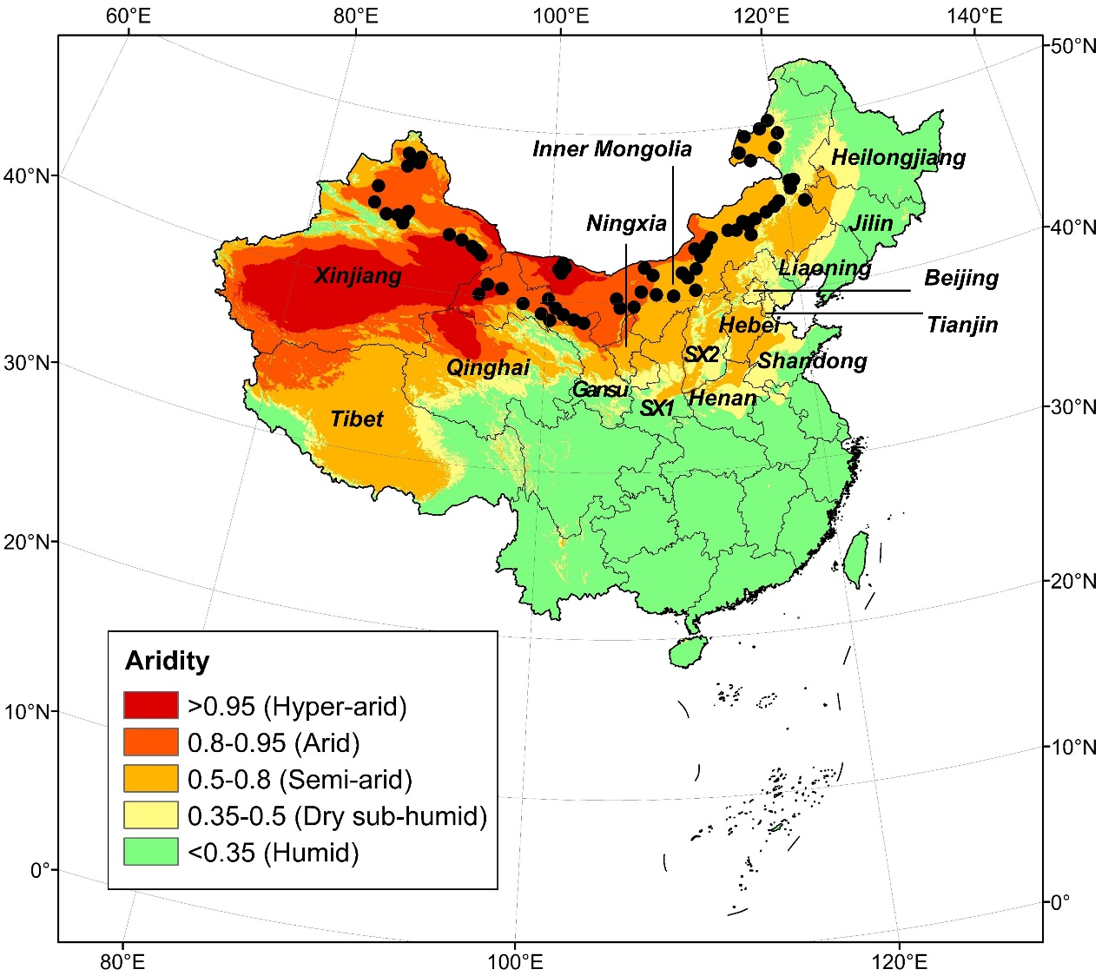

**FIGURE 1 Map of the sampling sites across China’s drylands.** The sites represent the four dryland subtypes (i.e. dry sub-humid, semi-arid, arid, and hyper-arid), which are defined with different aridity levels, as demonstrated in the legend. SX1: Shaanxi Province; SX2: Shanxi Province.

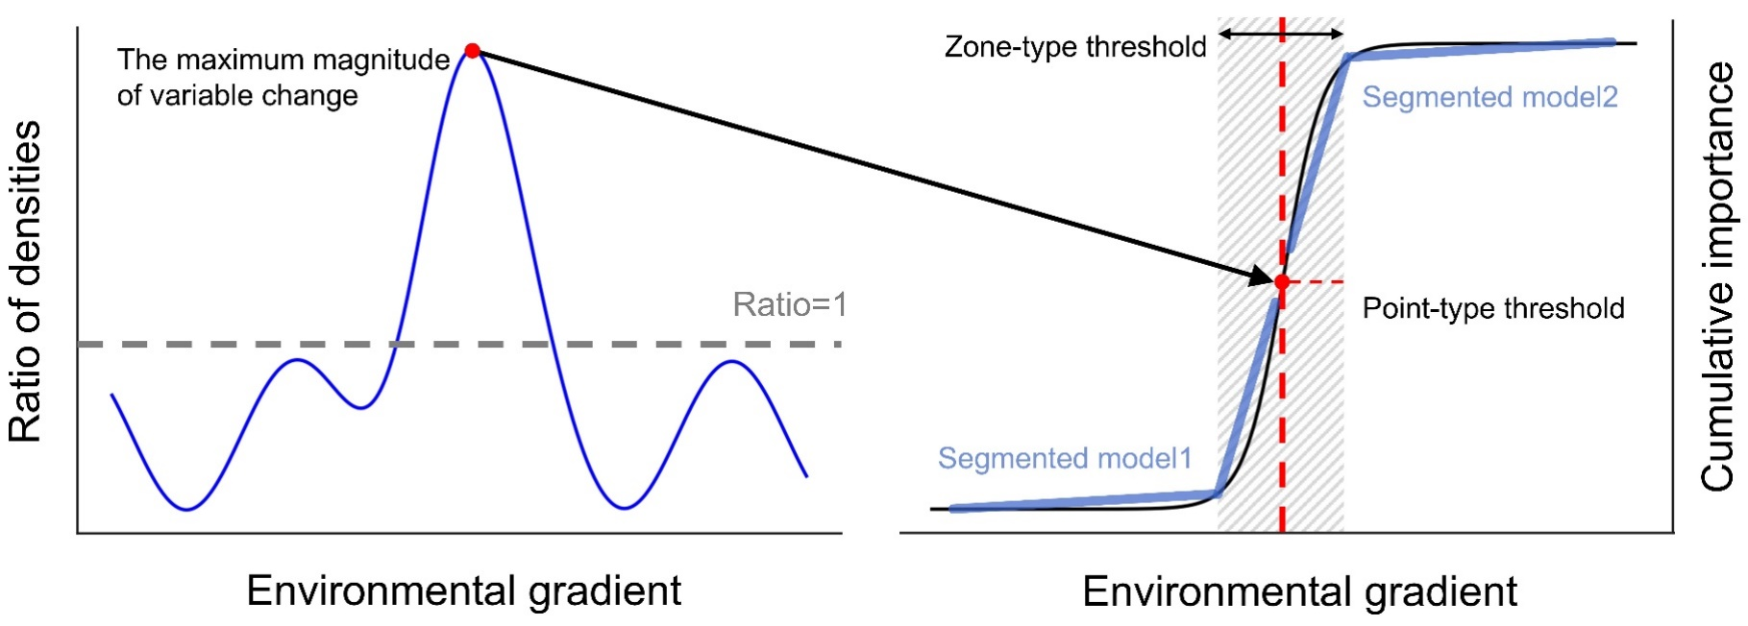**FIGURE 2 Graphical representation of the detection of the critical range.** (a) The gradient forest model generates split values (standardized by the density of observations, blue curve) and identifies the peak indicating the point of maximum variable change (i.e., “point-type” threshold, red dot). (b) The critical range (i.e., “zone-type” threshold, grey area) is identified through calculating the cumulative importance of environmental factors, based on two segmented models (blue lines) and the “point-type” threshold (red vertical dashed line).

(b)

(a)

**FIGURE 3** **Environmental predictors of soil organic, inorganic and total carbon in China’s drylands.** R2 weighted importance, the relative importance weighted by R2 values of each environmental predictor included in the gradient forest analysis. Red bars are key drivers that are both significant (*p* < 0.05) and ranked highly in the random forest analysis. CEC, cation exchange capacity; Gravel, gravel content; MAT, mean annual temperature; Sand, sand content; STK, soil total K; STN, soil total nitrogen; STP, soil total phosphorus; VEGCOV, vegetation coverage.

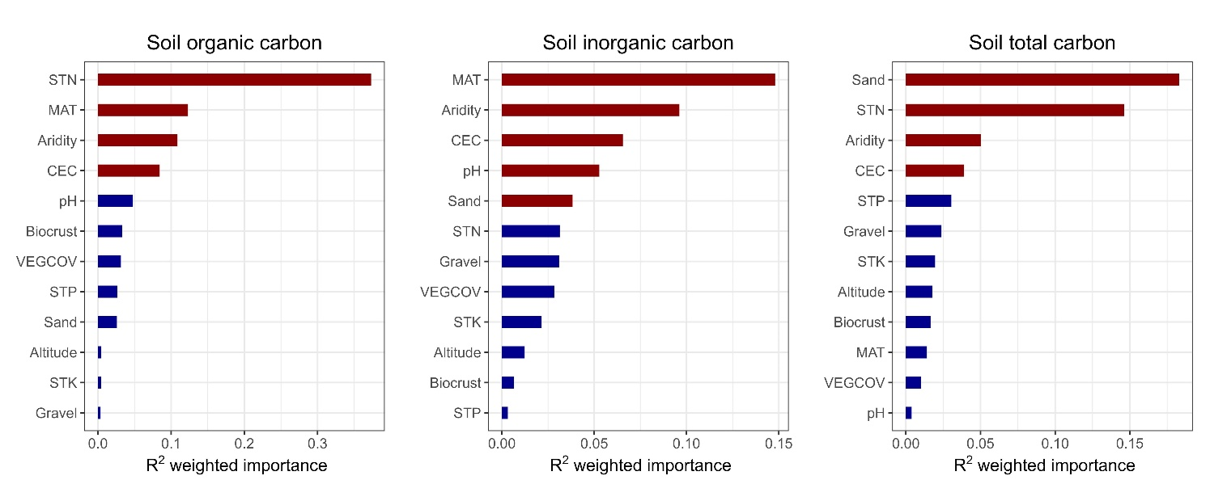

(a)

(b)

(c)

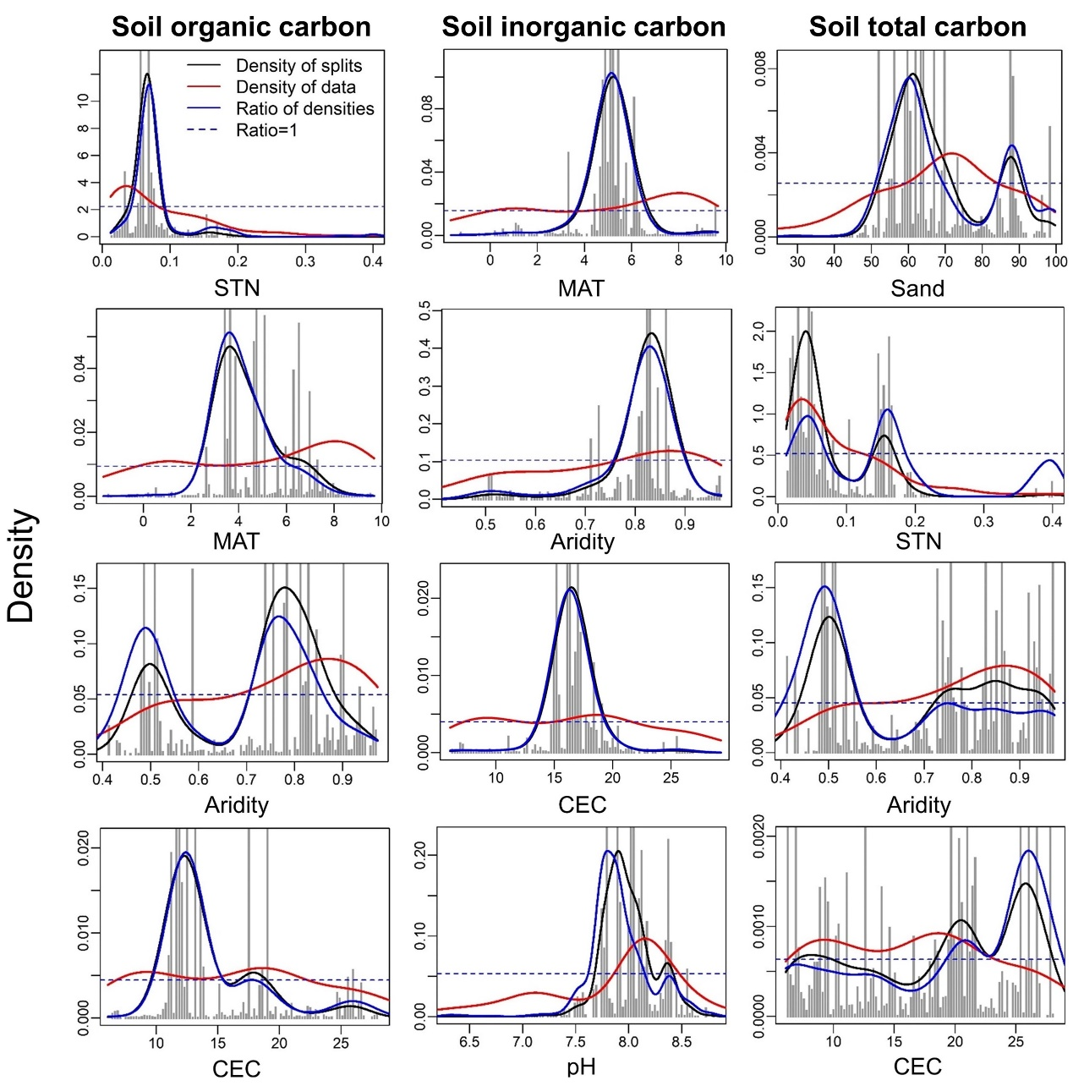

**FIGURE 4 Kernel density of random forest splits across the four most important environmental gradients for soil organic, inorganic and total carbon.** Black lines are the kernel density of the histograms, red lines show the (normalized) distribution of the data along the environmental gradients, and blue lines indicate the ratio between splits and data (ratio between black and red lines). Ratios > 1 (above the dotted line) indicate conditions of relatively greater change in soil carbon. Individual plots depict the key predictors, arranged (top to bottom) from the most to the least important.

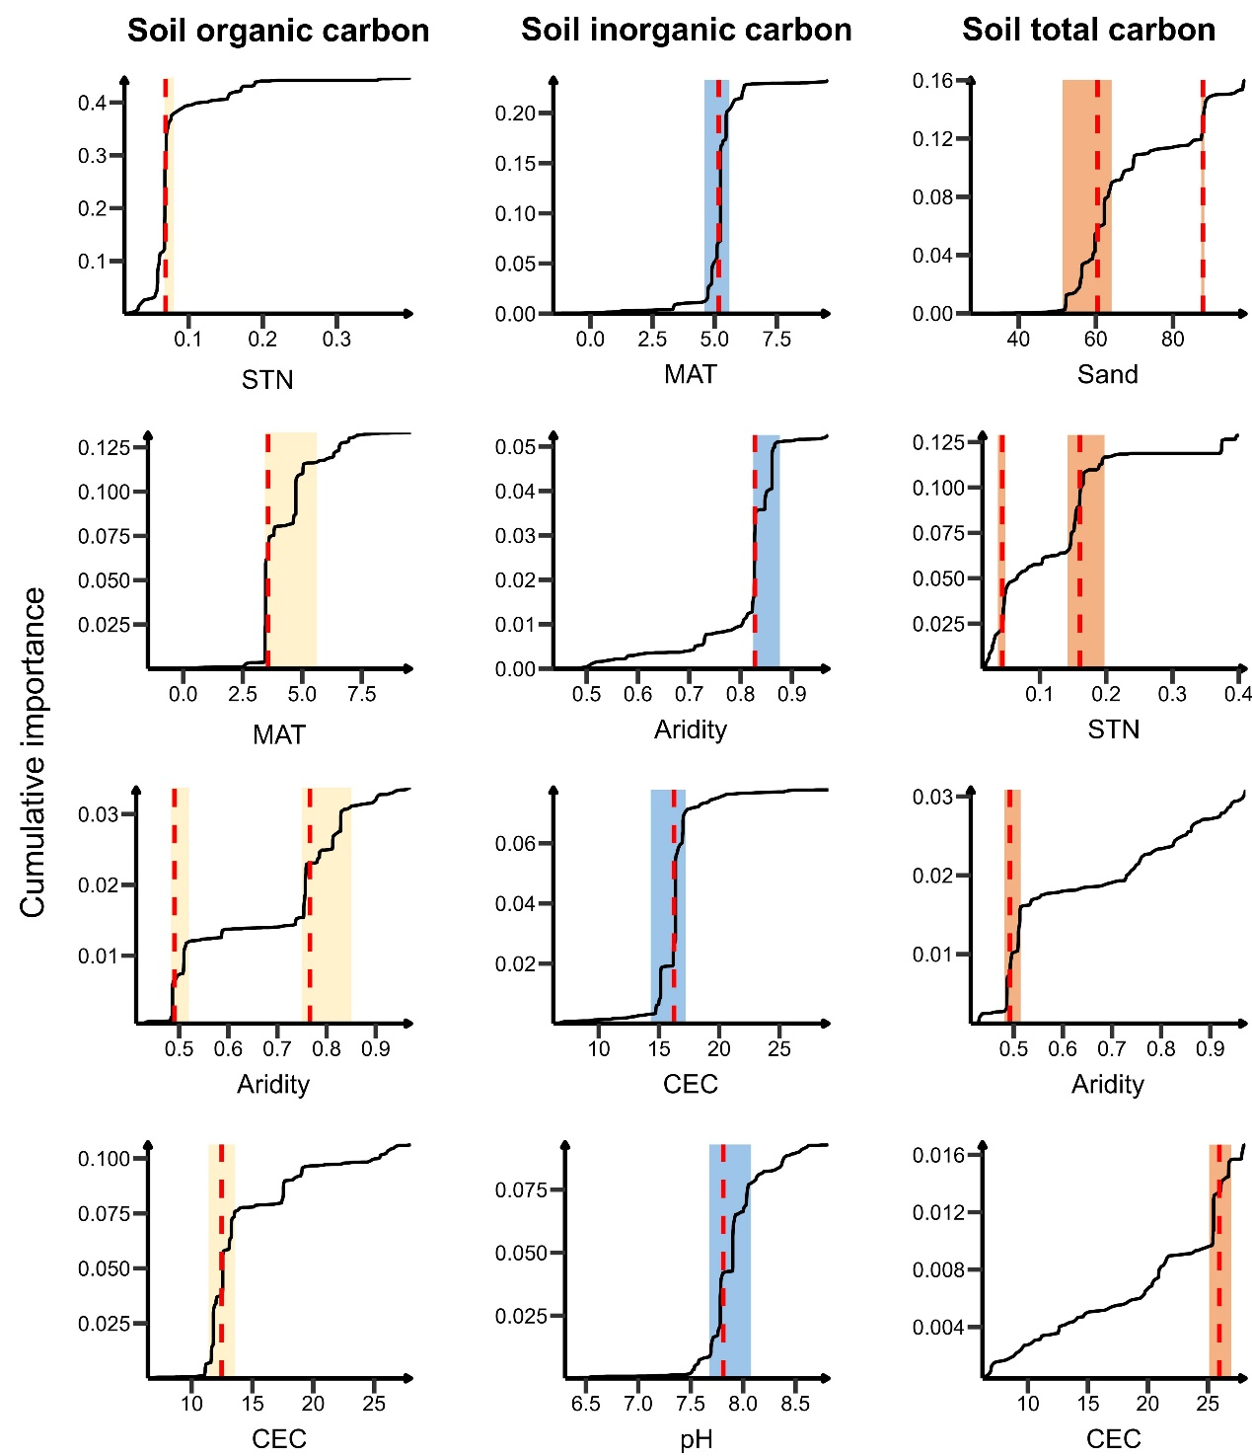

**FIGURE 5** **Critical ranges of environmental factors for soil organic, inorganic and total carbon.** Individual plots depict the key predictors, arranged (top to bottom) from the most to the least important. CEC, cation exchange capacity; MAT, mean annual temperature; Sand, sand content; STN, soil total nitrogen.

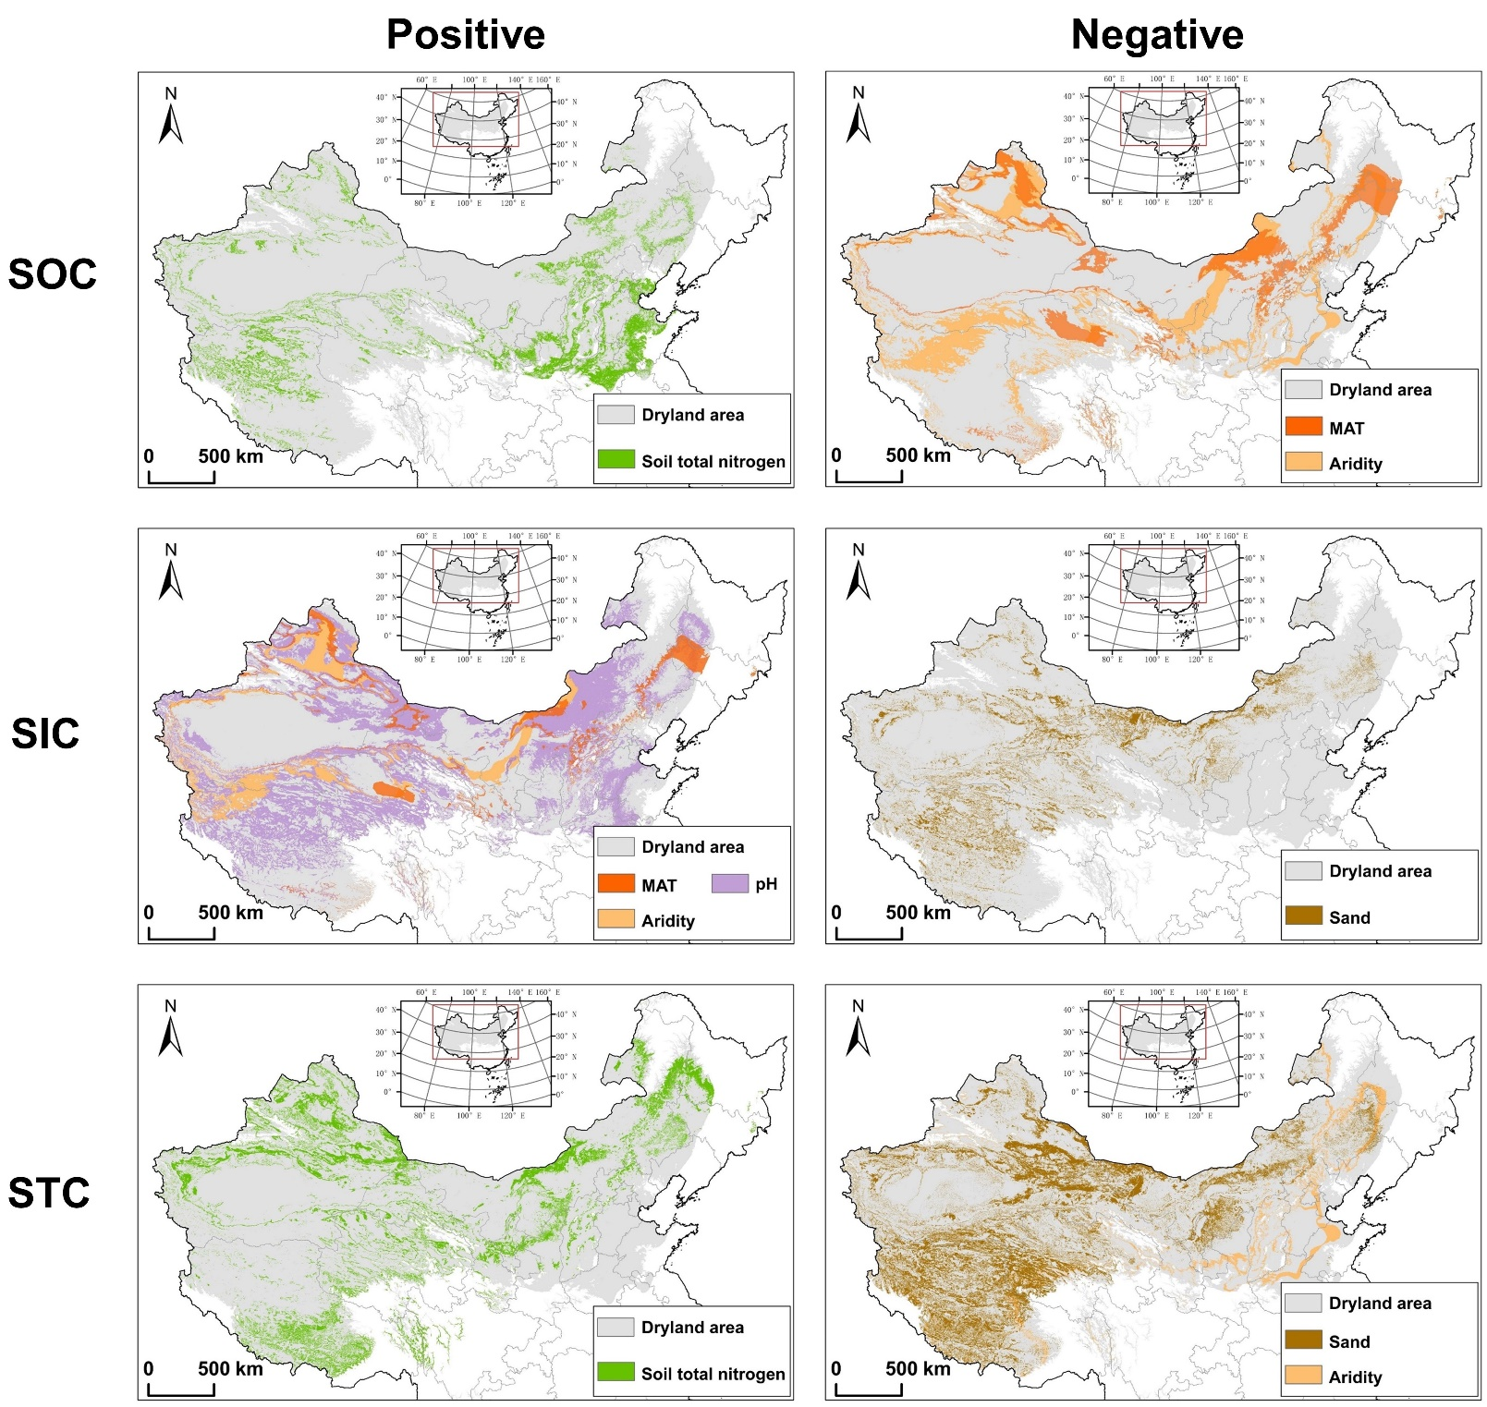**FIGURE 6 Spatial distribution of critical areas for soil organic, inorganic and total carbon changes in China’s drylands.** Positive and Negative indicate whether the key factors have a positive or negative relationship with soil carbon, respectively. MAT, mean annual temperature; Sand, sand content; SOC, soil organic carbon; SIC, soil inorganic carbon; STC, soil total carbon.

(f)

(d)

(b)

(e)

(c)

(a)