A note on the relationship between stock market volatility and cryptocurrencies: New evidence from China – U.S. trade frictions

Abstract
In the context of the China-U.S. trade friction, we use the TVP-VAR model to examine the spillover volatility, hedging and safe-haven effects of cryptocurrencies based on daily data of Bitcoin (BTC), Ethereum (ETH), the CSI 300 Index, and the S&P 500 Index. Our findings reveal a significant short-term time-varying asymmetric volatility spillover effect between cryptocurrencies and the U.S. and Chinese stock markets. BTC and ETH can also be used as short-term hedging assets for the CSI 300 Index. Evidence also indicates no long-term correlation between cryptocurrencies and the stock market. Consequently, during periods of economic instability and volatility caused by trade frictions between the two countries, such as the imposition of high tariffs, investors can consider cryptocurrencies as short-term hedging assets and long-term safe-haven assets to mitigate losses caused by stock market fluctuations.

Keywords: Trade friction, Cryptocurrency, Spillover effect, Hedge, Safe haven, Stock market.

JEL: F13, F21, G11, G38

Declarations of interest: none

1. Introduction
The China-U.S. trade frictions, a significant global economic uncertainty, have drawn worldwide attention. Initiated by the Trump administration's tariffs on Chinese imports to shield domestic firms and balance trade deficits, China retaliated similarly (Chong and Li, 2019). The dispute spanned from March 2018 to January 2020, culminating in a phase one trade agreement (Moosa et al., 2020). Given the broad spectrum of sectors involved, including manufacturing, agriculture, and oil, the tit-for-tat tariffs between two of the world's economic powerhouses affected these industries and stock prices, which often react to such information. Scholars have extensively studied the friction's impact across sectors, from agriculture (Zhu et al., 2021) and oil (Wang and Li, 2021) to carbon emissions (Fan et al., 2020) and manufacturing (Bown, 2021). Financial markets, such as exchange rates (Xu and Lien, 2020) and stocks (Zhang, 2021), also felt the ripple effects. Studies by Gu et al. (2021) and Egger and Zhu (2020) affirmed the trade dispute's impact on both countries' stock markets. Wen and Liu (2021) and Gu et al. (2021) observed a common volatility effect in the two countries' stock markets. However, previous literature has neglected the impact of these trade frictions on the cryptocurrency sector, which had a growing market capitalisation of more than $1 trillion in the third quarter of 2023 (CoinMarketCap, 2023). Although Hou et al. (2022) studied Bitcoin during the China-U.S. trade friction, they focused on the spillover effects between the crude oil market and Bitcoin during this period.
Thus, this study is the first to investigate the relationship between stock market volatility and cryptocurrencies in the critical context of the China-U.S. trade frictions. Most of the existing research on the spillover effect and the role of cryptocurrencies as hedge or safe-haven assets has focused on the global COVID-19 pandemic (Conlon et al., 2020; Conlon and McGee, 2020; Goodell and Goutte, 2021; Grobys, 2021; Mariana et al., 2021; Elsayed et al., 2022; Grira et al., 2022). We adopt Baur and Lucey's (2010) definition of hedging assets: one asset is negatively related to another or a portfolio. Safe-haven assets are “not correlated with other assets or portfolios during market stress or volatility.” However, the pandemic is an unexpected global public health event, significantly different from the regular operation and historical scenarios of financial markets. Therefore, it may not be the best reference for responding to changes in financial markets after emergencies. In contrast, trade tensions among nations have become more commonplace, and the economic implications of these strategic trade actions are profound. We consider our research timely and essential, given the tremendous growth of cryptocurrencies and the potential for trade frictions between the two largest economies to severely damage the global economic climate as protectionist measures escalate.
Stock market fluctuations often induce spillover effects on other financial assets. Typically, economic instability prompts stock market volatility, driving investors to seek alternative investments for hedging or safe havens. Historically, gold has been the go-to hedge, but since Bitcoin's debut in 2008, it has become an increasingly popular hedging alternative, drawing significant investor interest. Satoshi Nakamoto (2008) describes Bitcoin as a peer-to-peer electronic cash system facilitating direct online transactions without intermediaries. Unlike conventional assets, cryptocurrencies lack a physical form, are highly divisible, and derive their value not from tangible assets or economies but from algorithms that securely track all exchanges. These characteristics have catapulted cryptocurrencies into the limelight, causing spikes in trading volume, volatility, and price (Corbet et al., 2019). There are over a thousand cryptocurrencies, with notable entrants like Ethereum, Ripple, Litecoin, and Dash collectively contributing nearly $190 billion to market capitalisation (Corbet et al., 2019). In early 2019, more than 5,000 tokens were actively traded on over 300 digital markets (Benedetti and Nikbakht, 2021). Bitcoin pioneered this digital revolution and continues to dominate the market. Cahill and Liu (2021) also indicate that Bitcoin strongly correlates with the cryptocurrency market, and any shocks to Bitcoin will likely spill over into the remainder of the cryptocurrency market. As the public becomes increasingly optimistic about its potential value, more money flows into the Bitcoin market, boosting its valuation (Lee et al., 2020). Between October 2016 and December 2017, Bitcoin's price skyrocketed from $616 to $19,500, an increase of approximately 30 times (Corbet et al., 2019). By the end of 2020, the market value of Bitcoin had reached $539.05 billion (Shen et al., 2022). Ethereum, another significant cryptocurrency, ranks second in market capitalisation (Mensi et al., 2019). Both remain the most actively traded regarding volume and market value (Uzonwanne, 2021).
Due to the unique properties of cryptocurrencies, many scholars have studied the relationship between cryptocurrencies and the stock market. Uzonwanne (2021) explores the volatility spillover effect between Bitcoin and the five major stock markets, finding that investors use Bitcoin to rebalance their portfolios when the stock market faces shocks. Conrad et al. (2018) investigate the interplay between U.S. stock market turbulence and Bitcoin volatility, discovering a significant negative relationship between them. Moreover, the volatility risk premium of the S&P 500 Index exhibited a strong positive influence on Bitcoin’s enduring volatility. Dai et al. (2023) propose that after a cryptocurrency crash, there is an 80% probability that it will lead to common crashes in the stock market. Understanding spillover effects is pivotal in determining whether stock market investors turn to cryptocurrencies for portfolio adjustment during market disruptions. If the spillover is bidirectional, it suggests a mutual influence between the two markets (Corbet et al., 2019). Based on the relationship between the two markets, an essential question in crypto research is its potential role as a hedging asset or safe haven amid stock market turbulence (Gambarelli et al., 2023).
Our study contributes to the academic literature and, to our knowledge, is the first to explore the volatility spillover effects between cryptocurrencies and the U.S. and Chinese stock markets before and during the China-U.S. trade friction. Additionally, it is the first to investigate whether cryptocurrencies can serve as hedge or safe haven assets during these periods. We use the TVP-VAR model to study the dynamics of short-term and long-term spillover volatility effects to understand cryptocurrencies better and to extend and complement previous studies on the impact of trade frictions on various industries (Xu and Lien, 2020; Zhang, 2021; Gu et al., 2021). Our study has implications for investors coping with stock market shocks under trade policy uncertainty. Specifically, it can help investors use cryptocurrencies as short-term hedging assets when trade friction events lead to stock market downturns. In addition, investors can include cryptocurrencies in their diversified investment portfolios in the long run, as cryptocurrencies can serve as a safe haven for the stock market.
Our study has several interesting findings. By analysing the volatility spillover relationship between the CSI 300 Index, S&P 500 Index, BTC, and ETH from 2017 to 2022 (including pre-, peak-, and post-trade friction periods), we discover a short-term, two-way asymmetric volatility spillover effect among these assets throughout the entire period based on the TVP-VAR model. Notably, this short-term volatility exhibits time-varying properties. During the trade friction event, when the China and U.S. stock markets were in a downturn, BTC and ETH served as short-term hedging assets for the CSI 300 Index. However, BTC and ETH exhibited similar directional fluctuations to the S&P 500 Index. Additionally, we find no long-term volatility spillover effect between these markets. In other words, no long-term relationship exists between the Chinese and U.S. stock markets and BTC and ETH. Thus, in the long run, BTC and ETH can act as safe haven assets for the CSI300 index and S&P500 index.
The structure of this paper is as follows: Section 2 presents the literature. Section 3 describes the data sample and methodology. Section 4 shows our main results and related discussions. Finally, section 5 concludes the paper.

2. Literature Review

2.1 Spillover Effect
Stocks are frequently a prominent component of a portfolio's traditional financial assets. Nevertheless, they often present pronounced volatility due to unpredictable economic conditions. Cryptocurrencies claim to be independent and not affected by any asset fluctuations. Consequently, this phenomenon has spurred considerable scholarly investigation into the volatility spillover effect between cryptocurrencies and the stock market. Existing research findings yield varying perspectives among scholars. Some contend that there exists an asymmetric two-way spillover effect between the two.
Tiwari et al. (2019) examine the volatility spillovers between S&P 500 prices and six cryptocurrencies, utilising the copula-ADCC-EGARCH model. They find an asymmetric volatility and a weak positive correlation between each cryptocurrency and the S&P500 index. They also find that cryptocurrencies and traditional stock markets respond more strongly to adverse shocks than positive ones, and the overall time-varying correlation is very low. In a similar study, Conrad et al. (2018) use the GARCH-MIDAS model, focused on the correlation dynamics between the S&P 500 index and Bitcoin and demonstrate that the volatility of the S&P 500 index exerts a significant negative impact on the long-term fluctuations of Bitcoin; in addition, the S&P 500 index risk premium significantly influences Bitcoin’s long-term volatility. Both Tiwari et al. (2019) and Conrad et al. (2018) thus document that the S&P 500 index exerts a negative spillover effect on BTC, while BTC exerts a positive spillover effect on the S&P 500 index. However, the two studies focus on the volatility spillover effects between cryptocurrencies and the U.S. stock market without considering the relationship between cryptocurrencies and other traditional financial assets. Urom et al. (2020) examine the volatility spillovers between Bitcoin and various traditional financial assets across 12 developed countries during bullish and bearish market scenarios. Employing the TVP-VAR model, they document substantial dependencies and positive directional predictability between Bitcoin and most stocks and crude oil when market conditions were bullish. Conversely, Bitcoin displays a negative dependence and predictability during bearish market stages in the Finnish, Dutch, American, and crude oil markets.
Nevertheless, a divergence of scholarly views exists regarding the intricate relationship between cryptocurrencies and the stock market. Studies such as Baur et al. (2018), Uzonwanne (2021), and Omri (2023) suggest that this relationship is dynamic, exhibiting periods of two-way and one-way spillovers and, at times, no discernible connection at all. Uzonwanne (2021), in particular, employs the VARMA-GARCH model to separately investigate the volatility spillover effects between five major stock markets and Bitcoin, revealing that the volatility spillover effects are time-varying, with two-way spillovers in some cases and one-way spillovers in others; therefore, the Bitcoin can be an alternative investment avenue for returns and portfolio management. Omri (2023) employs the VAR model and Granger causality tests to scrutinise volatility spillover effects between Bitcoin and stock market returns across 15 developed and 15 emerging countries. Notably, only three indices from developed markets (Japan's Nikkei 225, South Korea's KOSPI Composite Index, and Sweden's OMX Stockholm 30) and three indices from emerging markets (Qatar's QE Index, Saudi Arabia's TASI, and Tunisia's Tunindex), emerged as significant influencers in the predictability of Bitcoin returns. Omri (2023) also assesses Bitcoin’s response to stock market shocks through impulse response functions; they observe that investors react differently to shocks originating from emerging markets than those from developed markets, with Bitcoin primarily receiving shocks from the former. However, shocks in mature stock markets have negligible impacts on Bitcoin's return volatility. Most stock indices do not successfully predict Bitcoin returns and directional predictability does not vary substantially between developed and developing markets.
Baur et al. (2018) analyse 15 financial crises, natural disasters, and terrorism/war to examine the volatility relationship between the S&P 500 index and Bitcoin during these events. They show that the S&P 500 index exhibits harmful returns when an economic crisis transpires, whereas Bitcoin returns do not show significant correlations. In the case of terrorist attention or war events, both the S&P 500 index and Bitcoin returns display a weak negative correlation. However, there is a positive correlation between the S&P 500 index and Bitcoin during natural disasters.
In summary, the existing literature examining the presence of a volatility spillover effect between cryptocurrencies and the stock market is inconclusive and investigates only certain aspects of this subject. Also, there are some contradictory results, especially when analysing the volatility spillover effects between cryptocurrencies and financial markets, and the trade friction is not considered when examining this relationship. Consequently, this strand of literature needs further exploration and investigation. The limited literature related to our study serves as the motivation for our article. In particular, we address the following questions about the China-U.S. trade friction: (i) Is there a spillover effect between the Chinese and the U.S. stock markets and the cryptocurrency market pre-, peak- and post-trade friction event? (ii) if yes, is the volatility spillover effect of the Chinese and American stock markets and cryptocurrency markets bidirectional? In the first question, we examine whether the Chinese and U.S. stock markets exhibit certain relationships with the cryptocurrency market during pre-, peak- and post-trade friction periods. We also discuss the impact of the trade frictions on the underlying spillover effects. In the second question, we investigate whether the spillover effect of the China-U.S. stock markets on the cryptocurrency market is one-way or two-way during pre-, peak- and post-trade friction periods. Additionally, we explore whether the volatility of cryptocurrencies also affects the Chinese and American stock markets.

2.2 Hedge Tool or Safe Haven
Another prominent research area in cryptocurrencies is their potential as hedging assets or safe havens for traditional financial assets. More specifically, under volatile stock markets, cryptocurrencies can serve as a protective hedge or a refuge for investors seeking to mitigate losses. Like previous studies about volatility spillovers between cryptocurrencies and the stock market, there are divergent academic views on the capacity of cryptocurrencies to act as hedges in stock market scenarios. Some scholars posit that the cryptocurrency market can emerge as a robust hedge asset during periods of stock market volatility.
Dyhrberg (2016) utilise the TGARCH model to examine the hedging capabilities of Bitcoin in comparison to traditional assets. They show that Bitcoin can effectively hedge against the FTSE index. Bitcoin's effectiveness as a hedge against stocks and bonds saw a modest increase when accounting for the impact of economic policy uncertainty (Fang et al., 2019). Chan et al. (2019) document that Bitcoin has strong hedging potential against returns of the Euro Index, Shanghai A-Shares, S&P 500 index, Nikkei, and Toronto Stock Exchange indices. Furthermore, the study suggests that investors with a long-term Bitcoin holding strategy possess more robust hedging capabilities than those with short-term holdings. Bouri et al.'s (2017b) study aligns with that of Chan et al. (2019). They delve into the dynamics between Bitcoin and price indices of various financial assets and show that Bitcoin is a potent hedge against movements in the Asia-Pacific stock markets. Unlike Chan et al. (2019), who find that Bitcoin has hedging properties for developed and developing countries, Stensås et al. (2019) findings underscore qualitative distinctions between developed and developing markets regarding Bitcoin's hedging capabilities.
Bitcoin emerges as a robust hedge for investors in most developing markets. Still, in contrast, it functions primarily as an effective diversification tool for investors in developed markets, regional indices, and commodities. Nonetheless, some scholars assert that cryptocurrencies have weak hedging properties against stock markets. Jiang et al. (2021) indicate that cryptocurrencies predominantly exhibit weak hedging attributes in the stock market. This view differs from Chan et al. (2019), who claim that Bitcoin has strong hedging properties against the S&P 500 Index, Nikkei 200 Index, and Shanghai Composite Index.
In addition, Stensås et al. (2019) find that the hedging properties of Bitcoin in the stock markets of developed and developing countries are significantly different. Jiang et al. (2021) suggest that Bitcoin provides a weak hedging for these stock markets. Grobys (2021) provides evidence that Bitcoin does not serve as an effective hedge tool, especially during the economic turmoil caused by COVID-19. Employing a difference-in-differences approach, Grobys (2021) studies the hedging relationship between Bitcoin and the U.S. stock market, concluding that Bitcoin does not function as a hedge against tail risk in U.S. stocks. In addition, Charfeddine et al. (2020) findings highlight that including Bitcoin and ETH alongside traditional assets offers fresh opportunities for portfolio diversification. They further note that optimal portfolio diversification can be achieved by incorporating only a small number of cryptocurrencies, and a single cryptocurrency's hedging capacity is weak. Moreover, the relationship between cryptocurrencies and traditional assets seems sensitive to external shocks.
On the other hand, some studies examine whether cryptocurrencies can be a safe haven asset. Bouri et al. (2017a) analyse Bitcoin prices and the U.S. stock market and demonstrate that before the U.S. stock price crash (in 2013), the Bitcoin addition to a U.S. stock portfolio could have functioned as a safe haven asset. However, after the price crash, this safe haven property disappears. On the contrary, Kang et al. (2020) examine the relationship between the S&P 500 index, U.S. Treasury bonds, U.S. dollar index, gold futures derivatives, and Bitcoin. They find a significant negative correlation between Bitcoin and these four asset classes during the European sovereign crisis. Consequently, Bitcoin can be considered an effective safe haven for these four asset classes. Furthermore, Bitcoin did not lose its safe haven functionality even after the U.S. stock index declined in 2013; its safe haven property appeared to strengthen.
However, some contradictory studies show that cryptocurrencies exhibit weak or non-existent safe haven attributes. Shahzad et al. (2019) studied the hedging effects of Bitcoin, gold, and commodities on the stock market, employing bivariate cross-quantification graphs. They show that Bitcoin, gold, and commodities display weaker safe haven properties concerning the world stock market index. Bitcoin is identified as a weaker haven in the context of China, while commodities are the only weaker safe haven for the U.S. stock market. Furthermore, there was evidence for time-varying safe haven attributes for Bitcoin, gold, and commodities, exhibiting variations across stock market indices. Goodell and Goutte (2021) examine the co-movement between four cryptocurrencies and seven stock indices in developed countries. They indicate that the co-movement positively correlates with cryptocurrencies being a safe haven. While most cryptocurrencies do not demonstrate safe haven properties during COVID-19, Tether's attributes as a safe haven become more evident during this period of extreme market turbulence.
Elsayed et al. (2022) utilise the TVP-VAR model to explore the relationship between Bitcoin and traditional assets (S&P 500 index, bonds, gold, VIX, and crude oil) during the COVID-19 crisis. They find that Bitcoin is pivotal in transmitting risk to these assets and doesn’t act as a receiver of return spillovers from these markets. Grira et al. (2022) employ the Granger causality test and confirm Bitcoin's risk-averse properties concerning the S&P 500 index before and during the COVID-19 pandemic. Their findings indicate no significant relationship between Bitcoin and S&P 500 index returns before the pandemic, implying that Bitcoin could serve as a safe haven. However, Bitcoin did not exhibit safe haven characteristics during the pandemic and moved in tandem with the S&P 500 Index (Conlon and McGee, 2020). They further note that even a small allocation to Bitcoin could significantly increase a portfolio's downside risk when held alongside the S&P 500 index. Employing a similar methodology, Conlon et al. (2020) indicate that Bitcoin and ETH generally do not exhibit safe haven characteristics in international stock markets and that allocating them to portfolios increases the downside risk compared to holding the underlying stock index alone.
From the discussions above, it becomes apparent that much of the research on the inability of cryptocurrencies to function as safe havens for stock markets is concentrated around the COVID-19 pandemic period (Conlon and McGee, 2020; Conlon et al., 2020; Goodell and Goutte, 2021; Elsayed et al., 2022; Grira et al., 2022). However, Mariana et al. (2021) provide opposite conclusions. They argue that Bitcoin and ETH can serve as short-term safe havens for the S&P 500 index, contending that this disparity in findings with Conlon and McGee (2020) and Conlon et al. (2020) stems from their focus on short-term safe haven assets and a relatively shorter observation window. It is worth noting that Conlon and McGee (2020), Goodell and Goutte (2021), and Grira et al. (2022) examine a similar period and data sample frequency as Mariana et al. (2021) used. In conclusion, there is no consensus regarding the volatility spillover effects between cryptocurrencies and stock markets, nor is there a consensus on cryptocurrencies' hedging or safe haven properties. Therefore, this paper addresses the third question about China-U.S. trade friction: (iii) In the face of volatility in the Chinese and U.S. stock markets, are cryptocurrencies a hedge asset or a safe haven? The third research question examines whether cryptocurrencies can serve as a hedge asset or safe haven against Chinese and U.S. stock market volatility during pre-, peak- and post-trade friction periods.

3. Data and Methodology

3.1 Data Description
We utilise daily closing prices of the CSI 300 Index, S&P 500 Index, Bitcoin (BTC), and Ethereum (ETH) from 2017 to 2022 (including pre-trade friction, peak-trade friction, and post-trade friction) to construct the TVP-VAR Model. This is due to the China-U.S. trade friction that started in March 2018, where both sides imposed a series of high tariffs on a large part of each other's export products in a tit-for-tat manner (Chen and Wang, 2022). The first phase of the trade agreement was finally reached in January 2020 (Moosa et al., 2020). The CSI 300 Index is a proxy for the Chinese stock market, while the S&P 500 Index represents the US stock market. BTC and ETH act as proxies for the cryptocurrency market. Daily data for the CSI 300 Index and S&P 500 Index are derived from Refinitiv, while the CoinGecko database provides daily price data for BTC and ETH. To ensure data consistency, the data for BTC and ETH are filtered to exclude days when the Chinese and US stock markets are closed (Saturdays, Sundays, and public holidays).
To ensure the stationarity of time series data, the daily closing prices of the CSI 300 Index, S&P 500 Index, BTC and ETH are processed by logarithm and first-order difference, and the processed values ​​are magnified 100 times. Table 1 provides the descriptive statistics for the CSI 300 Index, S&P 500 Index, BTC, and ETH. We observe a four-time series with kurtosis more significant than 3 and negative skewness, indicating that they all have peaked, left-tailed distributions. The S&P 500 Index has the highest kurtosis and negative skewness, suggesting the presence of extreme values and numerous abnormal events. The Jarque-Bera normality tests for the four-time series reject the null hypothesis of normality in returns. Additionally, the ADF test results are less than 5%, indicating the absence of unit roots and confirming that the returns are stationary.
***Insert Table 1 around here***

3.2 Methods
Primiceri (2005) introduced a time-varying parameter vector autoregression (TVP-VAR) model with stochastic volatility. Since then, this model has been widely applied in various analyses, particularly macroeconomics. Nakajima (2011a) further refined the computational methods for the TVP-VAR model based on Primiceri (2005). The TVP-VAR model offers the flexibility to specify parameters where the sources of time variation encompass both the slope coefficients and the variance-covariance matrix of innovations. This flexibility allows for capturing potential time-varying dynamics within the underlying structure of multivariate data (Nakajima, 2011b). Following the approach outlined by Primiceri (2005) and Nakajima (2011a), the initial step involves establishing the structural vector autoregressive (SVAR) model as follows:
$$\begin{aligned}Ay_{t}=F_{1}y_{t-1}+…+F_{s}y_{t-s}+μ_{t}, t=s+1,…,n\#\left(1\right)\end{aligned}$$
Where $y_{t}$ is a $k×1$ vector of observed variables, A and $F_{1},F_{2},⋯F_{s}$ are $k×k$ matrices of coefficients. $t$ is the time and $s$ is the leg order. The $μ_{t}$ is a $k×1$ structural shock and assumes $μ_{t}\sim N(0,ΣΣ)$.
$$\begin{aligned}downright Σ=\left(\begin{matrix}σ_{1} & 0 & ⋯ & 0 \\ 0 & ⋱ & ⋱ & ⋮ \\ ⋮ & ⋱ & ⋱ & 0 \\ 0 & ⋯ & 0 & σ_{k}\end{matrix}\right) (2)\end{aligned}$$
Where $σ_{i}(i=1,…,k)$ is the standard deviation of the structural shock. Suppose the parameter matrix A is a lower triangular matrix whose diagonal elements are all 1.
$$\begin{aligned} A=\left(\begin{matrix}1 & 0 & ⋯ & 0 \\ a_{21} & ⋱ & ⋱ & ⋮ \\ ⋮ & ⋱ & ⋱ & 0 \\ a_{k1} & ⋯ & a_{k,k-1} & 1\end{matrix}\right) \left(3\right)\end{aligned}$$
Multiply both sides of Equation (1) superscript to further simplify the model to:
$$the \begin{aligned}{ y}_{t}=B_{1}y_{t-1}+……+B_{s}y_{t-s}+A^{-1}\sum{ε_{t}}, ε_{t}\sim N\left(0,I_{k}\right) \left(4\right)\end{aligned}$$
Where $B_{i}=A^{-1}F_{i}$ and $i=1,…,s$. In addition, the row elements of $B_{s}$ are stacked to obtain the $k^{2}s×1$ vector $β$, and then $X_{t}=I_{k}⨂(1,y_{t-1}^{'},……,y_{t-s}^{'})$ is defined, where $⨂$ represents the Kronecker product. This model can be expressed as:
$$\begin{aligned}y_{t}=X_{t}β+A^{-1}\sum{ε_{t}}\#\left(5\right)\end{aligned}$$
The above parameters are all constant, and the parameters in the equation are expanded into time-varying parameters to obtain the TVP-VAR model:
$$\begin{aligned}y_{t}=X_{t}β_{t}+A_{t}^{-1}\sum_{t}{ε_{t}}, t=s+1,…,n\#\left(6\right)\end{aligned}$$
Where $β_{t}$, $A_{t}$, $Σ_{t}$ are the time-varying parameters.
According to the Primiceri (2005) and Nakajima et al. (2011), stack the elements in the lower triangular matrix $A_{t}$ into a column of vectors. Besides, the parameters all obey the following random walk process:
$$double\begin{aligned}a_{t}={\left(a_{21},…,a_{k,k-1}\right)}^{'} \\ { h}_{t}={\left(h_{1t},…,h_{kt}\right)}^{'} \left(7\right)\end{aligned}$$
Where $h_{jt}=logσ_{jt}^{2}$, $j=1,…,k, t=s+1,…,n$.
$$\begin{aligned}β_{t+1}=β_{t}+μ_{βt} \\ α_{t+1}=α_{t}+μ_{αt}\#\left(8\right) \\ h_{t+1}=h_{t}+μ_{ht}\#\end{aligned}$$
For $t=s+1,…,n$, where $β_{s+1}∼N\left(μ_{β_{0}},\sum_{β_{0}}{ }\right)$, $a_{s+1}∼N\left(μ_{a_{0}},\sum_{a_{0}}{ }\right)$, $h_{s+1}∼N\left(μ_{h_{0}},\sum_{h_{0}}{ }\right)$. Among them, the disturbance items $μ_{βt}$, $μ_{αt}$ and $μ_{ht}$ are all normal random vectors with zero mean, and the variances are $∑_{β}, ∑_{α}$ and $∑_{h}$, respectively. However, $∑_{β}, ∑_{α}$ and $∑_{h}$ are assumed to be diagonal matrices for simplicity.
$$\begin{aligned}\left(\begin{aligned}&ε_{t} \\ &μ_{βt} \\ &μ_{αt} \\ &μ_{ht}\end{aligned}\right)∼N\left(0,\left(\begin{matrix}1 & 0 & 0 & 0 \\ 0 & Σ_{β} & 0 & 0 \\ 0 & 0 & Σ_{α} & 0 \\ 0 & 0 & 0 & Σ_{h}\end{matrix}\right)\right)\#\left(9\right)\end{aligned}$$
The TVP-VAR model employs Markov chain Monte Carlo (MCMC) simulation for parameter estimation. It introduces the concept of a Markov process into Monte Carlo simulation, allowing for dynamic sampling distribution simulations that adapt with the progress of the simulation. This method offers several inherent advantages: Firstly, it optimises the selection of prior probabilities in parameter estimation, effectively mitigating the adverse effects of outliers or deviations. Secondly, MCMC leverages unique data in the estimation process, allowing for parameter fitting between the formulas to be estimated and the likelihood function through non-specific probability distributions. Lastly, the MCMC estimation method significantly reduces the complexity of parameter estimation, making it suitable for models with high-dimensional parameter spaces and non-parametric properties.
It is set that the parameter vector $ω$ contains all diagonal elements of $∑_{β}, ∑_{α}$ and $∑_{h}$, and the state vector includes $β=(β_{1},β_{2},⋯,β_{t})$, $α=(α_{1},α_{2},⋯,α_{t})$ and logarithmic fluctuation $h=(h_{1},h_{2},⋯,h_{t})$. Y is observable data information, including explained variable $y_{t}$ and explanatory variable $x_{t}$. TVP-VAR model sampling can be divided into six steps. The first step is to initialise β, α, h, $ω$. The second, third, fourth, and fifth steps extract $β$ from $p(β|Y,α,h,ω)$, $α$ from $p(α|Y,β,h,ω)$, $h$ from $p(h|Y,β,α,ω)$, and $θ$ from $p(ω|Y,β,α,h)$. The sixth step is to update the parameters and return to the second step. The specific steps refer to by Nakajima (2011a) are as follows:
Extract the VAR parameters β:
$$y_{t}=X_{t}β_{t}+ A_{t}^{-1}\sum_{t}{ε_{t}}, t=s+1,⋯,n,$$
$$\begin{aligned}β_{t}=β_{t-1}+u_{βt}, t=s,⋯,n-1\#\left(10\right)\end{aligned}$$
Where $β_{s}=μ_{β_{0}}$ and $μ_{β_{s}}\sim N(0, Σ_{β_{0}})$
Extract the covariance states α:
$${\hat{y}}_{t}={\hat{X}}_{t}α_{t}+\sum_{t}{ε_{t}},t=s+1,…,n$$
$$\begin{aligned}α_{t+1}=α_{t}+u_{αt},t=s,…,n-1\#\left(11\right)\end{aligned}$$
Where $α_{s}=μ_{α_{0}}, μ_{α_{s}}\sim N(0, Σ_{α_{0}})$, ${\hat{y}}_{t}=y_{t}-X_{t}β_{t}$ and $t=s+1,…,n$.
$$downright\begin{aligned}{\hat{X}}_{t}=\left(\begin{matrix}0 & … & & & & & & 0 \\ -{\hat{y}}_{1t} & 0 & 0 & … & & & & ⋮ \\ 0 & -{\hat{y}}_{1t} & -{\hat{y}}_{2t} & 0 & … & & & \\ 0 & 0 & 0 & -{\hat{y}}_{1t} & … & & & \\ ⋮ & & & & ⋱ & 0 & … & 0 \\ 0 & … & & & 0 & -{\hat{y}}_{1t} & … & -{\hat{y}}_{k-1,t}\end{matrix}\right) \left(12\right)\end{aligned}$$
Extract stochastic volatility states h:
$$y_{it}^{*}=exp⁡\left(h_{it}/2\right)ε_{it},t=s+1,⋯,n$$
$$\begin{aligned}h_{i,t+1}=h_{it}+ξ_{it}, t=s,⋯,n-1\#\left(13\right)\end{aligned}$$
$$\left(\begin{aligned}&ε_{it} \\ &ξ_{it}\end{aligned}\right)∼N\left(0,\left(\begin{matrix}1 & 0 \\ 0 & v_{i}^{2}\end{matrix}\right)\right)$$
Where $ξ_{is}\sim N(0,v_{i_{0}}^{2})$, $v_{i}^{2}$ and $v_{i_{0}}^{2}$ are the $i$ elements of $Σ_{h}$ and $Σ_{h_{0}}$, respectively, $ξ_{it}$ is the $i$ element of $μ_{it}$. ($h_{i,s+1},⋯,h_{i,n}$) sample the conditional posterior density under random fluctuations using the multiple moving sampling methods.
The main tool for economic analysis using the TVP-VAR model is the time-varying esponse function. First, the estimated values of model parameters, including ${\hat{β}}_{t},{ \hat{α}}_{t}$ and logarithmic volatility ${\hat{h}}_{t}$, can be obtained according to MCMC algorithm. Therefore, a simplified TVP-VAR model can be obtained: $\begin{aligned}y_{t}=B_{0,t}+B_{1,t}y_{t-1}+⋯+B_{p,t}y_{t-p}+L_{t}ω_{t}\#\left(14\right)\end{aligned}$
Where the estimated value of $B_{0,t},B_{1,t},B_{2,t},⋯,B_{p,t}$ can be obtained by reorganising ${\hat{β}}_{t}$, $L_{t}=A_{t}^{-1}\sum_{t}{ε_{t}}$, the estimated values of $A_{t}^{-1}$ can be obtained by reorganising${\hat{α}}_{t}$ into a lower triangular matrix and deriving. ${\hat{Σ}}_{u,t}=\operatorname{diag}\left(\exp\left({\hat{h}}_{t}\right)\right), diag⁡(⋅)$ means to reorganise the vector into a diagonal matrix.
To calculate the impulse response function, the formula (15) is first expressed in TVP-VMA ($∞$) form:
$$\begin{aligned}y_{t}=c_{t}+C_{0,t}ε_{t}+C_{1,t}ε_{t-1}+⋯+C_{h,t}ε_{t-h}\#\left(15\right)\end{aligned}$$
Where the disturbance items $ε_{t}=L_{t}ω_{t}{, ε}_{t}\sim N(0,Ω_{t})$, $Ω_{t}=A_{t}^{-1}\sum_{t}{ε_{t}}{(A_{t}^{-1})}^{'}=L_{t}L_{t}^{'}$. Since $C_{h,t}$ is a non-orthogonal time-varying impulse response function, substituting $ε_{t}=L_{t}ω_{t}$ into:
$$\begin{aligned}y_{t}=c_{t}+C_{0,t}L_{t}ω_{t}+C_{1,t}L_{t-1}ω_{t-1}+⋯+C_{h,t}L_{t-h}ω_{t-h}\#\left(16\right)\end{aligned}$$
Further, rewrite the above formula as:
$$\begin{aligned}y_{t}=c_{t}+D_{0,t}ω_{t}+D_{1,t}ω_{t-1}+⋯+D_{h,t}ω_{t-h}\#\left(17\right)\end{aligned}$$
Among them, $D_{h,t}=C_{h,t}L_{t-h}$ is the orthogonalised impulse response function, which represents the marginal impact of the unit shock in the $t-h$ period on the value of the $t$ variable.
To consider the h-step forward impulse response function at time t:
$$\begin{aligned}y_{t+h}=c_{t}+D_{0,t+h}ω_{t+h}+D_{1,t+h}ω_{t+h-1}+⋯+D_{h,t+h}ω_{t}\#\left(18\right)\end{aligned}$$
Then, combine the coefficients of the TVP-VAR model and the TVP-VMA ($∞$) model. According to formula (17), it can be obtained:
$$y_{t-1}=c_{t-1}+C_{0,t-1}ε_{t-1}+C_{1,t-1}ε_{t-2}+⋯+C_{h,t-1}ε_{t-1-h}$$
$$\begin{aligned}⋮\#\left(19\right)\end{aligned}$$
$$y_{t-p}=c_{t-p}+C_{0,t-p}ε_{t-p}+C_{1,t-p}ε_{t-p-1}+⋯+C_{h,t-p}ε_{t-p-h}$$
Substituting the above formula into (18) gives:
$$\begin{aligned}{ C}_{0,t}ε_{t}+C_{1,t}ε_{t-1}+⋯+C_{h,t}ε_{t-h}+⋯=B_{1,t}\left(C_{0,t-1}ε_{t-1}+⋯+C_{h,t-1}ε_{t-1-h}+⋯\right)+ \\ ⋯+B_{p,t}\left(C_{0,t-p}ε_{t-p}+⋯+C_{h,t-p}ε_{t-p-h}+⋯\right)+L_{t}ε_{t}\end{aligned}(20)$$

Comparing the coefficients on both sides of formula (16), the following procedure can be deduced:
$$C_{0,t}=I_{k}$$
$$C_{1,t}=B_{1,t}C_{0,t-1}$$
$$\begin{aligned} C_{2,t}=B_{1,t}C_{1,t-1}+B_{2,t}C_{2,t-2}\#\left(21\right)\end{aligned}$$
$$\begin{aligned}⋮\end{aligned}$$
$$C_{h,t}=B_{1,t}C_{h-1,t-1}+B_{2,t}C_{h-2,t-2}+⋯+B_{p,t}C_{h-p,t-p}$$
According to formula (21), the recursive relational expression of $C_{h,t+h}$ can be obtained, by multiplying both sides of the relational expression by $L_{t}$, we can get:
$\begin{aligned} D_{h,t+h}=B_{1,t+h}D_{h-1,t+h-1}+B_{2,t+h}D_{h-2,t+h-2}+⋯+B_{p,t+h}D_{h-p,t+h-p} (22)\#\end{aligned}$
Where $D_{h,t+h}=L_{t}C_{h,t+h}$, $D_{0,t}=L_{t}$, and there is $D_{h,t+h}=0$ when $h<0$.
Nakajima (2011a) calculated the impulse response function $D_{h,t+h}$ at time $t$ based on the recurrence relation (22). At the same time, Nakajima (2011a) used the average volatility of all periods when calculating ${\hat{Σ}}_{u,t}$ to eliminate the influence of random volatility. Thus, the meaning of the impulse response is a unit of marginal effects of average structural shocks.
We use the TVP-VAR model to investigate the volatility spillover relationship between the stock and cryptocurrency markets. The TVP-VAR model offers several advantages. Firstly, it features a time-varying variance-covariance matrix, allowing it to address heteroscedasticity effectively. Secondly, the TVP-VAR model provides greater flexibility and robustness in capturing the inherent time-varying nature of economic structures (Nakajima, 2011a). Thirdly, it eliminates the need to partition the data into subsamples to identify model structure changes (Nakajima et al., 2011) and mitigates the risk of information loss associated with subsample selections. Instead of dividing the sample into multiple subsamples, the TVP-VAR model accurately pinpoints transition dates through the temporal variation of parameters. Variance over time captures changes in the impact and nature of shocks, making the magnitude of changes in simulated volatility more apparent (Jebabli et al., 2014). Moreover, the TVP-VAR model introduces an additional dimension, time, which facilitates examining responses at various time points (Jebabli et al., 2014). Based on the above factors, we choose the TVP-VAR model, which is particularly important for studying the transmission of volatility shocks between different markets.

4. Results and Discussion

4.1 MCMC Algorithm
Before constructing the TVP-VAR model, we must first establish the VAR model and determine the optimal lag order. According to the Akaike Information Criterion (AIC), the optimal lag order is 2. Table 2 presents the estimation results of the TVP-VAR model. The results show that the estimated posterior means are included in the 95% confidence intervals, and the standard deviations are small. The Geweke statistics for all figures are below 1.96, and the parameters cannot reject the null hypothesis of the posterior distribution that converges to the 5% significance level. Moreover, the inefficiency factors of most parameters are relatively low (most are within 100), proving the MCMC algorithms' effectiveness.
***Insert Table 2 around here***
Figure 1 presents three graphical representations based on the MCMC algorithm. The top row displays the autocorrelation function plot, which exhibits a rapid decay of autocorrelation coefficients, indicating a continuous decrease in autocorrelation with iterative sampling. The middle row depicts the sample value path diagram, revealing the presence of fewer extreme values, indicative of a stable value path. The bottom row shows the posterior distribution density function graph, which closely resembles a normal distribution, signifying the effectiveness of the sampling process.
***Insert Figure 1 around here***
Figure 2 presents the dynamics of estimated stochastic volatility for the CSI 300 index, S&P 500 index, BTC, and ETH return series over time, based on the posterior mean and 95% credible interval. There are significant variations in volatility over time, as evidenced by the substantial posterior estimates of stochastic volatility. These variations underscore the necessity of employing a TVP-VAR model with stochastic volatility to mitigate estimation bias (Jebabli et al. 2014). In October 2017, the Chinese stock market witnessed a price surge, leading to significant profits for investors. Subsequently, in early November, some investors opted to capitalise on these gains by selling their stocks, resulting in increased supply and a subsequent decline in stock prices, triggering a drop in the index. BTC exhibited steady growth during this period, while ETH experienced a downward trend from July 2017 to September. The decline in ETH's volatility was linked to the subsiding ICO boom, prompting many investors to sell their ETH holdings, causing a market oversupply and a subsequent price decline. Additionally, the market lost confidence in ETH following the price flash crash on the GDAX exchange in late June, leading to further selling pressure on ETH. Although ETH began to recover, ongoing scalability issues and increased uncertainty eroded investor confidence, contributing to a price decline in January 2018.
In February 2018, both the CSI 300 index and the S&P 500 index experienced a sharp decline in volatility, coinciding with the onset of trade friction. The stock markets in China and the U.S. were impacted, with the U.S. market initially displaying greater stability. The fluctuations of the CSI 300 and S&P 500 indexes align with the timeline of China-U.S. trade friction, as indicated in Table 3. China and the United States exhibited significant concurrent fluctuations during the trade friction period (Liu, 2023). While the CSI 300 and S&P 500 indexes mostly follow a similar trend, the former experiences more pronounced changes, suggesting greater susceptibility to trade friction in China. BTC and ETH also demonstrate consistent volatility during the trade friction period. After the China-U.S. trade friction ended, the Chinese and U.S. stock markets began fluctuating in September 2020. The United States banned imports of cotton, clothing, natural hair products, computer parts and other goods from six Chinese companies or institutions. It imposed a comprehensive ban on WeChat and TikTok.
***Insert Figure 2 around here***
***Insert Table 3 around here***

4.2 Impulse Response and Time-varying Impulse Response
The TVP-VAR model can capture the dynamic impulse response across different lag periods. Figures 3, 4, 5 and 6 present the dynamic impulse response diagrams for the CSI 300 Index, S&P 500 Index, BTC, and ETH at lags of 1, 3, and 6 periods (days) from March 2017 to February 2022. We select the impulse response values from the dynamic impulse response diagram at four specific time points and display them in Table 4. According to Table 3, the dates Aug 8, 2018, and Jan 15, 2020, mark the start of the China-U.S. trade frictions and the subsequent negotiation period, respectively. The period from March 2017 to February 2018 is considered before the trade friction event, while March 2020 to February 2022 is considered after the trade friction event ended. To represent the early and late stages of the trade friction event, we select the middle dates of July 3, 2017, and July 1, 2021.
***Insert Figure 3, 4, 5 and 6 around here***
***Insert Table 4 around here***
Figure 3 shows the time-varying effects of BTC on the CSI 300 Index and the CSI 300 Index on BTC at different lags. Figure 3 (a) indicates that the CSI 300 Index hurts BTC, and the negative effect is significant after the start of the trade friction event (-0.005) and continues until the end of the trade friction event (-0.03). Although there is a slight rebound, it is still negative. Figure 3 (b) shows the opposite trend to Figure 3 (a). The positive impact of BTC on CSI300 has been fluctuating upward from 0.001 to 0.009. It was not until September 2020 that the effects began to decline sharply and showed a negative impact after July 2021. Therefore, the effect of the CSI300 index on BTC and the impact of BTC on the CSI300 index show an opposite trend, which indicates that there is a two-way asymmetric time-varying volatility spillover effect between the CSI300 index and BTC. From the observation of different lag periods, the impact of lag 1 is the largest, followed by the third and sixth lags, indicating that the effect of the CSI300 index on BTC and the impact of BTC on the CSI300 index are also different in different periods. The effect gradually weakens with the increase in lag time, and there is almost no impact in the sixth lag.
Figure 4 shows the time-varying impact of ETH on the CSI 300 Index and the CSI 300 Index on ETH at different lags. Figure 4 (a) indicates that the CSI 300 Index positively impacted ETH before the trade friction event began (0.003) but has had a significant negative downward trend since then. Figure 4 (b) shows a similar trend before the end of the trade friction event, but after that, the CSI300 Index has a positive volatility impact (0.037). This shows a two-way symmetric volatility spillover effect between the CSI300 Index and ETH before the trade friction event but a two-way asymmetric volatility spillover effect after the end of the trade friction event. Therefore, the relationship between the CSI300 Index and ETH is time-varying. Similarly, the impact of lag 1 is the largest, and as the lag time increases, the effect gradually weakens, and there is almost no impact at lag 6.
Figure 5 shows the time-varying impact of BTC on the S&P500 index and the S&P500 index on BTC at different lag periods. Figure 5 (a) shows that when the S&P500 index is affected, BTC fluctuates positively from 0.016 to 0.004 before the end of the trade friction event. After the trade friction event ends, it fluctuates in a small range between positive and negative fluctuations. Figure 5 (b) shows that when BTC is affected, the S&P500 index fluctuates positively with a small amplitude before the trade friction event. At the beginning of the trade friction event, it first shows a significant upward trend until the initial negotiations between China and the United States (January to March 2019), and then immediately shows a significant downward fluctuation trend to a negative value, and then slowly recovers to a positive value when the China-U.S. trade friction event ends. This trend is generally the same as Figure 5 (a), but Figure 5 (a) does not have the significant fluctuation amplitude of Figure 5 (b). After the China-U.S. trade friction event ends, Figures 5 (a) and (b) show fluctuation trends in the opposite direction. The S&P500 index and BTC have a two-way symmetric volatility spillover effect before the end of the trade friction event and a two-way asymmetric volatility spillover effect after the trade friction event, so the relationship between the two indexes is time-varying. Similarly, when lagged by one order, the volatility changes significantly.
Figure 6 shows the time-varying impact of ETH on the S&P500 index and the S&P500 index on ETH at different lags. Figure 6 (a) shows that ETH has shown a downward trend from positive to negative volatility throughout the time series. Unlike Figure 6 (a), Figure 6 (b) indicates tiny fluctuations before the China-U.S. trade negotiations. Still, there was a significant unfavourable fluctuation when the talks began in January 2019 and continued until the end of the negotiations in March, when it gradually rose to positive fluctuations and continued. There is also a two-way asymmetric volatility spillover effect between ETH and the S&P500 index. The fluctuation in the first lag period is the most significant; there is also apparent fluctuation in the third lag period, and there is almost no fluctuation in the sixth lag period.
Generally, when the CSI300 index experiences a shock, BTC and ETH show adverse effects. However, when BTC experienced a shock, the CSI300 index showed an alternating positive and negative effect before the negotiations between China and the United States, with significant short-term cycles, and it gradually recovered to a positive effect after the talks. After the United States announced the ban on WeChat and TikTok, the positive effect began to decay into a negative effect. Conversely, after the ban, the effect of ETH decayed but remained optimistic. When the S&P500 index experiences a shock, both BTC and ETH gradually decay from a positive to a negative effect. When BTC is shocked, the S&P500 index shows an alternating positive and negative effect, with significant short-term cycles before the start of the trade friction event. There was a significant positive effect at the beginning of the trade friction event. Still, as China and the United States began trade negotiations, the positive effect turned into an adverse effect. It gradually recovered to a positive effect until the two countries agreed on tariff terms. After the trade friction event ended, the S&P500 index again showed an alternating positive and negative effect with significant short-term cycles. When ETH experience a shock, the S&P500 index mainly indicates a negative effect during the trade friction event. After the trade friction event ends, the S&P500 index has a positive effect. In addition, as the number of lags increases, the impact of the CSI300 index, the S&P500 index, BTC and ETH weakens significantly, with almost no effect in the sixth period.
We select four time points, namely 03/07/2017 (black dot line), 08/03/2018 (blue line), 15/01/2020 (red line) and 01/07/2021 (green line) for impulse response testing. Figure 7 is the time point impulse response diagram. In general, when the stock market is shocked, the cryptocurrency market responds positively and quickly, then drops to the bottom in the first period, rises to a peak in the second period, and then falls rapidly until it converges in the sixth period. However, when the cryptocurrency market is shocked, the stock market responds differently at the four time points. Most responses are generally positive, except for the CSI300 index's impact on BTC and the S&P500 index's effect on ETH, which were negative on March 8, 2018 (the beginning of the China-U.S. trade friction). The above time-point impulse response tests converged entirely in the sixth period, indicating that the impact of the shock is short-lived and time-varying.
***Insert Figure 7 around here***
4.3 Results analysis
Based on the above analysis, we address the underlying three research questions. Specifically, for the first question, we find a short-term volatility spillover effect between the Chinese and American stock markets and the cryptocurrency market in the pre-, peak- and post-trade friction. This volatility spillover effect lasted for a short time, with significant fluctuations in the first period, weak fluctuations in the third period, and almost no fluctuations in the sixth. Therefore, there is no volatility spillover effect in the long run between the Chinese and American stock markets and the cryptocurrency market. For the second research question, we find a two-way volatility spillover effect between the Chinese and American stock markets and the cryptocurrency market. Still, sometimes the volatility effect is symmetrical and sometimes asymmetrical, so it has a time-varying characteristic.
For the third research question, we find that cryptocurrencies and the Chinese and U.S. stock markets are each other's safe havens in the long run, and BTC and ETH can be used as short-term hedging assets for the Chinese stock market. According to Figures 3 and 4, when the CSI300 index is impacted, BTC shows a negative impact (significant at lags 1 and 3), indicating that BTC can be used as a short-term hedging asset for the CSI300 index. There is no apparent fluctuation at the lag of six periods, indicating no relationship between BTC and the CSI300 index in the long term, and it can be added to the portfolio as a safe-haven asset in long-term asset allocation. Unlike BTC, ETH and the CSI300 index showed positive fluctuations before the China-U.S. trade friction incident. However, when the trade friction incident began, ETH also showed a negative impact, which can serve as a short-term hedging asset and a long-term safe-haven asset for the CSI300 index. When BTC is impacted, the CSI300 index mainly shows a positive impact, and the hedging function often fails. When ETH is impacted, the CSI300 index can serve as a short-term hedging asset during the trade friction period, and the rest of the time is favourable.
Figures 5 and 6 show that when the S&P500 index is impacted, BTC and ETH mainly show positive effects. They cannot be used as hedging assets for the S&P500 but can be long-term safe havens (no significant fluctuations after six lag periods). When BTC is impacted, the S&P500 index also mainly shows a positive impact. When ETH is impacted, the S&P500 index can be used as a hedging asset during trade friction events. In summary, there is no volatility spillover effect between BTC, ETH, the CSI 300 Index and the S&P 500 Index in the long term, and they can serve as each other's long-term safe haven assets. In addition, BTC and ETH can be used as short-term hedging assets for the CSI300 Index when the Chinese stock market suffers fluctuations. The CSI300 Index and the S&P500 Index can be used as short-term hedging assets for ETH during trade frictions.
Our results are partially consistent with Plakandaras et al. (2021), who studied whether the China-U.S. trade friction event can predict the return of BTC and found that trade policy uncertainty has no significant impact on the return of BTC, which indicates that investors can regard BTC as a safe haven asset in this situation. In the long run, trade policy uncertainty has no significant impact on the returns of BTC and ETH, and BTC can be regarded as a safe haven for the CSI300 index and the S&P500 index. However, in the short run, BTC can be considered a hedge asset for the CSI300 index. In addition, Cao and Xie (2022) show that the volatility spillover effect between cryptocurrencies and Chinese financial markets from 2015 to 2020 is asymmetric and time-varying. They point out that the risk spillover effect of cryptocurrencies on Chinese financial markets is significant, while the reverse risk spillover effect is weak. Our study further shows that the relationship between cryptocurrency and Chinese stock markets is a two-way asymmetric volatility spillover effect in the short run. The two markets will not significantly impact each other in the long run.
Additionally, Omri (2023) examined the relationship between BTC and stock markets in developed and developing countries from 2017 to 2021, covering the time frame covered in this article. Their results show that most stocks do not significantly predict Bitcoin returns, suggesting that cryptocurrencies can act as a hedge in certain circumstances given their lack of correlation with most developed and emerging stock markets. The conclusions drawn in this article provide a more detailed perspective, suggesting that cryptocurrencies can indeed act as a short-term hedge in certain circumstances despite their lack of significant correlation with Chinese and US stock markets over the long term.

5. Conclusions
While the volatility spillover effect between cryptocurrencies and stock markets has gained the attention of many researchers, the existing work remains notably incomplete and somewhat inconsistent. Moreover, most of these studies have concentrated on the impact of the global COVID-19 pandemic on cryptocurrencies. The research exploring the potential of cryptocurrencies as safe-haven assets during frequent trade wars and resulting stock market turbulence is quite limited.
We use the TVP-VAR model to study the dynamics of the spillover volatility effect between the stock and cryptocurrency markets in the context of the China-U.S. trade friction. We have obtained some interesting findings. First, before the trade friction event, the cryptocurrency market showed a negative volatility spillover effect on the Chinese stock market, indicating that cryptocurrencies could serve as a hedging asset for the stock market during this period. In contrast, the US stock market showed a positive volatility spillover effect on the cryptocurrency market. There are two-way asymmetric volatility spillover effects between the US, China and the cryptocurrency market throughout the time series. These effects are short-term, and no volatility spillover effects are observed in the medium and long term. Therefore, in the long run, they are mutually safe-havens.
Our study provides a different perspective and helps investors cope with the impact of trade policy uncertainty on the stock market. There is evidence that cryptocurrencies can be used as short-term hedging assets for the CSI300 index when trade friction events lead to stock market declines. In the long run, there is no significant correlation between cryptocurrencies and the stock market, which establishes the status of cryptocurrencies as a long-term safe haven. Therefore, investors can use cryptocurrencies to hedge against short-term stock market losses. When constructing a portfolio including cryptocurrencies, they can use different asset types to obtain diversification benefits, achieve risk mitigation in the long run, or even avoid losses during trade frictions.

References
Akaike, H. (1974). A new look at the identification of statistical models. IEEE transactions on automatic control. 19(6), 716-723.
Baur, D. G., Hong, K., Lee, A. D. (2018). Bitcoin: Medium of exchange or speculative assets?. Journal of International Financial Markets, Institutions and Money. 54, 177-189.
Baur, D. G., and Lucey, B. M. (2010). Is gold a hedge or a safe haven? An analysis of stocks, bonds and gold. Financial review, 45(2), 217-229.
Benedetti, H., Nikbakht, E. (2021). Returns and network growth of digital tokens after cross-listings. Journal of Corporate Finance. 66, 101853.
Bouri, E., Azzi, G., Dyhrberg, A. H. (2017a). On the return-volatility relationship in the Bitcoin market around the price crash 2013. Economics. 11(1).
Bouri, E., Molnár, P., Azzi, G., Roubaud, D., Hagfors, L. I. (2017b). On the hedge and safe haven properties of Bitcoin: Is it really more than a diversifier? Finance Research Letters. 20, 192-198.
Bown, C. P. (2021). The US–China trade war and Phase One agreement. Journal of Policy Modeling. 43(4), 805-843.
Cahill, D., Liu, Z. F. (2021). Limitations of imitation: Lessons from another Bitcoin copycat. Journal of Corporate Finance. 69, 101992.
Cao, G., Xie, W. (2022). Asymmetric dynamic spillover effect between cryptocurrency and China's financial market: Evidence from TVP-VAR based connectedness approach. Finance Research Letters. 49, 103070.
Charfeddine, L., Benlagha, N., Maouchi, Y. (2020). Investigating the dynamic relationship between cryptocurrencies and conventional assets: Implications for financial investors. Economic Modelling. 85, 198-217.
Chan, W. H., Le, M., Wu, Y. W. (2019). Holding Bitcoin longer: The dynamic hedging abilities of Bitcoin. The Quarterly Review of Economics and Finance. 71, 107-113.
Chen, F. and Wang, G. (2022). A war or merely friction? Examining news reports on the current Sino-US trade dispute in The New York Times and China Daily. Critical Discourse Studies, 19(1), 1-18.
Corbet, S., Lucey, B., Urquhart, A., Yarovaya, L. (2019). Cryptocurrencies as a financial asset: A systematic analysis. International Review of Financial Analysis. 62, 182-199.
Conrad, C., Custovic, A., Ghysels, E. (2018). Long-and short-term cryptocurrency volatility components: A GARCH-MIDAS analysis. Journal of Risk and Financial Management. 11(2), 23.
Conlon, T., Corbet, S., McGee, R. J. 2020. Are cryptocurrencies a safe haven for equity markets? An international perspective from the COVID-19 pandemic. Research in International Business and Finance. 54, 101248.
Conlon, T., McGee, R. (2020). Safe haven or risky hazard? Bitcoin during the COVID-19 bear market. Finance Research Letters. 35, 101607.
Dai, P. F., Goodell, J. W., Huynh, L. D. T., Liu, Z., Corbet, S. (2023). Understanding the transmission of crash risk between cryptocurrency and equity markets. Financial Review, 58(3), 539-573.
Dyhrberg, A. H. (2016). Hedging capabilities of bitcoin. Is it the virtual gold? Finance Research Letters. 16, 139-144.
Egger, P. H., Zhu, J. (2021). Dynamic network and own effects on abnormal returns: evidence from China’s stock market. Empirical Economics. 60(1), 487-512
Elsayed, A. H., Gozgor, G., Lau, C. K. M. (2022). Risk transmissions between bitcoin and traditional financial assets during the COVID-19 era: The role of global uncertainties. International Review of Financial Analysis. 81, 102069.
Fan, J. L., Dong, Y., Zhang, X. (2020). How does “the Belt and Road” and the Sino-US trade conflict affect global and Chinese CO2 emissions?. Environmental Science and Pollution Research. 27(31), 38715-38731.
Fang, L., Bouri, E., Gupta, R., Roubaud, D. (2019). Does global economic uncertainty matter for the volatility and hedging effectiveness of Bitcoin? International Review of Financial Analysis. 61, 29-36.
Gambarelli, L., Marchi, G., Muzzioli, S. (2023). Hedging effectiveness of cryptocurrencies in the European stock market. Journal of International Financial Markets, Institutions and Money, 84, 101757.
Goodell, J. W., Goutte, S. (2021). Diversifying equity with cryptocurrencies during COVID-19. International Review of Financial Analysis. 76, 101781.
Grobys, K. (2021). When Bitcoin has the flu: On Bitcoin’s performance to hedge equity risk in the early wake of the COVID-19 outbreak. Applied Economics Letters. 28(10), 860-865.
Grira, J., Guizani, S., Kahloul, I. (2022). Bitcoin's hedging attributes against equity market volatility: empirical evidence during the COVID-19 pandemic. The Journal of Risk Finance. 23(5), 605-618.
Gu, X., Zhang, W., Cheng, S. (2021). How do investors in Chinese stock market react to external uncertainty? An event study to the Sino-US disputes. Pacific-Basin Finance Journal. 68, 101614.
Hou, Y., Li, Y., Hu, Y., Oxley, L. (2022). Time-varying spillovers of higher moments between Bitcoin and crude oil markets and the impact of the US–China trade war: a regime-switching perspective. The European Journal of Finance, 1-31.
Jebabli, I., Arouri, M., Teulon, F. (2014). On the effects of world stock market and oil price shocks on food prices: An empirical investigation based on TVP-VAR models with stochastic volatility. Energy Economics. 45, 66-98.
Jiang, Y., Lie, J., Wang, J., Mu, J. (2021). Revisiting the roles of cryptocurrencies in stock markets: A quantile coherency perspective. Economic Modelling. 95, 21-34.
Kang, S. H., Yoon, S. M., Bekiros, S., Uddin, G. S. (2020). Bitcoin as hedge or safe haven: evidence from stock, currency, bond and derivatives markets. Computational Economics. 56, 529-545.
Lee, A. D., Li, M., Zheng, H. (2020). Bitcoin: Speculative asset or innovative technology?. Journal of International Financial Markets, Institutions and Money, 67, 101209.
Mariana, C. D., Ekaputra, I. A., Husodo, Z. A. (2021). Are Bitcoin and Ethereum safe-havens for stocks during the COVID-19 pandemic? Finance research letters. 38, 101798.
Mensi, W., Lee, Y. J., Al-Yahyaee, K. H., Sensoy, A., Yoon, S. M. (2019). Intraday downward/upward multifractality and long memory in Bitcoin and Ethereum markets: An asymmetric multifractal detrended fluctuation analysis. Finance Research Letters. 31, 19-25.
Moosa, N., Ramiah, V., Pham, H., Watson, A. (2020). The origin of the US-China trade war. Applied Economics. 52(35), 3842-3857.
Nakajima, J. (2011a). Time-varying parameter VAR model with stochastic volatility: An overview of methodology and empirical applications.
Nakajima, J. (2011b). Monetary policy transmission under zero interest rates: An extended time-varying parameter vector autoregression approach. The BE Journal of Macroeconomics. 11(1).
Nakajima, J., Kasuya, M., Watanabe, T. (2011). Bayesian analysis of time-varying parameter vector autoregressive model for the Japanese economy and monetary policy. Journal of the Japanese and International Economies, 25(3). 225-245.
Nakamoto, S. (2008). Bitcoin: A peer-to-peer electronic cash system. Decentralized business review.
Omri, I. (2023). Directional predictability and volatility spillover effect from stock market indexes to Bitcoin: evidence from developed and emerging markets. The Journal of Risk Finance. 24(2), 226-243.
Plakandaras, V., Bouri, E., Gupta, R. (2021). Forecasting Bitcoin returns: is there a role for the US–China trade war?. Journal of Risk. 23(3).
Primiceri, G. E. (2005). Time varying structural vector autoregressions and monetary policy. The Review of Economic Studies. 72(3), 821-852.
Robert, C., Casella, G. (2011). A short history of Markov chain Monte Carlo: Subjective recollections from incomplete data.
Shahzad, S. J. H., Bouri, E., Roubaud, D., Kristoufek, L., Lucey, B. (2019). Is Bitcoin a better safe-haven investment than gold and commodities?. International Review of Financial Analysis. 63, 322-330.
Shen, D., Urquhart, A., Wang, P. (2022). Bitcoin intraday time series momentum. Financial Review, 57(2), 319-344.
Stensås, A., Nygaard, M. F., Kyaw, K., Treepongkaruna, S. (2019). Can Bitcoin be a diversifier, hedge or safe haven tool? Cogent Economics & Finance. 7(1), 1593072.
Tiwari, A. K., Raheem, I. D., Kang, S. H. (2019). Time-varying dynamic conditional correlation between stock and cryptocurrency markets using the copula-ADCC-EGARCH model. Physica A: Statistical Mechanics and Its Applications. 535, 122295.
Urom, C., Abid, I., Guesmi, K., Chevallier, J. (2020). Quantile spillovers and dependence between Bitcoin, equities and strategic commodities. Economic Modelling. 93, 230-258.
Uzonwanne, G. (2021). Volatility and return spillovers between stock markets and cryptocurrencies. The Quarterly Review of Economics and Finance. 82, 30-36.
Wang, H., Li, S. (2021). Asymmetric volatility spillovers between crude oil and China's financial markets. Energy. 233, 121168.
Wen, Y., Liu, X. (2021). Research on the Linkage Between the US and China Stock Markets in the Context of COVID-19 Based on the EMD Model. In Journal of Physics: Conference Series (Vol. 1948, No. 1, p. 012169). IOP Publishing.
Xu, Y., Lien, D. (2020). Dynamic exchange rate dependences: The effect of the US-China trade war. Journal of International Financial Markets, Institutions and Money. 68, 101238.
Zhang, W. (2021). China-US Trade Frictions, Opinion Divergence, and Stock Volatilities. International Journal of Economics and Finance, 13(6), 1-19.
Zhu, Q., Ruan, Y., Liu, S., Wang, L. (2021). Novel information fusion model for simulating the effect of global public events on the Sino-US soybean futures market. Data Science and Management. 1(1), 48-59.

Appendix
Table 1. Description statistics of CSI300, S&P500, BTC and ETH
BasicStats | CSI300 | S&P500 | BTC | ETH
nobs | 1177 | 1177 | 1177 | 1177
Minimum | -9.41 | -12.76 | -43.37 | -56.3
Maximum | 8.13 | 8.96 | 28.7 | 33.26
Mean | 0.03 | 0.05 | 0.3 | 0.42
Median | 0.06 | 0.09 | 0.28 | 0.15
Variance | 1.76 | 1.6 | 27.74 | 51.41
Stdev | 1.33 | 1.26 | 5.26 | 7.17
Skewness | -0.37 | -1.07 | -0.5 | -0.21
Kurtosis | 4.68 | 19.86 | 6.91 | 6.61
Jarque-Bera Statistic | P<2.2e-16 | P<2.2e-16 | P<2.2e-16 | P<2.2e-16
ADF | P<2.2e-16 | P<2.2e-16 | P<2.2e-16 | P<2.2e-16

Table 2. MCMC Algorithm Estimation Results of TVP-VAR Models
This table presents the estimates of selected parameters in the TVP-VAR model using the MCMC algorithm. The results are obtained by generating 10,000 draws from the posterior after the initial 1000 samples are discarded. We estimate the four-variable TVP-VAR models comprising the CSI300 index, S&P500 index, BTC and ETH. The table include posterior means (mean), standard deviations (Stdev), 95% upper credible intervals limit and 95% lower credible interval limit (95%U and 95%L), Geweke convergence diagnostics statistics (Geweke), and inefficiency factors (Inef).
Parameter | Mean | Stdev | 95%U | 95%L | Geweke | Inef.
$${(Σ_{β})}_{1}$$ | 0.0022 | 0 | 0.0022 | 0.0022 | 0.563 | 1.15
$${(Σ_{β})}_{2}$$ | 0.0022 | 0 | 0.0022 | 0.0022 | 0.555 | 1.19
$${(Σ_{α})}_{1}$$ | 0.0052 | 0.0011 | 0.0034 | 0.0076 | 0.184 | 127.35
$${(Σ_{α})}_{2}$$ | 0.0051 | 0.0012 | 0.0034 | 0.0082 | 0.876 | 165.34
$${(Σ_{h})}_{1}$$ | 0.2051 | 0.0237 | 0.163 | 0.2558 | 0.153 | 89.65
$${(Σ_{h})}_{2}$$ | 0.3321 | 0.0293 | 0.2773 | 0.3931 | 0.461 | 49.57

Table 3. Timeline of China-U.S. trade friction events
Time | China | U.S.
08/03/2018 |  | The U.S. has formally announced a tariff of 25% on imported steel and 10% on imported aluminium. The U.S. Trade Representative (USTR) unveiled the "301 Investigation Report", indicating intentions to levy punitive tariffs on over $60 billion worth of Chinese imports spanning high-tech sectors, including steel, electronics, IT and communications, aerospace, and biomedicine.
16/03/2018 |  | Trump declared tariffs on $60 billion of Chinese exports to the United States and limited Chinese firms' U.S. investments and mergers.
23/03/2018 | China's Ministry of Commerce revealed plans to levy tariffs on $53 billion of U.S. exports, with added tariffs of 15% to 25% on 128 United States products.
03/04/2018 |  | The U.S. intended to levy tariffs on $50 billion of Chinese goods.
04/04/2018 | China proposed tariffs on 106 United States products valued at $50 billion.
05/04/2018 |  | Trump tweeted his consideration of tariffs on an additional $100 billion in Chinese goods.
03/05/2018 | The initial China-U.S. trade talks concluded in Beijing, with both parties finding consensus on certain issues. | The initial China-U.S. trade talks concluded in Beijing, with both parties finding consensus on certain issues.
29/05/2018 |  | The U.S. again suggested a 25% tariff on $50 billion of Chinese imports.
15/06/2018 |  | The U.S. government revealed plans to impose 25% tariffs on 1,102 goods worth $50 billion. Tariffs on $34 billion will take effect on July 6, with the remaining $16 billion pending further review.
16/06/2018 | China's Tariff Commission opted for a 25% tariff on $50 billion in U.S. goods.
06/07/2018 | China retaliated with a 25% tariff on equivalent U.S. products. | The U.S. applied a 25% tariff on $34 billion worth of 818 types of Chinese imports.
10/07/2018 |  | The U.S. announced intentions for 10% tariffs on $200 billion in Chinese goods.
01/08/2018 |  | Trump directed the USTR to increase tariffs from 10% to 25% on $200 billion of Chinese goods.
03/08/2018 | The Tariff Commission chose to levy tariffs on $16 billion in U.S. goods.
07/08/2018 |  | The U.S. Trade Representative's Office declared a 25% tariff on $16 billion of Chinese goods.
18/09/2018 | China levied tariffs on $60 billion in U.S. goods. | The U.S. set a 10% tariff on $200 billion of Chinese goods, threatening an increase to 25% by January 1, 2019, if no deal is reached.
24/09/2018 | The State Council Information Office issued a white paper titled "Facts and China's Position on China-U.S. Economic and Trade Friction", outlining the facts of the trade dispute, expressing China's stance, and advocating for a reasonable resolution.
01/12/2018 | At the G20 Buenos Aires summit, Chinese and U.S. leaders agreed to a 90-day tariff truce. The planned increase to a 25% tariff on $200 billion of Chinese goods set for January 1, 2019, was deferred to March 1. China committed to significantly increasing U.S. imports. | At the G20 Buenos Aires summit, Chinese and U.S. leaders reached a 90-day tariff truce. The planned 25% tariff hike on $200 billion of Chinese goods, set for January 1, 2019, was delayed to March 1. China pledged to substantially increase imports of U.S. products.
2019/1/7-2019/3/17 | China and the U.S. held high-level trade consultations. | China and the U.S. engaged in high-level trade talks.
10/05/2019 |  | The U.S. raised tariffs from 10% to 25% on $200 billion of Chinese goods.
14/05/2019 | China imposed tariffs on 5,140 U.S. goods.
11/10/2019 | China and the U.S. announced a preliminary "phase one" agreement in their 13th round of high-level trade talks, making significant progress in areas like agriculture exports, intellectual property protection, currency exchange rates, financial services, and technology transfer. | China and the U.S. announced a preliminary "phase one" agreement in their 13th round of high-level trade talks, making significant progress in areas like agriculture exports, intellectual property protection, currency exchange rates, financial services, and technology transfer.
15/01/2020 | The U.S. and China achieved a preliminary "phase one" trade agreement. | The U.S. and China achieved a preliminary "phase one" trade agreement.
Table 4. Impulse response value of TVP-VAR model
Time | 03/07/2017 | 08/03/2018 | 15/01/2020 | 01/07/2021
Panel A: 1-period ahead
CSI300→BTC | -0.015 | -0.005 | -0.03 | -0.05
CSI300→ETH | 0.003 | 0.002 | -0.004 | -0.02
BTC→CSI300 | 0.001 | -0.015 | 0.009 | 0.013
ETH→CSI300 | 0.01 | 0.02 | -0.012 | 0.036
S&P500→BTC | 0.016 | 0.023 | 0.004 | -0.009
S&P500→ETH | 0.04 | 0.039 | 0.021 | -0.004
BTC→S&P500 | 0.019 | 0.044 | 0.034 | -0.018
ETH→S&P500 | 0.013 | -0.003 | -0.004 | 0.037
Panel B: 3-period ahead
CSI300→BTC | -0.002 | -0.002 | -0.006 | -0.009
CSI300→ETH | 0.001 | 0.0009 | -0.007 | -0.01
BTC→CSI300 | 0 | -0.005 | 0.02 | 0.013
ETH→CSI300 | 0 | -0.003 | 0.007 | 0.005
S&P500→BTC | 0.004 | 0.005 | 0.003 | 0.002
S&P500→ETH | 0.018 | 0.018 | 0.012 | 0.011
BTC→S&P500 | 0 | 0.003 | -0.014 | 0
ETH→S&P500 | 0 | 0.002 | -0.004 | 0

Figure 1. Autocorrelation Function Diagram, Sample Value Path Diagram and Posterior Distribution Density Function Diagram
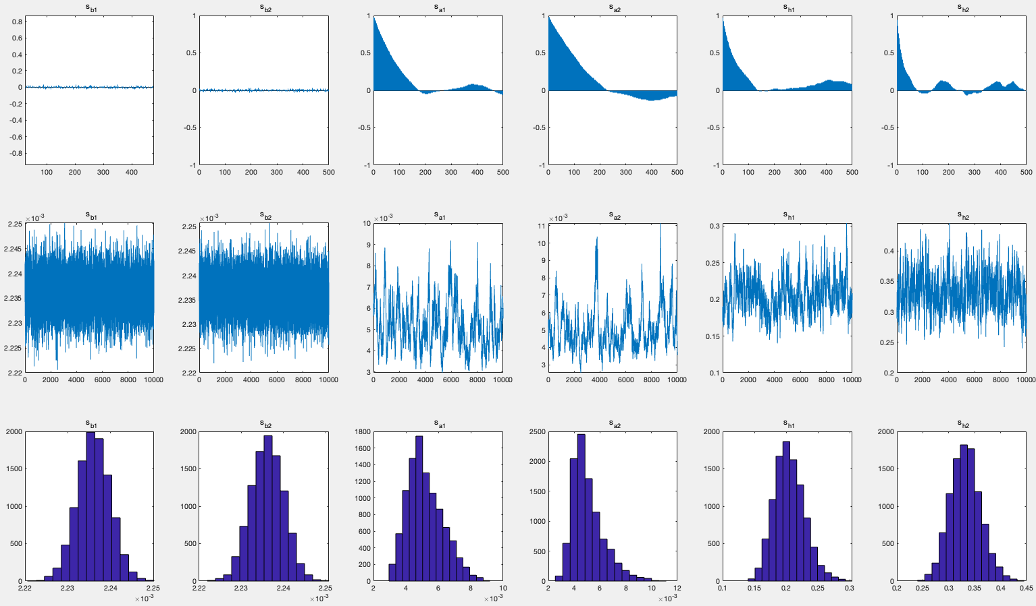

Figure 2. Stochastic Volatility Estimation
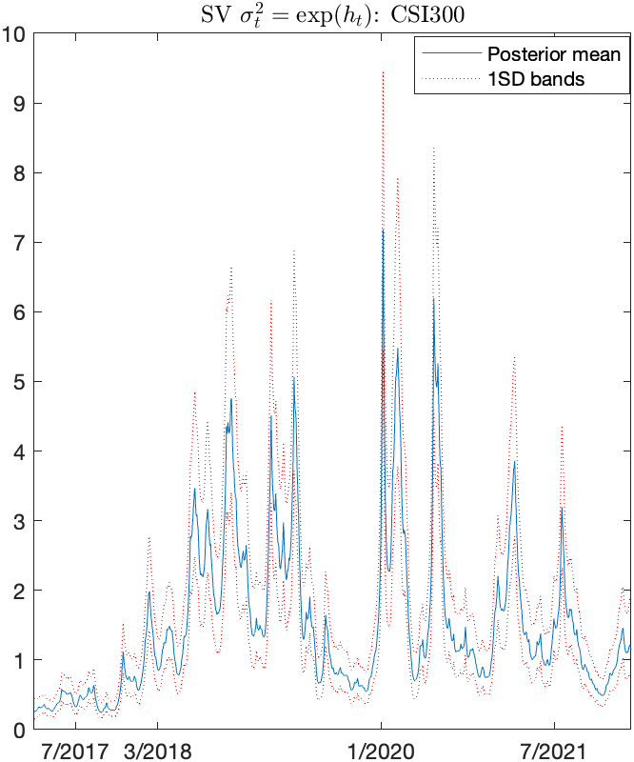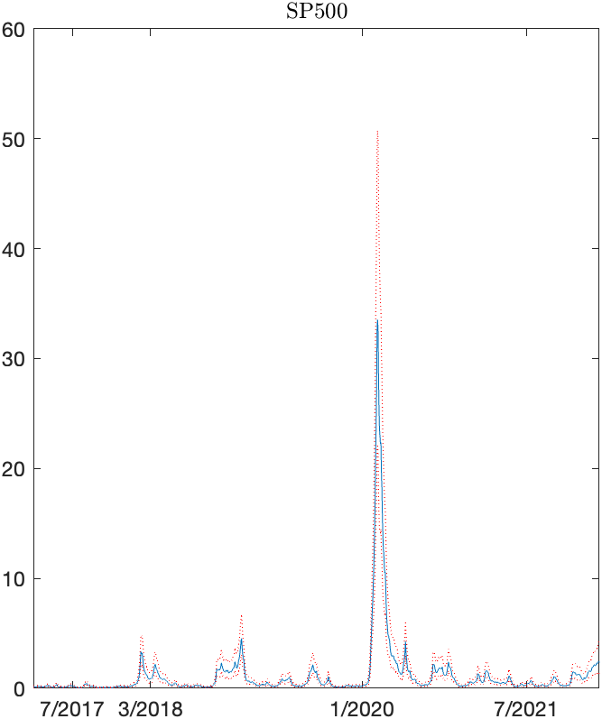
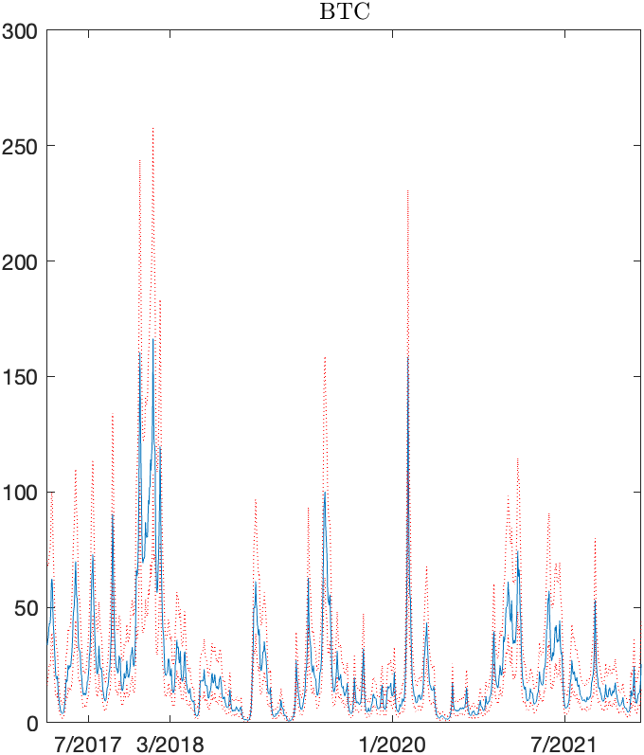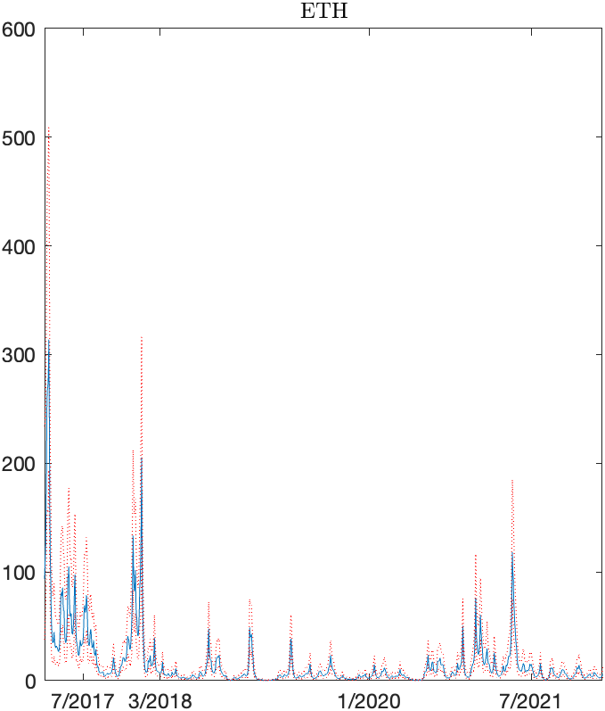

Figure 3. The impulse responses of BTC to the CSI300 index and the CSI300 index to BTC in different lag periods.
The 1-period ahead (green line), 3-period ahead (blue line) and 6-period ahead (red line).
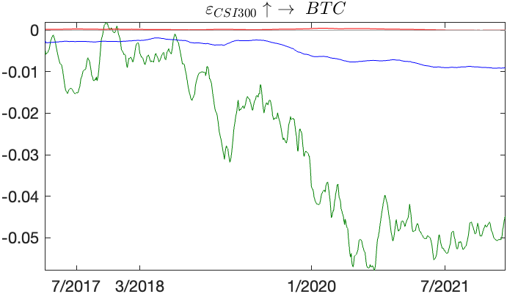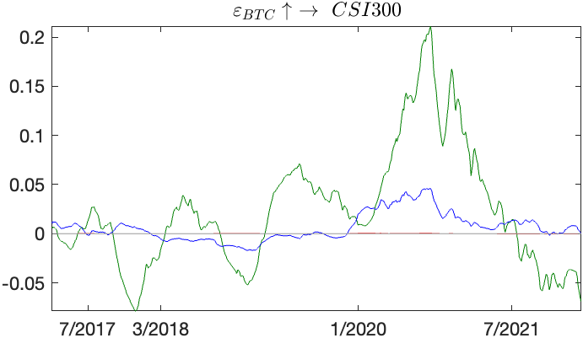
(a) (b)
Figure 4. The impulse responses of ETH to the CSI300 index and the CSI300 index to the ETH in different lag periods.
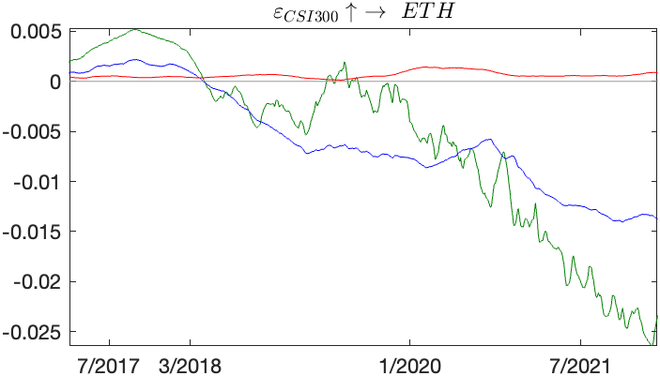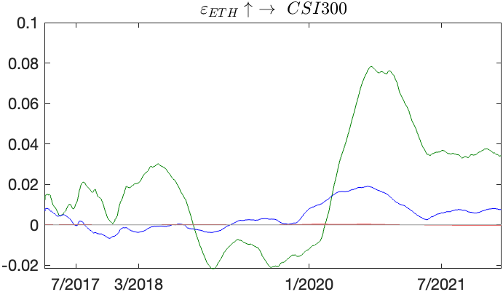
(a) (b)
Figure 5. The impulse responses of BTC to the S&P500 index and the S&P500 index to BTC in different lag periods.
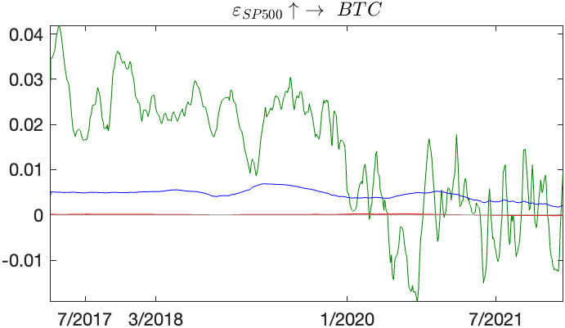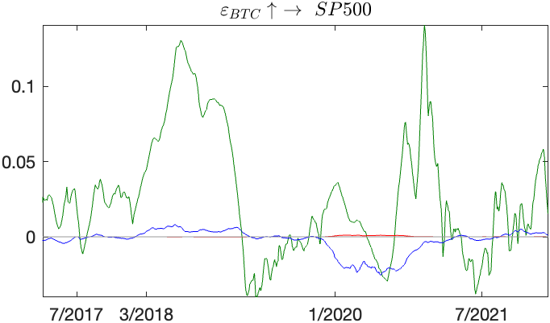
(a) (b)

Figure 6. The impulse responses of ETH to the S&P500 index and the S&P500 index to ETH in different lag periods.
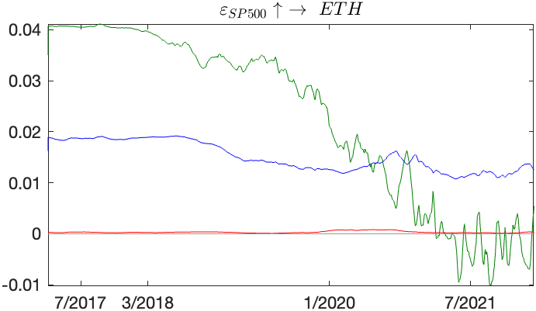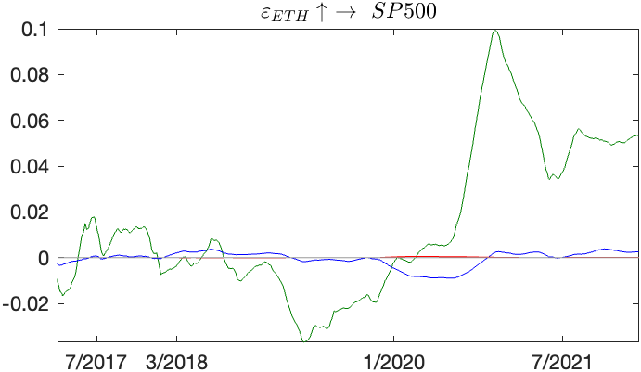
(a) (b)

Figure 7. Time Point Impulse Response Graph
The figure shows four time point impulse response: 03/07/2017 (black dot line), 08/03/2018 (blue line), 15/01/2020 (red line) and 01/07/2021 (green line).
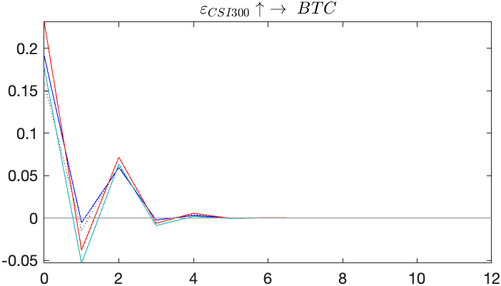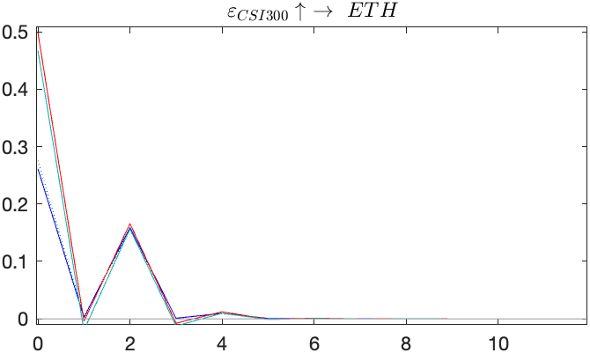
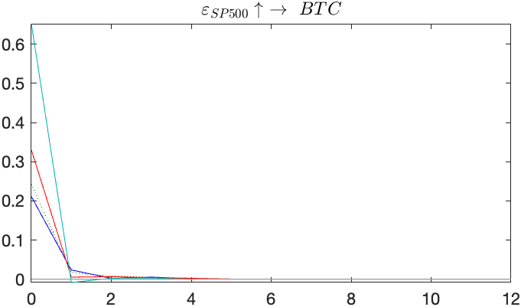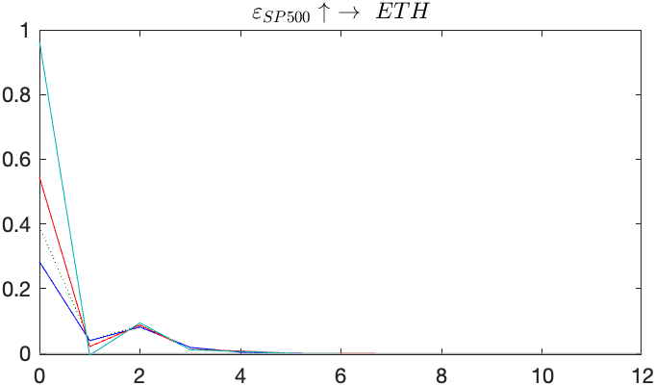
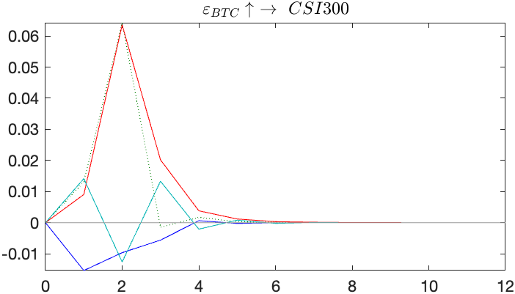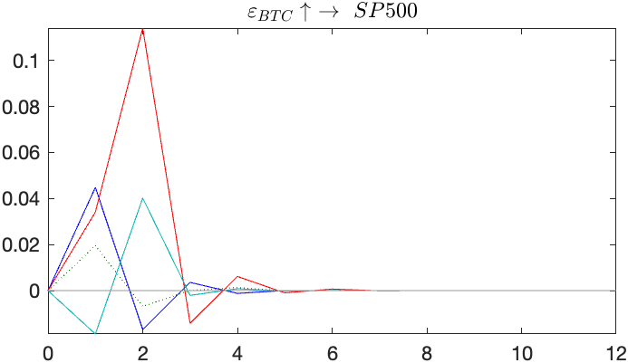
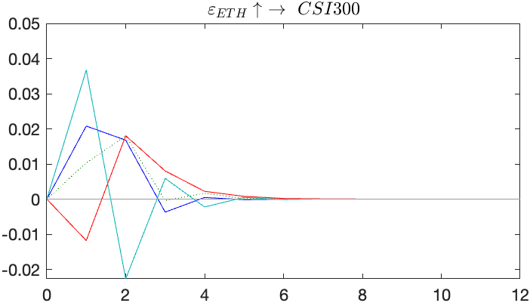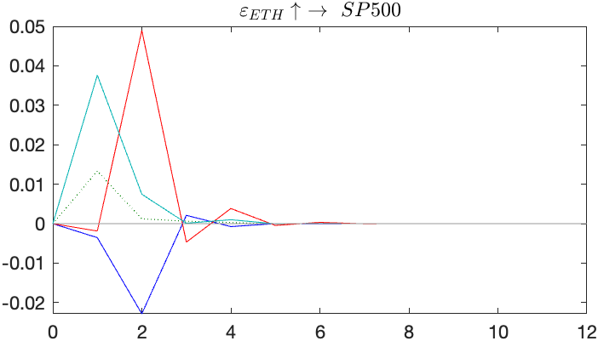

MCMC, rooted in the Bayesian theory framework, has been in use since the early 1950s (Robert and Casella, 2011).
AIC test (Akaike, 1974), serves as a measure of the model's goodness of fit, balancing the model's complexity with its fit to the data.

