**TRIBOLOGICAL BEHAVIOR OF CUO@RGO NANOPARTICLES UNDER DIFFERENT SLIDE-TO-ROLL**

S. M. Alvesa*, R. D. Cunhaa, and A. Morina b

a School of Sciences and Technology, Federal University of Rio Grande do Norte, Av. Senador Salgado Filho, 3000 zipcode 59078-900, Brazil.

b Institute of Functional Surfaces, School of Mechanical Engineering, University of Leeds, LS2 9JT, Leeds, United Kingdom

* Corresponding author: salete.alves@ufrn.br

**Abstract**

This paper aims to develop core-shell nanoparticles by combining CuO (core) and reduced graphene oxide (shell) as lubricant additives and understand their action under different slide-to-roll ratios. The SRRs evaluated were 50 and 200%, with nanoparticles concentrations of 0.05 and 0.1wt%.  The worn tracks were characterized through WLI, SEM, TEM and Raman Spectroscopy. The results showed that the lubrication mechanism and tribofilm formation are strongly associated with the type of contact. At SRR 200%, nanolubricant reduced friction and wear; it was observed exfoliation of nanoparticles, the CuO acted as rolling, and the rGO sheet was deposited on a worn surface. On the other hand, for SRR 50% doesn´t decrease the friction coefficient; however, a thicker tribofilm was produced with nanoparticles.

**Keywords:** nanolubricants, core-shell nanoparticles, sliding-rolling ratio, lubrication mechanisms**.**

1. **Introduction**

The development of lubricants for high-performance applications is a suitable and effective way to minimize failures in mechanical components, ensuring a long life and reducing maintenance time. In particular, the latest developments have led to the design of lubricants with advanced nanoparticles as extreme pressure, anti-wear and friction modifier additives [1]. They can form a protective tribofilm due to their small size, allowing them to enter friction contact areas. Their high surface activity can improve the film-forming stability by physical and/or chemical adsorption effects [2].

Various studies have been implemented to investigate the potential of nanomaterials and nanocomposites as lubricating oil additives; why have these materials attracted so much interest? It can mention three aspects: small sizes and nanostructure (geometry, shape); unique physical properties (like high mechanical strength, large specific surface area, and load capacity); and synergistic lubrication (act synergistically with conventional lubricating additives and with other nanomaterials). Moreover, the preparation of nanocomposites is one potential method to improve nanomaterials tribological properties on boundary lubrication, due to different synergistic mechanisms, integrating physical and chemical properties of the nanomaterials simultaneously [3]. It is possible to design a specific nanoparticle for one determinate application. Wang et al. [4] synthesized a core-shell structure from polytetrafluoroethylene and silica (PFTFE@SiO2) and prepared a nanolubricant with Polyalphaolefin 6. The results showed that these nanoparticles have superior EP and anti-wear properties compared to ZDDP. Another combination of nanomaterials was developed by Gao et al. [5]; they produced nano-sized copper oxide particles that are deposited on boron nitride nanosheets; the CuO@BNNS composites were dispersed in lubricating oil (paraffin liquid) and tested them in four-ball tribometer. The results demonstrate that CuO@BNNS nanoparticles effectively improve tribological properties, reducing friction and wear. According to the authors, the tribofilm formation (containing CuO@BNNS) on the worn surface was responsible for enhanced lubricant performance. Ma et al. [6] studied two core-shell nanoparticles, keeping the same hard core, SiO2@Cu and SiO2@MoS2 microspheres. SiO2@Cu presented tribological behaviours superior to SiO2@MoS2; this can be attributed to the synergistic effect of the hard SiO2 core and Cu shell. The synergy between the rolling effect of SiO2, easy-shearing, and self-repairing of the Cu shell promoted the formation of a dense protection film, contributing to optimal lubrication performance. Also, they concluded that the performance of nanoparticles is better at high contact pressure. Zhang et al. [7] combined the lubrication characteristics of carbon spheres (CS) with high load-bearing capacity and molybdenum disulfide (MoS2) with exceptional low-shear friction performance, CS wrapped with MoS2 (C@MoS2) produced by hydrothermal method. When this nanocomposite was added to PAO 40, it showed excellent tribological performance, attributed to the synergistic lubrication between the bearing and filling effect of CS and the superior anti-friction capacity of the MoS2 shell.

A recent review paper published in 2024 by HTWE et al. [3] showed that metallic oxides and carbon-based materials are investigated as lubricant additives. Metal oxide nanoparticles are widely employed as lubricant additives, and the most common are CuO and TiO2 [3]. Due to their high wear resistance and hardness, metal oxide NPs are usually used as additives to improve the lubricating behaviour, including extreme pressure and anti-wear properties [5]. They also have high surface energy, strong adsorption, and diffusivity. On the other hand,

1. Graphene-based nanomaterials can easily enter the friction interface, preventing contact between these surfaces due to their thin laminated structure, high surface energy, high specific surface area, and self-shear properties[8]. Carbon-based nanomaterials offer good tribological properties and environment-friendly performance for a sustainable future. In particular, graphene and graphene-based nanocomposites exhibit outstanding friction-reduction and wear-resistance properties and are also regarded as potential candidates for green and effective lubricant additives. Graphene-based nanocomposites exhibit excellent tribological performances due to the synergistic “slide-roll” effect. Ren et al. [9] synthesized a coated nanocomposite with a hard core of ZnO and a soft shell of Graphene as a lubricant additive. They analyzed the nanoparticle's lubricating performance in a four-ball machine, and the results showed that ZnO@Graphene nanoparticles are more suitable for a dynamic friction environment, exhibiting excellent tribological properties. Man et al. [10] synthesized a CuO@graphene nanocomposite that showed superior tribological properties when compared to each component (CuO and Graphene) and their mixture under different load and sliding speed conditions. Adding 0.5 wt% of CuO@G to PAO 6 base oil reduced the coefficient of friction by more than 50% and made wear insignificant. This enhancement in tribological performance is due to the synergistic effect. Meng et al. [11] dispersed CuO nanoparticles of 6 nm diameter on the rGO nanosheets to form a composite; the tribological performance was evaluated by adding CuO/rGO into 10w40 engine oil and four-ball testing—the addition of nanocomposites reduced in 46.62 and 77.05% for friction coefficient and wear rate, respectively.

In the literature, however, most previous works have focused on evaluating nanolubricants in pure sliding contacts. It should be noted that pure sliding contact, in most cases, does not simulate the actual contact in mechanical components; it is a combination of sliding and rolling motions. Sliding and rolling contacts are commonly found in mechanical components such as gears, cam, and roller bearings. The combination of sliding and rolling motion can lead to challenges with lubrication, high loads, and variations in film thickness [12]. Few studies have been conducted concerning rolling-sliding contact and the effect of contact conditions on nanoparticle action. Tomala et al. [13] verified that the synergy between MoS2 nanotubes and additives in lubricant oils depends on contact conditions. MoS2 exhibits excellent synergy with AW additives under mixed rolling/sliding conditions because of the exfoliation of MoS2 platelets onto the AW tribofilm.

On the other hand, under reciprocating sliding, the interaction between the MoS2 nanotubes and dispersant leads to higher antagonisms. The action of nano metallic oxide dispersed on Ionic liquid on lubrication in rolling/sliding contact was investigated by Ta et al. [14]. The results showed a slight friction reduction was observed with NP addition, and ZnO produced a significant reduction in wear rate. The mechanism of action is different for CuO and ZnO, tribo-sintering and third body with pure rolling mechanisms, respectively. Adding nanoparticles in the base oil is one way to improve low-viscosity gear oil. Elinski et al. [15] investigated the addition of ZrO2 nanoparticles in pure base oil (PAO4 and PAO10) at different rolling/sliding conditions (from SRR 0% to SRR 100%); therefore, an increase of friction coefficient was observed for all rolling/sliding condition, there was a tribofilm formation and its thickness was independent of the SRR, but the wear depth increased linearly with the SRR. Furthermore, it didn’t mention the influence of SRR on the lubrication mechanism of NP.

Despite all this, to develop nanolubricants for gear contacts in a real application, it is essential to apply laboratory tests that represent the real applications. With this understanding, this paper aims to develop a nanocomposite nanoparticle by combining different properties in core-shell nanostructure from CuO (core) and reduced graphene oxide (shell) as a lubricant additive to be employed in gearboxes. Moreover, this paper evaluated the nanoparticle performance under pure sliding and rolling-sliding conditions. Also of interest is understanding the differences in nanoparticle mechanism action under different slide-to-roll ratios.

1. **Experimental Procedur**e

***Nanolubricants Preparation***

The CuO@rGO nanoparticles were synthesized from sheets of reduced graphene oxide were purchased from Carbon Explore (Brazil), while Copper (II) oxide with a diameter of about 50 nm and Poly(allylamine hydrochloride) with molecular weight of 40000-90000 g/mol were bought from Sigma-Aldrich. The methodology employed to produce the CuO@rGO nanoparticles consisted of 2 steps: 1. Functionalizing CuO nanoparticles with positive amino groups, 1 g of CuO was added into 200 ml of PAH solution (1 g/L) under magnetic stirring for 2 h. The second step was recovering the CuO functionalized nanoparticle with rGO; 0.3 g of rGO was added to a mixture of 35 ml of ethanol and 700 ml of distilled water. The solution was kept under stirring for 60 min, followed by 20 min of sonication. The residual solution was evaporated, and CuO@rGO dried at 90 C for 6 h.

The CuO@rGO nanoparticle surfaces were modified with oleic acid to minimize the agglomeration. Adding oleic acid could improve the particle size distribution by forming a protective layer on its surface [16], avoiding the increase in size that can negatively affect lubrication. 100 millilitres of ethanol was added into a beaker containing 0.06 g of oleic acid and 1.0 g of CuO@rGO nanoparticles. Then, the solution was kept at 60 °C while stirring for 2 h. After the reaction, the solution was dried until ethanol evaporation was complete. In order to improve the nanoparticle's dispersion, firstly, they were added to toluene and then to PAO; the mixture was kept at 40 °C under stirring for 4 h following the methodology described by [16]. After that, the solution was dried at 90 °C until complete evaporation of the toluene. Nanolubricants were prepared in concentration of 0.05 and 0.1% of Nanoparticles, the choice of these concentratitions was based on literature and previous work [11, 17]. The analysis of the dispersion of nanoparticles in oil was done visually because the intense back colour, even at lower concentrations, makes it challenging to analyse using DLS or Zeta Potential techniques.

CuO@rGO nanoparticles were characterized by Raman spectroscopy in A Renishaw inVia™ spectrometer with 488 nm wavelength and 10% power, 50x objective. X-ray diffraction (XRD) was performed on a Shimadzu SDR-7000 using Cu-Kα radiation, 40 kV and 30 mA. SEM/FEG with an X-ray energy dispersive spectrometer (EDS) and Transmission electron microscope (TEM) were used to evaluate NPs morphology.

***Tribological Test:***

The Mini Traction Machine (MTM) was utilized to assess the frictional performance of CuO@rGO nanoparticles added to PAO 6 under mixed-boundary lubrication conditions. This involved loading and rubbing a 19.05 mm diameter ball against a 46 mm diameter disc, both submerged in the lubricant. The samples were cleaned ultrasonically before the test using heptane for 15 min and dry with compressed air. Long-duration tests were carried out in the MTM tribometer to observe the stability of the nanolubricants over a period under the boundary lubrication regime. The test conditions employed in this study were: applied load = 60 N, corresponding to a contact pressure of 1.24 GPa; entrainment speed = 50 mm/s; temperature = 60 ℃; sliding/rolling ratio = 50% and 200%. Each test was performed three times, and the reported results were the average of the three experiments.

***Surfaces analysis:***

Before the worn surface characterization, the residual lubricant on the specimen was cleaned through flushing n-heptane before SEM analysis. The wear track profile measurement has been carried out using Bruker’s NPFLEX based on white light interferometry (WLI)) technology. Also, a Carl Zeiss EVO MA15 SEM was utilised to capture images through a secondary electron detector, collecting the secondary electrons emitted from the surface of disk samples. The specimen’s electrons have been excited by electrons from the electron gun with an acceleration voltage of 5kV. In this work, the discs' Energy-Dispersive X-ray (EDX) spectra were obtained from inside the wear track using mapping mode. Raman spectroscopy has been widely used to determine the structure/composition of the tribofilms generated in a tribocontact. A Renishaw inVia™ Raman spectrometer with 488 nm wavelength and 10% power filter was used to observe the structural modifications inside the wear track of the disks. Tribofilm structure was examined in cross-section cut with High-resolution monochromated Focused Ion Beam (FIB, Helois G4 CX Dual Beam). The samples were analysed with an FEI Titan3 Themis 300 Scanning Transmission Electron Microscopy (STEM) instrument equipped with Energy Dispersive X-ray (EDX) and High-Angle Annular Dark-Field Scanning (HAADF).

**3. Results and Discussion**

***3.1 Nanolubricants Characterization***

Figure 1a shows the crystallographic structure of CuO@rGO determined by XRD analysis. As shown in the XRD pattern, it was possible to identify peaks related to CuO at 32.50°, 35.42°, 38.70°, 48.70°, 53.50°, 58.26°, 61.50°, 66.22°, 67.9°, 72.37°, 74.98°, which correspond well to the reference crystallographic data (JCPDS no. 48-1548). Also, a slight peak in 24.2° related to carbon peak in the rGO pattern was found. It is noticed that diffraction peaks of metal oxide present much stronger diffraction intensity than the peaks for carbon material. This pattern suggested that the CuO nanoparticles were successfully recovered with rGO nanosheets.

Raman spectra of CuO@rGO is presented in Figure 1b. It shows D and G bands at around 1350 and 1570 cm-1, respectively, and 2D band at 2670 cm-1. The intensity ratio of the disordered D band and the crystalline G band (ID/IG) is 0.55, indicating a structure with few defects, even after encapsulation of CuO nanoparticles. The presence of CuO in the core-shell nanoparticles was confirmed by the presence of three characteristic peaks of CuO around 295, 620 and 1120 cm-1; these intensities are weaker due to the encapsulation structure.

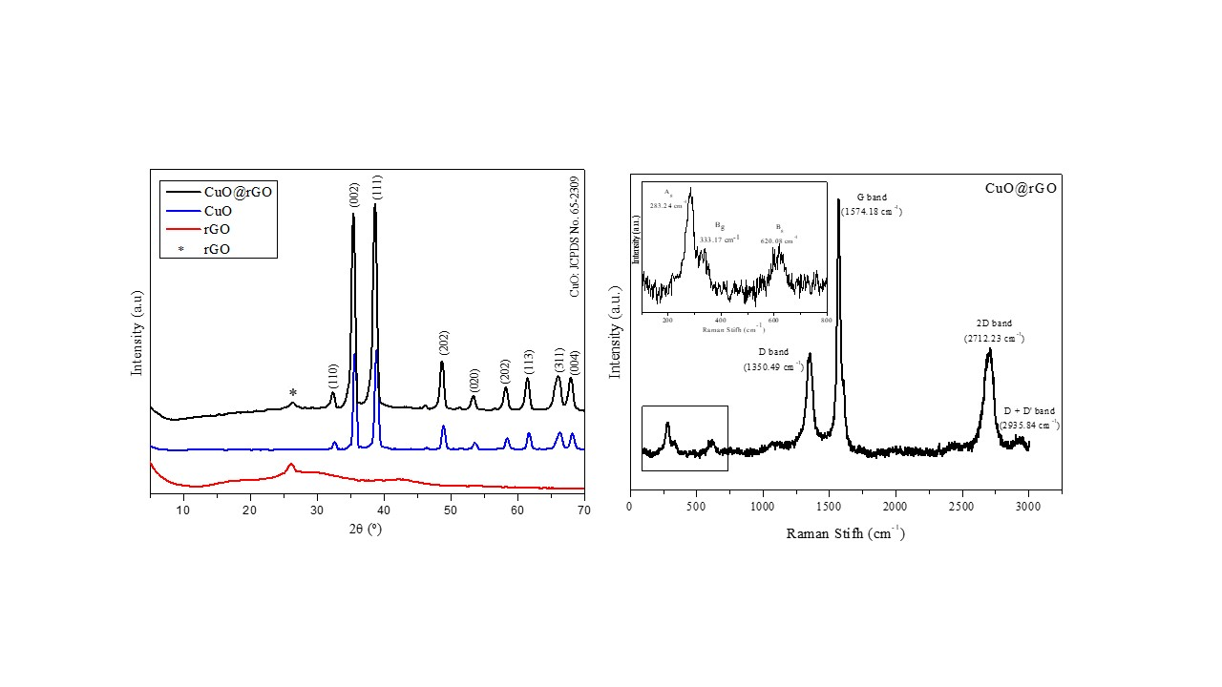

Figure 1: XRD patterns and Raman Spectra of CuO@rGO

Nanoparticles Morphologies of CuO@rGO were observed by TEM and SEM (Fig. 2). The TEM image revealed that rGO nanosheets efficiently coated the CuO nanoparticles in synthesize the core-shell nanocomposites, as observed by [18], and agreeing well with the analysis of Raman spectra. The EDS mapping confirms CuO's encapsulation by rGO, evidencing Cu, O and C elements in the same particle. The rGO has functional groups with oxygen; they increase rGO adhesion with CuO recovered with PAH nanostructure by van der Waals interaction [19].

Figure 2: TEM image of CuO@rGO (a), SEM images of CuO@rGO (b), The EDS mapping results of the CuO@rGO core-shell structures (c).

After dispersion onto base oil, the stability of nanolubricants was monitored for 30 days by sedimentation method (visual analysis), as can be seen in Fig. 3a. These images reveal a good dispersion at low concentrations (0.05 and 0.1%). It is well known that in various polar functionalities like hydroxyl and carboxyl groups, rGO is hydrophilic and has poor dispersibility in lubricant oil [20]; the same behaviour is found for CuO nanoparticles. In this work, CuO@rGO nanoparticles were functionalized with oleic acid to facilitate its well dispersion in PAO 6, and the stable dispersion was reached around 30 days. Figure 3b shows the nanolubricant prepared with nanoparticles coated and uncoated with oleic acid in test tubes 1 and 2, respectively, after 24 hours. This image can prove the effect of oleic acid recovering on nanoparticles dispersion; after 24 hours, the uncoated nanoparticles tend to sediment on the bottom of the test tube, while coated nanoparticles kept dispersion in PAO6.

Figure 3: Visual analysis of nanolubricant stability: a) stability in 30 days, b) effect of acid oleic on NPs dispersion.

***3.1 Friction results***

The long-duration test was carried out to identify the stability of the lubricant film through a specific period. Figure 4 shows friction behaviour over time for each CuO@rGO concentration at 50% SRR and 200% SRR values. The trend for base oil and nanolubricant depends on SRR value; when SRR was 200%, pure sliding and more severe conditions, a short running was observed mainly for nanolubricants, where the nanoparticles caused a rapid rise of COF in the first minutes. After this initial period, the COF values remained constant over time, but there were fluctuations resulting from the severe test conditions. The action of nanoparticles reduces the friction coefficient for this condition during sliding; the steady state friction was given as the average friction values of the last hour of the test, being 0.095, 0.085, and 0.083, for base oil, NP 0.1% and NP 0.05%, respectively.

On the other hand, for SRR 50% was observed smaller COF values were, and they present different trends; the COF increased with test duration, showing that a stable lubricant film was not formed until four hours of the test, didn’t reach the steady state, in the first hour of test the nanoparticles promoted a reduction in friction, probably in this period, the NPs were acting as rolling elements; once the initial surface of the disc was polished. However, with tribofilm formation and increase of roughness over time the friction behaviour became similar for base oil and nanolubricant with 0.05% of CuO@rGO, therefore with a rise in NP concentration, the friction coefficient values were a little higher than other lubricants. This fact shows that short-duration tests are sometimes unsuitable for evaluating the performance of nanolubricants. Moreover, the COF values are smaller than SRR 200%, and this finding showed the influence of the sliding/rolling ratio on nanoparticle action during contact between ball and disc. An increase in friction coefficient values obtained for nanolubricants can be attributable to the increase in surface roughness as the action of NPs in tribofilm formation (see later discussions on the worn surface analysis). Similar behaviour was observed by Ellinski et al. [15] for nanolubricants from ZrO2 nanoparticles in PAO at SRR 50%; however, in their work, the COF for nanolubricants is two or three times higher than base oil, promoting the transition from mixed to boundary lubrication regime. However, this is due to the influence of the sliding/rolling ratio on surface chemistry. The details of this will be discussed in the following section.

|  |
| --- |
|  |
|  |

Figure 4: Friction Coefficient as a function of time: a) 50% SRR and b) 200% SRR

***3.2 Wear track analysis***

Figures 5 and 6 show the wear profile of the disc lubricated with base oil and nanolubricants at SRR 200% and 50%, respectively, and SRR clearly affect the wear strongly. At SRR 200%, more severe changes in the surface are observed for base oil, with some signal of abrasion and a deep groove in the track centre, shown in detail in the 2D profile. On the other hand, adding nanoparticles to base oil promoted changes in wear behaviour; instead of presenting a deep grove, these surfaces showed a material deposition on the worn surface, indicating probably a film formation from the deposit of NP on the disc surface. This phenomenon is more uniform for 0.05% of concentration;  low nanoparticle concentration avoids NP agglomeration during the tribological test, and this agglomerate particle can act as a third-body promoting abrasive wear as evidenced by deep groove in worn surface with 0.1% [21]. This suggests that most severe sliding conditions favour NP film formation. Elinski et al. [15] found the same behaviour for ZrO2 nanoparticles in PAO. The wear profiles of the disc at SRR 50% clearly show considerably less wear on the surfaces compared to the SRR 200%. It should be noted from 3D images that an antagonistic effect of nanoparticles increases the wear signals on the worn surface, and more abrasive marks, but not deep grooves, can be seen on discs lubricated with nanolubricants. For both SRRs, the wear volume cannot be determined because the material removal was small.

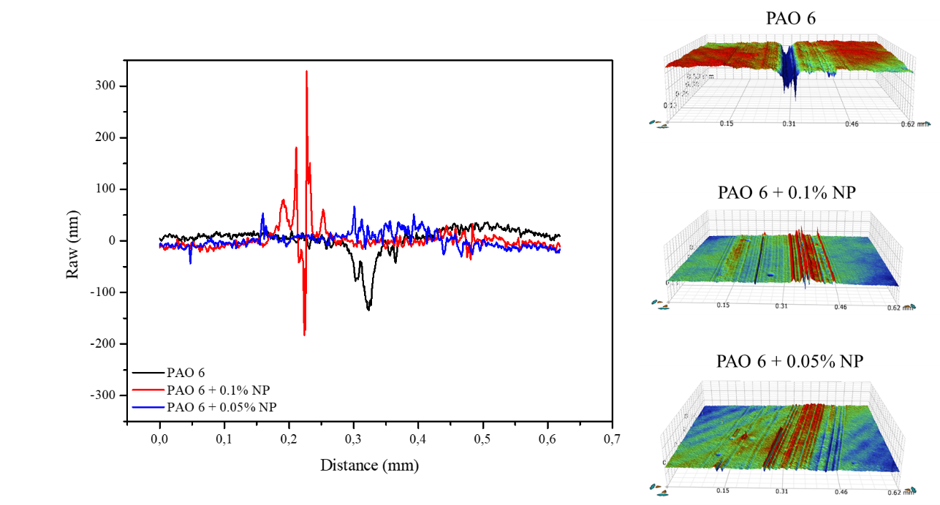

Figure 5: Interferometer 3D images and 2D roughness profile of the disc surface lubricated with (a) PAO 6, (b) PAO 6 + 0.1% NP, (c) PAO6 + 0.05% NP at SRR 200%.

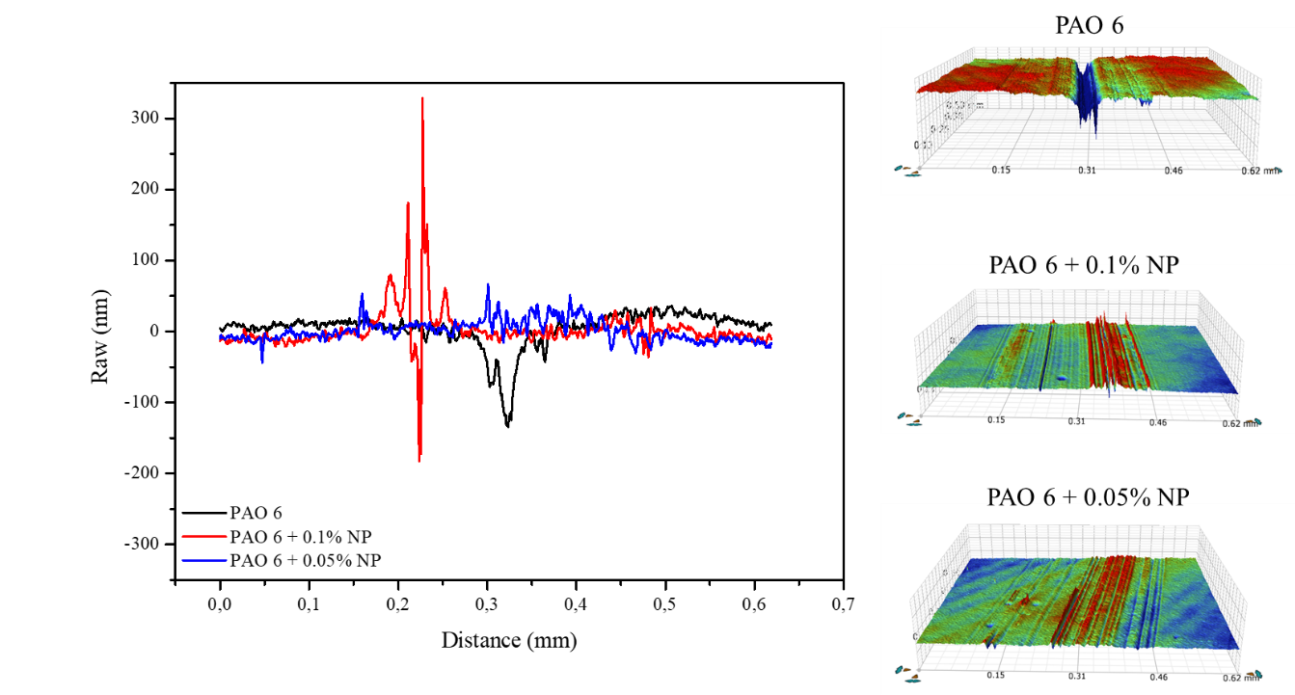

Figure 6: Interferometer 3D images and 2D roughness profile of the disc surface lubricated with (a) PAO 6, (b) PAO 6 + 0.1% NP, (c) PAO6 + 0.05% NP at SRR 50%.

Moreover, 3D and 2D profiles can consider the transformations of the surface topographies described above from the 3D surface roughness parameter. This analysis allows to distingue characteristics imposed by the increased SRR on wear and surface changes after rubbing test under lubrication with different concentrations of NP. Tables 1 and 2 describe different parameters for 3D surface of Figs 5 and 6. The action of NP for different SRR conditions was evaluated in function of mainly Sa, Sq and Sz. At pure sliding (SRR 200%), the average roughness increases for the base by around 45% compared with Sa for the disk before the test, while the addition of NP in low concentration (0.05%) promoted a polishing of the surface. The "Sq" parameter is especially interesting as it is commonly used to estimate lambda. (λ = hm/Sq) that identifies lubrication regime The fact that the Sq has increased by approximately 75% and 64% for base oil and nanolubricant with 0.1% of CuO@rGO, respectively, promoted a decrease the lambda and changes in lubrication corroborating with mentioned before about reduction of film thickness with SRR 200%. It is noted that Sp for surfaces tested with nanolubricants showed higher SP than base oil, showing the deposition of nanoparticles on the worn surface, forming a tribofilm. On the other hand, in rolling/sliding conditions, a decrease of Sa for all lubricants is observed, being more pronounced by base oil. However, Sq remained practically at the same value after the tribological test, with a slight increase for the base oil, indicating that there was no change in the thickness of the lubricating film and that deformation of asperities is due to the hydrodynamic pressure and NP acting as a third body.

Table 1: Surface roughness parameters evaluated on wear track after tribological test with SRR 200%.

|  |  |  |  |  |
| --- | --- | --- | --- | --- |
| SRR 200% | PAO 6 | PAO 0.1% NP | PAO 0.05% | Disk Before Test |
| Sa (nm) | 16.559 | 14.256 | 12.337 | 13.605 |
| Sku | 22.191 | 35.058 | 12.084 | 3.117 |
| Sp (nm) | 89.014 | 539.000 | 479.000 | 87.364 |
| Sq (nm) | 29.450 | 27.955 | 16.286 | 17.033 |
| Ssk | -3.785 | -3.307 | 0.8180 | 0.060 |
| Sv (µm) | -0.384 | -0.387 | -0.290 | 0.130 |
| Sz (µm) | 0.473 | 0.926 | 0.769 | 0.217 |

Table 2: Surface roughness parameters evaluated on wear track after tribological test with SRR 50%.

|  |  |  |  |
| --- | --- | --- | --- |
| SRR 50% | PAO 6 | PAO 0.1% NP | PAO 0.05% |
| Sa (nm) | 9.7713 | 11.827 | 11.090 |
| Sku | 243.490 | 7.740 | 28.581 |
| Sp (um) | 0.685 | 0.104 | 0.205 |
| Sq (nm) | 19.701 | 16.290 | 17.506 |
| Ssk | -9.116 | -1.325 | -0.3119 |
| Sv (µm) | -0.792 | -0.160 | -0.334 |
| Sz (µm) | 1.477 | 0.264 | 0.539 |

***3.3 Worn track surface characterization***

SEM-EDS analysis was performed to reveal the interactions between lubricants, types of contact, and disc surfaces (Figs. 7 and 8). The chemical composition of the worn surface was found to vary with changing the type of contact. Comparing sliding/rolling contact to pure sliding contact, it is noted that the chemical composition of tribofilm is different, which confirms that tribological performance was controlled not only by the action of nanoparticles but also by the contact type. Under pure sliding (Fig. 8), high friction and mild wear on the worn surface were observed, and the presence of oxygen, iron, and copper was not detected even when lubricated with nanolubricants. This composition suggested that the nanoparticles are exfoliated, generating two different materials, layers of rGO and spherical CuO; this mechanism was verified for other works [9, 22]. As mentioned, the film thickness decreases with high SRR, allowing direct contact between NP and the surface. In this case, the CuO NP acted as a bearing, promoting a rolling mechanism, but it didn’t form the protective film. The Raman Analysis confirms the presence of rGO in the worn surface and evidence of oxidation, as shown in Fig. 9, which shows that due to lower molecular weight, carbon is not identified with accurate EDS analysis.

On the other hand, probably due to EHD film thickness, the CuO@rGO nanoparticles kept dispersed in the oil and deposited on the worn surface at SRR 50%, as seen in EDS mapping from Figure 7. For surface lubricated with nanolubricants, it is evident that moderate shear stress is sufficient to compact NP on the worn surface, probably as nanocomposite probably didn’t occur the exfoliation of rGO. This statement is supported by Raman analysis of the worn surface, which showed the D and G bands of rGO and CuO peaks (295, 620 and 1120 cm-1). Moreover, for disks lubricated with PAO in Raman spectra, it is possible to identify peaks corresponding to Fe3O4. These peaks were decreased with the addition of nanoparticles. Also, at some points in the worn surface with PAO, broad peaks were found at 1370 cm−1 and 1580 cm-1 due to the formation of amorphous carbon [23].

|  |
| --- |
|  |

Figure 7: SEM images and EDS mapping of disks at the end of the test with SRR 50%: a) PAO 6, b) PAO+0.05% NP, and c) PAO+0.1% NP

|  |  |  |
| --- | --- | --- |
|  | |  |
|  |  | |

Figure 8: SEM images and EDS mapping of disks at the end of the test with SRR 200%: a) PAO 6, b) PAO+0.05% NP, and c) PAO+0.1% NP.

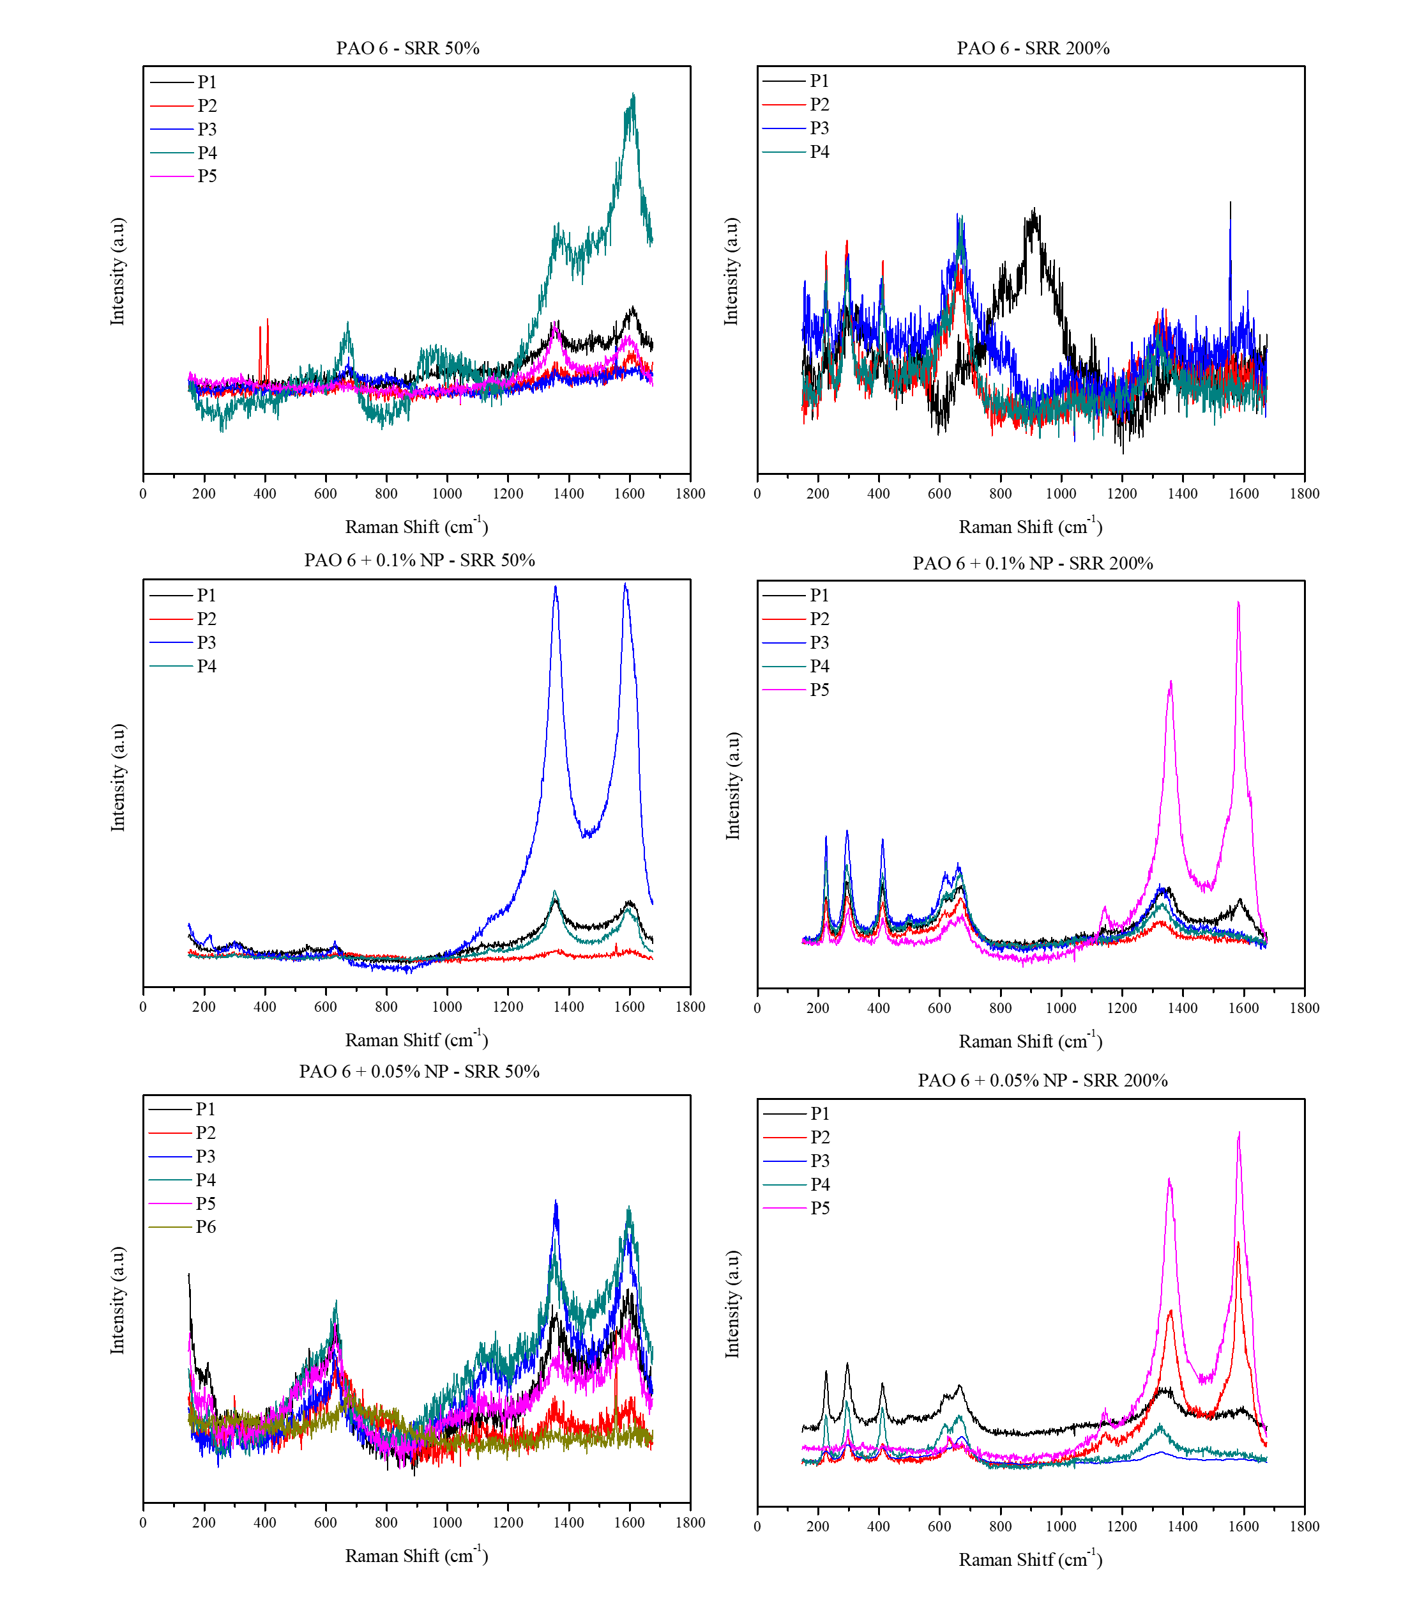

Figure 9: Raman spectra obtained from different positions on disc wear scars after 4 h tests: SRR = 50% (left column) and SRR = 200% (right column)

To provide insights into the lubrication mechanism of CuO@rGO nanolubricant in the friction process, a thin section was cut of the disk using FIB. This section was composed of tribofilm and steel within the wear scar. TEM and HRTEM were used to analyse the tribofilm formed on the disc surfaces for two different SRRs with nanolubricant with 0.05% of NP in detail. Once this concentration gave better results on friction behaviour, Figure 10 shows these tribofilms taken from TEM under low magnification. The upper layer is Platinum layer, the middle layer is the tribofilm, and the steel substrate is below the film. The thickness of the formed tribofilm is strongly influenced by the contact condition; they were in the ranges 33-38 nm and 9-13 nm, respectively, for SRR 50% and 200%. Tribofilm was formed by tribo-sintering under high pressure and frictional heat, thus reducing friction and wear [24]. In TEM images, crystalline regions typically appear darker, while amorphous regions appear lighter [23]. Less severe contact favours the formation of thickener tribofilm, while pure sliding leads to thin tribofilm. Also, the nanoparticles are visible and distributed in tribofilm from SRR 50%.

Figure 10: TEM images for formed tribofilm.

High-resolution TEM (HRTEM) images regarding the detailed microstructures of the tribofilm as shown in Fig. 11. The HRTEM images of tribofilm obtained with SRR 50%, with ampliation of 100 nm (Fig. 11a) and 10 nm (Figs. 11 b and c). Figure 11b shows that some nanoparticles were kept intact in the core-shell structure, the darker colour corresponding to crystalline regions, in this case, CuO. In contrast, amorphous regions (rGO) appear in light colour [23]. On the other hand, in Fig. 11c, amorphous regions that could be rGO sheets are present, produced by the exfoliation of core-shell nanoparticles and deformed CuO nanoparticles. Figure 12 confirmed the presence of CuO nanoparticles on the tribofilm. The tribofilm consists mainly of O, Cu and C; also, the EDS suggested that we have a thin layer of iron oxide under the tribofilm. EDS of Fig.12b confirmed that the nanoparticle is CuO@rGO.

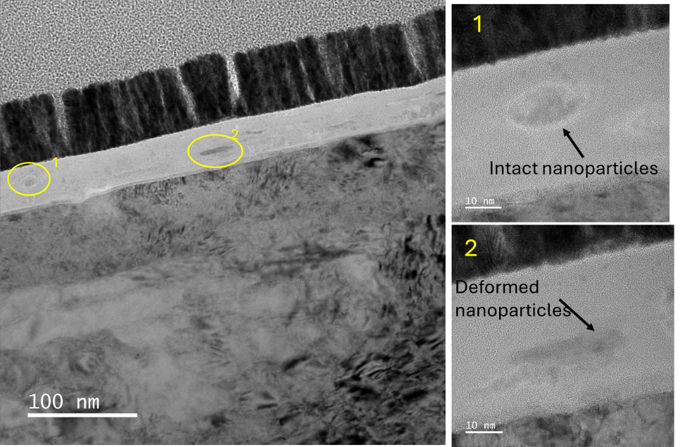

Figure 11: HRTEM image of SRR 50% tribofilm after 4h of MTM test: a) Cross-section view of Tribofilm layer; b) Core-shell nanoparticles found on the tribofilm and c) rGO sheet on tribfilm.

|  |
| --- |
|  |
|  |

Figure 12: a) EDS measurement by HAADF image of SRR 50% tribofilm cross-section (upper) b) EDS analysis of nanoparticles embedded in tribofilm (down).

Besides nanoparticles, amorphous areas can also be found in the bulk of the tribofilm, a similar result was observed by [20, 25]. According to Wu et al. [25], amorphous areas result from oxidation processes that produce the growth of graphene oxide defects and mechanical interaction owing to the rolling/sliding process. In addition, due to the unique morphological structure, graphene oxide could easily enter the contact zone during the rolling/sliding process [20].

Based on HRTEM and EDS results (Figs. 13 and 14), under severe contact (pure sliding), it is possible to confirm the difference in tribofilm formation compared to SRR 50% contact. Figure 14 shows that oxides were generated on the worn surface due to the tribochemical reaction, while carbon was attributed to the rGO exfoliation. It has been revealed that metal oxides formed low friction tribofilm for excellent self-lubrication and antiwear properties [24], corroborating with friction results. Combined with the easy-to-shear property of rGO, the lubrication performance of nanolubricant was promoted. For SRR 200%, it forms an iron oxide layer; on it, we have a thinner graphene oxide layer formed by rGO exfoliation. The CuO don´t take part in tribofilm, contributing to the hypothesis that they acted as rolling, minimizing the friction. At some points, the rGO sheet inside tribofilm was found, as can be seen in this EDS mapping. The tribofilm was not uniform in its thickness; Figure 14 shows a region of ticker film, where some graphene exfoliated onto tribofilm (black spots) can be seen.

Figure 13: EDS measurement by HAADF image of SRR 200% tribofilm cross-section, mapping and line mode.

Figure 14: EDS measurement by HAADF image of SRR 200% tribofilm cross-section, mapping

**3.4 Lubrication mechanism of CuO@rGO nanoparticles**

Both materials were chosen based on the good anti-friction effect of graphene oxide [9, 25] and the good anti-wear effect from CuO [26]; these characteristics are perfectly found in core-shell composite NPs. To understand the lubrication mechanism of CuO@rGO, it considers friction behaviour, Raman. SEM/EDS and TEM/EDS analysis. The Raman spectra of the wear scars have two groups of characteristic peaks, which respectively belong to RGO and CuO in CuO@G nanocomposites, as can be seen in Fig. 9. From the presented results, it is possible to conclude that the sliding/rolling ratio influences strongly the nanoparticles action, in this work it was compared pure sliding (SRR 200%) and common a combination of rolling and sliding contact (SRR 50%). Analysing the results from SRR 200%, the NP decreased the friction coefficient and reduced the surface damage; also, WLI analysis identified materials adhesion on worn surfaces, forming a tribofilm. SEM, TEM, EDS, and Raman results aim to explain the NP mechanism; the presence of rGO and Fe3O4 on the worn surface was identified. From HRTEM images, two layers of tribofilm, iron oxide, and a thin layer of rGO can be found. The rGO and CuO nanoparticles are grafted by PAH to synthesize a core-shell structure. Under continuous shear and stress, the layer of rGO in the core-shell can easily exfoliate, reducing the friction resistance, and rGO nanosheets supply a strong mechanical strength to the nanocomposite to bear the load and resist the wear [11]. Due to the friction pair's interface flow, the rGO adapts to the worn surface as a pinning reinforcement. With this, the rGO nanosheets are exfoliated from the CuO@rGO nanoparticle, and thus, the encapsulated CuO nanoparticles are exposed and released from core-shell structure because of friction and shear. The CuO nanoparticles with spherical shape may act as “micro-rolling balls”, minimizing friction and wear but not being physically adsorbed. Plastic deformation releases high energy, which is helpful for the physisorption and chemisorption of graphene/graphite [27]. Also, layered rGO has a three-dimensional morphology and may show an excellent adhesion and repair capacity for the wear surface [9].

When a combination of rolling and sliding contact is verified, different behaviours of nanoparticle lubrication are observed. With the decrease of stress and shear compared to pure sliding conditions, adding NP didn’t improve lubricant performance, and friction behaviour was similar for all lubricants. However, the tribofilm formation from CuO@rGO was observed; in this case, the shear and stress were probably insufficient to promote the rGO exfoliation and the core-shell structure was kept. Raman spectra and EDS analysis support this statement; from EDS mapping, it is possible to see Cu deposited on entire worn surface, while Raman spectra showed peaks corresponding to rGO and CuO, spectra like Fig. 1b. HRTEM images showed intact and deformed core-shell nanoparticles within tribofilm. Moderate shear and stress are sufficient to compact NPs on contact surfaces without exfoliating them, and rGO facilitates this adhesion because the weaker Van der Walls force between the layers allows the core-shell structure to slide under low shear force [9]. This finding corroborates with the decrease of Sa after the tribological test, as seen in Table 2; the NPs filling the valleys and making the surface smoother. This tribofilm may help minimize component wear subject to more operating cycles. Figure 15 shows a reasonable tribofilm formation according to the above discussions.

Figure 15: Schematic diagram of the lubrication mechanism of nanolubricants as a function of the Sliding-Rolling ratio.

The combination of a strong core and flexible shell can give full play to the advantages of each component, which is an ideal candidate as a lubricant additive. Above all, it proves that the compound nano additive with a soft shell and hard core can introduce an advantage for tribological modification of lubricant.

**4. Conclusions**

The nanoparticle core-shell is an attractive additive for lubricants because it combines good properties of different materials, improving tribological performance. This work presents hard core-soft shell CuO@rGO nanoparticles as lubricant additives, and their lubrication mechanism considers two types of contact: pure sliding and rolling/sliding. Based on experimental results, some conclusions can be drawn:

* Core-shell CuO@rGO was successfully synthesized via a hydrothermal process, combining different properties.
* The CuO@rGO nanoparticles effectively reduced friction in pure sliding condition (SRR 200%); for conditions where it has rolling and sliding (SRR 50%), they reduced friction just in the beginning, probably due to the rolling mechanism. In the case of a low concentration of 0.05%, the friction behaviour is like that of base oil during all tests.
* The tribofilm formation is strongly influenced by contact conditions. For SRR 50%, the tribofilm is ticker, with nanoparticles embedded, some kept intact, and others deformed. In the case of SRR 200%, a more severe condition, produced a tribofilm thinner composed of oxides; no Copper was found in it, suggesting exfoliation of CuO@rGO, CuO behave as rolling minimizing the friction. A second rGO layer of tribolfim was identified.
* In summary, the nanolubricants for a specific application should be tested in real contact conditions once their action depends on contact type.

**Acknowledgements**

Thanks to the financial support from the Coordenação de Aperfeiçoamento de Pessoal de Nível Superior – Brasil (CAPES) (Grant no. 88887.832656/2023-00) and Institute of Functional Surfaces of the University of Leeds by the laboratory support in this project.

**References**

1. Saidi, M.Z., El Moujahid, C., Pasc, A., Canilho, N., Delgado-Sanchez, C., Celzard, A., Fierro, V., Kouitat-Njiwa, R., Chafik, T.: Enhanced tribological properties of wind turbine engine oil formulated with flower-shaped MoS2 nano-additives. Colloids Surfaces A Physicochem. Eng. Asp. 620, 126509 (2021). https://doi.org/10.1016/j.colsurfa.2021.126509

2. Zhao, J., Huang, Y., He, Y., Shi, Y.: Nanolubricant additives: A review. Friction. 9, 891–917 (2021). https://doi.org/10.1007/s40544-020-0450-8

3. Htwe, Y.Z.N., Al-Janabi, A.S., Wadzer, Y., Mamat, H.: Review of tribological properties of nanoparticle-based lubricants and their hybrids and composites. Friction. 12, 569–590 (2024). https://doi.org/10.1007/s40544-023-0774-2

4. Wang, N., Wang, H., Ren, J., Gao, G., Zhao, G., Yang, Y., Wang, J.: High-efficient and environmental-friendly PTFE@SiO2 core-shell additive with excellent AW/EP properties in PAO6. Tribol. Int. 158, (2021). https://doi.org/10.1016/j.triboint.2021.106930

5. Gao, X., Wang, Y., Wang, Y., Wang, Y., Li, P., Zhang, Z., Li, F., Feng, H., Li, Z., Zhang, X.: Effect of copper oxide@boron nitride nanosheet hybrid nanocomposite on tribological properties of paraffin liquid. SN Appl. Sci. 4, (2022). https://doi.org/10.1007/s42452-022-05094-w

6. Ma, X., Gan, C., Li, X., Li, Y., Feng, P., Fan, X., Ye, X., Zhu, M.: Tribological Properties of SiO2@Cu and SiO2@MoS2 Core–Shell Microspheres as Lubricant Additives. Tribol. Lett. 69, (2021). https://doi.org/10.1007/s11249-021-01483-1

7. Zhang, Z., Fan, X., Ma, X., Zhu, M.: Synergistic lubrication mechanism of core/shell C@MoS2 particles as lubricant additives. Appl. Surf. Sci. 639, (2023). https://doi.org/10.1016/j.apsusc.2023.158234

8. Gao, Q., Liu, S., Hou, K., Li, Z., Wang, J.: Graphene-Based Nanomaterials as Lubricant Additives: A Review, (2022)

9. Ren, B., Gao, L., BotaoXie, Li, M., Zhang, S., Zu, guoqing, Ran, X.: Tribological properties and anti-wear mechanism of ZnO@graphene core-shell nanoparticles as lubricant additives. Tribol. Int. 144, (2020). https://doi.org/10.1016/j.triboint.2019.106114

10. Man, W., Huang, Y., Gou, H., Li, Y., Zhao, J., Shi, Y.: Synthesis of novel CuO@Graphene nanocomposites for lubrication application via a convenient and economical method. Wear. 498–499, (2022). https://doi.org/10.1016/j.wear.2022.204323

11. Meng, Y., Su, F., Li, Z.: Boundary and Elastohydrodynamic Lubrication Behaviors of Nano-CuO/Reduced Graphene Oxide Nanocomposite as an Efficient Oil-Based Additive. Langmuir. 35, 10322–10333 (2019). https://doi.org/10.1021/acs.langmuir.9b01244

12. Al-Jeboori, Y., Kosarieh, S., Morina, A., Neville, A.: Investigation of pure sliding and sliding/rolling contacts in a DLC/Cast iron system when lubricated in oils containing MoDTC-Type friction modifier. Tribol. Int. 122, 23–37 (2018). https://doi.org/10.1016/j.triboint.2018.02.015

13. Tomala, A., Ripoll, M.R., Kogovšek, J., Kalin, M., Bednarska, A., Michalczewski, R., Szczerek, M.: Synergisms and antagonisms between MoS2 nanotubes and representative oil additives under various contact conditions. Tribol. Int. 129, 137–150 (2019). https://doi.org/10.1016/j.triboint.2018.08.005

14. Ta, T.N., Chern, S.Y., Horng, J.H.: Tribological behavior of ionic liquid with nanoparticles. Materials (Basel). 14, (2021). https://doi.org/10.3390/ma14216318

15. Elinski, M.B., LaMascus, P., Zheng, L., Jackson, A., Wiacek, R.J., Carpick, R.W.: Cooperativity Between Zirconium Dioxide Nanoparticles and Extreme Pressure Additives in Forming Protective Tribofilms: Toward Enabling Low Viscosity Lubricants. Tribol. Lett. 68, (2020). https://doi.org/10.1007/s11249-020-01346-1

16. Alves, S.M., Mello, V.S., Faria, E.A., Camargo, A.P.P.: Nanolubricants developed from tiny CuO nanoparticles. Tribol. Int. 100, (2016). https://doi.org/10.1016/j.triboint.2016.01.050

17. Alves, S.M., Mello, V.S., Faria, E.A., Camargo, A.P.P.: Nanolubricants developed from tiny CuO nanoparticles. Tribol. Int. 100, 263–271 (2016). https://doi.org/10.1016/j.triboint.2016.01.050

18. Dandia, A., Bansal, S., Sharma, R., Rathore, K.S., Parewa, V.: Microwave-assisted nanocatalysis: A CuO NPs/rGO composite as an efficient and recyclable catalyst for the Petasis-borono-Mannich reaction. RSC Adv. 8, 30280–30288 (2018). https://doi.org/10.1039/c8ra05203d

19. Kırkbınar, M., Demir, A., Altındal, Ş., Çalışkan, F.: The effect of different rates of ultra-thin gossamer-like rGO coatings on photocatalytic performance in ZnO core-shell structures for optoelectronic applications. Diam. Relat. Mater. 130, (2022). https://doi.org/10.1016/j.diamond.2022.109435

20. Wu, P., Chen, X., Zhang, C., Zhang, J., Luo, J., Zhang, J.: Modified graphene as novel lubricating additive with high dispersion stability in oil. Friction. 9, 143–154 (2021). https://doi.org/10.1007/s40544-019-0359-2

21. Kong, L., Sun, J., Bao, Y.: Preparation, characterization and tribological mechanism of nanofluids. RSC Adv. 7, 12599–12609 (2017). https://doi.org/10.1039/c6ra28243a

22. He, G., Li, Y., Wu, L., Wang, Y., Liu, M., Yuan, J., Men, X.: Synergy of core-shell Cu@rGO hybrids for significantly improved thermal and tribological properties of polyimide composites. Tribol. Int. 161, (2021). https://doi.org/10.1016/j.triboint.2021.107091

23. Khaemba, D.N., Jarnias, F., Thiebaut, B., Neville, A., Morina, A.: The role of surface roughness and slide-roll ratio on the decomposition of MoDTC in tribological contacts. J. Phys. D. Appl. Phys. 50, (2017). https://doi.org/10.1088/1361-6463/aa5905

24. Wang, J., Han, B., Wang, C., Neville, A., Morina, A.: Study on the effect of graphene/Fe3O4 film on friction and wear performance under water lubrication. Diam. Relat. Mater. 130, (2022). https://doi.org/10.1016/j.diamond.2022.109429

25. Wu, P., Chen, X., Zhang, C., Luo, J.: Synergistic tribological behaviors of graphene oxide and nanodiamond as lubricating additives in water. Tribol. Int. 132, 177–184 (2019). https://doi.org/10.1016/j.triboint.2018.12.021

26. Alves, S.M., Silva E Mello, V., Sinatora, A.: Nanolubrication mechanisms: Influence of size and concentration of CuO nanoparticles. Mater. Perform. Charact. 7, (2018). https://doi.org/10.1520/MPC20170064

27. Gupta, B., Kumar, N., Panda, K., Dash, S., Tyagi, A.K.: Energy efficient reduced graphene oxide additives: Mechanism of effective lubrication and antiwear properties. Sci. Rep. 6, (2016). https://doi.org/10.1038/srep18372