# DNA double strand break repair is important for the longevity of primed seeds

Wanda M Waterworth1*, Dapeng Wang2,3*, Lerissa S Dsilva1 and Christopher E West1

*These authors contributed equally to this work as first authors

Correspondence to:

Christopher E West

1Centre for Plant Sciences

University of Leeds

Woodhouse Lane,

Leeds LS2 9JT

UK

Telephone: 0113 343 2915

Fax: 0113 343 3144

c.e.west@leeds.ac.uk

1Faculty of Biological Sciences, University of Leeds, Leeds, LS2 9JT, United Kingdom

2Shandong Key Laboratory of Intelligent Oil & Gas Industrial Software, Qingdao Institute of Software, College of Computer Science and Technology, China University of Petroleum (East China), Qingdao, 266580, China

3National Heart and Lung Institute, Imperial College London, London, SW3 6LY, United Kingdom

**Email addresses**

Wanda M Waterworth [w.m.waterworth@leeds.ac.uk](mailto:w.m.waterworth@leeds.ac.uk)

Dapeng Wang dapeng.wang@imperial.ac.uk

Lerissa Dsilva silvalerissa144@gmail.com

Christopher E West c.e.west@leeds.ac.uk

**ORCID**

Christopher E West 0000-0003-1853-0969

Dapeng Wang 0000-0002-9925-4574

## Word count 6680 (excluding references)

Introduction: 767

Materials and Methods: 896

Results (inc. figure legends): 3367

Discussion: 1513

Number of figures: 7 (figures should be published in colour: 1-6)

Tables: 0

Supporting information:

Table S1: List of primers

Table S2: Gene set enrichment gene lists (GMX file)

Tables S3-14: Lists of differentially expressed genes

Figure S1: Frequency of abnormal seedlings

Figures S2-S11: Gene ontology analysis

Figure S12: DDR gene expression in LIG6 overexpression lines

Figure S13: Heatmap of hypoxia responsive gene expression in control, aged and primed seeds

# Abstract

Germination of many crop species is improved by priming, which facilitates pre-germinative metabolism through controlled hydration. However, priming is often associated with reduced seed longevity. Here, a screen of *Arabidopsis thaliana* DNA repair mutants identified *dna ligase 6* and *dna ligase 4* (*lig6lig4*) seeds as most sensitive to ageing of primed seed. Genetic analysis of wild type and *lig6lig4* mutants provided mechanistic insight into the link between DNA double strand break (DSB) repair and longevity of primed seeds. RNAseq analysis of naturally aged seeds demonstrated that, while the transcriptome changes in primed aged seeds mirrors the enhancement of germination, priming significantly activated the transcriptional response to chromosomal breaks and, in *lig6lig4* mutant seed, greatly exacerbated programmed cell death. These results revealed that DSB repair is an important factor in promoting longevity of primed seed, further supported by the improved longevity of primed seeds with enhanced expression of *LIG6*. Collectively our findings establish the genetic requirement for LIG6 in longevity of primed seed and indicate that the reduced longevity of primed seeds is mitigated by DSB repair activities. These results provide insight into the molecular basis of the reduced longevity of primed seed, important for sustainable crop production under changing climates.

## Plain Language Summary (300 characters)

Seed priming is widely used to improve germination of crop species but often leads to loss of seed storability. Here we show pathways for the repair of DNA double strand breaks are required to maintain the longevity of primed seeds, promoting germination and minimising cell death.

**Keywords**

DNA repair, hypoxia, proteosome, osmopriming, PCD, priming, RNAseq, seed biology, transcriptomics

# Introduction

Seed germination performance is central to agriculture and plant survival in the natural environment. High seed vigour, defined as rapid, uniform germination and robust seedling establishment, tolerant of adverse environmental conditions, is a major determinant of successful crop yields (Finch-Savage and Bassel, 2016, Rehmani *et al.*, 2023). Low quality seed negatively impacts on final yield through reduced emergence, slower and weaker seedling establishment and reduced harvesting efficiency arising from non-uniformity of crop growth. Reduced cellular maintenance in the dry seed and cycle(s) of desiccation and rehydration are associated with severe deterioration of cellular membranes, proteins and DNA in the seed (Nadarajan *et al.*, 2023). Germination is initiated upon seed hydration (imbibition) and culminates in emergence of the radicle (young root) through the seed coat (Bewley, 1997). The capacity to withstand or repair cellular damage is crucial to germination vigour and seed viability and loss of seed vigour is associated with an extended period of repair (Waterworth *et al.*, 2016, Waterworth and West, 2023). DNA damage accumulated in the dry seed must be repaired before initiation of cell cycle to minimise growth inhibition and mutation of genetic information. Chromosomal breaks (DNA double strand breaks (DSBs)) are a particularly cytotoxic forms of DNA damage, potentially resulting in chromosome fragmentation, loss of genetic information and cell death. Genetic analysis of *Arabidopsis thaliana* (Arabidopsis) mutants deficient in the DSB repair factors DNA LIGASE 4 (LIG4) and DNA LIGASE 6 (LIG6) established the importance of DSB end-joining pathways for seed longevity (Waterworth *et al.*, 2010, Waterworth *et al.*, 2022).

Several crop species, including high value vegetable seeds, are routinely improved by priming, a pre-germinative seed treatment in which controlled hydration increases the speed of germination and enhances field emergence (Heydecker *et al.*, 1973). Controlled hydration using an osmoticum (osmopriming), partial hydration or limited time of hydration (hydropriming), allows cellular repair processes to proceed prior to drying back before completion of germination (Heydecker *et al.*, 1973, McDonald, 1999). Priming reverses the lag period to germination in low vigour seeds and promotes uniformity of germination and stress tolerant growth of emerging seedlings. Seedling field emergence for many commercial species can be increased 5-10% by priming (Finch-Savage and Bassel, 2016). However, priming can result in a significant reduction in seed longevity as the loss of viability over time is accelerated, resulting in substantial economic losses in crop species (Tarquis and Bradford, 1992, Dekkers *et al.*, 2015). The molecular basis for this loss of storability remains unknown, although over-priming, where germination is allow to progress to the initiation of DNA replication, was associated with reduced viability in tomato (vanPijlen *et al.*, 1996). Previous studies have suggested that seed priming treatments improve germination vigour by enhancing the innate seed stress response through exposure to stress conditions during the priming process. This can result in seeds with improved resilience upon drying back, for example through increased levels of antioxidants (Pagano *et al.*, 2022). Analysis of factors associated with reduced longevity of primed seeds identified differences in brassinosteroid (BR) signalling genes and cell wall modification factors in priming-sensitive Arabidopsis ecotypes (Sano *et al.*, 2017). Recently, RNAseq analysis of hydroprimed Arabidopsis seeds, in which access to water was time-limited, reported decreased ribosome association of stress-responsive transcripts using polysome profiling, providing an explanation for the increased stress-resistance of primed seeds (Gran *et al.*, 2025). Furthermore, increased expression of base excision repair enzymes has been reported in primed seeds (Forti *et al.*, 2020).

To establish the molecular basis by which priming reduces seed longevity, we screened mutants in the main plant DNA repair pathways, finding that the repair of DSBs by DNA ligases was most critical to the lifespan of primed seeds. Therefore, we analysed the transcriptional profiles associated with priming naturally aged wild type and *lig6lig4* mutants compared to control high quality seed lots. RNAseq revealed that the vigour improvement exhibited by primed seeds was reflected at the transcriptional level, with priming largely removing the response to seed ageing. However, priming significantly activated the transcriptional response to chromosomal breaks in wild type and DSB repair mutant seeds and resulted in extensive programmed cell death (PCD) in *lig6lig4* mutants. These results provide a mechanistic explanation for the requirement for DNA ligases in primed seeds and highlights DSB repair as an important factor in both seed ageing and the reduced longevity of primed seed. Confirmation of these findings was provided by analysis of transgenic seed lots with elevated levels *LIG6* expression, which displayed an enhanced resistance to accelerated ageing. Collectively our findings establish the genetic requirement for DSB repair in seed priming and the function of DNA ligases to promote the longevity of primed seeds.

# Materials and Methods

## Plant material and growth conditions

*Arabidopsis* plants were raised in growth chambers under constant humidity (30%), with 16-h light and 8-h dark cycles at 23 °C. Plants were grown on half-strength MS, 1% sucrose, 0.5 g l−1 2-(N-morpholino)ethanesulfonic acid (MES) and 0.8% plant agar (Duchefa) pH 5.7 on 16 h:8 h light–dark cycles at 22 °C. The following genotypes were obtained from the NASC and have been described previously: Col-0, *arp1-1* (AT2G41460, SALK_021478), *ercc1-1* (AT3G05210, SALK_033397), *ku70-1* (AT1G16970, SALK_123114),  *atr-2* (AT5G40820), *atm-3* (AT3G48190, SALK_089805), *lig6-1* (AT1G66730, SALK_079499), *lig4-5* (AT5G57160, SALK_095962) and *xrcc2-1* (AT5G64520, SALK_029106) (Waterworth *et al.*, 2016, Waterworth *et al.*, 2022). The *sog-2* (AT1G25580) mutant was generated using CRISPR-Cas9 mutagenesis (Waterworth *et al.*, 2022). For each experimental replicate, seeds from all lines were harvested simultaneously and stored at 15°C and 15% humidity for 2 months to allow after-ripening. Germination tests and accelerated ageing were performed according to published protocols (Waterworth *et al.*, 2022). Accelerated ageing was performed at 35°C and 83% relative humidity by incubating seeds over saturated KCl in a sealed container. For natural ageing experiments *colo* and *lig6lig4* seed harvests dated from 2012 and 2020 were stored at ambient temperature and humidity as described previously (Waterworth and West, 2023). Arabidopsis seeds were primed as previously described with -0.75MPa PEG6000 for 48h in the dark at 20°C before washing with dH2O to remove residual PEG (Gallardo *et al* 2001). Seeds were then dried spread out thinly on white filter paper in a drying oven at 23°C in a thin layer in the dark for 3 days. After drying back, the weight of 100 primed *Arabidopsis* seeds was comparable to that of unprimed control seeds.

## Plant Genotyping, Overexpression and Microscopy.

Arabidopsis DNA extraction for PCR genotyping was performed by grinding plant tissue in shorty buffer (0.2 M Tris pH 9.0, 1% sodium dodecyl sulphate (SDS), 0.4 M LiCl, 25 mM ethylenediaminetetraacetic acid (EDTA)) in a 1.5 mL microfuge tube using a plastic micropestle. Cell debris was pelleted at 13,000 g for 5 min and the supernatant mixed 1:1 with 100% isopropanol and DNA recovered by centrifugation and dissolved in TE buffer. Plant genotyping was performed by PCR (GoTaq, Promega) using primers designed by iSect software ([signal.salk.edu/tdnaprimers.2.html](http://signal.salk.edu/tdnaprimers.2.html)) and insertion sites confirmed by sequence analysis (Genewiz). LIG6 overexpression was performed by cloning *LIG6* cDNA in pENTR1A using primers as listed in Table S1 using Gibson assembly into BamHI XhoI digested vector. The cDNA was subcloned into pEarleyGate100 by Gateway cloning, providing plant expression under 35S. The construct was introduced into Col-0 lines using floral dip transformation with Agrobacterium strain GV3101 and seeds were selected on media supplemented with hygromycin. Lines with elevated *LIG6* expression were identified by qRT-PCR. Confocal microscopy was performed using a Zeiss LSM880 inverted microscope. Programmed cell death was analysed after staining with propidium iodide (10 mg/l). The *z*-section containing the quiescent centre was used for quantification of cell death area using the microscope operating software (Zen, Zeiss).

## Sequence Analysis.

Total RNA was isolated from seeds ground in liquid nitrogen using an SV RNA isolation kit (Promega). Library preparation and paired-end sequencing was conducted by Novogene. Quality assessment of FASTQ files was performed using FastQC (<https://www.bioinformatics.babraham.ac.uk/projects/fastqc/>), and adapter sequence was removed using Cutadapt (Martin, 2011), followed by trimming and filtering of low-quality reads using PRINSEQ (Schmieder and Edwards, 2011). Processed reads were aligned to the *Arabidopsis thaliana* reference genome (TAIR10) from Ensembl Plants (release 50) (Howe *et al.*, 2020) using the STAR aligner (Dobin *et al.*, 2013). Alignment files were then processed with SAMtools (Li *et al.*, 2009) for format conversion, sorting, and indexing. Only uniquely mapped reads were retained for downstream analysis. Gene-level read counts were generated from the GTF annotation using the featureCounts() function in the Rsubread package (Liao *et al.*, 2019). Differential expression analysis was performed using the DESeq2 package (Love *et al.*, 2014) to identify significantly altered genes across experimental conditions. Confirmation of gene expression profiles was performed using qPCR with a CFX96 thermocycler and Ssofast SYBR green (BioRad) with normalisation to *ACTIN7*. Primer sequences are presented in Table S1. Gene ontology analysis was performed using g:Profiler (<https://biit.cs.ut.ee/gprofiler/gost>). Gene set enrichment analysis was performed as described previously (Mootha *et al.*, 2003, Subramanian *et al.*, 2005) using available software (<https://www.gsea-msigdb.org/gsea/index.jsp>). Germination time series gene sets were generated using published microarray data (Nakabayashi *et al.*, 2005, Winter *et al.*, 2007, Bassel *et al.*, 2008) by pairwise comparison of each timepoint with dry seeds using limma (Ritchie *et al.*, 2015). The top 30 genes with highest positive or negative fold change in expression between time points (filtering out genes that are represented at earlier time points) were used to generate GMX files (Table S2). RNAseq data for each treatment was compared to dry seeds and genes ranked by fold change for testing for enrichment against the GMX file to produce a normalized enrichment score (NES) quantifying the overrepresentation of the gene set in the upper or lower sections of the ranked differential expression list.

## Statistical Analyses.

Data were analysed using R (R_Core_Team, 2025). Kolmogorov-Smirnov (KS) tests (*P* > 0.05) were used to test for normality, homogeneous variance was determined using Levene’s test (*P* > 0.05). ANOVA with post hoc Tukey’s tests was used for multiple comparisons and Kruskal–Wallis Test with Bonferroni correction used for non-normal data. Boxplots display the interquartile range (IQR), with whiskers showing the data range within 1.5-fold of the IQR.

# Results

## Genome maintenance pathways important for longevity of primed seeds.

To establish the role of DNA repair pathways in the storability of primed seeds, the longevity of mutant seed deficient in the main plant DNA repair pathways was analysed post-priming. Repair factors investigated included the base excision repair gene *ARF1* and the nucleotide excision repair factor *ERCC1*. Chromosomal break repair factors included *XRCC2* (homologous recombination) and the double *lig6lig4* mutant deficient in both NHEJ and alternative end-joining (Waterworth *et al*. 2010). Wild type and mutant Arabidopsis seed were osmoprimed in PEG6000 for 48h before drying and accelerated ageing (35 °C and 83% relative humidity for 7 days), followed by evaluation of germination performance (Figure 1a). Mean germination time (MGT) in the wild type and DNA repair deficient mutant lines was decreased by priming, consistent with advancement of germination in all genetic backgrounds. However, primed *lig6lig4* seeds showed a marked decrease in viability after seed ageing compared to other mutant lines, implicating DSB repair as an important mechanism for maintenance of seed longevity after priming. Seed ageing can result in the appearance of abnormal seedlings which can be classified according to published standards (www.seedtest.org). The priming and accelerated ageing regimes used here produced no significant increase in the frequency of abnormal seedlings (Supporting Information Figure S1).

## Priming of naturally aged wild type and DSB repair-deficient *lig6lig4* seed lots

The aim of this study was to determine the seed stress responses associated with osmopriming, specifically to determine the genetic requirement for DNA ligases in primed seed and to identify evidence of chromosomal break signalling pathways. Previously we demonstrated that *lig6lig4* DSB repair mutants displayed hyper-sensitivity to accelerated ageing (Waterworth *et al.*, 2010) and more recently confirmed this result with naturally aged seeds (Waterworth and West, 2023). These studies established DSB end-joining as a determinant of longevity in seed ageing. LIG4 catalyses the final DNA end joining step in the canonical NHEJ pathway, conserved across eukaryotes, whilst LIG6 participates in an alternative NHEJ (Alt-NHEJ) back-up pathway, with loss of both factors progressively reducing germination vigour (Waterworth et al 2010). Here, to further investigate the link between DSB repair and priming, we compared the effects of osmopriming the previously characterised naturally aged Arabidopsis seed lots (produced in 2012) of wild type (Col-0) and *lig6lig4* double mutants (Waterworth and West, 2023), using unaged seed lots (2022) as controls. The aged seed lots were primed with -0.75MPa PEG6000 for 48h before washing and drying. Priming significantly increased the germination vigour of aged seeds of both wild type and *lig6lig4* mutant lines, with a markedly decreased mean germination time after priming, consistent with priming advancing germination of aged seeds (Figure 1b, c). For all treatments the *lig6lig4* mutant line displayed lower germination vigour than wild type.

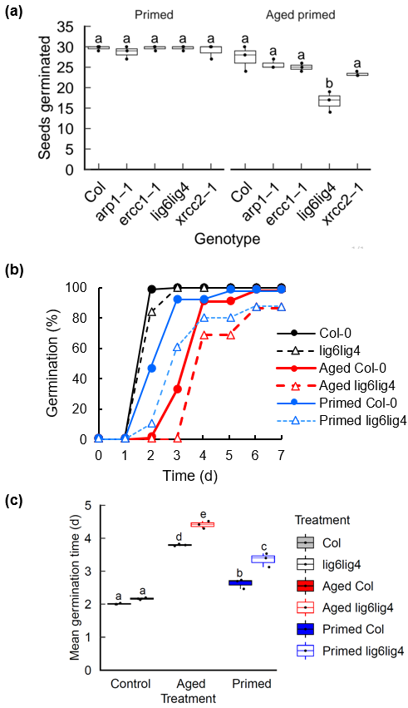

**Figure 1. Germination analysis of primed wild type and DNA repair mutant seeds.** Seeds were stratified at 4 °C for 2 d before transfer to 23 °C 16-h day and scored for radicle emergence each day post-stratification **(a)** Seeds of WT and DNA repair mutant lines were primed for 48h with -0.75 MPa PEG6000 before drying. Germination of primed Col-0 and mutant primed seed was analysed before and after accelerated aging at 35 °C and 83% RH for 7 days. **(b)** Germination profiles of Col-0 and *lig6lig4* mutant lines, showing control (unaged) seeds, seed lots naturally aged for 10 years and aged seed lots subjected to priming. Data for control and aged seeds was previously published in Waterworth and West (2023) **(c)** Mean germination time of Col-0 and *lig6lig4* mutant lines. Letters denote homogeneous subsets (p<0.01, ANOVA with Tukey correction). Error bars represent the SEM of the mean of three replicates of 30 seeds. Wild type: filled boxes; *lig6lig4* mutants: unfilled boxes.

Transcriptomic analysis of wild type and *lig6lig4* mutant seed lots was conducted to determine the gene expression patterns associated with the loss of germination vigour after seed ageing and recovery after seed priming. For each of the three treatments (control, aged and primed aged seeds), both dry seeds and seeds imbibed for 6h were analysed, producing six treatments for each genotype (Col-0 and *lig6lig4*) in three replicates (Figure 2a). The 6h imbibition time point was selected for analysis as the transcriptional DNA damage response is activated early in Arabidopsis seed germination, around the reinitiation of cellular metabolism upon rehydration and peaks at 6h (Waterworth *et al.*, 2010). Principal component analysis identified small differences between Col-0 and *lig6lig4* mutants. Most variation in expression was observed upon seed imbibition and after priming (PC1, Figure 2b,c). Seed ageing resulted in significant differences to control seeds in RNA expression profile upon seed imbibition (Figure. 2c: PC2). Notably, priming was able to partially reverse this ageing-related profile, such that the subsequent imbibition of primed seeds resulted in gene expression profiles similar to those of high quality, unaged seed lots. This demonstrates that the beneficial effects of seed priming on germination vigour are reflected at the transcriptional level, whereby priming alters the transcriptional profile of imbibed aged seeds to one more comparable to imbibed unaged seeds (Figure 2). The large changes in gene expression in imbibed seeds (Figure 2b) was previously shown to be a combination of the turnover of transcripts associated with seed maturation together with a rapid *de novo* synthesis of genes involved in germination (Nakabayashi *et al.*, 2005). The transcriptional profiles associated with progression through germination was assessed using gene set enrichment analysis (GSEA) (Subramanian *et al.*, 2005). Sets of genes displaying high expression at specific time points in germination were identified using a previously published time course of gene expression 0-24h after the onset of Arabidopsis seed imbibition (Nakabayashi *et al.*, 2005) (Table S2). Here, analysis of differentially expressed genes in imbibed Col-0, relative to dry seeds, found enrichment of 3h imbibition genes in all samples (Figure 2d). However, 6h imbibition genes were only identified in imbibed unaged and imbibed primed seed samples and were not significantly enriched in imbibed aged seeds (Figure 2d). This is consistent with the delayed germination of aged seeds, reflected in a delayed profile of gene expression after seed imbibition. Similarly, analysis of genes that display reduced transcript levels following seed imbibition found evidence of delayed mRNA turnover in aged seeds which was largely restored by priming treatments (Figure 2d). Taken together, this data indicates that naturally aged seeds displayed delayed germination that is also reflected at the transcriptional level, but also reveals specific transcriptional responses to seed ageing, distinct from the normal imbibition transcriptional programme. Furthermore, seed priming reverses the effects of seed ageing, restoring transcriptional profiles closer to those of unaged, control seed lots.

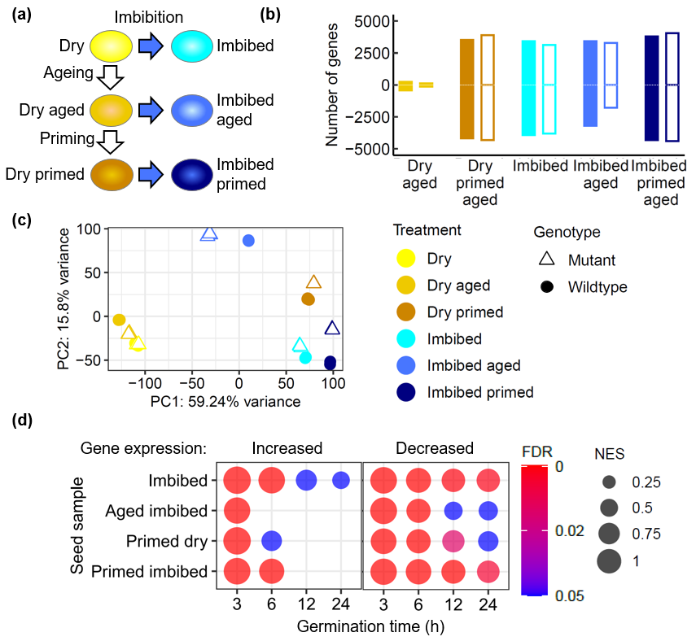**Figure 2. Analysis of gene expression during priming of naturally aged *lig6lig4* mutant seeds. (a)** Outline of samples used in the analysis. Each treatment was repeated in triplicate for both wild type and *lig6lig4* mutant lines. **(b)** Numbers of differentially expressed genes relative to dry control Col-0 seeds for each of the treatments. **(c)** Principal component analysis of gene expression levels in each of the samples of wild type (Col-0) and mutant (*lig6lig4*) including dry seeds (control and naturally aged seed before and after priming) and 6h imbibed seeds (control and naturally aged seed before and after priming) **(d)** Expression of genes associated with germination progression in each sample was assayed using gene set enrichment analysis in Col-0. Normalised enrichment score (NES) is plotted as point size and the adjusted p value (false discovery rate) is plotted by colour. Wild type: filled symbols; *lig6lig4* mutants: unfilled symbols.

## Transcriptional responses to seed ageing

Seed longevity is complex quantitative agriculture trait which is determined by the interaction of multiple genetic and environmental factors (Zinsmeister *et al.*, 2020). Previous studies have analysed transcriptional responses to seed ageing in pea, rice and Arabidopsis employing accelerated ageing protocols widely used to simulate natural seed deterioration (Chen *et al.*, 2013, Wang *et al.*, 2022, Taylor *et al.*, 2023). However, the biochemical mechanisms of seed ageing under conventional storage conditions may differ from those of accelerated ageing methodologies that use elevated temperature and humidity (Hay *et al.*, 2019). Here we analysed the transcriptomes of Arabidopsis seeds naturally aged over a 10 year period in ambient, dry-storage conditions, which were previously reported to display a two-fold reduction in germination vigour (p<0.001) but no significant change in viability (p>0.05) (Figure 1b,c; (Waterworth and West, 2023)). RNAseq analysis revealed that dry seeds displayed relatively few differences in gene expression between aged and control seed lots (Figure 2b, Table S3), with genes with higher expression in aged seeds enriched in oxidoreductase activity and reduced expression of ribosomal protein genes (Supporting Information Figure S2,3). Imbibition of control (unaged) seeds or aged seeds resulted in large changes in gene expression (Figure 2b; Supporting Information Tables S4,5). Genes with increased expression in control unaged seeds at 6h imbibition were enriched in translation and metabolic factors, reflecting the rapid resumption of cellular activity on imbibition (Liew *et al.*, 2024, Gran *et al.*, 2025), whereas aged seeds displayed distinct changes in gene expression (Figure 3a, Supporting Information Figure S4,5). In both control and aged seed lots, decreased expression of photosynthesis transcripts revealed turnover of transcripts remaining after seed maturation (Supporting Information Figure S6,7). The transcriptional differences between aged and unaged Col-0 seeds were much larger after imbibition compared to differences in the dry seed, with over six thousand genes differentially expressed between imbibed aged seeds and imbibed controls (Supporting Information Table S6; Figure S8,9). The transcriptional response associated with seed ageing was analysed by identifying those genes with increased expression after imbibition of aged seeds which displayed significantly higher expression levels than imbibed control seeds, referred to as ‘ageing-specific’ in Figure 3a. These genes were enriched in hypoxia related transcripts (GO term 0071456, Supporting Information Figure S10,11). In addition to hypoxia-related genes, wild type imbibed aged seeds displayed significant enrichment in glutathione transferase (GST) gene expression (Figure 3a), which was also observed in the *lig6lig4* mutant line (Figure 3b). The increased expression of GST genes in response to ageing was confirmed by qPCR (Figure 3c) and is in line with a previous study reporting increased *GSTU22* expression in aged seeds (Kimura and Nambara, 2010).

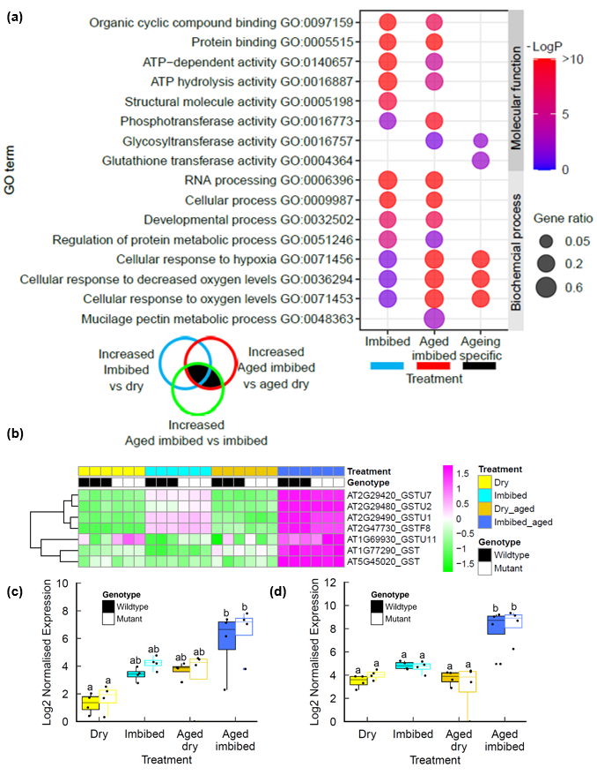

**Figure 3. Transcriptional profiles of seed ageing in naturally aged seeds. (a)** Ontology enrichment in genes differentially expressed in aged Col-0 seeds **(b)** Heatmap of Glutathione S transferase genes in naturally aged Col-0 and *lig6lig4* mutant seeds. **(c)** qPCR of *GSTU2* expression in seeds. **(d)** qPCR of *GSTU7* expression in seeds. Letters denote homogeneous subsets (p<0.01, ANOVA with Tukey correction). Wild type: filled boxes; *lig6lig4* mutants: unfilled boxes.

## Osmopriming is associated with elevated expression of proteasome components

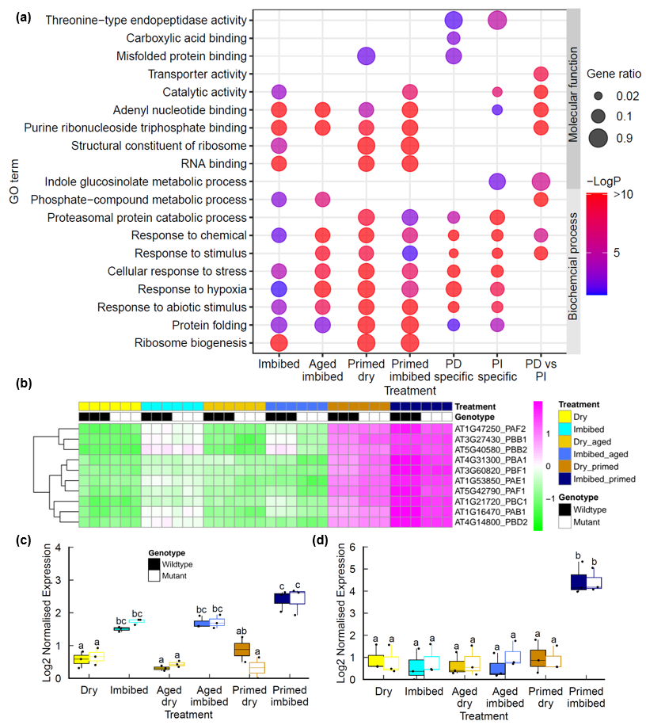Our findings indicated that the loss of germination vigour exhibited by the aged seed lots (i.e. slower and less synchronous germination) can be reversed by seed priming treatment (Figure 1b,c). Primed seed lots of many species display reduced longevity, although the molecular basis for this remains unclear (Fabrissin *et al.*, 2021b, Gran *et al.*, 2025). Work in our lab and others has shown the chromosomal breaks contribute to loss of germination vigour (Waterworth *et al.*, 2022) and base damage has also been implicated (Macovei *et al.*, 2011, Chen *et al.*, 2012, Cordoba-Canero *et al.*, 2014, Macovei *et al.*, 2017). Here we conducted RNAseq to determine the transcriptional changes associated with seed priming in wild type and DSB repair mutants to gain insight into the cellular stresses associated with the controlled hydration of the priming process and subsequent dry back / imbibition cycle. Priming resulted in large changes in gene expression in both the dry primed seed and imbibed seeds (Figure 2c, Supporting Information Table S7,8). As with imbibition, osmopriming is associated with a large hypoxia response and increased expression of ribosome biogenesis factors (Figure 4a), which surprisingly contrasts with the reduced hypoxia response in hydroprimed seeds (Gran *et al.*, 2025). Large differences are observed in the transcriptional profile of primed seeds compared to imbibed seeds, with significant increases in components of proteasomal protein catabolic processes in both primed dry and primed imbibed seeds (Figure 4a) which was confirmed by qPCR (Figure 4c,d). Proteasome components can be induced by a range of cellular stresses including drought and pathogen infection (Xu *et al.*, 2024) and is involved in modulating ABA-mediated signalling through degradation of the proteasome component PDE1 (Han *et al.*, 2019).

**Figure 4. Transcriptional profiles of seed priming of naturally aged seeds. (a)** Ontology enrichment in genes differentially expressed in primed Col-0 seeds **(b)** Heatmap of endopeptidase genes in naturally aged Col-0 and *lig6lig4* mutant seeds. **(c)** qPCR of *PDD1* expression in seeds. **(d)** qPCR of *PDE2* expression in seeds. Letters denote homogeneous subsets (p<0.01, ANOVA with Tukey correction). Wild type: filled boxes; *lig6lig4* mutants: unfilled boxes.

## Analysis of DSB responses in primed wild type and *lig6lig4* mutant seeds

The *lig6lig4* mutant is deficient in the repair of DSBs and deficiency in both LIG6 and LIG4 results in an additive hypersensitivity to seed ageing, consistent with functions of each DNA ligase specific pathways of end joining (Waterworth *et al.*, 2010). The decreased longevity of aged and primed *lig6lig4* mutant seeds (Figure 1) implicates the induction of chromosomal breaks as a factor in the reduced storability of primed seeds. Here, the transcriptional profile across the different seed treatments was compared between wild type and *lig6lig4* mutant seeds using gene ontology enrichment analysis of DEGs. The transcriptional DNA damage response (DDR) to chromosomal breaks is under control of Ataxia-telangiectasia (ATM) (Culligan *et al.*, 2006) and distinct to the induction of other repair pathways. The DSB-DDR is observed early in seed imbibition, even in high vigour seeds (Waterworth *et al.*, 2010, Sincinelli *et al.*, 2025). Dry, imbibed and primed imbibed *lig6lig4* mutant seeds displayed elevated expression of genes associated with cellular response to stress, DNA repair and DNA metabolism, relative to Col-0 (Figure 5a, Supporting Information Table S9-13). This is consistent with previous reports that *ku80* mutants displayed constitutive activation of the DDR (West *et al.*, 2004). These GO categories are significantly upregulated in primed *lig6lig4* mutant after imbibition (Figure 5a), consistent with increased chromosomal breaks associated with priming. The transcriptional DNA damage response was further analysed using DSB-DDR gene set enrichment analysis (GSEA) in pairwise comparisons of each treatment relative to dry Col-0 seeds. The DDR gene set consisted of the top 22 DNA repair factors that were identified in the Arabidopsis response to gamma irradiation (Culligan *et al.*, 2006). Both wild type and *lig6lig4* mutants display significant enrichment in DDR gene expression in imbibed seeds of unaged, aged and primed seeds (Figure 5b; FDR<0.001), consistent with the presence of chromosomal breaks upon seed hydration and priming. DDR activation was further analysed in wild type and *lig6lig6* mutants, focussing on expression of the top four most inducible DNA repair genes (*RAD51*, *XRI1*, *PARP2* and *BRCA1*; (Culligan *et al.*, 2006)). This further supported that increased genome stress is associated with priming, with an elevated DDR in primed seeds, especially in the *lig6lig4* mutant (Figure 5c). For example, expression of *RAD51*, a gene required for DSB repair, in wild type seeds is induced 17-fold upon imbibition, but this value increases to ~30-fold in primed seeds and 150-fold in primed dry *lig6lig4* mutant seeds. The DDR activation identified in the RNAseq data was confirmed by qPCR (Figure 5d,e), highlighting the high levels of genome stress in primed seeds. The elevated DNA damage response in primed *lig6lig4* mutant seed is consistent with significant levels of chromosomal breaks and loss of longevity in primed DSB repair mutants (Figure 1a). This was further investigated though analysis of cell death in germinated seeds from different treatments.

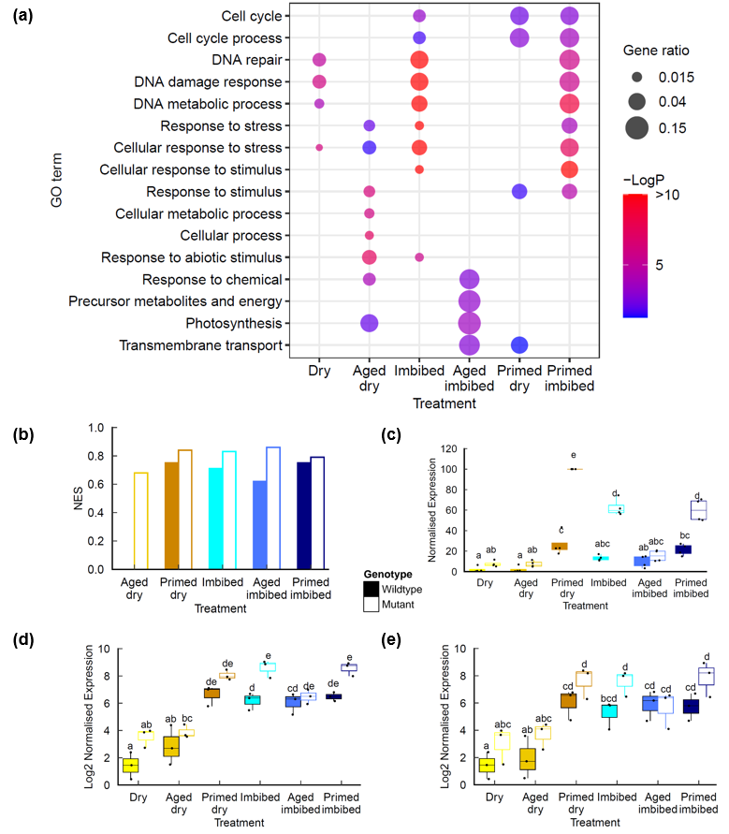

**Figure 5. Transcriptional profiles in during priming of naturally aged Col-0 and** ***lig6lig4* mutant seeds (a)** Ontology enrichment in genes differentially expressed in *lig6lig4* seeds relative to Col-0 **(b)** DDR Gene set enrichment analysis comparing each treatment to Col-0 dry seed expression values. NES values shown for samples that are display significant DDR gene expression enrichment (FDR<0.01) **(c)** DDR gene expression in naturally aged Col-0 and *lig6lig4* mutant seeds. Normalised expression of the top four inducible DDR genes (*BRCA1, XRI, PARP2, RAD51*) are shown **(d)** qPCR of RAD51 expression in seeds. **(e)** qPCR of *XRI* expression in seeds. Letters denote homogeneous subsets (p<0.01, ANOVA with Tukey correction). Wild type: filled boxes; *lig6lig4* mutants: unfilled boxes.

## Increased programmed cell death in primed *lig6lig4* DNA ligase mutant seed.

A hallmark of the plant response to chromosomal breaks is SOG1-dependent programmed cell death (PCD) in stem cell initials which eliminates cells with compromised genomes (Fulcher and Sablowski, 2009). Previously, we identified that SOG1 induces PCD in the root apical meristem (RAM) in germinated aged seeds, indicative of increased genome damage (Waterworth *et al.*, 2022). We therefore investigated the effects of priming on PCD in the RAM of wild type and *lig6lig4* mutant seeds using propidium iodide staining of recently harvested and naturally aged seed lots (2012) (Figure 6). We observed significantly higher incidence of cells undergoing PCD in aged *lig6lig4* seeds, as previously published (Waterworth *et al.* 2022). However, although germination vigour is significantly improved by priming treatment (Fig1b), PCD is notably exacerbated in primed aged *lig6lig4* mutant seed (Figure 6b). This is indicative that seed priming is associated with marked increase in genome stress including DSBs, providing further support that the accumulation of DSBs contributes to the decreased longevity of primed seed.

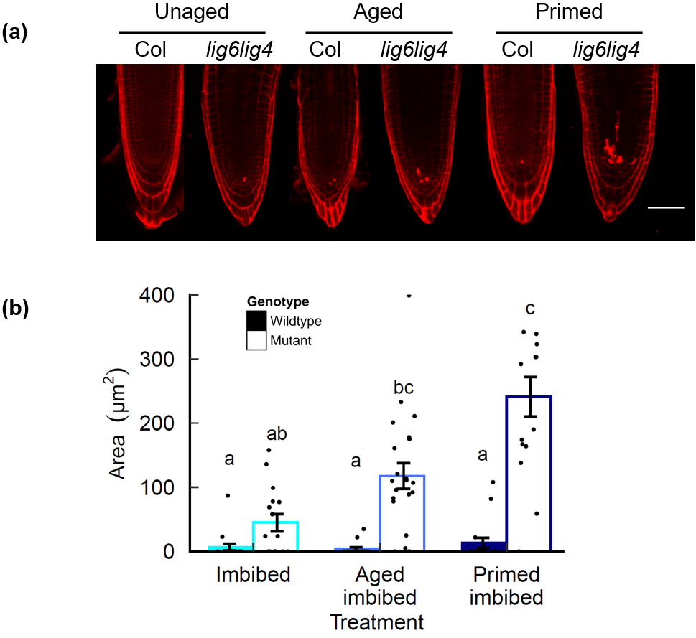

**Figure 6.** **Programmed cell death (PCD) after priming of naturally aged *lig6lig4* mutant seed.** Germination of unaged control, aged and primed aged wild type and *lig6lig4* mutant seed. Seeds were stratified at 4 °C for 2 d before transfer to 23 °C 16-h day and scored for radicle emergence each day post-stratification. PCD in wild-type and DNA repair mutant seed was analysed by viability staining. (a) Confocal images of roots stained with propidium iodide. Bar is 50 μm (b) quantification of PI staining. PCD was quantified as the area of cell death in unaged control, aged and primed aged seeds. Control (unaged) seeds; Aged: seeds aged for 10 days at 35°C and 83 % RH; Primed: aged seeds primed for 2d. Significance groups are indicated by letters (P < 0.05, n > 10 per treatment, Kruskal–Wallis with Bonferroni post hoc correction for multiple tests) and data points represent PCD area of individual roots. Wild type: filled columns; *lig6lig4* mutants: unfilled columns.

## *LIG6* overexpression improves germination vigour and longevity of primed seed

Our data indicates that LIG4 and LIG6 are key determinants of seed longevity post-priming, indicative of a requirement for genome maintenance in primed seeds. Deficiency in chromosomal break repair resulted in an elevated transcriptional DDR and increased incidence of PCD in the RAM in primed *lig4lig6* mutant seed (Figure 5, 6). To investigate the potential of LIG6 overexpression to enhance seed germination vigour and longevity after priming, we generated a series of *35S:LIG6* transgenic lines with elevated levels of *LIG6* expression. LIG6 overexpression lines exhibited reduced MTG (improved seed vigour) relative to wild type after accelerated ageing for 7 day at 35 °C and 83% RH (Figure 7a). Primed seed of *35S:LIG6* transgenic lines additionally exhibited enhanced seed longevity, revealed by accelerated ageing of primed wild type and overexpression lines (Figure 7a, b). The resistance to seed ageing of lines with elevated levels of *LIG6* coincided with a reduced transcriptional DDR (Supporting Information Figure S12). This further confirms the role of LIG6 in longevity of primed seed and indicates the potential for using genetic approaches to improve seed longevity after priming treatments.

**Figure 7. *LIG6* overexpression improves germination vigour and longevity of primed seed.** Germination performance of transgenic *35S:LIG6* lines of Arabidopsis with increased expression of *LIG6* relative to wild type lines. (a) Viability of control wild type and *35S:LIG6* lines showing control, aged, primed and aged primed seed lots (aged after priming) (b) Mean germination time of control wild type and *35S:LIG6* lines showing control, aged, primed and aged primed seed lots. Accelerated ageing was performed at 35 °C and 83% RH and priming was with -0.75MPa PEG6000 for 48h. Seeds were stratified at 4 °C for 2 d before transfer to 23 °C 16-h day and scored for radicle emergence each day post-stratification. Error bars represent the SEM of the mean of three replicates of 30 seeds. Data were analysed by ANOVA with Tukey’s post hoc correction for multiple testing (P < 0.05) to compare genotypes within each treatment.

# Discussion

Germination performance and seedling establishment are routinely improved in many crop species by priming pre-treatment of seeds, in which controlled hydration activates pre-germinative processes without completion of germination. However, seed longevity is reduced in primed seeds of many species, although the molecular basis for this remains obscure (Pagano *et al.*, 2023). Here, RNAseq analysis of naturally aged and osmoprimed Arabidopsis wild type and *lig6lig4* mutant seed lots revealed a transcriptome shift in aged seeds upon imbibition that was largely reversed by seed priming, leading to an imbibition transcriptome similar to their unaged counterparts. Furthermore, this study establishes the importance of DSB repair to these processes, with activation of the transcriptional response to chromosomal breaks in wild type and *lig6lig4* mutant seed, together with increased programmed cell death (PCD) in the primed DSB repair mutants. This is indicative of DSBs arising during priming, consistent with genome damage being a causative factor of the reduced longevity of primed seeds. Moreover, transgenic lines with enhanced expression of *LIG6* showed increased resistance to accelerated ageing of primed seed. Collectively this data provides the molecular basis for the reduced longevity of primed seed, indicating that loss of longevity in primed seeds is linked to exacerbation of DSBs in primed seed and establishing the genetic requirement for DNA ligases to promote seed viability.

The genetic factors that underlie seed longevity remain incompletely understood, despite the fundamental importance to world agriculture and international germplasm conservation in seed banks (Macovei *et al.*, 2017). Seed vigour and longevity are complex agronomic traits, integrating genetic, biochemical, biophysical and environmental factors including hormone signalling, anti-oxidant systems, cell wall permeability and maintenance of biological macromolecules (Fleming *et al.*, 2019, Zinsmeister *et al.*, 2020, Arif *et al.*, 2022). Genetic approaches in Arabidopsis and other plants have identified a number of processes that contribute to seed longevity including factors that protect the major cellular macromolecules, including proteins, nucleic acids and membranes (Sano *et al.*, 2016, Zinsmeister *et al.*, 2020, Waterworth *et al.*, 2024). Here we show that seed ageing under ambient conditions is accompanied by the transcriptional induction of GST factors, as observed in a number of environmental stress responses and previously shown to be important for seed viability. GSTs are a large gene family in plants and animals, with specific sub-families found in vascular plants including tau and phi GSTs and have a range of different substrates and activities. These include detoxification (e.g. herbicides) and glutathione peroxidase activity to reduce organic hydroperoxides of fatty acids and nucleic acids to the corresponding monohydroxyalcohols, conferring oxidative-stress tolerance (Labrou *et al.*, 2015). GSTs may also function in stress tolerance through a role in cell signalling and some GSTs are highly induced by oxidative stress. Previously, functional roles for GSTU7 were found in seeds, where mutants displayed loss of viability under conditions of oxidative stress (Wu *et al.*, 2020), indicating essential roles of GSTs in supporting seed germination.

Aged seeds also displayed increased expression of hypoxia related genes. A low oxygen response in imbibed seeds was previously reported in Arabidopsis (Liew *et al.*, 2024), with a greater response observed in aged seeds, dependent on the WHIRLY1 and WHIRLY3 transcription factors (Taylor *et al.*, 2023). Oxygen levels are sensed by the N-end rule pathway, whereby oxidation of the amino-terminal cysteine of group VII Ethylene Response Factor transcription factors (ERFVIIs) results in their degradation in a pathway mediated by ARGINYL TRANSFERASES (ATEs) and the E3 ligase PROTEOLYSIS 6 (PRT6). This pathway can also mediate abiotic stress signalling by NO, which, like oxygen, can react with the ERFVII N-terminus (Vicente *et al.*, 2017). Plants lacking PRT6 or ATEs have stabilised ERFVII and a constitutive hypoxia response (Gibbs *et al.*, 2011) including elevated expression of 201 genes in the mutants, 45 of which have the hypoxia-response GO term GO:0071456. Surprisingly, analysis of the expression of these 45 N-end rule hypoxia genes in seeds found varied expression across the treatments, some displaying high expression in aged imbibed seeds, imbibed seeds or dry seeds (Supporting Information Figure S13). This indicates that the expression of ERFVII-hypoxia responsive genes is differentially regulated in response to the different stresses incurred in seeds and may not simply reflect a state of hypoxia. Seed ageing also resulted in increased genome stress, revealed by the increased PCD in *lig6lig4* mutants (Figure 6).

Primed *lig6lig4* DSB repairmutants display significant hypersensitivity to ageing and exhibit an increased transcriptional DDR and PCD after priming, whilst overexpression of LIG6 confers resistance to ageing to primed seed. Taken together this is consistent with priming exacerbating the formation of chromosomal breaks, resulting in reduced longevity which is mitigated by the activity of DNA ligases in wild type seeds. However, priming has beneficial effects on germination vigour in the short term. Our transcriptomic analysis of naturally aged wild type and *lig6lig4* mutants seed revealed that priming reduced ageing-associated transcript levels, and gene expression profiles of primed seeds displayed greater similarity to those of unaged imbibed seeds. This is in line with activation of pre-germinative metabolism during priming, reversing the cellular effects of ageing and provides an explanation at the transcriptional level for the improvement germination vigour observed in primed crop species. However, gene expression during imbibition of primed and control seeds displayed key differences, for example in the expression of proteasome factors, indicative of high levels of protein turnover in primed seeds. Furthermore, a large ATM-dependent transcriptional DNA damage response was observed in primed seeds, both in the primed seed after drying back and upon re-imbibition, indicative that high levels of chromosomal breaks associated with priming. This observation is further supported by an increase in PCD in the root apical meristem of primed *lig6lig4* seeds post-germination. Current understanding of the molecular basis of the associated loss of seed longevity remains limited and the increased genome stress was surprising, given that restoration of genome integrity by repair processes is observed during priming as shown in leek (*Allium porrum* L.) seeds (Ashraf and Bray, 1993, vanPijlen *et al.*, 1996), with nuclear replicative DNA synthesis and cell cycle progression occurring post-priming. Repair activities would be expected to reduce genome stress responses in primed seeds, in contrast to the findings of our RNAseq, qPCR and PCD analysis. Our results extend previous reports demonstrating increased expression of base excision repair factors in primed and over-primed seeds (Forti *et al.*, 2020, Pagano *et al.*, 2022, Pagano *et al.*, 2023). We show that priming activates the canonical transcriptional DDR, previously demonstrated to be a product of ATM-SOG1 signalling in response to DSBs (Culligan *et al.*, 2006). The increased genome stress, indicative of DSBs in primed seeds, may arise from partial loss of desiccation tolerance, for example through activation of DNA replication origins and initiation of S-phase, or loss of genome protection factors, as found in some other desiccation tolerant species (Karssen *et al.*, 1990, Chavez *et al.*, 2019). During priming cells of the root tip of tomato embryos progress from the G1 phase of the cell cycle into G2 via a round of replicative DNA synthesis but cell division is not observed (Bino *et al.*, 1992, DawidowiczGrzegorzewska, 1997, de Castro *et al.*, 2000). This is consistent with cell cycle activity contributing to the advancement of germination in primed seeds, but potentially leading increased levels of genome stress and contributing to the reduced longevity observed in many species (Fabrissin *et al.*, 2021a). Priming therefore leads to an increased requirement for DNA repair activities in the recovery from extensive genome damage incurred by desiccation and seed ageing (Waterworth *et al.*, 2010). Furthermore, we show increased proteasome transcript levels in primed seeds. The proteasome regulates cellular signalling, including ABA pathways through turnover of ABI5. Reduced ABA signalling in primed seeds has the potential to reduce any residual dormancy but also decrease desiccation tolerance and longevity, given ABA’s central role in protecting seeds during maturation drying (Zinsmeister *et al.*, 2020).

The advancement of germination conferred by priming may also arise through storage protein mobilisation, endosperm weakening and DNA repair synthesis, as identified in a number of priming studies (Capron *et al.*, 2007, Waterworth *et al.*, 2015). In addition, stress responses have been associated with vigour improvement in primed seeds, including upregulation of heat shock factors in tomato (Barbosa Batista *et al.*, 2020), and more recently an attenuation of stress responses in Arabidopsis (Gran *et al.*, 2025). The advancement of germination conferred by hydropriming results in enhanced translation capacity as stored mRNAs are recruited to ribosomes, revealed by polysome profiling (Gran *et al.*, 2025). In natural ecosystems in temperate wet climates, seeds of wild species can exist in the soil seed bank for several years, undergoing multiple wet-dry cycles. Priming-like activities may therefore effectively occur in the soil seed bank and lead to a requirement for DNA repair pathways to prolong seed longevity (Sano, 2025). Seed priming provides a low-cost, low technology approach which can improve crop yields through improved germination and seedling vigour without a requirement for genetic improvement by plant breeding or gene editing approaches. As such, optimisation of seed priming represents a powerful approach to improve crop yields and stress resistance under changing climates.

## Acknowledgements

The financial support was provided from the UK Biotechnology and Biological Sciences Research Council grant numbers BB/Y010426/1 and BB/S002081/1 to W.M.W. and C.E.W. DW is supported by the Taishan Scholars Program of Shandong Province (tsqn202312110) and the Fundamental Research Funds for the Central Universities (25CX06001A). We thank George Bassel for providing the normalised Nakabayashi dataset (Bassel *et al.*, 2008).

## Competing interests

The authors declare no conflict of interest.

## Author contributions

WMW, DW and CEW planned and designed the research. WMW, DW and LSD performed experiments and analyzed data. WMW, DW, LSD and CEW wrote the manuscript. WMW and DW contributed equally.

## Data Availability

The data that support the findings of this study are openly available in National Center for Biotechnology (NCBI) Information Sequence Read Archive (SRA) at https://www.ncbi.nlm.nih.gov/sra, reference number PRJNA875594.

# References

**Arif, M.A.R., Afzal, I. and Borner, A.** (2022) Genetic Aspects and Molecular Causes of Seed Longevity in Plants-A Review. *Plants (Basel)*, **11**.

**Ashraf, M. and Bray, C.M.** (1993) DNA synthesis in osmoprimed leek (*Allium porrum* L.) seeds and evidence for repair and replication. *Seed Science Research*, **3**, 15-23.

**Barbosa Batista, T., Javier Fernandez, G., Alexandre da Silva, T., Maia, J. and Amaral da Silva, E.A.** (2020) Transcriptome analysis in osmo-primed tomato seeds with enhanced longevity by heat shock treatment. *AoB PLANTS*, **12**.

**Bassel, G.W., Fung, P., Chow, T.F., Foong, J.A., Provart, N.J. and Cutler, S.R.** (2008) Elucidating the germination transcriptional program using small molecules. *Plant Physiol*, **147**, 143-155.

**Bewley, J.D.** (1997) Seed Germination and Dormancy. *Plant Cell*, **9**, 1055-1066.

**Bino, R.J., Devries, J.N., Kraak, H.L. and Vanpijlen, J.G.** (1992) Flow Cytometric Determination of Nuclear Replication Stages in Tomato Seeds during Priming and Germination. *Ann Bot-London*, **69**, 231-236.

**Capron, I., Corbineau, F., Dacher, F., Job, C., Côme, D. and Job, D.** (2007) Sugarbeet seed priming: effects of priming conditions on germination, solubilization of 11-S globulin and accumulation of LEA proteins. *Seed Science Research*, **10**, 243-254.

**Chavez, C., Cruz-Becerra, G., Fei, J., Kassavetis, G.A. and Kadonaga, J.T.** (2019) The tardigrade damage suppressor protein binds to nucleosomes and protects DNA from hydroxyl radicals. *eLife*, **8**, e47682.

**Chen, H., Chu, P., Zhou, Y., Li, Y., Liu, J., Ding, Y., Tsang, E.W.T., Jiang, L., Wu, K. and Huang, S.** (2012) Overexpression of AtOGG1, a DNA glycosylase/AP lyase, enhances seed longevity and abiotic stress tolerance in Arabidopsis. *Journal of Experimental Botany*, **63**, 4107-4121.

**Chen, H., Osuna, D., Colville, L., Lorenzo, O., Graeber, K., Kuster, H., Leubner-Metzger, G. and Kranner, I.** (2013) Transcriptome-wide mapping of pea seed ageing reveals a pivotal role for genes related to oxidative stress and programmed cell death. *PLoS One*, **8**, e78471.

**Cordoba-Canero, D., Roldan-Arjona, T. and Ariza, R.R.** (2014) Arabidopsis ZDP DNA 3'-phosphatase and ARP endonuclease function in 8-oxoG repair initiated by FPG and OGG1 DNA glycosylases. *Plant J*, **79**, 824-834.

**Culligan, K.M., Robertson, C.E., Foreman, J., Doerner, P. and Britt, A.B.** (2006) ATR and ATM play both distinct and additive roles in response to ionizing radiation. *Plant J*, **48**, 947-961.

**DawidowiczGrzegorzewska, A.** (1997) Ultrastructure of carrot seeds during matriconditioning with Micro-Cel E. *Ann Bot-London*, **79**, 535-545.

**de Castro, R.D., van Lammeren, A.A.M., Groot, S.P.C., Bino, R.J. and Hilhorst, H.W.M.** (2000) Cell division and subsequent radicle protrusion in tomato seeds are inhibited by osmotic stress but DNA synthesis and formation of microtubular cytoskeleton are not. *Plant Physiology*, **122**, 327-335.

**Dekkers, B.J., Costa, M.C., Maia, J., Bentsink, L., Ligterink, W. and Hilhorst, H.W.** (2015) Acquisition and loss of desiccation tolerance in seeds: from experimental model to biological relevance. *Planta*, **241**, 563-577.

**Dobin, A., Davis, C.A., Schlesinger, F., Drenkow, J., Zaleski, C., Jha, S., Batut, P., Chaisson, M. and Gingeras, T.R.** (2013) STAR: ultrafast universal RNA-seq aligner. *Bioinformatics*, **29**, 15-21.

**Fabrissin, I., Sano, N., Seo, M. and North, H.M.** (2021a) Ageing beautifully: can the benefits of seed priming be separated from a reduced lifespan trade-off? *J Exp Bot*, **72**, 2312-2333.

**Fabrissin, I., Sano, N., Seo, M. and North, H.M.** (2021b) Ageing beautifully: can the benefits of seed priming be separated from a reduced lifespan trade-off? *Journal of Experimental Botany*, **72**, 2312-2333.

**Finch-Savage, W.E. and Bassel, G.W.** (2016) Seed vigour and crop establishment: extending performance beyond adaptation. *J Exp Bot*, **67**, 567-591.

**Fleming, M.B., Hill, L.M. and Walters, C.** (2019) The kinetics of ageing in dry-stored seeds: a comparison of viability loss and RNA degradation in unique legacy seed collections. *Ann Bot*, **123**, 1133-1146.

**Forti, C., Shankar, A., Singh, A., Balestrazzi, A., Prasad, V. and Macovei, A.** (2020) Hydropriming and Biopriming Improve Medicago truncatula Seed Germination and Upregulate DNA Repair and Antioxidant Genes. *Genes (Basel)*, **11**.

**Fulcher, N. and Sablowski, R.** (2009) Hypersensitivity to DNA damage in plant stem cell niches. *Proc Natl Acad Sci U S A*, **106**, 20984-20988.

**Gibbs, D.J., Lee, S.C., Isa, N.M., Gramuglia, S., Fukao, T., Bassel, G.W., Correia, C.S., Corbineau, F., Theodoulou, F.L., Bailey-Serres, J. and Holdsworth, M.J.** (2011) Homeostatic response to hypoxia is regulated by the N-end rule pathway in plants. *Nature*, **479**, 415-418.

**Gran, P., Visscher, T.W., Bai, B., Nijveen, H., Mahboubi, A., Bakermans, L.L., Willems, L.A.J. and Bentsink, L.** (2025) Unravelling the dynamics of seed-stored mRNAs during seed priming. *New Phytol*.

**Han, J.J., Yang, X., Wang, Q., Tang, L., Yu, F., Huang, X., Wang, Y., Liu, J.X. and Xie, Q.** (2019) The beta5 subunit is essential for intact 26S proteasome assembly to specifically promote plant autotrophic growth under salt stress. *New Phytol*, **221**, 1359-1368.

**Hay, F.R., Valdez, R., Lee, J.S. and Sta Cruz, P.C.** (2019) Seed longevity phenotyping: recommendations on research methodology. *J Exp Bot*, **70**, 425-434.

**Heydecker, W., Higgins, J. and Gulliver, R.L.** (1973) Accelerated Germination by Osmotic Seed Treatment. *Nature*, **246**, 42-44.

**Howe, K.L., Contreras-Moreira, B., De Silva, N., Maslen, G., Akanni, W., Allen, J., Alvarez-Jarreta, J., Barba, M., Bolser, D.M., Cambell, L., Carbajo, M., Chakiachvili, M., Christensen, M., Cummins, C., Cuzick, A., Davis, P., Fexova, S., Gall, A., George, N., Gil, L., Gupta, P., Hammond-Kosack, K.E., Haskell, E., Hunt, S.E., Jaiswal, P., Janacek, S.H., Kersey, P.J., Langridge, N., Maheswari, U., Maurel, T., McDowall, M.D., Moore, B., Muffato, M., Naamati, G., Naithani, S., Olson, A., Papatheodorou, I., Patricio, M., Paulini, M., Pedro, H., Perry, E., Preece, J., Rosello, M., Russell, M., Sitnik, V., Staines, D.M., Stein, J., Tello-Ruiz, M.K., Trevanion, S.J., Urban, M., Wei, S., Ware, D., Williams, G., Yates, A.D. and Flicek, P.** (2020) Ensembl Genomes 2020-enabling non-vertebrate genomic research. *Nucleic Acids Res*, **48**, D689-d695.

**Karssen, C.M., Haigh, A., Toorn, P. and Weges, R.** (1990) Physiological Mechanisms Involved in Seed Priming. In *Recent Advances in the Development and Germination of Seeds* (Taylorson, R.B. ed: Plenum Press. London & New York, pp. 269-280.

**Kimura, M. and Nambara, E.** (2010) Stored and neosynthesized mRNA in Arabidopsis seeds: effects of cycloheximide and controlled deterioration treatment on the resumption of transcription during imbibition. *Plant Molecular Biology*, **73**, 119-129.

**Labrou, N.E., Papageorgiou, A.C., Pavli, O. and Flemetakis, E.** (2015) Plant GSTome: structure and functional role in xenome network and plant stress response. *Curr Opin Biotechnol*, **32**, 186-194.

**Li, H., Handsaker, B., Wysoker, A., Fennell, T., Ruan, J., Homer, N., Marth, G., Abecasis, G. and Durbin, R.** (2009) The Sequence Alignment/Map format and SAMtools. *Bioinformatics*, **25**, 2078-2079.

**Liao, Y., Smyth, G.K. and Shi, W.** (2019) The R package Rsubread is easier, faster, cheaper and better for alignment and quantification of RNA sequencing reads. *Nucleic Acids Res*, **47**, e47.

**Liew, L.C., You, Y., Auroux, L., Oliva, M., Peirats-Llobet, M., Ng, S., Tamiru-Oli, M., Berkowitz, O., Hong, U.V.T., Haslem, A., Stuart, T., Ritchie, M.E., Bassel, G.W., Lister, R., Whelan, J., Gouil, Q. and Lewsey, M.G.** (2024) Establishment of single-cell transcriptional states during seed germination. *Nature Plants*, **10**, 1418-1434.

**Love, M.I., Huber, W. and Anders, S.** (2014) Moderated estimation of fold change and dispersion for RNA-seq data with DESeq2. *Genome Biol*, **15**, 550.

**Macovei, A., Balestrazzi, A., Confalonieri, M., Faé, M. and Carbonera, D.** (2011) New insights on the barrel medic MtOGG1 and MtFPG functions in relation to oxidative stress response in planta and during seed imbibition. *Plant Physiology and Biochemistry*, **49**, 1040-1050.

**Macovei, A., Pagano, A., Leonetti, P., Carbonera, D., Balestrazzi, A. and Araújo, S.S.** (2017) Systems biology and genome-wide approaches to unveil the molecular players involved in the pre-germinative metabolism: implications on seed technology traits. *Plant Cell Rep*, **36**, 669-688.

**Martin, M.** (2011) Cutadapt removes adapter sequences from high-throughput sequencing reads. *2011*, **17**, 3.

**McDonald, M.B.** (1999) Seed deterioration: physiology, repair and assessment. *Seed Science and Technology*, **27**, 177-237.

**Mootha, V.K., Lindgren, C.M., Eriksson, K.F., Subramanian, A., Sihag, S., Lehar, J., Puigserver, P., Carlsson, E., Ridderstrale, M., Laurila, E., Houstis, N., Daly, M.J., Patterson, N., Mesirov, J.P., Golub, T.R., Tamayo, P., Spiegelman, B., Lander, E.S., Hirschhorn, J.N., Altshuler, D. and Groop, L.C.** (2003) PGC-1alpha-responsive genes involved in oxidative phosphorylation are coordinately downregulated in human diabetes. *Nat Genet*, **34**, 267-273.

**Nadarajan, J., Walters, C., Pritchard, H.W., Ballesteros, D. and Colville, L.** (2023) Seed Longevity-The Evolution of Knowledge and a Conceptual Framework. *Plants (Basel)*, **12**.

**Nakabayashi, K., Okamoto, M., Koshiba, T., Kamiya, Y. and Nambara, E.** (2005) Genome-wide profiling of stored mRNA in Arabidopsis thaliana seed germination: epigenetic and genetic regulation of transcription in seed. **41**, 697-709.

**Pagano, A., Macovei, A. and Balestrazzi, A.** (2023) Molecular dynamics of seed priming at the crossroads between basic and applied research. *Plant Cell Rep*, **42**, 657-688.

**Pagano, A., Zannino, L., Pagano, P., Doria, E., Dondi, D., Macovei, A., Biggiogera, M., Araújo, S.S. and Balestrazzi, A.** (2022) Changes in genotoxic stress response, ribogenesis and PAP (3'-phosphoadenosine 5'-phosphate) levels are associated with loss of desiccation tolerance in overprimed Medicago truncatula seeds. *Plant Cell Environ*, **45**, 1457-1473.

**R_Core_Team** (2025) R: A Language and Environment for Statistical Computing.

**Rehmani, M.S., Xian, B., Wei, S., He, J., Feng, Z., Huang, H. and Shu, K.** (2023) Seedling establishment: The neglected trait in the seed longevity field. *Plant Physiol Biochem*, **200**, 107765.

**Ritchie, M.E., Phipson, B., Wu, D., Hu, Y., Law, C.W., Shi, W. and Smyth, G.K.** (2015) limma powers differential expression analyses for RNA-sequencing and microarray studies. *Nucleic Acids Res*, **43**, e47.

**Sano, N.** (2025) Priming the pump: translational dynamics from seed to seedling transition under priming treatment. *New Phytol*.

**Sano, N., Kim, J.S., Onda, Y., Nomura, T., Mochida, K., Okamoto, M. and Seo, M.** (2017) RNA-Seq using bulked recombinant inbred line populations uncovers the importance of brassinosteroid for seed longevity after priming treatments. *Sci Rep*, **7**, 8095.

**Sano, N., Rajjou, L., North, H.M., Debeaujon, I., Marion-Poll, A. and Seo, M.** (2016) Staying Alive: Molecular Aspects of Seed Longevity. *Plant Cell Physiol*, **57**, 660-674.

**Schmieder, R. and Edwards, R.** (2011) Quality control and preprocessing of metagenomic datasets. *Bioinformatics*, **27**, 863-864.

**Sincinelli, F., Gaonkar, S.S., Tondepu, S.A.G., Duenas, C.J. and Pagano, A.** (2025) Hallmarks of DNA Damage Response in Germination Across Model and Crop Species. *Genes (Basel)*, **16**.

**Subramanian, A., Tamayo, P., Mootha, V.K., Mukherjee, S., Ebert, B.L., Gillette, M.A., Paulovich, A., Pomeroy, S.L., Golub, T.R., Lander, E.S. and Mesirov, J.P.** (2005) Gene set enrichment analysis: a knowledge-based approach for interpreting genome-wide expression profiles. *Proc Natl Acad Sci U S A*, **102**, 15545-15550.

**Tarquis, A.M. and Bradford, K.J.** (1992) Prehydration and Priming Treatments That Advance Germination Also Increase the Rate of Deterioration of Lettuce Seeds. *Journal of Experimental Botany*, **43**, 307-317.

**Taylor, R.E., Waterworth, W., West, C.E. and Foyer, C.H.** (2023) WHIRLY proteins maintain seed longevity by effects on seed oxygen signalling during imbibition. *Biochem J*, **480**, 941-956.

**vanPijlen, J.G., Groot, S.P.C., Kraak, H.L., Bergervoet, J.H.W. and Bino, R.J.** (1996) Effects of pre-storage hydration treatments on germination performance, moisture content, DNA synthesis and controlled deterioration tolerance of tomato (Lycopersicon esculentum Mill) seeds. *Seed Science Research*, **6**, 57-63.

**Vicente, J., Mendiondo, G.M., Movahedi, M., Peirats-Llobet, M., Juan, Y.T., Shen, Y.Y., Dambire, C., Smart, K., Rodriguez, P.L., Charng, Y.Y., Gray, J.E. and Holdsworth, M.J.** (2017) The Cys-Arg/N-End Rule Pathway Is a General Sensor of Abiotic Stress in Flowering Plants. *Current biology : CB*, **27**, 3183-3190.e3184.

**Wang, B., Wang, S., Tang, Y., Jiang, L., He, W., Lin, Q., Yu, F. and Wang, L.** (2022) Transcriptome-Wide Characterization of Seed Aging in Rice: Identification of Specific Long-Lived mRNAs for Seed Longevity. *Frontiers in plant science*, **13**, 857390.

**Waterworth, W.M., Balobaid, A. and West, C.** (2024) Seed longevity and genome damage. *Biosci Rep*, **44**.

**Waterworth, W.M., Bray, C.M. and West, C.E.** (2015) The importance of safeguarding genome integrity in germination and seed longevity. *Journal of Experimental Botany*, **66**, 3549-3558.

**Waterworth, W.M., Footitt, S., Bray, C.M., Finch-Savage, W.E. and West, C.E.** (2016) DNA damage checkpoint kinase ATM regulates germination and maintains genome stability in seeds. *Proc Natl Acad Sci U S A*, **113**, 9647-9652.

**Waterworth, W.M., Latham, R., Wang, D., Alsharif, M. and West, C.E.** (2022) Seed DNA damage responses promote germination and growth in Arabidopsis thaliana. *Proc Natl Acad Sci U S A*, **119**, e2202172119.

**Waterworth, W.M., Masnavi, G., Bhardwaj, R.M., Jiang, Q., Bray, C.M. and West, C.E.** (2010) A plant DNA ligase is an important determinant of seed longevity. *Plant J*, **63**, 848-860.

**Waterworth, W.M. and West, C.E.** (2023) Genome damage accumulated in seed ageing leads to plant genome instability and growth inhibition. *Biochem J*, **480**, 461-470.

**West, C.E., Waterworth, W.M., Sunderland, P.A. and Bray, C.M.** (2004) Arabidopsis DNA double-strand break repair pathways. *Biochem Soc Trans*, **32**, 964-966.

**Winter, D., Vinegar, B., Nahal, H., Ammar, R., Wilson, G.V. and Provart, N.J.** (2007) An "Electronic Fluorescent Pictograph" browser for exploring and analyzing large-scale biological data sets. *PLoS One*, **2**, e718.

**Wu, J., Zhang, N., Liu, Z., Liu, S., Liu, C., Lin, J., Yang, H., Li, S. and Yukawa, Y.** (2020) The AtGSTU7 gene influences glutathione-dependent seed germination under ABA and osmotic stress in Arabidopsis. *Biochemical and Biophysical Research Communications*, **528**, 538-544.

**Xu, J., Liu, H., Zhou, C., Wang, J., Wang, J., Han, Y., Zheng, N., Zhang, M. and Li, X.** (2024) The ubiquitin-proteasome system in the plant response to abiotic stress: Potential role in crop resilience improvement. *Plant Sci*, **342**, 112035.

**Zinsmeister, J., Leprince, O. and Buitink, J.** (2020) Molecular and environmental factors regulating seed longevity. *Biochem J*, **477**, 305-323.

## Supporting Information (brief legends)

Table S1: Primers

Table S2: GSEA gene lists

Gene set enrichment gene lists (GMX file): Gene sets were identified through analysis of published germination microarray studies (Nakabayashi *et al.*, 2005) and transcriptional responses to gamma irradiation (Culligan *et al.*, 2006).

Table S3: Differentially expressed genes identified by DeSeq2: wild type dry seeds vs wild type aged dry seeds

Table S4: Differentially expressed genes identified by DeSeq2: wild type dry seeds vs wild type imbibed seeds

Table S5: Differentially expressed genes identified by DeSeq2: wild type aged dry seeds vs wild type aged imbibed seeds

Table S6: Differentially expressed genes identified by DeSeq2: wild type imbibed seeds vs wild type aged imbibed seeds

Table S7: Differentially expressed genes identified by DeSeq2: wild type dry seeds vs wild type aged primed dry seeds

Table S8: Differentially expressed genes identified by DeSeq2: wild type dry seeds vs wild type aged primed imbibed seeds

Table S9: Differentially expressed genes identified by DeSeq2: wild type dry seeds vs *lig6lig4* dry seeds

Table S10: Differentially expressed genes identified by DeSeq2: wild type aged dry seeds vs *lig6lig4* aged dry seeds

Table S11: Differentially expressed genes identified by DeSeq2: wild type aged imbibed seeds vs *lig6lig4* aged imbibed seeds

Table S12: Differentially expressed genes identified by DeSeq2: wild type primed dry seeds vs *lig6lig4* primed dry seeds

Table S13: Differentially expressed genes identified by DeSeq2: wild type primed imbibed seeds vs *lig6lig4* primed imbibed seeds

Figure S1: Frequencies of abnormal seedlings germinated from unaged, primed aged primed WT and DNA repair mutant seed (as Figure 1a). Seeds of WT and DNA repair mutant lines were primed for 48h with -0.75 MPa PEG6000 before drying. Frequency of abnormal seedlings from primed Col-0 and mutant primed seed was analysed before and after accelerated aging at 35 °C and 83% RH for 7 days.Seeds were stratified at 4 °C for 2 d before transfer to 23 °C 16-h day and seedling abnormalities were analysed in accordance with ISTA guidelines in germinated seedlings at 8 days post-stratification. Germination data of seedlots analysed is presented in Figure 1a**.** Error bars represent the SEM of the mean of three replicates of 30 seedlings.

Figure S2: Gene ontology analysis: increased in wild type dry aged seeds vs wild type dry seeds

Figure S3: Gene ontology analysis: decreased in wild type dry aged seeds vs wild type dry seeds

Figure S4: Gene ontology analysis: increased in wild type imbibed seeds vs wild type dry seeds

Figure S5: Gene ontology analysis: increased in wild type aged imbibed seeds vs wild type imbibed seeds

Figure S6: Gene ontology analysis: decreased in wild type imbibed seeds vs wild type dry seeds

Figure S7: Gene ontology analysis: decreased in wild type aged imbibed seeds vs wild type imbibed seeds

Figure S8: Gene ontology analysis: increased in wild type aged imbibed seeds vs wild type imbibed seeds

Figure S9: Gene ontology analysis: decreased in wild type aged imbibed seeds vs wild type imbibed seeds

Figure S10: Gene ontology analysis: greatest increase in wild type aged imbibed seeds

Figure S11: Gene ontology analysis: greatest decrease in wild type aged imbibed seeds

Figure S12: DDR gene expression in *DNA LIGASE 6* overexpression lines. Germination performance of transgenic *35S:LIG6* lines of Arabidopsis with increased expression of *LIG6* relative to wild type lines is presented in Figure 7. The transcriptional DDR, indicative of genome stress, is lower in seed of *DNA LIGASE 6* overexpression lines relative to WT after seed priming. qPCR analysis of (a) *RAD51* and (b) *XRI1 expression* in 0h (dry) or 6h (imbibed) seeds*.* Letters denote homogeneous subsets (p<0.01, ANOVA with Tukey correction).

Figure S13: Heatmap of hypoxia related genes. Transcript levels across wild type seed samples of the 45 ERFVII responsive genes that have the hypoxia-response GO term GO:0071456.