Assessing the affordance, equity and wellbeing implications of mobility provision, governance and operation in East African cities

Steve Cinderby¹, Nancy Abira², Rachel Pateman¹, Romanus Opiyo³, Howard Cambridge¹, Cassilde Muhoza³, Constant Cap⁴ and Sherlyne Omangi⁵
- Stockholm Environment Institute – York centre, University of York, York, UK
- Global Road Safety Facility, World Bank, Washington, USA
- Stockholm Environment Institute – Africa centre, World Agroforestry Centre, Nairobi, Kenya
- Independent Transport Researcher, Nairobi, Kenya
- Independent Transport Researcher, Nairobi, Kenya

Highlights
- Mapping of journeys effects upon wellbeing for low-income Kenyan urban residents
- Novel combination use of sensors reveals physiological and environmental mobility impacts
- Combining psychological, physiological and environmental data reveals new insights
- Results compared to new framework combining dimensions of mobility, wellbeing and inclusion
- Findings highlight need to look at overall journey experience not just infrastructure provision

Abstract

Introduction
Delivering enhanced inclusive and safe mobility choices addresses many elements of the inclusive city concept. Urban mobility is a key factor supporting health and wellbeing and is linked to infrastructure quality, governance, and individuals’ behaviours particularly in the context of dynamic rapidly changing cities. This paper investigates from a multidisciplinary perspective how the quality of urban environments interacts with mobility, health and wellbeing.

Setting
Addressing recent calls for African mobility research focussed on socio-economic equity this paper presents mixed methods research from low-income communities in two Kenyan cities.

Methods
Using combinations of participatory mapping, transect walks, subjective and physiological wellbeing measurements alongside recording of environmental conditions we consider the interactions of mobility on health and wellbeing for vulnerable travellers typically excluded from mobility planning considerations. We assess our findings in relation to a new framework combining dimensions of mobility, wellbeing and inclusion. This framework incorporates elements of physical infrastructure provision; mobility systems and governance; and the influence of other user behaviour.

Results
Our findings highlight how focussing on infrastructure provision and not overall journey experiences could result in investments that do not support healthy mobility choices. Collecting better (spatially explicit) environmental measurements and diverse wellbeing data would enable decision makers to understand existing environments more holistically to identify the most appropriate mobility investments. Overall, the framework and results forefront how inclusive and equitable mobility solutions that actively support people’s health and wellbeing should go beyond provision of adequate and safe infrastructure. They should include user awareness and behaviour changes that are effectively governed ensuring the benefits of any improvements are not undermined thereby risking exposing travellers to more dangerous pollution or hazardous road safety environments.

Introduction
Mobility affording environments are a key element of urban spaces that support and underpin wellbeing (Musau, Pisa and Masoumi, 2023). Supporting wellbeing is critical for urban residents -particularly the younger populations that typically characterise Low and middle-income countries (LMIC) cities (Hannon et al., 2024) -as mental health problems now account for more than 10% of the total burden of disease in adolescents, with estimates ranging from 12% to 15% (World Health Organization (WHO), no date; Liu et al., 2022). While definitions may vary, environments that support wellbeing are generally characterised by their ability to promote mental health, enable individuals to realise their potential, manage everyday stresses, work productively, and contribute to their community (WHO, 2023). Wellbeing encompasses various dimensions that collectively contribute to overall health outcomes including supporting mental health. The objective dimensions include access to basic needs resources (e.g., food, housing, and income) and social attributes (education, health, political voice, social networks) all of which may necessitate urban mobility. The subjective dimension focuses on individuals’ own life satisfaction and level of happiness (Western and Tomaszewski, 2016). Finally, there is overarching physiological wellbeing (Reyes-Riveros et al., 2021), which focuses upon ‘external tangible conditions, such as the person’s “physical state” or the quality of their surrounding environment’ (p.2). Wellbeing can be measured through various methods including household surveys and questionnaires, subjective scales (using self-reported validated instruments) and physiological monitoring and neurophysiological recording (i.e., heart rate variability (Neale et al., 2020), muscle tension, blood volume pulse, skin conductance, cortisol (Ward Thompson et al., 2012; Roe et al., 2013)).
Much global research on transport options focuses on a single sector, such as health or emissions, rather than looking at the intersections of these, including poverty and equity (Public Health Scotland, 2014). Recent recommendations highlight that research is needed in African cities that focuses on transport and wellbeing (Oviedo and Sabogal, 2020; Stanley et al., 2021) particularly from a socio-economic equity perspective (Heydari et al., 2019; Oviedo and Sabogal, 2020) and how this is shaped by- and shapes- the interaction between, the formal and informal sectors (Mullen, 2021; Harada, 2023). It is emerging that transport policies affect the quality of life and social wellbeing of citizens and communities (Gärling et al., 2020; van Burgsteden, Grigolon and Geurs, 2024). The interaction of mobility with health and wellbeing is linked to infrastructure quality, governance, and individuals’ behaviours particularly in the context of rapidly changing cities (Friman et al., 2017; Mouratidis, 2021). It should be noted the concept of wellbeing presented here focuses upon the subjective and emotional (Cinderby, Archer, et al., 2021) rather than the relational and material outcomes that have similarly been shown to be strongly correlated with transport availability (Oviedo and Sabogal, 2020). This interrelationship of factors entails a consideration of this issue from an interdisciplinary perspective (Oviedo et al., 2024). Single disciplinary approaches risk revealing or privileging a particular facet of the topic (e.g., using travel diaries or subjective wellbeing assessments in isolation). This could lead to inappropriate policy, planning or engineering recommendations due to biases in the data collected or the information considered valuable. Furthermore, the interactions of mobility on other dimensions of health, poverty alleviation through enhanced livelihoods, access to education and equitable urban infrastructure entails more holistic considerations of the relationships between these intertwined issues of development and inclusion.
In many regions, travel around cities is not inclusive due to poor walking and cycling infrastructure, traffic congestion leading to long travel times, and exposure to pollution and road safety hazards (Heydari et al., 2019), all of which impact on people’s health and wellbeing (Loo and Siiba, 2019). For example, the transport sector in urban Africa vividly demonstrates how structural and wealth inequalities play out. Those living in low-income settlements and working in the informal sector suffer disproportionate negative impacts on their health, livelihoods and quality of life (Verlinghieri and Schwanen, 2020). The predominance of private cars used by the middle and upper classes in cities of LMICs creates congestion but dominate road infrastructure investments (Thondoo et al., 2020). Low income urban residents bear the burden of this unequal mobility, in terms of health impacts from exposure to traffic pollution, noise, inadequate active travel infrastructure and long hours trapped in traffic on public (or para-) transit when they are not earning an income (Sietchiping, Permezel and Ngomsi, 2012). However, these most vulnerable users are often excluded from planning considerations (World Health Organization (WHO), 2018) despite their high exposure to transport externalities to which they do not contribute via personal vehicle travel.
There is no universally accepted single definition of an inclusive city. However, most versions agree that this ideal city is one that ensures a safe, liveable environment for all its residents regardless of their economic condition, gender, ethnicity, religion or physical abilities with affordable and equitable access to urban services and infrastructure that provides livelihood opportunities (for an example see (UN Habitat 2004)(Shah et al., 2015)). A number of Sustainable Development Goal (SDG) targets are directly linked to inclusive transport (Hackl, 2018), including SDG 3 on health (increased road safety) and SDG 11 on sustainable cities (access to transport and expanded public transport). A still much wider range of targets can be indirectly linked such as those for SDG 1 on poverty elimination, SDG 7 on energy, SDG 8 on decent work and economic growth, SDG 9 on resilient infrastructure, and SDG 12 on sustainable consumption and production. Delivering sustainable transport will enable the implementation of nearly all the SDGs through inter-linkage impacts. Infrastructure, systems, or services that enable equitable mobility should therefore be a key focus for the delivery of significant elements of an inclusive city.
Developing more sustainable cities, particularly in the Global South (we appreciate that this term is problematic but we use it here as shorthand to describe a very diverse range of typically rapidly growing cities (Khan et al., 2022)), requires both improvement of infrastructure but also the systems and operation of the infrastructure that affect residents lives and use of everyday environments (Corburn, 2017; Shackleton et al., 2021). To support this, city planners need to not only better understand the needs from a wider cross-section of urban residents but also people’s wants which can ultimately underpin their wellbeing. Ideally city authorities, including those in LMICs, should be striving for equity, equality, social and spatial justice in their planning decisions and outcomes (Soja, 2010; Bai et al., 2017; Zuniga-Teran and Gerlak, 2019; Bell et al., 2021).
This paper identifies and compares specific mobility and wellbeing challenges experienced by vulnerable road users who are typically excluded from consideration or participation in transport planning processes. For two Kenyan cities, we explicitly reveal the lived mobility experience of children, older adults, persons with physical disabilities impairing their mobility choices, women and those from the poorest communities (including informal settlements), as well as the intersections between these groups. To highlight critical mobility and wellbeing issues in both cities, we test the use of a new framework combining dimensions of mobility, wellbeing and inclusion. This new framework includes the quality (and availability) of physical infrastructure provision, the systems and official services and systems in place governing the use of these resources, and the influence of other users’ behaviour on these interactions (Cinderby et al. 2018). These elements have been nested within Shah’s framework on inclusion (Shah et al., 2015) which highlights the need for spatial, social and economic inclusion. Non-inclusive practices in any one of these dimensions can intensify urban poverty, inequality, and marginalisation.
This paper aims to systematically assess how urban mobility is linked to health and wellbeing by examining how infrastructure quality and governance shapes journey behaviours and choices of the vulnerable road users. Our study investigates the extent to which interactions between these nested dimensions, leading to poor mobility affordances, undermine individuals’ wellbeing.

Case study cities
To explore the issues of the affordances, equity and wellbeing of mobility, we undertook urban research in Kenya – a country with conditions representative of several other East African cities and relevant to the broader transport challenges faced by rapidly growing cities in LMICs. Kenya has 36% of its population living below the poverty line (World Bank, 2023), along with high income inequality, evidenced by a Gini coefficient of 47.7 (which is above the Sub-Saharan Africa 2013 average of 43.88 (Chokerah, 2021)) making it an ideal case study location for investigating inequalities in mobility.
Kenya recorded 3,572 road traffic fatalities in 2019 with deaths increasing to 4,579 by 2021 (World Health Organization (WHO), 2022) making traffic fatalities one of the top five leading causes of death in the country. However, this number is considered to be an underestimation with the WHO estimating a figure of 13,463 fatalities (Kelley, 2020). Traffic crashes are also estimated to cost Kenya 5% of its GDP annually (Muguro et al., 2022).
Our study took place in Kenya’s capital Nairobi, one of the largest and fastest growing metropolitan areas in SSA (population growth 4.06% per annum) (Macrotrends, 2024) and Mombasa, the country’s second-largest city (see figure 1). Nairobi, is home to (an estimated) 6.5 million residents within the metropolitan area, who face significant mobility challenges linked to poor infrastructure. Statistics show that pedestrians account for 47% of road traffic fatalities in Nairobi, with the majority being the city’s poorest residents who have limited access to affordable mobility options (Kiama, 2022). Congestion is diminishing the effectiveness of the existing mass paratransit systems, leading to increased stress for users due to unreliable travel times. Delays in traffic reduce economic productivity of the city, costing the metropolis an estimated $570,000 per day ((Dixon, Irshad and Labuschagne, 2018). Mombasa, Kenya’s second-largest city, has approximately 3 million residents in its metropolitan area. It provides a useful case site as it is currently planning a Bus Rapid Transit (BRT) system and new bridge crossings, and features interesting mobility interactions for locals around infrastructure designed to service tourists, and interchanges from ferries to other modes.
To engage the most vulnerable road users in Nairobi, we undertook our study in Mathare informal settlement. Mathare is home to approximately 206,550 people, with a population density of 68,940 persons per square kilometre (Kenya National Bureau of Statistics, 2019) where the vast majority of the population lives under the poverty index. Recognised as Nairobi’s oldest slum (The Mathare Slums Community Association, 2024), Mathare faces significant infrastructure challenges including a lack of passable roads. The settlement borders two major transport corridors (the Thika Highway and Juja Road), both of which are linked to a proposed BRT corridor. In Mombasa, we worked in Likoni, another densely populated neighbourhood of 250,358 residents (Kenya National Bureau of Statistics, 2019) located to the south of Mombasa Island but separated by the Likoni Channel. Residents rely on the congested ferry service or the newly installed floating bridge to access the island or the north coast.
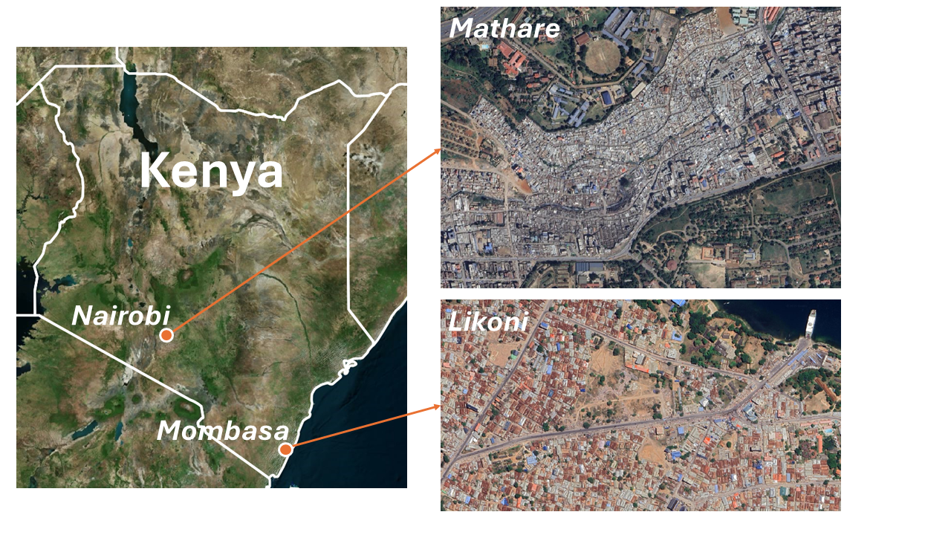
Figure 1 Case study area locations (Left - Kenya, Top Right - Zoom in on Mathare, Bottom Right - Zoom in on Likoni). [Source background map data: Google Maps [n.d], accessed through QGIS, 11th Feb 2025]

Methods

Research hypothesis and testing
Our hypothesis for testing was that poor mobility affordance -the opportunities the environment provides individuals- negatively affects multiple dimensions of wellbeing. This includes objective dimensions such as safety and security, livelihoods, social relations, and freedoms of choice and action, as well as subjective psychological physiological and aspects of mental health (informed by the Millennium Ecosystem Assessment).

Assessment frameworks
To test the affordance of the mobility choices available to vulnerable residents in the selected case study areas, we adopted a framework previously developed and tested in UK studies (Cinderby et al., 2018) which considers the interaction of:
- Mobility supporting infrastructure provision and quality,
- Systems and services governing mobility infrastructure use, and
- Mobility infrastructure and systems user’s behaviours.
We further linked the issues of mobility and wellbeing to Shah et al. (2015) framework of inclusion relevant to SDG 11 along the triangulating axes of:
- Spatial inclusion - the geographic equity of mobility and access to services and urban infrastructure
- Social inclusion - the social equity of inclusion of mobility and access, and
- Economic inclusion - accessibility of livelihood, education, and skills development.
Finally, we connected these concepts of mobility affordance and inclusion to their impacts on different dimensions of wellbeing. The complexity of wellbeing means its components cannot be discretely tied to specific individual dimensions of affordance or inclusion, instead these factors interact to either support objective, subjective or physiological aspects. For example, provision of infrastructure enables mobility that can support employment, thereby delivering objective wellbeing and economic inclusion. However, if the improved infrastructure - and the way it is operated and used - also makes travelling safer, more enjoyable, or enables social interactions, it will support subjective and physiological benefits alongside potentially reinforcing the safety dimension of objective wellbeing.

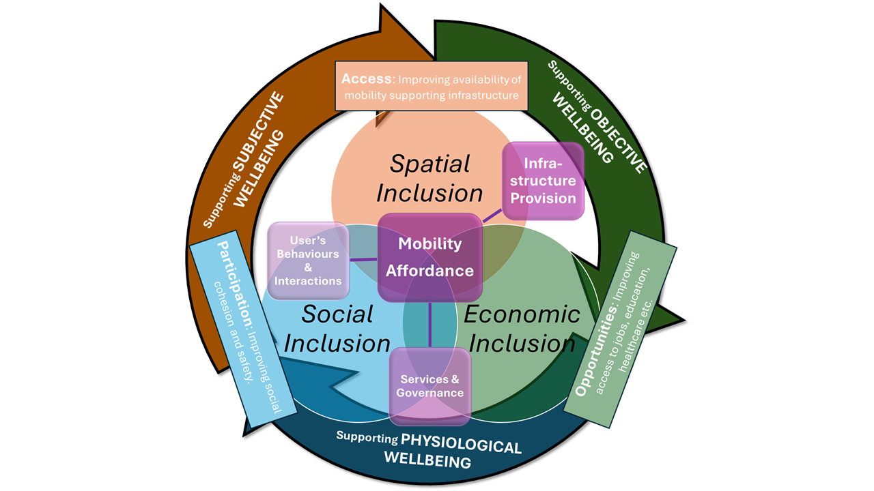Figure 2 Interacting frameworks assessing the affordance, equity and wellbeing implications of mobility provision, governance and operation (after (Shah et al., 2015; Cinderby et al., 2018)).

Data collection methods
To assess the interactions of these multiple dimensions of mobility on wellbeing, we used a mixed methods approach aimed at robustly characterising both the physiological and psychological impacts of urban commutes and other important daily trips on participants. Two themes of data were collected: the first set explored how infrastructure and mobility interacted in space and time; while the second examined in more detail the impact of mobility on health and wellbeing.

Participatory mapping
Recognising that mobility is a spatial concept, we aimed to work with a minimum of 60 individuals (30 in each city) using participatory GIS (PGIS) mapping approaches (Cinderby, Snell and Forrester, 2008; Cinderby et al., 2018) to understand their travel demands and interactions with dimensions of our intersecting assessment framework (figure 2). We developed a focus group PGIS methodology to map individuals’ journey routes for important or regular trips and the challenges faced en-route, for a cross-section of users (including vulnerable groups, women and men, and different ages including children) (see table 1). This included capturing their journey experiences (both positive and negative). The mapping was enhanced by collecting a smaller sample of representative digital stories (Haq et al., 2022) using still imagery and video to better understand the temporal dimensions of commuting and how mobility affordance affected participants. These additional materials were analysed to supplement the identification of factors supporting or undermining mobility affordances and wellbeing for different types of residents that had been identified from the mapping.
Table 1 Participatory mapping participant numbers by gender, neighbourhood [Note: Numbers in () indicates a self-declared physical disability that impacts their mobility]
 | Age | 7 to 19 | 20 to 29 | 30 to 39 | 40 to 49 | 50 to 59 | 60 to 69 | 70+ | Total
Mathare | Female | 6 (1) | 0 | 2 | 3 (1) | 3 (2) | 1 (1) | 3 (3) | 18 (8)
 | Male | 1 | 3 | 3 (1) | 3 (1) | 3 (1) | 2 (1) |  | 15 (4)
Likoni | Female | 3 | 3 (1) | 6 (3) | 2 (2) | 2 (1) | 1 |  | 17 (7)
 | Male | 3 | 2 | 2 (2) | 1 (1) | 2 (1) | 3 (1) |  | 13 (5)

Transect Walk Activity
To further characterise the health and wellbeing impacts of mobility in detail, we recruited a smaller cohort of 20 residents from each neighbourhood to undertake a pre-determined transect walk co-designed with the community. The participants were selected from the group that undertook the participatory mapping, ensuring representation of a cross-section of ages and genders. The walk was designed to include different elements of the environment and mobility infrastructure quality within each case study location. This included locations with better mobility infrastructure provision (for example, paved footpaths), places where user behaviour influenced experience (such as locations where sidewalks were occupied by street vendors or motorbike taxi operators), and places where the management of a space affected its use (for example, sites where the participatory maps revealed a fear of crime for some users).
The physiological impacts of journeys on health, and interaction with elements of infrastructure and environmental quality was assessed through personal monitoring data. Smart watches and chest strap monitors were used to collect data on heart-rate variability (HRV), which can reveal the influence of environments on the nervous system, indicating stress or relaxation. A low variation indicates physiological stress, while a high variability suggests recovery (refer to Figure 3). Although collecting heart rate variability (HRV) data in the field through mobile monitoring is still experimental, it has shown potential in identifying the influence of different environments on individuals' health and well-being (Neale, Boukhechba and Cinderby, 2023).
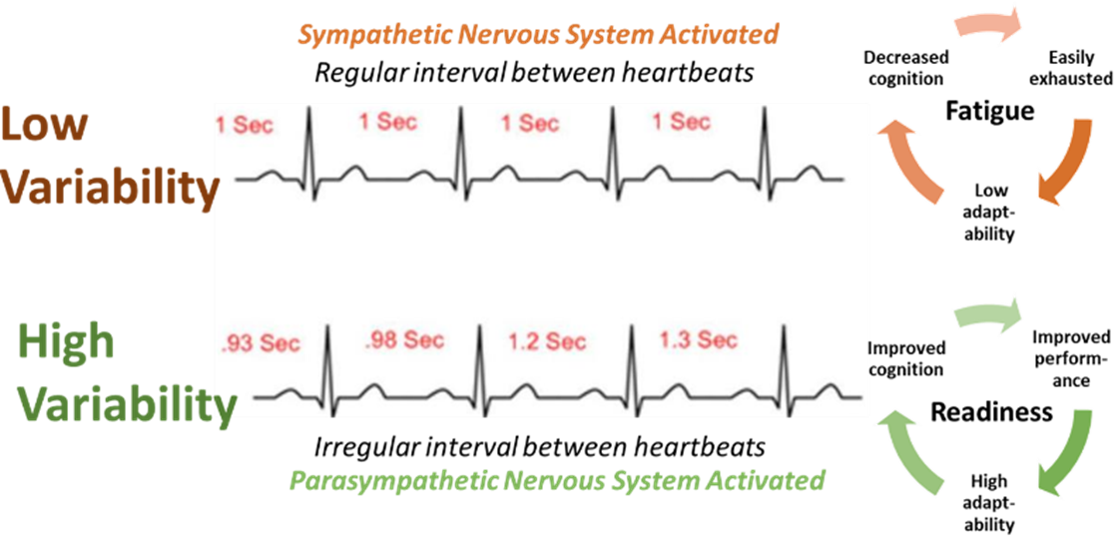
The Figure 3 Relationship between heart rate variability and physiological wellbeing (stress fatigue or relaxed readiness response).
The mean HRV measurement for each 1-minute interval of the walk was calculated to reduce noise in the data. The change between each 1-minute HRV segment (reducing variability indicating increasing stress and rising variability indicating a more relaxed state) was calculated for each participant. The variation between the maximum change in HRV (positive and negative) was scaled for each individual to range between -1 to +1. The mean change in the scaled HRV across all participants was then calculated and allocated to 5m spaced points along the route based upon the GPS coordinate locations for that 1-minute interval (start and end points). The HRV data was analysed using Kubios software (Kubios, 2024).
To assess the direct health implications of pollution in the environment, participants’ air pollution and noise exposure were measured using low-cost wearable particulate matter (PM) counters (Purple Air sensors (purpleair.com/products/purpleair-pa-ii)), along with temperature, humidity and noise monitors to identify ambient conditions. Particulate matter comes from combustion (linked to internal combustion engines, cooking and manufacturing processes) as well as from dust, including tyre wear and brake dust (Wang et al., 2019). The PurpleAir sensors use a laser particle counter to record the number of airborne particles. Both PM₁₀ and PM_{2.5} were measured (with the smaller sized particles considered the most damaging for respiratory health with no safe threshold). The levels of pollution recorded were classified according to the (World Health Organization (WHO), 2021) interim targets (IT) for emission levels exceeding their Air Quality Guidance (AQG) level. IT1 corresponds to the most polluted locations, while IT4 represents locations with the least severe pollution that still exceeds the target AQG.
To identify how the environment along the transect walks affected people subjectively, we asked each participant to independently map sections of the route, indicating whether they perceived these spaces to be stressful, neutral or relaxing. This data integrated participants’ experiences of infrastructure quality with how spaces were being used and how those spaces made them feel. Participants assigned scores (-1 for negative scores, 0 for neutral, +1 for positive) for each section of the route, which were then summed and presented in four categories to indicate the most to least stressful sections. These maps were subsequently compared to the physiological and environmental measurements to provide an overall assessment of how journeys affect people’s health and well-being, incorporating elements of objective, subjective and physiological wellbeing. The breakdown of the data collected through the transect walks is illustrated in Table 2.
Table 2 Participant numbers in the transect walk HRV and PM data sets (Note: in total data from 19 people was collected for Likoni and 34 people in Mathare but after cleaning for data integrity only a subset of the information could be included in the final analysis).
Location | Women | Men | Total | Mean Age | Age Range
Mathare | 2 | 5 | 7 | 38 | 19-64
Likoni | 6 | 7 | 13 | 32.9 | 19-60

Results

Participatory Mapping Findings

Understanding journey needs
The participatory maps as illustrated in Figure 4, of key journeys (for work, education, healthcare etc.) highlight the importance of walking in both cities, aligning with findings of Benton et al., 2023. Walking is universally important, particularly for short trips within the neighbourhood as well as for longer commutes and transitions between motorised modes of transport. In both cities, walking trips for commuting to work exceeded 5km each way. For longer trips, motorised paratransit options such as matatus (mini-bus taxis), boda-bodas (motorbike taxis) and tuk-tuks (3-wheeler taxis used in Mombasa) were predominantly utilised.
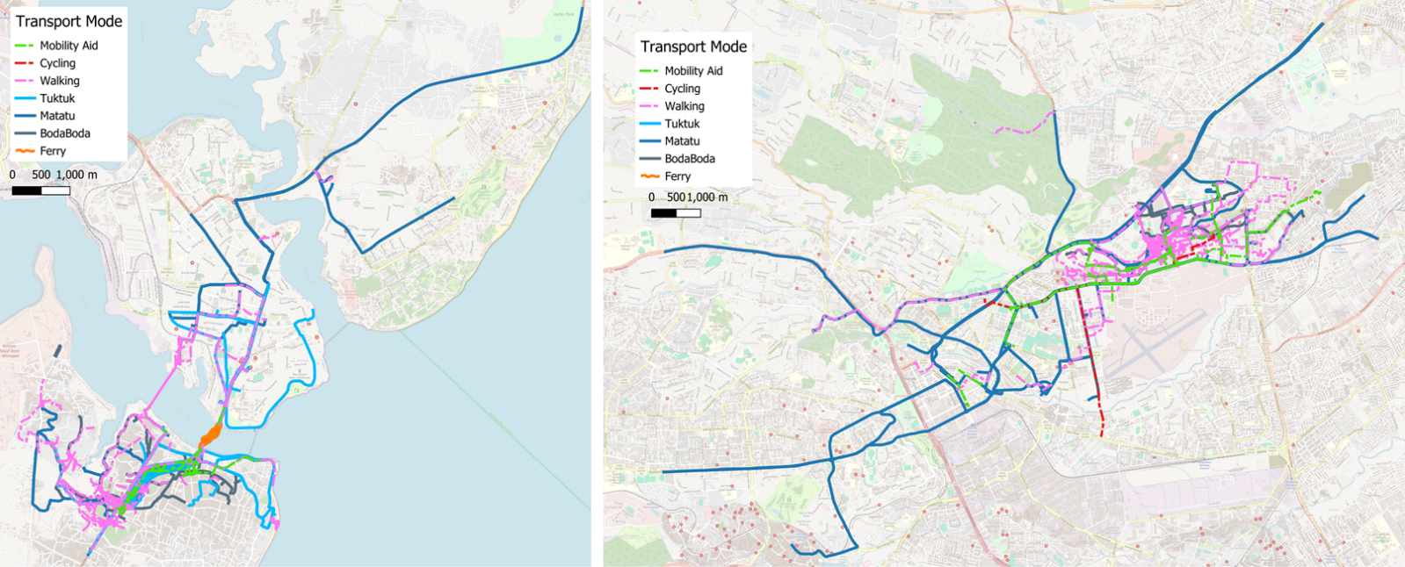
Figure 4 Regular journeys by mode undertaken by our participants (Mombasa left, Nairobi right). [Source background map data: Open Street Map [n.d], accessed through QGIS, March 2023]
The participants identified specific locations along their routes with features or issues that positively or negatively impacted their journeys (see Figure 5). The concentration of negative features at specific locations highlight sections of the routes where existing infrastructure and people’s use of the space is affecting mobility and wellbeing of vulnerable road users. In both cities, the negative features were concentrated along busy roads where there were significant conflicts over the use of space by motorised vehicles, street vendors and pedestrians. The data indicates that certain locations negatively impacted specific vulnerable groups such as the older adults, PWDs and women, revealing the gendered dimensions of mobility affordance. Some mixed locations, which were negative for women or the older adults but positive for men or youth, highlight how groups are affected differently by the same space. For example, a location around a food outlet could be positive for young people as a space to socialise, whilst simultaneously hindering mobility for others due to fear of crime (or actual experiences).
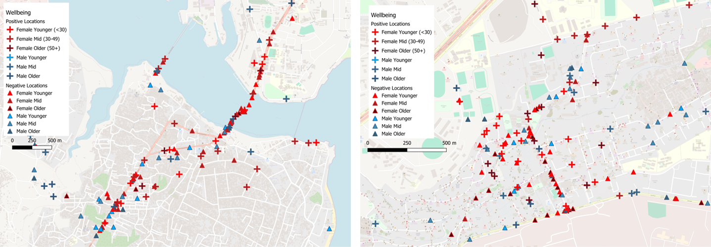
Figure 5 Locations of positive and negative experiences along participants routes (Mombasa left, Nairobi right). [Source background map data: Open Street Map [n.d], accessed through QGIS, March 2023]
The participants described why these mapped places either encouraged or undermined their mobility (see Figure 6). This information was useful in identifying the key issues at specific places and the broader themes that planners and designers need to consider when developing improvements. The key issues identified were multi-faceted, requiring solutions that address a range of concerns rather than focusing on a single aspect.

Infrastructure and mobility wellbeing and affordance interactions
The negative factors participants reported on their journey maps were analysed and grouped into broader themes based on our three-hinged framework (see Figure 2) relating to:
- Infrastructure: The provision and quality of physical features affecting mobility
- Behaviours: The ways in which people use spaces, which can impact the mobility of others.
- Services: The organization and use of infrastructure or systems that impact mobility.
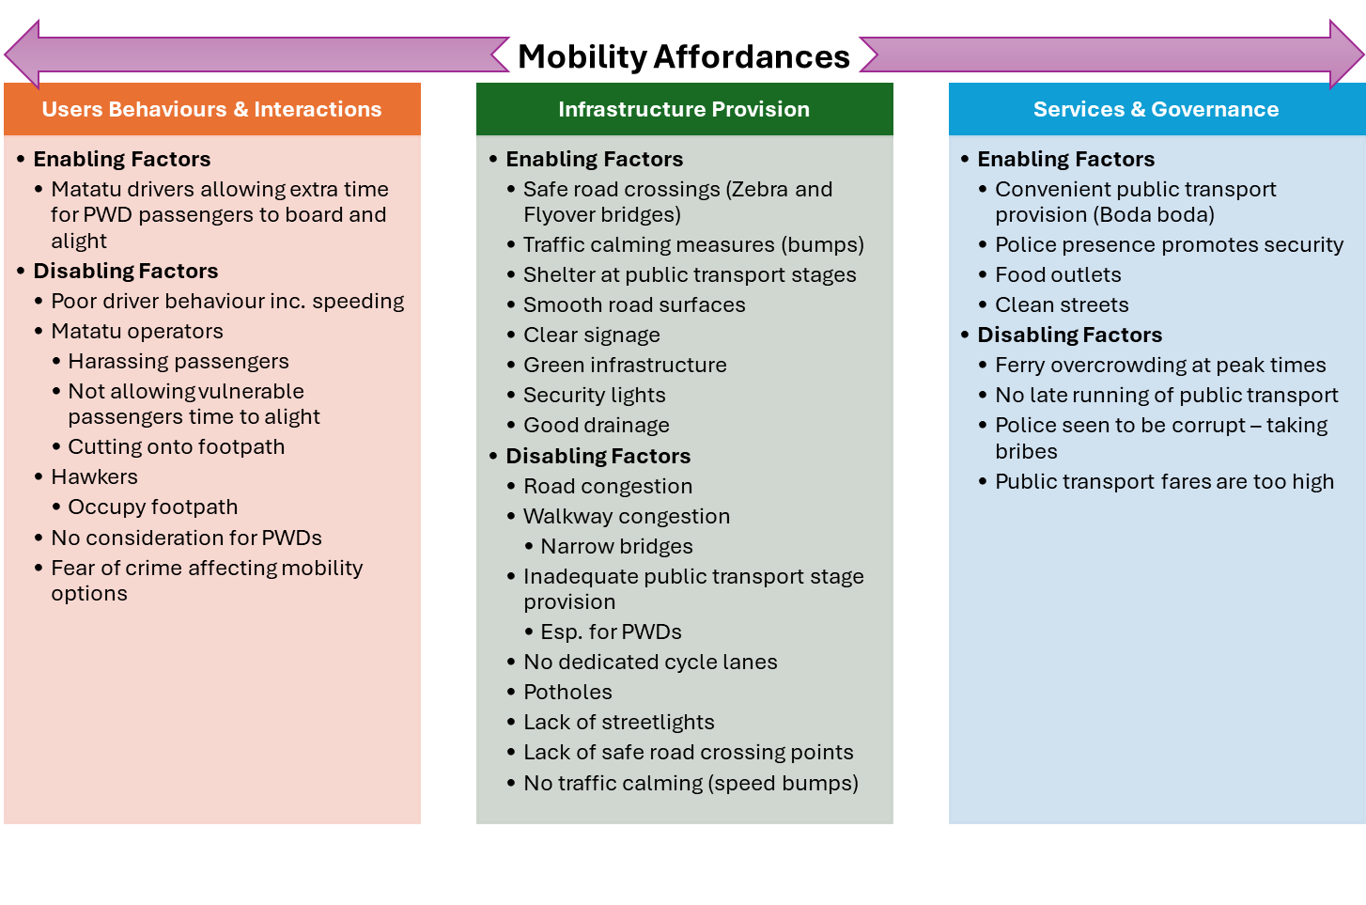 Figure 6 Factors revealed from the participatory mapping of facilitating (enabling) or undermining (disabling) mobility affordances (linked to the Figure 2 framing)
These themes overlap with the quality and provision of infrastructure, influencing how people behave in that space and are linked to the way services have been delivered. For example, lack of refuse disposal infrastructure and waste collection services results in people disposing of waste on the street, blocking pedestrian footpaths and forcing pedestrians onto the live carriageway. Similarly, lack of police presence and poor street lighting infrastructure lead to increased perceptions (or experiences) of crime among users of that space, deterring travel and limiting mobility options.
The negative factors of mobility affordance described by the participants linked to inadequate provision of infrastructure such as narrow footpaths leading to congestion or the absence of dedicated cycle lanes. However, they also included factors related to safety and security such as fear of crime that sometimes had temporal dimensions. The behaviour of drivers such as speeding, aggressive and dangerous driving of matatus negatively impacted participants’ perception of their journeys. Use of pedestrian footpaths by street vendors as retail spaces forced pedestrians onto the carriageway increasing conflict with motorised traffic. Overcrowding, high fares, and a lack of late-night operations of public transport vehicles also affected peoples’ journeys.
Positive spaces were characterised by better quality infrastructure, safer environments (both in terms of road safety and personal safety), ease of navigation, and more pleasant aesthetics. These included locations with green infrastructure provision (trees and plants) that make journeys more pleasant and potentially cooler experiences (Sun and Chen, 2017). From our data, positive public transport mobility experiences were associated with considerate behaviour from transport operators and well-functioning services that met users’ demands.

Transect Walk Findings
By analysing participants' physiological responses in relation to their perception of their route, several differences emerged between their subjective impression and measured stress levels. The findings were then compared to the air quality levels along the route to identify the exposure of participants to air pollution.

Mathare Transect Data Findings
The majority of participants (see Figure 7) perceived Juja Road and Mathare North Road to be relatively pleasant, relaxing environments that facilitated their mobility. This could be attributed to the presence of relatively good infrastructure along Juja road (presence of a wide segregated paved footpath) and the busy sociable environment on Mathare North Road due to the presence of street vendors. In contrast, Mau Mau Road was perceived as stressful along its entire length, likely due to its mixed-use nature, characterised by a combination of light industry, street vending, fast-moving traffic and absence of dedicated safe footpaths.
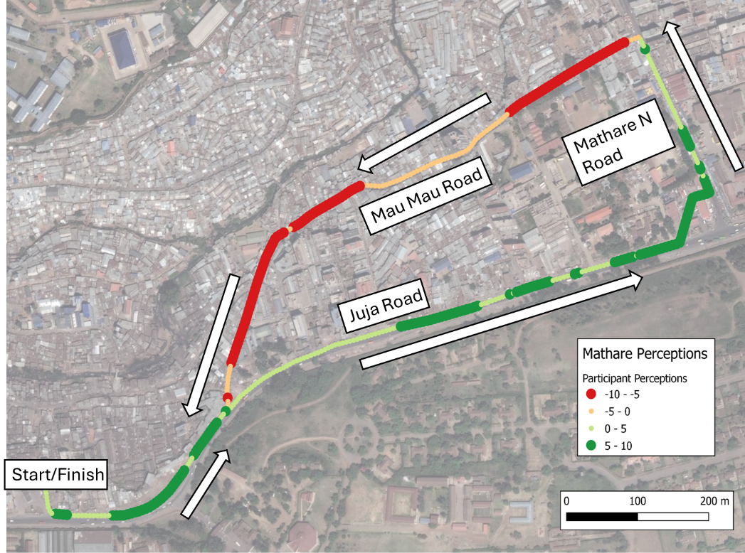
Figure 7 Mathare participant subjective perceptions of transect walk stressful (red) vs relaxing (green). [Source background map data: Google Maps [n.d], accessed through QGIS, Mar 2023]
However, the HRV data (Figure 8) revealed that participants exhibited stressful reactions at certain sections on both roads. We hypothesised that this physiological response could be associated with the high volume of fast-moving motorised traffic, particularly on Juja Road, and the obstruction of pedestrian footpaths by street vendors on Mathare North, which forces pedestrians onto the live carriageway.
On Mau Mau Road, the sections with greater greenspace were less physiologically stressful than Juja Road according to the HRV data. However, the busier mixed-use space on Mau Mau Road was the most stressful section of the route. This section exhibited high traffic flows and speeds, along with poor mobility infrastructure, exacerbating road safety risks.
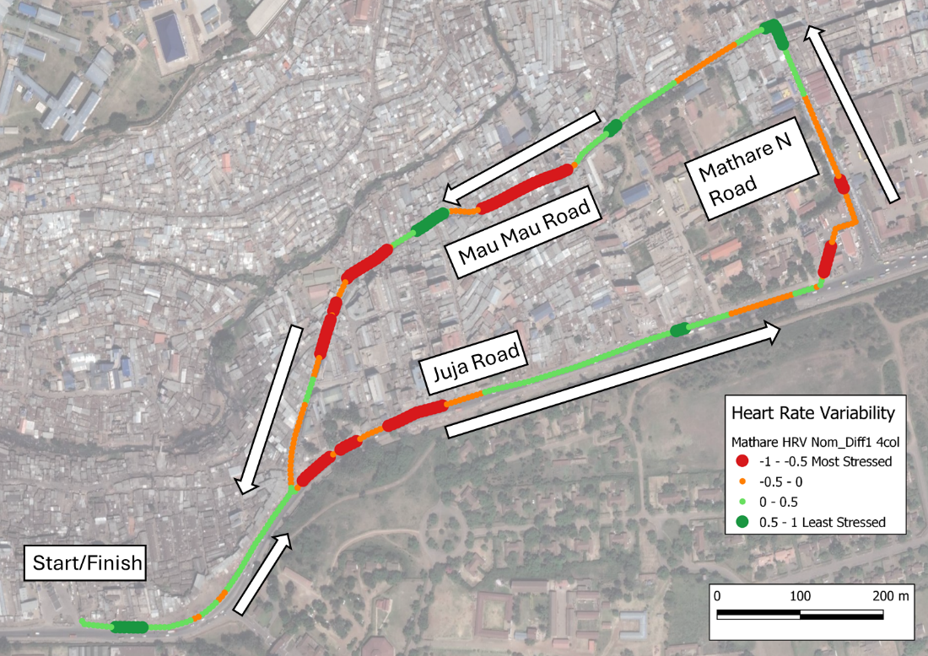
Figure 8 Mathare normalised average heart rate variability (HRV) responses (red increasing stress, green increasing relaxation). [Source background map data: Google Maps [n.d], accessed through QGIS, Mar 2023]
Regarding environmental conditions during the transect walk, air pollution data (mapped in Figure 9) showed that for PM_{2.5} measurements, most of Mau Mau Road was classified as IT2 while Juja Road was predominantly IT1 or worse. This suggests that road users were exposed to high levels of dangerous particle pollution, especially along the busy transport corridor of Juja Road. A critical finding emerged on comparing the stress level data to the pollution exposure data on Juja Road- despite the presence of better walking infrastructure and participants reporting lower stress levels, they were exposed to higher air pollution levels.
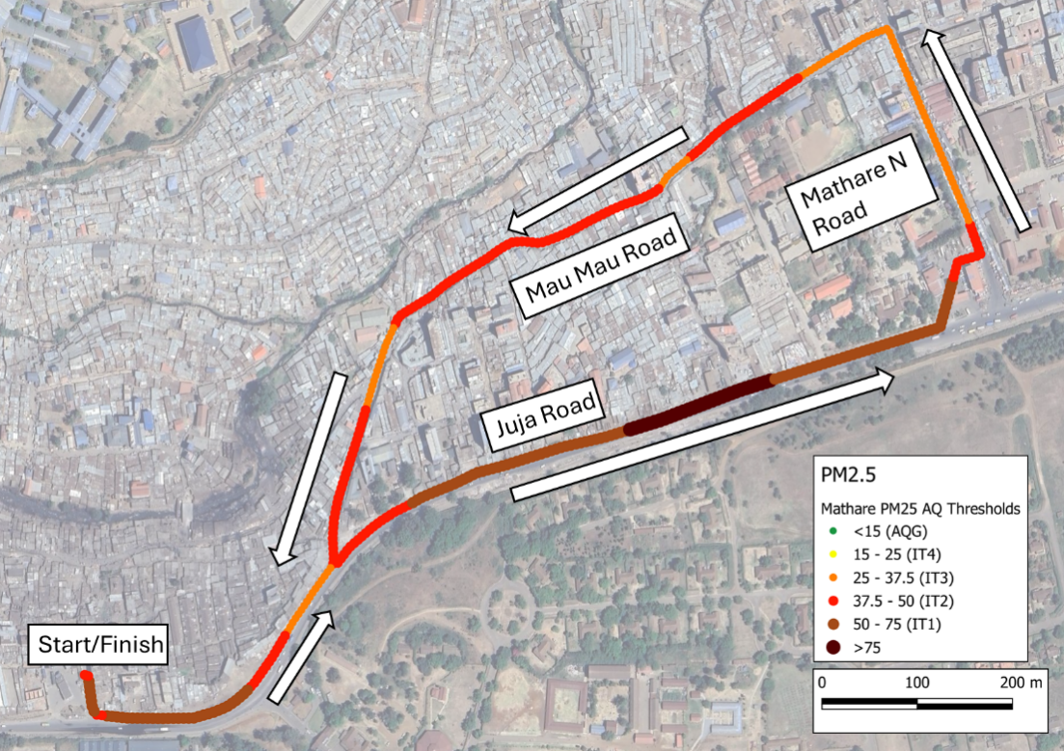
Figure 9 Mathare average particulate matter (PM_{2.5} fraction) measurements classified into WHO interim target measures (>75 exceeding target measure, IT 1 to 4 and Air Quality Guidance (AQG) level). [Source background map data: Google Maps [n.d], accessed through QGIS, Mar 2023]

Likoni Transect Data Findings
Participants perceived the start of the route and parts of Likoni-Ukundu Road where the footpaths were congested with shoppers and street vendors to be the most stressful (Figure 10). At the junction between these two roads at the ferry junction, the road space was occupied by paratransit operators and passengers making this area particularly stressful. The rest of the route was relatively less stressful, particularly, the section towards the end of Likoni-Ukundu Road where the pedestrian footpaths were wide and less congested with vendors or shoppers.
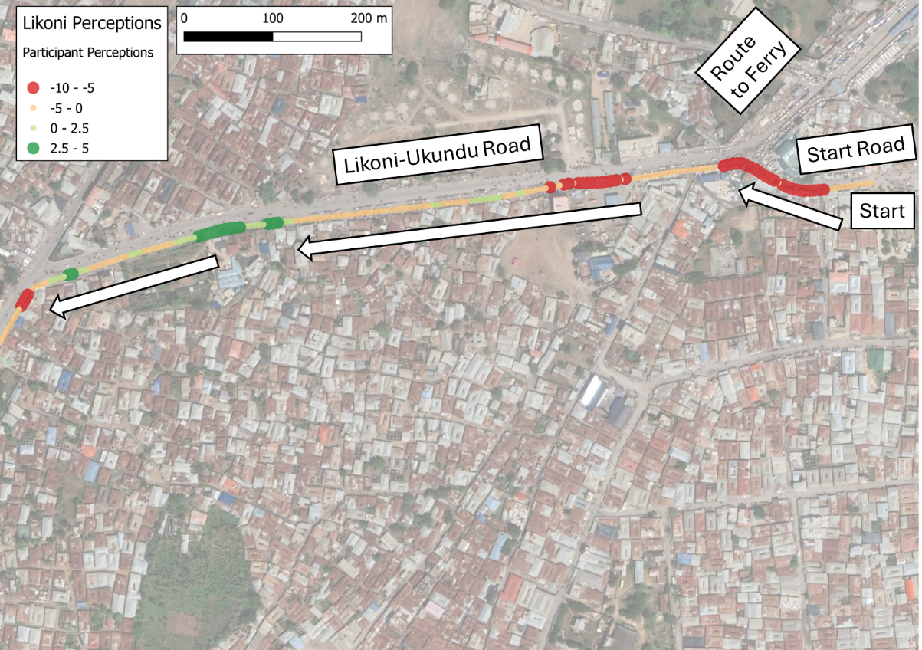
Figure 10 Likoni participant subjective perceptions of transect walk stressful (red) vs relaxing (green). [Source background map data: Google Maps [n.d], accessed through QGIS, Mar 2023]
The HRV data (Figure 11) indicated that these locations were also stressful physiologically particularly the start of the route and at the junction to the ferry. A section neighbouring greenspace towards the end of the route was perceived as relaxing with reduced physiological stress. However, the data indicated that much of the route was mildly stressful for the participants.
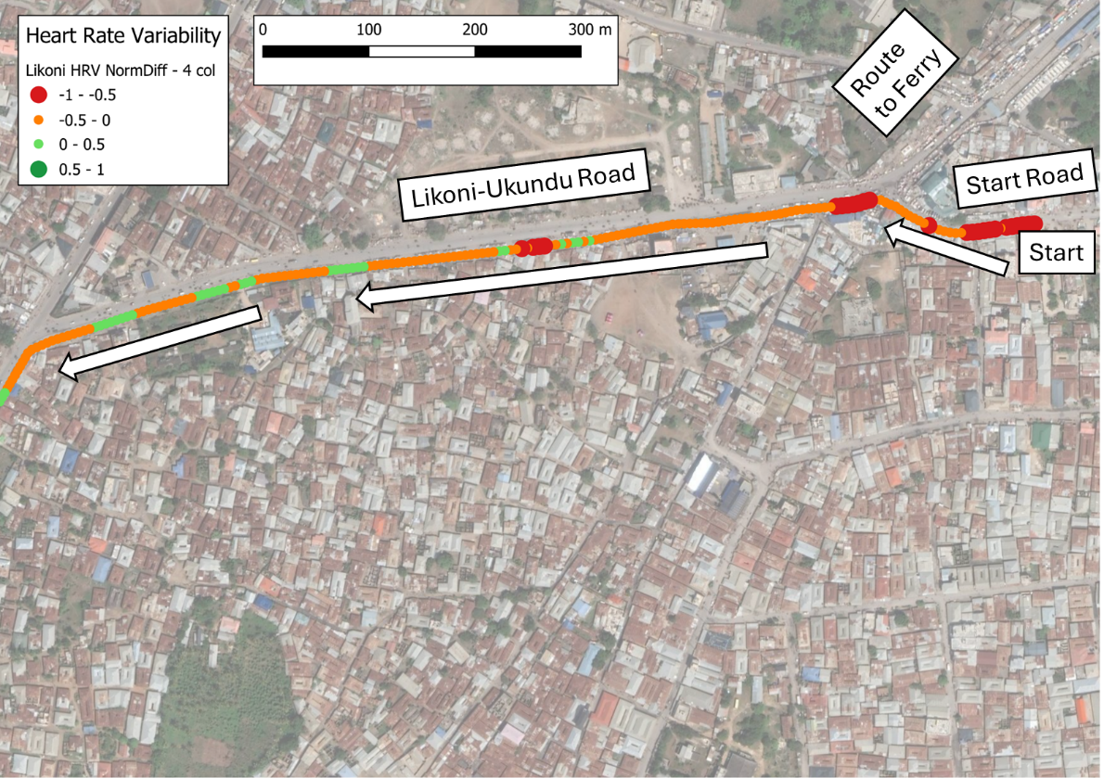
Figure 11 Likoni normalised average heart rate variability (HRV) responses (red increasing stress, green increasing relaxation). [Source background map data: Google Maps [n.d], accessed through QGIS, Mar 2023]
The air quality measurements (Figure 12) indicated that pollution was less poor than for the Mathare transect route. However, significant pollution issues were still observed, particularly near the ferry junction where paratransit services operated intensively. Interestingly, these locations did not directly correspond with locations that recorded the highest perceived or measured stress. This suggests that higher traffic ( while a major source of emissions) volumes may not be the sole driver of stressful responses. Other factors, such as how spaces are used and the impact of the behaviour of other road users may exhibit a stronger influence on other users’ stress levels.
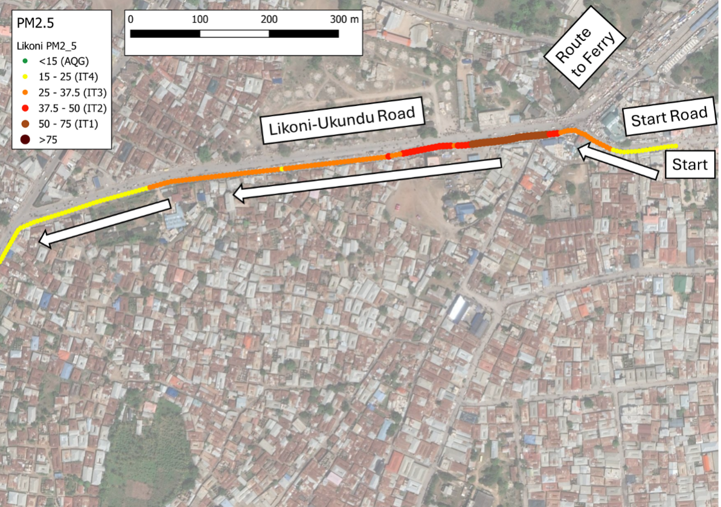
Figure 12 Likoni average particulate matter (PM_{2.5} fraction) measurements classified into WHO interim target measures (>75 exceeding target measure, IT 1 to 4 and Air Quality Guidance (AQG) level). [Source background map data: Google Maps [n.d], accessed through QGIS, Mar 2023]

Discussion
Our findings highlight specific factors in our case study locations that serve to illustrate a broader understanding of the interactions of mobility, wellbeing and inclusion within our integrative framework.
Affordances of mobility: The participatory mapping highlights the ubiquity of walking as a mode in both cities, supporting the pressing calls for planners to provide adequate and safe walking (or wheeling for those using mobility aids) infrastructure (e.g., Sietchiping, Permezel and Ngomsi, 2012; Benton et al., 2023). The journey mapping evidences how the provision of quality of walking infrastructure greatly impacts people’s wellbeing and their ability to undertake safe and regular essential journeys.
Public (and para) transit: The findings reveal that for vulnerable road users, the quality of passenger infrastructure (waiting and transit areas) is critical to improving their mobility experiences. This was particularly the case for women (with caring roles), older adults, PWDs and children, further highlighting the gendered dimensions of mobility affordance. These factors highlight how quantity and quality of infrastructure are critical to supporting the mobility of vulnerable groups but should be linked to their modal preferences.
Users’ behaviours and service governance: The widespread reliance on paratransit in both cities underscores the need for service providers to consider specific needs of vulnerable groups (especially PWDs, older adults and women). Further to this, targeted training and policies aimed at enhancing operator behaviour can help improve overall quality of mobility for the road users. There is also a need to expand the delivery of convenient and reliable public transport services. In Mombasa, for example, the ferry serves as a crucial link for journeys into the city (see Figure 4). This high demand brings specific challenges to vulnerable groups, particularly at peak times.
The maps illustrate how the interactions between people’s mobility and the behaviours of other users within shared spaces can either enhance and improve journey experiences, supporting wellbeing, or detract and undermine them. Our data reveals numerous instances of undermining behaviours, including poor driving practices, street vendors obstructing footpaths, and prevalent fears for crime and personal safety during journeys. Contrastingly, data on enabling behaviours was significantly sparser, with only a few instances of supporting attitudes from some para-transit operators toward PWDs reported. These findings clearly highlight how actively managing and enforcing certain behaviours should be considered as effective as provision of quality infrastructure in enabling inclusive mobility.
Considering the inclusion factors associated with these findings demonstrates how the mobility affordance concepts relate to urban equity issues. Infrastructure provision has a spatial dimension, with some neighbourhoods and modes receiving adequate resources while others, especially in low income areas such as our case study locations, remaining under-resourced, thereby undermining mobility. The interactions between users and the way that services are delivered further connects mobility choices to opportunities for economic gain and social interaction. Additionally, poor behaviours and the lack of effective management and governance of key mobility services, including supporting services such as policing to reduce crime, reinforce inequities in social and economic inclusion within cities.
The novelty of our framework is in grounding the connection between mobility concepts, wellbeing and inclusion for urban residents which has recently been receiving greater attention in academic studies (Ferdman, 2021). Similar studies have been undertaken in European (Friman et al., 2017; Lorenz, 2018) and North American (Legrain, Eluru and El-Geneidy, 2015; Smith, 2017; Tajalli and Hajbabaie, 2017) cities. While our case studies were Nairobi and Mombasa, these two cities serve as representative of many rapidly urbanising centres across Sub-Saharan Africa especially in East Africa, where urbanisation trends are rapidly accelerating (United Nations, 2018).
Our transect walk and mapping results provided novel insights into how inclusive mobility affordance can either support or undermine the elements of wellbeing. The variations in mobility experiences observed through the participatory mapping based on age, gender and PWDs status, emphasize the need for planners to provide a variety of mobility options rather than defining a single solution that may not fit all travellers’ needs or worse, disadvantage specific groups. This aligns with the findings from New Zealand that planners should consider intersectionality in their design decisions (Spray et al., 2022). For example, while the proposed large-scale investment in Bus-Rapid Transit in Nairobi could enhance the mobility and wellbeing of some travellers, it could inadvertently undermine other user’s needs and journey experiences (particularly if it neglects walking and cycling experiences). This is similarly reflected in the findings of the Johannesburg BRT scheme impacts on wellbeing and mobility (Lionjanga and Venter, 2018).
Understanding how journeys affect people’s health and wellbeing provided a useful way to identify key locations for infrastructure improvements. The new approaches presented here combining the subjective and physiological dimensions of wellbeing with environmental conditions in terms of pollution exposures could help decision makers consider the totality of the urban environment when designing, installing and assessing the impacts of changes to mobility infrastructure and services. The transect walk experiments helped to bring together these different elements with quantitative spatially explicit data on the impacts journeys were having on vulnerable user’s health and wellbeing. These data highlighted how relying on subjective perceptions could give unreliable results with participants underestimating the effect poor infrastructure was having upon their stress levels. Whilst the findings are for a relatively small sample and geographic extent, they highlight the potential of these approaches to better understand urban mobility experiences for the most vulnerable traveller’s perspectives. The low-cost sensors provided fine-scale (small area) information on environmental conditions along different transport corridors. The subjective and physiological readings begin to reveal the impacts that these conditions have on user’s wellbeing from complimentary perspectives. Combining these types of information could usefully reveal priority locations which require improvements for active travellers’ and how they could benefit their mobility but also support health and wellbeing. For example, the Nairobi results indicated how improvements to footpath infrastructure quality and availability, but in an inappropriate heavily trafficked and polluted location, was undermining health and wellbeing gains by exposing active travellers to worse environmental (air quality) conditions than alternative less well serviced but relatively cleaner routes. However, this interaction also needs to consider the relative safety of these alternative routes (from a crime and traffic perspective) to incorporate the whole environment and experience. These connections demonstrate how planners need to consider the totality of interacting aspects when delivering inclusive mobility improvements rather than purely infrastructure delivery or service changes. There is a need to consider the whole environment not just improvements along the main transport routes especially for people walking or using mobility aids, i.e. the routes people need to take before reaching the main roads. Lack of paved surfaces, physical obstructions, poor road surfaces, flooding, open drainage systems, waste (rubble and rubbish), poorly maintained bridges all contribute to negative journey experiences particularly in low-income neighbourhoods.
Focussing primarily on infrastructure provision and not journey experiences could result in investments that do not support healthy mobility choices when all aspects are included. When creating plans to promote active travel options, planners and designers must look at the overall impact on health and wellbeing, rather than just focusing on individual aspects of mobility (like improving footpaths). Better (spatially explicit) and diverse (subjective and physiological) data would be useful for decision makers to understand existing environments more holistically to identify the most appropriate alternatives. Including qualitative data collection approaches such as digital storytelling also enables communities to better share their lived experience and mobility demands with experts and planners (Cinderby, de Bruin, et al., 2021; Haq et al., 2022). Ideally, this planning should enable a wider cross section of particularly vulnerable users to participate through co-design events to ensure the widest cross-section of needs and affordances are including in improvement schemes. This should encourage innovation in street design, service provision and the way spaces are governed.
The limitations of our data were that they are for only two cities and a relatively small sample of residents. This is particularly the case for the transect data where we had a small sample making showing statistical relationships impossible. However, the data does indicate a proof of concept that this type of information could be useful for integrating issues of mobility, inclusion and wellbeing along with the quality of the urban environments to identify more equitable and safer (from a whole systems perspective) mobility solutions. For the novel HRV and environmental experiments it should also be noted that making these data protocols work reliably can be challenging. This work was undertaken in and around COVID restrictions meaning the UK and Kenyan research teams could not physically meet to undertake training in the data collection approaches. This led to issues in the final collected datasets (see table 2) which reduced the robustness and statistical power of the information collected. However, the data is indicative of the potential for these approaches but also demonstrates that these technologies and approaches are still experimental and evolving.

Conclusions
Urban mobility is a key factor supporting health and wellbeing and is linked to infrastructure quality, governance, and individuals’ behaviours. Delivering enhanced inclusive and safe mobility choices addresses many elements of the inclusive city concept. Addressing recent calls for African mobility research focussed on socio-economic equity this paper’s findings draw upon a mix of novel methods from two Kenyan cities to capture the interactions of travel on health and wellbeing for vulnerable residents. Assessing these findings in relation to our new framework that combines issues of mobility affordance, inclusion, equity and wellbeing highlight how focussing on infrastructure provision and not overall journey experiences could result in investments that do not support healthy mobility choices. Collecting better (spatially explicit) environmental measurements and diverse wellbeing data would enable decision makers to understand existing environments more holistically to identify the most appropriate mobility investments. Our work highlights how combining subjective, physiological and environmental data provides new perspectives on how infrastructure and behaviours are affecting vulnerable travellers. Overall, framework and results forefront how inclusive and equitable mobility solutions that actively support people’s health and wellbeing should go beyond provision of adequate and safe infrastructure. They should include user awareness and behaviour changes that are effectively governed ensuring the benefits of any improvements are not undermined thereby risking exposing travellers to more dangerous pollution or hazardous road safety environments instead of effectively delivering equitable mobility that supports health and wellbeing.

Funding statement
This work was supported by the British Academy, Award Reference: UWB190003, Urban Infrastructures of Well-Being Programme 2019.

References
Bai, X. et al. (2017) ‘Linking Urbanization and the Environment: Conceptual and Empirical Advances’, Annual Review of Environment and Resources, 42, pp. 215–240. doi:10.1146/annurev-environ-102016-061128.
Bell, R. et al. (2021) ‘Co-creating solutions to local mobility and transport challenges for the enhancement of health and wellbeing in an area of socioeconomic disadvantage’, Journal of Transport and Health, 21(April), p. 101046. doi:10.1016/j.jth.2021.101046.
Benton, J.S. et al. (2023) ‘“Walking is our asset”: How to retain walking as a valued mode of transport in African cities’, Cities, 137(March), p. 104297. doi:10.1016/j.cities.2023.104297.
van Burgsteden, M., Grigolon, A. and Geurs, K. (2024) ‘Improving Community Wellbeing through transport policy: a literature review and theoretical framework, based on the Capability Approach’, Transport Reviews, 44(6), pp. 1161–1186. doi:10.1080/01441647.2024.2374818.
Chokerah, J. (2021) UN Sustainable Development Cooperation Framework and national poverty eradication: The experience of Kenya.
Cinderby, S. et al. (2018) ‘Co-designing Urban Living Solutions to Improve Older People’s Mobility and Well-Being’, Journal of Urban Health, pp. 20–22. doi:10.1007/s11524-018-0232-z.
Cinderby, S., Archer, D., et al. (2021) ‘Assessing Inequalities in Wellbeing at a Neighbourhood Scale in Secondary Cities and Their Implications for Long-Term Livability’, Frontiers in Sociology, 6(November), pp. 1–16. doi:10.3389/fsoc.2021.729453.
Cinderby, S., de Bruin, A., et al. (2021) ‘Transforming urban planning processes and outcomes through creative methods’, Ambio, (Feb), pp. 1–17. doi:10.1007/s13280-020-01436-3.
Cinderby, S., Snell, C. and Forrester, J. (2008) ‘Participatory GIS and its application in governance: the example of air quality and the implications for noise pollution’, Local Environment, 13(4), pp. 309–320. doi:10.1080/13549830701803265.
Corburn, J. (2017) ‘Urban place and health equity: Critical issues and practices’, International Journal of Environmental Research and Public Health, 14(2), pp. 1–10. doi:10.3390/ijerph14020117.
Dixon, S., Irshad, H. and Labuschagne, J.-P. (2018) Deloitte City Mobility Index - Nairobi. London, UK.
Ferdman, A. (2021) ‘Well-being and mobility: A new perspective’, Transportation Research Part A: Policy and Practice, 146(December 2020), pp. 44–55. doi:10.1016/j.tra.2021.02.003.
Friman, M. et al. (2017) ‘How does travel affect emotional well-being and life satisfaction?’, Transportation Research Part A: Policy and Practice, 106(September), pp. 170–180. doi:10.1016/j.tra.2017.09.024.
Gärling, T. et al. (2020) ‘Review and assessment of self-reports of travel-related emotional wellbeing’, Journal of Transport and Health, 17(April), pp. 1–10. doi:10.1016/j.jth.2020.100843.
Hackl, A. (2018) ‘Mobility equity in a globalized world: Reducing inequalities in the sustainable development agenda’, World Development, 112, pp. 150–162. doi:10.1016/j.worlddev.2018.08.005.
Haq, G. et al. (2022) Using creative participatory approaches for inclusive climate resilient transport in Africa: Guidelines for practitioners. Stockholm. Available at: https://www.gov.uk/research-for-development-outputs/using-creative-participatory-approaches-for-inclusive-climate-resilient-transport-in-africa.
Harada, T. (2023) ‘Mobility Justice and Sustainable Futures’, Australian Geographer [Preprint]. doi:10.1080/00049182.2023.2271615.
Heydari, S. et al. (2019) ‘Road safety in low-income countries: State of knowledge and future directions’, Sustainability (Switzerland), 11(22), pp. 1–29. doi:10.3390/su11226249.
Kelley, K.J. (2020) ‘WHO: Kenya road deaths four times higher than NTSA reported’, Nation, 28 June, p. 1. Available at: https://nation.africa/kenya/news/Kenya-road-deaths-grossly-underreported 13WHO/1056-4893792-ve7d07z/index.html.
Kenya National Bureau of Statistics (2019) 2019 Kenya Population and Housing Census: Volume II, Government of Kenya. Nairobi.
Khan, T. et al. (2022) ‘How we classify countries and people - and why it matters’, BMJ Global Health, 7(6), pp. 1–6. doi:10.1136/bmjgh-2022-009704.
Kiama, P.W. (2022) ‘Pattern of road traffic accident deaths: A critical autopsy analysis in Kenya’, Journal of Medical and Health Sciences (JMHS), 1(1), pp. 34–39. doi:10.51317/jmhs.v2i1.195.
Kubios Oy, “HRV Scientific Users Guide 2024." Available at: https://www.kubios.com/downloads/HRV-Scientific-Users-Guide.pdf. (Accessed: 26 June 2025).
Legrain, A., Eluru, N. and El-Geneidy, A.M. (2015) ‘Am stressed, must travel: The relationship between mode choice and commuting stress’, Transportation Research Part F: Traffic Psychology and Behaviour, 34, pp. 141–151. doi:10.1016/j.trf.2015.08.001.
Lionjanga, N. and Venter, C. (2018) ‘Does public transport accessibility enhance subjective well-being? A study of the City of Johannesburg’, Research in Transportation Economics, 69(November 2017), pp. 523–535. doi:10.1016/j.retrec.2018.07.011.
Liu, L. et al. (2022) ‘National, regional, and global causes of mortality in 5–19-year-olds from 2000 to 2019: a systematic analysis’, The Lancet Global Health, 10(3), pp. e337–e347. doi:10.1016/S2214-109X(21)00566-0.
Loo, B.P.Y. and Siiba, A. (2019) ‘Active transport in Africa and beyond: towards a strategic framework’, Transport Reviews, 39(2), pp. 181–203. doi:10.1080/01441647.2018.1442889.
Lorenz, O. (2018) ‘Does commuting matter to subjective well-being?’, Journal of Transport Geography, 66(November 2017), pp. 180–199. doi:10.1016/j.jtrangeo.2017.11.019.
Macrotrends (2024) Nairobi, Kenya Metro Area Population 1950-2024. Available at: https://www.macrotrends.net/global-metrics/cities/21711/nairobi/population#:~:text=The current metro area population,a 4%25 increase from 2021. (Accessed: 3 October 2024).
Mouratidis, K. (2021) ‘Urban planning and quality of life: A review of pathways linking the built environment to subjective well-being’, Cities, 115(November 2020), p. 103229. doi:10.1016/j.cities.2021.103229.
Muguro, J. et al. (2022) ‘Road traffic conditions in Kenya: Exploring the policies and traffic cultures from unstructured user-generated data using NLP’, IATSS Research, 46(3), pp. 329–344. doi:10.1016/j.iatssr.2022.03.003.
Mullen, C.A. (2021) ‘Why Mobility Justice Means Prioritising Accessible Walking Environments’, Active Travel Studies, 1(1), pp. 1–9. doi:10.16997/ats.1066.
Musau, E.G., Pisa, N.M. and Masoumi, H.E. (2023) ‘Association between transport-related physical activity and wellness in sub-Saharan Africa: A systematic literature review’, Transportation Research Interdisciplinary Perspectives, 22(October), p. 100928. doi:10.1016/j.trip.2023.100928.
Neale, C. et al. (2020) ‘The impact of walking in different urban environments on brain activity in older people’, Cities & Health, 4(1), pp. 94–106. doi:10.1080/23748834.2019.1619893.
Neale, C., Boukhechba, M. and Cinderby, S. (2023) ‘Understanding psychophysiological responses to walking in urban settings in Asia and Africa’, Journal of Environmental Psychology, 86(January), p. 101973. doi:10.1016/j.jenvp.2023.101973.
Oviedo, D. et al. (2024) ‘Everyday accessibility practices and experiences in a context of transitions to sustainable mobility: Qualitative evidence from Sub-Saharan Africa’, International Journal of Sustainable Transportation, 18(4), pp. 328–343. doi:10.1080/15568318.2024.2308258.
Oviedo, D. and Sabogal, O. (2020) ‘Unpacking the connections between transport and well-being in socially disadvantaged communities: Structural equations approach to low-income neighbourhoods in Nigeria’, Journal of Transport and Health, 19(October), p. 100966. doi:10.1016/j.jth.2020.100966.
Public Health Scotland (2014) Transport Poverty: A public health issue (Summary). Available at: https://publichealthscotland.scot/media/24758/transport-poverty-summary_jan2024.pdf.
Reyes-Riveros, R. et al. (2021) ‘Linking public urban green spaces and human well-being: A systematic review’, Urban Forestry and Urban Greening, 61(September 2020). doi:10.1016/j.ufug.2021.127105.
Roe, J.J. et al. (2013) ‘Green space and stress: Evidence from cortisol measures in deprived urban communities’, International Journal of Environmental Research and Public Health, 10(9), pp. 4086–4103. doi:10.3390/ijerph10094086.
Shackleton, C.M. et al. (2021) Urban Ecology in the Global South. Springer International Publishing (Cities and Nature). Available at: https://books.google.co.uk/books?id=vZYqEAAAQBAJ.
Shah, P. et al. (2015) ‘World - Inclusive Cities Approach Paper’, World bank, (May), pp. 1–86.
Sietchiping, R., Permezel, M.J. and Ngomsi, C. (2012) ‘Transport and mobility in sub-Saharan African cities: An overview of practices, lessons and options for improvements’, Cities, 29(3), pp. 183–189. doi:10.1016/j.cities.2011.11.005.
Smith, O. (2017) ‘Commute well-being differences by mode: Evidence from Portland, Oregon, USA’, Journal of Transport and Health, 4, pp. 246–254. doi:10.1016/j.jth.2016.08.005.
Soja, E.W. (2010) Seeking Spatial Justice. Minneapolis, MN: University of Minnesota Press.
Spray, J. et al. (2022) ‘Inequitable mobilities: intersections of diversity with urban infrastructure influence mobility, health and wellbeing’, Cities and Health, 6(4), pp. 711–725. doi:10.1080/23748834.2020.1827881.
Stanley, J.K. et al. (2021) ‘Valuing changes in wellbeing and its relevance for transport policy’, Transport Policy, 110(May), pp. 16–27. doi:10.1016/j.tranpol.2021.05.017.
Sun, R. and Chen, L. (2017) ‘Effects of green space dynamics on urban heat islands: Mitigation and diversification’, Ecosystem Services, 23(October 2016), pp. 38–46. doi:10.1016/j.ecoser.2016.11.011.
Tajalli, M. and Hajbabaie, A. (2017) ‘On the relationships between commuting mode choice and public health’, Journal of Transport and Health, 4, pp. 267–277. doi:10.1016/j.jth.2016.12.007.
The Mathare Slums Community Association (2024) History of Mathare. Available at: https://mathare.org/history-of-mathare/ (Accessed: 30 August 2024).
Thondoo, M. et al. (2020) ‘Small cities, big needs: Urban transport planning in cities of developing countries’, Journal of Transport and Health, 19(August), pp. 1–14. doi:10.1016/j.jth.2020.100944.
United Nations (2018) World Urbanization Prospects 2018, Department of Economic and Social Affairs. World Population Prospects 2018. Available at: https://population.un.org/wup/.
Verlinghieri, E. and Schwanen, T. (2020) ‘Transport and mobility justice’, Journal of Transport Geography, 87(July).
Wang, Q. et al. (2019) ‘The impacts of urbanization on fine particulate matter (PM2.5) concentrations: Empirical evidence from 135 countries worldwide’, Environmental Pollution, 247, pp. 989–998. doi:10.1016/j.envpol.2019.01.086.
Ward Thompson, C. et al. (2012) ‘More green space is linked to less stress in deprived communities: Evidence from salivary cortisol patterns’, Landscape and Urban Planning, 105(3), pp. 221–229. doi:10.1016/j.landurbplan.2011.12.015.
Western, M. and Tomaszewski, W. (2016) ‘Subjective wellbeing, objective wellbeing and inequality in Australia’, PLoS ONE, 11(10), pp. 1–20. doi:10.1371/journal.pone.0163345.
World Bank (2023) Poverty & Equity Brief, Africa Eastern & Southern, Kenya, World Bank Annual Report Brief, Equity. Available at: povertydata.worldbank.org.
World Health Organization (WHO) (2018) Global status report on road safety 2018. Geneva.
World Health Organization (WHO) (2021) WHO global air quality guidelines, Particulate matter (PM2.5 and PM10), ozone, nitrogen dioxide, sulfur dioxide and carbon monoxide.
World Health Organization (WHO) (2022) Kenya launches road safety initiative to reduce crashes. Available at: https://www.afro.who.int/countries/kenya/news/kenya-launches-road-safety-initiative-reduce-crashes (Accessed: 26 September 2024).
World Health Organization (WHO) (2023) Health and Well-Being, THE GLOBAL HEALTH OBSERVATORY: Explore a world of health data. Available at: https://www.who.int/data/gho/data/major-themes/health-and-well-being#:~:text=Mental health is a state,to his or her community. (Accessed: 20 December 2023).
World Health Organization (WHO) (no date) Mental health of adolescents. Available at: https://www.who.int/news-room/fact-sheets/detail/adolescent-mental-health (Accessed: 26 September 2024).
Zuniga-Teran, A.A. and Gerlak, A.K. (2019) ‘A multidisciplinary approach to analyzing questions of justice issues in urban greenspace’, Sustainability (Switzerland), 11(11), pp. 1–22. doi:10.3390/su11113055.

