Polysaccharide-Derived Sulfur-Containing Mesoporous Carbon Materials for Platinum Group Metal Recovery

Nicholas Garlanda[1], Ross Gordon b, Iain Hopkins b, Ewan Ward a, Con Robert McElroy c, Duncan MacQuarriea and Alison Parkina*

a Department of Chemistry, University of York, York, YO10 5DD, UK

b Johnson Matthey Technology Centre, Sonning Common, Reading, RG4 9NH, UK

c School of Chemistry, University of Lincoln, Lincoln, LN6 7TS

# Abstract

As cost effective and sustainable materials for the recovery of platinum and palladium we have investigated the potential of sulfur-containing porous carbon materials. Utilising the naturally abundant sulfur-containing κ-carrageenan, or by doping K2SO4 into alternative polysaccharides (i.e. alginic acid), the Starbon process provides a sustainable route to high surface area mesoporous materials without the need for templates or activating agents. X-ray diffraction, elemental analysis and X-ray photoelectron spectroscopy were used to elucidate the development of sulfur chemistry during pyrolysis so that conditions could be optimised to yield materials with significant quantities of reduced organic sulfur chemistry, considered most promising for platinum group metal adsorption. The resulting materials were found to exhibit large capacities for Pd(II) (156 mg.g-1) and Pt(II) (246 mg.g-1) as well as selectivity over the other platinum group metals and the common contaminant ions Cu(II), Ni(II) and Co(II) in large excess. Pd(II) and Pt(II) could be removed by elution in thiourea and the material reused, suggesting excellent potential for the application of these materials to the recovery of platinum and palladium from low grade feeds. Analysis of adsorbed palladium using X-ray photoelectron and X-ray absorption spectroscopies provides evidence for coordination to organic sulfur-containing groups on the Starbon surface.

# Introduction

From automotive emissions control to pharmaceutical synthesis, modern society is increasingly dependent on the catalytic performance of the platinum group metals (PGMs) across a wide range of applications.1 However, at their current extraction rates and given their limited recycling, natural reserves of the PGMs Pt and Pd are expected to last only 50 and 100 years respectively.2 As a result, there is significant incentive to find more efficient and cost-effective technologies for the recovery of Pt and Pd from secondary sources and, in particular, from increasingly low-grade waste streams. In addition to concerns about their criticality, the recovery of Pt and Pd from secondary sources presents an opportunity to dramatically reduce their environmental impact. A 2022 report by the International Platinum Group Metals Association estimated the global warming potential of mining Pt and Pd from primary ores to be 33.3 and 23.7 kg of CO2 equivalent (per gram of metal mined) respectively, while the impact of recovery from secondary sources was in both cases only ~3 % of these values (0.64 and 0.73 kg CO2 equiv. g-1).3 Rising demand in recent years has also seen a substantial increase in the values of both Pt and Pd.4,5 In particular, the excellent electrocatalytic performance of Pt, has seen its use in membrane electrode assemblies (MEAs) for fuel cells and electrolysers increase significantly, further incentivising companies to turn to increasingly low-grade sources of PGMs.6–8

The potential for selectivity and the inherent sustainability of solid phase adsorption makes it an excellent candidate for extracting compounds at especially low concentrations. For the extraction of Pt(II) and Pd(II), the most effective solid phase materials have utilised either nitrogen or sulfur based ligands, or a combination of both.9,10 To this end, a range of materials including polymeric resins, silica, alumina and metal organic frameworks have been successfully used to support PGM-ligating groups.11–14 While amine modified supports are seen to exhibit excellent capacities and selectivities under certain conditions,11,15 they suffer from limitations common to all ion exchange media in that adsorption is dependent on the close control of solution conditions. Both pH and chloride concentration are important in ensuring the protonation of the sorbent and the desired PGM speciation.16 Alternatively, reduced sulfur functional groups such as thiols, sulfides and thiophenes are known to form very strong coordinate bonds with soft metal centers. As a result, sulfur-containing ligands can be supported to facilitate extremely selective uptake of Pd(II) and Pt(II) under a wide range of conditions.15,17

With the potential to be a more sustainable and cost-effective solution, porous carbon materials have been widely explored for application to the recovery of precious metals.18,19 While they have proven to be very effective for, and are now widely applied to, the recovery of gold from cyanide leach solution, carbon materials are yet to find widespread use in the refining of either platinum or palladium.20,21 Although carbon materials are seen to exhibit selective adsorption of both Pd(II) and Pt(II) via π-bonding with unsaturated groups on the carbon surface, the size and strength of this interaction with the unmodified carbon surface is insufficient to effect useful separation from more dilute media.22,23 Many common methods for carbon surface modification, including oxidation by gaseous oxygen, oxidation by a range of chemical oxidants, reduction using hydrogen and sulfonation have been found to impart no significant improvement to PGM uptake over the unmodified carbon.22,24,25 Probably the most successful attempts to enhance the sorptive properties of carbon materials have been by the incorporation of amines to form strongly basic anion exchange media. To this end, chitosan, pyridine and dimethylglyoxime have all been shown to substantially increase the capacity of carbon materials for Pd(II).26–28 While amine modified carbon materials have been shown to be very effective under certain conditions, they suffer from the same limitations as other anion exchange media previously described.

Despite the large volume of research towards the modification of carbon materials for precious metal uptake, we could not find prior investigations into the potential for carbon materials containing reduced sulfur chemistry to be used for the adsorption and recovery of Pd(II) and Pt(II). We anticipate that if it is possible to incorporate these functionalities into a porous carbon material, it may be possible to dramatically improve adsorption selectivity and capacity towards these metals. To this end, there is considerable precedent for the production of sulfur-doped pyrolytic carbon materials from a range of sources of both sulfur and carbon.29,30 Furthermore, in many cases the inherent reducing power of the carbon support is seen to result in the formation of reduced sulfur chemistry without the need for chemical reducing agents.31–33 However, there are currently very few reports of the preparation of sulfur-containing carbon materials from entirely bio-based feedstocks despite the advantages this would offer regarding cost and sustainability.

The Starbon process, first published in 2006, provides a route to producing non-templated mesoporous carbon materials sustainably from a range of polysaccharide feedstocks.34–36 Utilising the inherent porosity of polysaccharide hydrogels, the Starbon process does not rely on pore activation during pyrolysis, providing access to a range of surface chemistries dependent on the pyrolysis temperature of choice. This has been shown to result in the ability to ‘fine tune’ material properties towards a range of applications including heterogeneous catalysis, organic and inorganic separations, gas capture and electrochemistry.37–41

Two approaches to the production of sulfur-containing Starbon materials were identified. The first approach utilizes the inherent sulfur content of the marine polysaccharide κ-carrageenan, a naturally abundant linear sulfated copolymer of repeating β-D-galactopyranose and 3,6-anhydro-α-D-galactopyranose units.42 Fast growing and already widely cultivated throughout the world’s tropical coastal regions, carrageenan containing seaweeds (i.e. Kappaphycus and Eucheuma) provide a sustainable and accessible source of both sulfur and carbon.43 Additionally, κ-carrageenan is known to readily form rigid hydrogels and was anticipated to be a good candidate for substitution into the Starbon process previously described for both pectin and alginic acid.44,45 As an alternative approach, the incorporation of sulfur from an inorganic source, during the production of materials from the sulfur-free polysaccharide, alginic acid, was explored. With similar potential to be sustainably derived from aquaculture, alginic acid offers the additional advantage that a range of highly porous alginate-derived Starbon materials have already been reported. Using the Starbon process, we anticipate the potential to fine tune the chemistry of sulfur incorporated by both approaches for the adsorption of Pd(II) and Pt(II). Herein we report the production of the first κ-carrageenan-derived Starbon materials as well as the first sulfur-containing alginate-derived Starbon materials, the characterization of their chemical and textural properties, and their adsorption of Pd(II) and Pt(II). In particular, we have investigated the impact of incorporated sulfur chemistry on the capacity, selectivity and reversibility of PGM sorption.

# Experimental

## Materials

Alginic acid was supplied by Marine Biopolymers. Palladium (II) chloride, Iridium (III) chloride, Rhodium (III) chloride and Ruthenium (III) chloride were supplied by Johnson Matthey. Sodium chloride was purchased from Acros Organics. Potassium sulfate was purchased from Avantor. Copper(II) chloride anhydrous (98%) was purchased from Alfa Aesar. Hydrochloric acid 37% (analytical grade) was purchased from Fisher. Tert-butanol (99%) was purchased from Fluorochem. Nickel chloride hexahydrate (trace metal basis), cobalt chloride (anhydrous), sodium tetrachloroplatinate, thiourea and κ-carrageenan were purchased from Sigma Aldrich.

## Synthesis

Unless stated otherwise, all Starbon materials were produced via the freeze-drying method previously described by Borisova et al.44 Importantly, this methodology enables the recycling and reuse of the *tert*-butanol-water eutectic used in the expansion of the polysaccharide precursor. After freeze drying, materials were pyrolysed to 300 °C under reduced pressure (20-30 mbar) (temperature ramped at 5 °.min-1 up to 150 °C and at 0.2 °.min-1 from 150-300 °C) before pyrolysis to the final temperature under N2 (temperature ramped at 5° per minute, with no hold at the final temperature). Materials were then washed using excess 2M HCl, equilibrating for 24 hours before washing with excess water until washings were neutral. Starbons have been abbreviated according to existing precedent, by a letter and three numbers where the letter indicates the polysaccharide precursor (starch-S, pectin-P, alginate-A, κ-carrageenan-C) and the numbers indicate the pyrolysis temperature in degrees Celsius.

For the carrageenan-derived materials produced under a range of conditions, a more descriptive naming convention has been used. In addition to the final temperature (indicated by the three-digit number) a subscript RP or N2 has been used to indicate whether that stage in the pyrolysis was conducted under reduced pressure (RP) or under nitrogen (N2). Where the pyrolysis was conducted in two stages using different conditions for each, two numbers are given, again with the RP or N2 suffix to indicate the condition used for each stage in the pyrolysis. For example, the material ‘C300RP-800N2’ was pyrolysed first to 300 °C under reduced pressure, before pyrolysis to 800 °C under nitrogen. The subscript NE is used to indicate that the carrageenan precursor was not expanded prior to pyrolysis.

## Characterisation

TGA-MS was conducted by Newcastle University analytical services. 5 mg of sample in an alumina crucible was analysed under a 211 mL.min-1 flow of helium using a Netzsch STA 449C thermogravimetric analyser interfaced to an Aeolos QMS 403 quadrupole mass spectrometer. The temperature was ramped from 35 °C to 1000 °C at 10 °.min-1.

CHNS combustion analysis was conducted using an Exeter Analytical CE440 CHN Elemental Analyser. Samples were analysed in duplicate, with the average value reported.

X-ray diffraction was obtained using a Panalytical Aeris powder XRD equipped with a Cu source. Ca. 50 mg of sample was ground using mortar and pestle before mounting on low background silicon sample holders for analysis.

Elemental composition of all carbon materials was determined by SEM-EDX (JEOL 7800F Prime SEM). Atom % was determined as an average of 4 sites per sample. SEM micrographs were obtained at a range of magnifications and energies.

XPS measurements were carried out on a Thermo Scientific NEXSA with a monochromated Al Κα source with a 400 μm elliptical X-ray spot. A dual beam flood gun was used for charge compensation and a pass energy of 30 eV was used. Experiments were carried out under UHV with a base pressure better than 2×10-9 mbar. The samples were heaped into a specialised powder holder plate for the NEXSA instrument for analysis. XPS data was fit using Casa XPS software.46 S 2p signals were fit using doublets with a separation of 1.18 Ev and area ratio of 2:1.

The textural properties of all materials were determined by N2-sorption porosimetry using a Micromeritics ASAP 2020 volumetric adsorption analyser at 77 K. Prior to analysis, materials (~0.15 g) were degassed at 150 °C and 50 μm Hg for 4 hours. Total surface area was determined using the BET model and total pore volume was defined as the sum of the t-plot micropore volume and the BJH (adsorption) mesopore volume.

X-ray absorption spectra were recorded ex situ at ambient temperature and pressure using the B18 line at Diamond Light Source. A Si(311) crystal monochromator was employed for energy selection and harmonic rejection mirror utilised. Pd K-edge data were collected between 24150 and 25335 eV using a 0.3 eV step. Solid samples (PdO, Pd black, metallic Pd, PdCl2(s) and Pd-C800) were mixed with cellulose powder and pressed into pellets before analysis, while PdCl2(aq) was transfer to a microcentrifuge tube for analysis. Pd-C800 was analysed in fluorescence mode using Ge fluorescence detector, while all other samples were analysed in transmission mode using ionisation chambers. A Pd foil reference spectrum was obtained after each sample and was used to calibrate the energy for the first scan. All spectra are the result of merging at least two scans of a sample immediately following acquisition. Baseline subtraction, normalisation and EXAFS fitting was conducted using Athena and Artemis from the Demeter software package.47 Further details of XAS spectral processing can be found in the supplementary information.

## PGM adsorption

### Pd(II) adsorption isotherms

Palladium stock solutions at a range of concentrations (50-1200 ppm) were prepared by dissolution of PdCl2 in 2M NaCl solution acidified to pH 1 using HCl. ~15 mg of sorbent was added to 4 mL of each palladium solution in a 6mL screw-cap sample vial. Solutions were stirred for 48 hours before filtering using 0.22 μm regenerated cellulose syringe filters and diluting in 2M HCl for analysis. Pd concentration before and after adsorption was determined using a Shimadzu UV-1800 UV/Visible Scanning Spectrophotometer on the basis that under these conditions Pd is known to exist almost entirely as the PdCl42- anion, with λmax = 282 nm and molar absorbance of 10500 dm3.mol-1.cm-1.48,49 Adsorption capacity qe (mg.g-1) calculated by:

|  |  |
| --- | --- |
|  | 1 |

Where C0 and Ce are the initial and equilibrium concentration of Pd (mg.L-1), V is the volume of solution used (L) and m is the mass of sorbent (g). The Freundlich isotherm:

|  |  |
| --- | --- |
| $$q_{e}=K.{C_{e}}^{1/n}$$ | 2 |

was found to describe the data well in all cases and, as a result, was fit to the experimental isotherms to allow determination of the Freundlich parameters K (distribution coefficient) and n (correction factor), and comparison of adsorption capacity at specified Pd concentrations.

### Adsorption selectivity and kinetics

To determine the sorption selectivity of sulfur-containing Starbons, two mixed metal solutions were prepared: 1) 0.5 mmol.L-1 Pd(II), Pt(II), Ir(III), Rh(III), Ru(III/IV), prepared by the dissolution of the respective PGM chlorides in 2M NaCl acidified to pH 1 using HCl. 2) 0.5 mmol.L-1 Pd(II), Pt(II), Ir(III), Rh(III), Ru(III/IV) and 25 mmol.L-1 Cu(II), Ni(II), Co(II), prepared by the addition of copper, nickel and cobalt chlorides to solution 1. In 6 mL screw-cap vials, ~10 mg of sorbent was added to 5 mL of either solution 1 or 2. The solutions were then stirred for 48 hours before filtering, using 0.22 μm regenerated cellulose syringe filters, and diluting in 2M HCl for analysis. The concentration of metal ions before and after adsorption were determined using a Thermo Scientific iCAP 7400 ICP-OES spectrometer. Samples were introduced via auto sampler and intensities were obtained by both axial and radial measurements. Experiments were run in triplicate to allow for determination of uncertainty.

To determine the kinetics of PGM sorption, in a 100 mL round-bottom flask, ~100 mg of S-A800 was added to 20 mL of 2M NaCl solution at pH 1. The suspension of S-A800 was stirred for 48 hours to allow for wetting of the material surface. After equilibration, 65 mL of mixed metal solution 2 was added and the suspension stirred for a further 7 days with aliquots taken as indicated in Figure 8c. 1 mL aliquots were taken by syringe and filtered immediately using 0.22 μm regenerated cellulose syringe filters before diluting for analysis by ICP-OES.

### Desorption and reuse

To determine the extent to which Pd/Pt could be removed after adsorption, ~80 mg of S-A800 was loaded onto a fritted glass column. ~7 mL of 3.5 g.L-1 Pd or Pt chloride in 2M NaCl (pH 1) solution was added to saturate the sorbent. After allowing the sorbent/solution to equilibrate for 48 hours the solution was eluted and diluted in 2M HCl for ICP-OES analysis to determine the concentration of Pt/Pd. The first part of elution was conducted using 5 x10 mL volumes of 2M HCl. Each 10 mL volume was equilibrated for at least 4 hours before elution and dilution for analysis. The second part of elution was conducted using 6 x 10 mL volumes of 0.5M thiourea acidified to pH 1 using HCl. Again, 4 hours was given for each to equilibrate before elution. Initial Pd/Pt loading and quantity eluted (mg.g-1) by each volume of eluent was calculated using equation 1. Metal loading after each step was determined by subtracting the quantity of metal eluted from the previous metal loading.

The efficiency of successive Pd adsorption cycles was determined using ~40 mg of S-A800 in a 50 mL centrifuge tube. Adsorption was determined using 25 mL of 80 mg.L-1 Pd(II) chloride in 2M NaCl (pH 1), agitated for 72 hours to equilibrate and then centrifuged using a Thermo Fisher Scientific Heraeus Megafuge 40R Refrigerated Centrifuge at 3900 rpm for 20 minutes (acceleration = 7, deceleration = 3). Supernatant solution was removed by syringe and collected for quantification of Pd concentration by UV-vis as previously described. Following each adsorption, Pd was desorbed using 5 x 50 mL volumes of 0.5M thiourea acidified to pH 1 using HCl. Each volume was equilibrated for at least 4 hours before being centrifuged and the supernatant removed as previously described. After desorption using thiourea, 2 x 50 mL of 2M HCl and then 50 mL of deionised water was used to remove residual thiourea before the next adsorption cycle was started.

# Results and discussion

## Synthesis of S-Starbons

### Development of sulfur chemistry during pyrolysis

Known to readily form rigid hydrogels, the ester-sulfate containing polysaccharide κ-carrageenan was expected to be a good candidate as a new feedstock for Starbon synthesis and was initially investigated by substitution into the Starbon process previously reported for pectin and alginic acid.44,45 The procedure developed by Borisova et al. follows three principal steps: 1) Expansion/gelation of the polysaccharide precursor in water. 2) Removal of the solvent by freeze drying to yield a mesoporous aerogel. 3) Pyrolysis/carbonisation of the resulting aerogel to between 300-800 °C.

The gelation of κ-carrageenan was induced thermally, whereby heating in water to 95 °C results in dissolution, followed by cooling to result in the organisation of carrageenan coils into helices that assemble in a way that imparts macroscopic order.50 After gelation, 30 wt% t-butanol was added to form a eutectic mixture with water that was subsequently removed by freeze drying to preserve the mesoporous gel structure. The resulting aerogel (C000) was then pyrolysed to a range of temperatures for characterisation so that the evolution of porous structure and surface chemistry could be explored.

C000 pyrolysis was analysed by simultaneous thermogravimetric, mass spectrometry analysis reported in Figure 1. The loss of H2O, CO2 and CO are seen to mirror the decomposition events previously reported in the extensive literature covering the pyrolysis of polysaccharides. Thermogravimetric analysis (Figure 1) reveals that decomposition begins at 200 °C with a pronounced mass loss between 200-230 °C. Simultaneous mass spectrometry of the evolved gases identifies the rapid loss of water over this temperature range attributed to both intermolecular dehydration, resulting in the crosslinking of polysaccharide chains, and intramolecular dehydration, resulting in increasing unsaturation.39,51 From 275 °C, further dehydration is accompanied by decarboxylation and decarbonylation which is expected to result in the increasingly condensed unsaturated, and eventually, aromatic structures typical of activated carbons.51,52 More pertinent to the development of sulfur chemistry, at ~310 °C an event occurs that results in the evolution of SO2 over a narrow temperature range, indicative of the decomposition of the organic ester sulfate in the carrageenan structure. The next major decomposition event, occurring between 700-800 °C, is seen to coincide with a sharp rise in the evolution of CO2. Almost no mass is lost upon pyrolysis to beyond 800 °C.

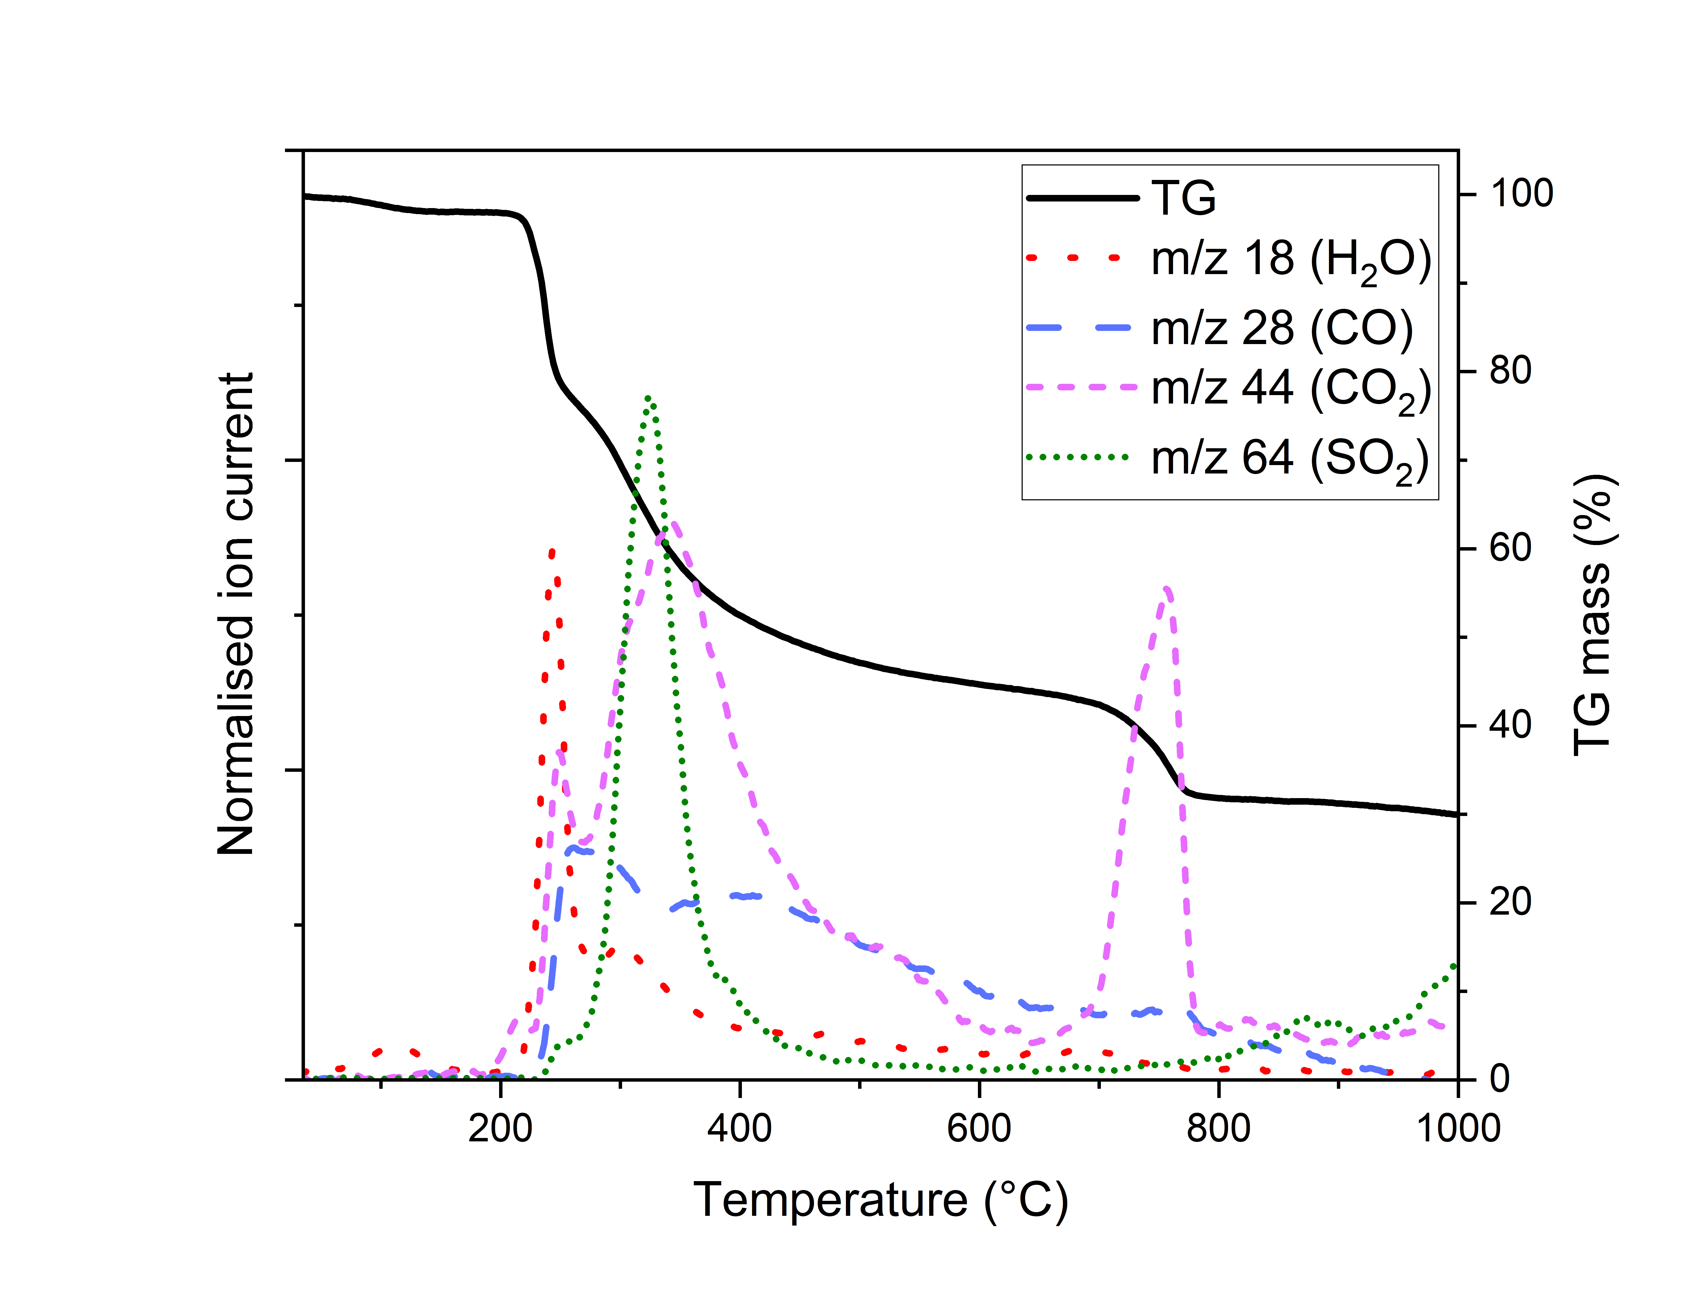

Figure 1. Simultaneous thermal analysis of C000 pyrolysed under Ar to 1000 °C. Thermogravimetric (black line – right y-axis) and mass spectrometry analysis (left y-axis) of gases evolved during thermal analysis.

To determine the extent to which sulfur remained incorporated, CHNS combustion analysis was used to monitor changes in elemental composition over the course of pyrolysis. The κ-carrageenan starting material was understood to be predominantly the potassium ester sulfate form, and as a result, was expected to contain a mixture of potassium salts after pyrolysis. To remove this inorganic content, materials were subjected to an aqueous wash after pyrolysis and the resulting materials were characterised by CHNS combustion analysis (Table 1). In all cases energy-dispersive X-ray spectroscopy (EDX) elemental analysis (Table S 1) revealed no significant inorganic content after washing. As such, the sulfur content that remains after washing was assumed to be covalently incorporated into the carbon matrix.

Table 1. CHNS elemental analysis for the C000 aerogel pyrolysed to 450, 600, 800 and 900 °C before and after aqueous washing.

|  |  |  |  |  |
| --- | --- | --- | --- | --- |
| **Pyrolysis temperature (°C)** | **Elemental composition (wt%)**  **(after aqueous wash)** | | | |
| **N** | **C** | **H** | **S** |
| 0 | 0.1  (-) | 44.0  (-) | 6.7  (-) | 7.6  (-) |
| 450 | 0.1  (0.2) | 43.1  (77.5) | 1.5  (2.7) | 6.9  (0.3) |
| 600 | 0.1  (0.3) | 45.3  (82.5) | 0.9  (1.4) | 8.4  (1.4) |
| 800 | 0.1  (0.1) | 46.7  (64.7) | 1.0  (1.5) | 8.0  (11.5) |
| 900 | 0.1  (0.1) | 33.0  (63.0) | 1.0  (0.4) | 10.4  (12.5) |

Despite the apparent loss of SO2 at 310 °C, upon pyrolysis to 450 °C, elemental analysis reveals that 6.9 wt% sulfur remains. However, washing this material is seen to result in the near complete removal of sulfur from the carbon matrix. This suggests the decomposition of ester sulfate groups to a water-soluble salt removed by washing. Upon pyrolysis to temperatures above 450 °C, sulfur incorporation is seen to increase, and in particular, between 600-800 °C, there is an increase from 1.4 wt% to 11.5 wt% sulfur. This is consistent with existing theory that the carbon surface will be more strongly reducing at higher temperatures up to the temperature at which graphitisation begins.53,54 Beyond 800 °C, further incorporation of sulfur is limited.

Powder X-ray diffractograms of the S-Starbons produced by pyrolysis of C000 to a range of temperatures were obtained before (Figure 2) and after (Figure S 2) washing. The diffraction patterns of the materials produced at 450, 600, 800 and 900 °C after washing feature only broad amorphous peaks attributed to graphitic crystallites, confirming the removal of inorganic content. Upon pyrolysis to 450 °C, and prior to washing, a single well-defined crystal phase arises that was assigned to potassium sulfate. This is consistent with CHNS elemental analysis and TG-MS and suggests decomposition of ester sulfate groups at 310 °C to K2SO4 and an equivalent of SO2, followed by the complete removal of sulfur when the material is washed. Between 450-700 °C, limited change to the diffraction pattern is seen, consistent with elemental analysis which suggests only 1.4 wt% sulfur is incorporated over this temperature range. However, upon pyrolysis to 800 °C, concurrent with the incorporation of 11.5 wt% sulfur, analysis reveals an additional crystalline phase attributed to K2CO3ꞏH2O. It is suggested that upon reaching sufficiently high temperatures (~700 °C), sulfate is reduced by the carbon surface to yield CO2 (exhibited in Figure 1) organic sulfur in lower oxidation states and K2O. The TGA of K2SO4 in the absence of the carbon matrix (Figure S 3) reveals no decomposition below 1000 °C, suggesting that reaction with the carbon matrix results in the decomposition of sulfate. CO2 evolved by concurrent oxidation of the carbon surface is expected to react readily with K2O to form K2CO3, while any K2O remaining after pyrolysis will readily react with atmospheric CO2. Beyond 800 °C, there is an increase in the ratio K2CO3ꞏH2O : K2SO4, suggesting further decomposition of sulfate in agreement with the continued evolution of SO2 seen in Figure 1.



Figure 2. pXRD of C000 pyrolysed to a range of temperatures under nitrogen, prior to washing.

EDX elemental mapping of C800 before (Figure 3a-g) and after (Figure 3h-n) washing was used to analyse the distribution of elements over the material surface and to confirm that aqueous washing had successfully removed inorganic content. EDX of C800 prior to washing reveals, in addition to the expected K2SO4, a minor sodium component and a small number of KCl crystallites, while the remaining potassium, sodium, oxygen and sulfur are seen to be evenly distributed over the carbon surface. Upon washing, this is seen to result in the uniform distribution of sulfur over the material surface. SEM-EDX of C450 and C600 (Figure S 1) yield a similar result whereby potassium, sulfur and oxygen are evenly distributed over the material prior to washing, but in both of these cases, washing is seen to remove the vast majority of sulfur in addition to potassium and sodium.

Figure 3. SEM-EDX analysis of C800 before (a, b, c, d, e, f and g) and after (h, i, j, k, l, m and n) aqueous wash. SEM micrographs (a, h), and EDX elemental mapping for carbon (b, i), oxygen (f, k), sulfur (e, j), potassium (c, n), sodium (g, m) and chlorine (d, l).

After pyrolysis to 450, 600 and 800 °C and aqueous washing to remove inorganic content, X-ray photoelectron spectroscopy (XPS) was used to characterise the state of the sulfur that remained and was thus assumed to be covalently incorporated. Additionally, the elemental compositions of C450, C600 and C800 as determined by XPS, have been summarized in Table 2. Analysis of the S 2p XPS signal allows for clear differentiation of contributions by different functionalities, where sulfur is known to exhibit XPS signals over a very wide range of binding energies determined largely by the sulfur oxidation state. The S 2p signals, plotted in Figure 4, of the materials prepared at all three temperatures was found to be well described by combinations of the same three sulfur environments centered at 163.9, 167.8 and 168.9 eV. The relative contributions of each have been summarised in Table 3. A well-defined doublet at lower binding energy, 163.9 eV, could be attributed to reduced sulfur in a range of functionalities such as thiols, sulfides, disulfides and thiophenes, but in similar sulfur-containing carbon materials, a signal at ~164 eV is often attributed to sulfide groups.55–57 Thus confirming the incorporation of a significant quantity of reduced sulfur chemistry, considered most promising for soft PGM adsorption, by 800 °C.

Table . Elemental composition of C450, C600 and C800 as determined by XPS

|  |  |  |  |  |  |  |  |  |
| --- | --- | --- | --- | --- | --- | --- | --- | --- |
| **Material** | **Elemental composition (at. %)** | | | | | | | |
| **C** | **O** | **S** | **Si** | **Na** | **N** | **F** | **Cl** |
| C450 | 85.1 | 14.3 | 0.3 | - | - | - | 0.2 | 0.1 |
| C600 | 86.8 | 12.0 | 0.7 | - | - | - | 0.3 | 0.2 |
| C800 | 86.6 | 8.8 | 4.1 | 0.1 | 0.1 | 0.2 | 0.2 | - |

Table . Summary of the contributions of different sulfur species to the total S 2p XPS signal of C450, C600 and C800 after washing.

|  |  |  |  |  |
| --- | --- | --- | --- | --- |
| **Species** | **Energy (eV)** | **Contribution to total S content (%)** | | |
| **C450** | **C600** | **C800** |
| C-**S**O3- | 168.9 | 28.5 | 8.5 | 36.0 |
| C-**S**O-C | 167.8 | 14.1 | 20.6 | 14.2 |
| C-**S**-C | 163.9 | 28.5 | 70.9 | 49.9 |



Figure . X-ray photoelectron spectroscopy a - survey spectra and b – analysis of S (2p) chemistry that remains after washing of C450, C600 and C800 materials.

The two species at higher binding energy (167.8 and 168.9 eV) can be attributed to sulfur in higher oxidation states. The signal at 168.9 eV is likely due to the formation of sulfonate groups which are known to form upon the reaction of sulfuric acid with carbonaceous materials, a common method for sulfonation.58,59 The signal at 167.8 eV was attributed to other oxidised sulfur functionalities such as sulfones and sulfoxides, with the more difficult resolution of the doublets at higher binding energy being indicative of sulfur in a wider range of environments.55 XPS reveals that in addition to the significant increase in reduced sulfur content upon pyrolysing to 800 °C, a range of higher oxidation states are also incorporated and the changing ratio of reduced to oxidised sulfur follows no clear trend. The increase in sulfur incorporated from just 0.3 wt% in C450 to 11.5 wt% in C800 is indicative of the substantial increase in the reducing power of the carbon surface at higher temperatures. However, even at these higher temperatures the heterogeneity of the material surface is seen to result in sites with a wide range of reduction potentials, and as a result, sulfur is incorporated as the range of oxidation states illustrated in Figure 5. In addition to XPS, TG-FTIR analysis (Figure S 6) of C800 identified sulfur containing species which decomposed at ~200 °C to liberate gaseous sulfur dioxide, confirming the presence of oxidised sulfur species that were not found to participate in PGM adsorption.

Figure 5. Schematic representation of the suggested evolution of sulfur chemistry during the pyrolysis of C000

Organic ester sulfate groups present in the carrageenan starting material are seen to decompose during pyrolysis before the eventual reduction and incorporation of sulfur via inorganic sulfate salts. On this basis we expected that it would be possible to produce similar materials by artificially doping potassium sulfate into a range of polysaccharide hydrogels with differing porous structures. This was seen as an attractive way of increasing the final sulfur content and demonstrating the wider scope of our approach to producing sustainably derived sulfur-containing mesoporous carbon materials. To this end, S-A800 was produced by the addition of K2SO4 to an alginic acid hydrogel at 7.5 wt% sulfur, before drying and pyrolysis under the same conditions used to produce S-Starbons from κ-carrageenan. Characterisation of the porous structure and surface chemistry of S-A800 are reported in the following sections.

### The role of process conditions in the development of porous structure

The atmosphere under which carbon materials are pyrolysed is understood to have a significant impact on subsequent surface chemistry and in the preparation of Starbon materials, pyrolysis conditions have been shown to be important in determining porous properties.53,60 To this end, pyrolysis under reduced pressure and under a flow of N2 gas were compared for the preparation of carrageenan-derived Starbon materials. The N­2-sorption porosimetry for S-Starbon materials prepared under a range of conditions are summarised in Table 4, while differences in mesopore size distributions are illustrated in Figure 6.

Upon pyrolysis of the C000 aerogel to 300 °C, porosity is only retained when initial pyrolysis is conducted under reduced pressure (C300RP), while the N2 pyrolysis to 300 °C is seen to result in the non-porous C300N2. This is consistent with previous work that found that the material porosity is highly dependent on this initial pyrolysis, in particular, the rate at which the material is heated between 150-300 °C.60 Marriott et al found that increasing the rate of pyrolysis negatively impacted pore volume and surface area and it was suggested that this is largely due to the insufficient removal of volatile organic compounds released within this temperature range. Similarly, we would suggest that the limited flow of nitrogen sustained during N2 pyrolysis was not able to sufficiently remove volatile organic compounds and water liberated during the initial stages of pyrolysis, resulting in the collapse of the porous structure. Upon further pyrolysis of C300­RP to 800 °C, a significant volume of intermediate-sized mesopore (10-40 nm), characteristic of Starbon materials, is retained (Figure 5).44,45,59 However, beyond 300 °C, no significant difference in porous structure was observed between the materials pyrolysed under reduced pressure and N2. Upon further pyrolysis of C300N2 to 800 °C, some porosity begins to develop due to thermal activation, however, this is largely limited to micropore (<2 nm). Likewise, when non-expanded κ-carrageenan powder was pyrolysed to 800 °C, under reduced pressure to 300 °C and then under N2, the material develops extensive surface area (624 m2.g-1), but this is attributed almost entirely to micropore and small mesopore (<4nm in width).

While the porosity of alginate-derived Starbons have previously been reported several times,36,39,45,60 comparison of S-A800, doped at a range of sulfate loadings (Table S 3), to the sulfur-free A800, reveals the impact of sulfate-doping on porous structure. Sulfate doping of S-A800 was found to result in a substantial increase in both surface area and pore volume (BET surface area = 1377 m2.g-1, BJH mesopore volume = 1.70 cm3.g-1) compared to the S-free A800 (BET surface area = 504 m2.g-1, BJH mesopore volume = 0.76 cm3.g-1). This additional porosity may be attributed to the corrosive effect of sulfate reduction at elevated temperatures which has been shown to result in the oxidation of the carbon support and evolution of CO2.59

|  |  |  |  |  |  |  |  |  |
| --- | --- | --- | --- | --- | --- | --- | --- | --- |
| **Material** | **Starting material** | **Expanded  a** | **Final temperature**  **(°C)** | **Pyrolysis conditions b** | | **N2-sorption porosimetry** | | |
| **0-300 °C** | **300-800 °C** | **Surface area (m2.g-1)  c** | **Pore volume (cm3.g-1)  d** | **% micropore** |
| C300N2 | Carrageenan | Yes | 300 | N2 | - | 13 | 0.05 | 2.2 |
| C300RP | Carrageenan | Yes | 300 | RP | - | 368 | 0.68 | 8.1 |
| C800RP | Carrageenan | Yes | 800 | RP | RP | 612 | 1.12 | 15.1 |
| C800N2 | Carrageenan | Yes | 800 | N2 | N2 | 847 | 0.49 | 69.0 |
| C300RP-800N2 | Carrageenan | Yes | 800 | RP | N2 | 766 | 0.93 | 28.0 |
| CNE300RP-800N2 | Carrageenan | No | 800 | RP | N2 | 624 | 0.47 | 40.8 |
| A800 | Alginic acid | Yes | 800 | RP | N2 | 504 | 0.76 | 18.4 |
| S-A800 | Alginic acid | Yes | 800 | RP | N2 | 1377 | 1.70 | 8.8 |

Table 4. Summary of N2-sorption porosimetry for Starbons produced under a range of conditions described below.

a Refers to whether the materials were prepared either via the direct pyrolysis of the precursor (as received) or via expansion in water followed by freeze drying and pyrolysis. b Refers to whether the materials were prepared by pyrolysis under a flow of N2 or under reduced pressure (RP). c  Surface area estimated using the BET equation. d Total pore volume was defined as the sum of the t-plot micropore volume and the BJH (adsorption) mesopore volume.

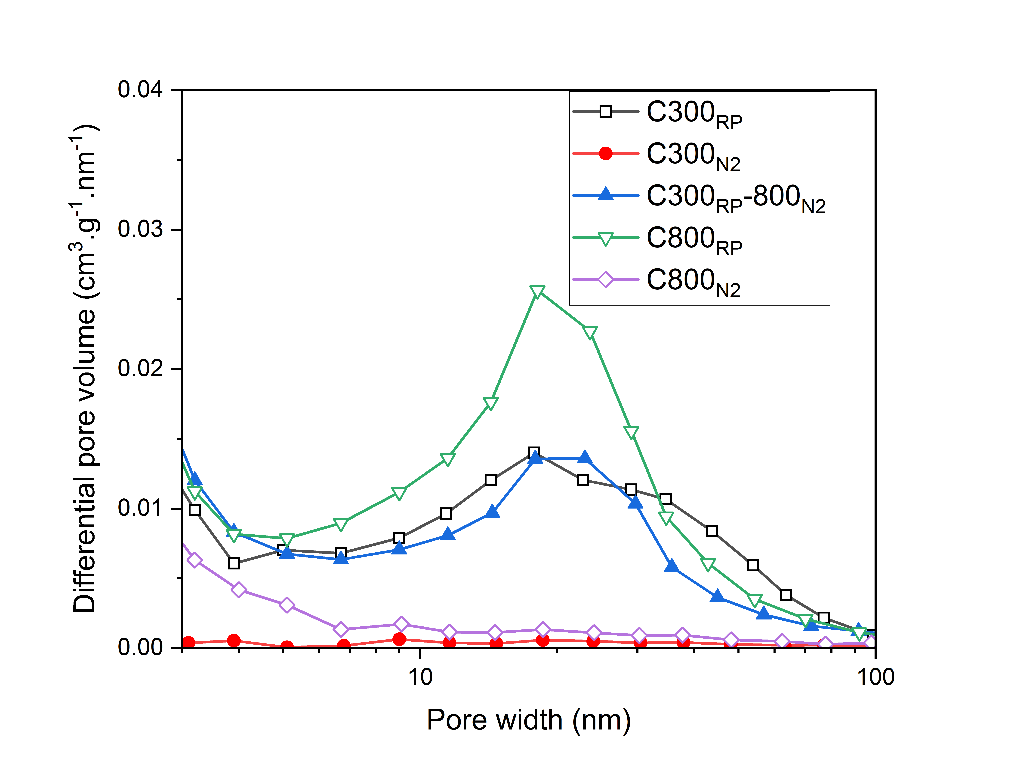

Figure 6. BJH adsorption differential pore size distribution of C300RP, C300N2, C300RP-800N2, C800RP and C800N2.

### The influence of process conditions on sulfur incorporation

Given that pyrolysis between 300-800 °C could be conducted under either reduced pressure or a flow of nitrogen to yield materials with similar textural properties, the surface chemistry resulting from each was explored. In addition, to determine the impact of wash solution pH, materials were washed in either 2M HCl or water, whereby water washing resulted in a moderately basic (ca. pH 10) eluent. CHNS elemental analysis of S-Starbons produced under a range of conditions are summarised in Table 5.

Table 5. Elemental analysis of S-Starbons produced under a range of conditions described below.

|  |  |  |  |  |  |
| --- | --- | --- | --- | --- | --- |
| **Material** | **Expanded a** | **300-800 °C pyrolysis b** | **Wash solution c** | **Sulfur content (wt%)** | |
| **Combustion analysis** | **EDX** |
| C300RP-800N2 | Yes | N2 | HCl | 11.5 | 10.6 |
| C300RP-800N2 | Yes | N2 | Water | 3.8 | 3.1 |
| C800RP | Yes | RP | HCl | 6.3 | 5.8 |
| C800RP | Yes | RP | Water | 3.1 | 5.2 |
| CNE300RP-800N2 | No | N2 | HCl | 5.1 | 6.0 |
| A800 | Yes | N2 | HCl | 0.6 | 0.2 |
| S-A800 | Yes | N2 | HCl | 17.4 | 17.8 |

a Refers to whether the materials were prepared either via the direct pyrolysis of the precursor (as received) or via expansion in water followed by freeze drying and pyrolysis. b Refers to whether the materials were prepared by pyrolysis either under a flow of N2 or under reduced pressure (RP).  c Refers to whether the materials were washed in either 2M HCl or water after pyrolysis.

Comparison of C300RP-800N2 materials, washed with 2M HCl and water respectively, reveals a 3-fold increase in the final sulfur content (10.6 wt%) when washing with HCl as compared to washing in water alone (3.1 wt%). Additionally, pXRD (Figure 2), reveals only partial reduction of sulfate during pyrolysis to 800 °C, suggesting that the remaining sulfur is incorporated during the washing step. Pyrolysis of carbon materials under an inert atmosphere is known to result in a highly reactive surface that, if not quenched, will go on to react readily with atmospheric oxygen yielding a range of surface oxides.53,54 As a result, when these sulfate containing materials are washed very soon after pyrolysis, there is the potential for further sulfur incorporation by reaction of solubilised SO42- with the reactive carbon surface. The differences in reactivity between the acidified and basic solutions are easily rationalised in terms of the relative stability of the SO42- anion, and the successively reduced sulfur species (Figure S 9), whereby SO42- is more readily reduced and incorporated under acidic conditions than neutral or basic.61

Comparison of the sulfur content of the materials pyrolysed to 800 °C under reduced pressure (C800RP) and under N2 (C300RP-800N2), 5.8 wt% and 10.6 wt% respectively (after an acidic wash), reveals a substantial increase in sulfur content when pyrolysed under N2. While the acid wash of C300RP-800N2 resulted in a significant increase in sulfur content over the base washed material, comparison of C800RP-water (5.2 wt% S) and C800RP-HCl (5.8 wt% S), suggests limited sulfur incorporation during the wash step. This would suggest that, despite the similar textural properties of C300RP-800N2 and C800RP, N2 pyrolysis results in a substantially more reactive surface that facilitates additional sulfur incorporation. S 2p XPS characterisation of C300RP-800N2-water, C300RP-800N2-HCl, C800RP-water and C800RP-HCl (Figure S 7) reveals no significant differences in the ratio of incorporated sulfur oxidation states.

In addition to pyrolysis conditions, material porous structure is seen to have an impact on sulfur incorporation. Despite being pyrolysed under the same conditions as C300RP-800N2, the microporous CNE300RP-800N2 produced from non-expanded carrageenan was found to retain only 6.0 wt% sulfur after acidic wash. If final sulfur incorporation is ultimately dependent on the reduction of SO42- by the reactive carbon matrix during the washing step, then it follows that the non-expanded CNE300RP-800N2, possessing no significant mesoporosity, would suffer from a lack of reactive surface area accessible to SO42- ions during washing.

In addition to increased porosity, the sulfate doped alginate-derived Starbon (S-A800) resulted in a significant quantity of sulfur being retained by the carbon matrix. Despite sulfur initially being doped to the same 7.5 wt% found in κ-carrageenan, the sulfur content of S-A800 was found to be substantially higher than C800. This is attributed to the decomposition of the organic ester sulfate in carrageenan at <300 °C to yield ca. 0.5 equivalents of SO2. By comparison the potassium sulfate incorporated into the alginate hydrogel is expected to be thermally stable until eventual reduction by the carbon matrix at <700 °C or during the washing step.

## Platinum group metal adsorption

In all PGM adsorption experiments, PGM salts were dissolved in aqueous 2M NaCl acidified to pH 1 using HCl which is expected to result in the formation of the stable tetrachloride anions of both Pd(II) and Pt(II).48,49 These conditions were chosen to explore the adsorptive properties of S-Starbons under conditions relevant to low grade PGM refinery streams and to avoid the complications of PGM hydroxide formation that occur at particularly low chloride concentration or high pH.62 In order to compare the Pd(II) sorption properties of a range of S-Starbon materials, adsorption isotherms have been plotted (Figure 7) whereby the capacity for Pd(II) was measured as a function of Pd(II) concentration. It was found that in all cases, the adsorption isotherms were well descried by the Freundlich isotherm, which has allowed for both the determination of Freundlich parameters and a comparison of estimated capacities at 1 and 100 ppm, as summarised in Table 6.

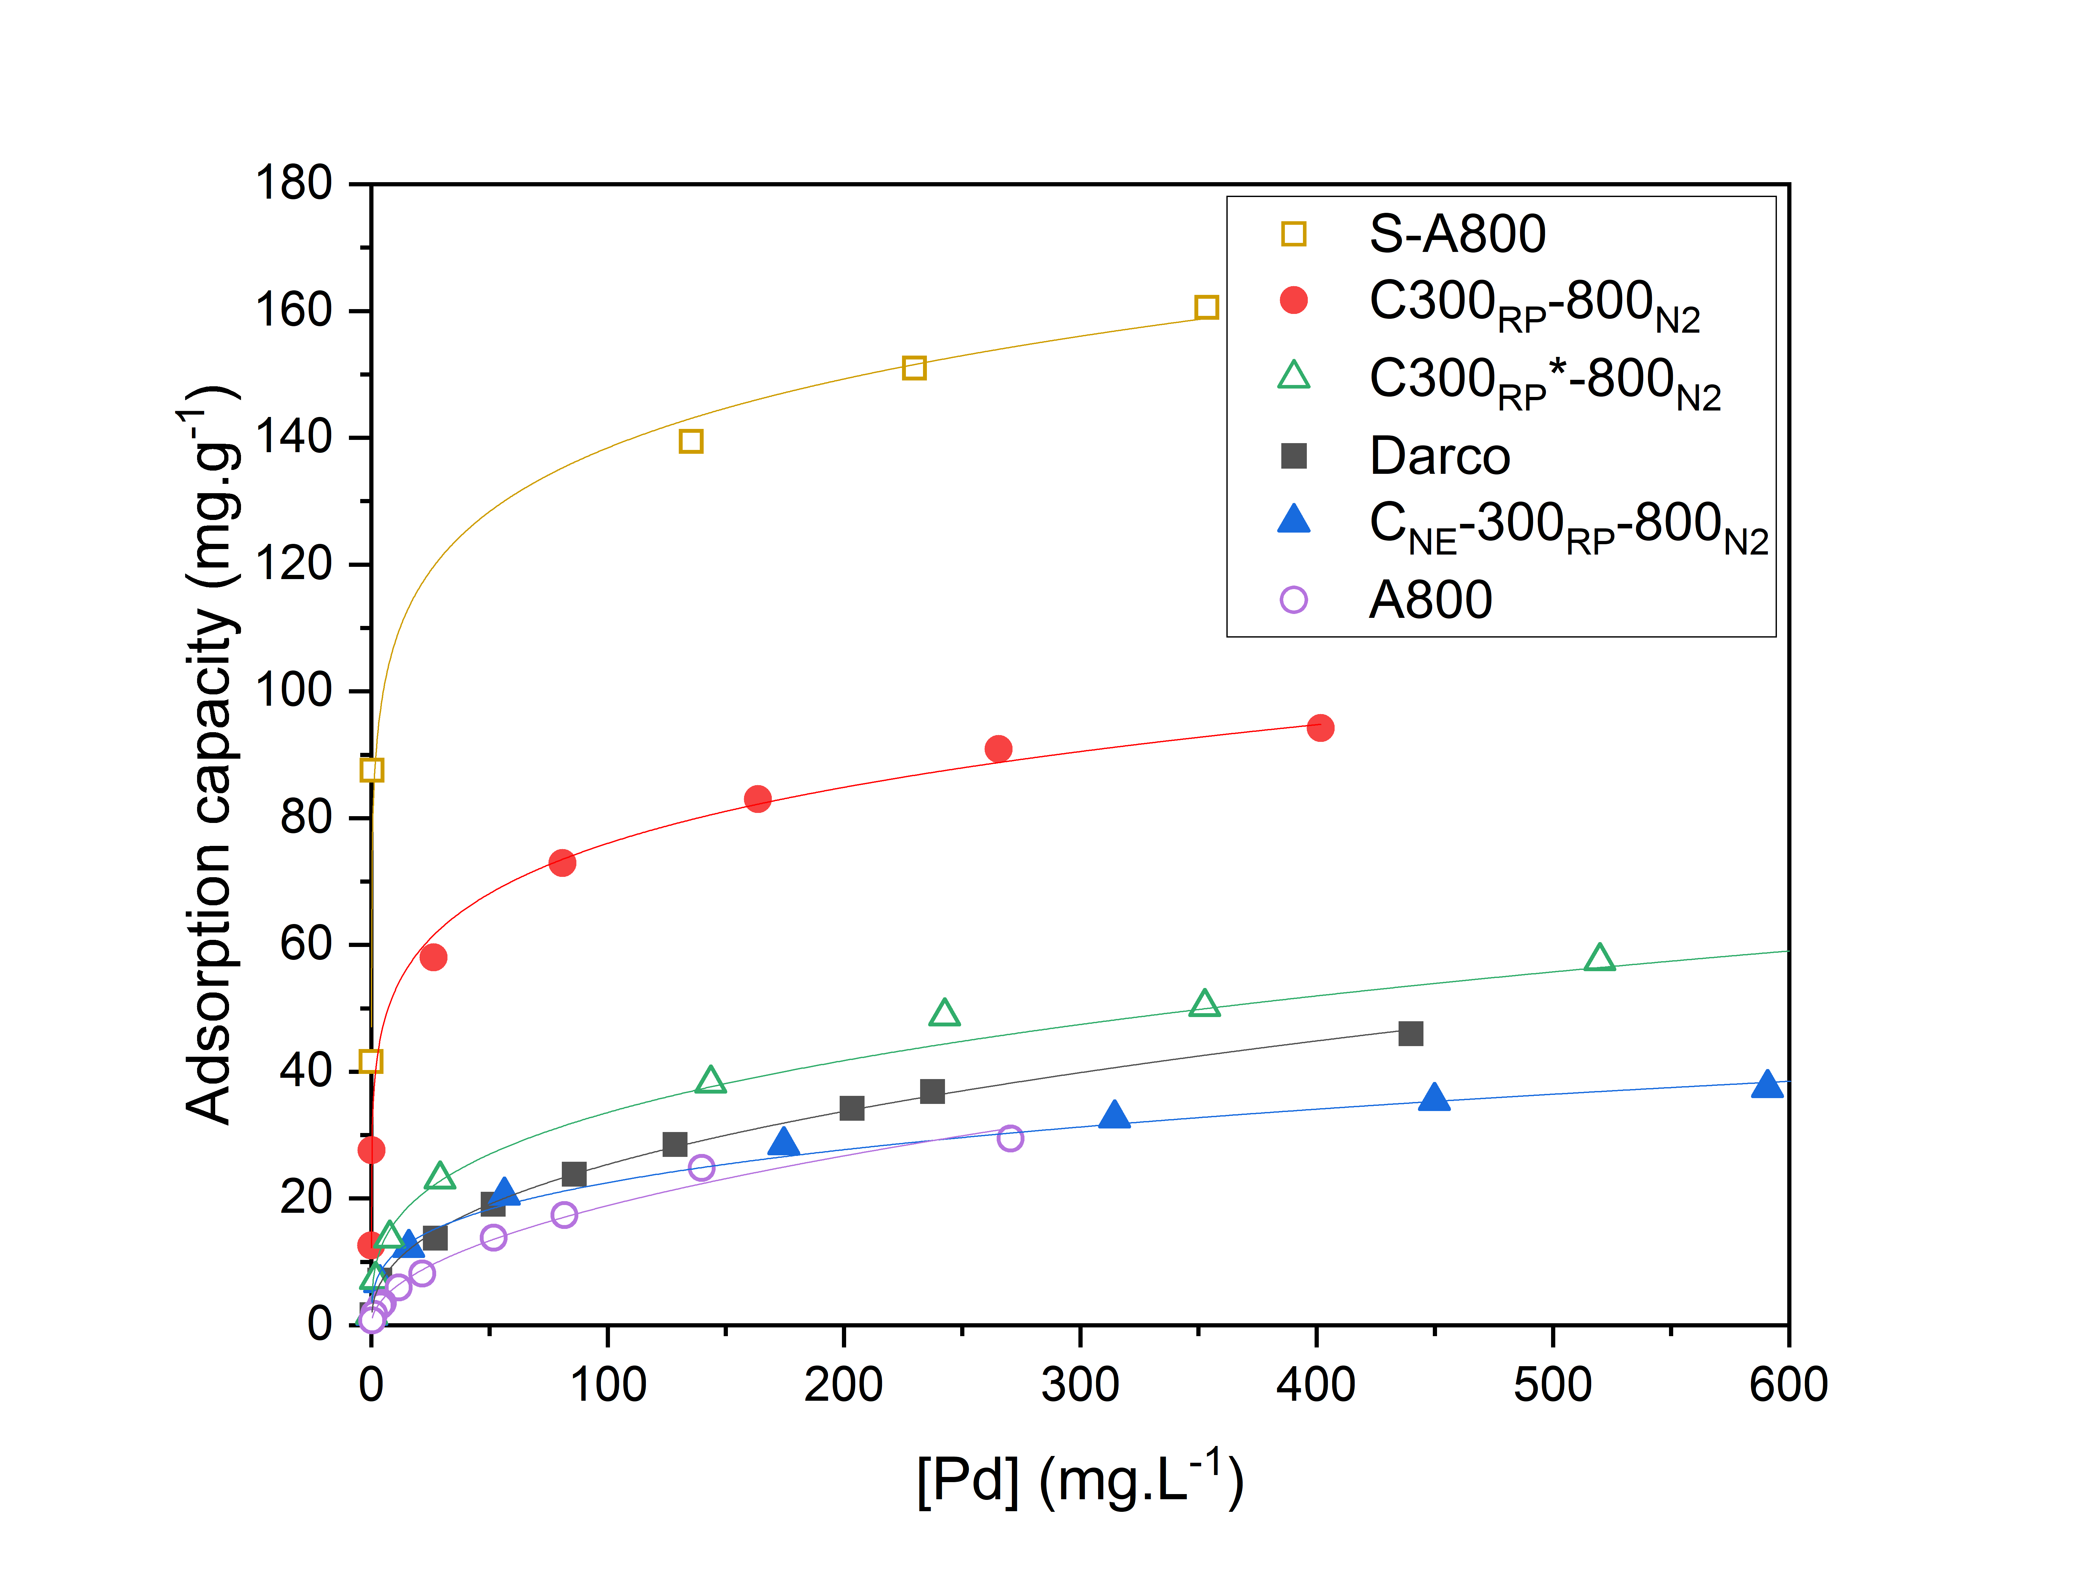

Figure 7. Isotherms for the adsorption of Pd(II) by Darco, C300RP-800N2, CNE800N2, C300RP*-800N2, A800 and S-A800 from 2M NaCl at pH 1.

Table 6. Freundlich parameters and calculated adsorption capacities at equilibrium Pd concentrations of 1 and 100 mg.L-1

|  |  |  |  |  |
| --- | --- | --- | --- | --- |
| **Material** | **Freundlich parameters** | | **Adsorption capacity (mg.g-1)** | |
| **K** | **1/n** | **ceq = 1 mg.L-1** | **ceq = 100 mg.L-1** |
| Darco | 3.83 | 0.41 | 3.83 | 25.4 |
| C300RP-800N2 | 33.3 | 0.18 | 33.3 | 75.2 |
| CNE800N2 | 5.67 | 0.30 | 5.67 | 22.5 |
| C300RP*-800N2 | 5.45 | 0.32 | 5.45 | 23.3 |
| A800 | 1.87 | 0.50 | 1.87 | 18.9 |
| S-A800 | 89.0 | 0.10 | 89.0 | 140 |

To determine the contribution of the carbon matrix in the absence of sulfur, C300RP*-800N2 was prepared as a sulfur-free analogue of C300RP-800N2. After pyrolysis to 300 °C under reduced pressure, the resulting C300 was acid washed to remove inorganic sulfates. The sulfur free C300 was then pyrolysed to 800 °C under N2, resulting in a material with very similar porous structure to C300RP-800N2 as determined by N2-sorption porosimetry (Table S 2). Comparison of the Pd(II) adsorption capacities of C300RP*-800N2 and C300RP-800N2 at 1 ppm (33.3 and 5.45 mg.g-1 respectively) reveals a 6-fold increase upon the incorporation of reduced sulfur chemistry. This confirms that the carbon matrix alone possesses some capacity for Pd(II) adsorption, as has been previously reported many times. This property of carbon materials has been convincingly attributed to the π-interaction between the soft Pd(II) center and unsaturated groups on the carbon surface and is known to be selective for Pd(II) and Pt(II).24,25 The increase in capacity, particularly at low Pd concentrations, is expected to be a result of the strong specific interaction between incorporated organic sulfur and Pd(II). Of a similar magnitude to C300RP*-800N2, the capacity of the commercial activated carbon Darco (3.83 mg.g-1) at 1 ppm is representative of the limited potential of unmodified carbon materials for Pd/Pt separations and recovery.

Similarly, a comparison of A800 and S-A800 highlights the contribution of reduced sulfur chemistry to the Pd(II) capacity of S-Starbons. In particular, at 1 ppm Pd, A800 and S-A800 are seen to exhibit capacities of 1.87 mg.g-1 and 89.0 mg.g-1 respectively, representing a 48-fold increase upon inclusion of sulfur. However, in this instance, the presence of sulfate during pyrolysis is seen to result in a significant increase in the porosity of S-A800 which may facilitate PGM uptake in addition to the inclusion of sulfur chemistry. As might be expected, the Pd(II) capacity of S-A800 was found to increase proportionally with the quantity of K2SO4 doped at the gel stage (Figure S 10).

The role of S-Starbon porosity on Pd(II) uptake may be inferred by the limited capacity of the microporous CNE300RP-800N2 (5.67 mg.g-1 at 1 ppm), produced from non-expanded carrageenan. Despite the substantial retention of sulfur by CNE300RP-800N2, in the absence of mesoporosity, Pd(II) uptake is seen to be significantly reduced. Similar conclusions have been previously reported about the importance of Starbon mesoporosity on both dye adsorption and electrochemical properties, where capacity and charge kinetics were far more dependent on mesopore volume than specific surface area.41,60,63 However, it is important to note that the limited capacity of CNE300RP-800N2 could also be, in part, due to the limited development of sulfur chemistry in the material with reduced porosity.

### Adsorption selectivity and kinetics

To determine the selectivity of S-Starbon materials, the adsorption of Pd, Pt, Ir, Ru and Rh from a mixed metal solution was determined in both the absence (Figure 8a) and in the presence (Figure 8b) of a 50-fold excess of the base metals Cu(II), Ni(II) and Co(II) by S-A800, C800 (C300RP-800N2)and Darco.



Figure 8. Batch adsorption of Ir(III), Pd(II), Pt(II), Rh(III) and Ru(III) from a mixed metal solution of 2M NaCl at pH 1. a - in the absence of and, b – in the presence of a large excess of the base metals Cu(II), Ni(II) and Co(II), by C800 and P800. Error bars represent 95 % confidence interval. c – Kinetics of PGM uptake by S-A800 from a mixed metal solution in the presence of excess base metals.

Changes in PGM concentration are reported in Figure 8, while in all cases, no meaningful change in the concentration of base metals (Cu, Ni and Co) was observed. All three materials, including Darco, were found to selectively adsorb Pd(II) and Pt(II) irrespective of the presence of the excess base metals confirming that competition with the first row transition metals had no impact on PGM adsorption. However, the selectivity of the sulfur-containing Starbons was found to be substantially greater than Darco, with C800 removing 99.5 % Pd and 96.0% Pt and S-A800, proving more selective still, removing 99.8 % Pd and 99.2 % Pt, in the presence of excess Cu(II), Ni(II) and Co(II). This minor preferential adsorption of Pd(II) over Pt(II) is characteristic of the interaction with soft donor atoms and is seen for other PGM scavenging materials.64 The selective removal of Pd and Pt in the presence of a range of other metals highlights the excellent potential for S-Starbons to be used towards the recovery of these PGMs from low grade waste streams. In particular, the removal of Pd(II) and Pt(II) by S-A800 was highly efficient, resulting in residual concentrations of <0.1 ppm Pd and <0.8 ppm Pt.

To better understand the mechanisms of PGM uptake, the rate of Pd, Pt, Ir, Ru and Rh adsorption from a mixed metal solution by S-A800 were determined (Figure 8c). Following very fast initial adsorption, whereby ca. ~30% of both Pd and Pt are adsorbed within the first 30 seconds, the remaining Pd and Pt is seen to be adsorbed gradually over the course of 24 hours, while Rh, Ru and Ir adsorption appears to be complete within the first 50 minutes, with Ru and Rh then beginning to desorb over the subsequent 24 hours. Contrary to the relative ligand exchange kinetics for Pd(II) and Pt(II) chlorides, which predicts the uptake of Pt(II) over several orders of magnitude more slowly than Pd(II),65 both are seen to adsorb at similar rates, suggesting an alternative limiting process in this case, such as diffusion.

### Desorption and reuse

Having established excellent selectivity and capacity for Pd(II) and Pt(II), the feasibility of recovering the metals by elution, thus regenerating the S-Starbon material for further use, was investigated. By stripping first using HCl and then an acidified thiourea solution, it was possible to determine both the maximum reversible capacity and then the capacity of sites of intermediate strength, most useful for selective PGM recovery (Figure 9). It is assumed that during adsorption from a concentrated Pd/Pt solution, all adsorption sites, including the strongest and the weakest will become occupied. As a mild stripping agent, aqueous HCl is expected to elute Pt/Pd adsorbed by the weakest sites only.66 The subsequent elution with acidified thiourea, a ligand with a much higher affinity for Pd/Pt(II),67 is expected to strip Pt/Pd from sites of intermediate strength. The capacity that can be stripped using thiourea is considered to be the most useful. While these sites are sufficiently strong to adsorb Pt/Pd selectively and to very low residual concentrations, they are not so strong as to irreversibly bind the metals. The Pt/Pd that remains after elution by thiourea is adsorbed by the strongest sites and cannot be recovered easily by stripping.

Following column adsorption of either Pd or Pt, S-A800 was initially eluted using 50 mL of 2M HCl, whereby the most weakly bound 0.55 mmol.g-1 Pd and 0.42 mmol.g-1 Pt were desorbed. Next, 60 mL of acidified thiourea was used to elute Pd/Pt bound to sites of intermediate strength. The capacity of these sites, 0.82 mmol.g-1 Pd and 0.53 mmol.g-1 Pt, represents the useful (reusable) capacity of S-A800 and is the capacity attributed to soft sulfur-containing donor groups. While the quantity of Pt adsorbed by weak and intermediate strength sites was very similar to that of Pd, the size of irreversible adsorption was seen to differ significantly, where just 0.09 mmol.g-1 Pd remained after elution with thiourea while 0.31 mmol.g-1 Pt remained. This may be rationalised in terms of the reduction potentials of the Pd(II/0) and Pt(II/0) chloride couples, 0.59 and 0.76 V vs SHE respectively.61 Given that Pt(IV) and Pt(II) are known to be readily reduced by carbon materials, we anticipate a component of irreversible reductive sorption, whereby Pt(0) is not easily resolubilised without the use of an oxidant.68

Following desorption by acidified thiourea, S-A800 was washed using HCl and then water before being reused to determine the efficiency of subsequent adsorption cycles (Table 7). Over 48 hours, S-A800 was found to remove 96.3 % Pd during the first adsorption. After stripping, the removal efficiency of the second adsorption was found to increase to 99.9 %. This is attributed to the improved kinetics after conditioning S-A800 by the first adsorption/desorption cycle, whereby the second adsorption was seen to be substantially faster than the first (Figure S 10). After again stripping with thiourea, the efficiency of the third adsorption (99.3 %) was seen to remain high. While this doesn’t account for the long-term reusability of S-Starbons, it provides evidence for the reversible nature of the Pd(II) uptake mechanism and suggests the excellent potential for recovery of the metals after extraction.

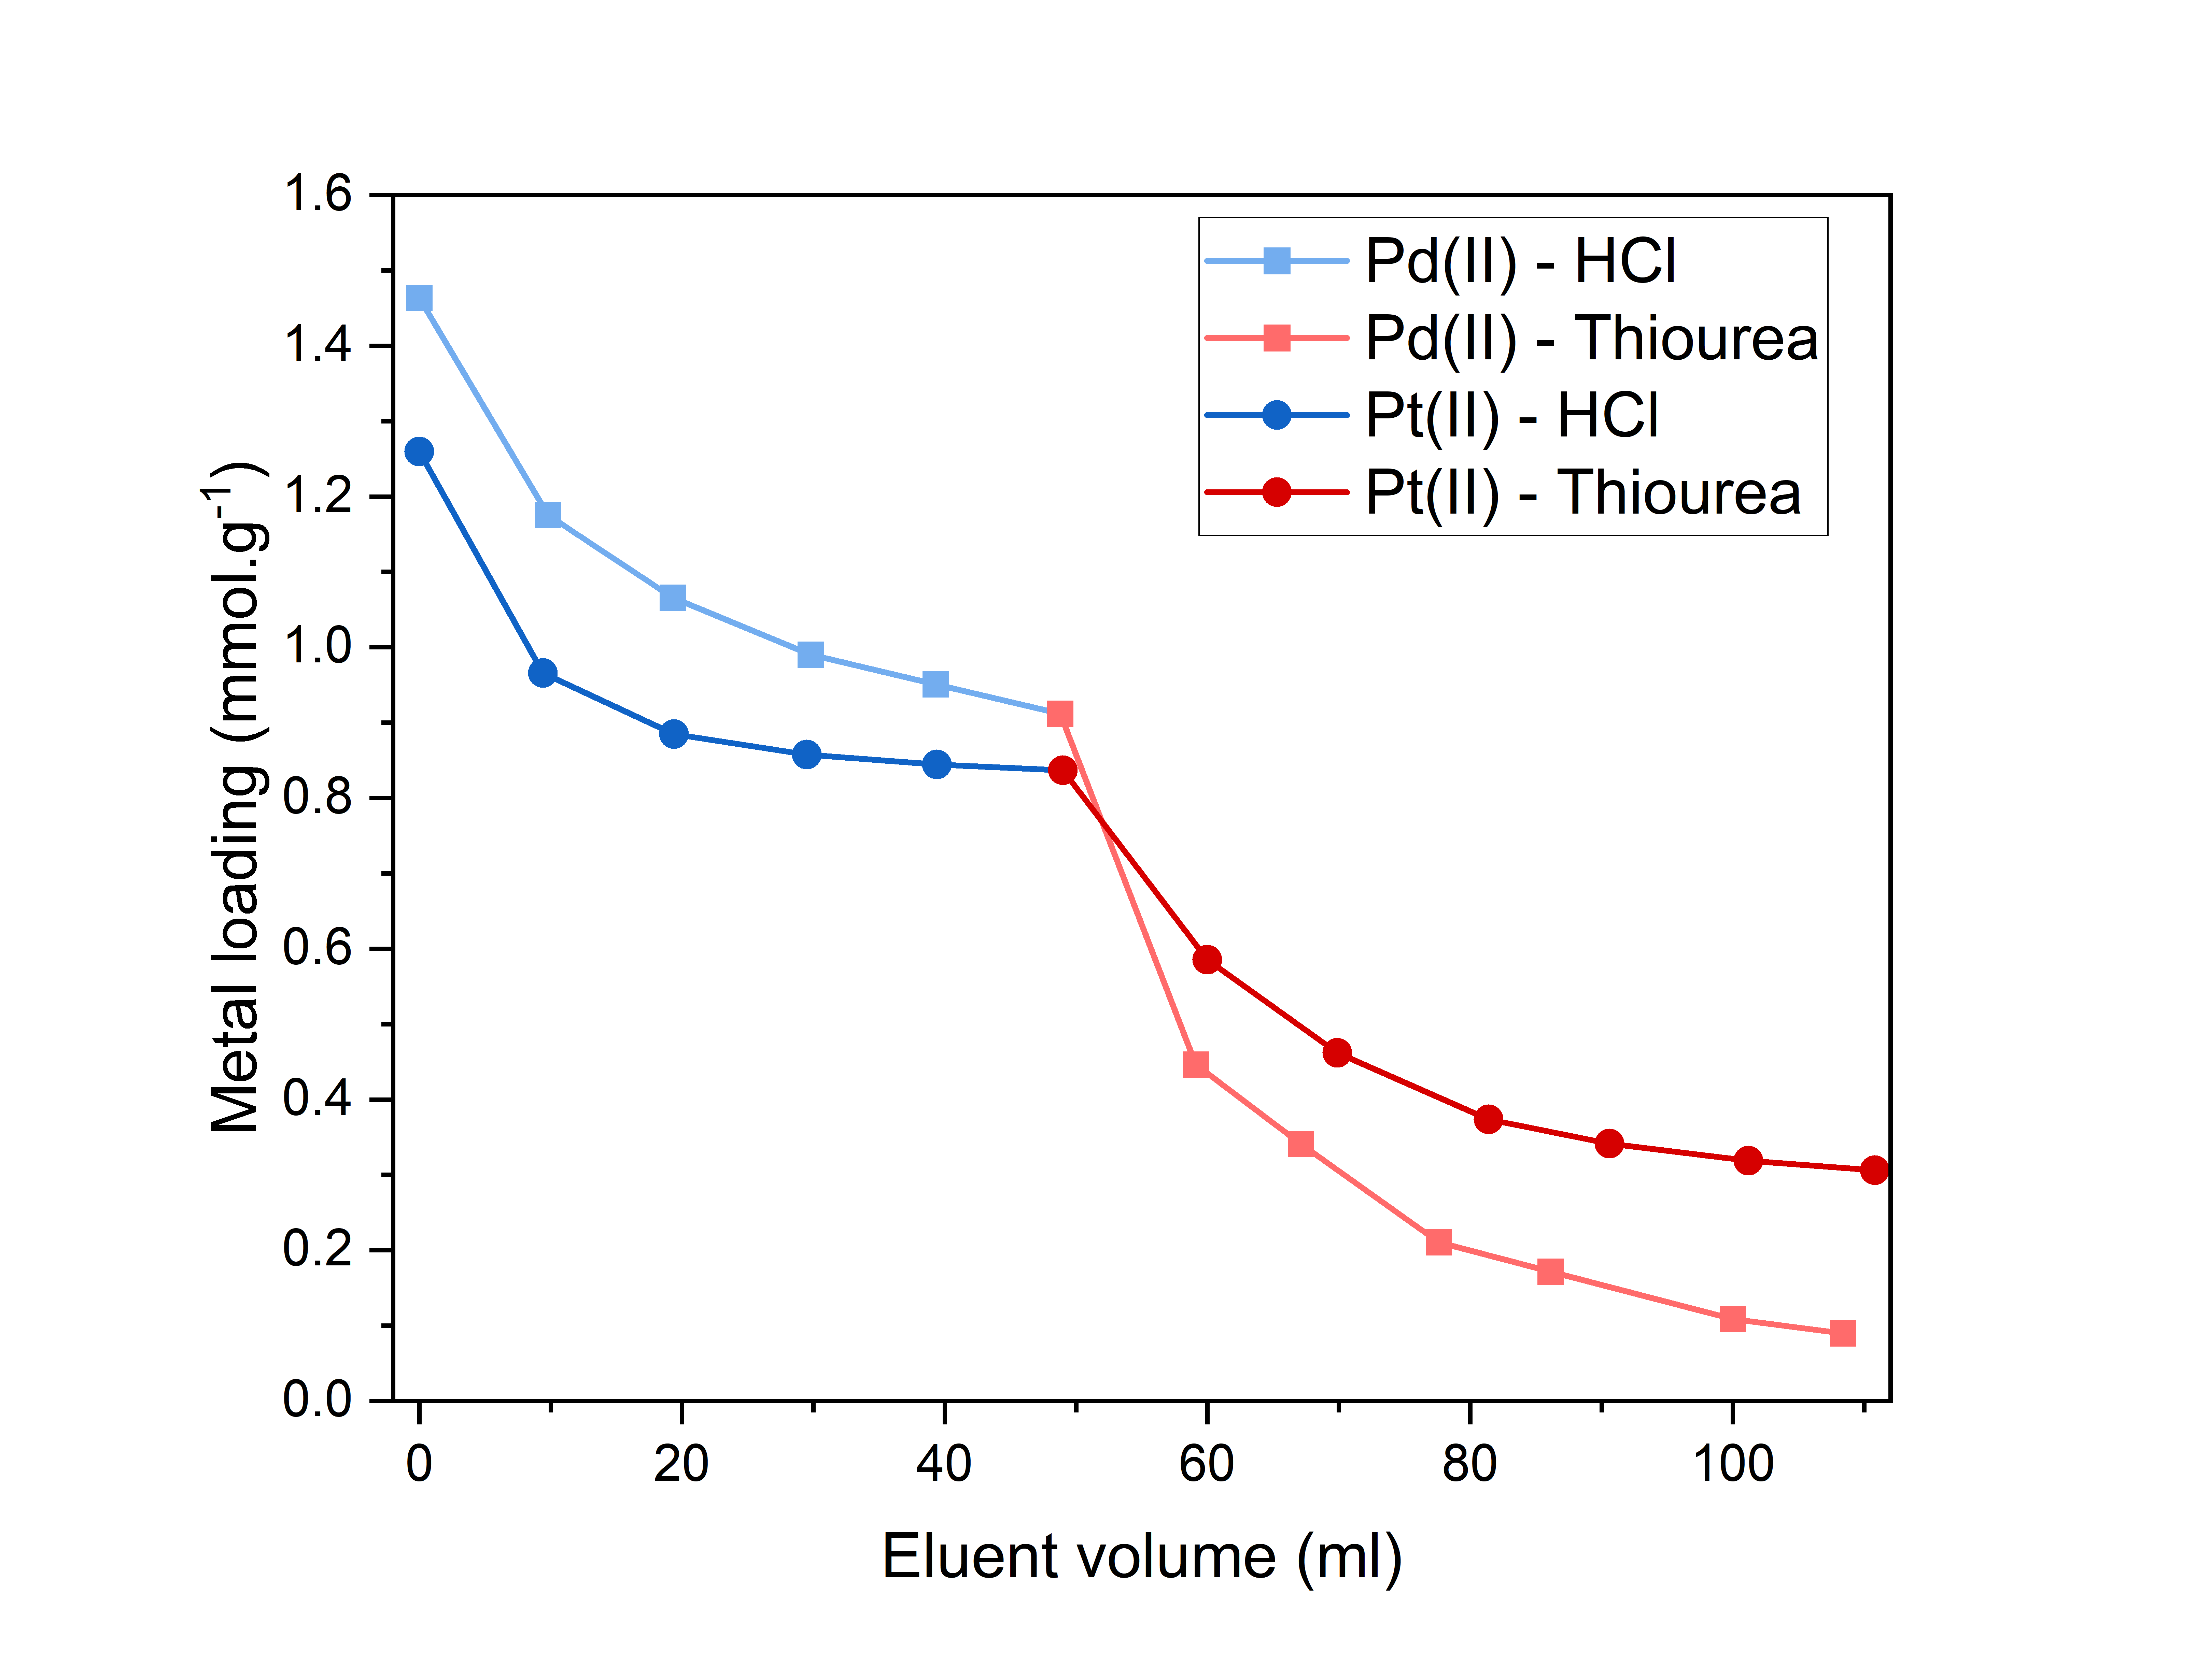

Figure 9. Elution of Pd(II) from S-A800 by HCl (blue) and then acidified thiourea (red)

Table 7. Adsorption efficiency for successive reuses of S-A800 for Pd(II) uptake. Pd stripped using acidified thiourea between each use.

|  |  |
| --- | --- |
| **Adsorption cycle** | **Pd(II) removal (%)** |
| 1 | 96.3 |
| 2 | 99.9 |
| 3 | 99.3 |

### Characterisation of Pd-C800

To probe the interaction responsible for Pd adsorption by S-Starbons, Pd-loaded C300RP-800N2 (5 wt.%) was characterised by pXRD, XAS and XPS. While high selectivity for Pd(II) and Pt(II), and the reversibility of sorption strongly suggests coordination to soft Lewis basic sulfur on the Starbon surface, physical characterisation of the state of adsorbed Pd(II) was required to confirm this and to exclude alternative mechanisms.

pXRD of C300RP-800N2 before and after Pd(II) sorption (Figure S 12) revealed minimal changes, where only a single crystalline phase, matched to NaCl, was identified, suggesting that precipitation of Pd-containing species did not contribute significantly to adsorption.

Resulting from the excitation of an electron from a 1s orbital, XAS analysis of the Pd k-edge energy allows for qualitative comparison of the formal oxidation state of the Pd centre.69 To more easily allow for this comparison to be made, the first derivative of the Pd k-edge has been plotted in Figure 10b. The Pd-C800 k-edge energy is seen to very closely coincide with the PdCl2 and PdO standard samples in the +II oxidation state at 24353 eV, while the edge energy of metallic Pd and Pd black occurs at the lower energy of 24349 eV. This strongly suggests that Pd remains in the +II oxidation state upon adsorption and that very little if any Pd is adsorbed reductively. Upon transforming the Pd EXAFS data into χ(R) space (Figure 10b), a qualitative analysis of the scattering environment around Pd can be made. Comparison of Pd-C800 to the range of standard samples reveals a similarity to both PdCl2 standards, while the occurrence of any significant quantity of PdO or metallic Pd can be ruled out. A quick first shell fit of the Pd-C800 χ(R) spectrum was sufficient to confirm that palladium remains coordinated to four atoms of similar size to chlorine, but a comparison of the fits by chlorine and sulfur revealed no meaningful difference.

Being more sensitive to changes in electronic environment, XPS analysis of the Pd 3d orbital (Figure 11) was obtained for both Pd loaded C300RP-800N2and Pd adsorbed by the S-free Starbon, P800. Pd bound to both C800 and P800 was found to be in predominantly a single chemical environment with peaks at 337.2 and 337.6 eV respectively. The binding energy of Pd bound to S-free Starbon (P800) was found to correspond most closely to the reference value for Na2PdCl4 (337.9 eV), with only a small shift to lower binding energy that has been previously attributed to the electron rich π-bonding responsible for Pd(II) adsorption.66,70 By comparison, the XPS signal for Pd bound to C800 was shifted to even lower binding energy. This is to be expected for coordination to strongly σ-donating sulfur atoms, as illustrated by the binding energy of PdS (336.6 eV), and supports the Pd-S binding mechanism.70

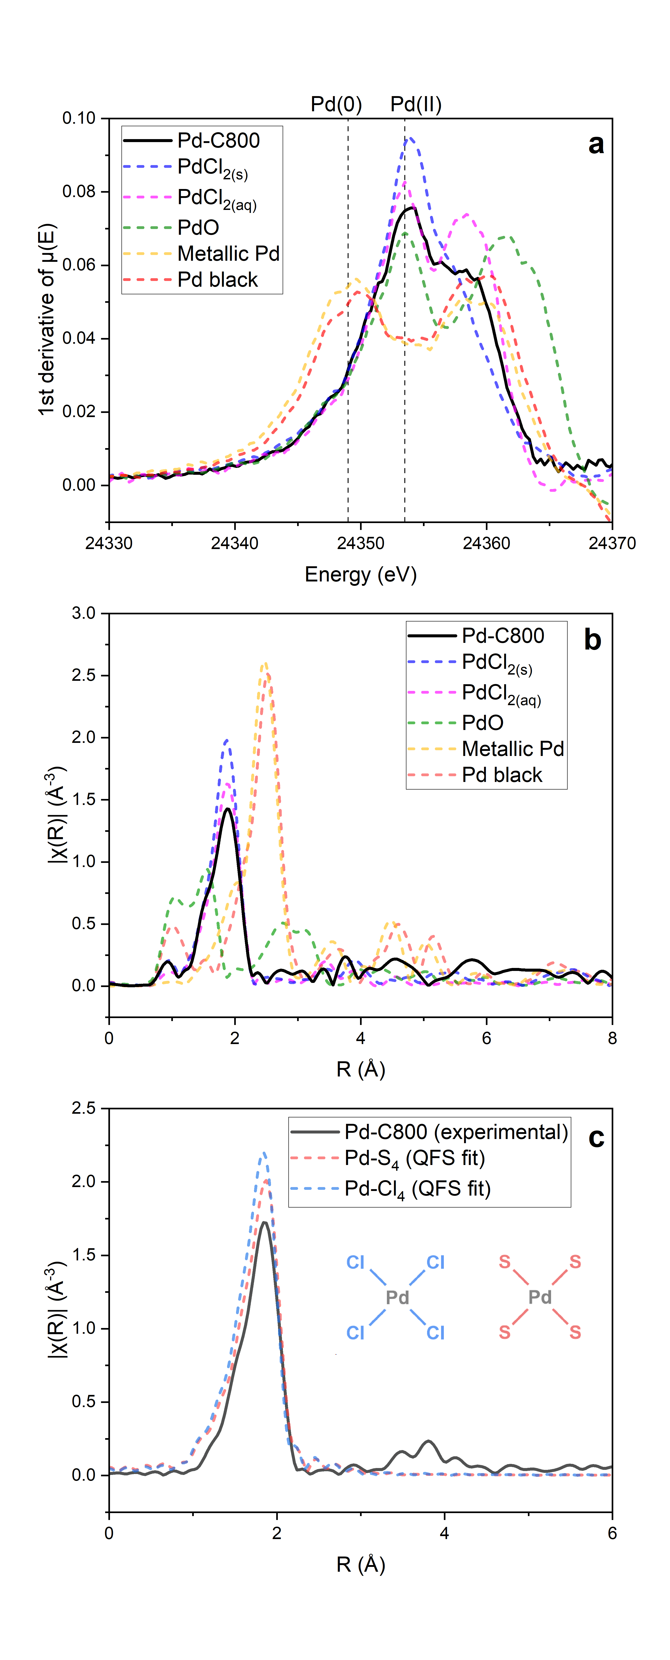

Figure 10. *a – 1st derivative of Pd k-edge and b - Fourier transformed χ(R) spectra of Pd-loaded C300RP-800N2, PdO, metallic Pd, Pd black, solid PdCl2 and an aqueous PdCl2 solution. c – overlay of χ(R) spectrum of Pd-loaded C300RP-800N2 and quick first shell fits of PdCl4 and PdS4 environments.*

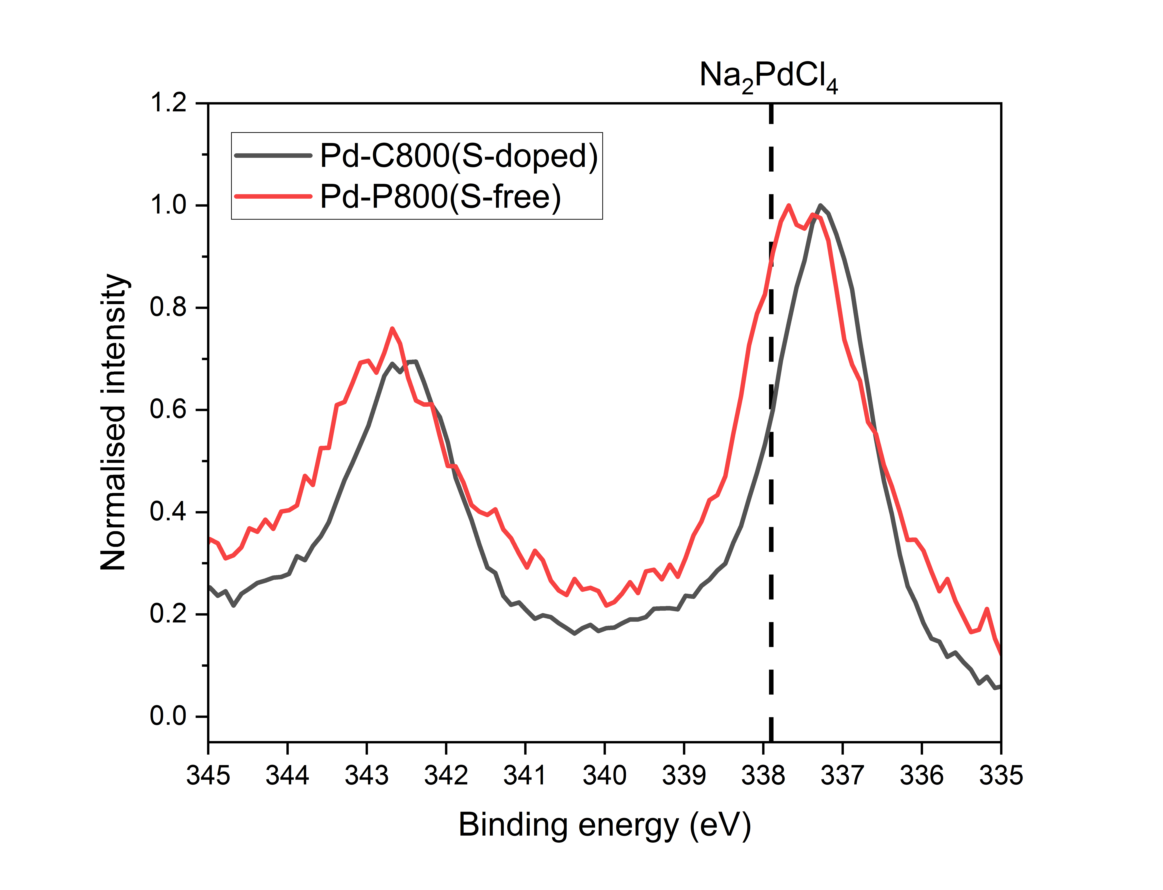

Figure 11. Pd 3d X-ray photoelectron spectroscopy of palladium loaded C800 and the sulfur-free Starbon P800 (pectin derived).

# Conclusions

Modern societal dependence on the platinum group metals has resulted in substantial financial incentive to develop cost effective and sustainable means for their recovery from increasingly low-grade feeds. Until now, the potential application of sulfur-containing carbon materials to this end, remained entirely unexplored. Owing to the versatility of the Starbon process, it was possible to produce mesoporous sulfur containing materials from the sulfur containing κ-carrageenan as well as from sulfate-doped alginic acid. Analysis of sulfur chemistry reveals the need to pyrolyse to 800 °C to generate a reactive surface that will subsequently reduce and incorporate significant quantities of organic sulfur when washed in acidic media immediately after pyrolysis.

The evaluation of the resulting materials reveals the profound impact that sulfur chemistry has on their PGM sorption properties. The sulfur-containing materials, C800 and S-A800, were found to adsorb large quantities of Pd(II) and Pt(II) and, as expected for soft Lewis basic sulfur sites, adsorb them with high selectivity over other PGMs and independently of the base metals Cu(II), Ni(II) and Co(II) present in large excess. Most pertinent to their potential for application to industrial processes, adsorption was found to be reversible and the materials reusable. In addition to the selectivity of these materials, physical characterisation of the sulfur containing C300RP-800N2, provides evidence that Pd/Pt are coordinated by sulfur containing groups on the carbon surface.

This work demonstrates the successful incorporation of metallophillic sulfur chemistry into sustainably derived porous carbon materials and their excellent potential for PGM recovery, necessitating further research into this area. In particular, the scope of the Starbon process for the incorporation of sulfur chemistry into a range of polysaccharide gels should enable the optimisation of a range of mechanical properties such as porous structure and particle size.

# Conflicts of Interest

Dr Rob McElroy is CTO of Starbons Ltd, a start-up from the University of York.

# Acknowledgements

From the University of York, we would like to thank Suranjana Bose and Richard Gammons for their expert technical support. From the Johnson Matthey Technology Centre, we would like to thank Deena Modeshia for running thermal analysis, Riho Green for running XPS, Alex Oje for running Raman spectroscopy and Huw Marchbank for running XAS. This work was funded by an EPSRC Industrial Cooperative Awards in Science and Technology (iCASE) studentship (EP/W522296/1).

# References

(1) Hughes, A. E.; Haque, N.; Northey, S. A.; Giddey, S. Platinum Group Metals: A Review of Resources, Production and Usage with a Focus on Catalysts. *Resources* **2021**, *10* (9), 93. https://doi.org/10.3390/resources10090093.

(2) Supanchaiyamat, N.; Hunt, A. J. Conservation of Critical Elements of the Periodic Table. *ChemSusChem* **2019**, *12* (2), 397–403. https://doi.org/10.1002/cssc.201802556.

(3) The Life Cycle Assessment of Platinum Group Metals, 2022. https://ipa-news.com/assets/sustainability/IPA_Guidance/2022-06-21-LCA%20Fact%20Sheet%202022_IPA.pdf (accessed 2024-09-30).

(4) PGM Market Data, 2024. https://matthey.com/products-and-markets/pgms-and-circularity/pgm-market-data (accessed 2024-10-09).

(5) The Palladium Market - Palladium Price Drivers, 2023. https://www.sfa-oxford.com/platinum-group-metals/palladium-market-and-palladium-price-drivers/ (accessed 2024-09-15).

(6) Mvokwe, S. A.; Oyedeji, O. O.; Agoro, M. A.; Meyer, E. L.; Rono, N. A Critical Review of the Hydrometallurgy and Pyrometallurgical Recovery Processes of Platinum Group Metals from End-of-Life Fuel Cells. *Membranes* **2025**, *15* (1), 13. https://doi.org/10.3390/membranes15010013.

(7) Kodama, K.; Nagai, T.; Kuwaki, A.; Jinnouchi, R.; Morimoto, Y. Challenges in Applying Highly Active Pt-Based Nanostructured Catalysts for Oxygen Reduction Reactions to Fuel Cell Vehicles. *Nat. Nanotechnol.* **2021**, *16* (2), 140–147. https://doi.org/10.1038/s41565-020-00824-w.

(8) Katsounaros, I.; Cherevko, S.; Zeradjanin, A. R.; Mayrhofer, K. J. J. Oxygen Electrochemistry as a Cornerstone for Sustainable Energy Conversion. *Angew Chem Int Ed* **2014**, *53* (1), 102–121. https://doi.org/10.1002/anie.201306588.

(9) Garrett, C. E.; Prasad, K. The Art of Meeting Palladium Specifications in Active Pharmaceutical Ingredients Produced by Pd‐Catalyzed Reactions. *Adv Synth Catal* **2004**, *346* (8), 889–900. https://doi.org/10.1002/adsc.200404071.

(10) MacDonald, L.; Zhang, D.; Karamalidis, A. Platinum Group Metals: Key Solid Phase Adsorption Technologies for Separation from Primary and Secondary Sources. *Resources, Conservation and Recycling* **2024**, *205*, 107590. https://doi.org/10.1016/j.resconrec.2024.107590.

(11) Fayemi, O. E.; Ogunlaja, A. S.; Kempgens, P. F. M.; Antunes, E.; Torto, N.; Nyokong, T.; Tshentu, Z. R. Adsorption and Separation of Platinum and Palladium by Polyamine Functionalized Polystyrene-Based Beads and Nanofibers. *Minerals Engineering* **2013**, *53*, 256–265. https://doi.org/10.1016/j.mineng.2013.06.006.

(12) Liu, H.; Ning, S.; Li, Z.; Zhang, S.; Chen, L.; Yin, X.; Fujita, T.; Wei, Y. Preparation of a Novel Silica-Based N-Donor Ligand Functional Adsorbent for Efficient Separation of Palladium from High Level Liquid Waste. *Separation and Purification Technology* **2022**, *296*, 121373. https://doi.org/10.1016/j.seppur.2022.121373.

(13) Nagarjuna, R.; Sharma, S.; Rajesh, N.; Ganesan, R. Effective Adsorption of Precious Metal Palladium over Polyethyleneimine-Functionalized Alumina Nanopowder and Its Reusability as a Catalyst for Energy and Environmental Applications. *ACS Omega* **2017**, *2* (8), 4494–4504. https://doi.org/10.1021/acsomega.7b00431.

(14) Lin, S.; Bediako, J. K.; Cho, C.-W.; Song, M.-H.; Zhao, Y.; Kim, J.-A.; Choi, J.-W.; Yun, Y.-S. Selective Adsorption of Pd(II) over Interfering Metal Ions (Co(II), Ni(II), Pt(IV)) from Acidic Aqueous Phase by Metal-Organic Frameworks. *Chemical Engineering Journal* **2018**, *345*, 337–344. https://doi.org/10.1016/j.cej.2018.03.173.

(15) Wu, F.; Yang, C.; Liu, Y.; Hu, S.; Ye, G.; Chen, J. Novel Polyazamacrocyclic Receptor Impregnated Macroporous Polymeric Resins for Highly Efficient Capture of Palladium from Nitric Acid Media. *Separation and Purification Technology* **2020**, *233*, 115953. https://doi.org/10.1016/j.seppur.2019.115953.

(16) Nikoloski, A. N.; Ang, K.-L. Review of the Application of Ion Exchange Resins for the Recovery of Platinum-Group Metals From Hydrochloric Acid Solutions. *Mineral Processing and Extractive Metallurgy Review* **2014**, *35* (6), 369–389. https://doi.org/10.1080/08827508.2013.764875.

(17) Torrejos, R. E. C.; Escobar, E. C.; Han, J. W.; Min, S. H.; Yook, H.; Parohinog, K. J.; Koo, S.; Kim, H.; Nisola, G. M.; Chung, W.-J. Multidentate Thia-Crown Ethers as Hyper-Crosslinked Macroporous Adsorbent Resins for the Efficient Pd/Pt Recovery and Separation from Highly Acidic Spent Automotive Catalyst Leachate. *Chemical Engineering Journal* **2021**, *424*, 130379. https://doi.org/10.1016/j.cej.2021.130379.

(18) Tarkovskaya, I.; Tikhonova, L.; Rosoka, S.; Kulik, N. Sorption of Platinoid Ions from Aqueous Solutions by Carbonaceous Materials. *Journal of Water Chemistry and Technology* **2001**, *23* (6), 1–10.

(19) Guo, J.; Wu, Y.; Wang, Z.; Yu, J.; Li, J.-R. Review: Adsorbents for the Recovery of Precious Metals from Wastewater. *J Mater Sci* **2022**, *57* (24), 10886–10911. https://doi.org/10.1007/s10853-022-07320-7.

(20) Staunton, W. P. Carbon-in-Pulp. In *Gold Ore Processing*; Elsevier, 2016; pp 535–552. https://doi.org/10.1016/B978-0-444-63658-4.00030-X.

(21) Xia, J.; Marthi, R.; Twinney, J.; Ghahreman, A. A Review on Adsorption Mechanism of Gold Cyanide Complex onto Activation Carbon. *Journal of Industrial and Engineering Chemistry* **2022**, *111*, 35–42. https://doi.org/10.1016/j.jiec.2022.04.014.

(22) Tarkovskaya, I.; Tikhonova, L.; tomashevskaya, A.; Goba, V.; Antonova, L.; Svarkovskaya, I. Sorption of Ruthenium, Rhodium and Palladium Complexes by Materials Based on Natural Coals. *Russian Journal of Physical Chemistry* **1996**, *70* (8), 1361–1365.

(23) Likholobov, V.; Simonov, P. Physicochemical Aspects of Preparation of Carbon-Supported Noble Metal Catalysts. In *Catalysis and Electrocatalysis at Nanoparticle Surfaces*; Wieckowski, A., Savinova, E., Vayenas, C., Eds.; CRC Press, 2003. https://doi.org/10.1201/9780203912713.ch12.

(24) Simonov, P. A.; Romanenko, A. V.; Prosvirin, I. P.; Moroz, E. M.; Boronin, A. I.; Chuvilin, A. L.; Likholobov, V. A. On the Nature of the Interaction of H2PdCl4 with the Surface of Graphite-like Carbon Materials. *Carbon* **1997**, *35* (1), 73–82. https://doi.org/10.1016/S0008-6223(96)00129-7.

(25) Tikhonova, L.; Tarkovskaya, I.; Rosoka, S.; Svarkovskaya, I.; Kulik, N.; Korovin, Y.; Komarov, V.; Kadochnikov, V. Selective Sorption of Platinum Group Metal Compounds by Various Sorbents. *Russian Journal of Physical Chemistry* **1998**, *71* (10), 1736–1741.

(26) Liu, L.; Li, C.; Bao, C.; Jia, Q.; Xiao, P.; Liu, X.; Zhang, Q. Preparation and Characterization of Chitosan/Graphene Oxide Composites for the Adsorption of Au(III) and Pd(II). *Talanta* **2012**, *93*, 350–357. https://doi.org/10.1016/j.talanta.2012.02.051.

(27) Chen, G.; Wang, Y.; Weng, H.; Wu, Z.; He, K.; Zhang, P.; Guo, Z.; Lin, M. Selective Separation of Pd(II) on Pyridine-Functionalized Graphene Oxide Prepared by Radiation-Induced Simultaneous Grafting Polymerization and Reduction. *ACS Appl. Mater. Interfaces* **2019**, *11* (27), 24560–24570. https://doi.org/10.1021/acsami.9b06162.

(28) Foersterling, H.-U.; Hallmeier, K.-H. Investigations of the Adsorption of Palladium on Carbonaceous Adsorbents Modified with Dimethylglyoxime II: The Adsorption of Palladium on an Activated Carbon in Its Unmodified Form and Modified with Dimethylglyoxime. *Carbon* **1990**, *28* (4), 497–502. https://doi.org/10.1016/0008-6223(90)90044-Y.

(29) Kiciński, W.; Szala, M.; Bystrzejewski, M. Sulfur-Doped Porous Carbons: Synthesis and Applications. *Carbon* **2014**, *68*, 1–32. https://doi.org/10.1016/j.carbon.2013.11.004.

(30) Ma, G.; Ning, G.; Wei, Q. S-Doped Carbon Materials: Synthesis, Properties and Applications. *Carbon* **2022**, *195*, 328–340. https://doi.org/10.1016/j.carbon.2022.03.043.

(31) Wu, T.; Jing, M.; Yang, L.; Zou, G.; Hou, H.; Zhang, Y.; Zhang, Y.; Cao, X.; Ji, X. Controllable Chain‐Length for Covalent Sulfur–Carbon Materials Enabling Stable and High‐Capacity Sodium Storage. *Advanced Energy Materials* **2019**, *9* (9), 1803478. https://doi.org/10.1002/aenm.201803478.

(32) Ma, X.; Ning, G.; Kan, Y.; Ma, Y.; Qi, C.; Chen, B.; Li, Y.; Lan, X.; Gao, J. Synthesis of S-Doped Mesoporous Carbon Fibres with Ultrahigh S Concentration and Their Application as High Performance Electrodes in Supercapacitors. *Electrochimica Acta* **2014**, *150*, 108–113. https://doi.org/10.1016/j.electacta.2014.10.128.

(33) Huang, J.; Zhang, W.; Huang, H.; Liu, Y.; Yang, Q.; Li, L. Facile Synthesis of N,S-Codoped Hierarchically Porous Carbon with High Volumetric Pseudocapacitance. *ACS Sustainable Chem. Eng.* **2019**, *7* (19), 16710–16719. https://doi.org/10.1021/acssuschemeng.9b04170.

(34) Budarin, V.; Clark, J. H.; Hardy, J. J. E.; Luque, R.; Milkowski, K.; Tavener, S. J.; Wilson, A. J. Starbons: New Starch-Derived Mesoporous Carbonaceous Materials with Tunable Properties. *Angew. Chem.* **2006**, *118* (23), 3866–3870. https://doi.org/10.1002/ange.200600460.

(35) White, R. J.; Budarin, V. L.; Clark, J. H. Pectin-Derived Porous Materials. *Chem. Eur. J.* **2010**, *16* (4), 1326–1335. https://doi.org/10.1002/chem.200901879.

(36) White, R. J.; Antonio, C.; Budarin, V. L.; Bergström, E.; Thomas‐Oates, J.; Clark, J. H. Polysaccharide‐Derived Carbons for Polar Analyte Separations. *Adv Funct Materials* **2010**, *20* (11), 1834–1841. https://doi.org/10.1002/adfm.201000169.

(37) Luque, R.; Clark, J. H.; Yoshida, K.; Gai, P. L. Efficient Aqueous Hydrogenation of Biomass Platform Molecules Using Supported Metal Nanoparticles on Starbons®. *Chem. Commun.* **2009**, No. 35, 5305. https://doi.org/10.1039/b911877b.

(38) Attard, T. M.; Goodwin, C.; Nalivaika, P.; Attard, J.; Budarin, V. L.; Lanot, A.; Bove, D.; Clark, J. H.; McElroy, C. R. Simple, Quick and Green Isolation of Cannabinoids from Complex Natural Product Extracts Using Sustainable Mesoporous Materials (Starbon®). *Mater. Chem. Front.* **2022**, *6* (10), 1324–1330. https://doi.org/10.1039/D2QM00028H.

(39) Garland, N.; Gordon, R.; McElroy, C. R.; Parkin, A.; MacQuarrie, D. Optimising Low Temperature Pyrolysis of Mesoporous Alginate‐Derived Starbon® for Selective Heavy Metal Adsorption. *ChemSusChem* **2024**, e202400015. https://doi.org/10.1002/cssc.202400015.

(40) Milescu, R. A.; Dennis, M. R.; McElroy, C. R.; Macquarrie, D. J.; Matharu, A. S.; Smith, M. W.; Clark, J. H.; Budarin, V. L. The Role of Surface Functionality of Sustainable Mesoporous Materials Starbon® on the Adsorption of Toxic Ammonia and Sulphur Gasses. *Sustainable Chemistry and Pharmacy* **2020**, *15*, 100230. https://doi.org/10.1016/j.scp.2020.100230.

(41) Uriburu-Gray, M.; Pinar-Serrano, A.; Cavus, G.; Knipping, E.; Aucher, C.; Conesa-Cabeza, A.; Satti, A.; Amantia, D.; Martínez-Crespiera, S. Mesoporous Carbons from Polysaccharides and Their Use in Li-O2 Batteries. *Nanomaterials* **2020**, *10* (10), 2036. https://doi.org/10.3390/nano10102036.

(42) Campo, V. L.; Kawano, D. F.; Silva, D. B. D.; Carvalho, I. Carrageenans: Biological Properties, Chemical Modifications and Structural Analysis – A Review. *Carbohydrate Polymers* **2009**, *77* (2), 167–180. https://doi.org/10.1016/j.carbpol.2009.01.020.

(43) Campbell, R.; Hotchkiss, S. Carrageenan Industry Market Overview. In *Tropical Seaweed Farming Trends, Problems and Opportunities*; Hurtado, A. Q., Critchley, A. T., Neish, I. C., Eds.; Springer International Publishing: Cham, 2017; pp 193–205. https://doi.org/10.1007/978-3-319-63498-2_13.

(44) Borisova, A.; De Bruyn, M.; Budarin, V. L.; Shuttleworth, P. S.; Dodson, J. R.; Segatto, M. L.; Clark, J. H. A Sustainable Freeze-Drying Route to Porous Polysaccharides with Tailored Hierarchical Meso- and Macroporosity. *Macromol. Rapid Commun.* **2015**, *36* (8), 774–779. https://doi.org/10.1002/marc.201400680.

(45) Kim, S.; Escamilla-Pérez, A. M.; De Bruyn, M.; Alauzun, J. G.; Louvain, N.; Brun, N.; Macquarrie, D.; Stievano, L.; Boury, B.; Monconduit, L.; Mutin, P. H. Sustainable Polysaccharide-Derived Mesoporous Carbons (Starbon®) as Additives in Lithium-Ion Batteries Negative Electrodes. *J. Mater. Chem. A* **2017**, *5* (46), 24380–24387. https://doi.org/10.1039/C7TA08165K.

(46) Fairley, N.; Fernandez, V.; Richard‐Plouet, M.; Guillot-Deudon, C.; Walton, J.; Smith, E.; Flahaut, D.; Greiner, M.; Biesinger, M.; Tougaard, S.; Morgan, D.; Baltrusaitis, J. Systematic and Collaborative Approach to Problem Solving Using X-Ray Photoelectron Spectroscopy. *Applied Surface Science Advances* **2021**, *5*, 100112. https://doi.org/10.1016/j.apsadv.2021.100112.

(47) Ravel, B.; Newville, M. *ATHENA* , *ARTEMIS* , *HEPHAESTUS* : Data Analysis for X-Ray Absorption Spectroscopy Using *IFEFFIT*. *J Synchrotron Rad* **2005**, *12* (4), 537–541. https://doi.org/10.1107/S0909049505012719.

(48) Drew Tait, C.; Janecky, D. R.; Rogers, P. S. Z. Speciation of Aqueous Palladium(II) Chloride Solutions Using Optical Spectroscopies. *Geochimica et Cosmochimica Acta* **1991**, *55* (5), 1253–1264. https://doi.org/10.1016/0016-7037(91)90304-N.

(49) Le Roux, C. J.; Kriek, R. J. A Detailed Spectrophotometric Investigation of the Complexation of Palladium(II) with Chloride and Bromide. *Hydrometallurgy* **2017**, *169*, 447–455. https://doi.org/10.1016/j.hydromet.2017.02.023.

(50) Nilsson, S.; Piculell, L. Helix-Coil Transitions of Ionic Polysaccharides Analyzed within the Poisson-Boltzmann Cell Model. 4. Effects of Site-Specific Counterion Binding. *Macromolecules* **1991**, *24* (13), 3804–3811. https://doi.org/10.1021/ma00013a010.

(51) Shuttleworth, P. S.; Budarin, V.; White, R. J.; Gun’ko, V. M.; Luque, R.; Clark, J. H. Molecular-Level Understanding of the Carbonisation of Polysaccharides. *Chem. Eur. J.* **2013**, *19* (28), 9351–9357. https://doi.org/10.1002/chem.201300825.

(52) Budarin, V. L.; Shuttleworth, P. S.; White, R. J.; Clark, J. H. From Polysaccharides to Starbons®. In *Porous Carbon Materials from Sustainable Precursors*; White, R. J., Ed.; The Royal Society of Chemistry, 2015; pp 53–81. https://doi.org/10.1039/9781782622277-00053.

(53) Menéndez, J. A.; Phillips, J.; Xia, B.; Radovic, L. R. On the Modification and Characterization of Chemical Surface Properties of Activated Carbon: In the Search of Carbons with Stable Basic Properties. *Langmuir* **1996**, *12* (18), 4404–4410. https://doi.org/10.1021/la9602022.

(54) Strelko, V. V.; Kartel, N. T.; Dukhno, I. N.; Kuts, V. S.; Clarkson, R. B.; Odintsov, B. M. Mechanism of Reductive Oxygen Adsorption on Active Carbons with Various Surface Chemistry. *Surface Science* **2004**, *548* (1–3), 281–290. https://doi.org/10.1016/j.susc.2003.11.012.

(55) B J Lindberg; K Hamrin; G Johansson; U Gelius; A Fahlman; C Nordling; K Siegbahn. Molecular Spectroscopy by Means of ESCA II. Sulfur Compounds. Correlation of Electron Binding Energy with Structure. *Phys. Scr.* **1970**, *1* (5–6), 286–298. https://doi.org/10.1088/0031-8949/1/5-6/020.

(56) Chen, T.; Wu, J.; Zhang, X.; Han, X.; Liu, S.; Yang, J. Pseudocapacitive Contribution in Sulfur-Doped Porous Carbon Nanosheets Enables High-Performance Sodium-Ion Storage. *Carbon* **2024**, *227*, 119276. https://doi.org/10.1016/j.carbon.2024.119276.

(57) Yang, Z.; Yao, Z.; Li, G.; Fang, G.; Nie, H.; Liu, Z.; Zhou, X.; Chen, X.; Huang, S. Sulfur-Doped Graphene as an Efficient Metal-Free Cathode Catalyst for Oxygen Reduction. *ACS Nano* **2012**, *6* (1), 205–211. https://doi.org/10.1021/nn203393d.

(58) Anderson, J. M.; Johnson, R. L.; Schmidt-Rohr, K.; Shanks, B. H. Solid State NMR Study of Chemical Structure and Hydrothermal Deactivation of Moderate-Temperature Carbon Materials with Acidic SO3H Sites. *Carbon* **2014**, *74*, 333–345. https://doi.org/10.1016/j.carbon.2014.03.041.

(59) Mena Duran, C. Synthesis and Characterisation of Sulfonated Starbons®, Bio-Based Catalysts. PhD Thesis, University of York, 2014. https://etheses.whiterose.ac.uk/7780/.

(60) Marriott, A. S.; Hunt, A. J.; Bergström, E.; Thomas-Oates, J.; Clark, J. H. Effect of Rate of Pyrolysis on the Textural Properties of Naturally-Templated Porous Carbons from Alginic Acid. *Journal of Analytical and Applied Pyrolysis* **2016**, *121*, 62–66. https://doi.org/10.1016/j.jaap.2016.07.002.

(61) Bard, A. J.; Parsons, R.; Jordan, J. *Standard Potentials in Aqueous Solution*, 1st ed.; Routledge, 2017. https://doi.org/10.1201/9780203738764.

(62) Van Middlesworth, J. M.; Wood, S. A. The Stability of Palladium(II) Hydroxide and Hydroxy–Chloride Complexes: An Experimental Solubility Study at 25–85°C and 1 Bar. *Geochimica et Cosmochimica Acta* **1999**, *63* (11–12), 1751–1765. https://doi.org/10.1016/S0016-7037(99)00058-7.

(63) Kim, S.; De Bruyn, M.; Alauzun, J. G.; Louvain, N.; Brun, N.; Macquarrie, D. J.; Stievano, L.; Boury, B.; Mutin, P. H.; Monconduit, L. Alginic Acid-Derived Mesoporous Carbonaceous Materials (Starbon®) as Negative Electrodes for Lithium Ion Batteries: Importance of Porosity and Electronic Conductivity. *Journal of Power Sources* **2018**, *406*, 18–25. https://doi.org/10.1016/j.jpowsour.2018.10.026.

(64) Kang, T.; Park, Y.; Yi, J. Highly Selective Adsorption of Pt2+ and Pd2+ Using Thiol-Functionalized Mesoporous Silica. *Ind. Eng. Chem. Res.* **2004**, *43* (6), 1478–1484. https://doi.org/10.1021/ie030590k.

(65) Bernardis, F. L.; Grant, R. A.; Sherrington, D. C. A Review of Methods of Separation of the Platinum-Group Metals through Their Chloro-Complexes. *Reactive and Functional Polymers* **2005**, *65* (3), 205–217. https://doi.org/10.1016/j.reactfunctpolym.2005.05.011.

(66) Simonov, P. A.; Semikolenov, V. A.; Likholobov, V. A.; Boronin, A. I.; Ermakov, Yu. I. Palladium Catalysts on Carbon Supports: 1. General Features of Adsorption of H2PdCl4 on Carbon Supports. *Russ Chem Bull* **1988**, *37* (12), 2447–2451. https://doi.org/10.1007/BF00952615.

(67) Mohdee, V.; Parasuk, V.; Pancharoen, U. Synergistic Effect of Thiourea and HCl on Palladium (II) Recovery: An Investigation on Chemical Structures and Thermodynamic Stability via DFT. *Arabian Journal of Chemistry* **2021**, *14* (7), 103196. https://doi.org/10.1016/j.arabjc.2021.103196.

(68) Simonov, P. A.; Romanenko, A. V.; Prosvirin, I. P.; Kryukova, G. N.; Chuvilin, A. L.; Bogdanov, S. V.; Moroz, E. M.; Likholobov, V. A. Electrochemical Behaviour of Quasi-Graphitic Carbons at Formation of Supported Noble Metal Catalysts. In *Studies in Surface Science and Catalysis*; Elsevier, 1998; Vol. 118, pp 15–30. https://doi.org/10.1016/S0167-2991(98)80164-X.

(69) Westawker, L. P.; Khusnutdinova, J. K.; Wallick, R. F.; Mirica, L. M. Palladium K-Edge X-Ray Absorption Spectroscopy Studies on Controlled Ligand Systems. *Inorg. Chem.* **2023**, *62* (51), 21128–21137. https://doi.org/10.1021/acs.inorgchem.3c03032.

(70) Hyland, M. M.; Bancroft, G. M. Palladium Sorption and Reduction on Sulphide Mineral Surfaces: An XPS and AES Study. *Geochimica et Cosmochimica Acta* **1990**, *54* (1), 117–130. https://doi.org/10.1016/0016-7037(90)90200-5.

1. Corresponding authors.

   Email addresses: [nphg500@york.ac.uk](mailto:nphg500@york.ac.uk) (Nicholas Garland), [alison.parkin@york.ac.uk](mailto:alison.parkin@york.ac.uk) (Alison Parkin)