How students get help: Institutional identities as a resource for recruitment
Rosario Neyra, Kobin Kendrick and Merran Toerien
This paper explores the intersection between institutional identity and recruitment practices in craft workshops. It argues that students orient to both their own identity as students in need and to the instructor’s institutional identity as assistance-provider as a key resource for obtaining assistance. The analysis is organised into three main analytic sections: instructors self-selecting to assist without being explicitly addressed, students selecting instructors as providers of assistance, and students pursuing assistance when an initial attempt is not immediately successful. Across these practices, students rely on the instructor's category-bound activity of providing assistance and their own identity as students. Through the analysis of a corpus of video recordings from a range of craft workshops, this study demonstrates how institutional identity and the category-bound activity of providing assistance are procedurally consequential in recruitment, highlighting the omnirelevance of the identity of the instructor in workshops. The data are in English.
Keywords: recruitment; institutional identity; membership categorisation; category-bound activities; classroom interaction

Introduction
A core goal of practical skills instruction is enabling students to perform new skills correctly. Most studies focus on corrective sequences, where instructors identify and correct students’ mistakes (e.g., Evans & Reynolds, 2016; Levin et al., 2017; Keevallik, 2010; Nishizaka, 2020; Okada, 2013). Less attention has been given to student-initiated sequences, where students recognise trouble and seek assistance to resolve it (but see Ekström & Lindwall, 2014; Solem et al., 2023). More generally, the identification and resolution of troubles by teachers and instructors in learning environments has been considered under the umbrella term of “instruction”, despite encompassing a range of individual practices (Lindwall & Mondada, 2025; Jakonen, 2020; Tyagunova & Breidenstein, 2023). In craft workshops, students can encounter troubles with technique (e.g., a stitch gone wrong), with materials and equipment (e.g., a faulty spray bottle) or with the steps required to complete the task, among other sources of difficulty.
The range of practices by ‘which one person can ask for, seek, or solicit help from another, including giving indirect and perhaps embodied indications of their need for assistance’ can be covered under the term recruitment (Kendrick & Drew, 2016, p. 2). Methods of recruitment, which include requests for assistance (Curl & Drew, 2008; Lindström, 2005; Kendrick & Drew, 2016; Zinken & Ogiermann, 2013), reports of needs, difficulties or troubles (Boudouraki et al., 2021; Fox & Heinemann, 2021; Keel et al., 2023; Kendrick 2021; Kendrick & Drew, 2016; Whalen & Zimmerman, 1990), trouble alerts (Goffman 1978; Keel et al., 2023; Kendrick & Drew, 2016) and embodied displays of trouble (Boudouraki et al., 2021; Drew & Kendrick, 2018; Keel et al., 2023; Kendrick, 2021; Kendrick & Drew, 2016; Lerner & Raymond, 2021; Mlynář, 2022; Solem et al., 2023; Vänttinen, 2022), are available to the students who encounter troubles in the classroom. Furthermore, recruitment methods can be adapted to specific institutional settings, as demonstrated by Gonzalez-Martínez and Drew (2021), who observed that informings were treated as requests by nurses in hospitals. In traditional classrooms, there are codified practices for recruiting the teacher, for example hand-raising (Sahlström, 2002). Cekaite (2009) describes methods that L2 children use in a classroom, where hand-raising was rare, which include summons-answer sequences and students getting up to approach a teacher, which she terms “ambulatory design” of a summons (pp. 35-36). Thinking about institutionality more broadly, Whalen and Zimmerman (1990) showed how a description of a trouble in 911 calls was treated as a request for help by the call-taker. This has also been observed in other institutional settings, such as in medical interactions (Robinson, 2003; Stivers, 2002) and in a shoe-shop (Fox & Heinemann, 2021). While descriptions of troubles and informings may commonly be treated as requests in institutional settings, in ordinary conversation, trouble reports can be responded to with, for example, affiliation (Jefferson, 1988), which may be construed as inappropriate in an institutional setting.
Additionally, students may combine recruitment methods with addressing techniques, such as using address terms, gaze or other context-specific strategies that tacitly select a recipient (Lerner, 2003; Sacks et al., 1974). As craft workshops occur over an extended period of time and lapses in conversation occur, students can also employ techniques for re-engaging talk, for example through questions, announcements and noticings that elicit a response (Szymanski, 1999). Students have available several methods and combinations of these in order to obtain assistance. For example, a trouble report may be addressed to the instructor through gaze, or it may be produced at a quiet volume, gazing down. These two will impose on the instructor different obligations to assist (see Stivers & Rossano, 2010).
The “institutional fingerprint” of an interaction is comprised of a set of practices ‘differentiating each form both from other institutional forms and from the baseline of mundane conversational interaction itself’ (Drew & Heritage, 1992, p. 26). As well as turn designs and action sequencing playing a role defining the institutional fingerprint, so do the characteristically asymmetrical properties of institutional interactions (Drew & Heritage, 1992). In these interactions, participants actively (re)create their identities through their actions, embodying their membership in a particular category by engaging in specific, identifiable practices and activities (Sacks, 1991; Schegloff, 2007a); when such activities are mentioned or performed, they evoke the corresponding institutional identity (Schegloff, 2007a). Much of the work around category-bound activities has focussed on person reference (Schegloff, 2007a; Stokoe, 2012; Stokoe et al., 2024; Whitehead, 2011), but it is also possible to see how categories are procedurally relevant for participants in ‘producing and interpreting conduct during interactions’ more generally (Schegloff, 1992, p. 109). Sacks (1992, p. 595) illustrates this through examples where certain actions, when performed by individuals in a specific role, clearly invoke an institutional identity, such as a therapist. This invocation is not just an implicit reference; it is recognised and treated by others as defining that institutional identity. These observations align with what Sacks (1992) describes as the “viewer’s maxim,” which suggests that when a category-bound activity is observed, if it can reasonably be attributed to a category member to whom this activity is bound, then it should be seen in that way (Schegloff, 1992). Another version of this maxim posits that if two actions are normatively related (e.g., a mother picking up a crying baby), and the actors can be seen as members of categories typically performing this pair of actions, then observers are guided to (a) recognise the actors as category members and (b) interpret the second action as conforming to this normative relationship (Sacks, 1991). This interpretative guidance allows participants to attribute activities as category-bound to certain identities based on observed, categorically relevant actions. For instance, in a 911 call, when the call taker treats a trouble report as a request rather than as an appeal for sympathy, they are enacting their identity as an emergency call taker. Similarly, the observation that interviewers ask questions while interviewees answer them, with each action associated with the respective identity category further exemplifies how institutional identities are both enacted and reinforced through category-bound activities (Clayman, 2012).
In this paper, we argue that institutional identity is procedurally consequential for the recruitment of assistance: students recruit assistance both by orienting to their identity as students and by drawing on instructors' institutional identities, leveraging the normative rights and responsibilities tied to their roles. The analysis shows that recruitment involves both observable practices (vocal, verbal, or visual) and categorisation work, highlighting how instructors and students are engaged as representatives of their institutional roles. This finding contributes to our theoretical understanding of recruitment within institutional contexts and for how institutional identities and associated category-bound activities can be made procedurally relevant by participants.
Our analysis uses the concepts of recruitment and assistance rather than vernacular terms like "instruction" or "teaching". While one might naturally describe an instructor correcting a student's technique, for example, as "instructing", such characterisation presupposes the very institutional orientations that our analysis seeks to explicate. By applying the concept of recruitment to classroom interactions, we can examine how participants actively orient to and enact their institutional rights and obligations through the sequential organisation of talk and embodied conduct. This approach allows us to track how institutional roles manifest in the details of interaction, rather than assuming them as given categories. In this way, our analysis does not deny that instructors are "instructing" as they help their students but rather unpacks how this institutional activity is interactionally constituted through participants' orientations to rights and obligations in the process of managing troubles in craft workshops.
We present evidence in three analytical sections: instructors self-selecting to assist, students selecting instructors, and students pursuing assistance when initial displays do not recruit the instructor to assist. When instructors self-select to assist, they embody their institutional identity, navigating interactional spaces to provide assistance, even when students' actions do not overtly signal a need for help. This highlights how the instructor’s identity as a resource for recruitment is exploited, supporting the central argument that students can rely on the instructor’s identity to resolve troubles, and students can exploit their own identity as students insofar as displaying need or difficulty as a student is sufficient to recruit the instructor to assist. We then provide further evidence for the importance of institutional identities in recruitment by showing instances where students cannot always rely on instructors to self-select to assist, for example instructors are occupied with other students. In these situations, students employ addressing techniques alongside verbal turns to secure assistance from the instructor, thus orienting to their identity as the designated provider of assistance in the classroom. We conclude by demonstrating that institutional identities form a central resource in classroom recruitment practices, highlighting the procedural role of institutional identity in shaping how students seek and receive assistance.

Data and methods
The data for this study come from video recordings of online and in-person craft workshops (e.g., pottery, embroidery, bundle dyeing) conducted in English in the UK. Workshop providers, including freelance artists and organisations, were approached via Eventbrite to participate. Providers identified suitable classes for recording, and informed consent was obtained from all participants prior to recording. This article focuses on the subset of 11 in-person workshops, totalling 30 hours of recordings, to ensure consistency. Ethical approval was granted by the University of York Language and Linguistic Science Ethics Committee.
The recordings were reviewed multiple times to identify instances where the instructor was recruited to assist with a student’s trouble or difficulty and analysed using multimodal conversation analysis. The analysis draws on Schegloff's framework of 'generic problems and practice(d) solutions' (2006, p. 71) and Kendrick's (2024) system-oriented analysis, which builds on the idea of practiced solutions. Instead of focusing on a single interactional or linguistic practice, the study examines a range of methods employed by students and instructors in the resolution of trouble or difficulty. A total of 79 cases were identified for analysis, encompassing practical troubles, such as difficulties in the physical manipulation of tools or the practical execution of techniques, as well as normative troubles (Küttner et al., 2024), where students required assistance due to uncertainty or issues relating to theoretical knowledge or standards of adequacy.
Transcriptions followed the conventions established by Jefferson (2004) and Mondada (2018). To ensure anonymity, names have been pseudonymised and faces blurred where requested.

Instructor self-selects to assist
This section presents a notable phenomenon observed across the collection: instructors frequently self-select to respond to student troubles. These interventions often begin with instructors identifying a student's difficulty and responding to it by initiating a sequence with a first pair-part (FPP) (Sacks et al., 1974). The cases presented in this section illustrate various circumstances in which instructors may provide assistance. These include cases when a student’s visible actions do not clearly indicate trouble, responses to turns when a student seeks assistance from another student, when students do not directly address the instructor, when trouble is not verbalised, and when the instructor must abandon their own tasks to assist. In all these instances, the instructor’s response to student troubles reveals their orientation to and enactment of the category-bound activity of providing assistance, indicative of an activity that is inherently tied to the identity of the instructor. Moreover, it shows how students can rely on instructors to monitor their conduct for displays of trouble or need and act on them without an explicit request for assistance (see Solem et al., 2023).
In Extract 1, the instructor self-selects to correct a student’s technique (line 2), despite no visible indication of trouble. This could be considered one end of the recruitment cline being presented in this article: instructors become aware of a student’s trouble in ongoing action, while the student remains unaware. In this bundle dyeing workshop, students are using natural dyes to dye silk scarves, testing the dyes on small samples before bundling and steaming them. Stephanie, the instructor (circled in white, Figure 1), is making the rounds (Greiffenhagen, 2012; Jankonen, 2021; Tyagunova & Breidenstein, 2023). At line 1, she is about to pass Wendy’s desk (circled in black), when she stops and pivots. At line 2, she issues corrective advice: “so make sure it’s really tight as we’re doing it”.
Extract 1. [BD0813AM 1:32:01]
01 #(0.2)• (0.3) • (0.6) •(0.4)*(0.3)
ste >>walk fwd--------------------*pivot-->
ste •gz to WEN•gz away•gz to WEN-->>
fig #fig.1
02 STE: -> so* make sure it’s rea*lly tight as* we’re [doing it.
-->*step left twd WEN--*feet together*lean fwd, reaching-->
03 WEN: [oh okay maybe
04 ti[ghter than that?
05 STE: [so *ye:ah but- maybe on *the table. *
-->*twists bundle-------*retracts l-hand*
06 * (0.1) *(0.3)
ste *point dwn*reach to bundle-->>
07 WEN: ↓o:::h
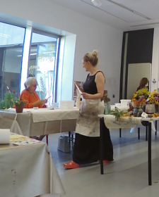

Figure 1. Stephanie walking past Wendy.

Stephanie’s advice at line 2 is not occasioned by any display of trouble by the student. Indeed, Wendy’s change-of-state token “oh”-prefaced response at line 3 demonstrates that she was unaware of the ongoing trouble (Heritage, 1984). Wendy continues with her turn with an understanding check (lines 3-4). At line 5, Stephanie confirms that the bundle should be tighter and issues instructions on how to accomplish that. This example shows how the instructor intervention situated towards the instructional end of a continuum of assistance practices. may self-select to provide assistance when they notice an instructible error in the student’s actions. Stephanie’s movement around the classroom involves monitoring the students’ work, demonstrating her professional vision (Goodwin, 1994) as she issues corrections. ‘Doing the rounds’ is a documented practice that instructors engage in (Greiffenhagen, 2012; Jakonen, 2021; Tyagunova & Breidenstein, 2023), and this monitoring embodies the norm that instructors provide assistance - an activity tied to the instructor’s identity, not the students’. While in ordinary talk there is a preference for self-repair (Schegloff et al., 1977) and self-remediation (Kendrick, 2017), in the institutional context of instruction, corrections are common (Evans & Reynolds, 2016; Keevallik, 2010; Nishizaka, 2020; Okada, 2013). Thus, the instructor's self-selected correction demonstrates institutional identities as they are performed, enacting expectations tied to the instructor’s identity.
Extract 2 shows how instructors can respond without sanction to turns that students address to other students, demonstrating the primacy instructors hold in responding to student troubles. This extract comes from a few minutes later in the bundle dyeing class. Amelia (circled in black, Figure 2) produces a trouble report addressed to Kate (lines 4-5), the student standing next to her, but it is Stephanie, the instructor (circled in white), who responds first (line 6).
Extract 2. [BD0813AM 1:49:50]
01 %(2.5)
ame %picks up spray bottle, tests on hand-->
02 TER: ºgod it’%s (a+ll good/awful)º%
ame -->%gaze twd KAT--------%
ste +begins walking twd main space-->
03 %(0.3)
ame %puts spray bottle down-->
04 AME: -> *what’s# your >spray† bo%ttle# like<?
-->%lifts bottle, tests
kat *shifts body position-->
ste †gz up-->
fig #fig.2
05 cause* mine comes out in like a (0.5) psh
kat -->*gz down, right
06 STE: oh y[ ou *%can tw]izzle i%t=
07 KAT: [you can *turn it]
*gz fwd-->
ame %gz up---------%gz down, twizzles-->
08 STE: =[>and it sh]*ould<.
09 AME: [ oh. ]
kat -->*gz right-->>
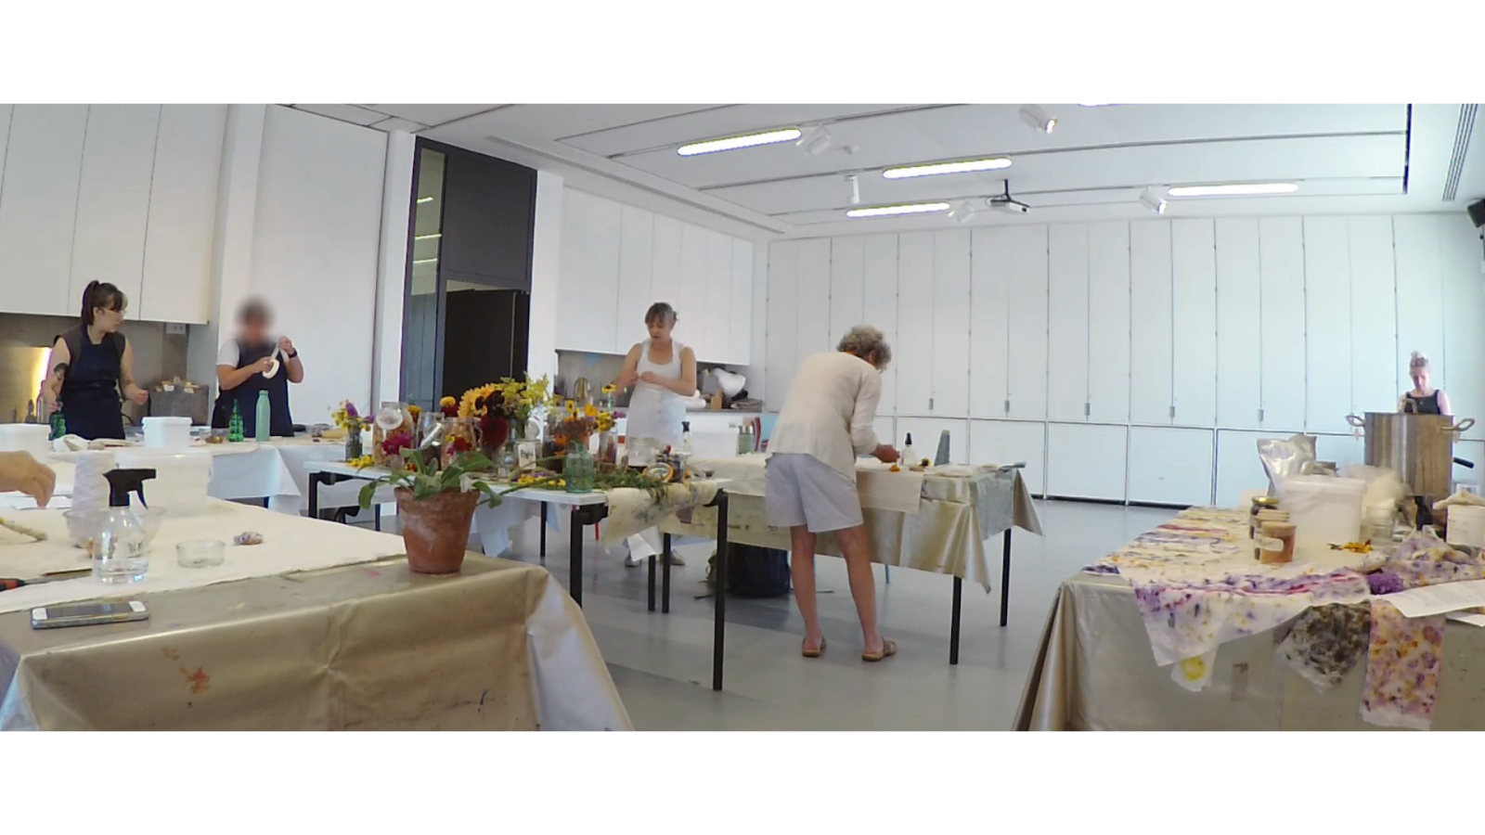Figure 2. Amelia addresses Kate who is standing next to her.

As Amelia is testing the spray bottle at line 2, Stephanie walks toward the main workspace. After testing, Amelia gazes at Kate, who begins to straighten up. Amelia puts the spray bottle down at line 3, and asks, “what’s your spray bottle like?” (line 4). In overlap with Amelia’s turn, Kate shifts body position and leans towards Amelia, indicating recipiency. Stephanie, still walking from across the room, gazes up as Amelia finishes producing the word “bottle”, displaying visual monitoring. Amelia accounts for her question with a trouble report (“cause mine comes out in like a (0.5) psh”, line 5). Thus, the question serves as a pre-expansion (Schegloff, 2007b) for the trouble report, seeking information about Kate’s experiences, but which answer could provide a solution to Amelia’s trouble.
The role of institutional identity in recruitment becomes apparent through turn-taking and sequence organisation in the responses that Amelia receives. Instructor Stephanie, who has continued to walk towards the main workspace while gazing in Amelia’s direction, responds with advice on how Amelia could remediate the problem herself (line 6): “oh you can twizzle it”. This turn is significant as it not only serves as an SPP (Sacks et al., 1974), as shown by the turn-initial “oh”, but also makes a response relevant from Amelia. In overlap with Stephanie’s turn, Kate also produces an SPP dispensing advice: “you can turn it” (line 7). Stephanie’s and Kate’s advice to Amelia’s trouble is very similar (“you can” implying self-remediation; “it” referring to the bottle’s nozzle; and “turn” and “twizzle” being different ways of providing the same solution). Therefore, two participants respond to Amelia’s troubles enquiry: Kate, who has been explicitly addressed and so has a right and obligation to respond (Sacks et al., 1974), and Stephanie, who has not been addressed and who was relatively far away from Amelia when she began her turn. Stephanie continues her turn despite the overlap and by adding to her turn at line 8, positioning herself as the primary advice-giver in the interaction.
In mundane interactions, participants sometimes respond to turns not addressed to them, but only after some delay (Lerner, 1992, 1996, 2019; Stivers & Robinson, 2006). Both Lerner (2019) and Stivers and Robinson (2006) argue that delays before an other-than-addressed recipient responds orients to the normative rights for the selected next speaker to respond first, yet we see through this example that Stephanie does not orient to Kate’s primary rights to the turn. By responding without delay, Stephanie orients to her primacy to respond, and to her responsibility as the instructor to assist in solving student troubles, thus embodying being an instructor.
Furthermore, through her “oh”-prefaced turn, Stephanie performs the interactional work to claim primary rights to knowledge. In assessments, “oh”-prefaced turns can signal a change of state (Heritage, 1984), which participants in second position can use to assert their independence and claim primary rights to the assessment (Heritage & Raymond, 2005; Raymond & Heritage, 2006). Thus, through her 'oh'-prefacing, and by beginning her turn before Kate begins to respond, Stephanie claims authority with respect to knowing how the equipment works, a domain in which she holds primary rights as the provider and expert on its use for the task at hand. By doing so, she signals that it is part of her identity, as the instructor, to respond to troubles – reinforcing the idea that students can rely on instructors for assistance without needing to request it.
Finally, participants’ embodied conduct also reveals their orientation to the category-bound activities associated with institutional identities. As Stephanie produces “can twizzle” (line 6), Amelia gazes up at her, and on the last item, looks down at her bottle and begins to turn the nozzle to adjust the spray. Amelia does not gaze at Kate as she accepts the advice through the performance of the remediating action and produces a change-of-state token at line 9, now being able to remediate the spraying trouble. While Kate is the selected next speaker, Stephanie intervenes in the sequence (Lerner, 2019), and when Amelia remediates the spray bottle problem, she gazes at Stephanie, not at the addressed recipient. Thus, Amelia treats Stephanie, the unaddressed participant, as having primacy over Kate, the addressed participant. It is in and through this orientation in Amelia’s conduct, that we see an orientation to the relevance of Stephanie’s incumbency in the category “instructor”.
Extract 3 shows how instructors may orient to their actions as delayed when responding to a student’s trouble turn – even when they did not have a normative expectation to respond, as imposed by the mechanism of turn-taking (Sacks et al., 1974). Instead, the normative expectation to respond stems from the instructor’s category-bound activity of providing assistance. In this extract from an embroidery class, Joyce (circled in black, Figure 3) produces a trouble report at line 2 (“I’m so lost”), which does not use any addressing techniques.
Extract 3. [WN0908 0:28:51]
jes >>gz down
01 (4.8)
02 JOY: -> #I’m so lo$st.
fra $gz to JOY-->
fig #fig.3
03 (0.2)+ (0.5) $+(0.7)$(0.7)$(0.1)+(0.6)
fra -->$gz dwn$gz up$gz down-->>
jes +needle to sample+holds position---+gz to JOY-->>
04 JES: +(>d’yh wanna-<)
+stands up-->
05 (0.7)+(2.3)
jes -->+walks twd JOY-->>
06 JES: are you strugg[ling. ]
07 JOY: [I just-]
08 (.)
09 JOY: ye:ah I think me thread’s too thick.
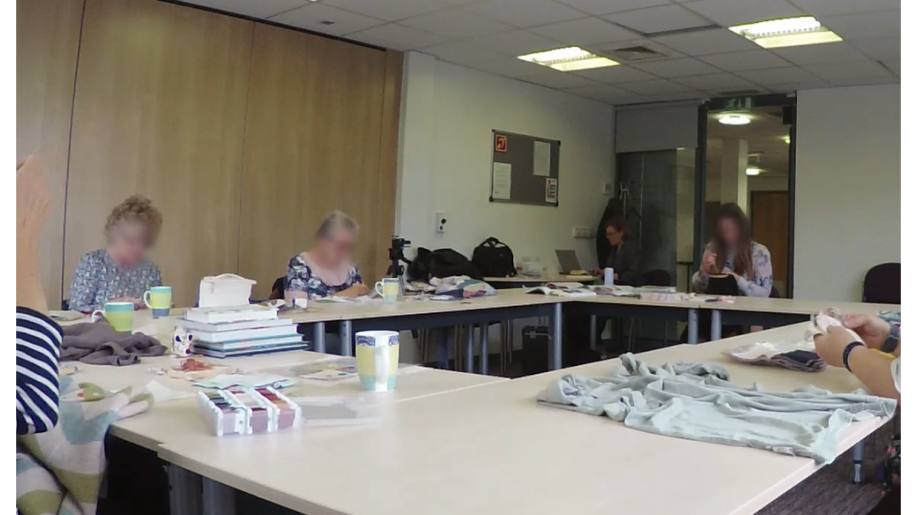

Figure 3. Joyce produces a trouble report as Jess is pulling through a stitch.

Joyce produces the trouble report in line 1 looking down at her work, at a quiet volume. It is non-specific, not locating the source or cause of the trouble, and there is an absence of addressing techniques in the turn design, so no response is made conditionally relevant (Sacks et al., 1974). In the silence that ensues (2.8 seconds, line 2), Frances, a student sitting across the room, gazes up at Joyce on two occasions. Each time Frances gazes up, she maintains her gaze on Joyce for 0.7 seconds. This indicates that the trouble report was heard by Frances, yet she is not recruited to assist. Instead, it is Jess, the instructor (circled in white), who will be recruited to assist. Jess is following her own project, working on her own embroidery and gazing down at her work, and sitting facing the students (see Figure 3). When Joyce begins her trouble report at line 2, Jess is pulling through a stitch, an action that she completes 0.2 seconds after Joyce’s turn finishes. Jess then returns the needle to the sample but does not complete an additional stitch and holds for 1.5 seconds.
Following this hold, Jess stands up in an accelerated manner (Lerner & Raymond, 2021): she raises her head sharply and stands up as she begins to produce a quick, truncated verbal offer or suggestion (“>d’yh wanna<”, line 4), which is not completed. The quickness of the aborted offer and her quick embodied actions are a remedial action (Lerner & Raymond, 2021): Jess’s response shows that she holds herself as accountable for responding to students’ trouble reports regardless of whether she has been explicitly addressed, thus suggesting that the offer was produced later than would normatively be expected. Jess’s accelerated response and the lack of response from other students highlight the normative association of certain activities with particular institutional identities. Jess’s actions and the students' inactions illustrate the classroom norms for category-bound activities, responding to student troubles is tied to the instructor’s identity, not the students’. Conversely, Joyce’s identity as a student means that a quiet, unaddressed trouble report is sufficient to recruit the instructor’s identity.
The final case in this section lies at the boundary between the instructor self-selecting to assist and the student selecting the instructor. Similar to Extracts 1 and 2, Extract 4 shows how students can rely on instructors to monitor their conduct for signs of trouble or need and act on them without an explicit request for assistance. Here, too, we can see an orientation to the instructor’s category-bound activity of providing assistance, embodied in the student's actions and the attentional practices of the instructor. Extract 4 is taken from a Japanese woodblock printing class. James, the student, and Xiao, the instructor, are following their own projects in close proximity to each other. James is painting his wooden block, and Xiao is sorting papers on her desk. At the start of the extract, James begins to show signs of trouble: he halts painting (lines 2-4), sets his paintbrush down (lines 4-5) and looks down at his work for a prolonged period (lines 5-6, Figure 4a). The case shows an array of embodied practices that in effect recruit the instructor, but they do not use an FPP (Sacks et al., 1974) to do so.
Extract 4. [JW1010 0:39:35]
01 ST1: oh *they’re very sup[ por ]*tive=
02 ST2: [they’re lovely]*
jam *L hand to chest-----------------*brush to L hand-->
03 =ye:[ah
04 ST1: [they’re very* nice there.
jam -->*brush on table-->
05 (0.6)•(0.5)*(0.3)
jam -->*moves hands to block-->
jam •begins to lower head-->
06 ST2: and we †kept•# on go*i†ng.
jam -->*hands on block-->
jam -->•head down-->
xia †..............†picks paper up and folds-->
fig #fig.4a
07 (0.3)+(0.3)•(0.1)+*(0.1)#(0.4)•(0.3)*
jam -->*.................*
jam -->•raise head--------•gz to XIA-->
xia +gz to JAM--+head fwd-->
fig #fig.4b
08 *(0.1)+(0.1)•(0.6)†(0.1)#
jam *R hand rest on table-->
jam -->•gz down-->
xia -->+head left, gz to JAM-->
xia -->†paper to table-->
fig #fig.4c
09 ST1: (because)*† the a*rt•*† (0.5) they
jam -->*R hand reach up*,,,*L hand reach to glass-->
jam -->•head left-->
xia -->†step back-----------†walk twd JAM-->>
10 do •(0.4)*(0.2) a-• I went [and then they
11 XIA: -> [how’s it going?
jam -->*hold glass-->>
jam -->•head right----•head down-->>
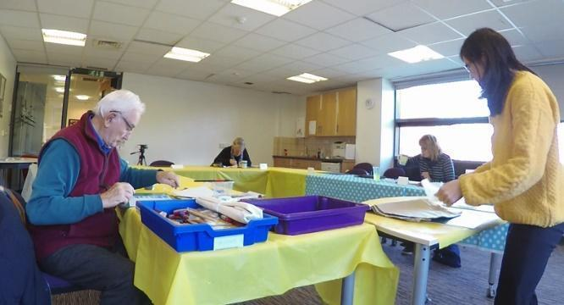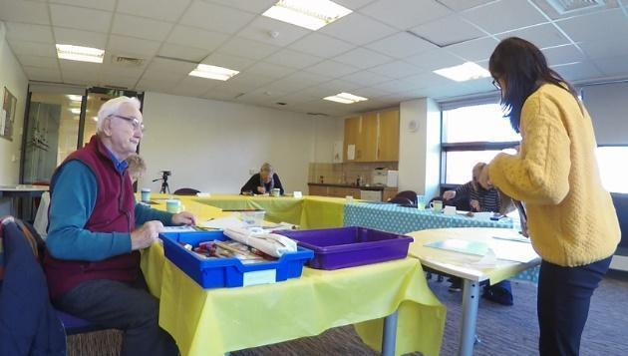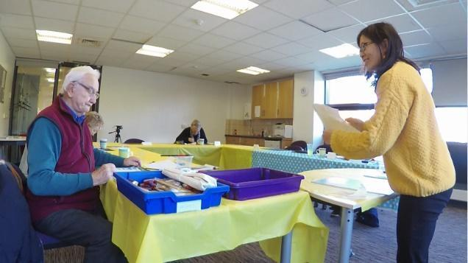
Figures 4a-4c. James’s embodied conduct recruits the instructor.

Interrupting a manual action before completion can signal trouble and may recruit the instructor even in the absence of verbal turns (Kendrick & Drew, 2016; Lerner & Raymond, 2021). As James looks down at his work (lines 6-7), he holds his position, which further indicates trouble (Floyd et al., 2015; Manrique, 2016). At line 7, this embodied gestalt elicits the instructor’s attention: she briefly monitors James, gazing towards his workstation but then returns to her own project. As Xiao is gazing at James, he begins to lift his head, his mouth forming a tight smile with pursed lips and slightly upturned sides and shifts his bodily positioning towards Xiao and solicits assistance through his embodied conduct (Figure 4b) (see Vänttinen, 2022). At line 8 (Figure 4c), Xiao gazes at James and sets down the paper she was holding (lines 8-9), abandoning her previous course of action in favour of assisting James.
By prioritising assistance over another activity that was already underway, Xiao demonstrates her orientation to the provision of assistance as central to her institutional identity. This illustrates how instructors manage multiple tasks and prioritise one activity in favour of another when they cannot happen simultaneously (e.g., Toerien & Kitzinger, 2007). In turn, James orients to the instructor’s category-bound activity of providing assistance by directing his embodied conduct toward her through gaze, rather than to other students. Xiao walks towards James’s station (line 9), and at line 11, she produces a question that provides the student with a slot to describe the trouble he is having, revealing that she has perceived James’s action as signalling trouble. Furthermore, James’s embodied conduct illustrates the expectation that such embodied displays are sufficient to recruit the instructor's assistance, functioning as recruitment methods by exploiting the instructor's category-bound activity of providing assistance.
The cases presented in this section demonstrate how identity plays a role in recruitment. In these instances, instructors are not explicitly selected as the next speaker but are recruited through their orientation to the category-bound activity of providing assistance, tied to the role of "instructor." Similarly, students’ identities as students can be exploited to receive assistance; just as instructors are assistance-providers, students are assistance-receivers. This occurs through the students' conduct, where the mere presence of trouble. whether verbalised, indicated through embodied conduct, or even signalled by a student’s action that deviates from what the instructor knows to be ideal, makes the instructor's category-bound activity of providing assistance relevant. As instructors actively monitor and respond to troubles, they reinforce their identity as assistance-providers, distinguishing themselves from students who do not treat themselves as sharing this responsibility.

Student selects the instructor
As shown in the previous section, instructors respond to students’ troubles in the workshops, regardless of whether these have been addressed to them, thus enacting their institutional identities as assistance-providers. Thus, institutional identities have been shown to play a role in the recruitment process in the workshops. However, instructors’ ability to assist is contingent on their monitoring and detection of student trouble. When instructors are otherwise engaged, for example with other students, obtaining assistance becomes more difficult. As the category-bound activity of assistance is context-sensitive and vulnerable to disruptions, students adopt alternative practices to manage these contingencies and secure the instructor’s involvement. This demonstrates students’ orientation to receiving assistance from the instructor, often by addressing them directly, rather than other students.
Extract 5 shows an instance where instructor Xiao (circled in black) has no visual access to Janet, the student (circled in white). At a transition-relevant place (TRP), Janet produces a summons (line 2), recruiting Xiao, who is walking away with her back turned, limiting her ability to monitor Janet’s progress. By using the address term (Sacks et al., 1974; Lerner, 2003), Janet orients to Xiao’s identity as the assistance-provider, demonstrating that if the instructor does not self-select, or has no basis for knowing to self-select, the student may select them to provide assistance.
Extract 5. [JW0926 2:07:01]
01 NAN: +°and (then) you n:- have to+ (saw)* this bit off+ it.°
xia +step away from JAN---------+step away from JAN--+stp away
jan *gaze up twd XIA-->
02 JAN: -> #Xiao?
#fig.5
03 (0.4)
04 XIA: y+es:: +
->+pivot+
05 +*(0.3)
xia +step twd JAN-->
jan ->*gaze down left-->
06 JAN: can I-+• (0.2) jus•t I’v-+ I’ve * added
-->*gaze to XIA-->>
•,,,,,,,,,,•picks up notebook-->
xia -->+step twd JAN----+step twd JAN-->
07 a-•*(0.5)+ this is from ages ag[o ]=
08 XIA: [↑mh]
xia -->+feet together-->>
jan -->*gaze to notebook
jan ->•opening notebook and finding page-->
09 JAN: =and I looked at it before I came but (0.7) hhh AND
10 I didn’t know whether these would be:
11 RIT: (º º)
12 XIA: mhm.
13 (0.3)
14 JAN: mh::
15 RIT: ((laughing and speaking, inaudible))
16 GLA: [mine isn’t as neat.•]
17 XIA: [( )•]
jan -->•
18 JAN: •and there’s one that was like mushroomy, is
•turns notebook to face XIA-->>
19 that too +complex.
xia -->+lean fwd-->>
20 (0.2)
21 XIA: ↑no. absolutely not.
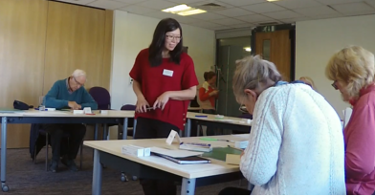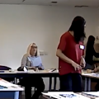

Figure 5. Xiao is walking away from Janet. Shown from two angles.
Although Janet has visual access to the instructor (she gazes up towards Xiao at line 1), Xiao does not have visual access to Janet. At the same time, Xiao is in close proximity to Nancy (Figure 5), who initiates a turn in line 1. Nancy’s turn, although produced quietly and while gazing downward, positions Xiao as a potential recipient. This creates a risk for Janet: if Xiao were to respond to Nancy’s turn, Janet might lose the opportunity to obtain the instructor's assistance at that moment. At the TRP, Janet produces a summons, without noticeable delay, recruiting the instructor. By coming in at the TRP, rather than allowing for an ‘unmarked next position onset’ (Jefferson, 1984, p. 18), which would be considered a ‘normal value of the transition space’ (Schegloff, 2000, p. 51), Janet demonstrates an orientation to this potential risk. Xiao then pivots and moves towards Janet (lines 4-8). At lines 8-17, Janet is opening her notebook, creating a delay as she prepares to show Xiao a design she is considering for her work. In this case, Janet’s trouble relates to the design that she wants to do on her woodblock, and whether it is “too complex” (line 19). By producing this query, Janet positions herself as lacking epistemic status about how complex a design she can accomplish on the woodblock and appeals to the instructor’s professional vision (Goodwin, 1994) to help her resolve this trouble.
Extract 5 highlights that, just as instructors monitor the classroom to provide assistance, students also monitor the instructor and produce assistance-implicative turns at points where the instructor could provide assistance. By using an address term (Sacks et al., 1974; Lerner, 2003), Janet not only summons the instructor but orients specifically to Xiao’s identity as the assistance-provider in the workshops. This demonstrates that who is recruited matters in the workshops: if the instructor does not self-select, or has no basis for knowing to do so, the student may select them to provide assistance. Thus, here too the student orients to their right to receive assistance from the instructor on the basis of their identity.
Extract 6 shows another example of a student using an address term to summon an instructor who is facing away. In this pottery class extract, the student, Susan (circled in white, Figure 6), attempts to open a paint pot (lines 1-2). She produces a series of embodied displays of trouble, which are not seen by the instructor, Pierre (circled in black), who is turned away (line 2). In this case, while there is no immediate risk of another student engaging the instructor, Pierre’s lack of visual access means he does not see the trouble unfold.
Extract 6. [PS0706 0:59:59]
01 ✝ (3.3) * (2.6)✝ (0.5) ✝ (1.1) ✝ (1.2) ✝
sus ✝pick shake pot✝pot to LH✝RH twist✝R elbow up lean back✝
pie *turns walks away-->
02 ✝(0.7)✝(0.5)*(0.2)+ #(0.7)✝ (0.5)+ ✝(0.4)*(0.6)✝(0.3)+(0.1)
sus ✝.....✝apron to pot------✝elbow up✝lean fwd---✝lean back->
sus +gz up--------+head down----------+head L>
pie -->*holds position--------------*head left-->
fig #fig.6
03 SUS: -> Pie*rre ✝can you open ✝the:*se?
pie -->*turns-----------------*walks twd SUS-->>
sus -->✝ ✝lean fwd elbow up-->
04 (1.2)+✝(0.6)
sus -->+head down-->>
sus ✝lean back-->
05 PIE: oh yes✝ °I’ll get that°.
sus -->✝
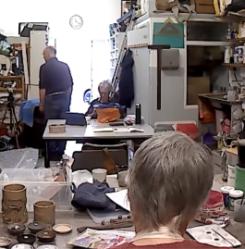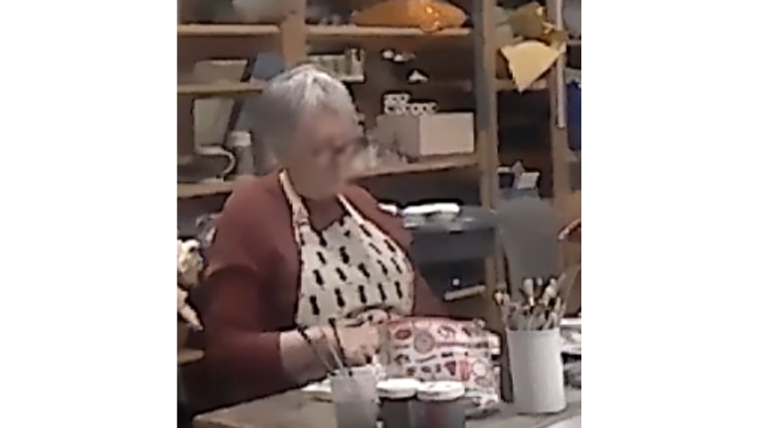

Figure 6. Susan attempts to open pot using her apron while Pierre is turned away. Shown from two angles.
Susan first picks up the pot and shakes it. Meanwhile, Pierre, who had been assisting another student, disengages and begins to walk away (line 2). Susan moves the pot to her left hand and twists the lid with her right hand. After 1.1 seconds (line 1), she raises her right elbow, indicating the application of force (Kendrick, 2021), and leans back. Pierre is now at the opposite end of the workshop with his back turned, while Susan gazes at him (line 2, Figure 6). Susan repeats the action of attempting to open the paintpot, raising her elbow and leaning forward, again displaying application of force (Kendrick, 2021). These embodied displays of trouble are not visible to Pierre, who is turned away. Susan’s repeated attempts indicate an orientation to the preference for self-remediation (Kendrick, 2017), where participants try to resolve issues independently before seeking assistance. However, as shown in the previous section, this preference for self-remediation could be superseded when the instructor has visual access to the trouble. In such cases, assistance may be provided as soon as the trouble is visibly or audibly apparent, irrespective of any ongoing attempts at self-remediation. Here, it is only after these initial, unsuccessful attempts that Susan requests assistance.
As Susan straightens up, she requests, “Pierre can you open the:se?” (line 3). “Can”-interrogatives are often used for high-entitlement requests (Curl & Drew, 2008) and to enlist assistance for a new project that benefits the requester (Zinken & Ogiermann, 2013). By using a high-entitlement request, Susan is orienting to the category-bound activity of instructors to provide assistance. The address term with an FPP identifies Pierre as the selected next speaker (Sacks et al., 1974). Susan’s request indicates the solution to her problem (Kendrick & Drew, 2016). At line 5, Pierre accepts the request with “oh yes”. Just as in extract 2, the “oh”-prefaced turn shows epistemic independence (Heritage & Raymond, 2005), denoting that the instructor has primary rights, or in this case, responsibility, to provide assistance. Thus, through his response, Pierre also orients to the category-bound activity of providing assistance.
This section presents cases where students use addressing techniques to secure assistance from the instructor. In these cases, reliance on the instructor’s identity alone is not sufficient due to context-dependent contingencies, such as being turned away, which limits the instructor’s availability. Instead, the students use addressing techniques to explicitly select the instructor as the next speaker. When instructors self-select to assist, sometimes abandoning their own projects, they perform their identity as assistance-providers. This section shows that students also select the instructor to provide assistance, even when the instructor is engaged on other tasks, thus also orienting to the category-bound activity of assistance-receiving and assistance-giving. In both cases, the instructor’s abandonment of their tasks to assist students highlights the category-bound nature of assistance. Thus, addressing techniques, when used alongside other recruitment practices, serve as a crucial means for students to engage with and make relevant the instructor’s institutional responsibilities while also orienting to students’ rights to receive assistance. These cases also demonstrate that it matters to students who is recruited to assist, as they will select the instructor when they encounter troubles.

Pursuing assistance
We have demonstrated that both students and instructors orient to the instructor as responsible for responding to student troubles, as revealed through how assistance is sought and trouble are responded to. A key finding is that while students can typically rely on the identity of the instructor and associated category-bound activities when seeking help, they may need to employ more explicit recruitment methods when contingencies arise that hinder this reliance.
In this final section, we present a case where a student, Carmen, addresses another student (James) with a trouble report but simultaneously monitors the instructor for a response, thus orienting to the instructor’s identity as a resource for recruitment. As seen in previous cases, producing a trouble report, even one addressed to another student, can be sufficient to recruit the instructor, and Carmen treats it as sufficient through her conduct. Before the extract begins, student Carmen (circled in black, Figure 7a), completes a step in the making process and leans back, crossing her arms and not working. The instructor, Xiao, is on the other side of the room, photographing students’ work and facing away from Carmen. At line 1, Carmen produces a turn with a question addressed to James through gaze and an address term.
Extract 7. [JW1017 0:32:50]
01 CAR: -> #WHAT ARE YOU DOING NOW? (.) JAMES?
>>gz to JAM-->
xia >>taking photograph-->
fig #fig.7a
02 are yo- (0.3) are y-
03 JAM: the s+ky.
xia -->+three steps back-->
04 (0.4)
05 CAR: ri:ght.+
xia -->+taking photographs-->
06 (.)
07 CAR: -> Y[EAH. so I’m jus-] >cos I’m just wondering<=
08 JAM: [ it’s the blue ]
09 CAR: -> =what [I should do next. ]
10 JAM: [(it’s going to be)] on the top.
11 (2.3)
12 CAR: hhhh .hh
13 (0.8)
14 XIA: +brilliant. hh +[ha +.hh]
15 NAN: +[>(I might well ju+st)]
xia +retracts phone+step right--------+pivot-->
16 say i+t I [( )]
xia -->+step L and twd NAN-->
17 CAR: [ I ]
18 XIA: [°haha°] *.hh
car -->*gz to XIA-->
19 CAR: -> I *DON’T KNOW what +me next #m[o*ve is. ]
20 XIA: [ *((sniff))] he+he*hehe
-->+step fwd and left---------+turn twd NAN>
car ->*gz to JAM--------------------*gz to XIA-------*gz R-->
fig #fig.7b
21 XIA: (*[ + ) [ hehe ]
22 CAR: -> *[I’ve forgotten +what to do [ne(h)(h)xt]+ hhhh
-->*gz to JAM-->
xia -->+walk twd JAM-----------+turn-->
23 +(1.0)* (0.4) *(0.9)*(0.1)+(1.1)+(7.1)*
car -->*gz to XIA*gz R-*unknown----------*
xia +walk fwd-------------------+.....+taking photographs-->
24 *(2.9) * (0.9) *(1.7)+(0.1)* (0.2) *(0.9)+(0.2)
car *head R*head fwd*head R-----*head fwd*head R-->
xia -->+lowers phone--------+lifts phone-->
25 CAR: -> #I’m not +sure what to do next now.
xia -->+hold-->
#fig.7c
26 (0.7)+ (0.2) +(0.3)
xia -->+head turn twd CAR+body turn twd CAR-->
27 XIA: +r:i*::ght.
+step twd CAR-->
car -->*gz to XIA-->>
28 (0.4)
29 CAR: #I think I want to do the +background but I’m not sure.
xia -->+lean fwd-->>
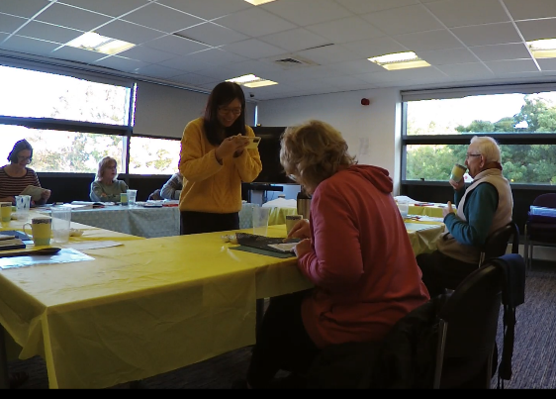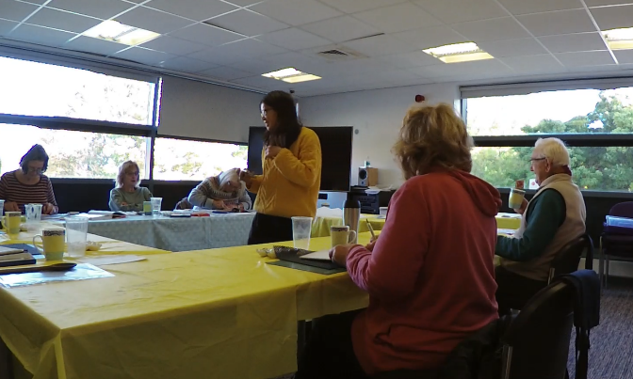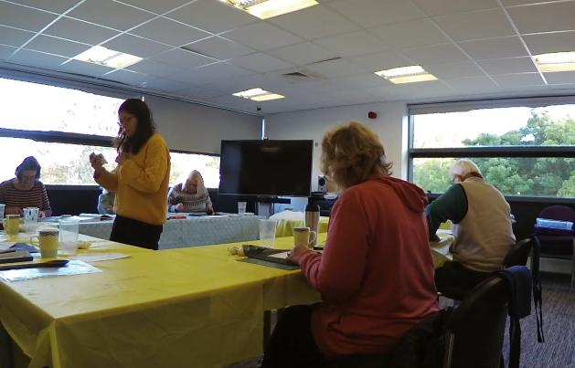

Figure 7a-7c. Carmen pursues assistance from instructor Xiao.

Carmen’s question at line 1 resembles Amelia’s in Extract 2, asking about another student’s experience. Despite having mutual gaze with James, the turn completes with an increment, James’s name. Lerner (2003, p. 186) argues that post-positioned address terms can be a ‘last-ditch effort’ to establish recipiency. However, Carmen has already established recipiency through mutual gaze, so the address term does more than this. The instructor, who is near James, does not have visual access to Carmen. By using James’s name, Carmen may be alerting the instructor and others to whom the turn is addressed.
At line 3, James produces an SPP (“the sky”), which received a minimal response from Carmen (“right”, line 5). At line 7, Carmen accounts for her question: “>cos I’m just wondering< what I should do next.”, while James continues to describe the sky (lines 8 and 10). Carmen competes for the turn despite the overlap, which positions her question as more than ‘just asking’: the turn at line 7 retroactively positions the turn at line 1 as a self-motivated query seeking guidance. Similarly to extract 2, the account also serves as a trouble report, contextualising the question as a pre-trouble report (Schegloff, 2007b).
At line 14, Xiao, who has been photographing Nancy’s work, produces an evaluation (“brilliant”), then steps away retracting her phone, indicating a potential sequence close. However, Nancy produces a turn at lines 15-16, which re-engages the instructor in a focused interaction. At line 17, Carmen begins a turn with “I,” pauses, gazes at Xiao (line 18), then shifts her gaze to James as she says “DON’T” (line 19). Carmen’s trouble report is upgraded in terms of turn design from “just wondering” to “I DON’T KNOW”, and also through prosody, through the use of a louder voice. As she produces the end of her turn, her gaze shifts back to the instructor, demonstrating that Xiao, not James, is the target of her turn. Carmen’s gaze acts as a monitoring mechanism, checking for the instructor’s availability and a potential response.
At line 22, Carmen produces a third trouble report (“I’ve forgotten what to do n(h)(h)ext”), but there is no uptake from either James or Xiao. At line 23, Xiao moves to another student closer to Carmen (Figure 7b), and Carmen continues to monitor her. At line 24, Xiao lowers her phone, and 0.2 seconds later, at a possible sequence close (i.e., photographing coming to an end), Carmen produces a fourth trouble report: “I’m not sure what to do next now” (line 25), with her head oriented towards Xiao. Unlike before, Xiao is no longer engaged with another student, and the classroom is quieter, so despite Xiao still being turned away from Carmen, she turns (line 26) and is recruited to assist.
This extract demonstrates that students can upgrade their recruitment practices to address the instructor in increasingly more explicit ways. Carmen’s turns are similar to those in extract 2, but here the instructor is otherwise engaged. Carmen redoes the trouble report twice and monitors the instructor while addressing James through gaze, treating James’s response as insufficient and orienting to the instructor as the primary assistance-provider, as she pursues a response from the instructor in order to resolve her trouble. Finally, after a gap, when the class quiets and Xiao is visibly disengaging from her photographing activity, she is successfully recruited. Even without mutual gaze, Xiao understands the expectation to respond. Thus, while contingencies initially hinder Xiao’s response, all that Carmen needs to do at line 25 is to redo her trouble report at a point where the instructor is more available. In this way, both Carmen and Xiao orient to the institutional identity of the instructor, and the associated category-bound activity of providing assistance.

Discussion
This study demonstrates how institutional identities are made procedurally relevant in the organisation of assistance in the classroom. We began by showing a case where the instructor issued a correction to a student who was unaware that there was trouble underway (Extract 1). Through doing the rounds (Greiffenhagen, 2012; Jankonen, 2021; Tyagunova & Breidenstein, 2023) and monitoring, instructors detect trouble and intervene where necessary. Instructors also respond to turns that are not addressed to them (Extract 2) and show remediating practices if their response is delayed (Extract 3), thus revealing, through their actions, that providing assistance is a category-bound activity tied to the identity of the instructor. Students also orient to the instructor’s identity and category-bound activity of assistance-provider in the way they respond to the instructors’ interventions (e.g., Extract 2), and the way they position themselves, treating gaze as sufficient to obtain assistance (Extract 4). Through these actions, students and instructors also orient to the identity of student as relevant in the organisation of assistance: assistance is mobilised by the fact that trouble is observable in student conduct. These behaviours highlight an implicit “maxim” for students to display trouble and an expectation for instructors to “look for trouble” and offer assistance wherever possible (cf. Kendrick & Drew, 2016, p. 16; Kendrick, 2021, p. 80).
However, we have also shown that it is not always easy to obtain assistance from the instructor, as there are often competing demands on their attention. In these cases, students may employ addressing techniques, doing additional work to recruit the instructor, demonstrating that students are oriented to getting assistance from the instructor, rather than other participants (e.g., Extracts 5 and 6). Extract 7 shows how a student may pursue assistance from the instructor above other students, indicating that students orient to the provision of assistance as bound to the category of instructor. Furthermore, the student prioritises reliance on the instructor to self-select, as evidenced by maintaining the same recruitment method while upgrading turns through prosody, rather than shifting to another method such as a direct request for assistance.
In this study, we adopted the concept of recruitment because it captures how assistance is achieved as an interactional outcome. While the term “instruction” typically highlights actions performed by instructors, recruitment directs the analytical attention towards the process by which someone becomes involved in another’s course of action. (Kendrick & Drew, 2016; Kendrick, 2021). Thus, rather than categorising instructors’ actions as instruction per se, we explored how students and instructors collaboratively make relevant institutional identities and obligations to achieve assistance. Previous research on instruction has provided detailed analyses of how instructors intervene, correct, and guide students in institutional settings (e.g., Ekström & Lindwall, 2014; Evans & Reynolds, 2016; Nishizaka, 2020; Keevallik, 2010). These studies confirm the instructor’s institutional role as corrective and attentive to student troubles, which aligns with our findings on instructors self-selecting to assist (Extracts 1-3). However, our study extends this by incorporating students’ recruitment practices. We show how students leverage gaze and addressing techniques as interactional resources to mobilise instructors’ institutional identity for assistance. Thus, we build upon previous literature by demonstrating that instructional interventions are not solely instructor-driven actions, but collaborative achievements shaped by mutual orientations to institutional identities and obligations.
By adopting recruitment as our analytical framework, this paper contributes to research on recruitment (Kendrick, 2021; Kendrick & Drew, 2016), showing how institutional identities and associated category-bound activities are relevant in the organisation of recruitment. We have shown that institutional identities such as "instructor" and "student" serve as resources that participants exploit to organise and achieve assistance outcomes. For instance, students often orient to the instructor's role as assistance-providers, relying on institutional identity rather than explicit requests to obtain assistance. Thus, these findings extend our understanding of recruitment by highlighting its procedural relationship with instructional identities and obligations.
We have aimed to demonstrate, as Schegloff (1992) suggests, that the identities of “student” and “instructor” are procedurally relevant for participants in ‘producing and interpreting conduct during interactions’ (p. 109). Just as picking up their crying baby is a category-bound activity for mothers, providing assistance is a category-bound activity for the instructor and receiving assistance is a category-bound activity for the student. Similar sentences to Sacks’s ‘The baby cried. The mommy picked it up’ can be constructed for the participants in the craft workshops: ‘The student encountered trouble. The instructor helped’. Just like in Sacks’s examples, the second sentence follows on from the first and occurrence 2 is contingent occurrence 1.
This paper bridges previous research on recruitment practices and institutional identities, highlighting the procedural consequences of such identities for interaction. Notably, this work demonstrates how institutional identities - and their associated category-bound activities - are made relevant by participants in this institutional context, operating as part of an interactional mechanism through which instructors are recruited to provide assistance. Thus, the category of “instructor” is made omnirelevant within the classroom (Sacks, 1992), ready to be mobilised at the first sign of potential trouble. This contributes to broader theories of membership categorisation and reinforces the idea that institutional roles are not only identifiers but also procedurally relevant for the organisation of interaction (see Whitehead et al., 2024).

References
Boudouraki, A., Fischer, J. E., Reeves, S., & Rintel, S. (2021). ‘I can’t get round’: Recruiting Assistance in Mobile Robotic Telepresence. Proceedings of the ACM on Human-Computer Interaction, 4(CSCW3), 248:1-248:21.
Cekaite, A. (2009). Soliciting Teacher Attention in an L2 Classroom: Affect Displays, Classroom Artefacts, and Embodied Action. Applied Linguistics, 30(1), 26–48.
Clayman, S.E. (2012). Conversation Analysis in the News Interview. In J. Sidnell & T. Stivers (Eds.), The Handbook of Conversation Analysis (pp. 630–656). Wiley-Blackwell.
Curl, T.S., & Drew, P. (2008). Contingency and Action: A Comparison of Two Forms of Requesting. Research on Language & Social Interaction, 41(2), 129–153.
Drew, P., & Heritage, J. (1992). Analyzing talk at work: An introduction. In P. Drew & J. Heritage (Eds.), Talk at Work (pp. 3–65). Cambridge University Press.
Drew, P., & Kendrick, K. H. (2018). Searching for Trouble: Recruiting Assistance Through Embodied Action. Social Interaction. Video-Based Studies of Human Sociality, 1(1).
Ekström, A., & Lindwall, O. (2014). To follow the materials: The detection, diagnosis and correction of mistakes in craft education. In M. Nevile, P. Haddington, T. Heinemann, & M. Rauniomaa (Eds.), Interacting with Objects: Language, materiality and social activity (pp. 227–247). John Benjamins Publishing Company.
Evans, B., & Reynolds, E. (2016). The Organization of Corrective Demonstrations Using Embodied Action in Sports Coaching Feedback. Symbolic Interaction, 39(4), 525–556.
Floyd, S., Manrique, E., Rossi, G., & Torreira, F. (2015). Timing of Visual Bodily Behavior in Repair Sequences: Evidence From Three Languages. Discourse Processes, 53(3), 175–204.
Fox, B.A., & Heinemann, T. (2021). Are They Requests? An Exploration of Declaratives of Trouble in Service Encounters. Research on Language and Social Interaction, 54(1), 20–38.
Goffman, E. (1978). Response Cries. Language, 54(4), 787–815.
González-Martínez, E., & Drew, P. (2021). Informings as recruitment in nurses′ intrahospital telephone calls. Journal of Pragmatics, 186, 48–59.
Goodwin, C. (1994) Professional Vision. American Anthropologist, 96(3), 606-633.
Greiffenhagen, C. (2012). Making rounds: The routine work of the teacher during collaborative learning with computers. International Journal of Computer-Supported Collaborative Learning, 7(1), 11–42.
Heritage, J. (1984). A change-of-state token and aspects of its sequential placement. In J.M. Atkinson (Ed.), Structures of Social Action (pp. 299–345). Cambridge University Press.
Heritage, J., & Raymond, G. (2005). The Terms of Agreement: Indexing Epistemic Authority and Subordination in Talk-in-Interaction. Social Psychology Quarterly, 68(1), 15–38.
Jefferson, G. (1984). Notes on some orderlinesses of overlap onset. In V. D'Urso & P. Leonardi (Eds.), Discourse analysis and natural rhetorics, pp. 11-38. Padova.
Jefferson, G. (1988). On the Sequential Organization of Troubles-Talk in Ordinary Conversation. Social Problems, 35(4), 418–441.
Jefferson, G. (2004). Glossary of transcript symbols with an introduction. In G.H. Lerner (Ed.), Conversation Analysis: Studies from the first generation (pp. 13–31). John Benjamins Publishing Company.
Jakonen, T. (2021). Professional Embodiment: Walking, Re-engagement of Desk Interactions, and Provision of Instruction during Classroom Rounds. Applied Linguistics, 41(2), 161–184.
Keel, S., Schmid, A., & Keller, F. (2024). Digital technology in physiotherapy consultations: Problem-solving sequences and recruitments. Prologi, 20(01), Article 01.
Keevallik, L. (2010). Bodily Quoting in Dance Correction. Research on Language and Social Interaction, 43(4), 401–426.
Kendrick, K.H. (2017). The preference for self-remediation over assistance in interaction. 1–8.
Kendrick, K.H. (2021). The ‘Other’ side of recruitment: Methods of assistance in social interaction. Journal of Pragmatics, 178, 68–82.
Kendrick, K.H. (2024). System-Oriented Analysis: Moving from Singular Practices to Organizations of Practice. In J.D. Robinson, R. Clift, K.H. Kendrick, & C.W. Raymond (Eds.), The Cambridge Handbook of Methods in Conversation Analysis. Cambridge University Press.
Kendrick, K.H., & Drew, P. (2016). Recruitment: Offers, Requests, and the Organization of Assistance in Interaction. Research on Language and Social Interaction, 49(1), 1–19.
Küttner, U.-A., Kornfield, L., Mack, C., Mondada, L., Rogowska, J., Rossi, G., Sorjonen, M.-L., Wiedner, M., & Zinken, J. (2024). Introducing the “Parallel European Corpus of Informal Interaction” (PECII): A novel resource for exploring cross-situational and cross-linguistic variability in social interaction. In M. Selting & D. Barth-Weingarten (Eds.), New Perspectives in Interactional Linguistic Research (pp. 132–160). John Benjamins Publishing Company.
Lerner, G.H. (1992). Assisted storytelling: Deploying shared knowledge as a practical matter. Qualitative Sociology, 15(3), 247–271.
Lerner, G.H. (1996). Finding ‘face’ in the preference structures of talk-in-interaction. Social Psychology Quarterly, 59(4), 303–321.
Lerner, G.H. (2003). Selecting next speaker: The context-sensitive operation of a context-free organization. Language in Society, 32(2), 177–201.
Lerner, G.H. (2019). When Someone Other than the Addressed Recipient Speaks Next: Three Kinds of Intervening Action After the Selection of Next Speaker. Research on Language and Social Interaction, 52(4), 388–405.
Lerner, G.H., & Raymond, G. (2021). Body Trouble: Some Sources of Difficulty in the Progressive Realization of Manual Action. Research on Language and Social Interaction, 54(3), 277–298.
Levin, L., Cromdal, J., Broth, M., Gazin, A.-D., Haddington, P., McIlvenny, P., Melander, H., & Rauniomaa, M. (2017). Unpacking corrections in mobile instruction: Error-occasioned learning opportunities in driving, cycling and aviation training. Linguistics and Education, 38, 11–23.
Lindström, A. (2005) Language as social action. A study of how senior citizens request assistance with practical tasks in the Swedish home help service. In A. Hakulinen & M. Selting (Eds.), Syntax and Lexis in Conversation (pp. 209–230). John Benhamins.
Lindwall, O., & Mondada, L. (2025). Sequence organization in the instruction of embodied activities. Language & Communication, 100, 11–24.
Manrique, E. (2016). Other-initiated Repair in Argentine Sign Language. Open Linguistics, 2(1).
Mlynář, J. (2022). Lifting the pen and the gaze: Embodied recruitment in collaborative writing. Text & Talk, 43(1), 69–91.
Mondada, L. (2018). Multiple Temporalities of Language and Body in Interaction: Challenges for Transcribing Multimodality. Research on Language and Social Interaction, 51(1), 85–106.
Nishizaka, A. (2020). Appearance and Action: The Sequential Organization of Instructions in Japanese Calligraphy Lessons. Research on Language and Social Interaction, 53(3), 295–323.
Okada, M. (2013). Embodied interactional competence in boxing practice: Coparticipants’ joint accomplishment of a teaching and learning activity. Language & Communication, 33(4), 390–403.
Raymond, G., & Heritage, J. (2006). The epistemics of social relations: Owning grandchildren. Language in Society, 35(5), 677–705.
Robinson, J.D. (2003). An Interactional Structure of Medical Activities During Acute Visits and Its Implications for Patients’ Participation. Health Communication, 15(1), 27–59.
Sacks, H. (1991). On the Analysability of Stories by Children. In F.C. Waskler (Ed.), Studying The Social Worlds Of Children. Routledge.
Sacks, H. (1992). Lectures on Conversation Volumes I & II (G. Jefferson, Ed.). Blackwell Publishing Ltd.
Sacks, H., Schegloff, E.A., & Jefferson, G. (1974). A Simplest Systematics for the Organization of Turn-Taking for Conversation. Language, 50(4), 696–735.
Sahlström, J.F. (2002). The Interactional Organization of Hand Raising in Classroom Interaction. The Journal of Classroom Interaction, 37(2), 47–57.
Schegloff, E.A. (1992). On talk and its institutional occasions. In P. Drew & J. Heritage (Eds.), Talk at Work: Interaction in institutional settings (pp. 101–134).
Schegloff, E.A. (2000). Overlapping talk and the organization of turn-taking for conversation. Language in Society, 29, 1-63.
Schegloff, E. A. (2006). Interaction: The infrastructure for social institutions, the natural ecological niche for language, and the arena in which culture is situated. In N. J. Enfield & S. C. Levinson (Eds.), Roots of Human Sociality: Culture, Cognition and Interaction (pp. 70–96). Berg.
Schegloff, E.A. (2007a). A tutorial on membership categorization. Journal of Pragmatics, 39(3), 462–482.
Schegloff, E.A. (2007b). Sequence Organization in Interaction: A Primer in Conversation Analysis. Cambridge: Cambridge University Press.
Schegloff, E.A., Jefferson, G., & Sacks, H. (1977). The Preference for Self-Correction in the Organization of Repair in Conversation. Language, 53(2), 361–382.
Solem, M.S., Sikveland, R.O., Stokoe, E., & Skovholt, K. (2023). How Do Students Receive Help from Teachers? Initiating Assistance in Small Group Classroom Interactions. Applied Linguistics, XX, 1-16.
Stivers, T. (2002). Presenting the Problem in Pediatric Encounters: ‘Symptoms Only’ Versus ‘Candidate Diagnosis’ Presentations. Health Communication, 14(3), 299–338.
Stivers, T., & Robinson, J.D. (2006). A preference for progressivity in interaction. Language in Society, 35(3), 367–392.
Stivers, T., & Rossano, F. (2010). Mobilizing Response. Research on Language and Social Interaction, 43(1), 3–31.
Stokoe, E. (2009). Doing actions with identity categories: Complaints and denials in neighbor disputes. Text & Talk, 29(1), 75–97.
Stokoe, E. (2012). Moving forward with membership categorization analysis: Methods for systematic analysis. Discourse Studies, 14(3), 277–303.
Stokoe E., Raymond G. & Whitehead K.A. (2024) Categories in Social Interaction: Unlocking the Resources of Conversation Analysis and Membership Categorization for Psychological Science. Annu Rev Psychol.
Szymanski, M.H. (1999). Re-engaging and dis-engaging talk in activity. Language in Society, 28(01).
Toerien, M., & Kitzinger, C. (2007). Emotional Labour in Action: Navigating Multiple Involvements in the Beauty Salon. Sociology, 41(4), 645–662.
Tyagunova, T., & Breidenstein, G. (2023). Instructional touch: The organisation of a close and closed interaction space for individualised instruction in ‘open classrooms’. Learning, Culture and Social Interaction, 42, 100752.
Vänttinen, M. (2022). Eye gaze as a resource in handling trouble around mobile devices in EFL classroom interactions: Katse ongelmanratkaisun resurssina luokkahuoneen mobiililaitetyöskentelyssä. AFinLAn Vuosikirja, 395–413.
Whalen, M.R., & Zimmerman, D.H. (1990). Describing Trouble: Practical Epistemology in Citizen Calls to the Police. Language in Society, 19(4), 465–492.
Whitehead, K.A. (2011). An Ethnomethodological, Conversation Analytic Approach to Investigating Race in South Africa. South African Review of Sociology, 42(3), 1–22.
Whitehead, K.A., Stokoe, E., & Raymond, G. (2024). Categories in Social Interaction (1st edition). Routledge.
Zinken, J., & Ogiermann, E. (2013). Responsibility and Action: Invariants and Diversity in Requests for Objects in British English and Polish Interaction. Research on Language and Social Interaction, 46(3), 256–276.

