Are vulnerable neighbourhoods left behind? Urban cooling disparities from greenspace inequality in Antananarivo, Madagascar
Rui Han ^{a, *}, Robert A. Marchant ^{a, b} Jessica P.R. Thorn ^{c,d,e}
a Department of Environment and Geography, University of York, YO10 5NG, UK
b Faculty of Environment and Resource Studies, Mahidol University, 73170, Thailand
c Centre for Environmental Policy, Imperial College London, UK, SW71NE
d School of Geography and Sustainable Development, University of St Andrews, KY16 9AL, UK
e Department of Environmental Sciences, University of Namibia, 13301, Namibia

Abstract: The escalation of urbanization contributes significantly to urban heat in both affluent and impoverished neighbourhoods. Community thermal vulnerability is often characterised by socio-demographic composition, with little consideration as places where people are unequally exposed to greenspace and how they associate with cooling disparities. Combining land surface temperature, this Antananarivo case study employed greenspace exposure Gini coefficient to map the locations of vulnerable neighbourhoods and evaluate how their cooling effect differs from others. Results show that nearly 25% neighbourhoods were unequal where values of exposure to greenspace is disproportionately higher in some of grid cells than others, raising vulnerability to urban heat. These vulnerable neighbourhoods exhibited an average 0.01°C greater cooling effect, compared to other neighbourhoods. Specifically, main cooling role for vulnerable neighbourhoods is agricultural land with a 1% of agricultural land increase leading to a 0.02-0.03°C temperature reduction in the day. Comparatively, the cooling effect for the rest of more equal neighbourhoods relies on non-agricultural greenspace with 1% coverage increase resulting in a 0.01-0.02°C temperature reduction at night. Meanwhile, the cooling threshold of 62% and 78% for greenspace land cover in equal neighbourhoods emerged from cooling models in 2017 and 2022, which estimated to reduce average 0.78°C, 1.24°C nighttime temperature to shift these vulnerable neighbourhoods experiencing the highest temperature to a more comfortable range regardless of any other factors. However, there was no thresholds detected in vulnerable neighbourhoods. These cooling disparities between vulnerable and equal neighbourhoods is influenced by factors of urbanisation and topology conditions, vegetation canopy and land cover contributions, day-to-night land surface temperature baseline variations. These cooling explanatory variations also depicted the trajectory of how neighbourhoods evolve from equal to vulnerable ones. Our findings emphasise the contributions of equitable greenspace distributions to urban heat mitigation and adaptation, implicating cooling strategies for marginalized communities in Antananarivo and other developing cities.
Keywords: Cooling threshold; gini coefficient; land use land cover; land surface temperature; neighbourhoods scale
1. Introduction
Urban areas, covering 3% of the Earth's land surface, are home to over 50% of the world’s population, contribute up to 70% of global greenhouse gas emissions and consume 75% of the resources (United Nations, 2018; Pappalardo et al., 2023). Intensified by climate change, urban heat exposes residents to higher thermal stress (Oke, 1982), producing increased threat to human health and mortality (Jay et al., 2021). This intensified effect is observed globally (Liu et al., 2022) and is anticipated to shift from Asia to Sub-Saharan Africa by mid-century due to rapidly population growth in African (United Nations, 2019; Peter et al., 2021; Li et al., 2022) and warmer climates at low latitudes (Alizadeh et al., 2022; Li et al., 2024). Currently Sub-Saharan African urban areas house 472 million people, with this number expected to double by 2050 and triple by 2100 (United Nations, 2017a). This rapid urbanisation presents significant challenges, with 70% of African cities vulnerable to climate shocks (IPCC, 2022; Mhedhbi et al., 2023) and between 59-62% of dwellers living in informal settlements without adequate green infrastructure to respond intensified urban heat (Amegah, 2021). These trends underscore the urgent need for urban planners to incorporate urban heat stress into climate change mitigation and adaptation during the Decade of Action (2020-2030), pursuing the Sustainable Development Goals (United Nations, 2015) and the vision of the African Union Agenda 2063 (United Nations, 2017b).
Urban ecological space that plays a key role in cooling cities can be classified into such as three categories: (i) agricultural vegetated surfaces, (ii) non-agriculture green infrastructure, and (iii) water bodies and wetlands (Martin et al., 2024; Masoudi & Tan 2019; Zhou et al., 2022). They are increasingly being incorporated into cities at the neighbourhood scale to provide cooling through shading, evaporation, and energy absorption (Wong et al., 2021; Liu and Zheng, 2024). Such neighbourhood-level cooling programmes offer advantages such as lower investment and simpler implementation than the large-scale greenery. In this context, the lower or upper threshold values of ecological space for neighbourhoods cooling effect can be calculated based on the proportion of land cover (Yu et al., 2020). However, studies on cooling values have generally focused on specific environments, such as within a community, a defined area or around parks (Zhen et al., 2024). For example, Aram et al. (2019) identified that 10 ha of greenspace produced a 1-2°C cooling effect across a 350m radius. Peng et al. (2016) found that green infrastructure exceeding 70% of a community's area in Beijing effectively reduced the UHI effect. Kirschnner et al. (2023) reviewed that park with less than 5.6 ha in Leipzig, 2-3 ha in London, 2 ha in Shanghai, and 0.49 ha in Almada had a negligible temperature reduction effect. So far comparisons of cooling values across diverse neighbourhoods with different gradients in social-demographical factors (i.e. income, ethnicity), particularly in access to natural space, have been under research.
Moreover, intensified by socio-demographic factors, inequality of access to natural spaces becomes more pronounced that exacerbates the threat of urban heat stress (Han et al., 2024; Wang et al., 2024; Chen et al., 2022; Robert, 2000). For example, some strategies, such as ‘compact cities’, encourage immigrants to live in populated streets where parks can help to reduce the installation and maintenance costs; while congested landscapes may hinder accessibility for those who live in the suburbs (Sakamoto et al., 2018). Some suggest ecological space is a ‘nice’ option, but such narratives are not always helpful (Rigolon et al., 2022); this approach inadvertently disincentives government investment in socially disadvantaged communities, triggering inequity (Chen et al., 2024). While these correlations between socioeconomic factors and green distribution are concerning for policy makers, less attention has been paid to identifying equality targets or to measure the degree of distributional inequality in cooling (He et al., 2024). In this case, we aim to shift focus from categorizing diverse neighbourhoods based on sociodemographic components, such as disadvantage in income, education, age (Kim and Kim, 2024; Wang et al., 2024; Mashhoodi, 2021; Sandholz et al., 2021), to directly examine disparity of cooling efficacy resulting from greenspace distributional inequality.
Greenspace distributional inequality is one of three proposal dimensions of environmental injustice – i.e., procedural, recognitional, and distributional (Grant et al., 2022) and is strongly tied to wellbeing (Nesbitt et al., 2018). A distributionally unequal neighbourhood is one where more greenery is found in disproportionately higher numbers in some of this neighbourhoos’ houses compared to others. Gini index, originally used to measure wealth inequality and today is useful for international income comparisons (Liu and Gasiwirth, 2020), has been increasingly adapted to assess distributional green inequality (Martin and Conway, 2024; Han et al., 2023). For example, Wüstemann et al (2017) using Gini to quantify the inequality of per capita urban green area. Chen et al (2022) mapped the spatially explicit inequality of human exposure to greenspace between Global South and North. The Gini Index incorporating greenspace access and population data, rather than solely location data, can assess and compare the magnitude of difference in greenspace access between individual housing structures or the overall level of inequality for neighbourhoods (Martin et al., 2024).
In this study, we go beyond traditional socio-demographic correlated analysis to adopt a Gini coefficient perspective to examine distributional inequalities. Specifically, through Gini coefficient and land surface temperature, we aim to understand: (i) how many neighbourhoods exhibit high greenspace exposure inequality? (ii) if these neighbourhoods overlap with the hotpots of urban heat stress? (iii) do these neighbourhoods have a smaller cooling effect and to what extent does their cooling effect differ from other neighbourhoods?
2. Methodology
2.1 Case study site
Madagascar, an island nation with unparalleled biodiversity and significant natural wealth, is heavily reliant on natural resources for its economy (World Bank, 2020). In 2023, extreme poverty affected 80.7% of the population on less than USD 2.15 per day. Wealth is unevenly distributed, especially in urban areas, with capital Antananarivo’s Gini coefficient for household income reaching 0.452 in 2016 - among the highest in developing countries (World Bank, 2020). According to Eckstein, et al., 2021, Madagascar is one of the world’s most vulnerable countries to climate change and the top three Sub-Saharan African countries likely to experience extreme weather events in 2020.
Antananarivo is undergoing rapid urbanisation (Ramiaramanana and Teller, 2021). The city’s population, estimated at 4 million in 2024, is projected to double by 2050 (Healy, 2017; World Bank, 2020). Cities are account for 75% of national GDP and home to about half of a country's urban population (Xavier, 2012). UN Habitat estimates that the Urban Commune of Antananarivo (UCA) population grows by 5% annually adding about 100,000 people each year. The UCA is one of the world’s most densely populated urban areas, with around 22,000 inhabitants per km² (World Bank, 2020; Frodella et al., 2021). As settlements extend, unplanned, improvised housing has emerged and about 70% of these settlements are informal (UNEP, 2021; Aubry et al., 2012). Rapid urbanisation and climate vulnerability are further placing increasing pressure on the city’s limited infrastructure and services.
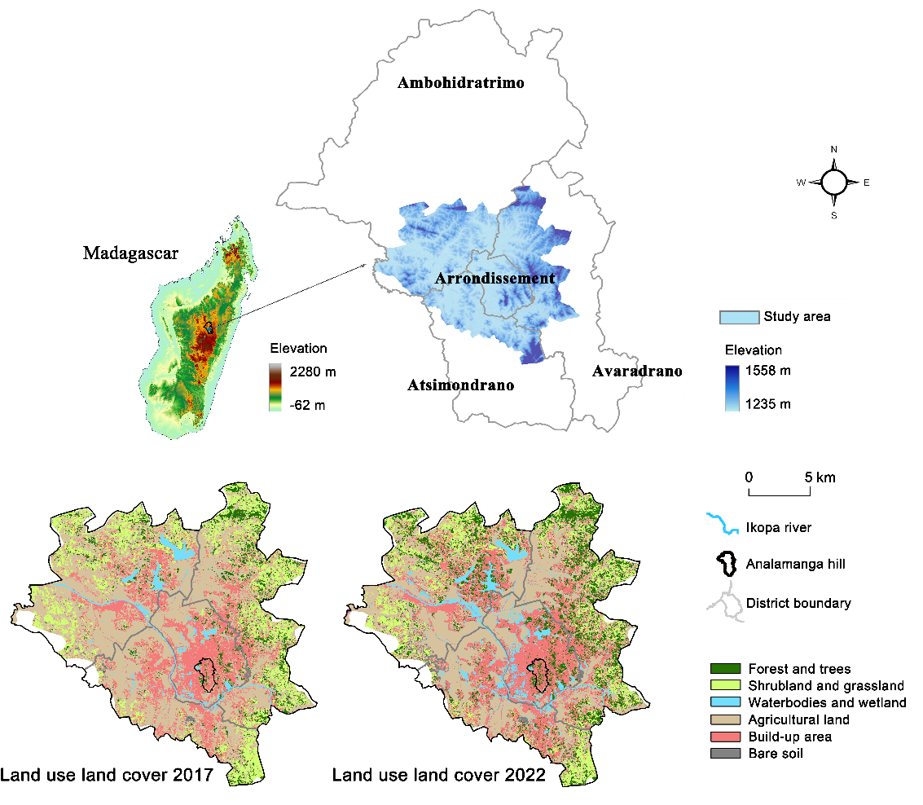
Figure 1. Map of the study area and land use land cover in 2017 and 2022 (Dupuy et al., 2023)
Existing studies on urban green infrastructure and temperature regulation services span at least 20 countries and 74 cities in Sub-Saharan Africa, but none in Antananarivo (Du Toit et al., 2018). This study focuses on Greater Antananarivo, covering urban and peri-urban areas across 598 km², including the districts of Avaradrano in the centre, Arrondissement to the east, Ambohideratrimo to the north, and Atsimondrao to the south (Fig. 1). The study area has an average elevation of 1,310 m, and experiences temperatures ranging from 20-30°C during the wet season (November to April) and 15-20°C during the dry season (May to October) (Randriamarolaza et al. 2022).
2.2 Data collection and processing
Land use land cover for 2017 and 2022 was sourced from Dupuy et al. (2022, 2023). This dataset was generated using a combination of a very high spatial resolution Pleiades Image (0.5m and 2m), the high spatial resolution image (10 m and 20 m) time series Sentinel-2, and Landsat-8 with a spatial resolution of 15 m for the panchromatic band and 30 m for the multispectral bands (Dupuy et al., 2020). Based on a global database of administrative unit-based census information (Llyod et al., 2019), the top-to-down unconstrained modelling projection of population numbers for 100 x 100 m grid cell in 2017 and 2020 were used to represent the estimated total number of people at 100m spatial resolution, through WorldPop (2020).
Multi-sensor fusion was used to detect the Land surface temperature (LST). Four sets of the eight-day daily MODIS/Terra (MOD11A2) and MODIS/Aqua (MYD11A2) images in February were applied to retrieve the LST, representing Greater Antananarivo’s hot month average temperature in 2017 and 2022, through NASA (2023). MODIS Terra captures daily LST at 10:30 and 22:30, and MODIS Aqua targets 01:30 and 13:30 LST. The original remote sensed LST images suffered from noise impact and data gaps due to undesirable weather conditions, atmospheric and radiation interferences, or sensor malfunctioning (Li et al., 2013). This study adopted the Multi-Task Gaussian Process Model (MTGP) to smooth noise and fill in missing data. The MTGP assumes the LST of coarse resolution to be a satisfactory proxy of variation of near surface temperature (Coutts et al., 2016, Yang et al., 2020).
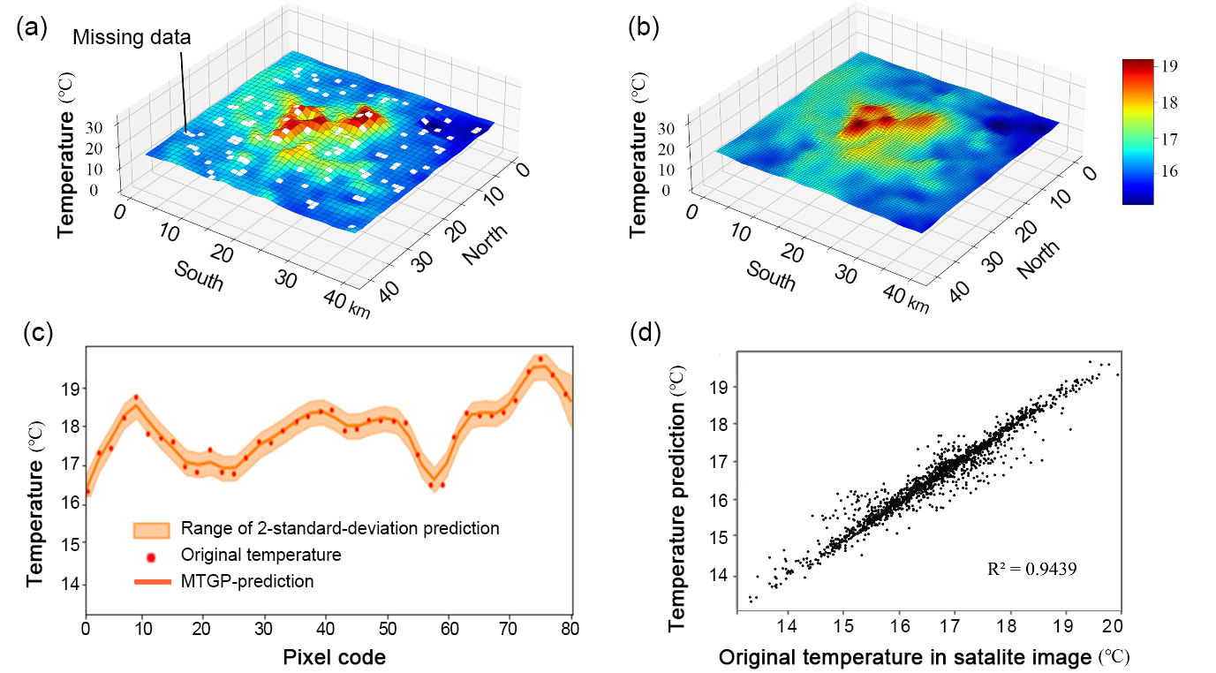
Figure 2. The modelling process of the Multi-Task Gaussian Process (MTGP) based on original Land Surface Temperature (LST) images: (a) original 8-day LST of Aqua (MYD11A2) image with 1 km resolution at 01:30 on 18-25th February, 2022; (b) the MTGP modelling fill in missing data and improved image resolution from 1 km to 500 m; (c) MTGP modelling process predictions were located within the 2-standard-deviation range; and (d) validation of LST prediction.
As shown in Fig. 2, an example of original LST image and MTGP-predicted LST image demonstrates that the recovery process filled the missing values and popularised the resolution of the image by a factor of two. This modelling process was repeated 10,000 times to ensure robustness (Pipia et al., 2021). In this case, the missing data was filled and the spatial resolution of 1 km in the original LST image was popularised to be 500m in the MTGP-predicted LST image. The predictions were mostly within two standard deviations, indicating that the difference between original temperature and predicted temperature images was acceptable, with an $r^{2}$ of 0.9439. Additionally, green metrics based on the Normalized Difference Vegetation Index (NDVI) at a 100 m × 100 m resolution were employed in this study (Copernicus, 2023). To minimize uncertainty caused by cloud cover and shadows in the NDVI composition, clear-sky Sentinel-2 images from March 1st, 2017 and 2022 were selected, as they were the clearest and most appropriate. This aligned well with the latent LST time series.
2.3. Gini coefficient calculation
Following the methodology of Chen et al. (2022) as applied by Song et al. (2021), this study extracted non-agricultural greenspace – i.e., forest and trees, shrubland and grassland - to evaluate Gini coefficient results. Gini coefficient is used to quantify the magnitude of inequality in greenspace exposure, which is mathematically derived from the Lorenz curve (Fig. S1 in Appendix). In our study, the calculation of Gini coefficient at neighbourhood scale calculated using the following three steps.
Firstly, we defined a neighbourhood as a 500m×500m pixel. The 500m×500m pixel representing one neighbourhood aligns with the MTGP-projected LST resolution, and each neighbourhood consists of 25 gride cells (Fig. 3c). A grid cell comprises is a 100m×100m pixel (Fig. 3a), corresponding to population data resolution.
Secondly, we calculated the greenspace access and greenspace exposure values for 25 individual grid cells in each neighbourhood. Greenspace access value refers as the total percentage of forests, trees, shrubland, and grassland within a grid cell’s accessible buffer zone (Fig. 3b). A value of 100% (best) and 0% (worst) indicates full and no greenspace coverage within the grid cell’s access radius, respectively. Greenspace exposure value is a composite metric that incorporates greenspace access area and population data to indicate how many people are exposed to how much greenspace area for this grid cell. The equation of calculating greenspace exposure is interpreted as Eq. (S2) in Appendix.
Thirdly, we upscaled from grid cell level to neighbourhood level to compute a Gini coefficient (0~1) for each neighbourhood based on greenspace exposure values from corresponding 25 individual grid cells. R Studio version 4.3.2 with code snippers from Chen et al. (2022) was applied to calculate, as first page of Appendix. A higher Gini coefficient indicates a higher inequality in greenspace exposure. In other words, this is a neighbourhood where greenspace exposure is found in disproportionately higher values in some grid cells over others, as examples in Fig. 3d (Guan et al., 2023).
A 300m was selected as buffer radius to calculate the accessible greenspace area for individual grid cells. To assess sensitivity, greenspace access and greenspace exposure values for each grid cell across the city were calculated using four different buffer radiuses which estimated within 15-min walk distance: 100m (Chen et al., 2022), 300m (Guan et al., 2023), 500m (Wang et al., 2019) and 700m (Trust for Public Land, 2022). Thus, a Gini coefficient for each neighbourhood could be calculated. Four times of Gini results across Antananarivo’s neighbourhoods were significantly different due to radius change, particularly between radius of 100m and 300m as the Kruskal-wallis test (p <0.05) (Fig. S2 in Appendix). Therefore, a radius of 300m was found to be most appropriate for Gini coefficient analysis in Antananarivo.
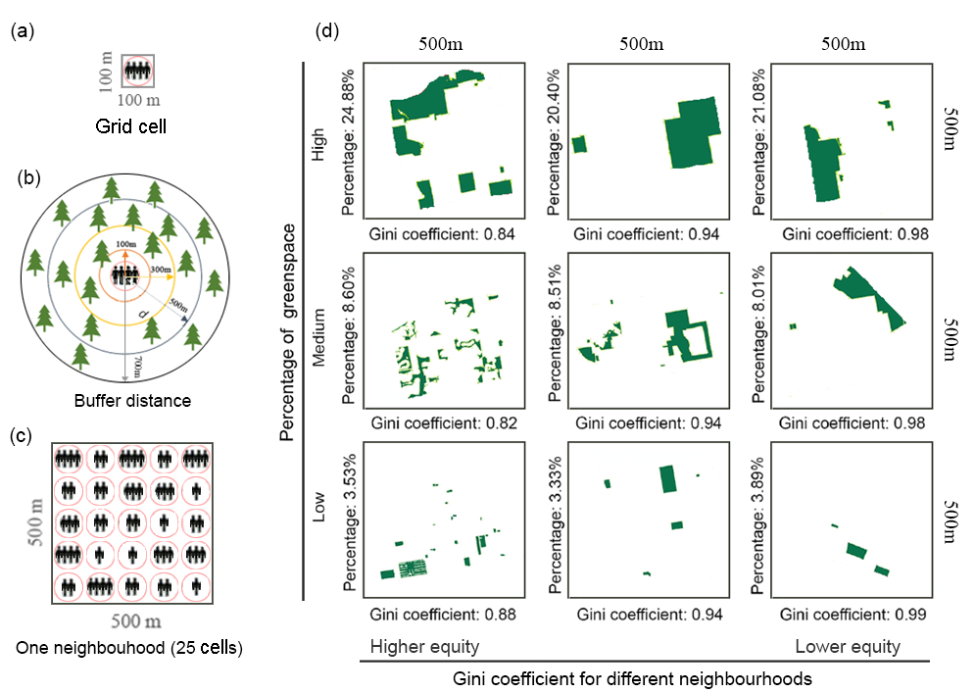
Figure 3. Diagram of (a) a grid cell unit, (b) access to greenspace at radiuses of 100m, 300m, 500m, 700m, (c) a neighbourhood consists of 25 grid cells, and (d) an example of Gini coefficient with different greenspace patterns, as applied by Guan et al. (2023).
2.4 Neighbourhoods definition
The Jenks natural-break classification method (Jenks, 1967) was used to group Gini coefficient results, as it optimally identifies natural groupings within the data by minimizing within-class variance and maximizing between-class variance. Subsequently, Kruskal-Wallis and Spearman analyses indicated a significant association between Gini coefficient groupings and latent LST, revealing notable disparities in LST variation when Gini coefficients were categorized into two groups (p<0.01), compared to one or multiple (i.e. three) types (p>0.05) (Table S3). As determined groups, neighbourhoods with a higher Gini (Gini>0.38) are considered as the first type. In such neighbourhood, greenspace exposure is disproportionately higher in some grid cells over others, labelled as "vulnerable neighbourhoods". Conversely, neighbourhoods with Gini <0.38 are classified as second type where greenspace exposure is relatively even in values across grid cells, categorized as "equal neighbourhoods".
2.5 Neighbourhoods cooling efficiency and threshold
Four steps were employed to detect the cooling disparities between vulnerable and equal neighbourhoods. First, a suite of variables was used to examine the characteristics of neighbourhoods, and their associations with LST. The seven variables included: urbanization level (percentage of build-up area), population size, altitude, NDVI, greenspace percentage (forest and tree cover, shrubland and grassland), agriculture land percentage, and water bodies and wetlands percentage. Pearson’s correlation was calculated to assess their relationship with LST. Variables with a p-value less than 0.05 would be identified (Andrade, 2019). Second, collinearity was tested among these identified variables. The variables with Variance Inflation Factor (VIF) value less than 10 suggest no multi-collinearity among them. Third, the multiple linear regression models based on ordinary least square was employed to investigate the association between variables (VIF<10) and LST in both equal and vulnerable neighbourhoods based on rule of $r^{2}$>0.25 and p<0.01 (Han et al. 2020).
Finally, increasing ecological space tends to reduce in LST in a linear or logarithmic fashion. This linear or logarithmic relationship between an influencing factor (x) and LST (y) is able to identify the absolute threshold of cooling (ToCabs) (Zhou et al. 2022). In this case, we detected the dominant cooling role of ecological space coverage from multiple linear regression models as the influencing factor (x). ToCabs represents the intersection between the temperature reference line (Tref) and the trend line, indicating that effective cooling (△T >0) is assured when ecological space coverage surpasses this point, irrespective of other factors. In other words, effective LST cooling becomes a “certainty” once dominant ecological space coverage reaches ToCabs, shown as Fig.4 in the box of cooling threshold detection. Additionally, LST was divided into three levels - low, medium, and high based on the Jenks natural-break classification approach (Jenks, 1967). Tref was defined as the LST threshold between the boundary high and medium levels. Consequently, neighbourhoods with temperatures classified as low or medium (below Tref) are considered more comfortable compared to neighbourhoods with temperature above Tref. The overall flow chart of analytical procedures in this study is described in Fig. 4.
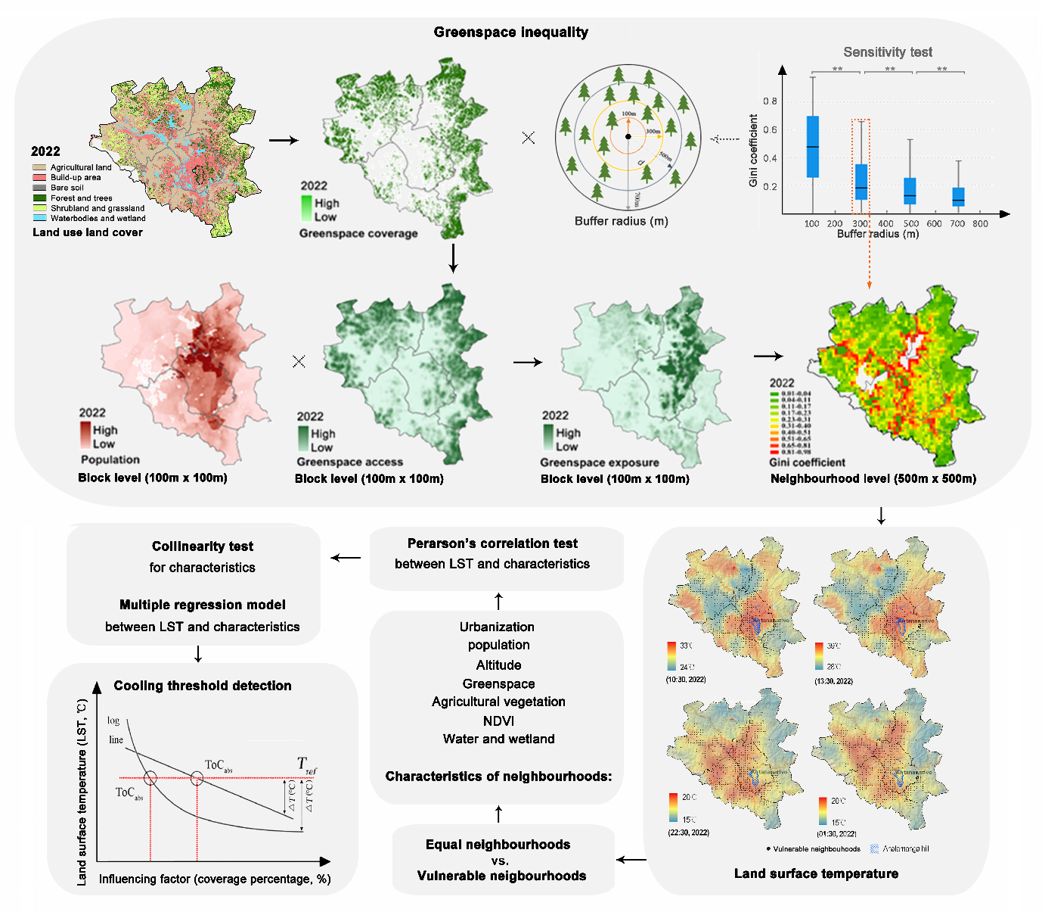
Figure 4. The methodological flow chart of this study.
3. Results
3.1 Greenspace exposure inequality
As Fig. 5, 78% and 58% of the grid cells had greenspace access below 50% and 25%, respectively in 2022. Eastern, northern, southern, and central districts had the average greenspace access as 35%, 30%, 19%, and 11%, respectively, and greenspace exposure values as 24%, 8%, 15%, and 26% (Table S1). For greenspace exposure inequality, most neighbourhoods (77%) have a Gini coefficient below 0.38, indicating relatively equitable greenspace exposure. Yet, a significant minority (23%) of neighbourhoods showed inequitable greenspace exposure (Gini>0.38). The average Gini coefficient at districts were 0.36 in the centre, 0.28 in the south, 0.20 in the north, and 0.18 in the east. Similar districts pattern was observed in 2017 (Table S1) that 74% of neighbourhoods had Gini coefficient less than 0.38 and 26% of neighbourhoods were Gini >0.38, with a downtrend in Gini coefficient from urban periphery to city centre. However, greenspace exposure was more equable at city level as Gini decreased from 0.662 in 2017 to 0.648 in 2022.
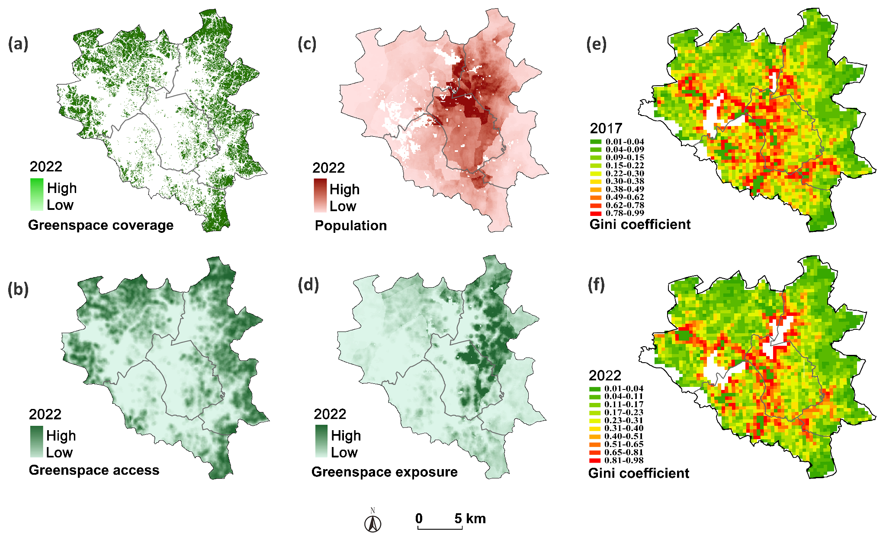Figure 5. The diagram of (a) greenspace coverage, (b) greenspace access, (c) population distribution, (d) greenspace exposure, and (e) Gini coefficient in 2017 and 2022. Background white areas in (c), (e), (f) indicate regions with no data.
3.2 Latent land surface temperature
In 2022, air temperatures at 13:30 during the hot-dry season were, on average, 15.84°C warmer than at night. Specifically, temperature increased from 17.24℃ at 01:30 to 28.11℃ at 10:30, reaching a peak of 33.08℃ at 13:30, and decreased to 17.54℃ by 22:30 (Table S2). Simultaneously, temperature varied by an average of 2.38℃ among four districts and by 10.15 ℃ between urban and periphery’s neighbourhoods at 13:30. LST hotspots, representing the indirect influence of latent heat flux on land surface temperature, were identified in the central district, ranging from 29.18 to 34.37℃ in the day, and from 17.75 to 18.80°C at night. In contrast, cold spots were identified in the northern district in the day, where daytime temperatures were approximately 2°C lower than LST hotpots areas, ranging from 27.51 to 31.99°C. At night, cold spots were differently identified in the eastern district, where nighttime temperatures were about 1.5°C lower than LST hotspots area, ranging from 16.52 to 16.92°C (Fig. 6). Similar variations were observed in 2017. However, the average temperature in 2017 was higher than in 2022 as indicated by a one-factor ANOVA test (p<0.05). Temperature records from 2013 to 2022 validated a peak in air temperatures occurring in 2017, with increases observed before this year and decreased thereafter (Fig. S3).
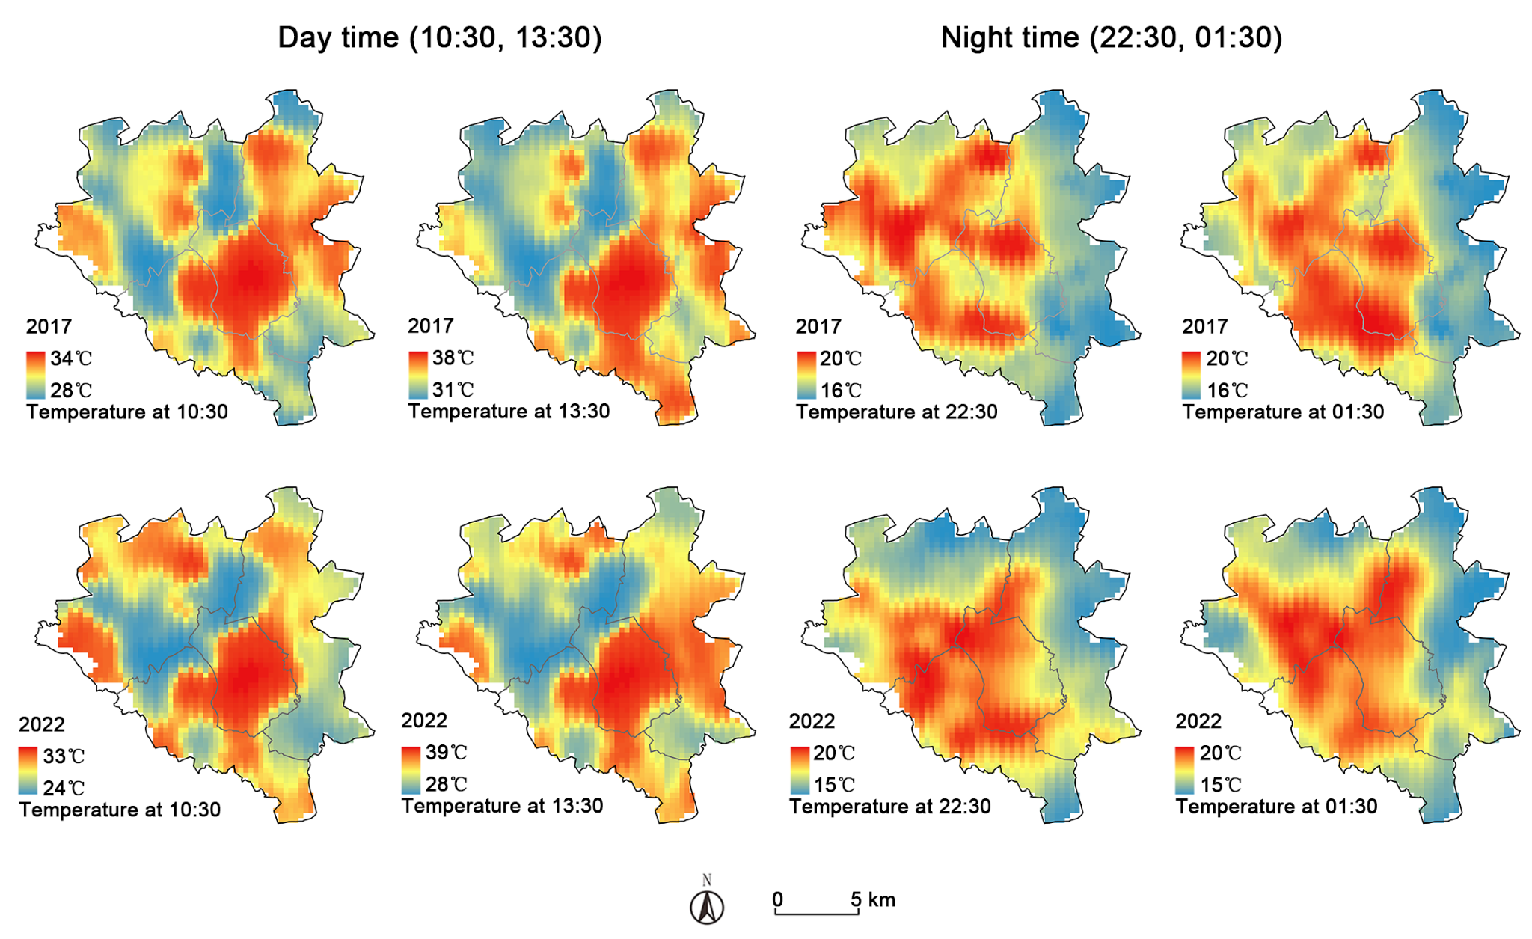
Figure 6. The average latent LST at 10:30, 13:30, 22:30, and 01:30 in February 2017 and 2022.
3.3 Characteristics of neighbourhoods
The LST varied among neighbourhoods, especially between vulnerable (Gini>0.38) and equal (Gini<0.38) neighbourhoods based on the Kruskal-wallis test of p<0.05 (Table S3). At night, equal neighbourhoods were generally located in the colder highlands in the eastern district. Meanwhile, vulnerable neighbourhoods were generally located in the LST hotspots in the western area. In the day, however, vulnerable neighbourhoods in the northern valley exhibited lowest temperature (Fig. 7a, Fig. S4 for 2017).
Several differences were identified between equal and vulnerable neighbourhoods. As illustrated in Fig.7b, vulnerable neighbourhoods exhibit a higher level of urbanisation and are more densely populated than equal ones. Agricultural land has been encroached across all neighbourhoods. Importantly, green infrastructure declined in vulnerable neighbourhoods, while equal neighbourhoods observed an increased in green coverage. Consequently, the greenness of NDVI decreased in vulnerable and increased in equal ones over time. Overall, equal neighbourhoods are located at higher altitudes, featured by significant greenspace and high NDVI values. In contrast, vulnerable neighbourhoods, generally located in lower altitude, maintain more agricultural land and lower NDVI values.
Two parallel trajectories are possible. The first (shown in green arrow in Fig.7c), is with urbanisation trends and population growth, neighbourhoods with initially large, consolidated greenspace get fragmented and transformed to a mixed landscape dominated by impervious surfaces (stage 1 in trajectory 1, Fig. 7c). Greenspace become more scattered and reduced with the further growth of informal settlements, resulting in vulnerable neighbourhoods (stage 2 in trajectory 1, Fig. 7c). The second (shown in orange arrow in Fig.7c), is where abundant greenspace is encroached by farmland, driven by intensified food demand and rural-to-urban migration (stage 1 in trajectory 2, Fig. 7c). After the stage of urban expansion at the cost of farmland, neighbourhoods further transition to be populated, urbanised, and unequal access to diminishing green infrastructure (stage 2 in trajectory 2, Fig. 7c).
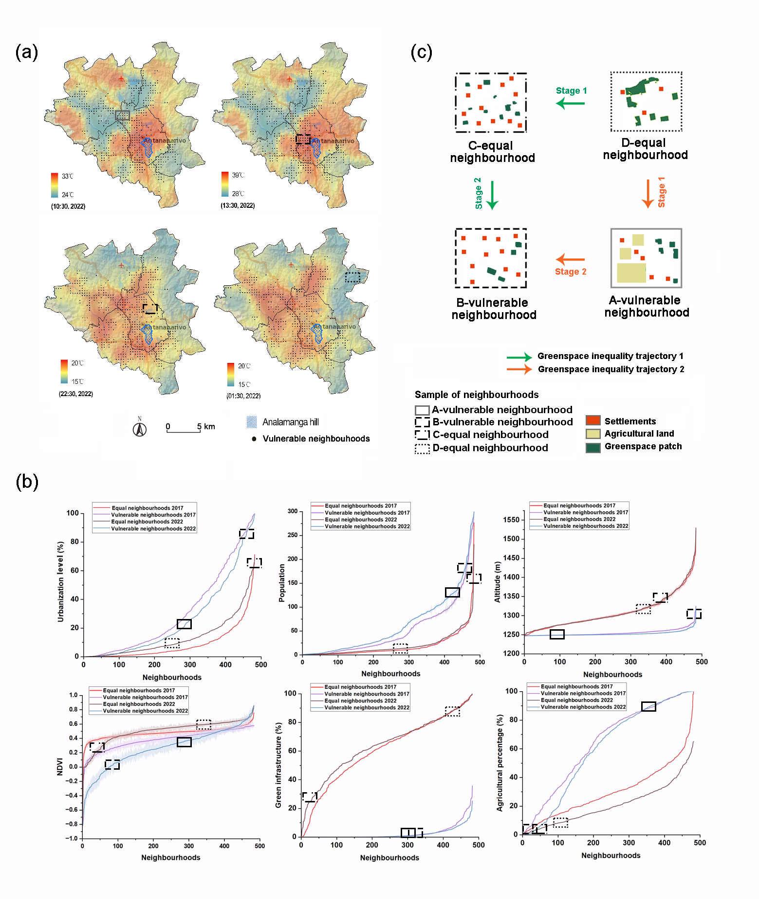
Figure 7. Land surface temperature difference and neighbourhoods characteristics: (a) latent land surface temperature in the day (10:30, 13:30) and at night (22:30, 01:30) in 2022; (b) differences of vulnerable and equal neighbourhoods in characteristics of urbanisation level, population number, altitude, NDVI, green infrastructure and agricultural land percentage; (c) two trajectories of neighbourhoods shifting from greenspace exposure equal condition to unequal status.
3.4 Cooling variables between neighbourhoods
Our study used a regression model to detect the relationship between neighbourhoods’ characteristics and LST at 10:30, 13:30, 22:30, and 01:30. We found that for the vulnerable neighbourhoods, LST reduction modelling was more significantly identified in the day (10:30, 13:30) ($r^{2}$>0.25, p<0.01) (Table S4), comparing to at night (22:30, 01:30) ($r^{2}$<0.25, p<0.01) (Table S5). In this case, the cooling variables for the vulnerable neighbourhoods during the day were recognised as agricultural land, water bodies and wetland, which contribute more than 25% explanation to the cooling modelling, as model 1:
$y=35.774 {- 0.026x}_{agri}+0.002x_{pop}$ ($r^{2}$=0.418, p<0.01, at 10:30 in 2017)
$y=31.784 {- 0.024x}_{agri}+0.003x_{pop}$ ($r^{2}$=0.450, p<0.01, at 13:30 in 2017)
$y=29.321 {- 0.026x}_{agri}+0.002x_{pop}-0.013x_{water}$ ($r^{2}$=0.291, p<0.01, at 10:30 in 2022)
$y=29.321 {- 0.026x}_{agri}+0.002x_{pop}-0.013x_{water}$ ($r^{2}$= 0.302, p<0.01, at 13:30 in 2022)
For equal neighbourhoods, the variables explained the LST reduction were significantly identified at night ($r^{2}$>0.25, p<0.01) (Table S7), comparing to in the day ($r^{2}$<0.25, p<0.01) (Table S6). At night, LST reduction modelling was contributed over 25% by factors of greenspace coverage, agricultural land cover, and altitude variation, as model 2:
$y={26.690-0.012x}_{green}{- 0.009x}_{agri}{+ 0.006x}_{dem}$ ($r^{2}$=0.387, p<0.01, at 22:30 in 2017)
$y={22.756-0.012x}_{green}{- 0.009x}_{agri}{+ 0.004x}_{dem}$ ($r^{2}$=0.387, p<0.01, at 01:30 in 2017)
$y=22.512 {- 0.011x}_{green}-0.0013x_{agri}-0.004x_{dem}$ ($r^{2}$=0.300, p<0.01, at 22:30 in 2022)
$y=22.988 {- 0.014x}_{green}- 0.0013x_{agri}-0.004x_{dem}$ ($r^{2}$=0.366, p<0.01, at 01:30 in 2022)
3.5 Cooling thresholds between neighbourhoods
As detected in model 1 and model 2, the dominant cooling spaces are agricultural land and greenspace. Regardless of other factors, LST was negatively correlated with agricultural land during the day and greenspace at night (p <0.05) (Fig. S5). We extracted these dominant cooling roles of agricultural land for the daytime and greenspace for the nighttime to detect their cooling thresholds.
As Fig.8, cooling effect for equal neighbourhoods was pronounced at night ($r^{2}$>0.25, p<0.01) in contrast to the daytime ($r^{2}$<0.25, p<0.01). At night, a 1% increase in greenspace corresponds to a 0.0172°C, 0.0195°C LST reduction at 22:30 and 01:30, with a threshold value of 62% detected in 2022. In other words, increasing greenspace cover from 0% to 62% is estimated to reduce temperature by 1.24°C in 2022 that is enough to shift these vulnerable neighbourhoods from the highest temperature range (above the Tref) to comfortable range (below the Tref). A similar observation was noted in 2017, where a 1% increase in greenspace was associated with a 0.0113°C, 0.0111°C LST reduction at 22:30 and 01:30, with a threshold of 78%. Increasing greenspace cover from 0% to 78% is estimated to reduce temperature by 0.78 reduction in 2017.
Conversely, cooling effect for vulnerable neighbourhoods was observed in the day ($r^{2}$>0.25, p<0.01) comparing to nighttime ($r^{2}$<0.25, p<0.01). Irrespective of other factors, a 1% increase in agricultural land associated with a 0.0223℃, 0.0308℃ LST decrease at 10:30 and 13:30 in 2022. Similar trend observed in 2017, each 1% increase in agricultural coverage was associated with a 0.0237℃, 0.0258℃ LST decrease at 10:30 and 13:30. However, no cooling threshold value was detected, that means no specific percentage of agricultural land ensures that all vulnerable neighbourhoods experiencing the highest temperatures (above the Tref) are brought into a more comfortable range (below Tref).
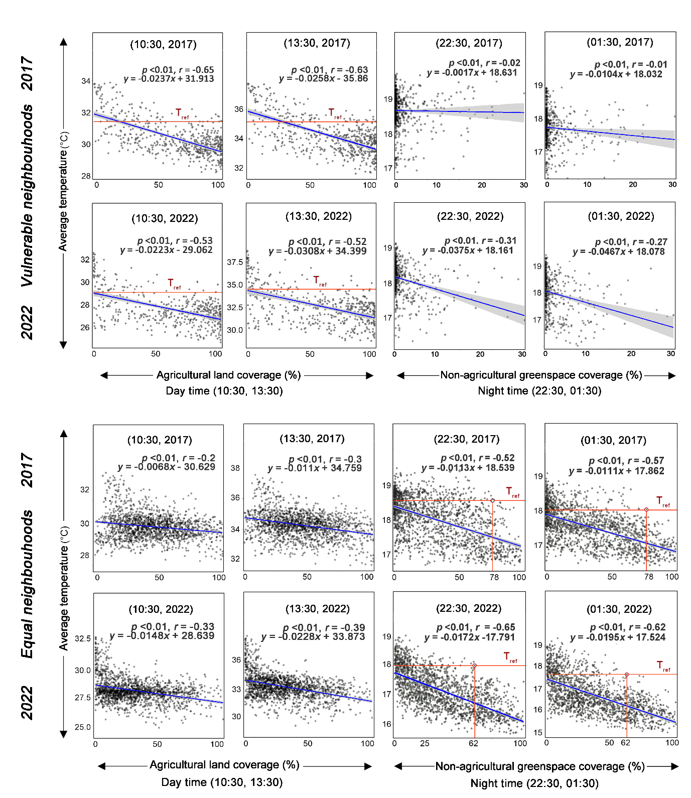
Figure 8. The cooling threshold detection for vulnerable and equal neighbourhoods during the day and at night in 2017, 2022.
4. Discussion
By combining high-resolution land maps with population data, we applied Gini coefficients to quantify greenspace exposure inequality and identify vulnerable neighbourhoods where greenery exposure is disproportionately higher in some grid cells than others. The LST variation allowed us to understand how vulnerable neighbourhoods benefit from ecological cooling services and how this cooling effect differs to equal neighbourhoods. Moreover, this is the first evidence comparing agricultural and non-agricultural cooling thresholds, and if present, how the cooling threshold values vary from one to another. The results can inform strategies to improve greenspace interactions and cooling capacity for marginalised populations living in dense urban conditions, supporting adaptation to future heat waves.
4.1 Impact of neighbourhood characteristics on greenspace inequality
The present work found a gap in Antananarivo that only 77% neighbourhoods have relatively equal greenspace exposure, and a significant portion (23%) of neighbourhoods show unequal greenspace exposure. This raises concerns about vulnerability to heat stress. The equal neighbourhoods are concentrated in the eastern district. Comparatively the vulnerable neighbourhoods span centre, south and north districts.
Several neighbourhoods’ characteristics influence greenspace inequality, as follows. Vulnerable neighbourhoods experience pronounced heat stress in the city centre. This city centre is characterised by a high percentage of impervious surfaces, densely packed buildings, and limited vegetation (Ciampalini et al., 2019). Moving from the city centre to the southern and northern peri-urban areas, these areas are characterised by flat terrain providing good conditions to be used as rice basins. Here, original greenspace has been converted into farmland and informal settlements due to population growth and rural-to-urban migration (Aubry et al., 2012). According to World Bank (2022), Great Antananarivo’s impervious surface has increased by 50% since 2003. Moving from the centre to the east, elevation rises with a lower population growth and a threefold higher percentage of forests and savanna (Dupuy, 2023). Here, the good provision of greenspace and low urbanisation levels contributes to a quality good greenspace exposure and high justice.
4.2 Impact of greenspace inequality on cooling effects
Our study shifts the focus from using traditional socio-demographic indicators (Zhou et al. 2021; Liu et al. 2023), to investigate how greenspace inequality influences cooling effects. Firstly, we show a 1% increase in agricultural land is associated with 0.02-0.03℃ temperature reduction in the day, and this pronounced daytime cooling effect is exhibited in vulnerable neighbourhoods. The cooling effect is driven by agriculture vegetation evapotranspiration, a process where plants release water vapour and draw heat from the surroundings (Pearlmutter et al., 2020; Chatterjee et al., 2019). For example, land use for cultivating rice receives much water for irrigation in large planations (Rakotobe et al., 2016). This large amount of irrigation and the water thermostatic effect add to mechanisms driving temperature reduction (Du et al., 2016).
Secondly, a 1% increase in vegetation is associated with 0.01-0.02℃ reduction at night, and this night cooling preference was observed in the equal neighbourhoods. Trees, shrubland and grassland provide shades to reduce heat buildup, and their greening enables evapotranspiration (Lai et al., 2019). However, vulnerable neighbourhoods showed an average 0.01℃ grater cooling effect compared to equal neighbourhoods. This could potentially be because equal neighbourhoods are located at a higher elevation with 60% of them having altitudes of 1300-1550m compared to vulnerable neighbourhoods located at 1250m. Furthermore, LST in the day is higher than at night. Combining day-night LST difference and altitude characteristic, equal neighbourhoods experienced a diminishing heatwave, and thus milder cooling. Additionally, water and wetland areas in equal neighbourhoods are generally small and scattered or are located near heat-retaining surfaces like roads or houses, resulting in a minimal cooling performance. This is different compared to cooling evident in vulnerable neighbourhoods especially along with large areas of agricultural irrigation.
Finally, we observed a difference in day and night cooling. This difference has been evidenced in many other locations (Ellison et al., 2017; Hathway & Sharples, 2012). In Northern European urban systems, greenspace was found to cool the air within a 300m radius during the day and within 200-300m at night (Hamada & Ohta, 2010). A 1% increase in tree cover in Beijing resulted in a 0.026℃ temperature decrease during the day and 0.056℃ at night (Yan & Dong, 2015). Global average 1% increase in greenspace coverage yielded annual daytime temperature reduction of 0.063℃ and 0.007℃ at night (Yang et al., 2022). Our results show that a 1% increase in vegetation is associated with a 0.02–0.03°C reduction in daytime and a 0.01–0.02°C reduction at night. These findings are consistent with previously reported temperature ranges, although variations are observed in more diverse environments. For example, Antananarivo’s cooling services in 2022 presented a greater effect and lower thresholds compared to 2017. This is may because Antananarivo experienced extreme heat in 2017. The severe ENSO event of 2015–2016 caused drought and temperature extremes (Anyamba et al., 2019), leading to a temporary temperature increase before 2017 and decrease afterwards (Fig. S2). Furthermore, ongoing reforestation actions, evidenced by an increase of 732ha in greenspace from 2017 to 2022, have enhanced overall green canopy cover and thus preformed a greater level of temperature reduction (Lin and Lin, 2016).
4.3. Implications
4.3.1 A target for temperature mitigation using greenspace
Only 42% and 22% of grid cells had accessible greenspace more than 25% and 50% within their radius environment. This greening state is not meeting the recommended targets set by international green city initiatives, such as the Urban Nature Declaration of C40 the Cities Climate Leadership Group’s 2030 which calls for a target of 70% of city communities to have good accessible greenery (Martin et al., 2024). These grid cells are often found in vulnerable communities, especially crucial in Antananarivo’s informal settlements which generally have a larger diurnal fluctuation, and their room temperature exceeds outdoor (Mabuya and Scholes, 2020). It is necessary to develop alternative strategies for vulnerable neighbourhoods to access greenspace, such as convenient buses to parks or friendly park ticket fees. Aligned buffer laws, distance to parks or traffic time should be considered. For green projects, our cooling effectiveness values provide a provisional guidance for temperature mitigation, and our threshold provides a target for Antananarivo green actions. Meanwhile, quality of greenspace, an important factor influencing cooling effect, should also be the focus of long-term strategies (Lin and Lin, 2016; Stessens et al., 2020).
4.3.2 Governance structures that involve local communities in future greenspace design
We observed the higher values in green space access comparing green space exposure across three districts (east, north, south), which are sparsely populated neighbourhoods (Table S1). In contrast, one patch of greenspace in densely populated areas (centre) is generally shared by a large number of people, leading to ‘crowded’ conditions. This requires developing robust governance structures to involve local communities who understand greenspace demand and residents’ mobility preferences – which can be incorporated into future green design (Jaimerean, et al., 2021). Involving local communities can furthermore foster a sense of social cohesion and ownership, ensuring the area is well used, popular, recognised, and well connected (Jennings and Bamkole, 2019; Jaimerean, et al., 2021).
4.3.3 Rethinking the vulnerability for the urban heat management
Some thinking, advantaged groups often control decisions related to the greenspace access, considering factors like the costs of planning or maintenance (Han et al. 2024). When prioritising projects to enhance community resilience against the urban heat, studies locate vulnerable neighbourhoods based on disadvantaged social-demographic characteristics. However, greenspace exposure and cooling effect is context specific. For example, some contrasting findings reveal that the vulnerable groups received more greenspace than the socially advantaged population (Xiao et al., 2017). As our study illustrates, vulnerable neighbourhoods have a 0.01℃ greater cooling effect than equal neighbourhoods. These contrasting results contribute to a broader understanding of vulnerability in the further urban heat risk management especially for developing or vulnerable cities in Sub-Saharan Africa where empirical socioeconomic data may be delayed or lacking when identifying disadvantaged groups.
4.3.4 Enhance vegetation cover and diversify forms of vegetation space
Due to the shortages of urban land, increasing greenspace patch size is not always feasible, nor sustainable (Wu et al., 2025; Gavrilidis et al., 2021). Innovative strategies are needed to preserve limited space while enhancing the quality of vegetation cover or diversifying forms of ecological space (Jaimerean, et al., 2021). According to greenspace inequality trajectory 2 (Fig. 7), small scale urban agriculture, agroforestry, fruit garden can be implemented in areas where there are houses or barren land and have co-benefits such as food security and cost saving. Antananarivo’s multifunctional rice fields, which supports fishing, provide recreational opportunities with walking paths (Brouillet et al. 2025). Food provision can be improved by planting fruit trees along rice field boundaries – which has been proven to be a viable cooling option in our study. Unlike cities that rely on food imports, these strategies remain a vital source of nutrition and income, which is essential for inclusive economic planning in rapidly developing economics facing substantive inequality. These small farming models may have relevance for the capital of Madagascar, but also other urban centres across Africa and beyond.
5. Limitations and future research directions
Limitations remain in this study. Firstly, we did not look at seasonal or long-term time series, that can help track historical trends. Looking forwards, predictive models exploring how cities may grow and climates change would be useful to forecast future scenarios. Secondly, our study relied solely on remote sensed data. This is park because empirical work was limited as access to private gardens is often restricted in wealthy areas in Antananarivo, while public parks fees are not always affordable. Further research can engage citizens to understand disparity in access and perception between public and private spaces. Thirdly, buildings in Antananarivo are generally at low height, such as one or two floors’ settlements or some multiple-floor hotels. Future studies should consider urban morphology. Finally, our approach to measure greenspace inequality is sensitive to the unit definition. The greenspace access radius used in our study may not be suitable for others context. While considered the unit of communities and all urban dwellers into our model, future research should consider other socio-economic factors, as well as the surrounding greenspace species composition and configuration.
6. Conclusions
This study identified (i) characteristics of equal and vulnerable neighbourhoods and associated greenspace inequality trajectories, (ii) LST disparities and cooling explanatory variables between two types of neighbourhoods, and (iii) their variations in cooling efficacy and threshold values from day to night. We found over half of grid cells had accessible greenspace less than 25%, and nearly 25% neighbourhoods were unequal where values of exposure to greenspace is disproportionately higher in some grid celled than others. However, these vulnerable neighbourhoods exhibited a 0.01°C greater cooling effect compared to equal neighbours. This cooling difference between vulnerable and rest of more equal neighbourhoods is influenced by several factors of day-night LST variation, urbanisation and topology conditions, vegetation and land cover contributions. Greenspace inequality trajectories depicted how neighbourhoods evolve from more equal level in greenspace exposure to vulnerable status. Specifically, a cooling threshold of 62-78% for greenspace land cover was detected; estimated to reduce averaged 0.78-1.24°C to shift the vulnerable neighbourhoods experiencing highest temperature to a more comfortable rage regardless of other factors. This study prioritises the locations of vulnerable neighbourhoods where inequality is present, contributing to a broader understanding of vulnerability. The findings outline proactive cooling planning and adaptation strategies for marginalised communities in Antananarivo and other emerging economies, particularly where empirical socioeconomic data may be delayed or lacking.
References
Alizadeh, M. R., Abatzoglou, J. T., Adamowski, J. F., Prestemon, J. P., Chittoori, B., Asanjan, A. A., & Sadegh, M. (2022). Increasing heat‐stress inequality in a warming climate. Earth's Future, 10(2), e2021EF002488. https://doi.org/10.1029/2021EF002488
Andrade C. (2019). The P value and statistical significance: misunderstandings, explanations, challenges, and alternatives. Indian J Psychol Med., 41(3):210-215. https://doi.org/10.4103/IJPSYM.IJPSYM_193_19
Anyamba A., Chretien J.P., Britch S.C., Soebiyanto R.P., Small J.L., Jepsen R., Forshey B.M., Sanchez J.L., Smith R.D., Harris R., Tucker C.J., Karesh W.B., Linthicum K.J. (2019). Global Disease Outbreaks Associated with the 2015–2016 El Niño Event. Sci Rep, 9(1), 1930. https://doi.org/10.1038/s41598-018-38034-z
Amegah, A. K. (2021). Slum decay in Sub-Saharan Africa: context, environmental pollution challenges, and impact on dweller’s health. Environ. Epidemiol., 5(3): e158. https://doi.org/10.1097/EE9.0000000000000158
Aram F., Higueras García E., Solgi E., Mansournia S. (2019). Urban green space cooling effect in cities. Heliyon, 5(4), e01339. https://doi.org/10.1016/j.heliyon.2019.e01339
Aubry, C., Ramamonjisoa, J., Dabat, M.H., Rakotoarisoa, J., Rakotondraibe, J., Rabeharisoa, L. (2012). Urban agriculture and land use in cities: An approach with the multi-functionality and sustainability concepts in the case of Antananarivo (Madagascar), Land Use Policy. 29, 2: 429-439. https://doi.org/10.1016/j.landusepol.2011.08.009

Brouillet, C., Grêt-Regamey, A., Andriamanga, A.V., Martin D.A., Salliou N. (2025) Soil extraction facilitates climate change adaptation and alters urban ecosystem services, Ecosystems and People, 21:1, 2469853, https://doi.org/10.1080/26395916.2025.2469853
Chatterjee, S., Khan, A., Dinda, A., Mithun, S., Khatun, R., Akbari, H., Bhatti, S.S. (2019). Simulating micro-scale thermal interactions in different building environments for mitigating urban heat islands. Sci. Total Environ., 663, 610–631. https://doi.org/10.1016/j.scitotenv.2019.01.299
Chen, B., Wu, S., Song, Y., Webster, C., Xu, B., Gong, P. (2022). Contrasting inequality in human exposure between cities of Global North and Global South. Nat. Commun., 13, 4636. https://doi.org/10.1038/s41467-022-32258-4.
Chen, J., Kinoshita, T., Li, H., Luo, S., & Su, D. (2024). Which green is more equitable? A study of urban green space equity based on morphological spatial patterns. Urban For. Urban Green., 91, 128178. https://doi.org/10.1016/j.ufug.2023.128178
Ciampalini, A., Frodell, W., Margottini, C., and Casagli, N. (2019). Rapid assessment of geo-hydrological hazards in Antananarivo (Madagascar) historical centre for damage prevention. Sustain. Cities Soci. 10(1): 1102-1124. https://doi.org/10.1080/19475705.2018.1564375.
Coutts, A.M., Harris, R.J., Phan, T., Livesley, S.J., Williams, N.S., Tapper, N.J. (2016). Thermal infrared remote sensing of urban heat: hotspots, vegetation, and an assessment of techniques for use in urban planning. Remote Sens. Environ., 186, 637–651. https://doi.org/10.1016/j.rse.2016.08.023
Copernicus, Europe’s eyes on Earth (2023). the Normalized Difference Vegetation Index (NDVI) [dataset]. https://browser.dataspace.copernicus.eu/
Du, H., Song, X., Jiang, H., Kan, Z., Wang, Z., & Cai, Y. (2016). Research on the cooling island effects of water body: A case study of Shanghai, China. Ecol. Indic., 67, 31–38. https://doi.org/10.1016/j.ecolind.2016.02.030
Du Toit, M., Cilliers, S.S., Dallimer, M., Goddard, M., Guenat, S., Cornelius, S.F. (2018). Urban green infrastructure and ecosystem services in sub-Saharan Africa. Landsc. Urban Plan. 180, 249–261. https://doi.org/10.1016/j.landurbplan.2018.06.001
Dupuy, S. Andriamanga, A.V., Burnod, P. (2023). Antananarivo - Madagascar - Land use change map between 2017 and 2022 [dataset], CIRAD Dataverse, V1. https://doi.org/10.18167/DVN1/CD2ZTF
Dupuy, S., Andriamanga, A.V., Gaetano, R., Burnod, P., (2022). Antananarivo - 2022 Land cover map [dataset]. CIRAD Dataverse, V3. https://doi.org/10.18167/DVN1/RE1MDM
Dupuy, S., Defrise, L., Gaetano, R., Andriamanga, V., Rasoamalala, E., (2020). Land cover maps of Antananarivo (capital of Madagascar) produced by processing multisource satellite imagery and geospatial reference data, Data Brief., 31,105952. https://doi.org/10.1016/j.dib.2020.105952.
Eckstein, D., Künzel, V., Schäfer, L. (2021). Global Climate Risk Index 2021 [dataset]. https://www.germanwatch.org/en/19777.
Ellison, D., Morris, C.E., Locatelli, B., Sheil, D., Cohen, J., Murdiyarso, D., Victoria Gutierrez, V., Noordwijk, M., Creed, I.F., Pokorny, J., Gaveau, D., Spracklen, D.V., Tobella, A.B., Ilstedt, U., Teuling, A.J., Gebrehiwot, S.G., Sands, D.C., Muys, B., Verbist, B., Springgay, E., Sugandi, Y.,, Sullivan, C.A. (2017). Trees, forests and water: Cool insights for a hot world. Glob. Environ. Change., 43, 51–61. https://doi.org/10.1016/j.gloenvcha.2017.01.002
Frodella, W., Spizzichino, D., Ciampalini, A., Margottini, C., Casagli, N. (2021). Hydrography and geomorphology of Antananarivo High City (Madagascar). Journal of Maps, 17, 215-226. https://doi.org/10.1080/17445647.2020.1721343.
Guan, J., Wang, R., Van Berkel, D., Liang, Z. (2023). How spatial patterns affect urban green space equity at different equity levels: A Bayesian quantile regression approach. Landsc. Urban Plan. 233, 104709. https://doi.org/10.1016/j.landurbplan.2022.104709
Grant, A., Millward, A. A., Edge, S., Roman, L. A., Teelucksingh, C. (2022). Where is environmental justice? A review of US urban forest management plans. Urban For. Urban Green. 77, 127737. https://doi.org/10.1016/j.ufug.2022.127737
Hamada, S. & Ohta, T. (2010). Seasonal variations in the cooling effect of urban green areas on surrounding urban areas. Urban For. Urban Green., 9, 15–24. https://doi.org/10.1016/j.ufug.2009.09.003
Han Y., He, J., Liu, D., Zhao, H., Huang, J. (2023). Inequality in urban green provision: A comparative study of large cities throughout the world. Sustain. Cities Soc. 89, 104229. https://doi.org/10.1016/j.scs.2022.104229.
Hathway, E. & Sharples, S. (2012). The interaction of rivers and urban form in mitigating the Urban Heat Island effect: A UK case study. Build. Environ. 58, 14–22. https://doi.org/10.1016/j.buildenv.2012.06.011
Han, R., Marchant, A.R., Thorn, J.P.R., (2024). Global disparities in wellbeing from green infrastructure cooling services: A systematic review. Urban For. Urban Gree., 97, 128372.https://doi.org/10.1016/j.ufug.2024.128372.
He. Y., Cai J., Tan L. (2024). A paradox of economic benefit and social equity of green space in megacity: Evidence from Tianjin in China. Sustain. Cities Soc. 109, 105530. https://doi.org/10.1016/j.scs.2024.105530
Healy, T. (2017). The deep south report: socio-economic, historic, cultural, political, anthropological and environmental analysis of Madagascar’s southern region. World Bank. https://documents1.worldbank.org/curated/en/587761530803052116/pdf/127982-WP-REVISED-deep-south-V27-07-2018-web.pdf
Intergovernmental Panel on Climate Change (IPCC). (2022). Chapter 9: Africa. In H.-O. Pörtner, D. C. Roberts, M. Tignor, E. S. Poloczanska, K. Mintenbeck, A. Alegría, M. Craig, S. Langsdorf, S. Löschke, V. Möller, A. Okem, & B. Rama (Eds.), Climate Change 2022: Impacts, Adaptation, and Vulnerability. Contribution of Working Group II to the Sixth Assessment Report of the Intergovernmental Panel on Climate Change (pp. 1265–1326). Cambridge University Press. https://doi.org/10.1017/9781009325844.011
Jaimerena, B.A., Rakotondramboa,M., Vermooten,S, (2021). Antananarivo: strengthening resilience through nature-based solutions and disaster-Informed urban planning (Vol. 2): executive summary (English). Washington, D.C., World Bank Group. http://documents.worldbank.org/curated/en/216861634812305202/Executive-summary
Jay, O., Capon, A., Berry, P., Broderick, C., de Dear, R., Havenith, G., et al. (2021). Reducing the health effects of hot weather and heat extremes: From personal cooling strategies to green cities. The Lancet, 398(10301), 709–724. https://doi.org/10.1016/S0140-6736(21)01209-5
Jenks, G. F. (1967). The Data Model Concept in Statistical Mapping. International Yearbook of Cartography, 7, 186-190.
Jennings V. and Bamkole O., (2019). The Relationship between social cohesion and urban green space: An avenue for health promotion. Int J Environ Res Public Health., 2019, 16(3):452. https://doi.org/10.3390/ijerph16030452
Kim, Y., Kim, Y.C., (2024). An analytical framework for assessing heat vulnerability in urban thermal environmental planning. Urban Clim., 58, 102145. https://doi.org/10.1016/j.uclim.2024.102145
Kirschner, V., Macků, K., Moravec, D., et al. (2023). Measuring the relationships between various urban green spaces and local climate zones. Sci. Rep., 13, 9799. https://doi.org/10.1038/s41598-023-36850-6
Lai, D., Liu, W., Gan, T., Liu, K., & Chen, Q. (2019). A review of mitigating strategies to improve the thermal environment and thermal comfort in urban outdoor spaces. Sci. Total Environ., 661, 337–353. https://doi.org/10.1016/j.scitotenv.2019.01.299
Lloyd, C. T., Chamberlain, H., Kerr, D., Yetman, G., Pistolesi, L., Stevens, F. R., Tatem, A. J. (2019). Global spatio-temporally harmonised datasets for producing high-resolution gridded population distribution datasets. Big Earth Data, 3(2), 108–139. https://doi.org/10.1080/20964471.2019.1625151
Li, X., Stringer, L.C., Dallimer, M., (2022). The Impacts of urbanisation and climate change on the Urban Thermal Environment in Africa. Climate, 10, 164. https://doi.org/10.3390/cli10110164
Li, Y., Svenning, JC., Zhou, W. et al. (2024). Green spaces provide substantial but unequal urban cooling globally. Nat Commun, 15, 7108. https://doi.org/10.1038/s41467-024-51355-0
Li, Z.L., Tang, B.H., Wu, H., Ren, H., Yan, G., Wan, Z., Trigo, I.F., Sobrino, J.A. (2013). Satellite-derived land surface temperature: current status and perspectives. Remote Sens. Environ. 131, 14–37. https://doi.org/10.1016/j.rse.2012.12.008
Lin, B.S. and Lin, C.T. (2016). Preliminary study of the influence of the spatial arrangement of urban parks on local temperature reduction. Urban For. Urban Green., 20, 348–357. https://doi.org/10.1016/j.ufug.2016.10.003
Liu, Y, and Gastwirth, J. L. (2020). On the capacity of the Gini index to represent income distributions. METRON, 78(1), 61–69. https://doi.org/10.1007/s40300-020-001648
Liu, Z., Zhan, W., Bechtel, B. Voogt, J., Lai, J., Chakrabory, T., Wang, Z., Li, M., Huang, F., Lee, X. (2022). Surface warming in global cities is substantially more rapid than in rural background areas. Commun Earth Environ, 3, 219. https://doi.org/10.1038/s43247-022-00539-x
Liu, L.L., Zheng, B., (2024). Greenspace coverage vs. enhanced vegetation index: Correlations with surface urban heat island intensity in different climate zones. Urban Clim., 58, 102140. https://doi.org/10.1016/j.uclim.2024.102140
Liu, L., He, H., Cai, Y., Hang, J., Liu, J., Liu, L., Jiang, P., He, H. (2023). Cooling effects of wetland parks in hot and humid areas based on remote sensing images and local climate zone scheme. Build. Environ., 243, 110660. https://doi.org/10.1016/j.buildenv.2023.110660
Martin, G.K., O’Dell, K., Kinney, P.L., Pescador-Jimenez, M., Rojas-Rueda, D., Canales, R., Anenberg, S.C. (2024). Tracking progress toward urban nature targets using land cover and vegetation indices: A global study for the 96 C40 Cities. GeoHealth 8, e2023GH000996. https://doi.org/10.1029/2023GH000996.
Martin, A.J.F. and Conway, T.M. (2024). Using the Gini Index to quantify urban green inequality: A systematic review and recommended reporting standards. Landsc. Urban Plann., 254, 105231. https://doi.org/10.1016/j.landurbplan.2024.105231.
Masoudi, M. & Tan, P.Y. (2019). Multi-year comparison of the effects of spatial pattern of urban green spaces on urban land surface temperature. Landsc. Urban Plann., 184, 44–58. https://doi.org/10.1016/j.landurbplan.2018.10.023.
Mabuya, B. and Scholes, M., (2020). The three little houses: A comparative study of indoor and ambient temperatures in three low-cost housing types in Gauteng and Mpumalanga, South Africa. Int. J. Environ. Res. Public Health., 17 (10), 3524. https://doi.org/10.3390/ijerph17103524
Mashhoodi, B., (2021). Feminization of surface temperature: Environmental justice and gender inequality among socioeconomic groups. Urban clim., 40, 101004. https://doi.org/10.1016/j.uclim.2021.101004
Mhedhbi Z., Mazzega P., Gaston M., Haouès-Jouve S., Hidalgo J. (2023) Mining the Web of Science for African cities and climate change (1991–2021). Front. Sustain. Cities 5:989266. https://doi.org/10.3389/frsc.2023.989266
NASA (2023). MODIS Land Surface Temperature and Emissivity (MOD11) [dataset]. Version 6.1. https://modis.gsfc.nasa.gov/data/dataprod/mod11.php.
Nesbitt, L., Meitner, M. J., Sheppard, S. R. J., Girling, C. (2018). The dimensions of urban green equity: A framework for analysis. Urban For. Urban Green, 34, 240–248. https://doi.org/10.1016/j.ufug.2018.07.009
Oke, T.R. (1982). The energetic basis of the urban heat island. Q. J. R. Meteorol. Soc. 208, 1-24. https://doi.org/10.1002/qj.49710845502.
Pappalardo, E.S., Zanetti, C., Todeschi, V. (2023). Mapping urban heat islands and heat-related risk during heat waves from a climate justice perspective: A case study in the municipality of Padua (Italy) for inclusive adaptation policies. Landsc. Urban Plann., 238, 104831. https://doi.org/10.1016/j.landurbplan.2023.104831.
Peter J. Marcotullio, Carsten Keßler, Balázs M. Fekete, (2021). The future urban heat-wave challenge in Africa: Exploratory analysis. Global Environ. Change, 66:102190. https://doi.org/10.1016/j.gloenvcha.2020.102190.
Peng, J., Xie, P., Liu, Y., Ma, J. (2016). Urban thermal environment dynamics and associated landscape pattern factors: A case study in the Beijing metropolitan region. Remote Sens. Environ., 173, 145–155. https://doi.org/10.1016/j.rse.2015.11.004
Pipia, L.; Amin, E.; Belda, S.; Delgado, M.S.; Verrelst, J. (2021). Green LAI mapping and cloud gap-filling using Gaussian process regression in Google Earth Engine. Remote Sens., 13, 403. https://doi.org/10.3390/rs13030403.
Pearlmutter, D., Theochari, D., Nehls, T., Pinho, P., Piro, P., Korolova, A., Papaefthimiou, S., Mateo, M.C.G., Calheiros, C.; Zluwa, I., Pitha, U., Schosseler, P., Florentin, Y., Ouannou, S., Gal, E., Aicher, A., Arnold, K., Igondová, E., Pucher, B. (2020). Enhancing the circular economy with nature-based solutions in the built urban environment: green building materials, systems and sites. Blue-Green Syst., 2(1), 46–72. https://doi.org/10.2166/bgs.2020.002
Ramiaramanana, F.N. and Teller, J. (2021). Urbanisation and floods in Sub-Saharan Africa: spatiotemporal study and analysis of vulnerability factors—case of Antananarivo Agglomeration (Madagascar). Water., 13, 149. https://doi.org/10.3390/w13020149.
Rakotobe, Z. L., Harvey, C. A., Rao, N. S., Dave, R., Rakotondravelo, J. C., Randrianarisoa, J., Ramanahadray, S., Andriambolantsoa, R., Razafimahatratra, H., Rabarijohn, R. H., Rajaofara, H., Rameson, H.,MacKinnon, J. L. (2016). Strategies of smallholder farmers for coping with the impacts of cyclones: A case study from Madagascar. Sustain. Cities Soc. 17, 114-122. https://doi.org/10.1016/j.ijdrr.2016.04.013
Randriamarolaza, L.Y.A., Aguilar, E., Skrynyk, O., Vicente-Serrano, S.M., Domínguez-Castro, F. (2022) Indices for daily temperature and precipitation in Madagascar, based on quality-controlled and homogenized data,1950–2018. Int. J. Climatol., 42(1), 265–288. https://doi.org/10.1002/joc.7243
Robert, B., 2000. Dumping in dixie: race, class and environmental quality. Westview press, New York, US. 2000. https://doi.org/10.4324/9780429495274.
Rigolon, A., Ya˜nez, E., Aboelata, M.J., Bennett, R., 2022. A park is not just a park: toward counter-narratives to advance equitable green space policy in the United States. Cities, 128, 103792. https://doi.org/10.1016/j.cities.2022.103792.
Sakamoto, K., Iida, A., Yokohari, M., 2018. Spatial patterns of population turnover in a Japanese Regional City for urban regeneration against population decline: is compact City policy effective? Cities, 81, 230–241. https://doi.org/10.1016/j.cities.2018.04.012
Sandholz, S., Sett, D., Greco, A., Wannewitz, M., Garschagen, M., (2021). Rethinking urban heat stress: Assessing risk and adaptation options across socioeconomic groups in Bonn, Germany. Urban Clim., 37, 100857. https://doi.org/10.1016/j.uclim.2021.100857
Song, Y., Chen, B., Ho, H.C., Kwan, M., Liu, D., Wang, F., Wang, J., Cai, J., Li, X., Xu, Y., He, Q., Wang, H., Xu, Q., Song, Y. (2021). Observed inequality in urban greenspace exposure in China. Environ. Int., 156, 106778. https://doi.org/10.1016/j.envint.2021.106778
Stessens, P., Canters,F., Huysmans, M., Khan, A.Z., (2020). Urban green space qualities: An integrated approach towards GIS-based assessment reflecting user perception. Land Use Policy, 2020, 91, 104319. https://doi.org/10.1016/j.landusepol.2019.104319
Trust for Public Land Policy, (2022). Which city is best for parks? https://www.tpl.org/parkscore, 2024 (accessed 14 November 2024)
United Nations, (2015). Sustainable Development Goals - global goals 2030. New York, US. 2015. https://sdgs.un.org/goals, 2024 (accessed 14 November 2024).
United Nation, (2017a). Drivers of migration and urbanization in Africa: key trends and issues. https://www.un.org/development/desa/pd/sites/www.un.org.development.desa.pd/files/unpd_egm_201709_s3_paper-awunbila-final.pdf, 2024 (accessed 14 November 2024)
United Nations, (2017b). New Urban Agenda. UN Habitat III Secretariat. Quito, Ecuador. 2016. https://habitat3.org/wp-content/uploads/NUA-English.pdf, 2024 (accessed 14 November 2024)
United Nations, Department of Economic and Social Affairs (2019). World Population Prospects 2019: highlights. https://population.un.org/wpp/Publications/Files/WPP2019_Highlights.pdf, 2024 (accessed 14 November 2024)
United Nations, Department of Economic and Social Affairs (2018). The World's Cities in 2018. World’s Cities 2018 - Data Booklet. https://www.un.org/development/desa/pd/content/worlds-cities-2018-data-booklet, 2024 (accessed 14 November 2024)
United Nations Environment Programme (UNEP) (2021). Adaptation Gap Report 2021: The gathering storm – Adapting to climate change in a post-pandemic world. https://www.unep.org/resources/adaptation-gap-report-2021, 2024 (accessed 14 November 2024)
Wang, J., Xu, C., Pauleit, S., Kindler, A., Banzhaf, E. (2019). Spatial patterns of urban green infrastructure for equity: A novel exploration. J. Clean. Prod. 238, 117858. https://doi.org/10.1016/j.jclepro.2019.117858.
Wang, Y., Yin, L., Dong, Q., Fei, F., Yao, Wang, Sun, J., Jiang, Z., (2024). From thermal demand characterization to accurate evaluation: Exploring seasonal differences in outdoor thermal comfort of the elderly in China's communities. Urban Clim., 58, 102220. https://doi.org/10.1016/j.uclim.2024.102220
World Bank, (2020). Support to Madagascar Urban Land Policy: Towards an Urban Land Reform in Madagascar? https://documents.worldbank.org/curated/en/517211592452939643/pdf/Towards-an-Urban-Land-Reform-in-Madagascar-Support-to-Urban-Land-Policy.pdf, 2024 (accessed 14 November 2024)
WorldPop, (2020). Unconstrained individual countries population data 2000-2020 UN adjusted (100m resolution) [dataset]. https://hub.worldpop.org/geodata/listing?id=69.
Wong, N.H., Tan, C.L., Kolokotsa, D.D., Takebayashi, H. (2021). Greenery as a mitigation and adaptation strategy to urban heat. Nat Rev Earth Environ, 2, 166–181. https://doi.org/10.1038/s43017-020-00129-5.
Wu,Y.H., Patuano, A., Mashhoodi, B., Lenzholzer, S., Acred, A., Zertuche, L.N. (2025). How small green spaces cool urban neighbourhoods: Optimising distribution, size and shape. Landsc. Urban Plann., 2025, 253, 105224.https://doi.org/10.1016/j.landurbplan.2024.105224
Wüstemann, H., Kalisch, D., and Kolbe, J. (2017). Access to urban green space and environmental inequalities in Germany. Landscape and Urban Planning, 164, 124–131. https://doi.org/10.1016/j.landurbplan.2017.04.002
Xavier G. (2012). Le defi urbain à Madagascar. https://www.researchgate.net/publication/335422149
Yan, H. & Dong, L. (2015). The impacts of land cover types on urban outdoor thermal environment: The case of Beijing, China. J. Environ. Health Sci. Eng., 13, 43. https://doi.org/10.1186/s40201-015-0204-6
Yang, J., et al. (2020). Characterizing the spatial and temporal variation of the land surface temperature hotspots in Wuhan from a local scale. Geo-spat. Inf. Sci. 23, 327–340. https://doi.org/10.1080/10095020.2020.1834882.
Yang, Q., Huang, X., Tong, X., Xiao, C., Yang, J., Liu, Y., & Cao, Y. (2022). Global assessment of urban trees' cooling efficiency based on satellite observations. Environ. Res. Lett., 17(3), 034029. https://doi.org/10.1088/1748-9326/ac64a3
Yu, Z., Yang, G., Zuo, S., Jørgensen, G., Koga, M., Vejre, H. (2020). Critical review on the cooling effect of urban blue-green space: A threshold-size perspective. Urban For. Urban Green., 49, 126630. https://doi.org/10.1016/j.ufug.2020.126630
Zhen, M., Zhou, J., He, Y., Geng, Z., Shang, D., Zhang, M., Nan, K., (2024). Study on thermal comfort and optimization strategies in outdoor open spaces of hospitals in cold regions of China during summer. Urban Clim., 58, 102135. https://doi.org/10.1016/j.uclim.2024.102135
Zhou, W., Huang, G., Pickett, S. T. A., Wang, J., Cadenasso, M. L., McPhearson, T., Grove, J. M., Wang, J. (2021). Urban tree canopy has greater cooling effects in socially vulnerable communities in the US. One Earth, 4(12), 1764-1775. https://doi.org/10.1016/j.oneear.2021.11.010
Zhou, W., Yu, W., Wu, T. (2022). An alternative method of developing landscape strategies for urban cooling: A threshold-based perspective. Landsc. Urban Plann., 225, 104449. https://doi.org/10.1016/j.landurbplan.2022.104449

