Laccase-catalyzed conversion of residual agricultural biomass to lignin-derived aromatic compounds

Laura E. Navas¹*, Ornella M. Ontañon¹, Juliana Topalian^{1,2}, Lucy L. Coria-Oriundo³, Sonia Wirth^{4,5}, Leonardo D. Gomez⁶, Lindsay D. Eltis⁷, Eleonora Campos¹.

1. Instituto de Agrobiotecnología y Biología Molecular (IABIMO), Instituto Nacional de Tecnología Agropecuaria (INTA), Consejo Nacional de investigaciones Científicas y Tecnológicas (CONICET), Dr. Nicolas Repetto y Los Reseros s/n, 1686, Hurlingham, Buenos Aires, Argentina
2. Universidad de Buenos Aires, Facultad de Ciencias Exactas y Naturales, Departamento de Química Biológica, Buenos Aires, Argentina.
3. Instituto de Química Física de los Materiales, Medio Ambiente y Energía, INQUIMAE, DQIAQF, Facultad de Ciencias Exactas y Naturales, Universidad de Buenos Aires, Pabellón 2, Ciudad Universitaria, C1428EGA, Buenos Aires, Argentina
4. Laboratorio de Agrobiotecnología, Departamento de Fisiología, Biología Molecular y Celular, Facultad de Ciencias Exactas y Naturales, Universidad de Buenos Aires, Intendente Güiraldes 2160, Ciudad Universitaria, C1428EGA, Buenos Aires, Argentina
5. Instituto de Biodiversidad y Biología Experimental y Aplicada, IBBEA-CONICET-UBA, Intendente Güiraldes 2160, Ciudad Universitaria, C1428EGA, Buenos Aires, Argentina
6. Centre for Novel Agricultural Products, Department of Biology, University of York, York, YO10 5DD, UK
7. Department of Microbiology & Immunology, Life Sciences Institute, The University of British Columbia, Vancouver, Canada.
* Corresponding author: navas.laura@inta.gob.ar, ORCID ID 0000-0002-8303-8439, telephone: +54911 30216207

Abstract
Lignin, one of the three major components of lignocellulosic biomass, is a promising feedstock for value-added bioproducts. However, its utilization is limited by its intrinsic heterogeneity and recalcitrance. Laccases are oxidoreductases that can act on a wide range of phenolic and aromatic compounds. SilA is a small robust thermostable laccase from the actinobacterium Streptomyces ipomoea that is active across a broad range of reaction conditions. In this study, we demonstrated that SilA transforms the lignin of sugar cane straw residue that has been pretreated by steam explosion (SCR_{SE}), into lignin-derived aromatic compounds (LDACs), specifically 4-hydroxybenzoate, vanillate, syringate, p-coumarate and ferulate, which are in great demand across diverse industries, including chemical, pharmaceutical, food, health, and cosmetic. Additionally, incubation of SCR_{SE} with SilA also produced acid-precipitable polymeric lignin (APPL), as an indirect indication of delignification. Finally, when the major fraction of SCR_{SE} polysaccharides was removed by the commercial enzymatic cocktail Cellic® CTec2, there was a significant increase in the release of LDACs, particularly p-coumarate. This research demonstrates a novel biocatalytic approach to transform lignin from the main residual solid waste stream of lignocellulosic biomass after the hydrolysis of most of the structural polysaccharides, particularly in the context of sugar cane biorefineries, contributing to the sustainable and efficient use of agricultural biomass waste.

Keywords: lignocellulose, lignin, laccase, biorefineries, sugar cane

Introduction
Lignocellulosic biomass (LCB) has been proposed as a renewable source of energy and bioproducts, with the potential to lower our dependence on fossil fuels, decarbonize our economy and reduce greenhouse gas emissions (Chundawat et al. 2011). Techno-economic analyses indicated that valorization of the three major components of LCB – cellulose, hemicelluloses and lignin – is critical for sustainable, next-generation biorefineries (Davis et al. 2013; Ragauskas et al. 2014). The main feedstocks studied worldwide are non- edible biomass such as wood residues (e.g., from poplar, eucalyptus and pine), perennial grasses (e.g., miscanthus and switchgrass) and agricultural crop residues (e.g., corn stover and corn cobs, sugar cane bagasse as well as straws from wheat, barley or sugar cane)(Gallego-García et al. 2023). Despite the ample abundance and relative low cost of LCB, the overall cost-effective collection, storage and efficient deconstruction remain significant barriers to its utilization (Yoo et al. 2020).
In lignocellulosic biorefineries, a crucial step is the enzymatic conversion of the major structural polysaccharides (cellulose and xylan) to simple sugars, glucose and xylose, for their fermentation to ethanol. To disrupt the fibers and allow access to the enzymes, a physico-thermo-chemical pretreatment step is required, which in many cases need to be adapted to the various types of feedstocks (Brienza et al. 2024). One of the most studied methods for pretreatment is steam explosion (SE) (Gallego-García et al. 2023; Hoang et al. 2023), in which the biomass is subjected to high-temperature (above 160 ºC) saturated steam followed by a sudden decrease of pressure, which elicits an explosive decompression of the material (Ricardo Soccol et al. 2011). This induces hemicellulose hydrolysis and chemical changes of lignin leading mostly to cleavage of β-O-4 bonds, which can be followed by recoupling to β-5 linkages (Heikkinen et al. 2014). Other pretreatment methods include alkaline or acid pretreatment, ammonia fiber expansion, hydrothermal, ultrasound, wet oxidations, and biological treatments (Karp et al. 2013; Basak et al. 2023). For cellulosic ethanol production, the polysaccharides contained in the pretreated biomass are saccharified using powerful enzymatic cocktails (with mainly cellulase and xylanase activities) to monomeric fermentable sugars. As a result, a residual solid waste rich in lignin is obtained. Industrially, this waste is burnt to generate power without further processing. However, efforts are being made to valorize the lignin fraction prior to burning (Ragauskas et al. 2014). Alternatively, some processes have attempted to remove most part of the lignin prior to enzymatic hydrolysis of polysaccharides, to improve the saccharification efficiency (Chandra Rajak and Banerjee 2015).
Lignin is a heterogeneous aromatic polymer and it is a source of aromatic compounds that can be precursors of valuable bio-based chemicals (Ragauskas et al. 2014; Becker and Wittmann 2019). However, the further processing after lignin depolymerization is complicated because it results in a highly heterogeneous mixture of compounds difficult to separate. In this regard, microbial cell factories (mostly based on Pseudomonas sp.) are being developed by synthetic biology and metabolic engineering to convert mixtures of these aromatic species to various compounds in high atom yield, to overcome the complex separations (Weiland et al. 2022).
Among strategies to depolymerize lignin in a controlled manner, biological approaches have attracted attention as they are carried out under mild conditions and require less energy than chemical approaches (Maurya et al. 2015). Lignin-depolymerizing enzymes, or ligninases, mainly include laccases (phenol oxidases) and peroxidases (Zhao et al. 2022), which typically oxidize small molecules, known as redox mediators, that act as electron carriers between the enzyme active site and the substrate structure (Moilanen et al. 2014). This initiates free radical chemistry in the lignin that ultimately results in the cleavage of C-C and C-O bonds between the aromatic subunits (Kirk and Cullen 1998). Redox mediators are classified as natural when they are found in lignin and lignin-rich material, such as syringaldehyde and vanillin, or synthetic, including 1-hydroxybenzotriazole, phenothiazines and its N-substituted derivatives. Although ligninases from wood-rotting fungi have been extensively studied, some bacterial enzymes have been reported to have lignin-depolymerizing activity (de Gonzalo et al. 2016; Lee et al. 2019).
Laccases are multi-copper oxidases that catalyze the one-electron oxidation of a wide range of phenolic substrates, reducing O₂ to H₂O (Kunamneni et al. 2008). Although these enzymes typically comprise three domains, a group of two-domain bacterial laccases known as “small laccases” have been identified in actinobacteria (Machczynski et al. 2004). Due to their thermal stability and their activity over a range of pH, small laccases have been investigated as potential replacement for fungal laccases in the pulp and paper industry for biobleaching, dye-decolorization, and other applications (Kaur et al. 2022). Moreover, bacterial enzymes are advantageous for industrial applications because they are relatively easy to engineer and to produce in high yields and they can tolerate a wide range of pH, temperature, and oxygen tensions (Chauhan 2020). Some small laccases have also been studied as ligninases. For example, sLac from Amycolatopsis sp. 75iv3 was used to effectively delignify steam-exploded poplar biomass (Singh et al. 2017). Related to this, small laccases from the Streptomyces genus have been reported to exhibit lower redox potentials and higher activity under alkaline conditions compared to fungal laccases (Gunne et al. 2014; Kaur et al. 2022).
SilA from Streptomyces ipomoeae belongs to the group of small two-domain bacterial laccases.
It was first cloned and biochemically characterized by Molina-Guijarro et al. (Molina-Guijarro et al. 2009) determining that the active form is an homodimer of 75-80 kDa, constituted by two identical monomers of 33-40 kDa for native and recombinant proteins. It is a robust enzyme showing optimum activity at 50 to 60 °C and remarkable thermostability, with previously reported half-lives of 24 h at 60 °C and more than 1 h at 95 °C (Molina-Guijarro et al. 2009; Blánquez et al. 2019). As many bacterial laccases that are active at alkaline pH, SilA shows optimum pH 8.0 for the oxidation of phenolic compounds and a wide range of textile dyes (Molina-Guijarro et al. 2009; Blánquez et al. 2019; Coria-Oriundo et al. 2021). Also, SilA retained up to 100% of its initial activity after 36 h of incubation at pH values between 5.0 and 9.0 (Molina-Guijarro et al. 2009). Other characteristics of SilA are its resistance to high salt concentrations, retaining 100% of activity in the presence of 1M sodium chloride at pH 8.0, and its tolerance to 10 mM sodium azide, retaining more than 60% of activity at pH 5.0 and more than 94% at pH 8.0 (Molina-Guijarro et al. 2009). In addition, SilA can oxidize lignin and monoaromatic compounds (Moya et al. 2011) and has been used to polymerize kraft lignin (Domínguez et al. 2021; García-Fuentevilla et al. 2023). Among natural and synthetic redox mediators, acetosyringone, methyl syringate and β-(10-phenothiazyl)-propionic (PhCOOH) acid have been used with SilA for effective decolorization of recalcitrant dyes (Blánquez et al. 2019; Coria-Oriundo et al. 2021). Interestingly, characterization of a ΔsilA mutant of S. ipomoeae indicates that the enzyme plays a role in lignin degradation (Blánquez et al. 2017). Despite the potential of SilA, its application for valorizing lignocellulosic biomass has not been extensively explored.
Herein, we studied the contribution of SilA to valorize the lignin fraction of sugar cane straw residue (SCR), an abundant and neglected lignocellulosic feedstock. SilA activity was assayed on raw SCR as well as on SCR pre-treated by steam-explosion (SCR_{SE}) or after saccharification of polysaccharides with Cellic Ctec2® (a powerful industrial enzymatic cocktail from Novozymes), and the generation of lignin-derived aromatic compounds (LDACs), in presence or absence of redox mediators, was evaluated.

Materials and methods
Chemicals and Reagents
All reagents were of analytical grade unless otherwise noted. PhCOOH was synthesized and provided by Lucy Coria-Oriundo according to the method from Coria-Oriundo et al. (2021).
Protein production
The DNA encoding the mature SilA protein was amplified from plasmid pHISTEV30a-silA (Coria-Oriundo et al. 2021) by PCR using primers: 5′- GCGAAGTTCATATGATTAAGATGT-ACGCGGAG -3′ and 5′- ATTAAGCTTTTAGTGTTGGTGCGCCGG -3′ (NdeI and HindIII restriction sites are underlined). The amplicon was cloned into pET28a using NdeI and HindIII restriction sites. The recombinant plasmid was transformed into Escherichia coli BL21 (DE3), and a recombinant clone was verified by sequencing. For SilA production, transformed E. coli cells were grown in LB broth at 37 ºC containing 100 mg/L kanamycin until OD_{600nm} = 0.6. Induction was performed by adding 0.5 mM isopropyl-b-D-thiogalactopyranoside (IPTG, ≥99% Sigma-Aldrich, St. Louis, USA) and at the same time 0.5 mM CuSO₄ was also added. Cells were grown overnight at 30 °C and 150 rpm. Cells were harvested and lysed in the presence of 1 mM CuSO₄. The soluble SilA was purified using a Ni–NTA affinity column following the manufacturer’s instructions. The eluted fractions containing the recombinant protein were pooled and the elution buffer was exchanged to 50 mM sodium phosphate, 150 mM NaCl, pH 8.0. sLac from Amycolatopsis sp. 75iv3 was produced and purified as described by Singh et al. (Singh et al. 2017). Protein samples were analyzed using 12% SDS-PAGE and stored at -70 °C. Protein concentrations were determined using the Pierce™ BCA Protein Assay Kit (Thermo Fisher Scientific, Waltham, MA, USA) with bovine serum albumin as a standard.
Laccase activity on 2,6-dimethoxyphenol
SilA and sLac activity was measured spectrophotometrically at 468 nm (ε = 49,600 M⁻¹ cm⁻¹) using 1 mM 2,6-dimethoxyphenol (DMP, (≥98% Sigma-Aldrich, St. Louis, USA) and 20 mM sodium phosphate, pH 8.0. One unit of activity (U) is defined as the amount of enzyme required to transform 1 μmol of substrate to product per minute at 30 °C. Thermal stability at 50 °C was determined using DMP after preincubation of the enzyme up to 3 days.
SilA activity on lignin model compounds and purified lignin
The activity of SilA on guaiacylglycerol-β-guaiacyl ether (Astatech, Bristol, PA, USA) and veratrylglycerol-β-guaiacyl ether (Astatech, Bristol, PA, USA) was performed essentially as described by Brown et al. (Brown et al. 2012). Briefly, 1 mM of lignin model compound was incubated with 0.2 μM SilA (final concentration 3.1 U/ml) in 20 mM sodium phosphate, pH 8.0. The reactions were incubated at 50 °C with stirring and quenched after 6 h by adding acetic acid to 10% final concentration. The quenched reaction was centrifuged at 16,000×g for 5 min and analyzed by reverse-phase high performance liquid chromatography (HPLC) using a Waters 2695 HPLC (Waters, Milford, MA, USA) equipped with a Luna® 5 µm C18(2) column 250 × 4.6 mm (Phenomenex, Torrance, CA, USA) and a UV detector. The column was operated at 0.7 ml min⁻¹ and the samples were eluted using a 16.8 ml linear gradient of 1% formic acid in H₂O to 100% methanol.
To characterize SilA activity on pure lignin, a lignin fraction obtained from wheat straw was used at 0.5% (w/v) for all assays. Briefly, wheat straw was milled and subjected to dioxane mild acidolysis extraction as described Hibino et al. (Hibino et al. 1994) and the resulting lignin fraction was dissolved in DMSO (100 mg ml⁻¹). Reactions were performed in 1 ml 12.5 mM potassium phosphate, pH 8.0, containing 10% DMSO, incubated with or without 1 μM SilA at 50 °C and 200 rpm for 2 days. In reactions with mediators, 0.5 mM acetosyringone (97% Sigma-Aldrich, St. Louis, USA) or PhCOOH was added. To analyze reaction products after incubation, 100 μl of each reaction was quenched by adding acetic acid to 10% final concentration and analyzed by reverse-phase HPLC, as indicated for lignin model compounds.
Activity on lignocellulosic biomasses
The lignocellulosic biomasses assayed were sugar cane straw residue (SCR) in its raw form or pre-treated by steam explosion (SCR_{SE}), provided and characterized by CIEMAT, Madrid, Spain. The steam explosion pre-treatment had been performed at 197.5 °C for 4 min (10 L bioreactor), after which the solid fraction was obtained by filtration, washed thoroughly and dried (Ballesteros et al. 2006). The relative compositions of the main polymers in SCR and SCR_{SE} were determined following standard protocols and detailed in Table S2 (Sluiter et al. 2010; Manfredi et al. 2018). The total lignin concentration in the reactions was estimated based on the relative composition. When using 2% biomass (equal to 20 mg/mL), lignin concentration corresponded to 3.6 mg/mL in SCR and 5.2 mg/mL in SCR_{SE}.
As model for woody hardwood biomass, Eucalyptus grandis pre-treated by steam explosion (EG_{SE}) (200 °C for 5 min), provided by the Forest Institute, University of British Columbia, Canada was also tested.
Unless otherwise indicated, biomass samples (2% w/v) were treated with 1 μM SilA or sLac (final concentration 15.5 U/ml) in 2 ml 50 mM Tris-HCl, pH 8.0, in the presence or absence of 2 mM PhCOOH, as redox mediator. Samples were incubated at 120 rpm and 30 ºC (for sLac) or 50 ºC (for SilA) for 48 h. Following incubation, the insoluble portion of the biomass was removed via centrifugation (20 min at 3100× g).
For acid precipitable polymeric lignin (APPL) extraction, the soluble portion was filtered through a 0.45 μm membrane filter (Whatman, GE Healthcare, UK) and acidified, using HCl (10% final concentration). Precipitated enzyme and lignin (APPL) upon acidification were collected via centrifugation (8 min at 3100× g), dried and weighted. The supernatant was analyzed by gass chromatography- mass spectrometry (GC-MS) (detailed below) and/or reverse-phase HPLC to identify and/or quantify the LDACs. For quantification of LDACs by HPLC, standard curves in a range of 5 to 100 µM were done for 4-hydroxybenzoate, vanillate, syringate, p-coumarate and ferulate (all from Sigma-Aldrich, St. Louis, USA). Standards and samples were run in an Agilent 1100 System (Agilent, CA, USA) and a UV detector using an Eclipse XDB – C18 column 250 × 4.6 mm (Agilent, CA, USA). The column was operated at 0.8 ml min⁻¹ and the sample was eluted using a gradient of 1% acetic acid to 40% acetonitrile in 40 min, then to 70% acetonitrile in 45 min, and 100% acetonitrile in 50 min of total run. Data from three biological replicates were averaged.
Gas chromatography- mass spectrometry analysis
Lignin derived aromatic compounds were analyzed using an Agilent Technologies (Santa Clara, USA) 6890N gas chromatograph equipped with a 30-m Agilent 190915-433 capillary column and an Agilent 5973 mass-selective detector. Monoaromatics were extracted using ethyl acetate, then dried under a stream of N₂ and finally derivatized using N,O-bis(trimethylsilyl)trifluoro-acetamide and trimethylchlorosilane in a 50/50 mixture with pyridine. Runs were held at 90 °C for 3 min, and then ramped to 290 °C at 12 °C min⁻¹ with a 10 min final hold. Samples were run in triplicate. LDACs were predicted using MassHunter Qualitative Analysis software and confirmed running standards.
Saccharification of lignocellulosic biomasses
To determine whether the treatment with laccases could improve the saccharification yield of plant structural polysaccharides (cellulose and xylan), samples of biomass treated or not with SilA (same condtitions as indicated above) were treated with a commercial industrial cellulolytic cocktail with cellulase, β-glucosidase and hemicellulose activities Cellic® CTec2 (CCTec2, supplied by Novozymes, Bagsværd, Denmark), using conditions previously established which are optimal for this cocktail (Montiel et al. 2024): 5 filter paper degradation units (FPAse) per gram of biomass (with a concentration of 2% w/v biomass), in a final volume 2 ml of 50 mM sodium acetate buffer (pH 5.5), for 16 h at 50 °C. The supernatant was recovered by centrifugation and the reducing sugars as glucose equivalents were quantified using 3,5-dinitrosalicylic acid (DNS) (Miller 1959).
Likewise, to evaluate the contribution of SilA to further valorize the solid residual fraction obtained after saccharification of the structural polysaccharides of biomass, SCR_{SE} (2% w/v) was first treated with Cellic® CTec2 using the same conditions (5 FPAse per gram of biomass in a final volume of 2 ml, 50 mM sodium acetate buffer, pH 5 for 48 h at 50 °C). Reactions were inactivated by heating, washed three times with distilled water, dried, and the resulting material was further treated with SilA as described above.
In all cases, control assays without enzyme and enzymes without substrate were included and subtracted. Data from three biological replicates were averaged.
Scanning electron microscopy
The samples of raw or steam-exploded SCR were metalized using palladium/gold (60/40) for 150 seconds. The scanning electron microscopy analyses were performed in a Zeiss GeminiSem 360 apparatus (Jena, Germany) with an electron accelerating voltage of 5kV. The analyses were performed at the Natural Science Argentinean Museum (Buenos Aires, Argentina).
Statistical analysis
One-way analysis of variance (ANOVA) followed by Tukey's post hoc test for pairwise comparisons (p < 0.05) was used to analyze the quantification of monoaromatic compounds, using GraphPad Prism 8 software (GraphPad Software, Inc., La Jolla, CA, USA). Significant differences were determined based on these analyses. Results are presented as means with standard deviations of biological triplicates.

Results
1. SilA reactivity towards lignin model compounds and purified lignin
The gene encoding the mature protein SilA was cloned and expressed in E. coli as an N-terminally His-tagged protein. SilA was purified by affinity chromatography using Ni–NTA resin with a yield of 13 mg/L of induced culture. The purified protein exhibited the blue color typical of laccases and had an apparent molecular mass consistent with the predicted molecular weight of 35.33 kDa (Fig. S1). We confirmed the thermal stability of SilA under the conditions of this study, as it retained 40% of activity after 3 days of incubation at 50 °C (Fig. S2). Therefore, subsequent experiments were conducted with SilA at 50 °C.
We assessed the reactivity of SilA towards two model compounds: guaiacylglycerol-β-guaiacyl ether (GGE) and veratrylglycerol-β-guaiacyl ether (VGE), phenolic and non-phenolic ethers respectively. Such compounds are used as an indication of the ability of laccases and peroxidases to transform lignin- like structures (Lahive et al. 2020). More specifically, β-O-4 linkages constitute the main linkages between lignin subunits and in GGE and VGE. Upon incubation with SilA, the peak corresponding to GGE decreased, and a few new peaks appeared later (Fig. 1), indicating that the products are more hydrophobic and thus they elute in higher retention times. In contrast, VGE remained unchanged after treatment. The retention time of the GGE oxidation products suggests that these may correspond to oligomerization products and that SilA could be catalyzing the coupling of the substrate under the conditions tested, an aspect that has been described for other laccases (Hilgers et al. 2018).
To gain further insights into the lignin-transforming ability of SilA, we incubated lignin (purified from wheat straw, WSL) (Hibino et al. 1994) with or without SilA for 2 days and analyzed the soluble product by high performance liquid chromatography (HPLC). Incubation with SilA resulted in a change in the profile of products (Fig. 2), with an increase in smaller products (early eluting peaks, up to t_{R} ~ 15 min), which may represent monoaromatic compounds, and a reduction in the larger products (broad band of oligomeric material, t_{R} = 15–22 min), indicating that SilA can modify purified lignin (Kiyota et al. 2012; Jarrell et al. 2014).
Similar results were obtained when redox mediators, acetosyringone or PhCOOH (Coria-Oriundo et al. 2021), were included in the reaction, indicating that they did not affect the modification of lignin, under the conditions of this assay (Fig. S3). Noteworthy, the HPLC peaks corresponding to acetosyringone (t_{R} = 14.7 min) and PhCOOH (t_{R} = 21.1 min) were modified by SilA (Fig. S3), suggesting that, under these reaction conditions, the enzyme may oxidize these compounds producing other species, which prevent the redox mediator being regenerated and available, as has also been observed for other laccase-mediator systems (Mani et al. 2018).
2. Activity of SilA on lignocellulosic biomass
Valorization of the lignin fraction is underachieved in cellulosic biorefineries and the potential contribution of laccases to biomass deconstruction is still unclear (Haq et al. 2024). So, we tested whether SilA could modify the lignin contained in sugar cane straw agricultural residue, either in its raw, native form (SCR) or pre-treated by steam explosion (SCR_{SE}), a well-established thermo-physical method, that opens the fibers and removes part of the hemicelluloses (Ziegler-Devin et al. 2021).
The composition of both types of biomasses varied, with a higher relative content of lignin and cellulose as well as a lower content of hemicelluloses in SCR_{SE} compared to the native form (Table S1). The effect of the pre-treatment on SCR was also visible on the morphology of the biomass, observed by scanning electron microscopy (SEM) (Fig. S4). The native SCR had an even and relatively smooth surface while in SCR_{SE} fiber disruption and cracking was observed, consistent with previous observations on other biomasses treated by the same method (Wang et al. 2009; Li et al. 2016).
SCR_{SE} and SCR were incubated with SilA at 50 °Cand the soluble products released (in the supernatant of the reaction) were then analyzed by gas chromatography- mass spectrometry (GC-MS) to identify LDACs, which were then quantified by HPLC using standard curves. As previously, the addition of the redox mediator PhCOOH was also evaluated. In parallel, we performed reactions with another small bacterial laccase, sLac from Amycolatopsis sp. 75iv3, as a positive control, to compare the released LDACs profile with that produced by a ligninolytic enzyme that had previously shown activity on a steam exploded woody biomass (Singh et al. 2017). Both enzymes share only 61% amino acid sequence identity, but have similar specific activities, determined on 2,6-dimethoxyphenol (DMP) (15 ± 2 U/nmol and 15.9 ± 0.6 U/nmol, for sLac and SilA, respectively).
Treatment of SCR_{SE} released aromatic compounds, identified by GC-MS and confirmed using authentic standards: 4-hydroxybenzoate, vanillate, syringate, p-coumarate, and ferulate (Fig. 3).
Once monoaromatic compounds were identified by GC-MS, we quantified them using HPLC (to avoid possible errors carried by solvent extraction and derivatization). Incubating SCR_{SE} with SilA resulted in a statistically significant increase of p-coumarate, while the overall concentration of the monoaromatics was only slightly increased (~10%, not statistically significant). Noteworthy, syringate and ferulate decreased with SilA treatment and were not detected (detection limit: 1 µM, Table 1). Including PhCOOH in the reactions had no significant effect on the identity and on the overall concentration of monoaromatic compounds quantified, although a slight difference in the concentration of each compound was observed. Treatment of SCR_{SE} with sLac (under its optimal conditions) resulted in the same profile of LDACs, further supporting their similar activity (Fig. S5).
Interestingly, no monoaromatic compounds were detected among the reaction products when raw SCR was treated with either SilA or sLac (Fig. S6). Peaks predicted as tricarballylic acid (t_{R} = 13.1), palmitic acid (t_{R} = 16) and stearic acid (t_{R} = 17.5) were observed for all blank and laccase treatment samples and are therefore considered intrinsic to the biomass. Consistent with these results, neither enzyme produced any detectable acid-precipitable polymeric lignin (APPL) from native SCR, indicating poor activity of the laccases on the raw form of the biomasses, reinforcing the need of pre-treatment.
To investigate whether SilA could also act on a hardwood biomass, Eucalyptus grandis pretreated by steam explosion (EG_{SE}) was assayed, and sLac was also included as a positive control (Fig. S7). By GC-MS analysis five different monoaromatic compounds were identified (Fig. 4), which differed from those released from SCR_{SE}, based on the differences in the lignin types in both biomasses. G and S-type LDACs were released from EG_{SE} as it is expected for a hardwood biomass, while H, G and S-type LDACs were produced from SCR_{SE}, consistent with the lignin units found in grasses (Ralph et al. 2019). Enzyme treatment with either SilA or sLac increased the amount of three of them (vanillin, 2,6 dimethoxy hydroquinone and syringaldehyde) and decreased the amounts of protocatechuic acid and syringic acid (as shown by GC-MS, peaks 2, 3, 4 in Fig 4 and Fig. S7). Overall, SilA acted on the lignin of crop residues, such as SCR, and of a hardwood biomass, such as EG, expanding its potential application in biorefineries.
It has been reported that some Streptomyces strains that degrade lignin produce high molecular weight APPL, as a result of their activity, either by cleavage of bonds in the lignin polymer, or by polymerization of the released compounds (Blánquez et al. 2017). Therefore, we also measured the amount of APPL generated after treatment with SilA or sLac, of SCR_{SE} and EG_{SE}, as an indirect indication of delignification. APPL increased 1.7 times respect of the blank (without enzyme) using SilA on both biomasses, and 1.4 times using sLac, with either biomass (Table S2). However, the increase observed was much lower than what had been previously reported for APPL produced by sLac treatment of steam exploded poplar biomass, which was around 6-times higher than the control reactions (Singh et al. 2017).
3. Contribution of SilA to valorization of lignin fraction before or after saccharification of structural polysaccharides
In the context of potential lignocellulosic biorefinery applications, we investigated whether (a) pretreatment with SilA could aid saccharification of plant structural polysaccharides from SCR_{SE} and (b) if treatment with SilA after saccharification of polysaccharides from SCR_{SE} could improve the release of LDACs, aiming to valorize the residual solid.
In the first experiment, SCR_{SE} was treated with SilA and then the resulting solid fraction was hydrolyzed with Cellic®Ctec2 (CCtec2), a complete efficient industrial cellulase/xylanase enzyme blend (Rodrigues et al. 2015), and the concentration of reducing sugars released (as glucose equivalents) was measured by dinitrosalicylic acid (DNS) method (Miller 1959). The treatment with SilA did not result in any difference in saccharification, obtaining 5.8 mg/ml of reducing sugars for either blank (no laccase control) or SilA treatment. This suggests that treatment with this laccase did not contribute to the accessibility of cellulose and hemicellulose to the action of polysaccharides hydrolytic enzymes.
We next investigated if treatment with SilA of the residual solid fraction of SCR_{SE} after saccharification with CCtec2, could improve the release of monoaromatic compounds respect of SilA treatment of SCR_{SE}. For this experiment, SCR_{SE} was first treated with CCtec2, then the biomass was washed, and the resulting material was incubated with SilA, in presence or absence of PhCOOH. In parallel, a control reaction with no CCtec2 was treated under the same conditions with SilA. Quantification of monoaromatics by HPLC revealed an overall increase of LDACs obtained by SilA activity from CCtec2- treated SCR_{SE} respect of SCR_{SE} (Fig. 5, Table S3). SilA treatment resulted in a statistically significant increase in the amount of p-coumarate released, which improved from 23.6 ± 0.6 (SCR_{SE}) to 44 ± 5 µM (CCtec2- treated SCR_{SE}). Moreover, the hydrolysis of SCR_{SE} with CCtec2 and the treatment of the residual solid fraction with SilA (including PhCOOH) increased the overall amount of monoaromatic compounds released to 80 µM, the highest obtained in this work, representing 30% more than that obtained from SCR_{SE}-SilA (62 µM, Table S3). Even though the yield of monoaromatics obtained still needs to be optimized, these results support the notion that SilA can be used to further extract valuable components from the residual biomass solid fraction after saccharification of polysaccharides, contributing to further valorization of the lignocellulosic biomass.

Discussion
Laccases are non-specific oxidative enzymes that can modify lignin by attacking different linkages which can lead to degradation or can rearrange lignin soluble components leading to polymerization, depending on the reaction conditions (Haq et al. 2024). Because lignin is an abundant source of various aromatic compounds, numerous efforts are being made to obtain lignin-derived valuable bioproducts. In this study, we investigated the activity of SilA, a bacterial small laccase that has been previously characterized (Molina-Guijarro et al. 2009; Coria-Oriundo et al. 2021), on lignin from agricultural lignocellulosic residues to determine the potential use of the enzyme in biorefineries.
SilA did not degrade the phenolic model compound GGE, in contrast to other small laccases from Streptomyces, which acted on GGE to produce vanillin as a degradation product (Majumdar et al. 2014). In our work, although GGE was consumed after SilA treatment, we did not detect any vanillin or other degradation products, indicating that there was no cleavage of the β-O-4 bond. However, SilA treatment of wheat straw lignin resulted in an increase in soluble products (LDACs) presumably corresponding to monoaromatic compounds, with a concomitant decrease in the soluble oligomeric material. Similar results were reported for SCLAC from Streptomyces coelicolor using organosolv lignin from Miscanthus x giganteus (Majumdar et al. 2014), as well as for sLac from Amycolatopsis sp. 75iv3 incubated with a native-like eucalyptus lignin (Levy-Booth et al. 2022). Collectively, these findings establish the ability of SilA to act on lignin. However, the precise nature of this lignin transformation activity still remains to be determined.
SilA also released LDACs from sugar cane agricultural residue and from Eucalyptus wood, when the biomasses had been previously pretreated by steam explosion, a well-established method for the production of cellulosic ethanol, that opens the fiber allowing access to hydrolytic saccharifying enzymes (Ricardo Soccol et al. 2011; Li et al. 2016). It is widely known that the steam explosion pretreatment strongly affects the structure and composition of the lignocellulosic biomass, resulting in a drastic reduction of on hemicelluloses apart from opening up the structure of lignocellulose (Brienza et al. 2024). Treatment of SCR_{SE} or EG_{SE} with SilA also resulted in the production of APPL, with a yield equivalent to that obtained using sLac, a previously characterized delignification enzyme. The fold increase of APPL in SilA or sLac reactions, compared to the no-enzyme control, is significantly less than that reported for poplar_{SE} using sLac, with ~1.5- and 6-fold increases, respectively (Singh et al. 2017). Interestingly, sLac catalyzed the depolymerization of lignin in poplar_{SE} using natural mediators generated in the depolymerization reaction. This suggests that lignin depolymerization depends to some extent on the composition of the lignin present in the biomass. The lignin-polymerization activity of SilA has recently been reported (García-Fuentevilla et al. 2023) as well as for other for other bacterial and fungal laccases (Ramalingam et al. 2017; Hilgers et al. 2018; Navas et al. 2019; Levy-Booth et al. 2022), which could also explain the production of APPL from lignin-derived monomers.
Analysis of the LDACs released from SCR_{SE} by SilA treatment can be interpreted in different ways. First, some LDACs were detected in the no-enzyme control. Among these, p-coumaric acid and ferulic acid are pendant groups decorating the lignin and hemicellulose and could therefore be easily released (Karlen et al. 2020; Timokhin et al. 2020). The depletion of ferulate with SilA treatment is in line with previous reports that this aromatic compound is a substrate for SilA and is polymerized (Moya et al. 2011). In contrast, the increase in p-coumarate with SilA treatment suggests it can be released in the absence of a redox mediator. This finding is consistent with a previous study in which SilA oxidized syringaldehyde and ferulic acid in steam-exploded wheat straw but not p-coumaric acid (De La Torre et al. 2017). Interestingly, the addition of redox mediators did not alter the yield of LDACs from wheat straw lignin in SilA reactions. However, the use of PhCOOH as mediator in SCR_{SE} reactions, increased the amount of vanillate. This suggests that SilA may selectively act on the most surface-accessible lignin without the need for a mediator, whereas less accessible lignin might be attacked through the action of a mediator. Alternatively, the observed changes in LDACs following treatment with SilA laccase could indicate a demethoxylation reaction. Several studies have reported that laccases, upon oxidizing phenolic compounds, can remove methoxy groups via O-demethylation (Bourbonnais and Paice 1992; Leonowicz et al. 2000; Ibrahim et al. 2011; Zhang et al. 2021). The reaction proceeds via a radical mechanism, where the methoxy group is removed as a result of electron transfer from the substrate to the enzyme's copper centers, followed by the transfer of oxygen. In our study, the disappearance of ferulate (which contains a methoxy group on its aromatic ring) and the concomitant increase in p-coumarate (which lacks the methoxy group), as well as the decrease in syringate and increase in vanillate, further supports the possibility of this reaction occurring. Given the established role of laccases in demethoxylation and the fact that SilA laccase shares similar catalytic features with other laccases, this demethoxylation hypothesis is plausible. On the other hand, it is known that laccases generate radicals in lignin that can lead to coupling reactions, which in turn can lead to repolymerization or grafting of low molecular weight compounds onto lignin, similar to what occurs during steam explosion (Munk et al. 2015). Based on this mechanism, an alternative interpretation for the increase in LDACs recovered after SilA treatment is that the monomers were grafted onto the biomass during pre-treatment and then released during laccase treatment. In any case, SilA has demonstrated to present a modest effect on LDAC recovery.
Although SilA acts on steam-pretreated residual biomass, SilA treatment did not increase the yield of simple sugars from the biomass by enzymatic saccharification, therefore not providing further accessibility to the polysaccharides. Noteworthy, it also did not negatively affect saccharification, an aspect that has been previously observed in the treatment of lignocellulosic biomass with bacterial or fungal laccases, potentially due to the phenols released by laccases (Yu et al. 2014; Oliva-Taravilla et al. 2016; De La Torre et al. 2017; Navas et al. 2019).
The most studied biorefinery applications of laccases are biomass pretreatment and hydrolysate detoxification to improve the saccharification and fermentation of lignocellulosic biomass (Roth and Spiess 2015; Malhotra and Suman 2021). Studies describing the use of laccases to valorize the ultimate solid residue rich in lignin in biorefineries are scarce. This is not surprising, since the potentially occurring cleavage of lignin bonds is countered by laccase-catalyzed repolymerization (Munk et al. 2015). Interestingly, in our work, removing the polysaccharides contained in the SCR_{SE} significantly increased the SilA-catalyzed release of LDACs. This strategy is similar to one described in which an Aspergillus cellulase and a Thermobifida sp. xylanase were used to treat sugar cane bagasse, ultimately improving the accessibility of a hydrogen peroxide-oxidase to the lignin (Chen et al. 2016). Therefore, SilA treatment of the residual saccharified solid biomass residue can result in the production of lignin- derived chemical precursors and valorize the main solid waste stream of lignocellulosic ethanol production from sugar cane.

Conclusion
This study establishes the biorefining potential of SilA. More specifically, SilA transforms the lignin in SCR_{SE} and EG_{SE} biomass, particularly at mid to high temperatures following hydrolysis of polysaccharides. This activity has the potential to extract value from the residual lignin fraction produced by lignocellulosic biorefineries. LDACs, as high-value aromatic compounds, are in great demanded across diverse industries, including chemical, pharmaceutical, food, health, and cosmetic (Holladay et al. 2007; Biddy et al. 2016; Sun et al. 2018). Furthermore, these monoaromatics have the potential to be biocatalytically transformed into other valuable compounds using microbial cell factories (Jimenez et al. 2002; Salvachúa et al. 2018). Additional studies on SilA, particularly in combination with natural and artificial mediators to enhance redox potential, will contribute to the development of biocatalysts for the efficient deconstruction of biomass and the valorization of lignin.
Acknowledgments
Authors acknowledge Dr. Mercedes Ballesteros and Paloma Manzanares, from Unidad de Biocarburantes, Centro de Investigaciones Energéticas, Medioambientales y Tecnológicas (CIEMAT), Madrid, Spain for the sugar cane residue pre-treated by steam explosion and for the composition analysis of the biomasses; Dr. Scott Renneckar, from the Forest Institute, University of British Columbia, Canada, for the steam-exploded eucalyptus biomass; and Rachael Simister from the University of York, United Kingdom, for preparing the purified lignin from wheat straw. LN, OO, SW and EC acknowledge CONICET as Research Career members; JT holds a doctoral fellowship from CONICET.
Competing interests
The authors declare that they have no competing interests.
Funding
This work was mainly funded by projects PICT 2018-2983 and PICT 2019-1474, from MINCYT (Argentina). Work in LDE´s lab was supported by a grant from the Natural Sciences and Engineering Research Council of Canada (DG171359). LDE is the recipient of a Canada Research Chair. Work at University of York, UK, was supported by BBSRC grant BB/X51195X/1.
Authors' contributions
EC, SW, LEN, LDE, and LDG designed research; LEN, OO and JT performed research; LLC contributed new reagents; LEN, LDE and EC wrote the paper. All authors reviewed, edited, and approved the final manuscript.

References
Ballesteros I, Negro MJ, Oliva JM, et al (2006) Ethanol Production From Steam-Explosion Pretreated Wheat Straw. Appl Biochem Biotechnol 130:496–508. https://doi.org/10.1385/ABAB:130:1:496
Basak B, Kumar R, Bharadwaj AVSLS, et al (2023) Advances in physicochemical pretreatment strategies for lignocellulose biomass and their effectiveness in bioconversion for biofuel production. Bioresour Technol 369:128413. https://doi.org/10.1016/j.biortech.2022.128413
Becker J, Wittmann C (2019) A field of dreams: Lignin valorization into chemicals, materials, fuels, and health-care products. Biotechnol Adv 37:107360. https://doi.org/10.1016/j.biotechadv.2019.02.016
Biddy MJ, Scarlata C, Kinchin C (2016) Chemicals from Biomass: A Market Assessment of Bioproducts with Near-Term Potential. Golden, CO (United States)
Blánquez A, Ball AS, González-Pérez JA, et al (2017) Laccase SilA from Streptomyces ipomoeae CECT 3341, a key enzyme for the degradation of lignin from agricultural residues? PLoS One 12:1–15. https://doi.org/10.1371/journal.pone.0187649
Blánquez A, Rodríguez J, Brissos V, et al (2019) Decolorization and detoxification of textile dyes using a versatile Streptomyces laccase-natural mediator system. Saudi J Biol Sci 26:913–920. https://doi.org/10.1016/j.sjbs.2018.05.020
Bourbonnais R, Paice MichaelG (1992) Demethylation and delignification of kraft pulp by Trametes versicolor laccase in the presence of 2,2?-azinobis-(3-ethylbenzthiazoline-6-sulphonate). Appl Microbiol Biotechnol 36:. https://doi.org/10.1007/BF00172202
Brienza F, Cannella D, Montesdeoca D, et al (2024) A guide to lignin valorization in biorefineries: traditional, recent, and forthcoming approaches to convert raw lignocellulose into valuable materials and chemicals. RSC Sustainability 2:37–90. https://doi.org/10.1039/D3SU00140G
Brown ME, Barros T, Chang MCY (2012) Identification and Characterization of a Multifunctional Dye Peroxidase from a Lignin-Reactive Bacterium. ACS Chem Biol 7:2074–2081. https://doi.org/10.1021/cb300383y
Chandra Rajak R, Banerjee R (2015) Enzymatic delignification: an attempt for lignin degradation from lignocellulosic feedstock. RSC Adv 5:75281–75291. https://doi.org/10.1039/C5RA09667G
Chauhan PS (2020) Role of various bacterial enzymes in complete depolymerization of lignin: A review. Biocatal Agric Biotechnol 23:101498. https://doi.org/10.1016/j.bcab.2020.101498
Chen C-Y, Lee C-C, Chen H-S, et al (2016) Modification of lignin in sugarcane bagasse by a monocopper hydrogen peroxide-generating oxidase from Thermobifida fusca. Process Biochemistry 51:1486–1495. https://doi.org/10.1016/j.procbio.2016.07.009
Chundawat SPS, Beckham GT, Himmel ME, Dale BE (2011) Deconstruction of Lignocellulosic Biomass to Fuels and Chemicals. Annu Rev Chem Biomol Eng 2:121–145. https://doi.org/10.1146/annurev-chembioeng-061010-114205
Coria-Oriundo LL, Battaglini F, Wirth SA (2021) Efficient decolorization of recalcitrant dyes at neutral/alkaline pH by a new bacterial laccase-mediator system. Ecotoxicol Environ Saf 217:112237. https://doi.org/10.1016/j.ecoenv.2021.112237
Davis R, Tao L, Tan ECD, et al (2013) Process Design and Economics for the Conversion of Lignocellulosic Biomass to Hydrocarbons. NREL Technical Report
de Gonzalo G, Colpa DI, Habib MHM, Fraaije MW (2016) Bacterial enzymes involved in lignin degradation. J Biotechnol 236:110–119
De La Torre M, Martín-Sampedro R, Fillat Ú, et al (2017) Comparison of the efficiency of bacterial and fungal laccases in delignification and detoxification of steam-pretreated lignocellulosic biomass for bioethanol production. J Ind Microbiol Biotechnol 44:1561–1573. https://doi.org/10.1007/s10295-017-1977-1
Domínguez G, Blánquez A, Borrero-López AM, et al (2021) Eco-Friendly Oleogels from Functionalized Kraft Lignin with Laccase SilA from Streptomyces ipomoeae: An Opportunity to Replace Commercial Lubricants. ACS Sustain Chem Eng 9:4611–4616. https://doi.org/10.1021/acssuschemeng.1c00113
Gallego-García M, Moreno AD, Manzanares P, et al (2023) Recent advances on physical technologies for the pretreatment of food waste and lignocellulosic residues. Bioresour Technol 369:128397. https://doi.org/10.1016/j.biortech.2022.128397
García-Fuentevilla L, Domínguez G, Martín-Sampedro R, et al (2023) Enzyme-Catalyzed Polymerization of Kraft Lignin from Eucalyptus globulus: Comparison of Bacterial and Fungal Laccases Efficacy. Polymers (Basel) 15:513. https://doi.org/10.3390/polym15030513
Gunne M, Höppner A, Hagedoorn P, Urlacher VB (2014) Structural and redox properties of the small laccase <scp>S</scp> sl1 from <scp>S</scp> treptomyces sviceus . FEBS J 281:4307–4318. https://doi.org/10.1111/febs.12755
Haq I ul, Saleem A, Chaudhary R, et al (2024) Role of microbial laccases in valorization of lignocellulosic biomass to bioethanol. Front Bioeng Biotechnol 12:. https://doi.org/10.3389/fbioe.2024.1441075
Heikkinen H, Elder T, Maaheimo H, et al (2014) Impact of Steam Explosion on the Wheat Straw Lignin Structure Studied by Solution-State Nuclear Magnetic Resonance and Density Functional Methods. J Agric Food Chem 62:10437–10444. https://doi.org/10.1021/jf504622j
Hibino T, Shibata D, Ito T, et al (1994) Chemical properties of lignin from Aralia cordata. Phytochemistry 37:445–448. https://doi.org/10.1016/0031-9422(94)85076-3
Hilgers R, Vincken JP, Gruppen H, Kabel MA (2018) Laccase/Mediator Systems: Their Reactivity toward Phenolic Lignin Structures. ACS Sustain Chem Eng 6:2037–2046. https://doi.org/10.1021/acssuschemeng.7b03451
Hoang AT, Nguyen XP, Duong XQ, et al (2023) Steam explosion as sustainable biomass pretreatment technique for biofuel production: Characteristics and challenges. Bioresour Technol 385:129398. https://doi.org/10.1016/j.biortech.2023.129398
Holladay JE, Bozell JJ, White JF, Johnson D (2007) Top Value-Added Chemicals from Biomass - Volume II—Results of Screening for Potential Candidates from Biorefinery Lignin
Ibrahim V, Mendoza L, Mamo G, Hatti-Kaul R (2011) Blue laccase from Galerina sp.: Properties and potential for Kraft lignin demethylation. Process Biochemistry 46:379–384. https://doi.org/10.1016/j.procbio.2010.07.013
Jarrell TM, Marcum CL, Sheng H, et al (2014) Characterization of organosolv switchgrass lignin by using high performance liquid chromatography/high resolution tandem mass spectrometry using hydroxide-doped negative-ion mode electrospray ionization. Green Chem 16:2713–2727. https://doi.org/10.1039/C3GC42355G
Jimenez JI, Minambres B, Garcia JL, Diaz E (2002) Genomic analysis of the aromatic catabolic pathways from Pseudomonas putida KT2440. Environ Microbiol 4:824–841. https://doi.org/10.1046/j.1462-2920.2002.00370.x
Karlen SD, Fasahati P, Mazaheri M, et al (2020) Assessing the Viability of Recovery of Hydroxycinnamic Acids from Lignocellulosic Biorefinery Alkaline Pretreatment Waste Streams. ChemSusChem 13:2012–2024. https://doi.org/10.1002/cssc.201903345
Karp SG, Woiciechowski AL, Soccol VT, Soccol CR (2013) Pretreatment strategies for delignification of sugarcane bagasse: a review. Brazilian Archives of Biology and Technology 56:679–689. https://doi.org/10.1590/S1516-89132013000400019
Kaur R, Salwan R, Sharma V (2022) Structural properties, genomic distribution of laccases from Streptomyces and their potential applications. Process Biochemistry 118:133–144. https://doi.org/10.1016/j.procbio.2022.04.015
Kirk T, Cullen D (1998) Enzymology and molecular genetics of wood degradation by white-rot fungi. In: Akhtar M, Young R (eds) Environmentally friendly technologies for the pulp and paper industry. Wiley, New York, pp 273–307
Kiyota E, Mazzafera P, Sawaya ACHF (2012) Analysis of Soluble Lignin in Sugarcane by Ultrahigh Performance Liquid Chromatography–Tandem Mass Spectrometry with a Do-It-Yourself Oligomer Database. Anal Chem 84:7015–7020. https://doi.org/10.1021/ac301112y
Kunamneni A, Plou F, Ballesteros A, Alcalde M (2008) Laccases and Their Applications: A Patent Review. Recent Pat Biotechnol 2:10–24. https://doi.org/10.2174/187220808783330965
Lahive CW, Kamer PCJ, Lancefield CS, Deuss PJ (2020) An Introduction to Model Compounds of Lignin Linking Motifs; Synthesis and Selection Considerations for Reactivity Studies. ChemSusChem 13:4238–4265. https://doi.org/10.1002/cssc.202000989
Lee S, Kang M, Bae J-H, et al (2019) Bacterial Valorization of Lignin: Strains, Enzymes, Conversion Pathways, Biosensors, and Perspectives. Front Bioeng Biotechnol 7:. https://doi.org/10.3389/fbioe.2019.00209
Leonowicz A, Rogalski J, Malarczyk E, et al (2000) Demethoxylation of Milled Wood Lignin and Lignin Related Compounds by Laccase from White-rot Fungus, Cerrena unicolor. Mokchae Konghak Journal of the Korean Wood Science and Technology 28:29–40
Levy-Booth DJ, Navas LE, Fetherolf MM, et al (2022) Discovery of lignin-transforming bacteria and enzymes in thermophilic environments using stable isotope probing. ISME J 16:1944–1956. https://doi.org/10.1038/s41396-022-01241-8
Li C, Liu G, Nges IA, Liu J (2016) Enhanced biomethane production from Miscanthus lutarioriparius using steam explosion pretreatment. Fuel 179:267–273. https://doi.org/10.1016/j.fuel.2016.03.087
Machczynski MC, Vijgenboom E, Samyn B, Canters GW (2004) Characterization of SLAC: A small laccase from Streptomyces coelicolor with unprecedented activity. Protein Science 13:2388–2397. https://doi.org/10.1110/ps.04759104
Majumdar S, Lukk T, Solbiati JO, et al (2014) Roles of small laccases from streptomyces in lignin degradation. Biochemistry 53:4047–4058. https://doi.org/10.1021/bi500285t
Malhotra M, Suman SK (2021) Laccase-mediated delignification and detoxification of lignocellulosic biomass: removing obstacles in energy generation. Environmental Science and Pollution Research 28:58929–58944. https://doi.org/10.1007/s11356-021-13283-0
Manfredi AP, Ballesteros I, Sáez F, et al (2018) Integral process assessment of sugarcane agricultural crop residues conversion to ethanol. Bioresour Technol 260:241–247. https://doi.org/10.1016/j.biortech.2018.03.114
Mani P, Fidal Kumar VT, Keshavarz T, et al (2018) The Role of Natural Laccase Redox Mediators in Simultaneous Dye Decolorization and Power Production in Microbial Fuel Cells. Energies (Basel) 11:3455. https://doi.org/10.3390/en11123455
Maurya DP, Singla A, Negi S (2015) An overview of key pretreatment processes for biological conversion of lignocellulosic biomass to bioethanol. 3 Biotech 5:597–609. https://doi.org/10.1007/s13205-015-0279-4
Miller GL (1959) Use of Dinitrosalicylic Acid Reagent for Determination of Reducing Sugar. Anal Chem 31:426–428. https://doi.org/10.1021/ac60147a030
Moilanen U, Kellock M, Várnai A, et al (2014) Mechanisms of laccase-mediator treatments improving the enzymatic hydrolysis of pre-treated spruce. Biotechnol Biofuels 7:. https://doi.org/10.1186/s13068-014-0177-8
Molina-Guijarro JM, Pérez J, Muñoz-Dorado J, et al (2009) Detoxification of azo dyes by a novel pH-versatile, salt-resistant laccase from Streptomyces ipomoea. Int Microbiol 12:13–21
Montiel C, Hernández-Meléndez O, Marques S, et al (2024) Application of In-House Xylanases as an Addition to a Commercial Cellulase Cocktail for the Sustainable Saccharification of Pretreated Blue Agave Bagasse Used for Bioethanol Production. Sustainability 16:6722. https://doi.org/10.3390/su16166722
Moya R, Saastamoinen P, Hernández M, et al (2011) Reactivity of bacterial and fungal laccases with lignin under alkaline conditions. Bioresour Technol 102:10006–10012. https://doi.org/10.1016/j.biortech.2011.08.046
Munk L, Sitarz AK, Kalyani DC, et al (2015) Can laccases catalyze bond cleavage in lignin? Biotechnol Adv 33:13–24. https://doi.org/10.1016/j.biotechadv.2014.12.008
Navas LE, Martínez FD, Taverna ME, et al (2019) A thermostable laccase from Thermus sp. 2.9 and its potential for delignification of Eucalyptus biomass. AMB Express 9:24. https://doi.org/10.1186/s13568-019-0748-y
Oliva-Taravilla A, Tomás-Pejó E, Demuez M, et al (2016) Phenols and lignin: Key players in reducing enzymatic hydrolysis yields of steam-pretreated biomass in presence of laccase. J Biotechnol 218:94–101. https://doi.org/10.1016/j.jbiotec.2015.11.004
Ragauskas AJ, Beckham GT, Biddy MJ, et al (2014) Lignin Valorization: Improving Lignin Processing in the Biorefinery. Science (1979) 344:1246843. https://doi.org/10.1126/science.1246843
Ralph J, Lapierre C, Boerjan W (2019) Lignin structure and its engineering. Curr Opin Biotechnol 56:240–249. https://doi.org/10.1016/j.copbio.2019.02.019
Ramalingam B, Sana B, Seayad J, et al (2017) Towards understanding of laccase-catalysed oxidative oligomerisation of dimeric lignin model compounds. RSC Adv 7:11951–11958. https://doi.org/10.1039/C6RA26975C
Ricardo Soccol C, Faraco V, Karp S, et al (2011) Chapter 5 - Lignocellulosic Bioethanol: Current Status and Future Perspectives. In: Pandey A, Larroche C, Ricke SC, et al. (eds) Biofuels. Academic Press, Amsterdam, pp 101–122
Rodrigues AC, Haven MØ, Lindedam J, et al (2015) Celluclast and Cellic® CTec2: Saccharification/fermentation of wheat straw, solid–liquid partition and potential of enzyme recycling by alkaline washing. Enzyme Microb Technol 79–80:70–77. https://doi.org/10.1016/j.enzmictec.2015.06.019
Roth S, Spiess AC (2015) Laccases for biorefinery applications: a critical review on challenges and perspectives. Bioprocess Biosyst Eng 38:2285–2313. https://doi.org/10.1007/s00449-015-1475-7
Salvachúa D, Johnson CW, Singer CA, et al (2018) Bioprocess development for muconic acid production from aromatic compounds and lignin. Green Chemistry 20:5007–5019. https://doi.org/10.1039/c8gc02519c
Singh R, Hu J, Regner MR, et al (2017) Enhanced delignification of steam-pretreated poplar by a bacterial laccase. Sci Rep 7:. https://doi.org/10.1038/srep42121
Sluiter JB, Ruiz RO, Scarlata CJ, et al (2010) Compositional Analysis of Lignocellulosic Feedstocks. 1. Review and Description of Methods. J Agric Food Chem 58:9043–9053. https://doi.org/10.1021/jf1008023
Sun Z, Fridrich B, de Santi A, et al (2018) Bright Side of Lignin Depolymerization: Toward New Platform Chemicals. Chem Rev 118:614–678. https://doi.org/10.1021/acs.chemrev.7b00588
Timokhin VI, Regner M, Motagamwala AH, et al (2020) Production of p -Coumaric Acid from Corn GVL-Lignin. ACS Sustain Chem Eng 8:17427–17438. https://doi.org/10.1021/acssuschemeng.0c05651
Wang K, Jiang JX, Xu F, Sun RC (2009) Influence of steaming pressure on steam explosion pretreatment of Lespedeza stalks (Lespedeza crytobotrya): Part 1. Characteristics of degraded cellulose. Polym Degrad Stab 94:1379–1388. https://doi.org/10.1016/j.polymdegradstab.2009.05.019
Weiland F, Kohlstedt M, Wittmann C (2022) Guiding stars to the field of dreams: Metabolically engineered pathways and microbial platforms for a sustainable lignin-based industry. Metab Eng 71:13–41. https://doi.org/10.1016/j.ymben.2021.11.011
Yoo CG, Meng X, Pu Y, Ragauskas AJ (2020) The critical role of lignin in lignocellulosic biomass conversion and recent pretreatment strategies: A comprehensive review. Bioresour Technol 301:122784. https://doi.org/10.1016/j.biortech.2020.122784
Yu H, Li X, Xing Y, et al (2014) A Sequential Combination of Laccase Pretreatment and Enzymatic Hydrolysis for Glucose Production from Furfural Residues. Bioresources 9:. https://doi.org/10.15376/biores.9.3.4581-4595
Zhang W, Wang W, Wang J, et al (2021) Isolation and Characterization of a Novel Laccase for Lignin Degradation, LacZ1. Appl Environ Microbiol 87:. https://doi.org/10.1128/AEM.01355-21
Zhao L, Zhang J, Zhao D, et al (2022) Biological degradation of lignin: A critical review on progress and perspectives. Ind Crops Prod 188:115715. https://doi.org/10.1016/j.indcrop.2022.115715
Ziegler-Devin I, Chrusciel L, Brosse N (2021) Steam Explosion Pretreatment of Lignocellulosic Biomass: A Mini-Review of Theorical and Experimental Approaches. Front Chem 9:. https://doi.org/10.3389/fchem.2021.705358

Figure legends
Fig. 1 Reactivity of SilA with β-O-4 biaryl ethers. SilA (1 µM) was incubated for 6 h with 1 mM guaiacylglycerol-β-guaiacyl ether (GGE, left) or veratrylglycerol-β-guaiacyl ether (VGE, right) in 20 mM sodium phosphate, pH 8.0 at 50 °C. High performance liquid chromatography (HPLC) profile of reaction products with (red line) and without (black dotted line) enzyme.

Fig. 2 Treatment of wheat straw lignin (WSL) with SilA. HPLC product profile of reactions with (red line) and without (black line) enzyme. WSL (0.5% w/v) was incubated for 2 days with SilA (1 μM) in 12.5 mM sodium phosphate, pH 8.0, 10% DMSO, at 50 °C.

Fig. 3 Treatment of steam-exploded sugar cane straw (SCR_{SE}) with SilA. Gas Chromatography-Mass Spectrometry (GC-MS) traces of the TMS-derivatized samples of reactions with SilA (red line) and without enzyme (black line). SCR (2% w/v) was incubated with SilA (1 μM) for 2 days in 50 mM Tris, pH 8.0, at 50 °C. Numbers indicate the peaks of compounds predicted by the GC-MS software; 1, 2, 3, 4 and 6 were experimentally confirmed by running standards.

Fig. 4 Treatment of steam-exploded Eucalyptus grandis (EG_{SE}) biomass with SilA. GC-MS traces of the TMS-derivatized samples of reactions with SilA (red line) and without enzyme (black line). EG_{SE} (2% w/v) was incubated with SilA at 50 °C (1 μM) and without laccase at 50 °C for 2 days in 50 mM Tris, pH 8.0. The identities of compounds in peaks 2, 3, 4, 5 and 6 were confirmed using standards. The identity of compounds in peaks 1, 7, 8 and 9 were predicted using the GC-MS software: MassHunter Qualitative Analysis

Fig. 5 Quantification by HPLC of monoaromatic compounds released from SCR_{SE} or CCtec2-treated SCR_{SE} by treatment with SilA or SilA with β-(10-phenothiazyl)- propionic acid (PhCOOH) (50 mM Tris, pH 8.0). References: 4-hydroxybenzoate: p-HB, vanillate: VA, syringate: SA, p-coumarate: p-CA and ferulate: FA

Figures
Figure 1
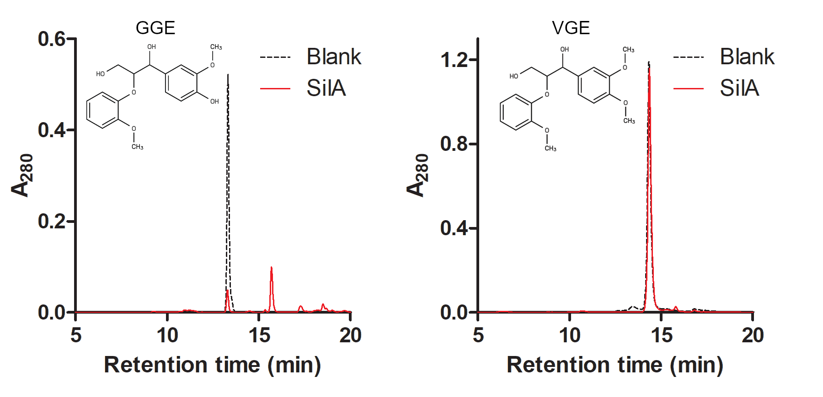

Figure 2
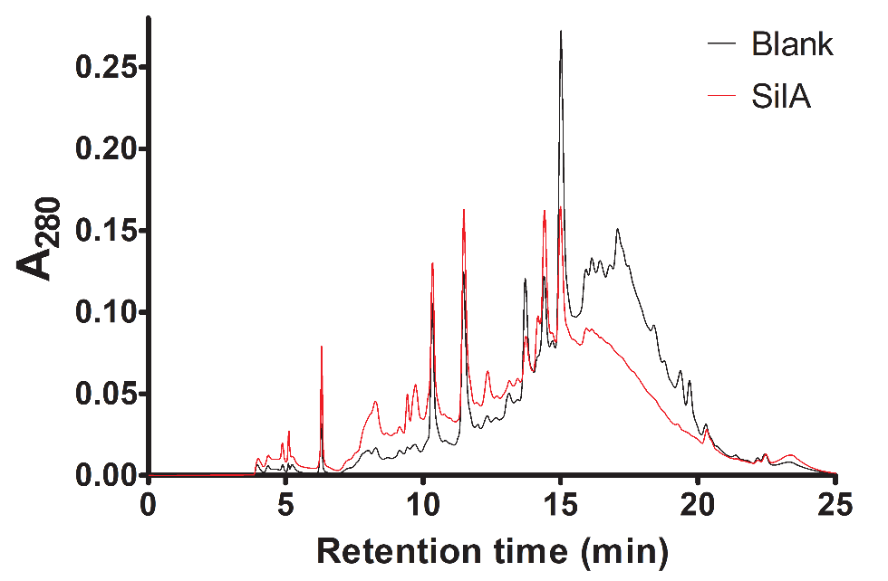

Figure 3
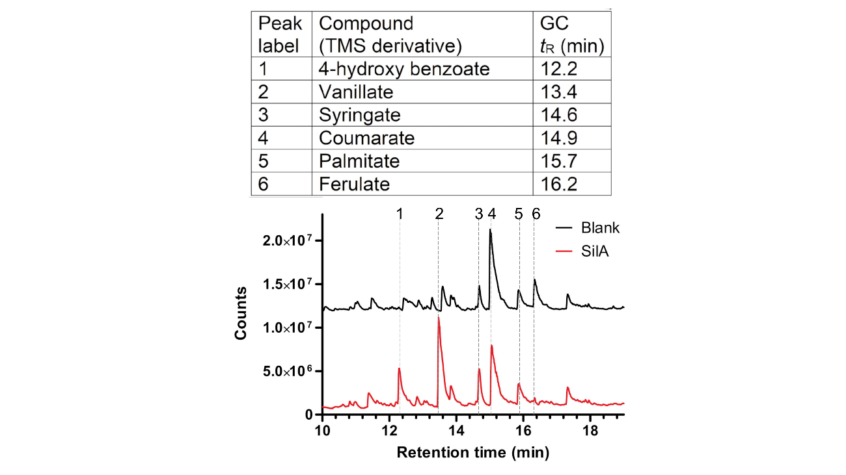

Figure 4
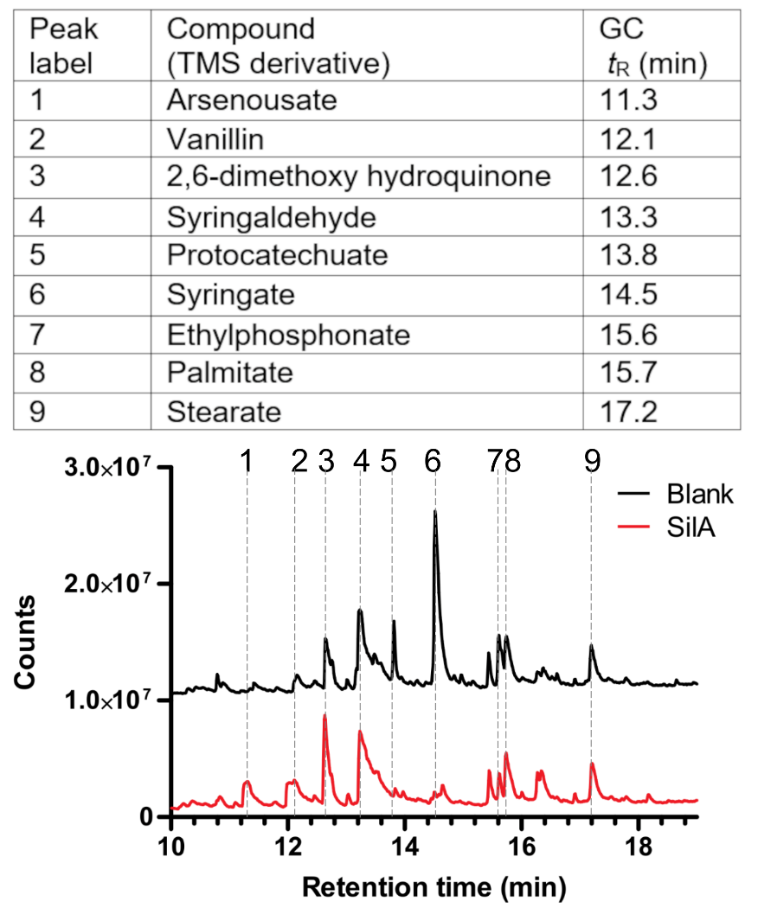

Figure 5
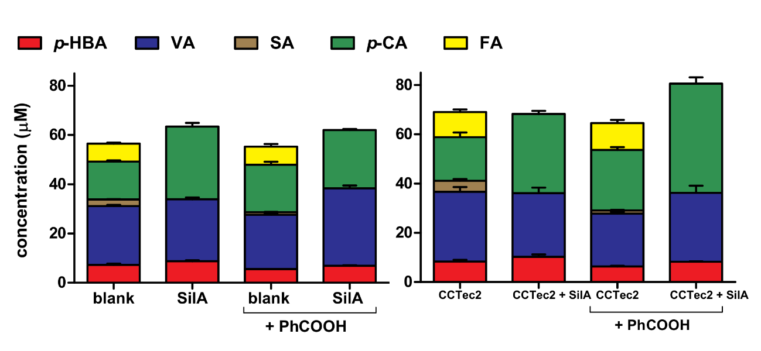

Tables
Table 1. Quantification (µM) of five monoaromatic compounds from SCR_{SE} by HPLC. SCR_{SE} was incubated with or without SilA, including or not the redox mediator β-(10-phenothiazyl)-propionic acid (PhCOOH). Monoaromatic released products were quantified in the soluble fraction. SDs are in parentheses. nd: not detected. * Indicates statistically significant differences referent to its blank (p < 0.05) (ANOVA, Tukey's post hoc test).

Compound | no mediator |  | PhCOOH
 | blank | SilA | blank | SilA
4-hydroxy benzoate | 7.2 (0.9) | 8.7 (0.7) | 5.576 (0.002) | 6.9 (0.3)
Vanillate | 23.9 (0.9) | 25 (1) | 22.0 (0.5) | 31 (2)*
Syringate | 2.7 (0.2) | nd* | 1.1 (0.1) | nd
p-coumarate | 15.3 (0.9) | 30 (3)* | 19 (2) | 23.6 (0.6)
Ferulate | 7.4 (0.5) | nd* | 7 (2) | nd*
Total | 57 (3) | 63 (5) | 55 (4) | 62 (2)

