Prevalence of comorbidity amongst people with palmoplantar pustulosis: a systematic review and meta-analysis.

Authors:
David Gleeson¹, Mark Corbett², Shern P Choy¹, Treasa Jiang¹, John YW Lee¹, Katie Bechman³, Mark D Russell³, Jonathan N Barker¹, James B Galloway³, Catherine H Smith⁺¹, Satveer K Mahil⁺¹
- St John’s Institute of Dermatology, Guy’s and St Thomas’ NHS Foundation Trust and King’s College London, London, UK
- Centre for Reviews and Dissemination, University of York, York, UK
- Centre for Rheumatic Diseases, King's College London, London, UK
⁺ Joint Senior Authors

Corresponding Author:
David Gleeson, David.gleeson@kcl.ac.uk
Address: St John’s Institute of Dermatology, 9th Floor, Tower Wing, Guy’s Hospital, Great Maze Pond, London, SE1 9RT

Funding Statement:
D.G. is a National Institute for Health and Care Research (NIHR) Doctoral Training Fellow (NIHR303264). S.K.M. is supported by an NIHR Advanced Fellowship (NIHR302258) and C.H.S by an NIHR Senior Investigator Award.

Conflict of interest disclosures:
DG has received educational support from Lilly. KB has received honoraria from UCB, Galapagos and viforpharma, and support for attending conferences from UCB. MDR has received honoraria from AbbVie, Biogen, Lilly, Galapagos, Menarini, UCB and Viforpharma; grant funding from Sandoz UK; and support for attending educational meetings from Lilly, Pfizer, Janssen and UCB. JNWNB has attended advisory boards and/or received consultancy fees and/or spoken at sponsored symposia, and/or received grant funding from AbbVie, Almirall, Amgen, Boehringer Ingelheim, Bristol-Meyers-Squibb, Celgene, Janssen, LEO Pharma, Lilly, Novartis, Pfizer, Samsung, Sienna, Sun Pharma, UCB. JBG has received speaker or advisory work fees from Abbvie, Alfasigma, Galapagos, Lilly, Pfizer and UCB, and grant funding from Abbvie, Galapagos, Glaxo-Smith Klein, Pfizer and Sanofi. C.H.S. reports grants from a Medical Research Council-funded stratified medicine consortium with multiple industry partners (PSORT.org), grants from IMI (Horizon 2020)-funded European consortium with multiple industry partners (BIOMAP-IMI.eu, HIPPOCRATES-IMI.eu, grants from Open Targets (Wellcome Sanger Institute), and others from AbbVie, Novartis, Pfizer, Sanofi, Boehringer Ingelheim and Swedish Orphan Biovitrum, outside the submitted work; and is Chair of UK guidelines on biologic therapy in psoriasis. S.K.M. reports departmental income from AbbVie, Almirall, Eli Lilly, Janssen-Cilag, Leo Pharma, Novartis, Pfizer, Sanofi and UCB, outside the submitted work. There were no conflicts of interest reported by the remaining authors.

Ethical Approval/Ethics Statement:
No ethical approval was required for this study. All data was obtained from published studies available in the literature.

Data Availability Statement:
All data was obtained from published studies available in the literature. The data that support the findings of this study and further supplementary materials are openly available in figshare: https://figshare.com/account/articles/28351418?file=52149425
Author Contribution Statement:
David Gleeson: Conceptualization (Lead), Data curation (Lead), Formal analysis (Lead), Funding acquisition (Lead), Investigation (Lead), Methodology (Lead), Project administration (Lead), Resources (Lead), Software (Lead), Writing – original draft (Lead)
Mark Corbett: Conceptualization (Equal), Formal analysis (Equal), Methodology (Equal), Supervision (Equal), Writing – review & editing (Lead)
Shern P Choy: Formal Analysis (Equal), Methodology (Equal), Writing – review and editing (Equal)
Treasa Jiang: Formal Analysis (Equal), Methodology (Equal), Writing – review and editing (Equal)
John YW Lee: Formal Analysis (Equal), Methodology (Equal), Writing – review and editing (Equal)
Katie Bechman: Formal Analysis (Equal), Methodology (Equal), Writing – review and editing (Equal)
Mark R Russell: Formal Analysis (Equal), Methodology (Equal), Writing – review and editing (Equal)
Jonathan N Barker: Methodology (Equal), Supervision (Equal), Writing – review and editing (Equal)
James B Galloway: Conceptualization (Equal), Methodology (Equal), Supervision (Equal), Writing – review and editing (Equal)
Catherine H Smith: Conceptualization (Equal), Methodology (Lead), Supervision (Lead), Writing – review and editing (Lead)
Satveer K Mahil: Conceptualization (Equal), Methodology (Lead), Supervision (Lead), Writing – review and editing (Lead)

Word Count: 597
Figure Count: 1
Table Count: 1

Key Words:
Palmoplantar pustulosis; Psoriasis; co-morbidity; prevalence; epidemiology

Dear Editor,
Palmoplantar pustulosis (PPP) is closely associated with smoking, but the wider comorbidity burden is poorly described.¹ Reviewing this burden is timely; Janus kinase (JAK) inhibitors have emerged as a promising immunomodulatory treatment for PPP. However a possible increased risk of major adverse cardiovascular events (MACE; myocardial infarction/stroke/transient ischaemic attack), venous thrombo-embolic events (VTE) and malignancy has led to regulatory bodies cautioning JAK inhibitor use in at-risk populations (age >65 years; current/long-term ex-smokers; those with cardiovascular or malignancy risk factors).²³ We undertook a systematic review and meta-analysis to quantify the prevalence of comorbidities, including cardiovascular risk factors and malignancy, in individuals with PPP.

A systematic search of six databases (Embase, Ovid, Pubmed, Web of Science, Cochrane, Cinahl) was conducted on 29th July 2024 for studies reporting prevalence of relevant comorbidities in adults with PPP (PROSPERO ref CRD42024508151).⁴ Conference abstracts, review articles, and case reports were excluded. Study quality was assessed using the Joanna Briggs Institute (JBI) Critical Appraisal Checklist.⁵ A consensus decision was made whether to include studies with low quality scores (<5) in the meta-analysis.⁶

Following quality assessment, studies of dermatologist-confirmed PPP conducted in a specialist setting were included in the meta-analysis. Population studies based on coding and claims databases were excluded.⁷ Prevalence estimates for comorbidities were pooled using a random-effects model and presented with 95% confidence intervals (95%CI). Heterogeneity between studies was assessed using the I² statistic. Egger’s test was used to explore publication bias.

Of 23,727 references identified, 86 studies were included in the systematic review, comprising 233,969 people with PPP (mean age 48.1 years; 67% female; Figure 1). Detailed search results are available on the associated figshare online repository (xxx). Studies reported on populations from Europe (n=44), Asia (n=27), North America (n=16), pan-continental (n=3), and South America (n=1). Study quality was variable; only fourteen studies (16.3%) met all relevant criteria of the JBI Critical Appraisal Checklist. Following quality assessment, 57 studies were included in the meta-analysis. Low heterogeneity was observed between studies for MACE (I²=0%) and diabetes mellitus (I²=33.2%, p=0.08; Table 1). Substantial heterogeneity (I²>50%) was observed between studies for all other comorbidities. No significant publication bias was identified.

Psoriasis vulgaris (prevalence 24.4% [95%CI 18.1-30.6%]) and psoriatic arthritis (19.7% [15.5-24.0%]) were common. The most prevalent cardiovascular risk factors were smoking (78.2% [73.6-82.6%]), hypertension (28.6% [24.4-32.8%]), hyperlipidaemia (28.3% [22.3-34.3%]), and obesity (25.2% [17.7-32.7%]). The prevalence of MACE and malignancy was 6.9% (3.8-9.9%) and 6.9% (2.6-11.2%), respectively. No studies were identified that reported the prevalence of VTE.

Sensitivity analyses excluding studies at higher risk of selection bias (case series, trials), studies relating to SAPHO and PAO, and studies not meeting two or more JBI quality criteria all identified only marginal differences in the prevalence estimates for most comorbidities. Analysis including population-based studies also identified only marginal differences in estimates.

Pooled smoking prevalence estimates were highest in studies published in the 2000’s (94.2% [89.6-98.8%]) and 1980’s (91.0% [85.9-94.4%]). Globally, adult smoking prevalence in 2020 was 32.6% and 6.5% among men and women respectively.⁸ The high prevalence of smoking identified in this study (78.2%) supports the recently described causal role for smoking in PPP pathogenesis.¹

Our results were not age- or ethnicity-matched, preventing direct comparisons to the general population. In line with high heterogeneity observed in meta-analyses of disease prevalence studies, our calculated estimates have wide confidence intervals and should be interpreted with caution.⁹

This systematic review and meta-analysis of 233,969 people with PPP highlights a high prevalence of smoking and cardiovascular risk factors. These findings should inform clinical screening efforts and treatment decision-making for people with PPP with novel therapeutic agents such as JAK inhibitors.

References:
1. Hernandez-Cordero A, Thomas L, Smail A, Lim ZQ, Saklatvala JR, Chung, R., et al. A genome-wide meta-analysis of palmoplantar pustulosis implicates Th2 responses and cigarette smoking in disease pathogenesis. J Allergy Clin Immunol. 24, S0091-6749 (2024).
2. Ytterberg SR, Bhatt DL, Mikuls TR, Koch GG, Fleischmann R, Rivas JL, et al. Cardiovascular and Cancer Risk with Tofacitinib in Rheumatoid Arthritis. N Engl J Med. 27, 316–326 (2022).
3. Medicines and Healthcare Products Regulatory Agency. Drug Safety Update. 15(3):1 (2021).
4. Page MJ, McKenzie JE, Bossuyt PM, Boutron I, Hoffmann TC, Mulrow CD, et al. The PRISMA 2020 statement: an updated guideline for reporting systematic reviews. BMJ 372, n71 (2021).
5. Munn Z, Moola S, Riitano D, & Lisy K. The development of a critical appraisal tool for use in systematic reviews addressing questions of prevalence. Int J Health Policy Manag. 3, 123–8 (2014).
6. Xu Y, Wang M, Chen D, Jiang X, Xiong Z. Inflammatory biomarkers in older adults with frailty: a systematic review and meta-analysis of cross-sectional studies. Aging Clin Exp Res. 34, 971–987 (2022).
7. Li AZ, Noe MH, Wafae BGO, Gelfand JM. Validity of International Classification of Diseases, Tenth Revision Codes for Identifying Patients with Palmoplantar Pustulosis: A Retrospective Cohort Study. Journal of Investigative Dermatology (2025) doi:10.1016/j.jid.2024.11.010.
8. Dai X, Gakidou E, & Lopez AD. Evolution of the global smoking epidemic over the past half century: strengthening the evidence base for policy action. Tob Control 31, 129 LP – 137 (2022).
9. Migliavaca CB, Stein C, Colpani V, Barker TH, Ziegelmann PK, Munn Z, et al. Meta-analysis of prevalence: I(2) statistic and how to deal with heterogeneity. Res Synth Methods 13, 363–367 (2022).

Figure 1. PRISMA flowchart showing the study selection process.
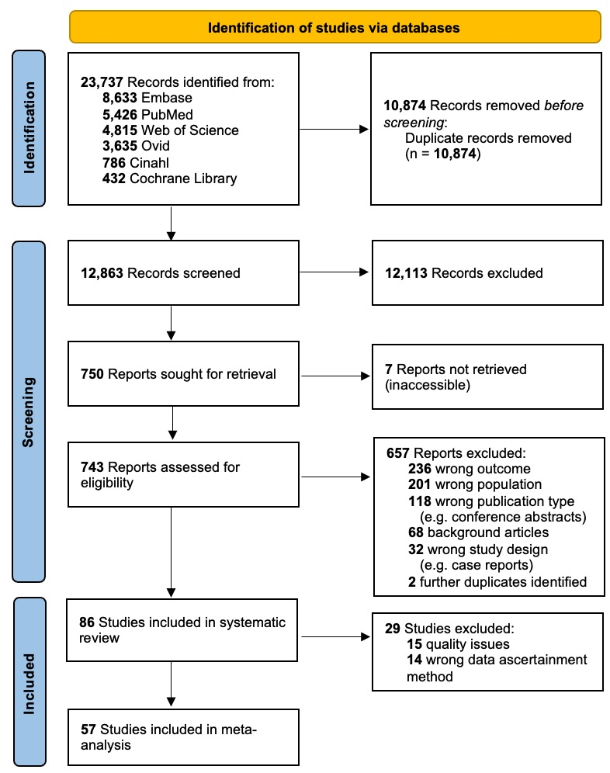

Table 1. Prevalence estimates for each comorbidity.

 | No. studies | No. participants | Meta-analysis prevalence estimate, % (95% CI) | Heterogeneity assessment |  | Publication bias (Egger’s test)
 |  |  |  | I² statistic (%) | p-value
Psoriatic Disease:
Psoriatic arthritis | 24 | 2,561 | 19.7 (15.5-24.0) | 88.0 | <0.01* | 0.06
Psoriasis vulgaris | 29 | 3,742 | 24.4 (18.1-30.6) | 97.5 | <0.01* | 0.12
Cardiovascular Risk Factors:
Diabetes mellitus | 18 | 2,716 | 12.6 (10.9-14.3) | 33.2 | 0.08 | 0.18
Hyperlipidaemia | 13 | 1,348 | 28.3 (22.3-34.3) | 83.8 | <0.01* | 0.67
Hypertension | 20 | 2,742 | 28.6 (24.4-32.8) | 81.9 | <0.01* | 0.50
Obesity | 9 | 1,637 | 25.2 (17.7-32.7) | 92.6 | <0.01* | 0.36
Smoking | 43 | 5,361 | 78.2 (73.6-82.6) | 96.0 | <0.01* | 0.57
Specific Outcomes:
Ischaemic heart disease | 9 | 941 | 8.9 (5.7-12.2) | 64.3 | <0.01* | 0.51
MACE | 2 | 261 | 6.9 (3.8-9.9) | 0.00 | - | -
Malignancy (exNMSC) | 3 | 320 | 6.9 (2.6-11.2) | 55.7 | 0.11 | 0.08
VTE | 0 | 0 | - | - | - | -
MACE, major adverse cardiovascular events; exNMSC, excluding non-melanomatous skin cancer; VTE, venous thrombo-embolic events; * p<0.05.

