The Contemporary Landscape of Gendered Personality Traits (full title)

Contemporary Landscape of Gendered Personality Traits (short title)

Sarah Shair-Rosenfield (corresponding author)
Sarah.shair-rosenfield@york.ac.uk
&
Melody E. Valdini
mev@pdx.edu

Associations that individuals make between a personality trait and its level of assumed masculinity or femininity are a prominent thread across the gender and politics literature. Yet, whether an attribute is categorized by scholars as “masculine” or “feminine” continues to be determined by studies that are decades old, and which often initially rested on scholarly assumptions rather than testing. Inaccurate assumptions may drive incorrect conclusions about the ways in which gendered associations influence voter and party decision-making, and contribute to ongoing gender bias in leadership evaluations. We use an original survey of 26 commonly-cited character traits associated with leadership, sampling 1,417 respondents in Australia, Canada, New Zealand, the United Kingdom, and the United States of America. We find evidence that scholarly categorization of the gendered associations diverges from how respondents rated many of those traits, and offer a modified list of gender-associated traits for researchers.

Keywords: gender stereotypes, leadership, personality traits, women in politics

Supplementary material for this article is available in Appendices I-V in the online edition.

Replication files are available in the JOP Dataverse (https://dataverse.harvard.edu/dataverse/jop). The empirical analysis has been successfully replicated by the JOP replication analyst.

This study (ETH2223-0670) was reviewed and received approval from the University of Essex’s Ethics Sub-Committee 3 on January 24, 2023.
It is a well-accepted finding in political science that voters care about the personal traits and attributes of their leaders (Bittner 2011; Ditonto 2017; Funk 1999); the fact that voters pay attention to the individual traits of candidates – not just the political party – impacts voter behavior in a multitude of ways. In the field of gender and politics, one prominent strand of analysis has been the exploration of the impact of candidate personality traits and associated stereotypes on the likelihood that voters will support women’s candidacies (Alexander & Andersen 1993; Barnes & Beaulieu 2014; Bauer 2015; Teele et al. 2018; Valdini 2019).
Yet, in the years since publication of many foundational works on the topic, substantial shifts in many gender-based economic, political, and social outcomes have occurred alongside increasing transformation of classifications of various aspects of gender in broader society. Do scholarly assumptions about how voters perceive the gendered nature of personal traits such as “honesty” or “independence” accurately reflect reality, or are the gendered association of personality traits more nuanced and less consistent than expected? Our goal is to assess whether individuals’ perceptions of the masculinity or femininity of certain character traits currently conform to scholarly expectations. We sample 1,417 respondents in Australia, Canada, New Zealand, the United Kingdom, and the United States of America using a short survey of personal character traits commonly associated with leadership. While some traits are consistently rated as traditionally gendered, we find evidence that several traits associated with leadership diverge from scholarly expectations.

Rationale
Across the world, substantial cultural shifts in societal understandings of gender and gender roles have occurred. For example, the millennial generation was raised in an internet age with regular exposure to higher levels of women’s labor force and political participation, as well as greater success of girls in secondary and tertiary education. This may affect whether younger generations see traits such as “hardworking” or “competent” as less clearly defined by gender. Beyond legislative bodies – where collective decisions can obscure individual leadership qualities – women’s representation in the executive and judicial branches has increased dramatically since the turn of the century (Escobar-Lemmon et al. 2021; Shair-Rosenfield & Stoyan 2018; Valdini & Shortell 2016). This representational shift may alter whether people perceive the necessary qualities for a judge or cabinet member – such as being articulate and ambitious – as associated only with men.
Furthermore, the increasing importance of characteristics such as ‘empathy’ have been highlighted in media coverage of both male and female political leaders such as Jacinda Ardern and Barack Obama. The marked increase in the use and perceived acceptability of the generic singular pronoun “they” in everyday speech as a replacement for the masculine “he,” the feminine “she,” or the still-gender binary phrase “he or she” (LaScotte 2016) highlights fluidity beyond the political realm. In the context of more complex and nuanced perceptions in gender norms, many traits that were traditionally associated with men and women may elicit different views about their masculinity or femininity today.
Amid changing cultural norms and exposure to women’s leadership altering the wider political landscape, some studies have demonstrated that stereotypes and the resulting word associations are surprisingly durable (e.g., Sczesny et. al 2019). However, there is evidence that changing social roles have caused a shift in the gendered associations of some traits (Charlesworth et. al 2022; Eagly et al. 2020) and thus scholars are returning to test more modern associations (van der Pas et al. 2024). For example, scholars seeking to understand evaluations of political candidates routinely associated the character trait of ‘competence’ with masculinity and the character trait of being ‘compassionate’ with femininity (Schneider & Bos 2014). In Appendix II, we present a list of traits that prominent works in previous literature have typically deemed either masculine of feminine. Such studies often find penalties (or perceived penalties) for female candidates who fail to exhibit “masculine” traits or heavily rely on “feminine” traits, even as more recent work notes the increasingly positive association with women politician stereotypes (van der Pas et al. 2024). However, if such traits are not thought of by voters in these gendered ways, scholars may be incorrectly attributing the source of the bias. Perhaps voters’ preferences to not vote for women stem from different reasons than those suggested by gendered trait associations, or they could result from inconsistencies in or misrepresentations of voters’ preferences of how a particular trait is valued in the context of a specific (gendered) individual. By rigorously evaluating the degree to which gendered trait associations exist, we aim to improve scholarship that seeks to understand these types of gender-biased political outcomes.

Research Design
In order to test theories of gender-based bias against political candidates and officeholders, political scientists commonly assess the effects of individual traits, or a series of individual traits, rather than using aggregate scales or indices. Drawing from lists of characteristics in the foundational literature established in Schneider and Bos (2014, 247), we selected 26 of the most frequently used traits used in existing surveys and literature on gendered trait association to test with our respondents (see Appendix I for full survey). For ease of interpretation, we group these traits into those commonly defined by the extant literature as “masculine” and “feminine.” It is important to reiterate that we are not applying our own gendered logic or definition to these traits; the goal here is to understand whether traits typically assumed to be associated with masculinity or femininity currently carry these associations for people (see Appendix II for the list of commonly used and classified traits).
To analyze contemporary gendered associations with these traits, we conducted a series of surveys with respondents from Amazon’s Mechanical Turk service in the USA and from Prolific in Australia, Canada, New Zealand, and the United Kingdom; all surveys were gender-balanced and performed from mid-March to early April 2023 (Study ETH2223-0670 approved by the University of Essex). Selection criteria for these cases was two-fold: 1) English is the dominant language used by the majority of the population; and 2) they have comparable levels of democracy and economic development. Our final sample includes 344 respondents from Australia, 304 from Canada, 192 from New Zealand, 301 from the UK, and 276 from the USA. For each trait, respondents were asked to rate the trait on a 5-point Likert scale with options ranging from ‘extremely feminine’ to ‘extremely masculine’ and the response option of ‘neither feminine nor masculine’ as the median response on the scale. On our scale, lower values (‘1’ and ‘2’) correspond to more feminine ratings, a ‘3’ as the ‘neither feminine nor masculine’ rating, and higher values (‘4’ and ‘5’) correspond to more masculine ratings. After rating the traits, respondents answered a short set of demographic questions, including age, gender, education level, relationship status, and parental status; descriptive statistics and sample representativeness are included in Appendix III.

Results
We consider a straightforward question, without any conditions or caveats: are gendered associations with different personality traits reflected in the perceptions of our contemporary sample? To assess this as simply as possible, we show histograms for all traits for all respondents, thus showing the number of respondents that selected each of the five Likert ratings on the scale. Presenting the data in this way allows the reader to judge for themselves how each trait is being perceived; rather than take the average or create an arbitrary cut off for masculinity or femininity, this illustrates the raw reality of how people view the gendered nature of commonly used leadership traits. The bar with darker shading in each histogram represents the respondents who chose ‘3’ for the trait (e.g., the gender “neutral” category); the horizontal reference line is placed at 50% of respondents, meaning that any bar crossing the reference line indicates a response category chosen by a majority of respondents.
Figure 1. Masculine-associated trait histograms
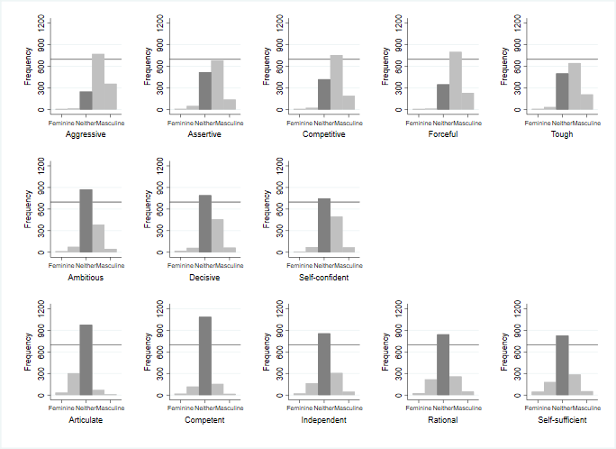
Figure 1 offers the histograms for all of the traditionally masculine-associated traits in our survey. As a reminder, a response of 1= “extremely feminine,” 3= “neither masculine nor feminine,” and 5= “extremely masculine.” The top row of Figure 1 shows five traits where the modal response is ‘4’ on the 5-point scale, indicating a masculine association by a plurality of respondents. Of these, ‘assertive’ and ‘tough’ have substantial minorities of respondents who chose the gender-neutral category of ‘3.’ The middle row of Figure 1 shows three traits where the majority response is ‘3’ but substantial minorities of respondents chose the masculine response of ‘4.’ The bottom row of Figure 1 shows the five traits where the overwhelmingly dominant response is ‘3’ and where few respondents selected ‘4’ or ‘5.’ The interpretation from Figure 1 is that five traits are associated as “masculine” for a majority of respondents, three traits are more ambiguous, and five traits – articulate, competent, independent, rational, and self-sufficient – are rated gender neutral by most respondents.
Figure 2. Feminine-associated trait histograms
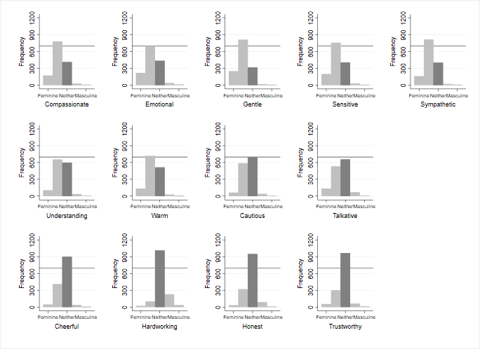
Figure 2 presents the histograms for the traditionally feminine-associated traits in our survey. Similar to Figure 1, some of these traits are firmly gendered in the expected way: the top two rows show seven traits where the modal response is ‘2’ on the 5-point scale, indicating a feminine association by a plurality of respondents. Of these, only ‘cautious’ and ‘talkative’ in the middle row have the modal response at ‘3’ with substantial minorities of respondents who chose the feminine response of ‘2.’ The bottom row of Figure 2 shows four traits where the overwhelmingly dominant response is ‘3’ and few respondents selected ‘1’ or ‘2.’ The interpretation from Figure 2 is that seven traits are associated as “feminine” for a majority of respondents, two traits are more ambiguous, and four traits – cheerful, hardworking, honest, and trustworthy – are rated as gender neutral by most respondents.
Taken together, Figures 1 and 2 paint an instructive picture of the degree to which the terms used in trait and leadership evaluations accurately reflect contemporary gendered-associations. While many traits with common feminine – warm, understanding, and compassionate – and masculine – assertive and competitive – usage are rated as such by our respondents, there are a comparable number of exceptions. Many commonly-used masculine- and feminine-associated traits do not appear to resonate as obviously gendered in the ways scholars have long assumed. In particular, a number of the most positive masculine-associated traits – ambitious, competent, independent, and rational – and feminine-associated traits – honest and trustworthy – are not rated as “masculine” by respondents in our sample. These ratings are also consistently demonstrated across the five cases, with one-way Anova and Tukey post hoc test results reported in Appendix V.

Conclusion

Our purpose in this study was to examine whether scholarly assumptions about the gendered nature of personality traits accurately reflect reality today. Using a cross-national data set of English-speaking survey respondents in Australia, Canada, New Zealand, the UK, and the US, our findings suggest that modern voters in advanced industrial democracies less clearly perceive the traditionally gendered nature of personality traits. Among the traits where there is congruence between existing scholarly expectations and respondent ratings are the traits that are most overtly associated with masculinity – being aggressive, assertive, competitive, forceful, and tough – and femininity – being compassionate, emotional, gentle, sensitive, sympathetic, understanding, and warm.
However, there is divergence from scholarly expectations for some of the traits that individuals often report matter most to them in their evaluation of leaders or have been shown to affect voting behavior. For example, our results suggest that the traits of “hardworking,” “honest,” “trustworthy,” “articulate,” “independent,” “self-confident,” and “self-sufficient” are all effectively rated as gender neutral (e.g., neither specifically feminine nor masculine associated) by respondents in our sample. Our findings reflect a similar trend in other recent work (e.g., Roberts & Utych 2020; van der Pas et al. 2024), which has important implications given the significance of competence-related traits to party strategies in candidate selection criteria and voters’ candidate evaluations. Although not globally generalizable, given that our sample is drawn exclusively from advanced industrial English-speaking democracies, our results show something distinct and consistent for a wider range of countries beyond the US. Regardless of whether specific leadership traits are desirable in women candidates compared to men candidates, contemporary respondents associate fewer personality traits in traditionally gendered ways. Scholarship, especially when seeking to pinpoint sources of gendered differences and potential bias in electability and public approval of political leaders, should reflect this more nuanced reality.

Acknowledgements
The authors would like to thank Nicholas Pyeatt, Reed Wood for their helpful comments and suggestions on earlier versions of the paper, and Michele Ford, Laura Montanaro, and Victoria Reddish for their confirmation on the lists of traits for respondents in Australia, Canada, and New Zealand respectively. All remaining errors are our own.

References
Alexander, Deborah, and Kristi Andersen. (1993) “Gender as a Factor in the Attribution of Leadership Traits.” Political Research Quarterly 46 (3): 527–45.
Barnes, Tiffany, and Emily Beaulieau. (2014) “Gender Stereotypes and Corruption: How Candidates Affect Perceptions of Election Fraud,” Politics & Gender 10 (3): 365–91.
Bauer, Nichole M. (2015) “Emotional, Sensitive, and Unfit for Office?” Political Psychology, 36: 691-708.
Bittner, Amanda. (2011) Platform or personality? The role of party leaders in elections. Oxford: Oxford University Press.
Charlesworth, Tessa E., and Mahzarin R. Banaji. (2022) "Patterns of implicit and explicit stereotypes III: Long-term change in gender stereotypes." Social Psychological and Personality Science 13 (1): 14-26.
Ditonto, Tessa. (2017) “A High Bar or a Double Standard? Gender, Competence, and Information in Political Campaigns.” Political Behavior 39: 301-325.
Eagly, Alice H., Christa Nater, David I. Miller, Michèle Kaufmann, and Sabine Sczesny. (2020) “Gender stereotypes have changed: A cross-temporal meta-analysis of U.S. public opinion polls from 1946 to 2018.” American Psychologist 75(3), 301–315.
Escobar-Lemmon, Maria, Valerie J. Hoekstra, Alice J. Kang, and Miki C. Kittilson. (2021) “Breaking the Judicial Glass Ceiling: The Appointment of Women to High Courts Worldwide.” Journal of Politics 83(2): 662-674.
Funk, Carolyn L. (1999) “Bringing the candidate into models of candidate evaluation.” Journal of Politics, 61(3): 700–720.
LaScotte, Darren K. (2016) “Singular They: An Empirical Study of Generic Pronoun Use.” American Speech 91(1): 62-80.
McDermott, Monika L. (2016) Masculinity, femininity, and American political behavior. Oxford University Press.
Oliver, Sarah, and Meredith Conroy. (2018) “Tough enough for the job? How masculinity predicts recruitment of city council members.” American Politics Research 46(6): 1094-1122.
Roberts, Damon C., and Stephen M. Utych. (2020) “Linking Gender, Language, and Partisanship: Developing a Database of Masculine and Feminine Words.” Political Research Quarterly 73(1): 40-50.
Schneider, Monica C., and Angela L. Bos. (2014) “Measuring Stereotype of Female Politicians.” Political Psychology 35(2): 245-266.
Sczesny, Sabine, Christa Nater, and Alice H. Eagly. (2019) “Agency and Communion: Their Implications for Gender Stereotypes and Gender Identities.” In Andrea Abele and Bogdan Wojciszke, eds., Agency and Communion in Social Psychology. Routledge, 103-116.
Shair-Rosenfield, Sarah, and Alissandra T. Stoyan. (2018) “Gendered opportunities and constraints: How executive sex and approval influence executive decree issuance.” Political Research Quarterly 71(3): 586-599.
Teele, Dawn L., Joshua Kalla, and Francis Rosenbluth. (2018) "The ties that double bind: social roles and women's underrepresentation in politics." American Political Science Review 112, no. 3: 525-541.
Valdini, Melody E. (2019) The inclusion calculation: Why men appropriate women's representation. Oxford University Press.
Valdini, Melody E., and Christopher Shortell. (2016) “Women’s representation in the highest court: A comparative analysis of the appointment of female justices.” Political Research Quarterly 69(4): 865-876.
van der Pas, Daphne, Loes Aaldering, and Angela L. Bos. (2024) “Looks Like a Leader: Measuring Evolution in Gendered Politician Stereotypes.” Political Behavior 46(3): 1653-1675.

SARAH SHAIR-ROSENFIELD is a PROFESSOR at the UNIVERSITY OF YORK, YORK, UK YO10 5DD
MELODY E. VALDINI is a PROFESSOR at PORTLAND STATE UNIVERSITY, PORTLAND, OR 97201

Some political psychologists use indices, see McDermott (2016) and Oliver & Conroy (2018).
A native Australian, New Zealander, and Canadian each confirmed that all traits would be used by co-nationals to describe individuals; US and UK usage confirmed by the authors.
Conclusions drawn from the histograms are also reflected in the means, standard deviations, and t-tests reported in Appendix IV.

