Gender inequalities in UK music higher education: the role of institutional stratification

Abstract
In creative higher education (HE) undergraduate courses in the UK, women students are over-represented by a proportion of two-to-one. However, music HE shows almost the reverse gender balance, with women students under-represented. This article, theorising HE as hierarchically stratified according to institutional prestige, uses descriptive analysis of data on all students in UK music HE between 2016-20 to explore how gender inequalities intersect with institution type across different levels of study. The analysis shows that older, more prestigious institutions have a more equal gender balance. However, these degree programmes may be less likely to equip students with digital skills needed for music industry careers. Furthermore, women of colour and working-class women are doubly marginalised: excluded from prestigious HEIs where white, middle-class women predominate, and from newer HEIs where men are over-represented. At PGT level, gender inequalities vary across institution type. Finally, among postgraduate researchers women remain under-represented.
Keywords: higher education, gender, music, creative industries, inequalities, students

Introduction
Does music higher education (HE) provide a route for women to have a musical and creative voice? Or does music HE compound and reproduce existing gender inequalities in education, the music industry and wider society? These questions about higher education’s role in reproducing or challenging inequalities have been explored in HE in general (Leathwood & Read, 2008) and in relation to creative higher education (Comunian et al., 2023) but have been less discussed in relation to music HE. This article explores these questions through an examination of gender inequalities in UK music HE, analysing who studies music in HE. Exploring who participates in music HE reveals whose culture is represented and amplified within formal music institutions, and the extent to which women’s creative musical voices are heard and supported. This is particularly urgent at a time when music HE is debating curricula reform and legitimate knowledge, for example by asking ‘what should university study of music consist of? (Heile, Rodriguez, and Stanley 2017) and critically examining music graduates’ employability (Prokop and Reitsamer 2024) even while many music departments are facing closures or downsizing (Geddes 2024).

Amidst persistent gender inequalities in the music industry and music education, most recently highlighted by the UK Government Women and Equalities Committee’s ‘Misogyny in Music’ report (2024), only a relatively small body of academic literature explores gender inequalities in music HE, by contrast with a large body of literature on gender inequalities in STEM education (Boaler and Sengupta-Irving 2006). Furthermore, in the creative industries more widely, creative arts degrees are dominated by women students but men continue to outnumber women in creative jobs (Comunian et al. 2023) but, as revealed below, music does not follow this trend. It is important, therefore, to examine music HE in its specificity, not only as part of the wider creative sector. Furthermore, UK music HE comprises both university-based degree programmes as well as provision at specialist institutions – conservatoires and popular music institutions – where the latter are seeing an increase in provision funded by private equity (Sovereign Capital 2025), creating a distinctive institutional ecosystem.

One of the reasons that these inequalities matter is because HE has been argued to be a key site for entry into creative careers, including music (Comunian et al. 2023, 16; O’Brien, Brook, and Taylor 2024). While some of those working in the music industry, particularly racially minoritised musicians (Black Lives in Music 2021, 13) have not studied music in HE, it remains an important route into the industry, particularly in genres such as classical music and jazz. Indeed, in the UK music industry there is substantial evidence that women are under-represented and disadvantaged (UK Music 2024; Musicians’ Union 2024, 15). Even in genres such as classical music where girls are over-represented at early stages of education, this does not translate to equal representation in the industry (Bull 2021; Cox and Kilshaw 2021; Scharff 2017).
Existing analyses (as detailed below) have not explored the role of institutional stratification, nor explained differences across levels of study. In order to push forward existing debates, this article makes three key contributions. First, building on analysis first published in the report Slow Train Coming (Bull et al. 2022), it provides a more comprehensive picture than previous research of gender inequalities across all students in UK music HE between 2016-20, analysing differences across types of higher education institution. Secondly, it draws on existing research to put forward explanations for these inequalities, revealing the ways in which existing hierarchies of institutional prestige are influential at the level of music as a discipline. Third, it outlines how gender inequalities in music HE differ from those in the creative HE. It concludes that on the basis of current patterns in music HE the prognosis for increasing gender equality in the music industry is extremely poor.
The article first outlines existing research on gender inequalities in music HE, before exploring existing literature on how gender inequalities and higher education institutional hierarchies intersect. It describes the data that the study draws on, which, due to the anonymity requirements for the dataset (discussed below) analyses gender as a binary, which is a significant limitation. The article then presents descriptive findings and draws out four key points of analysis.

Gender inequalities in UK music HE
Existing research on gender inequalities in UK music HE has mainly focused on gender segregation at undergraduate (UG)-level rather than institutional stratification, finding strong variation in gendered participation between types of music degrees. Bain examined data from 2013-18 from students in on music degree programmes in the UK, grouping UG degrees into four types. Music performance degrees were nearly equally balanced with 45% women, while on ‘theory/management/education’ music degrees 38% of students on were women. By contrast, women comprised only 14% of those studying composition degrees and 13% of those studying music technology (Bain 2019, 20). Similar findings at UG level from a less comprehensive dataset obtained via freedom of information requests were published by Tatlow, whereby ‘generic music degrees’ and degrees combining music and theatre showed women students as over-represented, while on degrees combining music and technology and on popular music degrees men were over-represented (Tatlow 2022).
An intersectional analysis is presented by Born and Devine, who – unusually – did also explore institutional stratification (as outlined below). Their study, examining earlier data (2007-12) from students on a selected sample of UK UG music degrees, found a ‘striking bifurcation’ of who studies different types of music degrees with ‘traditional’ (i.e. western classical music-dominated) music degrees drawing a mixed-gender cohort of students with higher social class profiles, while music technology attracted many more men from less privileged backgrounds (Born and Devine 2015). However, a limitation of this study is its use of POLAR, a geographical measure of class that has been heavily critiqued (Boliver, Gorard, and Siddiqui 2022).

Despite these stark patterns of gendered participation across degree types, little is known about gendered patterns of recruitment and admissions to UK music HE. De Boise and Scharff examined applications and acceptance rates across music HE and in conservatoires respectively, both finding that more women apply than men, but men are more likely to be accepted (Scharff 2017, 45; de Boise 2018, 28). At conservatoires, Scharff also found a higher acceptance rate for men at PG level (Scharff 2017, 45). Admissions practices vary widely between UK HEIs; Bull et al. (2022) found two categories among music HEIs, either requiring a high level of knowledge/experience prior to entry including specific A-level grades, or with very flexible entry requirements. However, no analysis of gendered patterns in admissions was carried out.

Nevertheless, research outlines multiple explanations for these gendered patterns. To explain differences between the gendered patterns in music technology degrees, Born and Devine argue that a ‘musicalized male hegemony’ means that ‘the gendering of music composition is compounded by the gendered practices associated with digital technologies’ (Born and Devine 2015, 151). As such, the gendered associations of creativity (Battersby 1994) are compounded by the gendered association with digital technologies (English, Drummond, and Kerrigan 2024). More generally, restrictions not only on women’s creativity but women’s musical self-expression more generally may affect participation. For example, women’s musical voices have been confined to private rather than public space, as ‘bedroom musicians’ (McRobbie 2000) or ‘salon composers’ (Citron 1993). An illustrative example comes from an interviewee in Scharff’s study of women classical musicians, Sasha, who describes how being a musician counters wider gendered silencing mechanisms in society, saying, 'I've got real issues about being heard… as a girl, I think I wasn't ever heard'. Performing as a musician became her opportunity to finally be heard (Scharff 2017, 163). This example reveals the specificity of music in relation to gender: that it is about taking up sonic space, in opposition to gender norms whereby women do not make noise or use their bodies (Bull 2019, chapter 7).
Further explanation comes from feminist musicology, which outlines how aesthetic norms in the male-dominated tradition of composition – which have also shaped the tertiary music education curriculum – exclude collaborative approaches which could allow more space for women composers (Macarthur 2010). Furthermore, gender-based violence is enabled by gender inequalities in music HE (Bull 2024). This disproportionately affects women and non-binary people in music HE (Equity, Incorporated Society of Musicians, and Musicians’ Union 2018) and can lead to attrition, depression and anxiety, academic disengagement, loss of faith in the institution/industry, as well as loss of confidence (McCarry et al., 2023; Bull and Bradley 2025).
There is also evidence of gendered differences in experiences of education, for example women students are more likely than men experience masterclasses in music HE as intimidating and unfriendly (Long et al. 2014), and teachers have been found to give more specific criticism to men than women students (Zhukov 2012). Gendered divisions of labour across instruments have been extensively documented (Abeles 2009; Casula 2023; Davies 2019) which contribute to creating gendered cultures that may disadvantage women students and staff (Bogdanovic 2015). Work placements – in important route into creative industries – may compound classed, racialised and gendered inequalities (Allen et al. 2013).
These gendered cultures can vary across musical genres. In jazz, male-dominated environments push women out of formal education into ‘DIY methods of musical development’ (Raine 2019, 192). In music technology, sound engineering and/or music production programmes, a study across Germany and the UK found women are in the minority in class, taught by predominantly male staff, where misogynistic comments occur that negatively impact their engagement in their education (Hopkins and Berkers 2019). The symbolic associations between masculinity and technology and the gendered cultures that this creates have been documented at various levels of education and the industry (Hopkins and Berkers 2019; Born and Devine 2015; Strong and Cannizzo 2019; Armstrong 2011). In popular music HE, gendered cultures at undergraduate level exclude women students from networks (Davies 2019). In classical music, a gendered canon and performance/cultural norms (Bull 2019; Citron 1993; Scharff 2017; Ramstedt 2023; Bull, Nooshin, and Scharff 2023; Bull and Scharff 2021; de Boise 2019a; Bull 2016) including ‘respectable femininity’ (Bull, 2019) relies on ‘heteronormative European white beauty ideals’ (Ramstedt 2023, p.103), as well as a gendered ‘social imaginary’ of famous musicians and gendered expectations of teachers (Reitsamer and Prokop, 2023; Ramstedt 2023). This limits women’s creative freedom and their ability to imagine themselves as professional musicians. Despite this, in previous research I found gendered patterns of aspiration among young people in classical music, with young women more likely to aspire to a career in this field than young men (Bull 2018).
However, gendered participation in music HE becomes more equal at postgraduate (PG) level (Bain, 2019). The trend of more women than men studying at PG level is by no means specific to music as a discipline; women are more likely than men to undertake Master’s degrees across a range of disciplines and countries across Europe (EURAXESS 2019). This has been argued to be due to ‘the better performance of women rather than men in their studies’ (EURAXESS 2019) echoing Leathwood and Read’s arguments on the ‘feminization’ of higher education (Leathwood and Read 2008). In creative degrees more generally, Comunian et al. hypothesise that ‘once marginalised graduates enter the job market and are not able to access employment, they seek alternative pathways and/or return to further education’ (Comunian et al. 2023, 79). However, existing research on gendered patterns of participation on music PG degrees (Bain, 2019) does not reveal whether these explanations also apply in music HE, nor does it include any intersectional analysis to reveal which women are studying PG music degrees.

Gender inequalities and institutional stratification
In the UK, these gender hierarchies intersect with hierarchies of institutional prestige in HE (Boliver 2015). Boliver describes how status distinctions between groupings of universities today can be mapped, more or less, onto their historical origins, with older universities characterised by higher levels of research activity, greater wealth and more academically successful and socioeconomically advantaged student intakes in a binary divide with new post-1992 universities. Attending a more prestigious institution leads to better employment outcomes and higher earnings for graduates (Britton et al. 2016).

Nevertheless, this institutional stratification remains underexplored in the literature above, other than by Born and Devine (2015). As they outline, institutional hierarchies intersect with the gender inequalities outlined above; music technology degrees proliferated in the 1990s and 2000s, particularly among post-1992 universities, with the number of music technology degrees increasing by nearly 1400 per cent between 1994 and 2011 (Born and Devine 2015, 141). As such, music technology degrees are primarily offered at newer, less prestigious HEIs while ‘traditional’ music degrees – focusing on classical music – are offered at older, more prestigious universities.

However, Born and Devine’s analysis includes only a selected sample of universities, omitting specialist institutions. These include conservatoires, specialising in classical music, most of which were established in the late 19th century (Bull, 2019). They also include specialist popular music institutions, set up in the 1980s and 1990s, such as the Institution of Contemporary Music Performance (ICMP) or BIMM (the British and Irish Modern Music Institute). These institutions are attracting investment from private equity firms, with Sovereign Capital promoting its success in increasing student numbers at BIMM from 1,150 to 8,200 between 2010-20 (Sovereign Capital 2025). UK Music HE is therefore an interesting context to explore how changing HE provision is shaping gender inequalities and how these inequalities intersect with institutional hierarchies of prestige.

Methods
The analysis below uses data from the Higher Education Statistics Agency (HESA) across four academic years (2016-20) for all students and staff in music HE. The article’s focus is predominantly on students, and a comprehensive discussion of inequalities among music HE staff is beyond its scope. Nevertheless, gendered representation among staff contributes to the gendered cultures and learning environments in music higher education (Hopkins and Berkers 2019) and so staff data is included in descriptive analysis of the pipeline.
The dataset includes all students who were taking a course where at least 50% of the content was designated as music, audio technology or music recording. This means that, unlike previous studies (Tatlow 2022; Born and Devine 2015; Bain 2019) this study includes all students studying music, not just those in music departments. Academic staff data – encompassing all staff including those on fixed-term, casual, and permanent contracts – was acquired where staff’s current academic discipline listed music in their top three disciplines. This revealed 133 institutions with staff and/or students teaching or studying music in the UK during 2016-20.

Despite the importance of genre cultures in patterns of gender inequalities, it was not possible to analyse HESA data around genre categories because institutions did not always return data attached to the correct course code; many degree courses were returned under the generic W300 code when they would have been a better fit elsewhere. For example, the code for jazz, which, as Sarah Raine has noted, would particularly benefit from gender inequality analysis (Raine 2019, 189) only shows between four and six institutions running degree programmes in jazz or jazz performance per year, omitting some institutions that advertise programmes in jazz performance as they return data to HESA under a generic ‘Bachelor of music (performance)’ course code.

The 133 institutions were categorised by age and type, into seven groups, informed by research into institutional groupings in UK HE (Boliver 2015) as follows:
1. Conservatoires, for example, Royal Academy of Music (n=7)
2. Specialist performing arts/music institutes (non-conservatoire), for example, Institute of Contemporary Music Performance (n=13)
3. Post-1992 university (former polytechnic), for example, Anglia Ruskin University (n=40)
4. Post-1992 university (not former polytechnics; many are former teacher training colleges), for example, York St John University (n=26)
5. Universities set up during the 1960s, for example, the University of York (n=18)
6. ‘Civic’ universities (established in the first half of the 20th century), for example, Queen Mary, University of London (n=19)
7. ‘Old and ancient’ universities (established in the 19th century or earlier), for example, Durham University (n=10)

In the analysis of gender inequalities below, the data is presented in binary (male/female) terms. HESA was not able to provide data on trans students or staff or non-binary staff as it could not be sufficiently anonymised. Data on non-binary students was provided, but the small numbers meant that according to HESA rules on rounding data for anonymity, it was not possible to report any meaningful analysis. However, the number of students selecting ‘other’ as their gender identity (as HESA designates non-binary students) increased from 15 in 2016/17 to 80 in 2019/20 (rounded to the nearest five). Ethical review was carried out by the University of Portsmouth Faculty of Humanities and Social Sciences ethics committee.

The analysis presented below firstly examines how gender inequalities of music students compare to the wider UK student population. Secondly, it explores how the characteristics of music students vary by type of institution, as grouped above. Finally, it analyses the levels of inequalities at different levels of study as well as different contract types and levels for staff to explore where inequalities exist, revealing some of the structural characteristics of gender inequalities in music HE. This analysis was also carried out across the seven groups of institutions to reveal the varying patterns of gender inequalities across different institution types. Subsequently, further descriptive analysis – by domicile (international or UK-domiciled students); by class (as outlined below); and by ‘race’ – was carried out on students at postgraduate taught (PGT) student level to understand why there are more women studying at this level than at UG or doctoral level. As noted below, data on class and ‘race’ is only available for UK-domiciled students, not for international students or for staff.

Gender inequalities among students in music HE
The music student population has more men than women students, the inverse of the wider UK student population. Combining data across 2016-20 across all levels of study (UG, PGT and postgraduate research (PGR)), music students are 59% male and 40% female, whereas the wider student population is predominantly female at 57% (see Figure 1).

[Figure 1 here]

The proportion of women students increased slightly between 2016/17 and 2019/20 from 39% (n=14,130) to 42% (n=16,245), with a corresponding decrease in men students, although men are still clearly in the majority (2016/17 male, 61%, n=22,460; 2019/20, 58%, n=22,350) (see Figure 2). Gender inequalities are more pronounced for British Asian and Black British music students; among both groups, the gender breakdown is approximately two-thirds male students and one-third female students.

[Figure 2 here]

These aggregate figures are not necessarily helpful in understanding what is going on within specific institutions, departments and degree courses. When the student population is divided up by institution type, clear differences emerge. Male-dominated music student populations were evident across four types of institutions: post-1992 ex-poly universities (female, 33%; male, 66%), post-1992 non-polytechnics (female, 43%; male, 57%), 1960s universities (female, 42%; male, 58%) and specialist institutions (non-conservatoire) (female, 33%; male, 67%).

A more equal gender split was evident across two types of institutions: ‘old and ancient’ universities (female, 50%; male, 49%), as well as conservatoires (female, 49%; male, 51%). The only type of university that had more women than men students on music courses were ‘civic’, or early-20th-century, universities (female, 54%; male, 46%) (see Figure 3).

[Figure 3 here]

Gender inequalities across music HE from undergraduate students through to staff
Examining the educational trajectory from undergraduate to postgraduate students and then to academic staff shows different patterns. At undergraduate level there were more men (61%) than women students (39%). The proportion then becomes more equal at Master’s level (men, 49%; women, 50%) before again becoming more unequal in favour of men at doctoral (men, 60%; women, 39%) and staff levels (men, 65%; women, 35%) (see Figure 4).

[Figure 4 here]

Exploring the data across the seven types of institutions, composition of undergraduate students varies by university type, with ‘civic’ universities having slightly more women undergraduates (54%) compared to men, while post-1960s universities are at the other end, having a majority of men (60%) (see Figures 5-11). At postgraduate level there is substantial variation across institution type, with ‘civic’ universities having more women than men (58%), while at post-1992 (non-poly) universities 64% of students at postgraduate level were men. At doctoral level all institutions’ groupings are predominantly men (between 54% and 65% across the different types of institutions), and at staff level there is roughly a two-to-one men-to-women ratio; in specialist non-conservatoires this pattern is even more pronounced, with 74% men and 26% women staff.

[Figures 5-1 here]

Notably, across all the different groups of institutions, a larger proportion of women are doing taught postgraduate (PGT) music degrees than undergraduate degrees or PhDs. This pattern varies substantially across different types of institutions, with conservatoires and ‘old and ancient’ universities relatively equal in terms of gender at undergraduate and PGT level but all institutions showing increasing numbers of men at doctoral level and among staff. In order to better understand the increase in women among PGT students, further analysis was carried out on the class, ‘race’, and domicile of PGT students.

For class background, only data on UK-domiciled, not international students, was available. Class is measured here through the UK government’s measure of class, The National Statistics Socio-Economic Classification (NS-SEC), in line with existing studies of class inequalities in the creative industries (O’Brien et al. 2016; O’Brien, Brook, and Taylor 2024). This measure analyses the occupation of the highest-earning parent/caregiver in the student’s family of origin (Office for National Statistics 2024). Occupational groupings NS-SEC 1 and 2 include those with parents in professional and managerial occupations; NS-SEC 3, 4 and 5 are those with parents in ‘intermediate’ or semi-skilled occupations; NS-SEC 6 and 7 have parents in routine and manual occupations; and NS-SEC 8 have parents who are long-term unemployed. As can be seen from Figure 12 and Table 1, the class profile of both women and men students at PGT level is markedly different to the profile at UG and doctoral level. At PGT level, there are fewer students from NS-SEC 1 and 2, and a greater proportion from NS-SEC 3, 4 and 5 as well as from NS-SEC 8. Indeed, the greater proportion of PGT students from NS-SEC 8 (whose parents are long-term unemployed or never worked) at PGT level compared to UG suggests that PGT students are studying music at this level having taken a different subject at UG level, given that this group were almost non-existent at undergraduate music level.

[Figure 12 here]

The profile in terms of ‘race’ (using Higher Education Statistics Agency (2022) categorisations) was also different among PGT students to UG students (again only data from UK-domiciled students is available for this analysis). While at undergraduate level, white students accounted for 85-87% of all music students, at PGT level this was 90% with similar levels of white men students (91%) to white women students (89%).

[Table 1 here]

Finally, amidst increasing discussion of cultural and pedagogical approaches for engaging East Asian students studying PGT programmes in the UK (see for example, Ford (2020)) the increase PGT women students is explained in part by higher numbers from this group. Among women PGT students, international students constitute 47% of the total, an increase from only 17% of women students being international students at UG level. For male students at PGT level, a smaller proportion, 30%, are international students (an increase from 12% of men at UG level).

Overall, the demographic patterns at PGT level are different to those at undergraduate level. The UK-domiciled students studying at PGT level – whether men or women – are more likely to be white as well as to come from less privileged class backgrounds than those studying music at undergraduate level. PGT students, particularly women, are also more likely to be international students than UG students.

Discussion

Differences in gendered patterns between music and creative arts
The findings presented here show very different patterns to the gender inequalities documented within HE in general, as well as in creative HE (Comunian et al. 2023; O’Brien, Brook, and Taylor 2024). In UK HE women students are over-represented, while in music, they are under-represented. The discussion in this article, however, focuses on the differences between music and the wider creative arts. In ‘creative arts and design’ UG courses in 2022, women were over-represented by two to one (Comunian et al. 2023, 40) while in music HE, at undergraduate level the student population has almost the opposite gender composition. These differences could be argued to be explained by the same factors as explain the dominance of men in technology and in STEM more generally (Born and Devine, 2015; Boaler & Sengupta-Irving, 2006). However, this explanation does not fully explain these inequalities. First, there is still only a 50-50 split – a lower proportion of women than in HE in general – studying music at ‘old and ancient’ universities that do not have any focus on technology or engineering (see for example University of Cambridge 2025). Furthermore, while identity associations with STEM are described as a major factor in girls’ disengagement (Brickhouse, Lowery, and Schultz 2000), by contrast, girls across all age groups are even more likely to describe music as ‘a big part of who I am’ than boys (Youth Music 2024, 34).

Therefore, there remain specificities to music education that require explanation. The literature review, above, outlined reasons for these patterns, including associations between masculinity, creativity and technology, as well as actively exclusionary mechanisms such as misogyny and gender-based violence whereby women are pushed out of spaces of musical creativity. However, examining gender inequalities together with institutional stratification can contribute further insights.

Hierarchies of institutional and genre prestige
There are contradictions within the gender inequalities outlined above. First, the ‘extra’ men studying music are concentrated in less prestigious institutions, whereas the gender balance is more equal in higher status institutions. Secondly, these prestigious institutions – which are close to 50-50 in terms of gender balance – are those that offer what Born and Devine call ‘traditional music’ degrees which have a substantial focus on classical music. Classical music is valued more highly than other genres in various ways: it receives substantially more state funding in the UK than other music genres and its institutions play a powerful role in the music industry landscape (Bull and Scharff 2017).
Therefore, it could be argued that, as women are well represented among students in the most privileged spaces – both in terms of genre and institutional prestige – then gender inequalities are not such a stark problem as the discussion above has suggested. This position assumes, however, that an equal gender balance means that gendered cultures are not a problem in these spaces. As the literature review outlined, an equal gender balance is not necessarily enabling gender-equitable experiences; there remain gender divisions of labour across different instruments which may contribute to exclusionary gendered cultures forming, such as the ‘lad culture’ among male brass players described by Higham-Edwards (Higham-Edwards 2023). Nor is this representation in higher education translating to equal pay or employment levels, whether in academia or in the music industry. Furthermore, it appears to be upper middle-class white women who are represented in the most privileged institutional spaces within HE.

This raises the questions: where are the working-class women and women of colour in music HE? To what musical cultures and spaces do these groups of women have access?
At post-1992 former polytechnics, and at specialist non-conservatoire institutions there is a particularly stark gender imbalance. As such, in contexts where women of colour and working-class women are more likely to have access, women are under-represented.
These patterns also affect gender inequalities in the music industry. For those working in the popular music industry (in particular), there is an increasing emphasis on digital and music technology skills and the technological mediation of musical creativity (Hughes et al. 2016, 108). By being more likely to graduate with music production-focused degrees and music technology skills, men are better placed to move into paid employment. As such, the equal gender representation in more prestigious music HEIs may in fact be compounding gender inequalities in the industry, because the digital and music technology skills that are required for the industry today are less likely to be taught in the degree programmes where women are better represented, leaving women less well equipped for the industry.

Changing demographic patterns at PGT level
Another factor that complicates this picture is the higher number of women studying at PG than at undergraduate level, initially identified by Bain (2019, p. 23). My analysis builds on Bain’s by separating out taught postgraduate degrees from postgraduate research degrees and analysing the social composition of students at PGT level. Part of the explanation for higher numbers of women students at PGT level is the presence of more international students who are predominantly women, partly driven by international PGT students at conservatoires. HEIs with over 100 international PGT students during the 2019-20 academic year are all conservatoires except the University of York, where international East Asian students (predominantly women) are strongly represented on the Music Education MA programme, reflecting the gendered hierarchy of value in which music education is feminised and devalued in comparison with other types of musical work (Bull and Scharff 2021). This trend reflects not only the wider growth in Chinese students in UK higher education across all disciplines (HESA, 2023) as well as the growth in popularity in classical music in East Asia, where classical music is deemed to perform normative femininity (Yoshihara 2008) similarly to the UK (Bull 2021; 2019).

However, higher numbers of women PGT students are not seen equally across all types of HEI. Two different types of HEI - ‘old and ancient’ universities (the most prestigious) and post-1992 universities that are not ex-polytechnics – have the same proportion or fewer women doing postgraduate taught degrees as undergraduate degrees. Analysing UK-domiciled students studying at PGT level reveals differences to the UG music population. UK-domiciled PGTs – women and men – were more likely to be white and were from less privileged class positions than those studying at UG level, despite evidence of classed barriers to postgraduate study in the UK (Marvell 2022). In keeping with the findings from the wider study (Bull et al. 2022), racialised inequalities in this sample were stark. The increase in UK-domiciled women students at PGT level is, then, an increase in white women students.

Lessard-Philips et al., examining postgraduate study among ‘ethnic minority’ students from elite universities, described a ‘compensatory strategy’ of ‘entering postgraduate education to avoid short-term unemployment or underemployment in a non-graduate job’ (Lessard-Phillips et al. 2018). However, against Lessard-Philips et al.’s finding that ethnic minority students at elite universities are more likely to undertake PGT study than white students, among UK-domiciled postgraduate music students, racialised minority students were under-represented at PGT compared to undergraduate level. It appears, then, that white women students in music HE are using PGT study as a compensatory strategy, but racially minoritised students (including women) are not.
Furthermore, despite women having higher levels of qualifications than men in the UK music industry, men still earn more than women (Musicians’ Union 2024, 18). Increased numbers of women students at PGT level has not, therefore, resulted in gender equity in the industry. Instead, it may reflect ongoing attempts by women to further demonstrate their value or professionalise their skills within a sector where there are gendered barriers to access and career progression.

Gendered patterns among postgraduate researchers
The greater numbers of women PGT music students suggest that women should also be well-represented in postgraduate research (PGR) level. This is not the case. While there was almost an equal gender balance among PGRs across UK HE in general in 2020 (48.9% women and 51.1% men), among music students, PGRs are 60% men and 39% women. The under-representation of women is even more stark compared to creative arts PGRs (which includes music), of which 57.7% are women (AdvanceHE 2020, 182). With the exception of conservatoires where there is an equal gender balance among PGRs, all other institution types show more men than women at PGR level. This is even the case for ‘civic’ universities, which at UG and PGT level have slightly more women than men students. As such, the atypical pattern of gender inequalities in music HE compared to other areas of creative HE continues at PGR level.
This finding that despite being equally represented among taught postgraduate students, women are not continuing onto doctoral-level study, points to a priority area for gender equality interventions. However, in a survey of EDI work across 32 UK music HEIs, gender equality work at PGR level was not mentioned (Bull et al., 2022). This issue has, however, been explored across other academic disciplines, for example, ‘the extent to which practitioners of a discipline believe that success depends on sheer brilliance is a strong predictor of women’s and African Americans’ representation [at PhD level] in that discipline’ (Leslie et al. 2015, 265). Similar findings have been explored in music. In French jazz, for example, inertia around introducing anti-discrimination strategies in jazz is partly due to ‘the ideology of talent’, that is, the assumption that talented women will be able to succeed regardless of social context (Buscatto 2021). As such, it seems likely that beliefs around ‘talent’ or ‘brilliance’ shape disciplinary gender inequalities, not only at PGR level but also more widely.

Conclusions

This article has outlined gender inequalities in music HE and their intersection with institutional prestige through examining quantitative data on women and men studying in UK music HE. There are four key findings. First, music HE shows starkly different patterns of gender inequalities to both creative arts degree programmes as well as the wider HE student and staff population, with women being less well represented at most stages. Second, there are contradictory aspects to this picture. The institutions with more a more equal gender balance are also the most prestigious ones in the hierarchical stratification of UK HE, and the ones which are more likely to focus on classical music, a genre which obtains more state funding. This means that the digital and music technology skills that are required for the industry today are less likely to be taught in the degree programmes where women are better represented, leaving women less well equipped for the industry. This analysis also reveals that in less prestigious institutions – to which women of colour and working-class women are more likely to have access – women are under-represented, raising questions as to these women’s double-marginalisation: excluded from prestigious HEIs where white, middle-class women are represented, and also from newer HEIs where men are over-represented. Third, there are complex patterns at PGT level that vary across institution type. Overall more women are studying than at UG, suggesting women are using PGT study as a ‘compensatory strategy’ for labour market inequality. Finally, pathways through to postgraduate research show a decreasing proportion of women. However, a significant limitation of this analysis should be noted; it was unable to report on trans and non-binary students so their experiences should be a focus for future research.

The article reveals the contradictory ways in which hierarchies of prestige within the higher education sector intersect with the reproduction of gender inequalities. Even in the most gender-equal institutions, music students are under-represented compared to the general student population and especially compared to the wider creative arts and design student population. Furthermore, the increase in private equity-funded specialist popular music HE appears to be contributing to ongoing gender inequalities, despite institutional initiatives from such providers to address this issue (Bull et al., 2022, 122-3).

There are concerning implications for gender inequalities in the music industry from these findings. Even with a higher proportion of women studying undergraduate creative arts and design programmes, women graduates in this field (along with non-white, lower socio-economic status and disabled graduates) have poorer employment prospects than men (Comunian et al. 2023, 79). Therefore in music, with a much lower proportion of women studying at undergraduate level, the prognosis for reaching gender equality in the industry is extremely poor. While there are very small increases in women students between 2016-20, this shift is insufficient to make a substantive difference to gender imbalances in the music industry or among staff working in music HE.

It is important to note that these inequalities are not inevitable; in Sweden, for example, women are applying to music technology and production courses in higher numbers than the UK and are more likely to have their applications accepted (de Boise 2018, 33). Curricular differentiation and occupational plans are key drivers of gender segregation in higher education (Herbaut and Barone 2021). However, these issues are not considered in UK policy in this area; strategies for addressing these inequalities in the UK context have been fragmented, reliant on institutional actors pushing for change (Bull et al. 2022) with no mention of gender in the most recent National Plan for Music Education (HM Government, 2022). By contrast, music HE gender equality programmes in Sweden and Norway draw on government support (Björck 2021; de Boise 2019b). These differences across national context, as well as the different patterns of gender inequality across type of institution and across genres, reminds us that these norms are locally specific and malleable, shaped through the cultures of different genres. More hopefully, in a survey of EDI initiatives taking place in music departments and institutions, gender was one of the most common areas in which initiatives were taking place, even if these interventions tended to be at an early stage (Bull, et al., 2022).
It bears repeating that music is an important expressive space for women, as for all genders. Unfortunately, as this article has shown, current patterns of gender inequality severely limit women’s access to musical representation and self-expression.

References
Abeles, Hal. 2009. ‘Are Musical Instrument Gender Associations Changing?’ Journal of Research in Music Education 57 (2): 127–39. https://doi.org/10.1177/0022429409335878.
AdvanceHE. 2020. ‘Equality in Higher Education: Students Statistical Report 2020’. https://www.advance-he.ac.uk/knowledge-hub/equality-higher-education-statistical-report-2020.
Allen, K., J. Quinn, S. Hollingworth, and A. Rose. 2013. ‘Becoming Employable Students and “Ideal” Creative Workers: Exclusion and Inequality in Higher Education Work Placements’. British Journal of Sociology of Education 34 (3): 431–52. https://doi.org/10.1080/01425692.2012.714249.
Armstrong, Victoria. 2011. Gender and Composition in the Music Technology Classroom. Burlington, VT: Ashgate.
Bain, Vick. 2019. ‘Counting the Music Industry’. https://www.ukmusic.org/wp-content/uploads/2020/09/Counting-the-Music-Industry-full-report-2019.pdf.
Bain, Vick. 2019. ‘Counting the Music Industry’. https://img1.wsimg.com/blobby/go/0f1af03e-1d6c-4b2f-a3fb-ffebb8cd6604/downloads/Counting%20the%20Music%20Industry%20summary%202019.pdf?ver=1645710521097.
Battersby, Christine. 1994. Gender and Genius: Towards a Feminist Aesthetics. Women’s Press.
Björck, Cecilia. 2021. ‘Music, Gender and Social Change: Contemporary Debates, Directions and Challenges’. In Gender Issues in Scandinavian Music Education: From Stereotypes to Multiple Possibilities, edited by Silje Valde Onsrud, Hilde Synnøve Blix, and Ingeborg Lunde Vestad, 1st edition, 28-. New York: Routledge.
Black Lives in Music. 2021. ‘Being Black in the UK Music Industry’. Black Lives in Music. https://blim.org.uk/report/.
Boaler, Jo, and T Sengupta-Irving. 2006. ‘Nature, Neglect and Nuance: Changing Accounts of Sex, Gender and Mathematics’. In The SAGE Handbook of Gender and Education, edited by Christine Skelton, Becky Francis, and Lisa Smulyan, 207–20. Thousand Oaks, CA: SAGE Publications Ltd.
Bogdanovic, Danijela. 2015. ‘Gender and Equality in Music Higher Education’. National Association for Music in Higher Education.
Boise, Sam de. 2018. ‘Gender Inequalities and Higher Music Education: Comparing the UK and Sweden’. British Journal of Music Education 35 (01): 23–41. https://doi.org/10.1017/S0265051717000134.
———. 2019a. ‘Gender Mainstreaming in the Music Industries: Perspectives from Sweden and the UK’. In Towards Gender Equality in the Music Industry: Education, Practice and Strategies for Change, edited by Catherine Strong and Sarah Raine. New York, UNITED STATES: Bloomsbury Academic & Professional.
———. 2019b. ‘Tackling Gender Inequalities in Music: A Comparative Study of Policy Responses in the UK and Sweden’. International Journal of Cultural Policy 25 (4): 486–99. https://doi.org/10.1080/10286632.2017.1341497.
Boliver, Vikki. 2015. ‘Are There Distinctive Clusters of Higher and Lower Status Universities in the UK?’ Oxford Review of Education 41 (5): 608–27. https://doi.org/10.1080/03054985.2015.1082905.
Boliver, Vikki, Stephen Gorard, and Nadia Siddiqui. 2022. ‘Who Counts as Socioeconomically Disadvantaged for the Purposes of Widening Access to Higher Education?’ British Journal of Sociology of Education 43 (3): 349–74. https://doi.org/10.1080/01425692.2021.2017852.
Born, Georgina, and Kyle Devine. 2015. ‘Music Technology, Gender, and Class: Digitization, Educational and Social Change in Britain’. Twentieth-Century Music 12 (02): 135–72. https://doi.org/10.1017/S1478572215000018.
Brickhouse, Nancy W., Patricia Lowery, and Katherine Schultz. 2000. ‘What Kind of a Girl Does Science? The Construction of School Science Identities’. Journal of Research in Science Teaching 37 (5): 441–58. https://doi.org/10.1002/(SICI)1098-2736(200005)37:5<441::AID-TEA4>3.0.CO;2-3.
Britton, Jack, Lorraine Dearden, Neil Shephard, and Anna Vignoles. 2016. ‘How English Domiciled Graduate Earnings Vary with Gender, Institution Attended, Subject and Socio-Economic Background’. Institute for Fiscal Studies. https://ifs.org.uk/publications/how-english-domiciled-graduate-earnings-vary-gender-institution-attended-subject-and.
Bull, Anna. 2016. ‘Gendering the Middle Classes: The Construction of Conductors’ Authority in Youth Classical Music Groups’. The Sociological Review 64 (4): 855–71. https://doi.org/10.1111/1467-954X.12426.
———. 2018. ‘Uncertain Capital: Class, Gender, and the “Imagined Futures” of Young Classical Musicians’. In The Classical Music Industry, edited by Chris Dromey and Julia Haferkorn, 79–95. London: Routledge.
———. 2019. Class, Control and Classical Music. New York: Oxford University Press.
———. 2021. ‘La « respectabilité » et La Musique Classique. Étudier Les Intersections de Classe, de Genre et de Race Pour Comprendre Les Inégalités Dans Les Formations Musicales’. Agone 65:43–64.
———. 2024. ‘Classical Music after #MeToo: Tackling Sexual Harassment and Misconduct in Music Higher Education Institutions’. In Higher Music Education and Employability in a Neoliberal World, edited by Rainer Prokop and Rosa Reitsamer. Bloomsbury Academic.
Bull, Anna, Diljeet Bhachu, Amy Blier-Carruthers, Alexander Bradley, and Seferin James. 2022. ‘Slow Train Coming? Equality, Diversity and Inclusion in UK Music Higher Education’. Equality, Diversity and Inclusion in Music Studies network. https://edims.network/report/slowtraincoming/.
Bull, Anna, and Alexander Bradley. 2025. ‘Losing Confidence and Networks as an Impact of Staff/Faculty-Student Sexual Harassment: Quantitative Findings From the UK’. Journal of Interpersonal Violence, February. https://doi.org/10.1177/08862605251322814.
Bull, Anna, Laudan Nooshin, and Christina Scharff, eds. 2023. Voices for Change in the Classical Music Profession: New Ideas for Tackling Inequalities and Exclusions. New York: Oxford University Press.
Bull, Anna, and Christina Scharff. 2017. ‘“McDonalds” Music’ Versus “Serious Music”: How Production and Consumption Practices Help to Reproduce Class Inequality in the Classical Music Profession’. Cultural Sociology 11 (3): 283–301. https://doi.org/10.1177/1749975517711045.
———. 2021. ‘Classical Music as Genre: Hierarchies of Value within Freelance Classical Musicians’ Discourses’. European Journal of Cultural Studies 24 (3): 673–89. https://doi.org/10.1177/13675494211006094.
Buscatto, Marie. 2021. Women in Jazz: Musicality, Femininity, Marginalization. New York, NY: Routledge.
Casula, Clementina. 2023. ‘Class and Gender Inequalities in the Recruitment of Classical Musicians: Reflections on the Case of Italian Music Conservatoires’. In Voices for Change in the Classical Music Profession: New Ideas for Tackling Inequalities and Exclusions, edited by Anna Bull, Laudan Nooshin, and Christina Scharff. New York: Oxford University Press.
Citron, Marcia J. 1993. Gender and the Musical Canon. Cambridge: Cambridge University Press.
Comunian, Roberta, Dave O’Brien, Dent, Tamsin, Tessa Read, and Natalie Wreyford. 2023. ‘Making the Creative Majority’. King’s College London. https://www.kcl.ac.uk/cultural/resources/reports/making-the-creative-majority-2023/making-the-creative-majority-full-report-2023.pdf.
Cox, Tamsin, and Hannah Kilshaw. 2021. ‘Creating a More Inclusive Classical Music. Executive Summary’. DHA and ICM. https://www.artscouncil.org.uk/sites/default/files/download-file/Executive_Summary.pdf.
Davies, Helen. 2019. ‘Preparing for the “Real World”? Exploring Gender Issues in the Music Industry and the Role of Vocational Popular Music Higher Education’. In Towards Gender Equality in the Music Industry: Education, Practice and Strategies for Change, edited by Catherine Strong and Sarah Raine. New York, US: Bloomsbury Academic & Professional.
English, Helen, Jon Drummond, and Susan Kerrigan. 2024. ‘Im/Possible Musical Selves: Experiences of Female Music Students in a Music Degree’. The Australian Educational Researcher 51 (5): 2031–47. https://doi.org/10.1007/s13384-023-00677-x.
Equity, Incorporated Society of Musicians, and Musicians’ Union. 2018. ‘Dignity in Study: A Survey of Higher Education Institutions’. https://musiciansunion.org.uk/MusiciansUnion/media/resource/Guides%20and%20reports/Equalities/Dignity-in-study_ISMEquityMU.pdf?ext=.pdf.
EURAXESS. 2019. ‘Status Update of Gender Equality in Research Careers in Europe: She Figures 2018’. EURAXESS. 9 April 2019. https://euraxess.ec.europa.eu/worldwide/japan/status-update-gender-equality-research-careers-europe-she-figures-2018.
Ford, Biranda. 2020. ‘Can Culturally Specific Perspectives to Teaching Western Classical Music Benefit International Students? A Call to Re-Examine “What the Teacher Does”’. Frontiers in Education 5. https://doi.org/10.3389/feduc.2020.00113.
Geddes, Jennifer. 2024. ‘UK Music Warns Of Threat To Talent Pipeline As Second University Closes Music Department’. UK Music, 25 March 2024. https://www.ukmusic.org/news/uk-music-warns-of-threat-to-talent-pipeline-as-second-university-closes-music-department/.
Heile, Björn, Eva Moreda Rodriguez, and Jane Stanley. 2017. Higher Education in Music in the Twenty-First Century. Routledge.
Herbaut, Estelle, and Carlo Barone. 2021. ‘Explaining Gender Segregation in Higher Education: Longitudinal Evidence on the French Case’. British Journal of Sociology of Education 42 (2): 260–86. https://doi.org/10.1080/01425692.2021.1875199.
Higham-Edwards, Beth. 2023. ‘Gender and Class: An Account of a Female Percussionist in the Classical Music Industry’. In Voices for Change in the Classical Music Profession: New Ideas for Tackling Inequalities and Exclusions, edited by Anna Bull, Laudan Nooshin, and Christina Scharff. New York: Oxford University Press. https://global.oup.com/academic/product/voices-for-change-in-the-classical-music-profession-9780197601228?lang=en&cc=nz.
Higher Education Statistics Agency. 2022. ‘Definitions: Students’. 2022. https://www.hesa.ac.uk/support/definitions/students.
HM Government. 2022. ‘The Power of Music to Change Lives - A National Plan for Music Education’. https://assets.publishing.service.gov.uk/media/62bc1242d3bf7f292040d364/The_Power_of_Music_to_Change_Lives.pdf.
Hopkins, Emma, and Pauwke Berkers. 2019. ‘Engineering a Place for Women: Gendered Experiences of the Music Technology Classroom’. In Towards Gender Equality in the Music Industry: Education, Practice and Strategies for Change, edited by Catherine Strong and Sarah Raine. New York, US: Bloomsbury Academic & Professional.
Hughes, Diane, Mark Evans, Guy Morrow, and Sarah Keith. 2016. The New Music Industries: Disruption and Discovery. Springer.
Leathwood, Carole, and Barbara Read. 2008. Gender and the Changing Face of Higher Education: A Feminized Future? Maidenhead: Open University Press.
Leslie, Sarah-Jane, Andrei Cimpian, Meredith Meyer, and Edward Freeland. 2015. ‘Expectations of Brilliance Underlie Gender Distributions across Academic Disciplines’. Science 347 (6219): 262–65. https://doi.org/10.1126/science.1261375.
Lessard-Phillips, Laurence, Vikki Boliver, Maria Pampaka, and Daniel Swain. 2018. ‘Exploring Ethnic Differences in the Post-University Destinations of Russell Group Graduates’. Ethnicities 18 (4): 496–517. https://doi.org/10.1177/1468796818777543.
Long, Marion, Andrea Creech, Helena Gaunt, and Susan Hallam. 2014. ‘Conservatoire Students’ Experiences and Perceptions of Instrument-Specific Master Classes’. Music Education Research 16 (2): 176–92. https://doi.org/10.1080/14613808.2013.859659.
Macarthur, Sally. 2010. Towards a Twenty-First-Century Feminist Politics of Music. Farnham, Surrey, England ; Burlington, VT: Routledge.
Marvell, Rosa. 2022. ‘“Walking through Fog”: Social Inequalities and the Journey to Postgraduate Taught Study in England’. Studies in Higher Education 0 (0): 1–13. https://doi.org/10.1080/03075079.2022.2072479.
McCarry, Melanie, Emmaleena Käkelä, Cassandra Jones, and Kallia Manoussaki. 2023. ‘The Sound of Misogyny: Sexual Harassment and Sexual Violence in the Music Industry’. Journal of Gender-Based Violence 7 (2): 220–34. https://doi.org/10.1332/239868021X16784676224611.
McRobbie, Angela. 2000. Feminism and Youth Culture. Basingstoke: Macmillan.
Musicians’ Union. 2024. ‘Musicians’ Census Women Musicians Insight Report’. Musicians’ Union. https://www.musicianscensus.co.uk/s/MC23-Womens-Insight-Report-0224-FA-7p6a.pdf.
O’Brien, Dave, Orian Brook, and Mark Taylor. 2024. ‘The Role of Higher Education in Class Inequalities in the Cultural and Creative Industries’. The Sutton Trust. https://www.suttontrust.com/wp-content/uploads/2024/11/The-role-of-higher-education-in-class-inequalities-in-the-cultural-and-creative-industries.pdf.
O’Brien, Dave, Daniel Laurison, Andrew Miles, and Sam Friedman. 2016. ‘Are the Creative Industries Meritocratic? An Analysis of the 2014 British Labour Force Survey’. Cultural Trends 25 (2): 116–31. https://doi.org/10.1080/09548963.2016.1170943.
Office for National Statistics. 2024. ‘The National Statistics Socio-Economic Classification (NS-SEC) - Office for National Statistics’. 2024. https://www.ons.gov.uk/methodology/classificationsandstandards/otherclassifications/thenationalstatisticssocioeconomicclassificationnssecrebasedonsoc2010#classes-and-collapses.
Prokop, Rainer, and Rosa Reitsamer, eds. 2024. Higher Music Education and Employability in a Neoliberal World. Bloomsbury Academic.
Raine, Sarah. 2019. ‘Keychanges at Cheltenham Jazz Festival: Issues of Gender in the UK Jazz Scene’. In Towards Gender Equality in the Music Industry: Education, Practice and Strategies for Change, edited by Catherine Strong and Sarah Raine. New York, UNITED STATES: Bloomsbury Academic & Professional.
Ramstedt, Anna. 2023. ‘“A Man Is Practically the General Norm” – A Case Study of Gender Inequality and Whiteness in the Classical Music Scene in Finland’. NORA - Nordic Journal of Feminist and Gender Research 31 (1): 91–107. https://doi.org/10.1080/08038740.2022.2088611.
Scharff, Christina. 2017. Gender, Subjectivity, and Cultural Work: The Classical Music Profession. London: Routledge.
Sovereign Capital. 2025. ‘BIMM Institute’. 2025. https://www.sovereigncapital.co.uk/our-investments/bimm-institute.
Strong, Catherine, and Fabian Cannizzo. 2019. ‘Qualified Careers: Gendered Attitudes towards Screen Composition Education in Australia’. In Towards Gender Equality in the Music Industry: Education, Practice and Strategies for Change, edited by Catherine Strong and Sarah Raine, 59-. New York, US: Bloomsbury Academic & Professional.
Tatlow, Stephen. 2022. ‘Exploring Issues in Categorisation of Higher Music Education Courses through FOI Surveys of Gender Demographics in UK Higher Education Institutions’. British Journal of Music Education, September, 1–21. https://doi.org/10.1017/S0265051722000249.
UK Music. 2024. ‘UK Music Diversity Report 2024’. https://www.ukmusic.org/wp-content/uploads/2024/06/UK-Music-Diversity-Report-2024.pdf.
University of Cambridge. 2025. ‘Music, BA (Hons) | Undergraduate Study’. 2025. https://www.undergraduate.study.cam.ac.uk/courses/music-ba-hons.
Yoshihara, Mari. 2008. Musicians from a Different Shore: Asians and Asian Americans in Classical Music. Philadelphia: Temple University Press.
Youth Music. 2024. ‘Sound of the Next Generation 2024’. https://www.youthmusic.org.uk/resources/sound-next-generation-2024.
Zhukov, Katie. 2012. ‘Teaching Strategies and Gender in Higher Education Instrumental Studios’. International Journal of Music Education 30 (1): 32–45. https://doi.org/10.1177/0255761411431392.

Figures and captions
Figure 1: Students’ (UG and PG) gender by student category, 2016-17 to 2019-20
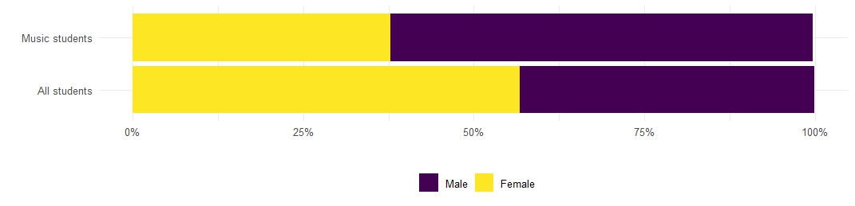
Figure 2: Gender of music students by academic year
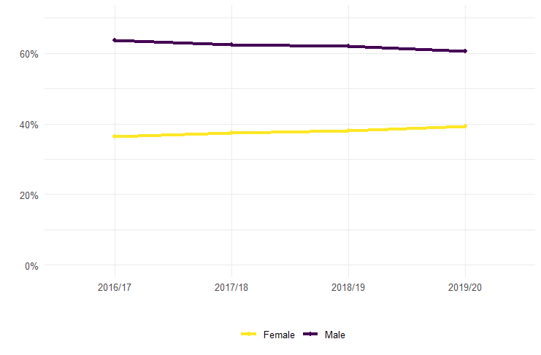
Figure 3: Music students’ (UG and PG) gender by institution type, 2016-17 to 2019-20
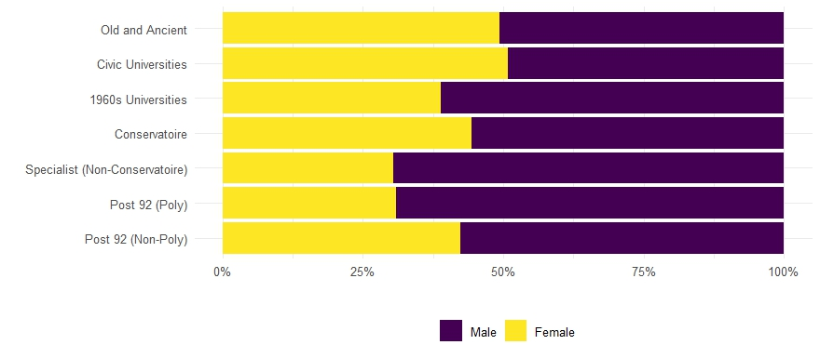

Figure 4. Gender inequalities across the pipeline from undergraduate music students to staff 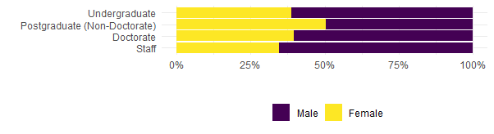
Figures 5-11. Gender breakdown by institution type
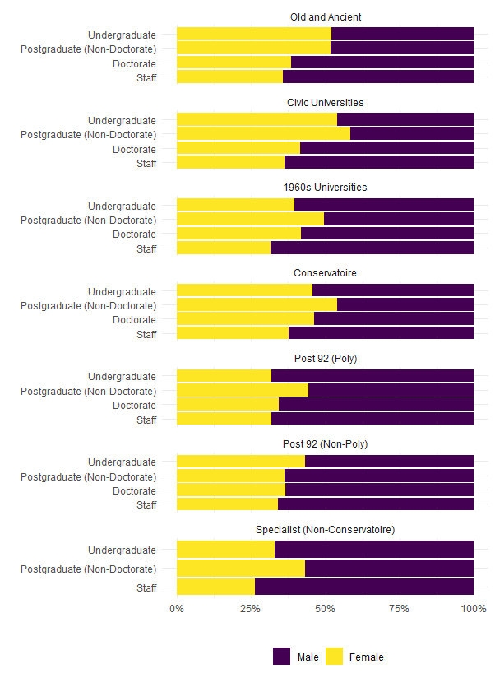

Figure 12: Class among UK-domiciled PGT students
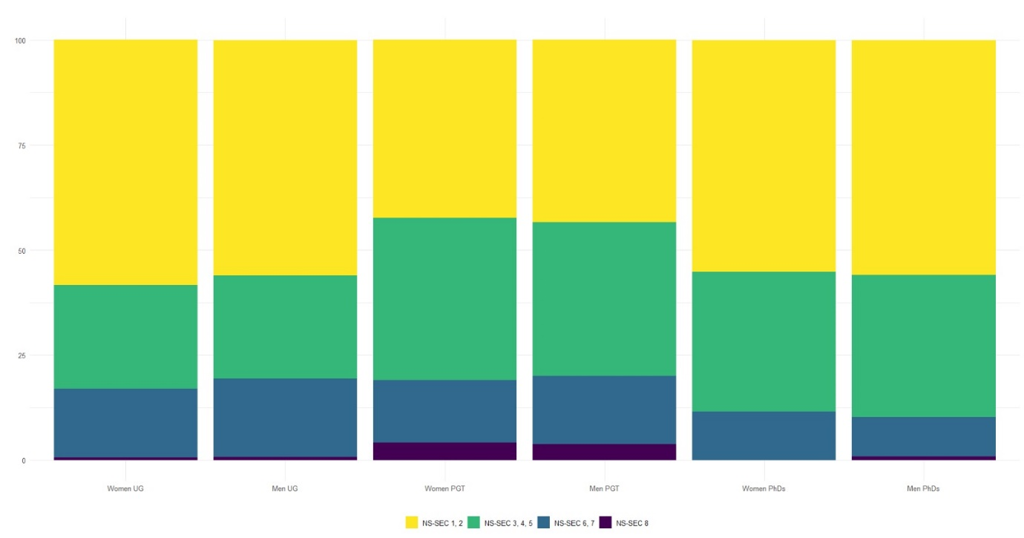
Table 1: ‘Race’ among UK-domiciled PGT students

 | % of men PGT (UK-domiciled students only)
Men Asian | 1.5
Men Black | 2.2
Men Chinese | 0.9
Men Mixed | 4
Men White | 91
 | % of women PGT (UK-domiciled students only)
Women Asian | 2
Women Black | 3
Women Chinese | 1
Women Mixed Race | 5
Women White | 89

In the UK, universities are often designated ‘post-1992’ or ‘pre-1992’, referring to the date when many teachers’ colleges and polytechnic institutions gained university status.
JACS codes (now updated as HECOS codes) classify academic subjects in UK higher education. This study includes all W3 courses (the general code for music degrees), as well as J930 (audio technology) and J931 (music recording).
I use inverted commas to draw attention to the constructedness of the concept and to counter views of racial categories as biologically rather than socially determined.
Specialist non-conservatoire institutions do not include gender at doctoral level due to the small numbers.

