**Combatting the antigenicity of common ragweed pollen and its primary allergen Amb a 1 with cold atmospheric pressure air plasma**

Nataša Hojnika,b, Vasyl Shvalyab, Janez Zavašnikb, Jernej Šribarc, Igor Križajc, and James L. Walsha,d

a Department of Electrical Engineering and Electronics, University of Liverpool, Brownlow Hill, Liverpool, L69 3GJ, United Kingdom.

b Department for Gaseous Electronics (F6), Jožef Stefan Institute, 1000 Ljubljana, Slovenia.

c Department of Molecular and Biomedical Sciences (B2), Jožef Stefan Institute, 1000 Ljubljana, Slovenia.

d York Plasma Institute, School of Physics, Engineering & Technology, University of York, Heslington, York, YO10 5DQ, United Kingdom.

**Corresponding author:** James L. Walsh, [james.l.walsh@york.ac.uk](mailto:james.l.walsh@york.ac.uk)

**Keywords:** Cold atmospheric pressure plasma; airborne allergens; common ragweed pollen; antigenicity reduction

**Abstract**

Airborne allergens, especially those originating from various types of pollen, significantly compromise the health and well-being of individuals on a global scale. Here, cold atmospheric pressure plasma (CAP) created in ambient air was used to treat highly allergenic and invasive *Ambrosia artemisiifolia* pollen. Immunoassays were used to evaluate the impact of CAP on the principal *A. artemisiifolia* allergen Amb a 1, demonstrating that >90% reduction in antigenicity could be achieved. Chemical analyses using Fourier Transform infrared revealed that CAP induced significant alterations to proteins on the surface of pollen grains, resulting in a 43% increase in the amide I peak area and a 57% increase in the amide II peak area. These findings were corroborated by Raman and X-ray photoelectron spectroscopy, which indicated that the protein modifications induced by CAP were due to carbonylation and nitration/nitrosylation processes. Beyond protein transformations, CAP also induced notable oxidation and modification of lipid-like compounds, polysaccharides and sporopollenin. Evident transformations at the chemical level translated into morphological changes at the grain surface, manifesting as increased roughness via significant outer-layer etching. These findings underscore the potential of CAP technology as a viable approach for mitigating against the allergenicity of pollen, providing a deeper understanding into the underlying chemical mechanisms.

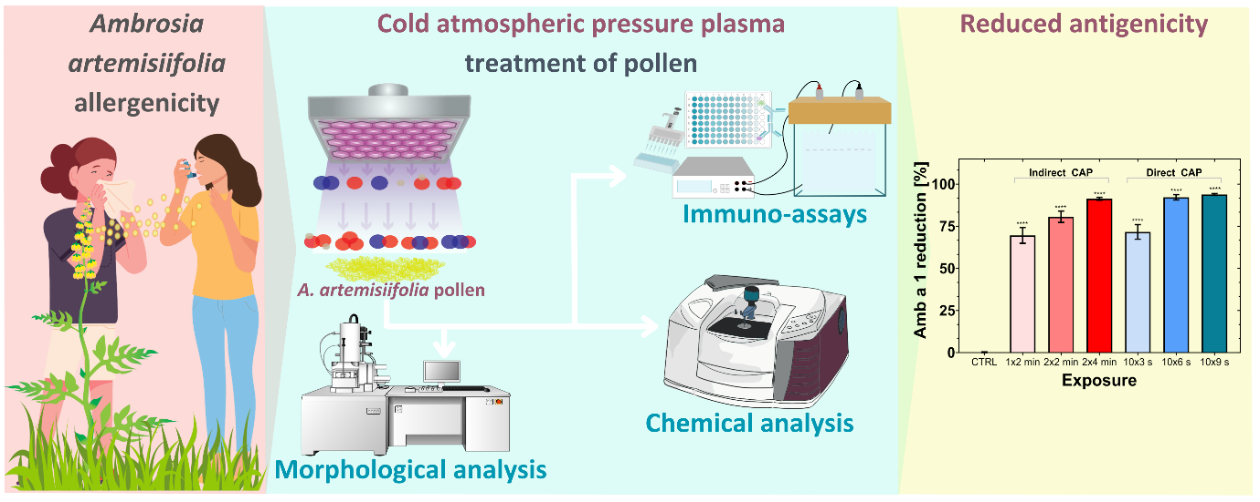

Graphical abstract

**1 Introduction**

Allergy or atopy is a clinical condition associated with immediate hypersensitivity reactions of the immune system towards specific antigenic substances, known as allergens. These compounds can be introduced into the body through inhalation, ingestion, tactile contact and injection, resulting in a range of health conditions such as allergic rhinitis or hay fever, bronchial asthma, food intolerances, and anaphylaxis [1]. Allergic diseases are among the most common immune system disorders. Recent studies have shown an increase in the prevalence of sensitization and the incidence of associated diseases, such as allergic rhinitis and atopic asthma, which began to rise steadily in the 1970’s and currently affect up to 40% of the population in most industrialized countries. Hence, respiratory disorders related to allergy have become one of the most significant causes of chronic respiratory disease [2]. Allergies are the 6th leading cause of chronic illness in the US, costing over 20 billion US Dollars annually [3]. In the European Union, asthma and allergic rhinitis alone result in over 100 million lost workdays and missed school days each year, causing economic losses between 55 and 151 billion Euros per year. This burden is expected to increase, with projections indicating that by 2025, more than 50% of Europeans will suffer from at least one type of allergy, affecting people of all ages, social backgrounds, and geographical regions [4]. Despite these costs, allergic respiratory diseases significantly reduce quality of life, impairing sleep, daily activities, productivity, concentration, and emotional well-being. Additionally, many patients experience side effects from prescribed medications, further diminishing their overall well-being [5].

Airborne allergens are the primary environmental agents responsible for respiratory allergies, particularly inhaled aeroallergens derived from different kinds of pollen [6]. The presence of pollen aeroallergens in the air reaches its maximum during the reproductive phase of seed-bearing plants. During this period, male gametophytes are produced and released in the form of pollen grains, which may contain allergenic proteins. Plants that are pollinated by wind pose a particular challenge, as they must release a significant amount of pollen to achieve successful reproduction, resulting in an exposure of humans to high levels of allergens [7,8]. One of the most problematic species in Europe, recognized for its highly allergenic properties and invasive nature, is common ragweed (*Ambrosia artemisiifolia*) with each individual ragweed plant producing over one billion pollen gains [9]. The IUIS database currently lists 11 distinct ragweed allergens, with Amb a 1 being the most significant due to its IgE sensitization rate between 90 and 95%. Amb a 1 belongs to the pectate lyase protein family and primarily aids in pollen growth by degrading pectins. Characterised as acidic non-glycosylated protein, it contains 397 amino acids and has a molecular weight of approximately 38 kDa [10]. The increasing prevalence of airborne allergens appears to be an inevitable consequence of global climate change and air pollution. Rising temperatures and elevated carbon dioxide concentrations have been found to prolong the pollen season and increase the abundance of pollen. Moreover, global warming further facilitates the geographic distribution of these allergens to regions that were previously unexposed [11]. In addition, modern houses are now constructed to limit ventilation to minimize heating and cooling expenses, which leads to additional accumulation of biophysical pollutants indoors [12]. The prospect of an ongoing rise in the incidence of the allergic respiratory conditions is worrisome. Although diseases such as allergic rhinitis do not inherently pose a threat to life, they can lead to illness and disability, and have a negative impact on overall quality of life [13]. Given the severity of allergy-related complications, a radical new approach is urgently needed to mitigate this widespread suffering.

Current approaches for the reduction and control of indoor allergens mostly involve methods such as air filtration where allergenic particles are trapped within a fibrous medium (*e.g.,* HEPA filtration). Although effective, these techniques have significant limitations, such as high energy requirements for air filtration, reduced efficacy when the filtration medium is saturated, and an inability to trap non-particulate pollutants like chemical vapours. Furthermore, improper maintenance of filtration devices can worsen the symptoms of respiratory allergies [14]. Over the past decade, cold atmospheric pressure plasma (CAP) has demonstrated an immense potential as a novel decontamination technique for the elimination of hazardous biological and chemical pollutants found in the air [15–19]. CAP produced using only air and electricity is a highly non-equilibrium system that exhibits remarkable physical and chemical characteristics. Electron temperatures in the plasma can exceed 30,000 K, while the temperature of neutral species remains near ambient; these unique conditions lead to the generation of multiple powerful decontamination modalities, including strong electric fields, high-energy ultraviolet photons, and most importantly, highly reactive oxygen and nitrogen species (RONS). These include short-lived species such as atomic oxygen (O) and nitrogen (N), hydroxyl radicals (OH), and superoxide (O2-), as well as long-lived species such as hydrogen peroxide (H2O2), ozone (O3), and various nitrogen oxides (NxOy) [20,21].

Until recently, the majority of advancements in the field of CAP-driven decontamination have focused on the inactivation of airborne pathogenic microorganisms. Notable investigations have explored inactivation of microbes such as *Escherichia coli*, *Pseudomonas alcaligenes*, *Pseudomonas fluorescens*, *Bacillus subtilis*, *Staphylococcus epidermidis*, *Penicillium expansum* and others, using different CAP systems built in laboratory-scale ventilation systems, capable of reaching up to 3.5 log reduction [22,23]. Besides microbial inactivation, CAP has also shown promise in decontamination of various organic contaminants, such as organochlorines, pesticides, mycotoxins, as well as allergens [24–26]. Although research on CAP's potential for allergen degradation has primarily focused on studies in food science, recent findings suggest that it may also be applicable to airborne allergens. Aerosolised allergens such as Der p 1, Der f 1, Asp f 1, Alt a 1 and Can f 1 have been exposed to air CAP produced with a dielectric barrier discharge system placed in the experimental exposure chamber. The results demonstrated significant reductions of allergenicity of the aerosols, ranging from 30% to 80% [27]. Nevertheless, no study has been conducted on CAP treatment of pollen derived allergens so far. This poses a unique challenge, as the potential CAP-induced rupture of pollen grains could result in the release of an even greater quantity of allergens, multiplying the issue and rendering CAP a poor choice in such applications.

The primary focus of this study centres on the treatment of common ragweed pollen and its prominent allergen, Amb a 1, using CAP. Two distinct CAP treatment modalities were investigated: an indirect Surface Barrier Discharge (SBD) system and a direct Dielectric Barrier Discharge (DBD) system. Plasma characteristics were evaluated through optical emission spectroscopy (OES) and Fourier transform infrared spectroscopy (FTIR). The protein composition of CAP-treated common ragweed pollen, with particular emphasis on Amb a 1, was analysed using a variety of techniques, including Bradford assay for total protein concentration, enzyme-linked immunosorbent assay (ELISA), sodium dodecyl sulphate polyacrylamide gel electrophoresis (SDS-PAGE), and immunoblotting. Additionally, the impact of plasma on the chemical and morphological surface characteristics of pollen grains was assessed using FTIR spectroscopy, Raman spectroscopy, X-ray photoelectron spectroscopy, and scanning electron microscopy (SEM). The outcomes of this investigation indicate that CAP exposure leads to a substantial reduction in Amb a 1 levels, alongside noteworthy alterations to the surface characteristics of exposed pollen grains.

**2 Experimental**

**2.1 Plasma Setup and Treatments**

An indirect CAP exposure was achieved using a surface barrier discharge (SBD) reactor that created 333 mm2 of air plasma at a distance of 5 mm from the pollen sample, thus forming an indirect treatment system where only longer-lived RONS could reach the target sample. A second reactor, employing a 31.4 mm2 diameter quartz coated powered electrode and a 20 mm2 diameter ground electrode was used to directly expose pollen to CAP. This was achieved by placing pollen samples on the grounded electrode for the duration of the CAP treatment, meaning both long- and short-lived RONS could interact with pollen surface (Fig. 1). Both reactors were powered using a home-made high voltage power source operating at kHz frequencies. For the purposes of comparison, both reactors were operated at a constant dissipated power of 18 W.

Preliminary tests were conducted to determine the optimal treatment durations for maximum allergen reduction. For indirect SBD treatments, exposure times of 1 x 2 minutes, 2 x 2 minutes, and 2 x 4 minutes were selected. During the 2 x 2 min and 2 x 4 min treatments, the pollen grains were stirred with a spoon to ensure an even distribution of plasma effluent throughout the sample. For direct plasma treatments, pollen was placed on the stainless-steel ground electrode with a 2 mm electrode separation and subjected to exposure times of 10 x 3 s, 10 x 6 s, and 10 x 9 s. A 15-second break was introduced between treatment repetitions to minimize the thermal effects generated by the direct plasma system. Each experiment was performed at least in duplicate and repeated independently more than three times.

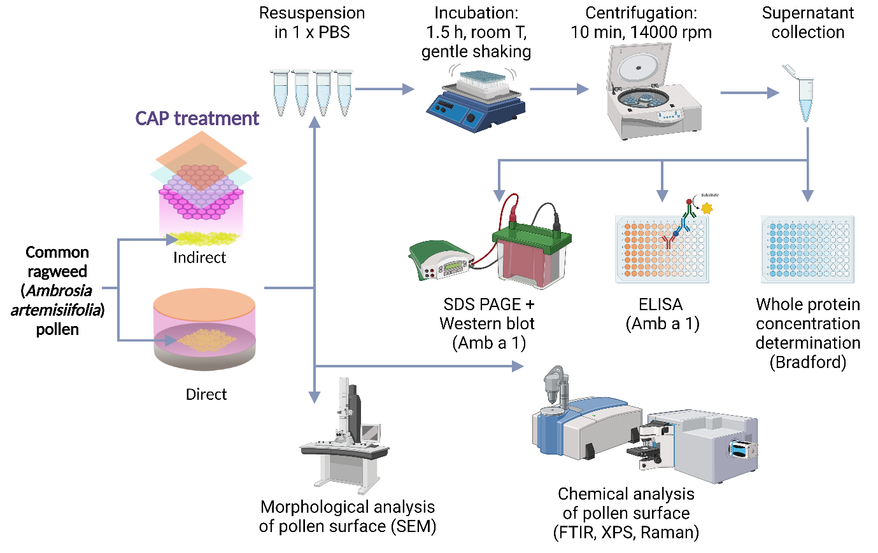

Fig. 1: Experimental scheme for treatment and assessment of pollen samples.

**2.2 Plasma Characterisation**

Optical emission spectroscopy (OES) was employed to obtain qualitative information of the excited states within the CAP generated in both reactors. The emitted light was directed into a spectrometer (Andor Shamrock 500i) through a 200 µm diameter optical fiber, featuring an entrance slit measuring 50 µm and an optical grating density of 600 lines mm-1. To detect long-lived IR active RONS created by the indirect plasma source, a Fourier-transform infrared spectroscopy system (FTIR, Frontier, Perkin Elmer, USA) was used. The measurements were conducted at a resolution of 4 cm−1 using a short-path gas cell with KBr windows and a path length of 100 mm.

**2.3 Preparation of the protein samples**

Pollen grains were incubated in 1 x PBS for 1.5 h at room temperature for ELISA tests and overnight at 4 oC, with gentle shaking. Afterwards, the pollen suspensions were centrifuged for 10 min at 14,000 rpm, followed by the recovery of the supernatants. The total protein concentrations were determined with addition of Bradford reagent and then measuring the absorbance at 595 nm.

**2.4 ELISA**

The concentration of major common ragweed allergen Amb a 1 was determined with the enzyme-linked immunosorbent assay (ELISA) kit, provided by Indoor Biotechnologies Inc., UK. In brief, protein samples and standards were introduced into an assay buffer, which had been preloaded into a 96-well microtiter plate coated with monoclonal antibody 2B6. These samples were subsequently incubated for 1 h at room temperature, shielded from direct sunlight, with gentle agitation. Following the incubation period, the plate was washed, and a mixture containing biotinylated detection antibody 4H7 was added. After another round of washing, a TMB substrate was introduced, followed by the addition of a stop solution to induce the development of a blue/yellow colour. The absorbance was measured at 450 nm. The reduction in antigenicity was expressed as normalised values relative to the control.

**2.5 Electrophoresis**

SDS-PAGE sample analysis was performed on 12.5% (m/v) hand-cast gels under reducing conditions (0.5% (m/v) SDS, 10% (v/v) glycerol, 50 mM DTT, 30 mM Tris/HCl, pH 6.8) following the procedure of Laemmli (1970) [28]. The proteins were stained using colloidal silver [29] and gel images captured on a ChemiDoc MP System (Bio-Rad, Hercules, CA, USA) imager.

**2.6 Immunoblotting**

Protein samples were analysed with SDS PAGE as described in section 2.5. The separated proteins were transferred onto a nitrocellulose membrane in Towbin buffer (25 mM Tris/HCl, 192 mM glycine, 0.1% (m/v) SDS and 20% (v/v) MeOH) using a constant current of 200 mA for a duration of 1.5 h. The membrane was blocked for 1 h at room temperature with 1% (m/v) blocking solution (Western Blocking Reagent, Roche, Switzerland) in Tris-buffered saline (TBS) (50 mM Tris; pH 7.5, 150 mM NaCl), followed by an overnight incubation with primary anti-Amb a 1 antibodies (diluted 1:1000 in 0.5% (m/v) blocking solution in TBS; Indoor Biotechnologies Inc., UK) at 4 °C. Subsequently, the membrane was washed twice for 10 min with TBS, containing 1% (m/v) Tween 20 (TBST), briefly rinsed with 0.5% (m/v) blocking solution in TBS, followed by a 1-hour incubation with secondary anti-mouse antibodies (diluted 1:10000 in 0.5% (m/v) blocking solution in TBS; Peroxidase AffiniPure Goat Anti-Mouse IgG (H+L), Jackson Immunoresearch, UK) at room temperature. The membrane was then washed 4 times with TBST and detection carried out with the Lumi-LightPLUS substrate (Roche, Switzerland) following the manufacturer's instructions. The signal was detected using a ChemiDoc MP System and the bands quantified using the ImageLab Software (Bio-Rad, Hercules, CA, USA) imager.

**2.7 FTIR**

Treated and untreated pollen samples were also analysed with the an FTIR spectrometer (Frontier, Perkin Elmer, USA), using an ATR module with a diamond crystal. The spectra were recorded as an average of 24 scans with a resolution of 4 cm-1 with air being taken as a background. Plasma induced chemical modifications of the pollen surface were tracked in the spectral range of 400 – 4000 cm-1.

**2.8 Raman**

Raman spectra were acquired using a He-Ne laser set at 633 nm and a confocal micro-Raman system (NT-MDT, model NTegra Spectra II, Ireland) that features a Peltier-cooled CCD sensor. To amplify the scattering signal from the pollen species, they were positioned on a high-purity, disc-shaped gold sputtering target (0.1 mm thickness, 57 mm diameter) sourced from Ted Pella Inc. A PLN20X/0.4 Plan Achromat Olympus Objective was used to direct and focus the laser. The exposure time was set at 1 s, with an accumulation count of 10.

**2.9 XPS**

The chemical composition of the untreated control samples and pollen samples exposed to direct CAP for 90 s and to indirect CAP for 480 s was determined using X-ray photoelectron spectroscopy (XPS). The analysis was performed with a TFA XPS spectrometer (Physical Electronics Inc., USA), supplied with a monochromated Al Kα X-Ray source and operated under ultra-high vacuum of 10-7 Pa and at 1486.6 eV. Samples were analysed at three different spots with a 0.4 mm diameter sample area and analysis depth of 3 to 5 nm. The take-off angle of the electron analyser to the sample in the XPS spectrometer was 45°. High resolution spectra were acquired at an energy resolution of ~0.6 eV and pass energy of 29 eV. Chemical compositions were determined with MultiPak software (Version 9.9.0).

**2.10 SEM**

The surface morphology of untreated and treated pollen samples was analysed using scanning electron microscopy (SEM, Prisma E, Thermo Fisher Scientific Inc., USA), operating at 2 kV and at elevated chamber pressure using water vapour as an amplifying gas. Before analysis, the pollen samples were submersed in a 2.5% glutaraldehyde fixative solution. After the overnight incubation, the dehydration of samples was performed in a sequence of increasing ethanol concentration, finally being placed in 100% ethanol, which was followed by the drying of the samples in hexamethyldisilazane (HMDS). Once in 100% HMDS, pollen samples were placed on bucky paper, and fixed on aluminium sample holders, which were inserted into the observation chamber of the SEM.

**2.11 Statistics**

Statistic calculations of the protein and Amb a 1 reductions according to Bradford assay, ELISA and immunoblotting were performed with Graph Pad Prism software (version 10.2.3) using two-way ANOVA and post-hoc multiple comparisons Tukey's test.

**3 Results and Discussion**

**3.1 Chemical characterisation of the plasma**

Optical emission spectra of plasma created by both systems was obtained (Fig. 2(b)). The recorded spectra from both systems were comparable, showing several emission lines between 290 and 410 nm, which are associated with the excited nitrogen second-positive band series. No other significant emission lines were observed between 280 and 600 nm. Given that both plasmas are created in the same gas, with the same electrical excitation it is not surprising that the emission spectra are similar in both cases. Critically, the main difference between the two CAP modalities examined in this study is in the composition of RONS arriving at the pollen surface. In the direct treatment scenario, short-lived and highly reactive RONS such as O, O2-, 1O2, OH and NO directly interact with the sample, these species are commonly known to affect the normal function of biological systems with the alternation of the main components involved [30]. In contrast, the spatial separation between plasma layer and sample in the direct treatment scenario acts as a spatial filter for RONS, significantly reducing the transport of highly reactive species to the pollen surface [31].

The composition of the gaseous phase generated by the in-direct system was characterised using FTIR spectroscopy. Fig 2(c) illustrates the infrared absorption spectra obtained at 120 s and 240 s after the initiation of plasma, these time intervals correspond to the those used in pollen treatment. The absorption spectra indicate distinct peaks located at wavenumbers of 1055 cm-1, 1275 cm-1, 1628 cm-1, 1715 cm-1, 1910 cm-1 and 2237 cm-1, corresponding to O3, N2O4, NO2, N2O5, and N2O, respectively. These absorption peaks were used to investigate the temporal behaviour of long-lived RONS present in the effluent of the CAP system (Fig. 2(d)). Evidently, within the initial 60 s of plasma operation, O3 was the dominant species, exhibiting the highest absorbance intensity and indicating the prevalence of reactive oxygen species (ROS) in the plasma effluent. Subsequently, the intensity of the O3 declined and eventually vanished after 120 s. Simultaneously, the peak associated with NO2 started to rise and became the prevalent species at 180 s. In contrast, N2O exhibited a linear increase, reaching its maximum at the end of the measurement period. The observed increase in the intensities of absorption peaks corresponding to NxOy clearly indicated a notable shift towards a gas phase chemistry that is dominated by reactive nitrogen species (RNS). The transition from O3 to NxOy, often referred to as 'O3 poisoning', can be attributed to two significant factors. Firstly, decomposition of O3 is partially induced by the thermal impact of plasma [32]. Secondly, the generation of NO consumes O, a precursor for O3 generation, while NO and O3 subsequently react to form NO2, further reducing O3 [33].

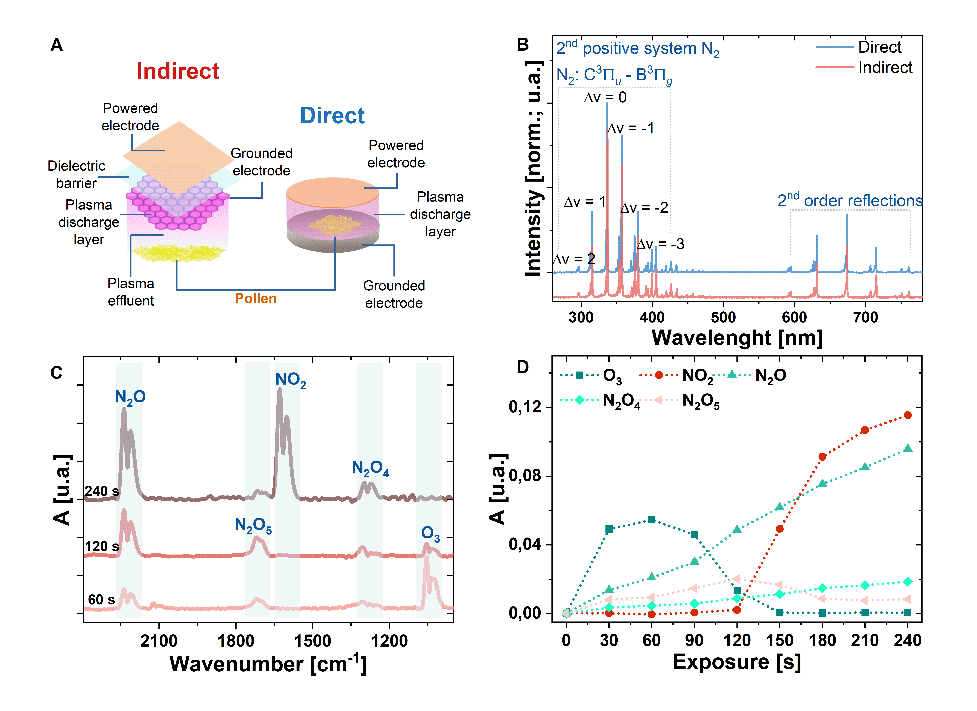

Fig. 2: (A) Schematic of indirect and direct CAP set-up; (B) OES spectra obtained from discharge layer of CAP generated with indirect and direct system; (C) FTIR spectra of CAP gaseous effluent generated with indirect system and recorded at 120 s and 240 s; (D) Time-resolved intensities of main FTIR spectral features of indirect CAP gaseous phase.

**3.2 Reduction of Amb a 1 and impact on the *A. artemisiifolia* total protein profile**

The application of CAP treatments resulted in significant reductions in both the whole protein content and Amb a 1, as shown in Fig. 3. The total protein concentration was determined using the Bradford assay (Fig. 3A), while the antigenicity level of Amb a 1 was measured separately through ELISA (Fig. 3B) and concentrations calculated from the intensities of the bands in western blots (Fig. 3C). All three methods demonstrated a consistent trend, indicating the reduction of concentration and antigenicity with increased CAP treatment. The most significant reduction rates were observed after the longest exposure times, namely 2 x 4 min for indirect CAP treatment and 10 x 9 s for direct CAP treatment. These reductions were as follows: 74% after indirect treatment and 86% after direct treatment for the whole protein; 91% after indirect treatment and 94% after direct treatment for Amb a 1, obtained from ELISA; and 64% after the indirect treatment and 86% after the direct treatment for Amb a 1 obtained from western blot. Notably, minor discrepancies were observed between the reduction rates of specific experimental points obtained when using ELISA and immunoblot. These variations could potentially be attributed to various factors, such as differences in sample preparation, assay sensitivity, or the specificities of the individual analytical methods. Nevertheless, the significant reductions in both the whole protein and Amb a 1 content demonstrate the effectiveness of CAP treatments in modulating protein levels, irrespective of the analytical approach employed. In addition, the analysis indicates that the highest efficiency was achieved with direct CAP system.

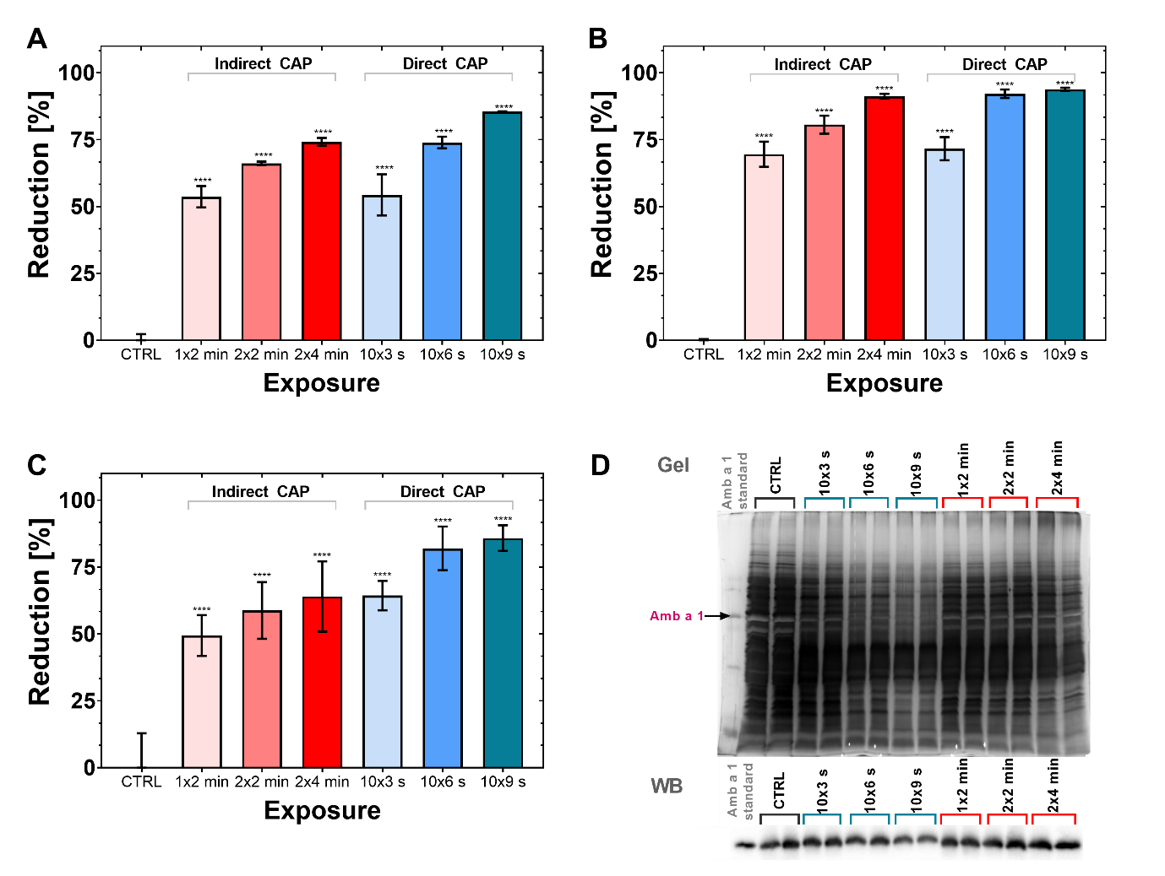

Fig. 3: CAP impact on A. artemisiifolia total protein profile and antigenicity of the Amb a 1; (A) reduction of total protein content; (B) Reduction of immunoreactive Amb a 1 content calculated from ELISA; (C) Reduction of immunoreactive Amb a 1 content calculated from the immunoblot; (D) SDS-PAGE gel with total protein profile and immunoblot of Amb a 1; A significant difference was performed by the two-way ANOVA, between control and treated samples (* p < 0.0332, ** p < 0.021, *** p < 0.0002 and **** p < 0.0001).

The CAP methods used in this study for the reduction of *A.* *artemisiifolia* allergens were highly effective when compared to previous studies focusing on plasma mediated allergen reduction. For example, a direct air fed DBD was applied to defatted peanut flour to inactivate the primary peanut allergen, Ara h 1. ELISA results indicated up to a 43% decrease in allergenicity after a 60-min exposure [34]. Another study exposed tropomyosin, a significant allergen in various crustaceans, including prawn, to an argon plasma jet, resulting in 17.6% and 26.9% reductions in IgE and IgG binding capacities after a 15-min treatment [35]. The results obtained in this study indicate a significantly higher level of reduction was achieved in shorter exposure times compared to prior studies, this is most likely attributed to the proficiency of CAP in targeting and removing surface-bound proteins without penetrating the internal matrix. Several previous studies have examined allergens that are likely internalised throughout a food matrix, thus making effective CAP treatment difficult, if not impossible. Ultimately, as CAP is primarily a surface treatment technique, its efficacy is limited by the ability of the RONS to penetrate into the sample.

Fig. 3D displays images of protein gels and immunoblots of the control and CAP treated *A. artemisiifolia* pollen samples. The representative gel shows the whole protein content of each experimental point without normalization, alongside the Amb a 1 standard. Notably, the protein bands observed in the case of samples exposed to direct plasma exhibited the most significant modification compared to the control, particularly for proteins with the highest and lowest molecular weights. Moreover, the intensity of the band, which was in line with the major band of the Amb a 1 standard (Fig. 3D, top panel, arrow), decreased with longer exposure times. In contrast, the disappearance of bands related to cleaved non-covalently associated chains of Amb a 1 that are typically susceptible to proteolysis, were less pronounced as observed in the case of the whole protein.

The SDS PAGE analysis of protein samples, which were normalized to the same concentration based on the determination of whole protein content, revealed that direct CAP exposure led to the formation of a significantly higher number of bands with apparent molecular masses between 22 and 40 kDa (Fig. SI1), indicating that the most important mechanism of CAP interaction with proteins likely involved CAP induced cleavage of peptide bonds. Similar trends were also noticed in samples exposed to indirect CAP; however, the changes in the protein band pattern were not as significant as those observed in the direct treatment group. As highlighted in Fig SI2, the Amb a 1 standard and Amb a 1 in the control migrated at the apparent molecular mass of about 48 kDa. For this reason, the cleaved products appeared at slightly higher molecular masses as well. Anti Amb a 1 western blots were performed with normalised concentrations of the total protein of each experimental point (Fig. 3D, bottom panel). As shown, no major differences were observed between most of the samples, except for the sample exposed to direct CAP for 10 x 9 s, where the bands appeared visibly less intense.

Other researchers have reported similar changes in the protein profiles of other allergens exposed to CAP; for example, Venkataratnam *et al.* reported a decrease in the intensities of SDS-PAGE gel bands and immunoblots corresponding to peanut allergens Ara h 1 and Ara h 2 following treatment in a pin-to-plate plasma reactor for more than 30 min [36]. While Wu *et al.* demonstrated significant changes in the SDS-PAGE gel profile of Asp f 1 after exposure to DBD plasma [27]. While Meinlschmidt *et al.* used direct and indirect air SBD plasma systems for treating soy protein isolate, resulting in the complete disappearance of its major protein bands [37]. Similarly, SDS-PAGE analysis of caseins exposed to spark and glow discharge plasmas revealed the loss of corresponding bands (Ng *et al*.). Conversely, no notable change in protein profile of peanut flour and Ara h 1 was observed upon exposure to a direct DBD plasma [34]. Interestingly, the study also reported on reduced intensities of the corresponding immunoblots, indicating that CAP treatments led to the loss of the Ara h 1 antigenicity [34]. In addition, Ekezie *et al*. presented similar findings on argon plasma jet treatment of tropomyosin [35]. Nevertheless, none of these studies demonstrated the generation of cleaved products following exposure to plasma.

The results demonstrate that CAP significantly altered the protein profile of *A. artemisiifolia* pollen. The reactivity of CAP generated in humid air with biological material is mostly attributed to its ability to generate high concentrations of RONS, especially OH, O2-, 1O2, O3, NO, and NO2 [21]. The combination of photochemical, photophysical and electrochemical activity may potentiate the impact of CAP on proteins, inducing the cleavage of peptide covalent bonds, modification of protein chain side groups and interacting with amino acids. This may lead to the formation of shorter peptides, unfolding and the conformational changes of proteins and aggregation [38]. Krewing *et al.* reported the DBD plasma induced degradation of proteins such as bovine serum albumin (BSA), lysozyme, RNase A, and superoxide dismutases A and B. This was partially reduced with the addition of OH scavenger D-mannitol, indicating that OH plays a key role in the CAP induced cleavage of the peptide bond [39]. It has also been shown that the short-lived CAP generated RONS such as OH, O2-, hydroperoxyl radicals (HOO) and NO contribute the most to the significant modifications of amino acids [40]. Given that the direct CAP system used in this study is capable of producing high concentrations of OH and other short-lived species, these results corroborate with our findings with direct CAP treatment resulting in more severe degradation of proteins. Pollen samples treated with the indirect CAP system were primarily exposed to long-lived RONS, especially O3 and NO2. The outcome in terms of protein profile modification was comparable to that observed during direct CAP treatments; however, OH and other short-lived RONS are unlikely to play a direct role given the spatial separation between plasma and target [41].

CAP exposure also affected the secondary and tertiary structure of the treated proteins. CAP induced modification of secondary structure included changes to the ratio of α-helixes, β-sheets and β-turns. This mostly likely occurs via RONS mediated modification of amino acid side chains, resulting in the disruption of non-covalent bonds inside the peptide chain [42,43]. Apart from peptide bond cleavage, the disruption of protein tertiary structure can be also attributed to the CAP oxidation of aromatics, particularly sulphur-containing amino acid side chains with thiol groups, which are strongly subjected to CAP oxidation [35,38,44]. All of these factors may contribute to the reduced immunoactivity of Amb a 1 which was most likely achieved by modification of the Amb a 1 epitope site by CAP induced degradation of the protein, disruption of its integrity, denaturation, and alternation of the epitope's amino acid side chains.

**3.3 Uncovering the CAP induced chemical modifications of the pollen surface**

The surface composition of pollen is chemically complex, containing a number of different organic compounds (Fig. 4A). Three complimentary methods were used for the chemical analysis of plasma-treated pollen samples, which were collected under the following conditions: indirect and direct CAP exposure for time periods of 2 x 4 min and 10 x 9 s, respectively. Significant peaks and bands of the FTIR spectra are presented in Table 1. As observed from Fig. 4B, CAP treatment led to significant chemical changes of the pollen surface which were the most evident in the FTIR spectral range between 1800 and 1000 cm-1.

Table 1: Wavenumbers taken from FTIR spectra, corresponding chemical groups bond vibrations of the control ragweed pollen sample surface.

|  |  |  |
| --- | --- | --- |
| Wavenumber[cm-1] | Chemical bond | Ref. |
| 3300 | O-H stretching vibrations of alcohol groups in pectin, cellulose, hemicellulose and lignin | [45] |
| 2900 and 2850 | sp2 hybridised C-H bond in aldehyde found in lipids, proteins and carbohydrates | [45,46] |
| 1735 | C=O stretching vibrations in lipids and pectin | [47–50] |
| 1700–1600 | C=O stretching vibrations typical for amide I in proteins | [45,46,50,51] |
| 1610 | Conjugated C=C stretching vibrations found in sporopollenin | [50,52] |
| 1580–1530 | N-H bending vibrations typical for amide II in proteins | [45,50,52] |
| 1510 | Phenolic ring vibrations | [45,49] |
| ~1450 | C-H bending vibrations found in all organic compounds on pollen surface | [48,50,53] |
| ~1415 | C-OH bending vibrations in carboxylic groups of lipids and proteins | [50] |
| 1375 | CH3 bending vibrations of cellulose, hemicelluloses and lipids | [45] |
| 1340 and 1315 | C-OH stretching vibrations of cellulose and hemicellulose | [45] |
| 1285 | C-OH stretching vibrations of pectin | [54] |
| 1225 | P=O stretching vibrations of phospholipids | [45,53] |
| 1190–900 | C-O-C stretching vibrations of cellulose, hemicellulose and sporopollenin | [46] |

Fig. 4C covers the spectral range from 1750 to 1590 cm-1, corresponding to vibration of C=O bonds found in various organic molecules. The cumulative peak area of the spectral range exhibited a respective increase of 35% and 48% in the samples treated with indirect and direct CAP, compared to the control group. The most notable differences were observed in the case of fitted peaks P1, P2, P4 and P5. Positioned at 1735 cm-1, P1 represents C=O stretching vibrations of alkyl esters found in pectin and lipids of waxy pollenkitt. P1 intensity doubled following direct CAP exposure, indicating drastic changes to the chemical structure. Moreover, the higher intensity of P1 can be also recognised as one of the indicators for lipid peroxidation [55,56]. This was also observed in the case of birch pollen grains exposed to O3. As reported, O3 reacted with double bounds of lipids chains, leading to the formation of more carbonyl groups and fatty acids saturation [57,58].

The peak areas of P2, P4 and P5 found at 1703, 1653 and 1626 cm-1, respectively, increased significantly in both the indirect and direct exposure scenarios. The peak areas underwent the following changes: P2 increased from 2.79 to 7.59 and 10.29, P4 increased from 14.22 to 19.16 and 20.34, and P5 increased from 9.75 to 18.3 for the indirect and direct treatment, respectively. Evidently, CAP treatments induced the formation of more carbonyl groups in the amide bonds on the pollen surface. While the intensity of P3 remained unaffected, it shifted towards higher wavenumbers (from 1669 to 1677 cm-1), suggesting a reduction in the molecular mass and indicating that CAP treatments led to the fragmentation of the ragweed pollen surface proteins. The notable alterations observed within the amide I region of the FTIR spectra provided evidence for the carbonylation of pollen proteins induced by CAP. The protein carbonylation predominantly takes place in the presence of ROS through three principal pathways: direct oxidation of amino acids bound within the protein structure, oxidative cleavage of the protein chain and addition of C=O groups as a result of generation of reactive intermediate products in the processes of lipid oxidation and glycation [59]. As such, the FTIR analysis corroborates the results obtained from SDS-PAGE, demonstrating that CAP treatments significantly altered the total protein profile of the exposed pollen surface.

Modifications in the spectral region from 1600-1500 cm-1 further indicate structural changes of the proteins and was composed of the fitted peaks P1, P2 and P3 (Fig. 4D). When compared to the control spectrum, indirect CAP treatment led to a 50% increase in the cumulative peak area, while exposure to the direct CAP resulted in 57% larger cumulative peak area. Clearly, P1, positioned at 1570 cm-1, was absent in the control sample spectrum and only became visible in the spectra of plasma treated samples. The P1 area reached 12.89 after indirect CAP exposure and 14.27 following direct CAP treatment. As both types of CAP led to the formation of RNS, P1 was most likely associated with asymmetrical stretching vibration of N-O bonds, indicative of the CAP-induced addition of nitro groups to the compounds [60]. Similarly in the control spectrum P2, at 1545 cm-1, is associated with the N-H bending vibration as a part of amide II [45,50,52]; both types of CAP exposure resulted in a greater than threefold increase in the P2 area. This pronounced change is again presumed to align with CAP's impact on nitration/nitrosylation of various compounds present on the pollen surface [61]. Certain segments of biomolecules are recognized to be particularly susceptible to the RNS attack. This includes phenol-based molecular portions like the aromatic amino acid tyrosine within protein chains and the phenol side chains of sporopollenin [62]. Furthermore, RNS are known for their ability to induce S-nitrosylation within cysteine side chains [59,63]. Comparable FTIR spectral features were also observed in the case of *Platanus* pollen when it was exposed to 0.025 ppm of NO2 [64]. In contrast, the area of P3 was reduced from 24.58 to 4.98 and 7.64 for samples exposed to indirect and direct CAP, respectively. Positioned at 1515 cm-1 and related to the phenolic ring vibrations, the reduced intensity of P3 indicated that CAP treatments induced drastic changes in pollen sporopollenin content [45,49]. A decrease in the peak position at similar a wavenumber was also observed when *Ambrosia* pollen was analysed following the fumigation of the plants with 80 ppb of O3 for the whole vegetation period [49]. Moreover, modifications in the sporopollenin FTIR profile were also reported in the case of NO2 treated *Platanus* pollen [64].

Following plasma treatments, the intensity of the cumulative peak area spanning from 1480 to 1250 cm-1 was nearly doubled (Fig. 4E). Composed of 7 fitted peaks, the most notable differences were observed in the case of P3 – P7. The increase of the P3 intensity, found at 1415 cm-1, indicated that both indirect and direct CAP led to the formation of more C-O bonds typical for carboxylic group [50]. Carboxylic groups likely originated from ozonolysis' Criegee mechanism within an oxidative environment, which led to the cleavage of alkene double bonds, found in unsaturated fatty acids of pollenkitt lipids and sporopollenin side phenolic parts [65,66]. The increased spectral features corresponding with carboxylic groups was also attributed to the CAP mediated cleavage of the glycosidic bond found in pollen polysaccharides [67]. Both CAP exposures led to a 3-fold intensity increase for P4, found at 1375 cm-1, indicating the formation of more -CH3 groups in polysaccharides and lipids [45], which is another indicator of CAP degradation of larger molecules into shorter transformation products. After exposure to CAP, significant changes were observed in the areas corresponding to P5, P6 and P7, positioned at 1340 cm-1, 1311 cm-1 and 1285 cm-1, respectively, which represent C-OH stretching vibrations of cellulose, hemicellulose and pectin [45,54]. Indirect CAP treatment resulted in a 5.5-fold increase in intensity for P5, a 11.6-fold increase for P6 and a 4-fold increase of P7. Similarly, direct CAP treatments led to the rise of the intensities of P5, P6 and P7, showing increases of 5, 10.5 and 3.8 times, respectively. These spectral changes can be attributed to CAP induced formation of more hydroxy groups in cellulose, hemicellulose and pectin as a result of depolymerisation [68,69].

CAP induced changes across the FTIR spectral range from 1250 cm-1 to 900 cm-1 were not as significant as the other presented spectra (Fig. SI4). In contrast to others, the cumulative peak of this spectral region, composed of 9 fitted peaks, was slightly reduced following CAP treatment, *i. e.*- 5% and 7% in the case of indirect and direct exposure, respectively. Positioned at 1225 cm-1, P1 represents the P=O bond found in phospholipids. Reduction of the P1 peak area of 54% and 39% indicated that the RONS generated by both types of CAP system could penetrate and affect the pollen cell membrane. A slight change in peaks P4, P6 and P8 located in the spectral region from 1150 to 900 cm-1 indicated that both CAP treatments also slightly affected C-O-C parts of cellulose and hemicellulose [46].

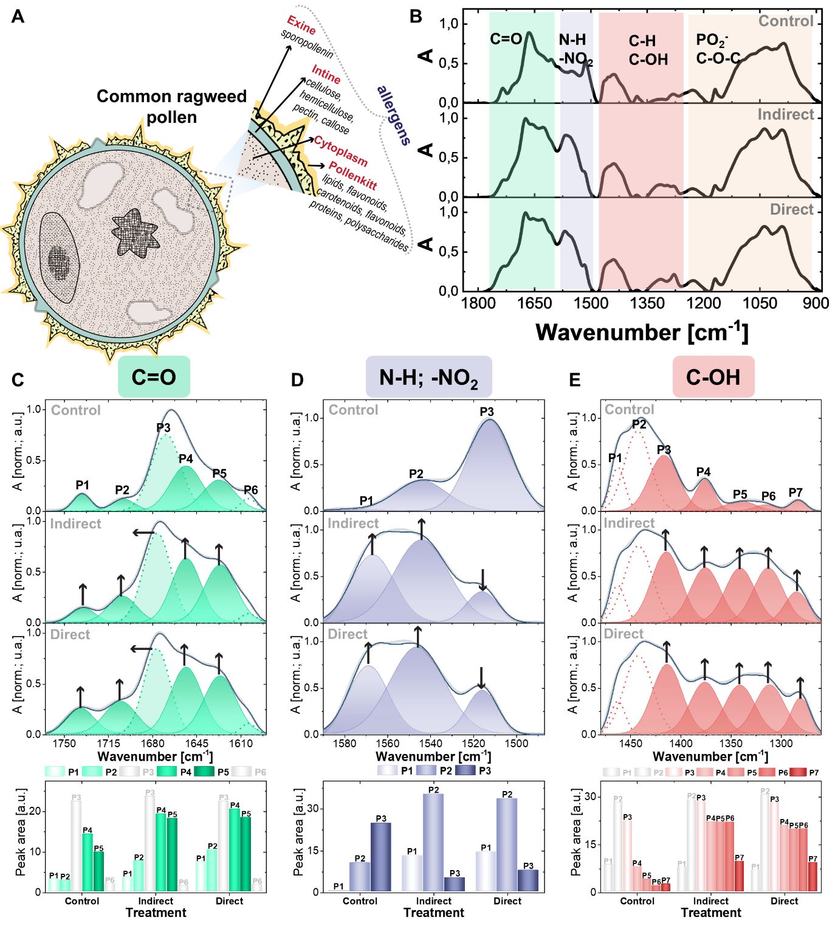

Fig. 4: Chemical characterisation of pollen surface with FTIR spectroscopy; (A) schematic of pollen and the composition of its surface; (B) general FTIR spectra of control sample and samples exposed to indirect and direct plasma treatment; fitted spectral areas of C=O (C), N-H and -NO2 (D), and C-OH (E) region; deconvolution of the spectra was performed with a use of Gaussian function.

Raman spectra, acquired within the 1800-500 cm-1 range, further corroborated the general trends observed within the FTIR data, while providing deeper insights into lower-frequency vibrational modes (Fig. 5). The increase in intensity of the peak at 1745 cm-1 exhibited a strong correlation with heightened ester C=O groups within lipid-like compounds, serving as conclusive evidence for the substantial modification of the pollenkitt due to CAP treatments [50]. Raman spectra revealed further alterations in protein structure due to CAP exposure. Firstly, the rearrangement of the spectral peak positions and an increase of the protein amide I band was observed in the region from 1700 to 1615 cm-1 which was most likely attributed to the presence of more C=O groups [70,71]. Secondly, notable changes in the amide III spectral region were observed, signifying a reduction in C-N/N-H content of the proteins following CAP treatment [72,73]. This outcome is likely a result of CAP-induced carbonylation of proteins, where lysine moieties act as one of the key precursors. The process involves OH abstraction from a hydrogen adjacent to the nitrogen of the lysine side amine group, leading to its loss and the generation of a new aldehyde group [59]. Furthermore, heightened intensities of the peaks in the spectral region 1500–1250 cm-1, with the special emphasis on the peak located at 1480 cm-1, could be generally attributed to the plasma induced rise of the in-plane bending and scissoring vibrations, typical for CH2 and CH3 in variety of compounds found on pollen surface. These findings underscore that CAP treatments trigger the degradation of these compounds into shorter fragments [50,70]. Moreover, the degradation of intine polysaccharides was evidenced by elevated intensities of peaks at 670, 620 and 535 cm-1, indicative of in-plane bending vibrations characteristic of monosaccharides [74].

In contrast to FTIR, Raman spectroscopy analysis revealed more prominently that CAP exposure caused substantial modifications to the phenolic/aromatic segments of pollen surface molecules, particularly sporopollenin within the exine layer feature within the spectral range from 1610 to 850 cm-1. This manifested as a decrease of the intensities of several peaks related to bonds found in sporopollenin, indicating that CAP treatments can partially remove it. Peaks at 1605 and 1565 cm-1 are correlated with the stretching vibrations of aromatic C=C bonds. Stretching vibrations of C-C bonds found in sporopollenin contributed to the formation of a peak at 1170 cm-1. The peak located at 850 cm-1 corresponded with the aromatic ring breathing vibrations [50]. Furthermore, the formation of new spectral feature at 1385 cm-1 most likely coincided with CAP mediated addition of nitro groups on aromatic rings of sporopollenin and proteins [75,76].

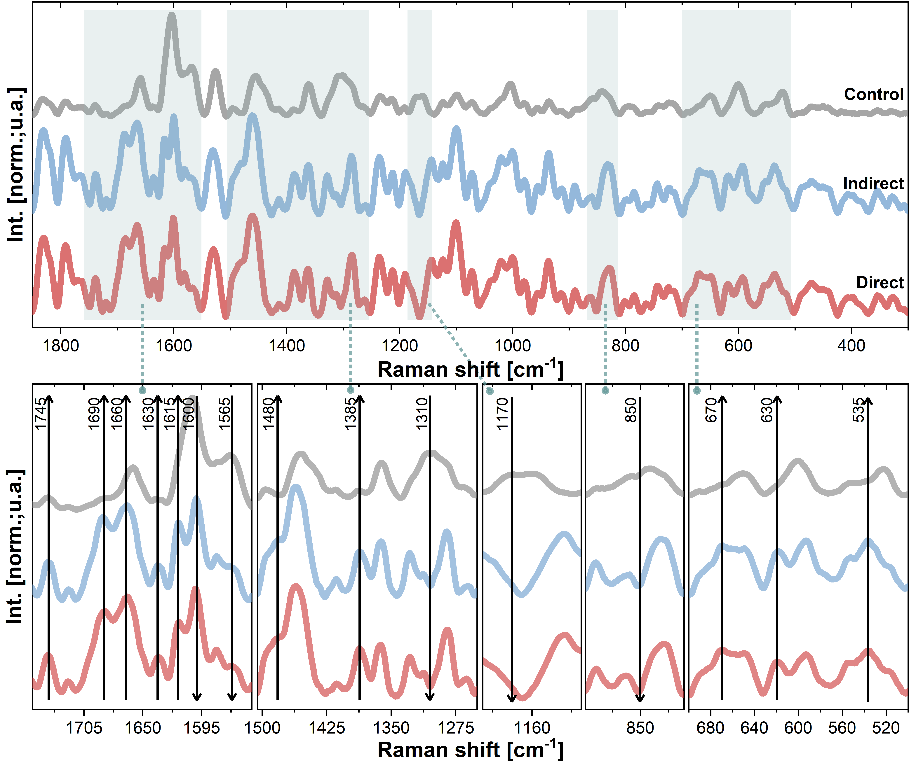

Fig. 5: Raman spectra of control sample and samples exposed to direct and indirect CAP with highlighted spectral regions with most significant modifications as a result of CAP treatments.

XPS data provides detailed information on the elemental composition of the surface of ragweed pollen. As observed from the survey spectrum of the non-treated sample (Fig. 6A), it was composed of 91.5% of carbon, 6.95% of oxygen and 1.5% of nitrogen. CAP treatments induced significant changes to the elemental surface composition. Carbon content was decreased to 88.8% after exposure to the indirect CAP and to 79.2% following the treatment with direct CAP. Simultaneously, the content of oxygen and nitrogen increased to 9.05 % and 2.2 %, respectively, after the indirect CAP treatment, and to 17.7 % and 2.7%, respectively, after the direct CAP treatment. Such changes yield a shift in the O/C ratio (Fig. 6B), moving from 0.08 in control to 0.1 and 0.22 in the samples exposed to indirect and direct CAP, respectively. Such results indicate that CAP treatments, especially direct exposure, led to the oxidation of the ragweed pollen surface.

The high-resolution spectra of carbon (C1s) exhibited four primary components (Fig. 6C). C1, located at a binding energy of approximately 284.5 eV, represents bonds such as C-C and C-H. While C2, with a binding energy around 285.7 eV, corresponds to single bonds between C and O or N (e.g., C-OH, C-N, C-N-C=O, C-COO). C3 was identified at a binding energy of around 287 eV and corresponds to double or two single bonds between C and O or N (e.g., C=O, C=N, C-O-C). Lastly, C4, appearing at binding energies around 289 eV, encompasses C=O bonds in carboxylic groups and esters [64,77,78]. It is noteworthy that C1 and C2 remained unaltered following CAP exposure, while the intensities of C3 and C4 increased; such results agree with the findings obtained from FTIR and Raman. The change in peak area was less pronounced in the case of indirect CAP treatment, where the intensities of C3 and C4 nearly doubled. In contrast, following direct CAP exposure, P3 was amplified by over threefold, while C4 increased by more than fivefold.

Significant alterations following the plasma treatment were also noted in the high-resolution spectra of oxygen (O1s; Fig. 6D). The O1s spectrum is characterized by three prominent peaks associated with the organic constituents of the pollen spectra (O2–O4), while O1 corresponds to oxygen bonded with inorganic substances, which manifested as a result of the XPS analysis process. O2 was positioned at a binding energy of approximately 532.3 eV and represents various bonds such as C-OH, O=C-O, O=C-N, and C-O-C-O-C. O3 appeared at around 533.7 eV, indicating the presence of O=C-OH and O=C-O-C bonds typical for proteins. Lastly, O4 exhibited a binding energy around 535 eV and corresponds to chemical bonds of O-(C=O)-O, commonly found in esters, and (C=O)-O-(C=O), prevalent in esters as well [77]. The impact of CAP treatment was most prominently observed as changes to the O3 and O4 components, confirming that CAP treatments significantly affected protein and lipid content of pollen surface. Unlike the C1s spectra, the disparity between CAP treatments was not as significant. The intensity of O3 more than doubled in both treatment cases, while O4 increased from 0.11 to 0.2 and 0.16 when samples were subjected to indirect and direct plasma treatment, respectively.

The high-resolution spectra of nitrogen additionally confirmed that CAP treatments affected the pollen surface proteins' structure (N1s; Fig. 6E). Three primary components can be observed in the untreated sample (N1-N3). N1 and N2 were located at approximately 399.8 eV and 401 eV, representing bonds N-C=O and C-N, respectively. Both CAP treatments resulted in an increase in the N1 peak area, reaching 0.7 for indirect plasma treatment and 0.98 for direct plasma treatment, compared to the initial value of 0.39. Conversely, the area of N2 slightly decreased by 8 % and 14 % following indirect and direct CAP treatments, respectively. N3, positioned around 402.3 eV, was associated with the presence of C-NH3+ and remained unchanged following the treatments [78]. CAP treatments, especially direct exposure, led to the formation of two new spectral features (N4 and N5), found at around 406.7 eV and 408.5 eV. N4 and N5 were indicative of bonds such as -NO2 and -O-NO2 [79]. As the CAP induced nitration/nitrosylation of the aromatic parts of the sporopollenin and proteins was also revealed by FTIR and Raman, XPS provided the information of formation of nitrooxy chemical groups which are typical for nitrated polysaccharides [80].

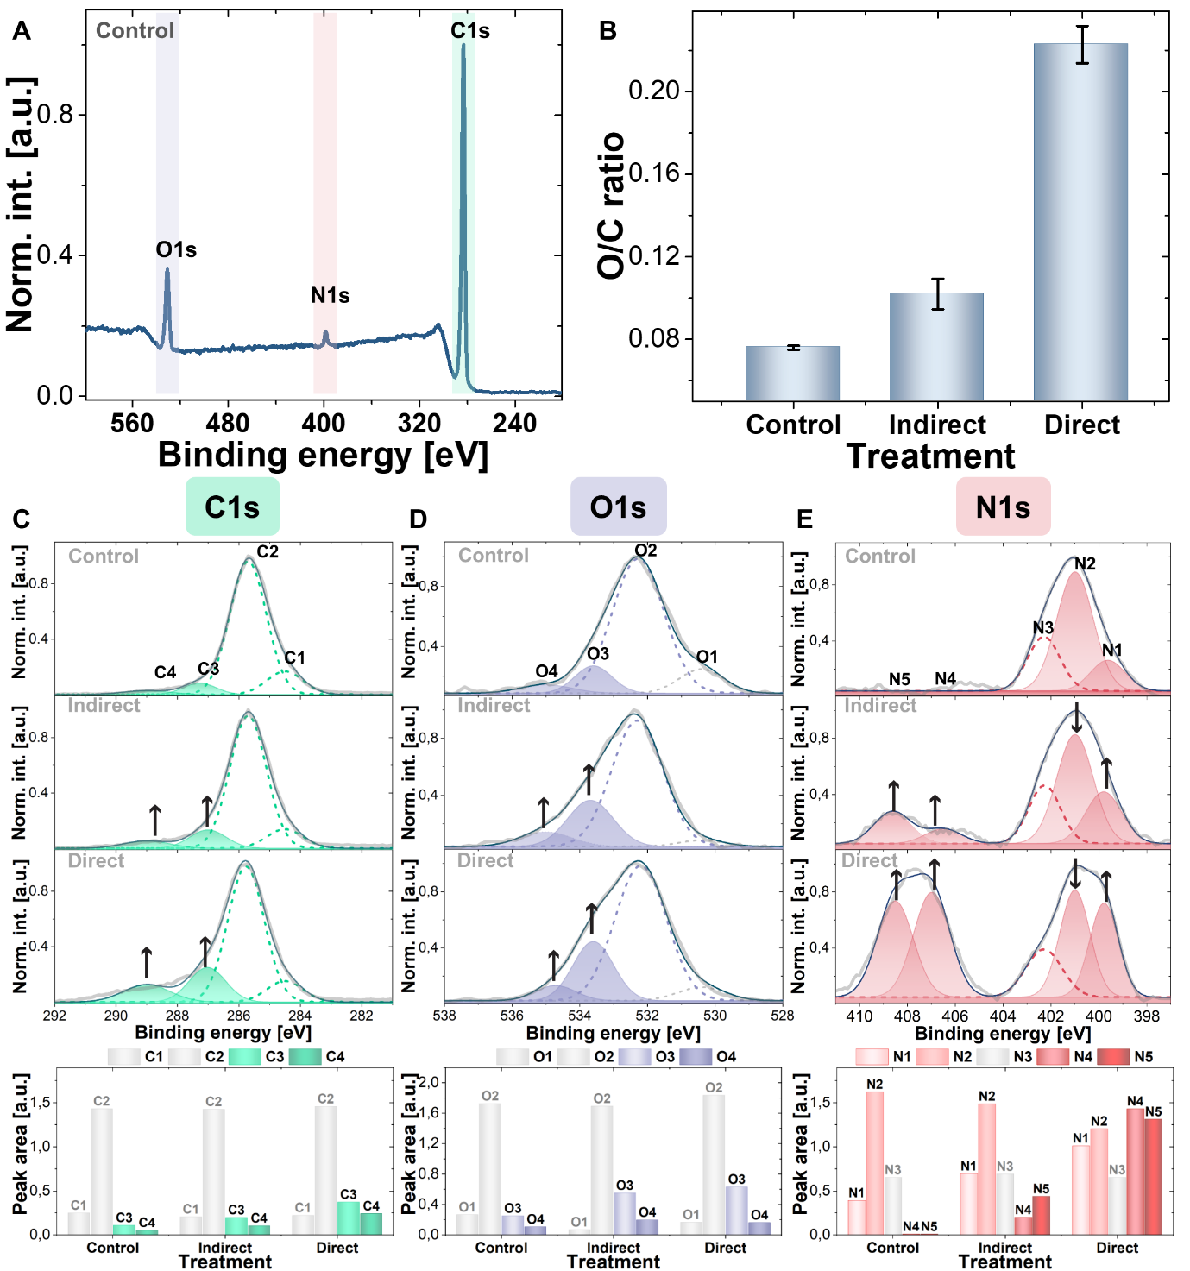

Fig. 6: Chemical characterisation of surface of non-treated pollen and pollen exposed to indirect and direct CAP with XPS spectroscopy; (A) survey spectra; (B) O/C ratio; high resolution spectra with fitted peaks (Gaussian function) of C1s (C), O1s (D) and N1s (E).

The spectroscopic methods used in this study provide complementary insights into the modifications induced by CAP on the ragweed pollen grain surface. The results highlight significant alterations in the pollen grain wall due to CAP treatments, demonstrating that RONS penetrating into its most inner part, known as the intine layer (Fig. 4A). Importantly, CAP did not selectively impact only the protein content and allergens of the grain wall; it also affects other biological components, including waxes, lipids, polysaccharides, and sporopollenin. As discussed previously, the principal mode of action in CAP treatment stems from its ability to generate high concentrations of RONS. Although components in the grain wall differ in their chemical structure, the presented spectroscopic results indicate that similar mechanisms are involved in CAP mediated modifications. The increase in spectral features associated with hydroxy, carbonyl, carboxyl, nitro, and nitrooxy groups suggests the generation of new chemical groups on the pollen surface primarily through CAP-induced oxidation and nitration. While direct treatment results in higher reduction rates of ragweed total protein content and the antigenicity of Amb a 1, FTIR and Raman analyses reveal that the severity of oxidation and nitration of components in the pollen grain wall do not differ between the presented CAP approaches. The increased formation of C-O and C=O groups and the increase of the intensities of their corresponding FTIR peaks was also reported in the case of *Aspergillus ochraceus* hyphe exposed to an ambient air SBD [81]. In addition, microspectroscopic FTIR and Raman studies on the effects of an air DBD on *B. subtilis* and *E. coli* revealed the increase of the carbonyl and carboxyl groups [82] . Moreover, the increase in abundance of FTIR spectral features, which correspond to nitro groups, was recorded when an air plasma was used for the treatment of aspartic and glutamic acid, both important components of bacterial spore structure [83]. The spectral modifications also indicated structural changes such as distorted secondary structure of proteins alongside skeletal and side-chains bond cleavages of polymeric compounds found in the pollen wall. Further, modified FTIR amide I and amide II spectral regions of guar seed flour, treated with air plasma, indicated the destruction of the protein secondary structure of exposed samples [84]. Changes of the FTIR spectra that indicated protein structure deformation and depolymerisation of the glycosidic linkages were also reported when jackfruit seed flour was exposed to air plasma [85]. While the reduction of FTIR peak intensities corresponding to glycosidic C-O-C bonds were also reported when mango seed kernel starch was exposed to air plasma generated in a pin to plate plasma reactor [86].

**3.3 Morphological characterisation**

The morphological modifications of *A.* *artemisiifolia* pollen following CAP exposure were examined with SEM (Fig. 7). Untreated samples (Fig. 7 A-B) contained pollen grains of a similar spherical shape with a diameter around 20 µm with typical surface ornamentation, exhibiting small spikes in the shape of cones. Each spike was approximately 2 µm in diameter and covered with a thick pollenkitt layer (Fig. 3C). Fig. 3(D-E) and 3(G-H) show pollen samples exposed to indirect and direct CAP, respectively, under the longest exposure conditions for both systems (*i.e.*, 2 x 4 min and 10 x 9 s). Notably, CAP treatments did not significantly reduce the size of the pollen, nor did they induce the fragmentation of the pollen grains. Thus, CAP does not promote additional pollen allergen release, which can happen in the case of pollen wall breakdown. However, CAP caused significant changes on the pollen surface (Fig. 3 F&I). Both exposure modalities made the layer of pollenkitt thinner, with the surface appearing significantly rougher with sharper spikes in the comparison to the control. The modifications were especially evident in the case of direct exposure (Fig. 3I), which caused the formation of a large number of fragments on the pollen surface and less defined tips on the spikes, demonstrating that direct treatment was more aggressive in comparison to the indirect treatment.

CAP generated RONS are known to affect the cell integrity, starting at the outer layer and migrating inwards with longer treatment time. The etching effect is a likely consequence of the chemical interactions between RONS and the grain surface, resulting in the breaking of the bonds of biomolecules such as lipids, polysaccharides and proteins present in the pollenkitt, exine and intine. No similar studies examining the impact of CAP on pollen grains have been identified; yet a number of studies have considered CAP interaction with similar biological materials. In a study using a high voltage atmospheric cold plasma (HVACP), with characteristics similar to the direct system used in this study, *Aspergillus flavus* spores were exposed and analysed using SEM, with the results highlighting structural damage of the outer layer of the spore cell wall and the generation of considerable cell debris [87]. Similarly, it was reported that the surface of *Saccharomyces cerevisie* became rougher following the exposure to an air CAP jet. In addition, the same treatment of *A. flavus* spores led to the fragmentation of the spore cell wall, which was not observed in the case of untreated samples [88]. A SBD system, similar to the indirect CAP system used in this study, was used to treat spores of phytopathogenic fungi species *Botrytis cinerea*, *Monilinia fructicola*, *Aspergillus carbonarius* and *Alternaria alternata*. SEM analysis revealed that plasma treatment led to significant morphological damages of the spore surface, inducing complete removal of outer layer of the cell wall [89]. Other comparable methods were studied for their effects on pollen, including exposure to O3, NO2 and O3 in the combination with NO2 on *Platanus* pollen, the results indicated significant damage to the pollen exine following exposure [90]. Similarly, the surface morphology of the *Quercusmongolica* pollen was comparingly altered following the exposure to 2 ppm of NO2 [91].

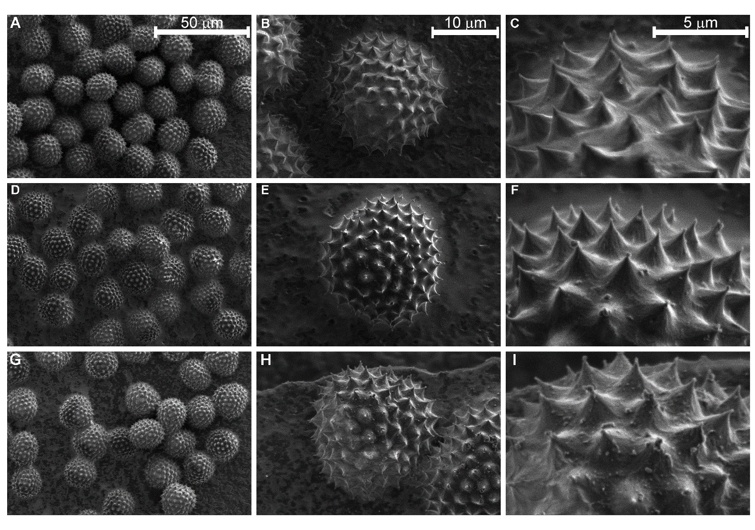

Fig. 7: SEM secondary electron micrographs of the surface features of A. artemisiifolia pollen at increasing magnification of control (A-C), treated with indirect CAP for 2 × 4 min (D-F) and treated with direct CAP for 10 × 9 s (G-I) sample.

**4 Conclusions**

This study sheds light on the impact of CAP treatment of *A. artemisiifolia* pollen, a significant source of problematic aeroallergens. Direct CAP induced significant chemical and structural modification of the primary *A. artemisiifolia* allergen, Amb a 1. This impact was primarily attributed to CAP induced oxidation, resulting in chain cleavage within the protein. Consequently, the antigenicity of Amb a 1 was considerably diminished. Additionally, CAP treatment was shown to influence various other essential compounds present on the pollen surface. These findings underscore the potential of CAP technology as an innovative approach for air purification, mitigating the issues related to airborne allergens and associated health concerns. While the results are encouraging, further research is warranted to expand upon these findings, including assessments of the allergenicity of CAP-treated allergens via immunological methods. Moreover, the method has only been tested on one type of pollen, whereas a multitude of pollen types contribute to seasonal allergies. Additionally, other aeroallergens such as house dust mites, animal saliva, dander, urine allergens, and mold spores also play a significant role in allergic reactions. Despite these encouraging results, thorough research is necessary to determine the mechanisms of action for the degradation of each individual aeroallergen. This will ensure the technology's efficacy across a broader spectrum of allergens and solidify its application in comprehensive air purification solutions. Finally, before a functional CAP-based air-treatment device can be realised, the engineering challenge of removing long-lived and potentially harmful RONS from the device effluent must be overcome, this is vital to ensure CAP-based air treatment systems do not pose a risk to user safety.

**Acknowledgement:**

This work was supported grants Z3-3210 (to N.H.) and P1-0207 (to I.K.) from the Slovenian Research and Innovation Agency (ARIS) and grants EP/R041849/1, EP/N021347/1, and EP/S025790/1 from the UK Engineering and Physical Science Research Council (EPSRC).

**References**

[1] A.K. Abbas, A.H. Lichtman, P. Shiv, Basic immunology: functions and disorders of the immune system, 7th ed., Elsevier, United States, Philadelphia, 2023.

[2] P.G. Holt, W.R. Thomas, Sensitization to airborne environmental allergens: unresolved issues, Nat Immunol 6 (2005) 957–960. https://doi.org/10.1038/ni1005-957.

[3] T. Yan, X. Song, X. Ding, X. Liu, T. Lan, T. Chen, M. Wang, M. Wang, Exposure to household dust, allergens, and endotoxin and allergy-related outcomes alternation in the general U.S. population, Environ Res 226 (2023) 115713. https://doi.org/10.1016/j.envres.2023.115713.

[4] EAACI, The European Academy of Allergy and Clinical Immunology (EAACI) Advocacy Manifesto Tackling the Allergy Crisis in Europe-Concerted Policy Action Needed, (2015).

[5] E.O. Meltzer, J.R. Farrar, C. Sennett, Findings from an Online Survey Assessing the Burden and Management of Seasonal Allergic Rhinoconjunctivitis in US Patients, Journal of Allergy and Clinical Immunology: In Practice 5 (2017) 779-789.e6. https://doi.org/10.1016/j.jaip.2016.10.010.

[6] L. Martorano, A.E. Erwin, Aeroallergen exposure and spread in the modern era, J Allergy Clin Immunol Pract 6 (2018) 1835–1842. https://doi.org/10.1016/j.jaip.2018.08.014.

[7] S. V. Guryanova, E.I. Finkina, D.N. Melnikova, I. V. Bogdanov, B. Bohle, T. V. Ovchinnikova, How Do Pollen Allergens Sensitize?, Front Mol Biosci 9 (2022) 900533. https://doi.org/10.3389/FMOLB.2022.900533.

[8] M. Sinha, R.P. Singh, G.S. Kushwaha, N. Iqbal, A. Singh, S. Kaushik, P. Kaur, S. Sharma, T.P. Singh, Current Overview of Allergens of Plant Pathogenesis Related Protein Families, The Scientific World Journal 2014 (2014). https://doi.org/10.1155/2014/543195.

[9] N.R. Jones, M. Agnew, I. Banic, C.M. Grossi, F.J. Colón-González, D. Plavec, C.M. Goodess, M.M. Epstein, M. Turkalj, I.R. Lake, Ragweed pollen and allergic symptoms in children: Results from a three-year longitudinal study, Science of The Total Environment 683 (2019) 240–248. https://doi.org/10.1016/J.SCITOTENV.2019.05.284.

[10] K.W. Chen, L. Marusciac, P.T. Tamas, R. Valenta, C. Panaitescu, Ragweed Pollen Allergy: Burden, Characteristics, and Management of an Imported Allergen Source in Europe, Int Arch Allergy Immunol 176 (2018) 163–180. https://doi.org/10.1159/000487997.

[11] I.R. Lake, N.R. Jones, M. Agnew, C.M. Goodess, F. Giorgi, L. Hamaoui-Laguel, M.A. Semenov, F. Solomon, J. Storkey, R. Vautard, M.M. Epstein, Climate change and future pollen allergy in Europe, Environ Health Perspect 125 (2017) 385–391. https://doi.org/10.1289/EHP173.

[12] K.H. Kim, S.A. Jahan, E. Kabir, A review on human health perspective of air pollution with respect to allergies and asthma, Environ Int 59 (2013) 41–52. https://doi.org/10.1016/J.ENVINT.2013.05.007.

[13] B. Cvetkovski, V. Kritikos, R. Tan, K. Yan, E. Azzi, P. Srour, S. Bosnic-Anticevich, A qualitative investigation of the allergic rhinitis network from the perspective of the patient, Npj Primary Care Respiratory Medicine 2019 29:1 29 (2019) 1–8. https://doi.org/10.1038/s41533-019-0147-5.

[14] B.F. Leas, K.E. D’Anci, A.J. Apter, T. Bryant-Stephens, M.P. Lynch, J.L. Kaczmarek, C. A. Umscheid, Effectiveness of indoor allergen reduction in asthma management: a systematic review, Journal of Allergy and Clinical Immunology 141 (2018) 1854–1869. https://doi.org/10.1016/j.jaci.2018.02.001.

[15] P. Zhou, Y. Yang, A.C.K. Lai, G. Huang, Inactivation of airborne bacteria by cold plasma in air duct flow, Build Environ 106 (2016) 120–130. https://doi.org/10.1016/J.BUILDENV.2016.06.026.

[16] Y. Liang, Y. Wu, K. Sun, Q. Chen, F. Shen, J. Zhang, M. Yao, T. Zhu, J. Fang, Rapid inactivation of biological species in the air using atmospheric pressure nonthermal plasma, Environ Sci Technol 46 (2012) 34. https://doi.org/10.1021/es203770q.

[17] N.S. Heo, M.K. Lee, G.W. Kim, S.J. Lee, Park J. Y., Park T. J., Microbial inactivation and pesticide removal by remote exposure of atmospheric air plasma in confined environments, J Biosci Bioeng 117 (2014) 81–85. https://doi.org/10.1016/j.jbiosc.2013.06.007.

[18] A.A. Assadi, A. Bouzaza, D. Wolbert, Comparative study between laboratory and large pilot scales for VOC’s removal from gas streams in continuous flow surface discharge plasma, Chemical Engineering Research and Design 106 (2016) 308–314. https://doi.org/10.1016/J.CHERD.2015.12.025.

[19] W. Abou Saoud, A.A. Assadi, A. Kane, A.V. Jung, P. Le Cann, A. Gerard, F. Bazantay, A. Bouzaza, D. Wolbert, Integrated process for the removal of indoor VOCs from food industry manufacturing: Elimination of Butane-2,3-dione and Heptan-2-one by cold plasma-photocatalysis combination, J Photochem Photobiol A Chem 386 (2020) 112071. https://doi.org/10.1016/J.JPHOTOCHEM.2019.112071.

[20] M.I. Hasan, J.L. Walsh, Numerical investigation of the spatiotemporal distribution of chemical species in an atmospheric surface barrier-discharge, J Appl Phys 119 (2016) 203302. https://doi.org/10.1063/1.4952574/142642.

[21] X. Lu, G. Naidis, M. Laroussi, S. Reuter, D.B. Graves, K. Ostrikov, Reactive species in non-equilibrium atmospheric-pressure plasmas: Generation, transport, and biological effects, Phys Rep 630 (2016) 1–84. https://doi.org/10.1016/j.physrep.2016.03.003.

[22] A.C.K. Lai, A.C.T. Cheung, M.M.L. Wong, W. S. Li, Evaluation of cold plasma inactivation efficacy against different airborne bacteria in ventilation duct flow, Build Environ 98 (2016) 39–46. https://doi.org/10.1016/j.buildenv.2015.12.005.

[23] M.J. Gallagher, N. Vaze, S. Gangoli, V.N. Vasilets, A.F. Gutsol, T.N. Milovanova, S. Anandan, D.M. Murasko, A.A. Fridman, Rapid inactivation of airborne bacteria using atmospheric pressure dielectric barrier grating discharge, IEEE Transactions on Plasma Science 35 (2007) 1501–1510. https://doi.org/10.1109/TPS.2007.905209.

[24] S. Pascal, D. Moussa, E. Hnatiuc, J.-L. Brisset, Plasma chemical degradation of phosphorous-containing warfare agents simulants, J Hazard Mater 175 (2010) 1037–1041. https://doi.org/10.1016/j.jhazmat.2009.10.114.

[25] U. Cvelbar, J.L. Walsh, S. Reuter, B. Thierry, C. Carles, C. Miron, N. Hojnik, A. Jurov, H. Puliyalil, M. Gorjanc, S. Portal, R. Laurita, V. Colombo, J. Schäfer, A. Nikiforov, M. Modic, O. Kylian, M. Polak, L. Cedric, J.M. Canal, C. Canal, M. Gherardi, K. Bazaka, P. Sonar, K.K. Ostrikov, D. Cameron, S. Thomas, K.-D. Weltmann, White paper on the future of plasma science and technology in plastics and textiles, Plasma Processes and Polymers 19 (2018) 1700228. https://doi.org/10.1002/ppap.201700228.

[26] H. Tolouie, M.A. Mohammadifar, G. Ghomi, M. Hashemi, Cold atmospheric plasma manipulation of proteins in food systems, Crit Rev Food Sci Nutr 58 (2017) 2583–2597. https://doi.org/10.1080/10408398.2017.1335689.

[27] Y. Wu, Y. Liang, K. Wei, W. Li, M. Yao, J. Zhang, Rapid allergen inactivation using atmospheric pressure cold plasma, Environ Sci Technol 48 (2014) 2901–2909. https://doi.org/10.1021/es5003988.

[28] U.K. Laemmli, Cleavage of Structural Proteins during the Assembly of the Head of Bacteriophage T4, Nature 1970 227:5259 227 (1970) 680–685. https://doi.org/10.1038/227680a0.

[29] C.R. Merril, D. Goldman, S.A. Sedman, M.H. Ebert, Ultrasensitive stain for proteins in polyacrylamide gels shows regional variation in cerebrospinal fluid proteins, Science 211 (1981) 1437–1438. https://doi.org/10.1126/SCIENCE.6162199.

[30] M.P. Murphy, A. Holmgren, N.G. Larsson, B. Halliwell, C.J. Chang, B. Kalyanaraman, S.G. Rhee, P.J. Thornalley, L. Partridge, D. Gems, T. Nyström, V. Belousov, P.T. Schumacker, C.C. Winterbourn, Unraveling the biological roles of reactive oxygen species, Cell Metab 13 (2011) 361–366. https://doi.org/10.1016/j.cmet.2011.03.010.

[31] B.A.B. Salgado, S. Fabbri, A. Dickenson, M.I. Hasan, J.L. Walsh, Surface barrier discharges for Escherichia coli biofilm inactivation: Modes of action and the importance of UV radiation, PLoS One 16 (2021) e0247589. https://doi.org/10.1371/JOURNAL.PONE.0247589.

[32] S. Park, W. Choe, C. Jo, Interplay among ozone and nitrogen oxides in air plasmas: Rapid change in plasma chemistry, Chemical Engineering Journal 352 (2018) 1014–1021. https://doi.org/10.1016/J.CEJ.2018.07.039.

[33] M.A. Malik, K.H. Schoenbach, R. Heller, Coupled surface dielectric barrier discharge reactor-ozone synthesis and nitric oxide conversion from air, Chemical Engineering Journal 256 (2014) 222–229. https://doi.org/10.1016/J.CEJ.2014.07.003.

[34] H. Venkataratnam, C. Sarangapani, O. Cahill, C.B. Ryan, Effect of cold plasma treatment on the antigenicity of peanut allergen Ara h 1, Innovative Food Science & Emerging Technologies 52 (2019) 368–375. https://doi.org/10.1016/J.IFSET.2019.02.001.

[35] F.G.C. Ekezie, D.W. Sun, J.H. Cheng, Altering the IgE binding capacity of king prawn (Litopenaeus Vannamei) tropomyosin through conformational changes induced by cold argon-plasma jet, Food Chem 300 (2019) 125143. https://doi.org/10.1016/J.FOODCHEM.2019.125143.

[36] H. Venkataratnam, O. Cahill, C. Sarangapani, P.J. Cullen, C. Barry-Ryan, Impact of cold plasma processing on major peanut allergens, Scientific Reports 2020 10:1 10 (2020) 1–11. https://doi.org/10.1038/s41598-020-72636-w.

[37] P. Meinlschmidt, E. Ueberham, J. Lehmann, K. Reineke, O. Schlüter, U. Schweiggert-Weisz, P. Eisner, The effects of pulsed ultraviolet light, cold atmospheric pressure plasma, and gamma-irradiation on the immunoreactivity of soy protein isolate, Innovative Food Science & Emerging Technologies 38 (2016) 374–383. https://doi.org/10.1016/J.IFSET.2016.06.007.

[38] L. Xu, H. Hou, B. Farkas, K.M. Keener, A.L. Garner, B. Tao, High voltage atmospheric cold plasma modification of bovine serum albumin, LWT 149 (2021). https://doi.org/10.1016/J.LWT.2021.111995.

[39] M. Krewing, B. Schubert, J.E. Bandow, A Dielectric Barrier Discharge Plasma Degrades Proteins to Peptides by Cleaving the Peptide Bond, Plasma Chemistry and Plasma Processing 40 (2020) 685–696. https://doi.org/10.1007/S11090-019-10053-2.

[40] E. Takai, T. Kitamura, J. Kuwabara, S. Ikawa, S. Yoshizawa, K. Shiraki, H. Kawasaki, R. Arakawa, K. Kitano, Chemical modification of amino acids by atmospheric-pressure cold plasma in aqueous solution, J Phys D Appl Phys 47 (2014) 285403. https://doi.org/10.1088/0022-3727/47/28/285403.

[41] V. Travagli, E.L. Iorio, The Biological and Molecular Action of Ozone and Its Derivatives: State-of-the-Art, Enhanced Scenarios, and Quality Insights, International Journal of Molecular Sciences 2023, Vol. 24, Page 8465 24 (2023) 8465. https://doi.org/10.3390/IJMS24108465.

[42] Y.X. Han, J.H. Cheng, D.W. Sun, Changes in activity, structure and morphology of horseradish peroxidase induced by cold plasma, Food Chem 301 (2019). https://doi.org/10.1016/J.FOODCHEM.2019.125240.

[43] S.W. Ng, P. Lu, A. Rulikowska, D. Boehm, G. O’Neill, P. Bourke, The effect of atmospheric cold plasma treatment on the antigenic properties of bovine milk casein and whey proteins, Food Chem 342 (2021). https://doi.org/10.1016/J.FOODCHEM.2020.128283.

[44] Q. Li, F. Shen, X. He, C. Xing, W. Yan, Y. Fang, Q. Hu, Modification of soy protein isolate using dielectric barrier discharge cold plasma assisted by modified atmosphere packaging, Food Chem 401 (2023). https://doi.org/10.1016/J.FOODCHEM.2022.134158.

[45] J. Uddin, N. Abidi, J. Warzywoda, H.S. Gill, Investigation of the Fate of Proteins and Hydrophilicity/ Hydrophobicity of Lycopodium clavatum Spores after Organic Solvent−Base−Acid Treatment, ACS Appl Mater Interfaces 11 (2019) 20628–20641. https://doi.org/10.1021/acsami.9b03040.

[46] J. Depciuch, I. Kasprzyk, E. Drzymała, M. Parlinska-Wojtan, Identification of birch pollen species using FTIR spectroscopy, Aerobiologia (Bologna) 34 (2018) 525–538. https://doi.org/10.1007/S10453-018-9528-4.

[47] S. Diehn, B. Zimmermann, V. Tafintseva, & Murat Bağcıoğlu, A. Kohler, M. Ohlson, S. Fjellheim, J. Kneipp, Discrimination of grass pollen of different species by FTIR spectroscopy of individual pollen grains, (n.d.). https://doi.org/10.1007/s00216-020-02628-2.

[48] P. Gonzalez-Cruz, M.J. Uddin, S.U. Atwe, N. Abidi, H.S. Gill, Chemical Treatment Method for Obtaining Clean and Intact Pollen Shells of Different Species, ACS Biomater Sci Eng 4 (2018) 2319–2329. https://doi.org/10.1021/acsbiomaterials.8b00304.

[49] U. Kanter, W. Heller, J. Durner, J.B. Winkler, M. Engel, H. Behrendt, A. Holzinger, P. Braun, M. Hauser, F. Ferreira, K. Mayer, M. Pfeifer, D. Ernst, Molecular and Immunological Characterization of Ragweed (Ambrosia artemisiifolia L.) Pollen after Exposure of the Plants to Elevated Ozone over a Whole Growing Season, PLoS One 8 (2013) e61518. https://doi.org/10.1371/JOURNAL.PONE.0061518.

[50] A. Kenđel, B. Zimmermann, Chemical Analysis of Pollen by FT-Raman and FTIR Spectroscopies, Front Plant Sci 11 (2020) 503504. https://doi.org/10.3389/FPLS.2020.00352/BIBTEX.

[51] J. Depciuch, I. Kasprzyk, E. Roga, M. Parlinska-Wojtan, Analysis of morphological and molecular composition changes in allergenic Artemisia vulgaris L. pollen under traffic pollution using SEM and FTIR spectroscopy, Environ Sci Pollut Res Int 23 (2016) 23203–23214. https://doi.org/10.1007/S11356-016-7554-8.

[52] S. Diehn, B. Zimmermann, V. Tafintseva, S. Seifert, M. Bağcıoğlu, M. Ohlson, S. Weidner, S. Fjellheim, A. Kohler, J. Kneipp, Combining Chemical Information From Grass Pollen in Multimodal Characterization, Front Plant Sci 10 (2020) 494891. https://doi.org/10.3389/FPLS.2019.01788/BIBTEX.

[53] B.G. Pummer, H. Bauer, J. Bernardi, B. Chazallon, S. Facq, B. Lendl, K. Whitmore, H. Grothe, Chemistry and morphology of dried-up pollen suspension residues, Journal of Raman Spectroscopy 44 (2013) 1654–1658. https://doi.org/10.1002/JRS.4395.

[54] S. Farris, A. Kozioł, K. Sroda-Pomianek, A. Górniak, A. Wikiera, K. Cyprych, M. Malik, Structural Determination of Pectins by Spectroscopy Methods, Coatings 2022, Vol. 12, Page 546 12 (2022) 546. https://doi.org/10.3390/COATINGS12040546.

[55] B. Muik, B. Lendl, A. Molina-Diaz, M. Valcarcel, M.J. Ayora-Cañada, Two-dimensional correlation spectroscopy and multivariate curve resolution for the study of lipid oxidation in edible oils monitored by FTIR and FT-Raman spectroscopy, Anal Chim Acta 593 (2007) 54–67. https://doi.org/10.1016/J.ACA.2007.04.050.

[56] A. Rohman, Y.B.C. Man, Application of FTIR Spectroscopy for Monitoring the Stabilities of Selected Vegetable Oils During Thermal Oxidation, Int J Food Prop 16 (2013) 1594–1603. https://doi.org/10.1080/10942912.2011.603874.

[57] J. Farah, M. Choël, P. De Nadaï, J. Balsamelli, S. Gosselin, N. Visez, Organic and aqueous extraction of lipids from birch pollen grains exposed to gaseous pollutants, Environmental Science and Pollution Research 28 (2021) 34527–34538. https://doi.org/10.1007/s11356-021-12940-8.

[58] C. Zhu, J. Farah, M. Cho, S. Gosselin, M. Baroudi, D. Petitprez, N. Visez, Uptake of ozone and modification of lipids in Betula Pendula pollen, Environmental Pollution 242 (2018) 880–886. https://doi.org/10.1016/j.envpol.2018.07.025.

[59] R. Kehm, T. Baldensperger, J. Raupbach, A. Höhn, Protein oxidation - Formation mechanisms, detection and relevance as biomarkers in human diseases, Redox Biol 42 (2021) 101901. https://doi.org/10.1016/J.REDOX.2021.101901.

[60] M. Del, C. Landry, Organic Nitrogen Compounds X: Nitro Groups, An Explosive Proposition, Spectroscopy 35 (2020) 27–31–27–31. https://doi.org/10.1021/ACS.ACCOUNTS.2C00796.

[61] Y. Zhao, B. Jin, R. Peng, L. Ding, Interaction of nitrocellulose with pentaacyloxyphenyl fullerene derivatives: autocatalytic inhibition in thermal decomposition of nitrocellulose, Cellulose 27 (2020) 3611–3622. https://doi.org/10.1007/s10570-020-03027-7.

[62] F.J. Corpas, M. Chaki, M. Leterrier, J.B. Barroso, Protein tyrosine nitration: A new challenge in plants, Plant Signal Behav 4 (2009) 920. https://doi.org/10.4161/PSB.4.10.9466.

[63] V. Fernando, X. Zheng, Y. Walia, V. Sharma, J. Letson, S. Furuta, S-Nitrosylation: An Emerging Paradigm of Redox Signaling, Antioxidants 2019, Vol. 8, Page 404 8 (2019) 404. https://doi.org/10.3390/ANTIOX8090404.

[64] H. Ribeiro, C. Costa, I. Abreu, J.C.G. Esteves da Silva, Effect of O3 and NO2 atmospheric pollutants on Platanus x acerifolia pollen: Immunochemical and spectroscopic analysis, Science of The Total Environment 599–600 (2017) 291–297. https://doi.org/10.1016/J.SCITOTENV.2017.04.206.

[65] E. Pacini, M. Hesse, Pollenkitt – its composition, forms and functions, Flora - Morphology, Distribution, Functional Ecology of Plants 200 (2005) 399–415. https://doi.org/10.1016/J.FLORA.2005.02.006.

[66] F.S. Li, P. Phyo, J. Jacobowitz, M. Hong, J.K. Weng, The molecular structure of plant sporopollenin, Nature Plants 2018 5:1 5 (2018) 41–46. https://doi.org/10.1038/s41477-018-0330-7.

[67] J. Duan, D.L. Kasper, Oxidative depolymerization of polysaccharides by reactive oxygen/nitrogen species, Glycobiology 21 (2011) 401. https://doi.org/10.1093/GLYCOB/CWQ171.

[68] M. Benoit, A. Rodrigues, Q. Zhang, E. Fourré, K. De Oliveira Vigier, J.M. Tatibouët, F. Jérôme, Depolymerization of cellulose assisted by a nonthermal atmospheric plasma, Angew Chem Int Ed Engl 50 (2011) 8964–8967. https://doi.org/10.1002/ANIE.201104123.

[69] W. Lamine, F. Guégan, F. Jérôme, G. Frapper, Theoretical exploration of the reactivity of cellulose models under non-thermal plasma conditions—mechanistic and NBO studies, J Comput Chem 43 (2022) 1334–1341. https://doi.org/10.1002/JCC.26934.

[70] M. Węglińska, R. Szostak, A. Kita, A. Nemś, S. Mazurek, Determination of nutritional parameters of bee pollen by Raman and infrared spectroscopy, Talanta 212 (2020) 120790. https://doi.org/10.1016/J.TALANTA.2020.120790.

[71] I. Stawoska, D. Myszkowska, J. Oliwa, A. Skoczowski, A. Wesełucha-Birczyńska, D. Saja-Garbarz, M. Ziemianin, Air pollution in the places of Betula pendula growth and development changes the physicochemical properties and the main allergen content of its pollen, PLoS One 18 (2023) e0279826. https://doi.org/10.1371/JOURNAL.PONE.0279826.

[72] B. Gieroba, M. Krysa, K. Wojtowicz, A. Wiater, M. Pleszczyńska, M. Tomczyk, A. Sroka-Bartnicka, The FT-IR and Raman Spectroscopies as Tools for Biofilm Characterization Created by Cariogenic Streptococci, Int J Mol Sci 21 (2020). https://doi.org/10.3390/IJMS21113811.

[73] F. Madzharova, Z. Heiner, J. Kneipp, Surface Enhanced Hyper-Raman Scattering of the Amino Acids Tryptophan, Histidine, Phenylalanine, and Tyrosine, Journal of Physical Chemistry C 121 (2017) 1235–1242. https://doi.org/10.1021/ACS.JPCC.6B10905.

[74] E. Wiercigroch, E. Szafraniec, K. Czamara, M.Z. Pacia, K. Majzner, K. Kochan, A. Kaczor, M. Baranska, K. Malek, Raman and infrared spectroscopy of carbohydrates: A review, (2017). https://doi.org/10.1016/j.saa.2017.05.045.

[75] C. Passingham, P.J. Hendra, C. Hodges, H.A. Willis, The Raman spectra of some aromatic nitro compounds, Spectrochim Acta A 47 (1991) 1235–1245. https://doi.org/10.1016/0584-8539(91)80210-A.

[76] I.R. Lewis, N.W. Daniel, P.R. Griffiths, Interpretation of Raman Spectra of Nitro-Containing Explosive Materials. Part I: Group Frequency and Structural Class Membership, Appl Spectrosc 51 (1997) 1854–1867. https://doi.org/10.1366/0003702971939686.

[77] E. Jimenez-Relinque, M. Sapiña, R. Nevshupa, E. Roman, M. Castellote, Photocatalytic decomposition of pollen allergenic extracts of Cupressus arizonica and Platanus hybrida, Chemical Engineering Journal 286 (2016) 560–570. https://doi.org/10.1016/J.CEJ.2015.10.106.

[78] M.A. Puerto, T.M.H. Costa, J.A.H. Jornada, N.M. Balzaretti, Pyrolisys of α-aminoacids under high-pressure investigated by XPS, Raman and infrared spectroscopy, Mater Chem Phys 211 (2018) 107–116. https://doi.org/10.1016/J.MATCHEMPHYS.2018.02.018.

[79] G. Beamson, D. Briggs, High Resolution XPS of Organic Polymers: The Scienta ESCA300 Database, J Chem Educ 70 (1992) A25. https://doi.org/10.1021/ED070PA25.5.

[80] P. Jin, J. Li, X. Zhang, W. Liu, S. Liu, M. Zheng, W. Yang, Y. Luo, Novel azide polymer/NC/RDX composite microspheres: low sensitivity and excellent thermal stability, Journal of Energetic Materials (2023). https://doi.org/10.1080/07370652.2023.2255273.

[81] L. Hoppanová, J. Dylíková, D. Kováčik, V. Medvecká, P. Ďurina, S. Kryštofová, A. Zahoranová, B. Kaliňáková, The effect of cold atmospheric pressure plasma on Aspergillus ochraceus and ochratoxin A production, International Journal of General and Molecular Microbiology 113 (2020) 1479–1488. https://doi.org/10.1007/S10482-020-01457-8.

[82] K. Kartaschew, S. Baldus, M. Mischo, E. Bründermann, P. Awakowicz, M. Havenith, Cold atmospheric-pressure plasma and bacteria: understanding the mode of action using vibrational microspectroscopy, J Phys D Appl Phys 49 (2016) 374003. https://doi.org/10.1088/0022-3727/49/37/374003.

[83] R. Muto, N. Hayashi, Sterilization characteristics of narrow tubing by nitrogen oxides generated in atmospheric pressure air plasma, Scientific Reports 2023 13:1 13 (2023) 1–11. https://doi.org/10.1038/s41598-023-34243-3.

[84] A. Kheto, A. Mallik, R. Sehrawat, K. Gul, W. Routray, Atmospheric cold plasma induced nutritional & anti-nutritional, molecular modifications and in-vitro protein digestibility of guar seed (Cyamopsis tetragonoloba L.) flour, Food Research International 168 (2023) 112790. https://doi.org/10.1016/J.FOODRES.2023.112790.

[85] J. K Joy, R.G.T. Kalaivendan, G. Eazhumalai, S.P. Kahar, U.S. Annapure, Effect of pin-to-plate atmospheric cold plasma on jackfruit seed flour functionality modification, Innovative Food Science & Emerging Technologies 78 (2022) 103009. https://doi.org/10.1016/J.IFSET.2022.103009.

[86] R.G.T. Kalaivendan, A. Mishra, G. Eazhumalai, U.S. Annapure, Effect of atmospheric pressure non-thermal pin to plate plasma on the functional, rheological, thermal, and morphological properties of mango seed kernel starch, Int J Biol Macromol 196 (2022) 63–71. https://doi.org/10.1016/J.IJBIOMAC.2021.12.013.

[87] L.C. Ott, H.J. Appleton, H. Shi, K. Keener, M. Mellata, High voltage atmospheric cold plasma treatment inactivates Aspergillus flavus spores and deoxynivalenol toxin, Food Microbiol 95 (2021) 103669. https://doi.org/10.1016/j.fm.2020.103669.

[88] H. Xu, C. Liu, Q. Huang, Enhance the inactivation of fungi by the sequential use of cold atmospheric plasma and plasma-activated water: Synergistic effect and mechanism study, Chemical Engineering Journal 452 (2023) 1385–8947. https://doi.org/10.1016/j.cej.2022.139596.

[89] P.F. Ambrico, M. Šimek, C. Rotolo, M. Morano, A. Minafra, M. Ambrico, S. Pollastro, D. Gerin, F. Faretra, R.M. De Miccolis Angelini, Surface Dielectric Barrier Discharge plasma: a suitable measure against fungal plant pathogens, Scientific Reports 2020 10:1 10 (2020) 1–17. https://doi.org/10.1038/s41598-020-60461-0.

[90] S. Zhou, X. Wang, S. Lu, C. Yao, L. Zhang, L. Rao, X. Liu, W. Zhang, S. Li, W. Wang, Q. Wang, Characterization of allergenicity of Platanus pollen allergen a 3 (Pla a 3) after exposure to NO2 and O3, Environmental Pollution 278 (2021) 116913. https://doi.org/10.1016/J.ENVPOL.2021.116913.

[91] Y. Ouyang, Z. Xu, E. Fan, Y. Li, L. Zhang, Effect of nitrogen dioxide and sulfur dioxide on viability and morphology of oak pollen, Int Forum Allergy Rhinol 6 (2016) 95–100. https://doi.org/10.1002/ALR.21632.