Harnessing Virtualization to Transpose Place-Based Music

Matthew Barnard
Music, School of Arts & Creative Technologies
University of York
York, YO10 5DD, UK
matt.barnard@york.ac.uk
Adam Martin
Music, School of Arts & Humanities
University of Huddersfield
Huddersfield, HD1 3DH, UK
a.martin2@hud.ac.uk
Mark Slater
Music, School of Arts
University of Hull
Hull, HU6 7RX, UK
m.slater@hull.ac.uk

Abstract
The project Nightports at Hull Minster originally aimed to create a 30-minute musical composition intended for live performance across a loudspeaker orchestra in situ. As the project evolved, new dissemination opportunities emerged, leading to adaptations in spatialization techniques and approaches to performance. These opportunities, such as a live radio broadcast, prompted considerations about how a site-specific work tied to the unique acoustics of Hull Minster could be transposed to other formats and spaces. The capture of spatial room impulse responses (SRIRs) became key to transferring the work’s spatial qualities as both a novel hybrid acousmonium/virtualmonium and a full virtualmonium, offering a way to reframe the performance while retaining the acoustic essence of the Minster. This article outlines both the technical and artistic approaches behind Nightports at Hull Minster, exploring the relationships between performance and technological mediation within each transposition. Through its multiple iterations, the project reveals how site-specific music can be adapted and transformed while maintaining an intimate connection to its originating place.

«BEGIN ARTICLE»

Origins & Beginnings
Nightports at Hull Minster was born of opportunity. Culminating in the creation of a 30-minute live electronics performance spatialized over a 25-speaker array, the project was prompted by rare access to the bell tower of Hull Minster. Formally known as Holy Trinity Church, this building has been an iconic part of the skyline of Kingston upon Hull (a port city in the north of England) since circa 1285 and was granted minster status on November 7, 2016. For centuries, this building has marked time for the population of Hull with its timely peals ringing out over the city and the nearby river Humber. That resonating, enticing sound that simultaneously calls out and beckons in was the starting point for this musical project.
This article will trace the multiple intertwined strands of a musical project whose beginnings and raison d’être were intrinsically and inextricably linked to a very specific place, but whose end point encompasses fixed media, improvised electronic performances, and multi-faceted approaches to space and spatialization. Site-specific and site-responsive approaches to making new musical works is a well-established, embedded part of the landscape. The claim in this article is twofold: first, the project gave rise to significant innovations in how specific places can be transposed, or relocated, by harnessing a virtualized loudspeaker orchestra for both hybrid and entirely virtualized real-time presentation; second, the project (and this article) explores a new way of thinking about the idea of resonance as multi-layered and multi-faceted. The immediate meaning of resonance may be taken as something acoustical (how sound, from whatever source) behaves in a space but two other facets are proposed. Resonance is about personal response; a place can resonate with an individual – subjectively, viscerally, emotionally. Resonance also has a historical dimension – how one approaches responding to a place can align with, amplify, or reject the historical narrative of a place. This idea of multiple, simultaneous resonances is a guiding principle of all the layers and phases of work in this project: composition, production, performance, spatialization.
This article is part in-depth reflection on a creative project that is complete. And it is partly a proposal for new methods (relating to virtualizing place) and conceptual approaches to the creative act of making new music (relating to multi-part understanding of resonance). For the remainder of this section, the Nightports at Hull Minster project is outlined before being situated in the broader sweep of the Nightports project and the manifesto of constraint that governs its work. Then, what it means to compose with, in and for a place is discussed, leading to a detailed consideration of the spatialization systems and methods. The final section examines what it means to perform in and with a space, as a correlate to the compositional and spatial aesthetics developed throughout the project.

Nightports at Hull Minster
While Hull Minster is a welcoming public space, with doors opened wide for all-comers, access to the upper reaches of the belltower is rare. However, in September 2021 the authors were granted permission to ascend the 180 steps to the upper floors where the bells are housed and where the clock mechanism governs their chimes through a complex arrangement of ropes, pulleys and wooden beams. These two sources of sound – the minutiae of the clock mechanism and the grand bell tolls – were the sonic origins of the whole project, encapsulating both the symbolic dimensions of the building (of marking time, calling to worship) and matters of scale (how tiny springs inside a clock can coordinate and unite a population).
The central concept of the project was to create a 30-minute piece of electronic music that was to be performed in synchrony with the tolling of the bells, beginning on the hour and then timed with key moments of the passing of time at quarter-past and then ending at half-past. The music was created between January and June 2022, and eventually took several forms, including: 1) a live performance (with semi-improvised features) which was captured to create a film of the work (August 2022); 2) a performance for radio broadcast on BBC Radio 3 (recorded in November 2022 and broadcast in January 2023); 3) a diffusion event (without performers) of the filmed performance in Middleton Hall at the University of Hull; 4) a live performance (in Hull Minster) as part of the Awakening Festival (March 2023); and 5) a release on The Leaf Label (April 2023) based on the live video performance recorded in August 2022. The music for all of these was derived only from sounds recorded in the bell tower, which were then diffused through a ‘loudspeaker orchestra’ array, utilizing amplitude-panning to exploit the distinct acoustic characteristics of the space. This approach followed the fundamental traditions of the acousmonium: the intention of ‘diffusing’ signals across loudspeakers distributed in a performance space that exploits the acoustic topology of the environment (Bayle 2007). The performance of the work requires three people – two triggering and manipulating sounds (referred to as Nightports or performers 1 and 2), and one gathering the various categories of sound feeds and spatializing them in real-time (referred to as the diffusion performer, or performer 3). The multiple forms that this project eventually took required reactive adaptions of the spatial presentation and virtualization of the acoustic properties of the Minster. The project was in and of Hull Minster.

Limitation as a Catalyst
Nightports began in 2010 as an artistic project between Mark Slater and Adam Martin. The project was formed around a shared interest in the prospect of using limitation as a method for forcing the creation of new sonic worlds, compositional processes and technological interactions. Both had been involved in artistic projects up until the creation of the Nightports collaboration and saw the opportunities of limitation as a way to differentiate the project from previous works and act as a catalyst for emerging creativity. Nightports is governed by a seemingly simple manifesto:

“Nightports is based on a simple but unbreakable rule of restriction: only sounds produced by the featured musician or captured in the featured place can be used. Nothing else. These sounds can be transformed, distorted, translated, processed and reprocessed, stretched, cut, ordered and reordered without limitation” (www.nightports.com/manifesto)
Since 2010, Nightports has created a body of work that spans three interlocking categories: people, objects, and places. Beginning with a series of 3-track EPs with vocalist Emily Lynn, their first album Depart was self-released in 2015. This was followed by a trilogy of musician-focused albums released on The Leaf Label: Nightports w/ Matthew Bourne (2018; based on improvisations on many pianos in various states at Besbrode Pianos in Leeds, UK), Nightports w/ Betamax (2020; based on one continuous improvisation session by London-based drummer Max Hallett), and Nightports w/ Tom Herbert (2022; celebrating Herbert’s rich and dynamic double bass improvisation). Extending their collaboration with Matthew Bourne, two albums were released in 2024 (on The Leaf Label and Discus Music respectively) exploring the dulcitone (a little-known small keyboard instrument with a bell-like tone manufactured in Glasgow, Scotland from 1864) and a series of harpsichords in advancing states of disrepair. These albums focus on specific instruments as objects – with all modes of sound production using any part of them open for exploitation – as well as improvisatory musicianship. In summer 2018, Nightports collaborated with Leeds-based Anthology Brewing Company to create a 25-minute live electronics performance using sounds from the creation of a new porter beer (perhaps prompted by the pun ‘Nightporter’) captured during the early stages of the brewing process, culminating in the audience sampling the beer for the first time during the performance event in the brewery itself. Sound, taste, smell and place combined in one experience. Finally, Nightports explore places in two projects: Wat Chedi Luang (2020b) was based on field recordings from the Wat Chedi Luang temple in the Chiang Mai province in northern Thailand and, bringing us up to date, Nightports at Hull Minster which draws together explorations about places (their sounds and significances), improvisatory performance practices, and – in a new departure for the collective – spatialization in a new collaborative relationship with Matthew Barnard.
The idea of using limitation as a creative catalyst is not new. In his Poetics of Music, Igor Stravinsky wrote: ‘my freedom thus consists in my moving about within the narrow frame that I have assigned myself for each one of my undertakings’ (Stravinsky 1982) and ‘I shall go even further: my freedom will be so much the greater and more meaningful the more narrowly I limit my field of action and the more I surround myself with obstacles’ (ibid.). The seemingly inverse relationship between freedom and creativity is also a part of composer Matthew Herbert’s work as exemplified by his ‘Personal Contract for the Composition of Music’ from 2003 (www.matthewherbert.com/about). In this manifesto, Herbert sets out eleven rules for himself (which he may break at will) that resist the use of presets and the opting for a path of least resistance. In doing so, he forbids sound sources such as ‘sampling other people’s music’ and drum machines to embrace the possibility of accidents. This approach of devising a self-imposed set of guidelines was the ignition for Nightports’ own manifesto, particularly with regards excluding certain sound sources and in permitting, or indeed demanding, intervention in how sounds are treated.
The Nightports manifesto, written in 2010, uses the term ‘restriction’ and elsewhere ‘limitation’ is used. Instead, a more productive term may be ‘constraint’ because it implies a delimited territory (a set of materials, or modes of operation) that is fundamentally generative in nature. Constraints are an inherent aspect of all acts of creativity; constraints draw the outline of the conditions of making, or the poetics of a creative act (Nattiez 1990; Culler 1997; Zak 2001; Krims 2000; Stockwell 2002; Stobart 2006; Bordwell 2007; Slater 2022) Self-imposed constraint through the establishment and adoption of a manifesto is a generative act that it is proposed has four effects:

- It celebrates specificity by focusing on one musician, place, or object;
- It illuminates the heuristic path (Kozbelt 2009; (Slater 2016)) by demanding a consideration for working process, which then;
- Causes defamiliarization by resisting sources, tools, methods or approaches that have been used before, in a way that;
- Prompts invention by placing musicians in a position of re-discovery, akin to learning a new instrument all over again.

As David Hockney puts it: ‘[l]imitations are really good for you. They are a stimulant. If you were told to make a drawing of a tulip using five lines, or one using a hundred, you'd have to be more inventive with the five' (Gayford 2011). For this project Nightports chose Hull Minster, and perhaps more specifically, its bell tower, as their specific source of inspiration and sonic capture. Though grand in scale with a deep history, the architectural complexity and acoustic resonance of Hull Minster is also a form of constraint because it marks a specific point on a map while anchoring the musical work to the story of that place and the local population who know it so well. The rare permission granted to Slater, Martin and Barnard to access the bell tower, along with the prospect of future support to stage the ambitious performance piece in the minster itself fueled the enticing opportunity discussed in this article.

Composing with, in, and for a Place
A place, like Hull Minster, is not simply a container for an intended future musical experience. It is a dynamic and integrated aspect of the compositional process from the very beginning, which forms the materials and shapes the ideas in a teleological play of what may eventually come to pass in performance. As an architectural space, it carries with it its function (or resonance) as a place of worship for the people of Hull (a factor that could be deemed a ‘cultural’ or ‘dramaturgic’ influence (Knight-Hill 2018), which can be embraced or resisted) as well as its unique imprint as an acoustic, resonant space emanating from the materials, surfaces, and the complex sum of its internal refractive angles. The compositional process was always governed by the desire to have a carefully considered relationship with the acoustic of the building (whose properties (or ‘physical’ influence (Knight-Hill 2018)) were always intended to be woven into the fabric of the music and its performance) and its historical significances. The music is thoroughly in and of that place, with sounds recorded at an earlier point in the building’s history intermingled with those of the immediate, performed present to effect ‘a kind of doubling or layering or space’ (Gallagher 2015).
The performers do not just play the eventual musical materials in the acoustic, they will play with it. As Elblaus and Eckel would suggest, ‘without a site, there is no piece’ (Elblaus and Eckel 2020). The site provides the origins of all sounds to be used, but it also provides an acoustic frame that inspires and constrains in equal measure. As Gieryn puts it: ‘Walls and joists are arrayed so that a building is able to stand up, but eventual owners or occupants must also be able to see space that suits their needs’ (Gieryn 2002)p. 42). The acoustic may have been a secondary effect of the building, necessarily made of stone so it would stand up, whose scale was originally in praise of the Christian deity and in a city-wide powerplay of sheer presence, but now that characteristic (for the authors) was the primary feature that suited their needs. The Minster’s generous acoustic exerted a limit on the possible density and intensity of any one moment due to the potential for overlapping accumulations of sound – a kind of boundary of the sonic capacity that the surfaces of the building could hold. Most directly, this impacted compositional decisions with regards to percussion onsets (how frequent or dense these could be), the number of textural layers in play at any one time, and how sound might become blurred by pronounced acoustic responses (for better or worse).

Capture and manipulation of sound materials
In September 2021, a recording rig was carried up a narrow spiral staircase to the upper reaches of the Minster’s bell tower to capture a selection of the 15 ringing bells in stereo (using a pair of Schoeps CMC 6 microphones with MK 2 omnidirectional capsules mounted on a Jecklin disc) and ambisonics (using a Sennheiser Ambeo VR microphone) (Figure 1). The day of capture focused on five categories of sounds: 1) individual bell tolls (kindly rung by churchwarden Robin Alden); 2) peals occurring quarter-past, half-past, and quarter-to the hour (which are automated); 3) super-close recordings of the clock mechanism (Figure 2); mechanical noises of ropes in movement during peals along with miscellaneous metallic objects used for the maintenance of the apparatus; and 5) a sample set of the 25-bell carillon spanning two octaves.

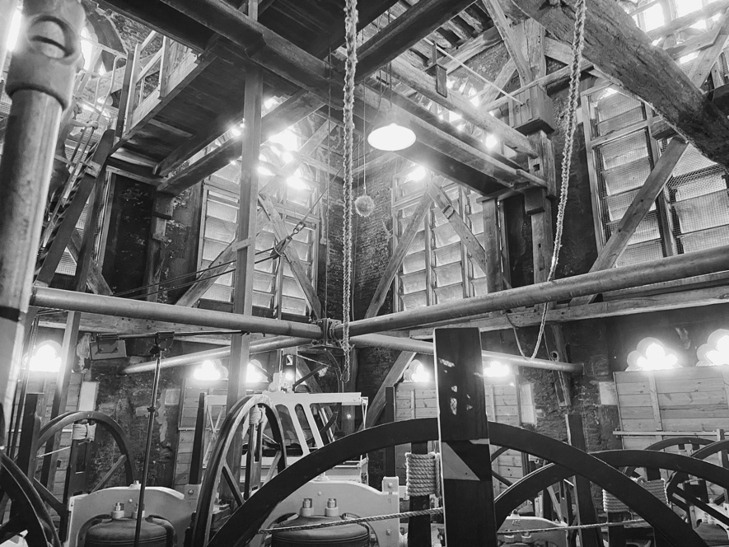
Figure 1. The belfry in Hull Minster
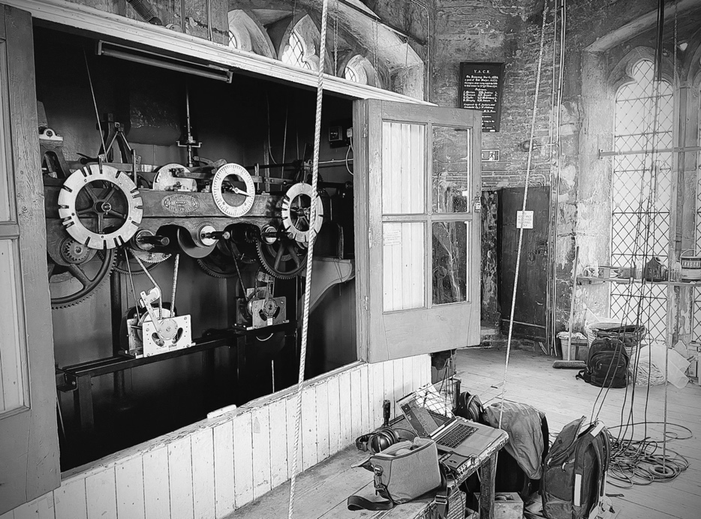
Figure 2. The clock mechanism in Hull Minster
This recording process created an archive of sounds that were subject to several phases of treatment and compositional development spanning 8 months: 1) preliminary treatments (noise reduction, EQ) and initial creative explorations (granular synthesis, delay processing); 2) compositional development (structure; harmonic, melodic, rhythmic, textural, metrical materials) and further treatment (extreme saturation, compression, and gating processes along with bouncing to tape using a Tascam Portastudio 424 and back into the digital domain); 3) design of performance set-up (creation of Ableton set, formation of outboard processing chains and connectivity between three laptop/performance set-ups, discussed later); 4) rehearsal; 5) filming and recording in-situ. The end-result is a 30-minute electronic composition designed for live performance, featuring a mixture of pre-composed elements with specified places for improvisatory responses, distributed across 7 stereo busses for spatialization via acousmonium-style diffusion. The relationship between what is composed (through decision-making about sonic elements, structure, or the use of technologies to render sounds repeatable) and what is performed (which includes triggering pre-determined sounds in pre-determined orders as well as real-time improvised triggering and interventions to shape and guide sounds) is “dialectical rather and dichotomous” (Butler 2014, p. 4). A similar position to Butler is adopted here that resists the assumption of “a clear separation between a composition and its performances, treating the former as fixed and unchangeable and the latter as ephemeral and variable” (ibid., p. 14) in favor of a much more dynamic understanding of how musical materials are created, captured, stored, presented, explored, and experienced.

Structure and the Minster’s time-keeping function
An early structural decision was to respond to the temporal function of the building and the sounding of the bells in the way the structure of the composition was shaped. It was decided that, as a sonic and conceptual gesture, the bells should start performance on the hour (a kind of call-to-attention) and end at half-past, with the quarter-past peal marking the halfway point. An hour-long performance would have overlapped with the start of the next performance, undermining the sense of fresh beginning marked by the tolling of the bells, so the 30-minute timeframe was partly practical in considering how a performance would play out in a repeated festival context, and partly about being realistic about workload (creating 30 minutes of music in 8 months with the given restrictions was a sufficient challenge). This structure implied two 15-minute semi-discrete segments of composition, which were then arbitrarily divided into 5-minute units, giving six subsections in total (principally as a means of navigating the time-frame canvas that had been designed, but also to assist in managing workload contributions across a collaboration that was both in-person and remote). Figure 3 shows an initial hand-drawn sketch that attempted to map the contrasts of each section as well as approximate tempo indications in BPM with proportional relationships to the passing of seconds and minutes; note also the notional annotations of 7:00pm, 7:15pm and 7:30pm to show the overall timeframe along with indications for general harmonic regions to be explored in each subsection.

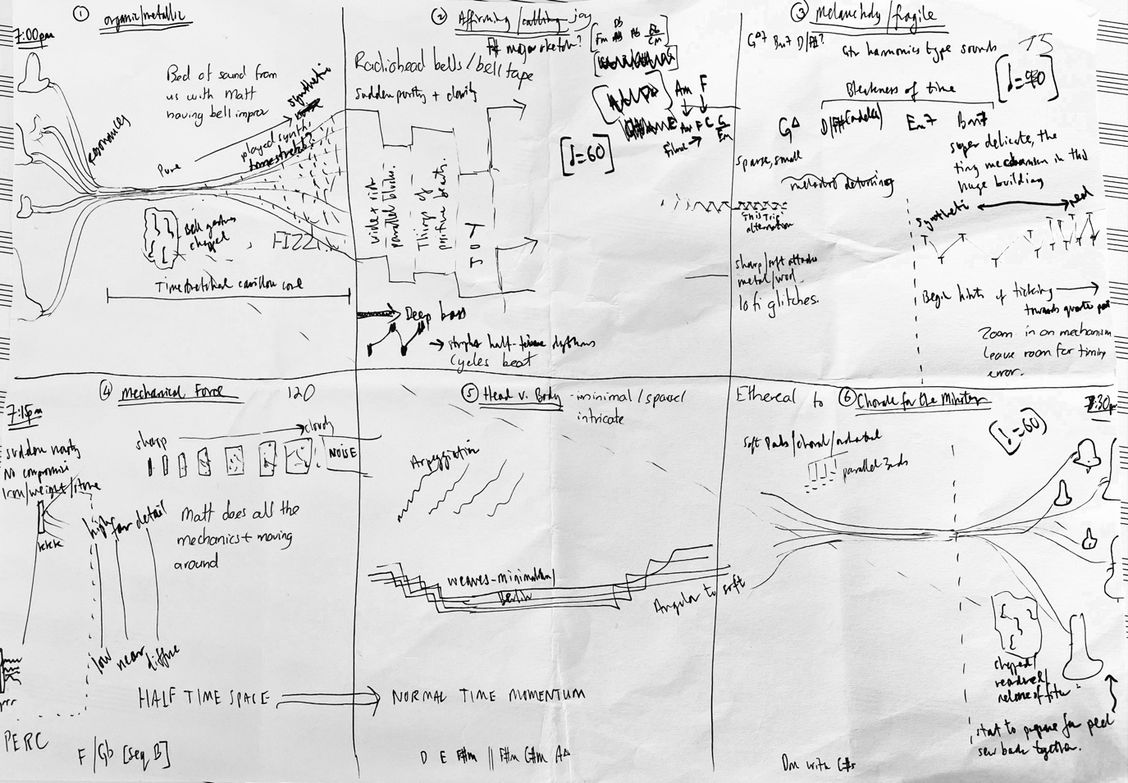
Figure 3. Initial structural sketch
At different points in the creative process the demarcation of six subsections was removed (when it felt too constraining) and then reintroduced (when the wide-open freedom of structural autonomy became unproductive). But, as the work solidified, the six-part subsectional structure (Table. 1) became fixed as a core element of the sonic identity of the work. The subsection titles shown only became attributed as part of the packaging up of the music for release on The Leaf Label. Prior to that, the working titles in the sketch map were used as our points of reference for carrying out the developmental work of composition. Timings are given with reference to the full performance film (youtu.be/8pBToHDIZUQ) with released versions trimmed slightly to create discrete tracks) and a brief commentary is offered to explain something of the intended function of each subsection and its main sound-source features.
Table 1. The Six-Part Subsectional Structure
Subsection | Timing | Duration | Intended Function & Main Features
I. Tolls  [60bpm] | 0:00 to 4:09 | 4:10 | Introduce main bell tolls (0:00, carillon (2:45); basic processing to create washes with fleeting rhythms of processed bells
II. Seek  [90bpm] | 4:10 to 9:51 | 5:42 | Introduce clock mechanism sounds (3:51); harmonic area shift, wide pulse chords to reverberate; sequencing of clock sounds to great downtempo rhythm and new carillon melody (6:39); processed metallic sounds as kick/snare pair (7:43)
III. Move  [90bpm] | 9:52 to 14:01 | 4:10 | Brighter character, continuing clock rhythms and synth washes derived from bells; more intricate beat programming (11:19); character shift with more rhythmic momentum and erratic synth interjections (12:00); fuller texture and rhythmic impetus.
IV. Mechanica  [60, 105 bpm] | 14:02 to 18:46 | 4:45 | Introduction of countdown clock mechanism and external illustrative traffic noises leading up to time-stretched quarter-past peal (at 15:18); sparse, free fully-improvised play with rhythmic sample focusing on extreme low and high frequencies.
V. Trinity [105bpm] | 18:47 to 24:23 | 5:37 | Down-pitched and gated bell sample creating interlocking rhythmic frame; intricate clock-sound programming; pulsing carillon synth (20:07); saturated beat production.
VI. Stone [105bpm] | 24:24 to 30:45 | 6:21 | Return to spacious ambient synth washes; slower musical setting; more overt use of sample set (bell tolls, carillon, clock sounds); half-tempo feel.
Subsections I (‘Tolls’) and II (‘Seek’) have essentially scene-setting functions with sounds presented without much intervention (apart from presentational processes such as EQ and gentle compression for presence). Subsection IV (‘Mechanica’) includes perhaps the most radical interventions by exploring the smallest noises of the clock mechanism as though through a microscope. This subsection is completely improvised and seeks to take the smallest sound to the extremes of the frequency spectrum in a play of exaggeration that subverts a sense of imagined perspective (clock mechanisms should be small and secret, not thunderous and reverberant around a cavernous space). Subsections III, V, and VI (‘Move’, ‘Trinity’, and ‘Stone’) each explore the rhythmic potential of the sound set with forensic editing techniques at the level of individual samples, delay effects, and increasingly intricate sequencing patterns. They also project a ‘discursive reconfiguration’ (Gieryn 2002, p. 44) of the building in which an ‘interpretative flexibility’ (ibid.) was applied to recast the Minster as a dance-music venue in direct challenge to the liturgical intentions of its construction.
These intended functions, taken together, gave access to a number of aesthetic territories to draw upon as a compositional approach was designed. The extreme treatment of samples to create ‘Mechanica’, deliberately tearing them from their functional origins, recalls the work of Aphex Twin, Squarepusher, and Ryoji Ikeda. And the spacious palette of synth washes and drum production in the dance-infused subsections prompted our interested in the work of figures such as Burial (particularly Untrue (2007)), Floating Points, and Jon Hopkins. In essence, in the exploration of how one could play with sound in Hull Minster, as both acoustic and narrative resonances, a ‘constellation of artefacts’ (Slater 2016, p. 21) was created that assembled a collective body of works that helped to establish a foothold in the sonic space that was intended to be occupied.

Spatialization System & Methods
The project was enacted for four events: 1) a filmed version; 2) a radio broadcast; 3) a diffusion; and 4) a live performance for an audience. These forms each demanded different approaches to the spatialization system and, in effect, drove the innovative technical applications presented here. In the first half of this section, the origins of the spatialization system and its application in the primary performance context – an in-situ performance captured for film (which later also became the audio released on The Leaf Label) is detailed. Following that, three different approaches are detailed: A) a physical acousmonium in-situ; b) a hybrid acousmonium and ambisonic virtualmonium (Barrett 2016a; 2016b); and C) headphone-targeted ambisonic virtualisations (subdivided into two subcategories C1 (fixed media) and C2 (radio performance)). These categories are proposed in order to show a conceptual move from physical, to hybrid, to virtual (even though, in reality, the events that prompted the establishment of each method happened in a different order):
- In-situ performance (A)
- Radio broadcast (C2)
- Record-label release (C1)
- Diffusion event (B)

Developing the primary array
The Hull Electroacoustic Research Organization (HEARO), based at the University of Hull, is a collective dedicated to the spatialized presentation of electronic musical works, typically employing a loudspeaker orchestra. At the core of HEARO’s approach is the HEARO spatialization system, an original implementation developed within the Plogue Bidule modular environment since 2020, offering scalability and flexibility in both presentation methods and performance techniques. This system supports a range of spatialization strategies, from traditional diffusion to ambisonics, drawing upon foundational diffusion techniques such as those described by Harrison (1998) and the affordances of the ‘BEASTMulch’ software system for diffusion performance (Wilson and Harrison 2010).
The HEARO system comprises several functions for the spatial presentation of musical works: the definition of a loudspeaker array of an arbitrary size (tested up to 64); frequency response adjustments and time-alignments of the arrays; input routing for both fixed-media and real-time sources; virtual channel propagation and routing; mapping of physical controllers (such as OSC or MIDI) to virtual channel amplitudes; performance-friendly interpolation between physical controller state presets; and virtual channel behaviors including amplitude modulation and rotation around segments of a loudspeaker array.
The system was notably adapted for the Nightports at Hull Minster project, where it needed to provide the necessary flexibility to spatialize multiple incoming stereo feeds in simultaneity, as well as the emerging need to provide virtualization of a loudspeaker array. The project required accommodating 14 input signals, arranged as 7 stereo pairs, with each pair representing discrete components of the musical arrangement. This discrete approach allowed for both a musical flexibility, where dynamics could be sculpted in an improvisatory manner, and a dynamic and precision in spatialization of the arrangement elements (see Table 2). These inputs were propagated into 80 virtual channels to facilitate discrete routing of musical elements to multiple loudspeaker destinations. Stereo relationships were maintained during this process, and certain musical components (e.g., “Bells & Swells”) required more virtual channels for spatialization than others (e.g., “Bass & Rumbles”), depending on the intended spatial choreography of the element.

Table 2. Arrangement Components Composed by Nightports and Respective Spatialization Requirements
Arrangement component(s)  Seven stereo pairs | Spatialization requirements
Bass & Rumbles | Fixed to subwoofer array and ‘main ring’
Drums | Anchored with dynamic expansion across front half of ‘main ring’
Percussion FX | Dynamic across full array
Bells & Swells | Dynamic across full array
Synths & Pads | Dynamic across full array
Performer 1 Return | Fixed in ‘diffuse ring’
Performer 2 Return | Independent and combined dynamic between ‘main ring’ and ‘diffuse ring’

The Primary Array
In August 2022, a loudspeaker array was installed in Hull Minster for diffusion based on the acousmonium principle to facilitate performances of the work that became the fixed-media film version. Consisting of 25 discrete channels, the array was arranged at ground level to envelop the performance area in the nave and extend along the building’s length, from the crossing to the chancel and beyond the high altar, spanning up to 70 meters at its longest point.
The August 2022 configuration, referred to as the “primary array” hereon in, serves as the foundation for all subsequent iterations of the project (see Figure 4). The primary array includes: eight large loudspeakers forming a “main ring” around the nave performance area; six smaller loudspeakers arranged in an oval, oriented 180° azimuth from the centre of the performance area and elevated at +45°, creating a diffuse response as the “diffuse ring”; eight additional small loudspeakers arranged in pairs, positioned approximately equidistantly as a column from the crossing to the east window behind the high altar, with their azimuthal orientation gradually rotating from 0° at the front to ±90° at the rear of the column, and elevation increasing from 0° to +45° along the column, forming the “distant throw.” Three discrete subwoofers were deployed to ensure robust low-frequency coverage in the performance area, with additional crossover-subwoofers used in conjunction with the small loudspeakers to enhance low-frequency extension.
The array design utilizes the shape and scale of the Minster by exploiting the more open and accessible nave area with a higher-density of loudspeaker coverage that enables direct and indirect sound-paths with planar envelopment. Additionally, directing the loudspeakers in the “distant ring” upwards provided a highly diffuse wash that ascended the height of the space. The structure of the “distant throw” array portion meant that a sense of distance could be instilled progressively and polyphonically across different arrangement elements, and it supported a gestural trajectory of movement towards and away from the audience/listener.
Time-alignment was implemented only for the loudspeakers located within the nave, as compensating for the distant speakers – requiring approximately 130 milliseconds of delay – would have adversely affected spatialization control and responsiveness.
Figure 4. The primary array design of August 2022 with subsequent alterations made in March 2023 to accommodate an audience (Barnard, Martin, and Slater 2023)

Spatial Room Impulse Response Capture for Virtualization
Contrary to the initial plans for a performance with a live audience, an audio-visual format became the first iteration of the project, targeted for online dissemination as part of Freedom Festival 2022 in Hull, UK. For the recording, passive capture via microphones was deemed problematic: primarily due to the pronounced noise-floor of the space, largely emanating from the lighting rig adopted for the performance, but secondarily due to the unsatisfactory translation of loudspeaker orchestra performance that the authors have tended to experience from that general approach. Instead, spatial room impulse responses (SRIRs) were recorded for each loudspeaker component as defined in the primary array, excluding the subwoofers as the low frequencies would be managed separately, detailed later. The SRIRs were produced using a Soundfield ST350 1st-order ambisonic microphone, utilizing the sine-sweep method (Farina 2007). The resulting SRIRs enabled ambisonic virtualization of each loudspeaker through convolution processing, implemented in all instances using the non-equal partitioned convolution technique to provide near-zero latency processing (Battisti et al. 2022). The SRIR array could consequently be harnessed for post-recording and real-time processing and ultimately afforded the flexibility necessary for the resulting variety of performances to have been realized.

Spatialization Methods
The project prompted the establishment of three approaches to spatialization, response to differing performance events, that are categorized from A to C as a means of showing a physical-hybrid-virtual progression.

A: Acousmonium in-situ
At The Awakening arts festival in Hull, UK, in March 2023, the music was presented to a public audience as part of a free public arts event. This performance marked a return to the origins of the project and, in many ways, the ‘purest’ manifestation of project – in-situ and for an audience, as originally intended (see ‘Performing in and with Space’ for more detail). This performance event utilized the primary array loudspeaker configuration, implementing a conventional amplitude-panning approach, wherein spatial impressions and dynamics were governed by the physical positioning of loudspeakers throughout the venue.
Both the size of the public audience and their movement around the performance space required that adjustments be made to the primary array design. (as detailed in Figure 4, depicted in Figure 5). The key alteration was made to the “main ring”, to enlarge the performance area to accommodate the shifting position and number of listeners within the venue. As a consequence of both the increased distance and potential obstructions, the response of the “main ring” became less direct and a so reliance on elevated sound pressure levels emerged to ensure that the spatialization effects remained perceptible and the materials audible against an elevated noise floor.

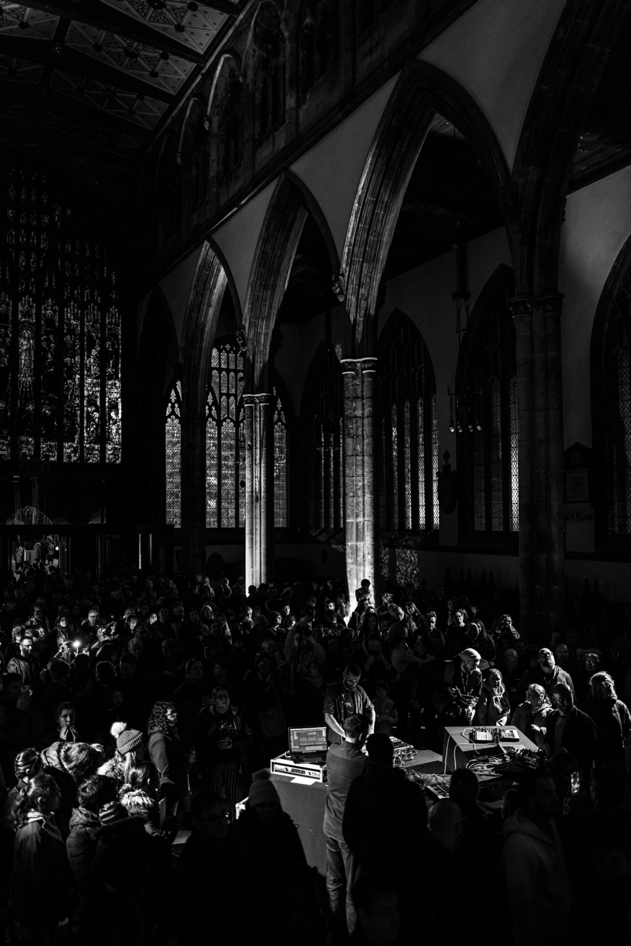
Figure 5. Performance at The Awakening Festival 2023, Hull, UK (Photograph by Oli Bentley)

B: Hybrid acousmonium and ambisonic virtualmonium
The HEARO loudspeaker orchestra was deployed in Middleton Hall, a concert venue at the University of Hull, UK, as a 56-loudspeaker array featuring mixed-loudspeaker models. The hall’s raked seating led to a dense loudspeaker arrangement at the front and sides of the audience, with some coverage above and only elevated rear coverage. Typically, the array is used for loudspeaker orchestra diffusion through amplitude-panning, with higher-order ambisonic (HOA) decoding via a 31-channel irregular array resembling a distorted dome. The hall itself has a short, subtle reverberation. The performance by Nightports recorded in August 2022 was used for a concert of real-time spatialization in November 2022.
For this concert, a hybrid spatialization approach was employed, involving an ‘electroacoustic coupling’ between the existing hall acoustics and a rendered simulation of Hull Minster’s acoustic, resembling an ‘active acoustic’ method (Woszczyk 2011; Woszczyk and Benson 2019). This was achieved through amplitude-panning, as used in Hull Minster itself, combined with real-time convolution of the SRIR array, which were upmixed to 3rd-order ambisonics using the high angular resolution planewave expansion (HARPEX) method (Berge and Barrett 2010). The convolved output was then decoded using the All-Round Ambisonic Decoder (AllRAD) method, utilized due to the partial loudspeaker coverage of the sphere resulting in a ‘non-ideal’ array shape (Zotter and Frank 2012). Each SRIR convolution kernel was fed the corresponding loudspeaker signal from the spatialization system, with the diffusion performer controlling virtual channel amplitudes.
The array layout in Middleton Hall emulated the primary array, though the equivalent “distant throw” portion, which in Hull Minster extended from the chancel to beyond the high altar, was absent. Instead, the two nearest pairs of the ‘distant throw’ were emulated at the far-stage area, while the remaining pairs were emulated above the audience using ceiling-mounted loudspeakers. To account for differences in array layout, the SRIRs captured in Hull Minster were rotated to match the loudspeaker positions in Middleton Hall, with azimuth alterations of 5–10° and elevation changes up to +90° applied to specific SRIRs.
This configuration allowed control over the direct and reverberant response of each loudspeaker. The amplitude-panning approach contributed a smaller portion of the overall energy, with those virtual loudspeakers meant to represent distant sources relying solely on the SRIR convolution feed. While the HEARO system imparts pronounced coloration and varying ambisonic coverage, as is typical of mixed-model loudspeaker arrays (Garavaglia 2019), the use of anchored SRIR positions mitigated timbral changes that might arise from perceived motion of the sources. This hybrid approach combined elements of a traditional loudspeaker orchestra acousmonium and an interpretation of Barrett’s virtualmonium, virtualizing the loudspeaker orchestra in ambisonics to create an ‘augmented’ auditory reality (Blauert and Rabenstein 2012).

C: Headphone-targeted virtualisations
Two iterations of the project leveraged ambisonic virtualization of the primary loudspeaker array for binaural stereo presentations: a fixed-media audio-visual format for Freedom Festival 2022, and a live performance broadcast on BBC Radio 3. Given the intricate relationship between the project’s technical and musical aspects - tied closely to the spatial acoustics of Hull Minster and the design of the loudspeaker orchestra - an alternative spatialization approach was devised specifically for headphone listening. This approach aimed to preserve and convey the method, character and immersive nature of the live performance within the Minster. By employing ambisonic techniques, the spatial qualities of the original performance could be represented, allowing listeners to experience a sense of immersion related to that of the Minster’s acoustical environment. This effort ensured that listeners could still grasp the spatial intent and the unique character of the performance, despite the shift from a physical, large-scale venue to the intimacy of headphone listening.

C1: Fixed Media
The filmed performance produced as part of the digital offering by the Freedom Festival 2022 was realized in 3rd-order ambisonics decoded to binaural, using a mix of decoder flavors. This performance, staged specifically for the filming, was recorded and subsequently used as the basis for an iteration in which post-recording spatialization was applied. To accomplish this, a native ambisonic method was developed, enabling the creation of a virtual loudspeaker array that emulated the primary array, akin to a virtualmonium. Signals that, in other presentations, would have been routed to physical loudspeakers were instead directed to distinct signal paths: (1) an array of convolution processors, each hosting the corresponding SRIRs, to generate a reverberant response upmixed to 3rd-order ambisonics; (2) a room encoder simulating the positions of the “main ring” loudspeakers from the primary array, used to emulate a direct sound response; (3) a discrete processing path for only the “Subs & Rumbles” and “Drums” arrangement elements with necessary virtual loudspeakers implemented as per (1) and (2).
These encoded signals were time-aligned before being processed through a combination of binaural decoders. The motivation for combining different decoders was to harness the qualities of different decoding methods and Head Related Impulse Response (HRIR) pre-processing approaches: for processing paths (1) and (2), a time-alignment method with diffuse covariance constraint (Zaunschirm, Schörkhuber, and Höldrich 2018) provided a satisfactory sense of envelopment and diffuseness that suited the arrangement elements that exhibited the most spatial dynamic; for (3), a phase-simplification pre-process in combination with the magnitude least-squares method (Schörkhuber, Zaunschirm, and Höldrich 2018) provided a more defined transient response and cleaner low-frequency reproduction at the cost of image width that was deemed to suit the arrangement elements. The implementation of both an emulated direct response and an emulated reverberant response proved creatively effective, producing a listening experience more akin to the original performance in Hull Minster than that using the SRIR representation of the “main ring” alone, which tended to sound too diffuse.
The production featured real-time spatialization performed by a diffusion performer using the same performance interfaces, with control data recorded as automation. This workflow, utilizing both a modular environment and a Digital Audio Workstation (DAW), introduced latency that would be problematic for live performance scenarios but was suitable for production of the audiovisual deliverables.

C2: Live Performance for Radio
A live performance of the work was recorded for broadcast as part of BBC Radio 3’s Northern Drift programme. This performance featured live performance from Nightports alongside real-time spatialization by the diffusion performer. Due to operating on limited computing resources, the density of SRIRs and room-encoded loudspeaker positions was reduced: from 8 to 4 for the “main ring” and from 6 to 4 for the “diffuse ring”. This reduction optimized the channel count and enabled a low, stable latency which was essential for the real-time performance context.
Further to this, and in a manner relating to the implementation in C1, a discrete stereo processing path was created for the “Subs & Rumbles” and non-convolved “Drums” arrangement elements, without any ambisonic encoding applied. This negated the need for an additional discrete binaural decoder (as per C1) which aided the pursuit of a more responsive and stable latency, yet still provided a cohesive virtual acoustic in the ambisonic stream.
The ambisonic signals were decoded into binaural stereo (using the time-alignment method with diffuse covariance constraint) and time-aligned with the non-ambisonic components. Performers monitored the output through fixed-orientation headphone feeds and used the familiar performance interfaces. The diffusion performer also had the capability to dynamically rotate the “diffuse ring” ambisonic sound field across the azimuth, adding an additional layer of spatial control during the live broadcast.

Technical Observations & Developments
The resolution of the SRIRs produced for each loudspeaker in the array was limited to 1st-order due to available inventory at the time of capture. Although upmixed versions of the SRIRs were produced, the methods outlined that utilize the SRIRs would be improved with a HOA microphone capture, especially given the density of loudspeakers that formed the array and the variety of presentation contexts. Additionally, of relevance for low and high order SRIRs, the spatial impulse response rendering (SIRR) method (McCormack et al. 2020) provides a technique of rendering SRIRs for specific loudspeaker arrays, potentially improving upon their perceptual qualities and needing direct convolution of each loudspeaker channel for spatialization, removing the ambisonic decoding layer. It should be noted that this method, if used in the context of spatialization method B, would require a matrix of 682 convolutions, which has become viable at the time of writing, in response to previous observations made by Barrett (2016b) of other potential, convolution-intensive models, despite the length of the SRIR kernels. A further utilization of the SIRR approach is to combine it into a T-format process to upmix from low to high order, by rendering to a t-design loudspeaker arrangement and subsequently encoding back into HOA (Pinardi, Farina, and Binelli 2023). This logically has implications for potential the number of convolutions: for a 5th order upmix of the SRIRs using the SIRR to T-format to HOA process, 792 convolutions would be required in addition to an ambisonic decode.
For headphone contexts, the SRIRs or SIRR-processed SRIRs could be decoded to emulated binaural room impulse responses (BRIRs) before convolution as a ‘virtual ambisonic’ approach (Noisternig et al. 2003), reducing the number of convolutions drastically and increasing the chances of a more responsive latency being achieved. This would negate any ambisonics-related image transforms from being enacted, but some targeted dynamic movement along a matrix array of BRIRs with differing perspectival qualities could enable some useful spatial dynamics. In most iterations, the nature of the musical materials and performance techniques employed meant that latency did not significantly hinder the ability to perform the work. However, for future projects involving more time-sensitive performance input, latency could become a limiting factor, necessitating the development of a more responsive system.
Finally, for the headphone-based presentations, head-tracked approaches were not explored and so remain an additional potential context to exploit in future work, nor was the possibility of a 6DoF realization of the primary array in the Minster that harnesses multiple SRIRs per-loudspeaker with interpolation, which would add further presentational flexibility.

Performing in and with Space

Performing sound
Though the three live performance contexts (creation of the film, radio broadcast, for a public audience) were about presenting the same musical material, their specific characteristics draw out useful comparative insights into performing semi-improvised electronic works. This section will cover the practicalities of the performance set-ups, a detailed discussion of the three performance contexts, and a consideration for what it means to perform in and with a space. For each performance, there were three performers whose roles remained the same across all three performance contexts. Performers 1 and 2 command the musical arrangement and sonic treatments with the third person as a performing the spatial diffusion. This structure lent cohesion to the different performance contexts and helped create a stronger sense of reliability for the performers (reassuring, given the complex, multi-part nature of the set-up). Performer 1 triggers pre-prepared sounds, marks the temporal structure of the piece, plays live sampler instruments, and treats a selection of sounds using software and outboard devices. Performer 2 plays synths and samplers and applies effects and processing to sounds coming from performer 1 via a discrete stereo feed. Performer 3 takes all of the sounds from performers 1 and 2 (detailed in Table 2) and has sole responsibility for real-time spatialization as the diffusion performer.

Practicalities of performance set-ups
With 189 audio clips spread out across 77 channels, plus 8 outboard signal processing devices alongside software plug-ins and a range of synth/sampler instruments diffused over a 25-speaker array, this music has a degree of complexity baked into it correlating with its durational, temporal, structural, textural and spatial ambitions. With two hands each and a finite cognitive bandwidth, the three performers had to devise set-ups that achieved a balance between fixity and freedom, predictability and flexibility, or between human control and pre-determined automation, so that the music maintained a vital ingredient of exploratory musicianship in and with the place of performance while having a degree of reliability in the moment. The most significant rationalization of the set-up was the grouping of sounds from performer 1 into five categories, that became five of the seven stereo feeds for the diffusion performer along with a send-return channel for each of the two sound performers. This grouping of signals significantly reduced the channel count, for both diffusion and cognitive categorization, to a manageable number. Each performer used a series of devices that constitutes ‘an actual site of mediation’ (Butler 2014 p. 70) for the performers, whose bodily, haptic and kinesthetic contact with their technologies creates a complex, interactional set of relationships.
Performer 1 used Ableton Live as the engine for triggering the core source sounds partnered with a Push controller (for triggering clips and adjusting individual channel levels), a Fader Fox PC12 controller bank (for detailed level adjustments and controlling send-return combinations), and a Novation Launch Control XL (mapped to control the levels of the five main categories of sounds). Clips were organized in blocks that correlated to the six main subsections of the structural design spanning the 30-minute duration. These blocks were arranged with a left-right and top-bottom logic, giving rise to a diagonal pattern that was further amplified by a color-based pattern to aid visual recognition (see Figure 6, which implies color grading with the greyscale reproduction shown). Color blocks are mirrored in scene labels on the right, with scene-based triggering taking care of changes to the underlying tempo-base of the music (see Table 1 for tempo regions across the work). There were also four outboard devices fed from three send-return channels: A) a Hologram Microcosm glitch-effect device; B) a Strymon Big Sky and a Strymon Timeline in serial to give reverb and delay options; and C) a Chase Bliss Gen Loss II tape emulator for saturation effects. Sends B and C were set up with the option to crossfade between internal software effects (B for delay/reverb and C for saturation/distortion) and their outboard counterparts.
Figure 6. screenshot of Ableton Live session used by Performer 1 showing the block- and colour-based arrangement logic of clips
This diagonal approach was of practical use by creating a flow through the musical materials (scenes moving from top to bottom, channels moving from left to right as the performance progresses) and by mapping visually onto the Push controller (particularly useful in dark performance situations). The order in which clips appear is fixed, though the timing of their appearance is a matter of judgement in performance along with relative levels, sonic treatments, and spatial positioning. Four types of automation were used to fix other aspects of the performance:

- A ‘starting position’ cue mapped to one button on an Akai MPK Mini keyboard which, when pressed, would return all faders across the whole set to a default level (levels for each channel would then be reliable, and easily changeable in performance);
- MIDI CC blocks for each of the outboard devices at given structural points to trigger pre-determined states (which could then be adjusted on the hardware devices);
- Audio fade blocks on individual selected channels to modulate channel levels and end clip playback; and
- Randomized ‘follow-on’ behaviors for consecutive audio clips on a given channel to cycle through in a random pattern (creating variability in local-level sections of the music).

These automation strategies do two things. First, they lend robustness to the performance by fixing key dimensions of the sound. Second, they relieve the performer of carrying out menial repetitive tasks that would detract from other aspects of intervention that have a more significant impact upon the resulting sound. These focal interventions concerned real-time control over: textural density (achieved through fine adjustments of channel levels, application of reverb/delay, application of saturation effects); stasis/change (achieved through triggered specific sounds, delay effects and the like, particularly around key structural moments); and clarity/noise (achieved through saturation and distortion effects, addition of synth parts, bathing sounds in reverb). These features are the site of in-the-moment decision making, which elevates the performance from just playback of prefabricated sounds to a responsive, unique performance moment.

Exploring three performances contexts
The three performance contexts invoked by this project, though sharing a core set of materials and technical approaches, differed and developed in several notable ways. First, the axis of risk/familiarity influenced how the performance approach changed as the project unfolded. Second, the perceived legacy of the specific performance event impinged on the performers’ sense of the experience and, as a result, what they did in performance. And third, the spatial characteristics of each performance event brought into relief the importance of performers’ relationship with a sense of space.
The performance captured on the film took place on Tuesday August 2nd 2022, following a load-in, set-up, and sound and lighting check on the previous day. On the day of filming, impulse responses were captured, and rehearsals took place in the afternoon until daylight faded so filming could begin. Four performances took place between 8pm and midnight for filming in situ, with carefully plotted lighting states syncing with key structural moments in the music so that video edits could be seamlessly achieved. Two of these performances were recorded as complete audio takes. The first was a technical disaster and couldn’t be used (except as for video footage); the second became the performance on the film and, eventually, formed the record-label release. The real-time spatialization of the performance moment impinged on the performers’ experience of the music as a visceral, exciting moment of privileged access to the Minster late at night (though the spatialization heard on the recording is a reconstructed virtualization).
The performance that became the ‘urtext’ was, then, the first successful run of the work as a whole. This was the point of exchange between thinking in terms of composition and production and thinking of the music as performance. It was also the point that all three performers were least familiar with the material. The triggering of sounds and the processing interventions were, in retrospect, careful and cautious. Yet, in a sense, this caution left space for more adventurous spatialization and sonic intervention in later performances.
On November 16th 2022, the authors traveled to the Trades Club in Hebden Bridge in the north of England to record a version of the music for BBC Radio 3’s ‘Northern Drift’ programme, hosted by Elizabeth Alker. This programme was broadcast on January 9th 2023. The performance took place in front of a live audience and was recorded ‘as live’, interspersed with interview segments that were later edited down to fit the broadcast slot. The live audience experienced the work over a stereo system with performers occupying a ‘traditional’ place on stage (see Figure 7). Where the perceived legacy of the performance for the video was bound with creating an urtext version of the work, the legacy of the radio performance was of creating a performance for a seated live audience (which was never part of the intended performance aesthetic of the work) that would be broadcast on national radio. In this sense, the performance was no different to that of any other live musician recording for radio. A key difference was that the performance, happening in Hebden Bridge, was torn from its origins back in Hull, which prized the conceptual and sonic connections between location and music apart to challenge the purity of the original location-specific concept. Furthermore, the temporal design connecting to the passing of clock-time was also necessarily lost as the timing of the broadcast had its own temporal logic. The subsections of music that was performed were taken out of their temporally continuous place in the work as a whole and truncated to fit specific timed segments.

Figure 7: Nightports performing on stage at the Trades Club in Hebden Bridge (UK) for BBC Radio 3 in November 2022.

To reconcile this fracture, the acoustic properties of the Minster were virtualized, and performers experience this illusory sense of place in headphones. From the moment of putting headphones on, the performers experienced the sudden attenuation of room and audience noise due to the use of closed-back and sonically isolating headphones. Sonic isolation was akin to an unwanted social isolation; there was no longer a shared soundscape between performer and audience, which felt particularly acute given the ‘standard’ layout of stage and audience. This is perhaps a flavor of the ‘privatizing impulse’ that Bull (2014) discusses in relation to the listening habits associated with iPods, Walkmans, and mobile phones with specific reference to urban spaces; though Downs (2021, p. 195) opposes the view that ‘headphone listeners are wholly excised from their wider acoustic environments’. This approach provided very detailed and accurate monitoring (revealing aspects of sound that had not been perceptible within the Minster performance due to the size of the building and location of the very furthest speakers in particular) but situationally abstracted. In the Minster, sounds were frequently moving around within the space and the performers could not fully be sure of the relative loudness of the parts they were playing as they could be positioned near or far away. As a result, the process became about intuition and returned the electronics performance imperative to one perhaps more akin to the proprioceptively-connected relationship between body and instrument. On headphones, where all performers and audience had the same mix, this seemed to create a more cautious approach to the balancing of each musician’s parts as no one wanted to stand out or above the others (compounded by the ’as live’ recording for future radio broadcast).
While the donning of headphones creates a rupture with the immediate sonic context (allowing the performers to enter an individualized sense of performance space) it created a purity of sonic experience that, counter-intuitively, was ‘better’ than being in the Minster itself. The Minster, though decidedly absent, was perceptually hyper-real. The close-up monitoring of sounds in headphones gave a sense of clarity, or purity, for the performers. The acoustics of the in-situ live performance in Hull Minster, in comparison, had a quality of ‘interference’. These consequences of iterating the work outside of the Minster were unexpected but add interesting ‘folding or doubling’ dimensions of different, superimposed and simultaneously experienced places.
Finally, on March 23rd 2023, four public performances were staged in Hull Minster for the Awakening Festival in Hull starting at 6, 7, 8 and 9pm. A defining characteristic of the performance (which aligns with the ethos of the festival) was to permit maximum autonomy to the audience to move freely around the space. The nave of the church was clear of pews and other furniture, leaving a wide-open space from which audience members could pick a perspective or move between any part of the church. This free flow of people was made possible by utilizing different entry and exit points to the venue. Over the course of the evening of performances, 3,800 people experienced the work.
A notable instance of this performance was when a child with his mother stood next to one of the performers. Such was the proximity that the boy could be heard asking his mother what all the buttons do, and his mother replying that he should not touch anything. This is notable because it demonstrates the potency of embedding performers in amongst the audience; with free-flow and accessibility to peer in at what is going on prompting curiosity and a sense of shared space.
The repetition of performances across the evening, coupled with the accumulation of the earlier performance situations, meant that the performers now had a much higher level of familiarity with the music and the ergonomics of the set-up, which led to increased willingness for risk across the evening. The use of sends to pedals to distort and glitch sounds became much more liberal in application and the whole effect was a form of sonic envelopment of and with the performance space. Longer stretches of time were left prior to triggering important compositional moments, heightening a sense of tension through anticipation. Additionally, the approach to spatialization became more dynamic and fluid, which prompted a greater degree of playfulness in how sounds were manipulated. All three performers entered into a mutual exploration of just how far (sometimes quite literally given the placement of speakers in the furthest reaches of the church) the sound could be taken.

Performing space
The spatialization of live materials across all settings was executed by the diffusion performer using a Glui 32-fader OSC device and a Faderfox LV3 MIDI controller equipped with XY controls. These devices facilitated the manipulation of virtual channel amplitudes, offering varying spatial resolution depending on the desired spatial dynamics. For instance, the “Bass & Rumbles” component is controlled by a single fader that adjusts overall dynamic amplitude without spatial movement. In contrast, the “Drums” component utilizes two faders to manage amplitude in a fixed position, with the option to broaden the sound image across the “main ring”. The “Synths & Pads” component involves a more complex arrangement, employing eight faders for front/back dynamic control and an XY controller to shift movement between the “main ring” and “diffuse ring”. Another XY controller introduces amplitude jitter control. This component-based spatial model is applied consistently, with minor variations across other elements, enabling refined spatial control conducive to the intended musical expression and performance variations. This spatial design enables various dimensions of dynamic, including anchored/vectorial space, anchored/dynamic diffuseness, proximate/distal space, and prospective/lateral space, amongst others(Smalley 2007).
The system’s resolution permits a ‘polyphonic’ diffusion, whereby the discrete arrangement elements can be dynamically located in the performance space. This attribute gives rise to possibilities of spatial counterpoint of elements in consonance or dissonance, as well as approaches akin to Stockhausen’s ‘raum-melodie’ (1989) - literally ‘room-melody’, interpretated more broadly as ‘spatial-melody’ - where as a principle, the dynamic spatial displacement of phrases can be considered a form of musical patterning.
A method enabling the diffusion performer to recall snapshots of motorized fader positions, pre-programmed for key moments between sections of the performance was developed. When activated, the system interpolates from the current fader position to the pre-set configuration at a customizable rate. Those faders actively touched by the performer during this process are excluded from the interpolation, allowing for any continued, improvised spatialization to unfold in parallel to the wider reconfiguration.
This functionality expanded the possibility for choreographing spatial movements that would be impractical with performer input alone. A notable example is the staging of clock mechanisms at precisely quarter-past the hour, incorporating extreme close-perspective recordings of clockwork mechanisms (accentuated through saturation and dynamics compression) juxtaposed with a soundscape from the bell tower. This soundscape integrated external sounds of the city, such as reversing vans with warning beeps, rushing traffic, and distant human laughter, into the performance space. Because these arrangement elements necessarily shared signal flows with other related but otherwise distinct materials occurring proximately in time, an agile reconfiguration of the spatial configuration became necessary, whilst allowing continual gestural control over other arrangement elements. This and other moments served as structural markers in the performance, not only due to the sonic material but also because of their spatial staging. These junctures, which emerged intuitively during rehearsals and repeated performances, were captured and recalled using the snapshot method described above.
Importantly, these moments were made possible by an interaction between the musical materials and the performance space, establishing a dynamic and immediate relationship. The structural scheme of the musical work became an emergent property, shaped in tandem with the architectural and acoustic characteristics of the environment.
Finally, the recall method introduced an “ecologically unlawful” aspect to the sound design. The sudden, non-linear changes - impossible for a single performer to execute due to the physical constraints of managing multiple faders - produced a perceptual “jump cut”. This disorienting, self-signaling effect served as an ideal perceptual artefact, highlighting significant structural markers that the creators intended for the audience to understand.

Concluding Remarks
The initial aim of the project was to create a 30-minute musical work to be filmed and for live performance in-situ. Spatialization was always part of the plan, but what could not be foreseen were the variant opportunities for dissemination that emerged. In response, approaches to spatialization were adjusted and developed by harnessing a variety of techniques while the lines of connection between composition and improvised performers were traced. The project brought into focus different ways of thinking about resonance, specifically in relation to Hull Minster: as an acoustic origin, as a narrative prospect, as a visceral experience. These creative responses, coupled with new opportunities for dissemination (e.g. a record label release destined for digital streaming platforms and a radio broadcast) raised questions about the viability of transferring a large-scale site-specific performance piece to other locations, and what this transposition meant both musically and technically. The process of SRIR capture became essential to providing a viable method of transportation and is considered a critical component of the technical approach of the project. Although there is scope for refinements and extensions within each iterative version of Nightports at Hull Minster, the project highlights the potential for adapting and transporting a site-specific work that is otherwise entwined with a location's acoustic and architecture.
This article has outlined the musical and technical methodologies and considerations for undertaking place-based music-making with technology while considering the implications for how to perform this music in a way that retains a sense of the improvisatory spontaneity that imbued the working method through (typically by tracing the balance between pre-determined, automated elements versus in-the-moment interventions). It has also shown how a single musical process refracts through different iterations to give multiple realizations, and how this re-situation demands responses in terms of composition, production, performance, and spatialization (which all continually interact). In sum, this project traces the complex relationships involved in place-based creativity, spatialization and electronic music production and performance practices.

Acknowledgments
This project was in part funded by the PRS Foundation’s Open Fund for Music Creators and was supported by the University of Hull and University of Huddersfield.

References
Barnard, Matthew, Adam Martin, and Mark Slater. 2023. “Nightports at Hull Minster: Physical, Hybrid and Virtualized Live Loudspeaker Array Spatialization of Electronic Music Performance.” In 2023 Immersive and 3D Audio: From Architecture to Automotive (I3DA), 1–7. IEEE. https://doi.org/10.1109/I3DA57090.2023.10289518.
Barrett, Natasha. 2016a. “A 3D Future for Loudspeaker Orchestras Emulated in Higher-Order Ambisonics.” In Proceedings of the International Computer Music Conference 2016, 2016:317–21. Michigan Publishing. http://hdl.handle.net/2027/spo.bbp2372.2016.063.
———. 2016b. “A Musical Journey towards Permanent High-Density Loudspeaker Arrays.” Computer Music Journal 40 (4). https://doi.org/10.1162/COMJ_a_00381.
Battisti, Luca, Angelo Farina, Antonella Bevilacqua, and Lamberto Tronchin. 2022. “Implementation of Non-Equal Partitioned Multi-Channel Convolver.” In Internoise 2022 - 51st International Congress and Exposition on Noise Control Engineering. https://doi.org/10.3397/in_2022_0220.
Bayle, Franois. 2007. “Space, and More.” Organised Sound 12 (3). https://doi.org/10.1017/S1355771807001872.
Berge, Svein, and Natasha Barrett. 2010. “High Angular Resolution Planewave Expansion.” In Proc. of the Second of International Symposium on Ambisonics and Spherical Acoustics.
Blauert, Jens, and Rudolf Rabenstein. 2012. “Providing Surround Sound with Loudspeakers: A Synopsis of Current Methods.” Archives of Acoustics 37 (1). https://doi.org/10.2478/v10168-012-0002-y.
Bordwell, David. 2007. Poetics of Cinema. 1st ed. New York: Routledge.
Bourne, Matthew. 2024. “Harpsichords.” Discus Music Discus 175CD, compact disc.
Bull, Michael. 2014. “IPod Use, Mediation, and Privatization in the Age of Mechanical Reproduction.” In The Oxford Handbook of Mobile Music Studies, edited by Sumanth Gopinath and Jason Stanyek, 1:103–17. Oxford Academic. https://doi.org/10.1093/oxfordhb/9780195375725.013.005.
Butler, Mark J. 2014. Playing with Something That Runs: Technology, Improvisation, and Composition in DJ and Laptop Performance. Oxford University Press. https://doi.org/10.1093/acprof:oso/9780195393613.001.0001.
Culler, Jonathan D. 1997. Literary Theory : A Very Short Introduction. Oxford: Oxford University Press.
Downs, Jacob Kingsbury. 2021. “Headphone Listening: Space, Embodiment, Materiality.” University of Sheffield. https://etheses.whiterose.ac.uk/32108/.
Elblaus, Ludvig, and Gerhard Eckel. 2020. “Acoustic Modelling as a Strategy for Composing Site-Specific Music.” In ACM International Conference Proceeding Series. https://doi.org/10.1145/3411109.3411141.
Farina, Angelo. 2007. “Advancements in Impulse Response Measurements by Sine Sweeps.” In Audio Engineering Society - 122nd Audio Engineering Society Convention 2007. Vol. 3.
Gallagher, Michael. 2015. “Field Recording and the Sounding of Spaces.” Environment and Planning D: Society and Space 33 (3): 560–76. https://doi.org/10.1177/0263775815594310.
Garavaglia, Javier Alejandro. 2019. “Spatialisating the Same Acousmatic Composition in Different Venues Featuring High-Density Loudspeaker Arrays.” In Proceedings of the 2019 International Computer Music Conference, 27–32. Michigan Publishing. https://hdl.handle.net/2027/fulcrum.jq085n56r.
Gayford, Martin. 2011. A Bigger Message : Conversations with David Hockney. 1st ed. London: Thames & Hudson.
Gieryn, Thomas F. 2002. “What Buildings Do.” Theory and Society 31 (1): 35–74. https://doi.org/10.1023/A:1014404201290.
Harrison, Jonty. 1998. “Sound, Space, Sculpture: Some Thoughts on the ‘What’, ‘How’ and ‘Why’ of Sound Diffusion.” Organised Sound 3 (2). https://doi.org/10.1017/s1355771898002040.
Knight-Hill, Andrew. 2018. “Theatres of Sounds: The Role of Context in the Presentation of Electroacoustic Music.” Scene 6 (2): 165–75. https://doi.org/10.1386/scene_00016_1.
Kozbelt, Aaron. 2009. “Ontogenetic Heterochrony and the Creative Process in Visual Art: A Precis.” Psychology of Aesthetics, Creativity, and the Arts 3 (February):35–37. https://doi.org/10.1037/a0014756.
Krims, Adam. 2000. Rap Music and the Poetics of Identity. Cambridge: Cambridge University Press.
McCormack, Leo, Ville Pulkki, Archontis Politis, Oliver Scheuregger, and Marton Marschall. 2020. “Higher-Order Spatial Impulse Response Rendering: Investigating the Perceived Effects of Spherical Order, Dedicated Diffuse Rendering, and Frequency Resolution.” Journal of the Audio Engineering Society 68 (5): 338–54. https://doi.org/10.17743/jaes.2020.0026.
Nattiez, Jean Jacques. 1990. Music and Discourse: Toward a Semiology of Music. Princeton: Princeton U.P.
Nightports. 2015. “Depart.” Self-released, Digital.
———. 2018. “Nightports w/ Matthew Bourne .” The Leaf Label BAY 108E, Digital.
———. 2020a. “Nightports w/ Betamax .” The Leaf Label BAY 118E, Digital
———. 2020b. “Wat Chedi Luang.” The Leaf Label NIGHT 7, Digital
———. 2022. “Nightports w/ Tom Herbert.” The Leaf Label BAY 129E, Digital
———. 2023. “Minster.” The Leaf Label NIGHT 11E, Digital
———. 2024. “Nightports w/ Matthew Bourne - Dulcitone 1804.” The Leaf Label BAY 139E, Digital
Noisternig, M, T Musil, A Sontacchi, and R Holdrich. 2003. “3D Binaural Sound Reproduction Using a Virtual Ambisonic Approach.” In IEEE International Symposium on Virtual Environments, Human-Computer Interfaces and Measurement Systems, 2003. VECIMS ’03. 2003, 174–78. IEEE. https://doi.org/10.1109/VECIMS.2003.1227050.
Pinardi, Daniel, Angelo Farina, and Marco Binelli. 2023. Transducer Distribution on Spherical Arrays for Ambisonics Recording and Playback. https://doi.org/10.1109/I3DA57090.2023.10289552.
Schörkhuber, Christian, Markus Zaunschirm, and Robert Höldrich. 2018. “Binaural Rendering of Ambisonic Signals via Magnitude Least Squares.” In DAGA 2018 Jahrestagung Für Akustik, 339–42. Munich.
Slater, Mark. 2016. “Locating Project Studios and Studio Projects.” Journal of the Royal Musical Association 141 (1): 167–202. https://doi.org/DOI: 10.1080/02690403.2016.1151241.
———. 2022. “Performing in the Studio.” In The Oxford Handbook of Music Performance, edited by Gary McPherson, 1:510–27. Oxford: Oxford University Press. https://doi.org/10.1093/oxfordhb/9780190056285.013.31.
Smalley, Denis. 2007. “Space-Form and the Acousmatic Image.” Organised Sound 12 (1): 35–58. https://doi.org/10.1017/S1355771807001665.
Stobart, Henry. 2006. Music and the Poetics of Production in the Bolivian Andes. 1st ed. Routledge.
Stockhausen, Karlheinz. 1989. Stockhausen on Music; / Lectures and Interviews Comp. by Robin Maconie. London: M. Boyars.
Stockwell, Peter. 2002. Cognitive Poetics. London: Routledge. https://doi.org/10.4324/9780203995143.
Stravinsky, Igor. 1982. Poetics of Music in the Form of Six Lessons. Translated by Arthur Knodel. Cambridge, MA: Harvard University Press.
Wilson, Scott, and Jonty Harrison. 2010. “Rethinking the BEAST: Recent Developments in Multichannel Composition at Birmingham ElectroAcoustic Sound Theatre.” Organised Sound 15 (3). https://doi.org/10.1017/S1355771810000312.
Woszczyk, Wieslaw. 2011. “Active Acoustics in Concert Halls - A New Approach.” Archives of Acoustics 36 (2). https://doi.org/10.2478/v10168-011-0028-6.
Woszczyk, Wieslaw, and David H Benson. 2019. “Experiencing Room Acoustics through a Library of Multichannel High-Resolution Room Impulse Responses.” In Proceedings of the International Congress on Acoustics. Vol. 2019-September. https://doi.org/10.18154/RWTH-CONV-239920.
Zak, Albin. 2001. The Poetics of Rock: Cutting Tracks, Making Records. Berkeley: University of California Press.
Zaunschirm, Markus, Christian Schörkhuber, and Robert Höldrich. 2018. “Binaural Rendering of Ambisonic Signals by Head-Related Impulse Response Time Alignment and a Diffuseness Constraint.” The Journal of the Acoustical Society of America 143 (6): 3616–27. https://doi.org/10.1121/1.5040489.
Zotter, Franz, and Matthias Frank. 2012. “All-Round Ambisonic Panning and Decoding.” Journal of the Audio Engineering Society 60 (10): 807–20.

