**UNIVERSITY OF YORK**

**Social Policy Research Unit**

**FUEL POVERTY IS STILL WITH US[1]**

Gianluca Munalli[2], Jonathan Bradshaw[3] and Dominic Richardson[4]

April 1 2025

**Summary**

We carried out a series of analyses of fuel poverty during the cost-of-living crisis,[5] and also explored the potential impact of social tariffs.[6] Since then, fuel prices have fallen, but they are still above pre-crisis levels, they increased in the last two quarters of 2024/25 and will increase again in the first quarter of 2025/26 by 6.4 per cent. At the same time, all mitigations have ended and the winter fuel allowance for pensioners has been restricted to pensioners on Pension Credit.

This paper presents a revised analysis of who will be affected by fuel poverty in January 2025, based on analysis of the ONS Living Costs and Food Survey. We use a threshold of households spending more than 10 and 20 per cent of their net income after housing costs on fuel. The analysis describes their characteristics, fuel poverty rates, and fuel poverty gaps.

We find that although there is a clear association between fuel poverty and net income, with fuel poverty concentrated in the lower-income deciles, some richer households also spend more than 20 per cent of their income on fuel, and 26.3% of households in fuel poverty are not income poor. Childless couples and couple pensioner households are less likely than average to be fuel poor, and couples with two or more children and lone parent households are more likely to be fuel poor.

**Background**

Since August 2022, we have been producing analyses of household fuel poverty based on the secondary analysis of the ONS Living Costs and Food Survey (LCFS).[7] Among these was a paper on social tariffs which compared the impact of a simple progressive social tariff (lower tariffs for lower consumers (paid for either by higher tariffs for higher consumers or by the taxpayer) with policies providing direct support by increasing the incomes of social security recipients. Broadly, we concluded that enhancing social security incomes was a better strategy, though far from perfect.[8]

To summarise: the problems are that not all the fuel poor are small consumers; not all social security recipients are in fuel poverty; not all households in fuel poverty are social security recipients; and neither the government nor fuel providers know who the ‘vulnerable customers’ are.

In this paper we extend and update our previous analyses to identify who the fuel poor will be after January 2025.

**Methods**

Fuel poverty is driven by low income and high energy costs. The latter can be further attributed to high unit cost of energy and poor thermal efficiency of some dwellings. In order to identify which households are most affected by fuel poverty, we use the latest available household data from the ONS Living Costs and Food Survey 2022-23.

There is no single agreed measure of fuel poverty.[9] Our earlier analyses used a variety of thresholds based on the percentage of net equivalent income spent on fuel (10 per cent, 20 per cent, 25 per cent and 30 per cent). Following convention, we tended to focus on those spending more than 10 per cent on fuel. The End Fuel Poverty Coalition has suggested that these households should be more accurately be referred to as living in ‘fuel stress’, and that fuel poverty should be limited to a higher threshold. In this paper we decided to adopt both the 10 percent (in Table 1) and concentrate on the 20 per cent definition (in Table 2).

The analysis is based on the LCFS for 2022-23 and we are seeking to present the situation in January 2025. This presents us with problems.

The LCFS in that year suffered a sharp decline in response rates, which has been a general problem of ONS surveys since the pandemic. The number of households in the survey was only 4460 and we are hoping that the weighted data which we use is still representative of the population. But it does not hide a major crisis in ONS survey research.

In 2022-23 an energy price guarantee of £2500 was still in place, which will have reduced the price of energy by about £5 per week per household and we assume this is reflected in recorded expenditure. More problematic might have been analysis from April 2023 as this was replaced by a new set of cost-of-living payments: £300 for all pensioner households, £150 for disability benefit recipients and £900 for recipients of means-tested working-age benefits. Our modelling of fuel poverty in December 2025 can ignore those payments because by December they had been abolished, as indeed had the winter fuel payments to all pensioners unless they were on Pension Credit.

We have still had to make assumptions about how much household energy prices/expenditure will have fallen between 2022-23 and December 2025 and, more problematically, we have to make an assumption about how much real net incomes after housing cost will have risen. Only time will tell how accurate these predictions are but having consulted with the End Fuel Poverty Coalition and others, we have adjusted fuel expenditure downwards by 19 per cent and increased real net income by 2 per cent.

Fuel poverty gaps are estimates of how much fuel cost for a household need to fall in order to escape fuel poverty.

**Results**

The results reported here are for the fuel poverty measure ‘spending more than 20% of net household income after housing costs on fuel’ – as a measure of fuel poverty – and compare estimates for households in the UK from 2022/23 with our estimates for January 2025.

More specifically, Figures 1 to 8 report differences in fuel poverty rates by household characteristics (See Annex Table 1 for fuel poverty measured at cost of 10% or more of net household income after housing costs and Annex Table 2 for cumulative proportions by category and fuel poverty gaps at 20%). The Figures also indicate when a household type is significantly more or less likely than the average household to experience fuel poverty after controls (see Annex Table 3 for the logistic regression model, and Figure notes).

Figure 1 reports the total fuel poverty rates as well as total fuel poverty rates in the UK household population. The results show that 16.8 per cent of households (or 4.9 million households) in the UK in 2022/23 were classified as fuel poor, as they will spend more than 20 per cent of their net income after housing costs on their fuel bills. In January 2025 this fuel poverty rate will have reduced only very slightly to 16.3% of households, a result which is not significantly different from the 2022/3 estimates. The same is true for fuel poverty gaps in the population – only a very small reduction will have occurred in both mean and median fuel poverty gaps (see Annex Table 2).

Fuel poverty is concentrated in income poor households (equivalent net household income after housing costs less than 60% of the median), 75% of the fuel poor are income poor, and in January 2025 their estimated fuel poverty rate is over 1 in 2, at 52%.

**Figure 1: More than half of the income poor experience fuel poverty**

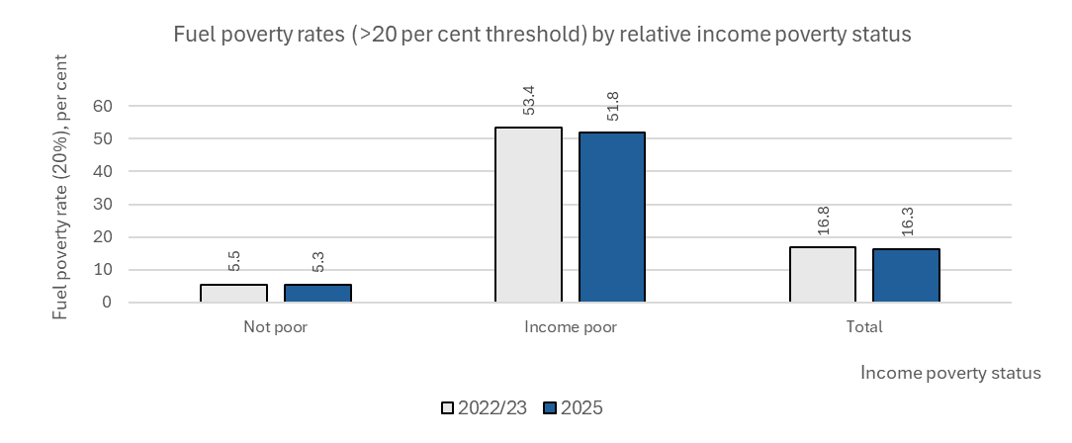

Source: Authors calculations of the LCFS for 2022-23.

Figure 2 reports the rates of fuel poverty by income decile and clearly shows household in poorest income deciles have the highest risks of fuel poverty, with the poorest ten per cent of the population having a fuel poverty affecting 7 in every 10 households. Indeed, 84% of all fuel poor households are in the lowest three deciles (See Annex Table 2). Since 2022/3 the minor falls in the rates of fuel poverty by decile are not significant.

The results of the logistic regression analysis show that household in the top four deciles and bottom four deciles are significantly more likely to have lower and higher rates of sever fuel poverty when compared to the average, after controlling for region, household composition, tenure type and employment status.

**Figure 2: Fuel poverty affects the poorest most**

Note: Results report poverty rates descriptives, with significances reporting significant deviation from the average condition for the category on the likelihood of being in fuel poverty (>20 per cent threshold) after controlling for region, short form household composition, tenure type and employment status in a logistic regression – see Annex Table 3. “***” is p<0.001, “**” is p<0.01, “*” is p<0.05, “.” is p<0.10. Data for 2025 are projections – see methodological annex. Poverty rates ordered low to high, based on 2025 estimates.

Source: Authors calculations of the LCFS for 2022-23.

The size of the fuel poverty gaps by income decile are not so concentrated, but they are still larger in the first two deciles (the gaps are also large in the top deciles, but the numbers are small – See Annex Table 2).

Figure 3 reports fuel poverty risk by household types and shows that the average household with children is at the highest risk of fuel poverty, with rates twice that of couple without children and pensioners, at 24%. Although falls are seen since 2022/3, these are slight, and not statistically significantly different.

What is significant, is the differences between the categories, after controlling for income decile, region, tenure type and employment status in a logistic regression. All categories, except for couples, are either significantly more likely to have lower poverty rates (pensioners or single person households) or high poverty rates (multi-unit households and households with children) based on household type alone.

**Figure 3: Households with children are at a higher risk of poverty than other households**

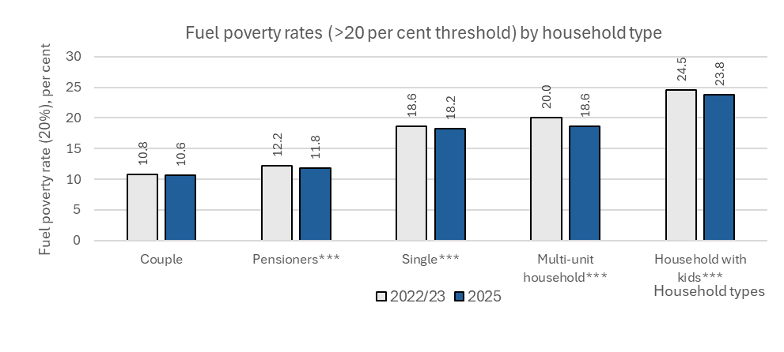

Note: Results report poverty rates descriptives, with significances reporting significant deviation from the average condition for the category on the likelihood of being in fuel poverty (>20 per cent threshold) after controlling for income decile, region, tenure type and employment status in a logistic regression – see Annex Table 3. “***” is p<0.001, “**” is p<0.01, “*” is p<0.05, “.” is p<0.10. Data for 2025 are projections – see methodological annex. Poverty rates ordered low to high, based on 2025 estimates.

Source: Authors calculations of the LCFS for 2022-23.

Figure 4 further breaks down the household types and shows that fuel poverty is most prevalent among large families and single parents specifically and least prevalent among childless couples and couple pensioners. Again, the differences between 2022/3 and 2025 are not significantly different, although slight falls in each case are reported. The size of poverty gaps do not follow the same pattern (See Annex Table 2). This further breakdown was not included in the logistic regression.

**Figure 4: Large families and single parents are at the highest risk of fuel poverty**

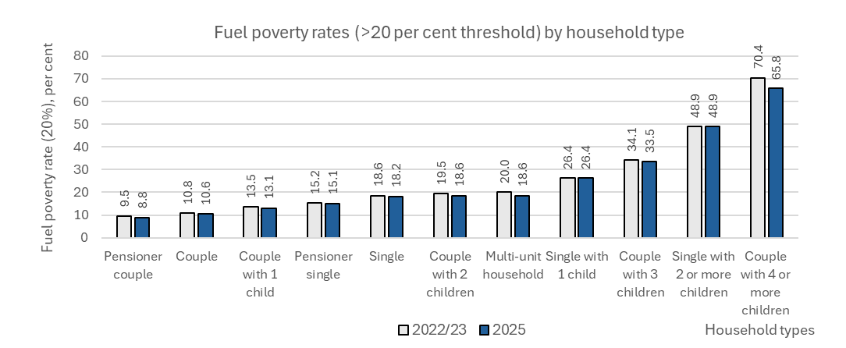

Source: Authors calculations of the LCFS for 2022-23.

Figure 5 reports the findings for fuel poverty by region, and shows that Northern Ireland and the West Midlands have the highest poverty rates and the lowest are in Wales and the South West. The size of the gaps do not follow the same pattern (See Annex Table 2).

The results of the logistic regression show that, in comparison to the average regional effect, in Northern Ireland employment differences, tenure, income and household type do not reduce the influence on regional difference when it comes to higher fuel poverty risks. Living in the South west, Eastern parts of the UK, and in London – net of other factors – lowers fuel poverty risks in relative to the average regional effect.

**Figure 5: Fuel poverty is highest in Northern Ireland, a finding that is independent of household structure, tenure, employment and income**

Note: Results report poverty rates descriptives, with significances reporting significant deviation from the average condition for the category on the likelihood of being in fuel poverty (>20 per cent threshold) after controlling for income decile, short form household composition, tenure type and employment status in a logistic regression – see Annex Table 3. “***” is p<0.001, “**” is p<0.01, “*” is p<0.05, “.” is p<0.10. Data for 2025 are projections – see methodological annex. Poverty rates ordered low to high, based on 2025 estimates.

Source: Authors calculations of the LCFS for 2022-23.

Figure 6 shows that unemployment and economic inactivity – when comparing bivariate statistics – have higher and lower rate of fuel poverty respectively. Nevertheless, when included in multivariate analysis (the logistic regression on in Annex table 3) no employment category retains significant influence on the likelihood of being fuel poor. This result suggest that other factors are mediating the relationship between employment status and fuel poverty – such as income levels or household type.

**Figure 6: The unemployed are at the highest risk of fuel poverty**

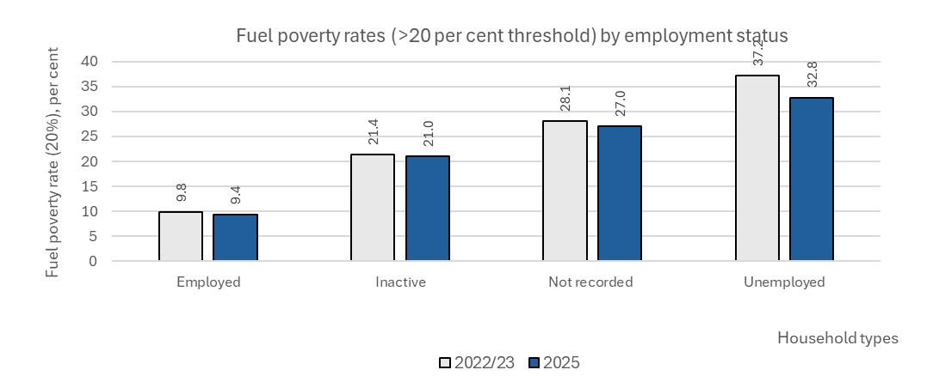

Note: Results report poverty rates descriptives, with significances reporting significant deviation from the average condition for the category on the likelihood of being in fuel poverty (>20 per cent threshold) after controlling for income deciles, region, short form household composition, and tenure type in a logistic regression – see Annex Table 3. “***” is p<0.001, “**” is p<0.01, “*” is p<0.05, “.” is p<0.10. Data for 2025 are projections – see methodological annex. Poverty rates ordered low to high, based on 2025 estimates.

Source: Authors calculations of the LCFS for 2022-23.

Figure 7 shows again that categories of fuel poverty risk by council tax band are statistically unchanged since 2022/3, with less a percentage point difference separating each council tax band category. There is an expected relationship with Council Tax Bands – the lower the band the higher the fuel poverty rate (except for the highest bands with very small numbers). There is much less variation in fuel poverty gaps.

**Figure 7:**

Note: Poverty rates ordered low to high, based on 2025 estimates. Source: Authors calculations of the LCFS for 2022-23.

Tenure type is the final factor considered in this analysis, and results show that housing association and local authority renting are most closely related to higher rates of fuel poverty. Rates in these housing groups are as high as 1 in 4 or 1 on 3 households effected by fuel poverty.

When looking instead as the raw numbers of fuel poor – influenced by the overall rate of tenure type – results show that 45% of the fuel poor live in owner occupied dwellings (see Annex Table 2). This result is due to the higher rates of owner-occupied accommodation in comparison to other tenure types.

After controlling for income, employment status, household type and region, private renters are still more likely to have lower fuel poverty rate than the average household, and housing association renters are more likely to have higher fuel poverty rates regardless of these other conditions.

**Figure 8: After controlling for other factors, housing association tenants are more likely to experience fuel poverty than other tenure types**

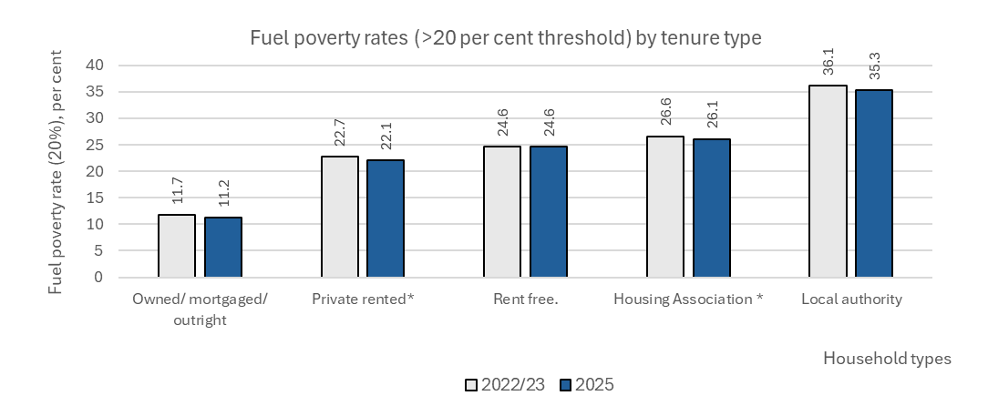

Note: Results report poverty rates descriptives, with significances reporting significant deviation from the average condition for the category on the likelihood of being in fuel poverty (>20 per cent threshold) after controlling for income decile, region, short form household composition, and employment status in a logistic regression – see Annex Table 3. “***” is p<0.001, “**” is p<0.01, “*” is p<0.05, “.” is p<0.10. Data for 2025 are projections – see methodological annex. Poverty rates ordered low to high, based on 2025 estimates.

Source: Authors calculations of the LCFS for 2022-23.

**Annex Table 1: Fuel stress number and % of households, rates and gaps at the >10% threshold in 2022/3 and estimates for January 2025**

|  | 2022/23 | | 2025 | | 2022/23 | 2025 | 2022/23 | | 2025 | |
| --- | --- | --- | --- | --- | --- | --- | --- | --- | --- | --- |
| **key variables** | **Number of households in fuel poverty** | **Fuel poor** | **Count** | **Fuel poor** | **Fuel poverty rate** | **Fuel poverty rate** | **Fuel poor gap** | | **Fuel poor gap** | |
|  | (000) | % | (000) | % | % | % | Mean | Median | Mean | Median |
| **income decile** |  |  |  |  |  |  |  |  |  |  |
| 1 | 3000.6 | 23.8 | 2975.6 | 24.6 | 88.8 | 88.1 | 28.5 | 21.1 | 28.6 | 21.3 |
| 2 | 2489.8 | 19.8 | 2444.1 | 20.2 | 79.2 | 77.8 | 24.9 | 17.6 | 24.7 | 17.4 |
| 3 | 1789.2 | 14.2 | 1772.6 | 14.6 | 62.3 | 61.7 | 22.1 | 15 | 21.7 | 14.8 |
| 4 | 1515 | 12 | 1399.8 | 11.6 | 51.4 | 47.4 | 19.1 | 15.1 | 19.8 | 16.5 |
| 5 | 1063.6 | 8.4 | 1013.4 | 8.4 | 37.1 | 35.6 | 19.7 | 15.3 | 19.2 | 15.3 |
| 6 | 947.5 | 7.5 | 924 | 7.6 | 34.5 | 33.5 | 21.7 | 15.3 | 22.2 | 15.4 |
| 7 | 672.1 | 5.3 | 581.1 | 4.8 | 24.8 | 21.4 | 17.7 | 12.7 | 19.2 | 13.5 |
| 8 | 530.2 | 4.2 | 486.8 | 4 | 19.8 | 18.2 | 26.1 | 15.1 | 27.9 | 15.5 |
| 9 | 407 | 3.2 | 373.6 | 3.1 | 13.8 | 12.7 | 30 | 16.3 | 30.2 | 15.6 |
| 10 | 174.9 | 1.4 | 144.2 | 1.2 | 5.8 | 4.8 | 26.4 | 8.67 | 29.7 | 8.73 |
| Total | 12590.1 | 100 | 12115.2 | 100.0 |  |  |  |  |  |  |
| **Household type (brief)** |  |  |  |  |  |  |  |  |  |  |
| single | 1763.8 | 14 | 1676.7 | 13.8 | 34.8 | 33.1 | 18.8 | 14.2 | 19.3 | 14.7 |
| couple | 1896.9 | 15.1 | 1822.3 | 15 | 30.8 | 29.6 | 26.3 | 16.2 | 26.6 | 17.1 |
| household with kids | 4098.8 | 32.6 | 3967.8 | 32.8 | 57 | 55.2 | 26.7 | 20.6 | 26.9 | 20.5 |
| pensioners | 3290.4 | 26.1 | 3160.2 | 26.1 | 41.7 | 40 | 19 | 13.5 | 19.1 | 13.3 |
| multi-unit household | 1540.2 | 12.2 | 1488.2 | 12.3 | 51.8 | 50 | 29.2 | 21.6 | 29.4 | 21.4 |
|  | 12590.1 | 100 | 12115.2 | 100.0 |  |  |  |  |  |  |
| **Household type** |  |  |  |  |  |  |  |  |  |  |
| single | 1763.8 | 14 | 1676.7 | 13.8 | 34.8 | 33.1 | 18.8 | 14.2 | 19.3 | 14.7 |
| single with 1 child | 408.6 | 3.2 | 408.6 | 3.4 | 51.3 | 51.3 | 20.9 | 14.5 | 20.4 | 13.6 |
| single with 2 or more children | 556.9 | 4.4 | 556.9 | 4.6 | 78.1 | 78.1 | 31.4 | 22.1 | 30.9 | 21.8 |
| couple | 1896.9 | 15.1 | 1822.3 | 15 | 30.8 | 29.6 | 26.3 | 16.2 | 26.6 | 17.1 |
| couple with 1 child | 983.4 | 7.8 | 947 | 7.8 | 43.2 | 41.6 | 22.9 | 16.7 | 23 | 16.6 |
| couple with 2 children | 1463.6 | 11.6 | 1369 | 11.3 | 57.7 | 54 | 24 | 19.4 | 24.9 | 20.1 |
| couple with 3 children | 403 | 3.2 | 403 | 3.3 | 69.7 | 69.7 | 33.7 | 26.7 | 32.9 | 26.3 |
| couple with 4 or more children | 283.4 | 2.3 | 283.4 | 2.3 | 99.6 | 99.6 | 43.4 | 27 | 42.9 | 26.7 |
| multi-unit household | 1540.2 | 12.2 | 1488.2 | 12.3 | 51.8 | 50 | 29.2 | 21.6 | 29.4 | 21.4 |
| pensioner single | 1554.5 | 12.3 | 1497 | 12.4 | 41.4 | 39.9 | 18.6 | 13 | 18.8 | 13.1 |
| pensioner couple | 1735.9 | 13.8 | 1663.2 | 13.7 | 42 | 40.2 | 19.4 | 13.6 | 19.5 | 13.4 |
| Total | 12590.1 | 100 | 12115.2 | 100.0 |  |  |  |  |  |  |
| **Region** |  |  |  |  |  |  |  |  |  |  |
| North East | 583.5 | 4.6 | 535.7 | 4.4 | 48.5 | 44.5 | 23.5 | 16.3 | 25 | 19.4 |
| North West and Merseyside | 1532.5 | 12.2 | 1472.9 | 12.2 | 47.3 | 45.5 | 21.7 | 13.9 | 21.9 | 14.3 |
| Yorkshire and the Humber | 1120.3 | 8.9 | 1093.7 | 9 | 46.5 | 45.4 | 24.4 | 16.5 | 24.3 | 16.8 |
| East Midlands | 906.7 | 7.2 | 852.5 | 7 | 43.5 | 40.9 | 17.8 | 13.3 | 18.3 | 13.5 |
| West Midlands | 1302.2 | 10.3 | 1283.1 | 10.6 | 51.9 | 51.2 | 25 | 16.7 | 24.7 | 16.4 |
| Eastern | 1113.6 | 8.8 | 1081.4 | 8.9 | 40.8 | 39.6 | 24 | 15.6 | 24 | 15.5 |
| London | 1239.2 | 9.8 | 1213.5 | 10 | 31.8 | 31.1 | 25.1 | 18.2 | 25 | 17.5 |
| South East | 1538.2 | 12.2 | 1441.5 | 11.9 | 38.6 | 36.2 | 25.7 | 17.3 | 26.6 | 17.6 |
| South West | 991.3 | 7.9 | 962.5 | 7.9 | 39.6 | 38.4 | 23.4 | 15.1 | 23.3 | 14.5 |
| Wales | 599.7 | 4.8 | 592.9 | 4.9 | 42.7 | 42.2 | 23 | 15.3 | 22.5 | 14.9 |
| Scotland | 1208.8 | 9.6 | 1138.4 | 9.4 | 47 | 44.3 | 23.6 | 15 | 24.4 | 15.5 |
| Northern Ireland | 454.3 | 3.6 | 447.2 | 3.7 | 60.2 | 59.3 | 31.5 | 23.7 | 31.3 | 23.5 |
| Total | 12590.1 | 100 | 12115.2 | 100.0 |  |  |  |  |  |  |
| **Council Tax band** |  |  |  |  |  |  |  |  |  |  |
| A | 2950.4 | 24.3 | 2808.2 | 24.1 | 51.7 | 49.2 | 21.6 | 15.2 | 22.1 | 15.6 |
| B | 2511.3 | 20.7 | 2418.1 | 20.7 | 42.8 | 41.2 | 20.9 | 13.7 | 21.1 | 13.5 |
| C | 2334.9 | 19.2 | 2269.2 | 19.4 | 38.1 | 37 | 23.4 | 13.6 | 23.5 | 14.4 |
| D | 1893.5 | 15.6 | 1810.6 | 15.5 | 39.9 | 38.2 | 20.1 | 15.5 | 20.2 | 15.4 |
| E | 1286.6 | 10.6 | 1266.9 | 10.9 | 39.9 | 39.3 | 23.2 | 17.4 | 22.8 | 17.3 |
| F | 691 | 5.7 | 632.7 | 5.4 | 39.1 | 35.8 | 31.7 | 23.4 | 33.5 | 22.9 |
| G | 391 | 3.2 | 385.3 | 3.3 | 41.7 | 41 | 50.4 | 29.8 | 50.1 | 30.8 |
| H | 74.1 | 0.6 | 74.1 | 0.6 | 60.1 | 60.3 | 72.8 | 63.6 | 71.5 | 61.8 |
| Household accommodation not valued separately | 3 | 0 | 3 | 0.0 | 10.9 | 10.9 | 10 | 10 | 10 | 10 |
| Total | 12135.9 | 100 | 11668.1 | 100 |  |  |  |  |  |  |
| **Employment status** |  |  |  |  |  |  |  |  |  |  |
| Employed | 4370.3 | 34.8 | 4115 | 34.0 | 30.4 | 28.6 | 24.1 | 15.9 | 24.8 | 16.6 |
| Unemployed | 450.2 | 3.6 | 441.7 | 3.7 | 65.2 | 64 | 22.6 | 17.3 | 22.7 | 16.8 |
| Inactive | 5665.8 | 45.1 | 5494.6 | 45.4 | 52.3 | 50.7 | 22 | 15.3 | 22.1 | 15.3 |
| Not recorded | 2089.5 | 16.6 | 2049.7 | 16.9 | 61.8 | 60.6 | 28.6 | 21.6 | 28.5 | 21.3 |
| Total | 12575.9 | 100 | 12101 | 100.0 |  |  |  |  |  |  |
|  |  |  |  |  |  |  |  |  |  |  |
| **Tenure type** |  |  |  |  |  |  |  |  |  |  |
| Local authority | 1526.1 | 12.1 | 1479.1 | 12.2 | 68.9 | 66.8 | 24.7 | 17.6 | 25 | 17.7 |
| Housing Association | 1135 | 9 | 1099.9 | 9.1 | 53.5 | 51.9 | 23.2 | 17.8 | 23.4 | 17.7 |
| Private rented | 2633.6 | 20.9 | 2548.7 | 21 | 48.5 | 46.9 | 24.5 | 17.3 | 24.7 | 17 |
| Owned/ mortgaged/ outright | 7143.7 | 56.7 | 6835.7 | 56.4 | 37.2 | 35.6 | 23.5 | 16 | 23.8 | 16 |
| Rent free | 151.9 | 1.2 | 151.9 | 1.3 | 45.1 | 45.1 | 24.9 | 28.8 | 24.4 | 28 |
| Total | 12590.1 | 100 | 12115.2 | 100.0 |  |  |  |  |  |  |
|  |  |  |  |  |  |  |  |  |  |  |
| **Income poverty** |  |  |  |  |  |  |  |  |  |  |
| No (i.e., >=60% median income) | 6801 | 54 | 6426.5 | 53.0 | 30.4 | 28.7 | 21.4 | 14.8 | 21.9 | 14.9 |
| Yes (i.e., < 60% median income) | 5789.1 | 46 | 5688.7 | 47.0 | 83.4 | 82.2 | 26.6 | 19.4 | 26.6 | 19.1 |
| Total | 12590.1 | 100 | 12115.2 | 100.0 |  |  |  |  |  |  |
| **Total** | **12590.1** | **100** | **12115.2** | **100.0** | **43** | **41.4** | **23.83** | **16.43** | **24.09** | **16.82** |
|  |  |  |  |  |  |  |  |  |  |  |

**Annex Table 2:** **Fuel poverty number and % of households, rates and gaps at the >20% threshold in 2022/3 and estimates for January 2025**

|  | 2022/23 | | 2025 | | 2022/23 | 2025 | 2022/23 | | 2025 | |
| --- | --- | --- | --- | --- | --- | --- | --- | --- | --- | --- |
| **key variables** | **Count** | **Fuel poor** | **Count** | **Fuel poor** | **Fuel poverty rate** | **Fuel poverty rate** | **Fuel poor gap** | | **Fuel poor gap** | |
|  | (000) | % | (000) | % | % | % | Mean | Median | Mean | Median |
| **income decile** |  |  |  |  |  |  |  |  |  |  |
| 1 | 2341.8 | 47.5 | 2318.3 | 48.6 | 69.3 | 68.6 | 27.7 | 20.2 | 27.6 | 20.3 |
| 2 | 1237.6 | 25.1 | 1155.1 | 24.2 | 39.4 | 36.8 | 22.9 | 16.4 | 23.2 | 15.6 |
| 3 | 530.8 | 10.8 | 506.9 | 10.6 | 18.5 | 17.6 | 23.9 | 13.7 | 23.8 | 13.2 |
| 4 | 361.9 | 7.3 | 338.5 | 7.1 | 12.3 | 11.5 | 15.5 | 12.0 | 15 | 12.1 |
| 5 | 179.7 | 3.6 | 166.9 | 3.5 | 6.3 | 5.9 | 20.2 | 15.6 | 17.5 | 14.1 |
| 6 | 134.7 | 2.7 | 144.9 | 3.0 | 4.9 | 5.3 | 30.0 | 19.9 | 29 | 21.2 |
| 7 | 39.4 | 0.8 | 39.4 | 0.8 | 1.5 | 1.5 | 29.8 | 13.1 | 27.9 | 11.2 |
| 8 | 55 | 1.1 | 55.0 | 1.2 | 2.0 | 2.1 | 43.7 | 24.8 | 40.9 | 22.5 |
| 9 | 38.1 | 0.8 | 38.1 | 0.8 | 1.3 | 1.3 | 55.1 | 55.8 | 51.9 | 52.4 |
| 10 | 10.5 | 0.2 | 10.5 | 0.2 | 0.3 | 0.3 | 30.5 | 30.5 | 25.2 | 25.2 |
| Total | 4929.4 | 100 | 4773.6 | 100 |  |  |  |  |  |  |
| **Household type (brief)** |  |  |  |  |  |  |  |  |  |  |
| single | 943.5 | 19.1 | 922.8 | 19.3 | 18.6 | 18.2 | 19.3 | 18.1 | 19.1 | 17.6 |
| couple | 668.7 | 13.6 | 655 | 13.7 | 10.8 | 10.6 | 33.2 | 23.0 | 32.9 | 22.7 |
| household with kids | 1757.8 | 35.7 | 1709.9 | 35.8 | 24.5 | 23.8 | 26.3 | 16.4 | 26.1 | 16.1 |
| pensioners | 964.3 | 19.6 | 931.9 | 19.5 | 12.2 | 11.8 | 20.9 | 15.2 | 20.7 | 15.4 |
| multi-unit household | 595.1 | 12.1 | 553.9 | 11.6 | 20 | 18.6 | 30.9 | 18.1 | 32 | 19.6 |
| Total | 4929.4 | 100 | 4773.6 | 100 |  |  |  |  |  |  |
| **Household type** |  |  |  |  |  |  |  |  |  |  |
| single | 943.5 | 19.1 | 922.8 | 19.3 | 18.6 | 18.2 | 19.3 | 18.1 | 19.1 | 17.6 |
| single with 1 child | 209.9 | 4.3 | 209.9 | 4.4 | 26.4 | 26.4 | 21.6 | 14.5 | 20.9 | 13.7 |
| single with 2 or more children | 349.1 | 7.1 | 349.1 | 7.3 | 48.9 | 48.9 | 28.4 | 20.3 | 27.6 | 19 |
| couple | 668.7 | 13.6 | 655 | 13.7 | 10.8 | 10.6 | 33.2 | 23.0 | 32.9 | 22.7 |
| couple with 1 child | 307.6 | 6.2 | 297.3 | 6.2 | 13.5 | 13.1 | 24.8 | 16.2 | 24.6 | 15.9 |
| couple with 2 children | 493.9 | 10 | 472.9 | 9.9 | 19.5 | 18.6 | 22.4 | 14.8 | 22.2 | 13.8 |
| couple with 3 children | 197.1 | 4 | 193.5 | 4.1 | 34.1 | 33.5 | 28.6 | 17.9 | 28 | 17 |
| couple with 4 or more children | 200.3 | 4.1 | 187.3 | 3.9 | 70.4 | 65.8 | 37.5 | 13.9 | 39.2 | 13.2 |
| multi-unit household | 595.1 | 12.1 | 553.9 | 11.6 | 20 | 18.6 | 30.9 | 18.1 | 32 | 19.6 |
| pensioner single | 570.2 | 11.6 | 566.1 | 11.9 | 15.2 | 15.1 | 19.7 | 14.4 | 18.9 | 14.5 |
| pensioner couple | 394.1 | 8 | 365.8 | 7.7 | 9.5 | 8.8 | 22.7 | 15.3 | 23.3 | 15.9 |
| Total | 4929.4 | 100 | 4773.6 | 100 |  |  |  |  |  |  |
| **Region** |  |  |  |  |  |  |  |  |  |  |
| North East | 212.4 | 4.3 | 212.4 | 4.4 | 17.7 | 17.7 | 23.4 | 13.6 | 22.5 | 12.6 |
| North West and Merseyside | 541.7 | 11 | 541.7 | 11.3 | 16.7 | 16.7 | 24.0 | 21.4 | 23 | 20.2 |
| Yorkshire and the Humber | 411.9 | 8.4 | 411.9 | 8.6 | 17.1 | 17.1 | 29.1 | 16.0 | 28.1 | 14.9 |
| East Midlands | 313.4 | 6.4 | 297.4 | 6.2 | 15 | 14.3 | 19.4 | 19.3 | 19.7 | 18.6 |
| West Midlands | 592.4 | 12 | 559.8 | 11.7 | 23.6 | 22.3 | 24.2 | 14.4 | 24.8 | 15.8 |
| Eastern | 385.1 | 7.8 | 379.7 | 8 | 14.1 | 13.9 | 24.6 | 14.7 | 23.9 | 13.9 |
| London | 655.7 | 13.3 | 655.7 | 13.7 | 16.8 | 16.8 | 26.1 | 18.9 | 25.3 | 18.2 |
| South East | 617.7 | 12.5 | 562.5 | 11.8 | 15.5 | 14.1 | 27.6 | 17.6 | 29.3 | 17.9 |
| South West | 326 | 6.6 | 306.8 | 6.4 | 13 | 12.2 | 27.6 | 24.8 | 28.1 | 23.9 |
| Wales | 170.1 | 3.5 | 170.1 | 3.6 | 12.1 | 12.1 | 25.0 | 14.9 | 23.8 | 13.7 |
| Scotland | 486 | 9.9 | 465.4 | 9.8 | 18.9 | 18.1 | 25.6 | 17.4 | 25.8 | 17 |
| Northern Ireland | 217 | 4.4 | 210 | 4.4 | 28.8 | 27.9 | 25.5 | 18.1 | 25.3 | 18.1 |
| Total | 4929.4 | 100 | 4773.6 | 100 |  |  |  |  |  |  |
| **Council Tax band** |  |  |  |  |  |  |  |  |  |  |
| A | 1392.9 | 29.6 | 1346.3 | 29.5 | 24.4 | 23.6 | 20.3 | 14.1 | 20.2 | 13.7 |
| B | 914.6 | 19.4 | 900.2 | 19.7 | 15.6 | 15.3 | 24.8 | 17.4 | 24.4 | 17.1 |
| C | 919.9 | 19.5 | 869.6 | 19.1 | 15 | 14.2 | 26.4 | 18.4 | 27 | 18.2 |
| D | 625.5 | 13.3 | 613.4 | 13.4 | 13.2 | 12.9 | 20.0 | 16.1 | 19.4 | 15.4 |
| E | 408.9 | 8.7 | 403.5 | 8.8 | 12.7 | 12.5 | 22.1 | 16.5 | 21.6 | 15.9 |
| F | 207.6 | 4.4 | 199 | 4.4 | 11.8 | 11.3 | 48.9 | 28.8 | 49.8 | 26.1 |
| G | 187.2 | 4 | 176 | 3.9 | 19.9 | 18.8 | 53.3 | 40.2 | 55.1 | 38.7 |
| H | 52.6 | 1.1 | 52.6 | 1.2 | 42.9 | 42.9 | 50.8 | 53.8 | 48.5 | 51.2 |
| Household accommodation not valued separately | 3 | 0.1 | 3 | 0.1 | 10.9 | 10.9 | 10 | 10 | 10 | 10 |
| Total | 4712.4 | 100 | 4563.5 | 100.0 |  |  |  |  |  |  |
| **Employment status** |  |  |  |  |  |  |  |  |  |  |
| Employed | 1401.9 | 28.5 | 1350.7 | 28.3 | 9.8 | 9.4 | 29.0 | 18.1 | 28.9 | 18 |
| Unemployed | 256.5 | 5.2 | 226.5 | 4.8 | 37.2 | 32.8 | 22.1 | 23.7 | 24.4 | 24.7 |
| Inactive | 2313.7 | 47 | 2275.9 | 47.7 | 21.4 | 21 | 22.4 | 17.1 | 21.9 | 16.3 |
| Not recorded | 951.3 | 19.3 | 914.4 | 19.2 | 28.1 | 27 | 28.4 | 16.5 | 28.5 | 16.9 |
| Total | 4923.4 | 100 | 4767.5 | 100.0 |  |  |  |  |  |  |
| **Tenure type** |  |  |  |  |  |  |  |  |  |  |
| Local authority | 800.3 | 16.2 | 781.8 | 16.4 | 36.1 | 35.3 | 23.4 | 15.0 | 23.1 | 15 |
| Housing Association | 565.1 | 11.5 | 553.9 | 11.6 | 26.6 | 26.1 | 23.2 | 21.7 | 22.8 | 21.8 |
| Private rented | 1234.1 | 25 | 1197.4 | 25.1 | 22.7 | 22.1 | 25.6 | 16.1 | 25.5 | 15.4 |
| Owned/ mortgaged/ outright | 2247.1 | 45.6 | 2157.7 | 45.2 | 11.7 | 11.2 | 26.9 | 18.0 | 26.9 | 18.1 |
| Rent free | 82.8 | 1.7 | 82.8 | 1.7 | 24.6 | 24.6 | 18.7 | 17.2 | 17.9 | 16.6 |
| **Income poverty** |  |  |  |  |  |  |  |  |  |  |
| No (i.e., >=60% median income) | 1222.3 | 24.8 | 1187.8 | 24.9 | 5.5 | 5.3 | 24.4 | 15.4 | 23.6 | 15.2 |
| Yes (i.e., < 60% median income) | 3707.1 | 75.2 | 3585.8 | 75.1 | 53.4 | 51.8 | 25.8 | 18.3 | 25.9 | 18.1 |
| Total | 4929.4 | 100 | 4773.6 | 100 |  |  |  |  |  |  |
| **Total** | **4929.4** | **100** | **4773.6** | **100** | **16.8** | **16.3** | **25.41** | **17.29** | **25.29** | **16.90** |

**Annex Table 3: Logistic regression analysis: likelihood of being fuel poor at >20 per cent**

|  |  |  |  |  |  |
| --- | --- | --- | --- | --- | --- |
|  | **Estimate** | **Std. Error** | **z value** | **P-value** |  |
| **(Intercept)** | -2.688 | 0.109 | -24.707 | 0.000 | *** |
| **decile 1** | 3.631 | 0.104 | 35.032 | 0.000 | *** |
| **decile 2** | 2.297 | 0.096 | 24.020 | 0.000 | *** |
| **decile 3** | 1.351 | 0.098 | 13.723 | 0.000 | *** |
| **decile 4** | 0.680 | 0.109 | 6.245 | 0.000 | *** |
| **decile 5** | 0.124 | 0.121 | 1.023 | 0.306 |  |
| **decile 6** | -0.148 | 0.130 | -1.141 | 0.254 |  |
| **decile 7** | -1.551 | 0.215 | -7.215 | 0.000 | *** |
| **decile 8** | -1.449 | 0.207 | -7.008 | 0.000 | *** |
| **decile 9** | -1.909 | 0.252 | -7.565 | 0.000 | *** |
| **decile 10** | -3.027 | 0.454 | -6.660 | 0.000 | *** |
| **region North East** | 0.250 | 0.133 | 1.878 | 0.060 | . |
| **region North West and Merseyside** | -0.091 | 0.107 | -0.846 | 0.397 |  |
| **region Yorkshire and the Humber** | -0.004 | 0.108 | -0.034 | 0.973 |  |
| **region East Midlands** | -0.435 | 0.127 | -3.433 | 0.001 | *** |
| **region West Midlands** | -0.050 | 0.107 | -0.472 | 0.637 |  |
| **region Eastern** | -0.128 | 0.120 | -1.073 | 0.283 |  |
| **region London** | -0.233 | 0.118 | -1.976 | 0.048 | * |
| **region South East** | 0.165 | 0.108 | 1.526 | 0.127 |  |
| **region South West** | -0.303 | 0.112 | -2.705 | 0.007 | ** |
| **region Wales** | -0.119 | 0.186 | -0.636 | 0.525 |  |
| **region Scotland** | 0.175 | 0.091 | 1.922 | 0.055 | . |
| **region Northen Ireland** | 0.773 | 0.093 | 8.272 | 0.000 | *** |
| **hh_comp Single** | -0.649 | 0.109 | -5.969 | 0.000 | *** |
| **hh_comp Couple** | 0.002 | 0.086 | 0.024 | 0.981 |  |
| **hh_comp Household with children** | 0.504 | 0.068 | 7.418 | 0.000 | *** |
| **hh_comp Pensioners** | -0.518 | 0.085 | -6.088 | 0.000 | *** |
| **hh_comp Multi-unit household** | 0.660 | 0.077 | 8.587 | 0.000 | *** |
| **housing_type Local authority** | -0.016 | 0.099 | -0.165 | 0.869 |  |
| **housing_type Housing association** | -0.250 | 0.110 | -2.279 | 0.023 | * |
| **housing_type Private rented** | -0.175 | 0.086 | -2.033 | 0.042 | * |
| **housing_type Owned/mortgaged/outright** | 0.030 | 0.075 | 0.400 | 0.689 |  |
| **housing_type Rent free** | 0.411 | 0.218 | 1.887 | 0.059 | . |
| **employment_status Employed** | -0.094 | 0.075 | -1.255 | 0.210 |  |
| **employment_status Unemployed** | -0.062 | 0.170 | -0.367 | 0.713 |  |
| **employment_status Inactive** | 0.064 | 0.081 | 0.796 | 0.426 |  |
| **employment_status Not recorded** | 0.092 | 0.086 | 1.071 | 0.284 |  |
|  |  |  |  |  |  |
| **Null deviance** | 9457.5 |  |  |  |  |
| **Residual deviance** | 5922 |  |  |  |  |
| **AIC** | 5986 |  |  |  |  |

1. This analysis was funded by Research England Policy Support Fund, distributed by The York Policy Engine. It is dedicated to our memories of Dr Antonia Keung who undertook most of our work on fuel poverty before she died tragically in 2024
2. Data scientist, The Learning for Well-being Institute
3. Emeritus Professor, University of York
4. Managing Director, The Learning for Well-being Institute
5. <https://cpag.org.uk/policy-and-campaigns/briefing/who-are-fuel-poor>
6. J Bradshaw and A Keung, [*Is a social tariff for energy feasible and effective?*](https://pure.york.ac.uk/portal/files/81132848/Social_tariffs_final_19_Oct_cp_latest_.docx), University of York, 2022 https://cpag.org.uk/sites/default/files/2023-08/Exploring%20social%20tariffs%20for%20energy.pdf
7. See J Bradshaw and A Keung, ‘[Rising fuel poverty](https://askcpag.org.uk/content/208471/rising_fuel_poverty)’, *Poverty,* CPAG, 173, 2022, and A Keung and J Bradshaw, ‘[Fuel poverty estimates for April 2023 following the Autumn Statement, including social security mitigations](https://cpag.org.uk/news-blogs/news-listings/fuel-poverty-estimates-april-2023-following-autumn-statement-including)’, CPAG, 9 December 2022
8. J Bradshaw and A Keung, [*Is a social tariff for energy feasible and effective?*](https://pure.york.ac.uk/portal/files/81132848/Social_tariffs_final_19_Oct_cp_latest_.docx), University of York, 2022
9. The official definition of fuel poverty( <https://assets.publishing.service.gov.uk/media/67e51e2cbb6002588a90d5d5/annual-fuel-poverty-statistics-report-2025.pdf>) is based on the English House Conditions Survey and involves a dwelling thermal efficiency rating. We cannot replicate this and indeed have criticisms of it (see Bradshaw, JR 2024, 'New Fuel Poverty Statistics', Blog fuel poverty statistics, pp. 1. <https://www.york.ac.uk/policy-engine/cost-of-living/news-and-blogs/2024/blogfuelpovertystatisticsfor2024/>). The main criticism is that better insulated households are excluded from fuel poverty, despite the fact that are often very poor households living in social housing and spending more than 10 or 20 percent of net income on fuel.