Fully Field-Free Spin-Orbit Torque Switching Induced by Spin Splitting Effect in Altermagnetic RuO2

*Zhuoyi Li1, 2, 3, †, Zhe Zhang1, 2, 3, †, Yuzhe Chen1, 2, 3, Sicong Hu1, 2, 3, Yingjie Ji1, 2, 3, Yu Yan1, 2, 3, Jun Du1, 4, Yao Li1, Liang He1, 2, 3, Xuefeng Wang1, 2, Jing Wu5, 6, Rong Zhang2, Yongbing Xu1, 2, 3, 6, *, Xianyang Lu1, 2, 3, \**

1National Key Laboratory of Spintronics, Nanjing University, Suzhou 215163, China.

2Jiangsu Provincial Key Laboratory of Advanced Photonic and Electronic Materials, School of Electronic Science and Engineering, Nanjing University, Nanjing 210093, China.

3School of Integrated Circuits, Nanjing University, Suzhou 215163, China.

4Department of Physics, Nanjing University, Nanjing 210093, China.

5School of Integrated Circuits, Guangdong University of Technology, Guangzhou 510006, China.

6York-Nanjing International Center for Spintronics (YNICS), School of Physics, Engineering and Technology, University of York, York YO10 5DD, UK.

*Authors to whom correspondence should be addressed: [xylu@nju.edu.cn](mailto:xylu@nju.edu.cn) and [ybxu@nju.edu.cn](mailto:ybxu@nju.edu.cn)

†Z. Li and Z. Zhang contributed equally to this work

Keywords: Altermagnetism, field-free, spin-orbit torque, ruthenium dioxide, out-of-plane spin polarization

Abstract

Altermagnetism, a newly identified class of magnetism blending characteristics of both ferromagnetism and antiferromagnetism, is emerging as a compelling frontier in spintronics. In this study, we report a groundbreaking discovery of robust, 100% field-free spin-orbit torque (SOT) switching in a RuO2(101)/[Co/Pt]2/Ta structure. Our experimental results reveal that the spin currents, induced by the in-plane charge current, flow along the [100] axis, with the spin polarization direction aligned parallel to the Néel vector. These z-polarized spins generate an out-of-plane anti-damping torque, enabling deterministic switching of the Co/Pt layer without the necessity of an external magnetic field. The altermagnetic spin splitting effect (ASSE) in RuO2 promotes the generation of spin currents with pronounced anisotropic behavior, maximized when the charge current flows along the [010] direction. This unique capability yields the highest field-free switching ratio, maintaining stable SOT switching even under a wide range of external magnetic fields, demonstrating exceptional resistance to magnetic interference. Notably, the ASSE-dominated spin current is found to be most effective when the current is aligned with the [010] direction. Our study highlights the potential of RuO2 as a powerful spin current generator, opening new avenues for advancing spin-torque switching technologies and other cutting-edge spintronic devices.

1. Introduction

Altermagnetism, a novel class of magnetism that exhibits characteristics of both ferromagnetism and antiferromagnetism, has garnered significant attention in recent years. This phenomenon, predicted to occur in over 200 materials[1, 2]. Materials like ruthenium dioxide (RuO2) are considered promising candidates for exhibiting this dual nature, combining the stable, fast spin-flipping properties of antiferromagnets with the distinct spin states of ferromagnets. Previously considered a paramagnet, RuO2 has been shown to exhibit itinerant antiferromagnetism, with a Néel temperature above 300 K and the Néel vector aligned along the [001] axis[3]. This has been confirmed in recent XMLD experiments, which demonstrate the presence of Néel order and prove that the Néel vector is indeed parallel to the [001] crystalline axis in RuO2[4]. Furthermore, recent theoretical studies have suggested that RuO2,as a collinear antiferromagnet, could generate strong electric-field-induced spin currents, with spin orientation roughly aligned along the Néel vector[5]. RuO2 crystallizes in the rutile structure with the *P*42/*mnm* space group, where ruthenium atoms are situated at the centers of oxygen octahedra[6]. This crystal structure induces an anisotropic electronic configuration and elliptical Fermi surfaces at *kz* = 0[5]. Rather than real-space inversion, the two crystal sublattices with opposite magnetic moments are connected by a real-space fourfold rotation transformation. The defining symmetry of the altermagnetic phase lies in this real-space rotation, which links the opposite-spin sublattices[7]. The 90° rotation of Ru atoms in opposite magnetic sublattices, surrounded by directionally distinct oxygen octahedra, leads to anisotropic spin band splitting in momentum space, making RuO2 an efficient spin splitter[8].

To date, several studies have provided theoretical predictions and transport measurements related to RuO2. Bai et al. demonstrated spin splitting torque (SST) in collinear antiferromagnet RuO2 films, revealing that the direction of spin current is correlated with the crystal orientation of RuO2, and that the spin polarization direction is parallel to the Néel vector[8]. When the Néel vector is slightly canted, a strong out-of-plane spin current can be generated. Complementary work by Bose et al. showed that (101)-oriented RuO2 films can induce a significant electric-field-induced out-of-plane damping-like torque on an adjacent permalloy layer[9]. Guo et al. further demonstrated that spin currents along the z-axis, generated by the altermagnetic spin splitting effect (ASSE), are anisotropic, with the spin current reaching its maximum value when the electric current flows along the [010] direction[10]. These findings underscore the potential of RuO2 as a powerful spin current generator, leveraging the ASSE in a collinear antiferromagnet. The spin current direction in these films is directly influenced by the crystal orientation, while the spin polarization direction is determined by the Néel vector of RuO2. This controllability enhances the efficiency of out-of-plane spin polarization generation, offering a promising alternative to other mechanisms that rely on low crystal symmetry and specific magnetic ordering[11, 12, 13].

Despite these promising findings, some recent studies have questioned the magnetic properties of RuO2. Independent muon-spin relaxation and rotation (*μSR*) studies, which are highly sensitive probes of local magnetic moments, have revealed an extremely small magnetically ordered moment in RuO2 single crystals[14], challenging the previously assumed altermagnetic ground state. Additionally, Liu et al. used spin- and angle-resolved photoemission spectroscopy to investigate the band structures and spin polarization of RuO2 films and single-crystals, finding that the electronic structure aligns with nonmagnetic predictions and shows no evidence of the hypothesized spin splitting[15]. The question of whether RuO2 exhibits true altermagnetism remains an active area of research.

In this work, we propose a RuO2(101)/[Co/Pt]2/Ta structure for efficient and robust field-free SOT switching with perpendicular magnetization. SOT devices have garnered significant attention over the past decade due to their potential in memory and logic applications, especially in spin-orbit torque magnetic random-access memory (SOT-MRAM)[16, 17, 18, 19]. Efficient spin current generation and control are key to improving device performance, energy efficiency, and scalability[20]. In our study, the z-polarized spins from the (101)-oriented RuO2 layer are found to generate an out-of-plane anti-damping torque, enabling deterministic switching of the Co/Pt layer without the need for an external magnetic field. We observe a clear dependence on the direction of the applied current *JC*. The sample achieves nearly 100% switching ratio at an applied in-plane field *Hx* = 0 Oe when *JC* flows along the [0 $\overline{1}$ 0] axis. Notably, the ASSE dominates the spin current, especially when the applied current aligns with the [010] direction (θ = 90°). In this configuration, the spin polarization component generates significant effective fields, especially a substantial field-like effective field generated by the out-of-plane spin polarization (*σz*), which plays a crucial role in the deterministic magnetization switching. This interplay elucidates the mechanics of spin flow modulation within this crystalline context. These results not only provide additional evidence for altermagnetism in RuO2 but also offer valuable insights into enhancing spin-torque efficiency. Our results pave the way for the development of next-generation, energy-efficient spin-based memory and logic devices[21, 22, 23].

2. Results and discussion

All the samples were grown on Al2O3(102) substrates using a magnetron sputtering system. The layer sequence RuO2(15 nm)/Co(0.5 nm)/Pt(1 nm)/Co(0.5 nm)/Pt(1 nm)/Ta(2 nm) was deposited from bottom to top, as shown in Fig. 1a. Recent reports have shown that in RuO2(101) films, a spin diffusion length over 11 nm was measured, which is an order of magnitude longer than that in conventional materials[24]. The (101)-oriented RuO2 generates spin current with out-of-plane spin polarization[25]. The spin current (*JS*) flowing along the [100] axis, induced by the charge current (*JC*) along the [0 $\overline{1}$ 0] axis.The spin polarization direction ($σ$) for *JS* is approximately aligned parallel to the Néel vector ([001] axis)[8]. High-quality RuO2(101) films were grown on single-crystal Al2O3(102) substrates by introducing O2 gas into an Ar base gas during film growth in our magnetron sputtering system. To achieve defect-free, high-quality RuO2 epitaxial films that can exhibit excellent ASSE, we optimized the growth conditions of the films and identified the optimal oxygen flow rate and growth temperature. During the film growth process, a 50 standard cubic centimeter per minute (sccm) Ar gas flow was introduced, while the O2 flow ratewas controlled at 10 sccm. A pure ruthenium target was used, with the Radio Frequency (RF) power set at 50 W. The substrate temperature was fixed at 500 ℃ during deposition. More details on the optimization process are presented in the supporting information. As shown in Fig. 1c, the clear and sharp RHEED pattern for the 15 nm RuO2(101) film indicates that the film exhibits good crystallinity with a flat, well-ordered surface[26, 27]. XRD measurements of a 50 nm RuO2 film, shown in Fig. 1d, reveal clear and sharp RuO2(101) and RuO2(202) peaks, confirming the good (101) orientation of our RuO2 films. Raman spectroscopy analysis, shown in Fig. 1e, indicates three Raman active modes for the RuO2(101) film: Eg, A1g and B2g modes[28, 29]. High-resolution cross-sectional scanning transmission electron microscopy (HRTEM) was conducted on the RuO2(101)/[Co/Pt]2/Ta structure, as shown in Fig. 1f. The results demonstrate the high-quality layered growth of the multilayer thin film structure. Additionally, the high-resolution high-angle annular dark field (HAADF) image, shown in Fig. 1g, reveals a highly ordered arrangement of alternately stacked Ru and O atoms. Simultaneously, we tested the resistivity of the RuO2 film. The I-V curve is provided in the supplementary materials, and the resistivity is 1.24 μΩ·m, which is consistent with the ultralow resistivity reported in single crystals in the literature, indicating excellent conductivity[30]. These results demonstrate the high quality and excellent crystal structural properties of the RuO2(101) films grown in this study. This is crucial for achieving 100% robust field-free spin-orbit torque switching.

We initially investigate the current induced field-free SOT switching behavior. Fig. 2a and Fig. 2b present schematic diagrams illustrating the generation of spin current via ASSE in the (101)-oriented RuO2 film, along with the Hall device used for the experiments. Fig. 2c compares the normalized anomalous Hall effect (AHE) measurement curves at different θ, all of which exhibit good perpendicular magnetic anisotropy (PMA) with coercive fields around 300 Oe. To achieve SOT switching, we swept a pulsed direct current and measured the Hall resistance change of the Hall bar. Fig. 2d-f display the current-induced SOT magnetization switching loops in RuO2(101)/[Co/Pt]2/Ta at different in-plane external fields (*Hext*) from + 400 Oe to - 400 Oe at θ values of 90°, 45°, and 0°, respectively, with *Hext* aligned parallel to the direction of the applied current (*Ipulse*). In conventional structures[31, 32, 33, 34], no switching loop occurs at zero magnetic field, necessitating *Hext* to break the rotational symmetry of the spin torque. Remarkably, at θ = 90°, where the current flows along the x-axis ([010] crystal direction), SOT switching has been achieved without *Hext*, with a switching ratio approaching 100% (*RSOT* /*RAHE* = 1, where *RSOT* and *RAHE* denote the Hall resistance responses to SOT and magnetic field variations, respectively), as shown in Fig. 2d and Fig. S10. Similarly, in Fig. 2e, field-free SOT switching is observed at θ = 45°, with a switching ratio of approximately 85%, while no magnetization switching occurs at θ = 0° (Fig. 2f). The SOT switching curves for other angles, including 30°, 60°, 120°, 135°, and 150°, as well as experimental results for different RuO2 thicknesses, are presented in the supporting information.

Recently, several studies have explored field-free SOT switching using RuO₂, but none have achieved 100% switching ratio under zero-field conditions, even under high current densities[35, 36]. This is likely due to the multidomain structure of the perpendicular magnetic layer induced by the exchange bias from the RuO2 layer, or the AFM domain structure inherent to RuO2 itself. To achieve full switching, the AFM domain structure in RuO2 needs to be reduced to enhance the z-polarized spin current. Due to the excellent growth quality of our RuO2 films as evidenced by the high-quality single-crystal structure in the RHEED images and the highly ordered alternating stacking of Ru and O atoms in the TEM images in Fig. 1, they are likely to exhibit fewer antiferromagnetic domains. This characteristic enables the generation of a sufficiently strong z-polarized spin current, leading to 100% field-free full switching.

To further investigate the process of current-induced switching, we employed a magneto-optical Kerr effect (MOKE) microscope to capture the evolution of magnetic domains. Initially, the sample was saturated at a high field to set the magnetization in the 'up' direction, serving as a reference image. Subsequent Kerr images were captured after each current pulse, and the resulting MOKE images were generated by subtracting the reference image. Fig. 3a illustrates the MOKE image and domain states after each current pulse (*Ipulse*) without an assisting field for the Hall bar of RuO2(101)/[Co/Pt]2/Ta multilayers. The gray (dark) areas in these MOKE images represent the 'up' ('down') magnetized states. Upon reaching a critical current value, domain nucleation initiated at the right edge, followed by current-induced propagation of the domain wall (DW) across the entire strip. The switching region gradually expanded with increasing current density, ultimately filling the entire current path to achieve deterministic full switching. This provides clear evidence of 100% field-free SOT switching. Additionally, reversible switching was observed through the backward motion of DWs when applying opposite currents. These results are consistent with the electrical measurements. Our field-free switching performance of 100% notably surpasses the 70% typically reported by others, a result of the exceptional smoothness and low defect density of our thin films. These attributes lead to weaker pinning effects, as evidenced by MOKE images. The reduced pinning effects likely improve the arrangement and dynamic behavior of domains, minimizing the formation of antiferromagnetic (AFM) domain structures in the RuO₂ layer. This enhancement allows for more effective generation and amplification of z-polarized spin currents, as well as boosting spin current transmission efficiency. This combination of material quality and optimized domain structures plays a critical role in achieving highly efficient spin-torque switching.

To verify the presence of the out-of-plane spin-orbit torque induced by the altermagnetic spin splitting effect in RuO2 and its role in the field-free SOT switching observed in RuO2(101)/[Co/Pt]2/Ta heterostructures, we conducted a detailed investigation of the current-induced effective field[37, 38, 39, 40, 41]. Specifically, we examined the current-induced deflection variations of *RH-Hz* hysteresis loops at different DC currents, in the absence of a transverse magnetic field *Hx*, as shown in Fig. S11. From the shift in the loops, we extracted the out-of-plane SOT effective field using the expression ${∆H}_{z}^{eff}=H_{shift}\left(I^{+}\right)-H_{shift}\left(I^{-}\right)$ and $H_{shift}\left(I^{±}\right) = [{|H}_{C}^{+}\left(I^{±}\right)|-{|H}_{C}^{-}\left(I^{±}\right)|$]/2. The significant threshold effect of ${∆H}_{z}^{eff}$ observed in the absence of a transverse magnetic field *Hx*, along with the phenomenon of field-free SOT switching, provides compelling evidence for the existence of z-polarized spin currents in the RuO2(101)/[Co/Pt]2/Ta multilayer system[12, 37].

In the RuO2(101)/[Co/Pt]2/Ta multilayer structure, the current-induced SOT magnetization switching loop, driven by the current flowing along the x-axis ([010] crystal direction), exhibits a remarkably stable clockwise rotation within a magnetic field range greater than 400 Oe, as shown in Fig. 4a. Fig. 4b summarizes the SOT switching ratios (*RSOT/RAHE*) under different θ and various magnitudes of *Hext*, indicating that the highest SOT switching ratios are achieved without any external field assistance, regardless of the current direction. The maximum ratio is near 100% at θ = 90° and the minimum at θ = 0°. Additionally, the switching direction remains unchanged regardless of the magnitude of *Hext*. This behavior is significantly different from traditional SOT magnetization switching curves[31, 33, 34]. Fig. 4c summarizes the field-free SOT switching ratio and the full width at half maximum (FWHM) of the switching ratio under different values of θ. It is evident that θ = 90° achieves the highest field-free switching ratio and FWHM, maintaining stable SOT switching within an external field range of approximately 400 Oe, indicating excellent resistance to magnetic interference under these conditions. The corresponding values for other angles are symmetrical about θ = 90° within the range of 0° to 180°, gradually decreasing away from θ = 90°. This indicates that the spin currents along the [100] direction with an out-of-plane spin polarization component $σ_{z}$, arising from the ASSE, exhibit anisotropic behavior and are maximized when the charge current flows along the [010] direction. These findings are consistent with previous reports in the literature[10, 25].

Furthermore, we investigated the current-induced deflection variations of *RH-Hz* hysteresis loops at different DC currents under an applied magnetic field. The observed linear relationship between ${∆H}_{z}^{eff}$ and $I$ serves as a quantitative measure of the SOT efficiency. Intriguingly, in the RuO2(101)/[Co/Pt]2/Ta (with θ = 90°), ${∆H}_{z}^{eff}$ remains isotropic even upon reversal of the applied magnetic field. The behavior contrasts sharply with that observed in Ta/[Co/Pt]2, where reverses with *Hx*, in line with the conventional mechanism resulting from the intrinsic Spin Hall Effect (SHE), as depicted in Fig. 4d-e.[32, 35, 42]. The angular dependence of this phenomenon indicates that the loop shift arises from the synergistic effects of both the conventional SHE and the altermagnetic spin splitting effect (ASSE)[8, 10, 25]. Notably, the ASSE appears to dominate the spin current, particularly when the applied current aligns with the [010] crystallographic direction (at θ = 90°), as illustrated in Fig. S12. A more detailed discussion of the potential mechanisms of spin current modulation in this crystalline environment is provided in the supporting information.

Significantly, the SOT switching rotation direction remains consistent regardless of variations in the applied magnetic field. This behavior is distinctly different from conventional SOT switching mechanism, where the switching direction typically reverses with changes in magnetic field orientation. The stability observed here, coupled with the distinct loop shift characteristics in the *RH-Hz* loops, compellingly highlights the dominant role of the σz component generated by the ASSE in governing the current-induced SOT switching dynamics. From an application perspective, achieving robust and deterministic magnetic-field-free perpendicular magnetization switching is crucial. This robustness is essential for reliable device performance in environments with external magnetic disturbances. To characterize the role of spin torque, we use the effective magnetic field. While this parameter is not typically used to assess switching efficiency, it offers an intuitive measure of the stability and robustness of field-free perpendicular switching. Fig. 4f shows a comparative analysis of perpendicular magnetic multilayer structures utilizing different spin source materials, evaluated in terms of the current-induced in-plane SOT effective field and the field-free SOT switching ratio (RSOT/RAHE). Our findings underscore significant advantages: the use of RuO2 as a spin source to provide the σz component results in a substantially larger current-induced effective magnetic field, enabling robust, 100% field-free SOT switching. However, several challenges must also be addressed in the future for the practical applications of RuO2. For instance, the growth of high-quality single-crystal RuO2 films requires a specific single-crystal substrate to maintain the necessary epitaxial relationship, which introduces certain limitations. Additionally, RuO2 film growth typically requires elevated temperatures, posing potential challenges for integration with standard CMOS fabrication processes. Nevertheless, we believe the advantages of RuO2 as a SOT material for field-free switching significantly outweigh these limitations. Further research may overcome these challenges, such as through hybrid epitaxy or buffer layer integration, as well as developments in low-temperature growth techniques.

**3. Conclusion**

In conclusion, we have demonstrated the 100% SOT switching in a RuO2(101)/[Co/Pt]2/Ta structure, where any potential pinning effects in the [Co/Pt]2 multi-layers are effectively eliminated. This is attributed to the reduced formation of AFM domains, which is facilitated by the high-quality growth of a single crystal RuO2(101) layer achieved through a precisely controlled magnetron sputtering process. Our findings further highlight that (101)-oriented RuO2 films are capable of generating spin currents with an out-of-plane spin polarization component $σ_{z}$, driven by the altermagnetic spin splitting effect (ASSE). These spin currents exhibit clear anisotropic behavior, with their magnitude peaking when the charge current is applied along the [010] direction.

SOT switching experiments provide compelling evidence for the strong interdependence between spin current direction and crystal orientation in RuO2, offering direct support for the material's altermagnetic properties and the generation of the ASSE. Notably, the application of a charge currentalong the [010] direction results in the highest field-free switching ratio, with stable SOT switching maintained even in external fields exceeding 400 Oe, demonstrating exceptional resilience against magnetic interference. Current-induced *R*H-*H*z hysteresis loop measurements further emphasize the privotal role of the $σ_{z}$ component in enhancing spin-torque efficiency, shedding light on the underlying mechanisms governing spin flow modulation within this crystalline structure.

The controllability of spin polarization and the efficient generation of out-of-plane spin currents position RuO2 as a promising candidate for next-generation spintronic devices. This work opens new avenues for practical applications in spin-torque switching technologies, with the potential to significantly enhance the functionality, efficiency, and scalability of SOT-MRAM and other spintronic memory and logic devices. By expanding the scope of spintronic applications, these results bring us closer to realizing energy-efficient, next-generation spin-based memory and logic devices.

**Data Availability**

The data that support the findings of this work are available within the paper and its supporting information. Additional data are available from the corresponding authors upon reasonable request.

**Associated Content**

**Supporting Information:** Methods to sample preparation and measurement technique; S1. Optimization of High-Quality Epitaxial RuO2 Thin Films for ASSE-Driven SOT Switching; S2. The epitaxy growth modes of RuO2(101) on Al2O3(102) substrate. S3. The voltage-current curve for a 15 nm RuO2(101) thin film; S4. Resistivity ρ versus temperature T for the RuO2(101) on Al2O3(102) substrate; S5. The VSM measurements of the RuO2(101)/[Co/Pt]2/Ta multilayers; S6. Optical image of the Hall bar device; S7. Current-induced SOT switching behaviors observed in RuO2(101)/[Co/Pt]2/Ta multilayers at θ = 0°, 30°, 45°, 60°, 90°, 120°, 135° and 150°; S8. Calculation of Switching Ratio; S9. Current-induced effective fields with z-polarized spin in RuO2(101); S10. Angle-dependent measurements of current-induced effective fields in RuO2(101); S11. Harmonic Hall measurements; S12. RuO2(101)/[Co/Pt]2/Ta samples with varying RuO2 thicknesses; S13. Current-induced magnetization switching behaviors were observed in the control samples.

**Acknowledgements**

This work is supported by the National Key Research and Development Program of China (Grant Nos. 2021YFB3601600, 2023YFA1406603, 2022YFA1403602) and the National Natural Science Foundation of China (Grant Nos. 12104216, 12241403, 61427812, 12374112, T2394473, T2394470, T2394473).

**Author contributions**

X.L. and Y.X. conceived the project and designed the experiments. Z.L. and Z.Z. prepared the samples with the help from Y.Y., Y.L. and L.H.. J.D. performed the VSM measurements. Z.L., Z.Z., X.L. and Y.X. performed the data analysis and wrote the paper with contributions from all authors. All authors discussed the results, interpretation and conclusion.

**Competing interests**

The authors declare no competing interests.

**Figures and captions**

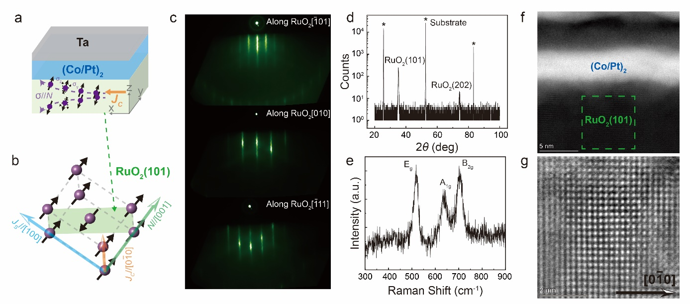

**Fig. 1. Charge-to-spin conversion via ASSE in RuO2(101). a,** Schematic representation of our sample. The spin polarization direction (*σ*) for the spin current (*JS*) is aligned parallel to the Néel vector ([001] axis). **b,** The schematic illustrates *JS* flowing along the [100] axis induced by the charge current (*JC*) along the [0 $\overline{1}$ 0] axis. The RuO2(101) crystal plane is highlighted by the green shading. **c,** Reflection high-energy electron diffraction (RHEED) patterns of a 15 nm RuO2(101) film grown on the Al2O3(102) substrate. **d,** *θ*-2*θ* scan x-ray diffraction (XRD) spectrum of a 50 nm thick RuO2(101) film grown on the Al2O3(102) substrate. Peaks from the substrate are marked with *. **e,** Raman spectra of a 50 nm thick RuO2(101) film grown on the Al2O3(102) substrate, showing three Raman active modes: Eg, A1g and B2g modes. **f,** High-resolution HAADF image of the cross-section of RuO2(101)/[Co/Pt]2/Ta and **g,** RuO2(101) film.

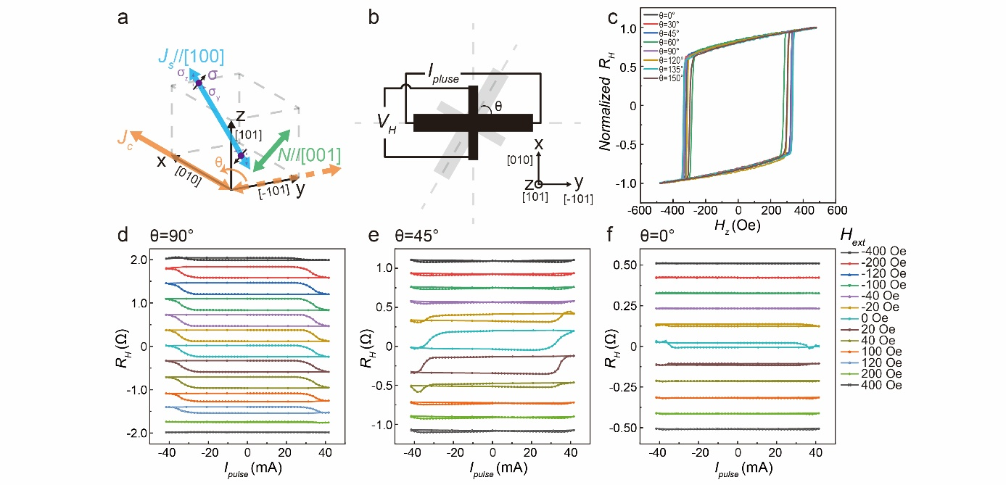

**Fig. 2. Current-driven SOT switching measurement in RuO2(101)/[Co/Pt]2/Ta. a,** Schematic diagram illustrating the generation of spin current via ASSE in the (101)-oriented RuO2 film. **b,** The Hall device used for the experiments. θ represents the angle between the current direction and the y-axis. **c,** Normalizedanomalous Hall effect (AHE) loops for diffenent values of θ. **d-f,** Corresponding current-induced magnetization switching behaviors observed in Co/Pt multilayers at θ = 90°, 45° and 0°.

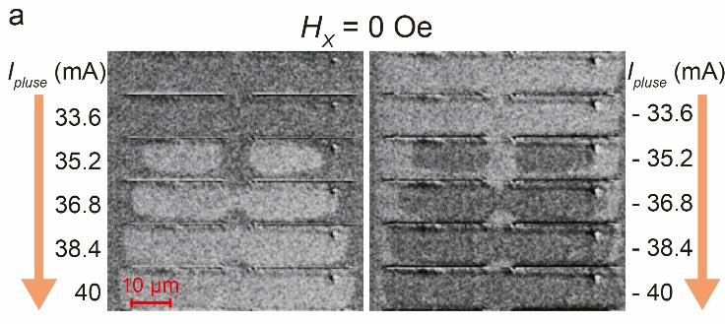

**Fig. 3. Magneto-optical Kerr effect imaging. a,** MOKE images showing the current-induced switching process of domain wall motion at *Hx* = 0 Oe for the RuO2(101)/[Co/Pt]2/Ta multilayers.

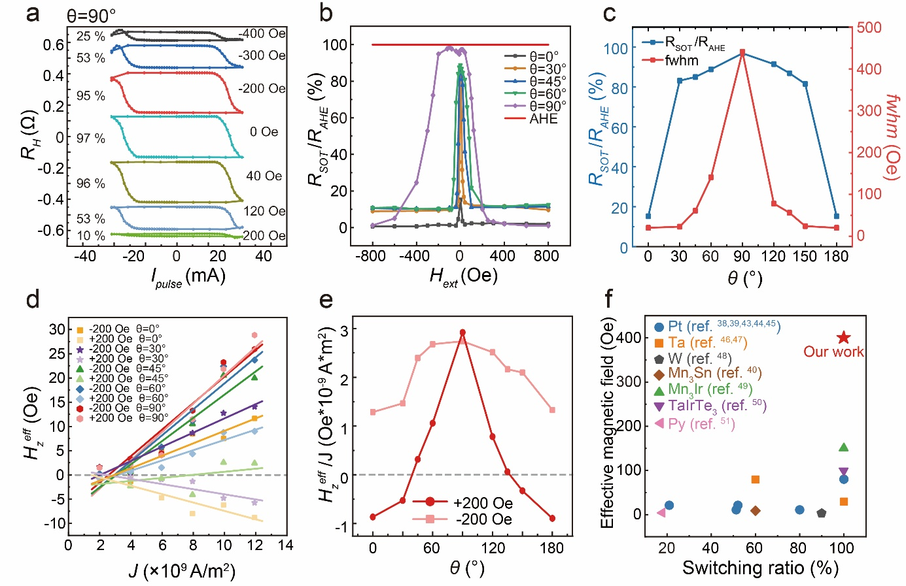

**Fig. 4. Angle-dependent σz component generated by the ASSE in RuO2. a,** *RH* against *Ipulse* under different external magnetic field *Hext* in RuO2(101)/[Co/Pt]2/Ta. **b,** The SOT switching ratios (*RSOT*/*RAHE*) under various θ and magnitudes of *Hext*. **c,** The field-free SOT switching ratio and the full width at half maximum (FWHM) of the switching ratio under different values of θ. **d,** A summary of the shift (${∆H}_{z}^{eff}$) at different bias currents (*I*) for RuO2(101)/[Co/Pt]2/Ta along different current angles θ with *Hx* = ± 200 Oe. **e,** A summary of the ${∆H}_{z}^{eff}/J$ for RuO2(101)/[Co/Pt]2/Ta at different values of θ. **f,** Comparison of the SOT in-plane effective magnetic field and field-free switching ratio (RSOT/RAHE) with other perpendicular magnetic multilayer structures using different spin source materials: Pt[38, 39, 43, 44, 45], Ta[46, 47], W[48], Mn3Sn[40], Mn3Ir[49], TaIrTe3[50] and Py[51].

**References**

[1] L. Šmejkal, J. Sinova, T. Jungwirth, *Physical Review X* **2022**, 12, 040501.

[2] L. Šmejkal, J. Sinova, T. Jungwirth, *Physical Review X* **2022**, 12, 031042.

[3] T. Berlijn, P. C. Snijders, O. Delaire, H. D. Zhou, T. A. Maier, H. B. Cao, S. X. Chi, M. Matsuda, Y. Wang, M. R. Koehler, P. R. Kent, H. H. Weitering, *Phys. Rev. Lett.* **2017**, 118, 077201.

[4] Y.-C. Zhang, H. Bai, C. Chen, L. Han, S.-X. Liang, R.-Y. Chu, J.-K. Dai, F. Pan, C. Song, *Chinese Phys. Lett.* **2025**.

[5] R. Gonzalez-Hernandez, L. Smejkal, K. Vyborny, Y. Yahagi, J. Sinova, T. Jungwirth, J. Zelezny, *Phys. Rev. Lett.* **2021**, 126, 127701.

[6] L. F. Mattheiss, *Phys. Rev. B* **1976**, 13, 2433.

[7] Z. Feng, X. Zhou, L. Šmejkal, L. Wu, Z. Zhu, H. Guo, R. González-Hernández, X. Wang, H. Yan, P. Qin, X. Zhang, H. Wu, H. Chen, Z. Meng, L. Liu, Z. Xia, J. Sinova, T. Jungwirth, Z. Liu, *Nat. Electron.* **2022**, 5, 735.

[8] H. Bai, L. Han, X. Y. Feng, Y. J. Zhou, R. X. Su, Q. Wang, L. Y. Liao, W. X. Zhu, X. Z. Chen, F. Pan, X. L. Fan, C. Song, *Phys. Rev. Lett.* **2022**, 128, 197202.

[9] A. Bose, N. J. Schreiber, R. Jain, D.-F. Shao, H. P. Nair, J. Sun, X. S. Zhang, D. A. Muller, E. Y. Tsymbal, D. G. Schlom, D. C. Ralph, *Nat. Electron.* **2022**, 5, 267.

[10] Y. Guo, J. Zhang, Z. Zhu, Y. Y. Jiang, L. Jiang, C. Wu, J. Dong, X. Xu, W. He, B. He, Z. Huang, L. Du, G. Zhang, K. Wu, X. Han, D. F. Shao, G. Yu, H. Wu, *Adv. Sci.* **2024**, 11, 2400967.

[11] D. MacNeill, G. M. Stiehl, M. H. D. Guimaraes, R. A. Buhrman, J. Park, D. C. Ralph, *Nat. Phys.* **2016**, 13, 300.

[12] S. C. Baek, V. P. Amin, Y. W. Oh, G. Go, S. J. Lee, G. H. Lee, K. J. Kim, M. D. Stiles, B. G. Park, K. J. Lee, *Nat. Mater.* **2018**, 17, 509.

[13] H. Xie, X. Chen, Q. Zhang, Z. Mu, X. Zhang, B. Yan, Y. Wu, *Nat. Commun.* **2022**, 13, 5744.

[14] M. Hiraishi, H. Okabe, A. Koda, R. Kadono, T. Muroi, D. Hirai, Z. Hiroi, *Phys. Rev. Lett.* **2024**, 132, 166702.

[15] J. Liu, J. Zhan, T. Li, J. Liu, S. Cheng, Y. Shi, L. Deng, M. Zhang, C. Li, J. Ding, Q. Jiang, M. Ye, Z. Liu, Z. Jiang, S. Wang, Q. Li, Y. Xie, Y. Wang, S. Qiao, J. Wen, Y. Sun, D. Shen, *Phys. Rev. Lett.* **2024**, 133, 176401.

[16] C. Song, R. Zhang, L. Liao, Y. Zhou, X. Zhou, R. Chen, Y. You, X. Chen, F. Pan, *Prog. Mater. Sci.* **2021**, 118, 100761.

[17] X. Han, X. Wang, C. Wan, G. Yu, X. Lv, *Appl. Phys. Lett.* **2021**, 118, 120502.

[18] A. Du, D. Zhu, K. Cao, Z. Zhang, Z. Guo, K. Shi, D. Xiong, R. Xiao, W. Cai, J. Yin, S. Lu, C. Zhang, Y. Zhang, S. Luo, A. Fert, W. Zhao, *Nat. Electron.* **2023**, 6, 425.

[19] Z. Li, Z. Zhang, M. Wei, X. Lu, T. Li, J. Zhou, Y. Yan, J. Du, X. Wang, Y. Li, L. He, J. Wu, Y. Gao, R. Zhang, Y. Xu, *Adv. Sci.* **2024**, 11, 2406924.

[20] F. Wang, G. Shi, K. W. Kim, H. J. Park, J. G. Jang, H. R. Tan, M. Lin, Y. Liu, T. Kim, D. Yang, S. Zhao, K. Lee, S. Yang, A. Soumyanarayanan, K. J. Lee, H. Yang, *Nat Mater* **2024**, 23, 768.

[21] V. Baltz, A. Manchon, M. Tsoi, T. Moriyama, T. Ono, Y. Tserkovnyak, *Rev. Mod. Phys.* **2018**, 90, 015005.

[22] T. Jungwirth, X. Marti, P. Wadley, J. Wunderlich, *Nat. Nanotechnol.* **2016**, 11, 231.

[23] Q. Shao, P. Li, L. Liu, H. Yang, S. Fukami, A. Razavi, H. Wu, K. Wang, F. Freimuth, Y. Mokrousov, M. D. Stiles, S. Emori, A. Hoffmann, J. Akerman, K. Roy, J.-P. Wang, S.-H. Yang, K. Garello, W. Zhang, *IEEE T. Magn.* **2021**, 57, 1.

[24] Y. Zhang, H. Bai, L. Han, C. Chen, Y. Zhou, C. H. Back, F. Pan, Y. Wang, C. Song, *Adv. Funct. Mater.* **2024**, 34, 2313332.

[25] H. Bai, Y. C. Zhang, Y. J. Zhou, P. Chen, C. H. Wan, L. Han, W. X. Zhu, S. X. Liang, Y. C. Su, X. F. Han, F. Pan, C. Song, *Phys. Rev. Lett.* **2023**, 130, 216701.

[26] Z. Zhang, X. Lu, Y. Yan, J. Lu, Z. Li, Q. Liu, F. Zhu, J. Cao, Y. Wang, Z. Huang, Y. Zhai, Y. Li, X. Ruan, L. He, J. Wu, J. Du, R. Zhang, Y. Xu, *Appl. Phys. Lett.* **2022**, 120, 182403.

[27] W. Nunn, S. Nair, H. Yun, A. Kamath Manjeshwar, A. Rajapitamahuni, D. Lee, K. A. Mkhoyan, B. Jalan, *APL Mater.* **2021**, 9, 091112.

[28] L. Meng, *Thin Solid Films* **2003**, 442, 93.

[29] S. Y. Mar, C. S. Chen, Y. S. Huang, K. K. Tiong, *Appl. Surf. Sci.* **1995**, 90, 497.

[30] W. D. Ryden, A. W. Lawson, C. C. Sartain, *Phys. Rev. B* **1970**, 1, 1494.

[31] W. J. Kong, C. H. Wan, X. Wang, B. S. Tao, L. Huang, C. Fang, C. Y. Guo, Y. Guang, M. Irfan, X. F. Han, *Nat. Commun.* **2019**, 10, 233.

[32] Z. Li, X. Lu, Z. Zhang, W. Li, T. Li, J. Zhou, Y. Yan, R. Liu, J. Du, R. Liu, X. Wang, Y. Li, L. He, J. Wu, R. Zhang, Y. Xu, *Appl. Phys. Lett.* **2023**, 123, 042404.

[33] L. Liu, O. J. Lee, T. J. Gudmundsen, D. C. Ralph, R. A. Buhrman, *Phys. Rev. Lett.* **2012**, 109, 096602.

[34] L. Liu, C. F. Pai, Y. Li, H. W. Tseng, D. C. Ralph, R. A. Buhrman, *Science* **2012**, 336, 555.

[35] S. Karube, T. Tanaka, D. Sugawara, N. Kadoguchi, M. Kohda, J. Nitta, *Phys. Rev. Lett.* **2022**, 129, 137201.

[36] Y. Fan, Q. Wang, W. Wang, D. Wang, Q. Huang, Z. Wang, X. Han, Y. Chen, L. Bai, S. Yan, Y. Tian, *ACS Nano* **2024**, 18, 25907.

[37] L. Liu, C. Zhou, X. Shu, C. Li, T. Zhao, W. Lin, J. Deng, Q. Xie, S. Chen, J. Zhou, R. Guo, H. Wang, J. Yu, S. Shi, P. Yang, S. Pennycook, A. Manchon, J. Chen, *Nat. Nanotechnol.* **2021**, 16, 277.

[38] M. Wang, J. Zhou, X. Xu, T. Zhang, Z. Zhu, Z. Guo, Y. Deng, M. Yang, K. Meng, B. He, J. Li, G. Yu, T. Zhu, A. Li, X. Han, Y. Jiang, *Nat. Commun.* **2023**, 14, 2871.

[39] T. Jin, G. J. Lim, H. Y. Poh, S. Wu, F. Tan, W. S. Lew, *ACS Appl. Mater. Interfaces* **2022**, 14, 9781.

[40] S. Hu, D. F. Shao, H. Yang, C. Pan, Z. Fu, M. Tang, Y. Yang, W. Fan, S. Zhou, E. Y. Tsymbal, X. Qiu, *Nat. Commun.* **2022**, 13, 4447.

[41] K. J. Lee, Y. Liu, A. Deac, M. Li, J. W. Chang, S. Liao, K. Ju, O. Redon, J. P. Nozières, B. Dieny, *J. Appl. Phys.* **2004**, 95, 7423.

[42] C.-F. Pai, M. Mann, A. J. Tan, G. S. D. Beach, *Phys. Rev. B* **2016**, 93, 144409.

[43] Y. Deng, W. Li, X. Lan, E. Zhang, R. Li, Y. Shang, S. Liu, B. Li, X. Liu, H. Zheng, K. Wang, *Adv. Funct. Mater.* **2023**, 34, 2307612.

[44] Q. Huang, C. Guan, Y. Fan, X. Zhao, X. Han, Y. Dong, X. Xie, T. Zhou, L. Bai, Y. Peng, Y. Tian, S. Yan, *ACS Nano* **2022**, 16, 12462.

[45] W. He, C. Wan, C. Zheng, Y. Wang, X. Wang, T. Ma, Y. Wang, C. Guo, X. Luo, M. E. Stebliy, G. Yu, Y. Liu, A. V. Ognev, A. S. Samardak, X. Han, *Nano Lett.* **2022**, 22, 6857.

[46] H. Wu, J. Nance, S. A. Razavi, D. Lujan, B. Dai, Y. Liu, H. He, B. Cui, D. Wu, K. Wong, K. Sobotkiewich, X. Li, G. P. Carman, K. L. Wang, *Nano Lett.* **2021**, 21, 515.

[47] T. Zhou, X. Xie, X. Zhao, Y. Dong, J. Wang, W. Chen, Q. Huang, Q. Leng, L. Bai, Y. Chen, S. Yan, Y. Tian, *Phys. Rev. B* **2022**, 105, 144434.

[48] N. Murray, W. B. Liao, T. C. Wang, L. J. Chang, L. Z. Tsai, T. Y. Tsai, S. F. Lee, C. F. Pai, *Phys. Rev. B* **2019**, 100, 104441.

[49] Y. Pu, G. Shi, Q. Yang, D. Yang, F. Wang, C. Zhang, H. Yang, *Adv. Funct. Mater.* **2024**, 34, 2400143.

[50] Y. Liu, G. Shi, D. Kumar, T. Kim, S. Shi, D. Yang, J. Zhang, C. Zhang, F. Wang, S. Yang, Y. Pu, P. Yu, K. Cai, H. Yang, *Nat. Electron.* **2023**, 6, 732.

[51] M. Yang, L. Sun, Y. Zeng, J. Cheng, K. He, X. Yang, Z. Wang, L. Yu, H. Niu, T. Ji, G. Chen, B. Miao, X. Wang, H. Ding, *Nat. Commun.* **2024**, 15, 3201.