**Title: New rites, local lives: strontium isotope analysis of cremated human remains from the Late Iron Age cemetery at Westhampnett, West Sussex, UK**

**Authors:** Madeleine Bleasdale1, Ian Armit1, Andrew Fitzpatrick2, Charlotte Primeau3, Christophe Snoeck4

1. Department of Archaeology, University of York, Kings Manor, Exhibition Square, York YO1 7EP, United Kingdom
2. School of Archaeology and Ancient History, University of Leicester [af215@leicester.ac.uk](mailto:af215@leicester.ac.uk)
3. Warwick Manufacturing Group (WMG), University of Warwick [charlie.primeau@warwick.ac.uk](mailto:charlie.primeau@warwick.ac.uk)
4. Archaeology, Environmental Changes & Geo-Chemistry, Vrije Universiteit Brussel, Belgium, [christophe.snoeck@vub.be](mailto:christophe.snoeck@vub.be)

**Corresponding author:** Madeleine Bleasdale,[maddy.bleasdale@york.ac.uk](mailto:maddy.bleasdale@york.ac.uk)

**Abstract**

The emergence of cremation burial during the Late Iron Age in southern Britain (c.150 BC - AD 43) occurred during a period of social and cultural transformation. Increased cross-channel connections are evident from similarities in funerary practice but, in the absence of preserved DNA, investigating whether these affinities might be directly linked to human mobility or more general cultural contact remains challenging. This paper presents the first strontium isotope analysis (87Sr/86Sr) of Iron Age cremation burials in Britain. The analysis was conducted on 31 individuals from cremation burials at the Late Iron Age cemetery of Westhampnett, West Sussex, United Kingdom. Contrary to previous interpretations based on funerary treatment and grave goods, the isotope results suggest that the cremated individuals were predominantly local and the narrow range of isotopic variation indicates a homogenous group, emphasising community stability. This research sheds light on social structure and mobility in Iron Age Britain.

**Keywords:** Cremation, Iron Age Britain, Strontium isotopes, Mobility, Funerary practices

**1. Introduction**

The Late Iron Age in southern Britain (c. 150 BC - AD 43) witnessed significant social and cultural changes, many of which appear to have been influenced by increasing cross-Channel contacts and entanglements with the expanding Roman world (Hill 2007). This period saw, for example, the adoption of coinage, the appearance of wheel-thrown pottery, an increase in imported goods, and the development of extensive, often multifocal, high-status settlements known as oppida. Underlying all these developments we can detect the increasing hierarchisation of Iron Age communities in southern and eastern Britain, culminating in the emergence of seemingly dynastic power structures in the decades following Caesar’s military expeditions of 55 and 54 BC (Creighton 2000).

Among the most striking developments in this period, mostly from c.75 BC onwards, is the adoption and spread of cremation burial, usually contained in urns, and frequently accompanied by grave goods (Fitzpatrick 2007; Harding 2016). This funerary tradition, known as the Aylesford-Swarling tradition (after two cemeteries in Kent), or more simply as Aylesford burials (Stead 1976; Fitzpatrick 1997, p208; Lamb 2022), extended over much of southern and eastern England and comprised mostly small cemeteries, usually containing less than a dozen burials (Harding 2016, p87–8). These burials are often called ‘Belgic’ a legacy from when they were thought to be the burials of the Belgae whom Julius Caesar described as having come from Belgic Gaul (northern France and Belgium) to plunder but who stayed to settle (*BG* 5.12). Most Aylesford-type burials are now known, however, to postdate the Gallic Wars. Accompanying grave goods appear to represent a spectrum of material wealth, with the less well-outfitted graves containing no more than the burial urn, while others might contain elaborately decorated bronze mirrors or wooden buckets encircled by decorated bronze bands. The most well-furnished graves in this tradition (although the term is used inconsistently), known as Welwyn burials, characteristically contained imported wine amphorae, items of iron hearth furniture known as ‘firedogs’, metalwork, and glass objects (Fitzpatrick 2007). Together this variation in the quality and quantity of grave goods and the incorporation of intrinsically valuable items and exotica, has been taken to indicate the role of funerals as a vector for social competition and display in an increasingly hierarchical society (e.g. Hill 2007).

Aylesford burials have clear affinities with contemporary cremation burials in north-eastern France, Belgium, Luxembourg, The Netherlands, and Central-western Germany (Fitzpatrick 1997: Figure 116, p211), suggesting strong cross-Channel links in relation to funerary practice, ideology, and religious beliefs. A central question concerning the adoption of the cremation burial rite in southern England is thus the extent to which it was initiated by the inward movement of individuals or groups from continental Europe, rather than reflecting more generalised cultural contact. It is not possible to directly address this issue using genetic analyses, since cremated human remains do not preserve ancient DNA which might enable the identification of cross-Channel migrants. The development of methods to analyse the strontium isotopic composition of calcined human bone (Snoeck et al. 2015), however, has now been applied to an ever-increasing number of archaeological sites and contexts (e.g. see synthesis of European data: Snoeck et al. 2022). This method has the potential to identify non-locals in cremation cemeteries and, in favourable circumstances, of inferring the geographical source of any migratory movements (Cavazzuti et al. 2021, Reiter et al. 2021, Löffelmann et al. 2023, Seghi et al. 2024).

As part of the ERC-funded COMMIOS project (Armit 2022), this study conducted the first strontium isotope analysis of Iron Age cremated remains from Britain, focussing on the cemetery of Westhampnett in West Sussex (**Figure 1**). As a large, relatively recently excavated, and exceptionally well-dated assemblage, Westhampnett presents an excellent opportunity to investigate the composition of a Late Iron Age cemetery population. Specifically, it allows us to assess the degree of homogeneity/heterogeneity and to elucidate any evidence for the presence of non-locals, as suggested by the strong cross-channel connections evidenced by the funerary rite and associated grave goods. As the earliest known Iron Age cremation burial cemetery in Britain, it has been suggested that this rite was introduced directly from neighbouring regions of northern Gaul, perhaps as the result of an influx of people from Belgic Gaul into the region of the counties of West Sussex and adjoining Hampshire (Cunliffe 2005, p176). Here we explore that hypothesis and examine if there is evidence for non-locals who could potentially represent cross-channel migrants who moved to the site later in life.

**2. Materials and Methods**

**2.1 Westhampnett Iron Age Cemetery**

**2.1.1 Site location and geology**

Excavations in 1992, conducted in advance of the construction of the A27 bypass at Westhampnett, West Sussex, uncovered a substantial Late Iron Age cremation burial cemetery (Fitzpatrick 1997). The site (**Figure 1**)sits on a low-lying hill on the West Sussex Coastal Plain, approximately 9 km inland from the Channel coast and 4 km east of the modern city of Chichester (Lat/long: 50.852772, -0.72859096, SU895066). The uppermost strata consist of marine gravel and calcareous marl (after Hodgson 1963/7) with areas of localised dense orange clay.

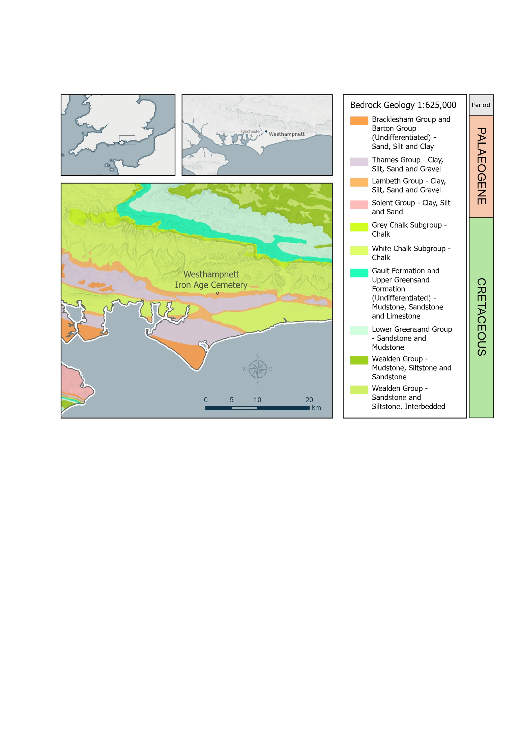

**Figure 1:** Map showing the location and geology of the Westhampnett cremation cemetery. Map made by Helen Goodchild, Department of Archaeology, University of York using ArcGIS Pro 3.1.3. Contains British Geological Survey materials © UKRI 2024; Contains public sector information licensed under the Open Government Licence v3.0. *COLOUR IMAGE NEEDED FOR PRINTED VERSION

**2.1.2 Archaeological background**

A number of features distinguish Westhampnett from most other Aylesford cemeteries. It was established earlier than other known examples, in the 2nd century BC, and it lies at the western edge of their distribution. The Westhampnett burials are also predominantly unurned, whereas most Aylesford burials are urned, and it is believed the Westhampnett individuals may have been wrapped in cloth or leather bags (Fitzpatrick 1997). The cemetery is also unusually large, containing 161 graves along with associated structures and deposits including pyres, pyre-related features, postholes, and small buildings interpreted as shrines (ibid., **Figure 2**). Of other Aylesford cemeteries, only the rather later, largely first century AD, site at King Harry Lane, Hertfordshire, contained more cremation burials (Stead and Rigby 1989).

**Figure 2:** Plan of the Westhampnett cemetery showing the cremation burials sampled in this study. Cremation burials from the inner circle (20087, 20208, 20274), the focal graves (20095, 20252, 20484), and the Earlier Iron Age individual with funerary monument (20566) are labelled. The plan is based on Figure 83 in Fitzpatrick et al. 2008, p178.

*COLOUR IMAGE NEEDED FOR PRINTED VERSION

The cemetery displayed a clear spatial organisation, with the majority of graves being set broadly in a circle around an open central area, close to a Bronze Age ring ditch whose upcast was presumably still upstanding (Fitzpatrick 1997). Most of the burials were unurned, comprising small quantities of cremated bone, although pottery vessels (including a few early wheel-made vessels) were included as grave goods in a majority of graves. Several graves also contained iron or copper alloy brooches (La Tène D1 and D2 types) and other metal objects, mainly costume fittings, which had been burnt on the pyre. Sometimes animal meat was placed on the pyre, but it was not placed as a grave good. There was little apparent change in the mortuary rituals during the use of the cemetery and there is little clear evidence for social stratification. As assessed solely by the Number of Artefact Types (NAT) placed in graves, women appear to have been provided with fewer grave goods than men, and individuals aged 18 years or younger had fewer grave goods than adults. Several graves were square in contrast to the frequent circular or oval graves. Some of the square graves may have been 'focal' burials for small groups and they generally contained more grave goods, but this is not statistically significant. Even so, it seems unlikely to be coincidental that the one instance in which a tiny fragment of gold was found, likely from a torc (Grave 20095), was a square grave and may have been a focal burial (Fitzpatrick 1997, p219). Three of these ‘focal’ graves were targeted for isotope analysis as well as three further individuals from an arc of graves at the north of the cemetery, termed the ‘inner circle,’ which contained a preponderance of older adults.

One of the most unusual burials at Westhampnett is that of an adult probable female (grave 20566), situated within a four-post structure inside a small ditched enclosure (**Figure 2**), c. 40 meters east of the main cemetery. The grave was urned, with the pot being the only one in the cemetery with a red slip. This type of funerary monument is well-known in northern France, dating to the 4th and 3rd centuries BC. This individual was sampled for isotope analysis to further explore potential continental connections.

In Northern Europe, cremation burial was widely practised in the 2nd century BC and burials of this date in France are often unurned, like those at Westhampnett (Fitzpatrick 1997, p211, Figure 116; Roymans 1990). Circular settings of graves have also been recognised in a few cemeteries in France and some of the pottery found at Westhampnett has strong continental parallels. These similarities suggest that the adoption of the cremation burial rite at Westhampnett and elsewhere may have been associated with the adoption of religious beliefs from France. Despite these strong links, however, only a few of the grave goods could be considered as potential imports from the Continent - most notably the possible torc and belt hook, though neither is certain. Although the ceramic assemblage has typological affinities with Normandy and adjacent regions of northern France, as well as within southern England (Fitzpatrick 1997), all the pottery was made locally even though imported vessels in styles that were copied at Westhampnett have been found in a settlement at North Bersted only c. 7 km away (Taylor et al. 2014).

**2.1.2 AMS-dating**

In the original excavation report (Fitzpatrick 1997) a date range of 100-40 BC was suggested, mainly based on the brooches, with a preferred date of 90-50 BC. When the radiocarbon dating of cremated bone became possible, 44 of the burials were AMS dated (Fitzpatrick et al. 2017). The results also placed the cemetery firmly in the Late Iron Age, although attempts to define it more closely are complicated by the potential age-offset in cremated bone caused by carbon exchange between the bioapatite component of the cremated bone, and the fuel used in the cremation process (for example, where old wood is used to construct the funeral pyre) (Fitzpatrick et al. 2017). Taking this issue into account, the preferred Bayesian model for the site’s chronology (the ‘Outlier model’) estimates a period of use for the cemetery beginning in 250–100 cal BC (95% probability, 235–130 cal BC, 68% probability) and ending in the period 140–15 cal BC (95% probability, 110–40 cal BC, 68% probability). The total period of use is estimated at 1–205 years (95% probability, 50–160 years, 68% probability) (Fitzpatrick et al. 2017). The latter probability would suggest that the site saw an average of 1-3 cremations per year throughout its use, although the rate of burial need not of course have been constant.

The Bayesian model summarised above excludes grave 20566 which dates significantly earlier to 745–400 cal BC (95% probability). This individual is therefore unique in terms of chronology, funerary architecture and their grave also contained pottery unique in the Westhampnett pottery assemblage. Even disregarding this earlier burial, however, Westhampnett represents the earliest Iron Age cremation burial cemetery so far known in southern Britain, lying at the start of a new and widespread tradition.

**2.1.3 Demography of the total burial population**

Although only small quantities of cremated bone were selected for burial, the approximate age of 121 individuals could be estimated (full report in McKinley 1997). Age was assessed using established methods for immature individuals (Van Beek 1983, Gray 1977; McMinn and Hutchings 1985) and adults (McMinn and Hutchings 1985; Webb and Suchey 1985, Bass 1987). The age ranges for the categories used are presented in **Table 1**. The age categories for each individual sampled in this study are presented in **Table 4** in the Results section. Where insufficient evidence was present to aid age assessment two categories were assigned (e.g. “Young/mature adult”).

|  |  |
| --- | --- |
| Foetus/neonate | < 6 months |
| Infant | 0-4 years |
| Juvenile | 5-12 years |
| Subadult | 13-18 years |
| Young adult | 19-25 years |
| Mature adult | 26-45 years |
| Older adult | 45 years + |

**Table 1:** Age categories used by McKinley in published osteological assessment of the Westhampnett human remains (1997).

The great majority of individuals from Westhampnett were adults, with infants and children being under-represented **(Table 2)**. It was possible to determine the sex of 26 individuals (21.5%), including only two subadult/adults. Sex estimation was based on sexually dimorphic skeletal traits (Bass 1987), including cranial vault thickness (Gejvall 1981). Individuals were categorised as follows: ? = unsexed, F = Female, M = Male, ??F = Possible Female, ??M = Possible Male , ?F = Probable Female and, ?M = Probable Male. Of the total buried population, 22 (18.2%) were identified as female and 4 (3.3%) as male, although this may reflect a bias in the ease of identification of females rather than being reflective of the original site demography (McKinley 1997).

|  |  |  |
| --- | --- | --- |
| **Age Groups** | **N** | **Percentage** |
| Immature | 14 | 11.6 |
| Subadult/adult | 20 | 16.5 |
| Adult | 87 | 71.9 |
| Total | 121 | 100 |

**Table 2:** The number of individuals per age group for all excavated individuals from Westhampnett cemetery.

**2.2 Strontium isotope analysis of cremated human remains**

A pivotal question regarding the emergence of cremation burial during the Late Iron Age in southern Britain revolves around whether it was introduced by incoming groups from continental Europe or was adopted through more generalised cross-cultural interactions. Unfortunately, it is impossible to address this question using ancient DNA as the high temperatures (up to 1000°C) reached during cremation result in the chemical alteration of bones and other tissues, making the retrieval of authentic ancient DNA unattainable. Furthermore, teeth seldom survive intact, often being highly fragmented or damaged, which hinders traditional strontium isotope methods targeting enamel to reconstruct residential origins. Fortunately, it has been demonstrated that calcined bone provides a reliable substrate for strontium isotope analysis (Harvig et al. 2014; Snoeck et al. 2015) and strontium isotope analysis has now been applied to archaeological cremated remains (Snoeck et al. 2022). By analysing bones from Westhampnett in this manner we aim to investigate the representation of non-locals at the site and explore the broader potential of the method to expand our understanding of mobility and connectivity during the Iron Age.

**2.3 Sampling strategy and site-specific research questions**

Fragments of calcined bone (~0.1 – 7 g) were selected from 31 individuals for strontium isotope analysis. In comparison to other broadly contemporary cemeteries, the amount of bone selected for burial was small; the mean weight of bone for adults was only 301.1 g (McKinley 1997, p68). Cortical bone, preferably from a long bone if identifiable, was selected, along with a single cranial fragment (grave 20225). Due to the small size of the fragments selected it was not possible to make more specific bone identifications. Minimising the destruction of the remains was a priority and one advantage of the method employed in this study is the small amounts of material required for analysis (e.g. c.50 mg). In some cases, only larger bone fragments were preserved but these were subsampled in the laboratory, with any unused material returned to the museum. At the lower end of the size range, existing bone fragments weighing less than 150 mg were selected for analysis. Sampling was conducted in agreement with the Novium Museum where the Westhampnett collection is deposited and all remaining material was returned after analysis. The 87Sr/86Sr and [Sr] data are openly available in the IsoArcH database (https://www.isoarch.org) (Salesse et al., 2018). All the individuals sampled in this study have associated radiocarbon dates (Fitzpatrick et al. 2017) **(Table 3)**.

|  |  |  |  |  |  |  |  |
| --- | --- | --- | --- | --- | --- | --- | --- |
| **Sample number** | **Grave** | **Context** | **Bone sampled for Sr analysis** | **Radiocarbon ID** | **δ13C (‰)** | **Radiocarbon age (BP)** | **Modelled date (95% probability)** |
| WH01 | 20018 (a) | 20019 | long bone | OxA-32485 | -21.7 | 2207 ±26 | 225–85 cal BC |
| WH02 | 20051 | 20050 | cortical bone | OxA-32487 | -19.9 | 2149 ±26 | 200–80 cal BC |
| WH03 | 20055 | 20056 | cortical bone | OxA-32488 | -17.3 | 2099 ±26 | 175–60 cal BC |
| WH04 | 20087 | 20086 | long bone | OxA-32489 | -19.4 | 2110 ±27 | 185–65 cal BC |
| WH05 | 20089 (a) | 20088 | long bone | OxA-32522 | -20.5 | 2068 ±28 | 165–55 cal BC |
| WH06 | 20095 (a) | 20094 | long bone | OxA-32523 | -20.3 | 2141 ±27 | 200–80 cal BC |
| WH07 | 20132 | 20131 | cortical bone | OxA-32617 | -21.1 | 2077 ±26 | 170–60 cal BC |
| WH08 | 20134 | 20133 | cortical bone | OxA-32524 | -22.1 | 2149 ±27 | 200–80 cal BC |
|  | 20169 (a) | 20168 | cortical bone | OxA-32527 | -22.6 | 2121 ±27 |  |
|  | 20169 (b) | 20168 | cortical bone | OxA-32557* | -21.9 | 2103 ±28 |  |
| **WH09** | **Mean 20169** | **T’ = 0.2; ν=1; T’ (5%)=3.8** | | | **-22.2^** | **2112±20** | **185-70 cal BC** |
| WH10 | 20191 | 20190 | cortical bone | OxA-32620 | -19.2 | 2102 ±26 | 180–60 cal BC |
| WH11 | 20208 | 20209 | long bone | OxA-32621 | -19.7 | 2099 ±26 | 175–60 cal BC |
| WH12 | 20235 | 20236 | long bone | OxA-32622 | -20.3 | 2145 ±27 | 200–80 cal BC |
| WH13 | 20245 (a) | 20246 | long bone | OxA-32623 | -20.9 | 2058 ±26 | 165–55 cal BC |
| WH14 | 20252 (a) | 20251 | long bone | OxA-32624 | -24.2 | 2147 ±29 | 200–80 cal BC |
| WH15 | 20253 (a) | 20254 | long bone | OxA-32625 | -21.7 | 2061 ±27 | 165–55 cal BC |
| WH16 | 20255 | 20256 | cranial frag. | OxA-32627 | -23.6 | 2091 ±27 | 175–60 cal BC |
| WH17 | 20274 | 20273 | long bone | OxA-32628 | -17.7 | 2125 ±26 | 195–75 cal BC |
| WH18 | 20451 | 20450 | long bone | OxA-32629 | -23.8 | 2107 ±28 | 185–65 cal BC |
|  | 20453 (a) | 20452 | cortical bone | OxA-32630 | -21.3 | 2195 ±27 |  |
|  | 20453 (b) | 20452 |  | OxA-32631* | -20.9 | 2184±26 |  |
| **WH19** | **Mean 20453** | **T’=0.5; ν=1; T’ (5%)=3.8** | | | **-21.1^** | **2075±20** | **220-85 cal BC** |
| WH20 | 20457 | 20456 | cortical bone | OxA-32632 | -26.3 | 2196 ±28 | 220–85 cal BC |
| WH21 | 20471 | 20470 | cortical bone | OxA-32633 | -20.9 | 2158 ±37 | 205–75 cal BC |
| WH22 | 20484 | 20485 | long bone | OxA-32635 | -23.6 | 2116 ±28 | 190–70 cal BC |
| WH23 | 20493 | 20492 | long bone | OxA-32636 | -19.7 | 2105 ±26 | 180–65 cal BC |
| WH24 | 20601 | 20600 | long bone | OxA-32641 | -19.2 | 2083 ±27 | 170–60 cal BC |
| WH25 | 20605 | 20604 | long bone | OxA-32859 | -19.5 | 2116 ±28 | 190–70 cal BC |
| WH26 | 20622 | 20621 | long bone | OxA-32643 | -19.1 | 2108 ±27 | 185–65 cal BC |
| WH27 | 20629 | 20628 | long bone | OxA-32860 | -19.4 | 2125 ±27 | 195–75 cal BC |
| WH28 | 20637 | 20636 | cortical bone | OxA-32957 | -25.1 | 2058 ±31 | 165–55 cal BC |
| WH29 | 20650 | 20649 | long bone | OxA-32658 | -21.1 | 2151 ±32 | 205–75 cal BC |
| WH30 | 20675 | 20676 | long bone | OxA-32644 | -19.4 | 2080 ±29 | 170–60 cal BC |
| WH31 | 20566 | 20567 | long bone | OxA-32638 | -18.4 | 2422 ± 27 | 745–400 cal BC |

**Table 3:** Westhampnett cremation burials sampled for strontium isotope analysis and their associated radiocarbon dates (as published in Fitzpatrick et al. 2017). *auto-replicate. Burial 20169 (a) and 20453 were double-dated as a standard lab control. The trimmed mean (T’) for each burial’s radiocarbon date was calculated and this was used to generate modelled date. ^For this study, the arithmetic mean (average) δ13C result was calculated.

As mentioned in the previous section, isotope studies of uncremated remains usually target dental enamel for 87Sr/86Sr to explore childhood residential origins. Teeth from cremated remains can be analysed (e.g. Taylor et al. 2020) but are rarely recovered and only available for a limited number of individuals. When considering the childhood origins of cremated individuals, a possible alternative is to target the densest part of the human skull, the otic capsule, which forms early in childhood and undergoes little remodelling. However, due to the fragmented nature of the Westhampnett remains and the desire to have a good overall sample size that encompassed individuals with radiocarbon dates, a range of ages, and different burial locations, it was not possible to target the otic capsule for this study group. Sampling was further constrained by the requirement to select only fully calcined bones for analysis. Consequently, the majority of samples in this study are from long bones and therefore reflect diet or residential origins approximately 10-20 years before death.

Of the study group presented here, only two individuals (Grave 20637 and Grave 20566) were urned burials, the remainder being unurned. Both males and females were sampled, representing all the various age categories (**Table 4**). Additionally, individuals were sampled from both the inner circle and focal graves. Sampling was strategically conducted to try and answer a series of site-specific research questions:

1. *What degree of mobility is evident within the cemetery population at Westhampnett?*
2. *How might patterns vary between males and females?*
3. *To what extent do the older adults buried in the ‘inner circle’ (20087, 20208, 20274) have distinct mobility profiles relative to those buried elsewhere in the cemetery?*
4. *To what extent do the individuals buried in ‘focal graves’ (20095; 20252; 20484) have distinct mobility profiles relative to those buried elsewhere in the cemetery?*
5. *Does the Earlier Iron Age individual (grave 20566), whose distinctive funerary monument has close parallels in France, have a non-local origin?*

**2.4 Analytical methods**

Cremated bone fragments were mechanically cleaned using a Dremel with a diamond burr, before being rinsed three times with milliQ water. For each rinse, the samples were placed for 10 minutes in an ultrasonication bath. Cremated bone were treated with 1M acetic acid for 3 to 10 minutes in the ultrasonication bath and then rinsed again with milliQ water and 10 minutes ultrasonication (Snoeck et al. 2015).

Strontium was extracted through column chemistry using ion exchange resin (Sr-Spec, Triskem). In short, the columns and resin were rinsed 2 x 1mL 2M HNO3 then 2 x 1mL 7M HNO3, samples loaded in 7M HNO3, charged 4 x 1mL 7M HNO3, rinsed using 5 x 1mL 7M HNO3 and Sr was collected with 6 x 1mL 0.05M HNO3 and evaporated again to dryness. 87Sr/86Sr measurements were carried out on a Nu Plasma 3 MC-ICP-MS (PD017 from Nu Instruments, Wrexham, UK) at VUB. Particular attention was paid to the purity of the Argon gas used inside the spectrometer to avoid any interference (from Kr for instance) on Sr isotope masses. The Sr isotopes were measured by static multi-collection.

Each analysis consisted of 60 ratio measurements (2 blocks of 30 cycles). All the Sr isotopes (84, 86, 87, 88) were measured, while the masses 85 (Rb) and 83 (Kr) were simultaneously monitored, allowing for interference corrections on masses 84, 86 (Kr) and 87 (Rb). The Sr isotopic ratios were automatically normalized to 86Sr/88Sr = 0.1194 using an exponential law. During this study, repeated measurements of the NBS987 standard yielded 87Sr/86Sr = 0.710243±31 (2SD for >140 analyses), which is consistent with the mean value of 0.710252±13 (2SD for 88 analyses) obtained by TIMS (Thermal Ionization Mass Spectrometry) instrumentation (Weis et al. 2006). All the sample measurements were normalised using a standard bracketing method with the recommended value of 87Sr/86Sr = 0.710248 (Weis et al. 2006). Procedural blanks were considered negligible (total Sr (V) of max 0.02 versus 10V for analyses, i.e. ≈ 0.2%). For each sample, the 87Sr/86Sr ratio is reported with a 2SE error (absolute error value of the individual sample analysis – internal error). [Sr] were calculated based on the voltage obtained for 88Sr. Repeated measurements of a matrix matched bone ash standard SRM NIST 1400 yielded a mean 87Sr/86Sr value of 0.713116 ± 0.000038 (2SD) and a [Sr] of 245 ppm ± 4% RSD (n = 7), which is similar to 0.713120 ± 0.000033 (2SD; n = 6; Lazzerini et al. 2021) and 0.713117 ± 0.000031 (2SD; n = 345; Gerritzen et al. 2024), and the certified [Sr] of 249 ± 7 ppm.

To test if the results were normally distributed a Shapiro-wilk test was performed using JASP (Version 0.16.3). A *p* value < 0.05 was considered statistically significant. Full statistical results are provided in **Supplementary Text**.Due to the unusual archaeological context and potential significance of the Earlier Iron Age individual (Grave 20566) two bone samples were taken and analysed (WH31.A and WH31.B) as it can occur that more than one individual are present in a single burial (Sabaux et al. 2021; 2024). The results for both samples are reported in **Table 4**. The results were almost identical suggesting the two bones belong to a single individual, so for the statistical tests an average of the two results was calculated and this 87Sr/86Sr ratio was used (“WH31 mean value” in **Table 4**).

**3. Results**

**3.1 Previously published δ13C (‰) values**

For the forty-four individuals that were previously radiocarbon dated, an associated bone δ13C value was also reported (Fitzpatrick et al. 2017). Unfortunately, the δ13C values of the Westhampnett individuals cannot provide any dietary information due to the chemical alterations that occur when bone is exposed to high temperatures. However experimental studies have demonstrated that δ13C values can offer some insights into the cremation process (Snoeck et al. 2016). The previously published δ13C for the Westhampnett individuals sampled in this study (n = 31) are therefore presented in **Figure 3.** The δ13C values range from -26.3**‰** to -17.3**‰** with a mean value of -20.9**‰**. The older adult sampled from grave 20457 has the lowest δ13C value of the study group (-26.3**‰**) which is 5.4‰ less than the mean value for the sample group.It is possible that this was due to slight differences in the way this individual was cremated compared to the rest of the study group (e.g. fuel, temperature, oxygen availability) but without accompanying δ18O measurements proposing a potential reason for the comparatively low δ13C value is limited (Snoeck et al 2016).

Notably the only infant sampled (grave 20637) has the second lowest carbon value (-25.1**‰**) which is 4.2‰less than mean value for the overall sample group. This was also observed at Herstal, Belgium, where the non-adults had a mean δ13C value of -24.2‰ compared to a mean value of -22.0‰ for the adults (Stamataki et al. 2021). This could be linked to the smaller size of children’s bones that probably exchange more CO2 with the fuel than adult bones, leading to more negative δ13C values.

During osteological assessment of the human remains from Westhampnett it was noted that most of the cremated bone was buff-white in colour, indicating it was well cremated (McKinley 1997), and only bone samples of this type were selected for strontium isotope analysis. However, as observed in other cremation burials, there can be instances where the organic components of the body are not completely oxidised leaving *“light, very brittle, black soft tissue residue”* (ibid. p66). Similar material was found in four contexts from Westhampnett including one grave which is included in our study (Focal grave 20484). For this individual, a δ13C value of -23.6**‰** was previously reported (Fitzpatrick et al. 2017). Fuel ash slag, recovered by flotation, was noted for two graves in our study: 20089 and 20493. These individuals had δ13C values of -20.5**‰** and -19.7**‰** respectively. As noted by McKinley (1997, p66) fuel ash slag is caused by the melting of silica/iron in soil, therefore the pyres used to cremate these two individuals were constructed over patches of sandy soil and high temperatures (~ 1000-1200°C) were reached during the cremation process.

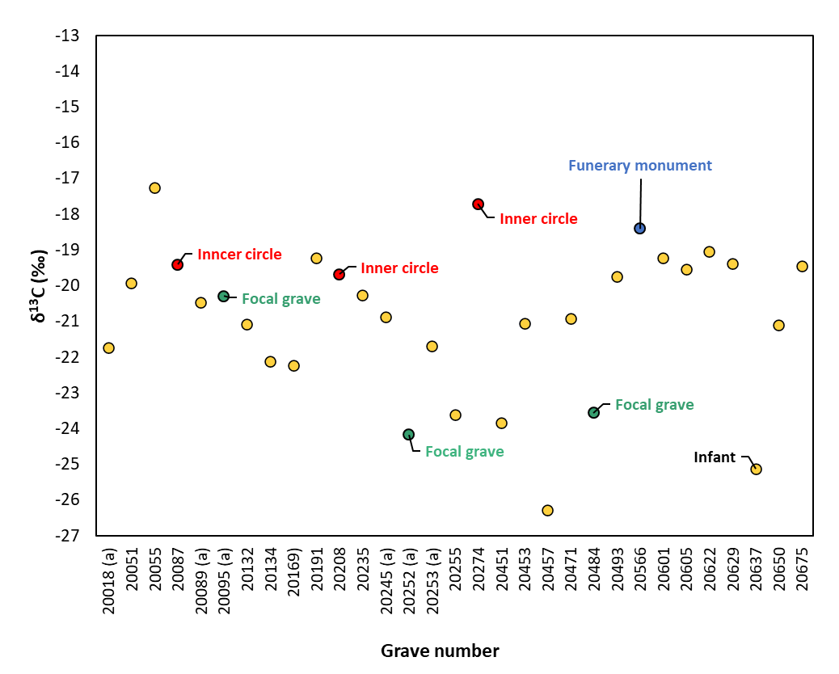

**Figure 3:** Previously published δ13C values (Fitzpatrick et al. 2017) for the individuals sampled in this study (n = 31). Red circle = grave from the inner circle, Green circle= focal grave, blue circle = Earlier Iron Age grave 20566 with funerary monument. Point labelled ‘Infant’ is grave 20637.

*COLOUR IMAGE NEEDED FOR PRINTED VERSION

**3.2 Strontium (87Sr/86Sr) results**

The full isotope results for Westhampnett are presented in **Table 4** and are openly available in the IsoArcH database (https://www.isoarch.org) (Salesse et al., 2018). The sampled individuals from Westhampnett (n = 31) have 87Sr/86Sr ratios ranging from 0.7090 to 0.7099 and mean of 0.7095. Shapiro-Wilk test indicated 87Sr/86Sr data was normally distributed *(p* = 0.78) and therefore parametric testing (ANOVA) was applied for the comparisons in the following sections. To investigate whether there were non-locals buried at Westhampnett the local 87Sr/86Sr bioavailable range must be considered. Here we use strontium isotope basemap data produced by Evans et al. (2022) which gives median domain values calculated using the BGS Biosphere Isotopes Domains (Great Britain) strontium dataset, which predominantly represent plant data (n = 1385). The isotope biosphere map aids in tracing residential origins of individuals and offers two levels at which to interrogate the strontium data. For provenancing human tooth enamel and bone samples, it is recommended to use the middle 50% of the plant data (the interquartile range). However, a broader range encompassing 90% of the biosphere data is also available for individuals with more restricted diets (e.g. herbivores) and samples that relate to shorter formation times (e.g. sequential slices of enamel) (Evans et al. 2022). Since the bone 87Sr/86Sr ratios here represent an averaged signal over some time, we have applied the interquartile range as recommended for human data.

For strontium isotope studies the analysis of local plants is advisable (Holt et al. 2021) however the anticipated biosphere 87Sr/86Sr ratios for the lithologies around Westhampnett is reasonably well characterised and understood. In the BGS dataset cretaceous chalk has a well-defined strontium isotope biosphere median 87Sr/86Sr ratio of0.7083 with an interquartile range between 0.7079 and 0.7087 based on 111 samples (BGS Biosphere Map), and Cenozoic mudrock has a IQR of 0.7087 to 0.7097 (n = 9) with a median of 0.7089.

|  |  |  |  |  |  |  |  |
| --- | --- | --- | --- | --- | --- | --- | --- |
| **Sample ID** | **Grave** | **Osteological Sex** | **Age of individual** | **Cemetery location/burial type** | **87Sr/86Sr** | **2SE** | **[Sr] P3** |
| WH01 | 20018 (a) | Unknown | Older mature/older adult | Other | 0.709563 | 0.000008 | 89.3 |
| WH02 | 20051 | Unknown | Subadult/adult | Other | 0.709274 | 0.000010 | 262 |
| WH03 | 20055 | Unknown | Older mature/older adult | Other | 0.709774 | 0.000009 | 120 |
| WH04 | 20087 | Unknown | Mature/Older adult | Inner circle | 0.709129 | 0.000011 | 136 |
| WH05 | 20089 (a) | ??F | Older mature adult | Other | 0.709484 | 0.000012 | 102 |
| WH06 | 20095 (a) | Unknown | 1) Older subadult; 2) older infant/young juvenile | Focal grave | 0.709578 | 0.000009 | 132 |
| WH07 | 20132 | Unknown | Older adult | Other | 0.709244 | 0.000010 | 87.6 |
| WH08 | 20134 | Unknown | Older mature/older adult | Other | 0.709472 | 0.000009 | 153 |
| WH09 | 20169 (a) | Unknown | Adult | Other | 0.709125 | 0.000009 | 114 |
| WH10 | 20191 | Unknown | Older adult | Other | 0.709196 | 0.000009 | 123 |
| WH11 | 20208 | ??F | Older mature/older adult | Inner circle | 0.709836 | 0.000008 | 111 |
| WH12 | 20235 | Unknown | Older mature/older adult | Other | 0.709491 | 0.000009 | 103 |
| WH13 | 20245 (a) | Unknown | Subadult/adult | Other | 0.709073 | 0.000009 | 85.1 |
| WH14 | 20252 (a) | ??F | Adult | Focal grave | 0.709742 | 0.000009 | 101 |
| WH15 | 20253 (a) | ??M | Young subadult | Other | 0.709417 | 0.000010 | 127 |
| WH16 | 20255 | Unknown | Adult | Other | 0.709550 | 0.000011 | 74.3 |
| WH17 | 20274 | Unknown | Older mature/older adult | Inner circle | 0.709579 | 0.000009 | 129 |
| WH18 | 20451 | Unknown | Subadult/adult | Other | 0.709435 | 0.000010 | 133 |
| WH19 | 20453 | ??F | Young/Younger mature adult | Other | 0.709611 | 0.000012 | 87.2 |
| WH20 | 20457 | Unknown | Older mature adult | Other | 0.709526 | 0.000007 | 135 |
| WH21 | 20471 | Unknown | Adult | Other | 0.709632 | 0.000007 | 102 |
| WH22 | 20484 | Unknown | Older mature/older adult | Focal grave | 0.709323 | 0.000009 | 108 |
| WH23 | 20493 | ??F | Older mature/older adult | Other | 0.709299 | 0.000008 | 104 |
| WH24 | 20601 | ?F | Young/mature adult | Other | 0.709711 | 0.000007 | 114 |
| WH25 | 20605 | ??F | Older mature/older adult | Other | 0.709808 | 0.000009 | 131 |
| WH26 | 20622 | Unknown | Young/mature adult | Other | 0.709306 | 0.000009 | 78.8 |
| WH27 | 20629 | ?M | Older mature/older adult | Other | 0.708966 | 0.000008 | 98.6 |
| WH28 | 20637 | Unknown | Young infant (3- 6 months) | Other | 0.709560 | 0.000008 | 82.4 |
| WH29 | 20650 | ??F | Adult | Other | 0.709022 | 0.000010 | 132 |
| WH30 | 20675 | Unknown | Young/mature adult | Other | 0.709360 | 0.000009 | 144 |
| WH31.A | 20566 | ?F | Older subadult/adult | EIA Funerary Monument | 0.709896 | 0.000014 | 81.3 |
| WH31.B | 20566 | same as WH31.A | same as WH31.A | same as WH31.A | 0.709916 | 0.000012 | 82.6 |
| WH31 mean value | 20605 | ??F | - | - | 0.709906 | - | 82.0 |

**Table 4:** Strontium isotope results for cremation burials from Westhampnett and associated osteological and archaeological information. WH31 is the Earlier Iron Age individual and was sampled twice. "WH31 mean value" is used in plots and statistical tests

Westhampnett is located on the West Sussex Coastal Plain which is bounded to the north by the dip-slope of the chalk escarpment of the South Downs (**Figure 1**). The local (50%) 87Sr/86Sr range for the cemetery is 0.7087 to 0.7097 and the neighbouring chalk has a range of 0.7079 to 0.7087 (Evans et al. 2022). Most individuals (25/31) fall within the range for the site **(Figure 4)** and therefore are likely to have consumed resources from the immediate local area. Six individuals (Graves: 20055, 20208, 20252 (a), 20566, 20601, 20605) have 87Sr/86Sr ratios above 0.7097 when considered at 5 decimal places. The Earlier Iron Age individual (grave 20566) has a 87Sr/86Sr of 0.7099 which is the highest out of the study group and 0.0004 higher than the Westhampnett mean 87Sr/86Sr. Collectively, the group with slightly higher 87Sr/86Sr ratios could be accommodated in the broader 90% bioavailable range (0.7083-0.7101) for Westhampnett, but this is less applicable to the bone samples analysed in this study which represent a dietary average over several years. Nevertheless, a degree of variation can occur within a single bone so we would not consider them to be extreme outliers although it is still possible, they may have consumed a diet that included some resources from outside the immediate local area. Marginally higher values than those at Westhampnett itself can be accommodated ~10km southwards towards the coast (e.g. on the nearby Manhood Peninsula) or slightly further to the north, in the western Weald. It is also notable that some individuals have 87Sr/86Sr ratios close to seawater (0.7092) which could suggest some impact of sea spray. The overall distribution of human bone 87Sr/86Sr ratios is quite narrow, ranging from 0.7090 to 0.7099. While there are areas of similar geology across southern England and Northern France the results are consistent with individuals consuming resources from the immediate local area or other areas nearby in Southeast England and we would therefore consider them to most likely represent local individuals.

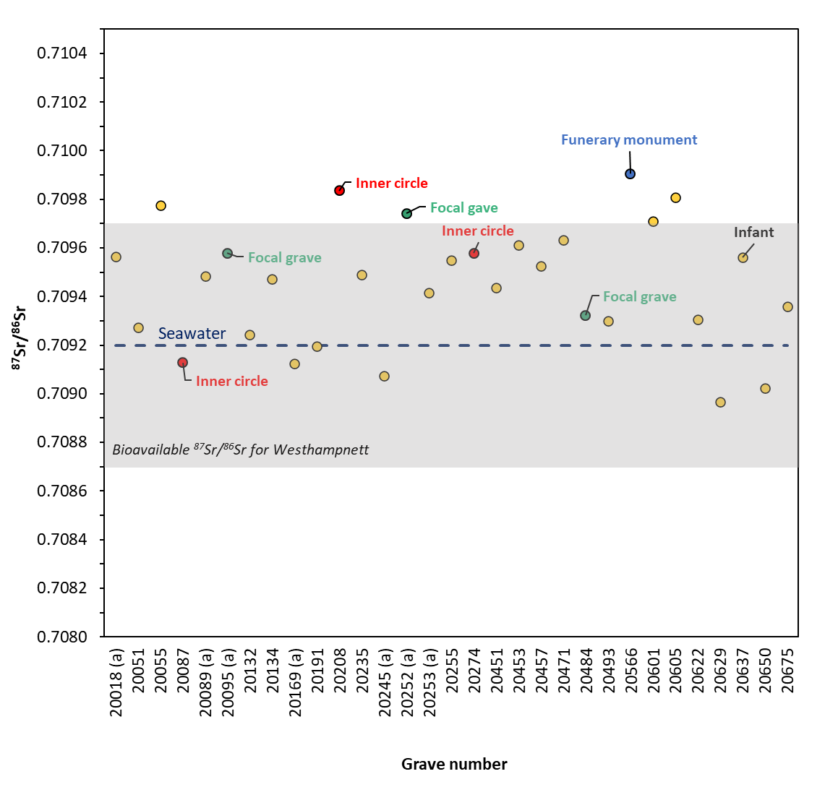

**Figure 4:** Strontium isotope ratios of the human remains (n = 31) from Westhampnett. The local bioavailable strontium range (50% range as per Biosphere Isotopes Domains map by Evans et al. 2022) is shown by the grey shaded box. The strontium isotope ratio for seawater (0.7092) is indicated by the blue dashed line. Red circle = grave from the inner circle, Green circle = focal grave. Point labelled ‘Infant’ is grave 20637. For grave 20566 “funerary monument” the value shown is the average for WH31.A and WH31.B.

*COLOUR IMAGE NEEDED FOR PRINTED VERSION

**3.3 Strontium concentration results**

The strontium concentrations range from 74 to 153 ppm with one outlier (Grave 20051) with a [Sr] of 262 ppm (**Table 4** and **Figure 5**). It is possible that 20051 had a different diet or origin from the rest of the study population. However, all other proxies are the same as the rest of the group, making it impossible to establish the reason for this difference. When comparing the concentrations from Westhampnett to those published for individuals from Belgium, the Westhampnett individuals are comparable to those from the Bronze and Iron Ages but have lower levels compared to the Roman period cremated bones (Dalle et al. 2022; 2023; Sabaux et al. 2021) (**Figure 5**). As not only diet but also geology impacts on [Sr] of human remains, it would be needed to contrast this data with [Sr] from a Roman population living in the same area and on the same geology. No correlation is observed between the strontium isotope ratios and concentrations (**Figure 6**).

Shapiro-Wilk test for normality indicated [Sr] [data deviated from a normal distribution (p = <0.001) therefore a non-parametric Kruskal-Wallis test was applied for the comparisons in the following sections.

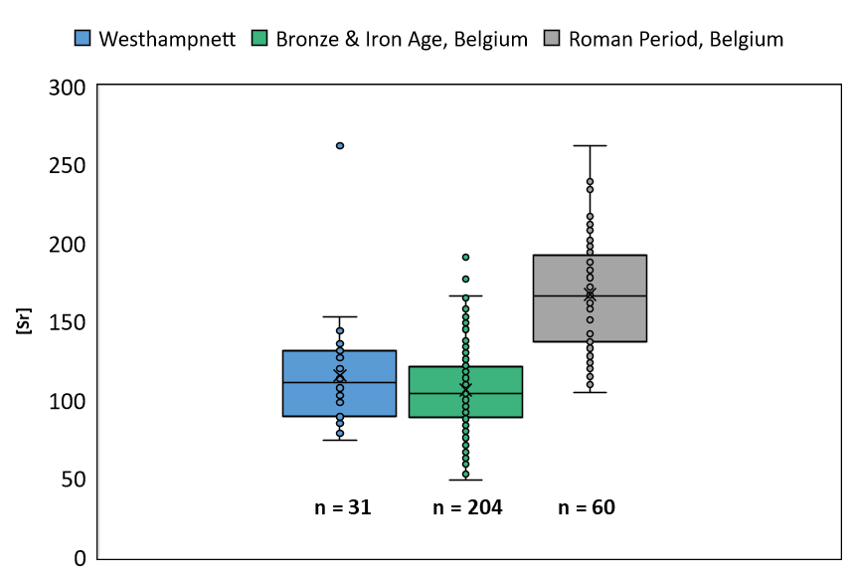

**Figure 5:** [Sr] from the cremated bones from Westhampnett compared to data from cremated bones from Belgium during the Iron Age and Roman periods (Dalle et al. 2022; 2023; Sabaux et al. 2021).

*COLOUR IMAGE NEEDED FOR PRINTED VERSION

**Figure 6:** Comparison of87Sr/86Sr and [Sr] from the cremated bones from Westhampnett.

**3.4 Males vs Females**

Eleven of the thirty-one individuals analysed have an osteological sex assigned (Mckinley 1997): seven possible females (??F), two probable females (?F); one possible male (??M), and one probable male (?M). For the remaining twenty, sex could not be determined. For comparative purposes possible/probable males have been combined and possible/probable females have been combined, results are shown in **Figure 7**. The 87Sr/86Sr ratios of the Females (n = 9) range from 0.7090 to 0.7099 with a mean of 0.7096. The strontium isotope ratios of the Males (n = 2) are 0.7090 and 0.7094 with a mean of 0.7092. Overall, females have a larger range of 87Sr/86Sr ratios and a higher mean when compared to the males, however there are only two males and therefore we cannot extrapolate this as a trend across the entire cemetery. The [Sr]of the Females (n = 9) range from 87 to 132 ppm with a mean of 110 ppm. The [Sr]of the Males (n = 2) range from 99 to 127 ppm with a mean value of 113 ppm. The number of samples within each sex category was insufficient for meaningful statistical comparisons, therefore no statistical tests were performed.

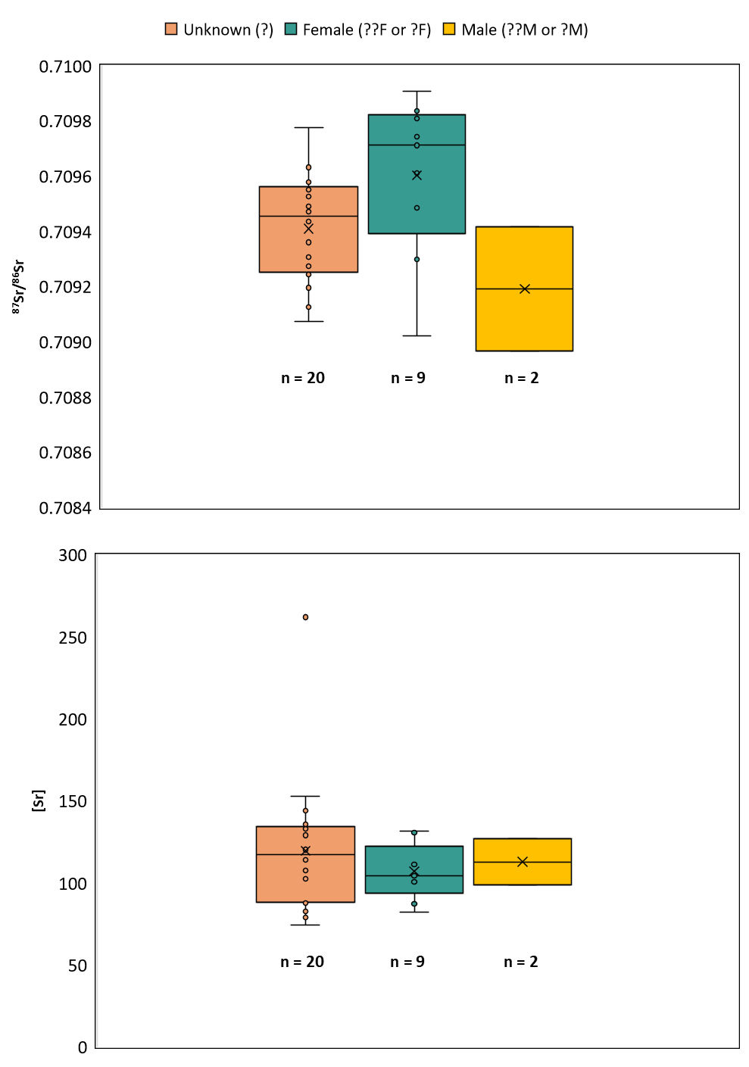

**Figure 7:** Boxplots showing 87Sr/86Sr and Sr concentration by sex (Mckinley 1997). NB: small sample size for “Male (??M or ?M)” (n = 2).

*COLOUR IMAGE NEEDED FOR PRINTED VERSION

**3.5 Age-at-death**

The 87Sr/86Sr results and [Sr] divided by age category are presented in **Figure 8**. WH06 is plotted separately as Feature 20095/Fill 20094 contained two individuals: an older subadult and an older infant/young juvenile (Mckinley 1997, p58) and we cannot be certain which individual was sampled. The majority of individuals were adults. To aid interpretation Grave 20253 (a) “young subadult” and Grave 20566 “Older subadult/adult” have been included in the “Subadult/adult” category. The “adult” category includes the following age estimations: “Young/Younger mature adult,” “Younger mature adult,” “Young/mature adult”, “Older mature adult,” “Mature/older adult”, “Older adult” and “Adult”.

The single infant (20637) sampled was 3-6 months old and has a strontium ratio of 0.7096. The adults (n = 24) have strontium isotope ratios ranging from 0.7090 to 0.7098 and a mean of 0.7095. The subadult/adults (n = 5) have a range from 0.7091 to 0.7099 and a mean of 0.7094. The [Sr]of the subadult/adults (n = 5) range from 82 to 262 ppm with a mean of 138 ppm. The [Sr]of the adults (n = 24) range from 74 to 153 ppm with a mean of 111 ppm. The number of samples within each age category was insufficient for meaningful statistical comparisons, therefore no statistical tests were performed. The older adults buried in the ‘inner circle’ (Graves 20087, 20208, 20274) are the only individuals in this study within this burial category and therefore their results are fully assessed in the following section focusing on burial type/location.

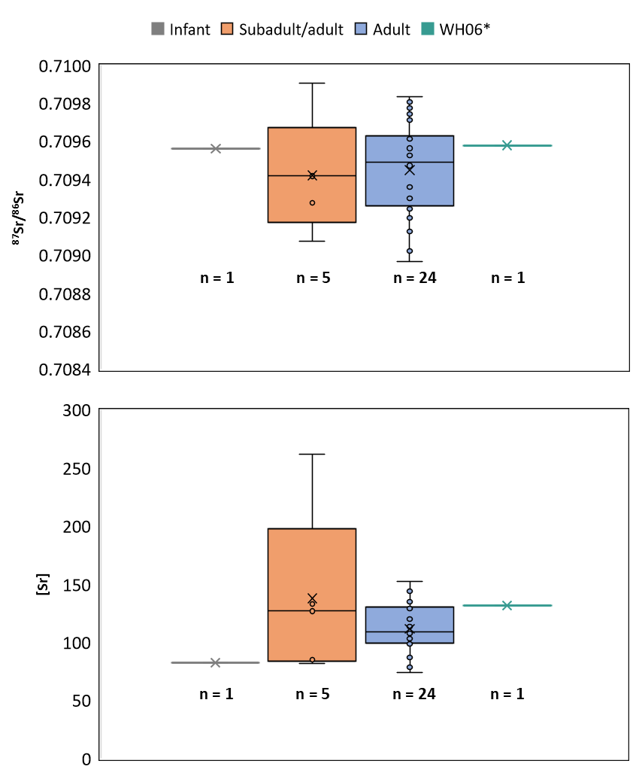

**Figure 8:** Boxplots showing 87Sr/86Sr and Sr concentration by age category (McKinley 1997). *WH06 grave 20095 (a) is plotted separately as the burial contained two individuals of different osteological age and either individual could be represented by the isotope sample.

*COLOUR IMAGE NEEDED FOR PRINTED VERSION

**3.6 Burial Type/Cemetery organisation**

All but two of the sampled individuals were unurned cremation burials. Grave 20637, fill 20636 was classified as possible urned burial (“?u”) as they were part of a potential double burial in which one individual was unurned and the other was possibly urned (Fitzpatrick 1997, p133). The other individual was Grave 20566 which is unique in dating to the Earlier Iron Age and was buried in a funerary monument. Since it was not possible to definitively confirm whether the individual from Grave 20637 originated from an urned burial, and only two individuals in the study group are different in this way, no statistical analysis was conducted to compare urned and unurned individuals at Westhampnett.

To explore differences relating to cemetery organisation the results are divided into four groups: Inner circle (20087, 20208, 20274); focal graves (20095; 20252; 20484), grave 20566 (Earlier Iron Age with funerary monument), and “other” (elsewhere in the cemetery) (**Figure 9**). The three focal graves have strontium isotope ratios ranging from 0.7093 to 0.7097 and a mean of 0.7096. The three graves containing older adults from the inner circle have strontium isotope ratios from 0.7091 – 0.7098, and a mean of 0.7095. Grave 20566 has a strontium isotope ratio of 0.7099. The other individuals (n = 24) have the largest range of 87Sr/86Sr ratios (0.7090 – 0.7098) and a mean of 0.7094. Independent one-way ANOVA showed no significant effect of burial type (focal, inner circle, elsewhere) on 87Sr/86Sr results: *F* (2, 27) = 2.68750×10-8, *p* = 0.46 (**Supplementary Text**).

The three focal graves have [Sr] ranging from 101 to 132 ppm and a mean value of 113 ppm. The three graves from the inner circle have [Sr] from 111 – 136 ppm, and a mean value of 125 ppm. Grave 20566 has a [Sr] of 82 ppm. The remaining individuals buried elsewhere in the cemetery (n = 24) have the largest range of values (74 – 262 ppm) and a mean value of 116 ppm. Strontium concentrations were not significantly affected by burial type (Kruskal-Wallis Test): *H* (2) = 1.33, p = 0.51 (**Supplementary Text**). In summary, the older individuals from the inner circle area of the cemetery, and the focal graves, do not have distinct mobility profiles relative to those buried elsewhere in the cemetery.

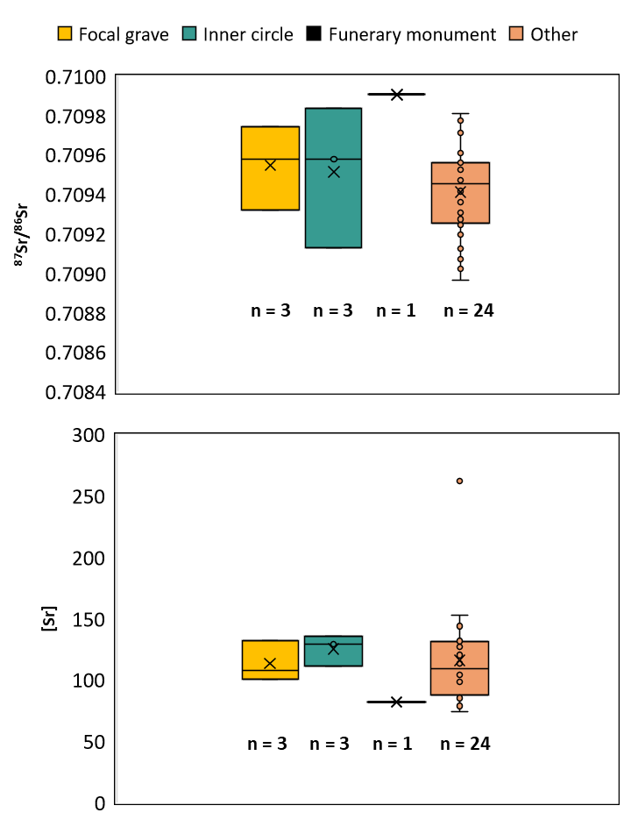

**Figure 9:** Boxplots showing 87Sr/86Sr and Sr concentration for focal graves, burials in the inner circle, the Earlier Iron Age individual (“funerary monument) and other burials (elsewhere in the cemetery).

*COLOUR IMAGE NEEDED FOR PRINTED VERSION.

1. **Discussion**

The strontium isotope results for the Westhampnett individuals are consistent with them living close to the site or within neighbouring areas of southern England during the decade or so prior to their death. There are geological similarities between southern Britain and areas of continental Europe and therefore we cannot completely exclude these as potential places of residence. Nonetheless, the narrow range of 87Sr/86Sr ratios across the sample group means that, if not local, they would have had to all migrate from locations with a similar strontium biosphere range c.10-20 years prior to their death. On balance, therefore, it is likely that they represent local individuals.

Most of the Late Iron Age settlements on the West Sussex Coastal Plain, and on the higher ground of the Downs to the north, are small farmsteads interpreted as being occupied by single families for a few generations. There is currently no indisputable evidence for the presence of an *oppidum*, which might have had a larger population, at Chichester at this time (Garland 2020, p109-118). Assuming that all the local population could bury their dead there, the size of the cemetery and the length of time that it was used for are consistent with it being used by several farmsteads, but it is also possible that a larger and longer-lived settlement is still to be discovered. In either case, the population buried in the cemetery appears to have been homogenous from an isotopic perspective and probably local and the use of the same mortuary rituals throughout the use of the cemetery may reflect this.

As the strontium isotope ratios of cremated bone reflects an averaged signal of the foods consumed approximately 10-20 years prior to death, they provide only a snapshot of individual mobility. Our results suggest a relatively settled and local community however using the methods employed here we cannot say definitively that all individuals were born and spent their childhood in this area. The majority (n = 24) were classified as “adult” (18yrs +), some of whom were older mature/older adults. Particularly for the older individuals sampled, it is possible that they may have lived in an area of different geology during childhood and early adulthood and only moved to Westhampnett a decade or more before death. During their time at Westhampnett they would consume local resources and their bones would end up with a “local” strontium isotope signature. Similarly, those with 87Sr/86Sr ratios that are slightly higher than the estimated 50% biosphere range for the site, could have bones that still reflect a small proportion of the strontium signal of origin and have not have yet fully incorporated only “local” 87Sr/86Sr. Most of the individuals from Westhampnett fall in the upper range of the 50% biosphere range, meaning that if this group of individuals migrated to Westhampnett they must be from an area with higher 87Sr/86Sr.

Unfortunately, any potential isotopic variability between males and females, and the different age groups cannot be assessed statistically as the number of samples was insufficient for meaningful comparisons. One of our main research questions was whether differences in burial location or type was linked to mobility, including the older adult burials in the ‘inner circle.’ Our study shows there was no significant difference in the isotope results between the different burial types or locations across the cemetery.

**5. Conclusion**

This study is the first to analyse the strontium isotopic composition of cremated bone from a British Iron Age cemetery. The narrow range of 87Sr/86Sr isotope ratios suggests that all the analysed individuals lived in a similar location and consumed similar resources. Our results indicate that the individuals from Westhampnett spent at least the final decade or so of their lives in the local area. Despite differences in burial form and location, and presence of pottery and brooches of a continental style, no significant isotopic differences were identified across the burial group. This suggests that cross-cultural similarities in funerary treatment and grave goods on either side of the Channel are more likely due to due to regular and long-standing cross-contacts rather than direct migration. Nevertheless, the methods employed here do not capture childhood residential origins and therefore we cannot exclude the possibility that individuals moved to the area in later life. Given the widespread practice of cremation during the Late Iron Age in southern England, the present study has demonstrated that this approach has the potential to unlock a wealth of data from cremated burial communities and offer more nuanced insights into regional mobility and social structure during this period.

**Data availability statement**

The data that support the findings of this study are included as part of the paper and supplementary materials. Data is also available in the IsoArcH database (https://www.isoarch.org).

**CRediT authorship contribution statement**

**Madeleine Bleasdale:** Resources, Methodology, Formal analysis, Project administration, Writing – Original Draft, Visualization. **Ian Armit:** Conceptualization, Methodology, Funding acquisition, Writing – Review & Editing. **Andrew Fitzpatrick:** Conceptualization, Methodology, Resources, Writing – Review & Editing. **Charlotte Primeau:** Resources, Project administration, Writing – Review & Editing. **Christophe Snoeck:** Conceptualization, Methodology, Investigation, Funding acquisition, Writing – Review & Editing**.**

**Declaration of competing interest**

The authors declare that they have no competing interests.

**Acknowledgements**

The authors wish to thank The Novium Museum, Chichester for allowing access to the Westhampnett human remains. Special thanks to Amy Roberts, Portia Tremlett, and staff at the Collections Discovery Centre for facilitating sampling. Thanks also to Ann Short and Tony Short for help with transportation and logistics. Research for this paper has received funding from theEuropean Research Council (ERC) under the European Union's Horizon 2020 research and innovation programme under grant agreement No 834087 (COMMIOS). The strontium isotope analyses are, in part, supported by the ERC Starting Grant LUMIERE (Landscape Use and Mobility In EuRope – Bridging the gap between cremation and inhumation), funded by European Union's Horizon 2020 research and innovation programme under grant agreement number 948913.

**References**

**Ancient Sources**

Julius Caesar, *Bellum Gallicum*, Translated by James J. O’Donnell. 2019, *The War for Gaul: A New Translation. Julius Caesar.* Princeton: Princeton University Press.

**Modern Sources**

Armit, I. 2022. Mobility and Migration in Bronze and Iron Age Britain: The COMMIOS Project, pp. 280–91 in M. Fernández-Götz, C. Nimura, P. W. Stockhammer, and R. Cartwright (eds) *Rethinking Migrations in Late Prehistoric Eurasia (Proceedings of the British Academy 254)*. Oxford University Press: Oxford.

Bass, W. M. 1987. *Human osteology: a laboratory and field manual*. Missouri Archaeological Society.

Cavazzuti, C., Hajdu, T., Lugli, F., Sperduti, A., Vicze, M., Horváth, A., Major, I., Molnár, M., Palcsu, L. and Kiss, V., 2021. Human mobility in a Bronze Age Vatya ‘urnfield’and the life history of a high-status woman. *PLoS One*, *16*(7), p.e0254360.

Creighton, J. 2000. *Coins and power in Late Iron Age Britain*. Cambridge: Cambridge University Press.

Cunliffe, B. 2005. *Iron Age Communities in Britain. An account of England, Scotland, and Wales from the seventh century BC until the Roman conquest*. 4th edition, London & New York: Routledge.

Dalle, S., Snoeck, C., Sengeløv, A., Salesse, K., Hlad, M., Annaert, R., Boudin, M., Capuzzo, G., Goderis, S., Sabaux, C., Stamataki, E., Vercauteren, M., Veselka, B., Warmenbol, E. & De Mulder, G. 2022. Strontium isotopes and concentrations in cremated bones reveal an increased salt consumption in Gallo-Roman diet. *Scientific Reports* 12(1) :9280.

Dalle, S., Capuzzo, G., Hlad, M., Veselka, B., Annaert, R., Boudin, M., Sabaux, C., Salesse, K., Sengeløv, A., Stamataki, E. Vercauteren, M., Warmenbol, E., Snoeck, C. & De Mulder, G. 2023. Hidden transitions. New insights into changing social dynamics between the Bronze and Iron Age in the cemetery of Destelbergen (Belgium). *Journal of Archaeological Science: Reports* 49: 103979.

Evans J.A., Chenery C.A., Mee K., Cartwright C.E., and, Marchant A.P. 2022. *Biosphere Isotope Domains GB (V2): Interactive Website*. British Geological Survey. (Interactive Resource) https://doi.org/10.5285/2ce7fc22-1b6e-4979-968f-42058c0120fb

Fitzpatrick, A. P. 1997. *Archaeological Excavations on the Route of the A27 Westhampnett Bypass, West Sussex, 1992. Volume 2: The late Iron Age, Romano-British, and Anglo-Saxon cemeteries*. Salisbury: Wessex Archaeology Report 12.

Fitzpatrick, A. P., Powell, A.B., and, Allen, M.J. 2008. *Archaeological Excavations on the Route of the A27 Westhampnett Bypass, West Sussex, 1992. Volume 1: Late Upper Palaeolithic-Anglo-Saxon.* Salisbury: Wessex Archaeology Report 21.

Fitzpatrick, A. P. 2007. The fire, the feast, and the funeral: Late Iron Age mortuary practices in south-eastern England. *Revue du Nord* 11: 123–142.

Fitzpatrick, A. P., Hamilton, D. and Haselgrove, C. 2017. Radiocarbon dating and Bayesian modelling of the Late Iron Age cremation burial cemetery at Westhampnett (West Sussex/GB). *Archäologisches Korrespondenzblatt* 47: 359–381.

Garland, N., 2020, The origins of British *oppida*: understanding transformation in Iron Age practice and society’, *Oxford Journal of Archaeology* 39: 107-125.

Gejvall, N.-G. 1981. *Determination of Burned Bones from Prehistoric Graves: Observations on the Cremated Bones from the Graves at Horn*. Osteological Research Laboratory at the University of Stockholm.

Gerritzen, C.T., Goderis, S., James, H.F., Snoeck, C. 2024. Optimizing Zr-doped MC-ICP-MS sample-standard bracketing to simultaneously determine 87Sr/86Sr and δ88Sr for high sample-throughput. *Spectrochimica Acta Part B: Atomic Spectroscopy* 217:106955.

Gray, H. 1977. *Anatomy*, New York, Bounty Books.

Harding, D.W. 2016. *Death and Burial in Iron Age Britain*. Oxford: Oxford University Press.

Harvig, L., Frei, K. M., Price, T. D., & Lynnerup, N. 2014. Strontium isotope signals in cremated petrous portions as indicator for childhood origin. *PloS One* *9*(7), e101603.

Hill, J. D. 2007. The dynamics of social change in Later Iron Age eastern and south-eastern England c. 300 BC–AD 43, pp. 16–40 in C. Haselgrove and T. Moore (eds) *The Later Iron Age in Britain and beyond*. Oxbow: Oxford.

Hodgson, J. M. 1963. Tangmere and Waterbeach, *Sussex Notes Queries* 15, 12-15

Hodgson, J. M. 1967. *Soils of the West Sussex Coastal Plain*, Harpenden, Bull. Soil Survey of Great Britain 3

Holt, E., Evans, J. A., & Madgwick, R. (2021). Strontium (87Sr/86Sr) mapping: A critical review of methods and approaches. *Earth-Science Reviews*, *216*, 103593

Lamb, A. 2022. Iron Age mortuary practices in Britain: an assessment of current trends and their characteristics within contemporary north-western European traditions. *Proceedings of the Prehistoric Society* 88: 227–260.

Löffelmann, T., Snoeck, C., Richards, J. D., Johnson, L. J., Claeys, P., & Montgomery, J. (2023). Sr analyses from only known Scandinavian cremation cemetery in Britain illuminate early Viking journey with horse and dog across the North Sea. *PloS One*, *18*(2), e0280589.

McMinn, R. M. H., & Hutchings, R. T. 1985. *A Colour Atlas of Human Anatomy* (New edition). Wolfe Medical Publications.

McKinley, J. I. 1997, ‘The Cremated Human Bone from Burial and Cremation-related Contexts’, pp 55-72, in Fitzpatrick, A. P. *Archaeological Excavations on the Route of the A27 Westhampnett Bypass, West Sussex, 1992. Volume 2: The late Iron Age, Romano-British, and Anglo-Saxon cemeteries*. Salisbury: Wessex Archaeology Report 12

Reiter, S.S., Møller, N.A., Nielsen, B.H., Bech, J.H., Olsen, A.L.H., Jørkov, M.L.S., Kaul, F., Mannering, U. and Frei, K.M., 2021. Into the fire: Investigating the introduction of cremation to Nordic Bronze Age Denmark: A comparative study between different regions applying strontium isotope analyses and archaeological methods. *Plos one*, 16(5), p.e0249476.

Roymans, N. 1990. *Tribal societies in Northern Gaul: an anthropological perspective*. Amsterdam: Cingula.

Sabaux, C., Veselka, B., Capuzzo, G., Snoeck, C., Sengeløv, A., Hlad, M., Warmenbol, E., Stamataki, E., Boudin, M., Annaert, R., Dalle, S., Salesse, K., Debaille ,V., Tys, D., Vercauteren, M. & De Mulder, G. 2021. Multi-proxy analyses reveal regional cremation practices and social status at the Late Bronze Age site of Herstal, Belgium. *Journal of Archaeological Science,* 132:105437.

Sabaux, C., Snoeck, C., Capuzzo, G., Veselka, B., Dalle, S., Warmenbol, E., Stamataki, E., Hlad, M., Sengeløv, A., Debaille, V., Boudin, M., Salesse, K., Annaert, R., Vercauteren, M. & De Mulder, G. In Press. Novel multidisciplinary approach detects multiple individuals within the same Late Bronze – Early Iron Age cremation graves. *Radiocarbon*.

Salesse, K., Fernandes, R., de Rochefort, X., Brůˇzek, J., Castex, D., Dufour, E., 2018. IsoArcH.eu: An open-access and collaborative isotope database for bioarchaeological samples from the Graeco-Roman world and its margins. *Jorunal of Archaeological Science: Reports* 19: 1050–1055.

Seghi, F., Lugli, F., James, H. F., Löffelmann, T., Armaroli, E., Vazzana, A., Cipriani, A., Snoeck, C., & Benazzi, S. (2024). Strontium isotopes and cremation: Investigating mobility patterns in the Roman city of Mutina (north-eastern Italy). *Journal of Archaeological Science, Reports*, *58*(104728), 104728.

Snoeck, C., Cheung, C., Griffith, J. I., James, H. F., & Salesse, K. (2022). Strontium isotope analyses of archaeological cremated remains - new data and perspectives. *Data in Brief*, *42*, 108115.

Snoeck C., Schulting R.J., Lee-Thorp J.A., de Jong J., Debouge W. & Mattielli N. 2015. Calcined bone provides a reliable substrate for strontium isotope ratios as shown by an enrichment experiment. *Rapid Communications in Mass Spectrometry* 29:107–114.

Snoeck, C., Schulting, R. J., Lee-Thorp, J. A., Lebon, M., & Zazzo, A. 2016. Impact of heating conditions on the carbon and oxygen isotope composition of calcined bone. *Journal of Archaeological Science* *65*: 32–43.

Stamataki, E., Kontopoulos, I., Salesse, K., McMillan, R., Veselka, B., Sabaux, C., Annaert, R., Boudin, M., Capuzzo, G., Claeys, Ph., Dalle, S., Hlad, M., Sengeløv, A., Vercauteren, M., Warmenbol, E., De Mulder, G. & Snoeck, C. 2021. Is it hot enough? A multi-proxy approach shows variations in cremation conditions during the Metal Ages in Belgium. *Journal of Archaeological Science* 136:105509.

Stead, I.M. 1976. The earliest burials of the Aylesford culture. In G. de Sieveking, G., Longworth, I.H. & Wilson, K.E. (eds), *Problems in Economic and Social Archaeology*, 401–416. London: Duckworth.

Stead, I.M. & Rigby, V. 1989. *Verulamium: the King Harry Lane site*. London. English Heritage Archaeological Report 12.

Taylor, N., Frei, K.M. and Frei, R., 2020. A strontium isotope pilot study using cremated teeth from the Vollmarshausen cemetery, Hesse, Germany. Journal of Archaeological Science: Reports, 31, p.102356.

Taylor, A., Weale, A., & Ford, S. 2014. *Bronze Age, Iron Age and Roman Landscapes of the Coastal Plain, and a Late Iron Age Warrior Burial at North Bersted, Bognor Regis, West Sussex: Excavations 2007-2010*. Thames Vally Archaeological Services Limited.

Van Beek, G.C. 1983. Dental Morphology: an illustrated Guide. Bristol, Wright.

Webb, P. A., & Suchey, J. M. (1985). Epiphyseal union of the anterior iliac crest and medial clavicle in a modern multiracial sample of American males and females. *American Journal of Physical Anthropology* *68*(4): 457–466.

Weis, D., Kieffer, B., Maerschalk, C., Barling, J., de Jong, J., Williams, G.A., Hanano, D., Pretorius, W., Mattielli, N., Scoates, J.S., Goolaerts, G., Friedman, R.M. & Mahoney, J.B. 2006. High-precision isotopic characterization of USGS reference materials by TIMS and MC-ICP-MS. *Geochem. Geophys. Geosyst.* 7 (8).